WDI Stock Document

Brian Stacy

10/4/2021

# 1 World Development Indicators

## 1.1 Environment: Agricultural production

### 1.1.1 Agricultural machinery, tractors

### What is the indicator?

Agricultural machinery refers to the number of wheel and crawler tractors (excluding garden tractors) in use in agriculture at the end of the calendar year specified or during the first quarter of the following year.

Topic: Environment: Agricultural production

Series ID: AG.AGR.TRAC.NO

Copyright: CC BY-4.0 , <https://datacatalog.worldbank.org/public-licenses#cc-by>

First year with any data: 1961

Last year with any data: 2009

### What years are data available?

The figure below shows years in which data is available for at least one country. Dates shaded in black have no data, while dates shaded in green have data for at least one country

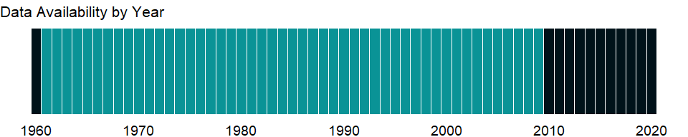

### Which countries have data?

The figure below shows the percentage of countries in each income group with a value since 2010 for that indicator.

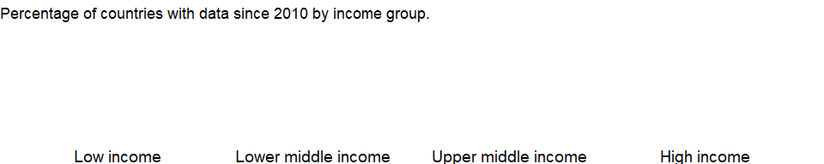

### Why is it relevant?

Agricultural land covers more than one-third of the world’s land area. In many industrialized countries, agricultural land is subject to zoning regulations. In the context of zoning, agricultural land (or more properly agriculturally zoned land) refers to plots that may be used for agricultural activities, regardless of the physical type or quality of land.

A substantial contribution to agriculture in the last century has been the escalation from manual and stock-animal farm work to gas-powered farm equipment. Globally, steel plows, mowers, mechanical reapers, seed drills, and threshers contributed to the development of mechanized agriculture, tractors enabled the farmer to sow and harvest large agricultural lands with less manpower. In modern times, powered machinery such as tractors, has replaced many jobs formerly carried out by men or animals such as oxen, horses and mules. FAO estimates that most farmers in developing countries experience a greater annual expenditure on farm power inputs than on fertilizer, seeds or agrochemicals.

Agriculture is still a major sector in many economies, and agricultural activities provide developing countries with food and revenue. But agricultural activities also can degrade natural resources as poor farming practices cause soil erosion and loss of soil fertility.

There is no single correct mix of inputs to the agricultural land, as it is dependent on local climate, land quality, and economic development; appropriate levels and application rates vary by country and over time and depend on the type of crops, the climate and soils, and the production process used.

### What is the data source?

Food and Agriculture Organization, electronic files and web site.

### What is the methodology?

A tractor provides the power and traction to mechanize agricultural tasks, especially tillage. Agricultural implements may be towed behind or mounted on the tractor, and the tractor may also provide a source of power if the implement is mechanized. The most common use of the term “tractor” is for the vehicles used on farms. The farm tractor is used for pulling or pushing agricultural machinery or trailers, for plowing, tilling, disking, harrowing, planting, and similar tasks. Planting, tending and harvesting a crop requires both a significant amount of power and a suitable range of tools and equipment. Mechanization of farming has allowed an increase to the area that can be planted and has contributed towards increased yields, mainly due to the precision with which the farming tasks can be accomplished.

### How is it aggregated?

Sum

### What are the limitations?

The data are collected by the Food and Agriculture Organization of the United Nations (FAO) through annual questionnaires. The FAO tries to impose standard definitions and reporting methods, but complete consistency across countries and over time is not possible. The data collected from official national sources through the questionnaire are supplemented with information from official secondary data sources. The secondary sources cover official country data from websites of national ministries, national publications and related country data reported by various international organizations.

### What else should I know?

NA

### 1.1.2 Fertilizer consumption (% of fertilizer production)

### What is the indicator?

Fertilizer consumption measures the quantity of plant nutrients used per unit of arable land. Fertilizer products cover nitrogenous, potash, and phosphate fertilizers (including ground rock phosphate). Traditional nutrients–animal and plant manures–are not included. For the purpose of data dissemination, FAO has adopted the concept of a calendar year (January to December). Some countries compile fertilizer data on a calendar year basis, while others are on a split-year basis.

Topic: Environment: Agricultural production

Series ID: AG.CON.FERT.PT.ZS

Copyright: CC BY-4.0 , <https://datacatalog.worldbank.org/public-licenses#cc-by>

First year with any data: 1961

Last year with any data: 2018

### What years are data available?

The figure below shows years in which data is available for at least one country. Dates shaded in black have no data, while dates shaded in green have data for at least one country

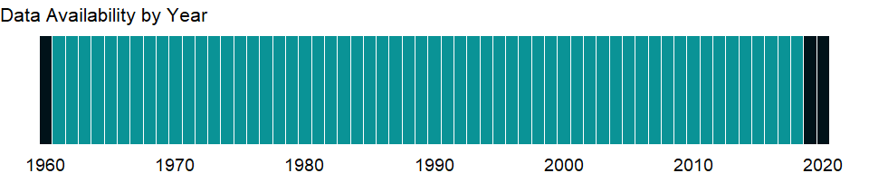

### Which countries have data?

The figure below shows the percentage of countries in each income group with a value since 2010 for that indicator.

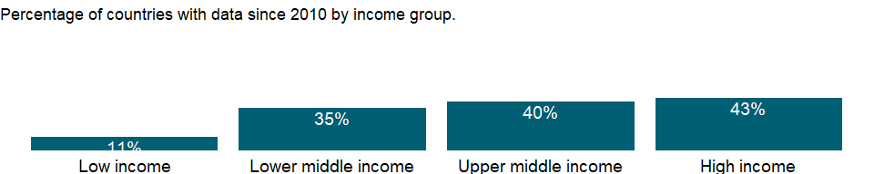

### Why is it relevant?

Factors such as the green revolution, has led to impressive progress in increasing crop yields over the last few decades. This progress, however, is not equal across all regions. Continued progress depends on maintaining agricultural research and education. The cultivation of cereals varies widely in different countries and depends partly upon the development of the economy. Production depends on the nature of the soil, the amount of rainfall, irrigation, quality od seeds, and the techniques applied to promote growth.

Agriculture is still a major sector in many economies, and agricultural activities provide developing countries with food and revenue. But agricultural activities also can degrade natural resources. Poor farming practices can cause soil erosion and loss of soil fertility. Efforts to increase productivity by using chemical fertilizers, pesticides, and intensive irrigation have environmental costs and health impacts. Salinization of irrigated land diminishes soil fertility. Thus, inappropriate use of inputs for agricultural production has far-reaching effects.

In many developed countries, excessive nitrogen fertilizer applications have sometime lead to pest problems by increasing the birth rate, longevity and overall fitness of certain agricultural pests, such as aphids. Further, excessive use of fertilizers emits significant quantities of greenhouse gas into the atmosphere. Over-fertilization of a vital nutrient can be detrimental, as “fertilizer burn” can occur when too much fertilizer is applied, resulting in drying out of the leaves and damage or even death of the plant. In many industrialized countries, overuse of fertilizers has resulted in contamination of surface water and groundwater.

There is no single correct mix of inputs to the agricultural land, as it is dependent on local climate, land quality, and economic development; appropriate levels and application rates vary by country and over time and depend on the type of crops, the climate and soils, and the production process used.

### What is the data source?

Food and Agriculture Organization, electronic files and web site.

### What is the methodology?

Fertilizer consumption measures the quantity of plant nutrients, and is calculated as production plus imports minus exports. Because some chemical compounds used for fertilizers have other industrial applications, the consumption data may overstate the quantity available for crops. Fertilizer consumption as a share of production shows the agriculture sector’s vulnerability to import and energy price fluctuation.

Most fertilizers that are commonly used in agriculture contain the three basic plant nutrients - nitrogen, phosphorus, and potassium. Some fertilizers also contain certain “micronutrients,” such as zinc and other metals that are necessary for plant growth. Materials that are applied to the land primarily to enhance soil characteristics (rather than as plant food) are commonly referred to as soil amendments. Fertilizers and soil amendments are largely derived from raw material, composts and other organic matter, and wastes, such as sewage sludge and certain industrial wastes.

FAO defines arable land as land under temporary crops (double-cropped areas are counted once), temporary meadows for mowing or for pasture, land under market or kitchen gardens, and land temporarily fallow; land abandoned as a result of shifting cultivation is excluded.

### How is it aggregated?

Weighted average

### What are the limitations?

The FAO has revised the time series for fertilizer consumption and irrigation for 2002 onward. FAO collects fertilizer statistics for production, imports, exports, and consumption through the new FAO fertilizer resources questionnaire. In the previous release, the data were based on total consumption of fertilizers, but the data in the recent release are based on the nutrients in fertilizers. Some countries compile fertilizer data on a calendar year basis, while others compile on a crop year basis (July-June). Previous editions of this indicator, Fertilizer consumption (100 grams per hectare of arable land), reported data on a crop year basis, but this edition uses the calendar year, as adopted by the FAO. Caution should thus be used when comparing data over time.

The data are collected by the Food and Agriculture Organization of the United Nations (FAO) through annual questionnaires. The FAO tries to impose standard definitions and reporting methods, but complete consistency across countries and over time is not possible. The secondary sources cover official country data from websites of national ministries, national publications and related country data reported by various international organizations.

### What else should I know?

NA

### 1.1.3 Fertilizer consumption (kilograms per hectare of arable land)

### What is the indicator?

Fertilizer consumption measures the quantity of plant nutrients used per unit of arable land. Fertilizer products cover nitrogenous, potash, and phosphate fertilizers (including ground rock phosphate). Traditional nutrients–animal and plant manures–are not included. For the purpose of data dissemination, FAO has adopted the concept of a calendar year (January to December). Some countries compile fertilizer data on a calendar year basis, while others are on a split-year basis. Arable land includes land defined by the FAO as land under temporary crops (double-cropped areas are counted once), temporary meadows for mowing or for pasture, land under market or kitchen gardens, and land temporarily fallow. Land abandoned as a result of shifting cultivation is excluded.

Topic: Environment: Agricultural production

Series ID: AG.CON.FERT.ZS

Copyright: CC BY-4.0 , <https://datacatalog.worldbank.org/public-licenses#cc-by>

First year with any data: 1961

Last year with any data: 2018

### What years are data available?

The figure below shows years in which data is available for at least one country. Dates shaded in black have no data, while dates shaded in green have data for at least one country



### Which countries have data?

The figure below shows the percentage of countries in each income group with a value since 2010 for that indicator.

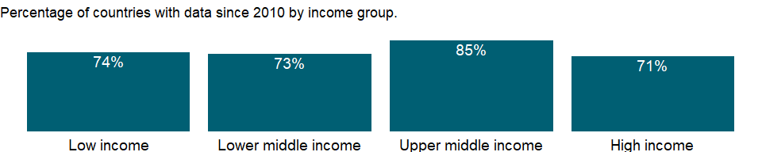

### Why is it relevant?

Factors such as the green revolution, has led to impressive progress in increasing crop yields over the last few decades. This progress, however, is not equal across all regions. Continued progress depends on maintaining agricultural research and education. The cultivation of cereals varies widely in different countries and depends partly upon the development of the economy. Production depends on the nature of the soil, the amount of rainfall, irrigation, quality od seeds, and the techniques applied to promote growth.

Agriculture is still a major sector in many economies, and agricultural activities provide developing countries with food and revenue. But agricultural activities also can degrade natural resources. Poor farming practices can cause soil erosion and loss of soil fertility. Efforts to increase productivity by using chemical fertilizers, pesticides, and intensive irrigation have environmental costs and health impacts. Salinization of irrigated land diminishes soil fertility. Thus, inappropriate use of inputs for agricultural production has far-reaching effects.

In many developed countries, excessive nitrogen fertilizer applications have sometime lead to pest problems by increasing the birth rate, longevity and overall fitness of certain agricultural pests, such as aphids. Further, excessive use of fertilizers emits significant quantities of greenhouse gas into the atmosphere. Over-fertilization of a vital nutrient can be detrimental, as “fertilizer burn” can occur when too much fertilizer is applied, resulting in drying out of the leaves and damage or even death of the plant. In many industrialized countries, overuse of fertilizers has resulted in contamination of surface water and groundwater.

There is no single correct mix of inputs to the agricultural land, as it is dependent on local climate, land quality, and economic development; appropriate levels and application rates vary by country and over time and depend on the type of crops, the climate and soils, and the production process used.

### What is the data source?

Food and Agriculture Organization, electronic files and web site.

### What is the methodology?

Fertilizer consumption measures the quantity of plant nutrients, and is calculated as production plus imports minus exports. Because some chemical compounds used for fertilizers have other industrial applications, the consumption data may overstate the quantity available for crops. Fertilizer consumption as a share of production shows the agriculture sector’s vulnerability to import and energy price fluctuation.

Most fertilizers that are commonly used in agriculture contain the three basic plant nutrients - nitrogen, phosphorus, and potassium. Some fertilizers also contain certain “micronutrients,” such as zinc and other metals that are necessary for plant growth. Materials that are applied to the land primarily to enhance soil characteristics (rather than as plant food) are commonly referred to as soil amendments. Fertilizers and soil amendments are largely derived from raw material, composts and other organic matter, and wastes, such as sewage sludge and certain industrial wastes.

FAO defines arable land as land under temporary crops (double-cropped areas are counted once), temporary meadows for mowing or for pasture, land under market or kitchen gardens, and land temporarily fallow; land abandoned as a result of shifting cultivation is excluded.

### How is it aggregated?

Weighted average

### What are the limitations?

The FAO has revised the time series for fertilizer consumption and irrigation for 2002 onward. FAO collects fertilizer statistics for production, imports, exports, and consumption through the new FAO fertilizer resources questionnaire. In the previous release, the data were based on total consumption of fertilizers, but the data in the recent release are based on the nutrients in fertilizers. Some countries compile fertilizer data on a calendar year basis, while others compile on a crop year basis (July-June). Previous editions of this indicator, Fertilizer consumption (100 grams per hectare of arable land), reported data on a crop year basis, but this edition uses the calendar year, as adopted by the FAO. Caution should thus be used when comparing data over time.

The data are collected by the Food and Agriculture Organization of the United Nations (FAO) through annual questionnaires. The FAO tries to impose standard definitions and reporting methods, but complete consistency across countries and over time is not possible. The secondary sources cover official country data from websites of national ministries, national publications and related country data reported by various international organizations.

### What else should I know?

NA

### 1.1.4 Land under cereal production (hectares)

### What is the indicator?

Land under cereal production refers to harvested area, although some countries report only sown or cultivated area. Cereals include wheat, rice, maize, barley, oats, rye, millet, sorghum, buckwheat, and mixed grains. Production data on cereals relate to crops harvested for dry grain only. Cereal crops harvested for hay or harvested green for food, feed, or silage and those used for grazing are excluded.

Topic: Environment: Agricultural production

Series ID: AG.LND.CREL.HA

Copyright: CC BY-4.0 , <https://datacatalog.worldbank.org/public-licenses#cc-by>

First year with any data: 1961

Last year with any data: 2018

### What years are data available?

The figure below shows years in which data is available for at least one country. Dates shaded in black have no data, while dates shaded in green have data for at least one country



### Which countries have data?

The figure below shows the percentage of countries in each income group with a value since 2010 for that indicator.

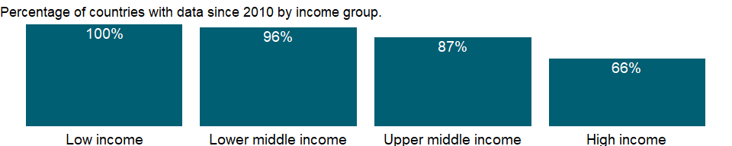

### Why is it relevant?

The cultivation of cereals varies widely in different countries and depends partly upon the development of the economy. Production depends on the nature of the soil, the amount of rainfall, irrigation, quality od seeds, and the techniques applied to promote growth.

In developed countries, cereal crops are universally machine-harvested, typically using a combine harvester, which cuts, threshes, and winnows the grain during a single pass across the field. In many industrialized countries, particularly in the United States and Canada, farmers commonly deliver their newly harvested grain to a grain elevator or a storage facility that consolidates the crops of many farmers. In developing countries, a variety of harvesting methods are used in cereal cultivation, depending on the cost of labor, from small combines to hand tools such as the scythe or cradle.

Crop production systems have evolved rapidly over the past century and have resulted in significantly increased crop yields, but have also created undesirable environmental side-effects such as soil degradation and erosion, pollution from chemical fertilizers and agrochemicals and a loss of bio-diversity. Factors such as the green revolution, has led to impressive progress in increasing cereals yields over the last few decades. This progress, however, is not equal across all regions. Continued progress depends on maintaining agricultural research and education. The cultivation of cereals varies widely in different countries and depends partly upon the development of the economy. Production depends on the nature of the soil, the amount of rainfall, irrigation, quality of seeds, and the techniques applied to promote growth.

Agriculture is still a major sector in many economies, and agricultural activities provide developing countries with food and revenue. But agricultural activities also can degrade natural resources. Poor farming practices can cause soil erosion and loss of soil fertility. Efforts to increase productivity by using chemical fertilizers, pesticides, and intensive irrigation have environmental costs and health impacts. Salinization of irrigated land diminishes soil fertility. Thus, inappropriate use of inputs for agricultural production has far-reaching effects.

There is no single correct mix of inputs to the agricultural land, as it is dependent on local climate, land quality, and economic development; appropriate levels and application rates vary by country and over time and depend on the type of crops, the climate and soils, and the production process used.

### What is the data source?

Food and Agriculture Organization, electronic files and web site.

### What is the methodology?

Cereals production includes wheat, rice, maize, barley, oats, rye, millet, sorghum, buckwheat, and mixed grains. Production data on cereals relate to crops harvested for dry grain only. Cereal crops harvested for hay or harvested green for food, feed, or silage and those used for grazing are excluded.

A cereal is a grass cultivated for the edible components of their grain, composed of the endosperm, germ, and bran. Cereal grains are grown in greater quantities and provide more food energy worldwide than any other type of crop; cereal crops therefore can also be called staple crops.

### How is it aggregated?

Sum

### What are the limitations?

The data are collected by the Food and Agriculture Organization of the United Nations (FAO) through annual questionnaires. They are supplemented with information from official secondary data sources. The secondary sources cover official country data from websites of national ministries, national publications and related country data reported by various international organizations. The FAO tries to impose standard definitions and reporting methods, but complete consistency across countries and over time is not possible. Thus, data on agricultural land in different climates may not be comparable. For example, permanent pastures are quite different in nature and intensity in African countries and dry Middle Eastern countries.

Data on agricultural land are valuable for conducting studies on a various perspectives concerning agricultural production, food security and for deriving cropping intensity among others uses.

### What else should I know?

NA

### 1.1.5 Agricultural machinery, tractors per 100 sq. km of arable land

### What is the indicator?

Agricultural machinery refers to the number of wheel and crawler tractors (excluding garden tractors) in use in agriculture at the end of the calendar year specified or during the first quarter of the following year. Arable land includes land defined by the FAO as land under temporary crops (double-cropped areas are counted once), temporary meadows for mowing or for pasture, land under market or kitchen gardens, and land temporarily fallow. Land abandoned as a result of shifting cultivation is excluded.

Topic: Environment: Agricultural production

Series ID: AG.LND.TRAC.ZS

Copyright: CC BY-4.0 , <https://datacatalog.worldbank.org/public-licenses#cc-by>

First year with any data: 1961

Last year with any data: 2009

### What years are data available?

The figure below shows years in which data is available for at least one country. Dates shaded in black have no data, while dates shaded in green have data for at least one country



### Which countries have data?

The figure below shows the percentage of countries in each income group with a value since 2010 for that indicator.



### Why is it relevant?

Agricultural land covers more than one-third of the world’s land area. In many industrialized countries, agricultural land is subject to zoning regulations. In the context of zoning, agricultural land (or more properly agriculturally zoned land) refers to plots that may be used for agricultural activities, regardless of the physical type or quality of land.

A substantial contribution to agriculture in the last century has been the escalation from manual and stock-animal farm work to gas-powered farm equipment. Globally, steel plows, mowers, mechanical reapers, seed drills, and threshers contributed to the development of mechanized agriculture, tractors enabled the farmer to sow and harvest large agricultural lands with less manpower. In modern times, powered machinery such as tractors, has replaced many jobs formerly carried out by men or animals such as oxen, horses and mules. FAO estimates that most farmers in developing countries experience a greater annual expenditure on farm power inputs than on fertilizer, seeds or agrochemicals.

Agriculture is still a major sector in many economies, and agricultural activities provide developing countries with food and revenue. But agricultural activities also can degrade natural resources as poor farming practices cause soil erosion and loss of soil fertility.

There is no single correct mix of inputs to the agricultural land, as it is dependent on local climate, land quality, and economic development; appropriate levels and application rates vary by country and over time and depend on the type of crops, the climate and soils, and the production process used.

### What is the data source?

Food and Agriculture Organization, electronic files and web site.

### What is the methodology?

A tractor provides the power and traction to mechanize agricultural tasks, especially tillage. Agricultural implements may be towed behind or mounted on the tractor, and the tractor may also provide a source of power if the implement is mechanized. The most common use of the term “tractor” is for the vehicles used on farms. The farm tractor is used for pulling or pushing agricultural machinery or trailers, for plowing, tilling, disking, harrowing, planting, and similar tasks. Planting, tending and harvesting a crop requires both a significant amount of power and a suitable range of tools and equipment. Mechanization of farming has allowed an increase to the area that can be planted and has contributed towards increased yields, mainly due to the precision with which the farming tasks can be accomplished.

Agricultural land constitutes only a part of any country’s total area, which can include areas not suitable for agriculture, such as forests, mountains, and inland water bodies. Data on agricultural land are valuable for conducting studies on a various perspectives concerning agricultural production, food security and for deriving cropping intensity among others uses. Agricultural land indicator, along with land-use indicators, can also elucidate the environmental sustainability of countries’ agricultural practices.

### How is it aggregated?

Weighted average

### What are the limitations?

The data are collected by the Food and Agriculture Organization of the United Nations (FAO) through annual questionnaires. The FAO tries to impose standard definitions and reporting methods, but complete consistency across countries and over time is not possible. Thus, data on agricultural land in different climates may not be comparable. For example, permanent pastures are quite different in nature and intensity in African countries and dry Middle Eastern countries. Data on agricultural employment, in particular, should be used with caution. In many countries much agricultural employment is informal and unrecorded, including substantial work performed by women and children. To address some of these concerns, this indicator is heavily footnoted in the database in sources, definition, and coverage.

The data collected from official national sources through the questionnaire are supplemented with information from official secondary data sources. The secondary sources cover official country data from websites of national ministries, national publications and related country data reported by various international organizations.

### What else should I know?

NA

### 1.1.6 Cereal production (metric tons)

### What is the indicator?

Production data on cereals relate to crops harvested for dry grain only. Cereal crops harvested for hay or harvested green for food, feed, or silage and those used for grazing are excluded.

Topic: Environment: Agricultural production

Series ID: AG.PRD.CREL.MT

Copyright: CC BY-4.0 , <https://datacatalog.worldbank.org/public-licenses#cc-by>

First year with any data: 1961

Last year with any data: 2018

### What years are data available?

The figure below shows years in which data is available for at least one country. Dates shaded in black have no data, while dates shaded in green have data for at least one country



### Which countries have data?

The figure below shows the percentage of countries in each income group with a value since 2010 for that indicator.



### Why is it relevant?

The Food and Agriculture Organization (FAO) estimates that cereals supply 51 percent of Calories and 47 percent of protein in the average diet. The total annual cereal production globally is about 2,500 million tons.

FAO estimates that maize (corn), wheat and rice together account for more than three-fourths of all grain production worldwide. In developed countries, cereal crops are universally machine-harvested, typically using a combine harvester, which cuts, threshes, and winnows the grain during a single pass across the field. In many industrialized countries, particularly in the United States and Canada, farmers commonly deliver their newly harvested grain to a grain elevator or a storage facility that consolidates the crops of many farmers. In developing countries, a variety of harvesting methods are used in cereal cultivation, depending on the cost of labor, from small combines to hand tools such as the scythe or cradle.

Crop production systems have evolved rapidly over the past century and have resulted in significantly increased crop yields, but have also created undesirable environmental side-effects such as soil degradation and erosion, pollution from chemical fertilizers and agrochemicals and a loss of bio-diversity. Factors such as the green revolution, has led to impressive progress in increasing cereals yields over the last few decades. This progress, however, is not equal across all regions. Continued progress depends on maintaining agricultural research and education. The cultivation of cereals varies widely in different countries and depends partly upon the development of the economy. Production depends on the nature of the soil, the amount of rainfall, irrigation, quality of seeds, and the techniques applied to promote growth.

### What is the data source?

Food and Agriculture Organization, electronic files and web site.

### What is the methodology?

A cereal is a grass cultivated for the edible components of their grain, composed of the endosperm, germ, and bran. Cereal grains are grown in greater quantities and provide more food energy worldwide than any other type of crop; cereal crops therefore can also be called staple crops. Cereals production data relate to crops harvested for dry grain only. Cereal crops harvested for hay or harvested green for food, feed, or silage and those used for grazing are excluded. The Food and Agriculture Organization (FAO) allocates production data to the calendar year in which the bulk of the harvest took place. Most of a crop harvested near the end of a year will be used in the following year.

### How is it aggregated?

Sum

### What are the limitations?

Data on cereal production may be affected by a variety of reporting and timing differences. Millet and sorghum, which are grown as feed for livestock and poultry in Europe and North America, are used as food in Africa, Asia, and countries of the former Soviet Union. So some cereal crops are excluded from the data for some countries and included elsewhere, depending on their use.

The data are collected by the Food and Agriculture Organization (FAO) of the United Nations through annual questionnaires and are supplemented with information from official secondary data sources. The secondary sources cover official country data from websites of national ministries, national publications and related country data reported by various international organizations. The FAO tries to impose standard definitions and reporting methods, but complete consistency across countries and over time is not possible. Thus, data on agricultural land in different climates may not be comparable. For example, permanent pastures are quite different in nature and intensity in African countries and dry Middle Eastern countries.

The data collected from official national sources.

### What else should I know?

NA

### 1.1.7 Crop production index (2014-2016 = 100)

### What is the indicator?

Crop production index shows agricultural production for each year relative to the base period 2014-2016. It includes all crops except fodder crops. Regional and income group aggregates for the FAO’s production indexes are calculated from the underlying values in international dollars, normalized to the base period 2014-2016.

Topic: Environment: Agricultural production

Series ID: AG.PRD.CROP.XD

Copyright: CC BY-4.0 , <https://datacatalog.worldbank.org/public-licenses#cc-by>

First year with any data: 1961

Last year with any data: 2018

### What years are data available?

The figure below shows years in which data is available for at least one country. Dates shaded in black have no data, while dates shaded in green have data for at least one country



### Which countries have data?

The figure below shows the percentage of countries in each income group with a value since 2010 for that indicator.

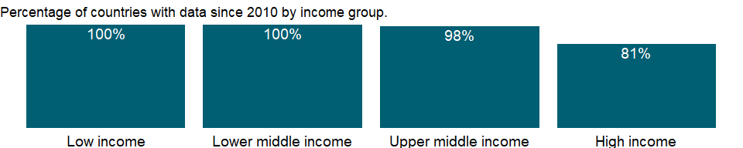

### Why is it relevant?

The commodities covered in the computation of indices of agricultural production are all crops and livestock products originating in each country. Practically all products are covered, with the main exception of fodder crops. The category of food production includes commodities that are considered edible and that contain nutrients. Accordingly, coffee and tea are excluded along with inedible commodities because, although edible, they have practically no nutritive value.

It should be noted that when calculating indices of agricultural, food and nonfood production, all intermediate primary inputs of agricultural origin are deducted. However, for indices of any other commodity group, only inputs originating from within the same group are deducted; thus, only seed is removed from the group “crops” and from all crop subgroups, such as cereals, oil crops, etc.; and both feed and seed originating from within the livestock sector (e.g. milk feed, hatching eggs) are removed from the group “livestock products”. For the main two livestock subgroups, namely, meat and milk, only feed originating from the respective subgroup is removed.

Crop production data refer to the actual harvested production from the field or orchard and gardens, excluding harvesting and threshing losses and that part of crop not harvested for any reason. Production therefore includes the quantities of the commodity sold in the market (marketed production) and the quantities consumed or used by the producers (auto-consumption).

### What is the data source?

Food and Agriculture Organization, electronic files and web site.

### What is the methodology?

The agricultural production index is prepared by the Food and Agriculture Organization of the United Nations (FAO). The FAO indices of agricultural production show the relative level of the aggregate volume of agricultural production for each year in comparison with the base period 2014-2016. They are based on the sum of price-weighted quantities of different agricultural commodities produced after deductions of quantities used as seed and feed weighted in a similar manner. The resulting aggregate represents, therefore, disposable production for any use except as seed and feed. All the indices at the country, regional and world levels are calculated by the Laspeyres formula*. Production quantities of each commodity are weighted by 2014-2016 average international commodity prices and summed for each year. To obtain the index, the aggregate for a given year is divided by the average aggregate for the base period 2014-2016. Since the FAO indices are based on the concept of agriculture as a single enterprise, amounts of seed and feed are subtracted from the production data to avoid double counting, once in the production data and once with the crops or livestock produced from them. Deductions for seed (in the case of eggs, for hatching) and for livestock and poultry feed apply to both domestically produced and imported commodities. They cover only primary agricultural products destined to animal feed (e.g. maize, potatoes, milk, etc.). Processed and semi-processed feed items such as bran, oilcakes, meals and molasses have been completely excluded from the calculations at all stages. It should be noted that when calculating indices of agricultural, food and nonfood production, all intermediate primary inputs of agricultural origin are deducted. However, for indices of any other commodity group, only inputs originating from within the same group are deducted; thus, only seed is removed from the group “crops” and from all crop subgroups, such as cereals, oil crops, etc.; and both feed and seed originating from within the livestock sector (e.g. milk feed, hatching eggs) are removed from the group “livestock products”. For the main two livestock subgroups, namely, meat and milk, only feed originating from the respective subgroup is removed. Indices which take into account deductions for feed and seed are referred to as ‘’net’‘. Indices calculated without any deductions for feed and seed are referred to as’’gross”. The “international commodity prices” are used in order to avoid the use of exchange rates for obtaining continental and world aggregates, and also to improve and facilitate international comparative analysis of productivity at the national level. These” international prices,” expressed in so-called “international dollars,” are derived using a Geary-Khamis formula** for the agricultural sector. This method assigns a single “price” to each commodity. For example, one metric ton of wheat has the same price regardless of the country where it was produced. The currency unit in which the prices are expressed has no influence on the indices published. The commodities covered in the computation of indices of agricultural production are all crops and livestock products originating in each country. Practically all products are covered, with the main exception of fodder crops.

* A Laspeyres Index is known as a “base-weighted” or “fixed-weighted” index because the price increases are weighted by the quantities in the base period. The Consumer Price Index is an example of a Laspeyres Index. <http://www.usna.edu/Users/econ/rbrady/312%20Materials/LaspeyresCalc.pdf> ** Geary-Khamis formula is an aggregation method in which category “international prices” (reflecting relative category values) and country purchasing power parities (PPPs), (depicting relative country price levels) are estimated simultaneously from a system of linear equations. <http://stats.oecd.org/glossary/detail.asp?ID=5528>

### How is it aggregated?

Weighted average

### What are the limitations?

The FAO indices may differ from those produced by the countries themselves because of differences in concepts of production, coverage, time periods, weights, time reference of data, methods of calculation, and use of international prices.

Agricultural data are collected by the Food and Agriculture Organization of the United Nations (FAO) from official national sources through annual questionnaires and are supplemented with information from official secondary data sources. The secondary sources cover official country data from websites of national ministries, national publications and related country data reported by various international organizations. The FAO tries to impose standard definitions and reporting methods, but complete consistency across countries and over time is not possible. Data on agricultural employment, in particular, should be used with caution. In many countries much agricultural employment is informal and unrecorded, including substantial work performed by women and children. To address some of these concerns, this indicator is heavily footnoted in the database in sources, definition, and coverage.

### What else should I know?

NA

### 1.1.8 Food production index (2014-2016 = 100)

### What is the indicator?

Food production index covers food crops that are considered edible and that contain nutrients. Coffee and tea are excluded because, although edible, they have no nutritive value.

Topic: Environment: Agricultural production

Series ID: AG.PRD.FOOD.XD

Copyright: CC BY-4.0 , <https://datacatalog.worldbank.org/public-licenses#cc-by>

First year with any data: 1961

Last year with any data: 2018

### What years are data available?

The figure below shows years in which data is available for at least one country. Dates shaded in black have no data, while dates shaded in green have data for at least one country



### Which countries have data?

The figure below shows the percentage of countries in each income group with a value since 2010 for that indicator.

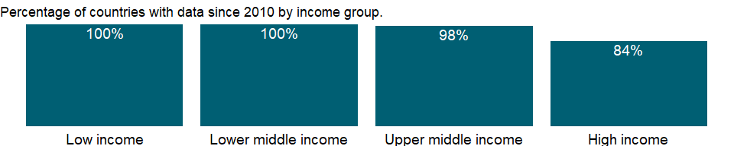

### Why is it relevant?

The commodities covered in the computation of indices of agricultural production are all crops and livestock products originating in each country. Practically all products are covered, with the main exception of fodder crops. The category of food production includes commodities that are considered edible and that contain nutrients. Accordingly, coffee and tea are excluded along with inedible commodities because, although edible, they have practically no nutritive value.

It should be noted that when calculating indices of agricultural, food and nonfood production, all intermediate primary inputs of agricultural origin are deducted. However, for indices of any other commodity group, only inputs originating from within the same group are deducted; thus, only seed is removed from the group “crops” and from all crop subgroups, such as cereals, oil crops, etc.; and both feed and seed originating from within the livestock sector (e.g. milk feed, hatching eggs) are removed from the group “livestock products”. For the main two livestock subgroups, namely, meat and milk, only feed originating from the respective subgroup is removed.

Crop production data refer to the actual harvested production from the field or orchard and gardens, excluding harvesting and threshing losses and that part of crop not harvested for any reason. Production therefore includes the quantities of the commodity sold in the market (marketed production) and the quantities consumed or used by the producers (auto-consumption).

### What is the data source?

Food and Agriculture Organization, electronic files and web site.

### What is the methodology?

The agricultural production index is prepared by the Food and Agriculture Organization of the United Nations (FAO). The FAO indices of agricultural production show the relative level of the aggregate volume of agricultural production for each year in comparison with the base period 2014-2016. They are based on the sum of price-weighted quantities of different agricultural commodities produced after deductions of quantities used as seed and feed weighted in a similar manner. The resulting aggregate represents, therefore, disposable production for any use except as seed and feed. All the indices at the country, regional and world levels are calculated by the Laspeyres formula*. Production quantities of each commodity are weighted by 2014-2016 average international commodity prices and summed for each year. To obtain the index, the aggregate for a given year is divided by the average aggregate for the base period 2014-2016. Since the FAO indices are based on the concept of agriculture as a single enterprise, amounts of seed and feed are subtracted from the production data to avoid double counting, once in the production data and once with the crops or livestock produced from them. Deductions for seed (in the case of eggs, for hatching) and for livestock and poultry feed apply to both domestically produced and imported commodities. They cover only primary agricultural products destined to animal feed (e.g. maize, potatoes, milk, etc.). Processed and semi-processed feed items such as bran, oilcakes, meals and molasses have been completely excluded from the calculations at all stages. It should be noted that when calculating indices of agricultural, food and nonfood production, all intermediate primary inputs of agricultural origin are deducted. However, for indices of any other commodity group, only inputs originating from within the same group are deducted; thus, only seed is removed from the group “crops” and from all crop subgroups, such as cereals, oil crops, etc.; and both feed and seed originating from within the livestock sector (e.g. milk feed, hatching eggs) are removed from the group “livestock products”. For the main two livestock subgroups, namely, meat and milk, only feed originating from the respective subgroup is removed. Indices which take into account deductions for feed and seed are referred to as ‘’net’‘. Indices calculated without any deductions for feed and seed are referred to as’’gross”. The “international commodity prices” are used in order to avoid the use of exchange rates for obtaining continental and world aggregates, and also to improve and facilitate international comparative analysis of productivity at the national level. These” international prices,” expressed in so-called “international dollars,” are derived using a Geary-Khamis formula** for the agricultural sector. This method assigns a single “price” to each commodity. For example, one metric ton of wheat has the same price regardless of the country where it was produced. The currency unit in which the prices are expressed has no influence on the indices published. The commodities covered in the computation of indices of agricultural production are all crops and livestock products originating in each country. Practically all products are covered, with the main exception of fodder crops.

* A Laspeyres Index is known as a “base-weighted” or “fixed-weighted” index because the price increases are weighted by the quantities in the base period. The Consumer Price Index is an example of a Laspeyres Index. <http://www.usna.edu/Users/econ/rbrady/312%20Materials/LaspeyresCalc.pdf> ** Geary-Khamis formula is an aggregation method in which category “international prices” (reflecting relative category values) and country purchasing power parities (PPPs), (depicting relative country price levels) are estimated simultaneously from a system of linear equations. <http://stats.oecd.org/glossary/detail.asp?ID=5528>

### How is it aggregated?

Weighted average

### What are the limitations?

Agricultural data are collected by the Food and Agriculture Organization of the United Nations (FAO) from official national sources through the questionnaire and are supplemented with information from official secondary data sources. The secondary sources cover official country data from websites of national ministries, national publications and related country data reported by various international organizations. The FAO tries to impose standard definitions and reporting methods, but complete consistency across countries and over time is not possible. Data on agricultural employment, in particular, should be used with caution. In many countries much agricultural employment is informal and unrecorded, including substantial work performed by women and children. To address some of these concerns, this indicator is heavily footnoted in the database in sources, definition, and coverage.

### What else should I know?

NA

### 1.1.9 Livestock production index (2014-2016 = 100)

### What is the indicator?

Livestock production index includes meat and milk from all sources, dairy products such as cheese, and eggs, honey, raw silk, wool, and hides and skins.

Topic: Environment: Agricultural production

Series ID: AG.PRD.LVSK.XD

Copyright: CC BY-4.0 , <https://datacatalog.worldbank.org/public-licenses#cc-by>

First year with any data: 1961

Last year with any data: 2018

### What years are data available?

The figure below shows years in which data is available for at least one country. Dates shaded in black have no data, while dates shaded in green have data for at least one country



### Which countries have data?

The figure below shows the percentage of countries in each income group with a value since 2010 for that indicator.

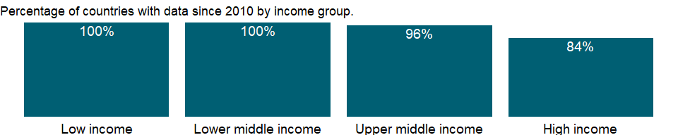

### Why is it relevant?

The commodities covered in the computation of indices of agricultural production are all crops and livestock products originating in each country. Practically all products are covered, with the main exception of fodder crops. The category of food production includes commodities that are considered edible and that contain nutrients. Accordingly, coffee and tea are excluded along with inedible commodities because, although edible, they have practically no nutritive value.

It should be noted that when calculating indices of agricultural, food and nonfood production, all intermediate primary inputs of agricultural origin are deducted. However, for indices of any other commodity group, only inputs originating from within the same group are deducted; thus, only seed is removed from the group “crops” and from all crop subgroups, such as cereals, oil crops, etc.; and both feed and seed originating from within the livestock sector (e.g. milk feed, hatching eggs) are removed from the group “livestock products”. For the main two livestock subgroups, namely, meat and milk, only feed originating from the respective subgroup is removed.

Crop production data refer to the actual harvested production from the field or orchard and gardens, excluding harvesting and threshing losses and that part of crop not harvested for any reason. Production therefore includes the quantities of the commodity sold in the market (marketed production) and the quantities consumed or used by the producers (auto-consumption).

### What is the data source?

Food and Agriculture Organization, electronic files and web site.

### What is the methodology?

The agricultural production index is prepared by the Food and Agriculture Organization of the United Nations (FAO). The FAO indices of agricultural production show the relative level of the aggregate volume of agricultural production for each year in comparison with the base period 2014-2016. They are based on the sum of price-weighted quantities of different agricultural commodities produced after deductions of quantities used as seed and feed weighted in a similar manner. The resulting aggregate represents, therefore, disposable production for any use except as seed and feed. All the indices at the country, regional and world levels are calculated by the Laspeyres formula*. Production quantities of each commodity are weighted by 2014-2016 average international commodity prices and summed for each year. To obtain the index, the aggregate for a given year is divided by the average aggregate for the base period 2014-2016. Since the FAO indices are based on the concept of agriculture as a single enterprise, amounts of seed and feed are subtracted from the production data to avoid double counting, once in the production data and once with the crops or livestock produced from them. Deductions for seed (in the case of eggs, for hatching) and for livestock and poultry feed apply to both domestically produced and imported commodities. They cover only primary agricultural products destined to animal feed (e.g. maize, potatoes, milk, etc.). Processed and semi-processed feed items such as bran, oilcakes, meals and molasses have been completely excluded from the calculations at all stages. It should be noted that when calculating indices of agricultural, food and nonfood production, all intermediate primary inputs of agricultural origin are deducted. However, for indices of any other commodity group, only inputs originating from within the same group are deducted; thus, only seed is removed from the group “crops” and from all crop subgroups, such as cereals, oil crops, etc.; and both feed and seed originating from within the livestock sector (e.g. milk feed, hatching eggs) are removed from the group “livestock products”. For the main two livestock subgroups, namely, meat and milk, only feed originating from the respective subgroup is removed. Indices which take into account deductions for feed and seed are referred to as ‘’net’‘. Indices calculated without any deductions for feed and seed are referred to as’’gross”. The “international commodity prices” are used in order to avoid the use of exchange rates for obtaining continental and world aggregates, and also to improve and facilitate international comparative analysis of productivity at the national level. These” international prices,” expressed in so-called “international dollars,” are derived using a Geary-Khamis formula** for the agricultural sector. This method assigns a single “price” to each commodity. For example, one metric ton of wheat has the same price regardless of the country where it was produced. The currency unit in which the prices are expressed has no influence on the indices published. The commodities covered in the computation of indices of agricultural production are all crops and livestock products originating in each country. Practically all products are covered, with the main exception of fodder crops.

* A Laspeyres Index is known as a “base-weighted” or “fixed-weighted” index because the price increases are weighted by the quantities in the base period. The Consumer Price Index is an example of a Laspeyres Index. <http://www.usna.edu/Users/econ/rbrady/312%20Materials/LaspeyresCalc.pdf> ** Geary-Khamis formula is an aggregation method in which category “international prices” (reflecting relative category values) and country purchasing power parities (PPPs), (depicting relative country price levels) are estimated simultaneously from a system of linear equations. <http://stats.oecd.org/glossary/detail.asp?ID=5528>

### How is it aggregated?

Weighted average

### What are the limitations?

Agricultural data are collected by the Food and Agriculture Organization of the United Nations (FAO) from official national sources through the questionnaire and are supplemented with information from official secondary data sources. The secondary sources cover official country data from websites of national ministries, national publications and related country data reported by various international organizations.

The FAO tries to impose standard definitions and reporting methods, but complete consistency across countries and over time is not possible. Data on agricultural employment, in particular, should be used with caution. In many countries much agricultural employment is informal and unrecorded, including substantial work performed by women and children. To address some of these concerns, this indicator is heavily footnoted in the database in sources, definition, and coverage.

### What else should I know?

NA

### 1.1.10 Cereal yield (kg per hectare)

### What is the indicator?

Cereal yield, measured as kilograms per hectare of harvested land, includes wheat, rice, maize, barley, oats, rye, millet, sorghum, buckwheat, and mixed grains. Production data on cereals relate to crops harvested for dry grain only. Cereal crops harvested for hay or harvested green for food, feed, or silage and those used for grazing are excluded. The FAO allocates production data to the calendar year in which the bulk of the harvest took place. Most of a crop harvested near the end of a year will be used in the following year.

Topic: Environment: Agricultural production

Series ID: AG.YLD.CREL.KG

Copyright: CC BY-4.0 , <https://datacatalog.worldbank.org/public-licenses#cc-by>

First year with any data: 1961

Last year with any data: 2018

### What years are data available?

The figure below shows years in which data is available for at least one country. Dates shaded in black have no data, while dates shaded in green have data for at least one country



### Which countries have data?

The figure below shows the percentage of countries in each income group with a value since 2010 for that indicator.



### Why is it relevant?

In developed countries, cereal crops are universally machine-harvested, typically using a combine harvester, which cuts, threshes, and winnows the grain during a single pass across the field. In many industrialized countries, particularly in the United States and Canada, farmers commonly deliver their newly harvested grain to a grain elevator or a storage facility that consolidates the crops of many farmers. In developing countries, a variety of harvesting methods are used in cereal cultivation, depending on the cost of labor, from small combines to hand tools such as the scythe or cradle.

Crop production systems have evolved rapidly over the past century and have resulted in significantly increased crop yields, but have also created undesirable environmental side-effects such as soil degradation and erosion, pollution from chemical fertilizers and agrochemicals and a loss of bio-diversity. Factors such as the green revolution, has led to impressive progress in increasing cereals yields over the last few decades. This progress, however, is not equal across all regions. Continued progress depends on maintaining agricultural research and education. The cultivation of cereals varies widely in different countries and depends partly upon the development of the economy. Production depends on the nature of the soil, the amount of rainfall, irrigation, quality of seeds, and the techniques applied to promote growth.

### What is the data source?

Food and Agriculture Organization, electronic files and web site.

### What is the methodology?

A cereal is a grass cultivated for the edible components of their grain, composed of the endosperm, germ, and bran. Cereal yield is measured as kilograms per hectare of harvested land. Cereal grains are grown in greater quantities and provide more food energy worldwide than any other type of crop; cereal crops therefore can also be called staple crops Cereals production includes wheat, rice, maize, barley, oats, rye, millet, sorghum, buckwheat, and mixed grains. Production data on cereals relate to crops harvested for dry grain only. Cereal crops harvested for hay or harvested green for food, feed, or silage and those used for grazing are excluded.

### How is it aggregated?

Weighted average

### What are the limitations?

Cereals production data relate to crops harvested for dry grain only. Cereal crops harvested for hay or harvested green for food, feed, or silage and those used for grazing are excluded. The FAO allocates production data to the calendar year in which the bulk of the harvest took place. Most of a crop harvested near the end of a year will be used in the following year.

The data are collected by the Food and Agriculture Organization of the United Nations (FAO) through annual questionnaires. The FAO tries to impose standard definitions and reporting methods, but complete consistency across countries and over time is not possible. Thus, data on agricultural land in different climates may not be comparable. For example, permanent pastures are quite different in nature and intensity in African countries and dry Middle Eastern countries.

Data on cereal yield may be affected by a variety of reporting and timing differences. Millet and sorghum, which are grown as feed for livestock and poultry in Europe and North America, are used as food in Africa, Asia, and countries of the former Soviet Union. So some cereal crops are excluded from the data for some countries and included elsewhere, depending on their use.

The data collected from official national sources through the questionnaire are supplemented with information from official secondary data sources. The secondary sources cover official country data from websites of national ministries, national publications and related country data reported by various international organizations.

### What else should I know?

NA

### 1.1.11 Aquaculture production (metric tons)

### What is the indicator?

Aquaculture is understood to mean the farming of aquatic organisms including fish, molluscs, crustaceans and aquatic plants. Aquaculture production specifically refers to output from aquaculture activities, which are designated for final harvest for consumption.

Topic: Environment: Agricultural production

Series ID: ER.FSH.AQUA.MT

Copyright: CC BY-4.0 , <https://datacatalog.worldbank.org/public-licenses#cc-by>

First year with any data: 1960

Last year with any data: 2018

### What years are data available?

The figure below shows years in which data is available for at least one country. Dates shaded in black have no data, while dates shaded in green have data for at least one country

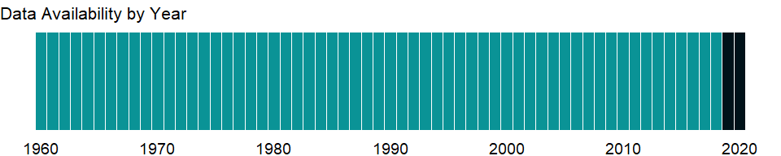

### Which countries have data?

The figure below shows the percentage of countries in each income group with a value since 2010 for that indicator.

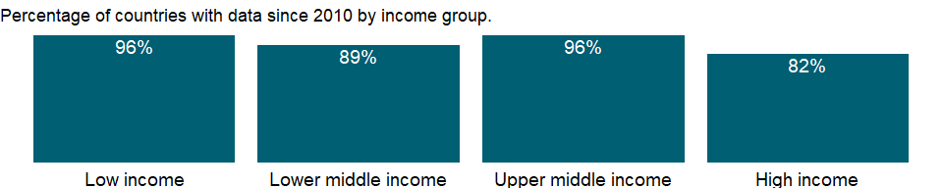

### Why is it relevant?

Aquaculture is understood to mean the farming of aquatic organisms including fish, molluscs, crustaceans and aquatic plants. Farming implies some form of intervention in the rearing process to enhance production, such as regular stocking, feeding, protection from predators, etc. Farming also implies individual or corporate ownership of the stock being cultivated. For statistical purposes, aquatic organisms which are harvested by an individual of corporate body which has owned them throughout their rearing period contribute to aquaculture while aquatic organisms which are exploitable by public as a common property resource, with or without appropriate licences, are the harvest of fisheries.

### What is the data source?

Food and Agriculture Organization.

### What is the methodology?

Aquaculture production specifically refers to output from aquaculture activities, which are designated for final harvest for consumption. At this time, harvest for ornamental purposes is not included.

### How is it aggregated?

Sum

### What are the limitations?

NA

### What else should I know?

NA

### 1.1.12 Capture fisheries production (metric tons)

### What is the indicator?

Capture fisheries production measures the volume of fish catches landed by a country for all commercial, industrial, recreational and subsistence purposes.

Topic: Environment: Agricultural production

Series ID: ER.FSH.CAPT.MT

Copyright: CC BY-4.0 , <https://datacatalog.worldbank.org/public-licenses#cc-by>

First year with any data: 1960

Last year with any data: 2018

### What years are data available?

The figure below shows years in which data is available for at least one country. Dates shaded in black have no data, while dates shaded in green have data for at least one country



### Which countries have data?

The figure below shows the percentage of countries in each income group with a value since 2010 for that indicator.

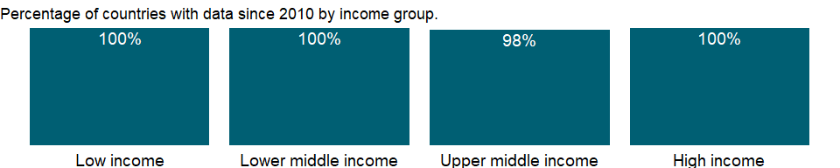

### Why is it relevant?

NA

### What is the data source?

Food and Agriculture Organization.

### What is the methodology?

In 2008, China revised its 2006 production statistics to reduce about 13 percent based on its Second National Agriculture Census conducted in 2007. This implied the downward adjustment of global capture production about 2 percent. Historical statistics of China for the period 1997-2005 were subsequently revised by FAO.

### How is it aggregated?

Sum

### What are the limitations?

NA

### What else should I know?

NA

### 1.1.13 Total fisheries production (metric tons)

### What is the indicator?

Total fisheries production measures the volume of aquatic species caught by a country for all commercial, industrial, recreational and subsistence purposes. The harvest from mariculture, aquaculture and other kinds of fish farming is also included.

Topic: Environment: Agricultural production

Series ID: ER.FSH.PROD.MT

Copyright: CC BY-4.0 , <https://datacatalog.worldbank.org/public-licenses#cc-by>

First year with any data: 1960

Last year with any data: 2018

### What years are data available?

The figure below shows years in which data is available for at least one country. Dates shaded in black have no data, while dates shaded in green have data for at least one country



### Which countries have data?

The figure below shows the percentage of countries in each income group with a value since 2010 for that indicator.



### Why is it relevant?

NA

### What is the data source?

Food and Agriculture Organization.

### What is the methodology?

NA

### How is it aggregated?

Sum

### What are the limitations?

NA

### What else should I know?

NA

## 1.2 Environment: Land use

### 1.2.1 Agricultural land (sq. km)

### What is the indicator?

Agricultural land refers to the share of land area that is arable, under permanent crops, and under permanent pastures. Arable land includes land defined by the FAO as land under temporary crops (double-cropped areas are counted once), temporary meadows for mowing or for pasture, land under market or kitchen gardens, and land temporarily fallow. Land abandoned as a result of shifting cultivation is excluded. Land under permanent crops is land cultivated with crops that occupy the land for long periods and need not be replanted after each harvest, such as cocoa, coffee, and rubber. This category includes land under flowering shrubs, fruit trees, nut trees, and vines, but excludes land under trees grown for wood or timber. Permanent pasture is land used for five or more years for forage, including natural and cultivated crops.

Topic: Environment: Land use

Series ID: AG.LND.AGRI.K2

Copyright: CC BY-4.0 , <https://datacatalog.worldbank.org/public-licenses#cc-by>

First year with any data: 1961

Last year with any data: 2018

### What years are data available?

The figure below shows years in which data is available for at least one country. Dates shaded in black have no data, while dates shaded in green have data for at least one country



### Which countries have data?

The figure below shows the percentage of countries in each income group with a value since 2010 for that indicator.

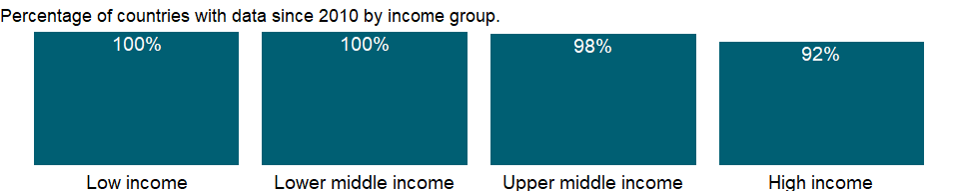

### Why is it relevant?

Agricultural land covers more than one-third of the world’s land area. In many industrialized countries, agricultural land is subject to zoning regulations. In the context of zoning, agricultural land (or more properly agriculturally zoned land) refers to plots that may be used for agricultural activities, regardless of the physical type or quality of land.

FAO’s agricultural land data contains a wide range of information on variables that are significant for understanding the structure of a country’s agricultural sector; making economic plans and policies for food security; and deriving environmental indicators, including those related to investment in agriculture and data on gross crop area and net crop area which are useful for policy formulation and monitoring.

Agriculture is still a major sector in many economies, and agricultural activities provide developing countries with food and revenue. But agricultural activities also can degrade natural resources. Poor farming practices can cause soil erosion and loss of soil fertility. Efforts to increase productivity by using chemical fertilizers, pesticides, and intensive irrigation have environmental costs and health impacts. Excessive use of chemical fertilizers can alter the chemistry of soil. Pesticide poisoning is common in developing countries. And salinization of irrigated land diminishes soil fertility. Thus, inappropriate use of inputs for agricultural production has far-reaching effects.

There is no single correct mix of inputs to the agricultural land, as it is dependent on local climate, land quality, and economic development; appropriate levels and application rates vary by country and over time and depend on the type of crops, the climate and soils, and the production process used.

### What is the data source?

Food and Agriculture Organization, electronic files and web site.

### What is the methodology?

Agricultural land constitutes only a part of any country’s total area, which can include areas not suitable for agriculture, such as forests, mountains, and inland water bodies. Three components of the agricultural land are a) arable land - land defined by the FAO as land under temporary crops (double-cropped areas are counted once), temporary meadows for mowing or for pasture, land under market or kitchen gardens, and land temporarily fallow, b) permanent pasture - land used for five or more years for forage, including natural and cultivated crops, and c) and under permanent crops - land cultivated with crops that occupy the land for long periods and need not be replanted after each harvest, such as cocoa, coffee, and rubber; land under flowering shrubs, fruit trees, nut trees, and vines is included, but land under trees grown for wood or timber is not.

Agricultural land is also sometimes classified as irrigated and non-irrigated land. In arid and semi-arid countries agriculture is often confined to irrigated land, with very little farming possible in non-irrigated areas. Land abandoned as a result of shifting cultivation is excluded from arable land.

Data on agricultural land are valuable for conducting studies on a various perspectives concerning agricultural production, food security and for deriving cropping intensity among others uses. Agricultural land indicator, along with land-use indicators, can also elucidate the environmental sustainability of countries’ agricultural practices.

### How is it aggregated?

Sum

### What are the limitations?

The data are collected by the Food and Agriculture Organization of the United Nations (FAO) through annual questionnaires. The FAO tries to impose standard definitions and reporting methods, but complete consistency across countries and over time is not possible. Thus, data on agricultural land in different climates may not be comparable. For example, permanent pastures are quite different in nature and intensity in African countries and dry Middle Eastern countries. Data on agricultural employment, in particular, should be used with caution. In many countries much agricultural employment is informal and unrecorded, including substantial work performed by women and children. To address some of these concerns, this indicator is heavily footnoted in the database in sources, definition, and coverage. The secondary sources cover official country data from websites of national ministries, national publications and related country data reported by various international organizations.

### What else should I know?

NA

### 1.2.2 Agricultural land (% of land area)

### What is the indicator?

Agricultural land refers to the share of land area that is arable, under permanent crops, and under permanent pastures. Arable land includes land defined by the FAO as land under temporary crops (double-cropped areas are counted once), temporary meadows for mowing or for pasture, land under market or kitchen gardens, and land temporarily fallow. Land abandoned as a result of shifting cultivation is excluded. Land under permanent crops is land cultivated with crops that occupy the land for long periods and need not be replanted after each harvest, such as cocoa, coffee, and rubber. This category includes land under flowering shrubs, fruit trees, nut trees, and vines, but excludes land under trees grown for wood or timber. Permanent pasture is land used for five or more years for forage, including natural and cultivated crops.

Topic: Environment: Land use

Series ID: AG.LND.AGRI.ZS

Copyright: CC BY-4.0 , <https://datacatalog.worldbank.org/public-licenses#cc-by>

First year with any data: 1961

Last year with any data: 2018

### What years are data available?

The figure below shows years in which data is available for at least one country. Dates shaded in black have no data, while dates shaded in green have data for at least one country



### Which countries have data?

The figure below shows the percentage of countries in each income group with a value since 2010 for that indicator.



### Why is it relevant?

Agricultural land covers more than one-third of the world’s land area, with arable land representing less than one-third of agricultural land (about 10 percent of the world’s land area). Agricultural land constitutes only a part of any country’s total area, which can include areas not suitable for agriculture, such as forests, mountains, and inland water bodies.

In many industrialized countries, agricultural land is subject to zoning regulations. In the context of zoning, agricultural land (or more properly agriculturally zoned land) refers to plots that may be used for agricultural activities, regardless of the physical type or quality of land.

FAO’s agricultural land data contains a wide range of information on variables that are significant for: understanding the structure of a country’s agricultural sector; making economic plans and policies for food security; deriving environmental indicators, including those related to investment in agriculture and data on gross crop area and net crop area which are useful for policy formulation and monitoring.

There is no single correct mix of inputs to the agricultural land, as it is dependent on local climate, land quality, and economic development; appropriate levels and application rates vary by country and over time and depend on the type of crops, the climate and soils, and the production process used.

### What is the data source?

Food and Agriculture Organization, electronic files and web site.

### What is the methodology?

Agriculture is still a major sector in many economies, and agricultural activities provide developing countries with food and revenue. But agricultural activities also can degrade natural resources. Poor farming practices can cause soil erosion and loss of soil fertility. Efforts to increase productivity by using chemical fertilizers, pesticides, and intensive irrigation have environmental costs and health impacts. Excessive use of chemical fertilizers can alter the chemistry of soil. Pesticide poisoning is common in developing countries. And salinization of irrigated land diminishes soil fertility. Thus, inappropriate use of inputs for agricultural production has far-reaching effects.

Agricultural land is also sometimes classified as irrigated and non-irrigated land. In arid and semi-arid countries agriculture is often confined to irrigated land, with very little farming possible in non-irrigated areas. Land abandoned as a result of shifting cultivation is excluded from Arable land.

Data on agricultural land are valuable for conducting studies on a various perspectives concerning agricultural production, food security and for deriving cropping intensity among others uses. Agricultural land indicator, along with land-use indicators, can also elucidate the environmental sustainability of countries’ agricultural practices.

Total land area does not include inland water bodies such as major rivers and lakes. Variations from year to year may be due to updated or revised data rather than to change in area.

### How is it aggregated?

Weighted average

### What are the limitations?

The data are collected by the Food and Agriculture Organization of the United Nations (FAO) from official national sources through annual questionnaires and are supplemented with information from official secondary data sources. The secondary sources cover official country data from websites of national ministries, national publications and related country data reported by various international organizations.. The FAO tries to impose standard definitions and reporting methods, but complete consistency across countries and over time is not possible. Thus, data on agricultural land in different climates may not be comparable. For example, permanent pastures are quite different in nature and intensity in African countries and dry Middle Eastern countries. Data on agricultural employment, in particular, should be used with caution. In many countries much agricultural employment is informal and unrecorded, including substantial work performed by women and children. To address some of these concerns, this indicator is heavily footnoted in the database in sources, definition, and coverage.

### What else should I know?

NA

### 1.2.3 Arable land (hectares)

### What is the indicator?

Arable land (in hectares) includes land defined by the FAO as land under temporary crops (double-cropped areas are counted once), temporary meadows for mowing or for pasture, land under market or kitchen gardens, and land temporarily fallow. Land abandoned as a result of shifting cultivation is excluded.

Topic: Environment: Land use

Series ID: AG.LND.ARBL.HA

Copyright: CC BY-4.0 , <https://datacatalog.worldbank.org/public-licenses#cc-by>

First year with any data: 1961

Last year with any data: 2018

### What years are data available?

The figure below shows years in which data is available for at least one country. Dates shaded in black have no data, while dates shaded in green have data for at least one country



### Which countries have data?

The figure below shows the percentage of countries in each income group with a value since 2010 for that indicator.

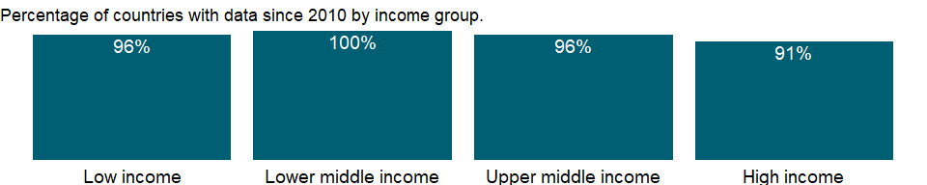

### Why is it relevant?

Agricultural land covers more than one-third of the world’s land area. Agricultural land constitutes only a part of any country’s total area, which can include areas not suitable for agriculture, such as forests, mountains, and inland water bodies.

Agriculture is still a major sector in many economies, and agricultural activities provide developing countries with food and revenue. But agricultural activities also can degrade natural resources. Poor farming practices can cause soil erosion and loss of soil fertility. Efforts to increase productivity by using chemical fertilizers, pesticides, and intensive irrigation have environmental costs and health impacts. Excessive use of chemical fertilizers can alter the chemistry of soil. Pesticide poisoning is common in developing countries. And salinization of irrigated land diminishes soil fertility. Thus, inappropriate use of inputs for agricultural production has far-reaching effects.

There is significant geographic variation in the availability of land considered suitable for agriculture. Increasing population and demand from other sectors place growing pressure on available resources. According to FAO, the world’s cultivated area has grown by 12 percent over the last 50 years. The global irrigated area has doubled over the same period, accounting for most of the net increase in cultivated land. Agriculture already uses 11 percent of the world’s land surface for crop production. It also makes use of 70 percent of all water withdrawn from aquifers, streams and lakes. Agricultural policies have primarily benefitted farmers with productive land and access to water, bypassing the majority of small-scale producers who are still locked in a poverty trap of high vulnerability, land degradation and climatic uncertainty.

Land resources are central to agriculture and rural development, and are intrinsically linked to global challenges of food insecurity and poverty, climate change adaptation and mitigation, as well as degradation and depletion of natural resources that affect the livelihoods of millions of rural people across the world.

In many industrialized countries, agricultural land is subject to zoning regulations. In the context of zoning, agricultural land (or more properly agriculturally zoned land) refers to plots that may be used for agricultural activities, regardless of the physical type or quality of land.

### What is the data source?

Food and Agriculture Organization, electronic files and web site.

### What is the methodology?

Temporary fallow land refers to land left fallow for less than five years. The abandoned land resulting from shifting cultivation is not included in this category. Data for “Arable land” are not meant to indicate the amount of land that is potentially cultivable.

### How is it aggregated?

NA

### What are the limitations?

The Food and Agriculture Organization (FAO) tries to impose standard definitions and reporting methods, but complete consistency across countries and over time is not possible. Thus, data on agricultural land in different climates may not be comparable. For example, permanent pastures are quite different in nature and intensity in African countries and dry Middle Eastern countries.

The data collected by the Food and Agriculture Organization (FAO) of the United Nations from official national sources through the questionnaire are supplemented with information from official secondary data sources. The secondary sources cover official country data from websites of national ministries, national publications and related country data reported by various international organizations. Data on agricultural land are valuable for conducting studies on a various perspectives concerning agricultural production, food security and for deriving cropping intensity among others uses. Agricultural land indicator, along with land-use indicators, can also elucidate the environmental sustainability of countries’ agricultural practices.

True comparability of the data is limited, however, by variations in definitions, statistical methods, and quality of data. Countries use different definitions land use. The Food and Agriculture Organization of the United Nations (FAO), the primary compiler of the data, occasionally adjusts its definitions of land use categories and revises earlier data. Because the data reflect changes in reporting procedures as well as actual changes in land use, apparent trends should be interpreted cautiously.

Satellite images show land use that differs from that of ground-based measures in area under cultivation and type of land use. Moreover, land use data in some countries (India is an example) are based on reporting systems designed for collecting tax revenue. With land taxes no longer a major source of government revenue, the quality and coverage of land use data have declined.

### What else should I know?

NA

### 1.2.4 Arable land (hectares per person)

### What is the indicator?

Arable land (hectares per person) includes land defined by the FAO as land under temporary crops (double-cropped areas are counted once), temporary meadows for mowing or for pasture, land under market or kitchen gardens, and land temporarily fallow. Land abandoned as a result of shifting cultivation is excluded.

Topic: Environment: Land use

Series ID: AG.LND.ARBL.HA.PC

Copyright: CC BY-4.0 , <https://datacatalog.worldbank.org/public-licenses#cc-by>

First year with any data: 1961

Last year with any data: 2018

### What years are data available?

The figure below shows years in which data is available for at least one country. Dates shaded in black have no data, while dates shaded in green have data for at least one country



### Which countries have data?

The figure below shows the percentage of countries in each income group with a value since 2010 for that indicator.



### Why is it relevant?

Agricultural land covers about one-third of the world’s land area, with arable land representing less than one-third of agricultural land (about 10 percent of the world’s land area). Agricultural land constitutes only a part of any country’s total area, which can include areas not suitable for agriculture, such as forests, mountains, and inland water bodies.

Agriculture is still a major sector in many economies, and agricultural activities provide developing countries with food and revenue. But agricultural activities also can degrade natural resources. Poor farming practices can cause soil erosion and loss of soil fertility. Efforts to increase productivity by using chemical fertilizers, pesticides, and intensive irrigation have environmental costs and health impacts. Excessive use of chemical fertilizers can alter the chemistry of soil. Pesticide poisoning is common in developing countries. And salinization of irrigated land diminishes soil fertility. Thus, inappropriate use of inputs for agricultural production has far-reaching effects.

There is significant geographic variation in the availability of land considered suitable for agriculture. Increasing population and demand from other sectors place growing pressure on available resources. According to FAO, the world’s cultivated area has grown by 12 percent over the last 50 years. The global irrigated area has doubled over the same period, accounting for most of the net increase in cultivated land. Agriculture already uses 11 percent of the world’s land surface for crop production. It also makes use of 70 percent of all water withdrawn from aquifers, streams and lakes. Agricultural policies have primarily benefitted farmers with productive land and access to water, bypassing the majority of small-scale producers who are still locked in a poverty trap of high vulnerability, land degradation and climatic uncertainty.

Data on agricultural land are valuable for conducting studies on a various perspectives concerning agricultural production, food security and for deriving cropping intensity among others uses. Agricultural land indicator, along with land-use indicators, can also elucidate the environmental sustainability of countries’ agricultural practices.

Land resources are central to agriculture and rural development, and are intrinsically linked to global challenges of food insecurity and poverty, climate change adaptation and mitigation, as well as degradation and depletion of natural resources that affect the livelihoods of millions of rural people across the world.

In many industrialized countries, agricultural land is subject to zoning regulations. In the context of zoning, agricultural land (or more properly agriculturally zoned land) refers to plots that may be used for agricultural activities, regardless of the physical type or quality of land.

### What is the data source?

Food and Agriculture Organization, electronic files and web site.

### What is the methodology?

Temporary fallow land refers to land left fallow for less than five years. The abandoned land resulting from shifting cultivation is not included in this category. Data for “Arable land” are not meant to indicate the amount of land that is potentially cultivable. The data collected by the Food and Agriculture Organization (FAO) of the United Nations from official national sources through the questionnaire are supplemented with information from official secondary data sources. The secondary sources cover official country data from websites of national ministries, national publications and related country data reported by various international organizations.

### How is it aggregated?

Weighted Average

### What are the limitations?

The Food and Agriculture Organization (FAO) tries to impose standard definitions and reporting methods, but complete consistency across countries and over time is not possible. Thus, data on agricultural land in different climates may not be comparable. For example, permanent pastures are quite different in nature and intensity in African countries and dry Middle Eastern countries.

True comparability of the data is limited, by variations in definitions, statistical methods, and quality of data. Countries use different definitions land use. The Food and Agriculture Organization of the United Nations (FAO), the primary compiler of the data, occasionally adjusts its definitions of land use categories and revises earlier data. Because the data reflect changes in reporting procedures as well as actual changes in land use, apparent trends should be interpreted cautiously.

Satellite images show land use that differs from that of ground-based measures in area under cultivation and type of land use. Moreover, land use data in some countries (India is an example) are based on reporting systems designed for collecting tax revenue. With land taxes no longer a major source of government revenue, the quality and coverage of land use data have declined.

### What else should I know?

NA

### 1.2.5 Arable land (% of land area)

### What is the indicator?

Arable land includes land defined by the FAO as land under temporary crops (double-cropped areas are counted once), temporary meadows for mowing or for pasture, land under market or kitchen gardens, and land temporarily fallow. Land abandoned as a result of shifting cultivation is excluded.

Topic: Environment: Land use

Series ID: AG.LND.ARBL.ZS

Copyright: CC BY-4.0 , <https://datacatalog.worldbank.org/public-licenses#cc-by>

First year with any data: 1961

Last year with any data: 2018

### What years are data available?

The figure below shows years in which data is available for at least one country. Dates shaded in black have no data, while dates shaded in green have data for at least one country



### Which countries have data?

The figure below shows the percentage of countries in each income group with a value since 2010 for that indicator.



### Why is it relevant?

Agricultural land covers more than one-third of the world’s land area. Agricultural land constitutes only a part of any country’s total area, which can include areas not suitable for agriculture, such as forests, mountains, and inland water bodies.

Agriculture is still a major sector in many economies, and agricultural activities provide developing countries with food and revenue. But agricultural activities also can degrade natural resources. Poor farming practices can cause soil erosion and loss of soil fertility. Efforts to increase productivity by using chemical fertilizers, pesticides, and intensive irrigation have environmental costs and health impacts. Excessive use of chemical fertilizers can alter the chemistry of soil. Pesticide poisoning is common in developing countries. And salinization of irrigated land diminishes soil fertility. Thus, inappropriate use of inputs for agricultural production has far-reaching effects.

There is significant geographic variation in the availability of land considered suitable for agriculture. Increasing population and demand from other sectors place growing pressure on available resources. According to FAO, the world’s cultivated area has grown by 12 percent over the last 50 years. The global irrigated area has doubled over the same period, accounting for most of the net increase in cultivated land. Agriculture already uses 11 percent of the world’s land surface for crop production. It also makes use of 70 percent of all water withdrawn from aquifers, streams and lakes. Agricultural policies have primarily benefitted farmers with productive land and access to water, bypassing the majority of small-scale producers who are still locked in a poverty trap of high vulnerability, land degradation and climatic uncertainty.

Land resources are central to agriculture and rural development, and are intrinsically linked to global challenges of food insecurity and poverty, climate change adaptation and mitigation, as well as degradation and depletion of natural resources that affect the livelihoods of millions of rural people across the world.

In many industrialized countries, agricultural land is subject to zoning regulations. In the context of zoning, agricultural land (or more properly agriculturally zoned land) refers to plots that may be used for agricultural activities, regardless of the physical type or quality of land.

FAO’s agricultural land data contains a wide range of information on variables that are significant for: understanding the structure of a country’s agricultural sector; making economic plans and policies for food security; deriving environmental indicators, including those related to investment in agriculture and data on gross crop area and net crop area which are useful for policy formulation and monitoring.

### What is the data source?

Food and Agriculture Organization, electronic files and web site.

### What is the methodology?

Temporary fallow land refers to land left fallow for less than five years. The abandoned land resulting from shifting cultivation is not included in this category. Data for “Arable land” are not meant to indicate the amount of land that is potentially cultivable. Total land area does not include inland water bodies such as major rivers and lakes. Variations from year to year may be due to updated or revised data rather than to change in area. The data collected by the Food and Agriculture Organization (FAO) of the United Nations from official national sources through the questionnaire are supplemented with information from official secondary data sources. The secondary sources cover official country data from websites of national ministries, national publications and related country data reported by various international organizations.

### How is it aggregated?

Weighted average

### What are the limitations?

The Food and Agriculture Organization (FAO) tries to impose standard definitions and reporting methods, but complete consistency across countries and over time is not possible. Thus, data on agricultural land in different climates may not be comparable. For example, permanent pastures are quite different in nature and intensity in African countries and dry Middle Eastern countries.

The data collected by the Food and Agriculture Organization (FAO) of the United Nations from official national sources through the questionnaire are supplemented with information from official secondary data sources. The secondary sources cover official country data from websites of national ministries, national publications and related country data reported by various international organizations. Data on agricultural land are valuable for conducting studies on a various perspectives concerning agricultural production, food security and for deriving cropping intensity among others uses. Agricultural land indicator, along with land-use indicators, can also elucidate the environmental sustainability of countries’ agricultural practices.

True comparability of the data is limited, by variations in definitions, statistical methods, and quality of data. Countries use different definitions land use. The Food and Agriculture Organization of the United Nations (FAO), the primary compiler of the data, occasionally adjusts its definitions of land use categories and revises earlier data. Because the data reflect changes in reporting procedures as well as actual changes in land use, apparent trends should be interpreted cautiously.

Satellite images show land use that differs from that of ground-based measures in area under cultivation and type of land use. Moreover, land use data in some countries (India is an example) are based on reporting systems designed for collecting tax revenue. With land taxes no longer a major source of government revenue, the quality and coverage of land use data have declined.

### What else should I know?

NA

### 1.2.6 Permanent cropland (% of land area)

### What is the indicator?

Permanent cropland is land cultivated with crops that occupy the land for long periods and need not be replanted after each harvest, such as cocoa, coffee, and rubber. This category includes land under flowering shrubs, fruit trees, nut trees, and vines, but excludes land under trees grown for wood or timber.

Topic: Environment: Land use

Series ID: AG.LND.CROP.ZS

Copyright: CC BY-4.0 , <https://datacatalog.worldbank.org/public-licenses#cc-by>

First year with any data: 1961

Last year with any data: 2018

### What years are data available?

The figure below shows years in which data is available for at least one country. Dates shaded in black have no data, while dates shaded in green have data for at least one country



### Which countries have data?

The figure below shows the percentage of countries in each income group with a value since 2010 for that indicator.

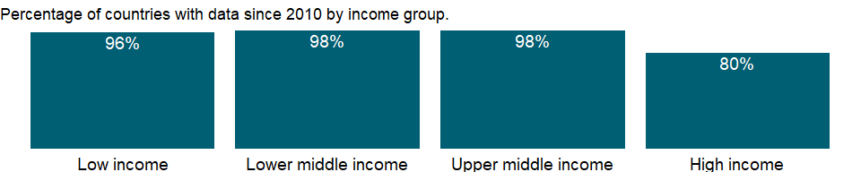

### Why is it relevant?

Agricultural land covers more than one-third of the world’s land area. Agricultural land constitutes only a part of any country’s total area, which can include areas not suitable for agriculture, such as forests, mountains, and inland water bodies.

Crops are divided into temporary and permanent crops. Permanent crops are sown or planted once, and then occupy the land for some years and need not be replanted after each annual harvest, such as cocoa, coffee and rubber. This category includes flowering shrubs, fruit trees, nut trees and vines, but excludes trees grown for wood or timber. Temporary crops are those which are both sown and harvested during the same agricultural year, sometimes more than once. Temporary crop land is used for crops with a less than one-year growing cycle and which must be newly sown or planted for further production after the harvest.

Agriculture is still a major sector in many economies, and agricultural activities provide developing countries with food and revenue. But agricultural activities also can degrade natural resources. Poor farming practices can cause soil erosion and loss of soil fertility. Efforts to increase productivity by using chemical fertilizers, pesticides, and intensive irrigation have environmental costs and health impacts. Excessive use of chemical fertilizers can alter the chemistry of soil. Pesticide poisoning is common in developing countries. And salinization of irrigated land diminishes soil fertility. Thus, inappropriate use of inputs for agricultural production has far-reaching effects.

There is significant geographic variation in the availability of land considered suitable for agriculture. Increasing population and demand from other sectors place growing pressure on available resources. According to FAO, the world’s cultivated area has grown by 12 percent over the last 50 years. The global irrigated area has doubled over the same period, accounting for most of the net increase in cultivated land. Agriculture already uses 11 percent of the world’s land surface for crop production. It also makes use of 70 percent of all water withdrawn from aquifers, streams and lakes. Agricultural policies have primarily benefitted farmers with productive land and access to water, bypassing the majority of small-scale producers who are still locked in a poverty trap of high vulnerability, land degradation and climatic uncertainty.

Land resources are central to agriculture and rural development, and are intrinsically linked to global challenges of food insecurity and poverty, climate change adaptation and mitigation, as well as degradation and depletion of natural resources that affect the livelihoods of millions of rural people across the world.

In many industrialized countries, agricultural land is subject to zoning regulations. In the context of zoning, agricultural land (or more properly agriculturally zoned land) refers to plots that may be used for agricultural activities, regardless of the physical type or quality of land.

### What is the data source?

Food and Agriculture Organization, electronic files and web site.

### What is the methodology?

The data on Permanent cropland and land area are collected by the Food and Agriculture Organization (FAO) of the United Nations from official national sources through the questionnaire are supplemented with information from official secondary data sources. The secondary sources cover official country data from websites of national ministries, national publications and related country data reported by various international organizations.

### How is it aggregated?

Weighted average

### What are the limitations?

The Food and Agriculture Organization (FAO) tries to impose standard definitions and reporting methods, but complete consistency across countries and over time is not possible. Thus, data on agricultural land in different climates may not be comparable. For example, permanent pastures are quite different in nature and intensity in African countries and dry Middle Eastern countries.

True comparability of the data is limited by variations in definitions, statistical methods, and quality of data. Countries use different definitions land use. The Food and Agriculture Organization of the United Nations (FAO), the primary compiler of the data, occasionally adjusts its definitions of land use categories and revises earlier data. Because the data reflect changes in reporting procedures as well as actual changes in land use, apparent trends should be interpreted cautiously.

Satellite images show land use that differs from that of ground-based measures in area under cultivation and type of land use. Moreover, land use data in some countries (India is an example) are based on reporting systems designed for collecting tax revenue. With land taxes no longer a major source of government revenue, the quality and coverage of land use data have declined.

### What else should I know?

NA

### 1.2.7 Rural land area where elevation is below 5 meters (sq. km)

### What is the indicator?

Rural land area below 5m is the total rural land area in square kilometers where the elevation is 5 meters or less.

Topic: Environment: Land use

Series ID: AG.LND.EL5M.RU.K2

Copyright: CC BY-4.0 , <https://datacatalog.worldbank.org/public-licenses#cc-by>

First year with any data: 1990

Last year with any data: 2010

### What years are data available?

The figure below shows years in which data is available for at least one country. Dates shaded in black have no data, while dates shaded in green have data for at least one country

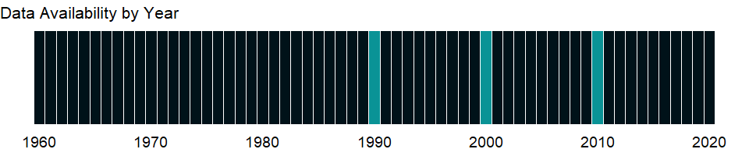

### Which countries have data?

The figure below shows the percentage of countries in each income group with a value since 2010 for that indicator.

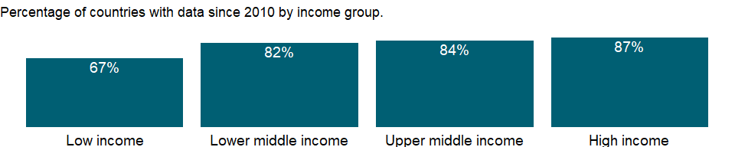

### Why is it relevant?

NA

### What is the data source?

Center for International Earth Science Information Network (CIESIN)/Columbia University. 2013. Urban-Rural Population and Land Area Estimates Version 2. Palisades, NY: NASA Socioeconomic Data and Applications Center (SEDAC). <http://sedac.ciesin.columbia.edu/data/set/lecz-urban-rural-population-land-area-estimates-v2>.

### What is the methodology?

Elevation data used to generate the low elevation coastal zones come from the SRTM3 Enhanced Global Map developed by ISCIENCES. The ISCIENCES digital elevation model was created using NASA’s Jet Propulsion Laboratory Shuttle Radar Topography Mission data processed to 3 arc-seconds (SRTM3).

### How is it aggregated?

Sum

### What are the limitations?

The 2007 Intergovernmental Panel on Climate Change’s (IPCC) assessment report concluded that global warming is “unequivocal” and gave the strongest warning yet about the role of human activities. The report estimated that sea levels would rise approximately 49 centimeters over the next 100 years, with a range of uncertainty of 20–86 centimeters. That will lead to increased coastal flooding through direct inundation and a higher base for storm surges, allowing flooding of larger areas and higher elevations. Climate model simulations predict an increase in average surface air temperature of about 2.5°C by 2100 (Kattenberg and others 1996) and increase of “killer” heat waves during the warm season (Karl and others 1997).

### What else should I know?

NA

### 1.2.8 Rural land area where elevation is below 5 meters (% of total land area)

### What is the indicator?

Rural land area below 5m is the percentage of total land where the rural land elevation is 5 meters or less.

Topic: Environment: Land use

Series ID: AG.LND.EL5M.RU.ZS

Copyright: CC BY-4.0 , <https://datacatalog.worldbank.org/public-licenses#cc-by>

First year with any data: 1990

Last year with any data: 2010

### What years are data available?

The figure below shows years in which data is available for at least one country. Dates shaded in black have no data, while dates shaded in green have data for at least one country



### Which countries have data?

The figure below shows the percentage of countries in each income group with a value since 2010 for that indicator.



### Why is it relevant?

Scientists use the terms climate change and global warming to refer to the gradual increase in the Earth’s surface temperature that has accelerated since the industrial revolution and especially over the past two decades. Most global warming has been caused by human activities that have changed the chemical composition of the atmosphere through a buildup of greenhouse gases - primarily carbon dioxide, methane, and nitrous oxide. Rising global temperatures will cause sea level rise and alter local climate conditions, affecting forests, crop yields, and water supplies, and may affect human health, animals, and many types of ecosystems.

### What is the data source?

Center for International Earth Science Information Network (CIESIN)/Columbia University. 2013. Urban-Rural Population and Land Area Estimates Version 2. Palisades, NY: NASA Socioeconomic Data and Applications Center (SEDAC). <http://sedac.ciesin.columbia.edu/data/set/lecz-urban-rural-population-land-area-estimates-v2>.

### What is the methodology?

Elevation data used to generate the low elevation coastal zones come from the SRTM3 Enhanced Global Map developed by ISCIENCES. The ISCIENCES digital elevation model was created using NASA’s Jet Propulsion Laboratory Shuttle Radar Topography Mission data processed to 3 arc-seconds (SRTM3).

### How is it aggregated?

Weighted Average

### What are the limitations?

The 2007 Intergovernmental Panel on Climate Change’s (IPCC) assessment report concluded that global warming is “unequivocal” and gave the strongest warning yet about the role of human activities. The report estimated that sea levels would rise approximately 49 centimeters over the next 100 years, with a range of uncertainty of 20–86 centimeters. That will lead to increased coastal flooding through direct inundation and a higher base for storm surges, allowing flooding of larger areas and higher elevations. Climate model simulations predict an increase in average surface air temperature of about 2.5°C by 2100 (Kattenberg and others 1996) and increase of “killer” heat waves during the warm season (Karl and others 1997).

### What else should I know?

NA

### 1.2.9 Urban land area where elevation is below 5 meters (sq. km)

### What is the indicator?

Urban land area below 5m is the total urban land area in square kilometers where the elevation is 5 meters or less.

Topic: Environment: Land use

Series ID: AG.LND.EL5M.UR.K2

Copyright: CC BY-4.0 , <https://datacatalog.worldbank.org/public-licenses#cc-by>

First year with any data: 1990

Last year with any data: 2010

### What years are data available?

The figure below shows years in which data is available for at least one country. Dates shaded in black have no data, while dates shaded in green have data for at least one country



### Which countries have data?

The figure below shows the percentage of countries in each income group with a value since 2010 for that indicator.



### Why is it relevant?

Scientists use the terms climate change and global warming to refer to the gradual increase in the Earth’s surface temperature that has accelerated since the industrial revolution and especially over the past two decades. Most global warming has been caused by human activities that have changed the chemical composition of the atmosphere through a buildup of greenhouse gases - primarily carbon dioxide, methane, and nitrous oxide. Rising global temperatures will cause sea level rise and alter local climate conditions, affecting forests, crop yields, and water supplies, and may affect human health, animals, and many types of ecosystems.

### What is the data source?

Center for International Earth Science Information Network (CIESIN)/Columbia University. 2013. Urban-Rural Population and Land Area Estimates Version 2. Palisades, NY: NASA Socioeconomic Data and Applications Center (SEDAC). <http://sedac.ciesin.columbia.edu/data/set/lecz-urban-rural-population-land-area-estimates-v2>.

### What is the methodology?

Elevation data used to generate the low elevation coastal zones come from the SRTM3 Enhanced Global Map developed by ISCIENCES. The ISCIENCES digital elevation model was created using NASA’s Jet Propulsion Laboratory Shuttle Radar Topography Mission data processed to 3 arc-seconds (SRTM3).

### How is it aggregated?

Sum

### What are the limitations?

NA

### What else should I know?

NA

### 1.2.10 Urban land area where elevation is below 5 meters (% of total land area)

### What is the indicator?

Urban land area below 5m is the percentage of total land where the urban land elevation is 5 meters or less.

Topic: Environment: Land use

Series ID: AG.LND.EL5M.UR.ZS

Copyright: CC BY-4.0 , <https://datacatalog.worldbank.org/public-licenses#cc-by>

First year with any data: 1990

Last year with any data: 2010

### What years are data available?

The figure below shows years in which data is available for at least one country. Dates shaded in black have no data, while dates shaded in green have data for at least one country



### Which countries have data?

The figure below shows the percentage of countries in each income group with a value since 2010 for that indicator.



### Why is it relevant?

Scientists use the terms climate change and global warming to refer to the gradual increase in the Earth’s surface temperature that has accelerated since the industrial revolution and especially over the past two decades. Most global warming has been caused by human activities that have changed the chemical composition of the atmosphere through a buildup of greenhouse gases - primarily carbon dioxide, methane, and nitrous oxide. Rising global temperatures will cause sea level rise and alter local climate conditions, affecting forests, crop yields, and water supplies, and may affect human health, animals, and many types of ecosystems.

### What is the data source?

Center for International Earth Science Information Network (CIESIN)/Columbia University. 2013. Urban-Rural Population and Land Area Estimates Version 2. Palisades, NY: NASA Socioeconomic Data and Applications Center (SEDAC). <http://sedac.ciesin.columbia.edu/data/set/lecz-urban-rural-population-land-area-estimates-v2>.

### What is the methodology?

Elevation data used to generate the low elevation coastal zones come from the SRTM3 Enhanced Global Map developed by ISCIENCES. The ISCIENCES digital elevation model was created using NASA’s Jet Propulsion Laboratory Shuttle Radar Topography Mission data processed to 3 arc-seconds (SRTM3).

### How is it aggregated?

Weighted Average

### What are the limitations?

NA

### What else should I know?

NA

### 1.2.11 Land area where elevation is below 5 meters (% of total land area)

### What is the indicator?

Land area below 5m is the percentage of total land where the elevation is 5 meters or less.

Topic: Environment: Land use

Series ID: AG.LND.EL5M.ZS

Copyright: CC BY-4.0 , <https://datacatalog.worldbank.org/public-licenses#cc-by>

First year with any data: 1990

Last year with any data: 2010

### What years are data available?

The figure below shows years in which data is available for at least one country. Dates shaded in black have no data, while dates shaded in green have data for at least one country



### Which countries have data?

The figure below shows the percentage of countries in each income group with a value since 2010 for that indicator.



### Why is it relevant?

Scientists use the terms climate change and global warming to refer to the gradual increase in the Earth’s surface temperature that has accelerated since the industrial revolution and especially over the past two decades. Most global warming has been caused by human activities that have changed the chemical composition of the atmosphere through a buildup of greenhouse gases - primarily carbon dioxide, methane, and nitrous oxide. Rising global temperatures will cause sea level rise and alter local climate conditions, affecting forests, crop yields, and water supplies, and may affect human health, animals, and many types of ecosystems.

### What is the data source?

Center for International Earth Science Information Network (CIESIN)/Columbia University. 2013. Urban-Rural Population and Land Area Estimates Version 2. Palisades, NY: NASA Socioeconomic Data and Applications Center (SEDAC). <http://sedac.ciesin.columbia.edu/data/set/lecz-urban-rural-population-land-area-estimates-v2>.

### What is the methodology?

Elevation data used to generate the low elevation coastal zones come from the SRTM3 Enhanced Global Map developed by ISCIENCES. The ISCIENCES digital elevation model was created using NASA’s Jet Propulsion Laboratory Shuttle Radar Topography Mission data processed to 3 arc-seconds (SRTM3).

### How is it aggregated?

Weighted Average

### What are the limitations?

The 2007 Intergovernmental Panel on Climate Change’s (IPCC) assessment report concluded that global warming is “unequivocal” and gave the strongest warning yet about the role of human activities. The report estimated that sea levels would rise approximately 49 centimeters over the next 100 years, with a range of uncertainty of 20–86 centimeters. That will lead to increased coastal flooding through direct inundation and a higher base for storm surges, allowing flooding of larger areas and higher elevations. Climate model simulations predict an increase in average surface air temperature of about 2.5°C by 2100 (Kattenberg and others 1996) and increase of “killer” heat waves during the warm season (Karl and others 1997).

### What else should I know?

NA

### 1.2.12 Forest area (sq. km)

### What is the indicator?

Forest area is land under natural or planted stands of trees of at least 5 meters in situ, whether productive or not, and excludes tree stands in agricultural production systems (for example, in fruit plantations and agroforestry systems) and trees in urban parks and gardens.

Topic: Environment: Land use

Series ID: AG.LND.FRST.K2

Copyright: CC BY-4.0 , <https://datacatalog.worldbank.org/public-licenses#cc-by>

First year with any data: 1990

Last year with any data: 2020

### What years are data available?

The figure below shows years in which data is available for at least one country. Dates shaded in black have no data, while dates shaded in green have data for at least one country

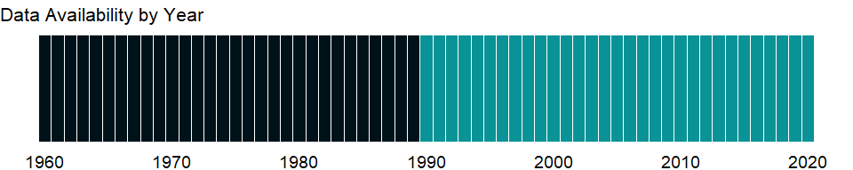

### Which countries have data?

The figure below shows the percentage of countries in each income group with a value since 2010 for that indicator.

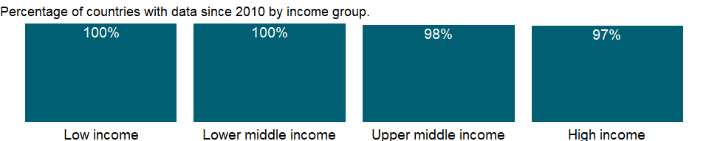

### Why is it relevant?

As threats to biodiversity mount, the international community is increasingly focusing on conserving diversity. Deforestation is a major cause of loss of biodiversity, and habitat conservation is vital for stemming this loss. Conservation efforts have focused on protecting areas of high biodiversity.

On a global average, more than one-third of all forest is primary forest, i.e. forest of native species where there are no clearly visible indications of human activities and the ecological processes have not been significantly disturbed. Primary forests, in particular tropical moist forests, include the most species-rich, diverse terrestrial ecosystems. The decrease of primary forest area, 0.4 percent over a ten-year period, is largely due to reclassification of primary forest to “other naturally regenerated forest” because of selective logging and other human interventions.

National parks, game reserves, wilderness areas and other legally established protected areas cover more than 10 percent of the total forest area in most countries and regions. FAO estimates that around 10 million people are employed in forest management and conservation - but many more are directly dependent on forests for their livelihoods. Also, 80 about percent of the world’s forests are publicly owned, but ownership and management of forests by communities, individuals and private companies is on the rise.

Close to 1.2 billion hectares of forest are managed primarily for the production of wood and non-wood forest products. An additional 25 percent of forest area is designated for multiple uses - in most cases including the production of wood and non-wood forest products. The area designated primarily for productive purposes has decreased by more than 50 million hectares since 1990 as forests have been designated for other purposes.

### What is the data source?

Food and Agriculture Organization, electronic files and web site.

### What is the methodology?

Forest is determined both by the presence of trees and the absence of other predominant land uses. The trees should reach a minimum height of 5 meters in situ. Areas under reforestation that have not yet reached but are expected to reach a canopy cover of 10 percent and a tree height of 5 meters are included, as are temporarily unstocked areas, resulting from human intervention or natural causes, which are expected to regenerate.

FAO provides detail information on forest cover, and adjusted estimates of forest cover. The current survey uses a uniform definition of forest. Although FAO provides a breakdown of forest cover between natural forest and plantation for developing countries, this indictor data does not reflect that breakdown. Thus the deforestation data may underestimate the rate at which natural forest is disappearing in some countries.

### How is it aggregated?

Sum

### What are the limitations?

The Food and Agricultural Organization (FAO) has been collecting and analyzing data on forest area since 1946. This is done at intervals of 5-10 years as part of the Global Forest Resources Assessment (FRA). FAO reports data for 229 countries and territories; for the remaining 56 small island states and territories where no information is provided, a report is prepared by FAO using existing information and a literature search. The data are aggregated at sub-regional, regional and global levels by the FRA team at FAO, and estimates are produced by straight summation.

The lag between the reference year and the actual production of data series as well as the frequency of data production varies between countries. Deforested areas do not include areas logged but intended for regeneration or areas degraded by fuelwood gathering, acid precipitation, or forest fires. Negative numbers indicate an increase in forest area.

Data includes areas with bamboo and palms; forest roads, firebreaks and other small open areas; forest in national parks, nature reserves and other protected areas such as those of specific scientific, historical, cultural or spiritual interest; windbreaks, shelterbelts and corridors of trees with an area of more than 0.5 hectares and width of more than 20 meters; plantations primarily used for forestry or protective purposes, such as rubber-wood plantations and cork oak stands. Data excludes tree stands in agricultural production systems, such as fruit plantations and agroforestry systems. Forest area also excludes trees in urban parks and gardens. The proportion of forest area to total land area is calculated and changes in the proportion are computed to identify trends.

### What else should I know?

NA

### 1.2.13 Forest area (% of land area)

### What is the indicator?

Forest area is land under natural or planted stands of trees of at least 5 meters in situ, whether productive or not, and excludes tree stands in agricultural production systems (for example, in fruit plantations and agroforestry systems) and trees in urban parks and gardens.

Topic: Environment: Land use

Series ID: AG.LND.FRST.ZS

Copyright: CC BY-4.0 , <https://datacatalog.worldbank.org/public-licenses#cc-by>

First year with any data: 1990

Last year with any data: 2020

### What years are data available?

The figure below shows years in which data is available for at least one country. Dates shaded in black have no data, while dates shaded in green have data for at least one country



### Which countries have data?

The figure below shows the percentage of countries in each income group with a value since 2010 for that indicator.



### Why is it relevant?

As threats to biodiversity mount, the international community is increasingly focusing on conserving diversity. Deforestation is a major cause of loss of biodiversity, and habitat conservation is vital for stemming this loss. Conservation efforts have focused on protecting areas of high biodiversity.

On a global average, more than one-third of all forest is primary forest, i.e. forest of native species where there are no clearly visible indications of human activities and the ecological processes have not been significantly disturbed. Primary forests, in particular tropical moist forests, include the most species-rich, diverse terrestrial ecosystems. The decrease of forest area, .11 percent over a ten-year period, is largely due to reclassification of primary forest to “other naturally regenerated forest” because of selective logging and other human interventions.

Destruction of rainforests remains a significant environmental problem Much of what remains of the world’s rainforests is in the Amazon basin, where the Amazon Rainforest covers approximately 4 million square kilometers. The regions with the highest tropical deforestation rate are in Central America and tropical Asia. FAO estimates that the decrease of primary forest area, 0.4 percent over a ten-year period, is largely due to reclassification of primary forest to “other naturally regenerated forest” because of selective logging and other human interventions. Large-scale planting of trees is significantly reducing the net loss of forest area globally, and afforestation and natural expansion of forests in some countries and regions have reduced the net loss of forest area significantly at the global level.

Forests cover about 31 percent of total land area of the world; the world’s total forest area is just over 4 billion hectares. On a global average, more than one-third of all forest is primary forest, i.e. forest of native species where there are no clearly visible indications of human activities and the ecological processes have not been significantly disturbed. Primary forests, in particular tropical moist forests, include the most species-rich, diverse terrestrial ecosystems.

National parks, game reserves, wilderness areas and other legally established protected areas cover more than 10 percent of the total forest area in most countries and regions. FAO estimates that around 10 million people are employed in forest management and conservation - but many more are directly dependent on forests for their livelihoods. Close to 1.2 billion hectares of forest are managed primarily for the production of wood and non-wood forest products. An additional 25 percent of forest area is designated for multiple uses - in most cases including the production of wood and non-wood forest products. The area designated primarily for productive purposes has decreased by more than 50 million hectares since 1990 as forests have been designated for other purposes.

### What is the data source?

Food and Agriculture Organization, electronic files and web site.

### What is the methodology?

Forest is determined both by the presence of trees and the absence of other predominant land uses. The trees should reach a minimum height of 5 meters in situ. Areas under reforestation that have not yet reached but are expected to reach a canopy cover of 10 percent and a tree height of 5 meters are included, as are temporarily unstocked areas, resulting from human intervention or natural causes, which are expected to regenerate.

The Food and Agriculture Organization (FAO) provides detail information on forest cover, and adjusted estimates of forest cover. The survey uses a uniform definition of forest. Although FAO provides a breakdown of forest cover between natural forest and plantation for developing countries, forest data used to derive this indictor data does not reflect that breakdown. Total land area does not include inland water bodies such as major rivers and lakes. Variations from year to year may be due to updated or revised data rather than to change in area. The indictor is derived by dividing total area under forest of a country by country’s total land area, and multiplying by 100.

### How is it aggregated?

Weighted average

### What are the limitations?

FAO has been collecting and analyzing data on forest area since 1946. This is done at intervals of 5-10 years as part of the Global Forest Resources Assessment (FRA). FAO reports data for 229 countries and territories; for the remaining 56 small island states and territories where no information is provided, a report is prepared by FAO using existing information and a literature search. The data are aggregated at sub-regional, regional and global levels by the FRA team at FAO, and estimates are produced by straight summation.

The lag between the reference year and the actual production of data series as well as the frequency of data production varies between countries. Deforested areas do not include areas logged but intended for regeneration or areas degraded by fuelwood gathering, acid precipitation, or forest fires. Negative numbers indicate an increase in forest area.

Data includes areas with bamboo and palms; forest roads, firebreaks and other small open areas; forest in national parks, nature reserves and other protected areas such as those of specific scientific, historical, cultural or spiritual interest; windbreaks, shelterbelts and corridors of trees with an area of more than 0.5 hectares and width of more than 20 meters; plantations primarily used for forestry or protective purposes, such as rubber-wood plantations and cork oak stands. Data excludes tree stands in agricultural production systems, such as fruit plantations and agroforestry systems. Forest area also excludes trees in urban parks and gardens. The proportion of forest area to total land area is calculated and changes in the proportion are computed to identify trends.

### What else should I know?

NA

### 1.2.14 Agricultural irrigated land (% of total agricultural land)

### What is the indicator?

Agricultural irrigated land refers to agricultural areas purposely provided with water, including land irrigated by controlled flooding.

Topic: Environment: Land use

Series ID: AG.LND.IRIG.AG.ZS

Copyright: CC BY-4.0 , <https://datacatalog.worldbank.org/public-licenses#cc-by>

First year with any data: 2001

Last year with any data: 2018

### What years are data available?

The figure below shows years in which data is available for at least one country. Dates shaded in black have no data, while dates shaded in green have data for at least one country

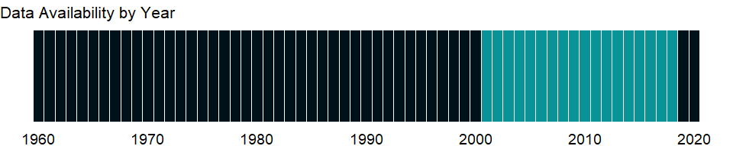

### Which countries have data?

The figure below shows the percentage of countries in each income group with a value since 2010 for that indicator.

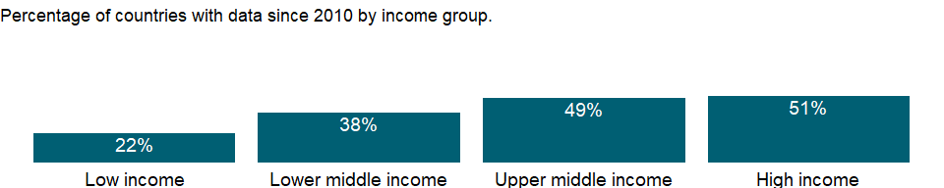

### Why is it relevant?

Worldwide, irrigated agriculture accounts for about four-fifths of global water withdrawals. The share of irrigated land ranges widely, from 4 percent of the total area cropped in Africa to 42 percent in South Asia. The leading countries are India and China with about 30 percent and 52 percent of all cropland irrigated, respectively. Without irrigation and drainage, much of the increases in agricultural output that has fed the world’s growing population and stabilized food production would not have been possible.

In the dry sub-humid countries, irrigation is critical for crop production. Due to highly variable rainfall, long dry seasons, and recurrent droughts, dry spells and floods, water management is a key determinant for agricultural production in these regions and is increasingly becoming more important with climate change. World Bank estimates that rainfed agriculture is most significant in Sub-Saharan Africa where it accounts for about 96 percent of the cropland.

Irrigation and drainage continue to be an important source of productivity growth, especially in Sub-Saharan Africa and parts of Latin America that still have large untapped water resources for agriculture. In other regions where the scope for further expanding irrigated agriculture is limited, more efforts are needed to enhance the policy, technical, and governance aspects of agricultural water use.

Agricultural land covers more than one-third of the world’s land area. In many industrialized countries, agricultural land is subject to zoning regulations. In the context of zoning, agricultural land (or more properly agriculturally zoned land) refers to plots that may be used for agricultural activities, regardless of the physical type or quality of land. Data on agricultural land are valuable for conducting studies on a various perspectives concerning agricultural production, food security and for deriving cropping intensity among others uses. Agricultural land indicator, along with land-use indicators, can also elucidate the environmental sustainability of countries’ agricultural practices. Agriculture is still a major sector in many economies, and agricultural activities provide developing countries with food and revenue. But agricultural activities also can degrade natural resources. Poor farming practices can cause soil erosion and loss of soil fertility. Efforts to increase productivity by using chemical fertilizers, pesticides, and intensive irrigation have environmental costs and health impacts. Salinization of irrigated land diminishes soil fertility. Thus, inappropriate use of inputs for agricultural production has far-reaching effects.

There is no single correct mix of inputs to the agricultural land, as it is dependent on local climate, land quality, and economic development; appropriate levels and application rates vary by country and over time and depend on the type of crops, the climate and soils, and the production process used.

### What is the data source?

Food and Agriculture Organization, electronic files and web site.

### What is the methodology?

Irrigated agricultural area refers to area equipped to provide water (via artificial means of irrigation such as by diverting streams, flooding, or spraying) to the crops. In non-irrigated agricultural areas, production of crops is dependent on rain-fed irrigation.

Agricultural land constitutes only a part of any country’s total area, which can include areas not suitable for agriculture, such as forests, mountains, and inland water bodies. Agricultural land can also be classified as irrigated and non-irrigated land. In arid and semi-arid countries agriculture is often confined to irrigated land, with very little farming possible in non-irrigated areas.

### How is it aggregated?

Weighted average

### What are the limitations?

The data are collected by the Food and Agriculture Organization of the United Nations (FAO) from official national sources through annual questionnaires and are supplemented with information from official secondary data sources. The secondary sources cover official country data from websites of national ministries, national publications and related country data reported by various international organizations.. The FAO tries to impose standard definitions and reporting methods, but complete consistency across countries and over time is not possible. Thus, data on agricultural land in different climates may not be comparable. For example, permanent pastures are quite different in nature and intensity in African countries and dry Middle Eastern countries.

### What else should I know?

NA

### 1.2.15 Average precipitation in depth (mm per year)

### What is the indicator?

Average precipitation is the long-term average in depth (over space and time) of annual precipitation in the country. Precipitation is defined as any kind of water that falls from clouds as a liquid or a solid.

Topic: Environment: Land use

Series ID: AG.LND.PRCP.MM

Copyright: CC BY-4.0 , <https://datacatalog.worldbank.org/public-licenses#cc-by>

First year with any data: 1962

Last year with any data: 2017

### What years are data available?

The figure below shows years in which data is available for at least one country. Dates shaded in black have no data, while dates shaded in green have data for at least one country

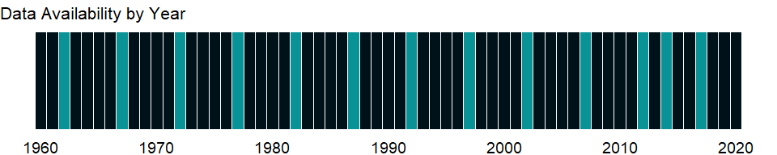

### Which countries have data?

The figure below shows the percentage of countries in each income group with a value since 2010 for that indicator.

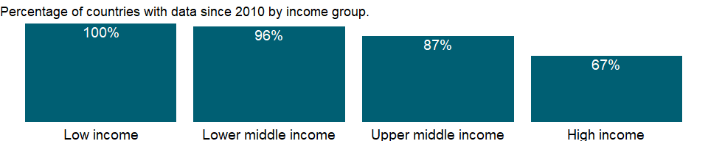

### Why is it relevant?

The agriculture sector is the most water-intensive sector, and water delivery in agriculture is increasingly important. Data on irrigated agricultural land and data on average precipitation illustrate how countries obtain water for agricultural use.

### What is the data source?

Food and Agriculture Organization, electronic files and web site.

### What is the methodology?

NA

### How is it aggregated?

NA

### What are the limitations?

The data are collected by the Food and Agriculture Organization of the United Nations (FAO) through annual questionnaires. The FAO tries to impose standard definitions and reporting methods, but complete consistency across countries and over time is not possible.

### What else should I know?

NA

### 1.2.16 Land area (sq. km)

### What is the indicator?

Land area is a country’s total area, excluding area under inland water bodies, national claims to continental shelf, and exclusive economic zones. In most cases the definition of inland water bodies includes major rivers and lakes.

Topic: Environment: Land use

Series ID: AG.LND.TOTL.K2

Copyright: CC BY-4.0 , <https://datacatalog.worldbank.org/public-licenses#cc-by>

First year with any data: 1961

Last year with any data: 2020

### What years are data available?

The figure below shows years in which data is available for at least one country. Dates shaded in black have no data, while dates shaded in green have data for at least one country

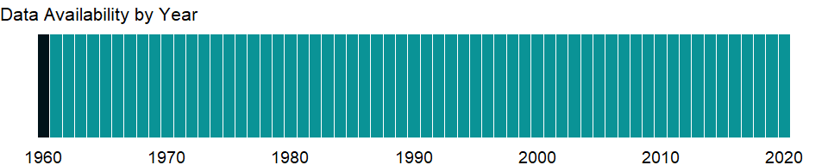

### Which countries have data?

The figure below shows the percentage of countries in each income group with a value since 2010 for that indicator.

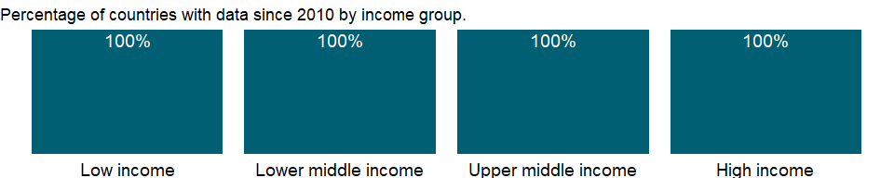

### Why is it relevant?

Land area is particularly important for understanding an economy’s agricultural capacity and the environmental effects of human activity. Innovations in satellite mapping and computer databases have resulted in more precise measurements of land and water areas.

Population, land area, income, and output are basic measures of the size of an economy. They also provide a broad indication of actual and potential resources. Land area is therefore used as one of the major indicator to normalize other indicators.

### What is the data source?

Food and Agriculture Organization, electronic files and web site.

### What is the methodology?

Total land area does not include inland water bodies such as major rivers and lakes. Variations from year to year may be due to updated or revised data rather than to change in area.

### How is it aggregated?

Sum

### What are the limitations?

The data are collected by the Food and Agriculture Organization (FAO) of the United Nations through annual questionnaires. The FAO tries to impose standard definitions and reporting methods, but complete consistency across countries and over time is not possible.

The data collected from official national sources through the questionnaire are supplemented with information from official secondary data sources. The secondary sources cover official country data from websites of national ministries, national publications and related country data reported by various international organizations.

### What else should I know?

NA

### 1.2.17 Rural land area (sq. km)

### What is the indicator?

Rural land area in square kilometers, derived from urban extent grids which distinguish urban and rural areas based on a combination of population counts (persons), settlement points, and the presence of Nighttime Lights. Areas are defined as urban where contiguous lighted cells from the Nighttime Lights or approximated urban extents based on buffered settlement points for which the total population is greater than 5,000 persons.

Topic: Environment: Land use

Series ID: AG.LND.TOTL.RU.K2

Copyright: CC BY-4.0 , <https://datacatalog.worldbank.org/public-licenses#cc-by>

First year with any data: 1990

Last year with any data: 2010

### What years are data available?

The figure below shows years in which data is available for at least one country. Dates shaded in black have no data, while dates shaded in green have data for at least one country



### Which countries have data?

The figure below shows the percentage of countries in each income group with a value since 2010 for that indicator.



### Why is it relevant?

NA

### What is the data source?

Center for International Earth Science Information Network (CIESIN)/Columbia University. 2013. Urban-Rural Population and Land Area Estimates Version 2. Palisades, NY: NASA Socioeconomic Data and Applications Center (SEDAC). <http://sedac.ciesin.columbia.edu/data/set/lecz-urban-rural-population-land-area-estimates-v2>.

### What is the methodology?

The Global Rural-Urban Mapping Project, Version 1 (GRUMPv1) urban extent grid distinguishes urban and rural areas based on a combination of population counts (persons), settlement points, and the presence of Nighttime Lights . Areas are defined as urban where contiguous lighted cells from the Nighttime Lights or approximated urban extents based on buffered settlement points for which the total population is greater than 5,000 persons. This dataset is produced by the Columbia University Center for International Earth Science Information Network (CIESIN) in collaboration with the International Food Policy Research Institute (IFPRI), The World Bank, and Centro Internacional de Agricultura Tropical (CIAT)

### How is it aggregated?

Sum

### What are the limitations?

The 2007 Intergovernmental Panel on Climate Change’s (IPCC) assessment report concluded that global warming is “unequivocal” and gave the strongest warning yet about the role of human activities. The report estimated that sea levels would rise approximately 49 centimeters over the next 100 years, with a range of uncertainty of 20–86 centimeters. That will lead to increased coastal flooding through direct inundation and a higher base for storm surges, allowing flooding of larger areas and higher elevations. Climate model simulations predict an increase in average surface air temperature of about 2.5°C by 2100 (Kattenberg and others 1996) and increase of “killer” heat waves during the warm season (Karl and others 1997).

### What else should I know?

NA

### 1.2.18 Urban land area (sq. km)

### What is the indicator?

Urban land area in square kilometers, based on a combination of population counts (persons), settlement points, and the presence of Nighttime Lights. Areas are defined as urban where contiguous lighted cells from the Nighttime Lights or approximated urban extents based on buffered settlement points for which the total population is greater than 5,000 persons.

Topic: Environment: Land use

Series ID: AG.LND.TOTL.UR.K2

Copyright: CC BY-4.0 , <https://datacatalog.worldbank.org/public-licenses#cc-by>

First year with any data: 1990

Last year with any data: 2010

### What years are data available?

The figure below shows years in which data is available for at least one country. Dates shaded in black have no data, while dates shaded in green have data for at least one country



### Which countries have data?

The figure below shows the percentage of countries in each income group with a value since 2010 for that indicator.



### Why is it relevant?

NA

### What is the data source?

Center for International Earth Science Information Network (CIESIN)/Columbia University. 2013. Urban-Rural Population and Land Area Estimates Version 2. Palisades, NY: NASA Socioeconomic Data and Applications Center (SEDAC). <http://sedac.ciesin.columbia.edu/data/set/lecz-urban-rural-population-land-area-estimates-v2>.

### What is the methodology?

The Global Rural-Urban Mapping Project, Version 1 (GRUMPv1) urban extent grid distinguishes urban and rural areas based on a combination of population counts (persons), settlement points, and the presence of Nighttime Lights . Areas are defined as urban where contiguous lighted cells from the Nighttime Lights or approximated urban extents based on buffered settlement points for which the total population is greater than 5,000 persons. This dataset is produced by the Columbia University Center for International Earth Science Information Network (CIESIN) in collaboration with the International Food Policy Research Institute (IFPRI), The World Bank, and Centro Internacional de Agricultura Tropical (CIAT)

### How is it aggregated?

Sum

### What are the limitations?

NA

### What else should I know?

NA

### 1.2.19 Surface area (sq. km)

### What is the indicator?

Surface area is a country’s total area, including areas under inland bodies of water and some coastal waterways.

Topic: Environment: Land use

Series ID: AG.SRF.TOTL.K2

Copyright: CC BY-4.0 , <https://datacatalog.worldbank.org/public-licenses#cc-by>

First year with any data: 1961

Last year with any data: 2018

### What years are data available?

The figure below shows years in which data is available for at least one country. Dates shaded in black have no data, while dates shaded in green have data for at least one country



### Which countries have data?

The figure below shows the percentage of countries in each income group with a value since 2010 for that indicator.



### Why is it relevant?

Total surface area is particularly important for understanding an economy’s agricultural capacity and the environmental effects of human activity. Innovations in satellite mapping and computer databases have resulted in more precise measurements of land and water areas.

Population, surface area, income, and output are basic measures of the size of an economy. They also provide a broad indication of actual and potential resources. Land area is therefore used as one of the major indicator to normalize other indicators.

### What is the data source?

Food and Agriculture Organization, electronic files and web site.

### What is the methodology?

Total land area includes inland water bodies such as major rivers and lakes. Variations from year to year may be due to updated or revised data rather than to change in area.

### How is it aggregated?

Sum

### What are the limitations?

The data are collected by the Food and Agriculture Organization (FAO) of the United Nations through annual questionnaires. The FAO tries to impose standard definitions and reporting methods, but complete consistency across countries and over time is not possible.

The data collected from official national sources through the questionnaire are supplemented with information from official secondary data sources. The secondary sources cover official country data from websites of national ministries, national publications and related country data reported by various international organizations.

### What else should I know?

NA

### 1.2.20 Disaster risk reduction progress score (1-5 scale; 5=best)

### What is the indicator?

Disaster risk reduction progress score is an average of self-assessment scores, ranging from 1 to 5, submitted by countries under Priority 1 of the Hyogo Framework National Progress Reports. The Hyogo Framework is a global blueprint for disaster risk reduction efforts that was adopted by 168 countries in 2005. Assessments of “Priority 1” include four indicators that reflect the degree to which countries have prioritized disaster risk reduction and the strengthening of relevant institutions.

Topic: Environment: Land use

Series ID: EN.CLC.DRSK.XQ

Copyright: CC BY-4.0 , <https://datacatalog.worldbank.org/public-licenses#cc-by>

First year with any data: 2011

Last year with any data: 2011

### What years are data available?

The figure below shows years in which data is available for at least one country. Dates shaded in black have no data, while dates shaded in green have data for at least one country

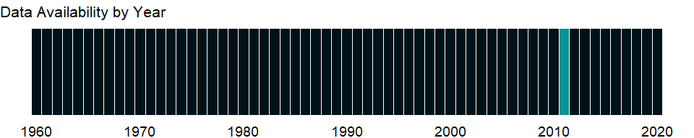

### Which countries have data?

The figure below shows the percentage of countries in each income group with a value since 2010 for that indicator.

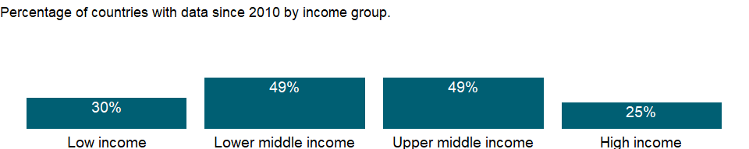

### Why is it relevant?

The Hyogo Framework’s goal is to substantially reduce disaster losses by 2015 - in lives, and in the social, economic, and environmental assets of communities and countries. The Hyogo Framework offers guiding principles, priorities for action, and practical means for achieving disaster resilience for vulnerable communities. Governments around the world have committed to take action to reduce disaster risk, and have adopted a guideline to reduce vulnerabilities to natural hazards, called the Hyogo Framework for Action (HFA). The HFA assists the efforts of nations and communities to become more resilient to, and cope better with the hazards that threaten their development gains.

Scientists use the terms climate change and global warming to refer to the gradual increase in the Earth’s surface temperature that has accelerated since the industrial revolution and especially over the past two decades. Most global warming has been caused by human activities that have changed the chemical composition of the atmosphere through a buildup of greenhouse gases - primarily carbon dioxide, methane, and nitrous oxide. Rising global temperatures will cause sea level rise and alter local climate conditions, affecting forests, crop yields, and water supplies, and may affect human health, animals, and many types of ecosystems.

### What is the data source?

(UNISDR, 2009-2011 Progress Reports, <http://www.preventionweb.net/english/hyogo>).

### What is the methodology?

Resilience is measured by the disaster risk reduction progress score, an average of self-assessment scores submitted by countries under Priority 1 of the Hyogo Framework National Progress Reports. The Hyogo Framework is a global blueprint for disaster risk reduction efforts that was adopted by 168 countries in 2005. Assessments of Priority 1 include four indicators that reflect the degree to which countries have prioritized disaster risk reduction and the strengthening of relevant institutions.

### How is it aggregated?

NA

### What are the limitations?

The Hyogo Framework for Action (FHA) national progress reports assess strategic priorities in the implementation of disaster risk reduction actions and establish baselines on levels of progress achieved in implementing the HFA’s five priorities for action. National reporting processes are led by officially designated HFA focal institutions in country, and regional reporting by regional intergovernmental organizations.

HFA’s five priorities are: 1. Making disaster risk reduction a policy priority, institutional strengthening 2. Risk assessment and early warning systems 3. Education, information and public awareness 4. Reducing underlying risk factors 5. Preparedness for effective response

### What else should I know?

NA

### 1.2.21 Droughts, floods, extreme temperatures (% of population, average 1990-2009)

### What is the indicator?

Droughts, floods and extreme temperatures is the annual average percentage of the population that is affected by natural disasters classified as either droughts, floods, or extreme temperature events. A drought is an extended period of time characterized by a deficiency in a region’s water supply that is the result of constantly below average precipitation. A drought can lead to losses to agriculture, affect inland navigation and hydropower plants, and cause a lack of drinking water and famine. A flood is a significant rise of water level in a stream, lake, reservoir or coastal region. Extreme temperature events are either cold waves or heat waves. A cold wave can be both a prolonged period of excessively cold weather and the sudden invasion of very cold air over a large area. Along with frost it can cause damage to agriculture, infrastructure, and property. A heat wave is a prolonged period of excessively hot and sometimes also humid weather relative to normal climate patterns of a certain region. Population affected is the number of people injured, left homeless or requiring immediate assistance during a period of emergency resulting from a natural disaster; it can also include displaced or evacuated people. Average percentage of population affected is calculated by dividing the sum of total affected for the period stated by the sum of the annual population figures for the period stated.

Topic: Environment: Land use

Series ID: EN.CLC.MDAT.ZS

Copyright: CC BY-4.0 , <https://datacatalog.worldbank.org/public-licenses#cc-by>

First year with any data: 2009

Last year with any data: 2009

### What years are data available?

The figure below shows years in which data is available for at least one country. Dates shaded in black have no data, while dates shaded in green have data for at least one country

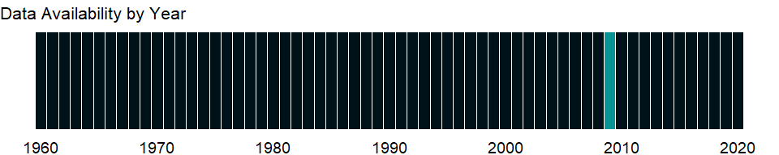

### Which countries have data?

The figure below shows the percentage of countries in each income group with a value since 2010 for that indicator.



### Why is it relevant?

Scientists use the terms climate change and global warming to refer to the gradual increase in the Earth’s surface temperature that has accelerated since the industrial revolution and especially over the past two decades. Most global warming has been caused by human activities that have changed the chemical composition of the atmosphere through a buildup of greenhouse gases - primarily carbon dioxide, methane, and nitrous oxide. Rising global temperatures will cause sea level rise and alter local climate conditions, affecting forests, crop yields, and water supplies, and may affect human health, animals, and many types of ecosystems.

A drought can lead to losses in agriculture, affect inland navigation and hydropower plants, reduce access to drinking water, and cause famines. A flood is a significant rise of water level in a stream, lake, reservoir, or coastal region. Extreme temperature events are either cold waves or heat waves. A cold wave can be both a prolonged period of excessively cold weather and the sudden invasion of very cold air over a large area. Accompanied by frost, it can damage agriculture, infrastructure, and property. A heat wave is a prolonged period of excessively hot and sometimes humid weather. Population affected by these natural disasters is the number of people injured, left homeless, or requiring immediate assistance and can include displaced or evacuated people.

### What is the data source?

EM-DAT: The OFDA/CRED International Disaster Database: www.emdat.be, Université Catholique de Louvain, Brussels (Belgium), World Bank.

### What is the methodology?

This indicator measures vulnerability of population affected by droughts, floods, and extreme temperature. A drought is an extended period of deficiency in a region’s water supply as a result of below average precipitation.

### How is it aggregated?

NA

### What are the limitations?

The 2007 Intergovernmental Panel on Climate Change’s (IPCC) assessment report concluded that global warming is “unequivocal” and gave the strongest warning yet about the role of human activities. The report estimated that sea levels would rise approximately 49 centimeters over the next 100 years, with a range of uncertainty of 20-86 centimeters. That will lead to increased coastal flooding through direct inundation and a higher base for storm surges, allowing flooding of larger areas and higher elevations. Climate model simulations predict an increase in average surface air temperature of about 2.5°C by 2100 (Kattenberg and others 1996) and increase of “killer” heat waves during the warm season (Karl and others 1997).

### What else should I know?

NA

### 1.2.22 Rural population living in areas where elevation is below 5 meters (% of total population)

### What is the indicator?

Rural population below 5m is the percentage of the total population, living in areas where the elevation is 5 meters or less.

Topic: Environment: Land use

Series ID: EN.POP.EL5M.RU.ZS

Copyright: CC BY-4.0 , <https://datacatalog.worldbank.org/public-licenses#cc-by>

First year with any data: 1990

Last year with any data: 2010

### What years are data available?

The figure below shows years in which data is available for at least one country. Dates shaded in black have no data, while dates shaded in green have data for at least one country



### Which countries have data?

The figure below shows the percentage of countries in each income group with a value since 2010 for that indicator.



### Why is it relevant?

NA

### What is the data source?

Center for International Earth Science Information Network (CIESIN)/Columbia University. 2013. Urban-Rural Population and Land Area Estimates Version 2. Palisades, NY: NASA Socioeconomic Data and Applications Center (SEDAC). <http://sedac.ciesin.columbia.edu/data/set/lecz-urban-rural-population-land-area-estimates-v2>.

### What is the methodology?

Population counts in low elevation zones in the year 1990 as described by GRUMPv1 input estimates allocated into 3 arc second grid cells. Population counts in low elevation zones in the year 2000 as described by GRUMPv1 input estimates allocated into 3 arc second grid cells. Population counts in low elevation zones in the year 2010 derived from the application of United Nations 2000-2010 national growth rates to year 2000 population data from GRUMPv1 ( see documentation for full description of methodologies ).

### How is it aggregated?

Weighted Average

### What are the limitations?

NA

### What else should I know?

NA

### 1.2.23 Urban population living in areas where elevation is below 5 meters (% of total population)

### What is the indicator?

Urban population below 5m is the percentage of the total population, living in areas where the elevation is 5 meters or less.

Topic: Environment: Land use

Series ID: EN.POP.EL5M.UR.ZS

Copyright: CC BY-4.0 , <https://datacatalog.worldbank.org/public-licenses#cc-by>

First year with any data: 1990

Last year with any data: 2010

### What years are data available?

The figure below shows years in which data is available for at least one country. Dates shaded in black have no data, while dates shaded in green have data for at least one country



### Which countries have data?

The figure below shows the percentage of countries in each income group with a value since 2010 for that indicator.



### Why is it relevant?

NA

### What is the data source?

Center for International Earth Science Information Network (CIESIN)/Columbia University. 2013. Urban-Rural Population and Land Area Estimates Version 2. Palisades, NY: NASA Socioeconomic Data and Applications Center (SEDAC). <http://sedac.ciesin.columbia.edu/data/set/lecz-urban-rural-population-land-area-estimates-v2>.

### What is the methodology?

Population counts in low elevation zones in the year 1990 as described by GRUMPv1 input estimates allocated into 3 arc second grid cells. Population counts in low elevation zones in the year 2000 as described by GRUMPv1 input estimates allocated into 3 arc second grid cells. Population counts in low elevation zones in the year 2010 derived from the application of United Nations 2000-2010 national growth rates to year 2000 population data from GRUMPv1 ( see documentation for full description of methodologies ).

### How is it aggregated?

Weighted Average

### What are the limitations?

NA

### What else should I know?

NA

### 1.2.24 Population living in areas where elevation is below 5 meters (% of total population)

### What is the indicator?

Population below 5m is the percentage of the total population living in areas where the elevation is 5 meters or less.

Topic: Environment: Land use

Series ID: EN.POP.EL5M.ZS

Copyright: CC BY-4.0 , <https://datacatalog.worldbank.org/public-licenses#cc-by>

First year with any data: 1990

Last year with any data: 2010

### What years are data available?

The figure below shows years in which data is available for at least one country. Dates shaded in black have no data, while dates shaded in green have data for at least one country



### Which countries have data?

The figure below shows the percentage of countries in each income group with a value since 2010 for that indicator.



### Why is it relevant?

Scientists use the terms climate change and global warming to refer to the gradual increase in the Earth’s surface temperature that has accelerated since the industrial revolution and especially over the past two decades. Most global warming has been caused by human activities that have changed the chemical composition of the atmosphere through a buildup of greenhouse gases - primarily carbon dioxide, methane, and nitrous oxide. Rising global temperatures will cause sea level rise and alter local climate conditions, affecting forests, crop yields, and water supplies, and may affect human health, animals, and many types of ecosystems.

### What is the data source?

Center for International Earth Science Information Network (CIESIN)/Columbia University. 2013. Urban-Rural Population and Land Area Estimates Version 2. Palisades, NY: NASA Socioeconomic Data and Applications Center (SEDAC). <http://sedac.ciesin.columbia.edu/data/set/lecz-urban-rural-population-land-area-estimates-v2>.

### What is the methodology?

Population counts in low elevation zones in the year 1990 as described by GRUMPv1 input estimates allocated into 3 arc second grid cells. Population counts in low elevation zones in the year 2000 as described by GRUMPv1 input estimates allocated into 3 arc second grid cells. Population counts in low elevation zones in the year 2010 derived from the application of United Nations 2000-2010 national growth rates to year 2000 population data from GRUMPv1 (see documentation for full description of methodologies).

### How is it aggregated?

Weighted Average

### What are the limitations?

The 2007 Intergovernmental Panel on Climate Change’s (IPCC) assessment report concluded that global warming is “unequivocal” and gave the strongest warning yet about the role of human activities. The report estimated that sea levels would rise approximately 49 centimeters over the next 100 years, with a range of uncertainty of 20–86 centimeters. That will lead to increased coastal flooding through direct inundation and a higher base for storm surges, allowing flooding of larger areas and higher elevations. Climate model simulations predict an increase in average surface air temperature of about 2.5°C by 2100 (Kattenberg and others 1996) and increase of “killer” heat waves during the warm season (Karl and others 1997).

### What else should I know?

NA

## 1.3 Economic Policy & Debt: Balance of payments: Current account: Goods, services & income

### 1.3.1 Trade in services (% of GDP)

### What is the indicator?

Trade in services is the sum of service exports and imports divided by the value of GDP, all in current U.S. dollars.

Topic: Economic Policy & Debt: Balance of payments: Current account: Goods, services & income

Series ID: BG.GSR.NFSV.GD.ZS

Copyright: CC BY-4.0 , <https://datacatalog.worldbank.org/public-licenses#cc-by>

First year with any data: 1960

Last year with any data: 2020

### What years are data available?

The figure below shows years in which data is available for at least one country. Dates shaded in black have no data, while dates shaded in green have data for at least one country

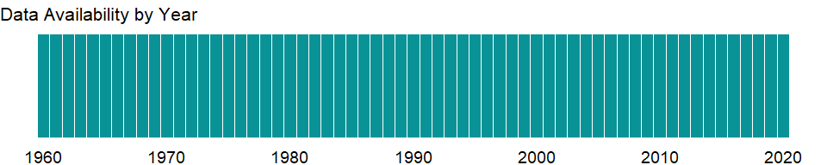

### Which countries have data?

The figure below shows the percentage of countries in each income group with a value since 2010 for that indicator.

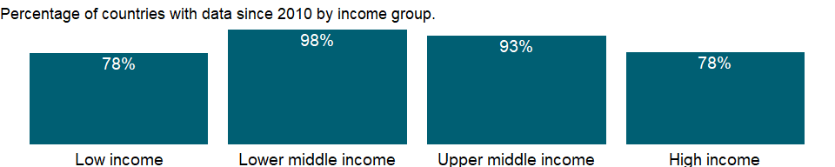

### Why is it relevant?

NA

### What is the data source?

International Monetary Fund, Balance of Payments Statistics Yearbook and data files, and World Bank and OECD GDP estimates.

### What is the methodology?

NA

### How is it aggregated?

Weighted average

### What are the limitations?

NA

### What else should I know?

Note: Data are based on the sixth edition of the IMF’s Balance of Payments Manual (BPM6) and are only available from 2005 onwards.

### 1.3.2 Communications, computer, etc. (% of service imports, BoP)

### What is the indicator?

Communications, computer, information, and other services cover international telecommunications; computer data; news-related service transactions between residents and nonresidents; construction services; royalties and license fees; miscellaneous business, professional, and technical services; personal, cultural, and recreational services; manufacturing services on physical inputs owned by others; and maintenance and repair services and government services not included elsewhere.

Topic: Economic Policy & Debt: Balance of payments: Current account: Goods, services & income

Series ID: BM.GSR.CMCP.ZS

Copyright: CC BY-4.0 , <https://datacatalog.worldbank.org/public-licenses#cc-by>

First year with any data: 1960

Last year with any data: 2020

### What years are data available?

The figure below shows years in which data is available for at least one country. Dates shaded in black have no data, while dates shaded in green have data for at least one country



### Which countries have data?

The figure below shows the percentage of countries in each income group with a value since 2010 for that indicator.

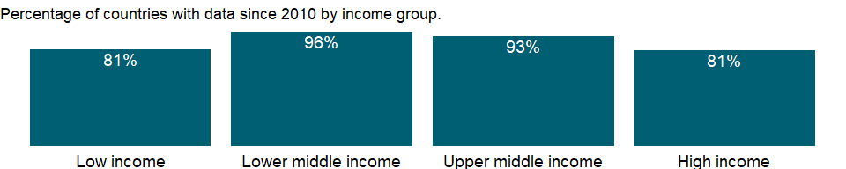

### Why is it relevant?

NA

### What is the data source?

International Monetary Fund, Balance of Payments Statistics Yearbook and data files.

### What is the methodology?

NA

### How is it aggregated?

Weighted average

### What are the limitations?

NA

### What else should I know?

Note: Data are based on the sixth edition of the IMF’s Balance of Payments Manual (BPM6) and are only available from 2005 onwards.

### 1.3.3 Primary income payments (BoP, current US$)

### What is the indicator?

Primary income payments refer to employee compensation paid to nonresident workers and investment income (payments on direct investment, portfolio investment, other investments). Data are in current U.S. dollars.

Topic: Economic Policy & Debt: Balance of payments: Current account: Goods, services & income

Series ID: BM.GSR.FCTY.CD

Copyright: CC BY-4.0 , <https://datacatalog.worldbank.org/public-licenses#cc-by>

First year with any data: 1960

Last year with any data: 2020

### What years are data available?

The figure below shows years in which data is available for at least one country. Dates shaded in black have no data, while dates shaded in green have data for at least one country



### Which countries have data?

The figure below shows the percentage of countries in each income group with a value since 2010 for that indicator.

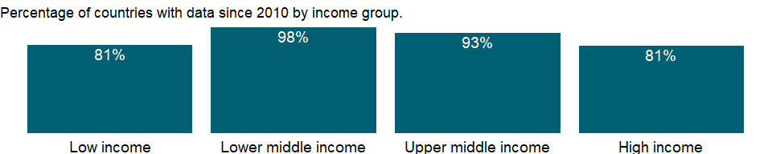

### Why is it relevant?

NA

### What is the data source?

International Monetary Fund, Balance of Payments Statistics Yearbook and data files.

### What is the methodology?

NA

### How is it aggregated?

Sum

### What are the limitations?

NA

### What else should I know?

Note: Data are based on the sixth edition of the IMF’s Balance of Payments Manual (BPM6) and are only available from 2005 onwards.

### 1.3.4 Imports of goods and services (BoP, current US$)

### What is the indicator?

Imports of goods and services comprise all transactions between residents of a country and the rest of the world involving a change of ownership from nonresidents to residents of general merchandise, nonmonetary gold, and services. Data are in current U.S. dollars.

Topic: Economic Policy & Debt: Balance of payments: Current account: Goods, services & income

Series ID: BM.GSR.GNFS.CD

Copyright: CC BY-4.0 , <https://datacatalog.worldbank.org/public-licenses#cc-by>

First year with any data: 1960

Last year with any data: 2020

### What years are data available?

The figure below shows years in which data is available for at least one country. Dates shaded in black have no data, while dates shaded in green have data for at least one country



### Which countries have data?

The figure below shows the percentage of countries in each income group with a value since 2010 for that indicator.



### Why is it relevant?

The balance of payments records an economy’s transactions with the rest of the world. Balance of payments accounts are divided into two groups: the current account, which records transactions in goods, services, primary income, and secondary income, and the capital and financial account, which records capital transfers, acquisition or disposal of nonproduced, nonfinancial assets, and transactions in financial assets and liabilities. The current account balance is one of the most analytically useful indicators of an external imbalance.

A primary purpose of the balance of payments accounts is to indicate the need to adjust an external imbalance. Where to draw the line for analytical purposes requires a judgment concerning the imbalance that best indicates the need for adjustment. There are a number of definitions in common use for this and related analytical purposes. The trade balance is the difference between exports and imports of goods. From an analytical view it is arbitrary to distinguish goods from services. For example, a unit of foreign exchange earned by a freight company strengthens the balance of payments to the same extent as the foreign exchange earned by a goods exporter. Even so, the trade balance is useful because it is often the most timely indicator of trends in the current account balance. Customs authorities are typically able to provide data on trade in goods long before data on trade in services are available.

### What is the data source?

International Monetary Fund, Balance of Payments Statistics Yearbook and data files.

### What is the methodology?

The balance of payments (BoP) is a double-entry accounting system that shows all flows of goods and services into and out of an economy; all transfers that are the counterpart of real resources or financial claims provided to or by the rest of the world without a quid pro quo, such as donations and grants; and all changes in residents’ claims on and liabilities to nonresidents that arise from economic transactions. All transactions are recorded twice - once as a credit and once as a debit. In principle the net balance should be zero, but in practice the accounts often do not balance, requiring inclusion of a balancing item, net errors and omissions.

The concepts and definitions underlying the data are based on the sixth edition of the International Monetary Fund’s (IMF) Balance of Payments Manual (BPM6). Balance of payments data for 2005 onward will be presented in accord with the BPM6. The historical BPM5 data series will end with data for 2008, which can be accessed through the World Development Indicators archives.

The complete balance of payments methodology can be accessed through the International Monetary Fund website (www.imf.org/external/np/sta/bop/bop.htm).

### How is it aggregated?

Gap-filled total

### What are the limitations?

Discrepancies may arise in the balance of payments because there is no single source for balance of payments data and therefore no way to ensure that the data are fully consistent. Sources include customs data, monetary accounts of the banking system, external debt records, information provided by enterprises, surveys to estimate service transactions, and foreign exchange records. Differences in collection methods - such as in timing, definitions of residence and ownership, and the exchange rate used to value transactions - contribute to net errors and omissions. In addition, smuggling and other illegal or quasi-legal transactions may be unrecorded or misrecorded.

### What else should I know?

Note: Data are based on the sixth edition of the IMF’s Balance of Payments Manual (BPM6) and are only available from 2005 onwards.

### 1.3.5 Insurance and financial services (% of service imports, BoP)

### What is the indicator?

Insurance and financial services cover various types of insurance provided to nonresidents by resident insurance enterprises and vice versa, and financial intermediary and auxiliary services (except those of insurance enterprises and pension funds) exchanged between residents and nonresidents.

Topic: Economic Policy & Debt: Balance of payments: Current account: Goods, services & income

Series ID: BM.GSR.INSF.ZS

Copyright: CC BY-4.0 , <https://datacatalog.worldbank.org/public-licenses#cc-by>

First year with any data: 1960

Last year with any data: 2020

### What years are data available?

The figure below shows years in which data is available for at least one country. Dates shaded in black have no data, while dates shaded in green have data for at least one country



### Which countries have data?

The figure below shows the percentage of countries in each income group with a value since 2010 for that indicator.



### Why is it relevant?

NA

### What is the data source?

International Monetary Fund, Balance of Payments Statistics Yearbook and data files.

### What is the methodology?

NA

### How is it aggregated?

Weighted average

### What are the limitations?

NA

### What else should I know?

Note: Data are based on the sixth edition of the IMF’s Balance of Payments Manual (BPM6) and are only available from 2005 onwards.

### 1.3.6 Goods imports (BoP, current US$)

### What is the indicator?

Goods imports refer to all movable goods (including nonmonetary gold) involved in a change of ownership from nonresidents to residents. Data are in current U.S. dollars.

Topic: Economic Policy & Debt: Balance of payments: Current account: Goods, services & income

Series ID: BM.GSR.MRCH.CD

Copyright: CC BY-4.0 , <https://datacatalog.worldbank.org/public-licenses#cc-by>

First year with any data: 1960

Last year with any data: 2020

### What years are data available?

The figure below shows years in which data is available for at least one country. Dates shaded in black have no data, while dates shaded in green have data for at least one country



### Which countries have data?

The figure below shows the percentage of countries in each income group with a value since 2010 for that indicator.



### Why is it relevant?

NA

### What is the data source?

International Monetary Fund, Balance of Payments Statistics Yearbook and data files.

### What is the methodology?

NA

### How is it aggregated?

Gap-filled total

### What are the limitations?

NA

### What else should I know?

Note: Data are based on the sixth edition of the IMF’s Balance of Payments Manual (BPM6) and are only available from 2005 onwards.

### 1.3.7 Service imports (BoP, current US$)

### What is the indicator?

Services refer to economic output of intangible commodities that may be produced, transferred, and consumed at the same time. Data are in current U.S. dollars.

Topic: Economic Policy & Debt: Balance of payments: Current account: Goods, services & income

Series ID: BM.GSR.NFSV.CD

Copyright: CC BY-4.0 , <https://datacatalog.worldbank.org/public-licenses#cc-by>

First year with any data: 1960

Last year with any data: 2020

### What years are data available?

The figure below shows years in which data is available for at least one country. Dates shaded in black have no data, while dates shaded in green have data for at least one country



### Which countries have data?

The figure below shows the percentage of countries in each income group with a value since 2010 for that indicator.



### Why is it relevant?

NA

### What is the data source?

International Monetary Fund, Balance of Payments Statistics Yearbook and data files.

### What is the methodology?

NA

### How is it aggregated?

Gap-filled total

### What are the limitations?

NA

### What else should I know?

Note: Data are based on the sixth edition of the IMF’s Balance of Payments Manual (BPM6) and are only available from 2005 onwards. Manufacturing services on physical inputs owned by others (goods for processing in BPM5) and maintenance and repair services n.i.e. are reclassified from goods to services.

### 1.3.8 Charges for the use of intellectual property, payments (BoP, current US$)

### What is the indicator?

Charges for the use of intellectual property are payments and receipts between residents and nonresidents for the authorized use of proprietary rights (such as patents, trademarks, copyrights, industrial processes and designs including trade secrets, and franchises) and for the use, through licensing agreements, of produced originals or prototypes (such as copyrights on books and manuscripts, computer software, cinematographic works, and sound recordings) and related rights (such as for live performances and television, cable, or satellite broadcast). Data are in current U.S. dollars.

Topic: Economic Policy & Debt: Balance of payments: Current account: Goods, services & income

Series ID: BM.GSR.ROYL.CD

Copyright: CC BY-4.0 , <https://datacatalog.worldbank.org/public-licenses#cc-by>

First year with any data: 1960

Last year with any data: 2020

### What years are data available?

The figure below shows years in which data is available for at least one country. Dates shaded in black have no data, while dates shaded in green have data for at least one country



### Which countries have data?

The figure below shows the percentage of countries in each income group with a value since 2010 for that indicator.

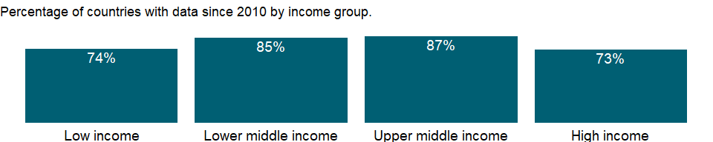

### Why is it relevant?

NA

### What is the data source?

International Monetary Fund, Balance of Payments Statistics Yearbook and data files.

### What is the methodology?

NA

### How is it aggregated?

Sum

### What are the limitations?

NA

### What else should I know?

Note: Data are based on the sixth edition of the IMF’s Balance of Payments Manual (BPM6) and are only available from 2005 onwards.

### 1.3.9 Imports of goods, services and primary income (BoP, current US$)

### What is the indicator?

Imports of goods, services and primary income is the sum of goods imports, service imports and primary income payments. Data are in current U.S. dollars.

Topic: Economic Policy & Debt: Balance of payments: Current account: Goods, services & income

Series ID: BM.GSR.TOTL.CD

Copyright: CC BY-4.0 , <https://datacatalog.worldbank.org/public-licenses#cc-by>

First year with any data: 1960

Last year with any data: 2020

### What years are data available?

The figure below shows years in which data is available for at least one country. Dates shaded in black have no data, while dates shaded in green have data for at least one country



### Which countries have data?

The figure below shows the percentage of countries in each income group with a value since 2010 for that indicator.



### Why is it relevant?

NA

### What is the data source?

International Monetary Fund, Balance of Payments Statistics Yearbook and data files.

### What is the methodology?

NA

### How is it aggregated?

Gap-filled total

### What are the limitations?

NA

### What else should I know?

Note: Data are based on the sixth edition of the IMF’s Balance of Payments Manual (BPM6) and are only available from 2005 onwards.

### 1.3.10 Transport services (% of service imports, BoP)

### What is the indicator?

Transport covers all transport services (sea, air, land, internal waterway, pipeline, space and electricity transmission) performed by residents of one economy for those of another and involving the carriage of passengers, the movement of goods (freight), rental of carriers with crew, and related support and auxiliary services. Also included are postal and courier services. Excluded are freight insurance (included in insurance services); goods procured in ports by nonresident carriers (included in goods); maintenance and repairs on transport equipment (included in maintenance and repair services n.i.e.); and repairs of railway facilities, harbors, and airfield facilities (included in construction).

Topic: Economic Policy & Debt: Balance of payments: Current account: Goods, services & income

Series ID: BM.GSR.TRAN.ZS

Copyright: CC BY-4.0 , <https://datacatalog.worldbank.org/public-licenses#cc-by>

First year with any data: 1960

Last year with any data: 2020

### What years are data available?

The figure below shows years in which data is available for at least one country. Dates shaded in black have no data, while dates shaded in green have data for at least one country



### Which countries have data?

The figure below shows the percentage of countries in each income group with a value since 2010 for that indicator.



### Why is it relevant?

NA

### What is the data source?

International Monetary Fund, Balance of Payments Statistics Yearbook and data files.

### What is the methodology?

NA

### How is it aggregated?

Weighted average

### What are the limitations?

NA

### What else should I know?

Note: Data are based on the sixth edition of the IMF’s Balance of Payments Manual (BPM6) and are only available from 2005 onwards.

### 1.3.11 Travel services (% of service imports, BoP)

### What is the indicator?

Travel covers goods and services acquired from an economy by travelers for their own use during visits of less than one year in that economy for either business or personal purposes. Travel includes local transport (i.e., transport within the economy being visited and provided by a resident of that economy), but excludes international transport (which is included in passenger transport. Travel also excludes goods for resale, which are included in general merchandise.

Topic: Economic Policy & Debt: Balance of payments: Current account: Goods, services & income

Series ID: BM.GSR.TRVL.ZS

Copyright: CC BY-4.0 , <https://datacatalog.worldbank.org/public-licenses#cc-by>

First year with any data: 1960

Last year with any data: 2020

### What years are data available?

The figure below shows years in which data is available for at least one country. Dates shaded in black have no data, while dates shaded in green have data for at least one country



### Which countries have data?

The figure below shows the percentage of countries in each income group with a value since 2010 for that indicator.



### Why is it relevant?

NA

### What is the data source?

International Monetary Fund, Balance of Payments Statistics Yearbook and data files.

### What is the methodology?

NA

### How is it aggregated?

Weighted average

### What are the limitations?

NA

### What else should I know?

Note: Data are based on the sixth edition of the IMF’s Balance of Payments Manual (BPM6) and are only available from 2005 onwards.

### 1.3.12 Net primary income (BoP, current US$)

### What is the indicator?

Net primary income refers to receipts and payments of employee compensation paid to nonresident workers and investment income (receipts and payments on direct investment, portfolio investment, other investments, and receipts on reserve assets). Data are in current U.S. dollars.

Topic: Economic Policy & Debt: Balance of payments: Current account: Goods, services & income

Series ID: BN.GSR.FCTY.CD

Copyright: CC BY-4.0 , <https://datacatalog.worldbank.org/public-licenses#cc-by>

First year with any data: 1960

Last year with any data: 2020

### What years are data available?

The figure below shows years in which data is available for at least one country. Dates shaded in black have no data, while dates shaded in green have data for at least one country



### Which countries have data?

The figure below shows the percentage of countries in each income group with a value since 2010 for that indicator.



### Why is it relevant?

The balance of payments records an economy’s transactions with the rest of the world. Balance of payments accounts are divided into two groups: the current account, which records transactions in goods, services, primary income, and secondary income, and the capital and financial account, which records capital transfers, acquisition or disposal of nonproduced, nonfinancial assets, and transactions in financial assets and liabilities. The current account balance is one of the most analytically useful indicators of an external imbalance.

A primary purpose of the balance of payments accounts is to indicate the need to adjust an external imbalance. Where to draw the line for analytical purposes requires a judgment concerning the imbalance that best indicates the need for adjustment. There are a number of definitions in common use for this and related analytical purposes. The trade balance is the difference between exports and imports of goods. From an analytical view it is arbitrary to distinguish goods from services. For example, a unit of foreign exchange earned by a freight company strengthens the balance of payments to the same extent as the foreign exchange earned by a goods exporter. Even so, the trade balance is useful because it is often the most timely indicator of trends in the current account balance. Customs authorities are typically able to provide data on trade in goods long before data on trade in services are available.

### What is the data source?

International Monetary Fund, Balance of Payments Statistics Yearbook and data files.

### What is the methodology?

The balance of payments (BoP) is a double-entry accounting system that shows all flows of goods and services into and out of an economy; all transfers that are the counterpart of real resources or financial claims provided to or by the rest of the world without a quid pro quo, such as donations and grants; and all changes in residents’ claims on and liabilities to nonresidents that arise from economic transactions. All transactions are recorded twice - once as a credit and once as a debit. In principle the net balance should be zero, but in practice the accounts often do not balance, requiring inclusion of a balancing item, net errors and omissions.

The concepts and definitions underlying the data are based on the sixth edition of the International Monetary Fund’s (IMF) Balance of Payments Manual (BPM6). Balance of payments data for 2005 onward will be presented in accord with the BPM6. The historical BPM5 data series will end with data for 2008, which can be accessed through the World Development Indicators archives.

The complete balance of payments methodology can be accessed through the International Monetary Fund website (www.imf.org/external/np/sta/bop/bop.htm).

### How is it aggregated?

NA

### What are the limitations?

Discrepancies may arise in the balance of payments because there is no single source for balance of payments data and therefore no way to ensure that the data are fully consistent. Sources include customs data, monetary accounts of the banking system, external debt records, information provided by enterprises, surveys to estimate service transactions, and foreign exchange records. Differences in collection methods - such as in timing, definitions of residence and ownership, and the exchange rate used to value transactions - contribute to net errors and omissions. In addition, smuggling and other illegal or quasi-legal transactions may be unrecorded or misrecorded.

### What else should I know?

Note: Data are based on the sixth edition of the IMF’s Balance of Payments Manual (BPM6) and are only available from 2005 onwards.

### 1.3.13 Communications, computer, etc. (% of service exports, BoP)

### What is the indicator?

Communications, computer, information, and other services cover international telecommunications; computer data; news-related service transactions between residents and nonresidents; construction services; royalties and license fees; miscellaneous business, professional, and technical services; personal, cultural, and recreational services; manufacturing services on physical inputs owned by others; and maintenance and repair services and government services not included elsewhere.

Topic: Economic Policy & Debt: Balance of payments: Current account: Goods, services & income

Series ID: BX.GSR.CMCP.ZS

Copyright: CC BY-4.0 , <https://datacatalog.worldbank.org/public-licenses#cc-by>

First year with any data: 1960

Last year with any data: 2020

### What years are data available?

The figure below shows years in which data is available for at least one country. Dates shaded in black have no data, while dates shaded in green have data for at least one country



### Which countries have data?

The figure below shows the percentage of countries in each income group with a value since 2010 for that indicator.



### Why is it relevant?

NA

### What is the data source?

International Monetary Fund, Balance of Payments Statistics Yearbook and data files.

### What is the methodology?

NA

### How is it aggregated?

Weighted average

### What are the limitations?

NA

### What else should I know?

Note: Data are based on the sixth edition of the IMF’s Balance of Payments Manual (BPM6) and are only available from 2005 onwards.

### 1.3.14 Primary income receipts (BoP, current US$)

### What is the indicator?

Primary income receipts refer to employee compensation paid to resident workers working abroad and investment income (receipts on direct investment, portfolio investment, other investments, and receipts on reserve assets). Data are in current U.S. dollars.

Topic: Economic Policy & Debt: Balance of payments: Current account: Goods, services & income

Series ID: BX.GSR.FCTY.CD

Copyright: CC BY-4.0 , <https://datacatalog.worldbank.org/public-licenses#cc-by>

First year with any data: 1960

Last year with any data: 2020

### What years are data available?

The figure below shows years in which data is available for at least one country. Dates shaded in black have no data, while dates shaded in green have data for at least one country



### Which countries have data?

The figure below shows the percentage of countries in each income group with a value since 2010 for that indicator.



### Why is it relevant?

NA

### What is the data source?

International Monetary Fund, Balance of Payments Statistics Yearbook and data files.

### What is the methodology?

NA

### How is it aggregated?

Sum

### What are the limitations?

NA

### What else should I know?

Note: Data are based on the sixth edition of the IMF’s Balance of Payments Manual (BPM6) and are only available from 2005 onwards.

### 1.3.15 Exports of goods and services (BoP, current US$)

### What is the indicator?

Exports of goods and services comprise all transactions between residents of a country and the rest of the world involving a change of ownership from residents to nonresidents of general merchandise, net exports of goods under merchanting, nonmonetary gold, and services. Data are in current U.S. dollars.

Topic: Economic Policy & Debt: Balance of payments: Current account: Goods, services & income

Series ID: BX.GSR.GNFS.CD

Copyright: CC BY-4.0 , <https://datacatalog.worldbank.org/public-licenses#cc-by>

First year with any data: 1960

Last year with any data: 2020

### What years are data available?

The figure below shows years in which data is available for at least one country. Dates shaded in black have no data, while dates shaded in green have data for at least one country



### Which countries have data?

The figure below shows the percentage of countries in each income group with a value since 2010 for that indicator.



### Why is it relevant?

The balance of payments records an economy’s transactions with the rest of the world. Balance of payments accounts are divided into two groups: the current account, which records transactions in goods, services, primary income, and secondary income, and the capital and financial account, which records capital transfers, acquisition or disposal of nonproduced, nonfinancial assets, and transactions in financial assets and liabilities. The current account balance is one of the most analytically useful indicators of an external imbalance.

A primary purpose of the balance of payments accounts is to indicate the need to adjust an external imbalance. Where to draw the line for analytical purposes requires a judgment concerning the imbalance that best indicates the need for adjustment. There are a number of definitions in common use for this and related analytical purposes. The trade balance is the difference between exports and imports of goods. From an analytical view it is arbitrary to distinguish goods from services. For example, a unit of foreign exchange earned by a freight company strengthens the balance of payments to the same extent as the foreign exchange earned by a goods exporter. Even so, the trade balance is useful because it is often the most timely indicator of trends in the current account balance. Customs authorities are typically able to provide data on trade in goods long before data on trade in services are available.

### What is the data source?

International Monetary Fund, Balance of Payments Statistics Yearbook and data files.

### What is the methodology?

The balance of payments (BoP) is a double-entry accounting system that shows all flows of goods and services into and out of an economy; all transfers that are the counterpart of real resources or financial claims provided to or by the rest of the world without a quid pro quo, such as donations and grants; and all changes in residents’ claims on and liabilities to nonresidents that arise from economic transactions. All transactions are recorded twice - once as a credit and once as a debit. In principle the net balance should be zero, but in practice the accounts often do not balance, requiring inclusion of a balancing item, net errors and omissions.

The concepts and definitions underlying the data are based on the sixth edition of the International Monetary Fund’s (IMF) Balance of Payments Manual (BPM6). Balance of payments data for 2005 onward will be presented in accord with the BPM6. The historical BPM5 data series will end with data for 2008, which can be accessed through the World Development Indicators archives.

The complete balance of payments methodology can be accessed through the International Monetary Fund website (www.imf.org/external/np/sta/bop/bop.htm).

### How is it aggregated?

Gap-filled total

### What are the limitations?

Discrepancies may arise in the balance of payments because there is no single source for balance of payments data and therefore no way to ensure that the data are fully consistent. Sources include customs data, monetary accounts of the banking system, external debt records, information provided by enterprises, surveys to estimate service transactions, and foreign exchange records. Differences in collection methods - such as in timing, definitions of residence and ownership, and the exchange rate used to value transactions - contribute to net errors and omissions. In addition, smuggling and other illegal or quasi-legal transactions may be unrecorded or misrecorded.

### What else should I know?

Note: Data are based on the sixth edition of the IMF’s Balance of Payments Manual (BPM6) and are only available from 2005 onwards.

### 1.3.16 Insurance and financial services (% of service exports, BoP)

### What is the indicator?

Insurance and financial services cover various types of insurance provided to nonresidents by resident insurance enterprises and vice versa, and financial intermediary and auxiliary services (except those of insurance enterprises and pension funds) exchanged between residents and nonresidents.

Topic: Economic Policy & Debt: Balance of payments: Current account: Goods, services & income

Series ID: BX.GSR.INSF.ZS

Copyright: CC BY-4.0 , <https://datacatalog.worldbank.org/public-licenses#cc-by>

First year with any data: 1960

Last year with any data: 2020

### What years are data available?

The figure below shows years in which data is available for at least one country. Dates shaded in black have no data, while dates shaded in green have data for at least one country



### Which countries have data?

The figure below shows the percentage of countries in each income group with a value since 2010 for that indicator.

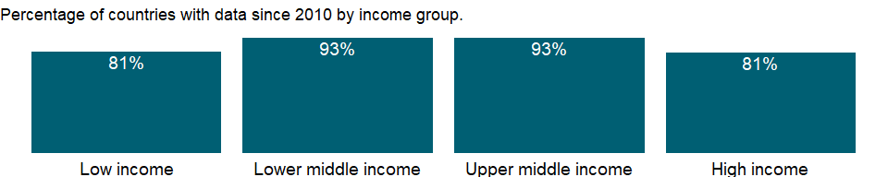

### Why is it relevant?

NA

### What is the data source?

International Monetary Fund, Balance of Payments Statistics Yearbook and data files.

### What is the methodology?

NA

### How is it aggregated?

Weighted average

### What are the limitations?

NA

### What else should I know?

Note: Data are based on the sixth edition of the IMF’s Balance of Payments Manual (BPM6) and are only available from 2005 onwards.

### 1.3.17 Goods exports (BoP, current US$)

### What is the indicator?

Goods exports refer to all movable goods (including nonmonetary gold and net exports of goods under merchanting) involved in a change of ownership from residents to nonresidents. Data are in current U.S. dollars.

Topic: Economic Policy & Debt: Balance of payments: Current account: Goods, services & income

Series ID: BX.GSR.MRCH.CD

Copyright: CC BY-4.0 , <https://datacatalog.worldbank.org/public-licenses#cc-by>

First year with any data: 1960

Last year with any data: 2020

### What years are data available?

The figure below shows years in which data is available for at least one country. Dates shaded in black have no data, while dates shaded in green have data for at least one country



### Which countries have data?

The figure below shows the percentage of countries in each income group with a value since 2010 for that indicator.



### Why is it relevant?

NA

### What is the data source?

International Monetary Fund, Balance of Payments Statistics Yearbook and data files.

### What is the methodology?

NA

### How is it aggregated?

Gap-filled total

### What are the limitations?

NA

### What else should I know?

Note: Data are based on the sixth edition of the IMF’s Balance of Payments Manual (BPM6) and are only available from 2005 onwards. Merchanting is reclassified from services to goods.

### 1.3.18 Service exports (BoP, current US$)

### What is the indicator?

Services refer to economic output of intangible commodities that may be produced, transferred, and consumed at the same time. Data are in current U.S. dollars.

Topic: Economic Policy & Debt: Balance of payments: Current account: Goods, services & income

Series ID: BX.GSR.NFSV.CD

Copyright: CC BY-4.0 , <https://datacatalog.worldbank.org/public-licenses#cc-by>

First year with any data: 1960

Last year with any data: 2020

### What years are data available?

The figure below shows years in which data is available for at least one country. Dates shaded in black have no data, while dates shaded in green have data for at least one country



### Which countries have data?

The figure below shows the percentage of countries in each income group with a value since 2010 for that indicator.



### Why is it relevant?

NA

### What is the data source?

International Monetary Fund, Balance of Payments Statistics Yearbook and data files.

### What is the methodology?

NA

### How is it aggregated?

Gap-filled total

### What are the limitations?

NA

### What else should I know?

Note: Data are based on the sixth edition of the IMF’s Balance of Payments Manual (BPM6) and are only available from 2005 onwards. Manufacturing services on physical inputs owned by others (goods for processing in BPM5) and maintenance and repair services n.i.e. are reclassified from goods to services.

### 1.3.19 Charges for the use of intellectual property, receipts (BoP, current US$)

### What is the indicator?

Charges for the use of intellectual property are payments and receipts between residents and nonresidents for the authorized use of proprietary rights (such as patents, trademarks, copyrights, industrial processes and designs including trade secrets, and franchises) and for the use, through licensing agreements, of produced originals or prototypes (such as copyrights on books and manuscripts, computer software, cinematographic works, and sound recordings) and related rights (such as for live performances and television, cable, or satellite broadcast). Data are in current U.S. dollars.

Topic: Economic Policy & Debt: Balance of payments: Current account: Goods, services & income

Series ID: BX.GSR.ROYL.CD

Copyright: CC BY-4.0 , <https://datacatalog.worldbank.org/public-licenses#cc-by>

First year with any data: 1960

Last year with any data: 2020

### What years are data available?

The figure below shows years in which data is available for at least one country. Dates shaded in black have no data, while dates shaded in green have data for at least one country



### Which countries have data?

The figure below shows the percentage of countries in each income group with a value since 2010 for that indicator.

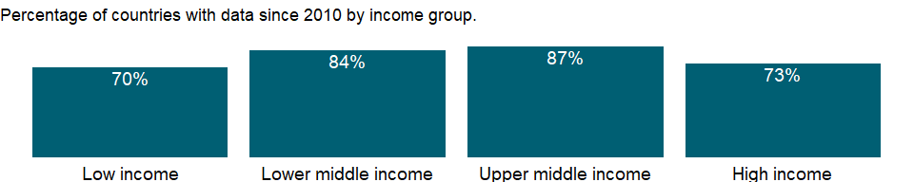

### Why is it relevant?

NA

### What is the data source?

International Monetary Fund, Balance of Payments Statistics Yearbook and data files.

### What is the methodology?

NA

### How is it aggregated?

Sum

### What are the limitations?

NA

### What else should I know?

Note: Data are based on the sixth edition of the IMF’s Balance of Payments Manual (BPM6) and are only available from 2005 onwards.

### 1.3.20 Exports of goods, services and primary income (BoP, current US$)

### What is the indicator?

Exports of goods, services and primary income is the sum of goods exports, service exports and primary income receipts. Data are in current U.S. dollars.

Topic: Economic Policy & Debt: Balance of payments: Current account: Goods, services & income

Series ID: BX.GSR.TOTL.CD

Copyright: CC BY-4.0 , <https://datacatalog.worldbank.org/public-licenses#cc-by>

First year with any data: 1960

Last year with any data: 2020

### What years are data available?

The figure below shows years in which data is available for at least one country. Dates shaded in black have no data, while dates shaded in green have data for at least one country



### Which countries have data?

The figure below shows the percentage of countries in each income group with a value since 2010 for that indicator.



### Why is it relevant?

NA

### What is the data source?

International Monetary Fund, Balance of Payments Statistics Yearbook and data files.

### What is the methodology?

NA

### How is it aggregated?

Gap-filled total

### What are the limitations?

NA

### What else should I know?

Note: Data are based on the sixth edition of the IMF’s Balance of Payments Manual (BPM6) and are only available from 2005 onwards.

### 1.3.21 Transport services (% of service exports, BoP)

### What is the indicator?

Transport covers all transport services (sea, air, land, internal waterway, pipeline, space and electricity transmission) performed by residents of one economy for those of another and involving the carriage of passengers, the movement of goods (freight), rental of carriers with crew, and related support and auxiliary services. Also included are postal and courier services. Excluded are freight insurance (included in insurance services); goods procured in ports by nonresident carriers (included in goods); maintenance and repairs on transport equipment (included in maintenance and repair services n.i.e.); and repairs of railway facilities, harbors, and airfield facilities (included in construction).

Topic: Economic Policy & Debt: Balance of payments: Current account: Goods, services & income

Series ID: BX.GSR.TRAN.ZS

Copyright: CC BY-4.0 , <https://datacatalog.worldbank.org/public-licenses#cc-by>

First year with any data: 1960

Last year with any data: 2020

### What years are data available?

The figure below shows years in which data is available for at least one country. Dates shaded in black have no data, while dates shaded in green have data for at least one country



### Which countries have data?

The figure below shows the percentage of countries in each income group with a value since 2010 for that indicator.

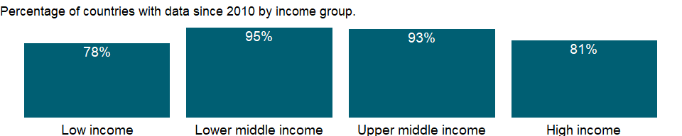

### Why is it relevant?

NA

### What is the data source?

International Monetary Fund, Balance of Payments Statistics Yearbook and data files.

### What is the methodology?

NA

### How is it aggregated?

Weighted average

### What are the limitations?

NA

### What else should I know?

Note: Data are based on the sixth edition of the IMF’s Balance of Payments Manual (BPM6) and are only available from 2005 onwards.

### 1.3.22 Travel services (% of service exports, BoP)

### What is the indicator?

Travel covers goods and services acquired from an economy by travelers for their own use during visits of less than one year in that economy for either business or personal purposes. Travel includes local transport (i.e., transport within the economy being visited and provided by a resident of that economy), but excludes international transport (which is included in passenger transport. Travel also excludes goods for resale, which are included in general merchandise.

Topic: Economic Policy & Debt: Balance of payments: Current account: Goods, services & income

Series ID: BX.GSR.TRVL.ZS

Copyright: CC BY-4.0 , <https://datacatalog.worldbank.org/public-licenses#cc-by>

First year with any data: 1960

Last year with any data: 2020

### What years are data available?

The figure below shows years in which data is available for at least one country. Dates shaded in black have no data, while dates shaded in green have data for at least one country



### Which countries have data?

The figure below shows the percentage of countries in each income group with a value since 2010 for that indicator.



### Why is it relevant?

NA

### What is the data source?

International Monetary Fund, Balance of Payments Statistics Yearbook and data files.

### What is the methodology?

NA

### How is it aggregated?

Weighted average

### What are the limitations?

NA

### What else should I know?

Note: Data are based on the sixth edition of the IMF’s Balance of Payments Manual (BPM6) and are only available from 2005 onwards.

## 1.4 Economic Policy & Debt: Balance of payments: Capital & financial account

### 1.4.1 Foreign direct investment, net outflows (BoP, current US$)

### What is the indicator?

Foreign direct investment refers to direct investment equity flows in an economy. It is the sum of equity capital, reinvestment of earnings, and other capital. Direct investment is a category of cross-border investment associated with a resident in one economy having control or a significant degree of influence on the management of an enterprise that is resident in another economy. Ownership of 10 percent or more of the ordinary shares of voting stock is the criterion for determining the existence of a direct investment relationship. This series shows net outflows of investment from the reporting economy to the rest of the world. Data are in current U.S. dollars.

Topic: Economic Policy & Debt: Balance of payments: Capital & financial account

Series ID: BM.KLT.DINV.CD.WD

Copyright: CC BY-4.0 , <https://datacatalog.worldbank.org/public-licenses#cc-by>

First year with any data: 1970

Last year with any data: 2020

### What years are data available?

The figure below shows years in which data is available for at least one country. Dates shaded in black have no data, while dates shaded in green have data for at least one country

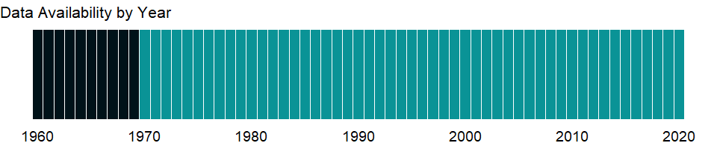

### Which countries have data?

The figure below shows the percentage of countries in each income group with a value since 2010 for that indicator.

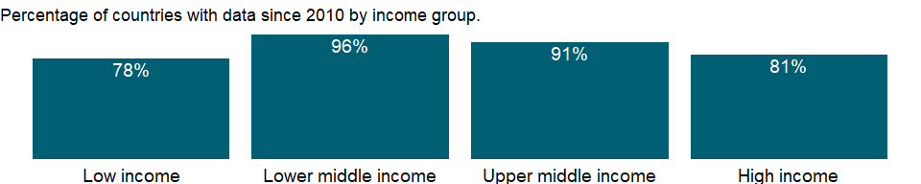

### Why is it relevant?

Private financial flows - equity and debt - account for the bulk of development finance. Equity flows comprise foreign direct investment (FDI) and portfolio equity. Debt flows are financing raised through bond issuance, bank lending, and supplier credits.

### What is the data source?

International Monetary Fund, Balance of Payments database, supplemented by data from the United Nations Conference on Trade and Development and official national sources.

### What is the methodology?

Data on equity flows are based on balance of payments data reported by the International Monetary Fund (IMF). Foreign direct investment (FDI) data are supplemented by the World Bank staff estimates using data from the United Nations Conference on Trade and Development (UNCTAD) and official national sources.

The internationally accepted definition of FDI (from the sixth edition of the IMF’s Balance of Payments Manual [2009]), includes the following components: equity investment, including investment associated with equity that gives rise to control or influence; investment in indirectly influenced or controlled enterprises; investment in fellow enterprises; debt (except selected debt); and reverse investment. The Framework for Direct Investment Relationships provides criteria for determining whether cross-border ownership results in a direct investment relationship, based on control and influence. Distinguished from other kinds of international investment, FDI is made to establish a lasting interest in or effective management control over an enterprise in another country. A lasting interest in an investment enterprise typically involves establishing warehouses, manufacturing facilities, and other permanent or long-term organizations abroad. Direct investments may take the form of greenfield investment, where the investor starts a new venture in a foreign country by constructing new operational facilities; joint venture, where the investor enters into a partnership agreement with a company abroad to establish a new enterprise; or merger and acquisition, where the investor acquires an existing enterprise abroad. The IMF suggests that investments should account for at least 10 percent of voting stock to be counted as FDI. In practice many countries set a higher threshold. Many countries fail to report reinvested earnings, and the definition of long-term loans differs among countries. BoP refers to Balance of Payments.

### How is it aggregated?

Sum

### What are the limitations?

FDI data do not give a complete picture of international investment in an economy. Balance of payments data on FDI do not include capital raised locally, an important source of investment financing in some developing countries. In addition, FDI data omit nonequity cross-border transactions such as intra-unit flows of goods and services.

The volume of global private financial flows reported by the World Bank generally differs from that reported by other sources because of differences in sources, classification of economies, and method used to adjust and disaggregate reported information. In addition, particularly for debt financing, differences may also reflect how some installments of the transactions and certain offshore issuances are treated.

Data on equity flows are shown for all countries for which data are available.

### What else should I know?

Note: Data starting from 2005 are based on the sixth edition of the IMF’s Balance of Payments Manual (BPM6).

### 1.4.2 Foreign direct investment, net outflows (% of GDP)

### What is the indicator?

Foreign direct investment refers to direct investment equity flows in an economy. It is the sum of equity capital, reinvestment of earnings, and other capital. Direct investment is a category of cross-border investment associated with a resident in one economy having control or a significant degree of influence on the management of an enterprise that is resident in another economy. Ownership of 10 percent or more of the ordinary shares of voting stock is the criterion for determining the existence of a direct investment relationship. This series shows net outflows of investment from the reporting economy to the rest of the world, and is divided by GDP.

Topic: Economic Policy & Debt: Balance of payments: Capital & financial account

Series ID: BM.KLT.DINV.WD.GD.ZS

Copyright: CC BY-4.0 , <https://datacatalog.worldbank.org/public-licenses#cc-by>

First year with any data: 1970

Last year with any data: 2020

### What years are data available?

The figure below shows years in which data is available for at least one country. Dates shaded in black have no data, while dates shaded in green have data for at least one country



### Which countries have data?

The figure below shows the percentage of countries in each income group with a value since 2010 for that indicator.

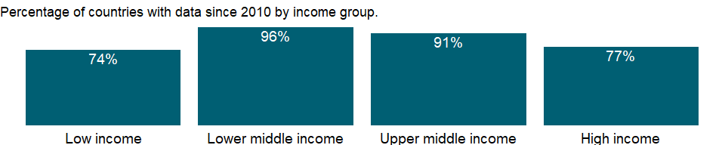

### Why is it relevant?

Private financial flows - equity and debt - account for the bulk of development finance. Equity flows comprise foreign direct investment (FDI) and portfolio equity. Debt flows are financing raised through bond issuance, bank lending, and supplier credits.

### What is the data source?

International Monetary Fund, Balance of Payments database, supplemented by data from the United Nations Conference on Trade and Development and official national sources.

### What is the methodology?

Data on equity flows are based on balance of payments data reported by the International Monetary Fund (IMF). Foreign direct investment (FDI) data are supplemented by the World Bank staff estimates using data from the United Nations Conference on Trade and Development (UNCTAD) and official national sources.

The internationally accepted definition of FDI (from the sixth edition of the IMF’s Balance of Payments Manual [2009]), includes the following components: equity investment, including investment associated with equity that gives rise to control or influence; investment in indirectly influenced or controlled enterprises; investment in fellow enterprises; debt (except selected debt); and reverse investment. The Framework for Direct Investment Relationships provides criteria for determining whether cross-border ownership results in a direct investment relationship, based on control and influence. Distinguished from other kinds of international investment, FDI is made to establish a lasting interest in or effective management control over an enterprise in another country. A lasting interest in an investment enterprise typically involves establishing warehouses, manufacturing facilities, and other permanent or long-term organizations abroad. Direct investments may take the form of greenfield investment, where the investor starts a new venture in a foreign country by constructing new operational facilities; joint venture, where the investor enters into a partnership agreement with a company abroad to establish a new enterprise; or merger and acquisition, where the investor acquires an existing enterprise abroad. The IMF suggests that investments should account for at least 10 percent of voting stock to be counted as FDI. In practice many countries set a higher threshold. Many countries fail to report reinvested earnings, and the definition of long-term loans differs among countries. BoP refers to Balance of Payments.

### How is it aggregated?

Weighted Average

### What are the limitations?

FDI data do not give a complete picture of international investment in an economy. Balance of payments data on FDI do not include capital raised locally, an important source of investment financing in some developing countries. In addition, FDI data omit nonequity cross-border transactions such as intra-unit flows of goods and services.

The volume of global private financial flows reported by the World Bank generally differs from that reported by other sources because of differences in sources, classification of economies, and method used to adjust and disaggregate reported information. In addition, particularly for debt financing, differences may also reflect how some installments of the transactions and certain offshore issuances are treated.

Data on equity flows are shown for all countries for which data are available.

### What else should I know?

Note: Data starting from 2005 are based on the sixth edition of the IMF’s Balance of Payments Manual (BPM6).

### 1.4.3 Net financial account (BoP, current US$)

### What is the indicator?

The net financial account shows net acquisition and disposal of financial assets and liabilities. It measures how net lending to or borrowing from nonresidents is financed, and is conceptually equal to the sum of the balances on the current and capital accounts. Data are in current U.S. dollars.

Topic: Economic Policy & Debt: Balance of payments: Capital & financial account

Series ID: BN.FIN.TOTL.CD

Copyright: CC BY-4.0 , <https://datacatalog.worldbank.org/public-licenses#cc-by>

First year with any data: 1960

Last year with any data: 2020

### What years are data available?

The figure below shows years in which data is available for at least one country. Dates shaded in black have no data, while dates shaded in green have data for at least one country



### Which countries have data?

The figure below shows the percentage of countries in each income group with a value since 2010 for that indicator.

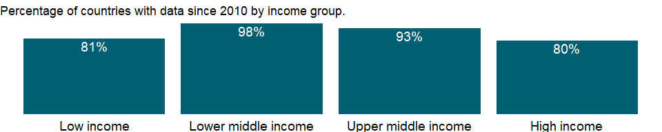

### Why is it relevant?

NA

### What is the data source?

International Monetary Fund, Balance of Payments Statistics Yearbook and data files.

### What is the methodology?

NA

### How is it aggregated?

NA

### What are the limitations?

NA

### What else should I know?

Note: Data are based on the sixth edition of the IMF’s Balance of Payments Manual (BPM6) and are only available from 2005 onwards. In BPM6, the headings of the financial account have been changed from credits and debits to net acquisition of financial assets and net incurrence of liabilities; i.e., all changes due to credit and debit entries are recorded on a net basis separately for financial assets and liabilities. Financial account balances are calculated as the change in assets minus the change in liabilities; signs are reversed from previous editions.

### 1.4.4 Net errors and omissions (BoP, current US$)

### What is the indicator?

Net errors and omissions constitute a residual category needed to ensure that accounts in the balance of payments statement sum to zero. Net errors and omissions are derived as the balance on the financial account minus the balances on the current and capital accounts. Data are in current U.S. dollars.

Topic: Economic Policy & Debt: Balance of payments: Capital & financial account

Series ID: BN.KAC.EOMS.CD

Copyright: CC BY-4.0 , <https://datacatalog.worldbank.org/public-licenses#cc-by>

First year with any data: 1960

Last year with any data: 2020

### What years are data available?

The figure below shows years in which data is available for at least one country. Dates shaded in black have no data, while dates shaded in green have data for at least one country



### Which countries have data?

The figure below shows the percentage of countries in each income group with a value since 2010 for that indicator.



### Why is it relevant?

NA

### What is the data source?

International Monetary Fund, Balance of Payments Statistics Yearbook and data files.

### What is the methodology?

NA

### How is it aggregated?

NA

### What are the limitations?

NA

### What else should I know?

Note: Data are based on the sixth edition of the IMF’s Balance of Payments Manual (BPM6) and are only available from 2005 onwards.

### 1.4.5 Foreign direct investment, net (BoP, current US$)

### What is the indicator?

Foreign direct investment are the net inflows of investment to acquire a lasting management interest (10 percent or more of voting stock) in an enterprise operating in an economy other than that of the investor. It is the sum of equity capital, reinvestment of earnings, other long-term capital, and short-term capital as shown in the balance of payments. This series shows total net FDI. In BPM6, financial account balances are calculated as the change in assets minus the change in liabilities. Net FDI outflows are assets and net FDI inflows are liabilities. Data are in current U.S. dollars.

Topic: Economic Policy & Debt: Balance of payments: Capital & financial account

Series ID: BN.KLT.DINV.CD

Copyright: CC BY-4.0 , <https://datacatalog.worldbank.org/public-licenses#cc-by>

First year with any data: 1960

Last year with any data: 2020

### What years are data available?

The figure below shows years in which data is available for at least one country. Dates shaded in black have no data, while dates shaded in green have data for at least one country



### Which countries have data?

The figure below shows the percentage of countries in each income group with a value since 2010 for that indicator.



### Why is it relevant?

NA

### What is the data source?

International Monetary Fund, Balance of Payments Statistics Yearbook and data files.

### What is the methodology?

NA

### How is it aggregated?

NA

### What are the limitations?

NA

### What else should I know?

Note: Data are based on the sixth edition of the IMF’s Balance of Payments Manual (BPM6) and are only available from 2005 onwards. In BPM6, the headings of the financial account have been changed from credits and debits to net acquisition of financial assets and net incurrence of liabilities; i.e., all changes due to credit and debit entries are recorded on a net basis separately for financial assets and liabilities. Financial account balances are calculated as the change in assets minus the change in liabilities; signs are reversed from previous editions.

### 1.4.6 Portfolio Investment, net (BoP, current US$)

### What is the indicator?

Portfolio investment covers transactions in equity securities and debt securities. Data are in current U.S. dollars.

Topic: Economic Policy & Debt: Balance of payments: Capital & financial account

Series ID: BN.KLT.PTXL.CD

Copyright: CC BY-4.0 , <https://datacatalog.worldbank.org/public-licenses#cc-by>

First year with any data: 1960

Last year with any data: 2020

### What years are data available?

The figure below shows years in which data is available for at least one country. Dates shaded in black have no data, while dates shaded in green have data for at least one country



### Which countries have data?

The figure below shows the percentage of countries in each income group with a value since 2010 for that indicator.

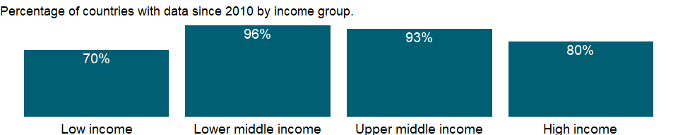

### Why is it relevant?

NA

### What is the data source?

International Monetary Fund, Balance of Payments Statistics Yearbook and data files.

### What is the methodology?

NA

### How is it aggregated?

NA

### What are the limitations?

NA

### What else should I know?

Note: Data are based on the sixth edition of the IMF’s Balance of Payments Manual (BPM6) and are only available from 2005 onwards. In BPM6, the headings of the financial account have been changed from credits and debits to net acquisition of financial assets and net incurrence of liabilities; i.e., all changes due to credit and debit entries are recorded on a net basis separately for financial assets and liabilities. Financial account balances are calculated as the change in assets minus the change in liabilities; signs are reversed from previous editions.

### 1.4.7 Reserves and related items (BoP, current US$)

### What is the indicator?

Reserves and related items is the net change in a country’s holdings of international reserves resulting from transactions on the current, capital, and financial accounts. Reserve assets are those external assets that are readily available to and controlled by monetary authorities for meeting balance of payments financing needs, and include holdings of monetary gold, special drawing rights (SDRs), reserve position in the International Monetary Fund (IMF), and other reserve assets. Also included are net credit and loans from the IMF (excluding reserve position) and total exceptional financing. Data are in current U.S. dollars.

Topic: Economic Policy & Debt: Balance of payments: Capital & financial account

Series ID: BN.RES.INCL.CD

Copyright: CC BY-4.0 , <https://datacatalog.worldbank.org/public-licenses#cc-by>

First year with any data: 1960

Last year with any data: 2020

### What years are data available?

The figure below shows years in which data is available for at least one country. Dates shaded in black have no data, while dates shaded in green have data for at least one country



### Which countries have data?

The figure below shows the percentage of countries in each income group with a value since 2010 for that indicator.



### Why is it relevant?

NA

### What is the data source?

International Monetary Fund, Balance of Payments Statistics Yearbook and data files.

### What is the methodology?

NA

### How is it aggregated?

NA

### What are the limitations?

NA

### What else should I know?

Note: Data are based on the sixth edition of the IMF’s Balance of Payments Manual (BPM6) and are only available from 2005 onwards. In BPM6, the headings of the financial account have been changed from credits and debits to net acquisition of financial assets and net incurrence of liabilities; i.e., all changes due to credit and debit entries are recorded on a net basis separately for financial assets and liabilities. Financial account balances are calculated as the change in assets minus the change in liabilities; signs are reversed from previous editions.

### 1.4.8 Net capital account (BoP, current US$)

### What is the indicator?

Net capital account records acquisitions and disposals of nonproduced nonfinancial assets, such as land sold to embassies and sales of leases and licenses, as well as capital transfers, including government debt forgiveness. The use of the term capital account in this context is designed to be consistent with the System of National Accounts, which distinguishes between capital transactions and financial transactions. Data are in current U.S. dollars.

Topic: Economic Policy & Debt: Balance of payments: Capital & financial account

Series ID: BN.TRF.KOGT.CD

Copyright: CC BY-4.0 , <https://datacatalog.worldbank.org/public-licenses#cc-by>

First year with any data: 1960

Last year with any data: 2020

### What years are data available?

The figure below shows years in which data is available for at least one country. Dates shaded in black have no data, while dates shaded in green have data for at least one country



### Which countries have data?

The figure below shows the percentage of countries in each income group with a value since 2010 for that indicator.

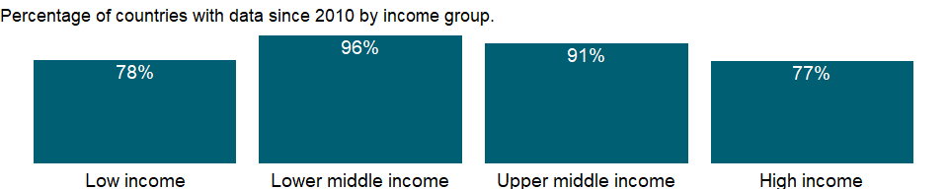

### Why is it relevant?

NA

### What is the data source?

International Monetary Fund, Balance of Payments Statistics Yearbook and data files.

### What is the methodology?

NA

### How is it aggregated?

NA

### What are the limitations?

NA

### What else should I know?

Note: Data are based on the sixth edition of the IMF’s Balance of Payments Manual (BPM6) and are only available from 2005 onwards.

### 1.4.9 Foreign direct investment, net inflows (BoP, current US$)

### What is the indicator?

Foreign direct investment refers to direct investment equity flows in the reporting economy. It is the sum of equity capital, reinvestment of earnings, and other capital. Direct investment is a category of cross-border investment associated with a resident in one economy having control or a significant degree of influence on the management of an enterprise that is resident in another economy. Ownership of 10 percent or more of the ordinary shares of voting stock is the criterion for determining the existence of a direct investment relationship. Data are in current U.S. dollars.

Topic: Economic Policy & Debt: Balance of payments: Capital & financial account

Series ID: BX.KLT.DINV.CD.WD

Copyright: CC BY-4.0 , <https://datacatalog.worldbank.org/public-licenses#cc-by>

First year with any data: 1970

Last year with any data: 2019

### What years are data available?

The figure below shows years in which data is available for at least one country. Dates shaded in black have no data, while dates shaded in green have data for at least one country

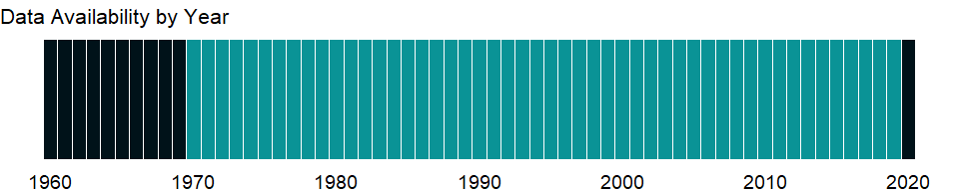

### Which countries have data?

The figure below shows the percentage of countries in each income group with a value since 2010 for that indicator.



### Why is it relevant?

Private financial flows - equity and debt - account for the bulk of development finance. Equity flows comprise foreign direct investment (FDI) and portfolio equity. Debt flows are financing raised through bond issuance, bank lending, and supplier credits.

### What is the data source?

International Monetary Fund, Balance of Payments database, supplemented by data from the United Nations Conference on Trade and Development and official national sources.

### What is the methodology?

Data on equity flows are based on balance of payments data reported by the International Monetary Fund (IMF). Foreign direct investment (FDI) data are supplemented by the World Bank staff estimates using data from the United Nations Conference on Trade and Development (UNCTAD) and official national sources.

The internationally accepted definition of FDI (from the sixth edition of the IMF’s Balance of Payments Manual [2009]), includes the following components: equity investment, including investment associated with equity that gives rise to control or influence; investment in indirectly influenced or controlled enterprises; investment in fellow enterprises; debt (except selected debt); and reverse investment. The Framework for Direct Investment Relationships provides criteria for determining whether cross-border ownership results in a direct investment relationship, based on control and influence. Distinguished from other kinds of international investment, FDI is made to establish a lasting interest in or effective management control over an enterprise in another country. A lasting interest in an investment enterprise typically involves establishing warehouses, manufacturing facilities, and other permanent or long-term organizations abroad. Direct investments may take the form of greenfield investment, where the investor starts a new venture in a foreign country by constructing new operational facilities; joint venture, where the investor enters into a partnership agreement with a company abroad to establish a new enterprise; or merger and acquisition, where the investor acquires an existing enterprise abroad. The IMF suggests that investments should account for at least 10 percent of voting stock to be counted as FDI. In practice many countries set a higher threshold. Many countries fail to report reinvested earnings, and the definition of long-term loans differs among countries. BoP refers to Balance of Payments.

### How is it aggregated?

Sum

### What are the limitations?

FDI data do not give a complete picture of international investment in an economy. Balance of payments data on FDI do not include capital raised locally, an important source of investment financing in some developing countries. In addition, FDI data omit nonequity cross-border transactions such as intra-unit flows of goods and services.

The volume of global private financial flows reported by the World Bank generally differs from that reported by other sources because of differences in sources, classification of economies, and method used to adjust and disaggregate reported information. In addition, particularly for debt financing, differences may also reflect how some installments of the transactions and certain offshore issuances are treated.

Data on equity flows are shown for all countries for which data are available.

### What else should I know?

Note: Data starting from 2005 are based on the sixth edition of the IMF’s Balance of Payments Manual (BPM6).

### 1.4.10 Foreign direct investment, net inflows (% of GDP)

### What is the indicator?

Foreign direct investment are the net inflows of investment to acquire a lasting management interest (10 percent or more of voting stock) in an enterprise operating in an economy other than that of the investor. It is the sum of equity capital, reinvestment of earnings, other long-term capital, and short-term capital as shown in the balance of payments. This series shows net inflows (new investment inflows less disinvestment) in the reporting economy from foreign investors, and is divided by GDP.

Topic: Economic Policy & Debt: Balance of payments: Capital & financial account

Series ID: BX.KLT.DINV.WD.GD.ZS

Copyright: CC BY-4.0 , <https://datacatalog.worldbank.org/public-licenses#cc-by>

First year with any data: 1970

Last year with any data: 2019

### What years are data available?

The figure below shows years in which data is available for at least one country. Dates shaded in black have no data, while dates shaded in green have data for at least one country



### Which countries have data?

The figure below shows the percentage of countries in each income group with a value since 2010 for that indicator.

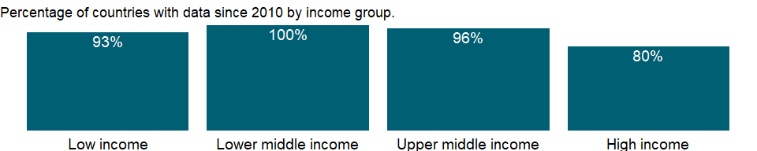

### Why is it relevant?

Private financial flows - equity and debt - account for the bulk of development finance. Equity flows comprise foreign direct investment (FDI) and portfolio equity. Debt flows are financing raised through bond issuance, bank lending, and supplier credits.

### What is the data source?

International Monetary Fund, International Financial Statistics and Balance of Payments databases, World Bank, International Debt Statistics, and World Bank and OECD GDP estimates.

### What is the methodology?

Data on equity flows are based on balance of payments data reported by the International Monetary Fund (IMF). Foreign direct investment (FDI) data are supplemented by the World Bank staff estimates using data from the United Nations Conference on Trade and Development (UNCTAD) and official national sources.

The internationally accepted definition of FDI (from the sixth edition of the IMF’s Balance of Payments Manual [2009]), includes the following components: equity investment, including investment associated with equity that gives rise to control or influence; investment in indirectly influenced or controlled enterprises; investment in fellow enterprises; debt (except selected debt); and reverse investment. The Framework for Direct Investment Relationships provides criteria for determining whether cross-border ownership results in a direct investment relationship, based on control and influence. Distinguished from other kinds of international investment, FDI is made to establish a lasting interest in or effective management control over an enterprise in another country. A lasting interest in an investment enterprise typically involves establishing warehouses, manufacturing facilities, and other permanent or long-term organizations abroad. Direct investments may take the form of greenfield investment, where the investor starts a new venture in a foreign country by constructing new operational facilities; joint venture, where the investor enters into a partnership agreement with a company abroad to establish a new enterprise; or merger and acquisition, where the investor acquires an existing enterprise abroad. The IMF suggests that investments should account for at least 10 percent of voting stock to be counted as FDI. In practice many countries set a higher threshold. Many countries fail to report reinvested earnings, and the definition of long-term loans differs among countries. BoP refers to Balance of Payments.

### How is it aggregated?

Weighted Average

### What are the limitations?

FDI data do not give a complete picture of international investment in an economy. Balance of payments data on FDI do not include capital raised locally, an important source of investment financing in some developing countries. In addition, FDI data omit nonequity cross-border transactions such as intra-unit flows of goods and services.

The volume of global private financial flows reported by the World Bank generally differs from that reported by other sources because of differences in sources, classification of economies, and method used to adjust and disaggregate reported information. In addition, particularly for debt financing, differences may also reflect how some installments of the transactions and certain offshore issuances are treated.

Data on equity flows are shown for all countries for which data are available.

### What else should I know?

Note: Data starting from 2005 are based on the sixth edition of the IMF’s Balance of Payments Manual (BPM6).

### 1.4.11 Portfolio equity, net inflows (BoP, current US$)

### What is the indicator?

Portfolio equity includes net inflows from equity securities other than those recorded as direct investment and including shares, stocks, depository receipts (American or global), and direct purchases of shares in local stock markets by foreign investors. Data are in current U.S. dollars.

Topic: Economic Policy & Debt: Balance of payments: Capital & financial account

Series ID: BX.PEF.TOTL.CD.WD

Copyright: CC BY-4.0 , <https://datacatalog.worldbank.org/public-licenses#cc-by>

First year with any data: 1960

Last year with any data: 2020

### What years are data available?

The figure below shows years in which data is available for at least one country. Dates shaded in black have no data, while dates shaded in green have data for at least one country



### Which countries have data?

The figure below shows the percentage of countries in each income group with a value since 2010 for that indicator.

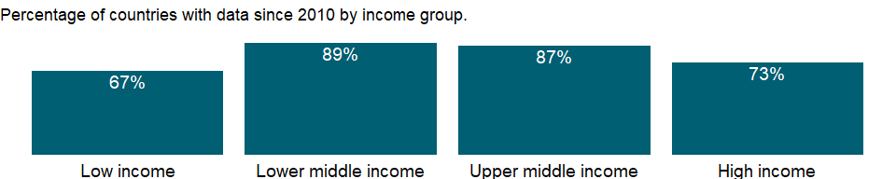

### Why is it relevant?

Private financial flows - equity and debt - account for the bulk of development finance. Equity flows comprise foreign direct investment (FDI) and portfolio equity. Debt flows are financing raised through bond issuance, bank lending, and supplier credits.

### What is the data source?

International Monetary Fund, Balance of Payments database, and World Bank, International Debt Statistics.

### What is the methodology?

Data on equity flows are based on balance of payments data reported by the International Monetary Fund (IMF).

Portfolio equity investment is defined as cross-border transactions and positions involving equity securities, other than those included in direct investment or reserve assets. Equity securities are equity instruments that are negotiable and designed to be traded, usually on organized exchanges or “over the counter.” The negotiability of securities facilitates trading, allowing securities to be held by different parties during their lives. Negotiability allows investors to diversify their portfolios and to withdraw their investment readily. Included in portfolio investment are investment fund shares or units (that is, those issued by investment funds) that are evidenced by securities and that are not reserve assets or direct investment. Although they are negotiable instruments, exchange-traded financial derivatives are not included in portfolio investment because they are in their own category.

### How is it aggregated?

Sum

### What are the limitations?

Portfolio investors typically have less of a role in the decision making of the enterprise with potentially important implications for future flows and for the volatility of the price and volume of positions. Portfolio investment differs from other investment in that it provides a direct way to access financial markets, and thus it can provide liquidity and flexibility. It is associated with financial markets and with their specialized service providers, such as exchanges, dealers, and regulators. The nature of financial derivatives as instruments through which risk is traded in its own right in financial markets sets them apart from other types of investment. Whereas other instruments may also have risk transfer elements, these other instruments also provide financial or other resources.

The volume of global private financial flows reported by the World Bank generally differs from that reported by other sources because of differences in sources, classification of economies, and method used to adjust and disaggregate reported information. In addition, particularly for debt financing, differences may also reflect how some installments of the transactions and certain offshore issuances are treated.

Data on equity flows are shown for all countries for which data are available.

### What else should I know?

Note: Data starting from 2005 are based on the sixth edition of the IMF’s Balance of Payments Manual (BPM6).

## 1.5 Economic Policy & Debt: Balance of payments: Current account: Transfers

### 1.5.1 Secondary income, other sectors, payments (BoP, current US$)

### What is the indicator?

Secondary income refers to transfers recorded in the balance of payments whenever an economy provides or receives goods, services, income, or financial items without a quid pro quo. All transfers not considered to be capital are current. Data are in current U.S. dollars.

Topic: Economic Policy & Debt: Balance of payments: Current account: Transfers

Series ID: BM.TRF.PRVT.CD

Copyright: CC BY-4.0 , <https://datacatalog.worldbank.org/public-licenses#cc-by>

First year with any data: 1960

Last year with any data: 2020

### What years are data available?

The figure below shows years in which data is available for at least one country. Dates shaded in black have no data, while dates shaded in green have data for at least one country



### Which countries have data?

The figure below shows the percentage of countries in each income group with a value since 2010 for that indicator.

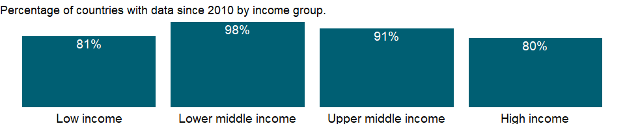

### Why is it relevant?

NA

### What is the data source?

International Monetary Fund, Balance of Payments Statistics Yearbook and data files.

### What is the methodology?

NA

### How is it aggregated?

Sum

### What are the limitations?

NA

### What else should I know?

Note: Data are based on the sixth edition of the IMF’s Balance of Payments Manual (BPM6) and are only available from 2005 onwards.

### 1.5.2 Personal remittances, paid (current US$)

### What is the indicator?

Personal remittances comprise personal transfers and compensation of employees. Personal transfers consist of all current transfers in cash or in kind made or received by resident households to or from nonresident households. Personal transfers thus include all current transfers between resident and nonresident individuals. Compensation of employees refers to the income of border, seasonal, and other short-term workers who are employed in an economy where they are not resident and of residents employed by nonresident entities. Data are the sum of two items defined in the sixth edition of the IMF’s Balance of Payments Manual: personal transfers and compensation of employees. Data are in current U.S. dollars.

Topic: Economic Policy & Debt: Balance of payments: Current account: Transfers

Series ID: BM.TRF.PWKR.CD.DT

Copyright: CC BY-4.0 , <https://datacatalog.worldbank.org/public-licenses#cc-by>

First year with any data: 1970

Last year with any data: 2020

### What years are data available?

The figure below shows years in which data is available for at least one country. Dates shaded in black have no data, while dates shaded in green have data for at least one country



### Which countries have data?

The figure below shows the percentage of countries in each income group with a value since 2010 for that indicator.

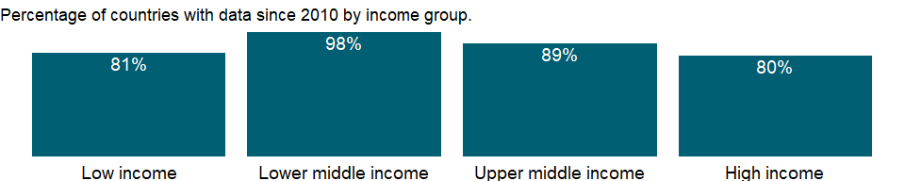

### Why is it relevant?

Movement of people, most often through migration, is a significant part of global integration. Migrants contribute to the economies of both their host country and their country of origin. Yet reliable statistics on migration are difficult to collect and are often incomplete, making international comparisons a challenge.

In most developed countries, refugees are admitted for resettlement and are routinely included in population counts by censuses or population registers. Globally, the number of refugees at end 2010 was 10.55 million, including 597,300 people considered by the United Nations High Commissioner for Refugees (UNHCR) to be in a refugee-like situation; developing countries hosted 8.5 million refugees, or 80 percent of the global refugee population.

Global migration patterns have become increasingly complex in modern times, involving not just refugees, but also millions of economic migrants. But refugees and migrants, even if they often travel in the same way, are fundamentally different, and for that reason are treated very differently under modern international law. Migrants, especially economic migrants, choose to move in order to improve the future prospects of themselves and their families. Refugees have to move if they are to save their lives or preserve their freedom. They have no protection from their own state - indeed it is often their own government that is threatening to persecute them. If other countries do not let them in, and do not help them once they are in, then they may be condemning them to death - or to an intolerable life in the shadows, without sustenance and without rights.

### What is the data source?

World Bank staff estimates based on IMF balance of payments data.

### What is the methodology?

The two main components of personal remittances, “personal transfers” and “compensation of employees”, are items in the balance of payments (BPM6) framework. Both of these standard components are recorded in the current account. “Personal transfers,” a new item in the Balance of Payments (BPM6) represents a broader definition of worker remittances. Personal transfers include all current transfers in cash or in kind between resident and nonresident individuals, independent of the source of income of the sender (irrespective of whether the sender receives income from labor, entrepreneurial or property income, social benefits, and any other types of transfers; or disposes assets) and the relationship between the households (irrespective of whether they are related or unrelated individuals).

Compensation of employees refers to the income of border, seasonal, and other short-term workers who are employed in an economy where they are not resident and of residents employed by nonresident entities. Compensation of employees represents remuneration in return for the labor input to the production process contributed by an individual in an employer-employee relationship with the enterprise. Compensation of employees is recorded gross and includes amounts paid by the employee as taxes or for other purposes in the economy where the work is performed. Compensation of employees has three main components: wages and salaries in cash, wages and salaries in kind, and employers’ social contributions.

### How is it aggregated?

Sum

### What are the limitations?

Remittance transactions have grown in importance over the past decade. In a number of developing economies, receipts of remittances have become an important and stable source of funds that exceeds receipts from exports of goods and services or from financial inflows on foreign direct investment. But the quality of statistical remittance data is not high. Remittances are a challenge to measure because of their nature. They are heterogeneous with numerous small transactions conducted by individuals through a wide variety of channels: formal channels, such as electronic wire, or through informal channels, such as cash or goods carried across borders. The large number of remittance transactions and the multitude of channels pose challenges to the compilation of comprehensive statistics. The small size of individual transactions means that they often go undetected by typical data source systems, although the aggregate level of transactions may be substantial.

Because of difficulties in obtaining data on informal remittance transactions, the remittance transactions undertaken through informal channels are sometimes not well covered in current balance of payments data. As a result, even though direct measurement of remittances - through transactions reporting or surveys - may be considered preferable if feasible, some countries instead combine different sources and estimation methods to achieve better coverage, by using direct measurements where practical and supplemented estimates where they are not. Model-based approaches are used in some countries as they are flexible. Compilers can design models to fill gaps in data sources or to provide global totals.

However, only reliable input data can lead to sound estimates, regardless of the sophistication of an estimation method or econometric model. Indirect data are converted to remittance estimates using a set of assumptions. These assumptions should be plausible, but it is often not possible to test or verify these assumptions and also the results in practice.

### What else should I know?

Note: Data starting from 2005 are based on the sixth edition of the IMF’s Balance of Payments Manual (BPM6).

### 1.5.3 Net secondary income (BoP, current US$)

### What is the indicator?

Secondary income refers to transfers recorded in the balance of payments whenever an economy provides or receives goods, services, income, or financial items without a quid pro quo. All transfers not considered to be capital are current. Data are in current U.S. dollars.

Topic: Economic Policy & Debt: Balance of payments: Current account: Transfers

Series ID: BN.TRF.CURR.CD

Copyright: CC BY-4.0 , <https://datacatalog.worldbank.org/public-licenses#cc-by>

First year with any data: 1960

Last year with any data: 2020

### What years are data available?

The figure below shows years in which data is available for at least one country. Dates shaded in black have no data, while dates shaded in green have data for at least one country



### Which countries have data?

The figure below shows the percentage of countries in each income group with a value since 2010 for that indicator.



### Why is it relevant?

The balance of payments records an economy’s transactions with the rest of the world. Balance of payments accounts are divided into two groups: the current account, which records transactions in goods, services, primary income, and secondary income, and the capital and financial account, which records capital transfers, acquisition or disposal of nonproduced, nonfinancial assets, and transactions in financial assets and liabilities. The current account balance is one of the most analytically useful indicators of an external imbalance.

A primary purpose of the balance of payments accounts is to indicate the need to adjust an external imbalance. Where to draw the line for analytical purposes requires a judgment concerning the imbalance that best indicates the need for adjustment. There are a number of definitions in common use for this and related analytical purposes. The trade balance is the difference between exports and imports of goods. From an analytical view it is arbitrary to distinguish goods from services. For example, a unit of foreign exchange earned by a freight company strengthens the balance of payments to the same extent as the foreign exchange earned by a goods exporter. Even so, the trade balance is useful because it is often the most timely indicator of trends in the current account balance. Customs authorities are typically able to provide data on trade in goods long before data on trade in services are available.

### What is the data source?

International Monetary Fund, Balance of Payments Statistics Yearbook and data files.

### What is the methodology?

The balance of payments (BoP) is a double-entry accounting system that shows all flows of goods and services into and out of an economy; all transfers that are the counterpart of real resources or financial claims provided to or by the rest of the world without a quid pro quo, such as donations and grants; and all changes in residents’ claims on and liabilities to nonresidents that arise from economic transactions. All transactions are recorded twice - once as a credit and once as a debit. In principle the net balance should be zero, but in practice the accounts often do not balance, requiring inclusion of a balancing item, net errors and omissions.

The concepts and definitions underlying the data are based on the sixth edition of the International Monetary Fund’s (IMF) Balance of Payments Manual (BPM6). Balance of payments data for 2005 onward will be presented in accord with the BPM6. The historical BPM5 data series will end with data for 2008, which can be accessed through the World Development Indicators archives.

The complete balance of payments methodology can be accessed through the International Monetary Fund website (www.imf.org/external/np/sta/bop/bop.htm).

### How is it aggregated?

NA

### What are the limitations?

Discrepancies may arise in the balance of payments because there is no single source for balance of payments data and therefore no way to ensure that the data are fully consistent. Sources include customs data, monetary accounts of the banking system, external debt records, information provided by enterprises, surveys to estimate service transactions, and foreign exchange records. Differences in collection methods - such as in timing, definitions of residence and ownership, and the exchange rate used to value transactions - contribute to net errors and omissions. In addition, smuggling and other illegal or quasi-legal transactions may be unrecorded or misrecorded.

### What else should I know?

Note: Data are based on the sixth edition of the IMF’s Balance of Payments Manual (BPM6) and are only available from 2005 onwards.

### 1.5.4 Secondary income receipts (BoP, current US$)

### What is the indicator?

Secondary income refers to transfers recorded in the balance of payments whenever an economy provides or receives goods, services, income, or financial items without a quid pro quo. All transfers not considered to be capital are current. Data are in current U.S. dollars.

Topic: Economic Policy & Debt: Balance of payments: Current account: Transfers

Series ID: BX.TRF.CURR.CD

Copyright: CC BY-4.0 , <https://datacatalog.worldbank.org/public-licenses#cc-by>

First year with any data: 1960

Last year with any data: 2020

### What years are data available?

The figure below shows years in which data is available for at least one country. Dates shaded in black have no data, while dates shaded in green have data for at least one country



### Which countries have data?

The figure below shows the percentage of countries in each income group with a value since 2010 for that indicator.



### Why is it relevant?

NA

### What is the data source?

International Monetary Fund, Balance of Payments Statistics Yearbook and data files.

### What is the methodology?

NA

### How is it aggregated?

Sum

### What are the limitations?

NA

### What else should I know?

Note: Data are based on the sixth edition of the IMF’s Balance of Payments Manual (BPM6) and are only available from 2005 onwards.

### 1.5.5 Personal transfers, receipts (BoP, current US$)

### What is the indicator?

Personal transfers consist of all current transfers in cash or in kind made or received by resident households to or from nonresident households. Personal transfers thus include all current transfers between resident and nonresident individuals. Data are in current U.S. dollars.

Topic: Economic Policy & Debt: Balance of payments: Current account: Transfers

Series ID: BX.TRF.PWKR.CD

Copyright: CC BY-4.0 , <https://datacatalog.worldbank.org/public-licenses#cc-by>

First year with any data: 1960

Last year with any data: 2020

### What years are data available?

The figure below shows years in which data is available for at least one country. Dates shaded in black have no data, while dates shaded in green have data for at least one country



### Which countries have data?

The figure below shows the percentage of countries in each income group with a value since 2010 for that indicator.

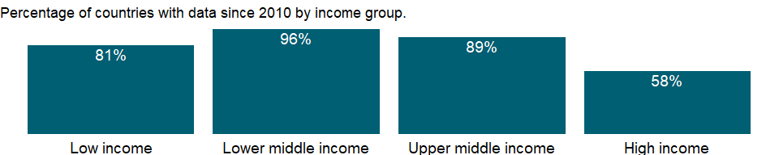

### Why is it relevant?

NA

### What is the data source?

International Monetary Fund, Balance of Payments Statistics Yearbook and data files.

### What is the methodology?

NA

### How is it aggregated?

Sum

### What are the limitations?

NA

### What else should I know?

Note: Data are based on the sixth edition of the IMF’s Balance of Payments Manual (BPM6) and are only available from 2005 onwards.

### 1.5.6 Personal remittances, received (current US$)

### What is the indicator?

Personal remittances comprise personal transfers and compensation of employees. Personal transfers consist of all current transfers in cash or in kind made or received by resident households to or from nonresident households. Personal transfers thus include all current transfers between resident and nonresident individuals. Compensation of employees refers to the income of border, seasonal, and other short-term workers who are employed in an economy where they are not resident and of residents employed by nonresident entities. Data are the sum of two items defined in the sixth edition of the IMF’s Balance of Payments Manual: personal transfers and compensation of employees. Data are in current U.S. dollars.

Topic: Economic Policy & Debt: Balance of payments: Current account: Transfers

Series ID: BX.TRF.PWKR.CD.DT

Copyright: CC BY-4.0 , <https://datacatalog.worldbank.org/public-licenses#cc-by>

First year with any data: 1970

Last year with any data: 2020

### What years are data available?

The figure below shows years in which data is available for at least one country. Dates shaded in black have no data, while dates shaded in green have data for at least one country



### Which countries have data?

The figure below shows the percentage of countries in each income group with a value since 2010 for that indicator.

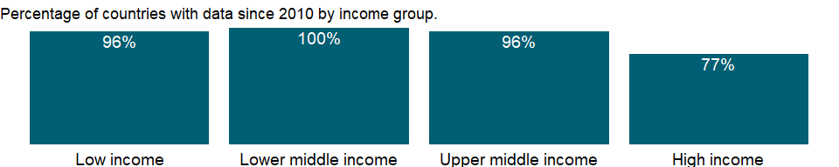

### Why is it relevant?

Movement of people, most often through migration, is a significant part of global integration. Migrants contribute to the economies of both their host country and their country of origin. Yet reliable statistics on migration are difficult to collect and are often incomplete, making international comparisons a challenge.

In most developed countries, refugees are admitted for resettlement and are routinely included in population counts by censuses or population registers. Globally, the number of refugees at end 2010 was 10.55 million, including 597,300 people considered by the United Nations High Commissioner for Refugees (UNHCR) to be in a refugee-like situation; developing countries hosted 8.5 million refugees, or 80 percent of the global refugee population.

Global migration patterns have become increasingly complex in modern times, involving not just refugees, but also millions of economic migrants. But refugees and migrants, even if they often travel in the same way, are fundamentally different, and for that reason are treated very differently under modern international law. Migrants, especially economic migrants, choose to move in order to improve the future prospects of themselves and their families. Refugees have to move if they are to save their lives or preserve their freedom. They have no protection from their own state - indeed it is often their own government that is threatening to persecute them. If other countries do not let them in, and do not help them once they are in, then they may be condemning them to death - or to an intolerable life in the shadows, without sustenance and without rights.

### What is the data source?

World Bank staff estimates based on IMF balance of payments data.

### What is the methodology?

The two main components of personal remittances, “personal transfers” and “compensation of employees”, are items in the balance of payments (BPM6) framework. Both of these standard components are recorded in the current account. “Personal transfers”, a new item in the Balance of Payments (BPM6) represents a broader definition of worker remittances. Personal transfers include all current transfers in cash or in kind between resident and nonresident individuals, independent of the source of income of the sender (irrespective of whether the sender receives income from labor, entrepreneurial or property income, social benefits, and any other types of transfers; or disposes assets) and the relationship between the households (irrespective of whether they are related or unrelated individuals).

Compensation of employees refers to the income of border, seasonal, and other short-term workers who are employed in an economy where they are not resident and of residents employed by nonresident entities. Compensation of employees represents remuneration in return for the labor input to the production process contributed by an individual in an employer-employee relationship with the enterprise. Compensation of employees is recorded gross and includes amounts paid by the employee as taxes or for other purposes in the economy where the work is performed. Compensation of employees has three main components: wages and salaries in cash, wages and salaries in kind, and employers’ social contributions.

### How is it aggregated?

Sum

### What are the limitations?

Remittance transactions have grown in importance over the past decade. In a number of developing economies, receipts of remittances have become an important and stable source of funds that exceeds receipts from exports of goods and services or from financial inflows on foreign direct investment. But the quality of statistical remittance data is not high. Remittances are a challenge to measure because of their nature. They are heterogeneous with numerous small transactions conducted by individuals through a wide variety of channels: formal channels, such as electronic wire, or through informal channels, such as cash or goods carried across borders. The large number of remittance transactions and the multitude of channels pose challenges to the compilation of comprehensive statistics. The small size of individual transactions means that they often go undetected by typical data source systems, although the aggregate level of transactions may be substantial.

Because of difficulties in obtaining data on informal remittance transactions, the remittance transactions undertaken through informal channels are sometimes not well covered in current balance of payments data. As a result, even though direct measurement of remittances - through transactions reporting or surveys - may be considered preferable if feasible, some countries instead combine different sources and estimation methods to achieve better coverage, by using direct measurements where practical and supplemented estimates where they are not. Model-based approaches are used in some countries as they are flexible. Compilers can design models to fill gaps in data sources or to provide global totals.

However, only reliable input data can lead to sound estimates, regardless of the sophistication of an estimation method or econometric model. Indirect data are converted to remittance estimates using a set of assumptions. These assumptions should be plausible, but it is often not possible to test or verify these assumptions and also the results in practice.

### What else should I know?

Note: Data starting from 2005 are based on the sixth edition of the IMF’s Balance of Payments Manual (BPM6).

### 1.5.7 Personal remittances, received (% of GDP)

### What is the indicator?

Personal remittances comprise personal transfers and compensation of employees. Personal transfers consist of all current transfers in cash or in kind made or received by resident households to or from nonresident households. Personal transfers thus include all current transfers between resident and nonresident individuals. Compensation of employees refers to the income of border, seasonal, and other short-term workers who are employed in an economy where they are not resident and of residents employed by nonresident entities. Data are the sum of two items defined in the sixth edition of the IMF’s Balance of Payments Manual: personal transfers and compensation of employees.

Topic: Economic Policy & Debt: Balance of payments: Current account: Transfers

Series ID: BX.TRF.PWKR.DT.GD.ZS

Copyright: CC BY-4.0 , <https://datacatalog.worldbank.org/public-licenses#cc-by>

First year with any data: 1970

Last year with any data: 2020

### What years are data available?

The figure below shows years in which data is available for at least one country. Dates shaded in black have no data, while dates shaded in green have data for at least one country



### Which countries have data?

The figure below shows the percentage of countries in each income group with a value since 2010 for that indicator.

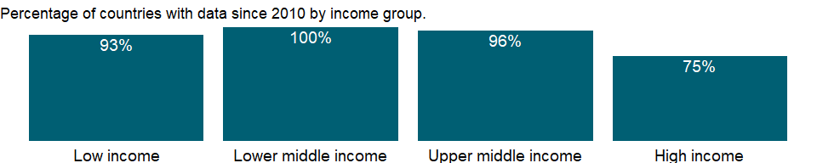

### Why is it relevant?

NA

### What is the data source?

World Bank staff estimates based on IMF balance of payments data, and World Bank and OECD GDP estimates.

### What is the methodology?

NA

### How is it aggregated?

Weighted Average

### What are the limitations?

NA

### What else should I know?

Note: Data starting from 2005 are based on the sixth edition of the IMF’s Balance of Payments Manual (BPM6).

## 1.6 Economic Policy & Debt: Balance of payments: Current account: Balances

### 1.6.1 Current account balance (BoP, current US$)

### What is the indicator?

Current account balance is the sum of net exports of goods and services, net primary income, and net secondary income. Data are in current U.S. dollars.

Topic: Economic Policy & Debt: Balance of payments: Current account: Balances

Series ID: BN.CAB.XOKA.CD

Copyright: CC BY-4.0 , <https://datacatalog.worldbank.org/public-licenses#cc-by>

First year with any data: 1960

Last year with any data: 2020

### What years are data available?

The figure below shows years in which data is available for at least one country. Dates shaded in black have no data, while dates shaded in green have data for at least one country



### Which countries have data?

The figure below shows the percentage of countries in each income group with a value since 2010 for that indicator.



### Why is it relevant?

The balance of payments records an economy’s transactions with the rest of the world. Balance of payments accounts are divided into two groups: the current account, which records transactions in goods, services, primary income, and secondary income, and the capital and financial account, which records capital transfers, acquisition or disposal of nonproduced, nonfinancial assets, and transactions in financial assets and liabilities. The current account balance is one of the most analytically useful indicators of an external imbalance.

A primary purpose of the balance of payments accounts is to indicate the need to adjust an external imbalance. Where to draw the line for analytical purposes requires a judgment concerning the imbalance that best indicates the need for adjustment. There are a number of definitions in common use for this and related analytical purposes. The trade balance is the difference between exports and imports of goods. From an analytical view it is arbitrary to distinguish goods from services. For example, a unit of foreign exchange earned by a freight company strengthens the balance of payments to the same extent as the foreign exchange earned by a goods exporter. Even so, the trade balance is useful because it is often the most timely indicator of trends in the current account balance. Customs authorities are typically able to provide data on trade in goods long before data on trade in services are available.

### What is the data source?

International Monetary Fund, Balance of Payments Statistics Yearbook and data files.

### What is the methodology?

The balance of payments (BoP) is a double-entry accounting system that shows all flows of goods and services into and out of an economy; all transfers that are the counterpart of real resources or financial claims provided to or by the rest of the world without a quid pro quo, such as donations and grants; and all changes in residents’ claims on and liabilities to nonresidents that arise from economic transactions. All transactions are recorded twice - once as a credit and once as a debit. In principle the net balance should be zero, but in practice the accounts often do not balance, requiring inclusion of a balancing item, net errors and omissions.

The concepts and definitions underlying the data are based on the sixth edition of the International Monetary Fund’s (IMF) Balance of Payments Manual (BPM6). Balance of payments data for 2005 onward will be presented in accord with the BPM6. The historical BPM5 data series will end with data for 2008, which can be accessed through the World Development Indicators archives.

The complete balance of payments methodology can be accessed through the International Monetary Fund website (www.imf.org/external/np/sta/bop/bop.htm).

### How is it aggregated?

NA

### What are the limitations?

Discrepancies may arise in the balance of payments because there is no single source for balance of payments data and therefore no way to ensure that the data are fully consistent. Sources include customs data, monetary accounts of the banking system, external debt records, information provided by enterprises, surveys to estimate service transactions, and foreign exchange records. Differences in collection methods - such as in timing, definitions of residence and ownership, and the exchange rate used to value transactions - contribute to net errors and omissions. In addition, smuggling and other illegal or quasi-legal transactions may be unrecorded or misrecorded.

### What else should I know?

Note: Data are based on the sixth edition of the IMF’s Balance of Payments Manual (BPM6) and are only available from 2005 onwards.

### 1.6.2 Current account balance (% of GDP)

### What is the indicator?

Current account balance is the sum of net exports of goods and services, net primary income, and net secondary income.

Topic: Economic Policy & Debt: Balance of payments: Current account: Balances

Series ID: BN.CAB.XOKA.GD.ZS

Copyright: CC BY-4.0 , <https://datacatalog.worldbank.org/public-licenses#cc-by>

First year with any data: 1960

Last year with any data: 2020

### What years are data available?

The figure below shows years in which data is available for at least one country. Dates shaded in black have no data, while dates shaded in green have data for at least one country



### Which countries have data?

The figure below shows the percentage of countries in each income group with a value since 2010 for that indicator.



### Why is it relevant?

NA

### What is the data source?

International Monetary Fund, Balance of Payments Statistics Yearbook and data files, and World Bank and OECD GDP estimates.

### What is the methodology?

NA

### How is it aggregated?

NA

### What are the limitations?

NA

### What else should I know?

Note: Data are based on the sixth edition of the IMF’s Balance of Payments Manual (BPM6) and are only available from 2005 onwards.

### 1.6.3 Net trade in goods and services (BoP, current US$)

### What is the indicator?

Net trade in goods and services is derived by offsetting imports of goods and services against exports of goods and services. Exports and imports of goods and services comprise all transactions involving a change of ownership of goods and services between residents of one country and the rest of the world. Data are in current U.S. dollars.

Topic: Economic Policy & Debt: Balance of payments: Current account: Balances

Series ID: BN.GSR.GNFS.CD

Copyright: CC BY-4.0 , <https://datacatalog.worldbank.org/public-licenses#cc-by>

First year with any data: 1960

Last year with any data: 2020

### What years are data available?

The figure below shows years in which data is available for at least one country. Dates shaded in black have no data, while dates shaded in green have data for at least one country



### Which countries have data?

The figure below shows the percentage of countries in each income group with a value since 2010 for that indicator.



### Why is it relevant?

NA

### What is the data source?

International Monetary Fund, Balance of Payments Statistics Yearbook and data files.

### What is the methodology?

NA

### How is it aggregated?

NA

### What are the limitations?

NA

### What else should I know?

Note: Data are based on the sixth edition of the IMF’s Balance of Payments Manual (BPM6) and are only available from 2005 onwards.

### 1.6.4 Net trade in goods (BoP, current US$)

### What is the indicator?

Net trade in goods is the difference between exports and imports of goods. Trade in services is not included. Data are in current U.S. dollars.

Topic: Economic Policy & Debt: Balance of payments: Current account: Balances

Series ID: BN.GSR.MRCH.CD

Copyright: CC BY-4.0 , <https://datacatalog.worldbank.org/public-licenses#cc-by>

First year with any data: 1960

Last year with any data: 2020

### What years are data available?

The figure below shows years in which data is available for at least one country. Dates shaded in black have no data, while dates shaded in green have data for at least one country



### Which countries have data?

The figure below shows the percentage of countries in each income group with a value since 2010 for that indicator.



### Why is it relevant?

NA

### What is the data source?

International Monetary Fund, Balance of Payments Statistics Yearbook and data files.

### What is the methodology?

NA

### How is it aggregated?

NA

### What are the limitations?

NA

### What else should I know?

Note: Data are based on the sixth edition of the IMF’s Balance of Payments Manual (BPM6) and are only available from 2005 onwards.

## 1.7 Economic Policy & Debt: Balance of payments: Reserves & other items

### 1.7.1 Grants, excluding technical cooperation (BoP, current US$)

### What is the indicator?

Grants are defined as legally binding commitments that obligate a specific value of funds available for disbursement for which there is no repayment requirement. Data are in current U.S. dollars.

Topic: Economic Policy & Debt: Balance of payments: Reserves & other items

Series ID: BX.GRT.EXTA.CD.WD

Copyright: CC BY-4.0 , <https://datacatalog.worldbank.org/public-licenses#cc-by>

First year with any data: 1960

Last year with any data: 2019

### What years are data available?

The figure below shows years in which data is available for at least one country. Dates shaded in black have no data, while dates shaded in green have data for at least one country

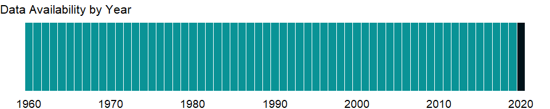

### Which countries have data?

The figure below shows the percentage of countries in each income group with a value since 2010 for that indicator.

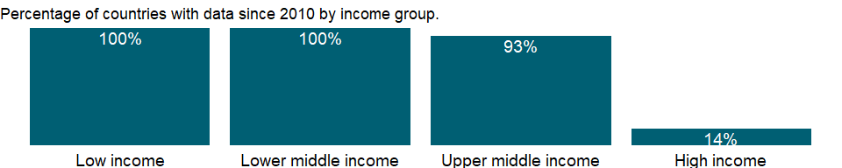

### Why is it relevant?

DAC exists to help its members coordinate their development assistance and to encourage the expansion and improve the effectiveness of the aggregate resources flowing to recipient economies. In this capacity DAC monitors the flow of all financial resources, but its main concern is official development assistance (ODA). Grants or loans to countries and territories on the DAC list of aid recipients have to meet three criteria to be counted as ODA. They are provided by official agencies, including state and local governments, or by their executive agencies. They promote economic development and welfare as the main objective. And they are provided on concessional financial terms (loans must have a grant element of at least 25 percent, calculated at a discount rate of 10 percent). The DAC Statistical Reporting Directives provide the most detailed explanation of this definition and all ODA-related rules.

OECD’s IDS database provides a set of readily available basic data that enables analysis on where aid goes, what purposes it serves and what policies it aims to implement, on a comparable basis for all DAC members. The aid data is most commonly used to analyze the sectoral and geographical breakdown of aid for selected years and donors or groups of donors. The data can also be used to target specific policy issues (e.g. tying status of aid) and monitor donors’ compliance with various international recommendations in the field of development co-operation.

### What is the data source?

World Bank, International Debt Statistics, and OECD.

### What is the methodology?

Grants are transfers made in cash, goods or services for which no repayment is required. Data excludes technical cooperation grants. The flows of official and private financial resources from the members of the Development Assistance Committee (DAC) of the Organisation for Economic Co-operation and Development (OECD) to developing economies are compiled by DAC, based principally on reporting by DAC members using standard questionnaires issued by the DAC Secretariat. A network of statistical correspondents collects data from aid agencies and government departments (central, state and local) on an ongoing basis. Their task is also to ensure that reporting conforms to the Reporting Directives (definitions and classifications) agreed by the DAC.

The official development assistance (ODA) estimates are published annually at the end of the calendar year in International Development Statistics (IDS) database. Data are in current U.S. dollars.

### How is it aggregated?

Sum

### What are the limitations?

Data on ODA is for aid-receiving countries. The data cover loans and grants from DAC member countries, multilateral organizations, and non-DAC donors. They do not reflect aid given by recipient countries to other developing countries. As a result, some countries that are net donors (such as Saudi Arabia) are shown as aid recipients. The indicator does not distinguish types of aid (program, project, or food aid; emergency assistance; or post-conflict peacekeeping assistance), which may have different effects on the economy.

Because the indicator relies on information from donors, it is not necessarily consistent with information recorded by recipients in the balance of payments, which often excludes all or some technical assistance - particularly payments to expatriates made directly by the donor. Similarly, grant commodity aid may not always be recorded in trade data or in the balance of payments. Moreover, DAC statistics exclude aid for military and antiterrorism purposes.

The aggregates refer to World Bank classifications of economies and therefore may differ from those of the OECD.

### What else should I know?

NA

### 1.7.2 Technical cooperation grants (BoP, current US$)

### What is the indicator?

Technical cooperation grants include free-standing technical cooperation grants, which are intended to finance the transfer of technical and managerial skills or of technology for the purpose of building up general national capacity without reference to any specific investment projects; and investment-related technical cooperation grants, which are provided to strengthen the capacity to execute specific investment projects. Data are in current U.S. dollars.

Topic: Economic Policy & Debt: Balance of payments: Reserves & other items

Series ID: BX.GRT.TECH.CD.WD

Copyright: CC BY-4.0 , <https://datacatalog.worldbank.org/public-licenses#cc-by>

First year with any data: 1960

Last year with any data: 2019

### What years are data available?

The figure below shows years in which data is available for at least one country. Dates shaded in black have no data, while dates shaded in green have data for at least one country



### Which countries have data?

The figure below shows the percentage of countries in each income group with a value since 2010 for that indicator.



### Why is it relevant?

DAC exists to help its members coordinate their development assistance and to encourage the expansion and improve the effectiveness of the aggregate resources flowing to recipient economies. In this capacity DAC monitors the flow of all financial resources, but its main concern is official development assistance (ODA). Grants or loans to countries and territories on the DAC list of aid recipients have to meet three criteria to be counted as ODA. They are provided by official agencies, including state and local governments, or by their executive agencies. They promote economic development and welfare as the main objective. And they are provided on concessional financial terms (loans must have a grant element of at least 25 percent, calculated at a discount rate of 10 percent). The DAC Statistical Reporting Directives provide the most detailed explanation of this definition and all ODA-related rules.

OECD’s IDS database provides a set of readily available basic data that enables analysis on where aid goes, what purposes it serves and what policies it aims to implement, on a comparable basis for all DAC members. The aid data is most commonly used to analyze the sectoral and geographical breakdown of aid for selected years and donors or groups of donors. The data can also be used to target specific policy issues (e.g. tying status of aid) and monitor donors’ compliance with various international recommendations in the field of development co-operation.

### What is the data source?

World Bank, International Debt Statistics, and OECD.

### What is the methodology?

Technical cooperation contributions take the form mainly of the supply of human resources from donors or action directed to human resources (such as training or advice). Also included are aid for promoting development awareness and aid provided to refugees in the donor economy. Assistance specifically to facilitate a capital project is not included. Technical cooperation ncludes both grants to nationals of aid recipient countries receiving education or training at home or abroad and payments to consultants, advisers and similar personnel as well as teachers and administrators serving in recipient countries (including the cost of associated equipment).

The flows of official and private financial resources from the members of the Development Assistance Committee (DAC) of the Organisation for Economic Co-operation and Development (OECD) to developing economies are compiled by DAC, based principally on reporting by DAC members using standard questionnaires issued by the DAC Secretariat. A network of statistical correspondents collects data from aid agencies and government departments (central, state and local) on an ongoing basis. Their task is also to ensure that reporting conforms to the Reporting Directives (definitions and classifications) agreed by the DAC.

The official development assistance (ODA) estimates are published annually at the end of the calendar year in International Development Statistics (IDS) database. Data are in current U.S. dollars.

### How is it aggregated?

Sum

### What are the limitations?

Data on ODA is for aid-receiving countries. The data cover loans and grants from DAC member countries, multilateral organizations, and non-DAC donors. They do not reflect aid given by recipient countries to other developing countries. As a result, some countries that are net donors (such as Saudi Arabia) are shown as aid recipients. The indicator does not distinguish types of aid (program, project, or food aid; emergency assistance; or post-conflict peacekeeping assistance), which may have different effects on the economy.

Because this indicator relies on information from donors, it is not necessarily consistent with information recorded by recipients in the balance of payments, which often excludes all or some technical assistance - particularly payments to expatriates made directly by the donor. Similarly, grant commodity aid may not always be recorded in trade data or in the balance of payments. Moreover, DAC statistics exclude aid for military and antiterrorism purposes.

The aggregates refer to World Bank classifications of economies and therefore may differ from those of the OECD.

### What else should I know?

NA

### 1.7.3 Total reserves (includes gold, current US$)

### What is the indicator?

Total reserves comprise holdings of monetary gold, special drawing rights, reserves of IMF members held by the IMF, and holdings of foreign exchange under the control of monetary authorities. The gold component of these reserves is valued at year-end (December 31) London prices. Data are in current U.S. dollars.

Topic: Economic Policy & Debt: Balance of payments: Reserves & other items

Series ID: FI.RES.TOTL.CD

Copyright: CC BY-4.0 , <https://datacatalog.worldbank.org/public-licenses#cc-by>

First year with any data: 1960

Last year with any data: 2020

### What years are data available?

The figure below shows years in which data is available for at least one country. Dates shaded in black have no data, while dates shaded in green have data for at least one country



### Which countries have data?

The figure below shows the percentage of countries in each income group with a value since 2010 for that indicator.

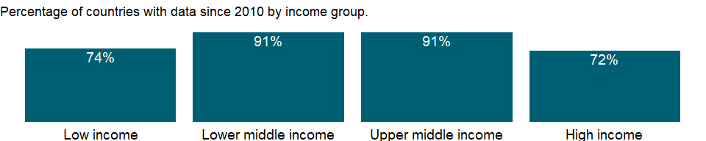

### Why is it relevant?

The balance of payments records an economy’s transactions with the rest of the world. Balance of payments accounts are divided into two groups: the current account, which records transactions in goods, services, primary income, and secondary income, and the capital and financial account, which records capital transfers, acquisition or disposal of nonproduced, nonfinancial assets, and transactions in financial assets and liabilities. The current account balance is one of the most analytically useful indicators of an external imbalance.

A primary purpose of the balance of payments accounts is to indicate the need to adjust an external imbalance. Where to draw the line for analytical purposes requires a judgment concerning the imbalance that best indicates the need for adjustment. There are a number of definitions in common use for this and related analytical purposes. The trade balance is the difference between exports and imports of goods. From an analytical view it is arbitrary to distinguish goods from services. For example, a unit of foreign exchange earned by a freight company strengthens the balance of payments to the same extent as the foreign exchange earned by a goods exporter. Even so, the trade balance is useful because it is often the most timely indicator of trends in the current account balance. Customs authorities are typically able to provide data on trade in goods long before data on trade in services are available.

### What is the data source?

International Monetary Fund, International Financial Statistics and data files.

### What is the methodology?

The balance of payments (BoP) is a double-entry accounting system that shows all flows of goods and services into and out of an economy; all transfers that are the counterpart of real resources or financial claims provided to or by the rest of the world without a quid pro quo, such as donations and grants; and all changes in residents’ claims on and liabilities to nonresidents that arise from economic transactions. All transactions are recorded twice - once as a credit and once as a debit. In principle the net balance should be zero, but in practice the accounts often do not balance, requiring inclusion of a balancing item, net errors and omissions.

### How is it aggregated?

NA

### What are the limitations?

Discrepancies may arise in the balance of payments because there is no single source for balance of payments data and therefore no way to ensure that the data are fully consistent. Sources include customs data, monetary accounts of the banking system, external debt records, information provided by enterprises, surveys to estimate service transactions, and foreign exchange records. Differences in collection methods - such as in timing, definitions of residence and ownership, and the exchange rate used to value transactions - contribute to net errors and omissions. In addition, smuggling and other illegal or quasi-legal transactions may be unrecorded or misrecorded.

### What else should I know?

NA

### 1.7.4 Total reserves (% of total external debt)

### What is the indicator?

International reserves to total external debt stocks.

Topic: Economic Policy & Debt: Balance of payments: Reserves & other items

Series ID: FI.RES.TOTL.DT.ZS

Copyright: CC BY-4.0 , <https://datacatalog.worldbank.org/public-licenses#cc-by>

First year with any data: 1971

Last year with any data: 2019

### What years are data available?

The figure below shows years in which data is available for at least one country. Dates shaded in black have no data, while dates shaded in green have data for at least one country

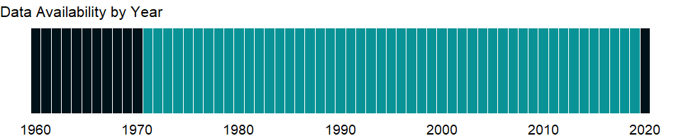

### Which countries have data?

The figure below shows the percentage of countries in each income group with a value since 2010 for that indicator.

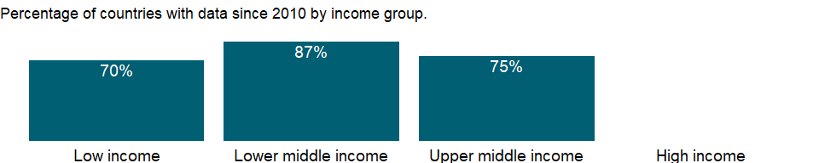

### Why is it relevant?

NA

### What is the data source?

World Bank, International Debt Statistics.

### What is the methodology?

NA

### How is it aggregated?

Weighted Average

### What are the limitations?

NA

### What else should I know?

NA

### 1.7.5 Total reserves in months of imports

### What is the indicator?

Total reserves comprise holdings of monetary gold, special drawing rights, reserves of IMF members held by the IMF, and holdings of foreign exchange under the control of monetary authorities. The gold component of these reserves is valued at year-end (December 31) London prices. This item shows reserves expressed in terms of the number of months of imports of goods and services they could pay for [Reserves/(Imports/12)].

Topic: Economic Policy & Debt: Balance of payments: Reserves & other items

Series ID: FI.RES.TOTL.MO

Copyright: CC BY-4.0 , <https://datacatalog.worldbank.org/public-licenses#cc-by>

First year with any data: 1960

Last year with any data: 2020

### What years are data available?

The figure below shows years in which data is available for at least one country. Dates shaded in black have no data, while dates shaded in green have data for at least one country



### Which countries have data?

The figure below shows the percentage of countries in each income group with a value since 2010 for that indicator.

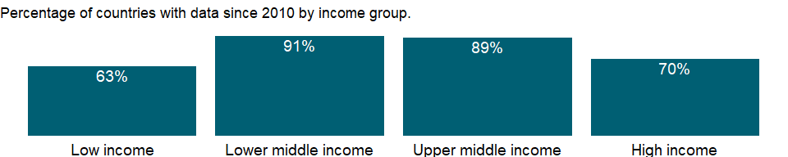

### Why is it relevant?

NA

### What is the data source?

International Monetary Fund, International Financial Statistics and data files.

### What is the methodology?

NA

### How is it aggregated?

Weighted average

### What are the limitations?

NA

### What else should I know?

NA

### 1.7.6 Total reserves minus gold (current US$)

### What is the indicator?

Total reserves minus gold comprise special drawing rights, reserves of IMF members held by the IMF, and holdings of foreign exchange under the control of monetary authorities. Gold holdings are excluded. Data are in current U.S. dollars.

Topic: Economic Policy & Debt: Balance of payments: Reserves & other items

Series ID: FI.RES.XGLD.CD

Copyright: CC BY-4.0 , <https://datacatalog.worldbank.org/public-licenses#cc-by>

First year with any data: 1960

Last year with any data: 2020

### What years are data available?

The figure below shows years in which data is available for at least one country. Dates shaded in black have no data, while dates shaded in green have data for at least one country



### Which countries have data?

The figure below shows the percentage of countries in each income group with a value since 2010 for that indicator.



### Why is it relevant?

NA

### What is the data source?

International Monetary Fund, International Financial Statistics and data files.

### What is the methodology?

NA

### How is it aggregated?

NA

### What are the limitations?

NA

### What else should I know?

NA

## 1.8 Infrastructure: Communications

### 1.8.1 ICT service exports (BoP, current US$)

### What is the indicator?

Information and communication technology service exports include computer and communications services (telecommunications and postal and courier services) and information services (computer data and news-related service transactions). Data are in current U.S. dollars.

Topic: Infrastructure: Communications

Series ID: BX.GSR.CCIS.CD

Copyright: CC BY-4.0 , <https://datacatalog.worldbank.org/public-licenses#cc-by>

First year with any data: 1960

Last year with any data: 2017

### What years are data available?

The figure below shows years in which data is available for at least one country. Dates shaded in black have no data, while dates shaded in green have data for at least one country

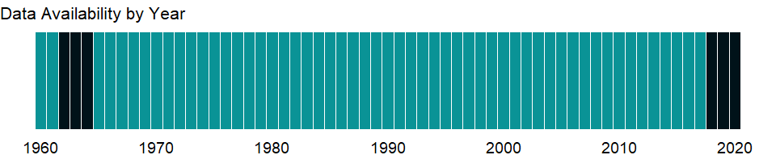

### Which countries have data?

The figure below shows the percentage of countries in each income group with a value since 2010 for that indicator.

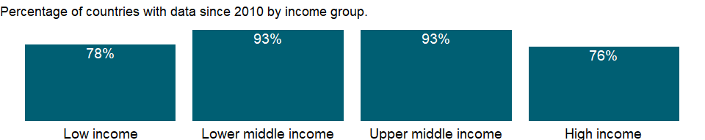

### Why is it relevant?

NA

### What is the data source?

International Monetary Fund, Balance of Payments Statistics Yearbook and data files.

### What is the methodology?

NA

### How is it aggregated?

Sum

### What are the limitations?

NA

### What else should I know?

Note: Data are based on the sixth edition of the IMF’s Balance of Payments Manual (BPM6) and are only available from 2005 onwards.

### 1.8.2 ICT service exports (% of service exports, BoP)

### What is the indicator?

Information and communication technology service exports include computer and communications services (telecommunications and postal and courier services) and information services (computer data and news-related service transactions).

Topic: Infrastructure: Communications

Series ID: BX.GSR.CCIS.ZS

Copyright: CC BY-4.0 , <https://datacatalog.worldbank.org/public-licenses#cc-by>

First year with any data: 1960

Last year with any data: 2017

### What years are data available?

The figure below shows years in which data is available for at least one country. Dates shaded in black have no data, while dates shaded in green have data for at least one country



### Which countries have data?

The figure below shows the percentage of countries in each income group with a value since 2010 for that indicator.



### Why is it relevant?

The balance of payments records an economy’s transactions with the rest of the world. Balance of payments accounts are divided into two groups: the current account, which records transactions in goods, services, income, and current transfers, and the capital and financial account, which records capital transfers, acquisition or disposal of non-produced, nonfinancial assets, and transactions in financial assets and liabilities.

### What is the data source?

International Monetary Fund, Balance of Payments Statistics Yearbook and data files.

### What is the methodology?

The balance of payments (BoP) is a double-entry accounting system that shows all flows of goods and services into and out of an economy; all transfers that are the counterpart of real resources or financial claims provided to or by the rest of the world without a quid pro quo, such as donations and grants; and all changes in residents’ claims on and liabilities to nonresidents that arise from economic transactions. All transactions are recorded twice - once as a credit and once as a debit. In principle the net balance should be zero, but in practice the accounts often do not balance, requiring inclusion of a balancing item, net errors and omissions.

The concepts and definitions underlying the data are based on the sixth edition of the International Monetary Fund’s (IMF) Balance of Payments Manual.

### How is it aggregated?

Weighted average

### What are the limitations?

Discrepancies may arise in the balance of payments because there is no single source for balance of payments data and therefore no way to ensure that the data are fully consistent. Sources include customs data, monetary accounts of the banking system, external debt records, information provided by enterprises, surveys to estimate service transactions, and foreign exchange records. Differences in collection methods - such as in timing, definitions of residence and ownership, and the exchange rate used to value transactions - contribute to net errors and omissions. In addition, smuggling and other illegal or quasi-legal transactions may be unrecorded or misrecorded.

### What else should I know?

Note: Data are based on the sixth edition of the IMF’s Balance of Payments Manual (BPM6) and are only available from 2005 onwards.

### 1.8.3 Mobile cellular subscriptions

### What is the indicator?

Mobile cellular telephone subscriptions are subscriptions to a public mobile telephone service that provide access to the PSTN using cellular technology. The indicator includes (and is split into) the number of postpaid subscriptions, and the number of active prepaid accounts (i.e. that have been used during the last three months). The indicator applies to all mobile cellular subscriptions that offer voice communications. It excludes subscriptions via data cards or USB modems, subscriptions to public mobile data services, private trunked mobile radio, telepoint, radio paging and telemetry services.

Topic: Infrastructure: Communications

Series ID: IT.CEL.SETS

Copyright: CC BY-4.0 , <https://datacatalog.worldbank.org/public-licenses#cc-by>

First year with any data: 1960

Last year with any data: 2020

### What years are data available?

The figure below shows years in which data is available for at least one country. Dates shaded in black have no data, while dates shaded in green have data for at least one country

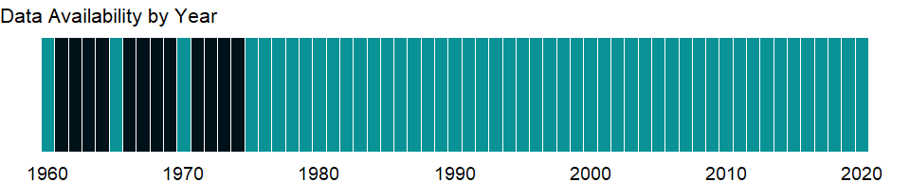

### Which countries have data?

The figure below shows the percentage of countries in each income group with a value since 2010 for that indicator.

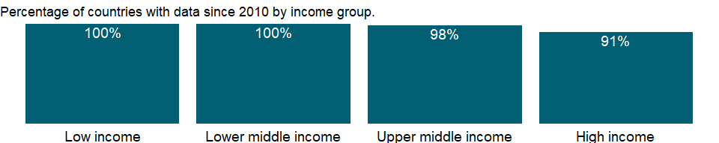

### Why is it relevant?

The quality of an economy’s infrastructure, including power and communications, is an important element in investment decisions for both domestic and foreign investors. Government effort alone is not enough to meet the need for investments in modern infrastructure; public-private partnerships, especially those involving local providers and financiers, are critical for lowering costs and delivering value for money. In telecommunications, competition in the marketplace, along with sound regulation, is lowering costs, improving quality, and easing access to services around the globe.

Access to telecommunication services rose on an unprecedented scale over the past two decades. This growth was driven primarily by wireless technologies and liberalization of telecommunications markets, which have enabled faster and less costly network rollout. The International Telecommunication Union (ITU) estimates that there were about 6 billion mobile subscriptions globally in the early 2010s. No technology has ever spread faster around the world. Mobile communications have a particularly important impact in rural areas. The mobility, ease of use, flexible deployment, and relatively low and declining rollout costs of wireless technologies enable them to reach rural populations with low levels of income and literacy. The next billion mobile subscribers will consist mainly of the rural poor. Access is the key to delivering telecommunications services to people. If the service is not affordable to most people, goals of universal usage will not be met.

Mobile cellular telephone subscriptions are subscriptions to a public mobile telephone service using cellular technology, which provide access to the public switched telephone network (PSTN) using cellular technology. It includes postpaid and prepaid subscriptions and includes analogue and digital cellular systems.

Over the past decade new financing and technology, along with privatization and market liberalization, have spurred dramatic growth in telecommunications in many countries. With the rapid development of mobile telephony and the global expansion of the Internet, information and communication technologies are increasingly recognized as essential tools of development, contributing to global integration and enhancing public sector effectiveness, efficiency, and transparency.

### What is the data source?

International Telecommunication Union (ITU) World Telecommunication/ICT Indicators Database

### What is the methodology?

Refers to the subscriptions to a public mobile telephone service and provides access to Public Switched Telephone Network (PSTN) using cellular technology, including number of pre-paid SIM cards active during the past three months. This includes both analogue and digital cellular systems (IMT-2000 (Third Generation, 3G) and 4G subscriptions, but excludes mobile broadband subscriptions via data cards or USB modems. Subscriptions to public mobile data services, private trunked mobile radio, telepoint or radio paging, and telemetry services should also be excluded. This should include all mobile cellular subscriptions that offer voice communications.

Data on mobile cellular subscribers are derived using administrative data that countries (usually the regulatory telecommunication authority or the Ministry in charge of telecommunications) regularly, and at least annually, collect from telecommunications operators.

Data for this indicator are readily available for approximately 90 percent of countries, either through ITU’s World Telecommunication Indicators questionnaires or from official information available on the Ministry or Regulator’s website. For the rest, information can be aggregated through operators’ data (mainly through annual reports) and complemented by market research reports. For additional/latest information on sources and country notes, please also refer to: <https://www.itu.int/en/ITU-D/Statistics/Pages/stat/default.aspx>

### How is it aggregated?

Sum

### What are the limitations?

Operators have traditionally been the main source of telecommunications data, so information on subscriptions has been widely available for most countries. This gives a general idea of access, but a more precise measure is the penetration rate - the share of households with access to telecommunications. During the past few years more information on information and communication technology use has become available from household and business surveys. Also important are data on actual use of telecommunications services. Ideally, statistics on telecommunications (and other information and communications technologies) should be compiled for all three measures: subscriptions, access, and use. The quality of data varies among reporting countries as a result of differences in regulations covering data provision and availability.

Discrepancies between global and national figures may arise when countries use a different definition than the one used by ITU. For example, some countries do not include the number of ISDN channels when calculating the number of fixed telephone lines. Discrepancies may also arise in cases where the end of a fiscal year differs from that used by ITU, which is the end of December of every year. A number of countries have fiscal years that end in March or June of every year. Data are usually not adjusted but discrepancies in the definition, reference year or the break in comparability in between years are noted in a data note. For this reason, data are not always strictly comparable. Missing values are estimated by ITU.

Mobile subscriptions include both analogue and digital cellular systems (IMT-2000 (Third Generation, 3G) and 4G subscriptions, but excludes mobile broadband subscriptions via data cards or USB modems. Subscriptions to public mobile data services, private trunked mobile radio, telepoint or radio paging, and telemetry services are also excluded, but all mobile cellular subscriptions that offer voice communications are included. Both postpaid and prepaid subscriptions are included.

### What else should I know?

Please cite the International Telecommunication Union for third-party use of these data.

### 1.8.4 Mobile cellular subscriptions (per 100 people)

### What is the indicator?

Mobile cellular telephone subscriptions are subscriptions to a public mobile telephone service that provide access to the PSTN using cellular technology. The indicator includes (and is split into) the number of postpaid subscriptions, and the number of active prepaid accounts (i.e. that have been used during the last three months). The indicator applies to all mobile cellular subscriptions that offer voice communications. It excludes subscriptions via data cards or USB modems, subscriptions to public mobile data services, private trunked mobile radio, telepoint, radio paging and telemetry services.

Topic: Infrastructure: Communications

Series ID: IT.CEL.SETS.P2

Copyright: CC BY-4.0 , <https://datacatalog.worldbank.org/public-licenses#cc-by>

First year with any data: 1960

Last year with any data: 2020

### What years are data available?

The figure below shows years in which data is available for at least one country. Dates shaded in black have no data, while dates shaded in green have data for at least one country



### Which countries have data?

The figure below shows the percentage of countries in each income group with a value since 2010 for that indicator.



### Why is it relevant?

The quality of an economy’s infrastructure, including power and communications, is an important element in investment decisions for both domestic and foreign investors. Government effort alone is not enough to meet the need for investments in modern infrastructure; public-private partnerships, especially those involving local providers and financiers, are critical for lowering costs and delivering value for money. In telecommunications, competition in the marketplace, along with sound regulation, is lowering costs, improving quality, and easing access to services around the globe.

Access to telecommunication services rose on an unprecedented scale over the past two decades. This growth was driven primarily by wireless technologies and liberalization of telecommunications markets, which have enabled faster and less costly network rollout. The International Telecommunication Union (ITU) estimates that there were about 6 billion mobile subscriptions globally in the early 2010s. No technology has ever spread faster around the world. Mobile communications have a particularly important impact in rural areas. The mobility, ease of use, flexible deployment, and relatively low and declining rollout costs of wireless technologies enable them to reach rural populations with low levels of income and literacy. The next billion mobile subscribers will consist mainly of the rural poor. Access is the key to delivering telecommunications services to people. If the service is not affordable to most people, goals of universal usage will not be met.

Mobile cellular telephone subscriptions are subscriptions to a public mobile telephone service using cellular technology, which provide access to the public switched telephone network (PSTN) using cellular technology. It includes postpaid and prepaid subscriptions and includes analogue and digital cellular systems.

Over the past decade new financing and technology, along with privatization and market liberalization, have spurred dramatic growth in telecommunications in many countries. With the rapid development of mobile telephony and the global expansion of the Internet, information and communication technologies are increasingly recognized as essential tools of development, contributing to global integration and enhancing public sector effectiveness, efficiency, and transparency.

### What is the data source?

International Telecommunication Union (ITU) World Telecommunication/ICT Indicators Database

### What is the methodology?

Refers to the subscriptions to a public mobile telephone service and provides access to Public Switched Telephone Network (PSTN) using cellular technology, including number of pre-paid SIM cards active during the past three months. This includes both analogue and digital cellular systems (IMT-2000 (Third Generation, 3G) and 4G subscriptions, but excludes mobile broadband subscriptions via data cards or USB modems. Subscriptions to public mobile data services, private trunked mobile radio, telepoint or radio paging, and telemetry services should also be excluded. This should include all mobile cellular subscriptions that offer voice communications.

Data on mobile cellular subscribers are derived using administrative data that countries (usually the regulatory telecommunication authority or the Ministry in charge of telecommunications) regularly, and at least annually, collect from telecommunications operators.

Data for this indicator are readily available for approximately 90 percent of countries, either through ITU’s World Telecommunication Indicators questionnaires or from official information available on the Ministry or Regulator’s website. For the rest, information can be aggregated through operators’ data (mainly through annual reports) and complemented by market research reports.

Mobile cellular subscriptions (per 100 people) indicator is derived by all mobile subscriptions divided by the country’s population and multiplied by 100. For additional/latest information on sources and country notes, please also refer to: <https://www.itu.int/en/ITU-D/Statistics/Pages/stat/default.aspx>

### How is it aggregated?

Weighted Average

### What are the limitations?

Operators have traditionally been the main source of telecommunications data, so information on subscriptions has been widely available for most countries. This gives a general idea of access, but a more precise measure is the penetration rate - the share of households with access to telecommunications. During the past few years more information on information and communication technology use has become available from household and business surveys. Also important are data on actual use of telecommunications services. Ideally, statistics on telecommunications (and other information and communications technologies) should be compiled for all three measures: subscriptions, access, and use. The quality of data varies among reporting countries as a result of differences in regulations covering data provision and availability.

Discrepancies between global and national figures may arise when countries use a different definition than the one used by ITU. For example, some countries do not include the number of ISDN channels when calculating the number of fixed telephone lines. Discrepancies may also arise in cases where the end of a fiscal year differs from that used by ITU, which is the end of December of every year. A number of countries have fiscal years that end in March or June of every year. Data are usually not adjusted but discrepancies in the definition, reference year or the break in comparability in between years are noted in a data note. For this reason, data are not always strictly comparable. Missing values are estimated by ITU.

Mobile subscriptions include both analogue and digital cellular systems (IMT-2000 (Third Generation, 3G) and 4G subscriptions, but excludes mobile broadband subscriptions via data cards or USB modems. Subscriptions to public mobile data services, private trunked mobile radio, telepoint or radio paging, and telemetry services are also excluded, but all mobile cellular subscriptions that offer voice communications are included. Both postpaid and prepaid subscriptions are included.

### What else should I know?

Please cite the International Telecommunication Union for third-party use of these data.

### 1.8.5 Fixed telephone subscriptions

### What is the indicator?

Fixed telephone subscriptions refers to the sum of active number of analogue fixed telephone lines, voice-over-IP (VoIP) subscriptions, fixed wireless local loop (WLL) subscriptions, ISDN voice-channel equivalents and fixed public payphones.

Topic: Infrastructure: Communications

Series ID: IT.MLT.MAIN

Copyright: CC BY-4.0 , <https://datacatalog.worldbank.org/public-licenses#cc-by>

First year with any data: 1960

Last year with any data: 2020

### What years are data available?

The figure below shows years in which data is available for at least one country. Dates shaded in black have no data, while dates shaded in green have data for at least one country



### Which countries have data?

The figure below shows the percentage of countries in each income group with a value since 2010 for that indicator.

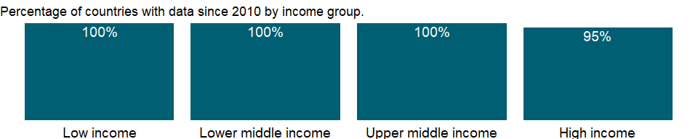

### Why is it relevant?

The quality of an economy’s infrastructure, including power and communications, is an important element in investment decisions for both domestic and foreign investors. Government effort alone is not enough to meet the need for investments in modern infrastructure; public-private partnerships, especially those involving local providers and financiers, are critical for lowering costs and delivering value for money. In telecommunications, competition in the marketplace, along with sound regulation, is lowering costs, improving quality, and easing access to services around the globe.

Access to telecommunication services rose on an unprecedented scale over the past two decades. This growth was driven primarily by wireless technologies and liberalization of telecommunications markets, which have enabled faster and less costly network rollout.

Fixed telephone lines are those that connect a subscriber’s terminal equipment to the public switched telephone network and that have a port on a telephone exchange. This term is synonymous with the term main station or Direct Exchange Line (DEL) that is commonly used in telecommunication documents. Integrated services digital network channels and fixed wireless subscribers are included. A fixed line also refers to a phone which uses a solid medium telephone line such as a metal wire or fiber optic cable for transmission as distinguished from a mobile cellular line which uses radio waves for transmission.

Over the past decade new financing and technology, along with privatization and market liberalization, have spurred dramatic growth in telecommunications in many countries. With the rapid development of mobile telephony and the global expansion of the Internet, information and communication technologies are increasingly recognized as essential tools of development, contributing to global integration and enhancing public sector effectiveness, efficiency, and transparency.

### What is the data source?

International Telecommunication Union (ITU) World Telecommunication/ICT Indicators Database

### What is the methodology?

A fixed telephone line (previously called main telephone line in operation) is an active line connecting the subscriber’s terminal equipment to the public switched telephone network (PSTN) and which has a dedicated port in the telephone exchange equipment. This term is synonymous with the terms main station or Direct Exchange Line (DEL) that are commonly used in telecommunication documents. It may not be the same as an access line or a subscriber. This should include the active number of analog fixed telephone lines, ISDN channels, fixed wireless, public payphones and VoIP subscriptions. Active lines are those that have registered an activity in the past three months.

Data on fixed telephone lines are derived using administrative data that countries (usually the regulatory telecommunication authority or the Ministry in charge of telecommunications) regularly, and at least annually, collect from telecommunications operators. Data are considered to be very reliable, timely, and complete.

Data for this indicator are readily available for approximately 90 percent of countries, either through ITU’s World Telecommunication Indicators questionnaires or from official information available on the Ministry or Regulator’s website. For the rest, information can be aggregated through operators’ data (mainly through annual reports) and complemented by market research reports. For additional/latest information on sources and country notes, please also refer to: <https://www.itu.int/en/ITU-D/Statistics/Pages/stat/default.aspx>

### How is it aggregated?

Sum

### What are the limitations?

Operators have traditionally been the main source of telecommunications data, so information on subscriptions has been widely available for most countries. This gives a general idea of access, but a more precise measure is the penetration rate - the share of households with access to telecommunications. During the past few years more information on information and communication technology use has become available from household and business surveys. Also important are data on actual use of telecommunications services. Ideally, statistics on telecommunications (and other information and communications technologies) should be compiled for all three measures: subscriptions, access, and use. The quality of data varies among reporting countries as a result of differences in regulations covering data provision and availability.

Discrepancies between global and national figures may arise when countries use a different definition than the one used by ITU. For example, some countries do not include the number of ISDN channels when calculating the number of fixed telephone lines. Discrepancies may also arise in cases where the end of a fiscal year differs from that used by ITU, which is the end of December of every year. A number of countries have fiscal years that end in March or June of every year. Data are usually not adjusted but discrepancies in the definition, reference year or the break in comparability in between years are noted in a data note. For this reason, data are not always strictly comparable. Missing values are estimated by ITU.

### What else should I know?

Please cite the International Telecommunication Union for third-party use of these data.

### 1.8.6 Fixed telephone subscriptions (per 100 people)

### What is the indicator?

Fixed telephone subscriptions refers to the sum of active number of analogue fixed telephone lines, voice-over-IP (VoIP) subscriptions, fixed wireless local loop (WLL) subscriptions, ISDN voice-channel equivalents and fixed public payphones.

Topic: Infrastructure: Communications

Series ID: IT.MLT.MAIN.P2

Copyright: CC BY-4.0 , <https://datacatalog.worldbank.org/public-licenses#cc-by>

First year with any data: 1960

Last year with any data: 2020

### What years are data available?

The figure below shows years in which data is available for at least one country. Dates shaded in black have no data, while dates shaded in green have data for at least one country



### Which countries have data?

The figure below shows the percentage of countries in each income group with a value since 2010 for that indicator.



### Why is it relevant?

The quality of an economy’s infrastructure, including power and communications, is an important element in investment decisions for both domestic and foreign investors. Government effort alone is not enough to meet the need for investments in modern infrastructure; public-private partnerships, especially those involving local providers and financiers, are critical for lowering costs and delivering value for money. In telecommunications, competition in the marketplace, along with sound regulation, is lowering costs, improving quality, and easing access to services around the globe.

Access to telecommunication services rose on an unprecedented scale over the past two decades. This growth was driven primarily by wireless technologies and liberalization of telecommunications markets, which have enabled faster and less costly network rollout.

Fixed telephone lines are those that connect a subscriber’s terminal equipment to the public switched telephone network and that have a port on a telephone exchange. This term is synonymous with the term main station or Direct Exchange Line (DEL) that is commonly used in telecommunication documents. Integrated services digital network channels and fixed wireless subscribers are included. A fixed line also refers to a phone which uses a solid medium telephone line such as a metal wire or fiber optic cable for transmission as distinguished from a mobile cellular line which uses radio waves for transmission.

Over the past decade new financing and technology, along with privatization and market liberalization, have spurred dramatic growth in telecommunications in many countries. With the rapid development of mobile telephony and the global expansion of the Internet, information and communication technologies are increasingly recognized as essential tools of development, contributing to global integration and enhancing public sector effectiveness, efficiency, and transparency.

### What is the data source?

International Telecommunication Union (ITU) World Telecommunication/ICT Indicators Database

### What is the methodology?

A fixed telephone line (previously called main telephone line in operation) is an active line connecting the subscriber’s terminal equipment to the public switched telephone network (PSTN) and which has a dedicated port in the telephone exchange equipment. This term is synonymous with the terms main station or Direct Exchange Line (DEL) that are commonly used in telecommunication documents. It may not be the same as an access line or a subscriber. This should include the active number of analog fixed telephone lines, ISDN channels, fixed wireless, public payphones and VoIP subscriptions. Active lines are those that have registered an activity in the past three months.

Data on fixed telephone lines are derived using administrative data that countries (usually the regulatory telecommunication authority or the Ministry in charge of telecommunications) regularly, and at least annually, collect from telecommunications operators. Data are considered to be very reliable, timely, and complete.

Data for this indicator are readily available for approximately 90 percent of countries, either through ITU’s World Telecommunication Indicators questionnaires or from official information available on the Ministry or Regulator’s website. For the rest, information can be aggregated through operators’ data (mainly through annual reports) and complemented by market research reports.

Telephone lines (per 100 people) indicator is derived by all telephone lines divided by the country’s population and multiplied by 100. For additional/latest information on sources and country notes, please also refer to: <https://www.itu.int/en/ITU-D/Statistics/Pages/stat/default.aspx>

### How is it aggregated?

Weighted average

### What are the limitations?

Operators have traditionally been the main source of telecommunications data, so information on subscriptions has been widely available for most countries. This gives a general idea of access, but a more precise measure is the penetration rate - the share of households with access to telecommunications. During the past few years more information on information and communication technology use has become available from household and business surveys. Also important are data on actual use of telecommunications services. Ideally, statistics on telecommunications (and other information and communications technologies) should be compiled for all three measures: subscriptions, access, and use. The quality of data varies among reporting countries as a result of differences in regulations covering data provision and availability.

Discrepancies between global and national figures may arise when countries use a different definition than the one used by ITU. For example, some countries do not include the number of ISDN channels when calculating the number of fixed telephone lines. Discrepancies may also arise in cases where the end of a fiscal year differs from that used by ITU, which is the end of December of every year. A number of countries have fiscal years that end in March or June of every year. Data are usually not adjusted but discrepancies in the definition, reference year or the break in comparability in between years are noted in a data note. For this reason, data are not always strictly comparable. Missing values are estimated by ITU.

### What else should I know?

Please cite the International Telecommunication Union for third-party use of these data.

### 1.8.7 Fixed broadband subscriptions

### What is the indicator?

Fixed broadband subscriptions refers to fixed subscriptions to high-speed access to the public Internet (a TCP/IP connection), at downstream speeds equal to, or greater than, 256 kbit/s. This includes cable modem, DSL, fiber-to-the-home/building, other fixed (wired)-broadband subscriptions, satellite broadband and terrestrial fixed wireless broadband. This total is measured irrespective of the method of payment. It excludes subscriptions that have access to data communications (including the Internet) via mobile-cellular networks. It should include fixed WiMAX and any other fixed wireless technologies. It includes both residential subscriptions and subscriptions for organizations.

Topic: Infrastructure: Communications

Series ID: IT.NET.BBND

Copyright: CC BY-4.0 , <https://datacatalog.worldbank.org/public-licenses#cc-by>

First year with any data: 1998

Last year with any data: 2020

### What years are data available?

The figure below shows years in which data is available for at least one country. Dates shaded in black have no data, while dates shaded in green have data for at least one country

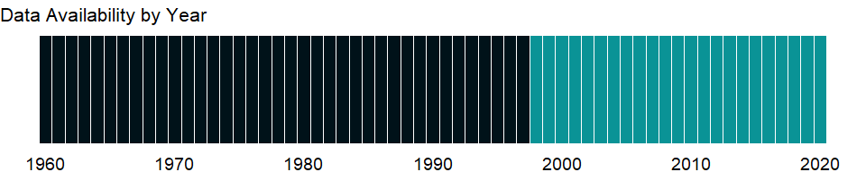

### Which countries have data?

The figure below shows the percentage of countries in each income group with a value since 2010 for that indicator.

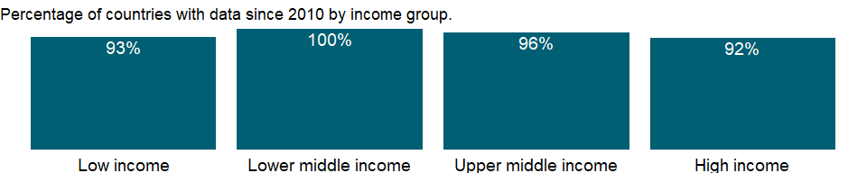

### Why is it relevant?

NA

### What is the data source?

International Telecommunication Union (ITU) World Telecommunication/ICT Indicators Database

### What is the methodology?

NA

### How is it aggregated?

Sum

### What are the limitations?

NA

### What else should I know?

Please cite the International Telecommunication Union for third-party use of these data.

### 1.8.8 Fixed broadband subscriptions (per 100 people)

### What is the indicator?

Fixed broadband subscriptions refers to fixed subscriptions to high-speed access to the public Internet (a TCP/IP connection), at downstream speeds equal to, or greater than, 256 kbit/s. This includes cable modem, DSL, fiber-to-the-home/building, other fixed (wired)-broadband subscriptions, satellite broadband and terrestrial fixed wireless broadband. This total is measured irrespective of the method of payment. It excludes subscriptions that have access to data communications (including the Internet) via mobile-cellular networks. It should include fixed WiMAX and any other fixed wireless technologies. It includes both residential subscriptions and subscriptions for organizations.

Topic: Infrastructure: Communications

Series ID: IT.NET.BBND.P2

Copyright: CC BY-4.0 , <https://datacatalog.worldbank.org/public-licenses#cc-by>

First year with any data: 1998

Last year with any data: 2020

### What years are data available?

The figure below shows years in which data is available for at least one country. Dates shaded in black have no data, while dates shaded in green have data for at least one country



### Which countries have data?

The figure below shows the percentage of countries in each income group with a value since 2010 for that indicator.



### Why is it relevant?

The quality of an economy’s infrastructure, including power and communications, is an important element in investment decisions for both domestic and foreign investors. Government effort alone is not enough to meet the need for investments in modern infrastructure; public-private partnerships, especially those involving local providers and financiers, are critical for lowering costs and delivering value for money. In telecommunications, competition in the marketplace, along with sound regulation, is lowering costs, improving quality, and easing access to services around the globe.

Comparable statistics on access, use, quality, and affordability of ICT are needed to formulate growth-enabling policies for the sector and to monitor and evaluate the sector’s impact on development. Although basic access data are available for many countries, in most developing countries little is known about who uses ICT; what they are used for (school, work, business, research, government); and how they affect people and businesses. The global Partnership on Measuring ICT for Development is helping to set standards, harmonize information and communications technology statistics, and build statistical capacity in developing countries. However, despite significant improvements in the developing world, the gap between the ICT haves and have-nots remains.

There are several economic gains associated with broadband. For example, with DSL, users can use a single standard phone line for both voice and data services. This enables them to surf the Internet and call a friend at the same time - all using the same phone line. Broadband also enhances many Internet applications such as new e-government services like electronic tax filing, online health care services, e-learning and increased levels of electronic commerce.

Access to telecommunication services rose on an unprecedented scale over the past two decades. This growth was driven primarily by wireless technologies and liberalization of telecommunications markets, which have enabled faster and less costly network rollout. Mobile communications have a particularly important impact in rural areas. The mobility, ease of use, flexible deployment, and relatively low and declining rollout costs of wireless technologies enable them to reach rural populations with low levels of income and literacy. The next billion mobile subscribers will consist mainly of the rural poor. Access is the key to delivering telecommunications services to people. If the service is not affordable to most people, goals of universal usage will not be met.

Over the past decade new financing and technology, along with privatization and market liberalization, have spurred dramatic growth in telecommunications in many countries. With the rapid development of mobile telephony and the global expansion of the Internet, information and communication technologies are increasingly recognized as essential tools of development, contributing to global integration and enhancing public sector effectiveness, efficiency, and transparency.

### What is the data source?

International Telecommunication Union (ITU) World Telecommunication/ICT Indicators Database

### What is the methodology?

Data refer to subscriptions to high-speed access to the public Internet (a TCP/IP connection), at downstream speeds equal to, or greater than, 256 kbit/s. This includes cable modem, DSL, fibre-to-the-home/building and other fixed (wired)-broadband subscriptions. This total is measured irrespective of the method of payment. It excludes subscriptions that have access to data communications (including the Internet) via mobile-cellular networks. It excludes technologies listed under the wireless-broadband category.

Fixed broadband Internet subscribers per 100 people is obtained by dividing the number of fixed broadband Internet subscribers by the population and then multiplying by 100. For additional/latest information on sources and country notes, please also refer to: <https://www.itu.int/en/ITU-D/Statistics/Pages/stat/default.aspx>

### How is it aggregated?

Weighted average

### What are the limitations?

Data are collected by national statistics offices through household surveys. Because survey questions and definitions differ, the estimates may not be strictly comparable across countries.

Fixed broadband Internet includes cable modem, DSL, fibre and other fixed broadband technology (such as satellite broadband Internet, Ethernet LANs, fixed-wireless access, Wireless Local Area Network, WiMAX etc.). Subscribers with access to data communications (including the Internet) via mobile cellular networks are excluded.

Advertised and real speeds can differ substantially. In some countries, regulatory authorities monitor the speed and quality of broadband services and oblige operators to provide accurate quality-of-service information to end users. Regional and global totals are calculated as unweighted sums of the country values. Regional and global penetration rates (per 100 inhabitants) are weighted averages of the country values weighted by the population of the countries/regions.

Discrepancies between global and national figures may arise when countries use a different definition than the one used by ITU. Discrepancies may also arise in cases where the end of a fiscal year differs from that used by ITU, which is end of December of every year. A number of countries have fiscal years that end in March or June of every year.

### What else should I know?

Please cite the International Telecommunication Union for third-party use of these data.

### 1.8.9 Secure Internet servers

### What is the indicator?

The number of distinct, publicly-trusted TLS/SSL certificates found in the Netcraft Secure Server Survey.

Topic: Infrastructure: Communications

Series ID: IT.NET.SECR

Copyright: CC BY-4.0 , <https://datacatalog.worldbank.org/public-licenses#cc-by>

First year with any data: 2010

Last year with any data: 2020

### What years are data available?

The figure below shows years in which data is available for at least one country. Dates shaded in black have no data, while dates shaded in green have data for at least one country

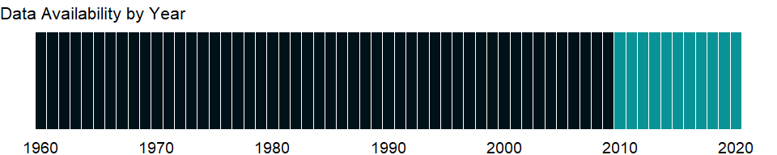

### Which countries have data?

The figure below shows the percentage of countries in each income group with a value since 2010 for that indicator.

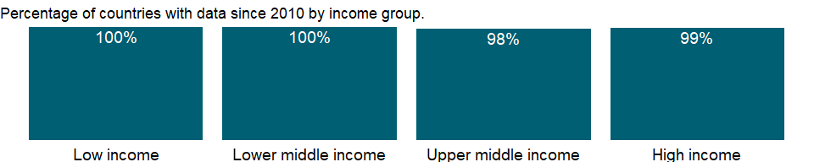

### Why is it relevant?

The quality of an economy’s infrastructure, including power and communications, is an important element in investment decisions for both domestic and foreign investors. Government effort alone is not enough to meet the need for investments in modern infrastructure; public-private partnerships, especially those involving local providers and financiers, are critical for lowering costs and delivering value for money. In telecommunications, competition in the marketplace, along with sound regulation, is lowering costs, improving quality, and easing access to services around the globe. Today’s smartphones and tablets have computer power equivalent to that of yesterday’s computers and provide a similar range of functions. Device convergence is thus rendering the conventional definition obsolete.

Comparable statistics on access, use, quality, and affordability of ICT are needed to formulate growth-enabling policies for the sector and to monitor and evaluate the sector’s impact on development. Although basic access data are available for many countries, in most developing countries little is known about who uses ICT; what they are used for (school, work, business, research, government); and how they affect people and businesses. The global Partnership on Measuring ICT for Development is helping to set standards, harmonize information and communications technology statistics, and build statistical capacity in developing countries. However, despite significant improvements in the developing world, the gap between the ICT haves and have-nots remains.

Access to telecommunication services rose on an unprecedented scale over the past two decades. This growth was driven primarily by wireless technologies and liberalization of telecommunications markets, which have enabled faster and less costly network rollout. Mobile communications have a particularly important impact in rural areas. The mobility, ease of use, flexible deployment, and relatively low and declining rollout costs of wireless technologies enable them to reach rural populations with low levels of income and literacy. The next billion mobile subscribers will consist mainly of the rural poor. Access is the key to delivering telecommunications services to people. If the service is not affordable to most people, goals of universal usage will not be met.

Over the past decade new financing and technology, along with privatization and market liberalization, have spurred dramatic growth in telecommunications in many countries. With the rapid development of mobile telephony and the global expansion of the Internet, information and communication technologies are increasingly recognized as essential tools of development, contributing to global integration and enhancing public sector effectiveness, efficiency, and transparency.

### What is the data source?

Netcraft (<http://www.netcraft.com/>)

### What is the methodology?

The survey examines the use of encrypted transactions through extensive automated exploration, tallying the number of web sites using HTTPS. This analysis relates to those sites found in the survey where the certificate is valid for the hostname, and the certificate has been issued from a publicly-trusted root. The indicator refers to valid, third-party certificates. Included are sites found in the survey where the common name in the certificate matched the hostname, and the certificate’s digital signature was not detected as being self-signed. The location is derived from the hosting location of the sites using the certificates (rather than the countries indicated on the certificates themselves.) “Netcraft’s survey counts (unique) valid certificates issued by widely-trusted third-party certification authorities. A certificate must be valid, that is it must be within its validity period (certificates are usually valid for up to 39 months), and the digital signatures on the certificate must check successfully. It must be issued by third party certificate issuer that is recognised by Netcraft. Netcraft investigate new issuers each month and determine whether they are third party issuers that could be expected to be trusted by some user base; CAs that issue only for one company are generally excluded, as are self-signed certificates.” Netcraft note on the term “valid certificates”: “There is nothing inherently”invalid” about private certification or self-signed certificates. But neither of these types of certificates are generally accepted by end-users’ browsers, and browsers would typically report them as “invalid”, so our terminology is consistent with normal user expectations.” [<https://www.netcraft.com/>] The data reflects the December survey in that year.

### How is it aggregated?

Sum

### What are the limitations?

NA

### What else should I know?

NA

### 1.8.10 Secure Internet servers (per 1 million people)

### What is the indicator?

The number of distinct, publicly-trusted TLS/SSL certificates found in the Netcraft Secure Server Survey.

Topic: Infrastructure: Communications

Series ID: IT.NET.SECR.P6

Copyright: CC BY-4.0 , <https://datacatalog.worldbank.org/public-licenses#cc-by>

First year with any data: 2010

Last year with any data: 2020

### What years are data available?

The figure below shows years in which data is available for at least one country. Dates shaded in black have no data, while dates shaded in green have data for at least one country



### Which countries have data?

The figure below shows the percentage of countries in each income group with a value since 2010 for that indicator.



### Why is it relevant?

The quality of an economy’s infrastructure, including power and communications, is an important element in investment decisions for both domestic and foreign investors. Government effort alone is not enough to meet the need for investments in modern infrastructure; public-private partnerships, especially those involving local providers and financiers, are critical for lowering costs and delivering value for money. In telecommunications, competition in the marketplace, along with sound regulation, is lowering costs, improving quality, and easing access to services around the globe. Today’s smartphones and tablets have computer power equivalent to that of yesterday’s computers and provide a similar range of functions. Device convergence is thus rendering the conventional definition obsolete.

Comparable statistics on access, use, quality, and affordability of ICT are needed to formulate growth-enabling policies for the sector and to monitor and evaluate the sector’s impact on development. Although basic access data are available for many countries, in most developing countries little is known about who uses ICT; what they are used for (school, work, business, research, government); and how they affect people and businesses. The global Partnership on Measuring ICT for Development is helping to set standards, harmonize information and communications technology statistics, and build statistical capacity in developing countries. However, despite significant improvements in the developing world, the gap between the ICT haves and have-nots remains.

Access to telecommunication services rose on an unprecedented scale over the past two decades. This growth was driven primarily by wireless technologies and liberalization of telecommunications markets, which have enabled faster and less costly network rollout. Mobile communications have a particularly important impact in rural areas. The mobility, ease of use, flexible deployment, and relatively low and declining rollout costs of wireless technologies enable them to reach rural populations with low levels of income and literacy. The next billion mobile subscribers will consist mainly of the rural poor. Access is the key to delivering telecommunications services to people. If the service is not affordable to most people, goals of universal usage will not be met.

Over the past decade new financing and technology, along with privatization and market liberalization, have spurred dramatic growth in telecommunications in many countries. With the rapid development of mobile telephony and the global expansion of the Internet, information and communication technologies are increasingly recognized as essential tools of development, contributing to global integration and enhancing public sector effectiveness, efficiency, and transparency.

### What is the data source?

Netcraft (<http://www.netcraft.com/>) and World Bank population estimates.

### What is the methodology?

The survey examines the use of encrypted transactions through extensive automated exploration, tallying the number of web sites using HTTPS. This analysis relates to those sites found in the survey where the certificate is valid for the hostname, and the certificate has been issued from a publicly-trusted root. The indicator refers to valid, third-party certificates. Included are sites found in the survey where the common name in the certificate matched the hostname, and the certificate’s digital signature was not detected as being self-signed. The location is derived from the hosting location of the sites using the certificates (rather than the countries indicated on the certificates themselves.) “Netcraft’s survey counts (unique) valid certificates issued by widely-trusted third-party certification authorities. A certificate must be valid, that is it must be within its validity period (certificates are usually valid for up to 39 months), and the digital signatures on the certificate must check successfully. It must be issued by third party certificate issuer that is recognised by Netcraft. Netcraft investigate new issuers each month and determine whether they are third party issuers that could be expected to be trusted by some user base; CAs that issue only for one company are generally excluded, as are self-signed certificates.” Netcraft note on the term “valid certificates”: “There is nothing inherently”invalid” about private certification or self-signed certificates. But neither of these types of certificates are generally accepted by end-users’ browsers, and browsers would typically report them as “invalid”, so our terminology is consistent with normal user expectations.” [<https://www.netcraft.com/>] The data reflects the December survey in that year.

### How is it aggregated?

Weighted Average

### What are the limitations?

NA

### What else should I know?

NA

### 1.8.11 Individuals using the Internet (% of population)

### What is the indicator?

Internet users are individuals who have used the Internet (from any location) in the last 3 months. The Internet can be used via a computer, mobile phone, personal digital assistant, games machine, digital TV etc.

Topic: Infrastructure: Communications

Series ID: IT.NET.USER.ZS

Copyright: CC BY-4.0 , <https://datacatalog.worldbank.org/public-licenses#cc-by>

First year with any data: 1960

Last year with any data: 2020

### What years are data available?

The figure below shows years in which data is available for at least one country. Dates shaded in black have no data, while dates shaded in green have data for at least one country



### Which countries have data?

The figure below shows the percentage of countries in each income group with a value since 2010 for that indicator.

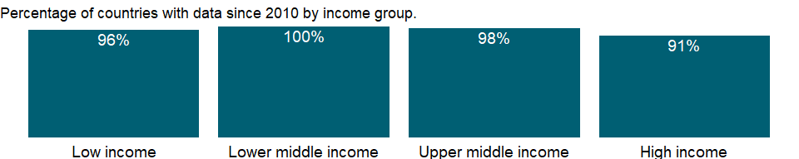

### Why is it relevant?

The digital and information revolution has changed the way the world learns, communicates, does business, and treats illnesses. New information and communications technologies (ICT) offer vast opportunities for progress in all walks of life in all countries - opportunities for economic growth, improved health, better service delivery, learning through distance education, and social and cultural advances.

Today’s smartphones and tablets have computer power equivalent to that of yesterday’s computers and provide a similar range of functions. Device convergence is thus rendering the conventional definition obsolete.

Comparable statistics on access, use, quality, and affordability of ICT are needed to formulate growth-enabling policies for the sector and to monitor and evaluate the sector’s impact on development. Although basic access data are available for many countries, in most developing countries little is known about who uses ICT; what they are used for (school, work, business, research, government); and how they affect people and businesses. The global Partnership on Measuring ICT for Development is helping to set standards, harmonize information and communications technology statistics, and build statistical capacity in developing countries. However, despite significant improvements in the developing world, the gap between the ICT haves and have-nots remains.

### What is the data source?

International Telecommunication Union (ITU) World Telecommunication/ICT Indicators Database

### What is the methodology?

The Internet is a world-wide public computer network. It provides access to a number of communication services including the World Wide Web and carries email, news, entertainment and data files, irrespective of the device used (not assumed to be only via a computer - it may also be by mobile phone, PDA, games machine, digital TV etc.). Access can be via a fixed or mobile network. For additional/latest information on sources and country notes, please also refer to: <https://www.itu.int/en/ITU-D/Statistics/Pages/stat/default.aspx>

### How is it aggregated?

Weighted average

### What are the limitations?

Operators have traditionally been the main source of telecommunications data, so information on subscriptions has been widely available for most countries. This gives a general idea of access, but a more precise measure is the penetration rate - the share of households with access to telecommunications. During the past few years more information on information and communication technology use has become available from household and business surveys. Also important are data on actual use of telecommunications services. Ideally, statistics on telecommunications (and other information and communications technologies) should be compiled for all three measures: subscriptions, access, and use. The quality of data varies among reporting countries as a result of differences in regulations covering data provision and availability.

Discrepancies may also arise in cases where the end of a fiscal year differs from that used by ITU, which is the end of December of every year. A number of countries have fiscal years that end in March or June of every year.

### What else should I know?

Please cite the International Telecommunication Union for third-party use of these data.

### 1.8.12 ICT goods imports (% total goods imports)

### What is the indicator?

Information and communication technology goods imports include computers and peripheral equipment, communication equipment, consumer electronic equipment, electronic components, and other information and technology goods (miscellaneous).

Topic: Infrastructure: Communications

Series ID: TM.VAL.ICTG.ZS.UN

Copyright: CC BY-4.0 , <https://datacatalog.worldbank.org/public-licenses#cc-by>

First year with any data: 2000

Last year with any data: 2019

### What years are data available?

The figure below shows years in which data is available for at least one country. Dates shaded in black have no data, while dates shaded in green have data for at least one country

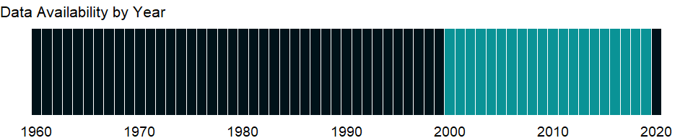

### Which countries have data?

The figure below shows the percentage of countries in each income group with a value since 2010 for that indicator.

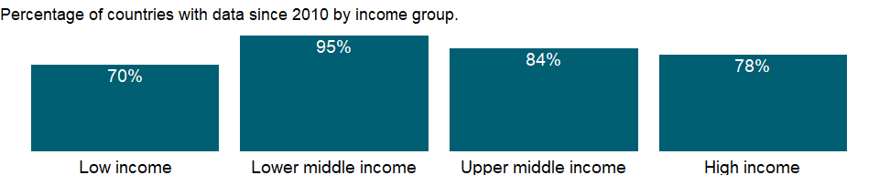

### Why is it relevant?

The digital and information revolution has changed the way the world learns, communicates, does business, and treats illnesses. New information and communications technologies (ICT) offer vast opportunities for progress in all walks of life in all countries - opportunities for economic growth, improved health, better service delivery, learning through distance education, and social and cultural advances.

Comparable statistics on access, use, quality, and affordability of ICT are needed to formulate growth-enabling policies for the sector and to monitor and evaluate the sector’s impact on development. Although basic access data are available for many countries, in most developing countries little is known about who uses ICT; what they are used for (school, work, business, research, government); and how they affect people and businesses. The global Partnership on Measuring ICT for Development is helping to set standards, harmonize information and communications technology statistics, and build statistical capacity in developing countries. For more information see www.itu.int/ITU-D/ict/partnership/.

The work of the Partnership is directed towards achieving internationally comparable and reliable ICT statistics. In order to achieve this, its members are involved in developing and maintaining a core list of ICT indicators. Other activities include the compilation and dissemination of ICT data, and the provision of technical assistance enabling statistical agencies to collect data that underlie the core list of ICT indicators.

### What is the data source?

United Nations Conference on Trade and Development’s UNCTADstat database at <http://unctadstat.unctad.org/ReportFolders/reportFolders.aspx>.

### What is the methodology?

Information and communication technology goods imports include computers and peripheral equipment, communication equipment, consumer electronic equipment, electronic components, and other information and technology goods (miscellaneous). Software is generally excluded, as there is a preference to record it under services (not an ICT good but an ICT product) to the extent possible. However it is hard to completely exclude embedded software from certain types of ICT goods, such as video game consoles (see for example the discussion on page 30 of the OECD guide cited below). ICT goods imports as a percentage of total imports is calculated for each country by dividing the value of its ICT goods imports by the total value of its goods imports. The result is then multiplied by 100 to be expressed as a percentage.

ICT goods are defined according to the OECD’s Guide on Measuring the Information Society 2011 for Harmonized System (HS) 2007 and adapted to HS12 by UNCTAD in collaboration with UNSD (United Nations Statistics Division). This new list consists of 93 goods defined at the 6 digit level of the 2012 version of the HS. The technical note is available online at: <http://unctad.org/en/PublicationsLibrary/tn_unctad_ict4d02_en.pdf> Data were downloaded from COMTRADE according to the reported classification (HS92, 96, 02, 07, 12) and aggregated into ICT groups by UNCTAD.

### How is it aggregated?

Weighted average

### What are the limitations?

Detailed trade data are widely available from country trade statistics. These are collected by the UNSD and published in their UN COMTRADE database. The ICT goods trade indicators are usually compiled by interested international and national agencies using COMTRADE data. Concepts are therefore consistent with those applying to the COMTRADE database.

The main statistical issue associated with this indicator appears to be the different treatment of re-exports and re-imports by countries, depending on whether the Special or General Trade System is used.2 Re-imports are separately reported for some countries and the value of ICT re-imports (which is included in the value of ICT imports for those countries) is generally small.

### What else should I know?

NA

### 1.8.13 ICT goods exports (% of total goods exports)

### What is the indicator?

Information and communication technology goods exports include computers and peripheral equipment, communication equipment, consumer electronic equipment, electronic components, and other information and technology goods (miscellaneous).

Topic: Infrastructure: Communications

Series ID: TX.VAL.ICTG.ZS.UN

Copyright: CC BY-4.0 , <https://datacatalog.worldbank.org/public-licenses#cc-by>

First year with any data: 2000

Last year with any data: 2019

### What years are data available?

The figure below shows years in which data is available for at least one country. Dates shaded in black have no data, while dates shaded in green have data for at least one country



### Which countries have data?

The figure below shows the percentage of countries in each income group with a value since 2010 for that indicator.

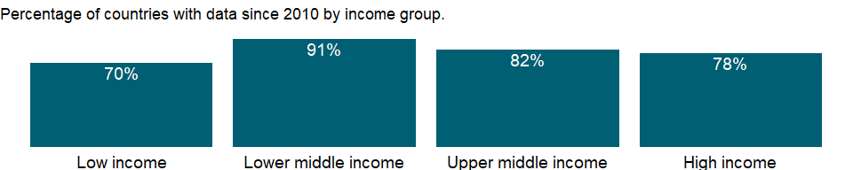

### Why is it relevant?

The digital and information revolution has changed the way the world learns, communicates, does business, and treats illnesses. New information and communications technologies (ICT) offer vast opportunities for progress in all walks of life in all countries - opportunities for economic growth, improved health, better service delivery, learning through distance education, and social and cultural advances.

Comparable statistics on access, use, quality, and affordability of ICT are needed to formulate growth-enabling policies for the sector and to monitor and evaluate the sector’s impact on development. Although basic access data are available for many countries, in most developing countries little is known about who uses ICT; what they are used for (school, work, business, research, government); and how they affect people and businesses. The global Partnership on Measuring ICT for Development is helping to set standards, harmonize information and communications technology statistics, and build statistical capacity in developing countries. For more information see www.itu.int/ITU-D/ict/partnership/.

The work of the Partnership is directed towards achieving internationally comparable and reliable ICT statistics. In order to achieve this, its members are involved in developing and maintaining a core list of ICT indicators. Other activities include the compilation and dissemination of ICT data, and the provision of technical assistance enabling statistical agencies to collect data that underlie the core list of ICT indicators.

### What is the data source?

United Nations Conference on Trade and Development’s UNCTADstat database at <http://unctadstat.unctad.org/ReportFolders/reportFolders.aspx>.

### What is the methodology?

Information and communication technology goods exports include computers and peripheral equipment, communication equipment, consumer electronic equipment, electronic components, and other information and technology goods (miscellaneous). Software is generally excluded, as there is a preference to record it under services (not an ICT good but an ICT product) to the extent possible. However it is hard to completely exclude embedded software from certain types of ICT goods, such as video game consoles (see for example the discussion on page 30 of the OECD guide cited below). ICT goods exports as a percentage of total goods exports is calculated for each country by dividing the value of its ICT goods exports by the total value of its goods exports. The result is then multiplied by 100 to be expressed as a percentage.

ICT goods are defined according to the OECD’s Guide on Measuring the Information Society 2011 for Harmonized System (HS) 2007 and adapted to HS12 by UNCTAD in collaboration with UNSD (United Nations Statistics Division). This new list consists of 93 goods defined at the 6 digit level of the 2012 version of the HS. The technical note is available online at: <http://unctad.org/en/PublicationsLibrary/tn_unctad_ict4d02_en.pdf> Data were downloaded from COMTRADE according to the reported classification (HS92, 96, 02, 07, 12) and aggregated into ICT groups by UNCTAD.

### How is it aggregated?

Weighted average

### What are the limitations?

Detailed trade data are widely available from country trade statistics. These are collected by the UNSD and published in their UN COMTRADE database. The ICT goods trade indicators are usually compiled by interested international and national agencies using COMTRADE data. Concepts are therefore consistent with those applying to the COMTRADE database.

The main statistical issue associated with this indicator appears to be the different treatment of re-exports and re-imports by countries, depending on whether the Special or General Trade System is used.2 Re-imports are separately reported for some countries and the value of ICT re-imports (which is included in the value of ICT imports for those countries) is generally small.

### What else should I know?

NA

## 1.9 Financial Sector: Capital markets

### 1.9.1 S&P Global Equity Indices (annual % change)

### What is the indicator?

S&P Global Equity Indices measure the U.S. dollar price change in the stock markets covered by the S&P/IFCI and S&P/Frontier BMI country indices.

Topic: Financial Sector: Capital markets

Series ID: CM.MKT.INDX.ZG

Copyright: CC BY-4.0 , <https://datacatalog.worldbank.org/public-licenses#cc-by>

First year with any data: 1990

Last year with any data: 2020

### What years are data available?

The figure below shows years in which data is available for at least one country. Dates shaded in black have no data, while dates shaded in green have data for at least one country



### Which countries have data?

The figure below shows the percentage of countries in each income group with a value since 2010 for that indicator.

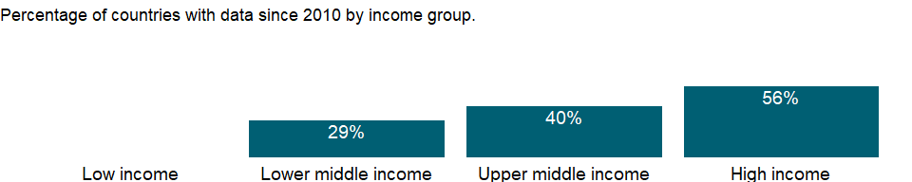

### Why is it relevant?

Stock market size can be measured in various ways, and each may produce a different ranking of countries.

The development of an economy’s financial markets is closely related to its overall development. Well-functioning financial systems provide good and easily accessible information. That lowers transaction costs, which in turn improves resource allocation and boosts economic growth. Both banking systems and stock markets enhance growth, the main factor in poverty reduction. At low levels of economic development commercial banks tend to dominate the financial system, while at higher levels domestic stock markets tend to become more active and efficient relative to domestic banks.

Open economies with sound macroeconomic policies, good legal systems, and shareholder protection attract capital and therefore have larger financial markets. Recent research on stock market development shows that modern communications technology and increased financial integration have resulted in more cross-border capital flows, a stronger presence of financial firms around the world, and the migration of stock exchange activities to international exchanges. Many firms in emerging markets now cross-list on international exchanges, which provides them with lower cost capital and more liquidity-traded shares. However, this also means that exchanges in emerging markets may not have enough financial activity to sustain them, putting pressure on them to rethink their operations.

The S&P Global Equity Index Series covers approximately 11,000 securities from over 80 countries. It includes the S&P Global Broad Market Index (BMI), S&P Global 1200, S&P/IFCI, and S&P Frontier BMI. All indices are float-adjusted, market capitalization-weighted indices and include security classifications for country, size, style and industry.

The S&P Global Broad Market Index (BMI) is a global index suite with a transparent, modular structure that has been fully float adjusted since 1989. This index series employs a transparent and consistent methodology across all countries and includes approximately 10,000 stocks from 26 developed and 20 emerging markets.

The S&P Global 1200, a real-time, tradable global equity index covers approximately 70 percent of the world’s market capitalization, giving a detail view of the world economy. It is a composite of seven headline regional indices: S&P 500®, S&P Europe 350, S&P TOPIX 150, S&P/TSX 60, S&P/ASX All Australian 50, S&P Asia 50 and S&P Latin America 40.

### What is the data source?

Standard & Poor’s, Global Stock Markets Factbook and supplemental S&P data.

### What is the methodology?

Ratios of end-of-period levels in U.S. dollars over previous end-of-period values in U.S. dollars times 100. These indexes are widely used benchmarks for international portfolio management.

### How is it aggregated?

NA

### What are the limitations?

The percentage change in stock market prices in U.S. dollars for developing economies is from Standard & Poor’s Global Equity Indices (S&P IFCI) and Standard & Poor’s Frontier Broad Market Index (BMI). The percentage change for France, Germany, Japan, the United Kingdom, and the United States is from local stock market prices.

The indicator is an important measure of overall performance. Regulatory and institutional factors that can affect investor confidence, such as entry and exit restrictions, the existence of a securities and exchange commission, and the quality of laws to protect investors, may influence the functioning of stock markets.

Because markets included in Standard & Poor’s emerging markets category vary widely in level of development, it is best to look at the entire category to identify the most significant market trends. And it is useful to remember that stock market trends may be distorted by currency conversions, especially when a currency has registered a significant devaluation.

### What else should I know?

NA

### 1.9.2 Market capitalization of listed domestic companies (current US$)

### What is the indicator?

Market capitalization (also known as market value) is the share price times the number of shares outstanding (including their several classes) for listed domestic companies. Investment funds, unit trusts, and companies whose only business goal is to hold shares of other listed companies are excluded. Data are end of year values converted to U.S. dollars using corresponding year-end foreign exchange rates.

Topic: Financial Sector: Capital markets

Series ID: CM.MKT.LCAP.CD

Copyright: CC BY-4.0 , <https://datacatalog.worldbank.org/public-licenses#cc-by>

First year with any data: 1975

Last year with any data: 2020

### What years are data available?

The figure below shows years in which data is available for at least one country. Dates shaded in black have no data, while dates shaded in green have data for at least one country

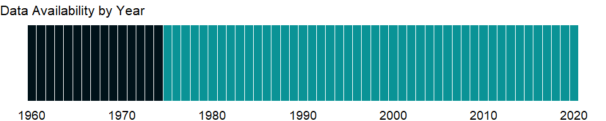

### Which countries have data?

The figure below shows the percentage of countries in each income group with a value since 2010 for that indicator.

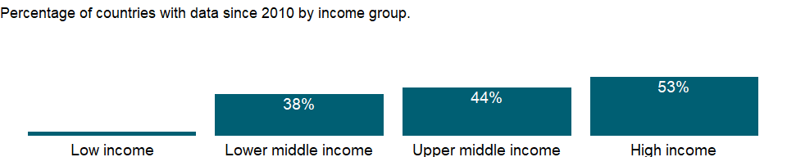

### Why is it relevant?

Stock market size can be measured in various ways, and each may produce a different ranking of countries.

The development of an economy’s financial markets is closely related to its overall development. Well-functioning financial systems provide good and easily accessible information which can lower transaction costs and subsequently improve resource allocation and boosts economic growth. Both banking systems and stock markets enhance growth, the main factor in poverty reduction. At low levels of economic development commercial banks tend to dominate the financial system, while at higher levels domestic stock markets tend to become more active and efficient relative to domestic banks.

Open economies with sound macroeconomic policies, good legal systems, and shareholder protection attract capital and therefore have larger financial markets. Recent research on stock market development shows that modern communications technology and increased financial integration have resulted in more cross-border capital flows, a stronger presence of financial firms around the world, and the migration of stock exchange activities to international exchanges. Many firms in emerging markets now cross-list on international exchanges, which provides them with lower cost capital and more liquidity-traded shares. However, this also means that exchanges in emerging markets may not have enough financial activity to sustain them, putting pressure on them to rethink their operations.

### What is the data source?

World Federation of Exchanges database.

### What is the methodology?

Market capitalization figures include: shares of listed domestic companies; shares of foreign companies which are exclusively listed on an exchange (i.e., the foreign company is not listed on any other exchange); common and preferred shares of domestic companies; and shares without voting rights. Market capitalization figures exclude: collective investment funds ; rights, warrants, ETFs, convertible instruments ; options, futures ; foreign listed shares other than exclusively listed ones; companies whose only business goal is to hold shares of other listed companies, such as holding companies and investment companies, regardless of their legal status; and companies admitted to trading (i.e., companies whose shares are traded at the exchange but not listed at the exchange).

### How is it aggregated?

Sum

### What are the limitations?

Data cover measures of size (market capitalization, number of listed domestic companies) and liquidity (value of shares traded as a percentage of gross domestic product, value of shares traded as a percentage of market capitalization). The comparability of such data across countries may be limited by conceptual and statistical weaknesses, such as inaccurate reporting and differences in accounting standards.

### What else should I know?

Stock market data were previously sourced from Standard & Poor’s until they discontinued their “Global Stock Markets Factbook” and database in April 2013. Time series have been replaced in December 2015 with data from the World Federation of Exchanges and may differ from the previous S&P definitions and methodology.

### 1.9.3 Market capitalization of listed domestic companies (% of GDP)

### What is the indicator?

Market capitalization (also known as market value) is the share price times the number of shares outstanding (including their several classes) for listed domestic companies. Investment funds, unit trusts, and companies whose only business goal is to hold shares of other listed companies are excluded. Data are end of year values.

Topic: Financial Sector: Capital markets

Series ID: CM.MKT.LCAP.GD.ZS

Copyright: CC BY-4.0 , <https://datacatalog.worldbank.org/public-licenses#cc-by>

First year with any data: 1975

Last year with any data: 2020

### What years are data available?

The figure below shows years in which data is available for at least one country. Dates shaded in black have no data, while dates shaded in green have data for at least one country



### Which countries have data?

The figure below shows the percentage of countries in each income group with a value since 2010 for that indicator.



### Why is it relevant?

Stock market size can be measured in various ways, and each may produce a different ranking of countries.

The development of an economy’s financial markets is closely related to its overall development. Well-functioning financial systems provide good and easily accessible information which can lower transaction costs and subsequently improve resource allocation and boosts economic growth. Both banking systems and stock markets enhance growth, the main factor in poverty reduction. At low levels of economic development commercial banks tend to dominate the financial system, while at higher levels domestic stock markets tend to become more active and efficient relative to domestic banks.

Open economies with sound macroeconomic policies, good legal systems, and shareholder protection attract capital and therefore have larger financial markets. Recent research on stock market development shows that modern communications technology and increased financial integration have resulted in more cross-border capital flows, a stronger presence of financial firms around the world, and the migration of stock exchange activities to international exchanges. Many firms in emerging markets now cross-list on international exchanges, which provides them with lower cost capital and more liquidity-traded shares. However, this also means that exchanges in emerging markets may not have enough financial activity to sustain them, putting pressure on them to rethink their operations.

### What is the data source?

World Federation of Exchanges database.

### What is the methodology?

Market capitalization figures include: shares of listed domestic companies; shares of foreign companies which are exclusively listed on an exchange (i.e., the foreign company is not listed on any other exchange); common and preferred shares of domestic companies; and shares without voting rights. Market capitalization figures exclude: collective investment funds ; rights, warrants, ETFs, convertible instruments ; options, futures ; foreign listed shares other than exclusively listed ones; companies whose only business goal is to hold shares of other listed companies, such as holding companies and investment companies, regardless of their legal status; and companies admitted to trading (i.e., companies whose shares are traded at the exchange but not listed at the exchange).

### How is it aggregated?

Weighted Average

### What are the limitations?

Data cover measures of size (market capitalization, number of listed domestic companies) and liquidity (value of shares traded as a percentage of gross domestic product, value of shares traded as a percentage of market capitalization). The comparability of such data across countries may be limited by conceptual and statistical weaknesses, such as inaccurate reporting and differences in accounting standards.

### What else should I know?

Stock market data were previously sourced from Standard & Poor’s until they discontinued their “Global Stock Markets Factbook” and database in April 2013. Time series have been replaced in December 2015 with data from the World Federation of Exchanges and may differ from the previous S&P definitions and methodology.

### 1.9.4 Listed domestic companies, total

### What is the indicator?

Listed domestic companies, including foreign companies which are exclusively listed, are those which have shares listed on an exchange at the end of the year. Investment funds, unit trusts, and companies whose only business goal is to hold shares of other listed companies, such as holding companies and investment companies, regardless of their legal status, are excluded. A company with several classes of shares is counted once. Only companies admitted to listing on the exchange are included.

Topic: Financial Sector: Capital markets

Series ID: CM.MKT.LDOM.NO

Copyright: CC BY-4.0 , <https://datacatalog.worldbank.org/public-licenses#cc-by>

First year with any data: 1975

Last year with any data: 2020

### What years are data available?

The figure below shows years in which data is available for at least one country. Dates shaded in black have no data, while dates shaded in green have data for at least one country



### Which countries have data?

The figure below shows the percentage of countries in each income group with a value since 2010 for that indicator.

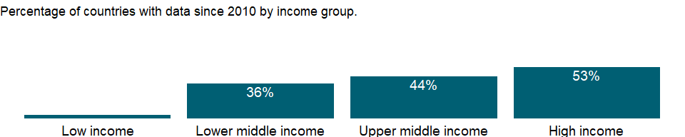

### Why is it relevant?

Stock market size can be measured in various ways, and each may produce a different ranking of countries.

The development of an economy’s financial markets is closely related to its overall development. Well-functioning financial systems provide good and easily accessible information which can lower transaction costs and subsequently improve resource allocation and boosts economic growth. Both banking systems and stock markets enhance growth, the main factor in poverty reduction. At low levels of economic development commercial banks tend to dominate the financial system, while at higher levels domestic stock markets tend to become more active and efficient relative to domestic banks.

Open economies with sound macroeconomic policies, good legal systems, and shareholder protection attract capital and therefore have larger financial markets. Recent research on stock market development shows that modern communications technology and increased financial integration have resulted in more cross-border capital flows, a stronger presence of financial firms around the world, and the migration of stock exchange activities to international exchanges. Many firms in emerging markets now cross-list on international exchanges, which provides them with lower cost capital and more liquidity-traded shares. However, this also means that exchanges in emerging markets may not have enough financial activity to sustain them, putting pressure on them to rethink their operations.

### What is the data source?

World Federation of Exchanges database.

### What is the methodology?

A company is considered domestic when it is incorporated in the same country as where the exchange is located. The only exception is the case of foreign companies which are exclusively listed on an exchange (i.e., the foreign company is not listed on any other exchange as defined in the domestic market capitalization definition).

### How is it aggregated?

Sum

### What are the limitations?

Data cover measures of size (market capitalization, number of listed domestic companies) and liquidity (value of shares traded as a percentage of gross domestic product, value of shares traded as a percentage of market capitalization). The comparability of such data across countries may be limited by conceptual and statistical weaknesses, such as inaccurate reporting and differences in accounting standards.

### What else should I know?

Stock market data were previously sourced from Standard & Poor’s until they discontinued their “Global Stock Markets Factbook” and database in April 2013. Time series have been replaced in December 2015 with data from the World Federation of Exchanges and may differ from the previous S&P definitions and methodology.

### 1.9.5 Stocks traded, total value (current US$)

### What is the indicator?

The value of shares traded is the total number of shares traded, both domestic and foreign, multiplied by their respective matching prices. Figures are single counted (only one side of the transaction is considered). Companies admitted to listing and admitted to trading are included in the data. Data are end of year values converted to U.S. dollars using corresponding year-end foreign exchange rates.

Topic: Financial Sector: Capital markets

Series ID: CM.MKT.TRAD.CD

Copyright: CC BY-4.0 , <https://datacatalog.worldbank.org/public-licenses#cc-by>

First year with any data: 1975

Last year with any data: 2020

### What years are data available?

The figure below shows years in which data is available for at least one country. Dates shaded in black have no data, while dates shaded in green have data for at least one country



### Which countries have data?

The figure below shows the percentage of countries in each income group with a value since 2010 for that indicator.



### Why is it relevant?

Stock market size can be measured in various ways, and each may produce a different ranking of countries.

The development of an economy’s financial markets is closely related to its overall development. Well-functioning financial systems provide good and easily accessible information which can lower transaction costs and subsequently improve resource allocation and boosts economic growth. Both banking systems and stock markets enhance growth, the main factor in poverty reduction. At low levels of economic development commercial banks tend to dominate the financial system, while at higher levels domestic stock markets tend to become more active and efficient relative to domestic banks.

Open economies with sound macroeconomic policies, good legal systems, and shareholder protection attract capital and therefore have larger financial markets. Recent research on stock market development shows that modern communications technology and increased financial integration have resulted in more cross-border capital flows, a stronger presence of financial firms around the world, and the migration of stock exchange activities to international exchanges. Many firms in emerging markets now cross-list on international exchanges, which provides them with lower cost capital and more liquidity-traded shares. However, this also means that exchanges in emerging markets may not have enough financial activity to sustain them, putting pressure on them to rethink their operations.

### What is the data source?

World Federation of Exchanges database.

### What is the methodology?

The value of shares traded represent the transfer of ownership effected automatically through the exchange’s electronic order book (EOB), where orders placed by trading members are usually exposed to all market users and automatically matched according to precise rules set up by the exchange, generally on a price/time priority basis. For data before 2001, the WFE used two different approaches for the collection of trading data, depending on the individual stock exchange’s market organization and rules. The first approach is the Trading System View (TSV). Stock exchanges adopting this view count only those transactions which pass through their trading system or trading floor. The TSV is generally adopted by exchanges which operate a centralized order book (order-driven market). Trades done by their members off the exchange are not included. The second approach is the Regulated Environment View (REV). Stock exchanges in this category include all transactions subject to supervision by the market authority, including transactions made by members, and sometimes non-members, on outside trading systems and transactions into foreign markets. Figures reported under the REV approach will be higher than those reported under the TSV approach.

### How is it aggregated?

Sum

### What are the limitations?

Data cover measures of size (market capitalization, number of listed domestic companies) and liquidity (value of shares traded as a percentage of gross domestic product, value of shares traded as a percentage of market capitalization). The comparability of such data across countries may be limited by conceptual and statistical weaknesses, such as inaccurate reporting and differences in accounting standards. Only EOB trades are included in the total value of shares traded.

### What else should I know?

Stock market data were previously sourced from Standard & Poor’s until they discontinued their “Global Stock Markets Factbook” and database in April 2013. Time series have been replaced in December 2015 with data from the World Federation of Exchanges and may differ from the previous S&P definitions and methodology.

### 1.9.6 Stocks traded, total value (% of GDP)

### What is the indicator?

The value of shares traded is the total number of shares traded, both domestic and foreign, multiplied by their respective matching prices. Figures are single counted (only one side of the transaction is considered). Companies admitted to listing and admitted to trading are included in the data. Data are end of year values.

Topic: Financial Sector: Capital markets

Series ID: CM.MKT.TRAD.GD.ZS

Copyright: CC BY-4.0 , <https://datacatalog.worldbank.org/public-licenses#cc-by>

First year with any data: 1975

Last year with any data: 2020

### What years are data available?

The figure below shows years in which data is available for at least one country. Dates shaded in black have no data, while dates shaded in green have data for at least one country



### Which countries have data?

The figure below shows the percentage of countries in each income group with a value since 2010 for that indicator.



### Why is it relevant?

Stock market size can be measured in various ways, and each may produce a different ranking of countries.

The development of an economy’s financial markets is closely related to its overall development. Well-functioning financial systems provide good and easily accessible information which can lower transaction costs and subsequently improve resource allocation and boosts economic growth. Both banking systems and stock markets enhance growth, the main factor in poverty reduction. At low levels of economic development commercial banks tend to dominate the financial system, while at higher levels domestic stock markets tend to become more active and efficient relative to domestic banks.

Open economies with sound macroeconomic policies, good legal systems, and shareholder protection attract capital and therefore have larger financial markets. Recent research on stock market development shows that modern communications technology and increased financial integration have resulted in more cross-border capital flows, a stronger presence of financial firms around the world, and the migration of stock exchange activities to international exchanges. Many firms in emerging markets now cross-list on international exchanges, which provides them with lower cost capital and more liquidity-traded shares. However, this also means that exchanges in emerging markets may not have enough financial activity to sustain them, putting pressure on them to rethink their operations.

### What is the data source?

World Federation of Exchanges database.

### What is the methodology?

The value of shares traded represent the transfer of ownership effected automatically through the exchange’s electronic order book (EOB), where orders placed by trading members are usually exposed to all market users and automatically matched according to precise rules set up by the exchange, generally on a price/time priority basis. For data before 2001, the WFE used two different approaches for the collection of trading data, depending on the individual stock exchange’s market organization and rules. The first approach is the Trading System View (TSV). Stock exchanges adopting this view count only those transactions which pass through their trading system or trading floor. The TSV is generally adopted by exchanges which operate a centralized order book (order-driven market). Trades done by their members off the exchange are not included. The second approach is the Regulated Environment View (REV). Stock exchanges in this category include all transactions subject to supervision by the market authority, including transactions made by members, and sometimes non-members, on outside trading systems and transactions into foreign markets. Figures reported under the REV approach will be higher than those reported under the TSV approach.

### How is it aggregated?

Weighted Average

### What are the limitations?

Data cover measures of size (market capitalization, number of listed domestic companies) and liquidity (value of shares traded as a percentage of gross domestic product, value of shares traded as a percentage of market capitalization). The comparability of such data across countries may be limited by conceptual and statistical weaknesses, such as inaccurate reporting and differences in accounting standards. Only EOB trades are included in the total value of shares traded.

### What else should I know?

Stock market data were previously sourced from Standard & Poor’s until they discontinued their “Global Stock Markets Factbook” and database in April 2013. Time series have been replaced in December 2015 with data from the World Federation of Exchanges and may differ from the previous S&P definitions and methodology.

### 1.9.7 Stocks traded, turnover ratio of domestic shares (%)

### What is the indicator?

Turnover ratio is the value of domestic shares traded divided by their market capitalization. The value is annualized by multiplying the monthly average by 12.

Topic: Financial Sector: Capital markets

Series ID: CM.MKT.TRNR

Copyright: CC BY-4.0 , <https://datacatalog.worldbank.org/public-licenses#cc-by>

First year with any data: 1975

Last year with any data: 2020

### What years are data available?

The figure below shows years in which data is available for at least one country. Dates shaded in black have no data, while dates shaded in green have data for at least one country



### Which countries have data?

The figure below shows the percentage of countries in each income group with a value since 2010 for that indicator.

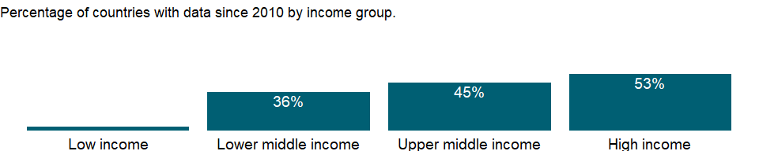

### Why is it relevant?

Stock market size can be measured in various ways, and each may produce a different ranking of countries.

The development of an economy’s financial markets is closely related to its overall development. Well-functioning financial systems provide good and easily accessible information which can lower transaction costs and subsequently improve resource allocation and boosts economic growth. Both banking systems and stock markets enhance growth, the main factor in poverty reduction. At low levels of economic development commercial banks tend to dominate the financial system, while at higher levels domestic stock markets tend to become more active and efficient relative to domestic banks.

Open economies with sound macroeconomic policies, good legal systems, and shareholder protection attract capital and therefore have larger financial markets. Recent research on stock market development shows that modern communications technology and increased financial integration have resulted in more cross-border capital flows, a stronger presence of financial firms around the world, and the migration of stock exchange activities to international exchanges. Many firms in emerging markets now cross-list on international exchanges, which provides them with lower cost capital and more liquidity-traded shares. However, this also means that exchanges in emerging markets may not have enough financial activity to sustain them, putting pressure on them to rethink their operations.

### What is the data source?

World Federation of Exchanges database.

### What is the methodology?

Turnover ratio is the value of electronic order book (EOB) domestic shares traded divided by their market capitalization. The value is annualized by multiplying the monthly average by 12, according to the following formula: (Monthly EOB domestic shares traded / Month-end domestic market capitalization) x 12.

### How is it aggregated?

Weighted average

### What are the limitations?

Data cover measures of size (market capitalization, number of listed domestic companies) and liquidity (value of shares traded as a percentage of gross domestic product, value of shares traded as a percentage of market capitalization). The comparability of such data across countries may be limited by conceptual and statistical weaknesses, such as inaccurate reporting and differences in accounting standards. Only domestic shares are used in order to be consistent with domestic market capitalization.

### What else should I know?

Stock market data were previously sourced from Standard & Poor’s until they discontinued their “Global Stock Markets Factbook” and database in April 2013. Time series have been replaced in December 2015 with data from the World Federation of Exchanges and may differ from the previous S&P definitions and methodology.

## 1.10 Economic Policy & Debt: Official development assistance

### 1.10.1 Net bilateral aid flows from DAC donors, Australia (current US$)

### What is the indicator?

Net bilateral aid flows from DAC donors are the net disbursements of official development assistance (ODA) or official aid from the members of the Development Assistance Committee (DAC). Net disbursements are gross disbursements of grants and loans minus repayments of principal on earlier loans. ODA consists of loans made on concessional terms (with a grant element of at least 25 percent, calculated at a rate of discount of 10 percent) and grants made to promote economic development and welfare in countries and territories in the DAC list of ODA recipients. Official aid refers to aid flows from official donors to countries and territories in part II of the DAC list of recipients: more advanced countries of Central and Eastern Europe, the countries of the former Soviet Union, and certain advanced developing countries and territories. Official aid is provided under terms and conditions similar to those for ODA. Part II of the DAC List was abolished in 2005. The collection of data on official aid and other resource flows to Part II countries ended with 2004 data. DAC members are Australia, Austria, Belgium, Canada, Czech Republic, Denmark, Finland, France, Germany, Greece, Hungary, Iceland, Ireland, Italy, Japan, Korea, Luxembourg, The Netherlands, New Zealand, Norway, Poland, Portugal, Slovak Republic, Slovienia, Spain, Sweden, Switzerland, United Kingdom, United States, and European Union Institutions. Regional aggregates include data for economies not specified elsewhere. World and income group totals include aid not allocated by country or region. Data are in current U.S. dollars.

Topic: Economic Policy & Debt: Official development assistance

Series ID: DC.DAC.AUSL.CD

Copyright: CC BY-4.0 , <https://datacatalog.worldbank.org/public-licenses#cc-by>

First year with any data: 1965

Last year with any data: 2019

### What years are data available?

The figure below shows years in which data is available for at least one country. Dates shaded in black have no data, while dates shaded in green have data for at least one country

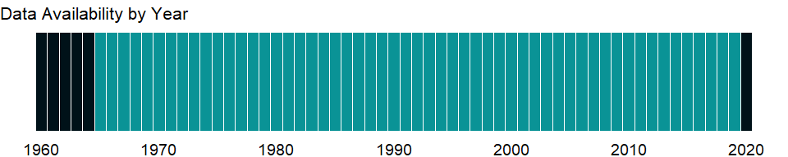

### Which countries have data?

The figure below shows the percentage of countries in each income group with a value since 2010 for that indicator.

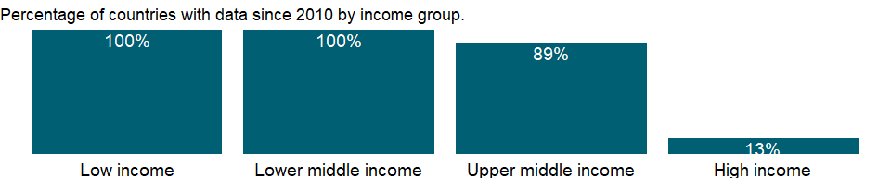

### Why is it relevant?

NA

### What is the data source?

Development Assistance Committee of the Organisation for Economic Co-operation and Development, Geographical Distribution of Financial Flows to Developing Countries, Development Co-operation Report, and International Development Statistics database. Data are available online at: <https://stats.oecd.org/>.

### What is the methodology?

The Development Assistance Committee (DAC) of the Organisation for Economic Co-operation and Development (OECD) has 30 members - 29 individual economies and 1 multilateral institution (European Union institutions).

Data are based on donor country reports of bilateral programs, which may differ from reports by recipient countries. Recipients may lack access to information on such aid expenditures as development-oriented research, stipends and tuition costs for aid-financed students in donor countries, and payment of experts hired by donor countries. Moreover, a full accounting would include donor country contributions to multilateral institutions, the flow of resources from multilateral institutions to recipient countries, and flows from countries that are not members of DAC.

Some of the aid recipients are also aid donors. Development cooperation activities by non-DAC members have increased in recent years and in some cases surpass those of individual DAC members. Some non-DAC donors report their development cooperation activities to DAC on a voluntary basis, but many do not yet report their aid flows to DAC.

### How is it aggregated?

Sum

### What are the limitations?

Data exclude DAC members’ multilateral aid (contributions to the regular budgets of the multilateral institutions). However, projects executed by multilateral institutions or nongovernmental organizations on behalf of DAC members are classified as bilateral aid (since the donor country effectively controls the use of the funds) and are included in the data.

Aid to unspecified economies is included in regional totals and, when possible, income group totals. Aid not allocated by country or region - including administrative costs, research on development, and aid to nongovernmental organizations - is included in the world total. Thus regional and income group totals do not sum to the world total.

### What else should I know?

NA

### 1.10.2 Net bilateral aid flows from DAC donors, Austria (current US$)

### What is the indicator?

Net bilateral aid flows from DAC donors are the net disbursements of official development assistance (ODA) or official aid from the members of the Development Assistance Committee (DAC). Net disbursements are gross disbursements of grants and loans minus repayments of principal on earlier loans. ODA consists of loans made on concessional terms (with a grant element of at least 25 percent, calculated at a rate of discount of 10 percent) and grants made to promote economic development and welfare in countries and territories in the DAC list of ODA recipients. Official aid refers to aid flows from official donors to countries and territories in part II of the DAC list of recipients: more advanced countries of Central and Eastern Europe, the countries of the former Soviet Union, and certain advanced developing countries and territories. Official aid is provided under terms and conditions similar to those for ODA. Part II of the DAC List was abolished in 2005. The collection of data on official aid and other resource flows to Part II countries ended with 2004 data. DAC members are Australia, Austria, Belgium, Canada, Czech Republic, Denmark, Finland, France, Germany, Greece, Hungary, Iceland, Ireland, Italy, Japan, Korea, Luxembourg, The Netherlands, New Zealand, Norway, Poland, Portugal, Slovak Republic, Slovienia, Spain, Sweden, Switzerland, United Kingdom, United States, and European Union Institutions. Regional aggregates include data for economies not specified elsewhere. World and income group totals include aid not allocated by country or region. Data are in current U.S. dollars.

Topic: Economic Policy & Debt: Official development assistance

Series ID: DC.DAC.AUTL.CD

Copyright: CC BY-4.0 , <https://datacatalog.worldbank.org/public-licenses#cc-by>

First year with any data: 1960

Last year with any data: 2019

### What years are data available?

The figure below shows years in which data is available for at least one country. Dates shaded in black have no data, while dates shaded in green have data for at least one country

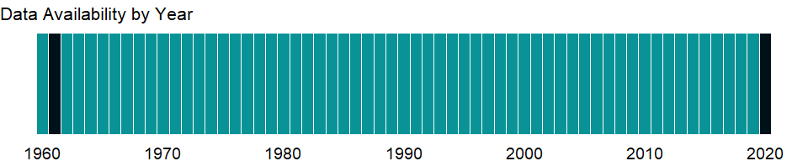

### Which countries have data?

The figure below shows the percentage of countries in each income group with a value since 2010 for that indicator.

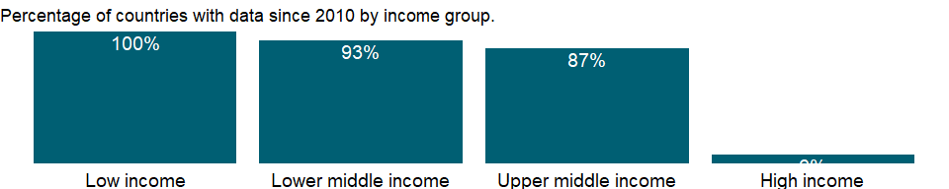

### Why is it relevant?

NA

### What is the data source?

Development Assistance Committee of the Organisation for Economic Co-operation and Development, Geographical Distribution of Financial Flows to Developing Countries, Development Co-operation Report, and International Development Statistics database. Data are available online at: <https://stats.oecd.org/>.

### What is the methodology?

The Development Assistance Committee (DAC) of the Organisation for Economic Co-operation and Development (OECD) has 30 members - 29 individual economies and 1 multilateral institution (European Union institutions).

Data are based on donor country reports of bilateral programs, which may differ from reports by recipient countries. Recipients may lack access to information on such aid expenditures as development-oriented research, stipends and tuition costs for aid-financed students in donor countries, and payment of experts hired by donor countries. Moreover, a full accounting would include donor country contributions to multilateral institutions, the flow of resources from multilateral institutions to recipient countries, and flows from countries that are not members of DAC.

Some of the aid recipients are also aid donors. Development cooperation activities by non-DAC members have increased in recent years and in some cases surpass those of individual DAC members. Some non-DAC donors report their development cooperation activities to DAC on a voluntary basis, but many do not yet report their aid flows to DAC.

### How is it aggregated?

Sum

### What are the limitations?

Data exclude DAC members’ multilateral aid (contributions to the regular budgets of the multilateral institutions). However, projects executed by multilateral institutions or nongovernmental organizations on behalf of DAC members are classified as bilateral aid (since the donor country effectively controls the use of the funds) and are included in the data.

Aid to unspecified economies is included in regional totals and, when possible, income group totals. Aid not allocated by country or region - including administrative costs, research on development, and aid to nongovernmental organizations - is included in the world total. Thus regional and income group totals do not sum to the world total.

### What else should I know?

NA

### 1.10.3 Net bilateral aid flows from DAC donors, Belgium (current US$)

### What is the indicator?

Net bilateral aid flows from DAC donors are the net disbursements of official development assistance (ODA) or official aid from the members of the Development Assistance Committee (DAC). Net disbursements are gross disbursements of grants and loans minus repayments of principal on earlier loans. ODA consists of loans made on concessional terms (with a grant element of at least 25 percent, calculated at a rate of discount of 10 percent) and grants made to promote economic development and welfare in countries and territories in the DAC list of ODA recipients. Official aid refers to aid flows from official donors to countries and territories in part II of the DAC list of recipients: more advanced countries of Central and Eastern Europe, the countries of the former Soviet Union, and certain advanced developing countries and territories. Official aid is provided under terms and conditions similar to those for ODA. Part II of the DAC List was abolished in 2005. The collection of data on official aid and other resource flows to Part II countries ended with 2004 data. DAC members are Australia, Austria, Belgium, Canada, Czech Republic, Denmark, Finland, France, Germany, Greece, Hungary, Iceland, Ireland, Italy, Japan, Korea, Luxembourg, The Netherlands, New Zealand, Norway, Poland, Portugal, Slovak Republic, Slovienia, Spain, Sweden, Switzerland, United Kingdom, United States, and European Union Institutions. Regional aggregates include data for economies not specified elsewhere. World and income group totals include aid not allocated by country or region. Data are in current U.S. dollars.

Topic: Economic Policy & Debt: Official development assistance

Series ID: DC.DAC.BELL.CD

Copyright: CC BY-4.0 , <https://datacatalog.worldbank.org/public-licenses#cc-by>

First year with any data: 1960

Last year with any data: 2019

### What years are data available?

The figure below shows years in which data is available for at least one country. Dates shaded in black have no data, while dates shaded in green have data for at least one country



### Which countries have data?

The figure below shows the percentage of countries in each income group with a value since 2010 for that indicator.

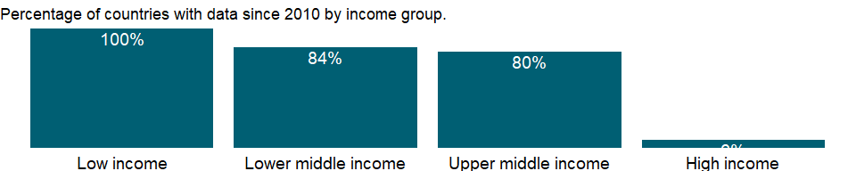

### Why is it relevant?

NA

### What is the data source?

Development Assistance Committee of the Organisation for Economic Co-operation and Development, Geographical Distribution of Financial Flows to Developing Countries, Development Co-operation Report, and International Development Statistics database. Data are available online at: <https://stats.oecd.org/>.

### What is the methodology?

The Development Assistance Committee (DAC) of the Organisation for Economic Co-operation and Development (OECD) has 30 members - 29 individual economies and 1 multilateral institution (European Union institutions).

Data are based on donor country reports of bilateral programs, which may differ from reports by recipient countries. Recipients may lack access to information on such aid expenditures as development-oriented research, stipends and tuition costs for aid-financed students in donor countries, and payment of experts hired by donor countries. Moreover, a full accounting would include donor country contributions to multilateral institutions, the flow of resources from multilateral institutions to recipient countries, and flows from countries that are not members of DAC.

Some of the aid recipients are also aid donors. Development cooperation activities by non-DAC members have increased in recent years and in some cases surpass those of individual DAC members. Some non-DAC donors report their development cooperation activities to DAC on a voluntary basis, but many do not yet report their aid flows to DAC.

### How is it aggregated?

Sum

### What are the limitations?

Data exclude DAC members’ multilateral aid (contributions to the regular budgets of the multilateral institutions). However, projects executed by multilateral institutions or nongovernmental organizations on behalf of DAC members are classified as bilateral aid (since the donor country effectively controls the use of the funds) and are included in the data.

Aid to unspecified economies is included in regional totals and, when possible, income group totals. Aid not allocated by country or region - including administrative costs, research on development, and aid to nongovernmental organizations - is included in the world total. Thus regional and income group totals do not sum to the world total.

### What else should I know?

NA

### 1.10.4 Net bilateral aid flows from DAC donors, Canada (current US$)

### What is the indicator?

Net bilateral aid flows from DAC donors are the net disbursements of official development assistance (ODA) or official aid from the members of the Development Assistance Committee (DAC). Net disbursements are gross disbursements of grants and loans minus repayments of principal on earlier loans. ODA consists of loans made on concessional terms (with a grant element of at least 25 percent, calculated at a rate of discount of 10 percent) and grants made to promote economic development and welfare in countries and territories in the DAC list of ODA recipients. Official aid refers to aid flows from official donors to countries and territories in part II of the DAC list of recipients: more advanced countries of Central and Eastern Europe, the countries of the former Soviet Union, and certain advanced developing countries and territories. Official aid is provided under terms and conditions similar to those for ODA. Part II of the DAC List was abolished in 2005. The collection of data on official aid and other resource flows to Part II countries ended with 2004 data. DAC members are Australia, Austria, Belgium, Canada, Czech Republic, Denmark, Finland, France, Germany, Greece, Hungary, Iceland, Ireland, Italy, Japan, Korea, Luxembourg, The Netherlands, New Zealand, Norway, Poland, Portugal, Slovak Republic, Slovienia, Spain, Sweden, Switzerland, United Kingdom, United States, and European Union Institutions. Regional aggregates include data for economies not specified elsewhere. World and income group totals include aid not allocated by country or region. Data are in current U.S. dollars.

Topic: Economic Policy & Debt: Official development assistance

Series ID: DC.DAC.CANL.CD

Copyright: CC BY-4.0 , <https://datacatalog.worldbank.org/public-licenses#cc-by>

First year with any data: 1960

Last year with any data: 2019

### What years are data available?

The figure below shows years in which data is available for at least one country. Dates shaded in black have no data, while dates shaded in green have data for at least one country



### Which countries have data?

The figure below shows the percentage of countries in each income group with a value since 2010 for that indicator.

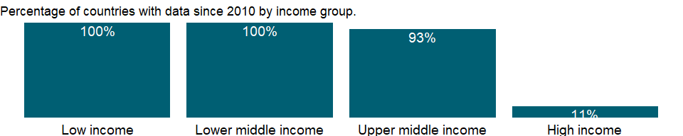

### Why is it relevant?

NA

### What is the data source?

Development Assistance Committee of the Organisation for Economic Co-operation and Development, Geographical Distribution of Financial Flows to Developing Countries, Development Co-operation Report, and International Development Statistics database. Data are available online at: <https://stats.oecd.org/>.

### What is the methodology?

The Development Assistance Committee (DAC) of the Organisation for Economic Co-operation and Development (OECD) has 30 members - 29 individual economies and 1 multilateral institution (European Union institutions).

Data are based on donor country reports of bilateral programs, which may differ from reports by recipient countries. Recipients may lack access to information on such aid expenditures as development-oriented research, stipends and tuition costs for aid-financed students in donor countries, and payment of experts hired by donor countries. Moreover, a full accounting would include donor country contributions to multilateral institutions, the flow of resources from multilateral institutions to recipient countries, and flows from countries that are not members of DAC.

Some of the aid recipients are also aid donors. Development cooperation activities by non-DAC members have increased in recent years and in some cases surpass those of individual DAC members. Some non-DAC donors report their development cooperation activities to DAC on a voluntary basis, but many do not yet report their aid flows to DAC.

### How is it aggregated?

Sum

### What are the limitations?

Data exclude DAC members’ multilateral aid (contributions to the regular budgets of the multilateral institutions). However, projects executed by multilateral institutions or nongovernmental organizations on behalf of DAC members are classified as bilateral aid (since the donor country effectively controls the use of the funds) and are included in the data.

Aid to unspecified economies is included in regional totals and, when possible, income group totals. Aid not allocated by country or region - including administrative costs, research on development, and aid to nongovernmental organizations - is included in the world total. Thus regional and income group totals do not sum to the world total.

### What else should I know?

NA

### 1.10.5 Net bilateral aid flows from DAC donors, European Union institutions (current US$)

### What is the indicator?

Net bilateral aid flows from DAC donors are the net disbursements of official development assistance (ODA) or official aid from the members of the Development Assistance Committee (DAC). Net disbursements are gross disbursements of grants and loans minus repayments of principal on earlier loans. ODA consists of loans made on concessional terms (with a grant element of at least 25 percent, calculated at a rate of discount of 10 percent) and grants made to promote economic development and welfare in countries and territories in the DAC list of ODA recipients. Official aid refers to aid flows from official donors to countries and territories in part II of the DAC list of recipients: more advanced countries of Central and Eastern Europe, the countries of the former Soviet Union, and certain advanced developing countries and territories. Official aid is provided under terms and conditions similar to those for ODA. Part II of the DAC List was abolished in 2005. The collection of data on official aid and other resource flows to Part II countries ended with 2004 data. DAC members are Australia, Austria, Belgium, Canada, Czech Republic, Denmark, Finland, France, Germany, Greece, Hungary, Iceland, Ireland, Italy, Japan, Korea, Luxembourg, The Netherlands, New Zealand, Norway, Poland, Portugal, Slovak Republic, Slovienia, Spain, Sweden, Switzerland, United Kingdom, United States, and European Union Institutions. Regional aggregates include data for economies not specified elsewhere. World and income group totals include aid not allocated by country or region. Data are in current U.S. dollars.

Topic: Economic Policy & Debt: Official development assistance

Series ID: DC.DAC.CECL.CD

Copyright: CC BY-4.0 , <https://datacatalog.worldbank.org/public-licenses#cc-by>

First year with any data: 1960

Last year with any data: 2019

### What years are data available?

The figure below shows years in which data is available for at least one country. Dates shaded in black have no data, while dates shaded in green have data for at least one country



### Which countries have data?

The figure below shows the percentage of countries in each income group with a value since 2010 for that indicator.

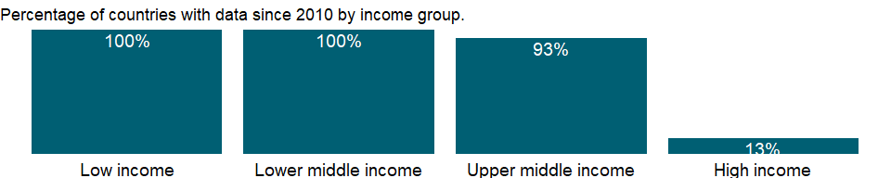

### Why is it relevant?

NA

### What is the data source?

Development Assistance Committee of the Organisation for Economic Co-operation and Development, Geographical Distribution of Financial Flows to Developing Countries, Development Co-operation Report, and International Development Statistics database. Data are available online at: <https://stats.oecd.org/>.

### What is the methodology?

The Development Assistance Committee (DAC) of the Organisation for Economic Co-operation and Development (OECD) has 30 members - 29 individual economies and 1 multilateral institution (European Union institutions).

Data are based on donor country reports of bilateral programs, which may differ from reports by recipient countries. Recipients may lack access to information on such aid expenditures as development-oriented research, stipends and tuition costs for aid-financed students in donor countries, and payment of experts hired by donor countries. Moreover, a full accounting would include donor country contributions to multilateral institutions, the flow of resources from multilateral institutions to recipient countries, and flows from countries that are not members of DAC.

Some of the aid recipients are also aid donors. Development cooperation activities by non-DAC members have increased in recent years and in some cases surpass those of individual DAC members. Some non-DAC donors report their development cooperation activities to DAC on a voluntary basis, but many do not yet report their aid flows to DAC.

### How is it aggregated?

Sum

### What are the limitations?

Data exclude DAC members’ multilateral aid (contributions to the regular budgets of the multilateral institutions). However, projects executed by multilateral institutions or nongovernmental organizations on behalf of DAC members are classified as bilateral aid (since the donor country effectively controls the use of the funds) and are included in the data.

Aid to unspecified economies is included in regional totals and, when possible, income group totals. Aid not allocated by country or region - including administrative costs, research on development, and aid to nongovernmental organizations - is included in the world total. Thus regional and income group totals do not sum to the world total.

### What else should I know?

NA

### 1.10.6 Net bilateral aid flows from DAC donors, Switzerland (current US$)

### What is the indicator?

Net bilateral aid flows from DAC donors are the net disbursements of official development assistance (ODA) or official aid from the members of the Development Assistance Committee (DAC). Net disbursements are gross disbursements of grants and loans minus repayments of principal on earlier loans. ODA consists of loans made on concessional terms (with a grant element of at least 25 percent, calculated at a rate of discount of 10 percent) and grants made to promote economic development and welfare in countries and territories in the DAC list of ODA recipients. Official aid refers to aid flows from official donors to countries and territories in part II of the DAC list of recipients: more advanced countries of Central and Eastern Europe, the countries of the former Soviet Union, and certain advanced developing countries and territories. Official aid is provided under terms and conditions similar to those for ODA. Part II of the DAC List was abolished in 2005. The collection of data on official aid and other resource flows to Part II countries ended with 2004 data. DAC members are Australia, Austria, Belgium, Canada, Czech Republic, Denmark, Finland, France, Germany, Greece, Hungary, Iceland, Ireland, Italy, Japan, Korea, Luxembourg, The Netherlands, New Zealand, Norway, Poland, Portugal, Slovak Republic, Slovienia, Spain, Sweden, Switzerland, United Kingdom, United States, and European Union Institutions. Regional aggregates include data for economies not specified elsewhere. World and income group totals include aid not allocated by country or region. Data are in current U.S. dollars.

Topic: Economic Policy & Debt: Official development assistance

Series ID: DC.DAC.CHEL.CD

Copyright: CC BY-4.0 , <https://datacatalog.worldbank.org/public-licenses#cc-by>

First year with any data: 1961

Last year with any data: 2019

### What years are data available?

The figure below shows years in which data is available for at least one country. Dates shaded in black have no data, while dates shaded in green have data for at least one country

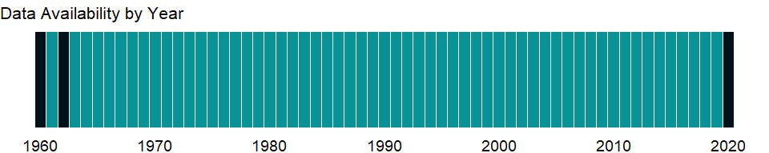

### Which countries have data?

The figure below shows the percentage of countries in each income group with a value since 2010 for that indicator.

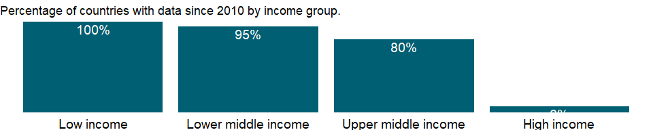

### Why is it relevant?

NA

### What is the data source?

Development Assistance Committee of the Organisation for Economic Co-operation and Development, Geographical Distribution of Financial Flows to Developing Countries, Development Co-operation Report, and International Development Statistics database. Data are available online at: <https://stats.oecd.org/>.

### What is the methodology?

The Development Assistance Committee (DAC) of the Organisation for Economic Co-operation and Development (OECD) has 30 members - 29 individual economies and 1 multilateral institution (European Union institutions).

Data are based on donor country reports of bilateral programs, which may differ from reports by recipient countries. Recipients may lack access to information on such aid expenditures as development-oriented research, stipends and tuition costs for aid-financed students in donor countries, and payment of experts hired by donor countries. Moreover, a full accounting would include donor country contributions to multilateral institutions, the flow of resources from multilateral institutions to recipient countries, and flows from countries that are not members of DAC.

Some of the aid recipients are also aid donors. Development cooperation activities by non-DAC members have increased in recent years and in some cases surpass those of individual DAC members. Some non-DAC donors report their development cooperation activities to DAC on a voluntary basis, but many do not yet report their aid flows to DAC.

### How is it aggregated?

Sum

### What are the limitations?

Data exclude DAC members’ multilateral aid (contributions to the regular budgets of the multilateral institutions). However, projects executed by multilateral institutions or nongovernmental organizations on behalf of DAC members are classified as bilateral aid (since the donor country effectively controls the use of the funds) and are included in the data.

Aid to unspecified economies is included in regional totals and, when possible, income group totals. Aid not allocated by country or region - including administrative costs, research on development, and aid to nongovernmental organizations - is included in the world total. Thus regional and income group totals do not sum to the world total.

### What else should I know?

NA

### 1.10.7 Net bilateral aid flows from DAC donors, Czech Republic (current US$)

### What is the indicator?

Net bilateral aid flows from DAC donors are the net disbursements of official development assistance (ODA) or official aid from the members of the Development Assistance Committee (DAC). Net disbursements are gross disbursements of grants and loans minus repayments of principal on earlier loans. ODA consists of loans made on concessional terms (with a grant element of at least 25 percent, calculated at a rate of discount of 10 percent) and grants made to promote economic development and welfare in countries and territories in the DAC list of ODA recipients. Official aid refers to aid flows from official donors to countries and territories in part II of the DAC list of recipients: more advanced countries of Central and Eastern Europe, the countries of the former Soviet Union, and certain advanced developing countries and territories. Official aid is provided under terms and conditions similar to those for ODA. Part II of the DAC List was abolished in 2005. The collection of data on official aid and other resource flows to Part II countries ended with 2004 data. DAC members are Australia, Austria, Belgium, Canada, Czech Republic, Denmark, Finland, France, Germany, Greece, Hungary, Iceland, Ireland, Italy, Japan, Korea, Luxembourg, The Netherlands, New Zealand, Norway, Poland, Portugal, Slovak Republic, Slovienia, Spain, Sweden, Switzerland, United Kingdom, United States, and European Union Institutions. Regional aggregates include data for economies not specified elsewhere. World and income group totals include aid not allocated by country or region. Data are in current U.S. dollars.

Topic: Economic Policy & Debt: Official development assistance

Series ID: DC.DAC.CZEL.CD

Copyright: CC BY-4.0 , <https://datacatalog.worldbank.org/public-licenses#cc-by>

First year with any data: 2005

Last year with any data: 2019

### What years are data available?

The figure below shows years in which data is available for at least one country. Dates shaded in black have no data, while dates shaded in green have data for at least one country

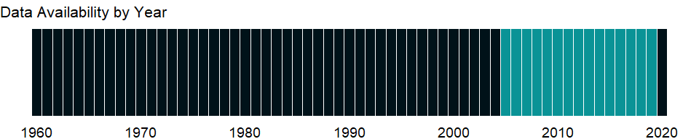

### Which countries have data?

The figure below shows the percentage of countries in each income group with a value since 2010 for that indicator.

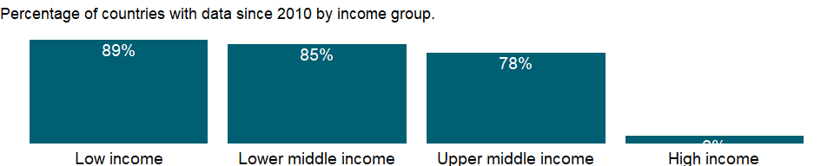

### Why is it relevant?

NA

### What is the data source?

Development Assistance Committee of the Organisation for Economic Co-operation and Development, Geographical Distribution of Financial Flows to Developing Countries, Development Co-operation Report, and International Development Statistics database. Data are available online at: <https://stats.oecd.org/>.

### What is the methodology?

The Development Assistance Committee (DAC) of the Organisation for Economic Co-operation and Development (OECD) has 30 members - 29 individual economies and 1 multilateral institution (European Union institutions).

Data are based on donor country reports of bilateral programs, which may differ from reports by recipient countries. Recipients may lack access to information on such aid expenditures as development-oriented research, stipends and tuition costs for aid-financed students in donor countries, and payment of experts hired by donor countries. Moreover, a full accounting would include donor country contributions to multilateral institutions, the flow of resources from multilateral institutions to recipient countries, and flows from countries that are not members of DAC.

Some of the aid recipients are also aid donors. Development cooperation activities by non-DAC members have increased in recent years and in some cases surpass those of individual DAC members. Some non-DAC donors report their development cooperation activities to DAC on a voluntary basis, but many do not yet report their aid flows to DAC.

### How is it aggregated?

Sum

### What are the limitations?

Data exclude DAC members’ multilateral aid (contributions to the regular budgets of the multilateral institutions). However, projects executed by multilateral institutions or nongovernmental organizations on behalf of DAC members are classified as bilateral aid (since the donor country effectively controls the use of the funds) and are included in the data.

Aid to unspecified economies is included in regional totals and, when possible, income group totals. Aid not allocated by country or region - including administrative costs, research on development, and aid to nongovernmental organizations - is included in the world total. Thus regional and income group totals do not sum to the world total.

### What else should I know?

NA

### 1.10.8 Net bilateral aid flows from DAC donors, Germany (current US$)

### What is the indicator?

Net bilateral aid flows from DAC donors are the net disbursements of official development assistance (ODA) or official aid from the members of the Development Assistance Committee (DAC). Net disbursements are gross disbursements of grants and loans minus repayments of principal on earlier loans. ODA consists of loans made on concessional terms (with a grant element of at least 25 percent, calculated at a rate of discount of 10 percent) and grants made to promote economic development and welfare in countries and territories in the DAC list of ODA recipients. Official aid refers to aid flows from official donors to countries and territories in part II of the DAC list of recipients: more advanced countries of Central and Eastern Europe, the countries of the former Soviet Union, and certain advanced developing countries and territories. Official aid is provided under terms and conditions similar to those for ODA. Part II of the DAC List was abolished in 2005. The collection of data on official aid and other resource flows to Part II countries ended with 2004 data. DAC members are Australia, Austria, Belgium, Canada, Czech Republic, Denmark, Finland, France, Germany, Greece, Hungary, Iceland, Ireland, Italy, Japan, Korea, Luxembourg, The Netherlands, New Zealand, Norway, Poland, Portugal, Slovak Republic, Slovienia, Spain, Sweden, Switzerland, United Kingdom, United States, and European Union Institutions. Regional aggregates include data for economies not specified elsewhere. World and income group totals include aid not allocated by country or region. Data are in current U.S. dollars.

Topic: Economic Policy & Debt: Official development assistance

Series ID: DC.DAC.DEUL.CD

Copyright: CC BY-4.0 , <https://datacatalog.worldbank.org/public-licenses#cc-by>

First year with any data: 1960

Last year with any data: 2019

### What years are data available?

The figure below shows years in which data is available for at least one country. Dates shaded in black have no data, while dates shaded in green have data for at least one country



### Which countries have data?

The figure below shows the percentage of countries in each income group with a value since 2010 for that indicator.



### Why is it relevant?

NA

### What is the data source?

Development Assistance Committee of the Organisation for Economic Co-operation and Development, Geographical Distribution of Financial Flows to Developing Countries, Development Co-operation Report, and International Development Statistics database. Data are available online at: <https://stats.oecd.org/>.

### What is the methodology?

The Development Assistance Committee (DAC) of the Organisation for Economic Co-operation and Development (OECD) has 30 members - 29 individual economies and 1 multilateral institution (European Union institutions).

Data are based on donor country reports of bilateral programs, which may differ from reports by recipient countries. Recipients may lack access to information on such aid expenditures as development-oriented research, stipends and tuition costs for aid-financed students in donor countries, and payment of experts hired by donor countries. Moreover, a full accounting would include donor country contributions to multilateral institutions, the flow of resources from multilateral institutions to recipient countries, and flows from countries that are not members of DAC.

Some of the aid recipients are also aid donors. Development cooperation activities by non-DAC members have increased in recent years and in some cases surpass those of individual DAC members. Some non-DAC donors report their development cooperation activities to DAC on a voluntary basis, but many do not yet report their aid flows to DAC.

### How is it aggregated?

Sum

### What are the limitations?

Data exclude DAC members’ multilateral aid (contributions to the regular budgets of the multilateral institutions). However, projects executed by multilateral institutions or nongovernmental organizations on behalf of DAC members are classified as bilateral aid (since the donor country effectively controls the use of the funds) and are included in the data.

Aid to unspecified economies is included in regional totals and, when possible, income group totals. Aid not allocated by country or region - including administrative costs, research on development, and aid to nongovernmental organizations - is included in the world total. Thus regional and income group totals do not sum to the world total.

### What else should I know?

NA

### 1.10.9 Net bilateral aid flows from DAC donors, Denmark (current US$)

### What is the indicator?

Net bilateral aid flows from DAC donors are the net disbursements of official development assistance (ODA) or official aid from the members of the Development Assistance Committee (DAC). Net disbursements are gross disbursements of grants and loans minus repayments of principal on earlier loans. ODA consists of loans made on concessional terms (with a grant element of at least 25 percent, calculated at a rate of discount of 10 percent) and grants made to promote economic development and welfare in countries and territories in the DAC list of ODA recipients. Official aid refers to aid flows from official donors to countries and territories in part II of the DAC list of recipients: more advanced countries of Central and Eastern Europe, the countries of the former Soviet Union, and certain advanced developing countries and territories. Official aid is provided under terms and conditions similar to those for ODA. Part II of the DAC List was abolished in 2005. The collection of data on official aid and other resource flows to Part II countries ended with 2004 data. DAC members are Australia, Austria, Belgium, Canada, Czech Republic, Denmark, Finland, France, Germany, Greece, Hungary, Iceland, Ireland, Italy, Japan, Korea, Luxembourg, The Netherlands, New Zealand, Norway, Poland, Portugal, Slovak Republic, Slovienia, Spain, Sweden, Switzerland, United Kingdom, United States, and European Union Institutions. Regional aggregates include data for economies not specified elsewhere. World and income group totals include aid not allocated by country or region. Data are in current U.S. dollars.

Topic: Economic Policy & Debt: Official development assistance

Series ID: DC.DAC.DNKL.CD

Copyright: CC BY-4.0 , <https://datacatalog.worldbank.org/public-licenses#cc-by>

First year with any data: 1960

Last year with any data: 2019

### What years are data available?

The figure below shows years in which data is available for at least one country. Dates shaded in black have no data, while dates shaded in green have data for at least one country



### Which countries have data?

The figure below shows the percentage of countries in each income group with a value since 2010 for that indicator.

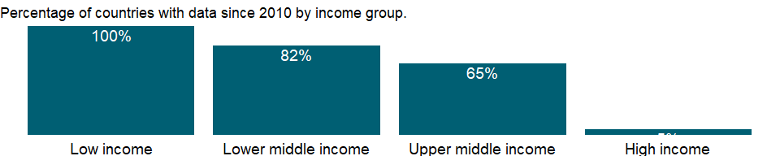

### Why is it relevant?

NA

### What is the data source?

Development Assistance Committee of the Organisation for Economic Co-operation and Development, Geographical Distribution of Financial Flows to Developing Countries, Development Co-operation Report, and International Development Statistics database. Data are available online at: <https://stats.oecd.org/>.

### What is the methodology?

The Development Assistance Committee (DAC) of the Organisation for Economic Co-operation and Development (OECD) has 30 members - 29 individual economies and 1 multilateral institution (European Union institutions).

Data are based on donor country reports of bilateral programs, which may differ from reports by recipient countries. Recipients may lack access to information on such aid expenditures as development-oriented research, stipends and tuition costs for aid-financed students in donor countries, and payment of experts hired by donor countries. Moreover, a full accounting would include donor country contributions to multilateral institutions, the flow of resources from multilateral institutions to recipient countries, and flows from countries that are not members of DAC.

Some of the aid recipients are also aid donors. Development cooperation activities by non-DAC members have increased in recent years and in some cases surpass those of individual DAC members. Some non-DAC donors report their development cooperation activities to DAC on a voluntary basis, but many do not yet report their aid flows to DAC.

### How is it aggregated?

Sum

### What are the limitations?

Data exclude DAC members’ multilateral aid (contributions to the regular budgets of the multilateral institutions). However, projects executed by multilateral institutions or nongovernmental organizations on behalf of DAC members are classified as bilateral aid (since the donor country effectively controls the use of the funds) and are included in the data.

Aid to unspecified economies is included in regional totals and, when possible, income group totals. Aid not allocated by country or region - including administrative costs, research on development, and aid to nongovernmental organizations - is included in the world total. Thus regional and income group totals do not sum to the world total.

### What else should I know?

NA

### 1.10.10 Net bilateral aid flows from DAC donors, Spain (current US$)

### What is the indicator?

Net bilateral aid flows from DAC donors are the net disbursements of official development assistance (ODA) or official aid from the members of the Development Assistance Committee (DAC). Net disbursements are gross disbursements of grants and loans minus repayments of principal on earlier loans. ODA consists of loans made on concessional terms (with a grant element of at least 25 percent, calculated at a rate of discount of 10 percent) and grants made to promote economic development and welfare in countries and territories in the DAC list of ODA recipients. Official aid refers to aid flows from official donors to countries and territories in part II of the DAC list of recipients: more advanced countries of Central and Eastern Europe, the countries of the former Soviet Union, and certain advanced developing countries and territories. Official aid is provided under terms and conditions similar to those for ODA. Part II of the DAC List was abolished in 2005. The collection of data on official aid and other resource flows to Part II countries ended with 2004 data. DAC members are Australia, Austria, Belgium, Canada, Czech Republic, Denmark, Finland, France, Germany, Greece, Hungary, Iceland, Ireland, Italy, Japan, Korea, Luxembourg, The Netherlands, New Zealand, Norway, Poland, Portugal, Slovak Republic, Slovienia, Spain, Sweden, Switzerland, United Kingdom, United States, and European Union Institutions. Regional aggregates include data for economies not specified elsewhere. World and income group totals include aid not allocated by country or region. Data are in current U.S. dollars.

Topic: Economic Policy & Debt: Official development assistance

Series ID: DC.DAC.ESPL.CD

Copyright: CC BY-4.0 , <https://datacatalog.worldbank.org/public-licenses#cc-by>

First year with any data: 1987

Last year with any data: 2019

### What years are data available?

The figure below shows years in which data is available for at least one country. Dates shaded in black have no data, while dates shaded in green have data for at least one country

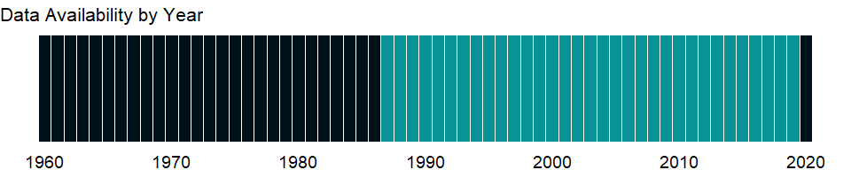

### Which countries have data?

The figure below shows the percentage of countries in each income group with a value since 2010 for that indicator.

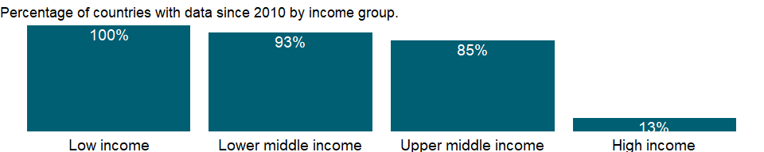

### Why is it relevant?

NA

### What is the data source?

Development Assistance Committee of the Organisation for Economic Co-operation and Development, Geographical Distribution of Financial Flows to Developing Countries, Development Co-operation Report, and International Development Statistics database. Data are available online at: <https://stats.oecd.org/>.

### What is the methodology?

The Development Assistance Committee (DAC) of the Organisation for Economic Co-operation and Development (OECD) has 30 members - 29 individual economies and 1 multilateral institution (European Union institutions).

Data are based on donor country reports of bilateral programs, which may differ from reports by recipient countries. Recipients may lack access to information on such aid expenditures as development-oriented research, stipends and tuition costs for aid-financed students in donor countries, and payment of experts hired by donor countries. Moreover, a full accounting would include donor country contributions to multilateral institutions, the flow of resources from multilateral institutions to recipient countries, and flows from countries that are not members of DAC.

Some of the aid recipients are also aid donors. Development cooperation activities by non-DAC members have increased in recent years and in some cases surpass those of individual DAC members. Some non-DAC donors report their development cooperation activities to DAC on a voluntary basis, but many do not yet report their aid flows to DAC.

### How is it aggregated?

Sum

### What are the limitations?

Data exclude DAC members’ multilateral aid (contributions to the regular budgets of the multilateral institutions). However, projects executed by multilateral institutions or nongovernmental organizations on behalf of DAC members are classified as bilateral aid (since the donor country effectively controls the use of the funds) and are included in the data.

Aid to unspecified economies is included in regional totals and, when possible, income group totals. Aid not allocated by country or region - including administrative costs, research on development, and aid to nongovernmental organizations - is included in the world total. Thus regional and income group totals do not sum to the world total.

### What else should I know?

NA

### 1.10.11 Net bilateral aid flows from DAC donors, Finland (current US$)

### What is the indicator?

Net bilateral aid flows from DAC donors are the net disbursements of official development assistance (ODA) or official aid from the members of the Development Assistance Committee (DAC). Net disbursements are gross disbursements of grants and loans minus repayments of principal on earlier loans. ODA consists of loans made on concessional terms (with a grant element of at least 25 percent, calculated at a rate of discount of 10 percent) and grants made to promote economic development and welfare in countries and territories in the DAC list of ODA recipients. Official aid refers to aid flows from official donors to countries and territories in part II of the DAC list of recipients: more advanced countries of Central and Eastern Europe, the countries of the former Soviet Union, and certain advanced developing countries and territories. Official aid is provided under terms and conditions similar to those for ODA. Part II of the DAC List was abolished in 2005. The collection of data on official aid and other resource flows to Part II countries ended with 2004 data. DAC members are Australia, Austria, Belgium, Canada, Czech Republic, Denmark, Finland, France, Germany, Greece, Hungary, Iceland, Ireland, Italy, Japan, Korea, Luxembourg, The Netherlands, New Zealand, Norway, Poland, Portugal, Slovak Republic, Slovienia, Spain, Sweden, Switzerland, United Kingdom, United States, and European Union Institutions. Regional aggregates include data for economies not specified elsewhere. World and income group totals include aid not allocated by country or region. Data are in current U.S. dollars.

Topic: Economic Policy & Debt: Official development assistance

Series ID: DC.DAC.FINL.CD

Copyright: CC BY-4.0 , <https://datacatalog.worldbank.org/public-licenses#cc-by>

First year with any data: 1971

Last year with any data: 2019

### What years are data available?

The figure below shows years in which data is available for at least one country. Dates shaded in black have no data, while dates shaded in green have data for at least one country



### Which countries have data?

The figure below shows the percentage of countries in each income group with a value since 2010 for that indicator.

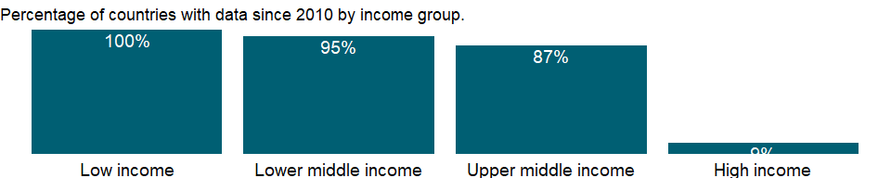

### Why is it relevant?

NA

### What is the data source?

Development Assistance Committee of the Organisation for Economic Co-operation and Development, Geographical Distribution of Financial Flows to Developing Countries, Development Co-operation Report, and International Development Statistics database. Data are available online at: <https://stats.oecd.org/>.

### What is the methodology?

The Development Assistance Committee (DAC) of the Organisation for Economic Co-operation and Development (OECD) has 30 members - 29 individual economies and 1 multilateral institution (European Union institutions).

Data are based on donor country reports of bilateral programs, which may differ from reports by recipient countries. Recipients may lack access to information on such aid expenditures as development-oriented research, stipends and tuition costs for aid-financed students in donor countries, and payment of experts hired by donor countries. Moreover, a full accounting would include donor country contributions to multilateral institutions, the flow of resources from multilateral institutions to recipient countries, and flows from countries that are not members of DAC.

Some of the aid recipients are also aid donors. Development cooperation activities by non-DAC members have increased in recent years and in some cases surpass those of individual DAC members. Some non-DAC donors report their development cooperation activities to DAC on a voluntary basis, but many do not yet report their aid flows to DAC.

### How is it aggregated?

Sum

### What are the limitations?

Data exclude DAC members’ multilateral aid (contributions to the regular budgets of the multilateral institutions). However, projects executed by multilateral institutions or nongovernmental organizations on behalf of DAC members are classified as bilateral aid (since the donor country effectively controls the use of the funds) and are included in the data.

Aid to unspecified economies is included in regional totals and, when possible, income group totals. Aid not allocated by country or region - including administrative costs, research on development, and aid to nongovernmental organizations - is included in the world total. Thus regional and income group totals do not sum to the world total.

### What else should I know?

NA

### 1.10.12 Net bilateral aid flows from DAC donors, France (current US$)

### What is the indicator?

Net bilateral aid flows from DAC donors are the net disbursements of official development assistance (ODA) or official aid from the members of the Development Assistance Committee (DAC). Net disbursements are gross disbursements of grants and loans minus repayments of principal on earlier loans. ODA consists of loans made on concessional terms (with a grant element of at least 25 percent, calculated at a rate of discount of 10 percent) and grants made to promote economic development and welfare in countries and territories in the DAC list of ODA recipients. Official aid refers to aid flows from official donors to countries and territories in part II of the DAC list of recipients: more advanced countries of Central and Eastern Europe, the countries of the former Soviet Union, and certain advanced developing countries and territories. Official aid is provided under terms and conditions similar to those for ODA. Part II of the DAC List was abolished in 2005. The collection of data on official aid and other resource flows to Part II countries ended with 2004 data. DAC members are Australia, Austria, Belgium, Canada, Czech Republic, Denmark, Finland, France, Germany, Greece, Hungary, Iceland, Ireland, Italy, Japan, Korea, Luxembourg, The Netherlands, New Zealand, Norway, Poland, Portugal, Slovak Republic, Slovienia, Spain, Sweden, Switzerland, United Kingdom, United States, and European Union Institutions. Regional aggregates include data for economies not specified elsewhere. World and income group totals include aid not allocated by country or region. Data are in current U.S. dollars.

Topic: Economic Policy & Debt: Official development assistance

Series ID: DC.DAC.FRAL.CD

Copyright: CC BY-4.0 , <https://datacatalog.worldbank.org/public-licenses#cc-by>

First year with any data: 1960

Last year with any data: 2019

### What years are data available?

The figure below shows years in which data is available for at least one country. Dates shaded in black have no data, while dates shaded in green have data for at least one country



### Which countries have data?

The figure below shows the percentage of countries in each income group with a value since 2010 for that indicator.



### Why is it relevant?

NA

### What is the data source?

Development Assistance Committee of the Organisation for Economic Co-operation and Development, Geographical Distribution of Financial Flows to Developing Countries, Development Co-operation Report, and International Development Statistics database. Data are available online at: <https://stats.oecd.org/>.

### What is the methodology?

The Development Assistance Committee (DAC) of the Organisation for Economic Co-operation and Development (OECD) has 30 members - 29 individual economies and 1 multilateral institution (European Union institutions).

Data are based on donor country reports of bilateral programs, which may differ from reports by recipient countries. Recipients may lack access to information on such aid expenditures as development-oriented research, stipends and tuition costs for aid-financed students in donor countries, and payment of experts hired by donor countries. Moreover, a full accounting would include donor country contributions to multilateral institutions, the flow of resources from multilateral institutions to recipient countries, and flows from countries that are not members of DAC.

Some of the aid recipients are also aid donors. Development cooperation activities by non-DAC members have increased in recent years and in some cases surpass those of individual DAC members. Some non-DAC donors report their development cooperation activities to DAC on a voluntary basis, but many do not yet report their aid flows to DAC.

### How is it aggregated?

Sum

### What are the limitations?

Data exclude DAC members’ multilateral aid (contributions to the regular budgets of the multilateral institutions). However, projects executed by multilateral institutions or nongovernmental organizations on behalf of DAC members are classified as bilateral aid (since the donor country effectively controls the use of the funds) and are included in the data.

Aid to unspecified economies is included in regional totals and, when possible, income group totals. Aid not allocated by country or region - including administrative costs, research on development, and aid to nongovernmental organizations - is included in the world total. Thus regional and income group totals do not sum to the world total.

### What else should I know?

NA

### 1.10.13 Net bilateral aid flows from DAC donors, United Kingdom (current US$)

### What is the indicator?

Net bilateral aid flows from DAC donors are the net disbursements of official development assistance (ODA) or official aid from the members of the Development Assistance Committee (DAC). Net disbursements are gross disbursements of grants and loans minus repayments of principal on earlier loans. ODA consists of loans made on concessional terms (with a grant element of at least 25 percent, calculated at a rate of discount of 10 percent) and grants made to promote economic development and welfare in countries and territories in the DAC list of ODA recipients. Official aid refers to aid flows from official donors to countries and territories in part II of the DAC list of recipients: more advanced countries of Central and Eastern Europe, the countries of the former Soviet Union, and certain advanced developing countries and territories. Official aid is provided under terms and conditions similar to those for ODA. Part II of the DAC List was abolished in 2005. The collection of data on official aid and other resource flows to Part II countries ended with 2004 data. DAC members are Australia, Austria, Belgium, Canada, Czech Republic, Denmark, Finland, France, Germany, Greece, Hungary, Iceland, Ireland, Italy, Japan, Korea, Luxembourg, The Netherlands, New Zealand, Norway, Poland, Portugal, Slovak Republic, Slovienia, Spain, Sweden, Switzerland, United Kingdom, United States, and European Union Institutions. Regional aggregates include data for economies not specified elsewhere. World and income group totals include aid not allocated by country or region. Data are in current U.S. dollars.

Topic: Economic Policy & Debt: Official development assistance

Series ID: DC.DAC.GBRL.CD

Copyright: CC BY-4.0 , <https://datacatalog.worldbank.org/public-licenses#cc-by>

First year with any data: 1960

Last year with any data: 2019

### What years are data available?

The figure below shows years in which data is available for at least one country. Dates shaded in black have no data, while dates shaded in green have data for at least one country



### Which countries have data?

The figure below shows the percentage of countries in each income group with a value since 2010 for that indicator.

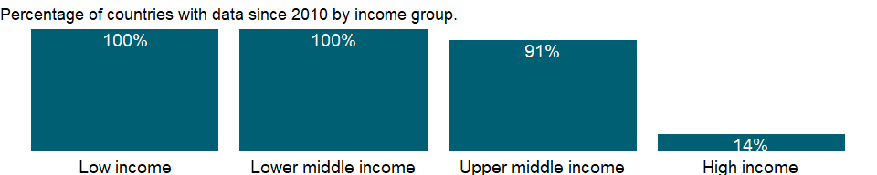

### Why is it relevant?

NA

### What is the data source?

Development Assistance Committee of the Organisation for Economic Co-operation and Development, Geographical Distribution of Financial Flows to Developing Countries, Development Co-operation Report, and International Development Statistics database. Data are available online at: <https://stats.oecd.org/>.

### What is the methodology?

The Development Assistance Committee (DAC) of the Organisation for Economic Co-operation and Development (OECD) has 30 members - 29 individual economies and 1 multilateral institution (European Union institutions).

Data are based on donor country reports of bilateral programs, which may differ from reports by recipient countries. Recipients may lack access to information on such aid expenditures as development-oriented research, stipends and tuition costs for aid-financed students in donor countries, and payment of experts hired by donor countries. Moreover, a full accounting would include donor country contributions to multilateral institutions, the flow of resources from multilateral institutions to recipient countries, and flows from countries that are not members of DAC.

Some of the aid recipients are also aid donors. Development cooperation activities by non-DAC members have increased in recent years and in some cases surpass those of individual DAC members. Some non-DAC donors report their development cooperation activities to DAC on a voluntary basis, but many do not yet report their aid flows to DAC.

### How is it aggregated?

Sum

### What are the limitations?

Data exclude DAC members’ multilateral aid (contributions to the regular budgets of the multilateral institutions). However, projects executed by multilateral institutions or nongovernmental organizations on behalf of DAC members are classified as bilateral aid (since the donor country effectively controls the use of the funds) and are included in the data.

Aid to unspecified economies is included in regional totals and, when possible, income group totals. Aid not allocated by country or region - including administrative costs, research on development, and aid to nongovernmental organizations - is included in the world total. Thus regional and income group totals do not sum to the world total.

### What else should I know?

NA

### 1.10.14 Net bilateral aid flows from DAC donors, Greece (current US$)

### What is the indicator?

Net bilateral aid flows from DAC donors are the net disbursements of official development assistance (ODA) or official aid from the members of the Development Assistance Committee (DAC). Net disbursements are gross disbursements of grants and loans minus repayments of principal on earlier loans. ODA consists of loans made on concessional terms (with a grant element of at least 25 percent, calculated at a rate of discount of 10 percent) and grants made to promote economic development and welfare in countries and territories in the DAC list of ODA recipients. Official aid refers to aid flows from official donors to countries and territories in part II of the DAC list of recipients: more advanced countries of Central and Eastern Europe, the countries of the former Soviet Union, and certain advanced developing countries and territories. Official aid is provided under terms and conditions similar to those for ODA. Part II of the DAC List was abolished in 2005. The collection of data on official aid and other resource flows to Part II countries ended with 2004 data. DAC members are Australia, Austria, Belgium, Canada, Czech Republic, Denmark, Finland, France, Germany, Greece, Hungary, Iceland, Ireland, Italy, Japan, Korea, Luxembourg, The Netherlands, New Zealand, Norway, Poland, Portugal, Slovak Republic, Slovienia, Spain, Sweden, Switzerland, United Kingdom, United States, and European Union Institutions. Regional aggregates include data for economies not specified elsewhere. World and income group totals include aid not allocated by country or region. Data are in current U.S. dollars.

Topic: Economic Policy & Debt: Official development assistance

Series ID: DC.DAC.GRCL.CD

Copyright: CC BY-4.0 , <https://datacatalog.worldbank.org/public-licenses#cc-by>

First year with any data: 1996

Last year with any data: 2019

### What years are data available?

The figure below shows years in which data is available for at least one country. Dates shaded in black have no data, while dates shaded in green have data for at least one country

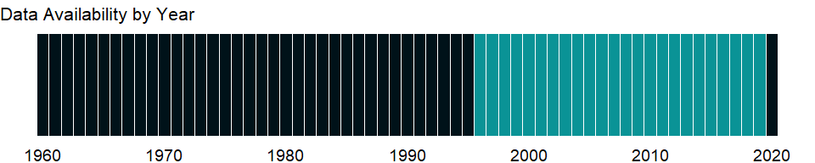

### Which countries have data?

The figure below shows the percentage of countries in each income group with a value since 2010 for that indicator.

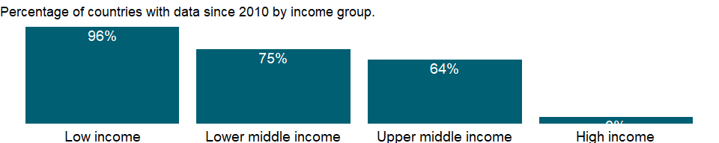

### Why is it relevant?

NA

### What is the data source?

Development Assistance Committee of the Organisation for Economic Co-operation and Development, Geographical Distribution of Financial Flows to Developing Countries, Development Co-operation Report, and International Development Statistics database. Data are available online at: <https://stats.oecd.org/>.

### What is the methodology?

The Development Assistance Committee (DAC) of the Organisation for Economic Co-operation and Development (OECD) has 30 members - 29 individual economies and 1 multilateral institution (European Union institutions).

Data are based on donor country reports of bilateral programs, which may differ from reports by recipient countries. Recipients may lack access to information on such aid expenditures as development-oriented research, stipends and tuition costs for aid-financed students in donor countries, and payment of experts hired by donor countries. Moreover, a full accounting would include donor country contributions to multilateral institutions, the flow of resources from multilateral institutions to recipient countries, and flows from countries that are not members of DAC.

Some of the aid recipients are also aid donors. Development cooperation activities by non-DAC members have increased in recent years and in some cases surpass those of individual DAC members. Some non-DAC donors report their development cooperation activities to DAC on a voluntary basis, but many do not yet report their aid flows to DAC.

### How is it aggregated?

Sum

### What are the limitations?

Data exclude DAC members’ multilateral aid (contributions to the regular budgets of the multilateral institutions). However, projects executed by multilateral institutions or nongovernmental organizations on behalf of DAC members are classified as bilateral aid (since the donor country effectively controls the use of the funds) and are included in the data.

Aid to unspecified economies is included in regional totals and, when possible, income group totals. Aid not allocated by country or region - including administrative costs, research on development, and aid to nongovernmental organizations - is included in the world total. Thus regional and income group totals do not sum to the world total.

### What else should I know?

NA

### 1.10.15 Net bilateral aid flows from DAC donors, Hungary (current US$)

### What is the indicator?

Net bilateral aid flows from DAC donors are the net disbursements of official development assistance (ODA) or official aid from the members of the Development Assistance Committee (DAC). Net disbursements are gross disbursements of grants and loans minus repayments of principal on earlier loans. ODA consists of loans made on concessional terms (with a grant element of at least 25 percent, calculated at a rate of discount of 10 percent) and grants made to promote economic development and welfare in countries and territories in the DAC list of ODA recipients. Official aid refers to aid flows from official donors to countries and territories in part II of the DAC list of recipients: more advanced countries of Central and Eastern Europe, the countries of the former Soviet Union, and certain advanced developing countries and territories. Official aid is provided under terms and conditions similar to those for ODA. Part II of the DAC List was abolished in 2005. The collection of data on official aid and other resource flows to Part II countries ended with 2004 data. DAC members are Australia, Austria, Belgium, Canada, Czech Republic, Denmark, Finland, France, Germany, Greece, Hungary, Iceland, Ireland, Italy, Japan, Korea, Luxembourg, The Netherlands, New Zealand, Norway, Poland, Portugal, Slovak Republic, Slovienia, Spain, Sweden, Switzerland, United Kingdom, United States, and European Union Institutions. Regional aggregates include data for economies not specified elsewhere. World and income group totals include aid not allocated by country or region. Data are in current U.S. dollars.

Topic: Economic Policy & Debt: Official development assistance

Series ID: DC.DAC.HUNL.CD

Copyright: CC BY-4.0 , <https://datacatalog.worldbank.org/public-licenses#cc-by>

First year with any data: 2005

Last year with any data: 2019

### What years are data available?

The figure below shows years in which data is available for at least one country. Dates shaded in black have no data, while dates shaded in green have data for at least one country



### Which countries have data?

The figure below shows the percentage of countries in each income group with a value since 2010 for that indicator.

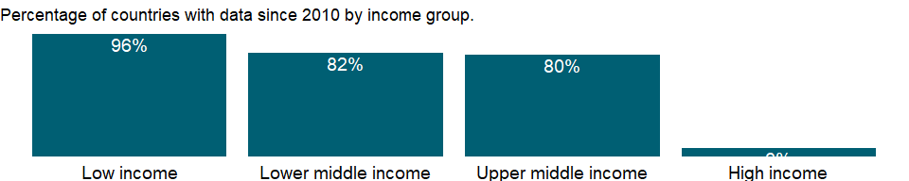

### Why is it relevant?

NA

### What is the data source?

Development Assistance Committee of the Organisation for Economic Co-operation and Development, Geographical Distribution of Financial Flows to Developing Countries, Development Co-operation Report, and International Development Statistics database. Data are available online at: <https://stats.oecd.org/>.

### What is the methodology?

The Development Assistance Committee (DAC) of the Organisation for Economic Co-operation and Development (OECD) has 30 members - 29 individual economies and 1 multilateral institution (European Union institutions).

Data are based on donor country reports of bilateral programs, which may differ from reports by recipient countries. Recipients may lack access to information on such aid expenditures as development-oriented research, stipends and tuition costs for aid-financed students in donor countries, and payment of experts hired by donor countries. Moreover, a full accounting would include donor country contributions to multilateral institutions, the flow of resources from multilateral institutions to recipient countries, and flows from countries that are not members of DAC.

Some of the aid recipients are also aid donors. Development cooperation activities by non-DAC members have increased in recent years and in some cases surpass those of individual DAC members. Some non-DAC donors report their development cooperation activities to DAC on a voluntary basis, but many do not yet report their aid flows to DAC.

### How is it aggregated?

Sum

### What are the limitations?

Data exclude DAC members’ multilateral aid (contributions to the regular budgets of the multilateral institutions). However, projects executed by multilateral institutions or nongovernmental organizations on behalf of DAC members are classified as bilateral aid (since the donor country effectively controls the use of the funds) and are included in the data.

Aid to unspecified economies is included in regional totals and, when possible, income group totals. Aid not allocated by country or region - including administrative costs, research on development, and aid to nongovernmental organizations - is included in the world total. Thus regional and income group totals do not sum to the world total.

### What else should I know?

NA

### 1.10.16 Net bilateral aid flows from DAC donors, Ireland (current US$)

### What is the indicator?

Net bilateral aid flows from DAC donors are the net disbursements of official development assistance (ODA) or official aid from the members of the Development Assistance Committee (DAC). Net disbursements are gross disbursements of grants and loans minus repayments of principal on earlier loans. ODA consists of loans made on concessional terms (with a grant element of at least 25 percent, calculated at a rate of discount of 10 percent) and grants made to promote economic development and welfare in countries and territories in the DAC list of ODA recipients. Official aid refers to aid flows from official donors to countries and territories in part II of the DAC list of recipients: more advanced countries of Central and Eastern Europe, the countries of the former Soviet Union, and certain advanced developing countries and territories. Official aid is provided under terms and conditions similar to those for ODA. Part II of the DAC List was abolished in 2005. The collection of data on official aid and other resource flows to Part II countries ended with 2004 data. DAC members are Australia, Austria, Belgium, Canada, Czech Republic, Denmark, Finland, France, Germany, Greece, Hungary, Iceland, Ireland, Italy, Japan, Korea, Luxembourg, The Netherlands, New Zealand, Norway, Poland, Portugal, Slovak Republic, Slovienia, Spain, Sweden, Switzerland, United Kingdom, United States, and European Union Institutions. Regional aggregates include data for economies not specified elsewhere. World and income group totals include aid not allocated by country or region. Data are in current U.S. dollars.

Topic: Economic Policy & Debt: Official development assistance

Series ID: DC.DAC.IRLL.CD

Copyright: CC BY-4.0 , <https://datacatalog.worldbank.org/public-licenses#cc-by>

First year with any data: 1974

Last year with any data: 2019

### What years are data available?

The figure below shows years in which data is available for at least one country. Dates shaded in black have no data, while dates shaded in green have data for at least one country

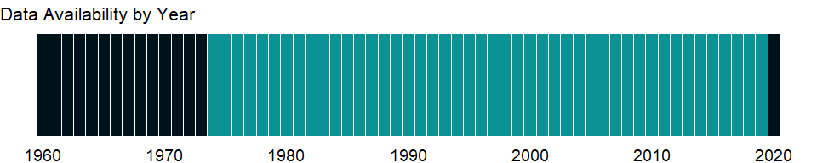

### Which countries have data?

The figure below shows the percentage of countries in each income group with a value since 2010 for that indicator.

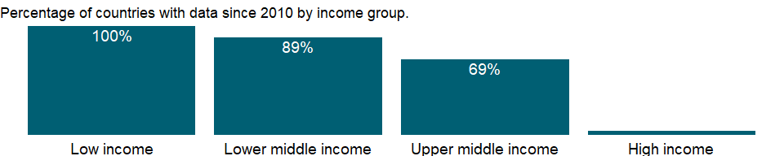

### Why is it relevant?

NA

### What is the data source?

Development Assistance Committee of the Organisation for Economic Co-operation and Development, Geographical Distribution of Financial Flows to Developing Countries, Development Co-operation Report, and International Development Statistics database. Data are available online at: <https://stats.oecd.org/>.

### What is the methodology?

The Development Assistance Committee (DAC) of the Organisation for Economic Co-operation and Development (OECD) has 30 members - 29 individual economies and 1 multilateral institution (European Union institutions).

Data are based on donor country reports of bilateral programs, which may differ from reports by recipient countries. Recipients may lack access to information on such aid expenditures as development-oriented research, stipends and tuition costs for aid-financed students in donor countries, and payment of experts hired by donor countries. Moreover, a full accounting would include donor country contributions to multilateral institutions, the flow of resources from multilateral institutions to recipient countries, and flows from countries that are not members of DAC.

Some of the aid recipients are also aid donors. Development cooperation activities by non-DAC members have increased in recent years and in some cases surpass those of individual DAC members. Some non-DAC donors report their development cooperation activities to DAC on a voluntary basis, but many do not yet report their aid flows to DAC.

### How is it aggregated?

Sum

### What are the limitations?

Data exclude DAC members’ multilateral aid (contributions to the regular budgets of the multilateral institutions). However, projects executed by multilateral institutions or nongovernmental organizations on behalf of DAC members are classified as bilateral aid (since the donor country effectively controls the use of the funds) and are included in the data.

Aid to unspecified economies is included in regional totals and, when possible, income group totals. Aid not allocated by country or region - including administrative costs, research on development, and aid to nongovernmental organizations - is included in the world total. Thus regional and income group totals do not sum to the world total.

### What else should I know?

NA

### 1.10.17 Net bilateral aid flows from DAC donors, Iceland (current US$)

### What is the indicator?

Net bilateral aid flows from DAC donors are the net disbursements of official development assistance (ODA) or official aid from the members of the Development Assistance Committee (DAC). Net disbursements are gross disbursements of grants and loans minus repayments of principal on earlier loans. ODA consists of loans made on concessional terms (with a grant element of at least 25 percent, calculated at a rate of discount of 10 percent) and grants made to promote economic development and welfare in countries and territories in the DAC list of ODA recipients. Official aid refers to aid flows from official donors to countries and territories in part II of the DAC list of recipients: more advanced countries of Central and Eastern Europe, the countries of the former Soviet Union, and certain advanced developing countries and territories. Official aid is provided under terms and conditions similar to those for ODA. Part II of the DAC List was abolished in 2005. The collection of data on official aid and other resource flows to Part II countries ended with 2004 data. DAC members are Australia, Austria, Belgium, Canada, Czech Republic, Denmark, Finland, France, Germany, Greece, Hungary, Iceland, Ireland, Italy, Japan, Korea, Luxembourg, The Netherlands, New Zealand, Norway, Poland, Portugal, Slovak Republic, Slovienia, Spain, Sweden, Switzerland, United Kingdom, United States, and European Union Institutions. Regional aggregates include data for economies not specified elsewhere. World and income group totals include aid not allocated by country or region. Data are in current U.S. dollars.

Topic: Economic Policy & Debt: Official development assistance

Series ID: DC.DAC.ISLL.CD

Copyright: CC BY-4.0 , <https://datacatalog.worldbank.org/public-licenses#cc-by>

First year with any data: 1992

Last year with any data: 2019

### What years are data available?

The figure below shows years in which data is available for at least one country. Dates shaded in black have no data, while dates shaded in green have data for at least one country

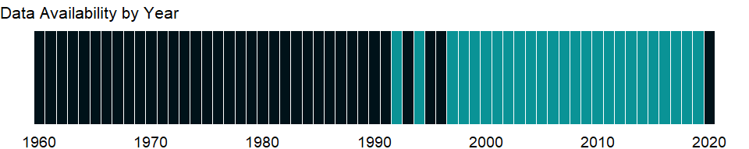

### Which countries have data?

The figure below shows the percentage of countries in each income group with a value since 2010 for that indicator.

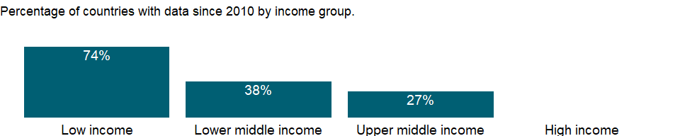

### Why is it relevant?

NA

### What is the data source?

Development Assistance Committee of the Organisation for Economic Co-operation and Development, Geographical Distribution of Financial Flows to Developing Countries, Development Co-operation Report, and International Development Statistics database. Data are available online at: <https://stats.oecd.org/>.

### What is the methodology?

The Development Assistance Committee (DAC) of the Organisation for Economic Co-operation and Development (OECD) has 30 members - 29 individual economies and 1 multilateral institution (European Union institutions).

Data are based on donor country reports of bilateral programs, which may differ from reports by recipient countries. Recipients may lack access to information on such aid expenditures as development-oriented research, stipends and tuition costs for aid-financed students in donor countries, and payment of experts hired by donor countries. Moreover, a full accounting would include donor country contributions to multilateral institutions, the flow of resources from multilateral institutions to recipient countries, and flows from countries that are not members of DAC.

Some of the aid recipients are also aid donors. Development cooperation activities by non-DAC members have increased in recent years and in some cases surpass those of individual DAC members. Some non-DAC donors report their development cooperation activities to DAC on a voluntary basis, but many do not yet report their aid flows to DAC.

### How is it aggregated?

Sum

### What are the limitations?

Data exclude DAC members’ multilateral aid (contributions to the regular budgets of the multilateral institutions). However, projects executed by multilateral institutions or nongovernmental organizations on behalf of DAC members are classified as bilateral aid (since the donor country effectively controls the use of the funds) and are included in the data.

Aid to unspecified economies is included in regional totals and, when possible, income group totals. Aid not allocated by country or region - including administrative costs, research on development, and aid to nongovernmental organizations - is included in the world total. Thus regional and income group totals do not sum to the world total.

### What else should I know?

NA

### 1.10.18 Net bilateral aid flows from DAC donors, Italy (current US$)

### What is the indicator?

Net bilateral aid flows from DAC donors are the net disbursements of official development assistance (ODA) or official aid from the members of the Development Assistance Committee (DAC). Net disbursements are gross disbursements of grants and loans minus repayments of principal on earlier loans. ODA consists of loans made on concessional terms (with a grant element of at least 25 percent, calculated at a rate of discount of 10 percent) and grants made to promote economic development and welfare in countries and territories in the DAC list of ODA recipients. Official aid refers to aid flows from official donors to countries and territories in part II of the DAC list of recipients: more advanced countries of Central and Eastern Europe, the countries of the former Soviet Union, and certain advanced developing countries and territories. Official aid is provided under terms and conditions similar to those for ODA. Part II of the DAC List was abolished in 2005. The collection of data on official aid and other resource flows to Part II countries ended with 2004 data. DAC members are Australia, Austria, Belgium, Canada, Czech Republic, Denmark, Finland, France, Germany, Greece, Hungary, Iceland, Ireland, Italy, Japan, Korea, Luxembourg, The Netherlands, New Zealand, Norway, Poland, Portugal, Slovak Republic, Slovienia, Spain, Sweden, Switzerland, United Kingdom, United States, and European Union Institutions. Regional aggregates include data for economies not specified elsewhere. World and income group totals include aid not allocated by country or region. Data are in current U.S. dollars.

Topic: Economic Policy & Debt: Official development assistance

Series ID: DC.DAC.ITAL.CD

Copyright: CC BY-4.0 , <https://datacatalog.worldbank.org/public-licenses#cc-by>

First year with any data: 1960

Last year with any data: 2019

### What years are data available?

The figure below shows years in which data is available for at least one country. Dates shaded in black have no data, while dates shaded in green have data for at least one country



### Which countries have data?

The figure below shows the percentage of countries in each income group with a value since 2010 for that indicator.

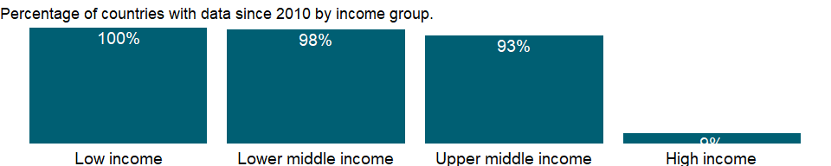

### Why is it relevant?

NA

### What is the data source?

Development Assistance Committee of the Organisation for Economic Co-operation and Development, Geographical Distribution of Financial Flows to Developing Countries, Development Co-operation Report, and International Development Statistics database. Data are available online at: <https://stats.oecd.org/>.

### What is the methodology?

The Development Assistance Committee (DAC) of the Organisation for Economic Co-operation and Development (OECD) has 30 members - 29 individual economies and 1 multilateral institution (European Union institutions).

Data are based on donor country reports of bilateral programs, which may differ from reports by recipient countries. Recipients may lack access to information on such aid expenditures as development-oriented research, stipends and tuition costs for aid-financed students in donor countries, and payment of experts hired by donor countries. Moreover, a full accounting would include donor country contributions to multilateral institutions, the flow of resources from multilateral institutions to recipient countries, and flows from countries that are not members of DAC.

Some of the aid recipients are also aid donors. Development cooperation activities by non-DAC members have increased in recent years and in some cases surpass those of individual DAC members. Some non-DAC donors report their development cooperation activities to DAC on a voluntary basis, but many do not yet report their aid flows to DAC.

### How is it aggregated?

Sum

### What are the limitations?

Data exclude DAC members’ multilateral aid (contributions to the regular budgets of the multilateral institutions). However, projects executed by multilateral institutions or nongovernmental organizations on behalf of DAC members are classified as bilateral aid (since the donor country effectively controls the use of the funds) and are included in the data.

Aid to unspecified economies is included in regional totals and, when possible, income group totals. Aid not allocated by country or region - including administrative costs, research on development, and aid to nongovernmental organizations - is included in the world total. Thus regional and income group totals do not sum to the world total.

### What else should I know?

NA

### 1.10.19 Net bilateral aid flows from DAC donors, Japan (current US$)

### What is the indicator?

Net bilateral aid flows from DAC donors are the net disbursements of official development assistance (ODA) or official aid from the members of the Development Assistance Committee (DAC). Net disbursements are gross disbursements of grants and loans minus repayments of principal on earlier loans. ODA consists of loans made on concessional terms (with a grant element of at least 25 percent, calculated at a rate of discount of 10 percent) and grants made to promote economic development and welfare in countries and territories in the DAC list of ODA recipients. Official aid refers to aid flows from official donors to countries and territories in part II of the DAC list of recipients: more advanced countries of Central and Eastern Europe, the countries of the former Soviet Union, and certain advanced developing countries and territories. Official aid is provided under terms and conditions similar to those for ODA. Part II of the DAC List was abolished in 2005. The collection of data on official aid and other resource flows to Part II countries ended with 2004 data. DAC members are Australia, Austria, Belgium, Canada, Czech Republic, Denmark, Finland, France, Germany, Greece, Hungary, Iceland, Ireland, Italy, Japan, Korea, Luxembourg, The Netherlands, New Zealand, Norway, Poland, Portugal, Slovak Republic, Slovienia, Spain, Sweden, Switzerland, United Kingdom, United States, and European Union Institutions. Regional aggregates include data for economies not specified elsewhere. World and income group totals include aid not allocated by country or region. Data are in current U.S. dollars.

Topic: Economic Policy & Debt: Official development assistance

Series ID: DC.DAC.JPNL.CD

Copyright: CC BY-4.0 , <https://datacatalog.worldbank.org/public-licenses#cc-by>

First year with any data: 1960

Last year with any data: 2019

### What years are data available?

The figure below shows years in which data is available for at least one country. Dates shaded in black have no data, while dates shaded in green have data for at least one country



### Which countries have data?

The figure below shows the percentage of countries in each income group with a value since 2010 for that indicator.

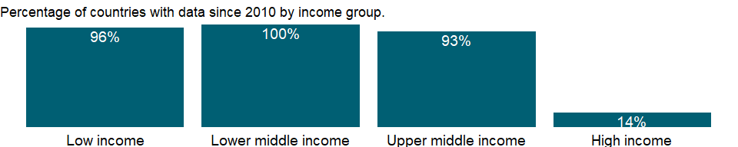

### Why is it relevant?

NA

### What is the data source?

Development Assistance Committee of the Organisation for Economic Co-operation and Development, Geographical Distribution of Financial Flows to Developing Countries, Development Co-operation Report, and International Development Statistics database. Data are available online at: <https://stats.oecd.org/>.

### What is the methodology?

The Development Assistance Committee (DAC) of the Organisation for Economic Co-operation and Development (OECD) has 30 members - 29 individual economies and 1 multilateral institution (European Union institutions).

Data are based on donor country reports of bilateral programs, which may differ from reports by recipient countries. Recipients may lack access to information on such aid expenditures as development-oriented research, stipends and tuition costs for aid-financed students in donor countries, and payment of experts hired by donor countries. Moreover, a full accounting would include donor country contributions to multilateral institutions, the flow of resources from multilateral institutions to recipient countries, and flows from countries that are not members of DAC.

Some of the aid recipients are also aid donors. Development cooperation activities by non-DAC members have increased in recent years and in some cases surpass those of individual DAC members. Some non-DAC donors report their development cooperation activities to DAC on a voluntary basis, but many do not yet report their aid flows to DAC.

### How is it aggregated?

Sum

### What are the limitations?

Data exclude DAC members’ multilateral aid (contributions to the regular budgets of the multilateral institutions). However, projects executed by multilateral institutions or nongovernmental organizations on behalf of DAC members are classified as bilateral aid (since the donor country effectively controls the use of the funds) and are included in the data.

Aid to unspecified economies is included in regional totals and, when possible, income group totals. Aid not allocated by country or region - including administrative costs, research on development, and aid to nongovernmental organizations - is included in the world total. Thus regional and income group totals do not sum to the world total.

### What else should I know?

NA

### 1.10.20 Net bilateral aid flows from DAC donors, Korea, Rep. (current US$)

### What is the indicator?

Net bilateral aid flows from DAC donors are the net disbursements of official development assistance (ODA) or official aid from the members of the Development Assistance Committee (DAC). Net disbursements are gross disbursements of grants and loans minus repayments of principal on earlier loans. ODA consists of loans made on concessional terms (with a grant element of at least 25 percent, calculated at a rate of discount of 10 percent) and grants made to promote economic development and welfare in countries and territories in the DAC list of ODA recipients. Official aid refers to aid flows from official donors to countries and territories in part II of the DAC list of recipients: more advanced countries of Central and Eastern Europe, the countries of the former Soviet Union, and certain advanced developing countries and territories. Official aid is provided under terms and conditions similar to those for ODA. Part II of the DAC List was abolished in 2005. The collection of data on official aid and other resource flows to Part II countries ended with 2004 data. DAC members are Australia, Austria, Belgium, Canada, Czech Republic, Denmark, Finland, France, Germany, Greece, Hungary, Iceland, Ireland, Italy, Japan, Korea, Luxembourg, The Netherlands, New Zealand, Norway, Poland, Portugal, Slovak Republic, Slovienia, Spain, Sweden, Switzerland, United Kingdom, United States, and European Union Institutions. Regional aggregates include data for economies not specified elsewhere. World and income group totals include aid not allocated by country or region. Data are in current U.S. dollars.

Topic: Economic Policy & Debt: Official development assistance

Series ID: DC.DAC.KORL.CD

Copyright: CC BY-4.0 , <https://datacatalog.worldbank.org/public-licenses#cc-by>

First year with any data: 1988

Last year with any data: 2019

### What years are data available?

The figure below shows years in which data is available for at least one country. Dates shaded in black have no data, while dates shaded in green have data for at least one country

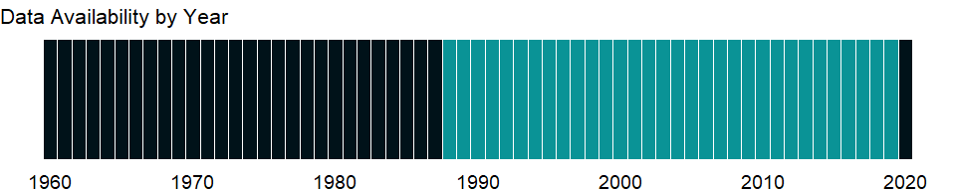

### Which countries have data?

The figure below shows the percentage of countries in each income group with a value since 2010 for that indicator.

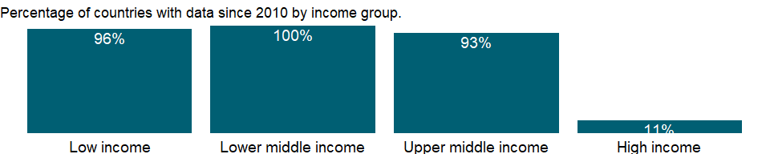

### Why is it relevant?

NA

### What is the data source?

Development Assistance Committee of the Organisation for Economic Co-operation and Development, Geographical Distribution of Financial Flows to Developing Countries, Development Co-operation Report, and International Development Statistics database. Data are available online at: <https://stats.oecd.org/>.

### What is the methodology?

The Development Assistance Committee (DAC) of the Organisation for Economic Co-operation and Development (OECD) has 30 members - 29 individual economies and 1 multilateral institution (European Union institutions).

Data are based on donor country reports of bilateral programs, which may differ from reports by recipient countries. Recipients may lack access to information on such aid expenditures as development-oriented research, stipends and tuition costs for aid-financed students in donor countries, and payment of experts hired by donor countries. Moreover, a full accounting would include donor country contributions to multilateral institutions, the flow of resources from multilateral institutions to recipient countries, and flows from countries that are not members of DAC.

Some of the aid recipients are also aid donors. Development cooperation activities by non-DAC members have increased in recent years and in some cases surpass those of individual DAC members. Some non-DAC donors report their development cooperation activities to DAC on a voluntary basis, but many do not yet report their aid flows to DAC.

### How is it aggregated?

Sum

### What are the limitations?

Data exclude DAC members’ multilateral aid (contributions to the regular budgets of the multilateral institutions). However, projects executed by multilateral institutions or nongovernmental organizations on behalf of DAC members are classified as bilateral aid (since the donor country effectively controls the use of the funds) and are included in the data.

Aid to unspecified economies is included in regional totals and, when possible, income group totals. Aid not allocated by country or region - including administrative costs, research on development, and aid to nongovernmental organizations - is included in the world total. Thus regional and income group totals do not sum to the world total.

### What else should I know?

NA

### 1.10.21 Net bilateral aid flows from DAC donors, Luxembourg (current US$)

### What is the indicator?

Net bilateral aid flows from DAC donors are the net disbursements of official development assistance (ODA) or official aid from the members of the Development Assistance Committee (DAC). Net disbursements are gross disbursements of grants and loans minus repayments of principal on earlier loans. ODA consists of loans made on concessional terms (with a grant element of at least 25 percent, calculated at a rate of discount of 10 percent) and grants made to promote economic development and welfare in countries and territories in the DAC list of ODA recipients. Official aid refers to aid flows from official donors to countries and territories in part II of the DAC list of recipients: more advanced countries of Central and Eastern Europe, the countries of the former Soviet Union, and certain advanced developing countries and territories. Official aid is provided under terms and conditions similar to those for ODA. Part II of the DAC List was abolished in 2005. The collection of data on official aid and other resource flows to Part II countries ended with 2004 data. DAC members are Australia, Austria, Belgium, Canada, Czech Republic, Denmark, Finland, France, Germany, Greece, Hungary, Iceland, Ireland, Italy, Japan, Korea, Luxembourg, The Netherlands, New Zealand, Norway, Poland, Portugal, Slovak Republic, Slovienia, Spain, Sweden, Switzerland, United Kingdom, United States, and European Union Institutions. Regional aggregates include data for economies not specified elsewhere. World and income group totals include aid not allocated by country or region. Data are in current U.S. dollars.

Topic: Economic Policy & Debt: Official development assistance

Series ID: DC.DAC.LUXL.CD

Copyright: CC BY-4.0 , <https://datacatalog.worldbank.org/public-licenses#cc-by>

First year with any data: 1990

Last year with any data: 2019

### What years are data available?

The figure below shows years in which data is available for at least one country. Dates shaded in black have no data, while dates shaded in green have data for at least one country

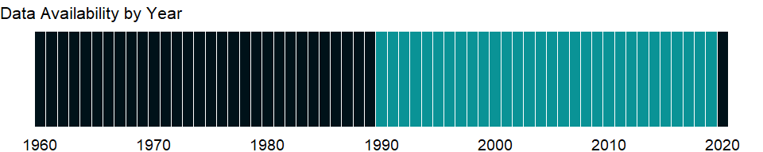

### Which countries have data?

The figure below shows the percentage of countries in each income group with a value since 2010 for that indicator.

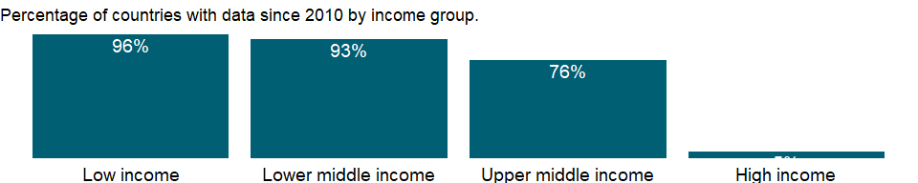

### Why is it relevant?

NA

### What is the data source?

Development Assistance Committee of the Organisation for Economic Co-operation and Development, Geographical Distribution of Financial Flows to Developing Countries, Development Co-operation Report, and International Development Statistics database. Data are available online at: <https://stats.oecd.org/>.

### What is the methodology?

The Development Assistance Committee (DAC) of the Organisation for Economic Co-operation and Development (OECD) has 30 members - 29 individual economies and 1 multilateral institution (European Union institutions).

Data are based on donor country reports of bilateral programs, which may differ from reports by recipient countries. Recipients may lack access to information on such aid expenditures as development-oriented research, stipends and tuition costs for aid-financed students in donor countries, and payment of experts hired by donor countries. Moreover, a full accounting would include donor country contributions to multilateral institutions, the flow of resources from multilateral institutions to recipient countries, and flows from countries that are not members of DAC.

Some of the aid recipients are also aid donors. Development cooperation activities by non-DAC members have increased in recent years and in some cases surpass those of individual DAC members. Some non-DAC donors report their development cooperation activities to DAC on a voluntary basis, but many do not yet report their aid flows to DAC.

### How is it aggregated?

Sum

### What are the limitations?

Data exclude DAC members’ multilateral aid (contributions to the regular budgets of the multilateral institutions). However, projects executed by multilateral institutions or nongovernmental organizations on behalf of DAC members are classified as bilateral aid (since the donor country effectively controls the use of the funds) and are included in the data.

Aid to unspecified economies is included in regional totals and, when possible, income group totals. Aid not allocated by country or region - including administrative costs, research on development, and aid to nongovernmental organizations - is included in the world total. Thus regional and income group totals do not sum to the world total.

### What else should I know?

NA

### 1.10.22 Net bilateral aid flows from DAC donors, Netherlands (current US$)

### What is the indicator?

Net bilateral aid flows from DAC donors are the net disbursements of official development assistance (ODA) or official aid from the members of the Development Assistance Committee (DAC). Net disbursements are gross disbursements of grants and loans minus repayments of principal on earlier loans. ODA consists of loans made on concessional terms (with a grant element of at least 25 percent, calculated at a rate of discount of 10 percent) and grants made to promote economic development and welfare in countries and territories in the DAC list of ODA recipients. Official aid refers to aid flows from official donors to countries and territories in part II of the DAC list of recipients: more advanced countries of Central and Eastern Europe, the countries of the former Soviet Union, and certain advanced developing countries and territories. Official aid is provided under terms and conditions similar to those for ODA. Part II of the DAC List was abolished in 2005. The collection of data on official aid and other resource flows to Part II countries ended with 2004 data. DAC members are Australia, Austria, Belgium, Canada, Czech Republic, Denmark, Finland, France, Germany, Greece, Hungary, Iceland, Ireland, Italy, Japan, Korea, Luxembourg, The Netherlands, New Zealand, Norway, Poland, Portugal, Slovak Republic, Slovienia, Spain, Sweden, Switzerland, United Kingdom, United States, and European Union Institutions. Regional aggregates include data for economies not specified elsewhere. World and income group totals include aid not allocated by country or region. Data are in current U.S. dollars.

Topic: Economic Policy & Debt: Official development assistance

Series ID: DC.DAC.NLDL.CD

Copyright: CC BY-4.0 , <https://datacatalog.worldbank.org/public-licenses#cc-by>

First year with any data: 1960

Last year with any data: 2019

### What years are data available?

The figure below shows years in which data is available for at least one country. Dates shaded in black have no data, while dates shaded in green have data for at least one country

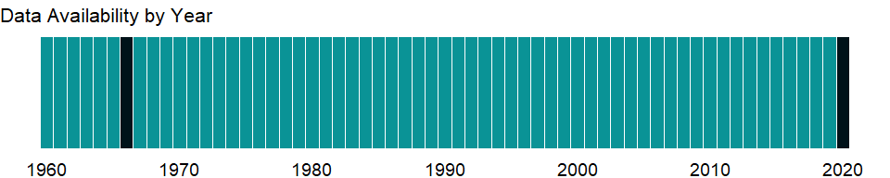

### Which countries have data?

The figure below shows the percentage of countries in each income group with a value since 2010 for that indicator.

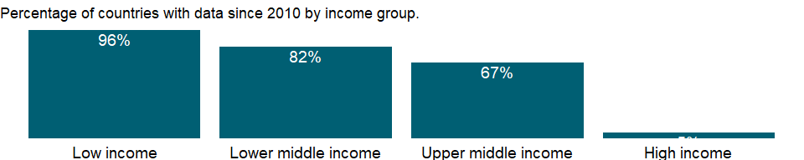

### Why is it relevant?

NA

### What is the data source?

Development Assistance Committee of the Organisation for Economic Co-operation and Development, Geographical Distribution of Financial Flows to Developing Countries, Development Co-operation Report, and International Development Statistics database. Data are available online at: <https://stats.oecd.org/>.

### What is the methodology?

The Development Assistance Committee (DAC) of the Organisation for Economic Co-operation and Development (OECD) has 30 members - 29 individual economies and 1 multilateral institution (European Union institutions).

Data are based on donor country reports of bilateral programs, which may differ from reports by recipient countries. Recipients may lack access to information on such aid expenditures as development-oriented research, stipends and tuition costs for aid-financed students in donor countries, and payment of experts hired by donor countries. Moreover, a full accounting would include donor country contributions to multilateral institutions, the flow of resources from multilateral institutions to recipient countries, and flows from countries that are not members of DAC.

Some of the aid recipients are also aid donors. Development cooperation activities by non-DAC members have increased in recent years and in some cases surpass those of individual DAC members. Some non-DAC donors report their development cooperation activities to DAC on a voluntary basis, but many do not yet report their aid flows to DAC.

### How is it aggregated?

Sum

### What are the limitations?

Data exclude DAC members’ multilateral aid (contributions to the regular budgets of the multilateral institutions). However, projects executed by multilateral institutions or nongovernmental organizations on behalf of DAC members are classified as bilateral aid (since the donor country effectively controls the use of the funds) and are included in the data.

Aid to unspecified economies is included in regional totals and, when possible, income group totals. Aid not allocated by country or region - including administrative costs, research on development, and aid to nongovernmental organizations - is included in the world total. Thus regional and income group totals do not sum to the world total.

### What else should I know?

NA

### 1.10.23 Net bilateral aid flows from DAC donors, Norway (current US$)

### What is the indicator?

Net bilateral aid flows from DAC donors are the net disbursements of official development assistance (ODA) or official aid from the members of the Development Assistance Committee (DAC). Net disbursements are gross disbursements of grants and loans minus repayments of principal on earlier loans. ODA consists of loans made on concessional terms (with a grant element of at least 25 percent, calculated at a rate of discount of 10 percent) and grants made to promote economic development and welfare in countries and territories in the DAC list of ODA recipients. Official aid refers to aid flows from official donors to countries and territories in part II of the DAC list of recipients: more advanced countries of Central and Eastern Europe, the countries of the former Soviet Union, and certain advanced developing countries and territories. Official aid is provided under terms and conditions similar to those for ODA. Part II of the DAC List was abolished in 2005. The collection of data on official aid and other resource flows to Part II countries ended with 2004 data. DAC members are Australia, Austria, Belgium, Canada, Czech Republic, Denmark, Finland, France, Germany, Greece, Hungary, Iceland, Ireland, Italy, Japan, Korea, Luxembourg, The Netherlands, New Zealand, Norway, Poland, Portugal, Slovak Republic, Slovienia, Spain, Sweden, Switzerland, United Kingdom, United States, and European Union Institutions. Regional aggregates include data for economies not specified elsewhere. World and income group totals include aid not allocated by country or region. Data are in current U.S. dollars.

Topic: Economic Policy & Debt: Official development assistance

Series ID: DC.DAC.NORL.CD

Copyright: CC BY-4.0 , <https://datacatalog.worldbank.org/public-licenses#cc-by>

First year with any data: 1960

Last year with any data: 2019

### What years are data available?

The figure below shows years in which data is available for at least one country. Dates shaded in black have no data, while dates shaded in green have data for at least one country



### Which countries have data?

The figure below shows the percentage of countries in each income group with a value since 2010 for that indicator.

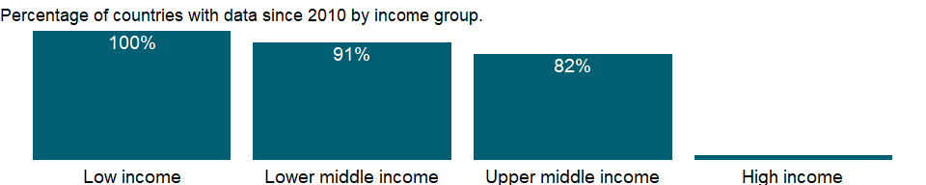

### Why is it relevant?

NA

### What is the data source?

Development Assistance Committee of the Organisation for Economic Co-operation and Development, Geographical Distribution of Financial Flows to Developing Countries, Development Co-operation Report, and International Development Statistics database. Data are available online at: <https://stats.oecd.org/>.

### What is the methodology?

The Development Assistance Committee (DAC) of the Organisation for Economic Co-operation and Development (OECD) has 30 members - 29 individual economies and 1 multilateral institution (European Union institutions).

Data are based on donor country reports of bilateral programs, which may differ from reports by recipient countries. Recipients may lack access to information on such aid expenditures as development-oriented research, stipends and tuition costs for aid-financed students in donor countries, and payment of experts hired by donor countries. Moreover, a full accounting would include donor country contributions to multilateral institutions, the flow of resources from multilateral institutions to recipient countries, and flows from countries that are not members of DAC.

Some of the aid recipients are also aid donors. Development cooperation activities by non-DAC members have increased in recent years and in some cases surpass those of individual DAC members. Some non-DAC donors report their development cooperation activities to DAC on a voluntary basis, but many do not yet report their aid flows to DAC.

### How is it aggregated?

Sum

### What are the limitations?

Data exclude DAC members’ multilateral aid (contributions to the regular budgets of the multilateral institutions). However, projects executed by multilateral institutions or nongovernmental organizations on behalf of DAC members are classified as bilateral aid (since the donor country effectively controls the use of the funds) and are included in the data.

Aid to unspecified economies is included in regional totals and, when possible, income group totals. Aid not allocated by country or region - including administrative costs, research on development, and aid to nongovernmental organizations - is included in the world total. Thus regional and income group totals do not sum to the world total.

### What else should I know?

NA

### 1.10.24 Net bilateral aid flows from DAC donors, New Zealand (current US$)

### What is the indicator?

Net bilateral aid flows from DAC donors are the net disbursements of official development assistance (ODA) or official aid from the members of the Development Assistance Committee (DAC). Net disbursements are gross disbursements of grants and loans minus repayments of principal on earlier loans. ODA consists of loans made on concessional terms (with a grant element of at least 25 percent, calculated at a rate of discount of 10 percent) and grants made to promote economic development and welfare in countries and territories in the DAC list of ODA recipients. Official aid refers to aid flows from official donors to countries and territories in part II of the DAC list of recipients: more advanced countries of Central and Eastern Europe, the countries of the former Soviet Union, and certain advanced developing countries and territories. Official aid is provided under terms and conditions similar to those for ODA. Part II of the DAC List was abolished in 2005. The collection of data on official aid and other resource flows to Part II countries ended with 2004 data. DAC members are Australia, Austria, Belgium, Canada, Czech Republic, Denmark, Finland, France, Germany, Greece, Hungary, Iceland, Ireland, Italy, Japan, Korea, Luxembourg, The Netherlands, New Zealand, Norway, Poland, Portugal, Slovak Republic, Slovienia, Spain, Sweden, Switzerland, United Kingdom, United States, and European Union Institutions. Regional aggregates include data for economies not specified elsewhere. World and income group totals include aid not allocated by country or region. Data are in current U.S. dollars.

Topic: Economic Policy & Debt: Official development assistance

Series ID: DC.DAC.NZLL.CD

Copyright: CC BY-4.0 , <https://datacatalog.worldbank.org/public-licenses#cc-by>

First year with any data: 1972

Last year with any data: 2019

### What years are data available?

The figure below shows years in which data is available for at least one country. Dates shaded in black have no data, while dates shaded in green have data for at least one country

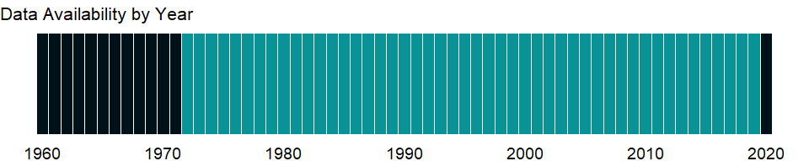

### Which countries have data?

The figure below shows the percentage of countries in each income group with a value since 2010 for that indicator.

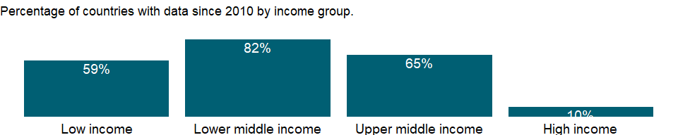

### Why is it relevant?

NA

### What is the data source?

Development Assistance Committee of the Organisation for Economic Co-operation and Development, Geographical Distribution of Financial Flows to Developing Countries, Development Co-operation Report, and International Development Statistics database. Data are available online at: <https://stats.oecd.org/>.

### What is the methodology?

The Development Assistance Committee (DAC) of the Organisation for Economic Co-operation and Development (OECD) has 30 members - 29 individual economies and 1 multilateral institution (European Union institutions).

Data are based on donor country reports of bilateral programs, which may differ from reports by recipient countries. Recipients may lack access to information on such aid expenditures as development-oriented research, stipends and tuition costs for aid-financed students in donor countries, and payment of experts hired by donor countries. Moreover, a full accounting would include donor country contributions to multilateral institutions, the flow of resources from multilateral institutions to recipient countries, and flows from countries that are not members of DAC.

Some of the aid recipients are also aid donors. Development cooperation activities by non-DAC members have increased in recent years and in some cases surpass those of individual DAC members. Some non-DAC donors report their development cooperation activities to DAC on a voluntary basis, but many do not yet report their aid flows to DAC.

### How is it aggregated?

Sum

### What are the limitations?

Data exclude DAC members’ multilateral aid (contributions to the regular budgets of the multilateral institutions). However, projects executed by multilateral institutions or nongovernmental organizations on behalf of DAC members are classified as bilateral aid (since the donor country effectively controls the use of the funds) and are included in the data.

Aid to unspecified economies is included in regional totals and, when possible, income group totals. Aid not allocated by country or region - including administrative costs, research on development, and aid to nongovernmental organizations - is included in the world total. Thus regional and income group totals do not sum to the world total.

### What else should I know?

NA

### 1.10.25 Net bilateral aid flows from DAC donors, Poland (current US$)

### What is the indicator?

Net bilateral aid flows from DAC donors are the net disbursements of official development assistance (ODA) or official aid from the members of the Development Assistance Committee (DAC). Net disbursements are gross disbursements of grants and loans minus repayments of principal on earlier loans. ODA consists of loans made on concessional terms (with a grant element of at least 25 percent, calculated at a rate of discount of 10 percent) and grants made to promote economic development and welfare in countries and territories in the DAC list of ODA recipients. Official aid refers to aid flows from official donors to countries and territories in part II of the DAC list of recipients: more advanced countries of Central and Eastern Europe, the countries of the former Soviet Union, and certain advanced developing countries and territories. Official aid is provided under terms and conditions similar to those for ODA. Part II of the DAC List was abolished in 2005. The collection of data on official aid and other resource flows to Part II countries ended with 2004 data. DAC members are Australia, Austria, Belgium, Canada, Czech Republic, Denmark, Finland, France, Germany, Greece, Hungary, Iceland, Ireland, Italy, Japan, Korea, Luxembourg, The Netherlands, New Zealand, Norway, Poland, Portugal, Slovak Republic, Slovienia, Spain, Sweden, Switzerland, United Kingdom, United States, and European Union Institutions. Regional aggregates include data for economies not specified elsewhere. World and income group totals include aid not allocated by country or region. Data are in current U.S. dollars.

Topic: Economic Policy & Debt: Official development assistance

Series ID: DC.DAC.POLL.CD

Copyright: CC BY-4.0 , <https://datacatalog.worldbank.org/public-licenses#cc-by>

First year with any data: 2005

Last year with any data: 2019

### What years are data available?

The figure below shows years in which data is available for at least one country. Dates shaded in black have no data, while dates shaded in green have data for at least one country



### Which countries have data?

The figure below shows the percentage of countries in each income group with a value since 2010 for that indicator.

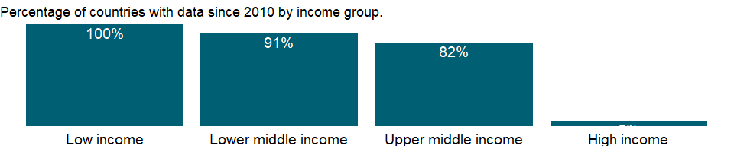

### Why is it relevant?

NA

### What is the data source?

Development Assistance Committee of the Organisation for Economic Co-operation and Development, Geographical Distribution of Financial Flows to Developing Countries, Development Co-operation Report, and International Development Statistics database. Data are available online at: <https://stats.oecd.org/>.

### What is the methodology?

The Development Assistance Committee (DAC) of the Organisation for Economic Co-operation and Development (OECD) has 30 members - 29 individual economies and 1 multilateral institution (European Union institutions).

Data are based on donor country reports of bilateral programs, which may differ from reports by recipient countries. Recipients may lack access to information on such aid expenditures as development-oriented research, stipends and tuition costs for aid-financed students in donor countries, and payment of experts hired by donor countries. Moreover, a full accounting would include donor country contributions to multilateral institutions, the flow of resources from multilateral institutions to recipient countries, and flows from countries that are not members of DAC.

Some of the aid recipients are also aid donors. Development cooperation activities by non-DAC members have increased in recent years and in some cases surpass those of individual DAC members. Some non-DAC donors report their development cooperation activities to DAC on a voluntary basis, but many do not yet report their aid flows to DAC.

### How is it aggregated?

Sum

### What are the limitations?

Data exclude DAC members’ multilateral aid (contributions to the regular budgets of the multilateral institutions). However, projects executed by multilateral institutions or nongovernmental organizations on behalf of DAC members are classified as bilateral aid (since the donor country effectively controls the use of the funds) and are included in the data.

Aid to unspecified economies is included in regional totals and, when possible, income group totals. Aid not allocated by country or region - including administrative costs, research on development, and aid to nongovernmental organizations - is included in the world total. Thus regional and income group totals do not sum to the world total.

### What else should I know?

NA

### 1.10.26 Net bilateral aid flows from DAC donors, Portugal (current US$)

### What is the indicator?

Net bilateral aid flows from DAC donors are the net disbursements of official development assistance (ODA) or official aid from the members of the Development Assistance Committee (DAC). Net disbursements are gross disbursements of grants and loans minus repayments of principal on earlier loans. ODA consists of loans made on concessional terms (with a grant element of at least 25 percent, calculated at a rate of discount of 10 percent) and grants made to promote economic development and welfare in countries and territories in the DAC list of ODA recipients. Official aid refers to aid flows from official donors to countries and territories in part II of the DAC list of recipients: more advanced countries of Central and Eastern Europe, the countries of the former Soviet Union, and certain advanced developing countries and territories. Official aid is provided under terms and conditions similar to those for ODA. Part II of the DAC List was abolished in 2005. The collection of data on official aid and other resource flows to Part II countries ended with 2004 data. DAC members are Australia, Austria, Belgium, Canada, Czech Republic, Denmark, Finland, France, Germany, Greece, Hungary, Iceland, Ireland, Italy, Japan, Korea, Luxembourg, The Netherlands, New Zealand, Norway, Poland, Portugal, Slovak Republic, Slovienia, Spain, Sweden, Switzerland, United Kingdom, United States, and European Union Institutions. Regional aggregates include data for economies not specified elsewhere. World and income group totals include aid not allocated by country or region. Data are in current U.S. dollars.

Topic: Economic Policy & Debt: Official development assistance

Series ID: DC.DAC.PRTL.CD

Copyright: CC BY-4.0 , <https://datacatalog.worldbank.org/public-licenses#cc-by>

First year with any data: 1960

Last year with any data: 2019

### What years are data available?

The figure below shows years in which data is available for at least one country. Dates shaded in black have no data, while dates shaded in green have data for at least one country

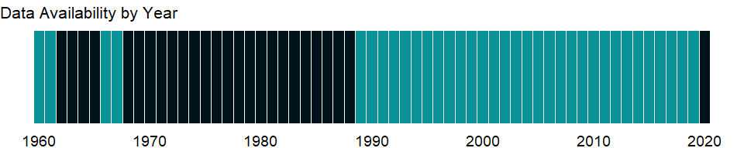

### Which countries have data?

The figure below shows the percentage of countries in each income group with a value since 2010 for that indicator.

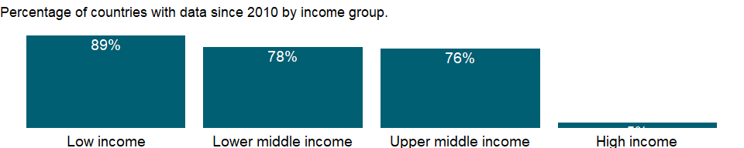

### Why is it relevant?

NA

### What is the data source?

Development Assistance Committee of the Organisation for Economic Co-operation and Development, Geographical Distribution of Financial Flows to Developing Countries, Development Co-operation Report, and International Development Statistics database. Data are available online at: <https://stats.oecd.org/>.

### What is the methodology?

The Development Assistance Committee (DAC) of the Organisation for Economic Co-operation and Development (OECD) has 30 members - 29 individual economies and 1 multilateral institution (European Union institutions).

Data are based on donor country reports of bilateral programs, which may differ from reports by recipient countries. Recipients may lack access to information on such aid expenditures as development-oriented research, stipends and tuition costs for aid-financed students in donor countries, and payment of experts hired by donor countries. Moreover, a full accounting would include donor country contributions to multilateral institutions, the flow of resources from multilateral institutions to recipient countries, and flows from countries that are not members of DAC.

Some of the aid recipients are also aid donors. Development cooperation activities by non-DAC members have increased in recent years and in some cases surpass those of individual DAC members. Some non-DAC donors report their development cooperation activities to DAC on a voluntary basis, but many do not yet report their aid flows to DAC.

### How is it aggregated?

Sum

### What are the limitations?

Data exclude DAC members’ multilateral aid (contributions to the regular budgets of the multilateral institutions). However, projects executed by multilateral institutions or nongovernmental organizations on behalf of DAC members are classified as bilateral aid (since the donor country effectively controls the use of the funds) and are included in the data.

Aid to unspecified economies is included in regional totals and, when possible, income group totals. Aid not allocated by country or region - including administrative costs, research on development, and aid to nongovernmental organizations - is included in the world total. Thus regional and income group totals do not sum to the world total.

### What else should I know?

NA

### 1.10.27 Net bilateral aid flows from DAC donors, Slovak Republic (current US$)

### What is the indicator?

Net bilateral aid flows from DAC donors are the net disbursements of official development assistance (ODA) or official aid from the members of the Development Assistance Committee (DAC). Net disbursements are gross disbursements of grants and loans minus repayments of principal on earlier loans. ODA consists of loans made on concessional terms (with a grant element of at least 25 percent, calculated at a rate of discount of 10 percent) and grants made to promote economic development and welfare in countries and territories in the DAC list of ODA recipients. Official aid refers to aid flows from official donors to countries and territories in part II of the DAC list of recipients: more advanced countries of Central and Eastern Europe, the countries of the former Soviet Union, and certain advanced developing countries and territories. Official aid is provided under terms and conditions similar to those for ODA. Part II of the DAC List was abolished in 2005. The collection of data on official aid and other resource flows to Part II countries ended with 2004 data. DAC members are Australia, Austria, Belgium, Canada, Czech Republic, Denmark, Finland, France, Germany, Greece, Hungary, Iceland, Ireland, Italy, Japan, Korea, Luxembourg, The Netherlands, New Zealand, Norway, Poland, Portugal, Slovak Republic, Slovienia, Spain, Sweden, Switzerland, United Kingdom, United States, and European Union Institutions. Regional aggregates include data for economies not specified elsewhere. World and income group totals include aid not allocated by country or region. Data are in current U.S. dollars.

Topic: Economic Policy & Debt: Official development assistance

Series ID: DC.DAC.SVKL.CD

Copyright: CC BY-4.0 , <https://datacatalog.worldbank.org/public-licenses#cc-by>

First year with any data: 2005

Last year with any data: 2019

### What years are data available?

The figure below shows years in which data is available for at least one country. Dates shaded in black have no data, while dates shaded in green have data for at least one country



### Which countries have data?

The figure below shows the percentage of countries in each income group with a value since 2010 for that indicator.

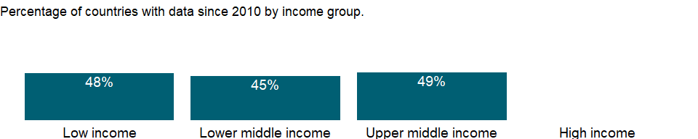

### Why is it relevant?

NA

### What is the data source?

Development Assistance Committee of the Organisation for Economic Co-operation and Development, Geographical Distribution of Financial Flows to Developing Countries, Development Co-operation Report, and International Development Statistics database. Data are available online at: <https://stats.oecd.org/>.

### What is the methodology?

The Development Assistance Committee (DAC) of the Organisation for Economic Co-operation and Development (OECD) has 30 members - 29 individual economies and 1 multilateral institution (European Union institutions).

Data are based on donor country reports of bilateral programs, which may differ from reports by recipient countries. Recipients may lack access to information on such aid expenditures as development-oriented research, stipends and tuition costs for aid-financed students in donor countries, and payment of experts hired by donor countries. Moreover, a full accounting would include donor country contributions to multilateral institutions, the flow of resources from multilateral institutions to recipient countries, and flows from countries that are not members of DAC.

Some of the aid recipients are also aid donors. Development cooperation activities by non-DAC members have increased in recent years and in some cases surpass those of individual DAC members. Some non-DAC donors report their development cooperation activities to DAC on a voluntary basis, but many do not yet report their aid flows to DAC.

### How is it aggregated?

Sum

### What are the limitations?

Data exclude DAC members’ multilateral aid (contributions to the regular budgets of the multilateral institutions). However, projects executed by multilateral institutions or nongovernmental organizations on behalf of DAC members are classified as bilateral aid (since the donor country effectively controls the use of the funds) and are included in the data.

Aid to unspecified economies is included in regional totals and, when possible, income group totals. Aid not allocated by country or region - including administrative costs, research on development, and aid to nongovernmental organizations - is included in the world total. Thus regional and income group totals do not sum to the world total.

### What else should I know?

NA

### 1.10.28 Net bilateral aid flows from DAC donors, Slovenia (current US$)

### What is the indicator?

Net bilateral aid flows from DAC donors are the net disbursements of official development assistance (ODA) or official aid from the members of the Development Assistance Committee (DAC). Net disbursements are gross disbursements of grants and loans minus repayments of principal on earlier loans. ODA consists of loans made on concessional terms (with a grant element of at least 25 percent, calculated at a rate of discount of 10 percent) and grants made to promote economic development and welfare in countries and territories in the DAC list of ODA recipients. Official aid refers to aid flows from official donors to countries and territories in part II of the DAC list of recipients: more advanced countries of Central and Eastern Europe, the countries of the former Soviet Union, and certain advanced developing countries and territories. Official aid is provided under terms and conditions similar to those for ODA. Part II of the DAC List was abolished in 2005. The collection of data on official aid and other resource flows to Part II countries ended with 2004 data. DAC members are Australia, Austria, Belgium, Canada, Czech Republic, Denmark, Finland, France, Germany, Greece, Hungary, Iceland, Ireland, Italy, Japan, Korea, Luxembourg, The Netherlands, New Zealand, Norway, Poland, Portugal, Slovak Republic, Slovienia, Spain, Sweden, Switzerland, United Kingdom, United States, and European Union Institutions. Regional aggregates include data for economies not specified elsewhere. World and income group totals include aid not allocated by country or region. Data are in current U.S. dollars.

Topic: Economic Policy & Debt: Official development assistance

Series ID: DC.DAC.SVNL.CD

Copyright: CC BY-4.0 , <https://datacatalog.worldbank.org/public-licenses#cc-by>

First year with any data: 2008

Last year with any data: 2019

### What years are data available?

The figure below shows years in which data is available for at least one country. Dates shaded in black have no data, while dates shaded in green have data for at least one country

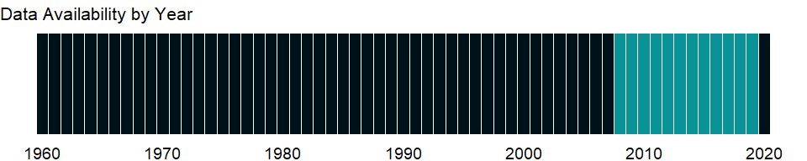

### Which countries have data?

The figure below shows the percentage of countries in each income group with a value since 2010 for that indicator.

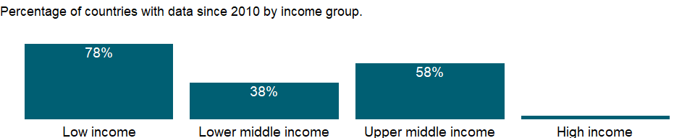

### Why is it relevant?

NA

### What is the data source?

Development Assistance Committee of the Organisation for Economic Co-operation and Development, Geographical Distribution of Financial Flows to Developing Countries, Development Co-operation Report, and International Development Statistics database. Data are available online at: <https://stats.oecd.org/>.

### What is the methodology?

The Development Assistance Committee (DAC) of the Organisation for Economic Co-operation and Development (OECD) has 30 members - 29 individual economies and 1 multilateral institution (European Union institutions).

Data are based on donor country reports of bilateral programs, which may differ from reports by recipient countries. Recipients may lack access to information on such aid expenditures as development-oriented research, stipends and tuition costs for aid-financed students in donor countries, and payment of experts hired by donor countries. Moreover, a full accounting would include donor country contributions to multilateral institutions, the flow of resources from multilateral institutions to recipient countries, and flows from countries that are not members of DAC.

Some of the aid recipients are also aid donors. Development cooperation activities by non-DAC members have increased in recent years and in some cases surpass those of individual DAC members. Some non-DAC donors report their development cooperation activities to DAC on a voluntary basis, but many do not yet report their aid flows to DAC.

### How is it aggregated?

Sum

### What are the limitations?

Data exclude DAC members’ multilateral aid (contributions to the regular budgets of the multilateral institutions). However, projects executed by multilateral institutions or nongovernmental organizations on behalf of DAC members are classified as bilateral aid (since the donor country effectively controls the use of the funds) and are included in the data.

Aid to unspecified economies is included in regional totals and, when possible, income group totals. Aid not allocated by country or region - including administrative costs, research on development, and aid to nongovernmental organizations - is included in the world total. Thus regional and income group totals do not sum to the world total.

### What else should I know?

NA

### 1.10.29 Net bilateral aid flows from DAC donors, Sweden (current US$)

### What is the indicator?

Net bilateral aid flows from DAC donors are the net disbursements of official development assistance (ODA) or official aid from the members of the Development Assistance Committee (DAC). Net disbursements are gross disbursements of grants and loans minus repayments of principal on earlier loans. ODA consists of loans made on concessional terms (with a grant element of at least 25 percent, calculated at a rate of discount of 10 percent) and grants made to promote economic development and welfare in countries and territories in the DAC list of ODA recipients. Official aid refers to aid flows from official donors to countries and territories in part II of the DAC list of recipients: more advanced countries of Central and Eastern Europe, the countries of the former Soviet Union, and certain advanced developing countries and territories. Official aid is provided under terms and conditions similar to those for ODA. Part II of the DAC List was abolished in 2005. The collection of data on official aid and other resource flows to Part II countries ended with 2004 data. DAC members are Australia, Austria, Belgium, Canada, Czech Republic, Denmark, Finland, France, Germany, Greece, Hungary, Iceland, Ireland, Italy, Japan, Korea, Luxembourg, The Netherlands, New Zealand, Norway, Poland, Portugal, Slovak Republic, Slovienia, Spain, Sweden, Switzerland, United Kingdom, United States, and European Union Institutions. Regional aggregates include data for economies not specified elsewhere. World and income group totals include aid not allocated by country or region. Data are in current U.S. dollars.

Topic: Economic Policy & Debt: Official development assistance

Series ID: DC.DAC.SWEL.CD

Copyright: CC BY-4.0 , <https://datacatalog.worldbank.org/public-licenses#cc-by>

First year with any data: 1960

Last year with any data: 2019

### What years are data available?

The figure below shows years in which data is available for at least one country. Dates shaded in black have no data, while dates shaded in green have data for at least one country



### Which countries have data?

The figure below shows the percentage of countries in each income group with a value since 2010 for that indicator.



### Why is it relevant?

NA

### What is the data source?

Development Assistance Committee of the Organisation for Economic Co-operation and Development, Geographical Distribution of Financial Flows to Developing Countries, Development Co-operation Report, and International Development Statistics database. Data are available online at: <https://stats.oecd.org/>.

### What is the methodology?

The Development Assistance Committee (DAC) of the Organisation for Economic Co-operation and Development (OECD) has 30 members - 29 individual economies and 1 multilateral institution (European Union institutions).

Data are based on donor country reports of bilateral programs, which may differ from reports by recipient countries. Recipients may lack access to information on such aid expenditures as development-oriented research, stipends and tuition costs for aid-financed students in donor countries, and payment of experts hired by donor countries. Moreover, a full accounting would include donor country contributions to multilateral institutions, the flow of resources from multilateral institutions to recipient countries, and flows from countries that are not members of DAC.

Some of the aid recipients are also aid donors. Development cooperation activities by non-DAC members have increased in recent years and in some cases surpass those of individual DAC members. Some non-DAC donors report their development cooperation activities to DAC on a voluntary basis, but many do not yet report their aid flows to DAC.

### How is it aggregated?

Sum

### What are the limitations?

Data exclude DAC members’ multilateral aid (contributions to the regular budgets of the multilateral institutions). However, projects executed by multilateral institutions or nongovernmental organizations on behalf of DAC members are classified as bilateral aid (since the donor country effectively controls the use of the funds) and are included in the data.

Aid to unspecified economies is included in regional totals and, when possible, income group totals. Aid not allocated by country or region - including administrative costs, research on development, and aid to nongovernmental organizations - is included in the world total. Thus regional and income group totals do not sum to the world total.

### What else should I know?

NA

### 1.10.30 Net bilateral aid flows from DAC donors, Total (current US$)

### What is the indicator?

Net bilateral aid flows from DAC donors are the net disbursements of official development assistance (ODA) or official aid from the members of the Development Assistance Committee (DAC). Net disbursements are gross disbursements of grants and loans minus repayments of principal on earlier loans. ODA consists of loans made on concessional terms (with a grant element of at least 25 percent, calculated at a rate of discount of 10 percent) and grants made to promote economic development and welfare in countries and territories in the DAC list of ODA recipients. Official aid refers to aid flows from official donors to countries and territories in part II of the DAC list of recipients: more advanced countries of Central and Eastern Europe, the countries of the former Soviet Union, and certain advanced developing countries and territories. Official aid is provided under terms and conditions similar to those for ODA. Part II of the DAC List was abolished in 2005. The collection of data on official aid and other resource flows to Part II countries ended with 2004 data. DAC members are Australia, Austria, Belgium, Canada, Czech Republic, Denmark, Finland, France, Germany, Greece, Hungary, Iceland, Ireland, Italy, Japan, Korea, Luxembourg, The Netherlands, New Zealand, Norway, Poland, Portugal, Slovak Republic, Slovienia, Spain, Sweden, Switzerland, United Kingdom, United States, and European Union Institutions. Regional aggregates include data for economies not specified elsewhere. World and income group totals include aid not allocated by country or region. Data are in current U.S. dollars.

Topic: Economic Policy & Debt: Official development assistance

Series ID: DC.DAC.TOTL.CD

Copyright: CC BY-4.0 , <https://datacatalog.worldbank.org/public-licenses#cc-by>

First year with any data: 1960

Last year with any data: 2019

### What years are data available?

The figure below shows years in which data is available for at least one country. Dates shaded in black have no data, while dates shaded in green have data for at least one country



### Which countries have data?

The figure below shows the percentage of countries in each income group with a value since 2010 for that indicator.



### Why is it relevant?

NA

### What is the data source?

Development Assistance Committee of the Organisation for Economic Co-operation and Development, Geographical Distribution of Financial Flows to Developing Countries, Development Co-operation Report, and International Development Statistics database. Data are available online at: <https://stats.oecd.org/>.

### What is the methodology?

The Development Assistance Committee (DAC) of the Organisation for Economic Co-operation and Development (OECD) has 30 members - 29 individual economies and 1 multilateral institution (European Union institutions).

Data are based on donor country reports of bilateral programs, which may differ from reports by recipient countries. Recipients may lack access to information on such aid expenditures as development-oriented research, stipends and tuition costs for aid-financed students in donor countries, and payment of experts hired by donor countries. Moreover, a full accounting would include donor country contributions to multilateral institutions, the flow of resources from multilateral institutions to recipient countries, and flows from countries that are not members of DAC.

Some of the aid recipients are also aid donors. Development cooperation activities by non-DAC members have increased in recent years and in some cases surpass those of individual DAC members. Some non-DAC donors report their development cooperation activities to DAC on a voluntary basis, but many do not yet report their aid flows to DAC.

### How is it aggregated?

Sum

### What are the limitations?

Data exclude DAC members’ multilateral aid (contributions to the regular budgets of the multilateral institutions). However, projects executed by multilateral institutions or nongovernmental organizations on behalf of DAC members are classified as bilateral aid (since the donor country effectively controls the use of the funds) and are included in the data.

Aid to unspecified economies is included in regional totals and, when possible, income group totals. Aid not allocated by country or region - including administrative costs, research on development, and aid to nongovernmental organizations - is included in the world total. Thus regional and income group totals do not sum to the world total.

### What else should I know?

NA

### 1.10.31 Net bilateral aid flows from DAC donors, United States (current US$)

### What is the indicator?

Net bilateral aid flows from DAC donors are the net disbursements of official development assistance (ODA) or official aid from the members of the Development Assistance Committee (DAC). Net disbursements are gross disbursements of grants and loans minus repayments of principal on earlier loans. ODA consists of loans made on concessional terms (with a grant element of at least 25 percent, calculated at a rate of discount of 10 percent) and grants made to promote economic development and welfare in countries and territories in the DAC list of ODA recipients. Official aid refers to aid flows from official donors to countries and territories in part II of the DAC list of recipients: more advanced countries of Central and Eastern Europe, the countries of the former Soviet Union, and certain advanced developing countries and territories. Official aid is provided under terms and conditions similar to those for ODA. Part II of the DAC List was abolished in 2005. The collection of data on official aid and other resource flows to Part II countries ended with 2004 data. DAC members are Australia, Austria, Belgium, Canada, Czech Republic, Denmark, Finland, France, Germany, Greece, Hungary, Iceland, Ireland, Italy, Japan, Korea, Luxembourg, The Netherlands, New Zealand, Norway, Poland, Portugal, Slovak Republic, Slovienia, Spain, Sweden, Switzerland, United Kingdom, United States, and European Union Institutions. Regional aggregates include data for economies not specified elsewhere. World and income group totals include aid not allocated by country or region. Data are in current U.S. dollars.

Topic: Economic Policy & Debt: Official development assistance

Series ID: DC.DAC.USAL.CD

Copyright: CC BY-4.0 , <https://datacatalog.worldbank.org/public-licenses#cc-by>

First year with any data: 1960

Last year with any data: 2019

### What years are data available?

The figure below shows years in which data is available for at least one country. Dates shaded in black have no data, while dates shaded in green have data for at least one country



### Which countries have data?

The figure below shows the percentage of countries in each income group with a value since 2010 for that indicator.



### Why is it relevant?

NA

### What is the data source?

Development Assistance Committee of the Organisation for Economic Co-operation and Development, Geographical Distribution of Financial Flows to Developing Countries, Development Co-operation Report, and International Development Statistics database. Data are available online at: <https://stats.oecd.org/>.

### What is the methodology?

The Development Assistance Committee (DAC) of the Organisation for Economic Co-operation and Development (OECD) has 30 members - 29 individual economies and 1 multilateral institution (European Union institutions).

Data are based on donor country reports of bilateral programs, which may differ from reports by recipient countries. Recipients may lack access to information on such aid expenditures as development-oriented research, stipends and tuition costs for aid-financed students in donor countries, and payment of experts hired by donor countries. Moreover, a full accounting would include donor country contributions to multilateral institutions, the flow of resources from multilateral institutions to recipient countries, and flows from countries that are not members of DAC.

Some of the aid recipients are also aid donors. Development cooperation activities by non-DAC members have increased in recent years and in some cases surpass those of individual DAC members. Some non-DAC donors report their development cooperation activities to DAC on a voluntary basis, but many do not yet report their aid flows to DAC.

### How is it aggregated?

Sum

### What are the limitations?

Data exclude DAC members’ multilateral aid (contributions to the regular budgets of the multilateral institutions). However, projects executed by multilateral institutions or nongovernmental organizations on behalf of DAC members are classified as bilateral aid (since the donor country effectively controls the use of the funds) and are included in the data.

Aid to unspecified economies is included in regional totals and, when possible, income group totals. Aid not allocated by country or region - including administrative costs, research on development, and aid to nongovernmental organizations - is included in the world total. Thus regional and income group totals do not sum to the world total.

### What else should I know?

NA

### 1.10.32 Net ODA provided, to the least developed countries (current US$)

### What is the indicator?

Net Official development assistance (ODA) comprises grants or loans to developing countries and territories on the OECD/DAC list of aid recipients that are undertaken by the official sector with promotion of economic development and welfare as the main objective and at concessional financial terms. The list of least developed countries (LDCs) has been agreed by the General Assembly, on the recommendation of the Committee for Development Policy, Economic and Social Council.

Topic: Economic Policy & Debt: Official development assistance

Series ID: DC.ODA.TLDC.CD

Copyright: CC BY-4.0 , <https://datacatalog.worldbank.org/public-licenses#cc-by>

First year with any data: 1960

Last year with any data: 2016

### What years are data available?

The figure below shows years in which data is available for at least one country. Dates shaded in black have no data, while dates shaded in green have data for at least one country

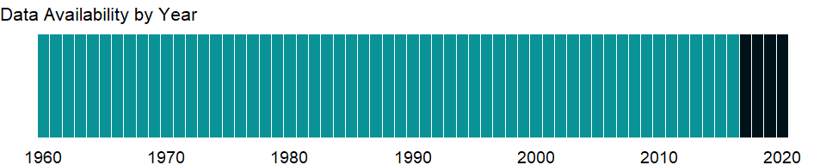

### Which countries have data?

The figure below shows the percentage of countries in each income group with a value since 2010 for that indicator.

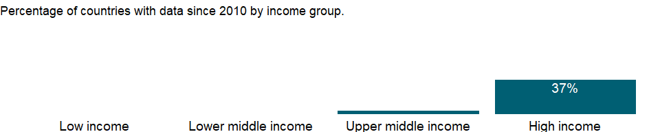

### Why is it relevant?

NA

### What is the data source?

Development Assistance Committee of the Organisation for Economic Co-operation and Development, Geographical Distribution of Financial Flows to Developing Countries, Development Co-operation Report, and International Development Statistics database. Data are available online at: www.oecd.org/dac/stats/idsonline.

### What is the methodology?

NA

### How is it aggregated?

NA

### What are the limitations?

NA

### What else should I know?

NA

### 1.10.33 Net ODA provided to the least developed countries (% of GNI)

### What is the indicator?

Net Official development assistance (ODA) comprises grants or loans to developing countries and territories on the OECD/DAC list of aid recipients that are undertaken by the official sector with promotion of economic development and welfare as the main objective and at concessional financial terms. The list of least developed countries (LDCs) has been agreed by the General Assembly, on the recommendation of the Committee for Development Policy, Economic and Social Council. Series is shown as a share of donors’ GNI.

Topic: Economic Policy & Debt: Official development assistance

Series ID: DC.ODA.TLDC.GN.ZS

Copyright: CC BY-4.0 , <https://datacatalog.worldbank.org/public-licenses#cc-by>

First year with any data: 1960

Last year with any data: 2016

### What years are data available?

The figure below shows years in which data is available for at least one country. Dates shaded in black have no data, while dates shaded in green have data for at least one country



### Which countries have data?

The figure below shows the percentage of countries in each income group with a value since 2010 for that indicator.



### Why is it relevant?

NA

### What is the data source?

Development Assistance Committee of the Organisation for Economic Co-operation and Development, Geographical Distribution of Financial Flows to Developing Countries, Development Co-operation Report, and International Development Statistics database. Data are available online at: www.oecd.org/dac/stats/idsonline.

### What is the methodology?

NA

### How is it aggregated?

NA

### What are the limitations?

NA

### What else should I know?

NA

### 1.10.34 Net ODA provided, total (current US$)

### What is the indicator?

Net Official development assistance (ODA) comprises grants or loans to developing countries and territories on the OECD/DAC list of aid recipients that are undertaken by the official sector with promotion of economic development and welfare as the main objective and at concessional financial terms.

Topic: Economic Policy & Debt: Official development assistance

Series ID: DC.ODA.TOTL.CD

Copyright: CC BY-4.0 , <https://datacatalog.worldbank.org/public-licenses#cc-by>

First year with any data: 1960

Last year with any data: 2016

### What years are data available?

The figure below shows years in which data is available for at least one country. Dates shaded in black have no data, while dates shaded in green have data for at least one country



### Which countries have data?

The figure below shows the percentage of countries in each income group with a value since 2010 for that indicator.



### Why is it relevant?

NA

### What is the data source?

Development Assistance Committee of the Organisation for Economic Co-operation and Development, Geographical Distribution of Financial Flows to Developing Countries, Development Co-operation Report, and International Development Statistics database. Data are available online at: www.oecd.org/dac/stats/idsonline.

### What is the methodology?

NA

### How is it aggregated?

NA

### What are the limitations?

NA

### What else should I know?

NA

### 1.10.35 Net ODA provided, total (% of GNI)

### What is the indicator?

Net Official development assistance (ODA) comprises grants or loans to developing countries and territories on the OECD/DAC list of aid recipients that are undertaken by the official sector with promotion of economic development and welfare as the main objective and at concessional financial terms. It is shown as a share of donors’ GNI.

Topic: Economic Policy & Debt: Official development assistance

Series ID: DC.ODA.TOTL.GN.ZS

Copyright: CC BY-4.0 , <https://datacatalog.worldbank.org/public-licenses#cc-by>

First year with any data: 1960

Last year with any data: 2016

### What years are data available?

The figure below shows years in which data is available for at least one country. Dates shaded in black have no data, while dates shaded in green have data for at least one country



### Which countries have data?

The figure below shows the percentage of countries in each income group with a value since 2010 for that indicator.



### Why is it relevant?

NA

### What is the data source?

Development Assistance Committee of the Organisation for Economic Co-operation and Development, Geographical Distribution of Financial Flows to Developing Countries, Development Co-operation Report, and International Development Statistics database. Data are available online at: www.oecd.org/dac/stats/idsonline.

### What is the methodology?

NA

### How is it aggregated?

NA

### What are the limitations?

NA

### What else should I know?

NA

### 1.10.36 Net ODA provided, total (constant 2015 US$)

### What is the indicator?

Net Official development assistance (ODA) comprises grants or loans to developing countries and territories on the OECD/DAC list of aid recipients that are undertaken by the official sector with promotion of economic development and welfare as the main objective and at concessional financial terms. Data are in constant 2015 U.S. dollars.

Topic: Economic Policy & Debt: Official development assistance

Series ID: DC.ODA.TOTL.KD

Copyright: CC BY-4.0 , <https://datacatalog.worldbank.org/public-licenses#cc-by>

First year with any data: 1960

Last year with any data: 2016

### What years are data available?

The figure below shows years in which data is available for at least one country. Dates shaded in black have no data, while dates shaded in green have data for at least one country



### Which countries have data?

The figure below shows the percentage of countries in each income group with a value since 2010 for that indicator.



### Why is it relevant?

NA

### What is the data source?

Development Assistance Committee of the Organisation for Economic Co-operation and Development, Geographical Distribution of Financial Flows to Developing Countries, Development Co-operation Report, and International Development Statistics database. Data are available online at: www.oecd.org/dac/stats/idsonline.

### What is the methodology?

NA

### How is it aggregated?

NA

### What are the limitations?

NA

### What else should I know?

NA

### 1.10.37 Net official flows from UN agencies, FAO (current US$)

### What is the indicator?

Net official flows from UN agencies are the net disbursements of total official flows from the UN agencies. Total official flows are the sum of Official Development Assistance (ODA) or official aid and Other Official Flows (OOF) and represent the total disbursements by the official sector at large to the recipient country. Net disbursements are gross disbursements of grants and loans minus repayments of principal on earlier loans. ODA consists of loans made on concessional terms (with a grant element of at least 25 percent, calculated at a rate of discount of 10 percent) and grants made to promote economic development and welfare in countries and territories in the DAC list of ODA recipients. Official aid refers to aid flows from official donors to countries and territories in part II of the DAC list of recipients: more advanced countries of Central and Eastern Europe, the countries of the former Soviet Union, and certain advanced developing countries and territories. Official aid is provided under terms and conditions similar to those for ODA. Part II of the DAC List was abolished in 2005. The collection of data on official aid and other resource flows to Part II countries ended with 2004 data. OOF are transactions by the official sector whose main objective is other than development-motivated, or, if development-motivated, whose grant element is below the 25 per cent threshold which would make them eligible to be recorded as ODA. The main classes of transactions included here are official export credits, official sector equity and portfolio investment, and debt reorganization undertaken by the official sector at nonconcessional terms (irrespective of the nature or the identity of the original creditor). UN agencies are United Nations includes the United Nations Children’s Fund (UNICEF), United Nations Relief and Works Agency for Palestine Refugees in the Near East (UNRWA), World Food Programme (WFP), International Fund for Agricultural Development (IFAD), United Nations Development Programme(UNDP), United Nations Population Fund (UNFPA), United Nations Refugee Agency (UNHCR), Joint United Nations Programme on HIV/AIDS (UNAIDS), United Nations Regular Programme for Technical Assistance (UNTA), United Nations Peacebuilding Fund (UNPBF), International Atomic Energy Agency (IAEA), World Health Organization (WHO), United Nations Economic Commission for Europe (UNECE), Food and Agriculture Organization of the United Nations (FAO), International Labour Organization (ILO), United Nations Environment Programme (UNEP), World Tourism Organization (UNWTO) and United Nations Institute for Disarmament Research (UNIDIR). Data are in current U.S. dollars.

Topic: Economic Policy & Debt: Official development assistance

Series ID: DT.NFL.FAOG.CD

Copyright: CC BY-4.0 , <https://datacatalog.worldbank.org/public-licenses#cc-by>

First year with any data: 2013

Last year with any data: 2019

### What years are data available?

The figure below shows years in which data is available for at least one country. Dates shaded in black have no data, while dates shaded in green have data for at least one country

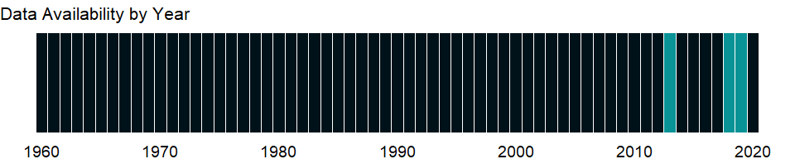

### Which countries have data?

The figure below shows the percentage of countries in each income group with a value since 2010 for that indicator.

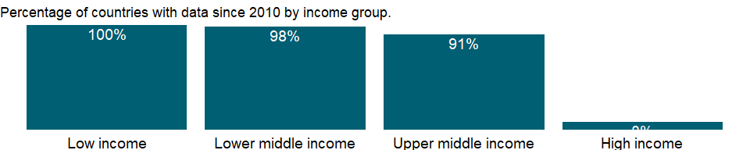

### Why is it relevant?

NA

### What is the data source?

Development Assistance Committee of the Organisation for Economic Co-operation and Development, Geographical Distribution of Financial Flows to Developing Countries, Development Co-operation Report, and International Development Statistics database. Data are available online at: <https://stats.oecd.org/>.

### What is the methodology?

NA

### How is it aggregated?

Sum

### What are the limitations?

NA

### What else should I know?

NA

### 1.10.38 Net official flows from UN agencies, IAEA (current US$)

### What is the indicator?

Net official flows from UN agencies are the net disbursements of total official flows from the UN agencies. Total official flows are the sum of Official Development Assistance (ODA) or official aid and Other Official Flows (OOF) and represent the total disbursements by the official sector at large to the recipient country. Net disbursements are gross disbursements of grants and loans minus repayments of principal on earlier loans. ODA consists of loans made on concessional terms (with a grant element of at least 25 percent, calculated at a rate of discount of 10 percent) and grants made to promote economic development and welfare in countries and territories in the DAC list of ODA recipients. Official aid refers to aid flows from official donors to countries and territories in part II of the DAC list of recipients: more advanced countries of Central and Eastern Europe, the countries of the former Soviet Union, and certain advanced developing countries and territories. Official aid is provided under terms and conditions similar to those for ODA. Part II of the DAC List was abolished in 2005. The collection of data on official aid and other resource flows to Part II countries ended with 2004 data. OOF are transactions by the official sector whose main objective is other than development-motivated, or, if development-motivated, whose grant element is below the 25 per cent threshold which would make them eligible to be recorded as ODA. The main classes of transactions included here are official export credits, official sector equity and portfolio investment, and debt reorganization undertaken by the official sector at nonconcessional terms (irrespective of the nature or the identity of the original creditor). UN agencies are United Nations includes the United Nations Children’s Fund (UNICEF), United Nations Relief and Works Agency for Palestine Refugees in the Near East (UNRWA), World Food Programme (WFP), International Fund for Agricultural Development (IFAD), United Nations Development Programme(UNDP), United Nations Population Fund (UNFPA), United Nations Refugee Agency (UNHCR), Joint United Nations Programme on HIV/AIDS (UNAIDS), United Nations Regular Programme for Technical Assistance (UNTA), United Nations Peacebuilding Fund (UNPBF), International Atomic Energy Agency (IAEA), World Health Organization (WHO), United Nations Economic Commission for Europe (UNECE), Food and Agriculture Organization of the United Nations (FAO), International Labour Organization (ILO), United Nations Environment Programme (UNEP), World Tourism Organization (UNWTO) and United Nations Institute for Disarmament Research (UNIDIR). Data are in current U.S. dollars.

Topic: Economic Policy & Debt: Official development assistance

Series ID: DT.NFL.IAEA.CD

Copyright: CC BY-4.0 , <https://datacatalog.worldbank.org/public-licenses#cc-by>

First year with any data: 2006

Last year with any data: 2019

### What years are data available?

The figure below shows years in which data is available for at least one country. Dates shaded in black have no data, while dates shaded in green have data for at least one country

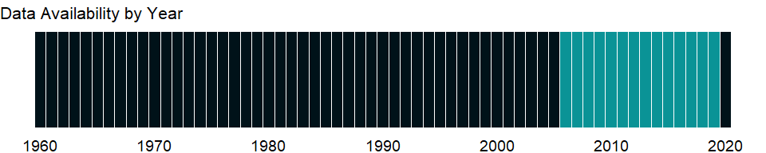

### Which countries have data?

The figure below shows the percentage of countries in each income group with a value since 2010 for that indicator.

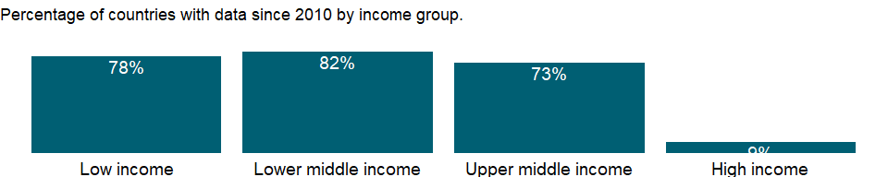

### Why is it relevant?

NA

### What is the data source?

Development Assistance Committee of the Organisation for Economic Co-operation and Development, Geographical Distribution of Financial Flows to Developing Countries, Development Co-operation Report, and International Development Statistics database. Data are available online at: <https://stats.oecd.org/>.

### What is the methodology?

NA

### How is it aggregated?

Sum

### What are the limitations?

NA

### What else should I know?

NA

### 1.10.39 Net official flows from UN agencies, IFAD (current US$)

### What is the indicator?

Net official flows from UN agencies are the net disbursements of total official flows from the UN agencies. Total official flows are the sum of Official Development Assistance (ODA) or official aid and Other Official Flows (OOF) and represent the total disbursements by the official sector at large to the recipient country. Net disbursements are gross disbursements of grants and loans minus repayments of principal on earlier loans. ODA consists of loans made on concessional terms (with a grant element of at least 25 percent, calculated at a rate of discount of 10 percent) and grants made to promote economic development and welfare in countries and territories in the DAC list of ODA recipients. Official aid refers to aid flows from official donors to countries and territories in part II of the DAC list of recipients: more advanced countries of Central and Eastern Europe, the countries of the former Soviet Union, and certain advanced developing countries and territories. Official aid is provided under terms and conditions similar to those for ODA. Part II of the DAC List was abolished in 2005. The collection of data on official aid and other resource flows to Part II countries ended with 2004 data. OOF are transactions by the official sector whose main objective is other than development-motivated, or, if development-motivated, whose grant element is below the 25 per cent threshold which would make them eligible to be recorded as ODA. The main classes of transactions included here are official export credits, official sector equity and portfolio investment, and debt reorganization undertaken by the official sector at nonconcessional terms (irrespective of the nature or the identity of the original creditor). UN agencies are United Nations includes the United Nations Children’s Fund (UNICEF), United Nations Relief and Works Agency for Palestine Refugees in the Near East (UNRWA), World Food Programme (WFP), International Fund for Agricultural Development (IFAD), United Nations Development Programme(UNDP), United Nations Population Fund (UNFPA), United Nations Refugee Agency (UNHCR), Joint United Nations Programme on HIV/AIDS (UNAIDS), United Nations Regular Programme for Technical Assistance (UNTA), United Nations Peacebuilding Fund (UNPBF), International Atomic Energy Agency (IAEA), World Health Organization (WHO), United Nations Economic Commission for Europe (UNECE), Food and Agriculture Organization of the United Nations (FAO), International Labour Organization (ILO), United Nations Environment Programme (UNEP), World Tourism Organization (UNWTO) and United Nations Institute for Disarmament Research (UNIDIR). Data are in current U.S. dollars.

Topic: Economic Policy & Debt: Official development assistance

Series ID: DT.NFL.IFAD.CD

Copyright: CC BY-4.0 , <https://datacatalog.worldbank.org/public-licenses#cc-by>

First year with any data: 1979

Last year with any data: 2019

### What years are data available?

The figure below shows years in which data is available for at least one country. Dates shaded in black have no data, while dates shaded in green have data for at least one country

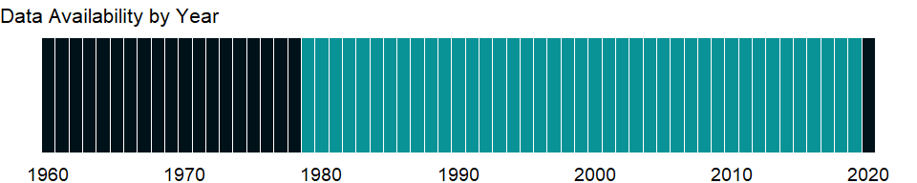

### Which countries have data?

The figure below shows the percentage of countries in each income group with a value since 2010 for that indicator.

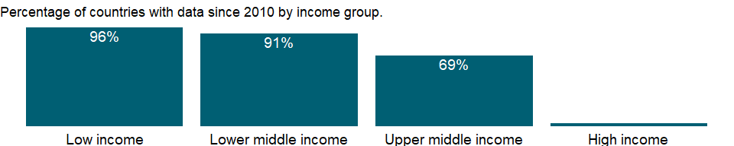

### Why is it relevant?

NA

### What is the data source?

Development Assistance Committee of the Organisation for Economic Co-operation and Development, Geographical Distribution of Financial Flows to Developing Countries, Development Co-operation Report, and International Development Statistics database. Data are available online at: <https://stats.oecd.org/>.

### What is the methodology?

NA

### How is it aggregated?

Sum

### What are the limitations?

NA

### What else should I know?

NA

### 1.10.40 Net official flows from UN agencies, ILO (current US$)

### What is the indicator?

Net official flows from UN agencies are the net disbursements of total official flows from the UN agencies. Total official flows are the sum of Official Development Assistance (ODA) or official aid and Other Official Flows (OOF) and represent the total disbursements by the official sector at large to the recipient country. Net disbursements are gross disbursements of grants and loans minus repayments of principal on earlier loans. ODA consists of loans made on concessional terms (with a grant element of at least 25 percent, calculated at a rate of discount of 10 percent) and grants made to promote economic development and welfare in countries and territories in the DAC list of ODA recipients. Official aid refers to aid flows from official donors to countries and territories in part II of the DAC list of recipients: more advanced countries of Central and Eastern Europe, the countries of the former Soviet Union, and certain advanced developing countries and territories. Official aid is provided under terms and conditions similar to those for ODA. Part II of the DAC List was abolished in 2005. The collection of data on official aid and other resource flows to Part II countries ended with 2004 data. OOF are transactions by the official sector whose main objective is other than development-motivated, or, if development-motivated, whose grant element is below the 25 per cent threshold which would make them eligible to be recorded as ODA. The main classes of transactions included here are official export credits, official sector equity and portfolio investment, and debt reorganization undertaken by the official sector at nonconcessional terms (irrespective of the nature or the identity of the original creditor). UN agencies are United Nations includes the United Nations Children’s Fund (UNICEF), United Nations Relief and Works Agency for Palestine Refugees in the Near East (UNRWA), World Food Programme (WFP), International Fund for Agricultural Development (IFAD), United Nations Development Programme(UNDP), United Nations Population Fund (UNFPA), United Nations Refugee Agency (UNHCR), Joint United Nations Programme on HIV/AIDS (UNAIDS), United Nations Regular Programme for Technical Assistance (UNTA), United Nations Peacebuilding Fund (UNPBF), International Atomic Energy Agency (IAEA), World Health Organization (WHO), United Nations Economic Commission for Europe (UNECE), Food and Agriculture Organization of the United Nations (FAO), International Labour Organization (ILO), United Nations Environment Programme (UNEP), World Tourism Organization (UNWTO) and United Nations Institute for Disarmament Research (UNIDIR). Data are in current U.S. dollars.

Topic: Economic Policy & Debt: Official development assistance

Series ID: DT.NFL.ILOG.CD

Copyright: CC BY-4.0 , <https://datacatalog.worldbank.org/public-licenses#cc-by>

First year with any data: 2012

Last year with any data: 2019

### What years are data available?

The figure below shows years in which data is available for at least one country. Dates shaded in black have no data, while dates shaded in green have data for at least one country

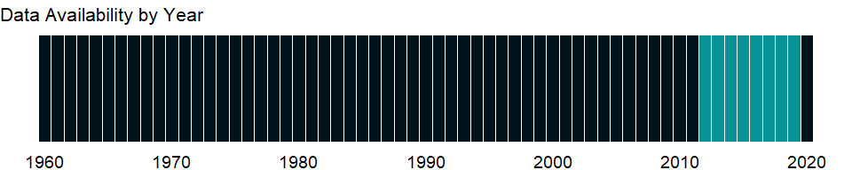

### Which countries have data?

The figure below shows the percentage of countries in each income group with a value since 2010 for that indicator.

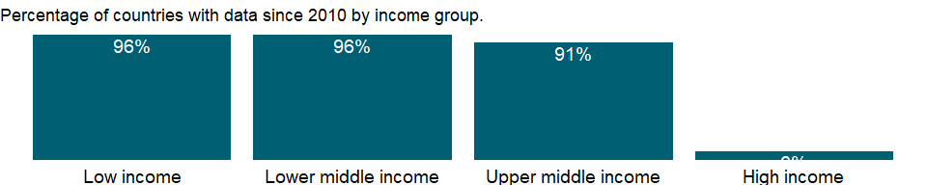

### Why is it relevant?

NA

### What is the data source?

Development Assistance Committee of the Organisation for Economic Co-operation and Development, Geographical Distribution of Financial Flows to Developing Countries, Development Co-operation Report, and International Development Statistics database. Data are available online at: <https://stats.oecd.org/>.

### What is the methodology?

NA

### How is it aggregated?

Sum

### What are the limitations?

NA

### What else should I know?

NA

### 1.10.41 Net official flows from UN agencies, UNAIDS (current US$)

### What is the indicator?

Net official flows from UN agencies are the net disbursements of total official flows from the UN agencies. Total official flows are the sum of Official Development Assistance (ODA) or official aid and Other Official Flows (OOF) and represent the total disbursements by the official sector at large to the recipient country. Net disbursements are gross disbursements of grants and loans minus repayments of principal on earlier loans. ODA consists of loans made on concessional terms (with a grant element of at least 25 percent, calculated at a rate of discount of 10 percent) and grants made to promote economic development and welfare in countries and territories in the DAC list of ODA recipients. Official aid refers to aid flows from official donors to countries and territories in part II of the DAC list of recipients: more advanced countries of Central and Eastern Europe, the countries of the former Soviet Union, and certain advanced developing countries and territories. Official aid is provided under terms and conditions similar to those for ODA. Part II of the DAC List was abolished in 2005. The collection of data on official aid and other resource flows to Part II countries ended with 2004 data. OOF are transactions by the official sector whose main objective is other than development-motivated, or, if development-motivated, whose grant element is below the 25 per cent threshold which would make them eligible to be recorded as ODA. The main classes of transactions included here are official export credits, official sector equity and portfolio investment, and debt reorganization undertaken by the official sector at nonconcessional terms (irrespective of the nature or the identity of the original creditor). UN agencies are United Nations includes the United Nations Children’s Fund (UNICEF), United Nations Relief and Works Agency for Palestine Refugees in the Near East (UNRWA), World Food Programme (WFP), International Fund for Agricultural Development (IFAD), United Nations Development Programme(UNDP), United Nations Population Fund (UNFPA), United Nations Refugee Agency (UNHCR), Joint United Nations Programme on HIV/AIDS (UNAIDS), United Nations Regular Programme for Technical Assistance (UNTA), United Nations Peacebuilding Fund (UNPBF), International Atomic Energy Agency (IAEA), World Health Organization (WHO), United Nations Economic Commission for Europe (UNECE), Food and Agriculture Organization of the United Nations (FAO), International Labour Organization (ILO), United Nations Environment Programme (UNEP), World Tourism Organization (UNWTO) and United Nations Institute for Disarmament Research (UNIDIR). Data are in current U.S. dollars.

Topic: Economic Policy & Debt: Official development assistance

Series ID: DT.NFL.UNAI.CD

Copyright: CC BY-4.0 , <https://datacatalog.worldbank.org/public-licenses#cc-by>

First year with any data: 2005

Last year with any data: 2019

### What years are data available?

The figure below shows years in which data is available for at least one country. Dates shaded in black have no data, while dates shaded in green have data for at least one country



### Which countries have data?

The figure below shows the percentage of countries in each income group with a value since 2010 for that indicator.

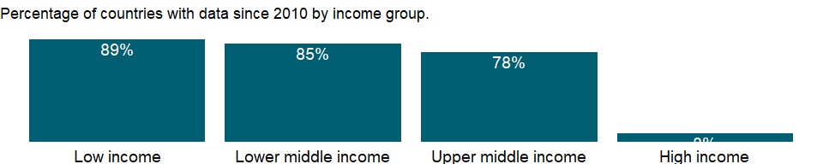

### Why is it relevant?

NA

### What is the data source?

Development Assistance Committee of the Organisation for Economic Co-operation and Development, Geographical Distribution of Financial Flows to Developing Countries, Development Co-operation Report, and International Development Statistics database. Data are available online at: <https://stats.oecd.org/>.

### What is the methodology?

NA

### How is it aggregated?

Sum

### What are the limitations?

NA

### What else should I know?

NA

### 1.10.42 Net official flows from UN agencies, UNICEF (current US$)

### What is the indicator?

Net official flows from UN agencies are the net disbursements of total official flows from the UN agencies. Total official flows are the sum of Official Development Assistance (ODA) or official aid and Other Official Flows (OOF) and represent the total disbursements by the official sector at large to the recipient country. Net disbursements are gross disbursements of grants and loans minus repayments of principal on earlier loans. ODA consists of loans made on concessional terms (with a grant element of at least 25 percent, calculated at a rate of discount of 10 percent) and grants made to promote economic development and welfare in countries and territories in the DAC list of ODA recipients. Official aid refers to aid flows from official donors to countries and territories in part II of the DAC list of recipients: more advanced countries of Central and Eastern Europe, the countries of the former Soviet Union, and certain advanced developing countries and territories. Official aid is provided under terms and conditions similar to those for ODA. Part II of the DAC List was abolished in 2005. The collection of data on official aid and other resource flows to Part II countries ended with 2004 data. OOF are transactions by the official sector whose main objective is other than development-motivated, or, if development-motivated, whose grant element is below the 25 per cent threshold which would make them eligible to be recorded as ODA. The main classes of transactions included here are official export credits, official sector equity and portfolio investment, and debt reorganization undertaken by the official sector at nonconcessional terms (irrespective of the nature or the identity of the original creditor). UN agencies are United Nations includes the United Nations Children’s Fund (UNICEF), United Nations Relief and Works Agency for Palestine Refugees in the Near East (UNRWA), World Food Programme (WFP), International Fund for Agricultural Development (IFAD), United Nations Development Programme(UNDP), United Nations Population Fund (UNFPA), United Nations Refugee Agency (UNHCR), Joint United Nations Programme on HIV/AIDS (UNAIDS), United Nations Regular Programme for Technical Assistance (UNTA), United Nations Peacebuilding Fund (UNPBF), International Atomic Energy Agency (IAEA), World Health Organization (WHO), United Nations Economic Commission for Europe (UNECE), Food and Agriculture Organization of the United Nations (FAO), International Labour Organization (ILO), United Nations Environment Programme (UNEP), World Tourism Organization (UNWTO) and United Nations Institute for Disarmament Research (UNIDIR). Data are in current U.S. dollars.

Topic: Economic Policy & Debt: Official development assistance

Series ID: DT.NFL.UNCF.CD

Copyright: CC BY-4.0 , <https://datacatalog.worldbank.org/public-licenses#cc-by>

First year with any data: 1970

Last year with any data: 2019

### What years are data available?

The figure below shows years in which data is available for at least one country. Dates shaded in black have no data, while dates shaded in green have data for at least one country



### Which countries have data?

The figure below shows the percentage of countries in each income group with a value since 2010 for that indicator.

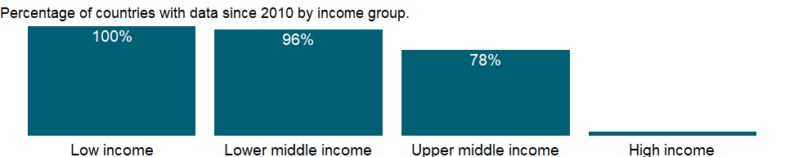

### Why is it relevant?

NA

### What is the data source?

Development Assistance Committee of the Organisation for Economic Co-operation and Development, Geographical Distribution of Financial Flows to Developing Countries, Development Co-operation Report, and International Development Statistics database. Data are available online at: <https://stats.oecd.org/>.

### What is the methodology?

NA

### How is it aggregated?

Sum

### What are the limitations?

NA

### What else should I know?

NA

### 1.10.43 Net official flows from UN agencies, UNHCR (current US$)

### What is the indicator?

Net official flows from UN agencies are the net disbursements of total official flows from the UN agencies. Total official flows are the sum of Official Development Assistance (ODA) or official aid and Other Official Flows (OOF) and represent the total disbursements by the official sector at large to the recipient country. Net disbursements are gross disbursements of grants and loans minus repayments of principal on earlier loans. ODA consists of loans made on concessional terms (with a grant element of at least 25 percent, calculated at a rate of discount of 10 percent) and grants made to promote economic development and welfare in countries and territories in the DAC list of ODA recipients. Official aid refers to aid flows from official donors to countries and territories in part II of the DAC list of recipients: more advanced countries of Central and Eastern Europe, the countries of the former Soviet Union, and certain advanced developing countries and territories. Official aid is provided under terms and conditions similar to those for ODA. Part II of the DAC List was abolished in 2005. The collection of data on official aid and other resource flows to Part II countries ended with 2004 data. OOF are transactions by the official sector whose main objective is other than development-motivated, or, if development-motivated, whose grant element is below the 25 per cent threshold which would make them eligible to be recorded as ODA. The main classes of transactions included here are official export credits, official sector equity and portfolio investment, and debt reorganization undertaken by the official sector at nonconcessional terms (irrespective of the nature or the identity of the original creditor). UN agencies are United Nations includes the United Nations Children’s Fund (UNICEF), United Nations Relief and Works Agency for Palestine Refugees in the Near East (UNRWA), World Food Programme (WFP), International Fund for Agricultural Development (IFAD), United Nations Development Programme(UNDP), United Nations Population Fund (UNFPA), United Nations Refugee Agency (UNHCR), Joint United Nations Programme on HIV/AIDS (UNAIDS), United Nations Regular Programme for Technical Assistance (UNTA), United Nations Peacebuilding Fund (UNPBF), International Atomic Energy Agency (IAEA), World Health Organization (WHO), United Nations Economic Commission for Europe (UNECE), Food and Agriculture Organization of the United Nations (FAO), International Labour Organization (ILO), United Nations Environment Programme (UNEP), World Tourism Organization (UNWTO) and United Nations Institute for Disarmament Research (UNIDIR). Data are in current U.S. dollars.

Topic: Economic Policy & Debt: Official development assistance

Series ID: DT.NFL.UNCR.CD

Copyright: CC BY-4.0 , <https://datacatalog.worldbank.org/public-licenses#cc-by>

First year with any data: 1969

Last year with any data: 2019

### What years are data available?

The figure below shows years in which data is available for at least one country. Dates shaded in black have no data, while dates shaded in green have data for at least one country

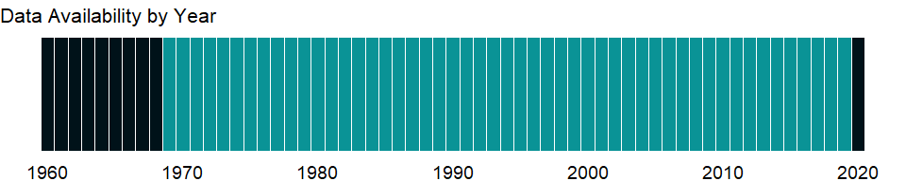

### Which countries have data?

The figure below shows the percentage of countries in each income group with a value since 2010 for that indicator.

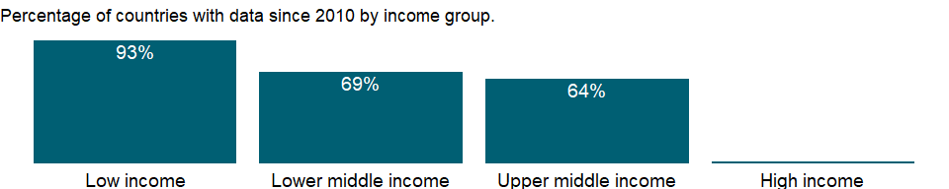

### Why is it relevant?

NA

### What is the data source?

Development Assistance Committee of the Organisation for Economic Co-operation and Development, Geographical Distribution of Financial Flows to Developing Countries, Development Co-operation Report, and International Development Statistics database. Data are available online at: <https://stats.oecd.org/>.

### What is the methodology?

NA

### How is it aggregated?

Sum

### What are the limitations?

NA

### What else should I know?

NA

### 1.10.44 Net official flows from UN agencies, UNDP (current US$)

### What is the indicator?

Net official flows from UN agencies are the net disbursements of total official flows from the UN agencies. Total official flows are the sum of Official Development Assistance (ODA) or official aid and Other Official Flows (OOF) and represent the total disbursements by the official sector at large to the recipient country. Net disbursements are gross disbursements of grants and loans minus repayments of principal on earlier loans. ODA consists of loans made on concessional terms (with a grant element of at least 25 percent, calculated at a rate of discount of 10 percent) and grants made to promote economic development and welfare in countries and territories in the DAC list of ODA recipients. Official aid refers to aid flows from official donors to countries and territories in part II of the DAC list of recipients: more advanced countries of Central and Eastern Europe, the countries of the former Soviet Union, and certain advanced developing countries and territories. Official aid is provided under terms and conditions similar to those for ODA. Part II of the DAC List was abolished in 2005. The collection of data on official aid and other resource flows to Part II countries ended with 2004 data. OOF are transactions by the official sector whose main objective is other than development-motivated, or, if development-motivated, whose grant element is below the 25 per cent threshold which would make them eligible to be recorded as ODA. The main classes of transactions included here are official export credits, official sector equity and portfolio investment, and debt reorganization undertaken by the official sector at nonconcessional terms (irrespective of the nature or the identity of the original creditor). UN agencies are United Nations includes the United Nations Children’s Fund (UNICEF), United Nations Relief and Works Agency for Palestine Refugees in the Near East (UNRWA), World Food Programme (WFP), International Fund for Agricultural Development (IFAD), United Nations Development Programme(UNDP), United Nations Population Fund (UNFPA), United Nations Refugee Agency (UNHCR), Joint United Nations Programme on HIV/AIDS (UNAIDS), United Nations Regular Programme for Technical Assistance (UNTA), United Nations Peacebuilding Fund (UNPBF), International Atomic Energy Agency (IAEA), World Health Organization (WHO), United Nations Economic Commission for Europe (UNECE), Food and Agriculture Organization of the United Nations (FAO), International Labour Organization (ILO), United Nations Environment Programme (UNEP), World Tourism Organization (UNWTO) and United Nations Institute for Disarmament Research (UNIDIR). Data are in current U.S. dollars.

Topic: Economic Policy & Debt: Official development assistance

Series ID: DT.NFL.UNDP.CD

Copyright: CC BY-4.0 , <https://datacatalog.worldbank.org/public-licenses#cc-by>

First year with any data: 1968

Last year with any data: 2019

### What years are data available?

The figure below shows years in which data is available for at least one country. Dates shaded in black have no data, while dates shaded in green have data for at least one country

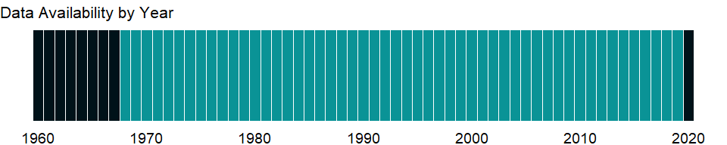

### Which countries have data?

The figure below shows the percentage of countries in each income group with a value since 2010 for that indicator.



### Why is it relevant?

NA

### What is the data source?

Development Assistance Committee of the Organisation for Economic Co-operation and Development, Geographical Distribution of Financial Flows to Developing Countries, Development Co-operation Report, and International Development Statistics database. Data are available online at: <https://stats.oecd.org/>.

### What is the methodology?

NA

### How is it aggregated?

Sum

### What are the limitations?

NA

### What else should I know?

NA

### 1.10.45 Net official flows from UN agencies, UNECE (current US$)

### What is the indicator?

Net official flows from UN agencies are the net disbursements of total official flows from the UN agencies. Total official flows are the sum of Official Development Assistance (ODA) or official aid and Other Official Flows (OOF) and represent the total disbursements by the official sector at large to the recipient country. Net disbursements are gross disbursements of grants and loans minus repayments of principal on earlier loans. ODA consists of loans made on concessional terms (with a grant element of at least 25 percent, calculated at a rate of discount of 10 percent) and grants made to promote economic development and welfare in countries and territories in the DAC list of ODA recipients. Official aid refers to aid flows from official donors to countries and territories in part II of the DAC list of recipients: more advanced countries of Central and Eastern Europe, the countries of the former Soviet Union, and certain advanced developing countries and territories. Official aid is provided under terms and conditions similar to those for ODA. Part II of the DAC List was abolished in 2005. The collection of data on official aid and other resource flows to Part II countries ended with 2004 data. OOF are transactions by the official sector whose main objective is other than development-motivated, or, if development-motivated, whose grant element is below the 25 per cent threshold which would make them eligible to be recorded as ODA. The main classes of transactions included here are official export credits, official sector equity and portfolio investment, and debt reorganization undertaken by the official sector at nonconcessional terms (irrespective of the nature or the identity of the original creditor). UN agencies are United Nations includes the United Nations Children’s Fund (UNICEF), United Nations Relief and Works Agency for Palestine Refugees in the Near East (UNRWA), World Food Programme (WFP), International Fund for Agricultural Development (IFAD), United Nations Development Programme(UNDP), United Nations Population Fund (UNFPA), United Nations Refugee Agency (UNHCR), Joint United Nations Programme on HIV/AIDS (UNAIDS), United Nations Regular Programme for Technical Assistance (UNTA), United Nations Peacebuilding Fund (UNPBF), International Atomic Energy Agency (IAEA), World Health Organization (WHO), United Nations Economic Commission for Europe (UNECE), Food and Agriculture Organization of the United Nations (FAO), International Labour Organization (ILO), United Nations Environment Programme (UNEP), World Tourism Organization (UNWTO) and United Nations Institute for Disarmament Research (UNIDIR). Data are in current U.S. dollars.

Topic: Economic Policy & Debt: Official development assistance

Series ID: DT.NFL.UNEC.CD

Copyright: CC BY-4.0 , <https://datacatalog.worldbank.org/public-licenses#cc-by>

First year with any data: 2010

Last year with any data: 2017

### What years are data available?

The figure below shows years in which data is available for at least one country. Dates shaded in black have no data, while dates shaded in green have data for at least one country

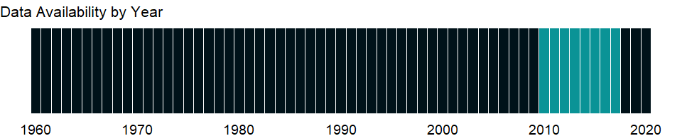

### Which countries have data?

The figure below shows the percentage of countries in each income group with a value since 2010 for that indicator.

### Why is it relevant?

NA

### What is the data source?

Development Assistance Committee of the Organisation for Economic Co-operation and Development, Geographical Distribution of Financial Flows to Developing Countries, Development Co-operation Report, and International Development Statistics database. Data are available online at: <https://stats.oecd.org/>.

### What is the methodology?

NA

### How is it aggregated?

Sum

### What are the limitations?

NA

### What else should I know?

Data for net official flows from UNECE at present are reported at the regional level only. A more detailed breakdown by recipient country will be available in the future.

### 1.10.46 Net official flows from UN agencies, UNEP (current US$)

## Warning in min(yr_df$date, na.rm = T): no non-missing arguments to min;  
## returning Inf

## Warning in max(yr_df$date, na.rm = T): no non-missing arguments to max;  
## returning -Inf

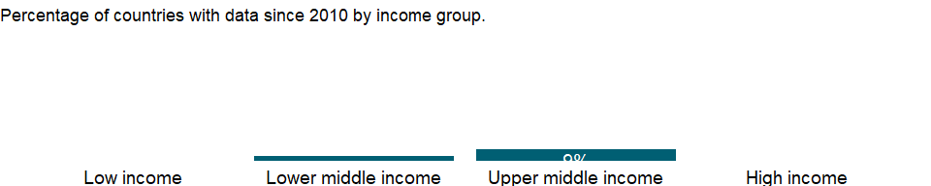### What is the indicator? {-}

Net official flows from UN agencies are the net disbursements of total official flows from the UN agencies. Total official flows are the sum of Official Development Assistance (ODA) or official aid and Other Official Flows (OOF) and represent the total disbursements by the official sector at large to the recipient country. Net disbursements are gross disbursements of grants and loans minus repayments of principal on earlier loans. ODA consists of loans made on concessional terms (with a grant element of at least 25 percent, calculated at a rate of discount of 10 percent) and grants made to promote economic development and welfare in countries and territories in the DAC list of ODA recipients. Official aid refers to aid flows from official donors to countries and territories in part II of the DAC list of recipients: more advanced countries of Central and Eastern Europe, the countries of the former Soviet Union, and certain advanced developing countries and territories. Official aid is provided under terms and conditions similar to those for ODA. Part II of the DAC List was abolished in 2005. The collection of data on official aid and other resource flows to Part II countries ended with 2004 data. OOF are transactions by the official sector whose main objective is other than development-motivated, or, if development-motivated, whose grant element is below the 25 per cent threshold which would make them eligible to be recorded as ODA. The main classes of transactions included here are official export credits, official sector equity and portfolio investment, and debt reorganization undertaken by the official sector at nonconcessional terms (irrespective of the nature or the identity of the original creditor). UN agencies are United Nations includes the United Nations Children’s Fund (UNICEF), United Nations Relief and Works Agency for Palestine Refugees in the Near East (UNRWA), World Food Programme (WFP), International Fund for Agricultural Development (IFAD), United Nations Development Programme(UNDP), United Nations Population Fund (UNFPA), United Nations Refugee Agency (UNHCR), Joint United Nations Programme on HIV/AIDS (UNAIDS), United Nations Regular Programme for Technical Assistance (UNTA), United Nations Peacebuilding Fund (UNPBF), International Atomic Energy Agency (IAEA), World Health Organization (WHO), United Nations Economic Commission for Europe (UNECE), Food and Agriculture Organization of the United Nations (FAO), International Labour Organization (ILO), United Nations Environment Programme (UNEP), World Tourism Organization (UNWTO) and United Nations Institute for Disarmament Research (UNIDIR). Data are in current U.S. dollars.

Topic: Economic Policy & Debt: Official development assistance

Series ID: DT.NFL.UNEP.CD

Copyright: CC BY-4.0 , <https://datacatalog.worldbank.org/public-licenses#cc-by>

First year with any data: Inf

Last year with any data: -Inf

### What years are data available?

The figure below shows years in which data is available for at least one country. Dates shaded in black have no data, while dates shaded in green have data for at least one country

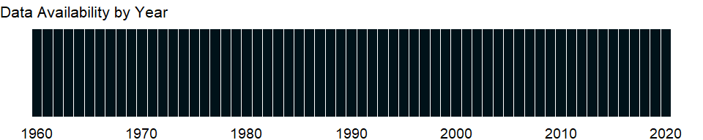

### Which countries have data?

The figure below shows the percentage of countries in each income group with a value since 2010 for that indicator.



### Why is it relevant?

NA

### What is the data source?

Development Assistance Committee of the Organisation for Economic Co-operation and Development, Geographical Distribution of Financial Flows to Developing Countries, Development Co-operation Report, and International Development Statistics database. Data are available online at: <https://stats.oecd.org/>.

### What is the methodology?

NA

### How is it aggregated?

Sum

### What are the limitations?

NA

### What else should I know?

NA

### 1.10.47 Net official flows from UN agencies, UNFPA (current US$)

### What is the indicator?

Net official flows from UN agencies are the net disbursements of total official flows from the UN agencies. Total official flows are the sum of Official Development Assistance (ODA) or official aid and Other Official Flows (OOF) and represent the total disbursements by the official sector at large to the recipient country. Net disbursements are gross disbursements of grants and loans minus repayments of principal on earlier loans. ODA consists of loans made on concessional terms (with a grant element of at least 25 percent, calculated at a rate of discount of 10 percent) and grants made to promote economic development and welfare in countries and territories in the DAC list of ODA recipients. Official aid refers to aid flows from official donors to countries and territories in part II of the DAC list of recipients: more advanced countries of Central and Eastern Europe, the countries of the former Soviet Union, and certain advanced developing countries and territories. Official aid is provided under terms and conditions similar to those for ODA. Part II of the DAC List was abolished in 2005. The collection of data on official aid and other resource flows to Part II countries ended with 2004 data. OOF are transactions by the official sector whose main objective is other than development-motivated, or, if development-motivated, whose grant element is below the 25 per cent threshold which would make them eligible to be recorded as ODA. The main classes of transactions included here are official export credits, official sector equity and portfolio investment, and debt reorganization undertaken by the official sector at nonconcessional terms (irrespective of the nature or the identity of the original creditor). UN agencies are United Nations includes the United Nations Children’s Fund (UNICEF), United Nations Relief and Works Agency for Palestine Refugees in the Near East (UNRWA), World Food Programme (WFP), International Fund for Agricultural Development (IFAD), United Nations Development Programme(UNDP), United Nations Population Fund (UNFPA), United Nations Refugee Agency (UNHCR), Joint United Nations Programme on HIV/AIDS (UNAIDS), United Nations Regular Programme for Technical Assistance (UNTA), United Nations Peacebuilding Fund (UNPBF), International Atomic Energy Agency (IAEA), World Health Organization (WHO), United Nations Economic Commission for Europe (UNECE), Food and Agriculture Organization of the United Nations (FAO), International Labour Organization (ILO), United Nations Environment Programme (UNEP), World Tourism Organization (UNWTO) and United Nations Institute for Disarmament Research (UNIDIR). Data are in current U.S. dollars.

Topic: Economic Policy & Debt: Official development assistance

Series ID: DT.NFL.UNFP.CD

Copyright: CC BY-4.0 , <https://datacatalog.worldbank.org/public-licenses#cc-by>

First year with any data: 1977

Last year with any data: 2019

### What years are data available?

The figure below shows years in which data is available for at least one country. Dates shaded in black have no data, while dates shaded in green have data for at least one country

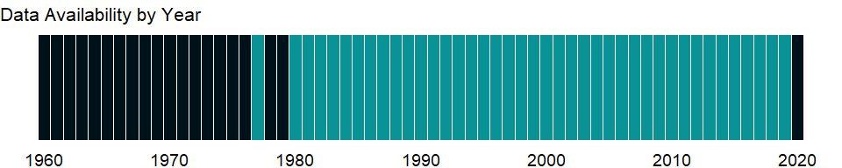

### Which countries have data?

The figure below shows the percentage of countries in each income group with a value since 2010 for that indicator.

### Why is it relevant?

NA

### What is the data source?

Development Assistance Committee of the Organisation for Economic Co-operation and Development, Geographical Distribution of Financial Flows to Developing Countries, Development Co-operation Report, and International Development Statistics database. Data are available online at: <https://stats.oecd.org/>.

### What is the methodology?

NA

### How is it aggregated?

Sum

### What are the limitations?

NA

### What else should I know?

NA

### 1.10.48 Net official flows from UN agencies, UNIDIR (current US$)

## Warning in min(yr_df$date, na.rm = T): no non-missing arguments to min;  
## returning Inf  
  
## Warning in min(yr_df$date, na.rm = T): no non-missing arguments to max;  
## returning -Inf

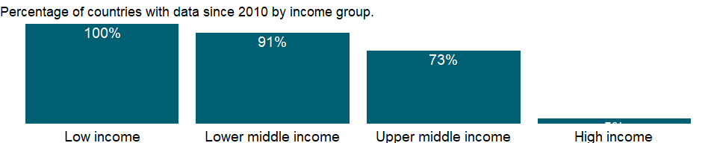### What is the indicator? {-}

Net official flows from UN agencies are the net disbursements of total official flows from the UN agencies. Total official flows are the sum of Official Development Assistance (ODA) or official aid and Other Official Flows (OOF) and represent the total disbursements by the official sector at large to the recipient country. Net disbursements are gross disbursements of grants and loans minus repayments of principal on earlier loans. ODA consists of loans made on concessional terms (with a grant element of at least 25 percent, calculated at a rate of discount of 10 percent) and grants made to promote economic development and welfare in countries and territories in the DAC list of ODA recipients. Official aid refers to aid flows from official donors to countries and territories in part II of the DAC list of recipients: more advanced countries of Central and Eastern Europe, the countries of the former Soviet Union, and certain advanced developing countries and territories. Official aid is provided under terms and conditions similar to those for ODA. Part II of the DAC List was abolished in 2005. The collection of data on official aid and other resource flows to Part II countries ended with 2004 data. OOF are transactions by the official sector whose main objective is other than development-motivated, or, if development-motivated, whose grant element is below the 25 per cent threshold which would make them eligible to be recorded as ODA. The main classes of transactions included here are official export credits, official sector equity and portfolio investment, and debt reorganization undertaken by the official sector at nonconcessional terms (irrespective of the nature or the identity of the original creditor). UN agencies are United Nations includes the United Nations Children’s Fund (UNICEF), United Nations Relief and Works Agency for Palestine Refugees in the Near East (UNRWA), World Food Programme (WFP), International Fund for Agricultural Development (IFAD), United Nations Development Programme(UNDP), United Nations Population Fund (UNFPA), United Nations Refugee Agency (UNHCR), Joint United Nations Programme on HIV/AIDS (UNAIDS), United Nations Regular Programme for Technical Assistance (UNTA), United Nations Peacebuilding Fund (UNPBF), International Atomic Energy Agency (IAEA), World Health Organization (WHO), United Nations Economic Commission for Europe (UNECE), Food and Agriculture Organization of the United Nations (FAO), International Labour Organization (ILO), United Nations Environment Programme (UNEP), World Tourism Organization (UNWTO) and United Nations Institute for Disarmament Research (UNIDIR). Data are in current U.S. dollars.

Topic: Economic Policy & Debt: Official development assistance

Series ID: DT.NFL.UNID.CD

Copyright: NA , NA

First year with any data: Inf

Last year with any data: -Inf

### What years are data available?

The figure below shows years in which data is available for at least one country. Dates shaded in black have no data, while dates shaded in green have data for at least one country



### Which countries have data?

The figure below shows the percentage of countries in each income group with a value since 2010 for that indicator.



### Why is it relevant?

NA

### What is the data source?

Development Assistance Committee of the Organisation for Economic Co-operation and Development, Geographical Distribution of Financial Flows to Developing Countries, Development Co-operation Report, and International Development Statistics database. Data are available online at: <https://stats.oecd.org/>.

### What is the methodology?

NA

### How is it aggregated?

Sum

### What are the limitations?

NA

### What else should I know?

NA

### 1.10.49 Net official flows from UN agencies, UNPBF (current US$)

### What is the indicator?

Net official flows from UN agencies are the net disbursements of total official flows from the UN agencies. Total official flows are the sum of Official Development Assistance (ODA) or official aid and Other Official Flows (OOF) and represent the total disbursements by the official sector at large to the recipient country. Net disbursements are gross disbursements of grants and loans minus repayments of principal on earlier loans. ODA consists of loans made on concessional terms (with a grant element of at least 25 percent, calculated at a rate of discount of 10 percent) and grants made to promote economic development and welfare in countries and territories in the DAC list of ODA recipients. Official aid refers to aid flows from official donors to countries and territories in part II of the DAC list of recipients: more advanced countries of Central and Eastern Europe, the countries of the former Soviet Union, and certain advanced developing countries and territories. Official aid is provided under terms and conditions similar to those for ODA. Part II of the DAC List was abolished in 2005. The collection of data on official aid and other resource flows to Part II countries ended with 2004 data. OOF are transactions by the official sector whose main objective is other than development-motivated, or, if development-motivated, whose grant element is below the 25 per cent threshold which would make them eligible to be recorded as ODA. The main classes of transactions included here are official export credits, official sector equity and portfolio investment, and debt reorganization undertaken by the official sector at nonconcessional terms (irrespective of the nature or the identity of the original creditor). UN agencies are United Nations includes the United Nations Children’s Fund (UNICEF), United Nations Relief and Works Agency for Palestine Refugees in the Near East (UNRWA), World Food Programme (WFP), International Fund for Agricultural Development (IFAD), United Nations Development Programme(UNDP), United Nations Population Fund (UNFPA), United Nations Refugee Agency (UNHCR), Joint United Nations Programme on HIV/AIDS (UNAIDS), United Nations Regular Programme for Technical Assistance (UNTA), United Nations Peacebuilding Fund (UNPBF), International Atomic Energy Agency (IAEA), World Health Organization (WHO), United Nations Economic Commission for Europe (UNECE), Food and Agriculture Organization of the United Nations (FAO), International Labour Organization (ILO), United Nations Environment Programme (UNEP), World Tourism Organization (UNWTO) and United Nations Institute for Disarmament Research (UNIDIR). Data are in current U.S. dollars.

Topic: Economic Policy & Debt: Official development assistance

Series ID: DT.NFL.UNPB.CD

Copyright: CC BY-4.0 , <https://datacatalog.worldbank.org/public-licenses#cc-by>

First year with any data: 2007

Last year with any data: 2019

### What years are data available?

The figure below shows years in which data is available for at least one country. Dates shaded in black have no data, while dates shaded in green have data for at least one country

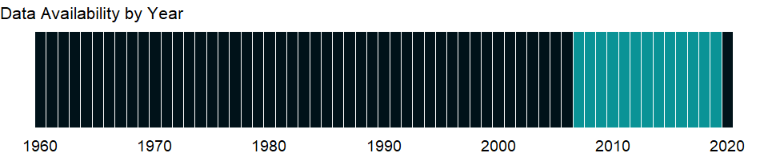

### Which countries have data?

The figure below shows the percentage of countries in each income group with a value since 2010 for that indicator.

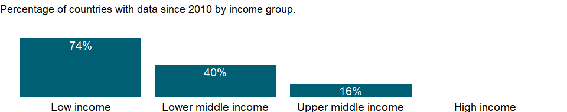

### Why is it relevant?

NA

### What is the data source?

Development Assistance Committee of the Organisation for Economic Co-operation and Development, Geographical Distribution of Financial Flows to Developing Countries, Development Co-operation Report, and International Development Statistics database. Data are available online at: <https://stats.oecd.org/>.

### What is the methodology?

NA

### How is it aggregated?

Sum

### What are the limitations?

NA

### What else should I know?

NA

### 1.10.50 Net official flows from UN agencies, UNRWA (current US$)

### What is the indicator?

Net official flows from UN agencies are the net disbursements of total official flows from the UN agencies. Total official flows are the sum of Official Development Assistance (ODA) or official aid and Other Official Flows (OOF) and represent the total disbursements by the official sector at large to the recipient country. Net disbursements are gross disbursements of grants and loans minus repayments of principal on earlier loans. ODA consists of loans made on concessional terms (with a grant element of at least 25 percent, calculated at a rate of discount of 10 percent) and grants made to promote economic development and welfare in countries and territories in the DAC list of ODA recipients. Official aid refers to aid flows from official donors to countries and territories in part II of the DAC list of recipients: more advanced countries of Central and Eastern Europe, the countries of the former Soviet Union, and certain advanced developing countries and territories. Official aid is provided under terms and conditions similar to those for ODA. Part II of the DAC List was abolished in 2005. The collection of data on official aid and other resource flows to Part II countries ended with 2004 data. OOF are transactions by the official sector whose main objective is other than development-motivated, or, if development-motivated, whose grant element is below the 25 per cent threshold which would make them eligible to be recorded as ODA. The main classes of transactions included here are official export credits, official sector equity and portfolio investment, and debt reorganization undertaken by the official sector at nonconcessional terms (irrespective of the nature or the identity of the original creditor). UN agencies are United Nations includes the United Nations Children’s Fund (UNICEF), United Nations Relief and Works Agency for Palestine Refugees in the Near East (UNRWA), World Food Programme (WFP), International Fund for Agricultural Development (IFAD), United Nations Development Programme(UNDP), United Nations Population Fund (UNFPA), United Nations Refugee Agency (UNHCR), Joint United Nations Programme on HIV/AIDS (UNAIDS), United Nations Regular Programme for Technical Assistance (UNTA), United Nations Peacebuilding Fund (UNPBF), International Atomic Energy Agency (IAEA), World Health Organization (WHO), United Nations Economic Commission for Europe (UNECE), Food and Agriculture Organization of the United Nations (FAO), International Labour Organization (ILO), United Nations Environment Programme (UNEP), World Tourism Organization (UNWTO) and United Nations Institute for Disarmament Research (UNIDIR). Data are in current U.S. dollars.

Topic: Economic Policy & Debt: Official development assistance

Series ID: DT.NFL.UNRW.CD

Copyright: CC BY-4.0 , <https://datacatalog.worldbank.org/public-licenses#cc-by>

First year with any data: 1969

Last year with any data: 2019

### What years are data available?

The figure below shows years in which data is available for at least one country. Dates shaded in black have no data, while dates shaded in green have data for at least one country

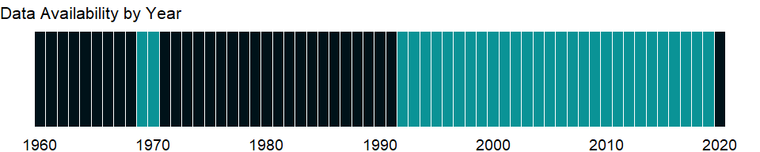

### Which countries have data?

The figure below shows the percentage of countries in each income group with a value since 2010 for that indicator.

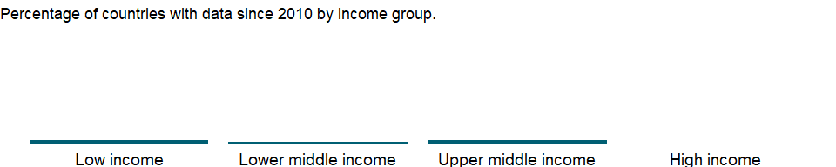

### Why is it relevant?

NA

### What is the data source?

Development Assistance Committee of the Organisation for Economic Co-operation and Development, Geographical Distribution of Financial Flows to Developing Countries, Development Co-operation Report, and International Development Statistics database. Data are available online at: <https://stats.oecd.org/>.

### What is the methodology?

NA

### How is it aggregated?

Sum

### What are the limitations?

NA

### What else should I know?

NA

### 1.10.51 Net official flows from UN agencies, UNTA (current US$)

### What is the indicator?

Net official flows from UN agencies are the net disbursements of total official flows from the UN agencies. Total official flows are the sum of Official Development Assistance (ODA) or official aid and Other Official Flows (OOF) and represent the total disbursements by the official sector at large to the recipient country. Net disbursements are gross disbursements of grants and loans minus repayments of principal on earlier loans. ODA consists of loans made on concessional terms (with a grant element of at least 25 percent, calculated at a rate of discount of 10 percent) and grants made to promote economic development and welfare in countries and territories in the DAC list of ODA recipients. Official aid refers to aid flows from official donors to countries and territories in part II of the DAC list of recipients: more advanced countries of Central and Eastern Europe, the countries of the former Soviet Union, and certain advanced developing countries and territories. Official aid is provided under terms and conditions similar to those for ODA. Part II of the DAC List was abolished in 2005. The collection of data on official aid and other resource flows to Part II countries ended with 2004 data. OOF are transactions by the official sector whose main objective is other than development-motivated, or, if development-motivated, whose grant element is below the 25 per cent threshold which would make them eligible to be recorded as ODA. The main classes of transactions included here are official export credits, official sector equity and portfolio investment, and debt reorganization undertaken by the official sector at nonconcessional terms (irrespective of the nature or the identity of the original creditor). UN agencies are United Nations includes the United Nations Children’s Fund (UNICEF), United Nations Relief and Works Agency for Palestine Refugees in the Near East (UNRWA), World Food Programme (WFP), International Fund for Agricultural Development (IFAD), United Nations Development Programme(UNDP), United Nations Population Fund (UNFPA), United Nations Refugee Agency (UNHCR), Joint United Nations Programme on HIV/AIDS (UNAIDS), United Nations Regular Programme for Technical Assistance (UNTA), United Nations Peacebuilding Fund (UNPBF), International Atomic Energy Agency (IAEA), World Health Organization (WHO), United Nations Economic Commission for Europe (UNECE), Food and Agriculture Organization of the United Nations (FAO), International Labour Organization (ILO), United Nations Environment Programme (UNEP), World Tourism Organization (UNWTO) and United Nations Institute for Disarmament Research (UNIDIR). Data are in current U.S. dollars.

Topic: Economic Policy & Debt: Official development assistance

Series ID: DT.NFL.UNTA.CD

Copyright: CC BY-4.0 , <https://datacatalog.worldbank.org/public-licenses#cc-by>

First year with any data: 1969

Last year with any data: 2008

### What years are data available?

The figure below shows years in which data is available for at least one country. Dates shaded in black have no data, while dates shaded in green have data for at least one country

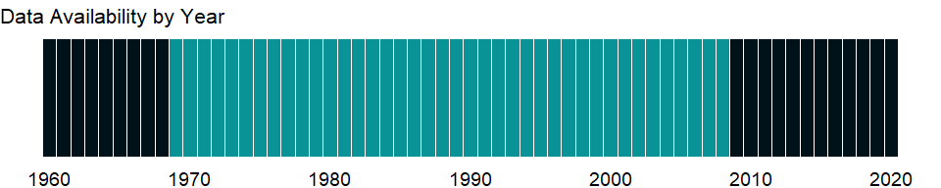

### Which countries have data?

The figure below shows the percentage of countries in each income group with a value since 2010 for that indicator.



### Why is it relevant?

NA

### What is the data source?

Development Assistance Committee of the Organisation for Economic Co-operation and Development, Geographical Distribution of Financial Flows to Developing Countries, Development Co-operation Report, and International Development Statistics database. Data are available online at: <https://stats.oecd.org/>.

### What is the methodology?

NA

### How is it aggregated?

Sum

### What are the limitations?

NA

### What else should I know?

NA

### 1.10.52 Net official flows from UN agencies, UNWTO (current US$)

### What is the indicator?

Net official flows from UN agencies are the net disbursements of total official flows from the UN agencies. Total official flows are the sum of Official Development Assistance (ODA) or official aid and Other Official Flows (OOF) and represent the total disbursements by the official sector at large to the recipient country. Net disbursements are gross disbursements of grants and loans minus repayments of principal on earlier loans. ODA consists of loans made on concessional terms (with a grant element of at least 25 percent, calculated at a rate of discount of 10 percent) and grants made to promote economic development and welfare in countries and territories in the DAC list of ODA recipients. Official aid refers to aid flows from official donors to countries and territories in part II of the DAC list of recipients: more advanced countries of Central and Eastern Europe, the countries of the former Soviet Union, and certain advanced developing countries and territories. Official aid is provided under terms and conditions similar to those for ODA. Part II of the DAC List was abolished in 2005. The collection of data on official aid and other resource flows to Part II countries ended with 2004 data. OOF are transactions by the official sector whose main objective is other than development-motivated, or, if development-motivated, whose grant element is below the 25 per cent threshold which would make them eligible to be recorded as ODA. The main classes of transactions included here are official export credits, official sector equity and portfolio investment, and debt reorganization undertaken by the official sector at nonconcessional terms (irrespective of the nature or the identity of the original creditor). UN agencies are United Nations includes the United Nations Children’s Fund (UNICEF), United Nations Relief and Works Agency for Palestine Refugees in the Near East (UNRWA), World Food Programme (WFP), International Fund for Agricultural Development (IFAD), United Nations Development Programme(UNDP), United Nations Population Fund (UNFPA), United Nations Refugee Agency (UNHCR), Joint United Nations Programme on HIV/AIDS (UNAIDS), United Nations Regular Programme for Technical Assistance (UNTA), United Nations Peacebuilding Fund (UNPBF), International Atomic Energy Agency (IAEA), World Health Organization (WHO), United Nations Economic Commission for Europe (UNECE), Food and Agriculture Organization of the United Nations (FAO), International Labour Organization (ILO), United Nations Environment Programme (UNEP), World Tourism Organization (UNWTO) and United Nations Institute for Disarmament Research (UNIDIR). Data are in current U.S. dollars.

Topic: Economic Policy & Debt: Official development assistance

Series ID: DT.NFL.UNWT.CD

Copyright: CC BY-4.0 , <https://datacatalog.worldbank.org/public-licenses#cc-by>

First year with any data: 2016

Last year with any data: 2016

### What years are data available?

The figure below shows years in which data is available for at least one country. Dates shaded in black have no data, while dates shaded in green have data for at least one country

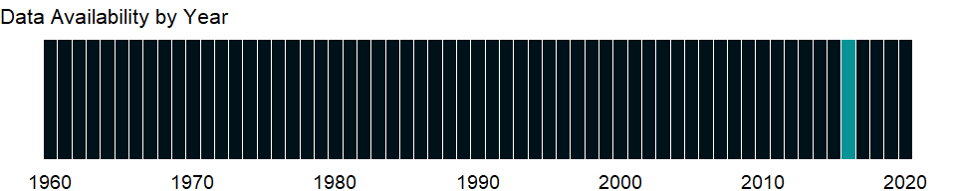

### Which countries have data?

The figure below shows the percentage of countries in each income group with a value since 2010 for that indicator.

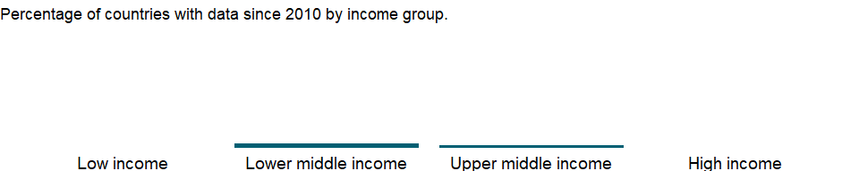

### Why is it relevant?

NA

### What is the data source?

Development Assistance Committee of the Organisation for Economic Co-operation and Development, Geographical Distribution of Financial Flows to Developing Countries, Development Co-operation Report, and International Development Statistics database. Data are available online at: <https://stats.oecd.org/>.

### What is the methodology?

NA

### How is it aggregated?

Sum

### What are the limitations?

NA

### What else should I know?

NA

### 1.10.53 Net official flows from UN agencies, WFP (current US$)

### What is the indicator?

Net official flows from UN agencies are the net disbursements of total official flows from the UN agencies. Total official flows are the sum of Official Development Assistance (ODA) or official aid and Other Official Flows (OOF) and represent the total disbursements by the official sector at large to the recipient country. Net disbursements are gross disbursements of grants and loans minus repayments of principal on earlier loans. ODA consists of loans made on concessional terms (with a grant element of at least 25 percent, calculated at a rate of discount of 10 percent) and grants made to promote economic development and welfare in countries and territories in the DAC list of ODA recipients. Official aid refers to aid flows from official donors to countries and territories in part II of the DAC list of recipients: more advanced countries of Central and Eastern Europe, the countries of the former Soviet Union, and certain advanced developing countries and territories. Official aid is provided under terms and conditions similar to those for ODA. Part II of the DAC List was abolished in 2005. The collection of data on official aid and other resource flows to Part II countries ended with 2004 data. OOF are transactions by the official sector whose main objective is other than development-motivated, or, if development-motivated, whose grant element is below the 25 per cent threshold which would make them eligible to be recorded as ODA. The main classes of transactions included here are official export credits, official sector equity and portfolio investment, and debt reorganization undertaken by the official sector at nonconcessional terms (irrespective of the nature or the identity of the original creditor). UN agencies are United Nations includes the United Nations Children’s Fund (UNICEF), United Nations Relief and Works Agency for Palestine Refugees in the Near East (UNRWA), World Food Programme (WFP), International Fund for Agricultural Development (IFAD), United Nations Development Programme(UNDP), United Nations Population Fund (UNFPA), United Nations Refugee Agency (UNHCR), Joint United Nations Programme on HIV/AIDS (UNAIDS), United Nations Regular Programme for Technical Assistance (UNTA), United Nations Peacebuilding Fund (UNPBF), International Atomic Energy Agency (IAEA), World Health Organization (WHO), United Nations Economic Commission for Europe (UNECE), Food and Agriculture Organization of the United Nations (FAO), International Labour Organization (ILO), United Nations Environment Programme (UNEP), World Tourism Organization (UNWTO) and United Nations Institute for Disarmament Research (UNIDIR). Data are in current U.S. dollars.

Topic: Economic Policy & Debt: Official development assistance

Series ID: DT.NFL.WFPG.CD

Copyright: CC BY-4.0 , <https://datacatalog.worldbank.org/public-licenses#cc-by>

First year with any data: 1969

Last year with any data: 2019

### What years are data available?

The figure below shows years in which data is available for at least one country. Dates shaded in black have no data, while dates shaded in green have data for at least one country



### Which countries have data?

The figure below shows the percentage of countries in each income group with a value since 2010 for that indicator.

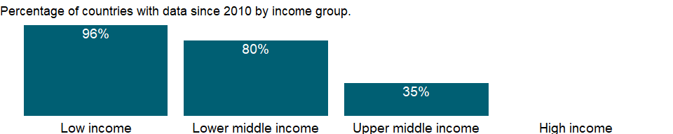

### Why is it relevant?

NA

### What is the data source?

Development Assistance Committee of the Organisation for Economic Co-operation and Development, Geographical Distribution of Financial Flows to Developing Countries, Development Co-operation Report, and International Development Statistics database. Data are available online at: <https://stats.oecd.org/>.

### What is the methodology?

NA

### How is it aggregated?

Sum

### What are the limitations?

NA

### What else should I know?

NA

### 1.10.54 Net official flows from UN agencies, WHO (current US$)

### What is the indicator?

Net official flows from UN agencies are the net disbursements of total official flows from the UN agencies. Total official flows are the sum of Official Development Assistance (ODA) or official aid and Other Official Flows (OOF) and represent the total disbursements by the official sector at large to the recipient country. Net disbursements are gross disbursements of grants and loans minus repayments of principal on earlier loans. ODA consists of loans made on concessional terms (with a grant element of at least 25 percent, calculated at a rate of discount of 10 percent) and grants made to promote economic development and welfare in countries and territories in the DAC list of ODA recipients. Official aid refers to aid flows from official donors to countries and territories in part II of the DAC list of recipients: more advanced countries of Central and Eastern Europe, the countries of the former Soviet Union, and certain advanced developing countries and territories. Official aid is provided under terms and conditions similar to those for ODA. Part II of the DAC List was abolished in 2005. The collection of data on official aid and other resource flows to Part II countries ended with 2004 data. OOF are transactions by the official sector whose main objective is other than development-motivated, or, if development-motivated, whose grant element is below the 25 per cent threshold which would make them eligible to be recorded as ODA. The main classes of transactions included here are official export credits, official sector equity and portfolio investment, and debt reorganization undertaken by the official sector at nonconcessional terms (irrespective of the nature or the identity of the original creditor). UN agencies are United Nations includes the United Nations Children’s Fund (UNICEF), United Nations Relief and Works Agency for Palestine Refugees in the Near East (UNRWA), World Food Programme (WFP), International Fund for Agricultural Development (IFAD), United Nations Development Programme(UNDP), United Nations Population Fund (UNFPA), United Nations Refugee Agency (UNHCR), Joint United Nations Programme on HIV/AIDS (UNAIDS), United Nations Regular Programme for Technical Assistance (UNTA), United Nations Peacebuilding Fund (UNPBF), International Atomic Energy Agency (IAEA), World Health Organization (WHO), United Nations Economic Commission for Europe (UNECE), Food and Agriculture Organization of the United Nations (FAO), International Labour Organization (ILO), United Nations Environment Programme (UNEP), World Tourism Organization (UNWTO) and United Nations Institute for Disarmament Research (UNIDIR). Data are in current U.S. dollars.

Topic: Economic Policy & Debt: Official development assistance

Series ID: DT.NFL.WHOL.CD

Copyright: CC BY-4.0 , <https://datacatalog.worldbank.org/public-licenses#cc-by>

First year with any data: 2011

Last year with any data: 2019

### What years are data available?

The figure below shows years in which data is available for at least one country. Dates shaded in black have no data, while dates shaded in green have data for at least one country

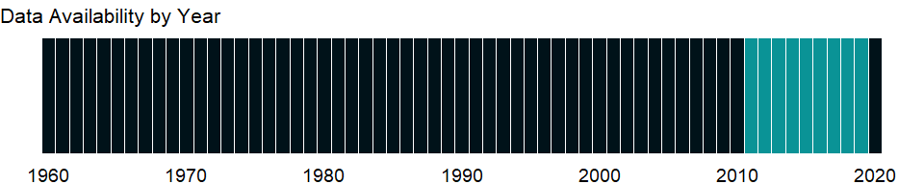

### Which countries have data?

The figure below shows the percentage of countries in each income group with a value since 2010 for that indicator.

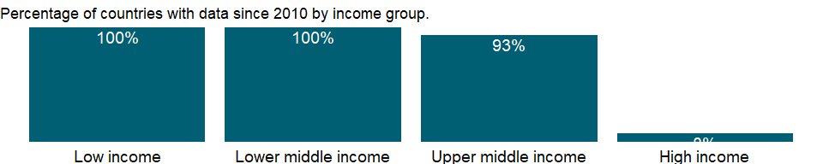

### Why is it relevant?

NA

### What is the data source?

Development Assistance Committee of the Organisation for Economic Co-operation and Development, Geographical Distribution of Financial Flows to Developing Countries, Development Co-operation Report, and International Development Statistics database. Data are available online at: <https://stats.oecd.org/>.

### What is the methodology?

NA

### How is it aggregated?

Sum

### What are the limitations?

NA

### What else should I know?

NA

### 1.10.55 Net official development assistance and official aid received (current US$)

### What is the indicator?

Net official development assistance (ODA) consists of disbursements of loans made on concessional terms (net of repayments of principal) and grants by official agencies of the members of the Development Assistance Committee (DAC), by multilateral institutions, and by non-DAC countries to promote economic development and welfare in countries and territories in the DAC list of ODA recipients. It includes loans with a grant element of at least 25 percent (calculated at a rate of discount of 10 percent). Net official aid refers to aid flows (net of repayments) from official donors to countries and territories in part II of the DAC list of recipients: more advanced countries of Central and Eastern Europe, the countries of the former Soviet Union, and certain advanced developing countries and territories. Official aid is provided under terms and conditions similar to those for ODA. Part II of the DAC List was abolished in 2005. The collection of data on official aid and other resource flows to Part II countries ended with 2004 data. Data are in current U.S. dollars.

Topic: Economic Policy & Debt: Official development assistance

Series ID: DT.ODA.ALLD.CD

Copyright: CC BY-4.0 , <https://datacatalog.worldbank.org/public-licenses#cc-by>

First year with any data: 1960

Last year with any data: 2019

### What years are data available?

The figure below shows years in which data is available for at least one country. Dates shaded in black have no data, while dates shaded in green have data for at least one country



### Which countries have data?

The figure below shows the percentage of countries in each income group with a value since 2010 for that indicator.



### Why is it relevant?

NA

### What is the data source?

Development Assistance Committee of the Organisation for Economic Co-operation and Development, Geographical Distribution of Financial Flows to Developing Countries, Development Co-operation Report, and International Development Statistics database. Data are available online at: <https://stats.oecd.org/>.

### What is the methodology?

NA

### How is it aggregated?

Sum

### What are the limitations?

NA

### What else should I know?

NA

### 1.10.56 Net official development assistance and official aid received (constant 2018 US$)

### What is the indicator?

Net official development assistance (ODA) consists of disbursements of loans made on concessional terms (net of repayments of principal) and grants by official agencies of the members of the Development Assistance Committee (DAC), by multilateral institutions, and by non-DAC countries to promote economic development and welfare in countries and territories in the DAC list of ODA recipients. It includes loans with a grant element of at least 25 percent (calculated at a rate of discount of 10 percent). Net official aid refers to aid flows (net of repayments) from official donors to countries and territories in part II of the DAC list of recipients: more advanced countries of Central and Eastern Europe, the countries of the former Soviet Union, and certain advanced developing countries and territories. Official aid is provided under terms and conditions similar to those for ODA. Part II of the DAC List was abolished in 2005. The collection of data on official aid and other resource flows to Part II countries ended with 2004 data. Data are in constant 2018 U.S. dollars.

Topic: Economic Policy & Debt: Official development assistance

Series ID: DT.ODA.ALLD.KD

Copyright: CC BY-4.0 , <https://datacatalog.worldbank.org/public-licenses#cc-by>

First year with any data: 1960

Last year with any data: 2019

### What years are data available?

The figure below shows years in which data is available for at least one country. Dates shaded in black have no data, while dates shaded in green have data for at least one country



### Which countries have data?

The figure below shows the percentage of countries in each income group with a value since 2010 for that indicator.



### Why is it relevant?

NA

### What is the data source?

Development Assistance Committee of the Organisation for Economic Co-operation and Development, Geographical Distribution of Financial Flows to Developing Countries, Development Co-operation Report, and International Development Statistics database. Data are available online at: <https://stats.oecd.org/>.

### What is the methodology?

NA

### How is it aggregated?

Sum

### What are the limitations?

NA

### What else should I know?

NA

### 1.10.57 Net official aid received (current US$)

### What is the indicator?

Net official aid refers to aid flows (net of repayments) from official donors to countries and territories in part II of the DAC list of recipients: more advanced countries of Central and Eastern Europe, the countries of the former Soviet Union, and certain advanced developing countries and territories. Official aid is provided under terms and conditions similar to those for ODA. Part II of the DAC List was abolished in 2005. The collection of data on official aid and other resource flows to Part II countries ended with 2004 data. Data are in current U.S. dollars.

Topic: Economic Policy & Debt: Official development assistance

Series ID: DT.ODA.OATL.CD

Copyright: CC BY-4.0 , <https://datacatalog.worldbank.org/public-licenses#cc-by>

First year with any data: 1990

Last year with any data: 2011

### What years are data available?

The figure below shows years in which data is available for at least one country. Dates shaded in black have no data, while dates shaded in green have data for at least one country

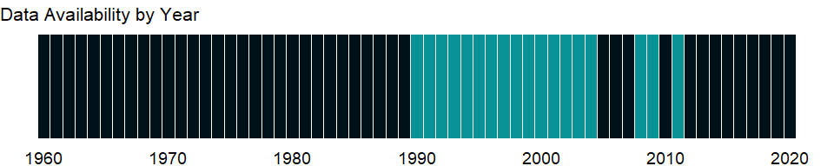

### Which countries have data?

The figure below shows the percentage of countries in each income group with a value since 2010 for that indicator.

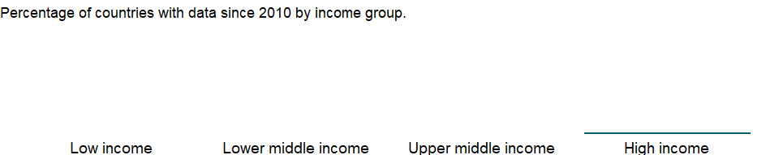

### Why is it relevant?

DAC exists to help its members coordinate their development assistance and to encourage the expansion and improve the effectiveness of the aggregate resources flowing to recipient economies. In this capacity DAC monitors the flow of all financial resources, but its main concern is official development assistance (ODA). Grants or loans to countries and territories on the DAC list of aid recipients have to meet three criteria to be counted as ODA. They are provided by official agencies, including state and local governments, or by their executive agencies. They promote economic development and welfare as the main objective. And they are provided on concessional financial terms (loans must have a grant element of at least 25 percent, calculated at a discount rate of 10 percent). The DAC Statistical Reporting Directives provide the most detailed explanation of this definition and all ODA-related rules.

DAC statistics aim to meet the needs of policy makers in the field of development co-operation, and to provide a means of assessing the comparative performance of aid donors. DAC statistics are used extensively in the Peer Reviews conducted for each DAC member every four to five years, and have a wide range of other applications. They are used to measure donors’ compliance with various international recommendations in the field of development co-operation (terms, volume), and are indispensable for analysis of virtually every aspect of development and development co-operation.

From 1960 to 1990, official development assistance (ODA) flows from DAC countries to developing countries rose steadily, but then fell sharply in the 1990s. Since then, a series of high-profile international conferences have boosted ODA flows. In the mid-2000s, ODA once again rose due to exceptional debt relief operations for Iraq and Nigeria. Despite the recent financial crisis, ODA flows have continued to rise and in the early 2010s reached their highest real level ever at about US $130 billion. This demonstrates effectiveness of aid pledges, especially when they are made on the basis of adequate resources and backed by strong political will.

### What is the data source?

Development Assistance Committee of the Organisation for Economic Co-operation and Development, Geographical Distribution of Financial Flows to Developing Countries, Development Co-operation Report, and International Development Statistics database. Data are available online at: <https://stats.oecd.org/>.

### What is the methodology?

Net official aid refers to aid flows (net of repayments) from official donors to countries and territories in part II of the DAC list of recipients: more advanced countries of Central and Eastern Europe, the countries of the former Soviet Union, and certain advanced developing countries and territories. Official aid is provided under terms and conditions similar to those for ODA. Part II of the DAC List was abolished in 2005. The collection of data on official aid and other resource flows to Part II countries ended with 2004 data. Data are in current U.S. dollars.

The flows of official and private financial resources from the members of the Development Assistance Committee (DAC) of the Organisation for Economic Co-operation and Development (OECD) to developing economies are compiled by DAC, based principally on donor reports on bilateral programs by DAC members using standard questionnaires issued by the DAC Secretariat. DAC has 24 members - 23 individual economies and 1 multilateral institution (European Union institutions).

Net official development assistance (ODA) consists of disbursements of loans made on concessional terms (net of repayments of principal) and grants by official agencies of the members of DAC, by multilateral institutions, and by non-DAC countries to promote economic development and welfare in countries and territories in the DAC list of ODA recipients. It includes loans with a grant element of at least 25 percent (calculated at a rate of discount of 10 percent). Data are in current U.S. dollars.

Total net disbursements is the sum of grants, capital subscriptions (deposit basis), recoveries and total net loans and other long-term capital.

The ODA excludes nonconcessional flows from official creditors, which are classified as “other official flows,” and aid for military and anti-terrorism purposes. Transfer payments to private individuals, such as pensions, reparations, and insurance payouts, are in general not counted. In addition to financial flows, ODA includes technical cooperation, most expenditures for peacekeeping under UN mandates and assistance to refugees, contributions to multilateral institutions such as the United Nations and its specialized agencies, and concessional funding to multilateral development banks.

Net official development assistance (ODA) per capita consists of disbursements of loans made on concessional terms (net of repayments of principal) and grants by official agencies of the members of the Development Assistance Committee (DAC), by multilateral institutions, and by non-DAC countries to promote economic development and welfare in countries and territories in the DAC list of ODA recipients. It includes loans with a grant element of at least 25 percent (calculated at a rate of discount of 10 percent).

The flows of official and private financial resources from the members of the Development Assistance Committee (DAC) of the Organisation for Economic Co-operation and Development (OECD) to developing economies are compiled by DAC, based principally on reporting by DAC members using standard questionnaires issued by the DAC Secretariat.

Flows are transfers of resources, either in cash or in the form of commodities or services measured on a cash basis. Short-term capital transactions (with one year or less maturity) are not counted. Repayments of the principal (but not interest) of ODA loans are recorded as negative flows. Proceeds from official equity investments in a developing country are reported as ODA, while proceeds from their later sale are recorded as negative flows.

The official development assistance (ODA) estimates are published annually at the end of the calendar year in International Development Statistics (IDS) database. Data are in current U.S. dollars.

### How is it aggregated?

Sum

### What are the limitations?

Data on ODA is for aid-receiving countries. The data cover loans and grants from DAC member countries, multilateral organizations, and non-DAC donors. They do not reflect aid given by recipient countries to other developing countries. As a result, some countries that are net donors are shown as aid recipients. The indicator does not distinguish types of aid (program, project, or food aid; emergency assistance; or post-conflict peacekeeping assistance), which may have different effects on the economy.

Because the indicator relies on information from donors, it is not necessarily consistent with information recorded by recipients in the balance of payments, which often excludes all or some technical assistance - particularly payments to expatriates made directly by the donor. Similarly, grant commodity aid may not always be recorded in trade data or in the balance of payments. Moreover, DAC statistics exclude aid for military and antiterrorism purposes.

The nominal values may overstate the real value of aid to recipients. Changes in international prices and exchange rates can reduce the purchasing power of aid. Tying aid, still prevalent though declining in importance, also tends to reduce its purchasing power. Tying requires recipients to purchase goods and services from the donor country or from a specified group of countries. Such arrangements prevent a recipient from misappropriating or mismanaging aid receipts, but they may also be motivated by a desire to benefit donor country suppliers.

The aggregates refer to World Bank classifications of economies and therefore may differ from those of the OECD.

### What else should I know?

NA

### 1.10.58 Net official aid received (constant 2018 US$)

### What is the indicator?

Net official aid refers to aid flows (net of repayments) from official donors to countries and territories in part II of the DAC list of recipients: more advanced countries of Central and Eastern Europe, the countries of the former Soviet Union, and certain advanced developing countries and territories. Official aid is provided under terms and conditions similar to those for ODA. Part II of the DAC List was abolished in 2005. The collection of data on official aid and other resource flows to Part II countries ended with 2004 data. Data are in constant 2018 U.S. dollars.

Topic: Economic Policy & Debt: Official development assistance

Series ID: DT.ODA.OATL.KD

Copyright: CC BY-4.0 , <https://datacatalog.worldbank.org/public-licenses#cc-by>

First year with any data: 1990

Last year with any data: 2011

### What years are data available?

The figure below shows years in which data is available for at least one country. Dates shaded in black have no data, while dates shaded in green have data for at least one country



### Which countries have data?

The figure below shows the percentage of countries in each income group with a value since 2010 for that indicator.



### Why is it relevant?

NA

### What is the data source?

Development Assistance Committee of the Organisation for Economic Co-operation and Development, Geographical Distribution of Financial Flows to Developing Countries, Development Co-operation Report, and International Development Statistics database. Data are available online at: <https://stats.oecd.org/>.

### What is the methodology?

NA

### How is it aggregated?

Sum

### What are the limitations?

NA

### What else should I know?

NA

### 1.10.59 Net official development assistance received (current US$)

### What is the indicator?

Net official development assistance (ODA) consists of disbursements of loans made on concessional terms (net of repayments of principal) and grants by official agencies of the members of the Development Assistance Committee (DAC), by multilateral institutions, and by non-DAC countries to promote economic development and welfare in countries and territories in the DAC list of ODA recipients. It includes loans with a grant element of at least 25 percent (calculated at a rate of discount of 10 percent). Data are in current U.S. dollars.

Topic: Economic Policy & Debt: Official development assistance

Series ID: DT.ODA.ODAT.CD

Copyright: CC BY-4.0 , <https://datacatalog.worldbank.org/public-licenses#cc-by>

First year with any data: 1960

Last year with any data: 2019

### What years are data available?

The figure below shows years in which data is available for at least one country. Dates shaded in black have no data, while dates shaded in green have data for at least one country



### Which countries have data?

The figure below shows the percentage of countries in each income group with a value since 2010 for that indicator.



### Why is it relevant?

DAC exists to help its members coordinate their development assistance and to encourage the expansion and improve the effectiveness of the aggregate resources flowing to recipient economies. In this capacity DAC monitors the flow of all financial resources, but its main concern is official development assistance (ODA). Grants or loans to countries and territories on the DAC list of aid recipients have to meet three criteria to be counted as ODA. They are provided by official agencies, including state and local governments, or by their executive agencies. They promote economic development and welfare as the main objective. And they are provided on concessional financial terms (loans must have a grant element of at least 25 percent, calculated at a discount rate of 10 percent). The DAC Statistical Reporting Directives provide the most detailed explanation of this definition and all ODA-related rules.

DAC statistics aim to meet the needs of policy makers in the field of development co-operation, and to provide a means of assessing the comparative performance of aid donors. DAC statistics are used extensively in the Peer Reviews conducted for each DAC member every four to five years, and have a wide range of other applications. They are used to measure donors’ compliance with various international recommendations in the field of development co-operation (terms, volume), and are indispensable for analysis of virtually every aspect of development and development co-operation.

From 1960 to 1990, official development assistance (ODA) flows from DAC countries to developing countries rose steadily, but then fell sharply in the 1990s. Since then, a series of high-profile international conferences have boosted ODA flows. In the mid-2000s, ODA once again rose due to exceptional debt relief operations for Iraq and Nigeria. Despite the recent financial crisis, ODA flows have continued to rise and in the early 2010s reached their highest real level ever at about USD 130 billion. This demonstrates effectiveness of aid pledges, especially when they are made on the basis of adequate resources and backed by strong political will.

### What is the data source?

Development Assistance Committee of the Organisation for Economic Co-operation and Development, Geographical Distribution of Financial Flows to Developing Countries, Development Co-operation Report, and International Development Statistics database. Data are available online at: <https://stats.oecd.org/>.

### What is the methodology?

The flows of official and private financial resources from the members of the Development Assistance Committee (DAC) of the Organisation for Economic Co-operation and Development (OECD) to developing economies are compiled by DAC, based principally on donor reports on bilateral programs by DAC members using standard questionnaires issued by the DAC Secretariat. DAC has 24 members - 23 individual economies and 1 multilateral institution (European Union institutions).

Net official development assistance (ODA) consists of disbursements of loans made on concessional terms (net of repayments of principal) and grants by official agencies of the members of DAC, by multilateral institutions, and by non-DAC countries to promote economic development and welfare in countries and territories in the DAC list of ODA recipients. It includes loans with a grant element of at least 25 percent (calculated at a rate of discount of 10 percent). Data are in current U.S. dollars.

Total net disbursements is the sum of grants, capital subscriptions (deposit basis), recoveries and total net loans and other long-term capital.

The ODA excludes nonconcessional flows from official creditors, which are classified as “other official flows,” and aid for military and anti-terrorism purposes. Transfer payments to private individuals, such as pensions, reparations, and insurance payouts, are in general not counted. In addition to financial flows, ODA includes technical cooperation, most expenditures for peacekeeping under UN mandates and assistance to refugees, contributions to multilateral institutions such as the United Nations and its specialized agencies, and concessional funding to multilateral development banks.

Flows are transfers of resources, either in cash or in the form of commodities or services measured on a cash basis. Short-term capital transactions (with one year or less maturity) are not counted. Repayments of the principal (but not interest) of ODA loans are recorded as negative flows. Proceeds from official equity investments in a developing country are reported as ODA, while proceeds from their later sale are recorded as negative flows.

The official development assistance (ODA) estimates are published annually at the end of the calendar year in International Development Statistics (IDS) database.

### How is it aggregated?

Sum

### What are the limitations?

Data on ODA is for aid-receiving countries. The data cover loans and grants from DAC member countries, multilateral organizations, and non-DAC donors. They do not reflect aid given by recipient countries to other developing countries. As a result, some countries that are net donors are shown as aid recipients. The indicator does not distinguish types of aid (program, project, or food aid; emergency assistance; or post-conflict peacekeeping assistance), which may have different effects on the economy.

Because the indicator relies on information from donors, it is not necessarily consistent with information recorded by recipients in the balance of payments, which often excludes all or some technical assistance - particularly payments to expatriates made directly by the donor. Similarly, grant commodity aid may not always be recorded in trade data or in the balance of payments. Moreover, DAC statistics exclude aid for military and antiterrorism purposes.

The nominal values may overstate the real value of aid to recipients. Changes in international prices and exchange rates can reduce the purchasing power of aid. Tying aid, still prevalent though declining in importance, also tends to reduce its purchasing power. Tying requires recipients to purchase goods and services from the donor country or from a specified group of countries. Such arrangements prevent a recipient from misappropriating or mismanaging aid receipts, but they may also be motivated by a desire to benefit donor country suppliers.

The aggregates refer to World Bank classifications of economies and therefore may differ from those of the OECD.

### What else should I know?

NA

### 1.10.60 Net ODA received (% of gross capital formation)

### What is the indicator?

Net official development assistance (ODA) consists of disbursements of loans made on concessional terms (net of repayments of principal) and grants by official agencies of the members of the Development Assistance Committee (DAC), by multilateral institutions, and by non-DAC countries to promote economic development and welfare in countries and territories in the DAC list of ODA recipients. It includes loans with a grant element of at least 25 percent (calculated at a rate of discount of 10 percent).

Topic: Economic Policy & Debt: Official development assistance

Series ID: DT.ODA.ODAT.GI.ZS

Copyright: CC BY-4.0 , <https://datacatalog.worldbank.org/public-licenses#cc-by>

First year with any data: 1960

Last year with any data: 2019

### What years are data available?

The figure below shows years in which data is available for at least one country. Dates shaded in black have no data, while dates shaded in green have data for at least one country



### Which countries have data?

The figure below shows the percentage of countries in each income group with a value since 2010 for that indicator.

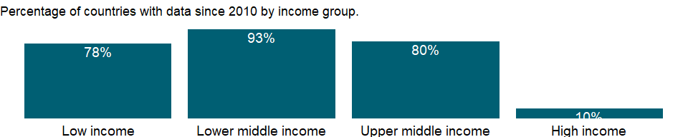

### Why is it relevant?

The ratio of aid to gross capital formation provides a measure of recipient country’s dependency on aid. Ratios of aid are generally much higher in Sub-Saharan Africa than in other regions, particularly in the 1980s. High ratios are due only in part to aid flows. Many African countries saw severe erosion in their terms of trade in the 1980s, along with weak policies, falling incomes, imports, and investment. Thus the increase in aid dependency ratios reflects events affecting both the numerator (aid) and the denominator (gross capital formation).

DAC exists to help its members coordinate their development assistance and to encourage the expansion and improve the effectiveness of the aggregate resources flowing to recipient economies. In this capacity DAC monitors the flow of all financial resources, but its main concern is official development assistance (ODA). Grants or loans to countries and territories on the DAC list of aid recipients have to meet three criteria to be counted as ODA. They are provided by official agencies, including state and local governments, or by their executive agencies. They promote economic development and welfare as the main objective. And they are provided on concessional financial terms (loans must have a grant element of at least 25 percent, calculated at a discount rate of 10 percent). The DAC Statistical Reporting Directives provide the most detailed explanation of this definition and all ODA-related rules.

DAC statistics aim to meet the needs of policy makers in the field of development co-operation, and to provide a means of assessing the comparative performance of aid donors. DAC statistics are used extensively in the Peer Reviews conducted for each DAC member every four to five years, and have a wide range of other applications. They are used to measure donors’ compliance with various international recommendations in the field of development co-operation (terms, volume), and are indispensable for analysis of virtually every aspect of development and development co-operation.

From 1960 to 1990, official development assistance (ODA) flows from DAC countries to developing countries rose steadily, but then fell sharply in the 1990s. Since then, a series of high-profile international conferences have boosted ODA flows. In the mid-2000s, ODA once again rose due to exceptional debt relief operations for Iraq and Nigeria. Despite the recent financial crisis, ODA flows have continued to rise and in the early 2010s reached their highest real level ever at about US $130 billion. This demonstrates effectiveness of aid pledges, especially when they are made on the basis of adequate resources and backed by strong political will.

### What is the data source?

Development Assistance Committee of the Organisation for Economic Co-operation and Development, Geographical Distribution of Financial Flows to Developing Countries, Development Co-operation Report, and International Development Statistics database. Data are available online at: www.oecd.org/dac/stats/idsonline. World Bank gross capital formation estimates are used for the denominator.

### What is the methodology?

Net official development assistance (ODA) per capita consists of disbursements of loans made on concessional terms (net of repayments of principal) and grants by official agencies of the members of the Development Assistance Committee (DAC), by multilateral institutions, and by non-DAC countries to promote economic development and welfare in countries and territories in the DAC list of ODA recipients. It includes loans with a grant element of at least 25 percent (calculated at a rate of discount of 10 percent).Gross capital formation consists of outlays on additions to the conomy’s fixed assets plus net changes in the level of inventories. It is generally obtained from industry reports of acquisitions and distinguishes only the broad categories of capital formation. Data on capital formation may be estimated from direct surveys of enterprises and administrative records or based on the commodity flow methods using data from production, trade and construction activities.

The flows of official and private financial resources from the members of the Development Assistance Committee (DAC) of the Organisation for Economic Co-operation and Development (OECD) to developing economies are compiled by DAC, based principally on reporting by DAC members using standard questionnaires issued by the DAC Secretariat.

The ODA excludes nonconcessional flows from official creditors, which are classified as “other official flows,” and aid for military and anti-terrorism purposes. Transfer payments to private individuals, such as pensions, reparations, and insurance payouts, are in general not counted. In addition to financial flows, ODA includes technical cooperation, most expenditures for peacekeeping under UN mandates and assistance to refugees, contributions to multilateral institutions such as the United Nations and its specialized agencies, and concessional funding to multilateral development banks.

Flows are transfers of resources, either in cash or in the form of commodities or services measured on a cash basis. Short-term capital transactions (with one year or less maturity) are not counted. Repayments of the principal (but not interest) of ODA loans are recorded as negative flows. Proceeds from official equity investments in a developing country are reported as ODA, while proceeds from their later sale are recorded as negative flows.

The official development assistance estimates are published annually at the end of the calendar year in International Development Statistics (IDS) database. Net ODA received as a percent of gross capital formation is calculated using values in U.S. dollars converted at official exchange rates.

### How is it aggregated?

Weighted Average

### What are the limitations?

Data on ODA is for aid-receiving countries. The data cover loans and grants from DAC member countries, multilateral organizations, and non-DAC donors. They do not reflect aid given by recipient countries to other developing countries. As a result, some countries that are net donors are shown as aid recipients. The indicator does not distinguish types of aid (program, project, or food aid; emergency assistance; or post-conflict peacekeeping assistance), which may have different effects on the economy.

Ratio of aid to gross capital formation provides measures of recipient country’s dependency on aid. But care must be taken in drawing policy conclusions. For foreign policy reasons some countries have traditionally received large amounts of aid. Thus aid dependency ratio may reveal as much about a donor’s interests as about a recipient’s needs. The quality of data on government fixed capital formation depends on the quality of government accounting systems which tend to be weak in developing countries. Measures of fixed capital formation by households and corporations - particularly capital outlays by small, unincorporated enterprises - are usually unreliable. Estimates of changes in inventories are rarely complete but usually include the most important activities of commodities.

Because the indicator relies on information from donors, it is not necessarily consistent with information recorded by recipients in the balance of payments, which often excludes all or some technical assistance - particularly payments to expatriates made directly by the donor. Similarly, grant commodity aid may not always be recorded in trade data or in the balance of payments. Moreover, DAC statistics exclude aid for military and antiterrorism purposes.

The aggregates refer to World Bank classifications of economies and therefore may differ from those of the OECD.

### What else should I know?

NA

### 1.10.61 Net ODA received (% of GNI)

### What is the indicator?

Net official development assistance (ODA) consists of disbursements of loans made on concessional terms (net of repayments of principal) and grants by official agencies of the members of the Development Assistance Committee (DAC), by multilateral institutions, and by non-DAC countries to promote economic development and welfare in countries and territories in the DAC list of ODA recipients. It includes loans with a grant element of at least 25 percent (calculated at a rate of discount of 10 percent).

Topic: Economic Policy & Debt: Official development assistance

Series ID: DT.ODA.ODAT.GN.ZS

Copyright: CC BY-4.0 , <https://datacatalog.worldbank.org/public-licenses#cc-by>

First year with any data: 1960

Last year with any data: 2019

### What years are data available?

The figure below shows years in which data is available for at least one country. Dates shaded in black have no data, while dates shaded in green have data for at least one country



### Which countries have data?

The figure below shows the percentage of countries in each income group with a value since 2010 for that indicator.

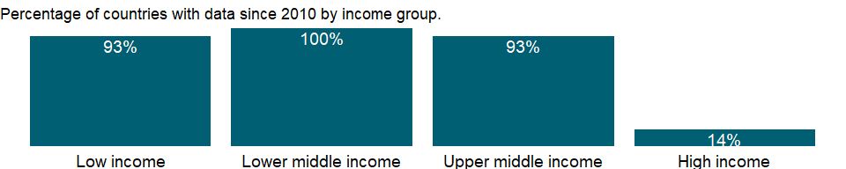

### Why is it relevant?

The ratio of aid to GNI provides a measure of recipient country’s dependency on aid. Ratios of aid are generally much higher in Sub-Saharan Africa than in other regions, and they increased in the 1980s. High ratios are due only in part to aid flows. Many African countries saw severe erosion in their terms of trade in the 1980s, along with weak policies, falling incomes, imports, and investment. Thus the increase in aid dependency ratios reflects events affecting both the numerator (aid) and the denominator (GNI).

DAC exists to help its members coordinate their development assistance and to encourage the expansion and improve the effectiveness of the aggregate resources flowing to recipient economies. In this capacity DAC monitors the flow of all financial resources, but its main concern is official development assistance (ODA). Grants or loans to countries and territories on the DAC list of aid recipients have to meet three criteria to be counted as ODA. They are provided by official agencies, including state and local governments, or by their executive agencies. They promote economic development and welfare as the main objective. And they are provided on concessional financial terms (loans must have a grant element of at least 25 percent, calculated at a discount rate of 10 percent). The DAC Statistical Reporting Directives provide the most detailed explanation of this definition and all ODA-related rules.

DAC statistics aim to meet the needs of policy makers in the field of development co-operation, and to provide a means of assessing the comparative performance of aid donors. DAC statistics are used extensively in the Peer Reviews conducted for each DAC member every four to five years, and have a wide range of other applications. They are used to measure donors’ compliance with various international recommendations in the field of development co-operation (terms, volume), and are indispensable for analysis of virtually every aspect of development and development co-operation.

From 1960 to 1990, official development assistance (ODA) flows from DAC countries to developing countries rose steadily, but then fell sharply in the 1990s. Since then, a series of high-profile international conferences have boosted ODA flows. In the mid-2000s, ODA once again rose due to exceptional debt relief operations for Iraq and Nigeria. Despite the recent financial crisis, ODA flows have continued to rise and in the early 2010s reached their highest real level ever at about US $130 billion. This demonstrates effectiveness of aid pledges, especially when they are made on the basis of adequate resources and backed by strong political will.

### What is the data source?

Development Assistance Committee of the Organisation for Economic Co-operation and Development, Geographical Distribution of Financial Flows to Developing Countries, Development Co-operation Report, and International Development Statistics database. Data are available online at: www.oecd.org/dac/stats/idsonline. World Bank GNI estimates are used for the denominator.

### What is the methodology?

The ODA excludes nonconcessional flows from official creditors, which are classified as “other official flows,” and aid for military and anti-terrorism purposes. Transfer payments to private individuals, such as pensions, reparations, and insurance payouts, are in general not counted. In addition to financial flows, ODA includes technical cooperation, most expenditures for peacekeeping under UN mandates and assistance to refugees, contributions to multilateral institutions such as the United Nations and its specialized agencies, and concessional funding to multilateral development banks.

The flows of official and private financial resources from the members of the Development Assistance Committee (DAC) of the Organisation for Economic Co-operation and Development (OECD) to developing economies are compiled by DAC, based principally on reporting by DAC members using standard questionnaires issued by the DAC Secretariat.

The ODA excludes nonconcessional flows from official creditors, which are classified as “other official flows,” and aid for military and anti-terrorism purposes. Transfer payments to private individuals, such as pensions, reparations, and insurance payouts, are in general not counted. In addition to financial flows, ODA includes technical cooperation, most expenditures for peacekeeping under UN mandates and assistance to refugees, contributions to multilateral institutions such as the United Nations and its specialized agencies, and concessional funding to multilateral development banks.

Flows are transfers of resources, either in cash or in the form of commodities or services measured on a cash basis. Short-term capital transactions (with one year or less maturity) are not counted. Repayments of the principal (but not interest) of ODA loans are recorded as negative flows. Proceeds from official equity investments in a developing country are reported as ODA, while proceeds from their later sale are recorded as negative flows.

The official development assistance estimates are published annually at the end of the calendar year in International Development Statistics (IDS) database. Net ODA received as a percent of GNI is calculated using values in U.S. dollars converted at official exchange rates.

### How is it aggregated?

Weighted Average

### What are the limitations?

Data on ODA is for aid-receiving countries. The data cover loans and grants from DAC member countries, multilateral organizations, and non-DAC donors. They do not reflect aid given by recipient countries to other developing countries. As a result, some countries that are net donors are shown as aid recipients. The indicator does not distinguish types of aid (program, project, or food aid; emergency assistance; or post-conflict peacekeeping assistance), which may have different effects on the economy.

Ratio of aid to gross national income (GNI) provides measures of recipient country’s dependency on aid. But care must be taken in drawing policy conclusions. For foreign policy reasons some countries have traditionally received large amounts of aid. Thus aid dependency ratio may reveal as much about a donor’s interests as about a recipient’s needs.

Because the indicator relies on information from donors, it is not necessarily consistent with information recorded by recipients in the balance of payments, which often excludes all or some technical assistance - particularly payments to expatriates made directly by the donor. Similarly, grant commodity aid may not always be recorded in trade data or in the balance of payments. Moreover, DAC statistics exclude aid for military and antiterrorism purposes.

The aggregates refer to World Bank classifications of economies and therefore may differ from those of the OECD.

### What else should I know?

NA

### 1.10.62 Net official development assistance received (constant 2018 US$)

### What is the indicator?

Net official development assistance (ODA) consists of disbursements of loans made on concessional terms (net of repayments of principal) and grants by official agencies of the members of the Development Assistance Committee (DAC), by multilateral institutions, and by non-DAC countries to promote economic development and welfare in countries and territories in the DAC list of ODA recipients. It includes loans with a grant element of at least 25 percent (calculated at a rate of discount of 10 percent). Data are in constant 2018 U.S. dollars.

Topic: Economic Policy & Debt: Official development assistance

Series ID: DT.ODA.ODAT.KD

Copyright: CC BY-4.0 , <https://datacatalog.worldbank.org/public-licenses#cc-by>

First year with any data: 1960

Last year with any data: 2019

### What years are data available?

The figure below shows years in which data is available for at least one country. Dates shaded in black have no data, while dates shaded in green have data for at least one country



### Which countries have data?

The figure below shows the percentage of countries in each income group with a value since 2010 for that indicator.



### Why is it relevant?

NA

### What is the data source?

Development Assistance Committee of the Organisation for Economic Co-operation and Development, Geographical Distribution of Financial Flows to Developing Countries, Development Co-operation Report, and International Development Statistics database. Data are available online at: <https://stats.oecd.org/>.

### What is the methodology?

NA

### How is it aggregated?

Sum

### What are the limitations?

NA

### What else should I know?

NA

### 1.10.63 Net ODA received (% of imports of goods, services and primary income)

### What is the indicator?

Net official development assistance (ODA) consists of disbursements of loans made on concessional terms (net of repayments of principal) and grants by official agencies of the members of the Development Assistance Committee (DAC), by multilateral institutions, and by non-DAC countries to promote economic development and welfare in countries and territories in the DAC list of ODA recipients. It includes loans with a grant element of at least 25 percent (calculated at a rate of discount of 10 percent).

Topic: Economic Policy & Debt: Official development assistance

Series ID: DT.ODA.ODAT.MP.ZS

Copyright: CC BY-4.0 , <https://datacatalog.worldbank.org/public-licenses#cc-by>

First year with any data: 1960

Last year with any data: 2019

### What years are data available?

The figure below shows years in which data is available for at least one country. Dates shaded in black have no data, while dates shaded in green have data for at least one country

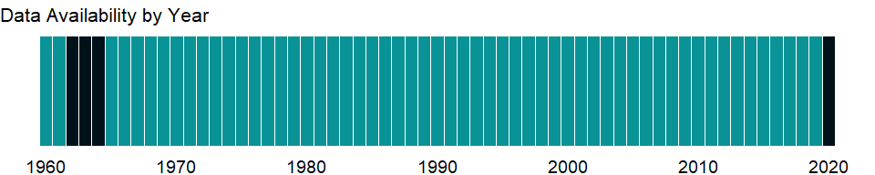

### Which countries have data?

The figure below shows the percentage of countries in each income group with a value since 2010 for that indicator.

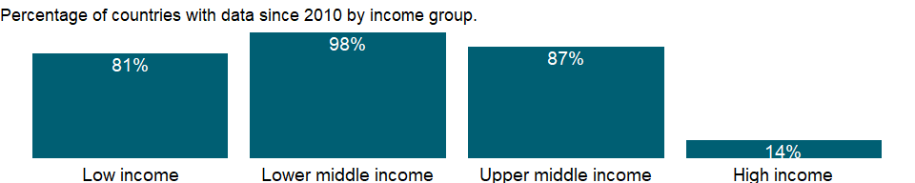

### Why is it relevant?

The ratio of aid to imports of goods and services provides a measure of recipient country’s dependency on aid. Ratios of aid are generally much higher in Sub-Saharan Africa than in other regions, and they increased in the 1980s. High ratios are due only in part to aid flows. Many African countries saw severe erosion in their terms of trade in the 1980s, along with weak policies, falling incomes, imports, and investment. Thus the increase in aid dependency ratios reflects events affecting both the numerator (aid) and the denominator (imports of goods and services).

DAC exists to help its members coordinate their development assistance and to encourage the expansion and improve the effectiveness of the aggregate resources flowing to recipient economies. In this capacity DAC monitors the flow of all financial resources, but its main concern is official development assistance (ODA). Grants or loans to countries and territories on the DAC list of aid recipients have to meet three criteria to be counted as ODA. They are provided by official agencies, including state and local governments, or by their executive agencies. They promote economic development and welfare as the main objective. And they are provided on concessional financial terms (loans must have a grant element of at least 25 percent, calculated at a discount rate of 10 percent). The DAC Statistical Reporting Directives provide the most detailed explanation of this definition and all ODA-related rules.

DAC statistics aim to meet the needs of policy makers in the field of development co-operation, and to provide a means of assessing the comparative performance of aid donors. DAC statistics are used extensively in the Peer Reviews conducted for each DAC member every four to five years, and have a wide range of other applications. They are used to measure donors’ compliance with various international recommendations in the field of development co-operation (terms, volume), and are indispensable for analysis of virtually every aspect of development and development co-operation.

From 1960 to 1990, official development assistance (ODA) flows from DAC countries to developing countries rose steadily, but then fell sharply in the 1990s. Since then, a series of high-profile international conferences have boosted ODA flows. In the mid-2000s, ODA once again rose due to exceptional debt relief operations for Iraq and Nigeria. Despite the recent financial crisis, ODA flows have continued to rise and in the early 2010s reached their highest real level ever at about US $130 billion. This demonstrates effectiveness of aid pledges, especially when they are made on the basis of adequate resources and backed by strong political will.

### What is the data source?

Development Assistance Committee of the Organisation for Economic Co-operation and Development, Geographical Distribution of Financial Flows to Developing Countries, Development Co-operation Report, and International Development Statistics database. Data are available online at: www.oecd.org/dac/stats/idsonline. World Bank imports of good and services estimates are used for the denominator.

### What is the methodology?

Net official development assistance (ODA) per capita consists of disbursements of loans made on concessional terms (net of repayments of principal) and grants by official agencies of the members of the Development Assistance Committee (DAC), by multilateral institutions, and by non-DAC countries to promote economic development and welfare in countries and territories in the DAC list of ODA recipients. It includes loans with a grant element of at least 25 percent (calculated at a rate of discount of 10 percent).

Data on imports are compiled from customs reports and balance of payments data. They include the value of merchandise, freight, insurance, transport, travel, royalties, license fees, and other services. They exclude compensation of employees and investment income (factor services in the 1969 SNA) and transfer payments.

The flows of official and private financial resources from the members of the Development Assistance Committee (DAC) of the Organisation for Economic Co-operation and Development (OECD) to developing economies are compiled by DAC, based principally on reporting by DAC members using standard questionnaires issued by the DAC Secretariat.

The ODA excludes nonconcessional flows from official creditors, which are classified as “other official flows,” and aid for military and anti-terrorism purposes. Transfer payments to private individuals, such as pensions, reparations, and insurance payouts, are in general not counted. In addition to financial flows, ODA includes technical cooperation, most expenditures for peacekeeping under UN mandates and assistance to refugees, contributions to multilateral institutions such as the United Nations and its specialized agencies, and concessional funding to multilateral development banks.

Flows are transfers of resources, either in cash or in the form of commodities or services measured on a cash basis. Short-term capital transactions (with one year or less maturity) are not counted. Repayments of the principal (but not interest) of ODA loans are recorded as negative flows. Proceeds from official equity investments in a developing country are reported as ODA, while proceeds from their later sale are recorded as negative flows.

The official development assistance estimates are published annually at the end of the calendar year in International Development Statistics (IDS) database. Net ODA received as a percent of imports of goods and services is calculated using values in U.S. dollars converted at official exchange rates.

### How is it aggregated?

Weighted Average

### What are the limitations?

Data on ODA is for aid-receiving countries. The data cover loans and grants from DAC member countries, multilateral organizations, and non-DAC donors. They do not reflect aid given by recipient countries to other developing countries. As a result, some countries that are net donors are shown as aid recipients. The indicator does not distinguish types of aid (program, project, or food aid; emergency assistance; or post-conflict peacekeeping assistance), which may have different effects on the economy.

Ratio of aid to imports of goods and services provides measures of recipient country’s dependency on aid. But care must be taken in drawing policy conclusions. For foreign policy reasons some countries have traditionally received large amounts of aid. Thus aid dependency ratio may reveal as much about a donor’s interests as about a recipient’s needs. Data on imports are compiled from customs reports and balance of payments data. Although data from the payments side provide reasonably reliable records of cross-border transactions, they may not adhere strictly to the appropriate definitions of valuation and timing used in the balance of payments or correspond to the change of ownership criterion. This issue has assumed greater significance with the increasing globalization of international business. Neither customs nor balance of payments data usually capture the illegal transactions that occur in many countries. Goods carried by travelers across borders in league but unreported shuttle trade may further distort trade statistics.

Because the indicator relies on information from donors, it is not necessarily consistent with information recorded by recipients in the balance of payments, which often excludes all or some technical assistance - particularly payments to expatriates made directly by the donor. Similarly, grant commodity aid may not always be recorded in trade data or in the balance of payments. Moreover, DAC statistics exclude aid for military and antiterrorism purposes.

The aggregates refer to World Bank classifications of economies and therefore may differ from those of the OECD.

### What else should I know?

NA

### 1.10.64 Net ODA received per capita (current US$)

### What is the indicator?

Net official development assistance (ODA) per capita consists of disbursements of loans made on concessional terms (net of repayments of principal) and grants by official agencies of the members of the Development Assistance Committee (DAC), by multilateral institutions, and by non-DAC countries to promote economic development and welfare in countries and territories in the DAC list of ODA recipients; and is calculated by dividing net ODA received by the midyear population estimate. It includes loans with a grant element of at least 25 percent (calculated at a rate of discount of 10 percent).

Topic: Economic Policy & Debt: Official development assistance

Series ID: DT.ODA.ODAT.PC.ZS

Copyright: CC BY-4.0 , <https://datacatalog.worldbank.org/public-licenses#cc-by>

First year with any data: 1960

Last year with any data: 2019

### What years are data available?

The figure below shows years in which data is available for at least one country. Dates shaded in black have no data, while dates shaded in green have data for at least one country



### Which countries have data?

The figure below shows the percentage of countries in each income group with a value since 2010 for that indicator.



### Why is it relevant?

The ratio of aid per capita provides a measure of recipient country’s dependency on aid. DAC exists to help its members coordinate their development assistance and to encourage the expansion and improve the effectiveness of the aggregate resources flowing to recipient economies. In this capacity DAC monitors the flow of all financial resources, but its main concern is official development assistance (ODA). Grants or loans to countries and territories on the DAC list of aid recipients have to meet three criteria to be counted as ODA. They are provided by official agencies, including state and local governments, or by their executive agencies. They promote economic development and welfare as the main objective. And they are provided on concessional financial terms (loans must have a grant element of at least 25 percent, calculated at a discount rate of 10 percent). The DAC Statistical Reporting Directives provide the most detailed explanation of this definition and all ODA-related rules.

DAC statistics aim to meet the needs of policy makers in the field of development co-operation, and to provide a means of assessing the comparative performance of aid donors. DAC statistics are used extensively in the Peer Reviews conducted for each DAC member every four to five years, and have a wide range of other applications. They are used to measure donors’ compliance with various international recommendations in the field of development co-operation (terms, volume), and are indispensable for analysis of virtually every aspect of development and development co-operation.

From 1960 to 1990, official development assistance (ODA) flows from DAC countries to developing countries rose steadily, but then fell sharply in the 1990s. Since then, a series of high-profile international conferences have boosted ODA flows. In the mid-2000s, ODA once again rose due to exceptional debt relief operations for Iraq and Nigeria. Despite the recent financial crisis, ODA flows have continued to rise and in the early 2010s reached their highest real level ever at about USD 130 billion. This demonstrates how effective aid pledges can be when they are made on the basis of adequate resources and backed by strong political will.

### What is the data source?

Development Assistance Committee of the Organisation for Economic Co-operation and Development, Geographical Distribution of Financial Flows to Developing Countries, Development Co-operation Report, and International Development Statistics database. Data are available online at: www.oecd.org/dac/stats/idsonline. World Bank population estimates are used for the denominator.

### What is the methodology?

Net official development assistance (ODA) per capita consists of disbursements of loans made on concessional terms (net of repayments of principal) and grants by official agencies of the members of the Development Assistance Committee (DAC), by multilateral institutions, and by non-DAC countries to promote economic development and welfare in countries and territories in the DAC list of ODA recipients. It includes loans with a grant element of at least 25 percent (calculated at a rate of discount of 10 percent).

Total population is based on the de facto definition of population, which counts all residents regardless of legal status or citizenship - except for refugees not permanently settled in the country of asylum, who are generally considered part of the population of their country of origin. The values shown are midyear estimates. Net official development assistance per capita is net ODA divided by midyear population.

The flows of official and private financial resources from the members of the Development Assistance Committee (DAC) of the Organisation for Economic Co-operation and Development (OECD) to developing economies are compiled by DAC, based principally on reporting by DAC members using standard questionnaires issued by the DAC Secretariat.

This definition excludes nonconcessional flows from official creditors, which are classified as “other official flows,” and aid for military and anti-terrorism purposes. Transfer payments to private individuals, such as pensions, reparations, and insurance payouts, are in general not counted. In addition to financial flows, ODA includes technical cooperation, most expenditures for peacekeeping under UN mandates and assistance to refugees, contributions to multilateral institutions such as the United Nations and its specialized agencies, and concessional funding to multilateral development banks.

Flows are transfers of resources, either in cash or in the form of commodities or services measured on a cash basis. Short-term capital transactions (with one year or less maturity) are not counted. Repayments of the principal (but not interest) of ODA loans are recorded as negative flows. Proceeds from official equity investments in a developing country are reported as ODA, while proceeds from their later sale are recorded as negative flows.

The official development assistance (ODA) estimates are published annually at the end of the calendar year in International Development Statistics (IDS) database.

### How is it aggregated?

Weighted Average

### What are the limitations?

Data on ODA is for aid-receiving countries. The data cover loans and grants from DAC member countries, multilateral organizations, and non-DAC donors. They do not reflect aid given by recipient countries to other developing countries. As a result, some countries that are net donors are shown as aid recipients. The indicator does not distinguish types of aid (program, project, or food aid; emergency assistance; or post-conflict peacekeeping assistance), which may have different effects on the economy.

Because the indicator relies on information from donors, it is not necessarily consistent with information recorded by recipients in the balance of payments, which often excludes all or some technical assistance - particularly payments to expatriates made directly by the donor. Similarly, grant commodity aid may not always be recorded in trade data or in the balance of payments. Moreover, DAC statistics exclude aid for military and antiterrorism purposes.

The aggregates refer to World Bank classifications of economies and therefore may differ from those of the OECD.

### What else should I know?

NA

### 1.10.65 Net ODA received (% of central government expense)

### What is the indicator?

Net official development assistance (ODA) consists of disbursements of loans made on concessional terms (net of repayments of principal) and grants by official agencies of the members of the Development Assistance Committee (DAC), by multilateral institutions, and by non-DAC countries to promote economic development and welfare in countries and territories in the DAC list of ODA recipients. It includes loans with a grant element of at least 25 percent (calculated at a rate of discount of 10 percent).

Topic: Economic Policy & Debt: Official development assistance

Series ID: DT.ODA.ODAT.XP.ZS

Copyright: CC BY-4.0 , <https://datacatalog.worldbank.org/public-licenses#cc-by>

First year with any data: 1972

Last year with any data: 2019

### What years are data available?

The figure below shows years in which data is available for at least one country. Dates shaded in black have no data, while dates shaded in green have data for at least one country



### Which countries have data?

The figure below shows the percentage of countries in each income group with a value since 2010 for that indicator.

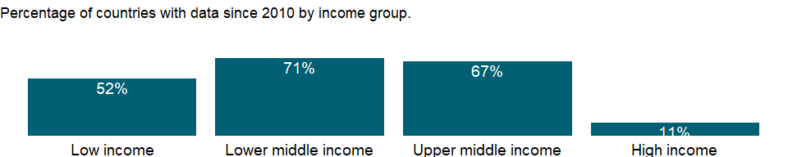

### Why is it relevant?

Ratio of aid to central government expense provides measures of recipient country’s dependency on aid. Ratios of aid are generally much higher in Sub-Saharan Africa than in other regions, and they increased in the 1980s. High ratios are due only in part to aid flows. Many African countries saw severe erosion in their terms of trade in the 1980salong with weak policies, falling incomes, imports, and investment. Thus the increase in aid dependency ratios reflects events affecting both the numerator (aid) and the denominator (central government expense).

DAC exists to help its members coordinate their development assistance and to encourage the expansion and improve the effectiveness of the aggregate resources flowing to recipient economies. In this capacity DAC monitors the flow of all financial resources, but its main concern is official development assistance (ODA). Grants or loans to countries and territories on the DAC list of aid recipients have to meet three criteria to be counted as ODA. They are provided by official agencies, including state and local governments, or by their executive agencies. They promote economic development and welfare as the main objective. And they are provided on concessional financial terms (loans must have a grant element of at least 25 percent, calculated at a discount rate of 10 percent). The DAC Statistical Reporting Directives provide the most detailed explanation of this definition and all ODA-related rules.

DAC statistics aim to meet the needs of policy makers in the field of development co-operation, and to provide a means of assessing the comparative performance of aid donors. DAC statistics are used extensively in the Peer Reviews conducted for each DAC member every four to five years, and have a wide range of other applications. They are used to measure donors’ compliance with various international recommendations in the field of development co-operation (terms, volume), and are indispensable for analysis of virtually every aspect of development and development co-operation.

From 1960 to 1990, official development assistance (ODA) flows from DAC countries to developing countries rose steadily, but then fell sharply in the 1990s. Since then, a series of high-profile international conferences have boosted ODA flows. In the mid-2000s, ODA once again rose due to exceptional debt relief operations for Iraq and Nigeria. Despite the recent financial crisis, ODA flows have continued to rise and in the early 2010s reached their highest real level ever at about US $130 billion. This demonstrates effectiveness of aid pledges, especially when they are made on the basis of adequate resources and backed by strong political will.

### What is the data source?

Development Assistance Committee of the Organisation for Economic Co-operation and Development, Geographical Distribution of Financial Flows to Developing Countries, Development Co-operation Report, and International Development Statistics database. Data are available online at: www.oecd.org/dac/stats/idsonline. IMF central government expense estimates are used for the denominator.

### What is the methodology?

Net official development assistance (ODA) per capita consists of disbursements of loans made on concessional terms (net of repayments of principal) and grants by official agencies of the members of the Development Assistance Committee (DAC), by multilateral institutions, and by non-DAC countries to promote economic development and welfare in countries and territories in the DAC list of ODA recipients. It includes loans with a grant element of at least 25 percent (calculated at a rate of discount of 10 percent).

Central government expense is cash payments for operating activities of the government in providing goods and services. It includes compensation of employees (such as wages and salaries), interest and subsidies, grants, social benefits, and other expenses such as rent and dividends.

The flows of official and private financial resources from the members of the Development Assistance Committee (DAC) of the Organisation for Economic Co-operation and Development (OECD) to developing economies are compiled by DAC, based principally on reporting by DAC members using standard questionnaires issued by the DAC Secretariat.

The ODA excludes nonconcessional flows from official creditors, which are classified as “other official flows,” and aid for military and anti-terrorism purposes. Transfer payments to private individuals, such as pensions, reparations, and insurance payouts, are in general not counted. In addition to financial flows, ODA includes technical cooperation, most expenditures for peacekeeping under UN mandates and assistance to refugees, contributions to multilateral institutions such as the United Nations and its specialized agencies, and concessional funding to multilateral development banks.

Flows are transfers of resources, either in cash or in the form of commodities or services measured on a cash basis. Short-term capital transactions (with one year or less maturity) are not counted. Repayments of the principal (but not interest) of ODA loans are recorded as negative flows. Proceeds from official equity investments in a developing country are reported as ODA, while proceeds from their later sale are recorded as negative flows.

The official development assistance estimates are published annually at the end of the calendar year in International Development Statistics (IDS) database. Net ODA received as a percent of central government expense is calculated using values in U.S. dollars converted using the DEC alternative conversion factor which is the underlying annual exchange rate used for the World Bank Atlas method.

### How is it aggregated?

NA

### What are the limitations?

Data on ODA is for aid-receiving countries. The data cover loans and grants from DAC member countries, multilateral organizations, and non-DAC donors. They do not reflect aid given by recipient countries to other developing countries. As a result, some countries that are net donors are shown as aid recipients. The indicator does not distinguish types of aid (program, project, or food aid; emergency assistance; or post-conflict peacekeeping assistance), which may have different effects on the economy.

Ratio of aid to central government expense provides measures of recipient country’s dependency on aid. But care must be taken in drawing policy conclusions. For foreign policy reasons some countries have traditionally received large amounts of aid. Thus aid dependency ratio may reveal as much about a donor’s interests as about a recipient’s needs.

The nominal values used here may overstate the real value of aid to recipients. Changes in international prices and exchange rates can reduce the purchasing power of aid. Tying aid, still prevalent though declining in importance, also tends to reduce its purchasing power. Tying requires recipients to purchase goods and services from the donor country or from a specified group of countries. Such arrangements prevent a recipient from misappropriating or mismanaging aid receipts, but they may also be motivated by a desire to benefit donor country suppliers.

Because the indicator relies on information from donors, it is not necessarily consistent with information recorded by recipients in the balance of payments, which often excludes all or some technical assistance - particularly payments to expatriates made directly by the donor. Similarly, grant commodity aid may not always be recorded in trade data or in the balance of payments. Moreover, DAC statistics exclude aid for military and antiterrorism purposes.

The aggregates refer to World Bank classifications of economies and therefore may differ from those of the OECD.

### What else should I know?

NA

## 1.11 Economic Policy & Debt: External debt: Debt outstanding

### 1.11.1 External debt stocks, total (DOD, current US$)

### What is the indicator?

Total external debt is debt owed to nonresidents repayable in currency, goods, or services. Total external debt is the sum of public, publicly guaranteed, and private nonguaranteed long-term debt, use of IMF credit, and short-term debt. Short-term debt includes all debt having an original maturity of one year or less and interest in arrears on long-term debt. Data are in current U.S. dollars.

Topic: Economic Policy & Debt: External debt: Debt outstanding

Series ID: DT.DOD.DECT.CD

Copyright: CC BY-4.0 , <https://datacatalog.worldbank.org/public-licenses#cc-by>

First year with any data: 1970

Last year with any data: 2019

### What years are data available?

The figure below shows years in which data is available for at least one country. Dates shaded in black have no data, while dates shaded in green have data for at least one country



### Which countries have data?

The figure below shows the percentage of countries in each income group with a value since 2010 for that indicator.

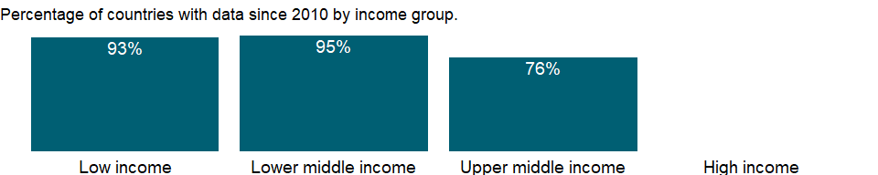

### Why is it relevant?

External indebtedness affects a country’s creditworthiness and investor perceptions. Nonreporting countries might have outstanding debt with the World Bank, other international financial institutions, or private creditors. Total debt service is contrasted with countries’ ability to obtain foreign exchange through exports of goods, services, primary income, and workers’ remittances.

Debt ratios are used to assess the sustainability of a country’s debt service obligations, but no absolute rules determine what values are too high. Empirical analysis of developing countries’ experience and debt service performance shows that debt service difficulties become increasingly likely when the present value of debt reaches 200 percent of exports. Still, what constitutes a sustainable debt burden varies by country. Countries with fast-growing economies and exports are likely to be able to sustain higher debt levels.

### What is the data source?

World Bank, International Debt Statistics.

### What is the methodology?

Data on external debt are gathered through the World Bank’s Debtor Reporting System (DRS). Long term debt data are compiled using the countries report on public and publicly guaranteed borrowing on a loan-by-loan basis and private non guaranteed borrowing on an aggregate basis. These data are supplemented by information from major multilateral banks and official lending agencies in major creditor countries. Short-term debt data are gathered from the Quarterly External Debt Statistics (QEDS) database, jointly developed by the World Bank and the IMF and from creditors through the reporting systems of the Bank for International Settlements. Debt data are reported in the currency of repayment and compiled and published in U.S. dollars. End-of-period exchange rates are used for the compilation of stock figures (amount of debt outstanding), and projected debt service and annual average exchange rates are used for the flows. Exchange rates are taken from the IMF’s International Financial Statistics. Debt repayable in multiple currencies, goods, or services and debt with a provision for maintenance of the value of the currency of repayment are shown at book value.

### How is it aggregated?

Sum

### What are the limitations?

NA

### What else should I know?

NA

### 1.11.2 Use of IMF credit (DOD, current US$)

### What is the indicator?

Use of IMF Credit: Data related to the operations of the IMF are provided by the IMF Treasurer’s Department. They are converted from special drawing rights into dollars using end-of-period exchange rates for stocks and average-over-the-period exchange rates for flows. IMF trust fund operations under the Enhanced Structural Adjustment Facility, Extended Fund Facility, Poverty Reduction and Growth Facility, and Structural Adjustment Facility (Enhanced Structural Adjustment Facility in 1999) are presented together with all of the IMF’s special facilities (buffer stock, supplemental reserve, compensatory and contingency facilities, oil facilities, and other facilities). SDR allocations are also included in this category. According to the BPM6, SDR allocations are recorded as the incurrence of a debt liability of the member receiving them (because of a requirement to repay the allocation in certain circumstances, and also because interest accrues). This debt item is introduced for the first time this year with historical data starting in 1999.

Topic: Economic Policy & Debt: External debt: Debt outstanding

Series ID: DT.DOD.DIMF.CD

Copyright: CC BY-4.0 , <https://datacatalog.worldbank.org/public-licenses#cc-by>

First year with any data: 1970

Last year with any data: 2019

### What years are data available?

The figure below shows years in which data is available for at least one country. Dates shaded in black have no data, while dates shaded in green have data for at least one country



### Which countries have data?

The figure below shows the percentage of countries in each income group with a value since 2010 for that indicator.

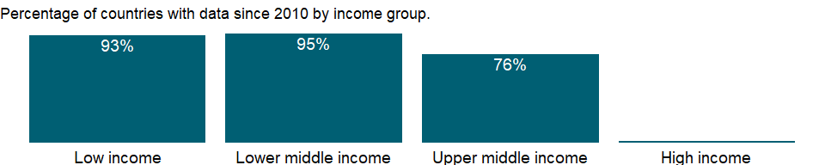

### Why is it relevant?

External indebtedness affects a country’s creditworthiness and investor perceptions. Nonreporting countries might have outstanding debt with the World Bank, other international financial institutions, or private creditors. Total debt service is contrasted with countries’ ability to obtain foreign exchange through exports of goods, services, primary income, and workers’ remittances.

Debt ratios are used to assess the sustainability of a country’s debt service obligations, but no absolute rules determine what values are too high. Empirical analysis of developing countries’ experience and debt service performance shows that debt service difficulties become increasingly likely when the present value of debt reaches 200 percent of exports. Still, what constitutes a sustainable debt burden varies by country. Countries with fast-growing economies and exports are likely to be able to sustain higher debt levels.

### What is the data source?

World Bank, International Debt Statistics.

### What is the methodology?

Data related to the operations of the IMF come from the IMF Treasurer’s Department and are converted from special drawing rights (SDRs) into dollars using end-of-period exchange rates for stocks and average over the period exchange rates for converting flows. DOD refers to disbursed and outstanding debt; data are in current U.S. dollars.

Data on external debt are gathered through the World Bank’s Debtor Reporting System (DRS). Long term debt data are compiled using the countries report on public and publicly guaranteed borrowing on a loan-by-loan basis and private non guaranteed borrowing on an aggregate basis. These data are supplemented by information from major multilateral banks and official lending agencies in major creditor countries. Short-term debt data are gathered from the Quarterly External Debt Statistics (QEDS) database, jointly developed by the World Bank and the IMF and from creditors through the reporting systems of the Bank for International Settlements. Debt data are reported in the currency of repayment and compiled and published in U.S. dollars. End-of-period exchange rates are used for the compilation of stock figures (amount of debt outstanding), and projected debt service and annual average exchange rates are used for the flows. Exchange rates are taken from the IMF’s International Financial Statistics. Debt repayable in multiple currencies, goods, or services and debt with a provision for maintenance of the value of the currency of repayment are shown at book value.

### How is it aggregated?

Sum

### What are the limitations?

NA

### What else should I know?

NA

### 1.11.3 External debt stocks, long-term (DOD, current US$)

### What is the indicator?

Long-term debt is debt that has an original or extended maturity of more than one year. It has three components: public, publicly guaranteed, and private nonguaranteed debt. Data are in current U.S. dollars.

Topic: Economic Policy & Debt: External debt: Debt outstanding

Series ID: DT.DOD.DLXF.CD

Copyright: CC BY-4.0 , <https://datacatalog.worldbank.org/public-licenses#cc-by>

First year with any data: 1970

Last year with any data: 2019

### What years are data available?

The figure below shows years in which data is available for at least one country. Dates shaded in black have no data, while dates shaded in green have data for at least one country



### Which countries have data?

The figure below shows the percentage of countries in each income group with a value since 2010 for that indicator.



### Why is it relevant?

External indebtedness affects a country’s creditworthiness and investor perceptions. Nonreporting countries might have outstanding debt with the World Bank, other international financial institutions, or private creditors. Total debt service is contrasted with countries’ ability to obtain foreign exchange through exports of goods, services, primary income, and workers’ remittances.

Debt ratios are used to assess the sustainability of a country’s debt service obligations, but no absolute rules determine what values are too high. Empirical analysis of developing countries’ experience and debt service performance shows that debt service difficulties become increasingly likely when the present value of debt reaches 200 percent of exports. Still, what constitutes a sustainable debt burden varies by country. Countries with fast-growing economies and exports are likely to be able to sustain higher debt levels.

### What is the data source?

World Bank, International Debt Statistics.

### What is the methodology?

Data on external debt are gathered through the World Bank’s Debtor Reporting System (DRS). Long term debt data are compiled using the countries report on public and publicly guaranteed borrowing on a loan-by-loan basis and private non guaranteed borrowing on an aggregate basis. These data are supplemented by information from major multilateral banks and official lending agencies in major creditor countries. Short-term debt data are gathered from the Quarterly External Debt Statistics (QEDS) database, jointly developed by the World Bank and the IMF and from creditors through the reporting systems of the Bank for International Settlements. Debt data are reported in the currency of repayment and compiled and published in U.S. dollars. End-of-period exchange rates are used for the compilation of stock figures (amount of debt outstanding), and projected debt service and annual average exchange rates are used for the flows. Exchange rates are taken from the IMF’s International Financial Statistics. Debt repayable in multiple currencies, goods, or services and debt with a provision for maintenance of the value of the currency of repayment are shown at book value.

### How is it aggregated?

Sum

### What are the limitations?

NA

### What else should I know?

NA

### 1.11.4 External debt stocks, private nonguaranteed (PNG) (DOD, current US$)

### What is the indicator?

Private nonguaranteed external debt comprises long-term external obligations of private debtors that are not guaranteed for repayment by a public entity. Data are in current U.S. dollars.

Topic: Economic Policy & Debt: External debt: Debt outstanding

Series ID: DT.DOD.DPNG.CD

Copyright: CC BY-4.0 , <https://datacatalog.worldbank.org/public-licenses#cc-by>

First year with any data: 1970

Last year with any data: 2019

### What years are data available?

The figure below shows years in which data is available for at least one country. Dates shaded in black have no data, while dates shaded in green have data for at least one country



### Which countries have data?

The figure below shows the percentage of countries in each income group with a value since 2010 for that indicator.

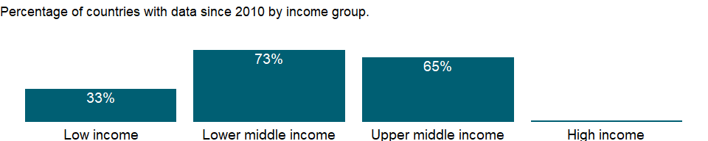

### Why is it relevant?

External indebtedness affects a country’s creditworthiness and investor perceptions. Nonreporting countries might have outstanding debt with the World Bank, other international financial institutions, or private creditors. Total debt service is contrasted with countries’ ability to obtain foreign exchange through exports of goods, services, primary income, and workers’ remittances.

Debt ratios are used to assess the sustainability of a country’s debt service obligations, but no absolute rules determine what values are too high. Empirical analysis of developing countries’ experience and debt service performance shows that debt service difficulties become increasingly likely when the present value of debt reaches 200 percent of exports. Still, what constitutes a sustainable debt burden varies by country. Countries with fast-growing economies and exports are likely to be able to sustain higher debt levels.

### What is the data source?

World Bank, International Debt Statistics.

### What is the methodology?

Data on external debt are gathered through the World Bank’s Debtor Reporting System (DRS). Long term debt data are compiled using the countries report on public and publicly guaranteed borrowing on a loan-by-loan basis and private non guaranteed borrowing on an aggregate basis. These data are supplemented by information from major multilateral banks and official lending agencies in major creditor countries. Short-term debt data are gathered from the Quarterly External Debt Statistics (QEDS) database, jointly developed by the World Bank and the IMF and from creditors through the reporting systems of the Bank for International Settlements. Debt data are reported in the currency of repayment and compiled and published in U.S. dollars. End-of-period exchange rates are used for the compilation of stock figures (amount of debt outstanding), and projected debt service and annual average exchange rates are used for the flows. Exchange rates are taken from the IMF’s International Financial Statistics. Debt repayable in multiple currencies, goods, or services and debt with a provision for maintenance of the value of the currency of repayment are shown at book value.

### How is it aggregated?

Sum

### What are the limitations?

NA

### What else should I know?

NA

### 1.11.5 External debt stocks, public and publicly guaranteed (PPG) (DOD, current US$)

### What is the indicator?

Public and publicly guaranteed debt comprises long-term external obligations of public debtors, including the national government, Public Corporations, State Owned Enterprises, Development Banks and Other Mixed Enterprises, political subdivisions (or an agency of either), autonomous public bodies, and external obligations of private debtors that are guaranteed for repayment by a public entity. Data are in current U.S. dollars.

Topic: Economic Policy & Debt: External debt: Debt outstanding

Series ID: DT.DOD.DPPG.CD

Copyright: CC BY-4.0 , <https://datacatalog.worldbank.org/public-licenses#cc-by>

First year with any data: 1970

Last year with any data: 2019

### What years are data available?

The figure below shows years in which data is available for at least one country. Dates shaded in black have no data, while dates shaded in green have data for at least one country



### Which countries have data?

The figure below shows the percentage of countries in each income group with a value since 2010 for that indicator.



### Why is it relevant?

External indebtedness affects a country’s creditworthiness and investor perceptions. Nonreporting countries might have outstanding debt with the World Bank, other international financial institutions, or private creditors. Total debt service is contrasted with countries’ ability to obtain foreign exchange through exports of goods, services, primary income, and workers’ remittances.

Debt ratios are used to assess the sustainability of a country’s debt service obligations, but no absolute rules determine what values are too high. Empirical analysis of developing countries’ experience and debt service performance shows that debt service difficulties become increasingly likely when the present value of debt reaches 200 percent of exports. Still, what constitutes a sustainable debt burden varies by country. Countries with fast-growing economies and exports are likely to be able to sustain higher debt levels.

### What is the data source?

World Bank, International Debt Statistics.

### What is the methodology?

Data on external debt are gathered through the World Bank’s Debtor Reporting System (DRS). Long term debt data are compiled using the countries report on public and publicly guaranteed borrowing on a loan-by-loan basis and private non guaranteed borrowing on an aggregate basis. These data are supplemented by information from major multilateral banks and official lending agencies in major creditor countries. Short-term debt data are gathered from the Quarterly External Debt Statistics (QEDS) database, jointly developed by the World Bank and the IMF and from creditors through the reporting systems of the Bank for International Settlements. Debt data are reported in the currency of repayment and compiled and published in U.S. dollars. End-of-period exchange rates are used for the compilation of stock figures (amount of debt outstanding), and projected debt service and annual average exchange rates are used for the flows. Exchange rates are taken from the IMF’s International Financial Statistics. Debt repayable in multiple currencies, goods, or services and debt with a provision for maintenance of the value of the currency of repayment are shown at book value.

### How is it aggregated?

Sum

### What are the limitations?

NA

### What else should I know?

NA

### 1.11.6 External debt stocks, short-term (DOD, current US$)

### What is the indicator?

Short-term external debt is defined as debt that has an original maturity of one year or less. Available data permit no distinction between public and private nonguaranteed short-term debt. Data are in current U.S. dollars.

Topic: Economic Policy & Debt: External debt: Debt outstanding

Series ID: DT.DOD.DSTC.CD

Copyright: CC BY-4.0 , <https://datacatalog.worldbank.org/public-licenses#cc-by>

First year with any data: 1970

Last year with any data: 2019

### What years are data available?

The figure below shows years in which data is available for at least one country. Dates shaded in black have no data, while dates shaded in green have data for at least one country



### Which countries have data?

The figure below shows the percentage of countries in each income group with a value since 2010 for that indicator.



### Why is it relevant?

External indebtedness affects a country’s creditworthiness and investor perceptions. Nonreporting countries might have outstanding debt with the World Bank, other international financial institutions, or private creditors. Total debt service is contrasted with countries’ ability to obtain foreign exchange through exports of goods, services, primary income, and workers’ remittances.

Debt ratios are used to assess the sustainability of a country’s debt service obligations, but no absolute rules determine what values are too high. Empirical analysis of developing countries’ experience and debt service performance shows that debt service difficulties become increasingly likely when the present value of debt reaches 200 percent of exports. Still, what constitutes a sustainable debt burden varies by country. Countries with fast-growing economies and exports are likely to be able to sustain higher debt levels.

### What is the data source?

World Bank, International Debt Statistics.

### What is the methodology?

Data on external debt are gathered through the World Bank’s Debtor Reporting System (DRS). Long term debt data are compiled using the countries report on public and publicly guaranteed borrowing on a loan-by-loan basis and private non guaranteed borrowing on an aggregate basis. These data are supplemented by information from major multilateral banks and official lending agencies in major creditor countries. Short-term debt data are gathered from the Quarterly External Debt Statistics (QEDS) database, jointly developed by the World Bank and the IMF and from creditors through the reporting systems of the Bank for International Settlements. Debt data are reported in the currency of repayment and compiled and published in U.S. dollars. End-of-period exchange rates are used for the compilation of stock figures (amount of debt outstanding), and projected debt service and annual average exchange rates are used for the flows. Exchange rates are taken from the IMF’s International Financial Statistics. Debt repayable in multiple currencies, goods, or services and debt with a provision for maintenance of the value of the currency of repayment are shown at book value.

### How is it aggregated?

Sum

### What are the limitations?

NA

### What else should I know?

NA

### 1.11.7 PPG, IBRD (DOD, current US$)

### What is the indicator?

Public and publicly guaranteed debt outstanding from the International Bank for Reconstruction and Development (IBRD) is nonconcessional. Nonconcessional debt excludes loans with an original grant element of 35 percent or more. Data are in current U.S. dollars.

Topic: Economic Policy & Debt: External debt: Debt outstanding

Series ID: DT.DOD.MIBR.CD

Copyright: CC BY-4.0 , <https://datacatalog.worldbank.org/public-licenses#cc-by>

First year with any data: 1970

Last year with any data: 2019

### What years are data available?

The figure below shows years in which data is available for at least one country. Dates shaded in black have no data, while dates shaded in green have data for at least one country



### Which countries have data?

The figure below shows the percentage of countries in each income group with a value since 2010 for that indicator.

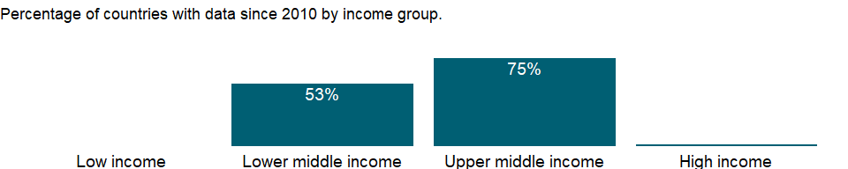

### Why is it relevant?

NA

### What is the data source?

World Bank, International Debt Statistics.

### What is the methodology?

NA

### How is it aggregated?

Sum

### What are the limitations?

NA

### What else should I know?

NA

### 1.11.8 PPG, IDA (DOD, current US$)

### What is the indicator?

Public and publicly guaranteed debt outstanding from the International Development Association (IDA) is concessional. Concessional debt is defined as loans with an original grant element of 35 percent or more. The grant element of a loan is the grant equivalent expressed as a percentage of the amount committed. It is used as a measure of the overall cost of borrowing. The grant equivalent of a loan is its commitment (present) value, less the discounted present value of its contractual debt service; conventionally, future service payments are discounted at 5 percent. Data are in current U.S. dollars.

Topic: Economic Policy & Debt: External debt: Debt outstanding

Series ID: DT.DOD.MIDA.CD

Copyright: CC BY-4.0 , <https://datacatalog.worldbank.org/public-licenses#cc-by>

First year with any data: 1970

Last year with any data: 2019

### What years are data available?

The figure below shows years in which data is available for at least one country. Dates shaded in black have no data, while dates shaded in green have data for at least one country



### Which countries have data?

The figure below shows the percentage of countries in each income group with a value since 2010 for that indicator.

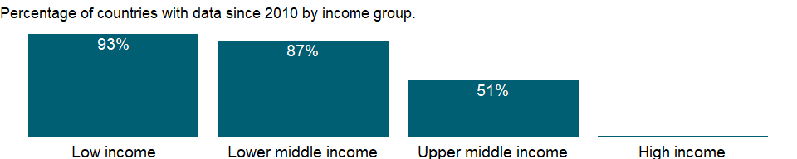

### Why is it relevant?

NA

### What is the data source?

World Bank, International Debt Statistics.

### What is the methodology?

NA

### How is it aggregated?

Sum

### What are the limitations?

NA

### What else should I know?

NA

### 1.11.9 IBRD loans and IDA credits (DOD, current US$)

### What is the indicator?

IBRD loans and IDA credits are public and publicly guaranteed debt extended by the World Bank Group. The International Bank for Reconstruction and Development (IBRD) lends at market rates. Credits from the International Development Association (IDA) are at concessional rates. Data are in current U.S. dollars.

Topic: Economic Policy & Debt: External debt: Debt outstanding

Series ID: DT.DOD.MWBG.CD

Copyright: CC BY-4.0 , <https://datacatalog.worldbank.org/public-licenses#cc-by>

First year with any data: 1970

Last year with any data: 2019

### What years are data available?

The figure below shows years in which data is available for at least one country. Dates shaded in black have no data, while dates shaded in green have data for at least one country



### Which countries have data?

The figure below shows the percentage of countries in each income group with a value since 2010 for that indicator.

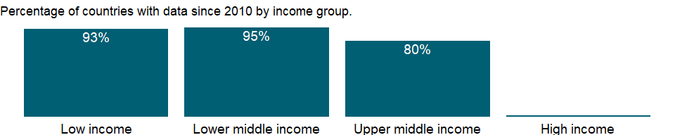

### Why is it relevant?

NA

### What is the data source?

World Bank, International Debt Statistics.

### What is the methodology?

NA

### How is it aggregated?

Sum

### What are the limitations?

NA

### What else should I know?

NA

### 1.11.10 Present value of external debt (current US$)

### What is the indicator?

Present value of debt is the sum of short-term external debt plus the discounted sum of total debt service payments due on public, publicly guaranteed, and private nonguaranteed long-term external debt over the life of existing loans. Data are in current U.S. dollars.

Topic: Economic Policy & Debt: External debt: Debt outstanding

Series ID: DT.DOD.PVLX.CD

Copyright: CC BY-4.0 , <https://datacatalog.worldbank.org/public-licenses#cc-by>

First year with any data: 2016

Last year with any data: 2019

### What years are data available?

The figure below shows years in which data is available for at least one country. Dates shaded in black have no data, while dates shaded in green have data for at least one country

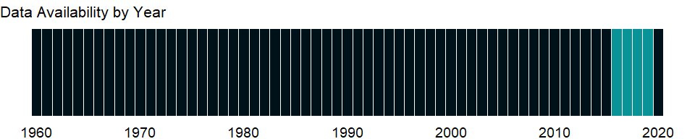

### Which countries have data?

The figure below shows the percentage of countries in each income group with a value since 2010 for that indicator.



### Why is it relevant?

External indebtedness affects a country’s creditworthiness and investor perceptions. Nonreporting countries might have outstanding debt with the World Bank, other international financial institutions, or private creditors. Total debt service is contrasted with countries’ ability to obtain foreign exchange through exports of goods, services, primary income, and workers’ remittances.

Debt ratios are used to assess the sustainability of a country’s debt service obligations, but no absolute rules determine what values are too high. Empirical analysis of developing countries’ experience and debt service performance shows that debt service difficulties become increasingly likely when the present value of debt reaches 200 percent of exports. Still, what constitutes a sustainable debt burden varies by country. Countries with fast-growing economies and exports are likely to be able to sustain higher debt levels.

### What is the data source?

World Bank, International Debt Statistics.

### What is the methodology?

Data on external debt are gathered through the World Bank’s Debtor Reporting System (DRS). Long term debt data are compiled using the countries report on public and publicly guaranteed borrowing on a loan-by-loan basis and private non guaranteed borrowing on an aggregate basis. These data are supplemented by information from major multilateral banks and official lending agencies in major creditor countries. Short-term debt data are gathered from the Quarterly External Debt Statistics (QEDS) database, jointly developed by the World Bank and the IMF and from creditors through the reporting systems of the Bank for International Settlements. Debt data are reported in the currency of repayment and compiled and published in U.S. dollars. End-of-period exchange rates are used for the compilation of stock figures (amount of debt outstanding), and projected debt service and annual average exchange rates are used for the flows. Exchange rates are taken from the IMF’s International Financial Statistics. Debt repayable in multiple currencies, goods, or services and debt with a provision for maintenance of the value of the currency of repayment are shown at book value.

### How is it aggregated?

Sum

### What are the limitations?

NA

### What else should I know?

NA

## 1.12 Economic Policy & Debt: External debt: Debt ratios & other items

### 1.12.1 External debt stocks (% of GNI)

### What is the indicator?

Total external debt stocks to gross national income. Total external debt is debt owed to nonresidents repayable in currency, goods, or services. Total external debt is the sum of public, publicly guaranteed, and private nonguaranteed long-term debt, use of IMF credit, and short-term debt. Short-term debt includes all debt having an original maturity of one year or less and interest in arrears on long-term debt. GNI (formerly GNP) is the sum of value added by all resident producers plus any product taxes (less subsidies) not included in the valuation of output plus net receipts of primary income (compensation of employees and property income) from abroad.

Topic: Economic Policy & Debt: External debt: Debt ratios & other items

Series ID: DT.DOD.DECT.GN.ZS

Copyright: CC BY-4.0 , <https://datacatalog.worldbank.org/public-licenses#cc-by>

First year with any data: 1970

Last year with any data: 2019

### What years are data available?

The figure below shows years in which data is available for at least one country. Dates shaded in black have no data, while dates shaded in green have data for at least one country



### Which countries have data?

The figure below shows the percentage of countries in each income group with a value since 2010 for that indicator.

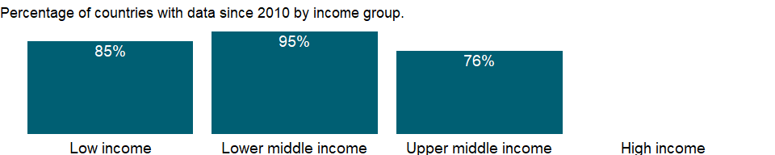

### Why is it relevant?

External debt is that part of the total debt in a country that is owed to creditors outside the country. The debtors can be the government, corporations or private households. The debt includes money owed to private commercial banks, other governments, or international financial institutions.

External indebtedness affects a country’s creditworthiness and investor perceptions. Nonreporting countries might have outstanding debt with the World Bank, other international financial institutions, or private creditors. Total debt service is contrasted with countries’ ability to obtain foreign exchange through exports of goods, services, primary income, and workers’ remittances.

Debt ratios are used to assess the sustainability of a country’s debt service obligations, but no absolute rules determine what values are too high. Empirical analysis of developing countries’ experience and debt service performance shows that debt service difficulties become increasingly likely when the present value of debt reaches 200 percent of exports. Still, what constitutes a sustainable debt burden varies by country. Countries with fast-growing economies and exports are likely to be able to sustain higher debt levels. Various indicators determine a sustainable level of external debt, including:

1. debt to GDP ratio
2. foreign debt to exports ratio
3. government debt to current fiscal revenue ratio
4. share of foreign debt
5. short-term debt
6. concessional debt in the total debt stock

### What is the data source?

World Bank, International Debt Statistics.

### What is the methodology?

Data on external debt are gathered through the World Bank’s Debtor Reporting System (DRS). Long term debt data are compiled using the countries report on public and publicly guaranteed borrowing on a loan-by-loan basis and private non guaranteed borrowing on an aggregate basis. These data are supplemented by information from major multilateral banks and official lending agencies in major creditor countries. Short-term debt data are gathered from the Quarterly External Debt Statistics (QEDS) database, jointly developed by the World Bank and the IMF and from creditors through the reporting systems of the Bank for International Settlements. Debt data are reported in the currency of repayment and compiled and published in U.S. dollars. End-of-period exchange rates are used for the compilation of stock figures (amount of debt outstanding), and projected debt service and annual average exchange rates are used for the flows. Exchange rates are taken from the IMF’s International Financial Statistics. Debt repayable in multiple currencies, goods, or services and debt with a provision for maintenance of the value of the currency of repayment are shown at book value.

### How is it aggregated?

Weighted average

### What are the limitations?

NA

### What else should I know?

NA

### 1.12.2 Short-term debt (% of total reserves)

### What is the indicator?

Short-term debt includes all debt having an original maturity of one year or less and interest in arrears on long-term debt. Total reserves includes gold.

Topic: Economic Policy & Debt: External debt: Debt ratios & other items

Series ID: DT.DOD.DSTC.IR.ZS

Copyright: CC BY-4.0 , <https://datacatalog.worldbank.org/public-licenses#cc-by>

First year with any data: 1970

Last year with any data: 2019

### What years are data available?

The figure below shows years in which data is available for at least one country. Dates shaded in black have no data, while dates shaded in green have data for at least one country



### Which countries have data?

The figure below shows the percentage of countries in each income group with a value since 2010 for that indicator.



### Why is it relevant?

External debt is that part of the total debt in a country that is owed to creditors outside the country. The debtors can be the government, corporations or private households. The debt includes money owed to private commercial banks, other governments, or international financial institutions.

External indebtedness affects a country’s creditworthiness and investor perceptions. Nonreporting countries might have outstanding debt with the World Bank, other international financial institutions, or private creditors. Total debt service is contrasted with countries’ ability to obtain foreign exchange through exports of goods, services, primary income, and workers’ remittances.

Debt ratios are used to assess the sustainability of a country’s debt service obligations, but no absolute rules determine what values are too high. Empirical analysis of developing countries’ experience and debt service performance shows that debt service difficulties become increasingly likely when the present value of debt reaches 200 percent of exports. Still, what constitutes a sustainable debt burden varies by country. Countries with fast-growing economies and exports are likely to be able to sustain higher debt levels. Various indicators determine a sustainable level of external debt, including:

1. debt to GDP ratio
2. foreign debt to exports ratio
3. government debt to current fiscal revenue ratio
4. share of foreign debt
5. short-term debt
6. concessional debt in the total debt stock

### What is the data source?

World Bank, International Debt Statistics.

### What is the methodology?

Data on external debt are gathered through the World Bank’s Debtor Reporting System (DRS). Long term debt data are compiled using the countries report on public and publicly guaranteed borrowing on a loan-by-loan basis and private non guaranteed borrowing on an aggregate basis. These data are supplemented by information from major multilateral banks and official lending agencies in major creditor countries. Short-term debt data are gathered from the Quarterly External Debt Statistics (QEDS) database, jointly developed by the World Bank and the IMF and from creditors through the reporting systems of the Bank for International Settlements. Debt data are reported in the currency of repayment and compiled and published in U.S. dollars. End-of-period exchange rates are used for the compilation of stock figures (amount of debt outstanding), and projected debt service and annual average exchange rates are used for the flows. Exchange rates are taken from the IMF’s International Financial Statistics. Debt repayable in multiple currencies, goods, or services and debt with a provision for maintenance of the value of the currency of repayment are shown at book value.

### How is it aggregated?

Weighted Average

### What are the limitations?

The DRS encourages debtor countries to voluntarily provide information on their short-term external obligations. By its nature, short-term external debt is difficult to monitor: loan-by-loan registration is normally impractical, and monitoring systems typically rely on information requested periodically by the central bank from the banking sector. The World Bank regards the debtor country as the authoritative source of information on its short-term debt. Where such information is not available from the debtor country, data are derived from BIS data on international bank lending based on time remaining to original maturity. The data are reported based on residual maturity, but an estimate of short-term external liabilities by original maturity can be derived by deducting from claims due in one year those that have a maturity of between one and two years. However, BIS data include liabilities reported only by banks within the BIS reporting area. The results should thus be interpreted with caution. Because short-term debt poses an immediate burden and is particularly important for monitoring vulnerability, it is compared with total debt and foreign exchange reserves, which are instrumental in providing coverage for such obligations.

A country’s external debt burden, both debt outstanding and debt service, affects its creditworthiness and vulnerability. While data related to public and publicly guaranteed debt are reported to the DRS on a loan-by-loan basis, aggregate data on long-term private nonguaranteed debt are reported annually and are reported by the country or estimated by World Bank staff for countries where this type of external debt is known to be significant. Estimates are based on national data from the World Bank’s Quarterly External Debt Statistics.

### What else should I know?

NA

### 1.12.3 Short-term debt (% of exports of goods, services and primary income)

### What is the indicator?

Short-term external debt is defined as debt that has an original maturity of one year or less. Available data permit no distinction between public and private nonguaranteed short-term debt.

Topic: Economic Policy & Debt: External debt: Debt ratios & other items

Series ID: DT.DOD.DSTC.XP.ZS

Copyright: CC BY-4.0 , <https://datacatalog.worldbank.org/public-licenses#cc-by>

First year with any data: 1970

Last year with any data: 2019

### What years are data available?

The figure below shows years in which data is available for at least one country. Dates shaded in black have no data, while dates shaded in green have data for at least one country



### Which countries have data?

The figure below shows the percentage of countries in each income group with a value since 2010 for that indicator.

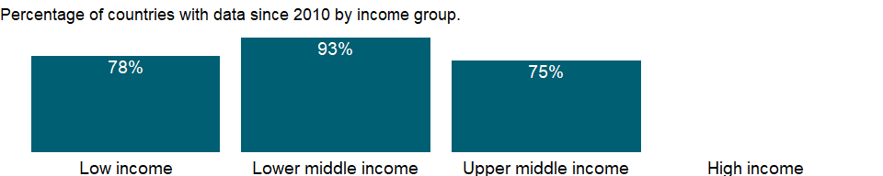

### Why is it relevant?

NA

### What is the data source?

World Bank, International Debt Statistics.

### What is the methodology?

NA

### How is it aggregated?

Weighted Average

### What are the limitations?

NA

### What else should I know?

NA

### 1.12.4 Short-term debt (% of total external debt)

### What is the indicator?

Short-term debt includes all debt having an original maturity of one year or less and interest in arrears on long-term debt. Total external debt is debt owed to nonresidents repayable in currency, goods, or services. Total external debt is the sum of public, publicly guaranteed, and private nonguaranteed long-term debt, use of IMF credit, and short-term debt.

Topic: Economic Policy & Debt: External debt: Debt ratios & other items

Series ID: DT.DOD.DSTC.ZS

Copyright: CC BY-4.0 , <https://datacatalog.worldbank.org/public-licenses#cc-by>

First year with any data: 1970

Last year with any data: 2019

### What years are data available?

The figure below shows years in which data is available for at least one country. Dates shaded in black have no data, while dates shaded in green have data for at least one country



### Which countries have data?

The figure below shows the percentage of countries in each income group with a value since 2010 for that indicator.



### Why is it relevant?

External debt is that part of the total debt in a country that is owed to creditors outside the country. The debtors can be the government, corporations or private households. The debt includes money owed to private commercial banks, other governments, or international financial institutions.

External indebtedness affects a country’s creditworthiness and investor perceptions. Nonreporting countries might have outstanding debt with the World Bank, other international financial institutions, or private creditors. Total debt service is contrasted with countries’ ability to obtain foreign exchange through exports of goods, services, primary income, and workers’ remittances.

Debt ratios are used to assess the sustainability of a country’s debt service obligations, but no absolute rules determine what values are too high. Empirical analysis of developing countries’ experience and debt service performance shows that debt service difficulties become increasingly likely when the present value of debt reaches 200 percent of exports. Still, what constitutes a sustainable debt burden varies by country. Countries with fast-growing economies and exports are likely to be able to sustain higher debt levels. Various indicators determine a sustainable level of external debt, including:

1. debt to GDP ratio
2. foreign debt to exports ratio
3. government debt to current fiscal revenue ratio
4. share of foreign debt
5. short-term debt
6. concessional debt in the total debt stock

### What is the data source?

World Bank, International Debt Statistics.

### What is the methodology?

Data on external debt are gathered through the World Bank’s Debtor Reporting System (DRS). Long term debt data are compiled using the countries report on public and publicly guaranteed borrowing on a loan-by-loan basis and private non guaranteed borrowing on an aggregate basis. These data are supplemented by information from major multilateral banks and official lending agencies in major creditor countries. Short-term debt data are gathered from the Quarterly External Debt Statistics (QEDS) database, jointly developed by the World Bank and the IMF and from creditors through the reporting systems of the Bank for International Settlements. Debt data are reported in the currency of repayment and compiled and published in U.S. dollars. End-of-period exchange rates are used for the compilation of stock figures (amount of debt outstanding), and projected debt service and annual average exchange rates are used for the flows. Exchange rates are taken from the IMF’s International Financial Statistics. Debt repayable in multiple currencies, goods, or services and debt with a provision for maintenance of the value of the currency of repayment are shown at book value.

### How is it aggregated?

Weighted average

### What are the limitations?

NA

### What else should I know?

NA

### 1.12.5 Present value of external debt (% of exports of goods, services and income)

### What is the indicator?

Present value of debt is the sum of short-term external debt plus the discounted sum of total debt service payments due on public, publicly guaranteed, and private nonguaranteed long-term external debt over the life of existing loans. The exports denominator is a three-year average.

Topic: Economic Policy & Debt: External debt: Debt ratios & other items

Series ID: DT.DOD.PVLX.EX.ZS

Copyright: CC BY-4.0 , <https://datacatalog.worldbank.org/public-licenses#cc-by>

First year with any data: 2019

Last year with any data: 2019

### What years are data available?

The figure below shows years in which data is available for at least one country. Dates shaded in black have no data, while dates shaded in green have data for at least one country

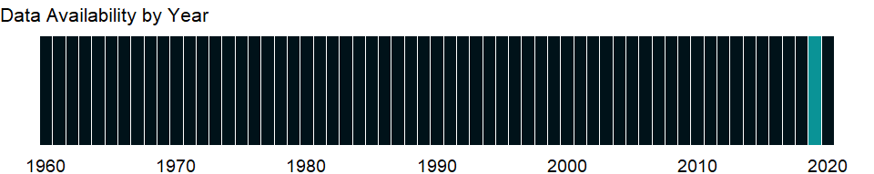

### Which countries have data?

The figure below shows the percentage of countries in each income group with a value since 2010 for that indicator.

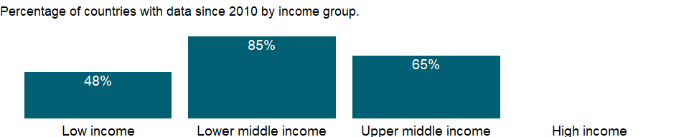

### Why is it relevant?

External debt is that part of the total debt in a country that is owed to creditors outside the country. The debtors can be the government, corporations or private households. The debt includes money owed to private commercial banks, other governments, or international financial institutions.

External indebtedness affects a country’s creditworthiness and investor perceptions. Nonreporting countries might have outstanding debt with the World Bank, other international financial institutions, or private creditors. Total debt service is contrasted with countries’ ability to obtain foreign exchange through exports of goods, services, primary income, and workers’ remittances.

Debt ratios are used to assess the sustainability of a country’s debt service obligations, but no absolute rules determine what values are too high. Empirical analysis of developing countries’ experience and debt service performance shows that debt service difficulties become increasingly likely when the present value of debt reaches 200 percent of exports. Still, what constitutes a sustainable debt burden varies by country. Countries with fast-growing economies and exports are likely to be able to sustain higher debt levels. Various indicators determine a sustainable level of external debt, including:

1. debt to GDP ratio
2. foreign debt to exports ratio
3. government debt to current fiscal revenue ratio
4. share of foreign debt
5. short-term debt
6. concessional debt in the total debt stock

### What is the data source?

World Bank, International Debt Statistics.

### What is the methodology?

Data on external debt are gathered through the World Bank’s Debtor Reporting System (DRS). Long term debt data are compiled using the countries report on public and publicly guaranteed borrowing on a loan-by-loan basis and private non guaranteed borrowing on an aggregate basis. These data are supplemented by information from major multilateral banks and official lending agencies in major creditor countries. Short-term debt data are gathered from the Quarterly External Debt Statistics (QEDS) database, jointly developed by the World Bank and the IMF and from creditors through the reporting systems of the Bank for International Settlements. Debt data are reported in the currency of repayment and compiled and published in U.S. dollars. End-of-period exchange rates are used for the compilation of stock figures (amount of debt outstanding), and projected debt service and annual average exchange rates are used for the flows. Exchange rates are taken from the IMF’s International Financial Statistics. Debt repayable in multiple currencies, goods, or services and debt with a provision for maintenance of the value of the currency of repayment are shown at book value.

### How is it aggregated?

NA

### What are the limitations?

NA

### What else should I know?

NA

### 1.12.6 Present value of external debt (% of GNI)

### What is the indicator?

Present value of debt is the sum of short-term external debt plus the discounted sum of total debt service payments due on public, publicly guaranteed, and private nonguaranteed long-term external debt over the life of existing loans. The GNI denominator is a three-year average.

Topic: Economic Policy & Debt: External debt: Debt ratios & other items

Series ID: DT.DOD.PVLX.GN.ZS

Copyright: CC BY-4.0 , <https://datacatalog.worldbank.org/public-licenses#cc-by>

First year with any data: 2019

Last year with any data: 2019

### What years are data available?

The figure below shows years in which data is available for at least one country. Dates shaded in black have no data, while dates shaded in green have data for at least one country



### Which countries have data?

The figure below shows the percentage of countries in each income group with a value since 2010 for that indicator.

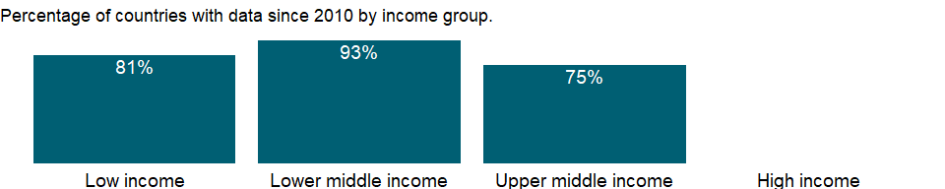

### Why is it relevant?

External debt is that part of the total debt in a country that is owed to creditors outside the country. The debtors can be the government, corporations or private households. The debt includes money owed to private commercial banks, other governments, or international financial institutions.

External indebtedness affects a country’s creditworthiness and investor perceptions. Nonreporting countries might have outstanding debt with the World Bank, other international financial institutions, or private creditors. Total debt service is contrasted with countries’ ability to obtain foreign exchange through exports of goods, services, primary income, and workers’ remittances.

Debt ratios are used to assess the sustainability of a country’s debt service obligations, but no absolute rules determine what values are too high. Empirical analysis of developing countries’ experience and debt service performance shows that debt service difficulties become increasingly likely when the present value of debt reaches 200 percent of exports. Still, what constitutes a sustainable debt burden varies by country. Countries with fast-growing economies and exports are likely to be able to sustain higher debt levels. Various indicators determine a sustainable level of external debt, including:

1. debt to GDP ratio
2. foreign debt to exports ratio
3. government debt to current fiscal revenue ratio
4. share of foreign debt
5. short-term debt
6. concessional debt in the total debt stock

### What is the data source?

World Bank, International Debt Statistics.

### What is the methodology?

Data on external debt are gathered through the World Bank’s Debtor Reporting System (DRS). Long term debt data are compiled using the countries report on public and publicly guaranteed borrowing on a loan-by-loan basis and private non guaranteed borrowing on an aggregate basis. These data are supplemented by information from major multilateral banks and official lending agencies in major creditor countries. Short-term debt data are gathered from the Quarterly External Debt Statistics (QEDS) database, jointly developed by the World Bank and the IMF and from creditors through the reporting systems of the Bank for International Settlements. Debt data are reported in the currency of repayment and compiled and published in U.S. dollars. End-of-period exchange rates are used for the compilation of stock figures (amount of debt outstanding), and projected debt service and annual average exchange rates are used for the flows. Exchange rates are taken from the IMF’s International Financial Statistics. Debt repayable in multiple currencies, goods, or services and debt with a provision for maintenance of the value of the currency of repayment are shown at book value.

### How is it aggregated?

NA

### What are the limitations?

NA

### What else should I know?

NA

### 1.12.7 Total debt service (% of exports of goods, services and primary income)

### What is the indicator?

Total debt service to exports of goods, services and primary income. Total debt service is the sum of principal repayments and interest actually paid in currency, goods, or services on long-term debt, interest paid on short-term debt, and repayments (repurchases and charges) to the IMF.

Topic: Economic Policy & Debt: External debt: Debt ratios & other items

Series ID: DT.TDS.DECT.EX.ZS

Copyright: CC BY-4.0 , <https://datacatalog.worldbank.org/public-licenses#cc-by>

First year with any data: 1970

Last year with any data: 2019

### What years are data available?

The figure below shows years in which data is available for at least one country. Dates shaded in black have no data, while dates shaded in green have data for at least one country



### Which countries have data?

The figure below shows the percentage of countries in each income group with a value since 2010 for that indicator.

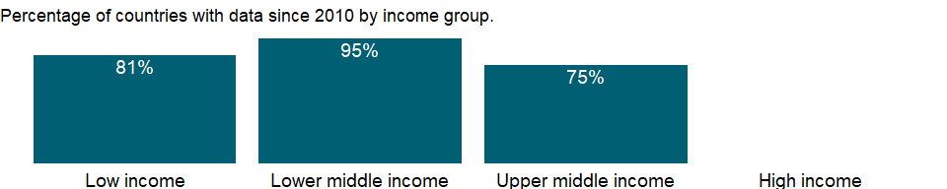

### Why is it relevant?

External debt is that part of the total debt in a country that is owed to creditors outside the country. The debtors can be the government, corporations or private households. The debt includes money owed to private commercial banks, other governments, or international financial institutions.

External indebtedness affects a country’s creditworthiness and investor perceptions. Nonreporting countries might have outstanding debt with the World Bank, other international financial institutions, or private creditors. Total debt service is contrasted with countries’ ability to obtain foreign exchange through exports of goods, services, primary income, and workers’ remittances.

Debt ratios are used to assess the sustainability of a country’s debt service obligations, but no absolute rules determine what values are too high. Empirical analysis of developing countries’ experience and debt service performance shows that debt service difficulties become increasingly likely when the present value of debt reaches 200 percent of exports. Still, what constitutes a sustainable debt burden varies by country. Countries with fast-growing economies and exports are likely to be able to sustain higher debt levels. Various indicators determine a sustainable level of external debt, including:

1. debt to GDP ratio
2. foreign debt to exports ratio
3. government debt to current fiscal revenue ratio
4. share of foreign debt
5. short-term debt
6. concessional debt in the total debt stock

### What is the data source?

World Bank, International Debt Statistics.

### What is the methodology?

Data on external debt are gathered through the World Bank’s Debtor Reporting System (DRS). Long term debt data are compiled using the countries report on public and publicly guaranteed borrowing on a loan-by-loan basis and private non guaranteed borrowing on an aggregate basis. These data are supplemented by information from major multilateral banks and official lending agencies in major creditor countries. Short-term debt data are gathered from the Quarterly External Debt Statistics (QEDS) database, jointly developed by the World Bank and the IMF and from creditors through the reporting systems of the Bank for International Settlements. Debt data are reported in the currency of repayment and compiled and published in U.S. dollars. End-of-period exchange rates are used for the compilation of stock figures (amount of debt outstanding), and projected debt service and annual average exchange rates are used for the flows. Exchange rates are taken from the IMF’s International Financial Statistics. Debt repayable in multiple currencies, goods, or services and debt with a provision for maintenance of the value of the currency of repayment are shown at book value.

### How is it aggregated?

Weighted average

### What are the limitations?

NA

### What else should I know?

The denominator for this indicator in previous versions of Global Development Finance included workers’ remittances. Workers’ remittances are no longer included.

### 1.12.8 Total debt service (% of GNI)

### What is the indicator?

Total debt service is the sum of principal repayments and interest actually paid in currency, goods, or services on long-term debt, interest paid on short-term debt, and repayments (repurchases and charges) to the IMF.

Topic: Economic Policy & Debt: External debt: Debt ratios & other items

Series ID: DT.TDS.DECT.GN.ZS

Copyright: CC BY-4.0 , <https://datacatalog.worldbank.org/public-licenses#cc-by>

First year with any data: 1970

Last year with any data: 2019

### What years are data available?

The figure below shows years in which data is available for at least one country. Dates shaded in black have no data, while dates shaded in green have data for at least one country



### Which countries have data?

The figure below shows the percentage of countries in each income group with a value since 2010 for that indicator.

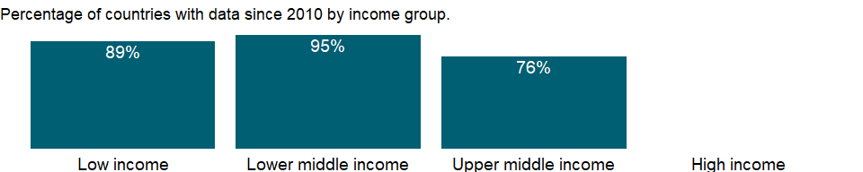

### Why is it relevant?

NA

### What is the data source?

World Bank, International Debt Statistics.

### What is the methodology?

NA

### How is it aggregated?

Weighted Average

### What are the limitations?

NA

### What else should I know?

NA

### 1.12.9 Public and publicly guaranteed debt service (% of GNI)

### What is the indicator?

Public and publicly guaranteed debt service is the sum of principal repayments and interest actually paid in currency, goods, or services on long-term obligations of public debtors and long-term private obligations guaranteed by a public entity.

Topic: Economic Policy & Debt: External debt: Debt ratios & other items

Series ID: DT.TDS.DPPG.GN.ZS

Copyright: CC BY-4.0 , <https://datacatalog.worldbank.org/public-licenses#cc-by>

First year with any data: 1970

Last year with any data: 2019

### What years are data available?

The figure below shows years in which data is available for at least one country. Dates shaded in black have no data, while dates shaded in green have data for at least one country



### Which countries have data?

The figure below shows the percentage of countries in each income group with a value since 2010 for that indicator.

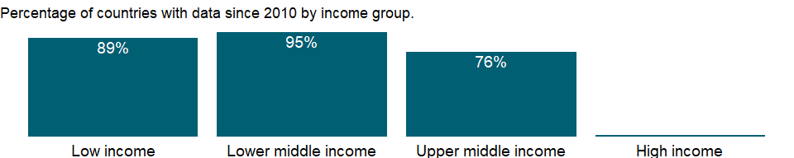

### Why is it relevant?

NA

### What is the data source?

World Bank, International Debt Statistics.

### What is the methodology?

NA

### How is it aggregated?

Weighted Average

### What are the limitations?

NA

### What else should I know?

NA

### 1.12.10 Public and publicly guaranteed debt service (% of exports of goods, services and primary income)

### What is the indicator?

Public and publicly guaranteed debt service is the sum of principal repayments and interest actually paid in currency, goods, or services on long-term obligations of public debtors and long-term private obligations guaranteed by a public entity. Exports refer to exports of goods, services, and income.

Topic: Economic Policy & Debt: External debt: Debt ratios & other items

Series ID: DT.TDS.DPPG.XP.ZS

Copyright: CC BY-4.0 , <https://datacatalog.worldbank.org/public-licenses#cc-by>

First year with any data: 1970

Last year with any data: 2019

### What years are data available?

The figure below shows years in which data is available for at least one country. Dates shaded in black have no data, while dates shaded in green have data for at least one country



### Which countries have data?

The figure below shows the percentage of countries in each income group with a value since 2010 for that indicator.

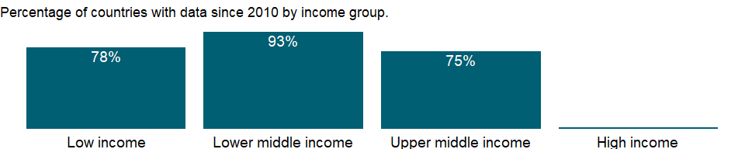

### Why is it relevant?

NA

### What is the data source?

World Bank.

### What is the methodology?

NA

### How is it aggregated?

Weighted Average

### What are the limitations?

NA

### What else should I know?

NA

### 1.12.11 Multilateral debt service (% of public and publicly guaranteed debt service)

### What is the indicator?

Multilateral debt service is the repayment of principal and interest to the World Bank, regional development banks, and other multilateral agencies. public and publicly guaranteed debt service is the sum of principal repayments and interest actually paid in currency, goods, or services on long-term obligations of public debtors and long-term private obligations guaranteed by a public entity.

Topic: Economic Policy & Debt: External debt: Debt ratios & other items

Series ID: DT.TDS.MLAT.PG.ZS

Copyright: CC BY-4.0 , <https://datacatalog.worldbank.org/public-licenses#cc-by>

First year with any data: 1970

Last year with any data: 2019

### What years are data available?

The figure below shows years in which data is available for at least one country. Dates shaded in black have no data, while dates shaded in green have data for at least one country



### Which countries have data?

The figure below shows the percentage of countries in each income group with a value since 2010 for that indicator.



### Why is it relevant?

NA

### What is the data source?

World Bank, International Debt Statistics.

### What is the methodology?

NA

### How is it aggregated?

Weighted average

### What are the limitations?

NA

### What else should I know?

NA

## 1.13 Economic Policy & Debt: External debt: Net flows

### 1.13.1 Net financial flows, bilateral (NFL, current US$)

### What is the indicator?

Bilateral debt includes loans from governments and their agencies (including central banks), loans from autonomous bodies, and direct loans from official export credit agencies. Net flows (or net lending or net disbursements) received by the borrower during the year are disbursements minus principal repayments. Data are in current U.S. dollars.

Topic: Economic Policy & Debt: External debt: Net flows

Series ID: DT.NFL.BLAT.CD

Copyright: CC BY-4.0 , <https://datacatalog.worldbank.org/public-licenses#cc-by>

First year with any data: 1970

Last year with any data: 2019

### What years are data available?

The figure below shows years in which data is available for at least one country. Dates shaded in black have no data, while dates shaded in green have data for at least one country



### Which countries have data?

The figure below shows the percentage of countries in each income group with a value since 2010 for that indicator.



### Why is it relevant?

NA

### What is the data source?

World Bank, International Debt Statistics.

### What is the methodology?

Data show concessional and nonconcessional financial flows from official bilateral sources. The Organisation for Economic Co-operation and Development’s (OECD) Development Assistance Committee (DAC) defines concessional flows from bilateral donors as flows with a grant element of at least 25 percent; they are evaluated assuming a 10 percent nominal discount rate.

### How is it aggregated?

Sum

### What are the limitations?

NA

### What else should I know?

NA

### 1.13.2 Portfolio investment, bonds (PPG + PNG) (NFL, current US$)

### What is the indicator?

Bonds are securities issued with a fixed rate of interest for a period of more than one year. They include net flows through cross-border public and publicly guaranteed and private nonguaranteed bond issues. Data are in current U.S. dollars.

Topic: Economic Policy & Debt: External debt: Net flows

Series ID: DT.NFL.BOND.CD

Copyright: CC BY-4.0 , <https://datacatalog.worldbank.org/public-licenses#cc-by>

First year with any data: 1970

Last year with any data: 2019

### What years are data available?

The figure below shows years in which data is available for at least one country. Dates shaded in black have no data, while dates shaded in green have data for at least one country



### Which countries have data?

The figure below shows the percentage of countries in each income group with a value since 2010 for that indicator.

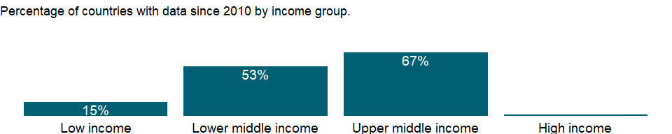

### Why is it relevant?

External indebtedness affects a country’s creditworthiness and investor perceptions. Nonreporting countries might have outstanding debt with the World Bank, other international financial institutions, or private creditors. Total debt service is contrasted with countries’ ability to obtain foreign exchange through exports of goods, services, primary income, and workers’ remittances.

Debt ratios are used to assess the sustainability of a country’s debt service obligations, but no absolute rules determine what values are too high. Empirical analysis of developing countries’ experience and debt service performance shows that debt service difficulties become increasingly likely when the present value of debt reaches 200 percent of exports. Still, what constitutes a sustainable debt burden varies by country. Countries with fast-growing economies and exports are likely to be able to sustain higher debt levels.

### What is the data source?

World Bank, International Debt Statistics.

### What is the methodology?

Bonds are debt instruments issued by public and publicly guaranteed or private debtors with durations of one year or longer. Bonds usually give the holder the unconditional right to fixed money income or contractually determined, variable money income.

Data on external debt are gathered through the World Bank’s Debtor Reporting System (DRS). Long term debt data are compiled using the countries report on public and publicly guaranteed borrowing on a loan-by-loan basis and private non guaranteed borrowing on an aggregate basis. These data are supplemented by information from major multilateral banks and official lending agencies in major creditor countries. Short-term debt data are gathered from the Quarterly External Debt Statistics (QEDS) database, jointly developed by the World Bank and the IMF and from creditors through the reporting systems of the Bank for International Settlements. Debt data are reported in the currency of repayment and compiled and published in U.S. dollars. End-of-period exchange rates are used for the compilation of stock figures (amount of debt outstanding), and projected debt service and annual average exchange rates are used for the flows. Exchange rates are taken from the IMF’s International Financial Statistics. Debt repayable in multiple currencies, goods, or services and debt with a provision for maintenance of the value of the currency of repayment are shown at book value.

### How is it aggregated?

Sum

### What are the limitations?

The DRS encourages debtor countries to voluntarily provide information on their short-term external obligations. By its nature, short-term external debt is difficult to monitor: loan-by-loan registration is normally impractical, and monitoring systems typically rely on information requested periodically by the central bank from the banking sector. The World Bank regards the debtor country as the authoritative source of information on its short-term debt. Where such information is not available from the debtor country, data are derived from BIS data on international bank lending based on time remaining to original maturity. The data are reported based on residual maturity, but an estimate of short-term external liabilities by original maturity can be derived by deducting from claims due in one year those that have a maturity of between one and two years. However, BIS data include liabilities reported only by banks within the BIS reporting area. The results should thus be interpreted with caution. Because short-term debt poses an immediate burden and is particularly important for monitoring vulnerability, it is compared with total debt and foreign exchange reserves, which are instrumental in providing coverage for such obligations.

A country’s external debt burden, both debt outstanding and debt service, affects its creditworthiness and vulnerability. While data related to public and publicly guaranteed debt are reported to the DRS on a loan-by-loan basis, aggregate data on long-term private nonguaranteed debt are reported annually and are reported by the country or estimated by World Bank staff for countries where this type of external debt is known to be significant. Estimates are based on national data from the World Bank’s Quarterly External Debt Statistics.

### What else should I know?

NA

### 1.13.3 Net flows on external debt, private nonguaranteed (PNG) (NFL, current US$)

### What is the indicator?

Private nonguaranteed external debt is an external obligation of a private debtor that is not guaranteed for repayment by a public entity. Net flows (or net lending or net disbursements) received by the borrower during the year are disbursements minus principal repayments. Long-term external debt is defined as debt that has an original or extended maturity of more than one year and that is owed to nonresidents by residents of an economy and repayable in currency, goods, or services. Data are in current U.S. dollars.

Topic: Economic Policy & Debt: External debt: Net flows

Series ID: DT.NFL.DPNG.CD

Copyright: CC BY-4.0 , <https://datacatalog.worldbank.org/public-licenses#cc-by>

First year with any data: 1970

Last year with any data: 2019

### What years are data available?

The figure below shows years in which data is available for at least one country. Dates shaded in black have no data, while dates shaded in green have data for at least one country



### Which countries have data?

The figure below shows the percentage of countries in each income group with a value since 2010 for that indicator.



### Why is it relevant?

NA

### What is the data source?

World Bank, International Debt Statistics.

### What is the methodology?

NA

### How is it aggregated?

Sum

### What are the limitations?

NA

### What else should I know?

NA

### 1.13.4 Net financial flows, IMF concessional (NFL, current US$)

### What is the indicator?

Net financial flows received by the borrower during the year are disbursements of loans and credits less repayments of principal. IMF is the International Monetary Fund, which provides concessional lending through the Poverty Reduction and Growth Facility and the IMF Trust Fund. Data are in current U.S. dollars.

Topic: Economic Policy & Debt: External debt: Net flows

Series ID: DT.NFL.IMFC.CD

Copyright: CC BY-4.0 , <https://datacatalog.worldbank.org/public-licenses#cc-by>

First year with any data: 1970

Last year with any data: 2019

### What years are data available?

The figure below shows years in which data is available for at least one country. Dates shaded in black have no data, while dates shaded in green have data for at least one country



### Which countries have data?

The figure below shows the percentage of countries in each income group with a value since 2010 for that indicator.

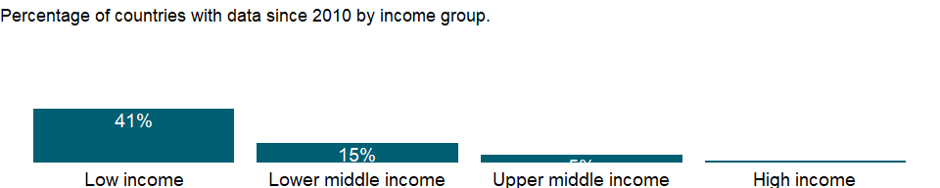

### Why is it relevant?

NA

### What is the data source?

World Bank, International Debt Statistics.

### What is the methodology?

The International Monetary Fund (IMF) makes concessional funds available through its Extended Credit Facility (which replaced the Poverty Reduction and Growth Facility in 2010), the Standby Credit Facility, and the Rapid Credit Facility. Eligibility is based principally on a country’s per capita income and eligibility under IDA.

### How is it aggregated?

Sum

### What are the limitations?

NA

### What else should I know?

NA

### 1.13.5 Net financial flows, IMF nonconcessional (NFL, current US$)

### What is the indicator?

Net financial flows received by the borrower during the year are disbursements of loans and credits less repayments of principal. IMF is the International Monetary Fund, which provides nonconcessional lending through the credit it provides to its members, mainly to meet balance of payments needs. Data are in current U.S. dollars.

Topic: Economic Policy & Debt: External debt: Net flows

Series ID: DT.NFL.IMFN.CD

Copyright: CC BY-4.0 , <https://datacatalog.worldbank.org/public-licenses#cc-by>

First year with any data: 1970

Last year with any data: 2019

### What years are data available?

The figure below shows years in which data is available for at least one country. Dates shaded in black have no data, while dates shaded in green have data for at least one country



### Which countries have data?

The figure below shows the percentage of countries in each income group with a value since 2010 for that indicator.

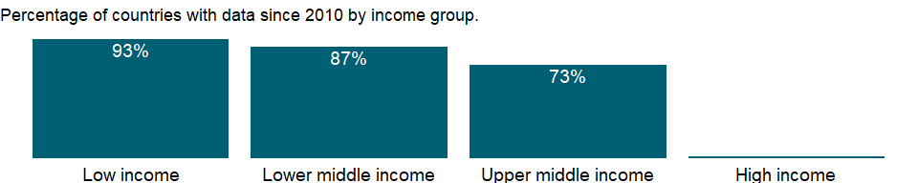

### Why is it relevant?

NA

### What is the data source?

World Bank, International Debt Statistics.

### What is the methodology?

Nonconcessional lending from the IMF is provided mainly through Stand-by Arrangements, the Flexible Credit Line, and the Extended Fund Facility.

### How is it aggregated?

Sum

### What are the limitations?

NA

### What else should I know?

NA

### 1.13.6 Net financial flows, IBRD (NFL, current US$)

### What is the indicator?

Net financial flows received by the borrower during the year are disbursements of loans and credits less repayments of principal. IBRD is the International Bank for Reconstruction and Development, the founding and largest member of the World Bank Group. Data are in current U.S. dollars.

Topic: Economic Policy & Debt: External debt: Net flows

Series ID: DT.NFL.MIBR.CD

Copyright: CC BY-4.0 , <https://datacatalog.worldbank.org/public-licenses#cc-by>

First year with any data: 1970

Last year with any data: 2019

### What years are data available?

The figure below shows years in which data is available for at least one country. Dates shaded in black have no data, while dates shaded in green have data for at least one country



### Which countries have data?

The figure below shows the percentage of countries in each income group with a value since 2010 for that indicator.

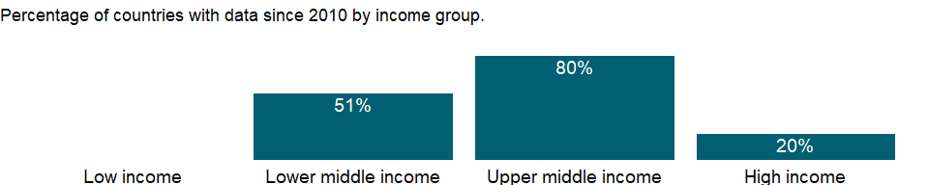

### Why is it relevant?

NA

### What is the data source?

World Bank, International Debt Statistics.

### What is the methodology?

The World Bank’s International Bank for Reconstruction and Development (IBRD) lends to creditworthy countries at a variable base rate of six-month LIBOR plus a spread, either variable or fixed, for the life of the loan. The rate is reset every six months and applies to the interest period beginning on that date.

### How is it aggregated?

Sum

### What are the limitations?

NA

### What else should I know?

NA

### 1.13.7 Net financial flows, IDA (NFL, current US$)

### What is the indicator?

Net financial flows received by the borrower during the year are disbursements of loans and credits less repayments of principal. IDA is the International Development Association, the concessional loan window of the World Bank Group. Data are in current U.S. dollars.

Topic: Economic Policy & Debt: External debt: Net flows

Series ID: DT.NFL.MIDA.CD

Copyright: CC BY-4.0 , <https://datacatalog.worldbank.org/public-licenses#cc-by>

First year with any data: 1970

Last year with any data: 2019

### What years are data available?

The figure below shows years in which data is available for at least one country. Dates shaded in black have no data, while dates shaded in green have data for at least one country



### Which countries have data?

The figure below shows the percentage of countries in each income group with a value since 2010 for that indicator.

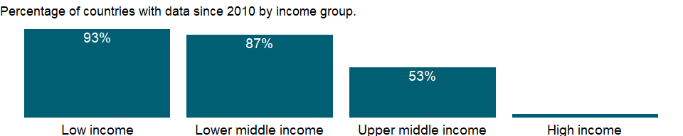

### Why is it relevant?

NA

### What is the data source?

World Bank, International Debt Statistics.

### What is the methodology?

World Bank concessional lending is done by the International Development Association (IDA) based on gross national income (GNI) per capita and performance standards assessed by World Bank staff.

### How is it aggregated?

Sum

### What are the limitations?

NA

### What else should I know?

NA

### 1.13.8 Net financial flows, multilateral (NFL, current US$)

### What is the indicator?

Public and publicly guaranteed multilateral loans include loans and credits from the World Bank, regional development banks, and other multilateral and intergovernmental agencies. Excluded are loans from funds administered by an international organization on behalf of a single donor government; these are classified as loans from governments. Net flows (or net lending or net disbursements) received by the borrower during the year are disbursements minus principal repayments. Data are in current U.S. dollars.

Topic: Economic Policy & Debt: External debt: Net flows

Series ID: DT.NFL.MLAT.CD

Copyright: CC BY-4.0 , <https://datacatalog.worldbank.org/public-licenses#cc-by>

First year with any data: 1970

Last year with any data: 2019

### What years are data available?

The figure below shows years in which data is available for at least one country. Dates shaded in black have no data, while dates shaded in green have data for at least one country



### Which countries have data?

The figure below shows the percentage of countries in each income group with a value since 2010 for that indicator.



### Why is it relevant?

NA

### What is the data source?

World Bank, International Debt Statistics.

### What is the methodology?

Data show concessional and nonconcessional financial flows from international financial institutions. International financial institutions fund nonconcessional lending operations primarily by selling low-interest, highly rated bonds backed by prudent lending and financial policies and the strong financial support of their members. Funds are then on-lent to developing countries at slightly higher interest rates with 15- to 20-year maturities. Lending terms vary with market conditions and institutional policies. Concessional flows from international financial institutions are credits provided through concessional lending facilities. Subsidies from donors or other resources reduce the cost of these loans. Grants are not included in net flows.

### How is it aggregated?

Sum

### What are the limitations?

NA

### What else should I know?

NA

### 1.13.9 Net financial flows, others (NFL, current US$)

### What is the indicator?

Net financial flows received by the borrower during the year are disbursements of loans and credits less repayments of principal. Others is a residual category in the World Bank’s Debtor Reporting System. It includes such institutions as the Caribbean Development Fund, Council of Europe, European Development Fund, Islamic Development Bank, Nordic Development Fund, and the like. Data are in current U.S. dollars.

Topic: Economic Policy & Debt: External debt: Net flows

Series ID: DT.NFL.MOTH.CD

Copyright: CC BY-4.0 , <https://datacatalog.worldbank.org/public-licenses#cc-by>

First year with any data: 1970

Last year with any data: 2019

### What years are data available?

The figure below shows years in which data is available for at least one country. Dates shaded in black have no data, while dates shaded in green have data for at least one country



### Which countries have data?

The figure below shows the percentage of countries in each income group with a value since 2010 for that indicator.

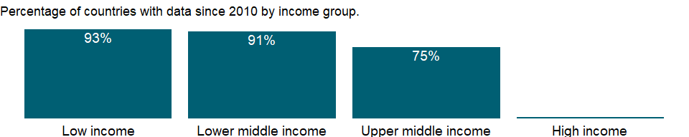

### Why is it relevant?

NA

### What is the data source?

World Bank, International Debt Statistics.

### What is the methodology?

NA

### How is it aggregated?

Sum

### What are the limitations?

NA

### What else should I know?

NA

### 1.13.10 IFC, private nonguaranteed (NFL, current US$)

### What is the indicator?

Nonguaranteed long-term debt privately placed from the International Finance Corporation (IFC). Net flows (or net lending or net disbursements) received by the borrower during the year are disbursements minus principal repayments. Data are in current U.S. dollars.

Topic: Economic Policy & Debt: External debt: Net flows

Series ID: DT.NFL.NIFC.CD

Copyright: CC BY-4.0 , <https://datacatalog.worldbank.org/public-licenses#cc-by>

First year with any data: 1970

Last year with any data: 2019

### What years are data available?

The figure below shows years in which data is available for at least one country. Dates shaded in black have no data, while dates shaded in green have data for at least one country



### Which countries have data?

The figure below shows the percentage of countries in each income group with a value since 2010 for that indicator.

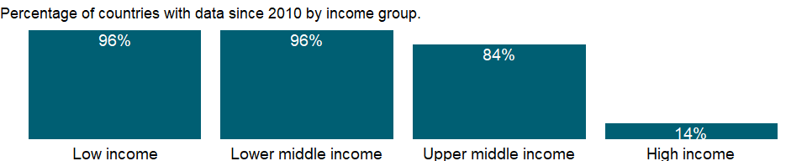

### Why is it relevant?

NA

### What is the data source?

World Bank, International Debt Statistics.

### What is the methodology?

NA

### How is it aggregated?

Sum

### What are the limitations?

NA

### What else should I know?

NA

### 1.13.11 PPG, official creditors (NFL, current US$)

### What is the indicator?

Public and publicly guaranteed debt from official creditors includes loans from international organizations (multilateral loans) and loans from governments (bilateral loans). Loans from international organization include loans and credits from the World Bank, regional development banks, and other multilateral and intergovernmental agencies. Excluded are loans from funds administered by an international organization on behalf of a single donor government; these are classified as loans from governments. Government loans include loans from governments and their agencies (including central banks), loans from autonomous bodies, and direct loans from official export credit agencies. Net flows (or net lending or net disbursements) received by the borrower during the year are disbursements minus principal repayments. Data are in current U.S. dollars.

Topic: Economic Policy & Debt: External debt: Net flows

Series ID: DT.NFL.OFFT.CD

Copyright: CC BY-4.0 , <https://datacatalog.worldbank.org/public-licenses#cc-by>

First year with any data: 1970

Last year with any data: 2019

### What years are data available?

The figure below shows years in which data is available for at least one country. Dates shaded in black have no data, while dates shaded in green have data for at least one country



### Which countries have data?

The figure below shows the percentage of countries in each income group with a value since 2010 for that indicator.



### Why is it relevant?

NA

### What is the data source?

World Bank, International Debt Statistics.

### What is the methodology?

NA

### How is it aggregated?

Sum

### What are the limitations?

NA

### What else should I know?

NA

### 1.13.12 PPG, bonds (NFL, current US$)

### What is the indicator?

Public and publicly guaranteed debt from bonds that are either publicly issued or privately placed. Net flows (or net lending or net disbursements) received by the borrower during the year are disbursements minus principal repayments. Data are in current U.S. dollars.

Topic: Economic Policy & Debt: External debt: Net flows

Series ID: DT.NFL.PBND.CD

Copyright: CC BY-4.0 , <https://datacatalog.worldbank.org/public-licenses#cc-by>

First year with any data: 1970

Last year with any data: 2019

### What years are data available?

The figure below shows years in which data is available for at least one country. Dates shaded in black have no data, while dates shaded in green have data for at least one country



### Which countries have data?

The figure below shows the percentage of countries in each income group with a value since 2010 for that indicator.



### Why is it relevant?

NA

### What is the data source?

World Bank, International Debt Statistics.

### What is the methodology?

NA

### How is it aggregated?

Sum

### What are the limitations?

NA

### What else should I know?

NA

### 1.13.13 PPG, commercial banks (NFL, current US$)

### What is the indicator?

Public and publicly guaranteed commercial bank loans from private banks and other private financial institutions. Net flows (or net lending or net disbursements) received by the borrower during the year are disbursements minus principal repayments. Data are in current U.S. dollars.

Topic: Economic Policy & Debt: External debt: Net flows

Series ID: DT.NFL.PCBK.CD

Copyright: CC BY-4.0 , <https://datacatalog.worldbank.org/public-licenses#cc-by>

First year with any data: 1970

Last year with any data: 2019

### What years are data available?

The figure below shows years in which data is available for at least one country. Dates shaded in black have no data, while dates shaded in green have data for at least one country



### Which countries have data?

The figure below shows the percentage of countries in each income group with a value since 2010 for that indicator.

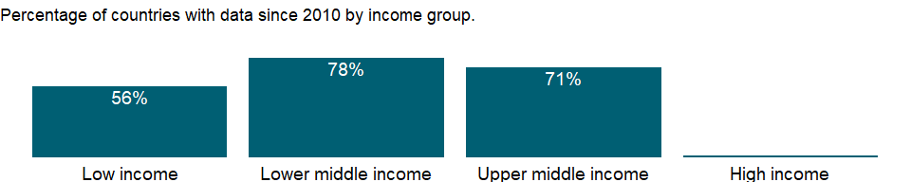

### Why is it relevant?

NA

### What is the data source?

World Bank, International Debt Statistics.

### What is the methodology?

NA

### How is it aggregated?

Sum

### What are the limitations?

NA

### What else should I know?

NA

### 1.13.14 Commercial banks and other lending (PPG + PNG) (NFL, current US$)

### What is the indicator?

Commercial bank and other lending includes net commercial bank lending (public and publicly guaranteed and private nonguaranteed) and other private credits. Data are in current U.S. dollars.

Topic: Economic Policy & Debt: External debt: Net flows

Series ID: DT.NFL.PCBO.CD

Copyright: CC BY-4.0 , <https://datacatalog.worldbank.org/public-licenses#cc-by>

First year with any data: 1970

Last year with any data: 2019

### What years are data available?

The figure below shows years in which data is available for at least one country. Dates shaded in black have no data, while dates shaded in green have data for at least one country



### Which countries have data?

The figure below shows the percentage of countries in each income group with a value since 2010 for that indicator.



### Why is it relevant?

External debt is that part of the total debt in a country that is owed to creditors outside the country. The debtors can be the government, corporations or private households. The debt includes money owed to private commercial banks, other governments, or international financial institutions.

External indebtedness affects a country’s creditworthiness and investor perceptions. Nonreporting countries might have outstanding debt with the World Bank, other international financial institutions, or private creditors. Total debt service is contrasted with countries’ ability to obtain foreign exchange through exports of goods, services, primary income, and workers’ remittances.

### What is the data source?

World Bank, International Debt Statistics.

### What is the methodology?

Commercial banks include all commercial banks, whether or not publicly owned, that provide loans and other financial services. Private creditors include commercial banks, bondholders, and other private creditors. This indicator includes only publicly guaranteed creditors. Nonguaranteed private creditors are shown separately. Bonds include publicly issued or privately placed bonds. Commercial bank loans are loans from private banks and other private financial institutions. Credits of other private creditors include credits from manufacturers, exporters, and other suppliers of goods, plus bank credits covered by a guarantee of an export credit agency.

### How is it aggregated?

Sum

### What are the limitations?

Data on external debt are gathered through the World Bank’s Debtor Reporting System (DRS). Long term debt data are compiled using the countries report on public and publicly guaranteed borrowing on a loan-by-loan basis and private non guaranteed borrowing on an aggregate basis. These data are supplemented by information from major multilateral banks and official lending agencies in major creditor countries. Short-term debt data are gathered from the Quarterly External Debt Statistics (QEDS) database, jointly developed by the World Bank and the IMF and from creditors through the reporting systems of the Bank for International Settlements. Debt data are reported in the currency of repayment and compiled and published in U.S. dollars. End-of-period exchange rates are used for the compilation of stock figures (amount of debt outstanding), and projected debt service and annual average exchange rates are used for the flows. Exchange rates are taken from the IMF’s International Financial Statistics. Debt repayable in multiple currencies, goods, or services and debt with a provision for maintenance of the value of the currency of repayment are shown at book value.

### What else should I know?

NA

### 1.13.15 PNG, bonds (NFL, current US$)

### What is the indicator?

Nonguaranteed long-term debt from bonds that are privately placed. Net flows (or net lending or net disbursements) received by the borrower during the year are disbursements minus principal repayments. Data are in current U.S. dollars.

Topic: Economic Policy & Debt: External debt: Net flows

Series ID: DT.NFL.PNGB.CD

Copyright: CC BY-4.0 , <https://datacatalog.worldbank.org/public-licenses#cc-by>

First year with any data: 1984

Last year with any data: 2019

### What years are data available?

The figure below shows years in which data is available for at least one country. Dates shaded in black have no data, while dates shaded in green have data for at least one country

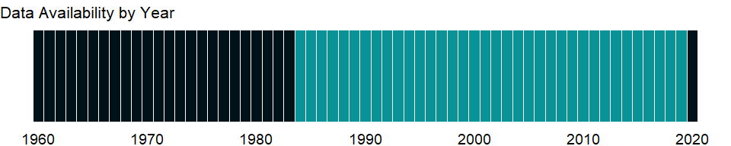

### Which countries have data?

The figure below shows the percentage of countries in each income group with a value since 2010 for that indicator.

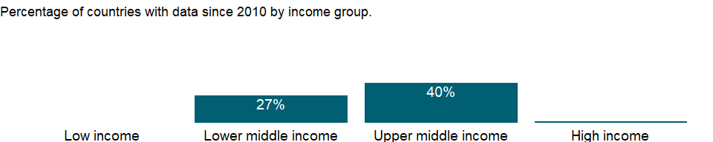

### Why is it relevant?

NA

### What is the data source?

World Bank, International Debt Statistics.

### What is the methodology?

NA

### How is it aggregated?

Sum

### What are the limitations?

NA

### What else should I know?

NA

### 1.13.16 PNG, commercial banks and other creditors (NFL, current US$)

### What is the indicator?

Nonguaranteed long-term commercial bank loans from private banks and other private financial institutions. Net flows (or net lending or net disbursements) received by the borrower during the year are disbursements minus principal repayments. Data are in current U.S. dollars.

Topic: Economic Policy & Debt: External debt: Net flows

Series ID: DT.NFL.PNGC.CD

Copyright: CC BY-4.0 , <https://datacatalog.worldbank.org/public-licenses#cc-by>

First year with any data: 1970

Last year with any data: 2019

### What years are data available?

The figure below shows years in which data is available for at least one country. Dates shaded in black have no data, while dates shaded in green have data for at least one country



### Which countries have data?

The figure below shows the percentage of countries in each income group with a value since 2010 for that indicator.

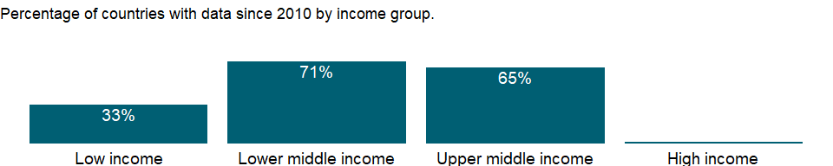

### Why is it relevant?

NA

### What is the data source?

World Bank, International Debt Statistics.

### What is the methodology?

NA

### How is it aggregated?

Sum

### What are the limitations?

NA

### What else should I know?

NA

### 1.13.17 PPG, other private creditors (NFL, current US$)

### What is the indicator?

Public and publicly guaranteed other private credits from manufacturers, exporters, and other suppliers of goods, and bank credits covered by a guarantee of an export credit agency. Net flows (or net lending or net disbursements) received by the borrower during the year are disbursements minus principal repayments. Data are in current U.S. dollars.

Topic: Economic Policy & Debt: External debt: Net flows

Series ID: DT.NFL.PROP.CD

Copyright: CC BY-4.0 , <https://datacatalog.worldbank.org/public-licenses#cc-by>

First year with any data: 1970

Last year with any data: 2019

### What years are data available?

The figure below shows years in which data is available for at least one country. Dates shaded in black have no data, while dates shaded in green have data for at least one country



### Which countries have data?

The figure below shows the percentage of countries in each income group with a value since 2010 for that indicator.

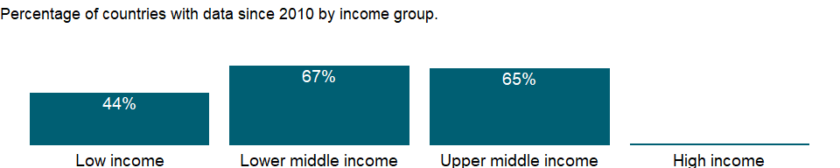

### Why is it relevant?

NA

### What is the data source?

World Bank, International Debt Statistics.

### What is the methodology?

NA

### How is it aggregated?

Sum

### What are the limitations?

NA

### What else should I know?

NA

### 1.13.18 PPG, private creditors (NFL, current US$)

### What is the indicator?

Public and publicly guaranteed debt from private creditors include bonds that are either publicly issued or privately placed; commercial bank loans from private banks and other private financial institutions; and other private credits from manufacturers, exporters, and other suppliers of goods, and bank credits covered by a guarantee of an export credit agency. Net flows (or net lending or net disbursements) received by the borrower during the year are disbursements minus principal repayments. Data are in current U.S. dollars.

Topic: Economic Policy & Debt: External debt: Net flows

Series ID: DT.NFL.PRVT.CD

Copyright: CC BY-4.0 , <https://datacatalog.worldbank.org/public-licenses#cc-by>

First year with any data: 1970

Last year with any data: 2019

### What years are data available?

The figure below shows years in which data is available for at least one country. Dates shaded in black have no data, while dates shaded in green have data for at least one country



### Which countries have data?

The figure below shows the percentage of countries in each income group with a value since 2010 for that indicator.

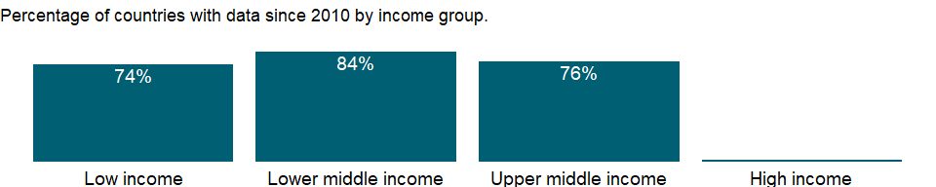

### Why is it relevant?

NA

### What is the data source?

World Bank, International Debt Statistics.

### What is the methodology?

NA

### How is it aggregated?

Sum

### What are the limitations?

NA

### What else should I know?

NA

### 1.13.19 Net financial flows, RDB concessional (NFL, current US$)

### What is the indicator?

Net financial flows received by the borrower during the year are disbursements of loans and credits less repayments of principal. Concessional financial flows cover disbursements made through concessional lending facilities. Regional development banks are the African Development Bank, in Tunis, Tunisia, which serves all of Africa, including North Africa; the Asian Development Bank, in Manila, Philippines, which serves South and Central Asia and East Asia and Pacific; the European Bank for Reconstruction and Development, in London, United Kingdom, which serves Europe and Central Asia; and the Inter-American Development Bank, in Washington, D.C., which serves the Americas. Aggregates include amounts for economies not specified elsewhere. Data are in current U.S. dollars.

Topic: Economic Policy & Debt: External debt: Net flows

Series ID: DT.NFL.RDBC.CD

Copyright: CC BY-4.0 , <https://datacatalog.worldbank.org/public-licenses#cc-by>

First year with any data: 1970

Last year with any data: 2019

### What years are data available?

The figure below shows years in which data is available for at least one country. Dates shaded in black have no data, while dates shaded in green have data for at least one country



### Which countries have data?

The figure below shows the percentage of countries in each income group with a value since 2010 for that indicator.

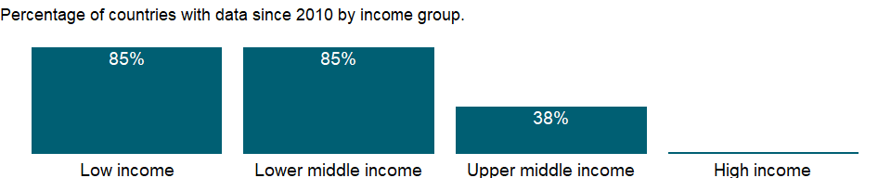

### Why is it relevant?

NA

### What is the data source?

World Bank, International Debt Statistics.

### What is the methodology?

Regional development banks also maintain concessional windows. Their loans are recorded according to each institution’s classification and not according to the Organisation for Economic Co-operation and Development’s (OECD) Development Assistance Committee (DAC) definition.

### How is it aggregated?

Sum

### What are the limitations?

NA

### What else should I know?

NA

### 1.13.20 Net financial flows, RDB nonconcessional (NFL, current US$)

### What is the indicator?

Net financial flows received by the borrower during the year are disbursements of loans and credits less repayments of principal. Nonconcessional financial flows cover all disbursements except those made through concessional lending facilities. Regional development banks are the African Development Bank, in Tunis, Tunisia, which serves all of Africa, including North Africa; the Asian Development Bank, in Manila, Philippines, which serves South and Central Asia and East Asia and Pacific; the European Bank for Reconstruction and Development, in London, United Kingdom, which serves Europe and Central Asia; and the Inter-American Development Bank, in Washington, D.C., which serves the Americas. Aggregates include amounts for economies not specified elsewhere. Data are in current U.S. dollars.

Topic: Economic Policy & Debt: External debt: Net flows

Series ID: DT.NFL.RDBN.CD

Copyright: CC BY-4.0 , <https://datacatalog.worldbank.org/public-licenses#cc-by>

First year with any data: 1970

Last year with any data: 2019

### What years are data available?

The figure below shows years in which data is available for at least one country. Dates shaded in black have no data, while dates shaded in green have data for at least one country



### Which countries have data?

The figure below shows the percentage of countries in each income group with a value since 2010 for that indicator.

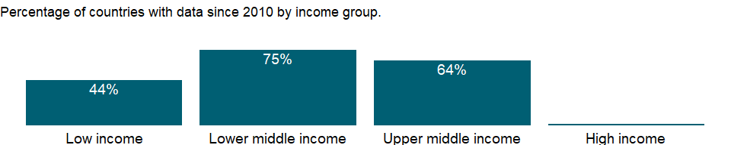

### Why is it relevant?

NA

### What is the data source?

World Bank, International Debt Statistics.

### What is the methodology?

NA

### How is it aggregated?

Sum

### What are the limitations?

NA

### What else should I know?

NA

## 1.14 Economic Policy & Debt: External debt: Debt service

### 1.14.1 Debt service on external debt, total (TDS, current US$)

### What is the indicator?

Total debt service is the sum of principal repayments and interest actually paid in currency, goods, or services on long-term debt, interest paid on short-term debt, and repayments (repurchases and charges) to the IMF. Data are in current U.S. dollars.

Topic: Economic Policy & Debt: External debt: Debt service

Series ID: DT.TDS.DECT.CD

Copyright: CC BY-4.0 , <https://datacatalog.worldbank.org/public-licenses#cc-by>

First year with any data: 1970

Last year with any data: 2019

### What years are data available?

The figure below shows years in which data is available for at least one country. Dates shaded in black have no data, while dates shaded in green have data for at least one country



### Which countries have data?

The figure below shows the percentage of countries in each income group with a value since 2010 for that indicator.



### Why is it relevant?

NA

### What is the data source?

World Bank, International Debt Statistics.

### What is the methodology?

NA

### How is it aggregated?

Sum

### What are the limitations?

NA

### What else should I know?

NA

### 1.14.2 IMF repurchases and charges (TDS, current US$)

### What is the indicator?

IMF repurchases are total repayments of outstanding drawings from the General Resources Account during the year specified, excluding repayments due in the reserve tranche. IMF charges cover interest payments with respect to all uses of IMF resources, excluding those resulting from drawings in the reserve tranche. Data are in current U.S. dollars.

Topic: Economic Policy & Debt: External debt: Debt service

Series ID: DT.TDS.DIMF.CD

Copyright: CC BY-4.0 , <https://datacatalog.worldbank.org/public-licenses#cc-by>

First year with any data: 1970

Last year with any data: 2019

### What years are data available?

The figure below shows years in which data is available for at least one country. Dates shaded in black have no data, while dates shaded in green have data for at least one country



### Which countries have data?

The figure below shows the percentage of countries in each income group with a value since 2010 for that indicator.



### Why is it relevant?

NA

### What is the data source?

World Bank, International Debt Statistics.

### What is the methodology?

NA

### How is it aggregated?

Sum

### What are the limitations?

NA

### What else should I know?

NA

### 1.14.3 Debt service on external debt, public and publicly guaranteed (PPG) (TDS, current US$)

### What is the indicator?

Public and publicly guaranteed debt service is the sum of principal repayments and interest actually paid in currency, goods, or services on long-term obligations of public debtors and long-term private obligations guaranteed by a public entity. Data are in current U.S. dollars.

Topic: Economic Policy & Debt: External debt: Debt service

Series ID: DT.TDS.DPPG.CD

Copyright: CC BY-4.0 , <https://datacatalog.worldbank.org/public-licenses#cc-by>

First year with any data: 1970

Last year with any data: 2019

### What years are data available?

The figure below shows years in which data is available for at least one country. Dates shaded in black have no data, while dates shaded in green have data for at least one country



### Which countries have data?

The figure below shows the percentage of countries in each income group with a value since 2010 for that indicator.



### Why is it relevant?

NA

### What is the data source?

World Bank, International Debt Statistics.

### What is the methodology?

NA

### How is it aggregated?

Sum

### What are the limitations?

NA

### What else should I know?

NA

### 1.14.4 Multilateral debt service (TDS, current US$)

### What is the indicator?

Public and publicly guaranteed multilateral loans include loans and credits from the World Bank, regional development banks, and other multilateral and intergovernmental agencies. Excluded are loans from funds administered by an international organization on behalf of a single donor government; these are classified as loans from governments. Debt service payments are the sum of principal repayments and interest payments actually made in the year specified. Data are in current U.S. dollars.

Topic: Economic Policy & Debt: External debt: Debt service

Series ID: DT.TDS.MLAT.CD

Copyright: CC BY-4.0 , <https://datacatalog.worldbank.org/public-licenses#cc-by>

First year with any data: 1970

Last year with any data: 2019

### What years are data available?

The figure below shows years in which data is available for at least one country. Dates shaded in black have no data, while dates shaded in green have data for at least one country



### Which countries have data?

The figure below shows the percentage of countries in each income group with a value since 2010 for that indicator.



### Why is it relevant?

NA

### What is the data source?

World Bank, International Debt Statistics.

### What is the methodology?

NA

### How is it aggregated?

Sum

### What are the limitations?

NA

### What else should I know?

NA

## 1.15 World Bank, International Debt Statistics.

### 1.15.1 Debt service to exports (%)

### What is the indicator?

Debt service (PPG and IMF only, % of exports of goods, services and primary income)

Topic: World Bank, International Debt Statistics.

Series ID: DT.TDS.DPPF.XP.ZS

Copyright: CC BY-4.0 , <https://datacatalog.worldbank.org/public-licenses#cc-by>

First year with any data: 1970

Last year with any data: 2019

### What years are data available?

The figure below shows years in which data is available for at least one country. Dates shaded in black have no data, while dates shaded in green have data for at least one country



### Which countries have data?

The figure below shows the percentage of countries in each income group with a value since 2010 for that indicator.

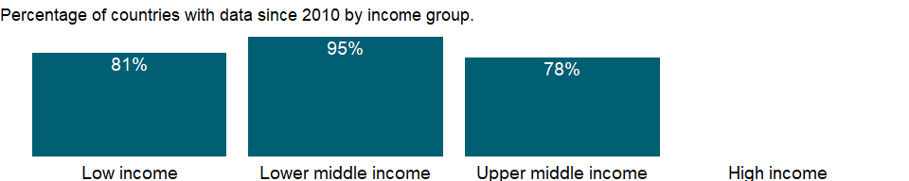

### Why is it relevant?

NA

### What is the data source?

Debt service is the sum of principle repayments and interest actually paid in currency, goods, or services. This series differs from the standard debt to exports series. It covers only long-term public and publicly guaranteed debt and repayments (repurchases and charges) to the IMF. Exports of goods and services include primary income, but do not include workers’ remittances.

### What is the methodology?

NA

### How is it aggregated?

World Bank, International Debt Statistics.

### What are the limitations?

NA

### What else should I know?

NA

## 1.16 Environment: Energy production & use

### 1.16.1 Access to clean fuels and technologies for cooking (% of population)

### What is the indicator?

Access to clean fuels and technologies for cooking is the proportion of total population primarily using clean cooking fuels and technologies for cooking. Under WHO guidelines, kerosene is excluded from clean cooking fuels.

Topic: Environment: Energy production & use

Series ID: EG.CFT.ACCS.ZS

Copyright: CC BY-4.0 , <https://datacatalog.worldbank.org/public-licenses#cc-by>

First year with any data: 2000

Last year with any data: 2016

### What years are data available?

The figure below shows years in which data is available for at least one country. Dates shaded in black have no data, while dates shaded in green have data for at least one country

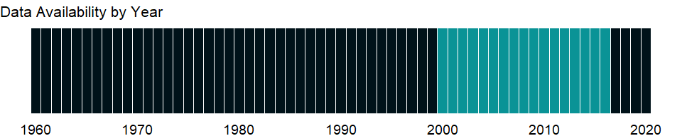

### Which countries have data?

The figure below shows the percentage of countries in each income group with a value since 2010 for that indicator.

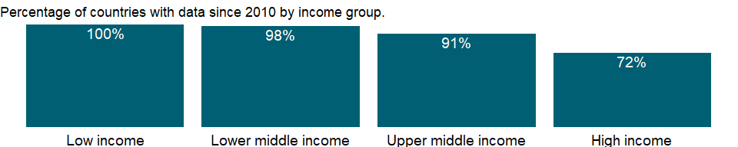

### Why is it relevant?

NA

### What is the data source?

World Bank, Sustainable Energy for All (SE4ALL) database from WHO Global Household Energy database.

### What is the methodology?

Data for access to clean fuels and technologies for cooking are based on the the World Health Organization’s (WHO) Global Household Energy Database. They are collected among different sources: only data from nationally representative household surveys (including national censuses) were used. Survey sources include Demographic and Health Surveys (DHS) and Living Standards Measurement Surveys (LSMS), Multi-Indicator Cluster Surveys (MICS), the World Health Survey (WHS), other nationally developed and implemented surveys, and various government agencies (for example, ministries of energy and utilities). To develop the historical evolution of clean fuels and technologies use rates, a multi-level non-parametrical mixed model, using both fixed and random effects, was used to derive polluting fuel use estimates for 150 countries (ref. Bonjour S, Adair-Rohani H, Wolf J, Bruce NG, Mehta S, Prüss-Ustün A, Lahiff M, Rehfuess EA, Mishra V, Smith KR. Solid Fuel Use for Household Cooking: Country and Regional Estimates for 1980-2010. Environ Health Perspect (): .doi:10.1289/ehp.1205987.). For a country with no data, estimates are derived by using regional trends or assumed to be universal access if a country is classified as developed by the United Nations.

### How is it aggregated?

Weighted Average

### What are the limitations?

NA

### What else should I know?

NA

### 1.16.2 Energy intensity level of primary energy (MJ/$2011 PPP GDP)

### What is the indicator?

Energy intensity level of primary energy is the ratio between energy supply and gross domestic product measured at purchasing power parity. Energy intensity is an indication of how much energy is used to produce one unit of economic output. Lower ratio indicates that less energy is used to produce one unit of output.

Topic: Environment: Energy production & use

Series ID: EG.EGY.PRIM.PP.KD

Copyright: CC BY-4.0 , <https://datacatalog.worldbank.org/public-licenses#cc-by>

First year with any data: 1990

Last year with any data: 2015

### What years are data available?

The figure below shows years in which data is available for at least one country. Dates shaded in black have no data, while dates shaded in green have data for at least one country

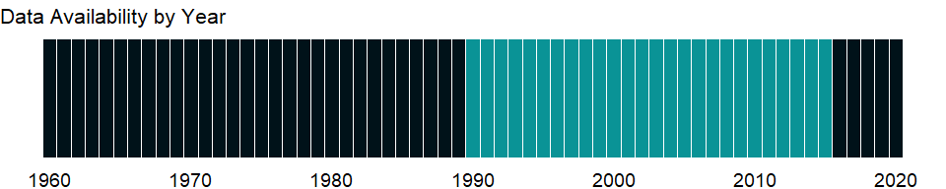

### Which countries have data?

The figure below shows the percentage of countries in each income group with a value since 2010 for that indicator.

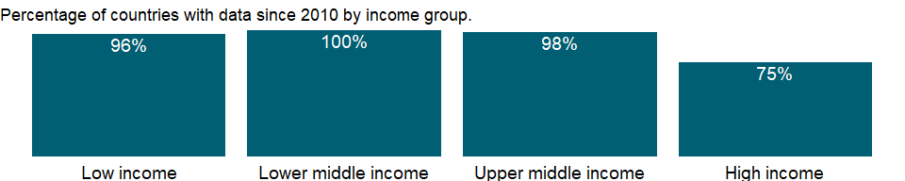

### Why is it relevant?

NA

### What is the data source?

World Bank, Sustainable Energy for All (SE4ALL) database from the SE4ALL Global Tracking Framework led jointly by the World Bank, International Energy Agency, and the Energy Sector Management Assistance Program.

### What is the methodology?

This indicator is obtained by dividing total primary energy supply over gross domestic product measured in constant 2011 US dollars at purchasing power parity.

### How is it aggregated?

Weighted Average

### What are the limitations?

Energy intensity level is only an imperfect proxy to energy efficiency indicator and it can be affected by a number of factors not necessarily linked to pure efficiency such as climate.

### What else should I know?

NA

### 1.16.3 Access to electricity, rural (% of rural population)

### What is the indicator?

Access to electricity, rural is the percentage of rural population with access to electricity.

Topic: Environment: Energy production & use

Series ID: EG.ELC.ACCS.RU.ZS

Copyright: CC BY-4.0 , <https://datacatalog.worldbank.org/public-licenses#cc-by>

First year with any data: 1990

Last year with any data: 2019

### What years are data available?

The figure below shows years in which data is available for at least one country. Dates shaded in black have no data, while dates shaded in green have data for at least one country



### Which countries have data?

The figure below shows the percentage of countries in each income group with a value since 2010 for that indicator.

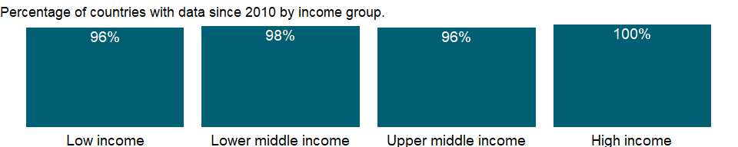

### Why is it relevant?

NA

### What is the data source?

World Bank Global Electrification Database from “Tracking SDG 7: The Energy Progress Report” led jointly by the custodian agencies: the International Energy Agency (IEA), the International Renewable Energy Agency (IRENA), the United Nations Statistics Division (UNSD), the World Bank and the World Health Organization (WHO).

### What is the methodology?

Data for access to electricity are collected among different sources: mostly data from nationally representative household surveys (including national censuses) were used. Survey sources include Demographic and Health Surveys (DHS) and Living Standards Measurement Surveys (LSMS), Multi-Indicator Cluster Surveys (MICS), the World Health Survey (WHS), other nationally developed and implemented surveys, and various government agencies (for example, ministries of energy and utilities). Given the low frequency and the regional distribution of some surveys, a number of countries have gaps in available data. To develop the historical evolution and starting point of electrification rates, a simple modeling approach was adopted to fill in the missing data points - around 1990, around 2000, and around 2010. Therefore, a country can have a continuum of zero to three data points. There are 42 countries with zero data point and the weighted regional average was used as an estimate for electrification in each of the data periods. 170 countries have between one and three data points and missing data are estimated by using a model with region, country, and time variables. The model keeps the original observation if data is available for any of the time periods. This modeling approach allowed the estimation of electrification rates for 212 countries over these three time periods (Indicated as “Estimate”). Notation “Assumption” refers to the assumption of universal access in countries classified as developed by the United Nations. Data begins from the year in which the first survey data is available for each country.

### How is it aggregated?

Weighted Average

### What are the limitations?

NA

### What else should I know?

NA

### 1.16.4 Access to electricity, urban (% of urban population)

### What is the indicator?

Access to electricity, urban is the percentage of urban population with access to electricity.

Topic: Environment: Energy production & use

Series ID: EG.ELC.ACCS.UR.ZS

Copyright: CC BY-4.0 , <https://datacatalog.worldbank.org/public-licenses#cc-by>

First year with any data: 1990

Last year with any data: 2019

### What years are data available?

The figure below shows years in which data is available for at least one country. Dates shaded in black have no data, while dates shaded in green have data for at least one country



### Which countries have data?

The figure below shows the percentage of countries in each income group with a value since 2010 for that indicator.

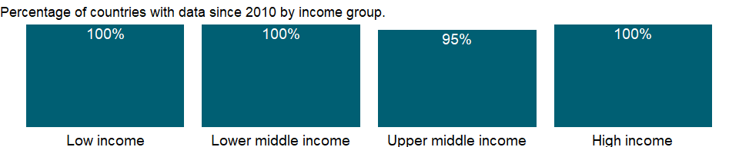

### Why is it relevant?

NA

### What is the data source?

World Bank Global Electrification Database from “Tracking SDG 7: The Energy Progress Report” led jointly by the custodian agencies: the International Energy Agency (IEA), the International Renewable Energy Agency (IRENA), the United Nations Statistics Division (UNSD), the World Bank and the World Health Organization (WHO).

### What is the methodology?

Data for access to electricity are collected among different sources: mostly data from nationally representative household surveys (including national censuses) were used. Survey sources include Demographic and Health Surveys (DHS) and Living Standards Measurement Surveys (LSMS), Multi-Indicator Cluster Surveys (MICS), the World Health Survey (WHS), other nationally developed and implemented surveys, and various government agencies (for example, ministries of energy and utilities). Given the low frequency and the regional distribution of some surveys, a number of countries have gaps in available data. To develop the historical evolution and starting point of electrification rates, a simple modeling approach was adopted to fill in the missing data points - around 1990, around 2000, and around 2010. Therefore, a country can have a continuum of zero to three data points. There are 42 countries with zero data point and the weighted regional average was used as an estimate for electrification in each of the data periods. 170 countries have between one and three data points and missing data are estimated by using a model with region, country, and time variables. The model keeps the original observation if data is available for any of the time periods. This modeling approach allowed the estimation of electrification rates for 212 countries over these three time periods (Indicated as “Estimate”). Notation “Assumption” refers to the assumption of universal access in countries classified as developed by the United Nations. Data begins from the year in which the first survey data is available for each country.

### How is it aggregated?

Weighted Average

### What are the limitations?

NA

### What else should I know?

NA

### 1.16.5 Access to electricity (% of population)

### What is the indicator?

Access to electricity is the percentage of population with access to electricity. Electrification data are collected from industry, national surveys and international sources.

Topic: Environment: Energy production & use

Series ID: EG.ELC.ACCS.ZS

Copyright: CC BY-4.0 , <https://datacatalog.worldbank.org/public-licenses#cc-by>

First year with any data: 1990

Last year with any data: 2019

### What years are data available?

The figure below shows years in which data is available for at least one country. Dates shaded in black have no data, while dates shaded in green have data for at least one country



### Which countries have data?

The figure below shows the percentage of countries in each income group with a value since 2010 for that indicator.



### Why is it relevant?

Maintaining reliable and secure electricity services while seeking to rapidly decarbonize power systems is a key challenge for countries throughout the world. More and more countries are becoming increasing dependent on reliable and secure electricity supplies to underpin economic growth and community prosperity. This reliance is set to grow as more efficient and less carbon intensive forms of power are developed and deployed to help decarbonize economies.

Energy is necessary for creating the conditions for economic growth. It is impossible to operate a factory, run a shop, grow crops or deliver goods to consumers without using some form of energy. Access to electricity is particularly crucial to human development as electricity is, in practice, indispensable for certain basic activities, such as lighting, refrigeration and the running of household appliances, and cannot easily be replaced by other forms of energy. Individuals’ access to electricity is one of the most clear and un-distorted indication of a country’s energy poverty status.

Electricity access is increasingly at the forefront of governments’ preoccupations, especially in the developing countries. As a consequence, a lot of rural electrification programs and national electrification agencies have been created in these countries to monitor more accurately the needs and the status of rural development and electrification.

Use of energy is important in improving people’s standard of living. But electricity generation also can damage the environment. Whether such damage occurs depends largely on how electricity is generated. For example, burning coal releases twice as much carbon dioxide - a major contributor to global warming - as does burning an equivalent amount of natural gas.

### What is the data source?

World Bank Global Electrification Database from “Tracking SDG 7: The Energy Progress Report” led jointly by the custodian agencies: the International Energy Agency (IEA), the International Renewable Energy Agency (IRENA), the United Nations Statistics Division (UNSD), the World Bank and the World Health Organization (WHO).

### What is the methodology?

Data for access to electricity are collected among different sources: mostly data from nationally representative household surveys (including national censuses) were used. Survey sources include Demographic and Health Surveys (DHS) and Living Standards Measurement Surveys (LSMS), Multi-Indicator Cluster Surveys (MICS), the World Health Survey (WHS), other nationally developed and implemented surveys, and various government agencies (for example, ministries of energy and utilities). Given the low frequency and the regional distribution of some surveys, a number of countries have gaps in available data. To develop the historical evolution and starting point of electrification rates, a simple modeling approach was adopted to fill in the missing data points - around 1990, around 2000, and around 2010. Therefore, a country can have a continuum of zero to three data points. There are 42 countries with zero data point and the weighted regional average was used as an estimate for electrification in each of the data periods. 170 countries have between one and three data points and missing data are estimated by using a model with region, country, and time variables. The model keeps the original observation if data is available for any of the time periods. This modeling approach allowed the estimation of electrification rates for 212 countries over these three time periods (Indicated as “Estimate”). Notation “Assumption” refers to the assumption of universal access in countries classified as developed by the United Nations. Data begins from the year in which the first survey data is available for each country.

### How is it aggregated?

Weighted Average

### What are the limitations?

NA

### What else should I know?

NA

### 1.16.6 Electricity production from coal sources (% of total)

### What is the indicator?

Sources of electricity refer to the inputs used to generate electricity. Coal refers to all coal and brown coal, both primary (including hard coal and lignite-brown coal) and derived fuels (including patent fuel, coke oven coke, gas coke, coke oven gas, and blast furnace gas). Peat is also included in this category.

Topic: Environment: Energy production & use

Series ID: EG.ELC.COAL.ZS

Copyright: Use and distribution of these data are subject to IEA terms and conditions. , <http://www.iea.org/t&c/termsandconditions>

First year with any data: 1960

Last year with any data: 2015

### What years are data available?

The figure below shows years in which data is available for at least one country. Dates shaded in black have no data, while dates shaded in green have data for at least one country

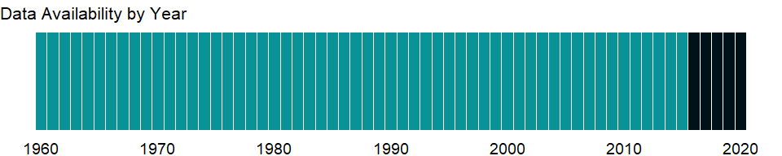

### Which countries have data?

The figure below shows the percentage of countries in each income group with a value since 2010 for that indicator.

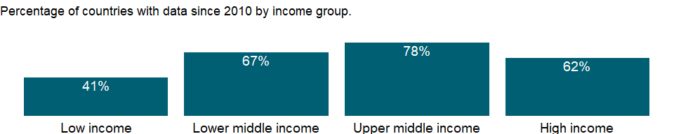

### Why is it relevant?

Since the beginning of the 21st century, coal has been the fastest-growing global energy source; it currently provides about 40 percent of the world’s electricity needs. Coal is the second source of primary energy in the world after oil, and the first source of electricity generation.. The last decade’s growth in coal use has been driven by the economic growth of developing economies, mainly China. Irrespective of its economic benefits for the countries, the environmental impact of coal use, especially that coming from carbon dioxide emissions, is significant, and efforts are underway globally to build more efficient plants, to retrofit old plants and to decommission the oldest and least efficient coal plants.

Use of energy is important in improving people’s standard of living. But electricity generation also can damage the environment. Whether such damage occurs depends largely on how electricity is generated. For example, burning coal releases twice as much carbon dioxide - a major contributor to global warming - as does burning an equivalent amount of natural gas.

Anthropogenic carbon dioxide emissions result primarily from fossil fuel combustion and cement manufacturing. In combustion different fossil fuels release different amounts of carbon dioxide for the same level of energy use: oil releases about 50 percent more carbon dioxide than natural gas, and coal releases about twice as much. Nuclear energy does not generate carbon dioxide emissions, but it produces other dangerous waste products.

### What is the data source?

IEA Statistics © OECD/IEA 2014 (<http://www.iea.org/stats/index.asp>), subject to <https://www.iea.org/t&c/termsandconditions/>

### What is the methodology?

Electricity production is total number of kWh generated by power plants separated into electricity plants and CHP plants. The International Energy Agency (IEA) compiles data on energy inputs used to generate electricity. IEA data for countries that are not members of the Organisation for Economic Co-operation and Development (OECD) are based on national energy data adjusted to conform to annual questionnaires completed by OECD member governments. In addition, estimates are sometimes made to complete major aggregates from which key data are missing, and adjustments are made to compensate for differences in definitions. The IEA makes these estimates in consultation with national statistical offices, oil companies, electric utilities, and national energy experts.

### How is it aggregated?

Weighted average

### What are the limitations?

IEA occasionally revises its time series to reflect political changes. For example, the IEA has constructed historical energy statistics for countries of the former Soviet Union. In addition, energy statistics for other countries have undergone continuous changes in coverage or methodology in recent years as more detailed energy accounts have become available. Breaks in series are therefore unavoidable.

### What else should I know?

Electricity production shares may not sum to 100 percent because other sources of generated electricity (such as geothermal, solar, and wind) are not shown. Restricted use: Please contact the International Energy Agency for third-party use of these data.

### 1.16.7 Electricity production from oil, gas and coal sources (% of total)

### What is the indicator?

Sources of electricity refer to the inputs used to generate electricity. Oil refers to crude oil and petroleum products. Gas refers to natural gas but excludes natural gas liquids. Coal refers to all coal and brown coal, both primary (including hard coal and lignite-brown coal) and derived fuels (including patent fuel, coke oven coke, gas coke, coke oven gas, and blast furnace gas). Peat is also included in this category.

Topic: Environment: Energy production & use

Series ID: EG.ELC.FOSL.ZS

Copyright: Use and distribution of these data are subject to IEA terms and conditions. , <http://www.iea.org/t&c/termsandconditions>

First year with any data: 1960

Last year with any data: 2015

### What years are data available?

The figure below shows years in which data is available for at least one country. Dates shaded in black have no data, while dates shaded in green have data for at least one country



### Which countries have data?

The figure below shows the percentage of countries in each income group with a value since 2010 for that indicator.



### Why is it relevant?

NA

### What is the data source?

IEA Statistics © OECD/IEA 2014 (<http://www.iea.org/stats/index.asp>), subject to <https://www.iea.org/t&c/termsandconditions/>

### What is the methodology?

NA

### How is it aggregated?

Weighted average

### What are the limitations?

NA

### What else should I know?

Restricted use: Please contact the International Energy Agency for third-party use of these data.

### 1.16.8 Electricity production from hydroelectric sources (% of total)

### What is the indicator?

Sources of electricity refer to the inputs used to generate electricity. Hydropower refers to electricity produced by hydroelectric power plants.

Topic: Environment: Energy production & use

Series ID: EG.ELC.HYRO.ZS

Copyright: Use and distribution of these data are subject to IEA terms and conditions. , <http://www.iea.org/t&c/termsandconditions>

First year with any data: 1960

Last year with any data: 2015

### What years are data available?

The figure below shows years in which data is available for at least one country. Dates shaded in black have no data, while dates shaded in green have data for at least one country



### Which countries have data?

The figure below shows the percentage of countries in each income group with a value since 2010 for that indicator.



### Why is it relevant?

Electrical energy from hydropower is derived from turbines being driven by flowing water in rivers, with or without man-made dams forming reservoirs. Presently, hydropower is the world’s largest source of renewable electricity. Hydropower represents the largest share of renewable electricity production. It was second only to wind power for new-built capacities between 2005 and 2010. IEA estimates that hydropower could produce up to 6,000 terawatt-hours in 2050, roughly twice as much as today.

Hydropower’s storage capacity and fast response characteristics are especially valuable to meet sudden fluctuations in electricity demand and to match supply from less flexible electricity sources and variable renewable sources, such as solar photovoltaic (PV) and wind power.

Use of energy is important in improving people’s standard of living. But electricity generation also can damage the environment. Whether such damage occurs depends largely on how electricity is generated. For example, burning coal releases twice as much carbon dioxide - a major contributor to global warming - as does burning an equivalent amount of natural gas.

Anthropogenic carbon dioxide emissions result primarily from fossil fuel combustion and cement manufacturing. In combustion different fossil fuels release different amounts of carbon dioxide for the same level of energy use: oil releases about 50 percent more carbon dioxide than natural gas, and coal releases about twice as much. Nuclear energy does not generate carbon dioxide emissions, but it produces other dangerous waste products.

### What is the data source?

IEA Statistics © OECD/IEA 2014 (<http://www.iea.org/stats/index.asp>), subject to <https://www.iea.org/t&c/termsandconditions/>

### What is the methodology?

Electricity production is total number of kWh generated by power plants separated into electricity plants and CHP plants. The International Energy Agency (IEA) compiles data on energy inputs used to generate electricity. IEA data for countries that are not members of the Organisation for Economic Co-operation and Development (OECD) are based on national energy data adjusted to conform to annual questionnaires completed by OECD member governments. In addition, estimates are sometimes made to complete major aggregates from which key data are missing, and adjustments are made to compensate for differences in definitions. The IEA makes these estimates in consultation with national statistical offices, oil companies, electric utilities, and national energy experts.

### How is it aggregated?

Weighted average

### What are the limitations?

IEA occasionally revises its time series to reflect political changes. For example, the IEA has constructed historical energy statistics for countries of the former Soviet Union. In addition, energy statistics for other countries have undergone continuous changes in coverage or methodology in recent years as more detailed energy accounts have become available. Breaks in series are therefore unavoidable.

### What else should I know?

Electricity production shares may not sum to 100 percent because other sources of generated electricity (such as geothermal, solar, and wind) are not shown. Restricted use: Please contact the International Energy Agency for third-party use of these data.

### 1.16.9 Electric power transmission and distribution losses (% of output)

### What is the indicator?

Electric power transmission and distribution losses include losses in transmission between sources of supply and points of distribution and in the distribution to consumers, including pilferage.

Topic: Environment: Energy production & use

Series ID: EG.ELC.LOSS.ZS

Copyright: Use and distribution of these data are subject to IEA terms and conditions. , <http://www.iea.org/t&c/termsandconditions>

First year with any data: 1960

Last year with any data: 2014

### What years are data available?

The figure below shows years in which data is available for at least one country. Dates shaded in black have no data, while dates shaded in green have data for at least one country

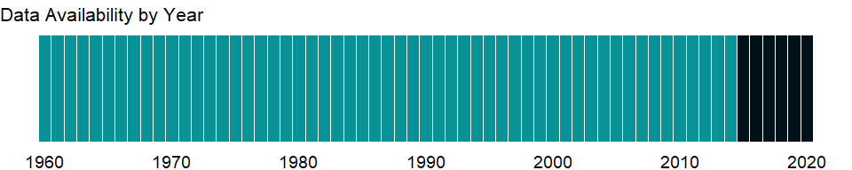

### Which countries have data?

The figure below shows the percentage of countries in each income group with a value since 2010 for that indicator.

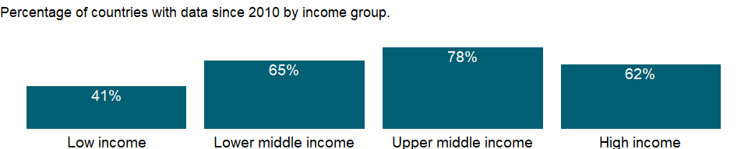

### Why is it relevant?

An economy’s production and consumption of electricity are basic indicators of its size and level of development. Although a few countries export electric power, most production is for domestic consumption. Expanding the supply of electricity to meet the growing demand of increasingly urbanized and industrialized economies without incurring unacceptable social, economic, and environmental costs is one of the great challenges facing developing countries.

Modern societies are becoming increasing dependent on reliable and secure electricity supplies to underpin economic growth and community prosperity. This reliance is set to grow as more efficient and less carbon intensive forms of power are developed and deployed to help decarbonize economies. Maintaining reliable and secure electricity services while seeking to rapidly decarbonize power systems is a key challenge for countries throughout the world.

In developing economies growth in energy use is closely related to growth in the modern sectors - industry, motorized transport, and urban areas - but energy use also reflects climatic, geographic, and economic factors (such as the relative price of energy). Energy use has been growing rapidly in low- and middle-income economies, but high-income economies still use almost five times as much energy on a per capita basis.

Governments in many countries are increasingly aware of the urgent need to make better use of the world’s energy resources. Improved energy efficiency is often the most economic and readily available means of improving energy security and reducing greenhouse gas emissions.

### What is the data source?

IEA Statistics © OECD/IEA 2018 (<http://www.iea.org/stats/index.asp>), subject to <https://www.iea.org/t&c/termsandconditions/>

### What is the methodology?

Data on electric power production and consumption are collected from national energy agencies by the International Energy Agency (IEA) and adjusted by the IEA to meet international definitions. Electric power transmission and distribution losses percentage of output is the share of electric power transmission and distribution losses to electricity production which is the total number of GWh generated by power plants separated into electricity plants and CHP plants.

### How is it aggregated?

Weighted average

### What are the limitations?

Electricity consumption is equivalent to production less power plants’ own use and transmission, distribution, and transformation losses less exports plus imports. It includes consumption by auxiliary stations, losses in transformers that are considered integral parts of those stations, and electricity produced by pumping installations. Where data are available, it covers electricity generated by primary sources of energy - coal, oil, gas, nuclear, hydro, geothermal, wind, tide and wave, and combustible renewables. Neither production nor consumption data capture the reliability of supplies, including breakdowns, load factors, and frequency of outages.

### What else should I know?

Restricted use: Please contact the International Energy Agency for third-party use of these data.

### 1.16.10 Electricity production from natural gas sources (% of total)

### What is the indicator?

Sources of electricity refer to the inputs used to generate electricity. Gas refers to natural gas but excludes natural gas liquids.

Topic: Environment: Energy production & use

Series ID: EG.ELC.NGAS.ZS

Copyright: Use and distribution of these data are subject to IEA terms and conditions. , <http://www.iea.org/t&c/termsandconditions>

First year with any data: 1960

Last year with any data: 2015

### What years are data available?

The figure below shows years in which data is available for at least one country. Dates shaded in black have no data, while dates shaded in green have data for at least one country



### Which countries have data?

The figure below shows the percentage of countries in each income group with a value since 2010 for that indicator.



### Why is it relevant?

Natural gas is considered a good source of electricity supply for a number of economic, operational and environmental reasons, such as:

1. it is technically and financially of low-risk;
2. lower carbon relative to other fossil fuels;
3. gas plants can be built relatively quickly in around two years, unlike nuclear facilities, which can take much longer.

Also, gas plants are flexible both in technical and economic terms, so they can react quickly to demand peaks, and are ideally twinned with intermittent renewable options such as wind power.

Use of energy is important in improving people’s standard of living. But electricity generation also can damage the environment. Whether such damage occurs depends largely on how electricity is generated. For example, burning coal releases twice as much carbon dioxide - a major contributor to global warming - as does burning an equivalent amount of natural gas.

Anthropogenic carbon dioxide emissions result primarily from fossil fuel combustion and cement manufacturing. In combustion different fossil fuels release different amounts of carbon dioxide for the same level of energy use: oil releases about 50 percent more carbon dioxide than natural gas, and coal releases about twice as much. Nuclear energy does not generate carbon dioxide emissions, but it produces other dangerous waste products.

### What is the data source?

IEA Statistics © OECD/IEA 2014 (<http://www.iea.org/stats/index.asp>), subject to <https://www.iea.org/t&c/termsandconditions/>

### What is the methodology?

Electricity production from natural gas sources (% of total) is the share of natutal gas, which is natural gas but not natural gas liquids, in total electricity production which is the total number of GWh generated by power plants separated into electricity plants and CHP plants. The International Energy Agency (IEA) compiles data on energy inputs used to generate electricity. IEA data for countries that are not members of the Organisation for Economic Co-operation and Development (OECD) are based on national energy data adjusted to conform to annual questionnaires completed by OECD member governments. In addition, estimates are sometimes made to complete major aggregates from which key data are missing, and adjustments are made to compensate for differences in definitions. The IEA makes these estimates in consultation with national statistical offices, oil companies, electric utilities, and national energy experts.

### How is it aggregated?

Weighted average

### What are the limitations?

IEA occasionally revises its time series to reflect political changes. For example, the IEA has constructed historical energy statistics for countries of the former Soviet Union. In addition, energy statistics for other countries have undergone continuous changes in coverage or methodology in recent years as more detailed energy accounts have become available. Breaks in series are therefore unavoidable.

### What else should I know?

Electricity production shares may not sum to 100 percent because other sources of generated electricity (such as geothermal, solar, and wind) are not shown. Restricted use: Please contact the International Energy Agency for third-party use of these data.

### 1.16.11 Electricity production from nuclear sources (% of total)

### What is the indicator?

Sources of electricity refer to the inputs used to generate electricity. Nuclear power refers to electricity produced by nuclear power plants.

Topic: Environment: Energy production & use

Series ID: EG.ELC.NUCL.ZS

Copyright: Use and distribution of these data are subject to IEA terms and conditions. , <http://www.iea.org/t&c/termsandconditions>

First year with any data: 1960

Last year with any data: 2015

### What years are data available?

The figure below shows years in which data is available for at least one country. Dates shaded in black have no data, while dates shaded in green have data for at least one country



### Which countries have data?

The figure below shows the percentage of countries in each income group with a value since 2010 for that indicator.



### Why is it relevant?

The generation of electricity using nuclear energy was first demonstrated in the 1950s, and the first commercial nuclear power plants entered operation in the early 1960s. Nuclear capacity grew rapidly in the 1970s and 1980s as countries sought to reduce dependence on fossil fuels, especially after the oil crises of the 1970s. There was a renewed interest in nuclear energy from 2000, and 60 new countries expressed interest in launching a nuclear program to the International Atomic Energy Agency (IAEA). However, after the earthquake and tsunami devastation of the Pacific coast of northern Japan, most nuclear countries announced safety reviews of their nuclear reactors (stress tests) and the revision/improvement of their plans to address similar emergency situations; countries such as Germany and Italy decided to eventually phase out nuclear power or to abandon their nuclear plant projects.

Use of energy is important in improving people’s standard of living. But electricity generation also can damage the environment. Whether such damage occurs depends largely on how electricity is generated. For example, burning coal releases twice as much carbon dioxide - a major contributor to global warming - as does burning an equivalent amount of natural gas.

Anthropogenic carbon dioxide emissions result primarily from fossil fuel combustion and cement manufacturing. In combustion different fossil fuels release different amounts of carbon dioxide for the same level of energy use: oil releases about 50 percent more carbon dioxide than natural gas, and coal releases about twice as much. Nuclear energy does not generate carbon dioxide emissions, but it produces other dangerous waste products.

### What is the data source?

IEA Statistics © OECD/IEA 2014 (<http://www.iea.org/stats/index.asp>), subject to <https://www.iea.org/t&c/termsandconditions/>

### What is the methodology?

Electricity production from nuclear sources (% of total) is the share of electricity produced by nuclear power plants in total electricity production which is the total number of GWh generated by power plants separated into electricity plants and CHP plants. The International Energy Agency (IEA) compiles data on energy inputs used to generate electricity. IEA data for countries that are not members of the Organisation for Economic Co-operation and Development (OECD) are based on national energy data adjusted to conform to annual questionnaires completed by OECD member governments. In addition, estimates are sometimes made to complete major aggregates from which key data are missing, and adjustments are made to compensate for differences in definitions. The IEA makes these estimates in consultation with national statistical offices, oil companies, electric utilities, and national energy experts.

### How is it aggregated?

Weighted average

### What are the limitations?

IEA occasionally revises its time series to reflect political changes. For example, the IEA has constructed historical energy statistics for countries of the former Soviet Union. In addition, energy statistics for other countries have undergone continuous changes in coverage or methodology in recent years as more detailed energy accounts have become available. Breaks in series are therefore unavoidable.

### What else should I know?

Electricity production shares may not sum to 100 percent because other sources of generated electricity (such as geothermal, solar, and wind) are not shown. Restricted use: Please contact the International Energy Agency for third-party use of these data.

### 1.16.12 Electricity production from oil sources (% of total)

### What is the indicator?

Sources of electricity refer to the inputs used to generate electricity. Oil refers to crude oil and petroleum products.

Topic: Environment: Energy production & use

Series ID: EG.ELC.PETR.ZS

Copyright: Use and distribution of these data are subject to IEA terms and conditions. , <http://www.iea.org/t&c/termsandconditions>

First year with any data: 1960

Last year with any data: 2015

### What years are data available?

The figure below shows years in which data is available for at least one country. Dates shaded in black have no data, while dates shaded in green have data for at least one country



### Which countries have data?

The figure below shows the percentage of countries in each income group with a value since 2010 for that indicator.



### Why is it relevant?

Oil includes crude oil, condensates, natural gas liquids, refinery feedstocks and additives, other hydrocarbons (including emulsified oils, synthetic crude oil, mineral oils extracted from bituminous minerals such as oil shale, and bituminous sand) and petroleum products (refinery gas, ethane, LPG, aviation gasoline, motor gasoline, jet fuels, kerosene, gas/diesel oil, heavy fuel oil, naphtha, white spirit, lubricants, bitumen, paraffin waxes and petroleum coke).

Use of energy is important in improving people’s standard of living. But electricity generation also can damage the environment. Whether such damage occurs depends largely on how electricity is generated. For example, burning coal releases twice as much carbon dioxide - a major contributor to global warming - as does burning an equivalent amount of natural gas.

Anthropogenic carbon dioxide emissions result primarily from fossil fuel combustion and cement manufacturing. In combustion different fossil fuels release different amounts of carbon dioxide for the same level of energy use: oil releases about 50 percent more carbon dioxide than natural gas, and coal releases about twice as much. Nuclear energy does not generate carbon dioxide emissions, but it produces other dangerous waste products.

### What is the data source?

IEA Statistics © OECD/IEA 2014 (<http://www.iea.org/stats/index.asp>), subject to <https://www.iea.org/t&c/termsandconditions/>

### What is the methodology?

Electricity production from oil sources (% of total) is the share of electricity produced by oil and petroleum products in total electricity production which is the total number of GWh generated by power plants separated into electricity plants and CHP plants. The International Energy Agency (IEA) compiles data on energy inputs used to generate electricity. IEA data for countries that are not members of the Organisation for Economic Co-operation and Development (OECD) are based on national energy data adjusted to conform to annual questionnaires completed by OECD member governments. In addition, estimates are sometimes made to complete major aggregates from which key data are missing, and adjustments are made to compensate for differences in definitions. The IEA makes these estimates in consultation with national statistical offices, oil companies, electric utilities, and national energy experts.

### How is it aggregated?

Weighted average

### What are the limitations?

IEA occasionally revises its time series to reflect political changes. For example, the IEA has constructed historical energy statistics for countries of the former Soviet Union. In addition, energy statistics for other countries have undergone continuous changes in coverage or methodology in recent years as more detailed energy accounts have become available. Breaks in series are therefore unavoidable.

Data on access to electricity are collected by the IEA from industry, national surveys, and international sources.

### What else should I know?

Electricity production shares may not sum to 100 percent because other sources of generated electricity (such as geothermal, solar, and wind) are not shown. Restricted use: Please contact the International Energy Agency for third-party use of these data.

### 1.16.13 Renewable electricity output (% of total electricity output)

### What is the indicator?

Renewable electricity is the share of electrity generated by renewable power plants in total electricity generated by all types of plants.

Topic: Environment: Energy production & use

Series ID: EG.ELC.RNEW.ZS

Copyright: Use and distribution of these data are subject to IEA terms and conditions. , <http://www.iea.org/t&c/termsandconditions>

First year with any data: 1990

Last year with any data: 2019

### What years are data available?

The figure below shows years in which data is available for at least one country. Dates shaded in black have no data, while dates shaded in green have data for at least one country



### Which countries have data?

The figure below shows the percentage of countries in each income group with a value since 2010 for that indicator.



### Why is it relevant?

NA

### What is the data source?

IEA Statistics © OECD/IEA 2018 (<http://www.iea.org/stats/index.asp>), subject to <https://www.iea.org/t&c/termsandconditions/>

### What is the methodology?

NA

### How is it aggregated?

Weighted Average

### What are the limitations?

NA

### What else should I know?

Restricted use: Please contact the International Energy Agency for third-party use of these data.

### 1.16.14 Electricity production from renewable sources, excluding hydroelectric (kWh)

### What is the indicator?

Electricity production from renewable sources, excluding hydroelectric, includes geothermal, solar, tides, wind, biomass, and biofuels.

Topic: Environment: Energy production & use

Series ID: EG.ELC.RNWX.KH

Copyright: Use and distribution of these data are subject to IEA terms and conditions. , <http://www.iea.org/t&c/termsandconditions>

First year with any data: 1960

Last year with any data: 2015

### What years are data available?

The figure below shows years in which data is available for at least one country. Dates shaded in black have no data, while dates shaded in green have data for at least one country



### Which countries have data?

The figure below shows the percentage of countries in each income group with a value since 2010 for that indicator.



### Why is it relevant?

NA

### What is the data source?

IEA Statistics © OECD/IEA 2014 (<http://www.iea.org/stats/index.asp>), subject to <https://www.iea.org/t&c/termsandconditions/>

### What is the methodology?

Electricity production from renewable sources (% of total) is the share of electricity produced by geothermal, solar photovoltaic, solar thermal, tide, wind, industrial waste, municipal waste, primary solid biofuels, biogases, biogasoline, biodiesels, other liquid biofuels, nonspecified primary biofuels and waste, and charcoal in total electricity production which is the total number of GWh generated by power plants separated into electricity plants and CHP plants. Hydropower is excluded. The International Energy Agency (IEA) compiles data on energy inputs used to generate electricity. IEA data for countries that are not members of the Organisation for Economic Co-operation and Development (OECD) are based on national energy data adjusted to conform to annual questionnaires completed by OECD member governments. In addition, estimates are sometimes made to complete major aggregates from which key data are missing, and adjustments are made to compensate for differences in definitions. The IEA makes these estimates in consultation with national statistical offices, oil companies, electric utilities, and national energy experts.

### How is it aggregated?

Sum

### What are the limitations?

IEA occasionally revises its time series to reflect political changes. For example, the IEA has constructed historical energy statistics for countries of the former Soviet Union. In addition, energy statistics for other countries have undergone continuous changes in coverage or methodology in recent years as more detailed energy accounts have become available. Breaks in series are therefore unavoidable.

### What else should I know?

Restricted use: Please contact the International Energy Agency for third-party use of these data.

### 1.16.15 Electricity production from renewable sources, excluding hydroelectric (% of total)

### What is the indicator?

Electricity production from renewable sources, excluding hydroelectric, includes geothermal, solar, tides, wind, biomass, and biofuels.

Topic: Environment: Energy production & use

Series ID: EG.ELC.RNWX.ZS

Copyright: Use and distribution of these data are subject to IEA terms and conditions. , <http://www.iea.org/t&c/termsandconditions>

First year with any data: 1960

Last year with any data: 2015

### What years are data available?

The figure below shows years in which data is available for at least one country. Dates shaded in black have no data, while dates shaded in green have data for at least one country



### Which countries have data?

The figure below shows the percentage of countries in each income group with a value since 2010 for that indicator.



### Why is it relevant?

NA

### What is the data source?

IEA Statistics © OECD/IEA 2014 (<http://www.iea.org/stats/index.asp>), subject to <https://www.iea.org/t&c/termsandconditions/>

### What is the methodology?

Electricity production from renewable sources (% of total) is the share of electricity produced by geothermal, solar photovoltaic, solar thermal, tide, wind, industrial waste, municipal waste, primary solid biofuels, biogases, biogasoline, biodiesels, other liquid biofuels, nonspecified primary biofuels and waste, and charcoal in total electricity production which is the total number of GWh generated by power plants separated into electricity plants and CHP plants. Hydropower is excluded. The International Energy Agency (IEA) compiles data on energy inputs used to generate electricity. IEA data for countries that are not members of the Organisation for Economic Co-operation and Development (OECD) are based on national energy data adjusted to conform to annual questionnaires completed by OECD member governments. In addition, estimates are sometimes made to complete major aggregates from which key data are missing, and adjustments are made to compensate for differences in definitions. The IEA makes these estimates in consultation with national statistical offices, oil companies, electric utilities, and national energy experts.

### How is it aggregated?

Weighted Average

### What are the limitations?

IEA occasionally revises its time series to reflect political changes. For example, the IEA has constructed historical energy statistics for countries of the former Soviet Union. In addition, energy statistics for other countries have undergone continuous changes in coverage or methodology in recent years as more detailed energy accounts have become available. Breaks in series are therefore unavoidable.

### What else should I know?

Restricted use: Please contact the International Energy Agency for third-party use of these data.

### 1.16.16 Renewable energy consumption (% of total final energy consumption)

### What is the indicator?

Renewable energy consumption is the share of renewables energy in total final energy consumption.

Topic: Environment: Energy production & use

Series ID: EG.FEC.RNEW.ZS

Copyright: CC BY-4.0 , <https://datacatalog.worldbank.org/public-licenses#cc-by>

First year with any data: 1990

Last year with any data: 2018

### What years are data available?

The figure below shows years in which data is available for at least one country. Dates shaded in black have no data, while dates shaded in green have data for at least one country

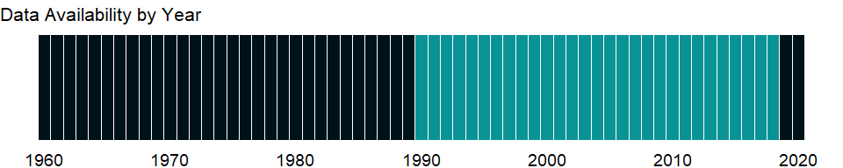

### Which countries have data?

The figure below shows the percentage of countries in each income group with a value since 2010 for that indicator.



### Why is it relevant?

NA

### What is the data source?

World Bank, Sustainable Energy for All (SE4ALL) database from the SE4ALL Global Tracking Framework led jointly by the World Bank, International Energy Agency, and the Energy Sector Management Assistance Program.

### What is the methodology?

NA

### How is it aggregated?

Weighted Average

### What are the limitations?

NA

### What else should I know?

NA

### 1.16.17 GDP per unit of energy use (PPP $ per kg of oil equivalent)

### What is the indicator?

GDP per unit of energy use is the PPP GDP per kilogram of oil equivalent of energy use. PPP GDP is gross domestic product converted to current international dollars using purchasing power parity rates based on the 2017 ICP round. An international dollar has the same purchasing power over GDP as a U.S. dollar has in the United States.

Topic: Environment: Energy production & use

Series ID: EG.GDP.PUSE.KO.PP

Copyright: Use and distribution of these data are subject to IEA terms and conditions. , <http://www.iea.org/t&c/termsandconditions>

First year with any data: 1990

Last year with any data: 2015

### What years are data available?

The figure below shows years in which data is available for at least one country. Dates shaded in black have no data, while dates shaded in green have data for at least one country



### Which countries have data?

The figure below shows the percentage of countries in each income group with a value since 2010 for that indicator.

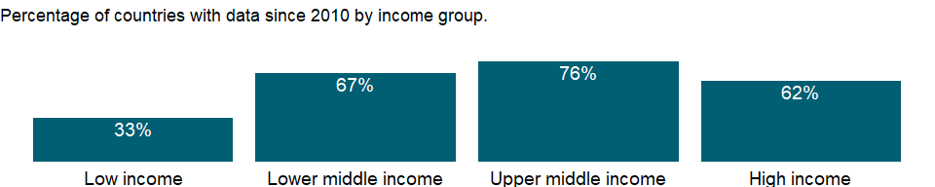

### Why is it relevant?

NA

### What is the data source?

IEA Statistics © OECD/IEA 2014 (<http://www.iea.org/stats/index.asp>), subject to <https://www.iea.org/t&c/termsandconditions/>

### What is the methodology?

NA

### How is it aggregated?

Weighted Average

### What are the limitations?

NA

### What else should I know?

Restricted use: Please contact the International Energy Agency for third-party use of these data.

### 1.16.18 GDP per unit of energy use (constant 2017 PPP $ per kg of oil equivalent)

### What is the indicator?

GDP per unit of energy use is the PPP GDP per kilogram of oil equivalent of energy use. PPP GDP is gross domestic product converted to 2017 constant international dollars using purchasing power parity rates. An international dollar has the same purchasing power over GDP as a U.S. dollar has in the United States.

Topic: Environment: Energy production & use

Series ID: EG.GDP.PUSE.KO.PP.KD

Copyright: Use and distribution of these data are subject to IEA terms and conditions. , <http://www.iea.org/t&c/termsandconditions>

First year with any data: 1990

Last year with any data: 2015

### What years are data available?

The figure below shows years in which data is available for at least one country. Dates shaded in black have no data, while dates shaded in green have data for at least one country



### Which countries have data?

The figure below shows the percentage of countries in each income group with a value since 2010 for that indicator.

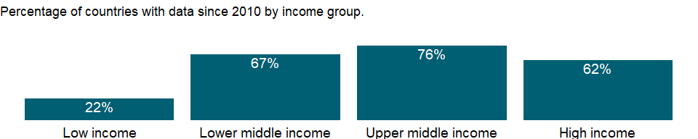

### Why is it relevant?

In developing economies growth in energy use is closely related to growth in the modern sectors - industry, motorized transport, and urban areas - but energy use also reflects climatic, geographic, and economic factors (such as the relative price of energy). Energy use has been growing rapidly in low- and middle-income economies, but high-income economies still use almost five times as much energy on a per capita basis.

Fossil fuels are non-renewable resources because they take millions of years to form, and reserves are being depleted much faster than new ones are being made. In developing economies growth in energy use is closely related to growth in the modern sectors - industry, motorized transport, and urban areas - but energy use also reflects climatic, geographic, and economic factors (such as the relative price of energy). Energy use has been growing rapidly in low- and middle-income economies, but high-income economies still use almost five times as much energy on a per capita basis.

### What is the data source?

IEA Statistics © OECD/IEA 2014 (<http://www.iea.org/stats/index.asp>), subject to <https://www.iea.org/t&c/termsandconditions/>

### What is the methodology?

The ratio of gross domestic product (GDP) to energy use indicates energy efficiency. To produce comparable and consistent estimates of real GDP across economies relative to physical inputs to GDP - that is, units of energy use - GDP is converted to 2017 international dollars using purchasing power parity (PPP) rates. Differences in this ratio over time and across economies reflect structural changes in an economy, changes in sectoral energy efficiency, and differences in fuel mixes. Total energy use refers to the use of primary energy before transformation to other end-use fuels (such as electricity and refined petroleum products). It includes energy from combustible renewables and waste - solid biomass and animal products, gas and liquid from biomass, and industrial and municipal waste. Biomass is any plant matter used directly as fuel or converted into fuel, heat, or electricity. Energy data are compiled by the International Energy Agency (IEA). IEA data for economies that are not members of the Organisation for Economic Co-operation and Development (OECD) are based on national energy data adjusted to conform to annual questionnaires completed by OECD member governments. GDP data are from World Bank’s national accounts files.

### How is it aggregated?

Weighted Average

### What are the limitations?

The IEA makes these estimates in consultation with national statistical offices, oil companies, electric utilities, and national energy experts. The IEA occasionally revises its time series to reflect political changes, and energy statistics undergo continual changes in coverage or methodology as more detailed energy accounts become available. Breaks in series are therefore unavoidable.

### What else should I know?

Restricted use: Please contact the International Energy Agency for third-party use of these data.

### 1.16.19 Energy imports, net (% of energy use)

### What is the indicator?

Net energy imports are estimated as energy use less production, both measured in oil equivalents. A negative value indicates that the country is a net exporter. Energy use refers to use of primary energy before transformation to other end-use fuels, which is equal to indigenous production plus imports and stock changes, minus exports and fuels supplied to ships and aircraft engaged in international transport.

Topic: Environment: Energy production & use

Series ID: EG.IMP.CONS.ZS

Copyright: Use and distribution of these data are subject to IEA terms and conditions. , <http://www.iea.org/t&c/termsandconditions>

First year with any data: 1960

Last year with any data: 2015

### What years are data available?

The figure below shows years in which data is available for at least one country. Dates shaded in black have no data, while dates shaded in green have data for at least one country



### Which countries have data?

The figure below shows the percentage of countries in each income group with a value since 2010 for that indicator.

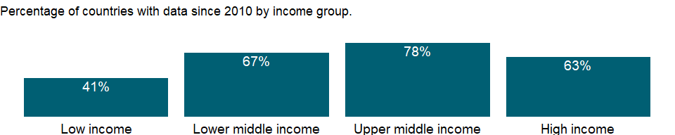

### Why is it relevant?

Modern energy services are crucial to a country’s economic development. Access to modern energy is essential for the provision of clean water, sanitation and healthcare and for the provision of reliable and efficient lighting, heating, cooking, mechanical power, and transport and telecommunications services.

Governments in many countries are increasingly aware of the urgent need to make better use of the world’s energy resources. Improved energy efficiency is often the most economic and readily available means of improving energy security and reducing greenhouse gas emissions.

### What is the data source?

IEA Statistics © OECD/IEA 2014 (<http://www.iea.org/stats/index.asp>), subject to <https://www.iea.org/t&c/termsandconditions/>

### What is the methodology?

Energy data are compiled by the International Energy Agency (IEA). IEA data for economies that are not members of the Organisation for Economic Co-operation and Development (OECD) are based on national energy data adjusted to conform to annual questionnaires completed by OECD member governments.

A negative value in energy imports indicates that the country is a net exporter. Energy use refers to use of primary energy before transformation to other end-use fuels, which is equal to indigenous production plus imports and stock changes, minus exports and fuels supplied to ships and aircraft engaged in international transport.

### How is it aggregated?

Weighted average

### What are the limitations?

The IEA makes these estimates in consultation with national statistical offices, oil companies, electric utilities, and national energy experts. The IEA occasionally revises its time series to reflect political changes, and energy statistics undergo continual changes in coverage or methodology as more detailed energy accounts become available. Breaks in series are therefore unavoidable.

### What else should I know?

Restricted use: Please contact the International Energy Agency for third-party use of these data.

### 1.16.20 Alternative and nuclear energy (% of total energy use)

### What is the indicator?

Clean energy is noncarbohydrate energy that does not produce carbon dioxide when generated. It includes hydropower and nuclear, geothermal, and solar power, among others.

Topic: Environment: Energy production & use

Series ID: EG.USE.COMM.CL.ZS

Copyright: Use and distribution of these data are subject to IEA terms and conditions. , <http://www.iea.org/t&c/termsandconditions>

First year with any data: 1960

Last year with any data: 2015

### What years are data available?

The figure below shows years in which data is available for at least one country. Dates shaded in black have no data, while dates shaded in green have data for at least one country



### Which countries have data?

The figure below shows the percentage of countries in each income group with a value since 2010 for that indicator.



### Why is it relevant?

Alternative energy is produced without the undesirable consequences of the burning of fossil fuels, such as high carbon dioxide emissions, which is considered to be the major contributing factor of global warming.

Past few decade have seen a rise in global investment in renewable energy, led by wind and solar. In transport, major car companies are adding hybrid and full-electric vehicles to their product lines and many governments have launched plans to encourage consumers to buy these vehicles Fossil fuels continue to outpace alternative and renewable energy growth. Coal has been the fastest-growing global energy source, meeting about one-half of new electricity demand.

Total energy use refers to the use of primary energy before transformation to other end-use fuels (such as electricity and refined petroleum products). It includes energy from combustible renewables and waste - solid biomass and animal products, gas and liquid from biomass, and industrial and municipal waste. Biomass is any plant matter used directly as fuel or converted into fuel, heat, or electricity.

Governments in many countries are increasingly aware of the urgent need to make better use of the world’s energy resources. Improved energy efficiency is often the most economic and readily available means of improving energy security and reducing greenhouse gas emissions.

### What is the data source?

IEA Statistics © OECD/IEA 2014 (<http://www.iea.org/stats/index.asp>), subject to <https://www.iea.org/t&c/termsandconditions/>

### What is the methodology?

Energy data are compiled by the International Energy Agency (IEA). IEA data for economies that are not members of the Organisation for Economic Co-operation and Development (OECD) are based on national energy data adjusted to conform to annual questionnaires completed by OECD member governments.

### How is it aggregated?

Weighted average

### What are the limitations?

The IEA makes these estimates in consultation with national statistical offices, oil companies, electric utilities, and national energy experts. The IEA occasionally revises its time series to reflect political changes, and energy statistics undergo continual changes in coverage or methodology as more detailed energy accounts become available. Breaks in series are therefore unavoidable.

### What else should I know?

Restricted use: Please contact the International Energy Agency for third-party use of these data.

### 1.16.21 Fossil fuel energy consumption (% of total)

### What is the indicator?

Fossil fuel comprises coal, oil, petroleum, and natural gas products.

Topic: Environment: Energy production & use

Series ID: EG.USE.COMM.FO.ZS

Copyright: Use and distribution of these data are subject to IEA terms and conditions. , <http://www.iea.org/t&c/termsandconditions>

First year with any data: 1960

Last year with any data: 2015

### What years are data available?

The figure below shows years in which data is available for at least one country. Dates shaded in black have no data, while dates shaded in green have data for at least one country



### Which countries have data?

The figure below shows the percentage of countries in each income group with a value since 2010 for that indicator.

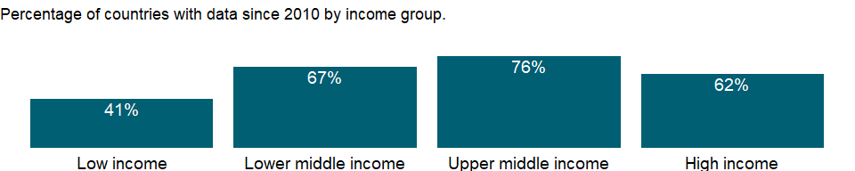

### Why is it relevant?

Fossil fuels are non-renewable resources because they take millions of years to form, and reserves are being depleted much faster than new ones are being made. In developing economies growth in energy use is closely related to growth in the modern sectors - industry, motorized transport, and urban areas - but energy use also reflects climatic, geographic, and economic factors (such as the relative price of energy). Energy use has been growing rapidly in low- and middle-income economies, but high-income economies still use almost five times as much energy on a per capita basis.

Total energy use refers to the use of primary energy before transformation to other end-use fuels (such as electricity and refined petroleum products). It includes energy from combustible renewables and waste - solid biomass and animal products, gas and liquid from biomass, and industrial and municipal waste. Biomass is any plant matter used directly as fuel or converted into fuel, heat, or electricity.

### What is the data source?

IEA Statistics © OECD/IEA 2014 (<http://www.iea.org/stats/index.asp>), subject to <https://www.iea.org/t&c/termsandconditions/>

### What is the methodology?

Energy data are compiled by the International Energy Agency (IEA). IEA data for economies that are not members of the Organisation for Economic Co-operation and Development (OECD) are based on national energy data adjusted to conform to annual questionnaires completed by OECD member governments.

Data for combustible renewables and waste are often based on small surveys or other incomplete information and thus give only a broad impression of developments and are not strictly comparable across countries. The IEA reports include country notes that explain some of these differences. All forms of energy - primary energy and primary electricity - are converted into oil equivalents. A notional thermal efficiency of 33 percent is assumed for converting nuclear electricity into oil equivalents and 100 percent efficiency for converting hydroelectric power.

### How is it aggregated?

Weighted average

### What are the limitations?

The IEA makes these estimates in consultation with national statistical offices, oil companies, electric utilities, and national energy experts. The IEA occasionally revises its time series to reflect political changes, and energy statistics undergo continual changes in coverage or methodology as more detailed energy accounts become available. Breaks in series are therefore unavoidable.

### What else should I know?

Restricted use: Please contact the International Energy Agency for third-party use of these data.

### 1.16.22 Energy use (kg of oil equivalent) per $1,000 GDP (constant 2017 PPP)

### What is the indicator?

Energy use per PPP GDP is the kilogram of oil equivalent of energy use per constant PPP GDP. Energy use refers to use of primary energy before transformation to other end-use fuels, which is equal to indigenous production plus imports and stock changes, minus exports and fuels supplied to ships and aircraft engaged in international transport. PPP GDP is gross domestic product converted to 2017 constant international dollars using purchasing power parity rates. An international dollar has the same purchasing power over GDP as a U.S. dollar has in the United States.

Topic: Environment: Energy production & use

Series ID: EG.USE.COMM.GD.PP.KD

Copyright: Use and distribution of these data are subject to IEA terms and conditions. , <http://www.iea.org/t&c/termsandconditions>

First year with any data: 1990

Last year with any data: 2015

### What years are data available?

The figure below shows years in which data is available for at least one country. Dates shaded in black have no data, while dates shaded in green have data for at least one country



### Which countries have data?

The figure below shows the percentage of countries in each income group with a value since 2010 for that indicator.



### Why is it relevant?

NA

### What is the data source?

IEA Statistics © OECD/IEA 2014 (<http://www.iea.org/stats/index.asp>), subject to <https://www.iea.org/t&c/termsandconditions/>

### What is the methodology?

NA

### How is it aggregated?

Weighted Average

### What are the limitations?

NA

### What else should I know?

Restricted use: Please contact the International Energy Agency for third-party use of these data.

### 1.16.23 Combustible renewables and waste (% of total energy)

### What is the indicator?

Combustible renewables and waste comprise solid biomass, liquid biomass, biogas, industrial waste, and municipal waste, measured as a percentage of total energy use.

Topic: Environment: Energy production & use

Series ID: EG.USE.CRNW.ZS

Copyright: Use and distribution of these data are subject to IEA terms and conditions. , <http://www.iea.org/t&c/termsandconditions>

First year with any data: 1960

Last year with any data: 2015

### What years are data available?

The figure below shows years in which data is available for at least one country. Dates shaded in black have no data, while dates shaded in green have data for at least one country



### Which countries have data?

The figure below shows the percentage of countries in each income group with a value since 2010 for that indicator.



### Why is it relevant?

Total energy use refers to the use of primary energy before transformation to other end-use fuels (such as electricity and refined petroleum products). It includes energy from combustible renewables and waste - solid biomass and animal products, gas and liquid from biomass, and industrial and municipal waste. Biomass is any plant matter used directly as fuel or converted into fuel, heat, or electricity.

Renewable energy is derived from natural processes (e.g. sunlight and wind) that are replenished at a higher rate than they are consumed. Solar, wind, geothermal, hydro, and biomass are common sources of renewable energy. Majority of renewable energy in the world is from solid biofuels and hydroelectricity.

Renewable sources of energy have been the driver of much of the growth in the global clean energy sector in the past few decades. Recent years have seen a major scale-up of wind and solar photovoltaic (PV) technologies. Other renewable technologies - including hydropower, geothermal and biomass - continued to grow from a strong established base, adding hundreds of gigawatts of new capacity worldwide.

Governments in many countries are increasingly aware of the urgent need to make better use of the world’s energy resources. Improved energy efficiency is often the most economic and readily available means of improving energy security and reducing greenhouse gas emissions.

### What is the data source?

IEA Statistics © OECD/IEA 2014 (<http://www.iea.org/stats/index.asp>), subject to <https://www.iea.org/t&c/termsandconditions/>

### What is the methodology?

Energy data are compiled by the International Energy Agency (IEA). IEA data for economies that are not members of the Organisation for Economic Co-operation and Development (OECD) are based on national energy data adjusted to conform to annual questionnaires completed by OECD member governments.

Data for combustible renewables and waste are often based on small surveys or other incomplete information and thus give only a broad impression of developments and are not strictly comparable across countries. The IEA reports include country notes that explain some of these differences. All forms of energy - primary energy and primary electricity - are converted into oil equivalents. A notional thermal efficiency of 33 percent is assumed for converting nuclear electricity into oil equivalents and 100 percent efficiency for converting hydroelectric power.

### How is it aggregated?

Weighted average

### What are the limitations?

The IEA makes these estimates in consultation with national statistical offices, oil companies, electric utilities, and national energy experts. The IEA occasionally revises its time series to reflect political changes, and energy statistics undergo continual changes in coverage or methodology as more detailed energy accounts become available. Breaks in series are therefore unavoidable.

### What else should I know?

Restricted use: Please contact the International Energy Agency for third-party use of these data.

### 1.16.24 Electric power consumption (kWh per capita)

### What is the indicator?

Electric power consumption measures the production of power plants and combined heat and power plants less transmission, distribution, and transformation losses and own use by heat and power plants.

Topic: Environment: Energy production & use

Series ID: EG.USE.ELEC.KH.PC

Copyright: Use and distribution of these data are subject to IEA terms and conditions. , <http://www.iea.org/t&c/termsandconditions>

First year with any data: 1960

Last year with any data: 2019

### What years are data available?

The figure below shows years in which data is available for at least one country. Dates shaded in black have no data, while dates shaded in green have data for at least one country



### Which countries have data?

The figure below shows the percentage of countries in each income group with a value since 2010 for that indicator.



### Why is it relevant?

An economy’s production and consumption of electricity are basic indicators of its size and level of development. Although a few countries export electric power, most production is for domestic consumption. Expanding the supply of electricity to meet the growing demand of increasingly urbanized and industrialized economies without incurring unacceptable social, economic, and environmental costs is one of the great challenges facing developing countries.

Modern societies are becoming increasing dependent on reliable and secure electricity supplies to underpin economic growth and community prosperity. This reliance is set to grow as more efficient and less carbon intensive forms of power are developed and deployed to help decarbonize economies. Maintaining reliable and secure electricity services while seeking to rapidly decarbonize power systems is a key challenge for countries throughout the world.

In developing economies growth in energy use is closely related to growth in the modern sectors - industry, motorized transport, and urban areas - but energy use also reflects climatic, geographic, and economic factors (such as the relative price of energy). Energy use has been growing rapidly in low- and middle-income economies, but high-income economies still use almost five times as much energy on a per capita basis.

Governments in many countries are increasingly aware of the urgent need to make better use of the world’s energy resources. Improved energy efficiency is often the most economic and readily available means of improving energy security and reducing greenhouse gas emissions.

### What is the data source?

IEA Statistics © OECD/IEA 2014 (<http://www.iea.org/stats/index.asp>), subject to <https://www.iea.org/t&c/termsandconditions/>

### What is the methodology?

Electric power consumption per capita (kWh ) is the production of power plants and combined heat and power plants less transmission, distribution, and transformation losses and own use by heat and power plants, divided by midyear population. Energy data are compiled by the International Energy Agency (IEA). IEA data for economies that are not members of the Organisation for Economic Co-operation and Development (OECD) are based on national energy data adjusted to conform to annual questionnaires completed by OECD member governments. Electricity consumption is equivalent to production less power plants’ own use and transmission, distribution, and transformation losses less exports plus imports. It includes consumption by auxiliary stations, losses in transformers that are considered integral parts of those stations, and electricity produced by pumping installations. Where data are available, it covers electricity generated by primary sources of energy - coal, oil, gas, nuclear, hydro, geothermal, wind, tide and wave, and combustible renewables. Neither production nor consumption data capture the reliability of supplies, including breakdowns, load factors, and frequency of outages.

### How is it aggregated?

Weighted Average

### What are the limitations?

Data on electric power production and consumption are collected from national energy agencies by the International Energy Agency (IEA) and adjusted by the IEA to meet international definitions. Data are reported as net consumption as opposed to gross consumption. Net consumption excludes the energy consumed by the generating units. For all countries except the United States, total electric power consumption is equal total net electricity generation plus electricity imports minus electricity exports minus electricity distribution losses.

The IEA makes these estimates in consultation with national statistical offices, oil companies, electric utilities, and national energy experts. The IEA occasionally revises its time series to reflect political changes, and energy statistics undergo continual changes in coverage or methodology as more detailed energy accounts become available. Breaks in series are therefore unavoidable.

### What else should I know?

Restricted use: Please contact the International Energy Agency for third-party use of these data.

### 1.16.25 Energy use (kg of oil equivalent per capita)

### What is the indicator?

Energy use refers to use of primary energy before transformation to other end-use fuels, which is equal to indigenous production plus imports and stock changes, minus exports and fuels supplied to ships and aircraft engaged in international transport.

Topic: Environment: Energy production & use

Series ID: EG.USE.PCAP.KG.OE

Copyright: Use and distribution of these data are subject to IEA terms and conditions. , <http://www.iea.org/t&c/termsandconditions>

First year with any data: 1960

Last year with any data: 2015

### What years are data available?

The figure below shows years in which data is available for at least one country. Dates shaded in black have no data, while dates shaded in green have data for at least one country



### Which countries have data?

The figure below shows the percentage of countries in each income group with a value since 2010 for that indicator.



### Why is it relevant?

In developing economies growth in energy use is closely related to growth in the modern sectors - industry, motorized transport, and urban areas - but energy use also reflects climatic, geographic, and economic factors (such as the relative price of energy). Energy use has been growing rapidly in low- and middle-income economies, but high-income economies still use almost five times as much energy on a per capita basis.

Governments in many countries are increasingly aware of the urgent need to make better use of the world’s energy resources. Improved energy efficiency is often the most economic and readily available means of improving energy security and reducing greenhouse gas emissions.

### What is the data source?

IEA Statistics © OECD/IEA 2014 (<http://www.iea.org/stats/index.asp>), subject to <https://www.iea.org/t&c/termsandconditions/>

### What is the methodology?

Total energy use refers to the use of primary energy before transformation to other end-use fuels (such as electricity and refined petroleum products). It includes energy from combustible renewables and waste - solid biomass and animal products, gas and liquid from biomass, and industrial and municipal waste. Biomass is any plant matter used directly as fuel or converted into fuel, heat, or electricity. World Bank population estimates are used to calculate per capita data.

Energy data are compiled by the International Energy Agency (IEA). IEA data for economies that are not members of the Organisation for Economic Co-operation and Development (OECD) are based on national energy data adjusted to conform to annual questionnaires completed by OECD member governments.

Data for combustible renewables and waste are often based on small surveys or other incomplete information and thus give only a broad impression of developments and are not strictly comparable across countries. The IEA reports include country notes that explain some of these differences. All forms of energy - primary energy and primary electricity - are converted into oil equivalents. A notional thermal efficiency of 33 percent is assumed for converting nuclear electricity into oil equivalents and 100 percent efficiency for converting hydroelectric power.

### How is it aggregated?

Weighted Average

### What are the limitations?

The IEA makes these estimates in consultation with national statistical offices, oil companies, electric utilities, and national energy experts. The IEA occasionally revises its time series to reflect political changes, and energy statistics undergo continual changes in coverage or methodology as more detailed energy accounts become available. Breaks in series are therefore unavoidable.

### What else should I know?

Restricted use: Please contact the International Energy Agency for third-party use of these data.

## 1.17 Environment: Emissions

### 1.17.1 CO2 intensity (kg per kg of oil equivalent energy use)

### What is the indicator?

Carbon dioxide emissions from solid fuel consumption refer mainly to emissions from use of coal as an energy source.

Topic: Environment: Emissions

Series ID: EN.ATM.CO2E.EG.ZS

Copyright: CC BY-4.0 , <https://datacatalog.worldbank.org/public-licenses#cc-by>

First year with any data: 1960

Last year with any data: 2015

### What years are data available?

The figure below shows years in which data is available for at least one country. Dates shaded in black have no data, while dates shaded in green have data for at least one country



### Which countries have data?

The figure below shows the percentage of countries in each income group with a value since 2010 for that indicator.

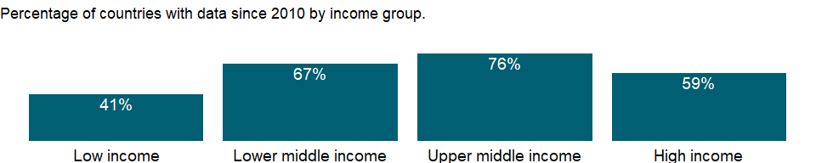

### Why is it relevant?

Carbon dioxide (CO2) is naturally occurring gas fixed by photosynthesis into organic matter. A byproduct of fossil fuel combustion and biomass burning, it is also emitted from land use changes and other industrial processes. It is the principal anthropogenic greenhouse gas that affects the Earth’s radiative balance. It is the reference gas against which other greenhouse gases are measured, thus having a Global Warming Potential of 1.

Burning of carbon-based fuels since the industrial revolution has rapidly increased concentrations of atmospheric carbon dioxide, increasing the rate of global warming and causing anthropogenic climate change. It is also a major source of ocean acidification since it dissolves in water to form carbonic acid.

The addition of man-made greenhouse gases to the Atmosphere disturbs the earth’s radiative balance. This is leading to an increase in the earth’s surface temperature and to related effects on climate, sea level rise and world agriculture. Emissions of CO2 are from burning oil, coal and gas for energy use, burning wood and waste materials, and from industrial processes such as cement production.

The carbon dioxide emissions of a country are only an indicator of one greenhouse gas. For a more complete idea of how a country influences climate change, gases such as methane and nitrous oxide should be taken into account. This is particularly important in agricultural economies.

The environmental effects of carbon dioxide are of significant interest. Carbon dioxide (CO2) makes up the largest share of the greenhouse gases contributing to global warming and climate change. Converting all other greenhouse gases (methane (CH4), nitrous oxide (N2O), hydrofluorocarbons (HFCs), perfluorocarbons (PFCs), sulphur hexafluoride (SF6)) to carbon dioxide (or CO2) equivalents makes it possible to compare them and to determine their individual and total contributions to global warming. The Kyoto Protocol, an environmental agreement adopted in 1997 by many of the parties to the United Nations Framework Convention on Climate Change (UNFCCC), is working towards curbing CO2 emissions globally.

### What is the data source?

Carbon Dioxide Information Analysis Center, Environmental Sciences Division, Oak Ridge National Laboratory, Tennessee, United States.

### What is the methodology?

Carbon intensity is the ratio of carbon dioxide per unit of energy, or the amount of carbon dioxide emitted as a result of using one unit of energy in production. Emission intensities are also used to compare the environmental impact of different fuels or activities. The related terms - emission factor and carbon intensity - are often used interchangeably.

Carbon dioxide emissions, largely by-products of energy production and use, account for the largest share of greenhouse gases, which are associated with global warming. Anthropogenic carbon dioxide emissions result primarily from fossil fuel combustion and cement manufacturing. In combustion different fossil fuels release different amounts of carbon dioxide for the same level of energy use: oil releases about 50 percent more carbon dioxide than natural gas, and coal releases about twice as much. Cement manufacturing releases about half a metric ton of carbon dioxide for each metric ton of cement produced. Carbon dioxide emissions are often calculated and reported as elemental carbon. The values were converted to actual carbon dioxide mass by multiplying them by 3.667 (the ratio of the mass of carbon to that of carbon dioxide).

### How is it aggregated?

Weighted average

### What are the limitations?

The U.S. Department of Energy’s Carbon Dioxide Information Analysis Center (CDIAC) calculates annual anthropogenic emissions from data on fossil fuel consumption (from the United Nations Statistics Division’s World Energy Data Set) and world cement manufacturing (from the U.S. Department of Interior’s Geological Survey, USGS 2011). Although estimates of global carbon dioxide emissions are probably accurate within 10 percent (as calculated from global average fuel chemistry and use), country estimates may have larger error bounds. Trends estimated from a consistent time series tend to be more accurate than individual values.

Each year the CDIAC recalculates the entire time series since 1949, incorporating recent findings and corrections. Estimates exclude fuels supplied to ships and aircraft in international transport because of the difficulty of apportioning the fuels among benefiting countries.

Data for carbon dioxide emissions include gases from the burning of fossil fuels and cement manufacture, but excludes emissions from land use such as deforestation.

### What else should I know?

NA

### 1.17.2 CO2 emissions from gaseous fuel consumption (kt)

### What is the indicator?

Carbon dioxide emissions from liquid fuel consumption refer mainly to emissions from use of natural gas as an energy source.

Topic: Environment: Emissions

Series ID: EN.ATM.CO2E.GF.KT

Copyright: CC BY-4.0 , <https://datacatalog.worldbank.org/public-licenses#cc-by>

First year with any data: 1960

Last year with any data: 2016

### What years are data available?

The figure below shows years in which data is available for at least one country. Dates shaded in black have no data, while dates shaded in green have data for at least one country



### Which countries have data?

The figure below shows the percentage of countries in each income group with a value since 2010 for that indicator.

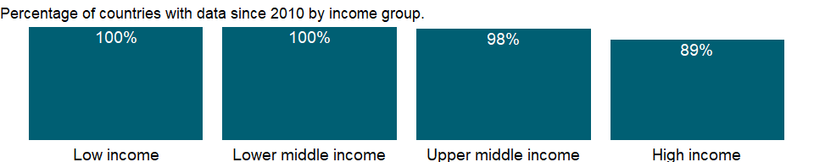

### Why is it relevant?

Carbon dioxide (CO2) is naturally occurring gas fixed by photosynthesis into organic matter. A byproduct of fossil fuel combustion and biomass burning, it is also emitted from land use changes and other industrial processes. It is the principal anthropogenic greenhouse gas that affects the Earth’s radiative balance. It is the reference gas against which other greenhouse gases are measured, thus having a Global Warming Potential of 1.

An emission intensity is the average emission rate of a given pollutant from a given source relative to the intensity of a specific activity. Emission intensities are also used to compare the environmental impact of different fuels or activities. The related terms - emission factor and carbon intensity - are often used interchangeably.

Burning of carbon-based fuels since the industrial revolution has rapidly increased concentrations of atmospheric carbon dioxide, increasing the rate of global warming and causing anthropogenic climate change. It is also a major source of ocean acidification since it dissolves in water to form carbonic acid.

The addition of man-made greenhouse gases to the Atmosphere disturbs the earth’s radiative balance. This is leading to an increase in the earth’s surface temperature and to related effects on climate, sea level rise and world agriculture. Emissions of CO2 are from burning oil, coal and gas for energy use, burning wood and waste materials, and from industrial processes such as cement production.

The carbon dioxide emissions of a country are only an indicator of one greenhouse gas. For a more complete idea of how a country influences climate change, gases such as methane and nitrous oxide should be taken into account. This is particularly important in agricultural economies.

The environmental effects of carbon dioxide are of significant interest. Carbon dioxide (CO2) makes up the largest share of the greenhouse gases contributing to global warming and climate change. Converting all other greenhouse gases (methane (CH4), nitrous oxide (N2O), hydrofluorocarbons (HFCs), perfluorocarbons (PFCs), sulphur hexafluoride (SF6)) to carbon dioxide (or CO2) equivalents makes it possible to compare them and to determine their individual and total contributions to global warming. The Kyoto Protocol, an environmental agreement adopted in 1997 by many of the parties to the United Nations Framework Convention on Climate Change (UNFCCC), is working towards curbing CO2 emissions globally.

### What is the data source?

Carbon Dioxide Information Analysis Center, Environmental Sciences Division, Oak Ridge National Laboratory, Tennessee, United States.

### What is the methodology?

Carbon dioxide emissions, largely by-products of energy production and use, account for the largest share of greenhouse gases, which are associated with global warming. Anthropogenic carbon dioxide emissions result primarily from fossil fuel combustion and cement manufacturing. In combustion different fossil fuels release different amounts of carbon dioxide for the same level of energy use: oil releases about 50 percent more carbon dioxide than natural gas, and coal releases about twice as much. Cement manufacturing releases about half a metric ton of carbon dioxide for each metric ton of cement produced. Data for carbon dioxide emissions include gases from the burning of fossil fuels and cement manufacture, but excludes emissions from land use such as deforestation. Carbon dioxide emissions are often calculated and reported as elemental carbon. The values were converted to actual carbon dioxide mass by multiplying them by 3.667 (the ratio of the mass of carbon to that of carbon dioxide).

### How is it aggregated?

Gap-filled total

### What are the limitations?

The U.S. Department of Energy’s Carbon Dioxide Information Analysis Center (CDIAC) calculates annual anthropogenic emissions from data on fossil fuel consumption (from the United Nations Statistics Division’s World Energy Data Set) and world cement manufacturing (from the U.S. Department of Interior’s Geological Survey, USGS 2011). Although estimates of global carbon dioxide emissions are probably accurate within 10 percent (as calculated from global average fuel chemistry and use), country estimates may have larger error bounds. Trends estimated from a consistent time series tend to be more accurate than individual values.

Each year the CDIAC recalculates the entire time series since 1949, incorporating recent findings and corrections. Estimates exclude fuels supplied to ships and aircraft in international transport because of the difficulty of apportioning the fuels among benefiting countries.

### What else should I know?

NA

### 1.17.3 CO2 emissions from gaseous fuel consumption (% of total)

### What is the indicator?

Carbon dioxide emissions from liquid fuel consumption refer mainly to emissions from use of natural gas as an energy source.

Topic: Environment: Emissions

Series ID: EN.ATM.CO2E.GF.ZS

Copyright: CC BY-4.0 , <https://datacatalog.worldbank.org/public-licenses#cc-by>

First year with any data: 1960

Last year with any data: 2016

### What years are data available?

The figure below shows years in which data is available for at least one country. Dates shaded in black have no data, while dates shaded in green have data for at least one country



### Which countries have data?

The figure below shows the percentage of countries in each income group with a value since 2010 for that indicator.

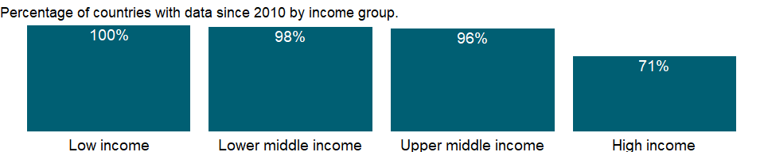

### Why is it relevant?

Carbon dioxide (CO2) is naturally occurring gas fixed by photosynthesis into organic matter. A byproduct of fossil fuel combustion and biomass burning, it is also emitted from land use changes and other industrial processes. It is the principal anthropogenic greenhouse gas that affects the Earth’s radiative balance. It is the reference gas against which other greenhouse gases are measured, thus having a Global Warming Potential of 1.

An emission intensity is the average emission rate of a given pollutant from a given source relative to the intensity of a specific activity. Emission intensities are also used to compare the environmental impact of different fuels or activities. The related terms - emission factor and carbon intensity - are often used interchangeably.

Burning of carbon-based fuels since the industrial revolution has rapidly increased concentrations of atmospheric carbon dioxide, increasing the rate of global warming and causing anthropogenic climate change. It is also a major source of ocean acidification since it dissolves in water to form carbonic acid.

The addition of man-made greenhouse gases to the Atmosphere disturbs the earth’s radiative balance. This is leading to an increase in the earth’s surface temperature and to related effects on climate, sea level rise and world agriculture. Emissions of CO2 are from burning oil, coal and gas for energy use, burning wood and waste materials, and from industrial processes such as cement production.

The carbon dioxide emissions of a country are only an indicator of one greenhouse gas. For a more complete idea of how a country influences climate change, gases such as methane and nitrous oxide should be taken into account. This is particularly important in agricultural economies.

The environmental effects of carbon dioxide are of significant interest. Carbon dioxide (CO2) makes up the largest share of the greenhouse gases contributing to global warming and climate change. Converting all other greenhouse gases (methane (CH4), nitrous oxide (N2O), hydrofluorocarbons (HFCs), perfluorocarbons (PFCs), sulphur hexafluoride (SF6)) to carbon dioxide (or CO2) equivalents makes it possible to compare them and to determine their individual and total contributions to global warming. The Kyoto Protocol, an environmental agreement adopted in 1997 by many of the parties to the United Nations Framework Convention on Climate Change (UNFCCC), is working towards curbing CO2 emissions globally.

### What is the data source?

Carbon Dioxide Information Analysis Center, Environmental Sciences Division, Oak Ridge National Laboratory, Tennessee, United States.

### What is the methodology?

Carbon dioxide emissions, largely by-products of energy production and use, account for the largest share of greenhouse gases, which are associated with global warming. Anthropogenic carbon dioxide emissions result primarily from fossil fuel combustion and cement manufacturing. In combustion different fossil fuels release different amounts of carbon dioxide for the same level of energy use: oil releases about 50 percent more carbon dioxide than natural gas, and coal releases about twice as much. Cement manufacturing releases about half a metric ton of carbon dioxide for each metric ton of cement produced. Data for carbon dioxide emissions include gases from the burning of fossil fuels and cement manufacture, but excludes emissions from land use such as deforestation. Carbon dioxide emissions are often calculated and reported as elemental carbon. The values were converted to actual carbon dioxide mass by multiplying them by 3.667 (the ratio of the mass of carbon to that of carbon dioxide).

### How is it aggregated?

Weighted Average

### What are the limitations?

The U.S. Department of Energy’s Carbon Dioxide Information Analysis Center (CDIAC) calculates annual anthropogenic emissions from data on fossil fuel consumption (from the United Nations Statistics Division’s World Energy Data Set) and world cement manufacturing (from the U.S. Department of Interior’s Geological Survey, USGS 2011). Although estimates of global carbon dioxide emissions are probably accurate within 10 percent (as calculated from global average fuel chemistry and use), country estimates may have larger error bounds. Trends estimated from a consistent time series tend to be more accurate than individual values.

Each year the CDIAC recalculates the entire time series since 1949, incorporating recent findings and corrections. Estimates exclude fuels supplied to ships and aircraft in international transport because of the difficulty of apportioning the fuels among benefiting countries.

### What else should I know?

NA

### 1.17.4 CO2 emissions (kg per 2010 US$ of GDP)

### What is the indicator?

Carbon dioxide emissions are those stemming from the burning of fossil fuels and the manufacture of cement. They include carbon dioxide produced during consumption of solid, liquid, and gas fuels and gas flaring.

Topic: Environment: Emissions

Series ID: EN.ATM.CO2E.KD.GD

Copyright: CC BY-4.0 , <https://datacatalog.worldbank.org/public-licenses#cc-by>

First year with any data: 1960

Last year with any data: 2018

### What years are data available?

The figure below shows years in which data is available for at least one country. Dates shaded in black have no data, while dates shaded in green have data for at least one country



### Which countries have data?

The figure below shows the percentage of countries in each income group with a value since 2010 for that indicator.

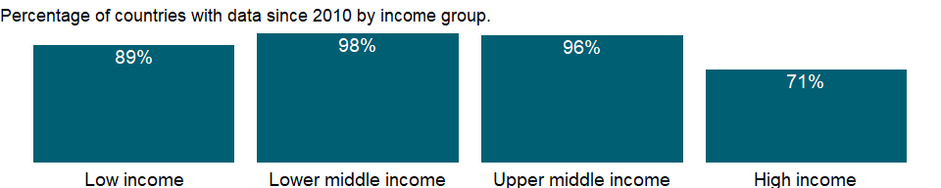

### Why is it relevant?

NA

### What is the data source?

Data for up to 1990 are sourced from Carbon Dioxide Information Analysis Center, Environmental Sciences Division, Oak Ridge National Laboratory, Tennessee, United States. Data from 1990 are CAIT data: Climate Watch. 2020. GHG Emissions. Washington, DC: World Resources Institute. Available at: <https://www.climatewatchdata.org/ghg-emissions>. See NY.GDP.MKTP.KD for the denominator’s source.

### What is the methodology?

NA

### How is it aggregated?

Weighted Average

### What are the limitations?

NA

### What else should I know?

NA

### 1.17.5 Total CO2 emissions (thousand metric tons of CO2 excluding Land-Use Change and Forestry)

### What is the indicator?

Carbon dioxide emissions are those stemming from the burning of fossil fuels and the manufacture of cement. They include carbon dioxide produced during consumption of solid, liquid, and gas fuels and gas flaring.

Topic: Environment: Emissions

Series ID: EN.ATM.CO2E.KT

Copyright: CC BY-4.0 , <https://datacatalog.worldbank.org/public-licenses#cc-by>

First year with any data: 1960

Last year with any data: 2018

### What years are data available?

The figure below shows years in which data is available for at least one country. Dates shaded in black have no data, while dates shaded in green have data for at least one country



### Which countries have data?

The figure below shows the percentage of countries in each income group with a value since 2010 for that indicator.



### Why is it relevant?

Carbon dioxide (CO2) is naturally occurring gas fixed by photosynthesis into organic matter. A byproduct of fossil fuel combustion and biomass burning, it is also emitted from land use changes and other industrial processes. It is the principal anthropogenic greenhouse gas that affects the Earth’s radiative balance. It is the reference gas against which other greenhouse gases are measured, thus having a Global Warming Potential of 1.

Burning of carbon-based fuels since the industrial revolution has rapidly increased concentrations of atmospheric carbon dioxide, increasing the rate of global warming and causing anthropogenic climate change. It is also a major source of ocean acidification since it dissolves in water to form carbonic acid.

The addition of man-made greenhouse gases to the Atmosphere disturbs the earth’s radiative balance. This is leading to an increase in the earth’s surface temperature and to related effects on climate, sea level rise and world agriculture. Emissions of CO2 are from burning oil, coal and gas for energy use, burning wood and waste materials, and from industrial processes such as cement production.

Emission intensity is the average emission rate of a given pollutant from a given source relative to the intensity of a specific activity. Emission intensities are also used to compare the environmental impact of different fuels or activities. The related terms - emission factor and carbon intensity - are often used interchangeably.

The carbon dioxide emissions of a country are only an indicator of one greenhouse gas. For a more complete idea of how a country influences climate change, gases such as methane and nitrous oxide should be taken into account. This is particularly important in agricultural economies.

The environmental effects of carbon dioxide are of significant interest. Carbon dioxide (CO2) makes up the largest share of the greenhouse gases contributing to global warming and climate change. Converting all other greenhouse gases (methane (CH4), nitrous oxide (N2O), hydrofluorocarbons (HFCs), perfluorocarbons (PFCs), sulphur hexafluoride (SF6)) to carbon dioxide (or CO2) equivalents makes it possible to compare them and to determine their individual and total contributions to global warming. The Kyoto Protocol, an environmental agreement adopted in 1997 by many of the parties to the United Nations Framework Convention on Climate Change (UNFCCC), is working towards curbing CO2 emissions globally.

### What is the data source?

Data for up to 1990 are sourced from Carbon Dioxide Information Analysis Center, Environmental Sciences Division, Oak Ridge National Laboratory, Tennessee, United States. Data from 1990 are CAIT data: Climate Watch. 2020. GHG Emissions. Washington, DC: World Resources Institute. Available at: <https://www.climatewatchdata.org/ghg-emissions>.

### What is the methodology?

Carbon dioxide emissions, largely by-products of energy production and use, account for the largest share of greenhouse gases, which are associated with global warming. Anthropogenic carbon dioxide emissions result primarily from fossil fuel combustion and cement manufacturing. In combustion different fossil fuels release different amounts of carbon dioxide for the same level of energy use: oil releases about 50 percent more carbon dioxide than natural gas, and coal releases about twice as much. Cement manufacturing releases about half a metric ton of carbon dioxide for each metric ton of cement produced. Data for carbon dioxide emissions include gases from the burning of fossil fuels and cement manufacture, but excludes emissions from land use such as deforestation. The unit of measurement is kt (kiloton). Carbon dioxide emissions are often calculated and reported as elemental carbon. The were converted to actual carbon dioxide mass by multiplying them by 3.667 (the ratio of the mass of carbon to that of carbon dioxide).

### How is it aggregated?

Gap-filled total

### What are the limitations?

The U.S. Department of Energy’s Carbon Dioxide Information Analysis Center (CDIAC) calculates annual anthropogenic emissions from data on fossil fuel consumption (from the United Nations Statistics Division’s World Energy Data Set) and world cement manufacturing (from the U.S. Department of Interior’s Geological Survey, USGS 2011). Although estimates of global carbon dioxide emissions are probably accurate within 10 percent (as calculated from global average fuel chemistry and use), country estimates may have larger error bounds. Trends estimated from a consistent time series tend to be more accurate than individual values.

Each year the CDIAC recalculates the entire time series since 1949, incorporating recent findings and corrections. Estimates exclude fuels supplied to ships and aircraft in international transport because of the difficulty of apportioning the fuels among benefiting countries.

### What else should I know?

NA

### 1.17.6 CO2 emissions from liquid fuel consumption (kt)

### What is the indicator?

Carbon dioxide emissions from liquid fuel consumption refer mainly to emissions from use of petroleum-derived fuels as an energy source.

Topic: Environment: Emissions

Series ID: EN.ATM.CO2E.LF.KT

Copyright: CC BY-4.0 , <https://datacatalog.worldbank.org/public-licenses#cc-by>

First year with any data: 1960

Last year with any data: 2016

### What years are data available?

The figure below shows years in which data is available for at least one country. Dates shaded in black have no data, while dates shaded in green have data for at least one country



### Which countries have data?

The figure below shows the percentage of countries in each income group with a value since 2010 for that indicator.



### Why is it relevant?

Carbon dioxide (CO2) is naturally occurring gas fixed by photosynthesis into organic matter. A byproduct of fossil fuel combustion and biomass burning, it is also emitted from land use changes and other industrial processes. It is the principal anthropogenic greenhouse gas that affects the Earth’s radiative balance. It is the reference gas against which other greenhouse gases are measured, thus having a Global Warming Potential of 1.

An emission intensity is the average emission rate of a given pollutant from a given source relative to the intensity of a specific activity. Emission intensities are also used to compare the environmental impact of different fuels or activities. The related terms - emission factor and carbon intensity - are often used interchangeably.

Burning of carbon-based fuels since the industrial revolution has rapidly increased concentrations of atmospheric carbon dioxide, increasing the rate of global warming and causing anthropogenic climate change. It is also a major source of ocean acidification since it dissolves in water to form carbonic acid.

The addition of man-made greenhouse gases to the Atmosphere disturbs the earth’s radiative balance. This is leading to an increase in the earth’s surface temperature and to related effects on climate, sea level rise and world agriculture. Emissions of CO2 are from burning oil, coal and gas for energy use, burning wood and waste materials, and from industrial processes such as cement production.

The carbon dioxide emissions of a country are only an indicator of one greenhouse gas. For a more complete idea of how a country influences climate change, gases such as methane and nitrous oxide should be taken into account. This is particularly important in agricultural economies.

The environmental effects of carbon dioxide are of significant interest. Carbon dioxide (CO2) makes up the largest share of the greenhouse gases contributing to global warming and climate change. Converting all other greenhouse gases (methane (CH4), nitrous oxide (N2O), hydrofluorocarbons (HFCs), perfluorocarbons (PFCs), sulphur hexafluoride (SF6)) to carbon dioxide (or CO2) equivalents makes it possible to compare them and to determine their individual and total contributions to global warming. The Kyoto Protocol, an environmental agreement adopted in 1997 by many of the parties to the United Nations Framework Convention on Climate Change (UNFCCC), is working towards curbing CO2 emissions globally.

### What is the data source?

Carbon Dioxide Information Analysis Center, Environmental Sciences Division, Oak Ridge National Laboratory, Tennessee, United States.

### What is the methodology?

Carbon dioxide emissions, largely by-products of energy production and use, account for the largest share of greenhouse gases, which are associated with global warming. Anthropogenic carbon dioxide emissions result primarily from fossil fuel combustion and cement manufacturing. In combustion different fossil fuels release different amounts of carbon dioxide for the same level of energy use: oil releases about 50 percent more carbon dioxide than natural gas, and coal releases about twice as much. Cement manufacturing releases about half a metric ton of carbon dioxide for each metric ton of cement produced. Data for carbon dioxide emissions include gases from the burning of fossil fuels and cement manufacture, but excludes emissions from land use such as deforestation. Carbon dioxide emissions are often calculated and reported as elemental carbon. The values were converted to actual carbon dioxide mass by multiplying them by 3.667 (the ratio of the mass of carbon to that of carbon dioxide).

### How is it aggregated?

Gap-filled total

### What are the limitations?

The U.S. Department of Energy’s Carbon Dioxide Information Analysis Center (CDIAC) calculates annual anthropogenic emissions from data on fossil fuel consumption (from the United Nations Statistics Division’s World Energy Data Set) and world cement manufacturing (from the U.S. Department of Interior’s Geological Survey, USGS 2011). Although estimates of global carbon dioxide emissions are probably accurate within 10 percent (as calculated from global average fuel chemistry and use), country estimates may have larger error bounds. Trends estimated from a consistent time series tend to be more accurate than individual values.

Each year the CDIAC recalculates the entire time series since 1949, incorporating recent findings and corrections. Estimates exclude fuels supplied to ships and aircraft in international transport because of the difficulty of apportioning the fuels among benefiting countries.

### What else should I know?

NA

### 1.17.7 CO2 emissions from liquid fuel consumption (% of total)

### What is the indicator?

Carbon dioxide emissions from liquid fuel consumption refer mainly to emissions from use of petroleum-derived fuels as an energy source.

Topic: Environment: Emissions

Series ID: EN.ATM.CO2E.LF.ZS

Copyright: CC BY-4.0 , <https://datacatalog.worldbank.org/public-licenses#cc-by>

First year with any data: 1960

Last year with any data: 2016

### What years are data available?

The figure below shows years in which data is available for at least one country. Dates shaded in black have no data, while dates shaded in green have data for at least one country



### Which countries have data?

The figure below shows the percentage of countries in each income group with a value since 2010 for that indicator.



### Why is it relevant?

Carbon dioxide (CO2) is naturally occurring gas fixed by photosynthesis into organic matter. A byproduct of fossil fuel combustion and biomass burning, it is also emitted from land use changes and other industrial processes. It is the principal anthropogenic greenhouse gas that affects the Earth’s radiative balance. It is the reference gas against which other greenhouse gases are measured, thus having a Global Warming Potential of 1.

An emission intensity is the average emission rate of a given pollutant from a given source relative to the intensity of a specific activity. Emission intensities are also used to compare the environmental impact of different fuels or activities. The related terms - emission factor and carbon intensity - are often used interchangeably.

Burning of carbon-based fuels since the industrial revolution has rapidly increased concentrations of atmospheric carbon dioxide, increasing the rate of global warming and causing anthropogenic climate change. It is also a major source of ocean acidification since it dissolves in water to form carbonic acid.

The addition of man-made greenhouse gases to the Atmosphere disturbs the earth’s radiative balance. This is leading to an increase in the earth’s surface temperature and to related effects on climate, sea level rise and world agriculture. Emissions of CO2 are from burning oil, coal and gas for energy use, burning wood and waste materials, and from industrial processes such as cement production.

The carbon dioxide emissions of a country are only an indicator of one greenhouse gas. For a more complete idea of how a country influences climate change, gases such as methane and nitrous oxide should be taken into account. This is particularly important in agricultural economies.

The environmental effects of carbon dioxide are of significant interest. Carbon dioxide (CO2) makes up the largest share of the greenhouse gases contributing to global warming and climate change. Converting all other greenhouse gases (methane (CH4), nitrous oxide (N2O), hydrofluorocarbons (HFCs), perfluorocarbons (PFCs), sulphur hexafluoride (SF6)) to carbon dioxide (or CO2) equivalents makes it possible to compare them and to determine their individual and total contributions to global warming. The Kyoto Protocol, an environmental agreement adopted in 1997 by many of the parties to the United Nations Framework Convention on Climate Change (UNFCCC), is working towards curbing CO2 emissions globally.

### What is the data source?

Carbon Dioxide Information Analysis Center, Environmental Sciences Division, Oak Ridge National Laboratory, Tennessee, United States.

### What is the methodology?

Carbon dioxide emissions, largely by-products of energy production and use, account for the largest share of greenhouse gases, which are associated with global warming. Anthropogenic carbon dioxide emissions result primarily from fossil fuel combustion and cement manufacturing. In combustion different fossil fuels release different amounts of carbon dioxide for the same level of energy use: oil releases about 50 percent more carbon dioxide than natural gas, and coal releases about twice as much. Cement manufacturing releases about half a metric ton of carbon dioxide for each metric ton of cement produced. Data for carbon dioxide emissions include gases from the burning of fossil fuels and cement manufacture, but excludes emissions from land use such as deforestation. Carbon dioxide emissions are often calculated and reported as elemental carbon. The values were converted to actual carbon dioxide mass by multiplying them by 3.667 (the ratio of the mass of carbon to that of carbon dioxide).

### How is it aggregated?

Weighted Average

### What are the limitations?

The U.S. Department of Energy’s Carbon Dioxide Information Analysis Center (CDIAC) calculates annual anthropogenic emissions from data on fossil fuel consumption (from the United Nations Statistics Division’s World Energy Data Set) and world cement manufacturing (from the U.S. Department of Interior’s Geological Survey, USGS 2011). Although estimates of global carbon dioxide emissions are probably accurate within 10 percent (as calculated from global average fuel chemistry and use), country estimates may have larger error bounds. Trends estimated from a consistent time series tend to be more accurate than individual values.

Each year the CDIAC recalculates the entire time series since 1949, incorporating recent findings and corrections. Estimates exclude fuels supplied to ships and aircraft in international transport because of the difficulty of apportioning the fuels among benefiting countries.

### What else should I know?

NA

### 1.17.8 CO2 emissions (metric tons per capita)

### What is the indicator?

Carbon dioxide emissions are those stemming from the burning of fossil fuels and the manufacture of cement. They include carbon dioxide produced during consumption of solid, liquid, and gas fuels and gas flaring.

Topic: Environment: Emissions

Series ID: EN.ATM.CO2E.PC

Copyright: CC BY-4.0 , <https://datacatalog.worldbank.org/public-licenses#cc-by>

First year with any data: 1960

Last year with any data: 2018

### What years are data available?

The figure below shows years in which data is available for at least one country. Dates shaded in black have no data, while dates shaded in green have data for at least one country



### Which countries have data?

The figure below shows the percentage of countries in each income group with a value since 2010 for that indicator.



### Why is it relevant?

Carbon dioxide (CO2) is naturally occurring gas fixed by photosynthesis into organic matter. A byproduct of fossil fuel combustion and biomass burning, it is also emitted from land use changes and other industrial processes. It is the principal anthropogenic greenhouse gas that affects the Earth’s radiative balance. It is the reference gas against which other greenhouse gases are measured, thus having a Global Warming Potential of 1.

Burning of carbon-based fuels since the industrial revolution has rapidly increased concentrations of atmospheric carbon dioxide, increasing the rate of global warming and causing anthropogenic climate change. It is also a major source of ocean acidification since it dissolves in water to form carbonic acid.

The addition of man-made greenhouse gases to the Atmosphere disturbs the earth’s radiative balance. This is leading to an increase in the earth’s surface temperature and to related effects on climate, sea level rise and world agriculture. Emissions of CO2 are from burning oil, coal and gas for energy use, burning wood and waste materials, and from industrial processes such as cement production.

The carbon dioxide emissions of a country are only an indicator of one greenhouse gas. For a more complete idea of how a country influences climate change, gases such as methane and nitrous oxide should be taken into account. This is particularly important in agricultural economies.

Emission intensity is the average emission rate of a given pollutant from a given source relative to the intensity of a specific activity. Emission intensities are also used to compare the environmental impact of different fuels or activities. The related terms - emission factor and carbon intensity - are often used interchangeably.

The environmental effects of carbon dioxide are of significant interest. Carbon dioxide (CO2) makes up the largest share of the greenhouse gases contributing to global warming and climate change. Converting all other greenhouse gases (methane (CH4), nitrous oxide (N2O), hydrofluorocarbons (HFCs), perfluorocarbons (PFCs), sulphur hexafluoride (SF6)) to carbon dioxide (or CO2) equivalents makes it possible to compare them and to determine their individual and total contributions to global warming. The Kyoto Protocol, an environmental agreement adopted in 1997 by many of the parties to the United Nations Framework Convention on Climate Change (UNFCCC), is working towards curbing CO2 emissions globally.

### What is the data source?

Data for up to 1990 are sourced from Carbon Dioxide Information Analysis Center, Environmental Sciences Division, Oak Ridge National Laboratory, Tennessee, United States. Data from 1990 are CAIT data: Climate Watch. 2020. GHG Emissions. Washington, DC: World Resources Institute. Available at: <https://www.climatewatchdata.org/ghg-emissions>. See SP.POP.TOTL for the denominator’s source.

### What is the methodology?

Carbon dioxide emissions, largely by-products of energy production and use, account for the largest share of greenhouse gases, which are associated with global warming. Anthropogenic carbon dioxide emissions result primarily from fossil fuel combustion and cement manufacturing. In combustion different fossil fuels release different amounts of carbon dioxide for the same level of energy use: oil releases about 50 percent more carbon dioxide than natural gas, and coal releases about twice as much. Cement manufacturing releases about half a metric ton of carbon dioxide for each metric ton of cement produced. Data for carbon dioxide emissions include gases from the burning of fossil fuels and cement manufacture, but excludes emissions from land use such as deforestation.

### How is it aggregated?

Weighted Average

### What are the limitations?

The U.S. Department of Energy’s Carbon Dioxide Information Analysis Center (CDIAC) calculates annual anthropogenic emissions from data on fossil fuel consumption (from the United Nations Statistics Division’s World Energy Data Set) and world cement manufacturing (from the U.S. Department of Interior’s Geological Survey, USGS 2011). Although estimates of global carbon dioxide emissions are probably accurate within 10 percent (as calculated from global average fuel chemistry and use), country estimates may have larger error bounds. Trends estimated from a consistent time series tend to be more accurate than individual values.

Each year the CDIAC recalculates the entire time series since 1949, incorporating recent findings and corrections. Estimates exclude fuels supplied to ships and aircraft in international transport because of the difficulty of apportioning the fuels among benefiting countries.

### What else should I know?

NA

### 1.17.9 CO2 emissions (kg per PPP $ of GDP)

### What is the indicator?

Carbon dioxide emissions are those stemming from the burning of fossil fuels and the manufacture of cement. They include carbon dioxide produced during consumption of solid, liquid, and gas fuels and gas flaring.

Topic: Environment: Emissions

Series ID: EN.ATM.CO2E.PP.GD

Copyright: CC BY-4.0 , <https://datacatalog.worldbank.org/public-licenses#cc-by>

First year with any data: 1990

Last year with any data: 2018

### What years are data available?

The figure below shows years in which data is available for at least one country. Dates shaded in black have no data, while dates shaded in green have data for at least one country



### Which countries have data?

The figure below shows the percentage of countries in each income group with a value since 2010 for that indicator.

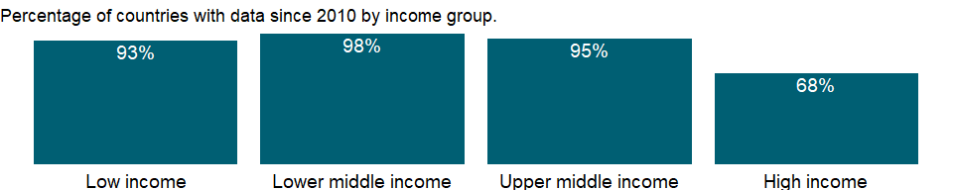

### Why is it relevant?

NA

### What is the data source?

Data for up to 1990 are sourced from Carbon Dioxide Information Analysis Center, Environmental Sciences Division, Oak Ridge National Laboratory, Tennessee, United States. Data from 1990 are CAIT data: Climate Watch. 2020. GHG Emissions. Washington, DC: World Resources Institute. Available at: <https://www.climatewatchdata.org/ghg-emissions>. See NY.GDP.MKTP.PP.CD for the denominator’s source.

### What is the methodology?

NA

### How is it aggregated?

Weighted Average

### What are the limitations?

NA

### What else should I know?

NA

### 1.17.10 CO2 emissions (kg per 2017 PPP $ of GDP)

### What is the indicator?

Carbon dioxide emissions are those stemming from the burning of fossil fuels and the manufacture of cement. They include carbon dioxide produced during consumption of solid, liquid, and gas fuels and gas flaring.

Topic: Environment: Emissions

Series ID: EN.ATM.CO2E.PP.GD.KD

Copyright: CC BY-4.0 , <https://datacatalog.worldbank.org/public-licenses#cc-by>

First year with any data: 1990

Last year with any data: 2018

### What years are data available?

The figure below shows years in which data is available for at least one country. Dates shaded in black have no data, while dates shaded in green have data for at least one country



### Which countries have data?

The figure below shows the percentage of countries in each income group with a value since 2010 for that indicator.

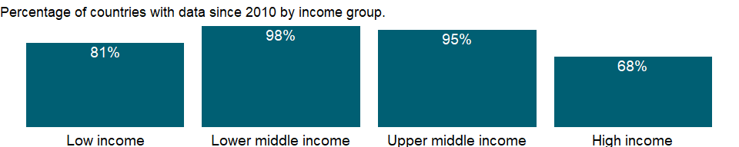

### Why is it relevant?

Carbon dioxide (CO2) is naturally occurring gas fixed by photosynthesis into organic matter. A byproduct of fossil fuel combustion and biomass burning, it is also emitted from land use changes and other industrial processes. It is the principal anthropogenic greenhouse gas that affects the Earth’s radiative balance. It is the reference gas against which other greenhouse gases are measured, thus having a Global Warming Potential of 1.

Emission intensity is the average emission rate of a given pollutant from a given source relative to the intensity of a specific activity. Emission intensities are also used to compare the environmental impact of different fuels or activities. The related terms - emission factor and carbon intensity - are often used interchangeably.

Burning of carbon-based fuels since the industrial revolution has rapidly increased concentrations of atmospheric carbon dioxide, increasing the rate of global warming and causing anthropogenic climate change. It is also a major source of ocean acidification since it dissolves in water to form carbonic acid.

The addition of man-made greenhouse gases to the Atmosphere disturbs the earth’s radiative balance. This is leading to an increase in the earth’s surface temperature and to related effects on climate, sea level rise and world agriculture. Emissions of CO2 are from burning oil, coal and gas for energy use, burning wood and waste materials, and from industrial processes such as cement production.

The carbon dioxide emissions of a country are only an indicator of one greenhouse gas. For a more complete idea of how a country influences climate change, gases such as methane and nitrous oxide should be taken into account. This is particularly important in agricultural economies.

The environmental effects of carbon dioxide are of significant interest. Carbon dioxide (CO2) makes up the largest share of the greenhouse gases contributing to global warming and climate change. Converting all other greenhouse gases (methane (CH4), nitrous oxide (N2O), hydrofluorocarbons (HFCs), perfluorocarbons (PFCs), sulphur hexafluoride (SF6)) to carbon dioxide (or CO2) equivalents makes it possible to compare them and to determine their individual and total contributions to global warming. The Kyoto Protocol, an environmental agreement adopted in 1997 by many of the parties to the United Nations Framework Convention on Climate Change (UNFCCC), is working towards curbing CO2 emissions globally.

### What is the data source?

Data for up to 1990 are sourced from Carbon Dioxide Information Analysis Center, Environmental Sciences Division, Oak Ridge National Laboratory, Tennessee, United States. Data from 1990 are CAIT data: Climate Watch. 2020. GHG Emissions. Washington, DC: World Resources Institute. Available at: <https://www.climatewatchdata.org/ghg-emissions>. See NY.GDP.MKTP.PP.KD for the denominator’s source.

### What is the methodology?

Carbon dioxide emissions, largely by-products of energy production and use, account for the largest share of greenhouse gases, which are associated with global warming. Anthropogenic carbon dioxide emissions result primarily from fossil fuel combustion and cement manufacturing. In combustion different fossil fuels release different amounts of carbon dioxide for the same level of energy use: oil releases about 50 percent more carbon dioxide than natural gas, and coal releases about twice as much. Cement manufacturing releases about half a metric ton of carbon dioxide for each metric ton of cement produced. Carbon dioxide emissions are often calculated and reported as elemental carbon. The values were converted to actual carbon dioxide mass by multiplying them by 3.667 (the ratio of the mass of carbon to that of carbon dioxide).

### How is it aggregated?

Weighted Average

### What are the limitations?

The U.S. Department of Energy’s Carbon Dioxide Information Analysis Center (CDIAC) calculates annual anthropogenic emissions from data on fossil fuel consumption (from the United Nations Statistics Division’s World Energy Data Set) and world cement manufacturing (from the U.S. Department of Interior’s Geological Survey, USGS 2011). Although estimates of global carbon dioxide emissions are probably accurate within 10 percent (as calculated from global average fuel chemistry and use), country estimates may have larger error bounds. Trends estimated from a consistent time series tend to be more accurate than individual values.

Each year the CDIAC recalculates the entire time series since 1949, incorporating recent findings and corrections. Estimates exclude fuels supplied to ships and aircraft in international transport because of the difficulty of apportioning the fuels among benefiting countries.

Data for carbon dioxide emissions include gases from the burning of fossil fuels and cement manufacture, but excludes emissions from land use such as deforestation.

### What else should I know?

NA

### 1.17.11 CO2 emissions from solid fuel consumption (kt)

### What is the indicator?

Carbon dioxide emissions from solid fuel consumption refer mainly to emissions from use of coal as an energy source.

Topic: Environment: Emissions

Series ID: EN.ATM.CO2E.SF.KT

Copyright: CC BY-4.0 , <https://datacatalog.worldbank.org/public-licenses#cc-by>

First year with any data: 1960

Last year with any data: 2016

### What years are data available?

The figure below shows years in which data is available for at least one country. Dates shaded in black have no data, while dates shaded in green have data for at least one country



### Which countries have data?

The figure below shows the percentage of countries in each income group with a value since 2010 for that indicator.



### Why is it relevant?

Carbon dioxide (CO2) is naturally occurring gas fixed by photosynthesis into organic matter. A byproduct of fossil fuel combustion and biomass burning, it is also emitted from land use changes and other industrial processes. It is the principal anthropogenic greenhouse gas that affects the Earth’s radiative balance. It is the reference gas against which other greenhouse gases are measured, thus having a Global Warming Potential of 1.

An emission intensity is the average emission rate of a given pollutant from a given source relative to the intensity of a specific activity. Emission intensities are also used to compare the environmental impact of different fuels or activities. The related terms - emission factor and carbon intensity - are often used interchangeably.

Burning of carbon-based fuels since the industrial revolution has rapidly increased concentrations of atmospheric carbon dioxide, increasing the rate of global warming and causing anthropogenic climate change. It is also a major source of ocean acidification since it dissolves in water to form carbonic acid.

The addition of man-made greenhouse gases to the Atmosphere disturbs the earth’s radiative balance. This is leading to an increase in the earth’s surface temperature and to related effects on climate, sea level rise and world agriculture. Emissions of CO2 are from burning oil, coal and gas for energy use, burning wood and waste materials, and from industrial processes such as cement production.

The carbon dioxide emissions of a country are only an indicator of one greenhouse gas. For a more complete idea of how a country influences climate change, gases such as methane and nitrous oxide should be taken into account. This is particularly important in agricultural economies.

The environmental effects of carbon dioxide are of significant interest. Carbon dioxide (CO2) makes up the largest share of the greenhouse gases contributing to global warming and climate change. Converting all other greenhouse gases (methane (CH4), nitrous oxide (N2O), hydrofluorocarbons (HFCs), perfluorocarbons (PFCs), sulphur hexafluoride (SF6)) to carbon dioxide (or CO2) equivalents makes it possible to compare them and to determine their individual and total contributions to global warming. The Kyoto Protocol, an environmental agreement adopted in 1997 by many of the parties to the United Nations Framework Convention on Climate Change (UNFCCC), is working towards curbing CO2 emissions globally.

### What is the data source?

Carbon Dioxide Information Analysis Center, Environmental Sciences Division, Oak Ridge National Laboratory, Tennessee, United States.

### What is the methodology?

Carbon dioxide emissions, largely by-products of energy production and use, account for the largest share of greenhouse gases, which are associated with global warming. Anthropogenic carbon dioxide emissions result primarily from fossil fuel combustion and cement manufacturing. In combustion different fossil fuels release different amounts of carbon dioxide for the same level of energy use: oil releases about 50 percent more carbon dioxide than natural gas, and coal releases about twice as much. Cement manufacturing releases about half a metric ton of carbon dioxide for each metric ton of cement produced. Data for carbon dioxide emissions include gases from the burning of fossil fuels and cement manufacture, but excludes emissions from land use such as deforestation. The unit of measurement is kt (kiloton). Carbon dioxide emissions are often calculated and reported as elemental carbon. The values were converted to actual carbon dioxide mass by multiplying them by 3.667 (the ratio of the mass of carbon to that of carbon dioxide).

### How is it aggregated?

Gap-filled total

### What are the limitations?

The U.S. Department of Energy’s Carbon Dioxide Information Analysis Center (CDIAC) calculates annual anthropogenic emissions from data on fossil fuel consumption (from the United Nations Statistics Division’s World Energy Data Set) and world cement manufacturing (from the U.S. Department of Interior’s Geological Survey, USGS 2011). Although estimates of global carbon dioxide emissions are probably accurate within 10 percent (as calculated from global average fuel chemistry and use), country estimates may have larger error bounds. Trends estimated from a consistent time series tend to be more accurate than individual values.

Each year the CDIAC recalculates the entire time series since 1949, incorporating recent findings and corrections. Estimates exclude fuels supplied to ships and aircraft in international transport because of the difficulty of apportioning the fuels among benefiting countries.

### What else should I know?

NA

### 1.17.12 CO2 emissions from solid fuel consumption (% of total)

### What is the indicator?

Carbon dioxide emissions from solid fuel consumption refer mainly to emissions from use of coal as an energy source.

Topic: Environment: Emissions

Series ID: EN.ATM.CO2E.SF.ZS

Copyright: CC BY-4.0 , <https://datacatalog.worldbank.org/public-licenses#cc-by>

First year with any data: 1960

Last year with any data: 2016

### What years are data available?

The figure below shows years in which data is available for at least one country. Dates shaded in black have no data, while dates shaded in green have data for at least one country



### Which countries have data?

The figure below shows the percentage of countries in each income group with a value since 2010 for that indicator.



### Why is it relevant?

Carbon dioxide (CO2) is naturally occurring gas fixed by photosynthesis into organic matter. A byproduct of fossil fuel combustion and biomass burning, it is also emitted from land use changes and other industrial processes. It is the principal anthropogenic greenhouse gas that affects the Earth’s radiative balance. It is the reference gas against which other greenhouse gases are measured, thus having a Global Warming Potential of 1.

An emission intensity is the average emission rate of a given pollutant from a given source relative to the intensity of a specific activity. Emission intensities are also used to compare the environmental impact of different fuels or activities. The related terms - emission factor and carbon intensity - are often used interchangeably.

Burning of carbon-based fuels since the industrial revolution has rapidly increased concentrations of atmospheric carbon dioxide, increasing the rate of global warming and causing anthropogenic climate change. It is also a major source of ocean acidification since it dissolves in water to form carbonic acid.

The addition of man-made greenhouse gases to the Atmosphere disturbs the earth’s radiative balance. This is leading to an increase in the earth’s surface temperature and to related effects on climate, sea level rise and world agriculture. Emissions of CO2 are from burning oil, coal and gas for energy use, burning wood and waste materials, and from industrial processes such as cement production.

The carbon dioxide emissions of a country are only an indicator of one greenhouse gas. For a more complete idea of how a country influences climate change, gases such as methane and nitrous oxide should be taken into account. This is particularly important in agricultural economies.

The environmental effects of carbon dioxide are of significant interest. Carbon dioxide (CO2) makes up the largest share of the greenhouse gases contributing to global warming and climate change. Converting all other greenhouse gases (methane (CH4), nitrous oxide (N2O), hydrofluorocarbons (HFCs), perfluorocarbons (PFCs), sulphur hexafluoride (SF6)) to carbon dioxide (or CO2) equivalents makes it possible to compare them and to determine their individual and total contributions to global warming. The Kyoto Protocol, an environmental agreement adopted in 1997 by many of the parties to the United Nations Framework Convention on Climate Change (UNFCCC), is working towards curbing CO2 emissions globally.

### What is the data source?

Carbon Dioxide Information Analysis Center, Environmental Sciences Division, Oak Ridge National Laboratory, Tennessee, United States.

### What is the methodology?

The U.S. Department of Energy’s Carbon Dioxide Information Analysis Center (CDIAC) calculates annual anthropogenic emissions from data on fossil fuel consumption (from the United Nations Statistics Division’s World Energy Data Set) and world cement manufacturing (from the U.S. Department of Interior’s Geological Survey (USGS 2011)). Although estimates of global carbon dioxide emissions are probably accurate within 10 percent (as calculated from global average fuel chemistry and use), country estimates may have larger error bounds. Trends estimated from a consistent time series tend to be more accurate than individual values.

Each year the CDIAC recalculates the entire time series since 1949, incorporating recent findings and corrections. Estimates exclude fuels supplied to ships and aircraft in international transport because of the difficulty of apportioning the fuels among benefiting countries.

### How is it aggregated?

Weighted average

### What are the limitations?

The U.S. Department of Energy’s Carbon Dioxide Information Analysis Center (CDIAC) calculates annual anthropogenic emissions from data on fossil fuel consumption (from the United Nations Statistics Division’s World Energy Data Set) and world cement manufacturing (from the U.S. Department of Interior’s Geological Survey, USGS 2011). Although estimates of global carbon dioxide emissions are probably accurate within 10 percent (as calculated from global average fuel chemistry and use), country estimates may have larger error bounds. Trends estimated from a consistent time series tend to be more accurate than individual values.

Each year the CDIAC recalculates the entire time series since 1949, incorporating recent findings and corrections. Estimates exclude fuels supplied to ships and aircraft in international transport because of the difficulty of apportioning the fuels among benefiting countries.

### What else should I know?

NA

### 1.17.13 Other greenhouse gas emissions, HFC, PFC and SF6 (thousand metric tons of CO2 equivalent)

### What is the indicator?

Other greenhouse gas emissions are by-product emissions of hydrofluorocarbons, perfluorocarbons, and sulfur hexafluoride.

Topic: Environment: Emissions

Series ID: EN.ATM.GHGO.KT.CE

Copyright: CC BY-4.0 , <https://datacatalog.worldbank.org/public-licenses#cc-by>

First year with any data: 1970

Last year with any data: 2016

### What years are data available?

The figure below shows years in which data is available for at least one country. Dates shaded in black have no data, while dates shaded in green have data for at least one country

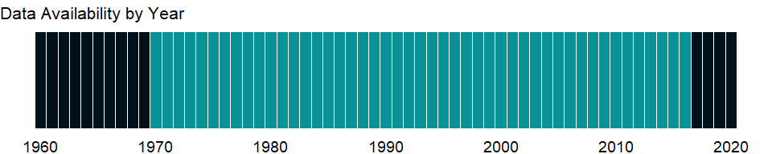

### Which countries have data?

The figure below shows the percentage of countries in each income group with a value since 2010 for that indicator.

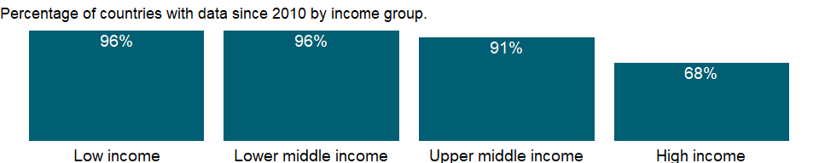

### Why is it relevant?

The addition of man-made greenhouse gases to the Atmosphere disturbs the earth’s radiative balance. This is leading to an increase in the earth’s surface temperature and to related effects on climate, sea level rise and world agriculture. Emissions of CO2 are from burning oil, coal and gas for energy use, burning wood and waste materials, and from industrial processes such as cement production. Emission intensity is the average emission rate of a given pollutant from a given source relative to the intensity of a specific activity. Emission intensities are also used to compare the environmental impact of different fuels or activities. The related terms - emission factor and carbon intensity - are often used interchangeably.

The carbon dioxide emissions of a country are only an indicator of one greenhouse gas. For a more complete idea of how a country influences climate change, gases such as methane and nitrous oxide should be taken into account. This is particularly important in agricultural economies.

The environmental effects of carbon dioxide are of significant interest. Carbon dioxide (CO2) makes up the largest share of the greenhouse gases contributing to global warming and climate change. Converting all other greenhouse gases (methane (CH4), nitrous oxide (N2O), hydrofluorocarbons (HFCs), perfluorocarbons (PFCs), Sulphur hexafluoride (SF6)) to carbon dioxide (or CO2) equivalents makes it possible to compare them and to determine their individual and total contributions to global warming. The Kyoto Protocol, an environmental agreement adopted in 1997 by many of the parties to the United Nations Framework Convention on Climate Change (UNFCCC), is working towards curbing CO2 emissions globally.

### What is the data source?

World Bank staff estimates from original source: European Commission, Joint Research Centre (JRC)/Netherlands Environmental Assessment Agency (PBL). Emission Database for Global Atmospheric Research (EDGAR): <http://edgar.jrc.ec.europa.eu/>.

### What is the methodology?

Other greenhouse gas emissions are by-product emissions of hydrofluorocarbons, perfluorocarbons, and sulfur hexafluoride (F-gases (c-C4F8 GWP=8700, C2F6 GWP=9200, C3F8 GWP=7000, C4F10 GWP=7000, C5F12 GWP=7500, C6F14 GWP=7400, C7F16 GWP=7820, CF4 GWP=6500, HFC-125 GWP=2800, HFC-134a GWP=1300, HFC-143a GWP=3800, HFC-152a GWP=140, HFC-227ea GWP=2900, HFC-23 GWP=11700, HFC-236fa GWP=6300, HFC-245fa GWP=858, HFC-32 GWP=650, HFC-365mfc GWP=804, HFC-43-10-mee GWP=1300, SF6 GWP=23900). Derived as residuals from total GHG emissions, CO2 emissions, CH4 emissions, and N2O emissions in kt of CO equivalent. Other greenhouse gases covered under the Kyoto Protocol are hydrofluorocarbons, perfluorocarbons, and sulfur hexafluoride. Although emissions of these artificial gases are small, they are more powerful greenhouse gases than carbon dioxide, with much higher atmospheric lifetimes and high global warming potential. The emissions are usually expressed in carbon dioxide equivalents using the global warming potential, which allows the effective contributions of different gases to be compared.

### How is it aggregated?

Sum

### What are the limitations?

National reporting to the United Nations Framework Convention on Climate Change that follows the Intergovernmental Panel on Climate Change guidelines is based on national emission inventories and covers all sources of anthropogenic carbon dioxide emissions as well as carbon sinks (such as forests). To estimate emissions, the countries that are Parties to the Climate Change Convention (UNFCCC) use complex, state-of-the-art methodologies recommended by the Intergovernmental Panel on Climate Change (IPCC).

### What else should I know?

NA

### 1.17.14 Other greenhouse gas emissions (% change from 1990)

### What is the indicator?

Other greenhouse gas emissions are by-product emissions of hydrofluorocarbons, perfluorocarbons, and sulfur hexafluoride. Each year of data shows the percentage change to that year from 1990.

Topic: Environment: Emissions

Series ID: EN.ATM.GHGO.ZG

Copyright: CC BY-4.0 , <https://datacatalog.worldbank.org/public-licenses#cc-by>

First year with any data: 1991

Last year with any data: 2012

### What years are data available?

The figure below shows years in which data is available for at least one country. Dates shaded in black have no data, while dates shaded in green have data for at least one country

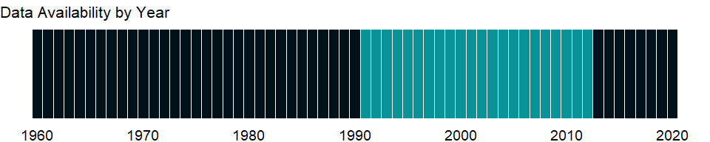

### Which countries have data?

The figure below shows the percentage of countries in each income group with a value since 2010 for that indicator.

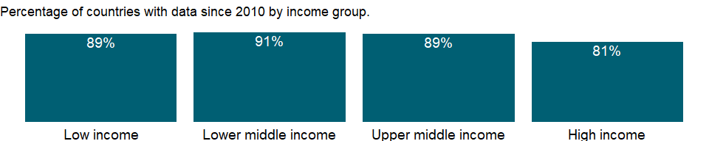

### Why is it relevant?

The addition of man-made greenhouse gases to the Atmosphere disturbs the earth’s radiative balance. This is leading to an increase in the earth’s surface temperature and to related effects on climate, sea level rise and world agriculture. Emissions of CO2 are from burning oil, coal and gas for energy use, burning wood and waste materials, and from industrial processes such as cement production. Emission intensity is the average emission rate of a given pollutant from a given source relative to the intensity of a specific activity. Emission intensities are also used to compare the environmental impact of different fuels or activities. The related terms - emission factor and carbon intensity - are often used interchangeably.

The carbon dioxide emissions of a country are only an indicator of one greenhouse gas. For a more complete idea of how a country influences climate change, gases such as methane and nitrous oxide should be taken into account. This is particularly important in agricultural economies.

The environmental effects of carbon dioxide are of significant interest. Carbon dioxide (CO2) makes up the largest share of the greenhouse gases contributing to global warming and climate change. Converting all other greenhouse gases (methane (CH4), nitrous oxide (N2O), hydrofluorocarbons (HFCs), perfluorocarbons (PFCs), Sulphur hexafluoride (SF6)) to carbon dioxide (or CO2) equivalents makes it possible to compare them and to determine their individual and total contributions to global warming. The Kyoto Protocol, an environmental agreement adopted in 1997 by many of the parties to the United Nations Framework Convention on Climate Change (UNFCCC), is working towards curbing CO2 emissions globally.

### What is the data source?

World Bank staff estimates from original source: European Commission, Joint Research Centre (JRC)/Netherlands Environmental Assessment Agency (PBL). Emission Database for Global Atmospheric Research (EDGAR): <http://edgar.jrc.ec.europa.eu/>.

### What is the methodology?

Other greenhouse gas emissions are by-product emissions of hydrofluorocarbons, perfluorocarbons, and sulfur hexafluoride (F-gases (c-C4F8 GWP=8700, C2F6 GWP=9200, C3F8 GWP=7000, C4F10 GWP=7000, C5F12 GWP=7500, C6F14 GWP=7400, C7F16 GWP=7820, CF4 GWP=6500, HFC-125 GWP=2800, HFC-134a GWP=1300, HFC-143a GWP=3800, HFC-152a GWP=140, HFC-227ea GWP=2900, HFC-23 GWP=11700, HFC-236fa GWP=6300, HFC-245fa GWP=858, HFC-32 GWP=650, HFC-365mfc GWP=804, HFC-43-10-mee GWP=1300, SF6 GWP=23900). Derived as residuals from total GHG emissions, CO2 emissions, CH4 emissions, and N2O emissions in kt of CO equivalent. Other greenhouse gases covered under the Kyoto Protocol are hydrofluorocarbons, perfluorocarbons, and sulfur hexafluoride. Although emissions of these artificial gases are small, they are more powerful greenhouse gases than carbon dioxide, with much higher atmospheric lifetimes and high global warming potential. The emissions are usually expressed in carbon dioxide equivalents using the global warming potential, which allows the effective contributions of different gases to be compared.

### How is it aggregated?

Weighted Average

### What are the limitations?

National reporting to the United Nations Framework Convention on Climate Change that follows the Intergovernmental Panel on Climate Change guidelines is based on national emission inventories and covers all sources of anthropogenic carbon dioxide emissions as well as carbon sinks (such as forests). To estimate emissions, the countries that are Parties to the Climate Change Convention (UNFCCC) use complex, state-of-the-art methodologies recommended by the Intergovernmental Panel on Climate Change (IPCC).

### What else should I know?

NA

### 1.17.15 Total greenhouse gas emissions (thousand metric tons of CO2 equivalent excluding Land-Use Change and Forestry)

### What is the indicator?

Total greenhouse gas emissions in kt of CO2 equivalent are composed of CO2 totals excluding short-cycle biomass burning (such as agricultural waste burning and savanna burning) but including other biomass burning (such as forest fires, post-burn decay, peat fires and decay of drained peatlands), all anthropogenic CH4 sources, N2O sources and F-gases (HFCs, PFCs and SF6).

Topic: Environment: Emissions

Series ID: EN.ATM.GHGT.KT.CE

Copyright: CC BY-4.0 , <https://datacatalog.worldbank.org/public-licenses#cc-by>

First year with any data: 1970

Last year with any data: 2018

### What years are data available?

The figure below shows years in which data is available for at least one country. Dates shaded in black have no data, while dates shaded in green have data for at least one country

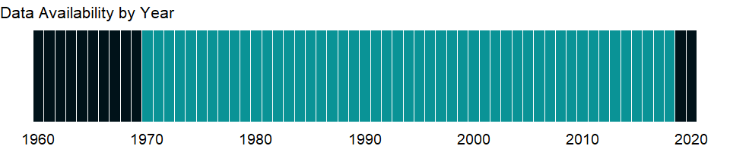

### Which countries have data?

The figure below shows the percentage of countries in each income group with a value since 2010 for that indicator.



### Why is it relevant?

The addition of man-made greenhouse gases to the Atmosphere disturbs the earth’s radiative balance. This is leading to an increase in the earth’s surface temperature and to related effects on climate, sea level rise and world agriculture. Emissions of CO2 are from burning oil, coal and gas for energy use, burning wood and waste materials, and from industrial processes such as cement production. Emission intensity is the average emission rate of a given pollutant from a given source relative to the intensity of a specific activity. Emission intensities are also used to compare the environmental impact of different fuels or activities. The related terms - emission factor and carbon intensity - are often used interchangeably.

The carbon dioxide emissions of a country are only an indicator of one greenhouse gas. For a more complete idea of how a country influences climate change, gases such as methane and nitrous oxide should be taken into account. This is particularly important in agricultural economies.

The environmental effects of carbon dioxide are of significant interest. Carbon dioxide (CO2) makes up the largest share of the greenhouse gases contributing to global warming and climate change. Converting all other greenhouse gases (methane (CH4), nitrous oxide (N2O), hydrofluorocarbons (HFCs), perfluorocarbons (PFCs), Sulphur hexafluoride (SF6)) to carbon dioxide (or CO2) equivalents makes it possible to compare them and to determine their individual and total contributions to global warming. The Kyoto Protocol, an environmental agreement adopted in 1997 by many of the parties to the United Nations Framework Convention on Climate Change (UNFCCC), is working towards curbing CO2 emissions globally.

### What is the data source?

Data for up to 1990 are sourced from Carbon Dioxide Information Analysis Center, Environmental Sciences Division, Oak Ridge National Laboratory, Tennessee, United States. Data from 1990 are CAIT data: Climate Watch. 2020. GHG Emissions. Washington, DC: World Resources Institute. Available at: <https://www.climatewatchdata.org/ghg-emissions>.

### What is the methodology?

The GHG totals are expressed in CO2 equivalent using the GWP100 metric of the Second Assessment Report of IPCC and include CO2 (GWP100=1), CH4 (GWP100=21), N2O (GWP100=310) and F-gases (c-C4F8 GWP=8700, C2F6 GWP=9200, C3F8 GWP=7000, C4F10 GWP=7000, C5F12 GWP=7500, C6F14 GWP=7400, C7F16 GWP=7820, CF4 GWP=6500, HFC-125 GWP=2800, HFC-134a GWP=1300, HFC-143a GWP=3800, HFC-152a GWP=140, HFC-227ea GWP=2900, HFC-23 GWP=11700, HFC-236fa GWP=6300, HFC-245fa GWP=858, HFC-32 GWP=650, HFC-365mfc GWP=804, HFC-43-10-mee GWP=1300, SF6 GWP=23900).

### How is it aggregated?

Sum

### What are the limitations?

National reporting to the United Nations Framework Convention on Climate Change that follows the Intergovernmental Panel on Climate Change guidelines is based on national emission inventories and covers all sources of anthropogenic carbon dioxide emissions as well as carbon sinks (such as forests). To estimate emissions, the countries that are Parties to the Climate Change Convention (UNFCCC) use complex, state-of-the-art methodologies recommended by the Intergovernmental Panel on Climate Change (IPCC).

### What else should I know?

NA

### 1.17.16 Total greenhouse gas emissions (% change from 1990)

### What is the indicator?

Total greenhouse gas emissions are composed of CO2 totals excluding short-cycle biomass burning (such as agricultural waste burning and savanna burning) but including other biomass burning (such as forest fires, post-burn decay, peat fires and decay of drained peatlands), all anthropogenic CH4 sources, N2O sources and F-gases (HFCs, PFCs and SF6). Each year of data shows the percentage change to that year from 1990.

Topic: Environment: Emissions

Series ID: EN.ATM.GHGT.ZG

Copyright: CC BY-4.0 , <https://datacatalog.worldbank.org/public-licenses#cc-by>

First year with any data: 1991

Last year with any data: 2012

### What years are data available?

The figure below shows years in which data is available for at least one country. Dates shaded in black have no data, while dates shaded in green have data for at least one country



### Which countries have data?

The figure below shows the percentage of countries in each income group with a value since 2010 for that indicator.

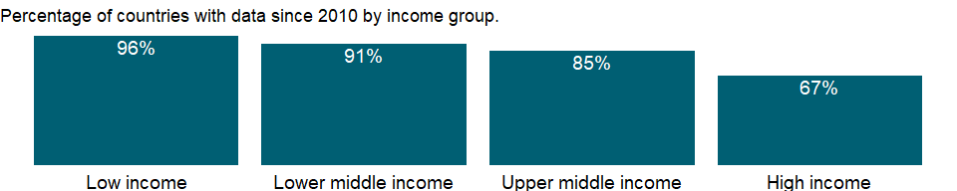

### Why is it relevant?

The addition of man-made greenhouse gases to the Atmosphere disturbs the earth’s radiative balance. This is leading to an increase in the earth’s surface temperature and to related effects on climate, sea level rise and world agriculture. Emissions of CO2 are from burning oil, coal and gas for energy use, burning wood and waste materials, and from industrial processes such as cement production. Emission intensity is the average emission rate of a given pollutant from a given source relative to the intensity of a specific activity. Emission intensities are also used to compare the environmental impact of different fuels or activities. The related terms - emission factor and carbon intensity - are often used interchangeably.

The carbon dioxide emissions of a country are only an indicator of one greenhouse gas. For a more complete idea of how a country influences climate change, gases such as methane and nitrous oxide should be taken into account. This is particularly important in agricultural economies.

The environmental effects of carbon dioxide are of significant interest. Carbon dioxide (CO2) makes up the largest share of the greenhouse gases contributing to global warming and climate change. Converting all other greenhouse gases (methane (CH4), nitrous oxide (N2O), hydrofluorocarbons (HFCs), perfluorocarbons (PFCs), Sulphur hexafluoride (SF6)) to carbon dioxide (or CO2) equivalents makes it possible to compare them and to determine their individual and total contributions to global warming. The Kyoto Protocol, an environmental agreement adopted in 1997 by many of the parties to the United Nations Framework Convention on Climate Change (UNFCCC), is working towards curbing CO2 emissions globally.

### What is the data source?

World Bank staff estimates from original source: European Commission, Joint Research Centre (JRC)/Netherlands Environmental Assessment Agency (PBL). Emission Database for Global Atmospheric Research (EDGAR): <http://edgar.jrc.ec.europa.eu/>.

### What is the methodology?

The GHG totals are expressed in CO2 equivalent using the GWP100 metric of the Second Assessment Report of IPCC and include CO2 (GWP100=1), CH4 (GWP100=21), N2O (GWP100=310) and F-gases (c-C4F8 GWP=8700, C2F6 GWP=9200, C3F8 GWP=7000, C4F10 GWP=7000, C5F12 GWP=7500, C6F14 GWP=7400, C7F16 GWP=7820, CF4 GWP=6500, HFC-125 GWP=2800, HFC-134a GWP=1300, HFC-143a GWP=3800, HFC-152a GWP=140, HFC-227ea GWP=2900, HFC-23 GWP=11700, HFC-236fa GWP=6300, HFC-245fa GWP=858, HFC-32 GWP=650, HFC-365mfc GWP=804, HFC-43-10-mee GWP=1300, SF6 GWP=23900).

### How is it aggregated?

Weighted Average

### What are the limitations?

National reporting to the United Nations Framework Convention on Climate Change that follows the Intergovernmental Panel on Climate Change guidelines is based on national emission inventories and covers all sources of anthropogenic carbon dioxide emissions as well as carbon sinks (such as forests). To estimate emissions, the countries that are Parties to the Climate Change Convention (UNFCCC) use complex, state-of-the-art methodologies recommended by the Intergovernmental Panel on Climate Change (IPCC).

### What else should I know?

NA

### 1.17.17 HFC gas emissions (thousand metric tons of CO2 equivalent)

### What is the indicator?

Hydrofluorocarbons, used as a replacement for chlorofluorocarbons, are used mainly in refrigeration and semiconductor manufacturing.

Topic: Environment: Emissions

Series ID: EN.ATM.HFCG.KT.CE

Copyright: CC BY-4.0 , <https://datacatalog.worldbank.org/public-licenses#cc-by>

First year with any data: 1990

Last year with any data: 2010

### What years are data available?

The figure below shows years in which data is available for at least one country. Dates shaded in black have no data, while dates shaded in green have data for at least one country

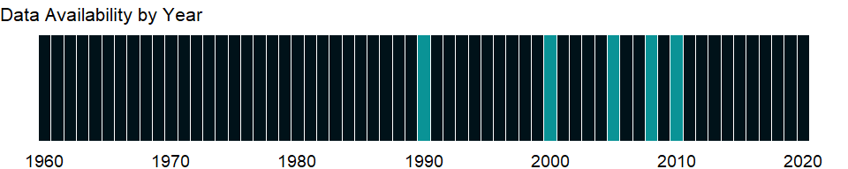

### Which countries have data?

The figure below shows the percentage of countries in each income group with a value since 2010 for that indicator.

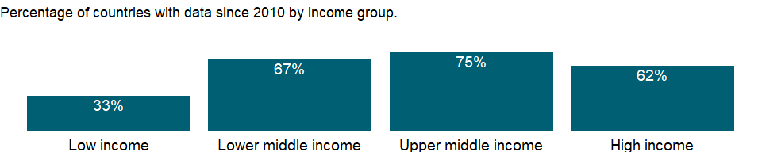

### Why is it relevant?

NA

### What is the data source?

European Commission, Joint Research Centre (JRC)/Netherlands Environmental Assessment Agency (PBL). Emission Database for Global Atmospheric Research (EDGAR): <http://edgar.jrc.ec.europa.eu/>

### What is the methodology?

NA

### How is it aggregated?

Gap-filled total

### What are the limitations?

NA

### What else should I know?

NA

### 1.17.18 Agricultural methane emissions (thousand metric tons of CO2 equivalent)

### What is the indicator?

Agricultural methane emissions are emissions from animals, animal waste, rice production, agricultural waste burning (nonenergy, on-site), and savanna burning.

Topic: Environment: Emissions

Series ID: EN.ATM.METH.AG.KT.CE

Copyright: CC BY-4.0 , <https://datacatalog.worldbank.org/public-licenses#cc-by>

First year with any data: 1969

Last year with any data: 2018

### What years are data available?

The figure below shows years in which data is available for at least one country. Dates shaded in black have no data, while dates shaded in green have data for at least one country

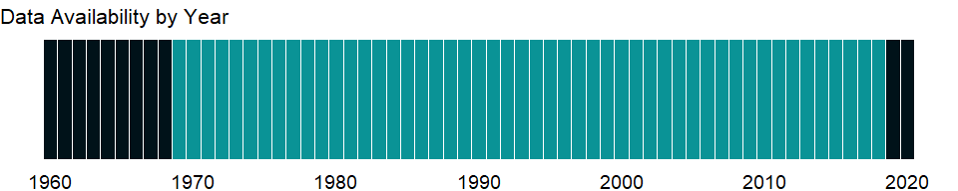

### Which countries have data?

The figure below shows the percentage of countries in each income group with a value since 2010 for that indicator.



### Why is it relevant?

The addition of man-made greenhouse gases to the Atmosphere disturbs the earth’s radiative balance. This is leading to an increase in the earth’s surface temperature and to related effects on climate, sea level rise and world agriculture. Emissions of CO2 are from burning oil, coal and gas for energy use, burning wood and waste materials, and from industrial processes such as cement production. Emission intensity is the average emission rate of a given pollutant from a given source relative to the intensity of a specific activity. Emission intensities are also used to compare the environmental impact of different fuels or activities. The related terms - emission factor and carbon intensity - are often used interchangeably.

The carbon dioxide emissions of a country are only an indicator of one greenhouse gas. For a more complete idea of how a country influences climate change, gases such as methane and nitrous oxide should be taken into account. This is particularly important in agricultural economies.

The environmental effects of carbon dioxide are of significant interest. Carbon dioxide (CO2) makes up the largest share of the greenhouse gases contributing to global warming and climate change. Converting all other greenhouse gases (methane (CH4), nitrous oxide (N2O), hydrofluorocarbons (HFCs), perfluorocarbons (PFCs), Sulphur hexafluoride (SF6)) to carbon dioxide (or CO2) equivalents makes it possible to compare them and to determine their individual and total contributions to global warming. The Kyoto Protocol, an environmental agreement adopted in 1997 by many of the parties to the United Nations Framework Convention on Climate Change (UNFCCC), is working towards curbing CO2 emissions globally.

### What is the data source?

Data for up to 1990 are sourced from Carbon Dioxide Information Analysis Center, Environmental Sciences Division, Oak Ridge National Laboratory, Tennessee, United States. Data from 1990 are CAIT data: Climate Watch. 2020. GHG Emissions. Washington, DC: World Resources Institute. Available at: <https://www.climatewatchdata.org/ghg-emissions>.

### What is the methodology?

IPCC category 4 = Agriculture. Expressed in CO2 equivalent using the GWP100 metric of the Second Assessment Report of IPCC and include CH4 (GWP100=21). Methane emissions result largely from agricultural activities, industrial production landfills and wastewater treatment, and other sources such as tropical forest and other vegetation fires. The emissions are usually expressed in carbon dioxide equivalents using the global warming potential, which allows the effective contributions of different gases to be compared. A kilogram of methane is 21 times as effective at trapping heat in the earth’s atmosphere as a kilogram of carbon dioxide within 100 years. The emissions are usually expressed in carbon dioxide equivalents using the global warming potential, which allows the effective contributions of different gases to be compared.

### How is it aggregated?

Sum

### What are the limitations?

National reporting to the United Nations Framework Convention on Climate Change that follows the Intergovernmental Panel on Climate Change guidelines is based on national emission inventories and covers all sources of anthropogenic carbon dioxide emissions as well as carbon sinks (such as forests). To estimate emissions, the countries that are Parties to the Climate Change Convention (UNFCCC) use complex, state-of-the-art methodologies recommended by the Intergovernmental Panel on Climate Change (IPCC).

### What else should I know?

NA

### 1.17.19 Agricultural methane emissions (% of total)

### What is the indicator?

Agricultural methane emissions are emissions from animals, animal waste, rice production, agricultural waste burning (nonenergy, on-site), and savanna burning.

Topic: Environment: Emissions

Series ID: EN.ATM.METH.AG.ZS

Copyright: CC BY-4.0 , <https://datacatalog.worldbank.org/public-licenses#cc-by>

First year with any data: 1970

Last year with any data: 2008

### What years are data available?

The figure below shows years in which data is available for at least one country. Dates shaded in black have no data, while dates shaded in green have data for at least one country

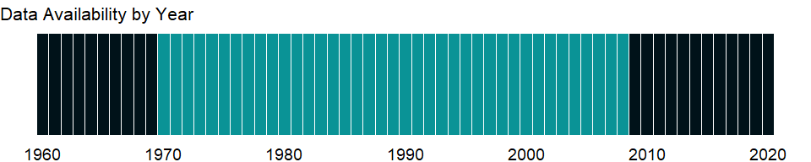

### Which countries have data?

The figure below shows the percentage of countries in each income group with a value since 2010 for that indicator.



### Why is it relevant?

The addition of man-made greenhouse gases to the Atmosphere disturbs the earth’s radiative balance. This is leading to an increase in the earth’s surface temperature and to related effects on climate, sea level rise and world agriculture. Emissions of CO2 are from burning oil, coal and gas for energy use, burning wood and waste materials, and from industrial processes such as cement production. Emission intensity is the average emission rate of a given pollutant from a given source relative to the intensity of a specific activity. Emission intensities are also used to compare the environmental impact of different fuels or activities. The related terms - emission factor and carbon intensity - are often used interchangeably.

The carbon dioxide emissions of a country are only an indicator of one greenhouse gas. For a more complete idea of how a country influences climate change, gases such as methane and nitrous oxide should be taken into account. This is particularly important in agricultural economies.

The environmental effects of carbon dioxide are of significant interest. Carbon dioxide (CO2) makes up the largest share of the greenhouse gases contributing to global warming and climate change. Converting all other greenhouse gases (methane (CH4), nitrous oxide (N2O), hydrofluorocarbons (HFCs), perfluorocarbons (PFCs), Sulphur hexafluoride (SF6)) to carbon dioxide (or CO2) equivalents makes it possible to compare them and to determine their individual and total contributions to global warming. The Kyoto Protocol, an environmental agreement adopted in 1997 by many of the parties to the United Nations Framework Convention on Climate Change (UNFCCC), is working towards curbing CO2 emissions globally.

### What is the data source?

World Bank staff estimates from original source: European Commission, Joint Research Centre (JRC)/Netherlands Environmental Assessment Agency (PBL). Emission Database for Global Atmospheric Research (EDGAR): <http://edgar.jrc.ec.europa.eu/>.

### What is the methodology?

IPCC category 4 = Agriculture. Methane emissions result largely from agricultural activities, industrial production landfills and wastewater treatment, and other sources such as tropical forest and other vegetation fires. The emissions are usually expressed in carbon dioxide equivalents using the global warming potential, which allows the effective contributions of different gases to be compared. A kilogram of methane is 21 times as effective at trapping heat in the earth’s atmosphere as a kilogram of carbon dioxide within 100 years.

### How is it aggregated?

Weighted average

### What are the limitations?

National reporting to the United Nations Framework Convention on Climate Change that follows the Intergovernmental Panel on Climate Change guidelines is based on national emission inventories and covers all sources of anthropogenic carbon dioxide emissions as well as carbon sinks (such as forests). To estimate emissions, the countries that are Parties to the Climate Change Convention (UNFCCC) use complex, state-of-the-art methodologies recommended by the Intergovernmental Panel on Climate Change (IPCC).

### What else should I know?

NA

### 1.17.20 Methane emissions in energy sector (thousand metric tons of CO2 equivalent)

### What is the indicator?

Methane emissions from energy processes are emissions from the production, handling, transmission, and combustion of fossil fuels and biofuels.

Topic: Environment: Emissions

Series ID: EN.ATM.METH.EG.KT.CE

Copyright: CC BY-4.0 , <https://datacatalog.worldbank.org/public-licenses#cc-by>

First year with any data: 1969

Last year with any data: 2018

### What years are data available?

The figure below shows years in which data is available for at least one country. Dates shaded in black have no data, while dates shaded in green have data for at least one country



### Which countries have data?

The figure below shows the percentage of countries in each income group with a value since 2010 for that indicator.



### Why is it relevant?

The addition of man-made greenhouse gases to the Atmosphere disturbs the earth’s radiative balance. This is leading to an increase in the earth’s surface temperature and to related effects on climate, sea level rise and world agriculture. Emissions of CO2 are from burning oil, coal and gas for energy use, burning wood and waste materials, and from industrial processes such as cement production. Emission intensity is the average emission rate of a given pollutant from a given source relative to the intensity of a specific activity. Emission intensities are also used to compare the environmental impact of different fuels or activities. The related terms - emission factor and carbon intensity - are often used interchangeably.

The carbon dioxide emissions of a country are only an indicator of one greenhouse gas. For a more complete idea of how a country influences climate change, gases such as methane and nitrous oxide should be taken into account. This is particularly important in agricultural economies.

The environmental effects of carbon dioxide are of significant interest. Carbon dioxide (CO2) makes up the largest share of the greenhouse gases contributing to global warming and climate change. Converting all other greenhouse gases (methane (CH4), nitrous oxide (N2O), hydrofluorocarbons (HFCs), perfluorocarbons (PFCs), Sulphur hexafluoride (SF6)) to carbon dioxide (or CO2) equivalents makes it possible to compare them and to determine their individual and total contributions to global warming. The Kyoto Protocol, an environmental agreement adopted in 1997 by many of the parties to the United Nations Framework Convention on Climate Change (UNFCCC), is working towards curbing CO2 emissions globally.

### What is the data source?

Data for up to 1990 are sourced from Carbon Dioxide Information Analysis Center, Environmental Sciences Division, Oak Ridge National Laboratory, Tennessee, United States. Data from 1990 are CAIT data: Climate Watch. 2020. GHG Emissions. Washington, DC: World Resources Institute. Available at: <https://www.climatewatchdata.org/ghg-emissions>.

### What is the methodology?

IPCC category 1 = Energy. Expressed in CO2 equivalent using the GWP100 metric of the Second Assessment Report of IPCC and include CH4 (GWP100=21). Methane emissions are those stemming from human activities such as agriculture and from industrial methane production. The emissions are usually expressed in carbon dioxide equivalents using the global warming potential, which allows the effective contributions of different gases to be compared. A kilogram of methane is 21 times as effective at trapping heat in the earth’s atmosphere as a kilogram of carbon dioxide within 100 years. The unit of measurement is kt (kiloton) of carbon dioxide equivalent.

### How is it aggregated?

Sum

### What are the limitations?

National reporting to the United Nations Framework Convention on Climate Change that follows the Intergovernmental Panel on Climate Change guidelines is based on national emission inventories and covers all sources of anthropogenic carbon dioxide emissions as well as carbon sinks (such as forests). To estimate emissions, the countries that are Parties to the Climate Change Convention (UNFCCC) use complex, state-of-the-art methodologies recommended by the Intergovernmental Panel on Climate Change (IPCC).

### What else should I know?

NA

### 1.17.21 Energy related methane emissions (% of total)

### What is the indicator?

Methane emissions from energy processes are emissions from the production, handling, transmission, and combustion of fossil fuels and biofuels.

Topic: Environment: Emissions

Series ID: EN.ATM.METH.EG.ZS

Copyright: CC BY-4.0 , <https://datacatalog.worldbank.org/public-licenses#cc-by>

First year with any data: 1970

Last year with any data: 2008

### What years are data available?

The figure below shows years in which data is available for at least one country. Dates shaded in black have no data, while dates shaded in green have data for at least one country



### Which countries have data?

The figure below shows the percentage of countries in each income group with a value since 2010 for that indicator.



### Why is it relevant?

The addition of man-made greenhouse gases to the Atmosphere disturbs the earth’s radiative balance. This is leading to an increase in the earth’s surface temperature and to related effects on climate, sea level rise and world agriculture. Emissions of CO2 are from burning oil, coal and gas for energy use, burning wood and waste materials, and from industrial processes such as cement production. Emission intensity is the average emission rate of a given pollutant from a given source relative to the intensity of a specific activity. Emission intensities are also used to compare the environmental impact of different fuels or activities. The related terms - emission factor and carbon intensity - are often used interchangeably.

The carbon dioxide emissions of a country are only an indicator of one greenhouse gas. For a more complete idea of how a country influences climate change, gases such as methane and nitrous oxide should be taken into account. This is particularly important in agricultural economies.

The environmental effects of carbon dioxide are of significant interest. Carbon dioxide (CO2) makes up the largest share of the greenhouse gases contributing to global warming and climate change. Converting all other greenhouse gases (methane (CH4), nitrous oxide (N2O), hydrofluorocarbons (HFCs), perfluorocarbons (PFCs), Sulphur hexafluoride (SF6)) to carbon dioxide (or CO2) equivalents makes it possible to compare them and to determine their individual and total contributions to global warming. The Kyoto Protocol, an environmental agreement adopted in 1997 by many of the parties to the United Nations Framework Convention on Climate Change (UNFCCC), is working towards curbing CO2 emissions globally.

### What is the data source?

World Bank staff estimates from original source: European Commission, Joint Research Centre (JRC)/Netherlands Environmental Assessment Agency (PBL). Emission Database for Global Atmospheric Research (EDGAR): <http://edgar.jrc.ec.europa.eu/>.

### What is the methodology?

IPCC category 1 = Energy. Methane emissions result largely from agricultural activities, industrial production landfills and wastewater treatment, and other sources such as tropical forest and other vegetation fires. The emissions are usually expressed in carbon dioxide equivalents using the global warming potential, which allows the effective contributions of different gases to be compared. A kilogram of methane is 21 times as effective at trapping heat in the earth’s atmosphere as a kilogram of carbon dioxide within 100 years. The emissions are usually expressed in carbon dioxide equivalents using the global warming potential, which allows the effective contributions of different gases to be compared.

### How is it aggregated?

Weighted Average

### What are the limitations?

National reporting to the United Nations Framework Convention on Climate Change that follows the Intergovernmental Panel on Climate Change guidelines is based on national emission inventories and covers all sources of anthropogenic carbon dioxide emissions as well as carbon sinks (such as forests). To estimate emissions, the countries that are Parties to the Climate Change Convention (UNFCCC) use complex, state-of-the-art methodologies recommended by the Intergovernmental Panel on Climate Change (IPCC).

### What else should I know?

NA

### 1.17.22 Total methane emissions (thousand metric tons of CO2 equivalent excluding Land-Use Change and Forestry)

### What is the indicator?

Methane emissions are those stemming from human activities such as agriculture and from industrial methane production.

Topic: Environment: Emissions

Series ID: EN.ATM.METH.KT.CE

Copyright: CC BY-4.0 , <https://datacatalog.worldbank.org/public-licenses#cc-by>

First year with any data: 1970

Last year with any data: 2018

### What years are data available?

The figure below shows years in which data is available for at least one country. Dates shaded in black have no data, while dates shaded in green have data for at least one country



### Which countries have data?

The figure below shows the percentage of countries in each income group with a value since 2010 for that indicator.



### Why is it relevant?

The addition of man-made greenhouse gases to the Atmosphere disturbs the earth’s radiative balance. This is leading to an increase in the earth’s surface temperature and to related effects on climate, sea level rise and world agriculture. Emissions of CO2 are from burning oil, coal and gas for energy use, burning wood and waste materials, and from industrial processes such as cement production. Emission intensity is the average emission rate of a given pollutant from a given source relative to the intensity of a specific activity. Emission intensities are also used to compare the environmental impact of different fuels or activities. The related terms - emission factor and carbon intensity - are often used interchangeably.

The carbon dioxide emissions of a country are only an indicator of one greenhouse gas. For a more complete idea of how a country influences climate change, gases such as methane and nitrous oxide should be taken into account. This is particularly important in agricultural economies.

The environmental effects of carbon dioxide are of significant interest. Carbon dioxide (CO2) makes up the largest share of the greenhouse gases contributing to global warming and climate change. Converting all other greenhouse gases (methane (CH4), nitrous oxide (N2O), hydrofluorocarbons (HFCs), perfluorocarbons (PFCs), Sulphur hexafluoride (SF6)) to carbon dioxide (or CO2) equivalents makes it possible to compare them and to determine their individual and total contributions to global warming. The Kyoto Protocol, an environmental agreement adopted in 1997 by many of the parties to the United Nations Framework Convention on Climate Change (UNFCCC), is working towards curbing CO2 emissions globally.

### What is the data source?

Data for up to 1990 are sourced from Carbon Dioxide Information Analysis Center, Environmental Sciences Division, Oak Ridge National Laboratory, Tennessee, United States. Data from 1990 are CAIT data: Climate Watch. 2020. GHG Emissions. Washington, DC: World Resources Institute. Available at: <https://www.climatewatchdata.org/ghg-emissions>.

### What is the methodology?

Methane emissions are those stemming from human activities such as agriculture and from industrial methane production. Expressed in CO2 equivalent using the GWP100 metric of the Second Assessment Report of IPCC and include CH4 (GWP100=21). The emissions are usually expressed in carbon dioxide equivalents using the global warming potential, which allows the effective contributions of different gases to be compared. A kilogram of methane is 21 times as effective at trapping heat in the earth’s atmosphere as a kilogram of carbon dioxide within 100 years.

### How is it aggregated?

Sum

### What are the limitations?

National reporting to the United Nations Framework Convention on Climate Change that follows the Intergovernmental Panel on Climate Change guidelines is based on national emission inventories and covers all sources of anthropogenic carbon dioxide emissions as well as carbon sinks (such as forests). To estimate emissions, the countries that are Parties to the Climate Change Convention (UNFCCC) use complex, state-of-the-art methodologies recommended by the Intergovernmental Panel on Climate Change (IPCC).

### What else should I know?

NA

### 1.17.23 Methane emissions (% change from 1990)

### What is the indicator?

Methane emissions are those stemming from human activities such as agriculture and from industrial methane production. Each year of data shows the percentage change to that year from 1990.

Topic: Environment: Emissions

Series ID: EN.ATM.METH.ZG

Copyright: CC BY-4.0 , <https://datacatalog.worldbank.org/public-licenses#cc-by>

First year with any data: 1991

Last year with any data: 2012

### What years are data available?

The figure below shows years in which data is available for at least one country. Dates shaded in black have no data, while dates shaded in green have data for at least one country



### Which countries have data?

The figure below shows the percentage of countries in each income group with a value since 2010 for that indicator.

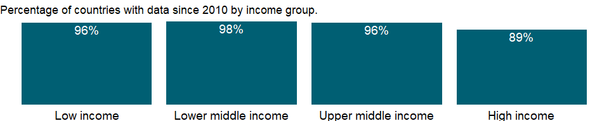

### Why is it relevant?

The addition of man-made greenhouse gases to the Atmosphere disturbs the earth’s radiative balance. This is leading to an increase in the earth’s surface temperature and to related effects on climate, sea level rise and world agriculture. Emissions of CO2 are from burning oil, coal and gas for energy use, burning wood and waste materials, and from industrial processes such as cement production. Emission intensity is the average emission rate of a given pollutant from a given source relative to the intensity of a specific activity. Emission intensities are also used to compare the environmental impact of different fuels or activities. The related terms - emission factor and carbon intensity - are often used interchangeably.

The carbon dioxide emissions of a country are only an indicator of one greenhouse gas. For a more complete idea of how a country influences climate change, gases such as methane and nitrous oxide should be taken into account. This is particularly important in agricultural economies.

The environmental effects of carbon dioxide are of significant interest. Carbon dioxide (CO2) makes up the largest share of the greenhouse gases contributing to global warming and climate change. Converting all other greenhouse gases (methane (CH4), nitrous oxide (N2O), hydrofluorocarbons (HFCs), perfluorocarbons (PFCs), Sulphur hexafluoride (SF6)) to carbon dioxide (or CO2) equivalents makes it possible to compare them and to determine their individual and total contributions to global warming. The Kyoto Protocol, an environmental agreement adopted in 1997 by many of the parties to the United Nations Framework Convention on Climate Change (UNFCCC), is working towards curbing CO2 emissions globally.

### What is the data source?

World Bank staff estimates from original source: European Commission, Joint Research Centre (JRC)/Netherlands Environmental Assessment Agency (PBL). Emission Database for Global Atmospheric Research (EDGAR): <http://edgar.jrc.ec.europa.eu/>.

### What is the methodology?

Methane emissions are those stemming from human activities such as agriculture and from industrial methane production. Expressed in CO2 equivalent using the GWP100 metric of the Second Assessment Report of IPCC and include CH4 (GWP100=21). The emissions are usually expressed in carbon dioxide equivalents using the global warming potential, which allows the effective contributions of different gases to be compared. A kilogram of methane is 21 times as effective at trapping heat in the earth’s atmosphere as a kilogram of carbon dioxide within 100 years.

### How is it aggregated?

Weighted Average

### What are the limitations?

National reporting to the United Nations Framework Convention on Climate Change that follows the Intergovernmental Panel on Climate Change guidelines is based on national emission inventories and covers all sources of anthropogenic carbon dioxide emissions as well as carbon sinks (such as forests). To estimate emissions, the countries that are Parties to the Climate Change Convention (UNFCCC) use complex, state-of-the-art methodologies recommended by the Intergovernmental Panel on Climate Change (IPCC).

### What else should I know?

NA

### 1.17.24 Agricultural nitrous oxide emissions (thousand metric tons of CO2 equivalent)

### What is the indicator?

Agricultural nitrous oxide emissions are emissions produced through fertilizer use (synthetic and animal manure), animal waste management, agricultural waste burning (nonenergy, on-site), and savanna burning.

Topic: Environment: Emissions

Series ID: EN.ATM.NOXE.AG.KT.CE

Copyright: CC BY-4.0 , <https://datacatalog.worldbank.org/public-licenses#cc-by>

First year with any data: 1969

Last year with any data: 2018

### What years are data available?

The figure below shows years in which data is available for at least one country. Dates shaded in black have no data, while dates shaded in green have data for at least one country



### Which countries have data?

The figure below shows the percentage of countries in each income group with a value since 2010 for that indicator.



### Why is it relevant?

The addition of man-made greenhouse gases to the Atmosphere disturbs the earth’s radiative balance. This is leading to an increase in the earth’s surface temperature and to related effects on climate, sea level rise and world agriculture. Emissions of CO2 are from burning oil, coal and gas for energy use, burning wood and waste materials, and from industrial processes such as cement production. Emission intensity is the average emission rate of a given pollutant from a given source relative to the intensity of a specific activity. Emission intensities are also used to compare the environmental impact of different fuels or activities. The related terms - emission factor and carbon intensity - are often used interchangeably.

The carbon dioxide emissions of a country are only an indicator of one greenhouse gas. For a more complete idea of how a country influences climate change, gases such as methane and nitrous oxide should be taken into account. This is particularly important in agricultural economies.

The environmental effects of carbon dioxide are of significant interest. Carbon dioxide (CO2) makes up the largest share of the greenhouse gases contributing to global warming and climate change. Converting all other greenhouse gases (methane (CH4), nitrous oxide (N2O), hydrofluorocarbons (HFCs), perfluorocarbons (PFCs), Sulphur hexafluoride (SF6)) to carbon dioxide (or CO2) equivalents makes it possible to compare them and to determine their individual and total contributions to global warming. The Kyoto Protocol, an environmental agreement adopted in 1997 by many of the parties to the United Nations Framework Convention on Climate Change (UNFCCC), is working towards curbing CO2 emissions globally.

### What is the data source?

Data for up to 1990 are sourced from Carbon Dioxide Information Analysis Center, Environmental Sciences Division, Oak Ridge National Laboratory, Tennessee, United States. Data from 1990 are CAIT data: Climate Watch. 2020. GHG Emissions. Washington, DC: World Resources Institute. Available at: <https://www.climatewatchdata.org/ghg-emissions>.

### What is the methodology?

Agricultural nitrous oxide emissions are emissions produced through fertilizer use (synthetic and animal manure), animal waste management, agricultural waste burning (nonenergy, on-site), and savannah burning. IPCC category 4 = Agriculture. Expressed in CO2 equivalent using the GWP100 metric of the Second Assessment Report of IPCC and include N2O (GWP100=310).

### How is it aggregated?

Sum

### What are the limitations?

National reporting to the United Nations Framework Convention on Climate Change that follows the Intergovernmental Panel on Climate Change guidelines is based on national emission inventories and covers all sources of anthropogenic carbon dioxide emissions as well as carbon sinks (such as forests). To estimate emissions, the countries that are Parties to the Climate Change Convention (UNFCCC) use complex, state-of-the-art methodologies recommended by the Intergovernmental Panel on Climate Change (IPCC).

### What else should I know?

NA

### 1.17.25 Agricultural nitrous oxide emissions (% of total)

### What is the indicator?

Agricultural nitrous oxide emissions are emissions produced through fertilizer use (synthetic and animal manure), animal waste management, agricultural waste burning (nonenergy, on-site), and savanna burning.

Topic: Environment: Emissions

Series ID: EN.ATM.NOXE.AG.ZS

Copyright: CC BY-4.0 , <https://datacatalog.worldbank.org/public-licenses#cc-by>

First year with any data: 1970

Last year with any data: 2008

### What years are data available?

The figure below shows years in which data is available for at least one country. Dates shaded in black have no data, while dates shaded in green have data for at least one country



### Which countries have data?

The figure below shows the percentage of countries in each income group with a value since 2010 for that indicator.



### Why is it relevant?

The addition of man-made greenhouse gases to the Atmosphere disturbs the earth’s radiative balance. This is leading to an increase in the earth’s surface temperature and to related effects on climate, sea level rise and world agriculture. Emissions of CO2 are from burning oil, coal and gas for energy use, burning wood and waste materials, and from industrial processes such as cement production. Emission intensity is the average emission rate of a given pollutant from a given source relative to the intensity of a specific activity. Emission intensities are also used to compare the environmental impact of different fuels or activities. The related terms - emission factor and carbon intensity - are often used interchangeably.

The carbon dioxide emissions of a country are only an indicator of one greenhouse gas. For a more complete idea of how a country influences climate change, gases such as methane and nitrous oxide should be taken into account. This is particularly important in agricultural economies.

The environmental effects of carbon dioxide are of significant interest. Carbon dioxide (CO2) makes up the largest share of the greenhouse gases contributing to global warming and climate change. Converting all other greenhouse gases (methane (CH4), nitrous oxide (N2O), hydrofluorocarbons (HFCs), perfluorocarbons (PFCs), Sulphur hexafluoride (SF6)) to carbon dioxide (or CO2) equivalents makes it possible to compare them and to determine their individual and total contributions to global warming. The Kyoto Protocol, an environmental agreement adopted in 1997 by many of the parties to the United Nations Framework Convention on Climate Change (UNFCCC), is working towards curbing CO2 emissions globally.

### What is the data source?

World Bank staff estimates from original source: European Commission, Joint Research Centre (JRC)/Netherlands Environmental Assessment Agency (PBL). Emission Database for Global Atmospheric Research (EDGAR): <http://edgar.jrc.ec.europa.eu/>.

### What is the methodology?

Agricultural nitrous oxide emissions are emissions produced through fertilizer use (synthetic and animal manure), animal waste management, agricultural waste burning (nonenergy, on-site), and savannah burning. IPCC category 4 = Agriculture. Expressed in CO2 equivalent using the GWP100 metric of the Second Assessment Report of IPCC and include N2O (GWP100=310).

### How is it aggregated?

Weighted average

### What are the limitations?

National reporting to the United Nations Framework Convention on Climate Change that follows the Intergovernmental Panel on Climate Change guidelines is based on national emission inventories and covers all sources of anthropogenic carbon dioxide emissions as well as carbon sinks (such as forests). To estimate emissions, the countries that are Parties to the Climate Change Convention (UNFCCC) use complex, state-of-the-art methodologies recommended by the Intergovernmental Panel on Climate Change (IPCC).

### What else should I know?

NA

### 1.17.26 Nitrous oxide emissions in energy sector (thousand metric tons of CO2 equivalent)

### What is the indicator?

Nitrous oxide emissions from energy processes are emissions produced by the combustion of fossil fuels and biofuels.

Topic: Environment: Emissions

Series ID: EN.ATM.NOXE.EG.KT.CE

Copyright: CC BY-4.0 , <https://datacatalog.worldbank.org/public-licenses#cc-by>

First year with any data: 1969

Last year with any data: 2018

### What years are data available?

The figure below shows years in which data is available for at least one country. Dates shaded in black have no data, while dates shaded in green have data for at least one country



### Which countries have data?

The figure below shows the percentage of countries in each income group with a value since 2010 for that indicator.



### Why is it relevant?

The addition of man-made greenhouse gases to the Atmosphere disturbs the earth’s radiative balance. This is leading to an increase in the earth’s surface temperature and to related effects on climate, sea level rise and world agriculture. Emissions of CO2 are from burning oil, coal and gas for energy use, burning wood and waste materials, and from industrial processes such as cement production. Emission intensity is the average emission rate of a given pollutant from a given source relative to the intensity of a specific activity. Emission intensities are also used to compare the environmental impact of different fuels or activities. The related terms - emission factor and carbon intensity - are often used interchangeably.

The carbon dioxide emissions of a country are only an indicator of one greenhouse gas. For a more complete idea of how a country influences climate change, gases such as methane and nitrous oxide should be taken into account. This is particularly important in agricultural economies.

The environmental effects of carbon dioxide are of significant interest. Carbon dioxide (CO2) makes up the largest share of the greenhouse gases contributing to global warming and climate change. Converting all other greenhouse gases (methane (CH4), nitrous oxide (N2O), hydrofluorocarbons (HFCs), perfluorocarbons (PFCs), Sulphur hexafluoride (SF6)) to carbon dioxide (or CO2) equivalents makes it possible to compare them and to determine their individual and total contributions to global warming. The Kyoto Protocol, an environmental agreement adopted in 1997 by many of the parties to the United Nations Framework Convention on Climate Change (UNFCCC), is working towards curbing CO2 emissions globally.

### What is the data source?

Data for up to 1990 are sourced from Carbon Dioxide Information Analysis Center, Environmental Sciences Division, Oak Ridge National Laboratory, Tennessee, United States. Data from 1990 are CAIT data: Climate Watch. 2020. GHG Emissions. Washington, DC: World Resources Institute. Available at: <https://www.climatewatchdata.org/ghg-emissions>.

### What is the methodology?

IPCC category 1 = Energy. Expressed in CO2 equivalent using the GWP100 metric of the Second Assessment Report of IPCC and include N2O (GWP100=310). Nitrous oxide emissions are mainly from fossil fuel combustion, fertilizers, rainforest fires, and animal waste. Nitrous oxide is a powerful greenhouse gas, with an estimated atmospheric lifetime of 114 years, compared with 12 years for methane. The per kilogram global warming potential of nitrous oxide is nearly 310 times that of carbon dioxide within 100 years. The emissions are usually expressed in carbon dioxide equivalents using the global warming potential, which allows the effective contributions of different gases to be compared.

### How is it aggregated?

Sum

### What are the limitations?

National reporting to the United Nations Framework Convention on Climate Change that follows the Intergovernmental Panel on Climate Change guidelines is based on national emission inventories and covers all sources of anthropogenic carbon dioxide emissions as well as carbon sinks (such as forests). To estimate emissions, the countries that are Parties to the Climate Change Convention (UNFCCC) use complex, state-of-the-art methodologies recommended by the Intergovernmental Panel on Climate Change (IPCC).

### What else should I know?

NA

### 1.17.27 Nitrous oxide emissions in energy sector (% of total)

### What is the indicator?

Nitrous oxide emissions from energy processes are emissions produced by the combustion of fossil fuels and biofuels.

Topic: Environment: Emissions

Series ID: EN.ATM.NOXE.EG.ZS

Copyright: CC BY-4.0 , <https://datacatalog.worldbank.org/public-licenses#cc-by>

First year with any data: 1970

Last year with any data: 2008

### What years are data available?

The figure below shows years in which data is available for at least one country. Dates shaded in black have no data, while dates shaded in green have data for at least one country



### Which countries have data?

The figure below shows the percentage of countries in each income group with a value since 2010 for that indicator.



### Why is it relevant?

The addition of man-made greenhouse gases to the Atmosphere disturbs the earth’s radiative balance. This is leading to an increase in the earth’s surface temperature and to related effects on climate, sea level rise and world agriculture. Emissions of CO2 are from burning oil, coal and gas for energy use, burning wood and waste materials, and from industrial processes such as cement production. Emission intensity is the average emission rate of a given pollutant from a given source relative to the intensity of a specific activity. Emission intensities are also used to compare the environmental impact of different fuels or activities. The related terms - emission factor and carbon intensity - are often used interchangeably.

The carbon dioxide emissions of a country are only an indicator of one greenhouse gas. For a more complete idea of how a country influences climate change, gases such as methane and nitrous oxide should be taken into account. This is particularly important in agricultural economies.

The environmental effects of carbon dioxide are of significant interest. Carbon dioxide (CO2) makes up the largest share of the greenhouse gases contributing to global warming and climate change. Converting all other greenhouse gases (methane (CH4), nitrous oxide (N2O), hydrofluorocarbons (HFCs), perfluorocarbons (PFCs), Sulphur hexafluoride (SF6)) to carbon dioxide (or CO2) equivalents makes it possible to compare them and to determine their individual and total contributions to global warming. The Kyoto Protocol, an environmental agreement adopted in 1997 by many of the parties to the United Nations Framework Convention on Climate Change (UNFCCC), is working towards curbing CO2 emissions globally.

### What is the data source?

World Bank staff estimates from original source: European Commission, Joint Research Centre (JRC)/Netherlands Environmental Assessment Agency (PBL). Emission Database for Global Atmospheric Research (EDGAR): <http://edgar.jrc.ec.europa.eu/>.

### What is the methodology?

Nitrous oxide emissions are mainly from fossil fuel combustion, fertilizers, rainforest fires, and animal waste. Nitrous oxide is a powerful greenhouse gas, with an estimated atmospheric lifetime of 114 years, compared with 12 years for methane. The per kilogram global warming potential of nitrous oxide is nearly 310 times that of carbon dioxide within 100 years. The emissions are usually expressed in carbon dioxide equivalents using the global warming potential, which allows the effective contributions of different gases to be compared.

### How is it aggregated?

Weighted Average

### What are the limitations?

National reporting to the United Nations Framework Convention on Climate Change that follows the Intergovernmental Panel on Climate Change guidelines is based on national emission inventories and covers all sources of anthropogenic carbon dioxide emissions as well as carbon sinks (such as forests). To estimate emissions, the countries that are Parties to the Climate Change Convention (UNFCCC) use complex, state-of-the-art methodologies recommended by the Intergovernmental Panel on Climate Change (IPCC).

### What else should I know?

NA

### 1.17.28 Total nitrous oxide emissions (thousand metric tons of CO2 equivalent excluding Land-Use Change and Forestry)

### What is the indicator?

Nitrous oxide emissions are emissions from agricultural biomass burning, industrial activities, and livestock management.

Topic: Environment: Emissions

Series ID: EN.ATM.NOXE.KT.CE

Copyright: CC BY-4.0 , <https://datacatalog.worldbank.org/public-licenses#cc-by>

First year with any data: 1970

Last year with any data: 2018

### What years are data available?

The figure below shows years in which data is available for at least one country. Dates shaded in black have no data, while dates shaded in green have data for at least one country



### Which countries have data?

The figure below shows the percentage of countries in each income group with a value since 2010 for that indicator.



### Why is it relevant?

The addition of man-made greenhouse gases to the Atmosphere disturbs the earth’s radiative balance. This is leading to an increase in the earth’s surface temperature and to related effects on climate, sea level rise and world agriculture. Emissions of CO2 are from burning oil, coal and gas for energy use, burning wood and waste materials, and from industrial processes such as cement production. Emission intensity is the average emission rate of a given pollutant from a given source relative to the intensity of a specific activity. Emission intensities are also used to compare the environmental impact of different fuels or activities. The related terms - emission factor and carbon intensity - are often used interchangeably.

The carbon dioxide emissions of a country are only an indicator of one greenhouse gas. For a more complete idea of how a country influences climate change, gases such as methane and nitrous oxide should be taken into account. This is particularly important in agricultural economies.

The environmental effects of carbon dioxide are of significant interest. Carbon dioxide (CO2) makes up the largest share of the greenhouse gases contributing to global warming and climate change. Converting all other greenhouse gases (methane (CH4), nitrous oxide (N2O), hydrofluorocarbons (HFCs), perfluorocarbons (PFCs), Sulphur hexafluoride (SF6)) to carbon dioxide (or CO2) equivalents makes it possible to compare them and to determine their individual and total contributions to global warming. The Kyoto Protocol, an environmental agreement adopted in 1997 by many of the parties to the United Nations Framework Convention on Climate Change (UNFCCC), is working towards curbing CO2 emissions globally.

### What is the data source?

Data for up to 1990 are sourced from Carbon Dioxide Information Analysis Center, Environmental Sciences Division, Oak Ridge National Laboratory, Tennessee, United States. Data from 1990 are CAIT data: Climate Watch. 2020. GHG Emissions. Washington, DC: World Resources Institute. Available at: <https://www.climatewatchdata.org/ghg-emissions>.

### What is the methodology?

Nitrous oxide emissions are mainly from fossil fuel combustion, fertilizers, rainforest fires, and animal waste. Nitrous oxide is a powerful greenhouse gas, with an estimated atmospheric lifetime of 114 years, compared with 12 years for methane. The per kilogram global warming potential of nitrous oxide is nearly 310 times that of carbon dioxide within 100 years. The emissions are usually expressed in carbon dioxide equivalents using the global warming potential, which allows the effective contributions of different gases to be compared.

### How is it aggregated?

Sum

### What are the limitations?

National reporting to the United Nations Framework Convention on Climate Change that follows the Intergovernmental Panel on Climate Change guidelines is based on national emission inventories and covers all sources of anthropogenic carbon dioxide emissions as well as carbon sinks (such as forests). To estimate emissions, the countries that are Parties to the Climate Change Convention (UNFCCC) use complex, state-of-the-art methodologies recommended by the Intergovernmental Panel on Climate Change (IPCC).

### What else should I know?

NA

### 1.17.29 Nitrous oxide emissions (% change from 1990)

### What is the indicator?

Nitrous oxide emissions are emissions from agricultural biomass burning, industrial activities, and livestock management. Each year of data shows the percentage change to that year from 1990.

Topic: Environment: Emissions

Series ID: EN.ATM.NOXE.ZG

Copyright: CC BY-4.0 , <https://datacatalog.worldbank.org/public-licenses#cc-by>

First year with any data: 1991

Last year with any data: 2012

### What years are data available?

The figure below shows years in which data is available for at least one country. Dates shaded in black have no data, while dates shaded in green have data for at least one country



### Which countries have data?

The figure below shows the percentage of countries in each income group with a value since 2010 for that indicator.

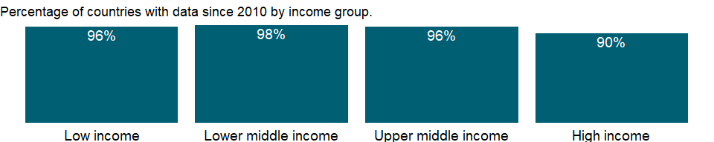

### Why is it relevant?

The addition of man-made greenhouse gases to the Atmosphere disturbs the earth’s radiative balance. This is leading to an increase in the earth’s surface temperature and to related effects on climate, sea level rise and world agriculture. Emissions of CO2 are from burning oil, coal and gas for energy use, burning wood and waste materials, and from industrial processes such as cement production. Emission intensity is the average emission rate of a given pollutant from a given source relative to the intensity of a specific activity. Emission intensities are also used to compare the environmental impact of different fuels or activities. The related terms - emission factor and carbon intensity - are often used interchangeably.

The carbon dioxide emissions of a country are only an indicator of one greenhouse gas. For a more complete idea of how a country influences climate change, gases such as methane and nitrous oxide should be taken into account. This is particularly important in agricultural economies.

The environmental effects of carbon dioxide are of significant interest. Carbon dioxide (CO2) makes up the largest share of the greenhouse gases contributing to global warming and climate change. Converting all other greenhouse gases (methane (CH4), nitrous oxide (N2O), hydrofluorocarbons (HFCs), perfluorocarbons (PFCs), Sulphur hexafluoride (SF6)) to carbon dioxide (or CO2) equivalents makes it possible to compare them and to determine their individual and total contributions to global warming. The Kyoto Protocol, an environmental agreement adopted in 1997 by many of the parties to the United Nations Framework Convention on Climate Change (UNFCCC), is working towards curbing CO2 emissions globally.

### What is the data source?

World Bank staff estimates from original source: European Commission, Joint Research Centre (JRC)/Netherlands Environmental Assessment Agency (PBL). Emission Database for Global Atmospheric Research (EDGAR): <http://edgar.jrc.ec.europa.eu/>.

### What is the methodology?

Nitrous oxide emissions are mainly from fossil fuel combustion, fertilizers, rainforest fires, and animal waste. Nitrous oxide is a powerful greenhouse gas, with an estimated atmospheric lifetime of 114 years, compared with 12 years for methane. The per kilogram global warming potential of nitrous oxide is nearly 310 times that of carbon dioxide within 100 years. The emissions are usually expressed in carbon dioxide equivalents using the global warming potential, which allows the effective contributions of different gases to be compared.

### How is it aggregated?

Weighted Average

### What are the limitations?

National reporting to the United Nations Framework Convention on Climate Change that follows the Intergovernmental Panel on Climate Change guidelines is based on national emission inventories and covers all sources of anthropogenic carbon dioxide emissions as well as carbon sinks (such as forests). To estimate emissions, the countries that are Parties to the Climate Change Convention (UNFCCC) use complex, state-of-the-art methodologies recommended by the Intergovernmental Panel on Climate Change (IPCC).

### What else should I know?

NA

### 1.17.30 PFC gas emissions (thousand metric tons of CO2 equivalent)

### What is the indicator?

Perfluorocarbons, used as a replacement for chlorofluorocarbons in manufacturing semiconductors, are a byproduct of aluminum smelting and uranium enrichment.

Topic: Environment: Emissions

Series ID: EN.ATM.PFCG.KT.CE

Copyright: CC BY-4.0 , <https://datacatalog.worldbank.org/public-licenses#cc-by>

First year with any data: 1990

Last year with any data: 2010

### What years are data available?

The figure below shows years in which data is available for at least one country. Dates shaded in black have no data, while dates shaded in green have data for at least one country



### Which countries have data?

The figure below shows the percentage of countries in each income group with a value since 2010 for that indicator.



### Why is it relevant?

NA

### What is the data source?

European Commission, Joint Research Centre (JRC)/Netherlands Environmental Assessment Agency (PBL). Emission Database for Global Atmospheric Research (EDGAR): <http://edgar.jrc.ec.europa.eu/>

### What is the methodology?

NA

### How is it aggregated?

Gap-filled total

### What are the limitations?

NA

### What else should I know?

NA

### 1.17.31 PM2.5 air pollution, mean annual exposure (micrograms per cubic meter)

### What is the indicator?

Population-weighted exposure to ambient PM2.5 pollution is defined as the average level of exposure of a nation’s population to concentrations of suspended particles measuring less than 2.5 microns in aerodynamic diameter, which are capable of penetrating deep into the respiratory tract and causing severe health damage. Exposure is calculated by weighting mean annual concentrations of PM2.5 by population in both urban and rural areas.

Topic: Environment: Emissions

Series ID: EN.ATM.PM25.MC.M3

Copyright: CC BY-4.0 , <https://datacatalog.worldbank.org/public-licenses#cc-by>

First year with any data: 1990

Last year with any data: 2017

### What years are data available?

The figure below shows years in which data is available for at least one country. Dates shaded in black have no data, while dates shaded in green have data for at least one country

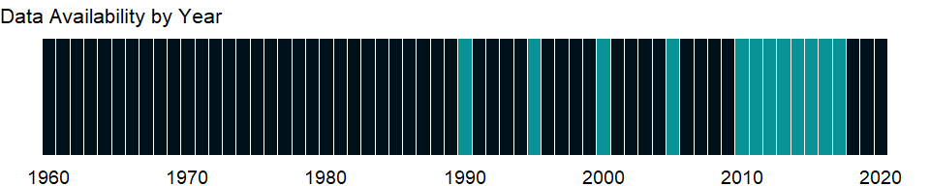

### Which countries have data?

The figure below shows the percentage of countries in each income group with a value since 2010 for that indicator.

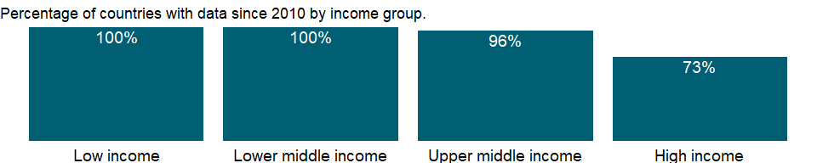

### Why is it relevant?

Air pollution places a major burden on world health. In many places, including cities but also in rural areas, exposure to air pollution is the main environmental threat to health, responsible for 6.5 million deaths per year, about one every 5 seconds. Around 40 percent of the world’s people rely on household burning of wood, charcoal, dung, crop waste, or coal to meet basic energy needs. Cooking and heating with solid fuels create harmful smoke and particles that fill homes and the surrounding environment. Household air pollution from cooking and heating with solid fuels is responsible for 2.9 million deaths a year. Long-term exposure to high levels of fine particles in the air contributes to a range of health effects, including respiratory diseases, lung cancer, and heart disease, resulting in 4.2 million deaths annually. Not only does exposure to air pollution affect the health of the world’s people, it also carries huge economic costs and represents a drag on development, particularly for low and middle income countries and vulnerable segments of the population such as children and the elderly.

### What is the data source?

Brauer, M. et al. 2017, for the Global Burden of Disease Study 2017.

### What is the methodology?

A. van Donkelaar, R.V. Martin, M. Brauer, N.C. Hsu, R.A. Kahn, R.C. Levy, A. Lyapustin, A.M. Sayer, D.M. Winker, “Global Estimates of Fine Particulate Matter using a Combined Geophysical-Statistical Method with Information from Satellites, Models, and Monitors,” Environ. Sci. Technol 50, no. 7 (2016): 3762–3772; GBD 2017 Risk Factors Collaborators, “Global, regional, and national comparative risk assessment of 84 behavioural, environmental and occupational, and metabolic risks or clusters of risks for 194 countries and territories, 1990–2017: a systematic analysis for the Global Burden of Disease Study 2017,” Lancet 392 (2018): 1923-1994; Shaddick G, Thomas M, Amini H, Broday DM, Cohen A, Frostad J, Green A, Gumy S, Liu Y, Martin RV, Prüss-Üstün A, Simpson D, van Donkelaar A, Brauer M. Data integration for the assessment of population exposure to ambient air pollution for global burden of disease assessment. Environ Sci Technol. 2018 Jun 29. Data provided by Institute for Health Metrics and Evaluation, University of Washington, Seattle. Data on exposure to ambient air pollution are derived from estimates of annual concentrations of very fine particulates produced by the Global Burden of Disease study, an international scientific effort led by the Institute for Health Metrics and Evaluation at the University of Washington. Estimates of annual concentrations are generated by combining data from atmospheric chemistry transport models, satellite observations of aerosols in the atmosphere, and ground-level monitoring of particulates. Exposure to concentrations of PM2.5 in both urban and rural areas is weighted by population and is aggregated at the national level.

### How is it aggregated?

Weighted Average

### What are the limitations?

Pollutant concentrations are sensitive to local conditions, and even monitoring sites in the same city may register different levels. Direct monitoring of PM2.5 is still rare in most parts of the world, and measurement protocols and standards are not the same for all countries. These data should be considered only a general indication of air quality, intended to inform cross-country comparisons of the health risks due to particulate matter pollution. The guideline set by the World Health Organization (WHO) for PM2.5 is that annual mean concentrations should not exceed 10 micrograms per cubic meter, representing the lower range over which adverse health effects have been observed. The WHO has also recommended guideline values for emissions of PM2.5 from burning fuels in households.

### What else should I know?

NA

### 1.17.32 PM2.5 pollution, population exposed to levels exceeding WHO Interim Target-1 value (% of total)

### What is the indicator?

Percent of population exposed to ambient concentrations of PM2.5 that exceed the World Health Organization (WHO) Interim Target 1 (IT-1) is defined as the portion of a country’s population living in places where mean annual concentrations of PM2.5 are greater than 35 micrograms per cubic meter. The Air Quality Guideline (AQG) of 10 micrograms per cubic meter is recommended by the WHO as the lower end of the range of concentrations over which adverse health effects due to PM2.5 exposure have been observed.

Topic: Environment: Emissions

Series ID: EN.ATM.PM25.MC.T1.ZS

Copyright: CC BY-4.0 , <https://datacatalog.worldbank.org/public-licenses#cc-by>

First year with any data: 1990

Last year with any data: 2017

### What years are data available?

The figure below shows years in which data is available for at least one country. Dates shaded in black have no data, while dates shaded in green have data for at least one country



### Which countries have data?

The figure below shows the percentage of countries in each income group with a value since 2010 for that indicator.



### Why is it relevant?

Air pollution places a major burden on world health. In many places, including cities but also in rural areas, exposure to air pollution is the main environmental threat to health, responsible for 6.5 million deaths per year, about one every 5 seconds. Around 40 percent of the world’s people rely on household burning of wood, charcoal, dung, crop waste, or coal to meet basic energy needs. Cooking and heating with solid fuels create harmful smoke and particles that fill homes and the surrounding environment. Household air pollution from cooking and heating with solid fuels is responsible for 2.9 million deaths a year. Long-term exposure to high levels of fine particles in the air contributes to a range of health effects, including respiratory diseases, lung cancer, and heart disease, resulting in 4.2 million deaths annually. Not only does exposure to air pollution affect the health of the world’s people, it also carries huge economic costs and represents a drag on development, particularly for low and middle income countries and vulnerable segments of the population such as children and the elderly. Three interim targets were defined for PM2.5 and have been shown to be achievable with successive and sustained abatement measures. Countries may find these interim targets particularly helpful in gauging progress over time in the difficult process of steadily reducing population exporsure to PM. IT-1 level corresponds to the highest mean concentrations reported in studies of long-term effects, and may also reflect higher but unknown historical concentrations that may have been contributed to observed health effects. IT-1 level has been shown to be associated with significant mortality in the developed world.

### What is the data source?

Brauer, M. et al. 2017, for the Global Burden of Disease Study 2017.

### What is the methodology?

A. van Donkelaar, R.V. Martin, M. Brauer, N.C. Hsu, R.A. Kahn, R.C. Levy, A. Lyapustin, A.M. Sayer, D.M. Winker, “Global Estimates of Fine Particulate Matter using a Combined Geophysical-Statistical Method with Information from Satellites, Models, and Monitors,” Environ. Sci. Technol 50, no. 7 (2016): 3762–3772;GBD 2017 Risk Factors Collaborators, “Global, regional, and national comparative risk assessment of 84 behavioural, environmental and occupational, and metabolic risks or clusters of risks for 194 countries and territories, 1990–2017: a systematic analysis for the Global Burden of Disease Study 2017,” Lancet 392 (2018): 1923-1994; Shaddick G, Thomas M, Amini H, Broday DM, Cohen A, Frostad J, Green A, Gumy S, Liu Y, Martin RV, Prüss-Üstün A, Simpson D, van Donkelaar A, Brauer M. Data integration for the assessment of population exposure to ambient air pollution for global burden of disease assessment. Environ Sci Technol. 2018 Jun 29. Data provided by Institute for Health Metrics and Evaluation, University of Washington, Seattle. Data on exposure to ambient air pollution are derived from estimates of annual concentrations of very fine particulates produced by the Global Burden of Disease study, an international scientific effort led by the Institute for Health Metrics and Evaluation at the University of Washington. Estimates of annual concentrations are generated by combining data from atmospheric chemistry transport models, satellite observations of aerosols in the atmosphere, and ground-level monitoring of particulates. Overlaying PM2.5 estimates with gridded population data, the percent of a nation’s people that lives in areas where PM2.5 concentrations exceed recommended levels is calculated by summing the population for grid cells where PM2.5 concentrations are beyond a threshold value, in this case 10 micrograms per cubic meter, and then dividing by total population.

### How is it aggregated?

Weighted Average

### What are the limitations?

Pollutant concentrations are sensitive to local conditions, and even monitoring sites in the same city may register different levels. Direct monitoring of PM2.5 is still rare in most parts of the world, and measurement protocols and standards are not the same for all countries. These data should be considered only a general indication of air quality, intended to inform cross-country comparisons of the health risks due to particulate matter pollution. The guideline set by the World Health Organization (WHO) for PM2.5 is that annual mean concentrations should not exceed 10 micrograms per cubic meter, representing the lower range over which adverse health effects have been observed. The WHO has also recommended guideline values for emissions of PM2.5 from burning fuels in households.

### What else should I know?

NA

### 1.17.33 PM2.5 pollution, population exposed to levels exceeding WHO Interim Target-2 value (% of total)

### What is the indicator?

Percent of population exposed to ambient concentrations of PM2.5 that exceed the World Health Organization (WHO) Interim Target 2 (IT-2) is defined as the portion of a country’s population living in places where mean annual concentrations of PM2.5 are greater than 25 micrograms per cubic meter. The Air Quality Guideline (AQG) of 10 micrograms per cubic meter is recommended by the WHO as the lower end of the range of concentrations over which adverse health effects due to PM2.5 exposure have been observed.

Topic: Environment: Emissions

Series ID: EN.ATM.PM25.MC.T2.ZS

Copyright: CC BY-4.0 , <https://datacatalog.worldbank.org/public-licenses#cc-by>

First year with any data: 1990

Last year with any data: 2017

### What years are data available?

The figure below shows years in which data is available for at least one country. Dates shaded in black have no data, while dates shaded in green have data for at least one country



### Which countries have data?

The figure below shows the percentage of countries in each income group with a value since 2010 for that indicator.



### Why is it relevant?

Air pollution places a major burden on world health. In many places, including cities but also in rural areas, exposure to air pollution is the main environmental threat to health, responsible for 6.5 million deaths per year, about one every 5 seconds. Around 40 percent of the world’s people rely on household burning of wood, charcoal, dung, crop waste, or coal to meet basic energy needs. Cooking and heating with solid fuels create harmful smoke and particles that fill homes and the surrounding environment. Household air pollution from cooking and heating with solid fuels is responsible for 2.9 million deaths a year. Long-term exposure to high levels of fine particles in the air contributes to a range of health effects, including respiratory diseases, lung cancer, and heart disease, resulting in 4.2 million deaths annually. Not only does exposure to air pollution affect the health of the world’s people, it also carries huge economic costs and represents a drag on development, particularly for low and middle income countries and vulnerable segments of the population such as children and the elderly. Three interim targets were defined for PM2.5 and have been shown to be achievable with successive and sustained abatement measures. Countries may find these interim targets particularly helpful in gauging progress over time in the difficult process of steadily reducing population exporsure to PM. IT-2 level is greater than the mean concentration at which effects have been observed in studies of long-term exposure and mortality and is likely to be associated with significant health impacts from both long-term and daily exposures to PM2.5. Attainment of IT-2 value would reduce the health risks of long-term exposure by about 6% relative to the IT-1 value.

### What is the data source?

Brauer, M. et al. 2017, for the Global Burden of Disease Study 2017.

### What is the methodology?

A. van Donkelaar, R.V. Martin, M. Brauer, N.C. Hsu, R.A. Kahn, R.C. Levy, A. Lyapustin, A.M. Sayer, D.M. Winker, “Global Estimates of Fine Particulate Matter using a Combined Geophysical-Statistical Method with Information from Satellites, Models, and Monitors,” Environ. Sci. Technol 50, no. 7 (2016): 3762–3772; GBD 2017 Risk Factors Collaborators, “Global, regional, and national comparative risk assessment of 84 behavioural, environmental and occupational, and metabolic risks or clusters of risks for 194 countries and territories, 1990–2017: a systematic analysis for the Global Burden of Disease Study 2017,” Lancet 392 (2018): 1923-1994; Shaddick G, Thomas M, Amini H, Broday DM, Cohen A, Frostad J, Green A, Gumy S, Liu Y, Martin RV, Prüss-Üstün A, Simpson D, van Donkelaar A, Brauer M. Data integration for the assessment of population exposure to ambient air pollution for global burden of disease assessment. Environ Sci Technol. 2018 Jun 29. Data provided by Institute for Health Metrics and Evaluation, University of Washington, Seattle. Data on exposure to ambient air pollution are derived from estimates of annual concentrations of very fine particulates produced by the Global Burden of Disease study, an international scientific effort led by the Institute for Health Metrics and Evaluation at the University of Washington. Estimates of annual concentrations are generated by combining data from atmospheric chemistry transport models, satellite observations of aerosols in the atmosphere, and ground-level monitoring of particulates. Overlaying PM2.5 estimates with gridded population data, the percent of a nation’s people that lives in areas where PM2.5 concentrations exceed recommended levels is calculated by summing the population for grid cells where PM2.5 concentrations are beyond a threshold value, in this case 10 micrograms per cubic meter, and then dividing by total population.

### How is it aggregated?

Weighted Average

### What are the limitations?

Pollutant concentrations are sensitive to local conditions, and even monitoring sites in the same city may register different levels. Direct monitoring of PM2.5 is still rare in most parts of the world, and measurement protocols and standards are not the same for all countries. These data should be considered only a general indication of air quality, intended to inform cross-country comparisons of the health risks due to particulate matter pollution. The guideline set by the World Health Organization (WHO) for PM2.5 is that annual mean concentrations should not exceed 10 micrograms per cubic meter, representing the lower range over which adverse health effects have been observed. The WHO has also recommended guideline values for emissions of PM2.5 from burning fuels in households.

### What else should I know?

NA

### 1.17.34 PM2.5 pollution, population exposed to levels exceeding WHO Interim Target-3 value (% of total)

### What is the indicator?

Percent of population exposed to ambient concentrations of PM2.5 that exceed the World Health Organization (WHO) Interim Target 3 (IT-3) is defined as the portion of a country’s population living in places where mean annual concentrations of PM2.5 are greater than 15 micrograms per cubic meter. The Air Quality Guideline (AQG) of 10 micrograms per cubic meter is recommended by the WHO as the lower end of the range of concentrations over which adverse health effects due to PM2.5 exposure have been observed.

Topic: Environment: Emissions

Series ID: EN.ATM.PM25.MC.T3.ZS

Copyright: CC BY-4.0 , <https://datacatalog.worldbank.org/public-licenses#cc-by>

First year with any data: 1990

Last year with any data: 2017

### What years are data available?

The figure below shows years in which data is available for at least one country. Dates shaded in black have no data, while dates shaded in green have data for at least one country



### Which countries have data?

The figure below shows the percentage of countries in each income group with a value since 2010 for that indicator.



### Why is it relevant?

Air pollution places a major burden on world health. In many places, including cities but also in rural areas, exposure to air pollution is the main environmental threat to health, responsible for 6.5 million deaths per year, about one every 5 seconds. Around 40 percent of the world’s people rely on household burning of wood, charcoal, dung, crop waste, or coal to meet basic energy needs. Cooking and heating with solid fuels create harmful smoke and particles that fill homes and the surrounding environment. Household air pollution from cooking and heating with solid fuels is responsible for 2.9 million deaths a year. Long-term exposure to high levels of fine particles in the air contributes to a range of health effects, including respiratory diseases, lung cancer, and heart disease, resulting in 4.2 million deaths annually. Not only does exposure to air pollution affect the health of the world’s people, it also carries huge economic costs and represents a drag on development, particularly for low and middle income countries and vulnerable segments of the population such as children and the elderly. Three interim targets were defined for PM2.5 and have been shown to be achievable with successive and sustained abatement measures. Countries may find these interim targets particularly helpful in gauging progress over time in the difficult process of steadily reducing population exporsure to PM. IT-3 level places greater weight than IT-2 on the likelihood of signifcant effects associated with long-term exposures. IT-3 value is close to the mean concentrations that are reported in studies of long-term exposure and provides an additional 6% reduction in mortality risk relative to the IT-2 value.

### What is the data source?

Brauer, M. et al. 2017, for the Global Burden of Disease Study 2017.

### What is the methodology?

A. van Donkelaar, R.V. Martin, M. Brauer, N.C. Hsu, R.A. Kahn, R.C. Levy, A. Lyapustin, A.M. Sayer, D.M. Winker, “Global Estimates of Fine Particulate Matter using a Combined Geophysical-Statistical Method with Information from Satellites, Models, and Monitors,” Environ. Sci. Technol 50, no. 7 (2016): 3762–3772; GBD 2017 Risk Factors Collaborators, “Global, regional, and national comparative risk assessment of 84 behavioural, environmental and occupational, and metabolic risks or clusters of risks for 194 countries and territories, 1990–2017: a systematic analysis for the Global Burden of Disease Study 2017,” Lancet 392 (2018): 1923-1994; Shaddick G, Thomas M, Amini H, Broday DM, Cohen A, Frostad J, Green A, Gumy S, Liu Y, Martin RV, Prüss-Üstün A, Simpson D, van Donkelaar A, Brauer M. Data integration for the assessment of population exposure to ambient air pollution for global burden of disease assessment. Environ Sci Technol. 2018 Jun 29. Data provided by Institute for Health Metrics and Evaluation, University of Washington, Seattle. Data on exposure to ambient air pollution are derived from estimates of annual concentrations of very fine particulates produced by the Global Burden of Disease study, an international scientific effort led by the Institute for Health Metrics and Evaluation at the University of Washington. Estimates of annual concentrations are generated by combining data from atmospheric chemistry transport models, satellite observations of aerosols in the atmosphere, and ground-level monitoring of particulates. Overlaying PM2.5 estimates with gridded population data, the percent of a nation’s people that lives in areas where PM2.5 concentrations exceed recommended levels is calculated by summing the population for grid cells where PM2.5 concentrations are beyond a threshold value, in this case 10 micrograms per cubic meter, and then dividing by total population.

### How is it aggregated?

Weighted Average

### What are the limitations?

Pollutant concentrations are sensitive to local conditions, and even monitoring sites in the same city may register different levels. Direct monitoring of PM2.5 is still rare in most parts of the world, and measurement protocols and standards are not the same for all countries. These data should be considered only a general indication of air quality, intended to inform cross-country comparisons of the health risks due to particulate matter pollution. The guideline set by the World Health Organization (WHO) for PM2.5 is that annual mean concentrations should not exceed 10 micrograms per cubic meter, representing the lower range over which adverse health effects have been observed. The WHO has also recommended guideline values for emissions of PM2.5 from burning fuels in households.

### What else should I know?

NA

### 1.17.35 PM2.5 air pollution, population exposed to levels exceeding WHO guideline value (% of total)

### What is the indicator?

Percent of population exposed to ambient concentrations of PM2.5 that exceed the WHO guideline value is defined as the portion of a country’s population living in places where mean annual concentrations of PM2.5 are greater than 10 micrograms per cubic meter, the guideline value recommended by the World Health Organization as the lower end of the range of concentrations over which adverse health effects due to PM2.5 exposure have been observed.

Topic: Environment: Emissions

Series ID: EN.ATM.PM25.MC.ZS

Copyright: CC BY-4.0 , <https://datacatalog.worldbank.org/public-licenses#cc-by>

First year with any data: 1990

Last year with any data: 2017

### What years are data available?

The figure below shows years in which data is available for at least one country. Dates shaded in black have no data, while dates shaded in green have data for at least one country



### Which countries have data?

The figure below shows the percentage of countries in each income group with a value since 2010 for that indicator.



### Why is it relevant?

Air pollution places a major burden on world health. In many places, including cities but also in rural areas, exposure to air pollution is the main environmental threat to health, responsible for 6.5 million deaths per year, about one every 5 seconds. Around 40 percent of the world’s people rely on household burning of wood, charcoal, dung, crop waste, or coal to meet basic energy needs. Cooking and heating with solid fuels create harmful smoke and particles that fill homes and the surrounding environment. Household air pollution from cooking and heating with solid fuels is responsible for 2.9 million deaths a year. Long-term exposure to high levels of fine particles in the air contributes to a range of health effects, including respiratory diseases, lung cancer, and heart disease, resulting in 4.2 million deaths annually. Not only does exposure to air pollution affect the health of the world’s people, it also carries huge economic costs and represents a drag on development, particularly for low and middle income countries and vulnerable segments of the population such as children and the elderly.

### What is the data source?

Brauer, M. et al. 2017, for the Global Burden of Disease Study 2017.

### What is the methodology?

A. van Donkelaar, R.V. Martin, M. Brauer, N.C. Hsu, R.A. Kahn, R.C. Levy, A. Lyapustin, A.M. Sayer, D.M. Winker, “Global Estimates of Fine Particulate Matter using a Combined Geophysical-Statistical Method with Information from Satellites, Models, and Monitors,” Environ. Sci. Technol 50, no. 7 (2016): 3762–3772; GBD 2017 Risk Factors Collaborators, “Global, regional, and national comparative risk assessment of 84 behavioural, environmental and occupational, and metabolic risks or clusters of risks for 194 countries and territories, 1990–2017: a systematic analysis for the Global Burden of Disease Study 2017,” Lancet 392 (2018): 1923-1994; Shaddick G, Thomas M, Amini H, Broday DM, Cohen A, Frostad J, Green A, Gumy S, Liu Y, Martin RV, Prüss-Üstün A, Simpson D, van Donkelaar A, Brauer M. Data integration for the assessment of population exposure to ambient air pollution for global burden of disease assessment. Environ Sci Technol. 2018 Jun 29. Data provided by Institute for Health Metrics and Evaluation, University of Washington, Seattle. Data on exposure to ambient air pollution are derived from estimates of annual concentrations of very fine particulates produced by the Global Burden of Disease study, an international scientific effort led by the Institute for Health Metrics and Evaluation at the University of Washington. Estimates of annual concentrations are generated by combining data from atmospheric chemistry transport models, satellite observations of aerosols in the atmosphere, and ground-level monitoring of particulates. Overlaying PM2.5 estimates with gridded population data, the percent of a nation’s people that lives in areas where PM2.5 concentrations exceed recommended levels is calculated by summing the population for grid cells where PM2.5 concentrations are beyond a threshold value, in this case 10 micrograms per cubic meter, and then dividing by total population.

### How is it aggregated?

Weighted Average

### What are the limitations?

Pollutant concentrations are sensitive to local conditions, and even monitoring sites in the same city may register different levels. Direct monitoring of PM2.5 is still rare in most parts of the world, and measurement protocols and standards are not the same for all countries. These data should be considered only a general indication of air quality, intended to inform cross-country comparisons of the health risks due to particulate matter pollution. The guideline set by the World Health Organization (WHO) for PM2.5 is that annual mean concentrations should not exceed 10 micrograms per cubic meter, representing the lower range over which adverse health effects have been observed. The WHO has also recommended guideline values for emissions of PM2.5 from burning fuels in households.

### What else should I know?

NA

### 1.17.36 SF6 gas emissions (thousand metric tons of CO2 equivalent)

### What is the indicator?

Sulfur hexafluoride is used largely to insulate high-voltage electric power equipment.

Topic: Environment: Emissions

Series ID: EN.ATM.SF6G.KT.CE

Copyright: CC BY-4.0 , <https://datacatalog.worldbank.org/public-licenses#cc-by>

First year with any data: 1990

Last year with any data: 2010

### What years are data available?

The figure below shows years in which data is available for at least one country. Dates shaded in black have no data, while dates shaded in green have data for at least one country



### Which countries have data?

The figure below shows the percentage of countries in each income group with a value since 2010 for that indicator.



### Why is it relevant?

NA

### What is the data source?

European Commission, Joint Research Centre (JRC)/Netherlands Environmental Assessment Agency (PBL). Emission Database for Global Atmospheric Research (EDGAR): <http://edgar.jrc.ec.europa.eu/>

### What is the methodology?

NA

### How is it aggregated?

Gap-filled total

### What are the limitations?

NA

### What else should I know?

NA

### 1.17.37 GHG net emissions/removals by LUCF (Mt of CO2 equivalent)

### What is the indicator?

GHG net emissions/removals by LUCF refers to changes in atmospheric levels of all greenhouse gases attributable to forest and land-use change activities, including but not limited to (1) emissions and removals of CO2 from decreases or increases in biomass stocks due to forest management, logging, fuelwood collection, etc.; (2) conversion of existing forests and natural grasslands to other land uses; (3) removal of CO2 from the abandonment of formerly managed lands (e.g. croplands and pastures); and (4) emissions and removals of CO2 in soil associated with land-use change and management. For Annex-I countries under the UNFCCC, these data are drawn from the annual GHG inventories submitted to the UNFCCC by each country; for non-Annex-I countries, data are drawn from the most recently submitted National Communication where available. Because of differences in reporting years and methodologies, these data are not generally considered comparable across countries. Data are in million metric tons.

Topic: Environment: Emissions

Series ID: EN.CLC.GHGR.MT.CE

Copyright: CC BY-4.0 , <https://datacatalog.worldbank.org/public-licenses#cc-by>

First year with any data: 1990

Last year with any data: 2009

### What years are data available?

The figure below shows years in which data is available for at least one country. Dates shaded in black have no data, while dates shaded in green have data for at least one country

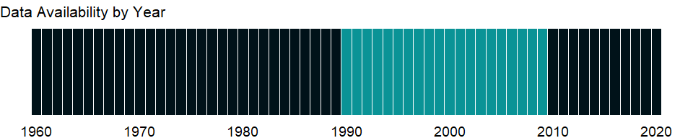

### Which countries have data?

The figure below shows the percentage of countries in each income group with a value since 2010 for that indicator.



### Why is it relevant?

NA

### What is the data source?

United Nations Framework Convention on Climate Change.

### What is the methodology?

NA

### How is it aggregated?

NA

### What are the limitations?

NA

### What else should I know?

NA

### 1.17.38 CO2 emissions from residential buildings and commercial and public services (% of total fuel combustion)

### What is the indicator?

CO2 emissions from residential buildings and commercial and public services contains all emissions from fuel combustion in households. This corresponds to IPCC Source/Sink Category 1 A 4 b. Commercial and public services includes emissions from all activities of ISIC Divisions 41, 50-52, 55, 63-67, 70-75, 80, 85, 90-93 and 99.

Topic: Environment: Emissions

Series ID: EN.CO2.BLDG.ZS

Copyright: Use and distribution of these data are subject to IEA terms and conditions. , <http://www.iea.org/t&c/termsandconditions>

First year with any data: 1960

Last year with any data: 2014

### What years are data available?

The figure below shows years in which data is available for at least one country. Dates shaded in black have no data, while dates shaded in green have data for at least one country



### Which countries have data?

The figure below shows the percentage of countries in each income group with a value since 2010 for that indicator.



### Why is it relevant?

Carbon dioxide (CO2) is naturally occurring gas fixed by photosynthesis into organic matter. A byproduct of fossil fuel combustion and biomass burning, it is also emitted from land use changes and other industrial processes. It is the principal anthropogenic greenhouse gas that affects the Earth’s radiative balance. It is the reference gas against which other greenhouse gases are measured, thus having a Global Warming Potential of 1.

Emission intensity is the average emission rate of a given pollutant from a given source relative to the intensity of a specific activity. Emission intensities are also used to compare the environmental impact of different fuels or activities. The related terms - emission factor and carbon intensity - are often used interchangeably.

Burning of carbon-based fuels since the industrial revolution has rapidly increased concentrations of atmospheric carbon dioxide, increasing the rate of global warming and causing anthropogenic climate change. It is also a major source of ocean acidification since it dissolves in water to form carbonic acid.

The addition of man-made greenhouse gases to the Atmosphere disturbs the earth’s radiative balance. This is leading to an increase in the earth’s surface temperature and to related effects on climate, sea level rise and world agriculture. Emissions of CO2 are from burning oil, coal and gas for energy use, burning wood and waste materials, and from industrial processes such as cement production.

Global emissions of carbon dioxide have risen by 99%, or on average 2.0% per year, since 1971, and are projected to rise by another 45% by 2030, or by 1.6% per year. It is estimated that emissions in China have risen by 5.7 percent per annum between 1971 and 2006 - the use of coal in China increased levels of CO2 by 4.8 billion tonnes over this period.

The environmental effects of carbon dioxide are of significant interest. Carbon dioxide (CO2) makes up the largest share of the greenhouse gases contributing to global warming and climate change. Converting all other greenhouse gases (methane (CH4), nitrous oxide (N2O), hydrofluorocarbons (HFCs), perfluorocarbons (PFCs), sulphur hexafluoride (SF6)) to carbon dioxide (or CO2) equivalents makes it possible to compare them and to determine their individual and total contributions to global warming. The Kyoto Protocol, an environmental agreement adopted in 1997 by many of the parties to the United Nations Framework Convention on Climate Change (UNFCCC), is working towards curbing CO2 emissions globally.

### What is the data source?

IEA Statistics © OECD/IEA 2014 (<http://www.iea.org/stats/index.asp>), subject to <https://www.iea.org/t&c/termsandconditions/>

### What is the methodology?

Carbon dioxide emissions , largely by-products of energy production and use, account for the largest share of greenhouse gases, which are associated with global warming. In 2010 the International Energy Agency (IEA) released data on carbon dioxide emissions by sector for the first time, allowing a more comprehensive understanding of each sector’s contribution to total emissions. The sectoral approach yields data on carbon dioxide emissions from fuel combustion (Intergovernmental Panel on Climate Change [IPCC] source/sink category 1A) as calculated using the IPCC tier 1 sectoral approach.

Carbon emissions from residential buildings and commercial and public services are the sum of emissions from fuel combustion in households (IPCC source/sink category 1A4b) and emissions from all activities of International Standard Industrial Classification divisions 41, 50-52, 55, 63-67, 70-75, 80, 85, 90-93, and 99.

Anthropogenic carbon dioxide emissions result primarily from fossil fuel combustion and cement manufacturing. In combustion different fossil fuels release different amounts of carbon dioxide for the same level of energy use: oil releases about 50 percent more carbon dioxide than natural gas, and coal releases about twice as much. Cement manufacturing releases about half a metric ton of carbon dioxide for each metric ton of cement produced.

### How is it aggregated?

Weighted Average

### What are the limitations?

As a response to the objectives of the UNFCCC, the IEA Secretariat, together with the IPCC, the OECD and umerous international experts, has helped to develop and refine an internationally-agreed methodology for the calculation and reporting of national greenhouse-gas emissions from fuel combustion. This methodology was published in 1995 in the IPCC Guidelines for National Greenhouse Gas Inventories. After the initial dissemination of the methodology, revisions were added to several chapters, and published as the Revised 1996 IPCC Guidelines for National Greenhouse Gas Inventories (1996 IPCC Guidelines). In April 2006, the IPCC approved the 2006 Guidelines at the 25th session of the IPCC in Mauritius. For now, most countries (as well as the IEA Secretariat) are still calculating their inventories using the 1996 IPCC Guidelines.1. Both the 1996 IPCC Guidelines and the 2006 IPCC Guidelines are available from the IPCC Greenhouse Gas Inventories Programme (www.ipcc-nggip.iges.or.jp).

Since the IPCC methodology for fuel combustion is largely based on energy balances, the IEA estimates for CO2 from fuel combustion have been calculated using the IEA energy balances and the default IPCC methodology. However, other possibly more detailed methodologies may be used by Parties to calculate their inventories. This may lead to different estimates of emissions.

The carbon dioxide emissions of a country are only an indicator of one greenhouse gas. For a more complete idea of how a country influences climate change, gases such as methane and nitrous oxide should be taken into account. This is particularly important in agricultural economies.

### What else should I know?

Restricted use: Please contact the International Energy Agency for third-party use of these data.

### 1.17.39 CO2 emissions from electricity and heat production, total (% of total fuel combustion)

### What is the indicator?

CO2 emissions from electricity and heat production is the sum of three IEA categories of CO2 emissions: (1) Main Activity Producer Electricity and Heat which contains the sum of emissions from main activity producer electricity generation, combined heat and power generation and heat plants. Main activity producers (formerly known as public utilities) are defined as those undertakings whose primary activity is to supply the public. They may be publicly or privately owned. This corresponds to IPCC Source/Sink Category 1 A 1 a. For the CO2 emissions from fuel combustion (summary) file, emissions from own on-site use of fuel in power plants (EPOWERPLT) are also included. (2) Unallocated Autoproducers which contains the emissions from the generation of electricity and/or heat by autoproducers. Autoproducers are defined as undertakings that generate electricity and/or heat, wholly or partly for their own use as an activity which supports their primary activity. They may be privately or publicly owned. In the 1996 IPCC Guidelines, these emissions would normally be distributed between industry, transport and “other” sectors. (3) Other Energy Industries contains emissions from fuel combusted in petroleum refineries, for the manufacture of solid fuels, coal mining, oil and gas extraction and other energy-producing industries. This corresponds to the IPCC Source/Sink Categories 1 A 1 b and 1 A 1 c. According to the 1996 IPCC Guidelines, emissions from coke inputs to blast furnaces can either be counted here or in the Industrial Processes source/sink category. Within detailed sectoral calculations, certain non-energy processes can be distinguished. In the reduction of iron in a blast furnace through the combustion of coke, the primary purpose of the coke oxidation is to produce pig iron and the emissions can be considered as an industrial process. Care must be taken not to double count these emissions in both Energy and Industrial Processes. In the IEA estimations, these emissions have been included in this category.

Topic: Environment: Emissions

Series ID: EN.CO2.ETOT.ZS

Copyright: Use and distribution of these data are subject to IEA terms and conditions. , <http://www.iea.org/t&c/termsandconditions>

First year with any data: 1960

Last year with any data: 2014

### What years are data available?

The figure below shows years in which data is available for at least one country. Dates shaded in black have no data, while dates shaded in green have data for at least one country



### Which countries have data?

The figure below shows the percentage of countries in each income group with a value since 2010 for that indicator.



### Why is it relevant?

Carbon dioxide (CO2) is naturally occurring gas fixed by photosynthesis into organic matter. A byproduct of fossil fuel combustion and biomass burning, it is also emitted from land use changes and other industrial processes. It is the principal anthropogenic greenhouse gas that affects the Earth’s radiative balance. It is the reference gas against which other greenhouse gases are measured, thus having a Global Warming Potential of 1.

Emission intensity is the average emission rate of a given pollutant from a given source relative to the intensity of a specific activity. Emission intensities are also used to compare the environmental impact of different fuels or activities. The related terms - emission factor and carbon intensity - are often used interchangeably.

Burning of carbon-based fuels since the industrial revolution has rapidly increased concentrations of atmospheric carbon dioxide, increasing the rate of global warming and causing anthropogenic climate change. It is also a major source of ocean acidification since it dissolves in water to form carbonic acid.

The addition of man-made greenhouse gases to the Atmosphere disturbs the earth’s radiative balance. This is leading to an increase in the earth’s surface temperature and to related effects on climate, sea level rise and world agriculture. Emissions of CO2 are from burning oil, coal and gas for energy use, burning wood and waste materials, and from industrial processes such as cement production.

Global emissions of carbon dioxide have risen by 99%, or on average 2.0% per year, since 1971, and are projected to rise by another 45% by 2030, or by 1.6% per year. It is estimated that emissions in China have risen by 5.7 percent per annum between 1971 and 2006 - the use of coal in China increased levels of CO2 by 4.8 billion tonnes over this period.

The environmental effects of carbon dioxide are of significant interest. Carbon dioxide (CO2) makes up the largest share of the greenhouse gases contributing to global warming and climate change. Converting all other greenhouse gases (methane (CH4), nitrous oxide (N2O), hydrofluorocarbons (HFCs), perfluorocarbons (PFCs), sulphur hexafluoride (SF6)) to carbon dioxide (or CO2) equivalents makes it possible to compare them and to determine their individual and total contributions to global warming. The Kyoto Protocol, an environmental agreement adopted in 1997 by many of the parties to the United Nations Framework Convention on Climate Change (UNFCCC), is working towards curbing CO2 emissions globally.

### What is the data source?

IEA Statistics © OECD/IEA 2014 (<http://www.iea.org/stats/index.asp>), subject to <https://www.iea.org/t&c/termsandconditions/>

### What is the methodology?

Carbon dioxide emissions account for the largest share of greenhouse gases, which are associated with global warming. In 2010 the International Energy Agency (IEA) released data on carbon dioxide emissions by sector for the first time, allowing a more comprehensive understanding of each sector’s contribution to total emissions. The sectoral approach yields data on carbon dioxide emissions from fuel combustion (Intergovernmental Panel on Climate Change [IPCC] source/sink category 1A) as calculated using the IPCC tier 1 sectoral approach.

Carbon dioxide emissions from electricity and heat production are the sum of emissions from main activity producers of electricity and heat, unallocated autoproducers, and other energy industries. Main activity producers (formerly known as public supply undertakings) generate electricity or heat for sale to third parties as their primary activity and may be privately or publicly owned. Emissions from own onsite use of fuel in power plants are also included in this category. Unallocated autoproducers are undertakings that generate electricity or heat, wholly or partly for their own use as an activity that supports their primary activity and may be privately or publicly owned. In the 1996 IPCC guidelines these emissions were allocated among industry, transport, and “other” sectors. Emissions from other energy industries are emissions from fuel combusted in petroleum refineries, the manufacture of solid fuels, coal mining, oil and gas extraction, and other energy-producing industries.

Carbon dioxide emissions, largely by-products of energy production and use, account for the largest share of greenhouse gases, which are associated with global warming. Anthropogenic carbon dioxide emissions result primarily from fossil fuel combustion and cement manufacturing. In combustion different fossil fuels release different amounts of carbon dioxide for the same level of energy use: oil releases about 50 percent more carbon dioxide than natural gas, and coal releases about twice as much. Cement manufacturing releases about half a metric ton of carbon dioxide for each metric ton of cement produced.

### How is it aggregated?

Weighted Average

### What are the limitations?

As a response to the objectives of the UNFCCC, the IEA Secretariat, together with the IPCC, the OECD and umerous international experts, has helped to develop and refine an internationally-agreed methodology for the calculation and reporting of national greenhouse-gas emissions from fuel combustion. This methodology was published in 1995 in the IPCC Guidelines for National Greenhouse Gas Inventories. After the initial dissemination of the methodology, revisions were added to several chapters, and published as the Revised 1996 IPCC Guidelines for National Greenhouse Gas Inventories (1996 IPCC Guidelines). In April 2006, the IPCC approved the 2006 Guidelines at the 25th session of the IPCC in Mauritius. For now, most countries (as well as the IEA Secretariat) are still calculating their inventories using the 1996 IPCC Guidelines.1. Both the 1996 IPCC Guidelines and the 2006 IPCC Guidelines are available from the IPCC Greenhouse Gas Inventories Programme (www.ipcc-nggip.iges.or.jp).

Since the IPCC methodology for fuel combustion is largely based on energy balances, the IEA estimates for CO2 from fuel combustion have been calculated using the IEA energy balances and the default IPCC methodology. However, other possibly more detailed methodologies may be used by Parties to calculate their inventories. This may lead to different estimates of emissions.

The carbon dioxide emissions of a country are only an indicator of one greenhouse gas. For a more complete idea of how a country influences climate change, gases such as methane and nitrous oxide should be taken into account. This is particularly important in agricultural economies.

### What else should I know?

Restricted use: Please contact the International Energy Agency for third-party use of these data.

### 1.17.40 CO2 emissions from manufacturing industries and construction (% of total fuel combustion)

### What is the indicator?

CO2 emissions from manufacturing industries and construction contains the emissions from combustion of fuels in industry. The IPCC Source/Sink Category 1 A 2 includes these emissions. However, in the 1996 IPCC Guidelines, the IPCC category also includes emissions from industry autoproducers that generate electricity and/or heat. The IEA data are not collected in a way that allows the energy consumption to be split by specific end-use and therefore, autoproducers are shown as a separate item (Unallocated Autoproducers). Manufacturing industries and construction also includes emissions from coke inputs into blast furnaces, which may be reported either in the transformation sector, the industry sector or the separate IPCC Source/Sink Category 2, Industrial Processes.

Topic: Environment: Emissions

Series ID: EN.CO2.MANF.ZS

Copyright: Use and distribution of these data are subject to IEA terms and conditions. , <http://www.iea.org/t&c/termsandconditions>

First year with any data: 1960

Last year with any data: 2014

### What years are data available?

The figure below shows years in which data is available for at least one country. Dates shaded in black have no data, while dates shaded in green have data for at least one country



### Which countries have data?

The figure below shows the percentage of countries in each income group with a value since 2010 for that indicator.



### Why is it relevant?

Carbon dioxide (CO2) is naturally occurring gas fixed by photosynthesis into organic matter. A byproduct of fossil fuel combustion and biomass burning, it is also emitted from land use changes and other industrial processes. It is the principal anthropogenic greenhouse gas that affects the Earth’s radiative balance. It is the reference gas against which other greenhouse gases are measured, thus having a Global Warming Potential of 1.

Emission intensity is the average emission rate of a given pollutant from a given source relative to the intensity of a specific activity. Emission intensities are also used to compare the environmental impact of different fuels or activities. The related terms - emission factor and carbon intensity - are often used interchangeably.

Burning of carbon-based fuels since the industrial revolution has rapidly increased concentrations of atmospheric carbon dioxide, increasing the rate of global warming and causing anthropogenic climate change. It is also a major source of ocean acidification since it dissolves in water to form carbonic acid.

The addition of man-made greenhouse gases to the Atmosphere disturbs the earth’s radiative balance. This is leading to an increase in the earth’s surface temperature and to related effects on climate, sea level rise and world agriculture. Emissions of CO2 are from burning oil, coal and gas for energy use, burning wood and waste materials, and from industrial processes such as cement production.

Global emissions of carbon dioxide have risen by 99%, or on average 2.0% per year, since 1971, and are projected to rise by another 45% by 2030, or by 1.6% per year. It is estimated that emissions in China have risen by 5.7 percent per annum between 1971 and 2006 - the use of coal in China increased levels of CO2 by 4.8 billion tonnes over this period.

The environmental effects of carbon dioxide are of significant interest. Carbon dioxide (CO2) makes up the largest share of the greenhouse gases contributing to global warming and climate change. Converting all other greenhouse gases (methane (CH4), nitrous oxide (N2O), hydrofluorocarbons (HFCs), perfluorocarbons (PFCs), sulphur hexafluoride (SF6)) to carbon dioxide (or CO2) equivalents makes it possible to compare them and to determine their individual and total contributions to global warming. The Kyoto Protocol, an environmental agreement adopted in 1997 by many of the parties to the United Nations Framework Convention on Climate Change (UNFCCC), is working towards curbing CO2 emissions globally.

### What is the data source?

IEA Statistics © OECD/IEA 2014 (<http://www.iea.org/stats/index.asp>), subject to <https://www.iea.org/t&c/termsandconditions/>

### What is the methodology?

Carbon dioxide emissions account for the largest share of greenhouse gases, which are associated with global warming. In 2010 the International Energy Agency (IEA) released data on carbon dioxide emissions by sector for the first time, allowing a more comprehensive understanding of each sector’s contribution to total emissions. The sectoral approach yields data on carbon dioxide emissions from fuel combustion (Intergovernmental Panel on Climate Change [IPCC] source/sink category 1A) as calculated using the IPCC tier 1 sectoral approach.

Carbon dioxide emissions from manufacturing industries and construction are the emissions from fuel combustion in industry (IPCC source/sink Category 1A2). Although in the 1996 IPCC guidelines, this category included emissions from industry autoproducers that generate electricity or heat, the IEA data do not allow energy consumption to be categorized by end-use, and thus emissions from autoproducers are listed separately under unallocated autoproducers. Emissions from manufacturing industries and construction include those from coke inputs into blast furnaces, which may be reported under the transformation sector, the industry sector, or industrial processes (IPCC source/sink category 2).

Carbon dioxide emissions, largely by-products of energy production and use, account for the largest share of greenhouse gases, which are associated with global warming. Anthropogenic carbon dioxide emissions result primarily from fossil fuel combustion and cement manufacturing. In combustion different fossil fuels release different amounts of carbon dioxide for the same level of energy use: oil releases about 50 percent more carbon dioxide than natural gas, and coal releases about twice as much. Cement manufacturing releases about half a metric ton of carbon dioxide for each metric ton of cement produced.

### How is it aggregated?

Weighted Average

### What are the limitations?

As a response to the objectives of the UNFCCC, the IEA Secretariat, together with the IPCC, the OECD and umerous international experts, has helped to develop and refine an internationally-agreed methodology for the calculation and reporting of national greenhouse-gas emissions from fuel combustion. This methodology was published in 1995 in the IPCC Guidelines for National Greenhouse Gas Inventories. After the initial dissemination of the methodology, revisions were added to several chapters, and published as the Revised 1996 IPCC Guidelines for National Greenhouse Gas Inventories (1996 IPCC Guidelines). In April 2006, the IPCC approved the 2006 Guidelines at the 25th session of the IPCC in Mauritius. For now, most countries (as well as the IEA Secretariat) are still calculating their inventories using the 1996 IPCC Guidelines.1. Both the 1996 IPCC Guidelines and the 2006 IPCC Guidelines are available from the IPCC Greenhouse Gas Inventories Programme (www.ipcc-nggip.iges.or.jp).

Since the IPCC methodology for fuel combustion is largely based on energy balances, the IEA estimates for CO2 from fuel combustion have been calculated using the IEA energy balances and the default IPCC methodology. However, other possibly more detailed methodologies may be used by Parties to calculate their inventories. This may lead to different estimates of emissions.

The carbon dioxide emissions of a country are only an indicator of one greenhouse gas. For a more complete idea of how a country influences climate change, gases such as methane and nitrous oxide should be taken into account. This is particularly important in agricultural economies.

### What else should I know?

Restricted use: Please contact the International Energy Agency for third-party use of these data.

### 1.17.41 CO2 emissions from other sectors, excluding residential buildings and commercial and public services (% of total fuel combustion)

### What is the indicator?

CO2 emissions from other sectors, less residential buildings and commercial and public services, contains the emissions from commercial/institutional activities, residential, agriculture/forestry, fishing and other emissions not specified elsewhere that are included in the IPCC Source/Sink Categories 1 A 4 and 1 A 5. In the 1996 IPCC Guidelines, the category also includes emissions from autoproducers in the commercial/residential/agricultural sectors that generate electricity and/or heat. The IEA data are not collected in a way that allows the energy consumption to be split by specific end-use and therefore, autoproducers are shown as a separate item (Unallocated Autoproducers).

Topic: Environment: Emissions

Series ID: EN.CO2.OTHX.ZS

Copyright: Use and distribution of these data are subject to IEA terms and conditions. , <http://www.iea.org/t&c/termsandconditions>

First year with any data: 1960

Last year with any data: 2014

### What years are data available?

The figure below shows years in which data is available for at least one country. Dates shaded in black have no data, while dates shaded in green have data for at least one country



### Which countries have data?

The figure below shows the percentage of countries in each income group with a value since 2010 for that indicator.



### Why is it relevant?

Carbon dioxide (CO2) is naturally occurring gas fixed by photosynthesis into organic matter. A byproduct of fossil fuel combustion and biomass burning, it is also emitted from land use changes and other industrial processes. It is the principal anthropogenic greenhouse gas that affects the Earth’s radiative balance. It is the reference gas against which other greenhouse gases are measured, thus having a Global Warming Potential of 1.

Emission intensity is the average emission rate of a given pollutant from a given source relative to the intensity of a specific activity. Emission intensities are also used to compare the environmental impact of different fuels or activities. The related terms - emission factor and carbon intensity - are often used interchangeably.

Burning of carbon-based fuels since the industrial revolution has rapidly increased concentrations of atmospheric carbon dioxide, increasing the rate of global warming and causing anthropogenic climate change. It is also a major source of ocean acidification since it dissolves in water to form carbonic acid.

The addition of man-made greenhouse gases to the Atmosphere disturbs the earth’s radiative balance. This is leading to an increase in the earth’s surface temperature and to related effects on climate, sea level rise and world agriculture. Emissions of CO2 are from burning oil, coal and gas for energy use, burning wood and waste materials, and from industrial processes such as cement production.

Global emissions of carbon dioxide have risen by 99%, or on average 2.0% per year, since 1971, and are projected to rise by another 45% by 2030, or by 1.6% per year. It is estimated that emissions in China have risen by 5.7 percent per annum between 1971 and 2006 - the use of coal in China increased levels of CO2 by 4.8 billion tonnes over this period.

The environmental effects of carbon dioxide are of significant interest. Carbon dioxide (CO2) makes up the largest share of the greenhouse gases contributing to global warming and climate change. Converting all other greenhouse gases (methane (CH4), nitrous oxide (N2O), hydrofluorocarbons (HFCs), perfluorocarbons (PFCs), sulphur hexafluoride (SF6)) to carbon dioxide (or CO2) equivalents makes it possible to compare them and to determine their individual and total contributions to global warming. The Kyoto Protocol, an environmental agreement adopted in 1997 by many of the parties to the United Nations Framework Convention on Climate Change (UNFCCC), is working towards curbing CO2 emissions globally.

### What is the data source?

IEA Statistics © OECD/IEA 2014 (<http://www.iea.org/stats/index.asp>), subject to <https://www.iea.org/t&c/termsandconditions/>

### What is the methodology?

Carbon dioxide emissions account for the largest share of greenhouse gases, which are associated with global warming. In 2010 the International Energy Agency (IEA) released data on carbon dioxide emissions by sector for the first time, allowing a more comprehensive understanding of each sector’s contribution to total emissions. The sectoral approach yields data on carbon dioxide emissions from fuel combustion (Intergovernmental Panel on Climate Change [IPCC] source/sink category 1A) as calculated using the IPCC tier 1 sectoral approach.

Carbon dioxide emissions from other sectors are emissions from commercial and institutional activities and from residential, agriculture and forestry, fishing, and other processes not specified elsewhere that are included in IPCC source/sink categories 1A4 and 1A5. Although in the 1996 IPCC guidelines, this category included emissions from autoproducers in the commercial, residential, and agricultural sectors that generate electricity or heat, the IEA data do not allow energy consumption to be classified by end-use, and thus emissions from autoproducers are listed separately under unallocated autoproducers.

Carbon dioxide emissions, largely by-products of energy production and use, account for the largest share of greenhouse gases, which are associated with global warming. Anthropogenic carbon dioxide emissions result primarily from fossil fuel combustion and cement manufacturing. In combustion different fossil fuels release different amounts of carbon dioxide for the same level of energy use: oil releases about 50 percent more carbon dioxide than natural gas, and coal releases about twice as much. Cement manufacturing releases about half a metric ton of carbon dioxide for each metric ton of cement produced.

### How is it aggregated?

Weighted Average

### What are the limitations?

As a response to the objectives of the UNFCCC, the IEA Secretariat, together with the IPCC, the OECD and umerous international experts, has helped to develop and refine an internationally-agreed methodology for the calculation and reporting of national greenhouse-gas emissions from fuel combustion. This methodology was published in 1995 in the IPCC Guidelines for National Greenhouse Gas Inventories. After the initial dissemination of the methodology, revisions were added to several chapters, and published as the Revised 1996 IPCC Guidelines for National Greenhouse Gas Inventories (1996 IPCC Guidelines). In April 2006, the IPCC approved the 2006 Guidelines at the 25th session of the IPCC in Mauritius. For now, most countries (as well as the IEA Secretariat) are still calculating their inventories using the 1996 IPCC Guidelines.1. Both the 1996 IPCC Guidelines and the 2006 IPCC Guidelines are available from the IPCC Greenhouse Gas Inventories Programme (www.ipcc-nggip.iges.or.jp).

Since the IPCC methodology for fuel combustion is largely based on energy balances, the IEA estimates for CO2 from fuel combustion have been calculated using the IEA energy balances and the default IPCC methodology. However, other possibly more detailed methodologies may be used by Parties to calculate their inventories. This may lead to different estimates of emissions.

The carbon dioxide emissions of a country are only an indicator of one greenhouse gas. For a more complete idea of how a country influences climate change, gases such as methane and nitrous oxide should be taken into account. This is particularly important in agricultural economies.

### What else should I know?

Restricted use: Please contact the International Energy Agency for third-party use of these data.

### 1.17.42 CO2 emissions from transport (% of total fuel combustion)

### What is the indicator?

CO2 emissions from transport contains emissions from the combustion of fuel for all transport activity, regardless of the sector, except for international marine bunkers and international aviation. This includes domestic aviation, domestic navigation, road, rail and pipeline transport, and corresponds to IPCC Source/Sink Category 1 A 3. In addition, the IEA data are not collected in a way that allows the autoproducer consumption to be split by specific end-use and therefore, autoproducers are shown as a separate item (Unallocated Autoproducers).

Topic: Environment: Emissions

Series ID: EN.CO2.TRAN.ZS

Copyright: Use and distribution of these data are subject to IEA terms and conditions. , <http://www.iea.org/t&c/termsandconditions>

First year with any data: 1960

Last year with any data: 2014

### What years are data available?

The figure below shows years in which data is available for at least one country. Dates shaded in black have no data, while dates shaded in green have data for at least one country



### Which countries have data?

The figure below shows the percentage of countries in each income group with a value since 2010 for that indicator.



### Why is it relevant?

Carbon dioxide (CO2) is naturally occurring gas fixed by photosynthesis into organic matter. A byproduct of fossil fuel combustion and biomass burning, it is also emitted from land use changes and other industrial processes. It is the principal anthropogenic greenhouse gas that affects the Earth’s radiative balance. It is the reference gas against which other greenhouse gases are measured, thus having a Global Warming Potential of 1.

Emission intensity is the average emission rate of a given pollutant from a given source relative to the intensity of a specific activity. Emission intensities are also used to compare the environmental impact of different fuels or activities. The related terms - emission factor and carbon intensity - are often used interchangeably.

Burning of carbon-based fuels since the industrial revolution has rapidly increased concentrations of atmospheric carbon dioxide, increasing the rate of global warming and causing anthropogenic climate change. It is also a major source of ocean acidification since it dissolves in water to form carbonic acid.

The addition of man-made greenhouse gases to the Atmosphere disturbs the earth’s radiative balance. This is leading to an increase in the earth’s surface temperature and to related effects on climate, sea level rise and world agriculture. Emissions of CO2 are from burning oil, coal and gas for energy use, burning wood and waste materials, and from industrial processes such as cement production.

Global emissions of carbon dioxide have risen by 99%, or on average 2.0% per year, since 1971, and are projected to rise by another 45% by 2030, or by 1.6% per year. It is estimated that emissions in China have risen by 5.7 percent per annum between 1971 and 2006 - the use of coal in China increased levels of CO2 by 4.8 billion tonnes over this period.

The environmental effects of carbon dioxide are of significant interest. Carbon dioxide (CO2) makes up the largest share of the greenhouse gases contributing to global warming and climate change. Converting all other greenhouse gases (methane (CH4), nitrous oxide (N2O), hydrofluorocarbons (HFCs), perfluorocarbons (PFCs), sulphur hexafluoride (SF6)) to carbon dioxide (or CO2) equivalents makes it possible to compare them and to determine their individual and total contributions to global warming. The Kyoto Protocol, an environmental agreement adopted in 1997 by many of the parties to the United Nations Framework Convention on Climate Change (UNFCCC), is working towards curbing CO2 emissions globally.

### What is the data source?

IEA Statistics © OECD/IEA 2014 (<http://www.iea.org/stats/index.asp>), subject to <https://www.iea.org/t&c/termsandconditions/>

### What is the methodology?

Carbon dioxide emissions account for the largest share of greenhouse gases, which are associated with global warming. In 2010 the International Energy Agency (IEA) released data on carbon dioxide emissions by sector for the first time, allowing a more comprehensive understanding of each sector’s contribution to total emissions. The sectoral approach yields data on carbon dioxide emissions from fuel combustion (Intergovernmental Panel on Climate Change [IPCC] source/sink category 1A) as calculated using the IPCC tier 1 sectoral approach.

Carbon dioxide emissions from transport are emissions from fuel combustion for all transport activity (IPCC source/sink category 1A3), including domestic aviation, domestic navigation, road, rail, and pipeline transport but excluding international marine bunkers and international aviation. The IEA data do not allow energy consumption to be categorized by end-use, and thus emissions from autoproducers are listed separately under unallocated autoproducers.

Carbon dioxide emissions, largely by-products of energy production and use, account for the largest share of greenhouse gases, which are associated with global warming. Anthropogenic carbon dioxide emissions result primarily from fossil fuel combustion and cement manufacturing. In combustion different fossil fuels release different amounts of carbon dioxide for the same level of energy use: oil releases about 50 percent more carbon dioxide than natural gas, and coal releases about twice as much. Cement manufacturing releases about half a metric ton of carbon dioxide for each metric ton of cement produced.

### How is it aggregated?

Weighted Average

### What are the limitations?

As a response to the objectives of the UNFCCC, the IEA Secretariat, together with the IPCC, the OECD and umerous international experts, has helped to develop and refine an internationally-agreed methodology for the calculation and reporting of national greenhouse-gas emissions from fuel combustion. This methodology was published in 1995 in the IPCC Guidelines for National Greenhouse Gas Inventories. After the initial dissemination of the methodology, revisions were added to several chapters, and published as the Revised 1996 IPCC Guidelines for National Greenhouse Gas Inventories (1996 IPCC Guidelines). In April 2006, the IPCC approved the 2006 Guidelines at the 25th session of the IPCC in Mauritius. For now, most countries (as well as the IEA Secretariat) are still calculating their inventories using the 1996 IPCC Guidelines.1. Both the 1996 IPCC Guidelines and the 2006 IPCC Guidelines are available from the IPCC Greenhouse Gas Inventories Programme (www.ipcc-nggip.iges.or.jp).

Since the IPCC methodology for fuel combustion is largely based on energy balances, the IEA estimates for CO2 from fuel combustion have been calculated using the IEA energy balances and the default IPCC methodology. However, other possibly more detailed methodologies may be used by Parties to calculate their inventories. This may lead to different estimates of emissions.

The carbon dioxide emissions of a country are only an indicator of one greenhouse gas. For a more complete idea of how a country influences climate change, gases such as methane and nitrous oxide should be taken into account. This is particularly important in agricultural economies.

### What else should I know?

Restricted use: Please contact the International Energy Agency for third-party use of these data.

## 1.18 Environment: Biodiversity & protected areas

### 1.18.1 Bird species, threatened

### What is the indicator?

Birds are listed for countries included within their breeding or wintering ranges. Threatened species are the number of species classified by the IUCN as endangered, vulnerable, rare, indeterminate, out of danger, or insufficiently known.

Topic: Environment: Biodiversity & protected areas

Series ID: EN.BIR.THRD.NO

Copyright: CC BY-4.0 , <https://datacatalog.worldbank.org/public-licenses#cc-by>

First year with any data: 2018

Last year with any data: 2018

### What years are data available?

The figure below shows years in which data is available for at least one country. Dates shaded in black have no data, while dates shaded in green have data for at least one country

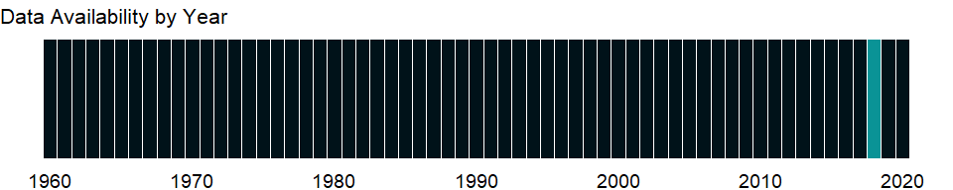

### Which countries have data?

The figure below shows the percentage of countries in each income group with a value since 2010 for that indicator.



### Why is it relevant?

As threats to biodiversity mount, the international community is increasingly focusing on conserving diversity. The Red List Index for the world’s birds shows that there has been a steady and continuing deterioration in the threat status of the world’s birds since 1988, when the first complete global assessment was carried out.

The number of threatened species is an important measure of the immediate need for conservation in an area. Global analyses of the status of threatened species have been carried out for few groups of organisms. Only for mammals, birds, and amphibians has the status of virtually all known species been assessed.

Threatened species are defined using the International Union for Conservation of Nature’s (IUCN) classification: endangered (in danger of extinction and unlikely to survive if causal factors continue operating) and vulnerable (likely to move into the endangered category in the near future if causal factors continue operating).

The International Union for Conservation of Nature (IUCN) Red List of Threatened Species is widely recognized as the most comprehensive, objective global approach for evaluating the conservation status of plant and animal species. The IUCN guides conservation activities of governments, NGOs and scientific institutions. The IUCN draws on and mobilizes a network of scientists and partner organizations working in almost every country in the world, who collectively hold what is likely the most complete scientific knowledge base on the biology and conservation status of species.

Globally, threatened birds occur worldwide - nearly all countries support one or more threatened bird species. Small islands hold disproportionately high numbers of Globally Threatened Birds, supporting over half of threatened species. Threatened seabirds are found throughout the world’s oceans. The most important threats to the world’s birds are the spread of agriculture and an ever increasing human use of biological resources.

Direct threats to species are the proximate human activities or processes that have impacted, are impacting, or may impact the status of the taxon being assessed (e.g., unsustainable fishing or logging). Direct threats are synonymous with sources of stress and proximate pressures. Threats can be past (historical, unlikely to return or historical, likely to return), ongoing, and/or likely to occur in the future.

### What is the data source?

United Nations Environmental Program and the World Conservation Monitoring Centre, and International Union for Conservation of Nature, Red List of Threatened Species.

### What is the methodology?

Species assessed as Critically Endangered (CR), Endangered (EN) or Vulnerable (VU) are referred to as “threatened” species. The International Union for Conservation of Nature (IUCN) Red List of Threatened Species collects and disseminates information on the global threated species.

Proportion of threatened species is only reported for the more completely evaluated groups (i.e., >90% of species evaluated). Also, the reported percentage of threatened species for each group is presented as a best estimate within a range of possible values bounded by lower and upper estimates:

Lower estimate = % threatened extant species if all Data Deficient species are not threatened, i.e., (CR + EN + VU) / (total assessed - EX)

Best estimate = % threatened extant species if Data Deficient species are equally threatened as data sufficient species, i.e., (CR + EN + VU) / (total assessed - EX - DD)

Upper estimate = % threatened extant species if all Data Deficient species are threatened, i.e., (CR + EN + VU + DD) / (total assessed - EX)

Additional information on ecology and habitat preferences, threats, and conservation action are also collated and assessed as part of Red List process.

### How is it aggregated?

Sum

### What are the limitations?

Reporting the proportion of threatened species on the Red List is complicated by the fact that not all species groups have been fully evaluated, and also by the fact that some species have so little information available that they can only be assessed as Data Deficient (DD). For many of the incompletely evaluated groups, assessment efforts have focused on species that are likely to be threatened; therefore any percentage of threatened species reported for these groups would be heavily biased (i.e., the percentage of threatened species would likely be an overestimate).

Since IUCN has evaluated extinction risk for less than 5 percent of the world’s described species, IUCN cannot provide an overall estimate for how many of the planet’s species are threatened. For those groups that have been comprehensively evaluated, the proportion of threatened species can be calculated, but the number of threatened species is often uncertain because it is not known whether Data Deficient species are actually threatened or not.

Due to variations in consistency and methods of collection, data quality is highly variable across countries. Some countries update their information more frequently than others, some have more accurate data on extent of coverage, and many underreport the number or extent of protected areas. Also, because of differences in definitions, reporting practices, and reporting periods, cross-country comparability of threatened species is limited.

In order to ensure global uniformity when describing the habitat in which a taxon (a taxonomic group of any rank) occurs, the threats to a taxon, what conservation actions are in place or are needed, and whether or not the taxon is utilized, a set of standard terms, called Classification Schemes, are being developed, for documenting taxonomy on the IUCN Red List.

### What else should I know?

NA

### 1.18.2 Fish species, threatened

### What is the indicator?

Fish species are based on Froese, R. and Pauly, D. (eds). 2008. Threatened species are the number of species classified by the IUCN as endangered, vulnerable, rare, indeterminate, out of danger, or insufficiently known.

Topic: Environment: Biodiversity & protected areas

Series ID: EN.FSH.THRD.NO

Copyright: CC BY-4.0 , <https://datacatalog.worldbank.org/public-licenses#cc-by>

First year with any data: 2018

Last year with any data: 2018

### What years are data available?

The figure below shows years in which data is available for at least one country. Dates shaded in black have no data, while dates shaded in green have data for at least one country



### Which countries have data?

The figure below shows the percentage of countries in each income group with a value since 2010 for that indicator.



### Why is it relevant?

As threats to biodiversity mount, the international community is increasingly focusing on conserving diversity. The Red List Index for the world’s birds shows that there has been a steady and continuing deterioration in the threat status of the world’s birds since 1988, when the first complete global assessment was carried out.

The number of threatened species is an important measure of the immediate need for conservation in an area. Global analyses of the status of threatened species have been carried out for few groups of organisms. Only for mammals, birds, and amphibians has the status of virtually all known species been assessed.

Threatened species are defined using the International Union for Conservation of Nature’s (IUCN) classification: endangered (in danger of extinction and unlikely to survive if causal factors continue operating) and vulnerable (likely to move into the endangered category in the near future if causal factors continue operating).

The International Union for Conservation of Nature (IUCN) Red List of Threatened Species is widely recognized as the most comprehensive, objective global approach for evaluating the conservation status of plant and animal species. The IUCN guides conservation activities of governments, NGOs and scientific institutions. The introduction in 1994 of a scientifically rigorous approach to determine risks of extinction that is applicable to all species, has become a world standard. The IUCN draws on and mobilizes a network of scientists and partner organizations working in almost every country in the world, who collectively hold what is likely the most complete scientific knowledge base on the biology and conservation status of species.

The freshwater system represents the most threatened of all ecosystems, and many freshwater species have a very high livelihood value for local human communities. IUCN’s freshwater focus is on the following taxonomic groups: fish; molluscs; crabs and crayfish; and dragonflies. Global assessment of these groups is being pursued through a series of regional projects, such as one for Africa that is currently being implemented.

The marine realm is poorly covered in the IUCN Red List, comprising less than 5 percent of the species included. IUCN has identified priority taxonomic groups of marine fish, invertebrates, plants (mangroves and seagrasses) and macro-algae (seaweeds). If these priority groups can be assessed, the number of marine species on the IUCN Red List will be increased more than six-fold.

Direct threats to species are the proximate human activities or processes that have impacted, are impacting, or may impact the status of the taxon being assessed (e.g., unsustainable fishing or logging). Direct threats are synonymous with sources of stress and proximate pressures. Threats can be past (historical, unlikely to return or historical, likely to return), ongoing, and/or likely to occur in the future.

### What is the data source?

Froese, R. and Pauly, D. (eds). 2008. FishBase database, www.fishbase.org.

### What is the methodology?

Species assessed as Critically Endangered (CR), Endangered (EN) or Vulnerable (VU) are referred to as “threatened” species. The International Union for Conservation of Nature (IUCN) Red List of Threatened Species collects and disseminates information on the global threated species.

Proportion of threatened species is only reported for the more completely evaluated groups (i.e., >90% of species evaluated). Also, the reported percentage of threatened species for each group is presented as a best estimate within a range of possible values bounded by lower and upper estimates:

Lower estimate = % threatened extant species if all Data Deficient species are not threatened, i.e., (CR + EN + VU) / (total assessed - EX)

Best estimate = % threatened extant species if Data Deficient species are equally threatened as data sufficient species, i.e., (CR + EN + VU) / (total assessed - EX - DD)

Upper estimate = % threatened extant species if all Data Deficient species are threatened, i.e., (CR + EN + VU + DD) / (total assessed - EX)

Additional information on ecology and habitat preferences, threats, and conservation action are also collated and assessed as part of Red List process.

### How is it aggregated?

Sum

### What are the limitations?

Reporting the proportion of threatened species on the Red List is complicated by the fact that not all species groups have been fully evaluated, and also by the fact that some species have so little information available that they can only be assessed as Data Deficient (DD). For many of the incompletely evaluated groups, assessment efforts have focused on species that are likely to be threatened; therefore any percentage of threatened species reported for these groups would be heavily biased (i.e., the percentage of threatened species would likely be an overestimate).

Since IUCN has evaluated extinction risk for less than 5 percent of the world’s described species, IUCN cannot provide an overall estimate for how many of the planet’s species are threatened. For those groups that have been comprehensively evaluated, the proportion of threatened species can be calculated, but the number of threatened species is often uncertain because it is not known whether Data Deficient species are actually threatened or not.

Due to variations in consistency and methods of collection, data quality is highly variable across countries. Some countries update their information more frequently than others, some have more accurate data on extent of coverage, and many underreport the number or extent of protected areas. Also, because of differences in definitions, reporting practices, and reporting periods, cross-country comparability of threatened species is limited.

In order to ensure global uniformity when describing the habitat in which a taxon (a taxonomic group of any rank) occurs, the threats to a taxon, what conservation actions are in place or are needed, and whether or not the taxon is utilized, a set of standard terms, called Classification Schemes, are being developed, for documenting taxonomy on the IUCN Red List.

### What else should I know?

NA

### 1.18.3 Plant species (higher), threatened

### What is the indicator?

Higher plants are native vascular plant species. Threatened species are the number of species classified by the IUCN as endangered, vulnerable, rare, indeterminate, out of danger, or insufficiently known.

Topic: Environment: Biodiversity & protected areas

Series ID: EN.HPT.THRD.NO

Copyright: CC BY-4.0 , <https://datacatalog.worldbank.org/public-licenses#cc-by>

First year with any data: 2018

Last year with any data: 2018

### What years are data available?

The figure below shows years in which data is available for at least one country. Dates shaded in black have no data, while dates shaded in green have data for at least one country



### Which countries have data?

The figure below shows the percentage of countries in each income group with a value since 2010 for that indicator.



### Why is it relevant?

The number of threatened species is an important measure of the immediate need for conservation in an area. Global analyses of the status of threatened species have been carried out for few groups of organisms. Only for mammals, birds, and amphibians has the status of virtually all known species been assessed.

Threatened species are defined using the International Union for Conservation of Nature’s (IUCN) classification: endangered (in danger of extinction and unlikely to survive if causal factors continue operating) and vulnerable (likely to move into the endangered category in the near future if causal factors continue operating).

The International Union for Conservation of Nature (IUCN) Red List of Threatened Species is widely recognized as the most comprehensive, objective global approach for evaluating the conservation status of plant and animal species. The IUCN guides conservation activities of governments, NGOs and scientific institutions. The IUCN draws on and mobilizes a network of scientists and partner organizations working in almost every country in the world, who collectively hold what is likely the most complete scientific knowledge base on the biology and conservation status of species.

The plants and animals assessed for the IUCN Red List are the bearers of genetic diversity and the building blocks of ecosystems, and information on their conservation status and distribution provides the foundation for making informed decisions about conserving biodiversity from local to global levels. Only a small number of the world’s plant and animal species have been assessed. In addition to the many thousands of species which have not yet been assessed so far, other species not included on the IUCN Red List are those that went extinct before 1500 AD and the “Least Concern” (plants that have been evaluated to have a low risk of extinction) species that have not yet been data based.

Direct threats to species are the proximate human activities or processes that have impacted, are impacting, or may impact the status of the taxon being assessed (e.g., unsustainable fishing or logging). Direct threats are synonymous with sources of stress and proximate pressures. Threats can be past (historical, unlikely to return or historical, likely to return), ongoing, and/or likely to occur in the future.

### What is the data source?

United Nations Environmental Program and the World Conservation Monitoring Centre, and International Union for Conservation of Nature, Red List of Threatened Species.

### What is the methodology?

Species assessed as Critically Endangered (CR), Endangered (EN) or Vulnerable (VU) are referred to as “threatened” species. The International Union for Conservation of Nature (IUCN) Red List of Threatened Species collects and disseminates information on the global threated species.

Proportion of threatened species is only reported for the more completely evaluated groups (i.e., >90% of species evaluated). Also, the reported percentage of threatened species for each group is presented as a best estimate within a range of possible values bounded by lower and upper estimates:

Lower estimate = % threatened extant species if all Data Deficient species are not threatened, i.e., (CR + EN + VU) / (total assessed - EX)

Best estimate = % threatened extant species if Data Deficient species are equally threatened as data sufficient species, i.e., (CR + EN + VU) / (total assessed - EX - DD)

Upper estimate = % threatened extant species if all Data Deficient species are threatened, i.e., (CR + EN + VU + DD) / (total assessed - EX)

Additional information on ecology and habitat preferences, threats, and conservation action are also collated and assessed as part of Red List process.

### How is it aggregated?

Sum

### What are the limitations?

Reporting the proportion of threatened species on the Red List is complicated by the fact that not all species groups have been fully evaluated, and also by the fact that some species have so little information available that they can only be assessed as Data Deficient (DD). For many of the incompletely evaluated groups, assessment efforts have focused on species that are likely to be threatened; therefore any percentage of threatened species reported for these groups would be heavily biased (i.e., the percentage of threatened species would likely be an overestimate).

Although there are over 12,000 plant species on the IUCN Red List, fewer than one thousand of these are properly documented. To help address this gap, IUCN is pursuing global assessments of plant species of value to people including species of high economic value. The conifer and cycad species already on the IUCN Red List need to be fully documented. IUCN is also developing a tool to assist with preliminary assessments of plant species.

Since IUCN has evaluated extinction risk for less than 5 percent of the world’s described species, IUCN cannot provide an overall estimate for how many of the planet’s species are threatened. For those groups that have been comprehensively evaluated, the proportion of threatened species can be calculated, but the number of threatened species is often uncertain because it is not known whether Data Deficient species are actually threatened or not.

Due to variations in consistency and methods of collection, data quality is highly variable across countries. Some countries update their information more frequently than others, some have more accurate data on extent of coverage, and many underreport the number or extent of protected areas. Also, because of differences in definitions, reporting practices, and reporting periods, cross-country comparability of threatened species is limited.

In order to ensure global uniformity when describing the habitat in which a taxon (a taxonomic group of any rank) occurs, the threats to a taxon, what conservation actions are in place or are needed, and whether or not the taxon is utilized, a set of standard terms, called Classification Schemes, are being developed, for documenting taxonomy on the IUCN Red List.

### What else should I know?

NA

### 1.18.4 Mammal species, threatened

### What is the indicator?

Mammal species are mammals excluding whales and porpoises. Threatened species are the number of species classified by the IUCN as endangered, vulnerable, rare, indeterminate, out of danger, or insufficiently known.

Topic: Environment: Biodiversity & protected areas

Series ID: EN.MAM.THRD.NO

Copyright: CC BY-4.0 , <https://datacatalog.worldbank.org/public-licenses#cc-by>

First year with any data: 2018

Last year with any data: 2018

### What years are data available?

The figure below shows years in which data is available for at least one country. Dates shaded in black have no data, while dates shaded in green have data for at least one country



### Which countries have data?

The figure below shows the percentage of countries in each income group with a value since 2010 for that indicator.



### Why is it relevant?

As threats to biodiversity mount, the international community is increasingly focusing on conserving diversity. The number of threatened species is an important measure of the immediate need for conservation in an area. Global analyses of the status of threatened species have been carried out for few groups of organisms. Only for mammals, birds, and amphibians has the status of virtually all known species been assessed.

Threatened species are defined using the International Union for Conservation of Nature’s (IUCN) classification: endangered (in danger of extinction and unlikely to survive if causal factors continue operating) and vulnerable (likely to move into the endangered category in the near future if causal factors continue operating).

The International Union for Conservation of Nature (IUCN) Red List of Threatened Species is widely recognized as the most comprehensive, objective global approach for evaluating the conservation status of plant and animal species. The IUCN draws on and mobilizes a network of scientists and partner organizations working in almost every country in the world, who collectively hold what is likely the most complete scientific knowledge base on the biology and conservation status of species.

the IUCN Red List covers a comprehensive assessment of the conservation status of the world’s 5,488 mammal species, including global summary statistics, individual species accounts/threat category, range map, ecology information, and some other data. Mammal species are found spread across the globe, with the exception of the land mass of Antarctica. Nearly one-quarter of the world’s mammal species are known to be globally threatened or extinct, 63 percent are known to not be threatened, and 15 percent have insufficient data to determine their threat status. Habitat loss, affecting over 2,000 mammal species, is the greatest threat globally. The second greatest threat is utilization which is affecting over 900 mammal species, mainly those in Asia.

Direct threats to species are the proximate human activities or processes that have impacted, are impacting, or may impact the status of the taxon being assessed (e.g., unsustainable fishing or logging). Direct threats are synonymous with sources of stress and proximate pressures. Threats can be past (historical, unlikely to return or historical, likely to return), ongoing, and/or likely to occur in the future.

### What is the data source?

United Nations Environmental Program and the World Conservation Monitoring Centre, and International Union for Conservation of Nature, Red List of Threatened Species.

### What is the methodology?

Species assessed as Critically Endangered (CR), Endangered (EN) or Vulnerable (VU) are referred to as “threatened” species. The International Union for Conservation of Nature (IUCN) Red List of Threatened Species collects and disseminates information on the global threated species.

Proportion of threatened species is only reported for the more completely evaluated groups (i.e., >90% of species evaluated). Also, the reported percentage of threatened species for each group is presented as a best estimate within a range of possible values bounded by lower and upper estimates:

Lower estimate = % threatened extant species if all Data Deficient species are not threatened, i.e., (CR + EN + VU) / (total assessed - EX)

Best estimate = % threatened extant species if Data Deficient species are equally threatened as data sufficient species, i.e., (CR + EN + VU) / (total assessed - EX - DD)

Upper estimate = % threatened extant species if all Data Deficient species are threatened, i.e., (CR + EN + VU + DD) / (total assessed - EX)

Additional information on ecology and habitat preferences, threats, and conservation action are also collated and assessed as part of Red List process.

### How is it aggregated?

Sum

### What are the limitations?

Reporting the proportion of threatened species on the Red List is complicated by the fact that not all species groups have been fully evaluated, and also by the fact that some species have so little information available that they can only be assessed as Data Deficient (DD). For many of the incompletely evaluated groups, assessment efforts have focused on species that are likely to be threatened; therefore any percentage of threatened species reported for these groups would be heavily biased (i.e., the percentage of threatened species would likely be an overestimate).

Some parts of the world, such as the Andes, Central and West Africa, Angola, parts of South and Southeast Asia, and Melanesia, still have sparse information available of their mammal faunas. In addition, many species’ names, especially in the tropics, actually represent complexes of several species that have not yet been resolved. The information on the relative importance of different threatening processes to mammal species is incomplete. IUCN codes all threats that appear to have an important impact, but not their relative importance for each species.

Since IUCN has evaluated extinction risk for less than 5 percent of the world’s described species, IUCN cannot provide an overall estimate for how many of the planet’s species are threatened. For those groups that have been comprehensively evaluated, the proportion of threatened species can be calculated, but the number of threatened species is often uncertain because it is not known whether Data Deficient species are actually threatened or not.

Due to variations in consistency and methods of collection, data quality is highly variable across countries. Some countries update their information more frequently than others, some have more accurate data on extent of coverage, and many underreport the number or extent of protected areas. Also, because of differences in definitions, reporting practices, and reporting periods, cross-country comparability of threatened species is limited.

In order to ensure global uniformity when describing the habitat in which a taxon (a taxonomic group of any rank) occurs, the threats to a taxon, what conservation actions are in place or are needed, and whether or not the taxon is utilized, a set of standard terms, called Classification Schemes, are being developed, for documenting taxonomy on the IUCN Red List.

### What else should I know?

NA

### 1.18.5 Terrestrial protected areas (% of total land area)

### What is the indicator?

Terrestrial protected areas are totally or partially protected areas of at least 1,000 hectares that are designated by national authorities as scientific reserves with limited public access, national parks, natural monuments, nature reserves or wildlife sanctuaries, protected landscapes, and areas managed mainly for sustainable use. Marine areas, unclassified areas, littoral (intertidal) areas, and sites protected under local or provincial law are excluded.

Topic: Environment: Biodiversity & protected areas

Series ID: ER.LND.PTLD.ZS

Copyright: Use and distribution of these data are subject to Protected Planet terms and conditions. , <https://www.protectedplanet.net/c/terms-and-conditions>

First year with any data: 2016

Last year with any data: 2018

### What years are data available?

The figure below shows years in which data is available for at least one country. Dates shaded in black have no data, while dates shaded in green have data for at least one country

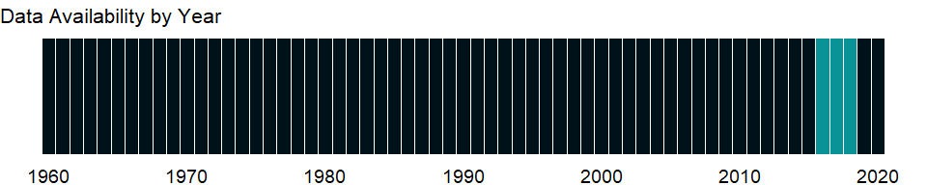

### Which countries have data?

The figure below shows the percentage of countries in each income group with a value since 2010 for that indicator.

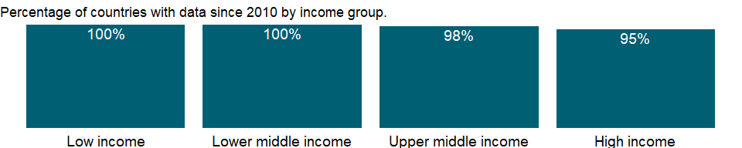

### Why is it relevant?

The International Union for Conservation of Nature (IUCN) defines a protected area as “a clearly defined geographical space, recognized, dedicated and managed, through legal or other effective means, to achieve the long-term conservation of nature with associated ecosystem services and cultural values.”

Terrestrial protected areas are totally or partially protected areas of at least 1,000 hectares that are designated by national authorities as scientific reserves with limited public access, national parks, natural monuments, nature reserves or wildlife sanctuaries, protected landscapes, and areas managed mainly for sustainable use. Nationally protected terrestrial are terrestrial areas as a percentage of total territorial area, where all nationally designated protected areas with known location and extent are included.

As threats to biodiversity mount, the international community is increasingly focusing on conserving diversity. Deforestation is a major cause of loss of biodiversity, and habitat conservation is vital for stemming this loss. Conservation efforts have focused on protecting areas of high biodiversity. Increasing the proportion of terrestrial and marine areas protected helps defend vulnerable plant and animal species and safeguard biodiversity.

Protected areas remain the fundamental building blocks of virtually all national and international conservation strategies, supported by governments and international institutions. They provide the core of efforts to protect the world’s threatened species and are increasingly recognized as essential providers of ecosystem services and biological resources. Some sites are owned and managed by governments, others by private individuals, companies, communities and faith groups.

The Sustainable Development Goals (SDGs) address concerns common to all economies. In recognition of the vulnerability of animal and plant species, SDGs include targets 14 and 15 to highlight the importance of marine and terrestorial protected areas. Increasing the proportion of terrestrial and marine areas protected helps defend vulnerable plant and animal species and safeguard biodiversity.

### What is the data source?

World Database on Protected Areas (WDPA) where the compilation and management is carried out by United Nations Environment World Conservation Monitoring Centre (UNEP-WCMC) in collaboration with governments, non-governmental organizations, academia and industry. The data is available online through the Protected Planet website (<https://www.protectedplanet.net/>).

### What is the methodology?

This indicator is calculated using all the nationally designated protected areas recorded in the World Database on Protected Areas (WDPA) whose location and extent is known. The WDPA database is stored within a Geographic Information System (GIS) that stores information about protected areas such as their name, type and date of designation, documented area, geographic location (point) and/or boundary (polygon).

Designating an area as protected does not mean that protection is in force. And for small countries that have only protected areas smaller than 1,000 hectares, the size limit in the definition leads to an underestimate of protected areas. Nationally protected areas are defined using the six IUCN management categories for areas of at least 1,000 hectares: scientific reserves and strict nature reserves with limited public access; national parks of national or international significance and not materially affected by human activity; natural monuments and natural landscapes with unique aspects; managed nature reserves and wildlife sanctuaries; protected landscapes (which may include cultural landscapes); and areas managed mainly for the sustainable use of natural systems to ensure long-term protection and maintenance of biological diversity.

A GIS analysis is used to calculate terrestrial and marine protection. For this a global protected area layer is created by combining the polygons and points recorded in the WDPA. Circular buffers are created around points based on the known extent of protected areas for which no polygon is available. Annual protected area layers are created by dissolving the global protected area layer by the known year of establishment of protected areas recorded in the WDPA. The annual protected area layers are overlaid with country/territory boundaries, coastlines and buffered coastlines (delineating the territorial waters) to obtain the absolute coverage (in square kilometers) of protected areas by country/territory. The total area of a country’s/territory’s terrestrial protected areas and marine protected areas in territorial waters is divided by the total area of its land areas (including inland waters) and territorial waters to obtain the relative coverage (percentage) of protected areas.

### How is it aggregated?

Weighted average

### What are the limitations?

The data source for this indicator is the World Database on Protected Areas (WDPA), the most comprehensive global dataset on marine and terrestrial protected areas available.

The extent to which the land areas, including inland waters, and territorial waters of a country/territory are protected is useful for planning purpose to protect biodiversity. However, it is neither an indication of how well managed the terrestrial and marine protected areas are, nor confirmation that protection measures are effectively enforced. Further, the indicator does not provide information on non-designated or internationally designated protected areas that may also be important for conserving biodiversity. There are known data and knowledge gaps for some countries/regions due to difficulties in reporting national protected area data to the WDPA and/or determining whether a site conforms to the IUCN definition of a protected area.

Gaps and/or time lags in reporting national protected area data to the WDPA can however result in discrepancies, which are resolved in communication with data providers. The World Conservation Monitoring Centre (WCMC) compiles data on protected areas, numbers of certain species, and numbers of those species under threat from various sources. Because of differences in definitions, reporting practices, and reporting periods, cross-country comparability is limited.

Due to variations in consistency and methods of collection, data quality is highly variable across countries. Some countries update their information more frequently than others, some have more accurate data on extent of coverage, and many underreport the number or extent of protected areas.

### What else should I know?

Restricted use: Please contact the Protected Planet for third-party use of these data.

### 1.18.6 Marine protected areas (% of territorial waters)

### What is the indicator?

Marine protected areas are areas of intertidal or subtidal terrain–and overlying water and associated flora and fauna and historical and cultural features–that have been reserved by law or other effective means to protect part or all of the enclosed environment.

Topic: Environment: Biodiversity & protected areas

Series ID: ER.MRN.PTMR.ZS

Copyright: Use and distribution of these data are subject to Protected Planet terms and conditions. , <https://www.protectedplanet.net/c/terms-and-conditions>

First year with any data: 2016

Last year with any data: 2018

### What years are data available?

The figure below shows years in which data is available for at least one country. Dates shaded in black have no data, while dates shaded in green have data for at least one country



### Which countries have data?

The figure below shows the percentage of countries in each income group with a value since 2010 for that indicator.

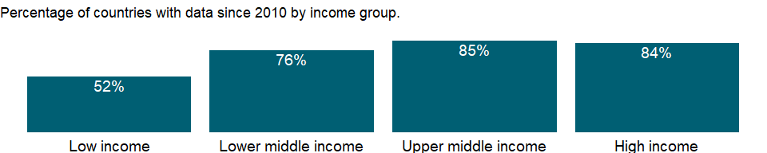

### Why is it relevant?

The International Union for Conservation of Nature (IUCN) defines a protected area as “a clearly defined geographical space, recognized, dedicated and managed, through legal or other effective means, to achieve the long-term conservation of nature with associated ecosystem services and cultural values.”

Marine protected areas are areas of intertidal or subtidal terrain - and overlying water and associated flora and fauna and historical and cultural features - that have been reserved by law or other effective means to protect part or the entire enclosed environment. Sites protected under local or provincial law are excluded.

As threats to biodiversity mount, the international community is increasingly focusing on conserving diversity. Deforestation is a major cause of loss of biodiversity, and habitat conservation is vital for stemming this loss. Conservation efforts have focused on protecting areas of high biodiversity. Increasing the proportion of terrestrial and marine areas protected helps defend vulnerable plant and animal species and safeguard biodiversity.

Protected areas remain the fundamental building blocks of virtually all national and international conservation strategies, supported by governments and international institutions. They provide the core of efforts to protect the world’s threatened species and are increasingly recognized as essential providers of ecosystem services and biological resources. Some sites are owned and managed by governments, others by private individuals, companies, communities and faith groups.

The Sustainable Development Goals (SDGs) address concerns common to all economies. In recognition of the vulnerability of animal and plant species, SDGs include targets 14 and 15 to highlight the importance of marine and terrestorial protected areas. Increasing the proportion of terrestrial and marine areas protected helps defend vulnerable plant and animal species and safeguard biodiversity.

### What is the data source?

World Database on Protected Areas (WDPA) where the compilation and management is carried out by United Nations Environment World Conservation Monitoring Centre (UNEP-WCMC) in collaboration with governments, non-governmental organizations, academia and industry. The data is available online through the Protected Planet website (<https://www.protectedplanet.net/>).

### What is the methodology?

This indicator is calculated using all the nationally designated protected areas recorded in the World Database on Protected Areas (WDPA) whose location and extent is known. The WDPA database is stored within a Geographic Information System (GIS) that stores information about protected areas such as their name, type and date of designation, documented area, geographic location (point) and/or boundary (polygon).

Designating an area as protected does not mean that protection is in force. And for small countries that have only protected areas smaller than 1,000 hectares, the size limit in the definition leads to an underestimate of protected areas. Nationally protected areas are defined using the six IUCN management categories for areas of at least 1,000 hectares: scientific reserves and strict nature reserves with limited public access; national parks of national or international significance and not materially affected by human activity; natural monuments and natural landscapes with unique aspects; managed nature reserves and wildlife sanctuaries; protected landscapes (which may include cultural landscapes); and areas managed mainly for the sustainable use of natural systems to ensure long-term protection and maintenance of biological diversity.

A GIS analysis is used to calculate terrestrial and marine protection. For this a global protected area layer is created by combining the polygons and points recorded in the WDPA. Circular buffers are created around points based on the known extent of protected areas for which no polygon is available. Annual protected area layers are created by dissolving the global protected area layer by the known year of establishment of protected areas recorded in the WDPA. The annual protected area layers are overlaid with country/territory boundaries, coastlines and buffered coastlines (delineating the territorial waters) to obtain the absolute coverage (in square kilometers) of protected areas by country/territory per year from 1990 to present. The total area of a country’s/territory’s terrestrial protected areas and marine protected areas in territorial waters is divided by the total area of its land areas (including inland waters) and territorial waters to obtain the relative coverage (percentage) of protected areas.

### How is it aggregated?

Weighted average

### What are the limitations?

The data source for this indicator is the World Database on Protected Areas (WDPA), the most comprehensive global dataset on marine and terrestrial protected areas available.

The extent to which the land areas, including inland waters, and territorial waters of a country/territory are protected is useful for planning purpose to protect biodiversity. However, it is neither an indication of how well managed the terrestrial and marine protected areas are, nor confirmation that protection measures are effectively enforced. Further, the indicator does not provide information on non-designated or internationally designated protected areas that may also be important for conserving biodiversity. There are known data and knowledge gaps for some countries/regions due to difficulties in reporting national protected area data to the WDPA and/or determining whether a site conforms to the IUCN definition of a protected area.

Gaps and/or time lags in reporting national protected area data to the WDPA can however result in discrepancies, which are resolved in communication with data providers. The World Conservation Monitoring Centre (WCMC) compiles data on protected areas, numbers of certain species, and numbers of those species under threat from various sources. Because of differences in definitions, reporting practices, and reporting periods, cross-country comparability is limited.

Due to variations in consistency and methods of collection, data quality is highly variable across countries. Some countries update their information more frequently than others, some have more accurate data on extent of coverage, and many underreport the number or extent of protected areas.

### What else should I know?

Restricted use: Please contact the Protected Planet for third-party use of these data.

### 1.18.7 Terrestrial and marine protected areas (% of total territorial area)

### What is the indicator?

Terrestrial protected areas are totally or partially protected areas of at least 1,000 hectares that are designated by national authorities as scientific reserves with limited public access, national parks, natural monuments, nature reserves or wildlife sanctuaries, protected landscapes, and areas managed mainly for sustainable use. Marine protected areas are areas of intertidal or subtidal terrain–and overlying water and associated flora and fauna and historical and cultural features–that have been reserved by law or other effective means to protect part or all of the enclosed environment. Sites protected under local or provincial law are excluded.

Topic: Environment: Biodiversity & protected areas

Series ID: ER.PTD.TOTL.ZS

Copyright: Use and distribution of these data are subject to Protected Planet terms and conditions. , <https://www.protectedplanet.net/c/terms-and-conditions>

First year with any data: 2016

Last year with any data: 2018

### What years are data available?

The figure below shows years in which data is available for at least one country. Dates shaded in black have no data, while dates shaded in green have data for at least one country



### Which countries have data?

The figure below shows the percentage of countries in each income group with a value since 2010 for that indicator.

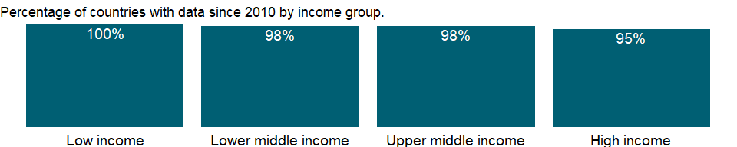

### Why is it relevant?

The International Union for Conservation of Nature (IUCN) defines a protected area as “a clearly defined geographical space, recognized, dedicated and managed, through legal or other effective means, to achieve the long-term conservation of nature with associated ecosystem services and cultural values.”

Terrestrial protected areas are totally or partially protected areas of at least 1,000 hectares that are designated by national authorities as scientific reserves with limited public access, national parks, natural monuments, nature reserves or wildlife sanctuaries, protected landscapes, and areas managed mainly for sustainable use.

Marine protected areas are areas of intertidal or subtidal terrain - and overlying water and associated flora and fauna and historical and cultural features - that have been reserved by law or other effective means to protect part or the entire enclosed environment. Sites protected under local or provincial law are excluded.

As threats to biodiversity mount, the international community is increasingly focusing on conserving diversity. Deforestation is a major cause of loss of biodiversity, and habitat conservation is vital for stemming this loss. Conservation efforts have focused on protecting areas of high biodiversity. Increasing the proportion of terrestrial and marine areas protected helps defend vulnerable plant and animal species and safeguard biodiversity.

Protected areas remain the fundamental building blocks of virtually all national and international conservation strategies, supported by governments and international institutions. They provide the core of efforts to protect the world’s threatened species and are increasingly recognized as essential providers of ecosystem services and biological resources. Some sites are owned and managed by governments, others by private individuals, companies, communities and faith groups.

The Sustainable Development Goals (SDGs) address concerns common to all economies. In recognition of the vulnerability of animal and plant species, SDGs include targets 14 and 15 to highlight the importance of marine and terrestorial protected areas. Increasing the proportion of terrestrial and marine areas protected helps defend vulnerable plant and animal species and safeguard biodiversity.

### What is the data source?

World Database on Protected Areas (WDPA) where the compilation and management is carried out by United Nations Environment World Conservation Monitoring Centre (UNEP-WCMC) in collaboration with governments, non-governmental organizations, academia and industry. The data is available online through the Protected Planet website (<https://www.protectedplanet.net/>).

### What is the methodology?

This indicator is calculated using all the nationally designated protected areas recorded in the World Database on Protected Areas (WDPA) whose location and extent is known. The WDPA database is stored within a Geographic Information System (GIS) that stores information about protected areas such as their name, type and date of designation, documented area, geographic location (point) and/or boundary (polygon).

A GIS analysis is used to calculate terrestrial and marine protection. For this a global protected area layer is created by combining the polygons and points recorded in the WDPA. Circular buffers are created around points based on the known extent of protected areas for which no polygon is available. Annual protected area layers are created by dissolving the global protected area layer by the known year of establishment of protected areas recorded in the WDPA. The annual protected area layers are overlaid with country/territory boundaries, coastlines and buffered coastlines (delineating the territorial waters) to obtain the absolute coverage (in square kilometers) of protected areas by country/territory per year from 1990 to present. The total area of a country’s/territory’s terrestrial protected areas and marine protected areas in territorial waters is divided by the total area of its land areas (including inland waters) and territorial waters to obtain the relative coverage (percentage) of protected areas.

### How is it aggregated?

Weighted Average

### What are the limitations?

The data source for this indicator is the World Database on Protected Areas (WDPA), the most comprehensive global dataset on marine and terrestrial protected areas available.

The extent to which the land areas, including inland waters, and territorial waters of a country/territory are protected is useful for planning purpose to protect biodiversity. However, it is neither an indication of how well managed the terrestrial and marine protected areas are, nor confirmation that protection measures are effectively enforced. Further, the indicator does not provide information on non-designated or internationally designated protected areas that may also be important for conserving biodiversity. There are known data and knowledge gaps for some countries/regions due to difficulties in reporting national protected area data to the WDPA and/or determining whether a site conforms to the IUCN definition of a protected area.

Gaps and/or time lags in reporting national protected area data to the WDPA can however result in discrepancies, which are resolved in communication with data providers. The World Conservation Monitoring Centre (WCMC) compiles data on protected areas, numbers of certain species, and numbers of those species under threat from various sources. Because of differences in definitions, reporting practices, and reporting periods, cross-country comparability is limited.

Due to variations in consistency and methods of collection, data quality is highly variable across countries. Some countries update their information more frequently than others, some have more accurate data on extent of coverage, and many underreport the number or extent of protected areas.

### What else should I know?

Restricted use: Please contact the Protected Planet for third-party use of these data.

## 1.19 Environment: Density & urbanization

### 1.19.1 Population density (people per sq. km of land area)

### What is the indicator?

Population density is midyear population divided by land area in square kilometers. Population is based on the de facto definition of population, which counts all residents regardless of legal status or citizenship–except for refugees not permanently settled in the country of asylum, who are generally considered part of the population of their country of origin. Land area is a country’s total area, excluding area under inland water bodies, national claims to continental shelf, and exclusive economic zones. In most cases the definition of inland water bodies includes major rivers and lakes.

Topic: Environment: Density & urbanization

Series ID: EN.POP.DNST

Copyright: CC BY-4.0 , <https://datacatalog.worldbank.org/public-licenses#cc-by>

First year with any data: 1961

Last year with any data: 2020

### What years are data available?

The figure below shows years in which data is available for at least one country. Dates shaded in black have no data, while dates shaded in green have data for at least one country



### Which countries have data?

The figure below shows the percentage of countries in each income group with a value since 2010 for that indicator.



### Why is it relevant?

Population estimates are usually based on national population censuses. Estimates for the years before and after the census are interpolations or extrapolations based on demographic models. Errors and undercounting occur even in high-income countries; in developing countries errors may be substantial because of limits in the transport, communications, and other resources required conducting and analyzing a full census.

Population density is a measure of the intensity of land-use, and can be calculated for a block, city, county, state, country, continent or the entire world. Considering that over half of the Earth’s land mass consists of areas inhospitable to human inhabitation, such as deserts and high mountains, and that population tends to cluster around seaports and fresh water sources, a simple number of population density by itself does not give any meaningful measurement of human population density.

Several of the most densely populated territories in the world are city-states, microstates, or dependencies.[6][7] These territories share a relatively small area and a high urbanization level, with an economically specialized city population drawing also on rural resources outside the area, illustrating the difference between high population density and overpopulation.

### What is the data source?

Food and Agriculture Organization and World Bank population estimates.

### What is the methodology?

Population density is midyear population divided by land area in square kilometers. This ratio can be calculated for any territorial unit for any point in time, depending on the source of the population data. Populationestimates are prepared by World Bank staff from variety of sources. They are based on the de facto definition of population and include all residents regardless of legal status or citizenship, within the physical boundaries of a country and under the jurisdiction of that country’s political control. Refugees not permanently settled in the country of asylum are considered part of the population of their country of origin. Population numbers are either current census data or historical census data extrapolated through demographic methods. The count also excludes visitors from overseas.

Population density is calculated by dividing midyear population by land area in a country. Population is based on the de facto definition of population, which counts all residents regardless of legal status or citizenship - except for refugees not permanently settled in the country of asylum, who are generally considered part of the population of their country of origin. Land area is a country’s total area, excluding area under inland water bodies, national claims to continental shelf, and exclusive economic zones. In most cases the definition of inland water bodies includes major rivers and lakes.

### How is it aggregated?

Weighted Average

### What are the limitations?

Current population estimates for developing countries that lack recent census data and pre- and post-census estimates for countries with census data are provided by the United Nations Population Division and other agencies. The cohort component method - a standard method for estimating and projecting population - requires fertility, mortality, and net migration data, often collected from sample surveys, which can be small or limited in coverage. Population estimates are from demographic modeling and so are susceptible to biases and errors from shortcomings in the model and in the data. Because the five-year age group is the cohort unit and five-year period data are used, interpolations to obtain annual data or single age structure may not reflect actual events or age composition.

The quality and reliability of official demographic data are also affected by public trust in the government, government commitment to full and accurate enumeration, confidentiality and protection against misuse of census data, and census agencies’ independence from political influence. Moreover, comparability of population indicators is limited by differences in the concepts, definitions, collection procedures, and estimation methods used by national statistical agencies and other organizations that collect the data.

### What else should I know?

NA

### 1.19.2 Population living in slums (% of urban population)

### What is the indicator?

Population living in slums is the proportion of the urban population living in slum households. A slum household is defined as a group of individuals living under the same roof lacking one or more of the following conditions: access to improved water, access to improved sanitation, sufficient living area, housing durability, and security of tenure, as adopted in the Millennium Development Goal Target 7.D. The successor, the Sustainable Development Goal 11.1.1, considers inadequate housing (housing affordability) to complement the above definition of slums/informal settlements.

Topic: Environment: Density & urbanization

Series ID: EN.POP.SLUM.UR.ZS

Copyright: NA , NA

First year with any data: 1990

Last year with any data: 2018

### What years are data available?

The figure below shows years in which data is available for at least one country. Dates shaded in black have no data, while dates shaded in green have data for at least one country

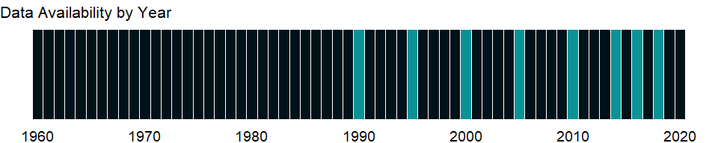

### Which countries have data?

The figure below shows the percentage of countries in each income group with a value since 2010 for that indicator.

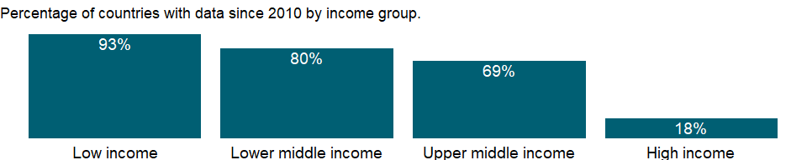

### Why is it relevant?

NA

### What is the data source?

United Nations Human Settlements Programme (UN-HABITAT)

### What is the methodology?

NA

### How is it aggregated?

Weighted Average

### What are the limitations?

NA

### What else should I know?

NA

### 1.19.3 Population in largest city

### What is the indicator?

Population in largest city is the urban population living in the country’s largest metropolitan area.

Topic: Environment: Density & urbanization

Series ID: EN.URB.LCTY

Copyright: CC BY-4.0 , <https://datacatalog.worldbank.org/public-licenses#cc-by>

First year with any data: 1960

Last year with any data: 2020

### What years are data available?

The figure below shows years in which data is available for at least one country. Dates shaded in black have no data, while dates shaded in green have data for at least one country



### Which countries have data?

The figure below shows the percentage of countries in each income group with a value since 2010 for that indicator.

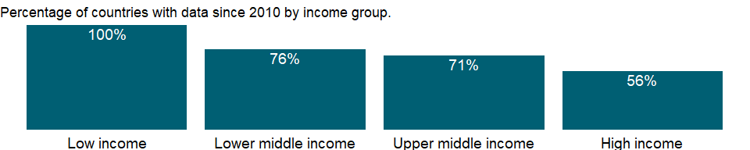

### Why is it relevant?

A metropolitan area includes the urban area, and its satellite cities plus intervening rural land that is socio-economically connected to the urban core city, typically by employment ties through commuting, with the urban core city being the primary labor market. According to the United Nations’ definition, a metropolitan area includes both the contiguous territory inhabited at urban levels of residential density and additional surrounding areas of lower settlement density that are also under the direct influence of the city (e.g., through frequent transport, road linkages, commuting facilities etc.).

Explosive growth of cities globally signifies the demographic transition from rural to urban, and is associated with shifts from an agriculture-based economy to mass industry, technology, and service. For the first time ever, the majority of the world’s population lives in a city, and this proportion continues to grow. One hundred years ago, 2 out of every 10 people lived in an urban area. By 1990, less than 40 percent of the global population lived in a city, but as of early 2010s, more than half of all people live in an urban area. By 2030, 6 out of every 10 people will live in a city, and by 2050, this proportion will increase to 7 out of 10 people. About half of all urban dwellers live in cities with between 100,000-500,000 people, and fewer than 10% of urban dwellers live in megacities (a city with a population of more than 10 million, as defined by UN HABITAT). Currently, the number of urban residents is growing by nearly 60 million every year.

By the middle of the 21st century, the urban population will almost double, reaching 6.4 billion in 2050. Almost all urban population growth in the next 30 years will occur in cities of developing countries. By the middle of the 21st century, it is estimated that the urban population of developing counties will more than double, reaching almost 5.2 billion in 2050. In high-income countries, the urban population is expected to remain largely unchanged over the next two decades, reaching to just over 1 billion by 2025. In these countries, immigration (legal and illegal) will account for more than two-thirds of urban growth. Without immigration, the urban population in these countries would most likely decline or remain static.

In principle, cities offer a more favorable setting for the resolution of social and environmental problems than rural areas. Cities generate jobs and income, and deliver education, health care and other services. Cities also present opportunities for social mobilization and women’s empowerment. Poverty is growing faster in urban than in rural areas. According to UN one billion people live in urban slums, which are typically overcrowded, polluted and dangerous, and lack basic services such as clean water and sanitation.

### What is the data source?

United Nations, World Urbanization Prospects.

### What is the methodology?

Urban population refers to people living in urban areas as defined by national statistical offices. The indicator is calculated using World Bank population estimates and urban ratios from the United Nations World Urbanization Prospects. The United Nations Population Division and other agencies provide current population estimates for developing countries that lack recent census data and pre- and post-census estimates for countries with census data. The cohort component method - a standard method for estimating and projecting population - requires fertility, mortality, and net migration data, often collected from sample surveys, which can be small or limited in coverage. Population estimates are from demographic modeling and so are susceptible to biases and errors from shortcomings in the model and in the data. Because the five-year age group is the cohort unit and five-year period data are used, interpolations to obtain annual data or single age structure may not reflect actual events or age composition.

Countries differ in the way they classify population as “urban” or “rural.” Typically, a community or settlement with a population of 2,000 or more is considered urban, but national definitions are most commonly based on size of locality. Eurostat defines urban areas as clusters of contiguous grid cells of 1 km2 with a density of at least 300 inhabitants per km2 and a minimum population of 5,000. Further it defines high-density cluster as contiguous grid cells of 1 km2 with a density of at least 1,500 inhabitants per km2 and a minimum population of 50,000.

The population of a city or metropolitan area depends on the boundaries chosen. For example, in 1990 Beijing, China, contained 2.3 million people in 87 square kilometers of “inner city” and 5.4 million in 158 square kilometers of “core city.” The population of “inner city and inner suburban districts” was 6.3 million and that of “inner city, inner and outer suburban districts, and inner and outer counties” was 10.8 million. (Most countries use the last definition.)

### How is it aggregated?

NA

### What are the limitations?

Aggregation of urban and rural population may not add up to total population because of different country coverage. There is no consistent and universally accepted standard for distinguishing urban from rural areas, in part because of the wide variety of situations across countries.

Most countries use an urban classification related to the size or characteristics of settlements. Some define urban areas based on the presence of certain infrastructure and services. And other countries designate urban areas based on administrative arrangements. Because of national differences in the characteristics that distinguish urban from rural areas, the distinction between urban and rural population is not amenable to a single definition that would be applicable to all countries. For example, in Botswana, agglomeration of 5,000 or more inhabitants where 75 per cent of the economic activity is non-agricultural is considered “urban” while in Iceland localities of 200 or more inhabitants, and in Peru population centers with 100 or more dwellings, are considered “urban.” In the United States places of 2,500 or more inhabitants, generally having population densities of 1,000 persons per square mile or more are considered “urban”.

Estimates of the world’s urban population would change significantly if China, India, and a few other populous nations were to change their definition of urban centers. According to China’s State Statistical Bureau, by the end of 1996 urban residents accounted for about 43 percent of China’s population, more than double the 20 percent considered urban in 1994. In addition to the continuous migration of people from rural to urban areas, one of the main reasons for this shift was the rapid growth in the hundreds of towns reclassified as cities in recent years.

Because the estimates of city and metropolitan area are based on national definitions of what constitutes a city or metropolitan area, cross-country comparisons should be made with caution. To estimate urban populations, UN ratios of urban to total population were applied to the World Bank’s estimates of total population.

### What else should I know?

NA

### 1.19.4 Population in the largest city (% of urban population)

### What is the indicator?

Population in largest city is the percentage of a country’s urban population living in that country’s largest metropolitan area.

Topic: Environment: Density & urbanization

Series ID: EN.URB.LCTY.UR.ZS

Copyright: CC BY-4.0 , <https://datacatalog.worldbank.org/public-licenses#cc-by>

First year with any data: 1960

Last year with any data: 2020

### What years are data available?

The figure below shows years in which data is available for at least one country. Dates shaded in black have no data, while dates shaded in green have data for at least one country



### Which countries have data?

The figure below shows the percentage of countries in each income group with a value since 2010 for that indicator.



### Why is it relevant?

A metropolitan area includes the urban area, and its satellite cities plus intervening rural land that is socio-economically connected to the urban core city, typically by employment ties through commuting, with the urban core city being the primary labor market. According to the United Nations’ definition, a metropolitan area includes both the contiguous territory inhabited at urban levels of residential density and additional surrounding areas of lower settlement density that are also under the direct influence of the city (e.g., through frequent transport, road linkages, commuting facilities etc.).

Explosive growth of cities globally signifies the demographic transition from rural to urban, and is associated with shifts from an agriculture-based economy to mass industry, technology, and service. For the first time ever, the majority of the world’s population lives in a city, and this proportion continues to grow. One hundred years ago, 2 out of every 10 people lived in an urban area. By 1990, less than 40 percent of the global population lived in a city, but as of early 2010s, more than half of all people live in an urban area. By 2030, 6 out of every 10 people will live in a city, and by 2050, this proportion will increase to 7 out of 10 people. About half of all urban dwellers live in cities with between 100,000-500,000 people, and fewer than 10% of urban dwellers live in megacities (a city with a population of more than 10 million, as defined by UN HABITAT). Currently, the number of urban residents is growing by nearly 60 million every year.

By the middle of the 21st century, the urban population will almost double, reaching 6.4 billion in 2050. Almost all urban population growth in the next 30 years will occur in cities of developing countries. By the middle of the 21st century, it is estimated that the urban population of developing counties will more than double, reaching almost 5.2 billion in 2050. In high-income countries, the urban population is expected to remain largely unchanged over the next two decades, reaching to just over 1 billion by 2025. In these countries, immigration (legal and illegal) will account for more than two-thirds of urban growth. Without immigration, the urban population in these countries would most likely decline or remain static.

In principle, cities offer a more favorable setting for the resolution of social and environmental problems than rural areas. Cities generate jobs and income, and deliver education, health care and other services. Cities also present opportunities for social mobilization and women’s empowerment. Poverty is growing faster in urban than in rural areas. According to UN one billion people live in urban slums, which are typically overcrowded, polluted and dangerous, and lack basic services such as clean water and sanitation.

### What is the data source?

United Nations, World Urbanization Prospects.

### What is the methodology?

Urban population refers to people living in urban areas as defined by national statistical offices. The indicator is calculated using World Bank population estimates and urban ratios from the United Nations World Urbanization Prospects. The United Nations Population Division and other agencies provide current population estimates for developing countries that lack recent census data and pre- and post-census estimates for countries with census data. The cohort component method - a standard method for estimating and projecting population - requires fertility, mortality, and net migration data, often collected from sample surveys, which can be small or limited in coverage. Population estimates are from demographic modeling and so are susceptible to biases and errors from shortcomings in the model and in the data. Because the five-year age group is the cohort unit and five-year period data are used, interpolations to obtain annual data or single age structure may not reflect actual events or age composition.

Countries differ in the way they classify population as “urban” or “rural.” Typically, a community or settlement with a population of 2,000 or more is considered urban, but national definitions are most commonly based on size of locality. Eurostat defines urban areas as clusters of contiguous grid cells of 1 km2 with a density of at least 300 inhabitants per km2 and a minimum population of 5,000. Further it defines high-density cluster as contiguous grid cells of 1 km2 with a density of at least 1,500 inhabitants per km2 and a minimum population of 50,000.

The population of a city or metropolitan area depends on the boundaries chosen. For example, in 1990 Beijing, China, contained 2.3 million people in 87 square kilometers of “inner city” and 5.4 million in 158 square kilometers of “core city.” The population of “inner city and inner suburban districts” was 6.3 million and that of “inner city, inner and outer suburban districts, and inner and outer counties” was 10.8 million. (Most countries use the last definition.)

### How is it aggregated?

Weighted Average

### What are the limitations?

Aggregation of urban and rural population may not add up to total population because of different country coverage. There is no consistent and universally accepted standard for distinguishing urban from rural areas, in part because of the wide variety of situations across countries.

Most countries use an urban classification related to the size or characteristics of settlements. Some define urban areas based on the presence of certain infrastructure and services. And other countries designate urban areas based on administrative arrangements. Because of national differences in the characteristics that distinguish urban from rural areas, the distinction between urban and rural population is not amenable to a single definition that would be applicable to all countries. For example, in Botswana, agglomeration of 5,000 or more inhabitants where 75 per cent of the economic activity is non-agricultural is considered “urban” while in Iceland localities of 200 or more inhabitants, and in Peru population centers with 100 or more dwellings, are considered “urban.” In the United States places of 2,500 or more inhabitants, generally having population densities of 1,000 persons per square mile or more are considered “urban”.

Estimates of the world’s urban population would change significantly if China, India, and a few other populous nations were to change their definition of urban centers. According to China’s State Statistical Bureau, by the end of 1996 urban residents accounted for about 43 percent of China’s population, more than double the 20 percent considered urban in 1994. In addition to the continuous migration of people from rural to urban areas, one of the main reasons for this shift was the rapid growth in the hundreds of towns reclassified as cities in recent years.

Because the estimates of city and metropolitan area are based on national definitions of what constitutes a city or metropolitan area, cross-country comparisons should be made with caution. To estimate urban populations, UN ratios of urban to total population were applied to the World Bank’s estimates of total population.

### What else should I know?

NA

### 1.19.5 Population in urban agglomerations of more than 1 million

### What is the indicator?

Population in urban agglomerations of more than one million is the country’s population living in metropolitan areas that in 2018 had a population of more than one million people.

Topic: Environment: Density & urbanization

Series ID: EN.URB.MCTY

Copyright: CC BY-4.0 , <https://datacatalog.worldbank.org/public-licenses#cc-by>

First year with any data: 1960

Last year with any data: 2020

### What years are data available?

The figure below shows years in which data is available for at least one country. Dates shaded in black have no data, while dates shaded in green have data for at least one country



### Which countries have data?

The figure below shows the percentage of countries in each income group with a value since 2010 for that indicator.

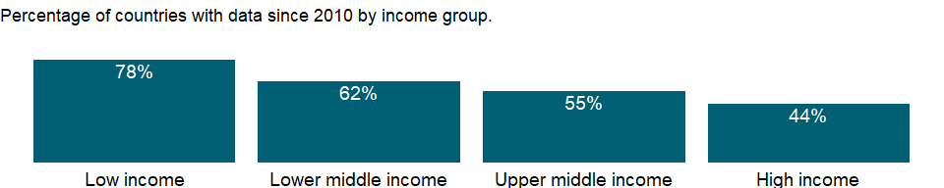

### Why is it relevant?

According to the United Nations, an Urban Agglomeration refers to the de facto population contained within the contours of a contiguous territory inhabited at urban density levels without regard to administrative boundaries. It usually incorporates the population in a city or town plus that in the sub-urban areas lying outside of but being adjacent to the city boundaries. In general, an urban agglomeration is an extended city or town area comprising the built-up area of a central place and any suburbs linked by continuous urban area. INSEE, the French Statistical Institute, uses the term unité urbaine, which means continuous urbanized area. There are differences in definitions of what does and does not constitute an “agglomeration”, as well as differenced in statistical and geographical methodology. Some of the well-known urban agglomerations of the world are Tokyo, New York City, Mexico City, New Delhi, and Seoul.

A metropolitan area includes the urban area, and its satellite cities plus intervening rural land that is socio-economically connected to the urban core city, typically by employment ties through commuting, with the urban core city being the primary labor market. According to the United Nations’ definition, a metropolitan area includes both the contiguous territory inhabited at urban levels of residential density and additional surrounding areas of lower settlement density that are also under the direct influence of the city (e.g., through frequent transport, road linkages, commuting facilities etc.).

Explosive growth of cities globally signifies the demographic transition from rural to urban, and is associated with shifts from an agriculture-based economy to mass industry, technology, and service. For the first time ever, the majority of the world’s population lives in a city, and this proportion continues to grow. One hundred years ago, 2 out of every 10 people lived in an urban area. By 1990, less than 40 percent of the global population lived in a city, but as of early 2010s, more than half of all people live in an urban area. By 2030, 6 out of every 10 people will live in a city, and by 2050, this proportion will increase to 7 out of 10 people. About half of all urban dwellers live in cities with between 100,000-500,000 people, and fewer than 10% of urban dwellers live in megacities (a city with a population of more than 10 million, as defined by UN HABITAT). Currently, the number of urban residents is growing by nearly 60 million every year.

By the middle of the 21st century, the urban population will almost double, reaching 6.4 billion in 2050. Almost all urban population growth in the next 30 years will occur in cities of developing countries. By the middle of the 21st century, it is estimated that the urban population of developing counties will more than double, reaching almost 5.2 billion in 2050. In high-income countries, the urban population is expected to remain largely unchanged over the next two decades, reaching to just over 1 billion by 2025. In these countries, immigration (legal and illegal) will account for more than two-thirds of urban growth. Without immigration, the urban population in these countries would most likely decline or remain static.

In principle, cities offer a more favorable setting for the resolution of social and environmental problems than rural areas. Cities generate jobs and income, and deliver education, health care and other services. Cities also present opportunities for social mobilization and women’s empowerment. Poverty is growing faster in urban than in rural areas. According to UN one billion people live in urban slums, which are typically overcrowded, polluted and dangerous, and lack basic services such as clean water and sanitation.

### What is the data source?

United Nations, World Urbanization Prospects.

### What is the methodology?

Urban population refers to people living in urban areas as defined by national statistical offices. The indicator is calculated using World Bank population estimates and urban ratios from the United Nations World Urbanization Prospects. The United Nations Population Division and other agencies provide current population estimates for developing countries that lack recent census data and pre- and post-census estimates for countries with census data. The cohort component method - a standard method for estimating and projecting population - requires fertility, mortality, and net migration data, often collected from sample surveys, which can be small or limited in coverage. Population estimates are from demographic modeling and so are susceptible to biases and errors from shortcomings in the model and in the data. Because the five-year age group is the cohort unit and five-year period data are used, interpolations to obtain annual data or single age structure may not reflect actual events or age composition.

Countries differ in the way they classify population as “urban” or “rural.” Typically, a community or settlement with a population of 2,000 or more is considered urban, but national definitions are most commonly based on size of locality. Eurostat defines urban areas as clusters of contiguous grid cells of 1 km2 with a density of at least 300 inhabitants per km2 and a minimum population of 5,000. Further it defines high-density cluster as contiguous grid cells of 1 km2 with a density of at least 1,500 inhabitants per km2 and a minimum population of 50,000.

The population of a city or metropolitan area depends on the boundaries chosen. For example, in 1990 Beijing, China, contained 2.3 million people in 87 square kilometers of “inner city” and 5.4 million in 158 square kilometers of “core city.” The population of “inner city and inner suburban districts” was 6.3 million and that of “inner city, inner and outer suburban districts, and inner and outer counties” was 10.8 million. (Most countries use the last definition.)

### How is it aggregated?

NA

### What are the limitations?

Due to varying definitions, it is not possible to compare different agglomerations around the world.

Aggregation of urban and rural population may not add up to total population because of different country coverage. There is no consistent and universally accepted standard for distinguishing urban from rural areas, in part because of the wide variety of situations across countries.

Most countries use an urban classification related to the size or characteristics of settlements. Some define urban areas based on the presence of certain infrastructure and services. And other countries designate urban areas based on administrative arrangements. Because of national differences in the characteristics that distinguish urban from rural areas, the distinction between urban and rural population is not amenable to a single definition that would be applicable to all countries. For example, in Botswana, agglomeration of 5,000 or more inhabitants where 75 per cent of the economic activity is non-agricultural is considered “urban” while in Iceland localities of 200 or more inhabitants, and in Peru population centers with 100 or more dwellings, are considered “urban.” In the United States places of 2,500 or more inhabitants, generally having population densities of 1,000 persons per square mile or more are considered “urban”.

Estimates of the world’s urban population would change significantly if China, India, and a few other populous nations were to change their definition of urban centers. According to China’s State Statistical Bureau, by the end of 1996 urban residents accounted for about 43 percent of China’s population, more than double the 20 percent considered urban in 1994. In addition to the continuous migration of people from rural to urban areas, one of the main reasons for this shift was the rapid growth in the hundreds of towns reclassified as cities in recent years.

Because the estimates of city and metropolitan area are based on national definitions of what constitutes a city or metropolitan area, cross-country comparisons should be made with caution. To estimate urban populations, UN ratios of urban to total population were applied to the World Bank’s estimates of total population.

### What else should I know?

NA

### 1.19.6 Population in urban agglomerations of more than 1 million (% of total population)

### What is the indicator?

Population in urban agglomerations of more than one million is the percentage of a country’s population living in metropolitan areas that in 2018 had a population of more than one million people.

Topic: Environment: Density & urbanization

Series ID: EN.URB.MCTY.TL.ZS

Copyright: CC BY-4.0 , <https://datacatalog.worldbank.org/public-licenses#cc-by>

First year with any data: 1960

Last year with any data: 2020

### What years are data available?

The figure below shows years in which data is available for at least one country. Dates shaded in black have no data, while dates shaded in green have data for at least one country



### Which countries have data?

The figure below shows the percentage of countries in each income group with a value since 2010 for that indicator.



### Why is it relevant?

According to the United Nations, an Urban Agglomeration refers to the de facto population contained within the contours of a contiguous territory inhabited at urban density levels without regard to administrative boundaries. It usually incorporates the population in a city or town plus that in the sub-urban areas lying outside of but being adjacent to the city boundaries. In general, an urban agglomeration is an extended city or town area comprising the built-up area of a central place and any suburbs linked by continuous urban area. INSEE, the French Statistical Institute, uses the term unité urbaine, which means continuous urbanized area. There are differences in definitions of what does and does not constitute an “agglomeration”, as well as differenced in statistical and geographical methodology. Some of the well-known urban agglomerations of the world are Tokyo, New York City, Mexico City, New Delhi, and Seoul.

A metropolitan area includes the urban area, and its satellite cities plus intervening rural land that is socio-economically connected to the urban core city, typically by employment ties through commuting, with the urban core city being the primary labor market. According to the United Nations’ definition, a metropolitan area includes both the contiguous territory inhabited at urban levels of residential density and additional surrounding areas of lower settlement density that are also under the direct influence of the city (e.g., through frequent transport, road linkages, commuting facilities etc.).

Explosive growth of cities globally signifies the demographic transition from rural to urban, and is associated with shifts from an agriculture-based economy to mass industry, technology, and service. For the first time ever, the majority of the world’s population lives in a city, and this proportion continues to grow. One hundred years ago, 2 out of every 10 people lived in an urban area. By 1990, less than 40 percent of the global population lived in a city, but as of early 2010s, more than half of all people live in an urban area. By 2030, 6 out of every 10 people will live in a city, and by 2050, this proportion will increase to 7 out of 10 people. About half of all urban dwellers live in cities with between 100,000-500,000 people, and fewer than 10% of urban dwellers live in megacities (a city with a population of more than 10 million, as defined by UN HABITAT). Currently, the number of urban residents is growing by nearly 60 million every year.

By the middle of the 21st century, the urban population will almost double, reaching 6.4 billion in 2050. Almost all urban population growth in the next 30 years will occur in cities of developing countries. By the middle of the 21st century, it is estimated that the urban population of developing counties will more than double, reaching almost 5.2 billion in 2050. In high-income countries, the urban population is expected to remain largely unchanged over the next two decades, reaching to just over 1 billion by 2025. In these countries, immigration (legal and illegal) will account for more than two-thirds of urban growth. Without immigration, the urban population in these countries would most likely decline or remain static.

In principle, cities offer a more favorable setting for the resolution of social and environmental problems than rural areas. Cities generate jobs and income, and deliver education, health care and other services. Cities also present opportunities for social mobilization and women’s empowerment. Poverty is growing faster in urban than in rural areas. According to UN one billion people live in urban slums, which are typically overcrowded, polluted and dangerous, and lack basic services such as clean water and sanitation.

### What is the data source?

United Nations, World Urbanization Prospects.

### What is the methodology?

Urban population refers to people living in urban areas as defined by national statistical offices. The indicator is calculated using World Bank population estimates and urban ratios from the United Nations World Urbanization Prospects. The United Nations Population Division and other agencies provide current population estimates for developing countries that lack recent census data and pre- and post-census estimates for countries with census data. The cohort component method - a standard method for estimating and projecting population - requires fertility, mortality, and net migration data, often collected from sample surveys, which can be small or limited in coverage. Population estimates are from demographic modeling and so are susceptible to biases and errors from shortcomings in the model and in the data. Because the five-year age group is the cohort unit and five-year period data are used, interpolations to obtain annual data or single age structure may not reflect actual events or age composition.

Countries differ in the way they classify population as “urban” or “rural.” Typically, a community or settlement with a population of 2,000 or more is considered urban, but national definitions are most commonly based on size of locality. Eurostat defines urban areas as clusters of contiguous grid cells of 1 km2 with a density of at least 300 inhabitants per km2 and a minimum population of 5,000. Further it defines high-density cluster as contiguous grid cells of 1 km2 with a density of at least 1,500 inhabitants per km2 and a minimum population of 50,000.

The population of a city or metropolitan area depends on the boundaries chosen. For example, in 1990 Beijing, China, contained 2.3 million people in 87 square kilometers of “inner city” and 5.4 million in 158 square kilometers of “core city.” The population of “inner city and inner suburban districts” was 6.3 million and that of “inner city, inner and outer suburban districts, and inner and outer counties” was 10.8 million. (Most countries use the last definition.)

### How is it aggregated?

Weighted Average

### What are the limitations?

Due to varying definitions, it is not possible to compare different agglomerations around the world.

Aggregation of urban and rural population may not add up to total population because of different country coverage. There is no consistent and universally accepted standard for distinguishing urban from rural areas, in part because of the wide variety of situations across countries.

Most countries use an urban classification related to the size or characteristics of settlements. Some define urban areas based on the presence of certain infrastructure and services. And other countries designate urban areas based on administrative arrangements. Because of national differences in the characteristics that distinguish urban from rural areas, the distinction between urban and rural population is not amenable to a single definition that would be applicable to all countries. For example, in Botswana, agglomeration of 5,000 or more inhabitants where 75 per cent of the economic activity is non-agricultural is considered “urban” while in Iceland localities of 200 or more inhabitants, and in Peru population centers with 100 or more dwellings, are considered “urban.” In the United States places of 2,500 or more inhabitants, generally having population densities of 1,000 persons per square mile or more are considered “urban”.

Estimates of the world’s urban population would change significantly if China, India, and a few other populous nations were to change their definition of urban centers. According to China’s State Statistical Bureau, by the end of 1996 urban residents accounted for about 43 percent of China’s population, more than double the 20 percent considered urban in 1994. In addition to the continuous migration of people from rural to urban areas, one of the main reasons for this shift was the rapid growth in the hundreds of towns reclassified as cities in recent years.

Because the estimates of city and metropolitan area are based on national definitions of what constitutes a city or metropolitan area, cross-country comparisons should be made with caution. To estimate urban populations, UN ratios of urban to total population were applied to the World Bank’s estimates of total population.

### What else should I know?

NA

### 1.19.7 Rural population

### What is the indicator?

Rural population refers to people living in rural areas as defined by national statistical offices. It is calculated as the difference between total population and urban population. Aggregation of urban and rural population may not add up to total population because of different country coverages.

Topic: Environment: Density & urbanization

Series ID: SP.RUR.TOTL

Copyright: CC BY-4.0 , <https://datacatalog.worldbank.org/public-licenses#cc-by>

First year with any data: 1960

Last year with any data: 2020

### What years are data available?

The figure below shows years in which data is available for at least one country. Dates shaded in black have no data, while dates shaded in green have data for at least one country



### Which countries have data?

The figure below shows the percentage of countries in each income group with a value since 2010 for that indicator.



### Why is it relevant?

The rural population is calculated using the urban share reported by the United Nations Population Division. There is no universal standard for distinguishing rural from urban areas, and any urban-rural dichotomy is an oversimplification.

The two distinct images - isolated farm, thriving metropolis - represent poles on a continuum. Life changes along a variety of dimensions, moving from the most remote forest outpost through fields and pastures, past tiny hamlets, through small towns with weekly farm markets, into intensively cultivated areas near large towns and small cities, eventually reaching the center of a megacity. Along the way access to infrastructure, social services, and nonfarm employment increase, and with them population density and income.

A 2005 World Bank Policy Research Paper proposes an operational definition of rurality based on population density and distance to large cities (Chomitz, Buys, and Thomas 2005). The report argues that these criteria are important gradients along which economic behavior and appropriate development interventions vary substantially. Where population densities are low, markets of all kinds are thin, and the unit cost of delivering most social services and many types of infrastructure is high. Where large urban areas are distant, farm-gate or factory-gate prices of outputs will be low and input prices will be high, and it will be difficult to recruit skilled people to public service or private enterprises. Thus, low population density and remoteness together define a set of rural areas that face special development challenges.

Countries differ in the way they classify population as “urban” or “rural.”

Most countries use an urban classification related to the size or characteristics of settlements. Some define urban areas based on the presence of certain infrastructure and services. And other countries designate urban areas based on administrative arrangements. Because of national differences in the characteristics that distinguish urban from rural areas, the distinction between urban and rural population is not amenable to a single definition that would be applicable to all countries.

Rural population methodology is defined by various national statistical offices. In the United States, for example, the US Census Bureau’s urban-rural classification is fundamentally a delineation of geographical areas, identifying both individual urban areas and the rural areas of the nation. “Rural” encompasses all population, housing, and territory not included within an urban area.

### What is the data source?

World Bank staff estimates based on the United Nations Population Division’s World Urbanization Prospects: 2018 Revision.

### What is the methodology?

Rural population is calculated as the difference between the total population and the urban population. Rural population is approximated as the midyear nonurban population. While a practical means of identifying the rural population, it is not a precise measure.

The United Nations Population Division and other agencies provide current population estimates for developing countries that lack recent census data and pre- and post-census estimates for countries with census data.

### How is it aggregated?

Sum

### What are the limitations?

Aggregation of urban and rural population may not add up to total population because of different country coverage. There is no consistent and universally accepted standard for distinguishing urban from rural areas, in part because of the wide variety of situations across countries.

Estimates of the world’s urban population would change significantly if China, India, and a few other populous nations were to change their definition of urban centers.

Because the estimates of city and metropolitan area are based on national definitions of what constitutes a city or metropolitan area, cross-country comparisons should be made with caution. To estimate urban populations, UN ratios of urban to total population were applied to the World Bank’s estimates of total population.

### What else should I know?

NA

### 1.19.8 Rural population growth (annual %)

### What is the indicator?

Rural population refers to people living in rural areas as defined by national statistical offices. It is calculated as the difference between total population and urban population.

Topic: Environment: Density & urbanization

Series ID: SP.RUR.TOTL.ZG

Copyright: CC BY-4.0 , <https://datacatalog.worldbank.org/public-licenses#cc-by>

First year with any data: 1961

Last year with any data: 2020

### What years are data available?

The figure below shows years in which data is available for at least one country. Dates shaded in black have no data, while dates shaded in green have data for at least one country



### Which countries have data?

The figure below shows the percentage of countries in each income group with a value since 2010 for that indicator.

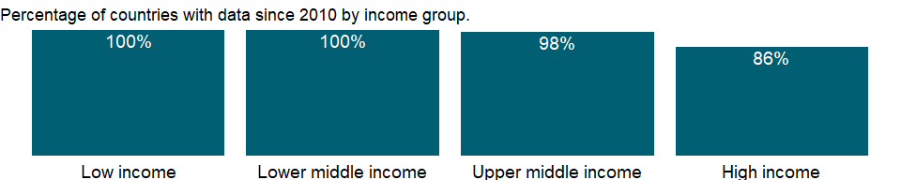

### Why is it relevant?

The rural population is calculated using the urban share reported by the United Nations Population Division. There is no universal standard for distinguishing rural from urban areas, and any urban-rural dichotomy is an oversimplification.

The two distinct images - isolated farm, thriving metropolis - represent poles on a continuum. Life changes along a variety of dimensions, moving from the most remote forest outpost through fields and pastures, past tiny hamlets, through small towns with weekly farm markets, into intensively cultivated areas near large towns and small cities, eventually reaching the center of a megacity. Along the way access to infrastructure, social services, and nonfarm employment increase, and with them population density and income.

A 2005 World Bank Policy Research Paper proposes an operational definition of rurality based on population density and distance to large cities (Chomitz, Buys, and Thomas 2005). The report argues that these criteria are important gradients along which economic behavior and appropriate development interventions vary substantially. Where population densities are low, markets of all kinds are thin, and the unit cost of delivering most social services and many types of infrastructure is high. Where large urban areas are distant, farm-gate or factory-gate prices of outputs will be low and input prices will be high, and it will be difficult to recruit skilled people to public service or private enterprises. Thus, low population density and remoteness together define a set of rural areas that face special development challenges.

Countries differ in the way they classify population as “urban” or “rural.”

Most countries use an urban classification related to the size or characteristics of settlements. Some define urban areas based on the presence of certain infrastructure and services. And other countries designate urban areas based on administrative arrangements. Because of national differences in the characteristics that distinguish urban from rural areas, the distinction between urban and rural population is not amenable to a single definition that would be applicable to all countries.

Rural population methodology is defined by various national statistical offices. In the United States, for example, the US Census Bureau’s urban-rural classification is fundamentally a delineation of geographical areas, identifying both individual urban areas and the rural areas of the nation. “Rural” encompasses all population, housing, and territory not included within an urban area.

### What is the data source?

World Bank staff estimates based on the United Nations Population Division’s World Urbanization Prospects: 2018 Revision.

### What is the methodology?

Rural population is calculated as the difference between the total population and the urban population. Rural population is approximated as the midyear nonurban population. While a practical means of identifying the rural population, it is not a precise measure.

The United Nations Population Division and other agencies provide current population estimates for developing countries that lack recent census data and pre- and post-census estimates for countries with census data.

### How is it aggregated?

Weighted average

### What are the limitations?

Aggregation of urban and rural population may not add up to total population because of different country coverage. There is no consistent and universally accepted standard for distinguishing urban from rural areas, in part because of the wide variety of situations across countries.

Estimates of the world’s urban population would change significantly if China, India, and a few other populous nations were to change their definition of urban centers.

Because the estimates of city and metropolitan area are based on national definitions of what constitutes a city or metropolitan area, cross-country comparisons should be made with caution. To estimate urban populations, UN ratios of urban to total population were applied to the World Bank’s estimates of total population.

### What else should I know?

NA

### 1.19.9 Rural population (% of total population)

### What is the indicator?

Rural population refers to people living in rural areas as defined by national statistical offices. It is calculated as the difference between total population and urban population.

Topic: Environment: Density & urbanization

Series ID: SP.RUR.TOTL.ZS

Copyright: CC BY-4.0 , <https://datacatalog.worldbank.org/public-licenses#cc-by>

First year with any data: 1960

Last year with any data: 2020

### What years are data available?

The figure below shows years in which data is available for at least one country. Dates shaded in black have no data, while dates shaded in green have data for at least one country



### Which countries have data?

The figure below shows the percentage of countries in each income group with a value since 2010 for that indicator.



### Why is it relevant?

The rural population is calculated using the urban share reported by the United Nations Population Division. There is no universal standard for distinguishing rural from urban areas, and any urban-rural dichotomy is an oversimplification.

The two distinct images - isolated farm, thriving metropolis - represent poles on a continuum. Life changes along a variety of dimensions, moving from the most remote forest outpost through fields and pastures, past tiny hamlets, through small towns with weekly farm markets, into intensively cultivated areas near large towns and small cities, eventually reaching the center of a megacity. Along the way access to infrastructure, social services, and nonfarm employment increase, and with them population density and income.

A 2005 World Bank Policy Research Paper proposes an operational definition of rurality based on population density and distance to large cities (Chomitz, Buys, and Thomas 2005). The report argues that these criteria are important gradients along which economic behavior and appropriate development interventions vary substantially. Where population densities are low, markets of all kinds are thin, and the unit cost of delivering most social services and many types of infrastructure is high. Where large urban areas are distant, farm-gate or factory-gate prices of outputs will be low and input prices will be high, and it will be difficult to recruit skilled people to public service or private enterprises. Thus, low population density and remoteness together define a set of rural areas that face special development challenges.

Countries differ in the way they classify population as “urban” or “rural.”

Most countries use an urban classification related to the size or characteristics of settlements. Some define urban areas based on the presence of certain infrastructure and services. And other countries designate urban areas based on administrative arrangements. Because of national differences in the characteristics that distinguish urban from rural areas, the distinction between urban and rural population is not amenable to a single definition that would be applicable to all countries.

Rural population methodology is defined by various national statistical offices. In the United States, for example, the US Census Bureau’s urban-rural classification is fundamentally a delineation of geographical areas, identifying both individual urban areas and the rural areas of the nation. “Rural” encompasses all population, housing, and territory not included within an urban area.

### What is the data source?

World Bank staff estimates based on the United Nations Population Division’s World Urbanization Prospects: 2018 Revision.

### What is the methodology?

Rural population is calculated as the difference between the total population and the urban population. Rural population is approximated as the midyear nonurban population. While a practical means of identifying the rural population, it is not a precise measure.

The United Nations Population Division and other agencies provide current population estimates for developing countries that lack recent census data and pre- and post-census estimates for countries with census data.

### How is it aggregated?

Weighted average

### What are the limitations?

Aggregation of urban and rural population may not add up to total population because of different country coverage. There is no consistent and universally accepted standard for distinguishing urban from rural areas, in part because of the wide variety of situations across countries.

Estimates of the world’s urban population would change significantly if China, India, and a few other populous nations were to change their definition of urban centers.

Because the estimates of city and metropolitan area are based on national definitions of what constitutes a city or metropolitan area, cross-country comparisons should be made with caution. To estimate urban populations, UN ratios of urban to total population were applied to the World Bank’s estimates of total population.

### What else should I know?

NA

### 1.19.10 Urban population growth (annual %)

### What is the indicator?

Urban population refers to people living in urban areas as defined by national statistical offices. It is calculated using World Bank population estimates and urban ratios from the United Nations World Urbanization Prospects.

Topic: Environment: Density & urbanization

Series ID: SP.URB.GROW

Copyright: CC BY-4.0 , <https://datacatalog.worldbank.org/public-licenses#cc-by>

First year with any data: 1961

Last year with any data: 2020

### What years are data available?

The figure below shows years in which data is available for at least one country. Dates shaded in black have no data, while dates shaded in green have data for at least one country



### Which countries have data?

The figure below shows the percentage of countries in each income group with a value since 2010 for that indicator.



### Why is it relevant?

Explosive growth of cities globally signifies the demographic transition from rural to urban, and is associated with shifts from an agriculture-based economy to mass industry, technology, and service.

In principle, cities offer a more favorable setting for the resolution of social and environmental problems than rural areas. Cities generate jobs and income, and deliver education, health care and other services. Cities also present opportunities for social mobilization and women’s empowerment.

### What is the data source?

World Bank staff estimates based on the United Nations Population Division’s World Urbanization Prospects: 2018 Revision.

### What is the methodology?

Urban population refers to people living in urban areas as defined by national statistical offices. The indicator is calculated using World Bank population estimates and urban ratios from the United Nations World Urbanization Prospects. To estimate urban populations, UN ratios of urban to total population were applied to the World Bank’s estimates of total population.

Countries differ in the way they classify population as “urban” or “rural.” The population of a city or metropolitan area depends on the boundaries chosen.

### How is it aggregated?

Weighted average

### What are the limitations?

There is no consistent and universally accepted standard for distinguishing urban from rural areas, in part because of the wide variety of situations across countries.

Most countries use an urban classification related to the size or characteristics of settlements. Some define urban areas based on the presence of certain infrastructure and services. And other countries designate urban areas based on administrative arrangements. Because of national differences in the characteristics that distinguish urban from rural areas, the distinction between urban and rural population is not amenable to a single definition that would be applicable to all countries.

Estimates of the world’s urban population would change significantly if China, India, and a few other populous nations were to change their definition of urban centers.

Because the estimates of city and metropolitan area are based on national definitions of what constitutes a city or metropolitan area, cross-country comparisons should be made with caution.

### What else should I know?

NA

### 1.19.11 Urban population

### What is the indicator?

Urban population refers to people living in urban areas as defined by national statistical offices. It is calculated using World Bank population estimates and urban ratios from the United Nations World Urbanization Prospects. Aggregation of urban and rural population may not add up to total population because of different country coverages.

Topic: Environment: Density & urbanization

Series ID: SP.URB.TOTL

Copyright: CC BY-4.0 , <https://datacatalog.worldbank.org/public-licenses#cc-by>

First year with any data: 1960

Last year with any data: 2020

### What years are data available?

The figure below shows years in which data is available for at least one country. Dates shaded in black have no data, while dates shaded in green have data for at least one country



### Which countries have data?

The figure below shows the percentage of countries in each income group with a value since 2010 for that indicator.



### Why is it relevant?

Explosive growth of cities globally signifies the demographic transition from rural to urban, and is associated with shifts from an agriculture-based economy to mass industry, technology, and service.

In principle, cities offer a more favorable setting for the resolution of social and environmental problems than rural areas. Cities generate jobs and income, and deliver education, health care and other services. Cities also present opportunities for social mobilization and women’s empowerment.

### What is the data source?

World Bank staff estimates based on the United Nations Population Division’s World Urbanization Prospects: 2018 Revision.

### What is the methodology?

Urban population refers to people living in urban areas as defined by national statistical offices. The indicator is calculated using World Bank population estimates and urban ratios from the United Nations World Urbanization Prospects. To estimate urban populations, UN ratios of urban to total population were applied to the World Bank’s estimates of total population.

Countries differ in the way they classify population as “urban” or “rural.” The population of a city or metropolitan area depends on the boundaries chosen.

### How is it aggregated?

Sum

### What are the limitations?

Aggregation of urban and rural population may not add up to total population because of different country coverage. There is no consistent and universally accepted standard for distinguishing urban from rural areas, in part because of the wide variety of situations across countries.

Most countries use an urban classification related to the size or characteristics of settlements. Some define urban areas based on the presence of certain infrastructure and services. And other countries designate urban areas based on administrative arrangements. Because of national differences in the characteristics that distinguish urban from rural areas, the distinction between urban and rural population is not amenable to a single definition that would be applicable to all countries.

Estimates of the world’s urban population would change significantly if China, India, and a few other populous nations were to change their definition of urban centers.

Because the estimates of city and metropolitan area are based on national definitions of what constitutes a city or metropolitan area, cross-country comparisons should be made with caution.

### What else should I know?

NA

### 1.19.12 Urban population (% of total population)

### What is the indicator?

Urban population refers to people living in urban areas as defined by national statistical offices. The data are collected and smoothed by United Nations Population Division.

Topic: Environment: Density & urbanization

Series ID: SP.URB.TOTL.IN.ZS

Copyright: CC BY-4.0 , <https://datacatalog.worldbank.org/public-licenses#cc-by>

First year with any data: 1960

Last year with any data: 2020

### What years are data available?

The figure below shows years in which data is available for at least one country. Dates shaded in black have no data, while dates shaded in green have data for at least one country



### Which countries have data?

The figure below shows the percentage of countries in each income group with a value since 2010 for that indicator.



### Why is it relevant?

Explosive growth of cities globally signifies the demographic transition from rural to urban, and is associated with shifts from an agriculture-based economy to mass industry, technology, and service.

In principle, cities offer a more favorable setting for the resolution of social and environmental problems than rural areas. Cities generate jobs and income, and deliver education, health care and other services. Cities also present opportunities for social mobilization and women’s empowerment.

### What is the data source?

United Nations Population Division. World Urbanization Prospects: 2018 Revision.

### What is the methodology?

Urban population refers to people living in urban areas as defined by national statistical offices. The indicator is calculated using World Bank population estimates and urban ratios from the United Nations World Urbanization Prospects.

Percentages urban are the numbers of persons residing in an area defined as ‘’urban’’ per 100 total population. They are calculated by the Statistics Division of the United Nations Department of Economic and Social Affairs. Particular caution should be used in interpreting the figures for percentage urban for different countries.

Countries differ in the way they classify population as “urban” or “rural.” The population of a city or metropolitan area depends on the boundaries chosen.

### How is it aggregated?

Weighted average

### What are the limitations?

Aggregation of urban and rural population may not add up to total population because of different country coverage. There is no consistent and universally accepted standard for distinguishing urban from rural areas, in part because of the wide variety of situations across countries.

Most countries use an urban classification related to the size or characteristics of settlements. Some define urban areas based on the presence of certain infrastructure and services. And other countries designate urban areas based on administrative arrangements. Because of national differences in the characteristics that distinguish urban from rural areas, the distinction between urban and rural population is not amenable to a single definition that would be applicable to all countries.

Estimates of the world’s urban population would change significantly if China, India, and a few other populous nations were to change their definition of urban centers.

Because the estimates of city and metropolitan area are based on national definitions of what constitutes a city or metropolitan area, cross-country comparisons should be made with caution.

### What else should I know?

NA

## 1.20 Infrastructure: Transportation

### 1.20.1 Pump price for diesel fuel (US$ per liter)

### What is the indicator?

Fuel prices refer to the pump prices of the most widely sold grade of diesel fuel. Prices have been converted from the local currency to U.S. dollars.

Topic: Infrastructure: Transportation

Series ID: EP.PMP.DESL.CD

Copyright: CC BY-4.0 , <https://datacatalog.worldbank.org/public-licenses#cc-by>

First year with any data: 1991

Last year with any data: 2016

### What years are data available?

The figure below shows years in which data is available for at least one country. Dates shaded in black have no data, while dates shaded in green have data for at least one country

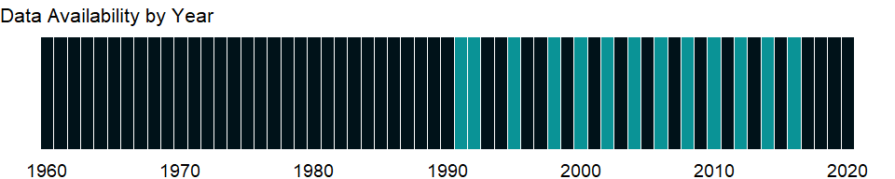

### Which countries have data?

The figure below shows the percentage of countries in each income group with a value since 2010 for that indicator.

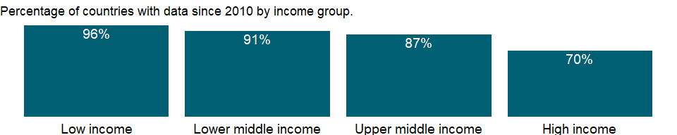

### Why is it relevant?

NA

### What is the data source?

German Agency for International Cooperation (GIZ).

### What is the methodology?

Data on fuel prices are compiled by the German Agency for International Cooperation (GIZ), from its global network and other sources, including the Allgemeiner Deutscher Automobile Club (for Europe) and the Latin American Energy Organization (for Latin America). Local prices are converted to U.S. dollars using the exchange rate in the Financial Times international monetary table on the survey date. When multiple exchange rates exist, the market, parallel, or black market rate is used.

### How is it aggregated?

Median

### What are the limitations?

NA

### What else should I know?

NA

### 1.20.2 Pump price for gasoline (US$ per liter)

### What is the indicator?

Fuel prices refer to the pump prices of the most widely sold grade of gasoline. Prices have been converted from the local currency to U.S. dollars.

Topic: Infrastructure: Transportation

Series ID: EP.PMP.SGAS.CD

Copyright: CC BY-4.0 , <https://datacatalog.worldbank.org/public-licenses#cc-by>

First year with any data: 1991

Last year with any data: 2016

### What years are data available?

The figure below shows years in which data is available for at least one country. Dates shaded in black have no data, while dates shaded in green have data for at least one country



### Which countries have data?

The figure below shows the percentage of countries in each income group with a value since 2010 for that indicator.

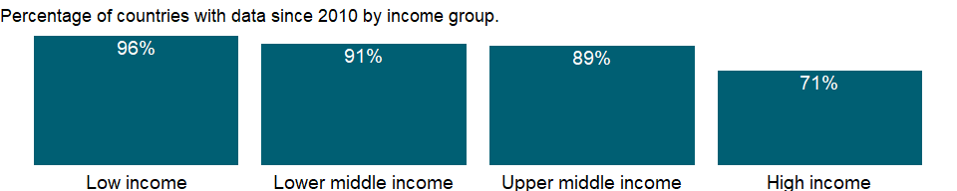

### Why is it relevant?

NA

### What is the data source?

German Agency for International Cooperation (GIZ).

### What is the methodology?

Data on fuel prices are compiled by the German Agency for International Cooperation (GIZ), from its global network and other sources, including the Allgemeiner Deutscher Automobile Club (for Europe) and the Latin American Energy Organization (for Latin America). Local prices are converted to U.S. dollars using the exchange rate in the Financial Times international monetary table on the survey date. When multiple exchange rates exist, the market, parallel, or black market rate is used.

### How is it aggregated?

Median

### What are the limitations?

NA

### What else should I know?

NA

### 1.20.3 Air transport, registered carrier departures worldwide

### What is the indicator?

Registered carrier departures worldwide are domestic takeoffs and takeoffs abroad of air carriers registered in the country.

Topic: Infrastructure: Transportation

Series ID: IS.AIR.DPRT

Copyright: CC BY-4.0 , <https://datacatalog.worldbank.org/public-licenses#cc-by>

First year with any data: 1970

Last year with any data: 2019

### What years are data available?

The figure below shows years in which data is available for at least one country. Dates shaded in black have no data, while dates shaded in green have data for at least one country



### Which countries have data?

The figure below shows the percentage of countries in each income group with a value since 2010 for that indicator.

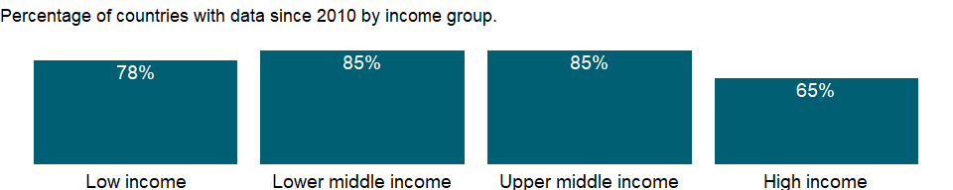

### Why is it relevant?

Transport infrastructure - highways, railways, ports and waterways, and airports and air traffic control systems - and the services that flow from it are crucial to the activities of households, producers, and governments. Because performance indicators vary widely by transport mode and focus (whether physical infrastructure or the services flowing from that infrastructure), highly specialized and carefully specified indicators are required to measure a country’s transport infrastructure.

The air transport industry a vital engine of global socio-economic growth. It is of vital importance for economic development, creating direct and indirect employment, supporting tourism and local businesses, and stimulating foreign investment and international trade. Economic growth, technological change, market liberalization, the growth of low cost carriers, airport congestion, oil prices and other trends affect commercial aviation throughout the world.

### What is the data source?

International Civil Aviation Organization, Civil Aviation Statistics of the World and ICAO staff estimates.

### What is the methodology?

The air transport data represent the total (international and domestic) scheduled traffic carried by the air carriers registered in a country. For statistical uses, departures are equal to the number of landings made or flight stages flown. A flight stage is the operation of an aircraft from take-off to its next landing. A flight stage is classified as either international or domestic. International flight stage is one or both terminals in the territory of a State, other than the State in which the air carrier has its principal place of business.

Domestic flight stage is not classifiable as international. Domestic flight stages include all flight stages flown between points within the domestic boundaries of a State by an air carrier whose principal place of business is in that State. Flight stages between a State and territories belonging to it, as well as any flight stages between two such territories, should be classified as domestic. This applies even though a stage may cross international waters or over the territory of another State.

### How is it aggregated?

Sum

### What are the limitations?

Countries submit air transport data to Civil Aviation Organization (ICAO) on the basis of standard instructions and definitions issued by ICAO. In many cases, however, the data include estimates by ICAO for nonreporting carriers. Where possible, these estimates are based on previous submissions supplemented by information published by the air carriers, such as flight schedules.

The data cover the air traffic carried on scheduled services, but changes in air transport regulations in Europe have made it more difficult to classify traffic as scheduled or nonscheduled. Thus recent increases shown for some European countries may be due to changes in the classification of air traffic rather than actual growth. In the case of multinational air carriers owned by partner States, traffic within each partner State is shown separately as domestic and all other traffic as international.

“Foreign” cabotage traffic (i.e. traffic carried between city-pairs in a State other than the one where the reporting carrier has its principal place of business) is shown as international traffic.

A technical stop does not result in any flight stage being classified differently than would have been the case had the technical stop not been made. For countries with few air carriers or only one, the addition or discontinuation of a home-based air carrier may cause significant changes in air traffic.

Data for transport sectors are not always internationally comparable. Unlike for demographic statistics, national income accounts, and international trade data, the collection of infrastructure data has not been “internationalized.”

### What else should I know?

NA

### 1.20.4 Air transport, freight (million ton-km)

### What is the indicator?

Air freight is the volume of freight, express, and diplomatic bags carried on each flight stage (operation of an aircraft from takeoff to its next landing), measured in metric tons times kilometers traveled.

Topic: Infrastructure: Transportation

Series ID: IS.AIR.GOOD.MT.K1

Copyright: CC BY-4.0 , <https://datacatalog.worldbank.org/public-licenses#cc-by>

First year with any data: 1970

Last year with any data: 2019

### What years are data available?

The figure below shows years in which data is available for at least one country. Dates shaded in black have no data, while dates shaded in green have data for at least one country



### Which countries have data?

The figure below shows the percentage of countries in each income group with a value since 2010 for that indicator.

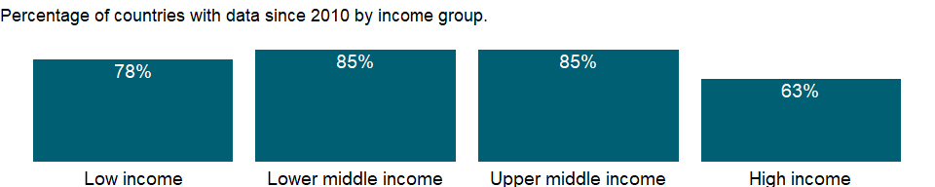

### Why is it relevant?

Transport infrastructure - highways, railways, ports and waterways, and airports and air traffic control systems - and the services that flow from it are crucial to the activities of households, producers, and governments. Because performance indicators vary widely by transport mode and focus (whether physical infrastructure or the services flowing from that infrastructure), highly specialized and carefully specified indicators are required to measure a country’s transport infrastructure.

The air transport industry a vital engine of global socio-economic growth. It is of vital importance for economic development, creating direct and indirect employment, supporting tourism and local businesses, and stimulating foreign investment and international trade. Economic growth, technological change, market liberalization, the growth of low cost carriers, airport congestion, oil prices and other trends affect commercial aviation throughout the world.

### What is the data source?

International Civil Aviation Organization, Civil Aviation Statistics of the World and ICAO staff estimates.

### What is the methodology?

For statistical uses, departures are equal to the number of landings made or flight stages flown. A flight stage is the operation of an aircraft from take-off to its next landing. A flight stage is classified as either international or domestic. International flight stage is one or both terminals in the territory of a State, other than the State in which the air carrier has its principal place of business.

Domestic flight stage is not classifiable as international. Domestic flight stages include all flight stages flown between points within the domestic boundaries of a State by an air carrier whose principal place of business is in that State. Flight stages between a State and territories belonging to it, as well as any flight stages between two such territories, should be classified as domestic. This applies even though a stage may cross international waters or over the territory of another State.

Freight tonne-kilometres performed measures a metric tonne of freight carried one kilometre. Freight tonne-kilometres equal the sum of the products obtained by multiplying the number of tonnes of freight, express, diplomatic bags carried on each flight stage by the stage distance. For ICAO statistical purposes freight includes express and diplomatic bags but not passenger baggage.

### How is it aggregated?

Sum

### What are the limitations?

The air transport data represent the total (international and domestic) scheduled traffic carried by the air carriers registered in a country. Countries submit air transport data to International Civil Aviation Organization (ICAO) on the basis of standard instructions and definitions issued by ICAO. In many cases, however, the data include estimates by ICAO for nonreporting carriers. Where possible, these estimates are based on previous submissions supplemented by information published by the air carriers, such as flight schedules.

The data cover the air traffic carried on scheduled services, but changes in air transport regulations in Europe have made it more difficult to classify traffic as scheduled or nonscheduled. Thus recent increases shown for some European countries may be due to changes in the classification of air traffic rather than actual growth. In the case of multinational air carriers owned by partner States, traffic within each partner State is shown separately as domestic and all other traffic as international.

“Foreign” cabotage traffic (i.e. traffic carried between city-pairs in a State other than the one where the reporting carrier has its principal place of business) is shown as international traffic.

A technical stop does not result in any flight stage being classified differently than would have been the case had the technical stop not been made. For countries with few air carriers or only one, the addition or discontinuation of a home-based air carrier may cause significant changes in air traffic.

Data for transport sectors are not always internationally comparable. Unlike for demographic statistics, national income accounts, and international trade data, the collection of infrastructure data has not been “internationalized.”

### What else should I know?

NA

### 1.20.5 Air transport, passengers carried

### What is the indicator?

Air passengers carried include both domestic and international aircraft passengers of air carriers registered in the country.

Topic: Infrastructure: Transportation

Series ID: IS.AIR.PSGR

Copyright: CC BY-4.0 , <https://datacatalog.worldbank.org/public-licenses#cc-by>

First year with any data: 1970

Last year with any data: 2019

### What years are data available?

The figure below shows years in which data is available for at least one country. Dates shaded in black have no data, while dates shaded in green have data for at least one country



### Which countries have data?

The figure below shows the percentage of countries in each income group with a value since 2010 for that indicator.



### Why is it relevant?

Transport infrastructure - highways, railways, ports and waterways, and airports and air traffic control systems - and the services that flow from it are crucial to the activities of households, producers, and governments. Because performance indicators vary widely by transport mode and focus (whether physical infrastructure or the services flowing from that infrastructure), highly specialized and carefully specified indicators are required to measure a country’s transport infrastructure.

The air transport industry a vital engine of global socio-economic growth. It is of vital importance for economic development, creating direct and indirect employment, supporting tourism and local businesses, and stimulating foreign investment and international trade. Economic growth, technological change, market liberalization, the growth of low cost carriers, airport congestion, oil prices and other trends affect commercial aviation throughout the world.

### What is the data source?

International Civil Aviation Organization, Civil Aviation Statistics of the World and ICAO staff estimates.

### What is the methodology?

For statistical uses, departures are equal to the number of landings made or flight stages flown. A flight stage is the operation of an aircraft from take-off to its next landing. A flight stage is classified as either international or domestic. International flight stage is one or both terminals in the territory of a State, other than the State in which the air carrier has its principal place of business.

Domestic flight stage is not classifiable as international. Domestic flight stages include all flight stages flown between points within the domestic boundaries of a State by an air carrier whose principal place of business is in that State. Flight stages between a State and territories belonging to it, as well as any flight stages between two such territories, should be classified as domestic. This applies even though a stage may cross international waters or over the territory of another State.

The number of passengers carried is obtained by counting each passenger on a particular flight (with one flight number) once only and not repeatedly on each individual stage of that flight, with a single exception that a passenger flying on both the international and domestic stages of the same flight should be counted as both a domestic and an international passenger.

### How is it aggregated?

Sum

### What are the limitations?

The air transport data represent the total (international and domestic) scheduled traffic carried by the air carriers registered in a country. Countries submit air transport data to International Civil Aviation Organization (ICAO) on the basis of standard instructions and definitions issued by ICAO. In many cases, however, the data include estimates by ICAO for nonreporting carriers. Where possible, these estimates are based on previous submissions supplemented by information published by the air carriers, such as flight schedules.

The data cover the air traffic carried on scheduled services, but changes in air transport regulations in Europe have made it more difficult to classify traffic as scheduled or nonscheduled. Thus recent increases shown for some European countries may be due to changes in the classification of air traffic rather than actual growth. In the case of multinational air carriers owned by partner States, traffic within each partner State is shown separately as domestic and all other traffic as international.

“Foreign” cabotage traffic (i.e. traffic carried between city-pairs in a State other than the one where the reporting carrier has its principal place of business) is shown as international traffic.

A technical stop does not result in any flight stage being classified differently than would have been the case had the technical stop not been made. For countries with few air carriers or only one, the addition or discontinuation of a home-based air carrier may cause significant changes in air traffic.

Data for transport sectors are not always internationally comparable. Unlike for demographic statistics, national income accounts, and international trade data, the collection of infrastructure data has not been “internationalized.”

### What else should I know?

NA

### 1.20.6 Railways, goods transported (million ton-km)

### What is the indicator?

Goods transported by railway are the volume of goods transported by railway, measured in metric tons times kilometers traveled.

Topic: Infrastructure: Transportation

Series ID: IS.RRS.GOOD.MT.K6

Copyright: CC BY-4.0 , <https://datacatalog.worldbank.org/public-licenses#cc-by>

First year with any data: 1995

Last year with any data: 2019

### What years are data available?

The figure below shows years in which data is available for at least one country. Dates shaded in black have no data, while dates shaded in green have data for at least one country

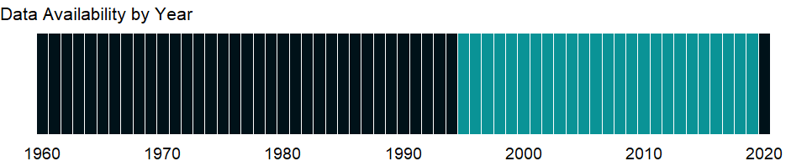

### Which countries have data?

The figure below shows the percentage of countries in each income group with a value since 2010 for that indicator.

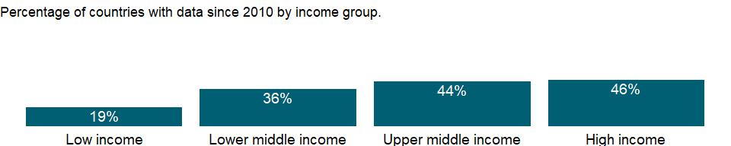

### Why is it relevant?

Transport infrastructure - highways, railways, ports and waterways, and airports and air traffic control systems - and the services that flow from it are crucial to the activities of households, producers, and governments. Because performance indicators vary widely by transport mode and focus (whether physical infrastructure or the services flowing from that infrastructure), highly specialized and carefully specified indicators are required to measure a country’s transport infrastructure.

The railway transport industry a vital engine of global socio-economic growth. It is of vital importance for economic development, creating direct and indirect employment, supporting tourism and local businesses. Economic growth, technological change, and market liberalization affect road transport throughout the world.

Railways have helped in the industrialization process of a country by easy transportation of coal and raw-materials at a cheaper rate. As railways require huge capital outlay, they may give rise to monopolies and work against public interest at large. Even if controlled and managed by the government, lack of competition sometimes results in inefficiency and high costs. Also, many times it is not economical to operate railways in sparsely settled rural areas. Thus, in many developing countries large rural areas have no railway even today.

Rail transport is a major form of passenger and freight transport in many countries. It is ubiquitous in Europe, with an integrated network covering virtually the whole continent. In India, China, South Korea and Japan, many millions use trains as regular transport. In the North America, freight rail transport is widespread and heavily used in for transporting gods. The western Europe region has the highest railway density in the world and has many individual trains which operate through several countries despite technical and organizational differences in each national network. Australia has a generally sparse network, mostly along its densely populated urban centers.

Bulk freight handling is a key advantage for rail transport. Low or even zero transshipment costs combined with energy efficiency and low inventory costs allow trains to handle bulk much cheaper than by road. Typical bulk cargo includes coal, ore, grains and liquids. Bulk goods can be transported in open-topped cars, hopper cars and tank cars. Container trains have become the dominant type in the US for non-bulk haulage.

### What is the data source?

Internation Union of Railways (UIC), OECD Statistics

### What is the methodology?

Freight traffic on any mode is typically measured in tons and ton-kilometers. A ton-kilometer equals cargo weight transported times distance transported. For railways, an important measure of work performed is gross ton-kilometers, this measure includes rail wagons’ empty weight for both empty and loaded movements. This measure of gross ton-kilometers is also called ‘trailing tons’ or the total tons being hauled. Sometimes gross ton-kilometer measures include the weight of locomotives used to haul freight trains.

### How is it aggregated?

Median

### What are the limitations?

Unlike the road sector, where numerous qualified motor vehicle operators can operate anywhere on the road network, railways are a restricted transport system with vehicles confined to a fixed guideway. Considering the cost and service characteristics, railways generally are best suited to carry - and can effectively compete for - bulk commodities and containerized freight for distances of 500-5,000 kilometers, and passengers for distances of 50-1,000 kilometers. Below these limits road transport tends to be more competitive, while above these limits air transport for passengers and freight and sea transport for freight tend to be more competitive.

Data for transport sectors are not always internationally comparable. Unlike for demographic statistics, national income accounts, and international trade data, the collection of infrastructure data has not been “internationalized.”

### What else should I know?

NA

### 1.20.7 Railways, passengers carried (million passenger-km)

### What is the indicator?

Passengers carried by railway are the number of passengers transported by rail times kilometers traveled.

Topic: Infrastructure: Transportation

Series ID: IS.RRS.PASG.KM

Copyright: CC BY-4.0 , <https://datacatalog.worldbank.org/public-licenses#cc-by>

First year with any data: 1995

Last year with any data: 2019

### What years are data available?

The figure below shows years in which data is available for at least one country. Dates shaded in black have no data, while dates shaded in green have data for at least one country



### Which countries have data?

The figure below shows the percentage of countries in each income group with a value since 2010 for that indicator.

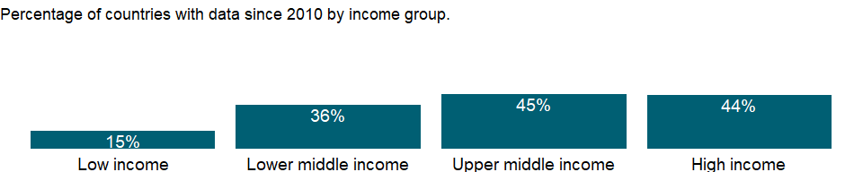

### Why is it relevant?

Transport infrastructure - highways, railways, ports and waterways, and airports and air traffic control systems - and the services that flow from it are crucial to the activities of households, producers, and governments. Because performance indicators vary widely by transport mode and focus (whether physical infrastructure or the services flowing from that infrastructure), highly specialized and carefully specified indicators are required to measure a country’s transport infrastructure.

The railway transport industry a vital engine of global socio-economic growth. It is of vital importance for economic development, creating direct and indirect employment, supporting tourism and local businesses. Economic growth, technological change, and market liberalization affect road transport throughout the world.

Railways have helped in the industrialization process of a country by easy transportation of coal and raw-materials at a cheaper rate. As railways require huge capital outlay, they may give rise to monopolies and work against public interest at large. Even if controlled and managed by the government, lack of competition sometimes results in inefficiency and high costs. Also, many times it is not economical to operate railways in sparsely settled rural areas. Thus, in many developing countries large rural areas have no railway even today.

Rail transport is a major form of passenger and freight transport in many countries. Passenger trains can involve a variety of functions including long distance travel, daily commuter trips, or local urban transit services. Railways are very popular mode of transportation in Europe, with an integrated network covering virtually the whole continent. In India, China, South Korea and Japan, many millions use trains as regular transport. In the North America, freight rail transport is widespread and heavily used in for transporting gods. The western Europe region has the highest railway density in the world and has many individual trains which operate through several countries despite technical and organizational differences in each national network. Australia has a generally sparse network, mostly along its densely populated urban centers.

### What is the data source?

Internation Union of Railways (UIC), OECD Statistics

### What is the methodology?

Passenger-kilometers are usually measured on the basis of the rail travel distance between origin and destination multiplied by the number of passengers traveling between each origin and destination.

### How is it aggregated?

Median

### What are the limitations?

Unlike the road sector, where numerous qualified motor vehicle operators can operate anywhere on the road network, railways are a restricted transport system with vehicles confined to a fixed guideway. Considering the cost and service characteristics, railways generally are best suited to carry - and can effectively compete for - bulk commodities and containerized freight for distances of 500-5,000 kilometers, and passengers for distances of 50-1,000 kilometers. Below these limits road transport tends to be more competitive, while above these limits air transport for passengers and freight and sea transport for freight tend to be more competitive.

Data for transport sectors are not always internationally comparable. Unlike for demographic statistics, national income accounts, and international trade data, the collection of infrastructure data has not been “internationalized.”

### What else should I know?

NA

### 1.20.8 Rail lines (total route-km)

### What is the indicator?

Rail lines are the length of railway route available for train service, irrespective of the number of parallel tracks.

Topic: Infrastructure: Transportation

Series ID: IS.RRS.TOTL.KM

Copyright: CC BY-4.0 , <https://datacatalog.worldbank.org/public-licenses#cc-by>

First year with any data: 1995

Last year with any data: 2019

### What years are data available?

The figure below shows years in which data is available for at least one country. Dates shaded in black have no data, while dates shaded in green have data for at least one country



### Which countries have data?

The figure below shows the percentage of countries in each income group with a value since 2010 for that indicator.

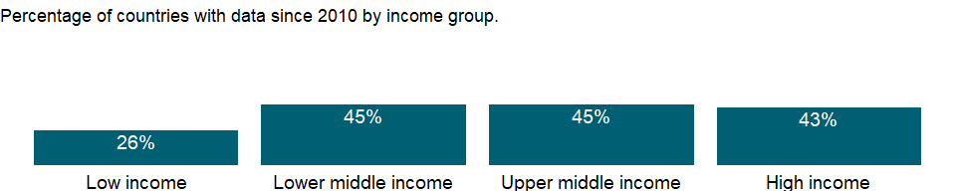

### Why is it relevant?

Transport infrastructure - highways, railways, ports and waterways, and airports and air traffic control systems - and the services that flow from it are crucial to the activities of households, producers, and governments. Because performance indicators vary widely by transport mode and focus (whether physical infrastructure or the services flowing from that infrastructure), highly specialized and carefully specified indicators are required to measure a country’s transport infrastructure.

The railway transport industry a vital engine of global socio-economic growth. It is of vital importance for economic development, creating direct and indirect employment, supporting tourism and local businesses. Economic growth, technological change, and market liberalization affect road transport throughout the world.

Railways have helped in the industrialization process of a country by easy transportation of coal and raw-materials at a cheaper rate. As railways require huge capital outlay, they may give rise to monopolies and work against public interest at large. Even if controlled and managed by the government, lack of competition sometimes results in inefficiency and high costs. Also, many times it is not economical to operate railways in sparsely settled rural areas. Thus, in many developing countries large rural areas have no railway even today.

Rail transport is a major form of passenger and freight transport in many countries. It is ubiquitous in Europe, with an integrated network covering virtually the whole continent. In India, China, South Korea and Japan, many millions use trains as regular transport. In the North America, freight rail transport is widespread and heavily used in for transporting gods. The western Europe region has the highest railway density in the world and has many individual trains which operate through several countries despite technical and organizational differences in each national network. Australia has a generally sparse network, mostly along its densely populated urban centers.

### What is the data source?

Internation Union of Railways (UIC)

### What is the methodology?

Rail lines are the length of railway route available for train service, irrespective of the number of parallel tracks. It includes railway routes that are open for public passenger and freight servies and excludes dedicated private resource railways.

### How is it aggregated?

NA

### What are the limitations?

Unlike the road sector, where numerous qualified motor vehicle operators can operate anywhere on the road network, railways are a restricted transport system with vehicles confined to a fixed guideway. Considering the cost and service characteristics, railways generally are best suited to carry - and can effectively compete for - bulk commodities and containerized freight for distances of 500-5,000 kilometers, and passengers for distances of 50-1,000 kilometers. Below these limits road transport tends to be more competitive, while above these limits air transport for passengers and freight and sea transport for freight tend to be more competitive.

Data for transport sectors are not always internationally comparable. Unlike for demographic statistics, national income accounts, and international trade data, the collection of infrastructure data has not been “internationalized”. The data is based a reporting by the railway companies and it can show a drastic increase or decrease for some of the years because of no reporting by some of the companies of a country.

### What else should I know?

NA

### 1.20.9 Liner shipping connectivity index (maximum value in 2004 = 100)

### What is the indicator?

The Liner Shipping Connectivity Index captures how well countries are connected to global shipping networks. It is computed by the United Nations Conference on Trade and Development (UNCTAD) based on five components of the maritime transport sector: number of ships, their container-carrying capacity, maximum vessel size, number of services, and number of companies that deploy container ships in a country’s ports. For each component a country’s value is divided by the maximum value of each component in 2004, the five components are averaged for each country, and the average is divided by the maximum average for 2004 and multiplied by 100. The index generates a value of 100 for the country with the highest average index in 2004. . The underlying data come from Containerisation International Online.

Topic: Infrastructure: Transportation

Series ID: IS.SHP.GCNW.XQ

Copyright: CC BY-4.0 , <https://datacatalog.worldbank.org/public-licenses#cc-by>

First year with any data: 2004

Last year with any data: 2019

### What years are data available?

The figure below shows years in which data is available for at least one country. Dates shaded in black have no data, while dates shaded in green have data for at least one country

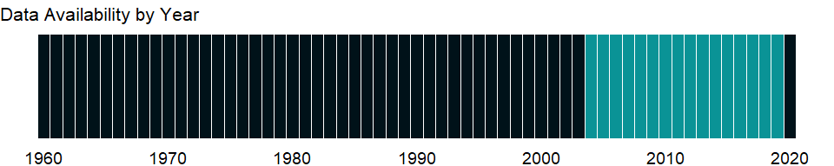

### Which countries have data?

The figure below shows the percentage of countries in each income group with a value since 2010 for that indicator.

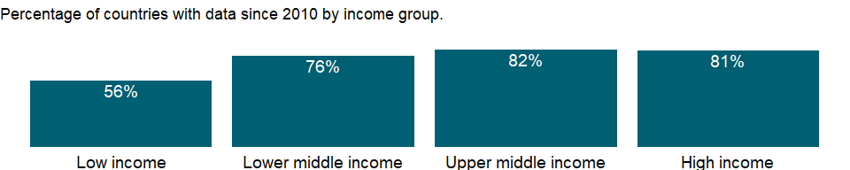

### Why is it relevant?

The liner shipping connectivity index (LSCI) aims at capturing a country’s integration level into global liner shipping networks. A country’s access to world markets depends largely on their transport connectivity, especially in regard to regular shipping services for the import and export of manufactured goods.

Trade facilitation encompasses customs efficiency and other physical and regulatory environments where trade takes place, harmonization of standards and conformance to international regulations, and the logistics of moving goods and associated documentation through countries and ports. Though collection of trade facilitation data has improved over the last decade, data that allow meaningful evaluation, especially for developing economies, are lacking. The quality and accessibility of ports and roads affect logistics performance.

Access to global shipping and air freight networks and the quality and accessibility of ports and roads affect logistics performance. Maritime transport is the backbone of international trade and a key engine driving globalization. Around 80 per cent of global trade by volume and over 70 per cent by value is carried by sea and is handled by ports worldwide; these shares are even higher in the case of most developing countries.

A total of 60 per cent of world seaborne trade by volume is loaded, and 57 per cent unloaded, in developing-country ports. That is a remarkable shift away from previous patterns, in which developing economies served mainly as loading areas for raw materials and natural resources.

### What is the data source?

United Nations Conference on Trade and Development, Review of Maritime Transport 2010.

### What is the methodology?

The Liner Shipping Connectivity Index captures how well countries are connected to global shipping networks. It is computed by the United Nations Conference on Trade and Development (UNCTAD) based on five components of the maritime transport sector: number of ships, their container-carrying capacity, maximum vessel size, number of services, and number of companies that deploy container ships in a country’s ports. The data are derived from Containerisation International Online (www.ci-online.co.uk). For each of the five components, a country’s value is divided by the maximum value of that component in 2004, and for each country, the average of the five components is calculated. This average is then divided by the maximum average for 2004 and multiplied by 100. In this way, the index generates the value 100 for the country with the highest average index of the five components in 2004.

### How is it aggregated?

NA

### What are the limitations?

Data on trade facilitation are drawn from research by private and international agencies. Most data are perception-based evaluations by business executives and professionals. Because of different backgrounds, values, and personalities, those surveyed may evaluate the same situation differently. Caution should thus be used when interpreting perception- based indicators. Nevertheless, they convey much needed information on trade facilitation.

### What else should I know?

NA

### 1.20.10 Container port traffic (TEU: 20 foot equivalent units)

### What is the indicator?

Port container traffic measures the flow of containers from land to sea transport modes., and vice versa, in twenty-foot equivalent units (TEUs), a standard-size container. Data refer to coastal shipping as well as international journeys. Transshipment traffic is counted as two lifts at the intermediate port (once to off-load and again as an outbound lift) and includes empty units.

Topic: Infrastructure: Transportation

Series ID: IS.SHP.GOOD.TU

Copyright: CC BY-4.0 , <https://datacatalog.worldbank.org/public-licenses#cc-by>

First year with any data: 2000

Last year with any data: 2019

### What years are data available?

The figure below shows years in which data is available for at least one country. Dates shaded in black have no data, while dates shaded in green have data for at least one country



### Which countries have data?

The figure below shows the percentage of countries in each income group with a value since 2010 for that indicator.



### Why is it relevant?

Transport infrastructure - highways, railways, ports and waterways, and airports and air traffic control systems - and the services that flow from it are crucial to the activities of households, producers, and governments. Because performance indicators vary widely by transport mode and focus (whether physical infrastructure or the services flowing from that infrastructure), highly specialized and carefully specified indicators are required to measure a country’s transport infrastructure.

The sea transport industry a vital engine of global socio-economic growth. It is of vital importance for economic development, creating direct and indirect employment, supporting tourism and local businesses, and stimulating foreign investment and international trade. Economic growth, technological change, market liberalization, and oil prices affect sea transport throughout the world.

### What is the data source?

UNCTAD (<http://unctad.org/en/Pages/statistics.aspx>)

### What is the methodology?

TEU is the standard unit, referring to 20-foot equivalent units or 20-foot-long cargo container. The size of cargo containers range from 20 feet long to more than 50 feet long. The international measure is the smallest box, the 20-footer or 20-foot-equivalent unit (TEU). Two twenty-foot containers (TEUs) equal one FEU. Container vessel capacity and port throughput capacity are frequently referred to in TEUs. 2015 and 2016 figures comprise estimates for countries where current year statistics were not available. In these cases, estimates include averages and extrapolations from previous years’ data.

### How is it aggregated?

Sum

### What are the limitations?

Measures of port container traffic, much of it commodities of medium to high value added, give some indication of economic growth in a country. But when traffic is merely transshipment, much of the economic benefit goes to the terminal operator and ancillary services for ships and containers rather than to the country more broadly. In transshipment centers empty containers may account for as much as 40 percent of traffic.

Data cover coastal shipping as well as international journeys. Transshipment traffic is counted as two lifts at the intermediate port (once to off-load and again as an outbound lift) and includes empty units. Data for transport sectors are not always internationally comparable. Unlike for demographic statistics, national income accounts, and international trade data, the collection of infrastructure data has not been “internationalized.”

### What else should I know?

NA

## 1.21 Environment: Freshwater

### 1.21.1 Water productivity, total (constant 2010 US$ GDP per cubic meter of total freshwater withdrawal)

### What is the indicator?

Water productivity is calculated as GDP in constant prices divided by annual total water withdrawal.

Topic: Environment: Freshwater

Series ID: ER.GDP.FWTL.M3.KD

Copyright: CC BY-4.0 , <https://datacatalog.worldbank.org/public-licenses#cc-by>

First year with any data: 1967

Last year with any data: 2017

### What years are data available?

The figure below shows years in which data is available for at least one country. Dates shaded in black have no data, while dates shaded in green have data for at least one country

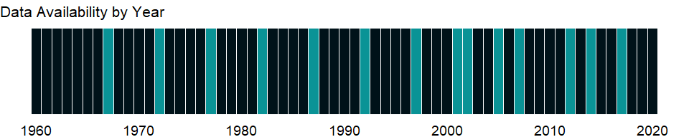

### Which countries have data?

The figure below shows the percentage of countries in each income group with a value since 2010 for that indicator.

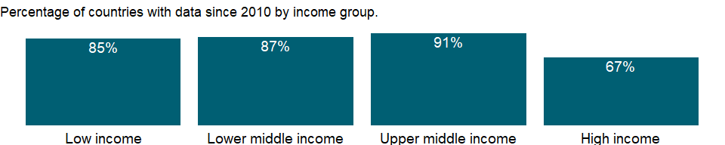

### Why is it relevant?

While some countries have an abundant supply of fresh water, others do not have as much. UN estimates that many areas of the world are already experiencing stress on water availability. Due to the accelerated pace of population growth and an increase in the amount of water a single person uses, it is expected that this situation will continue to get worse. The ability of developing countries to make more water available for domestic, agricultural, industrial and environmental uses will depend on better management of water resources and more cross-sectoral planning and integration. According to World Water Council, by 2020, water use is expected to increase by 40 percent, and 17 percent more water will be required for food production to meet the needs of the growing population. The three major factors causing increasing water demand over the past century are population growth, industrial development and the expansion of irrigated agriculture.

There is now ample evidence that increased hydrologic variability and change in climate has and will continue to have a profound impact on the water sector through the hydrologic cycle, water availability, water demand, and water allocation at the global, regional, basin, and local levels. Properly managed water resources are a critical component of growth, poverty reduction and equity. The livelihoods of the poorest are critically associated with access to water services. A shortage of water in the future would be detrimental to the human population as it would affect everything from sanitation, to overall health and the production of grain.

### What is the data source?

Food and Agriculture Organization, AQUASTAT data, and World Bank and OECD GDP estimates.

### What is the methodology?

Water productivity is an indication only of the efficiency by which each country uses its water resources. Given the different economic structure of each country, these indicators should be used carefully, taking into account a country’s sectorial activities and natural resource endowments. GDP data are from World Bank’s national accounts files.

Water withdrawals can exceed 100 percent of total renewable resources where extraction from nonrenewable aquifers or desalination plants is considerable or where water reuse is significant. Withdrawals for agriculture and industry are total withdrawals for irrigation and livestock production and for direct industrial use (including for cooling thermoelectric plants).

### How is it aggregated?

Weighted Average

### What are the limitations?

A common perception is that most of the available freshwater resources are visible (on the surfaces of lakes, reservoirs and rivers). However, this visible water represents only a tiny fraction of global freshwater resources, as most of it is stored in aquifers, with the largest stocks stored in solid form in the Antarctic and in Greenland’s ice cap.

The data on freshwater resources are based on estimates of runoff into rivers and recharge of groundwater. These estimates are based on different sources and refer to different years, so cross-country comparisons should be made with caution. Because the data are collected intermittently, they may hide significant variations in total renewable water resources from year to year. The data also fail to distinguish between seasonal and geographic variations in water availability within countries. Data for small countries and countries in arid and semiarid zones are less reliable than those for larger countries and countries with greater rainfall.

Caution should also be used in comparing data on annual freshwater withdrawals, which are subject to variations in collection and estimation methods. In addition, inflows and outflows are estimated at different times and at different levels of quality and precision, requiring caution in interpreting the data, particularly for water-short countries, notably in the Middle East and North Africa.

The data are based on surveys and estimates provided by governments to the Joint Monitoring Programme of the World Health Organization (WHO) and the United Nations Children’s Fund (UNICEF). The coverage rates are based on information from service users on actual household use rather than on information from service providers, which may include nonfunctioning systems.

### What else should I know?

NA

### 1.21.2 Annual freshwater withdrawals, agriculture (% of total freshwater withdrawal)

### What is the indicator?

Annual freshwater withdrawals refer to total water withdrawals, not counting evaporation losses from storage basins. Withdrawals also include water from desalination plants in countries where they are a significant source. Withdrawals can exceed 100 percent of total renewable resources where extraction from nonrenewable aquifers or desalination plants is considerable or where there is significant water reuse. Withdrawals for agriculture are total withdrawals for irrigation and livestock production. Data are for the most recent year available for 1987-2002.

Topic: Environment: Freshwater

Series ID: ER.H2O.FWAG.ZS

Copyright: CC BY-4.0 , <https://datacatalog.worldbank.org/public-licenses#cc-by>

First year with any data: 1965

Last year with any data: 2017

### What years are data available?

The figure below shows years in which data is available for at least one country. Dates shaded in black have no data, while dates shaded in green have data for at least one country

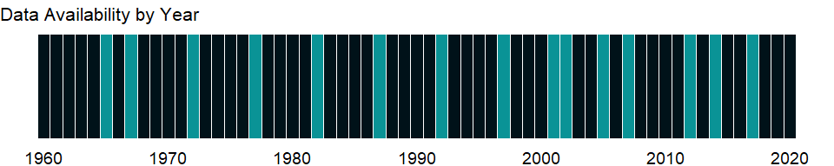

### Which countries have data?

The figure below shows the percentage of countries in each income group with a value since 2010 for that indicator.

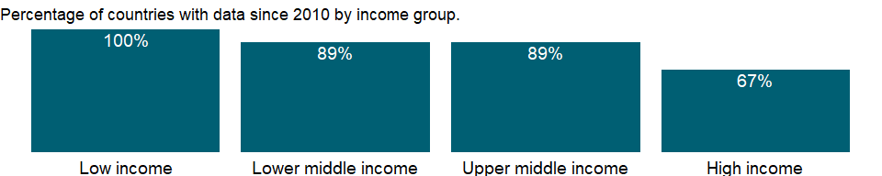

### Why is it relevant?

While some countries have an abundant supply of fresh water, others do not have as much. UN estimates that many areas of the world are already experiencing stress on water availability. Due to the accelerated pace of population growth and an increase in the amount of water a single person uses, it is expected that this situation will continue to get worse. The ability of developing countries to make more water available for domestic, agricultural, industrial and environmental uses will depend on better management of water resources and more cross-sectoral planning and integration. According to World Water Council, by 2020, water use is expected to increase by 40 percent, and 17 percent more water will be required for food production to meet the needs of the growing population. The three major factors causing increasing water demand over the past century are population growth, industrial development and the expansion of irrigated agriculture.

There is now ample evidence that increased hydrologic variability and change in climate has and will continue to have a profound impact on the water sector through the hydrologic cycle, water availability, water demand, and water allocation at the global, regional, basin, and local levels. Properly managed water resources are a critical component of growth, poverty reduction and equity. The livelihoods of the poorest are critically associated with access to water services. A shortage of water in the future would be detrimental to the human population as it would affect everything from sanitation, to overall health and the production of grain.

Freshwater use by continents is partly based on several socio-economic development factors, including population, physiography, and climatic characteristics. It is estimated that in the coming decades the most intensive growth of water withdrawal is expected to occur in Africa and South America (increasing by 1.5-1.6 times), while the smallest growth will take place in Europe and North America (1.2 times).

### What is the data source?

Food and Agriculture Organization, AQUASTAT data.

### What is the methodology?

This indicator measures the pressure on the renewable water resources of a country caused by irrigation. According to Commission on Sustainable Development (CSD) agriculture accounts for more than 70 percent of freshwater drawn from lakes, rivers and underground sources. Most is used for irrigation which provides about 40 percent of the world food production. Poor management has resulted in the salinization of about 20 percent of the world’s irrigated land, with an additional 1.5 million ha affected annually.

Water withdrawals can exceed 100 percent of total renewable resources where extraction from nonrenewable aquifers or desalination plants is considerable or where water reuse is significant. Withdrawals for agriculture and industry are total withdrawals for irrigation and livestock production and for direct industrial use (including for cooling thermoelectric plants).

### How is it aggregated?

Weighted average

### What are the limitations?

A common perception is that most of the available freshwater resources are visible (on the surfaces of lakes, reservoirs and rivers). However, this visible water represents only a tiny fraction of global freshwater resources, as most of it is stored in aquifers, with the largest stocks stored in solid form in the Antarctic and in Greenland’s ice cap.

The data on freshwater resources are based on estimates of runoff into rivers and recharge of groundwater. These estimates are based on different sources and refer to different years, so cross-country comparisons should be made with caution. Because the data are collected intermittently, they may hide significant variations in total renewable water resources from year to year. The data also fail to distinguish between seasonal and geographic variations in water availability within countries. Data for small countries and countries in arid and semiarid zones are less reliable than those for larger countries and countries with greater rainfall.

Caution should also be used in comparing data on annual freshwater withdrawals, which are subject to variations in collection and estimation methods. In addition, inflows and outflows are estimated at different times and at different levels of quality and precision, requiring caution in interpreting the data, particularly for water-short countries, notably in the Middle East and North Africa.

The data are based on surveys and estimates provided by governments to the Joint Monitoring Programme of the World Health Organization (WHO) and the United Nations Children’s Fund (UNICEF). The coverage rates are based on information from service users on actual household use rather than on information from service providers, which may include nonfunctioning systems.

### What else should I know?

NA

### 1.21.3 Annual freshwater withdrawals, domestic (% of total freshwater withdrawal)

### What is the indicator?

Annual freshwater withdrawals refer to total water withdrawals, not counting evaporation losses from storage basins. Withdrawals also include water from desalination plants in countries where they are a significant source. Withdrawals can exceed 100 percent of total renewable resources where extraction from nonrenewable aquifers or desalination plants is considerable or where there is significant water reuse. Withdrawals for domestic uses include drinking water, municipal use or supply, and use for public services, commercial establishments, and homes. Data are for the most recent year available for 1987-2002.

Topic: Environment: Freshwater

Series ID: ER.H2O.FWDM.ZS

Copyright: CC BY-4.0 , <https://datacatalog.worldbank.org/public-licenses#cc-by>

First year with any data: 1965

Last year with any data: 2017

### What years are data available?

The figure below shows years in which data is available for at least one country. Dates shaded in black have no data, while dates shaded in green have data for at least one country



### Which countries have data?

The figure below shows the percentage of countries in each income group with a value since 2010 for that indicator.



### Why is it relevant?

UNESCO estimates that in developing countries in Asia, Africa and Latin America, public water withdrawal represents just 50-100 liters (13 to 26 gallons) per person per day. In regions with insufficient water resources, this figure may be as low as 20-60 (5 to 15 gallons) liters per day. People in developed countries on average consume about 10 times more water daily than those in developing countries.

While some countries have an abundant supply of fresh water, others do not have as much. UN estimates that many areas of the world are already experiencing stress on water availability. Due to the accelerated pace of population growth and an increase in the amount of water a single person uses, it is expected that this situation will continue to get worse. The ability of developing countries to make more water available for domestic, agricultural, industrial and environmental uses will depend on better management of water resources and more cross-sectorial planning and integration. According to World Water Council, by 2020, water use is expected to increase by 40 percent, and 17 percent more water will be required for food production to meet the needs of the growing population. The three major factors causing increasing water demand over the past century are population growth, industrial development and the expansion of irrigated agriculture.

Water productivity is an indication only of the efficiency by which each country uses its water resources. Given the different economic structure of each country, these indicators should be used carefully, taking into account a country’s sectorial activities and natural resource endowments. According to Commission on Sustainable Development (CSD) agriculture accounts for more than 70 percent of freshwater drawn from lakes, rivers and underground sources. Most is used for irrigation which provides about 40 percent of the world food production. Poor management has resulted in the salinization of about 20 percent of the world’s irrigated land, with an additional 1.5 million ha affected annually.

There is now ample evidence that increased hydrologic variability and change in climate has and will continue to have a profound impact on the water sector through the hydrologic cycle, water availability, water demand, and water allocation at the global, regional, basin, and local levels. Properly managed water resources are a critical component of growth, poverty reduction and equity. The livelihoods of the poorest are critically associated with access to water services. A shortage of water in the future would be detrimental to the human population as it would affect everything from sanitation, to overall health and the production of grain.

Freshwater use by continents is partly based on several socio-economic development factors, including population, physiography, and climatic characteristics. It is estimated that in the coming decades the most intensive growth of water withdrawal is expected to occur in Africa and South America (increasing by 1.5-1.6 times), while the smallest growth will take place in Europe and North America (1.2 times).

The Commission for Sustainable Development (CSD) has reported that many countries lack adequate legislation and policies for efficient and equitable allocation and use of water resources. Progress is, however, being made with the review of national legislation and enactment of new laws and regulations.

### What is the data source?

Food and Agriculture Organization, AQUASTAT data.

### What is the methodology?

Domestic water withdrawal, sometimes used interchangeably with municipal water withdrawal, focuses on human needs (drinking, cooking, cleaning, and sanitation). Data includes renewable freshwater resources, potential over-abstraction of renewable groundwater, withdrawal of fossil groundwater, and the potential use of desalinated water or treated wastewater. It is usually computed as the total water withdrawn by the public distribution network, and includes that part of the industries, which is connected to the municipal network. The ratio between the net consumption and the water withdrawn can vary from 5 to 15 percent in urban areas and from 10 to 50 percent in rural areas.

Water withdrawals can exceed 100 percent of total renewable resources where extraction from nonrenewable aquifers or desalination plants is considerable or where water reuse is significant. Withdrawals for domestic uses include drinking water, municipal use or supply, and use for public services, commercial establishments, and homes.

### How is it aggregated?

Weighted average

### What are the limitations?

A common perception is that most of the available freshwater resources are visible (on the surfaces of lakes, reservoirs and rivers). However, this visible water represents only a tiny fraction of global freshwater resources, as most of it is stored in aquifers, with the largest stocks stored in solid form in the Antarctic and in Greenland’s ice cap.

The data on freshwater resources are based on estimates of runoff into rivers and recharge of groundwater. These estimates are based on different sources and refer to different years, so cross-country comparisons should be made with caution. Because the data are collected intermittently, they may hide significant variations in total renewable water resources from year to year. The data also fail to distinguish between seasonal and geographic variations in water availability within countries. Data for small countries and countries in arid and semiarid zones are less reliable than those for larger countries and countries with greater rainfall.

Caution should also be used in comparing data on annual freshwater withdrawals, which are subject to variations in collection and estimation methods. In addition, inflows and outflows are estimated at different times and at different levels of quality and precision, requiring caution in interpreting the data, particularly for water-short countries, notably in the Middle East and North Africa.

The data are based on surveys and estimates provided by governments to the Joint Monitoring Programme of the World Health Organization (WHO) and the United Nations Children’s Fund (UNICEF). The coverage rates are based on information from service users on actual household use rather than on information from service providers, which may include nonfunctioning systems.

### What else should I know?

NA

### 1.21.4 Annual freshwater withdrawals, industry (% of total freshwater withdrawal)

### What is the indicator?

Annual freshwater withdrawals refer to total water withdrawals, not counting evaporation losses from storage basins. Withdrawals also include water from desalination plants in countries where they are a significant source. Withdrawals can exceed 100 percent of total renewable resources where extraction from nonrenewable aquifers or desalination plants is considerable or where there is significant water reuse. Withdrawals for industry are total withdrawals for direct industrial use (including withdrawals for cooling thermoelectric plants). Data are for the most recent year available for 1987-2002.

Topic: Environment: Freshwater

Series ID: ER.H2O.FWIN.ZS

Copyright: CC BY-4.0 , <https://datacatalog.worldbank.org/public-licenses#cc-by>

First year with any data: 1965

Last year with any data: 2017

### What years are data available?

The figure below shows years in which data is available for at least one country. Dates shaded in black have no data, while dates shaded in green have data for at least one country



### Which countries have data?

The figure below shows the percentage of countries in each income group with a value since 2010 for that indicator.

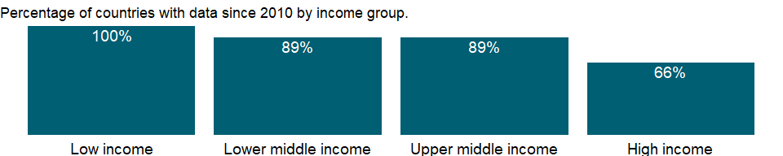

### Why is it relevant?

While some countries have an abundant supply of fresh water, others do not have as much. UN estimates that many areas of the world are already experiencing stress on water availability. Due to the accelerated pace of population growth and an increase in the amount of water a single person uses, it is expected that this situation will continue to get worse. The ability of developing countries to make more water available for domestic, agricultural, industrial and environmental uses will depend on better management of water resources and more cross-sectorial planning and integration. According to World Water Council, by 2020, water use is expected to increase by 40 percent, and 17 percent more water will be required for food production to meet the needs of the growing population. The three major factors causing increasing water demand over the past century are population growth, industrial development and the expansion of irrigated agriculture. UNESCO estimates that Industrial uses account for about 20 percent of global freshwater withdrawals. Of this, 57-69 percent is used for hydropower and nuclear power generation, 30-40 percent for industrial processes, and 0.5-3 percent for thermal power generation.

Water productivity is an indication only of the efficiency by which each country uses its water resources. Given the different economic structure of each country, these indicators should be used carefully, taking into account a country’s sectorial activities and natural resource endowments. According to Commission on Sustainable Development (CSD) agriculture accounts for more than 70 percent of freshwater drawn from lakes, rivers and underground sources. Most is used for irrigation which provides about 40 percent of the world food production. Poor management has resulted in the salinization of about 20 percent of the world’s irrigated land, with an additional 1.5 million ha affected annually.

There is now ample evidence that increased hydrologic variability and change in climate has and will continue to have a profound impact on the water sector through the hydrologic cycle, water availability, water demand, and water allocation at the global, regional, basin, and local levels. Properly managed water resources are a critical component of growth, poverty reduction and equity. The livelihoods of the poorest are critically associated with access to water services. A shortage of water in the future would be detrimental to the human population as it would affect everything from sanitation, to overall health and the production of grain.

Freshwater use by continents is partly based on several socio-economic development factors, including population, physiography, and climatic characteristics. It is estimated that in the coming decades the most intensive growth of water withdrawal is expected to occur in Africa and South America (increasing by 1.5-1.6 times), while the smallest growth will take place in Europe and North America (1.2 times).

The Commission for Sustainable Development (CSD) has reported that many countries lack adequate legislation and policies for efficient and equitable allocation and use of water resources. Progress is, however, being made with the review of national legislation and enactment of new laws and regulations.

### What is the data source?

Food and Agriculture Organization, AQUASTAT data.

### What is the methodology?

Annual industrial freshwater withdrawals include renewable water resources as well as potential over-abstraction of renewable groundwater or potential use of desalinated water or treated wastewater. It includes water for the cooling of thermoelectric plants, but it does not include hydropower.

Water withdrawals can exceed 100 percent of total renewable resources where extraction from nonrenewable aquifers or desalination plants is considerable or where water reuse is significant. Withdrawals for industry are total withdrawals for direct industrial use (including withdrawals for cooling thermoelectric plants). Withdrawals for domestic uses include drinking water, municipal use or supply, and use for public services, commercial establishments, and homes.

### How is it aggregated?

Weighted average

### What are the limitations?

A common perception is that most of the available freshwater resources are visible (on the surfaces of lakes, reservoirs and rivers). However, this visible water represents only a tiny fraction of global freshwater resources, as most of it is stored in aquifers, with the largest stocks stored in solid form in the Antarctic and in Greenland’s ice cap.

The data on freshwater resources are based on estimates of runoff into rivers and recharge of groundwater. These estimates are based on different sources and refer to different years, so cross-country comparisons should be made with caution. Because the data are collected intermittently, they may hide significant variations in total renewable water resources from year to year. The data also fail to distinguish between seasonal and geographic variations in water availability within countries. Data for small countries and countries in arid and semiarid zones are less reliable than those for larger countries and countries with greater rainfall.

Caution should also be used in comparing data on annual freshwater withdrawals, which are subject to variations in collection and estimation methods. In addition, inflows and outflows are estimated at different times and at different levels of quality and precision, requiring caution in interpreting the data, particularly for water-short countries, notably in the Middle East and North Africa.

The data are based on surveys and estimates provided by governments to the Joint Monitoring Programme of the World Health Organization (WHO) and the United Nations Children’s Fund (UNICEF). The coverage rates are based on information from service users on actual household use rather than on information from service providers, which may include nonfunctioning systems.

### What else should I know?

NA

### 1.21.5 Level of water stress: freshwater withdrawal as a proportion of available freshwater resources

### What is the indicator?

The level of water stress: freshwater withdrawal as a proportion of available freshwater resources is the ratio between total freshwater withdrawn by all major sectors and total renewable freshwater resources, after taking into account environmental water requirements. Main sectors, as defined by ISIC standards, include agriculture; forestry and fishing; manufacturing; electricity industry; and services. This indicator is also known as water withdrawal intensity.

Topic: Environment: Freshwater

Series ID: ER.H2O.FWST.ZS

Copyright: CC BY-4.0 , <https://datacatalog.worldbank.org/public-licenses#cc-by>

First year with any data: 1962

Last year with any data: 2017

### What years are data available?

The figure below shows years in which data is available for at least one country. Dates shaded in black have no data, while dates shaded in green have data for at least one country



### Which countries have data?

The figure below shows the percentage of countries in each income group with a value since 2010 for that indicator.

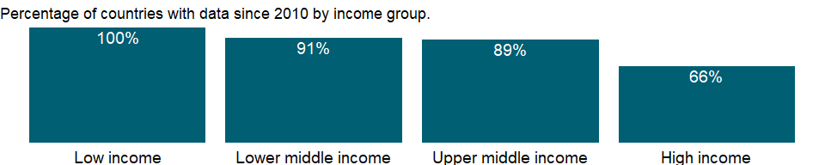

### Why is it relevant?

The level of water stress can show the degree to which water resources are being exploited to meet the country’s water demand. It measures a country’s pressure on its water resources and therefore the challenge on the sustainability of its water use. It tracks progress in regard to “withdrawals and supply of freshwater to address water scarcity”, i.e. the environmental component of target 6.4. It also shows to what extent water resources are already used, and signals the importance of effective supply and demand management policies. It indicates the likelihood of increasing competition and conflict between different water uses and users in a situation of increasing water scarcity. Increased water stress, shown by an increase in the value of the indicator, has potentially negative effects on the sustainability of the natural resources and on economic development. On the other hand, low values of water stress indicate that water does not represent a particular challenge for economic development and sustainability.

### What is the data source?

Food and Agriculture Organization, AQUASTAT data.

### What is the methodology?

Proportion of total renewable water resources withdrawn is the total volume of groundwater and surface water withdrawn from their sources for human use (in the agricultural, municipal and industrial sectors), expressed as a percentage of the total actual renewable water resources. The terms water resources and water withdrawal are understood as freshwater resources and freshwater withdrawal. Water withdrawal is estimated for the following three main sectors: agriculture, municipalities (including domestic water withdrawal) and industries, at country level and expressed in km3/year. The total actual renewable water resources for a country or region are defined as the sum of internal renewable water resources and the external renewable water resources, also expressed in km3/year. The indicator is computed by dividing total water withdrawal by total actual renewable water resources minus environmental requirements and expressed in percentage points.

Total freshwater withdrawal is the volume of freshwater extracted from its source (rivers, lakes, aquifers) for agriculture, industries and municipalities. It is estimated at the country level for the following three main sectors: agriculture, municipalities (including domestic water withdrawal) and industries. Freshwater withdrawal includes primary freshwater (not withdrawn before), secondary freshwater (previously withdrawn and returned to rivers and groundwater, such as discharged wastewater and agricultural drainage water) and fossil groundwater. It does not include non-conventional water, i.e. direct use of treated wastewater, direct use of agricultural drainage water and desalinated water. Total freshwater withdrawal is in general calculated as being the sum of total water withdrawal by sector minus direct use of wastewater, direct use of agricultural drainage water and use of desalinated water.

Total renewable freshwater resources are expressed as the sum of internal and external renewable water resources. The terms “water resources” and “water withdrawal” are understood here as freshwater resources and freshwater withdrawal. Internal renewable water resources are defined as the long-term average annual flow of rivers and recharge of groundwater for a given country generated from endogenous precipitation. External renewable water resources refer to the flows of water entering the country, taking into consideration the quantity of flows reserved to upstream and downstream countries through agreements or treaties.

Environmental water requirements (Env.) are the quantities of water required to sustain freshwater and estuarine ecosystems. Water quality and also the resulting ecosystem services are excluded from this formulation which is confined to water volumes. This does not imply that quality and the support to societies which are dependent on environmental flows are not important and should not be taken care of. Methods of computation of Env. are extremely variable and range from global estimates to comprehensive assessments for river reaches. Water volumes can be expressed in the same units as the total freshwater withdrawal, and then as percentages of the available water resources.

### How is it aggregated?

NA

### What are the limitations?

Water withdrawal as a percentage of water resources is a good indicator of pressure on limited water resources, one of the most important natural resources. However, it only partially addresses the issues related to sustainable water management. Supplementary indicators that capture the multiple dimensions of water management would combine data on water demand management, behavioural changes with regard to water use and the availability of appropriate infrastructure, and measure progress in increasing the efficiency and sustainability of water use, in particular in relation to population and economic growth. They would also recognize the different climatic environments that affect water use in countries, in particular in agriculture, which is the main user of water. Sustainability assessment is also linked to the critical thresholds fixed for this indicator and there is no universal consensus on such threshold.

Trends in water withdrawal show relatively slow patterns of change. Usually, three-five years are a minimum frequency to be able to detect significant changes, as it is unlikely that the indicator would show meaningful variations from one year to the other. Estimation of water withdrawal by sector is the main limitation to the computation of the indicator. Few countries actually publish water use data on a regular basis by sector. Renewable water resources include all surface water and groundwater resources that are available on a yearly basis without consideration of the capacity to harvest and use this resource. Exploitable water resources, which refer to the volume of surface water or groundwater that is available with an occurrence of 90% of the time, are considerably less than renewable water resources, but no universal method exists to assess such exploitable water resources. There is no universally agreed method for the computation of incoming freshwater flows originating outside of a country’s borders. Nor is there any standard method to account for return flows, the part of the water withdrawn from its source and which flows back to the river system after use. In countries where return flow represents a substantial part of water withdrawal, the indicator tends to underestimate available water and therefore overestimate the level of water stress.

Other limitations that affect the interpretation of the water stress indicator include: difficulty to obtain accurate, complete and up-to-date data; potentially large variation of sub-national data; lack of account of seasonal variations in water resources; lack of consideration to the distribution among water uses; lack of consideration of water quality and its suitability for use; and the indicator can be higher than 100 per cent when water withdrawal includes secondary freshwater (water withdrawn previously and returned to the system), non-renewable water (fossil groundwater), when annual groundwater withdrawal is higher than annual replenishment (over-abstraction) or when water withdrawal includes part or all of the water set aside for environmental water requirements. Some of these issues can be solved through disaggregation of the index at the level of hydrological units and by distinguishing between different use sectors. However, due to the complexity of water flows, both within a country and between countries, care should be taken not to double-count.

### What else should I know?

NA

### 1.21.6 Annual freshwater withdrawals, total (billion cubic meters)

### What is the indicator?

Annual freshwater withdrawals refer to total water withdrawals, not counting evaporation losses from storage basins. Withdrawals also include water from desalination plants in countries where they are a significant source. Withdrawals can exceed 100 percent of total renewable resources where extraction from nonrenewable aquifers or desalination plants is considerable or where there is significant water reuse. Withdrawals for agriculture and industry are total withdrawals for irrigation and livestock production and for direct industrial use (including withdrawals for cooling thermoelectric plants). Withdrawals for domestic uses include drinking water, municipal use or supply, and use for public services, commercial establishments, and homes. Data are for the most recent year available for 1987-2002.

Topic: Environment: Freshwater

Series ID: ER.H2O.FWTL.K3

Copyright: CC BY-4.0 , <https://datacatalog.worldbank.org/public-licenses#cc-by>

First year with any data: 1962

Last year with any data: 2017

### What years are data available?

The figure below shows years in which data is available for at least one country. Dates shaded in black have no data, while dates shaded in green have data for at least one country

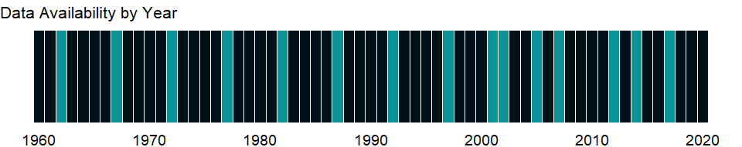

### Which countries have data?

The figure below shows the percentage of countries in each income group with a value since 2010 for that indicator.

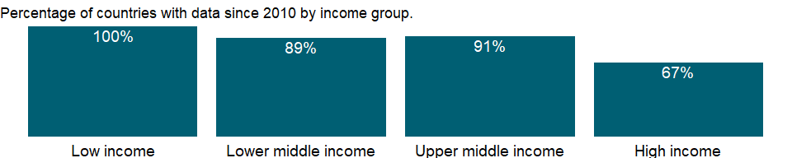

### Why is it relevant?

While some countries have an abundant supply of fresh water, others do not have as much. UN estimates that many areas of the world are already experiencing stress on water availability. Due to the accelerated pace of population growth and an increase in the amount of water a single person uses, it is expected that this situation will continue to get worse. The ability of developing countries to make more water available for domestic, agricultural, industrial and environmental uses will depend on better management of water resources and more cross-sectorial planning and integration.

There is now ample evidence that increased hydrologic variability and change in climate has and will continue to have a profound impact on the water sector through the hydrologic cycle, water availability, water demand, and water allocation at the global, regional, basin, and local levels. Properly managed water resources are a critical component of growth, poverty reduction and equity. The livelihoods of the poorest are critically associated with access to water services. A shortage of water in the future would be detrimental to the human population as it would affect everything from sanitation, to overall health and the production of grain.

Freshwater use by continents is partly based on several socio-economic development factors, including population, physiography, and climatic characteristics. It is estimated that in the coming decades the most intensive growth of water withdrawal is expected to occur in Africa and South America (increasing by 1.5-1.6 times), while the smallest growth will take place in Europe and North America (1.2 times).

### What is the data source?

Food and Agriculture Organization, AQUASTAT data.

### What is the methodology?

Annual freshwater withdrawals are total water withdrawals, not counting evaporation losses from storage basins. Withdrawals also include water from desalination plants in countries where they are a significant source. Water withdrawals can exceed 100 percent of total renewable resources where extraction from nonrenewable aquifers or desalination plants is considerable or where water reuse is significant. Withdrawals for agriculture and industry are total withdrawals for irrigation and livestock production and for direct industrial use (including for cooling thermoelectric plants). Withdrawals for domestic uses include drinking water, municipal use or supply, and use for public services, commercial establishments, and homes.

### How is it aggregated?

Sum

### What are the limitations?

A common perception is that most of the available freshwater resources are visible (on the surfaces of lakes, reservoirs and rivers). However, this visible water represents only a tiny fraction of global freshwater resources, as most of it is stored in aquifers, with the largest stocks stored in solid form in the Antarctic and in Greenland’s ice cap.

The data on freshwater resources are based on estimates of runoff into rivers and recharge of groundwater. These estimates are based on different sources and refer to different years, so cross-country comparisons should be made with caution. Because the data are collected intermittently, they may hide significant variations in total renewable water resources from year to year. The data also fail to distinguish between seasonal and geographic variations in water availability within countries. Data for small countries and countries in arid and semiarid zones are less reliable than those for larger countries and countries with greater rainfall.

Caution should also be used in comparing data on annual freshwater withdrawals, which are subject to variations in collection and estimation methods. In addition, inflows and outflows are estimated at different times and at different levels of quality and precision, requiring caution in interpreting the data, particularly for water-short countries, notably in the Middle East and North Africa.

The data are based on surveys and estimates provided by governments to the Joint Monitoring Programme of the World Health Organization (WHO) and the United Nations Children’s Fund (UNICEF). The coverage rates are based on information from service users on actual household use rather than on information from service providers, which may include nonfunctioning systems.

### What else should I know?

NA

### 1.21.7 Annual freshwater withdrawals, total (% of internal resources)

### What is the indicator?

Annual freshwater withdrawals refer to total water withdrawals, not counting evaporation losses from storage basins. Withdrawals also include water from desalination plants in countries where they are a significant source. Withdrawals can exceed 100 percent of total renewable resources where extraction from nonrenewable aquifers or desalination plants is considerable or where there is significant water reuse. Withdrawals for agriculture and industry are total withdrawals for irrigation and livestock production and for direct industrial use (including withdrawals for cooling thermoelectric plants). Withdrawals for domestic uses include drinking water, municipal use or supply, and use for public services, commercial establishments, and homes. Data are for the most recent year available for 1987-2002.

Topic: Environment: Freshwater

Series ID: ER.H2O.FWTL.ZS

Copyright: CC BY-4.0 , <https://datacatalog.worldbank.org/public-licenses#cc-by>

First year with any data: 1962

Last year with any data: 2017

### What years are data available?

The figure below shows years in which data is available for at least one country. Dates shaded in black have no data, while dates shaded in green have data for at least one country

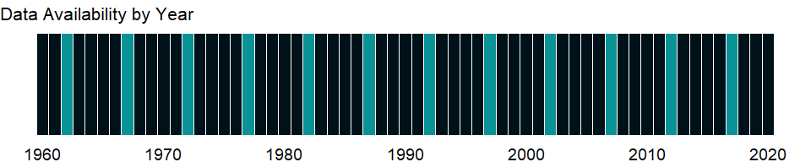

### Which countries have data?

The figure below shows the percentage of countries in each income group with a value since 2010 for that indicator.

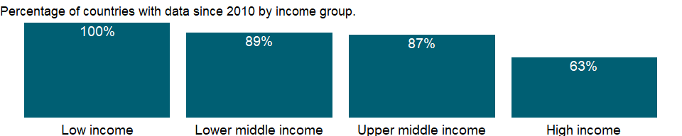

### Why is it relevant?

While some countries have an abundant supply of fresh water, others do not have as much. UN estimates that many areas of the world are already experiencing stress on water availability. Due to the accelerated pace of population growth and an increase in the amount of water a single person uses, it is expected that this situation will continue to get worse. The ability of developing countries to make more water available for domestic, agricultural, industrial and environmental uses will depend on better management of water resources and more cross-sectorial planning and integration. According to World Water Council, by 2020, water use is expected to increase by 40 percent, and 17 percent more water will be required for food production to meet the needs of the growing population. The three major factors causing increasing water demand over the past century are population growth, industrial development and the expansion of irrigated agriculture.

There is now ample evidence that increased hydrologic variability and change in climate has and will continue to have a profound impact on the water sector through the hydrologic cycle, water availability, water demand, and water allocation at the global, regional, basin, and local levels. Properly managed water resources are a critical component of growth, poverty reduction and equity. The livelihoods of the poorest are critically associated with access to water services. A shortage of water in the future would be detrimental to the human population as it would affect everything from sanitation, to overall health and the production of grain.

Freshwater use by continents is partly based on several socio-economic development factors, including population, physiography, and climatic characteristics. It is estimated that in the coming decades the most intensive growth of water withdrawal is expected to occur in Africa and South America (increasing by 1.5-1.6 times), while the smallest growth will take place in Europe and North America (1.2 times).

### What is the data source?

Food and Agriculture Organization, AQUASTAT data.

### What is the methodology?

Annual freshwater withdrawals are total water withdrawals, not counting evaporation losses from storage basins. Withdrawals also include water from desalination plants in countries where they are a significant source. Withdrawals can exceed 100 percent of total renewable resources where extraction from nonrenewable aquifers or desalination plants is considerable or where water reuse is significant. Withdrawals for agriculture and industry are total withdrawals for irrigation and livestock production and for direct industrial use (including for cooling thermoelectric plants). Withdrawals for domestic uses include drinking water, municipal use or supply, and use for public services, commercial establishments, and homes.

### How is it aggregated?

Weighted average

### What are the limitations?

A common perception is that most of the available freshwater resources are visible (on the surfaces of lakes, reservoirs and rivers). However, this visible water represents only a tiny fraction of global freshwater resources, as most of it is stored in aquifers, with the largest stocks stored in solid form in the Antarctic and in Greenland’s ice cap.

The data on freshwater resources are based on estimates of runoff into rivers and recharge of groundwater. These estimates are based on different sources and refer to different years, so cross-country comparisons should be made with caution. Because the data are collected intermittently, they may hide significant variations in total renewable water resources from year to year. The data also fail to distinguish between seasonal and geographic variations in water availability within countries. Data for small countries and countries in arid and semiarid zones are less reliable than those for larger countries and countries with greater rainfall.

Caution should also be used in comparing data on annual freshwater withdrawals, which are subject to variations in collection and estimation methods. In addition, inflows and outflows are estimated at different times and at different levels of quality and precision, requiring caution in interpreting the data, particularly for water-short countries, notably in the Middle East and North Africa.

The data are based on surveys and estimates provided by governments to the Joint Monitoring Programme of the World Health Organization (WHO) and the United Nations Children’s Fund (UNICEF). The coverage rates are based on information from service users on actual household use rather than on information from service providers, which may include nonfunctioning systems.

### What else should I know?

NA

### 1.21.8 Renewable internal freshwater resources, total (billion cubic meters)

### What is the indicator?

Renewable internal freshwater resources flows refer to internal renewable resources (internal river flows and groundwater from rainfall) in the country.

Topic: Environment: Freshwater

Series ID: ER.H2O.INTR.K3

Copyright: CC BY-4.0 , <https://datacatalog.worldbank.org/public-licenses#cc-by>

First year with any data: 1962

Last year with any data: 2017

### What years are data available?

The figure below shows years in which data is available for at least one country. Dates shaded in black have no data, while dates shaded in green have data for at least one country



### Which countries have data?

The figure below shows the percentage of countries in each income group with a value since 2010 for that indicator.

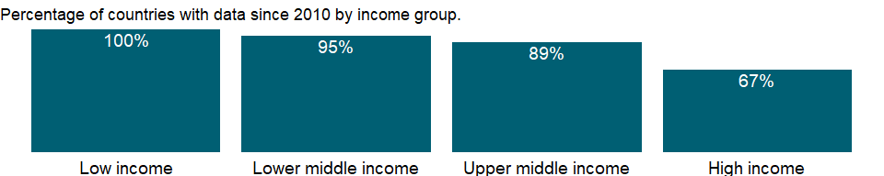

### Why is it relevant?

UNESCO estimates that in developing countries in Asia, Africa and Latin America, public water withdrawal represents just 50-100 liters (13 to 26 gallons) per person per day. In regions with insufficient water resources, this figure may be as low as 20-60 (5 to 15 gallons) liters per day. People in developed countries on average consume about 10 times more water daily than those in developing countries.

While some countries have an abundant supply of fresh water, others do not have as much. UN estimates that many areas of the world are already experiencing stress on water availability. Due to the accelerated pace of population growth and an increase in the amount of water a single person uses, it is expected that this situation will continue to get worse. The ability of developing countries to make more water available for domestic, agricultural, industrial and environmental uses will depend on better management of water resources and more cross-sectorial planning and integration. According to World Water Council, by 2020, water use is expected to increase by 40 percent, and 17 percent more water will be required for food production to meet the needs of the growing population. The three major factors causing increasing water demand over the past century are population growth, industrial development and the expansion of irrigated agriculture.

Water productivity is an indication only of the efficiency by which each country uses its water resources. Given the different economic structure of each country, these indicators should be used carefully, taking into account a country’s sectorial activities and natural resource endowments. According to Commission on Sustainable Development (CSD) agriculture accounts for more than 70 percent of freshwater drawn from lakes, rivers and underground sources. Most is used for irrigation which provides about 40 percent of the world food production. Poor management has resulted in the salinization of about 20 percent of the world’s irrigated land, with an additional 1.5 million ha affected annually.

There is now ample evidence that increased hydrologic variability and change in climate has and will continue to have a profound impact on the water sector through the hydrologic cycle, water availability, water demand, and water allocation at the global, regional, basin, and local levels. Properly managed water resources are a critical component of growth, poverty reduction and equity. The livelihoods of the poorest are critically associated with access to water services. A shortage of water in the future would be detrimental to the human population as it would affect everything from sanitation, to overall health and the production of grain.

Freshwater use by continents is partly based on several socio-economic development factors, including population, physiography, and climatic characteristics. It is estimated that in the coming decades the most intensive growth of water withdrawal is expected to occur in Africa and South America (increasing by 1.5-1.6 times), while the smallest growth will take place in Europe and North America (1.2 times).

The Commission for Sustainable Development (CSD) has reported that many countries lack adequate legislation and policies for efficient and equitable allocation and use of water resources. Progress is, however, being made with the review of national legislation and enactment of new laws and regulations.

### What is the data source?

Food and Agriculture Organization, AQUASTAT data.

### What is the methodology?

The data on freshwater resources are based on estimates of runoff into rivers and recharge of groundwater. Renewable water resources (internal and external) include average annual flow of rivers and recharge of aquifers generated from endogenous precipitation, and those water resources that are not generated in the country, such as inflows from upstream countries (groundwater and surface water), and part of the water of border lakes and/or rivers. Non-renewable water includes groundwater bodies (deep aquifers) that have a negligible rate of recharge on the human time-scale. While renewable water resources are expressed in flows, non-renewable water resources have to be expressed in quantity (stock). Runoff from glaciers where the mass balance is negative is considered non-renewable.

Total actual renewable water resources correspond to the maximum theoretical yearly amount of water actually available for a country at a given moment. The unit of calculation is km3/year or 109 m3/year. Calculation Criteria is [Water resources: total renewable (actual)] = [Surface water: total renewable (actual)] + [Groundwater: total renewable (actual)] - [Overlap between surface water and groundwater].*

Fresh water is naturally occurring water on the Earth’s surface. It is a renewable but limited natural resource. Fresh water can only be renewed through the process of the water cycle, where water from seas, lakes, forests, land, rivers, and dams evaporates, forms clouds, and returns as precipitation. However, if more fresh water is consumed through human activities than is restored by nature, the result is that the quantity of fresh water available in lakes, rivers, dams and underground waters can be reduced which can cause serious damage to the surrounding environment.

* <http://www.fao.org/nr/water/aquastat/data/glossary/search.html?termId=4188&submitBtn=s&cls=yes>

### How is it aggregated?

Sum

### What are the limitations?

A common perception is that most of the available freshwater resources are visible (on the surfaces of lakes, reservoirs and rivers). However, this visible water represents only a tiny fraction of global freshwater resources, as most of it is stored in aquifers, with the largest stocks stored in solid form in the Antarctic and in Greenland’s ice cap.

The data on freshwater resources are based on estimates of runoff into rivers and recharge of groundwater. These estimates are based on different sources and refer to different years, so cross-country comparisons should be made with caution. Because the data are collected intermittently, they may hide significant variations in total renewable water resources from year to year. The data also fail to distinguish between seasonal and geographic variations in water availability within countries. Data for small countries and countries in arid and semiarid zones are less reliable than those for larger countries and countries with greater rainfall.

Caution should also be used in comparing data on annual freshwater withdrawals, which are subject to variations in collection and estimation methods. In addition, inflows and outflows are estimated at different times and at different levels of quality and precision, requiring caution in interpreting the data, particularly for water-short countries, notably in the Middle East and North Africa.

The data are based on surveys and estimates provided by governments to the Joint Monitoring Programme of the World Health Organization (WHO) and the United Nations Children’s Fund (UNICEF). The coverage rates are based on information from service users on actual household use rather than on information from service providers, which may include nonfunctioning systems.

### What else should I know?

NA

### 1.21.9 Renewable internal freshwater resources per capita (cubic meters)

### What is the indicator?

Renewable internal freshwater resources flows refer to internal renewable resources (internal river flows and groundwater from rainfall) in the country. Renewable internal freshwater resources per capita are calculated using the World Bank’s population estimates.

Topic: Environment: Freshwater

Series ID: ER.H2O.INTR.PC

Copyright: CC BY-4.0 , <https://datacatalog.worldbank.org/public-licenses#cc-by>

First year with any data: 1962

Last year with any data: 2017

### What years are data available?

The figure below shows years in which data is available for at least one country. Dates shaded in black have no data, while dates shaded in green have data for at least one country



### Which countries have data?

The figure below shows the percentage of countries in each income group with a value since 2010 for that indicator.



### Why is it relevant?

UNESCO estimates that in developing countries in Asia, Africa and Latin America, public water withdrawal represents just 50-100 liters (13 to 26 gallons) per person per day. In regions with insufficient water resources, this figure may be as low as 20-60 (5 to 15 gallons) liters per day. People in developed countries on average consume about 10 times more water daily than those in developing countries.

While some countries have an abundant supply of fresh water, others do not have as much. UN estimates that many areas of the world are already experiencing stress on water availability. Due to the accelerated pace of population growth and an increase in the amount of water a single person uses, it is expected that this situation will continue to get worse. The ability of developing countries to make more water available for domestic, agricultural, industrial and environmental uses will depend on better management of water resources and more cross-sectorial planning and integration. According to World Water Council, by 2020, water use is expected to increase by 40 percent, and 17 percent more water will be required for food production to meet the needs of the growing population. The three major factors causing increasing water demand over the past century are population growth, industrial development and the expansion of irrigated agriculture.

Water productivity is an indication only of the efficiency by which each country uses its water resources. Given the different economic structure of each country, these indicators should be used carefully, taking into account a country’s sectorial activities and natural resource endowments. According to Commission on Sustainable Development (CSD) agriculture accounts for more than 70 percent of freshwater drawn from lakes, rivers and underground sources. Most is used for irrigation which provides about 40 percent of the world food production. Poor management has resulted in the salinization of about 20 percent of the world’s irrigated land, with an additional 1.5 million ha affected annually.

There is now ample evidence that increased hydrologic variability and change in climate has and will continue to have a profound impact on the water sector through the hydrologic cycle, water availability, water demand, and water allocation at the global, regional, basin, and local levels. Properly managed water resources are a critical component of growth, poverty reduction and equity. The livelihoods of the poorest are critically associated with access to water services. A shortage of water in the future would be detrimental to the human population as it would affect everything from sanitation, to overall health and the production of grain.

Freshwater use by continents is partly based on several socio-economic development factors, including population, physiography, and climatic characteristics. It is estimated that in the coming decades the most intensive growth of water withdrawal is expected to occur in Africa and South America (increasing by 1.5-1.6 times), while the smallest growth will take place in Europe and North America (1.2 times).

The Commission for Sustainable Development (CSD) has reported that many countries lack adequate legislation and policies for efficient and equitable allocation and use of water resources. Progress is, however, being made with the review of national legislation and enactment of new laws and regulations.

### What is the data source?

Food and Agriculture Organization, AQUASTAT data.

### What is the methodology?

Renewable water resources (internal and external) include average annual flow of rivers and recharge of aquifers generated from endogenous precipitation, and those water resources that are not generated in the country, such as inflows from upstream countries (groundwater and surface water), and part of the water of border lakes and/or rivers. Non-renewable water includes groundwater bodies (deep aquifers) that have a negligible rate of recharge on the human time-scale. While renewable water resources are expressed in flows, non-renewable water resources have to be expressed in quantity (stock). Runoff from glaciers where the mass balance is negative is considered non-renewable. Renewable internal freshwater resources per capita are calculated using the World Bank’s population estimates. The unit of calculation is m3/year per inhabitant. Internal renewable freshwater resources per capita are calculated using the World Bank’s population estimates.

Total actual renewable water resources correspond to the maximum theoretical yearly amount of water actually available for a country at a given moment. The unit of calculation is km3/year or 109 m3/year. Calculation Criteria is [Water resources: total renewable (actual)] = [Surface water: total renewable (actual)] + [Groundwater: total renewable (actual)] - [Overlap between surface water and groundwater].*

Fresh water is naturally occurring water on the Earth’s surface. It is a renewable but limited natural resource. Fresh water can only be renewed through the process of the water cycle, where water from seas, lakes, forests, land, rivers, and dams evaporates, forms clouds, and returns as precipitation. However, if more fresh water is consumed through human activities than is restored by nature, the result is that the quantity of fresh water available in lakes, rivers, dams and underground waters can be reduced which can cause serious damage to the surrounding environment.

* <http://www.fao.org/nr/water/aquastat/data/glossary/search.html?termId=4188&submitBtn=s&cls=yes>

### How is it aggregated?

Weighted Average

### What are the limitations?

A common perception is that most of the available freshwater resources are visible (on the surfaces of lakes, reservoirs and rivers). However, this visible water represents only a tiny fraction of global freshwater resources, as most of it is stored in aquifers, with the largest stocks stored in solid form in the Antarctic and in Greenland’s ice cap.

The data on freshwater resources are based on estimates of runoff into rivers and recharge of groundwater. These estimates are based on different sources and refer to different years, so cross-country comparisons should be made with caution. Because the data are collected intermittently, they may hide significant variations in total renewable water resources from year to year. The data also fail to distinguish between seasonal and geographic variations in water availability within countries. Data for small countries and countries in arid and semiarid zones are less reliable than those for larger countries and countries with greater rainfall.

Caution should also be used in comparing data on annual freshwater withdrawals, which are subject to variations in collection and estimation methods. In addition, inflows and outflows are estimated at different times and at different levels of quality and precision, requiring caution in interpreting the data, particularly for water-short countries, notably in the Middle East and North Africa.

The data are based on surveys and estimates provided by governments to the Joint Monitoring Programme of the World Health Organization (WHO) and the United Nations Children’s Fund (UNICEF). The coverage rates are based on information from service users on actual household use rather than on information from service providers, which may include nonfunctioning systems.

### What else should I know?

NA

## 1.22 Financial Sector: Assets

### 1.22.1 Bank nonperforming loans to total gross loans (%)

### What is the indicator?

Bank nonperforming loans to total gross loans are the value of nonperforming loans divided by the total value of the loan portfolio (including nonperforming loans before the deduction of specific loan-loss provisions). The loan amount recorded as nonperforming should be the gross value of the loan as recorded on the balance sheet, not just the amount that is overdue.

Topic: Financial Sector: Assets

Series ID: FB.AST.NPER.ZS

Copyright: CC BY-4.0 , <https://datacatalog.worldbank.org/public-licenses#cc-by>

First year with any data: 2000

Last year with any data: 2020

### What years are data available?

The figure below shows years in which data is available for at least one country. Dates shaded in black have no data, while dates shaded in green have data for at least one country

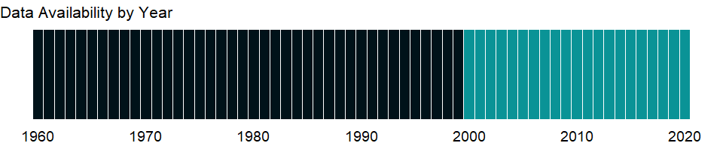

### Which countries have data?

The figure below shows the percentage of countries in each income group with a value since 2010 for that indicator.

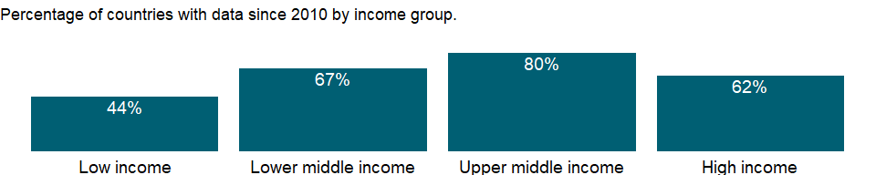

### Why is it relevant?

The size and mobility of international capital flows make it increasingly important to monitor the strength of financial systems. Robust financial systems can increase economic activity and welfare, but instability can disrupt financial activity and impose widespread costs on the economy. The ratio of bank nonperforming loans to total gross loans measures bank health and efficiency by identifying problems with asset quality in the loan portfolio. A high ratio may signal deterioration of the credit portfolio.

### What is the data source?

International Monetary Fund, Financial Soundness Indicators.

### What is the methodology?

The ratio of bank nonperforming loans to total gross loans is the value of nonperforming loans (gross value of the loan as recorded on the balance sheet) divided by the total value of the loan portfolio (including nonperforming loans before the deduction of loan loss provisions). It measures bank health and efficiency by identifying problems with asset quality in the loan portfolio. International guidelines recommend that loans be classified as nonperforming when payments of principal and interest are 90 days or more past due or when future payments are not expected to be received in full. Data are submitted by national authorities to the IMF following the Financial Soundness Indicators (FSI) Compilation Guide. For country specific metadata, including reporting period, please refer to the GFSR FSI Tables and the Data and Metadata Tables available through FSIs website: <http://data.imf.org/>.

### How is it aggregated?

NA

### What are the limitations?

Reporting countries compile the data using different methodologies, which may also vary for different points in time for the same country. Users are advised to consult the accompanying metadata on the IMF FSI website (data.imf.org) to conduct more meaningful cross-country comparisons or to assess the evolution of the indicator for any of the countries.

### What else should I know?

NA

### 1.22.2 Bank capital to assets ratio (%)

### What is the indicator?

Bank capital to assets is the ratio of bank capital and reserves to total assets. Capital and reserves include funds contributed by owners, retained earnings, general and special reserves, provisions, and valuation adjustments. Capital includes tier 1 capital (paid-up shares and common stock), which is a common feature in all countries’ banking systems, and total regulatory capital, which includes several specified types of subordinated debt instruments that need not be repaid if the funds are required to maintain minimum capital levels (these comprise tier 2 and tier 3 capital). Total assets include all nonfinancial and financial assets.

Topic: Financial Sector: Assets

Series ID: FB.BNK.CAPA.ZS

Copyright: CC BY-4.0 , <https://datacatalog.worldbank.org/public-licenses#cc-by>

First year with any data: 2000

Last year with any data: 2020

### What years are data available?

The figure below shows years in which data is available for at least one country. Dates shaded in black have no data, while dates shaded in green have data for at least one country



### Which countries have data?

The figure below shows the percentage of countries in each income group with a value since 2010 for that indicator.

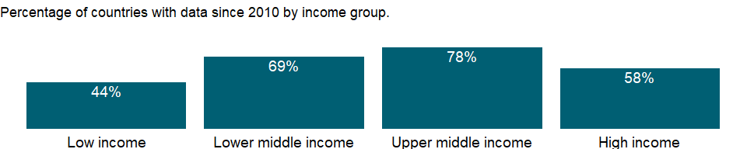

### Why is it relevant?

The size and mobility of international capital flows make it increasingly important to monitor the strength of financial systems. Robust financial systems can increase economic activity and welfare, but instability can disrupt financial activity and impose widespread costs on the economy. The ratio of bank capital to assets, a measure of bank solvency and resiliency, shows the extent to which banks can deal with unexpected losses. Capital includes tier 1 capital (paid-up shares and common stock), a common feature in all countries’ banking systems, and total regulatory capital, which includes several types of subordinated debt instruments that need not be repaid if the funds are required to maintain minimum capital levels (tier 2 and tier 3 capital). Total assets include all nonfinancial and financial assets. Data are from internally consistent financial statements.

### What is the data source?

International Monetary Fund, Financial Soundness Indicators.

### What is the methodology?

The ratio of capital to total assets, without the latter being risk weighted. Capital is measured as total capital and reserves as reported in the sectoral balance sheet; for cross-border consolidated data, Tier 1 capital can also be used. It indicates the extent to which assets are funded by other than own funds and is a measure of capital adequacy of the deposit-taking sector. It complements the capital adequacy ratios compiled based on the methodology agreed to by the Basle Committee on Banking Supervision. Also, it measures financial leverage and is sometimes called the leverage ratio. Data are submitted by national authorities to the IMF following the Financial Soundness Indicators (FSI) Compilation Guide. For country specific metadata, including reporting period, please refer to the GFSR FSI Tables and the Data and Metadata Tables available through FSIs website: <http://data.imf.org/>.

### How is it aggregated?

NA

### What are the limitations?

Reporting countries compile the data using different methodologies, which may also vary for different points in time for the same country. Users are advised to consult the accompanying metadata on the IMF FSI website (data.imf.org) to conduct more meaningful cross-country comparisons or to assess the evolution of the indicator for any of the countries.

### What else should I know?

NA

### 1.22.3 Domestic credit to private sector by banks (% of GDP)

### What is the indicator?

Domestic credit to private sector by banks refers to financial resources provided to the private sector by other depository corporations (deposit taking corporations except central banks), such as through loans, purchases of nonequity securities, and trade credits and other accounts receivable, that establish a claim for repayment. For some countries these claims include credit to public enterprises.

Topic: Financial Sector: Assets

Series ID: FD.AST.PRVT.GD.ZS

Copyright: CC BY-4.0 , <https://datacatalog.worldbank.org/public-licenses#cc-by>

First year with any data: 1960

Last year with any data: 2020

### What years are data available?

The figure below shows years in which data is available for at least one country. Dates shaded in black have no data, while dates shaded in green have data for at least one country



### Which countries have data?

The figure below shows the percentage of countries in each income group with a value since 2010 for that indicator.

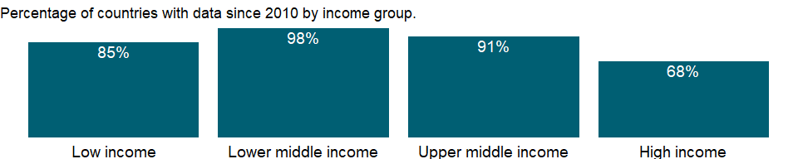

### Why is it relevant?

Private sector development and investment - tapping private sector initiative and investment for socially useful purposes - are critical for poverty reduction. In parallel with public sector efforts, private investment, especially in competitive markets, has tremendous potential to contribute to growth. Private markets are the engine of productivity growth, creating productive jobs and higher incomes. And with government playing a complementary role of regulation, funding, and service provision, private initiative and investment can help provide the basic services and conditions that empower poor people - by improving health, education, and infrastructure.

### What is the data source?

International Monetary Fund, International Financial Statistics and data files, and World Bank and OECD GDP estimates.

### What is the methodology?

Credit is an important link in money transmission; it finances production, consumption, and capital formation, which in turn affect economic activity. The data on domestic credit provided to the private sector by banks are taken from the other depository corporations survey (line 22D) of the International Monetary Fund’s (IMF) International Financial Statistics. The other depository corporations include all deposit taking corporations (deposit money banks) except monetary authorities (the central bank).

### How is it aggregated?

Weighted Average

### What are the limitations?

Credit to the private sector may sometimes include credit to state-owned or partially state-owned enterprises.

### What else should I know?

NA

### 1.22.4 Bank liquid reserves to bank assets ratio (%)

### What is the indicator?

Ratio of bank liquid reserves to bank assets is the ratio of domestic currency holdings and deposits with the monetary authorities to claims on other governments, nonfinancial public enterprises, the private sector, and other banking institutions.

Topic: Financial Sector: Assets

Series ID: FD.RES.LIQU.AS.ZS

Copyright: CC BY-4.0 , <https://datacatalog.worldbank.org/public-licenses#cc-by>

First year with any data: 2001

Last year with any data: 2020

### What years are data available?

The figure below shows years in which data is available for at least one country. Dates shaded in black have no data, while dates shaded in green have data for at least one country

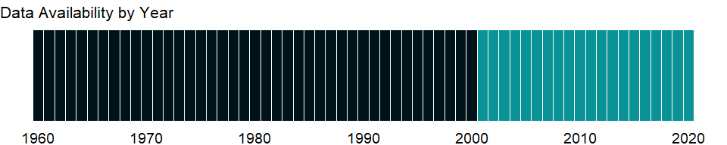

### Which countries have data?

The figure below shows the percentage of countries in each income group with a value since 2010 for that indicator.

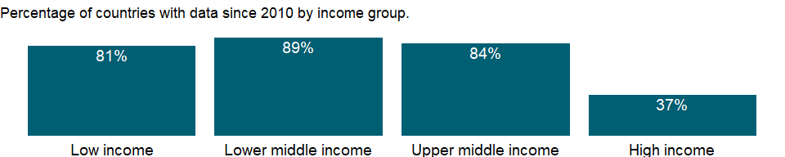

### Why is it relevant?

NA

### What is the data source?

International Monetary Fund, International Financial Statistics and data files.

### What is the methodology?

NA

### How is it aggregated?

Median

### What are the limitations?

NA

### What else should I know?

NA

### 1.22.5 Claims on central government (annual growth as % of broad money)

### What is the indicator?

Claims on central government (IFS line 32AN..ZK) include loans to central government institutions net of deposits.

Topic: Financial Sector: Assets

Series ID: FM.AST.CGOV.ZG.M3

Copyright: CC BY-4.0 , <https://datacatalog.worldbank.org/public-licenses#cc-by>

First year with any data: 1961

Last year with any data: 2020

### What years are data available?

The figure below shows years in which data is available for at least one country. Dates shaded in black have no data, while dates shaded in green have data for at least one country



### Which countries have data?

The figure below shows the percentage of countries in each income group with a value since 2010 for that indicator.

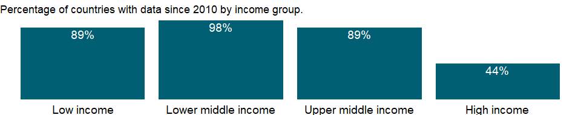

### Why is it relevant?

NA

### What is the data source?

International Monetary Fund, International Financial Statistics and data files.

### What is the methodology?

The banking system’s assets include its net foreign assets and net domestic credit. Net domestic credit includes credit extended to the private sector and general government and credit extended to the nonfinancial public sector in the form of investments in short- and long-term government securities and loans to state enterprises; liabilities to the public and private sectors in the form of deposits with the banking system are netted out. Net domestic credit also includes credit to banking and nonbank financial institutions.

Domestic credit is the main vehicle through which changes in the money supply are regulated, with central bank lending to the government often playing the most important role. The central bank can regulate lending to the private sector in several ways - for example, by adjusting the cost of the refinancing facilities it provides to banks, by changing market interest rates through open market operations, or by controlling the availability of credit through changes in the reserve requirements imposed on banks and ceilings on the credit provided by banks to the private sector.

### How is it aggregated?

NA

### What are the limitations?

Monetary accounts are derived from the balance sheets of financial institutions - the central bank, commercial banks, and nonbank financial intermediaries. Although these balance sheets are usually reliable, they are subject to errors of classification, valuation, and timing and to differences in accounting practices. For example, whether interest income is recorded on an accrual or a cash basis can make a substantial difference, as can the treatment of nonperforming assets. Valuation errors typically arise for foreign exchange transactions, particularly in countries with flexible exchange rates or in countries that have undergone currency devaluation during the reporting period. The valuation of financial derivatives and the net liabilities of the banking system can also be difficult. The quality of commercial bank reporting also may be adversely affected by delays in reports from bank branches, especially in countries where branch accounts are not computerized. Thus the data in the balance sheets of commercial banks may be based on preliminary estimates subject to constant revision. This problem is likely to be even more serious for nonbank financial intermediaries.

### What else should I know?

NA

### 1.22.6 Claims on other sectors of the domestic economy (annual growth as % of broad money)

### What is the indicator?

Claims on other sectors of the domestic economy (IFS line 32S..ZK) include gross credit from the financial system to households, nonprofit institutions serving households, nonfinancial corporations, state and local governments, and social security funds.

Topic: Financial Sector: Assets

Series ID: FM.AST.DOMO.ZG.M3

Copyright: CC BY-4.0 , <https://datacatalog.worldbank.org/public-licenses#cc-by>

First year with any data: 2002

Last year with any data: 2020

### What years are data available?

The figure below shows years in which data is available for at least one country. Dates shaded in black have no data, while dates shaded in green have data for at least one country

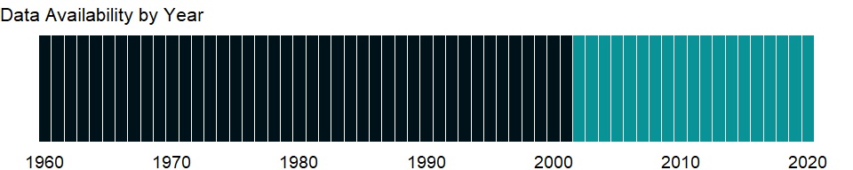

### Which countries have data?

The figure below shows the percentage of countries in each income group with a value since 2010 for that indicator.

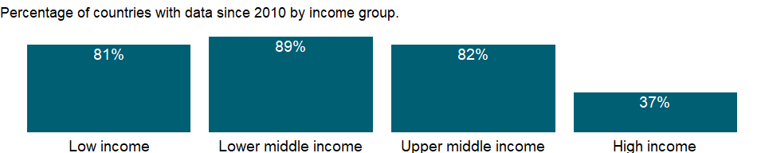

### Why is it relevant?

NA

### What is the data source?

International Monetary Fund, International Financial Statistics and data files.

### What is the methodology?

The banking system’s assets include its net foreign assets and net domestic credit. Net domestic credit includes credit extended to the private sector and general government and credit extended to the nonfinancial public sector in the form of investments in short- and long-term government securities and loans to state enterprises; liabilities to the public and private sectors in the form of deposits with the banking system are netted out. Net domestic credit also includes credit to banking and nonbank financial institutions.

Domestic credit is the main vehicle through which changes in the money supply are regulated, with central bank lending to the government often playing the most important role. The central bank can regulate lending to the private sector in several ways - for example, by adjusting the cost of the refinancing facilities it provides to banks, by changing market interest rates through open market operations, or by controlling the availability of credit through changes in the reserve requirements imposed on banks and ceilings on the credit provided by banks to the private sector.

### How is it aggregated?

NA

### What are the limitations?

Monetary accounts are derived from the balance sheets of financial institutions - the central bank, commercial banks, and nonbank financial intermediaries. Although these balance sheets are usually reliable, they are subject to errors of classification, valuation, and timing and to differences in accounting practices. For example, whether interest income is recorded on an accrual or a cash basis can make a substantial difference, as can the treatment of nonperforming assets. Valuation errors typically arise for foreign exchange transactions, particularly in countries with flexible exchange rates or in countries that have undergone currency devaluation during the reporting period. The valuation of financial derivatives and the net liabilities of the banking system can also be difficult. The quality of commercial bank reporting also may be adversely affected by delays in reports from bank branches, especially in countries where branch accounts are not computerized. Thus the data in the balance sheets of commercial banks may be based on preliminary estimates subject to constant revision. This problem is likely to be even more serious for nonbank financial intermediaries.

### What else should I know?

NA

### 1.22.7 Net domestic credit (current LCU)

### What is the indicator?

Net domestic credit is the sum of net claims on the central government and claims on other sectors of the domestic economy (IFS line 32). Data are in current local currency.

Topic: Financial Sector: Assets

Series ID: FM.AST.DOMS.CN

Copyright: CC BY-4.0 , <https://datacatalog.worldbank.org/public-licenses#cc-by>

First year with any data: 1960

Last year with any data: 2020

### What years are data available?

The figure below shows years in which data is available for at least one country. Dates shaded in black have no data, while dates shaded in green have data for at least one country



### Which countries have data?

The figure below shows the percentage of countries in each income group with a value since 2010 for that indicator.

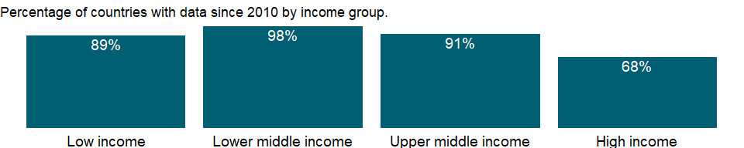

### Why is it relevant?

NA

### What is the data source?

International Monetary Fund, International Financial Statistics and data files.

### What is the methodology?

NA

### How is it aggregated?

NA

### What are the limitations?

NA

### What else should I know?

NA

### 1.22.8 Net foreign assets (current LCU)

### What is the indicator?

Net foreign assets are the sum of foreign assets held by monetary authorities and deposit money banks, less their foreign liabilities. Data are in current local currency.

Topic: Financial Sector: Assets

Series ID: FM.AST.NFRG.CN

Copyright: CC BY-4.0 , <https://datacatalog.worldbank.org/public-licenses#cc-by>

First year with any data: 1960

Last year with any data: 2020

### What years are data available?

The figure below shows years in which data is available for at least one country. Dates shaded in black have no data, while dates shaded in green have data for at least one country



### Which countries have data?

The figure below shows the percentage of countries in each income group with a value since 2010 for that indicator.



### Why is it relevant?

NA

### What is the data source?

International Monetary Fund, International Financial Statistics and data files.

### What is the methodology?

NA

### How is it aggregated?

NA

### What are the limitations?

NA

### What else should I know?

NA

### 1.22.9 Monetary Sector credit to private sector (% GDP)

### What is the indicator?

Domestic credit to private sector refers to financial resources provided to the private sector, such as through loans, purchases of nonequity securities, and trade credits and other accounts receivable, that establish a claim for repayment. For some countries these claims include credit to public enterprises.

Topic: Financial Sector: Assets

Series ID: FM.AST.PRVT.GD.ZS

Copyright: CC BY-4.0 , <https://datacatalog.worldbank.org/public-licenses#cc-by>

First year with any data: 1960

Last year with any data: 2020

### What years are data available?

The figure below shows years in which data is available for at least one country. Dates shaded in black have no data, while dates shaded in green have data for at least one country



### Which countries have data?

The figure below shows the percentage of countries in each income group with a value since 2010 for that indicator.



### Why is it relevant?

NA

### What is the data source?

International Monetary Fund, International Financial Statistics and data files, and World Bank and OECD GDP estimates.

### What is the methodology?

NA

### How is it aggregated?

NA

### What are the limitations?

NA

### What else should I know?

NA

### 1.22.10 Claims on private sector (annual growth as % of broad money)

### What is the indicator?

Claims on private sector (IFS line 32D..ZK or 32D..ZF) include gross credit from the financial system to individuals, enterprises, nonfinancial public entities not included under net domestic credit, and financial institutions not included elsewhere.

Topic: Financial Sector: Assets

Series ID: FM.AST.PRVT.ZG.M3

Copyright: CC BY-4.0 , <https://datacatalog.worldbank.org/public-licenses#cc-by>

First year with any data: 1961

Last year with any data: 2020

### What years are data available?

The figure below shows years in which data is available for at least one country. Dates shaded in black have no data, while dates shaded in green have data for at least one country



### Which countries have data?

The figure below shows the percentage of countries in each income group with a value since 2010 for that indicator.



### Why is it relevant?

NA

### What is the data source?

International Monetary Fund, International Financial Statistics and data files.

### What is the methodology?

NA

### How is it aggregated?

NA

### What are the limitations?

NA

### What else should I know?

NA

### 1.22.11 Claims on central government, etc. (% GDP)

### What is the indicator?

Claims on central government (IFS line 52AN or 32AN) include loans to central government institutions net of deposits.

Topic: Financial Sector: Assets

Series ID: FS.AST.CGOV.GD.ZS

Copyright: CC BY-4.0 , <https://datacatalog.worldbank.org/public-licenses#cc-by>

First year with any data: 1960

Last year with any data: 2020

### What years are data available?

The figure below shows years in which data is available for at least one country. Dates shaded in black have no data, while dates shaded in green have data for at least one country



### Which countries have data?

The figure below shows the percentage of countries in each income group with a value since 2010 for that indicator.



### Why is it relevant?

NA

### What is the data source?

International Monetary Fund, International Financial Statistics and data files, and World Bank and OECD GDP estimates.

### What is the methodology?

NA

### How is it aggregated?

Weighted Average

### What are the limitations?

NA

### What else should I know?

NA

### 1.22.12 Claims on other sectors of the domestic economy (% of GDP)

### What is the indicator?

Claims on other sectors of the domestic economy (IFS line 52S or 32S) include gross credit from the financial system to households, nonprofit institutions serving households, nonfinancial corporations, state and local governments, and social security funds.

Topic: Financial Sector: Assets

Series ID: FS.AST.DOMO.GD.ZS

Copyright: CC BY-4.0 , <https://datacatalog.worldbank.org/public-licenses#cc-by>

First year with any data: 2001

Last year with any data: 2020

### What years are data available?

The figure below shows years in which data is available for at least one country. Dates shaded in black have no data, while dates shaded in green have data for at least one country



### Which countries have data?

The figure below shows the percentage of countries in each income group with a value since 2010 for that indicator.

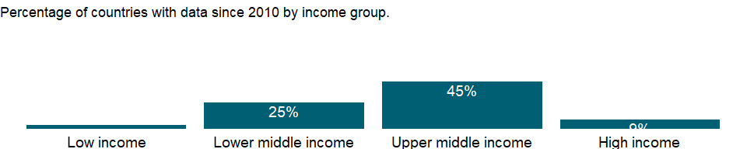

### Why is it relevant?

NA

### What is the data source?

International Monetary Fund, International Financial Statistics and data files, and World Bank and OECD GDP estimates.

### What is the methodology?

NA

### How is it aggregated?

Weighted Average

### What are the limitations?

NA

### What else should I know?

NA

### 1.22.13 Domestic credit provided by financial sector (% of GDP)

### What is the indicator?

Domestic credit provided by the financial sector includes all credit to various sectors on a gross basis, with the exception of credit to the central government, which is net. The financial sector includes monetary authorities and deposit money banks, as well as other financial corporations where data are available (including corporations that do not accept transferable deposits but do incur such liabilities as time and savings deposits). Examples of other financial corporations are finance and leasing companies, money lenders, insurance corporations, pension funds, and foreign exchange companies.

Topic: Financial Sector: Assets

Series ID: FS.AST.DOMS.GD.ZS

Copyright: CC BY-4.0 , <https://datacatalog.worldbank.org/public-licenses#cc-by>

First year with any data: 1960

Last year with any data: 2020

### What years are data available?

The figure below shows years in which data is available for at least one country. Dates shaded in black have no data, while dates shaded in green have data for at least one country



### Which countries have data?

The figure below shows the percentage of countries in each income group with a value since 2010 for that indicator.

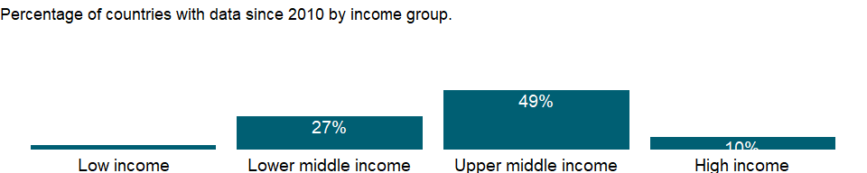

### Why is it relevant?

Both banking and financial systems enhance growth, the main factor in poverty reduction. At low levels of economic development commercial banks tend to dominate the financial system, while at higher levels domestic stock markets tend to become more active and efficient. The size and mobility of international capital flows make it increasingly important to monitor the strength of financial systems. Robust financial systems can increase economic activity and welfare, but instability can disrupt financial activity and impose widespread costs on the economy.

### What is the data source?

International Monetary Fund, International Financial Statistics and data files, and World Bank and OECD GDP estimates.

### What is the methodology?

Domestic credit provided by the financial sector as a share of GDP measures banking sector depth and financial sector development in terms of size. The data on domestic credit provided by the financial sector are taken from the financial corporations survey (line 52) of the International Monetary Fund’s (IMF) International Financial Statistics or, when unavailable, from its depository corporations survey (line 32). The financial sector includes monetary authorities (the central bank) and deposit money banks, as well as other financial institutions where data are available (including institutions that do not accept transferable deposits but do incur such liabilities as time and savings deposits). Examples of other banking institutions are savings and mortgage loan institutions, finance companies, development banks, and building and loan associations.

### How is it aggregated?

Weighted average

### What are the limitations?

In a few countries governments may hold international reserves as deposits in the banking system rather than in the central bank. Since claims on the central government are a net item (claims on the central government minus central government deposits), the figure may be negative, resulting in a negative figure for domestic credit provided by the banking sector.

### What else should I know?

NA

### 1.22.14 Domestic credit to private sector (% of GDP)

### What is the indicator?

Domestic credit to private sector refers to financial resources provided to the private sector by financial corporations, such as through loans, purchases of nonequity securities, and trade credits and other accounts receivable, that establish a claim for repayment. For some countries these claims include credit to public enterprises. The financial corporations include monetary authorities and deposit money banks, as well as other financial corporations where data are available (including corporations that do not accept transferable deposits but do incur such liabilities as time and savings deposits). Examples of other financial corporations are finance and leasing companies, money lenders, insurance corporations, pension funds, and foreign exchange companies.

Topic: Financial Sector: Assets

Series ID: FS.AST.PRVT.GD.ZS

Copyright: CC BY-4.0 , <https://datacatalog.worldbank.org/public-licenses#cc-by>

First year with any data: 1960

Last year with any data: 2020

### What years are data available?

The figure below shows years in which data is available for at least one country. Dates shaded in black have no data, while dates shaded in green have data for at least one country



### Which countries have data?

The figure below shows the percentage of countries in each income group with a value since 2010 for that indicator.



### Why is it relevant?

Private sector development and investment - tapping private sector initiative and investment for socially useful purposes - are critical for poverty reduction. In parallel with public sector efforts, private investment, especially in competitive markets, has tremendous potential to contribute to growth. Private markets are the engine of productivity growth, creating productive jobs and higher incomes. And with government playing a complementary role of regulation, funding, and service provision, private initiative and investment can help provide the basic services and conditions that empower poor people - by improving health, education, and infrastructure.

### What is the data source?

International Monetary Fund, International Financial Statistics and data files, and World Bank and OECD GDP estimates.

### What is the methodology?

Credit is an important link in money transmission; it finances production, consumption, and capital formation, which in turn affect economic activity. The data on domestic credit provided to the private sector are taken from the financial corporations survey (line 52D) of the International Monetary Fund’s (IMF) International Financial Statistics or, when unavailable, from its depository survey (line 32D). The banking sector includes monetary authorities (the central bank) and deposit money banks, as well as other financial corporations where data are available (including institutions that do not accept transferable deposits but do incur such liabilities as time and savings deposits). Examples of other financial corporations are finance and leasing companies, money lenders, insurance corporations, pension funds, and foreign exchange companies.

### How is it aggregated?

Weighted average

### What are the limitations?

Credit to the private sector may sometimes include credit to state-owned or partially state-owned enterprises.

### What else should I know?

NA

## 1.23 Financial Sector: Access

### 1.23.1 Automated teller machines (ATMs) (per 100,000 adults)

### What is the indicator?

Automated teller machines are computerized telecommunications devices that provide clients of a financial institution with access to financial transactions in a public place.

Topic: Financial Sector: Access

Series ID: FB.ATM.TOTL.P5

Copyright: CC BY-4.0 , <https://datacatalog.worldbank.org/public-licenses#cc-by>

First year with any data: 2004

Last year with any data: 2020

### What years are data available?

The figure below shows years in which data is available for at least one country. Dates shaded in black have no data, while dates shaded in green have data for at least one country

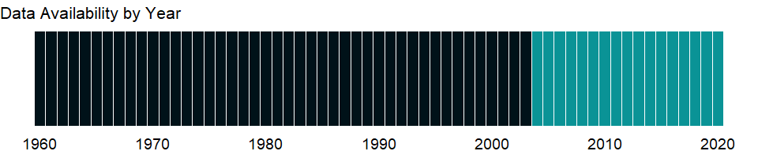

### Which countries have data?

The figure below shows the percentage of countries in each income group with a value since 2010 for that indicator.

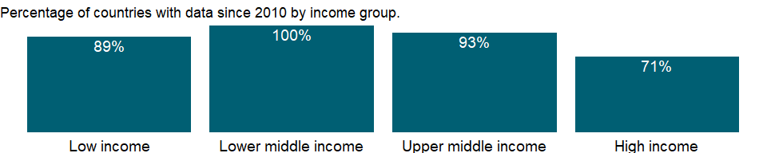

### Why is it relevant?

Access to finance can expand opportunities for all with higher levels of access and use of banking services associated with lower financing obstacles for people and businesses. A stable financial system that promotes efficient savings and investment is also crucial for a thriving democracy and market economy. There are several aspects of access to financial services: availability, cost, and quality of services. The development and growth of credit markets depend on access to timely, reliable, and accurate data on borrowers’ credit experiences. Access to credit can be improved by making it easy to create and enforce collateral agreements and by increasing information about potential borrowers’ creditworthiness. Lenders look at a borrower’s credit history and collateral. Where credit registries and effective collateral laws are absent - as in many developing countries - banks make fewer loans. Indicators that cover getting credit include the strength of legal rights index and the depth of credit information index.

### What is the data source?

International Monetary Fund, Financial Access Survey.

### What is the methodology?

Data are shown as the total number of ATMs for every 100,000 adults in the reporting country. Calculated as (number of ATMs)*100,000/adult population in the reporting country.

### How is it aggregated?

Median

### What are the limitations?

Population-based ratios of the number of branches and ATMs assume a uniform distribution of bank outlets within a country’s area and across its population, while in most countries bank branches and ATMs are concentrated in urban centers of the country and are accessible only to some individuals.

### What else should I know?

Country-specific metadata can be found on the IMF’s FAS website (data.imf.org).

### 1.23.2 Commercial bank branches (per 100,000 adults)

### What is the indicator?

Commercial bank branches are retail locations of resident commercial banks and other resident banks that function as commercial banks that provide financial services to customers and are physically separated from the main office but not organized as legally separated subsidiaries.

Topic: Financial Sector: Access

Series ID: FB.CBK.BRCH.P5

Copyright: CC BY-4.0 , <https://datacatalog.worldbank.org/public-licenses#cc-by>

First year with any data: 2004

Last year with any data: 2020

### What years are data available?

The figure below shows years in which data is available for at least one country. Dates shaded in black have no data, while dates shaded in green have data for at least one country



### Which countries have data?

The figure below shows the percentage of countries in each income group with a value since 2010 for that indicator.

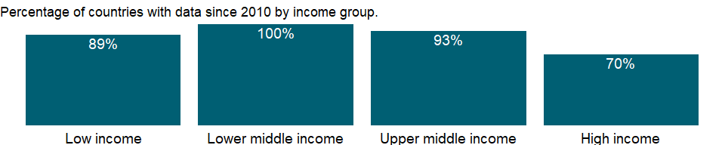

### Why is it relevant?

Access to finance can expand opportunities for all with higher levels of access and use of banking services associated with lower financing obstacles for people and businesses. A stable financial system that promotes efficient savings and investment is also crucial for a thriving democracy and market economy. There are several aspects of access to financial services: availability, cost, and quality of services. The development and growth of credit markets depend on access to timely, reliable, and accurate data on borrowers’ credit experiences. Access to credit can be improved by making it easy to create and enforce collateral agreements and by increasing information about potential borrowers’ creditworthiness. Lenders look at a borrower’s credit history and collateral. Where credit registries and effective collateral laws are absent - as in many developing countries - banks make fewer loans. Indicators that cover getting credit include the strength of legal rights index and the depth of credit information index.

### What is the data source?

International Monetary Fund, Financial Access Survey.

### What is the methodology?

Data are shown as the number of branches of commercial banks for every 100,000 adults in the reporting country. It is calculated as (number of institutions + number of branches)*100,000/adult population in the reporting country.

### How is it aggregated?

Median

### What are the limitations?

Population-based ratios of the number of branches and ATMs assume a uniform distribution of bank outlets within a country’s area and across its population, while in most countries bank branches and ATMs are concentrated in urban centers of the country and are accessible only to some individuals.

### What else should I know?

Country-specific metadata can be found on the IMF’s FAS website (data.imf.org).

### 1.23.3 Borrowers from commercial banks (per 1,000 adults)

### What is the indicator?

Borrowers from commercial banks are the reported number of resident customers that are nonfinancial corporations (public and private) and households who obtained loans from commercial banks and other banks functioning as commercial banks. For many countries data cover the total number of loan accounts due to lack of information on loan account holders.

Topic: Financial Sector: Access

Series ID: FB.CBK.BRWR.P3

Copyright: CC BY-4.0 , <https://datacatalog.worldbank.org/public-licenses#cc-by>

First year with any data: 2004

Last year with any data: 2020

### What years are data available?

The figure below shows years in which data is available for at least one country. Dates shaded in black have no data, while dates shaded in green have data for at least one country



### Which countries have data?

The figure below shows the percentage of countries in each income group with a value since 2010 for that indicator.

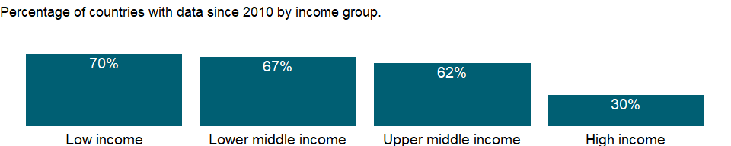

### Why is it relevant?

Access to finance can expand opportunities for all with higher levels of access and use of banking services associated with lower financing obstacles for people and businesses. A stable financial system that promotes efficient savings and investment is also crucial for a thriving democracy and market economy. There are several aspects of access to financial services: availability, cost, and quality of services. The development and growth of credit markets depend on access to timely, reliable, and accurate data on borrowers’ credit experiences. Access to credit can be improved by making it easy to create and enforce collateral agreements and by increasing information about potential borrowers’ creditworthiness. Lenders look at a borrower’s credit history and collateral. Where credit registries and effective collateral laws are absent - as in many developing countries - banks make fewer loans. Indicators that cover getting credit include the strength of legal rights index and the depth of credit information index.

### What is the data source?

International Monetary Fund, Financial Access Survey.

### What is the methodology?

Borrowers from commercial banks denotes the total number of resident customers that are nonfinancial corporations (public and private) and households who obtained loans from commercial banks for every 1,000 adults in the reporting country. It is calculated as (number of borrowers)*1,000/adult population in the reporting country.

### How is it aggregated?

Median

### What are the limitations?

For several countries, data cover all borrowers including commercial banks, credit unions and financial cooperatives, deposit taking microfinance institutions, and other deposit takers. These include all resident financial corporations and quasi-corporations (except the central bank) that are mainly engaged in financial intermediation and that issue liabilities included in the national definition of broad money. These institutions have varying names in different countries, such as savings and loan associations, building societies, rural banks and agricultural banks, post office giro institutions, post office savings banks, savings banks, and money market funds.

### What else should I know?

Country-specific metadata can be found on the IMF’s FAS website (data.imf.org).

### 1.23.4 Depositors with commercial banks (per 1,000 adults)

### What is the indicator?

Depositors with commercial banks are the reported number of deposit account holders at commercial banks and other resident banks functioning as commercial banks that are resident nonfinancial corporations (public and private) and households. For many countries data cover the total number of deposit accounts due to lack of information on account holders. The major types of deposits are checking accounts, savings accounts, and time deposits.

Topic: Financial Sector: Access

Series ID: FB.CBK.DPTR.P3

Copyright: CC BY-4.0 , <https://datacatalog.worldbank.org/public-licenses#cc-by>

First year with any data: 2004

Last year with any data: 2020

### What years are data available?

The figure below shows years in which data is available for at least one country. Dates shaded in black have no data, while dates shaded in green have data for at least one country



### Which countries have data?

The figure below shows the percentage of countries in each income group with a value since 2010 for that indicator.

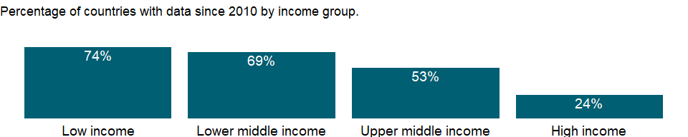

### Why is it relevant?

Access to finance can expand opportunities for all with higher levels of access and use of banking services associated with lower financing obstacles for people and businesses. A stable financial system that promotes efficient savings and investment is also crucial for a thriving democracy and market economy. There are several aspects of access to financial services: availability, cost, and quality of services. The development and growth of credit markets depend on access to timely, reliable, and accurate data on borrowers’ credit experiences. Access to credit can be improved by making it easy to create and enforce collateral agreements and by increasing information about potential borrowers’ creditworthiness. Lenders look at a borrower’s credit history and collateral. Where credit registries and effective collateral laws are absent - as in many developing countries - banks make fewer loans. Indicators that cover getting credit include the strength of legal rights index and the depth of credit information index.

### What is the data source?

International Monetary Fund, Financial Access Survey.

### What is the methodology?

Depositors with commercial banks are deposit account holders at commercial banks and other resident banks functioning as commercial banks that are resident nonfinancial corporations (public and private) and households. It is calculated as (number of depositors)*1,000/adult population in the reporting country. The major types of deposits are checking accounts, savings accounts, and time deposits.

### How is it aggregated?

Median

### What are the limitations?

Access to finance can expand opportunities for all with higher levels of access and use of banking services associated with lower financing obstacles for people and businesses. A stable financial system that promotes efficient savings and investment is also crucial for a thriving democracy and market economy. There are several aspects of access to financial services: availability, cost, and quality of services. The development and growth of credit markets depend on access to timely, reliable, and accurate data on borrowers’ credit experiences. Access to credit can be improved by making it easy to create and enforce collateral agreements and by increasing information about potential borrowers’ creditworthiness. Lenders look at a borrower’s credit history and collateral. Where credit registries and effective collateral laws are absent - as in many developing countries - banks make fewer loans. Indicators that cover getting credit include the strength of legal rights index and the depth of credit information index.

### What else should I know?

Country-specific metadata can be found on the IMF’s FAS website (data.imf.org).

### 1.23.5 Account ownership at a financial institution or with a mobile-money-service provider, poorest 40% (% of population ages 15+)

### What is the indicator?

Account denotes the percentage of respondents who report having an account (by themselves or together with someone else) at a bank or another type of financial institution or report personally using a mobile money service in the past 12 months (poorest 40%, share of population ages 15+).

Topic: Financial Sector: Access

Series ID: FX.OWN.TOTL.40.ZS

Copyright: CC BY-4.0 , <https://datacatalog.worldbank.org/public-licenses#cc-by>

First year with any data: 2011

Last year with any data: 2017

### What years are data available?

The figure below shows years in which data is available for at least one country. Dates shaded in black have no data, while dates shaded in green have data for at least one country

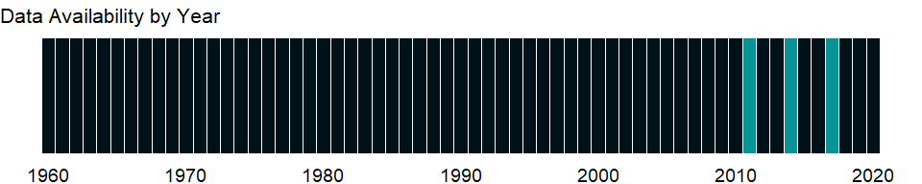

### Which countries have data?

The figure below shows the percentage of countries in each income group with a value since 2010 for that indicator.

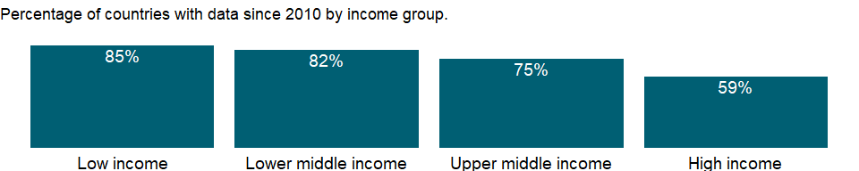

### Why is it relevant?

NA

### What is the data source?

Demirguc-Kunt et al., 2018, Global Financial Inclusion Database, World Bank.

### What is the methodology?

NA

### How is it aggregated?

Weighted Average

### What are the limitations?

NA

### What else should I know?

Each economy is classified based on the classification of World Bank Group’s fiscal year 2018 (July 1, 2017-June 30, 2018).

### 1.23.6 Account ownership at a financial institution or with a mobile-money-service provider, richest 60% (% of population ages 15+)

### What is the indicator?

Account denotes the percentage of respondents who report having an account (by themselves or together with someone else) at a bank or another type of financial institution or report personally using a mobile money service in the past 12 months (richest 60%, share of population ages 15+).

Topic: Financial Sector: Access

Series ID: FX.OWN.TOTL.60.ZS

Copyright: CC BY-4.0 , <https://datacatalog.worldbank.org/public-licenses#cc-by>

First year with any data: 2011

Last year with any data: 2017

### What years are data available?

The figure below shows years in which data is available for at least one country. Dates shaded in black have no data, while dates shaded in green have data for at least one country



### Which countries have data?

The figure below shows the percentage of countries in each income group with a value since 2010 for that indicator.



### Why is it relevant?

NA

### What is the data source?

Demirguc-Kunt et al., 2018, Global Financial Inclusion Database, World Bank.

### What is the methodology?

NA

### How is it aggregated?

Weighted Average

### What are the limitations?

NA

### What else should I know?

Each economy is classified based on the classification of World Bank Group’s fiscal year 2018 (July 1, 2017-June 30, 2018).

### 1.23.7 Account ownership at a financial institution or with a mobile-money-service provider, female (% of population ages 15+)

### What is the indicator?

Account denotes the percentage of respondents who report having an account (by themselves or together with someone else) at a bank or another type of financial institution or report personally using a mobile money service in the past 12 months (female, % age 15+).

Topic: Financial Sector: Access

Series ID: FX.OWN.TOTL.FE.ZS

Copyright: CC BY-4.0 , <https://datacatalog.worldbank.org/public-licenses#cc-by>

First year with any data: 2011

Last year with any data: 2017

### What years are data available?

The figure below shows years in which data is available for at least one country. Dates shaded in black have no data, while dates shaded in green have data for at least one country



### Which countries have data?

The figure below shows the percentage of countries in each income group with a value since 2010 for that indicator.

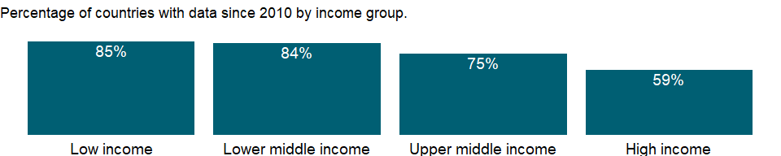

### Why is it relevant?

NA

### What is the data source?

Demirguc-Kunt et al., 2018, Global Financial Inclusion Database, World Bank.

### What is the methodology?

NA

### How is it aggregated?

Weighted Average

### What are the limitations?

NA

### What else should I know?

Each economy is classified based on the classification of World Bank Group’s fiscal year 2018 (July 1, 2017-June 30, 2018).

### 1.23.8 Account ownership at a financial institution or with a mobile-money-service provider, male (% of population ages 15+)

### What is the indicator?

Account denotes the percentage of respondents who report having an account (by themselves or together with someone else) at a bank or another type of financial institution or report personally using a mobile money service in the past 12 months (male, % age 15+).

Topic: Financial Sector: Access

Series ID: FX.OWN.TOTL.MA.ZS

Copyright: CC BY-4.0 , <https://datacatalog.worldbank.org/public-licenses#cc-by>

First year with any data: 2011

Last year with any data: 2017

### What years are data available?

The figure below shows years in which data is available for at least one country. Dates shaded in black have no data, while dates shaded in green have data for at least one country



### Which countries have data?

The figure below shows the percentage of countries in each income group with a value since 2010 for that indicator.



### Why is it relevant?

NA

### What is the data source?

Demirguc-Kunt et al., 2018, Global Financial Inclusion Database, World Bank.

### What is the methodology?

NA

### How is it aggregated?

Weighted Average

### What are the limitations?

NA

### What else should I know?

Each economy is classified based on the classification of World Bank Group’s fiscal year 2018 (July 1, 2017-June 30, 2018).

### 1.23.9 Account ownership at a financial institution or with a mobile-money-service provider, older adults (% of population ages 25+)

### What is the indicator?

Account denotes the percentage of respondents who report having an account (by themselves or together with someone else) at a bank or another type of financial institution or report personally using a mobile money service in the past 12 months (older adults, % of population ages 25+).

Topic: Financial Sector: Access

Series ID: FX.OWN.TOTL.OL.ZS

Copyright: CC BY-4.0 , <https://datacatalog.worldbank.org/public-licenses#cc-by>

First year with any data: 2011

Last year with any data: 2017

### What years are data available?

The figure below shows years in which data is available for at least one country. Dates shaded in black have no data, while dates shaded in green have data for at least one country



### Which countries have data?

The figure below shows the percentage of countries in each income group with a value since 2010 for that indicator.



### Why is it relevant?

NA

### What is the data source?

Demirguc-Kunt et al., 2018, Global Financial Inclusion Database, World Bank.

### What is the methodology?

NA

### How is it aggregated?

Weighted Average

### What are the limitations?

NA

### What else should I know?

Each economy is classified based on the classification of World Bank Group’s fiscal year 2018 (July 1, 2017-June 30, 2018).

### 1.23.10 Account ownership at a financial institution or with a mobile-money-service provider, primary education or less (% of population ages 15+)

### What is the indicator?

Account denotes the percentage of respondents who report having an account (by themselves or together with someone else) at a bank or another type of financial institution or report personally using a mobile money service in the past 12 months (primary education or less, % of population ages 15+).

Topic: Financial Sector: Access

Series ID: FX.OWN.TOTL.PL.ZS

Copyright: CC BY-4.0 , <https://datacatalog.worldbank.org/public-licenses#cc-by>

First year with any data: 2011

Last year with any data: 2017

### What years are data available?

The figure below shows years in which data is available for at least one country. Dates shaded in black have no data, while dates shaded in green have data for at least one country



### Which countries have data?

The figure below shows the percentage of countries in each income group with a value since 2010 for that indicator.



### Why is it relevant?

NA

### What is the data source?

Demirguc-Kunt et al., 2018, Global Financial Inclusion Database, World Bank.

### What is the methodology?

NA

### How is it aggregated?

Weighted Average

### What are the limitations?

NA

### What else should I know?

Each economy is classified based on the classification of World Bank Group’s fiscal year 2018 (July 1, 2017-June 30, 2018).

### 1.23.11 Account ownership at a financial institution or with a mobile-money-service provider, secondary education or more (% of population ages 15+)

### What is the indicator?

Account denotes the percentage of respondents who report having an account (by themselves or together with someone else) at a bank or another type of financial institution or report personally using a mobile money service in the past 12 months (secondary education or more, % of population ages 15+).

Topic: Financial Sector: Access

Series ID: FX.OWN.TOTL.SO.ZS

Copyright: CC BY-4.0 , <https://datacatalog.worldbank.org/public-licenses#cc-by>

First year with any data: 2011

Last year with any data: 2017

### What years are data available?

The figure below shows years in which data is available for at least one country. Dates shaded in black have no data, while dates shaded in green have data for at least one country



### Which countries have data?

The figure below shows the percentage of countries in each income group with a value since 2010 for that indicator.



### Why is it relevant?

NA

### What is the data source?

Demirguc-Kunt et al., 2018, Global Financial Inclusion Database, World Bank.

### What is the methodology?

NA

### How is it aggregated?

Weighted Average

### What are the limitations?

NA

### What else should I know?

Each economy is classified based on the classification of World Bank Group’s fiscal year 2018 (July 1, 2017-June 30, 2018).

### 1.23.12 Account ownership at a financial institution or with a mobile-money-service provider, young adults (% of population ages 15-24)

### What is the indicator?

Account denotes the percentage of respondents who report having an account (by themselves or together with someone else) at a bank or another type of financial institution or report personally using a mobile money service in the past 12 months (young adults, % of population ages 15-24).

Topic: Financial Sector: Access

Series ID: FX.OWN.TOTL.YG.ZS

Copyright: CC BY-4.0 , <https://datacatalog.worldbank.org/public-licenses#cc-by>

First year with any data: 2011

Last year with any data: 2017

### What years are data available?

The figure below shows years in which data is available for at least one country. Dates shaded in black have no data, while dates shaded in green have data for at least one country



### Which countries have data?

The figure below shows the percentage of countries in each income group with a value since 2010 for that indicator.



### Why is it relevant?

NA

### What is the data source?

Demirguc-Kunt et al., 2018, Global Financial Inclusion Database, World Bank.

### What is the methodology?

NA

### How is it aggregated?

Weighted Average

### What are the limitations?

NA

### What else should I know?

Each economy is classified based on the classification of World Bank Group’s fiscal year 2018 (July 1, 2017-June 30, 2018).

### 1.23.13 Account ownership at a financial institution or with a mobile-money-service provider (% of population ages 15+)

### What is the indicator?

Account denotes the percentage of respondents who report having an account (by themselves or together with someone else) at a bank or another type of financial institution or report personally using a mobile money service in the past 12 months (% age 15+).

Topic: Financial Sector: Access

Series ID: FX.OWN.TOTL.ZS

Copyright: CC BY-4.0 , <https://datacatalog.worldbank.org/public-licenses#cc-by>

First year with any data: 2011

Last year with any data: 2017

### What years are data available?

The figure below shows years in which data is available for at least one country. Dates shaded in black have no data, while dates shaded in green have data for at least one country



### Which countries have data?

The figure below shows the percentage of countries in each income group with a value since 2010 for that indicator.



### Why is it relevant?

NA

### What is the data source?

Demirguc-Kunt et al., 2018, Global Financial Inclusion Database, World Bank.

### What is the methodology?

NA

### How is it aggregated?

Weighted Average

### What are the limitations?

NA

### What else should I know?

Each economy is classified based on the classification of World Bank Group’s fiscal year 2018 (July 1, 2017-June 30, 2018).

### 1.23.14 Average transaction cost of sending remittances to a specific country (%)

### What is the indicator?

Average transaction cost of sending remittance to a specific country is the average of the total transaction cost in percentage of the amount sent for sending USD 200 charged by each single remittance service provider (RSP) included in the Remittance Prices Worldwide (RPW) database to a specific country.

Topic: Financial Sector: Access

Series ID: SI.RMT.COST.IB.ZS

Copyright: CC BY-4.0 , <https://datacatalog.worldbank.org/public-licenses#cc-by>

First year with any data: 2011

Last year with any data: 2020

### What years are data available?

The figure below shows years in which data is available for at least one country. Dates shaded in black have no data, while dates shaded in green have data for at least one country

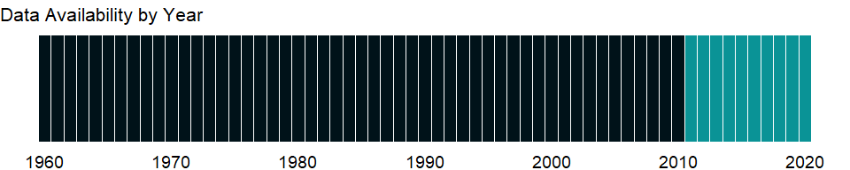

### Which countries have data?

The figure below shows the percentage of countries in each income group with a value since 2010 for that indicator.

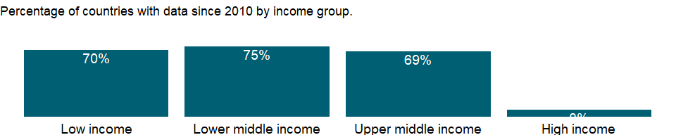

### Why is it relevant?

Reducing the cost of remittance transactions has a direct impact on development by freeing additional resources that, instead of being paid as transaction cost, will remain with the senders and receivers of the flows. Remittance cost is highlighted in Sustainable Development Goal 10. Target 10.c calls for reducing to less than 3 percent the transaction costs of migrant remittances and ensure that in no corridor remittance senders are required to pay more than 5 percent by 2030.

### What is the data source?

World Bank, Remittance Prices Worldwide, available at <http://remittanceprices.worldbank.org>

### What is the methodology?

The World Bank calculates and tracks the global average cost for sending remittances following each iteration of Remittance Prices Worldwide (RPW). This is intended to provide a tool to track the trend of remittance prices by various policy makers, including measuring progress towards the commitment by the G8 member countries to reduce the cost of remittances by five percentage points over five years (the “5x5 Objective”), as well as the commitment by the G20 member countries to also reduce the global average to 5 percent. The Global Average Total Cost is calculated as the average total cost for sending USD 200 with all remittance service providers (RSPs) worldwide. In other terms, the global average total cost is the simple average of the total cost for sending USD 200 charged by each single RSP included in the RPW database, expressed as the percentage of the amount sent. The regional and national average total costs are calculated using the same methodology used to calculate the Global Average Total Cost. These represent the simple average total cost for sending USD 200 with every single RSP to a specific region of the world (regional), or to a specific country (national). The reference years reflect third quarter data here; for example, data for 2016 refers to data in the third quarter of the year. For all quarterly data, visit <http://remittanceprices.worldbank.org>.

### How is it aggregated?

NA

### What are the limitations?

Remittance service providers (RSPs) are excluded when they do not disclose the exchange rate applied to the transaction

### What else should I know?

NA

### 1.23.15 Average transaction cost of sending remittances from a specific country (%)

### What is the indicator?

Average transaction cost of sending remittance from a specific country is the average of the total transaction cost in percentage of the amount sent for sending USD 200 charged by each single remittance service provider (RSP) included in the Remittance Prices Worldwide (RPW) database from a specific country.

Topic: Financial Sector: Access

Series ID: SI.RMT.COST.OB.ZS

Copyright: CC BY-4.0 , <https://datacatalog.worldbank.org/public-licenses#cc-by>

First year with any data: 2011

Last year with any data: 2020

### What years are data available?

The figure below shows years in which data is available for at least one country. Dates shaded in black have no data, while dates shaded in green have data for at least one country



### Which countries have data?

The figure below shows the percentage of countries in each income group with a value since 2010 for that indicator.

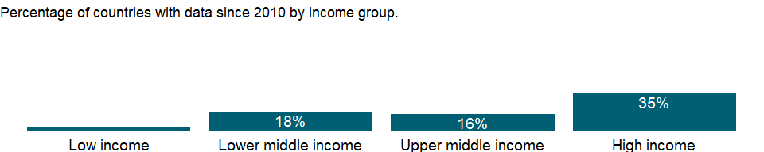

### Why is it relevant?

Reducing the cost of remittance transactions has a direct impact on development by freeing additional resources that, instead of being paid as transaction cost, will remain with the senders and receivers of the flows. Remittance cost is highlighted in Sustainable Development Goal 10. Target 10.c calls for reducing to less than 3 percent the transaction costs of migrant remittances and ensure that in no corridor remittance senders are required to pay more than 5 percent by 2030.

### What is the data source?

World Bank, Remittance Prices Worldwide, available at <http://remittanceprices.worldbank.org>

### What is the methodology?

The World Bank calculates and tracks the global average cost for sending remittances following each iteration of Remittance Prices Worldwide (RPW). This is intended to provide a tool to track the trend of remittance prices by various policy makers, including measuring progress towards the commitment by the G8 member countries to reduce the cost of remittances by five percentage points over five years (the “5x5 Objective”), as well as the commitment by the G20 member countries to also reduce the global average to 5 percent. The Global Average Total Cost is calculated as the average total cost for sending USD 200 with all remittance service providers (RSPs) worldwide. In other terms, the global average total cost is the simple average of the total cost for sending USD 200 charged by each single RSP included in the RPW database, expressed as the percentage of the amount sent. The regional and national average total costs are calculated using the same methodology used to calculate the Global Average Total Cost. These represent the simple average total cost for sending USD 200 with every single RSP from a specific region of the world (regional), or from a specific country (national). The same applies to other averages such as the G8 average, which calculates the average cost of sending USD 200 from the G8 member countries, or the bank average, which represent the average cost of sending USD 200 with a bank worldwide. The reference years reflect third quarter data here; for example, data for 2016 refers to data in the third quarter of the year. For all quarterly data, visit <http://remittanceprices.worldbank.org>.

### How is it aggregated?

NA

### What are the limitations?

Remittance service providers (RSPs) are excluded when they do not disclose the exchange rate applied to the transaction.

### What else should I know?

NA

## 1.24 Financial Sector: Monetary holdings (liabilities)

### 1.24.1 Broad money (current LCU)

### What is the indicator?

Broad money (IFS line 35L..ZK) is the sum of currency outside banks; demand deposits other than those of the central government; the time, savings, and foreign currency deposits of resident sectors other than the central government; bank and traveler’s checks; and other securities such as certificates of deposit and commercial paper.

Topic: Financial Sector: Monetary holdings (liabilities)

Series ID: FM.LBL.BMNY.CN

Copyright: CC BY-4.0 , <https://datacatalog.worldbank.org/public-licenses#cc-by>

First year with any data: 1960

Last year with any data: 2020

### What years are data available?

The figure below shows years in which data is available for at least one country. Dates shaded in black have no data, while dates shaded in green have data for at least one country



### Which countries have data?

The figure below shows the percentage of countries in each income group with a value since 2010 for that indicator.



### Why is it relevant?

NA

### What is the data source?

International Monetary Fund, International Financial Statistics and data files.

### What is the methodology?

NA

### How is it aggregated?

NA

### What are the limitations?

NA

### What else should I know?

NA

### 1.24.2 Broad money (% of GDP)

### What is the indicator?

Broad money (IFS line 35L..ZK) is the sum of currency outside banks; demand deposits other than those of the central government; the time, savings, and foreign currency deposits of resident sectors other than the central government; bank and traveler’s checks; and other securities such as certificates of deposit and commercial paper.

Topic: Financial Sector: Monetary holdings (liabilities)

Series ID: FM.LBL.BMNY.GD.ZS

Copyright: CC BY-4.0 , <https://datacatalog.worldbank.org/public-licenses#cc-by>

First year with any data: 1960

Last year with any data: 2020

### What years are data available?

The figure below shows years in which data is available for at least one country. Dates shaded in black have no data, while dates shaded in green have data for at least one country



### Which countries have data?

The figure below shows the percentage of countries in each income group with a value since 2010 for that indicator.

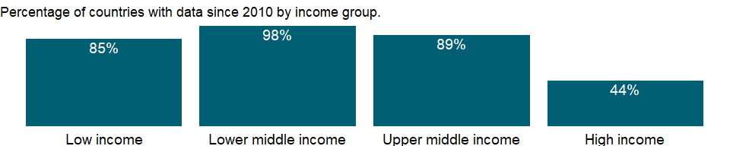

### Why is it relevant?

NA

### What is the data source?

International Monetary Fund, International Financial Statistics and data files, and World Bank and OECD GDP estimates.

### What is the methodology?

NA

### How is it aggregated?

Weighted Average

### What are the limitations?

NA

### What else should I know?

The derivation of this indicator was simplified in September 2012 to be current-year broad money divided by current-year GDP times 100.

### 1.24.3 Broad money to total reserves ratio

### What is the indicator?

Broad money (IFS line 35L..ZK) is the sum of currency outside banks; demand deposits other than those of the central government; the time, savings, and foreign currency deposits of resident sectors other than the central government; bank and traveler’s checks; and other securities such as certificates of deposit and commercial paper.

Topic: Financial Sector: Monetary holdings (liabilities)

Series ID: FM.LBL.BMNY.IR.ZS

Copyright: CC BY-4.0 , <https://datacatalog.worldbank.org/public-licenses#cc-by>

First year with any data: 1960

Last year with any data: 2020

### What years are data available?

The figure below shows years in which data is available for at least one country. Dates shaded in black have no data, while dates shaded in green have data for at least one country



### Which countries have data?

The figure below shows the percentage of countries in each income group with a value since 2010 for that indicator.

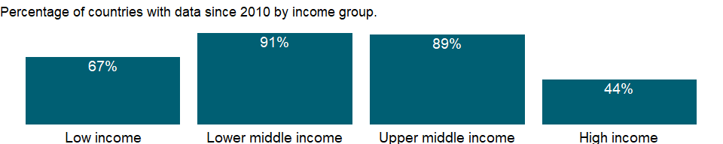

### Why is it relevant?

NA

### What is the data source?

International Monetary Fund, International Financial Statistics and data files.

### What is the methodology?

NA

### How is it aggregated?

NA

### What are the limitations?

NA

### What else should I know?

NA

### 1.24.4 Broad money growth (annual %)

### What is the indicator?

Broad money (IFS line 35L..ZK) is the sum of currency outside banks; demand deposits other than those of the central government; the time, savings, and foreign currency deposits of resident sectors other than the central government; bank and traveler’s checks; and other securities such as certificates of deposit and commercial paper.

Topic: Financial Sector: Monetary holdings (liabilities)

Series ID: FM.LBL.BMNY.ZG

Copyright: CC BY-4.0 , <https://datacatalog.worldbank.org/public-licenses#cc-by>

First year with any data: 1961

Last year with any data: 2020

### What years are data available?

The figure below shows years in which data is available for at least one country. Dates shaded in black have no data, while dates shaded in green have data for at least one country



### Which countries have data?

The figure below shows the percentage of countries in each income group with a value since 2010 for that indicator.



### Why is it relevant?

NA

### What is the data source?

International Monetary Fund, International Financial Statistics and data files.

### What is the methodology?

Money and the financial accounts that record the supply of money lie at the heart of a country’s financial system. There are several commonly used definitions of the money supply. The narrowest, M1, encompasses currency held by the public and demand deposits with banks. M2 includes M1 plus time and savings deposits with banks that require prior notice for withdrawal. M3 includes M2 as well as various money market instruments, such as certificates of deposit issued by banks, bank deposits denominated in foreign currency, and deposits with financial institutions other than banks. However defined, money is a liability of the banking system, distinguished from other bank liabilities by the special role it plays as a medium of exchange, a unit of account, and a store of value.

### How is it aggregated?

NA

### What are the limitations?

Monetary accounts are derived from the balance sheets of financial institutions - the central bank, commercial banks, and nonbank financial intermediaries. Although these balance sheets are usually reliable, they are subject to errors of classification, valuation, and timing and to differences in accounting practices. For example, whether interest income is recorded on an accrual or a cash basis can make a substantial difference, as can the treatment of nonperforming assets. Valuation errors typically arise for foreign exchange transactions, particularly in countries with flexible exchange rates or in countries that have undergone currency devaluation during the reporting period. The valuation of financial derivatives and the net liabilities of the banking system can also be difficult. The quality of commercial bank reporting also may be adversely affected by delays in reports from bank branches, especially in countries where branch accounts are not computerized. Thus the data in the balance sheets of commercial banks may be based on preliminary estimates subject to constant revision. This problem is likely to be even more serious for nonbank financial intermediaries.

### What else should I know?

NA

## 1.25 Financial Sector: Exchange rates & prices

### 1.25.1 Consumer price index (2010 = 100)

### What is the indicator?

Consumer price index reflects changes in the cost to the average consumer of acquiring a basket of goods and services that may be fixed or changed at specified intervals, such as yearly. The Laspeyres formula is generally used. Data are period averages.

Topic: Financial Sector: Exchange rates & prices

Series ID: FP.CPI.TOTL

Copyright: CC BY-4.0 , <https://datacatalog.worldbank.org/public-licenses#cc-by>

First year with any data: 1960

Last year with any data: 2020

### What years are data available?

The figure below shows years in which data is available for at least one country. Dates shaded in black have no data, while dates shaded in green have data for at least one country



### Which countries have data?

The figure below shows the percentage of countries in each income group with a value since 2010 for that indicator.

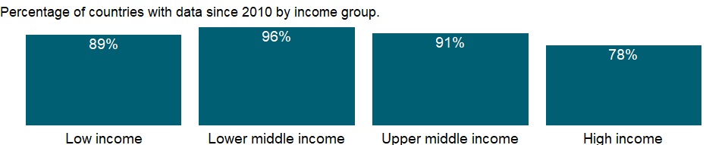

### Why is it relevant?

A general and continuing increase in an economy’s price level is called inflation. The increase in the average prices of goods and services in the economy should be distinguished from a change in the relative prices of individual goods and services. Generally accompanying an overall increase in the price level is a change in the structure of relative prices, but it is only the average increase, not the relative price changes, that constitutes inflation. A commonly used measure of inflation is the consumer price index, which measures the prices of a representative basket of goods and services purchased by a typical household. The consumer price index is usually calculated on the basis of periodic surveys of consumer prices. Other price indices are derived implicitly from indexes of current and constant price series.

### What is the data source?

International Monetary Fund, International Financial Statistics and data files.

### What is the methodology?

Consumer price indexes are constructed explicitly, using surveys of the cost of a defined basket of consumer goods and services.

### How is it aggregated?

NA

### What are the limitations?

Consumer price indexes should be interpreted with caution. The definition of a household, the basket of goods, and the geographic (urban or rural) and income group coverage of consumer price surveys can vary widely by country. In addition, weights are derived from household expenditure surveys, which, for budgetary reasons, tend to be conducted infrequently in developing countries, impairing comparability over time. Although useful for measuring consumer price inflation within a country, consumer price indexes are of less value in comparing countries.

### What else should I know?

NA

### 1.25.2 Inflation, consumer prices (annual %)

### What is the indicator?

Inflation as measured by the consumer price index reflects the annual percentage change in the cost to the average consumer of acquiring a basket of goods and services that may be fixed or changed at specified intervals, such as yearly. The Laspeyres formula is generally used.

Topic: Financial Sector: Exchange rates & prices

Series ID: FP.CPI.TOTL.ZG

Copyright: CC BY-4.0 , <https://datacatalog.worldbank.org/public-licenses#cc-by>

First year with any data: 1960

Last year with any data: 2020

### What years are data available?

The figure below shows years in which data is available for at least one country. Dates shaded in black have no data, while dates shaded in green have data for at least one country



### Which countries have data?

The figure below shows the percentage of countries in each income group with a value since 2010 for that indicator.



### Why is it relevant?

NA

### What is the data source?

International Monetary Fund, International Financial Statistics and data files.

### What is the methodology?

NA

### How is it aggregated?

Median

### What are the limitations?

NA

### What else should I know?

NA

### 1.25.3 Wholesale price index (2010 = 100)

### What is the indicator?

Wholesale price index refers to a mix of agricultural and industrial goods at various stages of production and distribution, including import duties. The Laspeyres formula is generally used.

Topic: Financial Sector: Exchange rates & prices

Series ID: FP.WPI.TOTL

Copyright: CC BY-4.0 , <https://datacatalog.worldbank.org/public-licenses#cc-by>

First year with any data: 1960

Last year with any data: 2020

### What years are data available?

The figure below shows years in which data is available for at least one country. Dates shaded in black have no data, while dates shaded in green have data for at least one country



### Which countries have data?

The figure below shows the percentage of countries in each income group with a value since 2010 for that indicator.

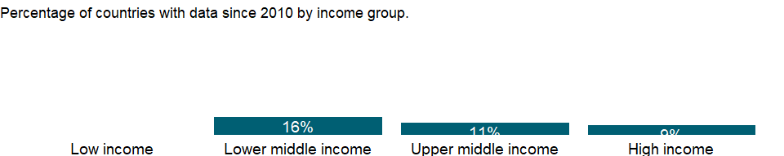

### Why is it relevant?

NA

### What is the data source?

International Monetary Fund, International Financial Statistics and data files.

### What is the methodology?

Wholesale price indexes are based on the prices at the first commercial transaction of commodities that are important in a country’s output or consumption. Prices are farm-gate for agricultural commodities and ex-factory for industrial goods. Preference is given to indexes with the broadest coverage of the economy.

### How is it aggregated?

NA

### What are the limitations?

NA

### What else should I know?

NA

### 1.25.4 Inflation, GDP deflator (annual %)

### What is the indicator?

Inflation as measured by the annual growth rate of the GDP implicit deflator shows the rate of price change in the economy as a whole. The GDP implicit deflator is the ratio of GDP in current local currency to GDP in constant local currency.

Topic: Financial Sector: Exchange rates & prices

Series ID: NY.GDP.DEFL.KD.ZG

Copyright: CC BY-4.0 , <https://datacatalog.worldbank.org/public-licenses#cc-by>

First year with any data: 1961

Last year with any data: 2020

### What years are data available?

The figure below shows years in which data is available for at least one country. Dates shaded in black have no data, while dates shaded in green have data for at least one country



### Which countries have data?

The figure below shows the percentage of countries in each income group with a value since 2010 for that indicator.

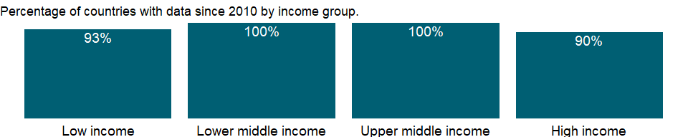

### Why is it relevant?

NA

### What is the data source?

World Bank national accounts data, and OECD National Accounts data files.

### What is the methodology?

NA

### How is it aggregated?

Median

### What are the limitations?

NA

### What else should I know?

NA

### 1.25.5 Inflation, GDP deflator: linked series (annual %)

### What is the indicator?

Inflation as measured by the annual growth rate of the GDP implicit deflator shows the rate of price change in the economy as a whole. This series has been linked to produce a consistent time series to counteract breaks in series over time due to changes in base years, source data and methodologies. Thus, it may not be comparable with other national accounts series in the database for historical years.

Topic: Financial Sector: Exchange rates & prices

Series ID: NY.GDP.DEFL.KD.ZG.AD

Copyright: CC BY-4.0 , <https://datacatalog.worldbank.org/public-licenses#cc-by>

First year with any data: 1990

Last year with any data: 2020

### What years are data available?

The figure below shows years in which data is available for at least one country. Dates shaded in black have no data, while dates shaded in green have data for at least one country



### Which countries have data?

The figure below shows the percentage of countries in each income group with a value since 2010 for that indicator.



### Why is it relevant?

NA

### What is the data source?

World Bank staff estimates based on World Bank national accounts data archives, OECD National Accounts, and the IMF WEO database.

### What is the methodology?

The accuracy of national accounts estimates and their comparability across countries depend on timely revisions to data on GDP and its components. The frequency of revisions to GDP data varies: some countries revise numbers monthly, others quarterly or annually, and others less frequently. Such revisions are usually small and based on additional information received during the year. However, larger revisions are required from time to time to rebase the national accounts and allow for incorporation of new methodologies and data sources.

Comprehensive revisions of GDP data often (but not always) result in upward adjustments to GDP and other major aggregates as improved data sources increase the coverage of the economy. And estimates of GDP growth may change as new weights are introduced. These revisions will cause breaks in series unless they are applied consistently to historical data. For constant price series a break caused by rebasing can be eliminated by linking the old series to the new using historical growth rates.

This inflation series based on the implicit GDP deflator has been linked to produce a consistent time series. It has been calculated by utilizing the change in the implicit GDP deflator in the WDI Archive and IMF WEO databases. Thus, earlier years (linked years) will not be comparable with other national accounts series in the database. Data are available for World Bank operational countries only.

### How is it aggregated?

NA

### What are the limitations?

NA

### What else should I know?

NA

### 1.25.6 GDP deflator (base year varies by country)

### What is the indicator?

The GDP implicit deflator is the ratio of GDP in current local currency to GDP in constant local currency. The base year varies by country.

Topic: Financial Sector: Exchange rates & prices

Series ID: NY.GDP.DEFL.ZS

Copyright: CC BY-4.0 , <https://datacatalog.worldbank.org/public-licenses#cc-by>

First year with any data: 1960

Last year with any data: 2020

### What years are data available?

The figure below shows years in which data is available for at least one country. Dates shaded in black have no data, while dates shaded in green have data for at least one country



### Which countries have data?

The figure below shows the percentage of countries in each income group with a value since 2010 for that indicator.



### Why is it relevant?

NA

### What is the data source?

World Bank national accounts data, and OECD National Accounts data files.

### What is the methodology?

Inflation is measured by the rate of increase in a price index, but actual price change can be negative. The index used depends on the prices being examined. The GDP deflator reflects price changes for total GDP. The most general measure of the overall price level, it accounts for changes in government consumption, capital formation (including inventory appreciation), international trade, and the main component, household final consumption expenditure. The GDP deflator is usually derived implicitly as the ratio of current to constant price GDP - or a Paasche index. It is defective as a general measure of inflation for policy use because of long lags in deriving estimates and because it is often an annual measure.

### How is it aggregated?

NA

### What are the limitations?

NA

### What else should I know?

NA

### 1.25.7 GDP deflator: linked series (base year varies by country)

### What is the indicator?

The GDP implicit deflator is calculated as the ratio of GDP in current local currency to GDP in constant local currency. This series has been linked to produce a consistent time series to counteract breaks in series over time due to changes in base years, source data and methodologies. Thus, it may not be comparable with other national accounts series in the database for historical years. The base year varies by country.

Topic: Financial Sector: Exchange rates & prices

Series ID: NY.GDP.DEFL.ZS.AD

Copyright: CC BY-4.0 , <https://datacatalog.worldbank.org/public-licenses#cc-by>

First year with any data: 1989

Last year with any data: 2020

### What years are data available?

The figure below shows years in which data is available for at least one country. Dates shaded in black have no data, while dates shaded in green have data for at least one country

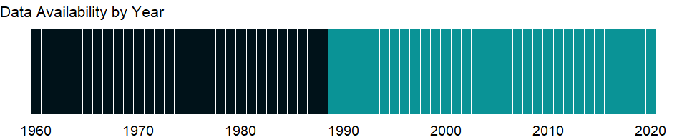

### Which countries have data?

The figure below shows the percentage of countries in each income group with a value since 2010 for that indicator.

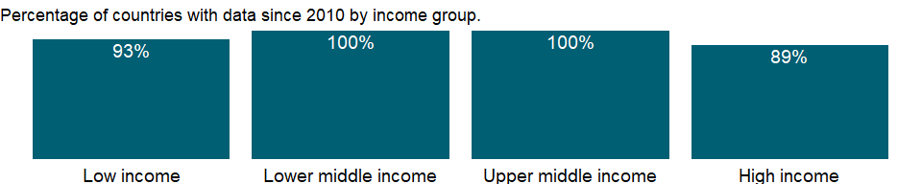

### Why is it relevant?

NA

### What is the data source?

World Bank staff estimates based on World Bank national accounts data archives, OECD National Accounts, and the IMF WEO database.

### What is the methodology?

The accuracy of national accounts estimates and their comparability across countries depend on timely revisions to data on GDP and its components. The frequency of revisions to GDP data varies: some countries revise numbers monthly, others quarterly or annually, and others less frequently. Such revisions are usually small and based on additional information received during the year. However, larger revisions are required from time to time to rebase the national accounts and allow for incorporation of new methodologies and data sources.

Comprehensive revisions of GDP data often (but not always) result in upward adjustments to GDP and other major aggregates as improved data sources increase the coverage of the economy. And estimates of GDP growth may change as new weights are introduced. These revisions will cause breaks in series unless they are applied consistently to historical data. For constant price series a break caused by rebasing can be eliminated by linking the old series to the new using historical growth rates.

This implicit GDP deflator series has been linked to produce a consistent time series. It has been calculated by utilizing the change in the implicit GDP deflator in the WDI Archive and IMF WEO databases. Thus, earlier years (linked years) will not be comparable with other national accounts series in the database. Data are available for World Bank operational countries only.

### How is it aggregated?

NA

### What are the limitations?

NA

### What else should I know?

NA

### 1.25.8 DEC alternative conversion factor (LCU per US$)

### What is the indicator?

The DEC alternative conversion factor is the underlying annual exchange rate used for the World Bank Atlas method. As a rule, it is the official exchange rate reported in the IMF’s International Financial Statistics (line rf). Exceptions arise where further refinements are made by World Bank staff. It is expressed in local currency units per U.S. dollar.

Topic: Financial Sector: Exchange rates & prices

Series ID: PA.NUS.ATLS

Copyright: CC BY-4.0 , <https://datacatalog.worldbank.org/public-licenses#cc-by>

First year with any data: 1960

Last year with any data: 2020

### What years are data available?

The figure below shows years in which data is available for at least one country. Dates shaded in black have no data, while dates shaded in green have data for at least one country



### Which countries have data?

The figure below shows the percentage of countries in each income group with a value since 2010 for that indicator.

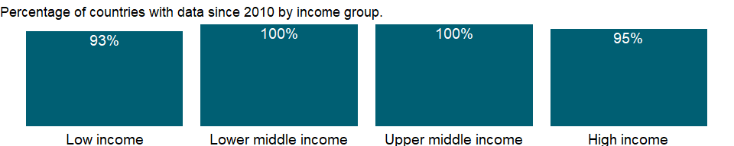

### Why is it relevant?

NA

### What is the data source?

International Monetary Fund, International Financial Statistics, supplemented by World Bank staff estimates.

### What is the methodology?

The World Bank systematically assesses the appropriateness of official exchange rates as conversion factors. An alternative conversion factor is used when the official exchange rate is judged to diverge by an exceptionally large margin from the rate effectively applied to domestic transactions of foreign currencies and traded products. This applies to only a small number of countries, as shown in the country-level metadata. Alternative conversion factors are used in the Atlas methodology and elsewhere in World Development Indicators as single-year conversion factors.

### How is it aggregated?

NA

### What are the limitations?

NA

### What else should I know?

In the WDI database, the DEC alternative conversion factor is used to convert data in local currency units (LCU) into U.S. dollars. For countries with multiple exchange rates, the DEC alternative conversion factor is a weighted average of the different exchange rates.

### 1.25.9 Official exchange rate (LCU per US$, period average)

### What is the indicator?

Official exchange rate refers to the exchange rate determined by national authorities or to the rate determined in the legally sanctioned exchange market. It is calculated as an annual average based on monthly averages (local currency units relative to the U.S. dollar).

Topic: Financial Sector: Exchange rates & prices

Series ID: PA.NUS.FCRF

Copyright: CC BY-4.0 , <https://datacatalog.worldbank.org/public-licenses#cc-by>

First year with any data: 1960

Last year with any data: 2020

### What years are data available?

The figure below shows years in which data is available for at least one country. Dates shaded in black have no data, while dates shaded in green have data for at least one country



### Which countries have data?

The figure below shows the percentage of countries in each income group with a value since 2010 for that indicator.

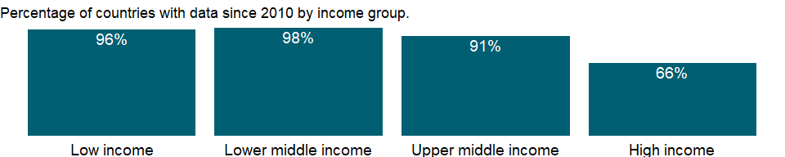

### Why is it relevant?

In a market-based economy, household, producer, and government choices about resource allocation are influenced by relative prices, including the real exchange rate, real wages, real interest rates, and other prices in the economy. Relative prices also largely reflect these agents’ choices. Thus relative prices convey vital information about the interaction of economic agents in an economy and with the rest of the world.

### What is the data source?

International Monetary Fund, International Financial Statistics.

### What is the methodology?

The exchange rate is the price of one currency in terms of another. Official exchange rates and exchange rate arrangements are established by governments. Other exchange rates recognized by governments include market rates, which are determined largely by legal market forces, and for countries with multiple exchange arrangements, principal rates, secondary rates, and tertiary rates.

### How is it aggregated?

NA

### What are the limitations?

Official or market exchange rates are often used to convert economic statistics in local currencies to a common currency in order to make comparisons across countries. Since market rates reflect at best the relative prices of tradable goods, the volume of goods and services that a U.S. dollar buys in the United States may not correspond to what a U.S. dollar converted to another country’s currency at the official exchange rate would buy in that country, particularly when nontradable goods and services account for a significant share of a country’s output. An alternative exchange rate - the purchasing power parity (PPP) conversion factor - is preferred because it reflects differences in price levels for both tradable and nontradable goods and services and therefore provides a more meaningful comparison of real output.

### What else should I know?

NA

### 1.25.10 Real effective exchange rate index (2010 = 100)

### What is the indicator?

Real effective exchange rate is the nominal effective exchange rate (a measure of the value of a currency against a weighted average of several foreign currencies) divided by a price deflator or index of costs.

Topic: Financial Sector: Exchange rates & prices

Series ID: PX.REX.REER

Copyright: CC BY-4.0 , <https://datacatalog.worldbank.org/public-licenses#cc-by>

First year with any data: 1979

Last year with any data: 2020

### What years are data available?

The figure below shows years in which data is available for at least one country. Dates shaded in black have no data, while dates shaded in green have data for at least one country

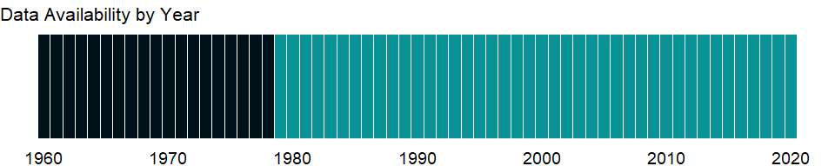

### Which countries have data?

The figure below shows the percentage of countries in each income group with a value since 2010 for that indicator.

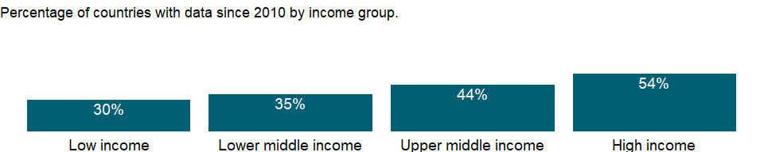

### Why is it relevant?

In a market-based economy, household, producer, and government choices about resource allocation are influenced by relative prices, including the real exchange rate, real wages, real interest rates, and other prices in the economy. Relative prices also largely reflect these agents’ choices. Thus relative prices convey vital information about the interaction of economic agents in an economy and with the rest of the world.

### What is the data source?

International Monetary Fund, International Financial Statistics.

### What is the methodology?

The real effective exchange rate is a nominal effective exchange rate index adjusted for relative movements in national price or cost indicators of the home country, selected countries, and the euro area. A nominal effective exchange rate index is the ratio (expressed on the base 2010 = 100) of an index of a currency’s period-average exchange rate to a weighted geometric average of exchange rates for currencies of selected countries and the euro area. For most high-income countries weights are derived from industrial country trade in manufactured goods. Data are compiled from the nominal effective exchange rate index and a cost indicator of relative normalized unit labor costs in manufacturing. For selected other countries the nominal effective exchange rate index is based on manufactured goods and primary products trade with partner or competitor countries. For these countries the real effective exchange rate index is the nominal index adjusted for relative changes in consumer prices; an increase represents an appreciation of the local currency.

### How is it aggregated?

NA

### What are the limitations?

Because of conceptual and data limitations, changes in real effective exchange rates should be interpreted with caution.

### What else should I know?

NA

## 1.26 Financial Sector: Interest rates

### 1.26.1 Deposit interest rate (%)

### What is the indicator?

Deposit interest rate is the rate paid by commercial or similar banks for demand, time, or savings deposits. The terms and conditions attached to these rates differ by country, however, limiting their comparability.

Topic: Financial Sector: Interest rates

Series ID: FR.INR.DPST

Copyright: CC BY-4.0 , <https://datacatalog.worldbank.org/public-licenses#cc-by>

First year with any data: 1960

Last year with any data: 2020

### What years are data available?

The figure below shows years in which data is available for at least one country. Dates shaded in black have no data, while dates shaded in green have data for at least one country



### Which countries have data?

The figure below shows the percentage of countries in each income group with a value since 2010 for that indicator.

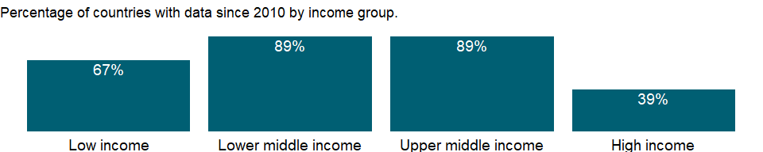

### Why is it relevant?

Both banking and financial systems enhance growth, the main factor in poverty reduction. At low levels of economic development commercial banks tend to dominate the financial system, while at higher levels domestic stock markets tend to become more active and efficient. The size and mobility of international capital flows make it increasingly important to monitor the strength of financial systems. Robust financial systems can increase economic activity and welfare, but instability can disrupt financial activity and impose widespread costs on the economy.

### What is the data source?

International Monetary Fund, International Financial Statistics and data files.

### What is the methodology?

Many interest rates coexist in an economy, reflecting competitive conditions, the terms governing loans and deposits, and differences in the position and status of creditors and debtors. In some economies interest rates are set by regulation or administrative fiat. In economies with imperfect markets, or where reported nominal rates are not indicative of effective rates, it may be difficult to obtain data on interest rates that reflect actual market transactions. Deposit and lending rates are collected by the International Monetary Fund (IMF) as representative interest rates offered by banks to resident customers. The terms and conditions attached to these rates differ by country, however, limiting their comparability.

In 2009 the IMF began publishing a new presentation of monetary statistics for countries that report data in accordance with its Monetary Financial Statistical Manual 2000. The presentation for countries that report data in accordance with its International Financial Statistics (IFS) remains the same.

### How is it aggregated?

NA

### What are the limitations?

Countries use a variety of reporting formats, sample designs, interest compounding formulas, averaging methods, and data presentations for indices and other data series on interest rates. The IMF’s Monetary and Financial Statistics Manual does not provide guidelines beyond the general recommendation that such data should reflect market prices and effective (rather than nominal) interest rates and should be representative of the financial assets and markets to be covered. For more information, please see <http://www.imf.org/external/pubs/ft/mfs/manual/index.htm>.

### What else should I know?

NA

### 1.26.2 Lending interest rate (%)

### What is the indicator?

Lending rate is the bank rate that usually meets the short- and medium-term financing needs of the private sector. This rate is normally differentiated according to creditworthiness of borrowers and objectives of financing. The terms and conditions attached to these rates differ by country, however, limiting their comparability.

Topic: Financial Sector: Interest rates

Series ID: FR.INR.LEND

Copyright: CC BY-4.0 , <https://datacatalog.worldbank.org/public-licenses#cc-by>

First year with any data: 1960

Last year with any data: 2020

### What years are data available?

The figure below shows years in which data is available for at least one country. Dates shaded in black have no data, while dates shaded in green have data for at least one country



### Which countries have data?

The figure below shows the percentage of countries in each income group with a value since 2010 for that indicator.

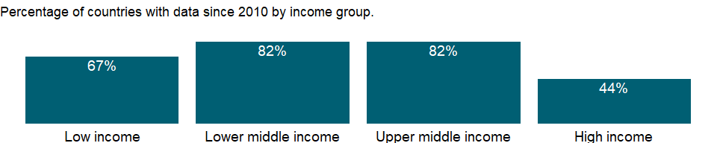

### Why is it relevant?

Both banking and financial systems enhance growth, the main factor in poverty reduction. At low levels of economic development commercial banks tend to dominate the financial system, while at higher levels domestic stock markets tend to become more active and efficient. The size and mobility of international capital flows make it increasingly important to monitor the strength of financial systems. Robust financial systems can increase economic activity and welfare, but instability can disrupt financial activity and impose widespread costs on the economy.

### What is the data source?

International Monetary Fund, International Financial Statistics and data files.

### What is the methodology?

Many interest rates coexist in an economy, reflecting competitive conditions, the terms governing loans and deposits, and differences in the position and status of creditors and debtors. In some economies interest rates are set by regulation or administrative fiat. In economies with imperfect markets, or where reported nominal rates are not indicative of effective rates, it may be difficult to obtain data on interest rates that reflect actual market transactions. Deposit and lending rates are collected by the International Monetary Fund (IMF) as representative interest rates offered by banks to resident customers. The terms and conditions attached to these rates differ by country, however, limiting their comparability.

In 2009 the IMF began publishing a new presentation of monetary statistics for countries that report data in accordance with its Monetary Financial Statistical Manual 2000. The presentation for countries that report data in accordance with its International Financial Statistics (IFS) remains the same.

### How is it aggregated?

NA

### What are the limitations?

Countries use a variety of reporting formats, sample designs, interest compounding formulas, averaging methods, and data presentations for indices and other data series on interest rates. The IMF’s Monetary and Financial Statistics Manual does not provide guidelines beyond the general recommendation that such data should reflect market prices and effective (rather than nominal) interest rates and should be representative of the financial assets and markets to be covered. For more information, please see <http://www.imf.org/external/pubs/ft/mfs/manual/index.htm>.

### What else should I know?

NA

### 1.26.3 Interest rate spread (lending rate minus deposit rate, %)

### What is the indicator?

Interest rate spread is the interest rate charged by banks on loans to private sector customers minus the interest rate paid by commercial or similar banks for demand, time, or savings deposits. The terms and conditions attached to these rates differ by country, however, limiting their comparability.

Topic: Financial Sector: Interest rates

Series ID: FR.INR.LNDP

Copyright: CC BY-4.0 , <https://datacatalog.worldbank.org/public-licenses#cc-by>

First year with any data: 1967

Last year with any data: 2020

### What years are data available?

The figure below shows years in which data is available for at least one country. Dates shaded in black have no data, while dates shaded in green have data for at least one country

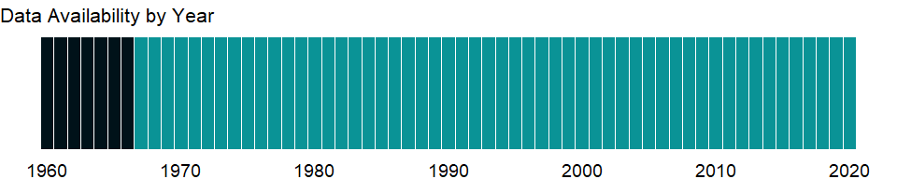

### Which countries have data?

The figure below shows the percentage of countries in each income group with a value since 2010 for that indicator.

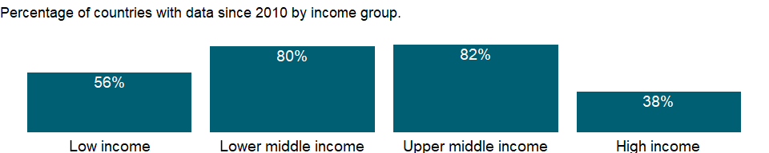

### Why is it relevant?

Both banking and financial systems enhance growth, the main factor in poverty reduction. At low levels of economic development commercial banks tend to dominate the financial system, while at higher levels domestic stock markets tend to become more active and efficient. The size and mobility of international capital flows make it increasingly important to monitor the strength of financial systems. Robust financial systems can increase economic activity and welfare, but instability can disrupt financial activity and impose widespread costs on the economy.

### What is the data source?

International Monetary Fund, International Financial Statistics and data files.

### What is the methodology?

The interest rate spread - the margin between the cost of mobilizing liabilities and the earnings on assets - measures financial sector efficiency in intermediation. A narrow spread means low transaction costs, which reduces the cost of funds for investment, crucial to economic growth.

### How is it aggregated?

Median

### What are the limitations?

Countries use a variety of reporting formats, sample designs, interest compounding formulas, averaging methods, and data presentations for indices and other data series on interest rates. The IMF’s Monetary and Financial Statistics Manual does not provide guidelines beyond the general recommendation that such data should reflect market prices and effective (rather than nominal) interest rates and should be representative of the financial assets and markets to be covered. For more information, please see <http://www.imf.org/external/pubs/ft/mfs/manual/index.htm>.

### What else should I know?

NA

### 1.26.4 Real interest rate (%)

### What is the indicator?

Real interest rate is the lending interest rate adjusted for inflation as measured by the GDP deflator. The terms and conditions attached to lending rates differ by country, however, limiting their comparability.

Topic: Financial Sector: Interest rates

Series ID: FR.INR.RINR

Copyright: CC BY-4.0 , <https://datacatalog.worldbank.org/public-licenses#cc-by>

First year with any data: 1961

Last year with any data: 2020

### What years are data available?

The figure below shows years in which data is available for at least one country. Dates shaded in black have no data, while dates shaded in green have data for at least one country



### Which countries have data?

The figure below shows the percentage of countries in each income group with a value since 2010 for that indicator.



### Why is it relevant?

The banking system’s assets include its net foreign assets and net domestic credit. Net domestic credit includes credit extended to the private sector and general government and credit extended to the nonfinancial public sector in the form of investments in short- and long-term government securities and loans to state enterprises; liabilities to the public and private sectors in the form of deposits with the banking system are netted out. Net domestic credit also includes credit to banking and nonbank financial institutions.

Domestic credit is the main vehicle through which changes in the money supply are regulated, with central bank lending to the government often playing the most important role. The central bank can regulate lending to the private sector in several ways - for example, by adjusting the cost of the refinancing facilities it provides to banks, by changing market interest rates through open market operations, or by controlling the availability of credit through changes in the reserve requirements imposed on banks and ceilings on the credit provided by banks to the private sector.

The real interest rate is used in various economic theories to explain such phenomena as the capital flight, business cycle and economic bubbles. When the real rate of interest is high, that is, demand for credit is high, then money will, all other things being equal, move from consumption to savings. Conversely, when the real rate of interest is low, demand will move from savings to investment and consumption.

### What is the data source?

International Monetary Fund, International Financial Statistics and data files using World Bank data on the GDP deflator.

### What is the methodology?

Many interest rates coexist in an economy, reflecting competitive conditions, the terms governing loans and deposits, and differences in the position and status of creditors and debtors. In some economies interest rates are set by regulation or administrative fiat. In economies with imperfect markets, or where reported nominal rates are not indicative of effective rates, it may be difficult to obtain data on interest rates that reflect actual market transactions. Deposit and lending rates are collected by the International Monetary Fund (IMF) as representative interest rates offered by banks to resident customers. The terms and conditions attached to these rates differ by country, however, limiting their comparability.

Real interest rates are calculated by adjusting nominal rates by an estimate of the inflation rate in the economy. A negative real interest rate indicates a loss in the purchasing power of the principal. The real interest rates are calculated as (i - P) / (1 + P), where i is the nominal lending interest rate and P is the inflation rate (as measured by the GDP deflator).

In 2009 the IMF began publishing a new presentation of monetary statistics for countries that report data in accordance with its Monetary Financial Statistical Manual 2000. The presentation for countries that report data in accordance with its International Financial Statistics (IFS) remains the same.

### How is it aggregated?

NA

### What are the limitations?

NA

### What else should I know?

NA

### 1.26.5 Risk premium on lending (lending rate minus treasury bill rate, %)

### What is the indicator?

Risk premium on lending is the interest rate charged by banks on loans to private sector customers minus the “risk free” treasury bill interest rate at which short-term government securities are issued or traded in the market. In some countries this spread may be negative, indicating that the market considers its best corporate clients to be lower risk than the government. The terms and conditions attached to lending rates differ by country, however, limiting their comparability.

Topic: Financial Sector: Interest rates

Series ID: FR.INR.RISK

Copyright: CC BY-4.0 , <https://datacatalog.worldbank.org/public-licenses#cc-by>

First year with any data: 1960

Last year with any data: 2020

### What years are data available?

The figure below shows years in which data is available for at least one country. Dates shaded in black have no data, while dates shaded in green have data for at least one country



### Which countries have data?

The figure below shows the percentage of countries in each income group with a value since 2010 for that indicator.

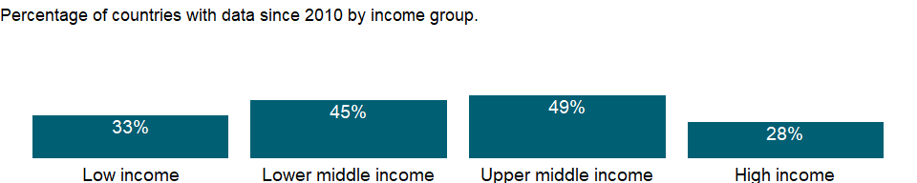

### Why is it relevant?

Both banking and financial systems enhance growth, the main factor in poverty reduction. At low levels of economic development commercial banks tend to dominate the financial system, while at higher levels domestic stock markets tend to become more active and efficient. The size and mobility of international capital flows make it increasingly important to monitor the strength of financial systems. Robust financial systems can increase economic activity and welfare, but instability can disrupt financial activity and impose widespread costs on the economy.

### What is the data source?

International Monetary Fund, International Financial Statistics database.

### What is the methodology?

The risk premium on lending is the spread between the lending rate to the private sector and the “risk-free” government rate. Spreads are expressed as an annual average. A small spread indicates that the market considers its best corporate customers to be low risk; a negative value indicates that the market considers its best corporate clients to be lower risk than the government.

### How is it aggregated?

NA

### What are the limitations?

Countries use a variety of reporting formats, sample designs, interest compounding formulas, averaging methods, and data presentations for indices and other data series on interest rates. The IMF’s Monetary and Financial Statistics Manual does not provide guidelines beyond the general recommendation that such data should reflect market prices and effective (rather than nominal) interest rates and should be representative of the financial assets and markets to be covered. For more information, please see <http://www.imf.org/external/pubs/ft/mfs/manual/index.htm>.

### What else should I know?

NA

## 1.27 Infrastructure: Technology

### 1.27.1 Research and development expenditure (% of GDP)

### What is the indicator?

Gross domestic expenditures on research and development (R&D), expressed as a percent of GDP. They include both capital and current expenditures in the four main sectors: Business enterprise, Government, Higher education and Private non-profit. R&D covers basic research, applied research, and experimental development.

Topic: Infrastructure: Technology

Series ID: GB.XPD.RSDV.GD.ZS

Copyright: CC BY-4.0 , <https://datacatalog.worldbank.org/public-licenses#cc-by>

First year with any data: 1996

Last year with any data: 2018

### What years are data available?

The figure below shows years in which data is available for at least one country. Dates shaded in black have no data, while dates shaded in green have data for at least one country

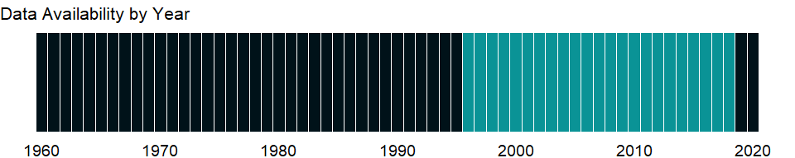

### Which countries have data?

The figure below shows the percentage of countries in each income group with a value since 2010 for that indicator.

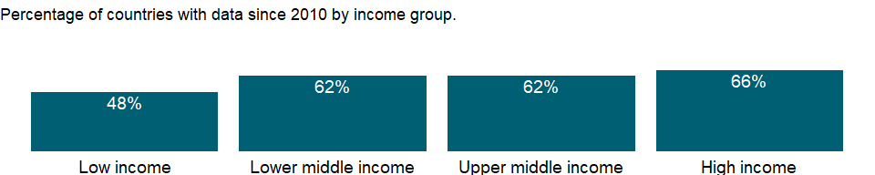

### Why is it relevant?

Expenditure on research and development (R&D) is a key indicator of government and private sector efforts to obtain competitive advantage in science and technology.

### What is the data source?

UNESCO Institute for Statistics (<http://uis.unesco.org/>)

### What is the methodology?

The gross domestic expenditure on R&D indicator consists of the total expenditure (current and capital) on R&D by all resident companies, research institutes, university and government laboratories, etc. It excludes R&D expenditures financed by domestic firms but performed abroad.

The OECD’s Frascati Manual defines research and experimental development as “creative work undertaken on a systemic basis in order to increase the stock of knowledge, including knowledge of man, culture and society, and the use of this stock of knowledge to devise new applications.” R&D covers basic research, applied research, and experimental development.

1. Basic research - Basic research is experimental or theoretical work undertaken primarily to acquire new knowledge of the underlying foundation of phenomena and observable facts, without any particular application or use in view
2. Applied research - Applied research is also original investigation undertaken in order to acquire new knowledge; it is, however, directed primarily towards a specific practical aim or objective.
3. Experimental development - Experimental development is systematic work, drawing on existing knowledge gained from research and/or practical experience, which is directed to producing new materials, products or devices, to installing new processes, systems and services, or to improving substantially those already produced or installed.

The fields of science and technology used to classify R&D according to the Revised Fields of Science and Technology Classification are: 1. Natural sciences; 2. Engineering and technology; 3. Medical and health sciences; 4. Agricultural sciences; 5. Social sciences; 6. Humanities and the arts.

The data are obtained through statistical surveys which are regularly conducted at national level covering R&D performing entities in the private and public sectors.

### How is it aggregated?

Weighted Average

### What are the limitations?

Estimates of the resources allocated to R&D are affected by national characteristics such as the periodicity and coverage of national R&D surveys across institutional sectors and industries; and the use of different sampling and estimation methods. R&D typically involves a few large performers, hence R&D surveys use various techniques to maintain up-to-date registers of known performers, while attempting to identify new or occasional performers.

R&D totals from SNA accounts may differ from these estimates, due in part to the different treatments of software R&D in the totals.

### What else should I know?

NA

### 1.27.2 Industrial design applications, nonresident, by count

### What is the indicator?

Industrial design applications are applications to register an industrial design with a national or regional Intellectual Property (IP) offices and designations received by relevant offices through the Hague System. Industrial designs are applied to a wide variety of industrial products and handicrafts. They refer to the ornamental or aesthetic aspects of a useful article, including compositions of lines or colors or any three-dimensional forms that give a special appearance to a product or handicraft. The holder of a registered industrial design has exclusive rights against unauthorized copying or imitation of the design by third parties. Industrial design registrations are valid for a limited period. The term of protection is usually 15 years for most jurisdictions. However, differences in legislation do exist, notably in China (which provides for a 10-year term from the application date). Non-resident application refers to an application filed with the IP office of or acting on behalf of a state or jurisdiction in which the first-named applicant in the application is not domiciled. Design count is used to render application data for industrial applications across offices comparable, as some offices follow a single-class/single-design filing system while other have a multiple class/design filing system.

Topic: Infrastructure: Technology

Series ID: IP.IDS.NRCT

Copyright: CC BY-4.0 , <https://datacatalog.worldbank.org/public-licenses#cc-by>

First year with any data: 1980

Last year with any data: 2019

### What years are data available?

The figure below shows years in which data is available for at least one country. Dates shaded in black have no data, while dates shaded in green have data for at least one country

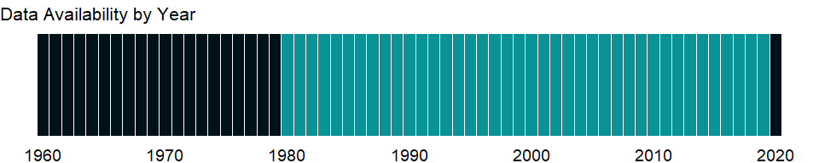

### Which countries have data?

The figure below shows the percentage of countries in each income group with a value since 2010 for that indicator.

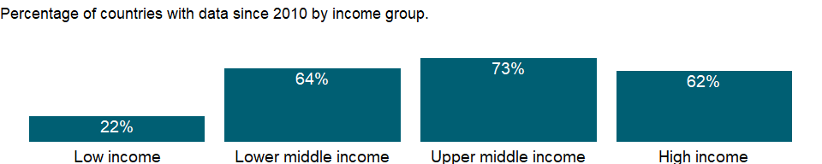

### Why is it relevant?

NA

### What is the data source?

World Intellectual Property Organization (WIPO), Statistics Database at www.wipo.int/ipstats/. The International Bureau of WIPO assumes no responsibility with respect to the transformation of these data.

### What is the methodology?

NA

### How is it aggregated?

Sum

### What are the limitations?

An industrial design right protects only the appearance or aesthetic features of a product, whereas a patent protects an invention that offers a new technical solution to a problem. In principle, an industrial design right does not protect the technical or functional features of a product. Industrial design registrations are valid for a limited period. The term of protection is usually 15 years for most jurisdictions. However, differences in legislation do exist, notably in China (which provides for a 10-year term from the application date). Data are based on information supplied to World Intellectual Property Organization (WIPO) by IP offices in annual surveys, supplemented by data in national IP office reports. Data may be missing for some offices or periods.

### What else should I know?

NA

### 1.27.3 Industrial design applications, resident, by count

### What is the indicator?

Industrial design applications are applications to register an industrial design with a national or regional Intellectual Property (IP) offices and designations received by relevant offices through the Hague System. Industrial designs are applied to a wide variety of industrial products and handicrafts. They refer to the ornamental or aesthetic aspects of a useful article, including compositions of lines or colors or any three-dimensional forms that give a special appearance to a product or handicraft. The holder of a registered industrial design has exclusive rights against unauthorized copying or imitation of the design by third parties. Industrial design registrations are valid for a limited period. The term of protection is usually 15 years for most jurisdictions. However, differences in legislation do exist, notably in China (which provides for a 10-year term from the application date). Resident application refers to an application filed with the IP office of or acting on behalf of the state or jurisdiction in which the first-named applicant in the application has residence. Design count is used to render application data for industrial applications across offices comparable, as some offices follow a single-class/single-design filing system while other have a multiple class/design filing system.

Topic: Infrastructure: Technology

Series ID: IP.IDS.RSCT

Copyright: CC BY-4.0 , <https://datacatalog.worldbank.org/public-licenses#cc-by>

First year with any data: 1980

Last year with any data: 2019

### What years are data available?

The figure below shows years in which data is available for at least one country. Dates shaded in black have no data, while dates shaded in green have data for at least one country



### Which countries have data?

The figure below shows the percentage of countries in each income group with a value since 2010 for that indicator.

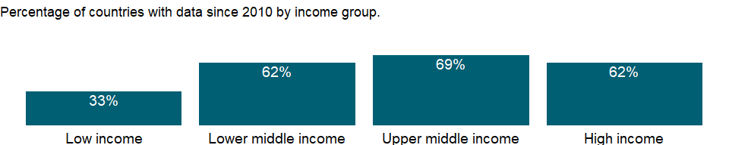

### Why is it relevant?

NA

### What is the data source?

World Intellectual Property Organization (WIPO), Statistics Database at www.wipo.int/ipstats/. The International Bureau of WIPO assumes no responsibility with respect to the transformation of these data.

### What is the methodology?

NA

### How is it aggregated?

Sum

### What are the limitations?

An industrial design right protects only the appearance or aesthetic features of a product, whereas a patent protects an invention that offers a new technical solution to a problem. In principle, an industrial design right does not protect the technical or functional features of a product. Industrial design registrations are valid for a limited period. The term of protection is usually 15 years for most jurisdictions. However, differences in legislation do exist, notably in China (which provides for a 10-year term from the application date). Data are based on information supplied to World Intellectual Property Organization (WIPO) by IP offices in annual surveys, supplemented by data in national IP office reports. Data may be missing for some offices or periods.

### What else should I know?

NA

### 1.27.4 Scientific and technical journal articles

### What is the indicator?

Scientific and technical journal articles refer to the number of scientific and engineering articles published in the following fields: physics, biology, chemistry, mathematics, clinical medicine, biomedical research, engineering and technology, and earth and space sciences.

Topic: Infrastructure: Technology

Series ID: IP.JRN.ARTC.SC

Copyright: CC BY-4.0 , <https://datacatalog.worldbank.org/public-licenses#cc-by>

First year with any data: 2000

Last year with any data: 2018

### What years are data available?

The figure below shows years in which data is available for at least one country. Dates shaded in black have no data, while dates shaded in green have data for at least one country

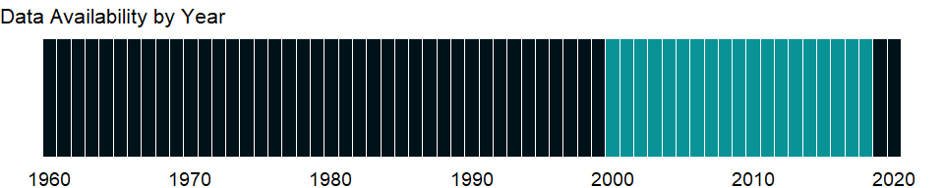

### Which countries have data?

The figure below shows the percentage of countries in each income group with a value since 2010 for that indicator.

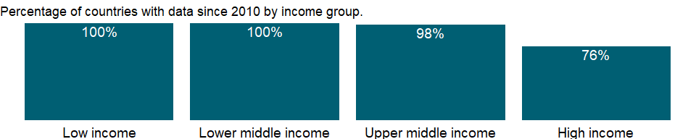

### Why is it relevant?

A scientific journal is a periodical publication intended to further the progress of science, usually by reporting new research. Most journals are highly specialized, although some of the oldest journals such as Nature publish articles and scientific papers across a wide range of scientific fields. Scientific journals contain articles that have been peer reviewed. When a scientific journal describes experiments or calculations, they must supply enough details that an independent researcher could repeat the experiment or calculation to verify the results. Each such journal article becomes part of the permanent scientific record.

Some journals, such as Nature, Science, Proceedings of the National Academy of Sciences of the United States of America (PNAS), and Physical Review Letters, have a reputation of publishing articles that mark a fundamental breakthrough in their respective fields.

### What is the data source?

National Science Foundation, Science and Engineering Indicators.

### What is the methodology?

The number of scientific and engineering articles published in the following fields: physics, biology, chemistry, mathematics, clinical medicine, biomedical research, engineering and technology, and earth and space sciences. The NSF considers article counts from a set of journals covered by Science Citation Index (SCI) and Social Sciences Citation Index (SSCI).

### How is it aggregated?

Gap-filled total

### What are the limitations?

Scientific and technical article counts are from journals classified by the Institute for Scientific Information’s Science Citation Index (SCI) and Social Sciences Citation Index (SSCI). Counts are based on fractional assignments; articles with authors from different countries are allocated proportionately to each country. The SCI and SSCI databases cover the core set of scientific journals but may exclude some of local importance and may reflect some bias toward English-language journals. Articles are classified by year of publication and assigned to region/country/economy on basis of institutional address(es) listed on the article. Articles are counted on a fractional-count basis that is, for articles with collaborating institutions from multiple countries/economies, each country/economy receives fractional credit on basis of proportion of its participating institutions. Details may not add to total because of rounding.

### What else should I know?

NA

### 1.27.5 Patent applications, nonresidents

### What is the indicator?

Patent applications are worldwide patent applications filed through the Patent Cooperation Treaty procedure or with a national patent office for exclusive rights for an invention–a product or process that provides a new way of doing something or offers a new technical solution to a problem. A patent provides protection for the invention to the owner of the patent for a limited period, generally 20 years.

Topic: Infrastructure: Technology

Series ID: IP.PAT.NRES

Copyright: CC BY-4.0 , <https://datacatalog.worldbank.org/public-licenses#cc-by>

First year with any data: 1980

Last year with any data: 2019

### What years are data available?

The figure below shows years in which data is available for at least one country. Dates shaded in black have no data, while dates shaded in green have data for at least one country



### Which countries have data?

The figure below shows the percentage of countries in each income group with a value since 2010 for that indicator.

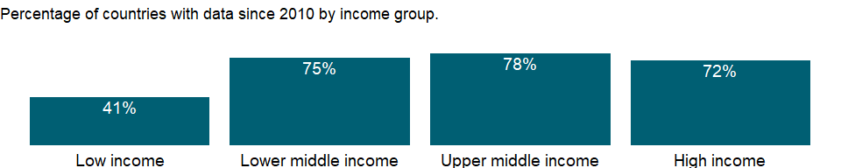

### Why is it relevant?

The Patent Cooperation Treaty (www.wipo.int/pct) provides a two phase system for filing patent. International applications under the treaty provide for a national patent grant only - there is no international patent. The national filing represents the applicant’s seeking of patent protection for a given territory, whereas international filings, while representing a legal right, do not accurately reflect where patent protection is sought. Resident filings are those from residents of the country concerned. Nonresident filings are from applicants abroad. For regional offices applications from residents of any member state of the regional patent convention are considered nonresident filings. Some offices (notably the U.S. Patent and Trademark Office) use the residence of the inventor rather than the applicant to classify filings.

Patent data are a great resource for the study of technical change in a country or region. Patent data provide a uniquely detailed source of information on inventive activity and the multiple dimensions of the inventive process (e.g. geographical location, technical and institutional origin, individuals and networks). Furthermore, patent data form a consistent basis for comparisons across time and across countries.

Patent data can be used in the analysis of a wide array of topics related to technical change and patenting activity including industry-science linkages, patenting strategies by companies, internationalization of research, and indicators on the value of patents. Patent-based statistics reflect the inventive performance of countries, regions and firms, as well as other aspects of the dynamics of the innovation process such as co-operation in innovation or technology paths.

### What is the data source?

World Intellectual Property Organization (WIPO), WIPO Patent Report: Statistics on Worldwide Patent Activity. The International Bureau of WIPO assumes no responsibility with respect to the transformation of these data.

### What is the methodology?

Non-resident patent applications are from applicants outside the relevant State or region. Patent data cover applications and grants classified by field of technology. International applications series distinguish four subcategories: a) patents taken out by residents of a country in that country; b) patents taken out in a country by non-residents of that country; c) total patents registered in the country or naming it; d) patents taken out outside a country by its residents. Data on patents granted only distinguish between patents awarded to residents and to non-residents. A patent provides protection for the invention to the owner of the patent for a limited period, generally 20 years.

Patent applications are worldwide patent applications filed through the Patent Cooperation Treaty procedure or with a national patent office for exclusive rights for an invention - a product or process that provides a new way of doing something or offers a new technical solution to a problem.

### How is it aggregated?

Sum

### What are the limitations?

A patent is an exclusive right granted for a specified period (generally 20 years) for a new way of doing something or a new technical solution to a problem - an invention. The invention must be of practical use and display a characteristic unknown in the existing body of knowledge in its field. Most countries have systems to protect patentable inventions.

Unless otherwise stated, statistics on the number of resident and non-resident patent applications include those filed via the PCT system as PCT national/regional phase entries.

### What else should I know?

NA

### 1.27.6 Patent applications, residents

### What is the indicator?

Patent applications are worldwide patent applications filed through the Patent Cooperation Treaty procedure or with a national patent office for exclusive rights for an invention–a product or process that provides a new way of doing something or offers a new technical solution to a problem. A patent provides protection for the invention to the owner of the patent for a limited period, generally 20 years.

Topic: Infrastructure: Technology

Series ID: IP.PAT.RESD

Copyright: CC BY-4.0 , <https://datacatalog.worldbank.org/public-licenses#cc-by>

First year with any data: 1980

Last year with any data: 2019

### What years are data available?

The figure below shows years in which data is available for at least one country. Dates shaded in black have no data, while dates shaded in green have data for at least one country



### Which countries have data?

The figure below shows the percentage of countries in each income group with a value since 2010 for that indicator.

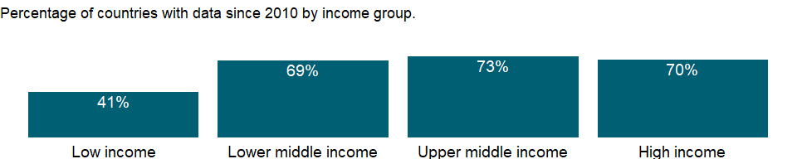

### Why is it relevant?

The Patent Cooperation Treaty (www.wipo.int/pct) provides a two phase system for filing patent. International applications under the treaty provide for a national patent grant only - there is no international patent. The national filing represents the applicant’s seeking of patent protection for a given territory, whereas international filings, while representing a legal right, do not accurately reflect where patent protection is sought. Resident filings are those from residents of the country concerned. Nonresident filings are from applicants abroad. For regional offices applications from residents of any member state of the regional patent convention are considered nonresident filings. Some offices (notably the U.S. Patent and Trademark Office) use the residence of the inventor rather than the applicant to classify filings.

Patent data are a great resource for the study of technical change in a country or region. Patent data provide a uniquely detailed source of information on inventive activity and the multiple dimensions of the inventive process (e.g. geographical location, technical and institutional origin, individuals and networks). Furthermore, patent data form a consistent basis for comparisons across time and across countries.

Patent data can be used in the analysis of a wide array of topics related to technical change and patenting activity including industry-science linkages, patenting strategies by companies, internationalization of research, and indicators on the value of patents. Patent-based statistics reflect the inventive performance of countries, regions and firms, as well as other aspects of the dynamics of the innovation process such as co-operation in innovation or technology paths.

### What is the data source?

World Intellectual Property Organization (WIPO), WIPO Patent Report: Statistics on Worldwide Patent Activity. The International Bureau of WIPO assumes no responsibility with respect to the transformation of these data.

### What is the methodology?

Resident patent applications are those for which the first-named applicant or assignee is a resident of the State or region concerned. In the case of regional offices such as the European Patent Office, a resident is an applicant from any of the member States of the regional patent convention.

Patent data cover applications and grants classified by field of technology. International applications series distinguish four subcategories: a) patents taken out by residents of a country in that country; b) patents taken out in a country by non-residents of that country; c) total patents registered in the country or naming it; d) patents taken out outside a country by its residents. Data on patents granted only distinguish between patents awarded to residents and to non-residents. A patent provides protection for the invention to the owner of the patent for a limited period, generally 20 years.

Patent applications are worldwide patent applications filed through the Patent Cooperation Treaty procedure or with a national patent office for exclusive rights for an invention - a product or process that provides a new way of doing something or offers a new technical solution to a problem.

### How is it aggregated?

Sum

### What are the limitations?

A patent is an exclusive right granted for a specified period (generally 20 years) for a new way of doing something or a new technical solution to a problem - an invention. The invention must be of practical use and display a characteristic unknown in the existing body of knowledge in its field. Most countries have systems to protect patentable inventions.

### What else should I know?

NA

### 1.27.7 Trademark applications, nonresident, by count

### What is the indicator?

Trademark applications filed are applications to register a trademark with a national or regional Intellectual Property (IP) offices and designations received by relevant offices through the Madrid System. A trademark is a distinctive sign which identifies certain goods or services as those produced or provided by a specific person or enterprise. A trademark provides protection to the owner of the mark by ensuring the exclusive right to use it to identify goods or services, or to authorize another to use it in return for payment. The period of protection varies, but a trademark can be renewed indefinitely beyond the time limit on payment of additional fees. Non-resident application refers to an application filed with the IP office of or acting on behalf of a state or jurisdiction in which the first-named applicant in the application is not domiciled. Class count is used to render application data for trademark applications across offices comparable, as some offices follow a single-class/single-design filing system while other have a multiple class/design filing system.

Topic: Infrastructure: Technology

Series ID: IP.TMK.NRCT

Copyright: CC BY-4.0 , <https://datacatalog.worldbank.org/public-licenses#cc-by>

First year with any data: 2004

Last year with any data: 2019

### What years are data available?

The figure below shows years in which data is available for at least one country. Dates shaded in black have no data, while dates shaded in green have data for at least one country



### Which countries have data?

The figure below shows the percentage of countries in each income group with a value since 2010 for that indicator.

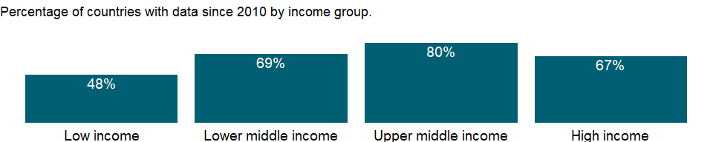

### Why is it relevant?

NA

### What is the data source?

World Intellectual Property Organization (WIPO), Statistics Database at www.wipo.int/ipstats/. The International Bureau of WIPO assumes no responsibility with respect to the transformation of these data.

### What is the methodology?

NA

### How is it aggregated?

Sum

### What are the limitations?

Depending on different legal systems, one or more classes can be specified in a trademark application, with the intent to obtain protection of the mark across different goods and/or services. For cross country comparison purposes, users are advised to refer to the trademark data rendered by the class count in the database 2004 onwards. Data are based on information supplied to World Intellectual Property Organization (WIPO) by IP offices in annual surveys, supplemented by data in national IP office reports. Data may be missing for some offices or periods.

### What else should I know?

NA

### 1.27.8 Trademark applications, direct nonresident

### What is the indicator?

Trademark applications filed are applications to register a trademark with a national or regional Intellectual Property (IP) office. A trademark is a distinctive sign which identifies certain goods or services as those produced or provided by a specific person or enterprise. A trademark provides protection to the owner of the mark by ensuring the exclusive right to use it to identify goods or services, or to authorize another to use it in return for payment. The period of protection varies, but a trademark can be renewed indefinitely beyond the time limit on payment of additional fees. Direct nonresident trademark applications are those filed by applicants from abroad directly at a given national IP office.

Topic: Infrastructure: Technology

Series ID: IP.TMK.NRES

Copyright: CC BY-4.0 , <https://datacatalog.worldbank.org/public-licenses#cc-by>

First year with any data: 1980

Last year with any data: 2019

### What years are data available?

The figure below shows years in which data is available for at least one country. Dates shaded in black have no data, while dates shaded in green have data for at least one country



### Which countries have data?

The figure below shows the percentage of countries in each income group with a value since 2010 for that indicator.

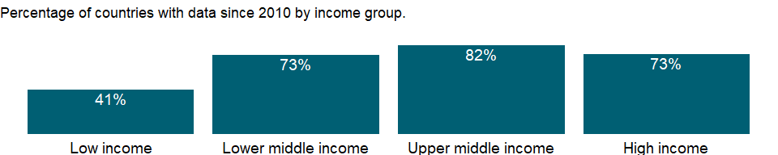

### Why is it relevant?

NA

### What is the data source?

World Intellectual Property Organization (WIPO), WIPO Patent Report: Statistics on Worldwide Patent Activity. The International Bureau of WIPO assumes no responsibility with respect to the transformation of these data.

### What is the methodology?

NA

### How is it aggregated?

Sum

### What are the limitations?

NA

### What else should I know?

NA

### 1.27.9 Trademark applications, direct resident

### What is the indicator?

Trademark applications filed are applications to register a trademark with a national or regional Intellectual Property (IP) office. A trademark is a distinctive sign which identifies certain goods or services as those produced or provided by a specific person or enterprise. A trademark provides protection to the owner of the mark by ensuring the exclusive right to use it to identify goods or services, or to authorize another to use it in return for payment. The period of protection varies, but a trademark can be renewed indefinitely beyond the time limit on payment of additional fees. Direct resident trademark applications are those filed by domestic applicants directly at a given national IP office.

Topic: Infrastructure: Technology

Series ID: IP.TMK.RESD

Copyright: CC BY-4.0 , <https://datacatalog.worldbank.org/public-licenses#cc-by>

First year with any data: 1980

Last year with any data: 2019

### What years are data available?

The figure below shows years in which data is available for at least one country. Dates shaded in black have no data, while dates shaded in green have data for at least one country



### Which countries have data?

The figure below shows the percentage of countries in each income group with a value since 2010 for that indicator.

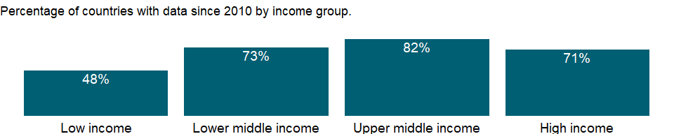

### Why is it relevant?

NA

### What is the data source?

World Intellectual Property Organization (WIPO), WIPO Patent Report: Statistics on Worldwide Patent Activity. The International Bureau of WIPO assumes no responsibility with respect to the transformation of these data.

### What is the methodology?

NA

### How is it aggregated?

Sum

### What are the limitations?

NA

### What else should I know?

NA

### 1.27.10 Trademark applications, resident, by count

### What is the indicator?

Trademark applications filed are applications to register a trademark with a national or regional Intellectual Property (IP) offices and designations received by relevant offices through the Madrid System. A trademark is a distinctive sign which identifies certain goods or services as those produced or provided by a specific person or enterprise. A trademark provides protection to the owner of the mark by ensuring the exclusive right to use it to identify goods or services, or to authorize another to use it in return for payment. The period of protection varies, but a trademark can be renewed indefinitely beyond the time limit on payment of additional fees. Resident application refers to an application filed with the IP office of or acting on behalf of the state or jurisdiction in which the first-named applicant in the application has residence. Class count is used to render application data for trademark applications across offices comparable, as some offices follow a single-class/single-design filing system while other have a multiple class/design filing system.

Topic: Infrastructure: Technology

Series ID: IP.TMK.RSCT

Copyright: CC BY-4.0 , <https://datacatalog.worldbank.org/public-licenses#cc-by>

First year with any data: 2004

Last year with any data: 2019

### What years are data available?

The figure below shows years in which data is available for at least one country. Dates shaded in black have no data, while dates shaded in green have data for at least one country



### Which countries have data?

The figure below shows the percentage of countries in each income group with a value since 2010 for that indicator.

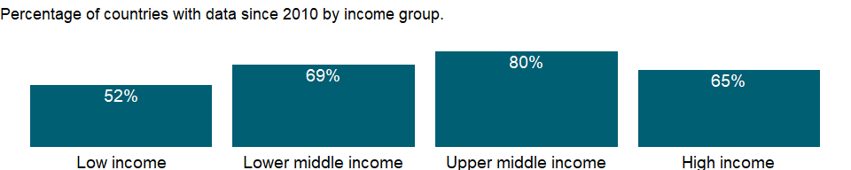

### Why is it relevant?

NA

### What is the data source?

World Intellectual Property Organization (WIPO), Statistics Database at www.wipo.int/ipstats/. The International Bureau of WIPO assumes no responsibility with respect to the transformation of these data.

### What is the methodology?

NA

### How is it aggregated?

Sum

### What are the limitations?

Depending on different legal systems, one or more classes can be specified in a trademark application, with the intent to obtain protection of the mark across different goods and/or services. For cross country comparison purposes, users are advised to refer to the trademark data rendered by the class count in the database 2004 onwards. Data are based on information supplied to World Intellectual Property Organization (WIPO) by IP offices in annual surveys, supplemented by data in national IP office reports. Data may be missing for some offices or periods.

### What else should I know?

NA

### 1.27.11 Trademark applications, total

### What is the indicator?

Trademark applications filed are applications to register a trademark with a national or regional Intellectual Property (IP) office. A trademark is a distinctive sign which identifies certain goods or services as those produced or provided by a specific person or enterprise. A trademark provides protection to the owner of the mark by ensuring the exclusive right to use it to identify goods or services, or to authorize another to use it in return for payment. The period of protection varies, but a trademark can be renewed indefinitely beyond the time limit on payment of additional fees.

Topic: Infrastructure: Technology

Series ID: IP.TMK.TOTL

Copyright: CC BY-4.0 , <https://datacatalog.worldbank.org/public-licenses#cc-by>

First year with any data: 1980

Last year with any data: 2019

### What years are data available?

The figure below shows years in which data is available for at least one country. Dates shaded in black have no data, while dates shaded in green have data for at least one country



### Which countries have data?

The figure below shows the percentage of countries in each income group with a value since 2010 for that indicator.

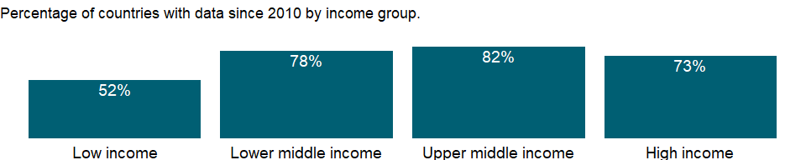

### Why is it relevant?

A trademark is a distinctive sign that identifies certain goods or services as those produced or provided by a specific person or enterprise. The holder of a registered trademark has the legal right to exclusive use of the mark in relation to the products or services for which it is registered. The owner can prevent unauthorized use of the trademark, or a confusingly similar mark, so as to prevent consumers and the public in general from being misled. Unlike patents, trademarks can be maintained indefinitely by paying renewal fees.

The procedures for registering trademarks are governed by the rules and regulations of national and regional IP offices. Trademark rights are limited to the jurisdiction of the authority that registers the trademark. Trademarks can be registered by filing an application at the relevant national or regional office(s), or by filing an international application through the Madrid system.

Many offices in middle- and low-income economies have considerably high numbers of trademark applications compared to other forms of IP, showing the emphasis placed on trademark rights in these markets.

### What is the data source?

World Intellectual Property Organization (WIPO), World Intellectual Property Indicators and www.wipo.int/econ_stat. The International Bureau of WIPO assumes no responsibility with respect to the transformation of these data.

### What is the methodology?

A trademark is a distinctive sign identifying goods or services as produced or provided by a specific person or enterprise. A trademark protects the owner of the mark by ensuring exclusive right to use it to identify goods or services or to authorize another to use it. The period of protection varies, but a trademark can be renewed indefinitely for an additional fee.

### How is it aggregated?

Sum

### What are the limitations?

Detailed components of trademark filings are available at the World Bank at <http://data.worldbank.org>. Data includes applications filed by direct residents (domestic applicants filing directly at a given national or regional intellectual property [IP] office); direct nonresident (foreign applicants filing directly at a given national or regional IP office); aggregate direct (applicants not identified as direct resident or direct nonresident by the national or regional office); and Madrid (designations received by the national or regional IP office based on international applications filed via the World Intellectual Property Organization-administered Madrid System).

Data are based on information supplied to World Intellectual Property Organization (WIPO) by IP offices in annual surveys, supplemented by data in national IP office reports. Data may be missing for some offices or periods.

Trademark registrations are exclusive rights, issued to an applicant by an IP office. For example, registrations are issued to applicants to make use of and exploit their trademark or industrial design for a limited period of time and can, in some cases, particularly in the case of trademarks, be renewed indefinitely.

### What else should I know?

NA

### 1.27.12 Researchers in R&D (per million people)

### What is the indicator?

The number of researchers engaged in Research &Development (R&D), expressed as per million. Researchers are professionals who conduct research and improve or develop concepts, theories, models techniques instrumentation, software of operational methods. R&D covers basic research, applied research, and experimental development.

Topic: Infrastructure: Technology

Series ID: SP.POP.SCIE.RD.P6

Copyright: CC BY-4.0 , <https://datacatalog.worldbank.org/public-licenses#cc-by>

First year with any data: 1996

Last year with any data: 2018

### What years are data available?

The figure below shows years in which data is available for at least one country. Dates shaded in black have no data, while dates shaded in green have data for at least one country



### Which countries have data?

The figure below shows the percentage of countries in each income group with a value since 2010 for that indicator.

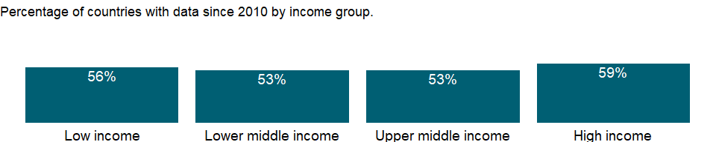

### Why is it relevant?

NA

### What is the data source?

UNESCO Institute for Statistics (<http://uis.unesco.org/>)

### What is the methodology?

Researchers are professionals engaged in the conception or creation of new knowledge, products, processes, methods and systems, as well as in the management of these projects. Students studying at the master’s or doctoral level (ISCED2011 level 7 or 8) engaged in R&D are included.

The OECD’s Frascati Manual defines research and experimental development as “creative work undertaken on a systemic basis in order to increase the stock of knowledge, including knowledge of man, culture and society, and the use of this stock of knowledge to devise new applications.” R&D covers basic research, applied research, and experimental development.

1. Basic research - Basic research is experimental or theoretical work undertaken primarily to acquire new knowledge of the underlying foundation of phenomena and observable facts, without any particular application or use in view.
2. Applied research - Applied research is also original investigation undertaken in order to acquire new knowledge; it is, however, directed primarily towards a specific practical aim or objective.
3. Experimental development - Experimental development is systematic work, drawing on existing knowledge gained from research and/or practical experience, which is directed to producing new materials, products or devices, to installing new processes, systems and services, or to improving substantially those already produced or installed.

The fields of science and technology used to classify R&D according to the Revised Fields of Science and Technology Classification are: 1. Natural sciences; 2. Engineering and technology; 3. Medical and health sciences; 4. Agricultural sciences; 5. Social sciences; 6. Humanities and the arts.

Data are for full-time equivalent (FTE); the FTE of R&D personnel is defined as the ratio of working hours actually spent on R&D during a specific reference period (usually a calendar year) divided by the total number of hours conventionally worked in the same period by an individual or by a group.

The data are obtained through statistical surveys which are regularly conducted at national level covering R&D performing entities in the private and public sectors.

### How is it aggregated?

Weighted Average

### What are the limitations?

Estimates of the resources allocated to R&D are affected by national characteristics such as the periodicity and coverage of national R&D surveys across institutional sectors and industries; and the use of different sampling and estimation methods. R&D typically involves a few large performers, hence R&D surveys use various techniques to maintain up-to-date registers of known performers, while attempting to identify new or occasional performers.

### What else should I know?

NA

### 1.27.13 Technicians in R&D (per million people)

### What is the indicator?

The number of technicians participated in Research & Development (R&D), expressed as per million. Technicians and equivalent staff are people who perform scientific and technical tasks involving the application of concepts and operational methods, normally under the supervision of researchers. R&D covers basic research, applied research, and experimental development.

Topic: Infrastructure: Technology

Series ID: SP.POP.TECH.RD.P6

Copyright: CC BY-4.0 , <https://datacatalog.worldbank.org/public-licenses#cc-by>

First year with any data: 1996

Last year with any data: 2018

### What years are data available?

The figure below shows years in which data is available for at least one country. Dates shaded in black have no data, while dates shaded in green have data for at least one country



### Which countries have data?

The figure below shows the percentage of countries in each income group with a value since 2010 for that indicator.

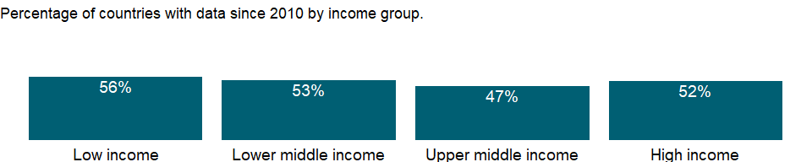

### Why is it relevant?

NA

### What is the data source?

UNESCO Institute for Statistics (<http://uis.unesco.org/>)

### What is the methodology?

Technicians in research and development (R&D) are persons whose main tasks require technical knowledge and experience in one or more fields of engineering, physical and life sciences, or social sciences and humanities.

The OECD’s Frascati Manual defines research and experimental development as “creative work undertaken on a systemic basis in order to increase the stock of knowledge, including knowledge of man, culture and society, and the use of this stock of knowledge to devise new applications.” R&D covers basic research, applied research, and experimental development.

1. Basic research - Basic research is experimental or theoretical work undertaken primarily to acquire new knowledge of the underlying foundation of phenomena and observable facts, without any particular application or use in view.
2. Applied research - Applied research is also original investigation undertaken in order to acquire new knowledge; it is, however, directed primarily towards a specific practical aim or objective.
3. Experimental development - Experimental development is systematic work, drawing on existing knowledge gained from research and/or practical experience, which is directed to producing new materials, products or devices, to installing new processes, systems and services, or to improving substantially those already produced or installed.

The fields of science and technology used to classify R&D according to the Revised Fields of Science and Technology Classification are: 1. Natural sciences; 2. Engineering and technology; 3. Medical and health sciences; 4. Agricultural sciences; 5. Social sciences; 6. Humanities and the arts.

Data are for full-time equivalent (FTE); the FTE of R&D personnel is defined as the ratio of working hours actually spent on R&D during a specific reference period (usually a calendar year) divided by the total number of hours conventionally worked in the same period by an individual or by a group.

The data are obtained through statistical surveys which are regularly conducted at national level covering R&D performing entities in the private and public sectors.

### How is it aggregated?

Weighted Average

### What are the limitations?

Estimates of the resources allocated to R&D are affected by national characteristics such as the periodicity and coverage of national R&D surveys across institutional sectors and industries; and the use of different sampling and estimation methods. R&D typically involves a few large performers, hence R&D surveys use various techniques to maintain up-to-date registers of known performers, while attempting to identify new or occasional performers.

### What else should I know?

NA

### 1.27.14 Medium and high-tech exports (% manufactured exports)

### What is the indicator?

Share of medium and high-tech manufactured exports in total manufactured exports.

Topic: Infrastructure: Technology

Series ID: TX.MNF.TECH.ZS.UN

Copyright: CC BY-4.0 , <https://datacatalog.worldbank.org/public-licenses#cc-by>

First year with any data: 1990

Last year with any data: 2018

### What years are data available?

The figure below shows years in which data is available for at least one country. Dates shaded in black have no data, while dates shaded in green have data for at least one country



### Which countries have data?

The figure below shows the percentage of countries in each income group with a value since 2010 for that indicator.

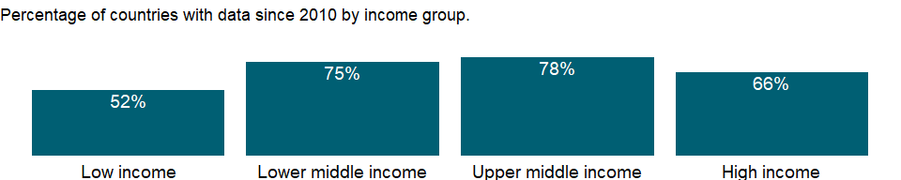

### Why is it relevant?

Industrial development generally entails a structural transition from resource-based and low technology activities to medium and high-tech industry (MHT) activities. A modern, highly complex production structure offers better opportunities for skills development and technological innovation. MHT activities are also the high value addition industries of manufacturing with higher technological intensity and labor productivity. Increasing the share of MHT sectors also reflects the impact of innovation.

### What is the data source?

United Nations Industrial Development Organization (UNIDO), Competitive Industrial Performance (CIP) database

### What is the methodology?

The data from UN COMTRADE is downloaded in SITC Revision 3, 3-digit, by reporting country, year, partner code, commodity and flow (export and re-export). SITC medium technology: 266, 267, 512, 513, 533, 553, 554, 562, 571, 572, 573, 574, 575, 579, 581, 582, 583, 591, 593, 597, 598, 653, 671, 672, 678, 711, 712,713, 714, 721, 722, 723, 724, 725, 726, 727, 728, 731, 733, 735, 737, 741, 742, 743, 744, 745, 746, 747, 748, 749, 761, 762, 763, 772, 773, 775, 778, 781, 782, 783, 784, 785, 786, 791, 793, 811, 812, 813, 872, 873, 882, 884, 885; SITC high technology: 525, 541, 542, 716, 718, 751, 752, 759, 764, 771, 774, 776, 792, 871, 874, 881, 891. Net-exports are calculated as exports minus re-exports. Manufactured exports, is the sum of the four categories resource-based exports, low-tech exports, medium tech exports and high-tech exports; and medium-high technology exports, is the sum of medium tech exports and high-tech exports. The world value of manufacturing exports is the sum of all manufacturing net exports. For additional information please see Table B.2.1 in Appendix B of UNIDO (2017): <http://stat.unido.org/content/publications/volume-i%252c-competitive-industrial-performance-report-2016>

### How is it aggregated?

NA

### What are the limitations?

Missing values at country level are imputed based on the methodology from Competitive Industrial Performance Report (UNIDO, 2017).

### What else should I know?

NA

### 1.27.15 High-technology exports (current US$)

### What is the indicator?

High-technology exports are products with high R&D intensity, such as aerospace, computers, pharmaceuticals, scientific instruments, and electrical machinery. Data are in current U.S. dollars.

Topic: Infrastructure: Technology

Series ID: TX.VAL.TECH.CD

Copyright: CC BY-4.0 , <https://datacatalog.worldbank.org/public-licenses#cc-by>

First year with any data: 2007

Last year with any data: 2020

### What years are data available?

The figure below shows years in which data is available for at least one country. Dates shaded in black have no data, while dates shaded in green have data for at least one country

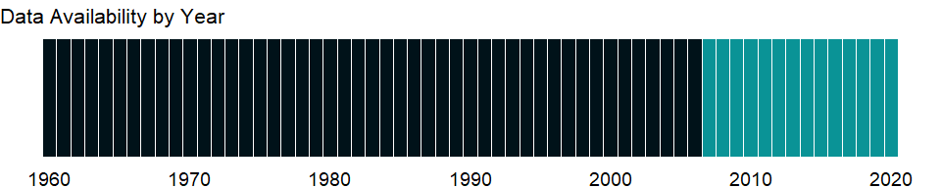

### Which countries have data?

The figure below shows the percentage of countries in each income group with a value since 2010 for that indicator.

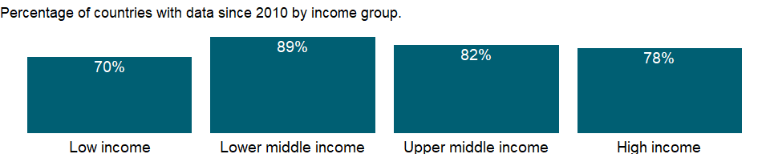

### Why is it relevant?

The OECD has developed a four-way classification of exports: high, medium-high, medium-low and low-technology. The classification is based on the importance of expenditures on research and development relative to the gross output and value added of different types of industries that produce goods for export. Examples of high-technology industries are aircraft, computers, and pharmaceuticals; medium-high-technology includes motor vehicles, electrical equipment and most chemicals; medium-low-technology includes rubber, plastics, basic metals and ship construction; low-technology industries include food processing, textiles, clothing and footwear.

### What is the data source?

United Nations, Comtrade database through the WITS platform.

### What is the methodology?

High technology products are defined according to SITC Rev.4 as the sum of the following products: Aerospace, Computers-office machines, Electronics-telecommunications, Pharmacy, Scientific instruments, Electrical machinery, Chemistry, Non-electrical machinery, Armament. The following product codes are used: Aerospace: (714 – 71489 -71499)+7921+7922+7924+7925+79291+79293+87411; Computers-office machines: 75194+75195+752+75997; Electronics-communication: 76331+7638+(764-76493-76499)+7722+77261+77318+77625+77627+7763+7764+7768+89844+89846; Pharmacy: 5413+5415+5416+5421+5422; Scientific instruments: 774+871+87211+(874-87411-8742)+88111+88121+88411+88419+(8996-89965-89969); Electrical machinery: (7786-77861-777866-77869)+7787+77884; Chemistry: 52222+52223+52229+52269+525+531+57433+591; Non-electrical machinery: 71489+71499+7187+72847+7311+73131+73135+73142+73144+73151+73153+73161+73163+73165+73312+73314+73316+7359+73733+73735; Armament: 891 The list can also be accessed on the Eurostat website. This list, based on the OECD definition, contains technical products of which the manufacturing involved a high intensity of R&D. The original high-tech products classification is based on SITC Rev. 3 and is taken from Table 4 of Annex 2 of the 1997 working paper of Thomas Hatzichronouglou, OECD. In September 2019 the definition in the World Development Indicators database was updated to SITC Rev.4 from SITC Rev. 3. The data are in current U.S. dollars and are sourced from the UN’s Comtrade database.

### How is it aggregated?

Sum

### What are the limitations?

Because industrial sectors specializing in a few high-technology products may also produce low-technology products, the product approach is more appropriate for international trade. The method takes only R&D intensity into account, but other characteristics of high technology are also important, such as knowhow, scientific personnel, and technology embodied in patents. Considering these characteristics would yield a different list (see Hatzichronoglou 1997). The indicator is based on data reported by countries to COMTRADE. The export values presented in the World Development Indicators represent Gross Exports less Re-Exports. The values may be impacted in cases of reporting errors or missing data, for example if countries do not report Re-Exports for one or more periods.

### What else should I know?

NA

### 1.27.16 High-technology exports (% of manufactured exports)

### What is the indicator?

High-technology exports are products with high R&D intensity, such as in aerospace, computers, pharmaceuticals, scientific instruments, and electrical machinery.

Topic: Infrastructure: Technology

Series ID: TX.VAL.TECH.MF.ZS

Copyright: CC BY-4.0 , <https://datacatalog.worldbank.org/public-licenses#cc-by>

First year with any data: 2007

Last year with any data: 2020

### What years are data available?

The figure below shows years in which data is available for at least one country. Dates shaded in black have no data, while dates shaded in green have data for at least one country



### Which countries have data?

The figure below shows the percentage of countries in each income group with a value since 2010 for that indicator.

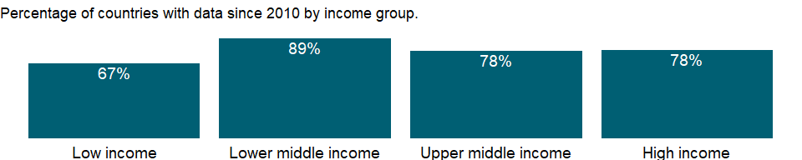

### Why is it relevant?

The OECD has developed a four-way classification of exports: high, medium-high, medium-low and low-technology. The classification is based on the importance of expenditures on research and development relative to the gross output and value added of different types of industries that produce goods for export. Examples of high-technology industries are aircraft, computers, and pharmaceuticals; medium-high-technology includes motor vehicles, electrical equipment and most chemicals; medium-low-technology includes rubber, plastics, basic metals and ship construction; low-technology industries include food processing, textiles, clothing and footwear.

Industries of high and medium-high-technology intensity account for over two-thirds of total OECD manufacturing exports. Differences among countries are substantial; the share of high and medium-high-technology industries ranges from over 80 percent in Japan and Ireland to less than 10 percent in Iceland. Technology exports have grown rapidly in Iceland, Turkey and the eastern European countries, although most of these countries, with Hungary and the Czech Republic as exceptions, still focus primarily on low and medium-low-technology exports.

### What is the data source?

United Nations, Comtrade database through the WITS platform.

### What is the methodology?

The method for determining high-technology exports was developed by the Organisation for Economic Co-operation and Development in collaboration with Eurostat. It takes a “product approach” (rather than a “sectoral approach”) based on R&D intensity (expenditure divided by total sales) for groups of products from Germany, Italy, Japan, the Netherlands, Sweden, and the United States.

The original high-tech products classification is based on SITC Rev. 3 and is taken from Table 4 of Annex 2 of the 1997 working paper of Thomas Hatzichronouglou, OECD. The methodology used to determine high-tech exports takes the “product approach” based on R&D intensity on products from Germany, Italy, Japan, the Netherlands, Sweden, and the United States.

High Technology Products List - SITC Rev. 3: 1 Aerospace 7921+7922+7923+7924+7925+79291+79293+(714-71489-71499)+87411 2 Computers-office machines 75113+75131+75132+75134+(752-7529)+75997 3 Electronics-telecommunications 76381+76383+(764-76493-76499) +7722+77261+77318+77625+77627+7763+7764+7768+89879 4 Pharmacy 5413+5415+5416+5421+5422 5 Scientific instruments 774+8711+8713+8714+8719+87211+(874-87411-8742) +88111+88121+88411+88419+89961+89963+89966+89967 6 Electrical machinery 77862+77863+77864+77865+7787+77884 7 Chemistry 52222+52223+52229+52269+525+531+57433+591 8 Non-electrical machinery 71489+71499+71871+71877+71878+72847+7311+73131+73135 +73142+73144+73151+73153+73161+73163+73165 +73312+73314+73316+7359+73733+73735 9 Armament 891

### How is it aggregated?

Weighted Average

### What are the limitations?

Because industrial sectors specializing in a few high-technology products may also produce low-technology products, the product approach is more appropriate for international trade. The method takes only R&D intensity into account, but other characteristics of high technology are also important, such as knowhow, scientific personnel, and technology embodied in patents. Considering these characteristics would yield a different list (see Hatzichronoglou 1997).

### What else should I know?

NA

## 1.28 Public Sector: Government finance: Deficit & financing

### 1.28.1 Net acquisition of financial assets (current LCU)

### What is the indicator?

Net acquisition of government financial assets includes domestic and foreign financial claims, SDRs, and gold bullion held by monetary authorities as a reserve asset. The net acquisition of financial assets should be offset by the net incurrence of liabilities.

Topic: Public Sector: Government finance: Deficit & financing

Series ID: GC.AST.TOTL.CN

Copyright: CC BY-4.0 , <https://datacatalog.worldbank.org/public-licenses#cc-by>

First year with any data: 1970

Last year with any data: 2020

### What years are data available?

The figure below shows years in which data is available for at least one country. Dates shaded in black have no data, while dates shaded in green have data for at least one country



### Which countries have data?

The figure below shows the percentage of countries in each income group with a value since 2010 for that indicator.

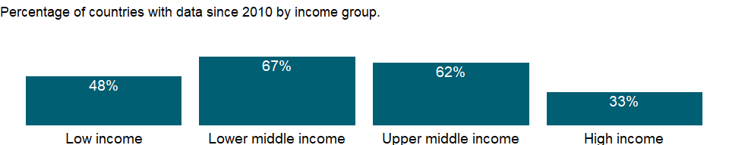

### Why is it relevant?

NA

### What is the data source?

International Monetary Fund, Government Finance Statistics Yearbook and data files.

### What is the methodology?

The IMF’s Government Finance Statistics Manual 2014, harmonized with the 2008 SNA, recommends an accrual accounting method, focusing on all economic events affecting assets, liabilities, revenues, and expenses, not just those represented by cash transactions. It accounts for all changes in stocks, so stock data at the end of an accounting period equal stock data at the beginning of the period plus flows over the period. The 1986 manual considered only debt stocks.

Government finance statistics are reported in local currency. Many countries report government finance data by fiscal year; see country metadata for information on fiscal year end by country.

### How is it aggregated?

NA

### What are the limitations?

For most countries central government finance data have been consolidated into one account, but for others only budgetary central government accounts are available. Countries reporting budgetary data are noted in the country metadata. Because budgetary accounts may not include all central government units (such as social security funds), they usually provide an incomplete picture. In federal states the central government accounts provide an incomplete view of total public finance.

Data on government revenue and expense are collected by the IMF through questionnaires to member countries and by the Organisation for Economic Co-operation and Development (OECD). Despite IMF efforts to standardize data collection, statistics are often incomplete, untimely, and not comparable across countries.

### What else should I know?

NA

### 1.28.2 Net acquisition of financial assets (% of GDP)

### What is the indicator?

Net acquisition of government financial assets includes domestic and foreign financial claims, SDRs, and gold bullion held by monetary authorities as a reserve asset. The net acquisition of financial assets should be offset by the net incurrence of liabilities.

Topic: Public Sector: Government finance: Deficit & financing

Series ID: GC.AST.TOTL.GD.ZS

Copyright: CC BY-4.0 , <https://datacatalog.worldbank.org/public-licenses#cc-by>

First year with any data: 1970

Last year with any data: 2020

### What years are data available?

The figure below shows years in which data is available for at least one country. Dates shaded in black have no data, while dates shaded in green have data for at least one country



### Which countries have data?

The figure below shows the percentage of countries in each income group with a value since 2010 for that indicator.



### Why is it relevant?

NA

### What is the data source?

International Monetary Fund, Government Finance Statistics Yearbook and data files.

### What is the methodology?

The IMF’s Government Finance Statistics Manual 2014, harmonized with the 2008 SNA, recommends an accrual accounting method, focusing on all economic events affecting assets, liabilities, revenues, and expenses, not just those represented by cash transactions. It accounts for all changes in stocks, so stock data at the end of an accounting period equal stock data at the beginning of the period plus flows over the period. The 1986 manual considered only debt stocks.

Government finance statistics are reported in local currency. Many countries report government finance data by fiscal year; see country metadata for information on fiscal year end by country.

### How is it aggregated?

Weighted Average

### What are the limitations?

For most countries central government finance data have been consolidated into one account, but for others only budgetary central government accounts are available. Countries reporting budgetary data are noted in the country metadata. Because budgetary accounts may not include all central government units (such as social security funds), they usually provide an incomplete picture. In federal states the central government accounts provide an incomplete view of total public finance.

Data on government revenue and expense are collected by the IMF through questionnaires to member countries and by the Organisation for Economic Co-operation and Development (OECD). Despite IMF efforts to standardize data collection, statistics are often incomplete, untimely, and not comparable across countries.

### What else should I know?

NA

### 1.28.3 Central government debt, total (current LCU)

### What is the indicator?

Debt is the entire stock of direct government fixed-term contractual obligations to others outstanding on a particular date. It includes domestic and foreign liabilities such as currency and money deposits, securities other than shares, and loans. It is the gross amount of government liabilities reduced by the amount of equity and financial derivatives held by the government. Because debt is a stock rather than a flow, it is measured as of a given date, usually the last day of the fiscal year.

Topic: Public Sector: Government finance: Deficit & financing

Series ID: GC.DOD.TOTL.CN

Copyright: CC BY-4.0 , <https://datacatalog.worldbank.org/public-licenses#cc-by>

First year with any data: 1970

Last year with any data: 2017

### What years are data available?

The figure below shows years in which data is available for at least one country. Dates shaded in black have no data, while dates shaded in green have data for at least one country

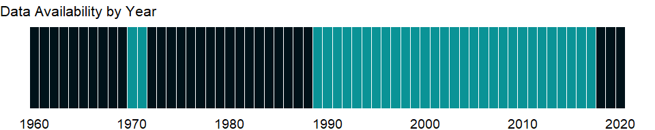

### Which countries have data?

The figure below shows the percentage of countries in each income group with a value since 2010 for that indicator.

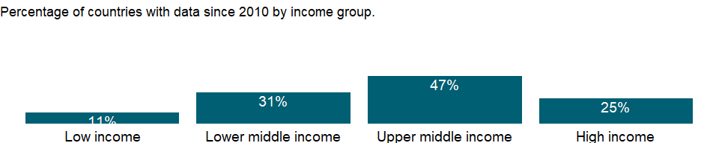

### Why is it relevant?

NA

### What is the data source?

International Monetary Fund, Government Finance Statistics Yearbook and data files.

### What is the methodology?

The IMF’s Government Finance Statistics Manual 2014, harmonized with the 2008 SNA, recommends an accrual accounting method, focusing on all economic events affecting assets, liabilities, revenues, and expenses, not just those represented by cash transactions. It accounts for all changes in stocks, so stock data at the end of an accounting period equal stock data at the beginning of the period plus flows over the period. The 1986 manual considered only debt stocks.

Government finance statistics are reported in local currency. Many countries report government finance data by fiscal year; see country metadata for information on fiscal year end by country.

### How is it aggregated?

NA

### What are the limitations?

For most countries central government finance data have been consolidated into one account, but for others only budgetary central government accounts are available. Countries reporting budgetary data are noted in the country metadata. Because budgetary accounts may not include all central government units (such as social security funds), they usually provide an incomplete picture. In federal states the central government accounts provide an incomplete view of total public finance.

Data on government revenue and expense are collected by the IMF through questionnaires to member countries and by the Organisation for Economic Co-operation and Development (OECD). Despite IMF efforts to standardize data collection, statistics are often incomplete, untimely, and not comparable across countries.

### What else should I know?

NA

### 1.28.4 Central government debt, total (% of GDP)

### What is the indicator?

Debt is the entire stock of direct government fixed-term contractual obligations to others outstanding on a particular date. It includes domestic and foreign liabilities such as currency and money deposits, securities other than shares, and loans. It is the gross amount of government liabilities reduced by the amount of equity and financial derivatives held by the government. Because debt is a stock rather than a flow, it is measured as of a given date, usually the last day of the fiscal year.

Topic: Public Sector: Government finance: Deficit & financing

Series ID: GC.DOD.TOTL.GD.ZS

Copyright: CC BY-4.0 , <https://datacatalog.worldbank.org/public-licenses#cc-by>

First year with any data: 1970

Last year with any data: 2017

### What years are data available?

The figure below shows years in which data is available for at least one country. Dates shaded in black have no data, while dates shaded in green have data for at least one country



### Which countries have data?

The figure below shows the percentage of countries in each income group with a value since 2010 for that indicator.



### Why is it relevant?

NA

### What is the data source?

International Monetary Fund, Government Finance Statistics Yearbook and data files, and World Bank and OECD GDP estimates.

### What is the methodology?

The IMF’s Government Finance Statistics Manual 2014, harmonized with the 2008 SNA, recommends an accrual accounting method, focusing on all economic events affecting assets, liabilities, revenues, and expenses, not just those represented by cash transactions. It accounts for all changes in stocks, so stock data at the end of an accounting period equal stock data at the beginning of the period plus flows over the period. The 1986 manual considered only debt stocks.

Government finance statistics are reported in local currency. Many countries report government finance data by fiscal year; see country metadata for information on fiscal year end by country.

### How is it aggregated?

Weighted average

### What are the limitations?

For most countries central government finance data have been consolidated into one account, but for others only budgetary central government accounts are available. Countries reporting budgetary data are noted in the country metadata. Because budgetary accounts may not include all central government units (such as social security funds), they usually provide an incomplete picture. In federal states the central government accounts provide an incomplete view of total public finance.

Data on government revenue and expense are collected by the IMF through questionnaires to member countries and by the Organisation for Economic Co-operation and Development (OECD). Despite IMF efforts to standardize data collection, statistics are often incomplete, untimely, and not comparable across countries.

### What else should I know?

NA

### 1.28.5 Net incurrence of liabilities, total (current LCU)

### What is the indicator?

Net incurrence of government liabilities includes foreign financing (obtained from nonresidents) and domestic financing (obtained from residents), or the means by which a government provides financial resources to cover a budget deficit or allocates financial resources arising from a budget surplus. The net incurrence of liabilities should be offset by the net acquisition of financial assets.

Topic: Public Sector: Government finance: Deficit & financing

Series ID: GC.LBL.TOTL.CN

Copyright: CC BY-4.0 , <https://datacatalog.worldbank.org/public-licenses#cc-by>

First year with any data: 1972

Last year with any data: 2020

### What years are data available?

The figure below shows years in which data is available for at least one country. Dates shaded in black have no data, while dates shaded in green have data for at least one country

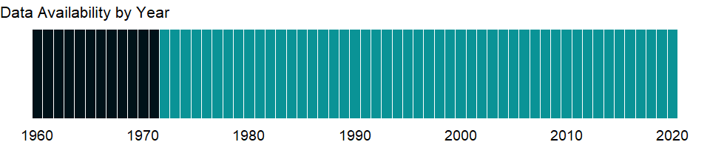

### Which countries have data?

The figure below shows the percentage of countries in each income group with a value since 2010 for that indicator.

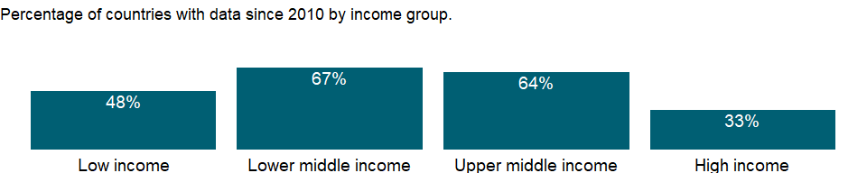

### Why is it relevant?

NA

### What is the data source?

International Monetary Fund, Government Finance Statistics Yearbook and data files.

### What is the methodology?

The IMF’s Government Finance Statistics Manual 2014, harmonized with the 2008 SNA, recommends an accrual accounting method, focusing on all economic events affecting assets, liabilities, revenues, and expenses, not just those represented by cash transactions. It accounts for all changes in stocks, so stock data at the end of an accounting period equal stock data at the beginning of the period plus flows over the period. The 1986 manual considered only debt stocks.

Government finance statistics are reported in local currency. Many countries report government finance data by fiscal year; see country metadata for information on fiscal year end by country.

### How is it aggregated?

NA

### What are the limitations?

For most countries central government finance data have been consolidated into one account, but for others only budgetary central government accounts are available. Countries reporting budgetary data are noted in the country metadata. Because budgetary accounts may not include all central government units (such as social security funds), they usually provide an incomplete picture. In federal states the central government accounts provide an incomplete view of total public finance.

Data on government revenue and expense are collected by the IMF through questionnaires to member countries and by the Organisation for Economic Co-operation and Development (OECD). Despite IMF efforts to standardize data collection, statistics are often incomplete, untimely, and not comparable across countries.

### What else should I know?

NA

### 1.28.6 Net incurrence of liabilities, total (% of GDP)

### What is the indicator?

Net incurrence of government liabilities includes foreign financing (obtained from nonresidents) and domestic financing (obtained from residents), or the means by which a government provides financial resources to cover a budget deficit or allocates financial resources arising from a budget surplus. The net incurrence of liabilities should be offset by the net acquisition of financial assets.

Topic: Public Sector: Government finance: Deficit & financing

Series ID: GC.LBL.TOTL.GD.ZS

Copyright: CC BY-4.0 , <https://datacatalog.worldbank.org/public-licenses#cc-by>

First year with any data: 1972

Last year with any data: 2020

### What years are data available?

The figure below shows years in which data is available for at least one country. Dates shaded in black have no data, while dates shaded in green have data for at least one country



### Which countries have data?

The figure below shows the percentage of countries in each income group with a value since 2010 for that indicator.



### Why is it relevant?

NA

### What is the data source?

International Monetary Fund, Government Finance Statistics Yearbook and data files.

### What is the methodology?

The IMF’s Government Finance Statistics Manual 2014, harmonized with the 2008 SNA, recommends an accrual accounting method, focusing on all economic events affecting assets, liabilities, revenues, and expenses, not just those represented by cash transactions. It accounts for all changes in stocks, so stock data at the end of an accounting period equal stock data at the beginning of the period plus flows over the period. The 1986 manual considered only debt stocks.

Government finance statistics are reported in local currency. Many countries report government finance data by fiscal year; see country metadata for information on fiscal year end by country.

### How is it aggregated?

Weighted Average

### What are the limitations?

For most countries central government finance data have been consolidated into one account, but for others only budgetary central government accounts are available. Countries reporting budgetary data are noted in the country metadata. Because budgetary accounts may not include all central government units (such as social security funds), they usually provide an incomplete picture. In federal states the central government accounts provide an incomplete view of total public finance.

Data on government revenue and expense are collected by the IMF through questionnaires to member countries and by the Organisation for Economic Co-operation and Development (OECD). Despite IMF efforts to standardize data collection, statistics are often incomplete, untimely, and not comparable across countries.

### What else should I know?

NA

### 1.28.7 Net investment in nonfinancial assets (current LCU)

### What is the indicator?

Net investment in government nonfinancial assets includes fixed assets, inventories, valuables, and nonproduced assets. Nonfinancial assets are stores of value and provide benefits either through their use in the production of goods and services or in the form of property income and holding gains. Net investment in nonfinancial assets also includes consumption of fixed capital.

Topic: Public Sector: Government finance: Deficit & financing

Series ID: GC.NFN.TOTL.CN

Copyright: CC BY-4.0 , <https://datacatalog.worldbank.org/public-licenses#cc-by>

First year with any data: 1972

Last year with any data: 2017

### What years are data available?

The figure below shows years in which data is available for at least one country. Dates shaded in black have no data, while dates shaded in green have data for at least one country

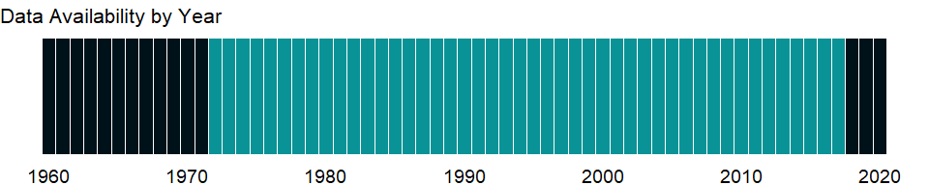

### Which countries have data?

The figure below shows the percentage of countries in each income group with a value since 2010 for that indicator.

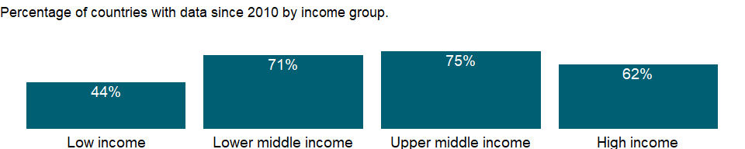

### Why is it relevant?

NA

### What is the data source?

International Monetary Fund, Government Finance Statistics Yearbook and data files.

### What is the methodology?

The IMF’s Government Finance Statistics Manual 2014, harmonized with the 2008 SNA, recommends an accrual accounting method, focusing on all economic events affecting assets, liabilities, revenues, and expenses, not just those represented by cash transactions. It accounts for all changes in stocks, so stock data at the end of an accounting period equal stock data at the beginning of the period plus flows over the period. The 1986 manual considered only debt stocks.

Government finance statistics are reported in local currency. Many countries report government finance data by fiscal year; see country metadata for information on fiscal year end by country.

### How is it aggregated?

NA

### What are the limitations?

For most countries central government finance data have been consolidated into one account, but for others only budgetary central government accounts are available. Countries reporting budgetary data are noted in the country metadata. Because budgetary accounts may not include all central government units (such as social security funds), they usually provide an incomplete picture. In federal states the central government accounts provide an incomplete view of total public finance.

Data on government revenue and expense are collected by the IMF through questionnaires to member countries and by the Organisation for Economic Co-operation and Development (OECD). Despite IMF efforts to standardize data collection, statistics are often incomplete, untimely, and not comparable across countries.

### What else should I know?

NA

### 1.28.8 Net investment in nonfinancial assets (% of GDP)

### What is the indicator?

Net investment in government nonfinancial assets includes fixed assets, inventories, valuables, and nonproduced assets. Nonfinancial assets are stores of value and provide benefits either through their use in the production of goods and services or in the form of property income and holding gains. Net investment in nonfinancial assets also includes consumption of fixed capital.

Topic: Public Sector: Government finance: Deficit & financing

Series ID: GC.NFN.TOTL.GD.ZS

Copyright: CC BY-4.0 , <https://datacatalog.worldbank.org/public-licenses#cc-by>

First year with any data: 1972

Last year with any data: 2017

### What years are data available?

The figure below shows years in which data is available for at least one country. Dates shaded in black have no data, while dates shaded in green have data for at least one country



### Which countries have data?

The figure below shows the percentage of countries in each income group with a value since 2010 for that indicator.



### Why is it relevant?

NA

### What is the data source?

International Monetary Fund, Government Finance Statistics Yearbook and data files.

### What is the methodology?

The IMF’s Government Finance Statistics Manual 2014, harmonized with the 2008 SNA, recommends an accrual accounting method, focusing on all economic events affecting assets, liabilities, revenues, and expenses, not just those represented by cash transactions. It accounts for all changes in stocks, so stock data at the end of an accounting period equal stock data at the beginning of the period plus flows over the period. The 1986 manual considered only debt stocks.

Government finance statistics are reported in local currency. Many countries report government finance data by fiscal year; see country metadata for information on fiscal year end by country.

### How is it aggregated?

Weighted Average

### What are the limitations?

For most countries central government finance data have been consolidated into one account, but for others only budgetary central government accounts are available. Countries reporting budgetary data are noted in the country metadata. Because budgetary accounts may not include all central government units (such as social security funds), they usually provide an incomplete picture. In federal states the central government accounts provide an incomplete view of total public finance.

Data on government revenue and expense are collected by the IMF through questionnaires to member countries and by the Organisation for Economic Co-operation and Development (OECD). Despite IMF efforts to standardize data collection, statistics are often incomplete, untimely, and not comparable across countries.

### What else should I know?

NA

### 1.28.9 Net lending (+) / net borrowing (-) (current LCU)

### What is the indicator?

Net lending (+) / net borrowing (–) equals government revenue minus expense, minus net investment in nonfinancial assets. It is also equal to the net result of transactions in financial assets and liabilities. Net lending/net borrowing is a summary measure indicating the extent to which government is either putting financial resources at the disposal of other sectors in the economy or abroad, or utilizing the financial resources generated by other sectors in the economy or from abroad.

Topic: Public Sector: Government finance: Deficit & financing

Series ID: GC.NLD.TOTL.CN

Copyright: CC BY-4.0 , <https://datacatalog.worldbank.org/public-licenses#cc-by>

First year with any data: 1972

Last year with any data: 2020

### What years are data available?

The figure below shows years in which data is available for at least one country. Dates shaded in black have no data, while dates shaded in green have data for at least one country



### Which countries have data?

The figure below shows the percentage of countries in each income group with a value since 2010 for that indicator.

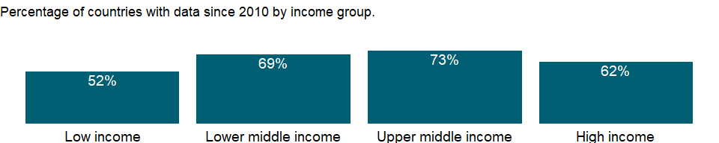

### Why is it relevant?

NA

### What is the data source?

International Monetary Fund, Government Finance Statistics Yearbook and data files.

### What is the methodology?

The IMF’s Government Finance Statistics Manual 2014, harmonized with the 2008 SNA, recommends an accrual accounting method, focusing on all economic events affecting assets, liabilities, revenues, and expenses, not just those represented by cash transactions. It accounts for all changes in stocks, so stock data at the end of an accounting period equal stock data at the beginning of the period plus flows over the period. The 1986 manual considered only debt stocks.

Government finance statistics are reported in local currency. Many countries report government finance data by fiscal year; see country metadata for information on fiscal year end by country.

### How is it aggregated?

NA

### What are the limitations?

For most countries central government finance data have been consolidated into one account, but for others only budgetary central government accounts are available. Countries reporting budgetary data are noted in the country metadata. Because budgetary accounts may not include all central government units (such as social security funds), they usually provide an incomplete picture. In federal states the central government accounts provide an incomplete view of total public finance.

Data on government revenue and expense are collected by the IMF through questionnaires to member countries and by the Organisation for Economic Co-operation and Development (OECD). Despite IMF efforts to standardize data collection, statistics are often incomplete, untimely, and not comparable across countries.

### What else should I know?

NA

### 1.28.10 Net lending (+) / net borrowing (-) (% of GDP)

### What is the indicator?

Net lending (+) / net borrowing (–) equals government revenue minus expense, minus net investment in nonfinancial assets. It is also equal to the net result of transactions in financial assets and liabilities. Net lending/net borrowing is a summary measure indicating the extent to which government is either putting financial resources at the disposal of other sectors in the economy or abroad, or utilizing the financial resources generated by other sectors in the economy or from abroad.

Topic: Public Sector: Government finance: Deficit & financing

Series ID: GC.NLD.TOTL.GD.ZS

Copyright: CC BY-4.0 , <https://datacatalog.worldbank.org/public-licenses#cc-by>

First year with any data: 1972

Last year with any data: 2020

### What years are data available?

The figure below shows years in which data is available for at least one country. Dates shaded in black have no data, while dates shaded in green have data for at least one country



### Which countries have data?

The figure below shows the percentage of countries in each income group with a value since 2010 for that indicator.



### Why is it relevant?

NA

### What is the data source?

International Monetary Fund, Government Finance Statistics Yearbook and data files.

### What is the methodology?

The IMF’s Government Finance Statistics Manual 2014, harmonized with the 2008 SNA, recommends an accrual accounting method, focusing on all economic events affecting assets, liabilities, revenues, and expenses, not just those represented by cash transactions. It accounts for all changes in stocks, so stock data at the end of an accounting period equal stock data at the beginning of the period plus flows over the period. The 1986 manual considered only debt stocks.

Government finance statistics are reported in local currency. Many countries report government finance data by fiscal year; see country metadata for information on fiscal year end by country.

### How is it aggregated?

Weighted Average

### What are the limitations?

For most countries central government finance data have been consolidated into one account, but for others only budgetary central government accounts are available. Countries reporting budgetary data are noted in the country metadata. Because budgetary accounts may not include all central government units (such as social security funds), they usually provide an incomplete picture. In federal states the central government accounts provide an incomplete view of total public finance.

Data on government revenue and expense are collected by the IMF through questionnaires to member countries and by the Organisation for Economic Co-operation and Development (OECD). Despite IMF efforts to standardize data collection, statistics are often incomplete, untimely, and not comparable across countries.

### What else should I know?

NA

## 1.29 Public Sector: Government finance: Revenue

### 1.29.1 Grants and other revenue (current LCU)

### What is the indicator?

Grants and other revenue include grants from other foreign governments, international organizations, and other government units; interest; dividends; rent; requited, nonrepayable receipts for public purposes (such as fines, administrative fees, and entrepreneurial income from government owner­ship of property); and voluntary, unrequited, nonrepayable receipts other than grants.

Topic: Public Sector: Government finance: Revenue

Series ID: GC.REV.GOTR.CN

Copyright: CC BY-4.0 , <https://datacatalog.worldbank.org/public-licenses#cc-by>

First year with any data: 1972

Last year with any data: 2020

### What years are data available?

The figure below shows years in which data is available for at least one country. Dates shaded in black have no data, while dates shaded in green have data for at least one country



### Which countries have data?

The figure below shows the percentage of countries in each income group with a value since 2010 for that indicator.

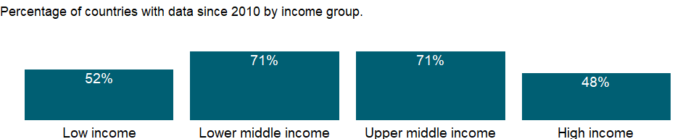

### Why is it relevant?

NA

### What is the data source?

International Monetary Fund, Government Finance Statistics Yearbook and data files.

### What is the methodology?

The IMF’s Government Finance Statistics Manual 2014, harmonized with the 2008 SNA, recommends an accrual accounting method, focusing on all economic events affecting assets, liabilities, revenues, and expenses, not just those represented by cash transactions. It accounts for all changes in stocks, so stock data at the end of an accounting period equal stock data at the beginning of the period plus flows over the period. The 1986 manual considered only debt stocks.

Government finance statistics are reported in local currency. Many countries report government finance data by fiscal year; see country metadata for information on fiscal year end by country.

### How is it aggregated?

NA

### What are the limitations?

For most countries central government finance data have been consolidated into one account, but for others only budgetary central government accounts are available. Countries reporting budgetary data are noted in the country metadata. Because budgetary accounts may not include all central government units (such as social security funds), they usually provide an incomplete picture. In federal states the central government accounts provide an incomplete view of total public finance.

Data on government revenue and expense are collected by the IMF through questionnaires to member countries and by the Organisation for Economic Co-operation and Development (OECD). Despite IMF efforts to standardize data collection, statistics are often incomplete, untimely, and not comparable across countries.

### What else should I know?

NA

### 1.29.2 Grants and other revenue (% of revenue)

### What is the indicator?

Grants and other revenue include grants from other foreign governments, international organizations, and other government units; interest; dividends; rent; requited, nonrepayable receipts for public purposes (such as fines, administrative fees, and entrepreneurial income from government owner­ship of property); and voluntary, unrequited, nonrepayable receipts other than grants.

Topic: Public Sector: Government finance: Revenue

Series ID: GC.REV.GOTR.ZS

Copyright: CC BY-4.0 , <https://datacatalog.worldbank.org/public-licenses#cc-by>

First year with any data: 1972

Last year with any data: 2020

### What years are data available?

The figure below shows years in which data is available for at least one country. Dates shaded in black have no data, while dates shaded in green have data for at least one country



### Which countries have data?

The figure below shows the percentage of countries in each income group with a value since 2010 for that indicator.



### Why is it relevant?

NA

### What is the data source?

International Monetary Fund, Government Finance Statistics Yearbook and data files.

### What is the methodology?

The IMF’s Government Finance Statistics Manual 2014, harmonized with the 2008 SNA, recommends an accrual accounting method, focusing on all economic events affecting assets, liabilities, revenues, and expenses, not just those represented by cash transactions. It accounts for all changes in stocks, so stock data at the end of an accounting period equal stock data at the beginning of the period plus flows over the period. The 1986 manual considered only debt stocks.

Government finance statistics are reported in local currency. Many countries report government finance data by fiscal year; see country metadata for information on fiscal year end by country.

### How is it aggregated?

Median

### What are the limitations?

For most countries central government finance data have been consolidated into one account, but for others only budgetary central government accounts are available. Countries reporting budgetary data are noted in the country metadata. Because budgetary accounts may not include all central government units (such as social security funds), they usually provide an incomplete picture. In federal states the central government accounts provide an incomplete view of total public finance.

Data on government revenue and expense are collected by the IMF through questionnaires to member countries and by the Organisation for Economic Co-operation and Development (OECD). Despite IMF efforts to standardize data collection, statistics are often incomplete, untimely, and not comparable across countries.

### What else should I know?

NA

### 1.29.3 Social contributions (current LCU)

### What is the indicator?

Social contributions include social security contributions by employees, employers, and self-employed individuals, and other contributions whose source cannot be determined. They also include actual or imputed contributions to social insurance schemes operated by governments.

Topic: Public Sector: Government finance: Revenue

Series ID: GC.REV.SOCL.CN

Copyright: CC BY-4.0 , <https://datacatalog.worldbank.org/public-licenses#cc-by>

First year with any data: 1972

Last year with any data: 2020

### What years are data available?

The figure below shows years in which data is available for at least one country. Dates shaded in black have no data, while dates shaded in green have data for at least one country



### Which countries have data?

The figure below shows the percentage of countries in each income group with a value since 2010 for that indicator.

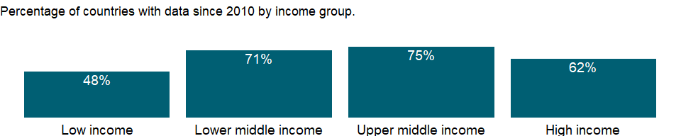

### Why is it relevant?

NA

### What is the data source?

International Monetary Fund, Government Finance Statistics Yearbook and data files.

### What is the methodology?

The IMF’s Government Finance Statistics Manual 2014, harmonized with the 2008 SNA, recommends an accrual accounting method, focusing on all economic events affecting assets, liabilities, revenues, and expenses, not just those represented by cash transactions. It accounts for all changes in stocks, so stock data at the end of an accounting period equal stock data at the beginning of the period plus flows over the period. The 1986 manual considered only debt stocks.

Government finance statistics are reported in local currency. Many countries report government finance data by fiscal year; see country metadata for information on fiscal year end by country.

### How is it aggregated?

NA

### What are the limitations?

For most countries central government finance data have been consolidated into one account, but for others only budgetary central government accounts are available. Countries reporting budgetary data are noted in the country metadata. Because budgetary accounts may not include all central government units (such as social security funds), they usually provide an incomplete picture. In federal states the central government accounts provide an incomplete view of total public finance.

Data on government revenue and expense are collected by the IMF through questionnaires to member countries and by the Organisation for Economic Co-operation and Development (OECD). Despite IMF efforts to standardize data collection, statistics are often incomplete, untimely, and not comparable across countries.

### What else should I know?

NA

### 1.29.4 Social contributions (% of revenue)

### What is the indicator?

Social contributions include social security contributions by employees, employers, and self-employed individuals, and other contributions whose source cannot be determined. They also include actual or imputed contributions to social insurance schemes operated by governments.

Topic: Public Sector: Government finance: Revenue

Series ID: GC.REV.SOCL.ZS

Copyright: CC BY-4.0 , <https://datacatalog.worldbank.org/public-licenses#cc-by>

First year with any data: 1972

Last year with any data: 2020

### What years are data available?

The figure below shows years in which data is available for at least one country. Dates shaded in black have no data, while dates shaded in green have data for at least one country



### Which countries have data?

The figure below shows the percentage of countries in each income group with a value since 2010 for that indicator.



### Why is it relevant?

NA

### What is the data source?

International Monetary Fund, Government Finance Statistics Yearbook and data files.

### What is the methodology?

The IMF’s Government Finance Statistics Manual 2014, harmonized with the 2008 SNA, recommends an accrual accounting method, focusing on all economic events affecting assets, liabilities, revenues, and expenses, not just those represented by cash transactions. It accounts for all changes in stocks, so stock data at the end of an accounting period equal stock data at the beginning of the period plus flows over the period. The 1986 manual considered only debt stocks.

Government finance statistics are reported in local currency. Many countries report government finance data by fiscal year; see country metadata for information on fiscal year end by country.

### How is it aggregated?

Median

### What are the limitations?

For most countries central government finance data have been consolidated into one account, but for others only budgetary central government accounts are available. Countries reporting budgetary data are noted in the country metadata. Because budgetary accounts may not include all central government units (such as social security funds), they usually provide an incomplete picture. In federal states the central government accounts provide an incomplete view of total public finance.

Data on government revenue and expense are collected by the IMF through questionnaires to member countries and by the Organisation for Economic Co-operation and Development (OECD). Despite IMF efforts to standardize data collection, statistics are often incomplete, untimely, and not comparable across countries.

### What else should I know?

NA

### 1.29.5 Revenue, excluding grants (current LCU)

### What is the indicator?

Revenue is cash receipts from taxes, social contributions, and other revenues such as fines, fees, rent, and income from property or sales. Grants are also considered as revenue but are excluded here.

Topic: Public Sector: Government finance: Revenue

Series ID: GC.REV.XGRT.CN

Copyright: CC BY-4.0 , <https://datacatalog.worldbank.org/public-licenses#cc-by>

First year with any data: 1972

Last year with any data: 2020

### What years are data available?

The figure below shows years in which data is available for at least one country. Dates shaded in black have no data, while dates shaded in green have data for at least one country



### Which countries have data?

The figure below shows the percentage of countries in each income group with a value since 2010 for that indicator.

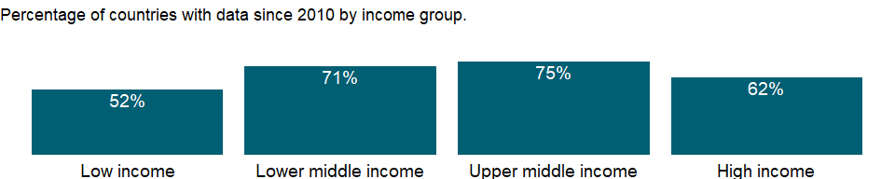

### Why is it relevant?

NA

### What is the data source?

International Monetary Fund, Government Finance Statistics Yearbook and data files.

### What is the methodology?

The IMF’s Government Finance Statistics Manual 2014, harmonized with the 2008 SNA, recommends an accrual accounting method, focusing on all economic events affecting assets, liabilities, revenues, and expenses, not just those represented by cash transactions. It accounts for all changes in stocks, so stock data at the end of an accounting period equal stock data at the beginning of the period plus flows over the period. The 1986 manual considered only debt stocks.

Government finance statistics are reported in local currency. Many countries report government finance data by fiscal year; see country metadata for information on fiscal year end by country.

### How is it aggregated?

NA

### What are the limitations?

For most countries central government finance data have been consolidated into one account, but for others only budgetary central government accounts are available. Countries reporting budgetary data are noted in the country metadata. Because budgetary accounts may not include all central government units (such as social security funds), they usually provide an incomplete picture. In federal states the central government accounts provide an incomplete view of total public finance.

Data on government revenue and expense are collected by the IMF through questionnaires to member countries and by the Organisation for Economic Co-operation and Development (OECD). Despite IMF efforts to standardize data collection, statistics are often incomplete, untimely, and not comparable across countries.

### What else should I know?

NA

### 1.29.6 Revenue, excluding grants (% of GDP)

### What is the indicator?

Revenue is cash receipts from taxes, social contributions, and other revenues such as fines, fees, rent, and income from property or sales. Grants are also considered as revenue but are excluded here.

Topic: Public Sector: Government finance: Revenue

Series ID: GC.REV.XGRT.GD.ZS

Copyright: CC BY-4.0 , <https://datacatalog.worldbank.org/public-licenses#cc-by>

First year with any data: 1972

Last year with any data: 2020

### What years are data available?

The figure below shows years in which data is available for at least one country. Dates shaded in black have no data, while dates shaded in green have data for at least one country



### Which countries have data?

The figure below shows the percentage of countries in each income group with a value since 2010 for that indicator.



### Why is it relevant?

NA

### What is the data source?

International Monetary Fund, Government Finance Statistics Yearbook and data files, and World Bank and OECD GDP estimates.

### What is the methodology?

The IMF’s Government Finance Statistics Manual 2014, harmonized with the 2008 SNA, recommends an accrual accounting method, focusing on all economic events affecting assets, liabilities, revenues, and expenses, not just those represented by cash transactions. It accounts for all changes in stocks, so stock data at the end of an accounting period equal stock data at the beginning of the period plus flows over the period. The 1986 manual considered only debt stocks.

Government finance statistics are reported in local currency. Many countries report government finance data by fiscal year; see country metadata for information on fiscal year end by country.

### How is it aggregated?

Weighted average

### What are the limitations?

For most countries central government finance data have been consolidated into one account, but for others only budgetary central government accounts are available. Countries reporting budgetary data are noted in the country metadata. Because budgetary accounts may not include all central government units (such as social security funds), they usually provide an incomplete picture. In federal states the central government accounts provide an incomplete view of total public finance.

Data on government revenue and expense are collected by the IMF through questionnaires to member countries and by the Organisation for Economic Co-operation and Development (OECD). Despite IMF efforts to standardize data collection, statistics are often incomplete, untimely, and not comparable across countries.

### What else should I know?

NA

### 1.29.7 Taxes on exports (current LCU)

### What is the indicator?

Taxes on exports are all levies on goods being transported out of the country or services being delivered to nonresidents by residents. Rebates on exported goods that are repayments of previously paid general consumption taxes, excise taxes, or import duties are deducted from the gross amounts receivable from these taxes, not from amounts receivable from export taxes.

Topic: Public Sector: Government finance: Revenue

Series ID: GC.TAX.EXPT.CN

Copyright: CC BY-4.0 , <https://datacatalog.worldbank.org/public-licenses#cc-by>

First year with any data: 1972

Last year with any data: 2020

### What years are data available?

The figure below shows years in which data is available for at least one country. Dates shaded in black have no data, while dates shaded in green have data for at least one country



### Which countries have data?

The figure below shows the percentage of countries in each income group with a value since 2010 for that indicator.

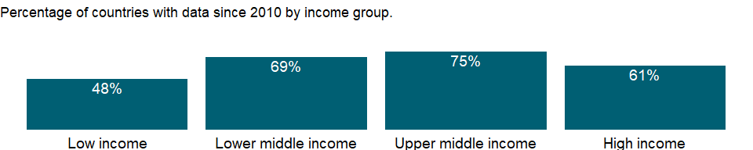

### Why is it relevant?

NA

### What is the data source?

International Monetary Fund, Government Finance Statistics Yearbook and data files.

### What is the methodology?

The IMF’s Government Finance Statistics Manual 2014, harmonized with the 2008 SNA, recommends an accrual accounting method, focusing on all economic events affecting assets, liabilities, revenues, and expenses, not just those represented by cash transactions. It accounts for all changes in stocks, so stock data at the end of an accounting period equal stock data at the beginning of the period plus flows over the period. The 1986 manual considered only debt stocks.

Government finance statistics are reported in local currency. Many countries report government finance data by fiscal year; see country metadata for information on fiscal year end by country.

### How is it aggregated?

NA

### What are the limitations?

For most countries central government finance data have been consolidated into one account, but for others only budgetary central government accounts are available. Countries reporting budgetary data are noted in the country metadata. Because budgetary accounts may not include all central government units (such as social security funds), they usually provide an incomplete picture. In federal states the central government accounts provide an incomplete view of total public finance.

Data on government revenue and expense are collected by the IMF through questionnaires to member countries and by the Organisation for Economic Co-operation and Development (OECD). Despite IMF efforts to standardize data collection, statistics are often incomplete, untimely, and not comparable across countries.

### What else should I know?

NA

### 1.29.8 Taxes on exports (% of tax revenue)

### What is the indicator?

Taxes on exports are all levies on goods being transported out of the country or services being delivered to nonresidents by residents. Rebates on exported goods that are repayments of previously paid general consumption taxes, excise taxes, or import duties are deducted from the gross amounts receivable from these taxes, not from amounts receivable from export taxes.

Topic: Public Sector: Government finance: Revenue

Series ID: GC.TAX.EXPT.ZS

Copyright: CC BY-4.0 , <https://datacatalog.worldbank.org/public-licenses#cc-by>

First year with any data: 1972

Last year with any data: 2020

### What years are data available?

The figure below shows years in which data is available for at least one country. Dates shaded in black have no data, while dates shaded in green have data for at least one country



### Which countries have data?

The figure below shows the percentage of countries in each income group with a value since 2010 for that indicator.



### Why is it relevant?

NA

### What is the data source?

International Monetary Fund, Government Finance Statistics Yearbook and data files.

### What is the methodology?

The IMF’s Government Finance Statistics Manual 2014, harmonized with the 2008 SNA, recommends an accrual accounting method, focusing on all economic events affecting assets, liabilities, revenues, and expenses, not just those represented by cash transactions. It accounts for all changes in stocks, so stock data at the end of an accounting period equal stock data at the beginning of the period plus flows over the period. The 1986 manual considered only debt stocks.

Government finance statistics are reported in local currency. Many countries report government finance data by fiscal year; see country metadata for information on fiscal year end by country.

### How is it aggregated?

NA

### What are the limitations?

For most countries central government finance data have been consolidated into one account, but for others only budgetary central government accounts are available. Countries reporting budgetary data are noted in the country metadata. Because budgetary accounts may not include all central government units (such as social security funds), they usually provide an incomplete picture. In federal states the central government accounts provide an incomplete view of total public finance.

Data on government revenue and expense are collected by the IMF through questionnaires to member countries and by the Organisation for Economic Co-operation and Development (OECD). Despite IMF efforts to standardize data collection, statistics are often incomplete, untimely, and not comparable across countries.

### What else should I know?

NA

### 1.29.9 Taxes on goods and services (current LCU)

### What is the indicator?

Taxes on goods and services include general sales and turnover or value added taxes, selective excises on goods, selective taxes on services, taxes on the use of goods or property, taxes on extraction and production of minerals, and profits of fiscal monopolies.

Topic: Public Sector: Government finance: Revenue

Series ID: GC.TAX.GSRV.CN

Copyright: CC BY-4.0 , <https://datacatalog.worldbank.org/public-licenses#cc-by>

First year with any data: 1972

Last year with any data: 2020

### What years are data available?

The figure below shows years in which data is available for at least one country. Dates shaded in black have no data, while dates shaded in green have data for at least one country



### Which countries have data?

The figure below shows the percentage of countries in each income group with a value since 2010 for that indicator.



### Why is it relevant?

NA

### What is the data source?

International Monetary Fund, Government Finance Statistics Yearbook and data files.

### What is the methodology?

The IMF’s Government Finance Statistics Manual 2014, harmonized with the 2008 SNA, recommends an accrual accounting method, focusing on all economic events affecting assets, liabilities, revenues, and expenses, not just those represented by cash transactions. It accounts for all changes in stocks, so stock data at the end of an accounting period equal stock data at the beginning of the period plus flows over the period. The 1986 manual considered only debt stocks.

Government finance statistics are reported in local currency. Many countries report government finance data by fiscal year; see country metadata for information on fiscal year end by country.

### How is it aggregated?

NA

### What are the limitations?

For most countries central government finance data have been consolidated into one account, but for others only budgetary central government accounts are available. Countries reporting budgetary data are noted in the country metadata. Because budgetary accounts may not include all central government units (such as social security funds), they usually provide an incomplete picture. In federal states the central government accounts provide an incomplete view of total public finance.

Data on government revenue and expense are collected by the IMF through questionnaires to member countries and by the Organisation for Economic Co-operation and Development (OECD). Despite IMF efforts to standardize data collection, statistics are often incomplete, untimely, and not comparable across countries.

### What else should I know?

NA

### 1.29.10 Taxes on goods and services (% of revenue)

### What is the indicator?

Taxes on goods and services include general sales and turnover or value added taxes, selective excises on goods, selective taxes on services, taxes on the use of goods or property, taxes on extraction and production of minerals, and profits of fiscal monopolies.

Topic: Public Sector: Government finance: Revenue

Series ID: GC.TAX.GSRV.RV.ZS

Copyright: CC BY-4.0 , <https://datacatalog.worldbank.org/public-licenses#cc-by>

First year with any data: 1972

Last year with any data: 2020

### What years are data available?

The figure below shows years in which data is available for at least one country. Dates shaded in black have no data, while dates shaded in green have data for at least one country



### Which countries have data?

The figure below shows the percentage of countries in each income group with a value since 2010 for that indicator.



### Why is it relevant?

NA

### What is the data source?

International Monetary Fund, Government Finance Statistics Yearbook and data files.

### What is the methodology?

The IMF’s Government Finance Statistics Manual 2014, harmonized with the 2008 SNA, recommends an accrual accounting method, focusing on all economic events affecting assets, liabilities, revenues, and expenses, not just those represented by cash transactions. It accounts for all changes in stocks, so stock data at the end of an accounting period equal stock data at the beginning of the period plus flows over the period. The 1986 manual considered only debt stocks.

Government finance statistics are reported in local currency. Many countries report government finance data by fiscal year; see country metadata for information on fiscal year end by country.

### How is it aggregated?

Median

### What are the limitations?

For most countries central government finance data have been consolidated into one account, but for others only budgetary central government accounts are available. Countries reporting budgetary data are noted in the country metadata. Because budgetary accounts may not include all central government units (such as social security funds), they usually provide an incomplete picture. In federal states the central government accounts provide an incomplete view of total public finance.

Data on government revenue and expense are collected by the IMF through questionnaires to member countries and by the Organisation for Economic Co-operation and Development (OECD). Despite IMF efforts to standardize data collection, statistics are often incomplete, untimely, and not comparable across countries.

### What else should I know?

NA

### 1.29.11 Taxes on goods and services (% value added of industry and services)

### What is the indicator?

Taxes on goods and services include general sales and turnover or value added taxes, selective excises on goods, selective taxes on services, taxes on the use of goods or property, taxes on extraction and production of minerals, and profits of fiscal monopolies.

Topic: Public Sector: Government finance: Revenue

Series ID: GC.TAX.GSRV.VA.ZS

Copyright: CC BY-4.0 , <https://datacatalog.worldbank.org/public-licenses#cc-by>

First year with any data: 1972

Last year with any data: 2020

### What years are data available?

The figure below shows years in which data is available for at least one country. Dates shaded in black have no data, while dates shaded in green have data for at least one country



### Which countries have data?

The figure below shows the percentage of countries in each income group with a value since 2010 for that indicator.

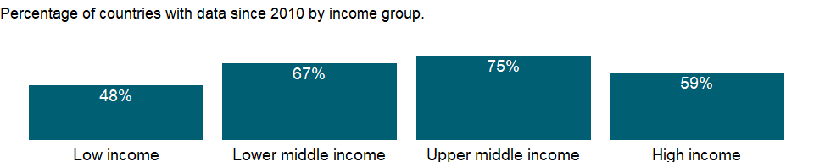

### Why is it relevant?

NA

### What is the data source?

International Monetary Fund, Government Finance Statistics Yearbook and data files, and World Bank and OECD value added estimates.

### What is the methodology?

The IMF’s Government Finance Statistics Manual 2014, harmonized with the 2008 SNA, recommends an accrual accounting method, focusing on all economic events affecting assets, liabilities, revenues, and expenses, not just those represented by cash transactions. It accounts for all changes in stocks, so stock data at the end of an accounting period equal stock data at the beginning of the period plus flows over the period. The 1986 manual considered only debt stocks.

Government finance statistics are reported in local currency. Many countries report government finance data by fiscal year; see country metadata for information on fiscal year end by country.

### How is it aggregated?

NA

### What are the limitations?

For most countries central government finance data have been consolidated into one account, but for others only budgetary central government accounts are available. Countries reporting budgetary data are noted in the country metadata. Because budgetary accounts may not include all central government units (such as social security funds), they usually provide an incomplete picture. In federal states the central government accounts provide an incomplete view of total public finance.

Data on government revenue and expense are collected by the IMF through questionnaires to member countries and by the Organisation for Economic Co-operation and Development (OECD). Despite IMF efforts to standardize data collection, statistics are often incomplete, untimely, and not comparable across countries.

### What else should I know?

NA

### 1.29.12 Customs and other import duties (current LCU)

### What is the indicator?

Customs and other import duties are all levies collected on goods that are entering the country or services delivered by nonresidents to residents. They include levies imposed for revenue or protection purposes and determined on a specific or ad valorem basis as long as they are restricted to imported goods or services.

Topic: Public Sector: Government finance: Revenue

Series ID: GC.TAX.IMPT.CN

Copyright: CC BY-4.0 , <https://datacatalog.worldbank.org/public-licenses#cc-by>

First year with any data: 1972

Last year with any data: 2020

### What years are data available?

The figure below shows years in which data is available for at least one country. Dates shaded in black have no data, while dates shaded in green have data for at least one country



### Which countries have data?

The figure below shows the percentage of countries in each income group with a value since 2010 for that indicator.



### Why is it relevant?

NA

### What is the data source?

International Monetary Fund, Government Finance Statistics Yearbook and data files.

### What is the methodology?

The IMF’s Government Finance Statistics Manual 2014, harmonized with the 2008 SNA, recommends an accrual accounting method, focusing on all economic events affecting assets, liabilities, revenues, and expenses, not just those represented by cash transactions. It accounts for all changes in stocks, so stock data at the end of an accounting period equal stock data at the beginning of the period plus flows over the period. The 1986 manual considered only debt stocks.

Government finance statistics are reported in local currency. Many countries report government finance data by fiscal year; see country metadata for information on fiscal year end by country.

### How is it aggregated?

NA

### What are the limitations?

For most countries central government finance data have been consolidated into one account, but for others only budgetary central government accounts are available. Countries reporting budgetary data are noted in the country metadata. Because budgetary accounts may not include all central government units (such as social security funds), they usually provide an incomplete picture. In federal states the central government accounts provide an incomplete view of total public finance.

Data on government revenue and expense are collected by the IMF through questionnaires to member countries and by the Organisation for Economic Co-operation and Development (OECD). Despite IMF efforts to standardize data collection, statistics are often incomplete, untimely, and not comparable across countries.

### What else should I know?

NA

### 1.29.13 Customs and other import duties (% of tax revenue)

### What is the indicator?

Customs and other import duties are all levies collected on goods that are entering the country or services delivered by nonresidents to residents. They include levies imposed for revenue or protection purposes and determined on a specific or ad valorem basis as long as they are restricted to imported goods or services.

Topic: Public Sector: Government finance: Revenue

Series ID: GC.TAX.IMPT.ZS

Copyright: CC BY-4.0 , <https://datacatalog.worldbank.org/public-licenses#cc-by>

First year with any data: 1972

Last year with any data: 2020

### What years are data available?

The figure below shows years in which data is available for at least one country. Dates shaded in black have no data, while dates shaded in green have data for at least one country



### Which countries have data?

The figure below shows the percentage of countries in each income group with a value since 2010 for that indicator.



### Why is it relevant?

NA

### What is the data source?

International Monetary Fund, Government Finance Statistics Yearbook and data files.

### What is the methodology?

The IMF’s Government Finance Statistics Manual 2014, harmonized with the 2008 SNA, recommends an accrual accounting method, focusing on all economic events affecting assets, liabilities, revenues, and expenses, not just those represented by cash transactions. It accounts for all changes in stocks, so stock data at the end of an accounting period equal stock data at the beginning of the period plus flows over the period. The 1986 manual considered only debt stocks.

Government finance statistics are reported in local currency. Many countries report government finance data by fiscal year; see country metadata for information on fiscal year end by country.

### How is it aggregated?

NA

### What are the limitations?

For most countries central government finance data have been consolidated into one account, but for others only budgetary central government accounts are available. Countries reporting budgetary data are noted in the country metadata. Because budgetary accounts may not include all central government units (such as social security funds), they usually provide an incomplete picture. In federal states the central government accounts provide an incomplete view of total public finance.

Data on government revenue and expense are collected by the IMF through questionnaires to member countries and by the Organisation for Economic Co-operation and Development (OECD). Despite IMF efforts to standardize data collection, statistics are often incomplete, untimely, and not comparable across countries.

### What else should I know?

NA

### 1.29.14 Taxes on international trade (current LCU)

### What is the indicator?

Taxes on international trade include import duties, export duties, profits of export or import monopolies, exchange profits, and exchange taxes.

Topic: Public Sector: Government finance: Revenue

Series ID: GC.TAX.INTT.CN

Copyright: CC BY-4.0 , <https://datacatalog.worldbank.org/public-licenses#cc-by>

First year with any data: 1972

Last year with any data: 2020

### What years are data available?

The figure below shows years in which data is available for at least one country. Dates shaded in black have no data, while dates shaded in green have data for at least one country



### Which countries have data?

The figure below shows the percentage of countries in each income group with a value since 2010 for that indicator.



### Why is it relevant?

NA

### What is the data source?

International Monetary Fund, Government Finance Statistics Yearbook and data files.

### What is the methodology?

The IMF’s Government Finance Statistics Manual 2014, harmonized with the 2008 SNA, recommends an accrual accounting method, focusing on all economic events affecting assets, liabilities, revenues, and expenses, not just those represented by cash transactions. It accounts for all changes in stocks, so stock data at the end of an accounting period equal stock data at the beginning of the period plus flows over the period. The 1986 manual considered only debt stocks.

Government finance statistics are reported in local currency. Many countries report government finance data by fiscal year; see country metadata for information on fiscal year end by country.

### How is it aggregated?

NA

### What are the limitations?

For most countries central government finance data have been consolidated into one account, but for others only budgetary central government accounts are available. Countries reporting budgetary data are noted in the country metadata. Because budgetary accounts may not include all central government units (such as social security funds), they usually provide an incomplete picture. In federal states the central government accounts provide an incomplete view of total public finance.

Data on government revenue and expense are collected by the IMF through questionnaires to member countries and by the Organisation for Economic Co-operation and Development (OECD). Despite IMF efforts to standardize data collection, statistics are often incomplete, untimely, and not comparable across countries.

### What else should I know?

NA

### 1.29.15 Taxes on international trade (% of revenue)

### What is the indicator?

Taxes on international trade include import duties, export duties, profits of export or import monopolies, exchange profits, and exchange taxes.

Topic: Public Sector: Government finance: Revenue

Series ID: GC.TAX.INTT.RV.ZS

Copyright: CC BY-4.0 , <https://datacatalog.worldbank.org/public-licenses#cc-by>

First year with any data: 1972

Last year with any data: 2020

### What years are data available?

The figure below shows years in which data is available for at least one country. Dates shaded in black have no data, while dates shaded in green have data for at least one country



### Which countries have data?

The figure below shows the percentage of countries in each income group with a value since 2010 for that indicator.



### Why is it relevant?

NA

### What is the data source?

International Monetary Fund, Government Finance Statistics Yearbook and data files.

### What is the methodology?

The IMF’s Government Finance Statistics Manual 2014, harmonized with the 2008 SNA, recommends an accrual accounting method, focusing on all economic events affecting assets, liabilities, revenues, and expenses, not just those represented by cash transactions. It accounts for all changes in stocks, so stock data at the end of an accounting period equal stock data at the beginning of the period plus flows over the period. The 1986 manual considered only debt stocks.

Government finance statistics are reported in local currency. Many countries report government finance data by fiscal year; see country metadata for information on fiscal year end by country.

### How is it aggregated?

Median

### What are the limitations?

For most countries central government finance data have been consolidated into one account, but for others only budgetary central government accounts are available. Countries reporting budgetary data are noted in the country metadata. Because budgetary accounts may not include all central government units (such as social security funds), they usually provide an incomplete picture. In federal states the central government accounts provide an incomplete view of total public finance.

Data on government revenue and expense are collected by the IMF through questionnaires to member countries and by the Organisation for Economic Co-operation and Development (OECD). Despite IMF efforts to standardize data collection, statistics are often incomplete, untimely, and not comparable across countries.

### What else should I know?

NA

### 1.29.16 Other taxes (current LCU)

### What is the indicator?

Other taxes include employer payroll or labor taxes, taxes on property, and taxes not allocable to other categories, such as penalties for late payment or nonpayment of taxes.

Topic: Public Sector: Government finance: Revenue

Series ID: GC.TAX.OTHR.CN

Copyright: CC BY-4.0 , <https://datacatalog.worldbank.org/public-licenses#cc-by>

First year with any data: 1972

Last year with any data: 2020

### What years are data available?

The figure below shows years in which data is available for at least one country. Dates shaded in black have no data, while dates shaded in green have data for at least one country



### Which countries have data?

The figure below shows the percentage of countries in each income group with a value since 2010 for that indicator.



### Why is it relevant?

NA

### What is the data source?

International Monetary Fund, Government Finance Statistics Yearbook and data files.

### What is the methodology?

The IMF’s Government Finance Statistics Manual 2014, harmonized with the 2008 SNA, recommends an accrual accounting method, focusing on all economic events affecting assets, liabilities, revenues, and expenses, not just those represented by cash transactions. It accounts for all changes in stocks, so stock data at the end of an accounting period equal stock data at the beginning of the period plus flows over the period. The 1986 manual considered only debt stocks.

Government finance statistics are reported in local currency. Many countries report government finance data by fiscal year; see country metadata for information on fiscal year end by country.

### How is it aggregated?

NA

### What are the limitations?

For most countries central government finance data have been consolidated into one account, but for others only budgetary central government accounts are available. Countries reporting budgetary data are noted in the country metadata. Because budgetary accounts may not include all central government units (such as social security funds), they usually provide an incomplete picture. In federal states the central government accounts provide an incomplete view of total public finance.

Data on government revenue and expense are collected by the IMF through questionnaires to member countries and by the Organisation for Economic Co-operation and Development (OECD). Despite IMF efforts to standardize data collection, statistics are often incomplete, untimely, and not comparable across countries.

### What else should I know?

NA

### 1.29.17 Other taxes (% of revenue)

### What is the indicator?

Other taxes include employer payroll or labor taxes, taxes on property, and taxes not allocable to other categories, such as penalties for late payment or nonpayment of taxes.

Topic: Public Sector: Government finance: Revenue

Series ID: GC.TAX.OTHR.RV.ZS

Copyright: CC BY-4.0 , <https://datacatalog.worldbank.org/public-licenses#cc-by>

First year with any data: 1972

Last year with any data: 2020

### What years are data available?

The figure below shows years in which data is available for at least one country. Dates shaded in black have no data, while dates shaded in green have data for at least one country



### Which countries have data?

The figure below shows the percentage of countries in each income group with a value since 2010 for that indicator.



### Why is it relevant?

NA

### What is the data source?

International Monetary Fund, Government Finance Statistics Yearbook and data files.

### What is the methodology?

The IMF’s Government Finance Statistics Manual 2014, harmonized with the 2008 SNA, recommends an accrual accounting method, focusing on all economic events affecting assets, liabilities, revenues, and expenses, not just those represented by cash transactions. It accounts for all changes in stocks, so stock data at the end of an accounting period equal stock data at the beginning of the period plus flows over the period. The 1986 manual considered only debt stocks.

Government finance statistics are reported in local currency. Many countries report government finance data by fiscal year; see country metadata for information on fiscal year end by country.

### How is it aggregated?

Median

### What are the limitations?

For most countries central government finance data have been consolidated into one account, but for others only budgetary central government accounts are available. Countries reporting budgetary data are noted in the country metadata. Because budgetary accounts may not include all central government units (such as social security funds), they usually provide an incomplete picture. In federal states the central government accounts provide an incomplete view of total public finance.

Data on government revenue and expense are collected by the IMF through questionnaires to member countries and by the Organisation for Economic Co-operation and Development (OECD). Despite IMF efforts to standardize data collection, statistics are often incomplete, untimely, and not comparable across countries.

### What else should I know?

NA

### 1.29.18 Tax revenue (current LCU)

### What is the indicator?

Tax revenue refers to compulsory transfers to the central government for public purposes. Certain compulsory transfers such as fines, penalties, and most social security contributions are excluded. Refunds and corrections of erroneously collected tax revenue are treated as negative revenue.

Topic: Public Sector: Government finance: Revenue

Series ID: GC.TAX.TOTL.CN

Copyright: CC BY-4.0 , <https://datacatalog.worldbank.org/public-licenses#cc-by>

First year with any data: 1972

Last year with any data: 2020

### What years are data available?

The figure below shows years in which data is available for at least one country. Dates shaded in black have no data, while dates shaded in green have data for at least one country



### Which countries have data?

The figure below shows the percentage of countries in each income group with a value since 2010 for that indicator.



### Why is it relevant?

NA

### What is the data source?

International Monetary Fund, Government Finance Statistics Yearbook and data files.

### What is the methodology?

The IMF’s Government Finance Statistics Manual 2014, harmonized with the 2008 SNA, recommends an accrual accounting method, focusing on all economic events affecting assets, liabilities, revenues, and expenses, not just those represented by cash transactions. It accounts for all changes in stocks, so stock data at the end of an accounting period equal stock data at the beginning of the period plus flows over the period. The 1986 manual considered only debt stocks.

Government finance statistics are reported in local currency. Many countries report government finance data by fiscal year; see country metadata for information on fiscal year end by country.

### How is it aggregated?

NA

### What are the limitations?

For most countries central government finance data have been consolidated into one account, but for others only budgetary central government accounts are available. Countries reporting budgetary data are noted in the country metadata. Because budgetary accounts may not include all central government units (such as social security funds), they usually provide an incomplete picture. In federal states the central government accounts provide an incomplete view of total public finance.

Data on government revenue and expense are collected by the IMF through questionnaires to member countries and by the Organisation for Economic Co-operation and Development (OECD). Despite IMF efforts to standardize data collection, statistics are often incomplete, untimely, and not comparable across countries.

### What else should I know?

NA

### 1.29.19 Tax revenue (% of GDP)

### What is the indicator?

Tax revenue refers to compulsory transfers to the central government for public purposes. Certain compulsory transfers such as fines, penalties, and most social security contributions are excluded. Refunds and corrections of erroneously collected tax revenue are treated as negative revenue.

Topic: Public Sector: Government finance: Revenue

Series ID: GC.TAX.TOTL.GD.ZS

Copyright: CC BY-4.0 , <https://datacatalog.worldbank.org/public-licenses#cc-by>

First year with any data: 1972

Last year with any data: 2020

### What years are data available?

The figure below shows years in which data is available for at least one country. Dates shaded in black have no data, while dates shaded in green have data for at least one country



### Which countries have data?

The figure below shows the percentage of countries in each income group with a value since 2010 for that indicator.



### Why is it relevant?

NA

### What is the data source?

International Monetary Fund, Government Finance Statistics Yearbook and data files, and World Bank and OECD GDP estimates.

### What is the methodology?

The IMF’s Government Finance Statistics Manual 2014, harmonized with the 2008 SNA, recommends an accrual accounting method, focusing on all economic events affecting assets, liabilities, revenues, and expenses, not just those represented by cash transactions. It accounts for all changes in stocks, so stock data at the end of an accounting period equal stock data at the beginning of the period plus flows over the period. The 1986 manual considered only debt stocks.

Government finance statistics are reported in local currency. Many countries report government finance data by fiscal year; see country metadata for information on fiscal year end by country.

### How is it aggregated?

Weighted average

### What are the limitations?

For most countries central government finance data have been consolidated into one account, but for others only budgetary central government accounts are available. Countries reporting budgetary data are noted in the country metadata. Because budgetary accounts may not include all central government units (such as social security funds), they usually provide an incomplete picture. In federal states the central government accounts provide an incomplete view of total public finance.

Data on government revenue and expense are collected by the IMF through questionnaires to member countries and by the Organisation for Economic Co-operation and Development (OECD). Despite IMF efforts to standardize data collection, statistics are often incomplete, untimely, and not comparable across countries.

### What else should I know?

NA

### 1.29.20 Taxes on income, profits and capital gains (current LCU)

### What is the indicator?

Taxes on income, profits, and capital gains are levied on the actual or presumptive net income of individuals, on the profits of corporations and enterprises, and on capital gains, whether realized or not, on land, securities, and other assets. Intragovernmental payments are eliminated in consolidation.

Topic: Public Sector: Government finance: Revenue

Series ID: GC.TAX.YPKG.CN

Copyright: CC BY-4.0 , <https://datacatalog.worldbank.org/public-licenses#cc-by>

First year with any data: 1972

Last year with any data: 2020

### What years are data available?

The figure below shows years in which data is available for at least one country. Dates shaded in black have no data, while dates shaded in green have data for at least one country



### Which countries have data?

The figure below shows the percentage of countries in each income group with a value since 2010 for that indicator.



### Why is it relevant?

NA

### What is the data source?

International Monetary Fund, Government Finance Statistics Yearbook and data files.

### What is the methodology?

The IMF’s Government Finance Statistics Manual 2014, harmonized with the 2008 SNA, recommends an accrual accounting method, focusing on all economic events affecting assets, liabilities, revenues, and expenses, not just those represented by cash transactions. It accounts for all changes in stocks, so stock data at the end of an accounting period equal stock data at the beginning of the period plus flows over the period. The 1986 manual considered only debt stocks.

Government finance statistics are reported in local currency. Many countries report government finance data by fiscal year; see country metadata for information on fiscal year end by country.

### How is it aggregated?

NA

### What are the limitations?

For most countries central government finance data have been consolidated into one account, but for others only budgetary central government accounts are available. Countries reporting budgetary data are noted in the country metadata. Because budgetary accounts may not include all central government units (such as social security funds), they usually provide an incomplete picture. In federal states the central government accounts provide an incomplete view of total public finance.

Data on government revenue and expense are collected by the IMF through questionnaires to member countries and by the Organisation for Economic Co-operation and Development (OECD). Despite IMF efforts to standardize data collection, statistics are often incomplete, untimely, and not comparable across countries.

### What else should I know?

NA

### 1.29.21 Taxes on income, profits and capital gains (% of revenue)

### What is the indicator?

Taxes on income, profits, and capital gains are levied on the actual or presumptive net income of individuals, on the profits of corporations and enterprises, and on capital gains, whether realized or not, on land, securities, and other assets. Intragovernmental payments are eliminated in consolidation.

Topic: Public Sector: Government finance: Revenue

Series ID: GC.TAX.YPKG.RV.ZS

Copyright: CC BY-4.0 , <https://datacatalog.worldbank.org/public-licenses#cc-by>

First year with any data: 1972

Last year with any data: 2020

### What years are data available?

The figure below shows years in which data is available for at least one country. Dates shaded in black have no data, while dates shaded in green have data for at least one country



### Which countries have data?

The figure below shows the percentage of countries in each income group with a value since 2010 for that indicator.



### Why is it relevant?

NA

### What is the data source?

International Monetary Fund, Government Finance Statistics Yearbook and data files.

### What is the methodology?

The IMF’s Government Finance Statistics Manual 2014, harmonized with the 2008 SNA, recommends an accrual accounting method, focusing on all economic events affecting assets, liabilities, revenues, and expenses, not just those represented by cash transactions. It accounts for all changes in stocks, so stock data at the end of an accounting period equal stock data at the beginning of the period plus flows over the period. The 1986 manual considered only debt stocks.

Government finance statistics are reported in local currency. Many countries report government finance data by fiscal year; see country metadata for information on fiscal year end by country.

### How is it aggregated?

Median

### What are the limitations?

For most countries central government finance data have been consolidated into one account, but for others only budgetary central government accounts are available. Countries reporting budgetary data are noted in the country metadata. Because budgetary accounts may not include all central government units (such as social security funds), they usually provide an incomplete picture. In federal states the central government accounts provide an incomplete view of total public finance.

Data on government revenue and expense are collected by the IMF through questionnaires to member countries and by the Organisation for Economic Co-operation and Development (OECD). Despite IMF efforts to standardize data collection, statistics are often incomplete, untimely, and not comparable across countries.

### What else should I know?

NA

### 1.29.22 Taxes on income, profits and capital gains (% of total taxes)

### What is the indicator?

Taxes on income, profits, and capital gains are levied on the actual or presumptive net income of individuals, on the profits of corporations and enterprises, and on capital gains, whether realized or not, on land, securities, and other assets. Intragovernmental payments are eliminated in consolidation.

Topic: Public Sector: Government finance: Revenue

Series ID: GC.TAX.YPKG.ZS

Copyright: CC BY-4.0 , <https://datacatalog.worldbank.org/public-licenses#cc-by>

First year with any data: 1972

Last year with any data: 2020

### What years are data available?

The figure below shows years in which data is available for at least one country. Dates shaded in black have no data, while dates shaded in green have data for at least one country



### Which countries have data?

The figure below shows the percentage of countries in each income group with a value since 2010 for that indicator.



### Why is it relevant?

NA

### What is the data source?

International Monetary Fund, Government Finance Statistics Yearbook and data files.

### What is the methodology?

The IMF’s Government Finance Statistics Manual 2014, harmonized with the 2008 SNA, recommends an accrual accounting method, focusing on all economic events affecting assets, liabilities, revenues, and expenses, not just those represented by cash transactions. It accounts for all changes in stocks, so stock data at the end of an accounting period equal stock data at the beginning of the period plus flows over the period. The 1986 manual considered only debt stocks.

Government finance statistics are reported in local currency. Many countries report government finance data by fiscal year; see country metadata for information on fiscal year end by country.

### How is it aggregated?

NA

### What are the limitations?

For most countries central government finance data have been consolidated into one account, but for others only budgetary central government accounts are available. Countries reporting budgetary data are noted in the country metadata. Because budgetary accounts may not include all central government units (such as social security funds), they usually provide an incomplete picture. In federal states the central government accounts provide an incomplete view of total public finance.

Data on government revenue and expense are collected by the IMF through questionnaires to member countries and by the Organisation for Economic Co-operation and Development (OECD). Despite IMF efforts to standardize data collection, statistics are often incomplete, untimely, and not comparable across countries.

### What else should I know?

NA

## 1.30 Public Sector: Government finance: Expense

### 1.30.1 Compensation of employees (current LCU)

### What is the indicator?

Compensation of employees consists of all payments in cash, as well as in kind (such as food and housing), to employees in return for services rendered, and government contributions to social insurance schemes such as social security and pensions that provide benefits to employees.

Topic: Public Sector: Government finance: Expense

Series ID: GC.XPN.COMP.CN

Copyright: CC BY-4.0 , <https://datacatalog.worldbank.org/public-licenses#cc-by>

First year with any data: 1972

Last year with any data: 2020

### What years are data available?

The figure below shows years in which data is available for at least one country. Dates shaded in black have no data, while dates shaded in green have data for at least one country



### Which countries have data?

The figure below shows the percentage of countries in each income group with a value since 2010 for that indicator.

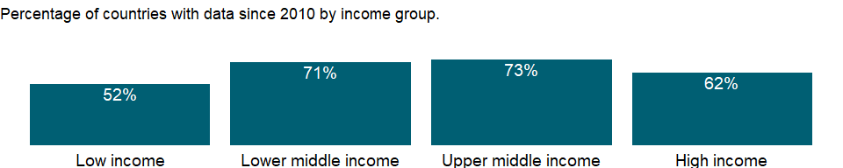

### Why is it relevant?

NA

### What is the data source?

International Monetary Fund, Government Finance Statistics Yearbook and data files.

### What is the methodology?

The IMF’s Government Finance Statistics Manual 2014, harmonized with the 2008 SNA, recommends an accrual accounting method, focusing on all economic events affecting assets, liabilities, revenues, and expenses, not just those represented by cash transactions. It accounts for all changes in stocks, so stock data at the end of an accounting period equal stock data at the beginning of the period plus flows over the period. The 1986 manual considered only debt stocks.

Government finance statistics are reported in local currency. Many countries report government finance data by fiscal year; see country metadata for information on fiscal year end by country.

### How is it aggregated?

NA

### What are the limitations?

For most countries central government finance data have been consolidated into one account, but for others only budgetary central government accounts are available. Countries reporting budgetary data are noted in the country metadata. Because budgetary accounts may not include all central government units (such as social security funds), they usually provide an incomplete picture. In federal states the central government accounts provide an incomplete view of total public finance.

Data on government revenue and expense are collected by the IMF through questionnaires to member countries and by the Organisation for Economic Co-operation and Development (OECD). Despite IMF efforts to standardize data collection, statistics are often incomplete, untimely, and not comparable across countries.

### What else should I know?

NA

### 1.30.2 Compensation of employees (% of expense)

### What is the indicator?

Compensation of employees consists of all payments in cash, as well as in kind (such as food and housing), to employees in return for services rendered, and government contributions to social insurance schemes such as social security and pensions that provide benefits to employees.

Topic: Public Sector: Government finance: Expense

Series ID: GC.XPN.COMP.ZS

Copyright: CC BY-4.0 , <https://datacatalog.worldbank.org/public-licenses#cc-by>

First year with any data: 1972

Last year with any data: 2020

### What years are data available?

The figure below shows years in which data is available for at least one country. Dates shaded in black have no data, while dates shaded in green have data for at least one country



### Which countries have data?

The figure below shows the percentage of countries in each income group with a value since 2010 for that indicator.



### Why is it relevant?

NA

### What is the data source?

International Monetary Fund, Government Finance Statistics Yearbook and data files.

### What is the methodology?

The IMF’s Government Finance Statistics Manual 2014, harmonized with the 2008 SNA, recommends an accrual accounting method, focusing on all economic events affecting assets, liabilities, revenues, and expenses, not just those represented by cash transactions. It accounts for all changes in stocks, so stock data at the end of an accounting period equal stock data at the beginning of the period plus flows over the period. The 1986 manual considered only debt stocks.

Government finance statistics are reported in local currency. Many countries report government finance data by fiscal year; see country metadata for information on fiscal year end by country.

### How is it aggregated?

Median

### What are the limitations?

For most countries central government finance data have been consolidated into one account, but for others only budgetary central government accounts are available. Countries reporting budgetary data are noted in the country metadata. Because budgetary accounts may not include all central government units (such as social security funds), they usually provide an incomplete picture. In federal states the central government accounts provide an incomplete view of total public finance.

Data on government revenue and expense are collected by the IMF through questionnaires to member countries and by the Organisation for Economic Co-operation and Development (OECD). Despite IMF efforts to standardize data collection, statistics are often incomplete, untimely, and not comparable across countries.

### What else should I know?

NA

### 1.30.3 Goods and services expense (current LCU)

### What is the indicator?

Goods and services include all government payments in exchange for goods and services used for the production of market and nonmarket goods and services. Own-account capital formation is excluded.

Topic: Public Sector: Government finance: Expense

Series ID: GC.XPN.GSRV.CN

Copyright: CC BY-4.0 , <https://datacatalog.worldbank.org/public-licenses#cc-by>

First year with any data: 1972

Last year with any data: 2020

### What years are data available?

The figure below shows years in which data is available for at least one country. Dates shaded in black have no data, while dates shaded in green have data for at least one country



### Which countries have data?

The figure below shows the percentage of countries in each income group with a value since 2010 for that indicator.

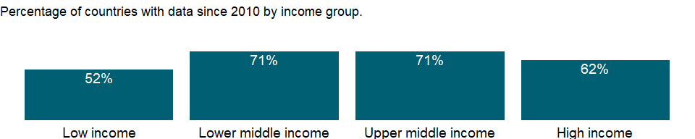

### Why is it relevant?

NA

### What is the data source?

International Monetary Fund, Government Finance Statistics Yearbook and data files.

### What is the methodology?

The IMF’s Government Finance Statistics Manual 2014, harmonized with the 2008 SNA, recommends an accrual accounting method, focusing on all economic events affecting assets, liabilities, revenues, and expenses, not just those represented by cash transactions. It accounts for all changes in stocks, so stock data at the end of an accounting period equal stock data at the beginning of the period plus flows over the period. The 1986 manual considered only debt stocks.

Government finance statistics are reported in local currency. Many countries report government finance data by fiscal year; see country metadata for information on fiscal year end by country.

### How is it aggregated?

NA

### What are the limitations?

For most countries central government finance data have been consolidated into one account, but for others only budgetary central government accounts are available. Countries reporting budgetary data are noted in the country metadata. Because budgetary accounts may not include all central government units (such as social security funds), they usually provide an incomplete picture. In federal states the central government accounts provide an incomplete view of total public finance.

Data on government revenue and expense are collected by the IMF through questionnaires to member countries and by the Organisation for Economic Co-operation and Development (OECD). Despite IMF efforts to standardize data collection, statistics are often incomplete, untimely, and not comparable across countries.

### What else should I know?

NA

### 1.30.4 Goods and services expense (% of expense)

### What is the indicator?

Goods and services include all government payments in exchange for goods and services used for the production of market and nonmarket goods and services. Own-account capital formation is excluded.

Topic: Public Sector: Government finance: Expense

Series ID: GC.XPN.GSRV.ZS

Copyright: CC BY-4.0 , <https://datacatalog.worldbank.org/public-licenses#cc-by>

First year with any data: 1972

Last year with any data: 2020

### What years are data available?

The figure below shows years in which data is available for at least one country. Dates shaded in black have no data, while dates shaded in green have data for at least one country



### Which countries have data?

The figure below shows the percentage of countries in each income group with a value since 2010 for that indicator.



### Why is it relevant?

NA

### What is the data source?

International Monetary Fund, Government Finance Statistics Yearbook and data files.

### What is the methodology?

The IMF’s Government Finance Statistics Manual 2014, harmonized with the 2008 SNA, recommends an accrual accounting method, focusing on all economic events affecting assets, liabilities, revenues, and expenses, not just those represented by cash transactions. It accounts for all changes in stocks, so stock data at the end of an accounting period equal stock data at the beginning of the period plus flows over the period. The 1986 manual considered only debt stocks.

Government finance statistics are reported in local currency. Many countries report government finance data by fiscal year; see country metadata for information on fiscal year end by country.

### How is it aggregated?

Median

### What are the limitations?

For most countries central government finance data have been consolidated into one account, but for others only budgetary central government accounts are available. Countries reporting budgetary data are noted in the country metadata. Because budgetary accounts may not include all central government units (such as social security funds), they usually provide an incomplete picture. In federal states the central government accounts provide an incomplete view of total public finance.

Data on government revenue and expense are collected by the IMF through questionnaires to member countries and by the Organisation for Economic Co-operation and Development (OECD). Despite IMF efforts to standardize data collection, statistics are often incomplete, untimely, and not comparable across countries.

### What else should I know?

NA

### 1.30.5 Interest payments (current LCU)

### What is the indicator?

Interest payments include interest payments on government debt–including long-term bonds, long-term loans, and other debt instruments–to domestic and foreign residents.

Topic: Public Sector: Government finance: Expense

Series ID: GC.XPN.INTP.CN

Copyright: CC BY-4.0 , <https://datacatalog.worldbank.org/public-licenses#cc-by>

First year with any data: 1972

Last year with any data: 2020

### What years are data available?

The figure below shows years in which data is available for at least one country. Dates shaded in black have no data, while dates shaded in green have data for at least one country



### Which countries have data?

The figure below shows the percentage of countries in each income group with a value since 2010 for that indicator.



### Why is it relevant?

NA

### What is the data source?

International Monetary Fund, Government Finance Statistics Yearbook and data files.

### What is the methodology?

The IMF’s Government Finance Statistics Manual 2014, harmonized with the 2008 SNA, recommends an accrual accounting method, focusing on all economic events affecting assets, liabilities, revenues, and expenses, not just those represented by cash transactions. It accounts for all changes in stocks, so stock data at the end of an accounting period equal stock data at the beginning of the period plus flows over the period. The 1986 manual considered only debt stocks.

Government finance statistics are reported in local currency. Many countries report government finance data by fiscal year; see country metadata for information on fiscal year end by country.

### How is it aggregated?

NA

### What are the limitations?

For most countries central government finance data have been consolidated into one account, but for others only budgetary central government accounts are available. Countries reporting budgetary data are noted in the country metadata. Because budgetary accounts may not include all central government units (such as social security funds), they usually provide an incomplete picture. In federal states the central government accounts provide an incomplete view of total public finance.

Data on government revenue and expense are collected by the IMF through questionnaires to member countries and by the Organisation for Economic Co-operation and Development (OECD). Despite IMF efforts to standardize data collection, statistics are often incomplete, untimely, and not comparable across countries.

### What else should I know?

NA

### 1.30.6 Interest payments (% of revenue)

### What is the indicator?

Interest payments include interest payments on government debt–including long-term bonds, long-term loans, and other debt instruments–to domestic and foreign residents.

Topic: Public Sector: Government finance: Expense

Series ID: GC.XPN.INTP.RV.ZS

Copyright: CC BY-4.0 , <https://datacatalog.worldbank.org/public-licenses#cc-by>

First year with any data: 1972

Last year with any data: 2020

### What years are data available?

The figure below shows years in which data is available for at least one country. Dates shaded in black have no data, while dates shaded in green have data for at least one country



### Which countries have data?

The figure below shows the percentage of countries in each income group with a value since 2010 for that indicator.



### Why is it relevant?

NA

### What is the data source?

International Monetary Fund, Government Finance Statistics Yearbook and data files.

### What is the methodology?

The IMF’s Government Finance Statistics Manual 2014, harmonized with the 2008 SNA, recommends an accrual accounting method, focusing on all economic events affecting assets, liabilities, revenues, and expenses, not just those represented by cash transactions. It accounts for all changes in stocks, so stock data at the end of an accounting period equal stock data at the beginning of the period plus flows over the period. The 1986 manual considered only debt stocks.

Government finance statistics are reported in local currency. Many countries report government finance data by fiscal year; see country metadata for information on fiscal year end by country.

### How is it aggregated?

Median

### What are the limitations?

For most countries central government finance data have been consolidated into one account, but for others only budgetary central government accounts are available. Countries reporting budgetary data are noted in the country metadata. Because budgetary accounts may not include all central government units (such as social security funds), they usually provide an incomplete picture. In federal states the central government accounts provide an incomplete view of total public finance.

Data on government revenue and expense are collected by the IMF through questionnaires to member countries and by the Organisation for Economic Co-operation and Development (OECD). Despite IMF efforts to standardize data collection, statistics are often incomplete, untimely, and not comparable across countries.

### What else should I know?

NA

### 1.30.7 Interest payments (% of expense)

### What is the indicator?

Interest payments include interest payments on government debt–including long-term bonds, long-term loans, and other debt instruments–to domestic and foreign residents.

Topic: Public Sector: Government finance: Expense

Series ID: GC.XPN.INTP.ZS

Copyright: CC BY-4.0 , <https://datacatalog.worldbank.org/public-licenses#cc-by>

First year with any data: 1972

Last year with any data: 2020

### What years are data available?

The figure below shows years in which data is available for at least one country. Dates shaded in black have no data, while dates shaded in green have data for at least one country



### Which countries have data?

The figure below shows the percentage of countries in each income group with a value since 2010 for that indicator.



### Why is it relevant?

NA

### What is the data source?

International Monetary Fund, Government Finance Statistics Yearbook and data files.

### What is the methodology?

The IMF’s Government Finance Statistics Manual 2014, harmonized with the 2008 SNA, recommends an accrual accounting method, focusing on all economic events affecting assets, liabilities, revenues, and expenses, not just those represented by cash transactions. It accounts for all changes in stocks, so stock data at the end of an accounting period equal stock data at the beginning of the period plus flows over the period. The 1986 manual considered only debt stocks.

Government finance statistics are reported in local currency. Many countries report government finance data by fiscal year; see country metadata for information on fiscal year end by country.

### How is it aggregated?

Median

### What are the limitations?

For most countries central government finance data have been consolidated into one account, but for others only budgetary central government accounts are available. Countries reporting budgetary data are noted in the country metadata. Because budgetary accounts may not include all central government units (such as social security funds), they usually provide an incomplete picture. In federal states the central government accounts provide an incomplete view of total public finance.

Data on government revenue and expense are collected by the IMF through questionnaires to member countries and by the Organisation for Economic Co-operation and Development (OECD). Despite IMF efforts to standardize data collection, statistics are often incomplete, untimely, and not comparable across countries.

### What else should I know?

NA

### 1.30.8 Other expense (current LCU)

### What is the indicator?

Other expense is spending on dividends, rent, and other miscellaneous expenses, including provision for consumption of fixed capital.

Topic: Public Sector: Government finance: Expense

Series ID: GC.XPN.OTHR.CN

Copyright: CC BY-4.0 , <https://datacatalog.worldbank.org/public-licenses#cc-by>

First year with any data: 1970

Last year with any data: 2020

### What years are data available?

The figure below shows years in which data is available for at least one country. Dates shaded in black have no data, while dates shaded in green have data for at least one country

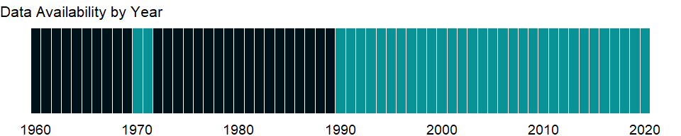

### Which countries have data?

The figure below shows the percentage of countries in each income group with a value since 2010 for that indicator.

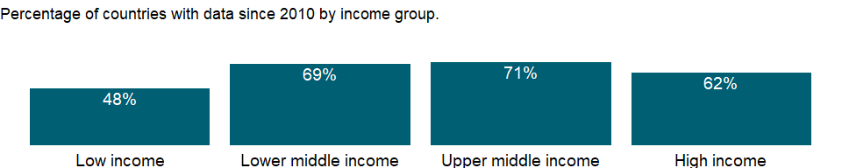

### Why is it relevant?

NA

### What is the data source?

International Monetary Fund, Government Finance Statistics Yearbook and data files.

### What is the methodology?

The IMF’s Government Finance Statistics Manual 2014, harmonized with the 2008 SNA, recommends an accrual accounting method, focusing on all economic events affecting assets, liabilities, revenues, and expenses, not just those represented by cash transactions. It accounts for all changes in stocks, so stock data at the end of an accounting period equal stock data at the beginning of the period plus flows over the period. The 1986 manual considered only debt stocks.

Government finance statistics are reported in local currency. Many countries report government finance data by fiscal year; see country metadata for information on fiscal year end by country.

### How is it aggregated?

NA

### What are the limitations?

For most countries central government finance data have been consolidated into one account, but for others only budgetary central government accounts are available. Countries reporting budgetary data are noted in the country metadata. Because budgetary accounts may not include all central government units (such as social security funds), they usually provide an incomplete picture. In federal states the central government accounts provide an incomplete view of total public finance.

Data on government revenue and expense are collected by the IMF through questionnaires to member countries and by the Organisation for Economic Co-operation and Development (OECD). Despite IMF efforts to standardize data collection, statistics are often incomplete, untimely, and not comparable across countries.

### What else should I know?

NA

### 1.30.9 Other expense (% of expense)

### What is the indicator?

Other expense is spending on dividends, rent, and other miscellaneous expenses, including provision for consumption of fixed capital.

Topic: Public Sector: Government finance: Expense

Series ID: GC.XPN.OTHR.ZS

Copyright: CC BY-4.0 , <https://datacatalog.worldbank.org/public-licenses#cc-by>

First year with any data: 1990

Last year with any data: 2020

### What years are data available?

The figure below shows years in which data is available for at least one country. Dates shaded in black have no data, while dates shaded in green have data for at least one country



### Which countries have data?

The figure below shows the percentage of countries in each income group with a value since 2010 for that indicator.



### Why is it relevant?

NA

### What is the data source?

International Monetary Fund, Government Finance Statistics Yearbook and data files.

### What is the methodology?

The IMF’s Government Finance Statistics Manual 2014, harmonized with the 2008 SNA, recommends an accrual accounting method, focusing on all economic events affecting assets, liabilities, revenues, and expenses, not just those represented by cash transactions. It accounts for all changes in stocks, so stock data at the end of an accounting period equal stock data at the beginning of the period plus flows over the period. The 1986 manual considered only debt stocks.

Government finance statistics are reported in local currency. Many countries report government finance data by fiscal year; see country metadata for information on fiscal year end by country.

### How is it aggregated?

Median

### What are the limitations?

For most countries central government finance data have been consolidated into one account, but for others only budgetary central government accounts are available. Countries reporting budgetary data are noted in the country metadata. Because budgetary accounts may not include all central government units (such as social security funds), they usually provide an incomplete picture. In federal states the central government accounts provide an incomplete view of total public finance.

Data on government revenue and expense are collected by the IMF through questionnaires to member countries and by the Organisation for Economic Co-operation and Development (OECD). Despite IMF efforts to standardize data collection, statistics are often incomplete, untimely, and not comparable across countries.

### What else should I know?

NA

### 1.30.10 Expense (current LCU)

### What is the indicator?

Expense is cash payments for operating activities of the government in providing goods and services. It includes compensation of employees (such as wages and salaries), interest and subsidies, grants, social benefits, and other expenses such as rent and dividends.

Topic: Public Sector: Government finance: Expense

Series ID: GC.XPN.TOTL.CN

Copyright: CC BY-4.0 , <https://datacatalog.worldbank.org/public-licenses#cc-by>

First year with any data: 1972

Last year with any data: 2020

### What years are data available?

The figure below shows years in which data is available for at least one country. Dates shaded in black have no data, while dates shaded in green have data for at least one country



### Which countries have data?

The figure below shows the percentage of countries in each income group with a value since 2010 for that indicator.



### Why is it relevant?

NA

### What is the data source?

International Monetary Fund, Government Finance Statistics Yearbook and data files.

### What is the methodology?

The IMF’s Government Finance Statistics Manual 2014, harmonized with the 2008 SNA, recommends an accrual accounting method, focusing on all economic events affecting assets, liabilities, revenues, and expenses, not just those represented by cash transactions. It accounts for all changes in stocks, so stock data at the end of an accounting period equal stock data at the beginning of the period plus flows over the period. The 1986 manual considered only debt stocks.

Government finance statistics are reported in local currency. Many countries report government finance data by fiscal year; see country metadata for information on fiscal year end by country.

### How is it aggregated?

NA

### What are the limitations?

For most countries central government finance data have been consolidated into one account, but for others only budgetary central government accounts are available. Countries reporting budgetary data are noted in the country metadata. Because budgetary accounts may not include all central government units (such as social security funds), they usually provide an incomplete picture. In federal states the central government accounts provide an incomplete view of total public finance.

Data on government revenue and expense are collected by the IMF through questionnaires to member countries and by the Organisation for Economic Co-operation and Development (OECD). Despite IMF efforts to standardize data collection, statistics are often incomplete, untimely, and not comparable across countries.

### What else should I know?

NA

### 1.30.11 Expense (% of GDP)

### What is the indicator?

Expense is cash payments for operating activities of the government in providing goods and services. It includes compensation of employees (such as wages and salaries), interest and subsidies, grants, social benefits, and other expenses such as rent and dividends.

Topic: Public Sector: Government finance: Expense

Series ID: GC.XPN.TOTL.GD.ZS

Copyright: CC BY-4.0 , <https://datacatalog.worldbank.org/public-licenses#cc-by>

First year with any data: 1972

Last year with any data: 2020

### What years are data available?

The figure below shows years in which data is available for at least one country. Dates shaded in black have no data, while dates shaded in green have data for at least one country



### Which countries have data?

The figure below shows the percentage of countries in each income group with a value since 2010 for that indicator.



### Why is it relevant?

NA

### What is the data source?

International Monetary Fund, Government Finance Statistics Yearbook and data files, and World Bank and OECD GDP estimates.

### What is the methodology?

The IMF’s Government Finance Statistics Manual 2014, harmonized with the 2008 SNA, recommends an accrual accounting method, focusing on all economic events affecting assets, liabilities, revenues, and expenses, not just those represented by cash transactions. It accounts for all changes in stocks, so stock data at the end of an accounting period equal stock data at the beginning of the period plus flows over the period. The 1986 manual considered only debt stocks.

Government finance statistics are reported in local currency. Many countries report government finance data by fiscal year; see country metadata for information on fiscal year end by country.

### How is it aggregated?

Weighted average

### What are the limitations?

For most countries central government finance data have been consolidated into one account, but for others only budgetary central government accounts are available. Countries reporting budgetary data are noted in the country metadata. Because budgetary accounts may not include all central government units (such as social security funds), they usually provide an incomplete picture. In federal states the central government accounts provide an incomplete view of total public finance.

Data on government revenue and expense are collected by the IMF through questionnaires to member countries and by the Organisation for Economic Co-operation and Development (OECD). Despite IMF efforts to standardize data collection, statistics are often incomplete, untimely, and not comparable across countries.

### What else should I know?

NA

### 1.30.12 Subsidies and other transfers (current LCU)

### What is the indicator?

Subsidies, grants, and other social benefits include all unrequited, nonrepayable transfers on current account to private and public enterprises; grants to foreign governments, international organizations, and other government units; and social security, social assistance benefits, and employer social benefits in cash and in kind.

Topic: Public Sector: Government finance: Expense

Series ID: GC.XPN.TRFT.CN

Copyright: CC BY-4.0 , <https://datacatalog.worldbank.org/public-licenses#cc-by>

First year with any data: 1970

Last year with any data: 2020

### What years are data available?

The figure below shows years in which data is available for at least one country. Dates shaded in black have no data, while dates shaded in green have data for at least one country



### Which countries have data?

The figure below shows the percentage of countries in each income group with a value since 2010 for that indicator.

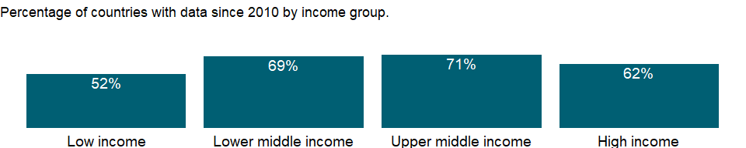

### Why is it relevant?

NA

### What is the data source?

International Monetary Fund, Government Finance Statistics Yearbook and data files.

### What is the methodology?

The IMF’s Government Finance Statistics Manual 2014, harmonized with the 2008 SNA, recommends an accrual accounting method, focusing on all economic events affecting assets, liabilities, revenues, and expenses, not just those represented by cash transactions. It accounts for all changes in stocks, so stock data at the end of an accounting period equal stock data at the beginning of the period plus flows over the period. The 1986 manual considered only debt stocks.

Government finance statistics are reported in local currency. Many countries report government finance data by fiscal year; see country metadata for information on fiscal year end by country.

### How is it aggregated?

NA

### What are the limitations?

For most countries central government finance data have been consolidated into one account, but for others only budgetary central government accounts are available. Countries reporting budgetary data are noted in the country metadata. Because budgetary accounts may not include all central government units (such as social security funds), they usually provide an incomplete picture. In federal states the central government accounts provide an incomplete view of total public finance.

Data on government revenue and expense are collected by the IMF through questionnaires to member countries and by the Organisation for Economic Co-operation and Development (OECD). Despite IMF efforts to standardize data collection, statistics are often incomplete, untimely, and not comparable across countries.

### What else should I know?

NA

### 1.30.13 Subsidies and other transfers (% of expense)

### What is the indicator?

Subsidies, grants, and other social benefits include all unrequited, nonrepayable transfers on current account to private and public enterprises; grants to foreign governments, international organizations, and other government units; and social security, social assistance benefits, and employer social benefits in cash and in kind.

Topic: Public Sector: Government finance: Expense

Series ID: GC.XPN.TRFT.ZS

Copyright: CC BY-4.0 , <https://datacatalog.worldbank.org/public-licenses#cc-by>

First year with any data: 1972

Last year with any data: 2020

### What years are data available?

The figure below shows years in which data is available for at least one country. Dates shaded in black have no data, while dates shaded in green have data for at least one country



### Which countries have data?

The figure below shows the percentage of countries in each income group with a value since 2010 for that indicator.



### Why is it relevant?

NA

### What is the data source?

International Monetary Fund, Government Finance Statistics Yearbook and data files.

### What is the methodology?

The IMF’s Government Finance Statistics Manual 2014, harmonized with the 2008 SNA, recommends an accrual accounting method, focusing on all economic events affecting assets, liabilities, revenues, and expenses, not just those represented by cash transactions. It accounts for all changes in stocks, so stock data at the end of an accounting period equal stock data at the beginning of the period plus flows over the period. The 1986 manual considered only debt stocks.

Government finance statistics are reported in local currency. Many countries report government finance data by fiscal year; see country metadata for information on fiscal year end by country.

### How is it aggregated?

Median

### What are the limitations?

For most countries central government finance data have been consolidated into one account, but for others only budgetary central government accounts are available. Countries reporting budgetary data are noted in the country metadata. Because budgetary accounts may not include all central government units (such as social security funds), they usually provide an incomplete picture. In federal states the central government accounts provide an incomplete view of total public finance.

Data on government revenue and expense are collected by the IMF through questionnaires to member countries and by the Organisation for Economic Co-operation and Development (OECD). Despite IMF efforts to standardize data collection, statistics are often incomplete, untimely, and not comparable across countries.

### What else should I know?

NA

## 1.31 Public Sector: Government finance

### 1.31.1 Primary government expenditures as a proportion of original approved budget (%)

### What is the indicator?

Primary government expenditures as a proportion of original approved budget measures the extent to which aggregate budget expenditure outturn reflects the amount originally approved, as defined in government budget documentation and fiscal reports. The coverage is budgetary central government (BCG) and the time period covered is the last three completed fiscal years.

Topic: Public Sector: Government finance

Series ID: GF.XPD.BUDG.ZS

Copyright: CC BY-4.0 , <https://datacatalog.worldbank.org/public-licenses#cc-by>

First year with any data: 2004

Last year with any data: 2020

### What years are data available?

The figure below shows years in which data is available for at least one country. Dates shaded in black have no data, while dates shaded in green have data for at least one country



### Which countries have data?

The figure below shows the percentage of countries in each income group with a value since 2010 for that indicator.

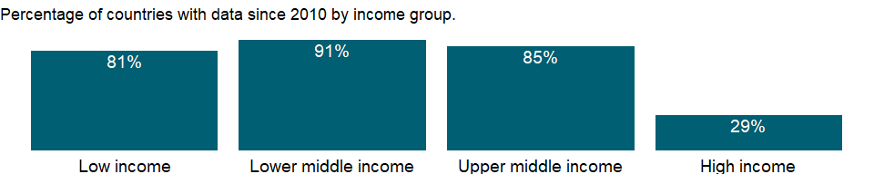

### Why is it relevant?

The indicator attempts to capture the reliability of government budgets: do governments spend what they intend to and do they collect what they set out to collect. The ability to implement the enacted budget is an important factor in government’s ability to deliver public services and achieve development objectives. The deviation between approved and actual spending is measured over a 12-month period (the budget year) and may have important implications for macroeconomic stability, public service delivery, and social welfare. A credibly implemented budget has only small deviations from the approved one. If expenditure is under-executed, beneficiaries may not receive crucial services. Over-executed budgets may result in budget deficits and increased public debt levels and can influence the macroeconomic stability. In both cases, lack of budget credibility undermines the usefulness of the budget process for policy making and implementation and erodes public trust in government.

### What is the data source?

Public Expenditure and Financial Accountability (PEFA). Ministry of Finance (MoF).

### What is the methodology?

NA

### How is it aggregated?

NA

### What are the limitations?

NA

### What else should I know?

NA

## 1.32 Public Sector: Policy & institutions

### 1.32.1 Human capital index (HCI) (scale 0-1)

### What is the indicator?

The HCI calculates the contributions of health and education to worker productivity. The final index score ranges from zero to one and measures the productivity as a future worker of child born today relative to the benchmark of full health and complete education.

Topic: Public Sector: Policy & institutions

Series ID: HD.HCI.OVRL

Copyright: CC BY-4.0 , <https://datacatalog.worldbank.org/public-licenses#cc-by>

First year with any data: 2010

Last year with any data: 2020

### What years are data available?

The figure below shows years in which data is available for at least one country. Dates shaded in black have no data, while dates shaded in green have data for at least one country

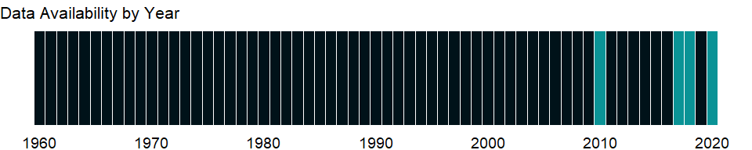

### Which countries have data?

The figure below shows the percentage of countries in each income group with a value since 2010 for that indicator.

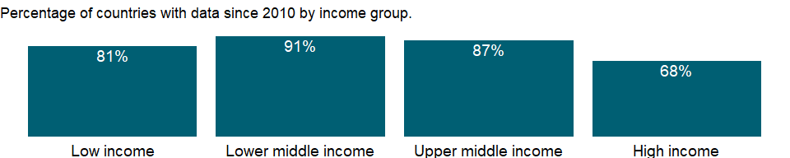

### Why is it relevant?

NA

### What is the data source?

World Bank staff calculations based on the methodology described in World Bank (2018). <https://openknowledge.worldbank.org/handle/10986/30498>

### What is the methodology?

NA

### How is it aggregated?

NA

### What are the limitations?

NA

### What else should I know?

NA

### 1.32.2 Human capital index (HCI), female (scale 0-1)

### What is the indicator?

The HCI calculates the contributions of health and education to worker productivity. The final index score ranges from zero to one and measures the productivity as a future worker of child born today relative to the benchmark of full health and complete education.

Topic: Public Sector: Policy & institutions

Series ID: HD.HCI.OVRL.FE

Copyright: CC BY-4.0 , <https://datacatalog.worldbank.org/public-licenses#cc-by>

First year with any data: 2010

Last year with any data: 2020

### What years are data available?

The figure below shows years in which data is available for at least one country. Dates shaded in black have no data, while dates shaded in green have data for at least one country



### Which countries have data?

The figure below shows the percentage of countries in each income group with a value since 2010 for that indicator.

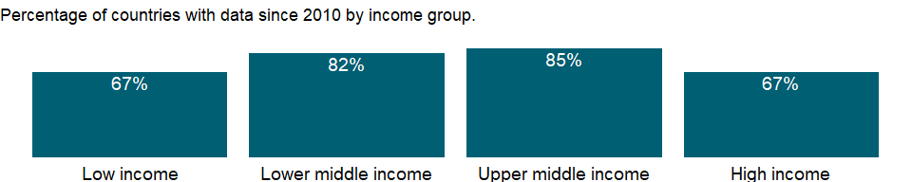

### Why is it relevant?

NA

### What is the data source?

World Bank staff calculations based on the methodology described in World Bank (2018). <https://openknowledge.worldbank.org/handle/10986/30498>

### What is the methodology?

NA

### How is it aggregated?

NA

### What are the limitations?

NA

### What else should I know?

NA

### 1.32.3 Human capital index (HCI), lower bound (scale 0-1)

### What is the indicator?

The HCI lower bound reflects uncertainty in the measurement of the components and the overall index. It is obtained by recalculating the HCI using estimates of the lower bounds of each of the components of the HCI. The range between the upper and lower bound is the uncertainty interval. While the uncertainty intervals constructed here do not have a rigorous statistical interpretation, a rule of thumb is that if for two countries they overlap substantially, the differences between their HCI values are not likely to be practically meaningful.

Topic: Public Sector: Policy & institutions

Series ID: HD.HCI.OVRL.LB

Copyright: CC BY-4.0 , <https://datacatalog.worldbank.org/public-licenses#cc-by>

First year with any data: 2010

Last year with any data: 2020

### What years are data available?

The figure below shows years in which data is available for at least one country. Dates shaded in black have no data, while dates shaded in green have data for at least one country



### Which countries have data?

The figure below shows the percentage of countries in each income group with a value since 2010 for that indicator.



### Why is it relevant?

NA

### What is the data source?

World Bank staff calculations based on the methodology described in World Bank (2018). <https://openknowledge.worldbank.org/handle/10986/30498>

### What is the methodology?

NA

### How is it aggregated?

NA

### What are the limitations?

NA

### What else should I know?

NA

### 1.32.4 Human capital index (HCI), female, lower bound (scale 0-1)

### What is the indicator?

The HCI lower bound reflects uncertainty in the measurement of the components and the overall index. It is obtained by recalculating the HCI using estimates of the lower bounds of each of the components of the HCI. The range between the upper and lower bound is the uncertainty interval. While the uncertainty intervals constructed here do not have a rigorous statistical interpretation, a rule of thumb is that if for two countries they overlap substantially, the differences between their HCI values are not likely to be practically meaningful.

Topic: Public Sector: Policy & institutions

Series ID: HD.HCI.OVRL.LB.FE

Copyright: CC BY-4.0 , <https://datacatalog.worldbank.org/public-licenses#cc-by>

First year with any data: 2010

Last year with any data: 2020

### What years are data available?

The figure below shows years in which data is available for at least one country. Dates shaded in black have no data, while dates shaded in green have data for at least one country



### Which countries have data?

The figure below shows the percentage of countries in each income group with a value since 2010 for that indicator.



### Why is it relevant?

NA

### What is the data source?

World Bank staff calculations based on the methodology described in World Bank (2018). <https://openknowledge.worldbank.org/handle/10986/30498>

### What is the methodology?

NA

### How is it aggregated?

NA

### What are the limitations?

NA

### What else should I know?

NA

### 1.32.5 Human capital index (HCI), male, lower bound (scale 0-1)

### What is the indicator?

The HCI lower bound reflects uncertainty in the measurement of the components and the overall index. It is obtained by recalculating the HCI using estimates of the lower bounds of each of the components of the HCI. The range between the upper and lower bound is the uncertainty interval. While the uncertainty intervals constructed here do not have a rigorous statistical interpretation, a rule of thumb is that if for two countries they overlap substantially, the differences between their HCI values are not likely to be practically meaningful.

Topic: Public Sector: Policy & institutions

Series ID: HD.HCI.OVRL.LB.MA

Copyright: CC BY-4.0 , <https://datacatalog.worldbank.org/public-licenses#cc-by>

First year with any data: 2010

Last year with any data: 2020

### What years are data available?

The figure below shows years in which data is available for at least one country. Dates shaded in black have no data, while dates shaded in green have data for at least one country



### Which countries have data?

The figure below shows the percentage of countries in each income group with a value since 2010 for that indicator.



### Why is it relevant?

NA

### What is the data source?

World Bank staff calculations based on the methodology described in World Bank (2018). <https://openknowledge.worldbank.org/handle/10986/30498>

### What is the methodology?

NA

### How is it aggregated?

NA

### What are the limitations?

NA

### What else should I know?

NA

### 1.32.6 Human capital index (HCI), male (scale 0-1)

### What is the indicator?

The HCI calculates the contributions of health and education to worker productivity. The final index score ranges from zero to one and measures the productivity as a future worker of child born today relative to the benchmark of full health and complete education.

Topic: Public Sector: Policy & institutions

Series ID: HD.HCI.OVRL.MA

Copyright: CC BY-4.0 , <https://datacatalog.worldbank.org/public-licenses#cc-by>

First year with any data: 2010

Last year with any data: 2020

### What years are data available?

The figure below shows years in which data is available for at least one country. Dates shaded in black have no data, while dates shaded in green have data for at least one country



### Which countries have data?

The figure below shows the percentage of countries in each income group with a value since 2010 for that indicator.



### Why is it relevant?

NA

### What is the data source?

World Bank staff calculations based on the methodology described in World Bank (2018). <https://openknowledge.worldbank.org/handle/10986/30498>

### What is the methodology?

NA

### How is it aggregated?

NA

### What are the limitations?

NA

### What else should I know?

NA

### 1.32.7 Human capital index (HCI), upper bound (scale 0-1)

### What is the indicator?

The HCI upper bound reflects uncertainty in the measurement of the components and the overall index. It is obtained by recalculating the HCI using estimates of the upper bounds of each of the components of the HCI. The range between the upper and lower bound is the uncertainty interval. While the uncertainty intervals constructed here do not have a rigorous statistical interpretation, a rule of thumb is that if for two countries they overlap substantially, the differences between their HCI values are not likely to be practically meaningful.

Topic: Public Sector: Policy & institutions

Series ID: HD.HCI.OVRL.UB

Copyright: CC BY-4.0 , <https://datacatalog.worldbank.org/public-licenses#cc-by>

First year with any data: 2010

Last year with any data: 2020

### What years are data available?

The figure below shows years in which data is available for at least one country. Dates shaded in black have no data, while dates shaded in green have data for at least one country



### Which countries have data?

The figure below shows the percentage of countries in each income group with a value since 2010 for that indicator.



### Why is it relevant?

NA

### What is the data source?

World Bank staff calculations based on the methodology described in World Bank (2018). <https://openknowledge.worldbank.org/handle/10986/30498>

### What is the methodology?

NA

### How is it aggregated?

NA

### What are the limitations?

NA

### What else should I know?

NA

### 1.32.8 Human capital index (HCI), female, upper bound (scale 0-1)

### What is the indicator?

The HCI upper bound reflects uncertainty in the measurement of the components and the overall index. It is obtained by recalculating the HCI using estimates of the upper bounds of each of the components of the HCI. The range between the upper and lower bound is the uncertainty interval. While the uncertainty intervals constructed here do not have a rigorous statistical interpretation, a rule of thumb is that if for two countries they overlap substantially, the differences between their HCI values are not likely to be practically meaningful.

Topic: Public Sector: Policy & institutions

Series ID: HD.HCI.OVRL.UB.FE

Copyright: CC BY-4.0 , <https://datacatalog.worldbank.org/public-licenses#cc-by>

First year with any data: 2010

Last year with any data: 2020

### What years are data available?

The figure below shows years in which data is available for at least one country. Dates shaded in black have no data, while dates shaded in green have data for at least one country



### Which countries have data?

The figure below shows the percentage of countries in each income group with a value since 2010 for that indicator.



### Why is it relevant?

NA

### What is the data source?

World Bank staff calculations based on the methodology described in World Bank (2018). <https://openknowledge.worldbank.org/handle/10986/30498>

### What is the methodology?

NA

### How is it aggregated?

NA

### What are the limitations?

NA

### What else should I know?

NA

### 1.32.9 Human capital index (HCI), male, upper bound (scale 0-1)

### What is the indicator?

The HCI upper bound reflects uncertainty in the measurement of the components and the overall index. It is obtained by recalculating the HCI using estimates of the upper bounds of each of the components of the HCI. The range between the upper and lower bound is the uncertainty interval. While the uncertainty intervals constructed here do not have a rigorous statistical interpretation, a rule of thumb is that if for two countries they overlap substantially, the differences between their HCI values are not likely to be practically meaningful.

Topic: Public Sector: Policy & institutions

Series ID: HD.HCI.OVRL.UB.MA

Copyright: CC BY-4.0 , <https://datacatalog.worldbank.org/public-licenses#cc-by>

First year with any data: 2010

Last year with any data: 2020

### What years are data available?

The figure below shows years in which data is available for at least one country. Dates shaded in black have no data, while dates shaded in green have data for at least one country



### Which countries have data?

The figure below shows the percentage of countries in each income group with a value since 2010 for that indicator.



### Why is it relevant?

NA

### What is the data source?

World Bank staff calculations based on the methodology described in World Bank (2018). <https://openknowledge.worldbank.org/handle/10986/30498>

### What is the methodology?

NA

### How is it aggregated?

NA

### What are the limitations?

NA

### What else should I know?

NA

### 1.32.10 CPIA business regulatory environment rating (1=low to 6=high)

### What is the indicator?

Business regulatory environment assesses the extent to which the legal, regulatory, and policy environments help or hinder private businesses in investing, creating jobs, and becoming more productive.

Topic: Public Sector: Policy & institutions

Series ID: IQ.CPA.BREG.XQ

Copyright: CC BY-4.0 , <https://datacatalog.worldbank.org/public-licenses#cc-by>

First year with any data: 2005

Last year with any data: 2020

### What years are data available?

The figure below shows years in which data is available for at least one country. Dates shaded in black have no data, while dates shaded in green have data for at least one country

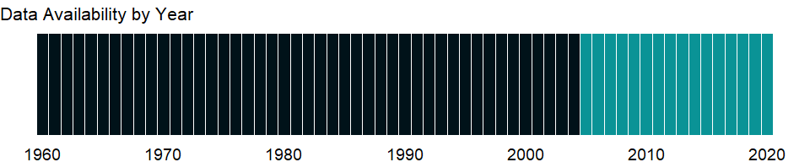

### Which countries have data?

The figure below shows the percentage of countries in each income group with a value since 2010 for that indicator.

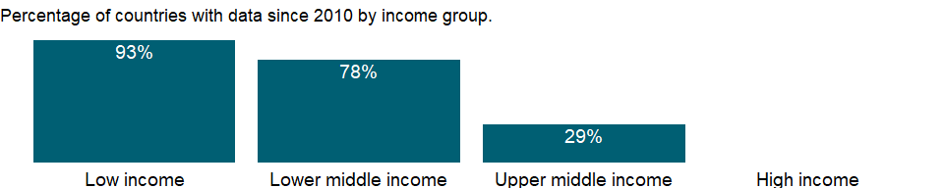

### Why is it relevant?

The International Development Association (IDA) is the part of the World Bank Group that helps the poorest countries reduce poverty by providing concessional loans and grants for programs aimed at boosting economic growth and improving living conditions. IDA funding helps these countries deal with the complex challenges they face in meeting the Millennium Development Goals.

The World Bank’s IDA Resource Allocation Index (IRAI) is based on the results of the annual Country Policy and Institutional Assessment (CPIA) exercise, which covers the IDA-eligible countries. Country assessments have been carried out annually since the mid-1970s by World Bank staff. Over time the criteria have been revised from a largely macroeconomic focus to include governance aspects and a broader coverage of social and structural dimensions. Country performance is assessed against a set of 16 criteria grouped into four clusters: economic management, structural policies, policies for social inclusion and equity, and public sector management and institutions. IDA resources are allocated to a country on per capita terms based on its IDA country performance rating and, to a limited extent, based on its per capita gross national income. This ensures that good performers receive a higher IDA allocation in per capita terms. The IRAI is a key element in the country performance rating.

### What is the data source?

World Bank Group, CPIA database (<http://www.worldbank.org/ida>).

### What is the methodology?

All criteria within each cluster receive equal weight, and each cluster has a 25 percent weight in the overall score, which is obtained by averaging the average scores of the four clusters. For each of the 16 criteria countries are rated on a scale of 1 (low) to 6 (high). The scores depend on the level of performance in a given year assessed against the criteria, rather than on changes in performance compared with the previous year. All 16 CPIA criteria contain a detailed description of each rating level. In assessing country performance, World Bank staff evaluate the country’s performance on each of the criteria and assign a rating. The ratings reflect a variety of indicators, observations, and judgments based on country knowledge and on relevant publicly available indicators. In interpreting the assessment scores, it should be noted that the criteria are designed in a developmentally neutral manner. Accordingly, higher scores can be attained by a country that, given its stage of development, has a policy and institutional framework that more strongly fosters growth and poverty reduction.

The country teams that prepare the ratings are very familiar with the country, and their assessments are based on country diagnostic studies prepared by the World Bank or other development organizations and on their own professional judgment. An early consultation is conducted with country authorities to make sure that the assessments are informed by up-to-date information. To ensure that scores are consistent across countries, the process involves two key phases. In the benchmarking phase a small representative sample of countries drawn from all regions is rated. Country teams prepare proposals that are reviewed first at the regional level and then in a Bankwide review process. A similar process is followed to assess the performance of the remaining countries, using the benchmark countries’ scores as guideposts. The final ratings are determined following a Bankwide review. The overall numerical IRAI score and the separate criteria scores were first publicly disclosed in June 2006.

### How is it aggregated?

Unweighted average

### What are the limitations?

The CPIA exercise is intended to capture the quality of a country’s policies and institutional arrangements, focusing on key elements that are within the country’s control, rather than on outcomes (such as economic growth rates) that are influenced by events beyond the country’s control. More specifically, the CPIA measures the extent to which a country’s policy and institutional framework supports sustainable growth and poverty reduction and, consequently, the effective use of development assistance.

### What else should I know?

NA

### 1.32.11 CPIA debt policy rating (1=low to 6=high)

### What is the indicator?

Debt policy assesses whether the debt management strategy is conducive to minimizing budgetary risks and ensuring long-term debt sustainability.

Topic: Public Sector: Policy & institutions

Series ID: IQ.CPA.DEBT.XQ

Copyright: CC BY-4.0 , <https://datacatalog.worldbank.org/public-licenses#cc-by>

First year with any data: 2005

Last year with any data: 2020

### What years are data available?

The figure below shows years in which data is available for at least one country. Dates shaded in black have no data, while dates shaded in green have data for at least one country



### Which countries have data?

The figure below shows the percentage of countries in each income group with a value since 2010 for that indicator.



### Why is it relevant?

The International Development Association (IDA) is the part of the World Bank Group that helps the poorest countries reduce poverty by providing concessional loans and grants for programs aimed at boosting economic growth and improving living conditions. IDA funding helps these countries deal with the complex challenges they face in meeting the Millennium Development Goals.

The World Bank’s IDA Resource Allocation Index (IRAI) is based on the results of the annual Country Policy and Institutional Assessment (CPIA) exercise, which covers the IDA-eligible countries. Country assessments have been carried out annually since the mid-1970s by World Bank staff. Over time the criteria have been revised from a largely macroeconomic focus to include governance aspects and a broader coverage of social and structural dimensions. Country performance is assessed against a set of 16 criteria grouped into four clusters: economic management, structural policies, policies for social inclusion and equity, and public sector management and institutions. IDA resources are allocated to a country on per capita terms based on its IDA country performance rating and, to a limited extent, based on its per capita gross national income. This ensures that good performers receive a higher IDA allocation in per capita terms. The IRAI is a key element in the country performance rating.

### What is the data source?

World Bank Group, CPIA database (<http://www.worldbank.org/ida>).

### What is the methodology?

All criteria within each cluster receive equal weight, and each cluster has a 25 percent weight in the overall score, which is obtained by averaging the average scores of the four clusters. For each of the 16 criteria countries are rated on a scale of 1 (low) to 6 (high). The scores depend on the level of performance in a given year assessed against the criteria, rather than on changes in performance compared with the previous year. All 16 CPIA criteria contain a detailed description of each rating level. In assessing country performance, World Bank staff evaluate the country’s performance on each of the criteria and assign a rating. The ratings reflect a variety of indicators, observations, and judgments based on country knowledge and on relevant publicly available indicators. In interpreting the assessment scores, it should be noted that the criteria are designed in a developmentally neutral manner. Accordingly, higher scores can be attained by a country that, given its stage of development, has a policy and institutional framework that more strongly fosters growth and poverty reduction.

The country teams that prepare the ratings are very familiar with the country, and their assessments are based on country diagnostic studies prepared by the World Bank or other development organizations and on their own professional judgment. An early consultation is conducted with country authorities to make sure that the assessments are informed by up-to-date information. To ensure that scores are consistent across countries, the process involves two key phases. In the benchmarking phase a small representative sample of countries drawn from all regions is rated. Country teams prepare proposals that are reviewed first at the regional level and then in a Bankwide review process. A similar process is followed to assess the performance of the remaining countries, using the benchmark countries’ scores as guideposts. The final ratings are determined following a Bankwide review. The overall numerical IRAI score and the separate criteria scores were first publicly disclosed in June 2006.

### How is it aggregated?

Unweighted average

### What are the limitations?

The CPIA exercise is intended to capture the quality of a country’s policies and institutional arrangements, focusing on key elements that are within the country’s control, rather than on outcomes (such as economic growth rates) that are influenced by events beyond the country’s control. More specifically, the CPIA measures the extent to which a country’s policy and institutional framework supports sustainable growth and poverty reduction and, consequently, the effective use of development assistance.

### What else should I know?

NA

### 1.32.12 CPIA economic management cluster average (1=low to 6=high)

### What is the indicator?

The economic management cluster includes macroeconomic management, fiscal policy, and debt policy.

Topic: Public Sector: Policy & institutions

Series ID: IQ.CPA.ECON.XQ

Copyright: CC BY-4.0 , <https://datacatalog.worldbank.org/public-licenses#cc-by>

First year with any data: 2005

Last year with any data: 2020

### What years are data available?

The figure below shows years in which data is available for at least one country. Dates shaded in black have no data, while dates shaded in green have data for at least one country



### Which countries have data?

The figure below shows the percentage of countries in each income group with a value since 2010 for that indicator.



### Why is it relevant?

The International Development Association (IDA) is the part of the World Bank Group that helps the poorest countries reduce poverty by providing concessional loans and grants for programs aimed at boosting economic growth and improving living conditions. IDA funding helps these countries deal with the complex challenges they face in meeting the Millennium Development Goals.

The World Bank’s IDA Resource Allocation Index (IRAI) is based on the results of the annual Country Policy and Institutional Assessment (CPIA) exercise, which covers the IDA-eligible countries. Country assessments have been carried out annually since the mid-1970s by World Bank staff. Over time the criteria have been revised from a largely macroeconomic focus to include governance aspects and a broader coverage of social and structural dimensions. Country performance is assessed against a set of 16 criteria grouped into four clusters: economic management, structural policies, policies for social inclusion and equity, and public sector management and institutions. IDA resources are allocated to a country on per capita terms based on its IDA country performance rating and, to a limited extent, based on its per capita gross national income. This ensures that good performers receive a higher IDA allocation in per capita terms. The IRAI is a key element in the country performance rating.

### What is the data source?

World Bank Group, CPIA database (<http://www.worldbank.org/ida>).

### What is the methodology?

All criteria within each cluster receive equal weight, and each cluster has a 25 percent weight in the overall score, which is obtained by averaging the average scores of the four clusters. For each of the 16 criteria countries are rated on a scale of 1 (low) to 6 (high). The scores depend on the level of performance in a given year assessed against the criteria, rather than on changes in performance compared with the previous year. All 16 CPIA criteria contain a detailed description of each rating level. In assessing country performance, World Bank staff evaluate the country’s performance on each of the criteria and assign a rating. The ratings reflect a variety of indicators, observations, and judgments based on country knowledge and on relevant publicly available indicators. In interpreting the assessment scores, it should be noted that the criteria are designed in a developmentally neutral manner. Accordingly, higher scores can be attained by a country that, given its stage of development, has a policy and institutional framework that more strongly fosters growth and poverty reduction.

The country teams that prepare the ratings are very familiar with the country, and their assessments are based on country diagnostic studies prepared by the World Bank or other development organizations and on their own professional judgment. An early consultation is conducted with country authorities to make sure that the assessments are informed by up-to-date information. To ensure that scores are consistent across countries, the process involves two key phases. In the benchmarking phase a small representative sample of countries drawn from all regions is rated. Country teams prepare proposals that are reviewed first at the regional level and then in a Bankwide review process. A similar process is followed to assess the performance of the remaining countries, using the benchmark countries’ scores as guideposts. The final ratings are determined following a Bankwide review. The overall numerical IRAI score and the separate criteria scores were first publicly disclosed in June 2006.

### How is it aggregated?

Unweighted average

### What are the limitations?

The CPIA exercise is intended to capture the quality of a country’s policies and institutional arrangements, focusing on key elements that are within the country’s control, rather than on outcomes (such as economic growth rates) that are influenced by events beyond the country’s control. More specifically, the CPIA measures the extent to which a country’s policy and institutional framework supports sustainable growth and poverty reduction and, consequently, the effective use of development assistance.

### What else should I know?

NA

### 1.32.13 CPIA policy and institutions for environmental sustainability rating (1=low to 6=high)

### What is the indicator?

Policy and institutions for environmental sustainability assess the extent to which environmental policies foster the protection and sustainable use of natural resources and the management of pollution.

Topic: Public Sector: Policy & institutions

Series ID: IQ.CPA.ENVR.XQ

Copyright: CC BY-4.0 , <https://datacatalog.worldbank.org/public-licenses#cc-by>

First year with any data: 2005

Last year with any data: 2020

### What years are data available?

The figure below shows years in which data is available for at least one country. Dates shaded in black have no data, while dates shaded in green have data for at least one country



### Which countries have data?

The figure below shows the percentage of countries in each income group with a value since 2010 for that indicator.



### Why is it relevant?

The International Development Association (IDA) is the part of the World Bank Group that helps the poorest countries reduce poverty by providing concessional loans and grants for programs aimed at boosting economic growth and improving living conditions. IDA funding helps these countries deal with the complex challenges they face in meeting the Millennium Development Goals.

The World Bank’s IDA Resource Allocation Index (IRAI) is based on the results of the annual Country Policy and Institutional Assessment (CPIA) exercise, which covers the IDA-eligible countries. Country assessments have been carried out annually since the mid-1970s by World Bank staff. Over time the criteria have been revised from a largely macroeconomic focus to include governance aspects and a broader coverage of social and structural dimensions. Country performance is assessed against a set of 16 criteria grouped into four clusters: economic management, structural policies, policies for social inclusion and equity, and public sector management and institutions. IDA resources are allocated to a country on per capita terms based on its IDA country performance rating and, to a limited extent, based on its per capita gross national income. This ensures that good performers receive a higher IDA allocation in per capita terms. The IRAI is a key element in the country performance rating.

### What is the data source?

World Bank Group, CPIA database (<http://www.worldbank.org/ida>).

### What is the methodology?

All criteria within each cluster receive equal weight, and each cluster has a 25 percent weight in the overall score, which is obtained by averaging the average scores of the four clusters. For each of the 16 criteria countries are rated on a scale of 1 (low) to 6 (high). The scores depend on the level of performance in a given year assessed against the criteria, rather than on changes in performance compared with the previous year. All 16 CPIA criteria contain a detailed description of each rating level. In assessing country performance, World Bank staff evaluate the country’s performance on each of the criteria and assign a rating. The ratings reflect a variety of indicators, observations, and judgments based on country knowledge and on relevant publicly available indicators. In interpreting the assessment scores, it should be noted that the criteria are designed in a developmentally neutral manner. Accordingly, higher scores can be attained by a country that, given its stage of development, has a policy and institutional framework that more strongly fosters growth and poverty reduction.

The country teams that prepare the ratings are very familiar with the country, and their assessments are based on country diagnostic studies prepared by the World Bank or other development organizations and on their own professional judgment. An early consultation is conducted with country authorities to make sure that the assessments are informed by up-to-date information. To ensure that scores are consistent across countries, the process involves two key phases. In the benchmarking phase a small representative sample of countries drawn from all regions is rated. Country teams prepare proposals that are reviewed first at the regional level and then in a Bankwide review process. A similar process is followed to assess the performance of the remaining countries, using the benchmark countries’ scores as guideposts. The final ratings are determined following a Bankwide review. The overall numerical IRAI score and the separate criteria scores were first publicly disclosed in June 2006.

### How is it aggregated?

Unweighted average

### What are the limitations?

The CPIA exercise is intended to capture the quality of a country’s policies and institutional arrangements, focusing on key elements that are within the country’s control, rather than on outcomes (such as economic growth rates) that are influenced by events beyond the country’s control. More specifically, the CPIA measures the extent to which a country’s policy and institutional framework supports sustainable growth and poverty reduction and, consequently, the effective use of development assistance.

### What else should I know?

NA

### 1.32.14 CPIA quality of budgetary and financial management rating (1=low to 6=high)

### What is the indicator?

Quality of budgetary and financial management assesses the extent to which there is a comprehensive and credible budget linked to policy priorities, effective financial management systems, and timely and accurate accounting and fiscal reporting, including timely and audited public accounts.

Topic: Public Sector: Policy & institutions

Series ID: IQ.CPA.FINQ.XQ

Copyright: CC BY-4.0 , <https://datacatalog.worldbank.org/public-licenses#cc-by>

First year with any data: 2005

Last year with any data: 2020

### What years are data available?

The figure below shows years in which data is available for at least one country. Dates shaded in black have no data, while dates shaded in green have data for at least one country



### Which countries have data?

The figure below shows the percentage of countries in each income group with a value since 2010 for that indicator.



### Why is it relevant?

The International Development Association (IDA) is the part of the World Bank Group that helps the poorest countries reduce poverty by providing concessional loans and grants for programs aimed at boosting economic growth and improving living conditions. IDA funding helps these countries deal with the complex challenges they face in meeting the Millennium Development Goals.

The World Bank’s IDA Resource Allocation Index (IRAI) is based on the results of the annual Country Policy and Institutional Assessment (CPIA) exercise, which covers the IDA-eligible countries. Country assessments have been carried out annually since the mid-1970s by World Bank staff. Over time the criteria have been revised from a largely macroeconomic focus to include governance aspects and a broader coverage of social and structural dimensions. Country performance is assessed against a set of 16 criteria grouped into four clusters: economic management, structural policies, policies for social inclusion and equity, and public sector management and institutions. IDA resources are allocated to a country on per capita terms based on its IDA country performance rating and, to a limited extent, based on its per capita gross national income. This ensures that good performers receive a higher IDA allocation in per capita terms. The IRAI is a key element in the country performance rating.

### What is the data source?

World Bank Group, CPIA database (<http://www.worldbank.org/ida>).

### What is the methodology?

All criteria within each cluster receive equal weight, and each cluster has a 25 percent weight in the overall score, which is obtained by averaging the average scores of the four clusters. For each of the 16 criteria countries are rated on a scale of 1 (low) to 6 (high). The scores depend on the level of performance in a given year assessed against the criteria, rather than on changes in performance compared with the previous year. All 16 CPIA criteria contain a detailed description of each rating level. In assessing country performance, World Bank staff evaluate the country’s performance on each of the criteria and assign a rating. The ratings reflect a variety of indicators, observations, and judgments based on country knowledge and on relevant publicly available indicators. In interpreting the assessment scores, it should be noted that the criteria are designed in a developmentally neutral manner. Accordingly, higher scores can be attained by a country that, given its stage of development, has a policy and institutional framework that more strongly fosters growth and poverty reduction.

The country teams that prepare the ratings are very familiar with the country, and their assessments are based on country diagnostic studies prepared by the World Bank or other development organizations and on their own professional judgment. An early consultation is conducted with country authorities to make sure that the assessments are informed by up-to-date information. To ensure that scores are consistent across countries, the process involves two key phases. In the benchmarking phase a small representative sample of countries drawn from all regions is rated. Country teams prepare proposals that are reviewed first at the regional level and then in a Bankwide review process. A similar process is followed to assess the performance of the remaining countries, using the benchmark countries’ scores as guideposts. The final ratings are determined following a Bankwide review. The overall numerical IRAI score and the separate criteria scores were first publicly disclosed in June 2006.

### How is it aggregated?

Unweighted average

### What are the limitations?

The CPIA exercise is intended to capture the quality of a country’s policies and institutional arrangements, focusing on key elements that are within the country’s control, rather than on outcomes (such as economic growth rates) that are influenced by events beyond the country’s control. More specifically, the CPIA measures the extent to which a country’s policy and institutional framework supports sustainable growth and poverty reduction and, consequently, the effective use of development assistance.

### What else should I know?

NA

### 1.32.15 CPIA financial sector rating (1=low to 6=high)

### What is the indicator?

Financial sector assesses the structure of the financial sector and the policies and regulations that affect it.

Topic: Public Sector: Policy & institutions

Series ID: IQ.CPA.FINS.XQ

Copyright: CC BY-4.0 , <https://datacatalog.worldbank.org/public-licenses#cc-by>

First year with any data: 2005

Last year with any data: 2020

### What years are data available?

The figure below shows years in which data is available for at least one country. Dates shaded in black have no data, while dates shaded in green have data for at least one country



### Which countries have data?

The figure below shows the percentage of countries in each income group with a value since 2010 for that indicator.



### Why is it relevant?

The International Development Association (IDA) is the part of the World Bank Group that helps the poorest countries reduce poverty by providing concessional loans and grants for programs aimed at boosting economic growth and improving living conditions. IDA funding helps these countries deal with the complex challenges they face in meeting the Millennium Development Goals.

The World Bank’s IDA Resource Allocation Index (IRAI) is based on the results of the annual Country Policy and Institutional Assessment (CPIA) exercise, which covers the IDA-eligible countries. Country assessments have been carried out annually since the mid-1970s by World Bank staff. Over time the criteria have been revised from a largely macroeconomic focus to include governance aspects and a broader coverage of social and structural dimensions. Country performance is assessed against a set of 16 criteria grouped into four clusters: economic management, structural policies, policies for social inclusion and equity, and public sector management and institutions. IDA resources are allocated to a country on per capita terms based on its IDA country performance rating and, to a limited extent, based on its per capita gross national income. This ensures that good performers receive a higher IDA allocation in per capita terms. The IRAI is a key element in the country performance rating.

### What is the data source?

World Bank Group, CPIA database (<http://www.worldbank.org/ida>).

### What is the methodology?

All criteria within each cluster receive equal weight, and each cluster has a 25 percent weight in the overall score, which is obtained by averaging the average scores of the four clusters. For each of the 16 criteria countries are rated on a scale of 1 (low) to 6 (high). The scores depend on the level of performance in a given year assessed against the criteria, rather than on changes in performance compared with the previous year. All 16 CPIA criteria contain a detailed description of each rating level. In assessing country performance, World Bank staff evaluate the country’s performance on each of the criteria and assign a rating. The ratings reflect a variety of indicators, observations, and judgments based on country knowledge and on relevant publicly available indicators. In interpreting the assessment scores, it should be noted that the criteria are designed in a developmentally neutral manner. Accordingly, higher scores can be attained by a country that, given its stage of development, has a policy and institutional framework that more strongly fosters growth and poverty reduction.

The country teams that prepare the ratings are very familiar with the country, and their assessments are based on country diagnostic studies prepared by the World Bank or other development organizations and on their own professional judgment. An early consultation is conducted with country authorities to make sure that the assessments are informed by up-to-date information. To ensure that scores are consistent across countries, the process involves two key phases. In the benchmarking phase a small representative sample of countries drawn from all regions is rated. Country teams prepare proposals that are reviewed first at the regional level and then in a Bankwide review process. A similar process is followed to assess the performance of the remaining countries, using the benchmark countries’ scores as guideposts. The final ratings are determined following a Bankwide review. The overall numerical IRAI score and the separate criteria scores were first publicly disclosed in June 2006.

### How is it aggregated?

Unweighted average

### What are the limitations?

The CPIA exercise is intended to capture the quality of a country’s policies and institutional arrangements, focusing on key elements that are within the country’s control, rather than on outcomes (such as economic growth rates) that are influenced by events beyond the country’s control. More specifically, the CPIA measures the extent to which a country’s policy and institutional framework supports sustainable growth and poverty reduction and, consequently, the effective use of development assistance.

### What else should I know?

NA

### 1.32.16 CPIA fiscal policy rating (1=low to 6=high)

### What is the indicator?

Fiscal policy assesses the short- and medium-term sustainability of fiscal policy (taking into account monetary and exchange rate policy and the sustainability of the public debt) and its impact on growth.

Topic: Public Sector: Policy & institutions

Series ID: IQ.CPA.FISP.XQ

Copyright: CC BY-4.0 , <https://datacatalog.worldbank.org/public-licenses#cc-by>

First year with any data: 2005

Last year with any data: 2020

### What years are data available?

The figure below shows years in which data is available for at least one country. Dates shaded in black have no data, while dates shaded in green have data for at least one country



### Which countries have data?

The figure below shows the percentage of countries in each income group with a value since 2010 for that indicator.



### Why is it relevant?

The International Development Association (IDA) is the part of the World Bank Group that helps the poorest countries reduce poverty by providing concessional loans and grants for programs aimed at boosting economic growth and improving living conditions. IDA funding helps these countries deal with the complex challenges they face in meeting the Millennium Development Goals.

The World Bank’s IDA Resource Allocation Index (IRAI) is based on the results of the annual Country Policy and Institutional Assessment (CPIA) exercise, which covers the IDA-eligible countries. Country assessments have been carried out annually since the mid-1970s by World Bank staff. Over time the criteria have been revised from a largely macroeconomic focus to include governance aspects and a broader coverage of social and structural dimensions. Country performance is assessed against a set of 16 criteria grouped into four clusters: economic management, structural policies, policies for social inclusion and equity, and public sector management and institutions. IDA resources are allocated to a country on per capita terms based on its IDA country performance rating and, to a limited extent, based on its per capita gross national income. This ensures that good performers receive a higher IDA allocation in per capita terms. The IRAI is a key element in the country performance rating.

### What is the data source?

World Bank Group, CPIA database (<http://www.worldbank.org/ida>).

### What is the methodology?

All criteria within each cluster receive equal weight, and each cluster has a 25 percent weight in the overall score, which is obtained by averaging the average scores of the four clusters. For each of the 16 criteria countries are rated on a scale of 1 (low) to 6 (high). The scores depend on the level of performance in a given year assessed against the criteria, rather than on changes in performance compared with the previous year. All 16 CPIA criteria contain a detailed description of each rating level. In assessing country performance, World Bank staff evaluate the country’s performance on each of the criteria and assign a rating. The ratings reflect a variety of indicators, observations, and judgments based on country knowledge and on relevant publicly available indicators. In interpreting the assessment scores, it should be noted that the criteria are designed in a developmentally neutral manner. Accordingly, higher scores can be attained by a country that, given its stage of development, has a policy and institutional framework that more strongly fosters growth and poverty reduction.

The country teams that prepare the ratings are very familiar with the country, and their assessments are based on country diagnostic studies prepared by the World Bank or other development organizations and on their own professional judgment. An early consultation is conducted with country authorities to make sure that the assessments are informed by up-to-date information. To ensure that scores are consistent across countries, the process involves two key phases. In the benchmarking phase a small representative sample of countries drawn from all regions is rated. Country teams prepare proposals that are reviewed first at the regional level and then in a Bankwide review process. A similar process is followed to assess the performance of the remaining countries, using the benchmark countries’ scores as guideposts. The final ratings are determined following a Bankwide review. The overall numerical IRAI score and the separate criteria scores were first publicly disclosed in June 2006.

### How is it aggregated?

Unweighted average

### What are the limitations?

The CPIA exercise is intended to capture the quality of a country’s policies and institutional arrangements, focusing on key elements that are within the country’s control, rather than on outcomes (such as economic growth rates) that are influenced by events beyond the country’s control. More specifically, the CPIA measures the extent to which a country’s policy and institutional framework supports sustainable growth and poverty reduction and, consequently, the effective use of development assistance.

### What else should I know?

NA

### 1.32.17 CPIA gender equality rating (1=low to 6=high)

### What is the indicator?

Gender equality assesses the extent to which the country has installed institutions and programs to enforce laws and policies that promote equal access for men and women in education, health, the economy, and protection under law.

Topic: Public Sector: Policy & institutions

Series ID: IQ.CPA.GNDR.XQ

Copyright: CC BY-4.0 , <https://datacatalog.worldbank.org/public-licenses#cc-by>

First year with any data: 2005

Last year with any data: 2020

### What years are data available?

The figure below shows years in which data is available for at least one country. Dates shaded in black have no data, while dates shaded in green have data for at least one country



### Which countries have data?

The figure below shows the percentage of countries in each income group with a value since 2010 for that indicator.



### Why is it relevant?

The International Development Association (IDA) is the part of the World Bank Group that helps the poorest countries reduce poverty by providing concessional loans and grants for programs aimed at boosting economic growth and improving living conditions. IDA funding helps these countries deal with the complex challenges they face in meeting the Millennium Development Goals.

The World Bank’s IDA Resource Allocation Index (IRAI) is based on the results of the annual Country Policy and Institutional Assessment (CPIA) exercise, which covers the IDA-eligible countries. Country assessments have been carried out annually since the mid-1970s by World Bank staff. Over time the criteria have been revised from a largely macroeconomic focus to include governance aspects and a broader coverage of social and structural dimensions. Country performance is assessed against a set of 16 criteria grouped into four clusters: economic management, structural policies, policies for social inclusion and equity, and public sector management and institutions. IDA resources are allocated to a country on per capita terms based on its IDA country performance rating and, to a limited extent, based on its per capita gross national income. This ensures that good performers receive a higher IDA allocation in per capita terms. The IRAI is a key element in the country performance rating.

### What is the data source?

World Bank Group, CPIA database (<http://www.worldbank.org/ida>).

### What is the methodology?

All criteria within each cluster receive equal weight, and each cluster has a 25 percent weight in the overall score, which is obtained by averaging the average scores of the four clusters. For each of the 16 criteria countries are rated on a scale of 1 (low) to 6 (high). The scores depend on the level of performance in a given year assessed against the criteria, rather than on changes in performance compared with the previous year. All 16 CPIA criteria contain a detailed description of each rating level. In assessing country performance, World Bank staff evaluate the country’s performance on each of the criteria and assign a rating. The ratings reflect a variety of indicators, observations, and judgments based on country knowledge and on relevant publicly available indicators. In interpreting the assessment scores, it should be noted that the criteria are designed in a developmentally neutral manner. Accordingly, higher scores can be attained by a country that, given its stage of development, has a policy and institutional framework that more strongly fosters growth and poverty reduction.

The country teams that prepare the ratings are very familiar with the country, and their assessments are based on country diagnostic studies prepared by the World Bank or other development organizations and on their own professional judgment. An early consultation is conducted with country authorities to make sure that the assessments are informed by up-to-date information. To ensure that scores are consistent across countries, the process involves two key phases. In the benchmarking phase a small representative sample of countries drawn from all regions is rated. Country teams prepare proposals that are reviewed first at the regional level and then in a Bankwide review process. A similar process is followed to assess the performance of the remaining countries, using the benchmark countries’ scores as guideposts. The final ratings are determined following a Bankwide review. The overall numerical IRAI score and the separate criteria scores were first publicly disclosed in June 2006.

### How is it aggregated?

Unweighted average

### What are the limitations?

The CPIA exercise is intended to capture the quality of a country’s policies and institutional arrangements, focusing on key elements that are within the country’s control, rather than on outcomes (such as economic growth rates) that are influenced by events beyond the country’s control. More specifically, the CPIA measures the extent to which a country’s policy and institutional framework supports sustainable growth and poverty reduction and, consequently, the effective use of development assistance.

### What else should I know?

NA

### 1.32.18 CPIA building human resources rating (1=low to 6=high)

### What is the indicator?

Building human resources assesses the national policies and public and private sector service delivery that affect the access to and quality of health and education services, including prevention and treatment of HIV/AIDS, tuberculosis, and malaria.

Topic: Public Sector: Policy & institutions

Series ID: IQ.CPA.HRES.XQ

Copyright: CC BY-4.0 , <https://datacatalog.worldbank.org/public-licenses#cc-by>

First year with any data: 2005

Last year with any data: 2020

### What years are data available?

The figure below shows years in which data is available for at least one country. Dates shaded in black have no data, while dates shaded in green have data for at least one country



### Which countries have data?

The figure below shows the percentage of countries in each income group with a value since 2010 for that indicator.



### Why is it relevant?

The International Development Association (IDA) is the part of the World Bank Group that helps the poorest countries reduce poverty by providing concessional loans and grants for programs aimed at boosting economic growth and improving living conditions. IDA funding helps these countries deal with the complex challenges they face in meeting the Millennium Development Goals.

The World Bank’s IDA Resource Allocation Index (IRAI) is based on the results of the annual Country Policy and Institutional Assessment (CPIA) exercise, which covers the IDA-eligible countries. Country assessments have been carried out annually since the mid-1970s by World Bank staff. Over time the criteria have been revised from a largely macroeconomic focus to include governance aspects and a broader coverage of social and structural dimensions. Country performance is assessed against a set of 16 criteria grouped into four clusters: economic management, structural policies, policies for social inclusion and equity, and public sector management and institutions. IDA resources are allocated to a country on per capita terms based on its IDA country performance rating and, to a limited extent, based on its per capita gross national income. This ensures that good performers receive a higher IDA allocation in per capita terms. The IRAI is a key element in the country performance rating.

### What is the data source?

World Bank Group, CPIA database (<http://www.worldbank.org/ida>).

### What is the methodology?

All criteria within each cluster receive equal weight, and each cluster has a 25 percent weight in the overall score, which is obtained by averaging the average scores of the four clusters. For each of the 16 criteria countries are rated on a scale of 1 (low) to 6 (high). The scores depend on the level of performance in a given year assessed against the criteria, rather than on changes in performance compared with the previous year. All 16 CPIA criteria contain a detailed description of each rating level. In assessing country performance, World Bank staff evaluate the country’s performance on each of the criteria and assign a rating. The ratings reflect a variety of indicators, observations, and judgments based on country knowledge and on relevant publicly available indicators. In interpreting the assessment scores, it should be noted that the criteria are designed in a developmentally neutral manner. Accordingly, higher scores can be attained by a country that, given its stage of development, has a policy and institutional framework that more strongly fosters growth and poverty reduction.

The country teams that prepare the ratings are very familiar with the country, and their assessments are based on country diagnostic studies prepared by the World Bank or other development organizations and on their own professional judgment. An early consultation is conducted with country authorities to make sure that the assessments are informed by up-to-date information. To ensure that scores are consistent across countries, the process involves two key phases. In the benchmarking phase a small representative sample of countries drawn from all regions is rated. Country teams prepare proposals that are reviewed first at the regional level and then in a Bankwide review process. A similar process is followed to assess the performance of the remaining countries, using the benchmark countries’ scores as guideposts. The final ratings are determined following a Bankwide review. The overall numerical IRAI score and the separate criteria scores were first publicly disclosed in June 2006.

### How is it aggregated?

Unweighted average

### What are the limitations?

The CPIA exercise is intended to capture the quality of a country’s policies and institutional arrangements, focusing on key elements that are within the country’s control, rather than on outcomes (such as economic growth rates) that are influenced by events beyond the country’s control. More specifically, the CPIA measures the extent to which a country’s policy and institutional framework supports sustainable growth and poverty reduction and, consequently, the effective use of development assistance.

### What else should I know?

NA

### 1.32.19 IDA resource allocation index (1=low to 6=high)

### What is the indicator?

IDA Resource Allocation Index is obtained by calculating the average score for each cluster and then by averaging those scores. For each of 16 criteria countries are rated on a scale of 1 (low) to 6 (high).

Topic: Public Sector: Policy & institutions

Series ID: IQ.CPA.IRAI.XQ

Copyright: CC BY-4.0 , <https://datacatalog.worldbank.org/public-licenses#cc-by>

First year with any data: 2005

Last year with any data: 2020

### What years are data available?

The figure below shows years in which data is available for at least one country. Dates shaded in black have no data, while dates shaded in green have data for at least one country



### Which countries have data?

The figure below shows the percentage of countries in each income group with a value since 2010 for that indicator.



### Why is it relevant?

The International Development Association (IDA) is the part of the World Bank Group that helps the poorest countries reduce poverty by providing concessional loans and grants for programs aimed at boosting economic growth and improving living conditions. IDA funding helps these countries deal with the complex challenges they face in meeting the Millennium Development Goals.

The World Bank’s IDA Resource Allocation Index (IRAI) is based on the results of the annual Country Policy and Institutional Assessment (CPIA) exercise, which covers the IDA-eligible countries. Country assessments have been carried out annually since the mid-1970s by World Bank staff. Over time the criteria have been revised from a largely macroeconomic focus to include governance aspects and a broader coverage of social and structural dimensions. Country performance is assessed against a set of 16 criteria grouped into four clusters: economic management, structural policies, policies for social inclusion and equity, and public sector management and institutions. IDA resources are allocated to a country on per capita terms based on its IDA country performance rating and, to a limited extent, based on its per capita gross national income. This ensures that good performers receive a higher IDA allocation in per capita terms. The IRAI is a key element in the country performance rating.

### What is the data source?

World Bank Group, CPIA database (<http://www.worldbank.org/ida>).

### What is the methodology?

All criteria within each cluster receive equal weight, and each cluster has a 25 percent weight in the overall score, which is obtained by averaging the average scores of the four clusters. For each of the 16 criteria countries are rated on a scale of 1 (low) to 6 (high). The scores depend on the level of performance in a given year assessed against the criteria, rather than on changes in performance compared with the previous year. All 16 CPIA criteria contain a detailed description of each rating level. In assessing country performance, World Bank staff evaluate the country’s performance on each of the criteria and assign a rating. The ratings reflect a variety of indicators, observations, and judgments based on country knowledge and on relevant publicly available indicators. In interpreting the assessment scores, it should be noted that the criteria are designed in a developmentally neutral manner. Accordingly, higher scores can be attained by a country that, given its stage of development, has a policy and institutional framework that more strongly fosters growth and poverty reduction.

The country teams that prepare the ratings are very familiar with the country, and their assessments are based on country diagnostic studies prepared by the World Bank or other development organizations and on their own professional judgment. An early consultation is conducted with country authorities to make sure that the assessments are informed by up-to-date information. To ensure that scores are consistent across countries, the process involves two key phases. In the benchmarking phase a small representative sample of countries drawn from all regions is rated. Country teams prepare proposals that are reviewed first at the regional level and then in a Bankwide review process. A similar process is followed to assess the performance of the remaining countries, using the benchmark countries’ scores as guideposts. The final ratings are determined following a Bankwide review. The overall numerical IRAI score and the separate criteria scores were first publicly disclosed in June 2006.

### How is it aggregated?

Unweighted average

### What are the limitations?

The CPIA exercise is intended to capture the quality of a country’s policies and institutional arrangements, focusing on key elements that are within the country’s control, rather than on outcomes (such as economic growth rates) that are influenced by events beyond the country’s control. More specifically, the CPIA measures the extent to which a country’s policy and institutional framework supports sustainable growth and poverty reduction and, consequently, the effective use of development assistance.

### What else should I know?

NA

### 1.32.20 CPIA macroeconomic management rating (1=low to 6=high)

### What is the indicator?

Macroeconomic management assesses the monetary, exchange rate, and aggregate demand policy framework.

Topic: Public Sector: Policy & institutions

Series ID: IQ.CPA.MACR.XQ

Copyright: CC BY-4.0 , <https://datacatalog.worldbank.org/public-licenses#cc-by>

First year with any data: 2005

Last year with any data: 2020

### What years are data available?

The figure below shows years in which data is available for at least one country. Dates shaded in black have no data, while dates shaded in green have data for at least one country



### Which countries have data?

The figure below shows the percentage of countries in each income group with a value since 2010 for that indicator.



### Why is it relevant?

The International Development Association (IDA) is the part of the World Bank Group that helps the poorest countries reduce poverty by providing concessional loans and grants for programs aimed at boosting economic growth and improving living conditions. IDA funding helps these countries deal with the complex challenges they face in meeting the Millennium Development Goals.

The World Bank’s IDA Resource Allocation Index (IRAI) is based on the results of the annual Country Policy and Institutional Assessment (CPIA) exercise, which covers the IDA-eligible countries. Country assessments have been carried out annually since the mid-1970s by World Bank staff. Over time the criteria have been revised from a largely macroeconomic focus to include governance aspects and a broader coverage of social and structural dimensions. Country performance is assessed against a set of 16 criteria grouped into four clusters: economic management, structural policies, policies for social inclusion and equity, and public sector management and institutions. IDA resources are allocated to a country on per capita terms based on its IDA country performance rating and, to a limited extent, based on its per capita gross national income. This ensures that good performers receive a higher IDA allocation in per capita terms. The IRAI is a key element in the country performance rating.

### What is the data source?

World Bank Group, CPIA database (<http://www.worldbank.org/ida>).

### What is the methodology?

All criteria within each cluster receive equal weight, and each cluster has a 25 percent weight in the overall score, which is obtained by averaging the average scores of the four clusters. For each of the 16 criteria countries are rated on a scale of 1 (low) to 6 (high). The scores depend on the level of performance in a given year assessed against the criteria, rather than on changes in performance compared with the previous year. All 16 CPIA criteria contain a detailed description of each rating level. In assessing country performance, World Bank staff evaluate the country’s performance on each of the criteria and assign a rating. The ratings reflect a variety of indicators, observations, and judgments based on country knowledge and on relevant publicly available indicators. In interpreting the assessment scores, it should be noted that the criteria are designed in a developmentally neutral manner. Accordingly, higher scores can be attained by a country that, given its stage of development, has a policy and institutional framework that more strongly fosters growth and poverty reduction.

The country teams that prepare the ratings are very familiar with the country, and their assessments are based on country diagnostic studies prepared by the World Bank or other development organizations and on their own professional judgment. An early consultation is conducted with country authorities to make sure that the assessments are informed by up-to-date information. To ensure that scores are consistent across countries, the process involves two key phases. In the benchmarking phase a small representative sample of countries drawn from all regions is rated. Country teams prepare proposals that are reviewed first at the regional level and then in a Bankwide review process. A similar process is followed to assess the performance of the remaining countries, using the benchmark countries’ scores as guideposts. The final ratings are determined following a Bankwide review. The overall numerical IRAI score and the separate criteria scores were first publicly disclosed in June 2006.

### How is it aggregated?

Unweighted average

### What are the limitations?

The CPIA exercise is intended to capture the quality of a country’s policies and institutional arrangements, focusing on key elements that are within the country’s control, rather than on outcomes (such as economic growth rates) that are influenced by events beyond the country’s control. More specifically, the CPIA measures the extent to which a country’s policy and institutional framework supports sustainable growth and poverty reduction and, consequently, the effective use of development assistance.

### What else should I know?

NA

### 1.32.21 CPIA quality of public administration rating (1=low to 6=high)

### What is the indicator?

Quality of public administration assesses the extent to which civilian central government staff is structured to design and implement government policy and deliver services effectively.

Topic: Public Sector: Policy & institutions

Series ID: IQ.CPA.PADM.XQ

Copyright: CC BY-4.0 , <https://datacatalog.worldbank.org/public-licenses#cc-by>

First year with any data: 2005

Last year with any data: 2020

### What years are data available?

The figure below shows years in which data is available for at least one country. Dates shaded in black have no data, while dates shaded in green have data for at least one country



### Which countries have data?

The figure below shows the percentage of countries in each income group with a value since 2010 for that indicator.



### Why is it relevant?

The International Development Association (IDA) is the part of the World Bank Group that helps the poorest countries reduce poverty by providing concessional loans and grants for programs aimed at boosting economic growth and improving living conditions. IDA funding helps these countries deal with the complex challenges they face in meeting the Millennium Development Goals.

The World Bank’s IDA Resource Allocation Index (IRAI) is based on the results of the annual Country Policy and Institutional Assessment (CPIA) exercise, which covers the IDA-eligible countries. Country assessments have been carried out annually since the mid-1970s by World Bank staff. Over time the criteria have been revised from a largely macroeconomic focus to include governance aspects and a broader coverage of social and structural dimensions. Country performance is assessed against a set of 16 criteria grouped into four clusters: economic management, structural policies, policies for social inclusion and equity, and public sector management and institutions. IDA resources are allocated to a country on per capita terms based on its IDA country performance rating and, to a limited extent, based on its per capita gross national income. This ensures that good performers receive a higher IDA allocation in per capita terms. The IRAI is a key element in the country performance rating.

### What is the data source?

World Bank Group, CPIA database (<http://www.worldbank.org/ida>).

### What is the methodology?

All criteria within each cluster receive equal weight, and each cluster has a 25 percent weight in the overall score, which is obtained by averaging the average scores of the four clusters. For each of the 16 criteria countries are rated on a scale of 1 (low) to 6 (high). The scores depend on the level of performance in a given year assessed against the criteria, rather than on changes in performance compared with the previous year. All 16 CPIA criteria contain a detailed description of each rating level. In assessing country performance, World Bank staff evaluate the country’s performance on each of the criteria and assign a rating. The ratings reflect a variety of indicators, observations, and judgments based on country knowledge and on relevant publicly available indicators. In interpreting the assessment scores, it should be noted that the criteria are designed in a developmentally neutral manner. Accordingly, higher scores can be attained by a country that, given its stage of development, has a policy and institutional framework that more strongly fosters growth and poverty reduction.

The country teams that prepare the ratings are very familiar with the country, and their assessments are based on country diagnostic studies prepared by the World Bank or other development organizations and on their own professional judgment. An early consultation is conducted with country authorities to make sure that the assessments are informed by up-to-date information. To ensure that scores are consistent across countries, the process involves two key phases. In the benchmarking phase a small representative sample of countries drawn from all regions is rated. Country teams prepare proposals that are reviewed first at the regional level and then in a Bankwide review process. A similar process is followed to assess the performance of the remaining countries, using the benchmark countries’ scores as guideposts. The final ratings are determined following a Bankwide review. The overall numerical IRAI score and the separate criteria scores were first publicly disclosed in June 2006.

### How is it aggregated?

Unweighted average

### What are the limitations?

The CPIA exercise is intended to capture the quality of a country’s policies and institutional arrangements, focusing on key elements that are within the country’s control, rather than on outcomes (such as economic growth rates) that are influenced by events beyond the country’s control. More specifically, the CPIA measures the extent to which a country’s policy and institutional framework supports sustainable growth and poverty reduction and, consequently, the effective use of development assistance.

### What else should I know?

NA

### 1.32.22 CPIA equity of public resource use rating (1=low to 6=high)

### What is the indicator?

Equity of public resource use assesses the extent to which the pattern of public expenditures and revenue collection affects the poor and is consistent with national poverty reduction priorities.

Topic: Public Sector: Policy & institutions

Series ID: IQ.CPA.PRES.XQ

Copyright: CC BY-4.0 , <https://datacatalog.worldbank.org/public-licenses#cc-by>

First year with any data: 2005

Last year with any data: 2020

### What years are data available?

The figure below shows years in which data is available for at least one country. Dates shaded in black have no data, while dates shaded in green have data for at least one country



### Which countries have data?

The figure below shows the percentage of countries in each income group with a value since 2010 for that indicator.



### Why is it relevant?

The International Development Association (IDA) is the part of the World Bank Group that helps the poorest countries reduce poverty by providing concessional loans and grants for programs aimed at boosting economic growth and improving living conditions. IDA funding helps these countries deal with the complex challenges they face in meeting the Millennium Development Goals.

The World Bank’s IDA Resource Allocation Index (IRAI) is based on the results of the annual Country Policy and Institutional Assessment (CPIA) exercise, which covers the IDA-eligible countries. Country assessments have been carried out annually since the mid-1970s by World Bank staff. Over time the criteria have been revised from a largely macroeconomic focus to include governance aspects and a broader coverage of social and structural dimensions. Country performance is assessed against a set of 16 criteria grouped into four clusters: economic management, structural policies, policies for social inclusion and equity, and public sector management and institutions. IDA resources are allocated to a country on per capita terms based on its IDA country performance rating and, to a limited extent, based on its per capita gross national income. This ensures that good performers receive a higher IDA allocation in per capita terms. The IRAI is a key element in the country performance rating.

### What is the data source?

World Bank Group, CPIA database (<http://www.worldbank.org/ida>).

### What is the methodology?

All criteria within each cluster receive equal weight, and each cluster has a 25 percent weight in the overall score, which is obtained by averaging the average scores of the four clusters. For each of the 16 criteria countries are rated on a scale of 1 (low) to 6 (high). The scores depend on the level of performance in a given year assessed against the criteria, rather than on changes in performance compared with the previous year. All 16 CPIA criteria contain a detailed description of each rating level. In assessing country performance, World Bank staff evaluate the country’s performance on each of the criteria and assign a rating. The ratings reflect a variety of indicators, observations, and judgments based on country knowledge and on relevant publicly available indicators. In interpreting the assessment scores, it should be noted that the criteria are designed in a developmentally neutral manner. Accordingly, higher scores can be attained by a country that, given its stage of development, has a policy and institutional framework that more strongly fosters growth and poverty reduction.

The country teams that prepare the ratings are very familiar with the country, and their assessments are based on country diagnostic studies prepared by the World Bank or other development organizations and on their own professional judgment. An early consultation is conducted with country authorities to make sure that the assessments are informed by up-to-date information. To ensure that scores are consistent across countries, the process involves two key phases. In the benchmarking phase a small representative sample of countries drawn from all regions is rated. Country teams prepare proposals that are reviewed first at the regional level and then in a Bankwide review process. A similar process is followed to assess the performance of the remaining countries, using the benchmark countries’ scores as guideposts. The final ratings are determined following a Bankwide review. The overall numerical IRAI score and the separate criteria scores were first publicly disclosed in June 2006.

### How is it aggregated?

Unweighted average

### What are the limitations?

The CPIA exercise is intended to capture the quality of a country’s policies and institutional arrangements, focusing on key elements that are within the country’s control, rather than on outcomes (such as economic growth rates) that are influenced by events beyond the country’s control. More specifically, the CPIA measures the extent to which a country’s policy and institutional framework supports sustainable growth and poverty reduction and, consequently, the effective use of development assistance.

### What else should I know?

NA

### 1.32.23 CPIA property rights and rule-based governance rating (1=low to 6=high)

### What is the indicator?

Property rights and rule-based governance assess the extent to which private economic activity is facilitated by an effective legal system and rule-based governance structure in which property and contract rights are reliably respected and enforced.

Topic: Public Sector: Policy & institutions

Series ID: IQ.CPA.PROP.XQ

Copyright: CC BY-4.0 , <https://datacatalog.worldbank.org/public-licenses#cc-by>

First year with any data: 2005

Last year with any data: 2020

### What years are data available?

The figure below shows years in which data is available for at least one country. Dates shaded in black have no data, while dates shaded in green have data for at least one country



### Which countries have data?

The figure below shows the percentage of countries in each income group with a value since 2010 for that indicator.



### Why is it relevant?

The International Development Association (IDA) is the part of the World Bank Group that helps the poorest countries reduce poverty by providing concessional loans and grants for programs aimed at boosting economic growth and improving living conditions. IDA funding helps these countries deal with the complex challenges they face in meeting the Millennium Development Goals.

The World Bank’s IDA Resource Allocation Index (IRAI) is based on the results of the annual Country Policy and Institutional Assessment (CPIA) exercise, which covers the IDA-eligible countries. Country assessments have been carried out annually since the mid-1970s by World Bank staff. Over time the criteria have been revised from a largely macroeconomic focus to include governance aspects and a broader coverage of social and structural dimensions. Country performance is assessed against a set of 16 criteria grouped into four clusters: economic management, structural policies, policies for social inclusion and equity, and public sector management and institutions. IDA resources are allocated to a country on per capita terms based on its IDA country performance rating and, to a limited extent, based on its per capita gross national income. This ensures that good performers receive a higher IDA allocation in per capita terms. The IRAI is a key element in the country performance rating.

### What is the data source?

World Bank Group, CPIA database (<http://www.worldbank.org/ida>).

### What is the methodology?

All criteria within each cluster receive equal weight, and each cluster has a 25 percent weight in the overall score, which is obtained by averaging the average scores of the four clusters. For each of the 16 criteria countries are rated on a scale of 1 (low) to 6 (high). The scores depend on the level of performance in a given year assessed against the criteria, rather than on changes in performance compared with the previous year. All 16 CPIA criteria contain a detailed description of each rating level. In assessing country performance, World Bank staff evaluate the country’s performance on each of the criteria and assign a rating. The ratings reflect a variety of indicators, observations, and judgments based on country knowledge and on relevant publicly available indicators. In interpreting the assessment scores, it should be noted that the criteria are designed in a developmentally neutral manner. Accordingly, higher scores can be attained by a country that, given its stage of development, has a policy and institutional framework that more strongly fosters growth and poverty reduction.

The country teams that prepare the ratings are very familiar with the country, and their assessments are based on country diagnostic studies prepared by the World Bank or other development organizations and on their own professional judgment. An early consultation is conducted with country authorities to make sure that the assessments are informed by up-to-date information. To ensure that scores are consistent across countries, the process involves two key phases. In the benchmarking phase a small representative sample of countries drawn from all regions is rated. Country teams prepare proposals that are reviewed first at the regional level and then in a Bankwide review process. A similar process is followed to assess the performance of the remaining countries, using the benchmark countries’ scores as guideposts. The final ratings are determined following a Bankwide review. The overall numerical IRAI score and the separate criteria scores were first publicly disclosed in June 2006.

### How is it aggregated?

Unweighted average

### What are the limitations?

The CPIA exercise is intended to capture the quality of a country’s policies and institutional arrangements, focusing on key elements that are within the country’s control, rather than on outcomes (such as economic growth rates) that are influenced by events beyond the country’s control. More specifically, the CPIA measures the extent to which a country’s policy and institutional framework supports sustainable growth and poverty reduction and, consequently, the effective use of development assistance.

### What else should I know?

NA

### 1.32.24 CPIA social protection rating (1=low to 6=high)

### What is the indicator?

Social protection and labor assess government policies in social protection and labor market regulations that reduce the risk of becoming poor, assist those who are poor to better manage further risks, and ensure a minimal level of welfare to all people.

Topic: Public Sector: Policy & institutions

Series ID: IQ.CPA.PROT.XQ

Copyright: CC BY-4.0 , <https://datacatalog.worldbank.org/public-licenses#cc-by>

First year with any data: 2005

Last year with any data: 2020

### What years are data available?

The figure below shows years in which data is available for at least one country. Dates shaded in black have no data, while dates shaded in green have data for at least one country



### Which countries have data?

The figure below shows the percentage of countries in each income group with a value since 2010 for that indicator.



### Why is it relevant?

The International Development Association (IDA) is the part of the World Bank Group that helps the poorest countries reduce poverty by providing concessional loans and grants for programs aimed at boosting economic growth and improving living conditions. IDA funding helps these countries deal with the complex challenges they face in meeting the Millennium Development Goals.

The World Bank’s IDA Resource Allocation Index (IRAI) is based on the results of the annual Country Policy and Institutional Assessment (CPIA) exercise, which covers the IDA-eligible countries. Country assessments have been carried out annually since the mid-1970s by World Bank staff. Over time the criteria have been revised from a largely macroeconomic focus to include governance aspects and a broader coverage of social and structural dimensions. Country performance is assessed against a set of 16 criteria grouped into four clusters: economic management, structural policies, policies for social inclusion and equity, and public sector management and institutions. IDA resources are allocated to a country on per capita terms based on its IDA country performance rating and, to a limited extent, based on its per capita gross national income. This ensures that good performers receive a higher IDA allocation in per capita terms. The IRAI is a key element in the country performance rating.

### What is the data source?

World Bank Group, CPIA database (<http://www.worldbank.org/ida>).

### What is the methodology?

All criteria within each cluster receive equal weight, and each cluster has a 25 percent weight in the overall score, which is obtained by averaging the average scores of the four clusters. For each of the 16 criteria countries are rated on a scale of 1 (low) to 6 (high). The scores depend on the level of performance in a given year assessed against the criteria, rather than on changes in performance compared with the previous year. All 16 CPIA criteria contain a detailed description of each rating level. In assessing country performance, World Bank staff evaluate the country’s performance on each of the criteria and assign a rating. The ratings reflect a variety of indicators, observations, and judgments based on country knowledge and on relevant publicly available indicators. In interpreting the assessment scores, it should be noted that the criteria are designed in a developmentally neutral manner. Accordingly, higher scores can be attained by a country that, given its stage of development, has a policy and institutional framework that more strongly fosters growth and poverty reduction.

The country teams that prepare the ratings are very familiar with the country, and their assessments are based on country diagnostic studies prepared by the World Bank or other development organizations and on their own professional judgment. An early consultation is conducted with country authorities to make sure that the assessments are informed by up-to-date information. To ensure that scores are consistent across countries, the process involves two key phases. In the benchmarking phase a small representative sample of countries drawn from all regions is rated. Country teams prepare proposals that are reviewed first at the regional level and then in a Bankwide review process. A similar process is followed to assess the performance of the remaining countries, using the benchmark countries’ scores as guideposts. The final ratings are determined following a Bankwide review. The overall numerical IRAI score and the separate criteria scores were first publicly disclosed in June 2006.

### How is it aggregated?

Unweighted average

### What are the limitations?

The CPIA exercise is intended to capture the quality of a country’s policies and institutional arrangements, focusing on key elements that are within the country’s control, rather than on outcomes (such as economic growth rates) that are influenced by events beyond the country’s control. More specifically, the CPIA measures the extent to which a country’s policy and institutional framework supports sustainable growth and poverty reduction and, consequently, the effective use of development assistance.

### What else should I know?

NA

### 1.32.25 CPIA public sector management and institutions cluster average (1=low to 6=high)

### What is the indicator?

The public sector management and institutions cluster includes property rights and rule-based governance, quality of budgetary and financial management, efficiency of revenue mobilization, quality of public administration, and transparency, accountability, and corruption in the public sector.

Topic: Public Sector: Policy & institutions

Series ID: IQ.CPA.PUBS.XQ

Copyright: CC BY-4.0 , <https://datacatalog.worldbank.org/public-licenses#cc-by>

First year with any data: 2005

Last year with any data: 2020

### What years are data available?

The figure below shows years in which data is available for at least one country. Dates shaded in black have no data, while dates shaded in green have data for at least one country



### Which countries have data?

The figure below shows the percentage of countries in each income group with a value since 2010 for that indicator.



### Why is it relevant?

The International Development Association (IDA) is the part of the World Bank Group that helps the poorest countries reduce poverty by providing concessional loans and grants for programs aimed at boosting economic growth and improving living conditions. IDA funding helps these countries deal with the complex challenges they face in meeting the Millennium Development Goals.

The World Bank’s IDA Resource Allocation Index (IRAI) is based on the results of the annual Country Policy and Institutional Assessment (CPIA) exercise, which covers the IDA-eligible countries. Country assessments have been carried out annually since the mid-1970s by World Bank staff. Over time the criteria have been revised from a largely macroeconomic focus to include governance aspects and a broader coverage of social and structural dimensions. Country performance is assessed against a set of 16 criteria grouped into four clusters: economic management, structural policies, policies for social inclusion and equity, and public sector management and institutions. IDA resources are allocated to a country on per capita terms based on its IDA country performance rating and, to a limited extent, based on its per capita gross national income. This ensures that good performers receive a higher IDA allocation in per capita terms. The IRAI is a key element in the country performance rating.

### What is the data source?

World Bank Group, CPIA database (<http://www.worldbank.org/ida>).

### What is the methodology?

All criteria within each cluster receive equal weight, and each cluster has a 25 percent weight in the overall score, which is obtained by averaging the average scores of the four clusters. For each of the 16 criteria countries are rated on a scale of 1 (low) to 6 (high). The scores depend on the level of performance in a given year assessed against the criteria, rather than on changes in performance compared with the previous year. All 16 CPIA criteria contain a detailed description of each rating level. In assessing country performance, World Bank staff evaluate the country’s performance on each of the criteria and assign a rating. The ratings reflect a variety of indicators, observations, and judgments based on country knowledge and on relevant publicly available indicators. In interpreting the assessment scores, it should be noted that the criteria are designed in a developmentally neutral manner. Accordingly, higher scores can be attained by a country that, given its stage of development, has a policy and institutional framework that more strongly fosters growth and poverty reduction.

The country teams that prepare the ratings are very familiar with the country, and their assessments are based on country diagnostic studies prepared by the World Bank or other development organizations and on their own professional judgment. An early consultation is conducted with country authorities to make sure that the assessments are informed by up-to-date information. To ensure that scores are consistent across countries, the process involves two key phases. In the benchmarking phase a small representative sample of countries drawn from all regions is rated. Country teams prepare proposals that are reviewed first at the regional level and then in a Bankwide review process. A similar process is followed to assess the performance of the remaining countries, using the benchmark countries’ scores as guideposts. The final ratings are determined following a Bankwide review. The overall numerical IRAI score and the separate criteria scores were first publicly disclosed in June 2006.

### How is it aggregated?

Unweighted average

### What are the limitations?

The CPIA exercise is intended to capture the quality of a country’s policies and institutional arrangements, focusing on key elements that are within the country’s control, rather than on outcomes (such as economic growth rates) that are influenced by events beyond the country’s control. More specifically, the CPIA measures the extent to which a country’s policy and institutional framework supports sustainable growth and poverty reduction and, consequently, the effective use of development assistance.

### What else should I know?

NA

### 1.32.26 CPIA efficiency of revenue mobilization rating (1=low to 6=high)

### What is the indicator?

Efficiency of revenue mobilization assesses the overall pattern of revenue mobilization–not only the de facto tax structure, but also revenue from all sources as actually collected.

Topic: Public Sector: Policy & institutions

Series ID: IQ.CPA.REVN.XQ

Copyright: CC BY-4.0 , <https://datacatalog.worldbank.org/public-licenses#cc-by>

First year with any data: 2005

Last year with any data: 2020

### What years are data available?

The figure below shows years in which data is available for at least one country. Dates shaded in black have no data, while dates shaded in green have data for at least one country



### Which countries have data?

The figure below shows the percentage of countries in each income group with a value since 2010 for that indicator.



### Why is it relevant?

The International Development Association (IDA) is the part of the World Bank Group that helps the poorest countries reduce poverty by providing concessional loans and grants for programs aimed at boosting economic growth and improving living conditions. IDA funding helps these countries deal with the complex challenges they face in meeting the Millennium Development Goals.

The World Bank’s IDA Resource Allocation Index (IRAI) is based on the results of the annual Country Policy and Institutional Assessment (CPIA) exercise, which covers the IDA-eligible countries. Country assessments have been carried out annually since the mid-1970s by World Bank staff. Over time the criteria have been revised from a largely macroeconomic focus to include governance aspects and a broader coverage of social and structural dimensions. Country performance is assessed against a set of 16 criteria grouped into four clusters: economic management, structural policies, policies for social inclusion and equity, and public sector management and institutions. IDA resources are allocated to a country on per capita terms based on its IDA country performance rating and, to a limited extent, based on its per capita gross national income. This ensures that good performers receive a higher IDA allocation in per capita terms. The IRAI is a key element in the country performance rating.

### What is the data source?

World Bank Group, CPIA database (<http://www.worldbank.org/ida>).

### What is the methodology?

All criteria within each cluster receive equal weight, and each cluster has a 25 percent weight in the overall score, which is obtained by averaging the average scores of the four clusters. For each of the 16 criteria countries are rated on a scale of 1 (low) to 6 (high). The scores depend on the level of performance in a given year assessed against the criteria, rather than on changes in performance compared with the previous year. All 16 CPIA criteria contain a detailed description of each rating level. In assessing country performance, World Bank staff evaluate the country’s performance on each of the criteria and assign a rating. The ratings reflect a variety of indicators, observations, and judgments based on country knowledge and on relevant publicly available indicators. In interpreting the assessment scores, it should be noted that the criteria are designed in a developmentally neutral manner. Accordingly, higher scores can be attained by a country that, given its stage of development, has a policy and institutional framework that more strongly fosters growth and poverty reduction.

The country teams that prepare the ratings are very familiar with the country, and their assessments are based on country diagnostic studies prepared by the World Bank or other development organizations and on their own professional judgment. An early consultation is conducted with country authorities to make sure that the assessments are informed by up-to-date information. To ensure that scores are consistent across countries, the process involves two key phases. In the benchmarking phase a small representative sample of countries drawn from all regions is rated. Country teams prepare proposals that are reviewed first at the regional level and then in a Bankwide review process. A similar process is followed to assess the performance of the remaining countries, using the benchmark countries’ scores as guideposts. The final ratings are determined following a Bankwide review. The overall numerical IRAI score and the separate criteria scores were first publicly disclosed in June 2006.

### How is it aggregated?

Unweighted average

### What are the limitations?

The CPIA exercise is intended to capture the quality of a country’s policies and institutional arrangements, focusing on key elements that are within the country’s control, rather than on outcomes (such as economic growth rates) that are influenced by events beyond the country’s control. More specifically, the CPIA measures the extent to which a country’s policy and institutional framework supports sustainable growth and poverty reduction and, consequently, the effective use of development assistance.

### What else should I know?

NA

### 1.32.27 CPIA policies for social inclusion/equity cluster average (1=low to 6=high)

### What is the indicator?

The policies for social inclusion and equity cluster includes gender equality, equity of public resource use, building human resources, social protection and labor, and policies and institutions for environmental sustainability.

Topic: Public Sector: Policy & institutions

Series ID: IQ.CPA.SOCI.XQ

Copyright: CC BY-4.0 , <https://datacatalog.worldbank.org/public-licenses#cc-by>

First year with any data: 2005

Last year with any data: 2020

### What years are data available?

The figure below shows years in which data is available for at least one country. Dates shaded in black have no data, while dates shaded in green have data for at least one country



### Which countries have data?

The figure below shows the percentage of countries in each income group with a value since 2010 for that indicator.



### Why is it relevant?

The International Development Association (IDA) is the part of the World Bank Group that helps the poorest countries reduce poverty by providing concessional loans and grants for programs aimed at boosting economic growth and improving living conditions. IDA funding helps these countries deal with the complex challenges they face in meeting the Millennium Development Goals.

The World Bank’s IDA Resource Allocation Index (IRAI) is based on the results of the annual Country Policy and Institutional Assessment (CPIA) exercise, which covers the IDA-eligible countries. Country assessments have been carried out annually since the mid-1970s by World Bank staff. Over time the criteria have been revised from a largely macroeconomic focus to include governance aspects and a broader coverage of social and structural dimensions. Country performance is assessed against a set of 16 criteria grouped into four clusters: economic management, structural policies, policies for social inclusion and equity, and public sector management and institutions. IDA resources are allocated to a country on per capita terms based on its IDA country performance rating and, to a limited extent, based on its per capita gross national income. This ensures that good performers receive a higher IDA allocation in per capita terms. The IRAI is a key element in the country performance rating.

### What is the data source?

World Bank Group, CPIA database (<http://www.worldbank.org/ida>).

### What is the methodology?

All criteria within each cluster receive equal weight, and each cluster has a 25 percent weight in the overall score, which is obtained by averaging the average scores of the four clusters. For each of the 16 criteria countries are rated on a scale of 1 (low) to 6 (high). The scores depend on the level of performance in a given year assessed against the criteria, rather than on changes in performance compared with the previous year. All 16 CPIA criteria contain a detailed description of each rating level. In assessing country performance, World Bank staff evaluate the country’s performance on each of the criteria and assign a rating. The ratings reflect a variety of indicators, observations, and judgments based on country knowledge and on relevant publicly available indicators. In interpreting the assessment scores, it should be noted that the criteria are designed in a developmentally neutral manner. Accordingly, higher scores can be attained by a country that, given its stage of development, has a policy and institutional framework that more strongly fosters growth and poverty reduction.

The country teams that prepare the ratings are very familiar with the country, and their assessments are based on country diagnostic studies prepared by the World Bank or other development organizations and on their own professional judgment. An early consultation is conducted with country authorities to make sure that the assessments are informed by up-to-date information. To ensure that scores are consistent across countries, the process involves two key phases. In the benchmarking phase a small representative sample of countries drawn from all regions is rated. Country teams prepare proposals that are reviewed first at the regional level and then in a Bankwide review process. A similar process is followed to assess the performance of the remaining countries, using the benchmark countries’ scores as guideposts. The final ratings are determined following a Bankwide review. The overall numerical IRAI score and the separate criteria scores were first publicly disclosed in June 2006.

### How is it aggregated?

Unweighted average

### What are the limitations?

The CPIA exercise is intended to capture the quality of a country’s policies and institutional arrangements, focusing on key elements that are within the country’s control, rather than on outcomes (such as economic growth rates) that are influenced by events beyond the country’s control. More specifically, the CPIA measures the extent to which a country’s policy and institutional framework supports sustainable growth and poverty reduction and, consequently, the effective use of development assistance.

### What else should I know?

NA

### 1.32.28 CPIA structural policies cluster average (1=low to 6=high)

### What is the indicator?

The structural policies cluster includes trade, financial sector, and business regulatory environment.

Topic: Public Sector: Policy & institutions

Series ID: IQ.CPA.STRC.XQ

Copyright: CC BY-4.0 , <https://datacatalog.worldbank.org/public-licenses#cc-by>

First year with any data: 2005

Last year with any data: 2020

### What years are data available?

The figure below shows years in which data is available for at least one country. Dates shaded in black have no data, while dates shaded in green have data for at least one country



### Which countries have data?

The figure below shows the percentage of countries in each income group with a value since 2010 for that indicator.



### Why is it relevant?

The International Development Association (IDA) is the part of the World Bank Group that helps the poorest countries reduce poverty by providing concessional loans and grants for programs aimed at boosting economic growth and improving living conditions. IDA funding helps these countries deal with the complex challenges they face in meeting the Millennium Development Goals.

The World Bank’s IDA Resource Allocation Index (IRAI) is based on the results of the annual Country Policy and Institutional Assessment (CPIA) exercise, which covers the IDA-eligible countries. Country assessments have been carried out annually since the mid-1970s by World Bank staff. Over time the criteria have been revised from a largely macroeconomic focus to include governance aspects and a broader coverage of social and structural dimensions. Country performance is assessed against a set of 16 criteria grouped into four clusters: economic management, structural policies, policies for social inclusion and equity, and public sector management and institutions. IDA resources are allocated to a country on per capita terms based on its IDA country performance rating and, to a limited extent, based on its per capita gross national income. This ensures that good performers receive a higher IDA allocation in per capita terms. The IRAI is a key element in the country performance rating.

### What is the data source?

World Bank Group, CPIA database (<http://www.worldbank.org/ida>).

### What is the methodology?

All criteria within each cluster receive equal weight, and each cluster has a 25 percent weight in the overall score, which is obtained by averaging the average scores of the four clusters. For each of the 16 criteria countries are rated on a scale of 1 (low) to 6 (high). The scores depend on the level of performance in a given year assessed against the criteria, rather than on changes in performance compared with the previous year. All 16 CPIA criteria contain a detailed description of each rating level. In assessing country performance, World Bank staff evaluate the country’s performance on each of the criteria and assign a rating. The ratings reflect a variety of indicators, observations, and judgments based on country knowledge and on relevant publicly available indicators. In interpreting the assessment scores, it should be noted that the criteria are designed in a developmentally neutral manner. Accordingly, higher scores can be attained by a country that, given its stage of development, has a policy and institutional framework that more strongly fosters growth and poverty reduction.

The country teams that prepare the ratings are very familiar with the country, and their assessments are based on country diagnostic studies prepared by the World Bank or other development organizations and on their own professional judgment. An early consultation is conducted with country authorities to make sure that the assessments are informed by up-to-date information. To ensure that scores are consistent across countries, the process involves two key phases. In the benchmarking phase a small representative sample of countries drawn from all regions is rated. Country teams prepare proposals that are reviewed first at the regional level and then in a Bankwide review process. A similar process is followed to assess the performance of the remaining countries, using the benchmark countries’ scores as guideposts. The final ratings are determined following a Bankwide review. The overall numerical IRAI score and the separate criteria scores were first publicly disclosed in June 2006.

### How is it aggregated?

Unweighted average

### What are the limitations?

The CPIA exercise is intended to capture the quality of a country’s policies and institutional arrangements, focusing on key elements that are within the country’s control, rather than on outcomes (such as economic growth rates) that are influenced by events beyond the country’s control. More specifically, the CPIA measures the extent to which a country’s policy and institutional framework supports sustainable growth and poverty reduction and, consequently, the effective use of development assistance.

### What else should I know?

NA

### 1.32.29 CPIA trade rating (1=low to 6=high)

### What is the indicator?

Trade assesses how the policy framework fosters trade in goods.

Topic: Public Sector: Policy & institutions

Series ID: IQ.CPA.TRAD.XQ

Copyright: CC BY-4.0 , <https://datacatalog.worldbank.org/public-licenses#cc-by>

First year with any data: 2005

Last year with any data: 2020

### What years are data available?

The figure below shows years in which data is available for at least one country. Dates shaded in black have no data, while dates shaded in green have data for at least one country



### Which countries have data?

The figure below shows the percentage of countries in each income group with a value since 2010 for that indicator.



### Why is it relevant?

The International Development Association (IDA) is the part of the World Bank Group that helps the poorest countries reduce poverty by providing concessional loans and grants for programs aimed at boosting economic growth and improving living conditions. IDA funding helps these countries deal with the complex challenges they face in meeting the Millennium Development Goals.

The World Bank’s IDA Resource Allocation Index (IRAI) is based on the results of the annual Country Policy and Institutional Assessment (CPIA) exercise, which covers the IDA-eligible countries. Country assessments have been carried out annually since the mid-1970s by World Bank staff. Over time the criteria have been revised from a largely macroeconomic focus to include governance aspects and a broader coverage of social and structural dimensions. Country performance is assessed against a set of 16 criteria grouped into four clusters: economic management, structural policies, policies for social inclusion and equity, and public sector management and institutions. IDA resources are allocated to a country on per capita terms based on its IDA country performance rating and, to a limited extent, based on its per capita gross national income. This ensures that good performers receive a higher IDA allocation in per capita terms. The IRAI is a key element in the country performance rating.

### What is the data source?

World Bank Group, CPIA database (<http://www.worldbank.org/ida>).

### What is the methodology?

All criteria within each cluster receive equal weight, and each cluster has a 25 percent weight in the overall score, which is obtained by averaging the average scores of the four clusters. For each of the 16 criteria countries are rated on a scale of 1 (low) to 6 (high). The scores depend on the level of performance in a given year assessed against the criteria, rather than on changes in performance compared with the previous year. All 16 CPIA criteria contain a detailed description of each rating level. In assessing country performance, World Bank staff evaluate the country’s performance on each of the criteria and assign a rating. The ratings reflect a variety of indicators, observations, and judgments based on country knowledge and on relevant publicly available indicators. In interpreting the assessment scores, it should be noted that the criteria are designed in a developmentally neutral manner. Accordingly, higher scores can be attained by a country that, given its stage of development, has a policy and institutional framework that more strongly fosters growth and poverty reduction.

The country teams that prepare the ratings are very familiar with the country, and their assessments are based on country diagnostic studies prepared by the World Bank or other development organizations and on their own professional judgment. An early consultation is conducted with country authorities to make sure that the assessments are informed by up-to-date information. To ensure that scores are consistent across countries, the process involves two key phases. In the benchmarking phase a small representative sample of countries drawn from all regions is rated. Country teams prepare proposals that are reviewed first at the regional level and then in a Bankwide review process. A similar process is followed to assess the performance of the remaining countries, using the benchmark countries’ scores as guideposts. The final ratings are determined following a Bankwide review. The overall numerical IRAI score and the separate criteria scores were first publicly disclosed in June 2006.

### How is it aggregated?

Unweighted average

### What are the limitations?

The CPIA exercise is intended to capture the quality of a country’s policies and institutional arrangements, focusing on key elements that are within the country’s control, rather than on outcomes (such as economic growth rates) that are influenced by events beyond the country’s control. More specifically, the CPIA measures the extent to which a country’s policy and institutional framework supports sustainable growth and poverty reduction and, consequently, the effective use of development assistance.

### What else should I know?

NA

### 1.32.30 CPIA transparency, accountability, and corruption in the public sector rating (1=low to 6=high)

### What is the indicator?

Transparency, accountability, and corruption in the public sector assess the extent to which the executive can be held accountable for its use of funds and for the results of its actions by the electorate and by the legislature and judiciary, and the extent to which public employees within the executive are required to account for administrative decisions, use of resources, and results obtained. The three main dimensions assessed here are the accountability of the executive to oversight institutions and of public employees for their performance, access of civil society to information on public affairs, and state capture by narrow vested interests.

Topic: Public Sector: Policy & institutions

Series ID: IQ.CPA.TRAN.XQ

Copyright: CC BY-4.0 , <https://datacatalog.worldbank.org/public-licenses#cc-by>

First year with any data: 2005

Last year with any data: 2020

### What years are data available?

The figure below shows years in which data is available for at least one country. Dates shaded in black have no data, while dates shaded in green have data for at least one country



### Which countries have data?

The figure below shows the percentage of countries in each income group with a value since 2010 for that indicator.



### Why is it relevant?

The International Development Association (IDA) is the part of the World Bank Group that helps the poorest countries reduce poverty by providing concessional loans and grants for programs aimed at boosting economic growth and improving living conditions. IDA funding helps these countries deal with the complex challenges they face in meeting the Millennium Development Goals.

The World Bank’s IDA Resource Allocation Index (IRAI) is based on the results of the annual Country Policy and Institutional Assessment (CPIA) exercise, which covers the IDA-eligible countries. Country assessments have been carried out annually since the mid-1970s by World Bank staff. Over time the criteria have been revised from a largely macroeconomic focus to include governance aspects and a broader coverage of social and structural dimensions. Country performance is assessed against a set of 16 criteria grouped into four clusters: economic management, structural policies, policies for social inclusion and equity, and public sector management and institutions. IDA resources are allocated to a country on per capita terms based on its IDA country performance rating and, to a limited extent, based on its per capita gross national income. This ensures that good performers receive a higher IDA allocation in per capita terms. The IRAI is a key element in the country performance rating.

### What is the data source?

World Bank Group, CPIA database (<http://www.worldbank.org/ida>).

### What is the methodology?

All criteria within each cluster receive equal weight, and each cluster has a 25 percent weight in the overall score, which is obtained by averaging the average scores of the four clusters. For each of the 16 criteria countries are rated on a scale of 1 (low) to 6 (high). The scores depend on the level of performance in a given year assessed against the criteria, rather than on changes in performance compared with the previous year. All 16 CPIA criteria contain a detailed description of each rating level. In assessing country performance, World Bank staff evaluate the country’s performance on each of the criteria and assign a rating. The ratings reflect a variety of indicators, observations, and judgments based on country knowledge and on relevant publicly available indicators. In interpreting the assessment scores, it should be noted that the criteria are designed in a developmentally neutral manner. Accordingly, higher scores can be attained by a country that, given its stage of development, has a policy and institutional framework that more strongly fosters growth and poverty reduction.

The country teams that prepare the ratings are very familiar with the country, and their assessments are based on country diagnostic studies prepared by the World Bank or other development organizations and on their own professional judgment. An early consultation is conducted with country authorities to make sure that the assessments are informed by up-to-date information. To ensure that scores are consistent across countries, the process involves two key phases. In the benchmarking phase a small representative sample of countries drawn from all regions is rated. Country teams prepare proposals that are reviewed first at the regional level and then in a Bankwide review process. A similar process is followed to assess the performance of the remaining countries, using the benchmark countries’ scores as guideposts. The final ratings are determined following a Bankwide review. The overall numerical IRAI score and the separate criteria scores were first publicly disclosed in June 2006.

### How is it aggregated?

Unweighted average

### What are the limitations?

The CPIA exercise is intended to capture the quality of a country’s policies and institutional arrangements, focusing on key elements that are within the country’s control, rather than on outcomes (such as economic growth rates) that are influenced by events beyond the country’s control. More specifically, the CPIA measures the extent to which a country’s policy and institutional framework supports sustainable growth and poverty reduction and, consequently, the effective use of development assistance.

### What else should I know?

NA

### 1.32.31 Methodology assessment of statistical capacity (scale 0 - 100)

### What is the indicator?

The methodology indicator measures a country’s ability to adhere to internationally recommended standards and methods. The methodology score is calculated as the weighted average of 10 underlying indicator scores. The final methodology score contributes 1/3 of the overall Statistical Capacity Indicator score.

Topic: Public Sector: Policy & institutions

Series ID: IQ.SCI.MTHD

Copyright: CC BY-4.0 , <https://datacatalog.worldbank.org/public-licenses#cc-by>

First year with any data: 2004

Last year with any data: 2020

### What years are data available?

The figure below shows years in which data is available for at least one country. Dates shaded in black have no data, while dates shaded in green have data for at least one country



### Which countries have data?

The figure below shows the percentage of countries in each income group with a value since 2010 for that indicator.

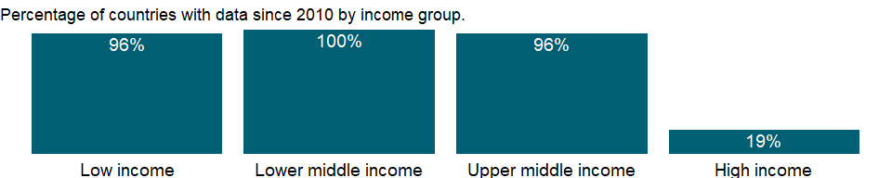

### Why is it relevant?

NA

### What is the data source?

World Bank, Bulletin Board on Statistical Capacity (<http://bbsc.worldbank.org>).

### What is the methodology?

The Practice score is calculated as weighted average of all 10 Practice indicator scores.

### How is it aggregated?

Unweighted average

### What are the limitations?

NA

### What else should I know?

NA

### 1.32.32 Overall level of statistical capacity (scale 0 - 100)

### What is the indicator?

The Statistical Capacity Indicator is a composite score assessing the capacity of a country’s statistical system. It is based on a diagnostic framework assessing the following areas: methodology; data sources; and periodicity and timeliness. Countries are scored against 25 criteria in these areas, using publicly available information and/or country input. The overall Statistical Capacity score is then calculated as a simple average of all three area scores on a scale of 0-100.

Topic: Public Sector: Policy & institutions

Series ID: IQ.SCI.OVRL

Copyright: CC BY-4.0 , <https://datacatalog.worldbank.org/public-licenses#cc-by>

First year with any data: 2004

Last year with any data: 2020

### What years are data available?

The figure below shows years in which data is available for at least one country. Dates shaded in black have no data, while dates shaded in green have data for at least one country



### Which countries have data?

The figure below shows the percentage of countries in each income group with a value since 2010 for that indicator.



### Why is it relevant?

Statistical Capacity is a nation’s ability to collect, analyze, and disseminate high-quality data about its population and economy. Quality statistics are essential for all stages of evidence-based decision-making, including: Monitoring social and economic indicators, Allocating political representation and government resources, Guiding private sector investment, as well as Informing the international donor community for program design and policy formulation.

### What is the data source?

World Bank, Bulletin Board on Statistical Capacity (<http://bbsc.worldbank.org>).

### What is the methodology?

The Statistical Capacity Indicator score is calculated as the average of the scores of the 3 dimensions, i.e. Availability, Collection, Practice.

### How is it aggregated?

Unweighted average

### What are the limitations?

NA

### What else should I know?

NA

### 1.32.33 Periodicity and timeliness assessment of statistical capacity (scale 0 - 100)

### What is the indicator?

The periodicity and timeliness indicator assesses the availability and periodicity of key socioeconomic indicators. It measures the extent to which data are made accessible to users through transformation of source data into timely statistical outputs. The periodicity score is calculated as the weighted average of 10 underlying indicator scores. The final periodicity score contributes 1/3 of the overall Statistical Capacity Indicator score.

Topic: Public Sector: Policy & institutions

Series ID: IQ.SCI.PRDC

Copyright: CC BY-4.0 , <https://datacatalog.worldbank.org/public-licenses#cc-by>

First year with any data: 2004

Last year with any data: 2020

### What years are data available?

The figure below shows years in which data is available for at least one country. Dates shaded in black have no data, while dates shaded in green have data for at least one country



### Which countries have data?

The figure below shows the percentage of countries in each income group with a value since 2010 for that indicator.



### Why is it relevant?

NA

### What is the data source?

World Bank, Bulletin Board on Statistical Capacity (<http://bbsc.worldbank.org>).

### What is the methodology?

The Availability score is calculated as weighted average of all 10 Availability indicator scores.

### How is it aggregated?

Unweighted average

### What are the limitations?

NA

### What else should I know?

NA

### 1.32.34 Source data assessment of statistical capacity (scale 0 - 100)

### What is the indicator?

The source data indicator reflects whether a country conducts data collection activities in line with internationally recommended periodicity, and whether data from administrative systems are available. The source data score is calculated as the weighted average of 5 underlying indicator scores. The final source data score contributes 1/3 of the overall Statistical Capacity Indicator score.

Topic: Public Sector: Policy & institutions

Series ID: IQ.SCI.SRCE

Copyright: CC BY-4.0 , <https://datacatalog.worldbank.org/public-licenses#cc-by>

First year with any data: 2004

Last year with any data: 2020

### What years are data available?

The figure below shows years in which data is available for at least one country. Dates shaded in black have no data, while dates shaded in green have data for at least one country



### Which countries have data?

The figure below shows the percentage of countries in each income group with a value since 2010 for that indicator.



### Why is it relevant?

NA

### What is the data source?

World Bank, Bulletin Board on Statistical Capacity (<http://bbsc.worldbank.org>).

### What is the methodology?

The Collection score is calculated as weighted average of all 5 Collection indicator scores.

### How is it aggregated?

Unweighted average

### What are the limitations?

NA

### What else should I know?

NA

### 1.32.35 Statistical performance indicators (SPI): Overall score (scale 0-100)

### What is the indicator?

The SPI overall score is a composite score measuing country performance across five pillars: data use, data services, data products, data sources, and data infrastructure. The new Statistical Performance Indicators (SPI) will replace the Statistical Capacity Index (SCI), which the World Bank has regularly published since 2004. Although the goals are the same, to offer a better tool to measure the statistical systems of countries, the new SPI framework has expanded into new areas including in the areas of data use, administrative data, geospatial data, data services, and data infrastructure. The SPI provides a framework that can help countries measure where they stand in several dimensions and offers an ambitious measurement agenda for the international community.

Topic: Public Sector: Policy & institutions

Series ID: IQ.SPI.OVRL

Copyright: CC BY-4.0 , <https://datacatalog.worldbank.org/public-licenses#cc-by>

First year with any data: 2016

Last year with any data: 2019

### What years are data available?

The figure below shows years in which data is available for at least one country. Dates shaded in black have no data, while dates shaded in green have data for at least one country



### Which countries have data?

The figure below shows the percentage of countries in each income group with a value since 2010 for that indicator.

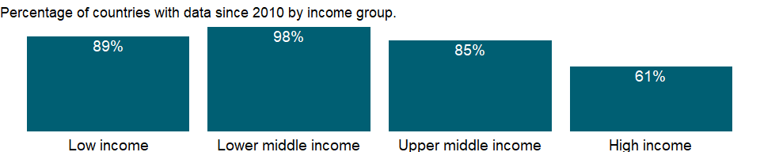

### Why is it relevant?

The new Statistical Performance Indicators (SPI) will replace the Statistical Capacity Index (SCI), which the World Bank has regularly published since 2004. Although the goals are the same, to offer a better tool to measure the statistical systems of countries, the new SPI framework has expanded into new areas including in the areas of data use, administrative data, geospatial data, data services, and data infrastructure. The SPI provides a framework that can help countries measure where they stand in several dimensions and offers an ambitious measurement agenda for the international community.

### What is the data source?

Statistical Performance Indicators, The World Bank (<https://datacatalog.worldbank.org/dataset/statistical-performance-indicators>)

### What is the methodology?

Weighted average of all statistical performance indicators. Scores range from 0-100 with 100 representing the best score.

### How is it aggregated?

Weighted Average

### What are the limitations?

NA

### What else should I know?

NA

### 1.32.36 Statistical performance indicators (SPI): Pillar 1 data use score (scale 0-100)

### What is the indicator?

The data use overall score is a composite score measuring the demand side of the statistical system. The data use pillar is segmented by five types of users: (i) the legislature, (ii) the executive branch, (iii) civil society (including sub-national actors), (iv) academia and (v) international bodies. Each dimension would have associated indicators to measure performance. A mature system would score well across all dimensions whereas a less mature one would have weaker scores along certain dimensions. The gaps would give insights into prioritization among user groups and help answer questions as to why the existing services are not resulting in higher use of national statistics in a particular segment. Currently, the SPI only features indicators for one of the five dimensions of data use, which is data use by international organizations. Indicators on whether statistical systems are providing useful data to their national governments (legislature and executive branches), to civil society, and to academia are absent. Thus the dashboard does not yet assess if national statistical systems are meeting the data needs of a large swathe of users.

Topic: Public Sector: Policy & institutions

Series ID: IQ.SPI.PIL1

Copyright: CC BY-4.0 , <https://datacatalog.worldbank.org/public-licenses#cc-by>

First year with any data: 2004

Last year with any data: 2019

### What years are data available?

The figure below shows years in which data is available for at least one country. Dates shaded in black have no data, while dates shaded in green have data for at least one country



### Which countries have data?

The figure below shows the percentage of countries in each income group with a value since 2010 for that indicator.



### Why is it relevant?

The data use (outcome) pillar is segmented by five types of users: (i) the legislature, (ii) the executive branch, (iii) civil society (including sub-national actors), (iv) academia and (v) international bodies. Each dimension would have associated indicators to measure performance. A mature system would score well across all dimensions whereas a less mature one would have weaker scores along certain dimensions. The gaps would give insights into prioritization among user groups and help answer questions as to why the existing services are not resulting in higher use of national statistics in a particular segment.

### What is the data source?

Statistical Performance Indicators, The World Bank (<https://datacatalog.worldbank.org/dataset/statistical-performance-indicators>)

### What is the methodology?

Weighted average of statistical performance indicators related to data use. Scores range from 0-100 with 100 representing the best score.

### How is it aggregated?

Weighted Average

### What are the limitations?

Currently, the dashboard only features indicators for one of the five dimensions of data use, which is data use by international organizations. Indicators on whether statistical systems are providing useful data to their national governments (legislature and executive branches), to civil society, and to academia are absent. Thus the dashboard does not yet assess if national statistical systems are meeting the data needs of a large swathe of users.

### What else should I know?

NA

### 1.32.37 Statistical performance indicators (SPI): Pillar 2 data services score (scale 0-100)

### What is the indicator?

The data services pillar overall score is a composite indicator based on four dimensions of data services: (i) the quality of data releases, (ii) the richness and openness of online access, (iii) the effectiveness of advisory and analytical services related to statistics, and (iv) the availability and use of data access services such as secure microdata access. Advisory and analytical services might incorporate elements related to data stewardship services including input to national data strategies, advice on data ethics and calling out misuse of data in accordance with the Fundamental Principles of Official Statistics.

Topic: Public Sector: Policy & institutions

Series ID: IQ.SPI.PIL2

Copyright: CC BY-4.0 , <https://datacatalog.worldbank.org/public-licenses#cc-by>

First year with any data: 2016

Last year with any data: 2019

### What years are data available?

The figure below shows years in which data is available for at least one country. Dates shaded in black have no data, while dates shaded in green have data for at least one country



### Which countries have data?

The figure below shows the percentage of countries in each income group with a value since 2010 for that indicator.

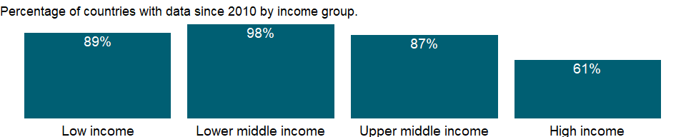

### Why is it relevant?

The data services (output) pillar is segmented by four service types: (i) the quality of data releases, (ii) the richness and openness of online access, (iii) the effectiveness of advisory and analytical services related to statistics, and (iv) the availability and use of data access services such as secure microdata access. Advisory and analytical services might incorporate elements related to data stewardship services including input to national data strategies, advice on data ethics and calling out misuse of data in accordance with the Fundamental Principles of Official Statistics.

### What is the data source?

Statistical Performance Indicators, The World Bank (<https://datacatalog.worldbank.org/dataset/statistical-performance-indicators>)

### What is the methodology?

Weighted average of statistical performance indicators related to data services. Scores range from 0-100 with 100 representing the best score.

### How is it aggregated?

Weighted Average

### What are the limitations?

Under the pillar of data services an area that needs improvement is the measurement of advisory and analytical services provided by NSOs, such as data stewardship services. By measuring this type of work done by NSOs that goes beyond producing data, the international community and the NSOs themselves can better assess whether this type of support is in place.

### What else should I know?

NA

### 1.32.38 Statistical performance indicators (SPI): Pillar 3 data products score (scale 0-100)

### What is the indicator?

The data products overall score is a composite score measureing whether the country is able to produce relevant indicators, primarily related to SDGs. The data products (internal process) pillar is segmented by four topics and organized into (i) social, (ii) economic, (iii) environmental, and (iv) institutional dimensions using the typology of the Sustainable Development Goals (SDGs). This approach anchors the national statistical system’s performance around the essential data required to support the achievement of the 2030 global goals, and enables comparisons across countries so that a global view can be generated while enabling country specific emphasis to reflect the user needs of that country.

Topic: Public Sector: Policy & institutions

Series ID: IQ.SPI.PIL3

Copyright: CC BY-4.0 , <https://datacatalog.worldbank.org/public-licenses#cc-by>

First year with any data: 2005

Last year with any data: 2019

### What years are data available?

The figure below shows years in which data is available for at least one country. Dates shaded in black have no data, while dates shaded in green have data for at least one country



### Which countries have data?

The figure below shows the percentage of countries in each income group with a value since 2010 for that indicator.



### Why is it relevant?

The data products (internal process) pillar is segmented by four topics and organized into (i) social, (ii) economic, (iii) environmental, and (iv) institutional dimensions using the typology of the Sustainable Development Goals (SDGs). This approach anchors the national statistical system’s performance around the essential data required to support the achievement of the 2030 global goals, and enables comparisons across countries so that a global view can be generated while enabling country specific emphasis to reflect the user needs of that country.

### What is the data source?

Statistical Performance Indicators, The World Bank (<https://datacatalog.worldbank.org/dataset/statistical-performance-indicators>)

### What is the methodology?

Weighted average of statistical performance indicators related to data products. Scores range from 0-100 with 100 representing the best score.

### How is it aggregated?

Weighted Average

### What are the limitations?

NA

### What else should I know?

NA

### 1.32.39 Statistical performance indicators (SPI): Pillar 4 data sources score (scale 0-100)

### What is the indicator?

The data sources overall score is a composity measure of whether countries have data available from the following sources: Censuses and surveys, administrative data, geospatial data, and private sector/citizen generated data. The data sources (input) pillar is segmented by four types of sources generated by (i) the statistical office (censuses and surveys), and sources accessed from elsewhere such as (ii) administrative data, (iii) geospatial data, and (iv) private sector data and citizen generated data. The appropriate balance between these source types will vary depending on a country’s institutional setting and the maturity of its statistical system. High scores should reflect the extent to which the sources being utilized enable the necessary statistical indicators to be generated. For example, a low score on environment statistics (in the data production pillar) may reflect a lack of use of (and low score for) geospatial data (in the data sources pillar). This type of linkage is inherent in the data cycle approach and can help highlight areas for investment required if country needs are to be met.

Topic: Public Sector: Policy & institutions

Series ID: IQ.SPI.PIL4

Copyright: CC BY-4.0 , <https://datacatalog.worldbank.org/public-licenses#cc-by>

First year with any data: 2016

Last year with any data: 2019

### What years are data available?

The figure below shows years in which data is available for at least one country. Dates shaded in black have no data, while dates shaded in green have data for at least one country



### Which countries have data?

The figure below shows the percentage of countries in each income group with a value since 2010 for that indicator.



### Why is it relevant?

The data sources (input) pillar is segmented by four types of sources generated by (i) the statistical office (censuses and surveys), and sources accessed from elsewhere such as (ii) administrative data, (iii) geospatial data, and (iv) private sector data and citizen generated data. The appropriate balance between these source types will vary depending on a country’s institutional setting and the maturity of its statistical system. High scores should reflect the extent to which the sources being utilized enable the necessary statistical indicators to be generated. For example, a low score on environment statistics (in the data production pillar) may reflect a lack of use of (and low score for) geospatial data (in the data sources pillar). This type of linkage is inherent in the data cycle approach and can help highlight areas for investment required if country needs are to be met.

### What is the data source?

Statistical Performance Indicators, The World Bank (<https://datacatalog.worldbank.org/dataset/statistical-performance-indicators>)

### What is the methodology?

Weighted average of statistical performance indicators related to data sources. Scores range from 0-100 with 100 representing the best score.

### How is it aggregated?

Weighted Average

### What are the limitations?

In the data sources pillar, more information is needed in the areas of administrative data, geospatial data, and private and citizen generated data. On administrative data, the picture is incomplete with no measures of whether countries have administrative data systems in place to measure health, education, labor, and social protection program statistics. For the geospatial indicator, there is a proxy measure of whether the country is able to produce indicators at the sub-national level, but as yet, no understanding of how countries are using geospatial information in other ways, for instance using satellite data. And while the world is increasingly awash with private and citizen generated data (e.g., on mobility, job search, or social networking), on a global scale there is no reliable source to measure how national statistical systems are incorporating this information.

### What else should I know?

NA

### 1.32.40 Statistical performance indicators (SPI): Pillar 5 data infrastructure score (scale 0-100)

### What is the indicator?

The data infrastructure pillar overall score measures the hard and soft infrastructure segments, itemizing essential cross cutting requirements for an effective statistical system. The segments are: (i) legislation and governance covering the existence of laws and a functioning institutional framework for the statistical system; (ii) standards and methods addressing compliance with recognized frameworks and concepts; (iii) skills including level of skills within the statistical system and among users (statistical literacy); (iv) partnerships reflecting the need for the statistical system to be inclusive and coherent; and (v) finance mobilized both domestically and from donors.

Topic: Public Sector: Policy & institutions

Series ID: IQ.SPI.PIL5

Copyright: CC BY-4.0 , <https://datacatalog.worldbank.org/public-licenses#cc-by>

First year with any data: 2016

Last year with any data: 2019

### What years are data available?

The figure below shows years in which data is available for at least one country. Dates shaded in black have no data, while dates shaded in green have data for at least one country



### Which countries have data?

The figure below shows the percentage of countries in each income group with a value since 2010 for that indicator.

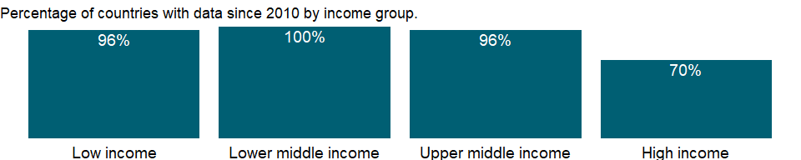

### Why is it relevant?

The data infrastructure (capability) pillar includes hard and soft infrastructure segments, itemizing essential cross cutting requirements for an effective statistical system. The segments are: (i) legislation and governance covering the existence of laws and a functioning institutional framework for the statistical system; (ii) standards and methods addressing compliance with recognized frameworks and concepts; (iii) skills including level of skills within the statistical system and among users (statistical literacy); (iv) partnerships reflecting the need for the statistical system to be inclusive and coherent; and (v) finance mobilized both domestically and from donors.

### What is the data source?

Statistical Performance Indicators, The World Bank (<https://datacatalog.worldbank.org/dataset/statistical-performance-indicators>)

### What is the methodology?

Weighted average of statistical performance indicators related to data infrastructure. Scores range from 0-100 with 100 representing the best score.

### How is it aggregated?

Weighted Average

### What are the limitations?

Finally, several of the ‘soft’ components of the data infrastructure pillar lack adequate data. This includes the areas of skills and of partnerships between entities in the national statistical system. The dashboard makes use of the PARIS21 led SDG indicator on whether the statistical legislations in countries met the standards of the UN Fundamental Principles of Statistics, but this was not incorporated into the overall SPI score, because of inadequate country coverage. This is also true of the PARIS21 led SDG indicator on whether the national statistical system is fully funded. Countries would need to be encouraged to report on this information.

### What else should I know?

NA

## 1.33 Private Sector & Trade: Business environment

### 1.33.1 Distance to frontier score (0=lowest performance to 100=frontier)

### What is the indicator?

Distance to frontier score illustrates the distance of an economy to the “frontier,” which represents the best performance observed on each Doing Business topic across all economies and years included since 2005. An economy’s distance to frontier is indicated on a scale from 0 to 100, where 0 represents the lowest performance and 100 the frontier. For example, a score of 75 in 2012 means an economy was 25 percentage points away from the frontier constructed from the best performances across all economies and across time. A score of 80 in 2013 would indicate the economy is improving.

Topic: Private Sector & Trade: Business environment

Series ID: IC.BUS.DFRN.XQ

Copyright: CC BY-4.0 , <https://datacatalog.worldbank.org/public-licenses#cc-by>

First year with any data: 2015

Last year with any data: 2019

### What years are data available?

The figure below shows years in which data is available for at least one country. Dates shaded in black have no data, while dates shaded in green have data for at least one country

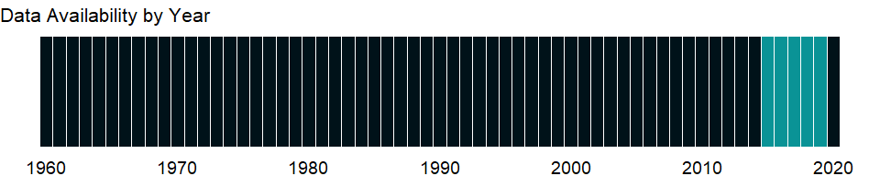

### Which countries have data?

The figure below shows the percentage of countries in each income group with a value since 2010 for that indicator.

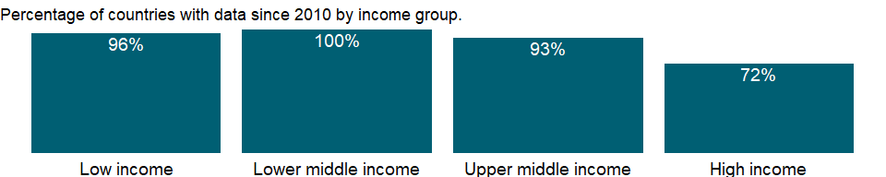

### Why is it relevant?

The distance to frontier score aids in assessing the absolute level of regulatory performance and how it improves over time. This allows users both to see the gap between a particular economy’s performance and the best performance at any point in time and to assess the absolute change in the economy’s regulatory environment over time as measured by Doing Business. In this way the distance to frontier measure complements the annual ease of doing business ranking, which compares economies with one another at a point in time.

### What is the data source?

World Bank, Doing Business project (<http://www.doingbusiness.org/>). NOTE: Doing Business has been discontinued as of 9/16/2021. For more information: <https://bit.ly/3CLCbme>

### What is the methodology?

NA

### How is it aggregated?

Unweighted average

### What are the limitations?

NA

### What else should I know?

Data are presented for the survey year instead of publication year. Data before 2013 are not comparable with data from 2013 onward due to methodological changes.

### 1.33.2 Business extent of disclosure index (0=less disclosure to 10=more disclosure)

### What is the indicator?

Disclosure index measures the extent to which investors are protected through disclosure of ownership and financial information. The index ranges from 0 to 10, with higher values indicating more disclosure.

Topic: Private Sector & Trade: Business environment

Series ID: IC.BUS.DISC.XQ

Copyright: CC BY-4.0 , <https://datacatalog.worldbank.org/public-licenses#cc-by>

First year with any data: 2005

Last year with any data: 2019

### What years are data available?

The figure below shows years in which data is available for at least one country. Dates shaded in black have no data, while dates shaded in green have data for at least one country



### Which countries have data?

The figure below shows the percentage of countries in each income group with a value since 2010 for that indicator.



### Why is it relevant?

The economic health of a country is measured not only in macroeconomic terms but also by other factors that shape daily economic activity such as laws, regulations, and institutional arrangements. The data measure business regulation, gauge regulatory outcomes, and measure the extent of legal protection of property, the flexibility of employment regulation, and the tax burden on businesses.

The fundamental premise of this data is that economic activity requires good rules and regulations that are efficient, accessible to all who need to use them, and simple to implement. Thus sometimes there is more emphasis on more regulation, such as stricter disclosure requirements in related-party transactions, and other times emphasis is on for simplified regulations, such as a one-stop shop for completing business startup formalities.

Entrepreneurs may not be aware of all required procedures or may avoid legally required procedures altogether. But where regulation is particularly onerous, levels of informality are higher, which comes at a cost: firms in the informal sector usually grow more slowly, have less access to credit, and employ fewer workers - and those workers remain outside the protections of labor law. The indicator can help policymakers understand the business environment in a country and - along with information from other sources such as the World Bank’s Enterprise Surveys - provide insights into potential areas of reform.

### What is the data source?

World Bank, Doing Business project (<http://www.doingbusiness.org/>). NOTE: Doing Business has been discontinued as of 9/16/2021. For more information: <https://bit.ly/3CLCbme>

### What is the methodology?

Data are collected by the World Bank with a standardized survey that uses a simple business case to ensure comparability across economies and over time - with assumptions about the legal form of the business, its size, its location, and nature of its operation. Surveys are administered through more than 9,000 local experts, including lawyers, business consultants, accountants, freight forwarders, government officials, and other professionals who routinely administer or advise on legal and regulatory requirements.

Corporations are instruments of entrepreneurship and growth. They can also be abused for personal gain. The indicator measures the strength of minority shareholder protections against directors’ misuse of corporate assets for personal gain.

The Doing Business project of the World Bank encompasses two types of data: data from readings of laws and regulations and data on time and motion indicators that measure efficiency in achieving a regulatory goal. Within the time and motion indicators cost estimates are recorded from official fee schedules where applicable. The data from surveys are subjected to numerous tests for robustness, which lead to revision or expansion of the information collected.

### How is it aggregated?

Unweighted average

### What are the limitations?

The Doing Business methodology has limitations that should be considered when interpreting the data. First, the data collected refer to businesses in the economy’s largest city and may not represent regulations in other locations of the economy. To address this limitation, subnational indicators are being collected for selected economies. These subnational studies point to significant differences in the speed of reform and the ease of doing business across cities in the same economy. Second, the data often focus on a specific business form - generally a limited liability company of a specified size - and may not represent regulation for other types of businesses such as sole proprietorships. Third, transactions described in a standardized business case refer to a specific set of issues and may not represent the full set of issues a business encounters. Fourth, the time measures involve an element of judgment by the expert respondents. When sources indicate different estimates, the Doing Business time indicators represent the median values of several responses given under the assumptions of the standardized case. Fifth, the methodology assumes that a business has full information on what is required and does not waste time when completing procedures.

### What else should I know?

Data are presented for the survey year instead of publication year.

### 1.33.3 Ease of doing business index (1=most business-friendly regulations)

### What is the indicator?

Ease of doing business ranks economies from 1 to 190, with first place being the best. A high ranking (a low numerical rank) means that the regulatory environment is conducive to business operation. The index averages the country’s percentile rankings on 10 topics covered in the World Bank’s Doing Business. The ranking on each topic is the simple average of the percentile rankings on its component indicators.

Topic: Private Sector & Trade: Business environment

Series ID: IC.BUS.EASE.XQ

Copyright: CC BY-4.0 , <https://datacatalog.worldbank.org/public-licenses#cc-by>

First year with any data: 2019

Last year with any data: 2019

### What years are data available?

The figure below shows years in which data is available for at least one country. Dates shaded in black have no data, while dates shaded in green have data for at least one country



### Which countries have data?

The figure below shows the percentage of countries in each income group with a value since 2010 for that indicator.

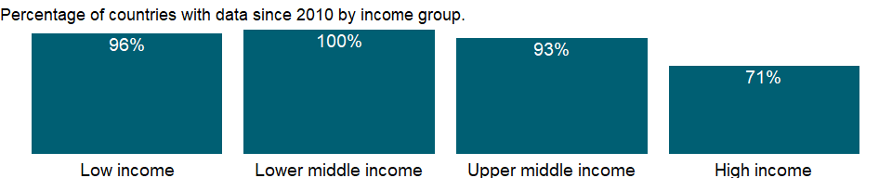

### Why is it relevant?

The economic health of a country is measured not only in macroeconomic terms but also by other factors that shape daily economic activity such as laws, regulations, and institutional arrangements. The data measure business regulation, gauge regulatory outcomes, and measure the extent of legal protection of property, the flexibility of employment regulation, and the tax burden on businesses.

The fundamental premise of this data is that economic activity requires good rules and regulations that are efficient, accessible to all who need to use them, and simple to implement. Thus sometimes there is more emphasis on more regulation, such as stricter disclosure requirements in related-party transactions, and other times emphasis is on for simplified regulations, such as a one-stop shop for completing business startup formalities.

Entrepreneurs may not be aware of all required procedures or may avoid legally required procedures altogether. But where regulation is particularly onerous, levels of informality are higher, which comes at a cost: firms in the informal sector usually grow more slowly, have less access to credit, and employ fewer workers - and those workers remain outside the protections of labor law. The indicator can help policymakers understand the business environment in a country and - along with information from other sources such as the World Bank’s Enterprise Surveys - provide insights into potential areas of reform.

### What is the data source?

World Bank, Doing Business project (<http://www.doingbusiness.org/>). NOTE: Doing Business has been discontinued as of 9/16/2021. For more information: <https://bit.ly/3CLCbme>

### What is the methodology?

Data are collected by the World Bank with a standardized survey that uses a simple business case to ensure comparability across economies and over time - with assumptions about the legal form of the business, its size, its location, and nature of its operation. Surveys are administered through more than 9,000 local experts, including lawyers, business consultants, accountants, freight forwarders, government officials, and other professionals who routinely administer or advise on legal and regulatory requirements.

The indicator measures the time, cost, and outcome of insolvency proceedings involving domestic entities. The time required for creditors to recover their credit is recorded in calendar years. The cost of the proceedings is recorded as a percentage of the value of the debtor’s estate.

The Doing Business project of the World Bank encompasses two types of data: data from readings of laws and regulations and data on time and motion indicators that measure efficiency in achieving a regulatory goal. Within the time and motion indicators cost estimates are recorded from official fee schedules where applicable. The data from surveys are subjected to numerous tests for robustness, which lead to revision or expansion of the information collected.

### How is it aggregated?

NA

### What are the limitations?

The Doing Business methodology has limitations that should be considered when interpreting the data. First, the data collected refer to businesses in the economy’s largest city and may not represent regulations in other locations of the economy. To address this limitation, subnational indicators are being collected for selected economies. These subnational studies point to significant differences in the speed of reform and the ease of doing business across cities in the same economy. Second, the data often focus on a specific business form - generally a limited liability company of a specified size - and may not represent regulation for other types of businesses such as sole proprietorships. Third, transactions described in a standardized business case refer to a specific set of issues and may not represent the full set of issues a business encounters. Fourth, the time measures involve an element of judgment by the expert respondents. When sources indicate different estimates, the Doing Business time indicators represent the median values of several responses given under the assumptions of the standardized case. Fifth, the methodology assumes that a business has full information on what is required and does not waste time when completing procedures.

### What else should I know?

Data are presented for the survey year instead of publication year. Data before 2013 are not comparable with data from 2013 onward due to methodological changes.

### 1.33.4 New business density (new registrations per 1,000 people ages 15-64)

### What is the indicator?

New businesses registered are the number of new limited liability corporations registered in the calendar year.

Topic: Private Sector & Trade: Business environment

Series ID: IC.BUS.NDNS.ZS

Copyright: CC BY-4.0 , <https://datacatalog.worldbank.org/public-licenses#cc-by>

First year with any data: 2006

Last year with any data: 2018

### What years are data available?

The figure below shows years in which data is available for at least one country. Dates shaded in black have no data, while dates shaded in green have data for at least one country

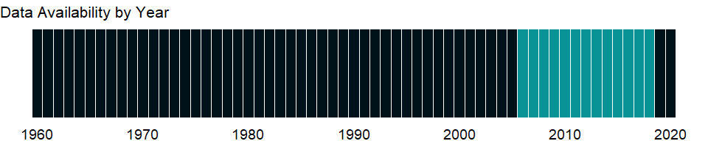

### Which countries have data?

The figure below shows the percentage of countries in each income group with a value since 2010 for that indicator.

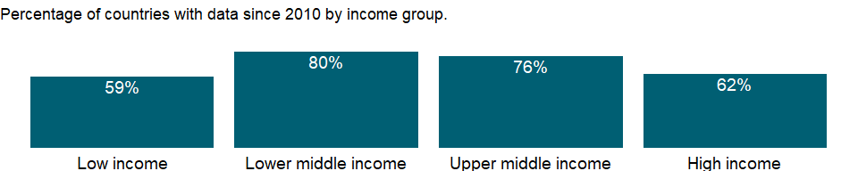

### Why is it relevant?

Entrepreneurship is a critical part of economic development and growth and important for the continued dynamism of the modern economy. To measure entrepreneurial activity, annual data is collected directly from 139 company registrars on the number of newly registered firms over the past seven years. The data shows the trends in new firm creation across regions, the relationship between entrepreneurship and the business environment and financial development, and the financial crisis’ effect on the entrepreneurial activity in the formal sector.

Private sector development and investment - tapping private sector initiative and investment for socially useful purposes - are critical for poverty reduction. In parallel with public sector efforts, private investment, especially in competitive markets, has tremendous potential to contribute to growth. Private markets are the engine of productivity growth, creating productive jobs and higher incomes. And with government playing a complementary role of regulation, funding, and service provision, private initiative and investment can help provide the basic services and conditions that empower poor people - by improving health, education, and infrastructure.

### What is the data source?

World Bank’s Entrepreneurship Survey and database (<http://www.doingbusiness.org/data/exploretopics/entrepreneurship>).

### What is the methodology?

The new business entry density, which is the number of newly registered limited liability corporations per calendar year, normalized by working age population. This is a valuable indicator which quantifies the impact of regulatory, political, and macroeconomic institutional changes on new business registration, a vital component of a dynamic private sector.

The data includes all limited liability corporations regardless of size. Partnerships and sole proprietorships are not considered in the analysis due to the differences with respect to their definition and regulation worldwide. Data on the number of total or closed firms are not included due to heterogeneity in how these entities are defined and measured.

To facilitate cross-country comparability, the Entrepreneurship Database employs a consistent unit of measurement, source of information, and concept of entrepreneurship that is applicable and available among the diverse sample of participating economies.

The data collection process involves telephone interviews and email correspondence with business registries in 139 economies. The main sources of information for this study are national business registries. In a limited number of cases where the business registry was unable to provide the data - most often due to an absence of digitized registration systems - the Entrepreneurship Database uses other alternatives sources, such as statistical agencies, tax and labor agencies, chambers of commerce, and private vendors or publicly available data.

The units of measurement are private, formal sector companies with limited liability.

### How is it aggregated?

Unweighted average

### What are the limitations?

The definition of entrepreneurship used is limited to the formal sector. Yet, it should be noted that the exclusion of the informal sector is based on the difficulties of quantifying the number of firms that compose it, rather than on its relevance for developing economies. The Entrepreneurship Database facilitates the analysis of the growth of the formal private sector and the identification of factors that encourage firms to begin operations in or transition to the formal sector. Data is collected all limited liability corporations regardless of size. Partnerships and sole proprietorships are not considered in the analysis due to the differences with respect to their definition and regulation worldwide. Data on the number of total or closed firms are not included due to heterogeneity in how these entities are defined and measured.

The data itself only provides a snapshot of a given economy’s business demographics, and cannot by itself explain the factors that affect the business creation cycle. However, when the Entrepreneurship Database is combined with other data such as the Doing Business Report, Investment Climate Assessments, and/or OECD Entrepreneurship Indicators, researchers and policymakers can better understand the dynamics of the business creation process.

The Entrepreneurship Database is a critical source of data that facilitates the measurement of entrepreneurial activity across countries and over time. The data also allows for a deeper understanding of the relationship between new firm registration, the regulatory environment, and economic growth. Previous research using the Entrepreneurship Database has shown a significant relationship between the level of cost, time, and procedures required to start a business and new firm registration.

### What else should I know?

For cross-country comparability, only limited liability corporations that operate in the formal sector are included.

### 1.33.5 New businesses registered (number)

### What is the indicator?

New businesses registered are the number of new limited liability corporations registered in the calendar year.

Topic: Private Sector & Trade: Business environment

Series ID: IC.BUS.NREG

Copyright: CC BY-4.0 , <https://datacatalog.worldbank.org/public-licenses#cc-by>

First year with any data: 2006

Last year with any data: 2018

### What years are data available?

The figure below shows years in which data is available for at least one country. Dates shaded in black have no data, while dates shaded in green have data for at least one country



### Which countries have data?

The figure below shows the percentage of countries in each income group with a value since 2010 for that indicator.



### Why is it relevant?

Entrepreneurship is a critical part of economic development and growth and important for the continued dynamism of the modern economy. To measure entrepreneurial activity, annual data is collected directly from 139 company registrars on the number of newly registered firms over the past seven years. The data shows the trends in new firm creation across regions, the relationship between entrepreneurship and the business environment and financial development, and the financial crisis’ effect on the entrepreneurial activity in the formal sector.

Private sector development and investment - tapping private sector initiative and investment for socially useful purposes - are critical for poverty reduction. In parallel with public sector efforts, private investment, especially in competitive markets, has tremendous potential to contribute to growth. Private markets are the engine of productivity growth, creating productive jobs and higher incomes. And with government playing a complementary role of regulation, funding, and service provision, private initiative and investment can help provide the basic services and conditions that empower poor people - by improving health, education, and infrastructure.

### What is the data source?

World Bank’s Entrepreneurship Survey and database (<http://www.doingbusiness.org/data/exploretopics/entrepreneurship>).

### What is the methodology?

To facilitate cross-country comparability, the Entrepreneurship Database employs a consistent unit of measurement, source of information, and concept of entrepreneurship that is applicable and available among the diverse sample of participating economies.

The data collection process involves telephone interviews and email correspondence with business registries in 139 economies. The main sources of information for this study are national business registries. In a limited number of cases where the business registry was unable to provide the data - most often due to an absence of digitized registration systems - the Entrepreneurship Database uses other alternatives sources, such as statistical agencies, tax and labor agencies, chambers of commerce, and private vendors or publicly available data.

The units of measurement are private, formal sector companies with limited liability.

### How is it aggregated?

NA

### What are the limitations?

The definition of entrepreneurship used is limited to the formal sector. Yet, it should be noted that the exclusion of the informal sector is based on the difficulties of quantifying the number of firms that compose it, rather than on its relevance for developing economies. The Entrepreneurship Database facilitates the analysis of the growth of the formal private sector and the identification of factors that encourage firms to begin operations in or transition to the formal sector. Data is collected all limited liability corporations regardless of size. Partnerships and sole proprietorships are not considered in the analysis due to the differences with respect to their definition and regulation worldwide. Data on the number of total or closed firms are not included due to heterogeneity in how these entities are defined and measured.

The Entrepreneurship Database is a critical source of data that facilitates the measurement of entrepreneurial activity across countries and over time. The data also allows for a deeper understanding of the relationship between new firm registration, the regulatory environment, and economic growth. Previous research using the Entrepreneurship Database has shown a significant relationship between the level of cost, time, and procedures required to start a business and new firm registration.

To facilitate cross-country comparability, the Entrepreneurship Database employs a consistent unit of measurement, source of information, and concept of entrepreneurship that is applicable and available among the diverse sample of participating economies.

### What else should I know?

For cross-country comparability, only limited liability corporations that operate in the formal sector are included.

### 1.33.6 Depth of credit information index (0=low to 8=high)

### What is the indicator?

Depth of credit information index measures rules affecting the scope, accessibility, and quality of credit information available through public or private credit registries. The index ranges from 0 to 8, with higher values indicating the availability of more credit information, from either a public registry or a private bureau, to facilitate lending decisions.

Topic: Private Sector & Trade: Business environment

Series ID: IC.CRD.INFO.XQ

Copyright: CC BY-4.0 , <https://datacatalog.worldbank.org/public-licenses#cc-by>

First year with any data: 2013

Last year with any data: 2019

### What years are data available?

The figure below shows years in which data is available for at least one country. Dates shaded in black have no data, while dates shaded in green have data for at least one country

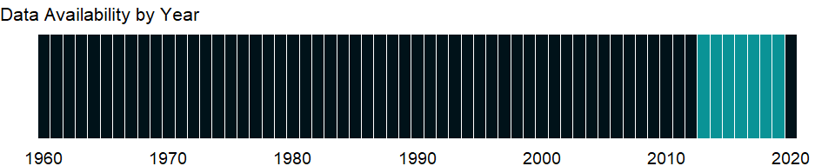

### Which countries have data?

The figure below shows the percentage of countries in each income group with a value since 2010 for that indicator.



### Why is it relevant?

Access to finance can expand opportunities for all with higher levels of access and use of banking services associated with lower financing obstacles for people and businesses. A stable financial system that promotes efficient savings and investment is also crucial for a thriving democracy and market economy.

There are several aspects of access to financial services: availability, cost, and quality of services. The development and growth of credit markets depend on access to timely, reliable, and accurate data on borrowers’ credit experiences. Access to credit can be improved by making it easy to create and enforce collateral agreements and by increasing information about potential borrowers’ creditworthiness. Lenders look at a borrower’s credit history and collateral. Where credit registries and effective collateral laws are absent - as in many developing countries - banks make fewer loans. Indicators that cover getting credit include the strength of legal rights index and the depth of credit information index.

The economic health of a country is measured not only in macroeconomic terms but also by other factors that shape daily economic activity such as laws, regulations, and institutional arrangements. The data measure business regulation, gauge regulatory outcomes, and measure the extent of legal protection of property, the flexibility of employment regulation, and the tax burden on businesses.

The fundamental premise of this data is that economic activity requires good rules and regulations that are efficient, accessible to all who need to use them, and simple to implement. Thus sometimes there is more emphasis on more regulation, such as stricter disclosure requirements in related-party transactions, and other times emphasis is on for simplified regulations, such as a one-stop shop for completing business startup formalities.

Entrepreneurs may not be aware of all required procedures or may avoid legally required procedures altogether. But where regulation is particularly onerous, levels of informality are higher, which comes at a cost: firms in the informal sector usually grow more slowly, have less access to credit, and employ fewer workers - and those workers remain outside the protections of labor law. The indicator can help policymakers understand the business environment in a country and - along with information from other sources such as the World Bank’s Enterprise Surveys - provide insights into potential areas of reform.

### What is the data source?

World Bank, Doing Business project (<http://www.doingbusiness.org/>). NOTE: Doing Business has been discontinued as of 9/16/2021. For more information: <https://bit.ly/3CLCbme>

### What is the methodology?

For Doing Business 2015, the credit information index has expanded with two new measurements, namely whether (1) banks and financial institutions access credit bureaus and credit registries’ databases through an online platform or system-to-system connection; and (2) bureau or registry credit scores are offered as a value added service to help banks and financial institutions to assess the creditworthiness of borrowers. Furthermore, if the credit bureau or registry is not operational or covers less than 5% of the adult population, the score on the depth of credit information index is 0. (Previously, the coverage threshold to score on the credit information index was 0.1%. In Doing Business 2015 this threshold has been increased to 5%.)

Data are collected by the World Bank with a standardized survey that uses a simple business case to ensure comparability across economies and over time - with assumptions about the legal form of the business, its size, its location, and nature of its operation. Surveys are administered through more than 9,000 local experts, including lawyers, business consultants, accountants, freight forwarders, government officials, and other professionals who routinely administer or advise on legal and regulatory requirements.

The Doing Business project of the World Bank encompasses two types of data: data from readings of laws and regulations and data on time and motion indicators that measure efficiency in achieving a regulatory goal. Within the time and motion indicators cost estimates are recorded from official fee schedules where applicable. The data from surveys are subjected to numerous tests for robustness, which lead to revision or expansion of the information collected. For more information on methodology, see <http://www.doingbusiness.org/Methodology/getting-credit#legalRights>.

### How is it aggregated?

Unweighted average

### What are the limitations?

The Doing Business methodology has limitations that should be considered when interpreting the data. First, the data collected refer to businesses in the economy’s largest city and may not represent regulations in other locations of the economy. To address this limitation, subnational indicators are being collected for selected economies. These subnational studies point to significant differences in the speed of reform and the ease of doing business across cities in the same economy. Second, the data often focus on a specific business form - generally a limited liability company of a specified size - and may not represent regulation for other types of businesses such as sole proprietorships. Third, transactions described in a standardized business case refer to a specific set of issues and may not represent the full set of issues a business encounters. Fourth, the time measures involve an element of judgment by the expert respondents. When sources indicate different estimates, the Doing Business time indicators represent the median values of several responses given under the assumptions of the standardized case. Fifth, the methodology assumes that a business has full information on what is required and does not waste time when completing procedures.

### What else should I know?

Data are presented for the survey year instead of publication year. Data before 2013 are not comparable with data from 2013 onward due to methodological changes.

### 1.33.7 Private credit bureau coverage (% of adults)

### What is the indicator?

Private credit bureau coverage reports the number of individuals or firms listed by a private credit bureau with current information on repayment history, unpaid debts, or credit outstanding. The number is expressed as a percentage of the adult population.

Topic: Private Sector & Trade: Business environment

Series ID: IC.CRD.PRVT.ZS

Copyright: CC BY-4.0 , <https://datacatalog.worldbank.org/public-licenses#cc-by>

First year with any data: 2004

Last year with any data: 2019

### What years are data available?

The figure below shows years in which data is available for at least one country. Dates shaded in black have no data, while dates shaded in green have data for at least one country



### Which countries have data?

The figure below shows the percentage of countries in each income group with a value since 2010 for that indicator.



### Why is it relevant?

NA

### What is the data source?

World Bank, Doing Business project (<http://www.doingbusiness.org/>). NOTE: Doing Business has been discontinued as of 9/16/2021. For more information: <https://bit.ly/3CLCbme>

### What is the methodology?

NA

### How is it aggregated?

Unweighted average

### What are the limitations?

NA

### What else should I know?

Data are presented for the survey year instead of publication year.

### 1.33.8 Public credit registry coverage (% of adults)

### What is the indicator?

Public credit registry coverage reports the number of individuals and firms listed in a public credit registry with current information on repayment history, unpaid debts, or credit outstanding. The number is expressed as a percentage of the adult population.

Topic: Private Sector & Trade: Business environment

Series ID: IC.CRD.PUBL.ZS

Copyright: CC BY-4.0 , <https://datacatalog.worldbank.org/public-licenses#cc-by>

First year with any data: 2004

Last year with any data: 2019

### What years are data available?

The figure below shows years in which data is available for at least one country. Dates shaded in black have no data, while dates shaded in green have data for at least one country



### Which countries have data?

The figure below shows the percentage of countries in each income group with a value since 2010 for that indicator.



### Why is it relevant?

NA

### What is the data source?

World Bank, Doing Business project (<http://www.doingbusiness.org/>). NOTE: Doing Business has been discontinued as of 9/16/2021. For more information: <https://bit.ly/3CLCbme>

### What is the methodology?

NA

### How is it aggregated?

Unweighted average

### What are the limitations?

NA

### What else should I know?

Data are presented for the survey year instead of publication year.

### 1.33.9 Average time to clear exports through customs (days)

### What is the indicator?

Average time to clear exports through customs is the average number of days to clear direct exports through customs.

Topic: Private Sector & Trade: Business environment

Series ID: IC.CUS.DURS.EX

Copyright: CC BY-4.0 , <https://datacatalog.worldbank.org/public-licenses#cc-by>

First year with any data: 2002

Last year with any data: 2020

### What years are data available?

The figure below shows years in which data is available for at least one country. Dates shaded in black have no data, while dates shaded in green have data for at least one country



### Which countries have data?

The figure below shows the percentage of countries in each income group with a value since 2010 for that indicator.

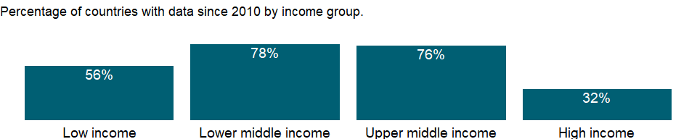

### Why is it relevant?

Firms evaluating investment options, governments interested in improving business conditions, and economists seeking to explain economic performance have all grappled with defining and measuring the business environment. The firm-level data from Enterprise Surveys provide a useful tool for benchmarking economies across a large number of indicators measured at the firm level.

International trade can be beneficial for firms in terms of less expensive inputs for manufacturing and new markets for exporting finished products and services. Time spent waiting for imports and exports to clear customs can be costly for firms and deter them from engaging in trade or making them uncompetitive globally.

### What is the data source?

World Bank, Enterprise Surveys (<http://www.enterprisesurveys.org/>).

### What is the methodology?

Firm-level surveys have been conducted since the 1990’s by different units within the World Bank. Since 2005-06, most data collection efforts have been centralized within the Enterprise Analysis Unit. Surveys implemented by the Enterprise Analysis Unit follow the Global Methodology.

Private contractors conduct the Enterprise Surveys on behalf of the World Bank. Due to sensitive survey questions addressing business-government relations and bribery-related topics, private contractors, rather than any government agency or an organization/institution associated with government, are hired by the World Bank to collect the data.

Confidentiality of the survey respondents and the sensitive information they provide is necessary to ensure the greatest degree of survey participation, integrity and confidence in the quality of the data. Surveys are usually carried out in cooperation with business organizations and government agencies promoting job creation and economic growth, but confidentiality is never compromised.

The Enterprise Survey is answered by business owners and top managers. Sometimes the survey respondent calls company accountants and human resource managers into the interview to answer questions in the sales and labor sections of the survey. Typically 1200-1800 interviews are conducted in larger economies, 360 interviews are conducted in medium-sized economies, and for smaller economies, 150 interviews take place.

The manufacturing and services sectors are the primary business sectors of interest. This corresponds to firms classified with ISIC codes 15-37, 45, 50-52, 55, 60-64, and 72 (ISIC Rev.3.1). Formal (registered) companies with 5 or more employees are targeted for interview. Services firms include construction, retail, wholesale, hotels, restaurants, transport, storage, communications, and IT. Firms with 100% government/state ownership are not eligible to participate in an Enterprise Survey. Occasionally, for a few surveyed countries, other sectors are included in the companies surveyed such as education or health-related businesses. In each country, businesses in the cities/regions of major economic activity are interviewed.

In some countries, other surveys, which depart from the usual Enterprise Survey methodology, are conducted. Examples include 1) Informal Surveys- surveys of informal (unregistered) enterprises, 2) Micro Surveys- surveys fielded to registered firms with less than five employees, and 3) Financial Crisis Assessment Surveys- short surveys administered by telephone to assess the effects of the global financial crisis of 2008-09.

The Enterprise Surveys Unit uses two instruments: the Manufacturing Questionnaire and the Services Questionnaire. Although many questions overlap, some are only applicable to one type of business. For example, retail firms are not asked about production and nonproduction workers.

The standard Enterprise Survey topics include firm characteristics, gender participation, access to finance, annual sales, costs of inputs/labor, workforce composition, bribery, licensing, infrastructure, trade, crime, competition, capacity utilization, land and permits, taxation, informality, business-government relations, innovation and technology, and performance measures.

Over 90% of the questions objectively ascertain characteristics of a country’s business environment. The remaining questions assess the survey respondents’ opinions on what are the obstacles to firm growth and performance. The mode of data collection is face-to-face interviews.

### How is it aggregated?

Unweighted average

### What are the limitations?

The sampling methodology for Enterprise Surveys is stratified random sampling. In a simple random sample, all members of the population have the same probability of being selected and no weighting of the observations is necessary. In a stratified random sample, all population units are grouped within homogeneous groups and simple random samples are selected within each group. This method allows computing estimates for each of the strata with a specified level of precision while population estimates can also be estimated by properly weighting individual observations. The sampling weights take care of the varying probabilities of selection across different strata. Under certain conditions, estimates’ precision under stratified random sampling will be higher than under simple random sampling (lower standard errors may result from the estimation procedure).

The strata for Enterprise Surveys are firm size, business sector, and geographic region within a country. Firm size levels are 5-19 (small), 20-99 (medium), and 100+ employees (large-sized firms). Since in most economies, the majority of firms are small and medium-sized, Enterprise Surveys oversample large firms since larger firms tend to be engines of job creation. Sector breakdown is usually manufacturing, retail, and other services. For larger economies, specific manufacturing sub-sectors are selected as additional strata on the basis of employment, value-added, and total number of establishments figures. Geographic regions within a country are selected based on which cities/regions collectively contain the majority of economic activity.

Ideally the survey sample frame is derived from the universe of eligible firms obtained from the country’s statistical office. Sometimes the master list of firms is obtained from other government agencies such as tax or business licensing authorities. In some cases, the list of firms is obtained from business associations or marketing databases. In a few cases, the sample frame is created via block enumeration, where the World Bank “manually” constructs a list of eligible firms after 1) partitioning a country’s cities of major economic activity into clusters and blocks, 2) randomly selecting a subset of blocks which will then be enumerated. In surveys conducted since 2005-06, survey documentation which explains the source of the sample frame and any special circumstances encountered during survey fieldwork are included with the collected datasets.

Obtaining panel data, i.e. interviews with the same firms across multiple years, is a priority in current Enterprise Surveys. When conducting a new Enterprise Survey in a country where data was previously collected, maximal effort is expended to re-interview as many firms (from the prior survey) as possible. For these panel firms, sampling weights can be adjusted to take into account the resulting altered probabilities of inclusion in the sample frame.

### What else should I know?

NA

### 1.33.10 Time to obtain an electrical connection (days)

### What is the indicator?

The average wait, in days, experienced to obtain an electrical connection from the day an establishment applies for it to the day it receives the service.

Topic: Private Sector & Trade: Business environment

Series ID: IC.ELC.DURS

Copyright: CC BY-4.0 , <https://datacatalog.worldbank.org/public-licenses#cc-by>

First year with any data: 2002

Last year with any data: 2020

### What years are data available?

The figure below shows years in which data is available for at least one country. Dates shaded in black have no data, while dates shaded in green have data for at least one country



### Which countries have data?

The figure below shows the percentage of countries in each income group with a value since 2010 for that indicator.

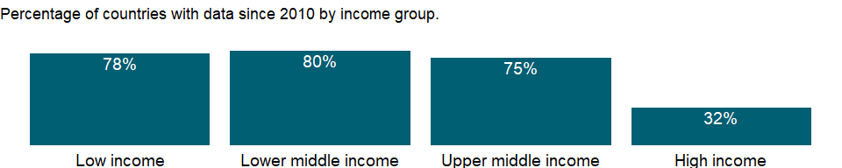

### Why is it relevant?

Firms evaluating investment options, governments interested in improving business conditions, and economists seeking to explain economic performance have all grappled with defining and measuring the business environment. The firm-level data from Enterprise Surveys provide a useful tool for benchmarking economies across a large number of indicators measured at the firm level.

International trade can be beneficial for firms in terms of less expensive inputs for manufacturing and new markets for exporting finished products and services. Time spent waiting for imports and exports to clear customs can be costly for firms and deter them from engaging in trade or making them uncompetitive globally.

### What is the data source?

World Bank, Enterprise Surveys (<http://www.enterprisesurveys.org/>).

### What is the methodology?

Firm-level surveys have been conducted since the 1990’s by different units within the World Bank. Since 2005-06, most data collection efforts have been centralized within the Enterprise Analysis Unit. Surveys implemented by the Enterprise Analysis Unit follow the Global Methodology.

Private contractors conduct the Enterprise Surveys on behalf of the World Bank. Due to sensitive survey questions addressing business-government relations and bribery-related topics, private contractors, rather than any government agency or an organization/institution associated with government, are hired by the World Bank to collect the data.

Confidentiality of the survey respondents and the sensitive information they provide is necessary to ensure the greatest degree of survey participation, integrity and confidence in the quality of the data. Surveys are usually carried out in cooperation with business organizations and government agencies promoting job creation and economic growth, but confidentiality is never compromised.

The Enterprise Survey is answered by business owners and top managers. Sometimes the survey respondent calls company accountants and human resource managers into the interview to answer questions in the sales and labor sections of the survey. Typically 1200-1800 interviews are conducted in larger economies, 360 interviews are conducted in medium-sized economies, and for smaller economies, 150 interviews take place.

The manufacturing and services sectors are the primary business sectors of interest. This corresponds to firms classified with ISIC codes 15-37, 45, 50-52, 55, 60-64, and 72 (ISIC Rev.3.1). Formal (registered) companies with 5 or more employees are targeted for interview. Services firms include construction, retail, wholesale, hotels, restaurants, transport, storage, communications, and IT. Firms with 100% government/state ownership are not eligible to participate in an Enterprise Survey. Occasionally, for a few surveyed countries, other sectors are included in the companies surveyed such as education or health-related businesses. In each country, businesses in the cities/regions of major economic activity are interviewed.

In some countries, other surveys, which depart from the usual Enterprise Survey methodology, are conducted. Examples include 1) Informal Surveys- surveys of informal (unregistered) enterprises, 2) Micro Surveys- surveys fielded to registered firms with less than five employees, and 3) Financial Crisis Assessment Surveys- short surveys administered by telephone to assess the effects of the global financial crisis of 2008-09.

The Enterprise Surveys Unit uses two instruments: the Manufacturing Questionnaire and the Services Questionnaire. Although many questions overlap, some are only applicable to one type of business. For example, retail firms are not asked about production and nonproduction workers.

The standard Enterprise Survey topics include firm characteristics, gender participation, access to finance, annual sales, costs of inputs/labor, workforce composition, bribery, licensing, infrastructure, trade, crime, competition, capacity utilization, land and permits, taxation, informality, business-government relations, innovation and technology, and performance measures.

Over 90% of the questions objectively ascertain characteristics of a country’s business environment. The remaining questions assess the survey respondents’ opinions on what are the obstacles to firm growth and performance. The mode of data collection is face-to-face interviews.

### How is it aggregated?

Unweighted average

### What are the limitations?

The sampling methodology for Enterprise Surveys is stratified random sampling. In a simple random sample, all members of the population have the same probability of being selected and no weighting of the observations is necessary. In a stratified random sample, all population units are grouped within homogeneous groups and simple random samples are selected within each group. This method allows computing estimates for each of the strata with a specified level of precision while population estimates can also be estimated by properly weighting individual observations. The sampling weights take care of the varying probabilities of selection across different strata. Under certain conditions, estimates’ precision under stratified random sampling will be higher than under simple random sampling (lower standard errors may result from the estimation procedure).

The strata for Enterprise Surveys are firm size, business sector, and geographic region within a country. Firm size levels are 5-19 (small), 20-99 (medium), and 100+ employees (large-sized firms). Since in most economies, the majority of firms are small and medium-sized, Enterprise Surveys oversample large firms since larger firms tend to be engines of job creation. Sector breakdown is usually manufacturing, retail, and other services. For larger economies, specific manufacturing sub-sectors are selected as additional strata on the basis of employment, value-added, and total number of establishments figures. Geographic regions within a country are selected based on which cities/regions collectively contain the majority of economic activity.

Ideally the survey sample frame is derived from the universe of eligible firms obtained from the country’s statistical office. Sometimes the master list of firms is obtained from other government agencies such as tax or business licensing authorities. In some cases, the list of firms is obtained from business associations or marketing databases. In a few cases, the sample frame is created via block enumeration, where the World Bank “manually” constructs a list of eligible firms after 1) partitioning a country’s cities of major economic activity into clusters and blocks, 2) randomly selecting a subset of blocks which will then be enumerated. In surveys conducted since 2005-06, survey documentation which explains the source of the sample frame and any special circumstances encountered during survey fieldwork are included with the collected datasets.

Obtaining panel data, i.e. interviews with the same firms across multiple years, is a priority in current Enterprise Surveys. When conducting a new Enterprise Survey in a country where data was previously collected, maximal effort is expended to re-interview as many firms (from the prior survey) as possible. For these panel firms, sampling weights can be adjusted to take into account the resulting altered probabilities of inclusion in the sample frame.

### What else should I know?

NA

### 1.33.11 Power outages in firms in a typical month (number)

### What is the indicator?

Power outages are the average number of power outages that establishments experience in a typical month.

Topic: Private Sector & Trade: Business environment

Series ID: IC.ELC.OUTG

Copyright: CC BY-4.0 , <https://datacatalog.worldbank.org/public-licenses#cc-by>

First year with any data: 2006

Last year with any data: 2020

### What years are data available?

The figure below shows years in which data is available for at least one country. Dates shaded in black have no data, while dates shaded in green have data for at least one country

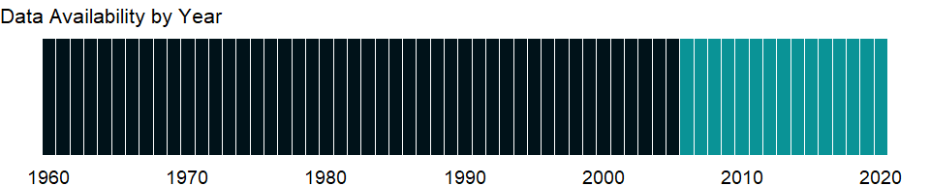

### Which countries have data?

The figure below shows the percentage of countries in each income group with a value since 2010 for that indicator.

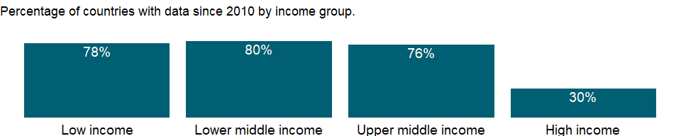

### Why is it relevant?

Firms evaluating investment options, governments interested in improving business conditions, and economists seeking to explain economic performance have all grappled with defining and measuring the business environment. The firm-level data from Enterprise Surveys provide a useful tool for benchmarking economies across a large number of indicators measured at the firm level.

International trade can be beneficial for firms in terms of less expensive inputs for manufacturing and new markets for exporting finished products and services. Time spent waiting for imports and exports to clear customs can be costly for firms and deter them from engaging in trade or making them uncompetitive globally.

### What is the data source?

World Bank, Enterprise Surveys (<http://www.enterprisesurveys.org/>).

### What is the methodology?

Firm-level surveys have been conducted since the 1990’s by different units within the World Bank. Since 2005-06, most data collection efforts have been centralized within the Enterprise Analysis Unit. Surveys implemented by the Enterprise Analysis Unit follow the Global Methodology.

Private contractors conduct the Enterprise Surveys on behalf of the World Bank. Due to sensitive survey questions addressing business-government relations and bribery-related topics, private contractors, rather than any government agency or an organization/institution associated with government, are hired by the World Bank to collect the data.

Confidentiality of the survey respondents and the sensitive information they provide is necessary to ensure the greatest degree of survey participation, integrity and confidence in the quality of the data. Surveys are usually carried out in cooperation with business organizations and government agencies promoting job creation and economic growth, but confidentiality is never compromised.

The Enterprise Survey is answered by business owners and top managers. Sometimes the survey respondent calls company accountants and human resource managers into the interview to answer questions in the sales and labor sections of the survey. Typically 1200-1800 interviews are conducted in larger economies, 360 interviews are conducted in medium-sized economies, and for smaller economies, 150 interviews take place.

The manufacturing and services sectors are the primary business sectors of interest. This corresponds to firms classified with ISIC codes 15-37, 45, 50-52, 55, 60-64, and 72 (ISIC Rev.3.1). Formal (registered) companies with 5 or more employees are targeted for interview. Services firms include construction, retail, wholesale, hotels, restaurants, transport, storage, communications, and IT. Firms with 100% government/state ownership are not eligible to participate in an Enterprise Survey. Occasionally, for a few surveyed countries, other sectors are included in the companies surveyed such as education or health-related businesses. In each country, businesses in the cities/regions of major economic activity are interviewed.

In some countries, other surveys, which depart from the usual Enterprise Survey methodology, are conducted. Examples include 1) Informal Surveys- surveys of informal (unregistered) enterprises, 2) Micro Surveys- surveys fielded to registered firms with less than five employees, and 3) Financial Crisis Assessment Surveys- short surveys administered by telephone to assess the effects of the global financial crisis of 2008-09.

The Enterprise Surveys Unit uses two instruments: the Manufacturing Questionnaire and the Services Questionnaire. Although many questions overlap, some are only applicable to one type of business. For example, retail firms are not asked about production and nonproduction workers.

The standard Enterprise Survey topics include firm characteristics, gender participation, access to finance, annual sales, costs of inputs/labor, workforce composition, bribery, licensing, infrastructure, trade, crime, competition, capacity utilization, land and permits, taxation, informality, business-government relations, innovation and technology, and performance measures.

Over 90% of the questions objectively ascertain characteristics of a country’s business environment. The remaining questions assess the survey respondents’ opinions on what are the obstacles to firm growth and performance. The mode of data collection is face-to-face interviews.

### How is it aggregated?

Unweighted average

### What are the limitations?

The sampling methodology for Enterprise Surveys is stratified random sampling. In a simple random sample, all members of the population have the same probability of being selected and no weighting of the observations is necessary. In a stratified random sample, all population units are grouped within homogeneous groups and simple random samples are selected within each group. This method allows computing estimates for each of the strata with a specified level of precision while population estimates can also be estimated by properly weighting individual observations. The sampling weights take care of the varying probabilities of selection across different strata. Under certain conditions, estimates’ precision under stratified random sampling will be higher than under simple random sampling (lower standard errors may result from the estimation procedure).

The strata for Enterprise Surveys are firm size, business sector, and geographic region within a country. Firm size levels are 5-19 (small), 20-99 (medium), and 100+ employees (large-sized firms). Since in most economies, the majority of firms are small and medium-sized, Enterprise Surveys oversample large firms since larger firms tend to be engines of job creation. Sector breakdown is usually manufacturing, retail, and other services. For larger economies, specific manufacturing sub-sectors are selected as additional strata on the basis of employment, value-added, and total number of establishments figures. Geographic regions within a country are selected based on which cities/regions collectively contain the majority of economic activity.

Ideally the survey sample frame is derived from the universe of eligible firms obtained from the country’s statistical office. Sometimes the master list of firms is obtained from other government agencies such as tax or business licensing authorities. In some cases, the list of firms is obtained from business associations or marketing databases. In a few cases, the sample frame is created via block enumeration, where the World Bank “manually” constructs a list of eligible firms after 1) partitioning a country’s cities of major economic activity into clusters and blocks, 2) randomly selecting a subset of blocks which will then be enumerated. In surveys conducted since 2005-06, survey documentation which explains the source of the sample frame and any special circumstances encountered during survey fieldwork are included with the collected datasets.

Obtaining panel data, i.e. interviews with the same firms across multiple years, is a priority in current Enterprise Surveys. When conducting a new Enterprise Survey in a country where data was previously collected, maximal effort is expended to re-interview as many firms (from the prior survey) as possible. For these panel firms, sampling weights can be adjusted to take into account the resulting altered probabilities of inclusion in the sample frame.

### What else should I know?

NA

### 1.33.12 Firms experiencing electrical outages (% of firms)

### What is the indicator?

Percent of firms experiencing electrical outages during the previous fiscal year.

Topic: Private Sector & Trade: Business environment

Series ID: IC.ELC.OUTG.ZS

Copyright: CC BY-4.0 , <https://datacatalog.worldbank.org/public-licenses#cc-by>

First year with any data: 2006

Last year with any data: 2020

### What years are data available?

The figure below shows years in which data is available for at least one country. Dates shaded in black have no data, while dates shaded in green have data for at least one country



### Which countries have data?

The figure below shows the percentage of countries in each income group with a value since 2010 for that indicator.



### Why is it relevant?

Firms evaluating investment options, governments interested in improving business conditions, and economists seeking to explain economic performance have all grappled with defining and measuring the business environment. The firm-level data from Enterprise Surveys provide a useful tool for benchmarking economies across a large number of indicators measured at the firm level.

Informality is associated with business operations without registration. The informal sector in an economy may be a source of unfair competition to formal firms and also deprive governments of potential tax revenue and diminish a government’s capacity for regulatory oversight.

Informality can be defined along different dimensions such as operating without registration, income tax evasion, labor tax evasion, or operating outside the legal framework of an economy. Firms may show different degrees of informality along these dimensions which may also overlap.

A large informal sector has serious consequences for the formal private sector, and may pose unfair competition for formal firms. It is an approximation to the prevalence of informality in the private economy.

### What is the data source?

World Bank, Enterprise Surveys (<http://www.enterprisesurveys.org/>).

### What is the methodology?

Firm-level surveys have been conducted since the 1990’s by different units within the World Bank. Since 2005-06, most data collection efforts have been centralized within the Enterprise Analysis Unit. Surveys implemented by the Enterprise Analysis Unit follow the Global Methodology.

Private contractors conduct the Enterprise Surveys on behalf of the World Bank. Due to sensitive survey questions addressing business-government relations and bribery-related topics, private contractors, rather than any government agency or an organization/institution associated with government, are hired by the World Bank to collect the data.

Confidentiality of the survey respondents and the sensitive information they provide is necessary to ensure the greatest degree of survey participation, integrity and confidence in the quality of the data. Surveys are usually carried out in cooperation with business organizations and government agencies promoting job creation and economic growth, but confidentiality is never compromised.

The Enterprise Survey is answered by business owners and top managers. Sometimes the survey respondent calls company accountants and human resource managers into the interview to answer questions in the sales and labor sections of the survey. Typically 1200-1800 interviews are conducted in larger economies, 360 interviews are conducted in medium-sized economies, and for smaller economies, 150 interviews take place.

The manufacturing and services sectors are the primary business sectors of interest. This corresponds to firms classified with ISIC codes 15-37, 45, 50-52, 55, 60-64, and 72 (ISIC Rev.3.1). Formal (registered) companies with 5 or more employees are targeted for interview. Services firms include construction, retail, wholesale, hotels, restaurants, transport, storage, communications, and IT. Firms with 100% government/state ownership are not eligible to participate in an Enterprise Survey. Occasionally, for a few surveyed countries, other sectors are included in the companies surveyed such as education or health-related businesses. In each country, businesses in the cities/regions of major economic activity are interviewed.

In some countries, other surveys, which depart from the usual Enterprise Survey methodology, are conducted. Examples include 1) Informal Surveys- surveys of informal (unregistered) enterprises, 2) Micro Surveys- surveys fielded to registered firms with less than five employees, and 3) Financial Crisis Assessment Surveys- short surveys administered by telephone to assess the effects of the global financial crisis of 2008-09.

The Enterprise Surveys Unit uses two instruments: the Manufacturing Questionnaire and the Services Questionnaire. Although many questions overlap, some are only applicable to one type of business. For example, retail firms are not asked about production and nonproduction workers.

The standard Enterprise Survey topics include firm characteristics, gender participation, access to finance, annual sales, costs of inputs/labor, workforce composition, bribery, licensing, infrastructure, trade, crime, competition, capacity utilization, land and permits, taxation, informality, business-government relations, innovation and technology, and performance measures.

Over 90% of the questions objectively ascertain characteristics of a country’s business environment. The remaining questions assess the survey respondents’ opinions on what are the obstacles to firm growth and performance. The mode of data collection is face-to-face interviews.

### How is it aggregated?

Unweighted average

### What are the limitations?

The sampling methodology for Enterprise Surveys is stratified random sampling. In a simple random sample, all members of the population have the same probability of being selected and no weighting of the observations is necessary. In a stratified random sample, all population units are grouped within homogeneous groups and simple random samples are selected within each group. This method allows computing estimates for each of the strata with a specified level of precision while population estimates can also be estimated by properly weighting individual observations. The sampling weights take care of the varying probabilities of selection across different strata. Under certain conditions, estimates’ precision under stratified random sampling will be higher than under simple random sampling (lower standard errors may result from the estimation procedure).

The strata for Enterprise Surveys are firm size, business sector, and geographic region within a country. Firm size levels are 5-19 (small), 20-99 (medium), and 100+ employees (large-sized firms). Since in most economies, the majority of firms are small and medium-sized, Enterprise Surveys oversample large firms since larger firms tend to be engines of job creation. Sector breakdown is usually manufacturing, retail, and other services. For larger economies, specific manufacturing sub-sectors are selected as additional strata on the basis of employment, value-added, and total number of establishments figures. Geographic regions within a country are selected based on which cities/regions collectively contain the majority of economic activity.

Ideally the survey sample frame is derived from the universe of eligible firms obtained from the country’s statistical office. Sometimes the master list of firms is obtained from other government agencies such as tax or business licensing authorities. In some cases, the list of firms is obtained from business associations or marketing databases. In a few cases, the sample frame is created via block enumeration, where the World Bank “manually” constructs a list of eligible firms after 1) partitioning a country’s cities of major economic activity into clusters and blocks, 2) randomly selecting a subset of blocks which will then be enumerated. In surveys conducted since 2005-06, survey documentation which explains the source of the sample frame and any special circumstances encountered during survey fieldwork are included with the collected datasets.

Obtaining panel data, i.e. interviews with the same firms across multiple years, is a priority in current Enterprise Surveys. When conducting a new Enterprise Survey in a country where data was previously collected, maximal effort is expended to re-interview as many firms (from the prior survey) as possible. For these panel firms, sampling weights can be adjusted to take into account the resulting altered probabilities of inclusion in the sample frame.

### What else should I know?

NA

### 1.33.13 Time required to get electricity (days)

### What is the indicator?

Time required to get electricity is the number of days to obtain a permanent electricity connection. The measure captures the median duration that the electricity utility and experts indicate is necessary in practice, rather than required by law, to complete a procedure.

Topic: Private Sector & Trade: Business environment

Series ID: IC.ELC.TIME

Copyright: CC BY-4.0 , <https://datacatalog.worldbank.org/public-licenses#cc-by>

First year with any data: 2009

Last year with any data: 2019

### What years are data available?

The figure below shows years in which data is available for at least one country. Dates shaded in black have no data, while dates shaded in green have data for at least one country

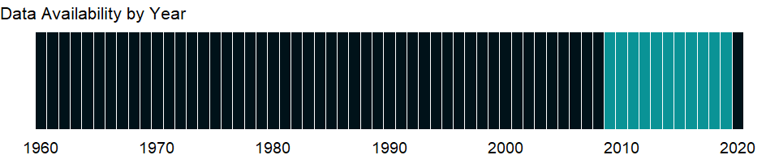

### Which countries have data?

The figure below shows the percentage of countries in each income group with a value since 2010 for that indicator.

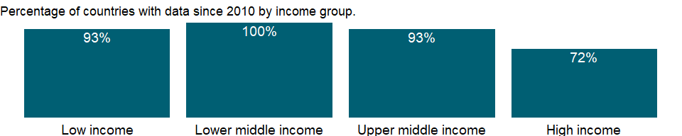

### Why is it relevant?

The economic health of a country is measured not only in macroeconomic terms but also by other factors that shape daily economic activity such as laws, regulations, and institutional arrangements. The data measure business regulation, gauge regulatory outcomes, and measure the extent of legal protection of property, the flexibility of employment regulation, and the tax burden on businesses.

The fundamental premise of this data is that economic activity requires good rules and regulations that are efficient, accessible to all who need to use them, and simple to implement. Thus sometimes there is more emphasis on more regulation, such as stricter disclosure requirements in related-party transactions, and other times emphasis is on for simplified regulations, such as a one-stop shop for completing business startup formalities.

Entrepreneurs may not be aware of all required procedures or may avoid legally required procedures altogether. But where regulation is particularly onerous, levels of informality are higher, which comes at a cost: firms in the informal sector usually grow more slowly, have less access to credit, and employ fewer workers - and those workers remain outside the protections of labor law. The indicator can help policymakers understand the business environment in a country and - along with information from other sources such as the World Bank’s Enterprise Surveys - provide insights into potential areas of reform.

### What is the data source?

World Bank, Doing Business project (<http://www.doingbusiness.org/>). NOTE: Doing Business has been discontinued as of 9/16/2021. For more information: <https://bit.ly/3CLCbme>

### What is the methodology?

Data are collected by the World Bank with a standardized survey that uses a simple business case to ensure comparability across economies and over time - with assumptions about the legal form of the business, its size, its location, and nature of its operation. Surveys are administered through more than 9,000 local experts, including lawyers, business consultants, accountants, freight forwarders, government officials, and other professionals who routinely administer or advise on legal and regulatory requirements.

Data records all procedures required for a business to obtain a permanent electricity connection. These procedures include applications and contracts with electricity utilities, all necessary inspections and clearances from the utility and other agencies and the external and final connection works.

The Doing Business project of the World Bank encompasses two types of data: data from readings of laws and regulations and data on time and motion indicators that measure efficiency in achieving a regulatory goal. Within the time and motion indicators cost estimates are recorded from official fee schedules where applicable. The data from surveys are subjected to numerous tests for robustness, which lead to revision or expansion of the information collected.

### How is it aggregated?

Unweighted average

### What are the limitations?

The Doing Business methodology has limitations that should be considered when interpreting the data. First, the data collected refer to businesses in the economy’s largest city and may not represent regulations in other locations of the economy. To address this limitation, subnational indicators are being collected for selected economies. These subnational studies point to significant differences in the speed of reform and the ease of doing business across cities in the same economy. Second, the data often focus on a specific business form - generally a limited liability company of a specified size - and may not represent regulation for other types of businesses such as sole proprietorships. Third, transactions described in a standardized business case refer to a specific set of issues and may not represent the full set of issues a business encounters. Fourth, the time measures involve an element of judgment by the expert respondents. When sources indicate different estimates, the Doing Business time indicators represent the median values of several responses given under the assumptions of the standardized case. Fifth, the methodology assumes that a business has full information on what is required and does not waste time when completing procedures.

### What else should I know?

Data are presented for the survey year instead of publication year.

### 1.33.14 Firms using banks to finance working capital (% of firms)

### What is the indicator?

Firms using banks to finance working capital are the percentage of firms using bank loans to finance working capital.

Topic: Private Sector & Trade: Business environment

Series ID: IC.FRM.BKWC.ZS

Copyright: CC BY-4.0 , <https://datacatalog.worldbank.org/public-licenses#cc-by>

First year with any data: 2002

Last year with any data: 2020

### What years are data available?

The figure below shows years in which data is available for at least one country. Dates shaded in black have no data, while dates shaded in green have data for at least one country



### Which countries have data?

The figure below shows the percentage of countries in each income group with a value since 2010 for that indicator.

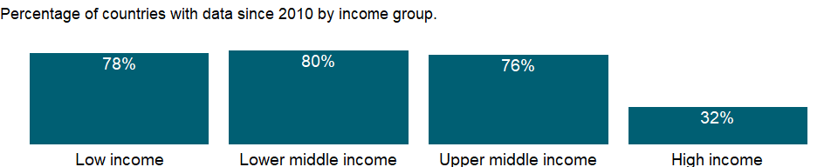

### Why is it relevant?

Firms evaluating investment options, governments interested in improving business conditions, and economists seeking to explain economic performance have all grappled with defining and measuring the business environment. The firm-level data from Enterprise Surveys provide a useful tool for benchmarking economies across a large number of indicators measured at the firm level.

Corruption by public officials may present a major administrative and financial burden on firms. Corruption creates an unfavorable business environment by undermining the operational efficiency of firms and raising the costs and risks associated with doing business.

In some countries doing business requires informal payments to “get things done” in customs, taxes, licenses, regulations, services, and the like. Such corruption can harm the business environment by distorting policymaking, undermining government credibility, and diverting public resources.

### What is the data source?

World Bank, Enterprise Surveys (<http://www.enterprisesurveys.org/>).

### What is the methodology?

Firm-level surveys have been conducted since the 1990’s by different units within the World Bank. Since 2005-06, most data collection efforts have been centralized within the Enterprise Analysis Unit. Surveys implemented by the Enterprise Analysis Unit follow the Global Methodology.

Private contractors conduct the Enterprise Surveys on behalf of the World Bank. Due to sensitive survey questions addressing business-government relations and bribery-related topics, private contractors, rather than any government agency or an organization/institution associated with government, are hired by the World Bank to collect the data.

Confidentiality of the survey respondents and the sensitive information they provide is necessary to ensure the greatest degree of survey participation, integrity and confidence in the quality of the data. Surveys are usually carried out in cooperation with business organizations and government agencies promoting job creation and economic growth, but confidentiality is never compromised.

The Enterprise Survey is answered by business owners and top managers. Sometimes the survey respondent calls company accountants and human resource managers into the interview to answer questions in the sales and labor sections of the survey. Typically 1200-1800 interviews are conducted in larger economies, 360 interviews are conducted in medium-sized economies, and for smaller economies, 150 interviews take place.

The manufacturing and services sectors are the primary business sectors of interest. This corresponds to firms classified with ISIC codes 15-37, 45, 50-52, 55, 60-64, and 72 (ISIC Rev.3.1). Formal (registered) companies with 5 or more employees are targeted for interview. Services firms include construction, retail, wholesale, hotels, restaurants, transport, storage, communications, and IT. Firms with 100% government/state ownership are not eligible to participate in an Enterprise Survey. Occasionally, for a few surveyed countries, other sectors are included in the companies surveyed such as education or health-related businesses. In each country, businesses in the cities/regions of major economic activity are interviewed.

In some countries, other surveys, which depart from the usual Enterprise Survey methodology, are conducted. Examples include 1) Informal Surveys- surveys of informal (unregistered) enterprises, 2) Micro Surveys- surveys fielded to registered firms with less than five employees, and 3) Financial Crisis Assessment Surveys- short surveys administered by telephone to assess the effects of the global financial crisis of 2008-09.

The Enterprise Surveys Unit uses two instruments: the Manufacturing Questionnaire and the Services Questionnaire. Although many questions overlap, some are only applicable to one type of business. For example, retail firms are not asked about production and nonproduction workers.

The standard Enterprise Survey topics include firm characteristics, gender participation, access to finance, annual sales, costs of inputs/labor, workforce composition, bribery, licensing, infrastructure, trade, crime, competition, capacity utilization, land and permits, taxation, informality, business-government relations, innovation and technology, and performance measures.

Over 90% of the questions objectively ascertain characteristics of a country’s business environment. The remaining questions assess the survey respondents’ opinions on what are the obstacles to firm growth and performance. The mode of data collection is face-to-face interviews.

### How is it aggregated?

Unweighted average

### What are the limitations?

The sampling methodology for Enterprise Surveys is stratified random sampling. In a simple random sample, all members of the population have the same probability of being selected and no weighting of the observations is necessary. In a stratified random sample, all population units are grouped within homogeneous groups and simple random samples are selected within each group. This method allows computing estimates for each of the strata with a specified level of precision while population estimates can also be estimated by properly weighting individual observations. The sampling weights take care of the varying probabilities of selection across different strata. Under certain conditions, estimates’ precision under stratified random sampling will be higher than under simple random sampling (lower standard errors may result from the estimation procedure).

The strata for Enterprise Surveys are firm size, business sector, and geographic region within a country. Firm size levels are 5-19 (small), 20-99 (medium), and 100+ employees (large-sized firms). Since in most economies, the majority of firms are small and medium-sized, Enterprise Surveys oversample large firms since larger firms tend to be engines of job creation. Sector breakdown is usually manufacturing, retail, and other services. For larger economies, specific manufacturing sub-sectors are selected as additional strata on the basis of employment, value-added, and total number of establishments figures. Geographic regions within a country are selected based on which cities/regions collectively contain the majority of economic activity.

Ideally the survey sample frame is derived from the universe of eligible firms obtained from the country’s statistical office. Sometimes the master list of firms is obtained from other government agencies such as tax or business licensing authorities. In some cases, the list of firms is obtained from business associations or marketing databases. In a few cases, the sample frame is created via block enumeration, where the World Bank “manually” constructs a list of eligible firms after 1) partitioning a country’s cities of major economic activity into clusters and blocks, 2) randomly selecting a subset of blocks which will then be enumerated. In surveys conducted since 2005-06, survey documentation which explains the source of the sample frame and any special circumstances encountered during survey fieldwork are included with the collected datasets.

Obtaining panel data, i.e. interviews with the same firms across multiple years, is a priority in current Enterprise Surveys. When conducting a new Enterprise Survey in a country where data was previously collected, maximal effort is expended to re-interview as many firms (from the prior survey) as possible. For these panel firms, sampling weights can be adjusted to take into account the resulting altered probabilities of inclusion in the sample frame.

### What else should I know?

NA

### 1.33.15 Firms using banks to finance investment (% of firms)

### What is the indicator?

Firms using banks to finance investment are the percentage of firms using banks to finance investments.

Topic: Private Sector & Trade: Business environment

Series ID: IC.FRM.BNKS.ZS

Copyright: CC BY-4.0 , <https://datacatalog.worldbank.org/public-licenses#cc-by>

First year with any data: 2002

Last year with any data: 2020

### What years are data available?

The figure below shows years in which data is available for at least one country. Dates shaded in black have no data, while dates shaded in green have data for at least one country



### Which countries have data?

The figure below shows the percentage of countries in each income group with a value since 2010 for that indicator.



### Why is it relevant?

Firms evaluating investment options, governments interested in improving business conditions, and economists seeking to explain economic performance have all grappled with defining and measuring the business environment. The firm-level data from Enterprise Surveys provide a useful tool for benchmarking economies across a large number of indicators measured at the firm level.

Financial markets connect firms to lenders and investors, allowing firms to grow their businesses: creditworthy firms can obtain credit from financial intermediaries at competitive prices. But too often market imperfections and government-induced distortions limit access to credit and thus restrain growth.

Excessive reliance on internal funds is a sign of potentially inefficient financial intermediation.

### What is the data source?

World Bank, Enterprise Surveys (<http://www.enterprisesurveys.org/>).

### What is the methodology?

Firm-level surveys have been conducted since the 1990’s by different units within the World Bank. Since 2005-06, most data collection efforts have been centralized within the Enterprise Analysis Unit. Surveys implemented by the Enterprise Analysis Unit follow the Global Methodology.

Private contractors conduct the Enterprise Surveys on behalf of the World Bank. Due to sensitive survey questions addressing business-government relations and bribery-related topics, private contractors, rather than any government agency or an organization/institution associated with government, are hired by the World Bank to collect the data.

Confidentiality of the survey respondents and the sensitive information they provide is necessary to ensure the greatest degree of survey participation, integrity and confidence in the quality of the data. Surveys are usually carried out in cooperation with business organizations and government agencies promoting job creation and economic growth, but confidentiality is never compromised.

The Enterprise Survey is answered by business owners and top managers. Sometimes the survey respondent calls company accountants and human resource managers into the interview to answer questions in the sales and labor sections of the survey. Typically 1200-1800 interviews are conducted in larger economies, 360 interviews are conducted in medium-sized economies, and for smaller economies, 150 interviews take place.

The manufacturing and services sectors are the primary business sectors of interest. This corresponds to firms classified with ISIC codes 15-37, 45, 50-52, 55, 60-64, and 72 (ISIC Rev.3.1). Formal (registered) companies with 5 or more employees are targeted for interview. Services firms include construction, retail, wholesale, hotels, restaurants, transport, storage, communications, and IT. Firms with 100% government/state ownership are not eligible to participate in an Enterprise Survey. Occasionally, for a few surveyed countries, other sectors are included in the companies surveyed such as education or health-related businesses. In each country, businesses in the cities/regions of major economic activity are interviewed.

In some countries, other surveys, which depart from the usual Enterprise Survey methodology, are conducted. Examples include 1) Informal Surveys- surveys of informal (unregistered) enterprises, 2) Micro Surveys- surveys fielded to registered firms with less than five employees, and 3) Financial Crisis Assessment Surveys- short surveys administered by telephone to assess the effects of the global financial crisis of 2008-09.

The Enterprise Surveys Unit uses two instruments: the Manufacturing Questionnaire and the Services Questionnaire. Although many questions overlap, some are only applicable to one type of business. For example, retail firms are not asked about production and nonproduction workers.

The standard Enterprise Survey topics include firm characteristics, gender participation, access to finance, annual sales, costs of inputs/labor, workforce composition, bribery, licensing, infrastructure, trade, crime, competition, capacity utilization, land and permits, taxation, informality, business-government relations, innovation and technology, and performance measures.

Over 90% of the questions objectively ascertain characteristics of a country’s business environment. The remaining questions assess the survey respondents’ opinions on what are the obstacles to firm growth and performance. The mode of data collection is face-to-face interviews.

### How is it aggregated?

Unweighted average

### What are the limitations?

The sampling methodology for Enterprise Surveys is stratified random sampling. In a simple random sample, all members of the population have the same probability of being selected and no weighting of the observations is necessary. In a stratified random sample, all population units are grouped within homogeneous groups and simple random samples are selected within each group. This method allows computing estimates for each of the strata with a specified level of precision while population estimates can also be estimated by properly weighting individual observations. The sampling weights take care of the varying probabilities of selection across different strata. Under certain conditions, estimates’ precision under stratified random sampling will be higher than under simple random sampling (lower standard errors may result from the estimation procedure).

The strata for Enterprise Surveys are firm size, business sector, and geographic region within a country. Firm size levels are 5-19 (small), 20-99 (medium), and 100+ employees (large-sized firms). Since in most economies, the majority of firms are small and medium-sized, Enterprise Surveys oversample large firms since larger firms tend to be engines of job creation. Sector breakdown is usually manufacturing, retail, and other services. For larger economies, specific manufacturing sub-sectors are selected as additional strata on the basis of employment, value-added, and total number of establishments figures. Geographic regions within a country are selected based on which cities/regions collectively contain the majority of economic activity.

Ideally the survey sample frame is derived from the universe of eligible firms obtained from the country’s statistical office. Sometimes the master list of firms is obtained from other government agencies such as tax or business licensing authorities. In some cases, the list of firms is obtained from business associations or marketing databases. In a few cases, the sample frame is created via block enumeration, where the World Bank “manually” constructs a list of eligible firms after 1) partitioning a country’s cities of major economic activity into clusters and blocks, 2) randomly selecting a subset of blocks which will then be enumerated. In surveys conducted since 2005-06, survey documentation which explains the source of the sample frame and any special circumstances encountered during survey fieldwork are included with the collected datasets.

Obtaining panel data, i.e. interviews with the same firms across multiple years, is a priority in current Enterprise Surveys. When conducting a new Enterprise Survey in a country where data was previously collected, maximal effort is expended to re-interview as many firms (from the prior survey) as possible. For these panel firms, sampling weights can be adjusted to take into account the resulting altered probabilities of inclusion in the sample frame.

### What else should I know?

NA

### 1.33.16 Bribery incidence (% of firms experiencing at least one bribe payment request)

### What is the indicator?

Bribery incidence is the percentage of firms experiencing at least one bribe payment request across 6 public transactions dealing with utilities access, permits, licenses, and taxes.

Topic: Private Sector & Trade: Business environment

Series ID: IC.FRM.BRIB.ZS

Copyright: CC BY-4.0 , <https://datacatalog.worldbank.org/public-licenses#cc-by>

First year with any data: 2006

Last year with any data: 2020

### What years are data available?

The figure below shows years in which data is available for at least one country. Dates shaded in black have no data, while dates shaded in green have data for at least one country



### Which countries have data?

The figure below shows the percentage of countries in each income group with a value since 2010 for that indicator.



### Why is it relevant?

Firms evaluating investment options, governments interested in improving business conditions, and economists seeking to explain economic performance have all grappled with defining and measuring the business environment. The firm-level data from Enterprise Surveys provide a useful tool for benchmarking economies across a large number of indicators measured at the firm level.

Corruption by public officials may present a major administrative and financial burden on firms. Corruption creates an unfavorable business environment by undermining the operational efficiency of firms and raising the costs and risks associated with doing business.

In some countries doing business requires informal payments to “get things done” in customs, taxes, licenses, regulations, services, and the like. Such corruption can harm the business environment by distorting policymaking, undermining government credibility, and diverting public resources.

### What is the data source?

World Bank, Enterprise Surveys (<http://www.enterprisesurveys.org/>).

### What is the methodology?

Firm-level surveys have been conducted since the 1990’s by different units within the World Bank. Since 2005-06, most data collection efforts have been centralized within the Enterprise Analysis Unit. Surveys implemented by the Enterprise Analysis Unit follow the Global Methodology.

Private contractors conduct the Enterprise Surveys on behalf of the World Bank. Due to sensitive survey questions addressing business-government relations and bribery-related topics, private contractors, rather than any government agency or an organization/institution associated with government, are hired by the World Bank to collect the data.

Confidentiality of the survey respondents and the sensitive information they provide is necessary to ensure the greatest degree of survey participation, integrity and confidence in the quality of the data. Surveys are usually carried out in cooperation with business organizations and government agencies promoting job creation and economic growth, but confidentiality is never compromised.

The Enterprise Survey is answered by business owners and top managers. Sometimes the survey respondent calls company accountants and human resource managers into the interview to answer questions in the sales and labor sections of the survey. Typically 1200-1800 interviews are conducted in larger economies, 360 interviews are conducted in medium-sized economies, and for smaller economies, 150 interviews take place.

The manufacturing and services sectors are the primary business sectors of interest. This corresponds to firms classified with ISIC codes 15-37, 45, 50-52, 55, 60-64, and 72 (ISIC Rev.3.1). Formal (registered) companies with 5 or more employees are targeted for interview. Services firms include construction, retail, wholesale, hotels, restaurants, transport, storage, communications, and IT. Firms with 100% government/state ownership are not eligible to participate in an Enterprise Survey. Occasionally, for a few surveyed countries, other sectors are included in the companies surveyed such as education or health-related businesses. In each country, businesses in the cities/regions of major economic activity are interviewed.

In some countries, other surveys, which depart from the usual Enterprise Survey methodology, are conducted. Examples include 1) Informal Surveys- surveys of informal (unregistered) enterprises, 2) Micro Surveys- surveys fielded to registered firms with less than five employees, and 3) Financial Crisis Assessment Surveys- short surveys administered by telephone to assess the effects of the global financial crisis of 2008-09.

The Enterprise Surveys Unit uses two instruments: the Manufacturing Questionnaire and the Services Questionnaire. Although many questions overlap, some are only applicable to one type of business. For example, retail firms are not asked about production and nonproduction workers.

The standard Enterprise Survey topics include firm characteristics, gender participation, access to finance, annual sales, costs of inputs/labor, workforce composition, bribery, licensing, infrastructure, trade, crime, competition, capacity utilization, land and permits, taxation, informality, business-government relations, innovation and technology, and performance measures.

Over 90% of the questions objectively ascertain characteristics of a country’s business environment. The remaining questions assess the survey respondents’ opinions on what are the obstacles to firm growth and performance. The mode of data collection is face-to-face interviews.

### How is it aggregated?

Unweighted average

### What are the limitations?

The sampling methodology for Enterprise Surveys is stratified random sampling. In a simple random sample, all members of the population have the same probability of being selected and no weighting of the observations is necessary. In a stratified random sample, all population units are grouped within homogeneous groups and simple random samples are selected within each group. This method allows computing estimates for each of the strata with a specified level of precision while population estimates can also be estimated by properly weighting individual observations. The sampling weights take care of the varying probabilities of selection across different strata. Under certain conditions, estimates’ precision under stratified random sampling will be higher than under simple random sampling (lower standard errors may result from the estimation procedure).

The strata for Enterprise Surveys are firm size, business sector, and geographic region within a country. Firm size levels are 5-19 (small), 20-99 (medium), and 100+ employees (large-sized firms). Since in most economies, the majority of firms are small and medium-sized, Enterprise Surveys oversample large firms since larger firms tend to be engines of job creation. Sector breakdown is usually manufacturing, retail, and other services. For larger economies, specific manufacturing sub-sectors are selected as additional strata on the basis of employment, value-added, and total number of establishments figures. Geographic regions within a country are selected based on which cities/regions collectively contain the majority of economic activity.

Ideally the survey sample frame is derived from the universe of eligible firms obtained from the country’s statistical office. Sometimes the master list of firms is obtained from other government agencies such as tax or business licensing authorities. In some cases, the list of firms is obtained from business associations or marketing databases. In a few cases, the sample frame is created via block enumeration, where the World Bank “manually” constructs a list of eligible firms after 1) partitioning a country’s cities of major economic activity into clusters and blocks, 2) randomly selecting a subset of blocks which will then be enumerated. In surveys conducted since 2005-06, survey documentation which explains the source of the sample frame and any special circumstances encountered during survey fieldwork are included with the collected datasets.

Obtaining panel data, i.e. interviews with the same firms across multiple years, is a priority in current Enterprise Surveys. When conducting a new Enterprise Survey in a country where data was previously collected, maximal effort is expended to re-interview as many firms (from the prior survey) as possible. For these panel firms, sampling weights can be adjusted to take into account the resulting altered probabilities of inclusion in the sample frame.

### What else should I know?

NA

### 1.33.17 Firms competing against unregistered firms (% of firms)

### What is the indicator?

Firms competing against unregistered firms are the percentage of firms competing against unregistered or informal firms.

Topic: Private Sector & Trade: Business environment

Series ID: IC.FRM.CMPU.ZS

Copyright: CC BY-4.0 , <https://datacatalog.worldbank.org/public-licenses#cc-by>

First year with any data: 2006

Last year with any data: 2020

### What years are data available?

The figure below shows years in which data is available for at least one country. Dates shaded in black have no data, while dates shaded in green have data for at least one country



### Which countries have data?

The figure below shows the percentage of countries in each income group with a value since 2010 for that indicator.



### Why is it relevant?

Firms evaluating investment options, governments interested in improving business conditions, and economists seeking to explain economic performance have all grappled with defining and measuring the business environment. The firm-level data from Enterprise Surveys provide a useful tool for benchmarking economies across a large number of indicators measured at the firm level.

Informality is associated with business operations without registration. The informal sector in an economy may be a source of unfair competition to formal firms and also deprive governments of potential tax revenue and diminish a government’s capacity for regulatory oversight.

Informality can be defined along different dimensions such as operating without registration, income tax evasion, labor tax evasion, or operating outside the legal framework of an economy. Firms may show different degrees of informality along these dimensions which may also overlap.

A large informal sector has serious consequences for the formal private sector, and may pose unfair competition for formal firms. It is an approximation to the prevalence of informality in the private economy.

### What is the data source?

World Bank, Enterprise Surveys (<http://www.enterprisesurveys.org/>).

### What is the methodology?

Firm-level surveys have been conducted since the 1990’s by different units within the World Bank. Since 2005-06, most data collection efforts have been centralized within the Enterprise Analysis Unit. Surveys implemented by the Enterprise Analysis Unit follow the Global Methodology.

Private contractors conduct the Enterprise Surveys on behalf of the World Bank. Due to sensitive survey questions addressing business-government relations and bribery-related topics, private contractors, rather than any government agency or an organization/institution associated with government, are hired by the World Bank to collect the data.

Confidentiality of the survey respondents and the sensitive information they provide is necessary to ensure the greatest degree of survey participation, integrity and confidence in the quality of the data. Surveys are usually carried out in cooperation with business organizations and government agencies promoting job creation and economic growth, but confidentiality is never compromised.

The Enterprise Survey is answered by business owners and top managers. Sometimes the survey respondent calls company accountants and human resource managers into the interview to answer questions in the sales and labor sections of the survey. Typically 1200-1800 interviews are conducted in larger economies, 360 interviews are conducted in medium-sized economies, and for smaller economies, 150 interviews take place.

The manufacturing and services sectors are the primary business sectors of interest. This corresponds to firms classified with ISIC codes 15-37, 45, 50-52, 55, 60-64, and 72 (ISIC Rev.3.1). Formal (registered) companies with 5 or more employees are targeted for interview. Services firms include construction, retail, wholesale, hotels, restaurants, transport, storage, communications, and IT. Firms with 100% government/state ownership are not eligible to participate in an Enterprise Survey. Occasionally, for a few surveyed countries, other sectors are included in the companies surveyed such as education or health-related businesses. In each country, businesses in the cities/regions of major economic activity are interviewed.

In some countries, other surveys, which depart from the usual Enterprise Survey methodology, are conducted. Examples include 1) Informal Surveys- surveys of informal (unregistered) enterprises, 2) Micro Surveys- surveys fielded to registered firms with less than five employees, and 3) Financial Crisis Assessment Surveys- short surveys administered by telephone to assess the effects of the global financial crisis of 2008-09.

The Enterprise Surveys Unit uses two instruments: the Manufacturing Questionnaire and the Services Questionnaire. Although many questions overlap, some are only applicable to one type of business. For example, retail firms are not asked about production and nonproduction workers.

The standard Enterprise Survey topics include firm characteristics, gender participation, access to finance, annual sales, costs of inputs/labor, workforce composition, bribery, licensing, infrastructure, trade, crime, competition, capacity utilization, land and permits, taxation, informality, business-government relations, innovation and technology, and performance measures.

Over 90% of the questions objectively ascertain characteristics of a country’s business environment. The remaining questions assess the survey respondents’ opinions on what are the obstacles to firm growth and performance. The mode of data collection is face-to-face interviews.

### How is it aggregated?

Unweighted average

### What are the limitations?

The sampling methodology for Enterprise Surveys is stratified random sampling. In a simple random sample, all members of the population have the same probability of being selected and no weighting of the observations is necessary. In a stratified random sample, all population units are grouped within homogeneous groups and simple random samples are selected within each group. This method allows computing estimates for each of the strata with a specified level of precision while population estimates can also be estimated by properly weighting individual observations. The sampling weights take care of the varying probabilities of selection across different strata. Under certain conditions, estimates’ precision under stratified random sampling will be higher than under simple random sampling (lower standard errors may result from the estimation procedure).

The strata for Enterprise Surveys are firm size, business sector, and geographic region within a country. Firm size levels are 5-19 (small), 20-99 (medium), and 100+ employees (large-sized firms). Since in most economies, the majority of firms are small and medium-sized, Enterprise Surveys oversample large firms since larger firms tend to be engines of job creation. Sector breakdown is usually manufacturing, retail, and other services. For larger economies, specific manufacturing sub-sectors are selected as additional strata on the basis of employment, value-added, and total number of establishments figures. Geographic regions within a country are selected based on which cities/regions collectively contain the majority of economic activity.

Ideally the survey sample frame is derived from the universe of eligible firms obtained from the country’s statistical office. Sometimes the master list of firms is obtained from other government agencies such as tax or business licensing authorities. In some cases, the list of firms is obtained from business associations or marketing databases. In a few cases, the sample frame is created via block enumeration, where the World Bank “manually” constructs a list of eligible firms after 1) partitioning a country’s cities of major economic activity into clusters and blocks, 2) randomly selecting a subset of blocks which will then be enumerated. In surveys conducted since 2005-06, survey documentation which explains the source of the sample frame and any special circumstances encountered during survey fieldwork are included with the collected datasets.

Obtaining panel data, i.e. interviews with the same firms across multiple years, is a priority in current Enterprise Surveys. When conducting a new Enterprise Survey in a country where data was previously collected, maximal effort is expended to re-interview as many firms (from the prior survey) as possible. For these panel firms, sampling weights can be adjusted to take into account the resulting altered probabilities of inclusion in the sample frame.

### What else should I know?

NA

### 1.33.18 Informal payments to public officials (% of firms)

### What is the indicator?

Informal payments to public officials are the percentage of firms expected to make informal payments to public officials to “get things done” with regard to customs, taxes, licenses, regulations, services, and the like.

Topic: Private Sector & Trade: Business environment

Series ID: IC.FRM.CORR.ZS

Copyright: CC BY-4.0 , <https://datacatalog.worldbank.org/public-licenses#cc-by>

First year with any data: 2002

Last year with any data: 2020

### What years are data available?

The figure below shows years in which data is available for at least one country. Dates shaded in black have no data, while dates shaded in green have data for at least one country



### Which countries have data?

The figure below shows the percentage of countries in each income group with a value since 2010 for that indicator.



### Why is it relevant?

Firms evaluating investment options, governments interested in improving business conditions, and economists seeking to explain economic performance have all grappled with defining and measuring the business environment. The firm-level data from Enterprise Surveys provide a useful tool for benchmarking economies across a large number of indicators measured at the firm level.

Corruption by public officials may present a major administrative and financial burden on firms. Corruption creates an unfavorable business environment by undermining the operational efficiency of firms and raising the costs and risks associated with doing business.

In some countries doing business requires informal payments to “get things done” in customs, taxes, licenses, regulations, services, and the like. Such corruption can harm the business environment by distorting policymaking, undermining government credibility, and diverting public resources.

### What is the data source?

World Bank, Enterprise Surveys (<http://www.enterprisesurveys.org/>).

### What is the methodology?

Firm-level surveys have been conducted since the 1990’s by different units within the World Bank. Since 2005-06, most data collection efforts have been centralized within the Enterprise Analysis Unit. Surveys implemented by the Enterprise Analysis Unit follow the Global Methodology.

Private contractors conduct the Enterprise Surveys on behalf of the World Bank. Due to sensitive survey questions addressing business-government relations and bribery-related topics, private contractors, rather than any government agency or an organization/institution associated with government, are hired by the World Bank to collect the data.

Confidentiality of the survey respondents and the sensitive information they provide is necessary to ensure the greatest degree of survey participation, integrity and confidence in the quality of the data. Surveys are usually carried out in cooperation with business organizations and government agencies promoting job creation and economic growth, but confidentiality is never compromised.

The Enterprise Survey is answered by business owners and top managers. Sometimes the survey respondent calls company accountants and human resource managers into the interview to answer questions in the sales and labor sections of the survey. Typically 1200-1800 interviews are conducted in larger economies, 360 interviews are conducted in medium-sized economies, and for smaller economies, 150 interviews take place.

The manufacturing and services sectors are the primary business sectors of interest. This corresponds to firms classified with ISIC codes 15-37, 45, 50-52, 55, 60-64, and 72 (ISIC Rev.3.1). Formal (registered) companies with 5 or more employees are targeted for interview. Services firms include construction, retail, wholesale, hotels, restaurants, transport, storage, communications, and IT. Firms with 100% government/state ownership are not eligible to participate in an Enterprise Survey. Occasionally, for a few surveyed countries, other sectors are included in the companies surveyed such as education or health-related businesses. In each country, businesses in the cities/regions of major economic activity are interviewed.

In some countries, other surveys, which depart from the usual Enterprise Survey methodology, are conducted. Examples include 1) Informal Surveys- surveys of informal (unregistered) enterprises, 2) Micro Surveys- surveys fielded to registered firms with less than five employees, and 3) Financial Crisis Assessment Surveys- short surveys administered by telephone to assess the effects of the global financial crisis of 2008-09.

The Enterprise Surveys Unit uses two instruments: the Manufacturing Questionnaire and the Services Questionnaire. Although many questions overlap, some are only applicable to one type of business. For example, retail firms are not asked about production and nonproduction workers.

The standard Enterprise Survey topics include firm characteristics, gender participation, access to finance, annual sales, costs of inputs/labor, workforce composition, bribery, licensing, infrastructure, trade, crime, competition, capacity utilization, land and permits, taxation, informality, business-government relations, innovation and technology, and performance measures.

Over 90% of the questions objectively ascertain characteristics of a country’s business environment. The remaining questions assess the survey respondents’ opinions on what are the obstacles to firm growth and performance. The mode of data collection is face-to-face interviews.

### How is it aggregated?

Unweighted average

### What are the limitations?

The sampling methodology for Enterprise Surveys is stratified random sampling. In a simple random sample, all members of the population have the same probability of being selected and no weighting of the observations is necessary. In a stratified random sample, all population units are grouped within homogeneous groups and simple random samples are selected within each group. This method allows computing estimates for each of the strata with a specified level of precision while population estimates can also be estimated by properly weighting individual observations. The sampling weights take care of the varying probabilities of selection across different strata. Under certain conditions, estimates’ precision under stratified random sampling will be higher than under simple random sampling (lower standard errors may result from the estimation procedure).

The strata for Enterprise Surveys are firm size, business sector, and geographic region within a country. Firm size levels are 5-19 (small), 20-99 (medium), and 100+ employees (large-sized firms). Since in most economies, the majority of firms are small and medium-sized, Enterprise Surveys oversample large firms since larger firms tend to be engines of job creation. Sector breakdown is usually manufacturing, retail, and other services. For larger economies, specific manufacturing sub-sectors are selected as additional strata on the basis of employment, value-added, and total number of establishments figures. Geographic regions within a country are selected based on which cities/regions collectively contain the majority of economic activity.

Ideally the survey sample frame is derived from the universe of eligible firms obtained from the country’s statistical office. Sometimes the master list of firms is obtained from other government agencies such as tax or business licensing authorities. In some cases, the list of firms is obtained from business associations or marketing databases. In a few cases, the sample frame is created via block enumeration, where the World Bank “manually” constructs a list of eligible firms after 1) partitioning a country’s cities of major economic activity into clusters and blocks, 2) randomly selecting a subset of blocks which will then be enumerated. In surveys conducted since 2005-06, survey documentation which explains the source of the sample frame and any special circumstances encountered during survey fieldwork are included with the collected datasets.

Obtaining panel data, i.e. interviews with the same firms across multiple years, is a priority in current Enterprise Surveys. When conducting a new Enterprise Survey in a country where data was previously collected, maximal effort is expended to re-interview as many firms (from the prior survey) as possible. For these panel firms, sampling weights can be adjusted to take into account the resulting altered probabilities of inclusion in the sample frame.

### What else should I know?

NA

### 1.33.19 Losses due to theft and vandalism (% of annual sales for affected firms)

### What is the indicator?

Average losses as a result of theft, robbery, vandalism or arson that occurred on the establishment’s premises calculated as a percentage of annual sales. The value represents the average losses for all firms which reported losses (please see indicator IC.FRM.THEV.ZS).

Topic: Private Sector & Trade: Business environment

Series ID: IC.FRM.CRIM.ZS

Copyright: CC BY-4.0 , <https://datacatalog.worldbank.org/public-licenses#cc-by>

First year with any data: 2006

Last year with any data: 2020

### What years are data available?

The figure below shows years in which data is available for at least one country. Dates shaded in black have no data, while dates shaded in green have data for at least one country



### Which countries have data?

The figure below shows the percentage of countries in each income group with a value since 2010 for that indicator.

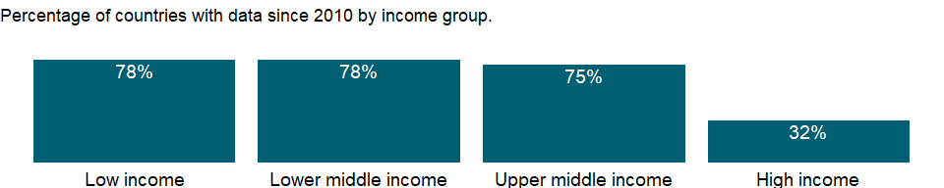

### Why is it relevant?

Firms evaluating investment options, governments interested in improving business conditions, and economists seeking to explain economic performance have all grappled with defining and measuring the business environment. The firm-level data from Enterprise Surveys provide a useful tool for benchmarking economies across a large number of indicators measured at the firm level.

Crime imposes costs on firms when they are forced to divert resources from productive uses to cover security costs. Both foreign and domestic investors perceive crime as an indication of social instability, and crime drives up the cost of doing business. Also, commercial disputes between firms and their clients occur regularly in the course of doing business. Resolving these disputes can be challenging when legal institutions are weak or nonexistent.

Crime, theft, and disorder may impose additional costs to businesses and society, and consume considerable resources.

### What is the data source?

World Bank, Enterprise Surveys (<http://www.enterprisesurveys.org/>).

### What is the methodology?

Firm-level surveys have been conducted since the 1990’s by different units within the World Bank. Since 2005-06, most data collection efforts have been centralized within the Enterprise Analysis Unit. Surveys implemented by the Enterprise Analysis Unit follow the Global Methodology.

Private contractors conduct the Enterprise Surveys on behalf of the World Bank. Due to sensitive survey questions addressing business-government relations and bribery-related topics, private contractors, rather than any government agency or an organization/institution associated with government, are hired by the World Bank to collect the data.

Confidentiality of the survey respondents and the sensitive information they provide is necessary to ensure the greatest degree of survey participation, integrity and confidence in the quality of the data. Surveys are usually carried out in cooperation with business organizations and government agencies promoting job creation and economic growth, but confidentiality is never compromised.

The Enterprise Survey is answered by business owners and top managers. Sometimes the survey respondent calls company accountants and human resource managers into the interview to answer questions in the sales and labor sections of the survey. Typically 1200-1800 interviews are conducted in larger economies, 360 interviews are conducted in medium-sized economies, and for smaller economies, 150 interviews take place.

The manufacturing and services sectors are the primary business sectors of interest. This corresponds to firms classified with ISIC codes 15-37, 45, 50-52, 55, 60-64, and 72 (ISIC Rev.3.1). Formal (registered) companies with 5 or more employees are targeted for interview. Services firms include construction, retail, wholesale, hotels, restaurants, transport, storage, communications, and IT. Firms with 100% government/state ownership are not eligible to participate in an Enterprise Survey. Occasionally, for a few surveyed countries, other sectors are included in the companies surveyed such as education or health-related businesses. In each country, businesses in the cities/regions of major economic activity are interviewed.

In some countries, other surveys, which depart from the usual Enterprise Survey methodology, are conducted. Examples include 1) Informal Surveys- surveys of informal (unregistered) enterprises, 2) Micro Surveys- surveys fielded to registered firms with less than five employees, and 3) Financial Crisis Assessment Surveys- short surveys administered by telephone to assess the effects of the global financial crisis of 2008-09.

The Enterprise Surveys Unit uses two instruments: the Manufacturing Questionnaire and the Services Questionnaire. Although many questions overlap, some are only applicable to one type of business. For example, retail firms are not asked about production and nonproduction workers.

The standard Enterprise Survey topics include firm characteristics, gender participation, access to finance, annual sales, costs of inputs/labor, workforce composition, bribery, licensing, infrastructure, trade, crime, competition, capacity utilization, land and permits, taxation, informality, business-government relations, innovation and technology, and performance measures.

Over 90% of the questions objectively ascertain characteristics of a country’s business environment. The remaining questions assess the survey respondents’ opinions on what are the obstacles to firm growth and performance. The mode of data collection is face-to-face interviews.

### How is it aggregated?

Unweighted average

### What are the limitations?

The sampling methodology for Enterprise Surveys is stratified random sampling. In a simple random sample, all members of the population have the same probability of being selected and no weighting of the observations is necessary. In a stratified random sample, all population units are grouped within homogeneous groups and simple random samples are selected within each group. This method allows computing estimates for each of the strata with a specified level of precision while population estimates can also be estimated by properly weighting individual observations. The sampling weights take care of the varying probabilities of selection across different strata. Under certain conditions, estimates’ precision under stratified random sampling will be higher than under simple random sampling (lower standard errors may result from the estimation procedure).

The strata for Enterprise Surveys are firm size, business sector, and geographic region within a country. Firm size levels are 5-19 (small), 20-99 (medium), and 100+ employees (large-sized firms). Since in most economies, the majority of firms are small and medium-sized, Enterprise Surveys oversample large firms since larger firms tend to be engines of job creation. Sector breakdown is usually manufacturing, retail, and other services. For larger economies, specific manufacturing sub-sectors are selected as additional strata on the basis of employment, value-added, and total number of establishments figures. Geographic regions within a country are selected based on which cities/regions collectively contain the majority of economic activity.

Ideally the survey sample frame is derived from the universe of eligible firms obtained from the country’s statistical office. Sometimes the master list of firms is obtained from other government agencies such as tax or business licensing authorities. In some cases, the list of firms is obtained from business associations or marketing databases. In a few cases, the sample frame is created via block enumeration, where the World Bank “manually” constructs a list of eligible firms after 1) partitioning a country’s cities of major economic activity into clusters and blocks, 2) randomly selecting a subset of blocks which will then be enumerated. In surveys conducted since 2005-06, survey documentation which explains the source of the sample frame and any special circumstances encountered during survey fieldwork are included with the collected datasets.

Obtaining panel data, i.e. interviews with the same firms across multiple years, is a priority in current Enterprise Surveys. When conducting a new Enterprise Survey in a country where data was previously collected, maximal effort is expended to re-interview as many firms (from the prior survey) as possible. For these panel firms, sampling weights can be adjusted to take into account the resulting altered probabilities of inclusion in the sample frame.

### What else should I know?

NA

### 1.33.20 Time required to obtain an operating license (days)

### What is the indicator?

Time required to obtain operating license is the average wait to obtain an operating license from the day the establishment applied for it to the day it was granted.

Topic: Private Sector & Trade: Business environment

Series ID: IC.FRM.DURS

Copyright: CC BY-4.0 , <https://datacatalog.worldbank.org/public-licenses#cc-by>

First year with any data: 2003

Last year with any data: 2020

### What years are data available?

The figure below shows years in which data is available for at least one country. Dates shaded in black have no data, while dates shaded in green have data for at least one country

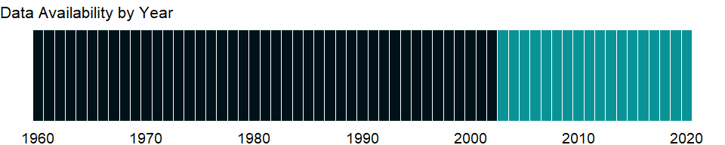

### Which countries have data?

The figure below shows the percentage of countries in each income group with a value since 2010 for that indicator.

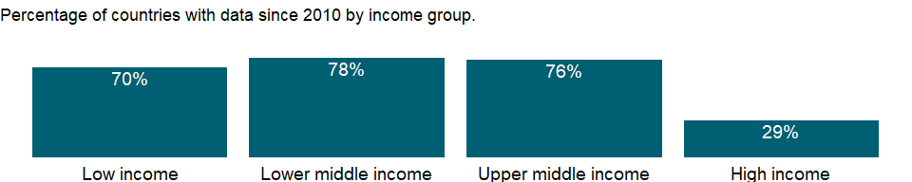

### Why is it relevant?

Firms evaluating investment options, governments interested in improving business conditions, and economists seeking to explain economic performance have all grappled with defining and measuring the business environment. The firm-level data from Enterprise Surveys provide a useful tool for benchmarking economies across a large number of indicators measured at the firm level.

Most countries can improve regulation and taxation without compromising broader social interests. Excessive regulation may harm business performance and growth. For example, time spent with tax officials is a burden firms may face in paying taxes. The business environment suffers when governments increase uncertainty and risks or impose unnecessary costs and unsound regulation and taxation. Time to obtain licenses and permits and the associated red tape constrain firm operations.

Open markets allow firms to expand, raise standards for efficiency on exporters, and enable firms to import low cost supplies. However, trading also forces firms to deal with customs services and trade regulations, obtain export and import licenses, and in some cases, firms also face additional costs due to losses during transport.

### What is the data source?

World Bank, Enterprise Surveys (<http://www.enterprisesurveys.org/>).

### What is the methodology?

Firm-level surveys have been conducted since the 1990’s by different units within the World Bank. Since 2005-06, most data collection efforts have been centralized within the Enterprise Analysis Unit. Surveys implemented by the Enterprise Analysis Unit follow the Global Methodology.

Private contractors conduct the Enterprise Surveys on behalf of the World Bank. Due to sensitive survey questions addressing business-government relations and bribery-related topics, private contractors, rather than any government agency or an organization/institution associated with government, are hired by the World Bank to collect the data.

Confidentiality of the survey respondents and the sensitive information they provide is necessary to ensure the greatest degree of survey participation, integrity and confidence in the quality of the data. Surveys are usually carried out in cooperation with business organizations and government agencies promoting job creation and economic growth, but confidentiality is never compromised.

The Enterprise Survey is answered by business owners and top managers. Sometimes the survey respondent calls company accountants and human resource managers into the interview to answer questions in the sales and labor sections of the survey. Typically 1200-1800 interviews are conducted in larger economies, 360 interviews are conducted in medium-sized economies, and for smaller economies, 150 interviews take place.

The manufacturing and services sectors are the primary business sectors of interest. This corresponds to firms classified with ISIC codes 15-37, 45, 50-52, 55, 60-64, and 72 (ISIC Rev.3.1). Formal (registered) companies with 5 or more employees are targeted for interview. Services firms include construction, retail, wholesale, hotels, restaurants, transport, storage, communications, and IT. Firms with 100% government/state ownership are not eligible to participate in an Enterprise Survey. Occasionally, for a few surveyed countries, other sectors are included in the companies surveyed such as education or health-related businesses. In each country, businesses in the cities/regions of major economic activity are interviewed.

In some countries, other surveys, which depart from the usual Enterprise Survey methodology, are conducted. Examples include 1) Informal Surveys- surveys of informal (unregistered) enterprises, 2) Micro Surveys- surveys fielded to registered firms with less than five employees, and 3) Financial Crisis Assessment Surveys- short surveys administered by telephone to assess the effects of the global financial crisis of 2008-09.

The Enterprise Surveys Unit uses two instruments: the Manufacturing Questionnaire and the Services Questionnaire. Although many questions overlap, some are only applicable to one type of business. For example, retail firms are not asked about production and nonproduction workers.

The standard Enterprise Survey topics include firm characteristics, gender participation, access to finance, annual sales, costs of inputs/labor, workforce composition, bribery, licensing, infrastructure, trade, crime, competition, capacity utilization, land and permits, taxation, informality, business-government relations, innovation and technology, and performance measures.

Over 90% of the questions objectively ascertain characteristics of a country’s business environment. The remaining questions assess the survey respondents’ opinions on what are the obstacles to firm growth and performance. The mode of data collection is face-to-face interviews.

### How is it aggregated?

Unweighted average

### What are the limitations?

The sampling methodology for Enterprise Surveys is stratified random sampling. In a simple random sample, all members of the population have the same probability of being selected and no weighting of the observations is necessary. In a stratified random sample, all population units are grouped within homogeneous groups and simple random samples are selected within each group. This method allows computing estimates for each of the strata with a specified level of precision while population estimates can also be estimated by properly weighting individual observations. The sampling weights take care of the varying probabilities of selection across different strata. Under certain conditions, estimates’ precision under stratified random sampling will be higher than under simple random sampling (lower standard errors may result from the estimation procedure).

The strata for Enterprise Surveys are firm size, business sector, and geographic region within a country. Firm size levels are 5-19 (small), 20-99 (medium), and 100+ employees (large-sized firms). Since in most economies, the majority of firms are small and medium-sized, Enterprise Surveys oversample large firms since larger firms tend to be engines of job creation. Sector breakdown is usually manufacturing, retail, and other services. For larger economies, specific manufacturing sub-sectors are selected as additional strata on the basis of employment, value-added, and total number of establishments figures. Geographic regions within a country are selected based on which cities/regions collectively contain the majority of economic activity.

Ideally the survey sample frame is derived from the universe of eligible firms obtained from the country’s statistical office. Sometimes the master list of firms is obtained from other government agencies such as tax or business licensing authorities. In some cases, the list of firms is obtained from business associations or marketing databases. In a few cases, the sample frame is created via block enumeration, where the World Bank “manually” constructs a list of eligible firms after 1) partitioning a country’s cities of major economic activity into clusters and blocks, 2) randomly selecting a subset of blocks which will then be enumerated. In surveys conducted since 2005-06, survey documentation which explains the source of the sample frame and any special circumstances encountered during survey fieldwork are included with the collected datasets.

Obtaining panel data, i.e. interviews with the same firms across multiple years, is a priority in current Enterprise Surveys. When conducting a new Enterprise Survey in a country where data was previously collected, maximal effort is expended to re-interview as many firms (from the prior survey) as possible. For these panel firms, sampling weights can be adjusted to take into account the resulting altered probabilities of inclusion in the sample frame.

### What else should I know?

NA

### 1.33.21 Firms with female top manager (% of firms)

### What is the indicator?

Firms with female top manager refers to the percentage of firms in the private sector who have females as top managers. Top manager refers to the highest ranking manager or CEO of the establishment. This person may be the owner if he/she works as the manager of the firm. The results are based on surveys of more than 100,000 private firms.

Topic: Private Sector & Trade: Business environment

Series ID: IC.FRM.FEMM.ZS

Copyright: CC BY-4.0 , <https://datacatalog.worldbank.org/public-licenses#cc-by>

First year with any data: 2007

Last year with any data: 2020

### What years are data available?

The figure below shows years in which data is available for at least one country. Dates shaded in black have no data, while dates shaded in green have data for at least one country



### Which countries have data?

The figure below shows the percentage of countries in each income group with a value since 2010 for that indicator.



### Why is it relevant?

Firms evaluating investment options, governments interested in improving business conditions, and economists seeking to explain economic performance have all grappled with defining and measuring the business environment. The firm-level data from Enterprise Surveys provide a useful tool for benchmarking economies across a large number of indicators measured at the firm level.

Firms with female top manager measures women’s integration as decision makers. Benchmarking firms with female top manager is important to achieving gender equality promotion and empowerment of women. The gender topic provides information about women’s entrepreneurship and economic participation in the labor force.

### What is the data source?

World Bank, Enterprise Surveys (<http://www.enterprisesurveys.org/>).

### What is the methodology?

Firm-level surveys have been conducted since the 1990’s by different units within the World Bank. Since 2005-06, most data collection efforts have been centralized within the Enterprise Analysis Unit. Surveys implemented by the Enterprise Analysis Unit follow the Global Methodology.

Private contractors conduct the Enterprise Surveys on behalf of the World Bank. Due to sensitive survey questions addressing business-government relations and bribery-related topics, private contractors, rather than any government agency or an organization/institution associated with government, are hired by the World Bank to collect the data.

Confidentiality of the survey respondents and the sensitive information they provide is necessary to ensure the greatest degree of survey participation, integrity and confidence in the quality of the data. Surveys are usually carried out in cooperation with business organizations and government agencies promoting job creation and economic growth, but confidentiality is never compromised.

The Enterprise Survey is answered by business owners and top managers. Sometimes the survey respondent calls company accountants and human resource managers into the interview to answer questions in the sales and labor sections of the survey. Typically 1200-1800 interviews are conducted in larger economies, 360 interviews are conducted in medium-sized economies, and for smaller economies, 150 interviews take place.

The manufacturing and services sectors are the primary business sectors of interest. This corresponds to firms classified with ISIC codes 15-37, 45, 50-52, 55, 60-64, and 72 (ISIC Rev.3.1). Formal (registered) companies with 5 or more employees are targeted for interview. Services firms include construction, retail, wholesale, hotels, restaurants, transport, storage, communications, and IT. Firms with 100% government/state ownership are not eligible to participate in an Enterprise Survey. Occasionally, for a few surveyed countries, other sectors are included in the companies surveyed such as education or health-related businesses. In each country, businesses in the cities/regions of major economic activity are interviewed.

In some countries, other surveys, which depart from the usual Enterprise Survey methodology, are conducted. Examples include 1) Informal Surveys- surveys of informal (unregistered) enterprises, 2) Micro Surveys- surveys fielded to registered firms with less than five employees, and 3) Financial Crisis Assessment Surveys- short surveys administered by telephone to assess the effects of the global financial crisis of 2008-09.

The Enterprise Surveys Unit uses two instruments: the Manufacturing Questionnaire and the Services Questionnaire. Although many questions overlap, some are only applicable to one type of business. For example, retail firms are not asked about production and nonproduction workers.

The standard Enterprise Survey topics include firm characteristics, gender participation, access to finance, annual sales, costs of inputs/labor, workforce composition, bribery, licensing, infrastructure, trade, crime, competition, capacity utilization, land and permits, taxation, informality, business-government relations, innovation and technology, and performance measures.

Over 90% of the questions objectively ascertain characteristics of a country’s business environment. The remaining questions assess the survey respondents’ opinions on what are the obstacles to firm growth and performance. The mode of data collection is face-to-face interviews.

### How is it aggregated?

Unweighted average

### What are the limitations?

The sampling methodology for Enterprise Surveys is stratified random sampling. In a simple random sample, all members of the population have the same probability of being selected and no weighting of the observations is necessary. In a stratified random sample, all population units are grouped within homogeneous groups and simple random samples are selected within each group. This method allows computing estimates for each of the strata with a specified level of precision while population estimates can also be estimated by properly weighting individual observations. The sampling weights take care of the varying probabilities of selection across different strata. Under certain conditions, estimates’ precision under stratified random sampling will be higher than under simple random sampling (lower standard errors may result from the estimation procedure).

The strata for Enterprise Surveys are firm size, business sector, and geographic region within a country. Firm size levels are 5-19 (small), 20-99 (medium), and 100+ employees (large-sized firms). Since in most economies, the majority of firms are small and medium-sized, Enterprise Surveys oversample large firms since larger firms tend to be engines of job creation. Sector breakdown is usually manufacturing, retail, and other services. For larger economies, specific manufacturing sub-sectors are selected as additional strata on the basis of employment, value-added, and total number of establishments figures. Geographic regions within a country are selected based on which cities/regions collectively contain the majority of economic activity.

Ideally the survey sample frame is derived from the universe of eligible firms obtained from the country’s statistical office. Sometimes the master list of firms is obtained from other government agencies such as tax or business licensing authorities. In some cases, the list of firms is obtained from business associations or marketing databases. In a few cases, the sample frame is created via block enumeration, where the World Bank “manually” constructs a list of eligible firms after 1) partitioning a country’s cities of major economic activity into clusters and blocks, 2) randomly selecting a subset of blocks which will then be enumerated. In surveys conducted since 2005-06, survey documentation which explains the source of the sample frame and any special circumstances encountered during survey fieldwork are included with the collected datasets.

Obtaining panel data, i.e. interviews with the same firms across multiple years, is a priority in current Enterprise Surveys. When conducting a new Enterprise Survey in a country where data was previously collected, maximal effort is expended to re-interview as many firms (from the prior survey) as possible. For these panel firms, sampling weights can be adjusted to take into account the resulting altered probabilities of inclusion in the sample frame.

### What else should I know?

Relevance to gender indicator: Women are vastly underrepresented in decision making positions at the top level in the private sector and this indicator monitors progress that has been made.

### 1.33.22 Firms with female participation in ownership (% of firms)

### What is the indicator?

Firms with female participation in ownership are the percentage of firms with a woman among the principal owners.

Topic: Private Sector & Trade: Business environment

Series ID: IC.FRM.FEMO.ZS

Copyright: CC BY-4.0 , <https://datacatalog.worldbank.org/public-licenses#cc-by>

First year with any data: 2004

Last year with any data: 2020

### What years are data available?

The figure below shows years in which data is available for at least one country. Dates shaded in black have no data, while dates shaded in green have data for at least one country



### Which countries have data?

The figure below shows the percentage of countries in each income group with a value since 2010 for that indicator.



### Why is it relevant?

Firms evaluating investment options, governments interested in improving business conditions, and economists seeking to explain economic performance have all grappled with defining and measuring the business environment. The firm-level data from Enterprise Surveys provide a useful tool for benchmarking economies across a large number of indicators measured at the firm level.

Female participation in firm ownership and in management measures women’s integration as decision makers. Benchmarking female participation in firm ownership, management, and the workforce is important to achieving gender equality promotion and empowerment of women. The gender topic provides information about women’s entrepreneurship and economic participation in the labor force.

### What is the data source?

World Bank, Enterprise Surveys (<http://www.enterprisesurveys.org/>).

### What is the methodology?

Firm-level surveys have been conducted since the 1990’s by different units within the World Bank. Since 2005-06, most data collection efforts have been centralized within the Enterprise Analysis Unit. Surveys implemented by the Enterprise Analysis Unit follow the Global Methodology.

Private contractors conduct the Enterprise Surveys on behalf of the World Bank. Due to sensitive survey questions addressing business-government relations and bribery-related topics, private contractors, rather than any government agency or an organization/institution associated with government, are hired by the World Bank to collect the data.

Confidentiality of the survey respondents and the sensitive information they provide is necessary to ensure the greatest degree of survey participation, integrity and confidence in the quality of the data. Surveys are usually carried out in cooperation with business organizations and government agencies promoting job creation and economic growth, but confidentiality is never compromised.

The Enterprise Survey is answered by business owners and top managers. Sometimes the survey respondent calls company accountants and human resource managers into the interview to answer questions in the sales and labor sections of the survey. Typically 1200-1800 interviews are conducted in larger economies, 360 interviews are conducted in medium-sized economies, and for smaller economies, 150 interviews take place.

The manufacturing and services sectors are the primary business sectors of interest. This corresponds to firms classified with ISIC codes 15-37, 45, 50-52, 55, 60-64, and 72 (ISIC Rev.3.1). Formal (registered) companies with 5 or more employees are targeted for interview. Services firms include construction, retail, wholesale, hotels, restaurants, transport, storage, communications, and IT. Firms with 100% government/state ownership are not eligible to participate in an Enterprise Survey. Occasionally, for a few surveyed countries, other sectors are included in the companies surveyed such as education or health-related businesses. In each country, businesses in the cities/regions of major economic activity are interviewed.

In some countries, other surveys, which depart from the usual Enterprise Survey methodology, are conducted. Examples include 1) Informal Surveys- surveys of informal (unregistered) enterprises, 2) Micro Surveys- surveys fielded to registered firms with less than five employees, and 3) Financial Crisis Assessment Surveys- short surveys administered by telephone to assess the effects of the global financial crisis of 2008-09.

The Enterprise Surveys Unit uses two instruments: the Manufacturing Questionnaire and the Services Questionnaire. Although many questions overlap, some are only applicable to one type of business. For example, retail firms are not asked about production and nonproduction workers.

The standard Enterprise Survey topics include firm characteristics, gender participation, access to finance, annual sales, costs of inputs/labor, workforce composition, bribery, licensing, infrastructure, trade, crime, competition, capacity utilization, land and permits, taxation, informality, business-government relations, innovation and technology, and performance measures.

Over 90% of the questions objectively ascertain characteristics of a country’s business environment. The remaining questions assess the survey respondents’ opinions on what are the obstacles to firm growth and performance. The mode of data collection is face-to-face interviews.

### How is it aggregated?

Unweighted average

### What are the limitations?

The sampling methodology for Enterprise Surveys is stratified random sampling. In a simple random sample, all members of the population have the same probability of being selected and no weighting of the observations is necessary. In a stratified random sample, all population units are grouped within homogeneous groups and simple random samples are selected within each group. This method allows computing estimates for each of the strata with a specified level of precision while population estimates can also be estimated by properly weighting individual observations. The sampling weights take care of the varying probabilities of selection across different strata. Under certain conditions, estimates’ precision under stratified random sampling will be higher than under simple random sampling (lower standard errors may result from the estimation procedure).

The strata for Enterprise Surveys are firm size, business sector, and geographic region within a country. Firm size levels are 5-19 (small), 20-99 (medium), and 100+ employees (large-sized firms). Since in most economies, the majority of firms are small and medium-sized, Enterprise Surveys oversample large firms since larger firms tend to be engines of job creation. Sector breakdown is usually manufacturing, retail, and other services. For larger economies, specific manufacturing sub-sectors are selected as additional strata on the basis of employment, value-added, and total number of establishments figures. Geographic regions within a country are selected based on which cities/regions collectively contain the majority of economic activity.

Ideally the survey sample frame is derived from the universe of eligible firms obtained from the country’s statistical office. Sometimes the master list of firms is obtained from other government agencies such as tax or business licensing authorities. In some cases, the list of firms is obtained from business associations or marketing databases. In a few cases, the sample frame is created via block enumeration, where the World Bank “manually” constructs a list of eligible firms after 1) partitioning a country’s cities of major economic activity into clusters and blocks, 2) randomly selecting a subset of blocks which will then be enumerated. In surveys conducted since 2005-06, survey documentation which explains the source of the sample frame and any special circumstances encountered during survey fieldwork are included with the collected datasets.

Obtaining panel data, i.e. interviews with the same firms across multiple years, is a priority in current Enterprise Surveys. When conducting a new Enterprise Survey in a country where data was previously collected, maximal effort is expended to re-interview as many firms (from the prior survey) as possible. For these panel firms, sampling weights can be adjusted to take into account the resulting altered probabilities of inclusion in the sample frame.

### What else should I know?

NA

### 1.33.23 Firms formally registered when operations started (% of firms)

### What is the indicator?

Firms formally registered when operations started are the percentage of firms formally registered when they started operations in the country.

Topic: Private Sector & Trade: Business environment

Series ID: IC.FRM.FREG.ZS

Copyright: CC BY-4.0 , <https://datacatalog.worldbank.org/public-licenses#cc-by>

First year with any data: 2006

Last year with any data: 2020

### What years are data available?

The figure below shows years in which data is available for at least one country. Dates shaded in black have no data, while dates shaded in green have data for at least one country



### Which countries have data?

The figure below shows the percentage of countries in each income group with a value since 2010 for that indicator.



### Why is it relevant?

Firms evaluating investment options, governments interested in improving business conditions, and economists seeking to explain economic performance have all grappled with defining and measuring the business environment. The firm-level data from Enterprise Surveys provide a useful tool for benchmarking economies across a large number of indicators measured at the firm level.

In this indicator informality is associated with business operations without registration. The informal sector in an economy may be a source of unfair competition to formal firms and also deprive governments of potential tax revenue and diminish a government’s capacity for regulatory oversight.

Informality can be defined along different dimensions such as operating without registration, income tax evasion, labor tax evasion, or operating outside the legal framework of an economy. Firms may show different degrees of informality along these dimensions which may also overlap.

A large informal sector has serious consequences for the formal private sector, and may pose unfair competition for formal firms. It is an approximation to the prevalence of informality in the private economy.

### What is the data source?

World Bank, Enterprise Surveys (<http://www.enterprisesurveys.org/>).

### What is the methodology?

Firm-level surveys have been conducted since the 1990’s by different units within the World Bank. Since 2005-06, most data collection efforts have been centralized within the Enterprise Analysis Unit. Surveys implemented by the Enterprise Analysis Unit follow the Global Methodology.

Private contractors conduct the Enterprise Surveys on behalf of the World Bank. Due to sensitive survey questions addressing business-government relations and bribery-related topics, private contractors, rather than any government agency or an organization/institution associated with government, are hired by the World Bank to collect the data.

Confidentiality of the survey respondents and the sensitive information they provide is necessary to ensure the greatest degree of survey participation, integrity and confidence in the quality of the data. Surveys are usually carried out in cooperation with business organizations and government agencies promoting job creation and economic growth, but confidentiality is never compromised.

The Enterprise Survey is answered by business owners and top managers. Sometimes the survey respondent calls company accountants and human resource managers into the interview to answer questions in the sales and labor sections of the survey. Typically 1200-1800 interviews are conducted in larger economies, 360 interviews are conducted in medium-sized economies, and for smaller economies, 150 interviews take place.

The manufacturing and services sectors are the primary business sectors of interest. This corresponds to firms classified with ISIC codes 15-37, 45, 50-52, 55, 60-64, and 72 (ISIC Rev.3.1). Formal (registered) companies with 5 or more employees are targeted for interview. Services firms include construction, retail, wholesale, hotels, restaurants, transport, storage, communications, and IT. Firms with 100% government/state ownership are not eligible to participate in an Enterprise Survey. Occasionally, for a few surveyed countries, other sectors are included in the companies surveyed such as education or health-related businesses. In each country, businesses in the cities/regions of major economic activity are interviewed.

In some countries, other surveys, which depart from the usual Enterprise Survey methodology, are conducted. Examples include 1) Informal Surveys- surveys of informal (unregistered) enterprises, 2) Micro Surveys- surveys fielded to registered firms with less than five employees, and 3) Financial Crisis Assessment Surveys- short surveys administered by telephone to assess the effects of the global financial crisis of 2008-09.

The Enterprise Surveys Unit uses two instruments: the Manufacturing Questionnaire and the Services Questionnaire. Although many questions overlap, some are only applicable to one type of business. For example, retail firms are not asked about production and nonproduction workers.

The standard Enterprise Survey topics include firm characteristics, gender participation, access to finance, annual sales, costs of inputs/labor, workforce composition, bribery, licensing, infrastructure, trade, crime, competition, capacity utilization, land and permits, taxation, informality, business-government relations, innovation and technology, and performance measures.

Over 90% of the questions objectively ascertain characteristics of a country’s business environment. The remaining questions assess the survey respondents’ opinions on what are the obstacles to firm growth and performance. The mode of data collection is face-to-face interviews.

### How is it aggregated?

Unweighted average

### What are the limitations?

The sampling methodology for Enterprise Surveys is stratified random sampling. In a simple random sample, all members of the population have the same probability of being selected and no weighting of the observations is necessary. In a stratified random sample, all population units are grouped within homogeneous groups and simple random samples are selected within each group. This method allows computing estimates for each of the strata with a specified level of precision while population estimates can also be estimated by properly weighting individual observations. The sampling weights take care of the varying probabilities of selection across different strata. Under certain conditions, estimates’ precision under stratified random sampling will be higher than under simple random sampling (lower standard errors may result from the estimation procedure).

The strata for Enterprise Surveys are firm size, business sector, and geographic region within a country. Firm size levels are 5-19 (small), 20-99 (medium), and 100+ employees (large-sized firms). Since in most economies, the majority of firms are small and medium-sized, Enterprise Surveys oversample large firms since larger firms tend to be engines of job creation. Sector breakdown is usually manufacturing, retail, and other services. For larger economies, specific manufacturing sub-sectors are selected as additional strata on the basis of employment, value-added, and total number of establishments figures. Geographic regions within a country are selected based on which cities/regions collectively contain the majority of economic activity.

Ideally the survey sample frame is derived from the universe of eligible firms obtained from the country’s statistical office. Sometimes the master list of firms is obtained from other government agencies such as tax or business licensing authorities. In some cases, the list of firms is obtained from business associations or marketing databases. In a few cases, the sample frame is created via block enumeration, where the World Bank “manually” constructs a list of eligible firms after 1) partitioning a country’s cities of major economic activity into clusters and blocks, 2) randomly selecting a subset of blocks which will then be enumerated. In surveys conducted since 2005-06, survey documentation which explains the source of the sample frame and any special circumstances encountered during survey fieldwork are included with the collected datasets.

Obtaining panel data, i.e. interviews with the same firms across multiple years, is a priority in current Enterprise Surveys. When conducting a new Enterprise Survey in a country where data was previously collected, maximal effort is expended to re-interview as many firms (from the prior survey) as possible. For these panel firms, sampling weights can be adjusted to take into account the resulting altered probabilities of inclusion in the sample frame.

### What else should I know?

NA

### 1.33.24 Firms that do not report all sales for tax purposes (% of firms)

### What is the indicator?

Firms that do not report all sales for tax purposes are the percentage of firms that expressed that a typical firm reports less than 100 percent of sales for tax purposes; such firms are termed “informal firms.”

Topic: Private Sector & Trade: Business environment

Series ID: IC.FRM.INFM.ZS

Copyright: CC BY-4.0 , <https://datacatalog.worldbank.org/public-licenses#cc-by>

First year with any data: 2002

Last year with any data: 2010

### What years are data available?

The figure below shows years in which data is available for at least one country. Dates shaded in black have no data, while dates shaded in green have data for at least one country

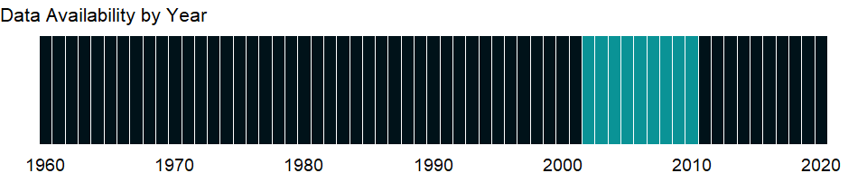

### Which countries have data?

The figure below shows the percentage of countries in each income group with a value since 2010 for that indicator.

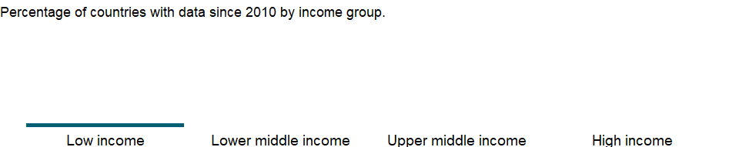

### Why is it relevant?

NA

### What is the data source?

World Bank, Enterprise Surveys (<http://www.enterprisesurveys.org/>).

### What is the methodology?

Firm-level surveys have been conducted since the 1990’s by different units within the World Bank. Since 2005-06, most data collection efforts have been centralized within the Enterprise Analysis Unit. Surveys implemented by the Enterprise Analysis Unit follow the Global Methodology.

Private contractors conduct the Enterprise Surveys on behalf of the World Bank. Due to sensitive survey questions addressing business-government relations and bribery-related topics, private contractors, rather than any government agency or an organization/institution associated with government, are hired by the World Bank to collect the data.

Confidentiality of the survey respondents and the sensitive information they provide is necessary to ensure the greatest degree of survey participation, integrity and confidence in the quality of the data. Surveys are usually carried out in cooperation with business organizations and government agencies promoting job creation and economic growth, but confidentiality is never compromised.

The Enterprise Survey is answered by business owners and top managers. Sometimes the survey respondent calls company accountants and human resource managers into the interview to answer questions in the sales and labor sections of the survey. Typically 1200-1800 interviews are conducted in larger economies, 360 interviews are conducted in medium-sized economies, and for smaller economies, 150 interviews take place.

The manufacturing and services sectors are the primary business sectors of interest. This corresponds to firms classified with ISIC codes 15-37, 45, 50-52, 55, 60-64, and 72 (ISIC Rev.3.1). Formal (registered) companies with 5 or more employees are targeted for interview. Services firms include construction, retail, wholesale, hotels, restaurants, transport, storage, communications, and IT. Firms with 100% government/state ownership are not eligible to participate in an Enterprise Survey. Occasionally, for a few surveyed countries, other sectors are included in the companies surveyed such as education or health-related businesses. In each country, businesses in the cities/regions of major economic activity are interviewed.

In some countries, other surveys, which depart from the usual Enterprise Survey methodology, are conducted. Examples include 1) Informal Surveys- surveys of informal (unregistered) enterprises, 2) Micro Surveys- surveys fielded to registered firms with less than five employees, and 3) Financial Crisis Assessment Surveys- short surveys administered by telephone to assess the effects of the global financial crisis of 2008-09.

The Enterprise Surveys Unit uses two instruments: the Manufacturing Questionnaire and the Services Questionnaire. Although many questions overlap, some are only applicable to one type of business. For example, retail firms are not asked about production and nonproduction workers.

The standard Enterprise Survey topics include firm characteristics, gender participation, access to finance, annual sales, costs of inputs/labor, workforce composition, bribery, licensing, infrastructure, trade, crime, competition, capacity utilization, land and permits, taxation, informality, business-government relations, innovation and technology, and performance measures.

Over 90% of the questions objectively ascertain characteristics of a country’s business environment. The remaining questions assess the survey respondents’ opinions on what are the obstacles to firm growth and performance. The mode of data collection is face-to-face interviews.

### How is it aggregated?

Unweighted average

### What are the limitations?

The sampling methodology for Enterprise Surveys is stratified random sampling. In a simple random sample, all members of the population have the same probability of being selected and no weighting of the observations is necessary. In a stratified random sample, all population units are grouped within homogeneous groups and simple random samples are selected within each group. This method allows computing estimates for each of the strata with a specified level of precision while population estimates can also be estimated by properly weighting individual observations. The sampling weights take care of the varying probabilities of selection across different strata. Under certain conditions, estimates’ precision under stratified random sampling will be higher than under simple random sampling (lower standard errors may result from the estimation procedure).

The strata for Enterprise Surveys are firm size, business sector, and geographic region within a country. Firm size levels are 5-19 (small), 20-99 (medium), and 100+ employees (large-sized firms). Since in most economies, the majority of firms are small and medium-sized, Enterprise Surveys oversample large firms since larger firms tend to be engines of job creation. Sector breakdown is usually manufacturing, retail, and other services. For larger economies, specific manufacturing sub-sectors are selected as additional strata on the basis of employment, value-added, and total number of establishments figures. Geographic regions within a country are selected based on which cities/regions collectively contain the majority of economic activity.

Ideally the survey sample frame is derived from the universe of eligible firms obtained from the country’s statistical office. Sometimes the master list of firms is obtained from other government agencies such as tax or business licensing authorities. In some cases, the list of firms is obtained from business associations or marketing databases. In a few cases, the sample frame is created via block enumeration, where the World Bank “manually” constructs a list of eligible firms after 1) partitioning a country’s cities of major economic activity into clusters and blocks, 2) randomly selecting a subset of blocks which will then be enumerated. In surveys conducted since 2005-06, survey documentation which explains the source of the sample frame and any special circumstances encountered during survey fieldwork are included with the collected datasets.

Obtaining panel data, i.e. interviews with the same firms across multiple years, is a priority in current Enterprise Surveys. When conducting a new Enterprise Survey in a country where data was previously collected, maximal effort is expended to re-interview as many firms (from the prior survey) as possible. For these panel firms, sampling weights can be adjusted to take into account the resulting altered probabilities of inclusion in the sample frame.

### What else should I know?

NA

### 1.33.25 Firms visited or required meetings with tax officials (% of firms)

### What is the indicator?

Percent of firms that were visited or required to meet with tax officials.

Topic: Private Sector & Trade: Business environment

Series ID: IC.FRM.METG.ZS

Copyright: CC BY-4.0 , <https://datacatalog.worldbank.org/public-licenses#cc-by>

First year with any data: 2006

Last year with any data: 2020

### What years are data available?

The figure below shows years in which data is available for at least one country. Dates shaded in black have no data, while dates shaded in green have data for at least one country



### Which countries have data?

The figure below shows the percentage of countries in each income group with a value since 2010 for that indicator.



### Why is it relevant?

Firms evaluating investment options, governments interested in improving business conditions, and economists seeking to explain economic performance have all grappled with defining and measuring the business environment. The firm-level data from Enterprise Surveys provide a useful tool for benchmarking economies across a large number of indicators measured at the firm level.

Informality is associated with business operations without registration. The informal sector in an economy may be a source of unfair competition to formal firms and also deprive governments of potential tax revenue and diminish a government’s capacity for regulatory oversight.

Informality can be defined along different dimensions such as operating without registration, income tax evasion, labor tax evasion, or operating outside the legal framework of an economy. Firms may show different degrees of informality along these dimensions which may also overlap.

A large informal sector has serious consequences for the formal private sector, and may pose unfair competition for formal firms. It is an approximation to the prevalence of informality in the private economy.

### What is the data source?

World Bank, Enterprise Surveys (<http://www.enterprisesurveys.org/>).

### What is the methodology?

Firm-level surveys have been conducted since the 1990’s by different units within the World Bank. Since 2005-06, most data collection efforts have been centralized within the Enterprise Analysis Unit. Surveys implemented by the Enterprise Analysis Unit follow the Global Methodology.

Private contractors conduct the Enterprise Surveys on behalf of the World Bank. Due to sensitive survey questions addressing business-government relations and bribery-related topics, private contractors, rather than any government agency or an organization/institution associated with government, are hired by the World Bank to collect the data.

Confidentiality of the survey respondents and the sensitive information they provide is necessary to ensure the greatest degree of survey participation, integrity and confidence in the quality of the data. Surveys are usually carried out in cooperation with business organizations and government agencies promoting job creation and economic growth, but confidentiality is never compromised.

The Enterprise Survey is answered by business owners and top managers. Sometimes the survey respondent calls company accountants and human resource managers into the interview to answer questions in the sales and labor sections of the survey. Typically 1200-1800 interviews are conducted in larger economies, 360 interviews are conducted in medium-sized economies, and for smaller economies, 150 interviews take place.

The manufacturing and services sectors are the primary business sectors of interest. This corresponds to firms classified with ISIC codes 15-37, 45, 50-52, 55, 60-64, and 72 (ISIC Rev.3.1). Formal (registered) companies with 5 or more employees are targeted for interview. Services firms include construction, retail, wholesale, hotels, restaurants, transport, storage, communications, and IT. Firms with 100% government/state ownership are not eligible to participate in an Enterprise Survey. Occasionally, for a few surveyed countries, other sectors are included in the companies surveyed such as education or health-related businesses. In each country, businesses in the cities/regions of major economic activity are interviewed.

In some countries, other surveys, which depart from the usual Enterprise Survey methodology, are conducted. Examples include 1) Informal Surveys- surveys of informal (unregistered) enterprises, 2) Micro Surveys- surveys fielded to registered firms with less than five employees, and 3) Financial Crisis Assessment Surveys- short surveys administered by telephone to assess the effects of the global financial crisis of 2008-09.

The Enterprise Surveys Unit uses two instruments: the Manufacturing Questionnaire and the Services Questionnaire. Although many questions overlap, some are only applicable to one type of business. For example, retail firms are not asked about production and nonproduction workers.

The standard Enterprise Survey topics include firm characteristics, gender participation, access to finance, annual sales, costs of inputs/labor, workforce composition, bribery, licensing, infrastructure, trade, crime, competition, capacity utilization, land and permits, taxation, informality, business-government relations, innovation and technology, and performance measures.

Over 90% of the questions objectively ascertain characteristics of a country’s business environment. The remaining questions assess the survey respondents’ opinions on what are the obstacles to firm growth and performance. The mode of data collection is face-to-face interviews.

### How is it aggregated?

Unweighted average

### What are the limitations?

The sampling methodology for Enterprise Surveys is stratified random sampling. In a simple random sample, all members of the population have the same probability of being selected and no weighting of the observations is necessary. In a stratified random sample, all population units are grouped within homogeneous groups and simple random samples are selected within each group. This method allows computing estimates for each of the strata with a specified level of precision while population estimates can also be estimated by properly weighting individual observations. The sampling weights take care of the varying probabilities of selection across different strata. Under certain conditions, estimates’ precision under stratified random sampling will be higher than under simple random sampling (lower standard errors may result from the estimation procedure).

The strata for Enterprise Surveys are firm size, business sector, and geographic region within a country. Firm size levels are 5-19 (small), 20-99 (medium), and 100+ employees (large-sized firms). Since in most economies, the majority of firms are small and medium-sized, Enterprise Surveys oversample large firms since larger firms tend to be engines of job creation. Sector breakdown is usually manufacturing, retail, and other services. For larger economies, specific manufacturing sub-sectors are selected as additional strata on the basis of employment, value-added, and total number of establishments figures. Geographic regions within a country are selected based on which cities/regions collectively contain the majority of economic activity.

Ideally the survey sample frame is derived from the universe of eligible firms obtained from the country’s statistical office. Sometimes the master list of firms is obtained from other government agencies such as tax or business licensing authorities. In some cases, the list of firms is obtained from business associations or marketing databases. In a few cases, the sample frame is created via block enumeration, where the World Bank “manually” constructs a list of eligible firms after 1) partitioning a country’s cities of major economic activity into clusters and blocks, 2) randomly selecting a subset of blocks which will then be enumerated. In surveys conducted since 2005-06, survey documentation which explains the source of the sample frame and any special circumstances encountered during survey fieldwork are included with the collected datasets.

Obtaining panel data, i.e. interviews with the same firms across multiple years, is a priority in current Enterprise Surveys. When conducting a new Enterprise Survey in a country where data was previously collected, maximal effort is expended to re-interview as many firms (from the prior survey) as possible. For these panel firms, sampling weights can be adjusted to take into account the resulting altered probabilities of inclusion in the sample frame.

### What else should I know?

NA

### 1.33.26 Value lost due to electrical outages (% of sales for affected firms)

### What is the indicator?

Average losses due to electrical outages, as percentage of total annual sales. The value represents average losses for all firms which reported outages (please see indicator IC.ELC.OUTG.ZS).

Topic: Private Sector & Trade: Business environment

Series ID: IC.FRM.OUTG.ZS

Copyright: CC BY-4.0 , <https://datacatalog.worldbank.org/public-licenses#cc-by>

First year with any data: 2006

Last year with any data: 2020

### What years are data available?

The figure below shows years in which data is available for at least one country. Dates shaded in black have no data, while dates shaded in green have data for at least one country



### Which countries have data?

The figure below shows the percentage of countries in each income group with a value since 2010 for that indicator.



### Why is it relevant?

Firms evaluating investment options, governments interested in improving business conditions, and economists seeking to explain economic performance have all grappled with defining and measuring the business environment. The firm-level data from Enterprise Surveys provide a useful tool for benchmarking economies across a large number of indicators measured at the firm level.

The reliability and availability of infrastructure benefit households and support development. Firms with access to modern and efficient infrastructure - telecommunications, electricity, and transport - can be more productive.

A strong infrastructure enhances the competitiveness of an economy and generates a business environment conducive to firm growth and development. Good infrastructure efficiently connects firms to their customers and suppliers, and enables the use of modern production technologies. Conversely, deficiencies in infrastructure, such as loss of electricity on regular basis, create barriers to productive opportunities and increase costs for all firms, from micro enterprises to large multinational corporations.

### What is the data source?

World Bank, Enterprise Surveys (<http://www.enterprisesurveys.org/>).

### What is the methodology?

Firm-level surveys have been conducted since the 1990’s by different units within the World Bank. Since 2005-06, most data collection efforts have been centralized within the Enterprise Analysis Unit. Surveys implemented by the Enterprise Analysis Unit follow the Global Methodology.

Private contractors conduct the Enterprise Surveys on behalf of the World Bank. Due to sensitive survey questions addressing business-government relations and bribery-related topics, private contractors, rather than any government agency or an organization/institution associated with government, are hired by the World Bank to collect the data.

Confidentiality of the survey respondents and the sensitive information they provide is necessary to ensure the greatest degree of survey participation, integrity and confidence in the quality of the data. Surveys are usually carried out in cooperation with business organizations and government agencies promoting job creation and economic growth, but confidentiality is never compromised.

The Enterprise Survey is answered by business owners and top managers. Sometimes the survey respondent calls company accountants and human resource managers into the interview to answer questions in the sales and labor sections of the survey. Typically 1200-1800 interviews are conducted in larger economies, 360 interviews are conducted in medium-sized economies, and for smaller economies, 150 interviews take place.

The manufacturing and services sectors are the primary business sectors of interest. This corresponds to firms classified with ISIC codes 15-37, 45, 50-52, 55, 60-64, and 72 (ISIC Rev.3.1). Formal (registered) companies with 5 or more employees are targeted for interview. Services firms include construction, retail, wholesale, hotels, restaurants, transport, storage, communications, and IT. Firms with 100% government/state ownership are not eligible to participate in an Enterprise Survey. Occasionally, for a few surveyed countries, other sectors are included in the companies surveyed such as education or health-related businesses. In each country, businesses in the cities/regions of major economic activity are interviewed.

In some countries, other surveys, which depart from the usual Enterprise Survey methodology, are conducted. Examples include 1) Informal Surveys- surveys of informal (unregistered) enterprises, 2) Micro Surveys- surveys fielded to registered firms with less than five employees, and 3) Financial Crisis Assessment Surveys- short surveys administered by telephone to assess the effects of the global financial crisis of 2008-09.

The Enterprise Surveys Unit uses two instruments: the Manufacturing Questionnaire and the Services Questionnaire. Although many questions overlap, some are only applicable to one type of business. For example, retail firms are not asked about production and nonproduction workers.

The standard Enterprise Survey topics include firm characteristics, gender participation, access to finance, annual sales, costs of inputs/labor, workforce composition, bribery, licensing, infrastructure, trade, crime, competition, capacity utilization, land and permits, taxation, informality, business-government relations, innovation and technology, and performance measures.

Over 90% of the questions objectively ascertain characteristics of a country’s business environment. The remaining questions assess the survey respondents’ opinions on what are the obstacles to firm growth and performance. The mode of data collection is face-to-face interviews.

### How is it aggregated?

Unweighted average

### What are the limitations?

The sampling methodology for Enterprise Surveys is stratified random sampling. In a simple random sample, all members of the population have the same probability of being selected and no weighting of the observations is necessary. In a stratified random sample, all population units are grouped within homogeneous groups and simple random samples are selected within each group. This method allows computing estimates for each of the strata with a specified level of precision while population estimates can also be estimated by properly weighting individual observations. The sampling weights take care of the varying probabilities of selection across different strata. Under certain conditions, estimates’ precision under stratified random sampling will be higher than under simple random sampling (lower standard errors may result from the estimation procedure).

The strata for Enterprise Surveys are firm size, business sector, and geographic region within a country. Firm size levels are 5-19 (small), 20-99 (medium), and 100+ employees (large-sized firms). Since in most economies, the majority of firms are small and medium-sized, Enterprise Surveys oversample large firms since larger firms tend to be engines of job creation. Sector breakdown is usually manufacturing, retail, and other services. For larger economies, specific manufacturing sub-sectors are selected as additional strata on the basis of employment, value-added, and total number of establishments figures. Geographic regions within a country are selected based on which cities/regions collectively contain the majority of economic activity.

Ideally the survey sample frame is derived from the universe of eligible firms obtained from the country’s statistical office. Sometimes the master list of firms is obtained from other government agencies such as tax or business licensing authorities. In some cases, the list of firms is obtained from business associations or marketing databases. In a few cases, the sample frame is created via block enumeration, where the World Bank “manually” constructs a list of eligible firms after 1) partitioning a country’s cities of major economic activity into clusters and blocks, 2) randomly selecting a subset of blocks which will then be enumerated. In surveys conducted since 2005-06, survey documentation which explains the source of the sample frame and any special circumstances encountered during survey fieldwork are included with the collected datasets.

Obtaining panel data, i.e. interviews with the same firms across multiple years, is a priority in current Enterprise Surveys. When conducting a new Enterprise Survey in a country where data was previously collected, maximal effort is expended to re-interview as many firms (from the prior survey) as possible. For these panel firms, sampling weights can be adjusted to take into account the resulting altered probabilities of inclusion in the sample frame.

### What else should I know?

NA

### 1.33.27 Firms that spend on R&D (% of firms)

### What is the indicator?

Percent of firms that spend on research and development.

Topic: Private Sector & Trade: Business environment

Series ID: IC.FRM.RSDV.ZS

Copyright: CC BY-4.0 , <https://datacatalog.worldbank.org/public-licenses#cc-by>

First year with any data: 2006

Last year with any data: 2020

### What years are data available?

The figure below shows years in which data is available for at least one country. Dates shaded in black have no data, while dates shaded in green have data for at least one country

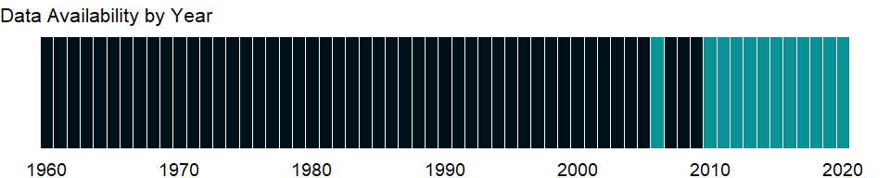

### Which countries have data?

The figure below shows the percentage of countries in each income group with a value since 2010 for that indicator.

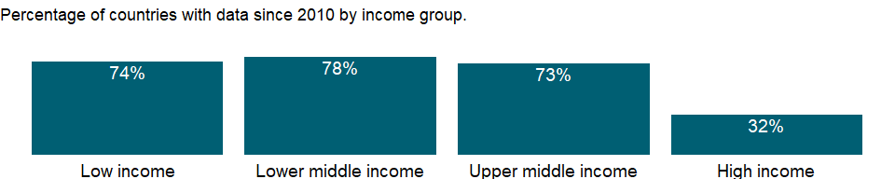

### Why is it relevant?

Firms evaluating investment options, governments interested in improving business conditions, and economists seeking to explain economic performance have all grappled with defining and measuring the business environment. The firm-level data from Enterprise Surveys provide a useful tool for benchmarking economies across a large number of indicators measured at the firm level.

Informality is associated with business operations without registration. The informal sector in an economy may be a source of unfair competition to formal firms and also deprive governments of potential tax revenue and diminish a government’s capacity for regulatory oversight.

Informality can be defined along different dimensions such as operating without registration, income tax evasion, labor tax evasion, or operating outside the legal framework of an economy. Firms may show different degrees of informality along these dimensions which may also overlap.

A large informal sector has serious consequences for the formal private sector, and may pose unfair competition for formal firms. It is an approximation to the prevalence of informality in the private economy.

### What is the data source?

World Bank, Enterprise Surveys (<http://www.enterprisesurveys.org/>).

### What is the methodology?

Firm-level surveys have been conducted since the 1990’s by different units within the World Bank. Since 2005-06, most data collection efforts have been centralized within the Enterprise Analysis Unit. Surveys implemented by the Enterprise Analysis Unit follow the Global Methodology.

Private contractors conduct the Enterprise Surveys on behalf of the World Bank. Due to sensitive survey questions addressing business-government relations and bribery-related topics, private contractors, rather than any government agency or an organization/institution associated with government, are hired by the World Bank to collect the data.

Confidentiality of the survey respondents and the sensitive information they provide is necessary to ensure the greatest degree of survey participation, integrity and confidence in the quality of the data. Surveys are usually carried out in cooperation with business organizations and government agencies promoting job creation and economic growth, but confidentiality is never compromised.

The Enterprise Survey is answered by business owners and top managers. Sometimes the survey respondent calls company accountants and human resource managers into the interview to answer questions in the sales and labor sections of the survey. Typically 1200-1800 interviews are conducted in larger economies, 360 interviews are conducted in medium-sized economies, and for smaller economies, 150 interviews take place.

The manufacturing and services sectors are the primary business sectors of interest. This corresponds to firms classified with ISIC codes 15-37, 45, 50-52, 55, 60-64, and 72 (ISIC Rev.3.1). Formal (registered) companies with 5 or more employees are targeted for interview. Services firms include construction, retail, wholesale, hotels, restaurants, transport, storage, communications, and IT. Firms with 100% government/state ownership are not eligible to participate in an Enterprise Survey. Occasionally, for a few surveyed countries, other sectors are included in the companies surveyed such as education or health-related businesses. In each country, businesses in the cities/regions of major economic activity are interviewed.

In some countries, other surveys, which depart from the usual Enterprise Survey methodology, are conducted. Examples include 1) Informal Surveys- surveys of informal (unregistered) enterprises, 2) Micro Surveys- surveys fielded to registered firms with less than five employees, and 3) Financial Crisis Assessment Surveys- short surveys administered by telephone to assess the effects of the global financial crisis of 2008-09.

The Enterprise Surveys Unit uses two instruments: the Manufacturing Questionnaire and the Services Questionnaire. Although many questions overlap, some are only applicable to one type of business. For example, retail firms are not asked about production and nonproduction workers.

The standard Enterprise Survey topics include firm characteristics, gender participation, access to finance, annual sales, costs of inputs/labor, workforce composition, bribery, licensing, infrastructure, trade, crime, competition, capacity utilization, land and permits, taxation, informality, business-government relations, innovation and technology, and performance measures.

Over 90% of the questions objectively ascertain characteristics of a country’s business environment. The remaining questions assess the survey respondents’ opinions on what are the obstacles to firm growth and performance. The mode of data collection is face-to-face interviews.

### How is it aggregated?

Unweighted average

### What are the limitations?

The sampling methodology for Enterprise Surveys is stratified random sampling. In a simple random sample, all members of the population have the same probability of being selected and no weighting of the observations is necessary. In a stratified random sample, all population units are grouped within homogeneous groups and simple random samples are selected within each group. This method allows computing estimates for each of the strata with a specified level of precision while population estimates can also be estimated by properly weighting individual observations. The sampling weights take care of the varying probabilities of selection across different strata. Under certain conditions, estimates’ precision under stratified random sampling will be higher than under simple random sampling (lower standard errors may result from the estimation procedure).

The strata for Enterprise Surveys are firm size, business sector, and geographic region within a country. Firm size levels are 5-19 (small), 20-99 (medium), and 100+ employees (large-sized firms). Since in most economies, the majority of firms are small and medium-sized, Enterprise Surveys oversample large firms since larger firms tend to be engines of job creation. Sector breakdown is usually manufacturing, retail, and other services. For larger economies, specific manufacturing sub-sectors are selected as additional strata on the basis of employment, value-added, and total number of establishments figures. Geographic regions within a country are selected based on which cities/regions collectively contain the majority of economic activity.

Ideally the survey sample frame is derived from the universe of eligible firms obtained from the country’s statistical office. Sometimes the master list of firms is obtained from other government agencies such as tax or business licensing authorities. In some cases, the list of firms is obtained from business associations or marketing databases. In a few cases, the sample frame is created via block enumeration, where the World Bank “manually” constructs a list of eligible firms after 1) partitioning a country’s cities of major economic activity into clusters and blocks, 2) randomly selecting a subset of blocks which will then be enumerated. In surveys conducted since 2005-06, survey documentation which explains the source of the sample frame and any special circumstances encountered during survey fieldwork are included with the collected datasets.

Obtaining panel data, i.e. interviews with the same firms across multiple years, is a priority in current Enterprise Surveys. When conducting a new Enterprise Survey in a country where data was previously collected, maximal effort is expended to re-interview as many firms (from the prior survey) as possible. For these panel firms, sampling weights can be adjusted to take into account the resulting altered probabilities of inclusion in the sample frame.

### What else should I know?

NA

### 1.33.28 Firms experiencing losses due to theft and vandalism (% of firms)

### What is the indicator?

Percent of firms experiencing losses due to theft, robbery, vandalism or arson that occurred on the establishment’s premises.

Topic: Private Sector & Trade: Business environment

Series ID: IC.FRM.THEV.ZS

Copyright: CC BY-4.0 , <https://datacatalog.worldbank.org/public-licenses#cc-by>

First year with any data: 2006

Last year with any data: 2020

### What years are data available?

The figure below shows years in which data is available for at least one country. Dates shaded in black have no data, while dates shaded in green have data for at least one country



### Which countries have data?

The figure below shows the percentage of countries in each income group with a value since 2010 for that indicator.



### Why is it relevant?

Firms evaluating investment options, governments interested in improving business conditions, and economists seeking to explain economic performance have all grappled with defining and measuring the business environment. The firm-level data from Enterprise Surveys provide a useful tool for benchmarking economies across a large number of indicators measured at the firm level.

Informality is associated with business operations without registration. The informal sector in an economy may be a source of unfair competition to formal firms and also deprive governments of potential tax revenue and diminish a government’s capacity for regulatory oversight.

Informality can be defined along different dimensions such as operating without registration, income tax evasion, labor tax evasion, or operating outside the legal framework of an economy. Firms may show different degrees of informality along these dimensions which may also overlap.

A large informal sector has serious consequences for the formal private sector, and may pose unfair competition for formal firms. It is an approximation to the prevalence of informality in the private economy.

### What is the data source?

World Bank, Enterprise Surveys (<http://www.enterprisesurveys.org/>).

### What is the methodology?

Firm-level surveys have been conducted since the 1990’s by different units within the World Bank. Since 2005-06, most data collection efforts have been centralized within the Enterprise Analysis Unit. Surveys implemented by the Enterprise Analysis Unit follow the Global Methodology.

Private contractors conduct the Enterprise Surveys on behalf of the World Bank. Due to sensitive survey questions addressing business-government relations and bribery-related topics, private contractors, rather than any government agency or an organization/institution associated with government, are hired by the World Bank to collect the data.

Confidentiality of the survey respondents and the sensitive information they provide is necessary to ensure the greatest degree of survey participation, integrity and confidence in the quality of the data. Surveys are usually carried out in cooperation with business organizations and government agencies promoting job creation and economic growth, but confidentiality is never compromised.

The Enterprise Survey is answered by business owners and top managers. Sometimes the survey respondent calls company accountants and human resource managers into the interview to answer questions in the sales and labor sections of the survey. Typically 1200-1800 interviews are conducted in larger economies, 360 interviews are conducted in medium-sized economies, and for smaller economies, 150 interviews take place.

The manufacturing and services sectors are the primary business sectors of interest. This corresponds to firms classified with ISIC codes 15-37, 45, 50-52, 55, 60-64, and 72 (ISIC Rev.3.1). Formal (registered) companies with 5 or more employees are targeted for interview. Services firms include construction, retail, wholesale, hotels, restaurants, transport, storage, communications, and IT. Firms with 100% government/state ownership are not eligible to participate in an Enterprise Survey. Occasionally, for a few surveyed countries, other sectors are included in the companies surveyed such as education or health-related businesses. In each country, businesses in the cities/regions of major economic activity are interviewed.

In some countries, other surveys, which depart from the usual Enterprise Survey methodology, are conducted. Examples include 1) Informal Surveys- surveys of informal (unregistered) enterprises, 2) Micro Surveys- surveys fielded to registered firms with less than five employees, and 3) Financial Crisis Assessment Surveys- short surveys administered by telephone to assess the effects of the global financial crisis of 2008-09.

The Enterprise Surveys Unit uses two instruments: the Manufacturing Questionnaire and the Services Questionnaire. Although many questions overlap, some are only applicable to one type of business. For example, retail firms are not asked about production and nonproduction workers.

The standard Enterprise Survey topics include firm characteristics, gender participation, access to finance, annual sales, costs of inputs/labor, workforce composition, bribery, licensing, infrastructure, trade, crime, competition, capacity utilization, land and permits, taxation, informality, business-government relations, innovation and technology, and performance measures.

Over 90% of the questions objectively ascertain characteristics of a country’s business environment. The remaining questions assess the survey respondents’ opinions on what are the obstacles to firm growth and performance. The mode of data collection is face-to-face interviews.

### How is it aggregated?

Unweighted average

### What are the limitations?

The sampling methodology for Enterprise Surveys is stratified random sampling. In a simple random sample, all members of the population have the same probability of being selected and no weighting of the observations is necessary. In a stratified random sample, all population units are grouped within homogeneous groups and simple random samples are selected within each group. This method allows computing estimates for each of the strata with a specified level of precision while population estimates can also be estimated by properly weighting individual observations. The sampling weights take care of the varying probabilities of selection across different strata. Under certain conditions, estimates’ precision under stratified random sampling will be higher than under simple random sampling (lower standard errors may result from the estimation procedure).

The strata for Enterprise Surveys are firm size, business sector, and geographic region within a country. Firm size levels are 5-19 (small), 20-99 (medium), and 100+ employees (large-sized firms). Since in most economies, the majority of firms are small and medium-sized, Enterprise Surveys oversample large firms since larger firms tend to be engines of job creation. Sector breakdown is usually manufacturing, retail, and other services. For larger economies, specific manufacturing sub-sectors are selected as additional strata on the basis of employment, value-added, and total number of establishments figures. Geographic regions within a country are selected based on which cities/regions collectively contain the majority of economic activity.

Ideally the survey sample frame is derived from the universe of eligible firms obtained from the country’s statistical office. Sometimes the master list of firms is obtained from other government agencies such as tax or business licensing authorities. In some cases, the list of firms is obtained from business associations or marketing databases. In a few cases, the sample frame is created via block enumeration, where the World Bank “manually” constructs a list of eligible firms after 1) partitioning a country’s cities of major economic activity into clusters and blocks, 2) randomly selecting a subset of blocks which will then be enumerated. In surveys conducted since 2005-06, survey documentation which explains the source of the sample frame and any special circumstances encountered during survey fieldwork are included with the collected datasets.

Obtaining panel data, i.e. interviews with the same firms across multiple years, is a priority in current Enterprise Surveys. When conducting a new Enterprise Survey in a country where data was previously collected, maximal effort is expended to re-interview as many firms (from the prior survey) as possible. For these panel firms, sampling weights can be adjusted to take into account the resulting altered probabilities of inclusion in the sample frame.

### What else should I know?

NA

### 1.33.29 Firms offering formal training (% of firms)

### What is the indicator?

Firms offering formal training are the percentage of firms offering formal training programs for their permanent, full-time employees.

Topic: Private Sector & Trade: Business environment

Series ID: IC.FRM.TRNG.ZS

Copyright: CC BY-4.0 , <https://datacatalog.worldbank.org/public-licenses#cc-by>

First year with any data: 2002

Last year with any data: 2020

### What years are data available?

The figure below shows years in which data is available for at least one country. Dates shaded in black have no data, while dates shaded in green have data for at least one country



### Which countries have data?

The figure below shows the percentage of countries in each income group with a value since 2010 for that indicator.



### Why is it relevant?

Firms evaluating investment options, governments interested in improving business conditions, and economists seeking to explain economic performance have all grappled with defining and measuring the business environment. The firm-level data from Enterprise Surveys provide a useful tool for benchmarking economies across a large number of indicators measured at the firm level.

The reliability and availability of infrastructure benefit households and support development. Firms with access to modern and efficient infrastructure - telecommunications, electricity, and transport - can be more productive.

A strong infrastructure enhances the competitiveness of an economy and generates a business environment conducive to firm growth and development. Good infrastructure efficiently connects firms to their customers and suppliers, and enables the use of modern production technologies. Conversely, deficiencies in infrastructure, such as loss of electricity on regular basis, create barriers to productive opportunities and increase costs for all firms, from micro enterprises to large multinational corporations.

### What is the data source?

World Bank, Enterprise Surveys (<http://www.enterprisesurveys.org/>).

### What is the methodology?

Firm-level surveys have been conducted since the 1990’s by different units within the World Bank. Since 2005-06, most data collection efforts have been centralized within the Enterprise Analysis Unit. Surveys implemented by the Enterprise Analysis Unit follow the Global Methodology.

Private contractors conduct the Enterprise Surveys on behalf of the World Bank. Due to sensitive survey questions addressing business-government relations and bribery-related topics, private contractors, rather than any government agency or an organization/institution associated with government, are hired by the World Bank to collect the data.

Confidentiality of the survey respondents and the sensitive information they provide is necessary to ensure the greatest degree of survey participation, integrity and confidence in the quality of the data. Surveys are usually carried out in cooperation with business organizations and government agencies promoting job creation and economic growth, but confidentiality is never compromised.

The Enterprise Survey is answered by business owners and top managers. Sometimes the survey respondent calls company accountants and human resource managers into the interview to answer questions in the sales and labor sections of the survey. Typically 1200-1800 interviews are conducted in larger economies, 360 interviews are conducted in medium-sized economies, and for smaller economies, 150 interviews take place.

The manufacturing and services sectors are the primary business sectors of interest. This corresponds to firms classified with ISIC codes 15-37, 45, 50-52, 55, 60-64, and 72 (ISIC Rev.3.1). Formal (registered) companies with 5 or more employees are targeted for interview. Services firms include construction, retail, wholesale, hotels, restaurants, transport, storage, communications, and IT. Firms with 100% government/state ownership are not eligible to participate in an Enterprise Survey. Occasionally, for a few surveyed countries, other sectors are included in the companies surveyed such as education or health-related businesses. In each country, businesses in the cities/regions of major economic activity are interviewed.

In some countries, other surveys, which depart from the usual Enterprise Survey methodology, are conducted. Examples include 1) Informal Surveys- surveys of informal (unregistered) enterprises, 2) Micro Surveys- surveys fielded to registered firms with less than five employees, and 3) Financial Crisis Assessment Surveys- short surveys administered by telephone to assess the effects of the global financial crisis of 2008-09.

The Enterprise Surveys Unit uses two instruments: the Manufacturing Questionnaire and the Services Questionnaire. Although many questions overlap, some are only applicable to one type of business. For example, retail firms are not asked about production and nonproduction workers.

The standard Enterprise Survey topics include firm characteristics, gender participation, access to finance, annual sales, costs of inputs/labor, workforce composition, bribery, licensing, infrastructure, trade, crime, competition, capacity utilization, land and permits, taxation, informality, business-government relations, innovation and technology, and performance measures.

Over 90% of the questions objectively ascertain characteristics of a country’s business environment. The remaining questions assess the survey respondents’ opinions on what are the obstacles to firm growth and performance. The mode of data collection is face-to-face interviews.

### How is it aggregated?

Unweighted average

### What are the limitations?

The sampling methodology for Enterprise Surveys is stratified random sampling. In a simple random sample, all members of the population have the same probability of being selected and no weighting of the observations is necessary. In a stratified random sample, all population units are grouped within homogeneous groups and simple random samples are selected within each group. This method allows computing estimates for each of the strata with a specified level of precision while population estimates can also be estimated by properly weighting individual observations. The sampling weights take care of the varying probabilities of selection across different strata. Under certain conditions, estimates’ precision under stratified random sampling will be higher than under simple random sampling (lower standard errors may result from the estimation procedure).

The strata for Enterprise Surveys are firm size, business sector, and geographic region within a country. Firm size levels are 5-19 (small), 20-99 (medium), and 100+ employees (large-sized firms). Since in most economies, the majority of firms are small and medium-sized, Enterprise Surveys oversample large firms since larger firms tend to be engines of job creation. Sector breakdown is usually manufacturing, retail, and other services. For larger economies, specific manufacturing sub-sectors are selected as additional strata on the basis of employment, value-added, and total number of establishments figures. Geographic regions within a country are selected based on which cities/regions collectively contain the majority of economic activity.

Ideally the survey sample frame is derived from the universe of eligible firms obtained from the country’s statistical office. Sometimes the master list of firms is obtained from other government agencies such as tax or business licensing authorities. In some cases, the list of firms is obtained from business associations or marketing databases. In a few cases, the sample frame is created via block enumeration, where the World Bank “manually” constructs a list of eligible firms after 1) partitioning a country’s cities of major economic activity into clusters and blocks, 2) randomly selecting a subset of blocks which will then be enumerated. In surveys conducted since 2005-06, survey documentation which explains the source of the sample frame and any special circumstances encountered during survey fieldwork are included with the collected datasets.

Obtaining panel data, i.e. interviews with the same firms across multiple years, is a priority in current Enterprise Surveys. When conducting a new Enterprise Survey in a country where data was previously collected, maximal effort is expended to re-interview as many firms (from the prior survey) as possible. For these panel firms, sampling weights can be adjusted to take into account the resulting altered probabilities of inclusion in the sample frame.

### What else should I know?

NA

### 1.33.30 Time spent dealing with the requirements of government regulations (% of senior management time)

### What is the indicator?

Time spent dealing with the requirements of government regulations is the proportion of senior management’s time, in a typical week, that is spent dealing with the requirements imposed by government regulations (e.g., taxes, customs, labor regulations, licensing and registration, including dealings with officials, and completing forms).

Topic: Private Sector & Trade: Business environment

Series ID: IC.GOV.DURS.ZS

Copyright: CC BY-4.0 , <https://datacatalog.worldbank.org/public-licenses#cc-by>

First year with any data: 2002

Last year with any data: 2020

### What years are data available?

The figure below shows years in which data is available for at least one country. Dates shaded in black have no data, while dates shaded in green have data for at least one country



### Which countries have data?

The figure below shows the percentage of countries in each income group with a value since 2010 for that indicator.



### Why is it relevant?

Firms evaluating investment options, governments interested in improving business conditions, and economists seeking to explain economic performance have all grappled with defining and measuring the business environment. The firm-level data from Enterprise Surveys provide a useful tool for benchmarking economies across a large number of indicators measured at the firm level.

The reliability and availability of infrastructure benefit households and support development. Firms with access to modern and efficient infrastructure - telecommunications, electricity, and transport - can be more productive.

A strong infrastructure enhances the competitiveness of an economy and generates a business environment conducive to firm growth and development. Good infrastructure efficiently connects firms to their customers and suppliers, and enables the use of modern production technologies. Conversely, deficiencies in infrastructure, such as loss of electricity on regular basis, create barriers to productive opportunities and increase costs for all firms, from micro enterprises to large multinational corporations.

### What is the data source?

World Bank, Enterprise Surveys (<http://www.enterprisesurveys.org/>).

### What is the methodology?

Firm-level surveys have been conducted since the 1990’s by different units within the World Bank. Since 2005-06, most data collection efforts have been centralized within the Enterprise Analysis Unit. Surveys implemented by the Enterprise Analysis Unit follow the Global Methodology.

Private contractors conduct the Enterprise Surveys on behalf of the World Bank. Due to sensitive survey questions addressing business-government relations and bribery-related topics, private contractors, rather than any government agency or an organization/institution associated with government, are hired by the World Bank to collect the data.

Confidentiality of the survey respondents and the sensitive information they provide is necessary to ensure the greatest degree of survey participation, integrity and confidence in the quality of the data. Surveys are usually carried out in cooperation with business organizations and government agencies promoting job creation and economic growth, but confidentiality is never compromised.

The Enterprise Survey is answered by business owners and top managers. Sometimes the survey respondent calls company accountants and human resource managers into the interview to answer questions in the sales and labor sections of the survey. Typically 1200-1800 interviews are conducted in larger economies, 360 interviews are conducted in medium-sized economies, and for smaller economies, 150 interviews take place.

The manufacturing and services sectors are the primary business sectors of interest. This corresponds to firms classified with ISIC codes 15-37, 45, 50-52, 55, 60-64, and 72 (ISIC Rev.3.1). Formal (registered) companies with 5 or more employees are targeted for interview. Services firms include construction, retail, wholesale, hotels, restaurants, transport, storage, communications, and IT. Firms with 100% government/state ownership are not eligible to participate in an Enterprise Survey. Occasionally, for a few surveyed countries, other sectors are included in the companies surveyed such as education or health-related businesses. In each country, businesses in the cities/regions of major economic activity are interviewed.

In some countries, other surveys, which depart from the usual Enterprise Survey methodology, are conducted. Examples include 1) Informal Surveys- surveys of informal (unregistered) enterprises, 2) Micro Surveys- surveys fielded to registered firms with less than five employees, and 3) Financial Crisis Assessment Surveys- short surveys administered by telephone to assess the effects of the global financial crisis of 2008-09.

The Enterprise Surveys Unit uses two instruments: the Manufacturing Questionnaire and the Services Questionnaire. Although many questions overlap, some are only applicable to one type of business. For example, retail firms are not asked about production and nonproduction workers.

The standard Enterprise Survey topics include firm characteristics, gender participation, access to finance, annual sales, costs of inputs/labor, workforce composition, bribery, licensing, infrastructure, trade, crime, competition, capacity utilization, land and permits, taxation, informality, business-government relations, innovation and technology, and performance measures.

Over 90% of the questions objectively ascertain characteristics of a country’s business environment. The remaining questions assess the survey respondents’ opinions on what are the obstacles to firm growth and performance. The mode of data collection is face-to-face interviews.

### How is it aggregated?

Unweighted average

### What are the limitations?

The sampling methodology for Enterprise Surveys is stratified random sampling. In a simple random sample, all members of the population have the same probability of being selected and no weighting of the observations is necessary. In a stratified random sample, all population units are grouped within homogeneous groups and simple random samples are selected within each group. This method allows computing estimates for each of the strata with a specified level of precision while population estimates can also be estimated by properly weighting individual observations. The sampling weights take care of the varying probabilities of selection across different strata. Under certain conditions, estimates’ precision under stratified random sampling will be higher than under simple random sampling (lower standard errors may result from the estimation procedure).

The strata for Enterprise Surveys are firm size, business sector, and geographic region within a country. Firm size levels are 5-19 (small), 20-99 (medium), and 100+ employees (large-sized firms). Since in most economies, the majority of firms are small and medium-sized, Enterprise Surveys oversample large firms since larger firms tend to be engines of job creation. Sector breakdown is usually manufacturing, retail, and other services. For larger economies, specific manufacturing sub-sectors are selected as additional strata on the basis of employment, value-added, and total number of establishments figures. Geographic regions within a country are selected based on which cities/regions collectively contain the majority of economic activity.

Ideally the survey sample frame is derived from the universe of eligible firms obtained from the country’s statistical office. Sometimes the master list of firms is obtained from other government agencies such as tax or business licensing authorities. In some cases, the list of firms is obtained from business associations or marketing databases. In a few cases, the sample frame is created via block enumeration, where the World Bank “manually” constructs a list of eligible firms after 1) partitioning a country’s cities of major economic activity into clusters and blocks, 2) randomly selecting a subset of blocks which will then be enumerated. In surveys conducted since 2005-06, survey documentation which explains the source of the sample frame and any special circumstances encountered during survey fieldwork are included with the collected datasets.

Obtaining panel data, i.e. interviews with the same firms across multiple years, is a priority in current Enterprise Surveys. When conducting a new Enterprise Survey in a country where data was previously collected, maximal effort is expended to re-interview as many firms (from the prior survey) as possible. For these panel firms, sampling weights can be adjusted to take into account the resulting altered probabilities of inclusion in the sample frame.

### What else should I know?

NA

### 1.33.31 Time to resolve insolvency (years)

### What is the indicator?

Time to resolve insolvency is the number of years from the filing for insolvency in court until the resolution of distressed assets.

Topic: Private Sector & Trade: Business environment

Series ID: IC.ISV.DURS

Copyright: CC BY-4.0 , <https://datacatalog.worldbank.org/public-licenses#cc-by>

First year with any data: 2003

Last year with any data: 2019

### What years are data available?

The figure below shows years in which data is available for at least one country. Dates shaded in black have no data, while dates shaded in green have data for at least one country

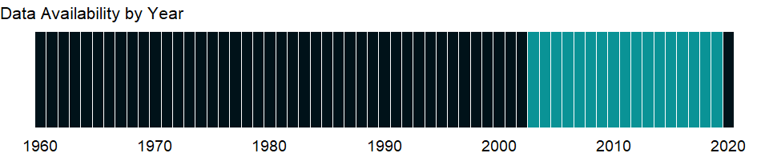

### Which countries have data?

The figure below shows the percentage of countries in each income group with a value since 2010 for that indicator.

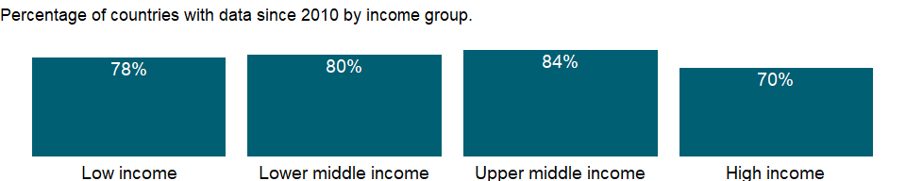

### Why is it relevant?

The economic health of a country is measured not only in macroeconomic terms but also by other factors that shape daily economic activity such as laws, regulations, and institutional arrangements. The data measure business regulation, gauge regulatory outcomes, and measure the extent of legal protection of property, the flexibility of employment regulation, and the tax burden on businesses.

The fundamental premise of this data is that economic activity requires good rules and regulations that are efficient, accessible to all who need to use them, and simple to implement. Thus sometimes there is more emphasis on more regulation, such as stricter disclosure requirements in related-party transactions, and other times emphasis is on for simplified regulations, such as a one-stop shop for completing business startup formalities.

Entrepreneurs may not be aware of all required procedures or may avoid legally required procedures altogether. But where regulation is particularly onerous, levels of informality are higher, which comes at a cost: firms in the informal sector usually grow more slowly, have less access to credit, and employ fewer workers - and those workers remain outside the protections of labor law. The indicator can help policymakers understand the business environment in a country and - along with information from other sources such as the World Bank’s Enterprise Surveys - provide insights into potential areas of reform.

### What is the data source?

World Bank, Doing Business project (<http://www.doingbusiness.org/>). NOTE: Doing Business has been discontinued as of 9/16/2021. For more information: <https://bit.ly/3CLCbme>

### What is the methodology?

Data are collected by the World Bank with a standardized survey that uses a simple business case to ensure comparability across economies and over time - with assumptions about the legal form of the business, its size, its location, and nature of its operation. Surveys are administered through more than 9,000 local experts, including lawyers, business consultants, accountants, freight forwarders, government officials, and other professionals who routinely administer or advise on legal and regulatory requirements.

The indicator measures the time, cost, and outcome of insolvency proceedings involving domestic entities. The time required for creditors to recover their credit is recorded in calendar years. The cost of the proceedings is recorded as a percentage of the value of the debtor’s estate.

The Doing Business project of the World Bank encompasses two types of data: data from readings of laws and regulations and data on time and motion indicators that measure efficiency in achieving a regulatory goal. Within the time and motion indicators cost estimates are recorded from official fee schedules where applicable. The data from surveys are subjected to numerous tests for robustness, which lead to revision or expansion of the information collected.

### How is it aggregated?

Unweighted average

### What are the limitations?

The Doing Business methodology has limitations that should be considered when interpreting the data. First, the data collected refer to businesses in the economy’s largest city and may not represent regulations in other locations of the economy. To address this limitation, subnational indicators are being collected for selected economies. These subnational studies point to significant differences in the speed of reform and the ease of doing business across cities in the same economy. Second, the data often focus on a specific business form - generally a limited liability company of a specified size - and may not represent regulation for other types of businesses such as sole proprietorships. Third, transactions described in a standardized business case refer to a specific set of issues and may not represent the full set of issues a business encounters. Fourth, the time measures involve an element of judgment by the expert respondents. When sources indicate different estimates, the Doing Business time indicators represent the median values of several responses given under the assumptions of the standardized case. Fifth, the methodology assumes that a business has full information on what is required and does not waste time when completing procedures.

### What else should I know?

Data are presented for the survey year instead of publication year.

### 1.33.32 Strength of legal rights index (0=weak to 12=strong)

### What is the indicator?

Strength of legal rights index measures the degree to which collateral and bankruptcy laws protect the rights of borrowers and lenders and thus facilitate lending. The index ranges from 0 to 12, with higher scores indicating that these laws are better designed to expand access to credit.

Topic: Private Sector & Trade: Business environment

Series ID: IC.LGL.CRED.XQ

Copyright: CC BY-4.0 , <https://datacatalog.worldbank.org/public-licenses#cc-by>

First year with any data: 2013

Last year with any data: 2019

### What years are data available?

The figure below shows years in which data is available for at least one country. Dates shaded in black have no data, while dates shaded in green have data for at least one country



### Which countries have data?

The figure below shows the percentage of countries in each income group with a value since 2010 for that indicator.



### Why is it relevant?

Access to finance can expand opportunities for all with higher levels of access and use of banking services associated with lower financing obstacles for people and businesses. A stable financial system that promotes efficient savings and investment is also crucial for a thriving democracy and market economy.

There are several aspects of access to financial services: availability, cost, and quality of services. The development and growth of credit markets depend on access to timely, reliable, and accurate data on borrowers’ credit experiences. Access to credit can be improved by making it easy to create and enforce collateral agreements and by increasing information about potential borrowers’ creditworthiness. Lenders look at a borrower’s credit history and collateral. Where credit registries and effective collateral laws are absent - as in many developing countries - banks make fewer loans. Indicators that cover getting credit include the strength of legal rights index and the depth of credit information index.

The economic health of a country is measured not only in macroeconomic terms but also by other factors that shape daily economic activity such as laws, regulations, and institutional arrangements. The data measure business regulation, gauge regulatory outcomes, and measure the extent of legal protection of property, the flexibility of employment regulation, and the tax burden on businesses.

The fundamental premise of this data is that economic activity requires good rules and regulations that are efficient, accessible to all who need to use them, and simple to implement. Thus sometimes there is more emphasis on more regulation, such as stricter disclosure requirements in related-party transactions, and other times emphasis is on for simplified regulations, such as a one-stop shop for completing business startup formalities.

Entrepreneurs may not be aware of all required procedures or may avoid legally required procedures altogether. But where regulation is particularly onerous, levels of informality are higher, which comes at a cost: firms in the informal sector usually grow more slowly, have less access to credit, and employ fewer workers - and those workers remain outside the protections of labor law. The indicator can help policymakers understand the business environment in a country and - along with information from other sources such as the World Bank’s Enterprise Surveys - provide insights into potential areas of reform.

### What is the data source?

World Bank, Doing Business project (<http://www.doingbusiness.org/>). NOTE: Doing Business has been discontinued as of 9/16/2021. For more information: <https://bit.ly/3CLCbme>

### What is the methodology?

Data are collected by the World Bank with a standardized survey that uses a simple business case to ensure comparability across economies and over time - with assumptions about the legal form of the business, its size, its location, and nature of its operation. Surveys are administered through more than 9,000 local experts, including lawyers, business consultants, accountants, freight forwarders, government officials, and other professionals who routinely administer or advise on legal and regulatory requirements.

The Doing Business project of the World Bank encompasses two types of data: data from readings of laws and regulations and data on time and motion indicators that measure efficiency in achieving a regulatory goal. Within the time and motion indicators cost estimates are recorded from official fee schedules where applicable. The data from surveys are subjected to numerous tests for robustness, which lead to revision or expansion of the information collected. For more information on methodology, see <http://www.doingbusiness.org/Methodology/getting-credit#legalRights>.

### How is it aggregated?

Unweighted average

### What are the limitations?

The Doing Business methodology has limitations that should be considered when interpreting the data. First, the data collected refer to businesses in the economy’s largest city and may not represent regulations in other locations of the economy. To address this limitation, subnational indicators are being collected for selected economies. These subnational studies point to significant differences in the speed of reform and the ease of doing business across cities in the same economy. Second, the data often focus on a specific business form - generally a limited liability company of a specified size - and may not represent regulation for other types of businesses such as sole proprietorships. Third, transactions described in a standardized business case refer to a specific set of issues and may not represent the full set of issues a business encounters. Fourth, the time measures involve an element of judgment by the expert respondents. When sources indicate different estimates, the Doing Business time indicators represent the median values of several responses given under the assumptions of the standardized case. Fifth, the methodology assumes that a business has full information on what is required and does not waste time when completing procedures.

### What else should I know?

Data are presented for the survey year instead of publication year. Data before 2013 are not comparable with data from 2013 onward due to methodological changes.

### 1.33.33 Time required to enforce a contract (days)

### What is the indicator?

Time required to enforce a contract is the number of calendar days from the filing of the lawsuit in court until the final determination and, in appropriate cases, payment.

Topic: Private Sector & Trade: Business environment

Series ID: IC.LGL.DURS

Copyright: CC BY-4.0 , <https://datacatalog.worldbank.org/public-licenses#cc-by>

First year with any data: 2003

Last year with any data: 2019

### What years are data available?

The figure below shows years in which data is available for at least one country. Dates shaded in black have no data, while dates shaded in green have data for at least one country



### Which countries have data?

The figure below shows the percentage of countries in each income group with a value since 2010 for that indicator.



### Why is it relevant?

The economic health of a country is measured not only in macroeconomic terms but also by other factors that shape daily economic activity such as laws, regulations, and institutional arrangements. The data measure business regulation, gauge regulatory outcomes, and measure the extent of legal protection of property, the flexibility of employment regulation, and the tax burden on businesses.

The fundamental premise of this data is that economic activity requires good rules and regulations that are efficient, accessible to all who need to use them, and simple to implement. Thus sometimes there is more emphasis on more regulation, such as stricter disclosure requirements in related-party transactions, and other times emphasis is on for simplified regulations, such as a one-stop shop for completing business startup formalities.

Entrepreneurs may not be aware of all required procedures or may avoid legally required procedures altogether. But where regulation is particularly onerous, levels of informality are higher, which comes at a cost: firms in the informal sector usually grow more slowly, have less access to credit, and employ fewer workers - and those workers remain outside the protections of labor law. The indicator can help policymakers understand the business environment in a country and - along with information from other sources such as the World Bank’s Enterprise Surveys - provide insights into potential areas of reform.

### What is the data source?

World Bank, Doing Business project (<http://www.doingbusiness.org/>). NOTE: Doing Business has been discontinued as of 9/16/2021. For more information: <https://bit.ly/3CLCbme>

### What is the methodology?

Data are collected by the World Bank with a standardized survey that uses a simple business case to ensure comparability across economies and over time - with assumptions about the legal form of the business, its size, its location, and nature of its operation. Surveys are administered through more than 9,000 local experts, including lawyers, business consultants, accountants, freight forwarders, government officials, and other professionals who routinely administer or advise on legal and regulatory requirements.

A judicial system that provides effective commercial dispute resolution is crucial to a healthy economy. Without one, firms risk finding themselves operating in an environment where compliance with contractual obligations is not the norm.

The Doing Business project of the World Bank encompasses two types of data: data from readings of laws and regulations and data on time and motion indicators that measure efficiency in achieving a regulatory goal. Within the time and motion indicators cost estimates are recorded from official fee schedules where applicable. The data from surveys are subjected to numerous tests for robustness, which lead to revision or expansion of the information collected.

### How is it aggregated?

Unweighted average

### What are the limitations?

The Doing Business methodology has limitations that should be considered when interpreting the data. First, the data collected refer to businesses in the economy’s largest city and may not represent regulations in other locations of the economy. To address this limitation, subnational indicators are being collected for selected economies. These subnational studies point to significant differences in the speed of reform and the ease of doing business across cities in the same economy. Second, the data often focus on a specific business form - generally a limited liability company of a specified size - and may not represent regulation for other types of businesses such as sole proprietorships. Third, transactions described in a standardized business case refer to a specific set of issues and may not represent the full set of issues a business encounters. Fourth, the time measures involve an element of judgment by the expert respondents. When sources indicate different estimates, the Doing Business time indicators represent the median values of several responses given under the assumptions of the standardized case. Fifth, the methodology assumes that a business has full information on what is required and does not waste time when completing procedures.

### What else should I know?

Data are presented for the survey year instead of publication year.

### 1.33.34 Time required to register property (days)

### What is the indicator?

Time required to register property is the number of calendar days needed for businesses to secure rights to property.

Topic: Private Sector & Trade: Business environment

Series ID: IC.PRP.DURS

Copyright: CC BY-4.0 , <https://datacatalog.worldbank.org/public-licenses#cc-by>

First year with any data: 2004

Last year with any data: 2019

### What years are data available?

The figure below shows years in which data is available for at least one country. Dates shaded in black have no data, while dates shaded in green have data for at least one country



### Which countries have data?

The figure below shows the percentage of countries in each income group with a value since 2010 for that indicator.

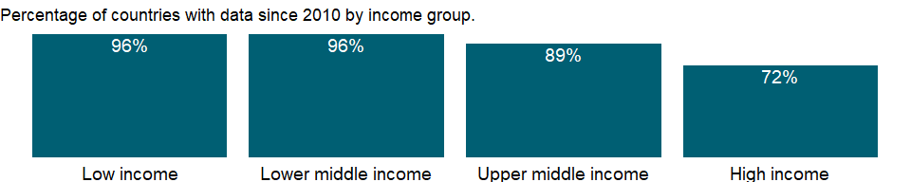

### Why is it relevant?

The economic health of a country is measured not only in macroeconomic terms but also by other factors that shape daily economic activity such as laws, regulations, and institutional arrangements. The data measure business regulation, gauge regulatory outcomes, and measure the extent of legal protection of property, the flexibility of employment regulation, and the tax burden on businesses.

The fundamental premise of this data is that economic activity requires good rules and regulations that are efficient, accessible to all who need to use them, and simple to implement. Thus sometimes there is more emphasis on more regulation, such as stricter disclosure requirements in related-party transactions, and other times emphasis is on for simplified regulations, such as a one-stop shop for completing business startup formalities.

Entrepreneurs may not be aware of all required procedures or may avoid legally required procedures altogether. But where regulation is particularly onerous, levels of informality are higher, which comes at a cost: firms in the informal sector usually grow more slowly, have less access to credit, and employ fewer workers - and those workers remain outside the protections of labor law. The indicator can help policymakers understand the business environment in a country and - along with information from other sources such as the World Bank’s Enterprise Surveys - provide insights into potential areas of reform.

### What is the data source?

World Bank, Doing Business project (<http://www.doingbusiness.org/>). NOTE: Doing Business has been discontinued as of 9/16/2021. For more information: <https://bit.ly/3CLCbme>

### What is the methodology?

Data are collected by the World Bank with a standardized survey that uses a simple business case to ensure comparability across economies and over time - with assumptions about the legal form of the business, its size, its location, and nature of its operation. Surveys are administered through more than 9,000 local experts, including lawyers, business consultants, accountants, freight forwarders, government officials, and other professionals who routinely administer or advise on legal and regulatory requirements.

The indicator records the procedures necessary for a business to purchase a property from another business and to formally transfer the property title to the buyer’s name. The process starts with obtaining the necessary documents, such as a copy of the seller’s title, and ends when the buyer is registered as the new owner of the property. Every procedure required by law or necessary in practice is included, whether it is the responsibility of the seller or the buyer and even if it must be completed by a third party on their behalf.

The Doing Business project of the World Bank encompasses two types of data: data from readings of laws and regulations and data on time and motion indicators that measure efficiency in achieving a regulatory goal. Within the time and motion indicators cost estimates are recorded from official fee schedules where applicable. The data from surveys are subjected to numerous tests for robustness, which lead to revision or expansion of the information collected.

### How is it aggregated?

Unweighted average

### What are the limitations?

The Doing Business methodology has limitations that should be considered when interpreting the data. First, the data collected refer to businesses in the economy’s largest city and may not represent regulations in other locations of the economy. To address this limitation, subnational indicators are being collected for selected economies. These subnational studies point to significant differences in the speed of reform and the ease of doing business across cities in the same economy. Second, the data often focus on a specific business form - generally a limited liability company of a specified size - and may not represent regulation for other types of businesses such as sole proprietorships. Third, transactions described in a standardized business case refer to a specific set of issues and may not represent the full set of issues a business encounters. Fourth, the time measures involve an element of judgment by the expert respondents. When sources indicate different estimates, the Doing Business time indicators represent the median values of several responses given under the assumptions of the standardized case. Fifth, the methodology assumes that a business has full information on what is required and does not waste time when completing procedures.

### What else should I know?

Data are presented for the survey year instead of publication year.

### 1.33.35 Procedures to register property (number)

### What is the indicator?

Number of procedures to register property is the number of procedures required for a businesses to secure rights to property.

Topic: Private Sector & Trade: Business environment

Series ID: IC.PRP.PROC

Copyright: CC BY-4.0 , <https://datacatalog.worldbank.org/public-licenses#cc-by>

First year with any data: 2004

Last year with any data: 2019

### What years are data available?

The figure below shows years in which data is available for at least one country. Dates shaded in black have no data, while dates shaded in green have data for at least one country



### Which countries have data?

The figure below shows the percentage of countries in each income group with a value since 2010 for that indicator.



### Why is it relevant?

The economic health of a country is measured not only in macroeconomic terms but also by other factors that shape daily economic activity such as laws, regulations, and institutional arrangements. The data measure business regulation, gauge regulatory outcomes, and measure the extent of legal protection of property, the flexibility of employment regulation, and the tax burden on businesses.

The fundamental premise of this data is that economic activity requires good rules and regulations that are efficient, accessible to all who need to use them, and simple to implement. Thus sometimes there is more emphasis on more regulation, such as stricter disclosure requirements in related-party transactions, and other times emphasis is on for simplified regulations, such as a one-stop shop for completing business startup formalities.

Entrepreneurs may not be aware of all required procedures or may avoid legally required procedures altogether. But where regulation is particularly onerous, levels of informality are higher, which comes at a cost: firms in the informal sector usually grow more slowly, have less access to credit, and employ fewer workers - and those workers remain outside the protections of labor law. The indicator can help policymakers understand the business environment in a country and - along with information from other sources such as the World Bank’s Enterprise Surveys - provide insights into potential areas of reform.

### What is the data source?

World Bank, Doing Business project (<http://www.doingbusiness.org/>). NOTE: Doing Business has been discontinued as of 9/16/2021. For more information: <https://bit.ly/3CLCbme>

### What is the methodology?

Data are collected by the World Bank with a standardized survey that uses a simple business case to ensure comparability across economies and over time - with assumptions about the legal form of the business, its size, its location, and nature of its operation. Surveys are administered through more than 9,000 local experts, including lawyers, business consultants, accountants, freight forwarders, government officials, and other professionals who routinely administer or advise on legal and regulatory requirements.

The indicator records the procedures necessary for a business to purchase a property from another business and to formally transfer the property title to the buyer’s name. The process starts with obtaining the necessary documents, such as a copy of the seller’s title, and ends when the buyer is registered as the new owner of the property. Every procedure required by law or necessary in practice is included, whether it is the responsibility of the seller or the buyer and even if it must be completed by a third party on their behalf.

The Doing Business project of the World Bank encompasses two types of data: data from readings of laws and regulations and data on time and motion indicators that measure efficiency in achieving a regulatory goal. Within the time and motion indicators cost estimates are recorded from official fee schedules where applicable. The data from surveys are subjected to numerous tests for robustness, which lead to revision or expansion of the information collected.

### How is it aggregated?

Unweighted average

### What are the limitations?

The Doing Business methodology has limitations that should be considered when interpreting the data. First, the data collected refer to businesses in the economy’s largest city and may not represent regulations in other locations of the economy. To address this limitation, subnational indicators are being collected for selected economies. These subnational studies point to significant differences in the speed of reform and the ease of doing business across cities in the same economy. Second, the data often focus on a specific business form - generally a limited liability company of a specified size - and may not represent regulation for other types of businesses such as sole proprietorships. Third, transactions described in a standardized business case refer to a specific set of issues and may not represent the full set of issues a business encounters. Fourth, the time measures involve an element of judgment by the expert respondents. When sources indicate different estimates, the Doing Business time indicators represent the median values of several responses given under the assumptions of the standardized case. Fifth, the methodology assumes that a business has full information on what is required and does not waste time when completing procedures.

### What else should I know?

Data are presented for the survey year instead of publication year.

### 1.33.36 Cost of business start-up procedures, female (% of GNI per capita)

### What is the indicator?

Cost to register a business is normalized by presenting it as a percentage of gross national income (GNI) per capita.

Topic: Private Sector & Trade: Business environment

Series ID: IC.REG.COST.PC.FE.ZS

Copyright: CC BY-4.0 , <https://datacatalog.worldbank.org/public-licenses#cc-by>

First year with any data: 2003

Last year with any data: 2019

### What years are data available?

The figure below shows years in which data is available for at least one country. Dates shaded in black have no data, while dates shaded in green have data for at least one country



### Which countries have data?

The figure below shows the percentage of countries in each income group with a value since 2010 for that indicator.



### Why is it relevant?

The economic health of a country is measured not only in macroeconomic terms but also by other factors that shape daily economic activity such as laws, regulations, and institutional arrangements. The data measure business regulation, gauge regulatory outcomes, and measure the extent of legal protection of property, the flexibility of employment regulation, and the tax burden on businesses.

The fundamental premise of this data is that economic activity requires good rules and regulations that are efficient, accessible to all who need to use them, and simple to implement. Thus sometimes there is more emphasis on more regulation, such as stricter disclosure requirements in related-party transactions, and other times emphasis is on for simplified regulations, such as a one-stop shop for completing business startup formalities.

Entrepreneurs may not be aware of all required procedures or may avoid legally required procedures altogether. But where regulation is particularly onerous, levels of informality are higher, which comes at a cost: firms in the informal sector usually grow more slowly, have less access to credit, and employ fewer workers - and those workers remain outside the protections of labor law. The indicator can help policymakers understand the business environment in a country and - along with information from other sources such as the World Bank’s Enterprise Surveys - provide insights into potential areas of reform.

### What is the data source?

World Bank, Doing Business project (<http://www.doingbusiness.org/>). NOTE: Doing Business has been discontinued as of 9/16/2021. For more information: <https://bit.ly/3CLCbme>

### What is the methodology?

Data are collected by the World Bank with a standardized survey that uses a simple business case to ensure comparability across economies and over time - with assumptions about the legal form of the business, its size, its location, and nature of its operation. Surveys are administered through more than 9,000 local experts, including lawyers, business consultants, accountants, freight forwarders, government officials, and other professionals who routinely administer or advise on legal and regulatory requirements.

Entrepreneurs around the world face a range of challenges. One of them is inefficient regulation. The indicator measures the procedures, time, cost and paid-in minimum capital required for a small or medium-size limited liability company to start up and formally operate.

The Doing Business project of the World Bank encompasses two types of data: data from readings of laws and regulations and data on time and motion indicators that measure efficiency in achieving a regulatory goal. Within the time and motion indicators cost estimates are recorded from official fee schedules where applicable. The data from surveys are subjected to numerous tests for robustness, which lead to revision or expansion of the information collected.

### How is it aggregated?

Unweighted average

### What are the limitations?

The Doing Business methodology has limitations that should be considered when interpreting the data. First, the data collected refer to businesses in the economy’s largest city and may not represent regulations in other locations of the economy. To address this limitation, subnational indicators are being collected for selected economies. These subnational studies point to significant differences in the speed of reform and the ease of doing business across cities in the same economy. Second, the data often focus on a specific business form - generally a limited liability company of a specified size - and may not represent regulation for other types of businesses such as sole proprietorships. Third, transactions described in a standardized business case refer to a specific set of issues and may not represent the full set of issues a business encounters. Fourth, the time measures involve an element of judgment by the expert respondents. When sources indicate different estimates, the Doing Business time indicators represent the median values of several responses given under the assumptions of the standardized case. Fifth, the methodology assumes that a business has full information on what is required and does not waste time when completing procedures.

### What else should I know?

Data are presented for the survey year instead of publication year.

### 1.33.37 Cost of business start-up procedures, male (% of GNI per capita)

### What is the indicator?

Cost to register a business is normalized by presenting it as a percentage of gross national income (GNI) per capita.

Topic: Private Sector & Trade: Business environment

Series ID: IC.REG.COST.PC.MA.ZS

Copyright: CC BY-4.0 , <https://datacatalog.worldbank.org/public-licenses#cc-by>

First year with any data: 2003

Last year with any data: 2019

### What years are data available?

The figure below shows years in which data is available for at least one country. Dates shaded in black have no data, while dates shaded in green have data for at least one country



### Which countries have data?

The figure below shows the percentage of countries in each income group with a value since 2010 for that indicator.



### Why is it relevant?

The economic health of a country is measured not only in macroeconomic terms but also by other factors that shape daily economic activity such as laws, regulations, and institutional arrangements. The data measure business regulation, gauge regulatory outcomes, and measure the extent of legal protection of property, the flexibility of employment regulation, and the tax burden on businesses.

The fundamental premise of this data is that economic activity requires good rules and regulations that are efficient, accessible to all who need to use them, and simple to implement. Thus sometimes there is more emphasis on more regulation, such as stricter disclosure requirements in related-party transactions, and other times emphasis is on for simplified regulations, such as a one-stop shop for completing business startup formalities.

Entrepreneurs may not be aware of all required procedures or may avoid legally required procedures altogether. But where regulation is particularly onerous, levels of informality are higher, which comes at a cost: firms in the informal sector usually grow more slowly, have less access to credit, and employ fewer workers - and those workers remain outside the protections of labor law. The indicator can help policymakers understand the business environment in a country and - along with information from other sources such as the World Bank’s Enterprise Surveys - provide insights into potential areas of reform.

### What is the data source?

World Bank, Doing Business project (<http://www.doingbusiness.org/>). NOTE: Doing Business has been discontinued as of 9/16/2021. For more information: <https://bit.ly/3CLCbme>

### What is the methodology?

Data are collected by the World Bank with a standardized survey that uses a simple business case to ensure comparability across economies and over time - with assumptions about the legal form of the business, its size, its location, and nature of its operation. Surveys are administered through more than 9,000 local experts, including lawyers, business consultants, accountants, freight forwarders, government officials, and other professionals who routinely administer or advise on legal and regulatory requirements.

Entrepreneurs around the world face a range of challenges. One of them is inefficient regulation. The indicator measures the procedures, time, cost and paid-in minimum capital required for a small or medium-size limited liability company to start up and formally operate.

The Doing Business project of the World Bank encompasses two types of data: data from readings of laws and regulations and data on time and motion indicators that measure efficiency in achieving a regulatory goal. Within the time and motion indicators cost estimates are recorded from official fee schedules where applicable. The data from surveys are subjected to numerous tests for robustness, which lead to revision or expansion of the information collected.

### How is it aggregated?

Unweighted average

### What are the limitations?

The Doing Business methodology has limitations that should be considered when interpreting the data. First, the data collected refer to businesses in the economy’s largest city and may not represent regulations in other locations of the economy. To address this limitation, subnational indicators are being collected for selected economies. These subnational studies point to significant differences in the speed of reform and the ease of doing business across cities in the same economy. Second, the data often focus on a specific business form - generally a limited liability company of a specified size - and may not represent regulation for other types of businesses such as sole proprietorships. Third, transactions described in a standardized business case refer to a specific set of issues and may not represent the full set of issues a business encounters. Fourth, the time measures involve an element of judgment by the expert respondents. When sources indicate different estimates, the Doing Business time indicators represent the median values of several responses given under the assumptions of the standardized case. Fifth, the methodology assumes that a business has full information on what is required and does not waste time when completing procedures.

### What else should I know?

Data are presented for the survey year instead of publication year.

### 1.33.38 Cost of business start-up procedures (% of GNI per capita)

### What is the indicator?

Cost to register a business is normalized by presenting it as a percentage of gross national income (GNI) per capita.

Topic: Private Sector & Trade: Business environment

Series ID: IC.REG.COST.PC.ZS

Copyright: CC BY-4.0 , <https://datacatalog.worldbank.org/public-licenses#cc-by>

First year with any data: 2003

Last year with any data: 2019

### What years are data available?

The figure below shows years in which data is available for at least one country. Dates shaded in black have no data, while dates shaded in green have data for at least one country



### Which countries have data?

The figure below shows the percentage of countries in each income group with a value since 2010 for that indicator.



### Why is it relevant?

The economic health of a country is measured not only in macroeconomic terms but also by other factors that shape daily economic activity such as laws, regulations, and institutional arrangements. The data measure business regulation, gauge regulatory outcomes, and measure the extent of legal protection of property, the flexibility of employment regulation, and the tax burden on businesses.

The fundamental premise of this data is that economic activity requires good rules and regulations that are efficient, accessible to all who need to use them, and simple to implement. Thus sometimes there is more emphasis on more regulation, such as stricter disclosure requirements in related-party transactions, and other times emphasis is on for simplified regulations, such as a one-stop shop for completing business startup formalities.

Entrepreneurs may not be aware of all required procedures or may avoid legally required procedures altogether. But where regulation is particularly onerous, levels of informality are higher, which comes at a cost: firms in the informal sector usually grow more slowly, have less access to credit, and employ fewer workers - and those workers remain outside the protections of labor law. The indicator can help policymakers understand the business environment in a country and - along with information from other sources such as the World Bank’s Enterprise Surveys - provide insights into potential areas of reform.

### What is the data source?

World Bank, Doing Business project (<http://www.doingbusiness.org/>). NOTE: Doing Business has been discontinued as of 9/16/2021. For more information: <https://bit.ly/3CLCbme>

### What is the methodology?

Data are collected by the World Bank with a standardized survey that uses a simple business case to ensure comparability across economies and over time - with assumptions about the legal form of the business, its size, its location, and nature of its operation. Surveys are administered through more than 9,000 local experts, including lawyers, business consultants, accountants, freight forwarders, government officials, and other professionals who routinely administer or advise on legal and regulatory requirements.

Entrepreneurs around the world face a range of challenges. One of them is inefficient regulation. The indicator measures the procedures, time, cost and paid-in minimum capital required for a small or medium-size limited liability company to start up and formally operate.

The Doing Business project of the World Bank encompasses two types of data: data from readings of laws and regulations and data on time and motion indicators that measure efficiency in achieving a regulatory goal. Within the time and motion indicators cost estimates are recorded from official fee schedules where applicable. The data from surveys are subjected to numerous tests for robustness, which lead to revision or expansion of the information collected.

### How is it aggregated?

Unweighted average

### What are the limitations?

The Doing Business methodology has limitations that should be considered when interpreting the data. First, the data collected refer to businesses in the economy’s largest city and may not represent regulations in other locations of the economy. To address this limitation, subnational indicators are being collected for selected economies. These subnational studies point to significant differences in the speed of reform and the ease of doing business across cities in the same economy. Second, the data often focus on a specific business form - generally a limited liability company of a specified size - and may not represent regulation for other types of businesses such as sole proprietorships. Third, transactions described in a standardized business case refer to a specific set of issues and may not represent the full set of issues a business encounters. Fourth, the time measures involve an element of judgment by the expert respondents. When sources indicate different estimates, the Doing Business time indicators represent the median values of several responses given under the assumptions of the standardized case. Fifth, the methodology assumes that a business has full information on what is required and does not waste time when completing procedures.

### What else should I know?

Data are presented for the survey year instead of publication year.

### 1.33.39 Time required to start a business (days)

### What is the indicator?

Time required to start a business is the number of calendar days needed to complete the procedures to legally operate a business. If a procedure can be speeded up at additional cost, the fastest procedure, independent of cost, is chosen.

Topic: Private Sector & Trade: Business environment

Series ID: IC.REG.DURS

Copyright: CC BY-4.0 , <https://datacatalog.worldbank.org/public-licenses#cc-by>

First year with any data: 2003

Last year with any data: 2019

### What years are data available?

The figure below shows years in which data is available for at least one country. Dates shaded in black have no data, while dates shaded in green have data for at least one country



### Which countries have data?

The figure below shows the percentage of countries in each income group with a value since 2010 for that indicator.



### Why is it relevant?

The economic health of a country is measured not only in macroeconomic terms but also by other factors that shape daily economic activity such as laws, regulations, and institutional arrangements. The data measure business regulation, gauge regulatory outcomes, and measure the extent of legal protection of property, the flexibility of employment regulation, and the tax burden on businesses.

The fundamental premise of this data is that economic activity requires good rules and regulations that are efficient, accessible to all who need to use them, and simple to implement. Thus sometimes there is more emphasis on more regulation, such as stricter disclosure requirements in related-party transactions, and other times emphasis is on for simplified regulations, such as a one-stop shop for completing business startup formalities.

Entrepreneurs may not be aware of all required procedures or may avoid legally required procedures altogether. But where regulation is particularly onerous, levels of informality are higher, which comes at a cost: firms in the informal sector usually grow more slowly, have less access to credit, and employ fewer workers - and those workers remain outside the protections of labor law. The indicator can help policymakers understand the business environment in a country and - along with information from other sources such as the World Bank’s Enterprise Surveys - provide insights into potential areas of reform.

### What is the data source?

World Bank, Doing Business project (<http://www.doingbusiness.org/>). NOTE: Doing Business has been discontinued as of 9/16/2021. For more information: <https://bit.ly/3CLCbme>

### What is the methodology?

Data are collected by the World Bank with a standardized survey that uses a simple business case to ensure comparability across economies and over time - with assumptions about the legal form of the business, its size, its location, and nature of its operation. Surveys are administered through more than 9,000 local experts, including lawyers, business consultants, accountants, freight forwarders, government officials, and other professionals who routinely administer or advise on legal and regulatory requirements.

Entrepreneurs around the world face a range of challenges. One of them is inefficient regulation. The indicator measures the procedures, time, cost and paid-in minimum capital required for a small or medium-size limited liability company to start up and formally operate.

The Doing Business project of the World Bank encompasses two types of data: data from readings of laws and regulations and data on time and motion indicators that measure efficiency in achieving a regulatory goal. Within the time and motion indicators cost estimates are recorded from official fee schedules where applicable. The data from surveys are subjected to numerous tests for robustness, which lead to revision or expansion of the information collected.

### How is it aggregated?

Unweighted average

### What are the limitations?

The Doing Business methodology has limitations that should be considered when interpreting the data. First, the data collected refer to businesses in the economy’s largest city and may not represent regulations in other locations of the economy. To address this limitation, subnational indicators are being collected for selected economies. These subnational studies point to significant differences in the speed of reform and the ease of doing business across cities in the same economy. Second, the data often focus on a specific business form - generally a limited liability company of a specified size - and may not represent regulation for other types of businesses such as sole proprietorships. Third, transactions described in a standardized business case refer to a specific set of issues and may not represent the full set of issues a business encounters. Fourth, the time measures involve an element of judgment by the expert respondents. When sources indicate different estimates, the Doing Business time indicators represent the median values of several responses given under the assumptions of the standardized case. Fifth, the methodology assumes that a business has full information on what is required and does not waste time when completing procedures.

### What else should I know?

Data are presented for the survey year instead of publication year.

### 1.33.40 Time required to start a business, female (days)

### What is the indicator?

Time required to start a business is the number of calendar days needed to complete the procedures to legally operate a business. If a procedure can be speeded up at additional cost, the fastest procedure, independent of cost, is chosen.

Topic: Private Sector & Trade: Business environment

Series ID: IC.REG.DURS.FE

Copyright: CC BY-4.0 , <https://datacatalog.worldbank.org/public-licenses#cc-by>

First year with any data: 2003

Last year with any data: 2019

### What years are data available?

The figure below shows years in which data is available for at least one country. Dates shaded in black have no data, while dates shaded in green have data for at least one country



### Which countries have data?

The figure below shows the percentage of countries in each income group with a value since 2010 for that indicator.



### Why is it relevant?

The economic health of a country is measured not only in macroeconomic terms but also by other factors that shape daily economic activity such as laws, regulations, and institutional arrangements. The data measure business regulation, gauge regulatory outcomes, and measure the extent of legal protection of property, the flexibility of employment regulation, and the tax burden on businesses.

The fundamental premise of this data is that economic activity requires good rules and regulations that are efficient, accessible to all who need to use them, and simple to implement. Thus sometimes there is more emphasis on more regulation, such as stricter disclosure requirements in related-party transactions, and other times emphasis is on for simplified regulations, such as a one-stop shop for completing business startup formalities.

Entrepreneurs may not be aware of all required procedures or may avoid legally required procedures altogether. But where regulation is particularly onerous, levels of informality are higher, which comes at a cost: firms in the informal sector usually grow more slowly, have less access to credit, and employ fewer workers - and those workers remain outside the protections of labor law. The indicator can help policymakers understand the business environment in a country and - along with information from other sources such as the World Bank’s Enterprise Surveys - provide insights into potential areas of reform.

### What is the data source?

World Bank, Doing Business project (<http://www.doingbusiness.org/>). NOTE: Doing Business has been discontinued as of 9/16/2021. For more information: <https://bit.ly/3CLCbme>

### What is the methodology?

Data are collected by the World Bank with a standardized survey that uses a simple business case to ensure comparability across economies and over time - with assumptions about the legal form of the business, its size, its location, and nature of its operation. Surveys are administered through more than 9,000 local experts, including lawyers, business consultants, accountants, freight forwarders, government officials, and other professionals who routinely administer or advise on legal and regulatory requirements.

Entrepreneurs around the world face a range of challenges. One of them is inefficient regulation. The indicator measures the procedures, time, cost and paid-in minimum capital required for a small or medium-size limited liability company to start up and formally operate.

The Doing Business project of the World Bank encompasses two types of data: data from readings of laws and regulations and data on time and motion indicators that measure efficiency in achieving a regulatory goal. Within the time and motion indicators cost estimates are recorded from official fee schedules where applicable. The data from surveys are subjected to numerous tests for robustness, which lead to revision or expansion of the information collected.

### How is it aggregated?

Unweighted average

### What are the limitations?

The Doing Business methodology has limitations that should be considered when interpreting the data. First, the data collected refer to businesses in the economy’s largest city and may not represent regulations in other locations of the economy. To address this limitation, subnational indicators are being collected for selected economies. These subnational studies point to significant differences in the speed of reform and the ease of doing business across cities in the same economy. Second, the data often focus on a specific business form - generally a limited liability company of a specified size - and may not represent regulation for other types of businesses such as sole proprietorships. Third, transactions described in a standardized business case refer to a specific set of issues and may not represent the full set of issues a business encounters. Fourth, the time measures involve an element of judgment by the expert respondents. When sources indicate different estimates, the Doing Business time indicators represent the median values of several responses given under the assumptions of the standardized case. Fifth, the methodology assumes that a business has full information on what is required and does not waste time when completing procedures.

### What else should I know?

Data are presented for the survey year instead of publication year.

### 1.33.41 Time required to start a business, male (days)

### What is the indicator?

Time required to start a business is the number of calendar days needed to complete the procedures to legally operate a business. If a procedure can be speeded up at additional cost, the fastest procedure, independent of cost, is chosen.

Topic: Private Sector & Trade: Business environment

Series ID: IC.REG.DURS.MA

Copyright: CC BY-4.0 , <https://datacatalog.worldbank.org/public-licenses#cc-by>

First year with any data: 2003

Last year with any data: 2019

### What years are data available?

The figure below shows years in which data is available for at least one country. Dates shaded in black have no data, while dates shaded in green have data for at least one country



### Which countries have data?

The figure below shows the percentage of countries in each income group with a value since 2010 for that indicator.



### Why is it relevant?

The economic health of a country is measured not only in macroeconomic terms but also by other factors that shape daily economic activity such as laws, regulations, and institutional arrangements. The data measure business regulation, gauge regulatory outcomes, and measure the extent of legal protection of property, the flexibility of employment regulation, and the tax burden on businesses.

The fundamental premise of this data is that economic activity requires good rules and regulations that are efficient, accessible to all who need to use them, and simple to implement. Thus sometimes there is more emphasis on more regulation, such as stricter disclosure requirements in related-party transactions, and other times emphasis is on for simplified regulations, such as a one-stop shop for completing business startup formalities.

Entrepreneurs may not be aware of all required procedures or may avoid legally required procedures altogether. But where regulation is particularly onerous, levels of informality are higher, which comes at a cost: firms in the informal sector usually grow more slowly, have less access to credit, and employ fewer workers - and those workers remain outside the protections of labor law. The indicator can help policymakers understand the business environment in a country and - along with information from other sources such as the World Bank’s Enterprise Surveys - provide insights into potential areas of reform.

### What is the data source?

World Bank, Doing Business project (<http://www.doingbusiness.org/>). NOTE: Doing Business has been discontinued as of 9/16/2021. For more information: <https://bit.ly/3CLCbme>

### What is the methodology?

Data are collected by the World Bank with a standardized survey that uses a simple business case to ensure comparability across economies and over time - with assumptions about the legal form of the business, its size, its location, and nature of its operation. Surveys are administered through more than 9,000 local experts, including lawyers, business consultants, accountants, freight forwarders, government officials, and other professionals who routinely administer or advise on legal and regulatory requirements.

Entrepreneurs around the world face a range of challenges. One of them is inefficient regulation. The indicator measures the procedures, time, cost and paid-in minimum capital required for a small or medium-size limited liability company to start up and formally operate.

The Doing Business project of the World Bank encompasses two types of data: data from readings of laws and regulations and data on time and motion indicators that measure efficiency in achieving a regulatory goal. Within the time and motion indicators cost estimates are recorded from official fee schedules where applicable. The data from surveys are subjected to numerous tests for robustness, which lead to revision or expansion of the information collected.

### How is it aggregated?

Unweighted average

### What are the limitations?

The Doing Business methodology has limitations that should be considered when interpreting the data. First, the data collected refer to businesses in the economy’s largest city and may not represent regulations in other locations of the economy. To address this limitation, subnational indicators are being collected for selected economies. These subnational studies point to significant differences in the speed of reform and the ease of doing business across cities in the same economy. Second, the data often focus on a specific business form - generally a limited liability company of a specified size - and may not represent regulation for other types of businesses such as sole proprietorships. Third, transactions described in a standardized business case refer to a specific set of issues and may not represent the full set of issues a business encounters. Fourth, the time measures involve an element of judgment by the expert respondents. When sources indicate different estimates, the Doing Business time indicators represent the median values of several responses given under the assumptions of the standardized case. Fifth, the methodology assumes that a business has full information on what is required and does not waste time when completing procedures.

### What else should I know?

Data are presented for the survey year instead of publication year.

### 1.33.42 Start-up procedures to register a business (number)

### What is the indicator?

Start-up procedures are those required to start a business, including interactions to obtain necessary permits and licenses and to complete all inscriptions, verifications, and notifications to start operations. Data are for businesses with specific characteristics of ownership, size, and type of production.

Topic: Private Sector & Trade: Business environment

Series ID: IC.REG.PROC

Copyright: CC BY-4.0 , <https://datacatalog.worldbank.org/public-licenses#cc-by>

First year with any data: 2003

Last year with any data: 2019

### What years are data available?

The figure below shows years in which data is available for at least one country. Dates shaded in black have no data, while dates shaded in green have data for at least one country



### Which countries have data?

The figure below shows the percentage of countries in each income group with a value since 2010 for that indicator.



### Why is it relevant?

The economic health of a country is measured not only in macroeconomic terms but also by other factors that shape daily economic activity such as laws, regulations, and institutional arrangements. The data measure business regulation, gauge regulatory outcomes, and measure the extent of legal protection of property, the flexibility of employment regulation, and the tax burden on businesses.

The fundamental premise of this data is that economic activity requires good rules and regulations that are efficient, accessible to all who need to use them, and simple to implement. Thus sometimes there is more emphasis on more regulation, such as stricter disclosure requirements in related-party transactions, and other times emphasis is on for simplified regulations, such as a one-stop shop for completing business startup formalities.

Entrepreneurs may not be aware of all required procedures or may avoid legally required procedures altogether. But where regulation is particularly onerous, levels of informality are higher, which comes at a cost: firms in the informal sector usually grow more slowly, have less access to credit, and employ fewer workers - and those workers remain outside the protections of labor law. The indicator can help policymakers understand the business environment in a country and - along with information from other sources such as the World Bank’s Enterprise Surveys - provide insights into potential areas of reform.

### What is the data source?

World Bank, Doing Business project (<http://www.doingbusiness.org/>). NOTE: Doing Business has been discontinued as of 9/16/2021. For more information: <https://bit.ly/3CLCbme>

### What is the methodology?

Data are collected by the World Bank with a standardized survey that uses a simple business case to ensure comparability across economies and over time - with assumptions about the legal form of the business, its size, its location, and nature of its operation. Surveys are administered through more than 9,000 local experts, including lawyers, business consultants, accountants, freight forwarders, government officials, and other professionals who routinely administer or advise on legal and regulatory requirements.

Entrepreneurs around the world face a range of challenges. One of them is inefficient regulation. The indicator measures the procedures, time, cost and paid-in minimum capital required for a small or medium-size limited liability company to start up and formally operate.

The Doing Business project of the World Bank encompasses two types of data: data from readings of laws and regulations and data on time and motion indicators that measure efficiency in achieving a regulatory goal. Within the time and motion indicators cost estimates are recorded from official fee schedules where applicable. The data from surveys are subjected to numerous tests for robustness, which lead to revision or expansion of the information collected.

### How is it aggregated?

Unweighted average

### What are the limitations?

The Doing Business methodology has limitations that should be considered when interpreting the data. First, the data collected refer to businesses in the economy’s largest city and may not represent regulations in other locations of the economy. To address this limitation, subnational indicators are being collected for selected economies. These subnational studies point to significant differences in the speed of reform and the ease of doing business across cities in the same economy. Second, the data often focus on a specific business form - generally a limited liability company of a specified size - and may not represent regulation for other types of businesses such as sole proprietorships. Third, transactions described in a standardized business case refer to a specific set of issues and may not represent the full set of issues a business encounters. Fourth, the time measures involve an element of judgment by the expert respondents. When sources indicate different estimates, the Doing Business time indicators represent the median values of several responses given under the assumptions of the standardized case. Fifth, the methodology assumes that a business has full information on what is required and does not waste time when completing procedures.

### What else should I know?

Data are presented for the survey year instead of publication year.

### 1.33.43 Start-up procedures to register a business, female (number)

### What is the indicator?

Start-up procedures are those required to start a business, including interactions to obtain necessary permits and licenses and to complete all inscriptions, verifications, and notifications to start operations. Data are for businesses with specific characteristics of ownership, size, and type of production.

Topic: Private Sector & Trade: Business environment

Series ID: IC.REG.PROC.FE

Copyright: CC BY-4.0 , <https://datacatalog.worldbank.org/public-licenses#cc-by>

First year with any data: 2003

Last year with any data: 2019

### What years are data available?

The figure below shows years in which data is available for at least one country. Dates shaded in black have no data, while dates shaded in green have data for at least one country



### Which countries have data?

The figure below shows the percentage of countries in each income group with a value since 2010 for that indicator.



### Why is it relevant?

The economic health of a country is measured not only in macroeconomic terms but also by other factors that shape daily economic activity such as laws, regulations, and institutional arrangements. The data measure business regulation, gauge regulatory outcomes, and measure the extent of legal protection of property, the flexibility of employment regulation, and the tax burden on businesses.

The fundamental premise of this data is that economic activity requires good rules and regulations that are efficient, accessible to all who need to use them, and simple to implement. Thus sometimes there is more emphasis on more regulation, such as stricter disclosure requirements in related-party transactions, and other times emphasis is on for simplified regulations, such as a one-stop shop for completing business startup formalities.

Entrepreneurs may not be aware of all required procedures or may avoid legally required procedures altogether. But where regulation is particularly onerous, levels of informality are higher, which comes at a cost: firms in the informal sector usually grow more slowly, have less access to credit, and employ fewer workers - and those workers remain outside the protections of labor law. The indicator can help policymakers understand the business environment in a country and - along with information from other sources such as the World Bank’s Enterprise Surveys - provide insights into potential areas of reform.

### What is the data source?

World Bank, Doing Business project (<http://www.doingbusiness.org/>). NOTE: Doing Business has been discontinued as of 9/16/2021. For more information: <https://bit.ly/3CLCbme>

### What is the methodology?

Data are collected by the World Bank with a standardized survey that uses a simple business case to ensure comparability across economies and over time - with assumptions about the legal form of the business, its size, its location, and nature of its operation. Surveys are administered through more than 9,000 local experts, including lawyers, business consultants, accountants, freight forwarders, government officials, and other professionals who routinely administer or advise on legal and regulatory requirements.

Entrepreneurs around the world face a range of challenges. One of them is inefficient regulation. The indicator measures the procedures, time, cost and paid-in minimum capital required for a small or medium-size limited liability company to start up and formally operate.

The Doing Business project of the World Bank encompasses two types of data: data from readings of laws and regulations and data on time and motion indicators that measure efficiency in achieving a regulatory goal. Within the time and motion indicators cost estimates are recorded from official fee schedules where applicable. The data from surveys are subjected to numerous tests for robustness, which lead to revision or expansion of the information collected.

### How is it aggregated?

Unweighted average

### What are the limitations?

The Doing Business methodology has limitations that should be considered when interpreting the data. First, the data collected refer to businesses in the economy’s largest city and may not represent regulations in other locations of the economy. To address this limitation, subnational indicators are being collected for selected economies. These subnational studies point to significant differences in the speed of reform and the ease of doing business across cities in the same economy. Second, the data often focus on a specific business form - generally a limited liability company of a specified size - and may not represent regulation for other types of businesses such as sole proprietorships. Third, transactions described in a standardized business case refer to a specific set of issues and may not represent the full set of issues a business encounters. Fourth, the time measures involve an element of judgment by the expert respondents. When sources indicate different estimates, the Doing Business time indicators represent the median values of several responses given under the assumptions of the standardized case. Fifth, the methodology assumes that a business has full information on what is required and does not waste time when completing procedures.

### What else should I know?

Data are presented for the survey year instead of publication year.

### 1.33.44 Start-up procedures to register a business, male (number)

### What is the indicator?

Start-up procedures are those required to start a business, including interactions to obtain necessary permits and licenses and to complete all inscriptions, verifications, and notifications to start operations. Data are for businesses with specific characteristics of ownership, size, and type of production.

Topic: Private Sector & Trade: Business environment

Series ID: IC.REG.PROC.MA

Copyright: CC BY-4.0 , <https://datacatalog.worldbank.org/public-licenses#cc-by>

First year with any data: 2003

Last year with any data: 2019

### What years are data available?

The figure below shows years in which data is available for at least one country. Dates shaded in black have no data, while dates shaded in green have data for at least one country



### Which countries have data?

The figure below shows the percentage of countries in each income group with a value since 2010 for that indicator.



### Why is it relevant?

The economic health of a country is measured not only in macroeconomic terms but also by other factors that shape daily economic activity such as laws, regulations, and institutional arrangements. The data measure business regulation, gauge regulatory outcomes, and measure the extent of legal protection of property, the flexibility of employment regulation, and the tax burden on businesses.

The fundamental premise of this data is that economic activity requires good rules and regulations that are efficient, accessible to all who need to use them, and simple to implement. Thus sometimes there is more emphasis on more regulation, such as stricter disclosure requirements in related-party transactions, and other times emphasis is on for simplified regulations, such as a one-stop shop for completing business startup formalities.

Entrepreneurs may not be aware of all required procedures or may avoid legally required procedures altogether. But where regulation is particularly onerous, levels of informality are higher, which comes at a cost: firms in the informal sector usually grow more slowly, have less access to credit, and employ fewer workers - and those workers remain outside the protections of labor law. The indicator can help policymakers understand the business environment in a country and - along with information from other sources such as the World Bank’s Enterprise Surveys - provide insights into potential areas of reform.

### What is the data source?

World Bank, Doing Business project (<http://www.doingbusiness.org/>). NOTE: Doing Business has been discontinued as of 9/16/2021. For more information: <https://bit.ly/3CLCbme>

### What is the methodology?

Data are collected by the World Bank with a standardized survey that uses a simple business case to ensure comparability across economies and over time - with assumptions about the legal form of the business, its size, its location, and nature of its operation. Surveys are administered through more than 9,000 local experts, including lawyers, business consultants, accountants, freight forwarders, government officials, and other professionals who routinely administer or advise on legal and regulatory requirements.

Entrepreneurs around the world face a range of challenges. One of them is inefficient regulation. The indicator measures the procedures, time, cost and paid-in minimum capital required for a small or medium-size limited liability company to start up and formally operate.

The Doing Business project of the World Bank encompasses two types of data: data from readings of laws and regulations and data on time and motion indicators that measure efficiency in achieving a regulatory goal. Within the time and motion indicators cost estimates are recorded from official fee schedules where applicable. The data from surveys are subjected to numerous tests for robustness, which lead to revision or expansion of the information collected.

### How is it aggregated?

Unweighted average

### What are the limitations?

The Doing Business methodology has limitations that should be considered when interpreting the data. First, the data collected refer to businesses in the economy’s largest city and may not represent regulations in other locations of the economy. To address this limitation, subnational indicators are being collected for selected economies. These subnational studies point to significant differences in the speed of reform and the ease of doing business across cities in the same economy. Second, the data often focus on a specific business form - generally a limited liability company of a specified size - and may not represent regulation for other types of businesses such as sole proprietorships. Third, transactions described in a standardized business case refer to a specific set of issues and may not represent the full set of issues a business encounters. Fourth, the time measures involve an element of judgment by the expert respondents. When sources indicate different estimates, the Doing Business time indicators represent the median values of several responses given under the assumptions of the standardized case. Fifth, the methodology assumes that a business has full information on what is required and does not waste time when completing procedures.

### What else should I know?

Data are presented for the survey year instead of publication year.

### 1.33.45 Time to prepare and pay taxes (hours)

### What is the indicator?

Time to prepare and pay taxes is the time, in hours per year, it takes to prepare, file, and pay (or withhold) three major types of taxes: the corporate income tax, the value added or sales tax, and labor taxes, including payroll taxes and social security contributions.

Topic: Private Sector & Trade: Business environment

Series ID: IC.TAX.DURS

Copyright: CC BY-4.0 , <https://datacatalog.worldbank.org/public-licenses#cc-by>

First year with any data: 2005

Last year with any data: 2019

### What years are data available?

The figure below shows years in which data is available for at least one country. Dates shaded in black have no data, while dates shaded in green have data for at least one country



### Which countries have data?

The figure below shows the percentage of countries in each income group with a value since 2010 for that indicator.



### Why is it relevant?

The total tax rate payable by businesses provides a comprehensive measure of the cost of all the taxes a business bears. It differs from the statutory tax rate, which is the factor applied to the tax base. In computing business tax rates, actual tax payable is divided by commercial profit.

Taxes are the main source of revenue for most governments. The sources of tax revenue and their relative contributions are determined by government policy choices about where and how to impose taxes and by changes in the structure of the economy. Tax policy may reflect concerns about distributional effects, economic efficiency (including corrections for externalities), and the practical problems of administering a tax system. There is no ideal level of taxation. But taxes influence incentives and thus the behavior of economic actors and the economy’s competitiveness.

### What is the data source?

World Bank, Doing Business project (<http://www.doingbusiness.org/>). NOTE: Doing Business has been discontinued as of 9/16/2021. For more information: <https://bit.ly/3CLCbme>

### What is the methodology?

The data covering taxes payable by businesses, measure all taxes and contributions that are government mandated (at any level - federal, state, or local), apply to standardized businesses, and have an impact in their income statements. The taxes covered go beyond the definition of a tax for government national accounts (compulsory, unrequited payments to general government) and also measure any imposts that affect business accounts. The main differences are in labor contributions and value added taxes.

The data account for government-mandated contributions paid by the employer to a requited private pension fund or workers insurance fund but exclude value added taxes because they do not affect the accounting profits of the business - that is, they are not reflected in the income statement.

### How is it aggregated?

Unweighted average

### What are the limitations?

To make the data comparable across countries, several assumptions are made about businesses. The main assumptions are that they are limited liability companies, they operate in the country’s most populous city, they are domestically owned, they perform general industrial or commercial activities, and they have certain levels of start-up capital, employees, and turnover.

The Doing Business methodology on business taxes is consistent with the Total Tax Contribution framework developed by PricewaterhouseCoopers (now PwC), which measures the taxes that are borne by companies and that affect their income statements. However, PwC bases its calculation on data from the largest companies in the economy, while Doing Business focuses on a standardized medium-size company.

### What else should I know?

Data are presented for the survey year instead of publication year.

### 1.33.46 Firms expected to give gifts in meetings with tax officials (% of firms)

### What is the indicator?

Firms expected to give gifts in meetings with tax officials is the percentage of firms that answered positively to the question “was a gift or informal payment expected or requested during a meeting with tax officials?”

Topic: Private Sector & Trade: Business environment

Series ID: IC.TAX.GIFT.ZS

Copyright: CC BY-4.0 , <https://datacatalog.worldbank.org/public-licenses#cc-by>

First year with any data: 2002

Last year with any data: 2020

### What years are data available?

The figure below shows years in which data is available for at least one country. Dates shaded in black have no data, while dates shaded in green have data for at least one country



### Which countries have data?

The figure below shows the percentage of countries in each income group with a value since 2010 for that indicator.



### Why is it relevant?

Firms evaluating investment options, governments interested in improving business conditions, and economists seeking to explain economic performance have all grappled with defining and measuring the business environment. The firm-level data from Enterprise Surveys provide a useful tool for benchmarking economies across a large number of indicators measured at the firm level.

The reliability and availability of infrastructure benefit households and support development. Firms with access to modern and efficient infrastructure - telecommunications, electricity, and transport - can be more productive.

A strong infrastructure enhances the competitiveness of an economy and generates a business environment conducive to firm growth and development. Good infrastructure efficiently connects firms to their customers and suppliers, and enables the use of modern production technologies. Conversely, deficiencies in infrastructure, such as loss of electricity on regular basis, create barriers to productive opportunities and increase costs for all firms, from micro enterprises to large multinational corporations.

### What is the data source?

World Bank, Enterprise Surveys (<http://www.enterprisesurveys.org/>).

### What is the methodology?

Firm-level surveys have been conducted since the 1990’s by different units within the World Bank. Since 2005-06, most data collection efforts have been centralized within the Enterprise Analysis Unit. Surveys implemented by the Enterprise Analysis Unit follow the Global Methodology.

Private contractors conduct the Enterprise Surveys on behalf of the World Bank. Due to sensitive survey questions addressing business-government relations and bribery-related topics, private contractors, rather than any government agency or an organization/institution associated with government, are hired by the World Bank to collect the data.

Confidentiality of the survey respondents and the sensitive information they provide is necessary to ensure the greatest degree of survey participation, integrity and confidence in the quality of the data. Surveys are usually carried out in cooperation with business organizations and government agencies promoting job creation and economic growth, but confidentiality is never compromised.

The Enterprise Survey is answered by business owners and top managers. Sometimes the survey respondent calls company accountants and human resource managers into the interview to answer questions in the sales and labor sections of the survey. Typically 1200-1800 interviews are conducted in larger economies, 360 interviews are conducted in medium-sized economies, and for smaller economies, 150 interviews take place.

The manufacturing and services sectors are the primary business sectors of interest. This corresponds to firms classified with ISIC codes 15-37, 45, 50-52, 55, 60-64, and 72 (ISIC Rev.3.1). Formal (registered) companies with 5 or more employees are targeted for interview. Services firms include construction, retail, wholesale, hotels, restaurants, transport, storage, communications, and IT. Firms with 100% government/state ownership are not eligible to participate in an Enterprise Survey. Occasionally, for a few surveyed countries, other sectors are included in the companies surveyed such as education or health-related businesses. In each country, businesses in the cities/regions of major economic activity are interviewed.

In some countries, other surveys, which depart from the usual Enterprise Survey methodology, are conducted. Examples include 1) Informal Surveys- surveys of informal (unregistered) enterprises, 2) Micro Surveys- surveys fielded to registered firms with less than five employees, and 3) Financial Crisis Assessment Surveys- short surveys administered by telephone to assess the effects of the global financial crisis of 2008-09.

The Enterprise Surveys Unit uses two instruments: the Manufacturing Questionnaire and the Services Questionnaire. Although many questions overlap, some are only applicable to one type of business. For example, retail firms are not asked about production and nonproduction workers.

The standard Enterprise Survey topics include firm characteristics, gender participation, access to finance, annual sales, costs of inputs/labor, workforce composition, bribery, licensing, infrastructure, trade, crime, competition, capacity utilization, land and permits, taxation, informality, business-government relations, innovation and technology, and performance measures.

Over 90% of the questions objectively ascertain characteristics of a country’s business environment. The remaining questions assess the survey respondents’ opinions on what are the obstacles to firm growth and performance. The mode of data collection is face-to-face interviews.

### How is it aggregated?

Unweighted average

### What are the limitations?

The sampling methodology for Enterprise Surveys is stratified random sampling. In a simple random sample, all members of the population have the same probability of being selected and no weighting of the observations is necessary. In a stratified random sample, all population units are grouped within homogeneous groups and simple random samples are selected within each group. This method allows computing estimates for each of the strata with a specified level of precision while population estimates can also be estimated by properly weighting individual observations. The sampling weights take care of the varying probabilities of selection across different strata. Under certain conditions, estimates’ precision under stratified random sampling will be higher than under simple random sampling (lower standard errors may result from the estimation procedure).

The strata for Enterprise Surveys are firm size, business sector, and geographic region within a country. Firm size levels are 5-19 (small), 20-99 (medium), and 100+ employees (large-sized firms). Since in most economies, the majority of firms are small and medium-sized, Enterprise Surveys oversample large firms since larger firms tend to be engines of job creation. Sector breakdown is usually manufacturing, retail, and other services. For larger economies, specific manufacturing sub-sectors are selected as additional strata on the basis of employment, value-added, and total number of establishments figures. Geographic regions within a country are selected based on which cities/regions collectively contain the majority of economic activity.

Ideally the survey sample frame is derived from the universe of eligible firms obtained from the country’s statistical office. Sometimes the master list of firms is obtained from other government agencies such as tax or business licensing authorities. In some cases, the list of firms is obtained from business associations or marketing databases. In a few cases, the sample frame is created via block enumeration, where the World Bank “manually” constructs a list of eligible firms after 1) partitioning a country’s cities of major economic activity into clusters and blocks, 2) randomly selecting a subset of blocks which will then be enumerated. In surveys conducted since 2005-06, survey documentation which explains the source of the sample frame and any special circumstances encountered during survey fieldwork are included with the collected datasets.

Obtaining panel data, i.e. interviews with the same firms across multiple years, is a priority in current Enterprise Surveys. When conducting a new Enterprise Survey in a country where data was previously collected, maximal effort is expended to re-interview as many firms (from the prior survey) as possible. For these panel firms, sampling weights can be adjusted to take into account the resulting altered probabilities of inclusion in the sample frame.

### What else should I know?

NA

### 1.33.47 Labor tax and contributions (% of commercial profits)

### What is the indicator?

Labor tax and contributions is the amount of taxes and mandatory contributions on labor paid by the business.

Topic: Private Sector & Trade: Business environment

Series ID: IC.TAX.LABR.CP.ZS

Copyright: CC BY-4.0 , <https://datacatalog.worldbank.org/public-licenses#cc-by>

First year with any data: 2005

Last year with any data: 2019

### What years are data available?

The figure below shows years in which data is available for at least one country. Dates shaded in black have no data, while dates shaded in green have data for at least one country



### Which countries have data?

The figure below shows the percentage of countries in each income group with a value since 2010 for that indicator.



### Why is it relevant?

The total tax rate payable by businesses provides a comprehensive measure of the cost of all the taxes a business bears. It differs from the statutory tax rate, which is the factor applied to the tax base. In computing business tax rates, actual tax payable is divided by commercial profit.

Taxes are the main source of revenue for most governments. The sources of tax revenue and their relative contributions are determined by government policy choices about where and how to impose taxes and by changes in the structure of the economy. Tax policy may reflect concerns about distributional effects, economic efficiency (including corrections for externalities), and the practical problems of administering a tax system. There is no ideal level of taxation. But taxes influence incentives and thus the behavior of economic actors and the economy’s competitiveness.

### What is the data source?

World Bank, Doing Business project (<http://www.doingbusiness.org/>). NOTE: Doing Business has been discontinued as of 9/16/2021. For more information: <https://bit.ly/3CLCbme>

### What is the methodology?

The data covering taxes payable by businesses, measure all taxes and contributions that are government mandated (at any level - federal, state, or local), apply to standardized businesses, and have an impact in their income statements. The taxes covered go beyond the definition of a tax for government national accounts (compulsory, unrequited payments to general government) and also measure any imposts that affect business accounts. The main differences are in labor contributions and value added taxes.

The data account for government-mandated contributions paid by the employer to a requited private pension fund or workers insurance fund but exclude value added taxes because they do not affect the accounting profits of the business - that is, they are not reflected in the income statement.

### How is it aggregated?

Unweighted average

### What are the limitations?

To make the data comparable across countries, several assumptions are made about businesses. The main assumptions are that they are limited liability companies, they operate in the country’s most populous city, they are domestically owned, they perform general industrial or commercial activities, and they have certain levels of start-up capital, employees, and turnover.

The Doing Business methodology on business taxes is consistent with the Total Tax Contribution framework developed by PricewaterhouseCoopers (now PwC), which measures the taxes that are borne by companies and that affect their income statements. However, PwC bases its calculation on data from the largest companies in the economy, while Doing Business focuses on a standardized medium-size company.

### What else should I know?

Data are presented for the survey year instead of publication year.

### 1.33.48 Number of visits or required meetings with tax officials (average for affected firms)

### What is the indicator?

Average number of visits or required meetings with tax officials during the year. The value represents the average number of visits for all firms which reported being visited or required to meet with tax officials (please see indicator IC.FRM.METG.ZS).

Topic: Private Sector & Trade: Business environment

Series ID: IC.TAX.METG

Copyright: CC BY-4.0 , <https://datacatalog.worldbank.org/public-licenses#cc-by>

First year with any data: 2006

Last year with any data: 2020

### What years are data available?

The figure below shows years in which data is available for at least one country. Dates shaded in black have no data, while dates shaded in green have data for at least one country



### Which countries have data?

The figure below shows the percentage of countries in each income group with a value since 2010 for that indicator.



### Why is it relevant?

Firms evaluating investment options, governments interested in improving business conditions, and economists seeking to explain economic performance have all grappled with defining and measuring the business environment. The firm-level data from Enterprise Surveys provide a useful tool for benchmarking economies across a large number of indicators measured at the firm level.

The reliability and availability of infrastructure benefit households and support development. Firms with access to modern and efficient infrastructure - telecommunications, electricity, and transport - can be more productive.

A strong infrastructure enhances the competitiveness of an economy and generates a business environment conducive to firm growth and development. Good infrastructure efficiently connects firms to their customers and suppliers, and enables the use of modern production technologies. Conversely, deficiencies in infrastructure, such as loss of electricity on regular basis, create barriers to productive opportunities and increase costs for all firms, from micro enterprises to large multinational corporations.

### What is the data source?

World Bank, Enterprise Surveys (<http://www.enterprisesurveys.org/>).

### What is the methodology?

Firm-level surveys have been conducted since the 1990’s by different units within the World Bank. Since 2005-06, most data collection efforts have been centralized within the Enterprise Analysis Unit. Surveys implemented by the Enterprise Analysis Unit follow the Global Methodology.

Private contractors conduct the Enterprise Surveys on behalf of the World Bank. Due to sensitive survey questions addressing business-government relations and bribery-related topics, private contractors, rather than any government agency or an organization/institution associated with government, are hired by the World Bank to collect the data.

Confidentiality of the survey respondents and the sensitive information they provide is necessary to ensure the greatest degree of survey participation, integrity and confidence in the quality of the data. Surveys are usually carried out in cooperation with business organizations and government agencies promoting job creation and economic growth, but confidentiality is never compromised.

The Enterprise Survey is answered by business owners and top managers. Sometimes the survey respondent calls company accountants and human resource managers into the interview to answer questions in the sales and labor sections of the survey. Typically 1200-1800 interviews are conducted in larger economies, 360 interviews are conducted in medium-sized economies, and for smaller economies, 150 interviews take place.

The manufacturing and services sectors are the primary business sectors of interest. This corresponds to firms classified with ISIC codes 15-37, 45, 50-52, 55, 60-64, and 72 (ISIC Rev.3.1). Formal (registered) companies with 5 or more employees are targeted for interview. Services firms include construction, retail, wholesale, hotels, restaurants, transport, storage, communications, and IT. Firms with 100% government/state ownership are not eligible to participate in an Enterprise Survey. Occasionally, for a few surveyed countries, other sectors are included in the companies surveyed such as education or health-related businesses. In each country, businesses in the cities/regions of major economic activity are interviewed.

In some countries, other surveys, which depart from the usual Enterprise Survey methodology, are conducted. Examples include 1) Informal Surveys- surveys of informal (unregistered) enterprises, 2) Micro Surveys- surveys fielded to registered firms with less than five employees, and 3) Financial Crisis Assessment Surveys- short surveys administered by telephone to assess the effects of the global financial crisis of 2008-09.

The Enterprise Surveys Unit uses two instruments: the Manufacturing Questionnaire and the Services Questionnaire. Although many questions overlap, some are only applicable to one type of business. For example, retail firms are not asked about production and nonproduction workers.

The standard Enterprise Survey topics include firm characteristics, gender participation, access to finance, annual sales, costs of inputs/labor, workforce composition, bribery, licensing, infrastructure, trade, crime, competition, capacity utilization, land and permits, taxation, informality, business-government relations, innovation and technology, and performance measures.

Over 90% of the questions objectively ascertain characteristics of a country’s business environment. The remaining questions assess the survey respondents’ opinions on what are the obstacles to firm growth and performance. The mode of data collection is face-to-face interviews.

### How is it aggregated?

Unweighted average

### What are the limitations?

The sampling methodology for Enterprise Surveys is stratified random sampling. In a simple random sample, all members of the population have the same probability of being selected and no weighting of the observations is necessary. In a stratified random sample, all population units are grouped within homogeneous groups and simple random samples are selected within each group. This method allows computing estimates for each of the strata with a specified level of precision while population estimates can also be estimated by properly weighting individual observations. The sampling weights take care of the varying probabilities of selection across different strata. Under certain conditions, estimates’ precision under stratified random sampling will be higher than under simple random sampling (lower standard errors may result from the estimation procedure).

The strata for Enterprise Surveys are firm size, business sector, and geographic region within a country. Firm size levels are 5-19 (small), 20-99 (medium), and 100+ employees (large-sized firms). Since in most economies, the majority of firms are small and medium-sized, Enterprise Surveys oversample large firms since larger firms tend to be engines of job creation. Sector breakdown is usually manufacturing, retail, and other services. For larger economies, specific manufacturing sub-sectors are selected as additional strata on the basis of employment, value-added, and total number of establishments figures. Geographic regions within a country are selected based on which cities/regions collectively contain the majority of economic activity.

Ideally the survey sample frame is derived from the universe of eligible firms obtained from the country’s statistical office. Sometimes the master list of firms is obtained from other government agencies such as tax or business licensing authorities. In some cases, the list of firms is obtained from business associations or marketing databases. In a few cases, the sample frame is created via block enumeration, where the World Bank “manually” constructs a list of eligible firms after 1) partitioning a country’s cities of major economic activity into clusters and blocks, 2) randomly selecting a subset of blocks which will then be enumerated. In surveys conducted since 2005-06, survey documentation which explains the source of the sample frame and any special circumstances encountered during survey fieldwork are included with the collected datasets.

Obtaining panel data, i.e. interviews with the same firms across multiple years, is a priority in current Enterprise Surveys. When conducting a new Enterprise Survey in a country where data was previously collected, maximal effort is expended to re-interview as many firms (from the prior survey) as possible. For these panel firms, sampling weights can be adjusted to take into account the resulting altered probabilities of inclusion in the sample frame.

### What else should I know?

NA

### 1.33.49 Other taxes payable by businesses (% of commercial profits)

### What is the indicator?

Other taxes payable by businesses include the amounts paid for property taxes, turnover taxes, and other small taxes such as municipal fees and vehicle and fuel taxes.

Topic: Private Sector & Trade: Business environment

Series ID: IC.TAX.OTHR.CP.ZS

Copyright: CC BY-4.0 , <https://datacatalog.worldbank.org/public-licenses#cc-by>

First year with any data: 2005

Last year with any data: 2019

### What years are data available?

The figure below shows years in which data is available for at least one country. Dates shaded in black have no data, while dates shaded in green have data for at least one country



### Which countries have data?

The figure below shows the percentage of countries in each income group with a value since 2010 for that indicator.



### Why is it relevant?

Low ratios of tax revenue to GDP may reflect weak administration and large-scale tax avoidance or evasion. Low ratios may also reflect a sizable parallel economy with unrecorded and undisclosed incomes. Tax revenue ratios tend to rise with income, with higher income countries relying on taxes to finance a much broader range of social services and social security than lower income countries are able to. The total tax rate payable by businesses provides a comprehensive measure of the cost of all the taxes a business bears. It differs from the statutory tax rate, which is the factor applied to the tax base. In computing business tax rates, actual tax payable is divided by commercial profit.

Taxes are the main source of revenue for most governments. The sources of tax revenue and their relative contributions are determined by government policy choices about where and how to impose taxes and by changes in the structure of the economy. Tax policy may reflect concerns about distributional effects, economic efficiency (including corrections for externalities), and the practical problems of administering a tax system. There is no ideal level of taxation. But taxes influence incentives and thus the behavior of economic actors and the economy’s competitiveness.

### What is the data source?

World Bank, Doing Business project (<http://www.doingbusiness.org/>). NOTE: Doing Business has been discontinued as of 9/16/2021. For more information: <https://bit.ly/3CLCbme>

### What is the methodology?

The data covering taxes payable by businesses, measure all taxes and contributions that are government mandated (at any level - federal, state, or local), apply to standardized businesses, and have an impact in their income statements. The taxes covered go beyond the definition of a tax for government national accounts (compulsory, unrequited payments to general government) and also measure any imposts that affect business accounts. The main differences are in labor contributions and value added taxes.

The data account for government-mandated contributions paid by the employer to a requited private pension fund or workers insurance fund but exclude value added taxes because they do not affect the accounting profits of the business - that is, they are not reflected in the income statement.

### How is it aggregated?

Unweighted average

### What are the limitations?

To make the data comparable across countries, several assumptions are made about businesses. The main assumptions are that they are limited liability companies, they operate in the country’s most populous city, they are domestically owned, they perform general industrial or commercial activities, and they have certain levels of start-up capital, employees, and turnover.

The Doing Business methodology on business taxes is consistent with the Total Tax Contribution framework developed by PricewaterhouseCoopers (now PwC), which measures the taxes that are borne by companies and that affect their income statements. However, PwC bases its calculation on data from the largest companies in the economy, while Doing Business focuses on a standardized medium-size company.

### What else should I know?

Data are presented for the survey year instead of publication year.

### 1.33.50 Tax payments (number)

### What is the indicator?

Tax payments by businesses are the total number of taxes paid by businesses, including electronic filing. The tax is counted as paid once a year even if payments are more frequent.

Topic: Private Sector & Trade: Business environment

Series ID: IC.TAX.PAYM

Copyright: CC BY-4.0 , <https://datacatalog.worldbank.org/public-licenses#cc-by>

First year with any data: 2005

Last year with any data: 2019

### What years are data available?

The figure below shows years in which data is available for at least one country. Dates shaded in black have no data, while dates shaded in green have data for at least one country



### Which countries have data?

The figure below shows the percentage of countries in each income group with a value since 2010 for that indicator.



### Why is it relevant?

The total tax rate payable by businesses provides a comprehensive measure of the cost of all the taxes a business bears. It differs from the statutory tax rate, which is the factor applied to the tax base. In computing business tax rates, actual tax payable is divided by commercial profit.

Taxes are the main source of revenue for most governments. The sources of tax revenue and their relative contributions are determined by government policy choices about where and how to impose taxes and by changes in the structure of the economy. Tax policy may reflect concerns about distributional effects, economic efficiency (including corrections for externalities), and the practical problems of administering a tax system. There is no ideal level of taxation. But taxes influence incentives and thus the behavior of economic actors and the economy’s competitiveness.

### What is the data source?

World Bank, Doing Business project (<http://www.doingbusiness.org/>). NOTE: Doing Business has been discontinued as of 9/16/2021. For more information: <https://bit.ly/3CLCbme>

### What is the methodology?

The data covering taxes payable by businesses, measure all taxes and contributions that are government mandated (at any level - federal, state, or local), apply to standardized businesses, and have an impact in their income statements. The taxes covered go beyond the definition of a tax for government national accounts (compulsory, unrequited payments to general government) and also measure any imposts that affect business accounts. The main differences are in labor contributions and value added taxes.

The data account for government-mandated contributions paid by the employer to a requited private pension fund or workers insurance fund but exclude value added taxes because they do not affect the accounting profits of the business - that is, they are not reflected in the income statement.

### How is it aggregated?

Unweighted average

### What are the limitations?

To make the data comparable across countries, several assumptions are made about businesses. The main assumptions are that they are limited liability companies, they operate in the country’s most populous city, they are domestically owned, they perform general industrial or commercial activities, and they have certain levels of start-up capital, employees, and turnover.

The Doing Business methodology on business taxes is consistent with the Total Tax Contribution framework developed by PricewaterhouseCoopers (now PwC), which measures the taxes that are borne by companies and that affect their income statements. However, PwC bases its calculation on data from the largest companies in the economy, while Doing Business focuses on a standardized medium-size company.

### What else should I know?

Data are presented for the survey year instead of publication year.

### 1.33.51 Profit tax (% of commercial profits)

### What is the indicator?

Profit tax is the amount of taxes on profits paid by the business.

Topic: Private Sector & Trade: Business environment

Series ID: IC.TAX.PRFT.CP.ZS

Copyright: CC BY-4.0 , <https://datacatalog.worldbank.org/public-licenses#cc-by>

First year with any data: 2005

Last year with any data: 2019

### What years are data available?

The figure below shows years in which data is available for at least one country. Dates shaded in black have no data, while dates shaded in green have data for at least one country



### Which countries have data?

The figure below shows the percentage of countries in each income group with a value since 2010 for that indicator.



### Why is it relevant?

The total tax rate payable by businesses provides a comprehensive measure of the cost of all the taxes a business bears. It differs from the statutory tax rate, which is the factor applied to the tax base. In computing business tax rates, actual tax payable is divided by commercial profit.

Taxes are the main source of revenue for most governments. The sources of tax revenue and their relative contributions are determined by government policy choices about where and how to impose taxes and by changes in the structure of the economy. Tax policy may reflect concerns about distributional effects, economic efficiency (including corrections for externalities), and the practical problems of administering a tax system. There is no ideal level of taxation. But taxes influence incentives and thus the behavior of economic actors and the economy’s competitiveness.

### What is the data source?

World Bank, Doing Business project (<http://www.doingbusiness.org/>). NOTE: Doing Business has been discontinued as of 9/16/2021. For more information: <https://bit.ly/3CLCbme>

### What is the methodology?

The data covering taxes payable by businesses, measure all taxes and contributions that are government mandated (at any level - federal, state, or local), apply to standardized businesses, and have an impact in their income statements. The taxes covered go beyond the definition of a tax for government national accounts (compulsory, unrequited payments to general government) and also measure any imposts that affect business accounts. The main differences are in labor contributions and value added taxes.

The data account for government-mandated contributions paid by the employer to a requited private pension fund or workers insurance fund but exclude value added taxes because they do not affect the accounting profits of the business - that is, they are not reflected in the income statement.

### How is it aggregated?

Unweighted average

### What are the limitations?

To make the data comparable across countries, several assumptions are made about businesses. The main assumptions are that they are limited liability companies, they operate in the country’s most populous city, they are domestically owned, they perform general industrial or commercial activities, and they have certain levels of start-up capital, employees, and turnover.

The Doing Business methodology on business taxes is consistent with the Total Tax Contribution framework developed by PricewaterhouseCoopers (now PwC), which measures the taxes that are borne by companies and that affect their income statements. However, PwC bases its calculation on data from the largest companies in the economy, while Doing Business focuses on a standardized medium-size company.

### What else should I know?

Data are presented for the survey year instead of publication year.

### 1.33.52 Total tax rate (% of commercial profits)

### What is the indicator?

Total tax rate measures the amount of taxes and mandatory contributions payable by businesses after accounting for allowable deductions and exemptions as a share of commercial profits. Taxes withheld (such as personal income tax) or collected and remitted to tax authorities (such as value added taxes, sales taxes or goods and service taxes) are excluded.

Topic: Private Sector & Trade: Business environment

Series ID: IC.TAX.TOTL.CP.ZS

Copyright: CC BY-4.0 , <https://datacatalog.worldbank.org/public-licenses#cc-by>

First year with any data: 2005

Last year with any data: 2019

### What years are data available?

The figure below shows years in which data is available for at least one country. Dates shaded in black have no data, while dates shaded in green have data for at least one country



### Which countries have data?

The figure below shows the percentage of countries in each income group with a value since 2010 for that indicator.



### Why is it relevant?

The total tax rate payable by businesses provides a comprehensive measure of the cost of all the taxes a business bears. It differs from the statutory tax rate, which is the factor applied to the tax base. In computing business tax rates, actual tax payable is divided by commercial profit.

Taxes are the main source of revenue for most governments. The sources of tax revenue and their relative contributions are determined by government policy choices about where and how to impose taxes and by changes in the structure of the economy. Tax policy may reflect concerns about distributional effects, economic efficiency (including corrections for externalities), and the practical problems of administering a tax system. There is no ideal level of taxation. But taxes influence incentives and thus the behavior of economic actors and the economy’s competitiveness.

### What is the data source?

World Bank, Doing Business project (<http://www.doingbusiness.org/>). NOTE: Doing Business has been discontinued as of 9/16/2021. For more information: <https://bit.ly/3CLCbme>

### What is the methodology?

The data covering taxes payable by businesses, measure all taxes and contributions that are government mandated (at any level - federal, state, or local), apply to standardized businesses, and have an impact in their income statements. The taxes covered go beyond the definition of a tax for government national accounts (compulsory, unrequited payments to general government) and also measure any imposts that affect business accounts. The main differences are in labor contributions and value added taxes.

The data account for government-mandated contributions paid by the employer to a requited private pension fund or workers insurance fund but exclude value added taxes because they do not affect the accounting profits of the business - that is, they are not reflected in the income statement.

### How is it aggregated?

Unweighted average

### What are the limitations?

To make the data comparable across countries, several assumptions are made about businesses. The main assumptions are that they are limited liability companies, they operate in the country’s most populous city, they are domestically owned, they perform general industrial or commercial activities, and they have certain levels of start-up capital, employees, and turnover.

The Doing Business methodology on business taxes is consistent with the Total Tax Contribution framework developed by PricewaterhouseCoopers (now PwC), which measures the taxes that are borne by companies and that affect their income statements. However, PwC bases its calculation on data from the largest companies in the economy, while Doing Business focuses on a standardized medium-size company.

### What else should I know?

Data are presented for the survey year instead of publication year.

### 1.33.53 Time required to build a warehouse (days)

### What is the indicator?

Time required to build a warehouse is the number of calendar days needed to complete the required procedures for building a warehouse. If a procedure can be speeded up at additional cost, the fastest procedure, independent of cost, is chosen.

Topic: Private Sector & Trade: Business environment

Series ID: IC.WRH.DURS

Copyright: CC BY-4.0 , <https://datacatalog.worldbank.org/public-licenses#cc-by>

First year with any data: 2005

Last year with any data: 2019

### What years are data available?

The figure below shows years in which data is available for at least one country. Dates shaded in black have no data, while dates shaded in green have data for at least one country



### Which countries have data?

The figure below shows the percentage of countries in each income group with a value since 2010 for that indicator.

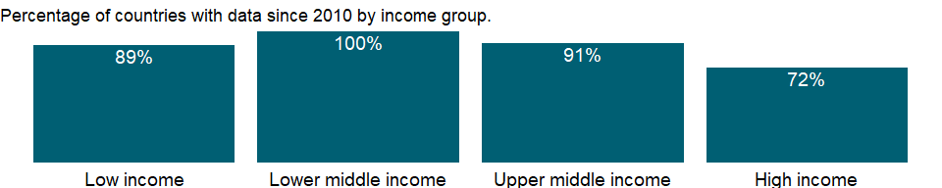

### Why is it relevant?

The economic health of a country is measured not only in macroeconomic terms but also by other factors that shape daily economic activity such as laws, regulations, and institutional arrangements. The data measure business regulation, gauge regulatory outcomes, and measure the extent of legal protection of property, the flexibility of employment regulation, and the tax burden on businesses.

The fundamental premise of this data is that economic activity requires good rules and regulations that are efficient, accessible to all who need to use them, and simple to implement. Thus sometimes there is more emphasis on more regulation, such as stricter disclosure requirements in related-party transactions, and other times emphasis is on for simplified regulations, such as a one-stop shop for completing business startup formalities.

Entrepreneurs may not be aware of all required procedures or may avoid legally required procedures altogether. But where regulation is particularly onerous, levels of informality are higher, which comes at a cost: firms in the informal sector usually grow more slowly, have less access to credit, and employ fewer workers - and those workers remain outside the protections of labor law. The indicator can help policymakers understand the business environment in a country and - along with information from other sources such as the World Bank’s Enterprise Surveys - provide insights into potential areas of reform.

### What is the data source?

World Bank, Doing Business project (<http://www.doingbusiness.org/>). NOTE: Doing Business has been discontinued as of 9/16/2021. For more information: <https://bit.ly/3CLCbme>

### What is the methodology?

Data are collected by the World Bank with a standardized survey that uses a simple business case to ensure comparability across economies and over time - with assumptions about the legal form of the business, its size, its location, and nature of its operation. Surveys are administered through more than 9,000 local experts, including lawyers, business consultants, accountants, freight forwarders, government officials, and other professionals who routinely administer or advise on legal and regulatory requirements.

To build a simple commercial warehouse and connect it to water, sewerage and a fixed telephone line, many construction regulations are required. Construction regulation matters for public safety. If procedures are too complicated or costly, builders tend to proceed without a permit. By some estimates 60-80 percent of building projects in developing economies are undertaken without the proper permits and approvals. Good regulations help ensure the safety standards that protect the public while making the permitting process efficient, transparent and affordable.

The Doing Business project of the World Bank encompasses two types of data: data from readings of laws and regulations and data on time and motion indicators that measure efficiency in achieving a regulatory goal. Within the time and motion indicators cost estimates are recorded from official fee schedules where applicable. The data from surveys are subjected to numerous tests for robustness, which lead to revision or expansion of the information collected.

### How is it aggregated?

Unweighted average

### What are the limitations?

The Doing Business methodology has limitations that should be considered when interpreting the data. First, the data collected refer to businesses in the economy’s largest city and may not represent regulations in other locations of the economy. To address this limitation, subnational indicators are being collected for selected economies. These subnational studies point to significant differences in the speed of reform and the ease of doing business across cities in the same economy. Second, the data often focus on a specific business form - generally a limited liability company of a specified size - and may not represent regulation for other types of businesses such as sole proprietorships. Third, transactions described in a standardized business case refer to a specific set of issues and may not represent the full set of issues a business encounters. Fourth, the time measures involve an element of judgment by the expert respondents. When sources indicate different estimates, the Doing Business time indicators represent the median values of several responses given under the assumptions of the standardized case. Fifth, the methodology assumes that a business has full information on what is required and does not waste time when completing procedures.

### What else should I know?

Data are presented for the survey year instead of publication year.

### 1.33.54 Procedures to build a warehouse (number)

### What is the indicator?

Number of procedures to build a warehouse is the number of interactions of a company’s employees or managers with external parties, including government agency staff, public inspectors, notaries, land registry and cadastre staff, and technical experts apart from architects and engineers.

Topic: Private Sector & Trade: Business environment

Series ID: IC.WRH.PROC

Copyright: CC BY-4.0 , <https://datacatalog.worldbank.org/public-licenses#cc-by>

First year with any data: 2005

Last year with any data: 2019

### What years are data available?

The figure below shows years in which data is available for at least one country. Dates shaded in black have no data, while dates shaded in green have data for at least one country



### Which countries have data?

The figure below shows the percentage of countries in each income group with a value since 2010 for that indicator.



### Why is it relevant?

The economic health of a country is measured not only in macroeconomic terms but also by other factors that shape daily economic activity such as laws, regulations, and institutional arrangements. The data measure business regulation, gauge regulatory outcomes, and measure the extent of legal protection of property, the flexibility of employment regulation, and the tax burden on businesses.

The fundamental premise of this data is that economic activity requires good rules and regulations that are efficient, accessible to all who need to use them, and simple to implement. Thus sometimes there is more emphasis on more regulation, such as stricter disclosure requirements in related-party transactions, and other times emphasis is on for simplified regulations, such as a one-stop shop for completing business startup formalities.

Entrepreneurs may not be aware of all required procedures or may avoid legally required procedures altogether. But where regulation is particularly onerous, levels of informality are higher, which comes at a cost: firms in the informal sector usually grow more slowly, have less access to credit, and employ fewer workers - and those workers remain outside the protections of labor law. The indicator can help policymakers understand the business environment in a country and - along with information from other sources such as the World Bank’s Enterprise Surveys - provide insights into potential areas of reform.

### What is the data source?

World Bank, Doing Business project (<http://www.doingbusiness.org/>). NOTE: Doing Business has been discontinued as of 9/16/2021. For more information: <https://bit.ly/3CLCbme>

### What is the methodology?

Data are collected by the World Bank with a standardized survey that uses a simple business case to ensure comparability across economies and over time - with assumptions about the legal form of the business, its size, its location, and nature of its operation. Surveys are administered through more than 9,000 local experts, including lawyers, business consultants, accountants, freight forwarders, government officials, and other professionals who routinely administer or advise on legal and regulatory requirements.

To build a simple commercial warehouse and connect it to water, sewerage and a fixed telephone line, many construction regulations are required. Construction regulation matters for public safety. If procedures are too complicated or costly, builders tend to proceed without a permit. By some estimates 60-80 percent of building projects in developing economies are undertaken without the proper permits and approvals. Good regulations help ensure the safety standards that protect the public while making the permitting process efficient, transparent and affordable.

The Doing Business project of the World Bank encompasses two types of data: data from readings of laws and regulations and data on time and motion indicators that measure efficiency in achieving a regulatory goal. Within the time and motion indicators cost estimates are recorded from official fee schedules where applicable. The data from surveys are subjected to numerous tests for robustness, which lead to revision or expansion of the information collected.

### How is it aggregated?

Unweighted average

### What are the limitations?

The Doing Business methodology has limitations that should be considered when interpreting the data. First, the data collected refer to businesses in the economy’s largest city and may not represent regulations in other locations of the economy. To address this limitation, subnational indicators are being collected for selected economies. These subnational studies point to significant differences in the speed of reform and the ease of doing business across cities in the same economy. Second, the data often focus on a specific business form - generally a limited liability company of a specified size - and may not represent regulation for other types of businesses such as sole proprietorships. Third, transactions described in a standardized business case refer to a specific set of issues and may not represent the full set of issues a business encounters. Fourth, the time measures involve an element of judgment by the expert respondents. When sources indicate different estimates, the Doing Business time indicators represent the median values of several responses given under the assumptions of the standardized case. Fifth, the methodology assumes that a business has full information on what is required and does not waste time when completing procedures.

### What else should I know?

Data are presented for the survey year instead of publication year.

## 1.34 Private Sector & Trade: Trade facilitation

### 1.34.1 Cost to export, border compliance (US$)

### What is the indicator?

Border compliance captures the time and cost associated with compliance with the economy’s customs regulations and with regulations relating to other inspections that are mandatory in order for the shipment to cross the economy’s border, as well as the time and cost for handling that takes place at its port or border. The time and cost for this segment include time and cost for customs clearance and inspection procedures conducted by other government agencies.

Topic: Private Sector & Trade: Trade facilitation

Series ID: IC.EXP.CSBC.CD

Copyright: CC BY-4.0 , <https://datacatalog.worldbank.org/public-licenses#cc-by>

First year with any data: 2014

Last year with any data: 2019

### What years are data available?

The figure below shows years in which data is available for at least one country. Dates shaded in black have no data, while dates shaded in green have data for at least one country

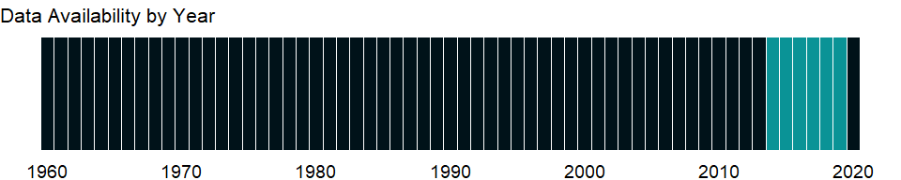

### Which countries have data?

The figure below shows the percentage of countries in each income group with a value since 2010 for that indicator.

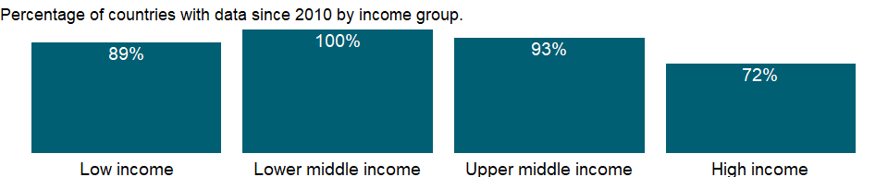

### Why is it relevant?

NA

### What is the data source?

World Bank, Doing Business project (<http://www.doingbusiness.org/>). NOTE: Doing Business has been discontinued as of 9/16/2021. For more information: <https://bit.ly/3CLCbme>

### What is the methodology?

The computation of border compliance time and cost depends on where the border compliance procedures take place, who requires and conducts the procedures and what is the probability that inspections will be conducted. If all customs clearance and other inspections take place at the port or border, the time estimate for border compliance takes this simultaneity into account. It is entirely possible that the border compliance time and cost could be negligible or zero, as in the case of trade between members of the European Union or other customs unions.

If some or all customs or other inspections take place at other locations, the time and cost for these procedures are added to the time and cost for those that take place at the port or border. In Kazakhstan, for example, all customs clearance and inspections take place at a customs post in Almaty that is not at the land border between Kazakhstan and China. In this case border compliance time is the sum of the time spent at the terminal in Almaty and the handling time at the border.

Doing Business asks contributors to estimate the time and cost for clearance and inspections by customs agencies— defined as documentary and physical inspections for the purpose of calculating duties by verifying product classification, confirming quantity, determining origin and checking the veracity of other information on the customs declaration. (This category includes all inspections aimed at preventing smuggling.) These are clearance and inspection procedures that take place in the majority of cases and thus are considered the “standard” case. The time and cost estimates capture the efficiency of the customs agency of the economy.

Doing Business also asks contributors to estimate the total time and cost for clearance and inspections by customs and all other government agencies for the specified product. These estimates account for inspections related to health, safety, phytosanitary standards, conformity and the like, and thus capture the efficiency of agencies that require and conduct these additional inspections.

### How is it aggregated?

Unweighted average

### What are the limitations?

If inspections by agencies other than customs are conducted in 20% or fewer cases, the border compliance time and cost measures take into account only clearance and inspections by customs (the standard case). If inspections by other agencies take place in more than 20% of cases, the time and cost measures account for clearance and inspections by all agencies. Different types of inspections may take place with different probabilities—for example, scanning may take place in 100% of cases while physical inspection occurs in 5% of cases. In situations like this, Doing Business would count the time only for scanning because it happens in more than 20% of cases while physical inspection does not. The border compliance time and cost for an economy do not include the time and cost for compliance with the regulations of any other economy.

### What else should I know?

Insurance cost and informal payments for which no receipt is issued are excluded from the costs recorded. Costs are reported in U.S. dollars. Contributors are asked to convert local currency into U.S. dollars based on the exchange rate prevailing on the day they answer the questionnaire. Contributors are private sector experts in international trade logistics and are informed about exchange rates and their movements.

Data are presented for the survey year instead of publication year.

### 1.34.2 Cost to export, documentary compliance (US$)

### What is the indicator?

Documentary compliance captures the time and cost associated with compliance with the documentary requirements of all government agencies of the origin economy, the destination economy and any transit economies. The aim is to measure the total burden of preparing the bundle of documents that will enable completion of the international trade for the product and partner pair assumed in the case study.

Topic: Private Sector & Trade: Trade facilitation

Series ID: IC.EXP.CSDC.CD

Copyright: CC BY-4.0 , <https://datacatalog.worldbank.org/public-licenses#cc-by>

First year with any data: 2014

Last year with any data: 2019

### What years are data available?

The figure below shows years in which data is available for at least one country. Dates shaded in black have no data, while dates shaded in green have data for at least one country



### Which countries have data?

The figure below shows the percentage of countries in each income group with a value since 2010 for that indicator.



### Why is it relevant?

NA

### What is the data source?

World Bank, Doing Business project (<http://www.doingbusiness.org/>). NOTE: Doing Business has been discontinued as of 9/16/2021. For more information: <https://bit.ly/3CLCbme>

### What is the methodology?

The time and cost for documentary compliance include the time and cost for obtaining documents (such as time spent to get the document issued and stamped); preparing documents (such as time spent gathering information to complete the customs declaration or certificate of origin); processing documents (such as time spent waiting for the relevant authority to issue a phytosanitary certificate); presenting documents (such as time spent showing a port terminal receipt to port authorities); and submitting documents (such as time spent submitting a customs declaration to the customs agency in person or electronically).

All electronic or paper submissions of information requested by any government agency in connection with the shipment are considered to be documents obtained, prepared and submitted during the export or import process. All documents prepared by the freight forwarder or customs broker for the product and partner pair assumed in the case study are included regardless of whether they are required by law or in practice. Any documents prepared and submitted so as to get access to preferential treatment— for example, a certificate of origin—are included in the calculation of the time and cost for documentary compliance. Any documents prepared and submitted because of a perception that they ease the passage of the shipment are also included (for example, freight forwarders may prepare a packing list because in their experience this reduces the probability of physical or other intrusive inspections).

In addition, any documents that are mandatory for exporting or importing are included in the calculation of time and cost. Documents that need to be obtained only once are not counted, however. And Doing Business does not include documents needed to produce and sell in the domestic market—such as certificates of third-party safety standards testing that may be required to sell toys domestically—unless a government agency needs to see these documents during the export process.

### How is it aggregated?

Unweighted average

### What are the limitations?

NA

### What else should I know?

Insurance cost and informal payments for which no receipt is issued are excluded from the costs recorded. Costs are reported in U.S. dollars. Contributors are asked to convert local currency into U.S. dollars based on the exchange rate prevailing on the day they answer the questionnaire. Contributors are private sector experts in international trade logistics and are informed about exchange rates and their movements.

Data are presented for the survey year instead of publication year.

### 1.34.3 Time to export, border compliance (hours)

### What is the indicator?

Border compliance captures the time and cost associated with compliance with the economy’s customs regulations and with regulations relating to other inspections that are mandatory in order for the shipment to cross the economy’s border, as well as the time and cost for handling that takes place at its port or border. The time and cost for this segment include time and cost for customs clearance and inspection procedures conducted by other government agencies.

Topic: Private Sector & Trade: Trade facilitation

Series ID: IC.EXP.TMBC

Copyright: CC BY-4.0 , <https://datacatalog.worldbank.org/public-licenses#cc-by>

First year with any data: 2014

Last year with any data: 2019

### What years are data available?

The figure below shows years in which data is available for at least one country. Dates shaded in black have no data, while dates shaded in green have data for at least one country



### Which countries have data?

The figure below shows the percentage of countries in each income group with a value since 2010 for that indicator.



### Why is it relevant?

NA

### What is the data source?

World Bank, Doing Business project (<http://www.doingbusiness.org/>). NOTE: Doing Business has been discontinued as of 9/16/2021. For more information: <https://bit.ly/3CLCbme>

### What is the methodology?

The computation of border compliance time and cost depends on where the border compliance procedures take place, who requires and conducts the procedures and what is the probability that inspections will be conducted. If all customs clearance and other inspections take place at the port or border, the time estimate for border compliance takes this simultaneity into account. It is entirely possible that the border compliance time and cost could be negligible or zero, as in the case of trade between members of the European Union or other customs unions.

If some or all customs or other inspections take place at other locations, the time and cost for these procedures are added to the time and cost for those that take place at the port or border. In Kazakhstan, for example, all customs clearance and inspections take place at a customs post in Almaty that is not at the land border between Kazakhstan and China. In this case border compliance time is the sum of the time spent at the terminal in Almaty and the handling time at the border.

Doing Business asks contributors to estimate the time and cost for clearance and inspections by customs agencies— defined as documentary and physical inspections for the purpose of calculating duties by verifying product classification, confirming quantity, determining origin and checking the veracity of other information on the customs declaration. (This category includes all inspections aimed at preventing smuggling.) These are clearance and inspection procedures that take place in the majority of cases and thus are considered the “standard” case. The time and cost estimates capture the efficiency of the customs agency of the economy.

Doing Business also asks contributors to estimate the total time and cost for clearance and inspections by customs and all other government agencies for the specified product. These estimates account for inspections related to health, safety, phytosanitary standards, conformity and the like, and thus capture the efficiency of agencies that require and conduct these additional inspections.

### How is it aggregated?

Unweighted average

### What are the limitations?

If inspections by agencies other than customs are conducted in 20% or fewer cases, the border compliance time and cost measures take into account only clearance and inspections by customs (the standard case). If inspections by other agencies take place in more than 20% of cases, the time and cost measures account for clearance and inspections by all agencies. Different types of inspections may take place with different probabilities—for example, scanning may take place in 100% of cases while physical inspection occurs in 5% of cases. In situations like this, Doing Business would count the time only for scanning because it happens in more than 20% of cases while physical inspection does not. The border compliance time and cost for an economy do not include the time and cost for compliance with the regulations of any other economy.

### What else should I know?

Time is measured in hours, and 1 day is 24 hours (for example, 22 days are recorded as 22 × 24 = 528 hours). If customs clearance takes 7.5 hours, the data are recorded as is. Alternatively, suppose that documents are submitted to a customs agency at 8:00 a.m., are processed overnight and can be picked up at 8:00 a.m. the next day. In this case the time for customs clearance would be recorded as 24 hours because the actual procedure took 24 hours.

Data are presented for the survey year instead of publication year.

### 1.34.4 Time to export, documentary compliance (hours)

### What is the indicator?

Documentary compliance captures the time and cost associated with compliance with the documentary requirements of all government agencies of the origin economy, the destination economy and any transit economies. The aim is to measure the total burden of preparing the bundle of documents that will enable completion of the international trade for the product and partner pair assumed in the case study.

Topic: Private Sector & Trade: Trade facilitation

Series ID: IC.EXP.TMDC

Copyright: CC BY-4.0 , <https://datacatalog.worldbank.org/public-licenses#cc-by>

First year with any data: 2014

Last year with any data: 2019

### What years are data available?

The figure below shows years in which data is available for at least one country. Dates shaded in black have no data, while dates shaded in green have data for at least one country



### Which countries have data?

The figure below shows the percentage of countries in each income group with a value since 2010 for that indicator.



### Why is it relevant?

NA

### What is the data source?

World Bank, Doing Business project (<http://www.doingbusiness.org/>). NOTE: Doing Business has been discontinued as of 9/16/2021. For more information: <https://bit.ly/3CLCbme>

### What is the methodology?

The time and cost for documentary compliance include the time and cost for obtaining documents (such as time spent to get the document issued and stamped); preparing documents (such as time spent gathering information to complete the customs declaration or certificate of origin); processing documents (such as time spent waiting for the relevant authority to issue a phytosanitary certificate); presenting documents (such as time spent showing a port terminal receipt to port authorities); and submitting documents (such as time spent submitting a customs declaration to the customs agency in person or electronically).

All electronic or paper submissions of information requested by any government agency in connection with the shipment are considered to be documents obtained, prepared and submitted during the export or import process. All documents prepared by the freight forwarder or customs broker for the product and partner pair assumed in the case study are included regardless of whether they are required by law or in practice. Any documents prepared and submitted so as to get access to preferential treatment— for example, a certificate of origin—are included in the calculation of the time and cost for documentary compliance. Any documents prepared and submitted because of a perception that they ease the passage of the shipment are also included (for example, freight forwarders may prepare a packing list because in their experience this reduces the probability of physical or other intrusive inspections).

In addition, any documents that are mandatory for exporting or importing are included in the calculation of time and cost. Documents that need to be obtained only once are not counted, however. And Doing Business does not include documents needed to produce and sell in the domestic market—such as certificates of third-party safety standards testing that may be required to sell toys domestically—unless a government agency needs to see these documents during the export process.

### How is it aggregated?

Unweighted average

### What are the limitations?

NA

### What else should I know?

Time is measured in hours, and 1 day is 24 hours (for example, 22 days are recorded as 22 × 24 = 528 hours). If customs clearance takes 7.5 hours, the data are recorded as is. Alternatively, suppose that documents are submitted to a customs agency at 8:00 a.m., are processed overnight and can be picked up at 8:00 a.m. the next day. In this case the time for customs clearance would be recorded as 24 hours because the actual procedure took 24 hours.

Data are presented for the survey year instead of publication year.

### 1.34.5 Cost to import, border compliance (US$)

### What is the indicator?

Border compliance captures the time and cost associated with compliance with the economy’s customs regulations and with regulations relating to other inspections that are mandatory in order for the shipment to cross the economy’s border, as well as the time and cost for handling that takes place at its port or border. The time and cost for this segment include time and cost for customs clearance and inspection procedures conducted by other government agencies.

Topic: Private Sector & Trade: Trade facilitation

Series ID: IC.IMP.CSBC.CD

Copyright: CC BY-4.0 , <https://datacatalog.worldbank.org/public-licenses#cc-by>

First year with any data: 2014

Last year with any data: 2019

### What years are data available?

The figure below shows years in which data is available for at least one country. Dates shaded in black have no data, while dates shaded in green have data for at least one country



### Which countries have data?

The figure below shows the percentage of countries in each income group with a value since 2010 for that indicator.



### Why is it relevant?

NA

### What is the data source?

World Bank, Doing Business project (<http://www.doingbusiness.org/>). NOTE: Doing Business has been discontinued as of 9/16/2021. For more information: <https://bit.ly/3CLCbme>

### What is the methodology?

The computation of border compliance time and cost depends on where the border compliance procedures take place, who requires and conducts the procedures and what is the probability that inspections will be conducted. If all customs clearance and other inspections take place at the port or border, the time estimate for border compliance takes this simultaneity into account. It is entirely possible that the border compliance time and cost could be negligible or zero, as in the case of trade between members of the European Union or other customs unions.

If some or all customs or other inspections take place at other locations, the time and cost for these procedures are added to the time and cost for those that take place at the port or border. In Kazakhstan, for example, all customs clearance and inspections take place at a customs post in Almaty that is not at the land border between Kazakhstan and China. In this case border compliance time is the sum of the time spent at the terminal in Almaty and the handling time at the border.

Doing Business asks contributors to estimate the time and cost for clearance and inspections by customs agencies— defined as documentary and physical inspections for the purpose of calculating duties by verifying product classification, confirming quantity, determining origin and checking the veracity of other information on the customs declaration. (This category includes all inspections aimed at preventing smuggling.) These are clearance and inspection procedures that take place in the majority of cases and thus are considered the “standard” case. The time and cost estimates capture the efficiency of the customs agency of the economy.

Doing Business also asks contributors to estimate the total time and cost for clearance and inspections by customs and all other government agencies for the specified product. These estimates account for inspections related to health, safety, phytosanitary standards, conformity and the like, and thus capture the efficiency of agencies that require and conduct these additional inspections.

### How is it aggregated?

Unweighted average

### What are the limitations?

If inspections by agencies other than customs are conducted in 20% or fewer cases, the border compliance time and cost measures take into account only clearance and inspections by customs (the standard case). If inspections by other agencies take place in more than 20% of cases, the time and cost measures account for clearance and inspections by all agencies. Different types of inspections may take place with different probabilities—for example, scanning may take place in 100% of cases while physical inspection occurs in 5% of cases. In situations like this, Doing Business would count the time only for scanning because it happens in more than 20% of cases while physical inspection does not. The border compliance time and cost for an economy do not include the time and cost for compliance with the regulations of any other economy.

### What else should I know?

Insurance cost and informal payments for which no receipt is issued are excluded from the costs recorded. Costs are reported in U.S. dollars. Contributors are asked to convert local currency into U.S. dollars based on the exchange rate prevailing on the day they answer the questionnaire. Contributors are private sector experts in international trade logistics and are informed about exchange rates and their movements.

Data are presented for the survey year instead of publication year.

### 1.34.6 Cost to import, documentary compliance (US$)

### What is the indicator?

Documentary compliance captures the time and cost associated with compliance with the documentary requirements of all government agencies of the origin economy, the destination economy and any transit economies. The aim is to measure the total burden of preparing the bundle of documents that will enable completion of the international trade for the product and partner pair assumed in the case study.

Topic: Private Sector & Trade: Trade facilitation

Series ID: IC.IMP.CSDC.CD

Copyright: CC BY-4.0 , <https://datacatalog.worldbank.org/public-licenses#cc-by>

First year with any data: 2014

Last year with any data: 2019

### What years are data available?

The figure below shows years in which data is available for at least one country. Dates shaded in black have no data, while dates shaded in green have data for at least one country



### Which countries have data?

The figure below shows the percentage of countries in each income group with a value since 2010 for that indicator.



### Why is it relevant?

NA

### What is the data source?

World Bank, Doing Business project (<http://www.doingbusiness.org/>). NOTE: Doing Business has been discontinued as of 9/16/2021. For more information: <https://bit.ly/3CLCbme>

### What is the methodology?

The time and cost for documentary compliance include the time and cost for obtaining documents (such as time spent to get the document issued and stamped); preparing documents (such as time spent gathering information to complete the customs declaration or certificate of origin); processing documents (such as time spent waiting for the relevant authority to issue a phytosanitary certificate); presenting documents (such as time spent showing a port terminal receipt to port authorities); and submitting documents (such as time spent submitting a customs declaration to the customs agency in person or electronically).

All electronic or paper submissions of information requested by any government agency in connection with the shipment are considered to be documents obtained, prepared and submitted during the export or import process. All documents prepared by the freight forwarder or customs broker for the product and partner pair assumed in the case study are included regardless of whether they are required by law or in practice. Any documents prepared and submitted so as to get access to preferential treatment— for example, a certificate of origin—are included in the calculation of the time and cost for documentary compliance. Any documents prepared and submitted because of a perception that they ease the passage of the shipment are also included (for example, freight forwarders may prepare a packing list because in their experience this reduces the probability of physical or other intrusive inspections).

In addition, any documents that are mandatory for exporting or importing are included in the calculation of time and cost. Documents that need to be obtained only once are not counted, however. And Doing Business does not include documents needed to produce and sell in the domestic market—such as certificates of third-party safety standards testing that may be required to sell toys domestically—unless a government agency needs to see these documents during the export process.

### How is it aggregated?

Unweighted average

### What are the limitations?

NA

### What else should I know?

Insurance cost and informal payments for which no receipt is issued are excluded from the costs recorded. Costs are reported in U.S. dollars. Contributors are asked to convert local currency into U.S. dollars based on the exchange rate prevailing on the day they answer the questionnaire. Contributors are private sector experts in international trade logistics and are informed about exchange rates and their movements.

Data are presented for the survey year instead of publication year.

### 1.34.7 Time to import, border compliance (hours)

### What is the indicator?

Border compliance captures the time and cost associated with compliance with the economy’s customs regulations and with regulations relating to other inspections that are mandatory in order for the shipment to cross the economy’s border, as well as the time and cost for handling that takes place at its port or border. The time and cost for this segment include time and cost for customs clearance and inspection procedures conducted by other government agencies.

Topic: Private Sector & Trade: Trade facilitation

Series ID: IC.IMP.TMBC

Copyright: CC BY-4.0 , <https://datacatalog.worldbank.org/public-licenses#cc-by>

First year with any data: 2014

Last year with any data: 2019

### What years are data available?

The figure below shows years in which data is available for at least one country. Dates shaded in black have no data, while dates shaded in green have data for at least one country



### Which countries have data?

The figure below shows the percentage of countries in each income group with a value since 2010 for that indicator.



### Why is it relevant?

NA

### What is the data source?

World Bank, Doing Business project (<http://www.doingbusiness.org/>). NOTE: Doing Business has been discontinued as of 9/16/2021. For more information: <https://bit.ly/3CLCbme>

### What is the methodology?

The computation of border compliance time and cost depends on where the border compliance procedures take place, who requires and conducts the procedures and what is the probability that inspections will be conducted. If all customs clearance and other inspections take place at the port or border, the time estimate for border compliance takes this simultaneity into account. It is entirely possible that the border compliance time and cost could be negligible or zero, as in the case of trade between members of the European Union or other customs unions.

If some or all customs or other inspections take place at other locations, the time and cost for these procedures are added to the time and cost for those that take place at the port or border. In Kazakhstan, for example, all customs clearance and inspections take place at a customs post in Almaty that is not at the land border between Kazakhstan and China. In this case border compliance time is the sum of the time spent at the terminal in Almaty and the handling time at the border.

Doing Business asks contributors to estimate the time and cost for clearance and inspections by customs agencies— defined as documentary and physical inspections for the purpose of calculating duties by verifying product classification, confirming quantity, determining origin and checking the veracity of other information on the customs declaration. (This category includes all inspections aimed at preventing smuggling.) These are clearance and inspection procedures that take place in the majority of cases and thus are considered the “standard” case. The time and cost estimates capture the efficiency of the customs agency of the economy.

Doing Business also asks contributors to estimate the total time and cost for clearance and inspections by customs and all other government agencies for the specified product. These estimates account for inspections related to health, safety, phytosanitary standards, conformity and the like, and thus capture the efficiency of agencies that require and conduct these additional inspections.

### How is it aggregated?

Unweighted average

### What are the limitations?

If inspections by agencies other than customs are conducted in 20% or fewer cases, the border compliance time and cost measures take into account only clearance and inspections by customs (the standard case). If inspections by other agencies take place in more than 20% of cases, the time and cost measures account for clearance and inspections by all agencies. Different types of inspections may take place with different probabilities—for example, scanning may take place in 100% of cases while physical inspection occurs in 5% of cases. In situations like this, Doing Business would count the time only for scanning because it happens in more than 20% of cases while physical inspection does not. The border compliance time and cost for an economy do not include the time and cost for compliance with the regulations of any other economy.

### What else should I know?

Time is measured in hours, and 1 day is 24 hours (for example, 22 days are recorded as 22 × 24 = 528 hours). If customs clearance takes 7.5 hours, the data are recorded as is. Alternatively, suppose that documents are submitted to a customs agency at 8:00 a.m., are processed overnight and can be picked up at 8:00 a.m. the next day. In this case the time for customs clearance would be recorded as 24 hours because the actual procedure took 24 hours.

Data are presented for the survey year instead of publication year.

### 1.34.8 Time to import, documentary compliance (hours)

### What is the indicator?

Documentary compliance captures the time and cost associated with compliance with the documentary requirements of all government agencies of the origin economy, the destination economy and any transit economies. The aim is to measure the total burden of preparing the bundle of documents that will enable completion of the international trade for the product and partner pair assumed in the case study.

Topic: Private Sector & Trade: Trade facilitation

Series ID: IC.IMP.TMDC

Copyright: CC BY-4.0 , <https://datacatalog.worldbank.org/public-licenses#cc-by>

First year with any data: 2014

Last year with any data: 2019

### What years are data available?

The figure below shows years in which data is available for at least one country. Dates shaded in black have no data, while dates shaded in green have data for at least one country



### Which countries have data?

The figure below shows the percentage of countries in each income group with a value since 2010 for that indicator.



### Why is it relevant?

NA

### What is the data source?

World Bank, Doing Business project (<http://www.doingbusiness.org/>). NOTE: Doing Business has been discontinued as of 9/16/2021. For more information: <https://bit.ly/3CLCbme>

### What is the methodology?

The time and cost for documentary compliance include the time and cost for obtaining documents (such as time spent to get the document issued and stamped); preparing documents (such as time spent gathering information to complete the customs declaration or certificate of origin); processing documents (such as time spent waiting for the relevant authority to issue a phytosanitary certificate); presenting documents (such as time spent showing a port terminal receipt to port authorities); and submitting documents (such as time spent submitting a customs declaration to the customs agency in person or electronically).

All electronic or paper submissions of information requested by any government agency in connection with the shipment are considered to be documents obtained, prepared and submitted during the export or import process. All documents prepared by the freight forwarder or customs broker for the product and partner pair assumed in the case study are included regardless of whether they are required by law or in practice. Any documents prepared and submitted so as to get access to preferential treatment— for example, a certificate of origin—are included in the calculation of the time and cost for documentary compliance. Any documents prepared and submitted because of a perception that they ease the passage of the shipment are also included (for example, freight forwarders may prepare a packing list because in their experience this reduces the probability of physical or other intrusive inspections).

In addition, any documents that are mandatory for exporting or importing are included in the calculation of time and cost. Documents that need to be obtained only once are not counted, however. And Doing Business does not include documents needed to produce and sell in the domestic market—such as certificates of third-party safety standards testing that may be required to sell toys domestically—unless a government agency needs to see these documents during the export process.

### How is it aggregated?

Unweighted average

### What are the limitations?

NA

### What else should I know?

Time is measured in hours, and 1 day is 24 hours (for example, 22 days are recorded as 22 × 24 = 528 hours). If customs clearance takes 7.5 hours, the data are recorded as is. Alternatively, suppose that documents are submitted to a customs agency at 8:00 a.m., are processed overnight and can be picked up at 8:00 a.m. the next day. In this case the time for customs clearance would be recorded as 24 hours because the actual procedure took 24 hours.

Data are presented for the survey year instead of publication year.

### 1.34.9 Lead time to export, median case (days)

### What is the indicator?

Lead time to export is the median time (the value for 50 percent of shipments) from shipment point to port of loading. Data are from the Logistics Performance Index survey. Respondents provided separate values for the best case (10 percent of shipments) and the median case (50 percent of shipments). The data are exponentiated averages of the logarithm of single value responses and of midpoint values of range responses for the median case.

Topic: Private Sector & Trade: Trade facilitation

Series ID: LP.EXP.DURS.MD

Copyright: CC BY-4.0 , <https://datacatalog.worldbank.org/public-licenses#cc-by>

First year with any data: 2007

Last year with any data: 2018

### What years are data available?

The figure below shows years in which data is available for at least one country. Dates shaded in black have no data, while dates shaded in green have data for at least one country

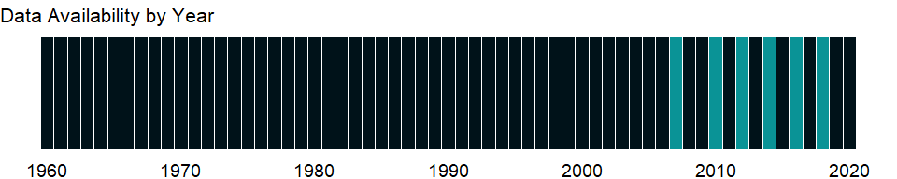

### Which countries have data?

The figure below shows the percentage of countries in each income group with a value since 2010 for that indicator.

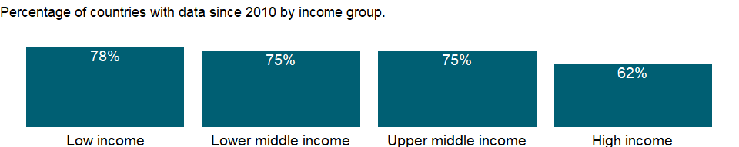

### Why is it relevant?

The LPI measures on-the-ground trade logistics performance, helping national leaders, key policymakers, and private sector traders understand the challenges they and their trading partners face in reducing logistical barriers to international commerce.

A useful outcome measure of logistics performance is the time taken to complete trade transactions. The median import lead time for port and airport supply chains, as measured for the LPI, is more than 3.5 times longer in low performing countries than in high-performing countries. The difference is around three times for land supply chains. The association suggests that geographical hurdles, and perhaps internal transport markets, still pose substantial difficulties in many countries. Besides geography and speed en route, another factor in import lead times is the border process. Time can be reduced at all stages of this process, but especially in the clearance of goods on arrival. Countries with low logistics performance need to reform their border management so that they can reduce red tape, excessive and opaque procedural requirements, and physical inspections. Although the time to clear goods through customs is a fairly small fraction of total import time for all LPI quintiles, it rises sharply if goods are physically inspected. Core customs procedures are similar across quintiles. But low-performing countries have a far higher prevalence of physical inspection, even subjecting the same shipment to repeated inspections by multiple agencies.

Many low-income countries have long export lead times, reducing their export competitiveness and ability to participate in international trade.

### What is the data source?

World Bank and Turku School of Economics, Logistic Performance Index Surveys. Data are available online at : <http://www.worldbank.org/lpi>. Summary results are published in Arvis and others’ Connecting to Compete: Trade Logistics in the Global Economy, The Logistics Performance Index and Its Indicators report.

### What is the methodology?

Data on lead time to export are from the Logistics Performance Index (LPI) survey. Respondents provided separate values for the best case (10 percent of shipments) and the median case (50 percent of shipments) of shipments from the point of origin (the seller’s factory, typically located either in the capital city or in the largest commercial center) to the port of loading or equivalent (port/airport), and excluding international shipping.

The Logistics Performance Index (LPI) uses a structured online survey of logistics professionals at multinational freight forwarders and at the main express carriers. The 2012 LPI data are based on the 2011 survey, which was administered to nearly 1,000 respondents at international logistics companies in 143 countries (domestic performance indicators). The international LPI covers 155 countries. The LPI assesses both large companies and small and medium enterprises. Most of the responses are from small and medium enterprises, with large companies (those with 250 employees or more) accounting for roughly 18 percent of responses. The respondents include groups of professionals who are directly involved in day-today operations, from company headquarters and from country offices such as senior executives, area or country managers, and department managers. Many of the respondents are at corporate or regional headquarters or at country branch offices. The rest are at local branch offices or independent firms. The majority of respondents are involved in providing most logistics services as their main line of work such as warehousing and distribution, customer-tailored logistics solutions, courier services, bulk or break bulk cargo transport, and less-than-full container, full-container, or full-trailer load transport.

For the lead time to export, respondents were asked for quantitative information on their countries’ international supply chains by picking choices from a dropdown menu. When a response indicates a single value, the answer is coded as the logarithm of that value. When a response indicates a range, the answer is coded as the logarithm of the midpoint of that range. Country scores are produced by exponentiating the average of responses in logarithms across all respondents for a given country. This method is equivalent to taking a geometric average in levels. Scores for regions, income groups, and LPI quintiles are simple averages of the relevant country scores.

### How is it aggregated?

Unweighted average

### What are the limitations?

The Logistics Performance Index is an interactive benchmarking tool created to help countries identify the challenges and opportunities they face in their performance on trade logistics and what they can do to improve their performance. Feedback from operators is supplemented with quantitative data on the performance of key components of the logistics chain in the country of work. Thus, the LPI consists of both qualitative and quantitative measures.

In addition, despite being the most comprehensive data source for country logistics and trade facilitation, the LPI has two important limitations. First, the experience of international freight forwarders might not represent the broader logistics environment in poor countries, which often rely on traditional operators. And the international and traditional operators might differ in their interactions with government agencies - and in their service levels. Second, for landlocked countries and small-island states, the LPI might reflect access problems outside the country assessed, such as transit difficulties. The low rating of a landlocked country might not adequately reflect its trade facilitation efforts, which depend on the workings of complex international transit systems. Landlocked countries cannot eliminate transit inefficiencies with domestic reforms.

### What else should I know?

NA

### 1.34.10 Lead time to import, median case (days)

### What is the indicator?

Lead time to import is the median time (the value for 50 percent of shipments) from port of discharge to arrival at the consignee. Data are from the Logistics Performance Index survey. Respondents provided separate values for the best case (10 percent of shipments) and the median case (50 percent of shipments). The data are exponentiated averages of the logarithm of single value responses and of midpoint values of range responses for the median case.

Topic: Private Sector & Trade: Trade facilitation

Series ID: LP.IMP.DURS.MD

Copyright: CC BY-4.0 , <https://datacatalog.worldbank.org/public-licenses#cc-by>

First year with any data: 2007

Last year with any data: 2018

### What years are data available?

The figure below shows years in which data is available for at least one country. Dates shaded in black have no data, while dates shaded in green have data for at least one country



### Which countries have data?

The figure below shows the percentage of countries in each income group with a value since 2010 for that indicator.

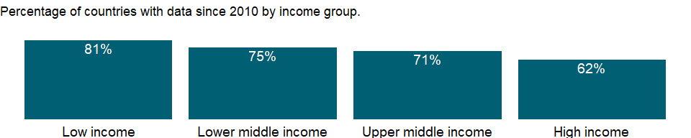

### Why is it relevant?

The LPI measures on-the-ground trade logistics performance, helping national leaders, key policymakers, and private sector traders understand the challenges they and their trading partners face in reducing logistical barriers to international commerce.

A useful outcome measure of logistics performance is the time taken to complete trade transactions. The median import lead time for port and airport supply chains, as measured for the LPI, is more than 3.5 times longer in low performing countries than in high-performing countries. The difference is around three times for land supply chains. The association suggests that geographical hurdles, and perhaps internal transport markets, still pose substantial difficulties in many countries. Besides geography and speed en route, another factor in import lead times is the border process. Time can be reduced at all stages of this process, but especially in the clearance of goods on arrival. Countries with low logistics performance need to reform their border management so that they can reduce red tape, excessive and opaque procedural requirements, and physical inspections. Although the time to clear goods through customs is a fairly small fraction of total import time for all LPI quintiles, it rises sharply if goods are physically inspected. Core customs procedures are similar across quintiles. But low-performing countries have a far higher prevalence of physical inspection, even subjecting the same shipment to repeated inspections by multiple agencies.

Many low-income countries have long export lead times, reducing their export competitiveness and ability to participate in international trade.

### What is the data source?

World Bank and Turku School of Economics, Logistic Performance Index Surveys. Data are available online at : <http://www.worldbank.org/lpi>. Summary results are published in Arvis and others’ Connecting to Compete: Trade Logistics in the Global Economy, The Logistics Performance Index and Its Indicators report.

### What is the methodology?

Data on lead time to import are from the Logistics Performance Index (LPI) survey. Respondents provided separate values for the best case (10 percent of shipments) and the median case (50 percent of shipments) of shipments from the port of discharge or equivalent to the buyer’s warehouse.

The Logistics Performance Index (LPI) uses a structured online survey of logistics professionals at multinational freight forwarders and at the main express carriers. The 2012 LPI data are based on the 2011 survey, which was administered to nearly 1,000 respondents at international logistics companies in 143 countries (domestic performance indicators). The international LPI covers 155 countries. The LPI assesses both large companies and small and medium enterprises. Most of the responses are from small and medium enterprises, with large companies (those with 250 employees or more) accounting for roughly 18 percent of responses. The respondents include groups of professionals who are directly involved in day-today operations, from company headquarters and from country offices such as senior executives, area or country managers, and department managers. Many of the respondents are at corporate or regional headquarters or at country branch offices. The rest are at local branch offices or independent firms. The majority of respondents are involved in providing most logistics services as their main line of work such as warehousing and distribution, customer-tailored logistics solutions, courier services, bulk or break bulk cargo transport, and less-than-full container, full-container, or full-trailer load transport.

For the lead time to import, respondents were asked for quantitative information on their countries’ international supply chains by picking choices from a dropdown menu. When a response indicates a single value, the answer is coded as the logarithm of that value. When a response indicates a range, the answer is coded as the logarithm of the midpoint of that range. Country scores are produced by exponentiating the average of responses in logarithms across all respondents for a given country. This method is equivalent to taking a geometric average in levels. Scores for regions, income groups, and LPI quintiles are simple averages of the relevant country scores.

### How is it aggregated?

Unweighted average

### What are the limitations?

The Logistics Performance Index is an interactive benchmarking tool created to help countries identify the challenges and opportunities they face in their performance on trade logistics and what they can do to improve their performance. Feedback from operators is supplemented with quantitative data on the performance of key components of the logistics chain in the country of work. Thus, the LPI consists of both qualitative and quantitative measures.

In addition, despite being the most comprehensive data source for country logistics and trade facilitation, the LPI has two important limitations. First, the experience of international freight forwarders might not represent the broader logistics environment in poor countries, which often rely on traditional operators. And the international and traditional operators might differ in their interactions with government agencies - and in their service levels. Second, for landlocked countries and small-island states, the LPI might reflect access problems outside the country assessed, such as transit difficulties. The low rating of a landlocked country might not adequately reflect its trade facilitation efforts, which depend on the workings of complex international transit systems. Landlocked countries cannot eliminate transit inefficiencies with domestic reforms.

### What else should I know?

NA

### 1.34.11 Logistics performance index: Efficiency of customs clearance process (1=low to 5=high)

### What is the indicator?

Data are from Logistics Performance Index surveys conducted by the World Bank in partnership with academic and international institutions and private companies and individuals engaged in international logistics. 2009 round of surveys covered more than 5,000 country assessments by nearly 1,000 international freight forwarders. Respondents evaluate eight markets on six core dimensions on a scale from 1 (worst) to 5 (best). The markets are chosen based on the most important export and import markets of the respondent’s country, random selection, and, for landlocked countries, neighboring countries that connect them with international markets. Details of the survey methodology are in Arvis and others’ Connecting to Compete 2010: Trade Logistics in the Global Economy (2010). Respondents evaluated efficiency of customs clearance processes (i.e. speed, simplicity and predictability of formalities), on a rating ranging from 1 (very low) to 5 (very high). Scores are averaged across all respondents.

Topic: Private Sector & Trade: Trade facilitation

Series ID: LP.LPI.CUST.XQ

Copyright: CC BY-4.0 , <https://datacatalog.worldbank.org/public-licenses#cc-by>

First year with any data: 2007

Last year with any data: 2018

### What years are data available?

The figure below shows years in which data is available for at least one country. Dates shaded in black have no data, while dates shaded in green have data for at least one country



### Which countries have data?

The figure below shows the percentage of countries in each income group with a value since 2010 for that indicator.

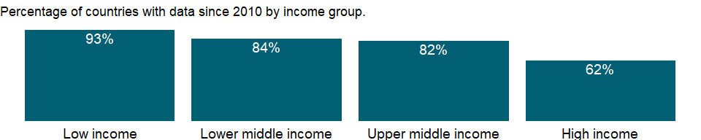

### Why is it relevant?

NA

### What is the data source?

World Bank and Turku School of Economics, Logistic Performance Index Surveys. Data are available online at : <http://www.worldbank.org/lpi>. Summary results are published in Arvis and others’ Connecting to Compete: Trade Logistics in the Global Economy, The Logistics Performance Index and Its Indicators report.

### What is the methodology?

NA

### How is it aggregated?

Unweighted average

### What are the limitations?

NA

### What else should I know?

NA

### 1.34.12 Logistics performance index: Quality of trade and transport-related infrastructure (1=low to 5=high)

### What is the indicator?

Data are from Logistics Performance Index surveys conducted by the World Bank in partnership with academic and international institutions and private companies and individuals engaged in international logistics. 2009 round of surveys covered more than 5,000 country assessments by nearly 1,000 international freight forwarders. Respondents evaluate eight markets on six core dimensions on a scale from 1 (worst) to 5 (best). The markets are chosen based on the most important export and import markets of the respondent’s country, random selection, and, for landlocked countries, neighboring countries that connect them with international markets. Details of the survey methodology are in Arvis and others’ Connecting to Compete 2010: Trade Logistics in the Global Economy (2010). Respondents evaluated the quality of trade and transport related infrastructure (e.g. ports, railroads, roads, information technology), on a rating ranging from 1 (very low) to 5 (very high). Scores are averaged across all respondents.

Topic: Private Sector & Trade: Trade facilitation

Series ID: LP.LPI.INFR.XQ

Copyright: CC BY-4.0 , <https://datacatalog.worldbank.org/public-licenses#cc-by>

First year with any data: 2007

Last year with any data: 2018

### What years are data available?

The figure below shows years in which data is available for at least one country. Dates shaded in black have no data, while dates shaded in green have data for at least one country



### Which countries have data?

The figure below shows the percentage of countries in each income group with a value since 2010 for that indicator.



### Why is it relevant?

NA

### What is the data source?

World Bank and Turku School of Economics, Logistic Performance Index Surveys. Data are available online at : <http://www.worldbank.org/lpi>. Summary results are published in Arvis and others’ Connecting to Compete: Trade Logistics in the Global Economy, The Logistics Performance Index and Its Indicators report.

### What is the methodology?

NA

### How is it aggregated?

Unweighted average

### What are the limitations?

NA

### What else should I know?

NA

### 1.34.13 Logistics performance index: Ease of arranging competitively priced shipments (1=low to 5=high)

### What is the indicator?

Data are from Logistics Performance Index surveys conducted by the World Bank in partnership with academic and international institutions and private companies and individuals engaged in international logistics. 2009 round of surveys covered more than 5,000 country assessments by nearly 1,000 international freight forwarders. Respondents evaluate eight markets on six core dimensions on a scale from 1 (worst) to 5 (best). The markets are chosen based on the most important export and import markets of the respondent’s country, random selection, and, for landlocked countries, neighboring countries that connect them with international markets. Details of the survey methodology are in Arvis and others’ Connecting to Compete 2010: Trade Logistics in the Global Economy (2010). Respondents assessed the ease of arranging competitively priced shipments to markets, on a rating ranging from 1 (very difficult) to 5 (very easy). Scores are averaged across all respondents.

Topic: Private Sector & Trade: Trade facilitation

Series ID: LP.LPI.ITRN.XQ

Copyright: CC BY-4.0 , <https://datacatalog.worldbank.org/public-licenses#cc-by>

First year with any data: 2007

Last year with any data: 2018

### What years are data available?

The figure below shows years in which data is available for at least one country. Dates shaded in black have no data, while dates shaded in green have data for at least one country



### Which countries have data?

The figure below shows the percentage of countries in each income group with a value since 2010 for that indicator.



### Why is it relevant?

NA

### What is the data source?

World Bank and Turku School of Economics, Logistic Performance Index Surveys. Data are available online at : <http://www.worldbank.org/lpi>. Summary results are published in Arvis and others’ Connecting to Compete: Trade Logistics in the Global Economy, The Logistics Performance Index and Its Indicators report.

### What is the methodology?

NA

### How is it aggregated?

Unweighted average

### What are the limitations?

NA

### What else should I know?

NA

### 1.34.14 Logistics performance index: Competence and quality of logistics services (1=low to 5=high)

### What is the indicator?

Data are from Logistics Performance Index surveys conducted by the World Bank in partnership with academic and international institutions and private companies and individuals engaged in international logistics. 2009 round of surveys covered more than 5,000 country assessments by nearly 1,000 international freight forwarders. Respondents evaluate eight markets on six core dimensions on a scale from 1 (worst) to 5 (best). The markets are chosen based on the most important export and import markets of the respondent’s country, random selection, and, for landlocked countries, neighboring countries that connect them with international markets. Details of the survey methodology are in Arvis and others’ Connecting to Compete 2010: Trade Logistics in the Global Economy (2010). Respondents evaluated the overall level of competence and quality of logistics services (e.g. transport operators, customs brokers), on a rating ranging from 1 (very low) to 5 (very high). Scores are averaged across all respondents.

Topic: Private Sector & Trade: Trade facilitation

Series ID: LP.LPI.LOGS.XQ

Copyright: CC BY-4.0 , <https://datacatalog.worldbank.org/public-licenses#cc-by>

First year with any data: 2007

Last year with any data: 2018

### What years are data available?

The figure below shows years in which data is available for at least one country. Dates shaded in black have no data, while dates shaded in green have data for at least one country



### Which countries have data?

The figure below shows the percentage of countries in each income group with a value since 2010 for that indicator.



### Why is it relevant?

NA

### What is the data source?

World Bank and Turku School of Economics, Logistic Performance Index Surveys. Data are available online at : <http://www.worldbank.org/lpi>. Summary results are published in Arvis and others’ Connecting to Compete: Trade Logistics in the Global Economy, The Logistics Performance Index and Its Indicators report.

### What is the methodology?

NA

### How is it aggregated?

Unweighted average

### What are the limitations?

NA

### What else should I know?

NA

### 1.34.15 Logistics performance index: Overall (1=low to 5=high)

### What is the indicator?

Logistics Performance Index overall score reflects perceptions of a country’s logistics based on efficiency of customs clearance process, quality of trade- and transport-related infrastructure, ease of arranging competitively priced shipments, quality of logistics services, ability to track and trace consignments, and frequency with which shipments reach the consignee within the scheduled time. The index ranges from 1 to 5, with a higher score representing better performance. Data are from Logistics Performance Index surveys conducted by the World Bank in partnership with academic and international institutions and private companies and individuals engaged in international logistics. 2009 round of surveys covered more than 5,000 country assessments by nearly 1,000 international freight forwarders. Respondents evaluate eight markets on six core dimensions on a scale from 1 (worst) to 5 (best). The markets are chosen based on the most important export and import markets of the respondent’s country, random selection, and, for landlocked countries, neighboring countries that connect them with international markets. Scores for the six areas are averaged across all respondents and aggregated to a single score using principal components analysis. Details of the survey methodology and index construction methodology are in Arvis and others’ Connecting to Compete 2010: Trade Logistics in the Global Economy (2010).

Topic: Private Sector & Trade: Trade facilitation

Series ID: LP.LPI.OVRL.XQ

Copyright: CC BY-4.0 , <https://datacatalog.worldbank.org/public-licenses#cc-by>

First year with any data: 2007

Last year with any data: 2018

### What years are data available?

The figure below shows years in which data is available for at least one country. Dates shaded in black have no data, while dates shaded in green have data for at least one country



### Which countries have data?

The figure below shows the percentage of countries in each income group with a value since 2010 for that indicator.



### Why is it relevant?

The LPI measures on-the-ground trade logistics performance, helping national leaders, key policymakers, and private sector traders understand the challenges they and their trading partners face in reducing logistical barriers to international commerce.

As the backbone of international trade, logistics encompasses freight transportation, warehousing, border clearance, payment systems, and many other functions. These functions are performed mostly by private service providers for private traders and owners of goods, but logistics is also important for the public policies of national governments and regional and international organizations. Because global supply chains are so varied and complex, the efficiency of logistics depends on government services, investments, and policies. Building infrastructure, developing a regulatory regime for transport services, and designing and implementing efficient customs clearance procedures are all areas where governments play an important role. The improvements in global logistics over the past two decades have been driven by innovation and a great increase in global trade. While policies and investments that enable good logistics practices help modernize the best-performing countries, logistics still lags in many developing countries. Indeed, the “logistics gap” evident in the first two editions of this report remains.

The tremendous importance of logistics performance for economic growth, diversification, and poverty reduction has long been widely recognized. National governments can facilitate trade through investments in both “hard” and “soft” infrastructure. Countries have improved their logistics performance by implementing strategic and sustained interventions, mobilizing actors across traditional sector silos, and involving the private sector. Logistics is also increasingly important for sustainability. A focus on the environmental impacts of logistics practices was recently included in the LPI.

### What is the data source?

World Bank and Turku School of Economics, Logistic Performance Index Surveys. Data are available online at : <http://www.worldbank.org/lpi>. Summary results are published in Arvis and others’ Connecting to Compete: Trade Logistics in the Global Economy, The Logistics Performance Index and Its Indicators report.

### What is the methodology?

The indicator presents data from Logistics Performance Surveys conducted by the World Bank in partnership with academic and international institutions and private companies and individuals engaged in international logistics.

The Logistics Performance Index (LPI) uses a structured online survey of logistics professionals at multinational freight forwarders and at the main express carriers. The 2012 LPI data are based on the 2011 survey, which was administered to nearly 1,000 respondents at international logistics companies in 143 countries (domestic performance indicators). The international LPI covers 155 countries. The LPI assesses both large companies and small and medium enterprises. Most of the responses are from small and medium enterprises, with large companies (those with 250 employees or more) accounting for roughly 18 percent of responses. The respondents include groups of professionals who are directly involved in day-today operations, from company headquarters and from country offices such as senior executives, area or country managers, and department managers. Many of the respondents are at corporate or regional headquarters or at country branch offices. The rest are at local branch offices or independent firms. The majority of respondents are involved in providing most logistics services as their main line of work such as warehousing and distribution, customer-tailored logistics solutions, courier services, bulk or break bulk cargo transport, and less-than-full container, full-container, or full-trailer load transport.

Each survey respondent rates eight overseas markets on six core components of logistics performance (the efficiency of customs and border management clearance, the quality of trade and transport infrastructure, the ease of arranging competitively priced shipments, the competence and quality of logistics services, the ability to track and trace consignments, and the frequency shipments reach consignees within scheduled or expected delivery times). The components are rated on a scale (lowest score to highest score) from 1 to 5. The eight countries are chosen based on the most important export and import markets of the country where the respondent is located, on random selection, and - for landlocked countries - on neighboring countries that form part of the land bridge connecting them with international markets. The method used to select the group of countries rated by each respondent varies by the characteristics of the country where the respondent is located. If respondents did not provide information for all six components, interpolation is used to fill in missing values. The missing values are replaced with the country mean response for each question, adjusted by the respondent’s average deviation from the country mean in the answered questions.

The LPI is constructed from the six indicators using principal component analysis (PCA), a standard statistical technique used to reduce the dimensionality of a dataset. In the LPI, the inputs for PCA are country scores on questions 10-15, averaged across all respondents providing data on a given overseas market. Scores are normalized by subtracting the sample mean and dividing by the standard deviation before conducting PCA. The output from PCA is a single indicator - the LPI - that is a weighted average of those scores. The weights are chosen to maximize the percentage of variation in the LPI’s original six indicators. To construct the international LPI, normalized scores for each of the six original indicators are multiplied by their component loadings and then summed. The component loadings represent the weight given to each original indicator in constructing the international LPI. Since the loadings are similar for all six, the international LPI is close to a simple average of the indicators. To account for the sampling error created by the LPI’s survey-based dataset, LPI scores are presented with approximate 80 percent confidence intervals.

### How is it aggregated?

Unweighted average

### What are the limitations?

The Logistics Performance Index is an interactive benchmarking tool created to help countries identify the challenges and opportunities they face in their performance on trade logistics and what they can do to improve their performance. Feedback from operators is supplemented with quantitative data on the performance of key components of the logistics chain in the country of work. Thus, the LPI consists of both qualitative and quantitative measures.

In addition, despite being the most comprehensive data source for country logistics and trade facilitation, the LPI has two important limitations. First, the experience of international freight forwarders might not represent the broader logistics environment in poor countries, which often rely on traditional operators. And the international and traditional operators might differ in their interactions with government agencies - and in their service levels. Second, for landlocked countries and small-island states, the LPI might reflect access problems outside the country assessed, such as transit difficulties. The low rating of a landlocked country might not adequately reflect its trade facilitation efforts, which depend on the workings of complex international transit systems. Landlocked countries cannot eliminate transit inefficiencies with domestic reforms.

### What else should I know?

NA

### 1.34.16 Logistics performance index: Frequency with which shipments reach consignee within scheduled or expected time (1=low to 5=high)

### What is the indicator?

Data are from Logistics Performance Index surveys conducted by the World Bank in partnership with academic and international institutions and private companies and individuals engaged in international logistics. 2009 round of surveys covered more than 5,000 country assessments by nearly 1,000 international freight forwarders. Respondents evaluate eight markets on six core dimensions on a scale from 1 (worst) to 5 (best). The markets are chosen based on the most important export and import markets of the respondent’s country, random selection, and, for landlocked countries, neighboring countries that connect them with international markets. Details of the survey methodology are in Arvis and others’ Connecting to Compete 2010: Trade Logistics in the Global Economy (2010). Respondents assessed how often the shipments to assessed markets reach the consignee within the scheduled or expected delivery time, on a rating ranging from 1 (hardly ever) to 5 (nearly always). Scores are averaged across all respondents.

Topic: Private Sector & Trade: Trade facilitation

Series ID: LP.LPI.TIME.XQ

Copyright: CC BY-4.0 , <https://datacatalog.worldbank.org/public-licenses#cc-by>

First year with any data: 2007

Last year with any data: 2018

### What years are data available?

The figure below shows years in which data is available for at least one country. Dates shaded in black have no data, while dates shaded in green have data for at least one country



### Which countries have data?

The figure below shows the percentage of countries in each income group with a value since 2010 for that indicator.



### Why is it relevant?

NA

### What is the data source?

World Bank and Turku School of Economics, Logistic Performance Index Surveys. Data are available online at : <http://www.worldbank.org/lpi>. Summary results are published in Arvis and others’ Connecting to Compete: Trade Logistics in the Global Economy, The Logistics Performance Index and Its Indicators report.

### What is the methodology?

NA

### How is it aggregated?

Unweighted average

### What are the limitations?

NA

### What else should I know?

NA

### 1.34.17 Logistics performance index: Ability to track and trace consignments (1=low to 5=high)

### What is the indicator?

Data are from Logistics Performance Index surveys conducted by the World Bank in partnership with academic and international institutions and private companies and individuals engaged in international logistics. 2009 round of surveys covered more than 5,000 country assessments by nearly 1,000 international freight forwarders. Respondents evaluate eight markets on six core dimensions on a scale from 1 (worst) to 5 (best). The markets are chosen based on the most important export and import markets of the respondent’s country, random selection, and, for landlocked countries, neighboring countries that connect them with international markets. Details of the survey methodology are in Arvis and others’ Connecting to Compete 2010: Trade Logistics in the Global Economy (2010). Respondents evaluated the ability to track and trace consignments when shipping to the market, on a rating ranging from 1 (very low) to 5 (very high). Scores are averaged across all respondents.

Topic: Private Sector & Trade: Trade facilitation

Series ID: LP.LPI.TRAC.XQ

Copyright: CC BY-4.0 , <https://datacatalog.worldbank.org/public-licenses#cc-by>

First year with any data: 2007

Last year with any data: 2018

### What years are data available?

The figure below shows years in which data is available for at least one country. Dates shaded in black have no data, while dates shaded in green have data for at least one country



### Which countries have data?

The figure below shows the percentage of countries in each income group with a value since 2010 for that indicator.



### Why is it relevant?

NA

### What is the data source?

World Bank and Turku School of Economics, Logistic Performance Index Surveys. Data are available online at : <http://www.worldbank.org/lpi>. Summary results are published in Arvis and others’ Connecting to Compete: Trade Logistics in the Global Economy, The Logistics Performance Index and Its Indicators report.

### What is the methodology?

NA

### How is it aggregated?

Unweighted average

### What are the limitations?

NA

### What else should I know?

NA

## 1.35 Private Sector & Trade: Private infrastructure investment

### 1.35.1 Investment in energy with private participation (current US$)

### What is the indicator?

Investment in energy projects with private participation refers to commitments to infrastructure projects in energy (electricity and natural gas: generation, transmission and distribution) that have reached financial closure and directly or indirectly serve the public. Movable assets and small projects such as windmills are excluded. The types of projects included are management and lease contracts, operations and management contracts with major capital expenditure, greenfield projects (in which a private entity or a public-private joint venture builds and operates a new facility), and divestitures. Investment commitments are the sum of investments in facilities and investments in government assets. Investments in facilities are the resources the project company commits to invest during the contract period either in new facilities or in expansion and modernization of existing facilities. Investments in government assets are the resources the project company spends on acquiring government assets such as state-owned enterprises, rights to provide services in a specific area, or the use of specific radio spectrums. Data is presented based on investment year. Data are in current U.S. dollars.

Topic: Private Sector & Trade: Private infrastructure investment

Series ID: IE.PPI.ENGY.CD

Copyright: CC BY-4.0 , <https://datacatalog.worldbank.org/public-licenses#cc-by>

First year with any data: 1984

Last year with any data: 2020

### What years are data available?

The figure below shows years in which data is available for at least one country. Dates shaded in black have no data, while dates shaded in green have data for at least one country

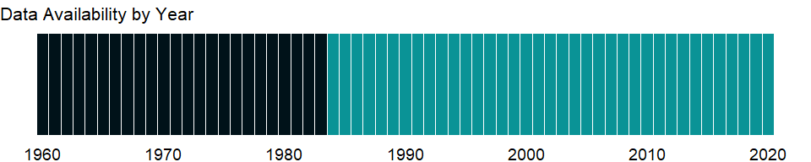

### Which countries have data?

The figure below shows the percentage of countries in each income group with a value since 2010 for that indicator.

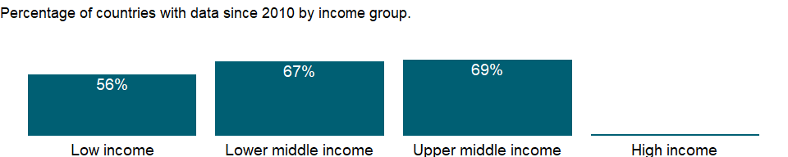

### Why is it relevant?

Investment in infrastructure projects with private participation has made important contributions to easing fiscal constraints, improving the efficiency of infrastructure services, and extending delivery to poor people. Developing countries have been in the forefront, pioneering better approaches to infrastructure services and reaping the benefits of greater competition and customer focus. Entrepreneurship is essential to the dynamism of the modern market economy, and a greater entry density of new businesses can foster competition and economic growth.

Private sector development and investment - tapping private sector initiative and investment for socially useful purposes - are critical for poverty reduction. In parallel with public sector efforts, private investment, especially in competitive markets, has tremendous potential to contribute to growth. Private markets are the engine of productivity growth, creating productive jobs and higher incomes. And with government playing a complementary role of regulation, funding, and service provision, private initiative and investment can help provide the basic services and conditions that empower poor people - by improving health, education, and infrastructure.

### What is the data source?

World Bank, Private Participation in Infrastructure Project Database (<http://ppi.worldbank.org>).

### What is the methodology?

The data are from the World Bank’s Private Participation in Infrastructure (PPI) Project database, which tracks infrastructure projects with private participation in developing countries. It provides information on more than 5,000 infrastructure projects in 139 developing economies from 1984. The database contains more than 30 fields per project record, including country, financial closure year, infrastructure services provided, type of private participation, investment, technology, capacity, project location, contract duration, private sponsors, bidding process, and development bank support.

The database is a joint product of the World Bank’s Finance, Economics, and Urban Development Department and the Public-Private Infrastructure Advisory Facility. Geographic and income aggregates are calculated by the World Bank’s Development Data Group.

Data are in current U.S. dollars.

### How is it aggregated?

Sum

### What are the limitations?

The data on investment in infrastructure projects with private participation refer to all investment (public and private) in projects in which a private company assumes operating risk during the operating period or development and operating risk during the contract period. Investment refers to commitments not disbursements. Foreign state-owned companies are considered private entities for the purposes of this measure.

Investment commitments are the sum of investments in physical assets and payments to the government. Investments in physical assets are resources the project company commits to invest during the contract period in new facilities or in expansion and modernization of existing facilities. Payments to the government are the resources the project company spends on acquiring government assets such as state-owned enterprises, rights to provide services in a specific area, or use of specific radio spectrums. Data on the projects are compiled from publicly available information. The database aims to be as comprehensive as possible, but some projects - particularly those involving local and small-scale operators - may be omitted because they are not publicly reported.

### What else should I know?

NA

### 1.35.2 Investment in ICT with private participation (current US$)

### What is the indicator?

Investment in ICT projects with private participation refers to commitments to projects in ICT backbone infrastructure (including land based and submarine cables) that have reached financial closure and directly or indirectly serve the public. Movable assets and small projects are excluded. The types of projects included are operations and management contracts, operations and management contracts with major capital expenditure, greenfield projects (in which a private entity or a public-private joint venture builds and operates a new facility), and divestitures. Investment commitments are the sum of investments in facilities and investments in government assets. Investments in facilities are the resources the project company commits to invest during the contract period either in new facilities or in expansion and modernization of existing facilities. Investments in government assets are the resources the project company spends on acquiring government assets such as state-owned enterprises, rights to provide services in a specific area, or the use of specific radio spectrums. Data is presented based on investment year. Data are in current U.S. dollars and available 2015 onwards only.

Topic: Private Sector & Trade: Private infrastructure investment

Series ID: IE.PPI.ICTI.CD

Copyright: CC BY-4.0 , <https://datacatalog.worldbank.org/public-licenses#cc-by>

First year with any data: 1985

Last year with any data: 2020

### What years are data available?

The figure below shows years in which data is available for at least one country. Dates shaded in black have no data, while dates shaded in green have data for at least one country

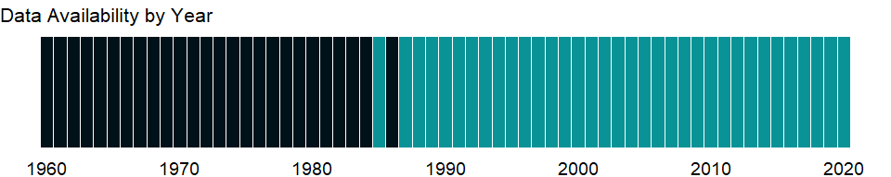

### Which countries have data?

The figure below shows the percentage of countries in each income group with a value since 2010 for that indicator.

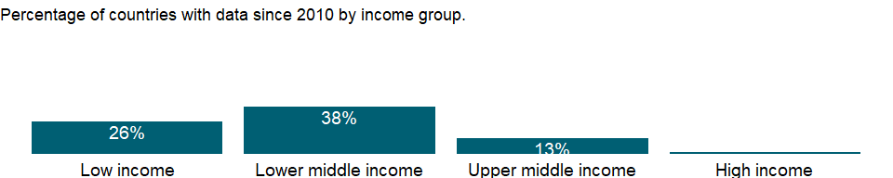

### Why is it relevant?

Investment in infrastructure projects with private participation has made important contributions to improving the efficiency of infrastructure services, and extending delivery to poor people. Developing countries have been in the forefront, looking for better approaches to infrastructure services and reaping the benefits of greater competition and customer focus. Entrepreneurship is essential to the dynamism of the modern market economy, and a greater entry density of new businesses can foster competition and economic growth.

Private sector development and investment - tapping private sector initiative and investment for socially useful purposes - are critical for poverty reduction. In parallel with public sector efforts, private investment, especially in competitive markets, has tremendous potential to contribute to growth. Private markets are the engine of productivity growth, creating productive jobs and higher incomes. And with government playing a complementary role of regulation, funding, and service provision, private initiative and investment can help provide the basic services and conditions that empower poor people - by improving health, education, and infrastructure.

### What is the data source?

World Bank, Private Participation in Infrastructure Project Database (<http://ppi.worldbank.org>).

### What is the methodology?

The data are from the World Bank’s Private Participation in Infrastructure (PPI) Project database, which tracks infrastructure projects with private participation in developing countries. It provides information on more than 6,400 infrastructure projects in 139 developing economies from 1984. The database contains more than 30 fields per project record, including country, financial closure year, infrastructure services provided, type of private participation, investment, technology, capacity, project location, contract duration, private sponsors, bidding process, and development bank support.

The database is a joint product of the World Bank’s Finance, Economics, and Urban Development Department and the Public-Private Infrastructure Advisory Facility. Geographic and income aggregates are calculated by the World Bank’s Development Data Group.

Data are in current U.S. dollars.

### How is it aggregated?

Sum

### What are the limitations?

The data on investment in infrastructure projects with private participation refer to all investment commitments (public and private) in projects in which a private company assumes operating risk during the operating period or development and operating risk during the contract period. Investment refers to commitments not disbursements. Foreign state-owned companies are considered private entities for the purposes of this measure.

Movable assets and small projects are excluded. The types of projects included are operations and management contracts, operations and management contracts with major capital expenditure, greenfield projects (in which a private entity or a public-private joint venture builds and operates a new facility), and divestitures. Investment commitments are the sum of investments in facilities and investments in government assets. Investments in facilities are the resources the project company commits to invest during the contract period either in new facilities or in expansion and modernization of existing facilities. Investments in government assets are the resources the project company spends on acquiring government assets such as state-owned enterprises, rights to provide services in a specific area, or the use of specific radio spectrums. Data on the projects are compiled from publicly available information. The database aims to be as comprehensive as possible, but some projects - particularly those involving local and small-scale operators - may be omitted because they are not publicly reported. Data are available 2015 onwards only for ICT.

### What else should I know?

NA

### 1.35.3 Investment in transport with private participation (current US$)

### What is the indicator?

Investment in transport projects with private participation refers to commitments to infrastructure projects in transport that have reached financial closure and directly or indirectly serve the public. Movable assets and small projects are excluded. The types of projects included are management and lease contracts, operations and management contracts with major capital expenditure, greenfield projects (in which a private entity or a public-private joint venture builds and operates a new facility), and divestitures. Investment commitments are the sum of investments in facilities and investments in government assets. Investments in facilities are the resources the project company commits to invest during the contract period either in new facilities or in expansion and modernization of existing facilities. Investments in government assets are the resources the project company spends on acquiring government assets such as state-owned enterprises, rights to provide services in a specific area, or the use of specific radio spectrums. Data is presented based on investment year. Data are in current U.S. dollars.

Topic: Private Sector & Trade: Private infrastructure investment

Series ID: IE.PPI.TRAN.CD

Copyright: CC BY-4.0 , <https://datacatalog.worldbank.org/public-licenses#cc-by>

First year with any data: 1984

Last year with any data: 2020

### What years are data available?

The figure below shows years in which data is available for at least one country. Dates shaded in black have no data, while dates shaded in green have data for at least one country

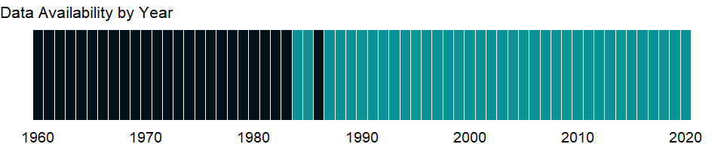

### Which countries have data?

The figure below shows the percentage of countries in each income group with a value since 2010 for that indicator.

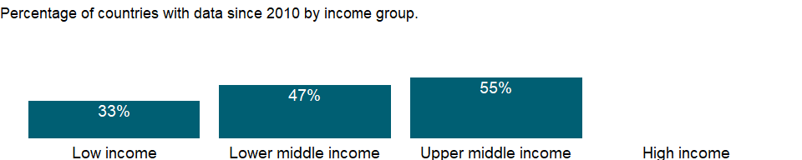

### Why is it relevant?

Investment in infrastructure projects with private participation has made important contributions to easing fiscal constraints, improving the efficiency of infrastructure services, and extending delivery to poor people. Developing countries have been in the forefront, pioneering better approaches to infrastructure services and reaping the benefits of greater competition and customer focus. Entrepreneurship is essential to the dynamism of the modern market economy, and a greater entry density of new businesses can foster competition and economic growth.

Private sector development and investment - tapping private sector initiative and investment for socially useful purposes - are critical for poverty reduction. In parallel with public sector efforts, private investment, especially in competitive markets, has tremendous potential to contribute to growth. Private markets are the engine of productivity growth, creating productive jobs and higher incomes. And with government playing a complementary role of regulation, funding, and service provision, private initiative and investment can help provide the basic services and conditions that empower poor people - by improving health, education, and infrastructure.

### What is the data source?

World Bank, Private Participation in Infrastructure Project Database (<http://ppi.worldbank.org>).

### What is the methodology?

The data are from the World Bank’s Private Participation in Infrastructure (PPI) Project database, which tracks infrastructure projects with private participation in developing countries. It provides information on more than 5,000 infrastructure projects in 139 developing economies from 1984. The database contains more than 30 fields per project record, including country, financial closure year, infrastructure services provided, type of private participation, investment, technology, capacity, project location, contract duration, private sponsors, bidding process, and development bank support.

The database is a joint product of the World Bank’s Finance, Economics, and Urban Development Department and the Public-Private Infrastructure Advisory Facility. Geographic and income aggregates are calculated by the World Bank’s Development Data Group.

Data are in current U.S. dollars.

### How is it aggregated?

Sum

### What are the limitations?

The data on investment in infrastructure projects with private participation refer to all investment (public and private) in projects in which a private company assumes operating risk during the operating period or development and operating risk during the contract period. Investment refers to commitments not disbursements. Foreign state-owned companies are considered private entities for the purposes of this measure.

Movable assets and small projects are excluded. The types of projects included are operations and management contracts, operations and management contracts with major capital expenditure, greenfield projects (in which a private entity or a public-private joint venture builds and operates a new facility), and divestitures. Investment commitments are the sum of investments in facilities and investments in government assets. Investments in facilities are the resources the project company commits to invest during the contract period either in new facilities or in expansion and modernization of existing facilities. Investments in government assets are the resources the project company spends on acquiring government assets such as state-owned enterprises, rights to provide services in a specific area, or the use of specific radio spectrums. Data on the projects are compiled from publicly available information. The database aims to be as comprehensive as possible, but some projects - particularly those involving local and small-scale operators - may be omitted because they are not publicly reported.

### What else should I know?

NA

### 1.35.4 Investment in water and sanitation with private participation (current US$)

### What is the indicator?

Investment in water and sanitation projects with private participation refers to commitments to infrastructure projects in water and sanitation that have reached financial closure and directly or indirectly serve the public. Movable assets, incinerators, standalone solid waste projects, and small projects are excluded. The types of projects included are management and lease contracts, operations and management contracts with major capital expenditure, greenfield projects (in which a private entity or a public-private joint venture builds and operates a new facility), and divestitures. Investment commitments are the sum of investments in facilities and investments in government assets. Investments in facilities are the resources the project company commits to invest during the contract period either in new facilities or in expansion and modernization of existing facilities. Investments in government assets are the resources the project company spends on acquiring government assets such as state-owned enterprises, rights to provide services in a specific area, or the use of specific radio spectrums. Data is presented based on investment year. Data are in current U.S. dollars.

Topic: Private Sector & Trade: Private infrastructure investment

Series ID: IE.PPI.WATR.CD

Copyright: CC BY-4.0 , <https://datacatalog.worldbank.org/public-licenses#cc-by>

First year with any data: 1987

Last year with any data: 2020

### What years are data available?

The figure below shows years in which data is available for at least one country. Dates shaded in black have no data, while dates shaded in green have data for at least one country

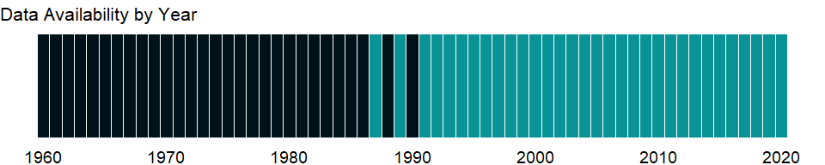

### Which countries have data?

The figure below shows the percentage of countries in each income group with a value since 2010 for that indicator.

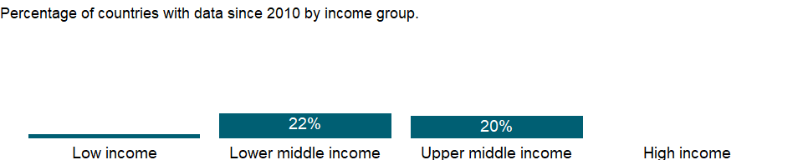

### Why is it relevant?

Investment in infrastructure projects with private participation has made important contributions to easing fiscal constraints, improving the efficiency of infrastructure services, and extending delivery to poor people. Developing countries have been in the forefront, pioneering better approaches to infrastructure services and reaping the benefits of greater competition and customer focus. Entrepreneurship is essential to the dynamism of the modern market economy, and a greater entry density of new businesses can foster competition and economic growth.

Private sector development and investment - tapping private sector initiative and investment for socially useful purposes - are critical for poverty reduction. In parallel with public sector efforts, private investment, especially in competitive markets, has tremendous potential to contribute to growth. Private markets are the engine of productivity growth, creating productive jobs and higher incomes. And with government playing a complementary role of regulation, funding, and service provision, private initiative and investment can help provide the basic services and conditions that empower poor people - by improving health, education, and infrastructure.

### What is the data source?

World Bank, Private Participation in Infrastructure Project Database (<http://ppi.worldbank.org>).

### What is the methodology?

The data are from the World Bank’s Private Participation in Infrastructure (PPI) Project database, which tracks infrastructure projects with private participation in developing countries. It provides information on more than 5,000 infrastructure projects in 139 developing economies from 1984. The database contains more than 30 fields per project record, including country, financial closure year, infrastructure services provided, type of private participation, investment, technology, capacity, project location, contract duration, private sponsors, bidding process, and development bank support.

The database is a joint product of the World Bank’s Finance, Economics, and Urban Development Department and the Public-Private Infrastructure Advisory Facility. Geographic and income aggregates are calculated by the World Bank’s Development Data Group.

Data are in current U.S. dollars.

### How is it aggregated?

Sum

### What are the limitations?

The data on investment in infrastructure projects with private participation refer to all investment (public and private) in projects in which a private company assumes operating risk during the operating period or development and operating risk during the contract period. Investment refers to commitments not disbursements. Foreign state-owned companies are considered private entities for the purposes of this measure.

Investment commitments are the sum of investments in physical assets and payments to the government. Investments in physical assets are resources the project company commits to invest during the contract period in new facilities or in expansion and modernization of existing facilities. Payments to the government are the resources the project company spends on acquiring government assets such as state-owned enterprises, rights to provide services in a specific area, or use of specific radio spectrums. Data on the projects are compiled from publicly available information. The database aims to be as comprehensive as possible, but some projects - particularly those involving local and small-scale operators - may be omitted because they are not publicly reported.

### What else should I know?

NA

### 1.35.5 Public private partnerships investment in energy (current US$)

### What is the indicator?

Public Private Partnerships in energy (current US$) refers to commitments to infrastructure projects in energy (electricity and natural gas transmission and distribution) that have reached financial closure and directly or indirectly serve the public. Movable assets and small projects such as windmills are excluded. The types of projects included are management and lease contracts, operations and management contracts with major capital expenditure, and greenfield projects (in which a private entity or a public-private joint venture builds and operates a new facility). It excludes divestitures and merchant projects. Investment commitments are the sum of investments in facilities and investments in government assets. Investments in facilities are the resources the project company commits to invest during the contract period either in new facilities or in expansion and modernization of existing facilities. Investments in government assets are the resources the project company spends on acquiring government assets such as state-owned enterprises, rights to provide services in a specific area, or the use of specific radio spectrums. Data is presented based on investment year. Data are in current U.S. dollars.

Topic: Private Sector & Trade: Private infrastructure investment

Series ID: IE.PPN.ENGY.CD

Copyright: CC BY-4.0 , <https://datacatalog.worldbank.org/public-licenses#cc-by>

First year with any data: 1984

Last year with any data: 2020

### What years are data available?

The figure below shows years in which data is available for at least one country. Dates shaded in black have no data, while dates shaded in green have data for at least one country



### Which countries have data?

The figure below shows the percentage of countries in each income group with a value since 2010 for that indicator.

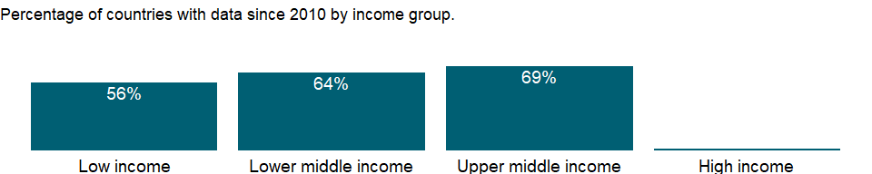

### Why is it relevant?

Investment in infrastructure projects with private participation has made important contributions to improving the efficiency of infrastructure services, and extending delivery to poor people. Developing countries have been in the forefront, looking for better approaches to infrastructure services and reaping the benefits of greater competition and customer focus. Entrepreneurship is essential to the dynamism of the modern market economy, and a greater entry density of new businesses can foster competition and economic growth.

Private sector development and investment - tapping private sector initiative and investment for socially useful purposes - are critical for poverty reduction. In parallel with public sector efforts, private investment, especially in competitive markets, has tremendous potential to contribute to growth. Private markets are the engine of productivity growth, creating productive jobs and higher incomes. And with government playing a complementary role of regulation, funding, and service provision, private initiative and investment can help provide the basic services and conditions that empower poor people - by improving health, education, and infrastructure.

### What is the data source?

World Bank, Private Participation in Infrastructure Project Database (<http://ppi.worldbank.org>).

### What is the methodology?

The data are from the World Bank’s Private Participation in Infrastructure (PPI) Project database, which tracks infrastructure projects with private participation in developing countries. It provides information on more than 6,400 infrastructure projects in 139 developing economies from 1984. The database contains more than 30 fields per project record, including country, financial closure year, infrastructure services provided, type of private participation, investment, technology, capacity, project location, contract duration, private sponsors, bidding process, and development bank support.

The database is a joint product of the World Bank’s Finance, Economics, and Urban Development Department and the Public-Private Infrastructure Advisory Facility. Geographic and income aggregates are calculated by the World Bank’s Development Data Group.

Data are in current U.S. dollars.

### How is it aggregated?

Sum

### What are the limitations?

The data on investment in infrastructure projects with private participation refer to all investment commitments (public and private) in projects in which a private company assumes operating risk during the operating period or development and operating risk during the contract period. Investment refers to commitments not disbursements. Foreign state-owned companies are considered private entities for the purposes of this measure.

Movable assets and small projects are excluded. The types of projects included are operations and management contracts, operations and management contracts with major capital expenditure, greenfield projects (in which a private entity or a public-private joint venture builds and operates a new facility), and divestitures. Investment commitments are the sum of investments in facilities and investments in government assets. Investments in facilities are the resources the project company commits to invest during the contract period either in new facilities or in expansion and modernization of existing facilities. Investments in government assets are the resources the project company spends on acquiring government assets such as state-owned enterprises, rights to provide services in a specific area, or the use of specific radio spectrums. Data on the projects are compiled from publicly available information. The database aims to be as comprehensive as possible, but some projects - particularly those involving local and small-scale operators - may be omitted because they are not publicly reported.

### What else should I know?

NA

### 1.35.6 Public private partnerships investment in ICT (current US$)

### What is the indicator?

Public Private Partnerships in ICT (current US$) refers to commitments to projects in ICT backbone infrastructure (including land based and submarine cables) that have reached financial closure and directly or indirectly serve the public. Movable assets and small projects are excluded. The types of projects included are management and lease contracts, operations and management contracts with major capital expenditure and greenfield projects (in which a private entity or a public-private joint venture builds and operates a new facility). It excludes divestitures and merchant projects. Investment commitments are the sum of investments in facilities and investments in government assets. Investments in facilities are the resources the project company commits to invest during the contract period either in new facilities or in expansion and modernization of existing facilities. Investments in government assets are the resources the project company spends on acquiring government assets such as state-owned enterprises, rights to provide services in a specific area, or the use of specific radio spectrums. Data is presented based on investment year. Data are in current U.S. dollars and available 2015 onwards only.

Topic: Private Sector & Trade: Private infrastructure investment

Series ID: IE.PPN.ICTI.CD

Copyright: CC BY-4.0 , <https://datacatalog.worldbank.org/public-licenses#cc-by>

First year with any data: 1985

Last year with any data: 2019

### What years are data available?

The figure below shows years in which data is available for at least one country. Dates shaded in black have no data, while dates shaded in green have data for at least one country

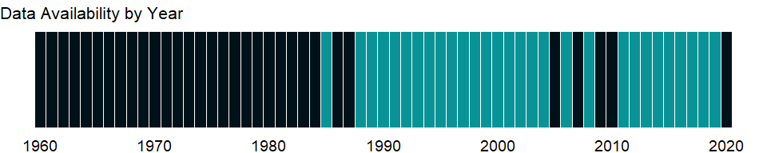

### Which countries have data?

The figure below shows the percentage of countries in each income group with a value since 2010 for that indicator.

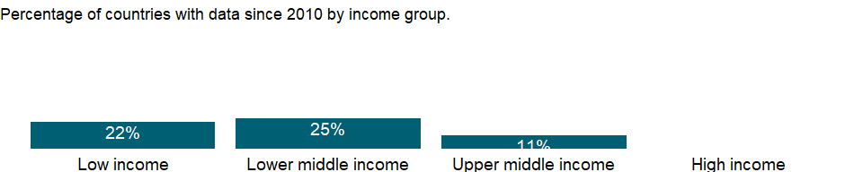

### Why is it relevant?

Investment in infrastructure projects with private participation has made important contributions to improving the efficiency of infrastructure services, and extending delivery to poor people. Developing countries have been in the forefront, looking for better approaches to infrastructure services and reaping the benefits of greater competition and customer focus. Entrepreneurship is essential to the dynamism of the modern market economy, and a greater entry density of new businesses can foster competition and economic growth.

Private sector development and investment - tapping private sector initiative and investment for socially useful purposes - are critical for poverty reduction. In parallel with public sector efforts, private investment, especially in competitive markets, has tremendous potential to contribute to growth. Private markets are the engine of productivity growth, creating productive jobs and higher incomes. And with government playing a complementary role of regulation, funding, and service provision, private initiative and investment can help provide the basic services and conditions that empower poor people - by improving health, education, and infrastructure.

### What is the data source?

World Bank, Private Participation in Infrastructure Project Database (<http://ppi.worldbank.org>).

### What is the methodology?

The data are from the World Bank’s Private Participation in Infrastructure (PPI) Project database, which tracks infrastructure projects with private participation in developing countries. It provides information on more than 6,400 infrastructure projects in 139 developing economies from 1984. The database contains more than 30 fields per project record, including country, financial closure year, infrastructure services provided, type of private participation, investment, technology, capacity, project location, contract duration, private sponsors, bidding process, and development bank support.

The database is a joint product of the World Bank’s Finance, Economics, and Urban Development Department and the Public-Private Infrastructure Advisory Facility. Geographic and income aggregates are calculated by the World Bank’s Development Data Group.

Data are in current U.S. dollars.

### How is it aggregated?

Sum

### What are the limitations?

The data on investment in infrastructure projects with private participation refer to all investment commitments (public and private) in projects in which a private company assumes operating risk during the operating period or development and operating risk during the contract period. Investment refers to commitments not disbursements. Foreign state-owned companies are considered private entities for the purposes of this measure.

Movable assets and small projects are excluded. The types of projects included are operations and management contracts, operations and management contracts with major capital expenditure, greenfield projects (in which a private entity or a public-private joint venture builds and operates a new facility), and divestitures. Investment commitments are the sum of investments in facilities and investments in government assets. Investments in facilities are the resources the project company commits to invest during the contract period either in new facilities or in expansion and modernization of existing facilities. Investments in government assets are the resources the project company spends on acquiring government assets such as state-owned enterprises, rights to provide services in a specific area, or the use of specific radio spectrums. Data on the projects are compiled from publicly available information. The database aims to be as comprehensive as possible, but some projects - particularly those involving local and small-scale operators - may be omitted because they are not publicly reported. Data are available 2015 onwards only for ICT.

### What else should I know?

NA

### 1.35.7 Public private partnerships investment in transport (current US$)

### What is the indicator?

Public Private Partnerships in transport (current US$) refers to commitments to infrastructure projects in transport that have reached financial closure and directly or indirectly serve the public. Movable assets and small projects are excluded. The types of projects included are management and lease contracts, operations and management contracts with major capital expenditure, and greenfield projects (in which a private entity or a public-private joint venture builds and operates a new facility). It excludes divestitures and merchant projects. Investment commitments are the sum of investments in facilities and investments in government assets. Investments in facilities are the resources the project company commits to invest during the contract period either in new facilities or in expansion and modernization of existing facilities. Investments in government assets are the resources the project company spends on acquiring government assets such as state-owned enterprises, rights to provide services in a specific area, or the use of specific radio spectrums. Data is presented based on investment year. Data are in current U.S. dollars.

Topic: Private Sector & Trade: Private infrastructure investment

Series ID: IE.PPN.TRAN.CD

Copyright: CC BY-4.0 , <https://datacatalog.worldbank.org/public-licenses#cc-by>

First year with any data: 1984

Last year with any data: 2020

### What years are data available?

The figure below shows years in which data is available for at least one country. Dates shaded in black have no data, while dates shaded in green have data for at least one country



### Which countries have data?

The figure below shows the percentage of countries in each income group with a value since 2010 for that indicator.



### Why is it relevant?

Investment in infrastructure projects with private participation has made important contributions to improving the efficiency of infrastructure services, and extending delivery to poor people. Developing countries have been in the forefront, looking for better approaches to infrastructure services and reaping the benefits of greater competition and customer focus. Entrepreneurship is essential to the dynamism of the modern market economy, and a greater entry density of new businesses can foster competition and economic growth.

Private sector development and investment - tapping private sector initiative and investment for socially useful purposes - are critical for poverty reduction. In parallel with public sector efforts, private investment, especially in competitive markets, has tremendous potential to contribute to growth. Private markets are the engine of productivity growth, creating productive jobs and higher incomes. And with government playing a complementary role of regulation, funding, and service provision, private initiative and investment can help provide the basic services and conditions that empower poor people - by improving health, education, and infrastructure.

### What is the data source?

World Bank, Private Participation in Infrastructure Project Database (<http://ppi.worldbank.org>).

### What is the methodology?

The data are from the World Bank’s Private Participation in Infrastructure (PPI) Project database, which tracks infrastructure projects with private participation in developing countries. It provides information on more than 6,400 infrastructure projects in 139 developing economies from 1984. The database contains more than 30 fields per project record, including country, financial closure year, infrastructure services provided, type of private participation, investment, technology, capacity, project location, contract duration, private sponsors, bidding process, and development bank support.

The database is a joint product of the World Bank’s Finance, Economics, and Urban Development Department and the Public-Private Infrastructure Advisory Facility. Geographic and income aggregates are calculated by the World Bank’s Development Data Group.

Data are in current U.S. dollars.

### How is it aggregated?

Sum

### What are the limitations?

The data on investment in infrastructure projects with private participation refer to all investment commitments (public and private) in projects in which a private company assumes operating risk during the operating period or development and operating risk during the contract period. Investment refers to commitments not disbursements. Foreign state-owned companies are considered private entities for the purposes of this measure.

Movable assets and small projects are excluded. The types of projects included are operations and management contracts, operations and management contracts with major capital expenditure, greenfield projects (in which a private entity or a public-private joint venture builds and operates a new facility), and divestitures. Investment commitments are the sum of investments in facilities and investments in government assets. Investments in facilities are the resources the project company commits to invest during the contract period either in new facilities or in expansion and modernization of existing facilities. Investments in government assets are the resources the project company spends on acquiring government assets such as state-owned enterprises, rights to provide services in a specific area, or the use of specific radio spectrums. Data on the projects are compiled from publicly available information. The database aims to be as comprehensive as possible, but some projects - particularly those involving local and small-scale operators - may be omitted because they are not publicly reported.

### What else should I know?

NA

### 1.35.8 Public private partnerships investment in water and sanitation (current US$)

### What is the indicator?

Public Private Partnerships in water and sanitation (current US$) refers to commitments to infrastructure projects in water and sanitation that have reached financial closure and directly or indirectly serve the public. Movable assets, incinerators, standalone solid waste projects, and small projects are excluded. The types of projects included are management and lease contracts, operations and management contracts with major capital expenditure, and greenfield projects (in which a private entity or a public-private joint venture builds and operates a new facility). It excludes divestitures and merchant projects. Investment commitments are the sum of investments in facilities and investments in government assets. Investments in facilities are the resources the project company commits to invest during the contract period either in new facilities or in expansion and modernization of existing facilities. Investments in government assets are the resources the project company spends on acquiring government assets such as state-owned enterprises, rights to provide services in a specific area, or the use of specific radio spectrums. Data is presented based on investment year. Data are in current U.S. dollars.

Topic: Private Sector & Trade: Private infrastructure investment

Series ID: IE.PPN.WATR.CD

Copyright: CC BY-4.0 , <https://datacatalog.worldbank.org/public-licenses#cc-by>

First year with any data: 1987

Last year with any data: 2020

### What years are data available?

The figure below shows years in which data is available for at least one country. Dates shaded in black have no data, while dates shaded in green have data for at least one country



### Which countries have data?

The figure below shows the percentage of countries in each income group with a value since 2010 for that indicator.

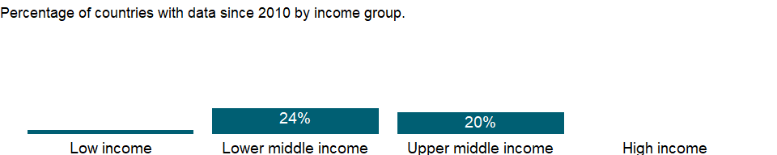

### Why is it relevant?

Investment in infrastructure projects with private participation has made important contributions to improving the efficiency of infrastructure services, and extending delivery to poor people. Developing countries have been in the forefront, looking for better approaches to infrastructure services and reaping the benefits of greater competition and customer focus. Entrepreneurship is essential to the dynamism of the modern market economy, and a greater entry density of new businesses can foster competition and economic growth.

Private sector development and investment - tapping private sector initiative and investment for socially useful purposes - are critical for poverty reduction. In parallel with public sector efforts, private investment, especially in competitive markets, has tremendous potential to contribute to growth. Private markets are the engine of productivity growth, creating productive jobs and higher incomes. And with government playing a complementary role of regulation, funding, and service provision, private initiative and investment can help provide the basic services and conditions that empower poor people - by improving health, education, and infrastructure.

### What is the data source?

World Bank, Private Participation in Infrastructure Project Database (<http://ppi.worldbank.org>).

### What is the methodology?

The data are from the World Bank’s Private Participation in Infrastructure (PPI) Project database, which tracks infrastructure projects with private participation in developing countries. It provides information on more than 6,400 infrastructure projects in 139 developing economies from 1984. The database contains more than 30 fields per project record, including country, financial closure year, infrastructure services provided, type of private participation, investment, technology, capacity, project location, contract duration, private sponsors, bidding process, and development bank support.

The database is a joint product of the World Bank’s Finance, Economics, and Urban Development Department and the Public-Private Infrastructure Advisory Facility. Geographic and income aggregates are calculated by the World Bank’s Development Data Group.

Data are in current U.S. dollars.

### How is it aggregated?

Sum

### What are the limitations?

The data on investment in infrastructure projects with private participation refer to all investment commitments (public and private) in projects in which a private company assumes operating risk during the operating period or development and operating risk during the contract period. Investment refers to commitments not disbursements. Foreign state-owned companies are considered private entities for the purposes of this measure.

Movable assets and small projects are excluded. The types of projects included are operations and management contracts, operations and management contracts with major capital expenditure, greenfield projects (in which a private entity or a public-private joint venture builds and operates a new facility), and divestitures. Investment commitments are the sum of investments in facilities and investments in government assets. Investments in facilities are the resources the project company commits to invest during the contract period either in new facilities or in expansion and modernization of existing facilities. Investments in government assets are the resources the project company spends on acquiring government assets such as state-owned enterprises, rights to provide services in a specific area, or the use of specific radio spectrums. Data on the projects are compiled from publicly available information. The database aims to be as comprehensive as possible, but some projects - particularly those involving local and small-scale operators - may be omitted because they are not publicly reported.

### What else should I know?

NA

## 1.36 Public Sector: Defense & arms trade

### 1.36.1 Arms imports (SIPRI trend indicator values)

### What is the indicator?

Arms transfers cover the supply of military weapons through sales, aid, gifts, and those made through manufacturing licenses. Data cover major conventional weapons such as aircraft, armored vehicles, artillery, radar systems, missiles, and ships designed for military use. Excluded are transfers of other military equipment such as small arms and light weapons, trucks, small artillery, ammunition, support equipment, technology transfers, and other services. Figures are SIPRI Trend Indicator Values (TIVs) expressed in US$ m. A ‘0’ indicates that the value of deliveries is less than US$0.5m.

Topic: Public Sector: Defense & arms trade

Series ID: MS.MIL.MPRT.KD

Copyright: CC BY-4.0 , <https://datacatalog.worldbank.org/public-licenses#cc-by>

First year with any data: 1960

Last year with any data: 2020

### What years are data available?

The figure below shows years in which data is available for at least one country. Dates shaded in black have no data, while dates shaded in green have data for at least one country



### Which countries have data?

The figure below shows the percentage of countries in each income group with a value since 2010 for that indicator.

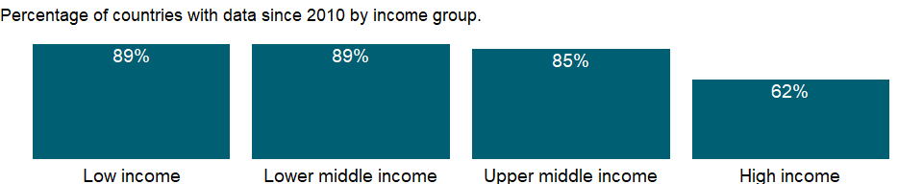

### Why is it relevant?

Although national defense is an important function of government and security from external threats that contributes to economic development, high military expenditures for defense or civil conflicts burden the economy and may impede growth. Data on military expenditures are a rough indicator of the portion of national resources used for military activities and of the burden on the economy.

Comparisons of military spending among countries should take into account the many factors that influence perceptions of vulnerability and risk, including historical and cultural traditions, the length of borders that need defending, the quality of relations with neighbors, and the role of the armed forces in the body politic.

### What is the data source?

Stockholm International Peace Research Institute (SIPRI), Arms Transfers Programme (<http://portal.sipri.org/publications/pages/transfer/splash>).

### What is the methodology?

Stockholm International Peace Research Institute (SIPRI)’s Arms Transfers Program collects data on arms transfers from open sources. Since publicly available information is inadequate for tracking all weapons and other military equipment, SIPRI covers only what it terms major conventional weapons. Data cover the supply of weapons through sales, aid, gifts, and manufacturing licenses; therefore the term arms transfers rather than arms trade is used. SIPRI data also cover weapons supplied to or from rebel forces in an armed conflict as well as arms deliveries for which neither the supplier nor the recipient can be identified with acceptable certainty; these data are available in SIPRI’s database.

Data cover major conventional weapons such as aircraft, armored vehicles, artillery, radar systems and other sensors, missiles, and ships designed for military use as well as some major components such as turrets for armored vehicles and engines. Excluded are other military equipment such as most small arms and light weapons, trucks, small artillery, ammunition, support equipment, technology transfers, and other services.

### How is it aggregated?

Sum

### What are the limitations?

SIPRI calculates the volume of transfers to, from and between all parties using the TIV and the number of weapon systems or subsystems delivered in a given year. This data is intended to provide a common unit to allow the measurement if trends in the flow of arms to particular countries and regions over time. Therefore, the main priority is to ensure that the TIV system remains consistent over time, and that any changes introduced are backdated.

SIPRI TIV figures do not represent sales prices for arms transfers. They should therefore not be directly compared with gross domestic product (GDP), military expenditure, sales values or the financial value of export licences in an attempt to measure the economic burden of arms imports or the economic benefits of exports. They are best used as the raw data for calculating trends in international arms transfers over periods of time, global percentages for suppliers and recipients, and percentages for the volume of transfers to or from particular states.

### What else should I know?

Data for some countries are based on partial or uncertain data or rough estimates.

### 1.36.2 Armed forces personnel, total

### What is the indicator?

Armed forces personnel are active duty military personnel, including paramilitary forces if the training, organization, equipment, and control suggest they may be used to support or replace regular military forces.

Topic: Public Sector: Defense & arms trade

Series ID: MS.MIL.TOTL.P1

Copyright: CC BY-4.0 , <https://datacatalog.worldbank.org/public-licenses#cc-by>

First year with any data: 1985

Last year with any data: 2018

### What years are data available?

The figure below shows years in which data is available for at least one country. Dates shaded in black have no data, while dates shaded in green have data for at least one country

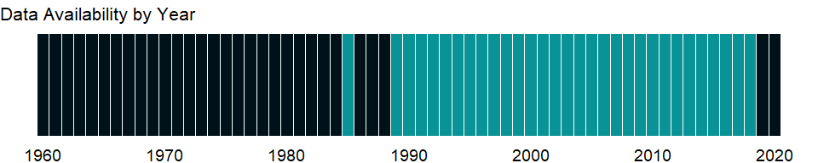

### Which countries have data?

The figure below shows the percentage of countries in each income group with a value since 2010 for that indicator.

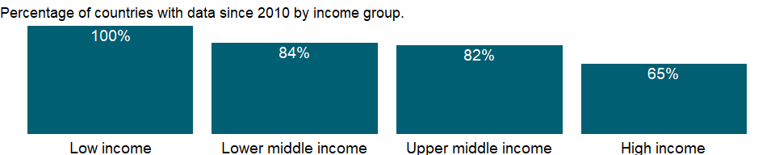

### Why is it relevant?

Although national defense is an important function of government and security from external threats that contributes to economic development, high military expenditures for defense or civil conflicts burden the economy and may impede growth. Data on military expenditures are a rough indicator of the portion of national resources used for military activities and of the burden on the economy.

Comparisons of military spending among countries should take into account the many factors that influence perceptions of vulnerability and risk, including historical and cultural traditions, the length of borders that need defending, the quality of relations with neighbors, and the role of the armed forces in the body politic.

### What is the data source?

International Institute for Strategic Studies, The Military Balance.

### What is the methodology?

Military data on manpower represent quantitative assessment of the personnel strengths of the world’s armed forces. The IISS collects the data from a wide variety of sources. The numbers are based on the most accurate data available to, or on the best estimate that can be made by the International Institute for Strategic Studies (IISS) at the time of its annual publication. The current WDI indicator includes active armed forces and active paramilitary (but not reservists). Armed forces personnel comprise all servicemen and women on full-time duty, including conscripts and long-term assignments from the Reserves (“Reserve” describes formations and units not fully manned or operational in peacetime, but which can be mobilized by recalling reservists in an emergency). The indicator includes paramilitary forces. The source of the data (IISS) reports armed forces and paramilitary forces separately, however these figures are added for the purpose of computing this series. Home Guard units are counted as paramilitary.

### How is it aggregated?

Sum

### What are the limitations?

Data excludes personnel not on active duty, therefore it underestimates the share of the labor force working for the defense establishment. The cooperation of governments of all countries listed in “The Military Balance” has been sought by IISS and, in many cases, received. However, some data in “The Military Balance” is estimated.

### What else should I know?

Data for some countries are based on partial or uncertain data or rough estimates.

### 1.36.3 Armed forces personnel (% of total labor force)

### What is the indicator?

Armed forces personnel are active duty military personnel, including paramilitary forces if the training, organization, equipment, and control suggest they may be used to support or replace regular military forces. Labor force comprises all people who meet the International Labour Organization’s definition of the economically active population.

Topic: Public Sector: Defense & arms trade

Series ID: MS.MIL.TOTL.TF.ZS

Copyright: CC BY-4.0 , <https://datacatalog.worldbank.org/public-licenses#cc-by>

First year with any data: 1990

Last year with any data: 2018

### What years are data available?

The figure below shows years in which data is available for at least one country. Dates shaded in black have no data, while dates shaded in green have data for at least one country



### Which countries have data?

The figure below shows the percentage of countries in each income group with a value since 2010 for that indicator.

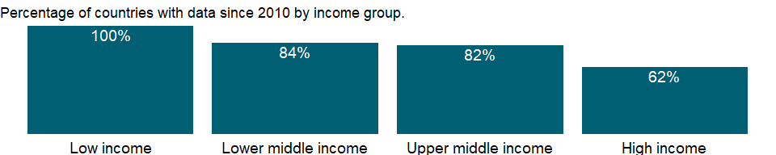

### Why is it relevant?

Although national defense is an important function of government and security from external threats that contributes to economic development, high military expenditures for defense or civil conflicts burden the economy and may impede growth. Data on military expenditures are a rough indicator of the portion of national resources used for military activities and of the burden on the economy.

Comparisons of military spending among countries should take into account the many factors that influence perceptions of vulnerability and risk, including historical and cultural traditions, the length of borders that need defending, the quality of relations with neighbors, and the role of the armed forces in the body politic.

### What is the data source?

International Institute for Strategic Studies, The Military Balance.

### What is the methodology?

Military data on manpower represent quantitative assessment of the personnel strengths of the world’s armed forces. The numbers are based on the most accurate data available to, or, on the best estimate that can be made by the International Institute for Strategic Studies (IISS) at the time of its annual publication. The IISS collects the data from national governments.

Armed forces personnel comprise all servicemen and women on full-time duty (including conscripts and long-term assignments from the Reserves). Reserve describes formations and units not fully manned or operational in peacetime, but which can be mobilized by recalling reservists in an emergency. IISS estimates of effective reservist strengths on the numbers available within five years of completing full-time service, unless there is good evidence that obligations are enforced for longer. Although paramilitary forces whose training, organization, equipment and control suggest they may be used to support or replace regular military forces, they are not included in the armed forces personnel. Home Guard units are counted as paramilitary.

Data are shown as percentage of total labor force. According to International Labour Organization (ILO armed forces occupations include all jobs held by members of the armed forces. Members of the armed forces are those personnel who are currently serving in the armed forces, including auxiliary services, whether on a voluntary or compulsory basis, and who are not free to accept civilian employment and are subject to military discipline. Included are regular members of the army, navy, air force and other military services, as well as conscripts enrolled for military training or other service for a specified period. Excluded are persons in civilian employment of government establishments concerned with defense issues; police (other than military police); customs inspectors and members of border or other armed civilian services; persons who have been temporarily withdrawn from civilian life for a short period of military training or retraining, according to national requirements, and members of military reserves not currently on active service.

### How is it aggregated?

Weighted Average

### What are the limitations?

Data exclude personnel not on active duty, therefore they underestimate the share of the labor force working for the defense establishment. Governments rarely report the size of their armed forces, so such data typically come from intelligence sources. Unless otherwise indicated, reserves includes all reservists committed to rejoining the armed forces in an emergency, except when national reserve service obligations following conscription last almost a lifetime.

### What else should I know?

Data for some countries are based on partial or uncertain data or rough estimates.

### 1.36.4 Military expenditure (current USD)

### What is the indicator?

Military expenditures data from SIPRI are derived from the NATO definition, which includes all current and capital expenditures on the armed forces, including peacekeeping forces; defense ministries and other government agencies engaged in defense projects; paramilitary forces, if these are judged to be trained and equipped for military operations; and military space activities. Such expenditures include military and civil personnel, including retirement pensions of military personnel and social services for personnel; operation and maintenance; procurement; military research and development; and military aid (in the military expenditures of the donor country). Excluded are civil defense and current expenditures for previous military activities, such as for veterans’ benefits, demobilization, conversion, and destruction of weapons. This definition cannot be applied for all countries, however, since that would require much more detailed information than is available about what is included in military budgets and off-budget military expenditure items. (For example, military budgets might or might not cover civil defense, reserves and auxiliary forces, police and paramilitary forces, dual-purpose forces such as military and civilian police, military grants in kind, pensions for military personnel, and social security contributions paid by one part of government to another).

Topic: Public Sector: Defense & arms trade

Series ID: MS.MIL.XPND.CD

Copyright: Use and distribution of these data are subject to Stockholm International Peace Research Institute (SIPRI) terms and conditions. , <https://www.sipri.org/about/terms-and-conditions>

First year with any data: 1960

Last year with any data: 2020

### What years are data available?

The figure below shows years in which data is available for at least one country. Dates shaded in black have no data, while dates shaded in green have data for at least one country



### Which countries have data?

The figure below shows the percentage of countries in each income group with a value since 2010 for that indicator.

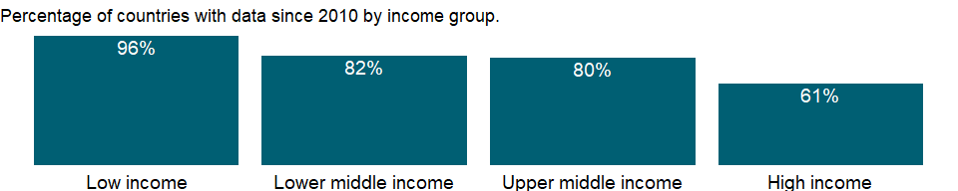

### Why is it relevant?

Although national defense is an important function of government and security from external threats that contributes to economic development, high military expenditures for defense or civil conflicts burden the economy and may impede growth. Data on military expenditures as a share of gross domestic product (GDP) are a rough indicator of the portion of national resources used for military activities and of the burden on the economy.

Data on military expenditures as a share of gross domestic product (GDP) are a rough indicator of the portion of national resources used for military activities and of the burden on the economy. As an “input” measure military expenditures are not directly related to the “output” of military activities, capabilities, or security. Comparisons of military spending among countries should take into account the many factors that influence perceptions of vulnerability and risk, including historical and cultural traditions, the length of borders that need defending, the quality of relations with neighbors, and the role of the armed forces in the body politic.

### What is the data source?

Stockholm International Peace Research Institute (SIPRI), Yearbook: Armaments, Disarmament and International Security.

### What is the methodology?

SIPRI military expenditure data includes military and civil personnel, including retirement pensions and social services for military personnel; operation and maintenance; procurement; military research and development; and military aid (in the military expenditures of the donor country). Excluded are civil defense and current expenditures for previous military activities, such as for veterans’ benefits, demobilization, and weapons conversion and destruction. This definition cannot be applied for all countries, however, since that would require more detailed information than is available about military budgets and off-budget military expenditures (for example, whether military budgets cover civil defense, reserves and auxiliary forces, police and paramilitary forces, and military pensions).

SIPRI data for the most recent years include two types of estimate which apply to all countries: (a) figures for the most recent years are for adopted budgets, budget estimates or revised estimates, and are revised, more often than not, in subsequent years; and (b) the deflator used for the latest year in the series is an estimate.

SIPRI’s primary source of military expenditure data is official data provided by national governments. These data are derived from budget documents, defense white papers, and other public documents from official government agencies, including government responses to questionnaires sent by SIPRI, the UNODA, or the Organization for Security and Co-operation in Europe. Secondary sources include international statistics, such as those of NATO and the IMF’s Government Finance Statistics Yearbook. Other secondary sources include country reports of the Economist Intelligence Unit, country reports by IMF staff, and specialist journals and newspapers.

The SIPRI military expenditure figures are presented on a calendar-year basis. The only exception is the USA, for which statistics report data on a fiscal-year basis. Calendar-year data are calculated on the assumption of an even rate of expenditure throughout the fiscal year.

### How is it aggregated?

Weighted Average

### What are the limitations?

Data on military expenditures are not compiled using standard definitions and are often incomplete and unreliable due to countries’ reluctance to disclose military information. Even in countries where the parliament vigilantly reviews budgets and spending, military expenditures and arms transfers rarely receive close scrutiny or full, public disclosure (see Ball 1984 and Happe and Wakeman-Linn 1994). However, the Stockholm International Peace Research Institute (SIPRI) has adopted a definition of military expenditure derived from the North Atlantic Treaty Organization’s (NATO) former definition (in use until 2002; see Definitions).

Data on military expenditures as a share of central government expenditures use data on central government expenditures from the International Monetary Fund (IMF). Therefore the data may differ from comparable data published by national governments.

In the many cases where SIPRI cannot make independent estimates, it uses the national data provided. Because of the differences in definitions and the difficulty in verifying the accuracy and completeness of data, data on military expenditures are not always comparable across countries. However, SIPRI puts a high priority on ensuring that the data series for each country is comparable over time.

### What else should I know?

Data for some countries are based on partial or uncertain data or rough estimates. For additional details please refer to the military expenditure database on the SIPRI website: <https://sipri.org/databases/milex>

### 1.36.5 Military expenditure (current LCU)

### What is the indicator?

Military expenditures data from SIPRI are derived from the NATO definition, which includes all current and capital expenditures on the armed forces, including peacekeeping forces; defense ministries and other government agencies engaged in defense projects; paramilitary forces, if these are judged to be trained and equipped for military operations; and military space activities. Such expenditures include military and civil personnel, including retirement pensions of military personnel and social services for personnel; operation and maintenance; procurement; military research and development; and military aid (in the military expenditures of the donor country). Excluded are civil defense and current expenditures for previous military activities, such as for veterans’ benefits, demobilization, conversion, and destruction of weapons. This definition cannot be applied for all countries, however, since that would require much more detailed information than is available about what is included in military budgets and off-budget military expenditure items. (For example, military budgets might or might not cover civil defense, reserves and auxiliary forces, police and paramilitary forces, dual-purpose forces such as military and civilian police, military grants in kind, pensions for military personnel, and social security contributions paid by one part of government to another.)

Topic: Public Sector: Defense & arms trade

Series ID: MS.MIL.XPND.CN

Copyright: Use and distribution of these data are subject to Stockholm International Peace Research Institute (SIPRI) terms and conditions. , <https://www.sipri.org/about/terms-and-conditions>

First year with any data: 1960

Last year with any data: 2019

### What years are data available?

The figure below shows years in which data is available for at least one country. Dates shaded in black have no data, while dates shaded in green have data for at least one country



### Which countries have data?

The figure below shows the percentage of countries in each income group with a value since 2010 for that indicator.

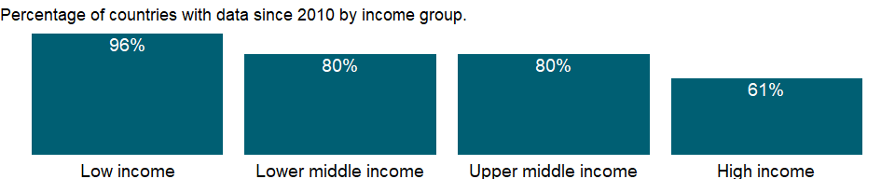

### Why is it relevant?

NA

### What is the data source?

Stockholm International Peace Research Institute (SIPRI), Yearbook: Armaments, Disarmament and International Security.

### What is the methodology?

NA

### How is it aggregated?

NA

### What are the limitations?

NA

### What else should I know?

Data for some countries are based on partial or uncertain data or rough estimates. For additional details please refer to the military expenditure database on the SIPRI website: <https://sipri.org/databases/milex>

### 1.36.6 Military expenditure (% of GDP)

### What is the indicator?

Military expenditures data from SIPRI are derived from the NATO definition, which includes all current and capital expenditures on the armed forces, including peacekeeping forces; defense ministries and other government agencies engaged in defense projects; paramilitary forces, if these are judged to be trained and equipped for military operations; and military space activities. Such expenditures include military and civil personnel, including retirement pensions of military personnel and social services for personnel; operation and maintenance; procurement; military research and development; and military aid (in the military expenditures of the donor country). Excluded are civil defense and current expenditures for previous military activities, such as for veterans’ benefits, demobilization, conversion, and destruction of weapons. This definition cannot be applied for all countries, however, since that would require much more detailed information than is available about what is included in military budgets and off-budget military expenditure items. (For example, military budgets might or might not cover civil defense, reserves and auxiliary forces, police and paramilitary forces, dual-purpose forces such as military and civilian police, military grants in kind, pensions for military personnel, and social security contributions paid by one part of government to another.)

Topic: Public Sector: Defense & arms trade

Series ID: MS.MIL.XPND.GD.ZS

Copyright: Use and distribution of these data are subject to Stockholm International Peace Research Institute (SIPRI) terms and conditions. , <https://www.sipri.org/about/terms-and-conditions>

First year with any data: 1960

Last year with any data: 2020

### What years are data available?

The figure below shows years in which data is available for at least one country. Dates shaded in black have no data, while dates shaded in green have data for at least one country



### Which countries have data?

The figure below shows the percentage of countries in each income group with a value since 2010 for that indicator.

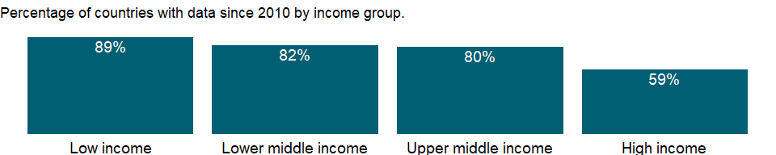

### Why is it relevant?

Although national defense is an important function of government and security from external threats that contributes to economic development, high military expenditures for defense or civil conflicts burden the economy and may impede growth. Data on military expenditures as a share of gross domestic product (GDP) are a rough indicator of the portion of national resources used for military activities and of the burden on the economy.

Data on military expenditures as a share of gross domestic product (GDP) are a rough indicator of the portion of national resources used for military activities and of the burden on the economy. As an “input” measure military expenditures are not directly related to the “output” of military activities, capabilities, or security. Comparisons of military spending among countries should take into account the many factors that influence perceptions of vulnerability and risk, including historical and cultural traditions, the length of borders that need defending, the quality of relations with neighbors, and the role of the armed forces in the body politic.

### What is the data source?

Stockholm International Peace Research Institute (SIPRI), Yearbook: Armaments, Disarmament and International Security.

### What is the methodology?

SIPRI military expenditure data includes military and civil personnel, including retirement pensions and social services for military personnel; operation and maintenance; procurement; military research and development; and military aid (in the military expenditures of the donor country). Excluded are civil defense and current expenditures for previous military activities, such as for veterans’ benefits, demobilization, and weapons conversion and destruction. This definition cannot be applied for all countries, however, since that would require more detailed information than is available about military budgets and off-budget military expenditures (for example, whether military budgets cover civil defense, reserves and auxiliary forces, police and paramilitary forces, and military pensions).

SIPRI data for the most recent years include two types of estimate which apply to all countries: (a) figures for the most recent years are for adopted budgets, budget estimates or revised estimates, and are revised, more often than not, in subsequent years; and (b) the deflator used for the latest year in the series is an estimate SIPRI’s primary source of military expenditure data is official data provided by national governments. These data are derived from budget documents, defense white papers, and other public documents from official government agencies, including government responses to questionnaires sent by SIPRI, the UNODA, or the Organization for Security and Co-operation in Europe. Secondary sources include international statistics, such as those of NATO and the IMF’s Government Finance Statistics Yearbook. Other secondary sources include country reports of the Economist Intelligence Unit, country reports by IMF staff, and specialist journals and newspapers.

The data on military expenditures as a share of GDP are SIPRI estimates. The SIPRI military expenditure figures are presented on a calendar-year basis. The only exception is the USA, for which statistics report data on a fiscal-year basis. Calendar-year data are calculated on the assumption of an even rate of expenditure throughout the fiscal year. The ratio of military expenditure to GDP is calculated in domestic currency at current prices and for calendar years.

The SIPRI military expenditure figures are presented on a calendar-year basis. The only exception is the USA, for which statistics report data on a fiscal-year basis. Calendar-year data are calculated on the assumption of an even rate of expenditure throughout the fiscal year.

### How is it aggregated?

Weighted average

### What are the limitations?

Data on military expenditures are not compiled using standard definitions and are often incomplete and unreliable due to countries’ reluctance to disclose military information. Even in countries where the parliament vigilantly reviews budgets and spending, military expenditures and arms transfers rarely receive close scrutiny or full, public disclosure (see Ball 1984 and Happe and Wakeman-Linn 1994). However, the Stockholm International Peace Research Institute (SIPRI) has adopted a definition of military expenditure derived from the North Atlantic Treaty Organization’s (NATO) former definition (in use until 2002; see Definitions).

In the many cases where SIPRI cannot make independent estimates, it uses the national data provided. Because of the differences in definitions and the difficulty in verifying the accuracy and completeness of data, data on military expenditures are not always comparable across countries. However, SIPRI puts a high priority on ensuring that the data series for each country is comparable over time.

### What else should I know?

Data for some countries are based on partial or uncertain data or rough estimates.

### 1.36.7 Military expenditure (% of general government expenditure)

### What is the indicator?

Military expenditures data from SIPRI are derived from the NATO definition, which includes all current and capital expenditures on the armed forces, including peacekeeping forces; defense ministries and other government agencies engaged in defense projects; paramilitary forces, if these are judged to be trained and equipped for military operations; and military space activities. Such expenditures include military and civil personnel, including retirement pensions of military personnel and social services for personnel; operation and maintenance; procurement; military research and development; and military aid (in the military expenditures of the donor country). Excluded are civil defense and current expenditures for previous military activities, such as for veterans’ benefits, demobilization, conversion, and destruction of weapons. This definition cannot be applied for all countries, however, since that would require much more detailed information than is available about what is included in military budgets and off-budget military expenditure items. (For example, military budgets might or might not cover civil defense, reserves and auxiliary forces, police and paramilitary forces, dual-purpose forces such as military and civilian police, military grants in kind, pensions for military personnel, and social security contributions paid by one part of government to another.)

Topic: Public Sector: Defense & arms trade

Series ID: MS.MIL.XPND.ZS

Copyright: Use and distribution of these data are subject to Stockholm International Peace Research Institute (SIPRI) terms and conditions. , <https://www.sipri.org/about/terms-and-conditions>

First year with any data: 1988

Last year with any data: 2020

### What years are data available?

The figure below shows years in which data is available for at least one country. Dates shaded in black have no data, while dates shaded in green have data for at least one country

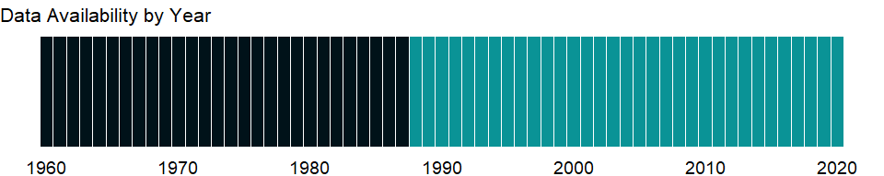

### Which countries have data?

The figure below shows the percentage of countries in each income group with a value since 2010 for that indicator.

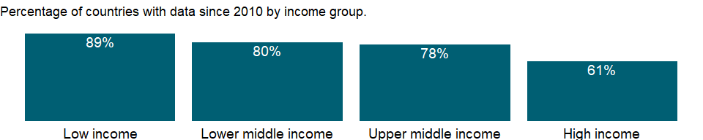

### Why is it relevant?

Although national defense is an important function of government and security from external threats that contributes to economic development, high military expenditures for defense or civil conflicts burden the economy and may impede growth. Data on military expenditures as a share of gross domestic product (GDP) are a rough indicator of the portion of national resources used for military activities and of the burden on the economy.

As an “input” measure military expenditures are not directly related to the “output” of military activities, capabilities, or security. Comparisons of military spending among countries should take into account the many factors that influence perceptions of vulnerability and risk, including historical and cultural traditions, the length of borders that need defending, the quality of relations with neighbors, and the role of the armed forces in the body politic.

Comparisons of military spending among countries should take into account the many factors that influence perceptions of vulnerability and risk, including historical and cultural traditions, the length of borders that need defending, the quality of relations with neighbors, and the role of the armed forces in the body politic.

### What is the data source?

Stockholm International Peace Research Institute (SIPRI), Yearbook: Armaments, Disarmament and International Security.

### What is the methodology?

SIPRI military expenditure data includes military and civil personnel, including retirement pensions and social services for military personnel; operation and maintenance; procurement; military research and development; and military aid (in the military expenditures of the donor country). Excluded are civil defense and current expenditures for previous military activities, such as for veterans’ benefits, demobilization, and weapons conversion and destruction. This definition cannot be applied for all countries, however, since that would require more detailed information than is available about military budgets and off-budget military expenditures (for example, whether military budgets cover civil defense, reserves and auxiliary forces, police and paramilitary forces, and military pensions).

SIPRI data for the most recent years include two types of estimate which apply to all countries: (a) figures for the most recent years are for adopted budgets, budget estimates or revised estimates, and are revised, more often than not, in subsequent years; and (b) the deflator used for the latest year in the series is an estimate.

SIPRI’s primary source of military expenditure data is official data provided by national governments. These data are derived from budget documents, defense white papers, and other public documents from official government agencies, including government responses to questionnaires sent by SIPRI, the UNODA, or the Organization for Security and Co-operation in Europe. Secondary sources include international statistics, such as those of NATO and the IMF’s Government Finance Statistics Yearbook. Other secondary sources include country reports of the Economist Intelligence Unit, country reports by IMF staff, and specialist journals and newspapers.

The SIPRI military expenditure figures are presented on a calendar-year basis. The only exception is the USA, for which statistics report data on a fiscal-year basis. Calendar-year data are calculated on the assumption of an even rate of expenditure throughout the fiscal year.

### How is it aggregated?

Weighted average

### What are the limitations?

Data on military expenditures are not compiled using standard definitions and are often incomplete and unreliable due to countries’ reluctance to disclose military information. Even in countries where the parliament vigilantly reviews budgets and spending, military expenditures and arms transfers rarely receive close scrutiny or full, public disclosure (see Ball 1984 and Happe and Wakeman-Linn 1994). However, the Stockholm International Peace Research Institute (SIPRI) has adopted a definition of military expenditure derived from the North Atlantic Treaty Organization’s (NATO) former definition (in use until 2002; see Definitions).

Data on military expenditures as a share of central government expenditures use data on central government expenditures from the International Monetary Fund (IMF). Therefore the data may differ from comparable data published by national governments.

In the many cases where SIPRI cannot make independent estimates, it uses the national data provided. Because of the differences in definitions and the difficulty in verifying the accuracy and completeness of data, data on military expenditures are not always comparable across countries. However, SIPRI puts a high priority on ensuring that the data series for each country is comparable over time.

### What else should I know?

Data for some countries are based on partial or uncertain data or rough estimates.

### 1.36.8 Arms exports (SIPRI trend indicator values)

### What is the indicator?

Arms transfers cover the supply of military weapons through sales, aid, gifts, and those made through manufacturing licenses. Data cover major conventional weapons such as aircraft, armored vehicles, artillery, radar systems, missiles, and ships designed for military use. Excluded are transfers of other military equipment such as small arms and light weapons, trucks, small artillery, ammunition, support equipment, technology transfers, and other services. Figures are SIPRI Trend Indicator Values (TIVs) expressed in US$ m. A ‘0’ indicates that the value of deliveries is less than US$0.5m

Topic: Public Sector: Defense & arms trade

Series ID: MS.MIL.XPRT.KD

Copyright: CC BY-4.0 , <https://datacatalog.worldbank.org/public-licenses#cc-by>

First year with any data: 1960

Last year with any data: 2020

### What years are data available?

The figure below shows years in which data is available for at least one country. Dates shaded in black have no data, while dates shaded in green have data for at least one country



### Which countries have data?

The figure below shows the percentage of countries in each income group with a value since 2010 for that indicator.

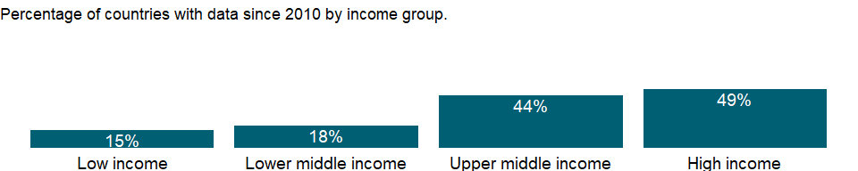

### Why is it relevant?

Although national defense is an important function of government and security from external threats that contributes to economic development, high military expenditures for defense or civil conflicts burden the economy and may impede growth. Data on military expenditures are a rough indicator of the portion of national resources used for military activities and of the burden on the economy.

Comparisons of military spending among countries should take into account the many factors that influence perceptions of vulnerability and risk, including historical and cultural traditions, the length of borders that need defending, the quality of relations with neighbors, and the role of the armed forces in the body politic.

### What is the data source?

Stockholm International Peace Research Institute (SIPRI), Arms Transfers Programme (<http://portal.sipri.org/publications/pages/transfer/splash>).

### What is the methodology?

Stockholm International Peace Research Institute (SIPRI)’s Arms Transfers Program collects data on arms transfers from open sources. Since publicly available information is inadequate for tracking all weapons and other military equipment, SIPRI covers only what it terms major conventional weapons. Data cover the supply of weapons through sales, aid, gifts, and manufacturing licenses; therefore the term arms transfers rather than arms trade is used. SIPRI data also cover weapons supplied to or from rebel forces in an armed conflict as well as arms deliveries for which neither the supplier nor the recipient can be identified with acceptable certainty; these data are available in SIPRI’s database.

Data cover major conventional weapons such as aircraft, armored vehicles, artillery, radar systems and other sensors, missiles, and ships designed for military use as well as some major components such as turrets for armored vehicles and engines. Excluded are other military equipment such as most small arms and light weapons, trucks, small artillery, ammunition, support equipment, technology transfers, and other services.

### How is it aggregated?

Sum

### What are the limitations?

SIPRI calculates the volume of transfers to, from and between all parties using the TIV and the number of weapon systems or subsystems delivered in a given year. This data is intended to provide a common unit to allow the measurement if trends in the flow of arms to particular countries and regions over time. Therefore, the main priority is to ensure that the TIV system remains consistent over time, and that any changes introduced are backdated.

SIPRI TIV figures do not represent sales prices for arms transfers. They should therefore not be directly compared with gross domestic product (GDP), military expenditure, sales values or the financial value of export licences in an attempt to measure the economic burden of arms imports or the economic benefits of exports. They are best used as the raw data for calculating trends in international arms transfers over periods of time, global percentages for suppliers and recipients, and percentages for the volume of transfers to or from particular states.

### What else should I know?

Data for some countries are based on partial or uncertain data or rough estimates.

## 1.37 Economic Policy & Debt: National accounts: US$ at current prices: Expenditure on GDP

### 1.37.1 General government final consumption expenditure (current US$)

### What is the indicator?

General government final consumption expenditure (formerly general government consumption) includes all government current expenditures for purchases of goods and services (including compensation of employees). It also includes most expenditures on national defense and security, but excludes government military expenditures that are part of government capital formation. Data are in current U.S. dollars.

Topic: Economic Policy & Debt: National accounts: US$ at current prices: Expenditure on GDP

Series ID: NE.CON.GOVT.CD

Copyright: CC BY-4.0 , <https://datacatalog.worldbank.org/public-licenses#cc-by>

First year with any data: 1960

Last year with any data: 2020

### What years are data available?

The figure below shows years in which data is available for at least one country. Dates shaded in black have no data, while dates shaded in green have data for at least one country



### Which countries have data?

The figure below shows the percentage of countries in each income group with a value since 2010 for that indicator.

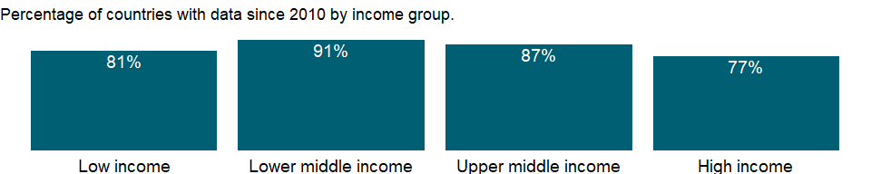

### Why is it relevant?

NA

### What is the data source?

World Bank national accounts data, and OECD National Accounts data files.

### What is the methodology?

Gross domestic product (GDP) from the expenditure side is made up of household final consumption expenditure, general government final consumption expenditure, gross capital formation (private and public investment in fixed assets, changes in inventories, and net acquisitions of valuables), and net exports (exports minus imports) of goods and services. Such expenditures are recorded in purchaser prices and include net taxes on products.

### How is it aggregated?

Gap-filled total

### What are the limitations?

Because policymakers have tended to focus on fostering the growth of output, and because data on production are easier to collect than data on spending, many countries generate their primary estimate of GDP using the production approach. Moreover, many countries do not estimate all the components of national expenditures but instead derive some of the main aggregates indirectly using GDP (based on the production approach) as the control total.

### What else should I know?

NA

### 1.37.2 Household final consumption expenditure (current US$)

### What is the indicator?

Household final consumption expenditure (formerly private consumption) is the market value of all goods and services, including durable products (such as cars, washing machines, and home computers), purchased by households. It excludes purchases of dwellings but includes imputed rent for owner-occupied dwellings. It also includes payments and fees to governments to obtain permits and licenses. Here, household consumption expenditure includes the expenditures of nonprofit institutions serving households, even when reported separately by the country. Data are in current U.S. dollars.

Topic: Economic Policy & Debt: National accounts: US$ at current prices: Expenditure on GDP

Series ID: NE.CON.PRVT.CD

Copyright: CC BY-4.0 , <https://datacatalog.worldbank.org/public-licenses#cc-by>

First year with any data: 1960

Last year with any data: 2020

### What years are data available?

The figure below shows years in which data is available for at least one country. Dates shaded in black have no data, while dates shaded in green have data for at least one country



### Which countries have data?

The figure below shows the percentage of countries in each income group with a value since 2010 for that indicator.

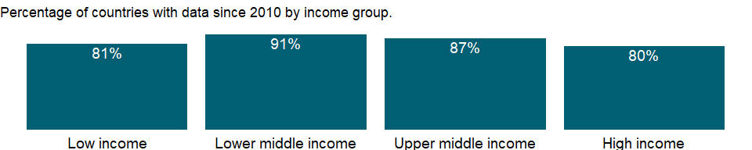

### Why is it relevant?

NA

### What is the data source?

World Bank national accounts data, and OECD National Accounts data files.

### What is the methodology?

NA

### How is it aggregated?

Gap-filled total

### What are the limitations?

NA

### What else should I know?

NA

### 1.37.3 Final consumption expenditure (current US$)

### What is the indicator?

Final consumption expenditure (formerly total consumption) is the sum of household final consumption expenditure (private consumption) and general government final consumption expenditure (general government consumption). Data are in current U.S. dollars.

Topic: Economic Policy & Debt: National accounts: US$ at current prices: Expenditure on GDP

Series ID: NE.CON.TOTL.CD

Copyright: CC BY-4.0 , <https://datacatalog.worldbank.org/public-licenses#cc-by>

First year with any data: 1960

Last year with any data: 2020

### What years are data available?

The figure below shows years in which data is available for at least one country. Dates shaded in black have no data, while dates shaded in green have data for at least one country



### Which countries have data?

The figure below shows the percentage of countries in each income group with a value since 2010 for that indicator.

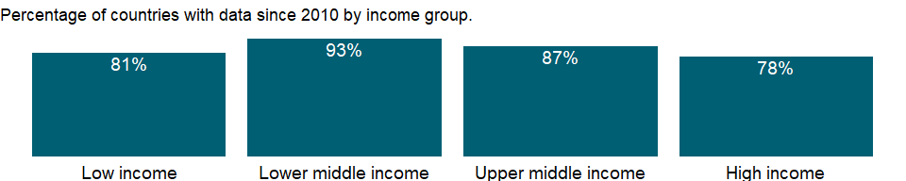

### Why is it relevant?

NA

### What is the data source?

World Bank national accounts data, and OECD National Accounts data files.

### What is the methodology?

NA

### How is it aggregated?

NA

### What are the limitations?

NA

### What else should I know?

NA

### 1.37.4 Gross national expenditure (current US$)

### What is the indicator?

Gross national expenditure (formerly domestic absorption) is the sum of household final consumption expenditure (formerly private consumption), general government final consumption expenditure (formerly general government consumption), and gross capital formation (formerly gross domestic investment). Data are in current U.S. dollars.

Topic: Economic Policy & Debt: National accounts: US$ at current prices: Expenditure on GDP

Series ID: NE.DAB.TOTL.CD

Copyright: CC BY-4.0 , <https://datacatalog.worldbank.org/public-licenses#cc-by>

First year with any data: 1960

Last year with any data: 2020

### What years are data available?

The figure below shows years in which data is available for at least one country. Dates shaded in black have no data, while dates shaded in green have data for at least one country



### Which countries have data?

The figure below shows the percentage of countries in each income group with a value since 2010 for that indicator.

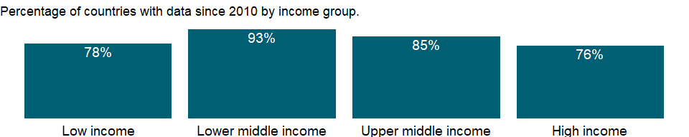

### Why is it relevant?

NA

### What is the data source?

World Bank national accounts data, and OECD National Accounts data files.

### What is the methodology?

NA

### How is it aggregated?

Gap-filled total

### What are the limitations?

NA

### What else should I know?

NA

### 1.37.5 Exports of goods and services (current US$)

### What is the indicator?

Exports of goods and services represent the value of all goods and other market services provided to the rest of the world. They include the value of merchandise, freight, insurance, transport, travel, royalties, license fees, and other services, such as communication, construction, financial, information, business, personal, and government services. They exclude compensation of employees and investment income (formerly called factor services) and transfer payments. Data are in current U.S. dollars.

Topic: Economic Policy & Debt: National accounts: US$ at current prices: Expenditure on GDP

Series ID: NE.EXP.GNFS.CD

Copyright: CC BY-4.0 , <https://datacatalog.worldbank.org/public-licenses#cc-by>

First year with any data: 1960

Last year with any data: 2020

### What years are data available?

The figure below shows years in which data is available for at least one country. Dates shaded in black have no data, while dates shaded in green have data for at least one country



### Which countries have data?

The figure below shows the percentage of countries in each income group with a value since 2010 for that indicator.

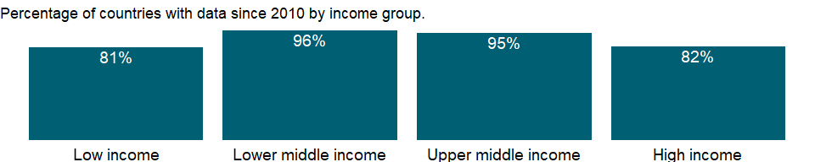

### Why is it relevant?

NA

### What is the data source?

World Bank national accounts data, and OECD National Accounts data files.

### What is the methodology?

Gross domestic product (GDP) from the expenditure side is made up of household final consumption expenditure, general government final consumption expenditure, gross capital formation (private and public investment in fixed assets, changes in inventories, and net acquisitions of valuables), and net exports (exports minus imports) of goods and services. Such expenditures are recorded in purchaser prices and include net taxes on products.

### How is it aggregated?

Gap-filled total

### What are the limitations?

Because policymakers have tended to focus on fostering the growth of output, and because data on production are easier to collect than data on spending, many countries generate their primary estimate of GDP using the production approach. Moreover, many countries do not estimate all the components of national expenditures but instead derive some of the main aggregates indirectly using GDP (based on the production approach) as the control total.

Data on exports and imports are compiled from customs reports and balance of payments data. Although the data from the payments side provide reasonably reliable records of cross-border transactions, they may not adhere strictly to the appropriate definitions of valuation and timing used in the balance of payments or corresponds to the change-of ownership criterion. This issue has assumed greater significance with the increasing globalization of international business. Neither customs nor balance of payments data usually capture the illegal transactions that occur in many countries. Goods carried by travelers across borders in legal but unreported shuttle trade may further distort trade statistics.

### What else should I know?

NA

### 1.37.6 Gross fixed capital formation (current US$)

### What is the indicator?

Gross fixed capital formation (formerly gross domestic fixed investment) includes land improvements (fences, ditches, drains, and so on); plant, machinery, and equipment purchases; and the construction of roads, railways, and the like, including schools, offices, hospitals, private residential dwellings, and commercial and industrial buildings. According to the 1993 SNA, net acquisitions of valuables are also considered capital formation. Data are in current U.S. dollars.

Topic: Economic Policy & Debt: National accounts: US$ at current prices: Expenditure on GDP

Series ID: NE.GDI.FTOT.CD

Copyright: CC BY-4.0 , <https://datacatalog.worldbank.org/public-licenses#cc-by>

First year with any data: 1960

Last year with any data: 2020

### What years are data available?

The figure below shows years in which data is available for at least one country. Dates shaded in black have no data, while dates shaded in green have data for at least one country



### Which countries have data?

The figure below shows the percentage of countries in each income group with a value since 2010 for that indicator.

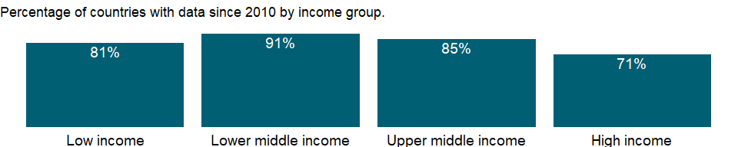

### Why is it relevant?

NA

### What is the data source?

World Bank national accounts data, and OECD National Accounts data files.

### What is the methodology?

NA

### How is it aggregated?

Gap-filled total

### What are the limitations?

NA

### What else should I know?

NA

### 1.37.7 Changes in inventories (current US$)

### What is the indicator?

Inventories are stocks of goods held by firms to meet temporary or unexpected fluctuations in production or sales, and “work in progress.” Data are in current U.S. dollars.

Topic: Economic Policy & Debt: National accounts: US$ at current prices: Expenditure on GDP

Series ID: NE.GDI.STKB.CD

Copyright: CC BY-4.0 , <https://datacatalog.worldbank.org/public-licenses#cc-by>

First year with any data: 1960

Last year with any data: 2020

### What years are data available?

The figure below shows years in which data is available for at least one country. Dates shaded in black have no data, while dates shaded in green have data for at least one country



### Which countries have data?

The figure below shows the percentage of countries in each income group with a value since 2010 for that indicator.

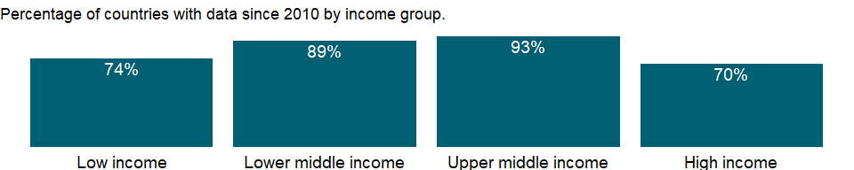

### Why is it relevant?

NA

### What is the data source?

World Bank national accounts data, and OECD National Accounts data files.

### What is the methodology?

NA

### How is it aggregated?

NA

### What are the limitations?

NA

### What else should I know?

NA

### 1.37.8 Gross capital formation (current US$)

### What is the indicator?

Gross capital formation (formerly gross domestic investment) consists of outlays on additions to the fixed assets of the economy plus net changes in the level of inventories. Fixed assets include land improvements (fences, ditches, drains, and so on); plant, machinery, and equipment purchases; and the construction of roads, railways, and the like, including schools, offices, hospitals, private residential dwellings, and commercial and industrial buildings. Inventories are stocks of goods held by firms to meet temporary or unexpected fluctuations in production or sales, and “work in progress.” According to the 1993 SNA, net acquisitions of valuables are also considered capital formation. Data are in current U.S. dollars.

Topic: Economic Policy & Debt: National accounts: US$ at current prices: Expenditure on GDP

Series ID: NE.GDI.TOTL.CD

Copyright: CC BY-4.0 , <https://datacatalog.worldbank.org/public-licenses#cc-by>

First year with any data: 1960

Last year with any data: 2020

### What years are data available?

The figure below shows years in which data is available for at least one country. Dates shaded in black have no data, while dates shaded in green have data for at least one country



### Which countries have data?

The figure below shows the percentage of countries in each income group with a value since 2010 for that indicator.



### Why is it relevant?

NA

### What is the data source?

World Bank national accounts data, and OECD National Accounts data files.

### What is the methodology?

Gross domestic product (GDP) from the expenditure side is made up of household final consumption expenditure, general government final consumption expenditure, gross capital formation (private and public investment in fixed assets, changes in inventories, and net acquisitions of valuables), and net exports (exports minus imports) of goods and services. Such expenditures are recorded in purchaser prices and include net taxes on products.

### How is it aggregated?

Gap-filled total

### What are the limitations?

Because policymakers have tended to focus on fostering the growth of output, and because data on production are easier to collect than data on spending, many countries generate their primary estimate of GDP using the production approach. Moreover, many countries do not estimate all the components of national expenditures but instead derive some of the main aggregates indirectly using GDP (based on the production approach) as the control total.

Data on capital formation may be estimated from direct surveys of enterprises and administrative records or based on the commodity flow method using data from production, trade, and construction activities. The quality of data on government fixed capital formation depends on the quality of government accounting systems (which tend to be weak in developing countries). Measures of fixed capital formation by households and corporations - particularly capital outlays by small, unincorporated enterprises - are usually unreliable.

Estimates of changes in inventories are rarely complete but usually include the most important activities or commodities. In some countries these estimates are derived as a composite residual along with household final consumption expenditure. According to national accounts conventions, adjustments should be made for appreciation of the value of inventory holdings due to price changes, but this is not always done. In highly inflationary economies this element can be substantial.

### What else should I know?

NA

### 1.37.9 Imports of goods and services (current US$)

### What is the indicator?

Imports of goods and services represent the value of all goods and other market services received from the rest of the world. They include the value of merchandise, freight, insurance, transport, travel, royalties, license fees, and other services, such as communication, construction, financial, information, business, personal, and government services. They exclude compensation of employees and investment income (formerly called factor services) and transfer payments. Data are in current U.S. dollars.

Topic: Economic Policy & Debt: National accounts: US$ at current prices: Expenditure on GDP

Series ID: NE.IMP.GNFS.CD

Copyright: CC BY-4.0 , <https://datacatalog.worldbank.org/public-licenses#cc-by>

First year with any data: 1960

Last year with any data: 2020

### What years are data available?

The figure below shows years in which data is available for at least one country. Dates shaded in black have no data, while dates shaded in green have data for at least one country



### Which countries have data?

The figure below shows the percentage of countries in each income group with a value since 2010 for that indicator.



### Why is it relevant?

NA

### What is the data source?

World Bank national accounts data, and OECD National Accounts data files.

### What is the methodology?

Gross domestic product (GDP) from the expenditure side is made up of household final consumption expenditure, general government final consumption expenditure, gross capital formation (private and public investment in fixed assets, changes in inventories, and net acquisitions of valuables), and net exports (exports minus imports) of goods and services. Such expenditures are recorded in purchaser prices and include net taxes on products.

### How is it aggregated?

Gap-filled total

### What are the limitations?

Because policymakers have tended to focus on fostering the growth of output, and because data on production are easier to collect than data on spending, many countries generate their primary estimate of GDP using the production approach. Moreover, many countries do not estimate all the components of national expenditures but instead derive some of the main aggregates indirectly using GDP (based on the production approach) as the control total.

Data on exports and imports are compiled from customs reports and balance of payments data. Although the data from the payments side provide reasonably reliable records of cross-border transactions, they may not adhere strictly to the appropriate definitions of valuation and timing used in the balance of payments or corresponds to the change-of ownership criterion. This issue has assumed greater significance with the increasing globalization of international business. Neither customs nor balance of payments data usually capture the illegal transactions that occur in many countries. Goods carried by travelers across borders in legal but unreported shuttle trade may further distort trade statistics.

### What else should I know?

NA

### 1.37.10 External balance on goods and services (current US$)

### What is the indicator?

External balance on goods and services (formerly resource balance) equals exports of goods and services minus imports of goods and services (previously nonfactor services). Data are in current U.S. dollars.

Topic: Economic Policy & Debt: National accounts: US$ at current prices: Expenditure on GDP

Series ID: NE.RSB.GNFS.CD

Copyright: CC BY-4.0 , <https://datacatalog.worldbank.org/public-licenses#cc-by>

First year with any data: 1960

Last year with any data: 2020

### What years are data available?

The figure below shows years in which data is available for at least one country. Dates shaded in black have no data, while dates shaded in green have data for at least one country



### Which countries have data?

The figure below shows the percentage of countries in each income group with a value since 2010 for that indicator.



### Why is it relevant?

NA

### What is the data source?

World Bank national accounts data, and OECD National Accounts data files.

### What is the methodology?

NA

### How is it aggregated?

NA

### What are the limitations?

NA

### What else should I know?

NA

## 1.38 Economic Policy & Debt: National accounts: Local currency at current prices: Expenditure on GDP

### 1.38.1 General government final consumption expenditure (current LCU)

### What is the indicator?

General government final consumption expenditure (formerly general government consumption) includes all government current expenditures for purchases of goods and services (including compensation of employees). It also includes most expenditures on national defense and security, but excludes government military expenditures that are part of government capital formation. Data are in current local currency.

Topic: Economic Policy & Debt: National accounts: Local currency at current prices: Expenditure on GDP

Series ID: NE.CON.GOVT.CN

Copyright: CC BY-4.0 , <https://datacatalog.worldbank.org/public-licenses#cc-by>

First year with any data: 1960

Last year with any data: 2020

### What years are data available?

The figure below shows years in which data is available for at least one country. Dates shaded in black have no data, while dates shaded in green have data for at least one country



### Which countries have data?

The figure below shows the percentage of countries in each income group with a value since 2010 for that indicator.



### Why is it relevant?

NA

### What is the data source?

World Bank national accounts data, and OECD National Accounts data files.

### What is the methodology?

NA

### How is it aggregated?

NA

### What are the limitations?

NA

### What else should I know?

NA

### 1.38.2 Household final consumption expenditure (current LCU)

### What is the indicator?

Household final consumption expenditure (formerly private consumption) is the market value of all goods and services, including durable products (such as cars, washing machines, and home computers), purchased by households. It excludes purchases of dwellings but includes imputed rent for owner-occupied dwellings. It also includes payments and fees to governments to obtain permits and licenses. Here, household consumption expenditure includes the expenditures of nonprofit institutions serving households, even when reported separately by the country. Data are in current local currency.

Topic: Economic Policy & Debt: National accounts: Local currency at current prices: Expenditure on GDP

Series ID: NE.CON.PRVT.CN

Copyright: CC BY-4.0 , <https://datacatalog.worldbank.org/public-licenses#cc-by>

First year with any data: 1960

Last year with any data: 2020

### What years are data available?

The figure below shows years in which data is available for at least one country. Dates shaded in black have no data, while dates shaded in green have data for at least one country



### Which countries have data?

The figure below shows the percentage of countries in each income group with a value since 2010 for that indicator.



### Why is it relevant?

NA

### What is the data source?

World Bank national accounts data, and OECD National Accounts data files.

### What is the methodology?

NA

### How is it aggregated?

NA

### What are the limitations?

NA

### What else should I know?

NA

### 1.38.3 Households and NPISHs final consumption expenditure: linked series (current LCU)

### What is the indicator?

Household final consumption expenditure (formerly private consumption) is the market value of all goods and services, including durable products (such as cars, washing machines, and home computers), purchased by households. It excludes purchases of dwellings but includes imputed rent for owner-occupied dwellings. It also includes payments and fees to governments to obtain permits and licenses. Here, household consumption expenditure includes the expenditures of nonprofit institutions serving households, even when reported separately by the country. This series has been linked to produce a consistent time series to counteract breaks in series over time due to changes in base years, source data and methodologies. Thus, it may not be comparable with other national accounts series in the database for historical years. Data are in local currency, at current prices.

Topic: Economic Policy & Debt: National accounts: Local currency at current prices: Expenditure on GDP

Series ID: NE.CON.PRVT.CN.AD

Copyright: CC BY-4.0 , <https://datacatalog.worldbank.org/public-licenses#cc-by>

First year with any data: 1990

Last year with any data: 2020

### What years are data available?

The figure below shows years in which data is available for at least one country. Dates shaded in black have no data, while dates shaded in green have data for at least one country



### Which countries have data?

The figure below shows the percentage of countries in each income group with a value since 2010 for that indicator.

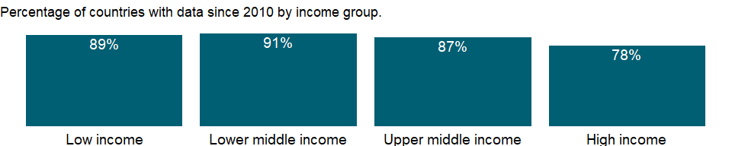

### Why is it relevant?

NA

### What is the data source?

World Bank staff estimates based on World Bank national accounts data archives, OECD National Accounts, and the IMF WEO database.

### What is the methodology?

NA

### How is it aggregated?

NA

### What are the limitations?

NA

### What else should I know?

NA

### 1.38.4 Final consumption expenditure (current LCU)

### What is the indicator?

Final consumption expenditure (formerly total consumption) is the sum of household final consumption expenditure (private consumption) and general government final consumption expenditure (general government consumption). Data are in current local currency.

Topic: Economic Policy & Debt: National accounts: Local currency at current prices: Expenditure on GDP

Series ID: NE.CON.TOTL.CN

Copyright: CC BY-4.0 , <https://datacatalog.worldbank.org/public-licenses#cc-by>

First year with any data: 1960

Last year with any data: 2020

### What years are data available?

The figure below shows years in which data is available for at least one country. Dates shaded in black have no data, while dates shaded in green have data for at least one country



### Which countries have data?

The figure below shows the percentage of countries in each income group with a value since 2010 for that indicator.



### Why is it relevant?

NA

### What is the data source?

World Bank national accounts data, and OECD National Accounts data files.

### What is the methodology?

NA

### How is it aggregated?

NA

### What are the limitations?

NA

### What else should I know?

NA

### 1.38.5 Gross national expenditure (current LCU)

### What is the indicator?

Gross national expenditure (formerly domestic absorption) is the sum of household final consumption expenditure (formerly private consumption), general government final consumption expenditure (formerly general government consumption), and gross capital formation (formerly gross domestic investment). Data are in current local currency.

Topic: Economic Policy & Debt: National accounts: Local currency at current prices: Expenditure on GDP

Series ID: NE.DAB.TOTL.CN

Copyright: CC BY-4.0 , <https://datacatalog.worldbank.org/public-licenses#cc-by>

First year with any data: 1960

Last year with any data: 2020

### What years are data available?

The figure below shows years in which data is available for at least one country. Dates shaded in black have no data, while dates shaded in green have data for at least one country



### Which countries have data?

The figure below shows the percentage of countries in each income group with a value since 2010 for that indicator.



### Why is it relevant?

NA

### What is the data source?

World Bank national accounts data, and OECD National Accounts data files.

### What is the methodology?

NA

### How is it aggregated?

NA

### What are the limitations?

NA

### What else should I know?

NA

### 1.38.6 Exports of goods and services (current LCU)

### What is the indicator?

Exports of goods and services represent the value of all goods and other market services provided to the rest of the world. They include the value of merchandise, freight, insurance, transport, travel, royalties, license fees, and other services, such as communication, construction, financial, information, business, personal, and government services. They exclude compensation of employees and investment income (formerly called factor services) and transfer payments. Data are in current local currency.

Topic: Economic Policy & Debt: National accounts: Local currency at current prices: Expenditure on GDP

Series ID: NE.EXP.GNFS.CN

Copyright: CC BY-4.0 , <https://datacatalog.worldbank.org/public-licenses#cc-by>

First year with any data: 1960

Last year with any data: 2020

### What years are data available?

The figure below shows years in which data is available for at least one country. Dates shaded in black have no data, while dates shaded in green have data for at least one country



### Which countries have data?

The figure below shows the percentage of countries in each income group with a value since 2010 for that indicator.



### Why is it relevant?

NA

### What is the data source?

World Bank national accounts data, and OECD National Accounts data files.

### What is the methodology?

NA

### How is it aggregated?

NA

### What are the limitations?

NA

### What else should I know?

NA

### 1.38.7 Gross fixed capital formation, private sector (current LCU)

### What is the indicator?

Private investment covers gross outlays by the private sector (including private nonprofit agencies) on additions to its fixed domestic assets.

Topic: Economic Policy & Debt: National accounts: Local currency at current prices: Expenditure on GDP

Series ID: NE.GDI.FPRV.CN

Copyright: CC BY-4.0 , <https://datacatalog.worldbank.org/public-licenses#cc-by>

First year with any data: 1960

Last year with any data: 2020

### What years are data available?

The figure below shows years in which data is available for at least one country. Dates shaded in black have no data, while dates shaded in green have data for at least one country



### Which countries have data?

The figure below shows the percentage of countries in each income group with a value since 2010 for that indicator.

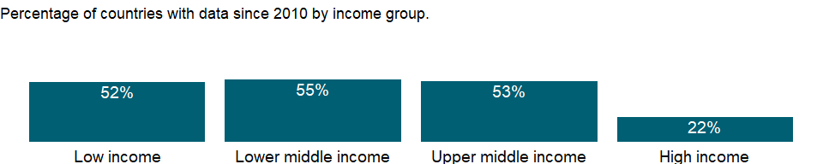

### Why is it relevant?

NA

### What is the data source?

World Bank national accounts data, and OECD National Accounts data files.

### What is the methodology?

NA

### How is it aggregated?

NA

### What are the limitations?

NA

### What else should I know?

NA

### 1.38.8 Gross fixed capital formation (current LCU)

### What is the indicator?

Gross fixed capital formation (formerly gross domestic fixed investment) includes land improvements (fences, ditches, drains, and so on); plant, machinery, and equipment purchases; and the construction of roads, railways, and the like, including schools, offices, hospitals, private residential dwellings, and commercial and industrial buildings. According to the 1993 SNA, net acquisitions of valuables are also considered capital formation. Data are in current local currency.

Topic: Economic Policy & Debt: National accounts: Local currency at current prices: Expenditure on GDP

Series ID: NE.GDI.FTOT.CN

Copyright: CC BY-4.0 , <https://datacatalog.worldbank.org/public-licenses#cc-by>

First year with any data: 1960

Last year with any data: 2020

### What years are data available?

The figure below shows years in which data is available for at least one country. Dates shaded in black have no data, while dates shaded in green have data for at least one country



### Which countries have data?

The figure below shows the percentage of countries in each income group with a value since 2010 for that indicator.



### Why is it relevant?

NA

### What is the data source?

World Bank national accounts data, and OECD National Accounts data files.

### What is the methodology?

NA

### How is it aggregated?

NA

### What are the limitations?

NA

### What else should I know?

NA

### 1.38.9 Changes in inventories (current LCU)

### What is the indicator?

Inventories are stocks of goods held by firms to meet temporary or unexpected fluctuations in production or sales, and “work in progress.” Data are in current local currency.

Topic: Economic Policy & Debt: National accounts: Local currency at current prices: Expenditure on GDP

Series ID: NE.GDI.STKB.CN

Copyright: CC BY-4.0 , <https://datacatalog.worldbank.org/public-licenses#cc-by>

First year with any data: 1960

Last year with any data: 2020

### What years are data available?

The figure below shows years in which data is available for at least one country. Dates shaded in black have no data, while dates shaded in green have data for at least one country



### Which countries have data?

The figure below shows the percentage of countries in each income group with a value since 2010 for that indicator.



### Why is it relevant?

NA

### What is the data source?

World Bank national accounts data, and OECD National Accounts data files.

### What is the methodology?

NA

### How is it aggregated?

NA

### What are the limitations?

NA

### What else should I know?

NA

### 1.38.10 Gross capital formation (current LCU)

### What is the indicator?

Gross capital formation (formerly gross domestic investment) consists of outlays on additions to the fixed assets of the economy plus net changes in the level of inventories. Fixed assets include land improvements (fences, ditches, drains, and so on); plant, machinery, and equipment purchases; and the construction of roads, railways, and the like, including schools, offices, hospitals, private residential dwellings, and commercial and industrial buildings. Inventories are stocks of goods held by firms to meet temporary or unexpected fluctuations in production or sales, and “work in progress.” According to the 1993 SNA, net acquisitions of valuables are also considered capital formation. Data are in current local currency.

Topic: Economic Policy & Debt: National accounts: Local currency at current prices: Expenditure on GDP

Series ID: NE.GDI.TOTL.CN

Copyright: CC BY-4.0 , <https://datacatalog.worldbank.org/public-licenses#cc-by>

First year with any data: 1960

Last year with any data: 2020

### What years are data available?

The figure below shows years in which data is available for at least one country. Dates shaded in black have no data, while dates shaded in green have data for at least one country



### Which countries have data?

The figure below shows the percentage of countries in each income group with a value since 2010 for that indicator.



### Why is it relevant?

NA

### What is the data source?

World Bank national accounts data, and OECD National Accounts data files.

### What is the methodology?

NA

### How is it aggregated?

NA

### What are the limitations?

NA

### What else should I know?

NA

### 1.38.11 Imports of goods and services (current LCU)

### What is the indicator?

Imports of goods and services represent the value of all goods and other market services received from the rest of the world. They include the value of merchandise, freight, insurance, transport, travel, royalties, license fees, and other services, such as communication, construction, financial, information, business, personal, and government services. They exclude compensation of employees and investment income (formerly called factor services) and transfer payments. Data are in current local currency.

Topic: Economic Policy & Debt: National accounts: Local currency at current prices: Expenditure on GDP

Series ID: NE.IMP.GNFS.CN

Copyright: CC BY-4.0 , <https://datacatalog.worldbank.org/public-licenses#cc-by>

First year with any data: 1960

Last year with any data: 2020

### What years are data available?

The figure below shows years in which data is available for at least one country. Dates shaded in black have no data, while dates shaded in green have data for at least one country



### Which countries have data?

The figure below shows the percentage of countries in each income group with a value since 2010 for that indicator.



### Why is it relevant?

NA

### What is the data source?

World Bank national accounts data, and OECD National Accounts data files.

### What is the methodology?

NA

### How is it aggregated?

NA

### What are the limitations?

NA

### What else should I know?

NA

### 1.38.12 External balance on goods and services (current LCU)

### What is the indicator?

External balance on goods and services (formerly resource balance) equals exports of goods and services minus imports of goods and services (previously nonfactor services). Data are in current local currency.

Topic: Economic Policy & Debt: National accounts: Local currency at current prices: Expenditure on GDP

Series ID: NE.RSB.GNFS.CN

Copyright: CC BY-4.0 , <https://datacatalog.worldbank.org/public-licenses#cc-by>

First year with any data: 1960

Last year with any data: 2020

### What years are data available?

The figure below shows years in which data is available for at least one country. Dates shaded in black have no data, while dates shaded in green have data for at least one country



### Which countries have data?

The figure below shows the percentage of countries in each income group with a value since 2010 for that indicator.



### Why is it relevant?

NA

### What is the data source?

World Bank national accounts data, and OECD National Accounts data files.

### What is the methodology?

NA

### How is it aggregated?

NA

### What are the limitations?

NA

### What else should I know?

NA

### 1.38.13 Discrepancy in expenditure estimate of GDP (current LCU)

### What is the indicator?

Discrepancy in expenditure estimate of GDP is the discrepancy included in final consumption expenditure, etc. (total consumption, etc.). This discrepancy is included to ensure that GDP from the expenditure side equals GDP measured by the income or output approach. Data are in current local currency.

Topic: Economic Policy & Debt: National accounts: Local currency at current prices: Expenditure on GDP

Series ID: NY.GDP.DISC.CN

Copyright: CC BY-4.0 , <https://datacatalog.worldbank.org/public-licenses#cc-by>

First year with any data: 1960

Last year with any data: 2020

### What years are data available?

The figure below shows years in which data is available for at least one country. Dates shaded in black have no data, while dates shaded in green have data for at least one country



### Which countries have data?

The figure below shows the percentage of countries in each income group with a value since 2010 for that indicator.



### Why is it relevant?

NA

### What is the data source?

World Bank national accounts data, and OECD National Accounts data files.

### What is the methodology?

NA

### How is it aggregated?

NA

### What are the limitations?

NA

### What else should I know?

NA

### 1.38.14 GNI: linked series (current LCU)

### What is the indicator?

GNI (formerly GNP) is the sum of value added by all resident producers plus any product taxes (less subsidies) not included in the valuation of output plus net receipts of primary income (compensation of employees and property income) from abroad. This series has been linked to produce a consistent time series to counteract breaks in series over time due to changes in base years, source data and methodologies. Thus, it may not be comparable with other national accounts series in the database for historical years. Data are in local currency, at current prices.

Topic: Economic Policy & Debt: National accounts: Local currency at current prices: Expenditure on GDP

Series ID: NY.GNP.MKTP.CN.AD

Copyright: CC BY-4.0 , <https://datacatalog.worldbank.org/public-licenses#cc-by>

First year with any data: 1989

Last year with any data: 2020

### What years are data available?

The figure below shows years in which data is available for at least one country. Dates shaded in black have no data, while dates shaded in green have data for at least one country



### Which countries have data?

The figure below shows the percentage of countries in each income group with a value since 2010 for that indicator.

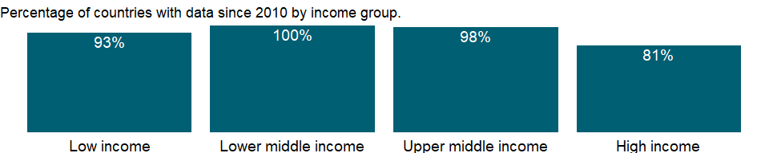

### Why is it relevant?

NA

### What is the data source?

World Bank staff estimates based on World Bank national accounts data archives, OECD National Accounts, and the IMF WEO database.

### What is the methodology?

NA

### How is it aggregated?

NA

### What are the limitations?

NA

### What else should I know?

NA

## 1.39 Economic Policy & Debt: National accounts: US$ at constant 2010 prices: Expenditure on GDP

### 1.39.1 General government final consumption expenditure (constant 2010 US$)

### What is the indicator?

General government final consumption expenditure (formerly general government consumption) includes all government current expenditures for purchases of goods and services (including compensation of employees). It also includes most expenditures on national defense and security, but excludes government military expenditures that are part of government capital formation. Data are in constant 2010 U.S. dollars.

Topic: Economic Policy & Debt: National accounts: US$ at constant 2010 prices: Expenditure on GDP

Series ID: NE.CON.GOVT.KD

Copyright: CC BY-4.0 , <https://datacatalog.worldbank.org/public-licenses#cc-by>

First year with any data: 1960

Last year with any data: 2020

### What years are data available?

The figure below shows years in which data is available for at least one country. Dates shaded in black have no data, while dates shaded in green have data for at least one country



### Which countries have data?

The figure below shows the percentage of countries in each income group with a value since 2010 for that indicator.

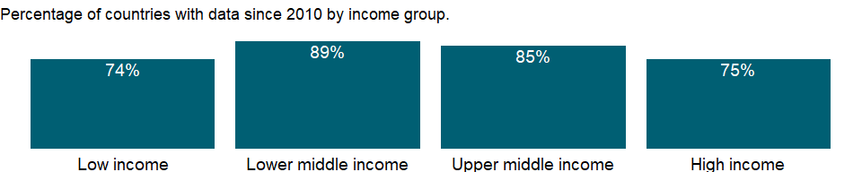

### Why is it relevant?

An economy’s growth is measured by the change in the volume of its output or in the real incomes of its residents. The 2008 United Nations System of National Accounts (2008 SNA) offers three plausible indicators for calculating growth: the volume of gross domestic product (GDP), real gross domestic income, and real gross national income. The volume of GDP is the sum of value added, measured at constant prices, by households, government, and industries operating in the economy. GDP accounts for all domestic production, regardless of whether the income accrues to domestic or foreign institutions.

### What is the data source?

World Bank national accounts data, and OECD National Accounts data files.

### What is the methodology?

Gross domestic product (GDP) from the expenditure side is made up of household final consumption expenditure, general government final consumption expenditure, gross capital formation (private and public investment in fixed assets, changes in inventories, and net acquisitions of valuables), and net exports (exports minus imports) of goods and services. Such expenditures are recorded in purchaser prices and include net taxes on products.

### How is it aggregated?

Gap-filled total

### What are the limitations?

Because policymakers have tended to focus on fostering the growth of output, and because data on production are easier to collect than data on spending, many countries generate their primary estimate of GDP using the production approach. Moreover, many countries do not estimate all the components of national expenditures but instead derive some of the main aggregates indirectly using GDP (based on the production approach) as the control total.

Measures of growth in consumption and capital formation are subject to two kinds of inaccuracy. The first stems from the difficulty of measuring expenditures at current price levels. The second arises in deflating current price data to measure volume growth, where results depend on the relevance and reliability of the price indexes and weights used. Measuring price changes is more difficult for investment goods than for consumption goods because of the one-time nature of many investments and because the rate of technological progress in capital goods makes capturing change in quality difficult. (An example is computers - prices have fallen as quality has improved.)

To obtain government consumption in constant prices, countries may deflate current values by applying a wage (price) index or extrapolate from the change in government employment. Neither technique captures improvements in productivity or changes in the quality of government services.

### What else should I know?

NA

### 1.39.2 Household final consumption expenditure (constant 2010 US$)

### What is the indicator?

Household final consumption expenditure (formerly private consumption) is the market value of all goods and services, including durable products (such as cars, washing machines, and home computers), purchased by households. It excludes purchases of dwellings but includes imputed rent for owner-occupied dwellings. It also includes payments and fees to governments to obtain permits and licenses. Here, household consumption expenditure includes the expenditures of nonprofit institutions serving households, even when reported separately by the country. Data are in constant 2010 U.S. dollars.

Topic: Economic Policy & Debt: National accounts: US$ at constant 2010 prices: Expenditure on GDP

Series ID: NE.CON.PRVT.KD

Copyright: CC BY-4.0 , <https://datacatalog.worldbank.org/public-licenses#cc-by>

First year with any data: 1960

Last year with any data: 2020

### What years are data available?

The figure below shows years in which data is available for at least one country. Dates shaded in black have no data, while dates shaded in green have data for at least one country



### Which countries have data?

The figure below shows the percentage of countries in each income group with a value since 2010 for that indicator.

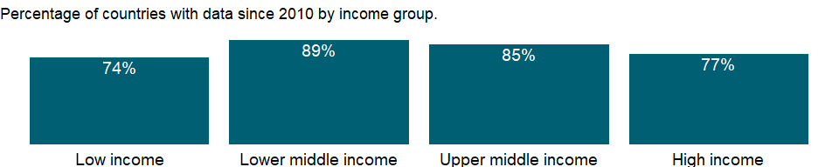

### Why is it relevant?

An economy’s growth is measured by the change in the volume of its output or in the real incomes of its residents. The 2008 United Nations System of National Accounts (2008 SNA) offers three plausible indicators for calculating growth: the volume of gross domestic product (GDP), real gross domestic income, and real gross national income. The volume of GDP is the sum of value added, measured at constant prices, by households, government, and industries operating in the economy. GDP accounts for all domestic production, regardless of whether the income accrues to domestic or foreign institutions.

### What is the data source?

World Bank national accounts data, and OECD National Accounts data files.

### What is the methodology?

Gross domestic product (GDP) from the expenditure side is made up of household final consumption expenditure, general government final consumption expenditure, gross capital formation (private and public investment in fixed assets, changes in inventories, and net acquisitions of valuables), and net exports (exports minus imports) of goods and services. Such expenditures are recorded in purchaser prices and include net taxes on products.

Deflators for household consumption are usually calculated on the basis of the consumer price index.

### How is it aggregated?

Gap-filled total

### What are the limitations?

Because policymakers have tended to focus on fostering the growth of output, and because data on production are easier to collect than data on spending, many countries generate their primary estimate of GDP using the production approach. Moreover, many countries do not estimate all the components of national expenditures but instead derive some of the main aggregates indirectly using GDP (based on the production approach) as the control total. Household final consumption expenditure is often estimated as a residual, by subtracting all other known expenditures from GDP. The resulting aggregate may incorporate fairly large discrepancies. When household consumption is calculated separately, many of the estimates are based on household surveys, which tend to be one-year studies with limited coverage. Thus the estimates quickly become outdated and must be supplemented by estimates using price- and quantity-based statistical procedures. Complicating the issue, in many developing countries the distinction between cash outlays for personal business and those for household use may be blurred.

Informal economic activities pose a particular measurement problem, especially in developing countries, where much economic activity is unrecorded. A complete picture of the economy requires estimating household outputs produced for home use, sales in informal markets, barter exchanges, and illicit or deliberately unreported activities. The consistency and completeness of such estimates depend on the skill and methods of the compiling statisticians.

Measures of growth in consumption and capital formation are subject to two kinds of inaccuracy. The first stems from the difficulty of measuring expenditures at current price levels. The second arises in deflating current price data to measure volume growth, where results depend on the relevance and reliability of the price indexes and weights used. Measuring price changes is more difficult for investment goods than for consumption goods because of the one-time nature of many investments and because the rate of technological progress in capital goods makes capturing change in quality difficult. (An example is computers - prices have fallen as quality has improved.)

### What else should I know?

NA

### 1.39.3 Household final consumption expenditure per capita (constant 2010 US$)

### What is the indicator?

Household final consumption expenditure per capita (private consumption per capita) is calculated using private consumption in constant 2010 prices and World Bank population estimates. Household final consumption expenditure is the market value of all goods and services, including durable products (such as cars, washing machines, and home computers), purchased by households. It excludes purchases of dwellings but includes imputed rent for owner-occupied dwellings. It also includes payments and fees to governments to obtain permits and licenses. Here, household consumption expenditure includes the expenditures of nonprofit institutions serving households, even when reported separately by the country. Data are in constant 2010 U.S. dollars.

Topic: Economic Policy & Debt: National accounts: US$ at constant 2010 prices: Expenditure on GDP

Series ID: NE.CON.PRVT.PC.KD

Copyright: CC BY-4.0 , <https://datacatalog.worldbank.org/public-licenses#cc-by>

First year with any data: 1960

Last year with any data: 2020

### What years are data available?

The figure below shows years in which data is available for at least one country. Dates shaded in black have no data, while dates shaded in green have data for at least one country



### Which countries have data?

The figure below shows the percentage of countries in each income group with a value since 2010 for that indicator.



### Why is it relevant?

An economy’s growth is measured by the change in the volume of its output or in the real incomes of its residents. The 2008 United Nations System of National Accounts (2008 SNA) offers three plausible indicators for calculating growth: the volume of gross domestic product (GDP), real gross domestic income, and real gross national income. The volume of GDP is the sum of value added, measured at constant prices, by households, government, and industries operating in the economy. GDP accounts for all domestic production, regardless of whether the income accrues to domestic or foreign institutions.

### What is the data source?

World Bank national accounts data, and OECD National Accounts data files.

### What is the methodology?

Gross domestic product (GDP) from the expenditure side is made up of household final consumption expenditure, general government final consumption expenditure, gross capital formation (private and public investment in fixed assets, changes in inventories, and net acquisitions of valuables), and net exports (exports minus imports) of goods and services. Such expenditures are recorded in purchaser prices and include net taxes on products.

Deflators for household consumption are usually calculated on the basis of the consumer price index.

### How is it aggregated?

Weighted Average

### What are the limitations?

Because policymakers have tended to focus on fostering the growth of output, and because data on production are easier to collect than data on spending, many countries generate their primary estimate of GDP using the production approach. Moreover, many countries do not estimate all the components of national expenditures but instead derive some of the main aggregates indirectly using GDP (based on the production approach) as the control total. Household final consumption expenditure is often estimated as a residual, by subtracting all other known expenditures from GDP. The resulting aggregate may incorporate fairly large discrepancies. When household consumption is calculated separately, many of the estimates are based on household surveys, which tend to be one-year studies with limited coverage. Thus the estimates quickly become outdated and must be supplemented by estimates using price- and quantity-based statistical procedures. Complicating the issue, in many developing countries the distinction between cash outlays for personal business and those for household use may be blurred.

Informal economic activities pose a particular measurement problem, especially in developing countries, where much economic activity is unrecorded. A complete picture of the economy requires estimating household outputs produced for home use, sales in informal markets, barter exchanges, and illicit or deliberately unreported activities. The consistency and completeness of such estimates depend on the skill and methods of the compiling statisticians.

Measures of growth in consumption and capital formation are subject to two kinds of inaccuracy. The first stems from the difficulty of measuring expenditures at current price levels. The second arises in deflating current price data to measure volume growth, where results depend on the relevance and reliability of the price indexes and weights used. Measuring price changes is more difficult for investment goods than for consumption goods because of the one-time nature of many investments and because the rate of technological progress in capital goods makes capturing change in quality difficult. (An example is computers - prices have fallen as quality has improved.)

### What else should I know?

NA

### 1.39.4 Final consumption expenditure (constant 2010 US$)

### What is the indicator?

Final consumption expenditure (formerly total consumption) is the sum of household final consumption expenditure (formerly private consumption) and general government final consumption expenditure (formerly general government consumption). Data are in constant 2010 U.S. dollars.

Topic: Economic Policy & Debt: National accounts: US$ at constant 2010 prices: Expenditure on GDP

Series ID: NE.CON.TOTL.KD

Copyright: CC BY-4.0 , <https://datacatalog.worldbank.org/public-licenses#cc-by>

First year with any data: 1960

Last year with any data: 2020

### What years are data available?

The figure below shows years in which data is available for at least one country. Dates shaded in black have no data, while dates shaded in green have data for at least one country



### Which countries have data?

The figure below shows the percentage of countries in each income group with a value since 2010 for that indicator.

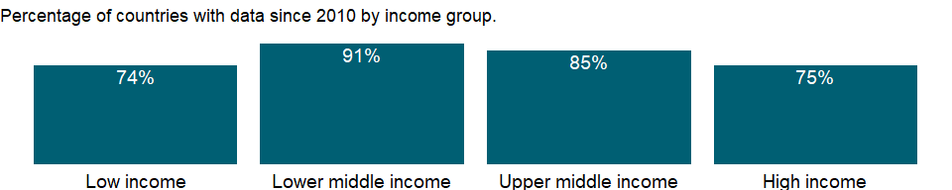

### Why is it relevant?

NA

### What is the data source?

World Bank national accounts data, and OECD National Accounts data files.

### What is the methodology?

NA

### How is it aggregated?

Gap-filled total

### What are the limitations?

NA

### What else should I know?

NA

### 1.39.5 Gross national expenditure (constant 2010 US$)

### What is the indicator?

Gross national expenditure (formerly domestic absorption) is the sum of household final consumption expenditure (formerly private consumption), general government final consumption expenditure (formerly general government consumption), and gross capital formation (formerly gross domestic investment). Data are in constant 2010 U.S. dollars.

Topic: Economic Policy & Debt: National accounts: US$ at constant 2010 prices: Expenditure on GDP

Series ID: NE.DAB.TOTL.KD

Copyright: CC BY-4.0 , <https://datacatalog.worldbank.org/public-licenses#cc-by>

First year with any data: 1960

Last year with any data: 2020

### What years are data available?

The figure below shows years in which data is available for at least one country. Dates shaded in black have no data, while dates shaded in green have data for at least one country



### Which countries have data?

The figure below shows the percentage of countries in each income group with a value since 2010 for that indicator.

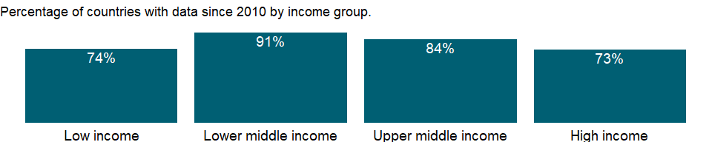

### Why is it relevant?

NA

### What is the data source?

World Bank national accounts data, and OECD National Accounts data files.

### What is the methodology?

NA

### How is it aggregated?

Gap-filled total

### What are the limitations?

NA

### What else should I know?

NA

### 1.39.6 Exports of goods and services (constant 2010 US$)

### What is the indicator?

Exports of goods and services represent the value of all goods and other market services provided to the rest of the world. They include the value of merchandise, freight, insurance, transport, travel, royalties, license fees, and other services, such as communication, construction, financial, information, business, personal, and government services. They exclude compensation of employees and investment income (formerly called factor services) and transfer payments. Data are in constant 2010 U.S. dollars.

Topic: Economic Policy & Debt: National accounts: US$ at constant 2010 prices: Expenditure on GDP

Series ID: NE.EXP.GNFS.KD

Copyright: CC BY-4.0 , <https://datacatalog.worldbank.org/public-licenses#cc-by>

First year with any data: 1960

Last year with any data: 2020

### What years are data available?

The figure below shows years in which data is available for at least one country. Dates shaded in black have no data, while dates shaded in green have data for at least one country



### Which countries have data?

The figure below shows the percentage of countries in each income group with a value since 2010 for that indicator.

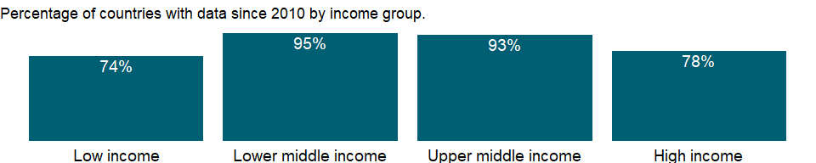

### Why is it relevant?

An economy’s growth is measured by the change in the volume of its output or in the real incomes of its residents. The 2008 United Nations System of National Accounts (2008 SNA) offers three plausible indicators for calculating growth: the volume of gross domestic product (GDP), real gross domestic income, and real gross national income. The volume of GDP is the sum of value added, measured at constant prices, by households, government, and industries operating in the economy. GDP accounts for all domestic production, regardless of whether the income accrues to domestic or foreign institutions.

### What is the data source?

World Bank national accounts data, and OECD National Accounts data files.

### What is the methodology?

Gross domestic product (GDP) from the expenditure side is made up of household final consumption expenditure, general government final consumption expenditure, gross capital formation (private and public investment in fixed assets, changes in inventories, and net acquisitions of valuables), and net exports (exports minus imports) of goods and services. Such expenditures are recorded in purchaser prices and include net taxes on products.

### How is it aggregated?

Gap-filled total

### What are the limitations?

Because policymakers have tended to focus on fostering the growth of output, and because data on production are easier to collect than data on spending, many countries generate their primary estimate of GDP using the production approach. Moreover, many countries do not estimate all the components of national expenditures but instead derive some of the main aggregates indirectly using GDP (based on the production approach) as the control total.

Data on exports and imports are compiled from customs reports and balance of payments data. Although the data from the payments side provide reasonably reliable records of cross-border transactions, they may not adhere strictly to the appropriate definitions of valuation and timing used in the balance of payments or corresponds to the change-of ownership criterion. This issue has assumed greater significance with the increasing globalization of international business. Neither customs nor balance of payments data usually capture the illegal transactions that occur in many countries. Goods carried by travelers across borders in legal but unreported shuttle trade may further distort trade statistics.

### What else should I know?

NA

### 1.39.7 Gross fixed capital formation (constant 2010 US$)

### What is the indicator?

Gross fixed capital formation (formerly gross domestic fixed investment) includes land improvements (fences, ditches, drains, and so on); plant, machinery, and equipment purchases; and the construction of roads, railways, and the like, including schools, offices, hospitals, private residential dwellings, and commercial and industrial buildings. According to the 1993 SNA, net acquisitions of valuables are also considered capital formation. Data are in constant 2010 U.S. dollars.

Topic: Economic Policy & Debt: National accounts: US$ at constant 2010 prices: Expenditure on GDP

Series ID: NE.GDI.FTOT.KD

Copyright: CC BY-4.0 , <https://datacatalog.worldbank.org/public-licenses#cc-by>

First year with any data: 1960

Last year with any data: 2020

### What years are data available?

The figure below shows years in which data is available for at least one country. Dates shaded in black have no data, while dates shaded in green have data for at least one country



### Which countries have data?

The figure below shows the percentage of countries in each income group with a value since 2010 for that indicator.

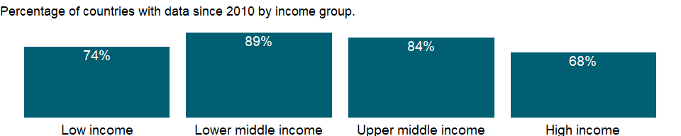

### Why is it relevant?

NA

### What is the data source?

World Bank national accounts data, and OECD National Accounts data files.

### What is the methodology?

NA

### How is it aggregated?

Gap-filled total

### What are the limitations?

NA

### What else should I know?

NA

### 1.39.8 Gross capital formation (constant 2010 US$)

### What is the indicator?

Gross capital formation (formerly gross domestic investment) consists of outlays on additions to the fixed assets of the economy plus net changes in the level of inventories. Fixed assets include land improvements (fences, ditches, drains, and so on); plant, machinery, and equipment purchases; and the construction of roads, railways, and the like, including schools, offices, hospitals, private residential dwellings, and commercial and industrial buildings. Inventories are stocks of goods held by firms to meet temporary or unexpected fluctuations in production or sales, and “work in progress.” According to the 1993 SNA, net acquisitions of valuables are also considered capital formation. Data are in constant 2010 U.S. dollars.

Topic: Economic Policy & Debt: National accounts: US$ at constant 2010 prices: Expenditure on GDP

Series ID: NE.GDI.TOTL.KD

Copyright: CC BY-4.0 , <https://datacatalog.worldbank.org/public-licenses#cc-by>

First year with any data: 1960

Last year with any data: 2020

### What years are data available?

The figure below shows years in which data is available for at least one country. Dates shaded in black have no data, while dates shaded in green have data for at least one country



### Which countries have data?

The figure below shows the percentage of countries in each income group with a value since 2010 for that indicator.

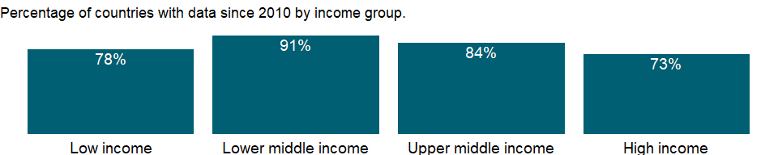

### Why is it relevant?

An economy’s growth is measured by the change in the volume of its output or in the real incomes of its residents. The 2008 United Nations System of National Accounts (2008 SNA) offers three plausible indicators for calculating growth: the volume of gross domestic product (GDP), real gross domestic income, and real gross national income. The volume of GDP is the sum of value added, measured at constant prices, by households, government, and industries operating in the economy. GDP accounts for all domestic production, regardless of whether the income accrues to domestic or foreign institutions.

### What is the data source?

World Bank national accounts data, and OECD National Accounts data files.

### What is the methodology?

Gross domestic product (GDP) from the expenditure side is made up of household final consumption expenditure, general government final consumption expenditure, gross capital formation (private and public investment in fixed assets, changes in inventories, and net acquisitions of valuables), and net exports (exports minus imports) of goods and services. Such expenditures are recorded in purchaser prices and include net taxes on products.

### How is it aggregated?

Gap-filled total

### What are the limitations?

Because policymakers have tended to focus on fostering the growth of output, and because data on production are easier to collect than data on spending, many countries generate their primary estimate of GDP using the production approach. Moreover, many countries do not estimate all the components of national expenditures but instead derive some of the main aggregates indirectly using GDP (based on the production approach) as the control total.

Data on capital formation may be estimated from direct surveys of enterprises and administrative records or based on the commodity flow method using data from production, trade, and construction activities. The quality of data on government fixed capital formation depends on the quality of government accounting systems (which tend to be weak in developing countries). Measures of fixed capital formation by households and corporations - particularly capital outlays by small, unincorporated enterprises - are usually unreliable.

Estimates of changes in inventories are rarely complete but usually include the most important activities or commodities. In some countries these estimates are derived as a composite residual along with household final consumption expenditure. According to national accounts conventions, adjustments should be made for appreciation of the value of inventory holdings due to price changes, but this is not always done. In highly inflationary economies this element can be substantial.

Measures of growth in consumption and capital formation are subject to two kinds of inaccuracy. The first stems from the difficulty of measuring expenditures at current price levels. The second arises in deflating current price data to measure volume growth, where results depend on the relevance and reliability of the price indexes and weights used. Measuring price changes is more difficult for investment goods than for consumption goods because of the one-time nature of many investments and because the rate of technological progress in capital goods makes capturing change in quality difficult. (An example is computers - prices have fallen as quality has improved.) Several countries estimate capital formation from the supply side, identifying capital goods entering an economy directly from detailed production and international trade statistics. This means that the price indexes used in deflating production and international trade, reflecting delivered or offered prices, will determine the deflator for capital formation expenditures on the demand side.

### What else should I know?

NA

### 1.39.9 Imports of goods and services (constant 2010 US$)

### What is the indicator?

Imports of goods and services represent the value of all goods and other market services received from the rest of the world. They include the value of merchandise, freight, insurance, transport, travel, royalties, license fees, and other services, such as communication, construction, financial, information, business, personal, and government services. They exclude compensation of employees and investment income (formerly called factor services) and transfer payments. Data are in constant 2010 U.S. dollars.

Topic: Economic Policy & Debt: National accounts: US$ at constant 2010 prices: Expenditure on GDP

Series ID: NE.IMP.GNFS.KD

Copyright: CC BY-4.0 , <https://datacatalog.worldbank.org/public-licenses#cc-by>

First year with any data: 1960

Last year with any data: 2020

### What years are data available?

The figure below shows years in which data is available for at least one country. Dates shaded in black have no data, while dates shaded in green have data for at least one country



### Which countries have data?

The figure below shows the percentage of countries in each income group with a value since 2010 for that indicator.



### Why is it relevant?

An economy’s growth is measured by the change in the volume of its output or in the real incomes of its residents. The 2008 United Nations System of National Accounts (2008 SNA) offers three plausible indicators for calculating growth: the volume of gross domestic product (GDP), real gross domestic income, and real gross national income. The volume of GDP is the sum of value added, measured at constant prices, by households, government, and industries operating in the economy. GDP accounts for all domestic production, regardless of whether the income accrues to domestic or foreign institutions.

### What is the data source?

World Bank national accounts data, and OECD National Accounts data files.

### What is the methodology?

Gross domestic product (GDP) from the expenditure side is made up of household final consumption expenditure, general government final consumption expenditure, gross capital formation (private and public investment in fixed assets, changes in inventories, and net acquisitions of valuables), and net exports (exports minus imports) of goods and services. Such expenditures are recorded in purchaser prices and include net taxes on products.

### How is it aggregated?

Gap-filled total

### What are the limitations?

Because policymakers have tended to focus on fostering the growth of output, and because data on production are easier to collect than data on spending, many countries generate their primary estimate of GDP using the production approach. Moreover, many countries do not estimate all the components of national expenditures but instead derive some of the main aggregates indirectly using GDP (based on the production approach) as the control total.

Data on exports and imports are compiled from customs reports and balance of payments data. Although the data from the payments side provide reasonably reliable records of cross-border transactions, they may not adhere strictly to the appropriate definitions of valuation and timing used in the balance of payments or corresponds to the change-of ownership criterion. This issue has assumed greater significance with the increasing globalization of international business. Neither customs nor balance of payments data usually capture the illegal transactions that occur in many countries. Goods carried by travelers across borders in legal but unreported shuttle trade may further distort trade statistics.

### What else should I know?

NA

## 1.40 Economic Policy & Debt: National accounts: Growth rates

### 1.40.1 General government final consumption expenditure (annual % growth)

### What is the indicator?

Annual percentage growth of general government final consumption expenditure based on constant local currency. Aggregates are based on constant 2010 U.S. dollars. General government final consumption expenditure (general government consumption) includes all government current expenditures for purchases of goods and services (including compensation of employees). It also includes most expenditures on national defense and security, but excludes government military expenditures that are part of government capital formation.

Topic: Economic Policy & Debt: National accounts: Growth rates

Series ID: NE.CON.GOVT.KD.ZG

Copyright: CC BY-4.0 , <https://datacatalog.worldbank.org/public-licenses#cc-by>

First year with any data: 1961

Last year with any data: 2020

### What years are data available?

The figure below shows years in which data is available for at least one country. Dates shaded in black have no data, while dates shaded in green have data for at least one country



### Which countries have data?

The figure below shows the percentage of countries in each income group with a value since 2010 for that indicator.

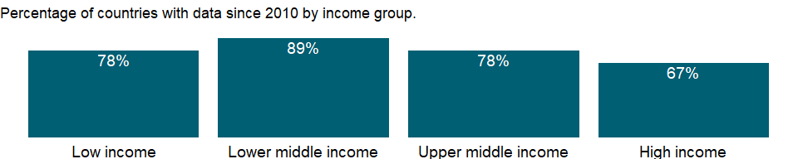

### Why is it relevant?

NA

### What is the data source?

World Bank national accounts data, and OECD National Accounts data files.

### What is the methodology?

NA

### How is it aggregated?

Weighted average

### What are the limitations?

NA

### What else should I know?

NA

### 1.40.2 Household final consumption expenditure (annual % growth)

### What is the indicator?

Annual percentage growth of household final consumption expenditure based on constant local currency. Aggregates are based on constant 2010 U.S. dollars. Household final consumption expenditure (formerly private consumption) is the market value of all goods and services, including durable products (such as cars, washing machines, and home computers), purchased by households. It excludes purchases of dwellings but includes imputed rent for owner-occupied dwellings. It also includes payments and fees to governments to obtain permits and licenses. Here, household consumption expenditure includes the expenditures of nonprofit institutions serving households, even when reported separately by the country.

Topic: Economic Policy & Debt: National accounts: Growth rates

Series ID: NE.CON.PRVT.KD.ZG

Copyright: CC BY-4.0 , <https://datacatalog.worldbank.org/public-licenses#cc-by>

First year with any data: 1961

Last year with any data: 2020

### What years are data available?

The figure below shows years in which data is available for at least one country. Dates shaded in black have no data, while dates shaded in green have data for at least one country



### Which countries have data?

The figure below shows the percentage of countries in each income group with a value since 2010 for that indicator.

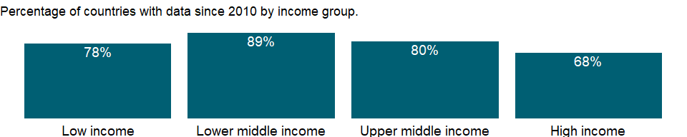

### Why is it relevant?

NA

### What is the data source?

World Bank national accounts data, and OECD National Accounts data files.

### What is the methodology?

NA

### How is it aggregated?

Weighted average

### What are the limitations?

NA

### What else should I know?

NA

### 1.40.3 Household final consumption expenditure per capita growth (annual %)

### What is the indicator?

Annual percentage growth of household final consumption expenditure per capita, which is calculated using household final consumption expenditure in constant 2010 prices and World Bank population estimates. Household final consumption expenditure (private consumption) is the market value of all goods and services, including durable products (such as cars, washing machines, and home computers), purchased by households. It excludes purchases of dwellings but includes imputed rent for owner-occupied dwellings. It also includes payments and fees to governments to obtain permits and licenses. Here, household consumption expenditure includes the expenditures of nonprofit institutions serving households, even when reported separately by the country.

Topic: Economic Policy & Debt: National accounts: Growth rates

Series ID: NE.CON.PRVT.PC.KD.ZG

Copyright: CC BY-4.0 , <https://datacatalog.worldbank.org/public-licenses#cc-by>

First year with any data: 1961

Last year with any data: 2020

### What years are data available?

The figure below shows years in which data is available for at least one country. Dates shaded in black have no data, while dates shaded in green have data for at least one country



### Which countries have data?

The figure below shows the percentage of countries in each income group with a value since 2010 for that indicator.

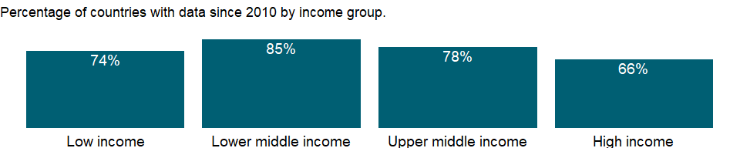

### Why is it relevant?

NA

### What is the data source?

World Bank national accounts data, and OECD National Accounts data files.

### What is the methodology?

NA

### How is it aggregated?

Weighted Average

### What are the limitations?

NA

### What else should I know?

NA

### 1.40.4 Final consumption expenditure (annual % growth)

### What is the indicator?

Average annual growth of final consumption expenditure based on constant local currency. Aggregates are based on constant 2010 U.S. dollars. Final consumption expenditure (formerly total consumption) is the sum of household final consumption expenditure (formerly private consumption) and general government final consumption expenditure (formerly general government consumption). This estimate includes any statistical discrepancy in the use of resources relative to the supply of resources.

Topic: Economic Policy & Debt: National accounts: Growth rates

Series ID: NE.CON.TOTL.KD.ZG

Copyright: CC BY-4.0 , <https://datacatalog.worldbank.org/public-licenses#cc-by>

First year with any data: 1961

Last year with any data: 2020

### What years are data available?

The figure below shows years in which data is available for at least one country. Dates shaded in black have no data, while dates shaded in green have data for at least one country



### Which countries have data?

The figure below shows the percentage of countries in each income group with a value since 2010 for that indicator.

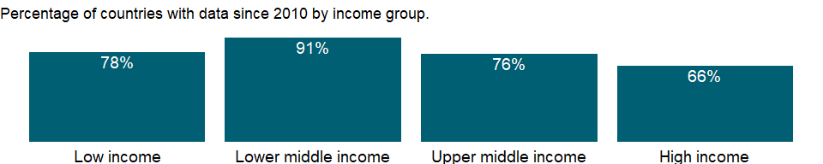

### Why is it relevant?

NA

### What is the data source?

World Bank national accounts data, and OECD National Accounts data files.

### What is the methodology?

NA

### How is it aggregated?

Weighted Average

### What are the limitations?

NA

### What else should I know?

NA

### 1.40.5 Exports of goods and services (annual % growth)

### What is the indicator?

Annual growth rate of exports of goods and services based on constant local currency. Aggregates are based on constant 2010 U.S. dollars. Exports of goods and services represent the value of all goods and other market services provided to the rest of the world. They include the value of merchandise, freight, insurance, transport, travel, royalties, license fees, and other services, such as communication, construction, financial, information, business, personal, and government services. They exclude compensation of employees and investment income (formerly called factor services) and transfer payments.

Topic: Economic Policy & Debt: National accounts: Growth rates

Series ID: NE.EXP.GNFS.KD.ZG

Copyright: CC BY-4.0 , <https://datacatalog.worldbank.org/public-licenses#cc-by>

First year with any data: 1961

Last year with any data: 2020

### What years are data available?

The figure below shows years in which data is available for at least one country. Dates shaded in black have no data, while dates shaded in green have data for at least one country



### Which countries have data?

The figure below shows the percentage of countries in each income group with a value since 2010 for that indicator.

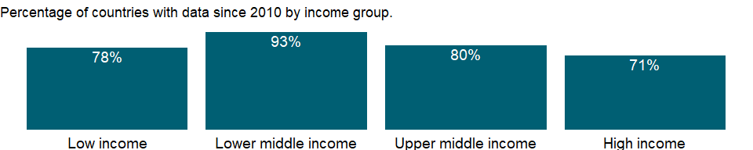

### Why is it relevant?

NA

### What is the data source?

World Bank national accounts data, and OECD National Accounts data files.

### What is the methodology?

NA

### How is it aggregated?

Weighted average

### What are the limitations?

NA

### What else should I know?

NA

### 1.40.6 Gross fixed capital formation (annual % growth)

### What is the indicator?

Average annual growth of gross fixed capital formation based on constant local currency. Aggregates are based on constant 2010 U.S. dollars. Gross fixed capital formation (formerly gross domestic fixed investment) includes land improvements (fences, ditches, drains, and so on); plant, machinery, and equipment purchases; and the construction of roads, railways, and the like, including schools, offices, hospitals, private residential dwellings, and commercial and industrial buildings. According to the 1993 SNA, net acquisitions of valuables are also considered capital formation.

Topic: Economic Policy & Debt: National accounts: Growth rates

Series ID: NE.GDI.FTOT.KD.ZG

Copyright: CC BY-4.0 , <https://datacatalog.worldbank.org/public-licenses#cc-by>

First year with any data: 1961

Last year with any data: 2020

### What years are data available?

The figure below shows years in which data is available for at least one country. Dates shaded in black have no data, while dates shaded in green have data for at least one country



### Which countries have data?

The figure below shows the percentage of countries in each income group with a value since 2010 for that indicator.

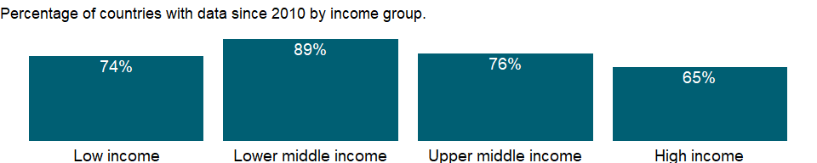

### Why is it relevant?

NA

### What is the data source?

World Bank national accounts data, and OECD National Accounts data files.

### What is the methodology?

NA

### How is it aggregated?

Weighted average

### What are the limitations?

NA

### What else should I know?

NA

### 1.40.7 Gross capital formation (annual % growth)

### What is the indicator?

Annual growth rate of gross capital formation based on constant local currency. Aggregates are based on constant 2010 U.S. dollars. Gross capital formation (formerly gross domestic investment) consists of outlays on additions to the fixed assets of the economy plus net changes in the level of inventories. Fixed assets include land improvements (fences, ditches, drains, and so on); plant, machinery, and equipment purchases; and the construction of roads, railways, and the like, including schools, offices, hospitals, private residential dwellings, and commercial and industrial buildings. Inventories are stocks of goods held by firms to meet temporary or unexpected fluctuations in production or sales, and “work in progress.” According to the 1993 SNA, net acquisitions of valuables are also considered capital formation.

Topic: Economic Policy & Debt: National accounts: Growth rates

Series ID: NE.GDI.TOTL.KD.ZG

Copyright: CC BY-4.0 , <https://datacatalog.worldbank.org/public-licenses#cc-by>

First year with any data: 1961

Last year with any data: 2020

### What years are data available?

The figure below shows years in which data is available for at least one country. Dates shaded in black have no data, while dates shaded in green have data for at least one country



### Which countries have data?

The figure below shows the percentage of countries in each income group with a value since 2010 for that indicator.

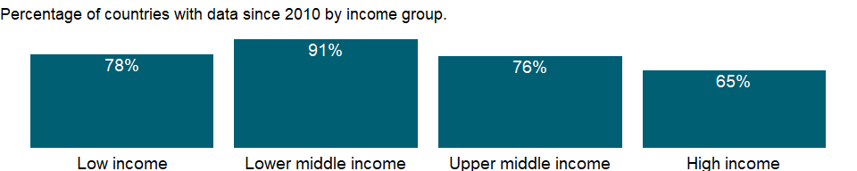

### Why is it relevant?

NA

### What is the data source?

World Bank national accounts data, and OECD National Accounts data files.

### What is the methodology?

NA

### How is it aggregated?

Weighted average

### What are the limitations?

NA

### What else should I know?

NA

### 1.40.8 Imports of goods and services (annual % growth)

### What is the indicator?

Annual growth rate of imports of goods and services based on constant local currency. Aggregates are based on constant 2010 U.S. dollars. Imports of goods and services represent the value of all goods and other market services received from the rest of the world. They include the value of merchandise, freight, insurance, transport, travel, royalties, license fees, and other services, such as communication, construction, financial, information, business, personal, and government services. They exclude compensation of employees and investment income (formerly called factor services) and transfer payments.

Topic: Economic Policy & Debt: National accounts: Growth rates

Series ID: NE.IMP.GNFS.KD.ZG

Copyright: CC BY-4.0 , <https://datacatalog.worldbank.org/public-licenses#cc-by>

First year with any data: 1961

Last year with any data: 2020

### What years are data available?

The figure below shows years in which data is available for at least one country. Dates shaded in black have no data, while dates shaded in green have data for at least one country



### Which countries have data?

The figure below shows the percentage of countries in each income group with a value since 2010 for that indicator.



### Why is it relevant?

NA

### What is the data source?

World Bank national accounts data, and OECD National Accounts data files.

### What is the methodology?

NA

### How is it aggregated?

Weighted average

### What are the limitations?

NA

### What else should I know?

NA

### 1.40.9 Agriculture, value added (annual % growth)

### What is the indicator?

Annual growth rate for agricultural value added based on constant local currency. Aggregates are based on constant 2010 U.S. dollars. Agriculture corresponds to ISIC divisions 1-5 and includes forestry, hunting, and fishing, as well as cultivation of crops and livestock production. Value added is the net output of a sector after adding up all outputs and subtracting intermediate inputs. It is calculated without making deductions for depreciation of fabricated assets or depletion and degradation of natural resources. The origin of value added is determined by the International Standard Industrial Classification (ISIC), revision 3.

Topic: Economic Policy & Debt: National accounts: Growth rates

Series ID: NV.AGR.TOTL.KD.ZG

Copyright: CC BY-4.0 , <https://datacatalog.worldbank.org/public-licenses#cc-by>

First year with any data: 1961

Last year with any data: 2020

### What years are data available?

The figure below shows years in which data is available for at least one country. Dates shaded in black have no data, while dates shaded in green have data for at least one country



### Which countries have data?

The figure below shows the percentage of countries in each income group with a value since 2010 for that indicator.

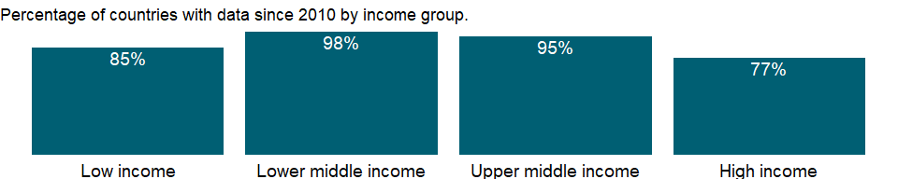

### Why is it relevant?

An economy’s growth is measured by the change in the volume of its output or in the real incomes of its residents. The 2008 United Nations System of National Accounts (2008 SNA) offers three plausible indicators for calculating growth: the volume of gross domestic product (GDP), real gross domestic income, and real gross national income. The volume of GDP is the sum of value added, measured at constant prices, by households, government, and industries operating in the economy. GDP accounts for all domestic production, regardless of whether the income accrues to domestic or foreign institutions.

### What is the data source?

World Bank national accounts data, and OECD National Accounts data files.

### What is the methodology?

Gross domestic product (GDP) represents the sum of value added by all its producers. Value added is the value of the gross output of producers less the value of intermediate goods and services consumed in production, before accounting for consumption of fixed capital in production. The United Nations System of National Accounts calls for value added to be valued at either basic prices (excluding net taxes on products) or producer prices (including net taxes on products paid by producers but excluding sales or value added taxes). Both valuations exclude transport charges that are invoiced separately by producers. Total GDP is measured at purchaser prices. Value added by industry is normally measured at basic prices.

### How is it aggregated?

Weighted average

### What are the limitations?

Among the difficulties faced by compilers of national accounts is the extent of unreported economic activity in the informal or secondary economy. In developing countries a large share of agricultural output is either not exchanged (because it is consumed within the household) or not exchanged for money. Agricultural production often must be estimated indirectly, using a combination of methods involving estimates of inputs, yields, and area under cultivation. This approach sometimes leads to crude approximations that can differ from the true values over time and across crops for reasons other than climate conditions or farming techniques. Similarly, agricultural inputs that cannot easily be allocated to specific outputs are frequently “netted out” using equally crude and ad hoc approximations.

### What else should I know?

Note: Data for OECD countries are based on ISIC, revision 4.

### 1.40.10 Manufacturing, value added (annual % growth)

### What is the indicator?

Annual growth rate for manufacturing value added based on constant local currency. Aggregates are based on constant 2010 U.S. dollars. Manufacturing refers to industries belonging to ISIC divisions 15-37. Value added is the net output of a sector after adding up all outputs and subtracting intermediate inputs. It is calculated without making deductions for depreciation of fabricated assets or depletion and degradation of natural resources. The origin of value added is determined by the International Standard Industrial Classification (ISIC), revision 3.

Topic: Economic Policy & Debt: National accounts: Growth rates

Series ID: NV.IND.MANF.KD.ZG

Copyright: CC BY-4.0 , <https://datacatalog.worldbank.org/public-licenses#cc-by>

First year with any data: 1961

Last year with any data: 2020

### What years are data available?

The figure below shows years in which data is available for at least one country. Dates shaded in black have no data, while dates shaded in green have data for at least one country



### Which countries have data?

The figure below shows the percentage of countries in each income group with a value since 2010 for that indicator.

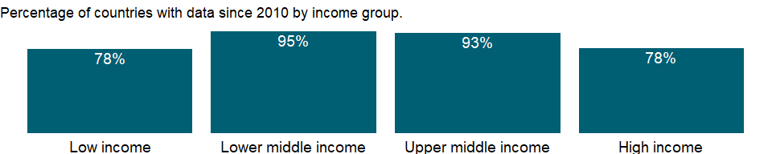

### Why is it relevant?

An economy’s growth is measured by the change in the volume of its output or in the real incomes of its residents. The 2008 United Nations System of National Accounts (2008 SNA) offers three plausible indicators for calculating growth: the volume of gross domestic product (GDP), real gross domestic income, and real gross national income. The volume of GDP is the sum of value added, measured at constant prices, by households, government, and industries operating in the economy. GDP accounts for all domestic production, regardless of whether the income accrues to domestic or foreign institutions.

### What is the data source?

World Bank national accounts data, and OECD National Accounts data files.

### What is the methodology?

Gross domestic product (GDP) represents the sum of value added by all its producers. Value added is the value of the gross output of producers less the value of intermediate goods and services consumed in production, before accounting for consumption of fixed capital in production. The United Nations System of National Accounts calls for value added to be valued at either basic prices (excluding net taxes on products) or producer prices (including net taxes on products paid by producers but excluding sales or value added taxes). Both valuations exclude transport charges that are invoiced separately by producers. Total GDP is measured at purchaser prices. Value added by industry is normally measured at basic prices.

### How is it aggregated?

Weighted average

### What are the limitations?

Ideally, industrial output should be measured through regular censuses and surveys of firms. But in most developing countries such surveys are infrequent, so earlier survey results must be extrapolated using an appropriate indicator. The choice of sampling unit, which may be the enterprise (where responses may be based on financial records) or the establishment (where production units may be recorded separately), also affects the quality of the data. Moreover, much industrial production is organized in unincorporated or owner-operated ventures that are not captured by surveys aimed at the formal sector. Even in large industries, where regular surveys are more likely, evasion of excise and other taxes and nondisclosure of income lower the estimates of value added. Such problems become more acute as countries move from state control of industry to private enterprise, because new firms and growing numbers of established firms fail to report. In accordance with the System of National Accounts, output should include all such unreported activity as well as the value of illegal activities and other unrecorded, informal, or small-scale operations. Data on these activities need to be collected using techniques other than conventional surveys of firms.

### What else should I know?

Note: Data for OECD countries are based on ISIC, revision 4.

### 1.40.11 Industry, value added (annual % growth)

### What is the indicator?

Annual growth rate for industrial value added based on constant local currency. Aggregates are based on constant 2010 U.S. dollars. Industry corresponds to ISIC divisions 10-45 and includes manufacturing (ISIC divisions 15-37). It comprises value added in mining, manufacturing (also reported as a separate subgroup), construction, electricity, water, and gas. Value added is the net output of a sector after adding up all outputs and subtracting intermediate inputs. It is calculated without making deductions for depreciation of fabricated assets or depletion and degradation of natural resources. The origin of value added is determined by the International Standard Industrial Classification (ISIC), revision 3.

Topic: Economic Policy & Debt: National accounts: Growth rates

Series ID: NV.IND.TOTL.KD.ZG

Copyright: CC BY-4.0 , <https://datacatalog.worldbank.org/public-licenses#cc-by>

First year with any data: 1961

Last year with any data: 2020

### What years are data available?

The figure below shows years in which data is available for at least one country. Dates shaded in black have no data, while dates shaded in green have data for at least one country



### Which countries have data?

The figure below shows the percentage of countries in each income group with a value since 2010 for that indicator.

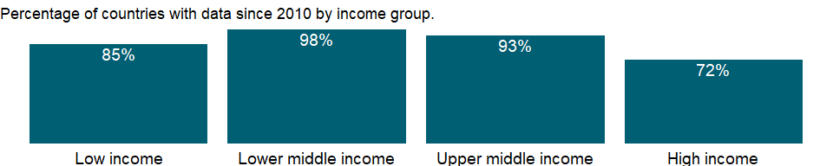

### Why is it relevant?

An economy’s growth is measured by the change in the volume of its output or in the real incomes of its residents. The 2008 United Nations System of National Accounts (2008 SNA) offers three plausible indicators for calculating growth: the volume of gross domestic product (GDP), real gross domestic income, and real gross national income. The volume of GDP is the sum of value added, measured at constant prices, by households, government, and industries operating in the economy. GDP accounts for all domestic production, regardless of whether the income accrues to domestic or foreign institutions.

### What is the data source?

World Bank national accounts data, and OECD National Accounts data files.

### What is the methodology?

Gross domestic product (GDP) represents the sum of value added by all its producers. Value added is the value of the gross output of producers less the value of intermediate goods and services consumed in production, before accounting for consumption of fixed capital in production. The United Nations System of National Accounts calls for value added to be valued at either basic prices (excluding net taxes on products) or producer prices (including net taxes on products paid by producers but excluding sales or value added taxes). Both valuations exclude transport charges that are invoiced separately by producers. Total GDP is measured at purchaser prices. Value added by industry is normally measured at basic prices.

### How is it aggregated?

Weighted average

### What are the limitations?

Ideally, industrial output should be measured through regular censuses and surveys of firms. But in most developing countries such surveys are infrequent, so earlier survey results must be extrapolated using an appropriate indicator. The choice of sampling unit, which may be the enterprise (where responses may be based on financial records) or the establishment (where production units may be recorded separately), also affects the quality of the data. Moreover, much industrial production is organized in unincorporated or owner-operated ventures that are not captured by surveys aimed at the formal sector. Even in large industries, where regular surveys are more likely, evasion of excise and other taxes and nondisclosure of income lower the estimates of value added. Such problems become more acute as countries move from state control of industry to private enterprise, because new firms and growing numbers of established firms fail to report. In accordance with the System of National Accounts, output should include all such unreported activity as well as the value of illegal activities and other unrecorded, informal, or small-scale operations. Data on these activities need to be collected using techniques other than conventional surveys of firms.

### What else should I know?

Note: Data for OECD countries are based on ISIC, revision 4.

### 1.40.12 Services, value added (annual % growth)

### What is the indicator?

Annual growth rate for value added in services based on constant local currency. Aggregates are based on constant 2010 U.S. dollars. Services correspond to ISIC divisions 50-99. They include value added in wholesale and retail trade (including hotels and restaurants), transport, and government, financial, professional, and personal services such as education, health care, and real estate services. Also included are imputed bank service charges, import duties, and any statistical discrepancies noted by national compilers as well as discrepancies arising from rescaling. Value added is the net output of a sector after adding up all outputs and subtracting intermediate inputs. It is calculated without making deductions for depreciation of fabricated assets or depletion and degradation of natural resources. The industrial origin of value added is determined by the International Standard Industrial Classification (ISIC), revision 3 or 4.

Topic: Economic Policy & Debt: National accounts: Growth rates

Series ID: NV.SRV.TOTL.KD.ZG

Copyright: CC BY-4.0 , <https://datacatalog.worldbank.org/public-licenses#cc-by>

First year with any data: 1961

Last year with any data: 2020

### What years are data available?

The figure below shows years in which data is available for at least one country. Dates shaded in black have no data, while dates shaded in green have data for at least one country



### Which countries have data?

The figure below shows the percentage of countries in each income group with a value since 2010 for that indicator.

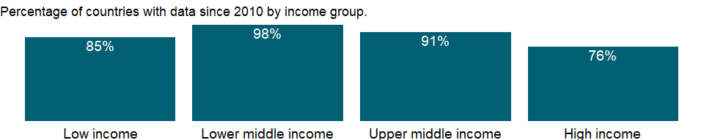

### Why is it relevant?

An economy’s growth is measured by the change in the volume of its output or in the real incomes of its residents. The 2008 United Nations System of National Accounts (2008 SNA) offers three plausible indicators for calculating growth: the volume of gross domestic product (GDP), real gross domestic income, and real gross national income. The volume of GDP is the sum of value added, measured at constant prices, by households, government, and industries operating in the economy. GDP accounts for all domestic production, regardless of whether the income accrues to domestic or foreign institutions.

### What is the data source?

World Bank national accounts data, and OECD National Accounts data files.

### What is the methodology?

Gross domestic product (GDP) represents the sum of value added by all its producers. Value added is the value of the gross output of producers less the value of intermediate goods and services consumed in production, before accounting for consumption of fixed capital in production. The United Nations System of National Accounts calls for value added to be valued at either basic prices (excluding net taxes on products) or producer prices (including net taxes on products paid by producers but excluding sales or value added taxes). Both valuations exclude transport charges that are invoiced separately by producers. Total GDP is measured at purchaser prices. Value added by industry is normally measured at basic prices.

### How is it aggregated?

Weighted Average

### What are the limitations?

In the services industries, including most of government, value added in constant prices is often imputed from labor inputs, such as real wages or number of employees. In the absence of well defined measures of output, measuring the growth of services remains difficult.

### What else should I know?

NA

### 1.40.13 GDP growth (annual %)

### What is the indicator?

Annual percentage growth rate of GDP at market prices based on constant local currency. Aggregates are based on constant 2010 U.S. dollars. GDP is the sum of gross value added by all resident producers in the economy plus any product taxes and minus any subsidies not included in the value of the products. It is calculated without making deductions for depreciation of fabricated assets or for depletion and degradation of natural resources.

Topic: Economic Policy & Debt: National accounts: Growth rates

Series ID: NY.GDP.MKTP.KD.ZG

Copyright: CC BY-4.0 , <https://datacatalog.worldbank.org/public-licenses#cc-by>

First year with any data: 1961

Last year with any data: 2020

### What years are data available?

The figure below shows years in which data is available for at least one country. Dates shaded in black have no data, while dates shaded in green have data for at least one country



### Which countries have data?

The figure below shows the percentage of countries in each income group with a value since 2010 for that indicator.



### Why is it relevant?

An economy’s growth is measured by the change in the volume of its output or in the real incomes of its residents. The 2008 United Nations System of National Accounts (2008 SNA) offers three plausible indicators for calculating growth: the volume of gross domestic product (GDP), real gross domestic income, and real gross national income. The volume of GDP is the sum of value added, measured at constant prices, by households, government, and industries operating in the economy. GDP accounts for all domestic production, regardless of whether the income accrues to domestic or foreign institutions.

### What is the data source?

World Bank national accounts data, and OECD National Accounts data files.

### What is the methodology?

Gross domestic product (GDP) represents the sum of value added by all its producers. Value added is the value of the gross output of producers less the value of intermediate goods and services consumed in production, before accounting for consumption of fixed capital in production. The United Nations System of National Accounts calls for value added to be valued at either basic prices (excluding net taxes on products) or producer prices (including net taxes on products paid by producers but excluding sales or value added taxes). Both valuations exclude transport charges that are invoiced separately by producers. Total GDP is measured at purchaser prices. Value added by industry is normally measured at basic prices. When value added is measured at producer prices.

Growth rates of GDP and its components are calculated using the least squares method and constant price data in the local currency. Constant price U.S. dollar series are used to calculate regional and income group growth rates. Local currency series are converted to constant U.S. dollars using an exchange rate in the common reference year.

### How is it aggregated?

Weighted average

### What are the limitations?

Each industry’s contribution to growth in the economy’s output is measured by growth in the industry’s value added. In principle, value added in constant prices can be estimated by measuring the quantity of goods and services produced in a period, valuing them at an agreed set of base year prices, and subtracting the cost of intermediate inputs, also in constant prices. This double-deflation method requires detailed information on the structure of prices of inputs and outputs.

In many industries, however, value added is extrapolated from the base year using single volume indexes of outputs or, less commonly, inputs. Particularly in the services industries, including most of government, value added in constant prices is often imputed from labor inputs, such as real wages or number of employees. In the absence of well defined measures of output, measuring the growth of services remains difficult.

Moreover, technical progress can lead to improvements in production processes and in the quality of goods and services that, if not properly accounted for, can distort measures of value added and thus of growth. When inputs are used to estimate output, as for nonmarket services, unmeasured technical progress leads to underestimates of the volume of output. Similarly, unmeasured improvements in quality lead to underestimates of the value of output and value added. The result can be underestimates of growth and productivity improvement and overestimates of inflation.

Informal economic activities pose a particular measurement problem, especially in developing countries, where much economic activity is unrecorded. A complete picture of the economy requires estimating household outputs produced for home use, sales in informal markets, barter exchanges, and illicit or deliberately unreported activities. The consistency and completeness of such estimates depend on the skill and methods of the compiling statisticians.

Rebasing of national accounts can alter the measured growth rate of an economy and lead to breaks in series that affect the consistency of data over time. When countries rebase their national accounts, they update the weights assigned to various components to better reflect current patterns of production or uses of output. The new base year should represent normal operation of the economy - it should be a year without major shocks or distortions. Some developing countries have not rebased their national accounts for many years. Using an old base year can be misleading because implicit price and volume weights become progressively less relevant and useful.

To obtain comparable series of constant price data for computing aggregates, the World Bank rescales GDP and value added by industrial origin to a common reference year. Because rescaling changes the implicit weights used in forming regional and income group aggregates, aggregate growth rates are not comparable with those from earlier editions with different base years. Rescaling may result in a discrepancy between the rescaled GDP and the sum of the rescaled components. To avoid distortions in the growth rates, the discrepancy is left unallocated. As a result, the weighted average of the growth rates of the components generally does not equal the GDP growth rate.

### What else should I know?

NA

### 1.40.14 GDP per capita growth (annual %)

### What is the indicator?

Annual percentage growth rate of GDP per capita based on constant local currency. Aggregates are based on constant 2010 U.S. dollars. GDP per capita is gross domestic product divided by midyear population. GDP at purchaser’s prices is the sum of gross value added by all resident producers in the economy plus any product taxes and minus any subsidies not included in the value of the products. It is calculated without making deductions for depreciation of fabricated assets or for depletion and degradation of natural resources.

Topic: Economic Policy & Debt: National accounts: Growth rates

Series ID: NY.GDP.PCAP.KD.ZG

Copyright: CC BY-4.0 , <https://datacatalog.worldbank.org/public-licenses#cc-by>

First year with any data: 1961

Last year with any data: 2020

### What years are data available?

The figure below shows years in which data is available for at least one country. Dates shaded in black have no data, while dates shaded in green have data for at least one country



### Which countries have data?

The figure below shows the percentage of countries in each income group with a value since 2010 for that indicator.



### Why is it relevant?

NA

### What is the data source?

World Bank national accounts data, and OECD National Accounts data files.

### What is the methodology?

For more information, see the metadata for constant U.S. dollar GDP (NY.GDP.MKTP.KD) and total population (SP.POP.TOTL).

### How is it aggregated?

Weighted Average

### What are the limitations?

NA

### What else should I know?

NA

### 1.40.15 GNI growth (annual %)

### What is the indicator?

GNI (formerly GNP) is the sum of value added by all resident producers plus any product taxes (less subsidies) not included in the valuation of output plus net receipts of primary income (compensation of employees and property income) from abroad.

Topic: Economic Policy & Debt: National accounts: Growth rates

Series ID: NY.GNP.MKTP.KD.ZG

Copyright: CC BY-4.0 , <https://datacatalog.worldbank.org/public-licenses#cc-by>

First year with any data: 1961

Last year with any data: 2020

### What years are data available?

The figure below shows years in which data is available for at least one country. Dates shaded in black have no data, while dates shaded in green have data for at least one country



### Which countries have data?

The figure below shows the percentage of countries in each income group with a value since 2010 for that indicator.

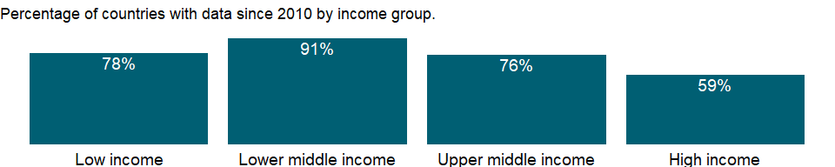

### Why is it relevant?

NA

### What is the data source?

World Bank national accounts data, and OECD National Accounts data files.

### What is the methodology?

NA

### How is it aggregated?

Weighted Average

### What are the limitations?

NA

### What else should I know?

NA

### 1.40.16 GNI per capita growth (annual %)

### What is the indicator?

Annual percentage growth rate of GNI per capita based on constant local currency. Aggregates are based on constant 2010 U.S. dollars. GNI per capita is gross national income divided by midyear population. GNI (formerly GNP) is the sum of value added by all resident producers plus any product taxes (less subsidies) not included in the valuation of output plus net receipts of primary income (compensation of employees and property income) from abroad.

Topic: Economic Policy & Debt: National accounts: Growth rates

Series ID: NY.GNP.PCAP.KD.ZG

Copyright: CC BY-4.0 , <https://datacatalog.worldbank.org/public-licenses#cc-by>

First year with any data: 1961

Last year with any data: 2020

### What years are data available?

The figure below shows years in which data is available for at least one country. Dates shaded in black have no data, while dates shaded in green have data for at least one country



### Which countries have data?

The figure below shows the percentage of countries in each income group with a value since 2010 for that indicator.



### Why is it relevant?

NA

### What is the data source?

World Bank national accounts data, and OECD National Accounts data files.

### What is the methodology?

NA

### How is it aggregated?

Weighted Average

### What are the limitations?

NA

### What else should I know?

NA

## 1.41 Economic Policy & Debt: National accounts: Local currency at constant prices: Expenditure on GDP

### 1.41.1 General government final consumption expenditure (constant LCU)

### What is the indicator?

General government final consumption expenditure (formerly general government consumption) includes all government current expenditures for purchases of goods and services (including compensation of employees). It also includes most expenditures on national defense and security, but excludes government military expenditures that are part of government capital formation. Data are in constant local currency.

Topic: Economic Policy & Debt: National accounts: Local currency at constant prices: Expenditure on GDP

Series ID: NE.CON.GOVT.KN

Copyright: CC BY-4.0 , <https://datacatalog.worldbank.org/public-licenses#cc-by>

First year with any data: 1960

Last year with any data: 2020

### What years are data available?

The figure below shows years in which data is available for at least one country. Dates shaded in black have no data, while dates shaded in green have data for at least one country



### Which countries have data?

The figure below shows the percentage of countries in each income group with a value since 2010 for that indicator.

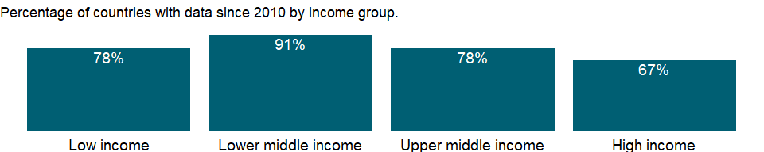

### Why is it relevant?

NA

### What is the data source?

World Bank national accounts data, and OECD National Accounts data files.

### What is the methodology?

NA

### How is it aggregated?

NA

### What are the limitations?

NA

### What else should I know?

NA

### 1.41.2 Household final consumption expenditure (constant LCU)

### What is the indicator?

Household final consumption expenditure (formerly private consumption) is the market value of all goods and services, including durable products (such as cars, washing machines, and home computers), purchased by households. It excludes purchases of dwellings but includes imputed rent for owner-occupied dwellings. It also includes payments and fees to governments to obtain permits and licenses. Here, household consumption expenditure includes the expenditures of nonprofit institutions serving households, even when reported separately by the country. Data are in constant local currency.

Topic: Economic Policy & Debt: National accounts: Local currency at constant prices: Expenditure on GDP

Series ID: NE.CON.PRVT.KN

Copyright: CC BY-4.0 , <https://datacatalog.worldbank.org/public-licenses#cc-by>

First year with any data: 1960

Last year with any data: 2020

### What years are data available?

The figure below shows years in which data is available for at least one country. Dates shaded in black have no data, while dates shaded in green have data for at least one country



### Which countries have data?

The figure below shows the percentage of countries in each income group with a value since 2010 for that indicator.

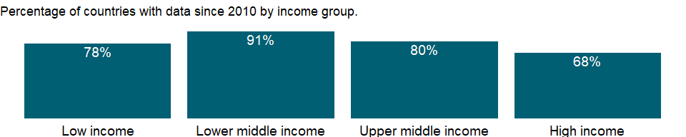

### Why is it relevant?

NA

### What is the data source?

World Bank national accounts data, and OECD National Accounts data files.

### What is the methodology?

NA

### How is it aggregated?

NA

### What are the limitations?

NA

### What else should I know?

NA

### 1.41.3 Final consumption expenditure (constant LCU)

### What is the indicator?

Final consumption expenditure (formerly total consumption) is the sum of household final consumption expenditure (formerly private consumption) and general government final consumption expenditure (formerly general government consumption). Data are in constant local currency.

Topic: Economic Policy & Debt: National accounts: Local currency at constant prices: Expenditure on GDP

Series ID: NE.CON.TOTL.KN

Copyright: CC BY-4.0 , <https://datacatalog.worldbank.org/public-licenses#cc-by>

First year with any data: 1960

Last year with any data: 2020

### What years are data available?

The figure below shows years in which data is available for at least one country. Dates shaded in black have no data, while dates shaded in green have data for at least one country



### Which countries have data?

The figure below shows the percentage of countries in each income group with a value since 2010 for that indicator.

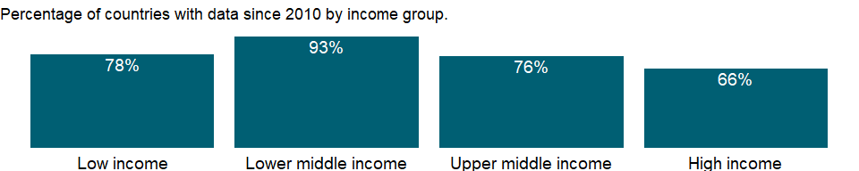

### Why is it relevant?

NA

### What is the data source?

World Bank national accounts data, and OECD National Accounts data files.

### What is the methodology?

NA

### How is it aggregated?

NA

### What are the limitations?

NA

### What else should I know?

NA

### 1.41.4 Gross national expenditure (constant LCU)

### What is the indicator?

Gross national expenditure (formerly domestic absorption) is the sum of household final consumption expenditure (formerly private consumption), general government final consumption expenditure (formerly general government consumption), and gross capital formation (formerly gross domestic investment). Data are in constant local currency.

Topic: Economic Policy & Debt: National accounts: Local currency at constant prices: Expenditure on GDP

Series ID: NE.DAB.TOTL.KN

Copyright: CC BY-4.0 , <https://datacatalog.worldbank.org/public-licenses#cc-by>

First year with any data: 1960

Last year with any data: 2020

### What years are data available?

The figure below shows years in which data is available for at least one country. Dates shaded in black have no data, while dates shaded in green have data for at least one country



### Which countries have data?

The figure below shows the percentage of countries in each income group with a value since 2010 for that indicator.

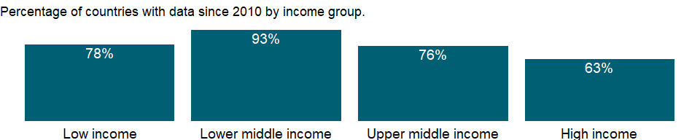

### Why is it relevant?

NA

### What is the data source?

World Bank national accounts data, and OECD National Accounts data files.

### What is the methodology?

NA

### How is it aggregated?

NA

### What are the limitations?

NA

### What else should I know?

NA

### 1.41.5 Exports of goods and services (constant LCU)

### What is the indicator?

Exports of goods and services represent the value of all goods and other market services provided to the rest of the world. They include the value of merchandise, freight, insurance, transport, travel, royalties, license fees, and other services, such as communication, construction, financial, information, business, personal, and government services. They exclude compensation of employees and investment income (formerly called factor services) and transfer payments. Data are in constant local currency.

Topic: Economic Policy & Debt: National accounts: Local currency at constant prices: Expenditure on GDP

Series ID: NE.EXP.GNFS.KN

Copyright: CC BY-4.0 , <https://datacatalog.worldbank.org/public-licenses#cc-by>

First year with any data: 1960

Last year with any data: 2020

### What years are data available?

The figure below shows years in which data is available for at least one country. Dates shaded in black have no data, while dates shaded in green have data for at least one country



### Which countries have data?

The figure below shows the percentage of countries in each income group with a value since 2010 for that indicator.



### Why is it relevant?

NA

### What is the data source?

World Bank national accounts data, and OECD National Accounts data files.

### What is the methodology?

NA

### How is it aggregated?

NA

### What are the limitations?

NA

### What else should I know?

NA

### 1.41.6 Gross fixed capital formation (constant LCU)

### What is the indicator?

Gross fixed capital formation (formerly gross domestic fixed investment) includes land improvements (fences, ditches, drains, and so on); plant, machinery, and equipment purchases; and the construction of roads, railways, and the like, including schools, offices, hospitals, private residential dwellings, and commercial and industrial buildings. According to the 1993 SNA, net acquisitions of valuables are also considered capital formation. Data are in constant local currency.

Topic: Economic Policy & Debt: National accounts: Local currency at constant prices: Expenditure on GDP

Series ID: NE.GDI.FTOT.KN

Copyright: CC BY-4.0 , <https://datacatalog.worldbank.org/public-licenses#cc-by>

First year with any data: 1960

Last year with any data: 2020

### What years are data available?

The figure below shows years in which data is available for at least one country. Dates shaded in black have no data, while dates shaded in green have data for at least one country



### Which countries have data?

The figure below shows the percentage of countries in each income group with a value since 2010 for that indicator.

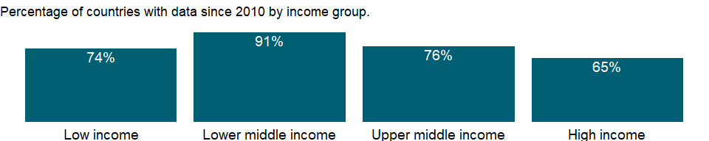

### Why is it relevant?

NA

### What is the data source?

World Bank national accounts data, and OECD National Accounts data files.

### What is the methodology?

NA

### How is it aggregated?

NA

### What are the limitations?

NA

### What else should I know?

NA

### 1.41.7 Changes in inventories (constant LCU)

### What is the indicator?

Inventories are stocks of goods held by firms to meet temporary or unexpected fluctuations in production or sales, and “work in progress.” Data are in constant local currency.

Topic: Economic Policy & Debt: National accounts: Local currency at constant prices: Expenditure on GDP

Series ID: NE.GDI.STKB.KN

Copyright: CC BY-4.0 , <https://datacatalog.worldbank.org/public-licenses#cc-by>

First year with any data: 1960

Last year with any data: 2020

### What years are data available?

The figure below shows years in which data is available for at least one country. Dates shaded in black have no data, while dates shaded in green have data for at least one country



### Which countries have data?

The figure below shows the percentage of countries in each income group with a value since 2010 for that indicator.

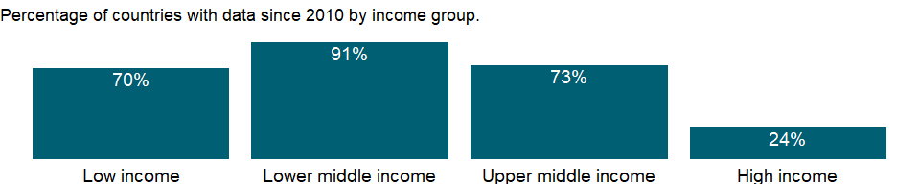

### Why is it relevant?

NA

### What is the data source?

World Bank national accounts data, and OECD National Accounts data files.

### What is the methodology?

NA

### How is it aggregated?

NA

### What are the limitations?

NA

### What else should I know?

NA

### 1.41.8 Gross capital formation (constant LCU)

### What is the indicator?

Gross capital formation (formerly gross domestic investment) consists of outlays on additions to the fixed assets of the economy plus net changes in the level of inventories. Fixed assets include land improvements (fences, ditches, drains, and so on); plant, machinery, and equipment purchases; and the construction of roads, railways, and the like, including schools, offices, hospitals, private residential dwellings, and commercial and industrial buildings. Inventories are stocks of goods held by firms to meet temporary or unexpected fluctuations in production or sales, and “work in progress.” According to the 1993 SNA, net acquisitions of valuables are also considered capital formation. Data are in constant local currency.

Topic: Economic Policy & Debt: National accounts: Local currency at constant prices: Expenditure on GDP

Series ID: NE.GDI.TOTL.KN

Copyright: CC BY-4.0 , <https://datacatalog.worldbank.org/public-licenses#cc-by>

First year with any data: 1960

Last year with any data: 2020

### What years are data available?

The figure below shows years in which data is available for at least one country. Dates shaded in black have no data, while dates shaded in green have data for at least one country



### Which countries have data?

The figure below shows the percentage of countries in each income group with a value since 2010 for that indicator.

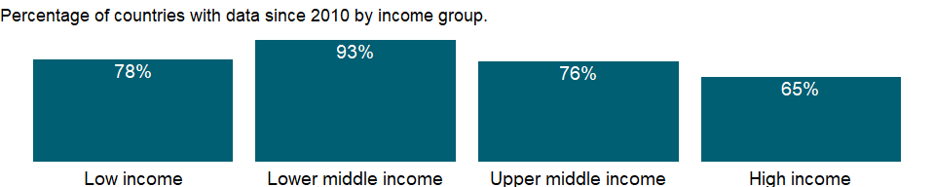

### Why is it relevant?

NA

### What is the data source?

World Bank national accounts data, and OECD National Accounts data files.

### What is the methodology?

NA

### How is it aggregated?

NA

### What are the limitations?

NA

### What else should I know?

NA

### 1.41.9 Imports of goods and services (constant LCU)

### What is the indicator?

Imports of goods and services represent the value of all goods and other market services received from the rest of the world. They include the value of merchandise, freight, insurance, transport, travel, royalties, license fees, and other services, such as communication, construction, financial, information, business, personal, and government services. They exclude compensation of employees and investment income (formerly called factor services) and transfer payments. Data are in constant local currency.

Topic: Economic Policy & Debt: National accounts: Local currency at constant prices: Expenditure on GDP

Series ID: NE.IMP.GNFS.KN

Copyright: CC BY-4.0 , <https://datacatalog.worldbank.org/public-licenses#cc-by>

First year with any data: 1960

Last year with any data: 2020

### What years are data available?

The figure below shows years in which data is available for at least one country. Dates shaded in black have no data, while dates shaded in green have data for at least one country



### Which countries have data?

The figure below shows the percentage of countries in each income group with a value since 2010 for that indicator.



### Why is it relevant?

NA

### What is the data source?

World Bank national accounts data, and OECD National Accounts data files.

### What is the methodology?

NA

### How is it aggregated?

NA

### What are the limitations?

NA

### What else should I know?

NA

### 1.41.10 External balance on goods and services (constant LCU)

### What is the indicator?

External balance on goods and services (formerly resource balance) equals exports of goods and services minus imports of goods and services (previously nonfactor services). Data are in constant local currency.

Topic: Economic Policy & Debt: National accounts: Local currency at constant prices: Expenditure on GDP

Series ID: NE.RSB.GNFS.KN

Copyright: CC BY-4.0 , <https://datacatalog.worldbank.org/public-licenses#cc-by>

First year with any data: 1960

Last year with any data: 2020

### What years are data available?

The figure below shows years in which data is available for at least one country. Dates shaded in black have no data, while dates shaded in green have data for at least one country



### Which countries have data?

The figure below shows the percentage of countries in each income group with a value since 2010 for that indicator.

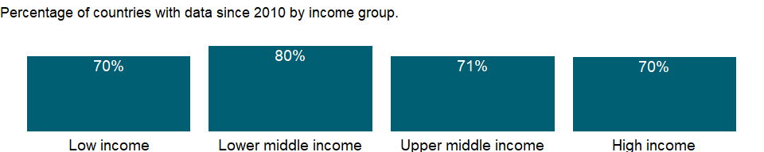

### Why is it relevant?

NA

### What is the data source?

World Bank national accounts data, and OECD National Accounts data files.

### What is the methodology?

NA

### How is it aggregated?

NA

### What are the limitations?

NA

### What else should I know?

NA

### 1.41.11 Discrepancy in expenditure estimate of GDP (constant LCU)

### What is the indicator?

A statistical discrepancy usually arises when the GDP components are estimated independently by industrial origin and by expenditure categories. This item represents the discrepancy in the use of resources (i.e., the estimate of GDP by expenditure categories). Data are in constant local currency.

Topic: Economic Policy & Debt: National accounts: Local currency at constant prices: Expenditure on GDP

Series ID: NY.GDP.DISC.KN

Copyright: CC BY-4.0 , <https://datacatalog.worldbank.org/public-licenses#cc-by>

First year with any data: 1960

Last year with any data: 2020

### What years are data available?

The figure below shows years in which data is available for at least one country. Dates shaded in black have no data, while dates shaded in green have data for at least one country



### Which countries have data?

The figure below shows the percentage of countries in each income group with a value since 2010 for that indicator.

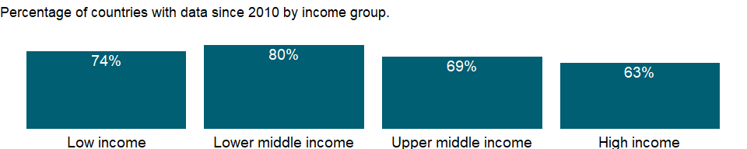

### Why is it relevant?

NA

### What is the data source?

World Bank national accounts data, and OECD National Accounts data files.

### What is the methodology?

NA

### How is it aggregated?

NA

### What are the limitations?

NA

### What else should I know?

NA

## 1.42 Economic Policy & Debt: National accounts: Shares of GDP & other

### 1.42.1 General government final consumption expenditure (% of GDP)

### What is the indicator?

General government final consumption expenditure (formerly general government consumption) includes all government current expenditures for purchases of goods and services (including compensation of employees). It also includes most expenditures on national defense and security, but excludes government military expenditures that are part of government capital formation.

Topic: Economic Policy & Debt: National accounts: Shares of GDP & other

Series ID: NE.CON.GOVT.ZS

Copyright: CC BY-4.0 , <https://datacatalog.worldbank.org/public-licenses#cc-by>

First year with any data: 1960

Last year with any data: 2020

### What years are data available?

The figure below shows years in which data is available for at least one country. Dates shaded in black have no data, while dates shaded in green have data for at least one country



### Which countries have data?

The figure below shows the percentage of countries in each income group with a value since 2010 for that indicator.



### Why is it relevant?

NA

### What is the data source?

World Bank national accounts data, and OECD National Accounts data files.

### What is the methodology?

Gross domestic product (GDP) from the expenditure side is made up of household final consumption expenditure, general government final consumption expenditure, gross capital formation (private and public investment in fixed assets, changes in inventories, and net acquisitions of valuables), and net exports (exports minus imports) of goods and services. Such expenditures are recorded in purchaser prices and include net taxes on products.

### How is it aggregated?

Weighted average

### What are the limitations?

Because policymakers have tended to focus on fostering the growth of output, and because data on production are easier to collect than data on spending, many countries generate their primary estimate of GDP using the production approach. Moreover, many countries do not estimate all the components of national expenditures but instead derive some of the main aggregates indirectly using GDP (based on the production approach) as the control total.

### What else should I know?

NA

### 1.42.2 Households and NPISHs final consumption expenditure (% of GDP)

### What is the indicator?

Household final consumption expenditure (formerly private consumption) is the market value of all goods and services, including durable products (such as cars, washing machines, and home computers), purchased by households. It excludes purchases of dwellings but includes imputed rent for owner-occupied dwellings. It also includes payments and fees to governments to obtain permits and licenses. Here, household consumption expenditure includes the expenditures of nonprofit institutions serving households, even when reported separately by the country. This item also includes any statistical discrepancy in the use of resources relative to the supply of resources.

Topic: Economic Policy & Debt: National accounts: Shares of GDP & other

Series ID: NE.CON.PRVT.ZS

Copyright: CC BY-4.0 , <https://datacatalog.worldbank.org/public-licenses#cc-by>

First year with any data: 1960

Last year with any data: 2020

### What years are data available?

The figure below shows years in which data is available for at least one country. Dates shaded in black have no data, while dates shaded in green have data for at least one country



### Which countries have data?

The figure below shows the percentage of countries in each income group with a value since 2010 for that indicator.



### Why is it relevant?

NA

### What is the data source?

World Bank national accounts data, and OECD National Accounts data files.

### What is the methodology?

Gross domestic product (GDP) from the expenditure side is made up of household final consumption expenditure, general government final consumption expenditure, gross capital formation (private and public investment in fixed assets, changes in inventories, and net acquisitions of valuables), and net exports (exports minus imports) of goods and services. Such expenditures are recorded in purchaser prices and include net taxes on products.

### How is it aggregated?

Weighted Average

### What are the limitations?

Because policymakers have tended to focus on fostering the growth of output, and because data on production are easier to collect than data on spending, many countries generate their primary estimate of GDP using the production approach. Moreover, many countries do not estimate all the components of national expenditures but instead derive some of the main aggregates indirectly using GDP (based on the production approach) as the control total. Household final consumption expenditure is often estimated as a residual, by subtracting all other known expenditures from GDP. The resulting aggregate may incorporate fairly large discrepancies. When household consumption is calculated separately, many of the estimates are based on household surveys, which tend to be one-year studies with limited coverage. Thus the estimates quickly become outdated and must be supplemented by estimates using price- and quantity-based statistical procedures. Complicating the issue, in many developing countries the distinction between cash outlays for personal business and those for household use may be blurred.

Informal economic activities pose a particular measurement problem, especially in developing countries, where much economic activity is unrecorded. A complete picture of the economy requires estimating household outputs produced for home use, sales in informal markets, barter exchanges, and illicit or deliberately unreported activities. The consistency and completeness of such estimates depend on the skill and methods of the compiling statisticians.

### What else should I know?

NA

### 1.42.3 Final consumption expenditure (% of GDP)

### What is the indicator?

Final consumption expenditure (formerly total consumption) is the sum of household final consumption expenditure (private consumption) and general government final consumption expenditure (general government consumption). This estimate includes any statistical discrepancy in the use of resources relative to the supply of resources.

Topic: Economic Policy & Debt: National accounts: Shares of GDP & other

Series ID: NE.CON.TOTL.ZS

Copyright: CC BY-4.0 , <https://datacatalog.worldbank.org/public-licenses#cc-by>

First year with any data: 1960

Last year with any data: 2020

### What years are data available?

The figure below shows years in which data is available for at least one country. Dates shaded in black have no data, while dates shaded in green have data for at least one country



### Which countries have data?

The figure below shows the percentage of countries in each income group with a value since 2010 for that indicator.



### Why is it relevant?

NA

### What is the data source?

World Bank national accounts data, and OECD National Accounts data files.

### What is the methodology?

NA

### How is it aggregated?

NA

### What are the limitations?

NA

### What else should I know?

NA

### 1.42.4 Gross national expenditure deflator (base year varies by country)

### What is the indicator?

Gross national expenditure (formerly domestic absorption) is the sum of household final consumption expenditure (formerly private consumption), general government final consumption expenditure (formerly general government consumption), and gross capital formation (formerly gross domestic investment).

Topic: Economic Policy & Debt: National accounts: Shares of GDP & other

Series ID: NE.DAB.DEFL.ZS

Copyright: CC BY-4.0 , <https://datacatalog.worldbank.org/public-licenses#cc-by>

First year with any data: 1960

Last year with any data: 2020

### What years are data available?

The figure below shows years in which data is available for at least one country. Dates shaded in black have no data, while dates shaded in green have data for at least one country



### Which countries have data?

The figure below shows the percentage of countries in each income group with a value since 2010 for that indicator.



### Why is it relevant?

NA

### What is the data source?

World Bank national accounts data, and OECD National Accounts data files.

### What is the methodology?

NA

### How is it aggregated?

NA

### What are the limitations?

NA

### What else should I know?

NA

### 1.42.5 Gross national expenditure (% of GDP)

### What is the indicator?

Gross national expenditure (formerly domestic absorption) is the sum of household final consumption expenditure (formerly private consumption), general government final consumption expenditure (formerly general government consumption), and gross capital formation (formerly gross domestic investment).

Topic: Economic Policy & Debt: National accounts: Shares of GDP & other

Series ID: NE.DAB.TOTL.ZS

Copyright: CC BY-4.0 , <https://datacatalog.worldbank.org/public-licenses#cc-by>

First year with any data: 1960

Last year with any data: 2020

### What years are data available?

The figure below shows years in which data is available for at least one country. Dates shaded in black have no data, while dates shaded in green have data for at least one country



### Which countries have data?

The figure below shows the percentage of countries in each income group with a value since 2010 for that indicator.



### Why is it relevant?

NA

### What is the data source?

World Bank national accounts data, and OECD National Accounts data files.

### What is the methodology?

NA

### How is it aggregated?

NA

### What are the limitations?

NA

### What else should I know?

NA

### 1.42.6 Exports of goods and services (% of GDP)

### What is the indicator?

Exports of goods and services represent the value of all goods and other market services provided to the rest of the world. They include the value of merchandise, freight, insurance, transport, travel, royalties, license fees, and other services, such as communication, construction, financial, information, business, personal, and government services. They exclude compensation of employees and investment income (formerly called factor services) and transfer payments.

Topic: Economic Policy & Debt: National accounts: Shares of GDP & other

Series ID: NE.EXP.GNFS.ZS

Copyright: CC BY-4.0 , <https://datacatalog.worldbank.org/public-licenses#cc-by>

First year with any data: 1960

Last year with any data: 2020

### What years are data available?

The figure below shows years in which data is available for at least one country. Dates shaded in black have no data, while dates shaded in green have data for at least one country



### Which countries have data?

The figure below shows the percentage of countries in each income group with a value since 2010 for that indicator.



### Why is it relevant?

NA

### What is the data source?

World Bank national accounts data, and OECD National Accounts data files.

### What is the methodology?

Gross domestic product (GDP) from the expenditure side is made up of household final consumption expenditure, general government final consumption expenditure, gross capital formation (private and public investment in fixed assets, changes in inventories, and net acquisitions of valuables), and net exports (exports minus imports) of goods and services. Such expenditures are recorded in purchaser prices and include net taxes on products.

### How is it aggregated?

Weighted average

### What are the limitations?

Because policymakers have tended to focus on fostering the growth of output, and because data on production are easier to collect than data on spending, many countries generate their primary estimate of GDP using the production approach. Moreover, many countries do not estimate all the components of national expenditures but instead derive some of the main aggregates indirectly using GDP (based on the production approach) as the control total.

Data on exports and imports are compiled from customs reports and balance of payments data. Although the data from the payments side provide reasonably reliable records of cross-border transactions, they may not adhere strictly to the appropriate definitions of valuation and timing used in the balance of payments or corresponds to the change-of ownership criterion. This issue has assumed greater significance with the increasing globalization of international business. Neither customs nor balance of payments data usually capture the illegal transactions that occur in many countries. Goods carried by travelers across borders in legal but unreported shuttle trade may further distort trade statistics.

### What else should I know?

NA

### 1.42.7 Gross fixed capital formation, private sector (% of GDP)

### What is the indicator?

Private investment covers gross outlays by the private sector (including private nonprofit agencies) on additions to its fixed domestic assets.

Topic: Economic Policy & Debt: National accounts: Shares of GDP & other

Series ID: NE.GDI.FPRV.ZS

Copyright: CC BY-4.0 , <https://datacatalog.worldbank.org/public-licenses#cc-by>

First year with any data: 1960

Last year with any data: 2020

### What years are data available?

The figure below shows years in which data is available for at least one country. Dates shaded in black have no data, while dates shaded in green have data for at least one country



### Which countries have data?

The figure below shows the percentage of countries in each income group with a value since 2010 for that indicator.



### Why is it relevant?

NA

### What is the data source?

World Bank national accounts data, and OECD National Accounts data files.

### What is the methodology?

NA

### How is it aggregated?

Weighted average

### What are the limitations?

NA

### What else should I know?

NA

### 1.42.8 Gross fixed capital formation (% of GDP)

### What is the indicator?

Gross fixed capital formation (formerly gross domestic fixed investment) includes land improvements (fences, ditches, drains, and so on); plant, machinery, and equipment purchases; and the construction of roads, railways, and the like, including schools, offices, hospitals, private residential dwellings, and commercial and industrial buildings. According to the 1993 SNA, net acquisitions of valuables are also considered capital formation.

Topic: Economic Policy & Debt: National accounts: Shares of GDP & other

Series ID: NE.GDI.FTOT.ZS

Copyright: CC BY-4.0 , <https://datacatalog.worldbank.org/public-licenses#cc-by>

First year with any data: 1960

Last year with any data: 2020

### What years are data available?

The figure below shows years in which data is available for at least one country. Dates shaded in black have no data, while dates shaded in green have data for at least one country



### Which countries have data?

The figure below shows the percentage of countries in each income group with a value since 2010 for that indicator.



### Why is it relevant?

NA

### What is the data source?

World Bank national accounts data, and OECD National Accounts data files.

### What is the methodology?

NA

### How is it aggregated?

Weighted average

### What are the limitations?

NA

### What else should I know?

NA

### 1.42.9 Gross capital formation (% of GDP)

### What is the indicator?

Gross capital formation (formerly gross domestic investment) consists of outlays on additions to the fixed assets of the economy plus net changes in the level of inventories. Fixed assets include land improvements (fences, ditches, drains, and so on); plant, machinery, and equipment purchases; and the construction of roads, railways, and the like, including schools, offices, hospitals, private residential dwellings, and commercial and industrial buildings. Inventories are stocks of goods held by firms to meet temporary or unexpected fluctuations in production or sales, and “work in progress.” According to the 1993 SNA, net acquisitions of valuables are also considered capital formation.

Topic: Economic Policy & Debt: National accounts: Shares of GDP & other

Series ID: NE.GDI.TOTL.ZS

Copyright: CC BY-4.0 , <https://datacatalog.worldbank.org/public-licenses#cc-by>

First year with any data: 1960

Last year with any data: 2020

### What years are data available?

The figure below shows years in which data is available for at least one country. Dates shaded in black have no data, while dates shaded in green have data for at least one country



### Which countries have data?

The figure below shows the percentage of countries in each income group with a value since 2010 for that indicator.



### Why is it relevant?

NA

### What is the data source?

World Bank national accounts data, and OECD National Accounts data files.

### What is the methodology?

Gross domestic product (GDP) from the expenditure side is made up of household final consumption expenditure, general government final consumption expenditure, gross capital formation (private and public investment in fixed assets, changes in inventories, and net acquisitions of valuables), and net exports (exports minus imports) of goods and services. Such expenditures are recorded in purchaser prices and include net taxes on products.

### How is it aggregated?

Weighted average

### What are the limitations?

Because policymakers have tended to focus on fostering the growth of output, and because data on production are easier to collect than data on spending, many countries generate their primary estimate of GDP using the production approach. Moreover, many countries do not estimate all the components of national expenditures but instead derive some of the main aggregates indirectly using GDP (based on the production approach) as the control total.

Data on capital formation may be estimated from direct surveys of enterprises and administrative records or based on the commodity flow method using data from production, trade, and construction activities. The quality of data on government fixed capital formation depends on the quality of government accounting systems (which tend to be weak in developing countries). Measures of fixed capital formation by households and corporations - particularly capital outlays by small, unincorporated enterprises - are usually unreliable.

Estimates of changes in inventories are rarely complete but usually include the most important activities or commodities. In some countries these estimates are derived as a composite residual along with household final consumption expenditure. According to national accounts conventions, adjustments should be made for appreciation of the value of inventory holdings due to price changes, but this is not always done. In highly inflationary economies this element can be substantial.

### What else should I know?

NA

### 1.42.10 Imports of goods and services (% of GDP)

### What is the indicator?

Imports of goods and services represent the value of all goods and other market services received from the rest of the world. They include the value of merchandise, freight, insurance, transport, travel, royalties, license fees, and other services, such as communication, construction, financial, information, business, personal, and government services. They exclude compensation of employees and investment income (formerly called factor services) and transfer payments.

Topic: Economic Policy & Debt: National accounts: Shares of GDP & other

Series ID: NE.IMP.GNFS.ZS

Copyright: CC BY-4.0 , <https://datacatalog.worldbank.org/public-licenses#cc-by>

First year with any data: 1960

Last year with any data: 2020

### What years are data available?

The figure below shows years in which data is available for at least one country. Dates shaded in black have no data, while dates shaded in green have data for at least one country



### Which countries have data?

The figure below shows the percentage of countries in each income group with a value since 2010 for that indicator.



### Why is it relevant?

NA

### What is the data source?

World Bank national accounts data, and OECD National Accounts data files.

### What is the methodology?

Gross domestic product (GDP) from the expenditure side is made up of household final consumption expenditure, general government final consumption expenditure, gross capital formation (private and public investment in fixed assets, changes in inventories, and net acquisitions of valuables), and net exports (exports minus imports) of goods and services. Such expenditures are recorded in purchaser prices and include net taxes on products.

### How is it aggregated?

Weighted average

### What are the limitations?

Because policymakers have tended to focus on fostering the growth of output, and because data on production are easier to collect than data on spending, many countries generate their primary estimate of GDP using the production approach. Moreover, many countries do not estimate all the components of national expenditures but instead derive some of the main aggregates indirectly using GDP (based on the production approach) as the control total.

Data on exports and imports are compiled from customs reports and balance of payments data. Although the data from the payments side provide reasonably reliable records of cross-border transactions, they may not adhere strictly to the appropriate definitions of valuation and timing used in the balance of payments or corresponds to the change-of ownership criterion. This issue has assumed greater significance with the increasing globalization of international business. Neither customs nor balance of payments data usually capture the illegal transactions that occur in many countries. Goods carried by travelers across borders in legal but unreported shuttle trade may further distort trade statistics.

### What else should I know?

NA

### 1.42.11 External balance on goods and services (% of GDP)

### What is the indicator?

External balance on goods and services (formerly resource balance) equals exports of goods and services minus imports of goods and services (previously nonfactor services).

Topic: Economic Policy & Debt: National accounts: Shares of GDP & other

Series ID: NE.RSB.GNFS.ZS

Copyright: CC BY-4.0 , <https://datacatalog.worldbank.org/public-licenses#cc-by>

First year with any data: 1960

Last year with any data: 2020

### What years are data available?

The figure below shows years in which data is available for at least one country. Dates shaded in black have no data, while dates shaded in green have data for at least one country



### Which countries have data?

The figure below shows the percentage of countries in each income group with a value since 2010 for that indicator.



### Why is it relevant?

NA

### What is the data source?

World Bank national accounts data, and OECD National Accounts data files.

### What is the methodology?

NA

### How is it aggregated?

Weighted average

### What are the limitations?

NA

### What else should I know?

NA

### 1.42.12 Trade (% of GDP)

### What is the indicator?

Trade is the sum of exports and imports of goods and services measured as a share of gross domestic product.

Topic: Economic Policy & Debt: National accounts: Shares of GDP & other

Series ID: NE.TRD.GNFS.ZS

Copyright: CC BY-4.0 , <https://datacatalog.worldbank.org/public-licenses#cc-by>

First year with any data: 1960

Last year with any data: 2020

### What years are data available?

The figure below shows years in which data is available for at least one country. Dates shaded in black have no data, while dates shaded in green have data for at least one country



### Which countries have data?

The figure below shows the percentage of countries in each income group with a value since 2010 for that indicator.



### Why is it relevant?

NA

### What is the data source?

World Bank national accounts data, and OECD National Accounts data files.

### What is the methodology?

NA

### How is it aggregated?

Weighted average

### What are the limitations?

NA

### What else should I know?

NA

### 1.42.13 Agriculture, value added (% of GDP)

### What is the indicator?

Agriculture corresponds to ISIC divisions 1-5 and includes forestry, hunting, and fishing, as well as cultivation of crops and livestock production. Value added is the net output of a sector after adding up all outputs and subtracting intermediate inputs. It is calculated without making deductions for depreciation of fabricated assets or depletion and degradation of natural resources. The origin of value added is determined by the International Standard Industrial Classification (ISIC), revision 3. Note: For VAB countries, gross value added at factor cost is used as the denominator.

Topic: Economic Policy & Debt: National accounts: Shares of GDP & other

Series ID: NV.AGR.TOTL.ZS

Copyright: CC BY-4.0 , <https://datacatalog.worldbank.org/public-licenses#cc-by>

First year with any data: 1960

Last year with any data: 2020

### What years are data available?

The figure below shows years in which data is available for at least one country. Dates shaded in black have no data, while dates shaded in green have data for at least one country



### Which countries have data?

The figure below shows the percentage of countries in each income group with a value since 2010 for that indicator.

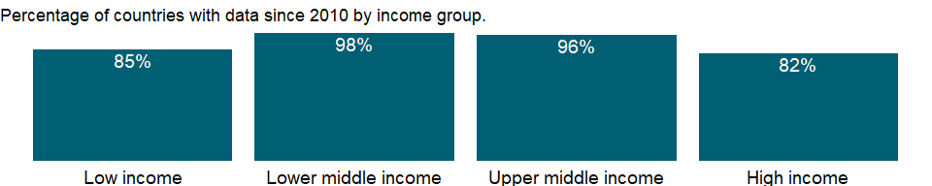

### Why is it relevant?

NA

### What is the data source?

World Bank national accounts data, and OECD National Accounts data files.

### What is the methodology?

Gross domestic product (GDP) represents the sum of value added by all its producers. Value added is the value of the gross output of producers less the value of intermediate goods and services consumed in production, before accounting for consumption of fixed capital in production. The United Nations System of National Accounts calls for value added to be valued at either basic prices (excluding net taxes on products) or producer prices (including net taxes on products paid by producers but excluding sales or value added taxes). Both valuations exclude transport charges that are invoiced separately by producers. Total GDP is measured at purchaser prices. Value added by industry is normally measured at basic prices.

### How is it aggregated?

Weighted average

### What are the limitations?

Among the difficulties faced by compilers of national accounts is the extent of unreported economic activity in the informal or secondary economy. In developing countries a large share of agricultural output is either not exchanged (because it is consumed within the household) or not exchanged for money. Agricultural production often must be estimated indirectly, using a combination of methods involving estimates of inputs, yields, and area under cultivation. This approach sometimes leads to crude approximations that can differ from the true values over time and across crops for reasons other than climate conditions or farming techniques. Similarly, agricultural inputs that cannot easily be allocated to specific outputs are frequently “netted out” using equally crude and ad hoc approximations.

### What else should I know?

Note: Data for OECD countries are based on ISIC, revision 4.

### 1.42.14 Manufacturing, value added (% of GDP)

### What is the indicator?

Manufacturing refers to industries belonging to ISIC divisions 15-37. Value added is the net output of a sector after adding up all outputs and subtracting intermediate inputs. It is calculated without making deductions for depreciation of fabricated assets or depletion and degradation of natural resources. The origin of value added is determined by the International Standard Industrial Classification (ISIC), revision 3. Note: For VAB countries, gross value added at factor cost is used as the denominator.

Topic: Economic Policy & Debt: National accounts: Shares of GDP & other

Series ID: NV.IND.MANF.ZS

Copyright: CC BY-4.0 , <https://datacatalog.worldbank.org/public-licenses#cc-by>

First year with any data: 1960

Last year with any data: 2020

### What years are data available?

The figure below shows years in which data is available for at least one country. Dates shaded in black have no data, while dates shaded in green have data for at least one country



### Which countries have data?

The figure below shows the percentage of countries in each income group with a value since 2010 for that indicator.

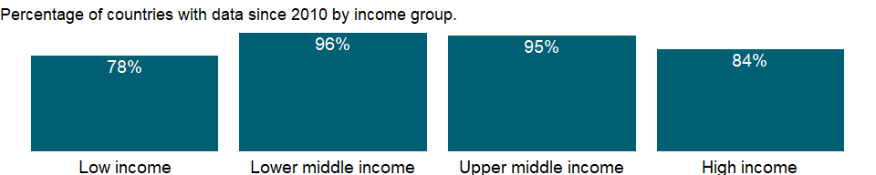

### Why is it relevant?

NA

### What is the data source?

World Bank national accounts data, and OECD National Accounts data files.

### What is the methodology?

Gross domestic product (GDP) represents the sum of value added by all its producers. Value added is the value of the gross output of producers less the value of intermediate goods and services consumed in production, before accounting for consumption of fixed capital in production. The United Nations System of National Accounts calls for value added to be valued at either basic prices (excluding net taxes on products) or producer prices (including net taxes on products paid by producers but excluding sales or value added taxes). Both valuations exclude transport charges that are invoiced separately by producers. Total GDP is measured at purchaser prices. Value added by industry is normally measured at basic prices.

### How is it aggregated?

Weighted average

### What are the limitations?

Ideally, industrial output should be measured through regular censuses and surveys of firms. But in most developing countries such surveys are infrequent, so earlier survey results must be extrapolated using an appropriate indicator. The choice of sampling unit, which may be the enterprise (where responses may be based on financial records) or the establishment (where production units may be recorded separately), also affects the quality of the data. Moreover, much industrial production is organized in unincorporated or owner-operated ventures that are not captured by surveys aimed at the formal sector. Even in large industries, where regular surveys are more likely, evasion of excise and other taxes and nondisclosure of income lower the estimates of value added. Such problems become more acute as countries move from state control of industry to private enterprise, because new firms and growing numbers of established firms fail to report. In accordance with the System of National Accounts, output should include all such unreported activity as well as the value of illegal activities and other unrecorded, informal, or small-scale operations. Data on these activities need to be collected using techniques other than conventional surveys of firms.

### What else should I know?

Note: Data for OECD countries are based on ISIC, revision 4.

### 1.42.15 Industry, value added (% of GDP)

### What is the indicator?

Industry corresponds to ISIC divisions 10-45 and includes manufacturing (ISIC divisions 15-37). It comprises value added in mining, manufacturing (also reported as a separate subgroup), construction, electricity, water, and gas. Value added is the net output of a sector after adding up all outputs and subtracting intermediate inputs. It is calculated without making deductions for depreciation of fabricated assets or depletion and degradation of natural resources. The origin of value added is determined by the International Standard Industrial Classification (ISIC), revision 3. Note: For VAB countries, gross value added at factor cost is used as the denominator.

Topic: Economic Policy & Debt: National accounts: Shares of GDP & other

Series ID: NV.IND.TOTL.ZS

Copyright: CC BY-4.0 , <https://datacatalog.worldbank.org/public-licenses#cc-by>

First year with any data: 1960

Last year with any data: 2020

### What years are data available?

The figure below shows years in which data is available for at least one country. Dates shaded in black have no data, while dates shaded in green have data for at least one country



### Which countries have data?

The figure below shows the percentage of countries in each income group with a value since 2010 for that indicator.

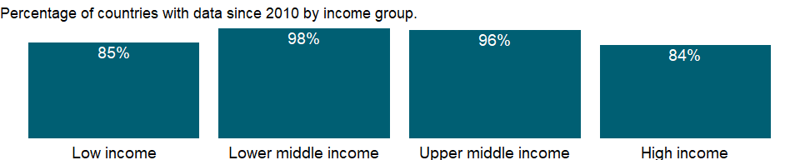

### Why is it relevant?

NA

### What is the data source?

World Bank national accounts data, and OECD National Accounts data files.

### What is the methodology?

Gross domestic product (GDP) represents the sum of value added by all its producers. Value added is the value of the gross output of producers less the value of intermediate goods and services consumed in production, before accounting for consumption of fixed capital in production. The United Nations System of National Accounts calls for value added to be valued at either basic prices (excluding net taxes on products) or producer prices (including net taxes on products paid by producers but excluding sales or value added taxes). Both valuations exclude transport charges that are invoiced separately by producers. Total GDP is measured at purchaser prices. Value added by industry is normally measured at basic prices.

### How is it aggregated?

Weighted average

### What are the limitations?

Ideally, industrial output should be measured through regular censuses and surveys of firms. But in most developing countries such surveys are infrequent, so earlier survey results must be extrapolated using an appropriate indicator. The choice of sampling unit, which may be the enterprise (where responses may be based on financial records) or the establishment (where production units may be recorded separately), also affects the quality of the data. Moreover, much industrial production is organized in unincorporated or owner-operated ventures that are not captured by surveys aimed at the formal sector. Even in large industries, where regular surveys are more likely, evasion of excise and other taxes and nondisclosure of income lower the estimates of value added. Such problems become more acute as countries move from state control of industry to private enterprise, because new firms and growing numbers of established firms fail to report. In accordance with the System of National Accounts, output should include all such unreported activity as well as the value of illegal activities and other unrecorded, informal, or small-scale operations. Data on these activities need to be collected using techniques other than conventional surveys of firms.

### What else should I know?

Note: Data for OECD countries are based on ISIC, revision 4.

### 1.42.16 Chemicals (% of value added in manufacturing)

### What is the indicator?

Value added in manufacturing is the sum of gross output less the value of intermediate inputs used in production for industries classified in ISIC major division D. Chemicals correspond to ISIC division 24.

Topic: Economic Policy & Debt: National accounts: Shares of GDP & other

Series ID: NV.MNF.CHEM.ZS.UN

Copyright: CC BY-4.0 , <https://datacatalog.worldbank.org/public-licenses#cc-by>

First year with any data: 1963

Last year with any data: 2018

### What years are data available?

The figure below shows years in which data is available for at least one country. Dates shaded in black have no data, while dates shaded in green have data for at least one country

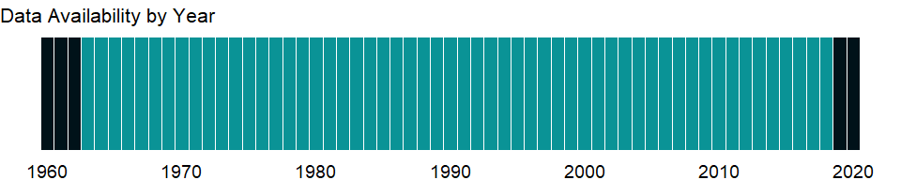

### Which countries have data?

The figure below shows the percentage of countries in each income group with a value since 2010 for that indicator.

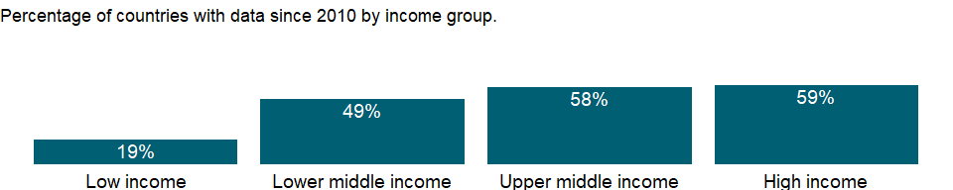

### Why is it relevant?

Firms typically use multiple processes to produce a product. For example, an automobile manufacturer engages in forging, welding, and painting as well as advertising, accounting, and other service activities. Collecting data at such a detailed level is not practical, nor is it useful to record production data at the highest level of a large, multiplant, multiproduct firm. The ISIC has therefore adopted as the definition of an establishment “an enterprise or part of an enterprise which independently engages in one, or predominantly one, kind of economic activity at or from one location . . . for which data are available . . .” (United Nations 1990). By design, this definition matches the reporting unit required for the production accounts of the United Nations System of National Accounts.

The ISIC system is described in the United Nations’ International Standard Industrial Classification of All Economic Activities, Third Revision (1990). The discussion of the ISIC draws on Ryten (1998).

### What is the data source?

United Nations Industrial Development Organization, International Yearbook of Industrial Statistics.

### What is the methodology?

The data on the distribution of manufacturing value added by industry are provided by the United Nations Industrial Development Organization (UNIDO). UNIDO obtains the data from a variety of national and international sources, including the United Nations Statistics Division, the World Bank, the Organisation for Economic Co-operation and Development, and the International Monetary Fund. To improve comparability over time and across countries, UNIDO supplements these data with information from industrial censuses, statistics from national and international organizations, unpublished data that it collects in the field, and estimates by the UNIDO Secretariat. Nevertheless, coverage may be incomplete, particularly for the informal sector. When direct information on inputs and outputs is not available, estimates may be used, which may result in errors in industry totals. Moreover, countries use different reference periods (calendar or fiscal year) and valuation methods (basic or producer prices) to estimate value added.

### How is it aggregated?

NA

### What are the limitations?

In establishing classifications systems compilers must define both the types of activities to be described and the units whose activities are to be reported. There are many possibilities, and the choices affect how the statistics can be interpreted and how useful they are in analyzing economic behavior. The ISIC emphasizes commonalities in the production process and is explicitly not intended to measure outputs (for which there is a newly developed Central Product Classification). Nevertheless, the ISIC views an activity as defined by “a process resulting in a homogeneous set of products.”

### What else should I know?

NA

### 1.42.17 Food, beverages and tobacco (% of value added in manufacturing)

### What is the indicator?

Value added in manufacturing is the sum of gross output less the value of intermediate inputs used in production for industries classified in ISIC major division D. Food, beverages, and tobacco correspond to ISIC divisions 15 and 16.

Topic: Economic Policy & Debt: National accounts: Shares of GDP & other

Series ID: NV.MNF.FBTO.ZS.UN

Copyright: CC BY-4.0 , <https://datacatalog.worldbank.org/public-licenses#cc-by>

First year with any data: 1963

Last year with any data: 2018

### What years are data available?

The figure below shows years in which data is available for at least one country. Dates shaded in black have no data, while dates shaded in green have data for at least one country



### Which countries have data?

The figure below shows the percentage of countries in each income group with a value since 2010 for that indicator.

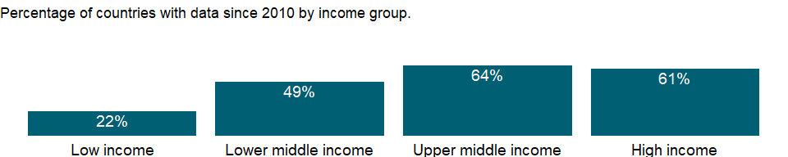

### Why is it relevant?

Firms typically use multiple processes to produce a product. For example, an automobile manufacturer engages in forging, welding, and painting as well as advertising, accounting, and other service activities. Collecting data at such a detailed level is not practical, nor is it useful to record production data at the highest level of a large, multiplant, multiproduct firm. The ISIC has therefore adopted as the definition of an establishment “an enterprise or part of an enterprise which independently engages in one, or predominantly one, kind of economic activity at or from one location . . . for which data are available . . .” (United Nations 1990). By design, this definition matches the reporting unit required for the production accounts of the United Nations System of National Accounts.

The ISIC system is described in the United Nations’ International Standard Industrial Classification of All Economic Activities, Third Revision (1990). The discussion of the ISIC draws on Ryten (1998).

### What is the data source?

United Nations Industrial Development Organization, International Yearbook of Industrial Statistics.

### What is the methodology?

The data on the distribution of manufacturing value added by industry are provided by the United Nations Industrial Development Organization (UNIDO). UNIDO obtains the data from a variety of national and international sources, including the United Nations Statistics Division, the World Bank, the Organisation for Economic Co-operation and Development, and the International Monetary Fund. To improve comparability over time and across countries, UNIDO supplements these data with information from industrial censuses, statistics from national and international organizations, unpublished data that it collects in the field, and estimates by the UNIDO Secretariat. Nevertheless, coverage may be incomplete, particularly for the informal sector. When direct information on inputs and outputs is not available, estimates may be used, which may result in errors in industry totals. Moreover, countries use different reference periods (calendar or fiscal year) and valuation methods (basic or producer prices) to estimate value added.

### How is it aggregated?

NA

### What are the limitations?

In establishing classifications systems compilers must define both the types of activities to be described and the units whose activities are to be reported. There are many possibilities, and the choices affect how the statistics can be interpreted and how useful they are in analyzing economic behavior. The ISIC emphasizes commonalities in the production process and is explicitly not intended to measure outputs (for which there is a newly developed Central Product Classification). Nevertheless, the ISIC views an activity as defined by “a process resulting in a homogeneous set of products.”

### What else should I know?

NA

### 1.42.18 Machinery and transport equipment (% of value added in manufacturing)

### What is the indicator?

Value added in manufacturing is the sum of gross output less the value of intermediate inputs used in production for industries classified in ISIC major division D. Machinery and transport equipment correspond to ISIC divisions 29, 30, 32, 34, and 35.

Topic: Economic Policy & Debt: National accounts: Shares of GDP & other

Series ID: NV.MNF.MTRN.ZS.UN

Copyright: CC BY-4.0 , <https://datacatalog.worldbank.org/public-licenses#cc-by>

First year with any data: 1963

Last year with any data: 2018

### What years are data available?

The figure below shows years in which data is available for at least one country. Dates shaded in black have no data, while dates shaded in green have data for at least one country



### Which countries have data?

The figure below shows the percentage of countries in each income group with a value since 2010 for that indicator.

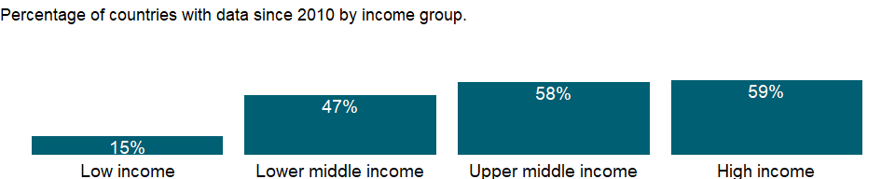

### Why is it relevant?

Firms typically use multiple processes to produce a product. For example, an automobile manufacturer engages in forging, welding, and painting as well as advertising, accounting, and other service activities. Collecting data at such a detailed level is not practical, nor is it useful to record production data at the highest level of a large, multiplant, multiproduct firm. The ISIC has therefore adopted as the definition of an establishment “an enterprise or part of an enterprise which independently engages in one, or predominantly one, kind of economic activity at or from one location . . . for which data are available . . .” (United Nations 1990). By design, this definition matches the reporting unit required for the production accounts of the United Nations System of National Accounts.

The ISIC system is described in the United Nations’ International Standard Industrial Classification of All Economic Activities, Third Revision (1990). The discussion of the ISIC draws on Ryten (1998).

### What is the data source?

United Nations Industrial Development Organization, International Yearbook of Industrial Statistics.

### What is the methodology?

The data on the distribution of manufacturing value added by industry are provided by the United Nations Industrial Development Organization (UNIDO). UNIDO obtains the data from a variety of national and international sources, including the United Nations Statistics Division, the World Bank, the Organisation for Economic Co-operation and Development, and the International Monetary Fund. To improve comparability over time and across countries, UNIDO supplements these data with information from industrial censuses, statistics from national and international organizations, unpublished data that it collects in the field, and estimates by the UNIDO Secretariat. Nevertheless, coverage may be incomplete, particularly for the informal sector. When direct information on inputs and outputs is not available, estimates may be used, which may result in errors in industry totals. Moreover, countries use different reference periods (calendar or fiscal year) and valuation methods (basic or producer prices) to estimate value added.

### How is it aggregated?

NA

### What are the limitations?

In establishing classifications systems compilers must define both the types of activities to be described and the units whose activities are to be reported. There are many possibilities, and the choices affect how the statistics can be interpreted and how useful they are in analyzing economic behavior. The ISIC emphasizes commonalities in the production process and is explicitly not intended to measure outputs (for which there is a newly developed Central Product Classification). Nevertheless, the ISIC views an activity as defined by “a process resulting in a homogeneous set of products.”

### What else should I know?

NA

### 1.42.19 Other manufacturing (% of value added in manufacturing)

### What is the indicator?

Value added in manufacturing is the sum of gross output less the value of intermediate inputs used in production for industries classified in ISIC major division D. Other manufacturing, a residual, covers wood and related products (ISIC division 20), paper and related products (ISIC divisions 21 and 22), petroleum and related products (ISIC division 23), basic metals and mineral products (ISIC division27), fabricated metal products and professional goods (ISIC division 28), and other industries (ISIC divisions 25, 26, 31, 33, 36, and 37). Includes unallocated data. When data for textiles, machinery, or chemicals are shown as not available, they are included in other manufacturing.

Topic: Economic Policy & Debt: National accounts: Shares of GDP & other

Series ID: NV.MNF.OTHR.ZS.UN

Copyright: CC BY-4.0 , <https://datacatalog.worldbank.org/public-licenses#cc-by>

First year with any data: 1963

Last year with any data: 2018

### What years are data available?

The figure below shows years in which data is available for at least one country. Dates shaded in black have no data, while dates shaded in green have data for at least one country



### Which countries have data?

The figure below shows the percentage of countries in each income group with a value since 2010 for that indicator.



### Why is it relevant?

Firms typically use multiple processes to produce a product. For example, an automobile manufacturer engages in forging, welding, and painting as well as advertising, accounting, and other service activities. Collecting data at such a detailed level is not practical, nor is it useful to record production data at the highest level of a large, multiplant, multiproduct firm. The ISIC has therefore adopted as the definition of an establishment “an enterprise or part of an enterprise which independently engages in one, or predominantly one, kind of economic activity at or from one location . . . for which data are available . . .” (United Nations 1990). By design, this definition matches the reporting unit required for the production accounts of the United Nations System of National Accounts.

The ISIC system is described in the United Nations’ International Standard Industrial Classification of All Economic Activities, Third Revision (1990). The discussion of the ISIC draws on Ryten (1998).

### What is the data source?

United Nations Industrial Development Organization, International Yearbook of Industrial Statistics.

### What is the methodology?

The data on the distribution of manufacturing value added by industry are provided by the United Nations Industrial Development Organization (UNIDO). UNIDO obtains the data from a variety of national and international sources, including the United Nations Statistics Division, the World Bank, the Organisation for Economic Co-operation and Development, and the International Monetary Fund. To improve comparability over time and across countries, UNIDO supplements these data with information from industrial censuses, statistics from national and international organizations, unpublished data that it collects in the field, and estimates by the UNIDO Secretariat. Nevertheless, coverage may be incomplete, particularly for the informal sector. When direct information on inputs and outputs is not available, estimates may be used, which may result in errors in industry totals. Moreover, countries use different reference periods (calendar or fiscal year) and valuation methods (basic or producer prices) to estimate value added.

### How is it aggregated?

NA

### What are the limitations?

In establishing classifications systems compilers must define both the types of activities to be described and the units whose activities are to be reported. There are many possibilities, and the choices affect how the statistics can be interpreted and how useful they are in analyzing economic behavior. The ISIC emphasizes commonalities in the production process and is explicitly not intended to measure outputs (for which there is a newly developed Central Product Classification). Nevertheless, the ISIC views an activity as defined by “a process resulting in a homogeneous set of products.”

### What else should I know?

NA

### 1.42.20 Medium and high-tech industry (% manufacturing value added)

### What is the indicator?

The proportion of medium and high-tech industry value added in total value added of manufacturing

Topic: Economic Policy & Debt: National accounts: Shares of GDP & other

Series ID: NV.MNF.TECH.ZS.UN

Copyright: CC BY-4.0 , <https://datacatalog.worldbank.org/public-licenses#cc-by>

First year with any data: 1990

Last year with any data: 2018

### What years are data available?

The figure below shows years in which data is available for at least one country. Dates shaded in black have no data, while dates shaded in green have data for at least one country



### Which countries have data?

The figure below shows the percentage of countries in each income group with a value since 2010 for that indicator.



### Why is it relevant?

Industrial development generally entails a structural transition from resource-based and low technology activities to medium and high-tech industry (MHT) activities. A modern, highly complex production structure offers better opportunities for skills development and technological innovation. MHT activities are also the high value addition industries of manufacturing with higher technological intensity and labour productivity. Increasing the share of MHT sectors also reflects the impact of innovation

### What is the data source?

United Nations Industrial Development Organization (UNIDO), Competitive Industrial Performance (CIP) database

### What is the methodology?

The indicator is calculated as the share of the sum of the value added from medium and high-tech industry economic activities to manufacturing value added. The medium and high-tech industry is defined using OECD classification as the following by International Standard Industrial Classification of All Economic Activities (ISIC) Revision 3 and Revision 4 Division respectively: ISIC Rev. 3 (24, 29, 30, 31, 32, 33, 34, 35 excluding 351). Manufacturing value added is the value added of manufacturing industry, which is Section C of ISIC Rev.4, and Section D of ISIC Rev.3. Data can be found in UNIDO INDSTAT4 Database by ISIC Revision 3 and ISIC Revision 4 respectively. Data are collected using General Industrial Statistics Questionnaire which is filled by NSOs and submitted to UNIDO annually. Data for OECD countries are obtained directly from OECD. Country data are also collected from official publications and official web-sites. For additional information please see Table B.2.2 in Appendix B of UNIDO (2017): <http://stat.unido.org/content/publications/volume-i%252c-competitive-industrial-performance-report-2016>

### How is it aggregated?

NA

### What are the limitations?

Value added by economic activity should be reported at least at 3-digit ISIC for compiling MHT values. Missing values at country level are imputed based on the methodology from Competitive Industrial Performance Report (UNIDO, 2017. Conversion to USD or difference in ISIC combinations may cause discrepancy between national and international figures. For additional information please see UNIDO (2017): <http://stat.unido.org/content/publications/volume-i%252c-competitive-industrial-performance-report-2016>

### What else should I know?

NA

### 1.42.21 Textiles and clothing (% of value added in manufacturing)

### What is the indicator?

Value added in manufacturing is the sum of gross output less the value of intermediate inputs used in production for industries classified in ISIC major division D. Textiles and clothing correspond to ISIC divisions 17-19.

Topic: Economic Policy & Debt: National accounts: Shares of GDP & other

Series ID: NV.MNF.TXTL.ZS.UN

Copyright: CC BY-4.0 , <https://datacatalog.worldbank.org/public-licenses#cc-by>

First year with any data: 1963

Last year with any data: 2018

### What years are data available?

The figure below shows years in which data is available for at least one country. Dates shaded in black have no data, while dates shaded in green have data for at least one country



### Which countries have data?

The figure below shows the percentage of countries in each income group with a value since 2010 for that indicator.



### Why is it relevant?

Firms typically use multiple processes to produce a product. For example, an automobile manufacturer engages in forging, welding, and painting as well as advertising, accounting, and other service activities. Collecting data at such a detailed level is not practical, nor is it useful to record production data at the highest level of a large, multiplant, multiproduct firm. The ISIC has therefore adopted as the definition of an establishment “an enterprise or part of an enterprise which independently engages in one, or predominantly one, kind of economic activity at or from one location . . . for which data are available . . .” (United Nations 1990). By design, this definition matches the reporting unit required for the production accounts of the United Nations System of National Accounts.

The ISIC system is described in the United Nations’ International Standard Industrial Classification of All Economic Activities, Third Revision (1990). The discussion of the ISIC draws on Ryten (1998).

### What is the data source?

United Nations Industrial Development Organization, International Yearbook of Industrial Statistics.

### What is the methodology?

The data on the distribution of manufacturing value added by industry are provided by the United Nations Industrial Development Organization (UNIDO). UNIDO obtains the data from a variety of national and international sources, including the United Nations Statistics Division, the World Bank, the Organisation for Economic Co-operation and Development, and the International Monetary Fund. To improve comparability over time and across countries, UNIDO supplements these data with information from industrial censuses, statistics from national and international organizations, unpublished data that it collects in the field, and estimates by the UNIDO Secretariat. Nevertheless, coverage may be incomplete, particularly for the informal sector. When direct information on inputs and outputs is not available, estimates may be used, which may result in errors in industry totals. Moreover, countries use different reference periods (calendar or fiscal year) and valuation methods (basic or producer prices) to estimate value added.

### How is it aggregated?

NA

### What are the limitations?

In establishing classifications systems compilers must define both the types of activities to be described and the units whose activities are to be reported. There are many possibilities, and the choices affect how the statistics can be interpreted and how useful they are in analyzing economic behavior. The ISIC emphasizes commonalities in the production process and is explicitly not intended to measure outputs (for which there is a newly developed Central Product Classification). Nevertheless, the ISIC views an activity as defined by “a process resulting in a homogeneous set of products.”

### What else should I know?

NA

### 1.42.22 Services, value added (% of GDP)

### What is the indicator?

Services correspond to ISIC divisions 50-99 and they include value added in wholesale and retail trade (including hotels and restaurants), transport, and government, financial, professional, and personal services such as education, health care, and real estate services. Also included are imputed bank service charges, import duties, and any statistical discrepancies noted by national compilers as well as discrepancies arising from rescaling. Value added is the net output of a sector after adding up all outputs and subtracting intermediate inputs. It is calculated without making deductions for depreciation of fabricated assets or depletion and degradation of natural resources. The industrial origin of value added is determined by the International Standard Industrial Classification (ISIC), revision 3 or 4.

Topic: Economic Policy & Debt: National accounts: Shares of GDP & other

Series ID: NV.SRV.TOTL.ZS

Copyright: CC BY-4.0 , <https://datacatalog.worldbank.org/public-licenses#cc-by>

First year with any data: 1960

Last year with any data: 2020

### What years are data available?

The figure below shows years in which data is available for at least one country. Dates shaded in black have no data, while dates shaded in green have data for at least one country



### Which countries have data?

The figure below shows the percentage of countries in each income group with a value since 2010 for that indicator.

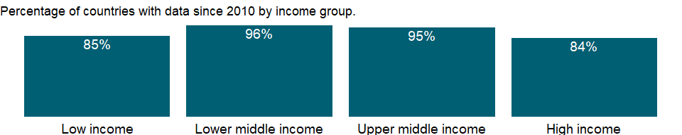

### Why is it relevant?

NA

### What is the data source?

World Bank national accounts data, and OECD National Accounts data files.

### What is the methodology?

Gross domestic product (GDP) represents the sum of value added by all its producers. Value added is the value of the gross output of producers less the value of intermediate goods and services consumed in production, before accounting for consumption of fixed capital in production. The United Nations System of National Accounts calls for value added to be valued at either basic prices (excluding net taxes on products) or producer prices (including net taxes on products paid by producers but excluding sales or value added taxes). Both valuations exclude transport charges that are invoiced separately by producers. Total GDP is measured at purchaser prices. Value added by industry is normally measured at basic prices. Financial intermediation services indirectly measured (FISIM) is an indirect measure of the value of financial intermediation services (i.e. output) provided but for which financial institutions do not charge explicitly as compared to explicit bank charges. Although the 1993 SNA recommends that the FISIM are allocated as intermediate and final consumption to the users, many countries still make a global (negative) adjustment to the sum of gross value added.

### How is it aggregated?

Weighted Average

### What are the limitations?

In the services industry the many self-employed workers and one-person businesses are sometimes difficult to locate, and they have little incentive to respond to surveys, let alone to report their full earnings. Compounding these problems are the many forms of economic activity that go unrecorded, including the work that women and children do for little or no pay.

### What else should I know?

NA

### 1.42.23 Gross domestic savings (% of GDP)

### What is the indicator?

Gross domestic savings are calculated as GDP less final consumption expenditure (total consumption).

Topic: Economic Policy & Debt: National accounts: Shares of GDP & other

Series ID: NY.GDS.TOTL.ZS

Copyright: CC BY-4.0 , <https://datacatalog.worldbank.org/public-licenses#cc-by>

First year with any data: 1960

Last year with any data: 2020

### What years are data available?

The figure below shows years in which data is available for at least one country. Dates shaded in black have no data, while dates shaded in green have data for at least one country



### Which countries have data?

The figure below shows the percentage of countries in each income group with a value since 2010 for that indicator.



### Why is it relevant?

NA

### What is the data source?

World Bank national accounts data, and OECD National Accounts data files.

### What is the methodology?

NA

### How is it aggregated?

Weighted average

### What are the limitations?

NA

### What else should I know?

NA

### 1.42.24 Gross savings (% of GNI)

### What is the indicator?

Gross savings are calculated as gross national income less total consumption, plus net transfers.

Topic: Economic Policy & Debt: National accounts: Shares of GDP & other

Series ID: NY.GNS.ICTR.GN.ZS

Copyright: CC BY-4.0 , <https://datacatalog.worldbank.org/public-licenses#cc-by>

First year with any data: 1960

Last year with any data: 2020

### What years are data available?

The figure below shows years in which data is available for at least one country. Dates shaded in black have no data, while dates shaded in green have data for at least one country



### Which countries have data?

The figure below shows the percentage of countries in each income group with a value since 2010 for that indicator.

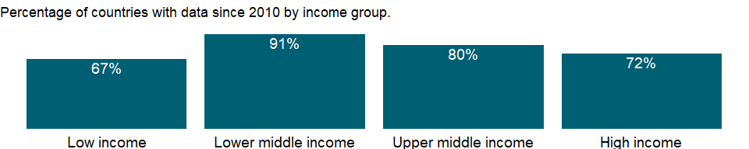

### Why is it relevant?

NA

### What is the data source?

World Bank national accounts data, and OECD National Accounts data files.

### What is the methodology?

NA

### How is it aggregated?

Weighted average

### What are the limitations?

NA

### What else should I know?

NA

### 1.42.25 Gross savings (% of GDP)

### What is the indicator?

Gross savings are calculated as gross national income less total consumption, plus net transfers.

Topic: Economic Policy & Debt: National accounts: Shares of GDP & other

Series ID: NY.GNS.ICTR.ZS

Copyright: CC BY-4.0 , <https://datacatalog.worldbank.org/public-licenses#cc-by>

First year with any data: 1960

Last year with any data: 2020

### What years are data available?

The figure below shows years in which data is available for at least one country. Dates shaded in black have no data, while dates shaded in green have data for at least one country



### Which countries have data?

The figure below shows the percentage of countries in each income group with a value since 2010 for that indicator.



### Why is it relevant?

NA

### What is the data source?

World Bank national accounts data, and OECD National Accounts data files.

### What is the methodology?

Gross savings represent the difference between disposable income and consumption and replace gross domestic savings, a concept used by the World Bank and included in World Development Indicators editions before 2006. The change was made to conform to SNA concepts and definitions.

### How is it aggregated?

Weighted average

### What are the limitations?

NA

### What else should I know?

NA

## 1.43 Economic Policy & Debt: Purchasing power parity

### 1.43.1 Households and NPISHs Final consumption expenditure, PPP (current international $)

### What is the indicator?

This indicator provides values for households and NPISHs final consumption expenditure expressed in current international dollars converted by purchasing power parity (PPP) conversion factor.

Household final consumption expenditure (formerly private consumption) is the market value of all goods and services, including durable products (such as cars, washing machines, and home computers), purchased by households. It excludes purchases of dwellings but includes imputed rent for owner-occupied dwellings. It also includes payments and fees to governments to obtain permits and licenses. Here, household consumption expenditure includes the expenditures of nonprofit institutions serving households, even when reported separately by the country.

PPP conversion factor is a spatial price deflator and currency converter that eliminates the effects of the differences in price levels between countries.

From July 2020, “Households and NPISHs final consumption expenditure: linked series (current LCU)” [NE.CON.PRVT.CN.AD] is used as underlying expenditure in local currency unit so that it’s in line with time series of PPP conversion factor, private consumption (LCU per international $), which are extrapolated with linked CPI.

Topic: Economic Policy & Debt: Purchasing power parity

Series ID: NE.CON.PRVT.PP.CD

Copyright: CC BY-4.0 , <https://datacatalog.worldbank.org/public-licenses#cc-by>

First year with any data: 1990

Last year with any data: 2020

### What years are data available?

The figure below shows years in which data is available for at least one country. Dates shaded in black have no data, while dates shaded in green have data for at least one country



### Which countries have data?

The figure below shows the percentage of countries in each income group with a value since 2010 for that indicator.

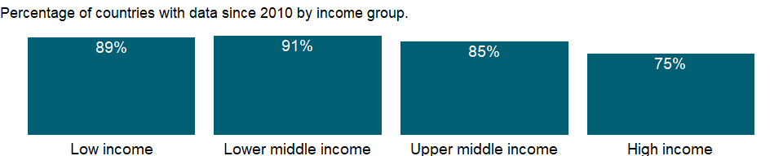

### Why is it relevant?

NA

### What is the data source?

International Comparison Program, World Bank | World Development Indicators database, World Bank | Eurostat-OECD PPP Programme.

### What is the methodology?

Typically, higher income countries have higher price levels, while lower income countries have lower price levels (Balassa-Samuelson effect). Market exchange rate-based cross-country comparisons of GDP at its expenditure components reflect both differences in economic outputs (volumes) and prices. Given the differences in price levels, the size of higher income countries is inflated, while the size of lower income countries is depressed in the comparison. PPP-based cross-country comparisons of GDP at its expenditure components only reflect differences in economic outputs (volume), as PPPs control for price level differences between the countries. Hence, the comparison reflects the real size of the countries.

For more information on underlying households and NPISHs final consumption expenditure in local currency, please refer to the metadata for “Households and NPISHs Final consumption expenditure, PPP (current international $)” [NE.CON.PRVT.PP.CD]. For more information on underlying PPP conversion factor, please refer to the metadata for “PPP conversion factor, private consumption (LCU per international $)” [PA.NUS.PRVT.PP].

For the concept and methodology of PPP, please refer to the International Comparison Program (ICP)’s website (<https://www.worldbank.org/en/programs/icp>).

### How is it aggregated?

Gap-filled total

### What are the limitations?

NA

### What else should I know?

NA

### 1.43.2 Households and NPISHs Final consumption expenditure, PPP (constant 2017 international $)

### What is the indicator?

Household final consumption expenditure (formerly private consumption) is the market value of all goods and services, including durable products (such as cars, washing machines, and home computers), purchased by households. It excludes purchases of dwellings but includes imputed rent for owner-occupied dwellings. It also includes payments and fees to governments to obtain permits and licenses. Here, household consumption expenditure includes the expenditures of nonprofit institutions serving households, even when reported separately by the country. Data are converted to constant 2017 international dollars using purchasing power parity rates.

Topic: Economic Policy & Debt: Purchasing power parity

Series ID: NE.CON.PRVT.PP.KD

Copyright: CC BY-4.0 , <https://datacatalog.worldbank.org/public-licenses#cc-by>

First year with any data: 1990

Last year with any data: 2020

### What years are data available?

The figure below shows years in which data is available for at least one country. Dates shaded in black have no data, while dates shaded in green have data for at least one country



### Which countries have data?

The figure below shows the percentage of countries in each income group with a value since 2010 for that indicator.

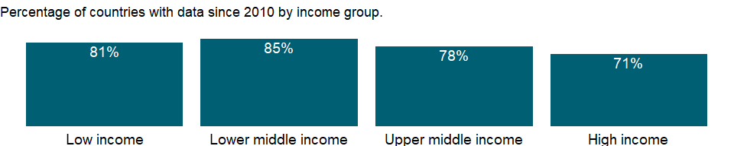

### Why is it relevant?

NA

### What is the data source?

International Comparison Program, World Bank | World Development Indicators database, World Bank | Eurostat-OECD PPP Programme.

### What is the methodology?

For the concept and methodology of 2017 PPP, please refer to the International Comparison Program (ICP)’s website (<https://www.worldbank.org/en/programs/icp>).

### How is it aggregated?

Gap-filled total

### What are the limitations?

NA

### What else should I know?

NA

### 1.43.3 GDP, PPP (current international $)

### What is the indicator?

This indicator provides values for gross domestic product (GDP) expressed in current international dollars, converted by purchasing power parity (PPP) conversion factor. GDP is the sum of gross value added by all resident producers in the country plus any product taxes and minus any subsidies not included in the value of the products. PPP conversion factor is a spatial price deflator and currency converter that eliminates the effects of the differences in price levels between countries. From April 2020, “GDP: linked series (current LCU)” [NY.GDP.MKTP.CN.AD] is used as underlying GDP in local currency unit so that it’s in line with time series of PPP conversion factors for GDP, which are extrapolated with linked GDP deflators.

Topic: Economic Policy & Debt: Purchasing power parity

Series ID: NY.GDP.MKTP.PP.CD

Copyright: CC BY-4.0 , <https://datacatalog.worldbank.org/public-licenses#cc-by>

First year with any data: 1990

Last year with any data: 2020

### What years are data available?

The figure below shows years in which data is available for at least one country. Dates shaded in black have no data, while dates shaded in green have data for at least one country



### Which countries have data?

The figure below shows the percentage of countries in each income group with a value since 2010 for that indicator.

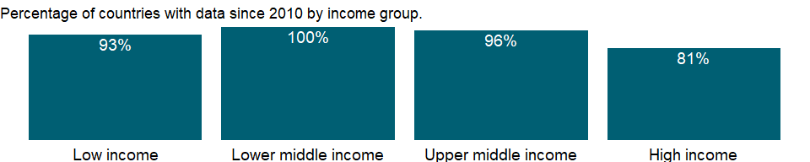

### Why is it relevant?

NA

### What is the data source?

International Comparison Program, World Bank | World Development Indicators database, World Bank | Eurostat-OECD PPP Programme.

### What is the methodology?

Typically, higher income countries have higher price levels, while lower income countries have lower price levels (Balassa-Samuelson effect). Market exchange rate-based cross-country comparisons of GDP at its expenditure components reflect both differences in economic outputs (volumes) and prices. Given the differences in price levels, the size of higher income countries is inflated, while the size of lower income countries is depressed in the comparison. PPP-based cross-country comparisons of GDP at its expenditure components only reflect differences in economic outputs (volume), as PPPs control for price level differences between the countries. Hence, the comparison reflects the real size of the countries.

For more information on underlying GDP in local currency, please refer to the metadata for “GDP: linked series (current LCU)” [NY.GDP.MKTP.CN.AD]. For more information on underlying PPP conversion factor, please refer to the metadata for “PPP conversion factor, GDP (LCU per international $)” [PA.NUS.PPP].

For the concept and methodology of PPP, please refer to the International Comparison Program (ICP)’s website (<https://www.worldbank.org/en/programs/icp>).

### How is it aggregated?

Gap-filled total

### What are the limitations?

NA

### What else should I know?

NA

### 1.43.4 GDP, PPP (constant 2017 international $)

### What is the indicator?

PPP GDP is gross domestic product converted to international dollars using purchasing power parity rates. An international dollar has the same purchasing power over GDP as the U.S. dollar has in the United States. GDP is the sum of gross value added by all resident producers in the country plus any product taxes and minus any subsidies not included in the value of the products. It is calculated without making deductions for depreciation of fabricated assets or for depletion and degradation of natural resources. Data are in constant 2017 international dollars.

Topic: Economic Policy & Debt: Purchasing power parity

Series ID: NY.GDP.MKTP.PP.KD

Copyright: CC BY-4.0 , <https://datacatalog.worldbank.org/public-licenses#cc-by>

First year with any data: 1990

Last year with any data: 2020

### What years are data available?

The figure below shows years in which data is available for at least one country. Dates shaded in black have no data, while dates shaded in green have data for at least one country



### Which countries have data?

The figure below shows the percentage of countries in each income group with a value since 2010 for that indicator.

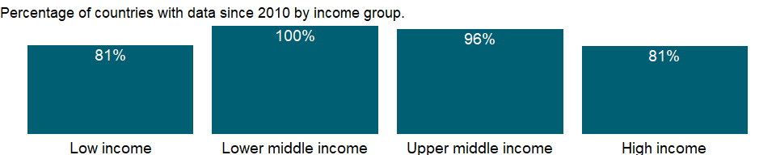

### Why is it relevant?

NA

### What is the data source?

International Comparison Program, World Bank | World Development Indicators database, World Bank | Eurostat-OECD PPP Programme.

### What is the methodology?

For the concept and methodology of 2017 PPP, please refer to the International Comparison Program (ICP)’s website (<https://www.worldbank.org/en/programs/icp>).

### How is it aggregated?

Gap-filled total

### What are the limitations?

NA

### What else should I know?

NA

### 1.43.5 GDP per capita, PPP (current international $)

### What is the indicator?

This indicator provides per capita values for gross domestic product (GDP) expressed in current international dollars converted by purchasing power parity (PPP) conversion factor.

GDP is the sum of gross value added by all resident producers in the country plus any product taxes and minus any subsidies not included in the value of the products. conversion factor is a spatial price deflator and currency converter that controls for price level differences between countries. Total population is a mid-year population based on the de facto definition of population, which counts all residents regardless of legal status or citizenship.

Topic: Economic Policy & Debt: Purchasing power parity

Series ID: NY.GDP.PCAP.PP.CD

Copyright: CC BY-4.0 , <https://datacatalog.worldbank.org/public-licenses#cc-by>

First year with any data: 1990

Last year with any data: 2020

### What years are data available?

The figure below shows years in which data is available for at least one country. Dates shaded in black have no data, while dates shaded in green have data for at least one country



### Which countries have data?

The figure below shows the percentage of countries in each income group with a value since 2010 for that indicator.



### Why is it relevant?

NA

### What is the data source?

International Comparison Program, World Bank | World Development Indicators database, World Bank | Eurostat-OECD PPP Programme.

### What is the methodology?

Typically, higher income countries have higher price levels, while lower income countries have lower price levels (Balassa-Samuelson effect). Market exchange rate-based cross-country comparisons of GDP at its expenditure components reflect both differences in economic outputs (volumes) and prices. Given the differences in price levels, the size of higher income countries is inflated, while the size of lower income countries is depressed in the comparison. PPP-based cross-country comparisons of GDP at its expenditure components only reflect differences in economic outputs (volume), as PPPs control for price level differences between the countries. Hence, the comparison reflects the real size of the countries.

For more information on underlying GDP in current international dollar, please refer to the metadata for “GDP, PPP (current international $)” [NY.GDP.MKTP.PP.CD]. For more information on underlying population, please refer to the metadata for “total population” [SP.POP.TOTL]. For the concept and methodology of PPP, please refer to the International Comparison Program (ICP)’s website (<https://www.worldbank.org/en/programs/icp>).

### How is it aggregated?

Weighted Average

### What are the limitations?

NA

### What else should I know?

NA

### 1.43.6 GDP per capita, PPP (constant 2017 international $)

### What is the indicator?

GDP per capita based on purchasing power parity (PPP). PPP GDP is gross domestic product converted to international dollars using purchasing power parity rates. An international dollar has the same purchasing power over GDP as the U.S. dollar has in the United States. GDP at purchaser’s prices is the sum of gross value added by all resident producers in the country plus any product taxes and minus any subsidies not included in the value of the products. It is calculated without making deductions for depreciation of fabricated assets or for depletion and degradation of natural resources. Data are in constant 2017 international dollars.

Topic: Economic Policy & Debt: Purchasing power parity

Series ID: NY.GDP.PCAP.PP.KD

Copyright: CC BY-4.0 , <https://datacatalog.worldbank.org/public-licenses#cc-by>

First year with any data: 1990

Last year with any data: 2020

### What years are data available?

The figure below shows years in which data is available for at least one country. Dates shaded in black have no data, while dates shaded in green have data for at least one country



### Which countries have data?

The figure below shows the percentage of countries in each income group with a value since 2010 for that indicator.



### Why is it relevant?

NA

### What is the data source?

International Comparison Program, World Bank | World Development Indicators database, World Bank | Eurostat-OECD PPP Programme.

### What is the methodology?

For the concept and methodology of 2017 PPP, please refer to the International Comparison Program (ICP)’s website (<https://www.worldbank.org/en/programs/icp>).

### How is it aggregated?

Weighted Average

### What are the limitations?

NA

### What else should I know?

NA

### 1.43.7 GNI, PPP (current international $)

### What is the indicator?

This indicator provides values for gross national income (GNI. Formerly GNP) expressed in current international dollars converted by purchasing power parity (PPP) conversion factor. Gross national income is the sum of value added by all resident producers plus any product taxes (less subsidies) not included in the valuation of output plus net receipts of primary income (compensation of employees and property income) from abroad. PPP conversion factor is a spatial price deflator and currency converter that eliminates the effects of the differences in price levels between countries.

From July 2020, “GNI: linked series (current LCU)” [NY.GNP.MKTP.CN.AD] is used as underlying GNI in local currency unit so that it’s in line with time series of PPP conversion factors, which are extrapolated with linked deflators.

Topic: Economic Policy & Debt: Purchasing power parity

Series ID: NY.GNP.MKTP.PP.CD

Copyright: CC BY-4.0 , <https://datacatalog.worldbank.org/public-licenses#cc-by>

First year with any data: 1990

Last year with any data: 2020

### What years are data available?

The figure below shows years in which data is available for at least one country. Dates shaded in black have no data, while dates shaded in green have data for at least one country



### Which countries have data?

The figure below shows the percentage of countries in each income group with a value since 2010 for that indicator.



### Why is it relevant?

Because development encompasses many factors - economic, environmental, cultural, educational, and institutional - no single measure gives a complete picture. However, the total earnings of the residents of an economy, measured by its gross national income (GNI), is a good measure of its capacity to provide for the well-being of its people.

### What is the data source?

International Comparison Program, World Bank | World Development Indicators database, World Bank | Eurostat-OECD PPP Programme.

### What is the methodology?

Typically, higher income countries have higher price levels, while lower income countries have lower price levels (Balassa-Samuelson effect). Market exchange rate-based cross-country comparisons of GDP at its expenditure components reflect both differences in economic outputs (volumes) and prices. Given the differences in price levels, the size of higher income countries is inflated, while the size of lower income countries is depressed in the comparison. PPP-based cross-country comparisons of GDP at its expenditure components only reflect differences in economic outputs (volume), as PPPs control for price level differences between the countries. Hence, the comparison reflects the real size of the countries.

For more information on underlying GNI in local currency, please refer to the metadata for “GNI (current LCU)” [NY.GNP.MKTP.CN]. For more information on underlying PPP conversion factor, please refer to the metadata for “PPP conversion factor, GDP (LCU per international $)” [PA.NUS.PPP].

For the concept and methodology of PPP, please refer to the International Comparison Program (ICP)’s website (<https://www.worldbank.org/en/programs/icp>).

### How is it aggregated?

Gap-filled total

### What are the limitations?

NA

### What else should I know?

NA

### 1.43.8 GNI, PPP (constant 2017 international $)

### What is the indicator?

PPP GNI (formerly PPP GNP) is gross national income (GNI) converted to international dollars using purchasing power parity rates. An international dollar has the same purchasing power over GNI as a U.S. dollar has in the United States. Gross national income is the sum of value added by all resident producers plus any product taxes (less subsidies) not included in the valuation of output plus net receipts of primary income (compensation of employees and property income) from abroad. Data are in constant 2017 international dollars.

Topic: Economic Policy & Debt: Purchasing power parity

Series ID: NY.GNP.MKTP.PP.KD

Copyright: CC BY-4.0 , <https://datacatalog.worldbank.org/public-licenses#cc-by>

First year with any data: 1990

Last year with any data: 2020

### What years are data available?

The figure below shows years in which data is available for at least one country. Dates shaded in black have no data, while dates shaded in green have data for at least one country



### Which countries have data?

The figure below shows the percentage of countries in each income group with a value since 2010 for that indicator.

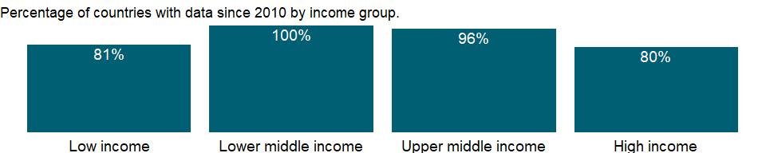

### Why is it relevant?

NA

### What is the data source?

International Comparison Program, World Bank | World Development Indicators database, World Bank | Eurostat-OECD PPP Programme.

### What is the methodology?

For the concept and methodology of 2017 PPP, please refer to the International Comparison Program (ICP)’s website (<https://www.worldbank.org/en/programs/icp>).

### How is it aggregated?

Gap-filled total

### What are the limitations?

NA

### What else should I know?

NA

### 1.43.9 GNI per capita, PPP (current international $)

### What is the indicator?

This indicator provides per capita values for gross national income (GNI. Formerly GNP) expressed in current international dollars converted by purchasing power parity (PPP) conversion factor. GNI is the sum of value added by all resident producers plus any product taxes (less subsidies) not included in the valuation of output plus net receipts of primary income (compensation of employees and property income) from abroad. PPP conversion factor is a spatial price deflator and currency converter that eliminates the effects of the differences in price levels between countries.

Topic: Economic Policy & Debt: Purchasing power parity

Series ID: NY.GNP.PCAP.PP.CD

Copyright: CC BY-4.0 , <https://datacatalog.worldbank.org/public-licenses#cc-by>

First year with any data: 1990

Last year with any data: 2020

### What years are data available?

The figure below shows years in which data is available for at least one country. Dates shaded in black have no data, while dates shaded in green have data for at least one country



### Which countries have data?

The figure below shows the percentage of countries in each income group with a value since 2010 for that indicator.



### Why is it relevant?

NA

### What is the data source?

International Comparison Program, World Bank | World Development Indicators database, World Bank | Eurostat-OECD PPP Programme.

### What is the methodology?

Typically, higher income countries have higher price levels, while lower income countries have lower price levels (Balassa-Samuelson effect). Market exchange rate-based cross-country comparisons of GDP at its expenditure components reflect both differences in economic outputs (volumes) and prices. Given the differences in price levels, the size of higher income countries is inflated, while the size of lower income countries is depressed in the comparison. PPP-based cross-country comparisons of GDP at its expenditure components only reflect differences in economic outputs (volume), as PPPs control for price level differences between the countries. Hence, the comparison reflects the real size of the countries.

For more information on underlying GNI in current international dollar, please refer to the metadata for “GNI, PPP (current international $)” [NY.GNP.MKTP.PP.CD]. For more information on underlying population, please refer to the metadata for “total population” [SP.POP.TOTL]. For the concept and methodology of PPP, please refer to the International Comparison Program (ICP)’s website (<https://www.worldbank.org/en/programs/icp>).

### How is it aggregated?

Weighted Average

### What are the limitations?

NA

### What else should I know?

NA

### 1.43.10 GNI per capita, PPP (constant 2017 international $)

### What is the indicator?

GNI per capita based on purchasing power parity (PPP). PPP GNI is gross national income (GNI) converted to international dollars using purchasing power parity rates. An international dollar has the same purchasing power over GNI as a U.S. dollar has in the United States. GNI is the sum of value added by all resident producers plus any product taxes (less subsidies) not included in the valuation of output plus net receipts of primary income (compensation of employees and property income) from abroad. Data are in constant 2017 international dollars.

Topic: Economic Policy & Debt: Purchasing power parity

Series ID: NY.GNP.PCAP.PP.KD

Copyright: CC BY-4.0 , <https://datacatalog.worldbank.org/public-licenses#cc-by>

First year with any data: 1990

Last year with any data: 2020

### What years are data available?

The figure below shows years in which data is available for at least one country. Dates shaded in black have no data, while dates shaded in green have data for at least one country



### Which countries have data?

The figure below shows the percentage of countries in each income group with a value since 2010 for that indicator.



### Why is it relevant?

NA

### What is the data source?

International Comparison Program, World Bank | World Development Indicators database, World Bank | Eurostat-OECD PPP Programme.

### What is the methodology?

For the concept and methodology of 2017 PPP, please refer to the International Comparison Program (ICP)’s website (<https://www.worldbank.org/en/programs/icp>).

### How is it aggregated?

Weighted Average

### What are the limitations?

NA

### What else should I know?

NA

### 1.43.11 PPP conversion factor, GDP (LCU per international $)

### What is the indicator?

Purchasing power parity (PPP) conversion factor is a spatial price deflator and currency converter that controls for price level differences between countries, thereby allowing volume comparisons of gross domestic product (GDP) and its expenditure components. This conversion factor is for GDP.

Topic: Economic Policy & Debt: Purchasing power parity

Series ID: PA.NUS.PPP

Copyright: CC BY-4.0 , <https://datacatalog.worldbank.org/public-licenses#cc-by>

First year with any data: 1990

Last year with any data: 2020

### What years are data available?

The figure below shows years in which data is available for at least one country. Dates shaded in black have no data, while dates shaded in green have data for at least one country



### Which countries have data?

The figure below shows the percentage of countries in each income group with a value since 2010 for that indicator.

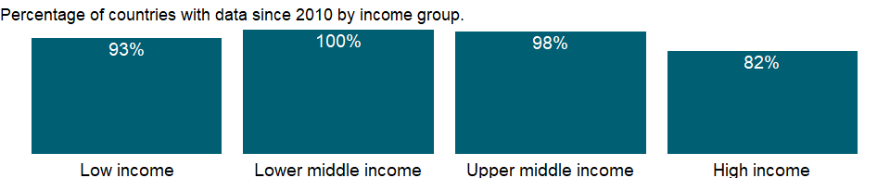

### Why is it relevant?

PPP can be used to convert national accounts data, like GDP and its expenditure components, into a common currency, while also eliminating the effect of price level differences between countries. They can also be used to derive price level indexes (PLIs), the ratio of a country’s PPP to its market exchange rate, to directly compare price levels across countries.

PPPs and the PLIs and real (or PPP-adjusted) expenditures to which they give rise allow for many use-cases, but they are particularly valuable for empirical work involving comparisons of per capita consumption or levels of GDP (or other GDP aggregates) across countries and for the measurement of global poverty and global income inequality. The breadth and depth of ICP data allows its use-cases to cover other areas of economics, including empirical analyses of economic growth, productivity and trade, and even beyond, for instance, to help track global targets such as the UN Sustainable Development Goals related to health, education, energy and emissions and labor. Other applications of ICP data include their use in the construction of indexes, for example cost-of-living measures. Uses-cases can even be extended into the policymaking domain at all levels (global, regional and national) given the increased importance of cross-country benchmarking, among other possibilities.

Recommended uses of PPPs include: To make spatial comparisons of GDP and its expenditure components | To make spatial comparisons of price levels | To group countries by their per capita volume indexes and price level indexes

Recommended uses of PPPs with limitations include: To analyze changes over time in relative GDP per capita and relative prices | To analyze price convergence | To make spatial comparisons of the cost of living | To use PPPs calculated for GDP and its expenditure components as deflators for other values.

### What is the data source?

International Comparison Program, World Bank | World Development Indicators database, World Bank | Eurostat-OECD PPP Programme.

### What is the methodology?

PPPs are both currency conversion factors and spatial price indexes. PPPs convert different currencies to a common currency and, in the process of conversion, equalize their purchasing power by controlling differences in price levels between countries.

Typically, higher income countries have higher price levels, while lower income countries have lower price levels (Balassa-Samuelson effect). Market exchange rate-based cross-country comparisons of GDP at its expenditure components reflect both differences in economic outputs (volumes) and prices. Given the differences in price levels, the size of higher income countries is inflated, while the size of lower income countries is depressed in the comparison. PPP-based cross-country comparisons of GDP at its expenditure components only reflect differences in economic outputs (volume), as PPPs control for price level differences between the countries. Hence, the comparison reflects the real size of the countries.

The International Comparison Program (ICP) estimates PPPs for the world’s countries. The ICP is conducted as a global partnership of countries, multilateral agencies, and academia. The most recent 2017 ICP comparison covered 176 countries, including 47 Eurostat-OECD countries. For countries that have not participated in ICP comparisons, the PPP are imputed based on a regression model.

ICP estimated PPPs cover years from 2011 to 2017. WDI extrapolates 2011 PPPs for years earlier years, and 2017 PPPs for later years. Description of WDI extrapolation approach is available here: <https://datahelpdesk.worldbank.org/knowledgebase/articles/665452-how-do-you-extrapolate-the-ppp-conversion-factors>

For the member countries of Eurostat-OECD PPP Programme, PPP conversion factors are periodically updated based on the organizations’ databases. For Eurostat-OECD PPP Programme, please refer to the following websites. (<http://www.oecd.org/sdd/prices-ppp/>) (<https://ec.europa.eu/eurostat/web/purchasing-power-parities/overview>)

For more information on the ICP and PPPs, please refer to the ICP website at <https://www.worldbank.org/en/programs/icp>.

### How is it aggregated?

NA

### What are the limitations?

Global PPP estimates provided by ICP are produced by the ICP Global Office and regional implementing agencies, based on data supplied by participating countries, and in accordance with the methodology recommended by the ICP Technical Advisory Group and approved by the ICP Governing Board. As such, these results are not produced by participating countries as part of their national official statistics.

PPPs are not recommended use: As a precise measure to establish strict rankings of countries | As a means of constructing national growth rates | As a measure to generate output and productivity comparisons by industry | As an indicator of the undervaluation or overvaluation of currencies | As an equilibrium exchange rate.

### What else should I know?

NA

### 1.43.12 Price level ratio of PPP conversion factor (GDP) to market exchange rate

### What is the indicator?

Price level ratio is the ratio of a purchasing power parity (PPP) conversion factor to an exchange rate. It provides a measure of the differences in price levels between countries by indicating the number of units of the common currency needed to buy the same volume of the aggregation level in each country. At the level of GDP, they provide a measure of the differences in the general price levels of countries.

Topic: Economic Policy & Debt: Purchasing power parity

Series ID: PA.NUS.PPPC.RF

Copyright: CC BY-4.0 , <https://datacatalog.worldbank.org/public-licenses#cc-by>

First year with any data: 1990

Last year with any data: 2020

### What years are data available?

The figure below shows years in which data is available for at least one country. Dates shaded in black have no data, while dates shaded in green have data for at least one country



### Which countries have data?

The figure below shows the percentage of countries in each income group with a value since 2010 for that indicator.



### Why is it relevant?

NA

### What is the data source?

International Comparison Program, World Bank | World Development Indicators database, World Bank | Eurostat-OECD PPP Programme.

### What is the methodology?

For more information on underlying GDP in current international dollar, please refer to the metadata for “GDP, PPP (current international $)" [NY.GDP.MKTP.PP.CD]. For more information on market exchange reate, please refer to the metadata for "DEC alternative conversion factor (LCU per US$)” [PA.NUS.ATLS]. For the concept and methodology of PPP, please refer to the International Comparison Program (ICP)’s website (<https://www.worldbank.org/en/programs/icp>).

### How is it aggregated?

NA

### What are the limitations?

NA

### What else should I know?

NA

### 1.43.13 PPP conversion factor, private consumption (LCU per international $)

### What is the indicator?

Purchasing power parity (PPP) conversion factor is a spatial price deflator and currency converter that controls for price level differences between countries, thereby allowing volume comparisons of gross domestic product (GDP) and its expenditure components. This conversion factor is for household final consumption expenditure.

Topic: Economic Policy & Debt: Purchasing power parity

Series ID: PA.NUS.PRVT.PP

Copyright: CC BY-4.0 , <https://datacatalog.worldbank.org/public-licenses#cc-by>

First year with any data: 1990

Last year with any data: 2020

### What years are data available?

The figure below shows years in which data is available for at least one country. Dates shaded in black have no data, while dates shaded in green have data for at least one country



### Which countries have data?

The figure below shows the percentage of countries in each income group with a value since 2010 for that indicator.

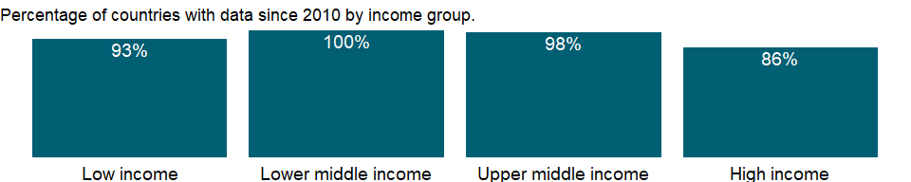

### Why is it relevant?

PPP can be used to convert national accounts data, like GDP and its expenditure components, into a common currency, while also eliminating the effect of price level differences between countries. They can also be used to derive price level indexes (PLIs), the ratio of a country’s PPP to its market exchange rate, to directly compare price levels across countries.

PPPs and the PLIs and real (or PPP-adjusted) expenditures to which they give rise allow for many use-cases, but they are particularly valuable for empirical work involving comparisons of per capita consumption or levels of GDP (or other GDP aggregates) across countries and for the measurement of global poverty and global income inequality. The breadth and depth of ICP data allows its use-cases to cover other areas of economics, including empirical analyses of economic growth, productivity and trade, and even beyond, for instance, to help track global targets such as the UN Sustainable Development Goals related to health, education, energy and emissions and labor. Other applications of ICP data include their use in the construction of indexes, for example cost-of-living measures. Uses-cases can even be extended into the policymaking domain at all levels (global, regional and national) given the increased importance of cross-country benchmarking, among other possibilities.

Recommended uses of PPPs include: To make spatial comparisons of GDP and its expenditure components | To make spatial comparisons of price levels | To group countries by their per capita volume indexes and price level indexes

Recommended uses of PPPs with limitations include: To analyze changes over time in relative GDP per capita and relative prices | To analyze price convergence | To make spatial comparisons of the cost of living | To use PPPs calculated for GDP and its expenditure components as deflators for other values.

### What is the data source?

International Comparison Program, World Bank | World Development Indicators database, World Bank | Eurostat-OECD PPP Programme.

### What is the methodology?

PPPs are both currency conversion factors and spatial price indexes. PPPs convert different currencies to a common currency and, in the process of conversion, equalize their purchasing power by controlling differences in price levels between countries.

Typically, higher income countries have higher price levels, while lower income countries have lower price levels (Balassa-Samuelson effect). Market exchange rate-based cross-country comparisons of GDP at its expenditure components reflect both differences in economic outputs (volumes) and prices. Given the differences in price levels, the size of higher income countries is inflated, while the size of lower income countries is depressed in the comparison. PPP-based cross-country comparisons of GDP at its expenditure components only reflect differences in economic outputs (volume), as PPPs control for price level differences between the countries. Hence, the comparison reflects the real size of the countries.

The International Comparison Program (ICP) estimates PPPs for the world’s countries. The ICP is conducted as a global partnership of countries, multilateral agencies, and academia. The most recent 2017 ICP comparison covered 176 countries, including 47 Eurostat-OECD countries. For countries that have not participated in ICP comparisons, the PPP are imputed based on a regression model.

ICP estimated PPPs cover years from 2011 to 2017. WDI extrapolates 2011 PPPs for years earlier years, and 2017 PPPs for later years. Description of WDI extrapolation approach is available here: <https://datahelpdesk.worldbank.org/knowledgebase/articles/665452-how-do-you-extrapolate-the-ppp-conversion-factors>

For the member countries of Eurostat-OECD PPP Programme, PPP conversion factors are periodically updated based on the organizations’ databases. For Eurostat-OECD PPP Programme, please refer to the following websites. (<http://www.oecd.org/sdd/prices-ppp/>) (<https://ec.europa.eu/eurostat/web/purchasing-power-parities/overview>)

For more information on the ICP and PPPs, please refer to the ICP website at <https://www.worldbank.org/en/programs/icp>.

### How is it aggregated?

NA

### What are the limitations?

Global PPP estimates provided by ICP are produced by the ICP Global Office and regional implementing agencies, based on data supplied by participating countries, and in accordance with the methodology recommended by the ICP Technical Advisory Group and approved by the ICP Governing Board. As such, these results are not produced by participating countries as part of their national official statistics.

PPPs are not recommended use: As a precise measure to establish strict rankings of countries | As a means of constructing national growth rates | As a measure to generate output and productivity comparisons by industry | As an indicator of the undervaluation or overvaluation of currencies | As an equilibrium exchange rate.

### What else should I know?

NA

## 1.44 Economic Policy & Debt: National accounts: US$ at constant 2010 prices: Value added

### 1.44.1 Agriculture, value added per worker (constant 2010 US$)

### What is the indicator?

Value added per worker is a measure of labor productivity—value added per unit of input. Value added denotes the net output of a sector after adding up all outputs and subtracting intermediate inputs. Data are in constant 2010 U.S. dollars. Agriculture corresponds to the International Standard Industrial Classification (ISIC) tabulation categories A and B (revision 3) or tabulation category A (revision 4), and includes forestry, hunting, and fishing as well as cultivation of crops and livestock production.

Topic: Economic Policy & Debt: National accounts: US$ at constant 2010 prices: Value added

Series ID: NV.AGR.EMPL.KD

Copyright: CC BY-4.0 , <https://datacatalog.worldbank.org/public-licenses#cc-by>

First year with any data: 1991

Last year with any data: 2019

### What years are data available?

The figure below shows years in which data is available for at least one country. Dates shaded in black have no data, while dates shaded in green have data for at least one country

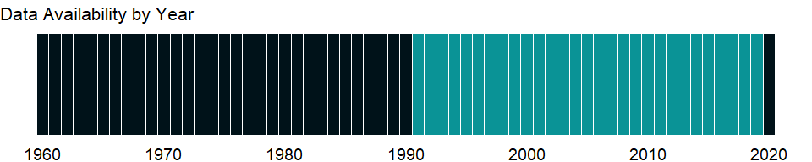

### Which countries have data?

The figure below shows the percentage of countries in each income group with a value since 2010 for that indicator.

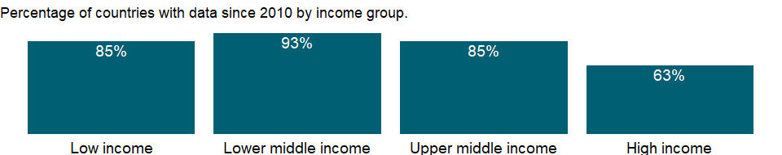

### Why is it relevant?

Labor productivity is used to assess a country’s economic ability to create and sustain decent employment opportunities with fair and equitable remuneration. Productivity increases obtained through investment, trade, technological progress, or changes in work organization can increase social protection and reduce poverty, which in turn reduce vulnerable employment and working poverty. Productivity increases do not guarantee these improvements, but without them—and the economic growth they bring—improvements are highly unlikely. Please also see GDP per person employed (constant 2011 PPP $) [SL.GDP.PCAP.EM.KD], which is a key measure for monitoring the Sustainable Development Goal 8 of promoting sustained, inclusive and sustainable economic growth, full and productive employment and decent work for all.

### What is the data source?

Derived using World Bank national accounts data and OECD National Accounts data files, and employment data from International Labour Organization, ILOSTAT database.

### What is the methodology?

Value added per worker is calculated by dividing value added of a sector by the number employed in the sector.  
Gross domestic product (GDP) represents the sum of value added by all producers. Value added is the value of the gross output of producers less the value of intermediate goods and services consumed in production, before accounting for consumption of fixed capital in production. The United Nations System of National Accounts calls for value added to be valued at either basic prices (excluding net taxes on products) or producer prices (including net taxes on products paid by producers but excluding sales or value added taxes). Both valuations exclude transport charges that are invoiced separately by producers. Value added by industry is normally measured at basic prices, while total GDP is measured at purchaser prices. Data on employment are modeled estimates by the International Labour Organization (ILO) ILOSTAT database. The concept of employment generally refers to people above a certain age who worked, or who held a job, during a reference period. Employment data include both full-time and part-time workers.

### How is it aggregated?

Weighted Average

### What are the limitations?

For comparability of individual sectors labor productivity is estimated according to national accounts conventions. However, there are still significant limitations on the availability of reliable data. Information on consistent series of output is not easily available, especially in low- and middle-income countries, because the definition, coverage, and methodology are not always consistent across countries. For more details, see Agriculture, value added (constant 2010 US) [NV.IND.TOTL.KD], and Services, etc., value added (constant 2010 US$) [NV.SRV.TOTL.KD].

### What else should I know?

NA

### 1.44.2 Agriculture, value added (constant 2010 US$)

### What is the indicator?

Agriculture corresponds to ISIC divisions 1-5 and includes forestry, hunting, and fishing, as well as cultivation of crops and livestock production. Value added is the net output of a sector after adding up all outputs and subtracting intermediate inputs. It is calculated without making deductions for depreciation of fabricated assets or depletion and degradation of natural resources. The origin of value added is determined by the International Standard Industrial Classification (ISIC), revision 3. Data are in constant 2010 U.S. dollars.

Topic: Economic Policy & Debt: National accounts: US$ at constant 2010 prices: Value added

Series ID: NV.AGR.TOTL.KD

Copyright: CC BY-4.0 , <https://datacatalog.worldbank.org/public-licenses#cc-by>

First year with any data: 1960

Last year with any data: 2020

### What years are data available?

The figure below shows years in which data is available for at least one country. Dates shaded in black have no data, while dates shaded in green have data for at least one country



### Which countries have data?

The figure below shows the percentage of countries in each income group with a value since 2010 for that indicator.

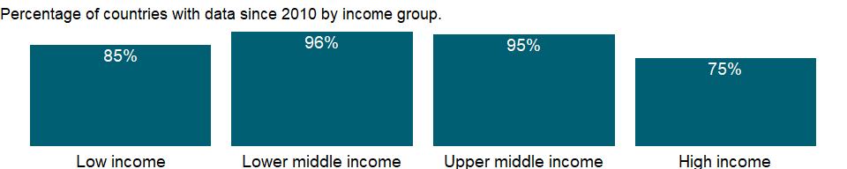

### Why is it relevant?

An economy’s growth is measured by the change in the volume of its output or in the real incomes of its residents. The 2008 United Nations System of National Accounts (2008 SNA) offers three plausible indicators for calculating growth: the volume of gross domestic product (GDP), real gross domestic income, and real gross national income. The volume of GDP is the sum of value added, measured at constant prices, by households, government, and industries operating in the economy. GDP accounts for all domestic production, regardless of whether the income accrues to domestic or foreign institutions.

### What is the data source?

World Bank national accounts data, and OECD National Accounts data files.

### What is the methodology?

Gross domestic product (GDP) represents the sum of value added by all its producers. Value added is the value of the gross output of producers less the value of intermediate goods and services consumed in production, before accounting for consumption of fixed capital in production. The United Nations System of National Accounts calls for value added to be valued at either basic prices (excluding net taxes on products) or producer prices (including net taxes on products paid by producers but excluding sales or value added taxes). Both valuations exclude transport charges that are invoiced separately by producers. Total GDP is measured at purchaser prices. Value added by industry is normally measured at basic prices.

### How is it aggregated?

Gap-filled total

### What are the limitations?

Among the difficulties faced by compilers of national accounts is the extent of unreported economic activity in the informal or secondary economy. In developing countries a large share of agricultural output is either not exchanged (because it is consumed within the household) or not exchanged for money. Agricultural production often must be estimated indirectly, using a combination of methods involving estimates of inputs, yields, and area under cultivation. This approach sometimes leads to crude approximations that can differ from the true values over time and across crops for reasons other than climate conditions or farming techniques. Similarly, agricultural inputs that cannot easily be allocated to specific outputs are frequently “netted out” using equally crude and ad hoc approximations.

### What else should I know?

Note: Data for OECD countries are based on ISIC, revision 4.

### 1.44.3 Industry, value added per worker (constant 2010 US$)

### What is the indicator?

Value added per worker is a measure of labor productivity—value added per unit of input. Value added denotes the net output of a sector after adding up all outputs and subtracting intermediate inputs. Data are in constant 2010 U.S. dollars. Industry corresponds to the International Standard Industrial Classification (ISIC) tabulation categories C-F (revision 3) or tabulation categories B-F (revision 4), and includes mining and quarrying (including oil production), manufacturing, construction, and public utilities (electricity, gas, and water).

Topic: Economic Policy & Debt: National accounts: US$ at constant 2010 prices: Value added

Series ID: NV.IND.EMPL.KD

Copyright: CC BY-4.0 , <https://datacatalog.worldbank.org/public-licenses#cc-by>

First year with any data: 1991

Last year with any data: 2019

### What years are data available?

The figure below shows years in which data is available for at least one country. Dates shaded in black have no data, while dates shaded in green have data for at least one country



### Which countries have data?

The figure below shows the percentage of countries in each income group with a value since 2010 for that indicator.



### Why is it relevant?

Labor productivity is used to assess a country’s economic ability to create and sustain decent employment opportunities with fair and equitable remuneration. Productivity increases obtained through investment, trade, technological progress, or changes in work organization can increase social protection and reduce poverty, which in turn reduce vulnerable employment and working poverty. Productivity increases do not guarantee these improvements, but without them—and the economic growth they bring—improvements are highly unlikely. Please also see GDP per person employed (constant 2011 PPP $) [SL.GDP.PCAP.EM.KD], which is a key measure for monitoring the Sustainable Development Goal 8 of promoting sustained, inclusive and sustainable economic growth, full and productive employment and decent work for all.

### What is the data source?

Derived using World Bank national accounts data and OECD National Accounts data files, and employment data from International Labour Organization, ILOSTAT database.

### What is the methodology?

Value added per worker is calculated by dividing value added of a sector by the number employed in the sector.  
Gross domestic product (GDP) represents the sum of value added by all producers. Value added is the value of the gross output of producers less the value of intermediate goods and services consumed in production, before accounting for consumption of fixed capital in production. The United Nations System of National Accounts calls for value added to be valued at either basic prices (excluding net taxes on products) or producer prices (including net taxes on products paid by producers but excluding sales or value added taxes). Both valuations exclude transport charges that are invoiced separately by producers. Value added by industry is normally measured at basic prices, while total GDP is measured at purchaser prices. Data on employment are modeled estimates by the International Labour Organization (ILO) ILOSTAT database. The concept of employment generally refers to people above a certain age who worked, or who held a job, during a reference period. Employment data include both full-time and part-time workers.

### How is it aggregated?

Weighted Average

### What are the limitations?

For comparability of individual sectors labor productivity is estimated according to national accounts conventions. However, there are still significant limitations on the availability of reliable data. Information on consistent series of output is not easily available, especially in low- and middle-income countries, because the definition, coverage, and methodology are not always consistent across countries. For more details, see Agriculture, value added (constant 2010 US) [NV.IND.TOTL.KD], and Services, etc., value added (constant 2010 US$) [NV.SRV.TOTL.KD].

### What else should I know?

NA

### 1.44.4 Manufacturing, value added (constant 2010 US$)

### What is the indicator?

Manufacturing refers to industries belonging to ISIC divisions 15-37. Value added is the net output of a sector after adding up all outputs and subtracting intermediate inputs. It is calculated without making deductions for depreciation of fabricated assets or depletion and degradation of natural resources. The origin of value added is determined by the International Standard Industrial Classification (ISIC), revision 3. Data are expressed constant 2010 U.S. dollars.

Topic: Economic Policy & Debt: National accounts: US$ at constant 2010 prices: Value added

Series ID: NV.IND.MANF.KD

Copyright: CC BY-4.0 , <https://datacatalog.worldbank.org/public-licenses#cc-by>

First year with any data: 1960

Last year with any data: 2020

### What years are data available?

The figure below shows years in which data is available for at least one country. Dates shaded in black have no data, while dates shaded in green have data for at least one country



### Which countries have data?

The figure below shows the percentage of countries in each income group with a value since 2010 for that indicator.

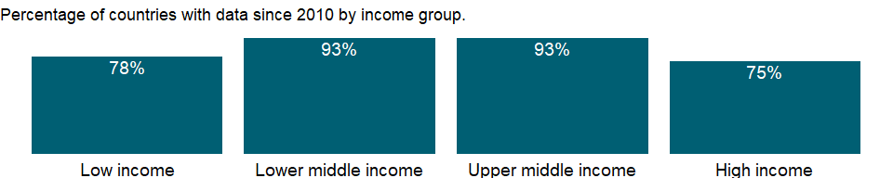

### Why is it relevant?

An economy’s growth is measured by the change in the volume of its output or in the real incomes of its residents. The 2008 United Nations System of National Accounts (2008 SNA) offers three plausible indicators for calculating growth: the volume of gross domestic product (GDP), real gross domestic income, and real gross national income. The volume of GDP is the sum of value added, measured at constant prices, by households, government, and industries operating in the economy. GDP accounts for all domestic production, regardless of whether the income accrues to domestic or foreign institutions.

### What is the data source?

World Bank national accounts data, and OECD National Accounts data files.

### What is the methodology?

Gross domestic product (GDP) represents the sum of value added by all its producers. Value added is the value of the gross output of producers less the value of intermediate goods and services consumed in production, before accounting for consumption of fixed capital in production. The United Nations System of National Accounts calls for value added to be valued at either basic prices (excluding net taxes on products) or producer prices (including net taxes on products paid by producers but excluding sales or value added taxes). Both valuations exclude transport charges that are invoiced separately by producers. Total GDP is measured at purchaser prices. Value added by industry is normally measured at basic prices.

### How is it aggregated?

Gap-filled total

### What are the limitations?

Ideally, industrial output should be measured through regular censuses and surveys of firms. But in most developing countries such surveys are infrequent, so earlier survey results must be extrapolated using an appropriate indicator. The choice of sampling unit, which may be the enterprise (where responses may be based on financial records) or the establishment (where production units may be recorded separately), also affects the quality of the data. Moreover, much industrial production is organized in unincorporated or owner-operated ventures that are not captured by surveys aimed at the formal sector. Even in large industries, where regular surveys are more likely, evasion of excise and other taxes and nondisclosure of income lower the estimates of value added. Such problems become more acute as countries move from state control of industry to private enterprise, because new firms and growing numbers of established firms fail to report. In accordance with the System of National Accounts, output should include all such unreported activity as well as the value of illegal activities and other unrecorded, informal, or small-scale operations. Data on these activities need to be collected using techniques other than conventional surveys of firms.

### What else should I know?

Note: Data for OECD countries are based on ISIC, revision 4.

### 1.44.5 Industry, value added (constant 2010 US$)

### What is the indicator?

Industry corresponds to ISIC divisions 10-45 and includes manufacturing (ISIC divisions 15-37). It comprises value added in mining, manufacturing (also reported as a separate subgroup), construction, electricity, water, and gas. Value added is the net output of a sector after adding up all outputs and subtracting intermediate inputs. It is calculated without making deductions for depreciation of fabricated assets or depletion and degradation of natural resources. The origin of value added is determined by the International Standard Industrial Classification (ISIC), revision 3. Data are in constant 2010 U.S. dollars.

Topic: Economic Policy & Debt: National accounts: US$ at constant 2010 prices: Value added

Series ID: NV.IND.TOTL.KD

Copyright: CC BY-4.0 , <https://datacatalog.worldbank.org/public-licenses#cc-by>

First year with any data: 1960

Last year with any data: 2020

### What years are data available?

The figure below shows years in which data is available for at least one country. Dates shaded in black have no data, while dates shaded in green have data for at least one country



### Which countries have data?

The figure below shows the percentage of countries in each income group with a value since 2010 for that indicator.

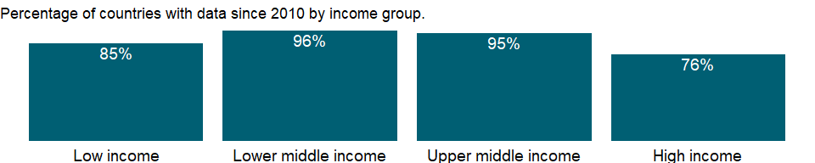

### Why is it relevant?

An economy’s growth is measured by the change in the volume of its output or in the real incomes of its residents. The 2008 United Nations System of National Accounts (2008 SNA) offers three plausible indicators for calculating growth: the volume of gross domestic product (GDP), real gross domestic income, and real gross national income. The volume of GDP is the sum of value added, measured at constant prices, by households, government, and industries operating in the economy. GDP accounts for all domestic production, regardless of whether the income accrues to domestic or foreign institutions.

### What is the data source?

World Bank national accounts data, and OECD National Accounts data files.

### What is the methodology?

Gross domestic product (GDP) represents the sum of value added by all its producers. Value added is the value of the gross output of producers less the value of intermediate goods and services consumed in production, before accounting for consumption of fixed capital in production. The United Nations System of National Accounts calls for value added to be valued at either basic prices (excluding net taxes on products) or producer prices (including net taxes on products paid by producers but excluding sales or value added taxes). Both valuations exclude transport charges that are invoiced separately by producers. Total GDP is measured at purchaser prices. Value added by industry is normally measured at basic prices.

### How is it aggregated?

Gap-filled total

### What are the limitations?

Ideally, industrial output should be measured through regular censuses and surveys of firms. But in most developing countries such surveys are infrequent, so earlier survey results must be extrapolated using an appropriate indicator. The choice of sampling unit, which may be the enterprise (where responses may be based on financial records) or the establishment (where production units may be recorded separately), also affects the quality of the data. Moreover, much industrial production is organized in unincorporated or owner-operated ventures that are not captured by surveys aimed at the formal sector. Even in large industries, where regular surveys are more likely, evasion of excise and other taxes and nondisclosure of income lower the estimates of value added. Such problems become more acute as countries move from state control of industry to private enterprise, because new firms and growing numbers of established firms fail to report. In accordance with the System of National Accounts, output should include all such unreported activity as well as the value of illegal activities and other unrecorded, informal, or small-scale operations. Data on these activities need to be collected using techniques other than conventional surveys of firms.

### What else should I know?

Note: Data for OECD countries are based on ISIC, revision 4.

### 1.44.6 Services, value added per worker (constant 2010 US$)

### What is the indicator?

Value added per worker is a measure of labor productivity—value added per unit of input. Value added denotes the net output of a sector after adding up all outputs and subtracting intermediate inputs. Data are in constant 2010 U.S. dollars. Services corresponds to the International Standard Industrial Classification (ISIC) tabulation categories G-P (revision 3) or tabulation categories G-U (revision 4), and includes wholesale and retail trade and restaurants and hotels; transport, storage, and communications; financing, insurance, real estate, and business services; and community, social and personal services.

Topic: Economic Policy & Debt: National accounts: US$ at constant 2010 prices: Value added

Series ID: NV.SRV.EMPL.KD

Copyright: CC BY-4.0 , <https://datacatalog.worldbank.org/public-licenses#cc-by>

First year with any data: 1991

Last year with any data: 2019

### What years are data available?

The figure below shows years in which data is available for at least one country. Dates shaded in black have no data, while dates shaded in green have data for at least one country



### Which countries have data?

The figure below shows the percentage of countries in each income group with a value since 2010 for that indicator.

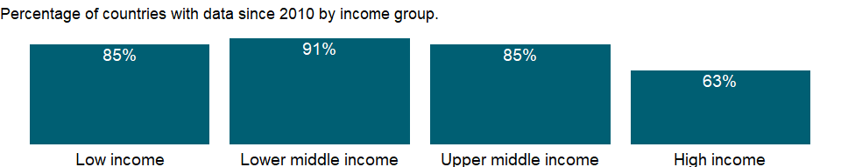

### Why is it relevant?

Labor productivity is used to assess a country’s economic ability to create and sustain decent employment opportunities with fair and equitable remuneration. Productivity increases obtained through investment, trade, technological progress, or changes in work organization can increase social protection and reduce poverty, which in turn reduce vulnerable employment and working poverty. Productivity increases do not guarantee these improvements, but without them—and the economic growth they bring—improvements are highly unlikely. Please also see GDP per person employed (constant 2011 PPP $) [SL.GDP.PCAP.EM.KD], which is a key measure for monitoring the Sustainable Development Goal 8 of promoting sustained, inclusive and sustainable economic growth, full and productive employment and decent work for all.

### What is the data source?

Derived using World Bank national accounts data and OECD National Accounts data files, and employment data from International Labour Organization, ILOSTAT database.

### What is the methodology?

Value added per worker is calculated by dividing value added of a sector by the number employed in the sector.  
Gross domestic product (GDP) represents the sum of value added by all producers. Value added is the value of the gross output of producers less the value of intermediate goods and services consumed in production, before accounting for consumption of fixed capital in production. The United Nations System of National Accounts calls for value added to be valued at either basic prices (excluding net taxes on products) or producer prices (including net taxes on products paid by producers but excluding sales or value added taxes). Both valuations exclude transport charges that are invoiced separately by producers. Value added by industry is normally measured at basic prices, while total GDP is measured at purchaser prices. Data on employment are modeled estimates by the International Labour Organization (ILO) ILOSTAT database. The concept of employment generally refers to people above a certain age who worked, or who held a job, during a reference period. Employment data include both full-time and part-time workers.

### How is it aggregated?

Weighted Average

### What are the limitations?

For comparability of individual sectors labor productivity is estimated according to national accounts conventions. However, there are still significant limitations on the availability of reliable data. Information on consistent series of output is not easily available, especially in low- and middle-income countries, because the definition, coverage, and methodology are not always consistent across countries. For more details, see Agriculture, value added (constant 2010 US) [NV.IND.TOTL.KD], and Services, etc., value added (constant 2010 US$) [NV.SRV.TOTL.KD].

### What else should I know?

NA

### 1.44.7 Services, value added (constant 2010 US$)

### What is the indicator?

Services correspond to ISIC divisions 50-99. They include value added in wholesale and retail trade (including hotels and restaurants), transport, and government, financial, professional, and personal services such as education, health care, and real estate services. Also included are imputed bank service charges, import duties, and any statistical discrepancies noted by national compilers as well as discrepancies arising from rescaling. Value added is the net output of a sector after adding up all outputs and subtracting intermediate inputs. It is calculated without making deductions for depreciation of fabricated assets or depletion and degradation of natural resources. The industrial origin of value added is determined by the International Standard Industrial Classification (ISIC), revision 3 or 4. Data are in constant 2010 U.S. dollars.

Topic: Economic Policy & Debt: National accounts: US$ at constant 2010 prices: Value added

Series ID: NV.SRV.TOTL.KD

Copyright: CC BY-4.0 , <https://datacatalog.worldbank.org/public-licenses#cc-by>

First year with any data: 1960

Last year with any data: 2020

### What years are data available?

The figure below shows years in which data is available for at least one country. Dates shaded in black have no data, while dates shaded in green have data for at least one country



### Which countries have data?

The figure below shows the percentage of countries in each income group with a value since 2010 for that indicator.

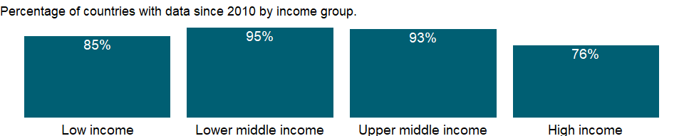

### Why is it relevant?

An economy’s growth is measured by the change in the volume of its output or in the real incomes of its residents. The 2008 United Nations System of National Accounts (2008 SNA) offers three plausible indicators for calculating growth: the volume of gross domestic product (GDP), real gross domestic income, and real gross national income. The volume of GDP is the sum of value added, measured at constant prices, by households, government, and industries operating in the economy. GDP accounts for all domestic production, regardless of whether the income accrues to domestic or foreign institutions.

### What is the data source?

World Bank national accounts data, and OECD National Accounts data files.

### What is the methodology?

Gross domestic product (GDP) represents the sum of value added by all its producers. Value added is the value of the gross output of producers less the value of intermediate goods and services consumed in production, before accounting for consumption of fixed capital in production. The United Nations System of National Accounts calls for value added to be valued at either basic prices (excluding net taxes on products) or producer prices (including net taxes on products paid by producers but excluding sales or value added taxes). Both valuations exclude transport charges that are invoiced separately by producers. Total GDP is measured at purchaser prices. Value added by industry is normally measured at basic prices.

### How is it aggregated?

Gap-filled total

### What are the limitations?

In the services industries, including most of government, value added in constant prices is often imputed from labor inputs, such as real wages or number of employees. In the absence of well defined measures of output, measuring the growth of services remains difficult.

### What else should I know?

NA

## 1.45 Economic Policy & Debt: National accounts: US$ at current prices: Value added

### 1.45.1 Agriculture, value added (current US$)

### What is the indicator?

Agriculture corresponds to ISIC divisions 1-5 and includes forestry, hunting, and fishing, as well as cultivation of crops and livestock production. Value added is the net output of a sector after adding up all outputs and subtracting intermediate inputs. It is calculated without making deductions for depreciation of fabricated assets or depletion and degradation of natural resources. The origin of value added is determined by the International Standard Industrial Classification (ISIC), revision 3. Data are in current U.S. dollars.

Topic: Economic Policy & Debt: National accounts: US$ at current prices: Value added

Series ID: NV.AGR.TOTL.CD

Copyright: CC BY-4.0 , <https://datacatalog.worldbank.org/public-licenses#cc-by>

First year with any data: 1960

Last year with any data: 2020

### What years are data available?

The figure below shows years in which data is available for at least one country. Dates shaded in black have no data, while dates shaded in green have data for at least one country



### Which countries have data?

The figure below shows the percentage of countries in each income group with a value since 2010 for that indicator.



### Why is it relevant?

NA

### What is the data source?

World Bank national accounts data, and OECD National Accounts data files.

### What is the methodology?

Gross domestic product (GDP) represents the sum of value added by all its producers. Value added is the value of the gross output of producers less the value of intermediate goods and services consumed in production, before accounting for consumption of fixed capital in production. The United Nations System of National Accounts calls for value added to be valued at either basic prices (excluding net taxes on products) or producer prices (including net taxes on products paid by producers but excluding sales or value added taxes). Both valuations exclude transport charges that are invoiced separately by producers. Total GDP is measured at purchaser prices. Value added by industry is normally measured at basic prices.

### How is it aggregated?

Gap-filled total

### What are the limitations?

Among the difficulties faced by compilers of national accounts is the extent of unreported economic activity in the informal or secondary economy. In developing countries a large share of agricultural output is either not exchanged (because it is consumed within the household) or not exchanged for money. Agricultural production often must be estimated indirectly, using a combination of methods involving estimates of inputs, yields, and area under cultivation. This approach sometimes leads to crude approximations that can differ from the true values over time and across crops for reasons other than climate conditions or farming techniques. Similarly, agricultural inputs that cannot easily be allocated to specific outputs are frequently “netted out” using equally crude and ad hoc approximations.

### What else should I know?

Note: Data for OECD countries are based on ISIC, revision 4.

### 1.45.2 Manufacturing, value added (current US$)

### What is the indicator?

Manufacturing refers to industries belonging to ISIC divisions 15-37. Value added is the net output of a sector after adding up all outputs and subtracting intermediate inputs. It is calculated without making deductions for depreciation of fabricated assets or depletion and degradation of natural resources. The origin of value added is determined by the International Standard Industrial Classification (ISIC), revision 3. Data are in current U.S. dollars.

Topic: Economic Policy & Debt: National accounts: US$ at current prices: Value added

Series ID: NV.IND.MANF.CD

Copyright: CC BY-4.0 , <https://datacatalog.worldbank.org/public-licenses#cc-by>

First year with any data: 1960

Last year with any data: 2020

### What years are data available?

The figure below shows years in which data is available for at least one country. Dates shaded in black have no data, while dates shaded in green have data for at least one country



### Which countries have data?

The figure below shows the percentage of countries in each income group with a value since 2010 for that indicator.



### Why is it relevant?

Firms typically use multiple processes to produce a product. For example, an automobile manufacturer engages in forging, welding, and painting as well as advertising, accounting, and other service activities. Collecting data at such a detailed level is not practical, nor is it useful to record production data at the highest level of a large, multiplant, multiproduct firm. The ISIC has therefore adopted as the definition of an establishment “an enterprise or part of an enterprise which independently engages in one, or predominantly one, kind of economic activity at or from one location . . . for which data are available . . .” (United Nations 1990). By design, this definition matches the reporting unit required for the production accounts of the United Nations System of National Accounts.

The ISIC system is described in the United Nations’ International Standard Industrial Classification of All Economic Activities, Third Revision (1990). The discussion of the ISIC draws on Ryten (1998).

### What is the data source?

World Bank national accounts data, and OECD National Accounts data files.

### What is the methodology?

The data on manufacturing value added in U.S. dollars are from the World Bank’s national accounts files and may differ from those UNIDO uses to calculate shares of value added by industry, in part because of differences in exchange rates. Thus value added in a particular industry estimated by applying the shares to total manufacturing value added will not match those from UNIDO sources. Classification of manufacturing industries accords with the United Nations International Standard Industrial Classification (ISIC) revision 3.

Data prior to 2008 used revision 2, first published in 1948. Revision 3 was completed in 1989, and many countries now use it. But revision 2 is still widely used for compiling cross-country data. UNIDO has converted these data to accord with revision 3. Concordances matching ISIC categories to national classification systems and to related systems such as the Standard International Trade Classification are available.

### How is it aggregated?

Gap-filled total

### What are the limitations?

In establishing classifications systems compilers must define both the types of activities to be described and the units whose activities are to be reported. There are many possibilities, and the choices affect how the statistics can be interpreted and how useful they are in analyzing economic behavior. The ISIC emphasizes commonalities in the production process and is explicitly not intended to measure outputs (for which there is a newly developed Central Product Classification). Nevertheless, the ISIC views an activity as defined by “a process resulting in a homogeneous set of products.”

### What else should I know?

Note: Data for OECD countries are based on ISIC, revision 4.

### 1.45.3 Industry, value added (current US$)

### What is the indicator?

Industry corresponds to ISIC divisions 10-45 and includes manufacturing (ISIC divisions 15-37). It comprises value added in mining, manufacturing (also reported as a separate subgroup), construction, electricity, water, and gas. Value added is the net output of a sector after adding up all outputs and subtracting intermediate inputs. It is calculated without making deductions for depreciation of fabricated assets or depletion and degradation of natural resources. The origin of value added is determined by the International Standard Industrial Classification (ISIC), revision 3. Data are in current U.S. dollars.

Topic: Economic Policy & Debt: National accounts: US$ at current prices: Value added

Series ID: NV.IND.TOTL.CD

Copyright: CC BY-4.0 , <https://datacatalog.worldbank.org/public-licenses#cc-by>

First year with any data: 1960

Last year with any data: 2020

### What years are data available?

The figure below shows years in which data is available for at least one country. Dates shaded in black have no data, while dates shaded in green have data for at least one country



### Which countries have data?

The figure below shows the percentage of countries in each income group with a value since 2010 for that indicator.



### Why is it relevant?

NA

### What is the data source?

World Bank national accounts data, and OECD National Accounts data files.

### What is the methodology?

Gross domestic product (GDP) represents the sum of value added by all its producers. Value added is the value of the gross output of producers less the value of intermediate goods and services consumed in production, before accounting for consumption of fixed capital in production. The United Nations System of National Accounts calls for value added to be valued at either basic prices (excluding net taxes on products) or producer prices (including net taxes on products paid by producers but excluding sales or value added taxes). Both valuations exclude transport charges that are invoiced separately by producers. Total GDP is measured at purchaser prices. Value added by industry is normally measured at basic prices.

### How is it aggregated?

Gap-filled total

### What are the limitations?

Ideally, industrial output should be measured through regular censuses and surveys of firms. But in most developing countries such surveys are infrequent, so earlier survey results must be extrapolated using an appropriate indicator. The choice of sampling unit, which may be the enterprise (where responses may be based on financial records) or the establishment (where production units may be recorded separately), also affects the quality of the data. Moreover, much industrial production is organized in unincorporated or owner-operated ventures that are not captured by surveys aimed at the formal sector. Even in large industries, where regular surveys are more likely, evasion of excise and other taxes and nondisclosure of income lower the estimates of value added. Such problems become more acute as countries move from state control of industry to private enterprise, because new firms and growing numbers of established firms fail to report. In accordance with the System of National Accounts, output should include all such unreported activity as well as the value of illegal activities and other unrecorded, informal, or small-scale operations. Data on these activities need to be collected using techniques other than conventional surveys of firms.

### What else should I know?

Note: Data for OECD countries are based on ISIC, revision 4.

### 1.45.4 Services, value added (current US$)

### What is the indicator?

Services correspond to ISIC divisions 50-99. They include value added in wholesale and retail trade (including hotels and restaurants), transport, and government, financial, professional, and personal services such as education, health care, and real estate services. Also included are imputed bank service charges and import duties. Value added is the net output of a sector after adding up all outputs and subtracting intermediate inputs. It is calculated without making deductions for depreciation of fabricated assets or depletion and degradation of natural resources. The industrial origin of value added is determined by the International Standard Industrial Classification (ISIC), revision 3. Data are in current U.S. dollars.

Topic: Economic Policy & Debt: National accounts: US$ at current prices: Value added

Series ID: NV.SRV.TOTL.CD

Copyright: CC BY-4.0 , <https://datacatalog.worldbank.org/public-licenses#cc-by>

First year with any data: 1960

Last year with any data: 2020

### What years are data available?

The figure below shows years in which data is available for at least one country. Dates shaded in black have no data, while dates shaded in green have data for at least one country



### Which countries have data?

The figure below shows the percentage of countries in each income group with a value since 2010 for that indicator.

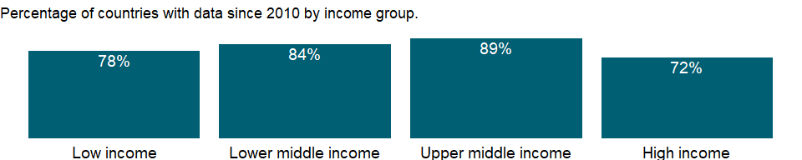

### Why is it relevant?

NA

### What is the data source?

World Bank national accounts data, and OECD National Accounts data files.

### What is the methodology?

NA

### How is it aggregated?

Gap-filled total

### What are the limitations?

NA

### What else should I know?

Note: Data for OECD countries are based on ISIC, revision 4.

## 1.46 Economic Policy & Debt: National accounts: Local currency at current prices: Value added

### 1.46.1 Agriculture, value added (current LCU)

### What is the indicator?

Agriculture corresponds to ISIC divisions 1-5 and includes forestry, hunting, and fishing, as well as cultivation of crops and livestock production. Value added is the net output of a sector after adding up all outputs and subtracting intermediate inputs. It is calculated without making deductions for depreciation of fabricated assets or depletion and degradation of natural resources. The origin of value added is determined by the International Standard Industrial Classification (ISIC), revision 3. Data are in current local currency.

Topic: Economic Policy & Debt: National accounts: Local currency at current prices: Value added

Series ID: NV.AGR.TOTL.CN

Copyright: CC BY-4.0 , <https://datacatalog.worldbank.org/public-licenses#cc-by>

First year with any data: 1960

Last year with any data: 2020

### What years are data available?

The figure below shows years in which data is available for at least one country. Dates shaded in black have no data, while dates shaded in green have data for at least one country



### Which countries have data?

The figure below shows the percentage of countries in each income group with a value since 2010 for that indicator.



### Why is it relevant?

NA

### What is the data source?

World Bank national accounts data, and OECD National Accounts data files.

### What is the methodology?

NA

### How is it aggregated?

NA

### What are the limitations?

NA

### What else should I know?

Note: Data for OECD countries are based on ISIC, revision 4.

### 1.46.2 Financial intermediary services indirectly Measured (FISIM) (current LCU)

### What is the indicator?

Financial intermediation services indirectly measured (FISIM) is an indirect measure of the value of financial intermediation services (i.e. output) provided but for which financial institutions do not charge explicitly as compared to explicit bank charges. Although the 1993 SNA recommends that the FISIM are allocated as intermediate and final consumption to the users, many countries still make a global (negative) adjustment to the sum of gross value added.

Topic: Economic Policy & Debt: National accounts: Local currency at current prices: Value added

Series ID: NV.FSM.TOTL.CN

Copyright: CC BY-4.0 , <https://datacatalog.worldbank.org/public-licenses#cc-by>

First year with any data: 1960

Last year with any data: 2020

### What years are data available?

The figure below shows years in which data is available for at least one country. Dates shaded in black have no data, while dates shaded in green have data for at least one country



### Which countries have data?

The figure below shows the percentage of countries in each income group with a value since 2010 for that indicator.

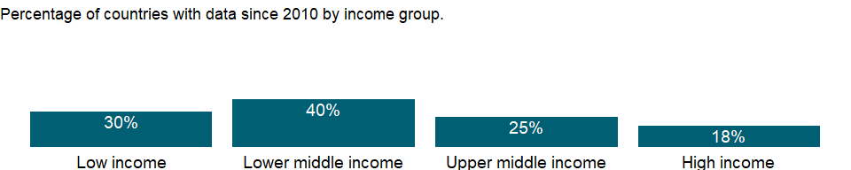

### Why is it relevant?

NA

### What is the data source?

World Bank national accounts data, and OECD National Accounts data files.

### What is the methodology?

NA

### How is it aggregated?

NA

### What are the limitations?

NA

### What else should I know?

NA

### 1.46.3 Manufacturing, value added (current LCU)

### What is the indicator?

Manufacturing refers to industries belonging to ISIC divisions 15-37. Value added is the net output of a sector after adding up all outputs and subtracting intermediate inputs. It is calculated without making deductions for depreciation of fabricated assets or depletion and degradation of natural resources. The origin of value added is determined by the International Standard Industrial Classification (ISIC), revision 3. Data are in current local currency.

Topic: Economic Policy & Debt: National accounts: Local currency at current prices: Value added

Series ID: NV.IND.MANF.CN

Copyright: CC BY-4.0 , <https://datacatalog.worldbank.org/public-licenses#cc-by>

First year with any data: 1960

Last year with any data: 2020

### What years are data available?

The figure below shows years in which data is available for at least one country. Dates shaded in black have no data, while dates shaded in green have data for at least one country



### Which countries have data?

The figure below shows the percentage of countries in each income group with a value since 2010 for that indicator.



### Why is it relevant?

NA

### What is the data source?

World Bank national accounts data, and OECD National Accounts data files.

### What is the methodology?

NA

### How is it aggregated?

NA

### What are the limitations?

NA

### What else should I know?

Note: Data for OECD countries are based on ISIC, revision 4.

### 1.46.4 Industry, value added (current LCU)

### What is the indicator?

Industry corresponds to ISIC divisions 10-45 and includes manufacturing (ISIC divisions 15-37). It comprises value added in mining, manufacturing (also reported as a separate subgroup), construction, electricity, water, and gas. Value added is the net output of a sector after adding up all outputs and subtracting intermediate inputs. It is calculated without making deductions for depreciation of fabricated assets or depletion and degradation of natural resources. The origin of value added is determined by the International Standard Industrial Classification (ISIC), revision 3. Data are in current local currency.

Topic: Economic Policy & Debt: National accounts: Local currency at current prices: Value added

Series ID: NV.IND.TOTL.CN

Copyright: CC BY-4.0 , <https://datacatalog.worldbank.org/public-licenses#cc-by>

First year with any data: 1960

Last year with any data: 2020

### What years are data available?

The figure below shows years in which data is available for at least one country. Dates shaded in black have no data, while dates shaded in green have data for at least one country



### Which countries have data?

The figure below shows the percentage of countries in each income group with a value since 2010 for that indicator.



### Why is it relevant?

NA

### What is the data source?

World Bank national accounts data, and OECD National Accounts data files.

### What is the methodology?

NA

### How is it aggregated?

NA

### What are the limitations?

NA

### What else should I know?

Note: Data for OECD countries are based on ISIC, revision 4.

### 1.46.5 Services, value added (current LCU)

### What is the indicator?

Services correspond to ISIC divisions 50-99. They include value added in wholesale and retail trade (including hotels and restaurants), transport, and government, financial, professional, and personal services such as education, health care, and real estate services. Also included are imputed bank service charges and import duties. Value added is the net output of a sector after adding up all outputs and subtracting intermediate inputs. It is calculated without making deductions for depreciation of fabricated assets or depletion and degradation of natural resources. The industrial origin of value added is determined by the International Standard Industrial Classification (ISIC), revision 3. Data are in current local currency.

Topic: Economic Policy & Debt: National accounts: Local currency at current prices: Value added

Series ID: NV.SRV.TOTL.CN

Copyright: CC BY-4.0 , <https://datacatalog.worldbank.org/public-licenses#cc-by>

First year with any data: 1960

Last year with any data: 2020

### What years are data available?

The figure below shows years in which data is available for at least one country. Dates shaded in black have no data, while dates shaded in green have data for at least one country



### Which countries have data?

The figure below shows the percentage of countries in each income group with a value since 2010 for that indicator.



### Why is it relevant?

NA

### What is the data source?

World Bank national accounts data, and OECD National Accounts data files.

### What is the methodology?

NA

### How is it aggregated?

NA

### What are the limitations?

NA

### What else should I know?

Note: Data for OECD countries are based on ISIC, revision 4.

## 1.47 Economic Policy & Debt: National accounts: Local currency at constant prices: Value added

### 1.47.1 Agriculture, value added (constant LCU)

### What is the indicator?

Agriculture corresponds to ISIC divisions 1-5 and includes forestry, hunting, and fishing, as well as cultivation of crops and livestock production. Value added is the net output of a sector after adding up all outputs and subtracting intermediate inputs. It is calculated without making deductions for depreciation of fabricated assets or depletion and degradation of natural resources. The origin of value added is determined by the International Standard Industrial Classification (ISIC), revision 3. Data are in constant local currency.

Topic: Economic Policy & Debt: National accounts: Local currency at constant prices: Value added

Series ID: NV.AGR.TOTL.KN

Copyright: CC BY-4.0 , <https://datacatalog.worldbank.org/public-licenses#cc-by>

First year with any data: 1960

Last year with any data: 2020

### What years are data available?

The figure below shows years in which data is available for at least one country. Dates shaded in black have no data, while dates shaded in green have data for at least one country



### Which countries have data?

The figure below shows the percentage of countries in each income group with a value since 2010 for that indicator.



### Why is it relevant?

NA

### What is the data source?

World Bank national accounts data, and OECD National Accounts data files.

### What is the methodology?

NA

### How is it aggregated?

NA

### What are the limitations?

NA

### What else should I know?

Note: Data for OECD countries are based on ISIC, revision 4.

### 1.47.2 Financial intermediary services indirectly Measured (FISIM) (constant LCU)

### What is the indicator?

Financial intermediation services indirectly measured (FISIM) is an indirect measure of the value of financial intermediation services (i.e. output) provided but for which financial institutions do not charge explicitly as compared to explicit bank charges. Although the 1993 SNA recommends that the FISIM are allocated as intermediate and final consumption to the users, many countries still make a global (negative) adjustment to the sum of gross value added.

Topic: Economic Policy & Debt: National accounts: Local currency at constant prices: Value added

Series ID: NV.FSM.TOTL.KN

Copyright: CC BY-4.0 , <https://datacatalog.worldbank.org/public-licenses#cc-by>

First year with any data: 1960

Last year with any data: 2020

### What years are data available?

The figure below shows years in which data is available for at least one country. Dates shaded in black have no data, while dates shaded in green have data for at least one country



### Which countries have data?

The figure below shows the percentage of countries in each income group with a value since 2010 for that indicator.

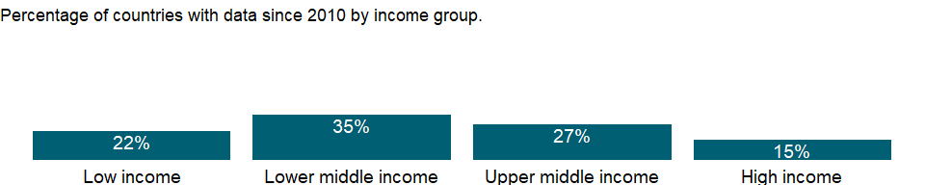

### Why is it relevant?

NA

### What is the data source?

World Bank national accounts data, and OECD National Accounts data files.

### What is the methodology?

NA

### How is it aggregated?

NA

### What are the limitations?

NA

### What else should I know?

NA

### 1.47.3 Manufacturing, value added (constant LCU)

### What is the indicator?

Manufacturing refers to industries belonging to ISIC divisions 15-37. Value added is the net output of a sector after adding up all outputs and subtracting intermediate inputs. It is calculated without making deductions for depreciation of fabricated assets or depletion and degradation of natural resources. The origin of value added is determined by the International Standard Industrial Classification (ISIC), revision 3. Data are in constant local currency.

Topic: Economic Policy & Debt: National accounts: Local currency at constant prices: Value added

Series ID: NV.IND.MANF.KN

Copyright: CC BY-4.0 , <https://datacatalog.worldbank.org/public-licenses#cc-by>

First year with any data: 1960

Last year with any data: 2020

### What years are data available?

The figure below shows years in which data is available for at least one country. Dates shaded in black have no data, while dates shaded in green have data for at least one country



### Which countries have data?

The figure below shows the percentage of countries in each income group with a value since 2010 for that indicator.



### Why is it relevant?

NA

### What is the data source?

World Bank national accounts data, and OECD National Accounts data files.

### What is the methodology?

NA

### How is it aggregated?

NA

### What are the limitations?

NA

### What else should I know?

Note: Data for OECD countries are based on ISIC, revision 4.

### 1.47.4 Industry, value added (constant LCU)

### What is the indicator?

Industry corresponds to ISIC divisions 10-45 and includes manufacturing (ISIC divisions 15-37). It comprises value added in mining, manufacturing (also reported as a separate subgroup), construction, electricity, water, and gas. Value added is the net output of a sector after adding up all outputs and subtracting intermediate inputs. It is calculated without making deductions for depreciation of fabricated assets or depletion and degradation of natural resources. The origin of value added is determined by the International Standard Industrial Classification (ISIC), revision 3. Data are in constant local currency.

Topic: Economic Policy & Debt: National accounts: Local currency at constant prices: Value added

Series ID: NV.IND.TOTL.KN

Copyright: CC BY-4.0 , <https://datacatalog.worldbank.org/public-licenses#cc-by>

First year with any data: 1960

Last year with any data: 2020

### What years are data available?

The figure below shows years in which data is available for at least one country. Dates shaded in black have no data, while dates shaded in green have data for at least one country



### Which countries have data?

The figure below shows the percentage of countries in each income group with a value since 2010 for that indicator.



### Why is it relevant?

NA

### What is the data source?

World Bank national accounts data, and OECD National Accounts data files.

### What is the methodology?

NA

### How is it aggregated?

NA

### What are the limitations?

NA

### What else should I know?

Note: Data for OECD countries are based on ISIC, revision 4.

### 1.47.5 Services, value added (constant LCU)

### What is the indicator?

Services correspond to ISIC divisions 50-99. They include value added in wholesale and retail trade (including hotels and restaurants), transport, and government, financial, professional, and personal services such as education, health care, and real estate services. Also included are imputed bank service charges and import duties. Value added is the net output of a sector after adding up all outputs and subtracting intermediate inputs. It is calculated without making deductions for depreciation of fabricated assets or depletion and degradation of natural resources. The industrial origin of value added is determined by the International Standard Industrial Classification (ISIC), revision 3. Data are in constant local currency.

Topic: Economic Policy & Debt: National accounts: Local currency at constant prices: Value added

Series ID: NV.SRV.TOTL.KN

Copyright: CC BY-4.0 , <https://datacatalog.worldbank.org/public-licenses#cc-by>

First year with any data: 1960

Last year with any data: 2020

### What years are data available?

The figure below shows years in which data is available for at least one country. Dates shaded in black have no data, while dates shaded in green have data for at least one country



### Which countries have data?

The figure below shows the percentage of countries in each income group with a value since 2010 for that indicator.



### Why is it relevant?

NA

### What is the data source?

World Bank national accounts data, and OECD National Accounts data files.

### What is the methodology?

NA

### How is it aggregated?

NA

### What are the limitations?

NA

### What else should I know?

Note: Data for OECD countries are based on ISIC, revision 4.

## 1.48 Economic Policy & Debt: National accounts: Adjusted savings & income

### 1.48.1 Adjusted savings: education expenditure (current US$)

### What is the indicator?

Education expenditure refers to the current operating expenditures in education, including wages and salaries and excluding capital investments in buildings and equipment.

Topic: Economic Policy & Debt: National accounts: Adjusted savings & income

Series ID: NY.ADJ.AEDU.CD

Copyright: CC BY-4.0 , <https://datacatalog.worldbank.org/public-licenses#cc-by>

First year with any data: 1970

Last year with any data: 2019

### What years are data available?

The figure below shows years in which data is available for at least one country. Dates shaded in black have no data, while dates shaded in green have data for at least one country



### Which countries have data?

The figure below shows the percentage of countries in each income group with a value since 2010 for that indicator.

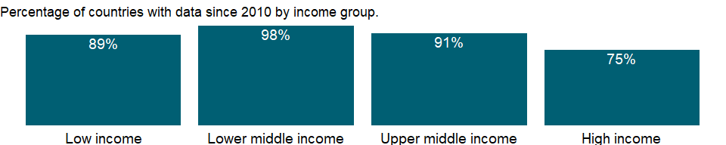

### Why is it relevant?

NA

### What is the data source?

UNESCO; data are extrapolated to the most recent year available

### What is the methodology?

NA

### How is it aggregated?

NA

### What are the limitations?

Public education expenditures are considered an addition to savings. However, because of the wide variability in the effectiveness of public education expenditures, these figures cannot be construed as the value of investments in human capital. A current expenditure of $1 on education does not necessarily yield $1 of human capital. The calculation should also consider private education expenditure, but data are not available for a large number of countries.

### What else should I know?

NA

### 1.48.2 Adjusted savings: education expenditure (% of GNI)

### What is the indicator?

Education expenditure refers to the current operating expenditures in education, including wages and salaries and excluding capital investments in buildings and equipment.

Topic: Economic Policy & Debt: National accounts: Adjusted savings & income

Series ID: NY.ADJ.AEDU.GN.ZS

Copyright: CC BY-4.0 , <https://datacatalog.worldbank.org/public-licenses#cc-by>

First year with any data: 1970

Last year with any data: 2019

### What years are data available?

The figure below shows years in which data is available for at least one country. Dates shaded in black have no data, while dates shaded in green have data for at least one country



### Which countries have data?

The figure below shows the percentage of countries in each income group with a value since 2010 for that indicator.

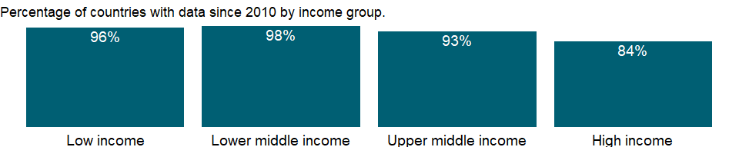

### Why is it relevant?

NA

### What is the data source?

UNESCO; data are extrapolated to the most recent year available

### What is the methodology?

NA

### How is it aggregated?

Weighted average

### What are the limitations?

Public education expenditures are considered an addition to savings. However, because of the wide variability in the effectiveness of public education expenditures, these figures cannot be construed as the value of investments in human capital. A current expenditure of $1 on education does not necessarily yield $1 of human capital. The calculation should also consider private education expenditure, but data are not available for a large number of countries.

### What else should I know?

NA

### 1.48.3 Adjusted savings: carbon dioxide damage (current US$)

### What is the indicator?

Cost of damage due to carbon dioxide emissions from fossil fuel use and the manufacture of cement, estimated to be US$40 per ton of CO2 (the unit damage in 2017 US dollars for CO2 emitted in 2020) times the number of tons of CO2 emitted.

Topic: Economic Policy & Debt: National accounts: Adjusted savings & income

Series ID: NY.ADJ.DCO2.CD

Copyright: CC BY-4.0 , <https://datacatalog.worldbank.org/public-licenses#cc-by>

First year with any data: 1970

Last year with any data: 2019

### What years are data available?

The figure below shows years in which data is available for at least one country. Dates shaded in black have no data, while dates shaded in green have data for at least one country



### Which countries have data?

The figure below shows the percentage of countries in each income group with a value since 2010 for that indicator.

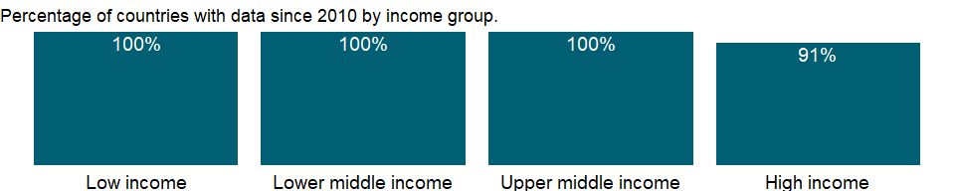

### Why is it relevant?

NA

### What is the data source?

World Bank staff estimates based on sources and methods described in the World Bank’s The Changing Wealth of Nations.

### What is the methodology?

Pollution damage from emissions of carbon dioxide is calculated as the marginal social cost per unit multiplied by the increase in the stock of carbon dioxide. The unit damage figure represents the present value of global damage to economic assets and to human welfare over the time the unit of pollution remains in the atmosphere.

### How is it aggregated?

NA

### What are the limitations?

NA

### What else should I know?

NA

### 1.48.4 Adjusted savings: carbon dioxide damage (% of GNI)

### What is the indicator?

Cost of damage due to carbon dioxide emissions from fossil fuel use and the manufacture of cement, estimated to be US$40 per ton of CO2 (the unit damage in 2017 US dollars for CO2 emitted in 2020) times the number of tons of CO2 emitted.

Topic: Economic Policy & Debt: National accounts: Adjusted savings & income

Series ID: NY.ADJ.DCO2.GN.ZS

Copyright: CC BY-4.0 , <https://datacatalog.worldbank.org/public-licenses#cc-by>

First year with any data: 1970

Last year with any data: 2019

### What years are data available?

The figure below shows years in which data is available for at least one country. Dates shaded in black have no data, while dates shaded in green have data for at least one country



### Which countries have data?

The figure below shows the percentage of countries in each income group with a value since 2010 for that indicator.

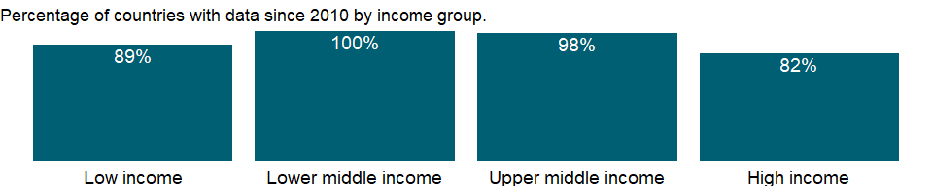

### Why is it relevant?

NA

### What is the data source?

World Bank staff estimates based on sources and methods described in the World Bank’s The Changing Wealth of Nations.

### What is the methodology?

Pollution damage from emissions of carbon dioxide is calculated as the marginal social cost per unit multiplied by the increase in the stock of carbon dioxide. The unit damage figure represents the present value of global damage to economic assets and to human welfare over the time the unit of pollution remains in the atmosphere.

### How is it aggregated?

Weighted average

### What are the limitations?

NA

### What else should I know?

NA

### 1.48.5 Adjusted savings: net forest depletion (current US$)

### What is the indicator?

Net forest depletion is calculated as the product of unit resource rents and the excess of roundwood harvest over natural growth. If growth exceeds harvest, this figure is zero.

Topic: Economic Policy & Debt: National accounts: Adjusted savings & income

Series ID: NY.ADJ.DFOR.CD

Copyright: CC BY-4.0 , <https://datacatalog.worldbank.org/public-licenses#cc-by>

First year with any data: 1970

Last year with any data: 2019

### What years are data available?

The figure below shows years in which data is available for at least one country. Dates shaded in black have no data, while dates shaded in green have data for at least one country



### Which countries have data?

The figure below shows the percentage of countries in each income group with a value since 2010 for that indicator.

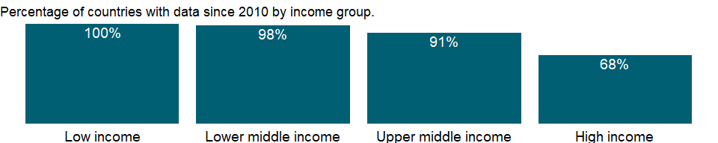

### Why is it relevant?

NA

### What is the data source?

World Bank staff estimates based on sources and methods described in the World Bank’s The Changing Wealth of Nations.

### What is the methodology?

NA

### How is it aggregated?

NA

### What are the limitations?

A positive net depletion figure for forest resources implies that the harvest rate exceeds the rate of natural growth; this is not the same as deforestation, which represents a change in land use. In principle, there should be an addition to savings in countries where growth exceeds harvest, but empirical estimates suggest that most of this net growth is in forested areas that cannot currently be exploited economically. Because the depletion estimates reflect only timber values, they ignore all the external and nontimber benefits associated with standing forests.

### What else should I know?

NA

### 1.48.6 Adjusted savings: net forest depletion (% of GNI)

### What is the indicator?

Net forest depletion is calculated as the product of unit resource rents and the excess of roundwood harvest over natural growth. If growth exceeds harvest, this figure is zero.

Topic: Economic Policy & Debt: National accounts: Adjusted savings & income

Series ID: NY.ADJ.DFOR.GN.ZS

Copyright: CC BY-4.0 , <https://datacatalog.worldbank.org/public-licenses#cc-by>

First year with any data: 1970

Last year with any data: 2019

### What years are data available?

The figure below shows years in which data is available for at least one country. Dates shaded in black have no data, while dates shaded in green have data for at least one country



### Which countries have data?

The figure below shows the percentage of countries in each income group with a value since 2010 for that indicator.

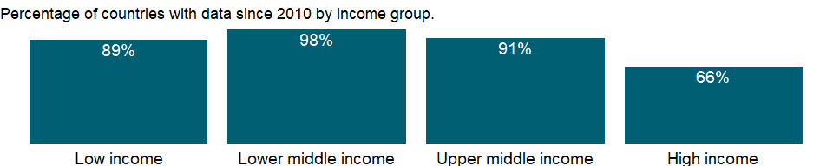

### Why is it relevant?

NA

### What is the data source?

World Bank staff estimates based on sources and methods described in the World Bank’s The Changing Wealth of Nations.

### What is the methodology?

NA

### How is it aggregated?

Weighted average

### What are the limitations?

A positive net depletion figure for forest resources implies that the harvest rate exceeds the rate of natural growth; this is not the same as deforestation, which represents a change in land use. In principle, there should be an addition to savings in countries where growth exceeds harvest, but empirical estimates suggest that most of this net growth is in forested areas that cannot currently be exploited economically. Because the depletion estimates reflect only timber values, they ignore all the external and nontimber benefits associated with standing forests.

### What else should I know?

NA

### 1.48.7 Adjusted savings: consumption of fixed capital (current US$)

### What is the indicator?

Consumption of fixed capital represents the replacement value of capital used up in the process of production.

Topic: Economic Policy & Debt: National accounts: Adjusted savings & income

Series ID: NY.ADJ.DKAP.CD

Copyright: CC BY-4.0 , <https://datacatalog.worldbank.org/public-licenses#cc-by>

First year with any data: 1970

Last year with any data: 2019

### What years are data available?

The figure below shows years in which data is available for at least one country. Dates shaded in black have no data, while dates shaded in green have data for at least one country



### Which countries have data?

The figure below shows the percentage of countries in each income group with a value since 2010 for that indicator.

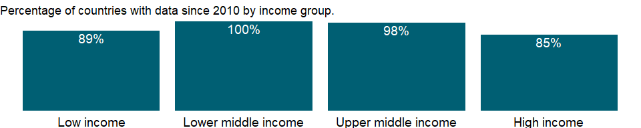

### Why is it relevant?

NA

### What is the data source?

World Bank staff estimates based on sources and methods described in the World Bank’s The Changing Wealth of Nations.

### What is the methodology?

NA

### How is it aggregated?

NA

### What are the limitations?

NA

### What else should I know?

NA

### 1.48.8 Adjusted savings: consumption of fixed capital (% of GNI)

### What is the indicator?

Consumption of fixed capital represents the replacement value of capital used up in the process of production.

Topic: Economic Policy & Debt: National accounts: Adjusted savings & income

Series ID: NY.ADJ.DKAP.GN.ZS

Copyright: CC BY-4.0 , <https://datacatalog.worldbank.org/public-licenses#cc-by>

First year with any data: 1970

Last year with any data: 2019

### What years are data available?

The figure below shows years in which data is available for at least one country. Dates shaded in black have no data, while dates shaded in green have data for at least one country



### Which countries have data?

The figure below shows the percentage of countries in each income group with a value since 2010 for that indicator.

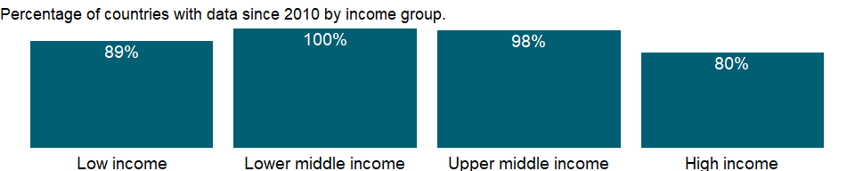

### Why is it relevant?

NA

### What is the data source?

World Bank staff estimates based on sources and methods described in the World Bank’s The Changing Wealth of Nations.

### What is the methodology?

NA

### How is it aggregated?

Weighted average

### What are the limitations?

NA

### What else should I know?

NA

### 1.48.9 Adjusted savings: mineral depletion (current US$)

### What is the indicator?

Mineral depletion is the ratio of the value of the stock of mineral resources to the remaining reserve lifetime. It covers tin, gold, lead, zinc, iron, copper, nickel, silver, bauxite, and phosphate.

Topic: Economic Policy & Debt: National accounts: Adjusted savings & income

Series ID: NY.ADJ.DMIN.CD

Copyright: CC BY-4.0 , <https://datacatalog.worldbank.org/public-licenses#cc-by>

First year with any data: 1970

Last year with any data: 2019

### What years are data available?

The figure below shows years in which data is available for at least one country. Dates shaded in black have no data, while dates shaded in green have data for at least one country



### Which countries have data?

The figure below shows the percentage of countries in each income group with a value since 2010 for that indicator.



### Why is it relevant?

NA

### What is the data source?

World Bank staff estimates based on sources and methods described in the World Bank’s The Changing Wealth of Nations.

### What is the methodology?

NA

### How is it aggregated?

NA

### What are the limitations?

NA

### What else should I know?

NA

### 1.48.10 Adjusted savings: mineral depletion (% of GNI)

### What is the indicator?

Mineral depletion is the ratio of the value of the stock of mineral resources to the remaining reserve lifetime. It covers tin, gold, lead, zinc, iron, copper, nickel, silver, bauxite, and phosphate.

Topic: Economic Policy & Debt: National accounts: Adjusted savings & income

Series ID: NY.ADJ.DMIN.GN.ZS

Copyright: CC BY-4.0 , <https://datacatalog.worldbank.org/public-licenses#cc-by>

First year with any data: 1970

Last year with any data: 2019

### What years are data available?

The figure below shows years in which data is available for at least one country. Dates shaded in black have no data, while dates shaded in green have data for at least one country



### Which countries have data?

The figure below shows the percentage of countries in each income group with a value since 2010 for that indicator.

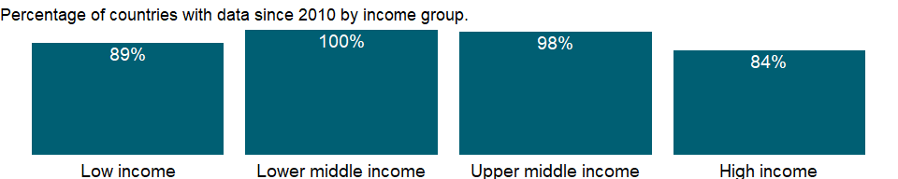

### Why is it relevant?

NA

### What is the data source?

World Bank staff estimates based on sources and methods described in the World Bank’s The Changing Wealth of Nations.

### What is the methodology?

NA

### How is it aggregated?

Weighted average

### What are the limitations?

NA

### What else should I know?

NA

### 1.48.11 Adjusted savings: energy depletion (current US$)

### What is the indicator?

Energy depletion is the ratio of the value of the stock of energy resources to the remaining reserve lifetime. It covers coal, crude oil, and natural gas.

Topic: Economic Policy & Debt: National accounts: Adjusted savings & income

Series ID: NY.ADJ.DNGY.CD

Copyright: CC BY-4.0 , <https://datacatalog.worldbank.org/public-licenses#cc-by>

First year with any data: 1970

Last year with any data: 2019

### What years are data available?

The figure below shows years in which data is available for at least one country. Dates shaded in black have no data, while dates shaded in green have data for at least one country



### Which countries have data?

The figure below shows the percentage of countries in each income group with a value since 2010 for that indicator.



### Why is it relevant?

NA

### What is the data source?

World Bank staff estimates based on sources and methods described in the World Bank’s The Changing Wealth of Nations.

### What is the methodology?

NA

### How is it aggregated?

NA

### What are the limitations?

NA

### What else should I know?

NA

### 1.48.12 Adjusted savings: energy depletion (% of GNI)

### What is the indicator?

Energy depletion is the ratio of the value of the stock of energy resources to the remaining reserve lifetime. It covers coal, crude oil, and natural gas.

Topic: Economic Policy & Debt: National accounts: Adjusted savings & income

Series ID: NY.ADJ.DNGY.GN.ZS

Copyright: CC BY-4.0 , <https://datacatalog.worldbank.org/public-licenses#cc-by>

First year with any data: 1970

Last year with any data: 2019

### What years are data available?

The figure below shows years in which data is available for at least one country. Dates shaded in black have no data, while dates shaded in green have data for at least one country



### Which countries have data?

The figure below shows the percentage of countries in each income group with a value since 2010 for that indicator.

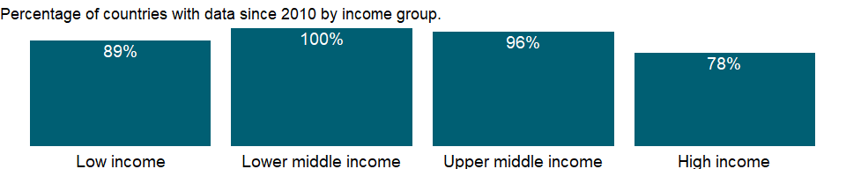

### Why is it relevant?

NA

### What is the data source?

World Bank staff estimates based on sources and methods described in the World Bank’s The Changing Wealth of Nations.

### What is the methodology?

NA

### How is it aggregated?

Weighted average

### What are the limitations?

NA

### What else should I know?

NA

### 1.48.13 Adjusted savings: particulate emission damage (current US$)

### What is the indicator?

Particulate emissions damage is the damage due to exposure of a country’s population to ambient concentrations of particulates measuring less than 2.5 microns in diameter (PM2.5), ambient ozone pollution, and indoor concentrations of PM2.5 in households cooking with solid fuels. Damages are calculated as foregone labor income due to premature death. Estimates of health impacts from the Global Burden of Disease Study 2019. Data for other years have been extrapolated from trends in mortality rates.

Topic: Economic Policy & Debt: National accounts: Adjusted savings & income

Series ID: NY.ADJ.DPEM.CD

Copyright: CC BY-4.0 , <https://datacatalog.worldbank.org/public-licenses#cc-by>

First year with any data: 1990

Last year with any data: 2019

### What years are data available?

The figure below shows years in which data is available for at least one country. Dates shaded in black have no data, while dates shaded in green have data for at least one country



### Which countries have data?

The figure below shows the percentage of countries in each income group with a value since 2010 for that indicator.

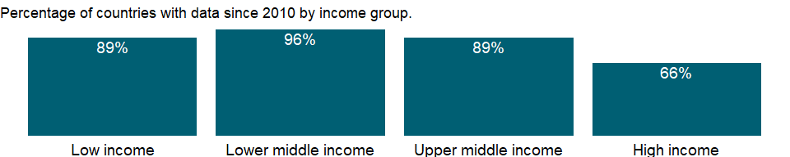

### Why is it relevant?

Air pollution places a major burden on world health. In many places, including cities but also nearby rural areas, exposure to air pollution exposure is the main environmental threat to health. Long-term exposure to high levels of fine particulates in the air contributes to a range of health effects, including respiratory diseases, lung cancer, and heart disease, resulting in 6.7 million deaths annually according to the Global Burden of Disease 2019 study. Not only does exposure to air pollution affect the health of the world’s people, it also carries huge economic costs and represents a drag on development, particularly for low and middle income countries and vulnerable segments of the population such as children and the elderly.

### What is the data source?

World Bank staff estimates based on sources and methods described in the World Bank’s The Changing Wealth of Nations.

### What is the methodology?

Within the national accounting framework, air pollution damages are estimated following a human capital approach. Damages from premature mortality are calculated as the present value of lost income during working age, 15-64. Premature mortality among children is valued by adjusting for years until working age and discounting more heavily into the future. Estimates are for both urban and rural areas. Exposure to household air pollution is proxied by the number of households in each country cooking with solid fuels.

### How is it aggregated?

NA

### What are the limitations?

Labor productivity losses, as calculated within the framework of adjusted net savings, represent only part of the economic costs of air pollution and should be interpreted as a lower-end estimate.

### What else should I know?

NA

### 1.48.14 Adjusted savings: particulate emission damage (% of GNI)

### What is the indicator?

Particulate emissions damage is the damage due to exposure of a country’s population to ambient concentrations of particulates measuring less than 2.5 microns in diameter (PM2.5), ambient ozone pollution, and indoor concentrations of PM2.5 in households cooking with solid fuels. Damages are calculated as foregone labor income due to premature death. Estimates of health impacts from the Global Burden of Disease Study 2019. Data for other years have been extrapolated from trends in mortality rates.

Topic: Economic Policy & Debt: National accounts: Adjusted savings & income

Series ID: NY.ADJ.DPEM.GN.ZS

Copyright: CC BY-4.0 , <https://datacatalog.worldbank.org/public-licenses#cc-by>

First year with any data: 1990

Last year with any data: 2019

### What years are data available?

The figure below shows years in which data is available for at least one country. Dates shaded in black have no data, while dates shaded in green have data for at least one country



### Which countries have data?

The figure below shows the percentage of countries in each income group with a value since 2010 for that indicator.

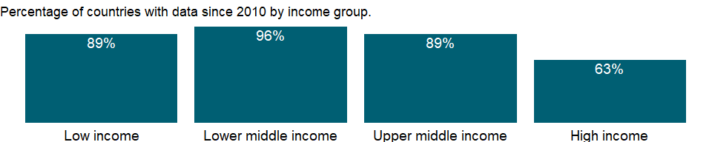

### Why is it relevant?

Air pollution places a major burden on world health. In many places, including cities but also nearby rural areas, exposure to air pollution exposure is the main environmental threat to health. Long-term exposure to high levels of fine particulates in the air contributes to a range of health effects, including respiratory diseases, lung cancer, and heart disease, resulting in 6.7 million deaths annually according to the Global Burden of Disease 2019 study. Not only does exposure to air pollution affect the health of the world’s people, it also carries huge economic costs and represents a drag on development, particularly for low and middle income countries and vulnerable segments of the population such as children and the elderly.

### What is the data source?

World Bank staff estimates based on sources and methods described in the World Bank’s The Changing Wealth of Nations.

### What is the methodology?

Within the national accounting framework, air pollution damages are estimated following a human capital approach. Damages from premature mortality are calculated as the present value of lost income during working age, 15-64. Premature mortality among children is valued by adjusting for years until working age and discounting more heavily into the future. Estimates are for both urban and rural areas. Exposure to household air pollution is proxied by the number of households in each country cooking with solid fuels.

### How is it aggregated?

Weighted average

### What are the limitations?

Labor productivity losses, as calculated within the framework of adjusted net savings, represent only part of the economic costs of air pollution and should be interpreted as a lower-end estimate.

### What else should I know?

NA

### 1.48.15 Adjusted savings: natural resources depletion (% of GNI)

### What is the indicator?

Natural resource depletion is the sum of net forest depletion, energy depletion, and mineral depletion. Net forest depletion is unit resource rents times the excess of roundwood harvest over natural growth. Energy depletion is the ratio of the value of the stock of energy resources to the remaining reserve lifetime. It covers coal, crude oil, and natural gas. Mineral depletion is the ratio of the value of the stock of mineral resources to the remaining reserve lifetime. It covers tin, gold, lead, zinc, iron, copper, nickel, silver, bauxite, and phosphate.

Topic: Economic Policy & Debt: National accounts: Adjusted savings & income

Series ID: NY.ADJ.DRES.GN.ZS

Copyright: CC BY-4.0 , <https://datacatalog.worldbank.org/public-licenses#cc-by>

First year with any data: 1970

Last year with any data: 2019

### What years are data available?

The figure below shows years in which data is available for at least one country. Dates shaded in black have no data, while dates shaded in green have data for at least one country



### Which countries have data?

The figure below shows the percentage of countries in each income group with a value since 2010 for that indicator.

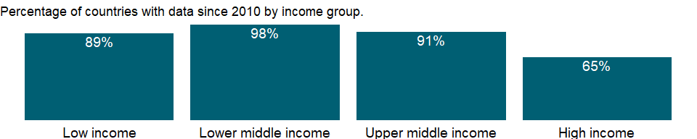

### Why is it relevant?

Natural resources depletion is a critical component in the calculation of adjusted net national income. Adjusted net national income is calculated by subtracting from GNI a charge for the consumption of fixed capital (a calculation that yields net national income) and for the depletion of natural resources. The deduction for the depletion of natural resources, which covers net forest depletion, energy depletion, and mineral depletion, reflects the decline in asset values associated with the extraction and harvest of natural resources - this is analogous to depreciation of fixed assets.

### What is the data source?

World Bank staff estimates based on sources and methods described in the World Bank’s The Changing Wealth of Nations.

### What is the methodology?

Natural resources depletion is the sum of net forest depletion, energy depletion, and mineral depletion:

Net forest depletion is the product of unit resource rents and the excess of roundwood harvest over natural growth. In a country where incremental growth exceeds wood extraction, net forest depletion would be zero, no matter the absolute volume or value of wood extracted.

Energy depletion is the ratio of the present value of energy resource rents, discounted at 4 percent, to the exhaustion time of the resource. Rent is calculated as the product of unit resource rents and the physical quantities of energy resources extracted. It covers hard and soft coal, crude oil, and natural gas.

Mineral depletion is the ratio of the present value of mineral resource rents, discounted at 4 percent, to the exhaustion time of the resource. Rent is calculated as the product of unit resource rents and the physical quantities of mineral extracted. It covers tin, gold, lead, zinc, iron, copper, nickel, silver, bauxite, and phosphate.

### How is it aggregated?

Weighted Average

### What are the limitations?

Net forest depletion is not the monetary value of deforestation. Roundwood and fuelwood production are different from deforestation, which represents a permanent change in land use and, thus, is not comparable. Areas logged out but intended for regeneration are not included in deforestation figures; rather, they are counted as producing timber depletion. Net forest depletion includes only timber values and does not include the loss of nontimber forest benefits and nonuse benefits.

For both energy and mineral depletion, unit resource rent is calculated as (unit price - average cost). Marginal cost should be used instead of average cost in order to calculate the true opportunity cost of extraction; however, marginal cost is difficult to compute and data are not readily available. Unit prices refer to international or regional price rather than local prices. This differs from methodologies of national accounts, which may use local prices to measure energy or mineral GDP. This difference explains eventual discrepancies in the values for energy or mineral depletion, verses energy or mineral GDP.

### What else should I know?

NA

### 1.48.16 Adjusted savings: gross savings (% of GNI)

### What is the indicator?

Gross savings are the difference between gross national income and public and private consumption, plus net current transfers.

Topic: Economic Policy & Debt: National accounts: Adjusted savings & income

Series ID: NY.ADJ.ICTR.GN.ZS

Copyright: CC BY-4.0 , <https://datacatalog.worldbank.org/public-licenses#cc-by>

First year with any data: 1970

Last year with any data: 2019

### What years are data available?

The figure below shows years in which data is available for at least one country. Dates shaded in black have no data, while dates shaded in green have data for at least one country



### Which countries have data?

The figure below shows the percentage of countries in each income group with a value since 2010 for that indicator.

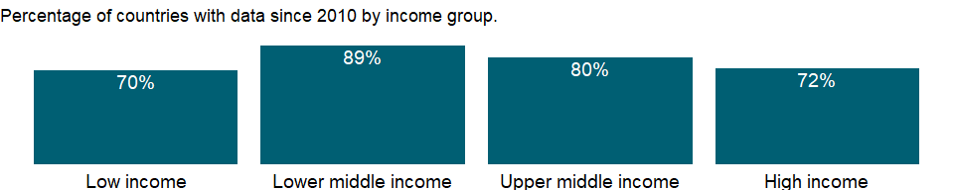

### Why is it relevant?

NA

### What is the data source?

World Bank national accounts data files.

### What is the methodology?

Gross savings are calculated as a residual from the national accounts by taking the difference between income earned by residents (including income received from abroad and workers’ remittances) and their consumption expenditures.

### How is it aggregated?

Weighted average

### What are the limitations?

Because gross savings is calculated as a residual it includes errors, which may not be offsetting, in its components.

### What else should I know?

NA

### 1.48.17 Adjusted savings: net national savings (current US$)

### What is the indicator?

Net national savings are equal to gross national savings less the value of consumption of fixed capital.

Topic: Economic Policy & Debt: National accounts: Adjusted savings & income

Series ID: NY.ADJ.NNAT.CD

Copyright: CC BY-4.0 , <https://datacatalog.worldbank.org/public-licenses#cc-by>

First year with any data: 1970

Last year with any data: 2019

### What years are data available?

The figure below shows years in which data is available for at least one country. Dates shaded in black have no data, while dates shaded in green have data for at least one country



### Which countries have data?

The figure below shows the percentage of countries in each income group with a value since 2010 for that indicator.

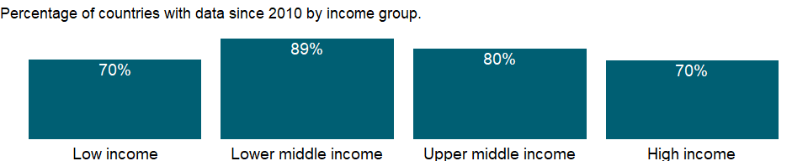

### Why is it relevant?

NA

### What is the data source?

World Bank staff estimates based on sources and methods described in the World Bank’s The Changing Wealth of Nations.

### What is the methodology?

NA

### How is it aggregated?

NA

### What are the limitations?

NA

### What else should I know?

NA

### 1.48.18 Adjusted savings: net national savings (% of GNI)

### What is the indicator?

Net national savings are equal to gross national savings less the value of consumption of fixed capital.

Topic: Economic Policy & Debt: National accounts: Adjusted savings & income

Series ID: NY.ADJ.NNAT.GN.ZS

Copyright: CC BY-4.0 , <https://datacatalog.worldbank.org/public-licenses#cc-by>

First year with any data: 1970

Last year with any data: 2019

### What years are data available?

The figure below shows years in which data is available for at least one country. Dates shaded in black have no data, while dates shaded in green have data for at least one country



### Which countries have data?

The figure below shows the percentage of countries in each income group with a value since 2010 for that indicator.



### Why is it relevant?

NA

### What is the data source?

World Bank staff estimates based on sources and methods described in the World Bank’s The Changing Wealth of Nations.

### What is the methodology?

NA

### How is it aggregated?

Weighted average

### What are the limitations?

NA

### What else should I know?

NA

### 1.48.19 Adjusted net national income (current US$)

### What is the indicator?

Adjusted net national income is GNI minus consumption of fixed capital and natural resources depletion.

Topic: Economic Policy & Debt: National accounts: Adjusted savings & income

Series ID: NY.ADJ.NNTY.CD

Copyright: CC BY-4.0 , <https://datacatalog.worldbank.org/public-licenses#cc-by>

First year with any data: 1970

Last year with any data: 2019

### What years are data available?

The figure below shows years in which data is available for at least one country. Dates shaded in black have no data, while dates shaded in green have data for at least one country



### Which countries have data?

The figure below shows the percentage of countries in each income group with a value since 2010 for that indicator.



### Why is it relevant?

Adjusted net national income is particularly useful in monitoring low-income, resource-rich economies, like many countries in Sub-Saharan Africa, because such economies often see large natural resources depletion as well as substantial exports of resource rents to foreign mining companies. For recent years adjusted net national income gives a picture of economic growth that is strikingly different from the one provided by GDP.

The key to increasing future consumption and thus the standard of living lies in increasing national wealth - including not only the traditional measures of capital (such as produced and human capital), but also natural capital. Natural capital comprises such assets as land, forests, and subsoil resources. All three types of capital are key to sustaining economic growth. By accounting for the consumption of fixed and natural capital depletion, adjusted net national income better measures the income available for consumption or for investment to increase a country’s future consumption.

### What is the data source?

World Bank staff estimates based on sources and methods described in the World Bank’s The Changing Wealth of Nations.

### What is the methodology?

Adjusted net national income complements gross national income (GNI) in assessing economic progress (Hamilton and Ley 2010) by providing a broader measure of national income that accounts for the depletion of natural resources.

Adjusted net national income is calculated by subtracting from GNI a charge for the consumption of fixed capital (a calculation that yields net national income) and for the depletion of natural resources. The deduction for the depletion of natural resources, which covers net forest depletion, energy depletion, and mineral depletion, reflects the decline in asset values associated with the extraction and harvesting of natural resources. This is analogous to depreciation of fixed assets.

### How is it aggregated?

Gap-filled total

### What are the limitations?

Adjusted net national income differs from the adjustments made in the calculation of adjusted net savings, by not accounting for investments in human capital or the damages from pollution. Thus, adjusted net national income remains within the boundaries of the United Nations System of National Accounts (SNA).

The SNA includes non-produced natural assets (such as land, mineral resources, and forests) within the asset boundary when they are under the effective control of institutional units. The calculation of adjusted net national income, which accounts for net forest, energy, and mineral depletion, as well as consumption of fixed capital, thus remains within the SNA boundaries. This point is critical because it allows for comparisons across GDP, GNI, and adjusted net national income; such comparisons reveal the impact of natural resource depletion, which is otherwise ignored by the popular economic indicators.

### What else should I know?

NA

### 1.48.20 Adjusted net national income (constant 2010 US$)

### What is the indicator?

Adjusted net national income is GNI minus consumption of fixed capital and natural resources depletion.

Topic: Economic Policy & Debt: National accounts: Adjusted savings & income

Series ID: NY.ADJ.NNTY.KD

Copyright: CC BY-4.0 , <https://datacatalog.worldbank.org/public-licenses#cc-by>

First year with any data: 1970

Last year with any data: 2019

### What years are data available?

The figure below shows years in which data is available for at least one country. Dates shaded in black have no data, while dates shaded in green have data for at least one country



### Which countries have data?

The figure below shows the percentage of countries in each income group with a value since 2010 for that indicator.

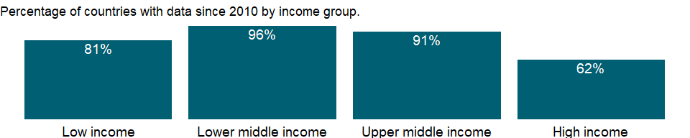

### Why is it relevant?

Adjusted net national income is particularly useful in monitoring low-income, resource-rich economies, like many countries in Sub-Saharan Africa, because such economies often see large natural resources depletion as well as substantial exports of resource rents to foreign mining companies. For recent years adjusted net national income gives a picture of economic growth that is strikingly different from the one provided by GDP.

The key to increasing future consumption and thus the standard of living lies in increasing national wealth - including not only the traditional measures of capital (such as produced and human capital), but also natural capital. Natural capital comprises such assets as land, forests, and subsoil resources. All three types of capital are key to sustaining economic growth. By accounting for the consumption of fixed and natural capital depletion, adjusted net national income better measures the income available for consumption or for investment to increase a country’s future consumption.

### What is the data source?

World Bank staff estimates based on sources and methods described in the World Bank’s The Changing Wealth of Nations.

### What is the methodology?

Adjusted net national income complements gross national income (GNI) in assessing economic progress (Hamilton and Ley 2010) by providing a broader measure of national income that accounts for the depletion of natural resources.

Adjusted net national income is calculated by subtracting from GNI a charge for the consumption of fixed capital (a calculation that yields net national income) and for the depletion of natural resources. The deduction for the depletion of natural resources, which covers net forest depletion, energy depletion, and mineral depletion, reflects the decline in asset values associated with the extraction and harvesting of natural resources. This is analogous to depreciation of fixed assets.

Growth rates of adjusted net national income are computed from constant price series deflated using the gross national expenditure (formerly domestic absorption) deflator.

### How is it aggregated?

Gap-filled total

### What are the limitations?

Adjusted net national income differs from the adjustments made in the calculation of adjusted net savings, by not accounting for investments in human capital or the damages from pollution. Thus, adjusted net national income remains within the boundaries of the United Nations System of National Accounts (SNA).

The SNA includes non-produced natural assets (such as land, mineral resources, and forests) within the asset boundary when they are under the effective control of institutional units. The calculation of adjusted net national income, which accounts for net forest, energy, and mineral depletion, as well as consumption of fixed capital, thus remains within the SNA boundaries. This point is critical because it allows for comparisons across GDP, GNI, and adjusted net national income; such comparisons reveal the impact of natural resource depletion, which is otherwise ignored by the popular economic indicators.

### What else should I know?

NA

### 1.48.21 Adjusted net national income (annual % growth)

### What is the indicator?

Adjusted net national income is GNI minus consumption of fixed capital and natural resources depletion.

Topic: Economic Policy & Debt: National accounts: Adjusted savings & income

Series ID: NY.ADJ.NNTY.KD.ZG

Copyright: CC BY-4.0 , <https://datacatalog.worldbank.org/public-licenses#cc-by>

First year with any data: 1971

Last year with any data: 2019

### What years are data available?

The figure below shows years in which data is available for at least one country. Dates shaded in black have no data, while dates shaded in green have data for at least one country



### Which countries have data?

The figure below shows the percentage of countries in each income group with a value since 2010 for that indicator.

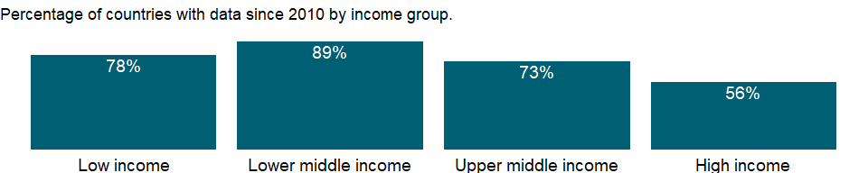

### Why is it relevant?

Adjusted net national income is particularly useful in monitoring low-income, resource-rich economies, like many countries in Sub-Saharan Africa, because such economies often see large natural resources depletion as well as substantial exports of resource rents to foreign mining companies. For recent years adjusted net national income gives a picture of economic growth that is strikingly different from the one provided by GDP.

The key to increasing future consumption and thus the standard of living lies in increasing national wealth - including not only the traditional measures of capital (such as produced and human capital), but also natural capital. Natural capital comprises such assets as land, forests, and subsoil resources. All three types of capital are key to sustaining economic growth. By accounting for the consumption of fixed and natural capital depletion, adjusted net national income better measures the income available for consumption or for investment to increase a country’s future consumption.

### What is the data source?

World Bank staff estimates based on sources and methods described in the World Bank’s The Changing Wealth of Nations.

### What is the methodology?

Adjusted net national income complements gross national income (GNI) in assessing economic progress (Hamilton and Ley 2010) by providing a broader measure of national income that accounts for the depletion of natural resources.

Adjusted net national income is calculated by subtracting from GNI a charge for the consumption of fixed capital (a calculation that yields net national income) and for the depletion of natural resources. The deduction for the depletion of natural resources, which covers net forest depletion, energy depletion, and mineral depletion, reflects the decline in asset values associated with the extraction and harvesting of natural resources. This is analogous to depreciation of fixed assets.

Growth rates of adjusted net national income are computed from constant price series deflated using the gross national expenditure (formerly domestic absorption) deflator.

### How is it aggregated?

Weighted Average

### What are the limitations?

Adjusted net national income differs from the adjustments made in the calculation of adjusted net savings, by not accounting for investments in human capital or the damages from pollution. Thus, adjusted net national income remains within the boundaries of the United Nations System of National Accounts (SNA).

The SNA includes non-produced natural assets (such as land, mineral resources, and forests) within the asset boundary when they are under the effective control of institutional units. The calculation of adjusted net national income, which accounts for net forest, energy, and mineral depletion, as well as consumption of fixed capital, thus remains within the SNA boundaries. This point is critical because it allows for comparisons across GDP, GNI, and adjusted net national income; such comparisons reveal the impact of natural resource depletion, which is otherwise ignored by the popular economic indicators.

### What else should I know?

NA

### 1.48.22 Adjusted net national income per capita (current US$)

### What is the indicator?

Adjusted net national income is GNI minus consumption of fixed capital and natural resources depletion.

Topic: Economic Policy & Debt: National accounts: Adjusted savings & income

Series ID: NY.ADJ.NNTY.PC.CD

Copyright: CC BY-4.0 , <https://datacatalog.worldbank.org/public-licenses#cc-by>

First year with any data: 1970

Last year with any data: 2019

### What years are data available?

The figure below shows years in which data is available for at least one country. Dates shaded in black have no data, while dates shaded in green have data for at least one country



### Which countries have data?

The figure below shows the percentage of countries in each income group with a value since 2010 for that indicator.



### Why is it relevant?

NA

### What is the data source?

World Bank staff estimates based on sources and methods in World Bank’s “The Changing Wealth of Nations: Measuring Sustainable Development in the New Millennium” (2011).

### What is the methodology?

NA

### How is it aggregated?

Weighted Average

### What are the limitations?

NA

### What else should I know?

NA

### 1.48.23 Adjusted net national income per capita (constant 2010 US$)

### What is the indicator?

Adjusted net national income is GNI minus consumption of fixed capital and natural resources depletion.

Topic: Economic Policy & Debt: National accounts: Adjusted savings & income

Series ID: NY.ADJ.NNTY.PC.KD

Copyright: CC BY-4.0 , <https://datacatalog.worldbank.org/public-licenses#cc-by>

First year with any data: 1970

Last year with any data: 2019

### What years are data available?

The figure below shows years in which data is available for at least one country. Dates shaded in black have no data, while dates shaded in green have data for at least one country



### Which countries have data?

The figure below shows the percentage of countries in each income group with a value since 2010 for that indicator.



### Why is it relevant?

Adjusted net national income is particularly useful in monitoring low-income, resource-rich economies, like many countries in Sub-Saharan Africa, because such economies often see large natural resources depletion as well as substantial exports of resource rents to foreign mining companies. For recent years adjusted net national income gives a picture of economic growth that is strikingly different from the one provided by GDP.

The key to increasing future consumption and thus the standard of living lies in increasing national wealth - including not only the traditional measures of capital (such as produced and human capital), but also natural capital. Natural capital comprises such assets as land, forests, and subsoil resources. All three types of capital are key to sustaining economic growth. By accounting for the consumption of fixed and natural capital depletion, adjusted net national income better measures the income available for consumption or for investment to increase a country’s future consumption.

### What is the data source?

World Bank staff estimates based on sources and methods in World Bank’s “The Changing Wealth of Nations: Measuring Sustainable Development in the New Millennium” (2011).

### What is the methodology?

Adjusted net national income complements gross national income (GNI) in assessing economic progress (Hamilton and Ley 2010) by providing a broader measure of national income that accounts for the depletion of natural resources.

Adjusted net national income is calculated by subtracting from GNI a charge for the consumption of fixed capital (a calculation that yields net national income) and for the depletion of natural resources. The deduction for the depletion of natural resources, which covers net forest depletion, energy depletion, and mineral depletion, reflects the decline in asset values associated with the extraction and harvesting of natural resources. This is analogous to depreciation of fixed assets.

Growth rates of adjusted net national income are computed from constant price series deflated using the gross national expenditure (formerly domestic absorption) deflator.

### How is it aggregated?

Weighted Average

### What are the limitations?

Adjusted net national income differs from the adjustments made in the calculation of adjusted net savings, by not accounting for investments in human capital or the damages from pollution. Thus, adjusted net national income remains within the boundaries of the United Nations System of National Accounts (SNA).

The SNA includes non-produced natural assets (such as land, mineral resources, and forests) within the asset boundary when they are under the effective control of institutional units. The calculation of adjusted net national income, which accounts for net forest, energy, and mineral depletion, as well as consumption of fixed capital, thus remains within the SNA boundaries. This point is critical because it allows for comparisons across GDP, GNI, and adjusted net national income; such comparisons reveal the impact of natural resource depletion, which is otherwise ignored by the popular economic indicators.

### What else should I know?

NA

### 1.48.24 Adjusted net national income per capita (annual % growth)

### What is the indicator?

Adjusted net national income is GNI minus consumption of fixed capital and natural resources depletion.

Topic: Economic Policy & Debt: National accounts: Adjusted savings & income

Series ID: NY.ADJ.NNTY.PC.KD.ZG

Copyright: CC BY-4.0 , <https://datacatalog.worldbank.org/public-licenses#cc-by>

First year with any data: 1971

Last year with any data: 2019

### What years are data available?

The figure below shows years in which data is available for at least one country. Dates shaded in black have no data, while dates shaded in green have data for at least one country



### Which countries have data?

The figure below shows the percentage of countries in each income group with a value since 2010 for that indicator.



### Why is it relevant?

Adjusted net national income is particularly useful in monitoring low-income, resource-rich economies, like many countries in Sub-Saharan Africa, because such economies often see large natural resources depletion as well as substantial exports of resource rents to foreign mining companies. For recent years adjusted net national income gives a picture of economic growth that is strikingly different from the one provided by GDP.

The key to increasing future consumption and thus the standard of living lies in increasing national wealth - including not only the traditional measures of capital (such as produced and human capital), but also natural capital. Natural capital comprises such assets as land, forests, and subsoil resources. All three types of capital are key to sustaining economic growth. By accounting for the consumption of fixed and natural capital depletion, adjusted net national income better measures the income available for consumption or for investment to increase a country’s future consumption.

### What is the data source?

World Bank staff estimates based on sources and methods in World Bank’s “The Changing Wealth of Nations: Measuring Sustainable Development in the New Millennium” (2011).

### What is the methodology?

Adjusted net national income complements gross national income (GNI) in assessing economic progress (Hamilton and Ley 2010) by providing a broader measure of national income that accounts for the depletion of natural resources.

Adjusted net national income is calculated by subtracting from GNI a charge for the consumption of fixed capital (a calculation that yields net national income) and for the depletion of natural resources. The deduction for the depletion of natural resources, which covers net forest depletion, energy depletion, and mineral depletion, reflects the decline in asset values associated with the extraction and harvesting of natural resources. This is analogous to depreciation of fixed assets.

Growth rates of adjusted net national income are computed from constant price series deflated using the gross national expenditure (formerly domestic absorption) deflator.

### How is it aggregated?

Weighted Average

### What are the limitations?

Adjusted net national income differs from the adjustments made in the calculation of adjusted net savings, by not accounting for investments in human capital or the damages from pollution. Thus, adjusted net national income remains within the boundaries of the United Nations System of National Accounts (SNA).

The SNA includes non-produced natural assets (such as land, mineral resources, and forests) within the asset boundary when they are under the effective control of institutional units. The calculation of adjusted net national income, which accounts for net forest, energy, and mineral depletion, as well as consumption of fixed capital, thus remains within the SNA boundaries. This point is critical because it allows for comparisons across GDP, GNI, and adjusted net national income; such comparisons reveal the impact of natural resource depletion, which is otherwise ignored by the popular economic indicators.

### What else should I know?

NA

### 1.48.25 Adjusted net savings, including particulate emission damage (current US$)

### What is the indicator?

Adjusted net savings are equal to net national savings plus education expenditure and minus energy depletion, mineral depletion, net forest depletion, and carbon dioxide and particulate emissions damage.

Topic: Economic Policy & Debt: National accounts: Adjusted savings & income

Series ID: NY.ADJ.SVNG.CD

Copyright: CC BY-4.0 , <https://datacatalog.worldbank.org/public-licenses#cc-by>

First year with any data: 1990

Last year with any data: 2019

### What years are data available?

The figure below shows years in which data is available for at least one country. Dates shaded in black have no data, while dates shaded in green have data for at least one country



### Which countries have data?

The figure below shows the percentage of countries in each income group with a value since 2010 for that indicator.

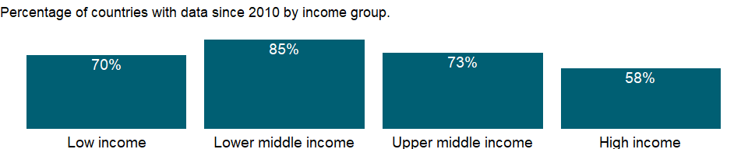

### Why is it relevant?

How wealth changes over time is critical to understanding a country’s prospects for sustainable development. Adjusted Net Saving (ANS) was developed as an indicator to approximate the change in wealth—based on simple economic theory in which savings equals investment, and investment equals the change in wealth. ANS measures gross national savings, adjusted for gains (spending on education) and losses (consumption of fixed capital, depletion of subsoil assets and forests, pollution damages). When ANS is negative, it may indicate that wealth is being run down; when ANS is positive, it may indicate that wealth is growing.

### What is the data source?

World Bank staff estimates based on sources and methods described in the World Bank’s The Changing Wealth of Nations.

### What is the methodology?

Adjusted net savings are derived from standard national accounting measures of gross savings by making four adjustments. First, estimates of fixed capital consumption of produced assets are deducted to obtain net savings. Second, current public expenditures on education are added to net savings (in standard national accounting these expenditures are treated as consumption). Third, estimates of the depletion of a variety of natural resources are deducted to reflect the decline in asset values associated with their extraction and harvest. And fourth, deductions are made for damages from carbon dioxide emissions and local pollution.

Estimates of resource depletion are based on the “change in real wealth” method described in Hamilton and Ruta (2008), which estimates depletion as the ratio between the total value of the resource and the remaining reserve lifetime. The total value of the resource is the present value of current and future rents from resource extractions. An economic rent represents an excess return to a given factor of production. Natural resources give rise to rents because they are not produced; in contrast, for produced goods and services competitive forces will expand supply until economic profits are driven to zero. For each type of resource and each country, unit resource rents are derived by taking the difference between prices and the average unit extraction or harvest costs. Unit rents are then multiplied by the physical quantity extracted or harvested to arrive at total rent. To estimate the value of the resource, rents are assumed to be constant over the life of the resource (the El Serafy approach), and the present value of the rent flow is calculated using a 4 percent discount rate.

### How is it aggregated?

NA

### What are the limitations?

The exercise treats public education expenditures as an addition to savings. However, because of the wide variability in the effectiveness of public education expenditures, these figures cannot be construed as the value of investments in human capital. A current expenditure of $1 on education does not necessarily yield $1 of human capital. The calculation should also consider private education expenditure, but data are not available for a large number of countries.

While extensive, the accounting of natural resource depletion and pollution costs still has some gaps. Key estimates missing on the resource side include the value of fossil water extracted from aquifers, net depletion of fish stocks, and depletion and degradation of soils. Important pollutants affecting human health and economic assets are also excluded.

### What else should I know?

NA

### 1.48.26 Adjusted net savings, including particulate emission damage (% of GNI)

### What is the indicator?

Adjusted net savings are equal to net national savings plus education expenditure and minus energy depletion, mineral depletion, net forest depletion, and carbon dioxide and particulate emissions damage.

Topic: Economic Policy & Debt: National accounts: Adjusted savings & income

Series ID: NY.ADJ.SVNG.GN.ZS

Copyright: CC BY-4.0 , <https://datacatalog.worldbank.org/public-licenses#cc-by>

First year with any data: 1990

Last year with any data: 2019

### What years are data available?

The figure below shows years in which data is available for at least one country. Dates shaded in black have no data, while dates shaded in green have data for at least one country



### Which countries have data?

The figure below shows the percentage of countries in each income group with a value since 2010 for that indicator.



### Why is it relevant?

How wealth changes over time is critical to understanding a country’s prospects for sustainable development. Adjusted Net Saving (ANS) was developed as an indicator to approximate the change in wealth—based on simple economic theory in which savings equals investment, and investment equals the change in wealth. ANS measures gross national savings, adjusted for gains (spending on education) and losses (consumption of fixed capital, depletion of subsoil assets and forests, pollution damages). When ANS is negative, it may indicate that wealth is being run down; when ANS is positive, it may indicate that wealth is growing.

### What is the data source?

World Bank staff estimates based on sources and methods described in the World Bank’s The Changing Wealth of Nations.

### What is the methodology?

Adjusted net savings are derived from standard national accounting measures of gross savings by making four adjustments. First, estimates of fixed capital consumption of produced assets are deducted to obtain net savings. Second, current public expenditures on education are added to net savings (in standard national accounting these expenditures are treated as consumption). Third, estimates of the depletion of a variety of natural resources are deducted to reflect the decline in asset values associated with their extraction and harvest. And fourth, deductions are made for damages from carbon dioxide emissions and local pollution.

Estimates of resource depletion are based on the “change in real wealth” method described in Hamilton and Ruta (2008), which estimates depletion as the ratio between the total value of the resource and the remaining reserve lifetime. The total value of the resource is the present value of current and future rents from resource extractions. An economic rent represents an excess return to a given factor of production. Natural resources give rise to rents because they are not produced; in contrast, for produced goods and services competitive forces will expand supply until economic profits are driven to zero. For each type of resource and each country, unit resource rents are derived by taking the difference between prices and the average unit extraction or harvest costs. Unit rents are then multiplied by the physical quantity extracted or harvested to arrive at total rent. To estimate the value of the resource, rents are assumed to be constant over the life of the resource (the El Serafy approach), and the present value of the rent flow is calculated using a 4 percent discount rate.

### How is it aggregated?

Weighted average

### What are the limitations?

The exercise treats public education expenditures as an addition to savings. However, because of the wide variability in the effectiveness of public education expenditures, these figures cannot be construed as the value of investments in human capital. A current expenditure of $1 on education does not necessarily yield $1 of human capital. The calculation should also consider private education expenditure, but data are not available for a large number of countries.

While extensive, the accounting of natural resource depletion and pollution costs still has some gaps. Key estimates missing on the resource side include the value of fossil water extracted from aquifers, net depletion of fish stocks, and depletion and degradation of soils. Important pollutants affecting human health and economic assets are also excluded.

### What else should I know?

NA

### 1.48.27 Adjusted net savings, excluding particulate emission damage (current US$)

### What is the indicator?

Adjusted net savings are equal to net national savings plus education expenditure and minus energy depletion, mineral depletion, net forest depletion, and carbon dioxide. This series excludes particulate emissions damage.

Topic: Economic Policy & Debt: National accounts: Adjusted savings & income

Series ID: NY.ADJ.SVNX.CD

Copyright: CC BY-4.0 , <https://datacatalog.worldbank.org/public-licenses#cc-by>

First year with any data: 1970

Last year with any data: 2019

### What years are data available?

The figure below shows years in which data is available for at least one country. Dates shaded in black have no data, while dates shaded in green have data for at least one country



### Which countries have data?

The figure below shows the percentage of countries in each income group with a value since 2010 for that indicator.

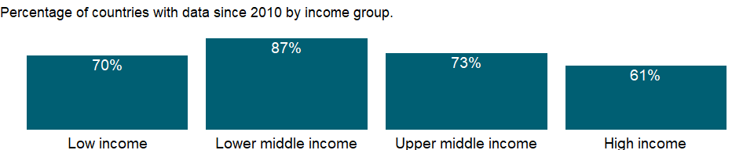

### Why is it relevant?

NA

### What is the data source?

World Bank staff estimates based on sources and methods described in the World Bank’s The Changing Wealth of Nations.

### What is the methodology?

NA

### How is it aggregated?

NA

### What are the limitations?

NA

### What else should I know?

NA

### 1.48.28 Adjusted net savings, excluding particulate emission damage (% of GNI)

### What is the indicator?

Adjusted net savings are equal to net national savings plus education expenditure and minus energy depletion, mineral depletion, net forest depletion, and carbon dioxide. This series excludes particulate emissions damage.

Topic: Economic Policy & Debt: National accounts: Adjusted savings & income

Series ID: NY.ADJ.SVNX.GN.ZS

Copyright: CC BY-4.0 , <https://datacatalog.worldbank.org/public-licenses#cc-by>

First year with any data: 1970

Last year with any data: 2019

### What years are data available?

The figure below shows years in which data is available for at least one country. Dates shaded in black have no data, while dates shaded in green have data for at least one country



### Which countries have data?

The figure below shows the percentage of countries in each income group with a value since 2010 for that indicator.



### Why is it relevant?

NA

### What is the data source?

World Bank staff estimates based on sources and methods described in the World Bank’s The Changing Wealth of Nations.

### What is the methodology?

NA

### How is it aggregated?

Weighted average

### What are the limitations?

NA

### What else should I know?

NA

## 1.49 Economic Policy & Debt: National accounts: Local currency at constant prices: Other items

### 1.49.1 Exports as a capacity to import (constant LCU)

### What is the indicator?

Exports as a capacity to import equals the current price value of exports of goods and services deflated by the import price index. Data are in constant local currency.

Topic: Economic Policy & Debt: National accounts: Local currency at constant prices: Other items

Series ID: NY.EXP.CAPM.KN

Copyright: CC BY-4.0 , <https://datacatalog.worldbank.org/public-licenses#cc-by>

First year with any data: 1960

Last year with any data: 2020

### What years are data available?

The figure below shows years in which data is available for at least one country. Dates shaded in black have no data, while dates shaded in green have data for at least one country



### Which countries have data?

The figure below shows the percentage of countries in each income group with a value since 2010 for that indicator.



### Why is it relevant?

NA

### What is the data source?

World Bank national accounts data, and OECD National Accounts data files.

### What is the methodology?

NA

### How is it aggregated?

NA

### What are the limitations?

NA

### What else should I know?

NA

### 1.49.2 Gross domestic income (constant LCU)

### What is the indicator?

Gross domestic income is derived as the sum of GDP and the terms of trade adjustment. Data are in constant local currency.

Topic: Economic Policy & Debt: National accounts: Local currency at constant prices: Other items

Series ID: NY.GDY.TOTL.KN

Copyright: CC BY-4.0 , <https://datacatalog.worldbank.org/public-licenses#cc-by>

First year with any data: 1960

Last year with any data: 2020

### What years are data available?

The figure below shows years in which data is available for at least one country. Dates shaded in black have no data, while dates shaded in green have data for at least one country



### Which countries have data?

The figure below shows the percentage of countries in each income group with a value since 2010 for that indicator.



### Why is it relevant?

NA

### What is the data source?

World Bank national accounts data, and OECD National Accounts data files.

### What is the methodology?

NA

### How is it aggregated?

NA

### What are the limitations?

NA

### What else should I know?

NA

### 1.49.3 Terms of trade adjustment (constant LCU)

### What is the indicator?

The terms of trade effect equals capacity to import less exports of goods and services in constant prices. Data are in constant local currency.

Topic: Economic Policy & Debt: National accounts: Local currency at constant prices: Other items

Series ID: NY.TTF.GNFS.KN

Copyright: CC BY-4.0 , <https://datacatalog.worldbank.org/public-licenses#cc-by>

First year with any data: 1960

Last year with any data: 2020

### What years are data available?

The figure below shows years in which data is available for at least one country. Dates shaded in black have no data, while dates shaded in green have data for at least one country



### Which countries have data?

The figure below shows the percentage of countries in each income group with a value since 2010 for that indicator.



### Why is it relevant?

NA

### What is the data source?

World Bank national accounts data, and OECD National Accounts data files.

### What is the methodology?

NA

### How is it aggregated?

NA

### What are the limitations?

NA

### What else should I know?

NA

## 1.50 Environment: Natural resources contribution to GDP

### 1.50.1 Coal rents (% of GDP)

### What is the indicator?

Coal rents are the difference between the value of both hard and soft coal production at world prices and their total costs of production.

Topic: Environment: Natural resources contribution to GDP

Series ID: NY.GDP.COAL.RT.ZS

Copyright: CC BY-4.0 , <https://datacatalog.worldbank.org/public-licenses#cc-by>

First year with any data: 1970

Last year with any data: 2019

### What years are data available?

The figure below shows years in which data is available for at least one country. Dates shaded in black have no data, while dates shaded in green have data for at least one country



### Which countries have data?

The figure below shows the percentage of countries in each income group with a value since 2010 for that indicator.

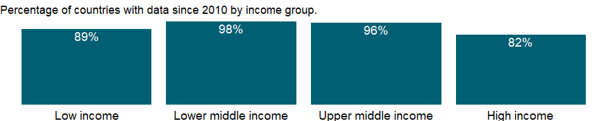

### Why is it relevant?

Accounting for the contribution of natural resources to economic output is important in building an analytical framework for sustainable development. In some countries earnings from natural resources, especially from fossil fuels and minerals, account for a sizable share of GDP, and much of these earnings come in the form of economic rents - revenues above the cost of extracting the resources.

Natural resources give rise to economic rents because they are not produced. For produced goods and services competitive forces expand supply until economic profits are driven to zero, but natural resources in fixed supply often command returns well in excess of their cost of production. Rents from nonrenewable resources - fossil fuels and minerals - as well as rents from overharvesting of forests indicate the liquidation of a country’s capital stock. When countries use such rents to support current consumption rather than to invest in new capital to replace what is being used up, they are, in effect, borrowing against their future.

### What is the data source?

World Bank staff estimates based on sources and methods described in the World Bank’s The Changing Wealth of Nations.

### What is the methodology?

The estimates of natural resources rents are calculated as the difference between the price of a commodity and the average cost of producing it. This is done by estimating the price of units of specific commodities and subtracting estimates of average unit costs of extraction or harvesting costs. These unit rents are then multiplied by the physical quantities countries extract or harvest to determine the rents for each commodity as a share of gross domestic product (GDP).

### How is it aggregated?

Weighted Average

### What are the limitations?

NA

### What else should I know?

NA

### 1.50.2 Forest rents (% of GDP)

### What is the indicator?

Forest rents are roundwood harvest times the product of regional prices and a regional rental rate.

Topic: Environment: Natural resources contribution to GDP

Series ID: NY.GDP.FRST.RT.ZS

Copyright: CC BY-4.0 , <https://datacatalog.worldbank.org/public-licenses#cc-by>

First year with any data: 1970

Last year with any data: 2019

### What years are data available?

The figure below shows years in which data is available for at least one country. Dates shaded in black have no data, while dates shaded in green have data for at least one country



### Which countries have data?

The figure below shows the percentage of countries in each income group with a value since 2010 for that indicator.

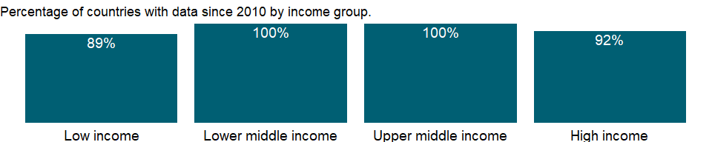

### Why is it relevant?

Accounting for the contribution of natural resources to economic output is important in building an analytical framework for sustainable development. In some countries earnings from natural resources, especially from fossil fuels and minerals, account for a sizable share of GDP, and much of these earnings come in the form of economic rents - revenues above the cost of extracting the resources.

Natural resources give rise to economic rents because they are not produced. For produced goods and services competitive forces expand supply until economic profits are driven to zero, but natural resources in fixed supply often command returns well in excess of their cost of production. Rents from nonrenewable resources - fossil fuels and minerals - as well as rents from overharvesting of forests indicate the liquidation of a country’s capital stock. When countries use such rents to support current consumption rather than to invest in new capital to replace what is being used up, they are, in effect, borrowing against their future.

### What is the data source?

World Bank staff estimates based on sources and methods described in the World Bank’s The Changing Wealth of Nations.

### What is the methodology?

The estimates of natural resources rents are calculated as the difference between the price of a commodity and the average cost of producing it. This is done by estimating the price of units of specific commodities and subtracting estimates of average unit costs of extraction or harvesting costs. These unit rents are then multiplied by the physical quantities countries extract or harvest to determine the rents for each commodity as a share of gross domestic product (GDP).

### How is it aggregated?

Weighted Average

### What are the limitations?

NA

### What else should I know?

NA

### 1.50.3 Mineral rents (% of GDP)

### What is the indicator?

Mineral rents are the difference between the value of production for a stock of minerals at world prices and their total costs of production. Minerals included in the calculation are tin, gold, lead, zinc, iron, copper, nickel, silver, bauxite, and phosphate.

Topic: Environment: Natural resources contribution to GDP

Series ID: NY.GDP.MINR.RT.ZS

Copyright: CC BY-4.0 , <https://datacatalog.worldbank.org/public-licenses#cc-by>

First year with any data: 1970

Last year with any data: 2019

### What years are data available?

The figure below shows years in which data is available for at least one country. Dates shaded in black have no data, while dates shaded in green have data for at least one country



### Which countries have data?

The figure below shows the percentage of countries in each income group with a value since 2010 for that indicator.



### Why is it relevant?

Accounting for the contribution of natural resources to economic output is important in building an analytical framework for sustainable development. In some countries earnings from natural resources, especially from fossil fuels and minerals, account for a sizable share of GDP, and much of these earnings come in the form of economic rents - revenues above the cost of extracting the resources.

Natural resources give rise to economic rents because they are not produced. For produced goods and services competitive forces expand supply until economic profits are driven to zero, but natural resources in fixed supply often command returns well in excess of their cost of production. Rents from nonrenewable resources - fossil fuels and minerals - as well as rents from overharvesting of forests indicate the liquidation of a country’s capital stock. When countries use such rents to support current consumption rather than to invest in new capital to replace what is being used up, they are, in effect, borrowing against their future.

### What is the data source?

World Bank staff estimates based on sources and methods described in the World Bank’s The Changing Wealth of Nations.

### What is the methodology?

The estimates of natural resources rents are calculated as the difference between the price of a commodity and the average cost of producing it. This is done by estimating the price of units of specific commodities and subtracting estimates of average unit costs of extraction or harvesting costs. These unit rents are then multiplied by the physical quantities countries extract or harvest to determine the rents for each commodity as a share of gross domestic product (GDP).

### How is it aggregated?

Weighted Average

### What are the limitations?

NA

### What else should I know?

NA

### 1.50.4 Natural gas rents (% of GDP)

### What is the indicator?

Natural gas rents are the difference between the value of natural gas production at regional prices and total costs of production.

Topic: Environment: Natural resources contribution to GDP

Series ID: NY.GDP.NGAS.RT.ZS

Copyright: CC BY-4.0 , <https://datacatalog.worldbank.org/public-licenses#cc-by>

First year with any data: 1970

Last year with any data: 2019

### What years are data available?

The figure below shows years in which data is available for at least one country. Dates shaded in black have no data, while dates shaded in green have data for at least one country



### Which countries have data?

The figure below shows the percentage of countries in each income group with a value since 2010 for that indicator.



### Why is it relevant?

Accounting for the contribution of natural resources to economic output is important in building an analytical framework for sustainable development. In some countries earnings from natural resources, especially from fossil fuels and minerals, account for a sizable share of GDP, and much of these earnings come in the form of economic rents - revenues above the cost of extracting the resources.

Natural resources give rise to economic rents because they are not produced. For produced goods and services competitive forces expand supply until economic profits are driven to zero, but natural resources in fixed supply often command returns well in excess of their cost of production. Rents from nonrenewable resources - fossil fuels and minerals - as well as rents from overharvesting of forests indicate the liquidation of a country’s capital stock. When countries use such rents to support current consumption rather than to invest in new capital to replace what is being used up, they are, in effect, borrowing against their future.

### What is the data source?

World Bank staff estimates based on sources and methods described in the World Bank’s The Changing Wealth of Nations.

### What is the methodology?

The estimates of natural resources rents are calculated as the difference between the price of a commodity and the average cost of producing it. This is done by estimating the price of units of specific commodities and subtracting estimates of average unit costs of extraction or harvesting costs. These unit rents are then multiplied by the physical quantities countries extract or harvest to determine the rents for each commodity as a share of gross domestic product (GDP).

### How is it aggregated?

Weighted Average

### What are the limitations?

NA

### What else should I know?

NA

### 1.50.5 Oil rents (% of GDP)

### What is the indicator?

Oil rents are the difference between the value of crude oil production at regional prices and total costs of production.

Topic: Environment: Natural resources contribution to GDP

Series ID: NY.GDP.PETR.RT.ZS

Copyright: CC BY-4.0 , <https://datacatalog.worldbank.org/public-licenses#cc-by>

First year with any data: 1970

Last year with any data: 2019

### What years are data available?

The figure below shows years in which data is available for at least one country. Dates shaded in black have no data, while dates shaded in green have data for at least one country



### Which countries have data?

The figure below shows the percentage of countries in each income group with a value since 2010 for that indicator.



### Why is it relevant?

Accounting for the contribution of natural resources to economic output is important in building an analytical framework for sustainable development. In some countries earnings from natural resources, especially from fossil fuels and minerals, account for a sizable share of GDP, and much of these earnings come in the form of economic rents - revenues above the cost of extracting the resources.

Natural resources give rise to economic rents because they are not produced. For produced goods and services competitive forces expand supply until economic profits are driven to zero, but natural resources in fixed supply often command returns well in excess of their cost of production. Rents from nonrenewable resources - fossil fuels and minerals - as well as rents from overharvesting of forests indicate the liquidation of a country’s capital stock. When countries use such rents to support current consumption rather than to invest in new capital to replace what is being used up, they are, in effect, borrowing against their future.

### What is the data source?

World Bank staff estimates based on sources and methods described in the World Bank’s The Changing Wealth of Nations.

### What is the methodology?

The estimates of natural resources rents are calculated as the difference between the price of a commodity and the average cost of producing it. This is done by estimating the price of units of specific commodities and subtracting estimates of average unit costs of extraction or harvesting costs. These unit rents are then multiplied by the physical quantities countries extract or harvest to determine the rents for each commodity as a share of gross domestic product (GDP).

### How is it aggregated?

Weighted Average

### What are the limitations?

NA

### What else should I know?

NA

### 1.50.6 Total natural resources rents (% of GDP)

### What is the indicator?

Total natural resources rents are the sum of oil rents, natural gas rents, coal rents (hard and soft), mineral rents, and forest rents.

Topic: Environment: Natural resources contribution to GDP

Series ID: NY.GDP.TOTL.RT.ZS

Copyright: CC BY-4.0 , <https://datacatalog.worldbank.org/public-licenses#cc-by>

First year with any data: 1970

Last year with any data: 2019

### What years are data available?

The figure below shows years in which data is available for at least one country. Dates shaded in black have no data, while dates shaded in green have data for at least one country



### Which countries have data?

The figure below shows the percentage of countries in each income group with a value since 2010 for that indicator.



### Why is it relevant?

Accounting for the contribution of natural resources to economic output is important in building an analytical framework for sustainable development. In some countries earnings from natural resources, especially from fossil fuels and minerals, account for a sizable share of GDP, and much of these earnings come in the form of economic rents - revenues above the cost of extracting the resources.

Natural resources give rise to economic rents because they are not produced. For produced goods and services competitive forces expand supply until economic profits are driven to zero, but natural resources in fixed supply often command returns well in excess of their cost of production. Rents from nonrenewable resources - fossil fuels and minerals - as well as rents from overharvesting of forests indicate the liquidation of a country’s capital stock. When countries use such rents to support current consumption rather than to invest in new capital to replace what is being used up, they are, in effect, borrowing against their future.

### What is the data source?

World Bank staff estimates based on sources and methods described in the World Bank’s The Changing Wealth of Nations.

### What is the methodology?

The estimates of natural resources rents are calculated as the difference between the price of a commodity and the average cost of producing it. This is done by estimating the price of units of specific commodities and subtracting estimates of average unit costs of extraction or harvesting costs. These unit rents are then multiplied by the physical quantities countries extract or harvest to determine the rents for each commodity as a share of gross domestic product (GDP).

### How is it aggregated?

Weighted Average

### What are the limitations?

NA

### What else should I know?

NA

## 1.51 Economic Policy & Debt: National accounts: US$ at current prices: Aggregate indicators

### 1.51.1 Gross value added at factor cost (current US$)

### What is the indicator?

Gross value added at factor cost (formerly GDP at factor cost) is derived as the sum of the value added in the agriculture, industry and services sectors. If the value added of these sectors is calculated at purchaser values, gross value added at factor cost is derived by subtracting net product taxes from GDP. Data are in current U.S. dollars.

Topic: Economic Policy & Debt: National accounts: US$ at current prices: Aggregate indicators

Series ID: NY.GDP.FCST.CD

Copyright: CC BY-4.0 , <https://datacatalog.worldbank.org/public-licenses#cc-by>

First year with any data: 1960

Last year with any data: 2020

### What years are data available?

The figure below shows years in which data is available for at least one country. Dates shaded in black have no data, while dates shaded in green have data for at least one country



### Which countries have data?

The figure below shows the percentage of countries in each income group with a value since 2010 for that indicator.

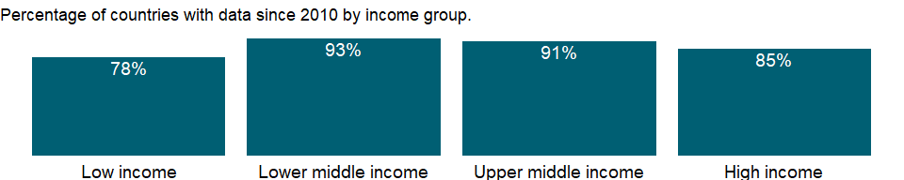

### Why is it relevant?

NA

### What is the data source?

World Bank national accounts data, and OECD National Accounts data files.

### What is the methodology?

NA

### How is it aggregated?

Gap-filled total

### What are the limitations?

NA

### What else should I know?

NA

### 1.51.2 GDP (current US$)

### What is the indicator?

GDP at purchaser’s prices is the sum of gross value added by all resident producers in the economy plus any product taxes and minus any subsidies not included in the value of the products. It is calculated without making deductions for depreciation of fabricated assets or for depletion and degradation of natural resources. Data are in current U.S. dollars. Dollar figures for GDP are converted from domestic currencies using single year official exchange rates. For a few countries where the official exchange rate does not reflect the rate effectively applied to actual foreign exchange transactions, an alternative conversion factor is used.

Topic: Economic Policy & Debt: National accounts: US$ at current prices: Aggregate indicators

Series ID: NY.GDP.MKTP.CD

Copyright: CC BY-4.0 , <https://datacatalog.worldbank.org/public-licenses#cc-by>

First year with any data: 1960

Last year with any data: 2020

### What years are data available?

The figure below shows years in which data is available for at least one country. Dates shaded in black have no data, while dates shaded in green have data for at least one country



### Which countries have data?

The figure below shows the percentage of countries in each income group with a value since 2010 for that indicator.

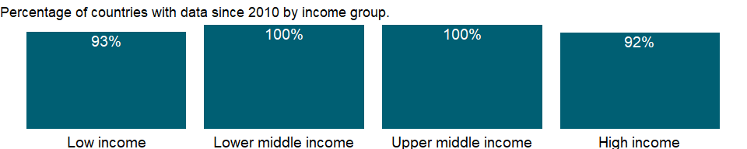

### Why is it relevant?

NA

### What is the data source?

World Bank national accounts data, and OECD National Accounts data files.

### What is the methodology?

Gross domestic product (GDP) represents the sum of value added by all its producers. Value added is the value of the gross output of producers less the value of intermediate goods and services consumed in production, before accounting for consumption of fixed capital in production. The United Nations System of National Accounts calls for value added to be valued at either basic prices (excluding net taxes on products) or producer prices (including net taxes on products paid by producers but excluding sales or value added taxes). Both valuations exclude transport charges that are invoiced separately by producers. Total GDP is measured at purchaser prices. Value added by industry is normally measured at basic prices.

### How is it aggregated?

Gap-filled total

### What are the limitations?

Gross domestic product (GDP), though widely tracked, may not always be the most relevant summary of aggregated economic performance for all economies, especially when production occurs at the expense of consuming capital stock.

While GDP estimates based on the production approach are generally more reliable than estimates compiled from the income or expenditure side, different countries use different definitions, methods, and reporting standards. World Bank staff review the quality of national accounts data and sometimes make adjustments to improve consistency with international guidelines. Nevertheless, significant discrepancies remain between international standards and actual practice. Many statistical offices, especially those in developing countries, face severe limitations in the resources, time, training, and budgets required to produce reliable and comprehensive series of national accounts statistics.

Among the difficulties faced by compilers of national accounts is the extent of unreported economic activity in the informal or secondary economy. In developing countries a large share of agricultural output is either not exchanged (because it is consumed within the household) or not exchanged for money.

### What else should I know?

NA

### 1.51.3 GDP per capita (current US$)

### What is the indicator?

GDP per capita is gross domestic product divided by midyear population. GDP is the sum of gross value added by all resident producers in the economy plus any product taxes and minus any subsidies not included in the value of the products. It is calculated without making deductions for depreciation of fabricated assets or for depletion and degradation of natural resources. Data are in current U.S. dollars.

Topic: Economic Policy & Debt: National accounts: US$ at current prices: Aggregate indicators

Series ID: NY.GDP.PCAP.CD

Copyright: CC BY-4.0 , <https://datacatalog.worldbank.org/public-licenses#cc-by>

First year with any data: 1960

Last year with any data: 2020

### What years are data available?

The figure below shows years in which data is available for at least one country. Dates shaded in black have no data, while dates shaded in green have data for at least one country



### Which countries have data?

The figure below shows the percentage of countries in each income group with a value since 2010 for that indicator.



### Why is it relevant?

NA

### What is the data source?

World Bank national accounts data, and OECD National Accounts data files.

### What is the methodology?

For more information, see the metadata for current U.S. dollar GDP (NY.GDP.MKTP.CD) and total population (SP.POP.TOTL).

### How is it aggregated?

Weighted Average

### What are the limitations?

NA

### What else should I know?

NA

### 1.51.4 Gross domestic savings (current US$)

### What is the indicator?

Gross domestic savings are calculated as GDP less final consumption expenditure (total consumption). Data are in current U.S. dollars.

Topic: Economic Policy & Debt: National accounts: US$ at current prices: Aggregate indicators

Series ID: NY.GDS.TOTL.CD

Copyright: CC BY-4.0 , <https://datacatalog.worldbank.org/public-licenses#cc-by>

First year with any data: 1960

Last year with any data: 2020

### What years are data available?

The figure below shows years in which data is available for at least one country. Dates shaded in black have no data, while dates shaded in green have data for at least one country



### Which countries have data?

The figure below shows the percentage of countries in each income group with a value since 2010 for that indicator.



### Why is it relevant?

NA

### What is the data source?

World Bank national accounts data, and OECD National Accounts data files.

### What is the methodology?

NA

### How is it aggregated?

Gap-filled total

### What are the limitations?

NA

### What else should I know?

NA

### 1.51.5 GNI (current US$)

### What is the indicator?

GNI (formerly GNP) is the sum of value added by all resident producers plus any product taxes (less subsidies) not included in the valuation of output plus net receipts of primary income (compensation of employees and property income) from abroad. Data are in current U.S. dollars.

Topic: Economic Policy & Debt: National accounts: US$ at current prices: Aggregate indicators

Series ID: NY.GNP.MKTP.CD

Copyright: CC BY-4.0 , <https://datacatalog.worldbank.org/public-licenses#cc-by>

First year with any data: 1960

Last year with any data: 2020

### What years are data available?

The figure below shows years in which data is available for at least one country. Dates shaded in black have no data, while dates shaded in green have data for at least one country



### Which countries have data?

The figure below shows the percentage of countries in each income group with a value since 2010 for that indicator.

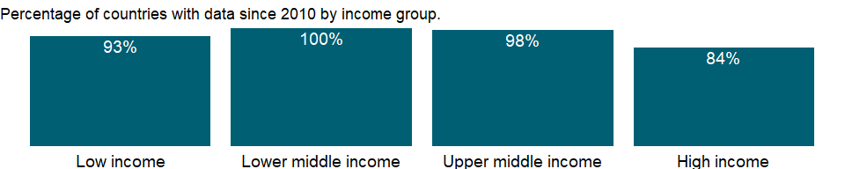

### Why is it relevant?

Because development encompasses many factors - economic, environmental, cultural, educational, and institutional - no single measure gives a complete picture. However, the total earnings of the residents of an economy, measured by its gross national income (GNI), is a good measure of its capacity to provide for the well-being of its people.

### What is the data source?

World Bank national accounts data, and OECD National Accounts data files.

### What is the methodology?

NA

### How is it aggregated?

Gap-filled total

### What are the limitations?

NA

### What else should I know?

NA

### 1.51.6 Gross savings (current US$)

### What is the indicator?

Gross savings are calculated as gross national income less total consumption, plus net transfers. Data are in current U.S. dollars.

Topic: Economic Policy & Debt: National accounts: US$ at current prices: Aggregate indicators

Series ID: NY.GNS.ICTR.CD

Copyright: CC BY-4.0 , <https://datacatalog.worldbank.org/public-licenses#cc-by>

First year with any data: 1960

Last year with any data: 2020

### What years are data available?

The figure below shows years in which data is available for at least one country. Dates shaded in black have no data, while dates shaded in green have data for at least one country



### Which countries have data?

The figure below shows the percentage of countries in each income group with a value since 2010 for that indicator.



### Why is it relevant?

NA

### What is the data source?

World Bank national accounts data, and OECD National Accounts data files.

### What is the methodology?

Gross savings represent the difference between disposable income and consumption and replace gross domestic savings, a concept used by the World Bank and included in World Development Indicators editions before 2006. The change was made to conform to SNA concepts and definitions.

### How is it aggregated?

NA

### What are the limitations?

NA

### What else should I know?

NA

### 1.51.7 Net income from abroad (current US$)

### What is the indicator?

Net income includes the net labor income and net property and entrepreneurial income components of the SNA. Labor income covers compensation of employees paid to nonresident workers. Property and entrepreneurial income covers investment income from the ownership of foreign financial claims (interest, dividends, rent, etc.) and nonfinancial property income (patents, copyrights, etc.). Data are in current U.S. dollars.

Topic: Economic Policy & Debt: National accounts: US$ at current prices: Aggregate indicators

Series ID: NY.GSR.NFCY.CD

Copyright: CC BY-4.0 , <https://datacatalog.worldbank.org/public-licenses#cc-by>

First year with any data: 1960

Last year with any data: 2020

### What years are data available?

The figure below shows years in which data is available for at least one country. Dates shaded in black have no data, while dates shaded in green have data for at least one country



### Which countries have data?

The figure below shows the percentage of countries in each income group with a value since 2010 for that indicator.



### Why is it relevant?

NA

### What is the data source?

World Bank national accounts data, and OECD National Accounts data files.

### What is the methodology?

NA

### How is it aggregated?

NA

### What are the limitations?

NA

### What else should I know?

NA

### 1.51.8 Net taxes on products (current US$)

### What is the indicator?

Net taxes on products (net indirect taxes) are the sum of product taxes less subsidies. Product taxes are those taxes payable by producers that relate to the production, sale, purchase or use of the goods and services. Subsidies are grants on the current account made by general government to private enterprises and unincorporated public enterprises. The grants may take the form of payments to ensure a guaranteed price or to enable maintenance of prices of goods and services below costs of production, and other forms of assistance to producers. Data are in current U.S. dollars.

Topic: Economic Policy & Debt: National accounts: US$ at current prices: Aggregate indicators

Series ID: NY.TAX.NIND.CD

Copyright: CC BY-4.0 , <https://datacatalog.worldbank.org/public-licenses#cc-by>

First year with any data: 1960

Last year with any data: 2020

### What years are data available?

The figure below shows years in which data is available for at least one country. Dates shaded in black have no data, while dates shaded in green have data for at least one country



### Which countries have data?

The figure below shows the percentage of countries in each income group with a value since 2010 for that indicator.

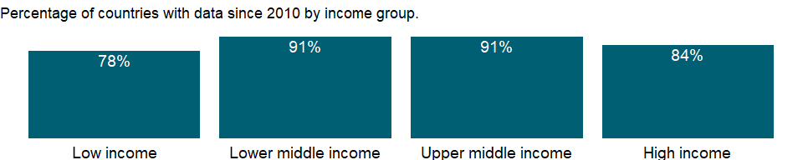

### Why is it relevant?

NA

### What is the data source?

World Bank national accounts data, and OECD National Accounts data files.

### What is the methodology?

NA

### How is it aggregated?

NA

### What are the limitations?

NA

### What else should I know?

NA

### 1.51.9 Net current transfers from abroad (current US$)

### What is the indicator?

Current transfers comprise transfers of income between residents of the reporting country and the rest of the world that carry no provisions for repayment. Net current transfers from abroad is equal to the unrequited transfers of income from nonresidents to residents minus the unrequited transfers from residents to nonresidents. Data are in current U.S. dollars.

Topic: Economic Policy & Debt: National accounts: US$ at current prices: Aggregate indicators

Series ID: NY.TRF.NCTR.CD

Copyright: CC BY-4.0 , <https://datacatalog.worldbank.org/public-licenses#cc-by>

First year with any data: 1960

Last year with any data: 2020

### What years are data available?

The figure below shows years in which data is available for at least one country. Dates shaded in black have no data, while dates shaded in green have data for at least one country



### Which countries have data?

The figure below shows the percentage of countries in each income group with a value since 2010 for that indicator.

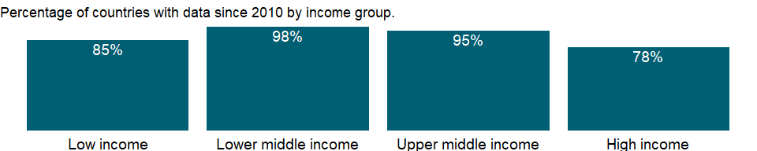

### Why is it relevant?

NA

### What is the data source?

World Bank national accounts data, and OECD National Accounts data files.

### What is the methodology?

NA

### How is it aggregated?

NA

### What are the limitations?

NA

### What else should I know?

NA

## 1.52 Economic Policy & Debt: National accounts: Local currency at current prices: Aggregate indicators

### 1.52.1 Gross value added at factor cost (current LCU)

### What is the indicator?

Gross value added at factor cost (formerly GDP at factor cost) is derived as the sum of the value added in the agriculture, industry and services sectors. If the value added of these sectors is calculated at purchaser values, gross value added at factor cost is derived by subtracting net product taxes from GDP. Data are in current local currency.

Topic: Economic Policy & Debt: National accounts: Local currency at current prices: Aggregate indicators

Series ID: NY.GDP.FCST.CN

Copyright: CC BY-4.0 , <https://datacatalog.worldbank.org/public-licenses#cc-by>

First year with any data: 1960

Last year with any data: 2020

### What years are data available?

The figure below shows years in which data is available for at least one country. Dates shaded in black have no data, while dates shaded in green have data for at least one country



### Which countries have data?

The figure below shows the percentage of countries in each income group with a value since 2010 for that indicator.



### Why is it relevant?

NA

### What is the data source?

World Bank national accounts data, and OECD National Accounts data files.

### What is the methodology?

NA

### How is it aggregated?

NA

### What are the limitations?

NA

### What else should I know?

NA

### 1.52.2 GDP (current LCU)

### What is the indicator?

GDP at purchaser’s prices is the sum of gross value added by all resident producers in the economy plus any product taxes and minus any subsidies not included in the value of the products. It is calculated without making deductions for depreciation of fabricated assets or for depletion and degradation of natural resources. Data are in current local currency.

Topic: Economic Policy & Debt: National accounts: Local currency at current prices: Aggregate indicators

Series ID: NY.GDP.MKTP.CN

Copyright: CC BY-4.0 , <https://datacatalog.worldbank.org/public-licenses#cc-by>

First year with any data: 1960

Last year with any data: 2020

### What years are data available?

The figure below shows years in which data is available for at least one country. Dates shaded in black have no data, while dates shaded in green have data for at least one country



### Which countries have data?

The figure below shows the percentage of countries in each income group with a value since 2010 for that indicator.



### Why is it relevant?

NA

### What is the data source?

World Bank national accounts data, and OECD National Accounts data files.

### What is the methodology?

NA

### How is it aggregated?

NA

### What are the limitations?

NA

### What else should I know?

NA

### 1.52.3 GDP at market prices: linked series (current LCU)

### What is the indicator?

GDP at purchaser’s prices is the sum of gross value added by all resident producers in the economy plus any product taxes and minus any subsidies not included in the value of the products. It is calculated without making deductions for depreciation of fabricated assets or for depletion and degradation of natural resources. This series has been linked to produce a consistent time series to counteract breaks in series over time due to changes in base years, source data and methodologies. Thus, it may not be comparable with other national accounts series in the database for historical years. Data are in current local currency.

Topic: Economic Policy & Debt: National accounts: Local currency at current prices: Aggregate indicators

Series ID: NY.GDP.MKTP.CN.AD

Copyright: CC BY-4.0 , <https://datacatalog.worldbank.org/public-licenses#cc-by>

First year with any data: 1989

Last year with any data: 2020

### What years are data available?

The figure below shows years in which data is available for at least one country. Dates shaded in black have no data, while dates shaded in green have data for at least one country



### Which countries have data?

The figure below shows the percentage of countries in each income group with a value since 2010 for that indicator.



### Why is it relevant?

NA

### What is the data source?

World Bank staff estimates based on World Bank national accounts data archives, OECD National Accounts, and the IMF WEO database.

### What is the methodology?

The accuracy of national accounts estimates and their comparability across countries depend on timely revisions to data on GDP and its components. The frequency of revisions to GDP data varies: some countries revise numbers monthly, others quarterly or annually, and others less frequently. Such revisions are usually small and based on additional information received during the year. However, larger revisions are required from time to time to rebase the national accounts and allow for incorporation of new methodologies and data sources.

Comprehensive revisions of GDP data often (but not always) result in upward adjustments to GDP and other major aggregates as improved data sources increase the coverage of the economy. And estimates of GDP growth may change as new weights are introduced. These revisions will cause breaks in series unless they are applied consistently to historical data. For constant price series a break caused by rebasing can be eliminated by linking the old series to the new using historical growth rates.

This current price GDP series has been linked to produce a consistent time series. It has been calculated by utilizing the change in the implicit GDP deflator in the WDI Archive and IMF WEO databases. Thus, earlier years (linked years) will not be comparable with other national accounts series in the database. Data are available for World Bank operational countries only.

### How is it aggregated?

NA

### What are the limitations?

NA

### What else should I know?

NA

### 1.52.4 GDP per capita (current LCU)

### What is the indicator?

GDP per capita is gross domestic product divided by midyear population. GDP is the sum of gross value added by all resident producers in the economy plus any product taxes and minus any subsidies not included in the value of the products. It is calculated without making deductions for depreciation of fabricated assets or for depletion and degradation of natural resources. Data are in current local currency.

Topic: Economic Policy & Debt: National accounts: Local currency at current prices: Aggregate indicators

Series ID: NY.GDP.PCAP.CN

Copyright: CC BY-4.0 , <https://datacatalog.worldbank.org/public-licenses#cc-by>

First year with any data: 1960

Last year with any data: 2020

### What years are data available?

The figure below shows years in which data is available for at least one country. Dates shaded in black have no data, while dates shaded in green have data for at least one country



### Which countries have data?

The figure below shows the percentage of countries in each income group with a value since 2010 for that indicator.



### Why is it relevant?

NA

### What is the data source?

World Bank national accounts data, and OECD National Accounts data files.

### What is the methodology?

NA

### How is it aggregated?

NA

### What are the limitations?

NA

### What else should I know?

NA

### 1.52.5 Gross domestic savings (current LCU)

### What is the indicator?

Gross domestic savings are calculated as GDP less final consumption expenditure (total consumption). Data are in current local currency.

Topic: Economic Policy & Debt: National accounts: Local currency at current prices: Aggregate indicators

Series ID: NY.GDS.TOTL.CN

Copyright: CC BY-4.0 , <https://datacatalog.worldbank.org/public-licenses#cc-by>

First year with any data: 1960

Last year with any data: 2020

### What years are data available?

The figure below shows years in which data is available for at least one country. Dates shaded in black have no data, while dates shaded in green have data for at least one country



### Which countries have data?

The figure below shows the percentage of countries in each income group with a value since 2010 for that indicator.



### Why is it relevant?

NA

### What is the data source?

World Bank national accounts data, and OECD National Accounts data files.

### What is the methodology?

NA

### How is it aggregated?

NA

### What are the limitations?

NA

### What else should I know?

NA

### 1.52.6 GNI (current LCU)

### What is the indicator?

GNI (formerly GNP) is the sum of value added by all resident producers plus any product taxes (less subsidies) not included in the valuation of output plus net receipts of primary income (compensation of employees and property income) from abroad. Data are in current local currency.

Topic: Economic Policy & Debt: National accounts: Local currency at current prices: Aggregate indicators

Series ID: NY.GNP.MKTP.CN

Copyright: CC BY-4.0 , <https://datacatalog.worldbank.org/public-licenses#cc-by>

First year with any data: 1960

Last year with any data: 2020

### What years are data available?

The figure below shows years in which data is available for at least one country. Dates shaded in black have no data, while dates shaded in green have data for at least one country



### Which countries have data?

The figure below shows the percentage of countries in each income group with a value since 2010 for that indicator.



### Why is it relevant?

NA

### What is the data source?

World Bank national accounts data, and OECD National Accounts data files.

### What is the methodology?

NA

### How is it aggregated?

NA

### What are the limitations?

NA

### What else should I know?

NA

### 1.52.7 GNI per capita (current LCU)

### What is the indicator?

GNI per capita is gross national income divided by midyear population. GNI (formerly GNP) is the sum of value added by all resident producers plus any product taxes (less subsidies) not included in the valuation of output plus net receipts of primary income (compensation of employees and property income) from abroad. Data are in current local currency.

Topic: Economic Policy & Debt: National accounts: Local currency at current prices: Aggregate indicators

Series ID: NY.GNP.PCAP.CN

Copyright: CC BY-4.0 , <https://datacatalog.worldbank.org/public-licenses#cc-by>

First year with any data: 1960

Last year with any data: 2020

### What years are data available?

The figure below shows years in which data is available for at least one country. Dates shaded in black have no data, while dates shaded in green have data for at least one country



### Which countries have data?

The figure below shows the percentage of countries in each income group with a value since 2010 for that indicator.



### Why is it relevant?

NA

### What is the data source?

World Bank national accounts data, and OECD National Accounts data files.

### What is the methodology?

NA

### How is it aggregated?

NA

### What are the limitations?

NA

### What else should I know?

NA

### 1.52.8 Gross savings (current LCU)

### What is the indicator?

Gross savings are calculated as gross national income less total consumption, plus net transfers. Data are in current local currency.

Topic: Economic Policy & Debt: National accounts: Local currency at current prices: Aggregate indicators

Series ID: NY.GNS.ICTR.CN

Copyright: CC BY-4.0 , <https://datacatalog.worldbank.org/public-licenses#cc-by>

First year with any data: 1960

Last year with any data: 2020

### What years are data available?

The figure below shows years in which data is available for at least one country. Dates shaded in black have no data, while dates shaded in green have data for at least one country



### Which countries have data?

The figure below shows the percentage of countries in each income group with a value since 2010 for that indicator.



### Why is it relevant?

NA

### What is the data source?

World Bank national accounts data, and OECD National Accounts data files.

### What is the methodology?

NA

### How is it aggregated?

NA

### What are the limitations?

NA

### What else should I know?

NA

### 1.52.9 Net income from abroad (current LCU)

### What is the indicator?

Net income includes the net labor income and net property and entrepreneurial income components of the SNA. Labor income covers compensation of employees paid to nonresident workers. Property and entrepreneurial income covers investment income from the ownership of foreign financial claims (interest, dividends, rent, etc.) and nonfinancial property income (patents, copyrights, etc.). Data are in current local currency.

Topic: Economic Policy & Debt: National accounts: Local currency at current prices: Aggregate indicators

Series ID: NY.GSR.NFCY.CN

Copyright: CC BY-4.0 , <https://datacatalog.worldbank.org/public-licenses#cc-by>

First year with any data: 1960

Last year with any data: 2020

### What years are data available?

The figure below shows years in which data is available for at least one country. Dates shaded in black have no data, while dates shaded in green have data for at least one country



### Which countries have data?

The figure below shows the percentage of countries in each income group with a value since 2010 for that indicator.



### Why is it relevant?

NA

### What is the data source?

World Bank national accounts data, and OECD National Accounts data files.

### What is the methodology?

NA

### How is it aggregated?

NA

### What are the limitations?

NA

### What else should I know?

NA

### 1.52.10 Net taxes on products (current LCU)

### What is the indicator?

Net taxes on products (net indirect taxes) are the sum of product taxes less subsidies. Product taxes are those taxes payable by producers that relate to the production, sale, purchase or use of the goods and services. Subsidies are grants on the current account made by general government to private enterprises and unincorporated public enterprises. The grants may take the form of payments to ensure a guaranteed price or to enable maintenance of prices of goods and services below costs of production, and other forms of assistance to producers. Data are in current local currency.

Topic: Economic Policy & Debt: National accounts: Local currency at current prices: Aggregate indicators

Series ID: NY.TAX.NIND.CN

Copyright: CC BY-4.0 , <https://datacatalog.worldbank.org/public-licenses#cc-by>

First year with any data: 1960

Last year with any data: 2020

### What years are data available?

The figure below shows years in which data is available for at least one country. Dates shaded in black have no data, while dates shaded in green have data for at least one country



### Which countries have data?

The figure below shows the percentage of countries in each income group with a value since 2010 for that indicator.



### Why is it relevant?

NA

### What is the data source?

World Bank national accounts data, and OECD National Accounts data files.

### What is the methodology?

NA

### How is it aggregated?

NA

### What are the limitations?

NA

### What else should I know?

NA

### 1.52.11 Net current transfers from abroad (current LCU)

### What is the indicator?

Current transfers comprise transfers of income between residents of the reporting country and the rest of the world that carry no provisions for repayment. Net current transfers from abroad is equal to the unrequited transfers of income from nonresidents to residents minus the unrequited transfers from residents to nonresidents. Data are in current local currency.

Topic: Economic Policy & Debt: National accounts: Local currency at current prices: Aggregate indicators

Series ID: NY.TRF.NCTR.CN

Copyright: CC BY-4.0 , <https://datacatalog.worldbank.org/public-licenses#cc-by>

First year with any data: 1960

Last year with any data: 2020

### What years are data available?

The figure below shows years in which data is available for at least one country. Dates shaded in black have no data, while dates shaded in green have data for at least one country



### Which countries have data?

The figure below shows the percentage of countries in each income group with a value since 2010 for that indicator.



### Why is it relevant?

NA

### What is the data source?

World Bank national accounts data, and OECD National Accounts data files.

### What is the methodology?

NA

### How is it aggregated?

NA

### What are the limitations?

NA

### What else should I know?

NA

## 1.53 Economic Policy & Debt: National accounts: US$ at constant 2010 prices: Aggregate indicators

### 1.53.1 Gross value added at factor cost (constant 2010 US$)

### What is the indicator?

Gross value added at factor cost (formerly GDP at factor cost) is derived as the sum of the value added in the agriculture, industry and services sectors. If the value added of these sectors is calculated at purchaser values, gross value added at factor cost is derived by subtracting net product taxes from GDP. Data are in constant 2010 U.S. dollars.

Topic: Economic Policy & Debt: National accounts: US$ at constant 2010 prices: Aggregate indicators

Series ID: NY.GDP.FCST.KD

Copyright: CC BY-4.0 , <https://datacatalog.worldbank.org/public-licenses#cc-by>

First year with any data: 1960

Last year with any data: 2020

### What years are data available?

The figure below shows years in which data is available for at least one country. Dates shaded in black have no data, while dates shaded in green have data for at least one country



### Which countries have data?

The figure below shows the percentage of countries in each income group with a value since 2010 for that indicator.

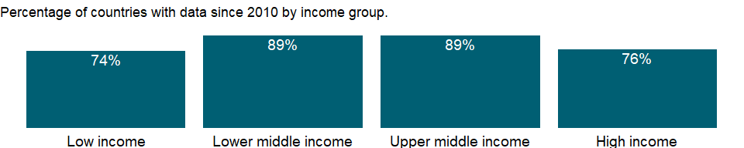

### Why is it relevant?

NA

### What is the data source?

World Bank national accounts data, and OECD National Accounts data files.

### What is the methodology?

NA

### How is it aggregated?

Gap-filled total

### What are the limitations?

NA

### What else should I know?

NA

### 1.53.2 GDP (constant 2010 US$)

### What is the indicator?

GDP at purchaser’s prices is the sum of gross value added by all resident producers in the economy plus any product taxes and minus any subsidies not included in the value of the products. It is calculated without making deductions for depreciation of fabricated assets or for depletion and degradation of natural resources. Data are in constant 2010 U.S. dollars. Dollar figures for GDP are converted from domestic currencies using 2010 official exchange rates. For a few countries where the official exchange rate does not reflect the rate effectively applied to actual foreign exchange transactions, an alternative conversion factor is used.

Topic: Economic Policy & Debt: National accounts: US$ at constant 2010 prices: Aggregate indicators

Series ID: NY.GDP.MKTP.KD

Copyright: CC BY-4.0 , <https://datacatalog.worldbank.org/public-licenses#cc-by>

First year with any data: 1960

Last year with any data: 2020

### What years are data available?

The figure below shows years in which data is available for at least one country. Dates shaded in black have no data, while dates shaded in green have data for at least one country



### Which countries have data?

The figure below shows the percentage of countries in each income group with a value since 2010 for that indicator.

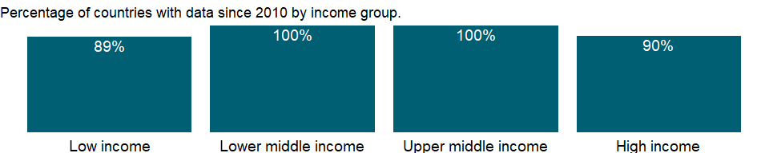

### Why is it relevant?

An economy’s growth is measured by the change in the volume of its output or in the real incomes of its residents. The 2008 United Nations System of National Accounts (2008 SNA) offers three plausible indicators for calculating growth: the volume of gross domestic product (GDP), real gross domestic income, and real gross national income. The volume of GDP is the sum of value added, measured at constant prices, by households, government, and industries operating in the economy. GDP accounts for all domestic production, regardless of whether the income accrues to domestic or foreign institutions.

### What is the data source?

World Bank national accounts data, and OECD National Accounts data files.

### What is the methodology?

Gross domestic product (GDP) represents the sum of value added by all its producers. Value added is the value of the gross output of producers less the value of intermediate goods and services consumed in production, before accounting for consumption of fixed capital in production. The United Nations System of National Accounts calls for value added to be valued at either basic prices (excluding net taxes on products) or producer prices (including net taxes on products paid by producers but excluding sales or value added taxes). Both valuations exclude transport charges that are invoiced separately by producers. Total GDP is measured at purchaser prices. Value added by industry is normally measured at basic prices. When value added is measured at producer prices.

Growth rates of GDP and its components are calculated using the least squares method and constant price data in the local currency. Constant price U.S. dollar series are used to calculate regional and income group growth rates. Local currency series are converted to constant U.S. dollars using an exchange rate in the common reference year.

### How is it aggregated?

Gap-filled total

### What are the limitations?

Each industry’s contribution to growth in the economy’s output is measured by growth in the industry’s value added. In principle, value added in constant prices can be estimated by measuring the quantity of goods and services produced in a period, valuing them at an agreed set of base year prices, and subtracting the cost of intermediate inputs, also in constant prices. This double-deflation method requires detailed information on the structure of prices of inputs and outputs.

In many industries, however, value added is extrapolated from the base year using single volume indexes of outputs or, less commonly, inputs. Particularly in the services industries, including most of government, value added in constant prices is often imputed from labor inputs, such as real wages or number of employees. In the absence of well defined measures of output, measuring the growth of services remains difficult.

Moreover, technical progress can lead to improvements in production processes and in the quality of goods and services that, if not properly accounted for, can distort measures of value added and thus of growth. When inputs are used to estimate output, as for nonmarket services, unmeasured technical progress leads to underestimates of the volume of output. Similarly, unmeasured improvements in quality lead to underestimates of the value of output and value added. The result can be underestimates of growth and productivity improvement and overestimates of inflation.

Informal economic activities pose a particular measurement problem, especially in developing countries, where much economic activity is unrecorded. A complete picture of the economy requires estimating household outputs produced for home use, sales in informal markets, barter exchanges, and illicit or deliberately unreported activities. The consistency and completeness of such estimates depend on the skill and methods of the compiling statisticians.

Rebasing of national accounts can alter the measured growth rate of an economy and lead to breaks in series that affect the consistency of data over time. When countries rebase their national accounts, they update the weights assigned to various components to better reflect current patterns of production or uses of output. The new base year should represent normal operation of the economy - it should be a year without major shocks or distortions. Some developing countries have not rebased their national accounts for many years. Using an old base year can be misleading because implicit price and volume weights become progressively less relevant and useful.

To obtain comparable series of constant price data for computing aggregates, the World Bank rescales GDP and value added by industrial origin to a common reference year. Because rescaling changes the implicit weights used in forming regional and income group aggregates, aggregate growth rates are not comparable with those from earlier editions with different base years. Rescaling may result in a discrepancy between the rescaled GDP and the sum of the rescaled components. To avoid distortions in the growth rates, the discrepancy is left unallocated. As a result, the weighted average of the growth rates of the components generally does not equal the GDP growth rate.

### What else should I know?

NA

### 1.53.3 GDP per capita (constant 2010 US$)

### What is the indicator?

GDP per capita is gross domestic product divided by midyear population. GDP is the sum of gross value added by all resident producers in the economy plus any product taxes and minus any subsidies not included in the value of the products. It is calculated without making deductions for depreciation of fabricated assets or for depletion and degradation of natural resources. Data are in constant 2010 U.S. dollars.

Topic: Economic Policy & Debt: National accounts: US$ at constant 2010 prices: Aggregate indicators

Series ID: NY.GDP.PCAP.KD

Copyright: CC BY-4.0 , <https://datacatalog.worldbank.org/public-licenses#cc-by>

First year with any data: 1960

Last year with any data: 2020

### What years are data available?

The figure below shows years in which data is available for at least one country. Dates shaded in black have no data, while dates shaded in green have data for at least one country



### Which countries have data?

The figure below shows the percentage of countries in each income group with a value since 2010 for that indicator.



### Why is it relevant?

NA

### What is the data source?

World Bank national accounts data, and OECD National Accounts data files.

### What is the methodology?

For more information, see the metadata for constant U.S. dollar GDP (NY.GDP.MKTP.KD) and total population (SP.POP.TOTL).

### How is it aggregated?

Weighted Average

### What are the limitations?

NA

### What else should I know?

NA

### 1.53.4 GNI (constant 2010 US$)

### What is the indicator?

GNI (formerly GNP) is the sum of value added by all resident producers plus any product taxes (less subsidies) not included in the valuation of output plus net receipts of primary income (compensation of employees and property income) from abroad. Data are in constant 2010 U.S. dollars.

Topic: Economic Policy & Debt: National accounts: US$ at constant 2010 prices: Aggregate indicators

Series ID: NY.GNP.MKTP.KD

Copyright: CC BY-4.0 , <https://datacatalog.worldbank.org/public-licenses#cc-by>

First year with any data: 1960

Last year with any data: 2020

### What years are data available?

The figure below shows years in which data is available for at least one country. Dates shaded in black have no data, while dates shaded in green have data for at least one country



### Which countries have data?

The figure below shows the percentage of countries in each income group with a value since 2010 for that indicator.

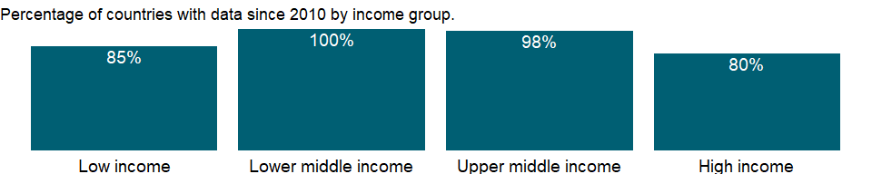

### Why is it relevant?

Because development encompasses many factors - economic, environmental, cultural, educational, and institutional - no single measure gives a complete picture. However, the total earnings of the residents of an economy, measured by its gross national income (GNI), is a good measure of its capacity to provide for the well-being of its people.

### What is the data source?

World Bank national accounts data, and OECD National Accounts data files.

### What is the methodology?

NA

### How is it aggregated?

Gap-filled total

### What are the limitations?

NA

### What else should I know?

NA

### 1.53.5 GNI per capita (constant 2010 US$)

### What is the indicator?

GNI per capita is gross national income divided by midyear population. GNI (formerly GNP) is the sum of value added by all resident producers plus any product taxes (less subsidies) not included in the valuation of output plus net receipts of primary income (compensation of employees and property income) from abroad. Data are in constant 2010 U.S. dollars.

Topic: Economic Policy & Debt: National accounts: US$ at constant 2010 prices: Aggregate indicators

Series ID: NY.GNP.PCAP.KD

Copyright: CC BY-4.0 , <https://datacatalog.worldbank.org/public-licenses#cc-by>

First year with any data: 1960

Last year with any data: 2020

### What years are data available?

The figure below shows years in which data is available for at least one country. Dates shaded in black have no data, while dates shaded in green have data for at least one country



### Which countries have data?

The figure below shows the percentage of countries in each income group with a value since 2010 for that indicator.



### Why is it relevant?

NA

### What is the data source?

World Bank national accounts data, and OECD National Accounts data files.

### What is the methodology?

NA

### How is it aggregated?

Weighted Average

### What are the limitations?

NA

### What else should I know?

NA

## 1.54 Economic Policy & Debt: National accounts: Local currency at constant prices: Aggregate indicators

### 1.54.1 Gross value added at factor cost (constant LCU)

### What is the indicator?

Gross value added at factor cost (formerly GDP at factor cost) is derived as the sum of the value added in the agriculture, industry and services sectors. If the value added of these sectors is calculated at purchaser values, gross value added at factor cost is derived by subtracting net product taxes from GDP. Data are in constant local currency.

Topic: Economic Policy & Debt: National accounts: Local currency at constant prices: Aggregate indicators

Series ID: NY.GDP.FCST.KN

Copyright: CC BY-4.0 , <https://datacatalog.worldbank.org/public-licenses#cc-by>

First year with any data: 1960

Last year with any data: 2020

### What years are data available?

The figure below shows years in which data is available for at least one country. Dates shaded in black have no data, while dates shaded in green have data for at least one country



### Which countries have data?

The figure below shows the percentage of countries in each income group with a value since 2010 for that indicator.

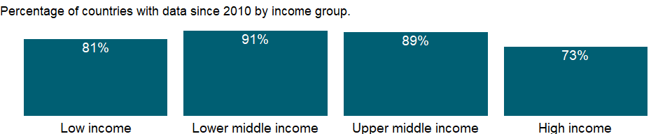

### Why is it relevant?

NA

### What is the data source?

World Bank national accounts data, and OECD National Accounts data files.

### What is the methodology?

NA

### How is it aggregated?

NA

### What are the limitations?

NA

### What else should I know?

NA

### 1.54.2 GDP (constant LCU)

### What is the indicator?

GDP is the sum of gross value added by all resident producers in the economy plus any product taxes and minus any subsidies not included in the value of the products. It is calculated without making deductions for depreciation of fabricated assets or for depletion and degradation of natural resources. Data are in constant local currency.

Topic: Economic Policy & Debt: National accounts: Local currency at constant prices: Aggregate indicators

Series ID: NY.GDP.MKTP.KN

Copyright: CC BY-4.0 , <https://datacatalog.worldbank.org/public-licenses#cc-by>

First year with any data: 1960

Last year with any data: 2020

### What years are data available?

The figure below shows years in which data is available for at least one country. Dates shaded in black have no data, while dates shaded in green have data for at least one country



### Which countries have data?

The figure below shows the percentage of countries in each income group with a value since 2010 for that indicator.



### Why is it relevant?

NA

### What is the data source?

World Bank national accounts data, and OECD National Accounts data files.

### What is the methodology?

NA

### How is it aggregated?

NA

### What are the limitations?

NA

### What else should I know?

NA

### 1.54.3 GDP per capita (constant LCU)

### What is the indicator?

GDP per capita is gross domestic product divided by midyear population. GDP at purchaser’s prices is the sum of gross value added by all resident producers in the economy plus any product taxes and minus any subsidies not included in the value of the products. It is calculated without making deductions for depreciation of fabricated assets or for depletion and degradation of natural resources. Data are in constant local currency.

Topic: Economic Policy & Debt: National accounts: Local currency at constant prices: Aggregate indicators

Series ID: NY.GDP.PCAP.KN

Copyright: CC BY-4.0 , <https://datacatalog.worldbank.org/public-licenses#cc-by>

First year with any data: 1960

Last year with any data: 2020

### What years are data available?

The figure below shows years in which data is available for at least one country. Dates shaded in black have no data, while dates shaded in green have data for at least one country



### Which countries have data?

The figure below shows the percentage of countries in each income group with a value since 2010 for that indicator.



### Why is it relevant?

NA

### What is the data source?

World Bank national accounts data, and OECD National Accounts data files.

### What is the methodology?

NA

### How is it aggregated?

NA

### What are the limitations?

NA

### What else should I know?

NA

### 1.54.4 GNI (constant LCU)

### What is the indicator?

GNI (formerly GNP) is the sum of value added by all resident producers plus any product taxes (less subsidies) not included in the valuation of output plus net receipts of primary income (compensation of employees and property income) from abroad. Data are in constant local currency.

Topic: Economic Policy & Debt: National accounts: Local currency at constant prices: Aggregate indicators

Series ID: NY.GNP.MKTP.KN

Copyright: CC BY-4.0 , <https://datacatalog.worldbank.org/public-licenses#cc-by>

First year with any data: 1960

Last year with any data: 2020

### What years are data available?

The figure below shows years in which data is available for at least one country. Dates shaded in black have no data, while dates shaded in green have data for at least one country



### Which countries have data?

The figure below shows the percentage of countries in each income group with a value since 2010 for that indicator.

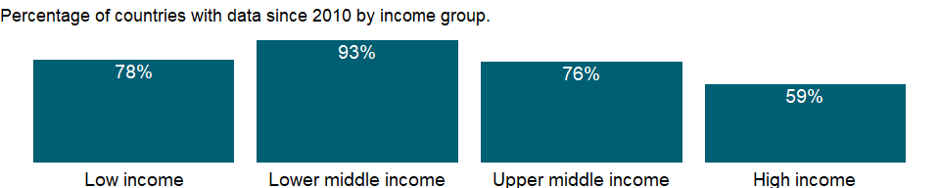

### Why is it relevant?

NA

### What is the data source?

World Bank national accounts data, and OECD National Accounts data files.

### What is the methodology?

NA

### How is it aggregated?

NA

### What are the limitations?

NA

### What else should I know?

NA

### 1.54.5 GNI per capita (constant LCU)

### What is the indicator?

GNI per capita is gross national income divided by midyear population. GNI (formerly GNP) is the sum of value added by all resident producers plus any product taxes (less subsidies) not included in the valuation of output plus net receipts of primary income (compensation of employees and property income) from abroad. Data are in constant local currency.

Topic: Economic Policy & Debt: National accounts: Local currency at constant prices: Aggregate indicators

Series ID: NY.GNP.PCAP.KN

Copyright: CC BY-4.0 , <https://datacatalog.worldbank.org/public-licenses#cc-by>

First year with any data: 1960

Last year with any data: 2020

### What years are data available?

The figure below shows years in which data is available for at least one country. Dates shaded in black have no data, while dates shaded in green have data for at least one country



### Which countries have data?

The figure below shows the percentage of countries in each income group with a value since 2010 for that indicator.



### Why is it relevant?

NA

### What is the data source?

World Bank national accounts data, and OECD National Accounts data files.

### What is the methodology?

NA

### How is it aggregated?

NA

### What are the limitations?

NA

### What else should I know?

NA

### 1.54.6 Net income from abroad (constant LCU)

### What is the indicator?

Net income includes the net labor income and net property and entrepreneurial income components of the SNA. Labor income covers compensation of employees paid to nonresident workers. Property and entrepreneurial income covers investment income from the ownership of foreign financial claims (interest, dividends, rent, etc.) and nonfinancial property income (patents, copyrights, etc.). Data are in constant local currency.

Topic: Economic Policy & Debt: National accounts: Local currency at constant prices: Aggregate indicators

Series ID: NY.GSR.NFCY.KN

Copyright: CC BY-4.0 , <https://datacatalog.worldbank.org/public-licenses#cc-by>

First year with any data: 1969

Last year with any data: 2020

### What years are data available?

The figure below shows years in which data is available for at least one country. Dates shaded in black have no data, while dates shaded in green have data for at least one country

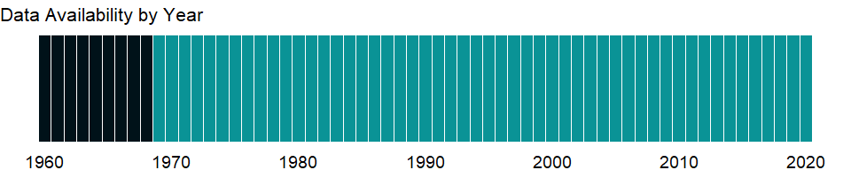

### Which countries have data?

The figure below shows the percentage of countries in each income group with a value since 2010 for that indicator.

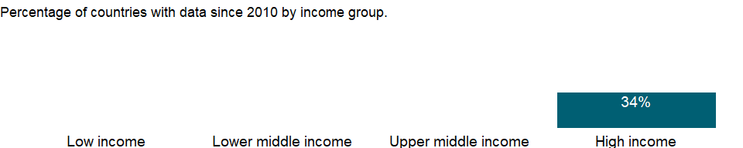

### Why is it relevant?

NA

### What is the data source?

World Bank national accounts data, and OECD National Accounts data files.

### What is the methodology?

NA

### How is it aggregated?

NA

### What are the limitations?

NA

### What else should I know?

NA

### 1.54.7 Net taxes on products (constant LCU)

### What is the indicator?

Net taxes on products (net indirect taxes) are the sum of product taxes less subsidies. Product taxes are those taxes payable by producers that relate to the production, sale, purchase or use of the goods and services. Subsidies are grants on the current account made by general government to private enterprises and unincorporated public enterprises. The grants may take the form of payments to ensure a guaranteed price or to enable maintenance of prices of goods and services below costs of production, and other forms of assistance to producers. Data are in constant local currency.

Topic: Economic Policy & Debt: National accounts: Local currency at constant prices: Aggregate indicators

Series ID: NY.TAX.NIND.KN

Copyright: CC BY-4.0 , <https://datacatalog.worldbank.org/public-licenses#cc-by>

First year with any data: 1960

Last year with any data: 2020

### What years are data available?

The figure below shows years in which data is available for at least one country. Dates shaded in black have no data, while dates shaded in green have data for at least one country



### Which countries have data?

The figure below shows the percentage of countries in each income group with a value since 2010 for that indicator.

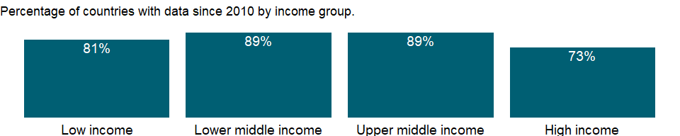

### Why is it relevant?

NA

### What is the data source?

World Bank national accounts data, and OECD National Accounts data files.

### What is the methodology?

NA

### How is it aggregated?

NA

### What are the limitations?

NA

### What else should I know?

NA

### 1.54.8 Net current transfers from abroad (constant LCU)

### What is the indicator?

Current transfers comprise transfers of income between residents of the reporting country and the rest of the world that carry no provisions for repayment. Net current transfers from abroad is equal to the unrequited transfers of income from nonresidents to residents minus the unrequited transfers from residents to nonresidents. Data are in constant local currency.

Topic: Economic Policy & Debt: National accounts: Local currency at constant prices: Aggregate indicators

Series ID: NY.TRF.NCTR.KN

Copyright: CC BY-4.0 , <https://datacatalog.worldbank.org/public-licenses#cc-by>

First year with any data: 1960

Last year with any data: 2013

### What years are data available?

The figure below shows years in which data is available for at least one country. Dates shaded in black have no data, while dates shaded in green have data for at least one country

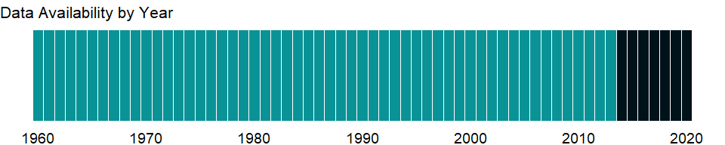

### Which countries have data?

The figure below shows the percentage of countries in each income group with a value since 2010 for that indicator.

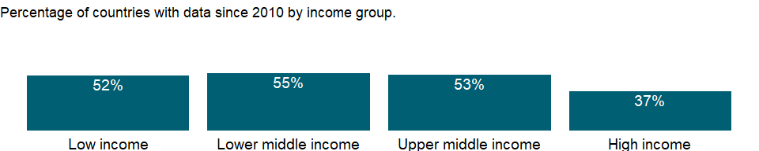

### Why is it relevant?

NA

### What is the data source?

World Bank national accounts data, and OECD National Accounts data files.

### What is the methodology?

NA

### How is it aggregated?

NA

### What are the limitations?

NA

### What else should I know?

NA

## 1.55 Economic Policy & Debt: National accounts: Atlas GNI & GNI per capita

### 1.55.1 GNI, Atlas method (current US$)

### What is the indicator?

GNI (formerly GNP) is the sum of value added by all resident producers plus any product taxes (less subsidies) not included in the valuation of output plus net receipts of primary income (compensation of employees and property income) from abroad. Data are in current U.S. dollars. GNI, calculated in national currency, is usually converted to U.S. dollars at official exchange rates for comparisons across economies, although an alternative rate is used when the official exchange rate is judged to diverge by an exceptionally large margin from the rate actually applied in international transactions. To smooth fluctuations in prices and exchange rates, a special Atlas method of conversion is used by the World Bank. This applies a conversion factor that averages the exchange rate for a given year and the two preceding years, adjusted for differences in rates of inflation between the country, and through 2000, the G-5 countries (France, Germany, Japan, the United Kingdom, and the United States). From 2001, these countries include the Euro area, Japan, the United Kingdom, and the United States.

Topic: Economic Policy & Debt: National accounts: Atlas GNI & GNI per capita

Series ID: NY.GNP.ATLS.CD

Copyright: CC BY-4.0 , <https://datacatalog.worldbank.org/public-licenses#cc-by>

First year with any data: 1962

Last year with any data: 2020

### What years are data available?

The figure below shows years in which data is available for at least one country. Dates shaded in black have no data, while dates shaded in green have data for at least one country

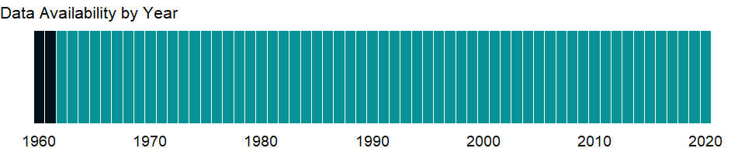

### Which countries have data?

The figure below shows the percentage of countries in each income group with a value since 2010 for that indicator.



### Why is it relevant?

Because development encompasses many factors - economic, environmental, cultural, educational, and institutional - no single measure gives a complete picture. However, the total earnings of the residents of an economy, measured by its gross national income (GNI), is a good measure of its capacity to provide for the well-being of its people.

### What is the data source?

World Bank national accounts data, and OECD National Accounts data files.

### What is the methodology?

In calculating GNI and GNI per capita in U.S. dollars for certain operational purposes, the World Bank uses the Atlas conversion factor. The purpose of the Atlas conversion factor is to reduce the impact of exchange rate fluctuations in the cross-country comparison of national incomes.

The Atlas conversion factor for any year is the average of a country’s exchange rate (or alternative conversion factor) for that year and its exchange rates for the two preceding years, adjusted for the difference between the rate of inflation in the country and that in Japan, the United Kingdom, the United States, and the Euro area. A country’s inflation rate is measured by the change in its GDP deflator.

The inflation rate for Japan, the United Kingdom, the United States, and the Euro area, representing international inflation, is measured by the change in the SDR deflator. (Special drawing rights, or SDRs, are the International Monetary Fund’s unit of account.) The SDR deflator is calculated as a weighted average of these countries’ GDP deflators in SDR terms, the weights being the amount of each country’s currency in one SDR unit. Weights vary over time because both the composition of the SDR and the relative exchange rates for each currency change. The SDR deflator is calculated in SDR terms first and then converted to U.S. dollars using the SDR to dollar Atlas conversion factor. The Atlas conversion factor is then applied to a country’s GNI. The resulting GNI in U.S. dollars is divided by the midyear population to derive GNI per capita.

The World Bank systematically assesses the appropriateness of official exchange rates as conversion factors. An alternative conversion factor is used in the Atlas formula when the official exchange rate is judged to diverge by an exceptionally large margin from the rate effectively applied to domestic transactions of foreign currencies and traded products. This applies to only a small number of countries, as shown in the country-level metadata. Alternative conversion factors are used in the Atlas methodology and elsewhere in World Development Indicators as single-year conversion factors.

### How is it aggregated?

Gap-filled total

### What are the limitations?

NA

### What else should I know?

NA

### 1.55.2 GNI per capita, Atlas method (current US$)

### What is the indicator?

GNI per capita (formerly GNP per capita) is the gross national income, converted to U.S. dollars using the World Bank Atlas method, divided by the midyear population. GNI is the sum of value added by all resident producers plus any product taxes (less subsidies) not included in the valuation of output plus net receipts of primary income (compensation of employees and property income) from abroad. GNI, calculated in national currency, is usually converted to U.S. dollars at official exchange rates for comparisons across economies, although an alternative rate is used when the official exchange rate is judged to diverge by an exceptionally large margin from the rate actually applied in international transactions. To smooth fluctuations in prices and exchange rates, a special Atlas method of conversion is used by the World Bank. This applies a conversion factor that averages the exchange rate for a given year and the two preceding years, adjusted for differences in rates of inflation between the country, and through 2000, the G-5 countries (France, Germany, Japan, the United Kingdom, and the United States). From 2001, these countries include the Euro area, Japan, the United Kingdom, and the United States.

Topic: Economic Policy & Debt: National accounts: Atlas GNI & GNI per capita

Series ID: NY.GNP.PCAP.CD

Copyright: CC BY-4.0 , <https://datacatalog.worldbank.org/public-licenses#cc-by>

First year with any data: 1962

Last year with any data: 2020

### What years are data available?

The figure below shows years in which data is available for at least one country. Dates shaded in black have no data, while dates shaded in green have data for at least one country



### Which countries have data?

The figure below shows the percentage of countries in each income group with a value since 2010 for that indicator.



### Why is it relevant?

NA

### What is the data source?

World Bank national accounts data, and OECD National Accounts data files.

### What is the methodology?

The World Bank uses Atlas method GNI per capita in U.S. dollars to classify countries for analytical purposes and to determine borrowing eligibility. For more information, see the metadata for Atlas method GNI in current U.S. dollars (NY.GNP.ATLS.CD) and total population (SP.POP.TOTL).

### How is it aggregated?

Weighted Average

### What are the limitations?

NA

### What else should I know?

NA

## 1.56 Social Protection & Labor: Performance

### 1.56.1 Adequacy of social protection and labor programs (% of total welfare of beneficiary households)

### What is the indicator?

Adequacy of social protection and labor programs (SPL) is measured by the total transfer amount received by the population participating in social insurance, social safety net, and unemployment benefits and active labor market programs as a share of their total welfare. Welfare is defined as the total income or total expenditure of beneficiary households. Estimates include both direct and indirect beneficiaries.

Topic: Social Protection & Labor: Performance

Series ID: per_allsp.adq_pop_tot

Copyright: CC BY-4.0 , <https://datacatalog.worldbank.org/public-licenses#cc-by>

First year with any data: 1998

Last year with any data: 2019

### What years are data available?

The figure below shows years in which data is available for at least one country. Dates shaded in black have no data, while dates shaded in green have data for at least one country

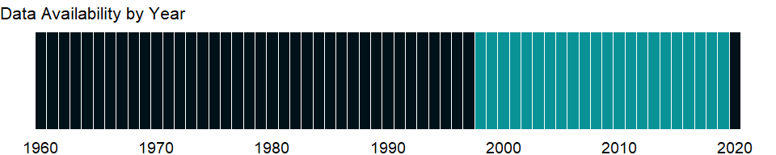

### Which countries have data?

The figure below shows the percentage of countries in each income group with a value since 2010 for that indicator.

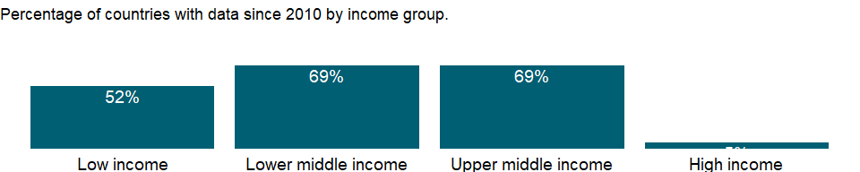

### Why is it relevant?

NA

### What is the data source?

ASPIRE: The Atlas of Social Protection - Indicators of Resilience and Equity, The World Bank. Data are based on national representative household surveys. (datatopics.worldbank.org/aspire/)

### What is the methodology?

NA

### How is it aggregated?

NA

### What are the limitations?

When interpreting ASPIRE performance indicators based on household surveys, it is important to note that the extent to which information on specific transfers and programs is captured in the household surveys can vary a lot across countries. Moreover, household surveys do not capture the universe of social protection programs in the country, in best practice cases just the largest programs. As a consequence, ASPIRE indicators are not fully comparable across program categories and countries; however, they provide approximate measures of social protection systems performance. In addition, there may be cases where ASPIRE performance indicators differ from official WB country reports as ASPIRE indicators are based on a first level analysis of original survey data and unified methodology that does not necessarily reflect country-specific knowledge and in depth country analysis relying on administrative program level data and/or imputations.

### What else should I know?

NA

### 1.56.2 Benefit incidence of social protection and labor programs to poorest quintile (% of total SPL benefits)

### What is the indicator?

Benefit incidence of social protection and labor programs (SPL) to poorest quintile shows the percentage of total social protection and labor programs benefits received by the poorest 20% of the population. Social protection and labor programs include social insurance, social safety nets, and unemployment benefits and active labor market programs. Estimates include both direct and indirect beneficiaries.

Topic: Social Protection & Labor: Performance

Series ID: per_allsp.ben_q1_tot

Copyright: CC BY-4.0 , <https://datacatalog.worldbank.org/public-licenses#cc-by>

First year with any data: 1998

Last year with any data: 2019

### What years are data available?

The figure below shows years in which data is available for at least one country. Dates shaded in black have no data, while dates shaded in green have data for at least one country



### Which countries have data?

The figure below shows the percentage of countries in each income group with a value since 2010 for that indicator.



### Why is it relevant?

NA

### What is the data source?

ASPIRE: The Atlas of Social Protection - Indicators of Resilience and Equity, The World Bank. Data are based on national representative household surveys. (datatopics.worldbank.org/aspire/)

### What is the methodology?

NA

### How is it aggregated?

NA

### What are the limitations?

When interpreting ASPIRE performance indicators based on household surveys, it is important to note that the extent to which information on specific transfers and programs is captured in the household surveys can vary a lot across countries. Moreover, household surveys do not capture the universe of social protection programs in the country, in best practice cases just the largest programs. As a consequence, ASPIRE indicators are not fully comparable across program categories and countries; however, they provide approximate measures of social protection systems performance. In addition, there may be cases where ASPIRE performance indicators differ from official WB country reports as ASPIRE indicators are based on a first level analysis of original survey data and unified methodology that does not necessarily reflect country-specific knowledge and in depth country analysis relying on administrative program level data and/or imputations.

### What else should I know?

NA

### 1.56.3 Coverage of social protection and labor programs (% of population)

### What is the indicator?

Coverage of social protection and labor programs (SPL) shows the percentage of population participating in social insurance, social safety net, and unemployment benefits and active labor market programs. Estimates include both direct and indirect beneficiaries.

Topic: Social Protection & Labor: Performance

Series ID: per_allsp.cov_pop_tot

Copyright: CC BY-4.0 , <https://datacatalog.worldbank.org/public-licenses#cc-by>

First year with any data: 1998

Last year with any data: 2019

### What years are data available?

The figure below shows years in which data is available for at least one country. Dates shaded in black have no data, while dates shaded in green have data for at least one country



### Which countries have data?

The figure below shows the percentage of countries in each income group with a value since 2010 for that indicator.

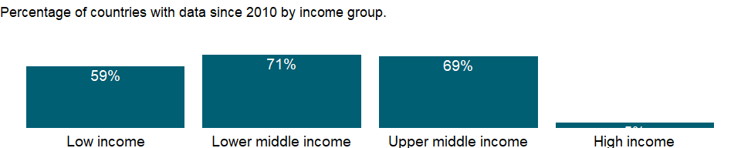

### Why is it relevant?

NA

### What is the data source?

ASPIRE: The Atlas of Social Protection - Indicators of Resilience and Equity, The World Bank. Data are based on national representative household surveys. (datatopics.worldbank.org/aspire/)

### What is the methodology?

NA

### How is it aggregated?

NA

### What are the limitations?

When interpreting ASPIRE performance indicators based on household surveys, it is important to note that the extent to which information on specific transfers and programs is captured in the household surveys can vary a lot across countries. Moreover, household surveys do not capture the universe of social protection programs in the country, in best practice cases just the largest programs. As a consequence, ASPIRE indicators are not fully comparable across program categories and countries; however, they provide approximate measures of social protection systems performance. In addition, there may be cases where ASPIRE performance indicators differ from official WB country reports as ASPIRE indicators are based on a first level analysis of original survey data and unified methodology that does not necessarily reflect country-specific knowledge and in depth country analysis relying on administrative program level data and/or imputations.

### What else should I know?

NA

### 1.56.4 Adequacy of unemployment benefits and ALMP (% of total welfare of beneficiary households)

### What is the indicator?

Adequacy of unemployment benefits and active labor market programs (ALMP) is measured by the total transfer amount received by the population participating in unemployment benefits and active labor market programs as a share of their total welfare. Welfare is defined as the total income or total expenditure of beneficiary households. Unemployment benefits and active labor market programs include unemployment compensation, severance pay, and early retirement due to labor market reasons, labor market services (intermediation), training (vocational, life skills, and cash for training), job rotation and job sharing, employment incentives and wage subsidies, supported employment and rehabilitation, and employment measures for the disabled. Estimates include both direct and indirect beneficiaries.

Topic: Social Protection & Labor: Performance

Series ID: per_lm_alllm.adq_pop_tot

Copyright: CC BY-4.0 , <https://datacatalog.worldbank.org/public-licenses#cc-by>

First year with any data: 2004

Last year with any data: 2019

### What years are data available?

The figure below shows years in which data is available for at least one country. Dates shaded in black have no data, while dates shaded in green have data for at least one country



### Which countries have data?

The figure below shows the percentage of countries in each income group with a value since 2010 for that indicator.

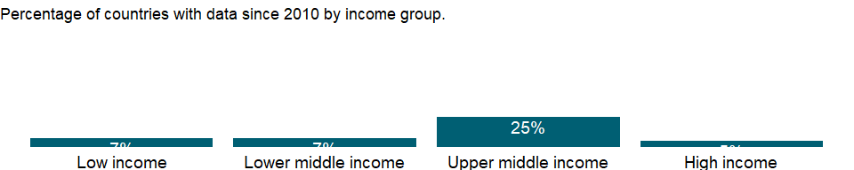

### Why is it relevant?

NA

### What is the data source?

ASPIRE: The Atlas of Social Protection - Indicators of Resilience and Equity, The World Bank. Data are based on national representative household surveys. (datatopics.worldbank.org/aspire/)

### What is the methodology?

NA

### How is it aggregated?

NA

### What are the limitations?

When interpreting ASPIRE performance indicators based on household surveys, it is important to note that the extent to which information on specific transfers and programs is captured in the household surveys can vary a lot across countries. Moreover, household surveys do not capture the universe of social protection programs in the country, in best practice cases just the largest programs. As a consequence, ASPIRE indicators are not fully comparable across program categories and countries; however, they provide approximate measures of social protection systems performance. In addition, there may be cases where ASPIRE performance indicators differ from official WB country reports as ASPIRE indicators are based on a first level analysis of original survey data and unified methodology that does not necessarily reflect country-specific knowledge and in depth country analysis relying on administrative program level data and/or imputations.

### What else should I know?

NA

### 1.56.5 Benefit incidence of unemployment benefits and ALMP to poorest quintile (% of total U/ALMP benefits)

### What is the indicator?

Benefit incidence of unemployment benefits and active labor market programs (ALMP) to poorest quintile shows the percentage of total unemployment and active labor market programs benefits received by the poorest 20% of the population. Unemployment benefits and active labor market programs include unemployment compensation, severance pay, and early retirement due to labor market reasons, labor market services (intermediation), training (vocational, life skills, and cash for training), job rotation and job sharing, employment incentives and wage subsidies, supported employment and rehabilitation, and employment measures for the disabled. Estimates include both direct and indirect beneficiaries.

Topic: Social Protection & Labor: Performance

Series ID: per_lm_alllm.ben_q1_tot

Copyright: CC BY-4.0 , <https://datacatalog.worldbank.org/public-licenses#cc-by>

First year with any data: 2004

Last year with any data: 2019

### What years are data available?

The figure below shows years in which data is available for at least one country. Dates shaded in black have no data, while dates shaded in green have data for at least one country



### Which countries have data?

The figure below shows the percentage of countries in each income group with a value since 2010 for that indicator.



### Why is it relevant?

NA

### What is the data source?

ASPIRE: The Atlas of Social Protection - Indicators of Resilience and Equity, The World Bank. Data are based on national representative household surveys. (datatopics.worldbank.org/aspire/)

### What is the methodology?

NA

### How is it aggregated?

NA

### What are the limitations?

When interpreting ASPIRE performance indicators based on household surveys, it is important to note that the extent to which information on specific transfers and programs is captured in the household surveys can vary a lot across countries. Moreover, household surveys do not capture the universe of social protection programs in the country, in best practice cases just the largest programs. As a consequence, ASPIRE indicators are not fully comparable across program categories and countries; however, they provide approximate measures of social protection systems performance. In addition, there may be cases where ASPIRE performance indicators differ from official WB country reports as ASPIRE indicators are based on a first level analysis of original survey data and unified methodology that does not necessarily reflect country-specific knowledge and in depth country analysis relying on administrative program level data and/or imputations.

### What else should I know?

NA

### 1.56.6 Coverage of unemployment benefits and ALMP (% of population)

### What is the indicator?

Coverage of unemployment benefits and active labor market programs (ALMP) shows the percentage of population participating in unemployment compensation, severance pay, and early retirement due to labor market reasons, labor market services (intermediation), training (vocational, life skills, and cash for training), job rotation and job sharing, employment incentives and wage subsidies, supported employment and rehabilitation, and employment measures for the disabled. Estimates include both direct and indirect beneficiaries.

Topic: Social Protection & Labor: Performance

Series ID: per_lm_alllm.cov_pop_tot

Copyright: CC BY-4.0 , <https://datacatalog.worldbank.org/public-licenses#cc-by>

First year with any data: 2002

Last year with any data: 2019

### What years are data available?

The figure below shows years in which data is available for at least one country. Dates shaded in black have no data, while dates shaded in green have data for at least one country

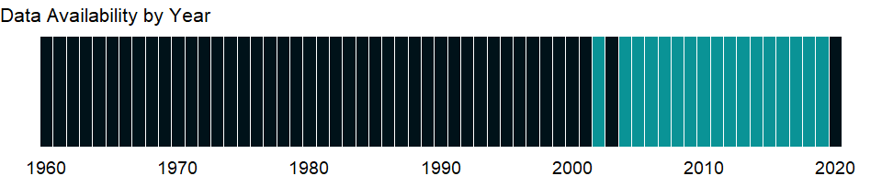

### Which countries have data?

The figure below shows the percentage of countries in each income group with a value since 2010 for that indicator.

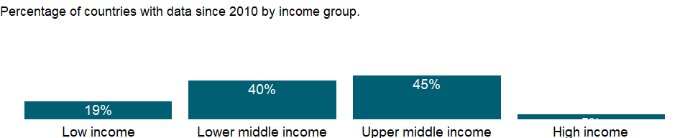

### Why is it relevant?

NA

### What is the data source?

ASPIRE: The Atlas of Social Protection - Indicators of Resilience and Equity, The World Bank. Data are based on national representative household surveys. (datatopics.worldbank.org/aspire/)

### What is the methodology?

NA

### How is it aggregated?

NA

### What are the limitations?

When interpreting ASPIRE performance indicators based on household surveys, it is important to note that the extent to which information on specific transfers and programs is captured in the household surveys can vary a lot across countries. Moreover, household surveys do not capture the universe of social protection programs in the country, in best practice cases just the largest programs. As a consequence, ASPIRE indicators are not fully comparable across program categories and countries; however, they provide approximate measures of social protection systems performance. In addition, there may be cases where ASPIRE performance indicators differ from official WB country reports as ASPIRE indicators are based on a first level analysis of original survey data and unified methodology that does not necessarily reflect country-specific knowledge and in depth country analysis relying on administrative program level data and/or imputations.

### What else should I know?

NA

### 1.56.7 Coverage of unemployment benefits and ALMP in poorest quintile (% of population)

### What is the indicator?

Coverage of unemployment benefits and active labor market programs (ALMP) shows the percentage of population participating in unemployment compensation, severance pay, and early retirement due to labor market reasons, labor market services (intermediation), training (vocational, life skills, and cash for training), job rotation and job sharing, employment incentives and wage subsidies, supported employment and rehabilitation, and employment measures for the disabled. Estimates include both direct and indirect beneficiaries.

Topic: Social Protection & Labor: Performance

Series ID: per_lm_alllm.cov_q1_tot

Copyright: CC BY-4.0 , <https://datacatalog.worldbank.org/public-licenses#cc-by>

First year with any data: 2002

Last year with any data: 2019

### What years are data available?

The figure below shows years in which data is available for at least one country. Dates shaded in black have no data, while dates shaded in green have data for at least one country



### Which countries have data?

The figure below shows the percentage of countries in each income group with a value since 2010 for that indicator.



### Why is it relevant?

NA

### What is the data source?

ASPIRE: The Atlas of Social Protection - Indicators of Resilience and Equity, The World Bank. Data are based on national representative household surveys. (datatopics.worldbank.org/aspire/)

### What is the methodology?

NA

### How is it aggregated?

NA

### What are the limitations?

When interpreting ASPIRE performance indicators based on household surveys, it is important to note that the extent to which information on specific transfers and programs is captured in the household surveys can vary a lot across countries. Moreover, household surveys do not capture the universe of social protection programs in the country, in best practice cases just the largest programs. As a consequence, ASPIRE indicators are not fully comparable across program categories and countries; however, they provide approximate measures of social protection systems performance. In addition, there may be cases where ASPIRE performance indicators differ from official WB country reports as ASPIRE indicators are based on a first level analysis of original survey data and unified methodology that does not necessarily reflect country-specific knowledge and in depth country analysis relying on administrative program level data and/or imputations.

### What else should I know?

NA

### 1.56.8 Coverage of unemployment benefits and ALMP in 2nd quintile (% of population)

### What is the indicator?

Coverage of unemployment benefits and active labor market programs (ALMP) shows the percentage of population participating in unemployment compensation, severance pay, and early retirement due to labor market reasons, labor market services (intermediation), training (vocational, life skills, and cash for training), job rotation and job sharing, employment incentives and wage subsidies, supported employment and rehabilitation, and employment measures for the disabled. Estimates include both direct and indirect beneficiaries.

Topic: Social Protection & Labor: Performance

Series ID: per_lm_alllm.cov_q2_tot

Copyright: CC BY-4.0 , <https://datacatalog.worldbank.org/public-licenses#cc-by>

First year with any data: 2002

Last year with any data: 2019

### What years are data available?

The figure below shows years in which data is available for at least one country. Dates shaded in black have no data, while dates shaded in green have data for at least one country



### Which countries have data?

The figure below shows the percentage of countries in each income group with a value since 2010 for that indicator.



### Why is it relevant?

NA

### What is the data source?

ASPIRE: The Atlas of Social Protection - Indicators of Resilience and Equity, The World Bank. Data are based on national representative household surveys. (datatopics.worldbank.org/aspire/)

### What is the methodology?

NA

### How is it aggregated?

NA

### What are the limitations?

When interpreting ASPIRE performance indicators based on household surveys, it is important to note that the extent to which information on specific transfers and programs is captured in the household surveys can vary a lot across countries. Moreover, household surveys do not capture the universe of social protection programs in the country, in best practice cases just the largest programs. As a consequence, ASPIRE indicators are not fully comparable across program categories and countries; however, they provide approximate measures of social protection systems performance. In addition, there may be cases where ASPIRE performance indicators differ from official WB country reports as ASPIRE indicators are based on a first level analysis of original survey data and unified methodology that does not necessarily reflect country-specific knowledge and in depth country analysis relying on administrative program level data and/or imputations.

### What else should I know?

NA

### 1.56.9 Coverage of unemployment benefits and ALMP in 3rd quintile (% of population)

### What is the indicator?

Coverage of unemployment benefits and active labor market programs (ALMP) shows the percentage of population participating in unemployment compensation, severance pay, and early retirement due to labor market reasons, labor market services (intermediation), training (vocational, life skills, and cash for training), job rotation and job sharing, employment incentives and wage subsidies, supported employment and rehabilitation, and employment measures for the disabled. Estimates include both direct and indirect beneficiaries.

Topic: Social Protection & Labor: Performance

Series ID: per_lm_alllm.cov_q3_tot

Copyright: CC BY-4.0 , <https://datacatalog.worldbank.org/public-licenses#cc-by>

First year with any data: 2002

Last year with any data: 2019

### What years are data available?

The figure below shows years in which data is available for at least one country. Dates shaded in black have no data, while dates shaded in green have data for at least one country



### Which countries have data?

The figure below shows the percentage of countries in each income group with a value since 2010 for that indicator.



### Why is it relevant?

NA

### What is the data source?

ASPIRE: The Atlas of Social Protection - Indicators of Resilience and Equity, The World Bank. Data are based on national representative household surveys. (datatopics.worldbank.org/aspire/)

### What is the methodology?

NA

### How is it aggregated?

NA

### What are the limitations?

When interpreting ASPIRE performance indicators based on household surveys, it is important to note that the extent to which information on specific transfers and programs is captured in the household surveys can vary a lot across countries. Moreover, household surveys do not capture the universe of social protection programs in the country, in best practice cases just the largest programs. As a consequence, ASPIRE indicators are not fully comparable across program categories and countries; however, they provide approximate measures of social protection systems performance. In addition, there may be cases where ASPIRE performance indicators differ from official WB country reports as ASPIRE indicators are based on a first level analysis of original survey data and unified methodology that does not necessarily reflect country-specific knowledge and in depth country analysis relying on administrative program level data and/or imputations.

### What else should I know?

NA

### 1.56.10 Coverage of unemployment benefits and ALMP in 4th quintile (% of population)

### What is the indicator?

Coverage of unemployment benefits and active labor market programs (ALMP) shows the percentage of population participating in unemployment compensation, severance pay, and early retirement due to labor market reasons, labor market services (intermediation), training (vocational, life skills, and cash for training), job rotation and job sharing, employment incentives and wage subsidies, supported employment and rehabilitation, and employment measures for the disabled. Estimates include both direct and indirect beneficiaries.

Topic: Social Protection & Labor: Performance

Series ID: per_lm_alllm.cov_q4_tot

Copyright: CC BY-4.0 , <https://datacatalog.worldbank.org/public-licenses#cc-by>

First year with any data: 2002

Last year with any data: 2019

### What years are data available?

The figure below shows years in which data is available for at least one country. Dates shaded in black have no data, while dates shaded in green have data for at least one country



### Which countries have data?

The figure below shows the percentage of countries in each income group with a value since 2010 for that indicator.



### Why is it relevant?

NA

### What is the data source?

ASPIRE: The Atlas of Social Protection - Indicators of Resilience and Equity, The World Bank. Data are based on national representative household surveys. (datatopics.worldbank.org/aspire/)

### What is the methodology?

NA

### How is it aggregated?

NA

### What are the limitations?

When interpreting ASPIRE performance indicators based on household surveys, it is important to note that the extent to which information on specific transfers and programs is captured in the household surveys can vary a lot across countries. Moreover, household surveys do not capture the universe of social protection programs in the country, in best practice cases just the largest programs. As a consequence, ASPIRE indicators are not fully comparable across program categories and countries; however, they provide approximate measures of social protection systems performance. In addition, there may be cases where ASPIRE performance indicators differ from official WB country reports as ASPIRE indicators are based on a first level analysis of original survey data and unified methodology that does not necessarily reflect country-specific knowledge and in depth country analysis relying on administrative program level data and/or imputations.

### What else should I know?

NA

### 1.56.11 Coverage of unemployment benefits and ALMP in richest quintile (% of population)

### What is the indicator?

Coverage of unemployment benefits and active labor market programs (ALMP) shows the percentage of population participating in unemployment compensation, severance pay, and early retirement due to labor market reasons, labor market services (intermediation), training (vocational, life skills, and cash for training), job rotation and job sharing, employment incentives and wage subsidies, supported employment and rehabilitation, and employment measures for the disabled. Estimates include both direct and indirect beneficiaries.

Topic: Social Protection & Labor: Performance

Series ID: per_lm_alllm.cov_q5_tot

Copyright: CC BY-4.0 , <https://datacatalog.worldbank.org/public-licenses#cc-by>

First year with any data: 2002

Last year with any data: 2019

### What years are data available?

The figure below shows years in which data is available for at least one country. Dates shaded in black have no data, while dates shaded in green have data for at least one country



### Which countries have data?

The figure below shows the percentage of countries in each income group with a value since 2010 for that indicator.



### Why is it relevant?

NA

### What is the data source?

ASPIRE: The Atlas of Social Protection - Indicators of Resilience and Equity, The World Bank. Data are based on national representative household surveys. (datatopics.worldbank.org/aspire/)

### What is the methodology?

NA

### How is it aggregated?

NA

### What are the limitations?

When interpreting ASPIRE performance indicators based on household surveys, it is important to note that the extent to which information on specific transfers and programs is captured in the household surveys can vary a lot across countries. Moreover, household surveys do not capture the universe of social protection programs in the country, in best practice cases just the largest programs. As a consequence, ASPIRE indicators are not fully comparable across program categories and countries; however, they provide approximate measures of social protection systems performance. In addition, there may be cases where ASPIRE performance indicators differ from official WB country reports as ASPIRE indicators are based on a first level analysis of original survey data and unified methodology that does not necessarily reflect country-specific knowledge and in depth country analysis relying on administrative program level data and/or imputations.

### What else should I know?

NA

### 1.56.12 Adequacy of social safety net programs (% of total welfare of beneficiary households)

### What is the indicator?

Adequacy of social safety net programs is measured by the total transfer amount received by the population participating in social safety net programs as a share of their total welfare. Welfare is defined as the total income or total expenditure of beneficiary households. Social safety net programs include cash transfers and last resort programs, noncontributory social pensions, other cash transfers programs (child, family and orphan allowances, birth and death grants, disability benefits, and other allowances), conditional cash transfers, in-kind food transfers (food stamps and vouchers, food rations, supplementary feeding, and emergency food distribution), school feeding, other social assistance programs (housing allowances, scholarships, fee waivers, health subsidies, and other social assistance) and public works programs (cash for work and food for work). Estimates include both direct and indirect beneficiaries.

Topic: Social Protection & Labor: Performance

Series ID: per_sa_allsa.adq_pop_tot

Copyright: CC BY-4.0 , <https://datacatalog.worldbank.org/public-licenses#cc-by>

First year with any data: 1998

Last year with any data: 2019

### What years are data available?

The figure below shows years in which data is available for at least one country. Dates shaded in black have no data, while dates shaded in green have data for at least one country

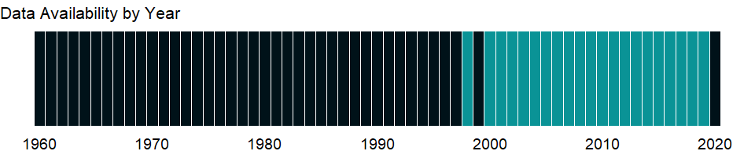

### Which countries have data?

The figure below shows the percentage of countries in each income group with a value since 2010 for that indicator.

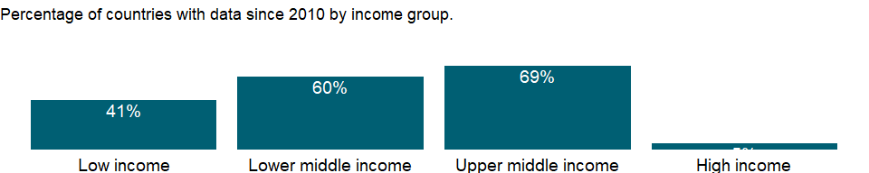

### Why is it relevant?

NA

### What is the data source?

ASPIRE: The Atlas of Social Protection - Indicators of Resilience and Equity, The World Bank. Data are based on national representative household surveys. (datatopics.worldbank.org/aspire/)

### What is the methodology?

NA

### How is it aggregated?

NA

### What are the limitations?

When interpreting ASPIRE performance indicators based on household surveys, it is important to note that the extent to which information on specific transfers and programs is captured in the household surveys can vary a lot across countries. Moreover, household surveys do not capture the universe of social protection programs in the country, in best practice cases just the largest programs. As a consequence, ASPIRE indicators are not fully comparable across program categories and countries; however, they provide approximate measures of social protection systems performance. In addition, there may be cases where ASPIRE performance indicators differ from official WB country reports as ASPIRE indicators are based on a first level analysis of original survey data and unified methodology that does not necessarily reflect country-specific knowledge and in depth country analysis relying on administrative program level data and/or imputations.

### What else should I know?

NA

### 1.56.13 Benefit incidence of social safety net programs to poorest quintile (% of total safety net benefits)

### What is the indicator?

Benefit incidence of social safety net programs to poorest quintile shows the percentage of total social safety net benefits received by the poorest 20% of the population. Social safety net programs include cash transfers and last resort programs, noncontributory social pensions, other cash transfers programs (child, family and orphan allowances, birth and death grants, disability benefits, and other allowances), conditional cash transfers, in-kind food transfers (food stamps and vouchers, food rations, supplementary feeding, and emergency food distribution), school feeding, other social assistance programs (housing allowances, scholarships, fee waivers, health subsidies, and other social assistance) and public works programs (cash for work and food for work). Estimates include both direct and indirect beneficiaries.

Topic: Social Protection & Labor: Performance

Series ID: per_sa_allsa.ben_q1_tot

Copyright: CC BY-4.0 , <https://datacatalog.worldbank.org/public-licenses#cc-by>

First year with any data: 1998

Last year with any data: 2019

### What years are data available?

The figure below shows years in which data is available for at least one country. Dates shaded in black have no data, while dates shaded in green have data for at least one country



### Which countries have data?

The figure below shows the percentage of countries in each income group with a value since 2010 for that indicator.



### Why is it relevant?

NA

### What is the data source?

ASPIRE: The Atlas of Social Protection - Indicators of Resilience and Equity, The World Bank. Data are based on national representative household surveys. (datatopics.worldbank.org/aspire/)

### What is the methodology?

NA

### How is it aggregated?

NA

### What are the limitations?

When interpreting ASPIRE performance indicators based on household surveys, it is important to note that the extent to which information on specific transfers and programs is captured in the household surveys can vary a lot across countries. Moreover, household surveys do not capture the universe of social protection programs in the country, in best practice cases just the largest programs. As a consequence, ASPIRE indicators are not fully comparable across program categories and countries; however, they provide approximate measures of social protection systems performance. In addition, there may be cases where ASPIRE performance indicators differ from official WB country reports as ASPIRE indicators are based on a first level analysis of original survey data and unified methodology that does not necessarily reflect country-specific knowledge and in depth country analysis relying on administrative program level data and/or imputations.

### What else should I know?

NA

### 1.56.14 Coverage of social safety net programs (% of population)

### What is the indicator?

Coverage of social safety net programs shows the percentage of population participating in cash transfers and last resort programs, noncontributory social pensions, other cash transfers programs (child, family and orphan allowances, birth and death grants, disability benefits, and other allowances), conditional cash transfers, in-kind food transfers (food stamps and vouchers, food rations, supplementary feeding, and emergency food distribution), school feeding, other social assistance programs (housing allowances, scholarships, fee waivers, health subsidies, and other social assistance) and public works programs (cash for work and food for work). Estimates include both direct and indirect beneficiaries.

Topic: Social Protection & Labor: Performance

Series ID: per_sa_allsa.cov_pop_tot

Copyright: CC BY-4.0 , <https://datacatalog.worldbank.org/public-licenses#cc-by>

First year with any data: 1998

Last year with any data: 2019

### What years are data available?

The figure below shows years in which data is available for at least one country. Dates shaded in black have no data, while dates shaded in green have data for at least one country



### Which countries have data?

The figure below shows the percentage of countries in each income group with a value since 2010 for that indicator.

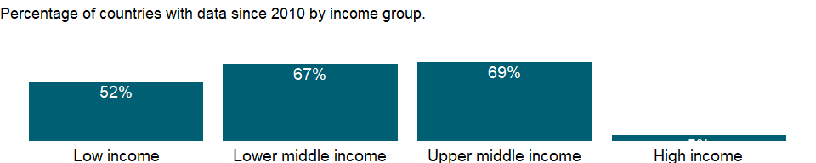

### Why is it relevant?

NA

### What is the data source?

ASPIRE: The Atlas of Social Protection - Indicators of Resilience and Equity, The World Bank. Data are based on national representative household surveys. (datatopics.worldbank.org/aspire/)

### What is the methodology?

NA

### How is it aggregated?

NA

### What are the limitations?

When interpreting ASPIRE performance indicators based on household surveys, it is important to note that the extent to which information on specific transfers and programs is captured in the household surveys can vary a lot across countries. Moreover, household surveys do not capture the universe of social protection programs in the country, in best practice cases just the largest programs. As a consequence, ASPIRE indicators are not fully comparable across program categories and countries; however, they provide approximate measures of social protection systems performance. In addition, there may be cases where ASPIRE performance indicators differ from official WB country reports as ASPIRE indicators are based on a first level analysis of original survey data and unified methodology that does not necessarily reflect country-specific knowledge and in depth country analysis relying on administrative program level data and/or imputations.

### What else should I know?

NA

### 1.56.15 Coverage of social safety net programs in poorest quintile (% of population)

### What is the indicator?

Coverage of social safety net programs shows the percentage of population participating in cash transfers and last resort programs, noncontributory social pensions, other cash transfers programs (child, family and orphan allowances, birth and death grants, disability benefits, and other allowances), conditional cash transfers, in-kind food transfers (food stamps and vouchers, food rations, supplementary feeding, and emergency food distribution), school feeding, other social assistance programs (housing allowances, scholarships, fee waivers, health subsidies, and other social assistance) and public works programs (cash for work and food for work). Estimates include both direct and indirect beneficiaries.

Topic: Social Protection & Labor: Performance

Series ID: per_sa_allsa.cov_q1_tot

Copyright: CC BY-4.0 , <https://datacatalog.worldbank.org/public-licenses#cc-by>

First year with any data: 1998

Last year with any data: 2019

### What years are data available?

The figure below shows years in which data is available for at least one country. Dates shaded in black have no data, while dates shaded in green have data for at least one country



### Which countries have data?

The figure below shows the percentage of countries in each income group with a value since 2010 for that indicator.



### Why is it relevant?

NA

### What is the data source?

ASPIRE: The Atlas of Social Protection - Indicators of Resilience and Equity, The World Bank. Data are based on national representative household surveys. (datatopics.worldbank.org/aspire/)

### What is the methodology?

NA

### How is it aggregated?

NA

### What are the limitations?

When interpreting ASPIRE performance indicators based on household surveys, it is important to note that the extent to which information on specific transfers and programs is captured in the household surveys can vary a lot across countries. Moreover, household surveys do not capture the universe of social protection programs in the country, in best practice cases just the largest programs. As a consequence, ASPIRE indicators are not fully comparable across program categories and countries; however, they provide approximate measures of social protection systems performance. In addition, there may be cases where ASPIRE performance indicators differ from official WB country reports as ASPIRE indicators are based on a first level analysis of original survey data and unified methodology that does not necessarily reflect country-specific knowledge and in depth country analysis relying on administrative program level data and/or imputations.

### What else should I know?

NA

### 1.56.16 Coverage of social safety net programs in 2nd quintile (% of population)

### What is the indicator?

Coverage of social safety net programs shows the percentage of population participating in cash transfers and last resort programs, noncontributory social pensions, other cash transfers programs (child, family and orphan allowances, birth and death grants, disability benefits, and other allowances), conditional cash transfers, in-kind food transfers (food stamps and vouchers, food rations, supplementary feeding, and emergency food distribution), school feeding, other social assistance programs (housing allowances, scholarships, fee waivers, health subsidies, and other social assistance) and public works programs (cash for work and food for work). Estimates include both direct and indirect beneficiaries.

Topic: Social Protection & Labor: Performance

Series ID: per_sa_allsa.cov_q2_tot

Copyright: CC BY-4.0 , <https://datacatalog.worldbank.org/public-licenses#cc-by>

First year with any data: 1998

Last year with any data: 2019

### What years are data available?

The figure below shows years in which data is available for at least one country. Dates shaded in black have no data, while dates shaded in green have data for at least one country



### Which countries have data?

The figure below shows the percentage of countries in each income group with a value since 2010 for that indicator.



### Why is it relevant?

NA

### What is the data source?

ASPIRE: The Atlas of Social Protection - Indicators of Resilience and Equity, The World Bank. Data are based on national representative household surveys. (datatopics.worldbank.org/aspire/)

### What is the methodology?

NA

### How is it aggregated?

NA

### What are the limitations?

When interpreting ASPIRE performance indicators based on household surveys, it is important to note that the extent to which information on specific transfers and programs is captured in the household surveys can vary a lot across countries. Moreover, household surveys do not capture the universe of social protection programs in the country, in best practice cases just the largest programs. As a consequence, ASPIRE indicators are not fully comparable across program categories and countries; however, they provide approximate measures of social protection systems performance. In addition, there may be cases where ASPIRE performance indicators differ from official WB country reports as ASPIRE indicators are based on a first level analysis of original survey data and unified methodology that does not necessarily reflect country-specific knowledge and in depth country analysis relying on administrative program level data and/or imputations.

### What else should I know?

NA

### 1.56.17 Coverage of social safety net programs in 3rd quintile (% of population)

### What is the indicator?

Coverage of social safety net programs shows the percentage of population participating in cash transfers and last resort programs, noncontributory social pensions, other cash transfers programs (child, family and orphan allowances, birth and death grants, disability benefits, and other allowances), conditional cash transfers, in-kind food transfers (food stamps and vouchers, food rations, supplementary feeding, and emergency food distribution), school feeding, other social assistance programs (housing allowances, scholarships, fee waivers, health subsidies, and other social assistance) and public works programs (cash for work and food for work). Estimates include both direct and indirect beneficiaries.

Topic: Social Protection & Labor: Performance

Series ID: per_sa_allsa.cov_q3_tot

Copyright: CC BY-4.0 , <https://datacatalog.worldbank.org/public-licenses#cc-by>

First year with any data: 1998

Last year with any data: 2019

### What years are data available?

The figure below shows years in which data is available for at least one country. Dates shaded in black have no data, while dates shaded in green have data for at least one country



### Which countries have data?

The figure below shows the percentage of countries in each income group with a value since 2010 for that indicator.



### Why is it relevant?

NA

### What is the data source?

ASPIRE: The Atlas of Social Protection - Indicators of Resilience and Equity, The World Bank. Data are based on national representative household surveys. (datatopics.worldbank.org/aspire/)

### What is the methodology?

NA

### How is it aggregated?

NA

### What are the limitations?

When interpreting ASPIRE performance indicators based on household surveys, it is important to note that the extent to which information on specific transfers and programs is captured in the household surveys can vary a lot across countries. Moreover, household surveys do not capture the universe of social protection programs in the country, in best practice cases just the largest programs. As a consequence, ASPIRE indicators are not fully comparable across program categories and countries; however, they provide approximate measures of social protection systems performance. In addition, there may be cases where ASPIRE performance indicators differ from official WB country reports as ASPIRE indicators are based on a first level analysis of original survey data and unified methodology that does not necessarily reflect country-specific knowledge and in depth country analysis relying on administrative program level data and/or imputations.

### What else should I know?

NA

### 1.56.18 Coverage of social safety net programs in 4th quintile (% of population)

### What is the indicator?

Coverage of social safety net programs shows the percentage of population participating in cash transfers and last resort programs, noncontributory social pensions, other cash transfers programs (child, family and orphan allowances, birth and death grants, disability benefits, and other allowances), conditional cash transfers, in-kind food transfers (food stamps and vouchers, food rations, supplementary feeding, and emergency food distribution), school feeding, other social assistance programs (housing allowances, scholarships, fee waivers, health subsidies, and other social assistance) and public works programs (cash for work and food for work). Estimates include both direct and indirect beneficiaries.

Topic: Social Protection & Labor: Performance

Series ID: per_sa_allsa.cov_q4_tot

Copyright: CC BY-4.0 , <https://datacatalog.worldbank.org/public-licenses#cc-by>

First year with any data: 1998

Last year with any data: 2019

### What years are data available?

The figure below shows years in which data is available for at least one country. Dates shaded in black have no data, while dates shaded in green have data for at least one country



### Which countries have data?

The figure below shows the percentage of countries in each income group with a value since 2010 for that indicator.



### Why is it relevant?

NA

### What is the data source?

ASPIRE: The Atlas of Social Protection - Indicators of Resilience and Equity, The World Bank. Data are based on national representative household surveys. (datatopics.worldbank.org/aspire/)

### What is the methodology?

NA

### How is it aggregated?

NA

### What are the limitations?

When interpreting ASPIRE performance indicators based on household surveys, it is important to note that the extent to which information on specific transfers and programs is captured in the household surveys can vary a lot across countries. Moreover, household surveys do not capture the universe of social protection programs in the country, in best practice cases just the largest programs. As a consequence, ASPIRE indicators are not fully comparable across program categories and countries; however, they provide approximate measures of social protection systems performance. In addition, there may be cases where ASPIRE performance indicators differ from official WB country reports as ASPIRE indicators are based on a first level analysis of original survey data and unified methodology that does not necessarily reflect country-specific knowledge and in depth country analysis relying on administrative program level data and/or imputations.

### What else should I know?

NA

### 1.56.19 Coverage of social safety net programs in richest quintile (% of population)

### What is the indicator?

Coverage of social safety net programs shows the percentage of population participating in cash transfers and last resort programs, noncontributory social pensions, other cash transfers programs (child, family and orphan allowances, birth and death grants, disability benefits, and other allowances), conditional cash transfers, in-kind food transfers (food stamps and vouchers, food rations, supplementary feeding, and emergency food distribution), school feeding, other social assistance programs (housing allowances, scholarships, fee waivers, health subsidies, and other social assistance) and public works programs (cash for work and food for work). Estimates include both direct and indirect beneficiaries.

Topic: Social Protection & Labor: Performance

Series ID: per_sa_allsa.cov_q5_tot

Copyright: CC BY-4.0 , <https://datacatalog.worldbank.org/public-licenses#cc-by>

First year with any data: 1998

Last year with any data: 2019

### What years are data available?

The figure below shows years in which data is available for at least one country. Dates shaded in black have no data, while dates shaded in green have data for at least one country



### Which countries have data?

The figure below shows the percentage of countries in each income group with a value since 2010 for that indicator.



### Why is it relevant?

NA

### What is the data source?

ASPIRE: The Atlas of Social Protection - Indicators of Resilience and Equity, The World Bank. Data are based on national representative household surveys. (datatopics.worldbank.org/aspire/)

### What is the methodology?

NA

### How is it aggregated?

NA

### What are the limitations?

When interpreting ASPIRE performance indicators based on household surveys, it is important to note that the extent to which information on specific transfers and programs is captured in the household surveys can vary a lot across countries. Moreover, household surveys do not capture the universe of social protection programs in the country, in best practice cases just the largest programs. As a consequence, ASPIRE indicators are not fully comparable across program categories and countries; however, they provide approximate measures of social protection systems performance. In addition, there may be cases where ASPIRE performance indicators differ from official WB country reports as ASPIRE indicators are based on a first level analysis of original survey data and unified methodology that does not necessarily reflect country-specific knowledge and in depth country analysis relying on administrative program level data and/or imputations.

### What else should I know?

NA

### 1.56.20 Adequacy of social insurance programs (% of total welfare of beneficiary households)

### What is the indicator?

Adequacy of social insurance programs is measured by the total transfer amount received by the population participating in social insurance programs as a share of their total welfare. Welfare is defined as the total income or total expenditure of beneficiary households. Social insurance programs include old age contributory pensions (including survivors and disability) and social security and health insurance benefits (including occupational injury benefits, paid sick leave, maternity and other social insurance). Estimates include both direct and indirect beneficiaries.

Topic: Social Protection & Labor: Performance

Series ID: per_si_allsi.adq_pop_tot

Copyright: CC BY-4.0 , <https://datacatalog.worldbank.org/public-licenses#cc-by>

First year with any data: 1998

Last year with any data: 2019

### What years are data available?

The figure below shows years in which data is available for at least one country. Dates shaded in black have no data, while dates shaded in green have data for at least one country

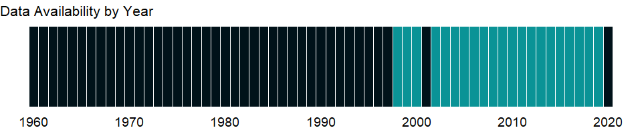

### Which countries have data?

The figure below shows the percentage of countries in each income group with a value since 2010 for that indicator.

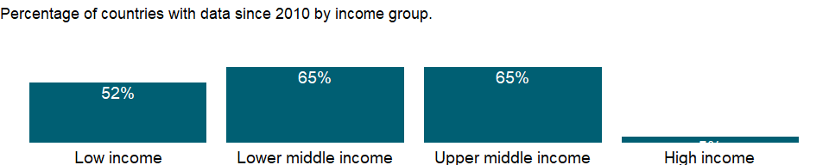

### Why is it relevant?

NA

### What is the data source?

ASPIRE: The Atlas of Social Protection - Indicators of Resilience and Equity, The World Bank. Data are based on national representative household surveys. (datatopics.worldbank.org/aspire/)

### What is the methodology?

NA

### How is it aggregated?

NA

### What are the limitations?

When interpreting ASPIRE performance indicators based on household surveys, it is important to note that the extent to which information on specific transfers and programs is captured in the household surveys can vary a lot across countries. Moreover, household surveys do not capture the universe of social protection programs in the country, in best practice cases just the largest programs. As a consequence, ASPIRE indicators are not fully comparable across program categories and countries; however, they provide approximate measures of social protection systems performance. In addition, there may be cases where ASPIRE performance indicators differ from official WB country reports as ASPIRE indicators are based on a first level analysis of original survey data and unified methodology that does not necessarily reflect country-specific knowledge and in depth country analysis relying on administrative program level data and/or imputations.

### What else should I know?

NA

### 1.56.21 Benefit incidence of social insurance programs to poorest quintile (% of total social insurance benefits)

### What is the indicator?

Benefit incidence of social insurance programs to poorest quintile shows the percentage of total social insurance benefits received by the poorest 20% of the population. Social insurance programs include old age contributory pensions (including survivors and disability) and social security and health insurance benefits (including occupational injury benefits, paid sick leave, maternity and other social insurance). Estimates include both direct and indirect beneficiaries.

Topic: Social Protection & Labor: Performance

Series ID: per_si_allsi.ben_q1_tot

Copyright: CC BY-4.0 , <https://datacatalog.worldbank.org/public-licenses#cc-by>

First year with any data: 1998

Last year with any data: 2019

### What years are data available?

The figure below shows years in which data is available for at least one country. Dates shaded in black have no data, while dates shaded in green have data for at least one country



### Which countries have data?

The figure below shows the percentage of countries in each income group with a value since 2010 for that indicator.



### Why is it relevant?

NA

### What is the data source?

ASPIRE: The Atlas of Social Protection - Indicators of Resilience and Equity, The World Bank. Data are based on national representative household surveys. (datatopics.worldbank.org/aspire/)

### What is the methodology?

NA

### How is it aggregated?

NA

### What are the limitations?

When interpreting ASPIRE performance indicators based on household surveys, it is important to note that the extent to which information on specific transfers and programs is captured in the household surveys can vary a lot across countries. Moreover, household surveys do not capture the universe of social protection programs in the country, in best practice cases just the largest programs. As a consequence, ASPIRE indicators are not fully comparable across program categories and countries; however, they provide approximate measures of social protection systems performance. In addition, there may be cases where ASPIRE performance indicators differ from official WB country reports as ASPIRE indicators are based on a first level analysis of original survey data and unified methodology that does not necessarily reflect country-specific knowledge and in depth country analysis relying on administrative program level data and/or imputations.

### What else should I know?

NA

### 1.56.22 Coverage of social insurance programs (% of population)

### What is the indicator?

Coverage of social insurance programs shows the percentage of population participating in programs that provide old age contributory pensions (including survivors and disability) and social security and health insurance benefits (including occupational injury benefits, paid sick leave, maternity and other social insurance). Estimates include both direct and indirect beneficiaries.

Topic: Social Protection & Labor: Performance

Series ID: per_si_allsi.cov_pop_tot

Copyright: CC BY-4.0 , <https://datacatalog.worldbank.org/public-licenses#cc-by>

First year with any data: 1998

Last year with any data: 2019

### What years are data available?

The figure below shows years in which data is available for at least one country. Dates shaded in black have no data, while dates shaded in green have data for at least one country



### Which countries have data?

The figure below shows the percentage of countries in each income group with a value since 2010 for that indicator.

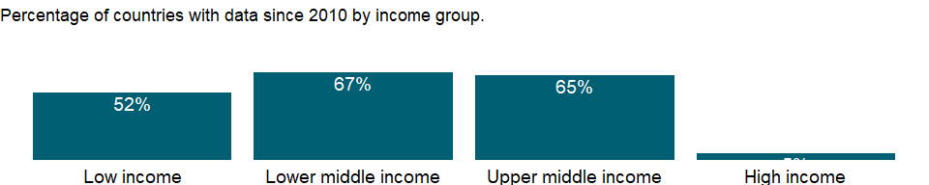

### Why is it relevant?

NA

### What is the data source?

ASPIRE: The Atlas of Social Protection - Indicators of Resilience and Equity, The World Bank. Data are based on national representative household surveys. (datatopics.worldbank.org/aspire/)

### What is the methodology?

NA

### How is it aggregated?

NA

### What are the limitations?

When interpreting ASPIRE performance indicators based on household surveys, it is important to note that the extent to which information on specific transfers and programs is captured in the household surveys can vary a lot across countries. Moreover, household surveys do not capture the universe of social protection programs in the country, in best practice cases just the largest programs. As a consequence, ASPIRE indicators are not fully comparable across program categories and countries; however, they provide approximate measures of social protection systems performance. In addition, there may be cases where ASPIRE performance indicators differ from official WB country reports as ASPIRE indicators are based on a first level analysis of original survey data and unified methodology that does not necessarily reflect country-specific knowledge and in depth country analysis relying on administrative program level data and/or imputations.

### What else should I know?

NA

### 1.56.23 Coverage of social insurance programs in poorest quintile (% of population)

### What is the indicator?

Coverage of social insurance programs shows the percentage of population participating in programs that provide old age contributory pensions (including survivors and disability) and social security and health insurance benefits (including occupational injury benefits, paid sick leave, maternity and other social insurance). Estimates include both direct and indirect beneficiaries.

Topic: Social Protection & Labor: Performance

Series ID: per_si_allsi.cov_q1_tot

Copyright: CC BY-4.0 , <https://datacatalog.worldbank.org/public-licenses#cc-by>

First year with any data: 1998

Last year with any data: 2019

### What years are data available?

The figure below shows years in which data is available for at least one country. Dates shaded in black have no data, while dates shaded in green have data for at least one country



### Which countries have data?

The figure below shows the percentage of countries in each income group with a value since 2010 for that indicator.



### Why is it relevant?

NA

### What is the data source?

ASPIRE: The Atlas of Social Protection - Indicators of Resilience and Equity, The World Bank. Data are based on national representative household surveys. (datatopics.worldbank.org/aspire/)

### What is the methodology?

NA

### How is it aggregated?

NA

### What are the limitations?

When interpreting ASPIRE performance indicators based on household surveys, it is important to note that the extent to which information on specific transfers and programs is captured in the household surveys can vary a lot across countries. Moreover, household surveys do not capture the universe of social protection programs in the country, in best practice cases just the largest programs. As a consequence, ASPIRE indicators are not fully comparable across program categories and countries; however, they provide approximate measures of social protection systems performance. In addition, there may be cases where ASPIRE performance indicators differ from official WB country reports as ASPIRE indicators are based on a first level analysis of original survey data and unified methodology that does not necessarily reflect country-specific knowledge and in depth country analysis relying on administrative program level data and/or imputations.

### What else should I know?

NA

### 1.56.24 Coverage of social insurance programs in 2nd quintile (% of population)

### What is the indicator?

Coverage of social insurance programs shows the percentage of population participating in programs that provide old age contributory pensions (including survivors and disability) and social security and health insurance benefits (including occupational injury benefits, paid sick leave, maternity and other social insurance). Estimates include both direct and indirect beneficiaries.

Topic: Social Protection & Labor: Performance

Series ID: per_si_allsi.cov_q2_tot

Copyright: CC BY-4.0 , <https://datacatalog.worldbank.org/public-licenses#cc-by>

First year with any data: 1998

Last year with any data: 2019

### What years are data available?

The figure below shows years in which data is available for at least one country. Dates shaded in black have no data, while dates shaded in green have data for at least one country



### Which countries have data?

The figure below shows the percentage of countries in each income group with a value since 2010 for that indicator.



### Why is it relevant?

NA

### What is the data source?

ASPIRE: The Atlas of Social Protection - Indicators of Resilience and Equity, The World Bank. Data are based on national representative household surveys. (datatopics.worldbank.org/aspire/)

### What is the methodology?

NA

### How is it aggregated?

NA

### What are the limitations?

When interpreting ASPIRE performance indicators based on household surveys, it is important to note that the extent to which information on specific transfers and programs is captured in the household surveys can vary a lot across countries. Moreover, household surveys do not capture the universe of social protection programs in the country, in best practice cases just the largest programs. As a consequence, ASPIRE indicators are not fully comparable across program categories and countries; however, they provide approximate measures of social protection systems performance. In addition, there may be cases where ASPIRE performance indicators differ from official WB country reports as ASPIRE indicators are based on a first level analysis of original survey data and unified methodology that does not necessarily reflect country-specific knowledge and in depth country analysis relying on administrative program level data and/or imputations.

### What else should I know?

NA

### 1.56.25 Coverage of social insurance programs in 3rd quintile (% of population)

### What is the indicator?

Coverage of social insurance programs shows the percentage of population participating in programs that provide old age contributory pensions (including survivors and disability) and social security and health insurance benefits (including occupational injury benefits, paid sick leave, maternity and other social insurance). Estimates include both direct and indirect beneficiaries.

Topic: Social Protection & Labor: Performance

Series ID: per_si_allsi.cov_q3_tot

Copyright: CC BY-4.0 , <https://datacatalog.worldbank.org/public-licenses#cc-by>

First year with any data: 1998

Last year with any data: 2019

### What years are data available?

The figure below shows years in which data is available for at least one country. Dates shaded in black have no data, while dates shaded in green have data for at least one country



### Which countries have data?

The figure below shows the percentage of countries in each income group with a value since 2010 for that indicator.



### Why is it relevant?

NA

### What is the data source?

ASPIRE: The Atlas of Social Protection - Indicators of Resilience and Equity, The World Bank. Data are based on national representative household surveys. (datatopics.worldbank.org/aspire/)

### What is the methodology?

NA

### How is it aggregated?

NA

### What are the limitations?

When interpreting ASPIRE performance indicators based on household surveys, it is important to note that the extent to which information on specific transfers and programs is captured in the household surveys can vary a lot across countries. Moreover, household surveys do not capture the universe of social protection programs in the country, in best practice cases just the largest programs. As a consequence, ASPIRE indicators are not fully comparable across program categories and countries; however, they provide approximate measures of social protection systems performance. In addition, there may be cases where ASPIRE performance indicators differ from official WB country reports as ASPIRE indicators are based on a first level analysis of original survey data and unified methodology that does not necessarily reflect country-specific knowledge and in depth country analysis relying on administrative program level data and/or imputations.

### What else should I know?

NA

### 1.56.26 Coverage of social insurance programs in 4th quintile (% of population)

### What is the indicator?

Coverage of social insurance programs shows the percentage of population participating in programs that provide old age contributory pensions (including survivors and disability) and social security and health insurance benefits (including occupational injury benefits, paid sick leave, maternity and other social insurance). Estimates include both direct and indirect beneficiaries.

Topic: Social Protection & Labor: Performance

Series ID: per_si_allsi.cov_q4_tot

Copyright: CC BY-4.0 , <https://datacatalog.worldbank.org/public-licenses#cc-by>

First year with any data: 1998

Last year with any data: 2019

### What years are data available?

The figure below shows years in which data is available for at least one country. Dates shaded in black have no data, while dates shaded in green have data for at least one country



### Which countries have data?

The figure below shows the percentage of countries in each income group with a value since 2010 for that indicator.



### Why is it relevant?

NA

### What is the data source?

ASPIRE: The Atlas of Social Protection - Indicators of Resilience and Equity, The World Bank. Data are based on national representative household surveys. (datatopics.worldbank.org/aspire/)

### What is the methodology?

NA

### How is it aggregated?

NA

### What are the limitations?

When interpreting ASPIRE performance indicators based on household surveys, it is important to note that the extent to which information on specific transfers and programs is captured in the household surveys can vary a lot across countries. Moreover, household surveys do not capture the universe of social protection programs in the country, in best practice cases just the largest programs. As a consequence, ASPIRE indicators are not fully comparable across program categories and countries; however, they provide approximate measures of social protection systems performance. In addition, there may be cases where ASPIRE performance indicators differ from official WB country reports as ASPIRE indicators are based on a first level analysis of original survey data and unified methodology that does not necessarily reflect country-specific knowledge and in depth country analysis relying on administrative program level data and/or imputations.

### What else should I know?

NA

### 1.56.27 Coverage of social insurance programs in richest quintile (% of population)

### What is the indicator?

Coverage of social insurance programs shows the percentage of population participating in programs that provide old age contributory pensions (including survivors and disability) and social security and health insurance benefits (including occupational injury benefits, paid sick leave, maternity and other social insurance). Estimates include both direct and indirect beneficiaries.

Topic: Social Protection & Labor: Performance

Series ID: per_si_allsi.cov_q5_tot

Copyright: CC BY-4.0 , <https://datacatalog.worldbank.org/public-licenses#cc-by>

First year with any data: 1998

Last year with any data: 2019

### What years are data available?

The figure below shows years in which data is available for at least one country. Dates shaded in black have no data, while dates shaded in green have data for at least one country



### Which countries have data?

The figure below shows the percentage of countries in each income group with a value since 2010 for that indicator.



### Why is it relevant?

NA

### What is the data source?

ASPIRE: The Atlas of Social Protection - Indicators of Resilience and Equity, The World Bank. Data are based on national representative household surveys. (datatopics.worldbank.org/aspire/)

### What is the methodology?

NA

### How is it aggregated?

NA

### What are the limitations?

When interpreting ASPIRE performance indicators based on household surveys, it is important to note that the extent to which information on specific transfers and programs is captured in the household surveys can vary a lot across countries. Moreover, household surveys do not capture the universe of social protection programs in the country, in best practice cases just the largest programs. As a consequence, ASPIRE indicators are not fully comparable across program categories and countries; however, they provide approximate measures of social protection systems performance. In addition, there may be cases where ASPIRE performance indicators differ from official WB country reports as ASPIRE indicators are based on a first level analysis of original survey data and unified methodology that does not necessarily reflect country-specific knowledge and in depth country analysis relying on administrative program level data and/or imputations.

### What else should I know?

NA

## 1.57 Education: Outcomes

### 1.57.1 Literacy rate, youth female (% of females ages 15-24)

### What is the indicator?

Youth literacy rate is the percentage of people ages 15-24 who can both read and write with understanding a short simple statement about their everyday life.

Topic: Education: Outcomes

Series ID: SE.ADT.1524.LT.FE.ZS

Copyright: CC BY-4.0 , <https://datacatalog.worldbank.org/public-licenses#cc-by>

First year with any data: 1970

Last year with any data: 2019

### What years are data available?

The figure below shows years in which data is available for at least one country. Dates shaded in black have no data, while dates shaded in green have data for at least one country

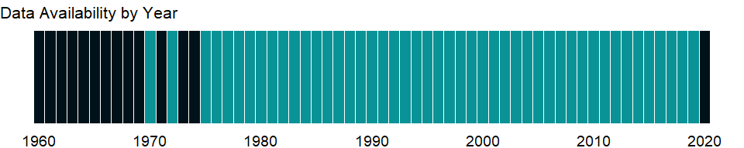

### Which countries have data?

The figure below shows the percentage of countries in each income group with a value since 2010 for that indicator.

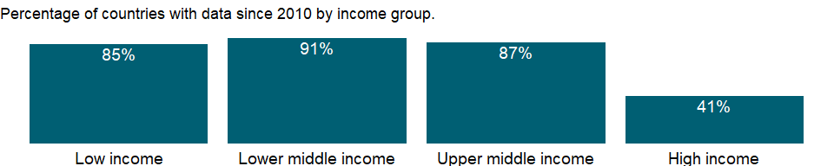

### Why is it relevant?

Literacy rate is an outcome indicator to evaluate educational attainment. This data can predict the quality of future labor force and can be used in ensuring policies for life skills for men and women.

It can be also used as a proxy instrument to see the effectiveness of education system; a high literacy rate suggests the capacity of an education system to provide a large population with opportunities to acquire literacy skills. The accumulated achievement of education is fundamental for further intellectual growth and social and economic development, although it doesn’t necessarily ensure the quality of education.

Literate women implies that they can seek and use information for the betterment of the health, nutrition and education of their household members. Literate women are also empowered to play a meaningful role.

### What is the data source?

UNESCO Institute for Statistics (<http://uis.unesco.org/>). Data as of September 2020.

### What is the methodology?

Literacy statistics for most countries cover the population ages 15 and older, but some include younger ages or are confined to age ranges that tend to inflate literacy rates. The youth literacy rate for ages 15-24 reflects recent progress in education. It measures the accumulated outcomes of primary education over the previous 10 years or so by indicating the proportion of the population who have passed through the primary education system and acquired basic literacy and numeracy skills. Generally, literacy also encompasses numeracy, the ability to make simple arithmetic calculations.

Data on literacy are compiled by the UNESCO Institute for Statistics based on national censuses and household surveys and, for countries without recent literacy data, using the Global Age-Specific Literacy Projection Model (GALP). For detailed information, see www.uis.unesco.org.

### How is it aggregated?

Weighted average

### What are the limitations?

In practice, literacy is difficult to measure. Estimating literacy rates requires census or survey measurements under controlled conditions. Many countries report the number of literate people from self-reported data. Some use educational attainment data as a proxy but apply different lengths of school attendance or levels of completion. Ant there is a trend among recent national and international surveys toward using a direct reading test of literacy skills. Because definitions and methods of data collection differ across countries, data should be used cautiously.

### What else should I know?

For aggregate data, each economy is classified based on the classification of World Bank Group’s fiscal year 2021 (July 1, 2020-June 30, 2021).

### 1.57.2 Literacy rate, youth (ages 15-24), gender parity index (GPI)

### What is the indicator?

Gender parity index for youth literacy rate is the ratio of females to males ages 15-24 who can both read and write with understanding a short simple statement about their everyday life.

Topic: Education: Outcomes

Series ID: SE.ADT.1524.LT.FM.ZS

Copyright: CC BY-4.0 , <https://datacatalog.worldbank.org/public-licenses#cc-by>

First year with any data: 1970

Last year with any data: 2019

### What years are data available?

The figure below shows years in which data is available for at least one country. Dates shaded in black have no data, while dates shaded in green have data for at least one country



### Which countries have data?

The figure below shows the percentage of countries in each income group with a value since 2010 for that indicator.



### Why is it relevant?

Literacy rate is an outcome indicator to evaluate educational attainment. This data can predict the quality of future labor force and can be used in ensuring policies for life skills for men and women.

It can be also used as a proxy instrument to see the effectiveness of education system; a high literacy rate suggests the capacity of an education system to provide a large population with opportunities to acquire literacy skills. The accumulated achievement of education is fundamental for further intellectual growth and social and economic development, although it doesn’t necessarily ensure the quality of education.

The Gender Parity Index (GPI) indicates parity between girls and boys. A GPI of less than 1 suggests girls are more disadvantaged than boys in learning opportunities and a GPI of greater than 1 suggests the other way around. Eliminating gender disparities in education would help increase the status and capabilities of women. Literate women implies that they can seek and use information for the betterment of the health, nutrition and education of their household members. Literate women are also empowered to play a meaningful role.

### What is the data source?

UNESCO Institute for Statistics (<http://uis.unesco.org/>). Data as of September 2020.

### What is the methodology?

This indicator is calculated by dividing female youth literacy rate by male youth literacy rate.

Literacy statistics for most countries cover the population ages 15 and older, but some include younger ages or are confined to age ranges that tend to inflate literacy rates. The youth literacy rate for ages 15-24 reflects recent progress in education. It measures the accumulated outcomes of primary education over the previous 10 years or so by indicating the proportion of the population who have passed through the primary education system and acquired basic literacy and numeracy skills. Generally, literacy also encompasses numeracy, the ability to make simple arithmetic calculations.

Data on literacy are compiled by the UNESCO Institute for Statistics based on national censuses and household surveys and, for countries without recent literacy data, using the Global Age-Specific Literacy Projection Model (GALP). For detailed information, see www.uis.unesco.org.

### How is it aggregated?

Weighted average

### What are the limitations?

In practice, literacy is difficult to measure. Estimating literacy rates requires census or survey measurements under controlled conditions. Many countries report the number of literate people from self-reported data. Some use educational attainment data as a proxy but apply different lengths of school attendance or levels of completion. Ant there is a trend among recent national and international surveys toward using a direct reading test of literacy skills. Because definitions and methods of data collection differ across countries, data should be used cautiously.

### What else should I know?

For aggregate data, each economy is classified based on the classification of World Bank Group’s fiscal year 2021 (July 1, 2020-June 30, 2021).

### 1.57.3 Literacy rate, youth male (% of males ages 15-24)

### What is the indicator?

Youth literacy rate is the percentage of people ages 15-24 who can both read and write with understanding a short simple statement about their everyday life.

Topic: Education: Outcomes

Series ID: SE.ADT.1524.LT.MA.ZS

Copyright: CC BY-4.0 , <https://datacatalog.worldbank.org/public-licenses#cc-by>

First year with any data: 1970

Last year with any data: 2019

### What years are data available?

The figure below shows years in which data is available for at least one country. Dates shaded in black have no data, while dates shaded in green have data for at least one country



### Which countries have data?

The figure below shows the percentage of countries in each income group with a value since 2010 for that indicator.



### Why is it relevant?

Literacy rate is an outcome indicator to evaluate educational attainment. This data can predict the quality of future labor force and can be used in ensuring policies for life skills for men and women.

It can be also used as a proxy instrument to see the effectiveness of education system; a high literacy rate suggests the capacity of an education system to provide a large population with opportunities to acquire literacy skills. The accumulated achievement of education is fundamental for further intellectual growth and social and economic development, although it doesn’t necessarily ensure the quality of education.

Literate women implies that they can seek and use information for the betterment of the health, nutrition and education of their household members. Literate women are also empowered to play a meaningful role.

### What is the data source?

UNESCO Institute for Statistics (<http://uis.unesco.org/>). Data as of September 2020.

### What is the methodology?

Literacy statistics for most countries cover the population ages 15 and older, but some include younger ages or are confined to age ranges that tend to inflate literacy rates. The youth literacy rate for ages 15-24 reflects recent progress in education. It measures the accumulated outcomes of primary education over the previous 10 years or so by indicating the proportion of the population who have passed through the primary education system and acquired basic literacy and numeracy skills. Generally, literacy also encompasses numeracy, the ability to make simple arithmetic calculations.

Data on literacy are compiled by the UNESCO Institute for Statistics based on national censuses and household surveys and, for countries without recent literacy data, using the Global Age-Specific Literacy Projection Model (GALP). For detailed information, see www.uis.unesco.org.

### How is it aggregated?

Weighted average

### What are the limitations?

In practice, literacy is difficult to measure. Estimating literacy rates requires census or survey measurements under controlled conditions. Many countries report the number of literate people from self-reported data. Some use educational attainment data as a proxy but apply different lengths of school attendance or levels of completion. Ant there is a trend among recent national and international surveys toward using a direct reading test of literacy skills. Because definitions and methods of data collection differ across countries, data should be used cautiously.

### What else should I know?

For aggregate data, each economy is classified based on the classification of World Bank Group’s fiscal year 2021 (July 1, 2020-June 30, 2021).

### 1.57.4 Literacy rate, youth total (% of people ages 15-24)

### What is the indicator?

Youth literacy rate is the percentage of people ages 15-24 who can both read and write with understanding a short simple statement about their everyday life.

Topic: Education: Outcomes

Series ID: SE.ADT.1524.LT.ZS

Copyright: CC BY-4.0 , <https://datacatalog.worldbank.org/public-licenses#cc-by>

First year with any data: 1970

Last year with any data: 2019

### What years are data available?

The figure below shows years in which data is available for at least one country. Dates shaded in black have no data, while dates shaded in green have data for at least one country



### Which countries have data?

The figure below shows the percentage of countries in each income group with a value since 2010 for that indicator.



### Why is it relevant?

Literacy rate is an outcome indicator to evaluate educational attainment. This data can predict the quality of future labor force and can be used in ensuring policies for life skills for men and women.

It can be also used as a proxy instrument to see the effectiveness of education system; a high literacy rate suggests the capacity of an education system to provide a large population with opportunities to acquire literacy skills. The accumulated achievement of education is fundamental for further intellectual growth and social and economic development, although it doesn’t necessarily ensure the quality of education.

Literate women implies that they can seek and use information for the betterment of the health, nutrition and education of their household members. Literate women are also empowered to play a meaningful role.

### What is the data source?

UNESCO Institute for Statistics (<http://uis.unesco.org/>). Data as of September 2020.

### What is the methodology?

Literacy statistics for most countries cover the population ages 15 and older, but some include younger ages or are confined to age ranges that tend to inflate literacy rates. The youth literacy rate for ages 15-24 reflects recent progress in education. It measures the accumulated outcomes of primary education over the previous 10 years or so by indicating the proportion of the population who have passed through the primary education system and acquired basic literacy and numeracy skills. Generally, literacy also encompasses numeracy, the ability to make simple arithmetic calculations.

Data on literacy are compiled by the UNESCO Institute for Statistics based on national censuses and household surveys and, for countries without recent literacy data, using the Global Age-Specific Literacy Projection Model (GALP). For detailed information, see www.uis.unesco.org.

### How is it aggregated?

Weighted average

### What are the limitations?

In practice, literacy is difficult to measure. Estimating literacy rates requires census or survey measurements under controlled conditions. Many countries report the number of literate people from self-reported data. Some use educational attainment data as a proxy but apply different lengths of school attendance or levels of completion. Ant there is a trend among recent national and international surveys toward using a direct reading test of literacy skills. Because definitions and methods of data collection differ across countries, data should be used cautiously.

### What else should I know?

For aggregate data, each economy is classified based on the classification of World Bank Group’s fiscal year 2021 (July 1, 2020-June 30, 2021).

### 1.57.5 Literacy rate, adult female (% of females ages 15 and above)

### What is the indicator?

Adult literacy rate is the percentage of people ages 15 and above who can both read and write with understanding a short simple statement about their everyday life.

Topic: Education: Outcomes

Series ID: SE.ADT.LITR.FE.ZS

Copyright: CC BY-4.0 , <https://datacatalog.worldbank.org/public-licenses#cc-by>

First year with any data: 1970

Last year with any data: 2019

### What years are data available?

The figure below shows years in which data is available for at least one country. Dates shaded in black have no data, while dates shaded in green have data for at least one country



### Which countries have data?

The figure below shows the percentage of countries in each income group with a value since 2010 for that indicator.

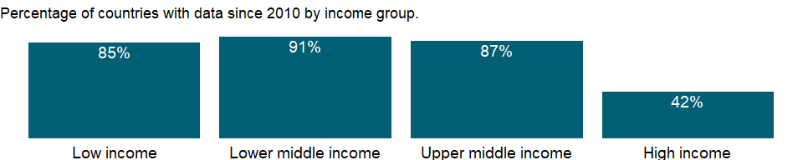

### Why is it relevant?

Literacy rate is an outcome indicator to evaluate educational attainment. This data can predict the quality of future labor force and can be used in ensuring policies for life skills for men and women.

It can be also used as a proxy instrument to see the effectiveness of education system; a high literacy rate suggests the capacity of an education system to provide a large population with opportunities to acquire literacy skills. The accumulated achievement of education is fundamental for further intellectual growth and social and economic development, although it doesn’t necessarily ensure the quality of education.

Literate women implies that they can seek and use information for the betterment of the health, nutrition and education of their household members. Literate women are also empowered to play a meaningful role.

### What is the data source?

UNESCO Institute for Statistics (<http://uis.unesco.org/>). Data as of September 2020.

### What is the methodology?

Literacy statistics for most countries cover the population ages 15 and older, but some include younger ages or are confined to age ranges that tend to inflate literacy rates. The youth literacy rate for ages 15-24 reflects recent progress in education. It measures the accumulated outcomes of primary education over the previous 10 years or so by indicating the proportion of the population who have passed through the primary education system and acquired basic literacy and numeracy skills. Generally, literacy also encompasses numeracy, the ability to make simple arithmetic calculations.

Data on literacy are compiled by the UNESCO Institute for Statistics based on national censuses and household surveys and, for countries without recent literacy data, using the Global Age-Specific Literacy Projection Model (GALP). For detailed information, see www.uis.unesco.org.

### How is it aggregated?

Weighted average

### What are the limitations?

In practice, literacy is difficult to measure. Estimating literacy rates requires census or survey measurements under controlled conditions. Many countries report the number of literate people from self-reported data. Some use educational attainment data as a proxy but apply different lengths of school attendance or levels of completion. Ant there is a trend among recent national and international surveys toward using a direct reading test of literacy skills. Because definitions and methods of data collection differ across countries, data should be used cautiously.

### What else should I know?

For aggregate data, each economy is classified based on the classification of World Bank Group’s fiscal year 2021 (July 1, 2020-June 30, 2021).

### 1.57.6 Literacy rate, adult male (% of males ages 15 and above)

### What is the indicator?

Adult literacy rate is the percentage of people ages 15 and above who can both read and write with understanding a short simple statement about their everyday life.

Topic: Education: Outcomes

Series ID: SE.ADT.LITR.MA.ZS

Copyright: CC BY-4.0 , <https://datacatalog.worldbank.org/public-licenses#cc-by>

First year with any data: 1970

Last year with any data: 2019

### What years are data available?

The figure below shows years in which data is available for at least one country. Dates shaded in black have no data, while dates shaded in green have data for at least one country



### Which countries have data?

The figure below shows the percentage of countries in each income group with a value since 2010 for that indicator.



### Why is it relevant?

Literacy rate is an outcome indicator to evaluate educational attainment. This data can predict the quality of future labor force and can be used in ensuring policies for life skills for men and women.

It can be also used as a proxy instrument to see the effectiveness of education system; a high literacy rate suggests the capacity of an education system to provide a large population with opportunities to acquire literacy skills. The accumulated achievement of education is fundamental for further intellectual growth and social and economic development, although it doesn’t necessarily ensure the quality of education.

Literate women implies that they can seek and use information for the betterment of the health, nutrition and education of their household members. Literate women are also empowered to play a meaningful role.

### What is the data source?

UNESCO Institute for Statistics (<http://uis.unesco.org/>). Data as of September 2020.

### What is the methodology?

Literacy statistics for most countries cover the population ages 15 and older, but some include younger ages or are confined to age ranges that tend to inflate literacy rates. The youth literacy rate for ages 15-24 reflects recent progress in education. It measures the accumulated outcomes of primary education over the previous 10 years or so by indicating the proportion of the population who have passed through the primary education system and acquired basic literacy and numeracy skills. Generally, literacy also encompasses numeracy, the ability to make simple arithmetic calculations.

Data on literacy are compiled by the UNESCO Institute for Statistics based on national censuses and household surveys and, for countries without recent literacy data, using the Global Age-Specific Literacy Projection Model (GALP). For detailed information, see www.uis.unesco.org.

### How is it aggregated?

Weighted average

### What are the limitations?

In practice, literacy is difficult to measure. Estimating literacy rates requires census or survey measurements under controlled conditions. Many countries report the number of literate people from self-reported data. Some use educational attainment data as a proxy but apply different lengths of school attendance or levels of completion. Ant there is a trend among recent national and international surveys toward using a direct reading test of literacy skills. Because definitions and methods of data collection differ across countries, data should be used cautiously.

### What else should I know?

For aggregate data, each economy is classified based on the classification of World Bank Group’s fiscal year 2021 (July 1, 2020-June 30, 2021).

### 1.57.7 Literacy rate, adult total (% of people ages 15 and above)

### What is the indicator?

Adult literacy rate is the percentage of people ages 15 and above who can both read and write with understanding a short simple statement about their everyday life.

Topic: Education: Outcomes

Series ID: SE.ADT.LITR.ZS

Copyright: CC BY-4.0 , <https://datacatalog.worldbank.org/public-licenses#cc-by>

First year with any data: 1970

Last year with any data: 2019

### What years are data available?

The figure below shows years in which data is available for at least one country. Dates shaded in black have no data, while dates shaded in green have data for at least one country



### Which countries have data?

The figure below shows the percentage of countries in each income group with a value since 2010 for that indicator.



### Why is it relevant?

Literacy rate is an outcome indicator to evaluate educational attainment. This data can predict the quality of future labor force and can be used in ensuring policies for life skills for men and women.

It can be also used as a proxy instrument to see the effectiveness of education system; a high literacy rate suggests the capacity of an education system to provide a large population with opportunities to acquire literacy skills. The accumulated achievement of education is fundamental for further intellectual growth and social and economic development, although it doesn’t necessarily ensure the quality of education.

Literate women implies that they can seek and use information for the betterment of the health, nutrition and education of their household members. Literate women are also empowered to play a meaningful role.

### What is the data source?

UNESCO Institute for Statistics (<http://uis.unesco.org/>). Data as of September 2020.

### What is the methodology?

Literacy statistics for most countries cover the population ages 15 and older, but some include younger ages or are confined to age ranges that tend to inflate literacy rates. The youth literacy rate for ages 15-24 reflects recent progress in education. It measures the accumulated outcomes of primary education over the previous 10 years or so by indicating the proportion of the population who have passed through the primary education system and acquired basic literacy and numeracy skills. Generally, literacy also encompasses numeracy, the ability to make simple arithmetic calculations.

Data on literacy are compiled by the UNESCO Institute for Statistics based on national censuses and household surveys and, for countries without recent literacy data, using the Global Age-Specific Literacy Projection Model (GALP). For detailed information, see www.uis.unesco.org.

### How is it aggregated?

Weighted average

### What are the limitations?

In practice, literacy is difficult to measure. Estimating literacy rates requires census or survey measurements under controlled conditions. Many countries report the number of literate people from self-reported data. Some use educational attainment data as a proxy but apply different lengths of school attendance or levels of completion. Ant there is a trend among recent national and international surveys toward using a direct reading test of literacy skills. Because definitions and methods of data collection differ across countries, data should be used cautiously.

### What else should I know?

For aggregate data, each economy is classified based on the classification of World Bank Group’s fiscal year 2021 (July 1, 2020-June 30, 2021).

### 1.57.8 Compulsory education, duration (years)

### What is the indicator?

Duration of compulsory education is the number of years that children are legally obliged to attend school.

Topic: Education: Outcomes

Series ID: SE.COM.DURS

Copyright: CC BY-4.0 , <https://datacatalog.worldbank.org/public-licenses#cc-by>

First year with any data: 1975

Last year with any data: 2020

### What years are data available?

The figure below shows years in which data is available for at least one country. Dates shaded in black have no data, while dates shaded in green have data for at least one country



### Which countries have data?

The figure below shows the percentage of countries in each income group with a value since 2010 for that indicator.

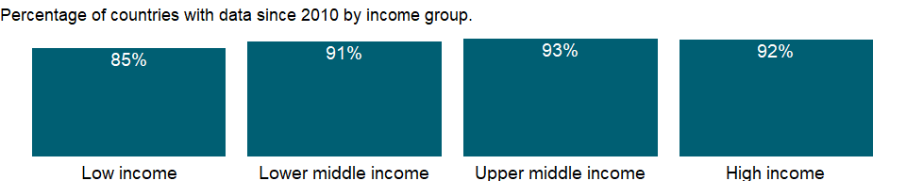

### Why is it relevant?

NA

### What is the data source?

UNESCO Institute for Statistics (<http://uis.unesco.org/>). Data as of September 2020.

### What is the methodology?

Data on education are collected by the UNESCO Institute for Statistics from official responses to its annual education survey. All the data are mapped to the International Standard Classification of Education (ISCED) to ensure the comparability of education programs at the international level. The current version was formally adopted by UNESCO Member States in 2011. Aggregate data are based on World Bank estimates.

The reference years reflect the school year for which the data are presented. In some countries the school year spans two calendar years (for example, from September 2010 to June 2011); in these cases the reference year refers to the year in which the school year ended (2011 in the example).

### How is it aggregated?

Median

### What are the limitations?

NA

### What else should I know?

NA

### 1.57.9 Primary completion rate, female (% of relevant age group)

### What is the indicator?

Primary completion rate, or gross intake ratio to the last grade of primary education, is the number of new entrants (enrollments minus repeaters) in the last grade of primary education, regardless of age, divided by the population at the entrance age for the last grade of primary education. Data limitations preclude adjusting for students who drop out during the final year of primary education.

Topic: Education: Outcomes

Series ID: SE.PRM.CMPT.FE.ZS

Copyright: CC BY-4.0 , <https://datacatalog.worldbank.org/public-licenses#cc-by>

First year with any data: 1970

Last year with any data: 2020

### What years are data available?

The figure below shows years in which data is available for at least one country. Dates shaded in black have no data, while dates shaded in green have data for at least one country



### Which countries have data?

The figure below shows the percentage of countries in each income group with a value since 2010 for that indicator.

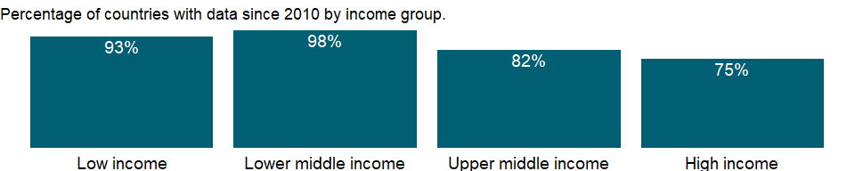

### Why is it relevant?

The World Bank and the UNESCO Institute for Statistics jointly developed the primary completion rate indicator. Increasingly used as a core indicator of an education system’s performance, it reflects an education system’s coverage and the educational attainment of students.

### What is the data source?

UNESCO Institute for Statistics (<http://uis.unesco.org/>). Data as of September 2020.

### What is the methodology?

Primary completion rate is calculated by dividing the number of new entrants (enrollment minus repeaters) in the last grade of primary education, regardless of age, by the population at the entrance age for the last grade of primary education and multiplying by 100.

Data on education are collected by the UNESCO Institute for Statistics from official responses to its annual education survey. All the data are mapped to the International Standard Classification of Education (ISCED) to ensure the comparability of education programs at the international level. The current version was formally adopted by UNESCO Member States in 2011. Population data are drawn from the United Nations Population Division. Using a single source for population data standardizes definitions, estimations, and interpolation methods, ensuring a consistent methodology across countries and minimizing potential enumeration problems in national censuses.

The reference years reflect the school year for which the data are presented. In some countries the school year spans two calendar years (for example, from September 2010 to June 2011); in these cases the reference year refers to the year in which the school year ended (2011 in the example).

### How is it aggregated?

Weighted average

### What are the limitations?

Data limitations preclude adjusting for students who drop out during the final year of primary education. Thus this rate is a proxy that should be taken as an upper estimate of the actual primary completion rate.

There are many reasons why the primary completion rate can exceed 100 percent. The numerator may include late entrants and overage children who have repeated one or more grades of primary education as well as children who entered school early, while the denominator is the number of children at the entrance age for the last grade of primary education.

### What else should I know?

For aggregate data, each economy is classified based on the classification of World Bank Group’s fiscal year 2021 (July 1, 2020-June 30, 2021).

### 1.57.10 Primary completion rate, male (% of relevant age group)

### What is the indicator?

Primary completion rate, or gross intake ratio to the last grade of primary education, is the number of new entrants (enrollments minus repeaters) in the last grade of primary education, regardless of age, divided by the population at the entrance age for the last grade of primary education. Data limitations preclude adjusting for students who drop out during the final year of primary education.

Topic: Education: Outcomes

Series ID: SE.PRM.CMPT.MA.ZS

Copyright: CC BY-4.0 , <https://datacatalog.worldbank.org/public-licenses#cc-by>

First year with any data: 1970

Last year with any data: 2020

### What years are data available?

The figure below shows years in which data is available for at least one country. Dates shaded in black have no data, while dates shaded in green have data for at least one country



### Which countries have data?

The figure below shows the percentage of countries in each income group with a value since 2010 for that indicator.



### Why is it relevant?

The World Bank and the UNESCO Institute for Statistics jointly developed the primary completion rate indicator. Increasingly used as a core indicator of an education system’s performance, it reflects an education system’s coverage and the educational attainment of students.

### What is the data source?

UNESCO Institute for Statistics (<http://uis.unesco.org/>). Data as of September 2020.

### What is the methodology?

Primary completion rate is calculated by dividing the number of new entrants (enrollment minus repeaters) in the last grade of primary education, regardless of age, by the population at the entrance age for the last grade of primary education and multiplying by 100.

Data on education are collected by the UNESCO Institute for Statistics from official responses to its annual education survey. All the data are mapped to the International Standard Classification of Education (ISCED) to ensure the comparability of education programs at the international level. The current version was formally adopted by UNESCO Member States in 2011. Population data are drawn from the United Nations Population Division. Using a single source for population data standardizes definitions, estimations, and interpolation methods, ensuring a consistent methodology across countries and minimizing potential enumeration problems in national censuses.

The reference years reflect the school year for which the data are presented. In some countries the school year spans two calendar years (for example, from September 2010 to June 2011); in these cases the reference year refers to the year in which the school year ended (2011 in the example).

### How is it aggregated?

Weighted average

### What are the limitations?

Data limitations preclude adjusting for students who drop out during the final year of primary education. Thus this rate is a proxy that should be taken as an upper estimate of the actual primary completion rate.

There are many reasons why the primary completion rate can exceed 100 percent. The numerator may include late entrants and overage children who have repeated one or more grades of primary education as well as children who entered school early, while the denominator is the number of children at the entrance age for the last grade of primary education.

### What else should I know?

For aggregate data, each economy is classified based on the classification of World Bank Group’s fiscal year 2021 (July 1, 2020-June 30, 2021).

### 1.57.11 Primary completion rate, total (% of relevant age group)

### What is the indicator?

Primary completion rate, or gross intake ratio to the last grade of primary education, is the number of new entrants (enrollments minus repeaters) in the last grade of primary education, regardless of age, divided by the population at the entrance age for the last grade of primary education. Data limitations preclude adjusting for students who drop out during the final year of primary education.

Topic: Education: Outcomes

Series ID: SE.PRM.CMPT.ZS

Copyright: CC BY-4.0 , <https://datacatalog.worldbank.org/public-licenses#cc-by>

First year with any data: 1970

Last year with any data: 2020

### What years are data available?

The figure below shows years in which data is available for at least one country. Dates shaded in black have no data, while dates shaded in green have data for at least one country



### Which countries have data?

The figure below shows the percentage of countries in each income group with a value since 2010 for that indicator.



### Why is it relevant?

The World Bank and the UNESCO Institute for Statistics jointly developed the primary completion rate indicator. Increasingly used as a core indicator of an education system’s performance, it reflects an education system’s coverage and the educational attainment of students.

### What is the data source?

UNESCO Institute for Statistics (<http://uis.unesco.org/>). Data as of September 2020.

### What is the methodology?

Primary completion rate is calculated by dividing the number of new entrants (enrollment minus repeaters) in the last grade of primary education, regardless of age, by the population at the entrance age for the last grade of primary education and multiplying by 100.

Data on education are collected by the UNESCO Institute for Statistics from official responses to its annual education survey. All the data are mapped to the International Standard Classification of Education (ISCED) to ensure the comparability of education programs at the international level. The current version was formally adopted by UNESCO Member States in 2011. Population data are drawn from the United Nations Population Division. Using a single source for population data standardizes definitions, estimations, and interpolation methods, ensuring a consistent methodology across countries and minimizing potential enumeration problems in national censuses.

The reference years reflect the school year for which the data are presented. In some countries the school year spans two calendar years (for example, from September 2010 to June 2011); in these cases the reference year refers to the year in which the school year ended (2011 in the example).

### How is it aggregated?

Weighted average

### What are the limitations?

Data limitations preclude adjusting for students who drop out during the final year of primary education. Thus this rate is a proxy that should be taken as an upper estimate of the actual primary completion rate.

There are many reasons why the primary completion rate can exceed 100 percent. The numerator may include late entrants and overage children who have repeated one or more grades of primary education as well as children who entered school early, while the denominator is the number of children at the entrance age for the last grade of primary education.

### What else should I know?

For aggregate data, each economy is classified based on the classification of World Bank Group’s fiscal year 2021 (July 1, 2020-June 30, 2021).

### 1.57.12 Educational attainment, at least completed primary, population 25+ years, female (%) (cumulative)

### What is the indicator?

The percentage of population ages 25 and over that attained or completed primary education.

Topic: Education: Outcomes

Series ID: SE.PRM.CUAT.FE.ZS

Copyright: CC BY-4.0 , <https://datacatalog.worldbank.org/public-licenses#cc-by>

First year with any data: 1970

Last year with any data: 2019

### What years are data available?

The figure below shows years in which data is available for at least one country. Dates shaded in black have no data, while dates shaded in green have data for at least one country

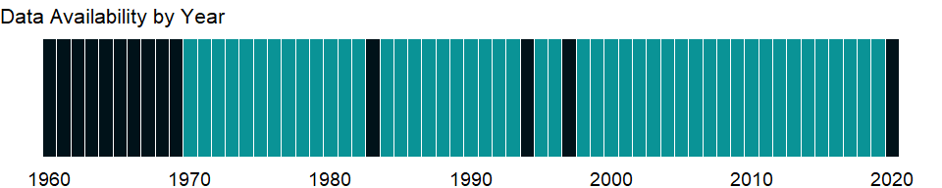

### Which countries have data?

The figure below shows the percentage of countries in each income group with a value since 2010 for that indicator.

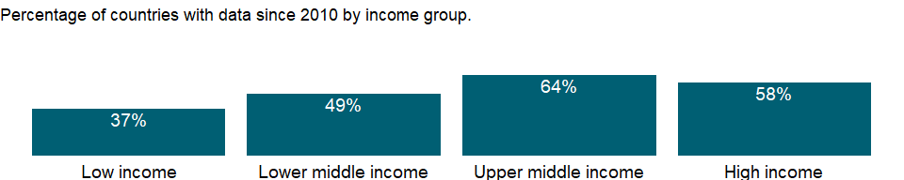

### Why is it relevant?

A relative high concentration of the adult population in a given level of education reflects the capacity of the educational system in the corresponding level of education. Educational attainment is closely related to the skills and competencies of a country’s population, and could be seen as a proxy of both the quantitative and qualitative aspects of the stock of human capital.

### What is the data source?

UNESCO Institute for Statistics (<http://uis.unesco.org/>). Data as of September 2020.

### What is the methodology?

It is calculated by dividing the number of population ages 25 and older who attained or completed primary education by the total population of the same age group and multiplying by 100. The number 0 means zero or small enough that the number would round to zero.

Data are collected by the UNESCO Institute for Statistics mainly from national population census, household survey, and labour force survey. All the data are mapped to the International Standard Classification of Education (ISCED) to ensure the comparability of education programs at the international level. The current version was formally adopted by UNESCO Member States in 2011.

### How is it aggregated?

NA

### What are the limitations?

Caution is required when using this indicator for cross-country comparison, since the countries do not always classify degrees and qualifications at the same International Standard Classification of Education (ISCED) levels, even if they are received at roughly the same age or after a similar number of years of schooling. Also, certain educational programmes and study courses cannot be easily classified according to ISCED. This indicator only measures educational attainment in terms of level of education attained, i.e. years of schooling, and do not necessarily reveal the quality of the education (learning achievement and other impacts).

### What else should I know?

NA

### 1.57.13 Educational attainment, at least completed primary, population 25+ years, male (%) (cumulative)

### What is the indicator?

The percentage of population ages 25 and over that attained or completed primary education.

Topic: Education: Outcomes

Series ID: SE.PRM.CUAT.MA.ZS

Copyright: CC BY-4.0 , <https://datacatalog.worldbank.org/public-licenses#cc-by>

First year with any data: 1970

Last year with any data: 2019

### What years are data available?

The figure below shows years in which data is available for at least one country. Dates shaded in black have no data, while dates shaded in green have data for at least one country



### Which countries have data?

The figure below shows the percentage of countries in each income group with a value since 2010 for that indicator.



### Why is it relevant?

A relative high concentration of the adult population in a given level of education reflects the capacity of the educational system in the corresponding level of education. Educational attainment is closely related to the skills and competencies of a country’s population, and could be seen as a proxy of both the quantitative and qualitative aspects of the stock of human capital.

### What is the data source?

UNESCO Institute for Statistics (<http://uis.unesco.org/>). Data as of September 2020.

### What is the methodology?

It is calculated by dividing the number of population ages 25 and older who attained or completed primary education by the total population of the same age group and multiplying by 100. The number 0 means zero or small enough that the number would round to zero.

Data are collected by the UNESCO Institute for Statistics mainly from national population census, household survey, and labour force survey. All the data are mapped to the International Standard Classification of Education (ISCED) to ensure the comparability of education programs at the international level. The current version was formally adopted by UNESCO Member States in 2011.

### How is it aggregated?

NA

### What are the limitations?

Caution is required when using this indicator for cross-country comparison, since the countries do not always classify degrees and qualifications at the same International Standard Classification of Education (ISCED) levels, even if they are received at roughly the same age or after a similar number of years of schooling. Also, certain educational programmes and study courses cannot be easily classified according to ISCED. This indicator only measures educational attainment in terms of level of education attained, i.e. years of schooling, and do not necessarily reveal the quality of the education (learning achievement and other impacts).

### What else should I know?

NA

### 1.57.14 Educational attainment, at least completed primary, population 25+ years, total (%) (cumulative)

### What is the indicator?

The percentage of population ages 25 and over that attained or completed primary education.

Topic: Education: Outcomes

Series ID: SE.PRM.CUAT.ZS

Copyright: CC BY-4.0 , <https://datacatalog.worldbank.org/public-licenses#cc-by>

First year with any data: 1970

Last year with any data: 2019

### What years are data available?

The figure below shows years in which data is available for at least one country. Dates shaded in black have no data, while dates shaded in green have data for at least one country



### Which countries have data?

The figure below shows the percentage of countries in each income group with a value since 2010 for that indicator.

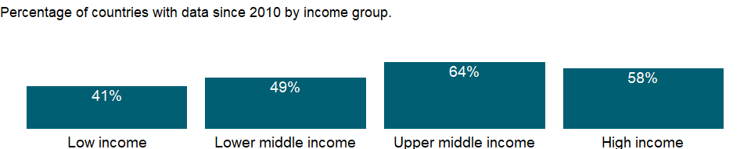

### Why is it relevant?

A relative high concentration of the adult population in a given level of education reflects the capacity of the educational system in the corresponding level of education. Educational attainment is closely related to the skills and competencies of a country’s population, and could be seen as a proxy of both the quantitative and qualitative aspects of the stock of human capital.

### What is the data source?

UNESCO Institute for Statistics (<http://uis.unesco.org/>). Data as of September 2020.

### What is the methodology?

It is calculated by dividing the number of population ages 25 and older who attained or completed primary education by the total population of the same age group and multiplying by 100. The number 0 means zero or small enough that the number would round to zero.

Data are collected by the UNESCO Institute for Statistics mainly from national population census, household survey, and labour force survey. All the data are mapped to the International Standard Classification of Education (ISCED) to ensure the comparability of education programs at the international level. The current version was formally adopted by UNESCO Member States in 2011.

### How is it aggregated?

NA

### What are the limitations?

Caution is required when using this indicator for cross-country comparison, since the countries do not always classify degrees and qualifications at the same International Standard Classification of Education (ISCED) levels, even if they are received at roughly the same age or after a similar number of years of schooling. Also, certain educational programmes and study courses cannot be easily classified according to ISCED. This indicator only measures educational attainment in terms of level of education attained, i.e. years of schooling, and do not necessarily reveal the quality of the education (learning achievement and other impacts).

### What else should I know?

NA

### 1.57.15 Primary education, duration (years)

### What is the indicator?

Primary duration refers to the number of grades (years) in primary school.

Topic: Education: Outcomes

Series ID: SE.PRM.DURS

Copyright: CC BY-4.0 , <https://datacatalog.worldbank.org/public-licenses#cc-by>

First year with any data: 1970

Last year with any data: 2020

### What years are data available?

The figure below shows years in which data is available for at least one country. Dates shaded in black have no data, while dates shaded in green have data for at least one country



### Which countries have data?

The figure below shows the percentage of countries in each income group with a value since 2010 for that indicator.



### Why is it relevant?

NA

### What is the data source?

UNESCO Institute for Statistics (<http://uis.unesco.org/>). Data as of September 2020.

### What is the methodology?

Data on education are collected by the UNESCO Institute for Statistics from official responses to its annual education survey. All the data are mapped to the International Standard Classification of Education (ISCED) to ensure the comparability of education programs at the international level. The current version was formally adopted by UNESCO Member States in 2011. Aggregate data are based on World Bank estimates.

The reference years reflect the school year for which the data are presented. In some countries the school year spans two calendar years (for example, from September 2010 to June 2011); in these cases the reference year refers to the year in which the school year ended (2011 in the example).

### How is it aggregated?

Median

### What are the limitations?

NA

### What else should I know?

NA

### 1.57.16 Lower secondary completion rate, female (% of relevant age group)

### What is the indicator?

Lower secondary education completion rate is measured as the gross intake ratio to the last grade of lower secondary education (general and pre-vocational). It is calculated as the number of new entrants in the last grade of lower secondary education, regardless of age, divided by the population at the entrance age for the last grade of lower secondary education.

Topic: Education: Outcomes

Series ID: SE.SEC.CMPT.LO.FE.ZS

Copyright: CC BY-4.0 , <https://datacatalog.worldbank.org/public-licenses#cc-by>

First year with any data: 1970

Last year with any data: 2020

### What years are data available?

The figure below shows years in which data is available for at least one country. Dates shaded in black have no data, while dates shaded in green have data for at least one country



### Which countries have data?

The figure below shows the percentage of countries in each income group with a value since 2010 for that indicator.



### Why is it relevant?

NA

### What is the data source?

UNESCO Institute for Statistics (<http://uis.unesco.org/>). Data as of September 2020.

### What is the methodology?

Lower secondary completion rate is calculated as the number of new entrants (enrollment minus repeaters) in the last grade of lower secondary education, regardless of age, divided by the population at the entrance age for the last grade of lower secondary education.

Data on education are collected by the UNESCO Institute for Statistics from official responses to its annual education survey. All the data are mapped to the International Standard Classification of Education (ISCED) to ensure the comparability of education programs at the international level. The current version was formally adopted by UNESCO Member States in 2011. Population data are drawn from the United Nations Population Division. Using a single source for population data standardizes definitions, estimations, and interpolation methods, ensuring a consistent methodology across countries and minimizing potential enumeration problems in national censuses.

The reference years reflect the school year for which the data are presented. In some countries the school year spans two calendar years (for example, from September 2010 to June 2011); in these cases the reference year refers to the year in which the school year ended (2011 in the example).

### How is it aggregated?

Weighted Average

### What are the limitations?

Data limitations preclude adjusting for students who drop out during the final year of lower secondary education. Thus this rate is a proxy that should be taken as an upper estimate of the actual lower secondary completion rate.

There are many reasons why the rate can exceed 100 percent. The numerator may include late entrants and overage children who have repeated one or more grades of lower secondary education as well as children who entered school early, while the denominator is the number of children at the entrance age for the last grade of lower secondary education.

### What else should I know?

For aggregate data, each economy is classified based on the classification of World Bank Group’s fiscal year 2021 (July 1, 2020-June 30, 2021).

### 1.57.17 Lower secondary completion rate, male (% of relevant age group)

### What is the indicator?

Lower secondary education completion rate is measured as the gross intake ratio to the last grade of lower secondary education (general and pre-vocational). It is calculated as the number of new entrants in the last grade of lower secondary education, regardless of age, divided by the population at the entrance age for the last grade of lower secondary education.

Topic: Education: Outcomes

Series ID: SE.SEC.CMPT.LO.MA.ZS

Copyright: CC BY-4.0 , <https://datacatalog.worldbank.org/public-licenses#cc-by>

First year with any data: 1970

Last year with any data: 2020

### What years are data available?

The figure below shows years in which data is available for at least one country. Dates shaded in black have no data, while dates shaded in green have data for at least one country



### Which countries have data?

The figure below shows the percentage of countries in each income group with a value since 2010 for that indicator.



### Why is it relevant?

NA

### What is the data source?

UNESCO Institute for Statistics (<http://uis.unesco.org/>). Data as of September 2020.

### What is the methodology?

Lower secondary completion rate is calculated as the number of new entrants (enrollment minus repeaters) in the last grade of lower secondary education, regardless of age, divided by the population at the entrance age for the last grade of lower secondary education.

Data on education are collected by the UNESCO Institute for Statistics from official responses to its annual education survey. All the data are mapped to the International Standard Classification of Education (ISCED) to ensure the comparability of education programs at the international level. The current version was formally adopted by UNESCO Member States in 2011. Population data are drawn from the United Nations Population Division. Using a single source for population data standardizes definitions, estimations, and interpolation methods, ensuring a consistent methodology across countries and minimizing potential enumeration problems in national censuses.

The reference years reflect the school year for which the data are presented. In some countries the school year spans two calendar years (for example, from September 2010 to June 2011); in these cases the reference year refers to the year in which the school year ended (2011 in the example).

### How is it aggregated?

Weighted Average

### What are the limitations?

Data limitations preclude adjusting for students who drop out during the final year of lower secondary education. Thus this rate is a proxy that should be taken as an upper estimate of the actual lower secondary completion rate.

There are many reasons why the rate can exceed 100 percent. The numerator may include late entrants and overage children who have repeated one or more grades of lower secondary education as well as children who entered school early, while the denominator is the number of children at the entrance age for the last grade of lower secondary education.

### What else should I know?

For aggregate data, each economy is classified based on the classification of World Bank Group’s fiscal year 2021 (July 1, 2020-June 30, 2021).

### 1.57.18 Lower secondary completion rate, total (% of relevant age group)

### What is the indicator?

Lower secondary education completion rate is measured as the gross intake ratio to the last grade of lower secondary education (general and pre-vocational). It is calculated as the number of new entrants in the last grade of lower secondary education, regardless of age, divided by the population at the entrance age for the last grade of lower secondary education.

Topic: Education: Outcomes

Series ID: SE.SEC.CMPT.LO.ZS

Copyright: CC BY-4.0 , <https://datacatalog.worldbank.org/public-licenses#cc-by>

First year with any data: 1970

Last year with any data: 2020

### What years are data available?

The figure below shows years in which data is available for at least one country. Dates shaded in black have no data, while dates shaded in green have data for at least one country



### Which countries have data?

The figure below shows the percentage of countries in each income group with a value since 2010 for that indicator.

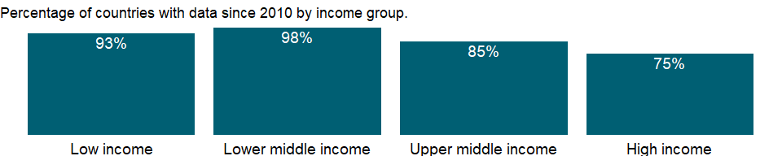

### Why is it relevant?

NA

### What is the data source?

UNESCO Institute for Statistics (<http://uis.unesco.org/>). Data as of September 2020.

### What is the methodology?

Lower secondary completion rate is calculated as the number of new entrants (enrollment minus repeaters) in the last grade of lower secondary education, regardless of age, divided by the population at the entrance age for the last grade of lower secondary education.

Data on education are collected by the UNESCO Institute for Statistics from official responses to its annual education survey. All the data are mapped to the International Standard Classification of Education (ISCED) to ensure the comparability of education programs at the international level. The current version was formally adopted by UNESCO Member States in 2011. Population data are drawn from the United Nations Population Division. Using a single source for population data standardizes definitions, estimations, and interpolation methods, ensuring a consistent methodology across countries and minimizing potential enumeration problems in national censuses.

The reference years reflect the school year for which the data are presented. In some countries the school year spans two calendar years (for example, from September 2010 to June 2011); in these cases the reference year refers to the year in which the school year ended (2011 in the example).

### How is it aggregated?

Weighted Average

### What are the limitations?

Data limitations preclude adjusting for students who drop out during the final year of lower secondary education. Thus this rate is a proxy that should be taken as an upper estimate of the actual lower secondary completion rate.

There are many reasons why the rate can exceed 100 percent. The numerator may include late entrants and overage children who have repeated one or more grades of lower secondary education as well as children who entered school early, while the denominator is the number of children at the entrance age for the last grade of lower secondary education.

### What else should I know?

For aggregate data, each economy is classified based on the classification of World Bank Group’s fiscal year 2021 (July 1, 2020-June 30, 2021).

### 1.57.19 Educational attainment, at least completed lower secondary, population 25+, female (%) (cumulative)

### What is the indicator?

The percentage of population ages 25 and over that attained or completed lower secondary education.

Topic: Education: Outcomes

Series ID: SE.SEC.CUAT.LO.FE.ZS

Copyright: CC BY-4.0 , <https://datacatalog.worldbank.org/public-licenses#cc-by>

First year with any data: 1970

Last year with any data: 2019

### What years are data available?

The figure below shows years in which data is available for at least one country. Dates shaded in black have no data, while dates shaded in green have data for at least one country

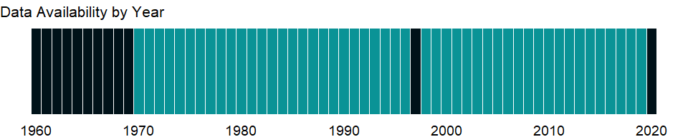

### Which countries have data?

The figure below shows the percentage of countries in each income group with a value since 2010 for that indicator.

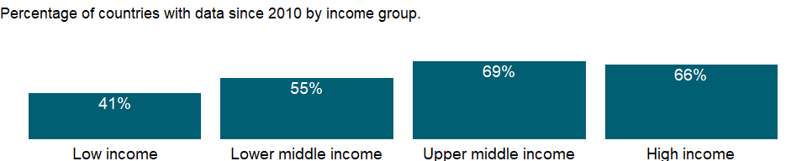

### Why is it relevant?

A relative high concentration of the adult population in a given level of education reflects the capacity of the educational system in the corresponding level of education. Educational attainment is closely related to the skills and competencies of a country’s population, and could be seen as a proxy of both the quantitative and qualitative aspects of the stock of human capital.

### What is the data source?

UNESCO Institute for Statistics (<http://uis.unesco.org/>). Data as of September 2020.

### What is the methodology?

It is calculated by dividing the number of population ages 25 and older who attained or completed lower secondary education by the total population of the same age group and multiplying by 100. The number 0 means zero or small enough that the number would round to zero.

Data are collected by the UNESCO Institute for Statistics mainly from national population census, household survey, and labour force survey. All the data are mapped to the International Standard Classification of Education (ISCED) to ensure the comparability of education programs at the international level. The current version was formally adopted by UNESCO Member States in 2011.

### How is it aggregated?

NA

### What are the limitations?

Caution is required when using this indicator for cross-country comparison, since the countries do not always classify degrees and qualifications at the same International Standard Classification of Education (ISCED) levels, even if they are received at roughly the same age or after a similar number of years of schooling. Also, certain educational programmes and study courses cannot be easily classified according to ISCED. This indicator only measures educational attainment in terms of level of education attained, i.e. years of schooling, and do not necessarily reveal the quality of the education (learning achievement and other impacts).

### What else should I know?

NA

### 1.57.20 Educational attainment, at least completed lower secondary, population 25+, male (%) (cumulative)

### What is the indicator?

The percentage of population ages 25 and over that attained or completed lower secondary education.

Topic: Education: Outcomes

Series ID: SE.SEC.CUAT.LO.MA.ZS

Copyright: CC BY-4.0 , <https://datacatalog.worldbank.org/public-licenses#cc-by>

First year with any data: 1970

Last year with any data: 2019

### What years are data available?

The figure below shows years in which data is available for at least one country. Dates shaded in black have no data, while dates shaded in green have data for at least one country



### Which countries have data?

The figure below shows the percentage of countries in each income group with a value since 2010 for that indicator.



### Why is it relevant?

A relative high concentration of the adult population in a given level of education reflects the capacity of the educational system in the corresponding level of education. Educational attainment is closely related to the skills and competencies of a country’s population, and could be seen as a proxy of both the quantitative and qualitative aspects of the stock of human capital.

### What is the data source?

UNESCO Institute for Statistics (<http://uis.unesco.org/>). Data as of September 2020.

### What is the methodology?

It is calculated by dividing the number of population ages 25 and older who attained or completed lower secondary education by the total population of the same age group and multiplying by 100. The number 0 means zero or small enough that the number would round to zero.

Data are collected by the UNESCO Institute for Statistics mainly from national population census, household survey, and labour force survey. All the data are mapped to the International Standard Classification of Education (ISCED) to ensure the comparability of education programs at the international level. The current version was formally adopted by UNESCO Member States in 2011.

### How is it aggregated?

NA

### What are the limitations?

Caution is required when using this indicator for cross-country comparison, since the countries do not always classify degrees and qualifications at the same International Standard Classification of Education (ISCED) levels, even if they are received at roughly the same age or after a similar number of years of schooling. Also, certain educational programmes and study courses cannot be easily classified according to ISCED. This indicator only measures educational attainment in terms of level of education attained, i.e. years of schooling, and do not necessarily reveal the quality of the education (learning achievement and other impacts).

### What else should I know?

NA

### 1.57.21 Educational attainment, at least completed lower secondary, population 25+, total (%) (cumulative)

### What is the indicator?

The percentage of population ages 25 and over that attained or completed lower secondary education.

Topic: Education: Outcomes

Series ID: SE.SEC.CUAT.LO.ZS

Copyright: CC BY-4.0 , <https://datacatalog.worldbank.org/public-licenses#cc-by>

First year with any data: 1970

Last year with any data: 2019

### What years are data available?

The figure below shows years in which data is available for at least one country. Dates shaded in black have no data, while dates shaded in green have data for at least one country



### Which countries have data?

The figure below shows the percentage of countries in each income group with a value since 2010 for that indicator.

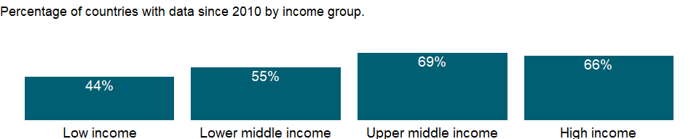

### Why is it relevant?

A relative high concentration of the adult population in a given level of education reflects the capacity of the educational system in the corresponding level of education. Educational attainment is closely related to the skills and competencies of a country’s population, and could be seen as a proxy of both the quantitative and qualitative aspects of the stock of human capital.

### What is the data source?

UNESCO Institute for Statistics (<http://uis.unesco.org/>). Data as of September 2020.

### What is the methodology?

It is calculated by dividing the number of population ages 25 and older who attained or completed lower secondary education by the total population of the same age group and multiplying by 100. The number 0 means zero or small enough that the number would round to zero.

Data are collected by the UNESCO Institute for Statistics mainly from national population census, household survey, and labour force survey. All the data are mapped to the International Standard Classification of Education (ISCED) to ensure the comparability of education programs at the international level. The current version was formally adopted by UNESCO Member States in 2011.

### How is it aggregated?

NA

### What are the limitations?

Caution is required when using this indicator for cross-country comparison, since the countries do not always classify degrees and qualifications at the same International Standard Classification of Education (ISCED) levels, even if they are received at roughly the same age or after a similar number of years of schooling. Also, certain educational programmes and study courses cannot be easily classified according to ISCED. This indicator only measures educational attainment in terms of level of education attained, i.e. years of schooling, and do not necessarily reveal the quality of the education (learning achievement and other impacts).

### What else should I know?

NA

### 1.57.22 Educational attainment, at least completed post-secondary, population 25+, female (%) (cumulative)

### What is the indicator?

The percentage of population ages 25 and over that attained or completed post-secondary non-tertiary education.

Topic: Education: Outcomes

Series ID: SE.SEC.CUAT.PO.FE.ZS

Copyright: CC BY-4.0 , <https://datacatalog.worldbank.org/public-licenses#cc-by>

First year with any data: 1970

Last year with any data: 2019

### What years are data available?

The figure below shows years in which data is available for at least one country. Dates shaded in black have no data, while dates shaded in green have data for at least one country



### Which countries have data?

The figure below shows the percentage of countries in each income group with a value since 2010 for that indicator.

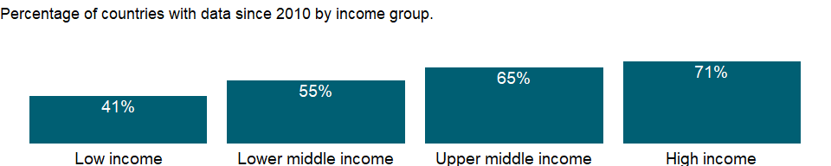

### Why is it relevant?

A relative high concentration of the adult population in a given level of education reflects the capacity of the educational system in the corresponding level of education. Educational attainment is closely related to the skills and competencies of a country’s population, and could be seen as a proxy of both the quantitative and qualitative aspects of the stock of human capital.

### What is the data source?

UNESCO Institute for Statistics (<http://uis.unesco.org/>). Data as of September 2020.

### What is the methodology?

It is calculated by dividing the number of population ages 25 and older who attained or completed post-secondary non-tertiary education by the total population of the same age group and multiplying by 100. The number 0 means zero or small enough that the number would round to zero.

Data are collected by the UNESCO Institute for Statistics mainly from national population census, household survey, and labour force survey. All the data are mapped to the International Standard Classification of Education (ISCED) to ensure the comparability of education programs at the international level. The current version was formally adopted by UNESCO Member States in 2011.

### How is it aggregated?

NA

### What are the limitations?

Caution is required when using this indicator for cross-country comparison, since the countries do not always classify degrees and qualifications at the same International Standard Classification of Education (ISCED) levels, even if they are received at roughly the same age or after a similar number of years of schooling. Also, certain educational programmes and study courses cannot be easily classified according to ISCED. This indicator only measures educational attainment in terms of level of education attained, i.e. years of schooling, and do not necessarily reveal the quality of the education (learning achievement and other impacts).

### What else should I know?

NA

### 1.57.23 Educational attainment, at least completed post-secondary, population 25+, male (%) (cumulative)

### What is the indicator?

The percentage of population ages 25 and over that attained or completed post-secondary non-tertiary education.

Topic: Education: Outcomes

Series ID: SE.SEC.CUAT.PO.MA.ZS

Copyright: CC BY-4.0 , <https://datacatalog.worldbank.org/public-licenses#cc-by>

First year with any data: 1970

Last year with any data: 2019

### What years are data available?

The figure below shows years in which data is available for at least one country. Dates shaded in black have no data, while dates shaded in green have data for at least one country



### Which countries have data?

The figure below shows the percentage of countries in each income group with a value since 2010 for that indicator.



### Why is it relevant?

A relative high concentration of the adult population in a given level of education reflects the capacity of the educational system in the corresponding level of education. Educational attainment is closely related to the skills and competencies of a country’s population, and could be seen as a proxy of both the quantitative and qualitative aspects of the stock of human capital.

### What is the data source?

UNESCO Institute for Statistics (<http://uis.unesco.org/>). Data as of September 2020.

### What is the methodology?

It is calculated by dividing the number of population ages 25 and older who attained or completed post-secondary non-tertiary education by the total population of the same age group and multiplying by 100. The number 0 means zero or small enough that the number would round to zero.

Data are collected by the UNESCO Institute for Statistics mainly from national population census, household survey, and labour force survey. All the data are mapped to the International Standard Classification of Education (ISCED) to ensure the comparability of education programs at the international level. The current version was formally adopted by UNESCO Member States in 2011.

### How is it aggregated?

NA

### What are the limitations?

Caution is required when using this indicator for cross-country comparison, since the countries do not always classify degrees and qualifications at the same International Standard Classification of Education (ISCED) levels, even if they are received at roughly the same age or after a similar number of years of schooling. Also, certain educational programmes and study courses cannot be easily classified according to ISCED. This indicator only measures educational attainment in terms of level of education attained, i.e. years of schooling, and do not necessarily reveal the quality of the education (learning achievement and other impacts).

### What else should I know?

NA

### 1.57.24 Educational attainment, at least completed post-secondary, population 25+, total (%) (cumulative)

### What is the indicator?

The percentage of population ages 25 and over that attained or completed post-secondary non-tertiary education.

Topic: Education: Outcomes

Series ID: SE.SEC.CUAT.PO.ZS

Copyright: CC BY-4.0 , <https://datacatalog.worldbank.org/public-licenses#cc-by>

First year with any data: 1970

Last year with any data: 2019

### What years are data available?

The figure below shows years in which data is available for at least one country. Dates shaded in black have no data, while dates shaded in green have data for at least one country



### Which countries have data?

The figure below shows the percentage of countries in each income group with a value since 2010 for that indicator.

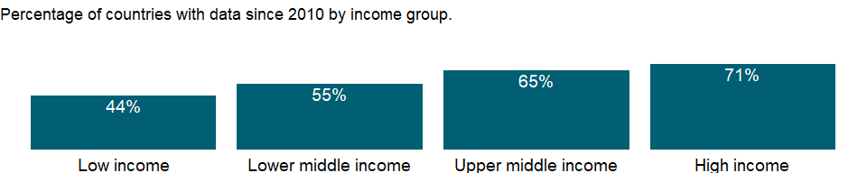

### Why is it relevant?

A relative high concentration of the adult population in a given level of education reflects the capacity of the educational system in the corresponding level of education. Educational attainment is closely related to the skills and competencies of a country’s population, and could be seen as a proxy of both the quantitative and qualitative aspects of the stock of human capital.

### What is the data source?

UNESCO Institute for Statistics (<http://uis.unesco.org/>). Data as of September 2020.

### What is the methodology?

It is calculated by dividing the number of population ages 25 and older who attained or completed post-secondary non-tertiary education by the total population of the same age group and multiplying by 100. The number 0 means zero or small enough that the number would round to zero.

Data are collected by the UNESCO Institute for Statistics mainly from national population census, household survey, and labour force survey. All the data are mapped to the International Standard Classification of Education (ISCED) to ensure the comparability of education programs at the international level. The current version was formally adopted by UNESCO Member States in 2011.

### How is it aggregated?

NA

### What are the limitations?

Caution is required when using this indicator for cross-country comparison, since the countries do not always classify degrees and qualifications at the same International Standard Classification of Education (ISCED) levels, even if they are received at roughly the same age or after a similar number of years of schooling. Also, certain educational programmes and study courses cannot be easily classified according to ISCED. This indicator only measures educational attainment in terms of level of education attained, i.e. years of schooling, and do not necessarily reveal the quality of the education (learning achievement and other impacts).

### What else should I know?

NA

### 1.57.25 Educational attainment, at least completed upper secondary, population 25+, female (%) (cumulative)

### What is the indicator?

The percentage of population ages 25 and over that attained or completed upper secondary education.

Topic: Education: Outcomes

Series ID: SE.SEC.CUAT.UP.FE.ZS

Copyright: CC BY-4.0 , <https://datacatalog.worldbank.org/public-licenses#cc-by>

First year with any data: 1970

Last year with any data: 2019

### What years are data available?

The figure below shows years in which data is available for at least one country. Dates shaded in black have no data, while dates shaded in green have data for at least one country

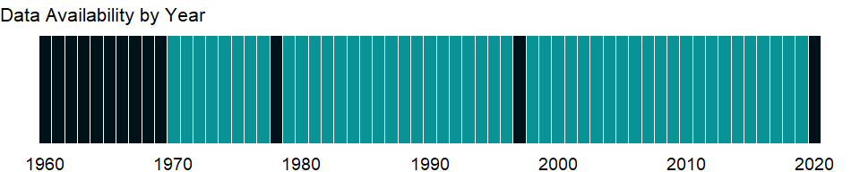

### Which countries have data?

The figure below shows the percentage of countries in each income group with a value since 2010 for that indicator.

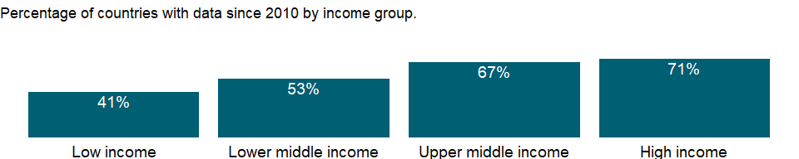

### Why is it relevant?

A relative high concentration of the adult population in a given level of education reflects the capacity of the educational system in the corresponding level of education. Educational attainment is closely related to the skills and competencies of a country’s population, and could be seen as a proxy of both the quantitative and qualitative aspects of the stock of human capital.

### What is the data source?

UNESCO Institute for Statistics (<http://uis.unesco.org/>). Data as of September 2020.

### What is the methodology?

It is calculated by dividing the number of population ages 25 and older who attained or completed upper secondary education by the total population of the same age group and multiplying by 100. The number 0 means zero or small enough that the number would round to zero.

Data are collected by the UNESCO Institute for Statistics mainly from national population census, household survey, and labour force survey. All the data are mapped to the International Standard Classification of Education (ISCED) to ensure the comparability of education programs at the international level. The current version was formally adopted by UNESCO Member States in 2011.

### How is it aggregated?

NA

### What are the limitations?

Caution is required when using this indicator for cross-country comparison, since the countries do not always classify degrees and qualifications at the same International Standard Classification of Education (ISCED) levels, even if they are received at roughly the same age or after a similar number of years of schooling. Also, certain educational programmes and study courses cannot be easily classified according to ISCED. This indicator only measures educational attainment in terms of level of education attained, i.e. years of schooling, and do not necessarily reveal the quality of the education (learning achievement and other impacts).

### What else should I know?

NA

### 1.57.26 Educational attainment, at least completed upper secondary, population 25+, male (%) (cumulative)

### What is the indicator?

The percentage of population ages 25 and over that attained or completed upper secondary education.

Topic: Education: Outcomes

Series ID: SE.SEC.CUAT.UP.MA.ZS

Copyright: CC BY-4.0 , <https://datacatalog.worldbank.org/public-licenses#cc-by>

First year with any data: 1970

Last year with any data: 2019

### What years are data available?

The figure below shows years in which data is available for at least one country. Dates shaded in black have no data, while dates shaded in green have data for at least one country



### Which countries have data?

The figure below shows the percentage of countries in each income group with a value since 2010 for that indicator.



### Why is it relevant?

A relative high concentration of the adult population in a given level of education reflects the capacity of the educational system in the corresponding level of education. Educational attainment is closely related to the skills and competencies of a country’s population, and could be seen as a proxy of both the quantitative and qualitative aspects of the stock of human capital.

### What is the data source?

UNESCO Institute for Statistics (<http://uis.unesco.org/>). Data as of September 2020.

### What is the methodology?

It is calculated by dividing the number of population ages 25 and older who attained or completed upper secondary education by the total population of the same age group and multiplying by 100. The number 0 means zero or small enough that the number would round to zero.

Data are collected by the UNESCO Institute for Statistics mainly from national population census, household survey, and labour force survey. All the data are mapped to the International Standard Classification of Education (ISCED) to ensure the comparability of education programs at the international level. The current version was formally adopted by UNESCO Member States in 2011.

### How is it aggregated?

NA

### What are the limitations?

Caution is required when using this indicator for cross-country comparison, since the countries do not always classify degrees and qualifications at the same International Standard Classification of Education (ISCED) levels, even if they are received at roughly the same age or after a similar number of years of schooling. Also, certain educational programmes and study courses cannot be easily classified according to ISCED. This indicator only measures educational attainment in terms of level of education attained, i.e. years of schooling, and do not necessarily reveal the quality of the education (learning achievement and other impacts).

### What else should I know?

NA

### 1.57.27 Educational attainment, at least completed upper secondary, population 25+, total (%) (cumulative)

### What is the indicator?

The percentage of population ages 25 and over that attained or completed upper secondary education.

Topic: Education: Outcomes

Series ID: SE.SEC.CUAT.UP.ZS

Copyright: CC BY-4.0 , <https://datacatalog.worldbank.org/public-licenses#cc-by>

First year with any data: 1970

Last year with any data: 2019

### What years are data available?

The figure below shows years in which data is available for at least one country. Dates shaded in black have no data, while dates shaded in green have data for at least one country



### Which countries have data?

The figure below shows the percentage of countries in each income group with a value since 2010 for that indicator.

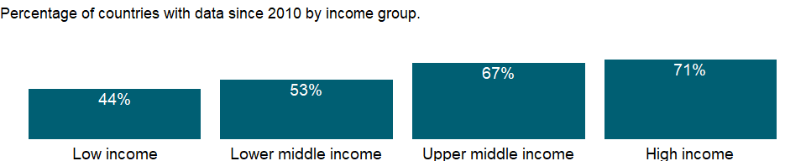

### Why is it relevant?

A relative high concentration of the adult population in a given level of education reflects the capacity of the educational system in the corresponding level of education. Educational attainment is closely related to the skills and competencies of a country’s population, and could be seen as a proxy of both the quantitative and qualitative aspects of the stock of human capital.

### What is the data source?

UNESCO Institute for Statistics (<http://uis.unesco.org/>). Data as of September 2020.

### What is the methodology?

It is calculated by dividing the number of population ages 25 and older who attained or completed upper secondary education by the total population of the same age group and multiplying by 100. The number 0 means zero or small enough that the number would round to zero.

Data are collected by the UNESCO Institute for Statistics mainly from national population census, household survey, and labour force survey. All the data are mapped to the International Standard Classification of Education (ISCED) to ensure the comparability of education programs at the international level. The current version was formally adopted by UNESCO Member States in 2011.

### How is it aggregated?

NA

### What are the limitations?

Caution is required when using this indicator for cross-country comparison, since the countries do not always classify degrees and qualifications at the same International Standard Classification of Education (ISCED) levels, even if they are received at roughly the same age or after a similar number of years of schooling. Also, certain educational programmes and study courses cannot be easily classified according to ISCED. This indicator only measures educational attainment in terms of level of education attained, i.e. years of schooling, and do not necessarily reveal the quality of the education (learning achievement and other impacts).

### What else should I know?

NA

### 1.57.28 Secondary education, duration (years)

### What is the indicator?

Secondary duration refers to the number of grades (years) in secondary school.

Topic: Education: Outcomes

Series ID: SE.SEC.DURS

Copyright: CC BY-4.0 , <https://datacatalog.worldbank.org/public-licenses#cc-by>

First year with any data: 1970

Last year with any data: 2020

### What years are data available?

The figure below shows years in which data is available for at least one country. Dates shaded in black have no data, while dates shaded in green have data for at least one country



### Which countries have data?

The figure below shows the percentage of countries in each income group with a value since 2010 for that indicator.

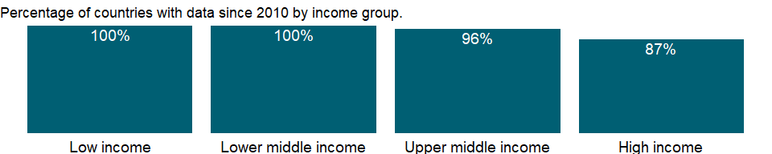

### Why is it relevant?

NA

### What is the data source?

UNESCO Institute for Statistics (<http://uis.unesco.org/>). Data as of September 2020.

### What is the methodology?

Data on education are collected by the UNESCO Institute for Statistics from official responses to its annual education survey. All the data are mapped to the International Standard Classification of Education (ISCED) to ensure the comparability of education programs at the international level. The current version was formally adopted by UNESCO Member States in 2011. Aggregate data are based on World Bank estimates.

The reference years reflect the school year for which the data are presented. In some countries the school year spans two calendar years (for example, from September 2010 to June 2011); in these cases the reference year refers to the year in which the school year ended (2011 in the example).

### How is it aggregated?

Median

### What are the limitations?

NA

### What else should I know?

NA

### 1.57.29 Educational attainment, at least Bachelor’s or equivalent, population 25+, female (%) (cumulative)

### What is the indicator?

The percentage of population ages 25 and over that attained or completed Bachelor’s or equivalent.

Topic: Education: Outcomes

Series ID: SE.TER.CUAT.BA.FE.ZS

Copyright: CC BY-4.0 , <https://datacatalog.worldbank.org/public-licenses#cc-by>

First year with any data: 1970

Last year with any data: 2019

### What years are data available?

The figure below shows years in which data is available for at least one country. Dates shaded in black have no data, while dates shaded in green have data for at least one country

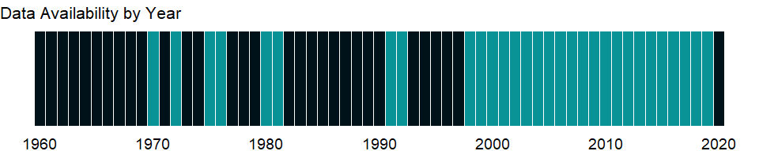

### Which countries have data?

The figure below shows the percentage of countries in each income group with a value since 2010 for that indicator.

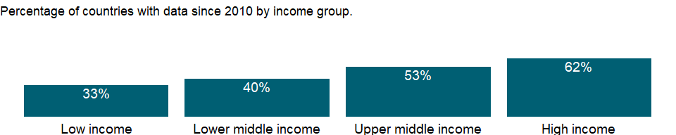

### Why is it relevant?

A relative high concentration of the adult population in a given level of education reflects the capacity of the educational system in the corresponding level of education. Educational attainment is closely related to the skills and competencies of a country’s population, and could be seen as a proxy of both the quantitative and qualitative aspects of the stock of human capital.

### What is the data source?

UNESCO Institute for Statistics (<http://uis.unesco.org/>). Data as of September 2020.

### What is the methodology?

It is calculated by dividing the number of population ages 25 and older who attained or completed Bachelor’s or equivalent by the total population of the same age group and multiplying by 100. The number 0 means zero or small enough that the number would round to zero.

Data are collected by the UNESCO Institute for Statistics mainly from national population census, household survey, and labour force survey. All the data are mapped to the International Standard Classification of Education (ISCED) to ensure the comparability of education programs at the international level. The current version was formally adopted by UNESCO Member States in 2011.

### How is it aggregated?

NA

### What are the limitations?

Caution is required when using this indicator for cross-country comparison, since the countries do not always classify degrees and qualifications at the same International Standard Classification of Education (ISCED) levels, even if they are received at roughly the same age or after a similar number of years of schooling. Also, certain educational programmes and study courses cannot be easily classified according to ISCED. This indicator only measures educational attainment in terms of level of education attained, i.e. years of schooling, and do not necessarily reveal the quality of the education (learning achievement and other impacts).

### What else should I know?

NA

### 1.57.30 Educational attainment, at least Bachelor’s or equivalent, population 25+, male (%) (cumulative)

### What is the indicator?

The percentage of population ages 25 and over that attained or completed Bachelor’s or equivalent.

Topic: Education: Outcomes

Series ID: SE.TER.CUAT.BA.MA.ZS

Copyright: CC BY-4.0 , <https://datacatalog.worldbank.org/public-licenses#cc-by>

First year with any data: 1970

Last year with any data: 2019

### What years are data available?

The figure below shows years in which data is available for at least one country. Dates shaded in black have no data, while dates shaded in green have data for at least one country



### Which countries have data?

The figure below shows the percentage of countries in each income group with a value since 2010 for that indicator.



### Why is it relevant?

A relative high concentration of the adult population in a given level of education reflects the capacity of the educational system in the corresponding level of education. Educational attainment is closely related to the skills and competencies of a country’s population, and could be seen as a proxy of both the quantitative and qualitative aspects of the stock of human capital.

### What is the data source?

UNESCO Institute for Statistics (<http://uis.unesco.org/>). Data as of September 2020.

### What is the methodology?

It is calculated by dividing the number of population ages 25 and older who attained or completed Bachelor’s or equivalent by the total population of the same age group and multiplying by 100. The number 0 means zero or small enough that the number would round to zero.

Data are collected by the UNESCO Institute for Statistics mainly from national population census, household survey, and labour force survey. All the data are mapped to the International Standard Classification of Education (ISCED) to ensure the comparability of education programs at the international level. The current version was formally adopted by UNESCO Member States in 2011.

### How is it aggregated?

NA

### What are the limitations?

Caution is required when using this indicator for cross-country comparison, since the countries do not always classify degrees and qualifications at the same International Standard Classification of Education (ISCED) levels, even if they are received at roughly the same age or after a similar number of years of schooling. Also, certain educational programmes and study courses cannot be easily classified according to ISCED. This indicator only measures educational attainment in terms of level of education attained, i.e. years of schooling, and do not necessarily reveal the quality of the education (learning achievement and other impacts).

### What else should I know?

NA

### 1.57.31 Educational attainment, at least Bachelor’s or equivalent, population 25+, total (%) (cumulative)

### What is the indicator?

The percentage of population ages 25 and over that attained or completed Bachelor’s or equivalent.

Topic: Education: Outcomes

Series ID: SE.TER.CUAT.BA.ZS

Copyright: CC BY-4.0 , <https://datacatalog.worldbank.org/public-licenses#cc-by>

First year with any data: 1970

Last year with any data: 2019

### What years are data available?

The figure below shows years in which data is available for at least one country. Dates shaded in black have no data, while dates shaded in green have data for at least one country



### Which countries have data?

The figure below shows the percentage of countries in each income group with a value since 2010 for that indicator.

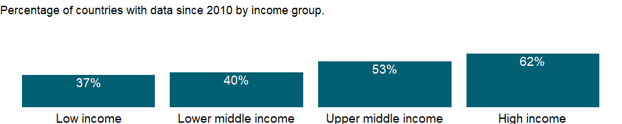

### Why is it relevant?

A relative high concentration of the adult population in a given level of education reflects the capacity of the educational system in the corresponding level of education. Educational attainment is closely related to the skills and competencies of a country’s population, and could be seen as a proxy of both the quantitative and qualitative aspects of the stock of human capital.

### What is the data source?

UNESCO Institute for Statistics (<http://uis.unesco.org/>). Data as of September 2020.

### What is the methodology?

It is calculated by dividing the number of population ages 25 and older who attained or completed Bachelor’s or equivalent by the total population of the same age group and multiplying by 100. The number 0 means zero or small enough that the number would round to zero.

Data are collected by the UNESCO Institute for Statistics mainly from national population census, household survey, and labour force survey. All the data are mapped to the International Standard Classification of Education (ISCED) to ensure the comparability of education programs at the international level. The current version was formally adopted by UNESCO Member States in 2011.

### How is it aggregated?

NA

### What are the limitations?

Caution is required when using this indicator for cross-country comparison, since the countries do not always classify degrees and qualifications at the same International Standard Classification of Education (ISCED) levels, even if they are received at roughly the same age or after a similar number of years of schooling. Also, certain educational programmes and study courses cannot be easily classified according to ISCED. This indicator only measures educational attainment in terms of level of education attained, i.e. years of schooling, and do not necessarily reveal the quality of the education (learning achievement and other impacts).

### What else should I know?

NA

### 1.57.32 Educational attainment, Doctoral or equivalent, population 25+, female (%) (cumulative)

### What is the indicator?

The percentage of population ages 25 and over that attained or completed Doctoral or equivalent.

Topic: Education: Outcomes

Series ID: SE.TER.CUAT.DO.FE.ZS

Copyright: CC BY-4.0 , <https://datacatalog.worldbank.org/public-licenses#cc-by>

First year with any data: 2008

Last year with any data: 2019

### What years are data available?

The figure below shows years in which data is available for at least one country. Dates shaded in black have no data, while dates shaded in green have data for at least one country



### Which countries have data?

The figure below shows the percentage of countries in each income group with a value since 2010 for that indicator.

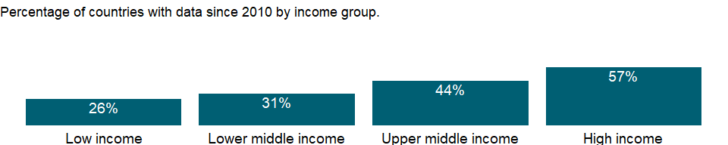

### Why is it relevant?

A relative high concentration of the adult population in a given level of education reflects the capacity of the educational system in the corresponding level of education. Educational attainment is closely related to the skills and competencies of a country’s population, and could be seen as a proxy of both the quantitative and qualitative aspects of the stock of human capital.

### What is the data source?

UNESCO Institute for Statistics (<http://uis.unesco.org/>). Data as of September 2020.

### What is the methodology?

It is calculated by dividing the number of population ages 25 and older who attained or completed Doctoral or equivalent by the total population of the same age group and multiplying by 100. The number 0 means zero or small enough that the number would round to zero.

Data are collected by the UNESCO Institute for Statistics mainly from national population census, household survey, and labour force survey. All the data are mapped to the International Standard Classification of Education (ISCED) to ensure the comparability of education programs at the international level. The current version was formally adopted by UNESCO Member States in 2011.

### How is it aggregated?

NA

### What are the limitations?

Caution is required when using this indicator for cross-country comparison, since the countries do not always classify degrees and qualifications at the same International Standard Classification of Education (ISCED) levels, even if they are received at roughly the same age or after a similar number of years of schooling. Also, certain educational programmes and study courses cannot be easily classified according to ISCED. This indicator only measures educational attainment in terms of level of education attained, i.e. years of schooling, and do not necessarily reveal the quality of the education (learning achievement and other impacts).

### What else should I know?

NA

### 1.57.33 Educational attainment, Doctoral or equivalent, population 25+, male (%) (cumulative)

### What is the indicator?

The percentage of population ages 25 and over that attained or completed Doctoral or equivalent.

Topic: Education: Outcomes

Series ID: SE.TER.CUAT.DO.MA.ZS

Copyright: CC BY-4.0 , <https://datacatalog.worldbank.org/public-licenses#cc-by>

First year with any data: 2008

Last year with any data: 2019

### What years are data available?

The figure below shows years in which data is available for at least one country. Dates shaded in black have no data, while dates shaded in green have data for at least one country



### Which countries have data?

The figure below shows the percentage of countries in each income group with a value since 2010 for that indicator.



### Why is it relevant?

A relative high concentration of the adult population in a given level of education reflects the capacity of the educational system in the corresponding level of education. Educational attainment is closely related to the skills and competencies of a country’s population, and could be seen as a proxy of both the quantitative and qualitative aspects of the stock of human capital.

### What is the data source?

UNESCO Institute for Statistics (<http://uis.unesco.org/>). Data as of September 2020.

### What is the methodology?

It is calculated by dividing the number of population ages 25 and older who attained or completed Doctoral or equivalent by the total population of the same age group and multiplying by 100. The number 0 means zero or small enough that the number would round to zero.

Data are collected by the UNESCO Institute for Statistics mainly from national population census, household survey, and labour force survey. All the data are mapped to the International Standard Classification of Education (ISCED) to ensure the comparability of education programs at the international level. The current version was formally adopted by UNESCO Member States in 2011.

### How is it aggregated?

NA

### What are the limitations?

Caution is required when using this indicator for cross-country comparison, since the countries do not always classify degrees and qualifications at the same International Standard Classification of Education (ISCED) levels, even if they are received at roughly the same age or after a similar number of years of schooling. Also, certain educational programmes and study courses cannot be easily classified according to ISCED. This indicator only measures educational attainment in terms of level of education attained, i.e. years of schooling, and do not necessarily reveal the quality of the education (learning achievement and other impacts).

### What else should I know?

NA

### 1.57.34 Educational attainment, Doctoral or equivalent, population 25+, total (%) (cumulative)

### What is the indicator?

The percentage of population ages 25 and over that attained or completed Doctoral or equivalent.

Topic: Education: Outcomes

Series ID: SE.TER.CUAT.DO.ZS

Copyright: CC BY-4.0 , <https://datacatalog.worldbank.org/public-licenses#cc-by>

First year with any data: 2008

Last year with any data: 2019

### What years are data available?

The figure below shows years in which data is available for at least one country. Dates shaded in black have no data, while dates shaded in green have data for at least one country



### Which countries have data?

The figure below shows the percentage of countries in each income group with a value since 2010 for that indicator.



### Why is it relevant?

A relative high concentration of the adult population in a given level of education reflects the capacity of the educational system in the corresponding level of education. Educational attainment is closely related to the skills and competencies of a country’s population, and could be seen as a proxy of both the quantitative and qualitative aspects of the stock of human capital.

### What is the data source?

UNESCO Institute for Statistics (<http://uis.unesco.org/>). Data as of September 2020.

### What is the methodology?

It is calculated by dividing the number of population ages 25 and older who attained or completed Doctoral or equivalent by the total population of the same age group and multiplying by 100. The number 0 means zero or small enough that the number would round to zero.

Data are collected by the UNESCO Institute for Statistics mainly from national population census, household survey, and labour force survey. All the data are mapped to the International Standard Classification of Education (ISCED) to ensure the comparability of education programs at the international level. The current version was formally adopted by UNESCO Member States in 2011.

### How is it aggregated?

NA

### What are the limitations?

Caution is required when using this indicator for cross-country comparison, since the countries do not always classify degrees and qualifications at the same International Standard Classification of Education (ISCED) levels, even if they are received at roughly the same age or after a similar number of years of schooling. Also, certain educational programmes and study courses cannot be easily classified according to ISCED. This indicator only measures educational attainment in terms of level of education attained, i.e. years of schooling, and do not necessarily reveal the quality of the education (learning achievement and other impacts).

### What else should I know?

NA

### 1.57.35 Educational attainment, at least Master’s or equivalent, population 25+, female (%) (cumulative)

### What is the indicator?

The percentage of population ages 25 and over that attained or completed Master’s or equivalent.

Topic: Education: Outcomes

Series ID: SE.TER.CUAT.MS.FE.ZS

Copyright: CC BY-4.0 , <https://datacatalog.worldbank.org/public-licenses#cc-by>

First year with any data: 2006

Last year with any data: 2019

### What years are data available?

The figure below shows years in which data is available for at least one country. Dates shaded in black have no data, while dates shaded in green have data for at least one country



### Which countries have data?

The figure below shows the percentage of countries in each income group with a value since 2010 for that indicator.

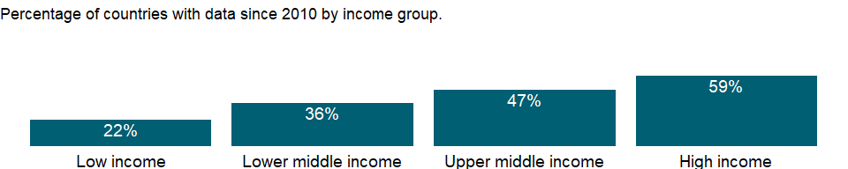

### Why is it relevant?

A relative high concentration of the adult population in a given level of education reflects the capacity of the educational system in the corresponding level of education. Educational attainment is closely related to the skills and competencies of a country’s population, and could be seen as a proxy of both the quantitative and qualitative aspects of the stock of human capital.

### What is the data source?

UNESCO Institute for Statistics (<http://uis.unesco.org/>). Data as of September 2020.

### What is the methodology?

It is calculated by dividing the number of population ages 25 and older who attained or completed Master’s or equivalent by the total population of the same age group and multiplying by 100. The number 0 means zero or small enough that the number would round to zero.

Data are collected by the UNESCO Institute for Statistics mainly from national population census, household survey, and labour force survey. All the data are mapped to the International Standard Classification of Education (ISCED) to ensure the comparability of education programs at the international level. The current version was formally adopted by UNESCO Member States in 2011.

### How is it aggregated?

NA

### What are the limitations?

Caution is required when using this indicator for cross-country comparison, since the countries do not always classify degrees and qualifications at the same International Standard Classification of Education (ISCED) levels, even if they are received at roughly the same age or after a similar number of years of schooling. Also, certain educational programmes and study courses cannot be easily classified according to ISCED. This indicator only measures educational attainment in terms of level of education attained, i.e. years of schooling, and do not necessarily reveal the quality of the education (learning achievement and other impacts).

### What else should I know?

NA

### 1.57.36 Educational attainment, at least Master’s or equivalent, population 25+, male (%) (cumulative)

### What is the indicator?

The percentage of population ages 25 and over that attained or completed Master’s or equivalent.

Topic: Education: Outcomes

Series ID: SE.TER.CUAT.MS.MA.ZS

Copyright: CC BY-4.0 , <https://datacatalog.worldbank.org/public-licenses#cc-by>

First year with any data: 2006

Last year with any data: 2019

### What years are data available?

The figure below shows years in which data is available for at least one country. Dates shaded in black have no data, while dates shaded in green have data for at least one country



### Which countries have data?

The figure below shows the percentage of countries in each income group with a value since 2010 for that indicator.



### Why is it relevant?

A relative high concentration of the adult population in a given level of education reflects the capacity of the educational system in the corresponding level of education. Educational attainment is closely related to the skills and competencies of a country’s population, and could be seen as a proxy of both the quantitative and qualitative aspects of the stock of human capital.

### What is the data source?

UNESCO Institute for Statistics (<http://uis.unesco.org/>). Data as of September 2020.

### What is the methodology?

It is calculated by dividing the number of population ages 25 and older who attained or completed Master’s or equivalent by the total population of the same age group and multiplying by 100. The number 0 means zero or small enough that the number would round to zero.

Data are collected by the UNESCO Institute for Statistics mainly from national population census, household survey, and labour force survey. All the data are mapped to the International Standard Classification of Education (ISCED) to ensure the comparability of education programs at the international level. The current version was formally adopted by UNESCO Member States in 2011.

### How is it aggregated?

NA

### What are the limitations?

Caution is required when using this indicator for cross-country comparison, since the countries do not always classify degrees and qualifications at the same International Standard Classification of Education (ISCED) levels, even if they are received at roughly the same age or after a similar number of years of schooling. Also, certain educational programmes and study courses cannot be easily classified according to ISCED. This indicator only measures educational attainment in terms of level of education attained, i.e. years of schooling, and do not necessarily reveal the quality of the education (learning achievement and other impacts).

### What else should I know?

NA

### 1.57.37 Educational attainment, at least Master’s or equivalent, population 25+, total (%) (cumulative)

### What is the indicator?

The percentage of population ages 25 and over that attained or completed Master’s or equivalent.

Topic: Education: Outcomes

Series ID: SE.TER.CUAT.MS.ZS

Copyright: CC BY-4.0 , <https://datacatalog.worldbank.org/public-licenses#cc-by>

First year with any data: 2006

Last year with any data: 2019

### What years are data available?

The figure below shows years in which data is available for at least one country. Dates shaded in black have no data, while dates shaded in green have data for at least one country



### Which countries have data?

The figure below shows the percentage of countries in each income group with a value since 2010 for that indicator.

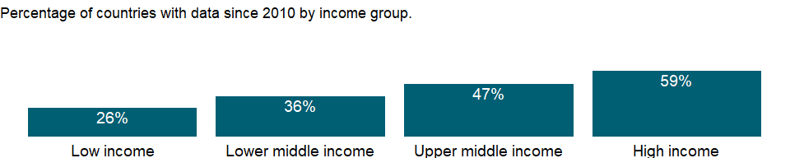

### Why is it relevant?

A relative high concentration of the adult population in a given level of education reflects the capacity of the educational system in the corresponding level of education. Educational attainment is closely related to the skills and competencies of a country’s population, and could be seen as a proxy of both the quantitative and qualitative aspects of the stock of human capital.

### What is the data source?

UNESCO Institute for Statistics (<http://uis.unesco.org/>). Data as of September 2020.

### What is the methodology?

It is calculated by dividing the number of population ages 25 and older who attained or completed Master’s or equivalent by the total population of the same age group and multiplying by 100. The number 0 means zero or small enough that the number would round to zero.

Data are collected by the UNESCO Institute for Statistics mainly from national population census, household survey, and labour force survey. All the data are mapped to the International Standard Classification of Education (ISCED) to ensure the comparability of education programs at the international level. The current version was formally adopted by UNESCO Member States in 2011.

### How is it aggregated?

NA

### What are the limitations?

Caution is required when using this indicator for cross-country comparison, since the countries do not always classify degrees and qualifications at the same International Standard Classification of Education (ISCED) levels, even if they are received at roughly the same age or after a similar number of years of schooling. Also, certain educational programmes and study courses cannot be easily classified according to ISCED. This indicator only measures educational attainment in terms of level of education attained, i.e. years of schooling, and do not necessarily reveal the quality of the education (learning achievement and other impacts).

### What else should I know?

NA

### 1.57.38 Educational attainment, at least completed short-cycle tertiary, population 25+, female (%) (cumulative)

### What is the indicator?

The percentage of population ages 25 and over that attained or completed short-cycle tertiary education.

Topic: Education: Outcomes

Series ID: SE.TER.CUAT.ST.FE.ZS

Copyright: CC BY-4.0 , <https://datacatalog.worldbank.org/public-licenses#cc-by>

First year with any data: 1970

Last year with any data: 2019

### What years are data available?

The figure below shows years in which data is available for at least one country. Dates shaded in black have no data, while dates shaded in green have data for at least one country

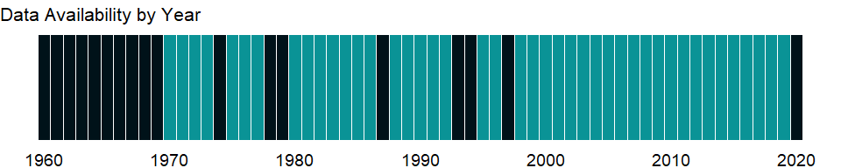

### Which countries have data?

The figure below shows the percentage of countries in each income group with a value since 2010 for that indicator.

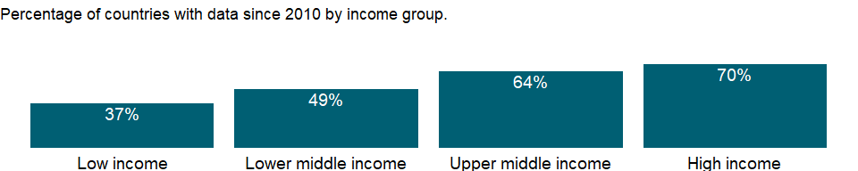

### Why is it relevant?

A relative high concentration of the adult population in a given level of education reflects the capacity of the educational system in the corresponding level of education. Educational attainment is closely related to the skills and competencies of a country’s population, and could be seen as a proxy of both the quantitative and qualitative aspects of the stock of human capital.

### What is the data source?

UNESCO Institute for Statistics (<http://uis.unesco.org/>). Data as of September 2020.

### What is the methodology?

It is calculated by dividing the number of population ages 25 and older who attained or completed short-cycle tertiary education by the total population of the same age group and multiplying by 100. The number 0 means zero or small enough that the number would round to zero.

Data are collected by the UNESCO Institute for Statistics mainly from national population census, household survey, and labour force survey. All the data are mapped to the International Standard Classification of Education (ISCED) to ensure the comparability of education programs at the international level. The current version was formally adopted by UNESCO Member States in 2011.

### How is it aggregated?

NA

### What are the limitations?

Caution is required when using this indicator for cross-country comparison, since the countries do not always classify degrees and qualifications at the same International Standard Classification of Education (ISCED) levels, even if they are received at roughly the same age or after a similar number of years of schooling. Also, certain educational programmes and study courses cannot be easily classified according to ISCED. This indicator only measures educational attainment in terms of level of education attained, i.e. years of schooling, and do not necessarily reveal the quality of the education (learning achievement and other impacts).

### What else should I know?

NA

### 1.57.39 Educational attainment, at least completed short-cycle tertiary, population 25+, male (%) (cumulative)

### What is the indicator?

The percentage of population ages 25 and over that attained or completed short-cycle tertiary education.

Topic: Education: Outcomes

Series ID: SE.TER.CUAT.ST.MA.ZS

Copyright: CC BY-4.0 , <https://datacatalog.worldbank.org/public-licenses#cc-by>

First year with any data: 1970

Last year with any data: 2019

### What years are data available?

The figure below shows years in which data is available for at least one country. Dates shaded in black have no data, while dates shaded in green have data for at least one country



### Which countries have data?

The figure below shows the percentage of countries in each income group with a value since 2010 for that indicator.



### Why is it relevant?

A relative high concentration of the adult population in a given level of education reflects the capacity of the educational system in the corresponding level of education. Educational attainment is closely related to the skills and competencies of a country’s population, and could be seen as a proxy of both the quantitative and qualitative aspects of the stock of human capital.

### What is the data source?

UNESCO Institute for Statistics (<http://uis.unesco.org/>). Data as of September 2020.

### What is the methodology?

It is calculated by dividing the number of population ages 25 and older who attained or completed short-cycle tertiary education by the total population of the same age group and multiplying by 100. The number 0 means zero or small enough that the number would round to zero.

Data are collected by the UNESCO Institute for Statistics mainly from national population census, household survey, and labour force survey. All the data are mapped to the International Standard Classification of Education (ISCED) to ensure the comparability of education programs at the international level. The current version was formally adopted by UNESCO Member States in 2011.

### How is it aggregated?

NA

### What are the limitations?

Caution is required when using this indicator for cross-country comparison, since the countries do not always classify degrees and qualifications at the same International Standard Classification of Education (ISCED) levels, even if they are received at roughly the same age or after a similar number of years of schooling. Also, certain educational programmes and study courses cannot be easily classified according to ISCED. This indicator only measures educational attainment in terms of level of education attained, i.e. years of schooling, and do not necessarily reveal the quality of the education (learning achievement and other impacts).

### What else should I know?

NA

### 1.57.40 Educational attainment, at least completed short-cycle tertiary, population 25+, total (%) (cumulative)

### What is the indicator?

The percentage of population ages 25 and over that attained or completed short-cycle tertiary education.

Topic: Education: Outcomes

Series ID: SE.TER.CUAT.ST.ZS

Copyright: CC BY-4.0 , <https://datacatalog.worldbank.org/public-licenses#cc-by>

First year with any data: 1970

Last year with any data: 2019

### What years are data available?

The figure below shows years in which data is available for at least one country. Dates shaded in black have no data, while dates shaded in green have data for at least one country



### Which countries have data?

The figure below shows the percentage of countries in each income group with a value since 2010 for that indicator.

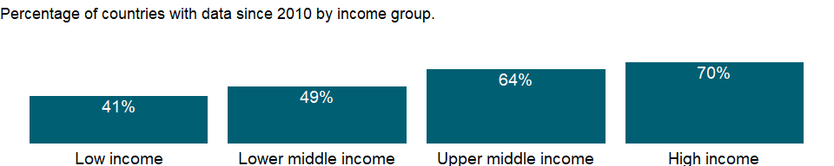

### Why is it relevant?

A relative high concentration of the adult population in a given level of education reflects the capacity of the educational system in the corresponding level of education. Educational attainment is closely related to the skills and competencies of a country’s population, and could be seen as a proxy of both the quantitative and qualitative aspects of the stock of human capital.

### What is the data source?

UNESCO Institute for Statistics (<http://uis.unesco.org/>). Data as of September 2020.

### What is the methodology?

It is calculated by dividing the number of population ages 25 and older who attained or completed short-cycle tertiary education by the total population of the same age group and multiplying by 100. The number 0 means zero or small enough that the number would round to zero.

Data are collected by the UNESCO Institute for Statistics mainly from national population census, household survey, and labour force survey. All the data are mapped to the International Standard Classification of Education (ISCED) to ensure the comparability of education programs at the international level. The current version was formally adopted by UNESCO Member States in 2011.

### How is it aggregated?

NA

### What are the limitations?

Caution is required when using this indicator for cross-country comparison, since the countries do not always classify degrees and qualifications at the same International Standard Classification of Education (ISCED) levels, even if they are received at roughly the same age or after a similar number of years of schooling. Also, certain educational programmes and study courses cannot be easily classified according to ISCED. This indicator only measures educational attainment in terms of level of education attained, i.e. years of schooling, and do not necessarily reveal the quality of the education (learning achievement and other impacts).

### What else should I know?

NA

## 1.58 Education: Participation

### 1.58.1 School enrollment, primary (gross), gender parity index (GPI)

### What is the indicator?

Gender parity index for gross enrollment ratio in primary education is the ratio of girls to boys enrolled at primary level in public and private schools.

Topic: Education: Participation

Series ID: SE.ENR.PRIM.FM.ZS

Copyright: CC BY-4.0 , <https://datacatalog.worldbank.org/public-licenses#cc-by>

First year with any data: 1970

Last year with any data: 2020

### What years are data available?

The figure below shows years in which data is available for at least one country. Dates shaded in black have no data, while dates shaded in green have data for at least one country



### Which countries have data?

The figure below shows the percentage of countries in each income group with a value since 2010 for that indicator.

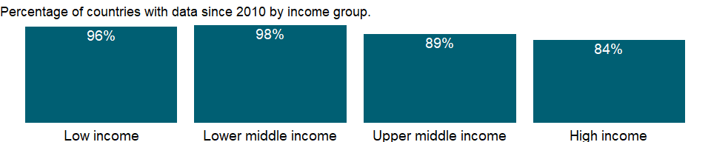

### Why is it relevant?

The Gender Parity Index (GPI) indicates parity between girls and boys. A GPI of less than 1 suggests girls are more disadvantaged than boys in learning opportunities and a GPI of greater than 1 suggests the other way around. Eliminating gender disparities in education would help increase the status and capabilities of women.

### What is the data source?

UNESCO Institute for Statistics (<http://uis.unesco.org/>). Data as of September 2020.

### What is the methodology?

This indicator is calculated by dividing female gross enrollment ratio in primary education by male gross enrollment ratio in primary education.

Data on education are collected by the UNESCO Institute for Statistics from official responses to its annual education survey. All the data are mapped to the International Standard Classification of Education (ISCED) to ensure the comparability of education programs at the international level. The current version was formally adopted by UNESCO Member States in 2011.

The reference years reflect the school year for which the data are presented. In some countries the school year spans two calendar years (for example, from September 2010 to June 2011); in these cases the reference year refers to the year in which the school year ended (2011 in the example).

### How is it aggregated?

Weighted average

### What are the limitations?

NA

### What else should I know?

For aggregate data, each economy is classified based on the classification of World Bank Group’s fiscal year 2021 (July 1, 2020-June 30, 2021).

### 1.58.2 School enrollment, primary and secondary (gross), gender parity index (GPI)

### What is the indicator?

Gender parity index for gross enrollment ratio in primary and secondary education is the ratio of girls to boys enrolled at primary and secondary levels in public and private schools.

Topic: Education: Participation

Series ID: SE.ENR.PRSC.FM.ZS

Copyright: CC BY-4.0 , <https://datacatalog.worldbank.org/public-licenses#cc-by>

First year with any data: 1970

Last year with any data: 2020

### What years are data available?

The figure below shows years in which data is available for at least one country. Dates shaded in black have no data, while dates shaded in green have data for at least one country



### Which countries have data?

The figure below shows the percentage of countries in each income group with a value since 2010 for that indicator.

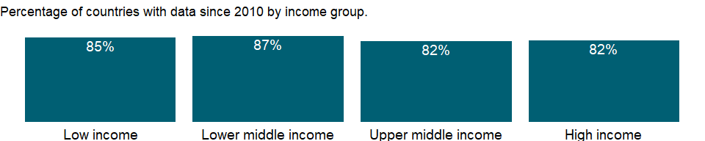

### Why is it relevant?

The Gender Parity Index (GPI) indicates parity between girls and boys. A GPI of less than 1 suggests girls are more disadvantaged than boys in learning opportunities and a GPI of greater than 1 suggests the other way around. Eliminating gender disparities in education would help increase the status and capabilities of women.

### What is the data source?

UNESCO Institute for Statistics (<http://uis.unesco.org/>). Data as of September 2020.

### What is the methodology?

This indicator is calculated by dividing female gross enrollment ratio in primary and secondary education by male gross enrollment ratio in primary and secondary education.

Data on education are collected by the UNESCO Institute for Statistics from official responses to its annual education survey. All the data are mapped to the International Standard Classification of Education (ISCED) to ensure the comparability of education programs at the international level. The current version was formally adopted by UNESCO Member States in 2011.

The reference years reflect the school year for which the data are presented. In some countries the school year spans two calendar years (for example, from September 2010 to June 2011); in these cases the reference year refers to the year in which the school year ended (2011 in the example).

### How is it aggregated?

Weighted average

### What are the limitations?

NA

### What else should I know?

For aggregate data, each economy is classified based on the classification of World Bank Group’s fiscal year 2021 (July 1, 2020-June 30, 2021).

### 1.58.3 School enrollment, secondary (gross), gender parity index (GPI)

### What is the indicator?

Gender parity index for gross enrollment ratio in secondary education is the ratio of girls to boys enrolled at secondary level in public and private schools.

Topic: Education: Participation

Series ID: SE.ENR.SECO.FM.ZS

Copyright: CC BY-4.0 , <https://datacatalog.worldbank.org/public-licenses#cc-by>

First year with any data: 1970

Last year with any data: 2020

### What years are data available?

The figure below shows years in which data is available for at least one country. Dates shaded in black have no data, while dates shaded in green have data for at least one country



### Which countries have data?

The figure below shows the percentage of countries in each income group with a value since 2010 for that indicator.

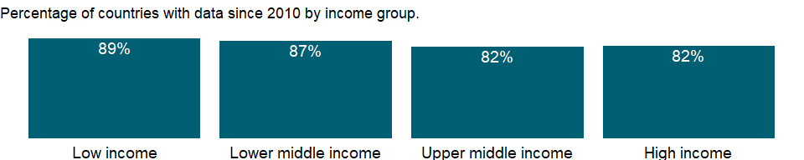

### Why is it relevant?

The Gender Parity Index (GPI) indicates parity between girls and boys. A GPI of less than 1 suggests girls are more disadvantaged than boys in learning opportunities and a GPI of greater than 1 suggests the other way around. Eliminating gender disparities in education would help increase the status and capabilities of women.

### What is the data source?

UNESCO Institute for Statistics (<http://uis.unesco.org/>). Data as of September 2020.

### What is the methodology?

This indicator is calculated by dividing female gross enrollment ratio in secondary education by male gross enrollment ratio in secondary education.

Data on education are collected by the UNESCO Institute for Statistics from official responses to its annual education survey. All the data are mapped to the International Standard Classification of Education (ISCED) to ensure the comparability of education programs at the international level. The current version was formally adopted by UNESCO Member States in 2011.

The reference years reflect the school year for which the data are presented. In some countries the school year spans two calendar years (for example, from September 2010 to June 2011); in these cases the reference year refers to the year in which the school year ended (2011 in the example).

### How is it aggregated?

Weighted average

### What are the limitations?

NA

### What else should I know?

For aggregate data, each economy is classified based on the classification of World Bank Group’s fiscal year 2021 (July 1, 2020-June 30, 2021).

### 1.58.4 School enrollment, tertiary (gross), gender parity index (GPI)

### What is the indicator?

Gender parity index for gross enrollment ratio in tertiary education is the ratio of women to men enrolled at tertiary level in public and private schools.

Topic: Education: Participation

Series ID: SE.ENR.TERT.FM.ZS

Copyright: CC BY-4.0 , <https://datacatalog.worldbank.org/public-licenses#cc-by>

First year with any data: 1970

Last year with any data: 2020

### What years are data available?

The figure below shows years in which data is available for at least one country. Dates shaded in black have no data, while dates shaded in green have data for at least one country



### Which countries have data?

The figure below shows the percentage of countries in each income group with a value since 2010 for that indicator.

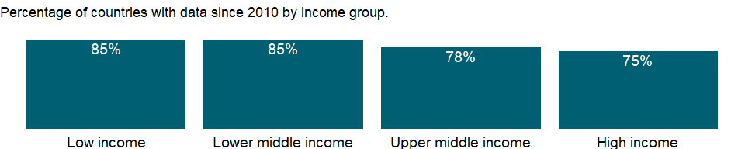

### Why is it relevant?

The Gender Parity Index (GPI) indicates parity between girls and boys. A GPI of less than 1 suggests girls are more disadvantaged than boys in learning opportunities and a GPI of greater than 1 suggests the other way around. Eliminating gender disparities in education would help increase the status and capabilities of women.

### What is the data source?

UNESCO Institute for Statistics (<http://uis.unesco.org/>). Data as of September 2020.

### What is the methodology?

This indicator is calculated by dividing female gross enrollment ratio in tertiary education by male gross enrollment ratio in tertiary education.

Data on education are collected by the UNESCO Institute for Statistics from official responses to its annual education survey. All the data are mapped to the International Standard Classification of Education (ISCED) to ensure the comparability of education programs at the international level. The current version was formally adopted by UNESCO Member States in 2011.

The reference years reflect the school year for which the data are presented. In some countries the school year spans two calendar years (for example, from September 2010 to June 2011); in these cases the reference year refers to the year in which the school year ended (2011 in the example).

### How is it aggregated?

Weighted average

### What are the limitations?

NA

### What else should I know?

For aggregate data, each economy is classified based on the classification of World Bank Group’s fiscal year 2021 (July 1, 2020-June 30, 2021).

### 1.58.5 School enrollment, preprimary (% gross)

### What is the indicator?

Gross enrollment ratio is the ratio of total enrollment, regardless of age, to the population of the age group that officially corresponds to the level of education shown. Preprimary education refers to programs at the initial stage of organized instruction, designed primarily to introduce very young children to a school-type environment and to provide a bridge between home and school.

Topic: Education: Participation

Series ID: SE.PRE.ENRR

Copyright: CC BY-4.0 , <https://datacatalog.worldbank.org/public-licenses#cc-by>

First year with any data: 1970

Last year with any data: 2020

### What years are data available?

The figure below shows years in which data is available for at least one country. Dates shaded in black have no data, while dates shaded in green have data for at least one country



### Which countries have data?

The figure below shows the percentage of countries in each income group with a value since 2010 for that indicator.

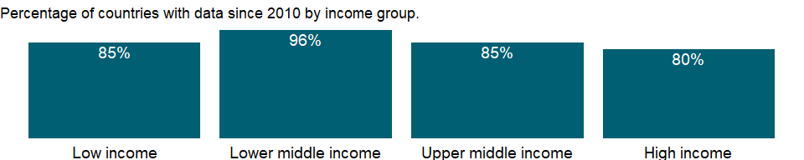

### Why is it relevant?

Gross enrollment ratios indicate the capacity of each level of the education system, but a high ratio may reflect a substantial number of overage children enrolled in each grade because of repetition or late entry rather than a successful education system. The net enrollment rate excludes overage and underage students and more accurately captures the system’s coverage and internal efficiency. Differences between the gross enrollment ratio and the net enrollment rate show the incidence of overage and underage enrollments.

### What is the data source?

UNESCO Institute for Statistics (<http://uis.unesco.org/>). Data as of September 2020.

### What is the methodology?

Gross enrollment ratio for pre-primary school is calculated by dividing the number of students enrolled in pre-primary education regardless of age by the population of the age group which officially corresponds to pre-primary education, and multiplying by 100.

Data on education are collected by the UNESCO Institute for Statistics from official responses to its annual education survey. All the data are mapped to the International Standard Classification of Education (ISCED) to ensure the comparability of education programs at the international level. The current version was formally adopted by UNESCO Member States in 2011. Population data are drawn from the United Nations Population Division. Using a single source for population data standardizes definitions, estimations, and interpolation methods, ensuring a consistent methodology across countries and minimizing potential enumeration problems in national censuses.

The reference years reflect the school year for which the data are presented. In some countries the school year spans two calendar years (for example, from September 2010 to June 2011); in these cases the reference year refers to the year in which the school year ended (2011 in the example).

### How is it aggregated?

Weighted average

### What are the limitations?

Enrollment indicators are based on annual school surveys, but do not necessarily reflect actual attendance or dropout rates during the year. Also, the length of education differs across countries and can influence enrollment rates, although the International Standard Classification of Education (ISCED) tries to minimize the difference. For example, a shorter duration for primary education tends to increase the rate; a longer one to decrease it (in part because older children are more at risk of dropping out). Moreover, age at enrollment may be inaccurately estimated or misstated, especially in communities where registration of births is not strictly enforced.

### What else should I know?

For aggregate data, each economy is classified based on the classification of World Bank Group’s fiscal year 2021 (July 1, 2020-June 30, 2021).

### 1.58.6 School enrollment, preprimary, female (% gross)

### What is the indicator?

Gross enrollment ratio is the ratio of total enrollment, regardless of age, to the population of the age group that officially corresponds to the level of education shown. Preprimary education refers to programs at the initial stage of organized instruction, designed primarily to introduce very young children to a school-type environment and to provide a bridge between home and school.

Topic: Education: Participation

Series ID: SE.PRE.ENRR.FE

Copyright: CC BY-4.0 , <https://datacatalog.worldbank.org/public-licenses#cc-by>

First year with any data: 1970

Last year with any data: 2020

### What years are data available?

The figure below shows years in which data is available for at least one country. Dates shaded in black have no data, while dates shaded in green have data for at least one country



### Which countries have data?

The figure below shows the percentage of countries in each income group with a value since 2010 for that indicator.

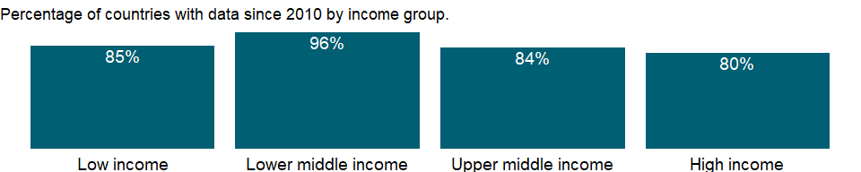

### Why is it relevant?

Gross enrollment ratios indicate the capacity of each level of the education system, but a high ratio may reflect a substantial number of overage children enrolled in each grade because of repetition or late entry rather than a successful education system. The net enrollment rate excludes overage and underage students and more accurately captures the system’s coverage and internal efficiency. Differences between the gross enrollment ratio and the net enrollment rate show the incidence of overage and underage enrollments.

### What is the data source?

UNESCO Institute for Statistics (<http://uis.unesco.org/>). Data as of September 2020.

### What is the methodology?

Gross enrollment ratio for pre-primary school is calculated by dividing the number of students enrolled in pre-primary education regardless of age by the population of the age group which officially corresponds to pre-primary education, and multiplying by 100.

Data on education are collected by the UNESCO Institute for Statistics from official responses to its annual education survey. All the data are mapped to the International Standard Classification of Education (ISCED) to ensure the comparability of education programs at the international level. The current version was formally adopted by UNESCO Member States in 2011. Population data are drawn from the United Nations Population Division. Using a single source for population data standardizes definitions, estimations, and interpolation methods, ensuring a consistent methodology across countries and minimizing potential enumeration problems in national censuses.

The reference years reflect the school year for which the data are presented. In some countries the school year spans two calendar years (for example, from September 2010 to June 2011); in these cases the reference year refers to the year in which the school year ended (2011 in the example).

### How is it aggregated?

Weighted average

### What are the limitations?

Enrollment indicators are based on annual school surveys, but do not necessarily reflect actual attendance or dropout rates during the year. Also, the length of education differs across countries and can influence enrollment rates, although the International Standard Classification of Education (ISCED) tries to minimize the difference. For example, a shorter duration for primary education tends to increase the rate; a longer one to decrease it (in part because older children are more at risk of dropping out). Moreover, age at enrollment may be inaccurately estimated or misstated, especially in communities where registration of births is not strictly enforced.

### What else should I know?

For aggregate data, each economy is classified based on the classification of World Bank Group’s fiscal year 2021 (July 1, 2020-June 30, 2021).

### 1.58.7 School enrollment, preprimary, male (% gross)

### What is the indicator?

Gross enrollment ratio is the ratio of total enrollment, regardless of age, to the population of the age group that officially corresponds to the level of education shown. Preprimary education refers to programs at the initial stage of organized instruction, designed primarily to introduce very young children to a school-type environment and to provide a bridge between home and school.

Topic: Education: Participation

Series ID: SE.PRE.ENRR.MA

Copyright: CC BY-4.0 , <https://datacatalog.worldbank.org/public-licenses#cc-by>

First year with any data: 1970

Last year with any data: 2020

### What years are data available?

The figure below shows years in which data is available for at least one country. Dates shaded in black have no data, while dates shaded in green have data for at least one country



### Which countries have data?

The figure below shows the percentage of countries in each income group with a value since 2010 for that indicator.



### Why is it relevant?

Gross enrollment ratios indicate the capacity of each level of the education system, but a high ratio may reflect a substantial number of overage children enrolled in each grade because of repetition or late entry rather than a successful education system. The net enrollment rate excludes overage and underage students and more accurately captures the system’s coverage and internal efficiency. Differences between the gross enrollment ratio and the net enrollment rate show the incidence of overage and underage enrollments.

### What is the data source?

UNESCO Institute for Statistics (<http://uis.unesco.org/>). Data as of September 2020.

### What is the methodology?

Gross enrollment ratio for pre-primary school is calculated by dividing the number of students enrolled in pre-primary education regardless of age by the population of the age group which officially corresponds to pre-primary education, and multiplying by 100.

Data on education are collected by the UNESCO Institute for Statistics from official responses to its annual education survey. All the data are mapped to the International Standard Classification of Education (ISCED) to ensure the comparability of education programs at the international level. The current version was formally adopted by UNESCO Member States in 2011. Population data are drawn from the United Nations Population Division. Using a single source for population data standardizes definitions, estimations, and interpolation methods, ensuring a consistent methodology across countries and minimizing potential enumeration problems in national censuses.

The reference years reflect the school year for which the data are presented. In some countries the school year spans two calendar years (for example, from September 2010 to June 2011); in these cases the reference year refers to the year in which the school year ended (2011 in the example).

### How is it aggregated?

Weighted average

### What are the limitations?

Enrollment indicators are based on annual school surveys, but do not necessarily reflect actual attendance or dropout rates during the year. Also, the length of education differs across countries and can influence enrollment rates, although the International Standard Classification of Education (ISCED) tries to minimize the difference. For example, a shorter duration for primary education tends to increase the rate; a longer one to decrease it (in part because older children are more at risk of dropping out). Moreover, age at enrollment may be inaccurately estimated or misstated, especially in communities where registration of births is not strictly enforced.

### What else should I know?

For aggregate data, each economy is classified based on the classification of World Bank Group’s fiscal year 2021 (July 1, 2020-June 30, 2021).

### 1.58.8 Primary education, pupils

### What is the indicator?

Primary education pupils is the total number of pupils enrolled at primary level in public and private schools.

Topic: Education: Participation

Series ID: SE.PRM.ENRL

Copyright: CC BY-4.0 , <https://datacatalog.worldbank.org/public-licenses#cc-by>

First year with any data: 1970

Last year with any data: 2020

### What years are data available?

The figure below shows years in which data is available for at least one country. Dates shaded in black have no data, while dates shaded in green have data for at least one country



### Which countries have data?

The figure below shows the percentage of countries in each income group with a value since 2010 for that indicator.

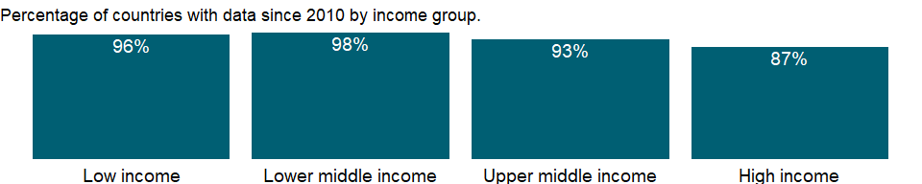

### Why is it relevant?

NA

### What is the data source?

UNESCO Institute for Statistics (<http://uis.unesco.org/>). Data as of September 2020.

### What is the methodology?

Enrollment includes Individuals officially registered in a given educational programme, or stage or module thereof, regardless of age.

Data on education are collected by the UNESCO Institute for Statistics from official responses to its annual education survey. All the data are mapped to the International Standard Classification of Education (ISCED) to ensure the comparability of education programs at the international level. The current version was formally adopted by UNESCO Member States in 2011.

The reference years reflect the school year for which the data are presented. In some countries the school year spans two calendar years (for example, from September 2010 to June 2011); in these cases the reference year refers to the year in which the school year ended (2011 in the example).

### How is it aggregated?

Sum

### What are the limitations?

NA

### What else should I know?

For aggregate data, each economy is classified based on the classification of World Bank Group’s fiscal year 2021 (July 1, 2020-June 30, 2021).

### 1.58.9 Primary education, pupils (% female)

### What is the indicator?

Female pupils as a percentage of total pupils at primary level include enrollments in public and private schools.

Topic: Education: Participation

Series ID: SE.PRM.ENRL.FE.ZS

Copyright: CC BY-4.0 , <https://datacatalog.worldbank.org/public-licenses#cc-by>

First year with any data: 1970

Last year with any data: 2019

### What years are data available?

The figure below shows years in which data is available for at least one country. Dates shaded in black have no data, while dates shaded in green have data for at least one country



### Which countries have data?

The figure below shows the percentage of countries in each income group with a value since 2010 for that indicator.



### Why is it relevant?

The share of girls allows an assessment on gender composition in school enrollment. A value greater than 50% indicates participation of more girls at a specific level or programme of education.

### What is the data source?

UNESCO Institute for Statistics (<http://uis.unesco.org/>). Data as of February 2020.

### What is the methodology?

Percentage of female enrollment is calculated by dividing the total number of female students at a given level of education by the total enrollment at the same level, and multiplying by 100.

Data on education are collected by the UNESCO Institute for Statistics from official responses to its annual education survey. All the data are mapped to the International Standard Classification of Education (ISCED) to ensure the comparability of education programs at the international level. The current version was formally adopted by UNESCO Member States in 2011.

The reference years reflect the school year for which the data are presented. In some countries the school year spans two calendar years (for example, from September 2010 to June 2011); in these cases the reference year refers to the year in which the school year ended (2011 in the example).

### How is it aggregated?

Weighted average

### What are the limitations?

The percentage of female enrollment is limited in assessing gender parity, because it’s affected by the gender composition of population. Ratio of female to male in enrollment rate provides a population adjusted measure of gender parity.

### What else should I know?

For aggregate data, each economy is classified based on the classification of World Bank Group’s fiscal year 2021 (July 1, 2020-June 30, 2021).

### 1.58.10 School enrollment, primary (% gross)

### What is the indicator?

Gross enrollment ratio is the ratio of total enrollment, regardless of age, to the population of the age group that officially corresponds to the level of education shown. Primary education provides children with basic reading, writing, and mathematics skills along with an elementary understanding of such subjects as history, geography, natural science, social science, art, and music.

Topic: Education: Participation

Series ID: SE.PRM.ENRR

Copyright: CC BY-4.0 , <https://datacatalog.worldbank.org/public-licenses#cc-by>

First year with any data: 1970

Last year with any data: 2020

### What years are data available?

The figure below shows years in which data is available for at least one country. Dates shaded in black have no data, while dates shaded in green have data for at least one country



### Which countries have data?

The figure below shows the percentage of countries in each income group with a value since 2010 for that indicator.



### Why is it relevant?

Gross enrollment ratios indicate the capacity of each level of the education system, but a high ratio may reflect a substantial number of overage children enrolled in each grade because of repetition or late entry rather than a successful education system. The net enrollment rate excludes overage and underage students and more accurately captures the system’s coverage and internal efficiency. Differences between the gross enrollment ratio and the net enrollment rate show the incidence of overage and underage enrollments.

### What is the data source?

UNESCO Institute for Statistics (<http://uis.unesco.org/>). Data as of September 2020.

### What is the methodology?

Gross enrollment ratio for primary school is calculated by dividing the number of students enrolled in primary education regardless of age by the population of the age group which officially corresponds to primary education, and multiplying by 100.

Data on education are collected by the UNESCO Institute for Statistics from official responses to its annual education survey. All the data are mapped to the International Standard Classification of Education (ISCED) to ensure the comparability of education programs at the international level. The current version was formally adopted by UNESCO Member States in 2011. Population data are drawn from the United Nations Population Division. Using a single source for population data standardizes definitions, estimations, and interpolation methods, ensuring a consistent methodology across countries and minimizing potential enumeration problems in national censuses.

The reference years reflect the school year for which the data are presented. In some countries the school year spans two calendar years (for example, from September 2010 to June 2011); in these cases the reference year refers to the year in which the school year ended (2011 in the example).

### How is it aggregated?

Weighted average

### What are the limitations?

Enrollment indicators are based on annual school surveys, but do not necessarily reflect actual attendance or dropout rates during the year. Also, the length of education differs across countries and can influence enrollment rates, although the International Standard Classification of Education (ISCED) tries to minimize the difference. For example, a shorter duration for primary education tends to increase the rate; a longer one to decrease it (in part because older children are more at risk of dropping out). Moreover, age at enrollment may be inaccurately estimated or misstated, especially in communities where registration of births is not strictly enforced.

### What else should I know?

For aggregate data, each economy is classified based on the classification of World Bank Group’s fiscal year 2021 (July 1, 2020-June 30, 2021).

### 1.58.11 School enrollment, primary, female (% gross)

### What is the indicator?

Gross enrollment ratio is the ratio of total enrollment, regardless of age, to the population of the age group that officially corresponds to the level of education shown. Primary education provides children with basic reading, writing, and mathematics skills along with an elementary understanding of such subjects as history, geography, natural science, social science, art, and music.

Topic: Education: Participation

Series ID: SE.PRM.ENRR.FE

Copyright: CC BY-4.0 , <https://datacatalog.worldbank.org/public-licenses#cc-by>

First year with any data: 1970

Last year with any data: 2020

### What years are data available?

The figure below shows years in which data is available for at least one country. Dates shaded in black have no data, while dates shaded in green have data for at least one country



### Which countries have data?

The figure below shows the percentage of countries in each income group with a value since 2010 for that indicator.



### Why is it relevant?

Gross enrollment ratios indicate the capacity of each level of the education system, but a high ratio may reflect a substantial number of overage children enrolled in each grade because of repetition or late entry rather than a successful education system. The net enrollment rate excludes overage and underage students and more accurately captures the system’s coverage and internal efficiency. Differences between the gross enrollment ratio and the net enrollment rate show the incidence of overage and underage enrollments.

### What is the data source?

UNESCO Institute for Statistics (<http://uis.unesco.org/>). Data as of September 2020.

### What is the methodology?

Gross enrollment ratio for primary school is calculated by dividing the number of students enrolled in primary education regardless of age by the population of the age group which officially corresponds to primary education, and multiplying by 100.

Data on education are collected by the UNESCO Institute for Statistics from official responses to its annual education survey. All the data are mapped to the International Standard Classification of Education (ISCED) to ensure the comparability of education programs at the international level. The current version was formally adopted by UNESCO Member States in 2011. Population data are drawn from the United Nations Population Division. Using a single source for population data standardizes definitions, estimations, and interpolation methods, ensuring a consistent methodology across countries and minimizing potential enumeration problems in national censuses.

The reference years reflect the school year for which the data are presented. In some countries the school year spans two calendar years (for example, from September 2010 to June 2011); in these cases the reference year refers to the year in which the school year ended (2011 in the example).

### How is it aggregated?

Weighted average

### What are the limitations?

Enrollment indicators are based on annual school surveys, but do not necessarily reflect actual attendance or dropout rates during the year. Also, the length of education differs across countries and can influence enrollment rates, although the International Standard Classification of Education (ISCED) tries to minimize the difference. For example, a shorter duration for primary education tends to increase the rate; a longer one to decrease it (in part because older children are more at risk of dropping out). Moreover, age at enrollment may be inaccurately estimated or misstated, especially in communities where registration of births is not strictly enforced.

### What else should I know?

For aggregate data, each economy is classified based on the classification of World Bank Group’s fiscal year 2021 (July 1, 2020-June 30, 2021).

### 1.58.12 School enrollment, primary, male (% gross)

### What is the indicator?

Gross enrollment ratio is the ratio of total enrollment, regardless of age, to the population of the age group that officially corresponds to the level of education shown. Primary education provides children with basic reading, writing, and mathematics skills along with an elementary understanding of such subjects as history, geography, natural science, social science, art, and music.

Topic: Education: Participation

Series ID: SE.PRM.ENRR.MA

Copyright: CC BY-4.0 , <https://datacatalog.worldbank.org/public-licenses#cc-by>

First year with any data: 1970

Last year with any data: 2020

### What years are data available?

The figure below shows years in which data is available for at least one country. Dates shaded in black have no data, while dates shaded in green have data for at least one country



### Which countries have data?

The figure below shows the percentage of countries in each income group with a value since 2010 for that indicator.



### Why is it relevant?

Gross enrollment ratios indicate the capacity of each level of the education system, but a high ratio may reflect a substantial number of overage children enrolled in each grade because of repetition or late entry rather than a successful education system. The net enrollment rate excludes overage and underage students and more accurately captures the system’s coverage and internal efficiency. Differences between the gross enrollment ratio and the net enrollment rate show the incidence of overage and underage enrollments.

### What is the data source?

UNESCO Institute for Statistics (<http://uis.unesco.org/>). Data as of September 2020.

### What is the methodology?

Gross enrollment ratio for primary school is calculated by dividing the number of students enrolled in primary education regardless of age by the population of the age group which officially corresponds to primary education, and multiplying by 100.

Data on education are collected by the UNESCO Institute for Statistics from official responses to its annual education survey. All the data are mapped to the International Standard Classification of Education (ISCED) to ensure the comparability of education programs at the international level. The current version was formally adopted by UNESCO Member States in 2011. Population data are drawn from the United Nations Population Division. Using a single source for population data standardizes definitions, estimations, and interpolation methods, ensuring a consistent methodology across countries and minimizing potential enumeration problems in national censuses.

The reference years reflect the school year for which the data are presented. In some countries the school year spans two calendar years (for example, from September 2010 to June 2011); in these cases the reference year refers to the year in which the school year ended (2011 in the example).

### How is it aggregated?

Weighted average

### What are the limitations?

Enrollment indicators are based on annual school surveys, but do not necessarily reflect actual attendance or dropout rates during the year. Also, the length of education differs across countries and can influence enrollment rates, although the International Standard Classification of Education (ISCED) tries to minimize the difference. For example, a shorter duration for primary education tends to increase the rate; a longer one to decrease it (in part because older children are more at risk of dropping out). Moreover, age at enrollment may be inaccurately estimated or misstated, especially in communities where registration of births is not strictly enforced.

### What else should I know?

For aggregate data, each economy is classified based on the classification of World Bank Group’s fiscal year 2021 (July 1, 2020-June 30, 2021).

### 1.58.13 School enrollment, primary (% net)

### What is the indicator?

Net enrollment rate is the ratio of children of official school age who are enrolled in school to the population of the corresponding official school age. Primary education provides children with basic reading, writing, and mathematics skills along with an elementary understanding of such subjects as history, geography, natural science, social science, art, and music.

Topic: Education: Participation

Series ID: SE.PRM.NENR

Copyright: CC BY-4.0 , <https://datacatalog.worldbank.org/public-licenses#cc-by>

First year with any data: 1970

Last year with any data: 2019

### What years are data available?

The figure below shows years in which data is available for at least one country. Dates shaded in black have no data, while dates shaded in green have data for at least one country



### Which countries have data?

The figure below shows the percentage of countries in each income group with a value since 2010 for that indicator.

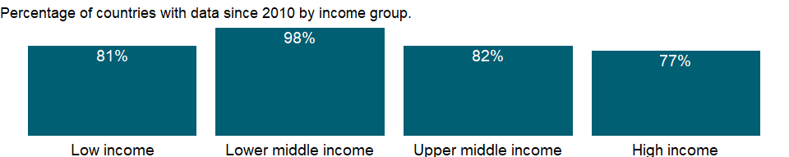

### Why is it relevant?

Gross enrollment ratios indicate the capacity of each level of the education system, but a high ratio may reflect a substantial number of overage children enrolled in each grade because of repetition or late entry rather than a successful education system. The net enrollment rate excludes overage and underage students and more accurately captures the system’s coverage and internal efficiency. Differences between the gross enrollment ratio and the net enrollment rate show the incidence of overage and underage enrollments.

### What is the data source?

UNESCO Institute for Statistics (<http://uis.unesco.org/>). Data as of February 2020.

### What is the methodology?

Net enrollment rate for primary school is calculated by dividing the number of students of official school age enrolled in primary education by the population of the age group which officially corresponds to primary education, and multiplying by 100.

Data on education are collected by the UNESCO Institute for Statistics from official responses to its annual education survey. All the data are mapped to the International Standard Classification of Education (ISCED) to ensure the comparability of education programs at the international level. The current version was formally adopted by UNESCO Member States in 2011. Population data are drawn from the United Nations Population Division. Using a single source for population data standardizes definitions, estimations, and interpolation methods, ensuring a consistent methodology across countries and minimizing potential enumeration problems in national censuses.

The reference years reflect the school year for which the data are presented. In some countries the school year spans two calendar years (for example, from September 2010 to June 2011); in these cases the reference year refers to the year in which the school year ended (2011 in the example).

### How is it aggregated?

Weighted average

### What are the limitations?

Enrollment indicators are based on annual school surveys, but do not necessarily reflect actual attendance or dropout rates during the year. Also, the length of education differs across countries and can influence enrollment rates, although the International Standard Classification of Education (ISCED) tries to minimize the difference. For example, a shorter duration for primary education tends to increase the rate; a longer one to decrease it (in part because older children are more at risk of dropping out). Moreover, age at enrollment may be inaccurately estimated or misstated, especially in communities where registration of births is not strictly enforced.

### What else should I know?

For aggregate data, each economy is classified based on the classification of World Bank Group’s fiscal year 2021 (July 1, 2020-June 30, 2021).

### 1.58.14 School enrollment, primary, female (% net)

### What is the indicator?

Net enrollment rate is the ratio of children of official school age who are enrolled in school to the population of the corresponding official school age. Primary education provides children with basic reading, writing, and mathematics skills along with an elementary understanding of such subjects as history, geography, natural science, social science, art, and music.

Topic: Education: Participation

Series ID: SE.PRM.NENR.FE

Copyright: CC BY-4.0 , <https://datacatalog.worldbank.org/public-licenses#cc-by>

First year with any data: 1970

Last year with any data: 2019

### What years are data available?

The figure below shows years in which data is available for at least one country. Dates shaded in black have no data, while dates shaded in green have data for at least one country



### Which countries have data?

The figure below shows the percentage of countries in each income group with a value since 2010 for that indicator.

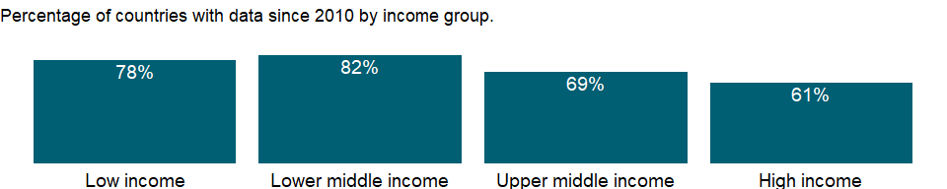

### Why is it relevant?

Gross enrollment ratios indicate the capacity of each level of the education system, but a high ratio may reflect a substantial number of overage children enrolled in each grade because of repetition or late entry rather than a successful education system. The net enrollment rate excludes overage and underage students and more accurately captures the system’s coverage and internal efficiency. Differences between the gross enrollment ratio and the net enrollment rate show the incidence of overage and underage enrollments.

### What is the data source?

UNESCO Institute for Statistics (<http://uis.unesco.org/>). Data as of February 2020.

### What is the methodology?

Net enrollment rate for primary school is calculated by dividing the number of students of official school age enrolled in primary education by the population of the age group which officially corresponds to primary education, and multiplying by 100.

Data on education are collected by the UNESCO Institute for Statistics from official responses to its annual education survey. All the data are mapped to the International Standard Classification of Education (ISCED) to ensure the comparability of education programs at the international level. The current version was formally adopted by UNESCO Member States in 2011. Population data are drawn from the United Nations Population Division. Using a single source for population data standardizes definitions, estimations, and interpolation methods, ensuring a consistent methodology across countries and minimizing potential enumeration problems in national censuses.

The reference years reflect the school year for which the data are presented. In some countries the school year spans two calendar years (for example, from September 2010 to June 2011); in these cases the reference year refers to the year in which the school year ended (2011 in the example).

### How is it aggregated?

Weighted average

### What are the limitations?

Enrollment indicators are based on annual school surveys, but do not necessarily reflect actual attendance or dropout rates during the year. Also, the length of education differs across countries and can influence enrollment rates, although the International Standard Classification of Education (ISCED) tries to minimize the difference. For example, a shorter duration for primary education tends to increase the rate; a longer one to decrease it (in part because older children are more at risk of dropping out). Moreover, age at enrollment may be inaccurately estimated or misstated, especially in communities where registration of births is not strictly enforced.

### What else should I know?

For aggregate data, each economy is classified based on the classification of World Bank Group’s fiscal year 2021 (July 1, 2020-June 30, 2021).

### 1.58.15 School enrollment, primary, male (% net)

### What is the indicator?

Net enrollment rate is the ratio of children of official school age who are enrolled in school to the population of the corresponding official school age. Primary education provides children with basic reading, writing, and mathematics skills along with an elementary understanding of such subjects as history, geography, natural science, social science, art, and music.

Topic: Education: Participation

Series ID: SE.PRM.NENR.MA

Copyright: CC BY-4.0 , <https://datacatalog.worldbank.org/public-licenses#cc-by>

First year with any data: 1970

Last year with any data: 2019

### What years are data available?

The figure below shows years in which data is available for at least one country. Dates shaded in black have no data, while dates shaded in green have data for at least one country



### Which countries have data?

The figure below shows the percentage of countries in each income group with a value since 2010 for that indicator.



### Why is it relevant?

Gross enrollment ratios indicate the capacity of each level of the education system, but a high ratio may reflect a substantial number of overage children enrolled in each grade because of repetition or late entry rather than a successful education system. The net enrollment rate excludes overage and underage students and more accurately captures the system’s coverage and internal efficiency. Differences between the gross enrollment ratio and the net enrollment rate show the incidence of overage and underage enrollments.

### What is the data source?

UNESCO Institute for Statistics (<http://uis.unesco.org/>). Data as of February 2020.

### What is the methodology?

Net enrollment rate for primary school is calculated by dividing the number of students of official school age enrolled in primary education by the population of the age group which officially corresponds to primary education, and multiplying by 100.

Data on education are collected by the UNESCO Institute for Statistics from official responses to its annual education survey. All the data are mapped to the International Standard Classification of Education (ISCED) to ensure the comparability of education programs at the international level. The current version was formally adopted by UNESCO Member States in 2011. Population data are drawn from the United Nations Population Division. Using a single source for population data standardizes definitions, estimations, and interpolation methods, ensuring a consistent methodology across countries and minimizing potential enumeration problems in national censuses.

The reference years reflect the school year for which the data are presented. In some countries the school year spans two calendar years (for example, from September 2010 to June 2011); in these cases the reference year refers to the year in which the school year ended (2011 in the example).

### How is it aggregated?

Weighted average

### What are the limitations?

Enrollment indicators are based on annual school surveys, but do not necessarily reflect actual attendance or dropout rates during the year. Also, the length of education differs across countries and can influence enrollment rates, although the International Standard Classification of Education (ISCED) tries to minimize the difference. For example, a shorter duration for primary education tends to increase the rate; a longer one to decrease it (in part because older children are more at risk of dropping out). Moreover, age at enrollment may be inaccurately estimated or misstated, especially in communities where registration of births is not strictly enforced.

### What else should I know?

For aggregate data, each economy is classified based on the classification of World Bank Group’s fiscal year 2021 (July 1, 2020-June 30, 2021).

### 1.58.16 School enrollment, primary, private (% of total primary)

### What is the indicator?

Private enrollment refers to pupils or students enrolled in institutions that are not operated by a public authority but controlled and managed, whether for profit or not, by a private body such as a nongovernmental organization, religious body, special interest group, foundation or business enterprise.

Topic: Education: Participation

Series ID: SE.PRM.PRIV.ZS

Copyright: CC BY-4.0 , <https://datacatalog.worldbank.org/public-licenses#cc-by>

First year with any data: 1970

Last year with any data: 2020

### What years are data available?

The figure below shows years in which data is available for at least one country. Dates shaded in black have no data, while dates shaded in green have data for at least one country



### Which countries have data?

The figure below shows the percentage of countries in each income group with a value since 2010 for that indicator.

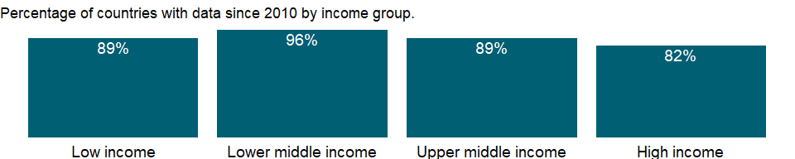

### Why is it relevant?

The share of enrollment in private institutions indicates the scale and capacity of private education within a country. A high percentage suggests strong involvement of the non-governmental sector (including religious bodies, other organizations, associations, communities, private enterprises or persons) in providing organized educational programmes. However, in countries where private institutions are substantially subsidized or aided by the government, the distinction between private and public educational institutions may be less clear-cut especially when certain students are directly financed through government scholarships.

### What is the data source?

UNESCO Institute for Statistics (<http://uis.unesco.org/>). Data as of September 2020.

### What is the methodology?

The share of students in private primary school is calculated by dividing the number of students enrolled in private educational institutions at primary level by total enrollment (public and private) at the same level of education, and multiplying by 100.

Data on education are collected by the UNESCO Institute for Statistics from official responses to its annual education survey. All the data are mapped to the International Standard Classification of Education (ISCED) to ensure the comparability of education programs at the international level. The current version was formally adopted by UNESCO Member States in 2011.

The reference years reflect the school year for which the data are presented. In some countries the school year spans two calendar years (for example, from September 2010 to June 2011); in these cases the reference year refers to the year in which the school year ended (2011 in the example).

### How is it aggregated?

Weighted average

### What are the limitations?

Religious or private schools, which are not registered with the government or don’t follow the common national curriculum, may not be captured.

### What else should I know?

For aggregate data, each economy is classified based on the classification of World Bank Group’s fiscal year 2021 (July 1, 2020-June 30, 2021).

### 1.58.17 Adjusted net enrollment rate, primary (% of primary school age children)

### What is the indicator?

Adjusted net enrollment is the number of pupils of the school-age group for primary education, enrolled either in primary or secondary education, expressed as a percentage of the total population in that age group.

Topic: Education: Participation

Series ID: SE.PRM.TENR

Copyright: CC BY-4.0 , <https://datacatalog.worldbank.org/public-licenses#cc-by>

First year with any data: 1970

Last year with any data: 2019

### What years are data available?

The figure below shows years in which data is available for at least one country. Dates shaded in black have no data, while dates shaded in green have data for at least one country



### Which countries have data?

The figure below shows the percentage of countries in each income group with a value since 2010 for that indicator.



### Why is it relevant?

Relevance to gender indicator: Women teachers are important as they serve as role models to girls and help to attract and retain girls in school.

### What is the data source?

UNESCO Institute for Statistics (<http://uis.unesco.org/>). Data as of February 2020.

### What is the methodology?

Adjusted net enrollment rate in primary education is calculated by dividing the number of children in the official primary school age who are enrolled in primary or secondary education by the population of the same age group and multiplying by 100.

Data on education are collected by the UNESCO Institute for Statistics from official responses to its annual education survey. All the data are mapped to the International Standard Classification of Education (ISCED) to ensure the comparability of education programs at the international level. The current version was formally adopted by UNESCO Member States in 2011. Population data are drawn from the United Nations Population Division. Using a single source for population data standardizes definitions, estimations, and interpolation methods, ensuring a consistent methodology across countries and minimizing potential enumeration problems in national censuses.

The reference years reflect the school year for which the data are presented. In some countries the school year spans two calendar years (for example, from September 2010 to June 2011); in these cases the reference year refers to the year in which the school year ended (2011 in the example).

### How is it aggregated?

Weighted Average

### What are the limitations?

Enrollment indicators are based on annual school surveys, but do not necessarily reflect actual attendance or dropout rates during the year. Also, the length of education differs across countries and can influence enrollment rates, although the International Standard Classification of Education (ISCED) tries to minimize the difference. For example, a shorter duration for primary education tends to increase the rate; a longer one to decrease it (in part because older children are more at risk of dropping out). Moreover, age at enrollment may be inaccurately estimated or misstated, especially in communities where registration of births is not strictly enforced.

### What else should I know?

For aggregate data, each economy is classified based on the classification of World Bank Group’s fiscal year 2021 (July 1, 2020-June 30, 2021).

### 1.58.18 Adjusted net enrollment rate, primary, female (% of primary school age children)

### What is the indicator?

Adjusted net enrollment is the number of pupils of the school-age group for primary education, enrolled either in primary or secondary education, expressed as a percentage of the total population in that age group.

Topic: Education: Participation

Series ID: SE.PRM.TENR.FE

Copyright: CC BY-4.0 , <https://datacatalog.worldbank.org/public-licenses#cc-by>

First year with any data: 1970

Last year with any data: 2019

### What years are data available?

The figure below shows years in which data is available for at least one country. Dates shaded in black have no data, while dates shaded in green have data for at least one country



### Which countries have data?

The figure below shows the percentage of countries in each income group with a value since 2010 for that indicator.

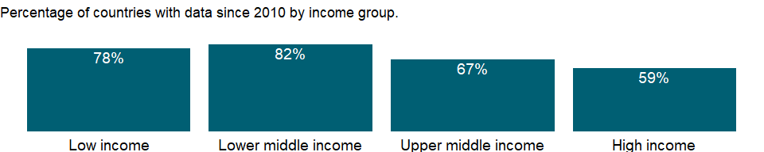

### Why is it relevant?

Relevance to gender indicator: Women teachers are important as they serve as role models to girls and help to attract and retain girls in school.

### What is the data source?

UNESCO Institute for Statistics (<http://uis.unesco.org/>). Data as of February 2020.

### What is the methodology?

Adjusted net enrollment rate in primary education is calculated by dividing the number of children in the official primary school age who are enrolled in primary or secondary education by the population of the same age group and multiplying by 100.

Data on education are collected by the UNESCO Institute for Statistics from official responses to its annual education survey. All the data are mapped to the International Standard Classification of Education (ISCED) to ensure the comparability of education programs at the international level. The current version was formally adopted by UNESCO Member States in 2011. Population data are drawn from the United Nations Population Division. Using a single source for population data standardizes definitions, estimations, and interpolation methods, ensuring a consistent methodology across countries and minimizing potential enumeration problems in national censuses.

The reference years reflect the school year for which the data are presented. In some countries the school year spans two calendar years (for example, from September 2010 to June 2011); in these cases the reference year refers to the year in which the school year ended (2011 in the example).

### How is it aggregated?

Weighted Average

### What are the limitations?

Enrollment indicators are based on annual school surveys, but do not necessarily reflect actual attendance or dropout rates during the year. Also, the length of education differs across countries and can influence enrollment rates, although the International Standard Classification of Education (ISCED) tries to minimize the difference. For example, a shorter duration for primary education tends to increase the rate; a longer one to decrease it (in part because older children are more at risk of dropping out). Moreover, age at enrollment may be inaccurately estimated or misstated, especially in communities where registration of births is not strictly enforced.

### What else should I know?

For aggregate data, each economy is classified based on the classification of World Bank Group’s fiscal year 2021 (July 1, 2020-June 30, 2021).

### 1.58.19 Adjusted net enrollment rate, primary, male (% of primary school age children)

### What is the indicator?

Adjusted net enrollment is the number of pupils of the school-age group for primary education, enrolled either in primary or secondary education, expressed as a percentage of the total population in that age group.

Topic: Education: Participation

Series ID: SE.PRM.TENR.MA

Copyright: CC BY-4.0 , <https://datacatalog.worldbank.org/public-licenses#cc-by>

First year with any data: 1970

Last year with any data: 2019

### What years are data available?

The figure below shows years in which data is available for at least one country. Dates shaded in black have no data, while dates shaded in green have data for at least one country



### Which countries have data?

The figure below shows the percentage of countries in each income group with a value since 2010 for that indicator.



### Why is it relevant?

Gross enrollment ratios indicate the capacity of each level of the education system, but a high ratio may reflect a substantial number of overage children enrolled in each grade because of repetition or late entry rather than a successful education system. The net enrollment rate excludes overage and underage students and more accurately captures the system’s coverage and internal efficiency. Differences between the gross enrollment ratio and the net enrollment rate show the incidence of overage and underage enrollments. The adjusted net enrollment rate in primary education captures primary school-age children who have progressed to secondary education faster than their peers have and who are not counted in the traditional net enrollment rate.

### What is the data source?

UNESCO Institute for Statistics (<http://uis.unesco.org/>). Data as of February 2020.

### What is the methodology?

Adjusted net enrollment rate in primary education is calculated by dividing the number of children in the official primary school age who are enrolled in primary or secondary education by the population of the same age group and multiplying by 100.

Data on education are collected by the UNESCO Institute for Statistics from official responses to its annual education survey. All the data are mapped to the International Standard Classification of Education (ISCED) to ensure the comparability of education programs at the international level. The current version was formally adopted by UNESCO Member States in 2011. Population data are drawn from the United Nations Population Division. Using a single source for population data standardizes definitions, estimations, and interpolation methods, ensuring a consistent methodology across countries and minimizing potential enumeration problems in national censuses.

The reference years reflect the school year for which the data are presented. In some countries the school year spans two calendar years (for example, from September 2010 to June 2011); in these cases the reference year refers to the year in which the school year ended (2011 in the example).

### How is it aggregated?

Weighted Average

### What are the limitations?

Enrollment indicators are based on annual school surveys, but do not necessarily reflect actual attendance or dropout rates during the year. Also, the length of education differs across countries and can influence enrollment rates, although the International Standard Classification of Education (ISCED) tries to minimize the difference. For example, a shorter duration for primary education tends to increase the rate; a longer one to decrease it (in part because older children are more at risk of dropping out). Moreover, age at enrollment may be inaccurately estimated or misstated, especially in communities where registration of births is not strictly enforced.

### What else should I know?

For aggregate data, each economy is classified based on the classification of World Bank Group’s fiscal year 2021 (July 1, 2020-June 30, 2021).

### 1.58.20 Children out of school, primary

### What is the indicator?

Children out of school are the number of primary-school-age children not enrolled in primary or secondary school.

Topic: Education: Participation

Series ID: SE.PRM.UNER

Copyright: CC BY-4.0 , <https://datacatalog.worldbank.org/public-licenses#cc-by>

First year with any data: 1970

Last year with any data: 2020

### What years are data available?

The figure below shows years in which data is available for at least one country. Dates shaded in black have no data, while dates shaded in green have data for at least one country



### Which countries have data?

The figure below shows the percentage of countries in each income group with a value since 2010 for that indicator.

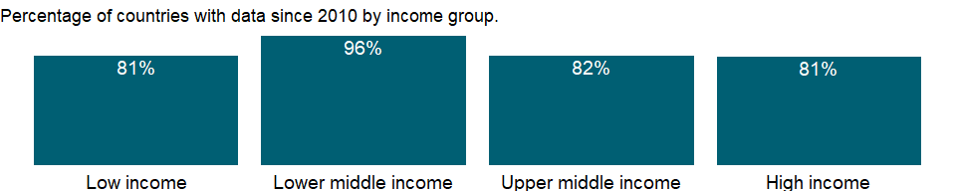

### Why is it relevant?

Large numbers of children out of school create pressure to enroll children and provide classrooms, teachers, and educational materials, a task made difficult in many countries by limited education budgets. However, getting children into school is a high priority for countries and crucial for achieving universal primary education.

### What is the data source?

UNESCO Institute for Statistics (<http://uis.unesco.org/>). Data as of September 2020.

### What is the methodology?

The number of out-of-school children is calculated by subtracting the number of primary school-age children enrolled in primary or secondary school from the total population of the official primary school-age children.

Data on education are collected by the UNESCO Institute for Statistics from official responses to its annual education survey. All the data are mapped to the International Standard Classification of Education (ISCED) to ensure the comparability of education programs at the international level. The current version was formally adopted by UNESCO Member States in 2011. Population data are drawn from the United Nations Population Division. Using a single source for population data standardizes definitions, estimations, and interpolation methods, ensuring a consistent methodology across countries and minimizing potential enumeration problems in national censuses.

The reference years reflect the school year for which the data are presented. In some countries the school year spans two calendar years (for example, from September 2010 to June 2011); in these cases the reference year refers to the year in which the school year ended (2011 in the example).

### How is it aggregated?

Sum

### What are the limitations?

Due to different data sources for enrollment and population data, the number may not capture the actual number of children not attending in primary school.

### What else should I know?

For aggregate data, each economy is classified based on the classification of World Bank Group’s fiscal year 2021 (July 1, 2020-June 30, 2021).

### 1.58.21 Children out of school, primary, female

### What is the indicator?

Children out of school are the number of primary-school-age children not enrolled in primary or secondary school.

Topic: Education: Participation

Series ID: SE.PRM.UNER.FE

Copyright: CC BY-4.0 , <https://datacatalog.worldbank.org/public-licenses#cc-by>

First year with any data: 1970

Last year with any data: 2020

### What years are data available?

The figure below shows years in which data is available for at least one country. Dates shaded in black have no data, while dates shaded in green have data for at least one country



### Which countries have data?

The figure below shows the percentage of countries in each income group with a value since 2010 for that indicator.

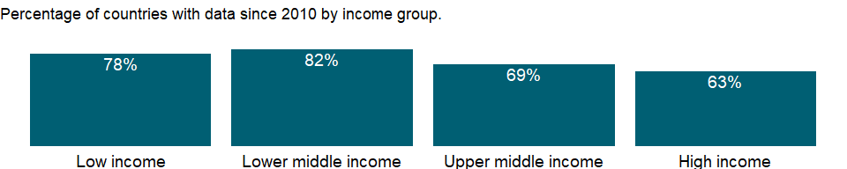

### Why is it relevant?

Large numbers of children out of school create pressure to enroll children and provide classrooms, teachers, and educational materials, a task made difficult in many countries by limited education budgets. However, getting children into school is a high priority for countries and crucial for achieving universal primary education.

### What is the data source?

UNESCO Institute for Statistics (<http://uis.unesco.org/>). Data as of September 2020.

### What is the methodology?

The number of out-of-school children is calculated by subtracting the number of primary school-age children enrolled in primary or secondary school from the total population of the official primary school-age children.

Data on education are collected by the UNESCO Institute for Statistics from official responses to its annual education survey. All the data are mapped to the International Standard Classification of Education (ISCED) to ensure the comparability of education programs at the international level. The current version was formally adopted by UNESCO Member States in 2011. Population data are drawn from the United Nations Population Division. Using a single source for population data standardizes definitions, estimations, and interpolation methods, ensuring a consistent methodology across countries and minimizing potential enumeration problems in national censuses.

The reference years reflect the school year for which the data are presented. In some countries the school year spans two calendar years (for example, from September 2010 to June 2011); in these cases the reference year refers to the year in which the school year ended (2011 in the example).

### How is it aggregated?

Sum

### What are the limitations?

Due to different data sources for enrollment and population data, the number may not capture the actual number of children not attending in primary school.

### What else should I know?

For aggregate data, each economy is classified based on the classification of World Bank Group’s fiscal year 2021 (July 1, 2020-June 30, 2021).

### 1.58.22 Children out of school, female (% of female primary school age)

### What is the indicator?

Children out of school are the percentage of primary-school-age children who are not enrolled in primary or secondary school. Children in the official primary age group that are in preprimary education should be considered out of school.

Topic: Education: Participation

Series ID: SE.PRM.UNER.FE.ZS

Copyright: CC BY-4.0 , <https://datacatalog.worldbank.org/public-licenses#cc-by>

First year with any data: 1970

Last year with any data: 2020

### What years are data available?

The figure below shows years in which data is available for at least one country. Dates shaded in black have no data, while dates shaded in green have data for at least one country



### Which countries have data?

The figure below shows the percentage of countries in each income group with a value since 2010 for that indicator.



### Why is it relevant?

NA

### What is the data source?

UNESCO Institute for Statistics (<http://uis.unesco.org/>). Data as of September 2020.

### What is the methodology?

The rate of out-of-school children allows to compare across countries with different population sizes. It shows the share of official primary-school-age children who never attended school or dropped out to the population of official primary school age.

Data on education are collected by the UNESCO Institute for Statistics from official responses to its annual education survey. All the data are mapped to the International Standard Classification of Education (ISCED) to ensure the comparability of education programs at the international level. The current version was formally adopted by UNESCO Member States in 2011. Population data are drawn from the United Nations Population Division. Using a single source for population data standardizes definitions, estimations, and interpolation methods, ensuring a consistent methodology across countries and minimizing potential enumeration problems in national censuses. The reference years reflect the school year for which the data are presented. In some countries the school year spans two calendar years (for example, from September 2010 to June 2011); in these cases the reference year refers to the year in which the school year ended (2011 in the example).

### How is it aggregated?

Weighted average

### What are the limitations?

The administrative data used in the calculation of the rate of out-of-school children are based on enrolment at a specific date which can bias the results by either counting enrolled children who never attend school or by omitting those who enroll after the reference date for reporting enrolment data. Furthermore, children who drop out of school after the reference date are not counted as out of school. Discrepancies between enrolment and population data from different sources can also result in over- or underestimates of the rate. Lastly, the international comparability of this indicator can be affected by the use of different concepts of enrolment and out-of-school children across countries.

### What else should I know?

For aggregate data, each economy is classified based on the classification of World Bank Group’s fiscal year 2021 (July 1, 2020-June 30, 2021).

### 1.58.23 Children out of school, primary, male

### What is the indicator?

Children out of school are the number of primary-school-age children not enrolled in primary or secondary school.

Topic: Education: Participation

Series ID: SE.PRM.UNER.MA

Copyright: CC BY-4.0 , <https://datacatalog.worldbank.org/public-licenses#cc-by>

First year with any data: 1970

Last year with any data: 2020

### What years are data available?

The figure below shows years in which data is available for at least one country. Dates shaded in black have no data, while dates shaded in green have data for at least one country



### Which countries have data?

The figure below shows the percentage of countries in each income group with a value since 2010 for that indicator.



### Why is it relevant?

Large numbers of children out of school create pressure to enroll children and provide classrooms, teachers, and educational materials, a task made difficult in many countries by limited education budgets. However, getting children into school is a high priority for countries and crucial for achieving universal primary education.

### What is the data source?

UNESCO Institute for Statistics (<http://uis.unesco.org/>). Data as of September 2020.

### What is the methodology?

The number of out-of-school children is calculated by subtracting the number of primary school-age children enrolled in primary or secondary school from the total population of the official primary school-age children.

Data on education are collected by the UNESCO Institute for Statistics from official responses to its annual education survey. All the data are mapped to the International Standard Classification of Education (ISCED) to ensure the comparability of education programs at the international level. The current version was formally adopted by UNESCO Member States in 2011. Population data are drawn from the United Nations Population Division. Using a single source for population data standardizes definitions, estimations, and interpolation methods, ensuring a consistent methodology across countries and minimizing potential enumeration problems in national censuses.

The reference years reflect the school year for which the data are presented. In some countries the school year spans two calendar years (for example, from September 2010 to June 2011); in these cases the reference year refers to the year in which the school year ended (2011 in the example).

### How is it aggregated?

Sum

### What are the limitations?

Due to different data sources for enrollment and population data, the number may not capture the actual number of children not attending in primary school.

### What else should I know?

For aggregate data, each economy is classified based on the classification of World Bank Group’s fiscal year 2021 (July 1, 2020-June 30, 2021).

### 1.58.24 Children out of school, male (% of male primary school age)

### What is the indicator?

Children out of school are the percentage of primary-school-age children who are not enrolled in primary or secondary school. Children in the official primary age group that are in preprimary education should be considered out of school.

Topic: Education: Participation

Series ID: SE.PRM.UNER.MA.ZS

Copyright: CC BY-4.0 , <https://datacatalog.worldbank.org/public-licenses#cc-by>

First year with any data: 1970

Last year with any data: 2020

### What years are data available?

The figure below shows years in which data is available for at least one country. Dates shaded in black have no data, while dates shaded in green have data for at least one country



### Which countries have data?

The figure below shows the percentage of countries in each income group with a value since 2010 for that indicator.



### Why is it relevant?

NA

### What is the data source?

UNESCO Institute for Statistics (<http://uis.unesco.org/>). Data as of September 2020.

### What is the methodology?

The rate of out-of-school children allows to compare across countries with different population sizes. It shows the share of official primary-school-age children who never attended school or dropped out to the population of official primary school age.

Data on education are collected by the UNESCO Institute for Statistics from official responses to its annual education survey. All the data are mapped to the International Standard Classification of Education (ISCED) to ensure the comparability of education programs at the international level. The current version was formally adopted by UNESCO Member States in 2011. Population data are drawn from the United Nations Population Division. Using a single source for population data standardizes definitions, estimations, and interpolation methods, ensuring a consistent methodology across countries and minimizing potential enumeration problems in national censuses. The reference years reflect the school year for which the data are presented. In some countries the school year spans two calendar years (for example, from September 2010 to June 2011); in these cases the reference year refers to the year in which the school year ended (2011 in the example).

### How is it aggregated?

Weighted average

### What are the limitations?

The administrative data used in the calculation of the rate of out-of-school children are based on enrolment at a specific date which can bias the results by either counting enrolled children who never attend school or by omitting those who enroll after the reference date for reporting enrolment data. Furthermore, children who drop out of school after the reference date are not counted as out of school. Discrepancies between enrolment and population data from different sources can also result in over- or underestimates of the rate. Lastly, the international comparability of this indicator can be affected by the use of different concepts of enrolment and out-of-school children across countries.

### What else should I know?

For aggregate data, each economy is classified based on the classification of World Bank Group’s fiscal year 2021 (July 1, 2020-June 30, 2021).

### 1.58.25 Children out of school (% of primary school age)

### What is the indicator?

Children out of school are the percentage of primary-school-age children who are not enrolled in primary or secondary school. Children in the official primary age group that are in preprimary education should be considered out of school.

Topic: Education: Participation

Series ID: SE.PRM.UNER.ZS

Copyright: CC BY-4.0 , <https://datacatalog.worldbank.org/public-licenses#cc-by>

First year with any data: 1970

Last year with any data: 2020

### What years are data available?

The figure below shows years in which data is available for at least one country. Dates shaded in black have no data, while dates shaded in green have data for at least one country



### Which countries have data?

The figure below shows the percentage of countries in each income group with a value since 2010 for that indicator.



### Why is it relevant?

NA

### What is the data source?

UNESCO Institute for Statistics (<http://uis.unesco.org/>). Data as of September 2020.

### What is the methodology?

The rate of out-of-school children allows to compare across countries with different population sizes. It shows the share of official primary-school-age children who never attended school or dropped out to the population of official primary school age.

Data on education are collected by the UNESCO Institute for Statistics from official responses to its annual education survey. All the data are mapped to the International Standard Classification of Education (ISCED) to ensure the comparability of education programs at the international level. The current version was formally adopted by UNESCO Member States in 2011. Population data are drawn from the United Nations Population Division. Using a single source for population data standardizes definitions, estimations, and interpolation methods, ensuring a consistent methodology across countries and minimizing potential enumeration problems in national censuses. The reference years reflect the school year for which the data are presented. In some countries the school year spans two calendar years (for example, from September 2010 to June 2011); in these cases the reference year refers to the year in which the school year ended (2011 in the example).

### How is it aggregated?

Weighted average

### What are the limitations?

The administrative data used in the calculation of the rate of out-of-school children are based on enrolment at a specific date which can bias the results by either counting enrolled children who never attend school or by omitting those who enroll after the reference date for reporting enrolment data. Furthermore, children who drop out of school after the reference date are not counted as out of school. Discrepancies between enrolment and population data from different sources can also result in over- or underestimates of the rate. Lastly, the international comparability of this indicator can be affected by the use of different concepts of enrolment and out-of-school children across countries.

### What else should I know?

For aggregate data, each economy is classified based on the classification of World Bank Group’s fiscal year 2021 (July 1, 2020-June 30, 2021).

### 1.58.26 Secondary education, pupils

### What is the indicator?

Secondary education pupils is the total number of pupils enrolled at secondary level in public and private schools.

Topic: Education: Participation

Series ID: SE.SEC.ENRL

Copyright: CC BY-4.0 , <https://datacatalog.worldbank.org/public-licenses#cc-by>

First year with any data: 1970

Last year with any data: 2020

### What years are data available?

The figure below shows years in which data is available for at least one country. Dates shaded in black have no data, while dates shaded in green have data for at least one country



### Which countries have data?

The figure below shows the percentage of countries in each income group with a value since 2010 for that indicator.

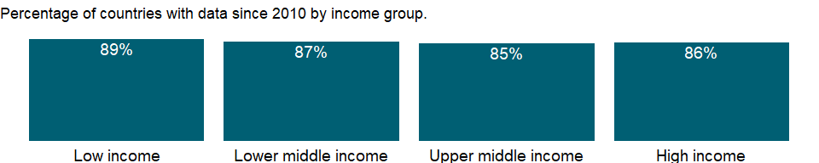

### Why is it relevant?

NA

### What is the data source?

UNESCO Institute for Statistics (<http://uis.unesco.org/>). Data as of September 2020.

### What is the methodology?

Enrollment includes Individuals officially registered in a given educational programme, or stage or module thereof, regardless of age.

Data on education are collected by the UNESCO Institute for Statistics from official responses to its annual education survey. All the data are mapped to the International Standard Classification of Education (ISCED) to ensure the comparability of education programs at the international level. The current version was formally adopted by UNESCO Member States in 2011.

The reference years reflect the school year for which the data are presented. In some countries the school year spans two calendar years (for example, from September 2010 to June 2011); in these cases the reference year refers to the year in which the school year ended (2011 in the example).

### How is it aggregated?

Sum

### What are the limitations?

NA

### What else should I know?

For aggregate data, each economy is classified based on the classification of World Bank Group’s fiscal year 2021 (July 1, 2020-June 30, 2021).

### 1.58.27 Secondary education, pupils (% female)

### What is the indicator?

Female pupils as a percentage of total pupils at secondary level includes enrollments in public and private schools.

Topic: Education: Participation

Series ID: SE.SEC.ENRL.FE.ZS

Copyright: CC BY-4.0 , <https://datacatalog.worldbank.org/public-licenses#cc-by>

First year with any data: 1970

Last year with any data: 2019

### What years are data available?

The figure below shows years in which data is available for at least one country. Dates shaded in black have no data, while dates shaded in green have data for at least one country



### Which countries have data?

The figure below shows the percentage of countries in each income group with a value since 2010 for that indicator.

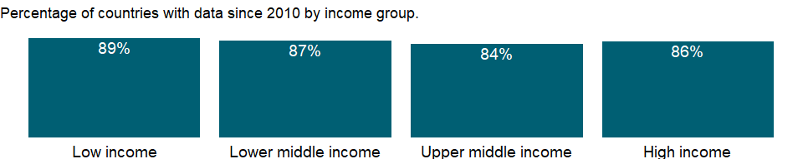

### Why is it relevant?

The share of girls allows an assessment on gender composition in school enrollment. A value greater than 50% indicates participation of more girls at a specific level or programme of education.

### What is the data source?

UNESCO Institute for Statistics (<http://uis.unesco.org/>). Data as of February 2020.

### What is the methodology?

Percentage of female enrollment is calculated by dividing the total number of female students at a given level of education by the total enrollment at the same level, and multiplying by 100.

Data on education are collected by the UNESCO Institute for Statistics from official responses to its annual education survey. All the data are mapped to the International Standard Classification of Education (ISCED) to ensure the comparability of education programs at the international level. The current version was formally adopted by UNESCO Member States in 2011.

The reference years reflect the school year for which the data are presented. In some countries the school year spans two calendar years (for example, from September 2010 to June 2011); in these cases the reference year refers to the year in which the school year ended (2011 in the example).

### How is it aggregated?

Weighted average

### What are the limitations?

The percentage of female enrollment is limited in assessing gender parity, because it’s affected by the gender composition of population. Ratio of female to male in enrollment rate provides a population adjusted measure of gender parity.

### What else should I know?

For aggregate data, each economy is classified based on the classification of World Bank Group’s fiscal year 2021 (July 1, 2020-June 30, 2021).

### 1.58.28 Secondary education, general pupils

### What is the indicator?

Secondary general pupils are the number of secondary students enrolled in general education programs, including teacher training.

Topic: Education: Participation

Series ID: SE.SEC.ENRL.GC

Copyright: CC BY-4.0 , <https://datacatalog.worldbank.org/public-licenses#cc-by>

First year with any data: 1970

Last year with any data: 2019

### What years are data available?

The figure below shows years in which data is available for at least one country. Dates shaded in black have no data, while dates shaded in green have data for at least one country



### Which countries have data?

The figure below shows the percentage of countries in each income group with a value since 2010 for that indicator.



### Why is it relevant?

NA

### What is the data source?

UNESCO Institute for Statistics (<http://uis.unesco.org/>). Data as of February 2020.

### What is the methodology?

Enrollment includes Individuals officially registered in a given educational programme, or stage or module thereof, regardless of age.

Data on education are collected by the UNESCO Institute for Statistics from official responses to its annual education survey. All the data are mapped to the International Standard Classification of Education (ISCED) to ensure the comparability of education programs at the international level. The current version was formally adopted by UNESCO Member States in 2011.

The reference years reflect the school year for which the data are presented. In some countries the school year spans two calendar years (for example, from September 2010 to June 2011); in these cases the reference year refers to the year in which the school year ended (2011 in the example).

### How is it aggregated?

Sum

### What are the limitations?

NA

### What else should I know?

For aggregate data, each economy is classified based on the classification of World Bank Group’s fiscal year 2021 (July 1, 2020-June 30, 2021).

### 1.58.29 Secondary education, general pupils (% female)

### What is the indicator?

Secondary general pupils are the number of secondary students enrolled in general education programs, including teacher training.

Topic: Education: Participation

Series ID: SE.SEC.ENRL.GC.FE.ZS

Copyright: CC BY-4.0 , <https://datacatalog.worldbank.org/public-licenses#cc-by>

First year with any data: 1970

Last year with any data: 2019

### What years are data available?

The figure below shows years in which data is available for at least one country. Dates shaded in black have no data, while dates shaded in green have data for at least one country



### Which countries have data?

The figure below shows the percentage of countries in each income group with a value since 2010 for that indicator.



### Why is it relevant?

The share of girls allows an assessment on gender composition in school enrollment. A value greater than 50% indicates participation of more girls at a specific level or programme of education.

### What is the data source?

UNESCO Institute for Statistics (<http://uis.unesco.org/>). Data as of February 2020.

### What is the methodology?

Percentage of female enrollment is calculated by dividing the total number of female students at a given level of education by the total enrollment at the same level, and multiplying by 100.

Data on education are collected by the UNESCO Institute for Statistics from official responses to its annual education survey. All the data are mapped to the International Standard Classification of Education (ISCED) to ensure the comparability of education programs at the international level. The current version was formally adopted by UNESCO Member States in 2011.

The reference years reflect the school year for which the data are presented. In some countries the school year spans two calendar years (for example, from September 2010 to June 2011); in these cases the reference year refers to the year in which the school year ended (2011 in the example).

### How is it aggregated?

Weighted average

### What are the limitations?

The percentage of female enrollment is limited in assessing gender parity, because it’s affected by the gender composition of population. Ratio of female to male in enrollment rate provides a population adjusted measure of gender parity.

### What else should I know?

For aggregate data, each economy is classified based on the classification of World Bank Group’s fiscal year 2021 (July 1, 2020-June 30, 2021).

### 1.58.30 Secondary education, vocational pupils

### What is the indicator?

Secondary vocational pupils are the number of secondary students enrolled in technical and vocational education programs, including teacher training.

Topic: Education: Participation

Series ID: SE.SEC.ENRL.VO

Copyright: CC BY-4.0 , <https://datacatalog.worldbank.org/public-licenses#cc-by>

First year with any data: 1970

Last year with any data: 2019

### What years are data available?

The figure below shows years in which data is available for at least one country. Dates shaded in black have no data, while dates shaded in green have data for at least one country



### Which countries have data?

The figure below shows the percentage of countries in each income group with a value since 2010 for that indicator.

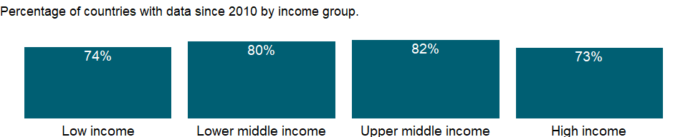

### Why is it relevant?

NA

### What is the data source?

UNESCO Institute for Statistics (<http://uis.unesco.org/>). Data as of February 2020.

### What is the methodology?

Enrollment includes Individuals officially registered in a given educational programme, or stage or module thereof, regardless of age.

Data on education are collected by the UNESCO Institute for Statistics from official responses to its annual education survey. All the data are mapped to the International Standard Classification of Education (ISCED) to ensure the comparability of education programs at the international level. The current version was formally adopted by UNESCO Member States in 2011.

The reference years reflect the school year for which the data are presented. In some countries the school year spans two calendar years (for example, from September 2010 to June 2011); in these cases the reference year refers to the year in which the school year ended (2011 in the example).

### How is it aggregated?

Sum

### What are the limitations?

NA

### What else should I know?

For aggregate data, each economy is classified based on the classification of World Bank Group’s fiscal year 2021 (July 1, 2020-June 30, 2021).

### 1.58.31 Secondary education, vocational pupils (% female)

### What is the indicator?

Secondary vocational pupils are the number of secondary students enrolled in technical and vocational education programs, including teacher training.

Topic: Education: Participation

Series ID: SE.SEC.ENRL.VO.FE.ZS

Copyright: CC BY-4.0 , <https://datacatalog.worldbank.org/public-licenses#cc-by>

First year with any data: 1970

Last year with any data: 2019

### What years are data available?

The figure below shows years in which data is available for at least one country. Dates shaded in black have no data, while dates shaded in green have data for at least one country



### Which countries have data?

The figure below shows the percentage of countries in each income group with a value since 2010 for that indicator.

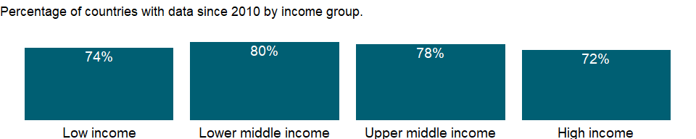

### Why is it relevant?

The share of girls allows an assessment on gender composition in school enrollment. A value greater than 50% indicates participation of more girls at a specific level or programme of education.

### What is the data source?

UNESCO Institute for Statistics (<http://uis.unesco.org/>). Data as of February 2020.

### What is the methodology?

Percentage of female enrollment is calculated by dividing the total number of female students at a given level of education by the total enrollment at the same level, and multiplying by 100.

Data on education are collected by the UNESCO Institute for Statistics from official responses to its annual education survey. All the data are mapped to the International Standard Classification of Education (ISCED) to ensure the comparability of education programs at the international level. The current version was formally adopted by UNESCO Member States in 2011.

The reference years reflect the school year for which the data are presented. In some countries the school year spans two calendar years (for example, from September 2010 to June 2011); in these cases the reference year refers to the year in which the school year ended (2011 in the example).

### How is it aggregated?

Weighted average

### What are the limitations?

The percentage of female enrollment is limited in assessing gender parity, because it’s affected by the gender composition of population. Ratio of female to male in enrollment rate provides a population adjusted measure of gender parity.

### What else should I know?

For aggregate data, each economy is classified based on the classification of World Bank Group’s fiscal year 2021 (July 1, 2020-June 30, 2021).

### 1.58.32 School enrollment, secondary (% gross)

### What is the indicator?

Gross enrollment ratio is the ratio of total enrollment, regardless of age, to the population of the age group that officially corresponds to the level of education shown. Secondary education completes the provision of basic education that began at the primary level, and aims at laying the foundations for lifelong learning and human development, by offering more subject- or skill-oriented instruction using more specialized teachers.

Topic: Education: Participation

Series ID: SE.SEC.ENRR

Copyright: CC BY-4.0 , <https://datacatalog.worldbank.org/public-licenses#cc-by>

First year with any data: 1970

Last year with any data: 2020

### What years are data available?

The figure below shows years in which data is available for at least one country. Dates shaded in black have no data, while dates shaded in green have data for at least one country



### Which countries have data?

The figure below shows the percentage of countries in each income group with a value since 2010 for that indicator.



### Why is it relevant?

Gross enrollment ratios indicate the capacity of each level of the education system, but a high ratio may reflect a substantial number of overage children enrolled in each grade because of repetition or late entry rather than a successful education system. The net enrollment rate excludes overage and underage students and more accurately captures the system’s coverage and internal efficiency. Differences between the gross enrollment ratio and the net enrollment rate show the incidence of overage and underage enrollments.

### What is the data source?

UNESCO Institute for Statistics (<http://uis.unesco.org/>). Data as of September 2020.

### What is the methodology?

Gross enrollment ratio for secondary school is calculated by dividing the number of students enrolled in secondary education regardless of age by the population of the age group which officially corresponds to secondary education, and multiplying by 100.

Data on education are collected by the UNESCO Institute for Statistics from official responses to its annual education survey. All the data are mapped to the International Standard Classification of Education (ISCED) to ensure the comparability of education programs at the international level. The current version was formally adopted by UNESCO Member States in 2011. Population data are drawn from the United Nations Population Division. Using a single source for population data standardizes definitions, estimations, and interpolation methods, ensuring a consistent methodology across countries and minimizing potential enumeration problems in national censuses.

The reference years reflect the school year for which the data are presented. In some countries the school year spans two calendar years (for example, from September 2010 to June 2011); in these cases the reference year refers to the year in which the school year ended (2011 in the example).

### How is it aggregated?

Weighted average

### What are the limitations?

Enrollment indicators are based on annual school surveys, but do not necessarily reflect actual attendance or dropout rates during the year. Also, the length of education differs across countries and can influence enrollment rates, although the International Standard Classification of Education (ISCED) tries to minimize the difference. For example, a shorter duration for primary education tends to increase the rate; a longer one to decrease it (in part because older children are more at risk of dropping out). Moreover, age at enrollment may be inaccurately estimated or misstated, especially in communities where registration of births is not strictly enforced.

### What else should I know?

For aggregate data, each economy is classified based on the classification of World Bank Group’s fiscal year 2021 (July 1, 2020-June 30, 2021).

### 1.58.33 School enrollment, secondary, female (% gross)

### What is the indicator?

Gross enrollment ratio is the ratio of total enrollment, regardless of age, to the population of the age group that officially corresponds to the level of education shown. Secondary education completes the provision of basic education that began at the primary level, and aims at laying the foundations for lifelong learning and human development, by offering more subject- or skill-oriented instruction using more specialized teachers.

Topic: Education: Participation

Series ID: SE.SEC.ENRR.FE

Copyright: CC BY-4.0 , <https://datacatalog.worldbank.org/public-licenses#cc-by>

First year with any data: 1970

Last year with any data: 2020

### What years are data available?

The figure below shows years in which data is available for at least one country. Dates shaded in black have no data, while dates shaded in green have data for at least one country



### Which countries have data?

The figure below shows the percentage of countries in each income group with a value since 2010 for that indicator.



### Why is it relevant?

Gross enrollment ratios indicate the capacity of each level of the education system, but a high ratio may reflect a substantial number of overage children enrolled in each grade because of repetition or late entry rather than a successful education system. The net enrollment rate excludes overage and underage students and more accurately captures the system’s coverage and internal efficiency. Differences between the gross enrollment ratio and the net enrollment rate show the incidence of overage and underage enrollments.

### What is the data source?

UNESCO Institute for Statistics (<http://uis.unesco.org/>). Data as of September 2020.

### What is the methodology?

Gross enrollment ratio for secondary school is calculated by dividing the number of students enrolled in secondary education regardless of age by the population of the age group which officially corresponds to secondary education, and multiplying by 100.

Data on education are collected by the UNESCO Institute for Statistics from official responses to its annual education survey. All the data are mapped to the International Standard Classification of Education (ISCED) to ensure the comparability of education programs at the international level. The current version was formally adopted by UNESCO Member States in 2011. Population data are drawn from the United Nations Population Division. Using a single source for population data standardizes definitions, estimations, and interpolation methods, ensuring a consistent methodology across countries and minimizing potential enumeration problems in national censuses.

The reference years reflect the school year for which the data are presented. In some countries the school year spans two calendar years (for example, from September 2010 to June 2011); in these cases the reference year refers to the year in which the school year ended (2011 in the example).

### How is it aggregated?

Weighted average

### What are the limitations?

Enrollment indicators are based on annual school surveys, but do not necessarily reflect actual attendance or dropout rates during the year. Also, the length of education differs across countries and can influence enrollment rates, although the International Standard Classification of Education (ISCED) tries to minimize the difference. For example, a shorter duration for primary education tends to increase the rate; a longer one to decrease it (in part because older children are more at risk of dropping out). Moreover, age at enrollment may be inaccurately estimated or misstated, especially in communities where registration of births is not strictly enforced.

### What else should I know?

For aggregate data, each economy is classified based on the classification of World Bank Group’s fiscal year 2021 (July 1, 2020-June 30, 2021).

### 1.58.34 School enrollment, secondary, male (% gross)

### What is the indicator?

Gross enrollment ratio is the ratio of total enrollment, regardless of age, to the population of the age group that officially corresponds to the level of education shown. Secondary education completes the provision of basic education that began at the primary level, and aims at laying the foundations for lifelong learning and human development, by offering more subject- or skill-oriented instruction using more specialized teachers.

Topic: Education: Participation

Series ID: SE.SEC.ENRR.MA

Copyright: CC BY-4.0 , <https://datacatalog.worldbank.org/public-licenses#cc-by>

First year with any data: 1970

Last year with any data: 2020

### What years are data available?

The figure below shows years in which data is available for at least one country. Dates shaded in black have no data, while dates shaded in green have data for at least one country



### Which countries have data?

The figure below shows the percentage of countries in each income group with a value since 2010 for that indicator.



### Why is it relevant?

Gross enrollment ratios indicate the capacity of each level of the education system, but a high ratio may reflect a substantial number of overage children enrolled in each grade because of repetition or late entry rather than a successful education system. The net enrollment rate excludes overage and underage students and more accurately captures the system’s coverage and internal efficiency. Differences between the gross enrollment ratio and the net enrollment rate show the incidence of overage and underage enrollments.

### What is the data source?

UNESCO Institute for Statistics (<http://uis.unesco.org/>). Data as of September 2020.

### What is the methodology?

Gross enrollment ratio for secondary school is calculated by dividing the number of students enrolled in secondary education regardless of age by the population of the age group which officially corresponds to secondary education, and multiplying by 100.

Data on education are collected by the UNESCO Institute for Statistics from official responses to its annual education survey. All the data are mapped to the International Standard Classification of Education (ISCED) to ensure the comparability of education programs at the international level. The current version was formally adopted by UNESCO Member States in 2011. Population data are drawn from the United Nations Population Division. Using a single source for population data standardizes definitions, estimations, and interpolation methods, ensuring a consistent methodology across countries and minimizing potential enumeration problems in national censuses.

The reference years reflect the school year for which the data are presented. In some countries the school year spans two calendar years (for example, from September 2010 to June 2011); in these cases the reference year refers to the year in which the school year ended (2011 in the example).

### How is it aggregated?

Weighted average

### What are the limitations?

Enrollment indicators are based on annual school surveys, but do not necessarily reflect actual attendance or dropout rates during the year. Also, the length of education differs across countries and can influence enrollment rates, although the International Standard Classification of Education (ISCED) tries to minimize the difference. For example, a shorter duration for primary education tends to increase the rate; a longer one to decrease it (in part because older children are more at risk of dropping out). Moreover, age at enrollment may be inaccurately estimated or misstated, especially in communities where registration of births is not strictly enforced.

### What else should I know?

For aggregate data, each economy is classified based on the classification of World Bank Group’s fiscal year 2021 (July 1, 2020-June 30, 2021).

### 1.58.35 School enrollment, secondary (% net)

### What is the indicator?

Net enrollment rate is the ratio of children of official school age who are enrolled in school to the population of the corresponding official school age. Secondary education completes the provision of basic education that began at the primary level, and aims at laying the foundations for lifelong learning and human development, by offering more subject- or skill-oriented instruction using more specialized teachers.

Topic: Education: Participation

Series ID: SE.SEC.NENR

Copyright: CC BY-4.0 , <https://datacatalog.worldbank.org/public-licenses#cc-by>

First year with any data: 1970

Last year with any data: 2019

### What years are data available?

The figure below shows years in which data is available for at least one country. Dates shaded in black have no data, while dates shaded in green have data for at least one country



### Which countries have data?

The figure below shows the percentage of countries in each income group with a value since 2010 for that indicator.

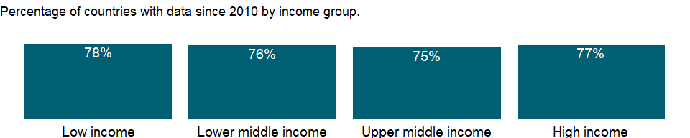

### Why is it relevant?

Gross enrollment ratios indicate the capacity of each level of the education system, but a high ratio may reflect a substantial number of overage children enrolled in each grade because of repetition or late entry rather than a successful education system. The net enrollment rate excludes overage and underage students and more accurately captures the system’s coverage and internal efficiency. Differences between the gross enrollment ratio and the net enrollment rate show the incidence of overage and underage enrollments.

### What is the data source?

UNESCO Institute for Statistics (<http://uis.unesco.org/>). Data as of February 2020.

### What is the methodology?

Net enrollment rate for secondary school is calculated by dividing the number of students of official school age enrolled in secondary education by the population of the age group which officially corresponds to secondary education, and multiplying by 100.

Data on education are collected by the UNESCO Institute for Statistics from official responses to its annual education survey. All the data are mapped to the International Standard Classification of Education (ISCED) to ensure the comparability of education programs at the international level. The current version was formally adopted by UNESCO Member States in 2011. Population data are drawn from the United Nations Population Division. Using a single source for population data standardizes definitions, estimations, and interpolation methods, ensuring a consistent methodology across countries and minimizing potential enumeration problems in national censuses.

The reference years reflect the school year for which the data are presented. In some countries the school year spans two calendar years (for example, from September 2010 to June 2011); in these cases the reference year refers to the year in which the school year ended (2011 in the example).

### How is it aggregated?

Weighted average

### What are the limitations?

Enrollment indicators are based on annual school surveys, but do not necessarily reflect actual attendance or dropout rates during the year. Also, the length of education differs across countries and can influence enrollment rates, although the International Standard Classification of Education (ISCED) tries to minimize the difference. For example, a shorter duration for primary education tends to increase the rate; a longer one to decrease it (in part because older children are more at risk of dropping out). Moreover, age at enrollment may be inaccurately estimated or misstated, especially in communities where registration of births is not strictly enforced.

### What else should I know?

For aggregate data, each economy is classified based on the classification of World Bank Group’s fiscal year 2021 (July 1, 2020-June 30, 2021).

### 1.58.36 School enrollment, secondary, female (% net)

### What is the indicator?

Net enrollment rate is the ratio of children of official school age who are enrolled in school to the population of the corresponding official school age. Secondary education completes the provision of basic education that began at the primary level, and aims at laying the foundations for lifelong learning and human development, by offering more subject- or skill-oriented instruction using more specialized teachers.

Topic: Education: Participation

Series ID: SE.SEC.NENR.FE

Copyright: CC BY-4.0 , <https://datacatalog.worldbank.org/public-licenses#cc-by>

First year with any data: 1970

Last year with any data: 2019

### What years are data available?

The figure below shows years in which data is available for at least one country. Dates shaded in black have no data, while dates shaded in green have data for at least one country



### Which countries have data?

The figure below shows the percentage of countries in each income group with a value since 2010 for that indicator.



### Why is it relevant?

Gross enrollment ratios indicate the capacity of each level of the education system, but a high ratio may reflect a substantial number of overage children enrolled in each grade because of repetition or late entry rather than a successful education system. The net enrollment rate excludes overage and underage students and more accurately captures the system’s coverage and internal efficiency. Differences between the gross enrollment ratio and the net enrollment rate show the incidence of overage and underage enrollments.

### What is the data source?

UNESCO Institute for Statistics (<http://uis.unesco.org/>). Data as of February 2020.

### What is the methodology?

Net enrollment rate for secondary school is calculated by dividing the number of students of official school age enrolled in secondary education by the population of the age group which officially corresponds to secondary education, and multiplying by 100.

Data on education are collected by the UNESCO Institute for Statistics from official responses to its annual education survey. All the data are mapped to the International Standard Classification of Education (ISCED) to ensure the comparability of education programs at the international level. The current version was formally adopted by UNESCO Member States in 2011. Population data are drawn from the United Nations Population Division. Using a single source for population data standardizes definitions, estimations, and interpolation methods, ensuring a consistent methodology across countries and minimizing potential enumeration problems in national censuses.

The reference years reflect the school year for which the data are presented. In some countries the school year spans two calendar years (for example, from September 2010 to June 2011); in these cases the reference year refers to the year in which the school year ended (2011 in the example).

### How is it aggregated?

Weighted average

### What are the limitations?

Enrollment indicators are based on annual school surveys, but do not necessarily reflect actual attendance or dropout rates during the year. Also, the length of education differs across countries and can influence enrollment rates, although the International Standard Classification of Education (ISCED) tries to minimize the difference. For example, a shorter duration for primary education tends to increase the rate; a longer one to decrease it (in part because older children are more at risk of dropping out). Moreover, age at enrollment may be inaccurately estimated or misstated, especially in communities where registration of births is not strictly enforced.

### What else should I know?

For aggregate data, each economy is classified based on the classification of World Bank Group’s fiscal year 2021 (July 1, 2020-June 30, 2021).

### 1.58.37 School enrollment, secondary, male (% net)

### What is the indicator?

Net enrollment rate is the ratio of children of official school age who are enrolled in school to the population of the corresponding official school age. Secondary education completes the provision of basic education that began at the primary level, and aims at laying the foundations for lifelong learning and human development, by offering more subject- or skill-oriented instruction using more specialized teachers.

Topic: Education: Participation

Series ID: SE.SEC.NENR.MA

Copyright: CC BY-4.0 , <https://datacatalog.worldbank.org/public-licenses#cc-by>

First year with any data: 1970

Last year with any data: 2019

### What years are data available?

The figure below shows years in which data is available for at least one country. Dates shaded in black have no data, while dates shaded in green have data for at least one country



### Which countries have data?

The figure below shows the percentage of countries in each income group with a value since 2010 for that indicator.



### Why is it relevant?

Gross enrollment ratios indicate the capacity of each level of the education system, but a high ratio may reflect a substantial number of overage children enrolled in each grade because of repetition or late entry rather than a successful education system. The net enrollment rate excludes overage and underage students and more accurately captures the system’s coverage and internal efficiency. Differences between the gross enrollment ratio and the net enrollment rate show the incidence of overage and underage enrollments.

### What is the data source?

UNESCO Institute for Statistics (<http://uis.unesco.org/>). Data as of February 2020.

### What is the methodology?

Net enrollment rate for secondary school is calculated by dividing the number of students of official school age enrolled in secondary education by the population of the age group which officially corresponds to secondary education, and multiplying by 100.

Data on education are collected by the UNESCO Institute for Statistics from official responses to its annual education survey. All the data are mapped to the International Standard Classification of Education (ISCED) to ensure the comparability of education programs at the international level. The current version was formally adopted by UNESCO Member States in 2011. Population data are drawn from the United Nations Population Division. Using a single source for population data standardizes definitions, estimations, and interpolation methods, ensuring a consistent methodology across countries and minimizing potential enumeration problems in national censuses.

The reference years reflect the school year for which the data are presented. In some countries the school year spans two calendar years (for example, from September 2010 to June 2011); in these cases the reference year refers to the year in which the school year ended (2011 in the example).

### How is it aggregated?

Weighted average

### What are the limitations?

Enrollment indicators are based on annual school surveys, but do not necessarily reflect actual attendance or dropout rates during the year. Also, the length of education differs across countries and can influence enrollment rates, although the International Standard Classification of Education (ISCED) tries to minimize the difference. For example, a shorter duration for primary education tends to increase the rate; a longer one to decrease it (in part because older children are more at risk of dropping out). Moreover, age at enrollment may be inaccurately estimated or misstated, especially in communities where registration of births is not strictly enforced.

### What else should I know?

For aggregate data, each economy is classified based on the classification of World Bank Group’s fiscal year 2021 (July 1, 2020-June 30, 2021).

### 1.58.38 School enrollment, secondary, private (% of total secondary)

### What is the indicator?

Private enrollment refers to pupils or students enrolled in institutions that are not operated by a public authority but controlled and managed, whether for profit or not, by a private body such as a nongovernmental organization, religious body, special interest group, foundation or business enterprise.

Topic: Education: Participation

Series ID: SE.SEC.PRIV.ZS

Copyright: CC BY-4.0 , <https://datacatalog.worldbank.org/public-licenses#cc-by>

First year with any data: 1998

Last year with any data: 2020

### What years are data available?

The figure below shows years in which data is available for at least one country. Dates shaded in black have no data, while dates shaded in green have data for at least one country



### Which countries have data?

The figure below shows the percentage of countries in each income group with a value since 2010 for that indicator.

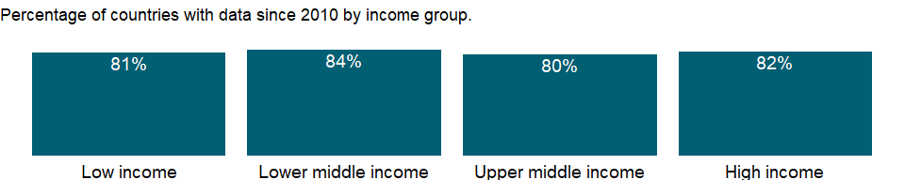

### Why is it relevant?

The share of enrollment in private institutions indicates the scale and capacity of private education within a country. A high percentage suggests strong involvement of the non-governmental sector (including religious bodies, other organizations, associations, communities, private enterprises or persons) in providing organized educational programmes. However, in countries where private institutions are substantially subsidized or aided by the government, the distinction between private and public educational institutions may be less clear-cut especially when certain students are directly financed through government scholarships.

### What is the data source?

UNESCO Institute for Statistics (<http://uis.unesco.org/>). Data as of September 2020.

### What is the methodology?

The share of students in private secondary school is calculated by dividing the number of students enrolled in private educational institutions at secondary level by total enrollment (public and private) at the same level of education, and multiplying by 100.

Data on education are collected by the UNESCO Institute for Statistics from official responses to its annual education survey. All the data are mapped to the International Standard Classification of Education (ISCED) to ensure the comparability of education programs at the international level. The current version was formally adopted by UNESCO Member States in 2011.

The reference years reflect the school year for which the data are presented. In some countries the school year spans two calendar years (for example, from September 2010 to June 2011); in these cases the reference year refers to the year in which the school year ended (2011 in the example).

### How is it aggregated?

Weighted average

### What are the limitations?

Religious or private schools, which are not registered with the government or don’t follow the common national curriculum, may not be captured.

### What else should I know?

For aggregate data, each economy is classified based on the classification of World Bank Group’s fiscal year 2021 (July 1, 2020-June 30, 2021).

### 1.58.39 Adolescents out of school, female (% of female lower secondary school age)

### What is the indicator?

Adolescents out of school are the percentage of lower secondary school age adolescents who are not enrolled in school.

Topic: Education: Participation

Series ID: SE.SEC.UNER.LO.FE.ZS

Copyright: CC BY-4.0 , <https://datacatalog.worldbank.org/public-licenses#cc-by>

First year with any data: 1970

Last year with any data: 2019

### What years are data available?

The figure below shows years in which data is available for at least one country. Dates shaded in black have no data, while dates shaded in green have data for at least one country



### Which countries have data?

The figure below shows the percentage of countries in each income group with a value since 2010 for that indicator.

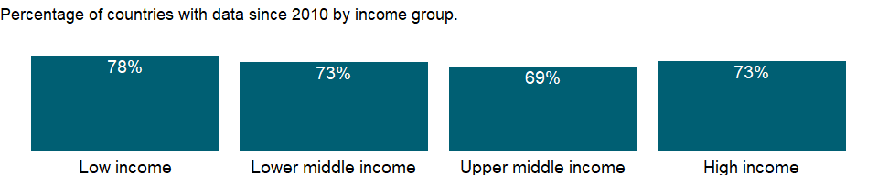

### Why is it relevant?

NA

### What is the data source?

UNESCO Institute for Statistics (<http://uis.unesco.org/>). Data as of September 2020.

### What is the methodology?

The rate of out-of-school adolescents allows to compare across countries with different population sizes. It shows the share of official lower secondary age adolescents who never attended school or dropped out to the population of official lower secondary school age.

Data on education are collected by the UNESCO Institute for Statistics from official responses to its annual education survey. All the data are mapped to the International Standard Classification of Education (ISCED) to ensure the comparability of education programs at the international level. The current version was formally adopted by UNESCO Member States in 2011. Population data are drawn from the United Nations Population Division. Using a single source for population data standardizes definitions, estimations, and interpolation methods, ensuring a consistent methodology across countries and minimizing potential enumeration problems in national censuses. The reference years reflect the school year for which the data are presented. In some countries the school year spans two calendar years (for example, from September 2010 to June 2011); in these cases the reference year refers to the year in which the school year ended (2011 in the example).

### How is it aggregated?

Weighted Average

### What are the limitations?

The administrative data used in the calculation of the rate of out-of-school children are based on enrolment at a specific date which can bias the results by either counting enrolled children who never attend school or by omitting those who enroll after the reference date for reporting enrolment data. Furthermore, children who drop out of school after the reference date are not counted as out of school. Discrepancies between enrolment and population data from different sources can also result in over- or underestimates of the rate. Lastly, the international comparability of this indicator can be affected by the use of different concepts of enrolment and out-of-school children across countries.

### What else should I know?

For aggregate data, each economy is classified based on the classification of World Bank Group’s fiscal year 2021 (July 1, 2020-June 30, 2021).

### 1.58.40 Adolescents out of school, male (% of male lower secondary school age)

### What is the indicator?

Adolescents out of school are the percentage of lower secondary school age adolescents who are not enrolled in school.

Topic: Education: Participation

Series ID: SE.SEC.UNER.LO.MA.ZS

Copyright: CC BY-4.0 , <https://datacatalog.worldbank.org/public-licenses#cc-by>

First year with any data: 1970

Last year with any data: 2019

### What years are data available?

The figure below shows years in which data is available for at least one country. Dates shaded in black have no data, while dates shaded in green have data for at least one country



### Which countries have data?

The figure below shows the percentage of countries in each income group with a value since 2010 for that indicator.



### Why is it relevant?

NA

### What is the data source?

UNESCO Institute for Statistics (<http://uis.unesco.org/>). Data as of September 2020.

### What is the methodology?

The rate of out-of-school adolescents allows to compare across countries with different population sizes. It shows the share of official lower secondary age adolescents who never attended school or dropped out to the population of official lower secondary school age.

Data on education are collected by the UNESCO Institute for Statistics from official responses to its annual education survey. All the data are mapped to the International Standard Classification of Education (ISCED) to ensure the comparability of education programs at the international level. The current version was formally adopted by UNESCO Member States in 2011. Population data are drawn from the United Nations Population Division. Using a single source for population data standardizes definitions, estimations, and interpolation methods, ensuring a consistent methodology across countries and minimizing potential enumeration problems in national censuses. The reference years reflect the school year for which the data are presented. In some countries the school year spans two calendar years (for example, from September 2010 to June 2011); in these cases the reference year refers to the year in which the school year ended (2011 in the example).

### How is it aggregated?

Weighted Average

### What are the limitations?

The administrative data used in the calculation of the rate of out-of-school children are based on enrolment at a specific date which can bias the results by either counting enrolled children who never attend school or by omitting those who enroll after the reference date for reporting enrolment data. Furthermore, children who drop out of school after the reference date are not counted as out of school. Discrepancies between enrolment and population data from different sources can also result in over- or underestimates of the rate. Lastly, the international comparability of this indicator can be affected by the use of different concepts of enrolment and out-of-school children across countries.

### What else should I know?

For aggregate data, each economy is classified based on the classification of World Bank Group’s fiscal year 2021 (July 1, 2020-June 30, 2021).

### 1.58.41 Adolescents out of school (% of lower secondary school age)

### What is the indicator?

Adolescents out of school are the percentage of lower secondary school age adolescents who are not enrolled in school.

Topic: Education: Participation

Series ID: SE.SEC.UNER.LO.ZS

Copyright: CC BY-4.0 , <https://datacatalog.worldbank.org/public-licenses#cc-by>

First year with any data: 1970

Last year with any data: 2019

### What years are data available?

The figure below shows years in which data is available for at least one country. Dates shaded in black have no data, while dates shaded in green have data for at least one country



### Which countries have data?

The figure below shows the percentage of countries in each income group with a value since 2010 for that indicator.

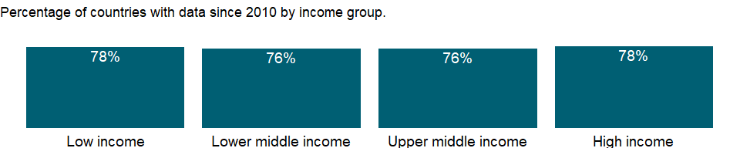

### Why is it relevant?

NA

### What is the data source?

UNESCO Institute for Statistics (<http://uis.unesco.org/>). Data as of September 2020.

### What is the methodology?

The rate of out-of-school adolescents allows to compare across countries with different population sizes. It shows the share of official lower secondary age adolescents who never attended school or dropped out to the population of official lower secondary school age.

Data on education are collected by the UNESCO Institute for Statistics from official responses to its annual education survey. All the data are mapped to the International Standard Classification of Education (ISCED) to ensure the comparability of education programs at the international level. The current version was formally adopted by UNESCO Member States in 2011. Population data are drawn from the United Nations Population Division. Using a single source for population data standardizes definitions, estimations, and interpolation methods, ensuring a consistent methodology across countries and minimizing potential enumeration problems in national censuses. The reference years reflect the school year for which the data are presented. In some countries the school year spans two calendar years (for example, from September 2010 to June 2011); in these cases the reference year refers to the year in which the school year ended (2011 in the example).

### How is it aggregated?

Weighted Average

### What are the limitations?

The administrative data used in the calculation of the rate of out-of-school children are based on enrolment at a specific date which can bias the results by either counting enrolled children who never attend school or by omitting those who enroll after the reference date for reporting enrolment data. Furthermore, children who drop out of school after the reference date are not counted as out of school. Discrepancies between enrolment and population data from different sources can also result in over- or underestimates of the rate. Lastly, the international comparability of this indicator can be affected by the use of different concepts of enrolment and out-of-school children across countries.

### What else should I know?

For aggregate data, each economy is classified based on the classification of World Bank Group’s fiscal year 2021 (July 1, 2020-June 30, 2021).

### 1.58.42 School enrollment, tertiary (% gross)

### What is the indicator?

Gross enrollment ratio is the ratio of total enrollment, regardless of age, to the population of the age group that officially corresponds to the level of education shown. Tertiary education, whether or not to an advanced research qualification, normally requires, as a minimum condition of admission, the successful completion of education at the secondary level.

Topic: Education: Participation

Series ID: SE.TER.ENRR

Copyright: CC BY-4.0 , <https://datacatalog.worldbank.org/public-licenses#cc-by>

First year with any data: 1970

Last year with any data: 2020

### What years are data available?

The figure below shows years in which data is available for at least one country. Dates shaded in black have no data, while dates shaded in green have data for at least one country



### Which countries have data?

The figure below shows the percentage of countries in each income group with a value since 2010 for that indicator.

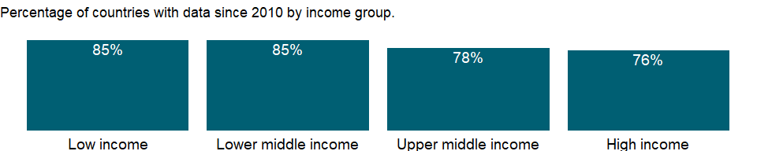

### Why is it relevant?

Gross enrollment ratios indicate the capacity of each level of the education system, but a high ratio may reflect a substantial number of overage children enrolled in each grade because of repetition or late entry rather than a successful education system. The net enrollment rate excludes overage and underage students and more accurately captures the system’s coverage and internal efficiency. Differences between the gross enrollment ratio and the net enrollment rate show the incidence of overage and underage enrollments.

### What is the data source?

UNESCO Institute for Statistics (<http://uis.unesco.org/>). Data as of September 2020.

### What is the methodology?

Gross enrollment ratio for tertiary school is calculated by dividing the number of students enrolled in tertiary education regardless of age by the population of the age group which officially corresponds to tertiary education, and multiplying by 100.

Data on education are collected by the UNESCO Institute for Statistics from official responses to its annual education survey. All the data are mapped to the International Standard Classification of Education (ISCED) to ensure the comparability of education programs at the international level. The current version was formally adopted by UNESCO Member States in 2011. Population data are drawn from the United Nations Population Division. Using a single source for population data standardizes definitions, estimations, and interpolation methods, ensuring a consistent methodology across countries and minimizing potential enumeration problems in national censuses.

The reference years reflect the school year for which the data are presented. In some countries the school year spans two calendar years (for example, from September 2010 to June 2011); in these cases the reference year refers to the year in which the school year ended (2011 in the example).

### How is it aggregated?

Weighted average

### What are the limitations?

Enrollment indicators are based on annual school surveys, but do not necessarily reflect actual attendance or dropout rates during the year. Also, the length of education differs across countries and can influence enrollment rates, although the International Standard Classification of Education (ISCED) tries to minimize the difference. For example, a shorter duration for primary education tends to increase the rate; a longer one to decrease it (in part because older children are more at risk of dropping out). Moreover, age at enrollment may be inaccurately estimated or misstated, especially in communities where registration of births is not strictly enforced.

### What else should I know?

For aggregate data, each economy is classified based on the classification of World Bank Group’s fiscal year 2021 (July 1, 2020-June 30, 2021).

### 1.58.43 School enrollment, tertiary, female (% gross)

### What is the indicator?

Gross enrollment ratio is the ratio of total enrollment, regardless of age, to the population of the age group that officially corresponds to the level of education shown. Tertiary education, whether or not to an advanced research qualification, normally requires, as a minimum condition of admission, the successful completion of education at the secondary level.

Topic: Education: Participation

Series ID: SE.TER.ENRR.FE

Copyright: CC BY-4.0 , <https://datacatalog.worldbank.org/public-licenses#cc-by>

First year with any data: 1970

Last year with any data: 2020

### What years are data available?

The figure below shows years in which data is available for at least one country. Dates shaded in black have no data, while dates shaded in green have data for at least one country



### Which countries have data?

The figure below shows the percentage of countries in each income group with a value since 2010 for that indicator.



### Why is it relevant?

Gross enrollment ratios indicate the capacity of each level of the education system, but a high ratio may reflect a substantial number of overage children enrolled in each grade because of repetition or late entry rather than a successful education system. The net enrollment rate excludes overage and underage students and more accurately captures the system’s coverage and internal efficiency. Differences between the gross enrollment ratio and the net enrollment rate show the incidence of overage and underage enrollments.

### What is the data source?

UNESCO Institute for Statistics (<http://uis.unesco.org/>). Data as of September 2020.

### What is the methodology?

Gross enrollment ratio for tertiary school is calculated by dividing the number of students enrolled in tertiary education regardless of age by the population of the age group which officially corresponds to tertiary education, and multiplying by 100.

Data on education are collected by the UNESCO Institute for Statistics from official responses to its annual education survey. All the data are mapped to the International Standard Classification of Education (ISCED) to ensure the comparability of education programs at the international level. The current version was formally adopted by UNESCO Member States in 2011. Population data are drawn from the United Nations Population Division. Using a single source for population data standardizes definitions, estimations, and interpolation methods, ensuring a consistent methodology across countries and minimizing potential enumeration problems in national censuses.

The reference years reflect the school year for which the data are presented. In some countries the school year spans two calendar years (for example, from September 2010 to June 2011); in these cases the reference year refers to the year in which the school year ended (2011 in the example).

### How is it aggregated?

Weighted average

### What are the limitations?

Enrollment indicators are based on annual school surveys, but do not necessarily reflect actual attendance or dropout rates during the year. Also, the length of education differs across countries and can influence enrollment rates, although the International Standard Classification of Education (ISCED) tries to minimize the difference. For example, a shorter duration for primary education tends to increase the rate; a longer one to decrease it (in part because older children are more at risk of dropping out). Moreover, age at enrollment may be inaccurately estimated or misstated, especially in communities where registration of births is not strictly enforced.

### What else should I know?

For aggregate data, each economy is classified based on the classification of World Bank Group’s fiscal year 2021 (July 1, 2020-June 30, 2021).

### 1.58.44 School enrollment, tertiary, male (% gross)

### What is the indicator?

Gross enrollment ratio is the ratio of total enrollment, regardless of age, to the population of the age group that officially corresponds to the level of education shown. Tertiary education, whether or not to an advanced research qualification, normally requires, as a minimum condition of admission, the successful completion of education at the secondary level.

Topic: Education: Participation

Series ID: SE.TER.ENRR.MA

Copyright: CC BY-4.0 , <https://datacatalog.worldbank.org/public-licenses#cc-by>

First year with any data: 1970

Last year with any data: 2020

### What years are data available?

The figure below shows years in which data is available for at least one country. Dates shaded in black have no data, while dates shaded in green have data for at least one country



### Which countries have data?

The figure below shows the percentage of countries in each income group with a value since 2010 for that indicator.



### Why is it relevant?

Gross enrollment ratios indicate the capacity of each level of the education system, but a high ratio may reflect a substantial number of overage children enrolled in each grade because of repetition or late entry rather than a successful education system. The net enrollment rate excludes overage and underage students and more accurately captures the system’s coverage and internal efficiency. Differences between the gross enrollment ratio and the net enrollment rate show the incidence of overage and underage enrollments.

### What is the data source?

UNESCO Institute for Statistics (<http://uis.unesco.org/>). Data as of September 2020.

### What is the methodology?

Gross enrollment ratio for tertiary school is calculated by dividing the number of students enrolled in tertiary education regardless of age by the population of the age group which officially corresponds to tertiary education, and multiplying by 100.

Data on education are collected by the UNESCO Institute for Statistics from official responses to its annual education survey. All the data are mapped to the International Standard Classification of Education (ISCED) to ensure the comparability of education programs at the international level. The current version was formally adopted by UNESCO Member States in 2011. Population data are drawn from the United Nations Population Division. Using a single source for population data standardizes definitions, estimations, and interpolation methods, ensuring a consistent methodology across countries and minimizing potential enumeration problems in national censuses.

The reference years reflect the school year for which the data are presented. In some countries the school year spans two calendar years (for example, from September 2010 to June 2011); in these cases the reference year refers to the year in which the school year ended (2011 in the example).

### How is it aggregated?

Weighted average

### What are the limitations?

Enrollment indicators are based on annual school surveys, but do not necessarily reflect actual attendance or dropout rates during the year. Also, the length of education differs across countries and can influence enrollment rates, although the International Standard Classification of Education (ISCED) tries to minimize the difference. For example, a shorter duration for primary education tends to increase the rate; a longer one to decrease it (in part because older children are more at risk of dropping out). Moreover, age at enrollment may be inaccurately estimated or misstated, especially in communities where registration of births is not strictly enforced.

### What else should I know?

For aggregate data, each economy is classified based on the classification of World Bank Group’s fiscal year 2021 (July 1, 2020-June 30, 2021).

## 1.59 Education: Inputs

### 1.59.1 Preprimary education, duration (years)

### What is the indicator?

Preprimary duration refers to the number of grades (years) in preprimary school.

Topic: Education: Inputs

Series ID: SE.PRE.DURS

Copyright: CC BY-4.0 , <https://datacatalog.worldbank.org/public-licenses#cc-by>

First year with any data: 1970

Last year with any data: 2020

### What years are data available?

The figure below shows years in which data is available for at least one country. Dates shaded in black have no data, while dates shaded in green have data for at least one country

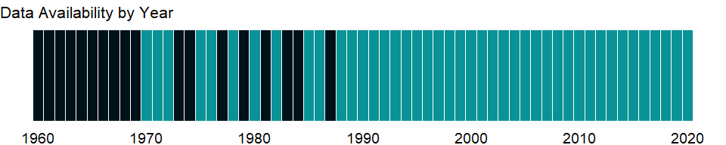

### Which countries have data?

The figure below shows the percentage of countries in each income group with a value since 2010 for that indicator.

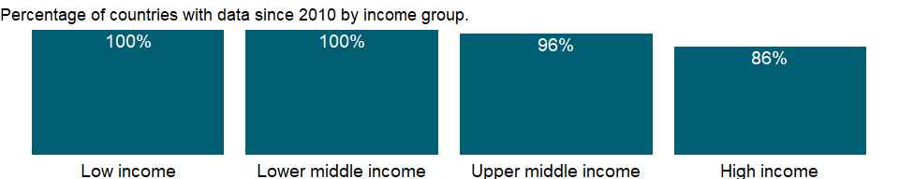

### Why is it relevant?

NA

### What is the data source?

UNESCO Institute for Statistics (<http://uis.unesco.org/>). Data as of September 2020.

### What is the methodology?

Data on education are collected by the UNESCO Institute for Statistics from official responses to its annual education survey. All the data are mapped to the International Standard Classification of Education (ISCED) to ensure the comparability of education programs at the international level. The current version was formally adopted by UNESCO Member States in 2011. Aggregate data are based on World Bank estimates.

The reference years reflect the school year for which the data are presented. In some countries the school year spans two calendar years (for example, from September 2010 to June 2011); in these cases the reference year refers to the year in which the school year ended (2011 in the example).

### How is it aggregated?

Median

### What are the limitations?

NA

### What else should I know?

For aggregate data, each economy is classified based on the classification of World Bank Group’s fiscal year 2021 (July 1, 2020-June 30, 2021).

### 1.59.2 Pupil-teacher ratio, preprimary

### What is the indicator?

Preprimary school pupil-teacher ratio is the average number of pupils per teacher in preprimary school.

Topic: Education: Inputs

Series ID: SE.PRE.ENRL.TC.ZS

Copyright: CC BY-4.0 , <https://datacatalog.worldbank.org/public-licenses#cc-by>

First year with any data: 1970

Last year with any data: 2019

### What years are data available?

The figure below shows years in which data is available for at least one country. Dates shaded in black have no data, while dates shaded in green have data for at least one country



### Which countries have data?

The figure below shows the percentage of countries in each income group with a value since 2010 for that indicator.

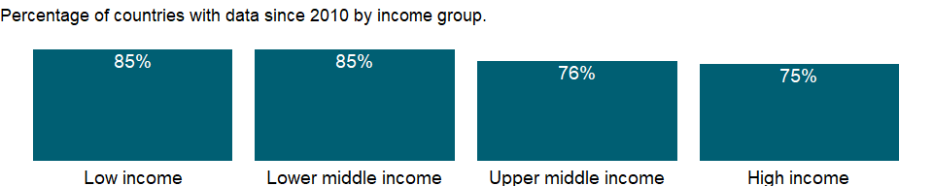

### Why is it relevant?

The pupil-teacher ratio is often used to compare the quality of schooling across countries, but it is often weakly related to student learning and quality of education.

### What is the data source?

UNESCO Institute for Statistics (<http://uis.unesco.org/>). Data as of February 2020.

### What is the methodology?

Pupil-teacher ratio is calculated by dividing the number of students at the specified level of education by the number of teachers at the same level of education.

Data on education are collected by the UNESCO Institute for Statistics from official responses to its annual education survey. All the data are mapped to the International Standard Classification of Education (ISCED) to ensure the comparability of education programs at the international level. The current version was formally adopted by UNESCO Member States in 2011.

The reference years reflect the school year for which the data are presented. In some countries the school year spans two calendar years (for example, from September 2010 to June 2011); in these cases the reference year refers to the year in which the school year ended (2011 in the example).

### How is it aggregated?

Weighted average

### What are the limitations?

The comparability of pupil-teacher ratios across countries is affected by the definition of teachers and by differences in class size by grade and in the number of hours taught, as well as the different practices countries employ such as part-time teachers, school shifts, and multi-grade classes. Moreover, the underlying enrollment levels are subject to a variety of reporting errors.

### What else should I know?

For aggregate data, each economy is classified based on the classification of World Bank Group’s fiscal year 2021 (July 1, 2020-June 30, 2021).

### 1.59.3 Trained teachers in preprimary education, female (% of female teachers)

### What is the indicator?

Trained teachers in preprimary education are the percentage of preprimary school teachers who have received the minimum organized teacher training (pre-service or in-service) required for teaching in a given country.

Topic: Education: Inputs

Series ID: SE.PRE.TCAQ.FE.ZS

Copyright: CC BY-4.0 , <https://datacatalog.worldbank.org/public-licenses#cc-by>

First year with any data: 1998

Last year with any data: 2020

### What years are data available?

The figure below shows years in which data is available for at least one country. Dates shaded in black have no data, while dates shaded in green have data for at least one country



### Which countries have data?

The figure below shows the percentage of countries in each income group with a value since 2010 for that indicator.

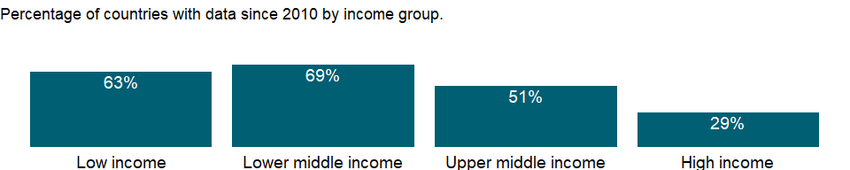

### Why is it relevant?

Trained teachers refer to teaching force with the necessary pedagogical skills to teach and use teaching materials in an effective manner. The share of trained teachers reveals a country’s commitment to investing in the development of its human capital engaged in teaching.

Teachers are important resource, especially for children who are the first-generation of receiving education in their families and heavily rely on teachers in acquiring basic literacy skills. However, rapid increase in enrollments may cause the shortage of trained teachers. Education finance is a key for appropriate teacher allocations, since teacher salaries account for a large share of education budgets. The shortage of trained teacher may result in low qualified teachers in more disadvantaged area.

### What is the data source?

UNESCO Institute for Statistics (<http://uis.unesco.org/>). Data as of September 2020.

### What is the methodology?

Share of trained teachers is calculated by dividing the number of trained teachers of the specified level of education by total number of teachers at the same level of education, and multiplying by 100.

Data on education are collected by the UNESCO Institute for Statistics from official responses to its annual education survey. All the data are mapped to the International Standard Classification of Education (ISCED) to ensure the comparability of education programs at the international level. The current version was formally adopted by UNESCO Member States in 2011.

The reference years reflect the school year for which the data are presented. In some countries the school year spans two calendar years (for example, from September 2010 to June 2011); in these cases the reference year refers to the year in which the school year ended (2011 in the example).

### How is it aggregated?

Weighted Average

### What are the limitations?

This indicator does not take into account differences in teachers’ experiences and status, teaching methods, teaching materials, and classroom conditions - all factors that affect the quality of teaching and learning. Some teachers without formal training may have acquired equivalent pedagogical skills through professional experience. In addition, national standards regarding teacher qualifications and pedagogical skills may vary.

### What else should I know?

For aggregate data, each economy is classified based on the classification of World Bank Group’s fiscal year 2021 (July 1, 2020-June 30, 2021).

### 1.59.4 Trained teachers in preprimary education, male (% of male teachers)

### What is the indicator?

Trained teachers in preprimary education are the percentage of preprimary school teachers who have received the minimum organized teacher training (pre-service or in-service) required for teaching in a given country.

Topic: Education: Inputs

Series ID: SE.PRE.TCAQ.MA.ZS

Copyright: CC BY-4.0 , <https://datacatalog.worldbank.org/public-licenses#cc-by>

First year with any data: 1998

Last year with any data: 2020

### What years are data available?

The figure below shows years in which data is available for at least one country. Dates shaded in black have no data, while dates shaded in green have data for at least one country



### Which countries have data?

The figure below shows the percentage of countries in each income group with a value since 2010 for that indicator.

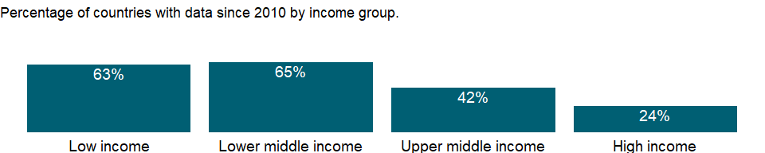

### Why is it relevant?

Trained teachers refer to teaching force with the necessary pedagogical skills to teach and use teaching materials in an effective manner. The share of trained teachers reveals a country’s commitment to investing in the development of its human capital engaged in teaching.

Teachers are important resource, especially for children who are the first-generation of receiving education in their families and heavily rely on teachers in acquiring basic literacy skills. However, rapid increase in enrollments may cause the shortage of trained teachers. Education finance is a key for appropriate teacher allocations, since teacher salaries account for a large share of education budgets. The shortage of trained teacher may result in low qualified teachers in more disadvantaged area.

### What is the data source?

UNESCO Institute for Statistics (<http://uis.unesco.org/>). Data as of September 2020.

### What is the methodology?

Share of trained teachers is calculated by dividing the number of trained teachers of the specified level of education by total number of teachers at the same level of education, and multiplying by 100.

Data on education are collected by the UNESCO Institute for Statistics from official responses to its annual education survey. All the data are mapped to the International Standard Classification of Education (ISCED) to ensure the comparability of education programs at the international level. The current version was formally adopted by UNESCO Member States in 2011.

The reference years reflect the school year for which the data are presented. In some countries the school year spans two calendar years (for example, from September 2010 to June 2011); in these cases the reference year refers to the year in which the school year ended (2011 in the example).

### How is it aggregated?

Weighted Average

### What are the limitations?

This indicator does not take into account differences in teachers’ experiences and status, teaching methods, teaching materials, and classroom conditions - all factors that affect the quality of teaching and learning. Some teachers without formal training may have acquired equivalent pedagogical skills through professional experience. In addition, national standards regarding teacher qualifications and pedagogical skills may vary.

### What else should I know?

For aggregate data, each economy is classified based on the classification of World Bank Group’s fiscal year 2021 (July 1, 2020-June 30, 2021).

### 1.59.5 Trained teachers in preprimary education (% of total teachers)

### What is the indicator?

Trained teachers in preprimary education are the percentage of preprimary school teachers who have received the minimum organized teacher training (pre-service or in-service) required for teaching in a given country.

Topic: Education: Inputs

Series ID: SE.PRE.TCAQ.ZS

Copyright: CC BY-4.0 , <https://datacatalog.worldbank.org/public-licenses#cc-by>

First year with any data: 1998

Last year with any data: 2020

### What years are data available?

The figure below shows years in which data is available for at least one country. Dates shaded in black have no data, while dates shaded in green have data for at least one country



### Which countries have data?

The figure below shows the percentage of countries in each income group with a value since 2010 for that indicator.

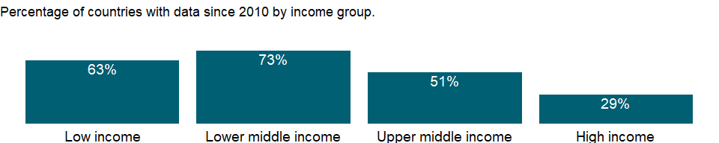

### Why is it relevant?

Trained teachers refer to teaching force with the necessary pedagogical skills to teach and use teaching materials in an effective manner. The share of trained teachers reveals a country’s commitment to investing in the development of its human capital engaged in teaching.

Teachers are important resource, especially for children who are the first-generation of receiving education in their families and heavily rely on teachers in acquiring basic literacy skills. However, rapid increase in enrollments may cause the shortage of trained teachers. Education finance is a key for appropriate teacher allocations, since teacher salaries account for a large share of education budgets. The shortage of trained teacher may result in low qualified teachers in more disadvantaged area.

### What is the data source?

UNESCO Institute for Statistics (<http://uis.unesco.org/>). Data as of September 2020.

### What is the methodology?

Share of trained teachers is calculated by dividing the number of trained teachers of the specified level of education by total number of teachers at the same level of education, and multiplying by 100.

Data on education are collected by the UNESCO Institute for Statistics from official responses to its annual education survey. All the data are mapped to the International Standard Classification of Education (ISCED) to ensure the comparability of education programs at the international level. The current version was formally adopted by UNESCO Member States in 2011.

The reference years reflect the school year for which the data are presented. In some countries the school year spans two calendar years (for example, from September 2010 to June 2011); in these cases the reference year refers to the year in which the school year ended (2011 in the example).

### How is it aggregated?

Weighted Average

### What are the limitations?

This indicator does not take into account differences in teachers’ experiences and status, teaching methods, teaching materials, and classroom conditions - all factors that affect the quality of teaching and learning. Some teachers without formal training may have acquired equivalent pedagogical skills through professional experience. In addition, national standards regarding teacher qualifications and pedagogical skills may vary.

### What else should I know?

For aggregate data, each economy is classified based on the classification of World Bank Group’s fiscal year 2021 (July 1, 2020-June 30, 2021).

### 1.59.6 Primary school starting age (years)

### What is the indicator?

Primary school starting age is the age at which students would enter primary education, assuming they had started at the official entrance age for the lowest level of education, had studied full-time throughout and had progressed through the system without repeating or skipping a grade.

Topic: Education: Inputs

Series ID: SE.PRM.AGES

Copyright: CC BY-4.0 , <https://datacatalog.worldbank.org/public-licenses#cc-by>

First year with any data: 1970

Last year with any data: 2020

### What years are data available?

The figure below shows years in which data is available for at least one country. Dates shaded in black have no data, while dates shaded in green have data for at least one country



### Which countries have data?

The figure below shows the percentage of countries in each income group with a value since 2010 for that indicator.



### Why is it relevant?

NA

### What is the data source?

UNESCO Institute for Statistics (<http://uis.unesco.org/>). Data as of September 2020.

### What is the methodology?

Data on education are collected by the UNESCO Institute for Statistics from official responses to its annual education survey. All the data are mapped to the International Standard Classification of Education (ISCED) to ensure the comparability of education programs at the international level. The current version was formally adopted by UNESCO Member States in 2011.

The reference years reflect the school year for which the data are presented. In some countries the school year spans two calendar years (for example, from September 2010 to June 2011); in these cases the reference year refers to the year in which the school year ended (2011 in the example).

### How is it aggregated?

NA

### What are the limitations?

The theoretical entrance age to a given programme or level is typically, but not always, the most common entrance age.

### What else should I know?

For aggregate data, each economy is classified based on the classification of World Bank Group’s fiscal year 2021 (July 1, 2020-June 30, 2021).

### 1.59.7 Pupil-teacher ratio, primary

### What is the indicator?

Primary school pupil-teacher ratio is the average number of pupils per teacher in primary school.

Topic: Education: Inputs

Series ID: SE.PRM.ENRL.TC.ZS

Copyright: CC BY-4.0 , <https://datacatalog.worldbank.org/public-licenses#cc-by>

First year with any data: 1970

Last year with any data: 2019

### What years are data available?

The figure below shows years in which data is available for at least one country. Dates shaded in black have no data, while dates shaded in green have data for at least one country



### Which countries have data?

The figure below shows the percentage of countries in each income group with a value since 2010 for that indicator.

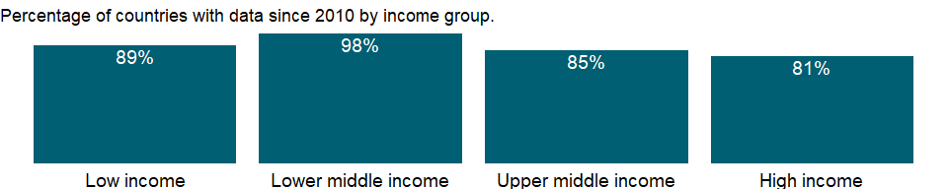

### Why is it relevant?

The pupil-teacher ratio is often used to compare the quality of schooling across countries, but it is often weakly related to student learning and quality of education.

### What is the data source?

UNESCO Institute for Statistics (<http://uis.unesco.org/>). Data as of February 2020.

### What is the methodology?

Pupil-teacher ratio is calculated by dividing the number of students at the specified level of education by the number of teachers at the same level of education.

Data on education are collected by the UNESCO Institute for Statistics from official responses to its annual education survey. All the data are mapped to the International Standard Classification of Education (ISCED) to ensure the comparability of education programs at the international level. The current version was formally adopted by UNESCO Member States in 2011.

The reference years reflect the school year for which the data are presented. In some countries the school year spans two calendar years (for example, from September 2010 to June 2011); in these cases the reference year refers to the year in which the school year ended (2011 in the example).

### How is it aggregated?

Weighted average

### What are the limitations?

The comparability of pupil-teacher ratios across countries is affected by the definition of teachers and by differences in class size by grade and in the number of hours taught, as well as the different practices countries employ such as part-time teachers, school shifts, and multi-grade classes. Moreover, the underlying enrollment levels are subject to a variety of reporting errors.

### What else should I know?

For aggregate data, each economy is classified based on the classification of World Bank Group’s fiscal year 2021 (July 1, 2020-June 30, 2021).

### 1.59.8 Trained teachers in primary education, female (% of female teachers)

### What is the indicator?

Trained teachers in primary education are the percentage of primary school teachers who have received the minimum organized teacher training (pre-service or in-service) required for teaching in a given country.

Topic: Education: Inputs

Series ID: SE.PRM.TCAQ.FE.ZS

Copyright: CC BY-4.0 , <https://datacatalog.worldbank.org/public-licenses#cc-by>

First year with any data: 1998

Last year with any data: 2020

### What years are data available?

The figure below shows years in which data is available for at least one country. Dates shaded in black have no data, while dates shaded in green have data for at least one country



### Which countries have data?

The figure below shows the percentage of countries in each income group with a value since 2010 for that indicator.

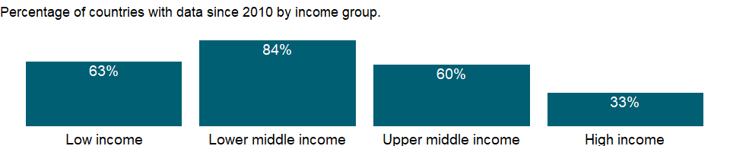

### Why is it relevant?

Trained teachers refer to teaching force with the necessary pedagogical skills to teach and use teaching materials in an effective manner. The share of trained teachers reveals a country’s commitment to investing in the development of its human capital engaged in teaching.

Teachers are important resource, especially for children who are the first-generation of receiving education in their families and heavily rely on teachers in acquiring basic literacy skills. However, rapid increase in enrollments may cause the shortage of trained teachers. Education finance is a key for appropriate teacher allocations, since teacher salaries account for a large share of education budgets. The shortage of trained teacher may result in low qualified teachers in more disadvantaged area.

### What is the data source?

UNESCO Institute for Statistics (<http://uis.unesco.org/>). Data as of September 2020.

### What is the methodology?

Share of trained teachers is calculated by dividing the number of trained teachers of the specified level of education by total number of teachers at the same level of education, and multiplying by 100.

Data on education are collected by the UNESCO Institute for Statistics from official responses to its annual education survey. All the data are mapped to the International Standard Classification of Education (ISCED) to ensure the comparability of education programs at the international level. The current version was formally adopted by UNESCO Member States in 2011.

The reference years reflect the school year for which the data are presented. In some countries the school year spans two calendar years (for example, from September 2010 to June 2011); in these cases the reference year refers to the year in which the school year ended (2011 in the example).

### How is it aggregated?

Weighted average

### What are the limitations?

This indicator does not take into account differences in teachers’ experiences and status, teaching methods, teaching materials, and classroom conditions - all factors that affect the quality of teaching and learning. Some teachers without formal training may have acquired equivalent pedagogical skills through professional experience. In addition, national standards regarding teacher qualifications and pedagogical skills may vary.

### What else should I know?

For aggregate data, each economy is classified based on the classification of World Bank Group’s fiscal year 2021 (July 1, 2020-June 30, 2021).

### 1.59.9 Trained teachers in primary education, male (% of male teachers)

### What is the indicator?

Trained teachers in primary education are the percentage of primary school teachers who have received the minimum organized teacher training (pre-service or in-service) required for teaching in a given country.

Topic: Education: Inputs

Series ID: SE.PRM.TCAQ.MA.ZS

Copyright: CC BY-4.0 , <https://datacatalog.worldbank.org/public-licenses#cc-by>

First year with any data: 1998

Last year with any data: 2020

### What years are data available?

The figure below shows years in which data is available for at least one country. Dates shaded in black have no data, while dates shaded in green have data for at least one country



### Which countries have data?

The figure below shows the percentage of countries in each income group with a value since 2010 for that indicator.



### Why is it relevant?

Trained teachers refer to teaching force with the necessary pedagogical skills to teach and use teaching materials in an effective manner. The share of trained teachers reveals a country’s commitment to investing in the development of its human capital engaged in teaching.

Teachers are important resource, especially for children who are the first-generation of receiving education in their families and heavily rely on teachers in acquiring basic literacy skills. However, rapid increase in enrollments may cause the shortage of trained teachers. Education finance is a key for appropriate teacher allocations, since teacher salaries account for a large share of education budgets. The shortage of trained teacher may result in low qualified teachers in more disadvantaged area.

### What is the data source?

UNESCO Institute for Statistics (<http://uis.unesco.org/>). Data as of September 2020.

### What is the methodology?

Share of trained teachers is calculated by dividing the number of trained teachers of the specified level of education by total number of teachers at the same level of education, and multiplying by 100.

Data on education are collected by the UNESCO Institute for Statistics from official responses to its annual education survey. All the data are mapped to the International Standard Classification of Education (ISCED) to ensure the comparability of education programs at the international level. The current version was formally adopted by UNESCO Member States in 2011.

The reference years reflect the school year for which the data are presented. In some countries the school year spans two calendar years (for example, from September 2010 to June 2011); in these cases the reference year refers to the year in which the school year ended (2011 in the example).

### How is it aggregated?

Weighted average

### What are the limitations?

This indicator does not take into account differences in teachers’ experiences and status, teaching methods, teaching materials, and classroom conditions - all factors that affect the quality of teaching and learning. Some teachers without formal training may have acquired equivalent pedagogical skills through professional experience. In addition, national standards regarding teacher qualifications and pedagogical skills may vary.

### What else should I know?

For aggregate data, each economy is classified based on the classification of World Bank Group’s fiscal year 2021 (July 1, 2020-June 30, 2021).

### 1.59.10 Trained teachers in primary education (% of total teachers)

### What is the indicator?

Trained teachers in primary education are the percentage of primary school teachers who have received the minimum organized teacher training (pre-service or in-service) required for teaching in a given country.

Topic: Education: Inputs

Series ID: SE.PRM.TCAQ.ZS

Copyright: CC BY-4.0 , <https://datacatalog.worldbank.org/public-licenses#cc-by>

First year with any data: 1998

Last year with any data: 2020

### What years are data available?

The figure below shows years in which data is available for at least one country. Dates shaded in black have no data, while dates shaded in green have data for at least one country



### Which countries have data?

The figure below shows the percentage of countries in each income group with a value since 2010 for that indicator.

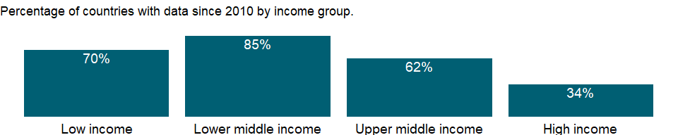

### Why is it relevant?

Trained teachers refer to teaching force with the necessary pedagogical skills to teach and use teaching materials in an effective manner. The share of trained teachers reveals a country’s commitment to investing in the development of its human capital engaged in teaching.

Teachers are important resource, especially for children who are the first-generation of receiving education in their families and heavily rely on teachers in acquiring basic literacy skills. However, rapid increase in enrollments may cause the shortage of trained teachers. Education finance is a key for appropriate teacher allocations, since teacher salaries account for a large share of education budgets. The shortage of trained teacher may result in low qualified teachers in more disadvantaged area.

### What is the data source?

UNESCO Institute for Statistics (<http://uis.unesco.org/>). Data as of September 2020.

### What is the methodology?

Share of trained teachers is calculated by dividing the number of trained teachers of the specified level of education by total number of teachers at the same level of education, and multiplying by 100.

Data on education are collected by the UNESCO Institute for Statistics from official responses to its annual education survey. All the data are mapped to the International Standard Classification of Education (ISCED) to ensure the comparability of education programs at the international level. The current version was formally adopted by UNESCO Member States in 2011.

The reference years reflect the school year for which the data are presented. In some countries the school year spans two calendar years (for example, from September 2010 to June 2011); in these cases the reference year refers to the year in which the school year ended (2011 in the example).

### How is it aggregated?

Weighted average

### What are the limitations?

This indicator does not take into account differences in teachers’ experiences and status, teaching methods, teaching materials, and classroom conditions - all factors that affect the quality of teaching and learning. Some teachers without formal training may have acquired equivalent pedagogical skills through professional experience. In addition, national standards regarding teacher qualifications and pedagogical skills may vary.

### What else should I know?

For aggregate data, each economy is classified based on the classification of World Bank Group’s fiscal year 2021 (July 1, 2020-June 30, 2021).

### 1.59.11 Primary education, teachers

### What is the indicator?

Primary education teachers includes full-time and part-time teachers.

Topic: Education: Inputs

Series ID: SE.PRM.TCHR

Copyright: CC BY-4.0 , <https://datacatalog.worldbank.org/public-licenses#cc-by>

First year with any data: 1970

Last year with any data: 2020

### What years are data available?

The figure below shows years in which data is available for at least one country. Dates shaded in black have no data, while dates shaded in green have data for at least one country



### Which countries have data?

The figure below shows the percentage of countries in each income group with a value since 2010 for that indicator.

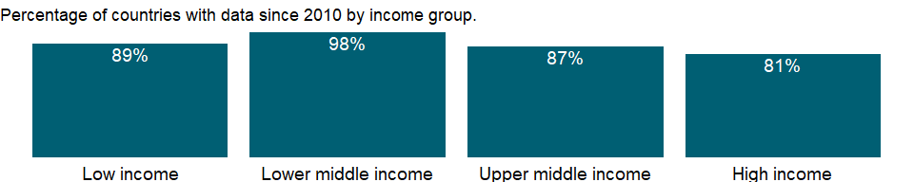

### Why is it relevant?

Women teachers are important as they serve as role models to girls and help to attract and retain girls in school.

### What is the data source?

UNESCO Institute for Statistics (<http://uis.unesco.org/>). Data as of September 2020.

### What is the methodology?

Teachers refer to persons employed full-time or part-time in an official capacity to guide and direct the learning experience of pupils and students, irrespective of their qualifications or the delivery mechanism, i.e. face-to-face and/or at a distance. This definition excludes educational personnel who have no active teaching duties (e.g. headmasters, headmistresses or principals who do not teach) or who work occasionally or in a voluntary capacity in educational institutions.

Data on education are collected by the UNESCO Institute for Statistics from official responses to its annual education survey. All the data are mapped to the International Standard Classification of Education (ISCED) to ensure the comparability of education programs at the international level. The current version was formally adopted by UNESCO Member States in 2011.

The reference years reflect the school year for which the data are presented. In some countries the school year spans two calendar years (for example, from September 2010 to June 2011); in these cases the reference year refers to the year in which the school year ended (2011 in the example).

### How is it aggregated?

Sum

### What are the limitations?

NA

### What else should I know?

For aggregate data, each economy is classified based on the classification of World Bank Group’s fiscal year 2021 (July 1, 2020-June 30, 2021).

### 1.59.12 Primary education, teachers (% female)

### What is the indicator?

Female teachers as a percentage of total primary education teachers includes full-time and part-time teachers.

Topic: Education: Inputs

Series ID: SE.PRM.TCHR.FE.ZS

Copyright: CC BY-4.0 , <https://datacatalog.worldbank.org/public-licenses#cc-by>

First year with any data: 1970

Last year with any data: 2020

### What years are data available?

The figure below shows years in which data is available for at least one country. Dates shaded in black have no data, while dates shaded in green have data for at least one country



### Which countries have data?

The figure below shows the percentage of countries in each income group with a value since 2010 for that indicator.

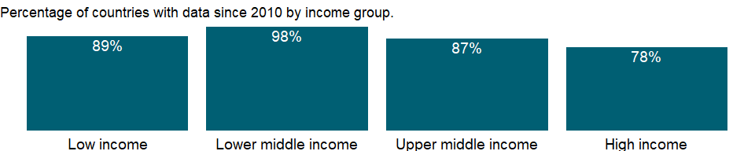

### Why is it relevant?

The share of female teachers shows the level of gender representation in the teaching force. A value of greater than 50% indicates more opportunities or preference for women to participate in teaching activities. Women teachers are important as they serve as role models to girls and help to attract and retain girls in school.

### What is the data source?

UNESCO Institute for Statistics (<http://uis.unesco.org/>). Data as of September 2020.

### What is the methodology?

The share of female teachers in primary education is calculated by dividing the total number of female teachers at primary level of education by the total number of teachers at the same level, and multiplying by 100.

Data on education are collected by the UNESCO Institute for Statistics from official responses to its annual education survey. All the data are mapped to the International Standard Classification of Education (ISCED) to ensure the comparability of education programs at the international level. The current version was formally adopted by UNESCO Member States in 2011.

The reference years reflect the school year for which the data are presented. In some countries the school year spans two calendar years (for example, from September 2010 to June 2011); in these cases the reference year refers to the year in which the school year ended (2011 in the example).

### How is it aggregated?

Weighted average

### What are the limitations?

NA

### What else should I know?

For aggregate data, each economy is classified based on the classification of World Bank Group’s fiscal year 2021 (July 1, 2020-June 30, 2021).

### 1.59.13 Lower secondary school starting age (years)

### What is the indicator?

Lower secondary school starting age is the age at which students would enter lower secondary education, assuming they had started at the official entrance age for the lowest level of education, had studied full-time throughout and had progressed through the system without repeating or skipping a grade.

Topic: Education: Inputs

Series ID: SE.SEC.AGES

Copyright: CC BY-4.0 , <https://datacatalog.worldbank.org/public-licenses#cc-by>

First year with any data: 1970

Last year with any data: 2020

### What years are data available?

The figure below shows years in which data is available for at least one country. Dates shaded in black have no data, while dates shaded in green have data for at least one country



### Which countries have data?

The figure below shows the percentage of countries in each income group with a value since 2010 for that indicator.



### Why is it relevant?

NA

### What is the data source?

UNESCO Institute for Statistics (<http://uis.unesco.org/>). Data as of September 2020.

### What is the methodology?

Data on education are collected by the UNESCO Institute for Statistics from official responses to its annual education survey. All the data are mapped to the International Standard Classification of Education (ISCED) to ensure the comparability of education programs at the international level. The current version was formally adopted by UNESCO Member States in 2011.

The reference years reflect the school year for which the data are presented. In some countries the school year spans two calendar years (for example, from September 2010 to June 2011); in these cases the reference year refers to the year in which the school year ended (2011 in the example).

### How is it aggregated?

NA

### What are the limitations?

The theoretical entrance age to a given programme or level is typically, but not always, the most common entrance age.

### What else should I know?

For aggregate data, each economy is classified based on the classification of World Bank Group’s fiscal year 2021 (July 1, 2020-June 30, 2021).

### 1.59.14 Pupil-teacher ratio, lower secondary

### What is the indicator?

Lower secondary school pupil-teacher ratio is the average number of pupils per teacher in lower secondary school.

Topic: Education: Inputs

Series ID: SE.SEC.ENRL.LO.TC.ZS

Copyright: CC BY-4.0 , <https://datacatalog.worldbank.org/public-licenses#cc-by>

First year with any data: 1981

Last year with any data: 2019

### What years are data available?

The figure below shows years in which data is available for at least one country. Dates shaded in black have no data, while dates shaded in green have data for at least one country

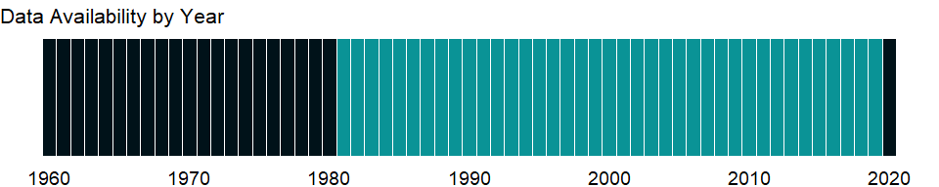

### Which countries have data?

The figure below shows the percentage of countries in each income group with a value since 2010 for that indicator.

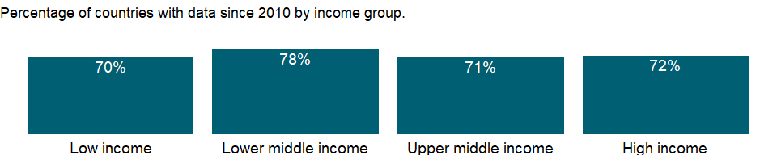

### Why is it relevant?

The pupil-teacher ratio is often used to compare the quality of schooling across countries, but it is often weakly related to student learning and quality of education.

### What is the data source?

UNESCO Institute for Statistics (<http://uis.unesco.org/>). Data as of February 2020.

### What is the methodology?

Pupil-teacher ratio is calculated by dividing the number of students at the specified level of education by the number of teachers at the same level of education.

Data on education are collected by the UNESCO Institute for Statistics from official responses to its annual education survey. All the data are mapped to the International Standard Classification of Education (ISCED) to ensure the comparability of education programs at the international level. The current version was formally adopted by UNESCO Member States in 2011.

The reference years reflect the school year for which the data are presented. In some countries the school year spans two calendar years (for example, from September 2010 to June 2011); in these cases the reference year refers to the year in which the school year ended (2011 in the example).

### How is it aggregated?

Weighted Average

### What are the limitations?

The comparability of pupil-teacher ratios across countries is affected by the definition of teachers and by differences in class size by grade and in the number of hours taught, as well as the different practices countries employ such as part-time teachers, school shifts, and multi-grade classes. Moreover, the underlying enrollment levels are subject to a variety of reporting errors.

### What else should I know?

For aggregate data, each economy is classified based on the classification of World Bank Group’s fiscal year 2021 (July 1, 2020-June 30, 2021).

### 1.59.15 Pupil-teacher ratio, secondary

### What is the indicator?

Secondary school pupil-teacher ratio is the average number of pupils per teacher in secondary school.

Topic: Education: Inputs

Series ID: SE.SEC.ENRL.TC.ZS

Copyright: CC BY-4.0 , <https://datacatalog.worldbank.org/public-licenses#cc-by>

First year with any data: 1970

Last year with any data: 2019

### What years are data available?

The figure below shows years in which data is available for at least one country. Dates shaded in black have no data, while dates shaded in green have data for at least one country



### Which countries have data?

The figure below shows the percentage of countries in each income group with a value since 2010 for that indicator.

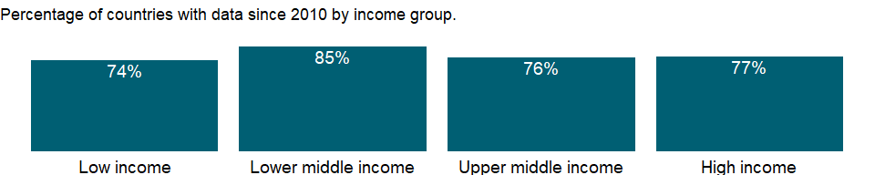

### Why is it relevant?

The pupil-teacher ratio is often used to compare the quality of schooling across countries, but it is often weakly related to student learning and quality of education.

### What is the data source?

UNESCO Institute for Statistics (<http://uis.unesco.org/>). Data as of February 2020.

### What is the methodology?

Pupil-teacher ratio is calculated by dividing the number of students at the specified level of education by the number of teachers at the same level of education.

Data on education are collected by the UNESCO Institute for Statistics from official responses to its annual education survey. All the data are mapped to the International Standard Classification of Education (ISCED) to ensure the comparability of education programs at the international level. The current version was formally adopted by UNESCO Member States in 2011.

The reference years reflect the school year for which the data are presented. In some countries the school year spans two calendar years (for example, from September 2010 to June 2011); in these cases the reference year refers to the year in which the school year ended (2011 in the example).

### How is it aggregated?

Weighted average

### What are the limitations?

The comparability of pupil-teacher ratios across countries is affected by the definition of teachers and by differences in class size by grade and in the number of hours taught, as well as the different practices countries employ such as part-time teachers, school shifts, and multi-grade classes. Moreover, the underlying enrollment levels are subject to a variety of reporting errors.

### What else should I know?

For aggregate data, each economy is classified based on the classification of World Bank Group’s fiscal year 2021 (July 1, 2020-June 30, 2021).

### 1.59.16 Pupil-teacher ratio, upper secondary

### What is the indicator?

Upper secondary school pupil-teacher ratio is the average number of pupils per teacher in upper secondary school.

Topic: Education: Inputs

Series ID: SE.SEC.ENRL.UP.TC.ZS

Copyright: CC BY-4.0 , <https://datacatalog.worldbank.org/public-licenses#cc-by>

First year with any data: 1981

Last year with any data: 2019

### What years are data available?

The figure below shows years in which data is available for at least one country. Dates shaded in black have no data, while dates shaded in green have data for at least one country

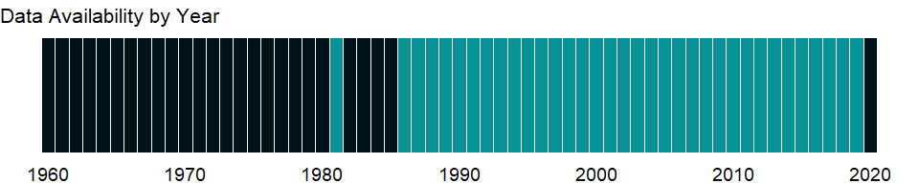

### Which countries have data?

The figure below shows the percentage of countries in each income group with a value since 2010 for that indicator.

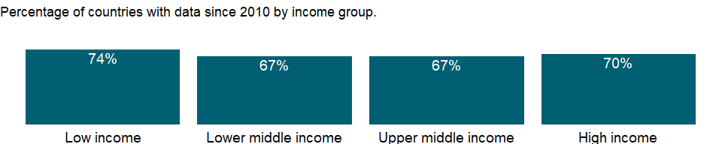

### Why is it relevant?

The pupil-teacher ratio is often used to compare the quality of schooling across countries, but it is often weakly related to student learning and quality of education.

### What is the data source?

UNESCO Institute for Statistics (<http://uis.unesco.org/>). Data as of February 2020.

### What is the methodology?

Pupil-teacher ratio is calculated by dividing the number of students at the specified level of education by the number of teachers at the same level of education.

Data on education are collected by the UNESCO Institute for Statistics from official responses to its annual education survey. All the data are mapped to the International Standard Classification of Education (ISCED) to ensure the comparability of education programs at the international level. The current version was formally adopted by UNESCO Member States in 2011.

The reference years reflect the school year for which the data are presented. In some countries the school year spans two calendar years (for example, from September 2010 to June 2011); in these cases the reference year refers to the year in which the school year ended (2011 in the example).

### How is it aggregated?

Weighted Average

### What are the limitations?

The comparability of pupil-teacher ratios across countries is affected by the definition of teachers and by differences in class size by grade and in the number of hours taught, as well as the different practices countries employ such as part-time teachers, school shifts, and multi-grade classes. Moreover, the underlying enrollment levels are subject to a variety of reporting errors.

### What else should I know?

For aggregate data, each economy is classified based on the classification of World Bank Group’s fiscal year 2021 (July 1, 2020-June 30, 2021).

### 1.59.17 Trained teachers in secondary education, female (% of female teachers)

### What is the indicator?

Trained teachers in secondary education are the percentage of secondary school teachers who have received the minimum organized teacher training (pre-service or in-service) required for teaching in a given country.

Topic: Education: Inputs

Series ID: SE.SEC.TCAQ.FE.ZS

Copyright: CC BY-4.0 , <https://datacatalog.worldbank.org/public-licenses#cc-by>

First year with any data: 1998

Last year with any data: 2019

### What years are data available?

The figure below shows years in which data is available for at least one country. Dates shaded in black have no data, while dates shaded in green have data for at least one country



### Which countries have data?

The figure below shows the percentage of countries in each income group with a value since 2010 for that indicator.

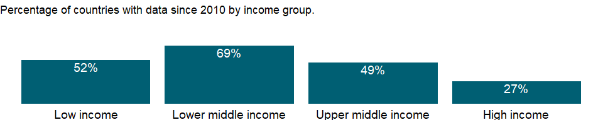

### Why is it relevant?

Trained teachers refer to teaching force with the necessary pedagogical skills to teach and use teaching materials in an effective manner. The share of trained teachers reveals a country’s commitment to investing in the development of its human capital engaged in teaching.

Teachers are important resource, especially for children who are the first-generation of receiving education in their families and heavily rely on teachers in acquiring basic literacy skills. However, rapid increase in enrollments may cause the shortage of trained teachers. Education finance is a key for appropriate teacher allocations, since teacher salaries account for a large share of education budgets. The shortage of trained teacher may result in low qualified teachers in more disadvantaged area.

### What is the data source?

UNESCO Institute for Statistics (<http://uis.unesco.org/>). Data as of September 2020.

### What is the methodology?

Share of trained teachers is calculated by dividing the number of trained teachers of the specified level of education by total number of teachers at the same level of education, and multiplying by 100.

Data on education are collected by the UNESCO Institute for Statistics from official responses to its annual education survey. All the data are mapped to the International Standard Classification of Education (ISCED) to ensure the comparability of education programs at the international level. The current version was formally adopted by UNESCO Member States in 2011.

The reference years reflect the school year for which the data are presented. In some countries the school year spans two calendar years (for example, from September 2010 to June 2011); in these cases the reference year refers to the year in which the school year ended (2011 in the example).

### How is it aggregated?

Weighted Average

### What are the limitations?

This indicator does not take into account differences in teachers’ experiences and status, teaching methods, teaching materials, and classroom conditions - all factors that affect the quality of teaching and learning. Some teachers without formal training may have acquired equivalent pedagogical skills through professional experience. In addition, national standards regarding teacher qualifications and pedagogical skills may vary.

### What else should I know?

For aggregate data, each economy is classified based on the classification of World Bank Group’s fiscal year 2021 (July 1, 2020-June 30, 2021).

### 1.59.18 Trained teachers in lower secondary education, female (% of female teachers)

### What is the indicator?

Trained teachers in lower secondary education are the percentage of lower secondary school teachers who have received the minimum organized teacher training (pre-service or in-service) required for teaching in a given country.

Topic: Education: Inputs

Series ID: SE.SEC.TCAQ.LO.FE.ZS

Copyright: CC BY-4.0 , <https://datacatalog.worldbank.org/public-licenses#cc-by>

First year with any data: 1998

Last year with any data: 2020

### What years are data available?

The figure below shows years in which data is available for at least one country. Dates shaded in black have no data, while dates shaded in green have data for at least one country



### Which countries have data?

The figure below shows the percentage of countries in each income group with a value since 2010 for that indicator.

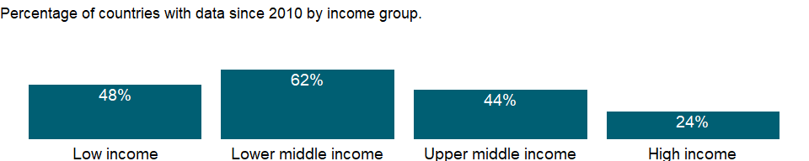

### Why is it relevant?

Trained teachers refer to teaching force with the necessary pedagogical skills to teach and use teaching materials in an effective manner. The share of trained teachers reveals a country’s commitment to investing in the development of its human capital engaged in teaching.

Teachers are important resource, especially for children who are the first-generation of receiving education in their families and heavily rely on teachers in acquiring basic literacy skills. However, rapid increase in enrollments may cause the shortage of trained teachers. Education finance is a key for appropriate teacher allocations, since teacher salaries account for a large share of education budgets. The shortage of trained teacher may result in low qualified teachers in more disadvantaged area.

### What is the data source?

UNESCO Institute for Statistics (<http://uis.unesco.org/>). Data as of September 2020.

### What is the methodology?

Share of trained teachers is calculated by dividing the number of trained teachers of the specified level of education by total number of teachers at the same level of education, and multiplying by 100.

Data on education are collected by the UNESCO Institute for Statistics from official responses to its annual education survey. All the data are mapped to the International Standard Classification of Education (ISCED) to ensure the comparability of education programs at the international level. The current version was formally adopted by UNESCO Member States in 2011.

The reference years reflect the school year for which the data are presented. In some countries the school year spans two calendar years (for example, from September 2010 to June 2011); in these cases the reference year refers to the year in which the school year ended (2011 in the example).

### How is it aggregated?

Weighted Average

### What are the limitations?

This indicator does not take into account differences in teachers’ experiences and status, teaching methods, teaching materials, and classroom conditions - all factors that affect the quality of teaching and learning. Some teachers without formal training may have acquired equivalent pedagogical skills through professional experience. In addition, national standards regarding teacher qualifications and pedagogical skills may vary.

### What else should I know?

For aggregate data, each economy is classified based on the classification of World Bank Group’s fiscal year 2021 (July 1, 2020-June 30, 2021).

### 1.59.19 Trained teachers in lower secondary education, male (% of male teachers)

### What is the indicator?

Trained teachers in lower secondary education are the percentage of lower secondary school teachers who have received the minimum organized teacher training (pre-service or in-service) required for teaching in a given country.

Topic: Education: Inputs

Series ID: SE.SEC.TCAQ.LO.MA.ZS

Copyright: CC BY-4.0 , <https://datacatalog.worldbank.org/public-licenses#cc-by>

First year with any data: 1998

Last year with any data: 2020

### What years are data available?

The figure below shows years in which data is available for at least one country. Dates shaded in black have no data, while dates shaded in green have data for at least one country



### Which countries have data?

The figure below shows the percentage of countries in each income group with a value since 2010 for that indicator.



### Why is it relevant?

Trained teachers refer to teaching force with the necessary pedagogical skills to teach and use teaching materials in an effective manner. The share of trained teachers reveals a country’s commitment to investing in the development of its human capital engaged in teaching.

Teachers are important resource, especially for children who are the first-generation of receiving education in their families and heavily rely on teachers in acquiring basic literacy skills. However, rapid increase in enrollments may cause the shortage of trained teachers. Education finance is a key for appropriate teacher allocations, since teacher salaries account for a large share of education budgets. The shortage of trained teacher may result in low qualified teachers in more disadvantaged area.

### What is the data source?

UNESCO Institute for Statistics (<http://uis.unesco.org/>). Data as of September 2020.

### What is the methodology?

Share of trained teachers is calculated by dividing the number of trained teachers of the specified level of education by total number of teachers at the same level of education, and multiplying by 100.

Data on education are collected by the UNESCO Institute for Statistics from official responses to its annual education survey. All the data are mapped to the International Standard Classification of Education (ISCED) to ensure the comparability of education programs at the international level. The current version was formally adopted by UNESCO Member States in 2011.

The reference years reflect the school year for which the data are presented. In some countries the school year spans two calendar years (for example, from September 2010 to June 2011); in these cases the reference year refers to the year in which the school year ended (2011 in the example).

### How is it aggregated?

Weighted Average

### What are the limitations?

This indicator does not take into account differences in teachers’ experiences and status, teaching methods, teaching materials, and classroom conditions - all factors that affect the quality of teaching and learning. Some teachers without formal training may have acquired equivalent pedagogical skills through professional experience. In addition, national standards regarding teacher qualifications and pedagogical skills may vary.

### What else should I know?

For aggregate data, each economy is classified based on the classification of World Bank Group’s fiscal year 2021 (July 1, 2020-June 30, 2021).

### 1.59.20 Trained teachers in lower secondary education (% of total teachers)

### What is the indicator?

Trained teachers in lower secondary education are the percentage of lower secondary school teachers who have received the minimum organized teacher training (pre-service or in-service) required for teaching in a given country.

Topic: Education: Inputs

Series ID: SE.SEC.TCAQ.LO.ZS

Copyright: CC BY-4.0 , <https://datacatalog.worldbank.org/public-licenses#cc-by>

First year with any data: 1998

Last year with any data: 2020

### What years are data available?

The figure below shows years in which data is available for at least one country. Dates shaded in black have no data, while dates shaded in green have data for at least one country



### Which countries have data?

The figure below shows the percentage of countries in each income group with a value since 2010 for that indicator.

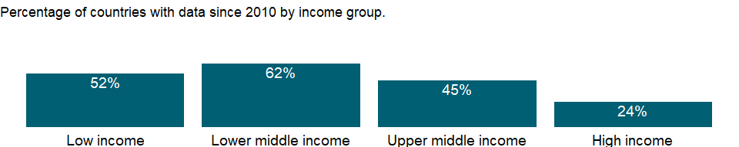

### Why is it relevant?

Trained teachers refer to teaching force with the necessary pedagogical skills to teach and use teaching materials in an effective manner. The share of trained teachers reveals a country’s commitment to investing in the development of its human capital engaged in teaching.

Teachers are important resource, especially for children who are the first-generation of receiving education in their families and heavily rely on teachers in acquiring basic literacy skills. However, rapid increase in enrollments may cause the shortage of trained teachers. Education finance is a key for appropriate teacher allocations, since teacher salaries account for a large share of education budgets. The shortage of trained teacher may result in low qualified teachers in more disadvantaged area.

### What is the data source?

UNESCO Institute for Statistics (<http://uis.unesco.org/>). Data as of September 2020.

### What is the methodology?

Share of trained teachers is calculated by dividing the number of trained teachers of the specified level of education by total number of teachers at the same level of education, and multiplying by 100.

Data on education are collected by the UNESCO Institute for Statistics from official responses to its annual education survey. All the data are mapped to the International Standard Classification of Education (ISCED) to ensure the comparability of education programs at the international level. The current version was formally adopted by UNESCO Member States in 2011.

The reference years reflect the school year for which the data are presented. In some countries the school year spans two calendar years (for example, from September 2010 to June 2011); in these cases the reference year refers to the year in which the school year ended (2011 in the example).

### How is it aggregated?

Weighted Average

### What are the limitations?

This indicator does not take into account differences in teachers’ experiences and status, teaching methods, teaching materials, and classroom conditions - all factors that affect the quality of teaching and learning. Some teachers without formal training may have acquired equivalent pedagogical skills through professional experience. In addition, national standards regarding teacher qualifications and pedagogical skills may vary.

### What else should I know?

For aggregate data, each economy is classified based on the classification of World Bank Group’s fiscal year 2021 (July 1, 2020-June 30, 2021).

### 1.59.21 Trained teachers in secondary education, male (% of male teachers)

### What is the indicator?

Trained teachers in secondary education are the percentage of secondary school teachers who have received the minimum organized teacher training (pre-service or in-service) required for teaching in a given country.

Topic: Education: Inputs

Series ID: SE.SEC.TCAQ.MA.ZS

Copyright: CC BY-4.0 , <https://datacatalog.worldbank.org/public-licenses#cc-by>

First year with any data: 1998

Last year with any data: 2019

### What years are data available?

The figure below shows years in which data is available for at least one country. Dates shaded in black have no data, while dates shaded in green have data for at least one country



### Which countries have data?

The figure below shows the percentage of countries in each income group with a value since 2010 for that indicator.



### Why is it relevant?

Trained teachers refer to teaching force with the necessary pedagogical skills to teach and use teaching materials in an effective manner. The share of trained teachers reveals a country’s commitment to investing in the development of its human capital engaged in teaching.

Teachers are important resource, especially for children who are the first-generation of receiving education in their families and heavily rely on teachers in acquiring basic literacy skills. However, rapid increase in enrollments may cause the shortage of trained teachers. Education finance is a key for appropriate teacher allocations, since teacher salaries account for a large share of education budgets. The shortage of trained teacher may result in low qualified teachers in more disadvantaged area.

### What is the data source?

UNESCO Institute for Statistics (<http://uis.unesco.org/>). Data as of September 2020.

### What is the methodology?

Share of trained teachers is calculated by dividing the number of trained teachers of the specified level of education by total number of teachers at the same level of education, and multiplying by 100.

Data on education are collected by the UNESCO Institute for Statistics from official responses to its annual education survey. All the data are mapped to the International Standard Classification of Education (ISCED) to ensure the comparability of education programs at the international level. The current version was formally adopted by UNESCO Member States in 2011.

The reference years reflect the school year for which the data are presented. In some countries the school year spans two calendar years (for example, from September 2010 to June 2011); in these cases the reference year refers to the year in which the school year ended (2011 in the example).

### How is it aggregated?

Weighted Average

### What are the limitations?

This indicator does not take into account differences in teachers’ experiences and status, teaching methods, teaching materials, and classroom conditions - all factors that affect the quality of teaching and learning. Some teachers without formal training may have acquired equivalent pedagogical skills through professional experience. In addition, national standards regarding teacher qualifications and pedagogical skills may vary.

### What else should I know?

For aggregate data, each economy is classified based on the classification of World Bank Group’s fiscal year 2021 (July 1, 2020-June 30, 2021).

### 1.59.22 Trained teachers in upper secondary education, female (% of female teachers)

### What is the indicator?

Trained teachers in upper secondary education are the percentage of upper secondary school teachers who have received the minimum organized teacher training (pre-service or in-service) required for teaching in a given country.

Topic: Education: Inputs

Series ID: SE.SEC.TCAQ.UP.FE.ZS

Copyright: CC BY-4.0 , <https://datacatalog.worldbank.org/public-licenses#cc-by>

First year with any data: 1998

Last year with any data: 2020

### What years are data available?

The figure below shows years in which data is available for at least one country. Dates shaded in black have no data, while dates shaded in green have data for at least one country



### Which countries have data?

The figure below shows the percentage of countries in each income group with a value since 2010 for that indicator.

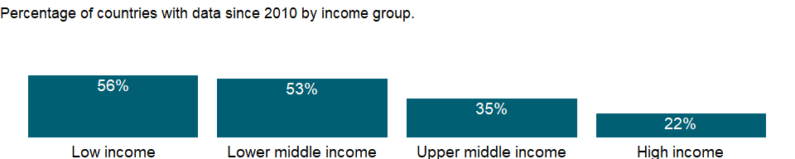

### Why is it relevant?

Trained teachers refer to teaching force with the necessary pedagogical skills to teach and use teaching materials in an effective manner. The share of trained teachers reveals a country’s commitment to investing in the development of its human capital engaged in teaching.

Teachers are important resource, especially for children who are the first-generation of receiving education in their families and heavily rely on teachers in acquiring basic literacy skills. However, rapid increase in enrollments may cause the shortage of trained teachers. Education finance is a key for appropriate teacher allocations, since teacher salaries account for a large share of education budgets. The shortage of trained teacher may result in low qualified teachers in more disadvantaged area.

### What is the data source?

UNESCO Institute for Statistics (<http://uis.unesco.org/>). Data as of September 2020.

### What is the methodology?

Share of trained teachers is calculated by dividing the number of trained teachers of the specified level of education by total number of teachers at the same level of education, and multiplying by 100.

Data on education are collected by the UNESCO Institute for Statistics from official responses to its annual education survey. All the data are mapped to the International Standard Classification of Education (ISCED) to ensure the comparability of education programs at the international level. The current version was formally adopted by UNESCO Member States in 2011.

The reference years reflect the school year for which the data are presented. In some countries the school year spans two calendar years (for example, from September 2010 to June 2011); in these cases the reference year refers to the year in which the school year ended (2011 in the example).

### How is it aggregated?

Weighted Average

### What are the limitations?

This indicator does not take into account differences in teachers’ experiences and status, teaching methods, teaching materials, and classroom conditions - all factors that affect the quality of teaching and learning. Some teachers without formal training may have acquired equivalent pedagogical skills through professional experience. In addition, national standards regarding teacher qualifications and pedagogical skills may vary.

### What else should I know?

For aggregate data, each economy is classified based on the classification of World Bank Group’s fiscal year 2021 (July 1, 2020-June 30, 2021).

### 1.59.23 Trained teachers in upper secondary education, male (% of male teachers)

### What is the indicator?

Trained teachers in upper secondary education are the percentage of upper secondary school teachers who have received the minimum organized teacher training (pre-service or in-service) required for teaching in a given country.

Topic: Education: Inputs

Series ID: SE.SEC.TCAQ.UP.MA.ZS

Copyright: CC BY-4.0 , <https://datacatalog.worldbank.org/public-licenses#cc-by>

First year with any data: 1998

Last year with any data: 2020

### What years are data available?

The figure below shows years in which data is available for at least one country. Dates shaded in black have no data, while dates shaded in green have data for at least one country



### Which countries have data?

The figure below shows the percentage of countries in each income group with a value since 2010 for that indicator.



### Why is it relevant?

Trained teachers refer to teaching force with the necessary pedagogical skills to teach and use teaching materials in an effective manner. The share of trained teachers reveals a country’s commitment to investing in the development of its human capital engaged in teaching.

Teachers are important resource, especially for children who are the first-generation of receiving education in their families and heavily rely on teachers in acquiring basic literacy skills. However, rapid increase in enrollments may cause the shortage of trained teachers. Education finance is a key for appropriate teacher allocations, since teacher salaries account for a large share of education budgets. The shortage of trained teacher may result in low qualified teachers in more disadvantaged area.

### What is the data source?

UNESCO Institute for Statistics (<http://uis.unesco.org/>). Data as of September 2020.

### What is the methodology?

Share of trained teachers is calculated by dividing the number of trained teachers of the specified level of education by total number of teachers at the same level of education, and multiplying by 100.

Data on education are collected by the UNESCO Institute for Statistics from official responses to its annual education survey. All the data are mapped to the International Standard Classification of Education (ISCED) to ensure the comparability of education programs at the international level. The current version was formally adopted by UNESCO Member States in 2011.

The reference years reflect the school year for which the data are presented. In some countries the school year spans two calendar years (for example, from September 2010 to June 2011); in these cases the reference year refers to the year in which the school year ended (2011 in the example).

### How is it aggregated?

Weighted Average

### What are the limitations?

This indicator does not take into account differences in teachers’ experiences and status, teaching methods, teaching materials, and classroom conditions - all factors that affect the quality of teaching and learning. Some teachers without formal training may have acquired equivalent pedagogical skills through professional experience. In addition, national standards regarding teacher qualifications and pedagogical skills may vary.

### What else should I know?

For aggregate data, each economy is classified based on the classification of World Bank Group’s fiscal year 2021 (July 1, 2020-June 30, 2021).

### 1.59.24 Trained teachers in upper secondary education (% of total teachers)

### What is the indicator?

Trained teachers in upper secondary education are the percentage of upper secondary school teachers who have received the minimum organized teacher training (pre-service or in-service) required for teaching in a given country.

Topic: Education: Inputs

Series ID: SE.SEC.TCAQ.UP.ZS

Copyright: CC BY-4.0 , <https://datacatalog.worldbank.org/public-licenses#cc-by>

First year with any data: 1998

Last year with any data: 2020

### What years are data available?

The figure below shows years in which data is available for at least one country. Dates shaded in black have no data, while dates shaded in green have data for at least one country



### Which countries have data?

The figure below shows the percentage of countries in each income group with a value since 2010 for that indicator.

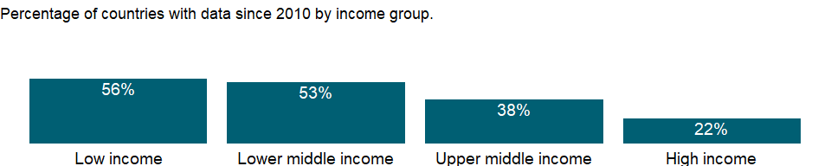

### Why is it relevant?

Trained teachers refer to teaching force with the necessary pedagogical skills to teach and use teaching materials in an effective manner. The share of trained teachers reveals a country’s commitment to investing in the development of its human capital engaged in teaching.

Teachers are important resource, especially for children who are the first-generation of receiving education in their families and heavily rely on teachers in acquiring basic literacy skills. However, rapid increase in enrollments may cause the shortage of trained teachers. Education finance is a key for appropriate teacher allocations, since teacher salaries account for a large share of education budgets. The shortage of trained teacher may result in low qualified teachers in more disadvantaged area.

### What is the data source?

UNESCO Institute for Statistics (<http://uis.unesco.org/>). Data as of September 2020.

### What is the methodology?

Share of trained teachers is calculated by dividing the number of trained teachers of the specified level of education by total number of teachers at the same level of education, and multiplying by 100.

Data on education are collected by the UNESCO Institute for Statistics from official responses to its annual education survey. All the data are mapped to the International Standard Classification of Education (ISCED) to ensure the comparability of education programs at the international level. The current version was formally adopted by UNESCO Member States in 2011.

The reference years reflect the school year for which the data are presented. In some countries the school year spans two calendar years (for example, from September 2010 to June 2011); in these cases the reference year refers to the year in which the school year ended (2011 in the example).

### How is it aggregated?

Weighted Average

### What are the limitations?

This indicator does not take into account differences in teachers’ experiences and status, teaching methods, teaching materials, and classroom conditions - all factors that affect the quality of teaching and learning. Some teachers without formal training may have acquired equivalent pedagogical skills through professional experience. In addition, national standards regarding teacher qualifications and pedagogical skills may vary.

### What else should I know?

For aggregate data, each economy is classified based on the classification of World Bank Group’s fiscal year 2021 (July 1, 2020-June 30, 2021).

### 1.59.25 Trained teachers in secondary education (% of total teachers)

### What is the indicator?

Trained teachers in secondary education are the percentage of secondary school teachers who have received the minimum organized teacher training (pre-service or in-service) required for teaching in a given country.

Topic: Education: Inputs

Series ID: SE.SEC.TCAQ.ZS

Copyright: CC BY-4.0 , <https://datacatalog.worldbank.org/public-licenses#cc-by>

First year with any data: 1998

Last year with any data: 2019

### What years are data available?

The figure below shows years in which data is available for at least one country. Dates shaded in black have no data, while dates shaded in green have data for at least one country



### Which countries have data?

The figure below shows the percentage of countries in each income group with a value since 2010 for that indicator.

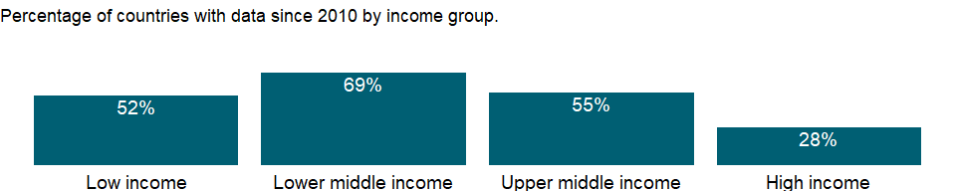

### Why is it relevant?

Trained teachers refer to teaching force with the necessary pedagogical skills to teach and use teaching materials in an effective manner. The share of trained teachers reveals a country’s commitment to investing in the development of its human capital engaged in teaching.

Teachers are important resource, especially for children who are the first-generation of receiving education in their families and heavily rely on teachers in acquiring basic literacy skills. However, rapid increase in enrollments may cause the shortage of trained teachers. Education finance is a key for appropriate teacher allocations, since teacher salaries account for a large share of education budgets. The shortage of trained teacher may result in low qualified teachers in more disadvantaged area.

### What is the data source?

UNESCO Institute for Statistics (<http://uis.unesco.org/>). Data as of September 2020.

### What is the methodology?

Share of trained teachers is calculated by dividing the number of trained teachers of the specified level of education by total number of teachers at the same level of education, and multiplying by 100.

Data on education are collected by the UNESCO Institute for Statistics from official responses to its annual education survey. All the data are mapped to the International Standard Classification of Education (ISCED) to ensure the comparability of education programs at the international level. The current version was formally adopted by UNESCO Member States in 2011.

The reference years reflect the school year for which the data are presented. In some countries the school year spans two calendar years (for example, from September 2010 to June 2011); in these cases the reference year refers to the year in which the school year ended (2011 in the example).

### How is it aggregated?

Weighted Average

### What are the limitations?

This indicator does not take into account differences in teachers’ experiences and status, teaching methods, teaching materials, and classroom conditions - all factors that affect the quality of teaching and learning. Some teachers without formal training may have acquired equivalent pedagogical skills through professional experience. In addition, national standards regarding teacher qualifications and pedagogical skills may vary.

### What else should I know?

For aggregate data, each economy is classified based on the classification of World Bank Group’s fiscal year 2021 (July 1, 2020-June 30, 2021).

### 1.59.26 Secondary education, teachers

### What is the indicator?

Secondary education teachers includes full-time and part-time teachers.

Topic: Education: Inputs

Series ID: SE.SEC.TCHR

Copyright: CC BY-4.0 , <https://datacatalog.worldbank.org/public-licenses#cc-by>

First year with any data: 1970

Last year with any data: 2019

### What years are data available?

The figure below shows years in which data is available for at least one country. Dates shaded in black have no data, while dates shaded in green have data for at least one country



### Which countries have data?

The figure below shows the percentage of countries in each income group with a value since 2010 for that indicator.

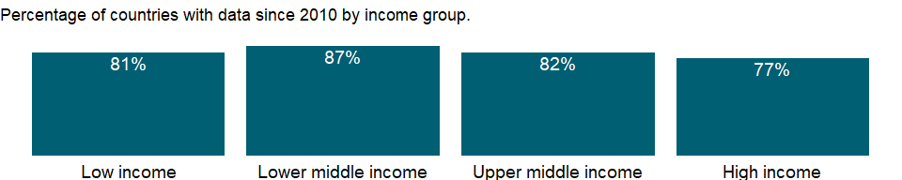

### Why is it relevant?

Women teachers are important as they serve as role models to girls and help to attract and retain girls in school.

### What is the data source?

UNESCO Institute for Statistics (<http://uis.unesco.org/>). Data as of September 2020.

### What is the methodology?

Teachers refer to persons employed full-time or part-time in an official capacity to guide and direct the learning experience of pupils and students, irrespective of their qualifications or the delivery mechanism, i.e. face-to-face and/or at a distance. This definition excludes educational personnel who have no active teaching duties (e.g. headmasters, headmistresses or principals who do not teach) or who work occasionally or in a voluntary capacity in educational institutions.

Data on education are collected by the UNESCO Institute for Statistics from official responses to its annual education survey. All the data are mapped to the International Standard Classification of Education (ISCED) to ensure the comparability of education programs at the international level. The current version was formally adopted by UNESCO Member States in 2011.

The reference years reflect the school year for which the data are presented. In some countries the school year spans two calendar years (for example, from September 2010 to June 2011); in these cases the reference year refers to the year in which the school year ended (2011 in the example).

### How is it aggregated?

Sum

### What are the limitations?

NA

### What else should I know?

For aggregate data, each economy is classified based on the classification of World Bank Group’s fiscal year 2021 (July 1, 2020-June 30, 2021).

### 1.59.27 Secondary education, teachers, female

### What is the indicator?

Secondary education teachers includes full-time and part-time teachers.

Topic: Education: Inputs

Series ID: SE.SEC.TCHR.FE

Copyright: CC BY-4.0 , <https://datacatalog.worldbank.org/public-licenses#cc-by>

First year with any data: 1970

Last year with any data: 2019

### What years are data available?

The figure below shows years in which data is available for at least one country. Dates shaded in black have no data, while dates shaded in green have data for at least one country



### Which countries have data?

The figure below shows the percentage of countries in each income group with a value since 2010 for that indicator.

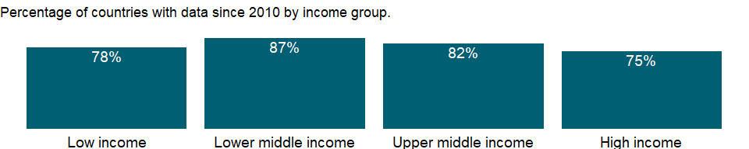

### Why is it relevant?

Women teachers are important as they serve as role models to girls and help to attract and retain girls in school.

### What is the data source?

UNESCO Institute for Statistics (<http://uis.unesco.org/>). Data as of September 2020.

### What is the methodology?

Teachers refer to persons employed full-time or part-time in an official capacity to guide and direct the learning experience of pupils and students, irrespective of their qualifications or the delivery mechanism, i.e. face-to-face and/or at a distance. This definition excludes educational personnel who have no active teaching duties (e.g. headmasters, headmistresses or principals who do not teach) or who work occasionally or in a voluntary capacity in educational institutions.

Data on education are collected by the UNESCO Institute for Statistics from official responses to its annual education survey. All the data are mapped to the International Standard Classification of Education (ISCED) to ensure the comparability of education programs at the international level. The current version was formally adopted by UNESCO Member States in 2011.

The reference years reflect the school year for which the data are presented. In some countries the school year spans two calendar years (for example, from September 2010 to June 2011); in these cases the reference year refers to the year in which the school year ended (2011 in the example).

### How is it aggregated?

Sum

### What are the limitations?

NA

### What else should I know?

For aggregate data, each economy is classified based on the classification of World Bank Group’s fiscal year 2021 (July 1, 2020-June 30, 2021).

### 1.59.28 Secondary education, teachers (% female)

### What is the indicator?

Female teachers as a percentage of total secondary education teachers includes full-time and part-time teachers.

Topic: Education: Inputs

Series ID: SE.SEC.TCHR.FE.ZS

Copyright: CC BY-4.0 , <https://datacatalog.worldbank.org/public-licenses#cc-by>

First year with any data: 1970

Last year with any data: 2019

### What years are data available?

The figure below shows years in which data is available for at least one country. Dates shaded in black have no data, while dates shaded in green have data for at least one country



### Which countries have data?

The figure below shows the percentage of countries in each income group with a value since 2010 for that indicator.



### Why is it relevant?

The share of female teachers shows the level of gender representation in the teaching force. A value of greater than 50% indicates more opportunities or preference for women to participate in teaching activities. Women teachers are important as they serve as role models to girls and help to attract and retain girls in school.

### What is the data source?

UNESCO Institute for Statistics (<http://uis.unesco.org/>). Data as of September 2020.

### What is the methodology?

The share of female teachers in secondary education is calculated by dividing the total number of female teachers at secondary level of education by the total number of teachers at the same level, and multiplying by 100.

Data on education are collected by the UNESCO Institute for Statistics from official responses to its annual education survey. All the data are mapped to the International Standard Classification of Education (ISCED) to ensure the comparability of education programs at the international level. The current version was formally adopted by UNESCO Member States in 2011.

The reference years reflect the school year for which the data are presented. In some countries the school year spans two calendar years (for example, from September 2010 to June 2011); in these cases the reference year refers to the year in which the school year ended (2011 in the example).

### How is it aggregated?

Weighted average

### What are the limitations?

NA

### What else should I know?

For aggregate data, each economy is classified based on the classification of World Bank Group’s fiscal year 2021 (July 1, 2020-June 30, 2021).

### 1.59.29 Pupil-teacher ratio, tertiary

### What is the indicator?

Tertiary school pupil-teacher ratio is the average number of pupils per teacher in tertiary school.

Topic: Education: Inputs

Series ID: SE.TER.ENRL.TC.ZS

Copyright: CC BY-4.0 , <https://datacatalog.worldbank.org/public-licenses#cc-by>

First year with any data: 1970

Last year with any data: 2019

### What years are data available?

The figure below shows years in which data is available for at least one country. Dates shaded in black have no data, while dates shaded in green have data for at least one country



### Which countries have data?

The figure below shows the percentage of countries in each income group with a value since 2010 for that indicator.

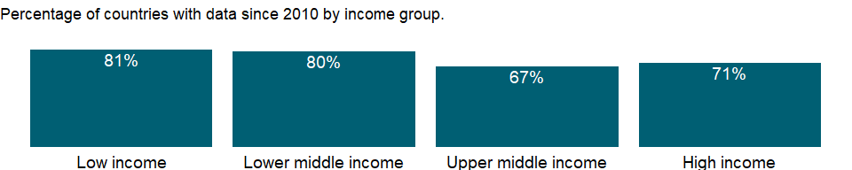

### Why is it relevant?

The pupil-teacher ratio is often used to compare the quality of schooling across countries, but it is often weakly related to student learning and quality of education.

### What is the data source?

UNESCO Institute for Statistics (<http://uis.unesco.org/>). Data as of February 2020.

### What is the methodology?

Pupil-teacher ratio is calculated by dividing the number of students at the specified level of education by the number of teachers at the same level of education.

Data on education are collected by the UNESCO Institute for Statistics from official responses to its annual education survey. All the data are mapped to the International Standard Classification of Education (ISCED) to ensure the comparability of education programs at the international level. The current version was formally adopted by UNESCO Member States in 2011.

The reference years reflect the school year for which the data are presented. In some countries the school year spans two calendar years (for example, from September 2010 to June 2011); in these cases the reference year refers to the year in which the school year ended (2011 in the example).

### How is it aggregated?

Weighted Average

### What are the limitations?

The comparability of pupil-teacher ratios across countries is affected by the definition of teachers and by differences in class size by grade and in the number of hours taught, as well as the different practices countries employ such as part-time teachers, school shifts, and multi-grade classes. Moreover, the underlying enrollment levels are subject to a variety of reporting errors.

### What else should I know?

For aggregate data, each economy is classified based on the classification of World Bank Group’s fiscal year 2021 (July 1, 2020-June 30, 2021).

### 1.59.30 Tertiary education, academic staff (% female)

### What is the indicator?

Tertiary education, academic staff (% female) is the share of female academic staff in tertiary education.

Topic: Education: Inputs

Series ID: SE.TER.TCHR.FE.ZS

Copyright: CC BY-4.0 , <https://datacatalog.worldbank.org/public-licenses#cc-by>

First year with any data: 1970

Last year with any data: 2020

### What years are data available?

The figure below shows years in which data is available for at least one country. Dates shaded in black have no data, while dates shaded in green have data for at least one country



### Which countries have data?

The figure below shows the percentage of countries in each income group with a value since 2010 for that indicator.

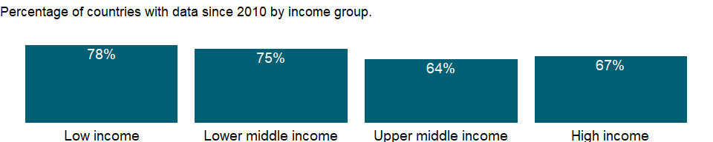

### Why is it relevant?

The share of female teachers shows the level of gender representation in the teaching force. A value of greater than 50% indicates more opportunities or preference for women to participate in teaching activities. Women teachers are important as they serve as role models to girls and help to attract and retain girls in school.

### What is the data source?

UNESCO Institute for Statistics (<http://uis.unesco.org/>). Data as of September 2020.

### What is the methodology?

The share of female academic staffs in tertiary education is calculated by dividing the total number of female academic staffs at tertiary level of education by the total number of academic staffs at the same level, and multiplying by 100.

Data on education are collected by the UNESCO Institute for Statistics from official responses to its annual education survey. All the data are mapped to the International Standard Classification of Education (ISCED) to ensure the comparability of education programs at the international level. The current version was formally adopted by UNESCO Member States in 2011.

The reference years reflect the school year for which the data are presented. In some countries the school year spans two calendar years (for example, from September 2010 to June 2011); in these cases the reference year refers to the year in which the school year ended (2011 in the example).

### How is it aggregated?

Weighted average

### What are the limitations?

NA

### What else should I know?

For aggregate data, each economy is classified based on the classification of World Bank Group’s fiscal year 2021 (July 1, 2020-June 30, 2021).

### 1.59.31 Current education expenditure, primary (% of total expenditure in primary public institutions)

### What is the indicator?

Current expenditure is expressed as a percentage of direct expenditure in public educational institutions (instructional and non-instructional) of the specified level of education. Financial aid to students and other transfers are excluded from direct expenditure. Current expenditure is consumed within the current year and would have to be renewed if needed in the following year. It includes staff compensation and current expenditure other than for staff compensation (ex. on teaching materials, ancillary services and administration).

Topic: Education: Inputs

Series ID: SE.XPD.CPRM.ZS

Copyright: CC BY-4.0 , <https://datacatalog.worldbank.org/public-licenses#cc-by>

First year with any data: 1995

Last year with any data: 2019

### What years are data available?

The figure below shows years in which data is available for at least one country. Dates shaded in black have no data, while dates shaded in green have data for at least one country

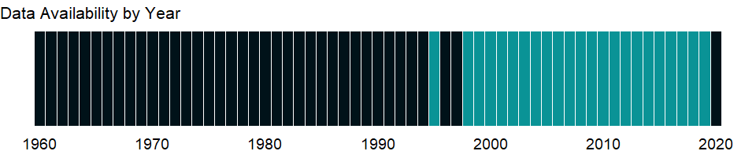

### Which countries have data?

The figure below shows the percentage of countries in each income group with a value since 2010 for that indicator.

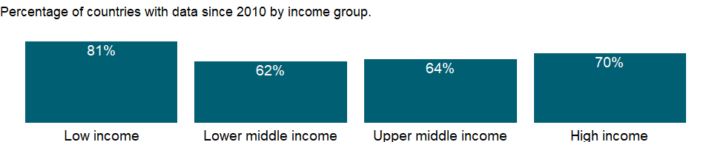

### Why is it relevant?

NA

### What is the data source?

UNESCO Institute for Statistics (<http://uis.unesco.org/>). Data as of September 2020.

### What is the methodology?

Current expenditure, primary is calculated by dividing all current expenditure in public institutions of primary education by total expenditure (current and capital) in public institutions of primary education, and multiplying by 100. Aggregate data are based on World Bank estimates.

Data on education are collected by the UNESCO Institute for Statistics from official responses to its annual education survey. All the data are mapped to the International Standard Classification of Education (ISCED) to ensure the comparability of education programs at the international level. The current version was formally adopted by UNESCO Member States in 2011.

The reference years reflect the school year for which the data are presented. In some countries the school year spans two calendar years (for example, from September 2010 to June 2011); in these cases the reference year refers to the year in which the school year ended (2011 in the example).

### How is it aggregated?

Median

### What are the limitations?

NA

### What else should I know?

For aggregate data, each economy is classified based on the classification of World Bank Group’s fiscal year 2021 (July 1, 2020-June 30, 2021).

### 1.59.32 Current education expenditure, secondary (% of total expenditure in secondary public institutions)

### What is the indicator?

Current expenditure is expressed as a percentage of direct expenditure in public educational institutions (instructional and non-instructional) of the specified level of education. Financial aid to students and other transfers are excluded from direct expenditure. Current expenditure is consumed within the current year and would have to be renewed if needed in the following year. It includes staff compensation and current expenditure other than for staff compensation (ex. on teaching materials, ancillary services and administration).

Topic: Education: Inputs

Series ID: SE.XPD.CSEC.ZS

Copyright: CC BY-4.0 , <https://datacatalog.worldbank.org/public-licenses#cc-by>

First year with any data: 1995

Last year with any data: 2019

### What years are data available?

The figure below shows years in which data is available for at least one country. Dates shaded in black have no data, while dates shaded in green have data for at least one country



### Which countries have data?

The figure below shows the percentage of countries in each income group with a value since 2010 for that indicator.

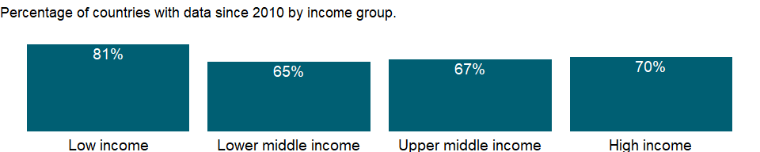

### Why is it relevant?

NA

### What is the data source?

UNESCO Institute for Statistics (<http://uis.unesco.org/>). Data as of September 2020.

### What is the methodology?

Current expenditure, secondary is calculated by dividing all current expenditure in public institutions of secondary education by total expenditure (current and capital) in public institutions of secondary education, and multiplying by 100. Aggregate data are based on World Bank estimates.

Data on education are collected by the UNESCO Institute for Statistics from official responses to its annual education survey. All the data are mapped to the International Standard Classification of Education (ISCED) to ensure the comparability of education programs at the international level. The current version was formally adopted by UNESCO Member States in 2011.

The reference years reflect the school year for which the data are presented. In some countries the school year spans two calendar years (for example, from September 2010 to June 2011); in these cases the reference year refers to the year in which the school year ended (2011 in the example).

### How is it aggregated?

Median

### What are the limitations?

NA

### What else should I know?

For aggregate data, each economy is classified based on the classification of World Bank Group’s fiscal year 2021 (July 1, 2020-June 30, 2021).

### 1.59.33 Current education expenditure, tertiary (% of total expenditure in tertiary public institutions)

### What is the indicator?

Current expenditure is expressed as a percentage of direct expenditure in public educational institutions (instructional and non-instructional) of the specified level of education. Financial aid to students and other transfers are excluded from direct expenditure. Current expenditure is consumed within the current year and would have to be renewed if needed in the following year. It includes staff compensation and current expenditure other than for staff compensation (ex. on teaching materials, ancillary services and administration).

Topic: Education: Inputs

Series ID: SE.XPD.CTER.ZS

Copyright: CC BY-4.0 , <https://datacatalog.worldbank.org/public-licenses#cc-by>

First year with any data: 1995

Last year with any data: 2019

### What years are data available?

The figure below shows years in which data is available for at least one country. Dates shaded in black have no data, while dates shaded in green have data for at least one country



### Which countries have data?

The figure below shows the percentage of countries in each income group with a value since 2010 for that indicator.

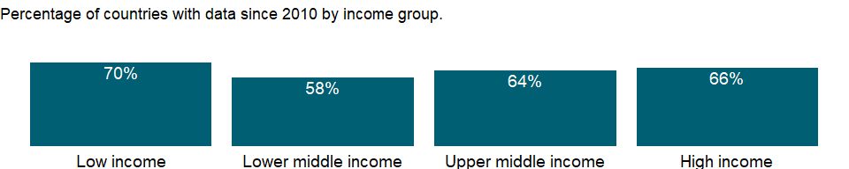

### Why is it relevant?

NA

### What is the data source?

UNESCO Institute for Statistics (<http://uis.unesco.org/>). Data as of September 2020.

### What is the methodology?

Current expenditure, tertiary is calculated by dividing all current expenditure in public institutions of tertiary education by total expenditure (current and capital) in public institutions of tertiary education, and multiplying by 100. Aggregate data are based on World Bank estimates.

Data on education are collected by the UNESCO Institute for Statistics from official responses to its annual education survey. All the data are mapped to the International Standard Classification of Education (ISCED) to ensure the comparability of education programs at the international level. The current version was formally adopted by UNESCO Member States in 2011.

The reference years reflect the school year for which the data are presented. In some countries the school year spans two calendar years (for example, from September 2010 to June 2011); in these cases the reference year refers to the year in which the school year ended (2011 in the example).

### How is it aggregated?

Median

### What are the limitations?

NA

### What else should I know?

For aggregate data, each economy is classified based on the classification of World Bank Group’s fiscal year 2021 (July 1, 2020-June 30, 2021).

### 1.59.34 Current education expenditure, total (% of total expenditure in public institutions)

### What is the indicator?

Current expenditure is expressed as a percentage of direct expenditure in public educational institutions (instructional and non-instructional) of the specified level of education. Financial aid to students and other transfers are excluded from direct expenditure. Current expenditure is consumed within the current year and would have to be renewed if needed in the following year. It includes staff compensation and current expenditure other than for staff compensation (ex. on teaching materials, ancillary services and administration).

Topic: Education: Inputs

Series ID: SE.XPD.CTOT.ZS

Copyright: CC BY-4.0 , <https://datacatalog.worldbank.org/public-licenses#cc-by>

First year with any data: 1995

Last year with any data: 2019

### What years are data available?

The figure below shows years in which data is available for at least one country. Dates shaded in black have no data, while dates shaded in green have data for at least one country



### Which countries have data?

The figure below shows the percentage of countries in each income group with a value since 2010 for that indicator.

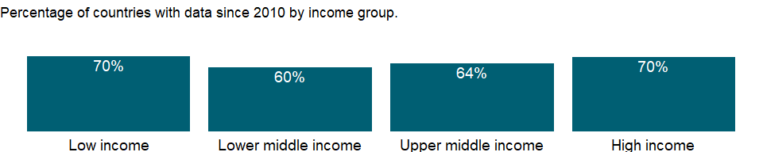

### Why is it relevant?

NA

### What is the data source?

UNESCO Institute for Statistics (<http://uis.unesco.org/>). Data as of September 2020.

### What is the methodology?

Current expenditure, total is calculated by dividing all current expenditure in public institutions of all levels of education by total expenditure (current and capital) in public institutions of all levels of education, and multiplying by 100. Aggregate data are based on World Bank estimates.

Data on education are collected by the UNESCO Institute for Statistics from official responses to its annual education survey. All the data are mapped to the International Standard Classification of Education (ISCED) to ensure the comparability of education programs at the international level. The current version was formally adopted by UNESCO Member States in 2011.

The reference years reflect the school year for which the data are presented. In some countries the school year spans two calendar years (for example, from September 2010 to June 2011); in these cases the reference year refers to the year in which the school year ended (2011 in the example).

### How is it aggregated?

Median

### What are the limitations?

NA

### What else should I know?

For aggregate data, each economy is classified based on the classification of World Bank Group’s fiscal year 2021 (July 1, 2020-June 30, 2021).

### 1.59.35 Government expenditure per student, primary (% of GDP per capita)

### What is the indicator?

Government expenditure per student is the average general government expenditure (current, capital, and transfers) per student in the given level of education, expressed as a percentage of GDP per capita.

Topic: Education: Inputs

Series ID: SE.XPD.PRIM.PC.ZS

Copyright: CC BY-4.0 , <https://datacatalog.worldbank.org/public-licenses#cc-by>

First year with any data: 1995

Last year with any data: 2018

### What years are data available?

The figure below shows years in which data is available for at least one country. Dates shaded in black have no data, while dates shaded in green have data for at least one country

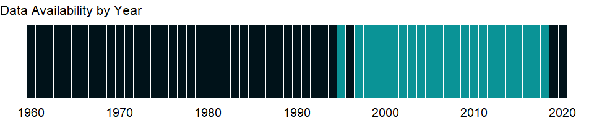

### Which countries have data?

The figure below shows the percentage of countries in each income group with a value since 2010 for that indicator.

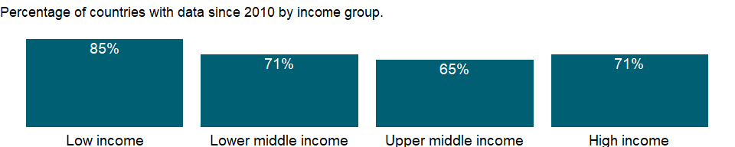

### Why is it relevant?

NA

### What is the data source?

UNESCO Institute for Statistics (<http://uis.unesco.org/>). Data as of February 2020.

### What is the methodology?

General government expenditure per student in primary education is calculated by dividing total government expenditure on primary education by the number of students at primary level, expressed as a percentage of GDP per capita. Aggregate data are World Bank estimates.

Data on education are collected by the UNESCO Institute for Statistics from official responses to its annual education survey. All the data are mapped to the International Standard Classification of Education (ISCED) to ensure the comparability of education programs at the international level. The current version was formally adopted by UNESCO Member States in 2011. Data on GDP per capita come from the World Bank.

The reference years reflect the school year for which the data are presented. In some countries the school year spans two calendar years (for example, from September 2010 to June 2011); in these cases the reference year refers to the year in which the school year ended (2011 in the example).

### How is it aggregated?

Median

### What are the limitations?

NA

### What else should I know?

NA

### 1.59.36 Expenditure on primary education (% of government expenditure on education)

### What is the indicator?

Expenditure on primary education is expressed as a percentage of total general government expenditure on education. General government usually refers to local, regional and central governments.

Topic: Education: Inputs

Series ID: SE.XPD.PRIM.ZS

Copyright: CC BY-4.0 , <https://datacatalog.worldbank.org/public-licenses#cc-by>

First year with any data: 1970

Last year with any data: 2019

### What years are data available?

The figure below shows years in which data is available for at least one country. Dates shaded in black have no data, while dates shaded in green have data for at least one country



### Which countries have data?

The figure below shows the percentage of countries in each income group with a value since 2010 for that indicator.

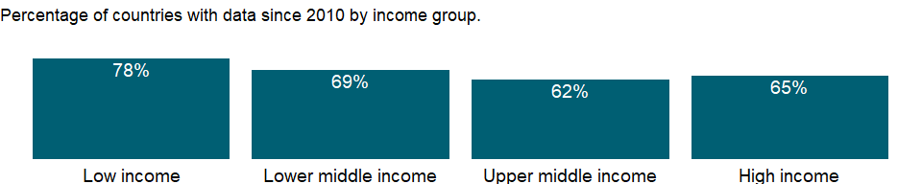

### Why is it relevant?

The share of government expenditure for a specific education level allows an assessment of the priority a government assigns to a level of education relative to other levels. Enrolment and the relative costs per student between different levels of education should be also taken into account.

### What is the data source?

UNESCO Institute for Statistics (<http://uis.unesco.org/>). Data as of February 2020.

### What is the methodology?

The share of expenditure on primary education to total government expenditure on education is calculated by dividing government expenditure on primary education by total government expenditure on education (all levels combined), and multiplying by 100. Aggregate data are based on World Bank estimates.

Data on education are collected by the UNESCO Institute for Statistics from official responses to its annual education survey. All the data are mapped to the International Standard Classification of Education (ISCED) to ensure the comparability of education programs at the international level. The current version was formally adopted by UNESCO Member States in 2011.

The reference years reflect the school year for which the data are presented. In some countries the school year spans two calendar years (for example, from September 2010 to June 2011); in these cases the reference year refers to the year in which the school year ended (2011 in the example).

### How is it aggregated?

Median

### What are the limitations?

Data disaggregated by level of education are estimates in some instances. It is often difficult to separate lower from upper secondary education expenditure, or pre-primary from primary.

### What else should I know?

NA

### 1.59.37 Government expenditure per student, secondary (% of GDP per capita)

### What is the indicator?

Government expenditure per student is the average general government expenditure (current, capital, and transfers) per student in the given level of education, expressed as a percentage of GDP per capita.

Topic: Education: Inputs

Series ID: SE.XPD.SECO.PC.ZS

Copyright: CC BY-4.0 , <https://datacatalog.worldbank.org/public-licenses#cc-by>

First year with any data: 1995

Last year with any data: 2018

### What years are data available?

The figure below shows years in which data is available for at least one country. Dates shaded in black have no data, while dates shaded in green have data for at least one country



### Which countries have data?

The figure below shows the percentage of countries in each income group with a value since 2010 for that indicator.

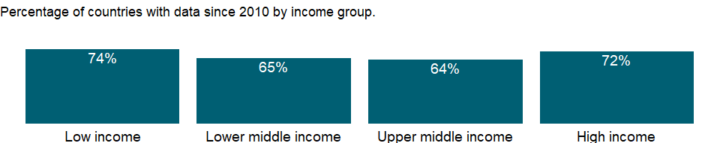

### Why is it relevant?

NA

### What is the data source?

UNESCO Institute for Statistics (<http://uis.unesco.org/>). Data as of February 2020.

### What is the methodology?

General government expenditure per student in secondary education is calculated by dividing total government expenditure on secondary education by the number of students at secondary level, expressed as a percentage of GDP per capita. Aggregate data are World Bank estimates.

Data on education are collected by the UNESCO Institute for Statistics from official responses to its annual education survey. All the data are mapped to the International Standard Classification of Education (ISCED) to ensure the comparability of education programs at the international level. The current version was formally adopted by UNESCO Member States in 2011. Data on GDP per capita come from the World Bank.

The reference years reflect the school year for which the data are presented. In some countries the school year spans two calendar years (for example, from September 2010 to June 2011); in these cases the reference year refers to the year in which the school year ended (2011 in the example).

### How is it aggregated?

Median

### What are the limitations?

NA

### What else should I know?

NA

### 1.59.38 Expenditure on secondary education (% of government expenditure on education)

### What is the indicator?

Expenditure on secondary education is expressed as a percentage of total general government expenditure on education. General government usually refers to local, regional and central governments.

Topic: Education: Inputs

Series ID: SE.XPD.SECO.ZS

Copyright: CC BY-4.0 , <https://datacatalog.worldbank.org/public-licenses#cc-by>

First year with any data: 1970

Last year with any data: 2019

### What years are data available?

The figure below shows years in which data is available for at least one country. Dates shaded in black have no data, while dates shaded in green have data for at least one country



### Which countries have data?

The figure below shows the percentage of countries in each income group with a value since 2010 for that indicator.

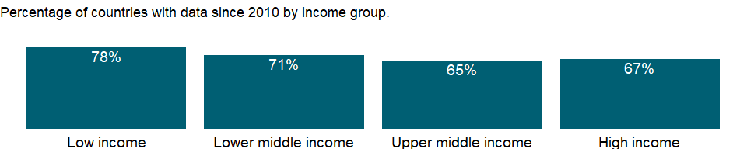

### Why is it relevant?

The share of government expenditure for a specific education level allows an assessment of the priority a government assigns to a level of education relative to other levels. Enrolment and the relative costs per student between different levels of education should be also taken into account.

### What is the data source?

UNESCO Institute for Statistics (<http://uis.unesco.org/>). Data as of February 2020.

### What is the methodology?

The share of expenditure on secondary education to total government expenditure on education is calculated by dividing government expenditure on secondary education by total government expenditure on education (all levels combined), and multiplying by 100. Aggregate data are based on World Bank estimates.

Data on education are collected by the UNESCO Institute for Statistics from official responses to its annual education survey. All the data are mapped to the International Standard Classification of Education (ISCED) to ensure the comparability of education programs at the international level. The current version was formally adopted by UNESCO Member States in 2011.

The reference years reflect the school year for which the data are presented. In some countries the school year spans two calendar years (for example, from September 2010 to June 2011); in these cases the reference year refers to the year in which the school year ended (2011 in the example).

### How is it aggregated?

Median

### What are the limitations?

Data disaggregated by level of education are estimates in some instances. It is often difficult to separate lower from upper secondary education expenditure, or pre-primary from primary.

### What else should I know?

NA

### 1.59.39 Government expenditure per student, tertiary (% of GDP per capita)

### What is the indicator?

Government expenditure per student is the average general government expenditure (current, capital, and transfers) per student in the given level of education, expressed as a percentage of GDP per capita.

Topic: Education: Inputs

Series ID: SE.XPD.TERT.PC.ZS

Copyright: CC BY-4.0 , <https://datacatalog.worldbank.org/public-licenses#cc-by>

First year with any data: 1970

Last year with any data: 2018

### What years are data available?

The figure below shows years in which data is available for at least one country. Dates shaded in black have no data, while dates shaded in green have data for at least one country

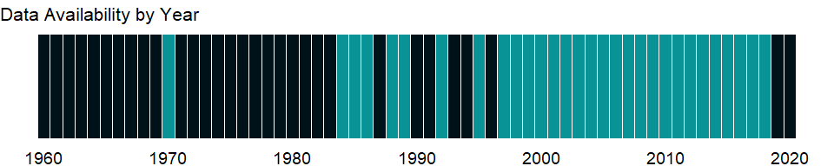

### Which countries have data?

The figure below shows the percentage of countries in each income group with a value since 2010 for that indicator.

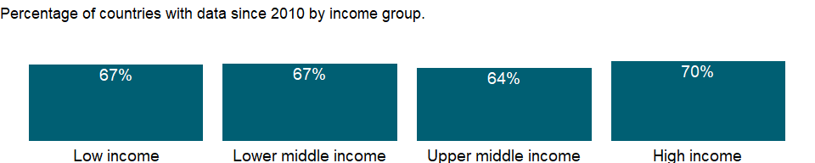

### Why is it relevant?

NA

### What is the data source?

UNESCO Institute for Statistics (<http://uis.unesco.org/>). Data as of February 2020.

### What is the methodology?

General government expenditure per student in tertiary education is calculated by dividing total government expenditure on tertiary education by the number of students at tertiary level, expressed as a percentage of GDP per capita. Aggregate data are World Bank estimates.

Data on education are collected by the UNESCO Institute for Statistics from official responses to its annual education survey. All the data are mapped to the International Standard Classification of Education (ISCED) to ensure the comparability of education programs at the international level. The current version was formally adopted by UNESCO Member States in 2011. Data on GDP per capita come from the World Bank.

The reference years reflect the school year for which the data are presented. In some countries the school year spans two calendar years (for example, from September 2010 to June 2011); in these cases the reference year refers to the year in which the school year ended (2011 in the example).

### How is it aggregated?

Median

### What are the limitations?

NA

### What else should I know?

NA

### 1.59.40 Expenditure on tertiary education (% of government expenditure on education)

### What is the indicator?

Expenditure on tertiary education is expressed as a percentage of total general government expenditure on education. General government usually refers to local, regional and central governments.

Topic: Education: Inputs

Series ID: SE.XPD.TERT.ZS

Copyright: CC BY-4.0 , <https://datacatalog.worldbank.org/public-licenses#cc-by>

First year with any data: 1970

Last year with any data: 2019

### What years are data available?

The figure below shows years in which data is available for at least one country. Dates shaded in black have no data, while dates shaded in green have data for at least one country



### Which countries have data?

The figure below shows the percentage of countries in each income group with a value since 2010 for that indicator.

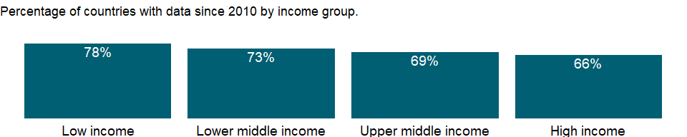

### Why is it relevant?

The share of government expenditure for a specific education level allows an assessment of the priority a government assigns to a level of education relative to other levels. Enrolment and the relative costs per student between different levels of education should be also taken into account.

### What is the data source?

UNESCO Institute for Statistics (<http://uis.unesco.org/>). Data as of February 2020.

### What is the methodology?

The share of expenditure on tertiary education to total government expenditure on education is calculated by dividing government expenditure on tertiary education by total government expenditure on education (all levels combined), and multiplying by 100. Aggregate data are based on World Bank estimates.

Data on education are collected by the UNESCO Institute for Statistics from official responses to its annual education survey. All the data are mapped to the International Standard Classification of Education (ISCED) to ensure the comparability of education programs at the international level. The current version was formally adopted by UNESCO Member States in 2011.

The reference years reflect the school year for which the data are presented. In some countries the school year spans two calendar years (for example, from September 2010 to June 2011); in these cases the reference year refers to the year in which the school year ended (2011 in the example).

### How is it aggregated?

Median

### What are the limitations?

Data disaggregated by level of education are estimates in some instances. It is often difficult to separate lower from upper secondary education expenditure, or pre-primary from primary.

### What else should I know?

NA

### 1.59.41 Government expenditure on education, total (% of government expenditure)

### What is the indicator?

General government expenditure on education (current, capital, and transfers) is expressed as a percentage of total general government expenditure on all sectors (including health, education, social services, etc.). It includes expenditure funded by transfers from international sources to government. General government usually refers to local, regional and central governments.

Topic: Education: Inputs

Series ID: SE.XPD.TOTL.GB.ZS

Copyright: CC BY-4.0 , <https://datacatalog.worldbank.org/public-licenses#cc-by>

First year with any data: 1980

Last year with any data: 2019

### What years are data available?

The figure below shows years in which data is available for at least one country. Dates shaded in black have no data, while dates shaded in green have data for at least one country



### Which countries have data?

The figure below shows the percentage of countries in each income group with a value since 2010 for that indicator.

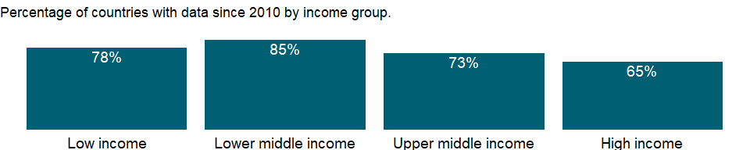

### Why is it relevant?

The share of government expenditure devoted to education allows an assessment of the priority a government assigns to education relative to other public investments, as well as a government’s commitment to investing in human capital development. Countries with younger populations may spend more on education in relation to other sector such as health or social security, and vice-versa.

### What is the data source?

UNESCO Institute for Statistics (<http://uis.unesco.org/>). Data as of September 2020.

### What is the methodology?

Expenditure on education, total (% of government expenditure) is calculated by dividing total government expenditure on education by the total government expenditure on all sectors and multiplying by 100. Aggregate data are based on World Bank estimates.

Data on education are collected by the UNESCO Institute for Statistics from official responses to its annual education survey. All the data are mapped to the International Standard Classification of Education (ISCED) to ensure the comparability of education programs at the international level. The current version was formally adopted by UNESCO Member States in 2011. Data on total general government expenditure were previously collected from countries through the annual questionnaire, but are from the International Monetary Fund’s World Economic Outlook database since January 2014. Therefore, current data cannot be compared with data in earlier editions.

The reference years reflect the school year for which the data are presented. In some countries the school year spans two calendar years (for example, from September 2010 to June 2011); in these cases the reference year refers to the year in which the school year ended (2011 in the example).

### How is it aggregated?

Median

### What are the limitations?

Data on government expenditure on education may refer to spending by the ministry of education only (excluding spending on educational activities by other ministries). In addition, definitions and methods of data on total general government expenditure may differ across countries.

### What else should I know?

NA

### 1.59.42 Government expenditure on education, total (% of GDP)

### What is the indicator?

General government expenditure on education (current, capital, and transfers) is expressed as a percentage of GDP. It includes expenditure funded by transfers from international sources to government. General government usually refers to local, regional and central governments.

Topic: Education: Inputs

Series ID: SE.XPD.TOTL.GD.ZS

Copyright: CC BY-4.0 , <https://datacatalog.worldbank.org/public-licenses#cc-by>

First year with any data: 1970

Last year with any data: 2019

### What years are data available?

The figure below shows years in which data is available for at least one country. Dates shaded in black have no data, while dates shaded in green have data for at least one country



### Which countries have data?

The figure below shows the percentage of countries in each income group with a value since 2010 for that indicator.

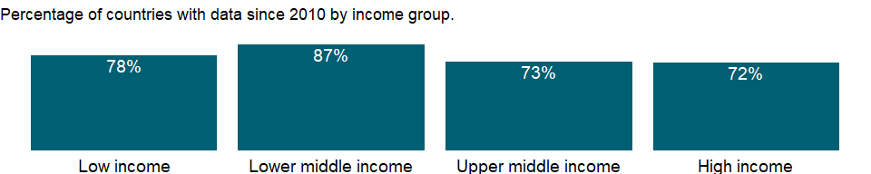

### Why is it relevant?

The percentage of government expenditure on education to GDP is useful to compare education expenditure between countries and/or over time in relation to the size of their economy; A high percentage to GDP suggests a high priority for education and a capacity of raising revenues for public spending. Note that government expenditure appears lower in some countries where the private sector and/or households have a large share in total funding for education.

### What is the data source?

UNESCO Institute for Statistics (<http://uis.unesco.org/>). Data as of September 2020.

### What is the methodology?

Government expenditure on education, total (% of GDP) is calculated by dividing total government expenditure for all levels of education by the GDP, and multiplying by 100. Aggregate data are based on World Bank estimates.

Data on education are collected by the UNESCO Institute for Statistics from official responses to its annual education survey. All the data are mapped to the International Standard Classification of Education (ISCED) to ensure the comparability of education programs at the international level. The current version was formally adopted by UNESCO Member States in 2011. GDP data come from the World Bank.

The reference years reflect the school year for which the data are presented. In some countries the school year spans two calendar years (for example, from September 2010 to June 2011); in these cases the reference year refers to the year in which the school year ended (2011 in the example).

### How is it aggregated?

Median

### What are the limitations?

Data may refer to spending by the ministry of education only (excluding spending on educational activities by other ministries).

### What else should I know?

NA

## 1.60 Education: Efficiency

### 1.60.1 Gross intake ratio in first grade of primary education, female (% of relevant age group)

### What is the indicator?

Gross intake ratio in first grade of primary education is the number of new entrants in the first grade of primary education regardless of age, expressed as a percentage of the population of the official primary entrance age.

Topic: Education: Efficiency

Series ID: SE.PRM.GINT.FE.ZS

Copyright: CC BY-4.0 , <https://datacatalog.worldbank.org/public-licenses#cc-by>

First year with any data: 1970

Last year with any data: 2019

### What years are data available?

The figure below shows years in which data is available for at least one country. Dates shaded in black have no data, while dates shaded in green have data for at least one country



### Which countries have data?

The figure below shows the percentage of countries in each income group with a value since 2010 for that indicator.

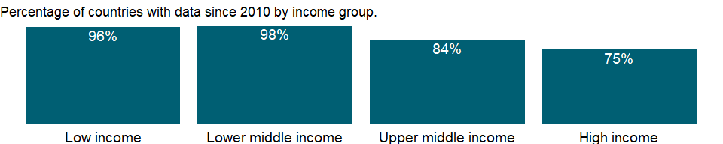

### Why is it relevant?

The gross intake ratio in the first grade of primary education indicates the level of access to primary education and the education system’s capacity to provide access to primary education. A low gross intake ratio in the first grade of primary education reflects the fact that many children do not enter primary education even though school attendance, at least through the primary level, is mandatory in most countries. Because the gross intake ratio includes all new entrants regardless of age, it can exceed 100 percent in some situations, such as immediately after fees have been abolished or when the number of reenrolled children is large.

### What is the data source?

UNESCO Institute for Statistics (<http://uis.unesco.org/>). Data as of February 2020.

### What is the methodology?

Gross intake ratio in the first grade of primary education is calculated by dividing the number of new entrants (enrollments minus repeaters) in the first grade of primary education, regardless of age, by the population of the official primary entrance age and multiplying the result by 100.

Data on education are collected by the UNESCO Institute for Statistics from official responses to its annual education survey. All the data are mapped to the International Standard Classification of Education (ISCED) to ensure the comparability of education programs at the international level. The current version was formally adopted by UNESCO Member States in 2011. Population data are drawn from the United Nations Population Division. Using a single source for population data standardizes definitions, estimations, and interpolation methods, ensuring a consistent methodology across countries and minimizing potential enumeration problems in national censuses.

The reference years reflect the school year for which the data are presented. In some countries the school year spans two calendar years (for example, from September 2010 to June 2011); in these cases the reference year refers to the year in which the school year ended (2011 in the example).

### How is it aggregated?

Weighted average

### What are the limitations?

The quality of data is affected when new entrants and repeaters are not correctly distinguished in the first grade of primary education. Caution is also needed for countries with a total population under 100,000 since the United Nations Population Division neither publish nor endorse single-age data for those countries. The data are highly subject to fluctuations in migration and other factors.

### What else should I know?

For aggregate data, each economy is classified based on the classification of World Bank Group’s fiscal year 2021 (July 1, 2020-June 30, 2021).

### 1.60.2 Gross intake ratio in first grade of primary education, male (% of relevant age group)

### What is the indicator?

Gross intake ratio in first grade of primary education is the number of new entrants in the first grade of primary education regardless of age, expressed as a percentage of the population of the official primary entrance age.

Topic: Education: Efficiency

Series ID: SE.PRM.GINT.MA.ZS

Copyright: CC BY-4.0 , <https://datacatalog.worldbank.org/public-licenses#cc-by>

First year with any data: 1970

Last year with any data: 2019

### What years are data available?

The figure below shows years in which data is available for at least one country. Dates shaded in black have no data, while dates shaded in green have data for at least one country



### Which countries have data?

The figure below shows the percentage of countries in each income group with a value since 2010 for that indicator.



### Why is it relevant?

The gross intake ratio in the first grade of primary education indicates the level of access to primary education and the education system’s capacity to provide access to primary education. A low gross intake ratio in the first grade of primary education reflects the fact that many children do not enter primary education even though school attendance, at least through the primary level, is mandatory in most countries. Because the gross intake ratio includes all new entrants regardless of age, it can exceed 100 percent in some situations, such as immediately after fees have been abolished or when the number of reenrolled children is large.

### What is the data source?

UNESCO Institute for Statistics (<http://uis.unesco.org/>). Data as of February 2020.

### What is the methodology?

Gross intake ratio in the first grade of primary education is calculated by dividing the number of new entrants (enrollments minus repeaters) in the first grade of primary education, regardless of age, by the population of the official primary entrance age and multiplying the result by 100.

Data on education are collected by the UNESCO Institute for Statistics from official responses to its annual education survey. All the data are mapped to the International Standard Classification of Education (ISCED) to ensure the comparability of education programs at the international level. The current version was formally adopted by UNESCO Member States in 2011. Population data are drawn from the United Nations Population Division. Using a single source for population data standardizes definitions, estimations, and interpolation methods, ensuring a consistent methodology across countries and minimizing potential enumeration problems in national censuses.

The reference years reflect the school year for which the data are presented. In some countries the school year spans two calendar years (for example, from September 2010 to June 2011); in these cases the reference year refers to the year in which the school year ended (2011 in the example).

### How is it aggregated?

Weighted average

### What are the limitations?

The quality of data is affected when new entrants and repeaters are not correctly distinguished in the first grade of primary education. Caution is also needed for countries with a total population under 100,000 since the United Nations Population Division neither publish nor endorse single-age data for those countries. The data are highly subject to fluctuations in migration and other factors.

### What else should I know?

For aggregate data, each economy is classified based on the classification of World Bank Group’s fiscal year 2021 (July 1, 2020-June 30, 2021).

### 1.60.3 Gross intake ratio in first grade of primary education, total (% of relevant age group)

### What is the indicator?

Gross intake ratio in first grade of primary education is the number of new entrants in the first grade of primary education regardless of age, expressed as a percentage of the population of the official primary entrance age.

Topic: Education: Efficiency

Series ID: SE.PRM.GINT.ZS

Copyright: CC BY-4.0 , <https://datacatalog.worldbank.org/public-licenses#cc-by>

First year with any data: 1970

Last year with any data: 2019

### What years are data available?

The figure below shows years in which data is available for at least one country. Dates shaded in black have no data, while dates shaded in green have data for at least one country



### Which countries have data?

The figure below shows the percentage of countries in each income group with a value since 2010 for that indicator.



### Why is it relevant?

The gross intake ratio in the first grade of primary education indicates the level of access to primary education and the education system’s capacity to provide access to primary education. A low gross intake ratio in the first grade of primary education reflects the fact that many children do not enter primary education even though school attendance, at least through the primary level, is mandatory in most countries. Because the gross intake ratio includes all new entrants regardless of age, it can exceed 100 percent in some situations, such as immediately after fees have been abolished or when the number of reenrolled children is large.

### What is the data source?

UNESCO Institute for Statistics (<http://uis.unesco.org/>). Data as of February 2020.

### What is the methodology?

Gross intake ratio in the first grade of primary education is calculated by dividing the number of new entrants (enrollments minus repeaters) in the first grade of primary education, regardless of age, by the population of the official primary entrance age and multiplying the result by 100.

Data on education are collected by the UNESCO Institute for Statistics from official responses to its annual education survey. All the data are mapped to the International Standard Classification of Education (ISCED) to ensure the comparability of education programs at the international level. The current version was formally adopted by UNESCO Member States in 2011. Population data are drawn from the United Nations Population Division. Using a single source for population data standardizes definitions, estimations, and interpolation methods, ensuring a consistent methodology across countries and minimizing potential enumeration problems in national censuses.

The reference years reflect the school year for which the data are presented. In some countries the school year spans two calendar years (for example, from September 2010 to June 2011); in these cases the reference year refers to the year in which the school year ended (2011 in the example).

### How is it aggregated?

Weighted average

### What are the limitations?

The quality of data is affected when new entrants and repeaters are not correctly distinguished in the first grade of primary education. Caution is also needed for countries with a total population under 100,000 since the United Nations Population Division neither publish nor endorse single-age data for those countries. The data are highly subject to fluctuations in migration and other factors.

### What else should I know?

For aggregate data, each economy is classified based on the classification of World Bank Group’s fiscal year 2021 (July 1, 2020-June 30, 2021).

### 1.60.4 Net intake rate in grade 1, female (% of official school-age population)

### What is the indicator?

Net intake rate in grade 1 is the number of new entrants in the first grade of primary education who are of official primary school entrance age, expressed as a percentage of the population of the corresponding age.

Topic: Education: Efficiency

Series ID: SE.PRM.NINT.FE.ZS

Copyright: CC BY-4.0 , <https://datacatalog.worldbank.org/public-licenses#cc-by>

First year with any data: 1998

Last year with any data: 2019

### What years are data available?

The figure below shows years in which data is available for at least one country. Dates shaded in black have no data, while dates shaded in green have data for at least one country



### Which countries have data?

The figure below shows the percentage of countries in each income group with a value since 2010 for that indicator.

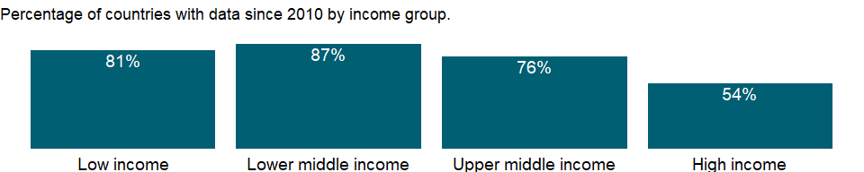

### Why is it relevant?

The net intake rate in the first grade of primary education indicates the level of access to primary education and the education system’s capacity to provide access to primary education. A high net intake rate indicates a high degree of access to primary education for the official primary school entrance age children.

### What is the data source?

UNESCO Institute for Statistics (<http://uis.unesco.org/>). Data as of February 2020.

### What is the methodology?

Net intake rate in the first grade of primary education is calculated by dividing the number of children of official primary school entrance age who enter grade 1 of primary education for the first time by the population of the same age, and multiplying by 100.

Data on education are collected by the UNESCO Institute for Statistics from official responses to its annual education survey. All the data are mapped to the International Standard Classification of Education (ISCED) to ensure the comparability of education programs at the international level. The current version was formally adopted by UNESCO Member States in 2011. Population data are drawn from the United Nations Population Division. Using a single source for population data standardizes definitions, estimations, and interpolation methods, ensuring a consistent methodology across countries and minimizing potential enumeration problems in national censuses.

The reference years reflect the school year for which the data are presented. In some countries the school year spans two calendar years (for example, from September 2010 to June 2011); in these cases the reference year refers to the year in which the school year ended (2011 in the example).

### How is it aggregated?

Weighted average

### What are the limitations?

The quality of data is affected when new entrants and repeaters are not correctly distinguished in the first grade of primary education. Caution is also needed for countries with a total population under 100,000 since the United Nations Population Division neither publish nor endorse single-age data for those countries. The data are highly subject to fluctuations in migration and other factors.

### What else should I know?

For aggregate data, each economy is classified based on the classification of World Bank Group’s fiscal year 2021 (July 1, 2020-June 30, 2021).

### 1.60.5 Net intake rate in grade 1, male (% of official school-age population)

### What is the indicator?

Net intake rate in grade 1 is the number of new entrants in the first grade of primary education who are of official primary school entrance age, expressed as a percentage of the population of the corresponding age.

Topic: Education: Efficiency

Series ID: SE.PRM.NINT.MA.ZS

Copyright: CC BY-4.0 , <https://datacatalog.worldbank.org/public-licenses#cc-by>

First year with any data: 1998

Last year with any data: 2019

### What years are data available?

The figure below shows years in which data is available for at least one country. Dates shaded in black have no data, while dates shaded in green have data for at least one country



### Which countries have data?

The figure below shows the percentage of countries in each income group with a value since 2010 for that indicator.



### Why is it relevant?

The net intake rate in the first grade of primary education indicates the level of access to primary education and the education system’s capacity to provide access to primary education. A high net intake rate indicates a high degree of access to primary education for the official primary school entrance age children.

### What is the data source?

UNESCO Institute for Statistics (<http://uis.unesco.org/>). Data as of February 2020.

### What is the methodology?

Net intake rate in the first grade of primary education is calculated by dividing the number of children of official primary school entrance age who enter grade 1 of primary education for the first time by the population of the same age, and multiplying by 100.

Data on education are collected by the UNESCO Institute for Statistics from official responses to its annual education survey. All the data are mapped to the International Standard Classification of Education (ISCED) to ensure the comparability of education programs at the international level. The current version was formally adopted by UNESCO Member States in 2011. Population data are drawn from the United Nations Population Division. Using a single source for population data standardizes definitions, estimations, and interpolation methods, ensuring a consistent methodology across countries and minimizing potential enumeration problems in national censuses.

The reference years reflect the school year for which the data are presented. In some countries the school year spans two calendar years (for example, from September 2010 to June 2011); in these cases the reference year refers to the year in which the school year ended (2011 in the example).

### How is it aggregated?

Weighted average

### What are the limitations?

The quality of data is affected when new entrants and repeaters are not correctly distinguished in the first grade of primary education. Caution is also needed for countries with a total population under 100,000 since the United Nations Population Division neither publish nor endorse single-age data for those countries. The data are highly subject to fluctuations in migration and other factors.

### What else should I know?

For aggregate data, each economy is classified based on the classification of World Bank Group’s fiscal year 2021 (July 1, 2020-June 30, 2021).

### 1.60.6 Net intake rate in grade 1 (% of official school-age population)

### What is the indicator?

Net intake rate in grade 1 is the number of new entrants in the first grade of primary education who are of official primary school entrance age, expressed as a percentage of the population of the corresponding age.

Topic: Education: Efficiency

Series ID: SE.PRM.NINT.ZS

Copyright: CC BY-4.0 , <https://datacatalog.worldbank.org/public-licenses#cc-by>

First year with any data: 1998

Last year with any data: 2019

### What years are data available?

The figure below shows years in which data is available for at least one country. Dates shaded in black have no data, while dates shaded in green have data for at least one country



### Which countries have data?

The figure below shows the percentage of countries in each income group with a value since 2010 for that indicator.



### Why is it relevant?

The net intake rate in the first grade of primary education indicates the level of access to primary education and the education system’s capacity to provide access to primary education. A high net intake rate indicates a high degree of access to primary education for the official primary school entrance age children.

### What is the data source?

UNESCO Institute for Statistics (<http://uis.unesco.org/>). Data as of February 2020.

### What is the methodology?

Net intake rate in the first grade of primary education is calculated by dividing the number of children of official primary school entrance age who enter grade 1 of primary education for the first time by the population of the same age, and multiplying by 100.

Data on education are collected by the UNESCO Institute for Statistics from official responses to its annual education survey. All the data are mapped to the International Standard Classification of Education (ISCED) to ensure the comparability of education programs at the international level. The current version was formally adopted by UNESCO Member States in 2011. Population data are drawn from the United Nations Population Division. Using a single source for population data standardizes definitions, estimations, and interpolation methods, ensuring a consistent methodology across countries and minimizing potential enumeration problems in national censuses.

The reference years reflect the school year for which the data are presented. In some countries the school year spans two calendar years (for example, from September 2010 to June 2011); in these cases the reference year refers to the year in which the school year ended (2011 in the example).

### How is it aggregated?

Weighted average

### What are the limitations?

The quality of data is affected when new entrants and repeaters are not correctly distinguished in the first grade of primary education. Caution is also needed for countries with a total population under 100,000 since the United Nations Population Division neither publish nor endorse single-age data for those countries. The data are highly subject to fluctuations in migration and other factors.

### What else should I know?

For aggregate data, each economy is classified based on the classification of World Bank Group’s fiscal year 2021 (July 1, 2020-June 30, 2021).

### 1.60.7 Over-age students, primary, female (% of female enrollment)

### What is the indicator?

Over-age students are the percentage of those enrolled who are older than the official school-age range for primary education.

Topic: Education: Efficiency

Series ID: SE.PRM.OENR.FE.ZS

Copyright: CC BY-4.0 , <https://datacatalog.worldbank.org/public-licenses#cc-by>

First year with any data: 1970

Last year with any data: 2019

### What years are data available?

The figure below shows years in which data is available for at least one country. Dates shaded in black have no data, while dates shaded in green have data for at least one country



### Which countries have data?

The figure below shows the percentage of countries in each income group with a value since 2010 for that indicator.

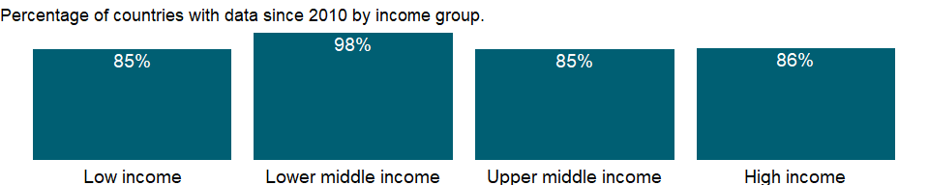

### Why is it relevant?

NA

### What is the data source?

UNESCO Institute for Statistics (<http://uis.unesco.org/>). Data as of February 2020.

### What is the methodology?

The percentage of over-age students is calculated by dividing the number of students who are older than the official school-age range for primary education by primary school enrollment, and multiplying by 100.

Data on education are collected by the UNESCO Institute for Statistics from official responses to its annual education survey. All the data are mapped to the International Standard Classification of Education (ISCED) to ensure the comparability of education programs at the international level. The current version was formally adopted by UNESCO Member States in 2011. Population data are drawn from the United Nations Population Division. Using a single source for population data standardizes definitions, estimations, and interpolation methods, ensuring a consistent methodology across countries and minimizing potential enumeration problems in national censuses. The reference years reflect the school year for which the data are presented. In some countries the school year spans two calendar years (for example, from September 2010 to June 2011); in these cases the reference year refers to the year in which the school year ended (2011 in the example).

### How is it aggregated?

NA

### What are the limitations?

NA

### What else should I know?

For aggregate data, each economy is classified based on the classification of World Bank Group’s fiscal year 2021 (July 1, 2020-June 30, 2021).

### 1.60.8 Over-age students, primary, male (% of male enrollment)

### What is the indicator?

Over-age students are the percentage of those enrolled who are older than the official school-age range for primary education.

Topic: Education: Efficiency

Series ID: SE.PRM.OENR.MA.ZS

Copyright: CC BY-4.0 , <https://datacatalog.worldbank.org/public-licenses#cc-by>

First year with any data: 1970

Last year with any data: 2019

### What years are data available?

The figure below shows years in which data is available for at least one country. Dates shaded in black have no data, while dates shaded in green have data for at least one country



### Which countries have data?

The figure below shows the percentage of countries in each income group with a value since 2010 for that indicator.



### Why is it relevant?

NA

### What is the data source?

UNESCO Institute for Statistics (<http://uis.unesco.org/>). Data as of February 2020.

### What is the methodology?

The percentage of over-age students is calculated by dividing the number of students who are older than the official school-age range for primary education by primary school enrollment, and multiplying by 100.

Data on education are collected by the UNESCO Institute for Statistics from official responses to its annual education survey. All the data are mapped to the International Standard Classification of Education (ISCED) to ensure the comparability of education programs at the international level. The current version was formally adopted by UNESCO Member States in 2011. Population data are drawn from the United Nations Population Division. Using a single source for population data standardizes definitions, estimations, and interpolation methods, ensuring a consistent methodology across countries and minimizing potential enumeration problems in national censuses. The reference years reflect the school year for which the data are presented. In some countries the school year spans two calendar years (for example, from September 2010 to June 2011); in these cases the reference year refers to the year in which the school year ended (2011 in the example).

### How is it aggregated?

NA

### What are the limitations?

NA

### What else should I know?

For aggregate data, each economy is classified based on the classification of World Bank Group’s fiscal year 2021 (July 1, 2020-June 30, 2021).

### 1.60.9 Over-age students, primary (% of enrollment)

### What is the indicator?

Over-age students are the percentage of those enrolled who are older than the official school-age range for primary education.

Topic: Education: Efficiency

Series ID: SE.PRM.OENR.ZS

Copyright: CC BY-4.0 , <https://datacatalog.worldbank.org/public-licenses#cc-by>

First year with any data: 1970

Last year with any data: 2019

### What years are data available?

The figure below shows years in which data is available for at least one country. Dates shaded in black have no data, while dates shaded in green have data for at least one country



### Which countries have data?

The figure below shows the percentage of countries in each income group with a value since 2010 for that indicator.



### Why is it relevant?

NA

### What is the data source?

UNESCO Institute for Statistics (<http://uis.unesco.org/>). Data as of February 2020.

### What is the methodology?

The percentage of over-age students is calculated by dividing the number of students who are older than the official school-age range for primary education by primary school enrollment, and multiplying by 100.

Data on education are collected by the UNESCO Institute for Statistics from official responses to its annual education survey. All the data are mapped to the International Standard Classification of Education (ISCED) to ensure the comparability of education programs at the international level. The current version was formally adopted by UNESCO Member States in 2011. Population data are drawn from the United Nations Population Division. Using a single source for population data standardizes definitions, estimations, and interpolation methods, ensuring a consistent methodology across countries and minimizing potential enumeration problems in national censuses. The reference years reflect the school year for which the data are presented. In some countries the school year spans two calendar years (for example, from September 2010 to June 2011); in these cases the reference year refers to the year in which the school year ended (2011 in the example).

### How is it aggregated?

NA

### What are the limitations?

NA

### What else should I know?

For aggregate data, each economy is classified based on the classification of World Bank Group’s fiscal year 2021 (July 1, 2020-June 30, 2021).

### 1.60.10 Persistence to grade 5, female (% of cohort)

### What is the indicator?

Persistence to grade 5 (percentage of cohort reaching grade 5) is the share of children enrolled in the first grade of primary school who eventually reach grade 5. The estimate is based on the reconstructed cohort method.

Topic: Education: Efficiency

Series ID: SE.PRM.PRS5.FE.ZS

Copyright: CC BY-4.0 , <https://datacatalog.worldbank.org/public-licenses#cc-by>

First year with any data: 1970

Last year with any data: 2019

### What years are data available?

The figure below shows years in which data is available for at least one country. Dates shaded in black have no data, while dates shaded in green have data for at least one country



### Which countries have data?

The figure below shows the percentage of countries in each income group with a value since 2010 for that indicator.

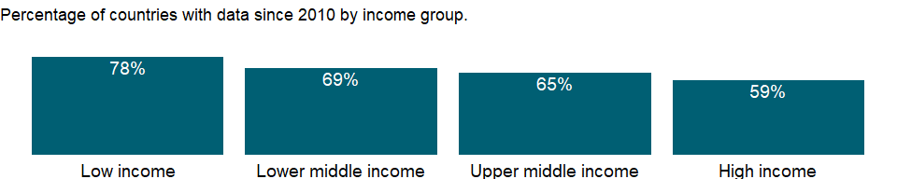

### Why is it relevant?

The cohort survival rate measures an education system’s holding power and internal efficiency. Rates approaching 100 percent indicate high retention and low dropout levels.

### What is the data source?

UNESCO Institute for Statistics (<http://uis.unesco.org/>). Data as of September 2020.

### What is the methodology?

Cohort survival rate is calculated by dividing the total number of children belonging to a cohort who reached each successive grade of the specified level of education by the number of children in the same cohort; those originally enrolled in the first grade of primary education, and multiplying by 100. To reflect current patterns of grade transition, it is calculated based on the reconstructed cohort method, which uses data on enrollment by grade for the two most recent years and data on repeaters by grade for the most recent of those two years. Aggregate data are based on World Bank estimates.

Data on education are collected by the UNESCO Institute for Statistics from official responses to its annual education survey. All the data are mapped to the International Standard Classification of Education (ISCED) to ensure the comparability of education programs at the international level. The current version was formally adopted by UNESCO Member States in 2011.

The reference years reflect the school year for which the data are presented. In some countries the school year spans two calendar years (for example, from September 2010 to June 2011); in these cases the reference year refers to the year in which the school year ended (2011 in the example).

### How is it aggregated?

Weighted average

### What are the limitations?

The estimates have limitations in capturing real trend in that an observed rate will be applied to the underlying indicators such as repetition rate and promotion rate throughout the cohort life, and re-entrants, grade skipping, migration or transfers during a school year are not adequately captured.

### What else should I know?

NA

### 1.60.11 Persistence to grade 5, male (% of cohort)

### What is the indicator?

Persistence to grade 5 (percentage of cohort reaching grade 5) is the share of children enrolled in the first grade of primary school who eventually reach grade 5. The estimate is based on the reconstructed cohort method.

Topic: Education: Efficiency

Series ID: SE.PRM.PRS5.MA.ZS

Copyright: CC BY-4.0 , <https://datacatalog.worldbank.org/public-licenses#cc-by>

First year with any data: 1970

Last year with any data: 2019

### What years are data available?

The figure below shows years in which data is available for at least one country. Dates shaded in black have no data, while dates shaded in green have data for at least one country



### Which countries have data?

The figure below shows the percentage of countries in each income group with a value since 2010 for that indicator.



### Why is it relevant?

The cohort survival rate measures an education system’s holding power and internal efficiency. Rates approaching 100 percent indicate high retention and low dropout levels.

### What is the data source?

UNESCO Institute for Statistics (<http://uis.unesco.org/>). Data as of September 2020.

### What is the methodology?

Cohort survival rate is calculated by dividing the total number of children belonging to a cohort who reached each successive grade of the specified level of education by the number of children in the same cohort; those originally enrolled in the first grade of primary education, and multiplying by 100. To reflect current patterns of grade transition, it is calculated based on the reconstructed cohort method, which uses data on enrollment by grade for the two most recent years and data on repeaters by grade for the most recent of those two years. Aggregate data are based on World Bank estimates.

Data on education are collected by the UNESCO Institute for Statistics from official responses to its annual education survey. All the data are mapped to the International Standard Classification of Education (ISCED) to ensure the comparability of education programs at the international level. The current version was formally adopted by UNESCO Member States in 2011.

The reference years reflect the school year for which the data are presented. In some countries the school year spans two calendar years (for example, from September 2010 to June 2011); in these cases the reference year refers to the year in which the school year ended (2011 in the example).

### How is it aggregated?

Weighted average

### What are the limitations?

The estimates have limitations in capturing real trend in that an observed rate will be applied to the underlying indicators such as repetition rate and promotion rate throughout the cohort life, and re-entrants, grade skipping, migration or transfers during a school year are not adequately captured.

### What else should I know?

NA

### 1.60.12 Persistence to grade 5, total (% of cohort)

### What is the indicator?

Persistence to grade 5 (percentage of cohort reaching grade 5) is the share of children enrolled in the first grade of primary school who eventually reach grade 5. The estimate is based on the reconstructed cohort method.

Topic: Education: Efficiency

Series ID: SE.PRM.PRS5.ZS

Copyright: CC BY-4.0 , <https://datacatalog.worldbank.org/public-licenses#cc-by>

First year with any data: 1970

Last year with any data: 2019

### What years are data available?

The figure below shows years in which data is available for at least one country. Dates shaded in black have no data, while dates shaded in green have data for at least one country



### Which countries have data?

The figure below shows the percentage of countries in each income group with a value since 2010 for that indicator.

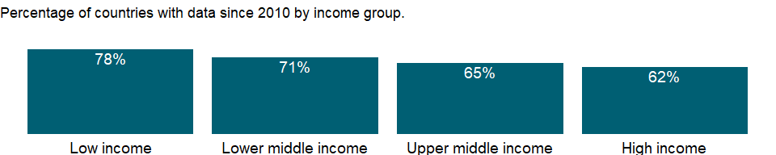

### Why is it relevant?

The cohort survival rate measures an education system’s holding power and internal efficiency. Rates approaching 100 percent indicate high retention and low dropout levels.

### What is the data source?

UNESCO Institute for Statistics (<http://uis.unesco.org/>). Data as of September 2020.

### What is the methodology?

Cohort survival rate is calculated by dividing the total number of children belonging to a cohort who reached each successive grade of the specified level of education by the number of children in the same cohort; those originally enrolled in the first grade of primary education, and multiplying by 100. To reflect current patterns of grade transition, it is calculated based on the reconstructed cohort method, which uses data on enrollment by grade for the two most recent years and data on repeaters by grade for the most recent of those two years. Aggregate data are based on World Bank estimates.

Data on education are collected by the UNESCO Institute for Statistics from official responses to its annual education survey. All the data are mapped to the International Standard Classification of Education (ISCED) to ensure the comparability of education programs at the international level. The current version was formally adopted by UNESCO Member States in 2011.

The reference years reflect the school year for which the data are presented. In some countries the school year spans two calendar years (for example, from September 2010 to June 2011); in these cases the reference year refers to the year in which the school year ended (2011 in the example).

### How is it aggregated?

Weighted average

### What are the limitations?

The estimates have limitations in capturing real trend in that an observed rate will be applied to the underlying indicators such as repetition rate and promotion rate throughout the cohort life, and re-entrants, grade skipping, migration or transfers during a school year are not adequately captured.

### What else should I know?

NA

### 1.60.13 Persistence to last grade of primary, female (% of cohort)

### What is the indicator?

Persistence to last grade of primary is the percentage of children enrolled in the first grade of primary school who eventually reach the last grade of primary education. The estimate is based on the reconstructed cohort method.

Topic: Education: Efficiency

Series ID: SE.PRM.PRSL.FE.ZS

Copyright: CC BY-4.0 , <https://datacatalog.worldbank.org/public-licenses#cc-by>

First year with any data: 1970

Last year with any data: 2019

### What years are data available?

The figure below shows years in which data is available for at least one country. Dates shaded in black have no data, while dates shaded in green have data for at least one country



### Which countries have data?

The figure below shows the percentage of countries in each income group with a value since 2010 for that indicator.

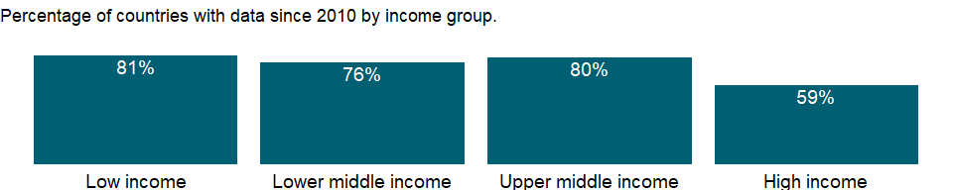

### Why is it relevant?

The cohort survival rate measures an education system’s holding power and internal efficiency. Rates approaching 100 percent indicate high retention and low dropout levels.

### What is the data source?

UNESCO Institute for Statistics (<http://uis.unesco.org/>). Data as of September 2020.

### What is the methodology?

Cohort survival rate is calculated by dividing the total number of children belonging to a cohort who reached each successive grade of the specified level of education by the number of children in the same cohort; those originally enrolled in the first grade of primary education, and multiplying by 100. To reflect current patterns of grade transition, it is calculated based on the reconstructed cohort method, which uses data on enrollment by grade for the two most recent years and data on repeaters by grade for the most recent of those two years.

Data on education are collected by the UNESCO Institute for Statistics from official responses to its annual education survey. All the data are mapped to the International Standard Classification of Education (ISCED) to ensure the comparability of education programs at the international level. The current version was formally adopted by UNESCO Member States in 2011.

The reference years reflect the school year for which the data are presented. In some countries the school year spans two calendar years (for example, from September 2010 to June 2011); in these cases the reference year refers to the year in which the school year ended (2011 in the example).

### How is it aggregated?

Weighted average

### What are the limitations?

The estimates have limitations in capturing real trend in that an observed rate will be applied to the underlying indicators such as repetition rate and promotion rate throughout the cohort life, and re-entrants, grade skipping, migration or transfers during a school year are not adequately captured.

### What else should I know?

For aggregate data, each economy is classified based on the classification of World Bank Group’s fiscal year 2021 (July 1, 2020-June 30, 2021).

### 1.60.14 Persistence to last grade of primary, male (% of cohort)

### What is the indicator?

Persistence to last grade of primary is the percentage of children enrolled in the first grade of primary school who eventually reach the last grade of primary education. The estimate is based on the reconstructed cohort method.

Topic: Education: Efficiency

Series ID: SE.PRM.PRSL.MA.ZS

Copyright: CC BY-4.0 , <https://datacatalog.worldbank.org/public-licenses#cc-by>

First year with any data: 1970

Last year with any data: 2019

### What years are data available?

The figure below shows years in which data is available for at least one country. Dates shaded in black have no data, while dates shaded in green have data for at least one country



### Which countries have data?

The figure below shows the percentage of countries in each income group with a value since 2010 for that indicator.



### Why is it relevant?

The cohort survival rate measures an education system’s holding power and internal efficiency. Rates approaching 100 percent indicate high retention and low dropout levels.

### What is the data source?

UNESCO Institute for Statistics (<http://uis.unesco.org/>). Data as of September 2020.

### What is the methodology?

Cohort survival rate is calculated by dividing the total number of children belonging to a cohort who reached each successive grade of the specified level of education by the number of children in the same cohort; those originally enrolled in the first grade of primary education, and multiplying by 100. To reflect current patterns of grade transition, it is calculated based on the reconstructed cohort method, which uses data on enrollment by grade for the two most recent years and data on repeaters by grade for the most recent of those two years.

Data on education are collected by the UNESCO Institute for Statistics from official responses to its annual education survey. All the data are mapped to the International Standard Classification of Education (ISCED) to ensure the comparability of education programs at the international level. The current version was formally adopted by UNESCO Member States in 2011.

The reference years reflect the school year for which the data are presented. In some countries the school year spans two calendar years (for example, from September 2010 to June 2011); in these cases the reference year refers to the year in which the school year ended (2011 in the example).

### How is it aggregated?

Weighted average

### What are the limitations?

The estimates have limitations in capturing real trend in that an observed rate will be applied to the underlying indicators such as repetition rate and promotion rate throughout the cohort life, and re-entrants, grade skipping, migration or transfers during a school year are not adequately captured.

### What else should I know?

For aggregate data, each economy is classified based on the classification of World Bank Group’s fiscal year 2021 (July 1, 2020-June 30, 2021).

### 1.60.15 Persistence to last grade of primary, total (% of cohort)

### What is the indicator?

Persistence to last grade of primary is the percentage of children enrolled in the first grade of primary school who eventually reach the last grade of primary education. The estimate is based on the reconstructed cohort method.

Topic: Education: Efficiency

Series ID: SE.PRM.PRSL.ZS

Copyright: CC BY-4.0 , <https://datacatalog.worldbank.org/public-licenses#cc-by>

First year with any data: 1970

Last year with any data: 2019

### What years are data available?

The figure below shows years in which data is available for at least one country. Dates shaded in black have no data, while dates shaded in green have data for at least one country



### Which countries have data?

The figure below shows the percentage of countries in each income group with a value since 2010 for that indicator.

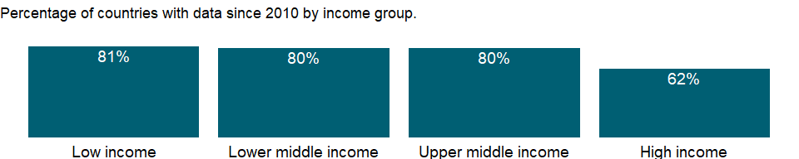

### Why is it relevant?

The cohort survival rate measures an education system’s holding power and internal efficiency. Rates approaching 100 percent indicate high retention and low dropout levels.

### What is the data source?

UNESCO Institute for Statistics (<http://uis.unesco.org/>). Data as of September 2020.

### What is the methodology?

Cohort survival rate is calculated by dividing the total number of children belonging to a cohort who reached each successive grade of the specified level of education by the number of children in the same cohort; those originally enrolled in the first grade of primary education, and multiplying by 100. To reflect current patterns of grade transition, it is calculated based on the reconstructed cohort method, which uses data on enrollment by grade for the two most recent years and data on repeaters by grade for the most recent of those two years. Data on education are collected by the UNESCO Institute for Statistics from official responses to its annual education survey. All the data are mapped to the International Standard Classification of Education (ISCED) to ensure the comparability of education programs at the international level. The current version was formally adopted by UNESCO Member States in 2011.

The reference years reflect the school year for which the data are presented. In some countries the school year spans two calendar years (for example, from September 2010 to June 2011); in these cases the reference year refers to the year in which the school year ended (2011 in the example).

### How is it aggregated?

Weighted average

### What are the limitations?

The estimates have limitations in capturing real trend in that an observed rate will be applied to the underlying indicators such as repetition rate and promotion rate throughout the cohort life, and re-entrants, grade skipping, migration or transfers during a school year are not adequately captured.

### What else should I know?

For aggregate data, each economy is classified based on the classification of World Bank Group’s fiscal year 2021 (July 1, 2020-June 30, 2021).

### 1.60.16 Repeaters, primary, female (% of female enrollment)

### What is the indicator?

Repeaters in primary school are the number of students enrolled in the same grade as in the previous year, as a percentage of all students enrolled in primary school.

Topic: Education: Efficiency

Series ID: SE.PRM.REPT.FE.ZS

Copyright: CC BY-4.0 , <https://datacatalog.worldbank.org/public-licenses#cc-by>

First year with any data: 1970

Last year with any data: 2019

### What years are data available?

The figure below shows years in which data is available for at least one country. Dates shaded in black have no data, while dates shaded in green have data for at least one country



### Which countries have data?

The figure below shows the percentage of countries in each income group with a value since 2010 for that indicator.

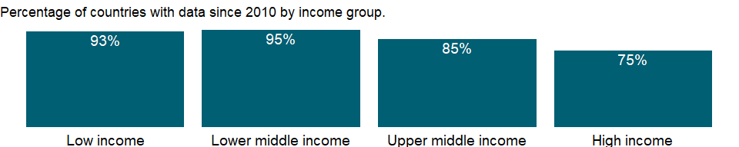

### Why is it relevant?

Data on repeaters are often used to indicate an education system’s internal efficiency. Repeaters not only increase the cost of education for the family and the school system, but also use limited school resources.

### What is the data source?

UNESCO Institute for Statistics (<http://uis.unesco.org/>). Data as of February 2020.

### What is the methodology?

Share of repeaters in primary school is calculated by dividing the sum of repeaters in all grades of primary school by the total number of students enrolled in primary school, and multiplying by 100.

Data on education are collected by the UNESCO Institute for Statistics from official responses to its annual education survey. All the data are mapped to the International Standard Classification of Education (ISCED) to ensure the comparability of education programs at the international level. The current version was formally adopted by UNESCO Member States in 2011.

The reference years reflect the school year for which the data are presented. In some countries the school year spans two calendar years (for example, from September 2010 to June 2011); in these cases the reference year refers to the year in which the school year ended (2011 in the example).

### How is it aggregated?

Weighted average

### What are the limitations?

Country policies on repetition and promotion differ. In some cases the number of repeaters is controlled because of limited capacity. In other cases the number of repeaters is almost 0 because of automatic promotion – suggesting a system that is highly efficient but that may not be endowing students with enough cognitive skills.

### What else should I know?

For aggregate data, each economy is classified based on the classification of World Bank Group’s fiscal year 2021 (July 1, 2020-June 30, 2021).

### 1.60.17 Repeaters, primary, male (% of male enrollment)

### What is the indicator?

Repeaters in primary school are the number of students enrolled in the same grade as in the previous year, as a percentage of all students enrolled in primary school.

Topic: Education: Efficiency

Series ID: SE.PRM.REPT.MA.ZS

Copyright: CC BY-4.0 , <https://datacatalog.worldbank.org/public-licenses#cc-by>

First year with any data: 1970

Last year with any data: 2019

### What years are data available?

The figure below shows years in which data is available for at least one country. Dates shaded in black have no data, while dates shaded in green have data for at least one country



### Which countries have data?

The figure below shows the percentage of countries in each income group with a value since 2010 for that indicator.



### Why is it relevant?

Data on repeaters are often used to indicate an education system’s internal efficiency. Repeaters not only increase the cost of education for the family and the school system, but also use limited school resources.

### What is the data source?

UNESCO Institute for Statistics (<http://uis.unesco.org/>). Data as of February 2020.

### What is the methodology?

Share of repeaters in primary school is calculated by dividing the sum of repeaters in all grades of primary school by the total number of students enrolled in primary school, and multiplying by 100.

Data on education are collected by the UNESCO Institute for Statistics from official responses to its annual education survey. All the data are mapped to the International Standard Classification of Education (ISCED) to ensure the comparability of education programs at the international level. The current version was formally adopted by UNESCO Member States in 2011.

The reference years reflect the school year for which the data are presented. In some countries the school year spans two calendar years (for example, from September 2010 to June 2011); in these cases the reference year refers to the year in which the school year ended (2011 in the example).

### How is it aggregated?

Weighted average

### What are the limitations?

Country policies on repetition and promotion differ. In some cases the number of repeaters is controlled because of limited capacity. In other cases the number of repeaters is almost 0 because of automatic promotion – suggesting a system that is highly efficient but that may not be endowing students with enough cognitive skills.

### What else should I know?

For aggregate data, each economy is classified based on the classification of World Bank Group’s fiscal year 2021 (July 1, 2020-June 30, 2021).

### 1.60.18 Repeaters, primary, total (% of total enrollment)

### What is the indicator?

Repeaters in primary school are the number of students enrolled in the same grade as in the previous year, as a percentage of all students enrolled in primary school.

Topic: Education: Efficiency

Series ID: SE.PRM.REPT.ZS

Copyright: CC BY-4.0 , <https://datacatalog.worldbank.org/public-licenses#cc-by>

First year with any data: 1970

Last year with any data: 2019

### What years are data available?

The figure below shows years in which data is available for at least one country. Dates shaded in black have no data, while dates shaded in green have data for at least one country



### Which countries have data?

The figure below shows the percentage of countries in each income group with a value since 2010 for that indicator.

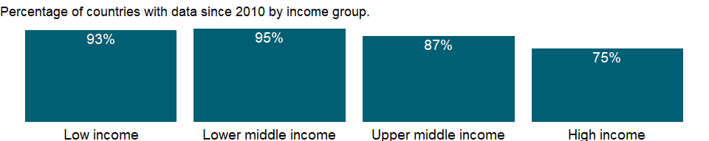

### Why is it relevant?

Data on repeaters are often used to indicate an education system’s internal efficiency. Repeaters not only increase the cost of education for the family and the school system, but also use limited school resources.

### What is the data source?

UNESCO Institute for Statistics (<http://uis.unesco.org/>). Data as of February 2020.

### What is the methodology?

Share of repeaters in primary school is calculated by dividing the sum of repeaters in all grades of primary school by the total number of students enrolled in primary school, and multiplying by 100.

Data on education are collected by the UNESCO Institute for Statistics from official responses to its annual education survey. All the data are mapped to the International Standard Classification of Education (ISCED) to ensure the comparability of education programs at the international level. The current version was formally adopted by UNESCO Member States in 2011.

The reference years reflect the school year for which the data are presented. In some countries the school year spans two calendar years (for example, from September 2010 to June 2011); in these cases the reference year refers to the year in which the school year ended (2011 in the example).

### How is it aggregated?

Weighted average

### What are the limitations?

Country policies on repetition and promotion differ. In some cases the number of repeaters is controlled because of limited capacity. In other cases the number of repeaters is almost 0 because of automatic promotion – suggesting a system that is highly efficient but that may not be endowing students with enough cognitive skills.

### What else should I know?

For aggregate data, each economy is classified based on the classification of World Bank Group’s fiscal year 2021 (July 1, 2020-June 30, 2021).

### 1.60.19 Progression to secondary school, female (%)

### What is the indicator?

Progression to secondary school refers to the number of new entrants to the first grade of secondary school in a given year as a percentage of the number of students enrolled in the final grade of primary school in the previous year (minus the number of repeaters from the last grade of primary education in the given year).

Topic: Education: Efficiency

Series ID: SE.SEC.PROG.FE.ZS

Copyright: CC BY-4.0 , <https://datacatalog.worldbank.org/public-licenses#cc-by>

First year with any data: 1970

Last year with any data: 2018

### What years are data available?

The figure below shows years in which data is available for at least one country. Dates shaded in black have no data, while dates shaded in green have data for at least one country



### Which countries have data?

The figure below shows the percentage of countries in each income group with a value since 2010 for that indicator.

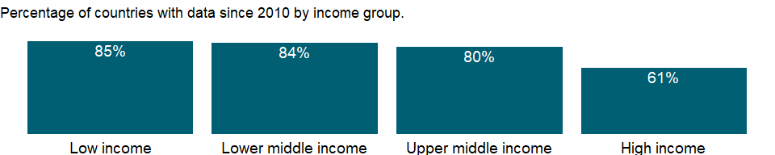

### Why is it relevant?

The effective transition rate from primary to secondary education conveys the degree of access or transition between the two levels. As completing primary education is a prerequisite for participating in lower secondary education, growing numbers of primary completers will inevitably create pressure for more available places at the secondary level. A low effective transition rate can signal such problems as an inadequate examination and promotion system or insufficient secondary education capacity.

### What is the data source?

UNESCO Institute for Statistics (<http://uis.unesco.org/>). Data as of February 2020.

### What is the methodology?

Effective transition rate is calculated by dividing the number of new entrants in the first grade of secondary education in a given year (t) by the number of students who enrolled in the final grade of primary education in the previous school year (t-1) minus the number of repeaters from the last grade of primary education in the given year (t), and multiplying by 100. Data on education are collected by the UNESCO Institute for Statistics from official responses to its annual education survey. All the data are mapped to the International Standard Classification of Education (ISCED) to ensure the comparability of education programs at the international level. The current version was formally adopted by UNESCO Member States in 2011.

The reference years reflect the school year for which the data are presented. In some countries the school year spans two calendar years (for example, from September 2010 to June 2011); in these cases the reference year refers to the year in which the school year ended (2011 in the example).

### How is it aggregated?

Weighted average

### What are the limitations?

The quality of data on the transition rate is affected when new entrants and repeaters are not correctly distinguished. Students who interrupt their studies after completing primary education could also affect data quality.

### What else should I know?

For aggregate data, each economy is classified based on the classification of World Bank Group’s fiscal year 2021 (July 1, 2020-June 30, 2021).

### 1.60.20 Progression to secondary school, male (%)

### What is the indicator?

Progression to secondary school refers to the number of new entrants to the first grade of secondary school in a given year as a percentage of the number of students enrolled in the final grade of primary school in the previous year (minus the number of repeaters from the last grade of primary education in the given year).

Topic: Education: Efficiency

Series ID: SE.SEC.PROG.MA.ZS

Copyright: CC BY-4.0 , <https://datacatalog.worldbank.org/public-licenses#cc-by>

First year with any data: 1970

Last year with any data: 2018

### What years are data available?

The figure below shows years in which data is available for at least one country. Dates shaded in black have no data, while dates shaded in green have data for at least one country



### Which countries have data?

The figure below shows the percentage of countries in each income group with a value since 2010 for that indicator.



### Why is it relevant?

The effective transition rate from primary to secondary education conveys the degree of access or transition between the two levels. As completing primary education is a prerequisite for participating in lower secondary education, growing numbers of primary completers will inevitably create pressure for more available places at the secondary level. A low effective transition rate can signal such problems as an inadequate examination and promotion system or insufficient secondary education capacity.

### What is the data source?

UNESCO Institute for Statistics (<http://uis.unesco.org/>). Data as of February 2020.

### What is the methodology?

Effective transition rate is calculated by dividing the number of new entrants in the first grade of secondary education in a given year (t) by the number of students who enrolled in the final grade of primary education in the previous school year (t-1) minus the number of repeaters from the last grade of primary education in the given year (t), and multiplying by 100. Data on education are collected by the UNESCO Institute for Statistics from official responses to its annual education survey. All the data are mapped to the International Standard Classification of Education (ISCED) to ensure the comparability of education programs at the international level. The current version was formally adopted by UNESCO Member States in 2011.

The reference years reflect the school year for which the data are presented. In some countries the school year spans two calendar years (for example, from September 2010 to June 2011); in these cases the reference year refers to the year in which the school year ended (2011 in the example).

### How is it aggregated?

Weighted average

### What are the limitations?

The quality of data on the transition rate is affected when new entrants and repeaters are not correctly distinguished. Students who interrupt their studies after completing primary education could also affect data quality.

### What else should I know?

For aggregate data, each economy is classified based on the classification of World Bank Group’s fiscal year 2021 (July 1, 2020-June 30, 2021).

### 1.60.21 Progression to secondary school (%)

### What is the indicator?

Progression to secondary school refers to the number of new entrants to the first grade of secondary school in a given year as a percentage of the number of students enrolled in the final grade of primary school in the previous year (minus the number of repeaters from the last grade of primary education in the given year).

Topic: Education: Efficiency

Series ID: SE.SEC.PROG.ZS

Copyright: CC BY-4.0 , <https://datacatalog.worldbank.org/public-licenses#cc-by>

First year with any data: 1970

Last year with any data: 2018

### What years are data available?

The figure below shows years in which data is available for at least one country. Dates shaded in black have no data, while dates shaded in green have data for at least one country



### Which countries have data?

The figure below shows the percentage of countries in each income group with a value since 2010 for that indicator.

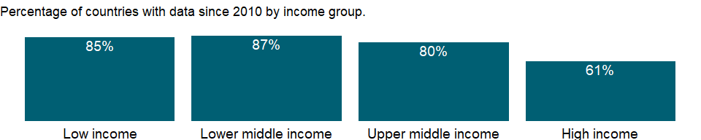

### Why is it relevant?

The effective transition rate from primary to secondary education conveys the degree of access or transition between the two levels. As completing primary education is a prerequisite for participating in lower secondary education, growing numbers of primary completers will inevitably create pressure for more available places at the secondary level. A low effective transition rate can signal such problems as an inadequate examination and promotion system or insufficient secondary education capacity.

### What is the data source?

UNESCO Institute for Statistics (<http://uis.unesco.org/>). Data as of February 2020.

### What is the methodology?

Effective transition rate is calculated by dividing the number of new entrants in the first grade of secondary education in a given year (t) by the number of students who enrolled in the final grade of primary education in the previous school year (t-1) minus the number of repeaters from the last grade of primary education in the given year (t), and multiplying by 100. Data on education are collected by the UNESCO Institute for Statistics from official responses to its annual education survey. All the data are mapped to the International Standard Classification of Education (ISCED) to ensure the comparability of education programs at the international level. The current version was formally adopted by UNESCO Member States in 2011.

The reference years reflect the school year for which the data are presented. In some countries the school year spans two calendar years (for example, from September 2010 to June 2011); in these cases the reference year refers to the year in which the school year ended (2011 in the example).

### How is it aggregated?

Weighted average

### What are the limitations?

The quality of data on the transition rate is affected when new entrants and repeaters are not correctly distinguished. Students who interrupt their studies after completing primary education could also affect data quality.

### What else should I know?

For aggregate data, each economy is classified based on the classification of World Bank Group’s fiscal year 2021 (July 1, 2020-June 30, 2021).

## 1.61 Gender: Public life & decision making

### 1.61.1 Women participating in the three decisions (own health care, major household purchases, and visiting family) (% of women age 15-49)

### What is the indicator?

Women participating in the three decisions (own health care, major household purchases, and visiting family) is the percentage of currently married women aged 15-49 who say that they alone or jointly have the final say in all of the three decisions (own health care, large purchases and visits to family, relatives, and friends).

Topic: Gender: Public life & decision making

Series ID: SG.DMK.ALLD.FN.ZS

Copyright: CC BY-4.0 , <https://datacatalog.worldbank.org/public-licenses#cc-by>

First year with any data: 1999

Last year with any data: 2018

### What years are data available?

The figure below shows years in which data is available for at least one country. Dates shaded in black have no data, while dates shaded in green have data for at least one country

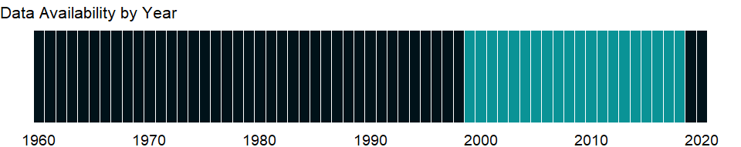

### Which countries have data?

The figure below shows the percentage of countries in each income group with a value since 2010 for that indicator.

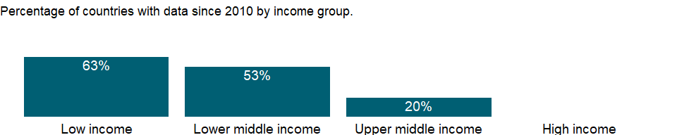

### Why is it relevant?

Women‘s participation in decisions being made in their own households, that is households in which they usually live with their spouse and/or children with or without others, is widely accepted as a universal indicator of women‘s empowerment. The ability of women to make decisions that affect their personal circumstances is an essential element of their empowerment and serves as an important contributor to their overall development.

### What is the data source?

Demographic and Health Surveys (DHS)

### What is the methodology?

Women participating in the three decisions (own health care, major household purchases, and visiting family) is the number of currently married women aged 15-49 who say they alone or jointly have the final say in the three decisions, expressed as percentage of currently married women age 15-49 who have been interviewed and It’s derived by dividing the number of currently married women aged 15-49 who responded they alone or jointly have the final say in the three decisions by total number of currently married women age 15-49 who have been interviewed.

### How is it aggregated?

NA

### What are the limitations?

NA

### What else should I know?

NA

### 1.61.2 Women making their own informed decisions regarding sexual relations, contraceptive use and reproductive health care (% of women age 15-49)

### What is the indicator?

Proportion of women ages 15-49 years (married or in union) who make their own decision on all three selected areas i.e. can say no to sexual intercourse with their husband or partner if they do not want; decide on use of contraception; and decide on their own health care. Only women who provide a “yes” answer to all three components are considered as women who “make her own decisions regarding sexual and reproductive”.

Topic: Gender: Public life & decision making

Series ID: SG.DMK.SRCR.FN.ZS

Copyright: CC BY-4.0 , <https://datacatalog.worldbank.org/public-licenses#cc-by>

First year with any data: 2006

Last year with any data: 2020

### What years are data available?

The figure below shows years in which data is available for at least one country. Dates shaded in black have no data, while dates shaded in green have data for at least one country



### Which countries have data?

The figure below shows the percentage of countries in each income group with a value since 2010 for that indicator.

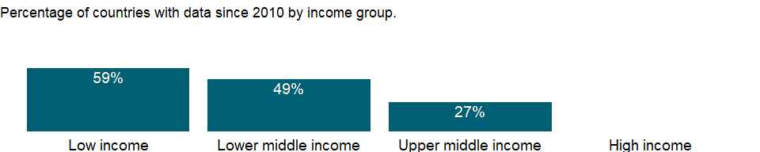

### Why is it relevant?

Women‘s participation in decisions being made in their own households, that is households in which they usually live with their spouse and/or children with or without others, is widely accepted as a universal indicator of women‘s empowerment. The ability of women to make decisions that affect their personal circumstances is an essential element of their empowerment and serves as an important contributor to their overall development.

### What is the data source?

Demographic and Health Surveys compiled by United Nations Population Fund

### What is the methodology?

Numerator of the indicator is number of married or in union women ages 15-49 who have been interviewed and satisfy all three empowerment criteria: 1)who can say “no” to sex; and 2)for whom the decision on contraception is not mainly made by the husband/partner; and 3) for whom decision on health care for themselves ins not usually made by the husband/partner or someone else. Denominator of the indicator is the total number of women ages 15-49 who are married or in union and who have been interviewed.

### How is it aggregated?

NA

### What are the limitations?

Current estimates of the indicator are based on currently married or in union women of reproductive age (15-49 years old) who are using any type of contraception. In the current Demographic and Health Surveys (DHS), the question on decision-making on use of contraception is only asked to women who are currently using contraception. Because the questions on decision- making on sexual relations and health care are restricted to women (15-49) currently married or in union, the denominator for Indicator 5.6.1 is women 15-49, who are currently married or in union and currently using contraception. However, agreement has been reached with Macro/ICF for upcoming DHS surveys to ask the question on decision on use of contraception to all married/ in union women aged 15-49 years, whether they are currently using any contraception or not. The DHS model questionnaire for Phase 7 already includes the question on decision-making for women who are not currently using any contraception.

### What else should I know?

This is the Sustainable Development Goal indicator 5.6.1[<https://unstats.un.org/sdgs/metadata/>].

### 1.61.3 Proportion of seats held by women in national parliaments (%)

### What is the indicator?

Women in parliaments are the percentage of parliamentary seats in a single or lower chamber held by women.

Topic: Gender: Public life & decision making

Series ID: SG.GEN.PARL.ZS

Copyright: CC BY-4.0 , <https://datacatalog.worldbank.org/public-licenses#cc-by>

First year with any data: 1997

Last year with any data: 2020

### What years are data available?

The figure below shows years in which data is available for at least one country. Dates shaded in black have no data, while dates shaded in green have data for at least one country

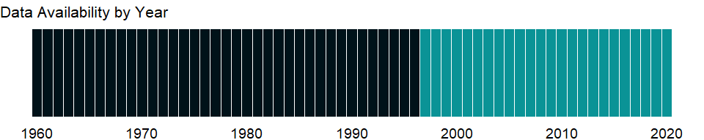

### Which countries have data?

The figure below shows the percentage of countries in each income group with a value since 2010 for that indicator.

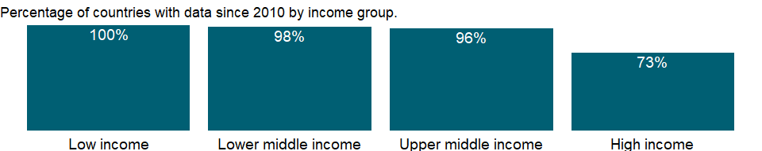

### Why is it relevant?

Despite much progress in recent decades, gender inequalities remain pervasive in many dimensions of life - worldwide. But while disparities exist throughout the world, they are most prevalent in developing countries. Gender inequalities in the allocation of such resources as education, health care, nutrition, and political voice matter because of the strong association with well-being, productivity, and economic growth. These patterns of inequality begin at an early age, with boys routinely receiving a larger share of education and health spending than do girls, for example.

Women are vastly underrepresented in decision-making positions in government, although there is some evidence of recent improvement. Gender parity in parliamentary representation is still far from being realized. Without representation at this level, it is difficult for women to influence policy.

A strong and vibrant democracy is possible only when parliament is fully inclusive of the population it represents. Parliaments cannot consider themselves inclusive, however, until they can boast the full participation of women. This is not just about women’s right to equality and their contribution to the conduct of public affairs, but also about using women’s resources and potential to determine political and development priorities that benefit societies and the global community.

### What is the data source?

Inter-Parliamentary Union (IPU) (www.ipu.org). For the year of 1998, the data is as of August 10, 1998.

### What is the methodology?

The proportion of seats held by women in national parliaments is the number of seats held by women members in single or lower chambers of national parliaments, expressed as a percentage of all occupied seats; it is derived by dividing the total number of seats occupied by women by the total number of seats in parliament.

National parliaments can be bicameral or unicameral. This indicator covers the single chamber in unicameral parliaments and the lower chamber in bicameral parliaments. It does not cover the upper chamber of bicameral parliaments. Seats are usually won by members in general parliamentary elections. Seats may also be filled by nomination, appointment, indirect election, rotation of members and by-election. Seats refer to the number of parliamentary mandates, or the number of members of parliament.

### How is it aggregated?

Weighted average

### What are the limitations?

The number of countries covered varies with suspensions or dissolutions of parliaments. There can be difficulties in obtaining information on by-election results and replacements due to death or resignation. These changes are ad hoc events which are more difficult to keep track of. By-elections, for instance, are often not announced internationally as general elections are. Parliaments vary considerably in their internal workings and procedures, however, generally legislate, oversee government and represent the electorate. In terms of measuring women’s contribution to political decision making, this indicator may not be sufficient because some women may face obstacles in fully and efficiently carrying out their parliamentary mandate.

The data is compiled by the Inter-Parliamentary Union on the basis of information provided by National Parliaments. The percentages do not take into account the case of parliaments for which no data was available at that date. Information is available in all countries where a national legislature exists and therefore does not include parliaments that have been dissolved or suspended for an indefinite period.

### What else should I know?

Relevance to gender indicator: Women are vastly underrepresented in decision making positions in government, although there is some evidence of recent improvement. Gender parity in parliamentary representation is still far from being realized. Without representation at this level, it is difficult for women to influence policy.

This is the Sustainable Development Goal indicator 5.5.1 (a). [<https://unstats.un.org/sdgs/metadata/>].

### 1.61.4 Women Business and the Law Index Score (scale 1-100)

### What is the indicator?

The index measures how laws and regulations affect women’s economic opportunity. Overall scores are calculated by taking the average score of each of the eight areas (Going Places, Starting a Job, Getting Paid, Getting Married, Having Children, Running a Business, Managing Assets and Getting a Pension), with 100 representing the highest possible score.

Topic: Gender: Public life & decision making

Series ID: SG.LAW.INDX

Copyright: CC BY-4.0 , <https://datacatalog.worldbank.org/public-licenses#cc-by>

First year with any data: 1970

Last year with any data: 2020

### What years are data available?

The figure below shows years in which data is available for at least one country. Dates shaded in black have no data, while dates shaded in green have data for at least one country



### Which countries have data?

The figure below shows the percentage of countries in each income group with a value since 2010 for that indicator.



### Why is it relevant?

The knowledge and analysis provided by Women, Business and the Law make a strong economic case for laws that empower women. Better performance in the areas measured by the Women, Business and the Law index is associated with more women in the labor force and with higher income and improved development outcomes. Equality before the law and of economic opportunity are not only wise social policy but also good economic policy. The equal participation of women and men will give every economy a chance to achieve its potential. Given the economic significance of women’s empowerment, the ultimate goal of Women, Business and the Law is to encourage governments to reform laws that hold women back from working and doing business.

### What is the data source?

World Bank: Women, Business and the Law. <https://wbl.worldbank.org/>

### What is the methodology?

Women, Business and the Law tracks progress toward legal equality between men and women in 190 economies. Data are collected with standardized questionnaires to ensure comparability across economies. Questionnaires are administered to over 2,000 respondents with expertise in family, labor, and criminal law, including lawyers, judges, academics, and members of civil society organizations working on gender issues. Respondents provide responses to the questionnaires and references to relevant laws and regulations. The Women, Business and the Law team collects the texts of these codified sources of national law - constitutions, codes, laws, statutes, rules, regulations, and procedures - and checks questionnaire responses for accuracy. Thirty-five data points are scored across eight indicators of four or five binary questions, with each indicator representing a different phase of a woman’s career. Indicator-level scores are obtained by calculating the unweighted average of the questions within that indicator and scaling the result to 100. Overall scores are then calculated by taking the average of each indicator, with 100 representing the highest possible score.

### How is it aggregated?

NA

### What are the limitations?

The Women, Business and the Law methodology has limitations that should be considered when interpreting the data. All eight indicators are based on standardized assumptions to ensure comparability across economies. Comparability is one of the strengths of the data, but the assumptions can also be limitations as they may not capture all restrictions or represent all particularities in a country. It is assumed that the woman resides in the economy’s main business city of the economy. In federal economies, laws affecting women can vary by state or province. Even in nonfederal economies, women in rural areas and small towns could face more restrictive local legislation. Such restrictions are not captured by Women, Business and the Law unless they are also found in the main business city. The woman has reached the legal age of majority and is capable of making decisions as an adult, is in good health and has no criminal record. She is a lawful citizen of the economy being examined, and she works as a cashier in the food retail sector in a supermarket or grocery store that has 60 employees. She is a cisgender, heterosexual woman in a monogamous first marriage registered with the appropriate authorities (de facto marriages and customary unions are not measured), she is of the same religion as her husband, and is in a marriage under the rules of the default marital property regime, or the most common regime for that jurisdiction, which will not change during the course of the marriage. She is not a member of a union, unless membership is mandatory. Membership is considered mandatory when collective bargaining agreements cover more than 50 percent of the workforce in the food retail sector and when they apply to individuals who were not party to the original collective bargaining agreement. Where personal law prescribes different rights and obligations for different groups of women, the data focus on the most populous group, which may mean that restrictions that apply only to minority populations are missed. Women, Business and the Law focuses solely on the ways in which the formal legal and regulatory environment determines whether women can work or open their own businesses. The data set is constructed using laws and regulations that are codified (de jure) and currently in force, therefore implementation of laws (de facto) is not measured. The data looks only at laws that apply to the private sector. These assumptions can limit the representativeness of the data for the entire population in each country. Finally, Women, Business and the Law recognizes that the laws it measures do not apply to all women in the same way. Women face intersectional forms of discrimination based on gender, sex, sexuality, race, gender identity, religion, family status, ethnicity, nationality, disability, and a myriad of other grounds. Women, Business and the Law therefore encourages readers to interpret the data in conjunction with other available research.

### What else should I know?

For the reference period, WDI and Gender Databases take the data coverage years instead of reporting years used in WBL (<https://wbl.worldbank.org/>). For example, the data for YR2020 in WBL (report year) corresponds to data for YR2019 in WDI and Gender Databases.

## 1.62 Gender: Participation & access

### 1.62.1 Proportion of time spent on unpaid domestic and care work, female (% of 24 hour day)

### What is the indicator?

The average time women spend on household provision of services for own consumption. Data are expressed as a proportion of time in a day. Domestic and care work includes food preparation, dishwashing, cleaning and upkeep of a dwelling, laundry, ironing, gardening, caring for pets, shopping, installation, servicing and repair of personal and household goods, childcare, and care of the sick, elderly or disabled household members, among others.

Topic: Gender: Participation & access

Series ID: SG.TIM.UWRK.FE

Copyright: CC BY-4.0 , <https://datacatalog.worldbank.org/public-licenses#cc-by>

First year with any data: 2000

Last year with any data: 2019

### What years are data available?

The figure below shows years in which data is available for at least one country. Dates shaded in black have no data, while dates shaded in green have data for at least one country



### Which countries have data?

The figure below shows the percentage of countries in each income group with a value since 2010 for that indicator.

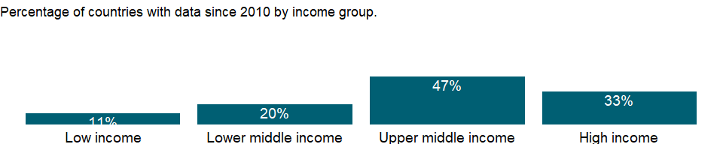

### Why is it relevant?

Women often spend disproportionately more time on unpaid domestic and care work than men. This unequal division of responsibilities is correlated with gender differences in economic opportunities, includign low female labor force participation, occupational sex segregation, and earnings diffrentials. The need for a gender balance in the distribution of unpaid domestic and care work has been increasingly recognized and the Sustainable Development Goals address the issue in the target 5.4.

### What is the data source?

National statistical offices or national database and publications compiled by United Nations Statistics Division. The data were downloaded on December 3 from the Global SDG Indicators Database: <https://unstats.un.org/sdgs/indicators/database/>

### What is the methodology?

Proportion of time spent on unpaid domestic and care work is calculated by dividing the daily average number of hours spent on unpaid domestic and care work by 24 hours. Data presented for this indicator are expressed as a proportion of time in a day. Weekly data is averaged over seven days of the week to obtain the daily average time.

### How is it aggregated?

NA

### What are the limitations?

Data may not be strictly comparable across countries as the methods and sampling involved for data collection may differ.

### What else should I know?

This is the Sustainable Development Goal indicator 5.4.1[<https://unstats.un.org/sdgs/metadata/>].

### 1.62.2 Proportion of time spent on unpaid domestic and care work, male (% of 24 hour day)

### What is the indicator?

The average time men spend on household provision of services for own consumption. Data are expressed as a proportion of time in a day. Domestic and care work includes food preparation, dishwashing, cleaning and upkeep of a dwelling, laundry, ironing, gardening, caring for pets, shopping, installation, servicing and repair of personal and household goods, childcare, and care of the sick, elderly or disabled household members, among others.

Topic: Gender: Participation & access

Series ID: SG.TIM.UWRK.MA

Copyright: CC BY-4.0 , <https://datacatalog.worldbank.org/public-licenses#cc-by>

First year with any data: 2000

Last year with any data: 2019

### What years are data available?

The figure below shows years in which data is available for at least one country. Dates shaded in black have no data, while dates shaded in green have data for at least one country



### Which countries have data?

The figure below shows the percentage of countries in each income group with a value since 2010 for that indicator.



### Why is it relevant?

Women often spend disproportionately more time on unpaid domestic and care work than men. This unequal division of responsibilities is correlated with gender differences in economic opportunities, includign low female labor force participation, occupational sex segregation, and earnings diffrentials. The need for a gender balance in the distribution of unpaid domestic and care work has been increasingly recognized and the Sustainable Development Goals address the issue in the target 5.4.

### What is the data source?

National statistical offices or national database and publications compiled by United Nations Statistics Division

### What is the methodology?

Proportion of time spent on unpaid domestic and care work is calculated by dividing the daily average number of hours spent on unpaid domestic and care work by 24 hours. Data presented for this indicator are expressed as a proportion of time in a day. Weekly data is averaged over seven days of the week to obtain the daily average time.

### How is it aggregated?

NA

### What are the limitations?

Data may not be strictly comparable across countries as the methods and sampling involved for data collection may differ.

### What else should I know?

This is the Sustainable Development Goal indicator 5.4.1[<https://unstats.un.org/sdgs/metadata/>].

## 1.63 Gender: Health

### 1.63.1 Proportion of women subjected to physical and/or sexual violence in the last 12 months (% of women age 15-49)

### What is the indicator?

Proportion of women subjected to physical and/or sexual violence in the last 12 months is the percentage of ever partnered women age 15-49 who are subjected to physical violence, sexual violence or both by a current or former intimate partner in the last 12 months.

Topic: Gender: Health

Series ID: SG.VAW.1549.ZS

Copyright: CC BY-4.0 , <https://datacatalog.worldbank.org/public-licenses#cc-by>

First year with any data: 2000

Last year with any data: 2017

### What years are data available?

The figure below shows years in which data is available for at least one country. Dates shaded in black have no data, while dates shaded in green have data for at least one country

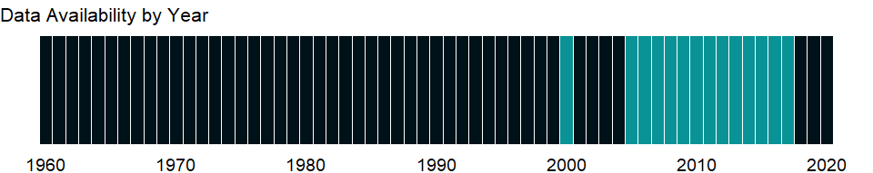

### Which countries have data?

The figure below shows the percentage of countries in each income group with a value since 2010 for that indicator.

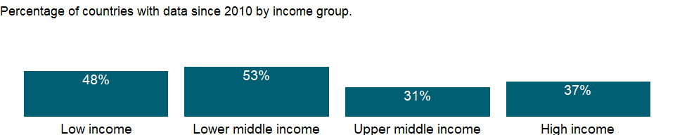

### Why is it relevant?

Violence against women is an obstacle to the achievement of the objectives of equality, development and peace. It both violates and impairs or nullifies the enjoyment by women of their human rights and fundamental freedoms. Tolerance and experience of domestic violence are significant barriers to the empowerment of women and it has a negative health consequences for victims, especially with respect to the reproductive health of women and the physical, emotional, and mental health of their children

### What is the data source?

United Nations Statistics Division (UNSD)

### What is the methodology?

NA

### How is it aggregated?

Weighted Average

### What are the limitations?

Collecting valid, reliable, and ethical data on domestic violence poses particular challenges because what constitutes violence or abuse varies across cultures and among individuals. In addition, a culture of silence usually surrounds domestic violence and can affect reporting.

### What else should I know?

This is the Sustainable Development Goal indicator 5.2.1[<https://unstats.un.org/sdgs/metadata/>].

### 1.63.2 Women who believe a husband is justified in beating his wife when she argues with him (%)

### What is the indicator?

Percentage of women ages 15-49 who believe a husband/partner is justified in hitting or beating his wife/partner when she argues with him.

Topic: Gender: Health

Series ID: SG.VAW.ARGU.ZS

Copyright: CC BY-4.0 , <https://datacatalog.worldbank.org/public-licenses#cc-by>

First year with any data: 1999

Last year with any data: 2020

### What years are data available?

The figure below shows years in which data is available for at least one country. Dates shaded in black have no data, while dates shaded in green have data for at least one country

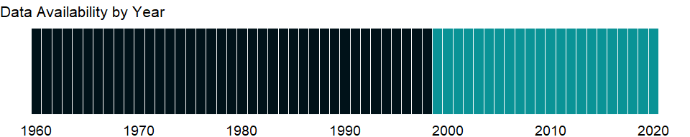

### Which countries have data?

The figure below shows the percentage of countries in each income group with a value since 2010 for that indicator.

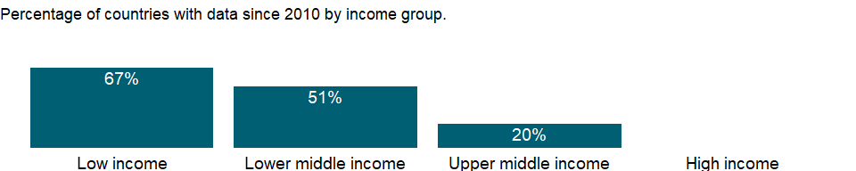

### Why is it relevant?

NA

### What is the data source?

Demographic and Health Surveys (DHS), Multiple Indicator Cluster Surveys (MICS), and other surveys

### What is the methodology?

NA

### How is it aggregated?

NA

### What are the limitations?

NA

### What else should I know?

NA

### 1.63.3 Women who believe a husband is justified in beating his wife when she burns the food (%)

### What is the indicator?

Percentage of women ages 15-49 who believe a husband/partner is justified in hitting or beating his wife/partner when she burns the food.

Topic: Gender: Health

Series ID: SG.VAW.BURN.ZS

Copyright: CC BY-4.0 , <https://datacatalog.worldbank.org/public-licenses#cc-by>

First year with any data: 1999

Last year with any data: 2020

### What years are data available?

The figure below shows years in which data is available for at least one country. Dates shaded in black have no data, while dates shaded in green have data for at least one country



### Which countries have data?

The figure below shows the percentage of countries in each income group with a value since 2010 for that indicator.



### Why is it relevant?

NA

### What is the data source?

Demographic and Health Surveys (DHS), Multiple Indicator Cluster Surveys (MICS), and other surveys

### What is the methodology?

NA

### How is it aggregated?

NA

### What are the limitations?

NA

### What else should I know?

NA

### 1.63.4 Women who believe a husband is justified in beating his wife when she goes out without telling him (%)

### What is the indicator?

Percentage of women ages 15-49 who believe a husband/partner is justified in hitting or beating his wife/partner when she goes out without telling him.

Topic: Gender: Health

Series ID: SG.VAW.GOES.ZS

Copyright: CC BY-4.0 , <https://datacatalog.worldbank.org/public-licenses#cc-by>

First year with any data: 1999

Last year with any data: 2020

### What years are data available?

The figure below shows years in which data is available for at least one country. Dates shaded in black have no data, while dates shaded in green have data for at least one country



### Which countries have data?

The figure below shows the percentage of countries in each income group with a value since 2010 for that indicator.

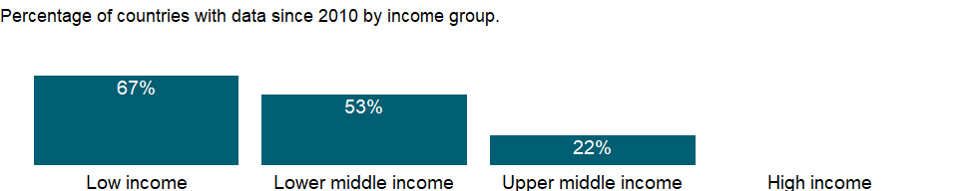

### Why is it relevant?

NA

### What is the data source?

Demographic and Health Surveys (DHS), Multiple Indicator Cluster Surveys (MICS), and other surveys

### What is the methodology?

NA

### How is it aggregated?

NA

### What are the limitations?

NA

### What else should I know?

NA

### 1.63.5 Women who believe a husband is justified in beating his wife when she neglects the children (%)

### What is the indicator?

Percentage of women ages 15-49 who believe a husband/partner is justified in hitting or beating his wife/partner when she neglects the children.

Topic: Gender: Health

Series ID: SG.VAW.NEGL.ZS

Copyright: CC BY-4.0 , <https://datacatalog.worldbank.org/public-licenses#cc-by>

First year with any data: 1999

Last year with any data: 2020

### What years are data available?

The figure below shows years in which data is available for at least one country. Dates shaded in black have no data, while dates shaded in green have data for at least one country



### Which countries have data?

The figure below shows the percentage of countries in each income group with a value since 2010 for that indicator.



### Why is it relevant?

NA

### What is the data source?

Demographic and Health Surveys (DHS), Multiple Indicator Cluster Surveys (MICS), and other surveys

### What is the methodology?

NA

### How is it aggregated?

NA

### What are the limitations?

NA

### What else should I know?

NA

### 1.63.6 Women who believe a husband is justified in beating his wife (any of five reasons) (%)

### What is the indicator?

Percentage of women ages 15-49 who believe a husband/partner is justified in hitting or beating his wife/partner for any of the following five reasons: argues with him; refuses to have sex; burns the food; goes out without telling him; or when she neglects the children.

Topic: Gender: Health

Series ID: SG.VAW.REAS.ZS

Copyright: CC BY-4.0 , <https://datacatalog.worldbank.org/public-licenses#cc-by>

First year with any data: 1999

Last year with any data: 2020

### What years are data available?

The figure below shows years in which data is available for at least one country. Dates shaded in black have no data, while dates shaded in green have data for at least one country



### Which countries have data?

The figure below shows the percentage of countries in each income group with a value since 2010 for that indicator.

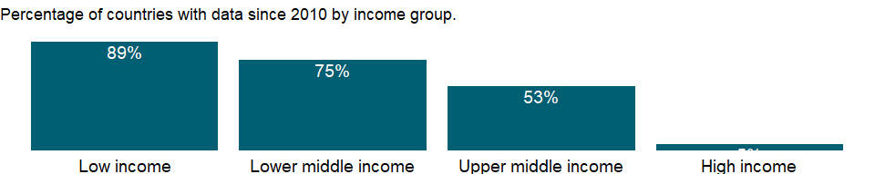

### Why is it relevant?

NA

### What is the data source?

Demographic and Health Surveys (DHS), Multiple Indicator Cluster Surveys (MICS), and other surveys

### What is the methodology?

NA

### How is it aggregated?

NA

### What are the limitations?

NA

### What else should I know?

NA

### 1.63.7 Women who believe a husband is justified in beating his wife when she refuses sex with him (%)

### What is the indicator?

Percentage of women ages 15-49 who believe a husband/partner is justified in hitting or beating his wife/partner when she refuses sex with him.

Topic: Gender: Health

Series ID: SG.VAW.REFU.ZS

Copyright: CC BY-4.0 , <https://datacatalog.worldbank.org/public-licenses#cc-by>

First year with any data: 1999

Last year with any data: 2020

### What years are data available?

The figure below shows years in which data is available for at least one country. Dates shaded in black have no data, while dates shaded in green have data for at least one country



### Which countries have data?

The figure below shows the percentage of countries in each income group with a value since 2010 for that indicator.

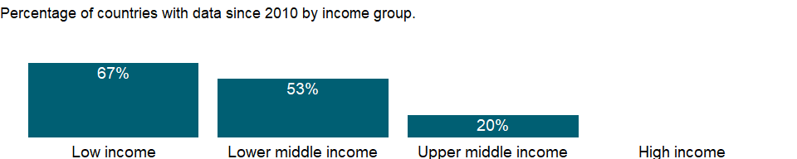

### Why is it relevant?

NA

### What is the data source?

Demographic and Health Surveys (DHS), Multiple Indicator Cluster Surveys (MICS), and other surveys

### What is the methodology?

NA

### How is it aggregated?

NA

### What are the limitations?

NA

### What else should I know?

NA

## 1.64 Health: Risk factors

### 1.64.1 Total alcohol consumption per capita, female (liters of pure alcohol, projected estimates, female 15+ years of age)

### What is the indicator?

Total alcohol per capita consumption is defined as the total (sum of recorded and unrecorded alcohol) amount of alcohol consumed per person (15 years of age or older) over a calendar year, in litres of pure alcohol, adjusted for tourist consumption.

Topic: Health: Risk factors

Series ID: SH.ALC.PCAP.FE.LI

Copyright: CC BY-4.0 , <https://datacatalog.worldbank.org/public-licenses#cc-by>

First year with any data: 2000

Last year with any data: 2018

### What years are data available?

The figure below shows years in which data is available for at least one country. Dates shaded in black have no data, while dates shaded in green have data for at least one country

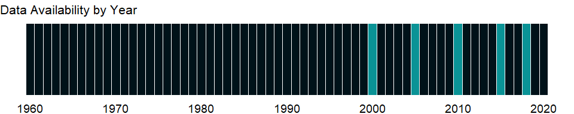

### Which countries have data?

The figure below shows the percentage of countries in each income group with a value since 2010 for that indicator.

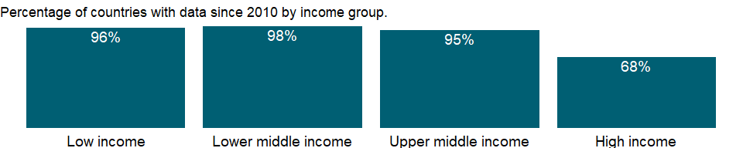

### Why is it relevant?

Acoording to the World Health Organization, alcohol consumption is a causal factor in more than 200 disease and injury conditions. In the world, an estimated 3 million deaths are from harmful use of alcohols every year. Drinking alcohol is associated with a risk of developing health problems such as mental and behavioural disorders, including alcohol dependence, major noncommunicable diseases such as liver cirrhosis, some cancers and cardiovascular diseases, as well as injuries resulting from violence and road clashes and collisions.

### What is the data source?

World Health Organization, Global Health Observatory Data Repository (<http://apps.who.int/ghodata/>).

### What is the methodology?

The estimates for the total alcohol consumption are produced by summing up the 3-year average per capita (15+) recorded alcohol consumption and an estimate of per capita (15+) unrecorded alcohol consumption for a calendar year. Tourist consumption takes into account tourists visiting the country and inhabitants visiting other countries.

### How is it aggregated?

Weighted Average

### What are the limitations?

NA

### What else should I know?

This is a sex-disaggregated indicator for Sustainable Development Goal 3.5.2 [<https://unstats.un.org/sdgs/metadata/>].

### 1.64.2 Total alcohol consumption per capita (liters of pure alcohol, projected estimates, 15+ years of age)

### What is the indicator?

Total alcohol per capita consumption is defined as the total (sum of recorded and unrecorded alcohol) amount of alcohol consumed per person (15 years of age or older) over a calendar year, in litres of pure alcohol, adjusted for tourist consumption.

Topic: Health: Risk factors

Series ID: SH.ALC.PCAP.LI

Copyright: CC BY-4.0 , <https://datacatalog.worldbank.org/public-licenses#cc-by>

First year with any data: 2000

Last year with any data: 2018

### What years are data available?

The figure below shows years in which data is available for at least one country. Dates shaded in black have no data, while dates shaded in green have data for at least one country



### Which countries have data?

The figure below shows the percentage of countries in each income group with a value since 2010 for that indicator.



### Why is it relevant?

Acoording to the World Health Organization, alcohol consumption is a causal factor in more than 200 disease and injury conditions. In the world, an estimated 3 million deaths are from harmful use of alcohols every year. Drinking alcohol is associated with a risk of developing health problems such as mental and behavioural disorders, including alcohol dependence, major noncommunicable diseases such as liver cirrhosis, some cancers and cardiovascular diseases, as well as injuries resulting from violence and road clashes and collisions.

### What is the data source?

World Health Organization, Global Health Observatory Data Repository (<http://apps.who.int/ghodata/>).

### What is the methodology?

The estimates for the total alcohol consumption are produced by summing up the 3-year average per capita (15+) recorded alcohol consumption and an estimate of per capita (15+) unrecorded alcohol consumption for a calendar year. Tourist consumption takes into account tourists visiting the country and inhabitants visiting other countries.

### How is it aggregated?

Weighted Average

### What are the limitations?

NA

### What else should I know?

This is the Sustainable Development Goal indicator 3.5.2[<https://unstats.un.org/sdgs/metadata/>].

### 1.64.3 Total alcohol consumption per capita, male (liters of pure alcohol, projected estimates, male 15+ years of age)

### What is the indicator?

Total alcohol per capita consumption is defined as the total (sum of recorded and unrecorded alcohol) amount of alcohol consumed per person (15 years of age or older) over a calendar year, in litres of pure alcohol, adjusted for tourist consumption.

Topic: Health: Risk factors

Series ID: SH.ALC.PCAP.MA.LI

Copyright: CC BY-4.0 , <https://datacatalog.worldbank.org/public-licenses#cc-by>

First year with any data: 2000

Last year with any data: 2018

### What years are data available?

The figure below shows years in which data is available for at least one country. Dates shaded in black have no data, while dates shaded in green have data for at least one country



### Which countries have data?

The figure below shows the percentage of countries in each income group with a value since 2010 for that indicator.



### Why is it relevant?

Acoording to the World Health Organization, alcohol consumption is a causal factor in more than 200 disease and injury conditions. In the world, an estimated 3 million deaths are from harmful use of alcohols every year. Drinking alcohol is associated with a risk of developing health problems such as mental and behavioural disorders, including alcohol dependence, major noncommunicable diseases such as liver cirrhosis, some cancers and cardiovascular diseases, as well as injuries resulting from violence and road clashes and collisions.

### What is the data source?

World Health Organization, Global Health Observatory Data Repository (<http://apps.who.int/ghodata/>).

### What is the methodology?

The estimates for the total alcohol consumption are produced by summing up the 3-year average per capita (15+) recorded alcohol consumption and an estimate of per capita (15+) unrecorded alcohol consumption for a calendar year. Tourist consumption takes into account tourists visiting the country and inhabitants visiting other countries.

### How is it aggregated?

Weighted Average

### What are the limitations?

NA

### What else should I know?

This is a sex-disaggregated indicator for Sustainable Development Goal 3.5.2 [<https://unstats.un.org/sdgs/metadata/>].

### 1.64.4 Cause of death, by communicable diseases and maternal, prenatal and nutrition conditions (% of total)

### What is the indicator?

Cause of death refers to the share of all deaths for all ages by underlying causes. Communicable diseases and maternal, prenatal and nutrition conditions include infectious and parasitic diseases, respiratory infections, and nutritional deficiencies such as underweight and stunting.

Topic: Health: Risk factors

Series ID: SH.DTH.COMM.ZS

Copyright: CC BY-4.0 , <https://datacatalog.worldbank.org/public-licenses#cc-by>

First year with any data: 2000

Last year with any data: 2019

### What years are data available?

The figure below shows years in which data is available for at least one country. Dates shaded in black have no data, while dates shaded in green have data for at least one country

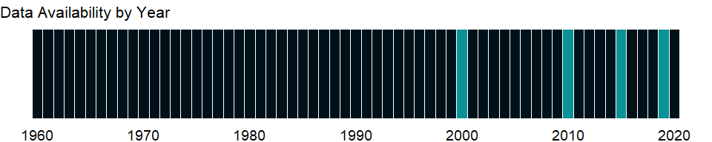

### Which countries have data?

The figure below shows the percentage of countries in each income group with a value since 2010 for that indicator.

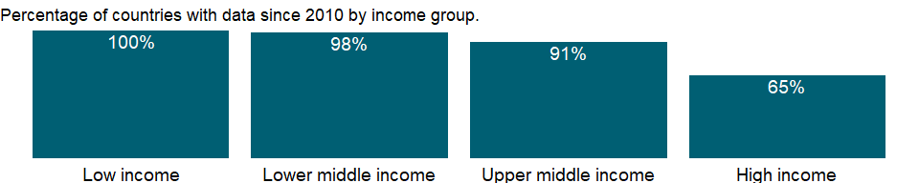

### Why is it relevant?

NA

### What is the data source?

Derived based on the data from Global Health Estimates 2020: Deaths by Cause, Age, Sex, by Country and by Region, 2000-2019. Geneva, World Health Organization; 2020. Link: <https://www.who.int/data/gho/data/themes/mortality-and-global-health-estimates/ghe-leading-causes-of-death>

### What is the methodology?

Data on cause of death are compiled by the WHO, based mainly on data from national vital registry systems, as well as sample registration systems, population laboratories, and epidemiological analysis of specific conditions. Data are classified based on the International Statistical Classification of Diseases and Related Health Problems, 10th revision. Data have been carefully analyzed to take into account incomplete coverage of vital registration and the likely differences in cause of death patterns that would be expected in undercovered and often poorer subpopulations. Special attention has also been paid to misattribution or miscoding of causes of death in cardiovascular diseases, cancer, injuries, and general ill-defined categories. For further information, consult the original source.

### How is it aggregated?

Weighted average

### What are the limitations?

The limited availability of data on health status is a major constraint in assessing the health situation in developing countries. Surveillance data are lacking for many major public health concerns. Estimates of prevalence and incidence are available for some diseases but are often unreliable and incomplete. National health authorities differ widely in capacity and willingness to collect or report information. To compensate for this and improve reliability and international comparability, the World Health Organization (WHO) prepares estimates in accordance with epidemiological models and statistical standards.

### What else should I know?

NA

### 1.64.5 Cause of death, by injury (% of total)

### What is the indicator?

Cause of death refers to the share of all deaths for all ages by underlying causes. Injuries include unintentional and intentional injuries.

Topic: Health: Risk factors

Series ID: SH.DTH.INJR.ZS

Copyright: CC BY-4.0 , <https://datacatalog.worldbank.org/public-licenses#cc-by>

First year with any data: 2000

Last year with any data: 2019

### What years are data available?

The figure below shows years in which data is available for at least one country. Dates shaded in black have no data, while dates shaded in green have data for at least one country



### Which countries have data?

The figure below shows the percentage of countries in each income group with a value since 2010 for that indicator.



### Why is it relevant?

NA

### What is the data source?

Derived based on the data from Global Health Estimates 2020: Deaths by Cause, Age, Sex, by Country and by Region, 2000-2019. Geneva, World Health Organization; 2020. Link: <https://www.who.int/data/gho/data/themes/mortality-and-global-health-estimates/ghe-leading-causes-of-death>

### What is the methodology?

Data on cause of death are compiled by the WHO, based mainly on data from national vital registry systems, as well as sample registration systems, population laboratories, and epidemiological analysis of specific conditions. Data are classified based on the International Statistical Classification of Diseases and Related Health Problems, 10th revision. Data have been carefully analyzed to take into account incomplete coverage of vital registration and the likely differences in cause of death patterns that would be expected in under-covered and often poorer subpopulations. Special attention has also been paid to misattribution or miscoding of causes of death in cardiovascular diseases, cancer, injuries, and general ill-defined categories. For further information, consult the original source.

### How is it aggregated?

Weighted average

### What are the limitations?

The limited availability of data on health status is a major constraint in assessing the health situation in developing countries. Surveillance data are lacking for many major public health concerns. Estimates of prevalence and incidence are available for some diseases but are often unreliable and incomplete. National health authorities differ widely in capacity and willingness to collect or report information. To compensate for this and improve reliability and international comparability, the World Health Organization (WHO) prepares estimates in accordance with epidemiological models and statistical standards.

### What else should I know?

NA

### 1.64.6 Cause of death, by non-communicable diseases (% of total)

### What is the indicator?

Cause of death refers to the share of all deaths for all ages by underlying causes. Non-communicable diseases include cancer, diabetes mellitus, cardiovascular diseases, digestive diseases, skin diseases, musculoskeletal diseases, and congenital anomalies.

Topic: Health: Risk factors

Series ID: SH.DTH.NCOM.ZS

Copyright: CC BY-4.0 , <https://datacatalog.worldbank.org/public-licenses#cc-by>

First year with any data: 2000

Last year with any data: 2019

### What years are data available?

The figure below shows years in which data is available for at least one country. Dates shaded in black have no data, while dates shaded in green have data for at least one country



### Which countries have data?

The figure below shows the percentage of countries in each income group with a value since 2010 for that indicator.



### Why is it relevant?

NA

### What is the data source?

Derived based on the data from Global Health Estimates 2020: Deaths by Cause, Age, Sex, by Country and by Region, 2000-2019. Geneva, World Health Organization; 2020. Link: <https://www.who.int/data/gho/data/themes/mortality-and-global-health-estimates/ghe-leading-causes-of-death>

### What is the methodology?

Data on cause of death are compiled by the WHO, based mainly on data from national vital registry systems, as well as sample registration systems, population laboratories, and epidemiological analysis of specific conditions. Data are classified based on the International Statistical Classification of Diseases and Related Health Problems, 10th revision. Data have been carefully analyzed to take into account incomplete coverage of vital registration and the likely differences in cause of death patterns that would be expected in undercovered and often poorer subpopulations. Special attention has also been paid to misattribution or miscoding of causes of death in cardiovascular diseases, cancer, injuries, and general ill-defined categories. For further information, consult the original source.

### How is it aggregated?

Weighted average

### What are the limitations?

The limited availability of data on health status is a major constraint in assessing the health situation in developing countries. Surveillance data are lacking for many major public health concerns. Estimates of prevalence and incidence are available for some diseases but are often unreliable and incomplete. National health authorities differ widely in capacity and willingness to collect or report information. To compensate for this and improve reliability and international comparability, the World Health Organization (WHO) prepares estimates in accordance with epidemiological models and statistical standards.

### What else should I know?

NA

### 1.64.7 Women’s share of population ages 15+ living with HIV (%)

### What is the indicator?

Prevalence of HIV is the percentage of people who are infected with HIV. Female rate is as a percentage of the total population ages 15+ who are living with HIV.

Topic: Health: Risk factors

Series ID: SH.DYN.AIDS.FE.ZS

Copyright: CC BY-4.0 , <https://datacatalog.worldbank.org/public-licenses#cc-by>

First year with any data: 1990

Last year with any data: 2020

### What years are data available?

The figure below shows years in which data is available for at least one country. Dates shaded in black have no data, while dates shaded in green have data for at least one country



### Which countries have data?

The figure below shows the percentage of countries in each income group with a value since 2010 for that indicator.

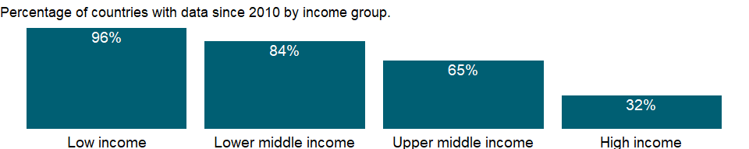

### Why is it relevant?

NA

### What is the data source?

UNAIDS estimates.

### What is the methodology?

HIV prevalence rates reflect the rate of HIV infection in each country’s population. Low national prevalence rates can be misleading, however. They often disguise epidemics that are initially concentrated in certain localities or population groups and threaten to spill over into the wider population. In many developing countries most new infections occur in young adults, with young women especially vulnerable.

Data on HIV are from the Joint United Nations Programme on HIV/AIDS (UNAIDS). Changes in procedures and assumptions for estimating the data and better coordination with countries have resulted in improved estimates of HIV and AIDS. The models, which are routinely updated, track the course of HIV epidemics and their impact, making full use of information in HIV prevalence trends from surveillance data as well as survey data. The models take into account reduced infectivity among people receiving antiretroviral therapy (which is having a larger impact on HIV prevalence and allowing HIV-positive people to live longer) and allow for changes in urbanization over time in generalized epidemics. The estimates include plausibility bounds, which reflect the certainty associated with each of the estimates.

### How is it aggregated?

Weighted average

### What are the limitations?

The limited availability of data on health status is a major constraint in assessing the health situation in developing countries. Surveillance data are lacking for many major public health concerns. Estimates of prevalence and incidence are available for some diseases but are often unreliable and incomplete. National health authorities differ widely in capacity and willingness to collect or report information.

### What else should I know?

NA

### 1.64.8 Prevalence of HIV, total (% of population ages 15-49)

### What is the indicator?

Prevalence of HIV refers to the percentage of people ages 15-49 who are infected with HIV.

Topic: Health: Risk factors

Series ID: SH.DYN.AIDS.ZS

Copyright: CC BY-4.0 , <https://datacatalog.worldbank.org/public-licenses#cc-by>

First year with any data: 1990

Last year with any data: 2020

### What years are data available?

The figure below shows years in which data is available for at least one country. Dates shaded in black have no data, while dates shaded in green have data for at least one country



### Which countries have data?

The figure below shows the percentage of countries in each income group with a value since 2010 for that indicator.

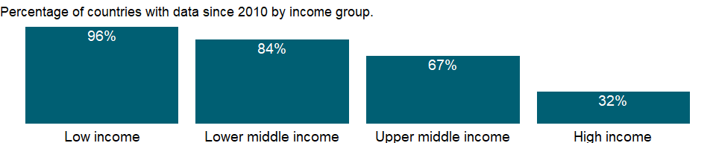

### Why is it relevant?

NA

### What is the data source?

UNAIDS estimates.

### What is the methodology?

HIV prevalence rates reflect the rate of HIV infection in each country’s population. Low national prevalence rates can be misleading, however. They often disguise epidemics that are initially concentrated in certain localities or population groups and threaten to spill over into the wider population. In many developing countries most new infections occur in young adults, with young women especially vulnerable.

Data on HIV are from the Joint United Nations Programme on HIV/AIDS (UNAIDS). Changes in procedures and assumptions for estimating the data and better coordination with countries have resulted in improved estimates of HIV and AIDS. The models, which are routinely updated, track the course of HIV epidemics and their impact, making full use of information in HIV prevalence trends from surveillance data as well as survey data. The models take into account reduced infectivity among people receiving antiretroviral therapy (which is having a larger impact on HIV prevalence and allowing HIV-positive people to live longer) and allow for changes in urbanization over time in generalized epidemics. The estimates include plausibility bounds, which reflect the certainty associated with each of the estimates.

### How is it aggregated?

Weighted Average

### What are the limitations?

The limited availability of data on health status is a major constraint in assessing the health situation in developing countries. Surveillance data are lacking for many major public health concerns. Estimates of prevalence and incidence are available for some diseases but are often unreliable and incomplete. National health authorities differ widely in capacity and willingness to collect or report information.

### What else should I know?

NA

### 1.64.9 Children (0-14) living with HIV

### What is the indicator?

Children living with HIV refers to the number of children ages 0-14 who are infected with HIV.

Topic: Health: Risk factors

Series ID: SH.HIV.0014

Copyright: CC BY-4.0 , <https://datacatalog.worldbank.org/public-licenses#cc-by>

First year with any data: 1990

Last year with any data: 2020

### What years are data available?

The figure below shows years in which data is available for at least one country. Dates shaded in black have no data, while dates shaded in green have data for at least one country



### Which countries have data?

The figure below shows the percentage of countries in each income group with a value since 2010 for that indicator.

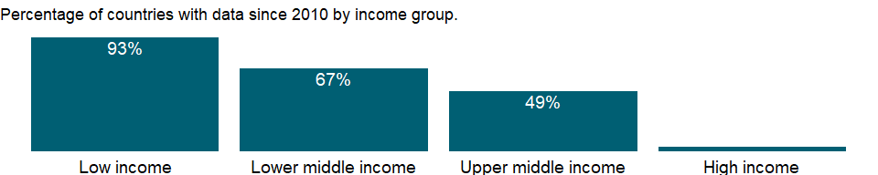

### Why is it relevant?

NA

### What is the data source?

UNAIDS estimates.

### What is the methodology?

NA

### How is it aggregated?

NA

### What are the limitations?

NA

### What else should I know?

NA

### 1.64.10 Prevalence of HIV, female (% ages 15-24)

### What is the indicator?

Prevalence of HIV, female is the percentage of females who are infected with HIV. Youth rates are as a percentage of the relevant age group.

Topic: Health: Risk factors

Series ID: SH.HIV.1524.FE.ZS

Copyright: CC BY-4.0 , <https://datacatalog.worldbank.org/public-licenses#cc-by>

First year with any data: 1990

Last year with any data: 2020

### What years are data available?

The figure below shows years in which data is available for at least one country. Dates shaded in black have no data, while dates shaded in green have data for at least one country



### Which countries have data?

The figure below shows the percentage of countries in each income group with a value since 2010 for that indicator.



### Why is it relevant?

NA

### What is the data source?

UNAIDS estimates.

### What is the methodology?

HIV prevalence rates reflect the rate of HIV infection in each country’s population. Low national prevalence rates can be misleading, however. They often disguise epidemics that are initially concentrated in certain localities or population groups and threaten to spill over into the wider population. In many developing countries most new infections occur in young adults, with young women especially vulnerable.

Data on HIV are from the Joint United Nations Programme on HIV/AIDS (UNAIDS). Changes in procedures and assumptions for estimating the data and better coordination with countries have resulted in improved estimates of HIV and AIDS. The models, which are routinely updated, track the course of HIV epidemics and their impact, making full use of information in HIV prevalence trends from surveillance data as well as survey data. The models take into account reduced infectivity among people receiving antiretroviral therapy (which is having a larger impact on HIV prevalence and allowing HIV-positive people to live longer) and allow for changes in urbanization over time in generalized epidemics. The estimates include plausibility bounds, which reflect the certainty associated with each of the estimates.

### How is it aggregated?

Weighted average

### What are the limitations?

The limited availability of data on health status is a major constraint in assessing the health situation in developing countries. Surveillance data are lacking for many major public health concerns. Estimates of prevalence and incidence are available for some diseases but are often unreliable and incomplete. National health authorities differ widely in capacity and willingness to collect or report information.

### What else should I know?

In many developing countries most new infections occur in young adults, with young women especially vulnerable.

### 1.64.11 Prevalence of HIV, male (% ages 15-24)

### What is the indicator?

Prevalence of HIV, male is the percentage of males who are infected with HIV. Youth rates are as a percentage of the relevant age group.

Topic: Health: Risk factors

Series ID: SH.HIV.1524.MA.ZS

Copyright: CC BY-4.0 , <https://datacatalog.worldbank.org/public-licenses#cc-by>

First year with any data: 1990

Last year with any data: 2020

### What years are data available?

The figure below shows years in which data is available for at least one country. Dates shaded in black have no data, while dates shaded in green have data for at least one country



### Which countries have data?

The figure below shows the percentage of countries in each income group with a value since 2010 for that indicator.



### Why is it relevant?

NA

### What is the data source?

UNAIDS estimates.

### What is the methodology?

HIV prevalence rates reflect the rate of HIV infection in each country’s population. Low national prevalence rates can be misleading, however. They often disguise epidemics that are initially concentrated in certain localities or population groups and threaten to spill over into the wider population. In many developing countries most new infections occur in young adults, with young women especially vulnerable.

Data on HIV are from the Joint United Nations Programme on HIV/AIDS (UNAIDS). Changes in procedures and assumptions for estimating the data and better coordination with countries have resulted in improved estimates of HIV and AIDS. The models, which are routinely updated, track the course of HIV epidemics and their impact, making full use of information in HIV prevalence trends from surveillance data as well as survey data. The models take into account reduced infectivity among people receiving antiretroviral therapy (which is having a larger impact on HIV prevalence and allowing HIV-positive people to live longer) and allow for changes in urbanization over time in generalized epidemics. The estimates include plausibility bounds, which reflect the certainty associated with each of the estimates.

### How is it aggregated?

Weighted average

### What are the limitations?

The limited availability of data on health status is a major constraint in assessing the health situation in developing countries. Surveillance data are lacking for many major public health concerns. Estimates of prevalence and incidence are available for some diseases but are often unreliable and incomplete. National health authorities differ widely in capacity and willingness to collect or report information.

### What else should I know?

In many developing countries most new infections occur in young adults, with young women being especially vulnerable.

### 1.64.12 Antiretroviral therapy coverage (% of people living with HIV)

### What is the indicator?

Antiretroviral therapy coverage indicates the percentage of all people living with HIV who are receiving antiretroviral therapy.

Topic: Health: Risk factors

Series ID: SH.HIV.ARTC.ZS

Copyright: CC BY-4.0 , <https://datacatalog.worldbank.org/public-licenses#cc-by>

First year with any data: 2000

Last year with any data: 2020

### What years are data available?

The figure below shows years in which data is available for at least one country. Dates shaded in black have no data, while dates shaded in green have data for at least one country



### Which countries have data?

The figure below shows the percentage of countries in each income group with a value since 2010 for that indicator.

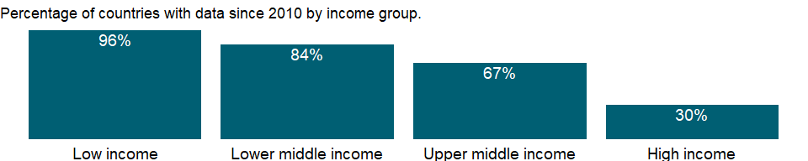

### Why is it relevant?

NA

### What is the data source?

UNAIDS estimates.

### What is the methodology?

Data on HIV are from the Joint United Nations Programme on HIV/AIDS (UNAIDS). Changes in procedures and assumptions for estimating the data and better coordination with countries have resulted in improved estimates of HIV and AIDS.

Antiretroviral therapy has led to huge reductions in death and suffering of people with advanced HIV infection.

### How is it aggregated?

Weighted Average

### What are the limitations?

The limited availability of data on health status is a major constraint in assessing the health situation in developing countries. Surveillance data are lacking for many major public health concerns. Estimates of prevalence and incidence are available for some diseases but are often unreliable and incomplete. National health authorities differ widely in capacity and willingness to collect or report information.

### What else should I know?

NA

### 1.64.13 Adults (ages 15-49) newly infected with HIV

### What is the indicator?

Number of adults (ages 15-49) newly infected with HIV.

Topic: Health: Risk factors

Series ID: SH.HIV.INCD

Copyright: CC BY-4.0 , <https://datacatalog.worldbank.org/public-licenses#cc-by>

First year with any data: 1990

Last year with any data: 2020

### What years are data available?

The figure below shows years in which data is available for at least one country. Dates shaded in black have no data, while dates shaded in green have data for at least one country



### Which countries have data?

The figure below shows the percentage of countries in each income group with a value since 2010 for that indicator.

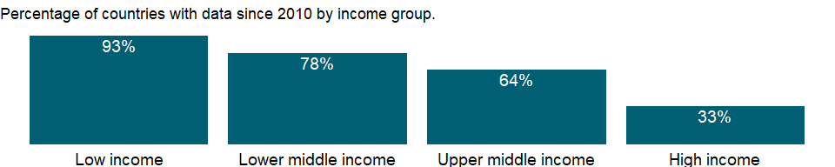

### Why is it relevant?

Despite the existence of effective medications and treatment, HIV/AIDS is still a leading cause of death and public health threat in the world. Low and middle income countries continue to bear a disproportionate share of the global burden of HIV/AIDS. The incidence rate provides a measure of progress toward preventing onward transmission of HIV. Also, the identification of newly infected persons will allow for interventions to reduce the risk of HIV transmission.

### What is the data source?

UNAIDS estimates.

### What is the methodology?

NA

### How is it aggregated?

NA

### What are the limitations?

NA

### What else should I know?

This indicator is related to Sustainable Development Goal 3.3.1 [<https://unstats.un.org/sdgs/metadata/>].

### 1.64.14 Children (ages 0-14) newly infected with HIV

### What is the indicator?

Number of children (ages 0-14) newly infected with HIV.

Topic: Health: Risk factors

Series ID: SH.HIV.INCD.14

Copyright: CC BY-4.0 , <https://datacatalog.worldbank.org/public-licenses#cc-by>

First year with any data: 1990

Last year with any data: 2020

### What years are data available?

The figure below shows years in which data is available for at least one country. Dates shaded in black have no data, while dates shaded in green have data for at least one country



### Which countries have data?

The figure below shows the percentage of countries in each income group with a value since 2010 for that indicator.

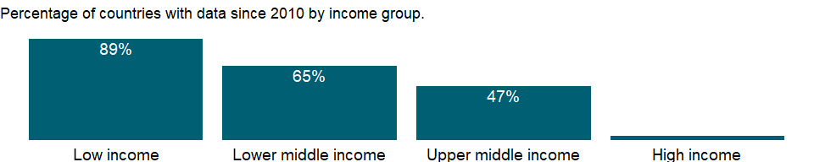

### Why is it relevant?

Despite the existence of effective medications and treatment, HIV/AIDS is still a leading cause of death and public health threat in the world. Low and middle income countries continue to bear a disproportionate share of the global burden of HIV/AIDS. The incidence rate provides a measure of progress toward preventing onward transmission of HIV. Also, the identification of newly infected persons will allow for interventions to reduce the risk of HIV transmission.

### What is the data source?

UNAIDS estimates.

### What is the methodology?

NA

### How is it aggregated?

NA

### What are the limitations?

NA

### What else should I know?

This indicator is related to Sustainable Development Goal 3.3.1 [<https://unstats.un.org/sdgs/metadata/>].

### 1.64.15 Adults (ages 15+) and children (ages 0-14) newly infected with HIV

### What is the indicator?

Number of adults (ages 15+) and children (ages 0-14) newly infected with HIV.

Topic: Health: Risk factors

Series ID: SH.HIV.INCD.TL

Copyright: CC BY-4.0 , <https://datacatalog.worldbank.org/public-licenses#cc-by>

First year with any data: 1990

Last year with any data: 2020

### What years are data available?

The figure below shows years in which data is available for at least one country. Dates shaded in black have no data, while dates shaded in green have data for at least one country



### Which countries have data?

The figure below shows the percentage of countries in each income group with a value since 2010 for that indicator.

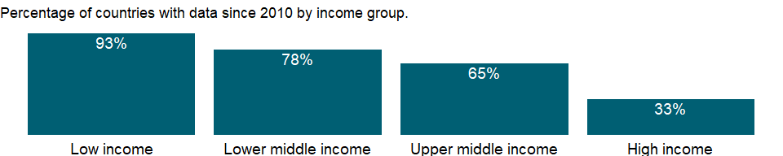

### Why is it relevant?

Despite the existence of effective medications and treatment, HIV/AIDS is still a leading cause of death and public health threat in the world. Low and middle income countries continue to bear a disproportionate share of the global burden of HIV/AIDS. The incidence rate provides a measure of progress toward preventing onward transmission of HIV. Also, the identification of newly infected persons will allow for interventions to reduce the risk of HIV transmission.

### What is the data source?

UNAIDS estimates.

### What is the methodology?

NA

### How is it aggregated?

NA

### What are the limitations?

NA

### What else should I know?

This indicator is related to Sustainable Development Goal 3.3.1 [<https://unstats.un.org/sdgs/metadata/>].

### 1.64.16 Incidence of HIV, all (per 1,000 uninfected population)

### What is the indicator?

Number of new HIV infections among uninfected populations expressed per 1,000 uninfected population in the year before the period.

Topic: Health: Risk factors

Series ID: SH.HIV.INCD.TL.P3

Copyright: NA , NA

First year with any data: 1990

Last year with any data: 2020

### What years are data available?

The figure below shows years in which data is available for at least one country. Dates shaded in black have no data, while dates shaded in green have data for at least one country



### Which countries have data?

The figure below shows the percentage of countries in each income group with a value since 2010 for that indicator.

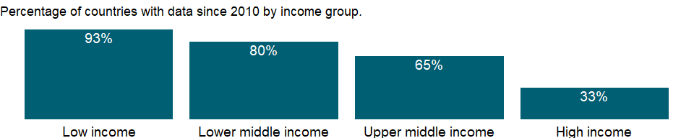

### Why is it relevant?

Despite the existence of effective medications and treatment, HIV/AIDS is still a leading cause of death and public health threat in the world. Low and middle income countries continue to bear a disproportionate share of the global burden of HIV/AIDS. The incidence rate provides a measure of progress toward preventing onward transmission of HIV. Also, the identification of newly infected persons will allow for interventions to reduce the risk of HIV transmission.

### What is the data source?

UNAIDS estimates.

### What is the methodology?

Data on incidence of HIV are from the Joint United Nations Programme on HIV/AIDS. Because of challenges in collecting direct measures of HIV incidence, modelled estimates are used (the Spectrum software). The models incorporate data on HIV prevalence from surveys of the general population, antenatal clinic attendees, and populations at increased risk of contracting HIV (such as sex workers, men who have sex with men, and people who inject drugs) and on the number of people receiving antiretroviral therapy, which will increase the prevalence of HIV because people living with HIV now survive longer. In countries with high-quality health information systems the models are also informed by case reporting and vital registration data.

### How is it aggregated?

Weighted Average

### What are the limitations?

NA

### What else should I know?

This is the Sustainable Development Goal indicator 3.3.1 [<https://unstats.un.org/sdgs/metadata/>].

### 1.64.17 Young people (ages 15-24) newly infected with HIV

### What is the indicator?

Number of young people (ages 15-24) newly infected with HIV.

Topic: Health: Risk factors

Series ID: SH.HIV.INCD.YG

Copyright: NA , NA

First year with any data: 1990

Last year with any data: 2020

### What years are data available?

The figure below shows years in which data is available for at least one country. Dates shaded in black have no data, while dates shaded in green have data for at least one country



### Which countries have data?

The figure below shows the percentage of countries in each income group with a value since 2010 for that indicator.

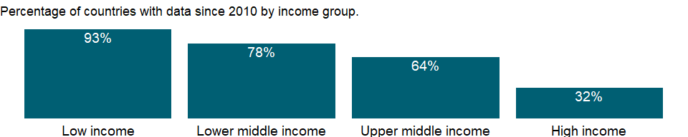

### Why is it relevant?

Despite the existence of effective medications and treatment, HIV/AIDS is still a leading cause of death and public health threat in the world. Low and middle income countries continue to bear a disproportionate share of the global burden of HIV/AIDS. The incidence rate provides a measure of progress toward preventing onward transmission of HIV. Also, the identification of newly infected persons will allow for interventions to reduce the risk of HIV transmission.

### What is the data source?

UNAIDS estimates.

### What is the methodology?

NA

### How is it aggregated?

NA

### What are the limitations?

NA

### What else should I know?

This indicator is related to Sustainable Development Goal 3.3.1 [<https://unstats.un.org/sdgs/metadata/>].

### 1.64.18 Incidence of HIV, ages 15-24 (per 1,000 uninfected population ages 15-24)

### What is the indicator?

Number of new HIV infections among uninfected populations ages 15-24 expressed per 1,000 uninfected population ages 15-24 in the year before the period.

Topic: Health: Risk factors

Series ID: SH.HIV.INCD.YG.P3

Copyright: NA , NA

First year with any data: 1990

Last year with any data: 2020

### What years are data available?

The figure below shows years in which data is available for at least one country. Dates shaded in black have no data, while dates shaded in green have data for at least one country



### Which countries have data?

The figure below shows the percentage of countries in each income group with a value since 2010 for that indicator.



### Why is it relevant?

Despite the existence of effective medications and treatment, HIV/AIDS is still a leading cause of death and public health threat in the world. Low and middle income countries continue to bear a disproportionate share of the global burden of HIV/AIDS. The incidence rate provides a measure of progress toward preventing onward transmission of HIV. Also, the identification of newly infected persons will allow for interventions to reduce the risk of HIV transmission.

### What is the data source?

UNAIDS estimates.

### What is the methodology?

Data on incidence of HIV are from the Joint United Nations Programme on HIV/AIDS. Because of challenges in collecting direct measures of HIV incidence, modelled estimates are used (the Spectrum software). The models incorporate data on HIV prevalence from surveys of the general population, antenatal clinic attendees, and populations at increased risk of contracting HIV (such as sex workers, men who have sex with men, and people who inject drugs) and on the number of people receiving antiretroviral therapy, which will increase the prevalence of HIV because people living with HIV now survive longer. In countries with high-quality health information systems the models are also informed by case reporting and vital registration data.

### How is it aggregated?

Weighted Average

### What are the limitations?

NA

### What else should I know?

This is an age-disaggregated indicator for Sustainable Development Goal 3.3.1 [<https://unstats.un.org/sdgs/metadata/>].

### 1.64.19 Incidence of HIV, ages 15-49 (per 1,000 uninfected population ages 15-49)

### What is the indicator?

Number of new HIV infections among uninfected populations ages 15-49 expressed per 1,000 uninfected population in the year before the period.

Topic: Health: Risk factors

Series ID: SH.HIV.INCD.ZS

Copyright: CC BY-4.0 , <https://datacatalog.worldbank.org/public-licenses#cc-by>

First year with any data: 1990

Last year with any data: 2020

### What years are data available?

The figure below shows years in which data is available for at least one country. Dates shaded in black have no data, while dates shaded in green have data for at least one country



### Which countries have data?

The figure below shows the percentage of countries in each income group with a value since 2010 for that indicator.



### Why is it relevant?

Despite the existence of effective medications and treatment, HIV/AIDS is still a leading cause of death and public health threat in the world. Low and middle income countries continue to bear a disproportionate share of the global burden of HIV/AIDS. The incidence rate provides a measure of progress toward preventing onward transmission of HIV. Also, the identification of newly infected persons will allow for interventions to reduce the risk of HIV transmission.

### What is the data source?

UNAIDS estimates.

### What is the methodology?

Data on incidence of HIV are from the Joint United Nations Programme on HIV/AIDS. Because of challenges in collecting direct measures of HIV incidence, modelled estimates are used (the Spectrum software). The models incorporate data on HIV prevalence from surveys of the general population, antenatal clinic attendees, and populations at increased risk of contracting HIV (such as sex workers, men who have sex with men, and people who inject drugs) and on the number of people receiving antiretroviral therapy, which will increase the prevalence of HIV because people living with HIV now survive longer. In countries with high-quality health information systems the models are also informed by case reporting and vital registration data.

### How is it aggregated?

Weighted Average

### What are the limitations?

NA

### What else should I know?

This is the Sustainable Development Goal indicator 3.3.1 [<https://unstats.un.org/sdgs/metadata/>].

### 1.64.20 Antiretroviral therapy coverage for PMTCT (% of pregnant women living with HIV)

### What is the indicator?

Percentage of pregnant women with HIV who receive antiretroviral medicine for prevention of mother-to-child transmission (PMTCT).

Topic: Health: Risk factors

Series ID: SH.HIV.PMTC.ZS

Copyright: CC BY-4.0 , <https://datacatalog.worldbank.org/public-licenses#cc-by>

First year with any data: 2000

Last year with any data: 2020

### What years are data available?

The figure below shows years in which data is available for at least one country. Dates shaded in black have no data, while dates shaded in green have data for at least one country



### Which countries have data?

The figure below shows the percentage of countries in each income group with a value since 2010 for that indicator.

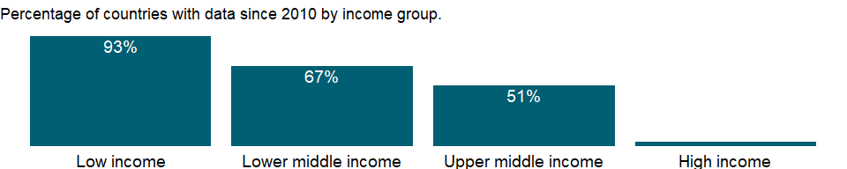

### Why is it relevant?

NA

### What is the data source?

UNAIDS estimates.

### What is the methodology?

NA

### How is it aggregated?

Weighted Average

### What are the limitations?

NA

### What else should I know?

NA

### 1.64.21 Incidence of malaria (per 1,000 population at risk)

### What is the indicator?

Incidence of malaria is the number of new cases of malaria in a year per 1,000 population at risk.

Topic: Health: Risk factors

Series ID: SH.MLR.INCD.P3

Copyright: CC BY-4.0 , <https://datacatalog.worldbank.org/public-licenses#cc-by>

First year with any data: 2000

Last year with any data: 2018

### What years are data available?

The figure below shows years in which data is available for at least one country. Dates shaded in black have no data, while dates shaded in green have data for at least one country



### Which countries have data?

The figure below shows the percentage of countries in each income group with a value since 2010 for that indicator.

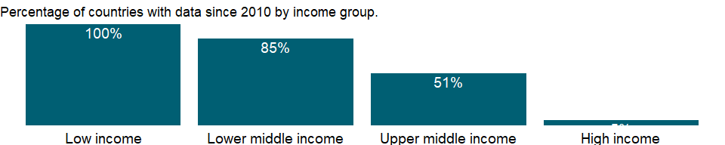

### Why is it relevant?

NA

### What is the data source?

World Health Organization, Global Health Observatory Data Repository/World Health Statistics (<http://apps.who.int/ghodata/>).

### What is the methodology?

NA

### How is it aggregated?

Weighted Average

### What are the limitations?

NA

### What else should I know?

This is the Sustainable Development Goal indicator 3.3.3[<https://unstats.un.org/sdgs/metadata/>].

### 1.64.22 Prevalence of current tobacco use (% of adults)

### What is the indicator?

The percentage of the population ages 15 years and over who currently use any tobacco product (smoked and/or smokeless tobacco) on a daily or non-daily basis. Tobacco products include cigarettes, pipes, cigars, cigarillos, waterpipes (hookah, shisha), bidis, kretek, heated tobacco products, and all forms of smokeless (oral and nasal) tobacco. Tobacco products exclude e-cigarettes (which do not contain tobacco), “e-cigars”, “e-hookahs”, JUUL and “e-pipes”. The rates are age-standardized to the WHO Standard Population.

Topic: Health: Risk factors

Series ID: SH.PRV.SMOK

Copyright: CC BY-4.0 , <https://datacatalog.worldbank.org/public-licenses#cc-by>

First year with any data: 2007

Last year with any data: 2018

### What years are data available?

The figure below shows years in which data is available for at least one country. Dates shaded in black have no data, while dates shaded in green have data for at least one country



### Which countries have data?

The figure below shows the percentage of countries in each income group with a value since 2010 for that indicator.

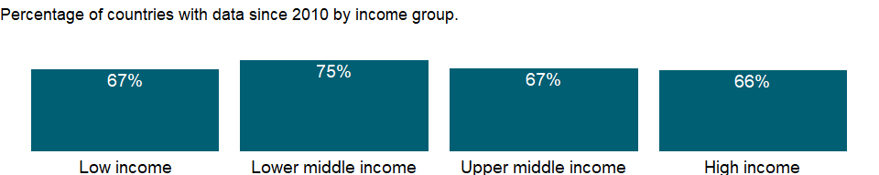

### Why is it relevant?

NA

### What is the data source?

World Health Organization, Global Health Observatory Data Repository (<http://apps.who.int/ghodata/>).

### What is the methodology?

The limited availability of data on health status is a major constraint in assessing the health situation in developing countries. Surveillance data are lacking for many major public health concerns. Estimates of prevalence and incidence are available for some diseases but are often unreliable and incomplete. National health authorities differ widely in capacity and willingness to collect or report information. To compensate for this and improve reliability and international comparability, the World Health Organization (WHO) prepares estimates in accordance with epidemiological models and statistical standards.

A statistical model based on a Bayesian negative binomial meta-regression is used to model prevalence of current tobacco use for each country, separately for men and women.

The model has two main components: (a) adjusting for missing indicators and age groups, and (b) generating an estimate of trends over time as well as the 95% credible interval around the estimate. Depending on the completeness/comprehensiveness of survey data from a particular country, the model at times makes use of data from other countries to fill information gaps. When a country has fewer than two nationally representative population-based surveys in different years, no attempt is made to fill data gaps and no estimates are calculated. To fill data gaps, information is “borrowed” from countries in the same UN subregion. The resulting trend lines are used to derive estimates for single years, so that a number can be reported even if the country did not run a survey in that year. In order to make the results comparable between countries, the prevalence rates are age-standardized to the WHO Standard Population. A full description of the method is available as a peer-reviewed article in The Lancet, volume 385, No. 9972, p966–976 (2015).

### How is it aggregated?

Weighted average

### What are the limitations?

Estimates for countries with irregular surveys or many data gaps have large uncertainty ranges, and such results should be interpreted with caution.

### What else should I know?

This is the Sustainable Development Goal indicator 3.a.1 [<https://unstats.un.org/sdgs/metadata/>].

Previous indicator name: Smoking prevalence, total (ages 15+) The previous indicator excluded smokeless tobacco use, while the current indicator includes. The indicator name and definition were updated in December, 2020.

### 1.64.23 Prevalence of current tobacco use, females (% of female adults)

### What is the indicator?

The percentage of the female population ages 15 years and over who currently use any tobacco product (smoked and/or smokeless tobacco) on a daily or non-daily basis. Tobacco products include cigarettes, pipes, cigars, cigarillos, waterpipes (hookah, shisha), bidis, kretek, heated tobacco products, and all forms of smokeless (oral and nasal) tobacco. Tobacco products exclude e-cigarettes (which do not contain tobacco), “e-cigars”, “e-hookahs”, JUUL and “e-pipes”. The rates are age-standardized to the WHO Standard Population.

Topic: Health: Risk factors

Series ID: SH.PRV.SMOK.FE

Copyright: CC BY-4.0 , <https://datacatalog.worldbank.org/public-licenses#cc-by>

First year with any data: 2007

Last year with any data: 2018

### What years are data available?

The figure below shows years in which data is available for at least one country. Dates shaded in black have no data, while dates shaded in green have data for at least one country



### Which countries have data?

The figure below shows the percentage of countries in each income group with a value since 2010 for that indicator.



### Why is it relevant?

NA

### What is the data source?

World Health Organization, Global Health Observatory Data Repository (<http://apps.who.int/ghodata/>).

### What is the methodology?

The limited availability of data on health status is a major constraint in assessing the health situation in developing countries. Surveillance data are lacking for many major public health concerns. Estimates of prevalence and incidence are available for some diseases but are often unreliable and incomplete. National health authorities differ widely in capacity and willingness to collect or report information. To compensate for this and improve reliability and international comparability, the World Health Organization (WHO) prepares estimates in accordance with epidemiological models and statistical standards.

A statistical model based on a Bayesian negative binomial meta-regression is used to model prevalence of current tobacco use for each country, separately for men and women.

The model has two main components: (a) adjusting for missing indicators and age groups, and (b) generating an estimate of trends over time as well as the 95% credible interval around the estimate. Depending on the completeness/comprehensiveness of survey data from a particular country, the model at times makes use of data from other countries to fill information gaps. When a country has fewer than two nationally representative population-based surveys in different years, no attempt is made to fill data gaps and no estimates are calculated. To fill data gaps, information is “borrowed” from countries in the same UN subregion. The resulting trend lines are used to derive estimates for single years, so that a number can be reported even if the country did not run a survey in that year. In order to make the results comparable between countries, the prevalence rates are age-standardized to the WHO Standard Population. A full description of the method is available as a peer-reviewed article in The Lancet, volume 385, No. 9972, p966–976 (2015).

### How is it aggregated?

Weighted average

### What are the limitations?

Estimates for countries with irregular surveys or many data gaps have large uncertainty ranges, and such results should be interpreted with caution.

### What else should I know?

This is the Sustainable Development Goal indicator 3.a.1 [<https://unstats.un.org/sdgs/metadata/>].

Previous indicator name: Smoking prevalence, females (% of adults) The previous indicator excluded smokeless tobacco use, while the current indicator includes it. The indicator name and definition were updated in December, 2020.

### 1.64.24 Prevalence of current tobacco use, males (% of male adults)

### What is the indicator?

The percentage of the male population ages 15 years and over who currently use any tobacco product (smoked and/or smokeless tobacco) on a daily or non-daily basis. Tobacco products include cigarettes, pipes, cigars, cigarillos, waterpipes (hookah, shisha), bidis, kretek, heated tobacco products, and all forms of smokeless (oral and nasal) tobacco. Tobacco products exclude e-cigarettes (which do not contain tobacco), “e-cigars”, “e-hookahs”, JUUL and “e-pipes”. The rates are age-standardized to the WHO Standard Population.

Topic: Health: Risk factors

Series ID: SH.PRV.SMOK.MA

Copyright: CC BY-4.0 , <https://datacatalog.worldbank.org/public-licenses#cc-by>

First year with any data: 2007

Last year with any data: 2018

### What years are data available?

The figure below shows years in which data is available for at least one country. Dates shaded in black have no data, while dates shaded in green have data for at least one country



### Which countries have data?

The figure below shows the percentage of countries in each income group with a value since 2010 for that indicator.



### Why is it relevant?

NA

### What is the data source?

World Health Organization, Global Health Observatory Data Repository (<http://apps.who.int/ghodata/>).

### What is the methodology?

The limited availability of data on health status is a major constraint in assessing the health situation in developing countries. Surveillance data are lacking for many major public health concerns. Estimates of prevalence and incidence are available for some diseases but are often unreliable and incomplete. National health authorities differ widely in capacity and willingness to collect or report information. To compensate for this and improve reliability and international comparability, the World Health Organization (WHO) prepares estimates in accordance with epidemiological models and statistical standards.

Smoking is the most common form of tobacco use and the prevalence of smoking is therefore a good measure of the tobacco epidemic. (Corrao MA, Guindon GE, Sharma N, Shokoohi DF (eds). Tobacco Control Country Profiles, 2000, American Cancer Society, Atlanta.) Tobacco use causes heart and other vascular diseases and cancers of the lung and other organs. Given the long delay between starting to smoke and the onset of disease, the health impact of smoking will increase rapidly only in the next few decades. The data presented are age-standardized rates for adults ages 15 and older from the WHO.

### How is it aggregated?

Weighted average

### What are the limitations?

Estimates for countries with irregular surveys or many data gaps have large uncertainty ranges, and such results should be interpreted with caution.

### What else should I know?

This is the Sustainable Development Goal indicator 3.a.1 [<https://unstats.un.org/sdgs/metadata/>].

Previous indicator name: Smoking prevalence, males (% of adults) The previous indicator excluded smokeless tobacco use, while the current indicator includes it. The indicator name and definition were updated in December, 2020.

### 1.64.25 Risk of catastrophic expenditure for surgical care (% of people at risk)

### What is the indicator?

The proportion of population at risk of catastrophic expenditure when surgical care is required. Catastrophic expenditure is defined as direct out of pocket payments for surgical and anaesthesia care exceeding 10% of total income.

Topic: Health: Risk factors

Series ID: SH.SGR.CRSK.ZS

Copyright: CC BY-4.0 , <https://datacatalog.worldbank.org/public-licenses#cc-by>

First year with any data: 2003

Last year with any data: 2020

### What years are data available?

The figure below shows years in which data is available for at least one country. Dates shaded in black have no data, while dates shaded in green have data for at least one country



### Which countries have data?

The figure below shows the percentage of countries in each income group with a value since 2010 for that indicator.

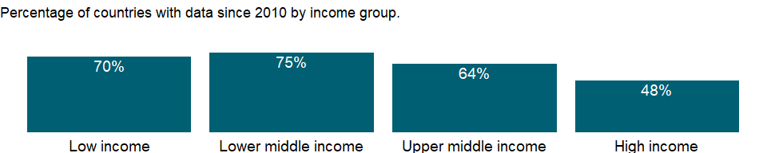

### Why is it relevant?

NA

### What is the data source?

The Program in Global Surgery and Social Change (PGSSC) at Harvard Medical School (<https://www.pgssc.org/>)

### What is the methodology?

NA

### How is it aggregated?

Weighted Average

### What are the limitations?

NA

### What else should I know?

NA

### 1.64.26 Risk of impoverishing expenditure for surgical care (% of people at risk)

### What is the indicator?

The proportion of population at risk of impoverishing expenditure when surgical care is required. Impoverishing expenditure is defined as direct out of pocket payments for surgical and anaesthesia care which drive people below a poverty threshold (using a threshold of $1.90 PPP/day).

Topic: Health: Risk factors

Series ID: SH.SGR.IRSK.ZS

Copyright: CC BY-4.0 , <https://datacatalog.worldbank.org/public-licenses#cc-by>

First year with any data: 2003

Last year with any data: 2020

### What years are data available?

The figure below shows years in which data is available for at least one country. Dates shaded in black have no data, while dates shaded in green have data for at least one country



### Which countries have data?

The figure below shows the percentage of countries in each income group with a value since 2010 for that indicator.



### Why is it relevant?

NA

### What is the data source?

The Program in Global Surgery and Social Change (PGSSC) at Harvard Medical School (<https://www.pgssc.org/>)

### What is the methodology?

NA

### How is it aggregated?

Weighted Average

### What are the limitations?

NA

### What else should I know?

NA

### 1.64.27 Diabetes prevalence (% of population ages 20 to 79)

### What is the indicator?

Diabetes prevalence refers to the percentage of people ages 20-79 who have type 1 or type 2 diabetes. It is calculated by adjusting to a standard population age-structure.

Topic: Health: Risk factors

Series ID: SH.STA.DIAB.ZS

Copyright: CC BY-4.0 , <https://datacatalog.worldbank.org/public-licenses#cc-by>

First year with any data: 2010

Last year with any data: 2019

### What years are data available?

The figure below shows years in which data is available for at least one country. Dates shaded in black have no data, while dates shaded in green have data for at least one country

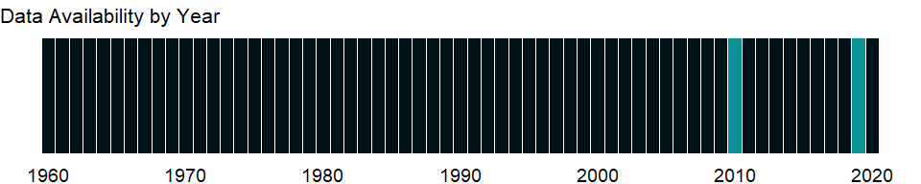

### Which countries have data?

The figure below shows the percentage of countries in each income group with a value since 2010 for that indicator.

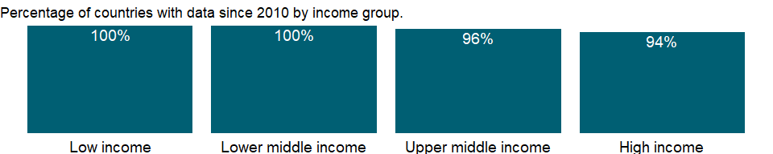

### Why is it relevant?

Diabetes, an important cause of ill health and a risk factor for other diseases in developed countries, is spreading rapidly in developing countries. Highest among the elderly, prevalence rates are rising among younger and productive populations in developing countries. Economic development has led to the spread of Western lifestyles and diet to developing countries, resulting in a substantial increase in diabetes. Without effective prevention and control programs, diabetes will likely continue to increase.

### What is the data source?

International Diabetes Federation, Diabetes Atlas.

### What is the methodology?

NA

### How is it aggregated?

Weighted average

### What are the limitations?

The limited availability of data on health status is a major constraint in assessing the health situation in developing countries. Surveillance data are lacking for many major public health concerns. Estimates of prevalence and incidence are available for some diseases but are often unreliable and incomplete. National health authorities differ widely in capacity and willingness to collect or report information.

### What else should I know?

NA

### 1.64.28 Female genital mutilation prevalence (%)

### What is the indicator?

Percentage of women aged 15–49 who have gone through partial or total removal of the female external genitalia or other injury to the female genital organs for cultural or other non-therapeutic reasons.

Topic: Health: Risk factors

Series ID: SH.STA.FGMS.ZS

Copyright: CC BY-4.0 , <https://datacatalog.worldbank.org/public-licenses#cc-by>

First year with any data: 1990

Last year with any data: 2020

### What years are data available?

The figure below shows years in which data is available for at least one country. Dates shaded in black have no data, while dates shaded in green have data for at least one country

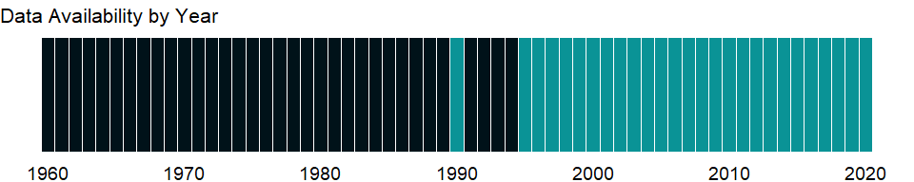

### Which countries have data?

The figure below shows the percentage of countries in each income group with a value since 2010 for that indicator.

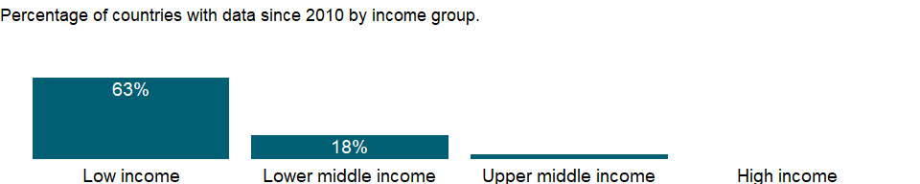

### Why is it relevant?

NA

### What is the data source?

UNICEF DATA (<http://www.data.unicef.org/>); Demographic and Health Surveys (DHS); Multiple Indicator Cluster Surveys (MICS), and other surveys.

### What is the methodology?

NA

### How is it aggregated?

NA

### What are the limitations?

NA

### What else should I know?

This is the Sustainable Development Goal indicator 5.3.2[<https://unstats.un.org/sdgs/metadata/>].

### 1.64.29 People practicing open defecation, rural (% of rural population)

### What is the indicator?

People practicing open defecation refers to the percentage of the population defecating in the open, such as in fields, forest, bushes, open bodies of water, on beaches, in other open spaces or disposed of with solid waste.

Topic: Health: Risk factors

Series ID: SH.STA.ODFC.RU.ZS

Copyright: CC BY-4.0 , <https://datacatalog.worldbank.org/public-licenses#cc-by>

First year with any data: 2000

Last year with any data: 2020

### What years are data available?

The figure below shows years in which data is available for at least one country. Dates shaded in black have no data, while dates shaded in green have data for at least one country



### Which countries have data?

The figure below shows the percentage of countries in each income group with a value since 2010 for that indicator.

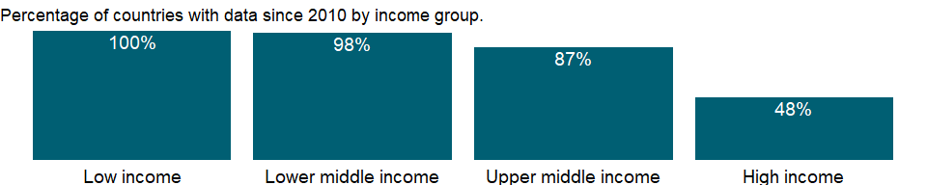

### Why is it relevant?

NA

### What is the data source?

WHO/UNICEF Joint Monitoring Programme (JMP) for Water Supply and Sanitation (<http://www.wssinfo.org/>).

### What is the methodology?

NA

### How is it aggregated?

Weighted Average

### What are the limitations?

NA

### What else should I know?

This is a disaggregated indicator for Sustainable Development Goal 6.2.1 [<https://unstats.un.org/sdgs/metadata/>].

### 1.64.30 People practicing open defecation, urban (% of urban population)

### What is the indicator?

People practicing open defecation refers to the percentage of the population defecating in the open, such as in fields, forest, bushes, open bodies of water, on beaches, in other open spaces or disposed of with solid waste.

Topic: Health: Risk factors

Series ID: SH.STA.ODFC.UR.ZS

Copyright: CC BY-4.0 , <https://datacatalog.worldbank.org/public-licenses#cc-by>

First year with any data: 2000

Last year with any data: 2020

### What years are data available?

The figure below shows years in which data is available for at least one country. Dates shaded in black have no data, while dates shaded in green have data for at least one country



### Which countries have data?

The figure below shows the percentage of countries in each income group with a value since 2010 for that indicator.

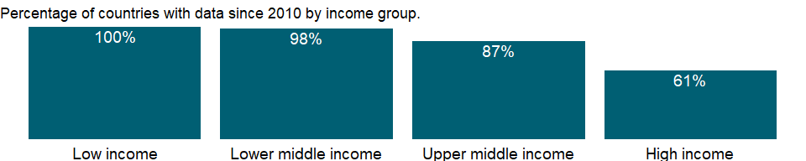

### Why is it relevant?

NA

### What is the data source?

WHO/UNICEF Joint Monitoring Programme (JMP) for Water Supply and Sanitation (<http://www.wssinfo.org/>).

### What is the methodology?

NA

### How is it aggregated?

Weighted Average

### What are the limitations?

NA

### What else should I know?

This is a disaggregated indicator for Sustainable Development Goal 6.2.1 [<https://unstats.un.org/sdgs/metadata/>].

### 1.64.31 People practicing open defecation (% of population)

### What is the indicator?

People practicing open defecation refers to the percentage of the population defecating in the open, such as in fields, forest, bushes, open bodies of water, on beaches, in other open spaces or disposed of with solid waste.

Topic: Health: Risk factors

Series ID: SH.STA.ODFC.ZS

Copyright: CC BY-4.0 , <https://datacatalog.worldbank.org/public-licenses#cc-by>

First year with any data: 2000

Last year with any data: 2020

### What years are data available?

The figure below shows years in which data is available for at least one country. Dates shaded in black have no data, while dates shaded in green have data for at least one country



### Which countries have data?

The figure below shows the percentage of countries in each income group with a value since 2010 for that indicator.



### Why is it relevant?

NA

### What is the data source?

WHO/UNICEF Joint Monitoring Programme (JMP) for Water Supply and Sanitation (<http://www.wssinfo.org/>).

### What is the methodology?

NA

### How is it aggregated?

Weighted Average

### What are the limitations?

NA

### What else should I know?

This is the Sustainable Development Goal indicator 6.2.1 [<https://unstats.un.org/sdgs/metadata/>].

### 1.64.32 Incidence of tuberculosis (per 100,000 people)

### What is the indicator?

Incidence of tuberculosis is the estimated number of new and relapse tuberculosis cases arising in a given year, expressed as the rate per 100,000 population. All forms of TB are included, including cases in people living with HIV. Estimates for all years are recalculated as new information becomes available and techniques are refined, so they may differ from those published previously.

Topic: Health: Risk factors

Series ID: SH.TBS.INCD

Copyright: CC BY-4.0 , <https://datacatalog.worldbank.org/public-licenses#cc-by>

First year with any data: 2000

Last year with any data: 2019

### What years are data available?

The figure below shows years in which data is available for at least one country. Dates shaded in black have no data, while dates shaded in green have data for at least one country



### Which countries have data?

The figure below shows the percentage of countries in each income group with a value since 2010 for that indicator.



### Why is it relevant?

NA

### What is the data source?

World Health Organization, Global Tuberculosis Report.

### What is the methodology?

Tuberculosis is one of the main causes of adult deaths from a single infectious agent in developing countries. In developed countries tuberculosis has reemerged largely as a result of cases among immigrants. Since tuberculosis incidence cannot be directly measured, estimates are obtained by eliciting expert opinion or are derived from measurements of prevalence or mortality.

### How is it aggregated?

Weighted average

### What are the limitations?

The limited availability of data on health status is a major constraint in assessing the health situation in developing countries. Surveillance data are lacking for many major public health concerns. Estimates of prevalence and incidence are available for some diseases but are often unreliable and incomplete. National health authorities differ widely in capacity and willingness to collect or report information. To compensate for this and improve reliability and international comparability, the World Health Organization (WHO) prepares estimates in accordance with epidemiological models and statistical standards.

Uncertainty bounds for the incidence are available at <http://data.worldbank.org>

### What else should I know?

Aggregate data by groups are computed based on the groupings for the World Bank fiscal year in which the data was released by the World Health Organization.

This is the Sustainable Development Goal indicator 3.3.2[<https://unstats.un.org/sdgs/metadata/>].

## 1.65 Health: Nutrition

### 1.65.1 Prevalence of anemia among women of reproductive age (% of women ages 15-49)

### What is the indicator?

Prevalence of anemia among women of reproductive age refers to the combined prevalence of both non-pregnant with haemoglobin levels below 12 g/dL and pregnant women with haemoglobin levels below 11 g/dL.

Topic: Health: Nutrition

Series ID: SH.ANM.ALLW.ZS

Copyright: CC BY-4.0 , <https://datacatalog.worldbank.org/public-licenses#cc-by>

First year with any data: 2000

Last year with any data: 2019

### What years are data available?

The figure below shows years in which data is available for at least one country. Dates shaded in black have no data, while dates shaded in green have data for at least one country



### Which countries have data?

The figure below shows the percentage of countries in each income group with a value since 2010 for that indicator.

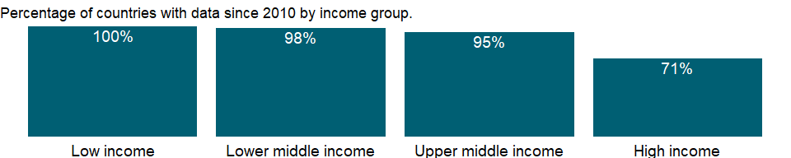

### Why is it relevant?

NA

### What is the data source?

World Health Organization, Global Health Observatory Data Repository/World Health Statistics.

### What is the methodology?

NA

### How is it aggregated?

Weighted Average

### What are the limitations?

NA

### What else should I know?

NA

### 1.65.2 Prevalence of anemia among children (% of children ages 6-59 months)

### What is the indicator?

Prevalence of anemia, children ages 6-59 months, is the percentage of children ages 6-59 months whose hemoglobin level is less than 110 grams per liter, adjusted for altitude.

Topic: Health: Nutrition

Series ID: SH.ANM.CHLD.ZS

Copyright: CC BY-4.0 , <https://datacatalog.worldbank.org/public-licenses#cc-by>

First year with any data: 2000

Last year with any data: 2019

### What years are data available?

The figure below shows years in which data is available for at least one country. Dates shaded in black have no data, while dates shaded in green have data for at least one country



### Which countries have data?

The figure below shows the percentage of countries in each income group with a value since 2010 for that indicator.



### Why is it relevant?

NA

### What is the data source?

World Health Organization, Global Health Observatory Data Repository/World Health Statistics.

### What is the methodology?

Data on anemia are compiled by the WHO, and a statistical model was used to estimate trends. WHO’s hemoglobin threshold concentration in blood was used.

### How is it aggregated?

Weighted average

### What are the limitations?

Data for blood haemoglobin concentrations are still limited, compared to other nutritional indicators such as hild anthropometry. As a result, the estimates may not capture the full variation across countries and regions.

### What else should I know?

Anemia is defined as a low blood haemoglobin concentration. Anaemia may result from a number of causes, with the most significant contributor being iron deficiency. Anaemia resulting from iron deficiency adversely affects cognitive and motor development and causes fatigue and low productivity. Children under age 5 and pregnant women have the highest risk for anemia.

### 1.65.3 Prevalence of anemia among non-pregnant women (% of women ages 15-49)

### What is the indicator?

Prevalence of anemia, non-pregnant women, is the percentage of non-pregnant women whose hemoglobin level is less than 120 grams per liter at sea level.

Topic: Health: Nutrition

Series ID: SH.ANM.NPRG.ZS

Copyright: CC BY-4.0 , <https://datacatalog.worldbank.org/public-licenses#cc-by>

First year with any data: 2000

Last year with any data: 2019

### What years are data available?

The figure below shows years in which data is available for at least one country. Dates shaded in black have no data, while dates shaded in green have data for at least one country



### Which countries have data?

The figure below shows the percentage of countries in each income group with a value since 2010 for that indicator.



### Why is it relevant?

NA

### What is the data source?

World Health Organization, Global Health Observatory Data Repository/World Health Statistics.

### What is the methodology?

NA

### How is it aggregated?

Weighted average

### What are the limitations?

NA

### What else should I know?

NA

### 1.65.4 Prevalence of anemia among pregnant women (%)

### What is the indicator?

Prevalence of anemia, pregnant women, is the percentage of pregnant women whose hemoglobin level is less than 110 grams per liter at sea level.

Topic: Health: Nutrition

Series ID: SH.PRG.ANEM

Copyright: CC BY-4.0 , <https://datacatalog.worldbank.org/public-licenses#cc-by>

First year with any data: 2000

Last year with any data: 2019

### What years are data available?

The figure below shows years in which data is available for at least one country. Dates shaded in black have no data, while dates shaded in green have data for at least one country



### Which countries have data?

The figure below shows the percentage of countries in each income group with a value since 2010 for that indicator.



### Why is it relevant?

NA

### What is the data source?

World Health Organization, Global Health Observatory Data Repository/World Health Statistics.

### What is the methodology?

Anemia is a condition in which the number of red blood cells or their oxygen-carrying capacity is insufficient to meet physiologic needs, which vary by age, sex, altitude, smoking status, and pregnancy status. In its severe form it is associated with fatigue, weakness, dizziness, and drowsiness. Children under age 5 and pregnant women have the highest risk for anemia.

### How is it aggregated?

Weighted average

### What are the limitations?

Data should be used with caution because surveys differ in quality, coverage, age group interviewed, and treatment of missing values across countries and over time.

Data on anemia are compiled by the WHO based mainly on nationally representative surveys, which measure hemoglobin in the blood. WHO’s hemoglobin thresholds are then used to determine anemia status based on age, sex, and physiological status.

### What else should I know?

NA

### 1.65.5 Exclusive breastfeeding (% of children under 6 months)

### What is the indicator?

Exclusive breastfeeding refers to the percentage of children less than six months old who are fed breast milk alone (no other liquids) in the past 24 hours.

Topic: Health: Nutrition

Series ID: SH.STA.BFED.ZS

Copyright: CC BY-4.0 , <https://datacatalog.worldbank.org/public-licenses#cc-by>

First year with any data: 1986

Last year with any data: 2018

### What years are data available?

The figure below shows years in which data is available for at least one country. Dates shaded in black have no data, while dates shaded in green have data for at least one country

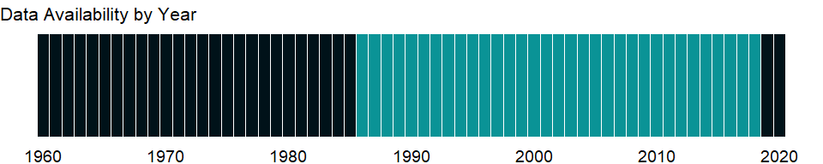

### Which countries have data?

The figure below shows the percentage of countries in each income group with a value since 2010 for that indicator.

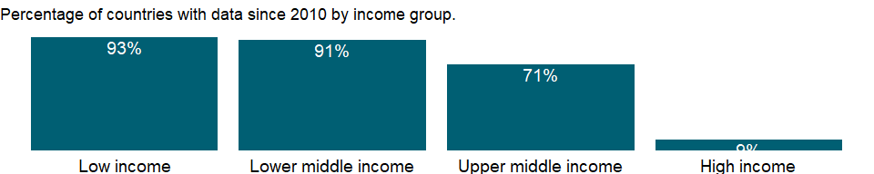

### Why is it relevant?

For optimal infant and young child feeding, mothers initiate breastfeeding within one hour of birth, breastfeed exclusively for the first six months, and continue to breastfeed for two years or more while providing nutritionally adequate, safe, and age-appropriate solid, semisolid, and soft foods. Breast milk alone contains all the nutrients, antibodies, hormones, and antioxidants an infant needs to thrive. It protects babies from diarrhea and acute respiratory infections, stimulates their immune systems and response to vaccination, and may confer cognitive benefits.

### What is the data source?

UNICEF, State of the World’s Children, Childinfo, and Demographic and Health Surveys.

### What is the methodology?

NA

### How is it aggregated?

Weighted average

### What are the limitations?

Most of the data on breastfeeding are derived from household surveys. For the data that are from household surveys, the year refers to the survey year.

### What else should I know?

NA

### 1.65.6 Low-birthweight babies (% of births)

### What is the indicator?

Low-birthweight babies are newborns weighing less than 2,500 grams, with the measurement taken within the first hour of life, before significant postnatal weight loss has occurred.

Topic: Health: Nutrition

Series ID: SH.STA.BRTW.ZS

Copyright: CC BY-4.0 , <https://datacatalog.worldbank.org/public-licenses#cc-by>

First year with any data: 2000

Last year with any data: 2015

### What years are data available?

The figure below shows years in which data is available for at least one country. Dates shaded in black have no data, while dates shaded in green have data for at least one country

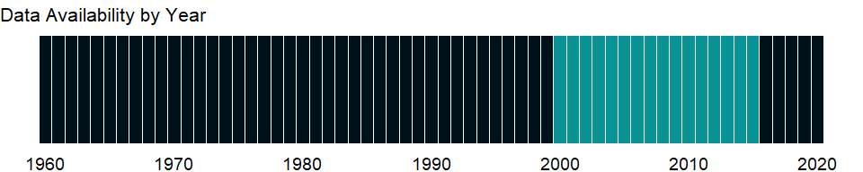

### Which countries have data?

The figure below shows the percentage of countries in each income group with a value since 2010 for that indicator.

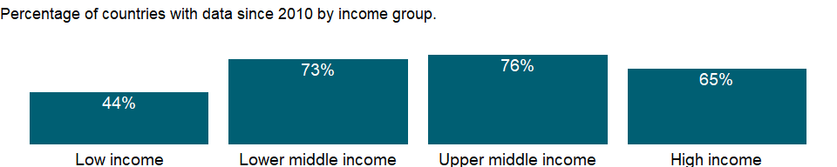

### Why is it relevant?

Low birth-weight, which is associated with maternal malnutrition, raises the risk of infant mortality and stunts growth in infancy and childhood. There is also emerging evidence that low-birth-weight babies are more prone to non-communicable diseases such as diabetes and cardiovascular diseases. Low birth-weight can arise as a result of a baby being born too soon or too small for gestational age. Babies born prematurely, who are also small for their gestational age, have the worst prognosis.

In low- and middle-income countries low birth-weight stems primarily from poor maternal health and nutrition. Three factors have the most impact: poor maternal nutritional status before conception, mother’s short stature (due mostly to under-nutrition and infections during childhood), and poor nutrition during pregnancy (UNICEF Data, <https://data.unicef.org/>).

### What is the data source?

UNICEF-WHO Low birthweight estimates [data.unicef.org]

### What is the methodology?

Model methods are used based on availability of country input data. Country input data included: (i) estimates from administrative sources representing =90 per cent of live births labelled as high coverage; (ii) estimates from administrative sources representing 80 to <90 per cent of live births labelled as medium coverage; and (iii) estimates from household surveys adjusted for missing birthweights and heaping. The model methods applied were: b-spline: data for countries with =8 data points from high coverage administrative sources with =1 prior to 2005 and =1 more recent than 2010, were smoothed with b-spline regression to generate annual LBW prevalence estimates that followed country-reported estimates very closely. Hierarchical regression: data for countries not meeting requirements for b-spline but with =1 LBW country input data point were fitted into a model using a set of covariates to generate annual LBW prevalence estimates. The covariates included the natural log of neonatal mortality rate; the proportion of children underweight (weight for-age z score below minus two standard deviations from median weight for age of reference population); data type (high coverage administrative, low coverage administrative, household survey); UN region (e.g., Southern Asia, Caribbean); and a country-specific random effect.). These estimates may vary substantially from those reported by countries. Partial data: the estimate is based on only partial data for the most recent survey, therefore modelled estimates not shown for the individual country.

### How is it aggregated?

Weighted average

### What are the limitations?

NA

### What else should I know?

NA

### 1.65.7 Prevalence of underweight, weight for age, female (% of children under 5)

### What is the indicator?

Prevalence of underweight, female, is the percentage of girls under age 5 whose weight for age is more than two standard deviations below the median for the international reference population ages 0-59 months. The data are based on the WHO’s new child growth standards released in 2006.

Topic: Health: Nutrition

Series ID: SH.STA.MALN.FE.ZS

Copyright: CC BY-4.0 , <https://datacatalog.worldbank.org/public-licenses#cc-by>

First year with any data: 1986

Last year with any data: 2020

### What years are data available?

The figure below shows years in which data is available for at least one country. Dates shaded in black have no data, while dates shaded in green have data for at least one country

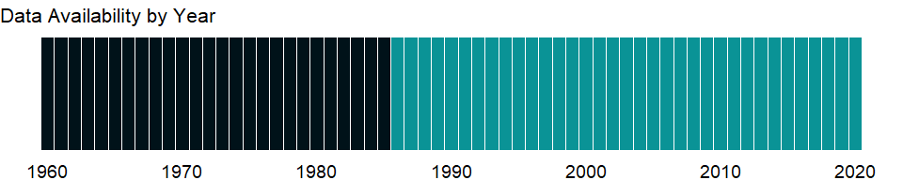

### Which countries have data?

The figure below shows the percentage of countries in each income group with a value since 2010 for that indicator.

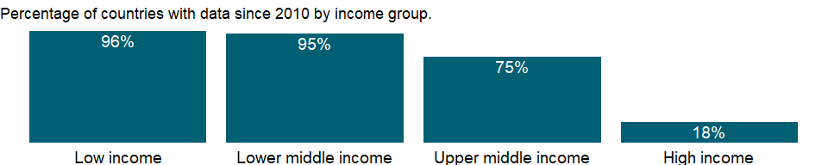

### Why is it relevant?

NA

### What is the data source?

UNICEF, WHO, World Bank: Joint child malnutrition estimates (JME). Aggregation is based on UNICEF, WHO, and the World Bank harmonized dataset (adjusted, comparable data) and methodology.

### What is the methodology?

NA

### How is it aggregated?

Linear mixed-effect model estimates

### What are the limitations?

NA

### What else should I know?

Undernourished children have lower resistance to infection and are more likely to die from common childhood ailments such as diarrheal diseases and respiratory infections. Frequent illness saps the nutritional status of those who survive, locking them into a vicious cycle of recurring sickness and faltering growth (UNICEF, www.childinfo.org). Estimates are from national survey data. Being even mildly underweight increases the risk of death and inhibits cognitive development in children. And it perpetuates the problem across generations, as malnourished women are more likely to have low-birth-weight babies. Stunting, or being below median height for age, is often used as a proxy for multifaceted deprivation and as an indicator of long-term changes in malnutrition.

### 1.65.8 Prevalence of underweight, weight for age, male (% of children under 5)

### What is the indicator?

Prevalence of underweight, male, is the percentage of boys under age 5 whose weight for age is more than two standard deviations below the median for the international reference population ages 0-59 months. The data are based on the WHO’s new child growth standards released in 2006.

Topic: Health: Nutrition

Series ID: SH.STA.MALN.MA.ZS

Copyright: CC BY-4.0 , <https://datacatalog.worldbank.org/public-licenses#cc-by>

First year with any data: 1986

Last year with any data: 2020

### What years are data available?

The figure below shows years in which data is available for at least one country. Dates shaded in black have no data, while dates shaded in green have data for at least one country



### Which countries have data?

The figure below shows the percentage of countries in each income group with a value since 2010 for that indicator.



### Why is it relevant?

NA

### What is the data source?

UNICEF, WHO, World Bank: Joint child malnutrition estimates (JME). Aggregation is based on UNICEF, WHO, and the World Bank harmonized dataset (adjusted, comparable data) and methodology.

### What is the methodology?

NA

### How is it aggregated?

Linear mixed-effect model estimates

### What are the limitations?

NA

### What else should I know?

Undernourished children have lower resistance to infection and are more likely to die from common childhood ailments such as diarrheal diseases and respiratory infections. Frequent illness saps the nutritional status of those who survive, locking them into a vicious cycle of recurring sickness and faltering growth (UNICEF, www.childinfo.org). Estimates are from national survey data. Being even mildly underweight increases the risk of death and inhibits cognitive development in children. And it perpetuates the problem across generations, as malnourished women are more likely to have low-birth-weight babies. Stunting, or being below median height for age, is often used as a proxy for multifaceted deprivation and as an indicator of long-term changes in malnutrition.

### 1.65.9 Prevalence of underweight, weight for age (% of children under 5)

### What is the indicator?

Prevalence of underweight children is the percentage of children under age 5 whose weight for age is more than two standard deviations below the median for the international reference population ages 0-59 months. The data are based on the WHO’s child growth standards released in 2006.

Topic: Health: Nutrition

Series ID: SH.STA.MALN.ZS

Copyright: CC BY-4.0 , <https://datacatalog.worldbank.org/public-licenses#cc-by>

First year with any data: 1983

Last year with any data: 2020

### What years are data available?

The figure below shows years in which data is available for at least one country. Dates shaded in black have no data, while dates shaded in green have data for at least one country

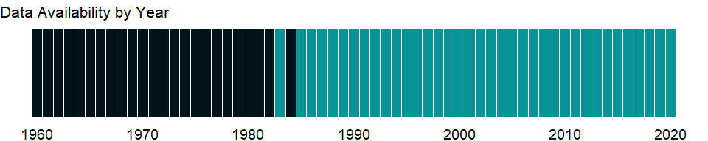

### Which countries have data?

The figure below shows the percentage of countries in each income group with a value since 2010 for that indicator.



### Why is it relevant?

NA

### What is the data source?

UNICEF, WHO, World Bank: Joint child malnutrition estimates (JME). Aggregation is based on UNICEF, WHO, and the World Bank harmonized dataset (adjusted, comparable data) and methodology.

### What is the methodology?

NA

### How is it aggregated?

Linear mixed-effect model estimates

### What are the limitations?

NA

### What else should I know?

Undernourished children have lower resistance to infection and are more likely to die from common childhood ailments such as diarrheal diseases and respiratory infections. Frequent illness saps the nutritional status of those who survive, locking them into a vicious cycle of recurring sickness and faltering growth (UNICEF, www.childinfo.org). Estimates are from national survey data. Being even mildly underweight increases the risk of death and inhibits cognitive development in children. And it perpetuates the problem across generations, as malnourished women are more likely to have low-birth-weight babies. Stunting, or being below median height for age, is often used as a proxy for multifaceted deprivation and as an indicator of long-term changes in malnutrition.

### 1.65.10 Prevalence of overweight, weight for height, female (% of children under 5)

### What is the indicator?

Prevalence of overweight, female, is the percentage of girls under age 5 whose weight for height is more than two standard deviations above the median for the international reference population of the corresponding age as established by the WHO’s new child growth standards released in 2006.

Topic: Health: Nutrition

Series ID: SH.STA.OWGH.FE.ZS

Copyright: CC BY-4.0 , <https://datacatalog.worldbank.org/public-licenses#cc-by>

First year with any data: 1986

Last year with any data: 2020

### What years are data available?

The figure below shows years in which data is available for at least one country. Dates shaded in black have no data, while dates shaded in green have data for at least one country



### Which countries have data?

The figure below shows the percentage of countries in each income group with a value since 2010 for that indicator.

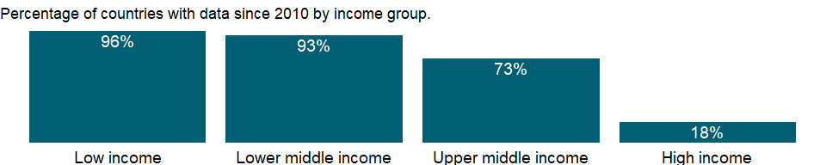

### Why is it relevant?

NA

### What is the data source?

UNICEF, WHO, World Bank: Joint child malnutrition estimates (JME). Aggregation is based on UNICEF, WHO, and the World Bank harmonized dataset (adjusted, comparable data) and methodology.

### What is the methodology?

NA

### How is it aggregated?

Linear mixed-effect model estimates

### What are the limitations?

NA

### What else should I know?

Estimates of overweight children are from national survey data. Once considered only a high-income economy problem, overweight children have become a growing concern in developing countries. Research shows an association between childhood obesity and a high prevalence of diabetes, respiratory disease, high blood pressure, and psychosocial and orthopedic disorders (de Onis and Blössner 2003). Childhood obesity is associated with a higher chance of obesity, premature death, and disability in adulthood. In addition to increased future risks, obese children experience breathing difficulties and increased risk of fractures, hypertension, early markers of cardiovascular disease, insulin resistance, and psychological effects. Children in low- and middle-income countries are more vulnerable to inadequate nutrition before birth and in infancy and early childhood. Many of these children are exposed to high-fat, high-sugar, high-salt, calorie-dense, micronutrient-poor foods, which tend be lower in cost than more nutritious foods. These dietary patterns, in conjunction with low levels of physical activity, result in sharp increases in childhood obesity, while under-nutrition continues.

### 1.65.11 Prevalence of overweight, weight for height, male (% of children under 5)

### What is the indicator?

Prevalence of overweight, male, is the percentage of boys under age 5 whose weight for height is more than two standard deviations above the median for the international reference population of the corresponding age as established by the WHO’s new child growth standards released in 2006.

Topic: Health: Nutrition

Series ID: SH.STA.OWGH.MA.ZS

Copyright: CC BY-4.0 , <https://datacatalog.worldbank.org/public-licenses#cc-by>

First year with any data: 1986

Last year with any data: 2020

### What years are data available?

The figure below shows years in which data is available for at least one country. Dates shaded in black have no data, while dates shaded in green have data for at least one country



### Which countries have data?

The figure below shows the percentage of countries in each income group with a value since 2010 for that indicator.



### Why is it relevant?

NA

### What is the data source?

UNICEF, WHO, World Bank: Joint child malnutrition estimates (JME). Aggregation is based on UNICEF, WHO, and the World Bank harmonized dataset (adjusted, comparable data) and methodology.

### What is the methodology?

NA

### How is it aggregated?

Linear mixed-effect model estimates

### What are the limitations?

NA

### What else should I know?

Estimates of overweight children are from national survey data. Once considered only a high-income economy problem, overweight children have become a growing concern in developing countries. Research shows an association between childhood obesity and a high prevalence of diabetes, respiratory disease, high blood pressure, and psychosocial and orthopedic disorders (de Onis and Blössner 2003). Childhood obesity is associated with a higher chance of obesity, premature death, and disability in adulthood. In addition to increased future risks, obese children experience breathing difficulties and increased risk of fractures, hypertension, early markers of cardiovascular disease, insulin resistance, and psychological effects. Children in low- and middle-income countries are more vulnerable to inadequate nutrition before birth and in infancy and early childhood. Many of these children are exposed to high-fat, high-sugar, high-salt, calorie-dense, micronutrient-poor foods, which tend be lower in cost than more nutritious foods. These dietary patterns, in conjunction with low levels of physical activity, result in sharp increases in childhood obesity, while under-nutrition continues.

### 1.65.12 Prevalence of overweight (modeled estimate, % of children under 5)

### What is the indicator?

Prevalence of overweight children is the percentage of children under age 5 whose weight for height is more than two standard deviations above the median for the international reference population of the corresponding age as established by the WHO’s new child growth standards released in 2006.

Topic: Health: Nutrition

Series ID: SH.STA.OWGH.ME.ZS

Copyright: CC BY-4.0 , <https://datacatalog.worldbank.org/public-licenses#cc-by>

First year with any data: 2000

Last year with any data: 2020

### What years are data available?

The figure below shows years in which data is available for at least one country. Dates shaded in black have no data, while dates shaded in green have data for at least one country



### Which countries have data?

The figure below shows the percentage of countries in each income group with a value since 2010 for that indicator.

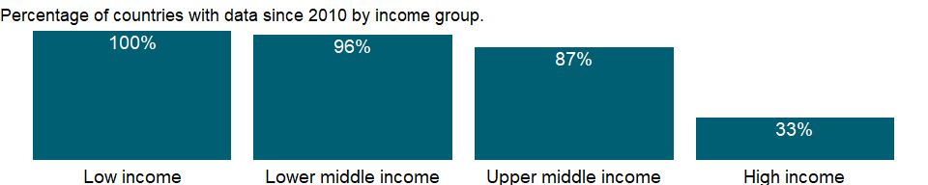

### Why is it relevant?

NA

### What is the data source?

UNICEF, WHO, World Bank: Joint child malnutrition estimates (JME).

### What is the methodology?

NA

### How is it aggregated?

Weighted Average

### What are the limitations?

NA

### What else should I know?

Once considered only a high-income economy problem, overweight children have become a growing concern in developing countries. Research shows an association between childhood obesity and a high prevalence of diabetes, respiratory disease, high blood pressure, and psychosocial and orthopedic disorders (de Onis and Blössner 2003). Childhood obesity is associated with a higher chance of obesity, premature death, and disability in adulthood. In addition to increased future risks, obese children experience breathing difficulties and increased risk of fractures, hypertension, early markers of cardiovascular disease, insulin resistance, and psychological effects. Children in low- and middle-income countries are more vulnerable to inadequate nutrition before birth and in infancy and early childhood. Many of these children are exposed to high-fat, high-sugar, high-salt, calorie-dense, micronutrient-poor foods, which tend be lower in cost than more nutritious foods. These dietary patterns, in conjunction with low levels of physical activity, result in sharp increases in childhood obesity, while under-nutrition continues.

Estimates are modeled estimates produced by the JME. Primary data sources of the anthropometric measurements are national surveys. These surveys are administered sporadically, resulting in sparse data for many countries. Furthermore, the trend of the indicators over time is usually not a straight line and varies by country. Tracking the current level and progress of indicators helps determine if countries are on track to meet certain thresholds, such as those indicated in the SDGs. Thus the JME developed statistical models and produced the modeled estimates.

### 1.65.13 Prevalence of overweight, weight for height (% of children under 5)

### What is the indicator?

Prevalence of overweight children is the percentage of children under age 5 whose weight for height is more than two standard deviations above the median for the international reference population of the corresponding age as established by the WHO’s new child growth standards released in 2006.

Topic: Health: Nutrition

Series ID: SH.STA.OWGH.ZS

Copyright: CC BY-4.0 , <https://datacatalog.worldbank.org/public-licenses#cc-by>

First year with any data: 1983

Last year with any data: 2020

### What years are data available?

The figure below shows years in which data is available for at least one country. Dates shaded in black have no data, while dates shaded in green have data for at least one country



### Which countries have data?

The figure below shows the percentage of countries in each income group with a value since 2010 for that indicator.

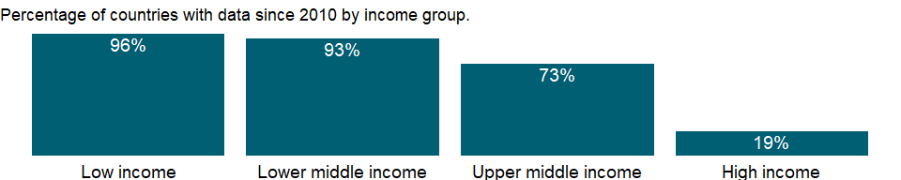

### Why is it relevant?

NA

### What is the data source?

UNICEF, WHO, World Bank: Joint child malnutrition estimates (JME). Aggregation is based on UNICEF, WHO, and the World Bank harmonized dataset (adjusted, comparable data) and methodology.

### What is the methodology?

NA

### How is it aggregated?

See SH.STA.OWGH.ME.ZS for aggregation

### What are the limitations?

NA

### What else should I know?

Estimates of overweight children are from national survey data. Once considered only a high-income economy problem, overweight children have become a growing concern in developing countries. Research shows an association between childhood obesity and a high prevalence of diabetes, respiratory disease, high blood pressure, and psychosocial and orthopedic disorders (de Onis and Blössner 2003). Childhood obesity is associated with a higher chance of obesity, premature death, and disability in adulthood. In addition to increased future risks, obese children experience breathing difficulties and increased risk of fractures, hypertension, early markers of cardiovascular disease, insulin resistance, and psychological effects. Children in low- and middle-income countries are more vulnerable to inadequate nutrition before birth and in infancy and early childhood. Many of these children are exposed to high-fat, high-sugar, high-salt, calorie-dense, micronutrient-poor foods, which tend be lower in cost than more nutritious foods. These dietary patterns, in conjunction with low levels of physical activity, result in sharp increases in childhood obesity, while under-nutrition continues.

### 1.65.14 Prevalence of stunting, height for age, female (% of children under 5)

### What is the indicator?

Prevalence of stunting, female, is the percentage of girls under age 5 whose height for age is more than two standard deviations below the median for the international reference population ages 0-59 months. For children up to two years old height is measured by recumbent length. For older children height is measured by stature while standing. The data are based on the WHO’s new child growth standards released in 2006.

Topic: Health: Nutrition

Series ID: SH.STA.STNT.FE.ZS

Copyright: CC BY-4.0 , <https://datacatalog.worldbank.org/public-licenses#cc-by>

First year with any data: 1986

Last year with any data: 2020

### What years are data available?

The figure below shows years in which data is available for at least one country. Dates shaded in black have no data, while dates shaded in green have data for at least one country



### Which countries have data?

The figure below shows the percentage of countries in each income group with a value since 2010 for that indicator.



### Why is it relevant?

NA

### What is the data source?

UNICEF, WHO, World Bank: Joint child malnutrition estimates (JME). Aggregation is based on UNICEF, WHO, and the World Bank harmonized dataset (adjusted, comparable data) and methodology.

### What is the methodology?

NA

### How is it aggregated?

Linear mixed-effect model estimates

### What are the limitations?

NA

### What else should I know?

Undernourished children have lower resistance to infection and are more likely to die from common childhood ailments such as diarrheal diseases and respiratory infections. Frequent illness saps the nutritional status of those who survive, locking them into a vicious cycle of recurring sickness and faltering growth (UNICEF, www.childinfo.org). Estimates are from national survey data. Being even mildly underweight increases the risk of death and inhibits cognitive development in children. And it perpetuates the problem across generations, as malnourished women are more likely to have low-birth-weight babies. Stunting, or being below median height for age, is often used as a proxy for multifaceted deprivation and as an indicator of long-term changes in malnutrition.

### 1.65.15 Prevalence of stunting, height for age, male (% of children under 5)

### What is the indicator?

Prevalence of stunting, male, is the percentage of boys under age 5 whose height for age is more than two standard deviations below the median for the international reference population ages 0-59 months. For children up to two years old height is measured by recumbent length. For older children height is measured by stature while standing. The data are based on the WHO’s new child growth standards released in 2006.

Topic: Health: Nutrition

Series ID: SH.STA.STNT.MA.ZS

Copyright: CC BY-4.0 , <https://datacatalog.worldbank.org/public-licenses#cc-by>

First year with any data: 1986

Last year with any data: 2020

### What years are data available?

The figure below shows years in which data is available for at least one country. Dates shaded in black have no data, while dates shaded in green have data for at least one country



### Which countries have data?

The figure below shows the percentage of countries in each income group with a value since 2010 for that indicator.



### Why is it relevant?

NA

### What is the data source?

UNICEF, WHO, World Bank: Joint child malnutrition estimates (JME). Aggregation is based on UNICEF, WHO, and the World Bank harmonized dataset (adjusted, comparable data) and methodology.

### What is the methodology?

NA

### How is it aggregated?

Linear mixed-effect model estimates

### What are the limitations?

NA

### What else should I know?

Undernourished children have lower resistance to infection and are more likely to die from common childhood ailments such as diarrheal diseases and respiratory infections. Frequent illness saps the nutritional status of those who survive, locking them into a vicious cycle of recurring sickness and faltering growth (UNICEF, www.childinfo.org). Estimates are from national survey data. Being even mildly underweight increases the risk of death and inhibits cognitive development in children. And it perpetuates the problem across generations, as malnourished women are more likely to have low-birth-weight babies. Stunting, or being below median height for age, is often used as a proxy for multifaceted deprivation and as an indicator of long-term changes in malnutrition.

### 1.65.16 Prevalence of stunting, height for age (modeled estimate, % of children under 5)

### What is the indicator?

Prevalence of stunting is the percentage of children under age 5 whose height for age is more than two standard deviations below the median for the international reference population ages 0-59 months. For children up to two years old height is measured by recumbent length. For older children height is measured by stature while standing. The data are based on the WHO’s new child growth standards released in 2006.

Topic: Health: Nutrition

Series ID: SH.STA.STNT.ME.ZS

Copyright: CC BY-4.0 , <https://datacatalog.worldbank.org/public-licenses#cc-by>

First year with any data: 2000

Last year with any data: 2020

### What years are data available?

The figure below shows years in which data is available for at least one country. Dates shaded in black have no data, while dates shaded in green have data for at least one country



### Which countries have data?

The figure below shows the percentage of countries in each income group with a value since 2010 for that indicator.

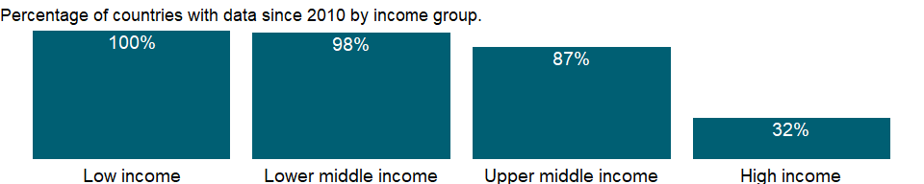

### Why is it relevant?

NA

### What is the data source?

UNICEF, WHO, World Bank: Joint child malnutrition estimates (JME).

### What is the methodology?

NA

### How is it aggregated?

Weighted Average

### What are the limitations?

NA

### What else should I know?

Undernourished children have lower resistance to infection and are more likely to die from common childhood ailments such as diarrheal diseases and respiratory infections. Frequent illness saps the nutritional status of those who survive, locking them into a vicious cycle of recurring sickness and faltering growth (UNICEF, www.childinfo.org). Being even mildly underweight increases the risk of death and inhibits cognitive development in children. And it perpetuates the problem across generations, as malnourished women are more likely to have low-birth-weight babies. Stunting, or being below median height for age, is often used as a proxy for multifaceted deprivation and as an indicator of long-term changes in malnutrition.

Estimates are modeled estimates produced by the JME. Primary data sources of the anthropometric measurements are national surveys. These surveys are administered sporadically, resulting in sparse data for many countries. Furthermore, the trend of the indicators over time is usually not a straight line and varies by country. Tracking the current level and progress of indicators helps determine if countries are on track to meet certain thresholds, such as those indicated in the SDGs. Thus the JME developed statistical models and produced the modeled estimates.

### 1.65.17 Prevalence of stunting, height for age (% of children under 5)

### What is the indicator?

Prevalence of stunting is the percentage of children under age 5 whose height for age is more than two standard deviations below the median for the international reference population ages 0-59 months. For children up to two years old height is measured by recumbent length. For older children height is measured by stature while standing. The data are based on the WHO’s new child growth standards released in 2006.

Topic: Health: Nutrition

Series ID: SH.STA.STNT.ZS

Copyright: CC BY-4.0 , <https://datacatalog.worldbank.org/public-licenses#cc-by>

First year with any data: 1983

Last year with any data: 2020

### What years are data available?

The figure below shows years in which data is available for at least one country. Dates shaded in black have no data, while dates shaded in green have data for at least one country



### Which countries have data?

The figure below shows the percentage of countries in each income group with a value since 2010 for that indicator.



### Why is it relevant?

NA

### What is the data source?

UNICEF, WHO, World Bank: Joint child malnutrition estimates (JME). Aggregation is based on UNICEF, WHO, and the World Bank harmonized dataset (adjusted, comparable data) and methodology.

### What is the methodology?

NA

### How is it aggregated?

See SH.STA.STNT.ME.ZS for aggregation

### What are the limitations?

NA

### What else should I know?

Undernourished children have lower resistance to infection and are more likely to die from common childhood ailments such as diarrheal diseases and respiratory infections. Frequent illness saps the nutritional status of those who survive, locking them into a vicious cycle of recurring sickness and faltering growth (UNICEF, www.childinfo.org). Estimates are from national survey data. Being even mildly underweight increases the risk of death and inhibits cognitive development in children. And it perpetuates the problem across generations, as malnourished women are more likely to have low-birth-weight babies. Stunting, or being below median height for age, is often used as a proxy for multifaceted deprivation and as an indicator of long-term changes in malnutrition.

### 1.65.18 Prevalence of wasting, weight for height, female (% of children under 5)

### What is the indicator?

Prevalence of wasting, female, is the proportion of girls under age 5 whose weight for height is more than two standard deviations below the median for the international reference population ages 0-59.

Topic: Health: Nutrition

Series ID: SH.STA.WAST.FE.ZS

Copyright: CC BY-4.0 , <https://datacatalog.worldbank.org/public-licenses#cc-by>

First year with any data: 1986

Last year with any data: 2020

### What years are data available?

The figure below shows years in which data is available for at least one country. Dates shaded in black have no data, while dates shaded in green have data for at least one country



### Which countries have data?

The figure below shows the percentage of countries in each income group with a value since 2010 for that indicator.

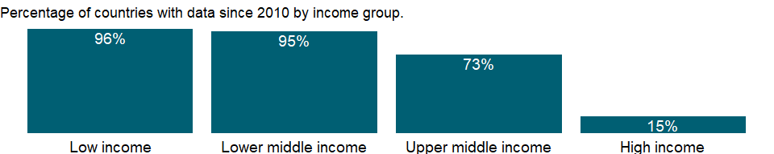

### Why is it relevant?

NA

### What is the data source?

UNICEF, WHO, World Bank: Joint child malnutrition estimates (JME). Aggregation is based on UNICEF, WHO, and the World Bank harmonized dataset (adjusted, comparable data) and methodology.

### What is the methodology?

NA

### How is it aggregated?

Linear mixed-effect model estimates

### What are the limitations?

NA

### What else should I know?

Undernourished children have lower resistance to infection and are more likely to die from common childhood ailments such as diarrheal diseases and respiratory infections. Frequent illness saps the nutritional status of those who survive, locking them into a vicious cycle of recurring sickness and faltering growth (UNICEF, www.childinfo.org). Estimates are from national survey data. Being even mildly underweight increases the risk of death and inhibits cognitive development in children. And it perpetuates the problem across generations, as malnourished women are more likely to have low-birth-weight babies. Stunting, or being below median height for age, is often used as a proxy for multifaceted deprivation and as an indicator of long-term changes in malnutrition.

### 1.65.19 Prevalence of wasting, weight for height, male (% of children under 5)

### What is the indicator?

Prevalence of wasting, male,is the proportion of boys under age 5 whose weight for height is more than two standard deviations below the median for the international reference population ages 0-59.

Topic: Health: Nutrition

Series ID: SH.STA.WAST.MA.ZS

Copyright: CC BY-4.0 , <https://datacatalog.worldbank.org/public-licenses#cc-by>

First year with any data: 1986

Last year with any data: 2020

### What years are data available?

The figure below shows years in which data is available for at least one country. Dates shaded in black have no data, while dates shaded in green have data for at least one country



### Which countries have data?

The figure below shows the percentage of countries in each income group with a value since 2010 for that indicator.

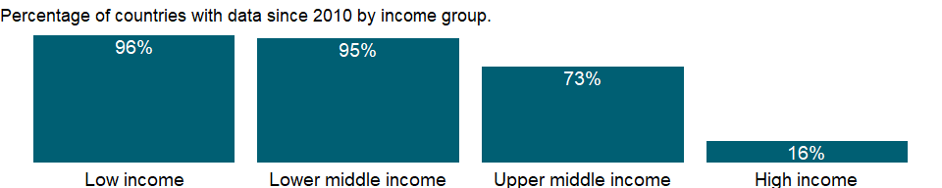

### Why is it relevant?

NA

### What is the data source?

UNICEF, WHO, World Bank: Joint child malnutrition estimates (JME). Aggregation is based on UNICEF, WHO, and the World Bank harmonized dataset (adjusted, comparable data) and methodology.

### What is the methodology?

NA

### How is it aggregated?

Linear mixed-effect model estimates

### What are the limitations?

NA

### What else should I know?

Undernourished children have lower resistance to infection and are more likely to die from common childhood ailments such as diarrheal diseases and respiratory infections. Frequent illness saps the nutritional status of those who survive, locking them into a vicious cycle of recurring sickness and faltering growth (UNICEF, www.childinfo.org). Estimates are from national survey data. Being even mildly underweight increases the risk of death and inhibits cognitive development in children. And it perpetuates the problem across generations, as malnourished women are more likely to have low-birth-weight babies. Stunting, or being below median height for age, is often used as a proxy for multifaceted deprivation and as an indicator of long-term changes in malnutrition.

### 1.65.20 Prevalence of wasting, weight for height (% of children under 5)

### What is the indicator?

Prevalence of wasting is the proportion of children under age 5 whose weight for height is more than two standard deviations below the median for the international reference population ages 0-59.

Topic: Health: Nutrition

Series ID: SH.STA.WAST.ZS

Copyright: CC BY-4.0 , <https://datacatalog.worldbank.org/public-licenses#cc-by>

First year with any data: 1983

Last year with any data: 2020

### What years are data available?

The figure below shows years in which data is available for at least one country. Dates shaded in black have no data, while dates shaded in green have data for at least one country



### Which countries have data?

The figure below shows the percentage of countries in each income group with a value since 2010 for that indicator.

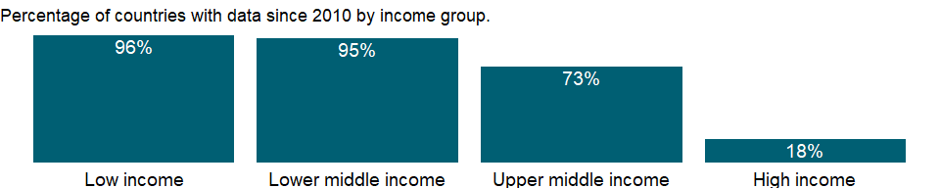

### Why is it relevant?

NA

### What is the data source?

UNICEF, WHO, World Bank: Joint child malnutrition estimates (JME). Aggregation is based on UNICEF, WHO, and the World Bank harmonized dataset (adjusted, comparable data) and methodology.

### What is the methodology?

NA

### How is it aggregated?

Linear mixed-effect model estimates

### What are the limitations?

NA

### What else should I know?

Undernourished children have lower resistance to infection and are more likely to die from common childhood ailments such as diarrheal diseases and respiratory infections. Frequent illness saps the nutritional status of those who survive, locking them into a vicious cycle of recurring sickness and faltering growth (UNICEF, www.childinfo.org). Estimates are from national survey data. Being even mildly underweight increases the risk of death and inhibits cognitive development in children. And it perpetuates the problem across generations, as malnourished women are more likely to have low-birth-weight babies. Stunting, or being below median height for age, is often used as a proxy for multifaceted deprivation and as an indicator of long-term changes in malnutrition.

### 1.65.21 Prevalence of severe wasting, weight for height, female (% of children under 5)

### What is the indicator?

Prevalence of severe wasting, female, is the proportion of girls under age 5 whose weight for height is more than three standard deviations below the median for the international reference population ages 0-59.

Topic: Health: Nutrition

Series ID: SH.SVR.WAST.FE.ZS

Copyright: CC BY-4.0 , <https://datacatalog.worldbank.org/public-licenses#cc-by>

First year with any data: 1986

Last year with any data: 2020

### What years are data available?

The figure below shows years in which data is available for at least one country. Dates shaded in black have no data, while dates shaded in green have data for at least one country



### Which countries have data?

The figure below shows the percentage of countries in each income group with a value since 2010 for that indicator.

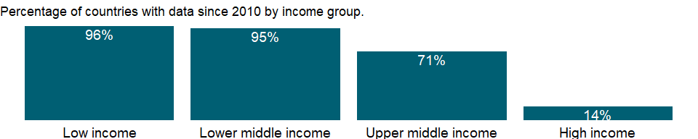

### Why is it relevant?

NA

### What is the data source?

UNICEF, WHO, World Bank: Joint child malnutrition estimates (JME). Aggregation is based on UNICEF, WHO, and the World Bank harmonized dataset (adjusted, comparable data) and methodology.

### What is the methodology?

NA

### How is it aggregated?

Linear mixed-effect model estimates

### What are the limitations?

NA

### What else should I know?

Undernourished children have lower resistance to infection and are more likely to die from common childhood ailments such as diarrheal diseases and respiratory infections. Frequent illness saps the nutritional status of those who survive, locking them into a vicious cycle of recurring sickness and faltering growth (UNICEF, www.childinfo.org). Estimates are from national survey data. Being even mildly underweight increases the risk of death and inhibits cognitive development in children. And it perpetuates the problem across generations, as malnourished women are more likely to have low-birth-weight babies. Stunting, or being below median height for age, is often used as a proxy for multifaceted deprivation and as an indicator of long-term changes in malnutrition.

### 1.65.22 Prevalence of severe wasting, weight for height, male (% of children under 5)

### What is the indicator?

Prevalence of severe wasting, male, is the proportion of boys under age 5 whose weight for height is more than three standard deviations below the median for the international reference population ages 0-59.

Topic: Health: Nutrition

Series ID: SH.SVR.WAST.MA.ZS

Copyright: CC BY-4.0 , <https://datacatalog.worldbank.org/public-licenses#cc-by>

First year with any data: 1986

Last year with any data: 2020

### What years are data available?

The figure below shows years in which data is available for at least one country. Dates shaded in black have no data, while dates shaded in green have data for at least one country



### Which countries have data?

The figure below shows the percentage of countries in each income group with a value since 2010 for that indicator.



### Why is it relevant?

NA

### What is the data source?

UNICEF, WHO, World Bank: Joint child malnutrition estimates (JME). Aggregation is based on UNICEF, WHO, and the World Bank harmonized dataset (adjusted, comparable data) and methodology.

### What is the methodology?

NA

### How is it aggregated?

Linear mixed-effect model estimates

### What are the limitations?

NA

### What else should I know?

Undernourished children have lower resistance to infection and are more likely to die from common childhood ailments such as diarrheal diseases and respiratory infections. Frequent illness saps the nutritional status of those who survive, locking them into a vicious cycle of recurring sickness and faltering growth (UNICEF, www.childinfo.org). Estimates are from national survey data. Being even mildly underweight increases the risk of death and inhibits cognitive development in children. And it perpetuates the problem across generations, as malnourished women are more likely to have low-birth-weight babies. Stunting, or being below median height for age, is often used as a proxy for multifaceted deprivation and as an indicator of long-term changes in malnutrition.

### 1.65.23 Prevalence of severe wasting, weight for height (% of children under 5)

### What is the indicator?

Prevalence of severe wasting is the proportion of children under age 5 whose weight for height is more than three standard deviations below the median for the international reference population ages 0-59.

Topic: Health: Nutrition

Series ID: SH.SVR.WAST.ZS

Copyright: CC BY-4.0 , <https://datacatalog.worldbank.org/public-licenses#cc-by>

First year with any data: 1983

Last year with any data: 2020

### What years are data available?

The figure below shows years in which data is available for at least one country. Dates shaded in black have no data, while dates shaded in green have data for at least one country

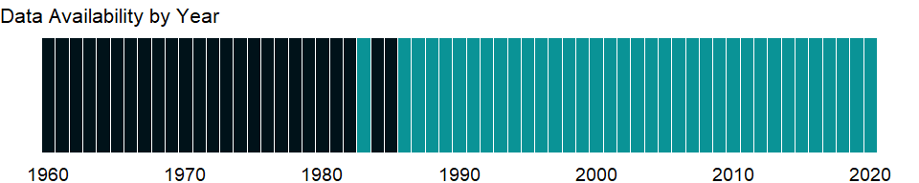

### Which countries have data?

The figure below shows the percentage of countries in each income group with a value since 2010 for that indicator.

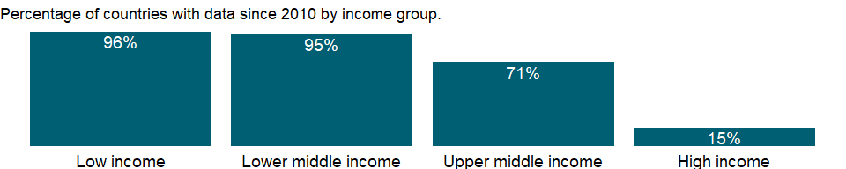

### Why is it relevant?

NA

### What is the data source?

UNICEF, WHO, World Bank: Joint child malnutrition estimates (JME). Aggregation is based on UNICEF, WHO, and the World Bank harmonized dataset (adjusted, comparable data) and methodology.

### What is the methodology?

NA

### How is it aggregated?

Linear mixed-effect model estimates

### What are the limitations?

NA

### What else should I know?

Undernourished children have lower resistance to infection and are more likely to die from common childhood ailments such as diarrheal diseases and respiratory infections. Frequent illness saps the nutritional status of those who survive, locking them into a vicious cycle of recurring sickness and faltering growth (UNICEF, www.childinfo.org). Estimates are from national survey data. Being even mildly underweight increases the risk of death and inhibits cognitive development in children. And it perpetuates the problem across generations, as malnourished women are more likely to have low-birth-weight babies. Stunting, or being below median height for age, is often used as a proxy for multifaceted deprivation and as an indicator of long-term changes in malnutrition.

### 1.65.24 Prevalence of undernourishment (% of population)

### What is the indicator?

Prevalence of undernourishments is the percentage of the population whose habitual food consumption is insufficient to provide the dietary energy levels that are required to maintain a normal active and healthy life. Data showing as 2.5 may signify a prevalence of undernourishment below 2.5%.

Topic: Health: Nutrition

Series ID: SN.ITK.DEFC.ZS

Copyright: CC BY-4.0 , <https://datacatalog.worldbank.org/public-licenses#cc-by>

First year with any data: 2001

Last year with any data: 2019

### What years are data available?

The figure below shows years in which data is available for at least one country. Dates shaded in black have no data, while dates shaded in green have data for at least one country

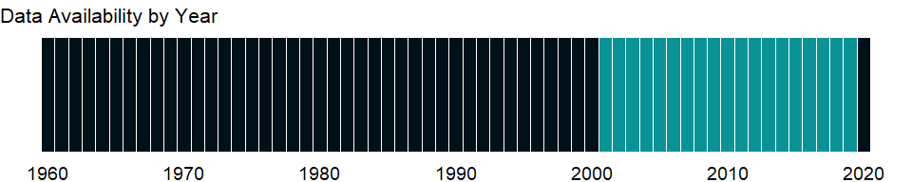

### Which countries have data?

The figure below shows the percentage of countries in each income group with a value since 2010 for that indicator.

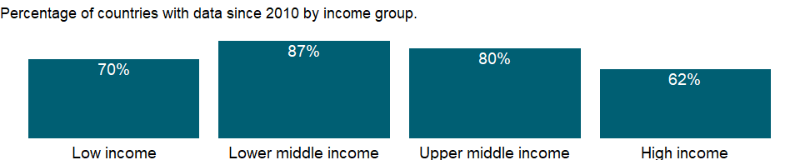

### Why is it relevant?

Good nutrition is the cornerstone for survival, health and development. Well-nourished children perform better in school, grow into healthy adults and in turn give their children a better start in life. Well-nourished women face fewer risks during pregnancy and childbirth, and their children set off on firmer developmental paths, both physically and mentally (UNICEF www.childinfo.org).

### What is the data source?

Food and Agriculture Organization (<http://www.fao.org/faostat/en/#home>).

### What is the methodology?

Data on undernourishment are from the Food and Agriculture Organization (FAO) of the United Nations and measure food deprivation based on average food available for human consumption per person, the level of inequality in access to food, and the minimum calories required for an average person.

### How is it aggregated?

Weighted average

### What are the limitations?

From a policy and program standpoint, this measure has its limits. First, food insecurity exists even where food availability is not a problem because of inadequate access of poor households to food. Second, food insecurity is an individual or household phenomenon, and the average food available to each person, even corrected for possible effects of low income, is not a good predictor of food insecurity among the population. And third, nutrition security is determined not only by food security but also by the quality of care of mothers and children and the quality of the household’s health environment (Smith and Haddad 2000).

### What else should I know?

This is the Sustainable Development Goal indicator 2.1.1[<https://unstats.un.org/sdgs/metadata/>].

### 1.65.25 Consumption of iodized salt (% of households)

### What is the indicator?

Percentage of households which have salt they used for cooking that tested positive (>0ppm) for presence of iodine.

Topic: Health: Nutrition

Series ID: SN.ITK.SALT.ZS

Copyright: CC BY-4.0 , <https://datacatalog.worldbank.org/public-licenses#cc-by>

First year with any data: 1994

Last year with any data: 2018

### What years are data available?

The figure below shows years in which data is available for at least one country. Dates shaded in black have no data, while dates shaded in green have data for at least one country

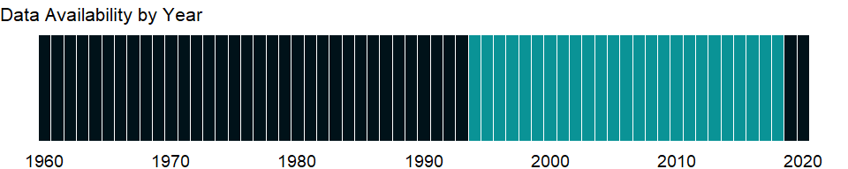

### Which countries have data?

The figure below shows the percentage of countries in each income group with a value since 2010 for that indicator.

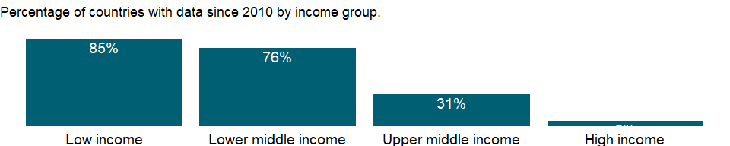

### Why is it relevant?

Iodine deficiency can lead to a variety of health and developmental consequences known as iodine deficiency disorders (IDDs). Iodine deficiency is a major cause of preventable mental retardation. It is especially damaging during pregnancy and in early childhood. In their most severe forms, IDDs can lead to cretinism, stillbirth and miscarriage; even mild deficiency can cause a significant loss of learning ability. Thus, it is crucially important that pregnant women and young children in particular get adequate levels of iodine. IDD can easily be prevented at low cost, however, with small quantities of iodine. One of the best and least expensive methods of preventing iodine deficiency disorder is by simply iodizing table salt, which is currently done in many countries. It represents one of the easiest and most cost-effective interventions for social and economic development.

### What is the data source?

United Nations Children’s Fund, Division of Data, Analysis, Planning and Monitoring (2019). UNICEF Global Databases on Iodized salt, New York, June 2019

### What is the methodology?

Most of the data on consumption of iodized salt are derived from household surveys. For the data that are from household surveys, the year refers to the survey year.

### How is it aggregated?

Weighted average

### What are the limitations?

NA

### What else should I know?

Iodine deficiency is the single most important cause of preventable mental retardation, contributes significantly to the risk of stillbirth and miscarriage, and increases the incidence of infant mortality. A diet low in iodine is the main cause of iodine deficiency. It usually occurs among populations living in areas where the soil has been depleted of iodine. If soil is deficient in iodine, then so are the plants grown in it, including the grains and vegetables that people and animals consume. There are almost no countries in the world where iodine deficiency has not been a public health problem. Many newborns in low- and middle-income countries remain unprotected from the lifelong consequences of brain damage associated with iodine deficiency disorders, which affect a child’s ability to learn and to earn a living as an adult, and in turn prevents children, communities, and countries from fulfilling their potential (UNICEF, www.childinfo.org). Widely used and inexpensive, iodized salt is the best source of iodine, and a global campaign to iodize edible salt is significantly reducing the risks associated with iodine deficiency.

### 1.65.26 Vitamin A supplementation coverage rate (% of children ages 6-59 months)

### What is the indicator?

Vitamin A supplementation refers to the percentage of children ages 6-59 months old who received at least two doses of vitamin A in the previous year.

Topic: Health: Nutrition

Series ID: SN.ITK.VITA.ZS

Copyright: CC BY-4.0 , <https://datacatalog.worldbank.org/public-licenses#cc-by>

First year with any data: 1999

Last year with any data: 2018

### What years are data available?

The figure below shows years in which data is available for at least one country. Dates shaded in black have no data, while dates shaded in green have data for at least one country



### Which countries have data?

The figure below shows the percentage of countries in each income group with a value since 2010 for that indicator.

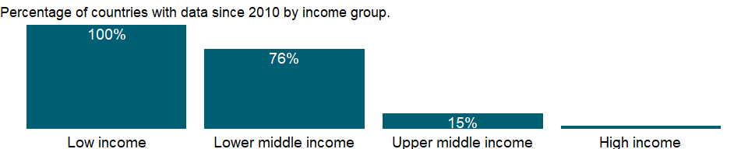

### Why is it relevant?

NA

### What is the data source?

United Nations Children’s Fund, State of the World’s Children.

### What is the methodology?

NA

### How is it aggregated?

Weighted average

### What are the limitations?

NA

### What else should I know?

Vitamin A is essential for optimal functioning of the immune system. Vitamin A deficiency, a leading cause of blindness, also causes a greater risk of dying from a range of childhood ailments such as measles, malaria, and diarrhea. In low- and middle-income countries, where vitamin A is consumed largely in fruits and vegetables, daily per capita intake is often insufficient to meet dietary requirements. Providing young children with two high-dose vitamin A capsules a year is a safe, cost-effective, efficient strategy for eliminating vitamin A deficiency and improving child survival. Giving vitamin A to new breastfeeding mothers helps protect their children during the first few months of life. Food fortification with vitamin A is being introduced in many developing countries.

## 1.66 Health: Disease prevention

### 1.66.1 Condom use, population ages 15-24, female (% of females ages 15-24)

### What is the indicator?

Condom use, female is the percentage of the female population ages 15-24 who used a condom at last intercourse in the last 12 months.

Topic: Health: Disease prevention

Series ID: SH.CON.1524.FE.ZS

Copyright: CC BY-4.0 , <https://datacatalog.worldbank.org/public-licenses#cc-by>

First year with any data: 1994

Last year with any data: 2015

### What years are data available?

The figure below shows years in which data is available for at least one country. Dates shaded in black have no data, while dates shaded in green have data for at least one country

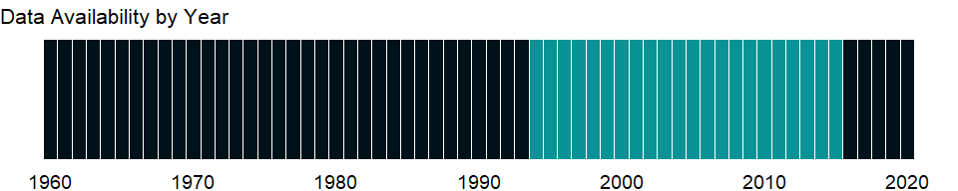

### Which countries have data?

The figure below shows the percentage of countries in each income group with a value since 2010 for that indicator.

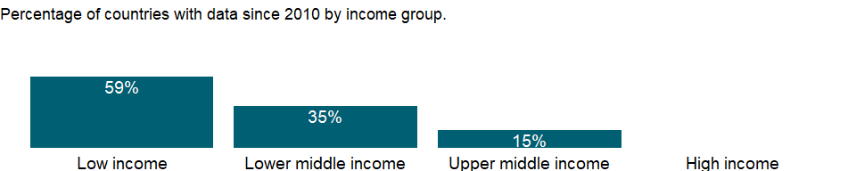

### Why is it relevant?

NA

### What is the data source?

Demographic and Health Surveys, and UNAIDS.

### What is the methodology?

NA

### How is it aggregated?

Weighted Average

### What are the limitations?

NA

### What else should I know?

NA

### 1.66.2 Condom use, population ages 15-24, male (% of males ages 15-24)

### What is the indicator?

Condom use, male is the percentage of the male population ages 15-24 who used a condom at last intercourse in the last 12 months.

Topic: Health: Disease prevention

Series ID: SH.CON.1524.MA.ZS

Copyright: CC BY-4.0 , <https://datacatalog.worldbank.org/public-licenses#cc-by>

First year with any data: 1994

Last year with any data: 2014

### What years are data available?

The figure below shows years in which data is available for at least one country. Dates shaded in black have no data, while dates shaded in green have data for at least one country

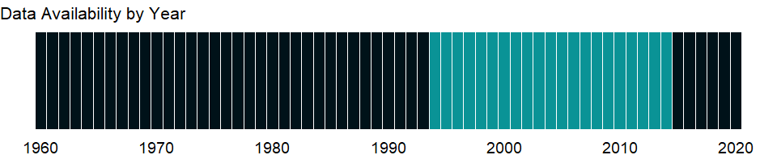

### Which countries have data?

The figure below shows the percentage of countries in each income group with a value since 2010 for that indicator.

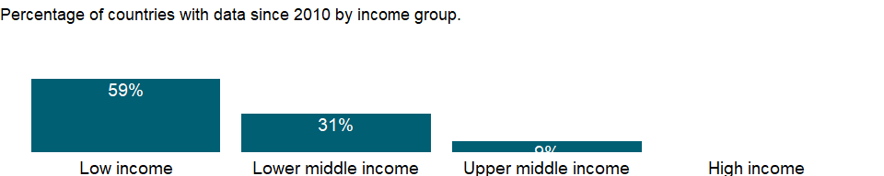

### Why is it relevant?

NA

### What is the data source?

Demographic and Health Surveys, and UNAIDS.

### What is the methodology?

NA

### How is it aggregated?

Weighted Average

### What are the limitations?

NA

### What else should I know?

NA

### 1.66.3 People using at least basic drinking water services, rural (% of rural population)

### What is the indicator?

The percentage of people using at least basic water services. This indicator encompasses both people using basic water services as well as those using safely managed water services. Basic drinking water services is defined as drinking water from an improved source, provided collection time is not more than 30 minutes for a round trip. Improved water sources include piped water, boreholes or tubewells, protected dug wells, protected springs, and packaged or delivered water.

Topic: Health: Disease prevention

Series ID: SH.H2O.BASW.RU.ZS

Copyright: CC BY-4.0 , <https://datacatalog.worldbank.org/public-licenses#cc-by>

First year with any data: 2000

Last year with any data: 2020

### What years are data available?

The figure below shows years in which data is available for at least one country. Dates shaded in black have no data, while dates shaded in green have data for at least one country



### Which countries have data?

The figure below shows the percentage of countries in each income group with a value since 2010 for that indicator.



### Why is it relevant?

Water is considered to be the most important resource for sustaining ecosystems, which provide life-supporting services for people, animals, and plants. Global access to safe water and proper hygiene education can reduce illness and death from disease, leading to improved health, poverty reduction, and socio-economic development. However, many countries are challenged to provide these basic necessities to their populations, leaving people at risk for water, sanitation, and hygiene (WASH)-related diseases. Because contaminated water is a major cause of illness and death, water quality is a determining factor in human poverty, education, and economic opportunities.

Lack of access to adequate drinking water services contributes to deaths and illness, especially in children. Water based disease transmission by drinking contaminated water is responsible for significant outbreaks of diseases such as cholera and typhoid and includes diarrheal diseases, viral hepatitis A, cholera, dysentery and dracunculiasis (Guineaworm disease). Improving access to clean drinking water is a crucial element in the reduction of under-five mortality and morbidity and there is evidence that ensuring higher levels of drinking water services has a greater impact.

Women and children spend millions of hours each year fetching water. The chore diverts their time from other important activities (for example attending school, caring for children, participating in the economy). When water is not available on premises and has to be collected, women and girls are almost two and a half times more likely than men and boys to be the main water carriers for their families.

Many international organizations use access to safe drinking water and hygienic sanitation facilities as a measure for progress in the fight against poverty, disease, and death. Access to safe drinking water is also considered to be a human right, not a privilege, for every man, woman, and child. Economic benefits of safe drinking water services include higher economic productivity, more education, and health-care savings.

### What is the data source?

WHO/UNICEF Joint Monitoring Programme (JMP) for Water Supply, Sanitation and Hygiene (washdata.org).

### What is the methodology?

Data on drinking water, sanitation and hygiene are produced by the Joint Monitoring Programme of the World Health Organization (WHO) and United Nations Children’s Fund (UNICEF) based on administrative sources, national censuses and nationally representative household surveys. WHO/UNICEF defines a basic drinking water service as drinking water from an improved source, provided collection time is not more than 30 minutes for a round trip. Improved water sources include piped water, boreholes or tubewells, protected dug wells, protected springs, and packaged or delivered water.

### How is it aggregated?

Weighted Average

### What are the limitations?

National, regional and income group estimates are made when data are available for at least 50 percent of the population.

### What else should I know?

NA

### 1.66.4 People using at least basic drinking water services, urban (% of urban population)

### What is the indicator?

The percentage of people using at least basic water services. This indicator encompasses both people using basic water services as well as those using safely managed water services. Basic drinking water services is defined as drinking water from an improved source, provided collection time is not more than 30 minutes for a round trip. Improved water sources include piped water, boreholes or tubewells, protected dug wells, protected springs, and packaged or delivered water.

Topic: Health: Disease prevention

Series ID: SH.H2O.BASW.UR.ZS

Copyright: CC BY-4.0 , <https://datacatalog.worldbank.org/public-licenses#cc-by>

First year with any data: 2000

Last year with any data: 2020

### What years are data available?

The figure below shows years in which data is available for at least one country. Dates shaded in black have no data, while dates shaded in green have data for at least one country



### Which countries have data?

The figure below shows the percentage of countries in each income group with a value since 2010 for that indicator.

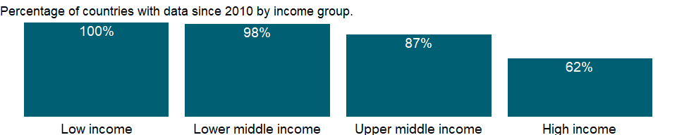

### Why is it relevant?

Water is considered to be the most important resource for sustaining ecosystems, which provide life-supporting services for people, animals, and plants. Global access to safe water and proper hygiene education can reduce illness and death from disease, leading to improved health, poverty reduction, and socio-economic development. However, many countries are challenged to provide these basic necessities to their populations, leaving people at risk for water, sanitation, and hygiene (WASH)-related diseases. Because contaminated water is a major cause of illness and death, water quality is a determining factor in human poverty, education, and economic opportunities.

Lack of access to adequate drinking water services contributes to deaths and illness, especially in children. Water based disease transmission by drinking contaminated water is responsible for significant outbreaks of diseases such as cholera and typhoid and includes diarrheal diseases, viral hepatitis A, cholera, dysentery and dracunculiasis (Guineaworm disease). Improving access to clean drinking water is a crucial element in the reduction of under-five mortality and morbidity and there is evidence that ensuring higher levels of drinking water services has a greater impact.

Women and children spend millions of hours each year fetching water. The chore diverts their time from other important activities (for example attending school, caring for children, participating in the economy). When water is not available on premises and has to be collected, women and girls are almost two and a half times more likely than men and boys to be the main water carriers for their families.

Many international organizations use access to safe drinking water and hygienic sanitation facilities as a measure for progress in the fight against poverty, disease, and death. Access to safe drinking water is also considered to be a human right, not a privilege, for every man, woman, and child. Economic benefits of safe drinking water services include higher economic productivity, more education, and health-care savings.

### What is the data source?

WHO/UNICEF Joint Monitoring Programme (JMP) for Water Supply, Sanitation and Hygiene (washdata.org).

### What is the methodology?

Data on drinking water, sanitation and hygiene are produced by the Joint Monitoring Programme of the World Health Organization (WHO) and United Nations Children’s Fund (UNICEF) based on administrative sources, national censuses and nationally representative household surveys. WHO/UNICEF defines a basic drinking water service as drinking water from an improved source, provided collection time is not more than 30 minutes for a round trip. Improved water sources include piped water, boreholes or tubewells, protected dug wells, protected springs, and packaged or delivered water.

### How is it aggregated?

Weighted Average

### What are the limitations?

National, regional and income group estimates are made when data are available for at least 50 percent of the population.

### What else should I know?

NA

### 1.66.5 People using at least basic drinking water services (% of population)

### What is the indicator?

The percentage of people using at least basic water services. This indicator encompasses both people using basic water services as well as those using safely managed water services. Basic drinking water services is defined as drinking water from an improved source, provided collection time is not more than 30 minutes for a round trip. Improved water sources include piped water, boreholes or tubewells, protected dug wells, protected springs, and packaged or delivered water.

Topic: Health: Disease prevention

Series ID: SH.H2O.BASW.ZS

Copyright: CC BY-4.0 , <https://datacatalog.worldbank.org/public-licenses#cc-by>

First year with any data: 2000

Last year with any data: 2020

### What years are data available?

The figure below shows years in which data is available for at least one country. Dates shaded in black have no data, while dates shaded in green have data for at least one country



### Which countries have data?

The figure below shows the percentage of countries in each income group with a value since 2010 for that indicator.



### Why is it relevant?

Water is considered to be the most important resource for sustaining ecosystems, which provide life-supporting services for people, animals, and plants. Global access to safe water and proper hygiene education can reduce illness and death from disease, leading to improved health, poverty reduction, and socio-economic development. However, many countries are challenged to provide these basic necessities to their populations, leaving people at risk for water, sanitation, and hygiene (WASH)-related diseases. Because contaminated water is a major cause of illness and death, water quality is a determining factor in human poverty, education, and economic opportunities.

Lack of access to adequate drinking water services contributes to deaths and illness, especially in children. Water based disease transmission by drinking contaminated water is responsible for significant outbreaks of diseases such as cholera and typhoid and includes diarrheal diseases, viral hepatitis A, cholera, dysentery and dracunculiasis (Guineaworm disease). Improving access to clean drinking water is a crucial element in the reduction of under-five mortality and morbidity and there is evidence that ensuring higher levels of drinking water services has a greater impact.

Women and children spend millions of hours each year fetching water. The chore diverts their time from other important activities (for example attending school, caring for children, participating in the economy). When water is not available on premises and has to be collected, women and girls are almost two and a half times more likely than men and boys to be the main water carriers for their families.

Many international organizations use access to safe drinking water and hygienic sanitation facilities as a measure for progress in the fight against poverty, disease, and death. Access to safe drinking water is also considered to be a human right, not a privilege, for every man, woman, and child. Economic benefits of safe drinking water services include higher economic productivity, more education, and health-care savings.

### What is the data source?

WHO/UNICEF Joint Monitoring Programme (JMP) for Water Supply, Sanitation and Hygiene (washdata.org).

### What is the methodology?

Data on drinking water, sanitation and hygiene are produced by the Joint Monitoring Programme of the World Health Organization (WHO) and United Nations Children’s Fund (UNICEF) based on administrative sources, national censuses and nationally representative household surveys. WHO/UNICEF defines a basic drinking water service as drinking water from an improved source, provided collection time is not more than 30 minutes for a round trip. Improved water sources include piped water, boreholes or tubewells, protected dug wells, protected springs, and packaged or delivered water.

### How is it aggregated?

Weighted Average

### What are the limitations?

National, regional and income group estimates are made when data are available for at least 50 percent of the population.

### What else should I know?

NA

### 1.66.6 People using safely managed drinking water services, rural (% of rural population)

### What is the indicator?

The percentage of people using drinking water from an improved source that is accessible on premises, available when needed and free from faecal and priority chemical contamination. Improved water sources include piped water, boreholes or tubewells, protected dug wells, protected springs, and packaged or delivered water.

Topic: Health: Disease prevention

Series ID: SH.H2O.SMDW.RU.ZS

Copyright: CC BY-4.0 , <https://datacatalog.worldbank.org/public-licenses#cc-by>

First year with any data: 2000

Last year with any data: 2020

### What years are data available?

The figure below shows years in which data is available for at least one country. Dates shaded in black have no data, while dates shaded in green have data for at least one country



### Which countries have data?

The figure below shows the percentage of countries in each income group with a value since 2010 for that indicator.

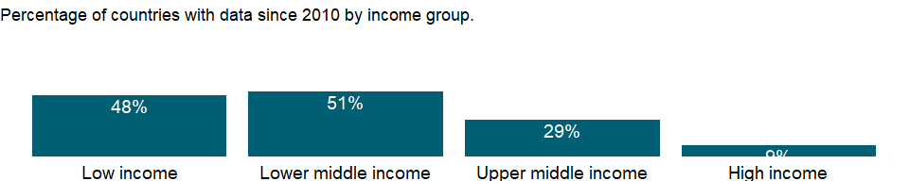

### Why is it relevant?

Water is considered to be the most important resource for sustaining ecosystems, which provide life-supporting services for people, animals, and plants. Global access to safe water and proper hygiene education can reduce illness and death from disease, leading to improved health, poverty reduction, and socio-economic development. However, many countries are challenged to provide these basic necessities to their populations, leaving people at risk for water, sanitation, and hygiene (WASH)-related diseases. Because contaminated water is a major cause of illness and death, water quality is a determining factor in human poverty, education, and economic opportunities.

Lack of access to adequate drinking water services contributes to deaths and illness, especially in children. Water based disease transmission by drinking contaminated water is responsible for significant outbreaks of diseases such as cholera and typhoid and includes diarrheal diseases, viral hepatitis A, cholera, dysentery and dracunculiasis (Guineaworm disease). Improving access to clean drinking water is a crucial element in the reduction of under-five mortality and morbidity and there is evidence that ensuring higher levels of drinking water services has a greater impact.

Women and children spend millions of hours each year fetching water. The chore diverts their time from other important activities (for example attending school, caring for children, participating in the economy). When water is not available on premises and has to be collected, women and girls are almost two and a half times more likely than men and boys to be the main water carriers for their families.

Many international organizations use access to safe drinking water and hygienic sanitation facilities as a measure for progress in the fight against poverty, disease, and death. Access to safe drinking water is also considered to be a human right, not a privilege, for every man, woman, and child. Economic benefits of safe drinking water services include higher economic productivity, more education, and health-care savings.

### What is the data source?

WHO/UNICEF Joint Monitoring Programme (JMP) for Water Supply, Sanitation and Hygiene (washdata.org).

### What is the methodology?

Data on drinking water, sanitation and hygiene are produced by the Joint Monitoring Programme of the World Health Organization (WHO) and United Nations Children’s Fund (UNICEF) based on administrative sources, national censuses and nationally representative household surveys. WHO/UNICEF defines a safely managed drinking water as an improved water source that is accessible on premises, available when needed and free from faecal and priority chemical contamination. Improved water sources include: piped water, boreholes or tubewells, protected dug wells, protected springs, and packaged or delivered water.

### How is it aggregated?

Weighted Average

### What are the limitations?

In order to meet the criteria for a safely managed drinking water service, an improved water source should meet three criteria: it should be accessible on the premises (accessibility), water should be available when needed (availability), and the water supplied should be free from contamination (quality). Many countries lack data on one or more elements of safely managed drinking water. The WHO/UNICEF Joint Monitoring Programme for Water Supply, Sanitation and Hygiene (JMP) provide national estimates only when data are available on drinking water quality and at least one of the other criteria (accessibility and availability). Regional and income group estimates are made when data are available for at least 30 percent of the population.

### What else should I know?

Aggregate data by groups are computed based on the groupings for the World Bank fiscal year in which the data was released by the WHO/UNICEF Joint Monitoring Programme (JMP) for Water Supply, Sanitation and Hygiene.

This is a disaggregated indicator for Sustainable Development Goal 6.1.1 [<https://unstats.un.org/sdgs/metadata/>].

### 1.66.7 People using safely managed drinking water services, urban (% of urban population)

### What is the indicator?

The percentage of people using drinking water from an improved source that is accessible on premises, available when needed and free from faecal and priority chemical contamination. Improved water sources include piped water, boreholes or tubewells, protected dug wells, protected springs, and packaged or delivered water.

Topic: Health: Disease prevention

Series ID: SH.H2O.SMDW.UR.ZS

Copyright: CC BY-4.0 , <https://datacatalog.worldbank.org/public-licenses#cc-by>

First year with any data: 2000

Last year with any data: 2020

### What years are data available?

The figure below shows years in which data is available for at least one country. Dates shaded in black have no data, while dates shaded in green have data for at least one country



### Which countries have data?

The figure below shows the percentage of countries in each income group with a value since 2010 for that indicator.

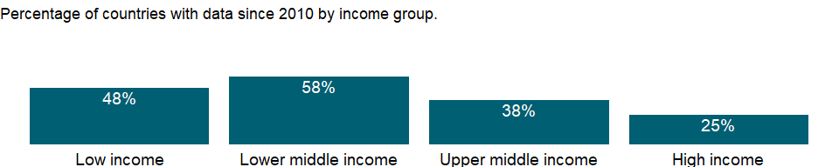

### Why is it relevant?

Water is considered to be the most important resource for sustaining ecosystems, which provide life-supporting services for people, animals, and plants. Global access to safe water and proper hygiene education can reduce illness and death from disease, leading to improved health, poverty reduction, and socio-economic development. However, many countries are challenged to provide these basic necessities to their populations, leaving people at risk for water, sanitation, and hygiene (WASH)-related diseases. Because contaminated water is a major cause of illness and death, water quality is a determining factor in human poverty, education, and economic opportunities.

Lack of access to adequate drinking water services contributes to deaths and illness, especially in children. Water based disease transmission by drinking contaminated water is responsible for significant outbreaks of diseases such as cholera and typhoid and includes diarrheal diseases, viral hepatitis A, cholera, dysentery and dracunculiasis (Guineaworm disease). Improving access to clean drinking water is a crucial element in the reduction of under-five mortality and morbidity and there is evidence that ensuring higher levels of drinking water services has a greater impact.

Women and children spend millions of hours each year fetching water. The chore diverts their time from other important activities (for example attending school, caring for children, participating in the economy). When water is not available on premises and has to be collected, women and girls are almost two and a half times more likely than men and boys to be the main water carriers for their families.

Many international organizations use access to safe drinking water and hygienic sanitation facilities as a measure for progress in the fight against poverty, disease, and death. Access to safe drinking water is also considered to be a human right, not a privilege, for every man, woman, and child. Economic benefits of safe drinking water services include higher economic productivity, more education, and health-care savings.

### What is the data source?

WHO/UNICEF Joint Monitoring Programme (JMP) for Water Supply, Sanitation and Hygiene (washdata.org).

### What is the methodology?

Data on drinking water, sanitation and hygiene are produced by the Joint Monitoring Programme of the World Health Organization (WHO) and United Nations Children’s Fund (UNICEF) based on administrative sources, national censuses and nationally representative household surveys. WHO/UNICEF defines a safely managed drinking water as an improved water source that is accessible on premises, available when needed and free from faecal and priority chemical contamination. Improved water sources include: piped water, boreholes or tubewells, protected dug wells, protected springs, and packaged or delivered water.

### How is it aggregated?

Weighted Average

### What are the limitations?

In order to meet the criteria for a safely managed drinking water service, an improved water source should meet three criteria: it should be accessible on the premises (accessibility), water should be available when needed (availability), and the water supplied should be free from contamination (quality). Many countries lack data on one or more elements of safely managed drinking water. The WHO/UNICEF Joint Monitoring Programme for Water Supply, Sanitation and Hygiene (JMP) provide national estimates only when data are available on drinking water quality and at least one of the other criteria (accessibility and availability). Regional and income group estimates are made when data are available for at least 30 percent of the population.

### What else should I know?

Aggregate data by groups are computed based on the groupings for the World Bank fiscal year in which the data was released by the WHO/UNICEF Joint Monitoring Programme (JMP) for Water Supply, Sanitation and Hygiene.

This is a disaggregated indicator for Sustainable Development Goal 6.1.1 [<https://unstats.un.org/sdgs/metadata/>].

### 1.66.8 People using safely managed drinking water services (% of population)

### What is the indicator?

The percentage of people using drinking water from an improved source that is accessible on premises, available when needed and free from faecal and priority chemical contamination. Improved water sources include piped water, boreholes or tubewells, protected dug wells, protected springs, and packaged or delivered water.

Topic: Health: Disease prevention

Series ID: SH.H2O.SMDW.ZS

Copyright: CC BY-4.0 , <https://datacatalog.worldbank.org/public-licenses#cc-by>

First year with any data: 2000

Last year with any data: 2020

### What years are data available?

The figure below shows years in which data is available for at least one country. Dates shaded in black have no data, while dates shaded in green have data for at least one country



### Which countries have data?

The figure below shows the percentage of countries in each income group with a value since 2010 for that indicator.

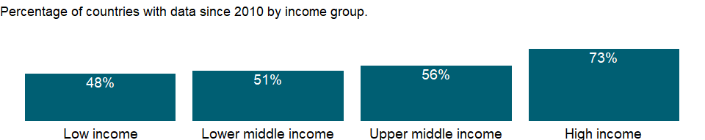

### Why is it relevant?

Water is considered to be the most important resource for sustaining ecosystems, which provide life-supporting services for people, animals, and plants. Global access to safe water and proper hygiene education can reduce illness and death from disease, leading to improved health, poverty reduction, and socio-economic development. However, many countries are challenged to provide these basic necessities to their populations, leaving people at risk for water, sanitation, and hygiene (WASH)-related diseases. Because contaminated water is a major cause of illness and death, water quality is a determining factor in human poverty, education, and economic opportunities.

Lack of access to adequate drinking water services contributes to deaths and illness, especially in children. Water based disease transmission by drinking contaminated water is responsible for significant outbreaks of diseases such as cholera and typhoid and includes diarrheal diseases, viral hepatitis A, cholera, dysentery and dracunculiasis (Guineaworm disease). Improving access to clean drinking water is a crucial element in the reduction of under-five mortality and morbidity and there is evidence that ensuring higher levels of drinking water services has a greater impact.

Women and children spend millions of hours each year fetching water. The chore diverts their time from other important activities (for example attending school, caring for children, participating in the economy). When water is not available on premises and has to be collected, women and girls are almost two and a half times more likely than men and boys to be the main water carriers for their families.

Many international organizations use access to safe drinking water and hygienic sanitation facilities as a measure for progress in the fight against poverty, disease, and death. Access to safe drinking water is also considered to be a human right, not a privilege, for every man, woman, and child. Economic benefits of safe drinking water services include higher economic productivity, more education, and health-care savings.

### What is the data source?

WHO/UNICEF Joint Monitoring Programme (JMP) for Water Supply, Sanitation and Hygiene (washdata.org).

### What is the methodology?

Data on drinking water, sanitation and hygiene are produced by the Joint Monitoring Programme of the World Health Organization (WHO) and United Nations Children’s Fund (UNICEF) based on administrative sources, national censuses and nationally representative household surveys. WHO/UNICEF defines a safely managed drinking water as an improved water source that is accessible on premises, available when needed and free from faecal and priority chemical contamination. Improved water sources include: piped water, boreholes or tubewells, protected dug wells, protected springs, and packaged or delivered water.

### How is it aggregated?

Weighted Average

### What are the limitations?

In order to meet the criteria for a safely managed drinking water service, an improved water source should meet three criteria: it should be accessible on the premises (accessibility), water should be available when needed (availability), and the water supplied should be free from contamination (quality). Many countries lack data on one or more elements of safely managed drinking water. The WHO/UNICEF Joint Monitoring Programme for Water Supply, Sanitation and Hygiene (JMP) provide national estimates only when data are available on drinking water quality and at least one of the other criteria (accessibility and availability). Regional and income group estimates are made when data are available for at least 30 percent of the population.

### What else should I know?

Aggregate data by groups are computed based on the groupings for the World Bank fiscal year in which the data was released by the WHO/UNICEF Joint Monitoring Programme (JMP) for Water Supply, Sanitation and Hygiene.

This is the Sustainable Development Goal indicator 6.1.1 [<https://unstats.un.org/sdgs/metadata/>].

### 1.66.9 Immunization, HepB3 (% of one-year-old children)

### What is the indicator?

Child immunization rate, hepatitis B is the percentage of children ages 12-23 months who received hepatitis B vaccinations before 12 months or at any time before the survey. A child is considered adequately immunized after three doses.

Topic: Health: Disease prevention

Series ID: SH.IMM.HEPB

Copyright: CC BY-4.0 , <https://datacatalog.worldbank.org/public-licenses#cc-by>

First year with any data: 1989

Last year with any data: 2019

### What years are data available?

The figure below shows years in which data is available for at least one country. Dates shaded in black have no data, while dates shaded in green have data for at least one country

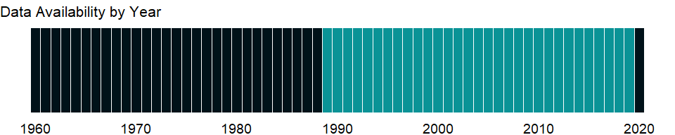

### Which countries have data?

The figure below shows the percentage of countries in each income group with a value since 2010 for that indicator.

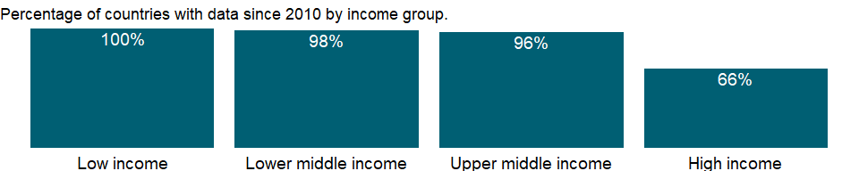

### Why is it relevant?

Immunization is one of the most cost-effective public health interventions, and is an essential component for reducing under-five mortality. Immunization coverage estimates are used to monitor coverage of immunization services and to guide disease eradication and elimination efforts.

### What is the data source?

WHO and UNICEF (<http://www.who.int/immunization/monitoring_surveillance/en/>).

### What is the methodology?

Governments in developing countries usually finance immunization against measles and diphtheria, pertussis (whooping cough), and tetanus (DTP) as part of the basic public health package. The data shown here are based on an assessment of national immunization coverage rates by the WHO and UNICEF. The assessment considered both administrative data from service providers and household survey data on children’s immunization histories. Based on the data available, consideration of potential biases, and contributions of local experts, the most likely true level of immunization coverage was determined for each year.

Notes on regional and global aggregates: When the vaccine is not introduced in a national immunization schedule, the missing value is assumed zero (or close to zero) in the relevant groups’ averages.

### How is it aggregated?

Weighted average

### What are the limitations?

In many developing countries a lack of precise information on the size of the cohort of one-year-old children makes immunization coverage difficult to estimate from program statistics.

### What else should I know?

NA

### 1.66.10 Immunization, DPT (% of children ages 12-23 months)

### What is the indicator?

Child immunization, DPT, measures the percentage of children ages 12-23 months who received DPT vaccinations before 12 months or at any time before the survey. A child is considered adequately immunized against diphtheria, pertussis (or whooping cough), and tetanus (DPT) after receiving three doses of vaccine.

Topic: Health: Disease prevention

Series ID: SH.IMM.IDPT

Copyright: CC BY-4.0 , <https://datacatalog.worldbank.org/public-licenses#cc-by>

First year with any data: 1980

Last year with any data: 2019

### What years are data available?

The figure below shows years in which data is available for at least one country. Dates shaded in black have no data, while dates shaded in green have data for at least one country



### Which countries have data?

The figure below shows the percentage of countries in each income group with a value since 2010 for that indicator.

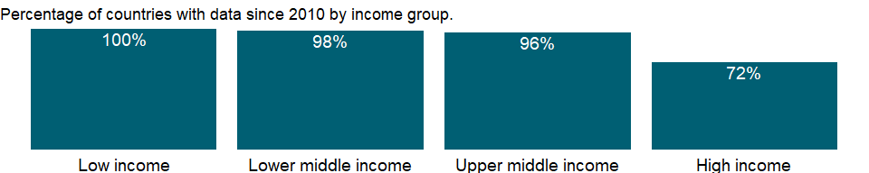

### Why is it relevant?

Immunization is one of the most cost-effective public health interventions, and is an essential component for reducing under-five mortality. Immunization coverage estimates are used to monitor coverage of immunization services and to guide disease eradication and elimination efforts.

### What is the data source?

WHO and UNICEF (<http://www.who.int/immunization/monitoring_surveillance/en/>).

### What is the methodology?

Governments in developing countries usually finance immunization against measles and diphtheria, pertussis (whooping cough), and tetanus (DTP) as part of the basic public health package. The data shown here are based on an assessment of national immunization coverage rates by the WHO and UNICEF. The assessment considered both administrative data from service providers and household survey data on children’s immunization histories. Based on the data available, consideration of potential biases, and contributions of local experts, the most likely true level of immunization coverage was determined for each year.

Notes on regional and global aggregates: When the vaccine is not introduced in a national immunization schedule, the missing value is assumed zero (or close to zero) in the relevant groups’ averages.

### How is it aggregated?

Weighted average

### What are the limitations?

In many developing countries a lack of precise information on the size of the cohort of one-year-old children makes immunization coverage difficult to estimate from program statistics.

### What else should I know?

This is the Sustainable Development Goal indicator 3.b.1 [<https://unstats.un.org/sdgs/metadata/>].

### 1.66.11 Immunization, measles (% of children ages 12-23 months)

### What is the indicator?

Child immunization, measles, measures the percentage of children ages 12-23 months who received the measles vaccination before 12 months or at any time before the survey. A child is considered adequately immunized against measles after receiving one dose of vaccine.

Topic: Health: Disease prevention

Series ID: SH.IMM.MEAS

Copyright: CC BY-4.0 , <https://datacatalog.worldbank.org/public-licenses#cc-by>

First year with any data: 1980

Last year with any data: 2019

### What years are data available?

The figure below shows years in which data is available for at least one country. Dates shaded in black have no data, while dates shaded in green have data for at least one country



### Which countries have data?

The figure below shows the percentage of countries in each income group with a value since 2010 for that indicator.



### Why is it relevant?

Immunization is one of the most cost-effective public health interventions, and is an essential component for reducing under-five mortality. Immunization coverage estimates are used to monitor coverage of immunization services and to guide disease eradication and elimination efforts.

### What is the data source?

WHO and UNICEF (<http://www.who.int/immunization/monitoring_surveillance/en/>).

### What is the methodology?

Governments in developing countries usually finance immunization against measles and diphtheria, pertussis (whooping cough), and tetanus (DTP) as part of the basic public health package. The data shown here are based on an assessment of national immunization coverage rates by the WHO and UNICEF. The assessment considered both administrative data from service providers and household survey data on children’s immunization histories. Based on the data available, consideration of potential biases, and contributions of local experts, the most likely true level of immunization coverage was determined for each year.

Notes on regional and global aggregates: When the vaccine is not introduced in a national immunization schedule, the missing value is assumed zero (or close to zero) in the relevant groups’ averages.

### How is it aggregated?

Weighted average

### What are the limitations?

In many developing countries a lack of precise information on the size of the cohort of one-year-old children makes immunization coverage difficult to estimate from program statistics.

### What else should I know?

NA

### 1.66.12 Use of insecticide-treated bed nets (% of under-5 population)

### What is the indicator?

Use of insecticide-treated bed nets refers to the percentage of children under age five who slept under an insecticide-treated bednet to prevent malaria.

Topic: Health: Disease prevention

Series ID: SH.MLR.NETS.ZS

Copyright: CC BY-4.0 , <https://datacatalog.worldbank.org/public-licenses#cc-by>

First year with any data: 1999

Last year with any data: 2020

### What years are data available?

The figure below shows years in which data is available for at least one country. Dates shaded in black have no data, while dates shaded in green have data for at least one country



### Which countries have data?

The figure below shows the percentage of countries in each income group with a value since 2010 for that indicator.

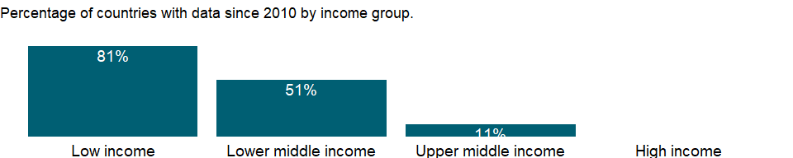

### Why is it relevant?

NA

### What is the data source?

UNICEF, State of the World’s Children, Childinfo, and Demographic and Health Surveys.

### What is the methodology?

Malaria is endemic to the poorest countries in the world, mainly in tropical and subtropical regions of Africa, Asia, and the Americas. Insecticide-treated nets, properly used and maintained, are one of the most important malaria-preventive strategies to limit human-mosquito contact.

### How is it aggregated?

Weighted average

### What are the limitations?

NA

### What else should I know?

NA

### 1.66.13 Children with fever receiving antimalarial drugs (% of children under age 5 with fever)

### What is the indicator?

Malaria treatment refers to the percentage of children under age five who were ill with fever in the last two weeks and received any appropriate (locally defined) anti-malarial drugs.

Topic: Health: Disease prevention

Series ID: SH.MLR.TRET.ZS

Copyright: CC BY-4.0 , <https://datacatalog.worldbank.org/public-licenses#cc-by>

First year with any data: 1998

Last year with any data: 2018

### What years are data available?

The figure below shows years in which data is available for at least one country. Dates shaded in black have no data, while dates shaded in green have data for at least one country

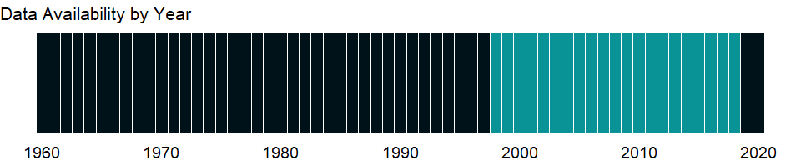

### Which countries have data?

The figure below shows the percentage of countries in each income group with a value since 2010 for that indicator.

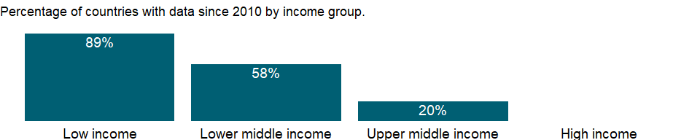

### Why is it relevant?

NA

### What is the data source?

UNICEF, State of the World’s Children, Childinfo, and Demographic and Health Surveys.

### What is the methodology?

Malaria is endemic to the poorest countries in the world, mainly in tropical and subtropical regions of Africa, Asia, and the Americas. Prompt and effective treatment of malaria is a critical element of malaria control. It is vital that sufferers, especially children under age 5, start treatment within 24 hours of the onset of symptoms, to prevent progression - often rapid - to severe malaria and death. Data on malaria are from national-level surveys, including Multiple Indicator Cluster Surveys, Demographic and Health Surveys, and Malaria Indicator Surveys.

### How is it aggregated?

Weighted average

### What are the limitations?

NA

### What else should I know?

NA

### 1.66.14 ARI treatment (% of children under 5 taken to a health provider)

### What is the indicator?

Children with acute respiratory infection (ARI) who are taken to a health provider refers to the percentage of children under age five with ARI in the last two weeks who were taken to an appropriate health provider, including hospital, health center, dispensary, village health worker, clinic, and private physician.

Topic: Health: Disease prevention

Series ID: SH.STA.ARIC.ZS

Copyright: CC BY-4.0 , <https://datacatalog.worldbank.org/public-licenses#cc-by>

First year with any data: 1990

Last year with any data: 2020

### What years are data available?

The figure below shows years in which data is available for at least one country. Dates shaded in black have no data, while dates shaded in green have data for at least one country



### Which countries have data?

The figure below shows the percentage of countries in each income group with a value since 2010 for that indicator.

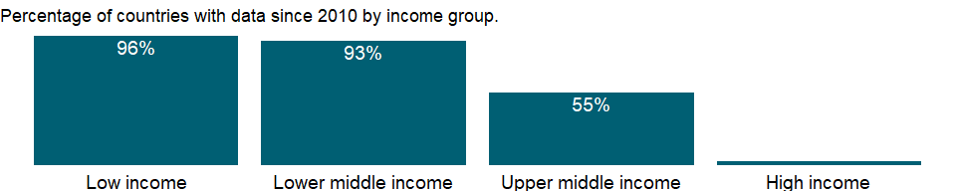

### Why is it relevant?

NA

### What is the data source?

UNICEF, State of the World’s Children, Childinfo, and Demographic and Health Surveys.

### What is the methodology?

Acute respiratory infection continues to be a leading cause of death among young children. Data are drawn mostly from household health surveys in which mothers report on number of episodes and treatment for acute respiratory infection.

### How is it aggregated?

Weighted average

### What are the limitations?

NA

### What else should I know?

NA

### 1.66.15 People using at least basic sanitation services, rural (% of rural population)

### What is the indicator?

The percentage of people using at least basic sanitation services, that is, improved sanitation facilities that are not shared with other households. This indicator encompasses both people using basic sanitation services as well as those using safely managed sanitation services. Improved sanitation facilities include flush/pour flush to piped sewer systems, septic tanks or pit latrines; ventilated improved pit latrines, compositing toilets or pit latrines with slabs.

Topic: Health: Disease prevention

Series ID: SH.STA.BASS.RU.ZS

Copyright: CC BY-4.0 , <https://datacatalog.worldbank.org/public-licenses#cc-by>

First year with any data: 2000

Last year with any data: 2020

### What years are data available?

The figure below shows years in which data is available for at least one country. Dates shaded in black have no data, while dates shaded in green have data for at least one country



### Which countries have data?

The figure below shows the percentage of countries in each income group with a value since 2010 for that indicator.



### Why is it relevant?

Sanitation is fundamental to human development. Many international organizations use hygienic sanitation facilities as a measure for progress in the fight against poverty, disease, and death. Access to proper sanitation is also considered to be a human right, not a privilege, for every man, woman, and child.

Sanitation generally refers to the provision of facilities and services for the safe disposal of human urine and feces. Inadequate sanitation is a major cause of disease world-wide and improving sanitation is known to have a significant beneficial impact on people’s health. Basic and safely managed sanitation services can reduce diarrheal disease, and can significantly lessen the adverse health impacts of other disorders responsible for death and disease among millions of children. Diarrhea and worm infections weaken children and make them more susceptible to malnutrition and opportunistic infections like pneumonia, measles and malaria.

The combined effects of inadequate sanitation, unsafe water supply and poor personal hygiene are responsible for many of childhood deaths. Every year, the failure to tackle these deficits results in severe welfare losses - wasted time, reduced productivity, ill health, impaired learning, environmental degradation and lost opportunities. Fundamental behavior changes are required before the use of improved facilities and services can be integrated into daily life. Many hygiene behaviors and habits are formed in childhood and, therefore, school health and hygiene education programs are an important part of water and sanitation improvements.

Most basic sanitation technologies are not expensive to implement. However, those facing the problems of inadequate sanitation may not be aware of either the origin of their ills, or the true costs of poor sanitation and hygiene. As a result, in most of the developing countries those without sanitation are hard to convince of the need to invest scarce resources in sanitation facilities, or of the critical importance of changing long-held habits and unhygienic behaviors. Consequently, the people’s representatives - governments and elected political leaders - rarely give sanitation or hygiene improvements the priority that is needed in order to tackle the massive sanitation deficit faced by the developing world.

Children bear the brunt of sanitation-related impacts - their health, nutrition, growth, education, self-respect, and life opportunities suffer as a result of inadequate sanitation. Without improved sanitation, many of the current generation of children in developing countries are unlikely to develop to their full potential. Countries that don’t take urgent action to redress sanitation deficiencies will find their future development and prosperity impaired.

### What is the data source?

WHO/UNICEF Joint Monitoring Programme (JMP) for Water Supply, Sanitation and Hygiene (washdata.org).

### What is the methodology?

Data on drinking water, sanitation and hygiene are produced by the Joint Monitoring Programme of the World Health Organization (WHO) and United Nations Children’s Fund (UNICEF) based on administrative sources, national censuses and nationally representative household surveys. WHO/UNICEF defines basic sanitation facilities as improved sanitation facilities that are not shared with other households. Improved sanitation facilities include flush/pour flush to piped sewer systems, septic tanks or pit latrines; ventilated improved pit latrines, compositing toilets or pit latrines with slabs.

### How is it aggregated?

Weighted Average

### What are the limitations?

National, regional and income group estimates are made when data are available for at least 50 percent of the population.

### What else should I know?

NA

### 1.66.16 People using at least basic sanitation services, urban (% of urban population)

### What is the indicator?

The percentage of people using at least basic sanitation services, that is, improved sanitation facilities that are not shared with other households. This indicator encompasses both people using basic sanitation services as well as those using safely managed sanitation services. Improved sanitation facilities include flush/pour flush to piped sewer systems, septic tanks or pit latrines; ventilated improved pit latrines, compositing toilets or pit latrines with slabs.

Topic: Health: Disease prevention

Series ID: SH.STA.BASS.UR.ZS

Copyright: CC BY-4.0 , <https://datacatalog.worldbank.org/public-licenses#cc-by>

First year with any data: 2000

Last year with any data: 2020

### What years are data available?

The figure below shows years in which data is available for at least one country. Dates shaded in black have no data, while dates shaded in green have data for at least one country



### Which countries have data?

The figure below shows the percentage of countries in each income group with a value since 2010 for that indicator.



### Why is it relevant?

Sanitation is fundamental to human development. Many international organizations use hygienic sanitation facilities as a measure for progress in the fight against poverty, disease, and death. Access to proper sanitation is also considered to be a human right, not a privilege, for every man, woman, and child.

Sanitation generally refers to the provision of facilities and services for the safe disposal of human urine and feces. Inadequate sanitation is a major cause of disease world-wide and improving sanitation is known to have a significant beneficial impact on people’s health. Basic and safely managed sanitation services can reduce diarrheal disease, and can significantly lessen the adverse health impacts of other disorders responsible for death and disease among millions of children. Diarrhea and worm infections weaken children and make them more susceptible to malnutrition and opportunistic infections like pneumonia, measles and malaria.

The combined effects of inadequate sanitation, unsafe water supply and poor personal hygiene are responsible for many of childhood deaths. Every year, the failure to tackle these deficits results in severe welfare losses - wasted time, reduced productivity, ill health, impaired learning, environmental degradation and lost opportunities. Fundamental behavior changes are required before the use of improved facilities and services can be integrated into daily life. Many hygiene behaviors and habits are formed in childhood and, therefore, school health and hygiene education programs are an important part of water and sanitation improvements.

Most basic sanitation technologies are not expensive to implement. However, those facing the problems of inadequate sanitation may not be aware of either the origin of their ills, or the true costs of poor sanitation and hygiene. As a result, in most of the developing countries those without sanitation are hard to convince of the need to invest scarce resources in sanitation facilities, or of the critical importance of changing long-held habits and unhygienic behaviors. Consequently, the people’s representatives - governments and elected political leaders - rarely give sanitation or hygiene improvements the priority that is needed in order to tackle the massive sanitation deficit faced by the developing world.

Children bear the brunt of sanitation-related impacts - their health, nutrition, growth, education, self-respect, and life opportunities suffer as a result of inadequate sanitation. Without improved sanitation, many of the current generation of children in developing countries are unlikely to develop to their full potential. Countries that don’t take urgent action to redress sanitation deficiencies will find their future development and prosperity impaired.

### What is the data source?

WHO/UNICEF Joint Monitoring Programme (JMP) for Water Supply, Sanitation and Hygiene (washdata.org).

### What is the methodology?

Data on drinking water, sanitation and hygiene are produced by the Joint Monitoring Programme of the World Health Organization (WHO) and United Nations Children’s Fund (UNICEF) based on administrative sources, national censuses and nationally representative household surveys. WHO/UNICEF defines basic sanitation facilities as improved sanitation facilities that are not shared with other households. Improved sanitation facilities include flush/pour flush to piped sewer systems, septic tanks or pit latrines; ventilated improved pit latrines, compositing toilets or pit latrines with slabs.

### How is it aggregated?

Weighted Average

### What are the limitations?

National, regional and income group estimates are made when data are available for at least 50 percent of the population.

### What else should I know?

NA

### 1.66.17 People using at least basic sanitation services (% of population)

### What is the indicator?

The percentage of people using at least basic sanitation services, that is, improved sanitation facilities that are not shared with other households. This indicator encompasses both people using basic sanitation services as well as those using safely managed sanitation services. Improved sanitation facilities include flush/pour flush to piped sewer systems, septic tanks or pit latrines; ventilated improved pit latrines, compositing toilets or pit latrines with slabs.

Topic: Health: Disease prevention

Series ID: SH.STA.BASS.ZS

Copyright: CC BY-4.0 , <https://datacatalog.worldbank.org/public-licenses#cc-by>

First year with any data: 2000

Last year with any data: 2020

### What years are data available?

The figure below shows years in which data is available for at least one country. Dates shaded in black have no data, while dates shaded in green have data for at least one country



### Which countries have data?

The figure below shows the percentage of countries in each income group with a value since 2010 for that indicator.



### Why is it relevant?

Sanitation is fundamental to human development. Many international organizations use hygienic sanitation facilities as a measure for progress in the fight against poverty, disease, and death. Access to proper sanitation is also considered to be a human right, not a privilege, for every man, woman, and child.

Sanitation generally refers to the provision of facilities and services for the safe disposal of human urine and feces. Inadequate sanitation is a major cause of disease world-wide and improving sanitation is known to have a significant beneficial impact on people’s health. Basic and safely managed sanitation services can reduce diarrheal disease, and can significantly lessen the adverse health impacts of other disorders responsible for death and disease among millions of children. Diarrhea and worm infections weaken children and make them more susceptible to malnutrition and opportunistic infections like pneumonia, measles and malaria.

The combined effects of inadequate sanitation, unsafe water supply and poor personal hygiene are responsible for many of childhood deaths. Every year, the failure to tackle these deficits results in severe welfare losses - wasted time, reduced productivity, ill health, impaired learning, environmental degradation and lost opportunities. Fundamental behavior changes are required before the use of improved facilities and services can be integrated into daily life. Many hygiene behaviors and habits are formed in childhood and, therefore, school health and hygiene education programs are an important part of water and sanitation improvements.

Most basic sanitation technologies are not expensive to implement. However, those facing the problems of inadequate sanitation may not be aware of either the origin of their ills, or the true costs of poor sanitation and hygiene. As a result, in most of the developing countries those without sanitation are hard to convince of the need to invest scarce resources in sanitation facilities, or of the critical importance of changing long-held habits and unhygienic behaviors. Consequently, the people’s representatives - governments and elected political leaders - rarely give sanitation or hygiene improvements the priority that is needed in order to tackle the massive sanitation deficit faced by the developing world.

Children bear the brunt of sanitation-related impacts - their health, nutrition, growth, education, self-respect, and life opportunities suffer as a result of inadequate sanitation. Without improved sanitation, many of the current generation of children in developing countries are unlikely to develop to their full potential. Countries that don’t take urgent action to redress sanitation deficiencies will find their future development and prosperity impaired.

### What is the data source?

WHO/UNICEF Joint Monitoring Programme (JMP) for Water Supply, Sanitation and Hygiene (washdata.org).

### What is the methodology?

Data on drinking water, sanitation and hygiene are produced by the Joint Monitoring Programme of the World Health Organization (WHO) and United Nations Children’s Fund (UNICEF) based on administrative sources, national censuses and nationally representative household surveys. WHO/UNICEF defines basic sanitation facilities as improved sanitation facilities that are not shared with other households. Improved sanitation facilities include flush/pour flush to piped sewer systems, septic tanks or pit latrines; ventilated improved pit latrines, compositing toilets or pit latrines with slabs.

### How is it aggregated?

Weighted Average

### What are the limitations?

National, regional and income group estimates are made when data are available for at least 50 percent of the population.

### What else should I know?

NA

### 1.66.18 People with basic handwashing facilities including soap and water, rural (% of rural population)

### What is the indicator?

The percentage of people living in households that have a handwashing facility with soap and water available on the premises. Handwashing facilities may be fixed or mobile and include a sink with tap water, buckets with taps, tippy-taps, and jugs or basins designated for handwashing. Soap includes bar soap, liquid soap, powder detergent, and soapy water but does not include ash, soil, sand or other handwashing agents.

Topic: Health: Disease prevention

Series ID: SH.STA.HYGN.RU.ZS

Copyright: CC BY-4.0 , <https://datacatalog.worldbank.org/public-licenses#cc-by>

First year with any data: 2000

Last year with any data: 2020

### What years are data available?

The figure below shows years in which data is available for at least one country. Dates shaded in black have no data, while dates shaded in green have data for at least one country



### Which countries have data?

The figure below shows the percentage of countries in each income group with a value since 2010 for that indicator.

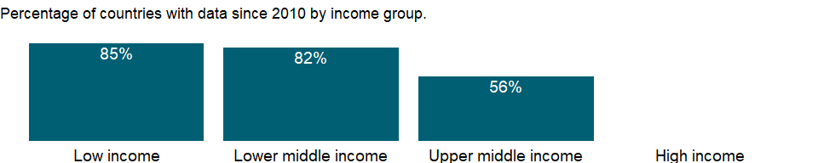

### Why is it relevant?

Hygiene is closely correlated with human health. Target 6.2 of the Sustainable Development Goals recognizes that access to facilities allowing good hygiene and sanitation should be universal, and especially important to women and girls, and those in vulnerable situations. Of the range of hygiene behaviors considered important for health, hand washing with soap and water is a top priority in all settings, and is considered one of the most cost-effective interventions to prevent diarrheal diseases. The availability of a basic handwashing facility is a prerequisite for basic hygiene facilities on premises, and is a useful proxy for hygienic behavior.

### What is the data source?

WHO/UNICEF Joint Monitoring Programme (JMP) for Water Supply, Sanitation and Hygiene (washdata.org).

### What is the methodology?

Data on drinking water, sanitation and hygiene are produced by the Joint Monitoring Programme of the World Health Organization (WHO) and United Nations Children’s Fund (UNICEF) based on administrative sources, national censuses and nationally representative household surveys. WHO/UNICEF defines a basic handwashing facility as a device to contain, transport or regulate the flow of water to facilitate handwashing with soap and water in the household.

### How is it aggregated?

NA

### What are the limitations?

Presence of a handwashing station with soap and water does not guarantee that household members consistently wash hands at key times, but is accepted as the most suitable proxy. Data on handwashing facilities are available for a growing number of low- and middle-income countries after hygiene questions were standardized in international surveys. However, this type of information is not available from most high-income countries, where access to basic handwashing facilities is assumed to be nearly universal.

### What else should I know?

This is a disaggregated indicator for Sustainable Development Goal 6.2.1 [<https://unstats.un.org/sdgs/metadata/>].

### 1.66.19 People with basic handwashing facilities including soap and water, urban (% of urban population)

### What is the indicator?

The percentage of people living in households that have a handwashing facility with soap and water available on the premises. Handwashing facilities may be fixed or mobile and include a sink with tap water, buckets with taps, tippy-taps, and jugs or basins designated for handwashing. Soap includes bar soap, liquid soap, powder detergent, and soapy water but does not include ash, soil, sand or other handwashing agents.

Topic: Health: Disease prevention

Series ID: SH.STA.HYGN.UR.ZS

Copyright: CC BY-4.0 , <https://datacatalog.worldbank.org/public-licenses#cc-by>

First year with any data: 2000

Last year with any data: 2020

### What years are data available?

The figure below shows years in which data is available for at least one country. Dates shaded in black have no data, while dates shaded in green have data for at least one country



### Which countries have data?

The figure below shows the percentage of countries in each income group with a value since 2010 for that indicator.

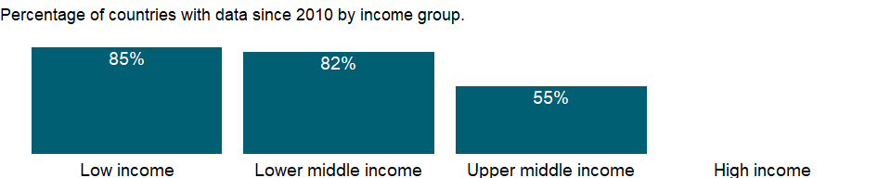

### Why is it relevant?

Hygiene is closely correlated with human health. Target 6.2 of the Sustainable Development Goals recognizes that access to facilities allowing good hygiene and sanitation should be universal, and especially important to women and girls, and those in vulnerable situations. Of the range of hygiene behaviors considered important for health, hand washing with soap and water is a top priority in all settings, and is considered one of the most cost-effective interventions to prevent diarrheal diseases. The availability of a basic handwashing facility is a prerequisite for basic hygiene facilities on premises, and is a useful proxy for hygienic behavior.

### What is the data source?

WHO/UNICEF Joint Monitoring Programme (JMP) for Water Supply, Sanitation and Hygiene (washdata.org).

### What is the methodology?

Data on drinking water, sanitation and hygiene are produced by the Joint Monitoring Programme of the World Health Organization (WHO) and United Nations Children’s Fund (UNICEF) based on administrative sources, national censuses and nationally representative household surveys. WHO/UNICEF defines a basic handwashing facility as a device to contain, transport or regulate the flow of water to facilitate handwashing with soap and water in the household.

### How is it aggregated?

NA

### What are the limitations?

Presence of a handwashing station with soap and water does not guarantee that household members consistently wash hands at key times, but is accepted as the most suitable proxy. Data on handwashing facilities are available for a growing number of low- and middle-income countries after hygiene questions were standardized in international surveys. However, this type of information is not available from most high-income countries, where access to basic handwashing facilities is assumed to be nearly universal.

### What else should I know?

This is a disaggregated indicator for Sustainable Development Goal 6.2.1 [<https://unstats.un.org/sdgs/metadata/>].

### 1.66.20 People with basic handwashing facilities including soap and water (% of population)

### What is the indicator?

The percentage of people living in households that have a handwashing facility with soap and water available on the premises. Handwashing facilities may be fixed or mobile and include a sink with tap water, buckets with taps, tippy-taps, and jugs or basins designated for handwashing. Soap includes bar soap, liquid soap, powder detergent, and soapy water but does not include ash, soil, sand or other handwashing agents.

Topic: Health: Disease prevention

Series ID: SH.STA.HYGN.ZS

Copyright: CC BY-4.0 , <https://datacatalog.worldbank.org/public-licenses#cc-by>

First year with any data: 2000

Last year with any data: 2020

### What years are data available?

The figure below shows years in which data is available for at least one country. Dates shaded in black have no data, while dates shaded in green have data for at least one country



### Which countries have data?

The figure below shows the percentage of countries in each income group with a value since 2010 for that indicator.

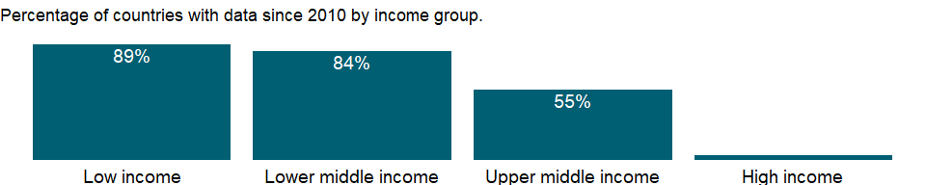

### Why is it relevant?

Hygiene is closely correlated with human health. Target 6.2 of the Sustainable Development Goals recognizes that access to facilities allowing good hygiene and sanitation should be universal, and especially important to women and girls, and those in vulnerable situations. Of the range of hygiene behaviors considered important for health, hand washing with soap and water is a top priority in all settings, and is considered one of the most cost-effective interventions to prevent diarrheal diseases. The availability of a basic handwashing facility is a prerequisite for basic hygiene facilities on premises, and is a useful proxy for hygienic behavior.

### What is the data source?

WHO/UNICEF Joint Monitoring Programme (JMP) for Water Supply, Sanitation and Hygiene (washdata.org).

### What is the methodology?

Data on drinking water, sanitation and hygiene are produced by the Joint Monitoring Programme of the World Health Organization (WHO) and United Nations Children’s Fund (UNICEF) based on administrative sources, national censuses and nationally representative household surveys. WHO/UNICEF defines a basic handwashing facility as a device to contain, transport or regulate the flow of water to facilitate handwashing with soap and water in the household.

### How is it aggregated?

NA

### What are the limitations?

Presence of a handwashing station with soap and water does not guarantee that household members consistently wash hands at key times, but is accepted as the most suitable proxy. Data on handwashing facilities are available for a growing number of low- and middle-income countries after hygiene questions were standardized in international surveys. However, this type of information is not available from most high-income countries, where access to basic handwashing facilities is assumed to be nearly universal.

### What else should I know?

This is the Sustainable Development Goal indicator 6.2.1 [<https://unstats.un.org/sdgs/metadata/>].

### 1.66.21 Diarrhea treatment (% of children under 5 receiving oral rehydration and continued feeding)

### What is the indicator?

Children with diarrhea who received oral rehydration and continued feeding refer to the percentage of children under age five with diarrhea in the two weeks prior to the survey who received either oral rehydration therapy or increased fluids, with continued feeding.

Topic: Health: Disease prevention

Series ID: SH.STA.ORCF.ZS

Copyright: CC BY-4.0 , <https://datacatalog.worldbank.org/public-licenses#cc-by>

First year with any data: 1986

Last year with any data: 2019

### What years are data available?

The figure below shows years in which data is available for at least one country. Dates shaded in black have no data, while dates shaded in green have data for at least one country

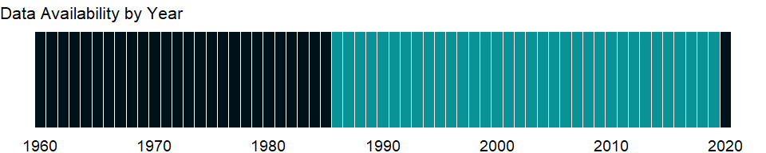

### Which countries have data?

The figure below shows the percentage of countries in each income group with a value since 2010 for that indicator.

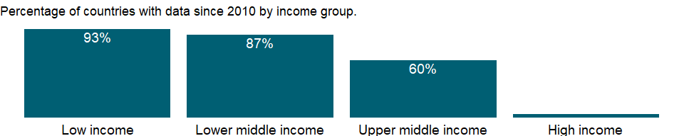

### Why is it relevant?

Most diarrhea-related deaths are due to dehydration, and many of these deaths can be prevented with the use of oral rehydration salts at home.

### What is the data source?

UNICEF, State of the World’s Children, Childinfo, and Demographic and Health Surveys.

### What is the methodology?

NA

### How is it aggregated?

Weighted average

### What are the limitations?

Recommendations for the use of oral rehydration therapy have changed over time based on scientific progress, so it is difficult to accurately compare use rates across countries. Until the current recommended method for home management of diarrhea is adopted and applied in all countries, the data should be used with caution. Also, the prevalence of diarrhea may vary by season. Since country surveys are administered at different times, data comparability is further affected.

### What else should I know?

NA

### 1.66.22 Diarrhea treatment (% of children under 5 who received ORS packet)

### What is the indicator?

Percentage of children under age 5 with diarrhea in the two weeks preceding the survey who received oral rehydration salts (ORS packets or pre-packaged ORS fluids).

Topic: Health: Disease prevention

Series ID: SH.STA.ORTH

Copyright: CC BY-4.0 , <https://datacatalog.worldbank.org/public-licenses#cc-by>

First year with any data: 1985

Last year with any data: 2020

### What years are data available?

The figure below shows years in which data is available for at least one country. Dates shaded in black have no data, while dates shaded in green have data for at least one country

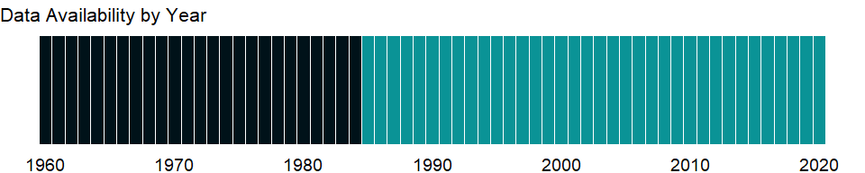

### Which countries have data?

The figure below shows the percentage of countries in each income group with a value since 2010 for that indicator.

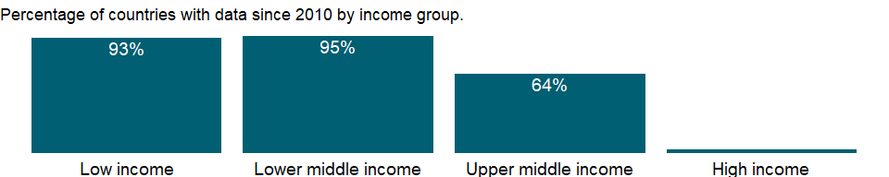

### Why is it relevant?

NA

### What is the data source?

UNICEF, State of the World’s Children, Childinfo, and Demographic and Health Surveys.

### What is the methodology?

NA

### How is it aggregated?

Weighted average

### What are the limitations?

NA

### What else should I know?

NA

### 1.66.23 People using safely managed sanitation services, rural (% of rural population)

### What is the indicator?

The percentage of people using improved sanitation facilities that are not shared with other households and where excreta are safely disposed of in situ or transported and treated offsite. Improved sanitation facilities include flush/pour flush to piped sewer systems, septic tanks or pit latrines: ventilated improved pit latrines, compositing toilets or pit latrines with slabs.

Topic: Health: Disease prevention

Series ID: SH.STA.SMSS.RU.ZS

Copyright: CC BY-4.0 , <https://datacatalog.worldbank.org/public-licenses#cc-by>

First year with any data: 2000

Last year with any data: 2020

### What years are data available?

The figure below shows years in which data is available for at least one country. Dates shaded in black have no data, while dates shaded in green have data for at least one country



### Which countries have data?

The figure below shows the percentage of countries in each income group with a value since 2010 for that indicator.

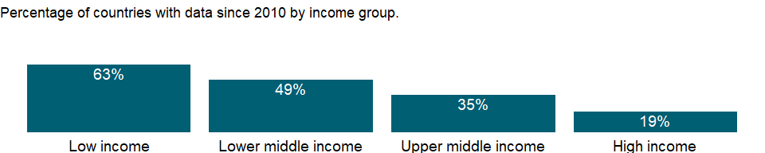

### Why is it relevant?

Sanitation is fundamental to human development. Many international organizations use hygienic sanitation facilities as a measure for progress in the fight against poverty, disease, and death. Access to proper sanitation is also considered to be a human right, not a privilege, for every man, woman, and child.

Sanitation generally refers to the provision of facilities and services for the safe disposal of human urine and feces. Inadequate sanitation is a major cause of disease world-wide and improving sanitation is known to have a significant beneficial impact on people’s health. Basic and safely managed sanitation services can reduce diarrheal disease, and can significantly lessen the adverse health impacts of other disorders responsible for death and disease among millions of children. Diarrhea and worm infections weaken children and make them more susceptible to malnutrition and opportunistic infections like pneumonia, measles and malaria.

The combined effects of inadequate sanitation, unsafe water supply and poor personal hygiene are responsible for many of childhood deaths. Every year, the failure to tackle these deficits results in severe welfare losses - wasted time, reduced productivity, ill health, impaired learning, environmental degradation and lost opportunities. Fundamental behavior changes are required before the use of improved facilities and services can be integrated into daily life. Many hygiene behaviors and habits are formed in childhood and, therefore, school health and hygiene education programs are an important part of water and sanitation improvements.

Most basic sanitation technologies are not expensive to implement. However, those facing the problems of inadequate sanitation may not be aware of either the origin of their ills, or the true costs of poor sanitation and hygiene. As a result, in most of the developing countries those without sanitation are hard to convince of the need to invest scarce resources in sanitation facilities, or of the critical importance of changing long-held habits and unhygienic behaviors. Consequently, the people’s representatives - governments and elected political leaders - rarely give sanitation or hygiene improvements the priority that is needed in order to tackle the massive sanitation deficit faced by the developing world.

Children bear the brunt of sanitation-related impacts - their health, nutrition, growth, education, self-respect, and life opportunities suffer as a result of inadequate sanitation. Without improved sanitation, many of the current generation of children in developing countries are unlikely to develop to their full potential. Countries that don’t take urgent action to redress sanitation deficiencies will find their future development and prosperity impaired.

### What is the data source?

WHO/UNICEF Joint Monitoring Programme (JMP) for Water Supply, Sanitation and Hygiene (washdata.org).

### What is the methodology?

Data on drinking water, sanitation and hygiene are produced by the Joint Monitoring Programme of the World Health Organization (WHO) and United Nations Children’s Fund (UNICEF) based on administrative sources, national censuses and nationally representative household surveys. WHO/UNICEF defines safely managed sanitation facilities as improved sanitation facilities that are not shared with other households and where excreta are safely disposed of in situ or transported and treated offsite. Improved sanitation facilities include flush/pour flush to piped sewer systems, septic tanks or pit latrines: ventilated improved pit latrines, compositing toilets or pit latrines with slabs.

### How is it aggregated?

Weighted Average

### What are the limitations?

There are three main ways to meet the criteria for having a safely managed sanitation service (People should use improved sanitation facilities that are not shared with other households, and the excreta produced should either be: treated and disposed of in situ; stored temporality and then emptied, transported and treated off-site, or transported through a sewer with wastewater and then treated off-site). Many countries lack information on either wastewater treatment or the management of on-site sanitation. A national estimate is produced if information is available for the dominant type of sanitation system. If no information is available, it is assumed that 50 percent is safely managed. Regional and income group estimates are made when data are available for at least 30 percent of the population.

### What else should I know?

Aggregate data by groups are computed based on the groupings for the World Bank fiscal year in which the data was released by the WHO/UNICEF Joint Monitoring Programme (JMP) for Water Supply, Sanitation and Hygiene.

This is a disaggregated indicator for Sustainable Development Goal 6.2.1 [<https://unstats.un.org/sdgs/metadata/>].

### 1.66.24 People using safely managed sanitation services, urban (% of urban population)

### What is the indicator?

The percentage of people using improved sanitation facilities that are not shared with other households and where excreta are safely disposed of in situ or transported and treated offsite. Improved sanitation facilities include flush/pour flush to piped sewer systems, septic tanks or pit latrines: ventilated improved pit latrines, compositing toilets or pit latrines with slabs.

Topic: Health: Disease prevention

Series ID: SH.STA.SMSS.UR.ZS

Copyright: CC BY-4.0 , <https://datacatalog.worldbank.org/public-licenses#cc-by>

First year with any data: 2000

Last year with any data: 2020

### What years are data available?

The figure below shows years in which data is available for at least one country. Dates shaded in black have no data, while dates shaded in green have data for at least one country



### Which countries have data?

The figure below shows the percentage of countries in each income group with a value since 2010 for that indicator.

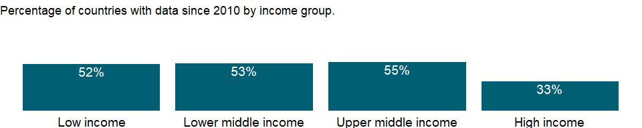

### Why is it relevant?

Sanitation is fundamental to human development. Many international organizations use hygienic sanitation facilities as a measure for progress in the fight against poverty, disease, and death. Access to proper sanitation is also considered to be a human right, not a privilege, for every man, woman, and child.

Sanitation generally refers to the provision of facilities and services for the safe disposal of human urine and feces. Inadequate sanitation is a major cause of disease world-wide and improving sanitation is known to have a significant beneficial impact on people’s health. Basic and safely managed sanitation services can reduce diarrheal disease, and can significantly lessen the adverse health impacts of other disorders responsible for death and disease among millions of children. Diarrhea and worm infections weaken children and make them more susceptible to malnutrition and opportunistic infections like pneumonia, measles and malaria.

The combined effects of inadequate sanitation, unsafe water supply and poor personal hygiene are responsible for many of childhood deaths. Every year, the failure to tackle these deficits results in severe welfare losses - wasted time, reduced productivity, ill health, impaired learning, environmental degradation and lost opportunities. Fundamental behavior changes are required before the use of improved facilities and services can be integrated into daily life. Many hygiene behaviors and habits are formed in childhood and, therefore, school health and hygiene education programs are an important part of water and sanitation improvements.

Most basic sanitation technologies are not expensive to implement. However, those facing the problems of inadequate sanitation may not be aware of either the origin of their ills, or the true costs of poor sanitation and hygiene. As a result, in most of the developing countries those without sanitation are hard to convince of the need to invest scarce resources in sanitation facilities, or of the critical importance of changing long-held habits and unhygienic behaviors. Consequently, the people’s representatives - governments and elected political leaders - rarely give sanitation or hygiene improvements the priority that is needed in order to tackle the massive sanitation deficit faced by the developing world.

Children bear the brunt of sanitation-related impacts - their health, nutrition, growth, education, self-respect, and life opportunities suffer as a result of inadequate sanitation. Without improved sanitation, many of the current generation of children in developing countries are unlikely to develop to their full potential. Countries that don’t take urgent action to redress sanitation deficiencies will find their future development and prosperity impaired.

### What is the data source?

WHO/UNICEF Joint Monitoring Programme (JMP) for Water Supply, Sanitation and Hygiene (washdata.org).

### What is the methodology?

Data on drinking water, sanitation and hygiene are produced by the Joint Monitoring Programme of the World Health Organization (WHO) and United Nations Children’s Fund (UNICEF) based on administrative sources, national censuses and nationally representative household surveys. WHO/UNICEF defines safely managed sanitation facilities as improved sanitation facilities that are not shared with other households and where excreta are safely disposed of in situ or transported and treated offsite. Improved sanitation facilities include flush/pour flush to piped sewer systems, septic tanks or pit latrines: ventilated improved pit latrines, compositing toilets or pit latrines with slabs.

### How is it aggregated?

Weighted Average

### What are the limitations?

There are three main ways to meet the criteria for having a safely managed sanitation service (People should use improved sanitation facilities that are not shared with other households, and the excreta produced should either be: treated and disposed of in situ; stored temporality and then emptied, transported and treated off-site, or transported through a sewer with wastewater and then treated off-site). Many countries lack information on either wastewater treatment or the management of on-site sanitation. A national estimate is produced if information is available for the dominant type of sanitation system. If no information is available, it is assumed that 50 percent is safely managed. Regional and income group estimates are made when data are available for at least 30 percent of the population.

### What else should I know?

Aggregate data by groups are computed based on the groupings for the World Bank fiscal year in which the data was released by the WHO/UNICEF Joint Monitoring Programme (JMP) for Water Supply, Sanitation and Hygiene.

This is a disaggregated indicator for Sustainable Development Goal 6.2.1 [<https://unstats.un.org/sdgs/metadata/>].

### 1.66.25 People using safely managed sanitation services (% of population)

### What is the indicator?

The percentage of people using improved sanitation facilities that are not shared with other households and where excreta are safely disposed of in situ or transported and treated offsite. Improved sanitation facilities include flush/pour flush to piped sewer systems, septic tanks or pit latrines: ventilated improved pit latrines, compositing toilets or pit latrines with slabs.

Topic: Health: Disease prevention

Series ID: SH.STA.SMSS.ZS

Copyright: CC BY-4.0 , <https://datacatalog.worldbank.org/public-licenses#cc-by>

First year with any data: 2000

Last year with any data: 2020

### What years are data available?

The figure below shows years in which data is available for at least one country. Dates shaded in black have no data, while dates shaded in green have data for at least one country



### Which countries have data?

The figure below shows the percentage of countries in each income group with a value since 2010 for that indicator.

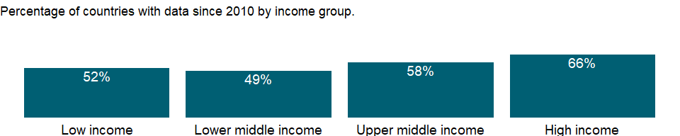

### Why is it relevant?

Sanitation is fundamental to human development. Many international organizations use hygienic sanitation facilities as a measure for progress in the fight against poverty, disease, and death. Access to proper sanitation is also considered to be a human right, not a privilege, for every man, woman, and child.

Sanitation generally refers to the provision of facilities and services for the safe disposal of human urine and feces. Inadequate sanitation is a major cause of disease world-wide and improving sanitation is known to have a significant beneficial impact on people’s health. Basic and safely managed sanitation services can reduce diarrheal disease, and can significantly lessen the adverse health impacts of other disorders responsible for death and disease among millions of children. Diarrhea and worm infections weaken children and make them more susceptible to malnutrition and opportunistic infections like pneumonia, measles and malaria.

The combined effects of inadequate sanitation, unsafe water supply and poor personal hygiene are responsible for many of childhood deaths. Every year, the failure to tackle these deficits results in severe welfare losses - wasted time, reduced productivity, ill health, impaired learning, environmental degradation and lost opportunities. Fundamental behavior changes are required before the use of improved facilities and services can be integrated into daily life. Many hygiene behaviors and habits are formed in childhood and, therefore, school health and hygiene education programs are an important part of water and sanitation improvements.

Most basic sanitation technologies are not expensive to implement. However, those facing the problems of inadequate sanitation may not be aware of either the origin of their ills, or the true costs of poor sanitation and hygiene. As a result, in most of the developing countries those without sanitation are hard to convince of the need to invest scarce resources in sanitation facilities, or of the critical importance of changing long-held habits and unhygienic behaviors. Consequently, the people’s representatives - governments and elected political leaders - rarely give sanitation or hygiene improvements the priority that is needed in order to tackle the massive sanitation deficit faced by the developing world.

Children bear the brunt of sanitation-related impacts - their health, nutrition, growth, education, self-respect, and life opportunities suffer as a result of inadequate sanitation. Without improved sanitation, many of the current generation of children in developing countries are unlikely to develop to their full potential. Countries that don’t take urgent action to redress sanitation deficiencies will find their future development and prosperity impaired.

### What is the data source?

WHO/UNICEF Joint Monitoring Programme (JMP) for Water Supply, Sanitation and Hygiene (washdata.org).

### What is the methodology?

Data on drinking water, sanitation and hygiene are produced by the Joint Monitoring Programme of the World Health Organization (WHO) and United Nations Children’s Fund (UNICEF) based on administrative sources, national censuses and nationally representative household surveys. WHO/UNICEF defines safely managed sanitation facilities as improved sanitation facilities that are not shared with other households and where excreta are safely disposed of in situ or transported and treated offsite. Improved sanitation facilities include flush/pour flush to piped sewer systems, septic tanks or pit latrines: ventilated improved pit latrines, compositing toilets or pit latrines with slabs.

### How is it aggregated?

Weighted Average

### What are the limitations?

There are three main ways to meet the criteria for having a safely managed sanitation service (People should use improved sanitation facilities that are not shared with other households, and the excreta produced should either be: treated and disposed of in situ; stored temporality and then emptied, transported and treated off-site, or transported through a sewer with wastewater and then treated off-site). Many countries lack information on either wastewater treatment or the management of on-site sanitation. A national estimate is produced if information is available for the dominant type of sanitation system. If no information is available, it is assumed that 50 percent is safely managed. Regional and income group estimates are made when data are available for at least 30 percent of the population.

### What else should I know?

Aggregate data by groups are computed based on the groupings for the World Bank fiscal year in which the data was released by the WHO/UNICEF Joint Monitoring Programme (JMP) for Water Supply, Sanitation and Hygiene.

This is the Sustainable Development Goal indicator 6.2.1 [<https://unstats.un.org/sdgs/metadata/>].

### 1.66.26 Tuberculosis treatment success rate (% of new cases)

### What is the indicator?

Tuberculosis treatment success rate is the percentage of all new tuberculosis cases (or new and relapse cases for some countries) registered under a national tuberculosis control programme in a given year that successfully completed treatment, with or without bacteriological evidence of success (“cured” and “treatment completed” respectively).

Topic: Health: Disease prevention

Series ID: SH.TBS.CURE.ZS

Copyright: CC BY-4.0 , <https://datacatalog.worldbank.org/public-licenses#cc-by>

First year with any data: 2000

Last year with any data: 2018

### What years are data available?

The figure below shows years in which data is available for at least one country. Dates shaded in black have no data, while dates shaded in green have data for at least one country



### Which countries have data?

The figure below shows the percentage of countries in each income group with a value since 2010 for that indicator.



### Why is it relevant?

NA

### What is the data source?

World Health Organization, Global Tuberculosis Report.

### What is the methodology?

Tuberculosis is one of the main causes of adult deaths from a single infectious agent in developing countries. Data on the success rate of tuberculosis treatment are provided for countries that have submitted data to the WHO. The treatment success rate for tuberculosis provides a useful indicator of the quality of health services. A low rate suggests that infectious patients may not be receiving adequate treatment. An important complement to the tuberculosis treatment success rate is the case detection rate, which indicates whether there is adequate coverage by the recommended case detection and treatment strategy.

### How is it aggregated?

Weighted average

### What are the limitations?

NA

### What else should I know?

Aggregate data by groups are computed based on the groupings for the World Bank fiscal year in which the data was released by the World Health Organization.

### 1.66.27 Tuberculosis case detection rate (%, all forms)

### What is the indicator?

Tuberculosis case detection rate (all forms) is the number of new and relapse tuberculosis cases notified to WHO in a given year, divided by WHO’s estimate of the number of incident tuberculosis cases for the same year, expressed as a percentage. Estimates for all years are recalculated as new information becomes available and techniques are refined, so they may differ from those published previously.

Topic: Health: Disease prevention

Series ID: SH.TBS.DTEC.ZS

Copyright: CC BY-4.0 , <https://datacatalog.worldbank.org/public-licenses#cc-by>

First year with any data: 2000

Last year with any data: 2019

### What years are data available?

The figure below shows years in which data is available for at least one country. Dates shaded in black have no data, while dates shaded in green have data for at least one country



### Which countries have data?

The figure below shows the percentage of countries in each income group with a value since 2010 for that indicator.

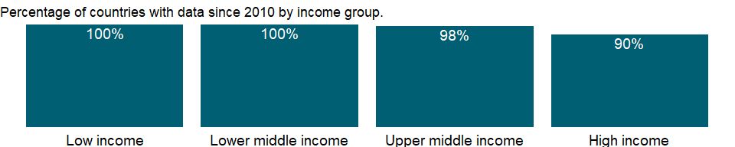

### Why is it relevant?

NA

### What is the data source?

World Health Organization, Global Tuberculosis Report.

### What is the methodology?

Tuberculosis is one of the main causes of adult deaths from a single infectious agent in developing countries. This indicator shows the tuberculosis detection rate for all detection methods. Editions before 2010 included the tuberculosis detection rates by DOTS, the internationally recommended strategy for tuberculosis control. Thus data on the case detection rate from 2010 onward cannot be compared with data in previous editions.

### How is it aggregated?

Weighted average

### What are the limitations?

NA

### What else should I know?

Aggregate data by groups are computed based on the groupings for the World Bank fiscal year in which the data was released by the World Health Organization.

## 1.67 Health: Mortality

### 1.67.1 Number of deaths ages 5-9 years

### What is the indicator?

Number of deaths of children ages 5-9 years

Topic: Health: Mortality

Series ID: SH.DTH.0509

Copyright: CC BY-4.0 , <https://datacatalog.worldbank.org/public-licenses#cc-by>

First year with any data: 1990

Last year with any data: 2019

### What years are data available?

The figure below shows years in which data is available for at least one country. Dates shaded in black have no data, while dates shaded in green have data for at least one country



### Which countries have data?

The figure below shows the percentage of countries in each income group with a value since 2010 for that indicator.

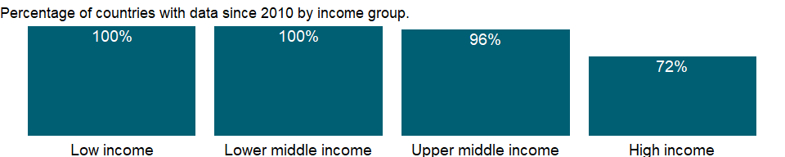

### Why is it relevant?

NA

### What is the data source?

Estimates developed by the UN Inter-agency Group for Child Mortality Estimation (UNICEF, WHO, World Bank, UN DESA Population Division) at www.childmortality.org.

### What is the methodology?

NA

### How is it aggregated?

Sum

### What are the limitations?

NA

### What else should I know?

Aggregate data for LIC, UMC, LMC, HIC are computed based on the groupings for the World Bank fiscal year in which the data was released by the UN Inter-agency Group for Child Mortality Estimation.

### 1.67.2 Number of deaths ages 10-14 years

### What is the indicator?

Number of deaths of adolescents ages 10-14 years

Topic: Health: Mortality

Series ID: SH.DTH.1014

Copyright: CC BY-4.0 , <https://datacatalog.worldbank.org/public-licenses#cc-by>

First year with any data: 1990

Last year with any data: 2019

### What years are data available?

The figure below shows years in which data is available for at least one country. Dates shaded in black have no data, while dates shaded in green have data for at least one country



### Which countries have data?

The figure below shows the percentage of countries in each income group with a value since 2010 for that indicator.



### Why is it relevant?

NA

### What is the data source?

Estimates developed by the UN Inter-agency Group for Child Mortality Estimation (UNICEF, WHO, World Bank, UN DESA Population Division) at www.childmortality.org.

### What is the methodology?

NA

### How is it aggregated?

Sum

### What are the limitations?

NA

### What else should I know?

Aggregate data for LIC, UMC, LMC, HIC are computed based on the groupings for the World Bank fiscal year in which the data was released by the UN Inter-agency Group for Child Mortality Estimation.

### 1.67.3 Number of deaths ages 15-19 years

### What is the indicator?

Number of deaths of adolescents ages 15-19 years

Topic: Health: Mortality

Series ID: SH.DTH.1519

Copyright: CC BY-4.0 , <https://datacatalog.worldbank.org/public-licenses#cc-by>

First year with any data: 1990

Last year with any data: 2019

### What years are data available?

The figure below shows years in which data is available for at least one country. Dates shaded in black have no data, while dates shaded in green have data for at least one country



### Which countries have data?

The figure below shows the percentage of countries in each income group with a value since 2010 for that indicator.



### Why is it relevant?

NA

### What is the data source?

Estimates developed by the UN Inter-agency Group for Child Mortality Estimation (UNICEF, WHO, World Bank, UN DESA Population Division) at www.childmortality.org.

### What is the methodology?

NA

### How is it aggregated?

Sum

### What are the limitations?

NA

### What else should I know?

Aggregate data for LIC, UMC, LMC, HIC are computed based on the groupings for the World Bank fiscal year in which the data was released by the UN Inter-agency Group for Child Mortality Estimation.

### 1.67.4 Number of deaths ages 20-24 years

### What is the indicator?

Number of deaths of youths ages 20-24 years

Topic: Health: Mortality

Series ID: SH.DTH.2024

Copyright: CC BY-4.0 , <https://datacatalog.worldbank.org/public-licenses#cc-by>

First year with any data: 1990

Last year with any data: 2019

### What years are data available?

The figure below shows years in which data is available for at least one country. Dates shaded in black have no data, while dates shaded in green have data for at least one country



### Which countries have data?

The figure below shows the percentage of countries in each income group with a value since 2010 for that indicator.



### Why is it relevant?

NA

### What is the data source?

Estimates developed by the UN Inter-agency Group for Child Mortality Estimation (UNICEF, WHO, World Bank, UN DESA Population Division) at www.childmortality.org.

### What is the methodology?

NA

### How is it aggregated?

Sum

### What are the limitations?

NA

### What else should I know?

Aggregate data for LIC, UMC, LMC, HIC are computed based on the groupings for the World Bank fiscal year in which the data was released by the UN Inter-agency Group for Child Mortality Estimation.

### 1.67.5 Number of infant deaths

### What is the indicator?

Number of infants dying before reaching one year of age.

Topic: Health: Mortality

Series ID: SH.DTH.IMRT

Copyright: CC BY-4.0 , <https://datacatalog.worldbank.org/public-licenses#cc-by>

First year with any data: 1960

Last year with any data: 2019

### What years are data available?

The figure below shows years in which data is available for at least one country. Dates shaded in black have no data, while dates shaded in green have data for at least one country



### Which countries have data?

The figure below shows the percentage of countries in each income group with a value since 2010 for that indicator.



### Why is it relevant?

NA

### What is the data source?

Estimates developed by the UN Inter-agency Group for Child Mortality Estimation (UNICEF, WHO, World Bank, UN DESA Population Division) at www.childmortality.org.

### What is the methodology?

NA

### How is it aggregated?

Sum

### What are the limitations?

NA

### What else should I know?

Aggregate data for LIC, UMC, LMC, HIC are computed based on the groupings for the World Bank fiscal year in which the data was released by the UN Inter-agency Group for Child Mortality Estimation.

### 1.67.6 Number of under-five deaths

### What is the indicator?

Number of children dying before reaching age five.

Topic: Health: Mortality

Series ID: SH.DTH.MORT

Copyright: CC BY-4.0 , <https://datacatalog.worldbank.org/public-licenses#cc-by>

First year with any data: 1960

Last year with any data: 2019

### What years are data available?

The figure below shows years in which data is available for at least one country. Dates shaded in black have no data, while dates shaded in green have data for at least one country



### Which countries have data?

The figure below shows the percentage of countries in each income group with a value since 2010 for that indicator.



### Why is it relevant?

NA

### What is the data source?

Estimates developed by the UN Inter-agency Group for Child Mortality Estimation (UNICEF, WHO, World Bank, UN DESA Population Division) at www.childmortality.org.

### What is the methodology?

NA

### How is it aggregated?

Sum

### What are the limitations?

NA

### What else should I know?

Aggregate data for LIC, UMC, LMC, HIC are computed based on the groupings for the World Bank fiscal year in which the data was released by the UN Inter-agency Group for Child Mortality Estimation.

### 1.67.7 Number of neonatal deaths

### What is the indicator?

Number of neonates dying before reaching 28 days of age.

Topic: Health: Mortality

Series ID: SH.DTH.NMRT

Copyright: CC BY-4.0 , <https://datacatalog.worldbank.org/public-licenses#cc-by>

First year with any data: 1960

Last year with any data: 2019

### What years are data available?

The figure below shows years in which data is available for at least one country. Dates shaded in black have no data, while dates shaded in green have data for at least one country



### Which countries have data?

The figure below shows the percentage of countries in each income group with a value since 2010 for that indicator.



### Why is it relevant?

NA

### What is the data source?

Estimates developed by the UN Inter-agency Group for Child Mortality Estimation (UNICEF, WHO, World Bank, UN DESA Population Division) at www.childmortality.org.

### What is the methodology?

NA

### How is it aggregated?

Sum

### What are the limitations?

NA

### What else should I know?

Aggregate data for LIC, UMC, LMC, HIC are computed based on the groupings for the World Bank fiscal year in which the data was released by the UN Inter-agency Group for Child Mortality Estimation.

This indicator is related to Sustainable Development Goal 3.2.2 [<https://unstats.un.org/sdgs/metadata/>].

### 1.67.8 Probability of dying among children ages 5-9 years (per 1,000)

### What is the indicator?

Probability of dying between age 5-9 years of age expressed per 1,000 children aged 5, if subject to age-specific mortality rates of the specified year.

Topic: Health: Mortality

Series ID: SH.DYN.0509

Copyright: CC BY-4.0 , <https://datacatalog.worldbank.org/public-licenses#cc-by>

First year with any data: 1990

Last year with any data: 2019

### What years are data available?

The figure below shows years in which data is available for at least one country. Dates shaded in black have no data, while dates shaded in green have data for at least one country



### Which countries have data?

The figure below shows the percentage of countries in each income group with a value since 2010 for that indicator.



### Why is it relevant?

Mortality rates for different age groups (infants, children, adolescents, youth and adults) and overall mortality indicators (life expectancy at birth or survival to a given age) are important indicators of health status in a country. Because data on the incidence and prevalence of diseases are frequently unavailable, mortality rates are often used to identify vulnerable populations. And they are among the indicators most frequently used to compare socioeconomic development across countries.

### What is the data source?

Estimates developed by the UN Inter-agency Group for Child Mortality Estimation (UNICEF, WHO, World Bank, UN DESA Population Division) at www.childmortality.org.

### What is the methodology?

The main sources of mortality data are vital registration systems and direct or indirect estimates based on sample surveys or censuses. A “complete” vital registration system - covering at least 90 percent of vital events in the population - is the best source of age-specific mortality data.

Estimates of neonatal, infant, and child mortality tend to vary by source and method for a given time and place. Years for available estimates also vary by country, making comparisons across countries and over time difficult. To make neonatal, infant, and child mortality estimates comparable and to ensure consistency across estimates by different agencies, the United Nations Inter-agency Group for Child Mortality Estimation (UN IGME), which comprises the United Nations Children’s Fund (UNICEF), the World Health Organization (WHO), the World Bank, the United Nations Population Division, and other universities and research institutes, developed and adopted a statistical method that uses all available information to reconcile differences. The method uses statistical models to obtain a best estimate trend line by fitting a country-specific regression model of mortality rates against their reference dates.

### How is it aggregated?

Weighted Average

### What are the limitations?

NA

### What else should I know?

Aggregate data for LIC, UMC, LMC, HIC are computed based on the groupings for the World Bank fiscal year in which the data was released by the UN Inter-agency Group for Child Mortality Estimation.

### 1.67.9 Probability of dying among adolescents ages 10-14 years (per 1,000)

### What is the indicator?

Probability of dying between age 10-14 years of age expressed per 1,000 adolescents age 10, if subject to age-specific mortality rates of the specified year.

Topic: Health: Mortality

Series ID: SH.DYN.1014

Copyright: CC BY-4.0 , <https://datacatalog.worldbank.org/public-licenses#cc-by>

First year with any data: 1990

Last year with any data: 2019

### What years are data available?

The figure below shows years in which data is available for at least one country. Dates shaded in black have no data, while dates shaded in green have data for at least one country



### Which countries have data?

The figure below shows the percentage of countries in each income group with a value since 2010 for that indicator.



### Why is it relevant?

Mortality rates for different age groups (infants, children, adolescents, youth and adults) and overall mortality indicators (life expectancy at birth or survival to a given age) are important indicators of health status in a country. Because data on the incidence and prevalence of diseases are frequently unavailable, mortality rates are often used to identify vulnerable populations. And they are among the indicators most frequently used to compare socioeconomic development across countries.

### What is the data source?

Estimates developed by the UN Inter-agency Group for Child Mortality Estimation (UNICEF, WHO, World Bank, UN DESA Population Division) at www.childmortality.org.

### What is the methodology?

The main sources of mortality data are vital registration systems and direct or indirect estimates based on sample surveys or censuses. A “complete” vital registration system - covering at least 90 percent of vital events in the population - is the best source of age-specific mortality data.

Estimates of neonatal, infant, and child mortality tend to vary by source and method for a given time and place. Years for available estimates also vary by country, making comparisons across countries and over time difficult. To make neonatal, infant, and child mortality estimates comparable and to ensure consistency across estimates by different agencies, the United Nations Inter-agency Group for Child Mortality Estimation (UN IGME), which comprises the United Nations Children’s Fund (UNICEF), the World Health Organization (WHO), the World Bank, the United Nations Population Division, and other universities and research institutes, developed and adopted a statistical method that uses all available information to reconcile differences. The method uses statistical models to obtain a best estimate trend line by fitting a country-specific regression model of mortality rates against their reference dates.

### How is it aggregated?

Weighted Average

### What are the limitations?

Complete vital registration systems are fairly uncommon in developing countries. Thus estimates must be obtained from sample surveys or derived by applying indirect estimation techniques to registration, census, or survey data. Survey data are subject to recall error, and surveys estimating infant/child deaths require large samples because households in which a birth has occurred during a given year cannot ordinarily be preselected for sampling. Indirect estimates rely on model life tables that may be inappropriate for the population concerned. Extrapolations based on outdated surveys may not be reliable for monitoring changes in health status or for comparative analytical work.

### What else should I know?

Aggregate data for LIC, UMC, LMC, HIC are computed based on the groupings for the World Bank fiscal year in which the data was released by the UN Inter-agency Group for Child Mortality Estimation.

### 1.67.10 Probability of dying among adolescents ages 15-19 years (per 1,000)

### What is the indicator?

Probability of dying between age 15-19 years of age expressed per 1,000 adolescents age 15, if subject to age-specific mortality rates of the specified year.

Topic: Health: Mortality

Series ID: SH.DYN.1519

Copyright: CC BY-4.0 , <https://datacatalog.worldbank.org/public-licenses#cc-by>

First year with any data: 1990

Last year with any data: 2019

### What years are data available?

The figure below shows years in which data is available for at least one country. Dates shaded in black have no data, while dates shaded in green have data for at least one country



### Which countries have data?

The figure below shows the percentage of countries in each income group with a value since 2010 for that indicator.



### Why is it relevant?

Mortality rates for different age groups (infants, children, adolescents, youth and adults) and overall mortality indicators (life expectancy at birth or survival to a given age) are important indicators of health status in a country. Because data on the incidence and prevalence of diseases are frequently unavailable, mortality rates are often used to identify vulnerable populations. And they are among the indicators most frequently used to compare socioeconomic development across countries.

### What is the data source?

Estimates developed by the UN Inter-agency Group for Child Mortality Estimation (UNICEF, WHO, World Bank, UN DESA Population Division) at www.childmortality.org.

### What is the methodology?

The main sources of mortality data are vital registration systems and direct or indirect estimates based on sample surveys or censuses. A “complete” vital registration system - covering at least 90 percent of vital events in the population - is the best source of age-specific mortality data.

Estimates of neonatal, infant, and child mortality tend to vary by source and method for a given time and place. Years for available estimates also vary by country, making comparisons across countries and over time difficult. To make neonatal, infant, and child mortality estimates comparable and to ensure consistency across estimates by different agencies, the United Nations Inter-agency Group for Child Mortality Estimation (UN IGME), which comprises the United Nations Children’s Fund (UNICEF), the World Health Organization (WHO), the World Bank, the United Nations Population Division, and other universities and research institutes, developed and adopted a statistical method that uses all available information to reconcile differences. The method uses statistical models to obtain a best estimate trend line by fitting a country-specific regression model of mortality rates against their reference dates.

### How is it aggregated?

Weighted Average

### What are the limitations?

Complete vital registration systems are fairly uncommon in developing countries. Thus estimates must be obtained from sample surveys or derived by applying indirect estimation techniques to registration, census, or survey data. Survey data are subject to recall error, and surveys estimating infant/child deaths require large samples because households in which a birth has occurred during a given year cannot ordinarily be preselected for sampling. Indirect estimates rely on model life tables that may be inappropriate for the population concerned. Extrapolations based on outdated surveys may not be reliable for monitoring changes in health status or for comparative analytical work.

### What else should I know?

Aggregate data for LIC, UMC, LMC, HIC are computed based on the groupings for the World Bank fiscal year in which the data was released by the UN Inter-agency Group for Child Mortality Estimation.

### 1.67.11 Probability of dying among youth ages 20-24 years (per 1,000)

### What is the indicator?

Probability of dying between age 20-24 years of age expressed per 1,000 youths age 20, if subject to age-specific mortality rates of the specified year.

Topic: Health: Mortality

Series ID: SH.DYN.2024

Copyright: CC BY-4.0 , <https://datacatalog.worldbank.org/public-licenses#cc-by>

First year with any data: 1990

Last year with any data: 2019

### What years are data available?

The figure below shows years in which data is available for at least one country. Dates shaded in black have no data, while dates shaded in green have data for at least one country



### Which countries have data?

The figure below shows the percentage of countries in each income group with a value since 2010 for that indicator.



### Why is it relevant?

Mortality rates for different age groups (infants, children, adolescents, youth and adults) and overall mortality indicators (life expectancy at birth or survival to a given age) are important indicators of health status in a country. Because data on the incidence and prevalence of diseases are frequently unavailable, mortality rates are often used to identify vulnerable populations. And they are among the indicators most frequently used to compare socioeconomic development across countries.

### What is the data source?

Estimates developed by the UN Inter-agency Group for Child Mortality Estimation (UNICEF, WHO, World Bank, UN DESA Population Division) at www.childmortality.org.

### What is the methodology?

The main sources of mortality data are vital registration systems and direct or indirect estimates based on sample surveys or censuses. A “complete” vital registration system - covering at least 90 percent of vital events in the population - is the best source of age-specific mortality data.

Estimates of neonatal, infant, and child mortality tend to vary by source and method for a given time and place. Years for available estimates also vary by country, making comparisons across countries and over time difficult. To make neonatal, infant, and child mortality estimates comparable and to ensure consistency across estimates by different agencies, the United Nations Inter-agency Group for Child Mortality Estimation (UN IGME), which comprises the United Nations Children’s Fund (UNICEF), the World Health Organization (WHO), the World Bank, the United Nations Population Division, and other universities and research institutes, developed and adopted a statistical method that uses all available information to reconcile differences. The method uses statistical models to obtain a best estimate trend line by fitting a country-specific regression model of mortality rates against their reference dates.

### How is it aggregated?

Weighted Average

### What are the limitations?

Complete vital registration systems are fairly uncommon in developing countries. Thus estimates must be obtained from sample surveys or derived by applying indirect estimation techniques to registration, census, or survey data. Survey data are subject to recall error, and surveys estimating infant/child deaths require large samples because households in which a birth has occurred during a given year cannot ordinarily be preselected for sampling. Indirect estimates rely on model life tables that may be inappropriate for the population concerned. Extrapolations based on outdated surveys may not be reliable for monitoring changes in health status or for comparative analytical work.

### What else should I know?

Aggregate data for LIC, UMC, LMC, HIC are computed based on the groupings for the World Bank fiscal year in which the data was released by the UN Inter-agency Group for Child Mortality Estimation.

### 1.67.12 Mortality rate, under-5 (per 1,000 live births)

### What is the indicator?

Under-five mortality rate is the probability per 1,000 that a newborn baby will die before reaching age five, if subject to age-specific mortality rates of the specified year.

Topic: Health: Mortality

Series ID: SH.DYN.MORT

Copyright: CC BY-4.0 , <https://datacatalog.worldbank.org/public-licenses#cc-by>

First year with any data: 1960

Last year with any data: 2019

### What years are data available?

The figure below shows years in which data is available for at least one country. Dates shaded in black have no data, while dates shaded in green have data for at least one country



### Which countries have data?

The figure below shows the percentage of countries in each income group with a value since 2010 for that indicator.



### Why is it relevant?

Mortality rates for different age groups (infants, children, and adults) and overall mortality indicators (life expectancy at birth or survival to a given age) are important indicators of health status in a country. Because data on the incidence and prevalence of diseases are frequently unavailable, mortality rates are often used to identify vulnerable populations. And they are among the indicators most frequently used to compare socioeconomic development across countries.

### What is the data source?

Estimates developed by the UN Inter-agency Group for Child Mortality Estimation (UNICEF, WHO, World Bank, UN DESA Population Division) at www.childmortality.org.

### What is the methodology?

The main sources of mortality data are vital registration systems and direct or indirect estimates based on sample surveys or censuses. A “complete” vital registration system - covering at least 90 percent of vital events in the population - is the best source of age-specific mortality data.

Estimates of neonatal, infant, and child mortality tend to vary by source and method for a given time and place. Years for available estimates also vary by country, making comparisons across countries and over time difficult. To make neonatal, infant, and child mortality estimates comparable and to ensure consistency across estimates by different agencies, the United Nations Inter-agency Group for Child Mortality Estimation (UN IGME), which comprises the United Nations Children’s Fund (UNICEF), the World Health Organization (WHO), the World Bank, the United Nations Population Division, and other universities and research institutes, developed and adopted a statistical method that uses all available information to reconcile differences. The method uses statistical models to obtain a best estimate trend line by fitting a country-specific regression model of mortality rates against their reference dates.

### How is it aggregated?

Weighted average

### What are the limitations?

Complete vital registration systems are fairly uncommon in developing countries. Thus estimates must be obtained from sample surveys or derived by applying indirect estimation techniques to registration, census, or survey data. Survey data are subject to recall error, and surveys estimating infant/child deaths require large samples because households in which a birth has occurred during a given year cannot ordinarily be preselected for sampling. Indirect estimates rely on model life tables that may be inappropriate for the population concerned. Extrapolations based on outdated surveys may not be reliable for monitoring changes in health status or for comparative analytical work.

### What else should I know?

Given that data on the incidence and prevalence of diseases are frequently unavailable, mortality rates are often used to identify vulnerable populations. Moreover, they are among the indicators most frequently used to compare socioeconomic development across countries. Under-five mortality rates are higher for boys than for girls in countries in which parental gender preferences are insignificant. Under-five mortality captures the effect of gender discrimination better than infant mortality does, as malnutrition and medical interventions have more significant impacts to this age group. Where female under-five mortality is higher, girls are likely to have less access to resources than boys.

Aggregate data for LIC, UMC, LMC, HIC are computed based on the groupings for the World Bank fiscal year in which the data was released by the UN Inter-agency Group for Child Mortality Estimation.

This is the Sustainable Development Goal indicator 3.2.1[<https://unstats.un.org/sdgs/metadata/>].

### 1.67.13 Mortality rate, under-5, female (per 1,000 live births)

### What is the indicator?

Under-five mortality rate, female is the probability per 1,000 that a newborn female baby will die before reaching age five, if subject to female age-specific mortality rates of the specified year.

Topic: Health: Mortality

Series ID: SH.DYN.MORT.FE

Copyright: CC BY-4.0 , <https://datacatalog.worldbank.org/public-licenses#cc-by>

First year with any data: 1960

Last year with any data: 2019

### What years are data available?

The figure below shows years in which data is available for at least one country. Dates shaded in black have no data, while dates shaded in green have data for at least one country



### Which countries have data?

The figure below shows the percentage of countries in each income group with a value since 2010 for that indicator.



### Why is it relevant?

Mortality rates for different age groups (infants, children, and adults) and overall mortality indicators (life expectancy at birth or survival to a given age) are important indicators of health status in a country. Because data on the incidence and prevalence of diseases are frequently unavailable, mortality rates are often used to identify vulnerable populations. And they are among the indicators most frequently used to compare socioeconomic development across countries.

### What is the data source?

Estimates developed by the UN Inter-agency Group for Child Mortality Estimation (UNICEF, WHO, World Bank, UN DESA Population Division) at www.childmortality.org.

### What is the methodology?

The main sources of mortality data are vital registration systems and direct or indirect estimates based on sample surveys or censuses. A “complete” vital registration system - covering at least 90 percent of vital events in the population - is the best source of age-specific mortality data.

Estimates of neonatal, infant, and child mortality tend to vary by source and method for a given time and place. Years for available estimates also vary by country, making comparisons across countries and over time difficult. To make neonatal, infant, and child mortality estimates comparable and to ensure consistency across estimates by different agencies, the United Nations Inter-agency Group for Child Mortality Estimation (UN IGME), which comprises the United Nations Children’s Fund (UNICEF), the World Health Organization (WHO), the World Bank, the United Nations Population Division, and other universities and research institutes, developed and adopted a statistical method that uses all available information to reconcile differences. The method uses statistical models to obtain a best estimate trend line by fitting a country-specific regression model of mortality rates against their reference dates.

### How is it aggregated?

Weighted Average

### What are the limitations?

Complete vital registration systems are fairly uncommon in developing countries. Thus estimates must be obtained from sample surveys or derived by applying indirect estimation techniques to registration, census, or survey data. Survey data are subject to recall error, and surveys estimating infant/child deaths require large samples because households in which a birth has occurred during a given year cannot ordinarily be preselected for sampling. Indirect estimates rely on model life tables that may be inappropriate for the population concerned. Extrapolations based on outdated surveys may not be reliable for monitoring changes in health status or for comparative analytical work.

### What else should I know?

Given that data on the incidence and prevalence of diseases are frequently unavailable, mortality rates are often used to identify vulnerable populations. Moreover, they are among the indicators most frequently used to compare socioeconomic development across countries. Under-five mortality rates are higher for boys than for girls in countries in which parental gender preferences are insignificant. Under-five mortality captures the effect of gender discrimination better than infant mortality does, as malnutrition and medical interventions have more significant impacts to this age group. Where female under-five mortality is higher, girls are likely to have less access to resources than boys.

Aggregate data for LIC, UMC, LMC, HIC are computed based on the groupings for the World Bank fiscal year in which the data was released by the UN Inter-agency Group for Child Mortality Estimation.

This is a sex-disaggregated indicator for Sustainable Development Goal 3.2.1 [<https://unstats.un.org/sdgs/metadata/>].

### 1.67.14 Mortality rate, under-5, male (per 1,000 live births)

### What is the indicator?

Under-five mortality rate, male is the probability per 1,000 that a newborn male baby will die before reaching age five, if subject to male age-specific mortality rates of the specified year.

Topic: Health: Mortality

Series ID: SH.DYN.MORT.MA

Copyright: CC BY-4.0 , <https://datacatalog.worldbank.org/public-licenses#cc-by>

First year with any data: 1960

Last year with any data: 2019

### What years are data available?

The figure below shows years in which data is available for at least one country. Dates shaded in black have no data, while dates shaded in green have data for at least one country



### Which countries have data?

The figure below shows the percentage of countries in each income group with a value since 2010 for that indicator.



### Why is it relevant?

Mortality rates for different age groups (infants, children, and adults) and overall mortality indicators (life expectancy at birth or survival to a given age) are important indicators of health status in a country. Because data on the incidence and prevalence of diseases are frequently unavailable, mortality rates are often used to identify vulnerable populations. And they are among the indicators most frequently used to compare socioeconomic development across countries.

### What is the data source?

Estimates developed by the UN Inter-agency Group for Child Mortality Estimation (UNICEF, WHO, World Bank, UN DESA Population Division) at www.childmortality.org.

### What is the methodology?

The main sources of mortality data are vital registration systems and direct or indirect estimates based on sample surveys or censuses. A “complete” vital registration system - covering at least 90 percent of vital events in the population - is the best source of age-specific mortality data.

Estimates of neonatal, infant, and child mortality tend to vary by source and method for a given time and place. Years for available estimates also vary by country, making comparisons across countries and over time difficult. To make neonatal, infant, and child mortality estimates comparable and to ensure consistency across estimates by different agencies, the United Nations Inter-agency Group for Child Mortality Estimation (UN IGME), which comprises the United Nations Children’s Fund (UNICEF), the World Health Organization (WHO), the World Bank, the United Nations Population Division, and other universities and research institutes, developed and adopted a statistical method that uses all available information to reconcile differences. The method uses statistical models to obtain a best estimate trend line by fitting a country-specific regression model of mortality rates against their reference dates.

### How is it aggregated?

Weighted Average

### What are the limitations?

Complete vital registration systems are fairly uncommon in developing countries. Thus estimates must be obtained from sample surveys or derived by applying indirect estimation techniques to registration, census, or survey data. Survey data are subject to recall error, and surveys estimating infant/child deaths require large samples because households in which a birth has occurred during a given year cannot ordinarily be preselected for sampling. Indirect estimates rely on model life tables that may be inappropriate for the population concerned. Extrapolations based on outdated surveys may not be reliable for monitoring changes in health status or for comparative analytical work.

### What else should I know?

Given that data on the incidence and prevalence of diseases are frequently unavailable, mortality rates are often used to identify vulnerable populations. Moreover, they are among the indicators most frequently used to compare socioeconomic development across countries. Under-five mortality rates are higher for boys than for girls in countries in which parental gender preferences are insignificant. Under-five mortality captures the effect of gender discrimination better than infant mortality does, as malnutrition and medical interventions have more significant impacts to this age group. Where female under-five mortality is higher, girls are likely to have less access to resources than boys.

Aggregate data for LIC, UMC, LMC, HIC are computed based on the groupings for the World Bank fiscal year in which the data was released by the UN Inter-agency Group for Child Mortality Estimation.

This is a sex-disaggregated indicator for Sustainable Development Goal 3.2.1 [<https://unstats.un.org/sdgs/metadata/>].

### 1.67.15 Mortality from CVD, cancer, diabetes or CRD between exact ages 30 and 70, female (%)

### What is the indicator?

Mortality from CVD, cancer, diabetes or CRD is the percent of 30-year-old-people who would die before their 70th birthday from any of cardiovascular disease, cancer, diabetes, or chronic respiratory disease, assuming that s/he would experience current mortality rates at every age and s/he would not die from any other cause of death (e.g., injuries or HIV/AIDS).

Topic: Health: Mortality

Series ID: SH.DYN.NCOM.FE.ZS

Copyright: CC BY-4.0 , <https://datacatalog.worldbank.org/public-licenses#cc-by>

First year with any data: 2000

Last year with any data: 2019

### What years are data available?

The figure below shows years in which data is available for at least one country. Dates shaded in black have no data, while dates shaded in green have data for at least one country



### Which countries have data?

The figure below shows the percentage of countries in each income group with a value since 2010 for that indicator.



### Why is it relevant?

NA

### What is the data source?

World Health Organization, Global Health Observatory Data Repository (<http://apps.who.int/ghodata/>).

### What is the methodology?

NA

### How is it aggregated?

Weighted Average

### What are the limitations?

NA

### What else should I know?

This is a sex-disaggregated indicator for Sustainable Development Goal 3.4.1 [<https://unstats.un.org/sdgs/metadata/>].

### 1.67.16 Mortality from CVD, cancer, diabetes or CRD between exact ages 30 and 70, male (%)

### What is the indicator?

Mortality from CVD, cancer, diabetes or CRD is the percent of 30-year-old-people who would die before their 70th birthday from any of cardiovascular disease, cancer, diabetes, or chronic respiratory disease, assuming that s/he would experience current mortality rates at every age and s/he would not die from any other cause of death (e.g., injuries or HIV/AIDS).

Topic: Health: Mortality

Series ID: SH.DYN.NCOM.MA.ZS

Copyright: CC BY-4.0 , <https://datacatalog.worldbank.org/public-licenses#cc-by>

First year with any data: 2000

Last year with any data: 2019

### What years are data available?

The figure below shows years in which data is available for at least one country. Dates shaded in black have no data, while dates shaded in green have data for at least one country



### Which countries have data?

The figure below shows the percentage of countries in each income group with a value since 2010 for that indicator.



### Why is it relevant?

NA

### What is the data source?

World Health Organization, Global Health Observatory Data Repository (<http://apps.who.int/ghodata/>).

### What is the methodology?

NA

### How is it aggregated?

Weighted Average

### What are the limitations?

NA

### What else should I know?

This is a sex-disaggregated indicator for Sustainable Development Goal 3.4.1 [<https://unstats.un.org/sdgs/metadata/>].

### 1.67.17 Mortality from CVD, cancer, diabetes or CRD between exact ages 30 and 70 (%)

### What is the indicator?

Mortality from CVD, cancer, diabetes or CRD is the percent of 30-year-old-people who would die before their 70th birthday from any of cardiovascular disease, cancer, diabetes, or chronic respiratory disease, assuming that s/he would experience current mortality rates at every age and s/he would not die from any other cause of death (e.g., injuries or HIV/AIDS).

Topic: Health: Mortality

Series ID: SH.DYN.NCOM.ZS

Copyright: CC BY-4.0 , <https://datacatalog.worldbank.org/public-licenses#cc-by>

First year with any data: 2000

Last year with any data: 2019

### What years are data available?

The figure below shows years in which data is available for at least one country. Dates shaded in black have no data, while dates shaded in green have data for at least one country



### Which countries have data?

The figure below shows the percentage of countries in each income group with a value since 2010 for that indicator.



### Why is it relevant?

NA

### What is the data source?

World Health Organization, Global Health Observatory Data Repository (<http://apps.who.int/ghodata/>).

### What is the methodology?

NA

### How is it aggregated?

Weighted Average

### What are the limitations?

NA

### What else should I know?

This is the Sustainable Development Goal indicator 3.4.1 [<https://unstats.un.org/sdgs/metadata/>].

### 1.67.18 Mortality rate, neonatal (per 1,000 live births)

### What is the indicator?

Neonatal mortality rate is the number of neonates dying before reaching 28 days of age, per 1,000 live births in a given year.

Topic: Health: Mortality

Series ID: SH.DYN.NMRT

Copyright: CC BY-4.0 , <https://datacatalog.worldbank.org/public-licenses#cc-by>

First year with any data: 1960

Last year with any data: 2019

### What years are data available?

The figure below shows years in which data is available for at least one country. Dates shaded in black have no data, while dates shaded in green have data for at least one country



### Which countries have data?

The figure below shows the percentage of countries in each income group with a value since 2010 for that indicator.



### Why is it relevant?

Mortality rates for different age groups (infants, children, and adults) and overall mortality indicators (life expectancy at birth or survival to a given age) are important indicators of health status in a country. Because data on the incidence and prevalence of diseases are frequently unavailable, mortality rates are often used to identify vulnerable populations. And they are among the indicators most frequently used to compare socioeconomic development across countries.

### What is the data source?

Estimates developed by the UN Inter-agency Group for Child Mortality Estimation (UNICEF, WHO, World Bank, UN DESA Population Division) at www.childmortality.org.

### What is the methodology?

The main sources of mortality data are vital registration systems and direct or indirect estimates based on sample surveys or censuses. A “complete” vital registration system - covering at least 90 percent of vital events in the population - is the best source of age-specific mortality data.

Estimates of neonatal, infant, and child mortality tend to vary by source and method for a given time and place. Years for available estimates also vary by country, making comparisons across countries and over time difficult. To make neonatal, infant, and child mortality estimates comparable and to ensure consistency across estimates by different agencies, the United Nations Inter-agency Group for Child Mortality Estimation (UN IGME), which comprises the United Nations Children’s Fund (UNICEF), the World Health Organization (WHO), the World Bank, the United Nations Population Division, and other universities and research institutes, developed and adopted a statistical method that uses all available information to reconcile differences. The method uses statistical models to obtain a best estimate trend line by fitting a country-specific regression model of mortality rates against their reference dates.

### How is it aggregated?

Weighted Average

### What are the limitations?

Complete vital registration systems are fairly uncommon in developing countries. Thus estimates must be obtained from sample surveys or derived by applying indirect estimation techniques to registration, census, or survey data. Survey data are subject to recall error, and surveys estimating infant/child deaths require large samples because households in which a birth has occurred during a given year cannot ordinarily be preselected for sampling. Indirect estimates rely on model life tables that may be inappropriate for the population concerned. Extrapolations based on outdated surveys may not be reliable for monitoring changes in health status or for comparative analytical work.

### What else should I know?

Given that data on the incidence and prevalence of diseases are frequently unavailable, mortality rates are often used to identify vulnerable populations. Moreover, they are among the indicators most frequently used to compare socioeconomic development across countries.

Aggregate data for LIC, UMC, LMC, HIC are computed based on the groupings for the World Bank fiscal year in which the data was released by the UN Inter-agency Group for Child Mortality Estimation.

This is the Sustainable Development Goal indicator 3.2.2 [<https://unstats.un.org/sdgs/metadata/>].

### 1.67.19 Mortality rate attributed to household and ambient air pollution, age-standardized, female (per 100,000 female population)

### What is the indicator?

Mortality rate attributed to household and ambient air pollution is the number of deaths attributable to the joint effects of household and ambient air pollution in a year per 100,000 population. The rates are age-standardized. Following diseases are taken into account: acute respiratory infections (estimated for all ages); cerebrovascular diseases in adults (estimated above 25 years); ischaemic heart diseases in adults (estimated above 25 years); chronic obstructive pulmonary disease in adults (estimated above 25 years); and lung cancer in adults (estimated above 25 years).

Topic: Health: Mortality

Series ID: SH.STA.AIRP.FE.P5

Copyright: CC BY-4.0 , <https://datacatalog.worldbank.org/public-licenses#cc-by>

First year with any data: 2016

Last year with any data: 2016

### What years are data available?

The figure below shows years in which data is available for at least one country. Dates shaded in black have no data, while dates shaded in green have data for at least one country



### Which countries have data?

The figure below shows the percentage of countries in each income group with a value since 2010 for that indicator.



### Why is it relevant?

Air pollution is one of the biggest environmental risks to health. According to the World Health Organization, the combined effects of ambient (outdoor) and household air pollution cause about 7 million premature deaths every year. Most deaths occur due to increased mortality from stroke, heart disease, chronic obstructive pulmonary disease, lung cancer and acute respiratory infections. The majority of the burden is borne by populations in low and middle income countries.

### What is the data source?

World Health Organization, Global Health Observatory Data Repository (<http://apps.who.int/ghodata/>).

### What is the methodology?

Burden of disease (or in the present case attributable mortality) is calculated by first combining information on the increased (or relative) risk of a disease resulting from exposure, with information on how widespread the exposure is in the population (e.g. the annual mean concentration of particulate matter to which the population is exposed). This allows calculation of the ‘population attributable fraction’ (PAF), which is the fraction of disease seen in a given population that can be attributed to the exposure (e.g in this case the annual mean concentration of particulate matter). Applying this fraction to the total burden of disease (e.g. cardiopulmonary disease expressed as deaths or DALYs), gives the total number of deaths or DALYs that results from exposure to that particular risk factor (in the example given above, to ambient air pollution). To estimate the combined effects of risk factors, a joint population attributable fraction is calculated, as described in Ezzati et al (2003).

### How is it aggregated?

Weighted Average

### What are the limitations?

Estimates of the joint effects of air pollution are constrained by limited knowledge on the distribution of the population exposed to both household and ambient air pollution, correlation of exposures at individual level as household air pollution is a contributor to ambient air pollution, and non-linear interactions

### What else should I know?

This is a sex-disaggregated indicator for Sustainable Development Goal 3.9.1 [<https://unstats.un.org/sdgs/metadata/>].

### 1.67.20 Mortality rate attributed to household and ambient air pollution, age-standardized, male (per 100,000 male population)

### What is the indicator?

Mortality rate attributed to household and ambient air pollution is the number of deaths attributable to the joint effects of household and ambient air pollution in a year per 100,000 population. The rates are age-standardized. Following diseases are taken into account: acute respiratory infections (estimated for all ages); cerebrovascular diseases in adults (estimated above 25 years); ischaemic heart diseases in adults (estimated above 25 years); chronic obstructive pulmonary disease in adults (estimated above 25 years); and lung cancer in adults (estimated above 25 years).

Topic: Health: Mortality

Series ID: SH.STA.AIRP.MA.P5

Copyright: CC BY-4.0 , <https://datacatalog.worldbank.org/public-licenses#cc-by>

First year with any data: 2016

Last year with any data: 2016

### What years are data available?

The figure below shows years in which data is available for at least one country. Dates shaded in black have no data, while dates shaded in green have data for at least one country



### Which countries have data?

The figure below shows the percentage of countries in each income group with a value since 2010 for that indicator.



### Why is it relevant?

Air pollution is one of the biggest environmental risks to health. According to the World Health Organization, the combined effects of ambient (outdoor) and household air pollution cause about 7 million premature deaths every year. Most deaths occur due to increased mortality from stroke, heart disease, chronic obstructive pulmonary disease, lung cancer and acute respiratory infections. The majority of the burden is borne by populations in low and middle income countries.

### What is the data source?

World Health Organization, Global Health Observatory Data Repository (<http://apps.who.int/ghodata/>).

### What is the methodology?

Burden of disease (or in the present case attributable mortality) is calculated by first combining information on the increased (or relative) risk of a disease resulting from exposure, with information on how widespread the exposure is in the population (e.g. the annual mean concentration of particulate matter to which the population is exposed). This allows calculation of the ‘population attributable fraction’ (PAF), which is the fraction of disease seen in a given population that can be attributed to the exposure (e.g in this case the annual mean concentration of particulate matter). Applying this fraction to the total burden of disease (e.g. cardiopulmonary disease expressed as deaths or DALYs), gives the total number of deaths or DALYs that results from exposure to that particular risk factor (in the example given above, to ambient air pollution). To estimate the combined effects of risk factors, a joint population attributable fraction is calculated, as described in Ezzati et al (2003).

### How is it aggregated?

Weighted Average

### What are the limitations?

Estimates of the joint effects of air pollution are constrained by limited knowledge on the distribution of the population exposed to both household and ambient air pollution, correlation of exposures at individual level as household air pollution is a contributor to ambient air pollution, and non-linear interactions

### What else should I know?

This is a sex-disaggregated indicator for Sustainable Development Goal 3.9.1 [<https://unstats.un.org/sdgs/metadata/>].

### 1.67.21 Mortality rate attributed to household and ambient air pollution, age-standardized (per 100,000 population)

### What is the indicator?

Mortality rate attributed to household and ambient air pollution is the number of deaths attributable to the joint effects of household and ambient air pollution in a year per 100,000 population. The rates are age-standardized. Following diseases are taken into account: acute respiratory infections (estimated for all ages); cerebrovascular diseases in adults (estimated above 25 years); ischaemic heart diseases in adults (estimated above 25 years); chronic obstructive pulmonary disease in adults (estimated above 25 years); and lung cancer in adults (estimated above 25 years).

Topic: Health: Mortality

Series ID: SH.STA.AIRP.P5

Copyright: CC BY-4.0 , <https://datacatalog.worldbank.org/public-licenses#cc-by>

First year with any data: 2016

Last year with any data: 2016

### What years are data available?

The figure below shows years in which data is available for at least one country. Dates shaded in black have no data, while dates shaded in green have data for at least one country



### Which countries have data?

The figure below shows the percentage of countries in each income group with a value since 2010 for that indicator.



### Why is it relevant?

Air pollution is one of the biggest environmental risks to health. According to the World Health Organization, the combined effects of ambient (outdoor) and household air pollution cause about 7 million premature deaths every year. Most deaths occur due to increased mortality from stroke, heart disease, chronic obstructive pulmonary disease, lung cancer and acute respiratory infections. The majority of the burden is borne by populations in low and middle income countries.

### What is the data source?

World Health Organization, Global Health Observatory Data Repository (<http://apps.who.int/ghodata/>).

### What is the methodology?

Burden of disease (or in the present case attributable mortality) is calculated by first combining information on the increased (or relative) risk of a disease resulting from exposure, with information on how widespread the exposure is in the population (e.g. the annual mean concentration of particulate matter to which the population is exposed). This allows calculation of the ‘population attributable fraction’ (PAF), which is the fraction of disease seen in a given population that can be attributed to the exposure (e.g in this case the annual mean concentration of particulate matter). Applying this fraction to the total burden of disease (e.g. cardiopulmonary disease expressed as deaths or DALYs), gives the total number of deaths or DALYs that results from exposure to that particular risk factor (in the example given above, to ambient air pollution). To estimate the combined effects of risk factors, a joint population attributable fraction is calculated, as described in Ezzati et al (2003).

### How is it aggregated?

Weighted Average

### What are the limitations?

Estimates of the joint effects of air pollution are constrained by limited knowledge on the distribution of the population exposed to both household and ambient air pollution, correlation of exposures at individual level as household air pollution is a contributor to ambient air pollution, and non-linear interactions

### What else should I know?

This is the Sustainable Development Goal indicator 3.9.1 [<https://unstats.un.org/sdgs/metadata/>].

### 1.67.22 Mortality rate attributed to unintentional poisoning (per 100,000 population)

### What is the indicator?

Mortality rate attributed to unintentional poisonings is the number of deaths from unintentional poisonings in a year per 100,000 population. Unintentional poisoning can be caused by household chemicals, pesticides, kerosene, carbon monoxide and medicines, or can be the result of environmental contamination or occupational chemical exposure.

Topic: Health: Mortality

Series ID: SH.STA.POIS.P5

Copyright: CC BY-4.0 , <https://datacatalog.worldbank.org/public-licenses#cc-by>

First year with any data: 2000

Last year with any data: 2019

### What years are data available?

The figure below shows years in which data is available for at least one country. Dates shaded in black have no data, while dates shaded in green have data for at least one country



### Which countries have data?

The figure below shows the percentage of countries in each income group with a value since 2010 for that indicator.



### Why is it relevant?

Mortality rates due to unintentional poisoning remains relatively high in low income countries. This indicator implicates inadequate management of hazardous chemicals and pollution, and of the effectiveness of a country’s health system.

### What is the data source?

World Health Organization, Global Health Observatory Data Repository (<http://apps.who.int/ghodata/>).

### What is the methodology?

NA

### How is it aggregated?

Weighted Average

### What are the limitations?

Some countries do not have death registration data or sample registration systems. The estimates on this indicator need to be completed with other type of information for these countries.

### What else should I know?

This is the Sustainable Development Goal indicator 3.9.3[<https://unstats.un.org/sdgs/metadata/>].

### 1.67.23 Mortality rate attributed to unintentional poisoning, female (per 100,000 female population)

### What is the indicator?

Mortality rate attributed to unintentional poisonings is the number of female deaths from unintentional poisonings in a year per 100,000 female population. Unintentional poisoning can be caused by household chemicals, pesticides, kerosene, carbon monoxide and medicines, or can be the result of environmental contamination or occupational chemical exposure.

Topic: Health: Mortality

Series ID: SH.STA.POIS.P5.FE

Copyright: CC BY-4.0 , <https://datacatalog.worldbank.org/public-licenses#cc-by>

First year with any data: 2000

Last year with any data: 2019

### What years are data available?

The figure below shows years in which data is available for at least one country. Dates shaded in black have no data, while dates shaded in green have data for at least one country



### Which countries have data?

The figure below shows the percentage of countries in each income group with a value since 2010 for that indicator.



### Why is it relevant?

Mortality rates due to unintentional poisoning remains relatively high in low income countries. This indicator implicates inadequate management of hazardous chemicals and pollution, and of the effectiveness of a country’s health system.

### What is the data source?

World Health Organization, Global Health Observatory Data Repository (<http://apps.who.int/ghodata/>).

### What is the methodology?

NA

### How is it aggregated?

Weighted Average

### What are the limitations?

Some countries do not have death registration data or sample registration systems. The estimates on this indicator need to be completed with other type of information for these countries.

### What else should I know?

This is a sex-disaggregated indicator for Sustainable Development Goal 3.9.3[<https://unstats.un.org/sdgs/metadata/>].

### 1.67.24 Mortality rate attributed to unintentional poisoning, male (per 100,000 male population)

### What is the indicator?

Mortality rate attributed to unintentional poisonings is the number of male deaths from unintentional poisonings in a year per 100,000 male population. Unintentional poisoning can be caused by household chemicals, pesticides, kerosene, carbon monoxide and medicines, or can be the result of environmental contamination or occupational chemical exposure.

Topic: Health: Mortality

Series ID: SH.STA.POIS.P5.MA

Copyright: CC BY-4.0 , <https://datacatalog.worldbank.org/public-licenses#cc-by>

First year with any data: 2000

Last year with any data: 2019

### What years are data available?

The figure below shows years in which data is available for at least one country. Dates shaded in black have no data, while dates shaded in green have data for at least one country



### Which countries have data?

The figure below shows the percentage of countries in each income group with a value since 2010 for that indicator.



### Why is it relevant?

Mortality rates due to unintentional poisoning remains relatively high in low income countries. This indicator implicates inadequate management of hazardous chemicals and pollution, and of the effectiveness of a country’s health system.

### What is the data source?

World Health Organization, Global Health Observatory Data Repository (<http://apps.who.int/ghodata/>).

### What is the methodology?

NA

### How is it aggregated?

Weighted Average

### What are the limitations?

Some countries do not have death registration data or sample registration systems. The estimates on this indicator need to be completed with other type of information for these countries.

### What else should I know?

This is a sex-disaggregated indicator for Sustainable Development Goal 3.9.3[<https://unstats.un.org/sdgs/metadata/>].

### 1.67.25 Suicide mortality rate, female (per 100,000 female population)

### What is the indicator?

Suicide mortality rate is the number of suicide deaths in a year per 100,000 population. Crude suicide rate (not age-adjusted).

Topic: Health: Mortality

Series ID: SH.STA.SUIC.FE.P5

Copyright: CC BY-4.0 , <https://datacatalog.worldbank.org/public-licenses#cc-by>

First year with any data: 2000

Last year with any data: 2019

### What years are data available?

The figure below shows years in which data is available for at least one country. Dates shaded in black have no data, while dates shaded in green have data for at least one country



### Which countries have data?

The figure below shows the percentage of countries in each income group with a value since 2010 for that indicator.



### Why is it relevant?

NA

### What is the data source?

World Health Organization, Global Health Observatory Data Repository (<http://apps.who.int/ghodata/>).

### What is the methodology?

NA

### How is it aggregated?

Weighted Average

### What are the limitations?

NA

### What else should I know?

This is a sex-disaggregated indicator for Sustainable Development Goal 3.4.2[<https://unstats.un.org/sdgs/metadata/>].

### 1.67.26 Suicide mortality rate, male (per 100,000 male population)

### What is the indicator?

Suicide mortality rate is the number of suicide deaths in a year per 100,000 population. Crude suicide rate (not age-adjusted).

Topic: Health: Mortality

Series ID: SH.STA.SUIC.MA.P5

Copyright: CC BY-4.0 , <https://datacatalog.worldbank.org/public-licenses#cc-by>

First year with any data: 2000

Last year with any data: 2019

### What years are data available?

The figure below shows years in which data is available for at least one country. Dates shaded in black have no data, while dates shaded in green have data for at least one country



### Which countries have data?

The figure below shows the percentage of countries in each income group with a value since 2010 for that indicator.



### Why is it relevant?

NA

### What is the data source?

World Health Organization, Global Health Observatory Data Repository (<http://apps.who.int/ghodata/>).

### What is the methodology?

NA

### How is it aggregated?

Weighted Average

### What are the limitations?

NA

### What else should I know?

This is a sex-disaggregated indicator for Sustainable Development Goal 3.4.2[<https://unstats.un.org/sdgs/metadata/>].

### 1.67.27 Suicide mortality rate (per 100,000 population)

### What is the indicator?

Suicide mortality rate is the number of suicide deaths in a year per 100,000 population. Crude suicide rate (not age-adjusted).

Topic: Health: Mortality

Series ID: SH.STA.SUIC.P5

Copyright: CC BY-4.0 , <https://datacatalog.worldbank.org/public-licenses#cc-by>

First year with any data: 2000

Last year with any data: 2019

### What years are data available?

The figure below shows years in which data is available for at least one country. Dates shaded in black have no data, while dates shaded in green have data for at least one country



### Which countries have data?

The figure below shows the percentage of countries in each income group with a value since 2010 for that indicator.



### Why is it relevant?

NA

### What is the data source?

World Health Organization, Global Health Observatory Data Repository (<http://apps.who.int/ghodata/>).

### What is the methodology?

NA

### How is it aggregated?

Weighted Average

### What are the limitations?

NA

### What else should I know?

This is the Sustainable Development Goal indicator 3.4.2[<https://unstats.un.org/sdgs/metadata/>].

### 1.67.28 Mortality caused by road traffic injury (per 100,000 population)

### What is the indicator?

Mortality caused by road traffic injury is estimated road traffic fatal injury deaths per 100,000 population.

Topic: Health: Mortality

Series ID: SH.STA.TRAF.P5

Copyright: CC BY-4.0 , <https://datacatalog.worldbank.org/public-licenses#cc-by>

First year with any data: 2000

Last year with any data: 2019

### What years are data available?

The figure below shows years in which data is available for at least one country. Dates shaded in black have no data, while dates shaded in green have data for at least one country



### Which countries have data?

The figure below shows the percentage of countries in each income group with a value since 2010 for that indicator.

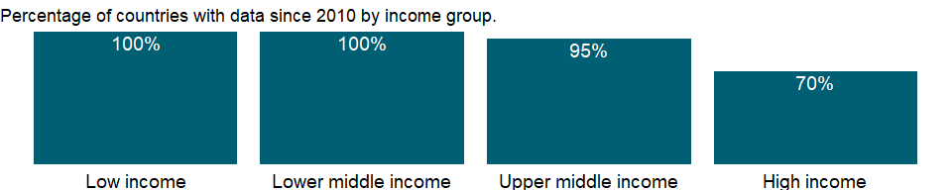

### Why is it relevant?

Road traffic injuries and deaths is a major global public health problem. Road traffic crashes are currently the leading cause of death for children and young adults in the world. There is a strong association between the risk of road traffic death and the income level of countries. The burden of road traffic deaths is disproportionately high among low- and middle-income countries.

### What is the data source?

World Health Organization, Global Health Observatory Data Repository (<http://apps.who.int/ghodata/>).

### What is the methodology?

NA

### How is it aggregated?

Weighted average

### What are the limitations?

NA

### What else should I know?

This is the Sustainable Development Goal indicator 3.6.1 [<https://unstats.un.org/sdgs/metadata/>].

### 1.67.29 Mortality rate attributed to unsafe water, unsafe sanitation and lack of hygiene (per 100,000 population)

### What is the indicator?

Mortality rate attributed to unsafe water, unsafe sanitation and lack of hygiene is deaths attributable to unsafe water, sanitation and hygiene focusing on inadequate WASH services per 100,000 population. Death rates are calculated by dividing the number of deaths by the total population. In this estimate, only the impact of diarrhoeal diseases, intestinal nematode infections, and protein-energy malnutrition are taken into account.

Topic: Health: Mortality

Series ID: SH.STA.WASH.P5

Copyright: CC BY-4.0 , <https://datacatalog.worldbank.org/public-licenses#cc-by>

First year with any data: 2016

Last year with any data: 2016

### What years are data available?

The figure below shows years in which data is available for at least one country. Dates shaded in black have no data, while dates shaded in green have data for at least one country



### Which countries have data?

The figure below shows the percentage of countries in each income group with a value since 2010 for that indicator.



### Why is it relevant?

Unsafe drinking water, unsafe sanitation and lack of hygiene are important causes of death. Most diarrheal deaths in the world are caused by unsafe water, sanitation or hygiene. According to the World Health Organization, in addition to diarrea, the following diseases could be prevented if adequate WASH services are provided: malnutrition, intestinal nematode infections, lymphatic filariasis, trachoma, schistosomiasis and malaria.

### What is the data source?

World Health Organization, Global Health Observatory Data Repository (<http://apps.who.int/ghodata/>).

### What is the methodology?

NA

### How is it aggregated?

Weighted Average

### What are the limitations?

Some countries do not have death registration data or sample registration systems. The estimates on this indicator need to be completed with other type of information for these countries.

### What else should I know?

This is the Sustainable Development Goal indicator 3.9.2[<https://unstats.un.org/sdgs/metadata/>].

### 1.67.30 Mortality rate, adult, female (per 1,000 female adults)

### What is the indicator?

Adult mortality rate, female, is the probability of dying between the ages of 15 and 60–that is, the probability of a 15-year-old female dying before reaching age 60, if subject to age-specific mortality rates of the specified year between those ages.

Topic: Health: Mortality

Series ID: SP.DYN.AMRT.FE

Copyright: CC BY-4.0 , <https://datacatalog.worldbank.org/public-licenses#cc-by>

First year with any data: 1960

Last year with any data: 2019

### What years are data available?

The figure below shows years in which data is available for at least one country. Dates shaded in black have no data, while dates shaded in green have data for at least one country



### Which countries have data?

The figure below shows the percentage of countries in each income group with a value since 2010 for that indicator.

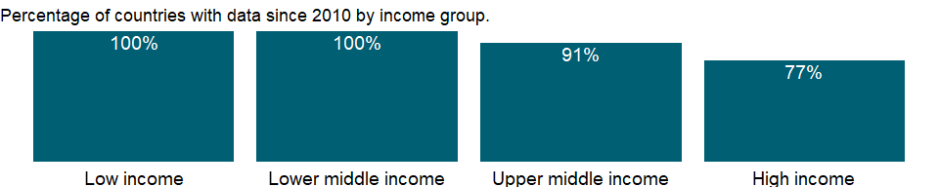

### Why is it relevant?

Mortality rates for different age groups (infants, children, and adults) and overall mortality indicators (life expectancy at birth or survival to a given age) are important indicators of health status in a country. Because data on the incidence and prevalence of diseases are frequently unavailable, mortality rates are often used to identify vulnerable populations. And they are among the indicators most frequently used to compare socioeconomic development across countries.

### What is the data source?

1. United Nations Population Division. World Population Prospects: 2019 Revision. (2) University of California, Berkeley, and Max Planck Institute for Demographic Research. The Human Mortality Database.

### What is the methodology?

The main sources of mortality data are vital registration systems and direct or indirect estimates based on sample surveys or censuses. A “complete” vital registration system - covering at least 90 percent of vital events in the population - is the best source of age-specific mortality data. Where reliable age-specific mortality data are available, life tables can be constructed from age-specific mortality data, and adult mortality rates can be calculated from life tables.

### How is it aggregated?

Weighted average

### What are the limitations?

Data from United Nations Population Division’s World Populaton Prospects are originally 5-year period data and the presented are linearly interpolated by the World Bank for annual series. Therefore they may not reflect real events as much as observed data.

### What else should I know?

NA

### 1.67.31 Mortality rate, adult, male (per 1,000 male adults)

### What is the indicator?

Adult mortality rate, male, is the probability of dying between the ages of 15 and 60–that is, the probability of a 15-year-old male dying before reaching age 60, if subject to age-specific mortality rates of the specified year between those ages.

Topic: Health: Mortality

Series ID: SP.DYN.AMRT.MA

Copyright: CC BY-4.0 , <https://datacatalog.worldbank.org/public-licenses#cc-by>

First year with any data: 1960

Last year with any data: 2019

### What years are data available?

The figure below shows years in which data is available for at least one country. Dates shaded in black have no data, while dates shaded in green have data for at least one country



### Which countries have data?

The figure below shows the percentage of countries in each income group with a value since 2010 for that indicator.



### Why is it relevant?

Mortality rates for different age groups (infants, children, and adults) and overall mortality indicators (life expectancy at birth or survival to a given age) are important indicators of health status in a country. Because data on the incidence and prevalence of diseases are frequently unavailable, mortality rates are often used to identify vulnerable populations. And they are among the indicators most frequently used to compare socioeconomic development across countries.

### What is the data source?

1. United Nations Population Division. World Population Prospects: 2019 Revision. (2) University of California, Berkeley, and Max Planck Institute for Demographic Research. The Human Mortality Database.

### What is the methodology?

The main sources of mortality data are vital registration systems and direct or indirect estimates based on sample surveys or censuses. A “complete” vital registration system - covering at least 90 percent of vital events in the population - is the best source of age-specific mortality data. Where reliable age-specific mortality data are available, life tables can be constructed from age-specific mortality data, and adult mortality rates can be calculated from life tables.

### How is it aggregated?

Weighted average

### What are the limitations?

Data from United Nations Population Division’s World Populaton Prospects are originally 5-year period data and the presented are linearly interpolated by the World Bank for annual series. Therefore they may not reflect real events as much as observed data.

### What else should I know?

NA

### 1.67.32 Mortality rate, infant, female (per 1,000 live births)

### What is the indicator?

Infant mortality rate, female is the number of female infants dying before reaching one year of age, per 1,000 female live births in a given year.

Topic: Health: Mortality

Series ID: SP.DYN.IMRT.FE.IN

Copyright: CC BY-4.0 , <https://datacatalog.worldbank.org/public-licenses#cc-by>

First year with any data: 1960

Last year with any data: 2019

### What years are data available?

The figure below shows years in which data is available for at least one country. Dates shaded in black have no data, while dates shaded in green have data for at least one country



### Which countries have data?

The figure below shows the percentage of countries in each income group with a value since 2010 for that indicator.



### Why is it relevant?

Mortality rates for different age groups (infants, children, and adults) and overall mortality indicators (life expectancy at birth or survival to a given age) are important indicators of health status in a country. Because data on the incidence and prevalence of diseases are frequently unavailable, mortality rates are often used to identify vulnerable populations. And they are among the indicators most frequently used to compare socioeconomic development across countries.

### What is the data source?

Estimates developed by the UN Inter-agency Group for Child Mortality Estimation (UNICEF, WHO, World Bank, UN DESA Population Division) at www.childmortality.org.

### What is the methodology?

The main sources of mortality data are vital registration systems and direct or indirect estimates based on sample surveys or censuses. A “complete” vital registration system - covering at least 90 percent of vital events in the population - is the best source of age-specific mortality data.

Estimates of neonatal, infant, and child mortality tend to vary by source and method for a given time and place. Years for available estimates also vary by country, making comparisons across countries and over time difficult. To make neonatal, infant, and child mortality estimates comparable and to ensure consistency across estimates by different agencies, the United Nations Inter-agency Group for Child Mortality Estimation (UN IGME), which comprises the United Nations Children’s Fund (UNICEF), the World Health Organization (WHO), the World Bank, the United Nations Population Division, and other universities and research institutes, developed and adopted a statistical method that uses all available information to reconcile differences. The method uses statistical models to obtain a best estimate trend line by fitting a country-specific regression model of mortality rates against their reference dates.

### How is it aggregated?

Weighted Average

### What are the limitations?

Complete vital registration systems are fairly uncommon in developing countries. Thus estimates must be obtained from sample surveys or derived by applying indirect estimation techniques to registration, census, or survey data. Survey data are subject to recall error, and surveys estimating infant/child deaths require large samples because households in which a birth has occurred during a given year cannot ordinarily be preselected for sampling. Indirect estimates rely on model life tables that may be inappropriate for the population concerned. Extrapolations based on outdated surveys may not be reliable for monitoring changes in health status or for comparative analytical work.

### What else should I know?

Given that data on the incidence and prevalence of diseases are frequently unavailable, mortality rates are often used to identify vulnerable populations. Moreover, they are among the indicators most frequently used to compare socioeconomic development across countries. Under-five mortality rates are higher for boys than for girls in countries in which parental gender preferences are insignificant. Under-five mortality captures the effect of gender discrimination better than infant mortality does, as malnutrition and medical interventions have more significant impacts to this age group. Where female under-five mortality is higher, girls are likely to have less access to resources than boys.

Aggregate data for LIC, UMC, LMC, HIC are computed based on the groupings for the World Bank fiscal year in which the data was released by the UN Inter-agency Group for Child Mortality Estimation.

### 1.67.33 Mortality rate, infant (per 1,000 live births)

### What is the indicator?

Infant mortality rate is the number of infants dying before reaching one year of age, per 1,000 live births in a given year.

Topic: Health: Mortality

Series ID: SP.DYN.IMRT.IN

Copyright: CC BY-4.0 , <https://datacatalog.worldbank.org/public-licenses#cc-by>

First year with any data: 1960

Last year with any data: 2019

### What years are data available?

The figure below shows years in which data is available for at least one country. Dates shaded in black have no data, while dates shaded in green have data for at least one country



### Which countries have data?

The figure below shows the percentage of countries in each income group with a value since 2010 for that indicator.



### Why is it relevant?

Mortality rates for different age groups (infants, children, and adults) and overall mortality indicators (life expectancy at birth or survival to a given age) are important indicators of health status in a country. Because data on the incidence and prevalence of diseases are frequently unavailable, mortality rates are often used to identify vulnerable populations. And they are among the indicators most frequently used to compare socioeconomic development across countries.

### What is the data source?

Estimates developed by the UN Inter-agency Group for Child Mortality Estimation (UNICEF, WHO, World Bank, UN DESA Population Division) at www.childmortality.org.

### What is the methodology?

The main sources of mortality data are vital registration systems and direct or indirect estimates based on sample surveys or censuses. A “complete” vital registration system - covering at least 90 percent of vital events in the population - is the best source of age-specific mortality data.

Estimates of neonatal, infant, and child mortality tend to vary by source and method for a given time and place. Years for available estimates also vary by country, making comparisons across countries and over time difficult. To make neonatal, infant, and child mortality estimates comparable and to ensure consistency across estimates by different agencies, the United Nations Inter-agency Group for Child Mortality Estimation (UN IGME), which comprises the United Nations Children’s Fund (UNICEF), the World Health Organization (WHO), the World Bank, the United Nations Population Division, and other universities and research institutes, developed and adopted a statistical method that uses all available information to reconcile differences. The method uses statistical models to obtain a best estimate trend line by fitting a country-specific regression model of mortality rates against their reference dates.

### How is it aggregated?

Weighted Average

### What are the limitations?

Complete vital registration systems are fairly uncommon in developing countries. Thus estimates must be obtained from sample surveys or derived by applying indirect estimation techniques to registration, census, or survey data. Survey data are subject to recall error, and surveys estimating infant/child deaths require large samples because households in which a birth has occurred during a given year cannot ordinarily be preselected for sampling. Indirect estimates rely on model life tables that may be inappropriate for the population concerned. Extrapolations based on outdated surveys may not be reliable for monitoring changes in health status or for comparative analytical work.

### What else should I know?

Given that data on the incidence and prevalence of diseases are frequently unavailable, mortality rates are often used to identify vulnerable populations. Moreover, they are among the indicators most frequently used to compare socioeconomic development across countries. Under-five mortality rates are higher for boys than for girls in countries in which parental gender preferences are insignificant. Under-five mortality captures the effect of gender discrimination better than infant mortality does, as malnutrition and medical interventions have more significant impacts to this age group. Where female under-five mortality is higher, girls are likely to have less access to resources than boys.

Aggregate data for LIC, UMC, LMC, HIC are computed based on the groupings for the World Bank fiscal year in which the data was released by the UN Inter-agency Group for Child Mortality Estimation.

### 1.67.34 Mortality rate, infant, male (per 1,000 live births)

### What is the indicator?

Infant mortality rate, male is the number of male infants dying before reaching one year of age, per 1,000 male live births in a given year.

Topic: Health: Mortality

Series ID: SP.DYN.IMRT.MA.IN

Copyright: CC BY-4.0 , <https://datacatalog.worldbank.org/public-licenses#cc-by>

First year with any data: 1960

Last year with any data: 2019

### What years are data available?

The figure below shows years in which data is available for at least one country. Dates shaded in black have no data, while dates shaded in green have data for at least one country



### Which countries have data?

The figure below shows the percentage of countries in each income group with a value since 2010 for that indicator.



### Why is it relevant?

Mortality rates for different age groups (infants, children, and adults) and overall mortality indicators (life expectancy at birth or survival to a given age) are important indicators of health status in a country. Because data on the incidence and prevalence of diseases are frequently unavailable, mortality rates are often used to identify vulnerable populations. And they are among the indicators most frequently used to compare socioeconomic development across countries.

### What is the data source?

Estimates developed by the UN Inter-agency Group for Child Mortality Estimation (UNICEF, WHO, World Bank, UN DESA Population Division) at www.childmortality.org.

### What is the methodology?

The main sources of mortality data are vital registration systems and direct or indirect estimates based on sample surveys or censuses. A “complete” vital registration system - covering at least 90 percent of vital events in the population - is the best source of age-specific mortality data.

Estimates of neonatal, infant, and child mortality tend to vary by source and method for a given time and place. Years for available estimates also vary by country, making comparisons across countries and over time difficult. To make neonatal, infant, and child mortality estimates comparable and to ensure consistency across estimates by different agencies, the United Nations Inter-agency Group for Child Mortality Estimation (UN IGME), which comprises the United Nations Children’s Fund (UNICEF), the World Health Organization (WHO), the World Bank, the United Nations Population Division, and other universities and research institutes, developed and adopted a statistical method that uses all available information to reconcile differences. The method uses statistical models to obtain a best estimate trend line by fitting a country-specific regression model of mortality rates against their reference dates.

### How is it aggregated?

Weighted Average

### What are the limitations?

Complete vital registration systems are fairly uncommon in developing countries. Thus estimates must be obtained from sample surveys or derived by applying indirect estimation techniques to registration, census, or survey data. Survey data are subject to recall error, and surveys estimating infant/child deaths require large samples because households in which a birth has occurred during a given year cannot ordinarily be preselected for sampling. Indirect estimates rely on model life tables that may be inappropriate for the population concerned. Extrapolations based on outdated surveys may not be reliable for monitoring changes in health status or for comparative analytical work.

### What else should I know?

Given that data on the incidence and prevalence of diseases are frequently unavailable, mortality rates are often used to identify vulnerable populations. Moreover, they are among the indicators most frequently used to compare socioeconomic development across countries. Under-five mortality rates are higher for boys than for girls in countries in which parental gender preferences are insignificant. Under-five mortality captures the effect of gender discrimination better than infant mortality does, as malnutrition and medical interventions have more significant impacts to this age group. Where female under-five mortality is higher, girls are likely to have less access to resources than boys.

Aggregate data for LIC, UMC, LMC, HIC are computed based on the groupings for the World Bank fiscal year in which the data was released by the UN Inter-agency Group for Child Mortality Estimation.

### 1.67.35 Life expectancy at birth, female (years)

### What is the indicator?

Life expectancy at birth indicates the number of years a newborn infant would live if prevailing patterns of mortality at the time of its birth were to stay the same throughout its life.

Topic: Health: Mortality

Series ID: SP.DYN.LE00.FE.IN

Copyright: CC BY-4.0 , <https://datacatalog.worldbank.org/public-licenses#cc-by>

First year with any data: 1960

Last year with any data: 2019

### What years are data available?

The figure below shows years in which data is available for at least one country. Dates shaded in black have no data, while dates shaded in green have data for at least one country



### Which countries have data?

The figure below shows the percentage of countries in each income group with a value since 2010 for that indicator.

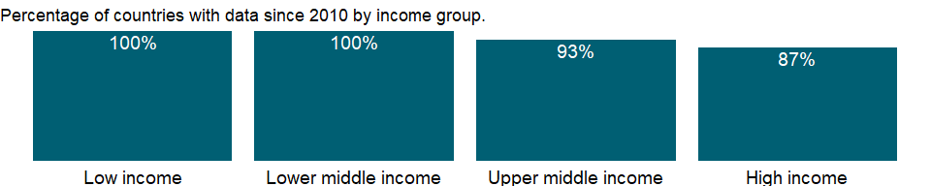

### Why is it relevant?

Mortality rates for different age groups (infants, children, and adults) and overall mortality indicators (life expectancy at birth or survival to a given age) are important indicators of health status in a country. Because data on the incidence and prevalence of diseases are frequently unavailable, mortality rates are often used to identify vulnerable populations. And they are among the indicators most frequently used to compare socioeconomic development across countries.

### What is the data source?

1. United Nations Population Division. World Population Prospects: 2019 Revision. (2) Census reports and other statistical publications from national statistical offices, (3) Eurostat: Demographic Statistics, (4) United Nations Statistical Division. Population and Vital Statistics Reprot (various years), (5) U.S. Census Bureau: International Database, and (6) Secretariat of the Pacific Community: Statistics and Demography Programme.

### What is the methodology?

Life expectancy at birth used here is the average number of years a newborn is expected to live if mortality patterns at the time of its birth remain constant in the future. It reflects the overall mortality level of a population, and summarizes the mortality pattern that prevails across all age groups in a given year. It is calculated in a period life table which provides a snapshot of a population’s mortality pattern at a given time. It therefore does not reflect the mortality pattern that a person actually experiences during his/her life, which can be calculated in a cohort life table.

High mortality in young age groups significantly lowers the life expectancy at birth. But if a person survives his/her childhood of high mortality, he/she may live much longer. For example, in a population with a life expectancy at birth of 50, there may be few people dying at age 50. The life expectancy at birth may be low due to the high childhood mortality so that once a person survives his/her childhood, he/she may live much longer than 50 years.

### How is it aggregated?

Weighted average

### What are the limitations?

Annual data series from United Nations Population Division’s World Population Prospects are interpolated data from 5-year period data. Therefore they may not reflect real events as much as observed data.

### What else should I know?

NA

### 1.67.36 Life expectancy at birth, total (years)

### What is the indicator?

Life expectancy at birth indicates the number of years a newborn infant would live if prevailing patterns of mortality at the time of its birth were to stay the same throughout its life.

Topic: Health: Mortality

Series ID: SP.DYN.LE00.IN

Copyright: CC BY-4.0 , <https://datacatalog.worldbank.org/public-licenses#cc-by>

First year with any data: 1960

Last year with any data: 2019

### What years are data available?

The figure below shows years in which data is available for at least one country. Dates shaded in black have no data, while dates shaded in green have data for at least one country



### Which countries have data?

The figure below shows the percentage of countries in each income group with a value since 2010 for that indicator.



### Why is it relevant?

Mortality rates for different age groups (infants, children, and adults) and overall mortality indicators (life expectancy at birth or survival to a given age) are important indicators of health status in a country. Because data on the incidence and prevalence of diseases are frequently unavailable, mortality rates are often used to identify vulnerable populations. And they are among the indicators most frequently used to compare socioeconomic development across countries.

### What is the data source?

1. United Nations Population Division. World Population Prospects: 2019 Revision, or derived from male and female life expectancy at birth from sources such as: (2) Census reports and other statistical publications from national statistical offices, (3) Eurostat: Demographic Statistics, (4) United Nations Statistical Division. Population and Vital Statistics Reprot (various years), (5) U.S. Census Bureau: International Database, and (6) Secretariat of the Pacific Community: Statistics and Demography Programme.

### What is the methodology?

Life expectancy at birth used here is the average number of years a newborn is expected to live if mortality patterns at the time of its birth remain constant in the future. It reflects the overall mortality level of a population, and summarizes the mortality pattern that prevails across all age groups in a given year. It is calculated in a period life table which provides a snapshot of a population’s mortality pattern at a given time. It therefore does not reflect the mortality pattern that a person actually experiences during his/her life, which can be calculated in a cohort life table.

High mortality in young age groups significantly lowers the life expectancy at birth. But if a person survives his/her childhood of high mortality, he/she may live much longer. For example, in a population with a life expectancy at birth of 50, there may be few people dying at age 50. The life expectancy at birth may be low due to the high childhood mortality so that once a person survives his/her childhood, he/she may live much longer than 50 years.

### How is it aggregated?

Weighted average

### What are the limitations?

Annual data series from United Nations Population Division’s World Population Prospects are interpolated data from 5-year period data. Therefore they may not reflect real events as much as observed data.

### What else should I know?

NA

### 1.67.37 Life expectancy at birth, male (years)

### What is the indicator?

Life expectancy at birth indicates the number of years a newborn infant would live if prevailing patterns of mortality at the time of its birth were to stay the same throughout its life.

Topic: Health: Mortality

Series ID: SP.DYN.LE00.MA.IN

Copyright: CC BY-4.0 , <https://datacatalog.worldbank.org/public-licenses#cc-by>

First year with any data: 1960

Last year with any data: 2019

### What years are data available?

The figure below shows years in which data is available for at least one country. Dates shaded in black have no data, while dates shaded in green have data for at least one country



### Which countries have data?

The figure below shows the percentage of countries in each income group with a value since 2010 for that indicator.



### Why is it relevant?

Mortality rates for different age groups (infants, children, and adults) and overall mortality indicators (life expectancy at birth or survival to a given age) are important indicators of health status in a country. Because data on the incidence and prevalence of diseases are frequently unavailable, mortality rates are often used to identify vulnerable populations. And they are among the indicators most frequently used to compare socioeconomic development across countries.

### What is the data source?

1. United Nations Population Division. World Population Prospects: 2019 Revision. (2) Census reports and other statistical publications from national statistical offices, (3) Eurostat: Demographic Statistics, (4) United Nations Statistical Division. Population and Vital Statistics Reprot (various years), (5) U.S. Census Bureau: International Database, and (6) Secretariat of the Pacific Community: Statistics and Demography Programme.

### What is the methodology?

Life expectancy at birth used here is the average number of years a newborn is expected to live if mortality patterns at the time of its birth remain constant in the future. It reflects the overall mortality level of a population, and summarizes the mortality pattern that prevails across all age groups in a given year. It is calculated in a period life table which provides a snapshot of a population’s mortality pattern at a given time. It therefore does not reflect the mortality pattern that a person actually experiences during his/her life, which can be calculated in a cohort life table.

High mortality in young age groups significantly lowers the life expectancy at birth. But if a person survives his/her childhood of high mortality, he/she may live much longer. For example, in a population with a life expectancy at birth of 50, there may be few people dying at age 50. The life expectancy at birth may be low due to the high childhood mortality so that once a person survives his/her childhood, he/she may live much longer than 50 years.

### How is it aggregated?

Weighted average

### What are the limitations?

Annual data series from United Nations Population Division’s World Population Prospects are interpolated data from 5-year period data. Therefore they may not reflect real events as much as observed data.

### What else should I know?

NA

### 1.67.38 Survival to age 65, female (% of cohort)

### What is the indicator?

Survival to age 65 refers to the percentage of a cohort of newborn infants that would survive to age 65, if subject to age specific mortality rates of the specified year.

Topic: Health: Mortality

Series ID: SP.DYN.TO65.FE.ZS

Copyright: CC BY-4.0 , <https://datacatalog.worldbank.org/public-licenses#cc-by>

First year with any data: 1960

Last year with any data: 2019

### What years are data available?

The figure below shows years in which data is available for at least one country. Dates shaded in black have no data, while dates shaded in green have data for at least one country



### Which countries have data?

The figure below shows the percentage of countries in each income group with a value since 2010 for that indicator.



### Why is it relevant?

NA

### What is the data source?

United Nations Population Division. World Population Prospects: 2019 Revision.

### What is the methodology?

NA

### How is it aggregated?

Weighted average

### What are the limitations?

NA

### What else should I know?

NA

### 1.67.39 Survival to age 65, male (% of cohort)

### What is the indicator?

Survival to age 65 refers to the percentage of a cohort of newborn infants that would survive to age 65, if subject to age specific mortality rates of the specified year.

Topic: Health: Mortality

Series ID: SP.DYN.TO65.MA.ZS

Copyright: CC BY-4.0 , <https://datacatalog.worldbank.org/public-licenses#cc-by>

First year with any data: 1960

Last year with any data: 2019

### What years are data available?

The figure below shows years in which data is available for at least one country. Dates shaded in black have no data, while dates shaded in green have data for at least one country



### Which countries have data?

The figure below shows the percentage of countries in each income group with a value since 2010 for that indicator.



### Why is it relevant?

NA

### What is the data source?

United Nations Population Division. World Population Prospects: 2019 Revision.

### What is the methodology?

NA

### How is it aggregated?

Weighted average

### What are the limitations?

NA

### What else should I know?

NA

## 1.68 Health: Reproductive health

### 1.68.1 Demand for family planning satisfied by modern methods (% of married women with demand for family planning)

### What is the indicator?

Demand for family planning satisfied by modern methods refers to the percentage of married women ages 15-49 years whose need for family planning is satisfied with modern methods.

Topic: Health: Reproductive health

Series ID: SH.FPL.SATM.ZS

Copyright: CC BY-4.0 , <https://datacatalog.worldbank.org/public-licenses#cc-by>

First year with any data: 1984

Last year with any data: 2019

### What years are data available?

The figure below shows years in which data is available for at least one country. Dates shaded in black have no data, while dates shaded in green have data for at least one country

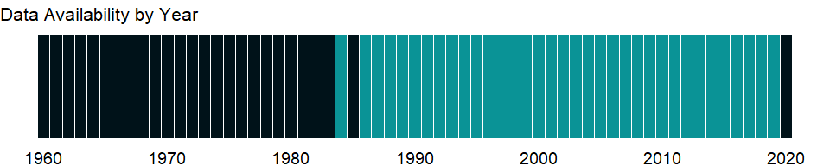

### Which countries have data?

The figure below shows the percentage of countries in each income group with a value since 2010 for that indicator.

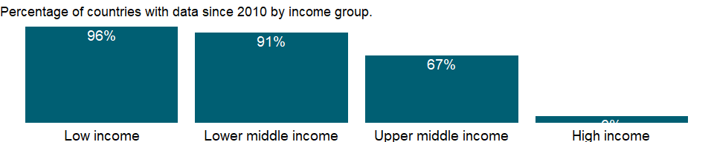

### Why is it relevant?

NA

### What is the data source?

Demographic and Health Surveys (DHS).

### What is the methodology?

NA

### How is it aggregated?

Weighted Average

### What are the limitations?

NA

### What else should I know?

This is the Sustainable Development Goal indicator 3.7.1 [<https://unstats.un.org/sdgs/metadata/>].

### 1.68.2 Number of maternal deaths

### What is the indicator?

A maternal death refers to the death of a woman while pregnant or within 42 days of termination of pregnancy, irrespective of the duration and site of the pregnancy, from any cause related to or aggravated by the pregnancy or its management but not from accidental or incidental causes.

Topic: Health: Reproductive health

Series ID: SH.MMR.DTHS

Copyright: CC BY-4.0 , <https://datacatalog.worldbank.org/public-licenses#cc-by>

First year with any data: 2000

Last year with any data: 2017

### What years are data available?

The figure below shows years in which data is available for at least one country. Dates shaded in black have no data, while dates shaded in green have data for at least one country

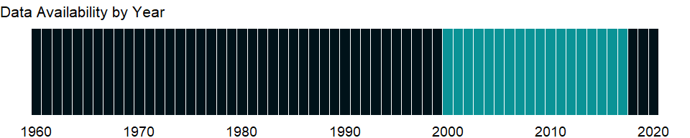

### Which countries have data?

The figure below shows the percentage of countries in each income group with a value since 2010 for that indicator.

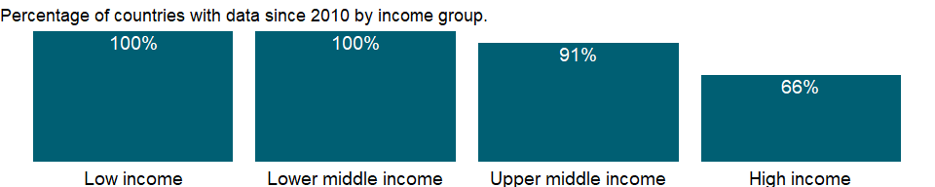

### Why is it relevant?

NA

### What is the data source?

WHO, UNICEF, UNFPA, World Bank Group, and the United Nations Population Division. Trends in Maternal Mortality: 2000 to 2017. Geneva, World Health Organization, 2019

### What is the methodology?

NA

### How is it aggregated?

Sum

### What are the limitations?

NA

### What else should I know?

NA

### 1.68.3 Lifetime risk of maternal death (1 in: rate varies by country)

### What is the indicator?

Life time risk of maternal death is the probability that a 15-year-old female will die eventually from a maternal cause assuming that current levels of fertility and mortality (including maternal mortality) do not change in the future, taking into account competing causes of death.

Topic: Health: Reproductive health

Series ID: SH.MMR.RISK

Copyright: CC BY-4.0 , <https://datacatalog.worldbank.org/public-licenses#cc-by>

First year with any data: 2000

Last year with any data: 2017

### What years are data available?

The figure below shows years in which data is available for at least one country. Dates shaded in black have no data, while dates shaded in green have data for at least one country



### Which countries have data?

The figure below shows the percentage of countries in each income group with a value since 2010 for that indicator.



### Why is it relevant?

NA

### What is the data source?

WHO, UNICEF, UNFPA, World Bank Group, and the United Nations Population Division. Trends in Maternal Mortality: 2000 to 2017. Geneva, World Health Organization, 2019

### What is the methodology?

Reproductive health is a state of physical and mental well-being in relation to the reproductive system and its functions and processes. Means of achieving reproductive health include education and services during pregnancy and childbirth, safe and effective contraception, and prevention and treatment of sexually transmitted diseases. Complications of pregnancy and childbirth are the leading cause of death and disability among women of reproductive age in developing countries.

Maternal mortality is generally of unknown reliability, as are many other cause-specific mortality indicators. Household surveys such as Demographic and Health Surveys attempt to measure maternal mortality by asking respondents about survivorship of sisters. The main disadvantage of this method is that the estimates of maternal mortality that it produces pertain to any time within the past few years before the survey, making them unsuitable for monitoring recent changes or observing the impact of interventions. In addition, measurement of maternal mortality is subject to many types of errors. Even in high-income countries with reliable vital registration systems, misclassification of maternal deaths has been found to lead to serious underestimation.

The estimates are based on an exercise by the Maternal Mortality Estimation Inter-Agency Group (MMEIG) which consists of World Health Organization (WHO), United Nations Children’s Fund (UNICEF), World Bank, and United Nations Population Fund (UNFPA), and include country-level time series data. For countries without complete registration data but with other types of data and for countries with no data, maternal mortality is estimated with a regression model using available national maternal mortality data and socioeconomic information.

In countries with a high risk of maternal death, many girls die before reaching reproductive age. Lifetime risk of maternal mortality refers to the probability that a 15-year-old girl will eventually die due to a maternal cause.

### How is it aggregated?

Weighted average

### What are the limitations?

The methodology differs from that used for previous estimates, so data should not be compared historically. Maternal mortality ratios are generally of unknown reliability, as are many other cause-specific mortality indicators. The probability cannot be assumed to provide an exact estimate of risk of maternal death.

### What else should I know?

NA

### 1.68.4 Lifetime risk of maternal death (%)

### What is the indicator?

Life time risk of maternal death is the probability that a 15-year-old female will die eventually from a maternal cause assuming that current levels of fertility and mortality (including maternal mortality) do not change in the future, taking into account competing causes of death.

Topic: Health: Reproductive health

Series ID: SH.MMR.RISK.ZS

Copyright: CC BY-4.0 , <https://datacatalog.worldbank.org/public-licenses#cc-by>

First year with any data: 2000

Last year with any data: 2017

### What years are data available?

The figure below shows years in which data is available for at least one country. Dates shaded in black have no data, while dates shaded in green have data for at least one country



### Which countries have data?

The figure below shows the percentage of countries in each income group with a value since 2010 for that indicator.



### Why is it relevant?

NA

### What is the data source?

WHO, UNICEF, UNFPA, World Bank Group, and the United Nations Population Division. Trends in Maternal Mortality: 2000 to 2017. Geneva, World Health Organization, 2019

### What is the methodology?

Reproductive health is a state of physical and mental well-being in relation to the reproductive system and its functions and processes. Means of achieving reproductive health include education and services during pregnancy and childbirth, safe and effective contraception, and prevention and treatment of sexually transmitted diseases. Complications of pregnancy and childbirth are the leading cause of death and disability among women of reproductive age in developing countries.

Maternal mortality is generally of unknown reliability, as are many other cause-specific mortality indicators. Household surveys such as Demographic and Health Surveys attempt to measure maternal mortality by asking respondents about survivorship of sisters. The main disadvantage of this method is that the estimates of maternal mortality that it produces pertain to any time within the past few years before the survey, making them unsuitable for monitoring recent changes or observing the impact of interventions. In addition, measurement of maternal mortality is subject to many types of errors. Even in high-income countries with reliable vital registration systems, misclassification of maternal deaths has been found to lead to serious underestimation.

The estimates are based on an exercise by the Maternal Mortality Estimation Inter-Agency Group (MMEIG) which consists of World Health Organization (WHO), United Nations Children’s Fund (UNICEF), World Bank, and United Nations Population Fund (UNFPA), and include country-level time series data. For countries without complete registration data but with other types of data and for countries with no data, maternal mortality is estimated with a regression model using available national maternal mortality data and socioeconomic information.

In countries with a high risk of maternal death, many girls die before reaching reproductive age. Lifetime risk of maternal mortality refers to the probability that a 15-year-old girl will eventually die due to a maternal cause.

### How is it aggregated?

Weighted average

### What are the limitations?

The methodology differs from that used for previous estimates, so data should not be compared historically. Maternal mortality ratios are generally of unknown reliability, as are many other cause-specific mortality indicators. The probability cannot be assumed to provide an exact estimate of risk of maternal death.

### What else should I know?

NA

### 1.68.5 Pregnant women receiving prenatal care (%)

### What is the indicator?

Pregnant women receiving prenatal care are the percentage of women attended at least once during pregnancy by skilled health personnel for reasons related to pregnancy.

Topic: Health: Reproductive health

Series ID: SH.STA.ANVC.ZS

Copyright: CC BY-4.0 , <https://datacatalog.worldbank.org/public-licenses#cc-by>

First year with any data: 1984

Last year with any data: 2020

### What years are data available?

The figure below shows years in which data is available for at least one country. Dates shaded in black have no data, while dates shaded in green have data for at least one country

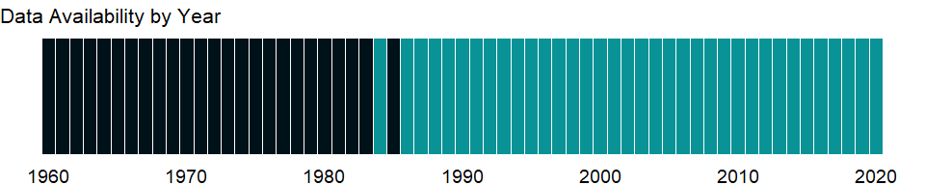

### Which countries have data?

The figure below shows the percentage of countries in each income group with a value since 2010 for that indicator.

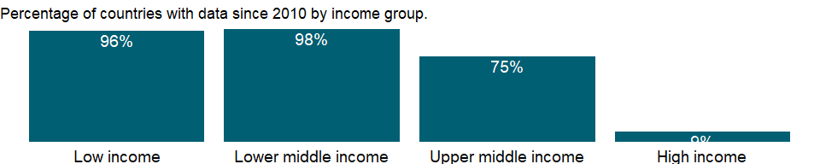

### Why is it relevant?

NA

### What is the data source?

UNICEF, State of the World’s Children, Childinfo, and Demographic and Health Surveys.

### What is the methodology?

Reproductive health is a state of physical and mental well-being in relation to the reproductive system and its functions and processes. Means of achieving reproductive health include education and services during pregnancy and childbirth, safe and effective contraception, and prevention and treatment of sexually transmitted diseases. Complications of pregnancy and childbirth are the leading cause of death and disability among women of reproductive age in developing countries.

Good prenatal and postnatal care improves maternal health and reduces maternal and infant mortality. However, indicators on use of antenatal care services provide no information on the content or quality of the services. Data on antenatal care are obtained mostly from household surveys, which ask women who have had a live birth whether and from whom they received antenatal care.

### How is it aggregated?

Weighted average

### What are the limitations?

For the indicators that are from household surveys, the year refers to the survey year. For more information, consult the original sources.

### What else should I know?

Good prenatal and postnatal care improve maternal health and reduce maternal and infant mortality.

### 1.68.6 Births attended by skilled health staff (% of total)

### What is the indicator?

Births attended by skilled health staff are the percentage of deliveries attended by personnel trained to give the necessary supervision, care, and advice to women during pregnancy, labor, and the postpartum period; to conduct deliveries on their own; and to care for newborns.

Topic: Health: Reproductive health

Series ID: SH.STA.BRTC.ZS

Copyright: CC BY-4.0 , <https://datacatalog.worldbank.org/public-licenses#cc-by>

First year with any data: 1980

Last year with any data: 2020

### What years are data available?

The figure below shows years in which data is available for at least one country. Dates shaded in black have no data, while dates shaded in green have data for at least one country

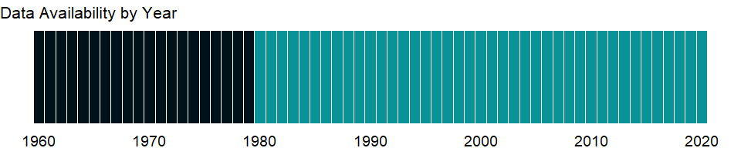

### Which countries have data?

The figure below shows the percentage of countries in each income group with a value since 2010 for that indicator.

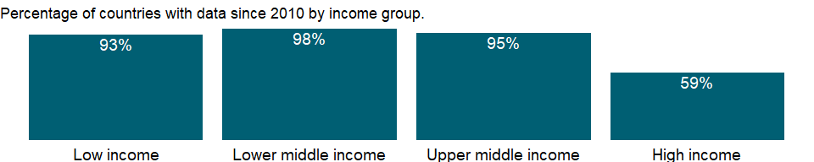

### Why is it relevant?

Reproductive health is a state of physical and mental well-being in relation to the reproductive system and its functions and processes. Means of achieving reproductive health include education and services during pregnancy and childbirth, safe and effective contraception, and prevention and treatment of sexually transmitted diseases. Complications of pregnancy and childbirth are the leading cause of death and disability among women of reproductive age in developing countries.

The share of births attended by skilled health staff is an indicator of a health system’s ability to provide adequate care for pregnant women.

### What is the data source?

UNICEF, State of the World’s Children, Childinfo, and Demographic and Health Surveys.

### What is the methodology?

NA

### How is it aggregated?

Weighted average

### What are the limitations?

For the indicators that are from household surveys, the year refers to the survey year. For more information, consult the original sources.

### What else should I know?

Assistance by trained professionals during birth reduces the incidence of maternal deaths during childbirth. The share of births attended by skilled health staff is an indicator of a health system’s ability to provide adequate care for pregnant women.

This is the Sustainable Development Goal indicator 3.1.2[<https://unstats.un.org/sdgs/metadata/>].

### 1.68.7 Maternal mortality ratio (modeled estimate, per 100,000 live births)

### What is the indicator?

Maternal mortality ratio is the number of women who die from pregnancy-related causes while pregnant or within 42 days of pregnancy termination per 100,000 live births. The data are estimated with a regression model using information on the proportion of maternal deaths among non-AIDS deaths in women ages 15-49, fertility, birth attendants, and GDP measured using purchasing power parities (PPPs).

Topic: Health: Reproductive health

Series ID: SH.STA.MMRT

Copyright: CC BY-4.0 , <https://datacatalog.worldbank.org/public-licenses#cc-by>

First year with any data: 2000

Last year with any data: 2017

### What years are data available?

The figure below shows years in which data is available for at least one country. Dates shaded in black have no data, while dates shaded in green have data for at least one country



### Which countries have data?

The figure below shows the percentage of countries in each income group with a value since 2010 for that indicator.



### Why is it relevant?

NA

### What is the data source?

WHO, UNICEF, UNFPA, World Bank Group, and the United Nations Population Division. Trends in Maternal Mortality: 2000 to 2017. Geneva, World Health Organization, 2019

### What is the methodology?

Reproductive health is a state of physical and mental well-being in relation to the reproductive system and its functions and processes. Means of achieving reproductive health include education and services during pregnancy and childbirth, safe and effective contraception, and prevention and treatment of sexually transmitted diseases. Complications of pregnancy and childbirth are the leading cause of death and disability among women of reproductive age in developing countries.

Maternal mortality is generally of unknown reliability, as are many other cause-specific mortality indicators. Household surveys such as Demographic and Health Surveys attempt to measure maternal mortality by asking respondents about survivorship of sisters. The main disadvantage of this method is that the estimates of maternal mortality that it produces pertain to any time within the past few years before the survey, making them unsuitable for monitoring recent changes or observing the impact of interventions. In addition, measurement of maternal mortality is subject to many types of errors. Even in high-income countries with reliable vital registration systems, misclassification of maternal deaths has been found to lead to serious underestimation.

The estimates are based on an exercise by the Maternal Mortality Estimation Inter-Agency Group (MMEIG) which consists of World Health Organization (WHO), United Nations Children’s Fund (UNICEF), World Bank, and United Nations Population Fund (UNFPA), and include country-level time series data. For countries without complete registration data but with other types of data and for countries with no data, maternal mortality is estimated with a regression model using available national maternal mortality data and socioeconomic information.

### How is it aggregated?

Weighted average

### What are the limitations?

The methodology differs from that used for previous estimates, so data should not be compared historically. Maternal mortality ratios are generally of unknown reliability, as are many other cause-specific mortality indicators. The ratios cannot be assumed to provide an exact estimate of maternal mortality.

### What else should I know?

This indicator represents the risk associated with each pregnancy and is also a Sustainable Development Goal Indicator (3.1.1) for monitoring maternal health.

### 1.68.8 Maternal mortality ratio (national estimate, per 100,000 live births)

### What is the indicator?

Maternal mortality ratio is the number of women who die from pregnancy-related causes while pregnant or within 42 days of pregnancy termination per 100,000 live births.

Topic: Health: Reproductive health

Series ID: SH.STA.MMRT.NE

Copyright: CC BY-4.0 , <https://datacatalog.worldbank.org/public-licenses#cc-by>

First year with any data: 1985

Last year with any data: 2018

### What years are data available?

The figure below shows years in which data is available for at least one country. Dates shaded in black have no data, while dates shaded in green have data for at least one country

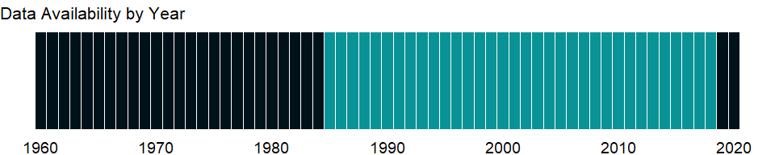

### Which countries have data?

The figure below shows the percentage of countries in each income group with a value since 2010 for that indicator.

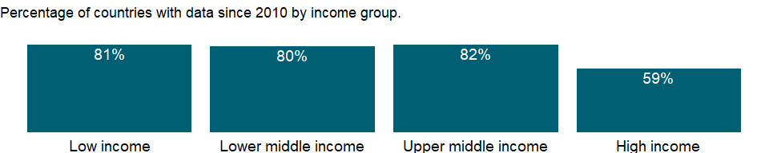

### Why is it relevant?

NA

### What is the data source?

The country data compiled, adjusted and used in the estimation model by the Maternal Mortality Estimation Inter-Agency Group (MMEIG). The country data were compiled from the following sources: civil registration and vital statistics; specialized studies on maternal mortality; population based surveys and censuses; other available data sources including data from surveillance sites.

### What is the methodology?

Reproductive health is a state of physical and mental well-being in relation to the reproductive system and its functions and processes. Means of achieving reproductive health include education and services during pregnancy and childbirth, safe and effective contraception, and prevention and treatment of sexually transmitted diseases. Complications of pregnancy and childbirth are the leading cause of death and disability among women of reproductive age in developing countries.

Maternal mortality ratios are generally of unknown reliability, as are many other cause-specific mortality indicators. Household surveys such as Demographic and Health Surveys attempt to measure maternal mortality by asking respondents about survivorship of sisters. The main disadvantage of this method is that the estimates of maternal mortality that it produces pertain to any time within the past few years before the survey, making them unsuitable for monitoring recent changes or observing the impact of interventions. In addition, measurement of maternal mortality is subject to many types of errors. Even in high-income countries with reliable vital registration systems, misclassification of maternal deaths has been found to lead to serious underestimation.

The national estimates of maternal mortality ratios are based on national surveys, vital registration records, and surveillance data or are derived from community and hospital records.

### How is it aggregated?

NA

### What are the limitations?

Maternal mortality ratios are generally of unknown reliability, as are many other cause-specific mortality indicators. The ratios cannot be assumed to provide an exact estimate of maternal mortality. Some of the figures shown were adjusted by the Maternal Mortality Estimation Inter-Agency Group (MMEIG) to enhance reliability, so that they may differ from the published figures from sources such as household surveys.

### What else should I know?

NA

### 1.68.9 Newborns protected against tetanus (%)

### What is the indicator?

Newborns protected against tetanus are the percentage of births by women of child-bearing age who are immunized against tetanus.

Topic: Health: Reproductive health

Series ID: SH.VAC.TTNS.ZS

Copyright: CC BY-4.0 , <https://datacatalog.worldbank.org/public-licenses#cc-by>

First year with any data: 1980

Last year with any data: 2019

### What years are data available?

The figure below shows years in which data is available for at least one country. Dates shaded in black have no data, while dates shaded in green have data for at least one country



### Which countries have data?

The figure below shows the percentage of countries in each income group with a value since 2010 for that indicator.

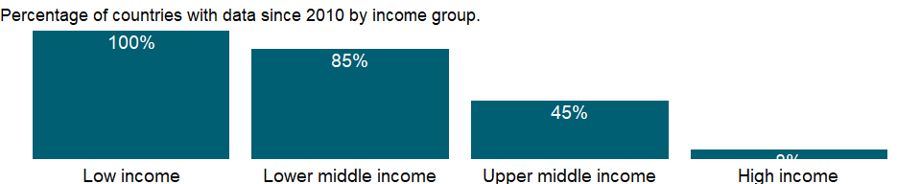

### Why is it relevant?

NA

### What is the data source?

WHO and UNICEF (<http://www.who.int/immunization/monitoring_surveillance/en/>).

### What is the methodology?

NA

### How is it aggregated?

Weighted average

### What are the limitations?

NA

### What else should I know?

NA

### 1.68.10 Adolescent fertility rate (births per 1,000 women ages 15-19)

### What is the indicator?

Adolescent fertility rate is the number of births per 1,000 women ages 15-19.

Topic: Health: Reproductive health

Series ID: SP.ADO.TFRT

Copyright: CC BY-4.0 , <https://datacatalog.worldbank.org/public-licenses#cc-by>

First year with any data: 1960

Last year with any data: 2019

### What years are data available?

The figure below shows years in which data is available for at least one country. Dates shaded in black have no data, while dates shaded in green have data for at least one country



### Which countries have data?

The figure below shows the percentage of countries in each income group with a value since 2010 for that indicator.



### Why is it relevant?

NA

### What is the data source?

United Nations Population Division, World Population Prospects.

### What is the methodology?

Reproductive health is a state of physical and mental well-being in relation to the reproductive system and its functions and processes. Means of achieving reproductive health include education and services during pregnancy and childbirth, safe and effective contraception, and prevention and treatment of sexually transmitted diseases. Complications of pregnancy and childbirth are the leading cause of death and disability among women of reproductive age in developing countries.

Adolescent fertility rates are based on data on registered live births from vital registration systems or, in the absence of such systems, from censuses or sample surveys. The estimated rates are generally considered reliable measures of fertility in the recent past. Where no empirical information on age-specific fertility rates is available, a model is used to estimate the share of births to adolescents. For countries without vital registration systems fertility rates are generally based on extrapolations from trends observed in censuses or surveys from earlier years.

### How is it aggregated?

Weighted Average

### What are the limitations?

NA

### What else should I know?

This is the Sustainable Development Goal indicator 3.7.2 [<https://unstats.un.org/sdgs/metadata/>].

### 1.68.11 Contraceptive prevalence, modern methods (% of women ages 15-49)

### What is the indicator?

Contraceptive prevalence rate is the percentage of women who are practicing, or whose sexual partners are practicing, at least one modern method of contraception. It is usually measured for women ages 15-49 who are married or in union. Modern methods of contraception include female and male sterilization, oral hormonal pills, the intra-uterine device (IUD), the male condom, injectables, the implant (including Norplant), vaginal barrier methods, the female condom and emergency contraception.

Topic: Health: Reproductive health

Series ID: SP.DYN.CONM.ZS

Copyright: CC BY-4.0 , <https://datacatalog.worldbank.org/public-licenses#cc-by>

First year with any data: 1961

Last year with any data: 2020

### What years are data available?

The figure below shows years in which data is available for at least one country. Dates shaded in black have no data, while dates shaded in green have data for at least one country

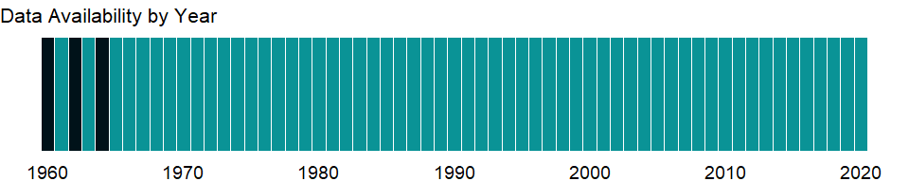

### Which countries have data?

The figure below shows the percentage of countries in each income group with a value since 2010 for that indicator.

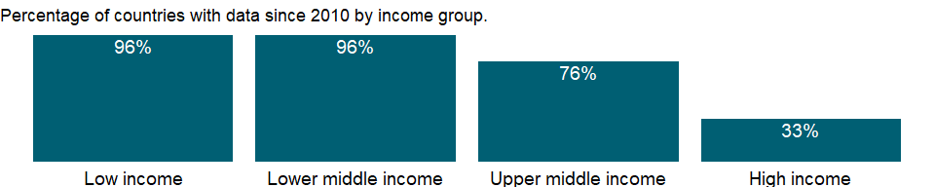

### Why is it relevant?

NA

### What is the data source?

Household surveys, including Demographic and Health Surveys and Multiple Indicator Cluster Surveys. Largely compiled by United Nations Population Division.

### What is the methodology?

NA

### How is it aggregated?

Weighted Average

### What are the limitations?

NA

### What else should I know?

NA

### 1.68.12 Contraceptive prevalence, any methods (% of women ages 15-49)

### What is the indicator?

Contraceptive prevalence rate is the percentage of women who are practicing, or whose sexual partners are practicing, any form of contraception. It is usually measured for women ages 15-49 who are married or in union.

Topic: Health: Reproductive health

Series ID: SP.DYN.CONU.ZS

Copyright: CC BY-4.0 , <https://datacatalog.worldbank.org/public-licenses#cc-by>

First year with any data: 1961

Last year with any data: 2020

### What years are data available?

The figure below shows years in which data is available for at least one country. Dates shaded in black have no data, while dates shaded in green have data for at least one country



### Which countries have data?

The figure below shows the percentage of countries in each income group with a value since 2010 for that indicator.

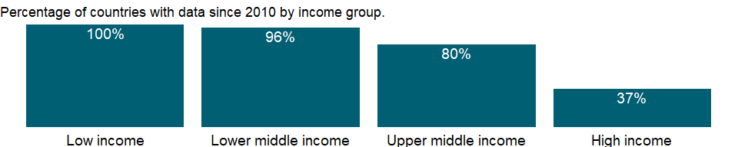

### Why is it relevant?

Reproductive health is a state of physical and mental well-being in relation to the reproductive system and its functions and processes. Means of achieving reproductive health include education and services during pregnancy and childbirth, safe and effective contraception, and prevention and treatment of sexually transmitted diseases. Complications of pregnancy and childbirth are the leading cause of death and disability among women of reproductive age in developing countries.

### What is the data source?

UNICEF’s State of the World’s Children and Childinfo, United Nations Population Division’s World Contraceptive Use, household surveys including Demographic and Health Surveys and Multiple Indicator Cluster Surveys.

### What is the methodology?

Contraceptive prevalence reflects all methods - ineffective traditional methods as well as highly effective modern methods. Contraceptive prevalence rates are obtained mainly from household surveys, including Demographic and Health Surveys, Multiple Indicator Cluster Surveys, and contraceptive prevalence surveys. Unmarried women are often excluded from such surveys, which may bias the estimates.

### How is it aggregated?

Weighted average

### What are the limitations?

NA

### What else should I know?

Contraceptive prevalence amongst women of reproductive age is an indicator of women’s empowerment and is related to maternal health, HIV/AIDS, and gender equality.

### 1.68.13 Fertility rate, total (births per woman)

### What is the indicator?

Total fertility rate represents the number of children that would be born to a woman if she were to live to the end of her childbearing years and bear children in accordance with age-specific fertility rates of the specified year.

Topic: Health: Reproductive health

Series ID: SP.DYN.TFRT.IN

Copyright: CC BY-4.0 , <https://datacatalog.worldbank.org/public-licenses#cc-by>

First year with any data: 1960

Last year with any data: 2019

### What years are data available?

The figure below shows years in which data is available for at least one country. Dates shaded in black have no data, while dates shaded in green have data for at least one country



### Which countries have data?

The figure below shows the percentage of countries in each income group with a value since 2010 for that indicator.

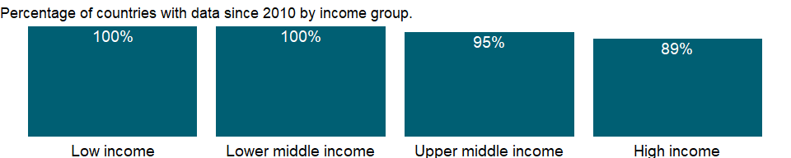

### Why is it relevant?

Reproductive health is a state of physical and mental well-being in relation to the reproductive system and its functions and processes. Means of achieving reproductive health include education and services during pregnancy and childbirth, safe and effective contraception, and prevention and treatment of sexually transmitted diseases. Complications of pregnancy and childbirth are the leading cause of death and disability among women of reproductive age in developing countries.

### What is the data source?

1. United Nations Population Division. World Population Prospects: 2019 Revision. (2) Census reports and other statistical publications from national statistical offices, (3) Eurostat: Demographic Statistics, (4) United Nations Statistical Division. Population and Vital Statistics Reprot (various years), (5) U.S. Census Bureau: International Database, and (6) Secretariat of the Pacific Community: Statistics and Demography Programme.

### What is the methodology?

Total fertility rates are based on data on registered live births from vital registration systems or, in the absence of such systems, from censuses or sample surveys. The estimated rates are generally considered reliable measures of fertility in the recent past. Where no empirical information on age-specific fertility rates is available, a model is used to estimate the share of births to adolescents. For countries without vital registration systems fertility rates are generally based on extrapolations from trends observed in censuses or surveys from earlier years.

### How is it aggregated?

Weighted average

### What are the limitations?

Annual data series from United Nations Population Division’s World Population Prospects are interpolated data from 5-year period data. Therefore they may not reflect real events as much as observed data.

### What else should I know?

Relevance to gender indicator: it can indicate the status of women within households and a woman’s decision about the number and spacing of children.

### 1.68.14 Wanted fertility rate (births per woman)

### What is the indicator?

Wanted fertility rate is an estimate of what the total fertility rate would be if all unwanted births were avoided.

Topic: Health: Reproductive health

Series ID: SP.DYN.WFRT

Copyright: CC BY-4.0 , <https://datacatalog.worldbank.org/public-licenses#cc-by>

First year with any data: 1985

Last year with any data: 2019

### What years are data available?

The figure below shows years in which data is available for at least one country. Dates shaded in black have no data, while dates shaded in green have data for at least one country

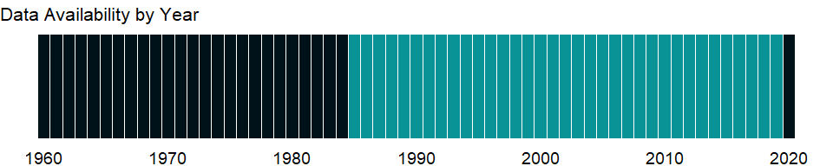

### Which countries have data?

The figure below shows the percentage of countries in each income group with a value since 2010 for that indicator.



### Why is it relevant?

NA

### What is the data source?

Demographic and Health Surveys.

### What is the methodology?

NA

### How is it aggregated?

Weighted Average

### What are the limitations?

NA

### What else should I know?

NA

### 1.68.15 Teenage mothers (% of women ages 15-19 who have had children or are currently pregnant)

### What is the indicator?

Teenage mothers are the percentage of women ages 15-19 who already have children or are currently pregnant.

Topic: Health: Reproductive health

Series ID: SP.MTR.1519.ZS

Copyright: CC BY-4.0 , <https://datacatalog.worldbank.org/public-licenses#cc-by>

First year with any data: 1985

Last year with any data: 2019

### What years are data available?

The figure below shows years in which data is available for at least one country. Dates shaded in black have no data, while dates shaded in green have data for at least one country



### Which countries have data?

The figure below shows the percentage of countries in each income group with a value since 2010 for that indicator.

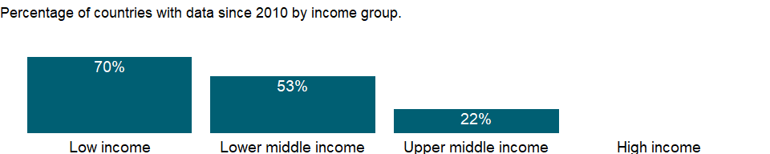

### Why is it relevant?

Having a child during the teenage years limits girls’ opportunities for better education, jobs, and income. Pregnancy is more likely to be unintended during the teenage years, and births are more likely to be premature and are associated with greater risks of complications during delivery and of death. In many countries maternal mortality is a leading cause of death among women of reproductive age, although most of those deaths are preventable. Infants of adolescent mothers are also more likely to have low birth weight, which can have a long-term impact on their health and development. Complications from pregnancy and childbirth are the leading cause of death among girls aged 15-19 years in many low- and middle-income countries.

### What is the data source?

Demographic and Health Surveys.

### What is the methodology?

NA

### How is it aggregated?

Weighted average

### What are the limitations?

NA

### What else should I know?

NA

### 1.68.16 Unmet need for contraception (% of married women ages 15-49)

### What is the indicator?

Unmet need for contraception is the percentage of fertile, married women of reproductive age who do not want to become pregnant and are not using contraception.

Topic: Health: Reproductive health

Series ID: SP.UWT.TFRT

Copyright: CC BY-4.0 , <https://datacatalog.worldbank.org/public-licenses#cc-by>

First year with any data: 1984

Last year with any data: 2020

### What years are data available?

The figure below shows years in which data is available for at least one country. Dates shaded in black have no data, while dates shaded in green have data for at least one country



### Which countries have data?

The figure below shows the percentage of countries in each income group with a value since 2010 for that indicator.

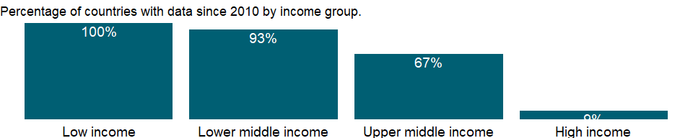

### Why is it relevant?

NA

### What is the data source?

Household surveys, including Demographic and Health Surveys and Multiple Indicator Cluster Surveys. Largely compiled by United Nations Population Division.

### What is the methodology?

Reproductive health is a state of physical and mental well-being in relation to the reproductive system and its functions and processes. Means of achieving reproductive health include education and services during pregnancy and childbirth, safe and effective contraception, and prevention and treatment of sexually transmitted diseases. Complications of pregnancy and childbirth are the leading cause of death and disability among women of reproductive age in developing countries.

Many couples in developing countries want to limit or postpone childbearing but are not using effective contraception. These couples have an unmet need for contraception. Common reasons are lack of knowledge about contraceptive methods and concerns about possible side effects. This indicator excludes women not exposed to the risk of unintended pregnancy because of menopause, infertility, or postpartum anovulation.

### How is it aggregated?

Weighted Average

### What are the limitations?

NA

### What else should I know?

Unmet need for contraception measures the capacity women have in achieving their desired family size and birth spacing. Many couples in developing countries want to limit or postpone childbearing but are not using effective contraception. These couples have an unmet need for contraception. Common reasons are lack of knowledge about contraceptive methods and concerns about possible side effects.

## 1.69 Health: Health systems

### 1.69.1 Hospital beds (per 1,000 people)

### What is the indicator?

Hospital beds include inpatient beds available in public, private, general, and specialized hospitals and rehabilitation centers. In most cases beds for both acute and chronic care are included.

Topic: Health: Health systems

Series ID: SH.MED.BEDS.ZS

Copyright: CC BY-4.0 , <https://datacatalog.worldbank.org/public-licenses#cc-by>

First year with any data: 1960

Last year with any data: 2019

### What years are data available?

The figure below shows years in which data is available for at least one country. Dates shaded in black have no data, while dates shaded in green have data for at least one country



### Which countries have data?

The figure below shows the percentage of countries in each income group with a value since 2010 for that indicator.

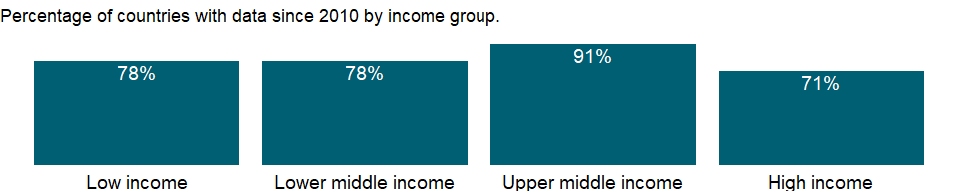

### Why is it relevant?

NA

### What is the data source?

Data are from the World Health Organization, supplemented by country data.

### What is the methodology?

Health systems - the combined arrangements of institutions and actions whose primary purpose is to promote, restore, or maintain health (World Health Organization, World Health Report 2000) - are increasingly being recognized as key to combating disease and improving the health status of populations. The World Bank’s Healthy Development: Strategy for Health, Nutrition, and Population Results emphasizes the need to strengthen health systems, which are weak in many countries, in order to increase the effectiveness of programs aimed at reducing specific diseases and further reduce morbidity and mortality. To evaluate health systems, the World Health Organization (WHO) has recommended that key components - such as financing, service delivery, workforce, governance, and information - be monitored using several key indicators. The data are a subset of the key indicators. Monitoring health systems allows the effectiveness, efficiency, and equity of different health system models to be compared. Health system data also help identify weaknesses and strengths and areas that need investment, such as additional health facilities, better health information systems, or better trained human resources.

Availability and use of health services, such as hospital beds per 1,000 people, reflect both demand- and supply-side factors. In the absence of a consistent definition this is a crude indicator of the extent of physical, financial, and other barriers to health care.

### How is it aggregated?

Weighted average

### What are the limitations?

Depending on the source and means of monitoring, data may not be exactly comparable across countries. For more information, see the original source.

### What else should I know?

NA

### 1.69.2 Community health workers (per 1,000 people)

### What is the indicator?

Community health workers include various types of community health aides, many with country-specific occupational titles such as community health officers, community health-education workers, family health workers, lady health visitors and health extension package workers.

Topic: Health: Health systems

Series ID: SH.MED.CMHW.P3

Copyright: CC BY-4.0 , <https://datacatalog.worldbank.org/public-licenses#cc-by>

First year with any data: 1990

Last year with any data: 2016

### What years are data available?

The figure below shows years in which data is available for at least one country. Dates shaded in black have no data, while dates shaded in green have data for at least one country

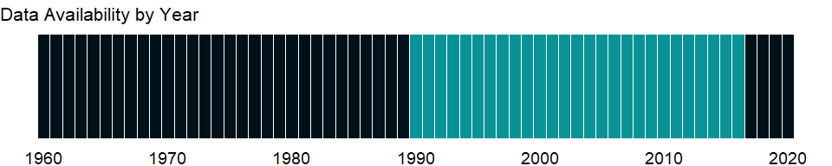

### Which countries have data?

The figure below shows the percentage of countries in each income group with a value since 2010 for that indicator.

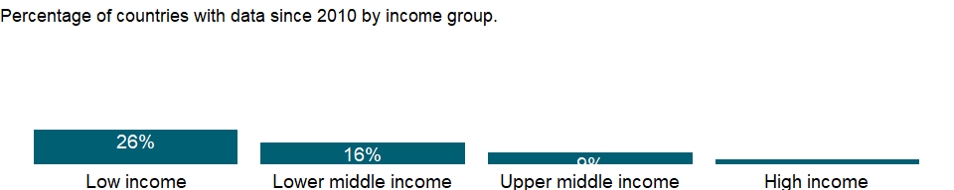

### Why is it relevant?

The WHO estimates that at least 2.5 medical staff (physicians, nurses and midwives) per 1,000 people are needed to provide adequate coverage with primary care interventions (WHO, World Health Report 2006).

### What is the data source?

World Health Organization’s Global Health Workforce Statistics, OECD, supplemented by country data.

### What is the methodology?

Health systems - the combined arrangements of institutions and actions whose primary purpose is to promote, restore, or maintain health (World Health Organization, World Health Report 2000) - are increasingly being recognized as key to combating disease and improving the health status of populations. The World Bank’s Healthy Development: Strategy for Health, Nutrition, and Population Results emphasizes the need to strengthen health systems, which are weak in many countries, in order to increase the effectiveness of programs aimed at reducing specific diseases and further reduce morbidity and mortality. To evaluate health systems, the World Health Organization (WHO) has recommended that key components - such as financing, service delivery, workforce, governance, and information - be monitored using several key indicators. The data are a subset of the key indicators. Monitoring health systems allows the effectiveness, efficiency, and equity of different health system models to be compared. Health system data also help identify weaknesses and strengths and areas that need investment, such as additional health facilities, better health information systems, or better trained human resources.

Data on health worker (physicians, nurses and midwives, and community health workers) density show the availability of medical personnel.

### How is it aggregated?

Weighted average

### What are the limitations?

The WHO compiles data from household and labor force surveys, censuses, and administrative records. Data comparability is limited by differences in definitions and training of medical personnel varies. In addition, human resources tend to be concentrated in urban areas, so that average densities do not provide a full picture of health personnel available to the entire population.

### What else should I know?

NA

### 1.69.3 Nurses and midwives (per 1,000 people)

### What is the indicator?

Nurses and midwives include professional nurses, professional midwives, auxiliary nurses, auxiliary midwives, enrolled nurses, enrolled midwives and other associated personnel, such as dental nurses and primary care nurses.

Topic: Health: Health systems

Series ID: SH.MED.NUMW.P3

Copyright: CC BY-4.0 , <https://datacatalog.worldbank.org/public-licenses#cc-by>

First year with any data: 1990

Last year with any data: 2018

### What years are data available?

The figure below shows years in which data is available for at least one country. Dates shaded in black have no data, while dates shaded in green have data for at least one country



### Which countries have data?

The figure below shows the percentage of countries in each income group with a value since 2010 for that indicator.

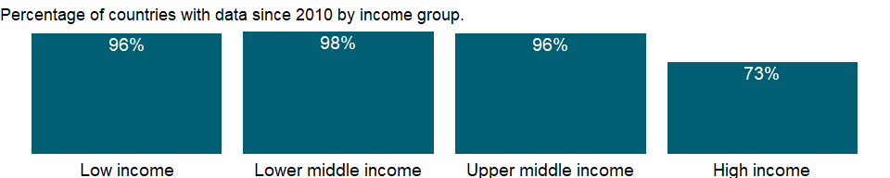

### Why is it relevant?

The WHO estimates that at least 2.5 medical staff (physicians, nurses and midwives) per 1,000 people are needed to provide adequate coverage with primary care interventions (WHO, World Health Report 2006).

### What is the data source?

World Health Organization’s Global Health Workforce Statistics, OECD, supplemented by country data.

### What is the methodology?

Health systems - the combined arrangements of institutions and actions whose primary purpose is to promote, restore, or maintain health (World Health Organization, World Health Report 2000) - are increasingly being recognized as key to combating disease and improving the health status of populations. The World Bank’s Healthy Development: Strategy for Health, Nutrition, and Population Results emphasizes the need to strengthen health systems, which are weak in many countries, in order to increase the effectiveness of programs aimed at reducing specific diseases and further reduce morbidity and mortality. To evaluate health systems, the World Health Organization (WHO) has recommended that key components - such as financing, service delivery, workforce, governance, and information - be monitored using several key indicators. The data are a subset of the key indicators. Monitoring health systems allows the effectiveness, efficiency, and equity of different health system models to be compared. Health system data also help identify weaknesses and strengths and areas that need investment, such as additional health facilities, better health information systems, or better trained human resources.

Data on health worker (physicians, nurses and midwives, and community health workers) density show the availability of medical personnel.

### How is it aggregated?

Weighted average

### What are the limitations?

The WHO compiles data from household and labor force surveys, censuses, and administrative records. Data comparability is limited by differences in definitions and training of medical personnel varies. In addition, human resources tend to be concentrated in urban areas, so that average densities do not provide a full picture of health personnel available to the entire population.

### What else should I know?

This is the Sustainable Development Goal indicator 3.c.1 [<https://unstats.un.org/sdgs/metadata/>].

### 1.69.4 Physicians (per 1,000 people)

### What is the indicator?

Physicians include generalist and specialist medical practitioners.

Topic: Health: Health systems

Series ID: SH.MED.PHYS.ZS

Copyright: CC BY-4.0 , <https://datacatalog.worldbank.org/public-licenses#cc-by>

First year with any data: 1960

Last year with any data: 2018

### What years are data available?

The figure below shows years in which data is available for at least one country. Dates shaded in black have no data, while dates shaded in green have data for at least one country



### Which countries have data?

The figure below shows the percentage of countries in each income group with a value since 2010 for that indicator.



### Why is it relevant?

The WHO estimates that at least 2.5 medical staff (physicians, nurses and midwives) per 1,000 people are needed to provide adequate coverage with primary care interventions (WHO, World Health Report 2006).

### What is the data source?

World Health Organization’s Global Health Workforce Statistics, OECD, supplemented by country data.

### What is the methodology?

Health systems - the combined arrangements of institutions and actions whose primary purpose is to promote, restore, or maintain health (World Health Organization, World Health Report 2000) - are increasingly being recognized as key to combating disease and improving the health status of populations. The World Bank’s Healthy Development: Strategy for Health, Nutrition, and Population Results emphasizes the need to strengthen health systems, which are weak in many countries, in order to increase the effectiveness of programs aimed at reducing specific diseases and further reduce morbidity and mortality. To evaluate health systems, the World Health Organization (WHO) has recommended that key components - such as financing, service delivery, workforce, governance, and information - be monitored using several key indicators. The data are a subset of the key indicators. Monitoring health systems allows the effectiveness, efficiency, and equity of different health system models to be compared. Health system data also help identify weaknesses and strengths and areas that need investment, such as additional health facilities, better health information systems, or better trained human resources.

Data on health worker (physicians, nurses and midwives, and community health workers) density show the availability of medical personnel.

### How is it aggregated?

Weighted average

### What are the limitations?

The WHO compiles data from household and labor force surveys, censuses, and administrative records. Data comparability is limited by differences in definitions and training of medical personnel varies. In addition, human resources tend to be concentrated in urban areas, so that average densities do not provide a full picture of health personnel available to the entire population.

### What else should I know?

This is the Sustainable Development Goal indicator 3.c.1 [<https://unstats.un.org/sdgs/metadata/>].

### 1.69.5 Specialist surgical workforce (per 100,000 population)

### What is the indicator?

Specialist surgical workforce is the number of specialist surgical, anaesthetic, and obstetric (SAO) providers who are working in each country per 100,000 population.

Topic: Health: Health systems

Series ID: SH.MED.SAOP.P5

Copyright: CC BY-4.0 , <https://datacatalog.worldbank.org/public-licenses#cc-by>

First year with any data: 2008

Last year with any data: 2018

### What years are data available?

The figure below shows years in which data is available for at least one country. Dates shaded in black have no data, while dates shaded in green have data for at least one country

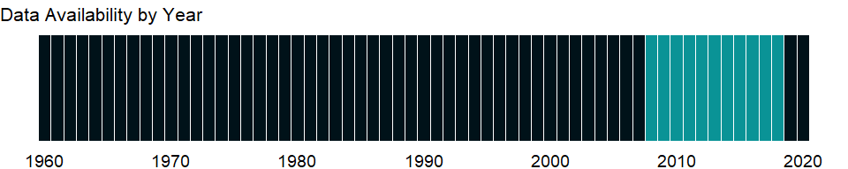

### Which countries have data?

The figure below shows the percentage of countries in each income group with a value since 2010 for that indicator.

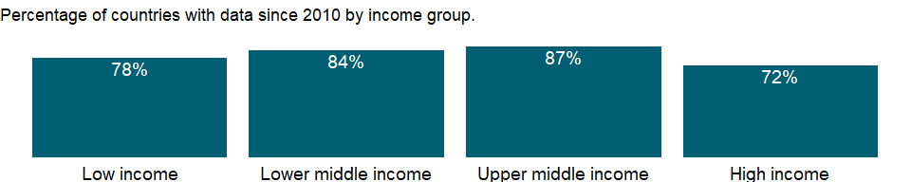

### Why is it relevant?

NA

### What is the data source?

Data collected by the Lancet Commission on Global Surgery (www.lancetglobalsurgery.org); Data collected by WHO Collaborating Centre for Surgery and Public Health at Lund University from various sources including Ministries of Health or equivalent national regulatory bodies, national official entities such as medical councils, Eurostat, OECD, WHO Euro Health For All Database, WHO EURO Technical resources for health Database; BMJ Glob Health.

### What is the methodology?

NA

### How is it aggregated?

Weighted Average

### What are the limitations?

NA

### What else should I know?

NA

### 1.69.6 Number of surgical procedures (per 100,000 population)

### What is the indicator?

The number of procedures undertaken in an operating theatre per 100,000 population per year in each country. A procedure is defined as the incision, excision, or manipulation of tissue that needs regional or general anaesthesia, or profound sedation to control pain.

Topic: Health: Health systems

Series ID: SH.SGR.PROC.P5

Copyright: CC BY-4.0 , <https://datacatalog.worldbank.org/public-licenses#cc-by>

First year with any data: 2010

Last year with any data: 2016

### What years are data available?

The figure below shows years in which data is available for at least one country. Dates shaded in black have no data, while dates shaded in green have data for at least one country

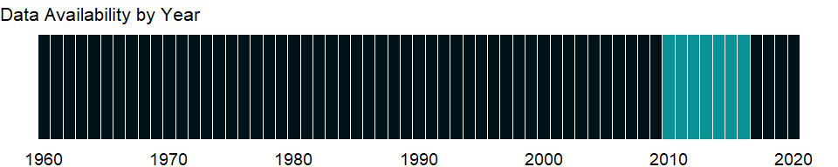

### Which countries have data?

The figure below shows the percentage of countries in each income group with a value since 2010 for that indicator.

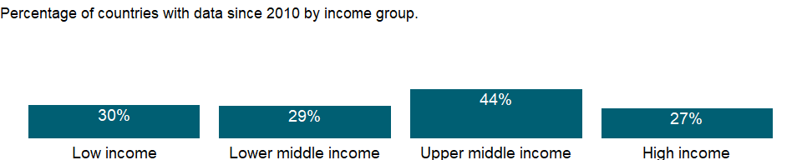

### Why is it relevant?

NA

### What is the data source?

The Lancet Commission on Global Surgery (www.lancetglobalsurgery.org).

### What is the methodology?

NA

### How is it aggregated?

Weighted Average

### What are the limitations?

NA

### What else should I know?

NA

### 1.69.7 Current health expenditure (% of GDP)

### What is the indicator?

Level of current health expenditure expressed as a percentage of GDP. Estimates of current health expenditures include healthcare goods and services consumed during each year. This indicator does not include capital health expenditures such as buildings, machinery, IT and stocks of vaccines for emergency or outbreaks.

Topic: Health: Health systems

Series ID: SH.XPD.CHEX.GD.ZS

Copyright: CC BY-4.0 , <https://datacatalog.worldbank.org/public-licenses#cc-by>

First year with any data: 2000

Last year with any data: 2018

### What years are data available?

The figure below shows years in which data is available for at least one country. Dates shaded in black have no data, while dates shaded in green have data for at least one country



### Which countries have data?

The figure below shows the percentage of countries in each income group with a value since 2010 for that indicator.

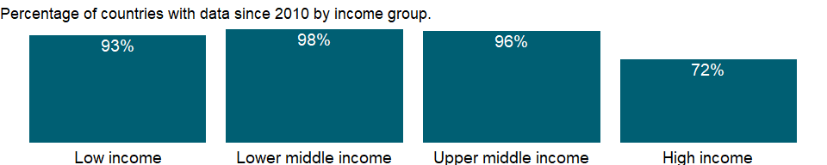

### Why is it relevant?

Strengthening health financing is one objective of Sustainable Development Goal 3 (SDG target 3.c). The levels and trends of health expenditure data identify key issues such as weaknesses and strengths and areas that need investment, for instance additional health facilities, better health information systems, or better trained human resources. Health financing is also critical for reaching universal health coverage (UHC) defined as all people obtaining the quality health services they need without suffering financial hardship (SDG 3.8). The data on out-of-pocket spending is a key indicator with regard to financial protection and hence of progress towards UHC.

### What is the data source?

World Health Organization Global Health Expenditure database (<http://apps.who.int/nha/database>).

### What is the methodology?

The health expenditure estimates have been prepared by the World Health Organization under the framework of the System of Health Accounts 2011 (SHA 2011). The Health SHA 2011 tracks all health spending in a given country over a defined period of time regardless of the entity or institution that financed and managed that spending. It generates consistent and comprehensive data on health spending in a country, which in turn can contribute to evidence-based policy-making.

### How is it aggregated?

Weighted Average

### What are the limitations?

NA

### What else should I know?

NA

### 1.69.8 Current health expenditure per capita (current US$)

### What is the indicator?

Current expenditures on health per capita in current US dollars. Estimates of current health expenditures include healthcare goods and services consumed during each year.

Topic: Health: Health systems

Series ID: SH.XPD.CHEX.PC.CD

Copyright: CC BY-4.0 , <https://datacatalog.worldbank.org/public-licenses#cc-by>

First year with any data: 2000

Last year with any data: 2018

### What years are data available?

The figure below shows years in which data is available for at least one country. Dates shaded in black have no data, while dates shaded in green have data for at least one country



### Which countries have data?

The figure below shows the percentage of countries in each income group with a value since 2010 for that indicator.



### Why is it relevant?

Strengthening health financing is one objective of Sustainable Development Goal 3 (SDG target 3.c). The levels and trends of health expenditure data identify key issues such as weaknesses and strengths and areas that need investment, for instance additional health facilities, better health information systems, or better trained human resources. Health financing is also critical for reaching universal health coverage (UHC) defined as all people obtaining the quality health services they need without suffering financial hardship (SDG 3.8). The data on out-of-pocket spending is a key indicator with regard to financial protection and hence of progress towards UHC.

### What is the data source?

World Health Organization Global Health Expenditure database (<http://apps.who.int/nha/database>).

### What is the methodology?

The health expenditure estimates have been prepared by the World Health Organization under the framework of the System of Health Accounts 2011 (SHA 2011). The Health SHA 2011 tracks all health spending in a given country over a defined period of time regardless of the entity or institution that financed and managed that spending. It generates consistent and comprehensive data on health spending in a country, which in turn can contribute to evidence-based policy-making.

### How is it aggregated?

Weighted Average

### What are the limitations?

NA

### What else should I know?

NA

### 1.69.9 Current health expenditure per capita, PPP (current international $)

### What is the indicator?

Current expenditures on health per capita expressed in international dollars at purchasing power parity (PPP time series based on ICP2011 PPP).

Topic: Health: Health systems

Series ID: SH.XPD.CHEX.PP.CD

Copyright: CC BY-4.0 , <https://datacatalog.worldbank.org/public-licenses#cc-by>

First year with any data: 2000

Last year with any data: 2018

### What years are data available?

The figure below shows years in which data is available for at least one country. Dates shaded in black have no data, while dates shaded in green have data for at least one country



### Which countries have data?

The figure below shows the percentage of countries in each income group with a value since 2010 for that indicator.



### Why is it relevant?

Strengthening health financing is one objective of Sustainable Development Goal 3 (SDG target 3.c). The levels and trends of health expenditure data identify key issues such as weaknesses and strengths and areas that need investment, for instance additional health facilities, better health information systems, or better trained human resources. Health financing is also critical for reaching universal health coverage (UHC) defined as all people obtaining the quality health services they need without suffering financial hardship (SDG 3.8). The data on out-of-pocket spending is a key indicator with regard to financial protection and hence of progress towards UHC.

### What is the data source?

World Health Organization Global Health Expenditure database (<http://apps.who.int/nha/database>).

### What is the methodology?

The health expenditure estimates have been prepared by the World Health Organization under the framework of the System of Health Accounts 2011 (SHA 2011). The Health SHA 2011 tracks all health spending in a given country over a defined period of time regardless of the entity or institution that financed and managed that spending. It generates consistent and comprehensive data on health spending in a country, which in turn can contribute to evidence-based policy-making.

### How is it aggregated?

Weighted Average

### What are the limitations?

NA

### What else should I know?

NA

### 1.69.10 External health expenditure (% of current health expenditure)

### What is the indicator?

Share of current health expenditures funded from external sources. External sources compose of direct foreign transfers and foreign transfers distributed by government encompassing all financial inflows into the national health system from outside the country. External sources either flow through the government scheme or are channeled through non-governmental organizations or other schemes.

Topic: Health: Health systems

Series ID: SH.XPD.EHEX.CH.ZS

Copyright: CC BY-4.0 , <https://datacatalog.worldbank.org/public-licenses#cc-by>

First year with any data: 2000

Last year with any data: 2018

### What years are data available?

The figure below shows years in which data is available for at least one country. Dates shaded in black have no data, while dates shaded in green have data for at least one country



### Which countries have data?

The figure below shows the percentage of countries in each income group with a value since 2010 for that indicator.



### Why is it relevant?

Strengthening health financing is one objective of Sustainable Development Goal 3 (SDG target 3.c). The levels and trends of health expenditure data identify key issues such as weaknesses and strengths and areas that need investment, for instance additional health facilities, better health information systems, or better trained human resources. Health financing is also critical for reaching universal health coverage (UHC) defined as all people obtaining the quality health services they need without suffering financial hardship (SDG 3.8). The data on out-of-pocket spending is a key indicator with regard to financial protection and hence of progress towards UHC.

### What is the data source?

World Health Organization Global Health Expenditure database (<http://apps.who.int/nha/database>).

### What is the methodology?

The health expenditure estimates have been prepared by the World Health Organization under the framework of the System of Health Accounts 2011 (SHA 2011). The Health SHA 2011 tracks all health spending in a given country over a defined period of time regardless of the entity or institution that financed and managed that spending. It generates consistent and comprehensive data on health spending in a country, which in turn can contribute to evidence-based policy-making.

### How is it aggregated?

Weighted Average

### What are the limitations?

NA

### What else should I know?

NA

### 1.69.11 External health expenditure per capita (current US$)

### What is the indicator?

Current external expenditures on health per capita expressed in current US dollars. External sources are composed of direct foreign transfers and foreign transfers distributed by government encompassing all financial inflows into the national health system from outside the country.

Topic: Health: Health systems

Series ID: SH.XPD.EHEX.PC.CD

Copyright: CC BY-4.0 , <https://datacatalog.worldbank.org/public-licenses#cc-by>

First year with any data: 2000

Last year with any data: 2018

### What years are data available?

The figure below shows years in which data is available for at least one country. Dates shaded in black have no data, while dates shaded in green have data for at least one country



### Which countries have data?

The figure below shows the percentage of countries in each income group with a value since 2010 for that indicator.



### Why is it relevant?

Strengthening health financing is one objective of Sustainable Development Goal 3 (SDG target 3.c). The levels and trends of health expenditure data identify key issues such as weaknesses and strengths and areas that need investment, for instance additional health facilities, better health information systems, or better trained human resources. Health financing is also critical for reaching universal health coverage (UHC) defined as all people obtaining the quality health services they need without suffering financial hardship (SDG 3.8). The data on out-of-pocket spending is a key indicator with regard to financial protection and hence of progress towards UHC.

### What is the data source?

World Health Organization Global Health Expenditure database (<http://apps.who.int/nha/database>).

### What is the methodology?

The health expenditure estimates have been prepared by the World Health Organization under the framework of the System of Health Accounts 2011 (SHA 2011). The Health SHA 2011 tracks all health spending in a given country over a defined period of time regardless of the entity or institution that financed and managed that spending. It generates consistent and comprehensive data on health spending in a country, which in turn can contribute to evidence-based policy-making.

### How is it aggregated?

Weighted Average

### What are the limitations?

NA

### What else should I know?

NA

### 1.69.12 External health expenditure per capita, PPP (current international $)

### What is the indicator?

Current external expenditures on health per capita expressed in international dollars at purchasing power parity (PPP time series based on ICP2011 PPP). External sources are composed of direct foreign transfers and foreign transfers distributed by government encompassing all financial inflows into the national health system from outside the country.

Topic: Health: Health systems

Series ID: SH.XPD.EHEX.PP.CD

Copyright: CC BY-4.0 , <https://datacatalog.worldbank.org/public-licenses#cc-by>

First year with any data: 2000

Last year with any data: 2018

### What years are data available?

The figure below shows years in which data is available for at least one country. Dates shaded in black have no data, while dates shaded in green have data for at least one country



### Which countries have data?

The figure below shows the percentage of countries in each income group with a value since 2010 for that indicator.



### Why is it relevant?

Strengthening health financing is one objective of Sustainable Development Goal 3 (SDG target 3.c). The levels and trends of health expenditure data identify key issues such as weaknesses and strengths and areas that need investment, for instance additional health facilities, better health information systems, or better trained human resources. Health financing is also critical for reaching universal health coverage (UHC) defined as all people obtaining the quality health services they need without suffering financial hardship (SDG 3.8). The data on out-of-pocket spending is a key indicator with regard to financial protection and hence of progress towards UHC.

### What is the data source?

World Health Organization Global Health Expenditure database (<http://apps.who.int/nha/database>).

### What is the methodology?

The health expenditure estimates have been prepared by the World Health Organization under the framework of the System of Health Accounts 2011 (SHA 2011). The Health SHA 2011 tracks all health spending in a given country over a defined period of time regardless of the entity or institution that financed and managed that spending. It generates consistent and comprehensive data on health spending in a country, which in turn can contribute to evidence-based policy-making.

### How is it aggregated?

Weighted Average

### What are the limitations?

NA

### What else should I know?

NA

### 1.69.13 Domestic general government health expenditure (% of current health expenditure)

### What is the indicator?

Share of current health expenditures funded from domestic public sources for health. Domestic public sources include domestic revenue as internal transfers and grants, transfers, subsidies to voluntary health insurance beneficiaries, non-profit institutions serving households (NPISH) or enterprise financing schemes as well as compulsory prepayment and social health insurance contributions. They do not include external resources spent by governments on health.

Topic: Health: Health systems

Series ID: SH.XPD.GHED.CH.ZS

Copyright: CC BY-4.0 , <https://datacatalog.worldbank.org/public-licenses#cc-by>

First year with any data: 2000

Last year with any data: 2018

### What years are data available?

The figure below shows years in which data is available for at least one country. Dates shaded in black have no data, while dates shaded in green have data for at least one country



### Which countries have data?

The figure below shows the percentage of countries in each income group with a value since 2010 for that indicator.



### Why is it relevant?

Strengthening health financing is one objective of Sustainable Development Goal 3 (SDG target 3.c). The levels and trends of health expenditure data identify key issues such as weaknesses and strengths and areas that need investment, for instance additional health facilities, better health information systems, or better trained human resources. Health financing is also critical for reaching universal health coverage (UHC) defined as all people obtaining the quality health services they need without suffering financial hardship (SDG 3.8). The data on out-of-pocket spending is a key indicator with regard to financial protection and hence of progress towards UHC.

### What is the data source?

World Health Organization Global Health Expenditure database (<http://apps.who.int/nha/database>).

### What is the methodology?

The health expenditure estimates have been prepared by the World Health Organization under the framework of the System of Health Accounts 2011 (SHA 2011). The Health SHA 2011 tracks all health spending in a given country over a defined period of time regardless of the entity or institution that financed and managed that spending. It generates consistent and comprehensive data on health spending in a country, which in turn can contribute to evidence-based policy-making.

### How is it aggregated?

Weighted Average

### What are the limitations?

NA

### What else should I know?

NA

### 1.69.14 Domestic general government health expenditure (% of GDP)

### What is the indicator?

Public expenditure on health from domestic sources as a share of the economy as measured by GDP.

Topic: Health: Health systems

Series ID: SH.XPD.GHED.GD.ZS

Copyright: CC BY-4.0 , <https://datacatalog.worldbank.org/public-licenses#cc-by>

First year with any data: 2000

Last year with any data: 2018

### What years are data available?

The figure below shows years in which data is available for at least one country. Dates shaded in black have no data, while dates shaded in green have data for at least one country



### Which countries have data?

The figure below shows the percentage of countries in each income group with a value since 2010 for that indicator.



### Why is it relevant?

Strengthening health financing is one objective of Sustainable Development Goal 3 (SDG target 3.c). The levels and trends of health expenditure data identify key issues such as weaknesses and strengths and areas that need investment, for instance additional health facilities, better health information systems, or better trained human resources. Health financing is also critical for reaching universal health coverage (UHC) defined as all people obtaining the quality health services they need without suffering financial hardship (SDG 3.8). The data on out-of-pocket spending is a key indicator with regard to financial protection and hence of progress towards UHC.

### What is the data source?

World Health Organization Global Health Expenditure database (<http://apps.who.int/nha/database>).

### What is the methodology?

The health expenditure estimates have been prepared by the World Health Organization under the framework of the System of Health Accounts 2011 (SHA 2011). The Health SHA 2011 tracks all health spending in a given country over a defined period of time regardless of the entity or institution that financed and managed that spending. It generates consistent and comprehensive data on health spending in a country, which in turn can contribute to evidence-based policy-making.

### How is it aggregated?

Weighted Average

### What are the limitations?

NA

### What else should I know?

NA

### 1.69.15 Domestic general government health expenditure (% of general government expenditure)

### What is the indicator?

Public expenditure on health from domestic sources as a share of total public expenditure. It indicates the priority of the government to spend on health from own domestic public resources.

Topic: Health: Health systems

Series ID: SH.XPD.GHED.GE.ZS

Copyright: CC BY-4.0 , <https://datacatalog.worldbank.org/public-licenses#cc-by>

First year with any data: 2000

Last year with any data: 2018

### What years are data available?

The figure below shows years in which data is available for at least one country. Dates shaded in black have no data, while dates shaded in green have data for at least one country



### Which countries have data?

The figure below shows the percentage of countries in each income group with a value since 2010 for that indicator.



### Why is it relevant?

Strengthening health financing is one objective of Sustainable Development Goal 3 (SDG target 3.c). The levels and trends of health expenditure data identify key issues such as weaknesses and strengths and areas that need investment, for instance additional health facilities, better health information systems, or better trained human resources. Health financing is also critical for reaching universal health coverage (UHC) defined as all people obtaining the quality health services they need without suffering financial hardship (SDG 3.8). The data on out-of-pocket spending is a key indicator with regard to financial protection and hence of progress towards UHC.

### What is the data source?

World Health Organization Global Health Expenditure database (<http://apps.who.int/nha/database>).

### What is the methodology?

The health expenditure estimates have been prepared by the World Health Organization under the framework of the System of Health Accounts 2011 (SHA 2011). The Health SHA 2011 tracks all health spending in a given country over a defined period of time regardless of the entity or institution that financed and managed that spending. It generates consistent and comprehensive data on health spending in a country, which in turn can contribute to evidence-based policy-making.

### How is it aggregated?

Weighted Average

### What are the limitations?

NA

### What else should I know?

NA

### 1.69.16 Domestic general government health expenditure per capita (current US$)

### What is the indicator?

Public expenditure on health from domestic sources per capita expressed in current US dollars.

Topic: Health: Health systems

Series ID: SH.XPD.GHED.PC.CD

Copyright: CC BY-4.0 , <https://datacatalog.worldbank.org/public-licenses#cc-by>

First year with any data: 2000

Last year with any data: 2018

### What years are data available?

The figure below shows years in which data is available for at least one country. Dates shaded in black have no data, while dates shaded in green have data for at least one country



### Which countries have data?

The figure below shows the percentage of countries in each income group with a value since 2010 for that indicator.



### Why is it relevant?

Strengthening health financing is one objective of Sustainable Development Goal 3 (SDG target 3.c). The levels and trends of health expenditure data identify key issues such as weaknesses and strengths and areas that need investment, for instance additional health facilities, better health information systems, or better trained human resources. Health financing is also critical for reaching universal health coverage (UHC) defined as all people obtaining the quality health services they need without suffering financial hardship (SDG 3.8). The data on out-of-pocket spending is a key indicator with regard to financial protection and hence of progress towards UHC.

### What is the data source?

World Health Organization Global Health Expenditure database (<http://apps.who.int/nha/database>).

### What is the methodology?

The health expenditure estimates have been prepared by the World Health Organization under the framework of the System of Health Accounts 2011 (SHA 2011). The Health SHA 2011 tracks all health spending in a given country over a defined period of time regardless of the entity or institution that financed and managed that spending. It generates consistent and comprehensive data on health spending in a country, which in turn can contribute to evidence-based policy-making.

### How is it aggregated?

Weighted Average

### What are the limitations?

NA

### What else should I know?

NA

### 1.69.17 Domestic general government health expenditure per capita, PPP (current international $)

### What is the indicator?

Public expenditure on health from domestic sources per capita expressed in international dollars at purchasing power parity (PPP time series based on ICP2011 PPP).

Topic: Health: Health systems

Series ID: SH.XPD.GHED.PP.CD

Copyright: CC BY-4.0 , <https://datacatalog.worldbank.org/public-licenses#cc-by>

First year with any data: 2000

Last year with any data: 2018

### What years are data available?

The figure below shows years in which data is available for at least one country. Dates shaded in black have no data, while dates shaded in green have data for at least one country



### Which countries have data?

The figure below shows the percentage of countries in each income group with a value since 2010 for that indicator.



### Why is it relevant?

Strengthening health financing is one objective of Sustainable Development Goal 3 (SDG target 3.c). The levels and trends of health expenditure data identify key issues such as weaknesses and strengths and areas that need investment, for instance additional health facilities, better health information systems, or better trained human resources. Health financing is also critical for reaching universal health coverage (UHC) defined as all people obtaining the quality health services they need without suffering financial hardship (SDG 3.8). The data on out-of-pocket spending is a key indicator with regard to financial protection and hence of progress towards UHC.

### What is the data source?

World Health Organization Global Health Expenditure database (<http://apps.who.int/nha/database>).

### What is the methodology?

The health expenditure estimates have been prepared by the World Health Organization under the framework of the System of Health Accounts 2011 (SHA 2011). The Health SHA 2011 tracks all health spending in a given country over a defined period of time regardless of the entity or institution that financed and managed that spending. It generates consistent and comprehensive data on health spending in a country, which in turn can contribute to evidence-based policy-making.

### How is it aggregated?

Weighted Average

### What are the limitations?

NA

### What else should I know?

NA

### 1.69.18 Out-of-pocket expenditure (% of current health expenditure)

### What is the indicator?

Share of out-of-pocket payments of total current health expenditures. Out-of-pocket payments are spending on health directly out-of-pocket by households.

Topic: Health: Health systems

Series ID: SH.XPD.OOPC.CH.ZS

Copyright: CC BY-4.0 , <https://datacatalog.worldbank.org/public-licenses#cc-by>

First year with any data: 2000

Last year with any data: 2018

### What years are data available?

The figure below shows years in which data is available for at least one country. Dates shaded in black have no data, while dates shaded in green have data for at least one country



### Which countries have data?

The figure below shows the percentage of countries in each income group with a value since 2010 for that indicator.



### Why is it relevant?

Strengthening health financing is one objective of Sustainable Development Goal 3 (SDG target 3.c). The levels and trends of health expenditure data identify key issues such as weaknesses and strengths and areas that need investment, for instance additional health facilities, better health information systems, or better trained human resources. Health financing is also critical for reaching universal health coverage (UHC) defined as all people obtaining the quality health services they need without suffering financial hardship (SDG 3.8). The data on out-of-pocket spending is a key indicator with regard to financial protection and hence of progress towards UHC.

### What is the data source?

World Health Organization Global Health Expenditure database (<http://apps.who.int/nha/database>).

### What is the methodology?

The health expenditure estimates have been prepared by the World Health Organization under the framework of the System of Health Accounts 2011 (SHA 2011). The Health SHA 2011 tracks all health spending in a given country over a defined period of time regardless of the entity or institution that financed and managed that spending. It generates consistent and comprehensive data on health spending in a country, which in turn can contribute to evidence-based policy-making.

### How is it aggregated?

Weighted Average

### What are the limitations?

NA

### What else should I know?

NA

### 1.69.19 Out-of-pocket expenditure per capita (current US$)

### What is the indicator?

Health expenditure through out-of-pocket payments per capita in USD. Out of pocket payments are spending on health directly out of pocket by households in each country.

Topic: Health: Health systems

Series ID: SH.XPD.OOPC.PC.CD

Copyright: CC BY-4.0 , <https://datacatalog.worldbank.org/public-licenses#cc-by>

First year with any data: 2000

Last year with any data: 2018

### What years are data available?

The figure below shows years in which data is available for at least one country. Dates shaded in black have no data, while dates shaded in green have data for at least one country



### Which countries have data?

The figure below shows the percentage of countries in each income group with a value since 2010 for that indicator.



### Why is it relevant?

Strengthening health financing is one objective of Sustainable Development Goal 3 (SDG target 3.c). The levels and trends of health expenditure data identify key issues such as weaknesses and strengths and areas that need investment, for instance additional health facilities, better health information systems, or better trained human resources. Health financing is also critical for reaching universal health coverage (UHC) defined as all people obtaining the quality health services they need without suffering financial hardship (SDG 3.8). The data on out-of-pocket spending is a key indicator with regard to financial protection and hence of progress towards UHC.

### What is the data source?

World Health Organization Global Health Expenditure database (<http://apps.who.int/nha/database>).

### What is the methodology?

The health expenditure estimates have been prepared by the World Health Organization under the framework of the System of Health Accounts 2011 (SHA 2011). The Health SHA 2011 tracks all health spending in a given country over a defined period of time regardless of the entity or institution that financed and managed that spending. It generates consistent and comprehensive data on health spending in a country, which in turn can contribute to evidence-based policy-making.

### How is it aggregated?

Weighted Average

### What are the limitations?

NA

### What else should I know?

NA

### 1.69.20 Out-of-pocket expenditure per capita, PPP (current international $)

### What is the indicator?

Health expenditure through out-of-pocket payments per capita in international dollars at purchasing power parity (PPP time series based on ICP2011 PPP).

Topic: Health: Health systems

Series ID: SH.XPD.OOPC.PP.CD

Copyright: CC BY-4.0 , <https://datacatalog.worldbank.org/public-licenses#cc-by>

First year with any data: 2000

Last year with any data: 2018

### What years are data available?

The figure below shows years in which data is available for at least one country. Dates shaded in black have no data, while dates shaded in green have data for at least one country



### Which countries have data?

The figure below shows the percentage of countries in each income group with a value since 2010 for that indicator.



### Why is it relevant?

Strengthening health financing is one objective of Sustainable Development Goal 3 (SDG target 3.c). The levels and trends of health expenditure data identify key issues such as weaknesses and strengths and areas that need investment, for instance additional health facilities, better health information systems, or better trained human resources. Health financing is also critical for reaching universal health coverage (UHC) defined as all people obtaining the quality health services they need without suffering financial hardship (SDG 3.8). The data on out-of-pocket spending is a key indicator with regard to financial protection and hence of progress towards UHC.

### What is the data source?

World Health Organization Global Health Expenditure database (<http://apps.who.int/nha/database>).

### What is the methodology?

The health expenditure estimates have been prepared by the World Health Organization under the framework of the System of Health Accounts 2011 (SHA 2011). The Health SHA 2011 tracks all health spending in a given country over a defined period of time regardless of the entity or institution that financed and managed that spending. It generates consistent and comprehensive data on health spending in a country, which in turn can contribute to evidence-based policy-making.

### How is it aggregated?

Weighted Average

### What are the limitations?

NA

### What else should I know?

NA

### 1.69.21 Domestic private health expenditure (% of current health expenditure)

### What is the indicator?

Share of current health expenditures funded from domestic private sources. Domestic private sources include funds from households, corporations and non-profit organizations. Such expenditures can be either prepaid to voluntary health insurance or paid directly to healthcare providers.

Topic: Health: Health systems

Series ID: SH.XPD.PVTD.CH.ZS

Copyright: CC BY-4.0 , <https://datacatalog.worldbank.org/public-licenses#cc-by>

First year with any data: 2000

Last year with any data: 2018

### What years are data available?

The figure below shows years in which data is available for at least one country. Dates shaded in black have no data, while dates shaded in green have data for at least one country



### Which countries have data?

The figure below shows the percentage of countries in each income group with a value since 2010 for that indicator.



### Why is it relevant?

Strengthening health financing is one objective of Sustainable Development Goal 3 (SDG target 3.c). The levels and trends of health expenditure data identify key issues such as weaknesses and strengths and areas that need investment, for instance additional health facilities, better health information systems, or better trained human resources. Health financing is also critical for reaching universal health coverage (UHC) defined as all people obtaining the quality health services they need without suffering financial hardship (SDG 3.8). The data on out-of-pocket spending is a key indicator with regard to financial protection and hence of progress towards UHC.

### What is the data source?

World Health Organization Global Health Expenditure database (<http://apps.who.int/nha/database>).

### What is the methodology?

The health expenditure estimates have been prepared by the World Health Organization under the framework of the System of Health Accounts 2011 (SHA 2011). The Health SHA 2011 tracks all health spending in a given country over a defined period of time regardless of the entity or institution that financed and managed that spending. It generates consistent and comprehensive data on health spending in a country, which in turn can contribute to evidence-based policy-making.

### How is it aggregated?

Weighted Average

### What are the limitations?

NA

### What else should I know?

NA

### 1.69.22 Domestic private health expenditure per capita (current US$)

### What is the indicator?

Current private expenditures on health per capita expressed in current US dollars. Domestic private sources include funds from households, corporations and non-profit organizations. Such expenditures can be either prepaid to voluntary health insurance or paid directly to healthcare providers.

Topic: Health: Health systems

Series ID: SH.XPD.PVTD.PC.CD

Copyright: CC BY-4.0 , <https://datacatalog.worldbank.org/public-licenses#cc-by>

First year with any data: 2000

Last year with any data: 2018

### What years are data available?

The figure below shows years in which data is available for at least one country. Dates shaded in black have no data, while dates shaded in green have data for at least one country



### Which countries have data?

The figure below shows the percentage of countries in each income group with a value since 2010 for that indicator.



### Why is it relevant?

Strengthening health financing is one objective of Sustainable Development Goal 3 (SDG target 3.c). The levels and trends of health expenditure data identify key issues such as weaknesses and strengths and areas that need investment, for instance additional health facilities, better health information systems, or better trained human resources. Health financing is also critical for reaching universal health coverage (UHC) defined as all people obtaining the quality health services they need without suffering financial hardship (SDG 3.8). The data on out-of-pocket spending is a key indicator with regard to financial protection and hence of progress towards UHC.

### What is the data source?

World Health Organization Global Health Expenditure database (<http://apps.who.int/nha/database>).

### What is the methodology?

The health expenditure estimates have been prepared by the World Health Organization under the framework of the System of Health Accounts 2011 (SHA 2011). The Health SHA 2011 tracks all health spending in a given country over a defined period of time regardless of the entity or institution that financed and managed that spending. It generates consistent and comprehensive data on health spending in a country, which in turn can contribute to evidence-based policy-making.

### How is it aggregated?

Weighted Average

### What are the limitations?

NA

### What else should I know?

NA

### 1.69.23 Domestic private health expenditure per capita, PPP (current international $)

### What is the indicator?

Current private expenditures on health per capita expressed in international dollars at purchasing power parity (PPP time series based on ICP2011 PPP).

Topic: Health: Health systems

Series ID: SH.XPD.PVTD.PP.CD

Copyright: CC BY-4.0 , <https://datacatalog.worldbank.org/public-licenses#cc-by>

First year with any data: 2000

Last year with any data: 2018

### What years are data available?

The figure below shows years in which data is available for at least one country. Dates shaded in black have no data, while dates shaded in green have data for at least one country



### Which countries have data?

The figure below shows the percentage of countries in each income group with a value since 2010 for that indicator.



### Why is it relevant?

Strengthening health financing is one objective of Sustainable Development Goal 3 (SDG target 3.c). The levels and trends of health expenditure data identify key issues such as weaknesses and strengths and areas that need investment, for instance additional health facilities, better health information systems, or better trained human resources. Health financing is also critical for reaching universal health coverage (UHC) defined as all people obtaining the quality health services they need without suffering financial hardship (SDG 3.8). The data on out-of-pocket spending is a key indicator with regard to financial protection and hence of progress towards UHC.

### What is the data source?

World Health Organization Global Health Expenditure database (<http://apps.who.int/nha/database>).

### What is the methodology?

The health expenditure estimates have been prepared by the World Health Organization under the framework of the System of Health Accounts 2011 (SHA 2011). The Health SHA 2011 tracks all health spending in a given country over a defined period of time regardless of the entity or institution that financed and managed that spending. It generates consistent and comprehensive data on health spending in a country, which in turn can contribute to evidence-based policy-making.

### How is it aggregated?

Weighted Average

### What are the limitations?

NA

### What else should I know?

NA

## 1.70 Health: Universal Health Coverage

### 1.70.1 Increase in poverty gap at 2011 PPP) poverty line due to out-of-pocket health care expenditure (USD)

### What is the indicator?

Increase in poverty gap at 2011 PPP) poverty line due to out-of-pocket health care expenditure, expressed in US dollars (2011 PPP). The poverty gap increase due to out-of-pocket health spending is one way to measure how much out-of-pocket health spending pushes people below or further below the poverty line (the difference in the poverty gap due to out-of-pocket health spending being included or excluded from the measure of household welfare). This difference corresponds to the total out-of-pocket health spending for households that are already below the poverty line, to the amount that exceeds the shortfall between the poverty line and total consumption for households that are impoverished by out-of-pocket health spending and to zero for households whose consumption is above the poverty line after accounting for out-of-pocket health spending.

Topic: Health: Universal Health Coverage

Series ID: SH.UHC.NOP1.CG

Copyright: CC BY-4.0 , <https://datacatalog.worldbank.org/public-licenses#cc-by>

First year with any data: 1985

Last year with any data: 2018

### What years are data available?

The figure below shows years in which data is available for at least one country. Dates shaded in black have no data, while dates shaded in green have data for at least one country

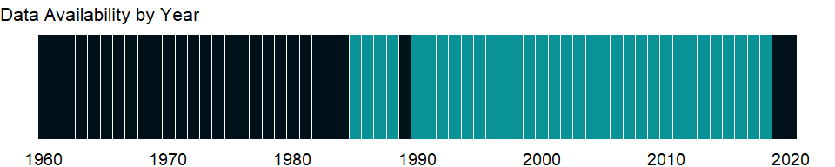

### Which countries have data?

The figure below shows the percentage of countries in each income group with a value since 2010 for that indicator.

### Why is it relevant?

Universal Health Coverage (UHC) is about ensuring that all people can access the health services they need – without facing financial hardship – is key to improving the well-being of a country’s population. UHC is also an investment in human capital and a foundational driver of inclusive and sustainable economic growth and development. UHC is a target associated with the Sustainable Development Goals (target 3.8), and it relates directly to Goal 3 (Ensure healthy lives and promote well-being for all at all ages) and to Goal 1 (End poverty in all its forms everywhere).

### What is the data source?

World Health Organization and World Bank. 2019. Global Monitoring Report on Financial Protection in Health 2019.

### What is the methodology?

Out-of-pocket payments are those made by people at the time of getting any type of service (preventive, curative, rehabilitative, palliative or long-term care) provided by any type of provider. They include cost-sharing (the part not covered by a third party like an insurer) and informal payments, but they exclude insurance premiums. Out-of-pocket payments exclude any reimbursement by a third party, such as the government, a health insurance fund or a private insurance company. This series measures the poverty gap increase attributable to OOP health expenditures. This amount can be interpreted as the per capita amount by which on average OOP spending pushes or further pushes the household below the PL. It is defined as the difference between the poverty gap based on a measure of consumption net of OOP health expenditures and a measure of consumption gross of OOP health expenditures. The difference is expressed in 2011 PPP international dollar.

### How is it aggregated?

Weighted Average

### What are the limitations?

NA

### What else should I know?

NA

### 1.70.2 Number of people pushed below the 2011 PPP) poverty line by out-of-pocket health care expenditure

## Warning in min(yr_df$date, na.rm = T): no non-missing arguments to min;  
## returning Inf  
  
## Warning in min(yr_df$date, na.rm = T): no non-missing arguments to max;  
## returning -Inf

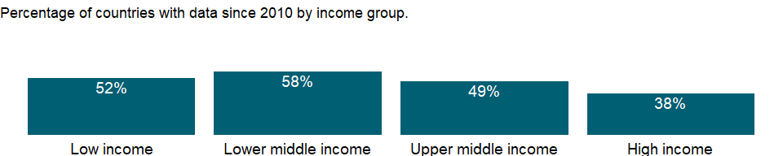### What is the indicator? {-}

Number of people pushed below the 2011 PPP) poverty line by out-of-pocket health care expenditure. This indicator shows the number of households experiencing impoverishing expenditures, defined as expenditures without which the household would have been above the $1.90 poverty line, but because of the expenditures is below the poverty line.

Topic: Health: Universal Health Coverage

Series ID: SH.UHC.NOP1.TO

Copyright: CC BY-4.0 , <https://datacatalog.worldbank.org/public-licenses#cc-by>

First year with any data: Inf

Last year with any data: -Inf

### What years are data available?

The figure below shows years in which data is available for at least one country. Dates shaded in black have no data, while dates shaded in green have data for at least one country



### Which countries have data?

The figure below shows the percentage of countries in each income group with a value since 2010 for that indicator.



### Why is it relevant?

Universal Health Coverage (UHC) is about ensuring that all people can access the health services they need – without facing financial hardship – is key to improving the well-being of a country’s population. UHC is also an investment in human capital and a foundational driver of inclusive and sustainable economic growth and development. UHC is a target associated with the Sustainable Development Goals (target 3.8), and it relates directly to Goal 3 (Ensure healthy lives and promote well-being for all at all ages) and to Goal 1 (End poverty in all its forms everywhere).

### What is the data source?

World Health Organization and World Bank. 2019. Global Monitoring Report on Financial Protection in Health 2019.

### What is the methodology?

Out-of-pocket payments are those made by people at the time of getting any type of service (preventive, curative, rehabilitative, palliative or long-term care) provided by any type of provider. They include cost-sharing (the part not covered by a third party like an insurer) and informal payments, but they exclude insurance premiums. Out-of-pocket payments exclude any reimbursement by a third party, such as the government, a health insurance fund or a private insurance company. Out-of-pocket payments are impoverishing at the $1.90 PL (PPP) for a household when consumption gross of out-of-pocket payments is higher than the $1.90 PL, but consumption net of out-of-pocket payments is lower than the 1.90 PL.

### How is it aggregated?

Sum

### What are the limitations?

NA

### What else should I know?

Aggregate data by groups are computed based on the groupings for the World Bank fiscal year in which the data was released by the World Health Organization and World Bank.

### 1.70.3 Increase in poverty gap at 2011 PPP) poverty line due to out-of-pocket health care expenditure (% of poverty line)

### What is the indicator?

Increase in poverty gap at 2011 PPP) poverty line due to out-of-pocket health care expenditure, as a percentage of the $1.90 poverty line. The poverty gap increase due to out-of-pocket health spending is one way to measure how much out-of-pocket health spending pushes people below or further below the poverty line (the difference in the poverty gap due to out-of-pocket health spending being included or excluded from the measure of household welfare). This difference corresponds to the total out-of-pocket health spending for households that are already below the poverty line, to the amount that exceeds the shortfall between the poverty line and total consumption for households that are impoverished by out-of-pocket health spending and to zero for households whose consumption is above the poverty line after accounting for out-of-pocket health spending.

Topic: Health: Universal Health Coverage

Series ID: SH.UHC.NOP1.ZG

Copyright: CC BY-4.0 , <https://datacatalog.worldbank.org/public-licenses#cc-by>

First year with any data: 1985

Last year with any data: 2018

### What years are data available?

The figure below shows years in which data is available for at least one country. Dates shaded in black have no data, while dates shaded in green have data for at least one country



### Which countries have data?

The figure below shows the percentage of countries in each income group with a value since 2010 for that indicator.



### Why is it relevant?

Universal Health Coverage (UHC) is about ensuring that all people can access the health services they need – without facing financial hardship – is key to improving the well-being of a country’s population. UHC is also an investment in human capital and a foundational driver of inclusive and sustainable economic growth and development. UHC is a target associated with the Sustainable Development Goals (target 3.8), and it relates directly to Goal 3 (Ensure healthy lives and promote well-being for all at all ages) and to Goal 1 (End poverty in all its forms everywhere).

### What is the data source?

World Health Organization and World Bank. 2019. Global Monitoring Report on Financial Protection in Health 2019.

### What is the methodology?

Out-of-pocket payments are those made by people at the time of getting any type of service (preventive, curative, rehabilitative, palliative or long-term care) provided by any type of provider. They include cost-sharing (the part not covered by a third party like an insurer) and informal payments, but they exclude insurance premiums. Out-of-pocket payments exclude any reimbursement by a third party, such as the government, a health insurance fund or a private insurance company. This series measures the poverty gap increase attributable to OOP health expenditures. This amount can be interpreted as the per capita amount by which on average OOP spending pushes or further pushes the household below the PL. It is defined as the difference between the poverty gap based on a measure of consumption net of OOP health expenditures and a measure of consumption gross of OOP health expenditures. The difference is expressed as a percentage of the PL.

### How is it aggregated?

Weighted Average

### What are the limitations?

NA

### What else should I know?

NA

### 1.70.4 Proportion of population pushed below the 2011 PPP) poverty line by out-of-pocket health care expenditure (%)

### What is the indicator?

Proportion of population pushed below the 2011 PPP) poverty line by out-of-pocket health care expenditure. This indicator shows the fraction of a country’s households experiencing impoverishing expenditures, defined as expenditures without which the household would have been above the $ 1.90 poverty line, but because of the expenditures is below the poverty line.

Topic: Health: Universal Health Coverage

Series ID: SH.UHC.NOP1.ZS

Copyright: CC BY-4.0 , <https://datacatalog.worldbank.org/public-licenses#cc-by>

First year with any data: 1985

Last year with any data: 2018

### What years are data available?

The figure below shows years in which data is available for at least one country. Dates shaded in black have no data, while dates shaded in green have data for at least one country



### Which countries have data?

The figure below shows the percentage of countries in each income group with a value since 2010 for that indicator.



### Why is it relevant?

Universal Health Coverage (UHC) is about ensuring that all people can access the health services they need – without facing financial hardship – is key to improving the well-being of a country’s population. UHC is also an investment in human capital and a foundational driver of inclusive and sustainable economic growth and development. UHC is a target associated with the Sustainable Development Goals (target 3.8), and it relates directly to Goal 3 (Ensure healthy lives and promote well-being for all at all ages) and to Goal 1 (End poverty in all its forms everywhere).

### What is the data source?

World Health Organization and World Bank. 2019. Global Monitoring Report on Financial Protection in Health 2019.

### What is the methodology?

Out-of-pocket payments are those made by people at the time of getting any type of service (preventive, curative, rehabilitative, palliative or long-term care) provided by any type of provider. They include cost-sharing (the part not covered by a third party like an insurer) and informal payments, but they exclude insurance premiums. Out-of-pocket payments exclude any reimbursement by a third party, such as the government, a health insurance fund or a private insurance company. Out-of-pocket payments are impoverishing at the $1.90 PL (PPP) for a household when consumption gross of out-of-pocket payments is higher than the $1.90 PL, but consumption net of out-of-pocket payments is lower than the 1.90 PL.

### How is it aggregated?

Weighted Average

### What are the limitations?

NA

### What else should I know?

Aggregate data by groups are computed based on the groupings for the World Bank fiscal year in which the data was released by the World Health Organization and World Bank.

### 1.70.5 Increase in poverty gap at 2011 PPP) poverty line due to out-of-pocket health care expenditure (USD)

### What is the indicator?

Increase in poverty gap at 2011 PPP) poverty line due to out-of-pocket health care expenditure, expressed in US dollars (2011 PPP). The poverty gap increase due to out-of-pocket health spending is one way to measure how much out-of-pocket health spending pushes people below or further below the poverty line (the difference in the poverty gap due to out-of-pocket health spending being included or excluded from the measure of household welfare). This difference corresponds to the total out-of-pocket health spending for households that are already below the poverty line, to the amount that exceeds the shortfall between the poverty line and total consumption for households that are impoverished by out-of-pocket health spending and to zero for households whose consumption is above the poverty line after accounting for out-of-pocket health spending.

Topic: Health: Universal Health Coverage

Series ID: SH.UHC.NOP2.CG

Copyright: CC BY-4.0 , <https://datacatalog.worldbank.org/public-licenses#cc-by>

First year with any data: 1985

Last year with any data: 2018

### What years are data available?

The figure below shows years in which data is available for at least one country. Dates shaded in black have no data, while dates shaded in green have data for at least one country



### Which countries have data?

The figure below shows the percentage of countries in each income group with a value since 2010 for that indicator.

### Why is it relevant?

Universal Health Coverage (UHC) is about ensuring that all people can access the health services they need – without facing financial hardship – is key to improving the well-being of a country’s population. UHC is also an investment in human capital and a foundational driver of inclusive and sustainable economic growth and development. UHC is a target associated with the Sustainable Development Goals (target 3.8), and it relates directly to Goal 3 (Ensure healthy lives and promote well-being for all at all ages) and to Goal 1 (End poverty in all its forms everywhere).

### What is the data source?

World Health Organization and World Bank. 2019. Global Monitoring Report on Financial Protection in Health 2019.

### What is the methodology?

Out-of-pocket payments are those made by people at the time of getting any type of service (preventive, curative, rehabilitative, palliative or long-term care) provided by any type of provider. They include cost-sharing (the part not covered by a third party like an insurer) and informal payments, but they exclude insurance premiums. Out-of-pocket payments exclude any reimbursement by a third party, such as the government, a health insurance fund or a private insurance company. This series measures the poverty gap increase attributable to OOP health expenditures. This amount can be interpreted as the per capita amount by which on average OOP spending pushes or further pushes the household below the PL. It is defined as the difference between the poverty gap based on a measure of consumption net of OOP health expenditures and a measure of consumption gross of OOP health expenditures. The difference is expressed in 2011 PPP international dollar.

### How is it aggregated?

Weighted Average

### What are the limitations?

NA

### What else should I know?

NA

### 1.70.6 Number of people pushed below the 2011 PPP) poverty line by out-of-pocket health care expenditure

## Warning in min(yr_df$date, na.rm = T): no non-missing arguments to min;  
## returning Inf  
  
## Warning in min(yr_df$date, na.rm = T): no non-missing arguments to max;  
## returning -Inf

### What is the indicator? {-}

Number of people pushed below the 2011 PPP) poverty line by out-of-pocket health care expenditure. This indicator shows the number of households experiencing impoverishing expenditures, defined as expenditures without which the household would have been above the $1.90 poverty line, but because of the expenditures is below the poverty line.

Topic: Health: Universal Health Coverage

Series ID: SH.UHC.NOP2.TO

Copyright: CC BY-4.0 , <https://datacatalog.worldbank.org/public-licenses#cc-by>

First year with any data: Inf

Last year with any data: -Inf

### What years are data available?

The figure below shows years in which data is available for at least one country. Dates shaded in black have no data, while dates shaded in green have data for at least one country



### Which countries have data?

The figure below shows the percentage of countries in each income group with a value since 2010 for that indicator.



### Why is it relevant?

Universal Health Coverage (UHC) is about ensuring that all people can access the health services they need – without facing financial hardship – is key to improving the well-being of a country’s population. UHC is also an investment in human capital and a foundational driver of inclusive and sustainable economic growth and development. UHC is a target associated with the Sustainable Development Goals (target 3.8), and it relates directly to Goal 3 (Ensure healthy lives and promote well-being for all at all ages) and to Goal 1 (End poverty in all its forms everywhere).

### What is the data source?

World Health Organization and World Bank. 2019. Global Monitoring Report on Financial Protection in Health 2019.

### What is the methodology?

Out-of-pocket payments are those made by people at the time of getting any type of service (preventive, curative, rehabilitative, palliative or long-term care) provided by any type of provider. They include cost-sharing (the part not covered by a third party like an insurer) and informal payments, but they exclude insurance premiums. Out-of-pocket payments exclude any reimbursement by a third party, such as the government, a health insurance fund or a private insurance company. Out-of-pocket payments are impoverishing at the $3.10 PL (PPP) for a household when consumption gross of out-of-pocket payments is higher than the $3.10 PL, but consumption net of out-of-pocket payments is lower than the 3.10 PL.

### How is it aggregated?

Sum

### What are the limitations?

NA

### What else should I know?

Aggregate data by groups are computed based on the groupings for the World Bank fiscal year in which the data was released by the World Health Organization and World Bank.

### 1.70.7 Increase in poverty gap at 2011 PPP) poverty line due to out-of-pocket health care expenditure (% of poverty line)

### What is the indicator?

Increase in poverty gap at 2011 PPP) poverty line due to out-of-pocket health care expenditure, as a percentage of the $3.20 poverty line. The poverty gap increase due to out-of-pocket health spending is one way to measure how much out-of-pocket health spending pushes people below or further below the poverty line (the difference in the poverty gap due to out-of-pocket health spending being included or excluded from the measure of household welfare). This difference corresponds to the total out-of-pocket health spending for households that are already below the poverty line, to the amount that exceeds the shortfall between the poverty line and total consumption for households that are impoverished by out-of-pocket health spending and to zero for households whose consumption is above the poverty line after accounting for out-of-pocket health spending.

Topic: Health: Universal Health Coverage

Series ID: SH.UHC.NOP2.ZG

Copyright: CC BY-4.0 , <https://datacatalog.worldbank.org/public-licenses#cc-by>

First year with any data: 1985

Last year with any data: 2018

### What years are data available?

The figure below shows years in which data is available for at least one country. Dates shaded in black have no data, while dates shaded in green have data for at least one country



### Which countries have data?

The figure below shows the percentage of countries in each income group with a value since 2010 for that indicator.

### Why is it relevant?

Universal Health Coverage (UHC) is about ensuring that all people can access the health services they need – without facing financial hardship – is key to improving the well-being of a country’s population. UHC is also an investment in human capital and a foundational driver of inclusive and sustainable economic growth and development. UHC is a target associated with the Sustainable Development Goals (target 3.8), and it relates directly to Goal 3 (Ensure healthy lives and promote well-being for all at all ages) and to Goal 1 (End poverty in all its forms everywhere).

### What is the data source?

World Health Organization and World Bank. 2019. Global Monitoring Report on Financial Protection in Health 2019.

### What is the methodology?

Out-of-pocket payments are those made by people at the time of getting any type of service (preventive, curative, rehabilitative, palliative or long-term care) provided by any type of provider. They include cost-sharing (the part not covered by a third party like an insurer) and informal payments, but they exclude insurance premiums. Out-of-pocket payments exclude any reimbursement by a third party, such as the government, a health insurance fund or a private insurance company. This series measures the poverty gap increase attributable to OOP health expenditures. This amount can be interpreted as the per capita amount by which on average OOP spending pushes or further pushes the household below the PL. It is defined as the difference between the poverty gap based on a measure of consumption net of OOP health expenditures and a measure of consumption gross of OOP health expenditures. The difference is expressed as a percentage of the PL.

### How is it aggregated?

Weighted Average

### What are the limitations?

NA

### What else should I know?

NA

### 1.70.8 Proportion of population pushed below the 2011 PPP) poverty line by out-of-pocket health care expenditure (%)

## Warning in min(yr_df$date, na.rm = T): no non-missing arguments to min;  
## returning Inf  
  
## Warning in min(yr_df$date, na.rm = T): no non-missing arguments to max;  
## returning -Inf

### What is the indicator? {-}

Proportion of population pushed below the $3.20 ($2011 PPP) poverty line by out-of-pocket health care expenditure. This indicator shows the fraction of a country’s households experiencing impoverishing expenditures, defined as expenditures without which the household would have been above the $3.20 poverty line, but because of the expenditures is below the poverty line.

Topic: Health: Universal Health Coverage

Series ID: SH.UHC.NOP2.ZS

Copyright: CC BY-4.0 , <https://datacatalog.worldbank.org/public-licenses#cc-by>

First year with any data: Inf

Last year with any data: -Inf

### What years are data available?

The figure below shows years in which data is available for at least one country. Dates shaded in black have no data, while dates shaded in green have data for at least one country



### Which countries have data?

The figure below shows the percentage of countries in each income group with a value since 2010 for that indicator.

### Why is it relevant?

Universal Health Coverage (UHC) is about ensuring that all people can access the health services they need – without facing financial hardship – is key to improving the well-being of a country’s population. UHC is also an investment in human capital and a foundational driver of inclusive and sustainable economic growth and development. UHC is a target associated with the Sustainable Development Goals (target 3.8), and it relates directly to Goal 3 (Ensure healthy lives and promote well-being for all at all ages) and to Goal 1 (End poverty in all its forms everywhere).

### What is the data source?

World Health Organization and World Bank. 2019. Global Monitoring Report on Financial Protection in Health 2019.

### What is the methodology?

Out-of-pocket payments are those made by people at the time of getting any type of service (preventive, curative, rehabilitative, palliative or long-term care) provided by any type of provider. They include cost-sharing (the part not covered by a third party like an insurer) and informal payments, but they exclude insurance premiums. Out-of-pocket payments exclude any reimbursement by a third party, such as the government, a health insurance fund or a private insurance company. Out-of-pocket payments are impoverishing at the $3.10 PL (PPP) for a household when consumption gross of out-of-pocket payments is higher than the $3.10 PL, but consumption net of out-of-pocket payments is lower than the 3.10 PL.

### How is it aggregated?

Weighted Average

### What are the limitations?

NA

### What else should I know?

Aggregate data by groups are computed based on the groupings for the World Bank fiscal year in which the data was released by the World Health Organization and World Bank.

### 1.70.9 Number of people spending more than 10% of household consumption or income on out-of-pocket health care expenditure

## Warning in min(yr_df$date, na.rm = T): no non-missing arguments to min;  
## returning Inf  
  
## Warning in min(yr_df$date, na.rm = T): no non-missing arguments to max;  
## returning -Inf

### What is the indicator? {-}

Number of people spending more than 10% of household consumption or income on out-of-pocket health care expenditure

Topic: Health: Universal Health Coverage

Series ID: SH.UHC.OOPC.10.TO

Copyright: CC BY-4.0 , <https://datacatalog.worldbank.org/public-licenses#cc-by>

First year with any data: Inf

Last year with any data: -Inf

### What years are data available?

The figure below shows years in which data is available for at least one country. Dates shaded in black have no data, while dates shaded in green have data for at least one country



### Which countries have data?

The figure below shows the percentage of countries in each income group with a value since 2010 for that indicator.



### Why is it relevant?

Universal Health Coverage (UHC) is about ensuring that all people can access the health services they need – without facing financial hardship – is key to improving the well-being of a country’s population. UHC is also an investment in human capital and a foundational driver of inclusive and sustainable economic growth and development. UHC is a target associated with the Sustainable Development Goals (target 3.8), and it relates directly to Goal 3 (Ensure healthy lives and promote well-being for all at all ages) and to Goal 1 (End poverty in all its forms everywhere).

### What is the data source?

World Health Organization and World Bank. 2019. Global Monitoring Report on Financial Protection in Health 2019.

### What is the methodology?

Out-of-pocket payments are those made by people at the time of getting any type of service (preventive, curative, rehabilitative, palliative or long-term care) provided by any type of provider. They include cost-sharing (the part not covered by a third party like an insurer) and informal payments, but they exclude insurance premiums. Out-of-pocket payments exclude any reimbursement by a third party, such as the government, a health insurance fund or a private insurance company. Out-of-pocket payments are defined as catastrophic at the 10% threshold when they represent 10% or more of total consumption or income.

### How is it aggregated?

Sum

### What are the limitations?

NA

### What else should I know?

Aggregate data by groups are computed based on the groupings for the World Bank fiscal year in which the data was released by the World Health Organization and World Bank.

This indicator is related to Sustainable Development Goal 3.8.2 [<https://unstats.un.org/sdgs/metadata/>].

### 1.70.10 Proportion of population spending more than 10% of household consumption or income on out-of-pocket health care expenditure (%)

### What is the indicator?

Proportion of population spending more than 10% of household consumption or income on out-of-pocket health care expenditure.

Topic: Health: Universal Health Coverage

Series ID: SH.UHC.OOPC.10.ZS

Copyright: CC BY-4.0 , <https://datacatalog.worldbank.org/public-licenses#cc-by>

First year with any data: 1985

Last year with any data: 2018

### What years are data available?

The figure below shows years in which data is available for at least one country. Dates shaded in black have no data, while dates shaded in green have data for at least one country



### Which countries have data?

The figure below shows the percentage of countries in each income group with a value since 2010 for that indicator.

### Why is it relevant?

Universal Health Coverage (UHC) is about ensuring that all people can access the health services they need – without facing financial hardship – is key to improving the well-being of a country’s population. UHC is also an investment in human capital and a foundational driver of inclusive and sustainable economic growth and development. UHC is a target associated with the Sustainable Development Goals (target 3.8), and it relates directly to Goal 3 (Ensure healthy lives and promote well-being for all at all ages) and to Goal 1 (End poverty in all its forms everywhere).

### What is the data source?

World Health Organization and World Bank. 2019. Global Monitoring Report on Financial Protection in Health 2019.

### What is the methodology?

Out-of-pocket payments are those made by people at the time of getting any type of service (preventive, curative, rehabilitative, palliative or long-term care) provided by any type of provider. They include cost-sharing (the part not covered by a third party like an insurer) and informal payments, but they exclude insurance premiums. Out-of-pocket payments exclude any reimbursement by a third party, such as the government, a health insurance fund or a private insurance company. Out-of-pocket payments are defined as catastrophic at the 10% threshold when they represent 10% or more of total consumption or income.

### How is it aggregated?

Weighted Average

### What are the limitations?

NA

### What else should I know?

Aggregate data by groups are computed based on the groupings for the World Bank fiscal year in which the data was released by the World Health Organization and World Bank.

This is the Sustainable Development Goal indicator 3.8.2[<https://unstats.un.org/sdgs/metadata/>].

### 1.70.11 Number of people spending more than 25% of household consumption or income on out-of-pocket health care expenditure

## Warning in min(yr_df$date, na.rm = T): no non-missing arguments to min;  
## returning Inf  
  
## Warning in min(yr_df$date, na.rm = T): no non-missing arguments to max;  
## returning -Inf

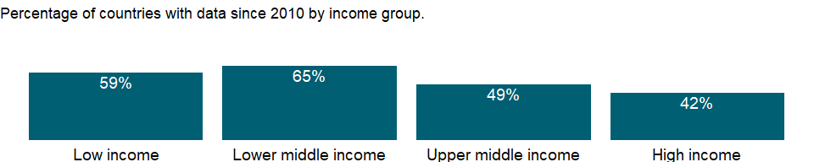### What is the indicator? {-}

Number of people spending more than 25% of household consumption or income on out-of-pocket health care expenditure

Topic: Health: Universal Health Coverage

Series ID: SH.UHC.OOPC.25.TO

Copyright: CC BY-4.0 , <https://datacatalog.worldbank.org/public-licenses#cc-by>

First year with any data: Inf

Last year with any data: -Inf

### What years are data available?

The figure below shows years in which data is available for at least one country. Dates shaded in black have no data, while dates shaded in green have data for at least one country



### Which countries have data?

The figure below shows the percentage of countries in each income group with a value since 2010 for that indicator.



### Why is it relevant?

Universal Health Coverage (UHC) is about ensuring that all people can access the health services they need – without facing financial hardship – is key to improving the well-being of a country’s population. UHC is also an investment in human capital and a foundational driver of inclusive and sustainable economic growth and development. UHC is a target associated with the Sustainable Development Goals (target 3.8), and it relates directly to Goal 3 (Ensure healthy lives and promote well-being for all at all ages) and to Goal 1 (End poverty in all its forms everywhere).

### What is the data source?

World Health Organization and World Bank. 2019. Global Monitoring Report on Financial Protection in Health 2019.

### What is the methodology?

Out-of-pocket payments are those made by people at the time of getting any type of service (preventive, curative, rehabilitative, palliative or long-term care) provided by any type of provider. They include cost-sharing (the part not covered by a third party like an insurer) and informal payments, but they exclude insurance premiums. Out-of-pocket payments exclude any reimbursement by a third party, such as the government, a health insurance fund or a private insurance company. Out-of-pocket payments are defined as catastrophic at the 25% threshold when they represent 25% or more of total consumption or income.

### How is it aggregated?

Sum

### What are the limitations?

NA

### What else should I know?

Aggregate data by groups are computed based on the groupings for the World Bank fiscal year in which the data was released by the World Health Organization and World Bank.

This indicator is related to Sustainable Development Goal 3.8.2 [<https://unstats.un.org/sdgs/metadata/>].

### 1.70.12 Proportion of population spending more than 25% of household consumption or income on out-of-pocket health care expenditure (%)

### What is the indicator?

Proportion of population spending more than 25% of household consumption or income on out-of-pocket health care expenditure.

Topic: Health: Universal Health Coverage

Series ID: SH.UHC.OOPC.25.ZS

Copyright: CC BY-4.0 , <https://datacatalog.worldbank.org/public-licenses#cc-by>

First year with any data: 1985

Last year with any data: 2018

### What years are data available?

The figure below shows years in which data is available for at least one country. Dates shaded in black have no data, while dates shaded in green have data for at least one country



### Which countries have data?

The figure below shows the percentage of countries in each income group with a value since 2010 for that indicator.



### Why is it relevant?

Universal Health Coverage (UHC) is about ensuring that all people can access the health services they need – without facing financial hardship – is key to improving the well-being of a country’s population. UHC is also an investment in human capital and a foundational driver of inclusive and sustainable economic growth and development. UHC is a target associated with the Sustainable Development Goals (target 3.8), and it relates directly to Goal 3 (Ensure healthy lives and promote well-being for all at all ages) and to Goal 1 (End poverty in all its forms everywhere).

### What is the data source?

World Health Organization and World Bank. 2019. Global Monitoring Report on Financial Protection in Health 2019.

### What is the methodology?

Out-of-pocket payments are those made by people at the time of getting any type of service (preventive, curative, rehabilitative, palliative or long-term care) provided by any type of provider. They include cost-sharing (the part not covered by a third party like an insurer) and informal payments, but they exclude insurance premiums. Out-of-pocket payments exclude any reimbursement by a third party, such as the government, a health insurance fund or a private insurance company. Out-of-pocket payments are defined as catastrophic at the 25% threshold when they represent 25% or more of total consumption or income.

### How is it aggregated?

Weighted Average

### What are the limitations?

NA

### What else should I know?

Aggregate data by groups are computed based on the groupings for the World Bank fiscal year in which the data was released by the World Health Organization and World Bank.

This is the Sustainable Development Goal indicator 3.8.2[<https://unstats.un.org/sdgs/metadata/>].

### 1.70.13 UHC service coverage index

### What is the indicator?

Coverage index for essential health services (based on tracer interventions that include reproductive, maternal, newborn and child health, infectious diseases, noncommunicable diseases and service capacity and access). It is presented on a scale of 0 to 100.

Topic: Health: Universal Health Coverage

Series ID: SH.UHC.SRVS.CV.XD

Copyright: CC BY-4.0 , <https://datacatalog.worldbank.org/public-licenses#cc-by>

First year with any data: 2015

Last year with any data: 2017

### What years are data available?

The figure below shows years in which data is available for at least one country. Dates shaded in black have no data, while dates shaded in green have data for at least one country

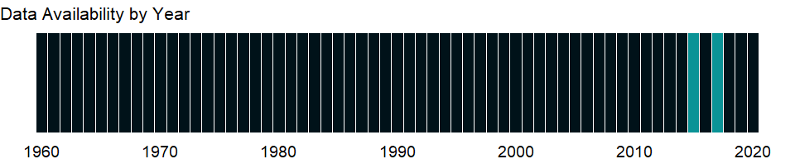

### Which countries have data?

The figure below shows the percentage of countries in each income group with a value since 2010 for that indicator.



### Why is it relevant?

Universal Health Coverage (UHC) is about ensuring that all people can access the health services they need – without facing financial hardship – is key to improving the well-being of a country’s population. UHC is also an investment in human capital and a foundational driver of inclusive and sustainable economic growth and development. UHC is a target associated with the Sustainable Development Goals (target 3.8), and it relates directly to Goal 3 (Ensure healthy lives and promote well-being for all at all ages) and to Goal 1 (End poverty in all its forms everywhere).

### What is the data source?

World Health Organization, Global Health Observatory Data Repository (<https://www.who.int/data/gho>).

### What is the methodology?

Under SDG 3.8.1, four categories were defined RMNCH, infectious diseases, non-communicable diseases and service capacity and access. Each category contains several tracers. The index is constructed from geometric means of the tracer indicators; first, within each of the four categories, and then across the four category-specific means to obtain the final summary index. See Source for details about methodology.

### How is it aggregated?

Weighted Average

### What are the limitations?

NA

### What else should I know?

This is the Sustainable Development Goal indicator 3.8.1[<https://unstats.un.org/sdgs/metadata/>].

## 1.71 Poverty: Income distribution

### 1.71.1 Income share held by second 20%

### What is the indicator?

Percentage share of income or consumption is the share that accrues to subgroups of population indicated by deciles or quintiles. Percentage shares by quintile may not sum to 100 because of rounding.

Topic: Poverty: Income distribution

Series ID: SI.DST.02ND.20

Copyright: CC BY-4.0 , <https://datacatalog.worldbank.org/public-licenses#cc-by>

First year with any data: 1967

Last year with any data: 2019

### What years are data available?

The figure below shows years in which data is available for at least one country. Dates shaded in black have no data, while dates shaded in green have data for at least one country

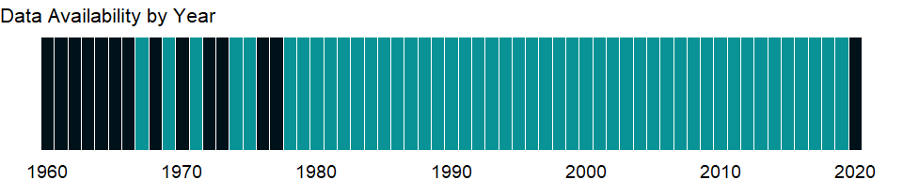

### Which countries have data?

The figure below shows the percentage of countries in each income group with a value since 2010 for that indicator.

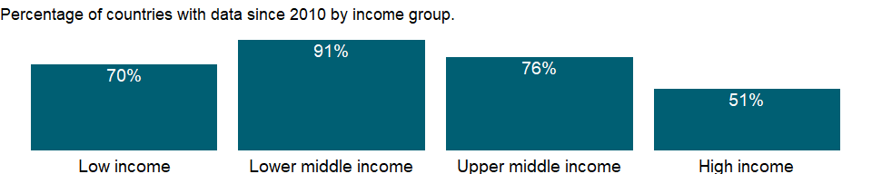

### Why is it relevant?

The World Bank Group’s goal of promoting shared prosperity has been defined as fostering income growth of the bottom 40 per cent of the welfare distribution in every country. Income distribution data and the Gini coefficient measure inequality in income or consumption and important indicators for measuring shared prosperity.

### What is the data source?

World Bank, Development Research Group. Data are based on primary household survey data obtained from government statistical agencies and World Bank country departments. Data for high-income economies are from the Luxembourg Income Study database. For more information and methodology, please see PovcalNet (<http://iresearch.worldbank.org/PovcalNet/index.htm>).

### What is the methodology?

Inequality in the distribution of income is reflected in the share of income or consumption accruing to a portion of the population ranked by income or consumption levels. The portions ranked lowest by personal income receive the smallest shares of total income.

Data on the distribution of income or consumption come from nationally representative household surveys. Where the original data from the household survey were available, they have been used to directly calculate the income or consumption shares by quintile. Otherwise, shares have been estimated from the best available grouped data.

The distribution data have been adjusted for household size, providing a more consistent measure of per capita income or consumption. No adjustment has been made for spatial differences in cost of living within countries, because the data needed for such calculations are generally unavailable. For further details on the estimation method for low- and middle-income economies, see Ravallion and Chen (1996).

Survey year is the year in which the underlying household survey data were collected or, when the data collection period bridged two calendar years, the year in which most of the data were collected.

Percentage shares by quintile may not sum to 100 because of rounding.

### How is it aggregated?

NA

### What are the limitations?

Despite progress in the last decade, the challenges of measuring poverty remain. The timeliness, frequency, quality, and comparability of household surveys need to increase substantially, particularly in the poorest countries. The availability and quality of poverty monitoring data remains low in small states, countries with fragile situations, and low-income countries and even some middle-income countries. The low frequency and lack of comparability of the data available in some countries create uncertainty over the magnitude of poverty reduction.

Besides the frequency and timeliness of survey data, other data quality issues arise in measuring household living standards. The surveys ask detailed questions on sources of income and how it was spent, which must be carefully recorded by trained personnel. Income is generally more difficult to measure accurately, and consumption comes closer to the notion of living standards. And income can vary over time even if living standards do not. But consumption data are not always available: the latest estimates reported here use consumption data for about two-thirds of countries.

However, even similar surveys may not be strictly comparable because of differences in timing or in the quality and training of enumerators. Comparisons of countries at different levels of development also pose a potential problem because of differences in the relative importance of the consumption of nonmarket goods. The local market value of all consumption in kind (including own production, particularly important in underdeveloped rural economies) should be included in total consumption expenditure but may not be. Most survey data now include valuations for consumption or income from own production, but valuation methods vary.

### What else should I know?

The World Bank’s internationally comparable poverty monitoring database now draws on income or detailed consumption data from more than one thousand six hundred household surveys across 164 countries in six regions and 25 other high income countries (industrialized economies). While income distribution data are published for all countries with data available, poverty data are published for low- and middle-income countries and countries eligible to receive loans from the World Bank (such as Chile) and recently graduated countries (such as Estonia) only. See PovcalNet (<http://iresearch.worldbank.org/PovcalNet/WhatIsNew.aspx>) for definitions of geographical regions and industrialized countries.

### 1.71.2 Income share held by third 20%

### What is the indicator?

Percentage share of income or consumption is the share that accrues to subgroups of population indicated by deciles or quintiles. Percentage shares by quintile may not sum to 100 because of rounding.

Topic: Poverty: Income distribution

Series ID: SI.DST.03RD.20

Copyright: CC BY-4.0 , <https://datacatalog.worldbank.org/public-licenses#cc-by>

First year with any data: 1967

Last year with any data: 2019

### What years are data available?

The figure below shows years in which data is available for at least one country. Dates shaded in black have no data, while dates shaded in green have data for at least one country



### Which countries have data?

The figure below shows the percentage of countries in each income group with a value since 2010 for that indicator.



### Why is it relevant?

The World Bank Group’s goal of promoting shared prosperity has been defined as fostering income growth of the bottom 40 per cent of the welfare distribution in every country. Income distribution data and the Gini coefficient measure inequality in income or consumption and important indicators for measuring shared prosperity.

### What is the data source?

World Bank, Development Research Group. Data are based on primary household survey data obtained from government statistical agencies and World Bank country departments. Data for high-income economies are from the Luxembourg Income Study database. For more information and methodology, please see PovcalNet (<http://iresearch.worldbank.org/PovcalNet/index.htm>).

### What is the methodology?

Inequality in the distribution of income is reflected in the share of income or consumption accruing to a portion of the population ranked by income or consumption levels. The portions ranked lowest by personal income receive the smallest shares of total income.

Data on the distribution of income or consumption come from nationally representative household surveys. Where the original data from the household survey were available, they have been used to directly calculate the income or consumption shares by quintile. Otherwise, shares have been estimated from the best available grouped data.

The distribution data have been adjusted for household size, providing a more consistent measure of per capita income or consumption. No adjustment has been made for spatial differences in cost of living within countries, because the data needed for such calculations are generally unavailable. For further details on the estimation method for low- and middle-income economies, see Ravallion and Chen (1996).

Survey year is the year in which the underlying household survey data were collected or, when the data collection period bridged two calendar years, the year in which most of the data were collected.

Percentage shares by quintile may not sum to 100 because of rounding.

### How is it aggregated?

NA

### What are the limitations?

Despite progress in the last decade, the challenges of measuring poverty remain. The timeliness, frequency, quality, and comparability of household surveys need to increase substantially, particularly in the poorest countries. The availability and quality of poverty monitoring data remains low in small states, countries with fragile situations, and low-income countries and even some middle-income countries. The low frequency and lack of comparability of the data available in some countries create uncertainty over the magnitude of poverty reduction.

Besides the frequency and timeliness of survey data, other data quality issues arise in measuring household living standards. The surveys ask detailed questions on sources of income and how it was spent, which must be carefully recorded by trained personnel. Income is generally more difficult to measure accurately, and consumption comes closer to the notion of living standards. And income can vary over time even if living standards do not. But consumption data are not always available: the latest estimates reported here use consumption data for about two-thirds of countries.

However, even similar surveys may not be strictly comparable because of differences in timing or in the quality and training of enumerators. Comparisons of countries at different levels of development also pose a potential problem because of differences in the relative importance of the consumption of nonmarket goods. The local market value of all consumption in kind (including own production, particularly important in underdeveloped rural economies) should be included in total consumption expenditure but may not be. Most survey data now include valuations for consumption or income from own production, but valuation methods vary.

### What else should I know?

The World Bank’s internationally comparable poverty monitoring database now draws on income or detailed consumption data from more than one thousand six hundred household surveys across 164 countries in six regions and 25 other high income countries (industrialized economies). While income distribution data are published for all countries with data available, poverty data are published for low- and middle-income countries and countries eligible to receive loans from the World Bank (such as Chile) and recently graduated countries (such as Estonia) only. See PovcalNet (<http://iresearch.worldbank.org/PovcalNet/WhatIsNew.aspx>) for definitions of geographical regions and industrialized countries.

### 1.71.3 Income share held by fourth 20%

### What is the indicator?

Percentage share of income or consumption is the share that accrues to subgroups of population indicated by deciles or quintiles. Percentage shares by quintile may not sum to 100 because of rounding.

Topic: Poverty: Income distribution

Series ID: SI.DST.04TH.20

Copyright: CC BY-4.0 , <https://datacatalog.worldbank.org/public-licenses#cc-by>

First year with any data: 1967

Last year with any data: 2019

### What years are data available?

The figure below shows years in which data is available for at least one country. Dates shaded in black have no data, while dates shaded in green have data for at least one country



### Which countries have data?

The figure below shows the percentage of countries in each income group with a value since 2010 for that indicator.



### Why is it relevant?

The World Bank Group’s goal of promoting shared prosperity has been defined as fostering income growth of the bottom 40 per cent of the welfare distribution in every country. Income distribution data and the Gini coefficient measure inequality in income or consumption and important indicators for measuring shared prosperity.

### What is the data source?

World Bank, Development Research Group. Data are based on primary household survey data obtained from government statistical agencies and World Bank country departments. Data for high-income economies are from the Luxembourg Income Study database. For more information and methodology, please see PovcalNet (<http://iresearch.worldbank.org/PovcalNet/index.htm>).

### What is the methodology?

Inequality in the distribution of income is reflected in the share of income or consumption accruing to a portion of the population ranked by income or consumption levels. The portions ranked lowest by personal income receive the smallest shares of total income.

Data on the distribution of income or consumption come from nationally representative household surveys. Where the original data from the household survey were available, they have been used to directly calculate the income or consumption shares by quintile. Otherwise, shares have been estimated from the best available grouped data.

The distribution data have been adjusted for household size, providing a more consistent measure of per capita income or consumption. No adjustment has been made for spatial differences in cost of living within countries, because the data needed for such calculations are generally unavailable. For further details on the estimation method for low- and middle-income economies, see Ravallion and Chen (1996).

Survey year is the year in which the underlying household survey data were collected or, when the data collection period bridged two calendar years, the year in which most of the data were collected.

Percentage shares by quintile may not sum to 100 because of rounding.

### How is it aggregated?

NA

### What are the limitations?

Despite progress in the last decade, the challenges of measuring poverty remain. The timeliness, frequency, quality, and comparability of household surveys need to increase substantially, particularly in the poorest countries. The availability and quality of poverty monitoring data remains low in small states, countries with fragile situations, and low-income countries and even some middle-income countries. The low frequency and lack of comparability of the data available in some countries create uncertainty over the magnitude of poverty reduction.

Besides the frequency and timeliness of survey data, other data quality issues arise in measuring household living standards. The surveys ask detailed questions on sources of income and how it was spent, which must be carefully recorded by trained personnel. Income is generally more difficult to measure accurately, and consumption comes closer to the notion of living standards. And income can vary over time even if living standards do not. But consumption data are not always available: the latest estimates reported here use consumption data for about two-thirds of countries.

However, even similar surveys may not be strictly comparable because of differences in timing or in the quality and training of enumerators. Comparisons of countries at different levels of development also pose a potential problem because of differences in the relative importance of the consumption of nonmarket goods. The local market value of all consumption in kind (including own production, particularly important in underdeveloped rural economies) should be included in total consumption expenditure but may not be. Most survey data now include valuations for consumption or income from own production, but valuation methods vary.

### What else should I know?

The World Bank’s internationally comparable poverty monitoring database now draws on income or detailed consumption data from more than one thousand six hundred household surveys across 164 countries in six regions and 25 other high income countries (industrialized economies). While income distribution data are published for all countries with data available, poverty data are published for low- and middle-income countries and countries eligible to receive loans from the World Bank (such as Chile) and recently graduated countries (such as Estonia) only. See PovcalNet (<http://iresearch.worldbank.org/PovcalNet/WhatIsNew.aspx>) for definitions of geographical regions and industrialized countries.

### 1.71.4 Income share held by highest 20%

### What is the indicator?

Percentage share of income or consumption is the share that accrues to subgroups of population indicated by deciles or quintiles. Percentage shares by quintile may not sum to 100 because of rounding.

Topic: Poverty: Income distribution

Series ID: SI.DST.05TH.20

Copyright: CC BY-4.0 , <https://datacatalog.worldbank.org/public-licenses#cc-by>

First year with any data: 1967

Last year with any data: 2019

### What years are data available?

The figure below shows years in which data is available for at least one country. Dates shaded in black have no data, while dates shaded in green have data for at least one country



### Which countries have data?

The figure below shows the percentage of countries in each income group with a value since 2010 for that indicator.



### Why is it relevant?

The World Bank Group’s goal of promoting shared prosperity has been defined as fostering income growth of the bottom 40 per cent of the welfare distribution in every country. Income distribution data and the Gini coefficient measure inequality in income or consumption and important indicators for measuring shared prosperity.

### What is the data source?

World Bank, Development Research Group. Data are based on primary household survey data obtained from government statistical agencies and World Bank country departments. Data for high-income economies are from the Luxembourg Income Study database. For more information and methodology, please see PovcalNet (<http://iresearch.worldbank.org/PovcalNet/index.htm>).

### What is the methodology?

Inequality in the distribution of income is reflected in the share of income or consumption accruing to a portion of the population ranked by income or consumption levels. The portions ranked lowest by personal income receive the smallest shares of total income.

Data on the distribution of income or consumption come from nationally representative household surveys. Where the original data from the household survey were available, they have been used to directly calculate the income or consumption shares by quintile. Otherwise, shares have been estimated from the best available grouped data.

The distribution data have been adjusted for household size, providing a more consistent measure of per capita income or consumption. No adjustment has been made for spatial differences in cost of living within countries, because the data needed for such calculations are generally unavailable. For further details on the estimation method for low- and middle-income economies, see Ravallion and Chen (1996).

Survey year is the year in which the underlying household survey data were collected or, when the data collection period bridged two calendar years, the year in which most of the data were collected.

Percentage shares by quintile may not sum to 100 because of rounding.

### How is it aggregated?

NA

### What are the limitations?

Despite progress in the last decade, the challenges of measuring poverty remain. The timeliness, frequency, quality, and comparability of household surveys need to increase substantially, particularly in the poorest countries. The availability and quality of poverty monitoring data remains low in small states, countries with fragile situations, and low-income countries and even some middle-income countries. The low frequency and lack of comparability of the data available in some countries create uncertainty over the magnitude of poverty reduction.

Besides the frequency and timeliness of survey data, other data quality issues arise in measuring household living standards. The surveys ask detailed questions on sources of income and how it was spent, which must be carefully recorded by trained personnel. Income is generally more difficult to measure accurately, and consumption comes closer to the notion of living standards. And income can vary over time even if living standards do not. But consumption data are not always available: the latest estimates reported here use consumption data for about two-thirds of countries.

However, even similar surveys may not be strictly comparable because of differences in timing or in the quality and training of enumerators. Comparisons of countries at different levels of development also pose a potential problem because of differences in the relative importance of the consumption of nonmarket goods. The local market value of all consumption in kind (including own production, particularly important in underdeveloped rural economies) should be included in total consumption expenditure but may not be. Most survey data now include valuations for consumption or income from own production, but valuation methods vary.

### What else should I know?

The World Bank’s internationally comparable poverty monitoring database now draws on income or detailed consumption data from more than one thousand six hundred household surveys across 164 countries in six regions and 25 other high income countries (industrialized economies). While income distribution data are published for all countries with data available, poverty data are published for low- and middle-income countries and countries eligible to receive loans from the World Bank (such as Chile) and recently graduated countries (such as Estonia) only. See PovcalNet (<http://iresearch.worldbank.org/PovcalNet/WhatIsNew.aspx>) for definitions of geographical regions and industrialized countries.

### 1.71.5 Income share held by highest 10%

### What is the indicator?

Percentage share of income or consumption is the share that accrues to subgroups of population indicated by deciles or quintiles.

Topic: Poverty: Income distribution

Series ID: SI.DST.10TH.10

Copyright: CC BY-4.0 , <https://datacatalog.worldbank.org/public-licenses#cc-by>

First year with any data: 1967

Last year with any data: 2019

### What years are data available?

The figure below shows years in which data is available for at least one country. Dates shaded in black have no data, while dates shaded in green have data for at least one country



### Which countries have data?

The figure below shows the percentage of countries in each income group with a value since 2010 for that indicator.



### Why is it relevant?

The World Bank Group’s goal of promoting shared prosperity has been defined as fostering income growth of the bottom 40 per cent of the welfare distribution in every country. Income distribution data and the Gini coefficient measure inequality in income or consumption and important indicators for measuring shared prosperity.

### What is the data source?

World Bank, Development Research Group. Data are based on primary household survey data obtained from government statistical agencies and World Bank country departments. Data for high-income economies are from the Luxembourg Income Study database. For more information and methodology, please see PovcalNet (<http://iresearch.worldbank.org/PovcalNet/index.htm>).

### What is the methodology?

Inequality in the distribution of income is reflected in the share of income or consumption accruing to a portion of the population ranked by income or consumption levels. The portions ranked lowest by personal income receive the smallest shares of total income.

Data on the distribution of income or consumption come from nationally representative household surveys. Where the original data from the household survey were available, they have been used to directly calculate the income or consumption shares by quintile. Otherwise, shares have been estimated from the best available grouped data.

The distribution data have been adjusted for household size, providing a more consistent measure of per capita income or consumption. No adjustment has been made for spatial differences in cost of living within countries, because the data needed for such calculations are generally unavailable. For further details on the estimation method for low- and middle-income economies, see Ravallion and Chen (1996).

Survey year is the year in which the underlying household survey data were collected or, when the data collection period bridged two calendar years, the year in which most of the data were collected.

Percentage shares by quintile may not sum to 100 because of rounding.

### How is it aggregated?

NA

### What are the limitations?

Despite progress in the last decade, the challenges of measuring poverty remain. The timeliness, frequency, quality, and comparability of household surveys need to increase substantially, particularly in the poorest countries. The availability and quality of poverty monitoring data remains low in small states, countries with fragile situations, and low-income countries and even some middle-income countries. The low frequency and lack of comparability of the data available in some countries create uncertainty over the magnitude of poverty reduction.

Besides the frequency and timeliness of survey data, other data quality issues arise in measuring household living standards. The surveys ask detailed questions on sources of income and how it was spent, which must be carefully recorded by trained personnel. Income is generally more difficult to measure accurately, and consumption comes closer to the notion of living standards. And income can vary over time even if living standards do not. But consumption data are not always available: the latest estimates reported here use consumption data for about two-thirds of countries.

However, even similar surveys may not be strictly comparable because of differences in timing or in the quality and training of enumerators. Comparisons of countries at different levels of development also pose a potential problem because of differences in the relative importance of the consumption of nonmarket goods. The local market value of all consumption in kind (including own production, particularly important in underdeveloped rural economies) should be included in total consumption expenditure but may not be. Most survey data now include valuations for consumption or income from own production, but valuation methods vary.

### What else should I know?

The World Bank’s internationally comparable poverty monitoring database now draws on income or detailed consumption data from more than one thousand six hundred household surveys across 164 countries in six regions and 25 other high income countries (industrialized economies). While income distribution data are published for all countries with data available, poverty data are published for low- and middle-income countries and countries eligible to receive loans from the World Bank (such as Chile) and recently graduated countries (such as Estonia) only. See PovcalNet (<http://iresearch.worldbank.org/PovcalNet/WhatIsNew.aspx>) for definitions of geographical regions and industrialized countries.

### 1.71.6 Proportion of people living below 50 percent of median income (%)

### What is the indicator?

The percentage of people in the population who live in households whose per capita income or consumption is below half of the median income or consumption per capita. The median is measured at 2011 Purchasing Power Parity (PPP) using PovcalNet (<http://iresearch.worldbank.org/PovcalNet>). For some countries, medians are not reported due to grouped and/or confidential data. The reference year is the year in which the underlying household survey data was collected. In cases for which the data collection period bridged two calendar years, the first year in which data were collected is reported.

Topic: Poverty: Income distribution

Series ID: SI.DST.50MD

Copyright: CC BY-4.0 , <https://datacatalog.worldbank.org/public-licenses#cc-by>

First year with any data: 1967

Last year with any data: 2019

### What years are data available?

The figure below shows years in which data is available for at least one country. Dates shaded in black have no data, while dates shaded in green have data for at least one country



### Which countries have data?

The figure below shows the percentage of countries in each income group with a value since 2010 for that indicator.

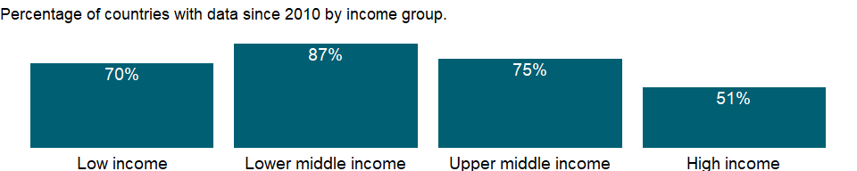

### Why is it relevant?

NA

### What is the data source?

World Bank, Development Research Group. Data are based on primary household survey data obtained from government statistical agencies and World Bank country departments. Data for high-income economies are from EU-SILC or the Luxembourg Income Study database. For more information and methodology, please see PovcalNet (iresearch.worldbank.org/PovcalNet/index.htm).

### What is the methodology?

NA

### How is it aggregated?

NA

### What are the limitations?

NA

### What else should I know?

NA

### 1.71.7 Income share held by lowest 10%

### What is the indicator?

Percentage share of income or consumption is the share that accrues to subgroups of population indicated by deciles or quintiles.

Topic: Poverty: Income distribution

Series ID: SI.DST.FRST.10

Copyright: CC BY-4.0 , <https://datacatalog.worldbank.org/public-licenses#cc-by>

First year with any data: 1967

Last year with any data: 2019

### What years are data available?

The figure below shows years in which data is available for at least one country. Dates shaded in black have no data, while dates shaded in green have data for at least one country



### Which countries have data?

The figure below shows the percentage of countries in each income group with a value since 2010 for that indicator.



### Why is it relevant?

The World Bank Group’s goal of promoting shared prosperity has been defined as fostering income growth of the bottom 40 per cent of the welfare distribution in every country. Income distribution data and the Gini coefficient measure inequality in income or consumption and important indicators for measuring shared prosperity.

### What is the data source?

World Bank, Development Research Group. Data are based on primary household survey data obtained from government statistical agencies and World Bank country departments. Data for high-income economies are from the Luxembourg Income Study database. For more information and methodology, please see PovcalNet (<http://iresearch.worldbank.org/PovcalNet/index.htm>).

### What is the methodology?

Inequality in the distribution of income is reflected in the share of income or consumption accruing to a portion of the population ranked by income or consumption levels. The portions ranked lowest by personal income receive the smallest shares of total income.

Data on the distribution of income or consumption come from nationally representative household surveys. Where the original data from the household survey were available, they have been used to directly calculate the income or consumption shares by quintile. Otherwise, shares have been estimated from the best available grouped data.

The distribution data have been adjusted for household size, providing a more consistent measure of per capita income or consumption. No adjustment has been made for spatial differences in cost of living within countries, because the data needed for such calculations are generally unavailable. For further details on the estimation method for low- and middle-income economies, see Ravallion and Chen (1996).

Survey year is the year in which the underlying household survey data were collected or, when the data collection period bridged two calendar years, the year in which most of the data were collected.

Percentage shares by quintile may not sum to 100 because of rounding.

### How is it aggregated?

NA

### What are the limitations?

Despite progress in the last decade, the challenges of measuring poverty remain. The timeliness, frequency, quality, and comparability of household surveys need to increase substantially, particularly in the poorest countries. The availability and quality of poverty monitoring data remains low in small states, countries with fragile situations, and low-income countries and even some middle-income countries. The low frequency and lack of comparability of the data available in some countries create uncertainty over the magnitude of poverty reduction.

Besides the frequency and timeliness of survey data, other data quality issues arise in measuring household living standards. The surveys ask detailed questions on sources of income and how it was spent, which must be carefully recorded by trained personnel. Income is generally more difficult to measure accurately, and consumption comes closer to the notion of living standards. And income can vary over time even if living standards do not. But consumption data are not always available: the latest estimates reported here use consumption data for about two-thirds of countries.

However, even similar surveys may not be strictly comparable because of differences in timing or in the quality and training of enumerators. Comparisons of countries at different levels of development also pose a potential problem because of differences in the relative importance of the consumption of nonmarket goods. The local market value of all consumption in kind (including own production, particularly important in underdeveloped rural economies) should be included in total consumption expenditure but may not be. Most survey data now include valuations for consumption or income from own production, but valuation methods vary.

### What else should I know?

The World Bank’s internationally comparable poverty monitoring database now draws on income or detailed consumption data from more than one thousand six hundred household surveys across 164 countries in six regions and 25 other high income countries (industrialized economies). While income distribution data are published for all countries with data available, poverty data are published for low- and middle-income countries and countries eligible to receive loans from the World Bank (such as Chile) and recently graduated countries (such as Estonia) only. See PovcalNet (<http://iresearch.worldbank.org/PovcalNet/WhatIsNew.aspx>) for definitions of geographical regions and industrialized countries.

### 1.71.8 Income share held by lowest 20%

### What is the indicator?

Percentage share of income or consumption is the share that accrues to subgroups of population indicated by deciles or quintiles. Percentage shares by quintile may not sum to 100 because of rounding.

Topic: Poverty: Income distribution

Series ID: SI.DST.FRST.20

Copyright: CC BY-4.0 , <https://datacatalog.worldbank.org/public-licenses#cc-by>

First year with any data: 1967

Last year with any data: 2019

### What years are data available?

The figure below shows years in which data is available for at least one country. Dates shaded in black have no data, while dates shaded in green have data for at least one country



### Which countries have data?

The figure below shows the percentage of countries in each income group with a value since 2010 for that indicator.



### Why is it relevant?

The World Bank Group’s goal of promoting shared prosperity has been defined as fostering income growth of the bottom 40 per cent of the welfare distribution in every country. Income distribution data and the Gini coefficient measure inequality in income or consumption and important indicators for measuring shared prosperity.

### What is the data source?

World Bank, Development Research Group. Data are based on primary household survey data obtained from government statistical agencies and World Bank country departments. Data for high-income economies are from the Luxembourg Income Study database. For more information and methodology, please see PovcalNet (<http://iresearch.worldbank.org/PovcalNet/index.htm>).

### What is the methodology?

Inequality in the distribution of income is reflected in the share of income or consumption accruing to a portion of the population ranked by income or consumption levels. The portions ranked lowest by personal income receive the smallest shares of total income.

Data on the distribution of income or consumption come from nationally representative household surveys. Where the original data from the household survey were available, they have been used to directly calculate the income or consumption shares by quintile. Otherwise, shares have been estimated from the best available grouped data.

The distribution data have been adjusted for household size, providing a more consistent measure of per capita income or consumption. No adjustment has been made for spatial differences in cost of living within countries, because the data needed for such calculations are generally unavailable. For further details on the estimation method for low- and middle-income economies, see Ravallion and Chen (1996).

Survey year is the year in which the underlying household survey data were collected or, when the data collection period bridged two calendar years, the year in which most of the data were collected.

Percentage shares by quintile may not sum to 100 because of rounding.

### How is it aggregated?

NA

### What are the limitations?

Despite progress in the last decade, the challenges of measuring poverty remain. The timeliness, frequency, quality, and comparability of household surveys need to increase substantially, particularly in the poorest countries. The availability and quality of poverty monitoring data remains low in small states, countries with fragile situations, and low-income countries and even some middle-income countries. The low frequency and lack of comparability of the data available in some countries create uncertainty over the magnitude of poverty reduction.

Besides the frequency and timeliness of survey data, other data quality issues arise in measuring household living standards. The surveys ask detailed questions on sources of income and how it was spent, which must be carefully recorded by trained personnel. Income is generally more difficult to measure accurately, and consumption comes closer to the notion of living standards. And income can vary over time even if living standards do not. But consumption data are not always available: the latest estimates reported here use consumption data for about two-thirds of countries.

However, even similar surveys may not be strictly comparable because of differences in timing or in the quality and training of enumerators. Comparisons of countries at different levels of development also pose a potential problem because of differences in the relative importance of the consumption of nonmarket goods. The local market value of all consumption in kind (including own production, particularly important in underdeveloped rural economies) should be included in total consumption expenditure but may not be. Most survey data now include valuations for consumption or income from own production, but valuation methods vary.

### What else should I know?

The World Bank’s internationally comparable poverty monitoring database now draws on income or detailed consumption data from more than one thousand six hundred household surveys across 164 countries in six regions and 25 other high income countries (industrialized economies). While income distribution data are published for all countries with data available, poverty data are published for low- and middle-income countries and countries eligible to receive loans from the World Bank (such as Chile) and recently graduated countries (such as Estonia) only. See PovcalNet (<http://iresearch.worldbank.org/PovcalNet/WhatIsNew.aspx>) for definitions of geographical regions and industrialized countries.

### 1.71.9 Gini index (World Bank estimate)

### What is the indicator?

Gini index measures the extent to which the distribution of income (or, in some cases, consumption expenditure) among individuals or households within an economy deviates from a perfectly equal distribution. A Lorenz curve plots the cumulative percentages of total income received against the cumulative number of recipients, starting with the poorest individual or household. The Gini index measures the area between the Lorenz curve and a hypothetical line of absolute equality, expressed as a percentage of the maximum area under the line. Thus a Gini index of 0 represents perfect equality, while an index of 100 implies perfect inequality.

Topic: Poverty: Income distribution

Series ID: SI.POV.GINI

Copyright: CC BY-4.0 , <https://datacatalog.worldbank.org/public-licenses#cc-by>

First year with any data: 1967

Last year with any data: 2019

### What years are data available?

The figure below shows years in which data is available for at least one country. Dates shaded in black have no data, while dates shaded in green have data for at least one country



### Which countries have data?

The figure below shows the percentage of countries in each income group with a value since 2010 for that indicator.

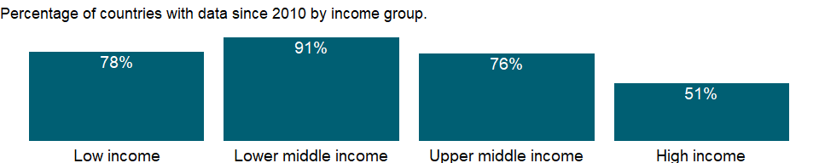

### Why is it relevant?

NA

### What is the data source?

World Bank, Development Research Group. Data are based on primary household survey data obtained from government statistical agencies and World Bank country departments. For more information and methodology, please see PovcalNet (<http://iresearch.worldbank.org/PovcalNet/index.htm>).

### What is the methodology?

The Gini index measures the area between the Lorenz curve and a hypothetical line of absolute equality, expressed as a percentage of the maximum area under the line. A Lorenz curve plots the cumulative percentages of total income received against the cumulative number of recipients, starting with the poorest individual. Thus a Gini index of 0 represents perfect equality, while an index of 100 implies perfect inequality.

The Gini index provides a convenient summary measure of the degree of inequality. Data on the distribution of income or consumption come from nationally representative household surveys. Where the original data from the household survey were available, they have been used to calculate the income or consumption shares by quintile. Otherwise, shares have been estimated from the best available grouped data.

The distribution data have been adjusted for household size, providing a more consistent measure of per capita income or consumption. No adjustment has been made for spatial differences in cost of living within countries, because the data needed for such calculations are generally unavailable. For further details on the estimation method for low- and middle-income economies, see Ravallion and Chen (1996).

Survey year is the year in which the underlying household survey data were collected or, when the data collection period bridged two calendar years, the year in which most of the data were collected.

### How is it aggregated?

NA

### What are the limitations?

Gini coefficients are not unique. It is possible for two different Lorenz curves to give rise to the same Gini coefficient. Furthermore it is possible for the Gini coefficient of a developing country to rise (due to increasing inequality of income) while the number of people in absolute poverty decreases. This is because the Gini coefficient measures relative, not absolute, wealth.

Another limitation of the Gini coefficient is that it is not additive across groups, i.e. the total Gini of a society is not equal to the sum of the Gini’s for its sub-groups. Thus, country-level Gini coefficients cannot be aggregated into regional or global Gini’s, although a Gini coefficient can be computed for the aggregate.

Because the underlying household surveys differ in methods and types of welfare measures collected, data are not strictly comparable across countries or even across years within a country. Two sources of non-comparability should be noted for distributions of income in particular. First, the surveys can differ in many respects, including whether they use income or consumption expenditure as the living standard indicator. The distribution of income is typically more unequal than the distribution of consumption. In addition, the definitions of income used differ more often among surveys. Consumption is usually a much better welfare indicator, particularly in developing countries. Second, households differ in size (number of members) and in the extent of income sharing among members. And individuals differ in age and consumption needs. Differences among countries in these respects may bias comparisons of distribution.

World Bank staff have made an effort to ensure that the data are as comparable as possible. Wherever possible, consumption has been used rather than income. Income distribution and Gini indexes for high-income economies are calculated directly from the Luxembourg Income Study database, using an estimation method consistent with that applied for developing countries.

### What else should I know?

The World Bank’s internationally comparable poverty monitoring database now draws on income or detailed consumption data from more than one thousand six hundred household surveys across 164 countries in six regions and 25 other high income countries (industrialized economies). While income distribution data are published for all countries with data available, poverty data are published for low- and middle-income countries and countries eligible to receive loans from the World Bank (such as Chile) and recently graduated countries (such as Estonia) only. See PovcalNet (<http://iresearch.worldbank.org/PovcalNet/WhatIsNew.aspx>) for definitions of geographical regions and industrialized countries.

## 1.72 Poverty: Poverty rates

### 1.72.1 Poverty headcount ratio at $1.90 a day (2011 PPP) (% of population)

### What is the indicator?

Poverty headcount ratio at $1.90 a day is the percentage of the population living on less than $1.90 a day at 2011 international prices. As a result of revisions in PPP exchange rates, poverty rates for individual countries cannot be compared with poverty rates reported in earlier editions.

Topic: Poverty: Poverty rates

Series ID: SI.POV.DDAY

Copyright: CC BY-4.0 , <https://datacatalog.worldbank.org/public-licenses#cc-by>

First year with any data: 1967

Last year with any data: 2019

### What years are data available?

The figure below shows years in which data is available for at least one country. Dates shaded in black have no data, while dates shaded in green have data for at least one country

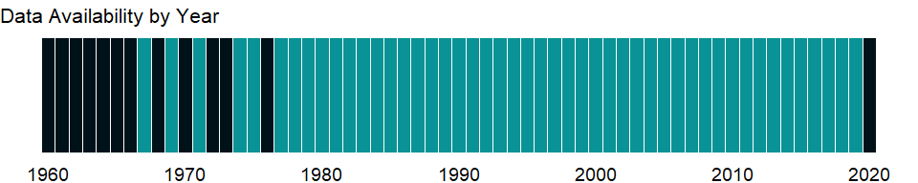

### Which countries have data?

The figure below shows the percentage of countries in each income group with a value since 2010 for that indicator.



### Why is it relevant?

The World Bank Group is committed to reducing extreme poverty to 3 percent or less, globally, by 2030. Monitoring poverty is important on the global development agenda as well as on the national development agenda of many countries. The World Bank produced its first global poverty estimates for developing countries for World Development Report 1990: Poverty (World Bank 1990) using household survey data for 22 countries (Ravallion, Datt, and van de Walle 1991). Since then there has been considerable expansion in the number of countries that field household income and expenditure surveys. The World Bank’s Development Research Group maintains a database that is updated annually as new survey data become available (and thus may contain more recent data or revisions) and conducts a major reassessment of progress against poverty every year. PovcalNet is an interactive computational tool that allows users to replicate these internationally comparable $1.90, $3.20 and $5.50 a day global, regional and country-level poverty estimates and to compute poverty measures for custom country groupings and for different poverty lines. The Poverty and Equity Data portal provides access to the database and user-friendly dashboards with graphs and interactive maps that visualize trends in key poverty and inequality indicators for different regions and countries. The country dashboards display trends in poverty measures based on the national poverty lines alongside the internationally comparable estimates, produced from and consistent with PovcalNet.

### What is the data source?

World Bank, Development Research Group. Data are based on primary household survey data obtained from government statistical agencies and World Bank country departments. Data for high-income economies are from the Luxembourg Income Study database. For more information and methodology, please see PovcalNet (<http://iresearch.worldbank.org/PovcalNet/index.htm>).

### What is the methodology?

International comparisons of poverty estimates entail both conceptual and practical problems. Countries have different definitions of poverty, and consistent comparisons across countries can be difficult. Local poverty lines tend to have higher purchasing power in rich countries, where more generous standards are used, than in poor countries.

Since World Development Report 1990, the World Bank has aimed to apply a common standard in measuring extreme poverty, anchored to what poverty means in the world’s poorest countries. The welfare of people living in different countries can be measured on a common scale by adjusting for differences in the purchasing power of currencies. The commonly used $1 a day standard, measured in 1985 international prices and adjusted to local currency using purchasing power parities (PPPs), was chosen for World Development Report 1990 because it was typical of the poverty lines in low-income countries at the time. As differences in the cost of living across the world evolve, the international poverty line has to be periodically updated using new PPP price data to reflect these changes. The last change was in October 2015, when we adopted $1.90 as the international poverty line using the 2011 PPP. Prior to that, the 2008 update set the international poverty line at $1.25 using the 2005 PPP. Poverty measures based on international poverty lines attempt to hold the real value of the poverty line constant across countries, as is done when making comparisons over time. The $3.20 poverty line is derived from typical national poverty lines in countries classified as Lower Middle Income. The $5.50 poverty line is derived from typical national poverty lines in countries classified as Upper Middle Income.

Early editions of World Development Indicators used PPPs from the Penn World Tables to convert values in local currency to equivalent purchasing power measured in U.S dollars. Later editions used 1993, 2005, and 2011 consumption PPP estimates produced by the World Bank. The current extreme poverty line is set at $1.90 a day in 2011 PPP terms, which represents the mean of the poverty lines found in 15 of the poorest countries ranked by per capita consumption. The new poverty line maintains the same standard for extreme poverty - the poverty line typical of the poorest countries in the world - but updates it using the latest information on the cost of living in developing countries. As a result of revisions in PPP exchange rates, poverty rates for individual countries cannot be compared with poverty rates reported in earlier editions.

The statistics reported here are based on consumption data or, when unavailable, on income surveys. Analysis of some 20 countries for which income and consumption expenditure data were both available from the same surveys found income to yield a higher mean than consumption but also higher inequality. When poverty measures based on consumption and income were compared, the two effects roughly cancelled each other out: there was no significant statistical difference.

### How is it aggregated?

NA

### What are the limitations?

Despite progress in the last decade, the challenges of measuring poverty remain. The timeliness, frequency, quality, and comparability of household surveys need to increase substantially, particularly in the poorest countries. The availability and quality of poverty monitoring data remains low in small states, countries with fragile situations, and low-income countries and even some middle-income countries. The low frequency and lack of comparability of the data available in some countries create uncertainty over the magnitude of poverty reduction.

Besides the frequency and timeliness of survey data, other data quality issues arise in measuring household living standards. The surveys ask detailed questions on sources of income and how it was spent, which must be carefully recorded by trained personnel. Income is generally more difficult to measure accurately, and consumption comes closer to the notion of living standards. And income can vary over time even if living standards do not. But consumption data are not always available: the latest estimates reported here use consumption data for about two-thirds of countries.

However, even similar surveys may not be strictly comparable because of differences in timing or in the quality and training of enumerators. Comparisons of countries at different levels of development also pose a potential problem because of differences in the relative importance of the consumption of nonmarket goods. The local market value of all consumption in kind (including own production, particularly important in underdeveloped rural economies) should be included in total consumption expenditure but may not be. Most survey data now include valuations for consumption or income from own production, but valuation methods vary.

### What else should I know?

The World Bank’s internationally comparable poverty monitoring database now draws on income or detailed consumption data from more than one thousand six hundred household surveys across 164 countries in six regions and 25 other high income countries (industrialized economies). While income distribution data are published for all countries with data available, poverty data are published for low- and middle-income countries and countries eligible to receive loans from the World Bank (such as Chile) and recently graduated countries (such as Estonia) only. The aggregated numbers for low- and middle-income countries correspond to the totals of 6 regions in PovcalNet, which include low- and middle-income countries and countries eligible to receive loans from the World Bank (such as Chile) and recently graduated countries (such as Estonia). See PovcalNet (<http://iresearch.worldbank.org/PovcalNet/WhatIsNew.aspx>) for definitions of geographical regions and industrialized countries.

### 1.72.2 Poverty gap at $1.90 a day (2011 PPP) (%)

### What is the indicator?

Poverty gap at $1.90 a day (2011 PPP) is the mean shortfall in income or consumption from the poverty line $1.90 a day (counting the nonpoor as having zero shortfall), expressed as a percentage of the poverty line. This measure reflects the depth of poverty as well as its incidence. As a result of revisions in PPP exchange rates, poverty rates for individual countries cannot be compared with poverty rates reported in earlier editions.

Topic: Poverty: Poverty rates

Series ID: SI.POV.GAPS

Copyright: CC BY-4.0 , <https://datacatalog.worldbank.org/public-licenses#cc-by>

First year with any data: 1967

Last year with any data: 2019

### What years are data available?

The figure below shows years in which data is available for at least one country. Dates shaded in black have no data, while dates shaded in green have data for at least one country



### Which countries have data?

The figure below shows the percentage of countries in each income group with a value since 2010 for that indicator.



### Why is it relevant?

The World Bank Group is committed to reducing extreme poverty to 3 percent or less, globally, by 2030. Monitoring poverty is important on the global development agenda as well as on the national development agenda of many countries. The World Bank produced its first global poverty estimates for developing countries for World Development Report 1990: Poverty (World Bank 1990) using household survey data for 22 countries (Ravallion, Datt, and van de Walle 1991). Since then there has been considerable expansion in the number of countries that field household income and expenditure surveys. The World Bank’s Development Research Group maintains a database that is updated annually as new survey data become available (and thus may contain more recent data or revisions) and conducts a major reassessment of progress against poverty every year. PovcalNet is an interactive computational tool that allows users to replicate these internationally comparable $1.90, $3.20 and $5.50 a day global, regional and country-level poverty estimates and to compute poverty measures for custom country groupings and for different poverty lines. The Poverty and Equity Data portal provides access to the database and user-friendly dashboards with graphs and interactive maps that visualize trends in key poverty and inequality indicators for different regions and countries. The country dashboards display trends in poverty measures based on the national poverty lines alongside the internationally comparable estimates, produced from and consistent with PovcalNet.

### What is the data source?

World Bank, Development Research Group. Data are based on primary household survey data obtained from government statistical agencies and World Bank country departments. Data for high-income economies are from the Luxembourg Income Study database. For more information and methodology, please see PovcalNet (<http://iresearch.worldbank.org/PovcalNet/index.htm>).

### What is the methodology?

International comparisons of poverty estimates entail both conceptual and practical problems. Countries have different definitions of poverty, and consistent comparisons across countries can be difficult. Local poverty lines tend to have higher purchasing power in rich countries, where more generous standards are used, than in poor countries.

Since World Development Report 1990, the World Bank has aimed to apply a common standard in measuring extreme poverty, anchored to what poverty means in the world’s poorest countries. The welfare of people living in different countries can be measured on a common scale by adjusting for differences in the purchasing power of currencies. The commonly used $1 a day standard, measured in 1985 international prices and adjusted to local currency using purchasing power parities (PPPs), was chosen for World Development Report 1990 because it was typical of the poverty lines in low-income countries at the time. As differences in the cost of living across the world evolve, the international poverty line has to be periodically updated using new PPP price data to reflect these changes. The last change was in October 2015, when we adopted $1.90 as the international poverty line using the 2011 PPP. Prior to that, the 2008 update set the international poverty line at $1.25 using the 2005 PPP. Poverty measures based on international poverty lines attempt to hold the real value of the poverty line constant across countries, as is done when making comparisons over time. The $3.20 poverty line is derived from typical national poverty lines in countries classified as Lower Middle Income. The $5.50 poverty line is derived from typical national poverty lines in countries classified as Upper Middle Income.

Early editions of World Development Indicators used PPPs from the Penn World Tables to convert values in local currency to equivalent purchasing power measured in U.S dollars. Later editions used 1993, 2005, and 2011 consumption PPP estimates produced by the World Bank. The current extreme poverty line is set at $1.90 a day in 2011 PPP terms, which represents the mean of the poverty lines found in 15 of the poorest countries ranked by per capita consumption. The new poverty line maintains the same standard for extreme poverty - the poverty line typical of the poorest countries in the world - but updates it using the latest information on the cost of living in developing countries. As a result of revisions in PPP exchange rates, poverty rates for individual countries cannot be compared with poverty rates reported in earlier editions.

The statistics reported here are based on consumption data or, when unavailable, on income surveys. Analysis of some 20 countries for which income and consumption expenditure data were both available from the same surveys found income to yield a higher mean than consumption but also higher inequality. When poverty measures based on consumption and income were compared, the two effects roughly cancelled each other out: there was no significant statistical difference.

### How is it aggregated?

NA

### What are the limitations?

Despite progress in the last decade, the challenges of measuring poverty remain. The timeliness, frequency, quality, and comparability of household surveys need to increase substantially, particularly in the poorest countries. The availability and quality of poverty monitoring data remains low in small states, countries with fragile situations, and low-income countries and even some middle-income countries. The low frequency and lack of comparability of the data available in some countries create uncertainty over the magnitude of poverty reduction.

Besides the frequency and timeliness of survey data, other data quality issues arise in measuring household living standards. The surveys ask detailed questions on sources of income and how it was spent, which must be carefully recorded by trained personnel. Income is generally more difficult to measure accurately, and consumption comes closer to the notion of living standards. And income can vary over time even if living standards do not. But consumption data are not always available: the latest estimates reported here use consumption data for about two-thirds of countries.

However, even similar surveys may not be strictly comparable because of differences in timing or in the quality and training of enumerators. Comparisons of countries at different levels of development also pose a potential problem because of differences in the relative importance of the consumption of nonmarket goods. The local market value of all consumption in kind (including own production, particularly important in underdeveloped rural economies) should be included in total consumption expenditure but may not be. Most survey data now include valuations for consumption or income from own production, but valuation methods vary.

### What else should I know?

The World Bank’s internationally comparable poverty monitoring database now draws on income or detailed consumption data from more than one thousand six hundred household surveys across 164 countries in six regions and 25 other high income countries (industrialized economies). While income distribution data are published for all countries with data available, poverty data are published for low- and middle-income countries and countries eligible to receive loans from the World Bank (such as Chile) and recently graduated countries (such as Estonia) only. The aggregated numbers for low- and middle-income countries correspond to the totals of 6 regions in PovcalNet, which include low- and middle-income countries and countries eligible to receive loans from the World Bank (such as Chile) and recently graduated countries (such as Estonia). See PovcalNet (<http://iresearch.worldbank.org/PovcalNet/WhatIsNew.aspx>) for definitions of geographical regions and industrialized countries.

### 1.72.3 Poverty headcount ratio at $3.20 a day (2011 PPP) (% of population)

### What is the indicator?

Poverty headcount ratio at $3.20 a day is the percentage of the population living on less than $3.20 a day at 2011 international prices. As a result of revisions in PPP exchange rates, poverty rates for individual countries cannot be compared with poverty rates reported in earlier editions.

Topic: Poverty: Poverty rates

Series ID: SI.POV.LMIC

Copyright: CC BY-4.0 , <https://datacatalog.worldbank.org/public-licenses#cc-by>

First year with any data: 1967

Last year with any data: 2019

### What years are data available?

The figure below shows years in which data is available for at least one country. Dates shaded in black have no data, while dates shaded in green have data for at least one country



### Which countries have data?

The figure below shows the percentage of countries in each income group with a value since 2010 for that indicator.



### Why is it relevant?

The World Bank Group is committed to reducing extreme poverty to 3 percent or less, globally, by 2030. Monitoring poverty is important on the global development agenda as well as on the national development agenda of many countries. The World Bank produced its first global poverty estimates for developing countries for World Development Report 1990: Poverty (World Bank 1990) using household survey data for 22 countries (Ravallion, Datt, and van de Walle 1991). Since then there has been considerable expansion in the number of countries that field household income and expenditure surveys. The World Bank’s Development Research Group maintains a database that is updated annually as new survey data become available (and thus may contain more recent data or revisions) and conducts a major reassessment of progress against poverty every year. PovcalNet is an interactive computational tool that allows users to replicate these internationally comparable $1.90, $3.20, $5.50 a day global, regional and country-level poverty estimates and to compute poverty measures for custom country groupings and for different poverty lines. The Poverty and Equity Data portal provides access to the database and user-friendly dashboards with graphs and interactive maps that visualize trends in key poverty and inequality indicators for different regions and countries. The country dashboards display trends in poverty measures based on the national poverty lines alongside the internationally comparable estimates, produced from and consistent with PovcalNet.

### What is the data source?

World Bank, Development Research Group. Data are based on primary household survey data obtained from government statistical agencies and World Bank country departments. Data for high-income economies are from the Luxembourg Income Study database. For more information and methodology, please see PovcalNet (<http://iresearch.worldbank.org/PovcalNet/index.htm>).

### What is the methodology?

International comparisons of poverty estimates entail both conceptual and practical problems. Countries have different definitions of poverty, and consistent comparisons across countries can be difficult. Local poverty lines tend to have higher purchasing power in rich countries, where more generous standards are used, than in poor countries.

Since World Development Report 1990, the World Bank has aimed to apply a common standard in measuring extreme poverty, anchored to what poverty means in the world’s poorest countries. The welfare of people living in different countries can be measured on a common scale by adjusting for differences in the purchasing power of currencies. The commonly used $1 a day standard, measured in 1985 international prices and adjusted to local currency using purchasing power parities (PPPs), was chosen for World Development Report 1990 because it was typical of the poverty lines in low-income countries at the time. As differences in the cost of living across the world evolve, the international poverty line has to be periodically updated using new PPP price data to reflect these changes. The last change was in October 2015, when we adopted $1.90 as the international poverty line using the 2011 PPP. Prior to that, the 2008 update set the international poverty line at $1.25 using the 2005 PPP. Poverty measures based on international poverty lines attempt to hold the real value of the poverty line constant across countries, as is done when making comparisons over time. The $3.20 poverty line is derived from typical national poverty lines in countries classified as Lower Middle Income. The $5.50 poverty line is derived from typical national poverty lines in countries classified as Upper Middle Income.

Early editions of World Development Indicators used PPPs from the Penn World Tables to convert values in local currency to equivalent purchasing power measured in U.S dollars. Later editions used 1993, 2005, and 2011 consumption PPP estimates produced by the World Bank. The current extreme poverty line is set at $1.90 a day in 2011 PPP terms, which represents the mean of the poverty lines found in 15 of the poorest countries ranked by per capita consumption. The new poverty line maintains the same standard for extreme poverty - the poverty line typical of the poorest countries in the world - but updates it using the latest information on the cost of living in developing countries. As a result of revisions in PPP exchange rates, poverty rates for individual countries cannot be compared with poverty rates reported in earlier editions.

The statistics reported here are based on consumption data or, when unavailable, on income surveys. Analysis of some 20 countries for which income and consumption expenditure data were both available from the same surveys found income to yield a higher mean than consumption but also higher inequality. When poverty measures based on consumption and income were compared, the two effects roughly cancelled each other out: there was no significant statistical difference.

### How is it aggregated?

NA

### What are the limitations?

Despite progress in the last decade, the challenges of measuring poverty remain. The timeliness, frequency, quality, and comparability of household surveys need to increase substantially, particularly in the poorest countries. The availability and quality of poverty monitoring data remains low in small states, countries with fragile situations, and low-income countries and even some middle-income countries. The low frequency and lack of comparability of the data available in some countries create uncertainty over the magnitude of poverty reduction.

Besides the frequency and timeliness of survey data, other data quality issues arise in measuring household living standards. The surveys ask detailed questions on sources of income and how it was spent, which must be carefully recorded by trained personnel. Income is generally more difficult to measure accurately, and consumption comes closer to the notion of living standards. And income can vary over time even if living standards do not. But consumption data are not always available: the latest estimates reported here use consumption data for about two-thirds of countries.

However, even similar surveys may not be strictly comparable because of differences in timing or in the quality and training of enumerators. Comparisons of countries at different levels of development also pose a potential problem because of differences in the relative importance of the consumption of nonmarket goods. The local market value of all consumption in kind (including own production, particularly important in underdeveloped rural economies) should be included in total consumption expenditure but may not be. Most survey data now include valuations for consumption or income from own production, but valuation methods vary.

### What else should I know?

The World Bank’s internationally comparable poverty monitoring database now draws on income or detailed consumption data from more than one thousand six hundred household surveys across 164 countries in six regions and 25 other high income countries (industrialized economies). While income distribution data are published for all countries with data available, poverty data are published for low- and middle-income countries and countries eligible to receive loans from the World Bank (such as Chile) and recently graduated countries (such as Estonia) only. The aggregated numbers for low- and middle-income countries correspond to the totals of 6 regions in PovcalNet, which include low- and middle-income countries and countries eligible to receive loans from the World Bank (such as Chile) and recently graduated countries (such as Estonia). See PovcalNet (<http://iresearch.worldbank.org/PovcalNet/WhatIsNew.aspx>) for definitions of geographical regions and industrialized countries.

### 1.72.4 Poverty gap at $3.20 a day (2011 PPP) (%)

### What is the indicator?

Poverty gap at $3.20 a day (2011 PPP) is the mean shortfall in income or consumption from the poverty line $3.20 a day (counting the nonpoor as having zero shortfall), expressed as a percentage of the poverty line. This measure reflects the depth of poverty as well as its incidence.

Topic: Poverty: Poverty rates

Series ID: SI.POV.LMIC.GP

Copyright: CC BY-4.0 , <https://datacatalog.worldbank.org/public-licenses#cc-by>

First year with any data: 1967

Last year with any data: 2019

### What years are data available?

The figure below shows years in which data is available for at least one country. Dates shaded in black have no data, while dates shaded in green have data for at least one country



### Which countries have data?

The figure below shows the percentage of countries in each income group with a value since 2010 for that indicator.



### Why is it relevant?

The World Bank Group is committed to reducing extreme poverty to 3 percent or less, globally, by 2030. Monitoring poverty is important on the global development agenda as well as on the national development agenda of many countries. The World Bank produced its first global poverty estimates for developing countries for World Development Report 1990: Poverty (World Bank 1990) using household survey data for 22 countries (Ravallion, Datt, and van de Walle 1991). Since then there has been considerable expansion in the number of countries that field household income and expenditure surveys. The World Bank’s Development Research Group maintains a database that is updated annually as new survey data become available (and thus may contain more recent data or revisions) and conducts a major reassessment of progress against poverty every year. PovcalNet is an interactive computational tool that allows users to replicate these internationally comparable $1.90 and $3.10 a day global, regional and country-level poverty estimates and to compute poverty measures for custom country groupings and for different poverty lines. The Poverty and Equity Data portal provides access to the database and user-friendly dashboards with graphs and interactive maps that visualize trends in key poverty and inequality indicators for different regions and countries. The country dashboards display trends in poverty measures based on the national poverty lines alongside the internationally comparable estimates, produced from and consistent with PovcalNet.

### What is the data source?

World Bank, Development Research Group. Data are based on primary household survey data obtained from government statistical agencies and World Bank country departments. Data for high-income economies are from the Luxembourg Income Study database. For more information and methodology, please see PovcalNet (<http://iresearch.worldbank.org/PovcalNet/index.htm>).

### What is the methodology?

International comparisons of poverty estimates entail both conceptual and practical problems. Countries have different definitions of poverty, and consistent comparisons across countries can be difficult. Local poverty lines tend to have higher purchasing power in rich countries, where more generous standards are used, than in poor countries.

Since World Development Report 1990, the World Bank has aimed to apply a common standard in measuring extreme poverty, anchored to what poverty means in the world’s poorest countries. The welfare of people living in different countries can be measured on a common scale by adjusting for differences in the purchasing power of currencies. The commonly used $1 a day standard, measured in 1985 international prices and adjusted to local currency using purchasing power parities (PPPs), was chosen for World Development Report 1990 because it was typical of the poverty lines in low-income countries at the time. As differences in the cost of living across the world evolve, the international poverty line has to be periodically updated using new PPP price data to reflect these changes. The last change was in October 2015, when we adopted $1.90 as the international poverty line using the 2011 PPP. Prior to that, the 2008 update set the international poverty line at $1.25 using the 2005 PPP. Poverty measures based on international poverty lines attempt to hold the real value of the poverty line constant across countries, as is done when making comparisons over time. The $3.20 poverty line is derived from typical national poverty lines in countries classified as Lower Middle Income. The $5.50 poverty line is derived from typical national poverty lines in countries classified as Upper Middle Income.

Early editions of World Development Indicators used PPPs from the Penn World Tables to convert values in local currency to equivalent purchasing power measured in U.S dollars. Later editions used 1993, 2005, and 2011 consumption PPP estimates produced by the World Bank. The current extreme poverty line is set at $1.90 a day in 2011 PPP terms, which represents the mean of the poverty lines found in 15 of the poorest countries ranked by per capita consumption. The new poverty line maintains the same standard for extreme poverty - the poverty line typical of the poorest countries in the world - but updates it using the latest information on the cost of living in developing countries. As a result of revisions in PPP exchange rates, poverty rates for individual countries cannot be compared with poverty rates reported in earlier editions.

The statistics reported here are based on consumption data or, when unavailable, on income surveys. Analysis of some 20 countries for which income and consumption expenditure data were both available from the same surveys found income to yield a higher mean than consumption but also higher inequality. When poverty measures based on consumption and income were compared, the two effects roughly cancelled each other out: there was no significant statistical difference.

### How is it aggregated?

NA

### What are the limitations?

Despite progress in the last decade, the challenges of measuring poverty remain. The timeliness, frequency, quality, and comparability of household surveys need to increase substantially, particularly in the poorest countries. The availability and quality of poverty monitoring data remains low in small states, countries with fragile situations, and low-income countries and even some middle-income countries. The low frequency and lack of comparability of the data available in some countries create uncertainty over the magnitude of poverty reduction.

Besides the frequency and timeliness of survey data, other data quality issues arise in measuring household living standards. The surveys ask detailed questions on sources of income and how it was spent, which must be carefully recorded by trained personnel. Income is generally more difficult to measure accurately, and consumption comes closer to the notion of living standards. And income can vary over time even if living standards do not. But consumption data are not always available: the latest estimates reported here use consumption data for about two-thirds of countries.

However, even similar surveys may not be strictly comparable because of differences in timing or in the quality and training of enumerators. Comparisons of countries at different levels of development also pose a potential problem because of differences in the relative importance of the consumption of nonmarket goods. The local market value of all consumption in kind (including own production, particularly important in underdeveloped rural economies) should be included in total consumption expenditure but may not be. Most survey data now include valuations for consumption or income from own production, but valuation methods vary.

### What else should I know?

The World Bank’s internationally comparable poverty monitoring database now draws on income or detailed consumption data from more than one thousand six hundred household surveys across 164 countries in six regions and 25 other high income countries (industrialized economies). While income distribution data are published for all countries with data available, poverty data are published for low- and middle-income countries and countries eligible to receive loans from the World Bank (such as Chile) and recently graduated countries (such as Estonia) only. The aggregated numbers for low- and middle-income countries correspond to the totals of 6 regions in PovcalNet, which include low- and middle-income countries and countries eligible to receive loans from the World Bank (such as Chile) and recently graduated countries (such as Estonia). See PovcalNet (<http://iresearch.worldbank.org/PovcalNet/WhatIsNew.aspx>) for definitions of geographical regions and industrialized countries.

### 1.72.5 Poverty headcount ratio at national poverty lines (% of population)

### What is the indicator?

National poverty headcount ratio is the percentage of the population living below the national poverty line(s). National estimates are based on population-weighted subgroup estimates from household surveys. For economies for which the data are from EU-SILC, the reported year is the income reference year, which is the year before the survey year.

Topic: Poverty: Poverty rates

Series ID: SI.POV.NAHC

Copyright: CC BY-4.0 , <https://datacatalog.worldbank.org/public-licenses#cc-by>

First year with any data: 1985

Last year with any data: 2019

### What years are data available?

The figure below shows years in which data is available for at least one country. Dates shaded in black have no data, while dates shaded in green have data for at least one country

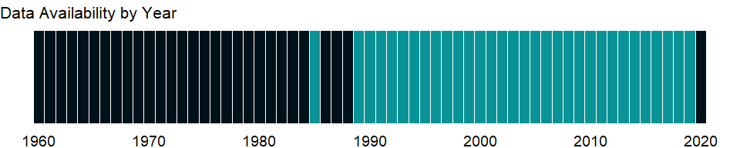

### Which countries have data?

The figure below shows the percentage of countries in each income group with a value since 2010 for that indicator.

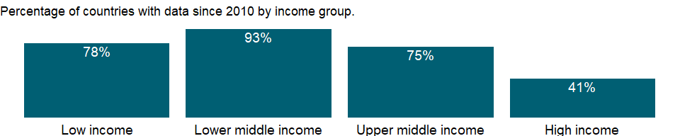

### Why is it relevant?

NA

### What is the data source?

World Bank, Global Poverty Working Group. Data are compiled from official government sources or are computed by World Bank staff using national (i.e. country–specific) poverty lines.

### What is the methodology?

Poverty headcount ratio among the population is measured based on national (i.e. country-specific) poverty lines. A country may have a unique national poverty line or separate poverty lines for rural and urban areas, or for different geographic areas to reflect differences in the cost of living or sometimes to reflect differences in diets and consumption baskets.

Poverty estimates at national poverty lines are computed from household survey data collected from nationally representative samples of households. These data must contain sufficiently detailed information to compute a comprehensive estimate of total household income or consumption (including consumption or income from own production), from which it is possible to construct a correctly weighted distribution of per capita consumption or income.

National poverty lines are the benchmark for estimating poverty indicators that are consistent with the country’s specific economic and social circumstances. National poverty lines reflect local perceptions of the level and composition of consumption or income needed to be non-poor. The perceived boundary between poor and non-poor typically rises with the average income of a country and thus does not provide a uniform measure for comparing poverty rates across countries. While poverty rates at national poverty lines should not be used for comparing poverty rates across countries, they are appropriate for guiding and monitoring the results of country-specific national poverty reduction strategies.

Almost all national poverty lines in developing economies are anchored to the cost of a food bundle - based on the prevailing national diet of the poor - that provides adequate nutrition for good health and normal activity, plus an allowance for nonfood spending. National poverty lines must be adjusted for inflation between survey years to remain constant in real terms and thus allow for meaningful comparisons of poverty over time. Because diets and consumption baskets change over time, countries periodically recalculate the poverty line based on new survey data. In such cases the new poverty lines should be deflated to obtain comparable poverty estimates from earlier years.

This series only includes estimates that to the best of our knowledge are reasonably comparable over time for a country. For economies for which the data are from EU-SILC, the reported year is the income reference year, which is the year before the survey year. For all other economies, the year reported is the year in which the underlying household survey data were collected or, when the data collection period bridged two calendar years, the year in which data collection started.

### How is it aggregated?

NA

### What are the limitations?

NA

### What else should I know?

This series only includes estimates that to the best of our knowledge are reasonably comparable over time for a country. Due to differences in estimation methodologies and poverty lines, estimates should not be compared across countries.

### 1.72.6 Poverty headcount ratio at $5.50 a day (2011 PPP) (% of population)

### What is the indicator?

Poverty headcount ratio at $5.50 a day is the percentage of the population living on less than $5.50 a day at 2011 international prices. As a result of revisions in PPP exchange rates, poverty rates for individual countries cannot be compared with poverty rates reported in earlier editions.

Topic: Poverty: Poverty rates

Series ID: SI.POV.UMIC

Copyright: CC BY-4.0 , <https://datacatalog.worldbank.org/public-licenses#cc-by>

First year with any data: 1967

Last year with any data: 2019

### What years are data available?

The figure below shows years in which data is available for at least one country. Dates shaded in black have no data, while dates shaded in green have data for at least one country



### Which countries have data?

The figure below shows the percentage of countries in each income group with a value since 2010 for that indicator.



### Why is it relevant?

The World Bank Group is committed to reducing extreme poverty to 3 percent or less, globally, by 2030. Monitoring poverty is important on the global development agenda as well as on the national development agenda of many countries. The World Bank produced its first global poverty estimates for developing countries for World Development Report 1990: Poverty (World Bank 1990) using household survey data for 22 countries (Ravallion, Datt, and van de Walle 1991). Since then there has been considerable expansion in the number of countries that field household income and expenditure surveys. The World Bank’s Development Research Group maintains a database that is updated annually as new survey data become available (and thus may contain more recent data or revisions) and conducts a major reassessment of progress against poverty every year. PovcalNet is an interactive computational tool that allows users to replicate these internationally comparable $1.90, $3.20, $5.50 a day global, regional and country-level poverty estimates and to compute poverty measures for custom country groupings and for different poverty lines. The Poverty and Equity Data portal provides access to the database and user-friendly dashboards with graphs and interactive maps that visualize trends in key poverty and inequality indicators for different regions and countries. The country dashboards display trends in poverty measures based on the national poverty lines alongside the internationally comparable estimates, produced from and consistent with PovcalNet.

### What is the data source?

World Bank, Development Research Group. Data are based on primary household survey data obtained from government statistical agencies and World Bank country departments. Data for high-income economies are from the Luxembourg Income Study database. For more information and methodology, please see PovcalNet (<http://iresearch.worldbank.org/PovcalNet/index.htm>).

### What is the methodology?

International comparisons of poverty estimates entail both conceptual and practical problems. Countries have different definitions of poverty, and consistent comparisons across countries can be difficult. Local poverty lines tend to have higher purchasing power in rich countries, where more generous standards are used, than in poor countries.

Since World Development Report 1990, the World Bank has aimed to apply a common standard in measuring extreme poverty, anchored to what poverty means in the world’s poorest countries. The welfare of people living in different countries can be measured on a common scale by adjusting for differences in the purchasing power of currencies. The commonly used $1 a day standard, measured in 1985 international prices and adjusted to local currency using purchasing power parities (PPPs), was chosen for World Development Report 1990 because it was typical of the poverty lines in low-income countries at the time. As differences in the cost of living across the world evolve, the international poverty line has to be periodically updated using new PPP price data to reflect these changes. The last change was in October 2015, when we adopted $1.90 as the international poverty line using the 2011 PPP. Prior to that, the 2008 update set the international poverty line at $1.25 using the 2005 PPP. Poverty measures based on international poverty lines attempt to hold the real value of the poverty line constant across countries, as is done when making comparisons over time. The $3.20 poverty line is derived from typical national poverty lines in countries classified as Lower Middle Income. The $5.50 poverty line is derived from typical national poverty lines in countries classified as Upper Middle Income.

Early editions of World Development Indicators used PPPs from the Penn World Tables to convert values in local currency to equivalent purchasing power measured in U.S dollars. Later editions used 1993, 2005, and 2011 consumption PPP estimates produced by the World Bank. The current extreme poverty line is set at $1.90 a day in 2011 PPP terms, which represents the mean of the poverty lines found in 15 of the poorest countries ranked by per capita consumption. The new poverty line maintains the same standard for extreme poverty - the poverty line typical of the poorest countries in the world - but updates it using the latest information on the cost of living in developing countries. As a result of revisions in PPP exchange rates, poverty rates for individual countries cannot be compared with poverty rates reported in earlier editions.

The statistics reported here are based on consumption data or, when unavailable, on income surveys. Analysis of some 20 countries for which income and consumption expenditure data were both available from the same surveys found income to yield a higher mean than consumption but also higher inequality. When poverty measures based on consumption and income were compared, the two effects roughly cancelled each other out: there was no significant statistical difference.

### How is it aggregated?

NA

### What are the limitations?

Despite progress in the last decade, the challenges of measuring poverty remain. The timeliness, frequency, quality, and comparability of household surveys need to increase substantially, particularly in the poorest countries. The availability and quality of poverty monitoring data remains low in small states, countries with fragile situations, and low-income countries and even some middle-income countries. The low frequency and lack of comparability of the data available in some countries create uncertainty over the magnitude of poverty reduction.

Besides the frequency and timeliness of survey data, other data quality issues arise in measuring household living standards. The surveys ask detailed questions on sources of income and how it was spent, which must be carefully recorded by trained personnel. Income is generally more difficult to measure accurately, and consumption comes closer to the notion of living standards. And income can vary over time even if living standards do not. But consumption data are not always available: the latest estimates reported here use consumption data for about two-thirds of countries.

However, even similar surveys may not be strictly comparable because of differences in timing or in the quality and training of enumerators. Comparisons of countries at different levels of development also pose a potential problem because of differences in the relative importance of the consumption of nonmarket goods. The local market value of all consumption in kind (including own production, particularly important in underdeveloped rural economies) should be included in total consumption expenditure but may not be. Most survey data now include valuations for consumption or income from own production, but valuation methods vary.

### What else should I know?

The World Bank’s internationally comparable poverty monitoring database now draws on income or detailed consumption data from more than one thousand six hundred household surveys across 164 countries in six regions and 25 other high income countries (industrialized economies). While income distribution data are published for all countries with data available, poverty data are published for low- and middle-income countries and countries eligible to receive loans from the World Bank (such as Chile) and recently graduated countries (such as Estonia) only. The aggregated numbers for low- and middle-income countries correspond to the totals of 6 regions in PovcalNet, which include low- and middle-income countries and countries eligible to receive loans from the World Bank (such as Chile) and recently graduated countries (such as Estonia). See PovcalNet (<http://iresearch.worldbank.org/PovcalNet/WhatIsNew.aspx>) for definitions of geographical regions and industrialized countries.

### 1.72.7 Poverty gap at $5.50 a day (2011 PPP) (%)

### What is the indicator?

Poverty gap at $5.50 a day (2011 PPP) is the mean shortfall in income or consumption from the poverty line $5.50 a day (counting the nonpoor as having zero shortfall), expressed as a percentage of the poverty line. This measure reflects the depth of poverty as well as its incidence.

Topic: Poverty: Poverty rates

Series ID: SI.POV.UMIC.GP

Copyright: CC BY-4.0 , <https://datacatalog.worldbank.org/public-licenses#cc-by>

First year with any data: 1967

Last year with any data: 2019

### What years are data available?

The figure below shows years in which data is available for at least one country. Dates shaded in black have no data, while dates shaded in green have data for at least one country



### Which countries have data?

The figure below shows the percentage of countries in each income group with a value since 2010 for that indicator.



### Why is it relevant?

The World Bank Group is committed to reducing extreme poverty to 3 percent or less, globally, by 2030. Monitoring poverty is important on the global development agenda as well as on the national development agenda of many countries. The World Bank produced its first global poverty estimates for developing countries for World Development Report 1990: Poverty (World Bank 1990) using household survey data for 22 countries (Ravallion, Datt, and van de Walle 1991). Since then there has been considerable expansion in the number of countries that field household income and expenditure surveys. The World Bank’s Development Research Group maintains a database that is updated annually as new survey data become available (and thus may contain more recent data or revisions) and conducts a major reassessment of progress against poverty every year. PovcalNet is an interactive computational tool that allows users to replicate these internationally comparable $1.90 and $3.10 a day global, regional and country-level poverty estimates and to compute poverty measures for custom country groupings and for different poverty lines. The Poverty and Equity Data portal provides access to the database and user-friendly dashboards with graphs and interactive maps that visualize trends in key poverty and inequality indicators for different regions and countries. The country dashboards display trends in poverty measures based on the national poverty lines alongside the internationally comparable estimates, produced from and consistent with PovcalNet.

### What is the data source?

World Bank, Development Research Group. Data are based on primary household survey data obtained from government statistical agencies and World Bank country departments. Data for high-income economies are from the Luxembourg Income Study database. For more information and methodology, please see PovcalNet (<http://iresearch.worldbank.org/PovcalNet/index.htm>).

### What is the methodology?

International comparisons of poverty estimates entail both conceptual and practical problems. Countries have different definitions of poverty, and consistent comparisons across countries can be difficult. Local poverty lines tend to have higher purchasing power in rich countries, where more generous standards are used, than in poor countries.

Since World Development Report 1990, the World Bank has aimed to apply a common standard in measuring extreme poverty, anchored to what poverty means in the world’s poorest countries. The welfare of people living in different countries can be measured on a common scale by adjusting for differences in the purchasing power of currencies. The commonly used $1 a day standard, measured in 1985 international prices and adjusted to local currency using purchasing power parities (PPPs), was chosen for World Development Report 1990 because it was typical of the poverty lines in low-income countries at the time. As differences in the cost of living across the world evolve, the international poverty line has to be periodically updated using new PPP price data to reflect these changes. The last change was in October 2015, when we adopted $1.90 as the international poverty line using the 2011 PPP. Prior to that, the 2008 update set the international poverty line at $1.25 using the 2005 PPP. Poverty measures based on international poverty lines attempt to hold the real value of the poverty line constant across countries, as is done when making comparisons over time. The $3.20 poverty line is derived from typical national poverty lines in countries classified as Lower Middle Income. The $5.50 poverty line is derived from typical national poverty lines in countries classified as Upper Middle Income.

Early editions of World Development Indicators used PPPs from the Penn World Tables to convert values in local currency to equivalent purchasing power measured in U.S dollars. Later editions used 1993, 2005, and 2011 consumption PPP estimates produced by the World Bank. The current extreme poverty line is set at $1.90 a day in 2011 PPP terms, which represents the mean of the poverty lines found in 15 of the poorest countries ranked by per capita consumption. The new poverty line maintains the same standard for extreme poverty - the poverty line typical of the poorest countries in the world - but updates it using the latest information on the cost of living in developing countries. As a result of revisions in PPP exchange rates, poverty rates for individual countries cannot be compared with poverty rates reported in earlier editions.

The statistics reported here are based on consumption data or, when unavailable, on income surveys. Analysis of some 20 countries for which income and consumption expenditure data were both available from the same surveys found income to yield a higher mean than consumption but also higher inequality. When poverty measures based on consumption and income were compared, the two effects roughly cancelled each other out: there was no significant statistical difference.

### How is it aggregated?

NA

### What are the limitations?

Despite progress in the last decade, the challenges of measuring poverty remain. The timeliness, frequency, quality, and comparability of household surveys need to increase substantially, particularly in the poorest countries. The availability and quality of poverty monitoring data remains low in small states, countries with fragile situations, and low-income countries and even some middle-income countries. The low frequency and lack of comparability of the data available in some countries create uncertainty over the magnitude of poverty reduction.

Besides the frequency and timeliness of survey data, other data quality issues arise in measuring household living standards. The surveys ask detailed questions on sources of income and how it was spent, which must be carefully recorded by trained personnel. Income is generally more difficult to measure accurately, and consumption comes closer to the notion of living standards. And income can vary over time even if living standards do not. But consumption data are not always available: the latest estimates reported here use consumption data for about two-thirds of countries.

However, even similar surveys may not be strictly comparable because of differences in timing or in the quality and training of enumerators. Comparisons of countries at different levels of development also pose a potential problem because of differences in the relative importance of the consumption of nonmarket goods. The local market value of all consumption in kind (including own production, particularly important in underdeveloped rural economies) should be included in total consumption expenditure but may not be. Most survey data now include valuations for consumption or income from own production, but valuation methods vary.

### What else should I know?

The World Bank’s internationally comparable poverty monitoring database now draws on income or detailed consumption data from more than one thousand six hundred household surveys across 164 countries in six regions and 25 other high income countries (industrialized economies). While income distribution data are published for all countries with data available, poverty data are published for low- and middle-income countries and countries eligible to receive loans from the World Bank (such as Chile) and recently graduated countries (such as Estonia) only. The aggregated numbers for low- and middle-income countries correspond to the totals of 6 regions in PovcalNet, which include low- and middle-income countries and countries eligible to receive loans from the World Bank (such as Chile) and recently graduated countries (such as Estonia). See PovcalNet (<http://iresearch.worldbank.org/PovcalNet/WhatIsNew.aspx>) for definitions of geographical regions and industrialized countries.

## 1.73 Poverty: Multidimensional poverty

### 1.73.1 Multidimensional poverty headcount ratio (% of total population)

### What is the indicator?

NA

Topic: Poverty: Multidimensional poverty

Series ID: SI.POV.MDIM

Copyright: CC BY-4.0 , <https://datacatalog.worldbank.org/public-licenses#cc-by>

First year with any data: 2010

Last year with any data: 2020

### What years are data available?

The figure below shows years in which data is available for at least one country. Dates shaded in black have no data, while dates shaded in green have data for at least one country



### Which countries have data?

The figure below shows the percentage of countries in each income group with a value since 2010 for that indicator.

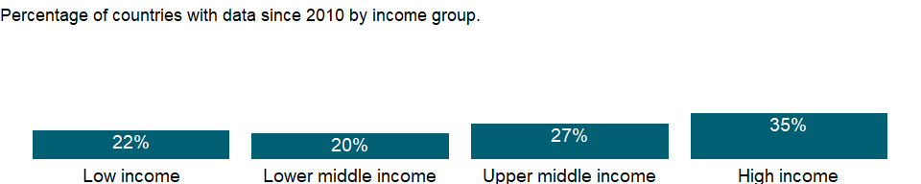

### Why is it relevant?

NA

### What is the data source?

Government statistical agencies. Data for EU countires are from the EUROSTAT

### What is the methodology?

NA

### How is it aggregated?

NA

### What are the limitations?

It should be clearly noted that these multidimensional indicators are not comparable across countries. For instance, AF methodology and AROPE are different, and although both produce some headcount ratio of people who are considered as “multidimensionally poor”, their definition of multidimensionality of poverty is utterly different, and so should not be compared.

Besides, even when they use the same approach, the numbers are not comparable across countries, as the important parameters to calculate the figures such as the number of indicators and the weight allocated to each indicator are tailored depending on the country specific context.

### What else should I know?

NA

### 1.73.2 Multidimensional poverty headcount ratio, children (% of child population)

### What is the indicator?

NA

Topic: Poverty: Multidimensional poverty

Series ID: SI.POV.MDIM.17

Copyright: CC BY-4.0 , <https://datacatalog.worldbank.org/public-licenses#cc-by>

First year with any data: 2010

Last year with any data: 2020

### What years are data available?

The figure below shows years in which data is available for at least one country. Dates shaded in black have no data, while dates shaded in green have data for at least one country



### Which countries have data?

The figure below shows the percentage of countries in each income group with a value since 2010 for that indicator.

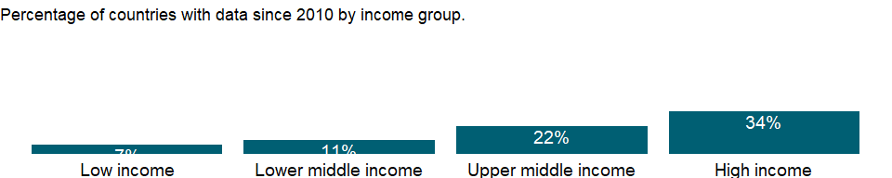

### Why is it relevant?

NA

### What is the data source?

Government statistical agencies. Data for EU countires are from the EUROSTAT

### What is the methodology?

NA

### How is it aggregated?

NA

### What are the limitations?

It should be clearly noted that these multidimensional indicators are not comparable across countries. For instance, AF methodology and AROPE are different, and although both produce some headcount ratio of people who are considered as “multidimensionally poor”, their definition of multidimensionality of poverty is utterly different, and so should not be compared.

Besides, even when they use the same approach, the numbers are not comparable across countries, as the important parameters to calculate the figures such as the number of indicators and the weight allocated to each indicator are tailored depending on the country specific context.

### What else should I know?

NA

### 1.73.3 Multidimensional poverty index, children (scale 0-1)

### What is the indicator?

NA

Topic: Poverty: Multidimensional poverty

Series ID: SI.POV.MDIM.17.XQ

Copyright: CC BY-4.0 , <https://datacatalog.worldbank.org/public-licenses#cc-by>

First year with any data: 2010

Last year with any data: 2020

### What years are data available?

The figure below shows years in which data is available for at least one country. Dates shaded in black have no data, while dates shaded in green have data for at least one country

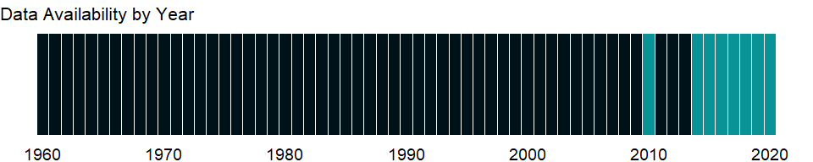

### Which countries have data?

The figure below shows the percentage of countries in each income group with a value since 2010 for that indicator.

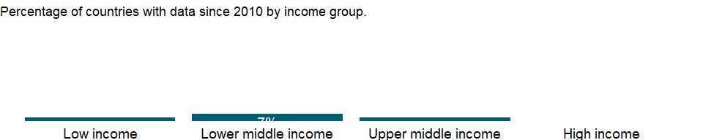

### Why is it relevant?

NA

### What is the data source?

Government statistical agencies. Data for EU countires are from the EUROSTAT

### What is the methodology?

NA

### How is it aggregated?

NA

### What are the limitations?

The MPI here is a national MPI reported by each country and differs from the global MPI collected by the UNDP. Unlike the global MPI which uses the same dimensional and indicators, the national MPI is calculated using different dimensions and indicators by each country, therefore, it is not comparable across countries.

### What else should I know?

NA

### 1.73.4 Multidimensional poverty headcount ratio, female (% of female population)

### What is the indicator?

NA

Topic: Poverty: Multidimensional poverty

Series ID: SI.POV.MDIM.FE

Copyright: CC BY-4.0 , <https://datacatalog.worldbank.org/public-licenses#cc-by>

First year with any data: 2010

Last year with any data: 2020

### What years are data available?

The figure below shows years in which data is available for at least one country. Dates shaded in black have no data, while dates shaded in green have data for at least one country



### Which countries have data?

The figure below shows the percentage of countries in each income group with a value since 2010 for that indicator.

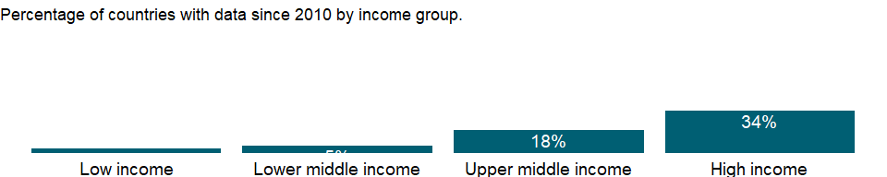

### Why is it relevant?

NA

### What is the data source?

Government statistical agencies. Data for EU countires are from the EUROSTAT

### What is the methodology?

NA

### How is it aggregated?

NA

### What are the limitations?

It should be clearly noted that these multidimensional indicators are not comparable across countries. For instance, AF methodology and AROPE are different, and although both produce some headcount ratio of people who are considered as “multidimensionally poor”, their definition of multidimensionality of poverty is utterly different, and so should not be compared.

Besides, even when they use the same approach, the numbers are not comparable across countries, as the important parameters to calculate the figures such as the number of indicators and the weight allocated to each indicator are tailored depending on the country specific context.

### What else should I know?

NA

### 1.73.5 Multidimensional poverty headcount ratio, household (% of total households)

### What is the indicator?

NA

Topic: Poverty: Multidimensional poverty

Series ID: SI.POV.MDIM.HH

Copyright: CC BY-4.0 , <https://datacatalog.worldbank.org/public-licenses#cc-by>

First year with any data: 2010

Last year with any data: 2019

### What years are data available?

The figure below shows years in which data is available for at least one country. Dates shaded in black have no data, while dates shaded in green have data for at least one country

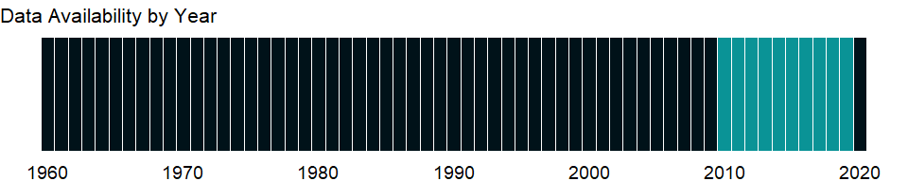

### Which countries have data?

The figure below shows the percentage of countries in each income group with a value since 2010 for that indicator.

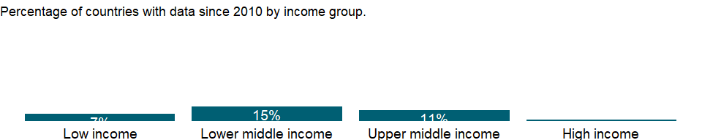

### Why is it relevant?

NA

### What is the data source?

Government statistical agencies. Data for EU countires are from the EUROSTAT

### What is the methodology?

NA

### How is it aggregated?

NA

### What are the limitations?

It should be clearly noted that these multidimensional indicators are not comparable across countries as the important parameters to calculate the figures such as the number of indicators and the weight allocated to each indicator are tailored accoding to each country specific context.

### What else should I know?

NA

### 1.73.6 Multidimensional poverty intensity

### What is the indicator?

NA

Topic: Poverty: Multidimensional poverty

Series ID: SI.POV.MDIM.IT

Copyright: CC BY-4.0 , <https://datacatalog.worldbank.org/public-licenses#cc-by>

First year with any data: 2010

Last year with any data: 2020

### What years are data available?

The figure below shows years in which data is available for at least one country. Dates shaded in black have no data, while dates shaded in green have data for at least one country



### Which countries have data?

The figure below shows the percentage of countries in each income group with a value since 2010 for that indicator.

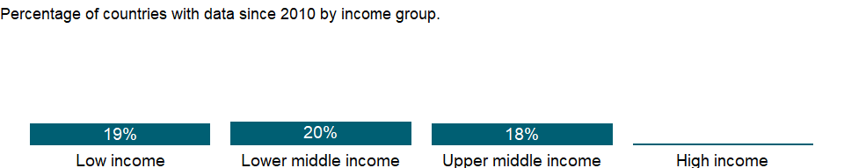

### Why is it relevant?

NA

### What is the data source?

Government statistical agencies. Data for EU countires are from the EUROSTAT

### What is the methodology?

NA

### How is it aggregated?

NA

### What are the limitations?

It should be noted that the intensity is not comparable across diffferent countries as it depends on the parameters used in the methodology such as what kind of dimensions and indicators are used, and how the weight is constructed, which varies significantly across countries.

### What else should I know?

NA

### 1.73.7 Multidimensional poverty headcount ratio, male (% of male population)

### What is the indicator?

NA

Topic: Poverty: Multidimensional poverty

Series ID: SI.POV.MDIM.MA

Copyright: CC BY-4.0 , <https://datacatalog.worldbank.org/public-licenses#cc-by>

First year with any data: 2010

Last year with any data: 2020

### What years are data available?

The figure below shows years in which data is available for at least one country. Dates shaded in black have no data, while dates shaded in green have data for at least one country



### Which countries have data?

The figure below shows the percentage of countries in each income group with a value since 2010 for that indicator.



### Why is it relevant?

NA

### What is the data source?

Government statistical agencies. Data for EU countires are from the EUROSTAT

### What is the methodology?

NA

### How is it aggregated?

NA

### What are the limitations?

It should be clearly noted that these multidimensional indicators are not comparable across countries. For instance, AF methodology and AROPE are fundamentally very different, and although both produce some headcount ratio of people who are considered as “multidimensionally poor”, their definition of multidimensionality of poverty is utterly different, and so should not be compared.

Besides, even when they use the same approach, the numbers are not comparable across countries, as the important parameters to calculate the figures such as the number of indicators and the weight allocated to each indicator are tailored accoding to the country specific context.

### What else should I know?

NA

### 1.73.8 Multidimensional poverty index (scale 0-1)

### What is the indicator?

NA

Topic: Poverty: Multidimensional poverty

Series ID: SI.POV.MDIM.XQ

Copyright: CC BY-4.0 , <https://datacatalog.worldbank.org/public-licenses#cc-by>

First year with any data: 2010

Last year with any data: 2020

### What years are data available?

The figure below shows years in which data is available for at least one country. Dates shaded in black have no data, while dates shaded in green have data for at least one country



### Which countries have data?

The figure below shows the percentage of countries in each income group with a value since 2010 for that indicator.

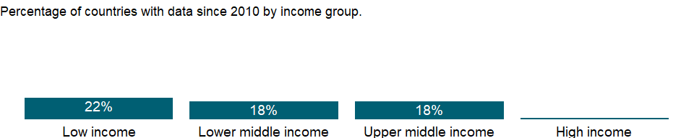

### Why is it relevant?

NA

### What is the data source?

Government statistical agencies. Data for EU countires are from the EUROSTAT

### What is the methodology?

NA

### How is it aggregated?

NA

### What are the limitations?

The MPI here is a national MPI reported by each country and differs from the global MPI collected by the UNDP. Unlike the global MPI which uses the same dimensions and indicators, the national MPI is calculated using different dimensions and indicators by each country, therefore, it is not comparable across countries.

### What else should I know?

NA

## 1.74 Poverty: Shared prosperity

### 1.74.1 Survey mean consumption or income per capita, bottom 40% of population (2011 PPP $ per day)

### What is the indicator?

Mean consumption or income per capita (2011 PPP $ per day) used in calculating the growth rate in the welfare aggregate of the bottom 40% of the population in the income distribution in a country.

Topic: Poverty: Shared prosperity

Series ID: SI.SPR.PC40

Copyright: CC BY-4.0 , <https://datacatalog.worldbank.org/public-licenses#cc-by>

First year with any data: 2010

Last year with any data: 2019

### What years are data available?

The figure below shows years in which data is available for at least one country. Dates shaded in black have no data, while dates shaded in green have data for at least one country



### Which countries have data?

The figure below shows the percentage of countries in each income group with a value since 2010 for that indicator.

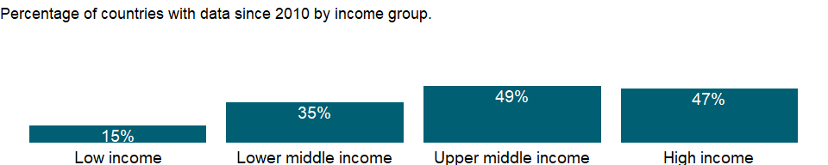

### Why is it relevant?

NA

### What is the data source?

World Bank, Global Database of Shared Prosperity (GDSP) circa 2011-2016 (<http://www.worldbank.org/en/topic/poverty/brief/global-database-of-shared-prosperity>).

### What is the methodology?

NA

### How is it aggregated?

NA

### What are the limitations?

Because household surveys are infrequent in most countries and are not aligned across countries, comparisons across countries or over time should be made with a high degree of caution.

### What else should I know?

The choice of consumption or income for a country is made according to which welfare aggregate is used to estimate extreme poverty in PovcalNet. The practice adopted by the World Bank for estimating global and regional poverty is, in principle, to use per capita consumption expenditure as the welfare measure wherever available; and to use income as the welfare measure for countries for which consumption is unavailable. However, in some cases data on consumption may be available but are outdated or not shared with the World Bank for recent survey years. In these cases, if data on income are available, income is used. Whether data are for consumption or income per capita is noted in the footnotes. Because household surveys are infrequent in most countries and are not aligned across countries, comparisons across countries or over time should be made with a high degree of caution.

### 1.74.2 Annualized average growth rate in per capita real survey mean consumption or income, bottom 40% of population (%)

### What is the indicator?

The growth rate in the welfare aggregate of the bottom 40% is computed as the annualized average growth rate in per capita real consumption or income of the bottom 40% of the population in the income distribution in a country from household surveys over a roughly 5-year period. Mean per capita real consumption or income is measured at 2011 Purchasing Power Parity (PPP) using the PovcalNet (<http://iresearch.worldbank.org/PovcalNet>). For some countries means are not reported due to grouped and/or confidential data. The annualized growth rate is computed as (Mean in final year/Mean in initial year)^(1/(Final year - Initial year)) - 1. The reference year is the year in which the underlying household survey data was collected. In cases for which the data collection period bridged two calendar years, the first year in which data were collected is reported. The initial year refers to the nearest survey collected 5 years before the most recent survey available, only surveys collected between 3 and 7 years before the most recent survey are considered. The final year refers to the most recent survey available between 2011 and 2015.

Growth rates for Iraq are based on survey means of 2005 PPP$. The coverage and quality of the 2011 PPP price data for Iraq and most other North African and Middle Eastern countries were hindered by the exceptional period of instability they faced at the time of the 2011 exercise of the International Comparison Program. See PovcalNet for detailed explanations.

Topic: Poverty: Shared prosperity

Series ID: SI.SPR.PC40.ZG

Copyright: CC BY-4.0 , <https://datacatalog.worldbank.org/public-licenses#cc-by>

First year with any data: 2015

Last year with any data: 2019

### What years are data available?

The figure below shows years in which data is available for at least one country. Dates shaded in black have no data, while dates shaded in green have data for at least one country



### Which countries have data?

The figure below shows the percentage of countries in each income group with a value since 2010 for that indicator.



### Why is it relevant?

NA

### What is the data source?

World Bank, Global Database of Shared Prosperity (GDSP) circa 2011-2016 (<http://www.worldbank.org/en/topic/poverty/brief/global-database-of-shared-prosperity>).

### What is the methodology?

NA

### How is it aggregated?

NA

### What are the limitations?

Growth rates for Iraq are based on survey means of 2005 PPP$. The coverage and quality of the 2011 PPP price data for Iraq and most other North African and Middle Eastern countries were hindered by the exceptional period of instability they faced at the time of the 2011 exercise of the International Comparison Program. See PovcalNet (<http://iresearch.worldbank.org/PovcalNet>) for detailed explanations.

Because household surveys are infrequent in most countries and are not aligned across countries, comparisons across countries or over time should be made with a high degree of caution.

### What else should I know?

The comparability of welfare aggregates (consumption or income) for the chosen years T0 and T1 is assessed for every country. If comparability across the two surveys is a major concern for a country, the selection criteria are re-applied to select the next best survey year(s). Annualized growth rates are calculated between the survey years, using a compound growth formula. The survey years defining the period for which growth rates are calculated and the type of welfare aggregate used to calculate the growth rates are noted in the footnotes.

### 1.74.3 Survey mean consumption or income per capita, total population (2011 PPP $ per day)

### What is the indicator?

Mean consumption or income per capita (2011 PPP $ per day) used in calculating the growth rate in the welfare aggregate of total population.

Topic: Poverty: Shared prosperity

Series ID: SI.SPR.PCAP

Copyright: CC BY-4.0 , <https://datacatalog.worldbank.org/public-licenses#cc-by>

First year with any data: 2010

Last year with any data: 2019

### What years are data available?

The figure below shows years in which data is available for at least one country. Dates shaded in black have no data, while dates shaded in green have data for at least one country



### Which countries have data?

The figure below shows the percentage of countries in each income group with a value since 2010 for that indicator.



### Why is it relevant?

NA

### What is the data source?

World Bank, Global Database of Shared Prosperity (GDSP) circa 2011-2016 (<http://www.worldbank.org/en/topic/poverty/brief/global-database-of-shared-prosperity>).

### What is the methodology?

NA

### How is it aggregated?

NA

### What are the limitations?

Because household surveys are infrequent in most countries and are not aligned across countries, comparisons across countries or over time should be made with a high degree of caution.

### What else should I know?

The choice of consumption or income for a country is made according to which welfare aggregate is used to estimate extreme poverty in PovcalNet. The practice adopted by the World Bank for estimating global and regional poverty is, in principle, to use per capita consumption expenditure as the welfare measure wherever available; and to use income as the welfare measure for countries for which consumption is unavailable. However, in some cases data on consumption may be available but are outdated or not shared with the World Bank for recent survey years. In these cases, if data on income are available, income is used. Whether data are for consumption or income per capita is noted in the footnotes. Because household surveys are infrequent in most countries and are not aligned across countries, comparisons across countries or over time should be made with a high degree of caution.

### 1.74.4 Annualized average growth rate in per capita real survey mean consumption or income, total population (%)

### What is the indicator?

The growth rate in the welfare aggregate of the total population is computed as the annualized average growth rate in per capita real consumption or income of the total population in the income distribution in a country from household surveys over a roughly 5-year period. Mean per capita real consumption or income is measured at 2011 Purchasing Power Parity (PPP) using the PovcalNet (<http://iresearch.worldbank.org/PovcalNet>). For some countries means are not reported due to grouped and/or confidential data. The annualized growth rate is computed as (Mean in final year/Mean in initial year)^(1/(Final year - Initial year)) - 1. The reference year is the year in which the underlying household survey data was collected. In cases for which the data collection period bridged two calendar years, the first year in which data were collected is reported. The initial year refers to the nearest survey collected 5 years before the most recent survey available, only surveys collected between 3 and 7 years before the most recent survey are considered. The final year refers to the most recent survey available between 2011 and 2015.

Growth rates for Iraq are based on survey means of 2005 PPP$. The coverage and quality of the 2011 PPP price data for Iraq and most other North African and Middle Eastern countries were hindered by the exceptional period of instability they faced at the time of the 2011 exercise of the International Comparison Program. See PovcalNet for detailed explanations.

Topic: Poverty: Shared prosperity

Series ID: SI.SPR.PCAP.ZG

Copyright: CC BY-4.0 , <https://datacatalog.worldbank.org/public-licenses#cc-by>

First year with any data: 2015

Last year with any data: 2019

### What years are data available?

The figure below shows years in which data is available for at least one country. Dates shaded in black have no data, while dates shaded in green have data for at least one country



### Which countries have data?

The figure below shows the percentage of countries in each income group with a value since 2010 for that indicator.



### Why is it relevant?

NA

### What is the data source?

World Bank, Global Database of Shared Prosperity (GDSP) circa 2011-2016 (<http://www.worldbank.org/en/topic/poverty/brief/global-database-of-shared-prosperity>).

### What is the methodology?

NA

### How is it aggregated?

NA

### What are the limitations?

Growth rates for Iraq are based on survey means of 2005 PPP$. The coverage and quality of the 2011 PPP price data for Iraq and most other North African and Middle Eastern countries were hindered by the exceptional period of instability they faced at the time of the 2011 exercise of the International Comparison Program. See PovcalNet (<http://iresearch.worldbank.org/PovcalNet>) for detailed explanations.

Because household surveys are infrequent in most countries and are not aligned across countries, comparisons across countries or over time should be made with a high degree of caution.

### What else should I know?

The comparability of welfare aggregates (consumption or income) for the chosen years T0 and T1 is assessed for every country. If comparability across the two surveys is a major concern for a country, the selection criteria are re-applied to select the next best survey year(s). Annualized growth rates are calculated between the survey years, using a compound growth formula. The survey years defining the period for which growth rates are calculated and the type of welfare aggregate used to calculate the growth rates are noted in the footnotes.

## 1.75 Social Protection & Labor: Economic activity

### 1.75.1 Child employment in agriculture, female (% of female economically active children ages 7-14)

### What is the indicator?

Employment by economic activity refers to the distribution of economically active children by the major industrial categories of the International Standard Industrial Classification (ISIC). Agriculture corresponds to division 1 (ISIC revision 2), categories A and B (ISIC revision 3), or category A (ISIC revision 4) and includes hunting, forestry, and fishing. Economically active children refer to children involved in economic activity for at least one hour in the reference week of the survey.

Topic: Social Protection & Labor: Economic activity

Series ID: SL.AGR.0714.FE.ZS

Copyright: CC BY-4.0 , <https://datacatalog.worldbank.org/public-licenses#cc-by>

First year with any data: 1998

Last year with any data: 2016

### What years are data available?

The figure below shows years in which data is available for at least one country. Dates shaded in black have no data, while dates shaded in green have data for at least one country

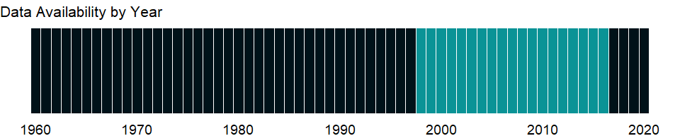

### Which countries have data?

The figure below shows the percentage of countries in each income group with a value since 2010 for that indicator.

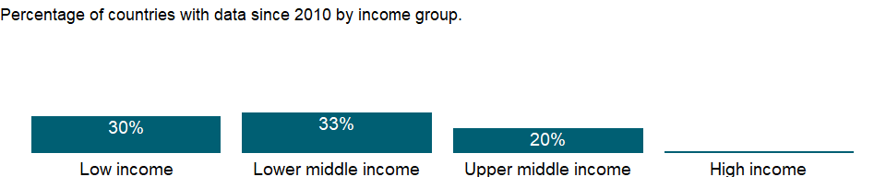

### Why is it relevant?

In most countries more boys are involved in employment, or the gender difference is small. However, girls are often more present in hidden or underreported forms of employment such as domestic service, and in almost all societies girls bear greater responsibility for household chores in their own homes, work that lies outside the System of National Accounts production boundary and is thus not considered in estimates of children’s employment.

### What is the data source?

Understanding Children’s Work project based on data from ILO, UNICEF and the World Bank.

### What is the methodology?

Data are from household surveys by the International Labor Organization (ILO), the United Nations Children’s Fund (UNICEF), the World Bank, and national statistical offices. The surveys yield data on education, employment, health, expenditure, and consumption indicators related to children’s work. Since children’s work is captured in the sense of “economic activity,” the data refer to children in employment, a broader concept than child labor (see ILO 2009a for details on this distinction).

Household survey data generally include information on work type - for example, whether a child is working for payment in cash or in kind or is involved in unpaid work, working for someone who is not a member of the household, or involved in any type of family work (on the farm or in a business).

### How is it aggregated?

NA

### What are the limitations?

Although efforts are made to harmonize the definition of employment and the questions on employment in survey questionnaires, significant differences remain in the survey instruments that collect data on children in employment and in the sampling design underlying the surveys. Differences exist not only across different household surveys in the same country but also across the same type of survey carried out in different countries, so estimates of working children are not fully comparable across countries. In addition, the shares of three sectors (Agriculture, Manufacturing and Services) may not add up to 100 percent because of a residual category not included.

### What else should I know?

NA

### 1.75.2 Child employment in agriculture, male (% of male economically active children ages 7-14)

### What is the indicator?

Employment by economic activity refers to the distribution of economically active children by the major industrial categories of the International Standard Industrial Classification (ISIC). Agriculture corresponds to division 1 (ISIC revision 2), categories A and B (ISIC revision 3), or category A (ISIC revision 4) and includes hunting, forestry, and fishing. Economically active children refer to children involved in economic activity for at least one hour in the reference week of the survey.

Topic: Social Protection & Labor: Economic activity

Series ID: SL.AGR.0714.MA.ZS

Copyright: CC BY-4.0 , <https://datacatalog.worldbank.org/public-licenses#cc-by>

First year with any data: 1998

Last year with any data: 2016

### What years are data available?

The figure below shows years in which data is available for at least one country. Dates shaded in black have no data, while dates shaded in green have data for at least one country



### Which countries have data?

The figure below shows the percentage of countries in each income group with a value since 2010 for that indicator.



### Why is it relevant?

In most countries more boys are involved in employment, or the gender difference is small. However, girls are often more present in hidden or underreported forms of employment such as domestic service, and in almost all societies girls bear greater responsibility for household chores in their own homes, work that lies outside the System of National Accounts production boundary and is thus not considered in estimates of children’s employment.

### What is the data source?

Understanding Children’s Work project based on data from ILO, UNICEF and the World Bank.

### What is the methodology?

Data are from household surveys by the International Labor Organization (ILO), the United Nations Children’s Fund (UNICEF), the World Bank, and national statistical offices. The surveys yield data on education, employment, health, expenditure, and consumption indicators related to children’s work. Since children’s work is captured in the sense of “economic activity,” the data refer to children in employment, a broader concept than child labor (see ILO 2009a for details on this distinction).

Household survey data generally include information on work type - for example, whether a child is working for payment in cash or in kind or is involved in unpaid work, working for someone who is not a member of the household, or involved in any type of family work (on the farm or in a business).

### How is it aggregated?

NA

### What are the limitations?

Although efforts are made to harmonize the definition of employment and the questions on employment in survey questionnaires, significant differences remain in the survey instruments that collect data on children in employment and in the sampling design underlying the surveys. Differences exist not only across different household surveys in the same country but also across the same type of survey carried out in different countries, so estimates of working children are not fully comparable across countries. In addition, the shares of three sectors (Agriculture, Manufacturing and Services) may not add up to 100 percent because of a residual category not included.

### What else should I know?

NA

### 1.75.3 Child employment in agriculture (% of economically active children ages 7-14)

### What is the indicator?

Employment by economic activity refers to the distribution of economically active children by the major industrial categories of the International Standard Industrial Classification (ISIC). Agriculture corresponds to division 1 (ISIC revision 2), categories A and B (ISIC revision 3), or category A (ISIC revision 4) and includes hunting, forestry, and fishing. Economically active children refer to children involved in economic activity for at least one hour in the reference week of the survey.

Topic: Social Protection & Labor: Economic activity

Series ID: SL.AGR.0714.ZS

Copyright: CC BY-4.0 , <https://datacatalog.worldbank.org/public-licenses#cc-by>

First year with any data: 1998

Last year with any data: 2016

### What years are data available?

The figure below shows years in which data is available for at least one country. Dates shaded in black have no data, while dates shaded in green have data for at least one country



### Which countries have data?

The figure below shows the percentage of countries in each income group with a value since 2010 for that indicator.



### Why is it relevant?

In most countries more boys are involved in employment, or the gender difference is small. However, girls are often more present in hidden or underreported forms of employment such as domestic service, and in almost all societies girls bear greater responsibility for household chores in their own homes, work that lies outside the System of National Accounts production boundary and is thus not considered in estimates of children’s employment.

### What is the data source?

Understanding Children’s Work project based on data from ILO, UNICEF and the World Bank.

### What is the methodology?

Data are from household surveys by the International Labor Organization (ILO), the United Nations Children’s Fund (UNICEF), the World Bank, and national statistical offices. The surveys yield data on education, employment, health, expenditure, and consumption indicators related to children’s work. Since children’s work is captured in the sense of “economic activity,” the data refer to children in employment, a broader concept than child labor (see ILO 2009a for details on this distinction).

Household survey data generally include information on work type - for example, whether a child is working for payment in cash or in kind or is involved in unpaid work, working for someone who is not a member of the household, or involved in any type of family work (on the farm or in a business).

### How is it aggregated?

NA

### What are the limitations?

Although efforts are made to harmonize the definition of employment and the questions on employment in survey questionnaires, significant differences remain in the survey instruments that collect data on children in employment and in the sampling design underlying the surveys. Differences exist not only across different household surveys in the same country but also across the same type of survey carried out in different countries, so estimates of working children are not fully comparable across countries. In addition, the shares of three sectors (Agriculture, Manufacturing and Services) may not add up to 100 percent because of a residual category not included.

### What else should I know?

NA

### 1.75.4 Employment in agriculture, female (% of female employment) (modeled ILO estimate)

### What is the indicator?

Employment is defined as persons of working age who were engaged in any activity to produce goods or provide services for pay or profit, whether at work during the reference period or not at work due to temporary absence from a job, or to working-time arrangement. The agriculture sector consists of activities in agriculture, hunting, forestry and fishing, in accordance with division 1 (ISIC 2) or categories A-B (ISIC 3) or category A (ISIC 4).

Topic: Social Protection & Labor: Economic activity

Series ID: SL.AGR.EMPL.FE.ZS

Copyright: CC BY-4.0 , <https://datacatalog.worldbank.org/public-licenses#cc-by>

First year with any data: 1991

Last year with any data: 2019

### What years are data available?

The figure below shows years in which data is available for at least one country. Dates shaded in black have no data, while dates shaded in green have data for at least one country



### Which countries have data?

The figure below shows the percentage of countries in each income group with a value since 2010 for that indicator.

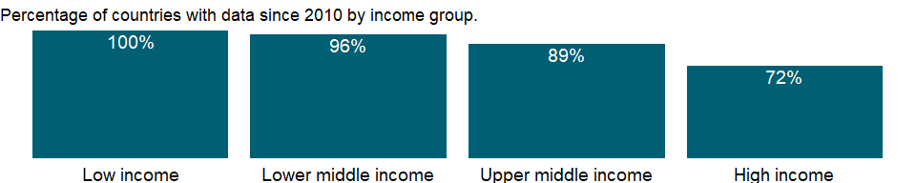

### Why is it relevant?

Sectoral information is particularly useful in identifying broad shifts in employment and stages of development. In the textbook case of economic development, labour flows from agriculture and other labour-intensive primary activities to industry and finally to the services sector; in the process, workers migrate from rural to urban areas.

The breakdown of the indicator by sex allows for analysis of gender segregation of employment by specific sector. Women may be drawn into lower-paying service activities that allow for more flexible work schedules thus making it easier to balance family responsibilities with work life. Segregation of women in certain sectors may also result from cultural attitudes that prevent them from entering industrial employment. Segregating one sex in a narrow range of occupations significantly reduces economic efficiency by reducing labor market flexibility and thus the economy’s ability to adapt to change. This segregation is particularly harmful for women, who have a much narrower range of labor market choices and lower levels of pay than men. But it is also detrimental to men when job losses are concentrated in industries dominated by men and job growth is centered in service occupations, where women have better chances, as has been the recent experience in many countries.

### What is the data source?

International Labour Organization, ILOSTAT database. Data retrieved on January 29, 2021.

### What is the methodology?

The International Labour Organization (ILO) classifies economic activity using the International Standard Industrial Classification (ISIC) of All Economic Activities, revision 2 (1968), revision 3 (1990), and revision 4 (2008). Because this classification is based on where work is performed (industry) rather than type of work performed (occupation), all of an enterprise’s employees are classified under the same industry, regardless of their trade or occupation. The categories should sum to 100 percent. Where they do not, the differences are due to workers who are not classified by economic activity.

The series is part of the ILO estimates and is harmonized to ensure comparability across countries and over time by accounting for differences in data source, scope of coverage, methodology, and other country-specific factors. The estimates are based mainly on nationally representative labor force surveys, with other sources (population censuses and nationally reported estimates) used only when no survey data are available.

### How is it aggregated?

Weighted average

### What are the limitations?

There are many differences in how countries define and measure employment status, particularly members of the armed forces, self-employed workers, and unpaid family workers. Where members of the armed forces are included, they are allocated to the service sector, causing that sector to be somewhat overstated relative to the service sector in economies where they are excluded. Where data are obtained from establishment surveys, data cover only employees; thus self-employed and unpaid family workers are excluded. In such cases the employment share of the agricultural sector is severely underreported. Caution should be also used where the data refer only to urban areas, which record little or no agricultural work. Moreover, the age group and area covered could differ by country or change over time within a country. For detailed information, consult the original source.

Countries also take different approaches to the treatment of unemployed people. In most countries unemployed people with previous job experience are classified according to their last job. But in some countries the unemployed and people seeking their first job are not classifiable by economic activity. Because of these differences, the size and distribution of employment by economic activity may not be fully comparable across countries.

The ILO reports data by major divisions of the ISIC revision 2, revision 3, or revision 4. Broad classification such as employment by agriculture, industry, and services may obscure fundamental shifts within countries’ industrial patterns. A slight majority of countries report economic activity according to the ISIC revision 3 instead of revision 2 or revision 4. The use of one classification or the other should not have a significant impact on the information for the employment of the three broad sectorsdata.

### What else should I know?

NA

### 1.75.5 Employment in agriculture, male (% of male employment) (modeled ILO estimate)

### What is the indicator?

Employment is defined as persons of working age who were engaged in any activity to produce goods or provide services for pay or profit, whether at work during the reference period or not at work due to temporary absence from a job, or to working-time arrangement. The agriculture sector consists of activities in agriculture, hunting, forestry and fishing, in accordance with division 1 (ISIC 2) or categories A-B (ISIC 3) or category A (ISIC 4).

Topic: Social Protection & Labor: Economic activity

Series ID: SL.AGR.EMPL.MA.ZS

Copyright: CC BY-4.0 , <https://datacatalog.worldbank.org/public-licenses#cc-by>

First year with any data: 1991

Last year with any data: 2019

### What years are data available?

The figure below shows years in which data is available for at least one country. Dates shaded in black have no data, while dates shaded in green have data for at least one country



### Which countries have data?

The figure below shows the percentage of countries in each income group with a value since 2010 for that indicator.



### Why is it relevant?

Sectoral information is particularly useful in identifying broad shifts in employment and stages of development. In the textbook case of economic development, labour flows from agriculture and other labour-intensive primary activities to industry and finally to the services sector; in the process, workers migrate from rural to urban areas.

The breakdown of the indicator by sex allows for analysis of gender segregation of employment by specific sector. Women may be drawn into lower-paying service activities that allow for more flexible work schedules thus making it easier to balance family responsibilities with work life. Segregation of women in certain sectors may also result from cultural attitudes that prevent them from entering industrial employment. Segregating one sex in a narrow range of occupations significantly reduces economic efficiency by reducing labor market flexibility and thus the economy’s ability to adapt to change. This segregation is particularly harmful for women, who have a much narrower range of labor market choices and lower levels of pay than men. But it is also detrimental to men when job losses are concentrated in industries dominated by men and job growth is centered in service occupations, where women have better chances, as has been the recent experience in many countries.

### What is the data source?

International Labour Organization, ILOSTAT database. Data retrieved on January 29, 2021.

### What is the methodology?

The International Labour Organization (ILO) classifies economic activity using the International Standard Industrial Classification (ISIC) of All Economic Activities, revision 2 (1968), revision 3 (1990), and revision 4 (2008). Because this classification is based on where work is performed (industry) rather than type of work performed (occupation), all of an enterprise’s employees are classified under the same industry, regardless of their trade or occupation. The categories should sum to 100 percent. Where they do not, the differences are due to workers who are not classified by economic activity.

The series is part of the ILO estimates and is harmonized to ensure comparability across countries and over time by accounting for differences in data source, scope of coverage, methodology, and other country-specific factors. The estimates are based mainly on nationally representative labor force surveys, with other sources (population censuses and nationally reported estimates) used only when no survey data are available.

### How is it aggregated?

Weighted average

### What are the limitations?

There are many differences in how countries define and measure employment status, particularly members of the armed forces, self-employed workers, and unpaid family workers. Where members of the armed forces are included, they are allocated to the service sector, causing that sector to be somewhat overstated relative to the service sector in economies where they are excluded. Where data are obtained from establishment surveys, data cover only employees; thus self-employed and unpaid family workers are excluded. In such cases the employment share of the agricultural sector is severely underreported. Caution should be also used where the data refer only to urban areas, which record little or no agricultural work. Moreover, the age group and area covered could differ by country or change over time within a country. For detailed information, consult the original source.

Countries also take different approaches to the treatment of unemployed people. In most countries unemployed people with previous job experience are classified according to their last job. But in some countries the unemployed and people seeking their first job are not classifiable by economic activity. Because of these differences, the size and distribution of employment by economic activity may not be fully comparable across countries.

The ILO reports data by major divisions of the ISIC revision 2, revision 3, or revision 4. Broad classification such as employment by agriculture, industry, and services may obscure fundamental shifts within countries’ industrial patterns. A slight majority of countries report economic activity according to the ISIC revision 3 instead of revision 2 or revision 4. The use of one classification or the other should not have a significant impact on the information for the employment of the three broad sectorsdata.

### What else should I know?

NA

### 1.75.6 Employment in agriculture (% of total employment) (modeled ILO estimate)

### What is the indicator?

Employment is defined as persons of working age who were engaged in any activity to produce goods or provide services for pay or profit, whether at work during the reference period or not at work due to temporary absence from a job, or to working-time arrangement. The agriculture sector consists of activities in agriculture, hunting, forestry and fishing, in accordance with division 1 (ISIC 2) or categories A-B (ISIC 3) or category A (ISIC 4).

Topic: Social Protection & Labor: Economic activity

Series ID: SL.AGR.EMPL.ZS

Copyright: CC BY-4.0 , <https://datacatalog.worldbank.org/public-licenses#cc-by>

First year with any data: 1991

Last year with any data: 2019

### What years are data available?

The figure below shows years in which data is available for at least one country. Dates shaded in black have no data, while dates shaded in green have data for at least one country



### Which countries have data?

The figure below shows the percentage of countries in each income group with a value since 2010 for that indicator.



### Why is it relevant?

Sectoral information is particularly useful in identifying broad shifts in employment and stages of development. In the textbook case of economic development, labour flows from agriculture and other labour-intensive primary activities to industry and finally to the services sector; in the process, workers migrate from rural to urban areas.

The breakdown of the indicator by sex allows for analysis of gender segregation of employment by specific sector. Women may be drawn into lower-paying service activities that allow for more flexible work schedules thus making it easier to balance family responsibilities with work life. Segregation of women in certain sectors may also result from cultural attitudes that prevent them from entering industrial employment. Segregating one sex in a narrow range of occupations significantly reduces economic efficiency by reducing labor market flexibility and thus the economy’s ability to adapt to change. This segregation is particularly harmful for women, who have a much narrower range of labor market choices and lower levels of pay than men. But it is also detrimental to men when job losses are concentrated in industries dominated by men and job growth is centered in service occupations, where women have better chances, as has been the recent experience in many countries.

### What is the data source?

International Labour Organization, ILOSTAT database. Data retrieved on January 29, 2021.

### What is the methodology?

The International Labour Organization (ILO) classifies economic activity using the International Standard Industrial Classification (ISIC) of All Economic Activities, revision 2 (1968), revision 3 (1990), and revision 4 (2008). Because this classification is based on where work is performed (industry) rather than type of work performed (occupation), all of an enterprise’s employees are classified under the same industry, regardless of their trade or occupation. The categories should sum to 100 percent. Where they do not, the differences are due to workers who are not classified by economic activity.

The series is part of the ILO estimates and is harmonized to ensure comparability across countries and over time by accounting for differences in data source, scope of coverage, methodology, and other country-specific factors. The estimates are based mainly on nationally representative labor force surveys, with other sources (population censuses and nationally reported estimates) used only when no survey data are available.

### How is it aggregated?

Weighted average

### What are the limitations?

There are many differences in how countries define and measure employment status, particularly members of the armed forces, self-employed workers, and unpaid family workers. Where members of the armed forces are included, they are allocated to the service sector, causing that sector to be somewhat overstated relative to the service sector in economies where they are excluded. Where data are obtained from establishment surveys, data cover only employees; thus self-employed and unpaid family workers are excluded. In such cases the employment share of the agricultural sector is severely underreported. Caution should be also used where the data refer only to urban areas, which record little or no agricultural work. Moreover, the age group and area covered could differ by country or change over time within a country. For detailed information, consult the original source.

Countries also take different approaches to the treatment of unemployed people. In most countries unemployed people with previous job experience are classified according to their last job. But in some countries the unemployed and people seeking their first job are not classifiable by economic activity. Because of these differences, the size and distribution of employment by economic activity may not be fully comparable across countries.

The ILO reports data by major divisions of the ISIC revision 2, revision 3, or revision 4. Broad classification such as employment by agriculture, industry, and services may obscure fundamental shifts within countries’ industrial patterns. A slight majority of countries report economic activity according to the ISIC revision 3 instead of revision 2 or revision 4. The use of one classification or the other should not have a significant impact on the information for the employment of the three broad sectorsdata.

### What else should I know?

NA

### 1.75.7 Employment to population ratio, ages 15-24, female (%) (national estimate)

### What is the indicator?

Employment to population ratio is the proportion of a country’s population that is employed. Employment is defined as persons of working age who, during a short reference period, were engaged in any activity to produce goods or provide services for pay or profit, whether at work during the reference period (i.e. who worked in a job for at least one hour) or not at work due to temporary absence from a job, or to working-time arrangements. Ages 15-24 are generally considered the youth population.

Topic: Social Protection & Labor: Economic activity

Series ID: SL.EMP.1524.SP.FE.NE.ZS

Copyright: CC BY-4.0 , <https://datacatalog.worldbank.org/public-licenses#cc-by>

First year with any data: 1960

Last year with any data: 2020

### What years are data available?

The figure below shows years in which data is available for at least one country. Dates shaded in black have no data, while dates shaded in green have data for at least one country



### Which countries have data?

The figure below shows the percentage of countries in each income group with a value since 2010 for that indicator.

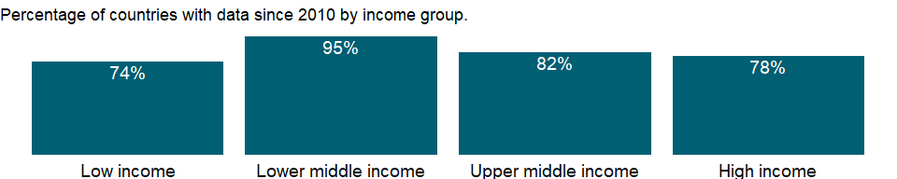

### Why is it relevant?

Four targets were added to the UN Millennium Declaration at the 2005 World Summit High-Level Plenary Meeting of the 60th Session of the UN General Assembly. One was full and productive employment and decent work for all, which is seen as the main route for people to escape poverty. Employment to population ratio is a key measure to monitor whether a country is on track to achieve the Millennium Development Goal of eradicating extreme poverty and hunger by 2015. And it continues to be a priority in the Sustainable Development Goal of promoting sustained, inclusive and sustainable economic growth, full and productive employment and decent work for all.

### What is the data source?

International Labour Organization, ILOSTAT database. Data retrieved on September 7, 2021.

### What is the methodology?

The employment to population ratio indicates how efficiently an economy provides jobs for people who want to work. A high ratio means that a large proportion of the population is employed. But a lower employment to population ratio can be seen as a positive sign, especially for young people, if it is caused by an increase in their education.

### How is it aggregated?

Weighted Average

### What are the limitations?

Data on employment by status are drawn from labor force surveys and household surveys, supplemented by official estimates and censuses for a small group of countries. The labor force survey is the most comprehensive source for internationally comparable employment, but there are still some limitations for comparing data across countries and over time even within a country.

Comparability of employment ratios across countries is affected by variations in definitions of employment and population. The biggest difference results from the age range used to define labor force activity. The population base for employment ratios can also vary. Most countries use the resident, non-institutionalized population of working age living in private households, which excludes members of the armed forces and individuals residing in mental, penal, or other types of institutions. But some countries include members of the armed forces in the population base of their employment ratio while excluding them from employment data.

The reference period of a census or survey is another important source of differences: in some countries data refer to people’s status on the day of the census or survey or during a specific period before the inquiry date, while in others data are recorded without reference to any period. Employment ratios tend to vary during the year as seasonal workers enter and leave.

This indicator also has a gender bias because women who do not consider their work employment or who are not perceived as working tend to be undercounted. This bias has different effects across countries and reflects demographic, social, legal, and cultural trends and norms.

### What else should I know?

The series for ILO estimates is also available in the WDI database. Caution should be used when comparing ILO estimates with national estimates.

### 1.75.8 Employment to population ratio, ages 15-24, female (%) (modeled ILO estimate)

### What is the indicator?

Employment to population ratio is the proportion of a country’s population that is employed. Employment is defined as persons of working age who, during a short reference period, were engaged in any activity to produce goods or provide services for pay or profit, whether at work during the reference period (i.e. who worked in a job for at least one hour) or not at work due to temporary absence from a job, or to working-time arrangements. Ages 15-24 are generally considered the youth population.

Topic: Social Protection & Labor: Economic activity

Series ID: SL.EMP.1524.SP.FE.ZS

Copyright: CC BY-4.0 , <https://datacatalog.worldbank.org/public-licenses#cc-by>

First year with any data: 1991

Last year with any data: 2019

### What years are data available?

The figure below shows years in which data is available for at least one country. Dates shaded in black have no data, while dates shaded in green have data for at least one country



### Which countries have data?

The figure below shows the percentage of countries in each income group with a value since 2010 for that indicator.



### Why is it relevant?

Four targets were added to the UN Millennium Declaration at the 2005 World Summit High-Level Plenary Meeting of the 60th Session of the UN General Assembly. One was full and productive employment and decent work for all, which is seen as the main route for people to escape poverty. Employment to population ratio is a key measure to monitor whether a country is on track to achieve the Millennium Development Goal of eradicating extreme poverty and hunger by 2015. And it continues to be a priority in the Sustainable Development Goal of promoting sustained, inclusive and sustainable economic growth, full and productive employment and decent work for all.

### What is the data source?

International Labour Organization, ILOSTAT database. Data retrieved on June 15, 2021.

### What is the methodology?

The employment to population ratio indicates how efficiently an economy provides jobs for people who want to work. A high ratio means that a large proportion of the population is employed. But a lower employment to population ratio can be seen as a positive sign, especially for young people, if it is caused by an increase in their education.

The series is part of the ILO estimates and is harmonized to ensure comparability across countries and over time by accounting for differences in data source, scope of coverage, methodology, and other country-specific factors. The estimates are based mainly on nationally representative labor force surveys, with other sources (population censuses and nationally reported estimates) used only when no survey data are available.

### How is it aggregated?

Weighted average

### What are the limitations?

Data on employment by status are drawn from labor force surveys and household surveys, supplemented by official estimates and censuses for a small group of countries. The labor force survey is the most comprehensive source for internationally comparable employment, but there are still some limitations for comparing data across countries and over time even within a country.

Comparability of employment ratios across countries is affected by variations in definitions of employment and population. The biggest difference results from the age range used to define labor force activity. The population base for employment ratios can also vary. Most countries use the resident, non-institutionalized population of working age living in private households, which excludes members of the armed forces and individuals residing in mental, penal, or other types of institutions. But some countries include members of the armed forces in the population base of their employment ratio while excluding them from employment data.

The reference period of a census or survey is another important source of differences: in some countries data refer to people’s status on the day of the census or survey or during a specific period before the inquiry date, while in others data are recorded without reference to any period. Employment ratios tend to vary during the year as seasonal workers enter and leave.

This indicator also has a gender bias because women who do not consider their work employment or who are not perceived as working tend to be undercounted. This bias has different effects across countries and reflects demographic, social, legal, and cultural trends and norms.

### What else should I know?

National estimates are also available in the WDI database. Caution should be used when comparing ILO estimates with national estimates.

### 1.75.9 Employment to population ratio, ages 15-24, male (%) (national estimate)

### What is the indicator?

Employment to population ratio is the proportion of a country’s population that is employed. Employment is defined as persons of working age who, during a short reference period, were engaged in any activity to produce goods or provide services for pay or profit, whether at work during the reference period (i.e. who worked in a job for at least one hour) or not at work due to temporary absence from a job, or to working-time arrangements. Ages 15-24 are generally considered the youth population.

Topic: Social Protection & Labor: Economic activity

Series ID: SL.EMP.1524.SP.MA.NE.ZS

Copyright: CC BY-4.0 , <https://datacatalog.worldbank.org/public-licenses#cc-by>

First year with any data: 1960

Last year with any data: 2020

### What years are data available?

The figure below shows years in which data is available for at least one country. Dates shaded in black have no data, while dates shaded in green have data for at least one country



### Which countries have data?

The figure below shows the percentage of countries in each income group with a value since 2010 for that indicator.



### Why is it relevant?

Four targets were added to the UN Millennium Declaration at the 2005 World Summit High-Level Plenary Meeting of the 60th Session of the UN General Assembly. One was full and productive employment and decent work for all, which is seen as the main route for people to escape poverty. Employment to population ratio is a key measure to monitor whether a country is on track to achieve the Millennium Development Goal of eradicating extreme poverty and hunger by 2015. And it continues to be a priority in the Sustainable Development Goal of promoting sustained, inclusive and sustainable economic growth, full and productive employment and decent work for all.

### What is the data source?

International Labour Organization, ILOSTAT database. Data retrieved on September 7, 2021.

### What is the methodology?

The employment to population ratio indicates how efficiently an economy provides jobs for people who want to work. A high ratio means that a large proportion of the population is employed. But a lower employment to population ratio can be seen as a positive sign, especially for young people, if it is caused by an increase in their education.

### How is it aggregated?

Weighted Average

### What are the limitations?

Data on employment by status are drawn from labor force surveys and household surveys, supplemented by official estimates and censuses for a small group of countries. The labor force survey is the most comprehensive source for internationally comparable employment, but there are still some limitations for comparing data across countries and over time even within a country.

Comparability of employment ratios across countries is affected by variations in definitions of employment and population. The biggest difference results from the age range used to define labor force activity. The population base for employment ratios can also vary. Most countries use the resident, non-institutionalized population of working age living in private households, which excludes members of the armed forces and individuals residing in mental, penal, or other types of institutions. But some countries include members of the armed forces in the population base of their employment ratio while excluding them from employment data.

The reference period of a census or survey is another important source of differences: in some countries data refer to people’s status on the day of the census or survey or during a specific period before the inquiry date, while in others data are recorded without reference to any period. Employment ratios tend to vary during the year as seasonal workers enter and leave.

This indicator also has a gender bias because women who do not consider their work employment or who are not perceived as working tend to be undercounted. This bias has different effects across countries and reflects demographic, social, legal, and cultural trends and norms.

### What else should I know?

The series for ILO estimates is also available in the WDI database. Caution should be used when comparing ILO estimates with national estimates.

### 1.75.10 Employment to population ratio, ages 15-24, male (%) (modeled ILO estimate)

### What is the indicator?

Employment to population ratio is the proportion of a country’s population that is employed. Employment is defined as persons of working age who, during a short reference period, were engaged in any activity to produce goods or provide services for pay or profit, whether at work during the reference period (i.e. who worked in a job for at least one hour) or not at work due to temporary absence from a job, or to working-time arrangements. Ages 15-24 are generally considered the youth population.

Topic: Social Protection & Labor: Economic activity

Series ID: SL.EMP.1524.SP.MA.ZS

Copyright: CC BY-4.0 , <https://datacatalog.worldbank.org/public-licenses#cc-by>

First year with any data: 1991

Last year with any data: 2019

### What years are data available?

The figure below shows years in which data is available for at least one country. Dates shaded in black have no data, while dates shaded in green have data for at least one country



### Which countries have data?

The figure below shows the percentage of countries in each income group with a value since 2010 for that indicator.



### Why is it relevant?

Four targets were added to the UN Millennium Declaration at the 2005 World Summit High-Level Plenary Meeting of the 60th Session of the UN General Assembly. One was full and productive employment and decent work for all, which is seen as the main route for people to escape poverty. Employment to population ratio is a key measure to monitor whether a country is on track to achieve the Millennium Development Goal of eradicating extreme poverty and hunger by 2015. And it continues to be a priority in the Sustainable Development Goal of promoting sustained, inclusive and sustainable economic growth, full and productive employment and decent work for all.

### What is the data source?

International Labour Organization, ILOSTAT database. Data retrieved on June 15, 2021.

### What is the methodology?

The employment to population ratio indicates how efficiently an economy provides jobs for people who want to work. A high ratio means that a large proportion of the population is employed. But a lower employment to population ratio can be seen as a positive sign, especially for young people, if it is caused by an increase in their education.

The series is part of the ILO estimates and is harmonized to ensure comparability across countries and over time by accounting for differences in data source, scope of coverage, methodology, and other country-specific factors. The estimates are based mainly on nationally representative labor force surveys, with other sources (population censuses and nationally reported estimates) used only when no survey data are available.

### How is it aggregated?

Weighted average

### What are the limitations?

Data on employment by status are drawn from labor force surveys and household surveys, supplemented by official estimates and censuses for a small group of countries. The labor force survey is the most comprehensive source for internationally comparable employment, but there are still some limitations for comparing data across countries and over time even within a country.

Comparability of employment ratios across countries is affected by variations in definitions of employment and population. The biggest difference results from the age range used to define labor force activity. The population base for employment ratios can also vary. Most countries use the resident, non-institutionalized population of working age living in private households, which excludes members of the armed forces and individuals residing in mental, penal, or other types of institutions. But some countries include members of the armed forces in the population base of their employment ratio while excluding them from employment data.

The reference period of a census or survey is another important source of differences: in some countries data refer to people’s status on the day of the census or survey or during a specific period before the inquiry date, while in others data are recorded without reference to any period. Employment ratios tend to vary during the year as seasonal workers enter and leave.

This indicator also has a gender bias because women who do not consider their work employment or who are not perceived as working tend to be undercounted. This bias has different effects across countries and reflects demographic, social, legal, and cultural trends and norms.

### What else should I know?

National estimates are also available in the WDI database. Caution should be used when comparing ILO estimates with national estimates.

### 1.75.11 Employment to population ratio, ages 15-24, total (%) (national estimate)

### What is the indicator?

Employment to population ratio is the proportion of a country’s population that is employed. Employment is defined as persons of working age who, during a short reference period, were engaged in any activity to produce goods or provide services for pay or profit, whether at work during the reference period (i.e. who worked in a job for at least one hour) or not at work due to temporary absence from a job, or to working-time arrangements. Ages 15-24 are generally considered the youth population.

Topic: Social Protection & Labor: Economic activity

Series ID: SL.EMP.1524.SP.NE.ZS

Copyright: CC BY-4.0 , <https://datacatalog.worldbank.org/public-licenses#cc-by>

First year with any data: 1960

Last year with any data: 2020

### What years are data available?

The figure below shows years in which data is available for at least one country. Dates shaded in black have no data, while dates shaded in green have data for at least one country



### Which countries have data?

The figure below shows the percentage of countries in each income group with a value since 2010 for that indicator.



### Why is it relevant?

Four targets were added to the UN Millennium Declaration at the 2005 World Summit High-Level Plenary Meeting of the 60th Session of the UN General Assembly. One was full and productive employment and decent work for all, which is seen as the main route for people to escape poverty. Employment to population ratio is a key measure to monitor whether a country is on track to achieve the Millennium Development Goal of eradicating extreme poverty and hunger by 2015. And it continues to be a priority in the Sustainable Development Goal of promoting sustained, inclusive and sustainable economic growth, full and productive employment and decent work for all.

### What is the data source?

International Labour Organization, ILOSTAT database. Data retrieved on September 7, 2021.

### What is the methodology?

The employment to population ratio indicates how efficiently an economy provides jobs for people who want to work. A high ratio means that a large proportion of the population is employed. But a lower employment to population ratio can be seen as a positive sign, especially for young people, if it is caused by an increase in their education.

### How is it aggregated?

Weighted Average

### What are the limitations?

Data on employment by status are drawn from labor force surveys and household surveys, supplemented by official estimates and censuses for a small group of countries. The labor force survey is the most comprehensive source for internationally comparable employment, but there are still some limitations for comparing data across countries and over time even within a country.

Comparability of employment ratios across countries is affected by variations in definitions of employment and population. The biggest difference results from the age range used to define labor force activity. The population base for employment ratios can also vary. Most countries use the resident, non-institutionalized population of working age living in private households, which excludes members of the armed forces and individuals residing in mental, penal, or other types of institutions. But some countries include members of the armed forces in the population base of their employment ratio while excluding them from employment data.

The reference period of a census or survey is another important source of differences: in some countries data refer to people’s status on the day of the census or survey or during a specific period before the inquiry date, while in others data are recorded without reference to any period. Employment ratios tend to vary during the year as seasonal workers enter and leave.

This indicator also has a gender bias because women who do not consider their work employment or who are not perceived as working tend to be undercounted. This bias has different effects across countries and reflects demographic, social, legal, and cultural trends and norms.

### What else should I know?

The series for ILO estimates is also available in the WDI database. Caution should be used when comparing ILO estimates with national estimates.

### 1.75.12 Employment to population ratio, ages 15-24, total (%) (modeled ILO estimate)

### What is the indicator?

Employment to population ratio is the proportion of a country’s population that is employed. Employment is defined as persons of working age who, during a short reference period, were engaged in any activity to produce goods or provide services for pay or profit, whether at work during the reference period (i.e. who worked in a job for at least one hour) or not at work due to temporary absence from a job, or to working-time arrangements. Ages 15-24 are generally considered the youth population.

Topic: Social Protection & Labor: Economic activity

Series ID: SL.EMP.1524.SP.ZS

Copyright: CC BY-4.0 , <https://datacatalog.worldbank.org/public-licenses#cc-by>

First year with any data: 1991

Last year with any data: 2019

### What years are data available?

The figure below shows years in which data is available for at least one country. Dates shaded in black have no data, while dates shaded in green have data for at least one country



### Which countries have data?

The figure below shows the percentage of countries in each income group with a value since 2010 for that indicator.



### Why is it relevant?

Four targets were added to the UN Millennium Declaration at the 2005 World Summit High-Level Plenary Meeting of the 60th Session of the UN General Assembly. One was full and productive employment and decent work for all, which is seen as the main route for people to escape poverty. Employment to population ratio is a key measure to monitor whether a country is on track to achieve the Millennium Development Goal of eradicating extreme poverty and hunger by 2015. And it continues to be a priority in the Sustainable Development Goal of promoting sustained, inclusive and sustainable economic growth, full and productive employment and decent work for all.

### What is the data source?

International Labour Organization, ILOSTAT database. Data retrieved on June 15, 2021.

### What is the methodology?

The employment to population ratio indicates how efficiently an economy provides jobs for people who want to work. A high ratio means that a large proportion of the population is employed. But a lower employment to population ratio can be seen as a positive sign, especially for young people, if it is caused by an increase in their education.

The series is part of the ILO estimates and is harmonized to ensure comparability across countries and over time by accounting for differences in data source, scope of coverage, methodology, and other country-specific factors. The estimates are based mainly on nationally representative labor force surveys, with other sources (population censuses and nationally reported estimates) used only when no survey data are available.

### How is it aggregated?

Weighted average

### What are the limitations?

Data on employment by status are drawn from labor force surveys and household surveys, supplemented by official estimates and censuses for a small group of countries. The labor force survey is the most comprehensive source for internationally comparable employment, but there are still some limitations for comparing data across countries and over time even within a country.

Comparability of employment ratios across countries is affected by variations in definitions of employment and population. The biggest difference results from the age range used to define labor force activity. The population base for employment ratios can also vary. Most countries use the resident, non-institutionalized population of working age living in private households, which excludes members of the armed forces and individuals residing in mental, penal, or other types of institutions. But some countries include members of the armed forces in the population base of their employment ratio while excluding them from employment data.

The reference period of a census or survey is another important source of differences: in some countries data refer to people’s status on the day of the census or survey or during a specific period before the inquiry date, while in others data are recorded without reference to any period. Employment ratios tend to vary during the year as seasonal workers enter and leave.

This indicator also has a gender bias because women who do not consider their work employment or who are not perceived as working tend to be undercounted. This bias has different effects across countries and reflects demographic, social, legal, and cultural trends and norms.

### What else should I know?

National estimates are also available in the WDI database. Caution should be used when comparing ILO estimates with national estimates.

### 1.75.13 Employers, female (% of female employment) (modeled ILO estimate)

### What is the indicator?

Employers are those workers who, working on their own account or with one or a few partners, hold the type of jobs defined as a “self-employment jobs” i.e. jobs where the remuneration is directly dependent upon the profits derived from the goods and services produced), and, in this capacity, have engaged, on a continuous basis, one or more persons to work for them as employee(s).

Topic: Social Protection & Labor: Economic activity

Series ID: SL.EMP.MPYR.FE.ZS

Copyright: CC BY-4.0 , <https://datacatalog.worldbank.org/public-licenses#cc-by>

First year with any data: 1991

Last year with any data: 2019

### What years are data available?

The figure below shows years in which data is available for at least one country. Dates shaded in black have no data, while dates shaded in green have data for at least one country



### Which countries have data?

The figure below shows the percentage of countries in each income group with a value since 2010 for that indicator.



### Why is it relevant?

Breaking down employment information by status in employment provides a statistical basis for describing workers’ behaviour and conditions of work, and for defining an individual’s socio-economic group. A high proportion of wage and salaried workers in a country can signify advanced economic development. If the proportion of own-account workers (self-employed without hired employees) is sizeable, it may be an indication of a large agriculture sector and low growth in the formal economy. A high proportion of contributing family workers — generally unpaid, although compensation might come indirectly in the form of family income — may indicate weak development, little job growth, and often a large rural economy.

Each status group faces different economic risks, and contributing family workers and own-account workers are the most vulnerable - and therefore the most likely to fall into poverty. They are the least likely to have formal work arrangements, are the least likely to have social protection and safety nets to guard against economic shocks, and often are incapable of generating sufficient savings to offset these shocks.

### What is the data source?

International Labour Organization, ILOSTAT database. Data retrieved on January 29, 2021.

### What is the methodology?

The indicator of status in employment distinguishes between two categories of the total employed. These are: (a) wage and salaried workers (also known as employees); and (b) self-employed workers. Self-employed group is broken down in the subcategories: self-employed workers with employees (employers), self-employed workers without employees (own-account workers), members of producers’ cooperatives and contributing family workers (also known as unpaid family workers). Vulnerable employment refers to the sum of contributing family workers and own-account workers.

The series is part of the ILO estimates and is harmonized to ensure comparability across countries and over time by accounting for differences in data source, scope of coverage, methodology, and other country-specific factors. The estimates are based mainly on nationally representative labor force surveys, with other sources (population censuses and nationally reported estimates) used only when no survey data are available.

### How is it aggregated?

Weighted Average

### What are the limitations?

Data are drawn from labor force surveys and household surveys, supplemented by official estimates and censuses for a small group of countries. Due to differences in definitions and coverage across countries, there are limitations for comparing data across countries and over time even within a country. Estimates of women in employment are not comparable internationally, reflecting that demographic, social, legal, and cultural trends and norms determine whether women’s activities are regarded as economic.

### What else should I know?

NA

### 1.75.14 Employers, male (% of male employment) (modeled ILO estimate)

### What is the indicator?

Employers are those workers who, working on their own account or with one or a few partners, hold the type of jobs defined as a “self-employment jobs” i.e. jobs where the remuneration is directly dependent upon the profits derived from the goods and services produced), and, in this capacity, have engaged, on a continuous basis, one or more persons to work for them as employee(s).

Topic: Social Protection & Labor: Economic activity

Series ID: SL.EMP.MPYR.MA.ZS

Copyright: CC BY-4.0 , <https://datacatalog.worldbank.org/public-licenses#cc-by>

First year with any data: 1991

Last year with any data: 2019

### What years are data available?

The figure below shows years in which data is available for at least one country. Dates shaded in black have no data, while dates shaded in green have data for at least one country



### Which countries have data?

The figure below shows the percentage of countries in each income group with a value since 2010 for that indicator.



### Why is it relevant?

Breaking down employment information by status in employment provides a statistical basis for describing workers’ behaviour and conditions of work, and for defining an individual’s socio-economic group. A high proportion of wage and salaried workers in a country can signify advanced economic development. If the proportion of own-account workers (self-employed without hired employees) is sizeable, it may be an indication of a large agriculture sector and low growth in the formal economy. A high proportion of contributing family workers — generally unpaid, although compensation might come indirectly in the form of family income — may indicate weak development, little job growth, and often a large rural economy.

Each status group faces different economic risks, and contributing family workers and own-account workers are the most vulnerable - and therefore the most likely to fall into poverty. They are the least likely to have formal work arrangements, are the least likely to have social protection and safety nets to guard against economic shocks, and often are incapable of generating sufficient savings to offset these shocks.

### What is the data source?

International Labour Organization, ILOSTAT database. Data retrieved on January 29, 2021.

### What is the methodology?

The indicator of status in employment distinguishes between two categories of the total employed. These are: (a) wage and salaried workers (also known as employees); and (b) self-employed workers. Self-employed group is broken down in the subcategories: self-employed workers with employees (employers), self-employed workers without employees (own-account workers), members of producers’ cooperatives and contributing family workers (also known as unpaid family workers). Vulnerable employment refers to the sum of contributing family workers and own-account workers.

The series is part of the ILO estimates and is harmonized to ensure comparability across countries and over time by accounting for differences in data source, scope of coverage, methodology, and other country-specific factors. The estimates are based mainly on nationally representative labor force surveys, with other sources (population censuses and nationally reported estimates) used only when no survey data are available.

### How is it aggregated?

Weighted Average

### What are the limitations?

Data are drawn from labor force surveys and household surveys, supplemented by official estimates and censuses for a small group of countries. Due to differences in definitions and coverage across countries, there are limitations for comparing data across countries and over time even within a country. Estimates of women in employment are not comparable internationally, reflecting that demographic, social, legal, and cultural trends and norms determine whether women’s activities are regarded as economic.

### What else should I know?

NA

### 1.75.15 Employers, total (% of total employment) (modeled ILO estimate)

### What is the indicator?

Employers are those workers who, working on their own account or with one or a few partners, hold the type of jobs defined as a “self-employment jobs” i.e. jobs where the remuneration is directly dependent upon the profits derived from the goods and services produced), and, in this capacity, have engaged, on a continuous basis, one or more persons to work for them as employee(s).

Topic: Social Protection & Labor: Economic activity

Series ID: SL.EMP.MPYR.ZS

Copyright: CC BY-4.0 , <https://datacatalog.worldbank.org/public-licenses#cc-by>

First year with any data: 1991

Last year with any data: 2019

### What years are data available?

The figure below shows years in which data is available for at least one country. Dates shaded in black have no data, while dates shaded in green have data for at least one country



### Which countries have data?

The figure below shows the percentage of countries in each income group with a value since 2010 for that indicator.



### Why is it relevant?

Breaking down employment information by status in employment provides a statistical basis for describing workers’ behaviour and conditions of work, and for defining an individual’s socio-economic group. A high proportion of wage and salaried workers in a country can signify advanced economic development. If the proportion of own-account workers (self-employed without hired employees) is sizeable, it may be an indication of a large agriculture sector and low growth in the formal economy. A high proportion of contributing family workers — generally unpaid, although compensation might come indirectly in the form of family income — may indicate weak development, little job growth, and often a large rural economy.

Each status group faces different economic risks, and contributing family workers and own-account workers are the most vulnerable - and therefore the most likely to fall into poverty. They are the least likely to have formal work arrangements, are the least likely to have social protection and safety nets to guard against economic shocks, and often are incapable of generating sufficient savings to offset these shocks.

### What is the data source?

International Labour Organization, ILOSTAT database. Data retrieved on January 29, 2021.

### What is the methodology?

The indicator of status in employment distinguishes between two categories of the total employed. These are: (a) wage and salaried workers (also known as employees); and (b) self-employed workers. Self-employed group is broken down in the subcategories: self-employed workers with employees (employers), self-employed workers without employees (own-account workers), members of producers’ cooperatives and contributing family workers (also known as unpaid family workers). Vulnerable employment refers to the sum of contributing family workers and own-account workers.

The series is part of the ILO estimates and is harmonized to ensure comparability across countries and over time by accounting for differences in data source, scope of coverage, methodology, and other country-specific factors. The estimates are based mainly on nationally representative labor force surveys, with other sources (population censuses and nationally reported estimates) used only when no survey data are available.

### How is it aggregated?

Weighted Average

### What are the limitations?

Data are drawn from labor force surveys and household surveys, supplemented by official estimates and censuses for a small group of countries. Due to differences in definitions and coverage across countries, there are limitations for comparing data across countries and over time even within a country. Estimates of women in employment are not comparable internationally, reflecting that demographic, social, legal, and cultural trends and norms determine whether women’s activities are regarded as economic.

### What else should I know?

NA

### 1.75.16 Self-employed, female (% of female employment) (modeled ILO estimate)

### What is the indicator?

Self-employed workers are those workers who, working on their own account or with one or a few partners or in cooperative, hold the type of jobs defined as a “self-employment jobs.” i.e. jobs where the remuneration is directly dependent upon the profits derived from the goods and services produced. Self-employed workers include four sub-categories of employers, own-account workers, members of producers’ cooperatives, and contributing family workers.

Topic: Social Protection & Labor: Economic activity

Series ID: SL.EMP.SELF.FE.ZS

Copyright: CC BY-4.0 , <https://datacatalog.worldbank.org/public-licenses#cc-by>

First year with any data: 1991

Last year with any data: 2019

### What years are data available?

The figure below shows years in which data is available for at least one country. Dates shaded in black have no data, while dates shaded in green have data for at least one country



### Which countries have data?

The figure below shows the percentage of countries in each income group with a value since 2010 for that indicator.



### Why is it relevant?

Breaking down employment information by status in employment provides a statistical basis for describing workers’ behaviour and conditions of work, and for defining an individual’s socio-economic group. A high proportion of wage and salaried workers in a country can signify advanced economic development. If the proportion of own-account workers (self-employed without hired employees) is sizeable, it may be an indication of a large agriculture sector and low growth in the formal economy. A high proportion of contributing family workers — generally unpaid, although compensation might come indirectly in the form of family income — may indicate weak development, little job growth, and often a large rural economy.

Each status group faces different economic risks, and contributing family workers and own-account workers are the most vulnerable - and therefore the most likely to fall into poverty. They are the least likely to have formal work arrangements, are the least likely to have social protection and safety nets to guard against economic shocks, and often are incapable of generating sufficient savings to offset these shocks.

### What is the data source?

International Labour Organization, ILOSTAT database. Data retrieved on January 29, 2021.

### What is the methodology?

The indicator of status in employment distinguishes between two categories of the total employed. These are: (a) wage and salaried workers (also known as employees); and (b) self-employed workers. Self-employed group is broken down in the subcategories: self-employed workers with employees (employers), self-employed workers without employees (own-account workers), members of producers’ cooperatives and contributing family workers (also known as unpaid family workers). Vulnerable employment refers to the sum of contributing family workers and own-account workers.

The series is part of the ILO estimates and is harmonized to ensure comparability across countries and over time by accounting for differences in data source, scope of coverage, methodology, and other country-specific factors. The estimates are based mainly on nationally representative labor force surveys, with other sources (population censuses and nationally reported estimates) used only when no survey data are available.

### How is it aggregated?

Weighted average

### What are the limitations?

Data are drawn from labor force surveys and household surveys, supplemented by official estimates and censuses for a small group of countries. Due to differences in definitions and coverage across countries, there are limitations for comparing data across countries and over time even within a country. Estimates of women in employment are not comparable internationally, reflecting that demographic, social, legal, and cultural trends and norms determine whether women’s activities are regarded as economic.

### What else should I know?

NA

### 1.75.17 Self-employed, male (% of male employment) (modeled ILO estimate)

### What is the indicator?

Self-employed workers are those workers who, working on their own account or with one or a few partners or in cooperative, hold the type of jobs defined as a “self-employment jobs.” i.e. jobs where the remuneration is directly dependent upon the profits derived from the goods and services produced. Self-employed workers include four sub-categories of employers, own-account workers, members of producers’ cooperatives, and contributing family workers.

Topic: Social Protection & Labor: Economic activity

Series ID: SL.EMP.SELF.MA.ZS

Copyright: CC BY-4.0 , <https://datacatalog.worldbank.org/public-licenses#cc-by>

First year with any data: 1991

Last year with any data: 2019

### What years are data available?

The figure below shows years in which data is available for at least one country. Dates shaded in black have no data, while dates shaded in green have data for at least one country



### Which countries have data?

The figure below shows the percentage of countries in each income group with a value since 2010 for that indicator.



### Why is it relevant?

Breaking down employment information by status in employment provides a statistical basis for describing workers’ behaviour and conditions of work, and for defining an individual’s socio-economic group. A high proportion of wage and salaried workers in a country can signify advanced economic development. If the proportion of own-account workers (self-employed without hired employees) is sizeable, it may be an indication of a large agriculture sector and low growth in the formal economy. A high proportion of contributing family workers — generally unpaid, although compensation might come indirectly in the form of family income — may indicate weak development, little job growth, and often a large rural economy.

Each status group faces different economic risks, and contributing family workers and own-account workers are the most vulnerable - and therefore the most likely to fall into poverty. They are the least likely to have formal work arrangements, are the least likely to have social protection and safety nets to guard against economic shocks, and often are incapable of generating sufficient savings to offset these shocks.

### What is the data source?

International Labour Organization, ILOSTAT database. Data retrieved on January 29, 2021.

### What is the methodology?

The indicator of status in employment distinguishes between two categories of the total employed. These are: (a) wage and salaried workers (also known as employees); and (b) self-employed workers. Self-employed group is broken down in the subcategories: self-employed workers with employees (employers), self-employed workers without employees (own-account workers), members of producers’ cooperatives and contributing family workers (also known as unpaid family workers). Vulnerable employment refers to the sum of contributing family workers and own-account workers.

The series is part of the ILO estimates and is harmonized to ensure comparability across countries and over time by accounting for differences in data source, scope of coverage, methodology, and other country-specific factors. The estimates are based mainly on nationally representative labor force surveys, with other sources (population censuses and nationally reported estimates) used only when no survey data are available.

### How is it aggregated?

Weighted average

### What are the limitations?

Data are drawn from labor force surveys and household surveys, supplemented by official estimates and censuses for a small group of countries. Due to differences in definitions and coverage across countries, there are limitations for comparing data across countries and over time even within a country. Estimates of women in employment are not comparable internationally, reflecting that demographic, social, legal, and cultural trends and norms determine whether women’s activities are regarded as economic.

### What else should I know?

NA

### 1.75.18 Self-employed, total (% of total employment) (modeled ILO estimate)

### What is the indicator?

Self-employed workers are those workers who, working on their own account or with one or a few partners or in cooperative, hold the type of jobs defined as a “self-employment jobs.” i.e. jobs where the remuneration is directly dependent upon the profits derived from the goods and services produced. Self-employed workers include four sub-categories of employers, own-account workers, members of producers’ cooperatives, and contributing family workers.

Topic: Social Protection & Labor: Economic activity

Series ID: SL.EMP.SELF.ZS

Copyright: CC BY-4.0 , <https://datacatalog.worldbank.org/public-licenses#cc-by>

First year with any data: 1991

Last year with any data: 2019

### What years are data available?

The figure below shows years in which data is available for at least one country. Dates shaded in black have no data, while dates shaded in green have data for at least one country



### Which countries have data?

The figure below shows the percentage of countries in each income group with a value since 2010 for that indicator.



### Why is it relevant?

Breaking down employment information by status in employment provides a statistical basis for describing workers’ behaviour and conditions of work, and for defining an individual’s socio-economic group. A high proportion of wage and salaried workers in a country can signify advanced economic development. If the proportion of own-account workers (self-employed without hired employees) is sizeable, it may be an indication of a large agriculture sector and low growth in the formal economy. A high proportion of contributing family workers — generally unpaid, although compensation might come indirectly in the form of family income — may indicate weak development, little job growth, and often a large rural economy.

Each status group faces different economic risks, and contributing family workers and own-account workers are the most vulnerable - and therefore the most likely to fall into poverty. They are the least likely to have formal work arrangements, are the least likely to have social protection and safety nets to guard against economic shocks, and often are incapable of generating sufficient savings to offset these shocks.

### What is the data source?

International Labour Organization, ILOSTAT database. Data retrieved on January 29, 2021.

### What is the methodology?

The indicator of status in employment distinguishes between two categories of the total employed. These are: (a) wage and salaried workers (also known as employees); and (b) self-employed workers. Self-employed group is broken down in the subcategories: self-employed workers with employees (employers), self-employed workers without employees (own-account workers), members of producers’ cooperatives and contributing family workers (also known as unpaid family workers). Vulnerable employment refers to the sum of contributing family workers and own-account workers.

The series is part of the ILO estimates and is harmonized to ensure comparability across countries and over time by accounting for differences in data source, scope of coverage, methodology, and other country-specific factors. The estimates are based mainly on nationally representative labor force surveys, with other sources (population censuses and nationally reported estimates) used only when no survey data are available.

### How is it aggregated?

Weighted average

### What are the limitations?

Data are drawn from labor force surveys and household surveys, supplemented by official estimates and censuses for a small group of countries. Due to differences in definitions and coverage across countries, there are limitations for comparing data across countries and over time even within a country. Estimates of women in employment are not comparable internationally, reflecting that demographic, social, legal, and cultural trends and norms determine whether women’s activities are regarded as economic.

### What else should I know?

NA

### 1.75.19 Female share of employment in senior and middle management (%)

### What is the indicator?

The proportion of females in total employment in senior and middle management. It corresponds to major group 1 in both ISCO-08 and ISCO-88 minus category 14 in ISCO-08 (hospitality, retail and other services managers) and minus category 13 in ISCO-88 (general managers), since these comprise mainly managers of small enterprises.

Topic: Social Protection & Labor: Economic activity

Series ID: SL.EMP.SMGT.FE.ZS

Copyright: CC BY-4.0 , <https://datacatalog.worldbank.org/public-licenses#cc-by>

First year with any data: 2000

Last year with any data: 2020

### What years are data available?

The figure below shows years in which data is available for at least one country. Dates shaded in black have no data, while dates shaded in green have data for at least one country



### Which countries have data?

The figure below shows the percentage of countries in each income group with a value since 2010 for that indicator.

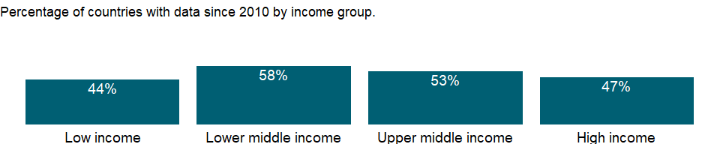

### Why is it relevant?

The indicator provides information on the proportion of women who are employed in decision-making and management roles in government, large enterprises and institutions.

### What is the data source?

International Labour Organization, ILOSTAT database. Data retrieved on January 29, 2021.

### What is the methodology?

NA

### How is it aggregated?

NA

### What are the limitations?

NA

### What else should I know?

NA

### 1.75.20 Employment to population ratio, 15+, female (%) (national estimate)

### What is the indicator?

Employment to population ratio is the proportion of a country’s population that is employed. Employment is defined as persons of working age who, during a short reference period, were engaged in any activity to produce goods or provide services for pay or profit, whether at work during the reference period (i.e. who worked in a job for at least one hour) or not at work due to temporary absence from a job, or to working-time arrangements. Ages 15 and older are generally considered the working-age population.

Topic: Social Protection & Labor: Economic activity

Series ID: SL.EMP.TOTL.SP.FE.NE.ZS

Copyright: CC BY-4.0 , <https://datacatalog.worldbank.org/public-licenses#cc-by>

First year with any data: 1960

Last year with any data: 2020

### What years are data available?

The figure below shows years in which data is available for at least one country. Dates shaded in black have no data, while dates shaded in green have data for at least one country



### Which countries have data?

The figure below shows the percentage of countries in each income group with a value since 2010 for that indicator.

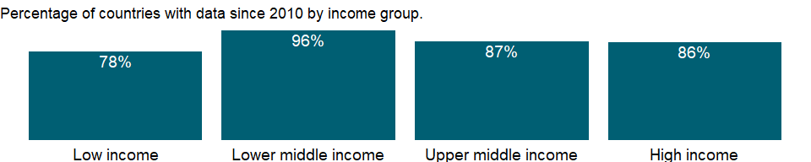

### Why is it relevant?

Four targets were added to the UN Millennium Declaration at the 2005 World Summit High-Level Plenary Meeting of the 60th Session of the UN General Assembly. One was full and productive employment and decent work for all, which is seen as the main route for people to escape poverty. Employment to population ratio is a key measure to monitor whether a country is on track to achieve the Millennium Development Goal of eradicating extreme poverty and hunger by 2015. And it continues to be a priority in the Sustainable Development Goal of promoting sustained, inclusive and sustainable economic growth, full and productive employment and decent work for all.

### What is the data source?

International Labour Organization, ILOSTAT database. Data retrieved on September 7, 2021.

### What is the methodology?

The employment to population ratio indicates how efficiently an economy provides jobs for people who want to work. A high ratio means that a large proportion of the population is employed. But a lower employment to population ratio can be seen as a positive sign, especially for young people, if it is caused by an increase in their education.

### How is it aggregated?

Weighted Average

### What are the limitations?

Data on employment by status are drawn from labor force surveys and household surveys, supplemented by official estimates and censuses for a small group of countries. The labor force survey is the most comprehensive source for internationally comparable employment, but there are still some limitations for comparing data across countries and over time even within a country.

Comparability of employment ratios across countries is affected by variations in definitions of employment and population. The biggest difference results from the age range used to define labor force activity. The population base for employment ratios can also vary. Most countries use the resident, non-institutionalized population of working age living in private households, which excludes members of the armed forces and individuals residing in mental, penal, or other types of institutions. But some countries include members of the armed forces in the population base of their employment ratio while excluding them from employment data.

The reference period of a census or survey is another important source of differences: in some countries data refer to people’s status on the day of the census or survey or during a specific period before the inquiry date, while in others data are recorded without reference to any period. Employment ratios tend to vary during the year as seasonal workers enter and leave.

This indicator also has a gender bias because women who do not consider their work employment or who are not perceived as working tend to be undercounted. This bias has different effects across countries and reflects demographic, social, legal, and cultural trends and norms.

### What else should I know?

The series for ILO estimates is also available in the WDI database. Caution should be used when comparing ILO estimates with national estimates.

### 1.75.21 Employment to population ratio, 15+, female (%) (modeled ILO estimate)

### What is the indicator?

Employment to population ratio is the proportion of a country’s population that is employed. Employment is defined as persons of working age who, during a short reference period, were engaged in any activity to produce goods or provide services for pay or profit, whether at work during the reference period (i.e. who worked in a job for at least one hour) or not at work due to temporary absence from a job, or to working-time arrangements. Ages 15 and older are generally considered the working-age population.

Topic: Social Protection & Labor: Economic activity

Series ID: SL.EMP.TOTL.SP.FE.ZS

Copyright: CC BY-4.0 , <https://datacatalog.worldbank.org/public-licenses#cc-by>

First year with any data: 1991

Last year with any data: 2019

### What years are data available?

The figure below shows years in which data is available for at least one country. Dates shaded in black have no data, while dates shaded in green have data for at least one country



### Which countries have data?

The figure below shows the percentage of countries in each income group with a value since 2010 for that indicator.



### Why is it relevant?

Four targets were added to the UN Millennium Declaration at the 2005 World Summit High-Level Plenary Meeting of the 60th Session of the UN General Assembly. One was full and productive employment and decent work for all, which is seen as the main route for people to escape poverty. Employment to population ratio is a key measure to monitor whether a country is on track to achieve the Millennium Development Goal of eradicating extreme poverty and hunger by 2015. And it continues to be a priority in the Sustainable Development Goal of promoting sustained, inclusive and sustainable economic growth, full and productive employment and decent work for all.

### What is the data source?

International Labour Organization, ILOSTAT database. Data retrieved on June 15, 2021.

### What is the methodology?

The employment to population ratio indicates how efficiently an economy provides jobs for people who want to work. A high ratio means that a large proportion of the population is employed. But a lower employment to population ratio can be seen as a positive sign, especially for young people, if it is caused by an increase in their education.

The series is part of the ILO estimates and is harmonized to ensure comparability across countries and over time by accounting for differences in data source, scope of coverage, methodology, and other country-specific factors. The estimates are based mainly on nationally representative labor force surveys, with other sources (population censuses and nationally reported estimates) used only when no survey data are available.

### How is it aggregated?

Weighted average

### What are the limitations?

Data on employment by status are drawn from labor force surveys and household surveys, supplemented by official estimates and censuses for a small group of countries. The labor force survey is the most comprehensive source for internationally comparable employment, but there are still some limitations for comparing data across countries and over time even within a country.

Comparability of employment ratios across countries is affected by variations in definitions of employment and population. The biggest difference results from the age range used to define labor force activity. The population base for employment ratios can also vary. Most countries use the resident, non-institutionalized population of working age living in private households, which excludes members of the armed forces and individuals residing in mental, penal, or other types of institutions. But some countries include members of the armed forces in the population base of their employment ratio while excluding them from employment data.

The reference period of a census or survey is another important source of differences: in some countries data refer to people’s status on the day of the census or survey or during a specific period before the inquiry date, while in others data are recorded without reference to any period. Employment ratios tend to vary during the year as seasonal workers enter and leave.

This indicator also has a gender bias because women who do not consider their work employment or who are not perceived as working tend to be undercounted. This bias has different effects across countries and reflects demographic, social, legal, and cultural trends and norms.

### What else should I know?

National estimates are also available in the WDI database. Caution should be used when comparing ILO estimates with national estimates.

### 1.75.22 Employment to population ratio, 15+, male (%) (national estimate)

### What is the indicator?

Employment to population ratio is the proportion of a country’s population that is employed. Employment is defined as persons of working age who, during a short reference period, were engaged in any activity to produce goods or provide services for pay or profit, whether at work during the reference period (i.e. who worked in a job for at least one hour) or not at work due to temporary absence from a job, or to working-time arrangements. Ages 15 and older are generally considered the working-age population.

Topic: Social Protection & Labor: Economic activity

Series ID: SL.EMP.TOTL.SP.MA.NE.ZS

Copyright: CC BY-4.0 , <https://datacatalog.worldbank.org/public-licenses#cc-by>

First year with any data: 1960

Last year with any data: 2020

### What years are data available?

The figure below shows years in which data is available for at least one country. Dates shaded in black have no data, while dates shaded in green have data for at least one country



### Which countries have data?

The figure below shows the percentage of countries in each income group with a value since 2010 for that indicator.

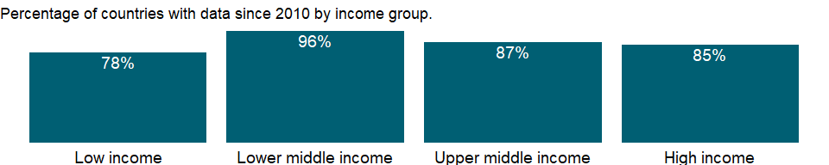

### Why is it relevant?

Four targets were added to the UN Millennium Declaration at the 2005 World Summit High-Level Plenary Meeting of the 60th Session of the UN General Assembly. One was full and productive employment and decent work for all, which is seen as the main route for people to escape poverty. Employment to population ratio is a key measure to monitor whether a country is on track to achieve the Millennium Development Goal of eradicating extreme poverty and hunger by 2015. And it continues to be a priority in the Sustainable Development Goal of promoting sustained, inclusive and sustainable economic growth, full and productive employment and decent work for all.

### What is the data source?

International Labour Organization, ILOSTAT database. Data retrieved on September 7, 2021.

### What is the methodology?

The employment to population ratio indicates how efficiently an economy provides jobs for people who want to work. A high ratio means that a large proportion of the population is employed. But a lower employment to population ratio can be seen as a positive sign, especially for young people, if it is caused by an increase in their education.

### How is it aggregated?

Weighted Average

### What are the limitations?

Data on employment by status are drawn from labor force surveys and household surveys, supplemented by official estimates and censuses for a small group of countries. The labor force survey is the most comprehensive source for internationally comparable employment, but there are still some limitations for comparing data across countries and over time even within a country.

Comparability of employment ratios across countries is affected by variations in definitions of employment and population. The biggest difference results from the age range used to define labor force activity. The population base for employment ratios can also vary. Most countries use the resident, non-institutionalized population of working age living in private households, which excludes members of the armed forces and individuals residing in mental, penal, or other types of institutions. But some countries include members of the armed forces in the population base of their employment ratio while excluding them from employment data.

The reference period of a census or survey is another important source of differences: in some countries data refer to people’s status on the day of the census or survey or during a specific period before the inquiry date, while in others data are recorded without reference to any period. Employment ratios tend to vary during the year as seasonal workers enter and leave.

This indicator also has a gender bias because women who do not consider their work employment or who are not perceived as working tend to be undercounted. This bias has different effects across countries and reflects demographic, social, legal, and cultural trends and norms.

### What else should I know?

The series for ILO estimates is also available in the WDI database. Caution should be used when comparing ILO estimates with national estimates.

### 1.75.23 Employment to population ratio, 15+, male (%) (modeled ILO estimate)

### What is the indicator?

Employment to population ratio is the proportion of a country’s population that is employed. Employment is defined as persons of working age who, during a short reference period, were engaged in any activity to produce goods or provide services for pay or profit, whether at work during the reference period (i.e. who worked in a job for at least one hour) or not at work due to temporary absence from a job, or to working-time arrangements. Ages 15 and older are generally considered the working-age population.

Topic: Social Protection & Labor: Economic activity

Series ID: SL.EMP.TOTL.SP.MA.ZS

Copyright: CC BY-4.0 , <https://datacatalog.worldbank.org/public-licenses#cc-by>

First year with any data: 1991

Last year with any data: 2019

### What years are data available?

The figure below shows years in which data is available for at least one country. Dates shaded in black have no data, while dates shaded in green have data for at least one country



### Which countries have data?

The figure below shows the percentage of countries in each income group with a value since 2010 for that indicator.



### Why is it relevant?

Four targets were added to the UN Millennium Declaration at the 2005 World Summit High-Level Plenary Meeting of the 60th Session of the UN General Assembly. One was full and productive employment and decent work for all, which is seen as the main route for people to escape poverty. Employment to population ratio is a key measure to monitor whether a country is on track to achieve the Millennium Development Goal of eradicating extreme poverty and hunger by 2015. And it continues to be a priority in the Sustainable Development Goal of promoting sustained, inclusive and sustainable economic growth, full and productive employment and decent work for all.

### What is the data source?

International Labour Organization, ILOSTAT database. Data retrieved on June 15, 2021.

### What is the methodology?

The employment to population ratio indicates how efficiently an economy provides jobs for people who want to work. A high ratio means that a large proportion of the population is employed. But a lower employment to population ratio can be seen as a positive sign, especially for young people, if it is caused by an increase in their education.

The series is part of the ILO estimates and is harmonized to ensure comparability across countries and over time by accounting for differences in data source, scope of coverage, methodology, and other country-specific factors. The estimates are based mainly on nationally representative labor force surveys, with other sources (population censuses and nationally reported estimates) used only when no survey data are available.

### How is it aggregated?

Weighted average

### What are the limitations?

Data on employment by status are drawn from labor force surveys and household surveys, supplemented by official estimates and censuses for a small group of countries. The labor force survey is the most comprehensive source for internationally comparable employment, but there are still some limitations for comparing data across countries and over time even within a country.

Comparability of employment ratios across countries is affected by variations in definitions of employment and population. The biggest difference results from the age range used to define labor force activity. The population base for employment ratios can also vary. Most countries use the resident, non-institutionalized population of working age living in private households, which excludes members of the armed forces and individuals residing in mental, penal, or other types of institutions. But some countries include members of the armed forces in the population base of their employment ratio while excluding them from employment data.

The reference period of a census or survey is another important source of differences: in some countries data refer to people’s status on the day of the census or survey or during a specific period before the inquiry date, while in others data are recorded without reference to any period. Employment ratios tend to vary during the year as seasonal workers enter and leave.

This indicator also has a gender bias because women who do not consider their work employment or who are not perceived as working tend to be undercounted. This bias has different effects across countries and reflects demographic, social, legal, and cultural trends and norms.

### What else should I know?

National estimates are also available in the WDI database. Caution should be used when comparing ILO estimates with national estimates.

### 1.75.24 Employment to population ratio, 15+, total (%) (national estimate)

### What is the indicator?

Employment to population ratio is the proportion of a country’s population that is employed. Employment is defined as persons of working age who, during a short reference period, were engaged in any activity to produce goods or provide services for pay or profit, whether at work during the reference period (i.e. who worked in a job for at least one hour) or not at work due to temporary absence from a job, or to working-time arrangements. Ages 15 and older are generally considered the working-age population.

Topic: Social Protection & Labor: Economic activity

Series ID: SL.EMP.TOTL.SP.NE.ZS

Copyright: CC BY-4.0 , <https://datacatalog.worldbank.org/public-licenses#cc-by>

First year with any data: 1960

Last year with any data: 2020

### What years are data available?

The figure below shows years in which data is available for at least one country. Dates shaded in black have no data, while dates shaded in green have data for at least one country



### Which countries have data?

The figure below shows the percentage of countries in each income group with a value since 2010 for that indicator.

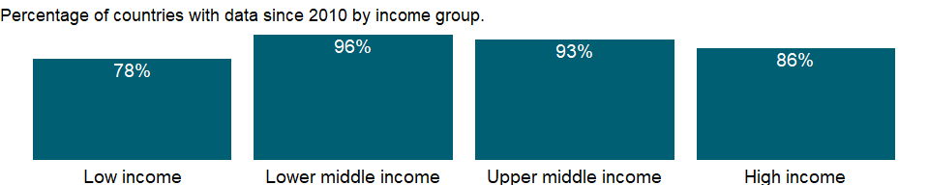

### Why is it relevant?

Four targets were added to the UN Millennium Declaration at the 2005 World Summit High-Level Plenary Meeting of the 60th Session of the UN General Assembly. One was full and productive employment and decent work for all, which is seen as the main route for people to escape poverty. Employment to population ratio is a key measure to monitor whether a country is on track to achieve the Millennium Development Goal of eradicating extreme poverty and hunger by 2015. And it continues to be a priority in the Sustainable Development Goal of promoting sustained, inclusive and sustainable economic growth, full and productive employment and decent work for all.

### What is the data source?

International Labour Organization, ILOSTAT database. Data retrieved on September 7, 2021.

### What is the methodology?

The employment to population ratio indicates how efficiently an economy provides jobs for people who want to work. A high ratio means that a large proportion of the population is employed. But a lower employment to population ratio can be seen as a positive sign, especially for young people, if it is caused by an increase in their education.

### How is it aggregated?

Weighted Average

### What are the limitations?

Data on employment by status are drawn from labor force surveys and household surveys, supplemented by official estimates and censuses for a small group of countries. The labor force survey is the most comprehensive source for internationally comparable employment, but there are still some limitations for comparing data across countries and over time even within a country.

Comparability of employment ratios across countries is affected by variations in definitions of employment and population. The biggest difference results from the age range used to define labor force activity. The population base for employment ratios can also vary. Most countries use the resident, non-institutionalized population of working age living in private households, which excludes members of the armed forces and individuals residing in mental, penal, or other types of institutions. But some countries include members of the armed forces in the population base of their employment ratio while excluding them from employment data.

The reference period of a census or survey is another important source of differences: in some countries data refer to people’s status on the day of the census or survey or during a specific period before the inquiry date, while in others data are recorded without reference to any period. Employment ratios tend to vary during the year as seasonal workers enter and leave.

This indicator also has a gender bias because women who do not consider their work employment or who are not perceived as working tend to be undercounted. This bias has different effects across countries and reflects demographic, social, legal, and cultural trends and norms.

### What else should I know?

The series for ILO estimates is also available in the WDI database. Caution should be used when comparing ILO estimates with national estimates.

### 1.75.25 Employment to population ratio, 15+, total (%) (modeled ILO estimate)

### What is the indicator?

Employment to population ratio is the proportion of a country’s population that is employed. Employment is defined as persons of working age who, during a short reference period, were engaged in any activity to produce goods or provide services for pay or profit, whether at work during the reference period (i.e. who worked in a job for at least one hour) or not at work due to temporary absence from a job, or to working-time arrangements. Ages 15 and older are generally considered the working-age population.

Topic: Social Protection & Labor: Economic activity

Series ID: SL.EMP.TOTL.SP.ZS

Copyright: CC BY-4.0 , <https://datacatalog.worldbank.org/public-licenses#cc-by>

First year with any data: 1991

Last year with any data: 2020

### What years are data available?

The figure below shows years in which data is available for at least one country. Dates shaded in black have no data, while dates shaded in green have data for at least one country

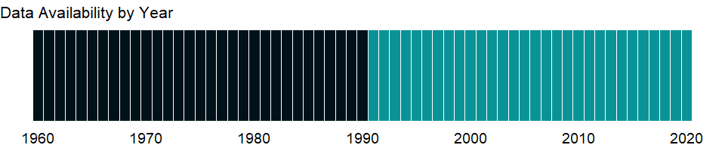

### Which countries have data?

The figure below shows the percentage of countries in each income group with a value since 2010 for that indicator.



### Why is it relevant?

Four targets were added to the UN Millennium Declaration at the 2005 World Summit High-Level Plenary Meeting of the 60th Session of the UN General Assembly. One was full and productive employment and decent work for all, which is seen as the main route for people to escape poverty. Employment to population ratio is a key measure to monitor whether a country is on track to achieve the Millennium Development Goal of eradicating extreme poverty and hunger by 2015. And it continues to be a priority in the Sustainable Development Goal of promoting sustained, inclusive and sustainable economic growth, full and productive employment and decent work for all.

### What is the data source?

International Labour Organization, ILOSTAT database. Data retrieved on June 15, 2021.

### What is the methodology?

The employment to population ratio indicates how efficiently an economy provides jobs for people who want to work. A high ratio means that a large proportion of the population is employed. But a lower employment to population ratio can be seen as a positive sign, especially for young people, if it is caused by an increase in their education.

The series is part of the ILO estimates and is harmonized to ensure comparability across countries and over time by accounting for differences in data source, scope of coverage, methodology, and other country-specific factors. The estimates are based mainly on nationally representative labor force surveys, with other sources (population censuses and nationally reported estimates) used only when no survey data are available.

### How is it aggregated?

Weighted average

### What are the limitations?

Data on employment by status are drawn from labor force surveys and household surveys, supplemented by official estimates and censuses for a small group of countries. The labor force survey is the most comprehensive source for internationally comparable employment, but there are still some limitations for comparing data across countries and over time even within a country.

Comparability of employment ratios across countries is affected by variations in definitions of employment and population. The biggest difference results from the age range used to define labor force activity. The population base for employment ratios can also vary. Most countries use the resident, non-institutionalized population of working age living in private households, which excludes members of the armed forces and individuals residing in mental, penal, or other types of institutions. But some countries include members of the armed forces in the population base of their employment ratio while excluding them from employment data.

The reference period of a census or survey is another important source of differences: in some countries data refer to people’s status on the day of the census or survey or during a specific period before the inquiry date, while in others data are recorded without reference to any period. Employment ratios tend to vary during the year as seasonal workers enter and leave.

This indicator also has a gender bias because women who do not consider their work employment or who are not perceived as working tend to be undercounted. This bias has different effects across countries and reflects demographic, social, legal, and cultural trends and norms.

### What else should I know?

National estimates are also available in the WDI database. Caution should be used when comparing ILO estimates with national estimates.

### 1.75.26 Vulnerable employment, female (% of female employment) (modeled ILO estimate)

### What is the indicator?

Vulnerable employment is contributing family workers and own-account workers as a percentage of total employment.

Topic: Social Protection & Labor: Economic activity

Series ID: SL.EMP.VULN.FE.ZS

Copyright: CC BY-4.0 , <https://datacatalog.worldbank.org/public-licenses#cc-by>

First year with any data: 1991

Last year with any data: 2019

### What years are data available?

The figure below shows years in which data is available for at least one country. Dates shaded in black have no data, while dates shaded in green have data for at least one country



### Which countries have data?

The figure below shows the percentage of countries in each income group with a value since 2010 for that indicator.



### Why is it relevant?

Breaking down employment information by status in employment provides a statistical basis for describing workers’ behaviour and conditions of work, and for defining an individual’s socio-economic group. A high proportion of wage and salaried workers in a country can signify advanced economic development. If the proportion of own-account workers (self-employed without hired employees) is sizeable, it may be an indication of a large agriculture sector and low growth in the formal economy. A high proportion of contributing family workers — generally unpaid, although compensation might come indirectly in the form of family income — may indicate weak development, little job growth, and often a large rural economy.

Each status group faces different economic risks, and contributing family workers and own-account workers are the most vulnerable - and therefore the most likely to fall into poverty. They are the least likely to have formal work arrangements, are the least likely to have social protection and safety nets to guard against economic shocks, and often are incapable of generating sufficient savings to offset these shocks.

### What is the data source?

Derived using data from International Labour Organization, ILOSTAT database. The data retrieved on January 29, 2021.

### What is the methodology?

The indicator of status in employment distinguishes between two categories of the total employed. These are: (a) wage and salaried workers (also known as employees); and (b) self-employed workers. Self-employed group is broken down in the subcategories: self-employed workers with employees (employers), self-employed workers without employees (own-account workers), members of producers’ cooperatives and contributing family workers (also known as unpaid family workers). Vulnerable employment refers to the sum of contributing family workers and own-account workers.

Data are derived using ILO modeled estimate series which are harmonized to ensure comparability across countries and over time by accounting for differences in data source, scope of coverage, methodology, and other country-specific factors. The estimates are based mainly on nationally representative labor force surveys, with other sources (population censuses and nationally reported estimates) used only when no survey data are available.

### How is it aggregated?

Weighted average

### What are the limitations?

Data are drawn from labor force surveys and household surveys, supplemented by official estimates and censuses for a small group of countries. Due to differences in definitions and coverage across countries, there are limitations for comparing data across countries and over time even within a country. Estimates of women in employment are not comparable internationally, reflecting that demographic, social, legal, and cultural trends and norms determine whether women’s activities are regarded as economic.

### What else should I know?

NA

### 1.75.27 Vulnerable employment, male (% of male employment) (modeled ILO estimate)

### What is the indicator?

Vulnerable employment is contributing family workers and own-account workers as a percentage of total employment.

Topic: Social Protection & Labor: Economic activity

Series ID: SL.EMP.VULN.MA.ZS

Copyright: CC BY-4.0 , <https://datacatalog.worldbank.org/public-licenses#cc-by>

First year with any data: 1991

Last year with any data: 2019

### What years are data available?

The figure below shows years in which data is available for at least one country. Dates shaded in black have no data, while dates shaded in green have data for at least one country



### Which countries have data?

The figure below shows the percentage of countries in each income group with a value since 2010 for that indicator.



### Why is it relevant?

Breaking down employment information by status in employment provides a statistical basis for describing workers’ behaviour and conditions of work, and for defining an individual’s socio-economic group. A high proportion of wage and salaried workers in a country can signify advanced economic development. If the proportion of own-account workers (self-employed without hired employees) is sizeable, it may be an indication of a large agriculture sector and low growth in the formal economy. A high proportion of contributing family workers — generally unpaid, although compensation might come indirectly in the form of family income — may indicate weak development, little job growth, and often a large rural economy.

Each status group faces different economic risks, and contributing family workers and own-account workers are the most vulnerable - and therefore the most likely to fall into poverty. They are the least likely to have formal work arrangements, are the least likely to have social protection and safety nets to guard against economic shocks, and often are incapable of generating sufficient savings to offset these shocks.

### What is the data source?

Derived using data from International Labour Organization, ILOSTAT database. The data retrieved on January 29, 2021.

### What is the methodology?

The indicator of status in employment distinguishes between two categories of the total employed. These are: (a) wage and salaried workers (also known as employees); and (b) self-employed workers. Self-employed group is broken down in the subcategories: self-employed workers with employees (employers), self-employed workers without employees (own-account workers), members of producers’ cooperatives and contributing family workers (also known as unpaid family workers). Vulnerable employment refers to the sum of contributing family workers and own-account workers.

Data are derived using ILO modeled estimate series which are harmonized to ensure comparability across countries and over time by accounting for differences in data source, scope of coverage, methodology, and other country-specific factors. The estimates are based mainly on nationally representative labor force surveys, with other sources (population censuses and nationally reported estimates) used only when no survey data are available.

### How is it aggregated?

Weighted average

### What are the limitations?

Data are drawn from labor force surveys and household surveys, supplemented by official estimates and censuses for a small group of countries. Due to differences in definitions and coverage across countries, there are limitations for comparing data across countries and over time even within a country. Estimates of women in employment are not comparable internationally, reflecting that demographic, social, legal, and cultural trends and norms determine whether women’s activities are regarded as economic.

### What else should I know?

NA

### 1.75.28 Vulnerable employment, total (% of total employment) (modeled ILO estimate)

### What is the indicator?

Vulnerable employment is contributing family workers and own-account workers as a percentage of total employment.

Topic: Social Protection & Labor: Economic activity

Series ID: SL.EMP.VULN.ZS

Copyright: CC BY-4.0 , <https://datacatalog.worldbank.org/public-licenses#cc-by>

First year with any data: 1991

Last year with any data: 2019

### What years are data available?

The figure below shows years in which data is available for at least one country. Dates shaded in black have no data, while dates shaded in green have data for at least one country



### Which countries have data?

The figure below shows the percentage of countries in each income group with a value since 2010 for that indicator.



### Why is it relevant?

Breaking down employment information by status in employment provides a statistical basis for describing workers’ behaviour and conditions of work, and for defining an individual’s socio-economic group. A high proportion of wage and salaried workers in a country can signify advanced economic development. If the proportion of own-account workers (self-employed without hired employees) is sizeable, it may be an indication of a large agriculture sector and low growth in the formal economy. A high proportion of contributing family workers — generally unpaid, although compensation might come indirectly in the form of family income — may indicate weak development, little job growth, and often a large rural economy.

Each status group faces different economic risks, and contributing family workers and own-account workers are the most vulnerable - and therefore the most likely to fall into poverty. They are the least likely to have formal work arrangements, are the least likely to have social protection and safety nets to guard against economic shocks, and often are incapable of generating sufficient savings to offset these shocks.

### What is the data source?

Derived using data from International Labour Organization, ILOSTAT database. The data retrieved on January 29, 2021.

### What is the methodology?

The indicator of status in employment distinguishes between two categories of the total employed. These are: (a) wage and salaried workers (also known as employees); and (b) self-employed workers. Self-employed group is broken down in the subcategories: self-employed workers with employees (employers), self-employed workers without employees (own-account workers), members of producers’ cooperatives and contributing family workers (also known as unpaid family workers). Vulnerable employment refers to the sum of contributing family workers and own-account workers.

Data are derived using ILO modeled estimate series which are harmonized to ensure comparability across countries and over time by accounting for differences in data source, scope of coverage, methodology, and other country-specific factors. The estimates are based mainly on nationally representative labor force surveys, with other sources (population censuses and nationally reported estimates) used only when no survey data are available.

### How is it aggregated?

Weighted average

### What are the limitations?

Data are drawn from labor force surveys and household surveys, supplemented by official estimates and censuses for a small group of countries. Due to differences in definitions and coverage across countries, there are limitations for comparing data across countries and over time even within a country. Estimates of women in employment are not comparable internationally, reflecting that demographic, social, legal, and cultural trends and norms determine whether women’s activities are regarded as economic.

### What else should I know?

NA

### 1.75.29 Wage and salaried workers, female (% of female employment) (modeled ILO estimate)

### What is the indicator?

Wage and salaried workers (employees) are those workers who hold the type of jobs defined as “paid employment jobs,” where the incumbents hold explicit (written or oral) or implicit employment contracts that give them a basic remuneration that is not directly dependent upon the revenue of the unit for which they work.

Topic: Social Protection & Labor: Economic activity

Series ID: SL.EMP.WORK.FE.ZS

Copyright: CC BY-4.0 , <https://datacatalog.worldbank.org/public-licenses#cc-by>

First year with any data: 1991

Last year with any data: 2019

### What years are data available?

The figure below shows years in which data is available for at least one country. Dates shaded in black have no data, while dates shaded in green have data for at least one country



### Which countries have data?

The figure below shows the percentage of countries in each income group with a value since 2010 for that indicator.



### Why is it relevant?

Breaking down employment information by status in employment provides a statistical basis for describing workers’ behaviour and conditions of work, and for defining an individual’s socio-economic group. A high proportion of wage and salaried workers in a country can signify advanced economic development. If the proportion of own-account workers (self-employed without hired employees) is sizeable, it may be an indication of a large agriculture sector and low growth in the formal economy. A high proportion of contributing family workers — generally unpaid, although compensation might come indirectly in the form of family income — may indicate weak development, little job growth, and often a large rural economy.

Each status group faces different economic risks, and contributing family workers and own-account workers are the most vulnerable - and therefore the most likely to fall into poverty. They are the least likely to have formal work arrangements, are the least likely to have social protection and safety nets to guard against economic shocks, and often are incapable of generating sufficient savings to offset these shocks.

### What is the data source?

International Labour Organization, ILOSTAT database. Data retrieved on January 29, 2021.

### What is the methodology?

The indicator of status in employment distinguishes between two categories of the total employed. These are: (a) wage and salaried workers (also known as employees); and (b) self-employed workers. Self-employed group is broken down in the subcategories: self-employed workers with employees (employers), self-employed workers without employees (own-account workers), members of producers’ cooperatives and contributing family workers (also known as unpaid family workers). Vulnerable employment refers to the sum of contributing family workers and own-account workers.

The series is part of the ILO estimates and is harmonized to ensure comparability across countries and over time by accounting for differences in data source, scope of coverage, methodology, and other country-specific factors. The estimates are based mainly on nationally representative labor force surveys, with other sources (population censuses and nationally reported estimates) used only when no survey data are available.

### How is it aggregated?

Weighted average

### What are the limitations?

Data are drawn from labor force surveys and household surveys, supplemented by official estimates and censuses for a small group of countries. Due to differences in definitions and coverage across countries, there are limitations for comparing data across countries and over time even within a country. Estimates of women in employment are not comparable internationally, reflecting that demographic, social, legal, and cultural trends and norms determine whether women’s activities are regarded as economic.

### What else should I know?

NA

### 1.75.30 Wage and salaried workers, male (% of male employment) (modeled ILO estimate)

### What is the indicator?

Wage and salaried workers (employees) are those workers who hold the type of jobs defined as “paid employment jobs,” where the incumbents hold explicit (written or oral) or implicit employment contracts that give them a basic remuneration that is not directly dependent upon the revenue of the unit for which they work.

Topic: Social Protection & Labor: Economic activity

Series ID: SL.EMP.WORK.MA.ZS

Copyright: CC BY-4.0 , <https://datacatalog.worldbank.org/public-licenses#cc-by>

First year with any data: 1991

Last year with any data: 2019

### What years are data available?

The figure below shows years in which data is available for at least one country. Dates shaded in black have no data, while dates shaded in green have data for at least one country



### Which countries have data?

The figure below shows the percentage of countries in each income group with a value since 2010 for that indicator.



### Why is it relevant?

Breaking down employment information by status in employment provides a statistical basis for describing workers’ behaviour and conditions of work, and for defining an individual’s socio-economic group. A high proportion of wage and salaried workers in a country can signify advanced economic development. If the proportion of own-account workers (self-employed without hired employees) is sizeable, it may be an indication of a large agriculture sector and low growth in the formal economy. A high proportion of contributing family workers — generally unpaid, although compensation might come indirectly in the form of family income — may indicate weak development, little job growth, and often a large rural economy.

Each status group faces different economic risks, and contributing family workers and own-account workers are the most vulnerable - and therefore the most likely to fall into poverty. They are the least likely to have formal work arrangements, are the least likely to have social protection and safety nets to guard against economic shocks, and often are incapable of generating sufficient savings to offset these shocks.

### What is the data source?

International Labour Organization, ILOSTAT database. Data retrieved on January 29, 2021.

### What is the methodology?

The indicator of status in employment distinguishes between two categories of the total employed. These are: (a) wage and salaried workers (also known as employees); and (b) self-employed workers. Self-employed group is broken down in the subcategories: self-employed workers with employees (employers), self-employed workers without employees (own-account workers), members of producers’ cooperatives and contributing family workers (also known as unpaid family workers). Vulnerable employment refers to the sum of contributing family workers and own-account workers.

The series is part of the ILO estimates and is harmonized to ensure comparability across countries and over time by accounting for differences in data source, scope of coverage, methodology, and other country-specific factors. The estimates are based mainly on nationally representative labor force surveys, with other sources (population censuses and nationally reported estimates) used only when no survey data are available.

### How is it aggregated?

Weighted average

### What are the limitations?

Data are drawn from labor force surveys and household surveys, supplemented by official estimates and censuses for a small group of countries. Due to differences in definitions and coverage across countries, there are limitations for comparing data across countries and over time even within a country. Estimates of women in employment are not comparable internationally, reflecting that demographic, social, legal, and cultural trends and norms determine whether women’s activities are regarded as economic.

### What else should I know?

NA

### 1.75.31 Wage and salaried workers, total (% of total employment) (modeled ILO estimate)

### What is the indicator?

Wage and salaried workers (employees) are those workers who hold the type of jobs defined as “paid employment jobs,” where the incumbents hold explicit (written or oral) or implicit employment contracts that give them a basic remuneration that is not directly dependent upon the revenue of the unit for which they work.

Topic: Social Protection & Labor: Economic activity

Series ID: SL.EMP.WORK.ZS

Copyright: CC BY-4.0 , <https://datacatalog.worldbank.org/public-licenses#cc-by>

First year with any data: 1991

Last year with any data: 2019

### What years are data available?

The figure below shows years in which data is available for at least one country. Dates shaded in black have no data, while dates shaded in green have data for at least one country



### Which countries have data?

The figure below shows the percentage of countries in each income group with a value since 2010 for that indicator.



### Why is it relevant?

Breaking down employment information by status in employment provides a statistical basis for describing workers’ behaviour and conditions of work, and for defining an individual’s socio-economic group. A high proportion of wage and salaried workers in a country can signify advanced economic development. If the proportion of own-account workers (self-employed without hired employees) is sizeable, it may be an indication of a large agriculture sector and low growth in the formal economy. A high proportion of contributing family workers — generally unpaid, although compensation might come indirectly in the form of family income — may indicate weak development, little job growth, and often a large rural economy.

Each status group faces different economic risks, and contributing family workers and own-account workers are the most vulnerable - and therefore the most likely to fall into poverty. They are the least likely to have formal work arrangements, are the least likely to have social protection and safety nets to guard against economic shocks, and often are incapable of generating sufficient savings to offset these shocks.

### What is the data source?

International Labour Organization, ILOSTAT database. Data retrieved on January 29, 2021.

### What is the methodology?

The indicator of status in employment distinguishes between two categories of the total employed. These are: (a) wage and salaried workers (also known as employees); and (b) self-employed workers. Self-employed group is broken down in the subcategories: self-employed workers with employees (employers), self-employed workers without employees (own-account workers), members of producers’ cooperatives and contributing family workers (also known as unpaid family workers). Vulnerable employment refers to the sum of contributing family workers and own-account workers.

The series is part of the ILO estimates and is harmonized to ensure comparability across countries and over time by accounting for differences in data source, scope of coverage, methodology, and other country-specific factors. The estimates are based mainly on nationally representative labor force surveys, with other sources (population censuses and nationally reported estimates) used only when no survey data are available.

### How is it aggregated?

Weighted average

### What are the limitations?

Data are drawn from labor force surveys and household surveys, supplemented by official estimates and censuses for a small group of countries. Due to differences in definitions and coverage across countries, there are limitations for comparing data across countries and over time even within a country. Estimates of women in employment are not comparable internationally, reflecting that demographic, social, legal, and cultural trends and norms determine whether women’s activities are regarded as economic.

### What else should I know?

NA

### 1.75.32 Children in employment, unpaid family workers, female (% of female children in employment, ages 7-14)

### What is the indicator?

Unpaid family workers are people who work without pay in a market-oriented establishment operated by a related person living in the same household.

Topic: Social Protection & Labor: Economic activity

Series ID: SL.FAM.0714.FE.ZS

Copyright: CC BY-4.0 , <https://datacatalog.worldbank.org/public-licenses#cc-by>

First year with any data: 1999

Last year with any data: 2016

### What years are data available?

The figure below shows years in which data is available for at least one country. Dates shaded in black have no data, while dates shaded in green have data for at least one country

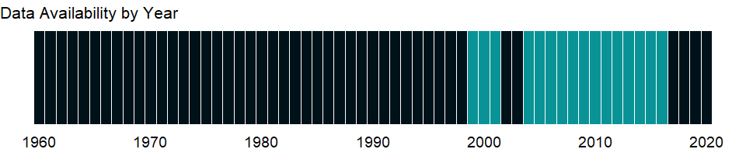

### Which countries have data?

The figure below shows the percentage of countries in each income group with a value since 2010 for that indicator.

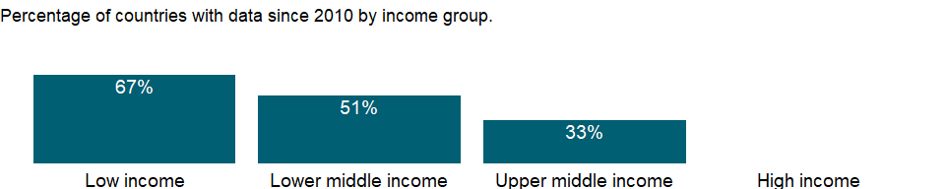

### Why is it relevant?

In most countries more boys are involved in employment, or the gender difference is small. However, girls are often more present in hidden or underreported forms of employment such as domestic service, and in almost all societies girls bear greater responsibility for household chores in their own homes, work that lies outside the System of National Accounts production boundary and is thus not considered in estimates of children’s employment.

### What is the data source?

Understanding Children’s Work project based on data from ILO, UNICEF and the World Bank.

### What is the methodology?

Data are from household surveys by the International Labor Organization (ILO), the United Nations Children’s Fund (UNICEF), the World Bank, and national statistical offices. The surveys yield data on education, employment, health, expenditure, and consumption indicators related to children’s work. Since children’s work is captured in the sense of “economic activity,” the data refer to children in employment, a broader concept than child labor (see ILO 2009a for details on this distinction).

Household survey data generally include information on work type - for example, whether a child is working for payment in cash or in kind or is involved in unpaid work, working for someone who is not a member of the household, or involved in any type of family work (on the farm or in a business).

In line with the definition of economic activity adopted by the 13th International Conference of Labour Statisticians, the threshold set by the 1993 UN System of National Accounts for classifying a person as employed is to have been engaged at least one hour in any activity relating to the production of goods and services during the reference period. Children seeking work are thus excluded. Economic activity covers all market production and certain nonmarket production, including production of goods for own use. It excludes unpaid household services (commonly called “household chores”) - that is, the production of domestic and personal services by household members for a household’s own consumption.

Country surveys define the ages for child labor as 5-17. The data here have been recalculated to present statistics for children ages 7-14.

### How is it aggregated?

NA

### What are the limitations?

Although efforts are made to harmonize the definition of employment and the questions on employment in survey questionnaires, significant differences remain in the survey instruments that collect data on children in employment and in the sampling design underlying the surveys. Differences exist not only across different household surveys in the same country but also across the same type of survey carried out in different countries, so estimates of working children are not fully comparable across countries. In addition, the shares of three categories (self-employed workers, wage workers, and unpaid family workers) may not add up to 100 percent because of a residual category not included.

### What else should I know?

NA

### 1.75.33 Children in employment, unpaid family workers, male (% of male children in employment, ages 7-14)

### What is the indicator?

Unpaid family workers are people who work without pay in a market-oriented establishment operated by a related person living in the same household.

Topic: Social Protection & Labor: Economic activity

Series ID: SL.FAM.0714.MA.ZS

Copyright: CC BY-4.0 , <https://datacatalog.worldbank.org/public-licenses#cc-by>

First year with any data: 1999

Last year with any data: 2016

### What years are data available?

The figure below shows years in which data is available for at least one country. Dates shaded in black have no data, while dates shaded in green have data for at least one country



### Which countries have data?

The figure below shows the percentage of countries in each income group with a value since 2010 for that indicator.



### Why is it relevant?

In most countries more boys are involved in employment, or the gender difference is small. However, girls are often more present in hidden or underreported forms of employment such as domestic service, and in almost all societies girls bear greater responsibility for household chores in their own homes, work that lies outside the System of National Accounts production boundary and is thus not considered in estimates of children’s employment.

### What is the data source?

Understanding Children’s Work project based on data from ILO, UNICEF and the World Bank.

### What is the methodology?

Data are from household surveys by the International Labor Organization (ILO), the United Nations Children’s Fund (UNICEF), the World Bank, and national statistical offices. The surveys yield data on education, employment, health, expenditure, and consumption indicators related to children’s work. Since children’s work is captured in the sense of “economic activity,” the data refer to children in employment, a broader concept than child labor (see ILO 2009a for details on this distinction).

Household survey data generally include information on work type - for example, whether a child is working for payment in cash or in kind or is involved in unpaid work, working for someone who is not a member of the household, or involved in any type of family work (on the farm or in a business).

In line with the definition of economic activity adopted by the 13th International Conference of Labour Statisticians, the threshold set by the 1993 UN System of National Accounts for classifying a person as employed is to have been engaged at least one hour in any activity relating to the production of goods and services during the reference period. Children seeking work are thus excluded. Economic activity covers all market production and certain nonmarket production, including production of goods for own use. It excludes unpaid household services (commonly called “household chores”) - that is, the production of domestic and personal services by household members for a household’s own consumption.

Country surveys define the ages for child labor as 5-17. The data here have been recalculated to present statistics for children ages 7-14.

### How is it aggregated?

NA

### What are the limitations?

Although efforts are made to harmonize the definition of employment and the questions on employment in survey questionnaires, significant differences remain in the survey instruments that collect data on children in employment and in the sampling design underlying the surveys. Differences exist not only across different household surveys in the same country but also across the same type of survey carried out in different countries, so estimates of working children are not fully comparable across countries. In addition, the shares of three categories (self-employed workers, wage workers, and unpaid family workers) may not add up to 100 percent because of a residual category not included.

### What else should I know?

NA

### 1.75.34 Children in employment, unpaid family workers (% of children in employment, ages 7-14)

### What is the indicator?

Unpaid family workers are people who work without pay in a market-oriented establishment operated by a related person living in the same household.

Topic: Social Protection & Labor: Economic activity

Series ID: SL.FAM.0714.ZS

Copyright: CC BY-4.0 , <https://datacatalog.worldbank.org/public-licenses#cc-by>

First year with any data: 1999

Last year with any data: 2016

### What years are data available?

The figure below shows years in which data is available for at least one country. Dates shaded in black have no data, while dates shaded in green have data for at least one country



### Which countries have data?

The figure below shows the percentage of countries in each income group with a value since 2010 for that indicator.



### Why is it relevant?

In most countries more boys are involved in employment, or the gender difference is small. However, girls are often more present in hidden or underreported forms of employment such as domestic service, and in almost all societies girls bear greater responsibility for household chores in their own homes, work that lies outside the System of National Accounts production boundary and is thus not considered in estimates of children’s employment.

### What is the data source?

Understanding Children’s Work project based on data from ILO, UNICEF and the World Bank.

### What is the methodology?

Data are from household surveys by the International Labor Organization (ILO), the United Nations Children’s Fund (UNICEF), the World Bank, and national statistical offices. The surveys yield data on education, employment, health, expenditure, and consumption indicators related to children’s work. Since children’s work is captured in the sense of “economic activity,” the data refer to children in employment, a broader concept than child labor (see ILO 2009a for details on this distinction).

Household survey data generally include information on work type - for example, whether a child is working for payment in cash or in kind or is involved in unpaid work, working for someone who is not a member of the household, or involved in any type of family work (on the farm or in a business).

In line with the definition of economic activity adopted by the 13th International Conference of Labour Statisticians, the threshold set by the 1993 UN System of National Accounts for classifying a person as employed is to have been engaged at least one hour in any activity relating to the production of goods and services during the reference period. Children seeking work are thus excluded. Economic activity covers all market production and certain nonmarket production, including production of goods for own use. It excludes unpaid household services (commonly called “household chores”) - that is, the production of domestic and personal services by household members for a household’s own consumption.

Country surveys define the ages for child labor as 5-17. The data here have been recalculated to present statistics for children ages 7-14.

### How is it aggregated?

NA

### What are the limitations?

Although efforts are made to harmonize the definition of employment and the questions on employment in survey questionnaires, significant differences remain in the survey instruments that collect data on children in employment and in the sampling design underlying the surveys. Differences exist not only across different household surveys in the same country but also across the same type of survey carried out in different countries, so estimates of working children are not fully comparable across countries. In addition, the shares of three categories (self-employed workers, wage workers, and unpaid family workers) may not add up to 100 percent because of a residual category not included.

### What else should I know?

NA

### 1.75.35 Contributing family workers, female (% of female employment) (modeled ILO estimate)

### What is the indicator?

Contributing family workers are those workers who hold “self-employment jobs” as own-account workers in a market-oriented establishment operated by a related person living in the same household.

Topic: Social Protection & Labor: Economic activity

Series ID: SL.FAM.WORK.FE.ZS

Copyright: CC BY-4.0 , <https://datacatalog.worldbank.org/public-licenses#cc-by>

First year with any data: 1991

Last year with any data: 2019

### What years are data available?

The figure below shows years in which data is available for at least one country. Dates shaded in black have no data, while dates shaded in green have data for at least one country



### Which countries have data?

The figure below shows the percentage of countries in each income group with a value since 2010 for that indicator.



### Why is it relevant?

Breaking down employment information by status in employment provides a statistical basis for describing workers’ behaviour and conditions of work, and for defining an individual’s socio-economic group. A high proportion of wage and salaried workers in a country can signify advanced economic development. If the proportion of own-account workers (self-employed without hired employees) is sizeable, it may be an indication of a large agriculture sector and low growth in the formal economy. A high proportion of contributing family workers — generally unpaid, although compensation might come indirectly in the form of family income — may indicate weak development, little job growth, and often a large rural economy.

Each status group faces different economic risks, and contributing family workers and own-account workers are the most vulnerable - and therefore the most likely to fall into poverty. They are the least likely to have formal work arrangements, are the least likely to have social protection and safety nets to guard against economic shocks, and often are incapable of generating sufficient savings to offset these shocks.

### What is the data source?

International Labour Organization, ILOSTAT database. Data retrieved on January 29, 2021.

### What is the methodology?

The indicator of status in employment distinguishes between two categories of the total employed. These are: (a) wage and salaried workers (also known as employees); and (b) self-employed workers. Self-employed group is broken down in the subcategories: self-employed workers with employees (employers), self-employed workers without employees (own-account workers), members of producers’ cooperatives and contributing family workers (also known as unpaid family workers). Vulnerable employment refers to the sum of contributing family workers and own-account workers.

The series is part of the ILO estimates and is harmonized to ensure comparability across countries and over time by accounting for differences in data source, scope of coverage, methodology, and other country-specific factors. The estimates are based mainly on nationally representative labor force surveys, with other sources (population censuses and nationally reported estimates) used only when no survey data are available.

### How is it aggregated?

Weighted average

### What are the limitations?

Data are drawn from labor force surveys and household surveys, supplemented by official estimates and censuses for a small group of countries. Due to differences in definitions and coverage across countries, there are limitations for comparing data across countries and over time even within a country. Estimates of women in employment are not comparable internationally, reflecting that demographic, social, legal, and cultural trends and norms determine whether women’s activities are regarded as economic.

### What else should I know?

NA

### 1.75.36 Contributing family workers, male (% of male employment) (modeled ILO estimate)

### What is the indicator?

Contributing family workers are those workers who hold “self-employment jobs” as own-account workers in a market-oriented establishment operated by a related person living in the same household.

Topic: Social Protection & Labor: Economic activity

Series ID: SL.FAM.WORK.MA.ZS

Copyright: CC BY-4.0 , <https://datacatalog.worldbank.org/public-licenses#cc-by>

First year with any data: 1991

Last year with any data: 2019

### What years are data available?

The figure below shows years in which data is available for at least one country. Dates shaded in black have no data, while dates shaded in green have data for at least one country



### Which countries have data?

The figure below shows the percentage of countries in each income group with a value since 2010 for that indicator.



### Why is it relevant?

Breaking down employment information by status in employment provides a statistical basis for describing workers’ behaviour and conditions of work, and for defining an individual’s socio-economic group. A high proportion of wage and salaried workers in a country can signify advanced economic development. If the proportion of own-account workers (self-employed without hired employees) is sizeable, it may be an indication of a large agriculture sector and low growth in the formal economy. A high proportion of contributing family workers — generally unpaid, although compensation might come indirectly in the form of family income — may indicate weak development, little job growth, and often a large rural economy.

Each status group faces different economic risks, and contributing family workers and own-account workers are the most vulnerable - and therefore the most likely to fall into poverty. They are the least likely to have formal work arrangements, are the least likely to have social protection and safety nets to guard against economic shocks, and often are incapable of generating sufficient savings to offset these shocks.

### What is the data source?

International Labour Organization, ILOSTAT database. Data retrieved on January 29, 2021.

### What is the methodology?

The indicator of status in employment distinguishes between two categories of the total employed. These are: (a) wage and salaried workers (also known as employees); and (b) self-employed workers. Self-employed group is broken down in the subcategories: self-employed workers with employees (employers), self-employed workers without employees (own-account workers), members of producers’ cooperatives and contributing family workers (also known as unpaid family workers). Vulnerable employment refers to the sum of contributing family workers and own-account workers.

The series is part of the ILO estimates and is harmonized to ensure comparability across countries and over time by accounting for differences in data source, scope of coverage, methodology, and other country-specific factors. The estimates are based mainly on nationally representative labor force surveys, with other sources (population censuses and nationally reported estimates) used only when no survey data are available.

### How is it aggregated?

Weighted average

### What are the limitations?

Data are drawn from labor force surveys and household surveys, supplemented by official estimates and censuses for a small group of countries. Due to differences in definitions and coverage across countries, there are limitations for comparing data across countries and over time even within a country. Estimates of women in employment are not comparable internationally, reflecting that demographic, social, legal, and cultural trends and norms determine whether women’s activities are regarded as economic.

### What else should I know?

NA

### 1.75.37 Contributing family workers, total (% of total employment) (modeled ILO estimate)

### What is the indicator?

Contributing family workers are those workers who hold “self-employment jobs” as own-account workers in a market-oriented establishment operated by a related person living in the same household.

Topic: Social Protection & Labor: Economic activity

Series ID: SL.FAM.WORK.ZS

Copyright: CC BY-4.0 , <https://datacatalog.worldbank.org/public-licenses#cc-by>

First year with any data: 1991

Last year with any data: 2019

### What years are data available?

The figure below shows years in which data is available for at least one country. Dates shaded in black have no data, while dates shaded in green have data for at least one country



### Which countries have data?

The figure below shows the percentage of countries in each income group with a value since 2010 for that indicator.



### Why is it relevant?

Breaking down employment information by status in employment provides a statistical basis for describing workers’ behaviour and conditions of work, and for defining an individual’s socio-economic group. A high proportion of wage and salaried workers in a country can signify advanced economic development. If the proportion of own-account workers (self-employed without hired employees) is sizeable, it may be an indication of a large agriculture sector and low growth in the formal economy. A high proportion of contributing family workers — generally unpaid, although compensation might come indirectly in the form of family income — may indicate weak development, little job growth, and often a large rural economy.

Each status group faces different economic risks, and contributing family workers and own-account workers are the most vulnerable - and therefore the most likely to fall into poverty. They are the least likely to have formal work arrangements, are the least likely to have social protection and safety nets to guard against economic shocks, and often are incapable of generating sufficient savings to offset these shocks.

### What is the data source?

International Labour Organization, ILOSTAT database. Data retrieved on January 29, 2021.

### What is the methodology?

The indicator of status in employment distinguishes between two categories of the total employed. These are: (a) wage and salaried workers (also known as employees); and (b) self-employed workers. Self-employed group is broken down in the subcategories: self-employed workers with employees (employers), self-employed workers without employees (own-account workers), members of producers’ cooperatives and contributing family workers (also known as unpaid family workers). Vulnerable employment refers to the sum of contributing family workers and own-account workers.

The series is part of the ILO estimates and is harmonized to ensure comparability across countries and over time by accounting for differences in data source, scope of coverage, methodology, and other country-specific factors. The estimates are based mainly on nationally representative labor force surveys, with other sources (population censuses and nationally reported estimates) used only when no survey data are available.

### How is it aggregated?

Weighted average

### What are the limitations?

Data are drawn from labor force surveys and household surveys, supplemented by official estimates and censuses for a small group of countries. Due to differences in definitions and coverage across countries, there are limitations for comparing data across countries and over time even within a country. Estimates of women in employment are not comparable internationally, reflecting that demographic, social, legal, and cultural trends and norms determine whether women’s activities are regarded as economic.

### What else should I know?

NA

### 1.75.38 GDP per person employed (constant 2017 PPP $)

### What is the indicator?

GDP per person employed is gross domestic product (GDP) divided by total employment in the economy. Purchasing power parity (PPP) GDP is GDP converted to 2017 constant international dollars using PPP rates. An international dollar has the same purchasing power over GDP that a U.S. dollar has in the United States.

Topic: Social Protection & Labor: Economic activity

Series ID: SL.GDP.PCAP.EM.KD

Copyright: CC BY-4.0 , <https://datacatalog.worldbank.org/public-licenses#cc-by>

First year with any data: 1991

Last year with any data: 2020

### What years are data available?

The figure below shows years in which data is available for at least one country. Dates shaded in black have no data, while dates shaded in green have data for at least one country



### Which countries have data?

The figure below shows the percentage of countries in each income group with a value since 2010 for that indicator.

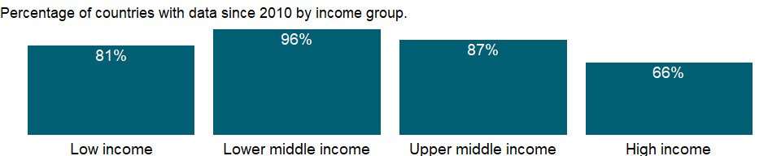

### Why is it relevant?

Labor productivity is used to assess a country’s economic ability to create and sustain decent employment opportunities with fair and equitable remuneration. Productivity increases obtained through investment, trade, technological progress, or changes in work organization can increase social protection and reduce poverty, which in turn reduce vulnerable employment and working poverty. Productivity increases do not guarantee these improvements, but without them - and the economic growth they bring - improvements are highly unlikely.

GDP per person employed is a key measure to monitor whether a country is on track to achieve the Sustainable Development Goal of promoting sustained, inclusive and sustainable economic growth, full and productive employment and decent work for all. [SDG Indicator 8.2.1]

### What is the data source?

Derived using data from International Labour Organization, ILOSTAT database. The data retrieved on June 15, 2021.

### What is the methodology?

GDP per person employed represents labor productivity — output per unit of labor input. To compare labor productivity levels across countries, GDP is converted to international dollars using purchasing power parity rates which take account of differences in relative prices between countries.

### How is it aggregated?

Weighted average

### What are the limitations?

For comparability of individual sectors labor productivity is estimated according to national accounts conventions. However, there are still significant limitations on the availability of reliable data. Information on consistent series of output in both national currencies and purchasing power parity dollars is not easily available, especially in developing countries, because the definition, coverage, and methodology are not always consistent across countries. For example, countries employ different methodologies for estimating the missing values for the nonmarket service sectors and use different definitions of the informal sector.

### What else should I know?

NA

### 1.75.39 Employment in industry, female (% of female employment) (modeled ILO estimate)

### What is the indicator?

Employment is defined as persons of working age who were engaged in any activity to produce goods or provide services for pay or profit, whether at work during the reference period or not at work due to temporary absence from a job, or to working-time arrangement. The industry sector consists of mining and quarrying, manufacturing, construction, and public utilities (electricity, gas, and water), in accordance with divisions 2-5 (ISIC 2) or categories C-F (ISIC 3) or categories B-F (ISIC 4).

Topic: Social Protection & Labor: Economic activity

Series ID: SL.IND.EMPL.FE.ZS

Copyright: CC BY-4.0 , <https://datacatalog.worldbank.org/public-licenses#cc-by>

First year with any data: 1991

Last year with any data: 2019

### What years are data available?

The figure below shows years in which data is available for at least one country. Dates shaded in black have no data, while dates shaded in green have data for at least one country



### Which countries have data?

The figure below shows the percentage of countries in each income group with a value since 2010 for that indicator.



### Why is it relevant?

Sectoral information is particularly useful in identifying broad shifts in employment and stages of development. In the textbook case of economic development, labour flows from agriculture and other labour-intensive primary activities to industry and finally to the services sector; in the process, workers migrate from rural to urban areas.

The breakdown of the indicator by sex allows for analysis of gender segregation of employment by specific sector. Women may be drawn into lower-paying service activities that allow for more flexible work schedules thus making it easier to balance family responsibilities with work life. Segregation of women in certain sectors may also result from cultural attitudes that prevent them from entering industrial employment.

Segregating one sex in a narrow range of occupations significantly reduces economic efficiency by reducing labor market flexibility and thus the economy’s ability to adapt to change. This segregation is particularly harmful for women, who have a much narrower range of labor market choices and lower levels of pay than men. But it is also detrimental to men when job losses are concentrated in industries dominated by men and job growth is centered in service occupations, where women have better chances, as has been the recent experience in many countries.

### What is the data source?

International Labour Organization, ILOSTAT database. Data retrieved on January 29, 2021.

### What is the methodology?

The International Labour Organization (ILO) classifies economic activity using the International Standard Industrial Classification (ISIC) of All Economic Activities, revision 2 (1968), revision 3 (1990), and revision 4 (2008). Because this classification is based on where work is performed (industry) rather than type of work performed (occupation), all of an enterprise’s employees are classified under the same industry, regardless of their trade or occupation. The categories should sum to 100 percent. Where they do not, the differences are due to workers who are not classified by economic activity.

The series is part of the ILO estimates and is harmonized to ensure comparability across countries and over time by accounting for differences in data source, scope of coverage, methodology, and other country-specific factors. The estimates are based mainly on nationally representative labor force surveys, with other sources (population censuses and nationally reported estimates) used only when no survey data are available.

### How is it aggregated?

Weighted average

### What are the limitations?

There are many differences in how countries define and measure employment status, particularly members of the armed forces, self-employed workers, and unpaid family workers. Where members of the armed forces are included, they are allocated to the service sector, causing that sector to be somewhat overstated relative to the service sector in economies where they are excluded. Where data are obtained from establishment surveys, data cover only employees; thus self-employed and unpaid family workers are excluded. In such cases the employment share of the agricultural sector is severely underreported. Caution should be also used where the data refer only to urban areas, which record little or no agricultural work. Moreover, the age group and area covered could differ by country or change over time within a country. For detailed information, consult the original source.

Countries also take different approaches to the treatment of unemployed people. In most countries unemployed people with previous job experience are classified according to their last job. But in some countries the unemployed and people seeking their first job are not classifiable by economic activity. Because of these differences, the size and distribution of employment by economic activity may not be fully comparable across countries.

The ILO reports data by major divisions of the ISIC revision 2, revision 3, or revision 4. Broad classification such as employment by agriculture, industry, and services may obscure fundamental shifts within countries’ industrial patterns. A slight majority of countries report economic activity according to the ISIC revision 3 instead of revision 2 or revision 4. The use of one classification or the other should not have a significant impact on the information for the employment of the three broad sectors data.

### What else should I know?

NA

### 1.75.40 Employment in industry, male (% of male employment) (modeled ILO estimate)

### What is the indicator?

Employment is defined as persons of working age who were engaged in any activity to produce goods or provide services for pay or profit, whether at work during the reference period or not at work due to temporary absence from a job, or to working-time arrangement. The industry sector consists of mining and quarrying, manufacturing, construction, and public utilities (electricity, gas, and water), in accordance with divisions 2-5 (ISIC 2) or categories C-F (ISIC 3) or categories B-F (ISIC 4).

Topic: Social Protection & Labor: Economic activity

Series ID: SL.IND.EMPL.MA.ZS

Copyright: CC BY-4.0 , <https://datacatalog.worldbank.org/public-licenses#cc-by>

First year with any data: 1991

Last year with any data: 2019

### What years are data available?

The figure below shows years in which data is available for at least one country. Dates shaded in black have no data, while dates shaded in green have data for at least one country



### Which countries have data?

The figure below shows the percentage of countries in each income group with a value since 2010 for that indicator.



### Why is it relevant?

Sectoral information is particularly useful in identifying broad shifts in employment and stages of development. In the textbook case of economic development, labour flows from agriculture and other labour-intensive primary activities to industry and finally to the services sector; in the process, workers migrate from rural to urban areas.

The breakdown of the indicator by sex allows for analysis of gender segregation of employment by specific sector. Women may be drawn into lower-paying service activities that allow for more flexible work schedules thus making it easier to balance family responsibilities with work life. Segregation of women in certain sectors may also result from cultural attitudes that prevent them from entering industrial employment.

Segregating one sex in a narrow range of occupations significantly reduces economic efficiency by reducing labor market flexibility and thus the economy’s ability to adapt to change. This segregation is particularly harmful for women, who have a much narrower range of labor market choices and lower levels of pay than men. But it is also detrimental to men when job losses are concentrated in industries dominated by men and job growth is centered in service occupations, where women have better chances, as has been the recent experience in many countries.

### What is the data source?

International Labour Organization, ILOSTAT database. Data retrieved on January 29, 2021.

### What is the methodology?

The International Labour Organization (ILO) classifies economic activity using the International Standard Industrial Classification (ISIC) of All Economic Activities, revision 2 (1968), revision 3 (1990), and revision 4 (2008). Because this classification is based on where work is performed (industry) rather than type of work performed (occupation), all of an enterprise’s employees are classified under the same industry, regardless of their trade or occupation. The categories should sum to 100 percent. Where they do not, the differences are due to workers who are not classified by economic activity.

The series is part of the ILO estimates and is harmonized to ensure comparability across countries and over time by accounting for differences in data source, scope of coverage, methodology, and other country-specific factors. The estimates are based mainly on nationally representative labor force surveys, with other sources (population censuses and nationally reported estimates) used only when no survey data are available.

### How is it aggregated?

Weighted average

### What are the limitations?

There are many differences in how countries define and measure employment status, particularly members of the armed forces, self-employed workers, and unpaid family workers. Where members of the armed forces are included, they are allocated to the service sector, causing that sector to be somewhat overstated relative to the service sector in economies where they are excluded. Where data are obtained from establishment surveys, data cover only employees; thus self-employed and unpaid family workers are excluded. In such cases the employment share of the agricultural sector is severely underreported. Caution should be also used where the data refer only to urban areas, which record little or no agricultural work. Moreover, the age group and area covered could differ by country or change over time within a country. For detailed information, consult the original source.

Countries also take different approaches to the treatment of unemployed people. In most countries unemployed people with previous job experience are classified according to their last job. But in some countries the unemployed and people seeking their first job are not classifiable by economic activity. Because of these differences, the size and distribution of employment by economic activity may not be fully comparable across countries.

The ILO reports data by major divisions of the ISIC revision 2, revision 3, or revision 4. Broad classification such as employment by agriculture, industry, and services may obscure fundamental shifts within countries’ industrial patterns. A slight majority of countries report economic activity according to the ISIC revision 3 instead of revision 2 or revision 4. The use of one classification or the other should not have a significant impact on the information for the employment of the three broad sectors data.

### What else should I know?

NA

### 1.75.41 Employment in industry (% of total employment) (modeled ILO estimate)

### What is the indicator?

Employment is defined as persons of working age who were engaged in any activity to produce goods or provide services for pay or profit, whether at work during the reference period or not at work due to temporary absence from a job, or to working-time arrangement. The industry sector consists of mining and quarrying, manufacturing, construction, and public utilities (electricity, gas, and water), in accordance with divisions 2-5 (ISIC 2) or categories C-F (ISIC 3) or categories B-F (ISIC 4).

Topic: Social Protection & Labor: Economic activity

Series ID: SL.IND.EMPL.ZS

Copyright: CC BY-4.0 , <https://datacatalog.worldbank.org/public-licenses#cc-by>

First year with any data: 1991

Last year with any data: 2019

### What years are data available?

The figure below shows years in which data is available for at least one country. Dates shaded in black have no data, while dates shaded in green have data for at least one country



### Which countries have data?

The figure below shows the percentage of countries in each income group with a value since 2010 for that indicator.



### Why is it relevant?

Sectoral information is particularly useful in identifying broad shifts in employment and stages of development. In the textbook case of economic development, labour flows from agriculture and other labour-intensive primary activities to industry and finally to the services sector; in the process, workers migrate from rural to urban areas.

The breakdown of the indicator by sex allows for analysis of gender segregation of employment by specific sector. Women may be drawn into lower-paying service activities that allow for more flexible work schedules thus making it easier to balance family responsibilities with work life. Segregation of women in certain sectors may also result from cultural attitudes that prevent them from entering industrial employment.

Segregating one sex in a narrow range of occupations significantly reduces economic efficiency by reducing labor market flexibility and thus the economy’s ability to adapt to change. This segregation is particularly harmful for women, who have a much narrower range of labor market choices and lower levels of pay than men. But it is also detrimental to men when job losses are concentrated in industries dominated by men and job growth is centered in service occupations, where women have better chances, as has been the recent experience in many countries.

### What is the data source?

International Labour Organization, ILOSTAT database. Data retrieved on January 29, 2021.

### What is the methodology?

The International Labour Organization (ILO) classifies economic activity using the International Standard Industrial Classification (ISIC) of All Economic Activities, revision 2 (1968), revision 3 (1990), and revision 4 (2008). Because this classification is based on where work is performed (industry) rather than type of work performed (occupation), all of an enterprise’s employees are classified under the same industry, regardless of their trade or occupation. The categories should sum to 100 percent. Where they do not, the differences are due to workers who are not classified by economic activity.

The series is part of the ILO estimates and is harmonized to ensure comparability across countries and over time by accounting for differences in data source, scope of coverage, methodology, and other country-specific factors. The estimates are based mainly on nationally representative labor force surveys, with other sources (population censuses and nationally reported estimates) used only when no survey data are available.

### How is it aggregated?

Weighted average

### What are the limitations?

There are many differences in how countries define and measure employment status, particularly members of the armed forces, self-employed workers, and unpaid family workers. Where members of the armed forces are included, they are allocated to the service sector, causing that sector to be somewhat overstated relative to the service sector in economies where they are excluded. Where data are obtained from establishment surveys, data cover only employees; thus self-employed and unpaid family workers are excluded. In such cases the employment share of the agricultural sector is severely underreported. Caution should be also used where the data refer only to urban areas, which record little or no agricultural work. Moreover, the age group and area covered could differ by country or change over time within a country. For detailed information, consult the original source.

Countries also take different approaches to the treatment of unemployed people. In most countries unemployed people with previous job experience are classified according to their last job. But in some countries the unemployed and people seeking their first job are not classifiable by economic activity. Because of these differences, the size and distribution of employment by economic activity may not be fully comparable across countries.

The ILO reports data by major divisions of the ISIC revision 2, revision 3, or revision 4. Broad classification such as employment by agriculture, industry, and services may obscure fundamental shifts within countries’ industrial patterns. A slight majority of countries report economic activity according to the ISIC revision 3 instead of revision 2 or revision 4. The use of one classification or the other should not have a significant impact on the information for the employment of the three broad sectors data.

### What else should I know?

NA

### 1.75.42 Child employment in manufacturing, female (% of female economically active children ages 7-14)

### What is the indicator?

Employment by economic activity refers to the distribution of economically active children by the major industrial categories of the International Standard Industrial Classification (ISIC). Manufacturing corresponds to division 3 (ISIC revision 2), category D (ISIC revision 3), or category C (ISIC revision 4). Economically active children refer to children involved in economic activity for at least one hour in the reference week of the survey.

Topic: Social Protection & Labor: Economic activity

Series ID: SL.MNF.0714.FE.ZS

Copyright: CC BY-4.0 , <https://datacatalog.worldbank.org/public-licenses#cc-by>

First year with any data: 1998

Last year with any data: 2016

### What years are data available?

The figure below shows years in which data is available for at least one country. Dates shaded in black have no data, while dates shaded in green have data for at least one country



### Which countries have data?

The figure below shows the percentage of countries in each income group with a value since 2010 for that indicator.



### Why is it relevant?

In most countries more boys are involved in employment, or the gender difference is small. However, girls are often more present in hidden or underreported forms of employment such as domestic service, and in almost all societies girls bear greater responsibility for household chores in their own homes, work that lies outside the System of National Accounts production boundary and is thus not considered in estimates of children’s employment.

### What is the data source?

Understanding Children’s Work project based on data from ILO, UNICEF and the World Bank.

### What is the methodology?

Data are from household surveys by the International Labor Organization (ILO), the United Nations Children’s Fund (UNICEF), the World Bank, and national statistical offices. The surveys yield data on education, employment, health, expenditure, and consumption indicators related to children’s work. Since children’s work is captured in the sense of “economic activity,” the data refer to children in employment, a broader concept than child labor (see ILO 2009a for details on this distinction).

Household survey data generally include information on work type - for example, whether a child is working for payment in cash or in kind or is involved in unpaid work, working for someone who is not a member of the household, or involved in any type of family work (on the farm or in a business).

### How is it aggregated?

NA

### What are the limitations?

Although efforts are made to harmonize the definition of employment and the questions on employment in survey questionnaires, significant differences remain in the survey instruments that collect data on children in employment and in the sampling design underlying the surveys. Differences exist not only across different household surveys in the same country but also across the same type of survey carried out in different countries, so estimates of working children are not fully comparable across countries. In addition, the shares of three sectors (Agriculture, Manufacturing and Services) may not add up to 100 percent because of a residual category not included.

### What else should I know?

NA

### 1.75.43 Child employment in manufacturing, male (% of male economically active children ages 7-14)

### What is the indicator?

Employment by economic activity refers to the distribution of economically active children by the major industrial categories of the International Standard Industrial Classification (ISIC). Manufacturing corresponds to division 3 (ISIC revision 2), category D (ISIC revision 3), or category C (ISIC revision 4). Economically active children refer to children involved in economic activity for at least one hour in the reference week of the survey.

Topic: Social Protection & Labor: Economic activity

Series ID: SL.MNF.0714.MA.ZS

Copyright: CC BY-4.0 , <https://datacatalog.worldbank.org/public-licenses#cc-by>

First year with any data: 1998

Last year with any data: 2016

### What years are data available?

The figure below shows years in which data is available for at least one country. Dates shaded in black have no data, while dates shaded in green have data for at least one country



### Which countries have data?

The figure below shows the percentage of countries in each income group with a value since 2010 for that indicator.



### Why is it relevant?

In most countries more boys are involved in employment, or the gender difference is small. However, girls are often more present in hidden or underreported forms of employment such as domestic service, and in almost all societies girls bear greater responsibility for household chores in their own homes, work that lies outside the System of National Accounts production boundary and is thus not considered in estimates of children’s employment.

### What is the data source?

Understanding Children’s Work project based on data from ILO, UNICEF and the World Bank.

### What is the methodology?

Data are from household surveys by the International Labor Organization (ILO), the United Nations Children’s Fund (UNICEF), the World Bank, and national statistical offices. The surveys yield data on education, employment, health, expenditure, and consumption indicators related to children’s work. Since children’s work is captured in the sense of “economic activity,” the data refer to children in employment, a broader concept than child labor (see ILO 2009a for details on this distinction).

Household survey data generally include information on work type - for example, whether a child is working for payment in cash or in kind or is involved in unpaid work, working for someone who is not a member of the household, or involved in any type of family work (on the farm or in a business).

### How is it aggregated?

NA

### What are the limitations?

Although efforts are made to harmonize the definition of employment and the questions on employment in survey questionnaires, significant differences remain in the survey instruments that collect data on children in employment and in the sampling design underlying the surveys. Differences exist not only across different household surveys in the same country but also across the same type of survey carried out in different countries, so estimates of working children are not fully comparable across countries. In addition, the shares of three sectors (Agriculture, Manufacturing and Services) may not add up to 100 percent because of a residual category not included.

### What else should I know?

NA

### 1.75.44 Child employment in manufacturing (% of economically active children ages 7-14)

### What is the indicator?

Employment by economic activity refers to the distribution of economically active children by the major industrial categories of the International Standard Industrial Classification (ISIC). Manufacturing corresponds to division 3 (ISIC revision 2), category D (ISIC revision 3), or category C (ISIC revision 4). Economically active children refer to children involved in economic activity for at least one hour in the reference week of the survey.

Topic: Social Protection & Labor: Economic activity

Series ID: SL.MNF.0714.ZS

Copyright: CC BY-4.0 , <https://datacatalog.worldbank.org/public-licenses#cc-by>

First year with any data: 1998

Last year with any data: 2016

### What years are data available?

The figure below shows years in which data is available for at least one country. Dates shaded in black have no data, while dates shaded in green have data for at least one country



### Which countries have data?

The figure below shows the percentage of countries in each income group with a value since 2010 for that indicator.



### Why is it relevant?

In most countries more boys are involved in employment, or the gender difference is small. However, girls are often more present in hidden or underreported forms of employment such as domestic service, and in almost all societies girls bear greater responsibility for household chores in their own homes, work that lies outside the System of National Accounts production boundary and is thus not considered in estimates of children’s employment.

### What is the data source?

Understanding Children’s Work project based on data from ILO, UNICEF and the World Bank.

### What is the methodology?

Data are from household surveys by the International Labor Organization (ILO), the United Nations Children’s Fund (UNICEF), the World Bank, and national statistical offices. The surveys yield data on education, employment, health, expenditure, and consumption indicators related to children’s work. Since children’s work is captured in the sense of “economic activity,” the data refer to children in employment, a broader concept than child labor (see ILO 2009a for details on this distinction).

Household survey data generally include information on work type - for example, whether a child is working for payment in cash or in kind or is involved in unpaid work, working for someone who is not a member of the household, or involved in any type of family work (on the farm or in a business).

### How is it aggregated?

NA

### What are the limitations?

Although efforts are made to harmonize the definition of employment and the questions on employment in survey questionnaires, significant differences remain in the survey instruments that collect data on children in employment and in the sampling design underlying the surveys. Differences exist not only across different household surveys in the same country but also across the same type of survey carried out in different countries, so estimates of working children are not fully comparable across countries. In addition, the shares of three sectors (Agriculture, Manufacturing and Services) may not add up to 100 percent because of a residual category not included.

### What else should I know?

NA

### 1.75.45 Children in employment, self-employed, female (% of female children in employment, ages 7-14)

### What is the indicator?

Self-employed workers are people whose remuneration depends directly on the profits derived from the goods and services they produce, with or without other employees, and include employers, own-account workers, and members of producers cooperatives.

Topic: Social Protection & Labor: Economic activity

Series ID: SL.SLF.0714.FE.ZS

Copyright: CC BY-4.0 , <https://datacatalog.worldbank.org/public-licenses#cc-by>

First year with any data: 1999

Last year with any data: 2016

### What years are data available?

The figure below shows years in which data is available for at least one country. Dates shaded in black have no data, while dates shaded in green have data for at least one country



### Which countries have data?

The figure below shows the percentage of countries in each income group with a value since 2010 for that indicator.

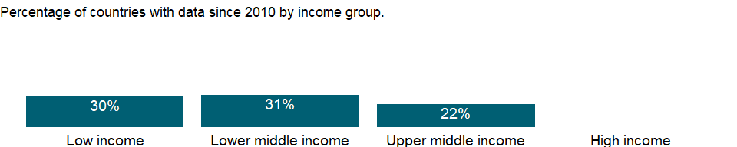

### Why is it relevant?

In most countries more boys are involved in employment, or the gender difference is small. However, girls are often more present in hidden or underreported forms of employment such as domestic service, and in almost all societies girls bear greater responsibility for household chores in their own homes, work that lies outside the System of National Accounts production boundary and is thus not considered in estimates of children’s employment.

### What is the data source?

Understanding Children’s Work project based on data from ILO, UNICEF and the World Bank.

### What is the methodology?

Data are from household surveys by the International Labor Organization (ILO), the United Nations Children’s Fund (UNICEF), the World Bank, and national statistical offices. The surveys yield data on education, employment, health, expenditure, and consumption indicators related to children’s work. Since children’s work is captured in the sense of “economic activity,” the data refer to children in employment, a broader concept than child labor (see ILO 2009a for details on this distinction).

Household survey data generally include information on work type - for example, whether a child is working for payment in cash or in kind or is involved in unpaid work, working for someone who is not a member of the household, or involved in any type of family work (on the farm or in a business).

In line with the definition of economic activity adopted by the 13th International Conference of Labour Statisticians, the threshold set by the 1993 UN System of National Accounts for classifying a person as employed is to have been engaged at least one hour in any activity relating to the production of goods and services during the reference period. Children seeking work are thus excluded. Economic activity covers all market production and certain nonmarket production, including production of goods for own use. It excludes unpaid household services (commonly called “household chores”) - that is, the production of domestic and personal services by household members for a household’s own consumption.

Country surveys define the ages for child labor as 5-17. The data here have been recalculated to present statistics for children ages 7-14.

### How is it aggregated?

NA

### What are the limitations?

Although efforts are made to harmonize the definition of employment and the questions on employment in survey questionnaires, significant differences remain in the survey instruments that collect data on children in employment and in the sampling design underlying the surveys. Differences exist not only across different household surveys in the same country but also across the same type of survey carried out in different countries, so estimates of working children are not fully comparable across countries. In addition, the shares of three categories (self-employed workers, wage workers, and unpaid family workers) may not add up to 100 percent because of a residual category not included.

### What else should I know?

NA

### 1.75.46 Children in employment, self-employed, male (% of male children in employment, ages 7-14)

### What is the indicator?

Self-employed workers are people whose remuneration depends directly on the profits derived from the goods and services they produce, with or without other employees, and include employers, own-account workers, and members of producers cooperatives.

Topic: Social Protection & Labor: Economic activity

Series ID: SL.SLF.0714.MA.ZS

Copyright: CC BY-4.0 , <https://datacatalog.worldbank.org/public-licenses#cc-by>

First year with any data: 1999

Last year with any data: 2016

### What years are data available?

The figure below shows years in which data is available for at least one country. Dates shaded in black have no data, while dates shaded in green have data for at least one country



### Which countries have data?

The figure below shows the percentage of countries in each income group with a value since 2010 for that indicator.



### Why is it relevant?

In most countries more boys are involved in employment, or the gender difference is small. However, girls are often more present in hidden or underreported forms of employment such as domestic service, and in almost all societies girls bear greater responsibility for household chores in their own homes, work that lies outside the System of National Accounts production boundary and is thus not considered in estimates of children’s employment.

### What is the data source?

Understanding Children’s Work project based on data from ILO, UNICEF and the World Bank.

### What is the methodology?

Data are from household surveys by the International Labor Organization (ILO), the United Nations Children’s Fund (UNICEF), the World Bank, and national statistical offices. The surveys yield data on education, employment, health, expenditure, and consumption indicators related to children’s work. Since children’s work is captured in the sense of “economic activity,” the data refer to children in employment, a broader concept than child labor (see ILO 2009a for details on this distinction).

Household survey data generally include information on work type - for example, whether a child is working for payment in cash or in kind or is involved in unpaid work, working for someone who is not a member of the household, or involved in any type of family work (on the farm or in a business).

In line with the definition of economic activity adopted by the 13th International Conference of Labour Statisticians, the threshold set by the 1993 UN System of National Accounts for classifying a person as employed is to have been engaged at least one hour in any activity relating to the production of goods and services during the reference period. Children seeking work are thus excluded. Economic activity covers all market production and certain nonmarket production, including production of goods for own use. It excludes unpaid household services (commonly called “household chores”) - that is, the production of domestic and personal services by household members for a household’s own consumption.

Country surveys define the ages for child labor as 5-17. The data here have been recalculated to present statistics for children ages 7-14.

### How is it aggregated?

NA

### What are the limitations?

Although efforts are made to harmonize the definition of employment and the questions on employment in survey questionnaires, significant differences remain in the survey instruments that collect data on children in employment and in the sampling design underlying the surveys. Differences exist not only across different household surveys in the same country but also across the same type of survey carried out in different countries, so estimates of working children are not fully comparable across countries. In addition, the shares of three categories (self-employed workers, wage workers, and unpaid family workers) may not add up to 100 percent because of a residual category not included.

### What else should I know?

NA

### 1.75.47 Children in employment, self-employed (% of children in employment, ages 7-14)

### What is the indicator?

Self-employed workers are people whose remuneration depends directly on the profits derived from the goods and services they produce, with or without other employees, and include employers, own-account workers, and members of producers cooperatives.

Topic: Social Protection & Labor: Economic activity

Series ID: SL.SLF.0714.ZS

Copyright: CC BY-4.0 , <https://datacatalog.worldbank.org/public-licenses#cc-by>

First year with any data: 1999

Last year with any data: 2016

### What years are data available?

The figure below shows years in which data is available for at least one country. Dates shaded in black have no data, while dates shaded in green have data for at least one country



### Which countries have data?

The figure below shows the percentage of countries in each income group with a value since 2010 for that indicator.



### Why is it relevant?

In most countries more boys are involved in employment, or the gender difference is small. However, girls are often more present in hidden or underreported forms of employment such as domestic service, and in almost all societies girls bear greater responsibility for household chores in their own homes, work that lies outside the System of National Accounts production boundary and is thus not considered in estimates of children’s employment.

### What is the data source?

Understanding Children’s Work project based on data from ILO, UNICEF and the World Bank.

### What is the methodology?

Data are from household surveys by the International Labor Organization (ILO), the United Nations Children’s Fund (UNICEF), the World Bank, and national statistical offices. The surveys yield data on education, employment, health, expenditure, and consumption indicators related to children’s work. Since children’s work is captured in the sense of “economic activity,” the data refer to children in employment, a broader concept than child labor (see ILO 2009a for details on this distinction).

Household survey data generally include information on work type - for example, whether a child is working for payment in cash or in kind or is involved in unpaid work, working for someone who is not a member of the household, or involved in any type of family work (on the farm or in a business).

In line with the definition of economic activity adopted by the 13th International Conference of Labour Statisticians, the threshold set by the 1993 UN System of National Accounts for classifying a person as employed is to have been engaged at least one hour in any activity relating to the production of goods and services during the reference period. Children seeking work are thus excluded. Economic activity covers all market production and certain nonmarket production, including production of goods for own use. It excludes unpaid household services (commonly called “household chores”) - that is, the production of domestic and personal services by household members for a household’s own consumption.

Country surveys define the ages for child labor as 5-17. The data here have been recalculated to present statistics for children ages 7-14.

### How is it aggregated?

NA

### What are the limitations?

Although efforts are made to harmonize the definition of employment and the questions on employment in survey questionnaires, significant differences remain in the survey instruments that collect data on children in employment and in the sampling design underlying the surveys. Differences exist not only across different household surveys in the same country but also across the same type of survey carried out in different countries, so estimates of working children are not fully comparable across countries. In addition, the shares of three categories (self-employed workers, wage workers, and unpaid family workers) may not add up to 100 percent because of a residual category not included.

### What else should I know?

NA

### 1.75.48 Child employment in services, female (% of female economically active children ages 7-14)

### What is the indicator?

Employment by economic activity refers to the distribution of economically active children by the major industrial categories of the International Standard Industrial Classification (ISIC). Services correspond to divisions 6-9 (ISIC revision 2), categories G-P (ISIC revision 3), or categories G-U (ISIC revision 4). Services include wholesale and retail trade, hotels and restaurants, transport, financial intermediation, real estate, public administration, education, health and social work, other community services, and private household activity. Economically active children refer to children involved in economic activity for at least one hour in the reference week of the survey.

Topic: Social Protection & Labor: Economic activity

Series ID: SL.SRV.0714.FE.ZS

Copyright: CC BY-4.0 , <https://datacatalog.worldbank.org/public-licenses#cc-by>

First year with any data: 1998

Last year with any data: 2016

### What years are data available?

The figure below shows years in which data is available for at least one country. Dates shaded in black have no data, while dates shaded in green have data for at least one country



### Which countries have data?

The figure below shows the percentage of countries in each income group with a value since 2010 for that indicator.



### Why is it relevant?

In most countries more boys are involved in employment, or the gender difference is small. However, girls are often more present in hidden or underreported forms of employment such as domestic service, and in almost all societies girls bear greater responsibility for household chores in their own homes, work that lies outside the System of National Accounts production boundary and is thus not considered in estimates of children’s employment.

### What is the data source?

Understanding Children’s Work project based on data from ILO, UNICEF and the World Bank.

### What is the methodology?

Data are from household surveys by the International Labor Organization (ILO), the United Nations Children’s Fund (UNICEF), the World Bank, and national statistical offices. The surveys yield data on education, employment, health, expenditure, and consumption indicators related to children’s work. Since children’s work is captured in the sense of “economic activity,” the data refer to children in employment, a broader concept than child labor (see ILO 2009a for details on this distinction).

Household survey data generally include information on work type - for example, whether a child is working for payment in cash or in kind or is involved in unpaid work, working for someone who is not a member of the household, or involved in any type of family work (on the farm or in a business).

### How is it aggregated?

NA

### What are the limitations?

Although efforts are made to harmonize the definition of employment and the questions on employment in survey questionnaires, significant differences remain in the survey instruments that collect data on children in employment and in the sampling design underlying the surveys. Differences exist not only across different household surveys in the same country but also across the same type of survey carried out in different countries, so estimates of working children are not fully comparable across countries. In addition, the shares of three sectors (Agriculture, Manufacturing and Services) may not add up to 100 percent because of a residual category not included.

### What else should I know?

NA

### 1.75.49 Child employment in services, male (% of male economically active children ages 7-14)

### What is the indicator?

Employment by economic activity refers to the distribution of economically active children by the major industrial categories of the International Standard Industrial Classification (ISIC). Services correspond to divisions 6-9 (ISIC revision 2), categories G-P (ISIC revision 3), or categories G-U (ISIC revision 4). Services include wholesale and retail trade, hotels and restaurants, transport, financial intermediation, real estate, public administration, education, health and social work, other community services, and private household activity. Economically active children refer to children involved in economic activity for at least one hour in the reference week of the survey.

Topic: Social Protection & Labor: Economic activity

Series ID: SL.SRV.0714.MA.ZS

Copyright: CC BY-4.0 , <https://datacatalog.worldbank.org/public-licenses#cc-by>

First year with any data: 1998

Last year with any data: 2016

### What years are data available?

The figure below shows years in which data is available for at least one country. Dates shaded in black have no data, while dates shaded in green have data for at least one country



### Which countries have data?

The figure below shows the percentage of countries in each income group with a value since 2010 for that indicator.



### Why is it relevant?

In most countries more boys are involved in employment, or the gender difference is small. However, girls are often more present in hidden or underreported forms of employment such as domestic service, and in almost all societies girls bear greater responsibility for household chores in their own homes, work that lies outside the System of National Accounts production boundary and is thus not considered in estimates of children’s employment.

### What is the data source?

Understanding Children’s Work project based on data from ILO, UNICEF and the World Bank.

### What is the methodology?

Data are from household surveys by the International Labor Organization (ILO), the United Nations Children’s Fund (UNICEF), the World Bank, and national statistical offices. The surveys yield data on education, employment, health, expenditure, and consumption indicators related to children’s work. Since children’s work is captured in the sense of “economic activity,” the data refer to children in employment, a broader concept than child labor (see ILO 2009a for details on this distinction).

Household survey data generally include information on work type - for example, whether a child is working for payment in cash or in kind or is involved in unpaid work, working for someone who is not a member of the household, or involved in any type of family work (on the farm or in a business).

### How is it aggregated?

NA

### What are the limitations?

Although efforts are made to harmonize the definition of employment and the questions on employment in survey questionnaires, significant differences remain in the survey instruments that collect data on children in employment and in the sampling design underlying the surveys. Differences exist not only across different household surveys in the same country but also across the same type of survey carried out in different countries, so estimates of working children are not fully comparable across countries. In addition, the shares of three sectors (Agriculture, Manufacturing and Services) may not add up to 100 percent because of a residual category not included.

### What else should I know?

NA

### 1.75.50 Child employment in services (% of economically active children ages 7-14)

### What is the indicator?

Employment by economic activity refers to the distribution of economically active children by the major industrial categories of the International Standard Industrial Classification (ISIC). Services correspond to divisions 6-9 (ISIC revision 2), categories G-P (ISIC revision 3), or categories G-U (ISIC revision 4). Services include wholesale and retail trade, hotels and restaurants, transport, financial intermediation, real estate, public administration, education, health and social work, other community services, and private household activity. Economically active children refer to children involved in economic activity for at least one hour in the reference week of the survey.

Topic: Social Protection & Labor: Economic activity

Series ID: SL.SRV.0714.ZS

Copyright: CC BY-4.0 , <https://datacatalog.worldbank.org/public-licenses#cc-by>

First year with any data: 1998

Last year with any data: 2016

### What years are data available?

The figure below shows years in which data is available for at least one country. Dates shaded in black have no data, while dates shaded in green have data for at least one country



### Which countries have data?

The figure below shows the percentage of countries in each income group with a value since 2010 for that indicator.



### Why is it relevant?

In most countries more boys are involved in employment, or the gender difference is small. However, girls are often more present in hidden or underreported forms of employment such as domestic service, and in almost all societies girls bear greater responsibility for household chores in their own homes, work that lies outside the System of National Accounts production boundary and is thus not considered in estimates of children’s employment.

### What is the data source?

Understanding Children’s Work project based on data from ILO, UNICEF and the World Bank.

### What is the methodology?

Data are from household surveys by the International Labor Organization (ILO), the United Nations Children’s Fund (UNICEF), the World Bank, and national statistical offices. The surveys yield data on education, employment, health, expenditure, and consumption indicators related to children’s work. Since children’s work is captured in the sense of “economic activity,” the data refer to children in employment, a broader concept than child labor (see ILO 2009a for details on this distinction).

Household survey data generally include information on work type - for example, whether a child is working for payment in cash or in kind or is involved in unpaid work, working for someone who is not a member of the household, or involved in any type of family work (on the farm or in a business).

### How is it aggregated?

NA

### What are the limitations?

Although efforts are made to harmonize the definition of employment and the questions on employment in survey questionnaires, significant differences remain in the survey instruments that collect data on children in employment and in the sampling design underlying the surveys. Differences exist not only across different household surveys in the same country but also across the same type of survey carried out in different countries, so estimates of working children are not fully comparable across countries. In addition, the shares of three sectors (Agriculture, Manufacturing and Services) may not add up to 100 percent because of a residual category not included.

### What else should I know?

NA

### 1.75.51 Employment in services, female (% of female employment) (modeled ILO estimate)

### What is the indicator?

Employment is defined as persons of working age who were engaged in any activity to produce goods or provide services for pay or profit, whether at work during the reference period or not at work due to temporary absence from a job, or to working-time arrangement. The services sector consists of wholesale and retail trade and restaurants and hotels; transport, storage, and communications; financing, insurance, real estate, and business services; and community, social, and personal services, in accordance with divisions 6-9 (ISIC 2) or categories G-Q (ISIC 3) or categories G-U (ISIC 4).

Topic: Social Protection & Labor: Economic activity

Series ID: SL.SRV.EMPL.FE.ZS

Copyright: CC BY-4.0 , <https://datacatalog.worldbank.org/public-licenses#cc-by>

First year with any data: 1991

Last year with any data: 2019

### What years are data available?

The figure below shows years in which data is available for at least one country. Dates shaded in black have no data, while dates shaded in green have data for at least one country



### Which countries have data?

The figure below shows the percentage of countries in each income group with a value since 2010 for that indicator.



### Why is it relevant?

Sectoral information is particularly useful in identifying broad shifts in employment and stages of development. In the textbook case of economic development, labour flows from agriculture and other labour-intensive primary activities to industry and finally to the services sector; in the process, workers migrate from rural to urban areas.

The breakdown of the indicator by sex allows for analysis of gender segregation of employment by specific sector. Women may be drawn into lower-paying service activities that allow for more flexible work schedules thus making it easier to balance family responsibilities with work life. Segregation of women in certain sectors may also result from cultural attitudes that prevent them from entering industrial employment.

Segregating one sex in a narrow range of occupations significantly reduces economic efficiency by reducing labor market flexibility and thus the economy’s ability to adapt to change. This segregation is particularly harmful for women, who have a much narrower range of labor market choices and lower levels of pay than men. But it is also detrimental to men when job losses are concentrated in industries dominated by men and job growth is centered in service occupations, where women have better chances, as has been the recent experience in many countries.

### What is the data source?

International Labour Organization, ILOSTAT database. Data retrieved on January 29, 2021.

### What is the methodology?

The International Labour Organization (ILO) classifies economic activity using the International Standard Industrial Classification (ISIC) of All Economic Activities, revision 2 (1968), revision 3 (1990), and revision 4 (2008). Because this classification is based on where work is performed (industry) rather than type of work performed (occupation), all of an enterprise’s employees are classified under the same industry, regardless of their trade or occupation. The categories should sum to 100 percent. Where they do not, the differences are due to workers who are not classified by economic activity.

The series is part of the ILO estimates and is harmonized to ensure comparability across countries and over time by accounting for differences in data source, scope of coverage, methodology, and other country-specific factors. The estimates are based mainly on nationally representative labor force surveys, with other sources (population censuses and nationally reported estimates) used only when no survey data are available.

### How is it aggregated?

Weighted average

### What are the limitations?

There are many differences in how countries define and measure employment status, particularly members of the armed forces, self-employed workers, and unpaid family workers. Where members of the armed forces are included, they are allocated to the service sector, causing that sector to be somewhat overstated relative to the service sector in economies where they are excluded. Where data are obtained from establishment surveys, data cover only employees; thus self-employed and unpaid family workers are excluded. In such cases the employment share of the agricultural sector is severely underreported. Caution should be also used where the data refer only to urban areas, which record little or no agricultural work. Moreover, the age group and area covered could differ by country or change over time within a country. For detailed information, consult the original source.

Countries also take different approaches to the treatment of unemployed people. In most countries unemployed people with previous job experience are classified according to their last job. But in some countries the unemployed and people seeking their first job are not classifiable by economic activity. Because of these differences, the size and distribution of employment by economic activity may not be fully comparable across countries.

The ILO reports data by major divisions of the ISIC revision 2, revision 3, or revision 4. Broad classification such as employment by agriculture, industry, and services may obscure fundamental shifts within countries’ industrial patterns. A slight majority of countries report economic activity according to the ISIC revision 3 instead of revision 2 or revision 4. The use of one classification or the other should not have a significant impact on the information for the employment of three broad sectors data.

### What else should I know?

NA

### 1.75.52 Employment in services, male (% of male employment) (modeled ILO estimate)

### What is the indicator?

Employment is defined as persons of working age who were engaged in any activity to produce goods or provide services for pay or profit, whether at work during the reference period or not at work due to temporary absence from a job, or to working-time arrangement. The services sector consists of wholesale and retail trade and restaurants and hotels; transport, storage, and communications; financing, insurance, real estate, and business services; and community, social, and personal services, in accordance with divisions 6-9 (ISIC 2) or categories G-Q (ISIC 3) or categories G-U (ISIC 4).

Topic: Social Protection & Labor: Economic activity

Series ID: SL.SRV.EMPL.MA.ZS

Copyright: CC BY-4.0 , <https://datacatalog.worldbank.org/public-licenses#cc-by>

First year with any data: 1991

Last year with any data: 2019

### What years are data available?

The figure below shows years in which data is available for at least one country. Dates shaded in black have no data, while dates shaded in green have data for at least one country



### Which countries have data?

The figure below shows the percentage of countries in each income group with a value since 2010 for that indicator.



### Why is it relevant?

Sectoral information is particularly useful in identifying broad shifts in employment and stages of development. In the textbook case of economic development, labour flows from agriculture and other labour-intensive primary activities to industry and finally to the services sector; in the process, workers migrate from rural to urban areas.

The breakdown of the indicator by sex allows for analysis of gender segregation of employment by specific sector. Women may be drawn into lower-paying service activities that allow for more flexible work schedules thus making it easier to balance family responsibilities with work life. Segregation of women in certain sectors may also result from cultural attitudes that prevent them from entering industrial employment.

Segregating one sex in a narrow range of occupations significantly reduces economic efficiency by reducing labor market flexibility and thus the economy’s ability to adapt to change. This segregation is particularly harmful for women, who have a much narrower range of labor market choices and lower levels of pay than men. But it is also detrimental to men when job losses are concentrated in industries dominated by men and job growth is centered in service occupations, where women have better chances, as has been the recent experience in many countries.

### What is the data source?

International Labour Organization, ILOSTAT database. Data retrieved on January 29, 2021.

### What is the methodology?

The International Labour Organization (ILO) classifies economic activity using the International Standard Industrial Classification (ISIC) of All Economic Activities, revision 2 (1968), revision 3 (1990), and revision 4 (2008). Because this classification is based on where work is performed (industry) rather than type of work performed (occupation), all of an enterprise’s employees are classified under the same industry, regardless of their trade or occupation. The categories should sum to 100 percent. Where they do not, the differences are due to workers who are not classified by economic activity.

The series is part of the ILO estimates and is harmonized to ensure comparability across countries and over time by accounting for differences in data source, scope of coverage, methodology, and other country-specific factors. The estimates are based mainly on nationally representative labor force surveys, with other sources (population censuses and nationally reported estimates) used only when no survey data are available.

### How is it aggregated?

Weighted average

### What are the limitations?

There are many differences in how countries define and measure employment status, particularly members of the armed forces, self-employed workers, and unpaid family workers. Where members of the armed forces are included, they are allocated to the service sector, causing that sector to be somewhat overstated relative to the service sector in economies where they are excluded. Where data are obtained from establishment surveys, data cover only employees; thus self-employed and unpaid family workers are excluded. In such cases the employment share of the agricultural sector is severely underreported. Caution should be also used where the data refer only to urban areas, which record little or no agricultural work. Moreover, the age group and area covered could differ by country or change over time within a country. For detailed information, consult the original source.

Countries also take different approaches to the treatment of unemployed people. In most countries unemployed people with previous job experience are classified according to their last job. But in some countries the unemployed and people seeking their first job are not classifiable by economic activity. Because of these differences, the size and distribution of employment by economic activity may not be fully comparable across countries.

The ILO reports data by major divisions of the ISIC revision 2, revision 3, or revision 4. Broad classification such as employment by agriculture, industry, and services may obscure fundamental shifts within countries’ industrial patterns. A slight majority of countries report economic activity according to the ISIC revision 3 instead of revision 2 or revision 4. The use of one classification or the other should not have a significant impact on the information for the employment of three broad sectors data.

### What else should I know?

NA

### 1.75.53 Employment in services (% of total employment) (modeled ILO estimate)

### What is the indicator?

Employment is defined as persons of working age who were engaged in any activity to produce goods or provide services for pay or profit, whether at work during the reference period or not at work due to temporary absence from a job, or to working-time arrangement. The services sector consists of wholesale and retail trade and restaurants and hotels; transport, storage, and communications; financing, insurance, real estate, and business services; and community, social, and personal services, in accordance with divisions 6-9 (ISIC 2) or categories G-Q (ISIC 3) or categories G-U (ISIC 4).

Topic: Social Protection & Labor: Economic activity

Series ID: SL.SRV.EMPL.ZS

Copyright: CC BY-4.0 , <https://datacatalog.worldbank.org/public-licenses#cc-by>

First year with any data: 1991

Last year with any data: 2019

### What years are data available?

The figure below shows years in which data is available for at least one country. Dates shaded in black have no data, while dates shaded in green have data for at least one country



### Which countries have data?

The figure below shows the percentage of countries in each income group with a value since 2010 for that indicator.



### Why is it relevant?

Sectoral information is particularly useful in identifying broad shifts in employment and stages of development. In the textbook case of economic development, labour flows from agriculture and other labour-intensive primary activities to industry and finally to the services sector; in the process, workers migrate from rural to urban areas.

The breakdown of the indicator by sex allows for analysis of gender segregation of employment by specific sector. Women may be drawn into lower-paying service activities that allow for more flexible work schedules thus making it easier to balance family responsibilities with work life. Segregation of women in certain sectors may also result from cultural attitudes that prevent them from entering industrial employment.

Segregating one sex in a narrow range of occupations significantly reduces economic efficiency by reducing labor market flexibility and thus the economy’s ability to adapt to change. This segregation is particularly harmful for women, who have a much narrower range of labor market choices and lower levels of pay than men. But it is also detrimental to men when job losses are concentrated in industries dominated by men and job growth is centered in service occupations, where women have better chances, as has been the recent experience in many countries.

### What is the data source?

International Labour Organization, ILOSTAT database. Data retrieved on January 29, 2021.

### What is the methodology?

The International Labour Organization (ILO) classifies economic activity using the International Standard Industrial Classification (ISIC) of All Economic Activities, revision 2 (1968), revision 3 (1990), and revision 4 (2008). Because this classification is based on where work is performed (industry) rather than type of work performed (occupation), all of an enterprise’s employees are classified under the same industry, regardless of their trade or occupation. The categories should sum to 100 percent. Where they do not, the differences are due to workers who are not classified by economic activity.

The series is part of the ILO estimates and is harmonized to ensure comparability across countries and over time by accounting for differences in data source, scope of coverage, methodology, and other country-specific factors. The estimates are based mainly on nationally representative labor force surveys, with other sources (population censuses and nationally reported estimates) used only when no survey data are available.

### How is it aggregated?

Weighted average

### What are the limitations?

There are many differences in how countries define and measure employment status, particularly members of the armed forces, self-employed workers, and unpaid family workers. Where members of the armed forces are included, they are allocated to the service sector, causing that sector to be somewhat overstated relative to the service sector in economies where they are excluded. Where data are obtained from establishment surveys, data cover only employees; thus self-employed and unpaid family workers are excluded. In such cases the employment share of the agricultural sector is severely underreported. Caution should be also used where the data refer only to urban areas, which record little or no agricultural work. Moreover, the age group and area covered could differ by country or change over time within a country. For detailed information, consult the original source.

Countries also take different approaches to the treatment of unemployed people. In most countries unemployed people with previous job experience are classified according to their last job. But in some countries the unemployed and people seeking their first job are not classifiable by economic activity. Because of these differences, the size and distribution of employment by economic activity may not be fully comparable across countries.

The ILO reports data by major divisions of the ISIC revision 2, revision 3, or revision 4. Broad classification such as employment by agriculture, industry, and services may obscure fundamental shifts within countries’ industrial patterns. A slight majority of countries report economic activity according to the ISIC revision 3 instead of revision 2 or revision 4. The use of one classification or the other should not have a significant impact on the information for the employment of three broad sectors data.

### What else should I know?

NA

### 1.75.54 Children in employment, female (% of female children ages 7-14)

### What is the indicator?

Children in employment refer to children involved in economic activity for at least one hour in the reference week of the survey.

Topic: Social Protection & Labor: Economic activity

Series ID: SL.TLF.0714.FE.ZS

Copyright: CC BY-4.0 , <https://datacatalog.worldbank.org/public-licenses#cc-by>

First year with any data: 1994

Last year with any data: 2016

### What years are data available?

The figure below shows years in which data is available for at least one country. Dates shaded in black have no data, while dates shaded in green have data for at least one country

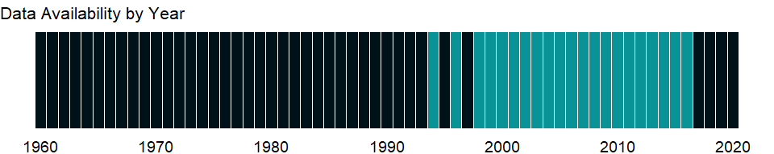

### Which countries have data?

The figure below shows the percentage of countries in each income group with a value since 2010 for that indicator.

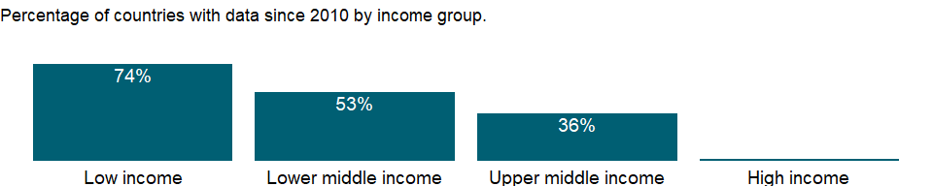

### Why is it relevant?

In most countries more boys are involved in employment, or the gender difference is small. However, girls are often more present in hidden or underreported forms of employment such as domestic service, and in almost all societies girls bear greater responsibility for household chores in their own homes, work that lies outside the System of National Accounts production boundary and is thus not considered in estimates of children’s employment.

### What is the data source?

Understanding Children’s Work project based on data from ILO, UNICEF and the World Bank.

### What is the methodology?

Data are from household surveys by the International Labor Organization (ILO), the United Nations Children’s Fund (UNICEF), the World Bank, and national statistical offices. The surveys yield data on education, employment, health, expenditure, and consumption indicators related to children’s work. Since children’s work is captured in the sense of “economic activity,” the data refer to children in employment, a broader concept than child labor (see ILO 2009a for details on this distinction).

Household survey data generally include information on work type - for example, whether a child is working for payment in cash or in kind or is involved in unpaid work, working for someone who is not a member of the household, or involved in any type of family work (on the farm or in a business).

In line with the definition of economic activity adopted by the 13th International Conference of Labour Statisticians, the threshold set by the 1993 UN System of National Accounts for classifying a person as employed is to have been engaged at least one hour in any activity relating to the production of goods and services during the reference period. Children seeking work are thus excluded. Economic activity covers all market production and certain nonmarket production, including production of goods for own use. It excludes unpaid household services (commonly called “household chores”) - that is, the production of domestic and personal services by household members for a household’s own consumption.

Country surveys define the ages for child labor as 5-17. The data here have been recalculated to present statistics for children ages 7-14.

### How is it aggregated?

NA

### What are the limitations?

Although efforts are made to harmonize the definition of employment and the questions on employment in survey questionnaires, significant differences remain in the survey instruments that collect data on children in employment and in the sampling design underlying the surveys. Differences exist not only across different household surveys in the same country but also across the same type of survey carried out in different countries, so estimates of working children are not fully comparable across countries. For detailed source information, see footnotes at each data point.

### What else should I know?

NA

### 1.75.55 Children in employment, male (% of male children ages 7-14)

### What is the indicator?

Children in employment refer to children involved in economic activity for at least one hour in the reference week of the survey.

Topic: Social Protection & Labor: Economic activity

Series ID: SL.TLF.0714.MA.ZS

Copyright: CC BY-4.0 , <https://datacatalog.worldbank.org/public-licenses#cc-by>

First year with any data: 1994

Last year with any data: 2016

### What years are data available?

The figure below shows years in which data is available for at least one country. Dates shaded in black have no data, while dates shaded in green have data for at least one country



### Which countries have data?

The figure below shows the percentage of countries in each income group with a value since 2010 for that indicator.



### Why is it relevant?

In most countries more boys are involved in employment, or the gender difference is small. However, girls are often more present in hidden or underreported forms of employment such as domestic service, and in almost all societies girls bear greater responsibility for household chores in their own homes, work that lies outside the System of National Accounts production boundary and is thus not considered in estimates of children’s employment.

### What is the data source?

Understanding Children’s Work project based on data from ILO, UNICEF and the World Bank.

### What is the methodology?

Data are from household surveys by the International Labor Organization (ILO), the United Nations Children’s Fund (UNICEF), the World Bank, and national statistical offices. The surveys yield data on education, employment, health, expenditure, and consumption indicators related to children’s work. Since children’s work is captured in the sense of “economic activity,” the data refer to children in employment, a broader concept than child labor (see ILO 2009a for details on this distinction).

Household survey data generally include information on work type - for example, whether a child is working for payment in cash or in kind or is involved in unpaid work, working for someone who is not a member of the household, or involved in any type of family work (on the farm or in a business).

In line with the definition of economic activity adopted by the 13th International Conference of Labour Statisticians, the threshold set by the 1993 UN System of National Accounts for classifying a person as employed is to have been engaged at least one hour in any activity relating to the production of goods and services during the reference period. Children seeking work are thus excluded. Economic activity covers all market production and certain nonmarket production, including production of goods for own use. It excludes unpaid household services (commonly called “household chores”) - that is, the production of domestic and personal services by household members for a household’s own consumption.

Country surveys define the ages for child labor as 5-17. The data here have been recalculated to present statistics for children ages 7-14.

### How is it aggregated?

NA

### What are the limitations?

Although efforts are made to harmonize the definition of employment and the questions on employment in survey questionnaires, significant differences remain in the survey instruments that collect data on children in employment and in the sampling design underlying the surveys. Differences exist not only across different household surveys in the same country but also across the same type of survey carried out in different countries, so estimates of working children are not fully comparable across countries. For detailed source information, see footnotes at each data point.

### What else should I know?

NA

### 1.75.56 Average working hours of children, study and work, female, ages 7-14 (hours per week)

### What is the indicator?

Average working hours of children studying and working refer to the average weekly working hours of those children who are attending school in combination with economic activity.

Topic: Social Protection & Labor: Economic activity

Series ID: SL.TLF.0714.SW.FE.TM

Copyright: CC BY-4.0 , <https://datacatalog.worldbank.org/public-licenses#cc-by>

First year with any data: 1999

Last year with any data: 2016

### What years are data available?

The figure below shows years in which data is available for at least one country. Dates shaded in black have no data, while dates shaded in green have data for at least one country

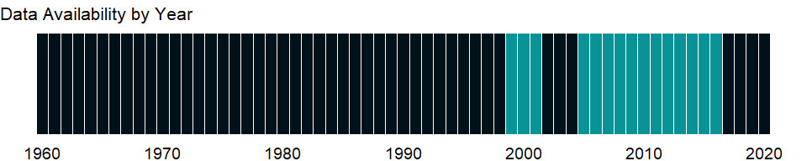

### Which countries have data?

The figure below shows the percentage of countries in each income group with a value since 2010 for that indicator.

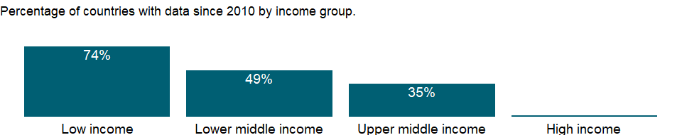

### Why is it relevant?

In most countries more boys are involved in employment, or the gender difference is small. However, girls are often more present in hidden or underreported forms of employment such as domestic service, and in almost all societies girls bear greater responsibility for household chores in their own homes, work that lies outside the System of National Accounts production boundary and is thus not considered in estimates of children’s employment.

### What is the data source?

Understanding Children’s Work project based on data from ILO, UNICEF and the World Bank.

### What is the methodology?

Data are from household surveys by the International Labor Organization (ILO), the United Nations Children’s Fund (UNICEF), the World Bank, and national statistical offices. The surveys yield data on education, employment, health, expenditure, and consumption indicators related to children’s work. Since children’s work is captured in the sense of “economic activity,” the data refer to children in employment, a broader concept than child labor (see ILO 2009a for details on this distinction).

Household survey data generally include information on work type - for example, whether a child is working for payment in cash or in kind or is involved in unpaid work, working for someone who is not a member of the household, or involved in any type of family work (on the farm or in a business).

### How is it aggregated?

NA

### What are the limitations?

Although efforts are made to harmonize the definition of employment and the questions on employment in survey questionnaires, significant differences remain in the survey instruments that collect data on children in employment and in the sampling design underlying the surveys. Differences exist not only across different household surveys in the same country but also across the same type of survey carried out in different countries, so estimates of working children are not fully comparable across countries. For detailed source information, see footnotes at each data point.

### What else should I know?

NA

### 1.75.57 Children in employment, study and work, female (% of female children in employment, ages 7-14)

### What is the indicator?

Children in employment refer to children involved in economic activity for at least one hour in the reference week of the survey. Study and work refer to children attending school in combination with economic activity.

Topic: Social Protection & Labor: Economic activity

Series ID: SL.TLF.0714.SW.FE.ZS

Copyright: CC BY-4.0 , <https://datacatalog.worldbank.org/public-licenses#cc-by>

First year with any data: 1994

Last year with any data: 2016

### What years are data available?

The figure below shows years in which data is available for at least one country. Dates shaded in black have no data, while dates shaded in green have data for at least one country

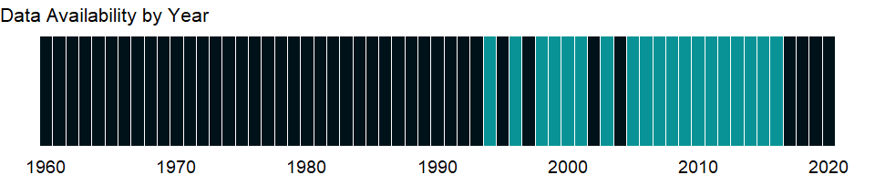

### Which countries have data?

The figure below shows the percentage of countries in each income group with a value since 2010 for that indicator.



### Why is it relevant?

In most countries more boys are involved in employment, or the gender difference is small. However, girls are often more present in hidden or underreported forms of employment such as domestic service, and in almost all societies girls bear greater responsibility for household chores in their own homes, work that lies outside the System of National Accounts production boundary and is thus not considered in estimates of children’s employment.

### What is the data source?

Understanding Children’s Work project based on data from ILO, UNICEF and the World Bank.

### What is the methodology?

Data are from household surveys by the International Labor Organization (ILO), the United Nations Children’s Fund (UNICEF), the World Bank, and national statistical offices. The surveys yield data on education, employment, health, expenditure, and consumption indicators related to children’s work. Since children’s work is captured in the sense of “economic activity,” the data refer to children in employment, a broader concept than child labor (see ILO 2009a for details on this distinction).

Household survey data generally include information on work type - for example, whether a child is working for payment in cash or in kind or is involved in unpaid work, working for someone who is not a member of the household, or involved in any type of family work (on the farm or in a business).

In line with the definition of economic activity adopted by the 13th International Conference of Labour Statisticians, the threshold set by the 1993 UN System of National Accounts for classifying a person as employed is to have been engaged at least one hour in any activity relating to the production of goods and services during the reference period. Children seeking work are thus excluded. Economic activity covers all market production and certain nonmarket production, including production of goods for own use. It excludes unpaid household services (commonly called “household chores”) - that is, the production of domestic and personal services by household members for a household’s own consumption.

Country surveys define the ages for child labor as 5-17. The data here have been recalculated to present statistics for children ages 7-14.

### How is it aggregated?

NA

### What are the limitations?

Although efforts are made to harmonize the definition of employment and the questions on employment in survey questionnaires, significant differences remain in the survey instruments that collect data on children in employment and in the sampling design underlying the surveys. Differences exist not only across different household surveys in the same country but also across the same type of survey carried out in different countries, so estimates of working children are not fully comparable across countries. For detailed source information, see footnotes at each data point.

### What else should I know?

NA

### 1.75.58 Average working hours of children, study and work, male, ages 7-14 (hours per week)

### What is the indicator?

Average working hours of children studying and working refer to the average weekly working hours of those children who are attending school in combination with economic activity.

Topic: Social Protection & Labor: Economic activity

Series ID: SL.TLF.0714.SW.MA.TM

Copyright: CC BY-4.0 , <https://datacatalog.worldbank.org/public-licenses#cc-by>

First year with any data: 1999

Last year with any data: 2016

### What years are data available?

The figure below shows years in which data is available for at least one country. Dates shaded in black have no data, while dates shaded in green have data for at least one country



### Which countries have data?

The figure below shows the percentage of countries in each income group with a value since 2010 for that indicator.



### Why is it relevant?

In most countries more boys are involved in employment, or the gender difference is small. However, girls are often more present in hidden or underreported forms of employment such as domestic service, and in almost all societies girls bear greater responsibility for household chores in their own homes, work that lies outside the System of National Accounts production boundary and is thus not considered in estimates of children’s employment.

### What is the data source?

Understanding Children’s Work project based on data from ILO, UNICEF and the World Bank.

### What is the methodology?

Data are from household surveys by the International Labor Organization (ILO), the United Nations Children’s Fund (UNICEF), the World Bank, and national statistical offices. The surveys yield data on education, employment, health, expenditure, and consumption indicators related to children’s work. Since children’s work is captured in the sense of “economic activity,” the data refer to children in employment, a broader concept than child labor (see ILO 2009a for details on this distinction).

Household survey data generally include information on work type - for example, whether a child is working for payment in cash or in kind or is involved in unpaid work, working for someone who is not a member of the household, or involved in any type of family work (on the farm or in a business).

### How is it aggregated?

NA

### What are the limitations?

Although efforts are made to harmonize the definition of employment and the questions on employment in survey questionnaires, significant differences remain in the survey instruments that collect data on children in employment and in the sampling design underlying the surveys. Differences exist not only across different household surveys in the same country but also across the same type of survey carried out in different countries, so estimates of working children are not fully comparable across countries. For detailed source information, see footnotes at each data point.

### What else should I know?

NA

### 1.75.59 Children in employment, study and work, male (% of male children in employment, ages 7-14)

### What is the indicator?

Children in employment refer to children involved in economic activity for at least one hour in the reference week of the survey. Study and work refer to children attending school in combination with economic activity.

Topic: Social Protection & Labor: Economic activity

Series ID: SL.TLF.0714.SW.MA.ZS

Copyright: CC BY-4.0 , <https://datacatalog.worldbank.org/public-licenses#cc-by>

First year with any data: 1994

Last year with any data: 2016

### What years are data available?

The figure below shows years in which data is available for at least one country. Dates shaded in black have no data, while dates shaded in green have data for at least one country



### Which countries have data?

The figure below shows the percentage of countries in each income group with a value since 2010 for that indicator.



### Why is it relevant?

In most countries more boys are involved in employment, or the gender difference is small. However, girls are often more present in hidden or underreported forms of employment such as domestic service, and in almost all societies girls bear greater responsibility for household chores in their own homes, work that lies outside the System of National Accounts production boundary and is thus not considered in estimates of children’s employment.

### What is the data source?

Understanding Children’s Work project based on data from ILO, UNICEF and the World Bank.

### What is the methodology?

Data are from household surveys by the International Labor Organization (ILO), the United Nations Children’s Fund (UNICEF), the World Bank, and national statistical offices. The surveys yield data on education, employment, health, expenditure, and consumption indicators related to children’s work. Since children’s work is captured in the sense of “economic activity,” the data refer to children in employment, a broader concept than child labor (see ILO 2009a for details on this distinction).

Household survey data generally include information on work type - for example, whether a child is working for payment in cash or in kind or is involved in unpaid work, working for someone who is not a member of the household, or involved in any type of family work (on the farm or in a business).

In line with the definition of economic activity adopted by the 13th International Conference of Labour Statisticians, the threshold set by the 1993 UN System of National Accounts for classifying a person as employed is to have been engaged at least one hour in any activity relating to the production of goods and services during the reference period. Children seeking work are thus excluded. Economic activity covers all market production and certain nonmarket production, including production of goods for own use. It excludes unpaid household services (commonly called “household chores”) - that is, the production of domestic and personal services by household members for a household’s own consumption.

Country surveys define the ages for child labor as 5-17. The data here have been recalculated to present statistics for children ages 7-14.

### How is it aggregated?

NA

### What are the limitations?

Although efforts are made to harmonize the definition of employment and the questions on employment in survey questionnaires, significant differences remain in the survey instruments that collect data on children in employment and in the sampling design underlying the surveys. Differences exist not only across different household surveys in the same country but also across the same type of survey carried out in different countries, so estimates of working children are not fully comparable across countries. For detailed source information, see footnotes at each data point.

### What else should I know?

NA

### 1.75.60 Average working hours of children, study and work, ages 7-14 (hours per week)

### What is the indicator?

Average working hours of children studying and working refer to the average weekly working hours of those children who are attending school in combination with economic activity.

Topic: Social Protection & Labor: Economic activity

Series ID: SL.TLF.0714.SW.TM

Copyright: CC BY-4.0 , <https://datacatalog.worldbank.org/public-licenses#cc-by>

First year with any data: 1999

Last year with any data: 2016

### What years are data available?

The figure below shows years in which data is available for at least one country. Dates shaded in black have no data, while dates shaded in green have data for at least one country



### Which countries have data?

The figure below shows the percentage of countries in each income group with a value since 2010 for that indicator.



### Why is it relevant?

In most countries more boys are involved in employment, or the gender difference is small. However, girls are often more present in hidden or underreported forms of employment such as domestic service, and in almost all societies girls bear greater responsibility for household chores in their own homes, work that lies outside the System of National Accounts production boundary and is thus not considered in estimates of children’s employment.

### What is the data source?

Understanding Children’s Work project based on data from ILO, UNICEF and the World Bank.

### What is the methodology?

Data are from household surveys by the International Labor Organization (ILO), the United Nations Children’s Fund (UNICEF), the World Bank, and national statistical offices. The surveys yield data on education, employment, health, expenditure, and consumption indicators related to children’s work. Since children’s work is captured in the sense of “economic activity,” the data refer to children in employment, a broader concept than child labor (see ILO 2009a for details on this distinction).

Household survey data generally include information on work type - for example, whether a child is working for payment in cash or in kind or is involved in unpaid work, working for someone who is not a member of the household, or involved in any type of family work (on the farm or in a business).

### How is it aggregated?

NA

### What are the limitations?

Although efforts are made to harmonize the definition of employment and the questions on employment in survey questionnaires, significant differences remain in the survey instruments that collect data on children in employment and in the sampling design underlying the surveys. Differences exist not only across different household surveys in the same country but also across the same type of survey carried out in different countries, so estimates of working children are not fully comparable across countries. For detailed source information, see footnotes at each data point.

### What else should I know?

NA

### 1.75.61 Children in employment, study and work (% of children in employment, ages 7-14)

### What is the indicator?

Children in employment refer to children involved in economic activity for at least one hour in the reference week of the survey. Study and work refer to children attending school in combination with economic activity.

Topic: Social Protection & Labor: Economic activity

Series ID: SL.TLF.0714.SW.ZS

Copyright: CC BY-4.0 , <https://datacatalog.worldbank.org/public-licenses#cc-by>

First year with any data: 1994

Last year with any data: 2016

### What years are data available?

The figure below shows years in which data is available for at least one country. Dates shaded in black have no data, while dates shaded in green have data for at least one country



### Which countries have data?

The figure below shows the percentage of countries in each income group with a value since 2010 for that indicator.



### Why is it relevant?

In most countries more boys are involved in employment, or the gender difference is small. However, girls are often more present in hidden or underreported forms of employment such as domestic service, and in almost all societies girls bear greater responsibility for household chores in their own homes, work that lies outside the System of National Accounts production boundary and is thus not considered in estimates of children’s employment.

### What is the data source?

Understanding Children’s Work project based on data from ILO, UNICEF and the World Bank.

### What is the methodology?

Data are from household surveys by the International Labor Organization (ILO), the United Nations Children’s Fund (UNICEF), the World Bank, and national statistical offices. The surveys yield data on education, employment, health, expenditure, and consumption indicators related to children’s work. Since children’s work is captured in the sense of “economic activity,” the data refer to children in employment, a broader concept than child labor (see ILO 2009a for details on this distinction).

Household survey data generally include information on work type - for example, whether a child is working for payment in cash or in kind or is involved in unpaid work, working for someone who is not a member of the household, or involved in any type of family work (on the farm or in a business).

In line with the definition of economic activity adopted by the 13th International Conference of Labour Statisticians, the threshold set by the 1993 UN System of National Accounts for classifying a person as employed is to have been engaged at least one hour in any activity relating to the production of goods and services during the reference period. Children seeking work are thus excluded. Economic activity covers all market production and certain nonmarket production, including production of goods for own use. It excludes unpaid household services (commonly called “household chores”) - that is, the production of domestic and personal services by household members for a household’s own consumption.

Country surveys define the ages for child labor as 5-17. The data here have been recalculated to present statistics for children ages 7-14.

### How is it aggregated?

NA

### What are the limitations?

Although efforts are made to harmonize the definition of employment and the questions on employment in survey questionnaires, significant differences remain in the survey instruments that collect data on children in employment and in the sampling design underlying the surveys. Differences exist not only across different household surveys in the same country but also across the same type of survey carried out in different countries, so estimates of working children are not fully comparable across countries. For detailed source information, see footnotes at each data point.

### What else should I know?

NA

### 1.75.62 Average working hours of children, working only, female, ages 7-14 (hours per week)

### What is the indicator?

Average working hours of children working only refers to the average weekly working hours of those children who are involved in economic activity and not attending school.

Topic: Social Protection & Labor: Economic activity

Series ID: SL.TLF.0714.WK.FE.TM

Copyright: CC BY-4.0 , <https://datacatalog.worldbank.org/public-licenses#cc-by>

First year with any data: 1999

Last year with any data: 2016

### What years are data available?

The figure below shows years in which data is available for at least one country. Dates shaded in black have no data, while dates shaded in green have data for at least one country



### Which countries have data?

The figure below shows the percentage of countries in each income group with a value since 2010 for that indicator.

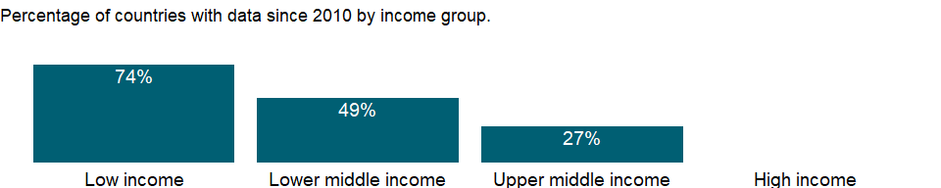

### Why is it relevant?

In most countries more boys are involved in employment, or the gender difference is small. However, girls are often more present in hidden or underreported forms of employment such as domestic service, and in almost all societies girls bear greater responsibility for household chores in their own homes, work that lies outside the System of National Accounts production boundary and is thus not considered in estimates of children’s employment.

### What is the data source?

Understanding Children’s Work project based on data from ILO, UNICEF and the World Bank.

### What is the methodology?

Data are from household surveys by the International Labor Organization (ILO), the United Nations Children’s Fund (UNICEF), the World Bank, and national statistical offices. The surveys yield data on education, employment, health, expenditure, and consumption indicators related to children’s work. Since children’s work is captured in the sense of “economic activity,” the data refer to children in employment, a broader concept than child labor (see ILO 2009a for details on this distinction).

Household survey data generally include information on work type - for example, whether a child is working for payment in cash or in kind or is involved in unpaid work, working for someone who is not a member of the household, or involved in any type of family work (on the farm or in a business).

### How is it aggregated?

NA

### What are the limitations?

Although efforts are made to harmonize the definition of employment and the questions on employment in survey questionnaires, significant differences remain in the survey instruments that collect data on children in employment and in the sampling design underlying the surveys. Differences exist not only across different household surveys in the same country but also across the same type of survey carried out in different countries, so estimates of working children are not fully comparable across countries. For detailed source information, see footnotes at each data point.

### What else should I know?

NA

### 1.75.63 Children in employment, work only, female (% of female children in employment, ages 7-14)

### What is the indicator?

Children in employment refer to children involved in economic activity for at least one hour in the reference week of the survey. Work only refers to children involved in economic activity and not attending school.

Topic: Social Protection & Labor: Economic activity

Series ID: SL.TLF.0714.WK.FE.ZS

Copyright: CC BY-4.0 , <https://datacatalog.worldbank.org/public-licenses#cc-by>

First year with any data: 1994

Last year with any data: 2016

### What years are data available?

The figure below shows years in which data is available for at least one country. Dates shaded in black have no data, while dates shaded in green have data for at least one country



### Which countries have data?

The figure below shows the percentage of countries in each income group with a value since 2010 for that indicator.



### Why is it relevant?

In most countries more boys are involved in employment, or the gender difference is small. However, girls are often more present in hidden or underreported forms of employment such as domestic service, and in almost all societies girls bear greater responsibility for household chores in their own homes, work that lies outside the System of National Accounts production boundary and is thus not considered in estimates of children’s employment.

### What is the data source?

Understanding Children’s Work project based on data from ILO, UNICEF and the World Bank.

### What is the methodology?

Data are from household surveys by the International Labor Organization (ILO), the United Nations Children’s Fund (UNICEF), the World Bank, and national statistical offices. The surveys yield data on education, employment, health, expenditure, and consumption indicators related to children’s work. Since children’s work is captured in the sense of “economic activity,” the data refer to children in employment, a broader concept than child labor (see ILO 2009a for details on this distinction).

Household survey data generally include information on work type - for example, whether a child is working for payment in cash or in kind or is involved in unpaid work, working for someone who is not a member of the household, or involved in any type of family work (on the farm or in a business).

In line with the definition of economic activity adopted by the 13th International Conference of Labour Statisticians, the threshold set by the 1993 UN System of National Accounts for classifying a person as employed is to have been engaged at least one hour in any activity relating to the production of goods and services during the reference period. Children seeking work are thus excluded. Economic activity covers all market production and certain nonmarket production, including production of goods for own use. It excludes unpaid household services (commonly called “household chores”) - that is, the production of domestic and personal services by household members for a household’s own consumption.

Country surveys define the ages for child labor as 5-17. The data here have been recalculated to present statistics for children ages 7-14.

### How is it aggregated?

NA

### What are the limitations?

Although efforts are made to harmonize the definition of employment and the questions on employment in survey questionnaires, significant differences remain in the survey instruments that collect data on children in employment and in the sampling design underlying the surveys. Differences exist not only across different household surveys in the same country but also across the same type of survey carried out in different countries, so estimates of working children are not fully comparable across countries. For detailed source information, see footnotes at each data point.

### What else should I know?

NA

### 1.75.64 Average working hours of children, working only, male, ages 7-14 (hours per week)

### What is the indicator?

Average working hours of children working only refers to the average weekly working hours of those children who are involved in economic activity and not attending school.

Topic: Social Protection & Labor: Economic activity

Series ID: SL.TLF.0714.WK.MA.TM

Copyright: CC BY-4.0 , <https://datacatalog.worldbank.org/public-licenses#cc-by>

First year with any data: 1999

Last year with any data: 2016

### What years are data available?

The figure below shows years in which data is available for at least one country. Dates shaded in black have no data, while dates shaded in green have data for at least one country



### Which countries have data?

The figure below shows the percentage of countries in each income group with a value since 2010 for that indicator.

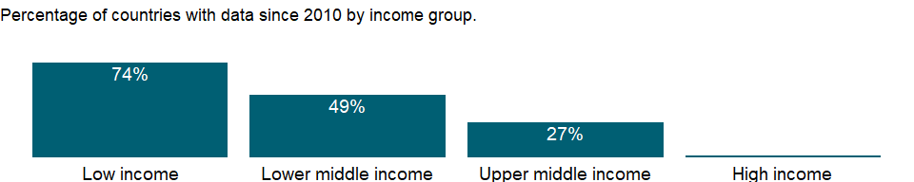

### Why is it relevant?

In most countries more boys are involved in employment, or the gender difference is small. However, girls are often more present in hidden or underreported forms of employment such as domestic service, and in almost all societies girls bear greater responsibility for household chores in their own homes, work that lies outside the System of National Accounts production boundary and is thus not considered in estimates of children’s employment.

### What is the data source?

Understanding Children’s Work project based on data from ILO, UNICEF and the World Bank.

### What is the methodology?

Data are from household surveys by the International Labor Organization (ILO), the United Nations Children’s Fund (UNICEF), the World Bank, and national statistical offices. The surveys yield data on education, employment, health, expenditure, and consumption indicators related to children’s work. Since children’s work is captured in the sense of “economic activity,” the data refer to children in employment, a broader concept than child labor (see ILO 2009a for details on this distinction).

Household survey data generally include information on work type - for example, whether a child is working for payment in cash or in kind or is involved in unpaid work, working for someone who is not a member of the household, or involved in any type of family work (on the farm or in a business).

### How is it aggregated?

NA

### What are the limitations?

Although efforts are made to harmonize the definition of employment and the questions on employment in survey questionnaires, significant differences remain in the survey instruments that collect data on children in employment and in the sampling design underlying the surveys. Differences exist not only across different household surveys in the same country but also across the same type of survey carried out in different countries, so estimates of working children are not fully comparable across countries. For detailed source information, see footnotes at each data point.

### What else should I know?

NA

### 1.75.65 Children in employment, work only, male (% of male children in employment, ages 7-14)

### What is the indicator?

Children in employment refer to children involved in economic activity for at least one hour in the reference week of the survey. Work only refers to children involved in economic activity and not attending school.

Topic: Social Protection & Labor: Economic activity

Series ID: SL.TLF.0714.WK.MA.ZS

Copyright: CC BY-4.0 , <https://datacatalog.worldbank.org/public-licenses#cc-by>

First year with any data: 1994

Last year with any data: 2016

### What years are data available?

The figure below shows years in which data is available for at least one country. Dates shaded in black have no data, while dates shaded in green have data for at least one country



### Which countries have data?

The figure below shows the percentage of countries in each income group with a value since 2010 for that indicator.



### Why is it relevant?

In most countries more boys are involved in employment, or the gender difference is small. However, girls are often more present in hidden or underreported forms of employment such as domestic service, and in almost all societies girls bear greater responsibility for household chores in their own homes, work that lies outside the System of National Accounts production boundary and is thus not considered in estimates of children’s employment.

### What is the data source?

Understanding Children’s Work project based on data from ILO, UNICEF and the World Bank.

### What is the methodology?

Data are from household surveys by the International Labor Organization (ILO), the United Nations Children’s Fund (UNICEF), the World Bank, and national statistical offices. The surveys yield data on education, employment, health, expenditure, and consumption indicators related to children’s work. Since children’s work is captured in the sense of “economic activity,” the data refer to children in employment, a broader concept than child labor (see ILO 2009a for details on this distinction).

Household survey data generally include information on work type - for example, whether a child is working for payment in cash or in kind or is involved in unpaid work, working for someone who is not a member of the household, or involved in any type of family work (on the farm or in a business).

In line with the definition of economic activity adopted by the 13th International Conference of Labour Statisticians, the threshold set by the 1993 UN System of National Accounts for classifying a person as employed is to have been engaged at least one hour in any activity relating to the production of goods and services during the reference period. Children seeking work are thus excluded. Economic activity covers all market production and certain nonmarket production, including production of goods for own use. It excludes unpaid household services (commonly called “household chores”) - that is, the production of domestic and personal services by household members for a household’s own consumption.

Country surveys define the ages for child labor as 5-17. The data here have been recalculated to present statistics for children ages 7-14.

### How is it aggregated?

NA

### What are the limitations?

Although efforts are made to harmonize the definition of employment and the questions on employment in survey questionnaires, significant differences remain in the survey instruments that collect data on children in employment and in the sampling design underlying the surveys. Differences exist not only across different household surveys in the same country but also across the same type of survey carried out in different countries, so estimates of working children are not fully comparable across countries. For detailed source information, see footnotes at each data point.

### What else should I know?

NA

### 1.75.66 Average working hours of children, working only, ages 7-14 (hours per week)

### What is the indicator?

Average working hours of children working only refers to the average weekly working hours of those children who are involved in economic activity and not attending school.

Topic: Social Protection & Labor: Economic activity

Series ID: SL.TLF.0714.WK.TM

Copyright: CC BY-4.0 , <https://datacatalog.worldbank.org/public-licenses#cc-by>

First year with any data: 1999

Last year with any data: 2016

### What years are data available?

The figure below shows years in which data is available for at least one country. Dates shaded in black have no data, while dates shaded in green have data for at least one country



### Which countries have data?

The figure below shows the percentage of countries in each income group with a value since 2010 for that indicator.



### Why is it relevant?

In most countries more boys are involved in employment, or the gender difference is small. However, girls are often more present in hidden or underreported forms of employment such as domestic service, and in almost all societies girls bear greater responsibility for household chores in their own homes, work that lies outside the System of National Accounts production boundary and is thus not considered in estimates of children’s employment.

### What is the data source?

Understanding Children’s Work project based on data from ILO, UNICEF and the World Bank.

### What is the methodology?

Data are from household surveys by the International Labor Organization (ILO), the United Nations Children’s Fund (UNICEF), the World Bank, and national statistical offices. The surveys yield data on education, employment, health, expenditure, and consumption indicators related to children’s work. Since children’s work is captured in the sense of “economic activity,” the data refer to children in employment, a broader concept than child labor (see ILO 2009a for details on this distinction).

Household survey data generally include information on work type - for example, whether a child is working for payment in cash or in kind or is involved in unpaid work, working for someone who is not a member of the household, or involved in any type of family work (on the farm or in a business).

### How is it aggregated?

NA

### What are the limitations?

Although efforts are made to harmonize the definition of employment and the questions on employment in survey questionnaires, significant differences remain in the survey instruments that collect data on children in employment and in the sampling design underlying the surveys. Differences exist not only across different household surveys in the same country but also across the same type of survey carried out in different countries, so estimates of working children are not fully comparable across countries. For detailed source information, see footnotes at each data point.

### What else should I know?

NA

### 1.75.67 Children in employment, work only (% of children in employment, ages 7-14)

### What is the indicator?

Children in employment refer to children involved in economic activity for at least one hour in the reference week of the survey. Work only refers to children involved in economic activity and not attending school.

Topic: Social Protection & Labor: Economic activity

Series ID: SL.TLF.0714.WK.ZS

Copyright: CC BY-4.0 , <https://datacatalog.worldbank.org/public-licenses#cc-by>

First year with any data: 1994

Last year with any data: 2016

### What years are data available?

The figure below shows years in which data is available for at least one country. Dates shaded in black have no data, while dates shaded in green have data for at least one country



### Which countries have data?

The figure below shows the percentage of countries in each income group with a value since 2010 for that indicator.



### Why is it relevant?

In most countries more boys are involved in employment, or the gender difference is small. However, girls are often more present in hidden or underreported forms of employment such as domestic service, and in almost all societies girls bear greater responsibility for household chores in their own homes, work that lies outside the System of National Accounts production boundary and is thus not considered in estimates of children’s employment.

### What is the data source?

Understanding Children’s Work project based on data from ILO, UNICEF and the World Bank.

### What is the methodology?

Data are from household surveys by the International Labor Organization (ILO), the United Nations Children’s Fund (UNICEF), the World Bank, and national statistical offices. The surveys yield data on education, employment, health, expenditure, and consumption indicators related to children’s work. Since children’s work is captured in the sense of “economic activity,” the data refer to children in employment, a broader concept than child labor (see ILO 2009a for details on this distinction).

Household survey data generally include information on work type - for example, whether a child is working for payment in cash or in kind or is involved in unpaid work, working for someone who is not a member of the household, or involved in any type of family work (on the farm or in a business).

In line with the definition of economic activity adopted by the 13th International Conference of Labour Statisticians, the threshold set by the 1993 UN System of National Accounts for classifying a person as employed is to have been engaged at least one hour in any activity relating to the production of goods and services during the reference period. Children seeking work are thus excluded. Economic activity covers all market production and certain nonmarket production, including production of goods for own use. It excludes unpaid household services (commonly called “household chores”) - that is, the production of domestic and personal services by household members for a household’s own consumption.

Country surveys define the ages for child labor as 5-17. The data here have been recalculated to present statistics for children ages 7-14.

### How is it aggregated?

NA

### What are the limitations?

Although efforts are made to harmonize the definition of employment and the questions on employment in survey questionnaires, significant differences remain in the survey instruments that collect data on children in employment and in the sampling design underlying the surveys. Differences exist not only across different household surveys in the same country but also across the same type of survey carried out in different countries, so estimates of working children are not fully comparable across countries. For detailed source information, see footnotes at each data point.

### What else should I know?

NA

### 1.75.68 Children in employment, total (% of children ages 7-14)

### What is the indicator?

Children in employment refer to children involved in economic activity for at least one hour in the reference week of the survey.

Topic: Social Protection & Labor: Economic activity

Series ID: SL.TLF.0714.ZS

Copyright: CC BY-4.0 , <https://datacatalog.worldbank.org/public-licenses#cc-by>

First year with any data: 1994

Last year with any data: 2016

### What years are data available?

The figure below shows years in which data is available for at least one country. Dates shaded in black have no data, while dates shaded in green have data for at least one country



### Which countries have data?

The figure below shows the percentage of countries in each income group with a value since 2010 for that indicator.



### Why is it relevant?

In most countries more boys are involved in employment, or the gender difference is small. However, girls are often more present in hidden or underreported forms of employment such as domestic service, and in almost all societies girls bear greater responsibility for household chores in their own homes, work that lies outside the System of National Accounts production boundary and is thus not considered in estimates of children’s employment.

### What is the data source?

Understanding Children’s Work project based on data from ILO, UNICEF and the World Bank.

### What is the methodology?

Data are from household surveys by the International Labor Organization (ILO), the United Nations Children’s Fund (UNICEF), the World Bank, and national statistical offices. The surveys yield data on education, employment, health, expenditure, and consumption indicators related to children’s work. Since children’s work is captured in the sense of “economic activity,” the data refer to children in employment, a broader concept than child labor (see ILO 2009a for details on this distinction).

Household survey data generally include information on work type - for example, whether a child is working for payment in cash or in kind or is involved in unpaid work, working for someone who is not a member of the household, or involved in any type of family work (on the farm or in a business).

In line with the definition of economic activity adopted by the 13th International Conference of Labour Statisticians, the threshold set by the 1993 UN System of National Accounts for classifying a person as employed is to have been engaged at least one hour in any activity relating to the production of goods and services during the reference period. Children seeking work are thus excluded. Economic activity covers all market production and certain nonmarket production, including production of goods for own use. It excludes unpaid household services (commonly called “household chores”) - that is, the production of domestic and personal services by household members for a household’s own consumption.

Country surveys define the ages for child labor as 5-17. The data here have been recalculated to present statistics for children ages 7-14.

### How is it aggregated?

NA

### What are the limitations?

Although efforts are made to harmonize the definition of employment and the questions on employment in survey questionnaires, significant differences remain in the survey instruments that collect data on children in employment and in the sampling design underlying the surveys. Differences exist not only across different household surveys in the same country but also across the same type of survey carried out in different countries, so estimates of working children are not fully comparable across countries. For detailed source information, see footnotes at each data point.

### What else should I know?

NA

### 1.75.69 Part time employment, female (% of total female employment)

### What is the indicator?

Part time employment refers to regular employment in which working time is substantially less than normal. Definitions of part time employment differ by country.

Topic: Social Protection & Labor: Economic activity

Series ID: SL.TLF.PART.FE.ZS

Copyright: CC BY-4.0 , <https://datacatalog.worldbank.org/public-licenses#cc-by>

First year with any data: 1976

Last year with any data: 2020

### What years are data available?

The figure below shows years in which data is available for at least one country. Dates shaded in black have no data, while dates shaded in green have data for at least one country

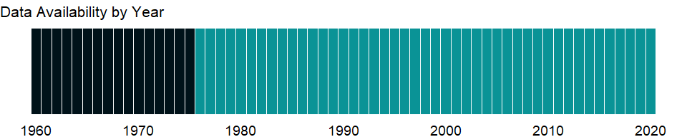

### Which countries have data?

The figure below shows the percentage of countries in each income group with a value since 2010 for that indicator.

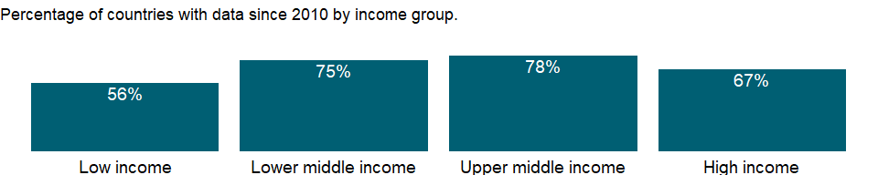

### Why is it relevant?

NA

### What is the data source?

International Labour Organization, ILOSTAT database. Data retrieved on January 29, 2021.

### What is the methodology?

NA

### How is it aggregated?

Weighted average

### What are the limitations?

NA

### What else should I know?

Relevance to gender indicator: More and more women are working part-time and one of the concern is that part time work does not provide the stability that full time work does.

### 1.75.70 Part time employment, male (% of total male employment)

### What is the indicator?

Part time employment refers to regular employment in which working time is substantially less than normal. Definitions of part time employment differ by country.

Topic: Social Protection & Labor: Economic activity

Series ID: SL.TLF.PART.MA.ZS

Copyright: CC BY-4.0 , <https://datacatalog.worldbank.org/public-licenses#cc-by>

First year with any data: 1976

Last year with any data: 2020

### What years are data available?

The figure below shows years in which data is available for at least one country. Dates shaded in black have no data, while dates shaded in green have data for at least one country



### Which countries have data?

The figure below shows the percentage of countries in each income group with a value since 2010 for that indicator.



### Why is it relevant?

NA

### What is the data source?

International Labour Organization, ILOSTAT database. Data retrieved on January 29, 2021.

### What is the methodology?

NA

### How is it aggregated?

Weighted average

### What are the limitations?

NA

### What else should I know?

Relevance to gender indicator: More and more women are working part-time and one of the concern is that part time work does not provide the stability that full time work does.

### 1.75.71 Part time employment, total (% of total employment)

### What is the indicator?

Part time employment refers to regular employment in which working time is substantially less than normal. Definitions of part time employment differ by country.

Topic: Social Protection & Labor: Economic activity

Series ID: SL.TLF.PART.ZS

Copyright: CC BY-4.0 , <https://datacatalog.worldbank.org/public-licenses#cc-by>

First year with any data: 1976

Last year with any data: 2020

### What years are data available?

The figure below shows years in which data is available for at least one country. Dates shaded in black have no data, while dates shaded in green have data for at least one country



### Which countries have data?

The figure below shows the percentage of countries in each income group with a value since 2010 for that indicator.



### Why is it relevant?

NA

### What is the data source?

International Labour Organization, ILOSTAT database. Data retrieved on January 29, 2021.

### What is the methodology?

NA

### How is it aggregated?

Weighted average

### What are the limitations?

NA

### What else should I know?

Relevance to gender indicator: More and more women are working part-time and one of the concern is that part time work does not provide the stability that full time work does.

### 1.75.72 Children in employment, wage workers, female (% of female children in employment, ages 7-14)

### What is the indicator?

Wage workers (also known as employees) are people who hold explicit (written or oral) or implicit employment contracts that provide basic remuneration that does not depend directly on the revenue of the unit for which they work.

Topic: Social Protection & Labor: Economic activity

Series ID: SL.WAG.0714.FE.ZS

Copyright: CC BY-4.0 , <https://datacatalog.worldbank.org/public-licenses#cc-by>

First year with any data: 1999

Last year with any data: 2016

### What years are data available?

The figure below shows years in which data is available for at least one country. Dates shaded in black have no data, while dates shaded in green have data for at least one country



### Which countries have data?

The figure below shows the percentage of countries in each income group with a value since 2010 for that indicator.

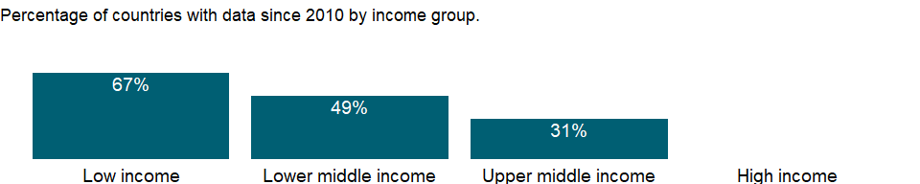

### Why is it relevant?

In most countries more boys are involved in employment, or the gender difference is small. However, girls are often more present in hidden or underreported forms of employment such as domestic service, and in almost all societies girls bear greater responsibility for household chores in their own homes, work that lies outside the System of National Accounts production boundary and is thus not considered in estimates of children’s employment.

### What is the data source?

Understanding Children’s Work project based on data from ILO, UNICEF and the World Bank.

### What is the methodology?

Data are from household surveys by the International Labor Organization (ILO), the United Nations Children’s Fund (UNICEF), the World Bank, and national statistical offices. The surveys yield data on education, employment, health, expenditure, and consumption indicators related to children’s work. Since children’s work is captured in the sense of “economic activity,” the data refer to children in employment, a broader concept than child labor (see ILO 2009a for details on this distinction).

Household survey data generally include information on work type - for example, whether a child is working for payment in cash or in kind or is involved in unpaid work, working for someone who is not a member of the household, or involved in any type of family work (on the farm or in a business).

In line with the definition of economic activity adopted by the 13th International Conference of Labour Statisticians, the threshold set by the 1993 UN System of National Accounts for classifying a person as employed is to have been engaged at least one hour in any activity relating to the production of goods and services during the reference period. Children seeking work are thus excluded. Economic activity covers all market production and certain nonmarket production, including production of goods for own use. It excludes unpaid household services (commonly called “household chores”) - that is, the production of domestic and personal services by household members for a household’s own consumption.

Country surveys define the ages for child labor as 5-17. The data here have been recalculated to present statistics for children ages 7-14.

### How is it aggregated?

NA

### What are the limitations?

Although efforts are made to harmonize the definition of employment and the questions on employment in survey questionnaires, significant differences remain in the survey instruments that collect data on children in employment and in the sampling design underlying the surveys. Differences exist not only across different household surveys in the same country but also across the same type of survey carried out in different countries, so estimates of working children are not fully comparable across countries. In addition, the shares of three categories (self-employed workers, wage workers, and unpaid family workers) may not add up to 100 percent because of a residual category not included.

### What else should I know?

NA

### 1.75.73 Children in employment, wage workers, male (% of male children in employment, ages 7-14)

### What is the indicator?

Wage workers (also known as employees) are people who hold explicit (written or oral) or implicit employment contracts that provide basic remuneration that does not depend directly on the revenue of the unit for which they work.

Topic: Social Protection & Labor: Economic activity

Series ID: SL.WAG.0714.MA.ZS

Copyright: CC BY-4.0 , <https://datacatalog.worldbank.org/public-licenses#cc-by>

First year with any data: 1999

Last year with any data: 2016

### What years are data available?

The figure below shows years in which data is available for at least one country. Dates shaded in black have no data, while dates shaded in green have data for at least one country



### Which countries have data?

The figure below shows the percentage of countries in each income group with a value since 2010 for that indicator.



### Why is it relevant?

In most countries more boys are involved in employment, or the gender difference is small. However, girls are often more present in hidden or underreported forms of employment such as domestic service, and in almost all societies girls bear greater responsibility for household chores in their own homes, work that lies outside the System of National Accounts production boundary and is thus not considered in estimates of children’s employment.

### What is the data source?

Understanding Children’s Work project based on data from ILO, UNICEF and the World Bank.

### What is the methodology?

Data are from household surveys by the International Labor Organization (ILO), the United Nations Children’s Fund (UNICEF), the World Bank, and national statistical offices. The surveys yield data on education, employment, health, expenditure, and consumption indicators related to children’s work. Since children’s work is captured in the sense of “economic activity,” the data refer to children in employment, a broader concept than child labor (see ILO 2009a for details on this distinction).

Household survey data generally include information on work type - for example, whether a child is working for payment in cash or in kind or is involved in unpaid work, working for someone who is not a member of the household, or involved in any type of family work (on the farm or in a business).

In line with the definition of economic activity adopted by the 13th International Conference of Labour Statisticians, the threshold set by the 1993 UN System of National Accounts for classifying a person as employed is to have been engaged at least one hour in any activity relating to the production of goods and services during the reference period. Children seeking work are thus excluded. Economic activity covers all market production and certain nonmarket production, including production of goods for own use. It excludes unpaid household services (commonly called “household chores”) - that is, the production of domestic and personal services by household members for a household’s own consumption.

Country surveys define the ages for child labor as 5-17. The data here have been recalculated to present statistics for children ages 7-14.

### How is it aggregated?

NA

### What are the limitations?

Although efforts are made to harmonize the definition of employment and the questions on employment in survey questionnaires, significant differences remain in the survey instruments that collect data on children in employment and in the sampling design underlying the surveys. Differences exist not only across different household surveys in the same country but also across the same type of survey carried out in different countries, so estimates of working children are not fully comparable across countries. In addition, the shares of three categories (self-employed workers, wage workers, and unpaid family workers) may not add up to 100 percent because of a residual category not included.

### What else should I know?

NA

### 1.75.74 Children in employment, wage workers (% of children in employment, ages 7-14)

### What is the indicator?

Wage workers (also known as employees) are people who hold explicit (written or oral) or implicit employment contracts that provide basic remuneration that does not depend directly on the revenue of the unit for which they work.

Topic: Social Protection & Labor: Economic activity

Series ID: SL.WAG.0714.ZS

Copyright: CC BY-4.0 , <https://datacatalog.worldbank.org/public-licenses#cc-by>

First year with any data: 1999

Last year with any data: 2016

### What years are data available?

The figure below shows years in which data is available for at least one country. Dates shaded in black have no data, while dates shaded in green have data for at least one country



### Which countries have data?

The figure below shows the percentage of countries in each income group with a value since 2010 for that indicator.



### Why is it relevant?

In most countries more boys are involved in employment, or the gender difference is small. However, girls are often more present in hidden or underreported forms of employment such as domestic service, and in almost all societies girls bear greater responsibility for household chores in their own homes, work that lies outside the System of National Accounts production boundary and is thus not considered in estimates of children’s employment.

### What is the data source?

Understanding Children’s Work project based on data from ILO, UNICEF and the World Bank.

### What is the methodology?

Data are from household surveys by the International Labor Organization (ILO), the United Nations Children’s Fund (UNICEF), the World Bank, and national statistical offices. The surveys yield data on education, employment, health, expenditure, and consumption indicators related to children’s work. Since children’s work is captured in the sense of “economic activity,” the data refer to children in employment, a broader concept than child labor (see ILO 2009a for details on this distinction).

Household survey data generally include information on work type - for example, whether a child is working for payment in cash or in kind or is involved in unpaid work, working for someone who is not a member of the household, or involved in any type of family work (on the farm or in a business).

In line with the definition of economic activity adopted by the 13th International Conference of Labour Statisticians, the threshold set by the 1993 UN System of National Accounts for classifying a person as employed is to have been engaged at least one hour in any activity relating to the production of goods and services during the reference period. Children seeking work are thus excluded. Economic activity covers all market production and certain nonmarket production, including production of goods for own use. It excludes unpaid household services (commonly called “household chores”) - that is, the production of domestic and personal services by household members for a household’s own consumption.

Country surveys define the ages for child labor as 5-17. The data here have been recalculated to present statistics for children ages 7-14.

### How is it aggregated?

NA

### What are the limitations?

Although efforts are made to harmonize the definition of employment and the questions on employment in survey questionnaires, significant differences remain in the survey instruments that collect data on children in employment and in the sampling design underlying the surveys. Differences exist not only across different household surveys in the same country but also across the same type of survey carried out in different countries, so estimates of working children are not fully comparable across countries. In addition, the shares of three categories (self-employed workers, wage workers, and unpaid family workers) may not add up to 100 percent because of a residual category not included.

### What else should I know?

NA

## 1.76 Social Protection & Labor: Labor force structure

### 1.76.1 Labor force participation rate for ages 15-24, female (%) (national estimate)

### What is the indicator?

Labor force participation rate for ages 15-24 is the proportion of the population ages 15-24 that is economically active: all people who supply labor for the production of goods and services during a specified period.

Topic: Social Protection & Labor: Labor force structure

Series ID: SL.TLF.ACTI.1524.FE.NE.ZS

Copyright: CC BY-4.0 , <https://datacatalog.worldbank.org/public-licenses#cc-by>

First year with any data: 1960

Last year with any data: 2020

### What years are data available?

The figure below shows years in which data is available for at least one country. Dates shaded in black have no data, while dates shaded in green have data for at least one country



### Which countries have data?

The figure below shows the percentage of countries in each income group with a value since 2010 for that indicator.

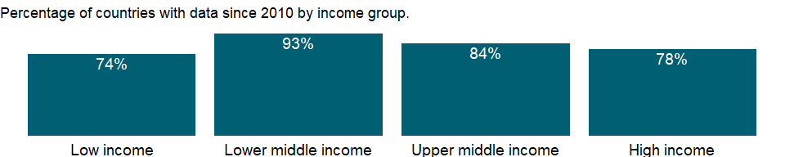

### Why is it relevant?

Estimates of women in the labor force and employment are generally lower than those of men and are not comparable internationally, reflecting that demographic, social, legal, and cultural trends and norms determine whether women’s activities are regarded as economic. In many low-income countries women often work on farms or in other family enterprises without pay, and others work in or near their homes, mixing work and family activities during the day. In many high-income economies, women have been increasingly acquiring higher education that has led to better-compensated, longer-term careers rather than lower-skilled, shorter-term jobs. However, access to good- paying occupations for women remains unequal in many occupations and countries around the world. Labor force statistics by gender is important to monitor gender disparities in employment and unemployment patterns.

### What is the data source?

International Labour Organization, ILOSTAT database. Data retrieved on September 7, 2021.

### What is the methodology?

The labor force is the supply of labor available for producing goods and services in an economy. It includes people who are currently employed and people who are unemployed but seeking work as well as first-time job-seekers. Not everyone who works is included, however. Unpaid workers, family workers, and students are often omitted, and some countries do not count members of the armed forces. Labor force size tends to vary during the year as seasonal workers enter and leave.

### How is it aggregated?

Weighted Average

### What are the limitations?

Data on the labor force are compiled by the ILO from labor force surveys, censuses, and establishment censuses and surveys. For some countries a combination of these sources is used. Labor force surveys are the most comprehensive source for internationally comparable labor force data. They can cover all non-institutionalized civilians, all branches and sectors of the economy, and all categories of workers, including people holding multiple jobs. By contrast, labor force data from population censuses are often based on a limited number of questions on the economic characteristics of individuals, with little scope to probe. The resulting data often differ from labor force survey data and vary considerably by country, depending on the census scope and coverage. Establishment censuses and surveys provide data only on the employed population, not unemployed workers, workers in small establishments, or workers in the informal sector.

The reference period of a census or survey is another important source of differences: in some countries data refer to people’s status on the day of the census or survey or during a specific period before the inquiry date, while in others data are recorded without reference to any period. In countries, where the household is the basic unit of production and all members contribute to output, but some at low intensity or irregularly, the estimated labor force may be much smaller than the numbers actually working.

Differing definitions of employment age also affect comparability. For most countries the working age is 15 and older, but in some countries children younger than 15 work full- or part-time and are included in the estimates. Similarly, some countries have an upper age limit. As a result, calculations may systematically over- or underestimate actual rates.

### What else should I know?

The series for ILO estimates is also available in the WDI database. Caution should be used when comparing ILO estimates with national estimates.

### 1.76.2 Labor force participation rate for ages 15-24, female (%) (modeled ILO estimate)

### What is the indicator?

Labor force participation rate for ages 15-24 is the proportion of the population ages 15-24 that is economically active: all people who supply labor for the production of goods and services during a specified period.

Topic: Social Protection & Labor: Labor force structure

Series ID: SL.TLF.ACTI.1524.FE.ZS

Copyright: CC BY-4.0 , <https://datacatalog.worldbank.org/public-licenses#cc-by>

First year with any data: 1990

Last year with any data: 2019

### What years are data available?

The figure below shows years in which data is available for at least one country. Dates shaded in black have no data, while dates shaded in green have data for at least one country



### Which countries have data?

The figure below shows the percentage of countries in each income group with a value since 2010 for that indicator.



### Why is it relevant?

Estimates of women in the labor force and employment are generally lower than those of men and are not comparable internationally, reflecting that demographic, social, legal, and cultural trends and norms determine whether women’s activities are regarded as economic. In many low-income countries women often work on farms or in other family enterprises without pay, and others work in or near their homes, mixing work and family activities during the day. In many high-income economies, women have been increasingly acquiring higher education that has led to better-compensated, longer-term careers rather than lower-skilled, shorter-term jobs. However, access to good- paying occupations for women remains unequal in many occupations and countries around the world. Labor force statistics by gender is important to monitor gender disparities in employment and unemployment patterns.

### What is the data source?

International Labour Organization, ILOSTAT database. Data retrieved on June 15, 2021.

### What is the methodology?

The labor force is the supply of labor available for producing goods and services in an economy. It includes people who are currently employed and people who are unemployed but seeking work as well as first-time job-seekers. Not everyone who works is included, however. Unpaid workers, family workers, and students are often omitted, and some countries do not count members of the armed forces. Labor force size tends to vary during the year as seasonal workers enter and leave.

The series is part of the ILO estimates and is harmonized to ensure comparability across countries and over time by accounting for differences in data source, scope of coverage, methodology, and other country-specific factors. The estimates are based mainly on nationally representative labor force surveys, with other sources (population censuses and nationally reported estimates) used only when no survey data are available.

### How is it aggregated?

Weighted Average

### What are the limitations?

Data on the labor force are compiled by the ILO from labor force surveys, censuses, and establishment censuses and surveys. For some countries a combination of these sources is used. Labor force surveys are the most comprehensive source for internationally comparable labor force data. They can cover all non-institutionalized civilians, all branches and sectors of the economy, and all categories of workers, including people holding multiple jobs. By contrast, labor force data from population censuses are often based on a limited number of questions on the economic characteristics of individuals, with little scope to probe. The resulting data often differ from labor force survey data and vary considerably by country, depending on the census scope and coverage. Establishment censuses and surveys provide data only on the employed population, not unemployed workers, workers in small establishments, or workers in the informal sector.

The reference period of a census or survey is another important source of differences: in some countries data refer to people’s status on the day of the census or survey or during a specific period before the inquiry date, while in others data are recorded without reference to any period. In countries, where the household is the basic unit of production and all members contribute to output, but some at low intensity or irregularly, the estimated labor force may be much smaller than the numbers actually working.

Differing definitions of employment age also affect comparability. For most countries the working age is 15 and older, but in some countries children younger than 15 work full- or part-time and are included in the estimates. Similarly, some countries have an upper age limit. As a result, calculations may systematically over- or underestimate actual rates.

### What else should I know?

National estimates are also available in the WDI database. Caution should be used when comparing ILO estimates with national estimates.

### 1.76.3 Labor force participation rate for ages 15-24, male (%) (national estimate)

### What is the indicator?

Labor force participation rate for ages 15-24 is the proportion of the population ages 15-24 that is economically active: all people who supply labor for the production of goods and services during a specified period.

Topic: Social Protection & Labor: Labor force structure

Series ID: SL.TLF.ACTI.1524.MA.NE.ZS

Copyright: CC BY-4.0 , <https://datacatalog.worldbank.org/public-licenses#cc-by>

First year with any data: 1960

Last year with any data: 2020

### What years are data available?

The figure below shows years in which data is available for at least one country. Dates shaded in black have no data, while dates shaded in green have data for at least one country



### Which countries have data?

The figure below shows the percentage of countries in each income group with a value since 2010 for that indicator.



### Why is it relevant?

Estimates of women in the labor force and employment are generally lower than those of men and are not comparable internationally, reflecting that demographic, social, legal, and cultural trends and norms determine whether women’s activities are regarded as economic. In many low-income countries women often work on farms or in other family enterprises without pay, and others work in or near their homes, mixing work and family activities during the day. In many high-income economies, women have been increasingly acquiring higher education that has led to better-compensated, longer-term careers rather than lower-skilled, shorter-term jobs. However, access to good- paying occupations for women remains unequal in many occupations and countries around the world. Labor force statistics by gender is important to monitor gender disparities in employment and unemployment patterns.

### What is the data source?

International Labour Organization, ILOSTAT database. Data retrieved on September 7, 2021.

### What is the methodology?

The labor force is the supply of labor available for producing goods and services in an economy. It includes people who are currently employed and people who are unemployed but seeking work as well as first-time job-seekers. Not everyone who works is included, however. Unpaid workers, family workers, and students are often omitted, and some countries do not count members of the armed forces. Labor force size tends to vary during the year as seasonal workers enter and leave.

### How is it aggregated?

Weighted Average

### What are the limitations?

Data on the labor force are compiled by the ILO from labor force surveys, censuses, and establishment censuses and surveys. For some countries a combination of these sources is used. Labor force surveys are the most comprehensive source for internationally comparable labor force data. They can cover all non-institutionalized civilians, all branches and sectors of the economy, and all categories of workers, including people holding multiple jobs. By contrast, labor force data from population censuses are often based on a limited number of questions on the economic characteristics of individuals, with little scope to probe. The resulting data often differ from labor force survey data and vary considerably by country, depending on the census scope and coverage. Establishment censuses and surveys provide data only on the employed population, not unemployed workers, workers in small establishments, or workers in the informal sector.

The reference period of a census or survey is another important source of differences: in some countries data refer to people’s status on the day of the census or survey or during a specific period before the inquiry date, while in others data are recorded without reference to any period. In countries, where the household is the basic unit of production and all members contribute to output, but some at low intensity or irregularly, the estimated labor force may be much smaller than the numbers actually working.

Differing definitions of employment age also affect comparability. For most countries the working age is 15 and older, but in some countries children younger than 15 work full- or part-time and are included in the estimates. Similarly, some countries have an upper age limit. As a result, calculations may systematically over- or underestimate actual rates.

### What else should I know?

The series for ILO estimates is also available in the WDI database. Caution should be used when comparing ILO estimates with national estimates.

### 1.76.4 Labor force participation rate for ages 15-24, male (%) (modeled ILO estimate)

### What is the indicator?

Labor force participation rate for ages 15-24 is the proportion of the population ages 15-24 that is economically active: all people who supply labor for the production of goods and services during a specified period.

Topic: Social Protection & Labor: Labor force structure

Series ID: SL.TLF.ACTI.1524.MA.ZS

Copyright: CC BY-4.0 , <https://datacatalog.worldbank.org/public-licenses#cc-by>

First year with any data: 1990

Last year with any data: 2019

### What years are data available?

The figure below shows years in which data is available for at least one country. Dates shaded in black have no data, while dates shaded in green have data for at least one country



### Which countries have data?

The figure below shows the percentage of countries in each income group with a value since 2010 for that indicator.



### Why is it relevant?

Estimates of women in the labor force and employment are generally lower than those of men and are not comparable internationally, reflecting that demographic, social, legal, and cultural trends and norms determine whether women’s activities are regarded as economic. In many low-income countries women often work on farms or in other family enterprises without pay, and others work in or near their homes, mixing work and family activities during the day. In many high-income economies, women have been increasingly acquiring higher education that has led to better-compensated, longer-term careers rather than lower-skilled, shorter-term jobs. However, access to good- paying occupations for women remains unequal in many occupations and countries around the world. Labor force statistics by gender is important to monitor gender disparities in employment and unemployment patterns.

### What is the data source?

International Labour Organization, ILOSTAT database. Data retrieved on June 15, 2021.

### What is the methodology?

The labor force is the supply of labor available for producing goods and services in an economy. It includes people who are currently employed and people who are unemployed but seeking work as well as first-time job-seekers. Not everyone who works is included, however. Unpaid workers, family workers, and students are often omitted, and some countries do not count members of the armed forces. Labor force size tends to vary during the year as seasonal workers enter and leave.

The series is part of the ILO estimates and is harmonized to ensure comparability across countries and over time by accounting for differences in data source, scope of coverage, methodology, and other country-specific factors. The estimates are based mainly on nationally representative labor force surveys, with other sources (population censuses and nationally reported estimates) used only when no survey data are available.

### How is it aggregated?

Weighted Average

### What are the limitations?

Data on the labor force are compiled by the ILO from labor force surveys, censuses, and establishment censuses and surveys. For some countries a combination of these sources is used. Labor force surveys are the most comprehensive source for internationally comparable labor force data. They can cover all non-institutionalized civilians, all branches and sectors of the economy, and all categories of workers, including people holding multiple jobs. By contrast, labor force data from population censuses are often based on a limited number of questions on the economic characteristics of individuals, with little scope to probe. The resulting data often differ from labor force survey data and vary considerably by country, depending on the census scope and coverage. Establishment censuses and surveys provide data only on the employed population, not unemployed workers, workers in small establishments, or workers in the informal sector.

The reference period of a census or survey is another important source of differences: in some countries data refer to people’s status on the day of the census or survey or during a specific period before the inquiry date, while in others data are recorded without reference to any period. In countries, where the household is the basic unit of production and all members contribute to output, but some at low intensity or irregularly, the estimated labor force may be much smaller than the numbers actually working.

Differing definitions of employment age also affect comparability. For most countries the working age is 15 and older, but in some countries children younger than 15 work full- or part-time and are included in the estimates. Similarly, some countries have an upper age limit. As a result, calculations may systematically over- or underestimate actual rates.

### What else should I know?

National estimates are also available in the WDI database. Caution should be used when comparing ILO estimates with national estimates.

### 1.76.5 Labor force participation rate for ages 15-24, total (%) (national estimate)

### What is the indicator?

Labor force participation rate for ages 15-24 is the proportion of the population ages 15-24 that is economically active: all people who supply labor for the production of goods and services during a specified period.

Topic: Social Protection & Labor: Labor force structure

Series ID: SL.TLF.ACTI.1524.NE.ZS

Copyright: CC BY-4.0 , <https://datacatalog.worldbank.org/public-licenses#cc-by>

First year with any data: 1960

Last year with any data: 2020

### What years are data available?

The figure below shows years in which data is available for at least one country. Dates shaded in black have no data, while dates shaded in green have data for at least one country



### Which countries have data?

The figure below shows the percentage of countries in each income group with a value since 2010 for that indicator.



### Why is it relevant?

Estimates of women in the labor force and employment are generally lower than those of men and are not comparable internationally, reflecting that demographic, social, legal, and cultural trends and norms determine whether women’s activities are regarded as economic. In many low-income countries women often work on farms or in other family enterprises without pay, and others work in or near their homes, mixing work and family activities during the day. In many high-income economies, women have been increasingly acquiring higher education that has led to better-compensated, longer-term careers rather than lower-skilled, shorter-term jobs. However, access to good- paying occupations for women remains unequal in many occupations and countries around the world. Labor force statistics by gender is important to monitor gender disparities in employment and unemployment patterns.

### What is the data source?

International Labour Organization, ILOSTAT database. Data retrieved on September 7, 2021.

### What is the methodology?

The labor force is the supply of labor available for producing goods and services in an economy. It includes people who are currently employed and people who are unemployed but seeking work as well as first-time job-seekers. Not everyone who works is included, however. Unpaid workers, family workers, and students are often omitted, and some countries do not count members of the armed forces. Labor force size tends to vary during the year as seasonal workers enter and leave.

### How is it aggregated?

Weighted Average

### What are the limitations?

Data on the labor force are compiled by the ILO from labor force surveys, censuses, and establishment censuses and surveys. For some countries a combination of these sources is used. Labor force surveys are the most comprehensive source for internationally comparable labor force data. They can cover all non-institutionalized civilians, all branches and sectors of the economy, and all categories of workers, including people holding multiple jobs. By contrast, labor force data from population censuses are often based on a limited number of questions on the economic characteristics of individuals, with little scope to probe. The resulting data often differ from labor force survey data and vary considerably by country, depending on the census scope and coverage. Establishment censuses and surveys provide data only on the employed population, not unemployed workers, workers in small establishments, or workers in the informal sector.

The reference period of a census or survey is another important source of differences: in some countries data refer to people’s status on the day of the census or survey or during a specific period before the inquiry date, while in others data are recorded without reference to any period. In countries, where the household is the basic unit of production and all members contribute to output, but some at low intensity or irregularly, the estimated labor force may be much smaller than the numbers actually working.

Differing definitions of employment age also affect comparability. For most countries the working age is 15 and older, but in some countries children younger than 15 work full- or part-time and are included in the estimates. Similarly, some countries have an upper age limit. As a result, calculations may systematically over- or underestimate actual rates.

### What else should I know?

The series for ILO estimates is also available in the WDI database. Caution should be used when comparing ILO estimates with national estimates.

### 1.76.6 Labor force participation rate for ages 15-24, total (%) (modeled ILO estimate)

### What is the indicator?

Labor force participation rate for ages 15-24 is the proportion of the population ages 15-24 that is economically active: all people who supply labor for the production of goods and services during a specified period.

Topic: Social Protection & Labor: Labor force structure

Series ID: SL.TLF.ACTI.1524.ZS

Copyright: CC BY-4.0 , <https://datacatalog.worldbank.org/public-licenses#cc-by>

First year with any data: 1990

Last year with any data: 2019

### What years are data available?

The figure below shows years in which data is available for at least one country. Dates shaded in black have no data, while dates shaded in green have data for at least one country



### Which countries have data?

The figure below shows the percentage of countries in each income group with a value since 2010 for that indicator.



### Why is it relevant?

Estimates of women in the labor force and employment are generally lower than those of men and are not comparable internationally, reflecting that demographic, social, legal, and cultural trends and norms determine whether women’s activities are regarded as economic. In many low-income countries women often work on farms or in other family enterprises without pay, and others work in or near their homes, mixing work and family activities during the day. In many high-income economies, women have been increasingly acquiring higher education that has led to better-compensated, longer-term careers rather than lower-skilled, shorter-term jobs. However, access to good- paying occupations for women remains unequal in many occupations and countries around the world. Labor force statistics by gender is important to monitor gender disparities in employment and unemployment patterns.

### What is the data source?

International Labour Organization, ILOSTAT database. Data retrieved on June 15, 2021.

### What is the methodology?

The labor force is the supply of labor available for producing goods and services in an economy. It includes people who are currently employed and people who are unemployed but seeking work as well as first-time job-seekers. Not everyone who works is included, however. Unpaid workers, family workers, and students are often omitted, and some countries do not count members of the armed forces. Labor force size tends to vary during the year as seasonal workers enter and leave.

The series is part of the ILO estimates and is harmonized to ensure comparability across countries and over time by accounting for differences in data source, scope of coverage, methodology, and other country-specific factors. The estimates are based mainly on nationally representative labor force surveys, with other sources (population censuses and nationally reported estimates) used only when no survey data are available.

### How is it aggregated?

Weighted Average

### What are the limitations?

Data on the labor force are compiled by the ILO from labor force surveys, censuses, and establishment censuses and surveys. For some countries a combination of these sources is used. Labor force surveys are the most comprehensive source for internationally comparable labor force data. They can cover all non-institutionalized civilians, all branches and sectors of the economy, and all categories of workers, including people holding multiple jobs. By contrast, labor force data from population censuses are often based on a limited number of questions on the economic characteristics of individuals, with little scope to probe. The resulting data often differ from labor force survey data and vary considerably by country, depending on the census scope and coverage. Establishment censuses and surveys provide data only on the employed population, not unemployed workers, workers in small establishments, or workers in the informal sector.

The reference period of a census or survey is another important source of differences: in some countries data refer to people’s status on the day of the census or survey or during a specific period before the inquiry date, while in others data are recorded without reference to any period. In countries, where the household is the basic unit of production and all members contribute to output, but some at low intensity or irregularly, the estimated labor force may be much smaller than the numbers actually working.

Differing definitions of employment age also affect comparability. For most countries the working age is 15 and older, but in some countries children younger than 15 work full- or part-time and are included in the estimates. Similarly, some countries have an upper age limit. As a result, calculations may systematically over- or underestimate actual rates.

### What else should I know?

National estimates are also available in the WDI database. Caution should be used when comparing ILO estimates with national estimates.

### 1.76.7 Labor force participation rate, female (% of female population ages 15-64) (modeled ILO estimate)

### What is the indicator?

Labor force participation rate is the proportion of the population ages 15-64 that is economically active: all people who supply labor for the production of goods and services during a specified period.

Topic: Social Protection & Labor: Labor force structure

Series ID: SL.TLF.ACTI.FE.ZS

Copyright: CC BY-4.0 , <https://datacatalog.worldbank.org/public-licenses#cc-by>

First year with any data: 1990

Last year with any data: 2019

### What years are data available?

The figure below shows years in which data is available for at least one country. Dates shaded in black have no data, while dates shaded in green have data for at least one country



### Which countries have data?

The figure below shows the percentage of countries in each income group with a value since 2010 for that indicator.



### Why is it relevant?

Estimates of women in the labor force and employment are generally lower than those of men and are not comparable internationally, reflecting that demographic, social, legal, and cultural trends and norms determine whether women’s activities are regarded as economic. In many low-income countries women often work on farms or in other family enterprises without pay, and others work in or near their homes, mixing work and family activities during the day. In many high-income economies, women have been increasingly acquiring higher education that has led to better-compensated, longer-term careers rather than lower-skilled, shorter-term jobs. However, access to good- paying occupations for women remains unequal in many occupations and countries around the world. Labor force statistics by gender is important to monitor gender disparities in employment and unemployment patterns.

### What is the data source?

International Labour Organization, ILOSTAT database. Data retrieved on June 15, 2021.

### What is the methodology?

The labor force is the supply of labor available for producing goods and services in an economy. It includes people who are currently employed and people who are unemployed but seeking work as well as first-time job-seekers. Not everyone who works is included, however. Unpaid workers, family workers, and students are often omitted, and some countries do not count members of the armed forces. Labor force size tends to vary during the year as seasonal workers enter and leave.

The series is part of the ILO estimates and is harmonized to ensure comparability across countries and over time by accounting for differences in data source, scope of coverage, methodology, and other country-specific factors. The estimates are based mainly on nationally representative labor force surveys, with other sources (population censuses and nationally reported estimates) used only when no survey data are available.

### How is it aggregated?

Weighted average

### What are the limitations?

Data on the labor force are compiled by the ILO from labor force surveys, censuses, and establishment censuses and surveys. For some countries a combination of these sources is used. Labor force surveys are the most comprehensive source for internationally comparable labor force data. They can cover all non-institutionalized civilians, all branches and sectors of the economy, and all categories of workers, including people holding multiple jobs. By contrast, labor force data from population censuses are often based on a limited number of questions on the economic characteristics of individuals, with little scope to probe. The resulting data often differ from labor force survey data and vary considerably by country, depending on the census scope and coverage. Establishment censuses and surveys provide data only on the employed population, not unemployed workers, workers in small establishments, or workers in the informal sector.

The reference period of a census or survey is another important source of differences: in some countries data refer to people’s status on the day of the census or survey or during a specific period before the inquiry date, while in others data are recorded without reference to any period. In countries, where the household is the basic unit of production and all members contribute to output, but some at low intensity or irregularly, the estimated labor force may be much smaller than the numbers actually working.

Differing definitions of employment age also affect comparability. For most countries the working age is 15 and older, but in some countries children younger than 15 work full- or part-time and are included in the estimates. Similarly, some countries have an upper age limit. As a result, calculations may systematically over- or underestimate actual rates.

### What else should I know?

National estimates are also available in the WDI database. Caution should be used when comparing ILO estimates with national estimates.

### 1.76.8 Labor force participation rate, male (% of male population ages 15-64) (modeled ILO estimate)

### What is the indicator?

Labor force participation rate is the proportion of the population ages 15-64 that is economically active: all people who supply labor for the production of goods and services during a specified period.

Topic: Social Protection & Labor: Labor force structure

Series ID: SL.TLF.ACTI.MA.ZS

Copyright: CC BY-4.0 , <https://datacatalog.worldbank.org/public-licenses#cc-by>

First year with any data: 1990

Last year with any data: 2019

### What years are data available?

The figure below shows years in which data is available for at least one country. Dates shaded in black have no data, while dates shaded in green have data for at least one country



### Which countries have data?

The figure below shows the percentage of countries in each income group with a value since 2010 for that indicator.



### Why is it relevant?

Estimates of women in the labor force and employment are generally lower than those of men and are not comparable internationally, reflecting that demographic, social, legal, and cultural trends and norms determine whether women’s activities are regarded as economic. In many low-income countries women often work on farms or in other family enterprises without pay, and others work in or near their homes, mixing work and family activities during the day. In many high-income economies, women have been increasingly acquiring higher education that has led to better-compensated, longer-term careers rather than lower-skilled, shorter-term jobs. However, access to good- paying occupations for women remains unequal in many occupations and countries around the world. Labor force statistics by gender is important to monitor gender disparities in employment and unemployment patterns.

### What is the data source?

International Labour Organization, ILOSTAT database. Data retrieved on June 15, 2021.

### What is the methodology?

The labor force is the supply of labor available for producing goods and services in an economy. It includes people who are currently employed and people who are unemployed but seeking work as well as first-time job-seekers. Not everyone who works is included, however. Unpaid workers, family workers, and students are often omitted, and some countries do not count members of the armed forces. Labor force size tends to vary during the year as seasonal workers enter and leave.

The series is part of the ILO estimates and is harmonized to ensure comparability across countries and over time by accounting for differences in data source, scope of coverage, methodology, and other country-specific factors. The estimates are based mainly on nationally representative labor force surveys, with other sources (population censuses and nationally reported estimates) used only when no survey data are available.

### How is it aggregated?

Weighted average

### What are the limitations?

Data on the labor force are compiled by the ILO from labor force surveys, censuses, and establishment censuses and surveys. For some countries a combination of these sources is used. Labor force surveys are the most comprehensive source for internationally comparable labor force data. They can cover all non-institutionalized civilians, all branches and sectors of the economy, and all categories of workers, including people holding multiple jobs. By contrast, labor force data from population censuses are often based on a limited number of questions on the economic characteristics of individuals, with little scope to probe. The resulting data often differ from labor force survey data and vary considerably by country, depending on the census scope and coverage. Establishment censuses and surveys provide data only on the employed population, not unemployed workers, workers in small establishments, or workers in the informal sector.

The reference period of a census or survey is another important source of differences: in some countries data refer to people’s status on the day of the census or survey or during a specific period before the inquiry date, while in others data are recorded without reference to any period. In countries, where the household is the basic unit of production and all members contribute to output, but some at low intensity or irregularly, the estimated labor force may be much smaller than the numbers actually working.

Differing definitions of employment age also affect comparability. For most countries the working age is 15 and older, but in some countries children younger than 15 work full- or part-time and are included in the estimates. Similarly, some countries have an upper age limit. As a result, calculations may systematically over- or underestimate actual rates.

### What else should I know?

National estimates are also available in the WDI database. Caution should be used when comparing ILO estimates with national estimates.

### 1.76.9 Labor force participation rate, total (% of total population ages 15-64) (modeled ILO estimate)

### What is the indicator?

Labor force participation rate is the proportion of the population ages 15-64 that is economically active: all people who supply labor for the production of goods and services during a specified period.

Topic: Social Protection & Labor: Labor force structure

Series ID: SL.TLF.ACTI.ZS

Copyright: CC BY-4.0 , <https://datacatalog.worldbank.org/public-licenses#cc-by>

First year with any data: 1990

Last year with any data: 2019

### What years are data available?

The figure below shows years in which data is available for at least one country. Dates shaded in black have no data, while dates shaded in green have data for at least one country



### Which countries have data?

The figure below shows the percentage of countries in each income group with a value since 2010 for that indicator.



### Why is it relevant?

Estimates of women in the labor force and employment are generally lower than those of men and are not comparable internationally, reflecting that demographic, social, legal, and cultural trends and norms determine whether women’s activities are regarded as economic. In many low-income countries women often work on farms or in other family enterprises without pay, and others work in or near their homes, mixing work and family activities during the day. In many high-income economies, women have been increasingly acquiring higher education that has led to better-compensated, longer-term careers rather than lower-skilled, shorter-term jobs. However, access to good- paying occupations for women remains unequal in many occupations and countries around the world. Labor force statistics by gender is important to monitor gender disparities in employment and unemployment patterns.

### What is the data source?

International Labour Organization, ILOSTAT database. Data retrieved on June 15, 2021.

### What is the methodology?

The labor force is the supply of labor available for producing goods and services in an economy. It includes people who are currently employed and people who are unemployed but seeking work as well as first-time job-seekers. Not everyone who works is included, however. Unpaid workers, family workers, and students are often omitted, and some countries do not count members of the armed forces. Labor force size tends to vary during the year as seasonal workers enter and leave.

The series is part of the ILO estimates and is harmonized to ensure comparability across countries and over time by accounting for differences in data source, scope of coverage, methodology, and other country-specific factors. The estimates are based mainly on nationally representative labor force surveys, with other sources (population censuses and nationally reported estimates) used only when no survey data are available.

### How is it aggregated?

Weighted average

### What are the limitations?

Data on the labor force are compiled by the ILO from labor force surveys, censuses, and establishment censuses and surveys. For some countries a combination of these sources is used. Labor force surveys are the most comprehensive source for internationally comparable labor force data. They can cover all non-institutionalized civilians, all branches and sectors of the economy, and all categories of workers, including people holding multiple jobs. By contrast, labor force data from population censuses are often based on a limited number of questions on the economic characteristics of individuals, with little scope to probe. The resulting data often differ from labor force survey data and vary considerably by country, depending on the census scope and coverage. Establishment censuses and surveys provide data only on the employed population, not unemployed workers, workers in small establishments, or workers in the informal sector.

The reference period of a census or survey is another important source of differences: in some countries data refer to people’s status on the day of the census or survey or during a specific period before the inquiry date, while in others data are recorded without reference to any period. In countries, where the household is the basic unit of production and all members contribute to output, but some at low intensity or irregularly, the estimated labor force may be much smaller than the numbers actually working.

Differing definitions of employment age also affect comparability. For most countries the working age is 15 and older, but in some countries children younger than 15 work full- or part-time and are included in the estimates. Similarly, some countries have an upper age limit. As a result, calculations may systematically over- or underestimate actual rates.

### What else should I know?

National estimates are also available in the WDI database. Caution should be used when comparing ILO estimates with national estimates.

### 1.76.10 Labor force with advanced education, female (% of female working-age population with advanced education)

### What is the indicator?

The ratio of the labor force with advanced education to the working-age population with advanced education. Advanced education comprises short-cycle tertiary education, a bachelor’s degree or equivalent education level, a master’s degree or equivalent education level, or doctoral degree or equivalent education level according to the International Standard Classification of Education 2011 (ISCED 2011).

Topic: Social Protection & Labor: Labor force structure

Series ID: SL.TLF.ADVN.FE.ZS

Copyright: CC BY-4.0 , <https://datacatalog.worldbank.org/public-licenses#cc-by>

First year with any data: 1990

Last year with any data: 2020

### What years are data available?

The figure below shows years in which data is available for at least one country. Dates shaded in black have no data, while dates shaded in green have data for at least one country



### Which countries have data?

The figure below shows the percentage of countries in each income group with a value since 2010 for that indicator.

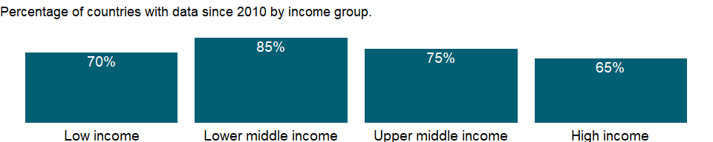

### Why is it relevant?

NA

### What is the data source?

International Labour Organization, ILOSTAT database. Data retrieved on January 29, 2021.

### What is the methodology?

NA

### How is it aggregated?

Weighted Average

### What are the limitations?

NA

### What else should I know?

NA

### 1.76.11 Labor force with advanced education, male (% of male working-age population with advanced education)

### What is the indicator?

The ratio of the labor force with advanced education to the working-age population with advanced education. Advanced education comprises short-cycle tertiary education, a bachelor’s degree or equivalent education level, a master’s degree or equivalent education level, or doctoral degree or equivalent education level according to the International Standard Classification of Education 2011 (ISCED 2011).

Topic: Social Protection & Labor: Labor force structure

Series ID: SL.TLF.ADVN.MA.ZS

Copyright: CC BY-4.0 , <https://datacatalog.worldbank.org/public-licenses#cc-by>

First year with any data: 1990

Last year with any data: 2020

### What years are data available?

The figure below shows years in which data is available for at least one country. Dates shaded in black have no data, while dates shaded in green have data for at least one country



### Which countries have data?

The figure below shows the percentage of countries in each income group with a value since 2010 for that indicator.

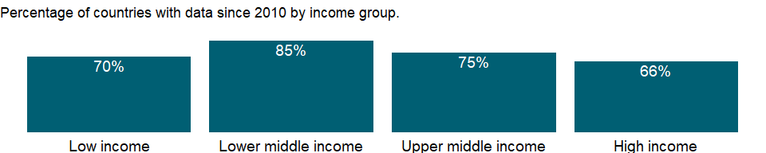

### Why is it relevant?

NA

### What is the data source?

International Labour Organization, ILOSTAT database. Data retrieved on January 29, 2021.

### What is the methodology?

NA

### How is it aggregated?

Weighted Average

### What are the limitations?

NA

### What else should I know?

NA

### 1.76.12 Labor force with advanced education (% of total working-age population with advanced education)

### What is the indicator?

The ratio of the labor force with advanced education to the working-age population with advanced education. Advanced education comprises short-cycle tertiary education, a bachelor’s degree or equivalent education level, a master’s degree or equivalent education level, or doctoral degree or equivalent education level according to the International Standard Classification of Education 2011 (ISCED 2011).

Topic: Social Protection & Labor: Labor force structure

Series ID: SL.TLF.ADVN.ZS

Copyright: CC BY-4.0 , <https://datacatalog.worldbank.org/public-licenses#cc-by>

First year with any data: 1990

Last year with any data: 2020

### What years are data available?

The figure below shows years in which data is available for at least one country. Dates shaded in black have no data, while dates shaded in green have data for at least one country



### Which countries have data?

The figure below shows the percentage of countries in each income group with a value since 2010 for that indicator.



### Why is it relevant?

NA

### What is the data source?

International Labour Organization, ILOSTAT database. Data retrieved on January 29, 2021.

### What is the methodology?

NA

### How is it aggregated?

Weighted Average

### What are the limitations?

NA

### What else should I know?

NA

### 1.76.13 Labor force with basic education, female (% of female working-age population with basic education)

### What is the indicator?

The ratio of the labor force with basic education to the working-age population with basic education. Basic education comprises primary education or lower secondary education according to the International Standard Classification of Education 2011 (ISCED 2011).

Topic: Social Protection & Labor: Labor force structure

Series ID: SL.TLF.BASC.FE.ZS

Copyright: CC BY-4.0 , <https://datacatalog.worldbank.org/public-licenses#cc-by>

First year with any data: 1990

Last year with any data: 2020

### What years are data available?

The figure below shows years in which data is available for at least one country. Dates shaded in black have no data, while dates shaded in green have data for at least one country



### Which countries have data?

The figure below shows the percentage of countries in each income group with a value since 2010 for that indicator.

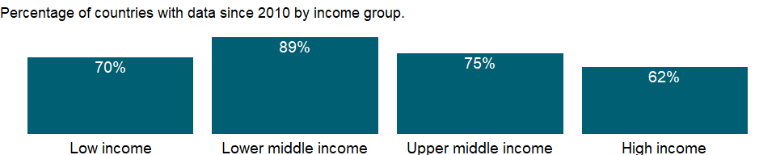

### Why is it relevant?

NA

### What is the data source?

International Labour Organization, ILOSTAT database. Data retrieved on January 29, 2021.

### What is the methodology?

NA

### How is it aggregated?

Weighted Average

### What are the limitations?

NA

### What else should I know?

NA

### 1.76.14 Labor force with basic education, male (% of male working-age population with basic education)

### What is the indicator?

The ratio of the labor force with basic education to the working-age population with basic education. Basic education comprises primary education or lower secondary education according to the International Standard Classification of Education 2011 (ISCED 2011).

Topic: Social Protection & Labor: Labor force structure

Series ID: SL.TLF.BASC.MA.ZS

Copyright: CC BY-4.0 , <https://datacatalog.worldbank.org/public-licenses#cc-by>

First year with any data: 1990

Last year with any data: 2020

### What years are data available?

The figure below shows years in which data is available for at least one country. Dates shaded in black have no data, while dates shaded in green have data for at least one country



### Which countries have data?

The figure below shows the percentage of countries in each income group with a value since 2010 for that indicator.

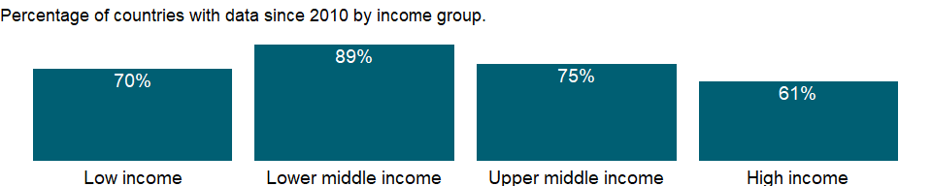

### Why is it relevant?

NA

### What is the data source?

International Labour Organization, ILOSTAT database. Data retrieved on January 29, 2021.

### What is the methodology?

NA

### How is it aggregated?

Weighted Average

### What are the limitations?

NA

### What else should I know?

NA

### 1.76.15 Labor force with basic education (% of total working-age population with basic education)

### What is the indicator?

The ratio of the labor force with basic education to the working-age population with basic education. Basic education comprises primary education or lower secondary education according to the International Standard Classification of Education 2011 (ISCED 2011).

Topic: Social Protection & Labor: Labor force structure

Series ID: SL.TLF.BASC.ZS

Copyright: CC BY-4.0 , <https://datacatalog.worldbank.org/public-licenses#cc-by>

First year with any data: 1990

Last year with any data: 2020

### What years are data available?

The figure below shows years in which data is available for at least one country. Dates shaded in black have no data, while dates shaded in green have data for at least one country



### Which countries have data?

The figure below shows the percentage of countries in each income group with a value since 2010 for that indicator.

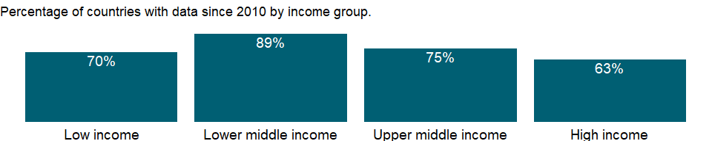

### Why is it relevant?

NA

### What is the data source?

International Labour Organization, ILOSTAT database. Data retrieved on January 29, 2021.

### What is the methodology?

NA

### How is it aggregated?

Weighted Average

### What are the limitations?

NA

### What else should I know?

NA

### 1.76.16 Labor force participation rate, female (% of female population ages 15+) (national estimate)

### What is the indicator?

Labor force participation rate is the proportion of the population ages 15 and older that is economically active: all people who supply labor for the production of goods and services during a specified period.

Topic: Social Protection & Labor: Labor force structure

Series ID: SL.TLF.CACT.FE.NE.ZS

Copyright: CC BY-4.0 , <https://datacatalog.worldbank.org/public-licenses#cc-by>

First year with any data: 1960

Last year with any data: 2020

### What years are data available?

The figure below shows years in which data is available for at least one country. Dates shaded in black have no data, while dates shaded in green have data for at least one country



### Which countries have data?

The figure below shows the percentage of countries in each income group with a value since 2010 for that indicator.

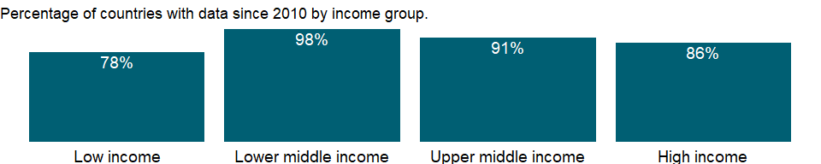

### Why is it relevant?

Estimates of women in the labor force and employment are generally lower than those of men and are not comparable internationally, reflecting that demographic, social, legal, and cultural trends and norms determine whether women’s activities are regarded as economic. In many low-income countries women often work on farms or in other family enterprises without pay, and others work in or near their homes, mixing work and family activities during the day. In many high-income economies, women have been increasingly acquiring higher education that has led to better-compensated, longer-term careers rather than lower-skilled, shorter-term jobs. However, access to good- paying occupations for women remains unequal in many occupations and countries around the world. Labor force statistics by gender is important to monitor gender disparities in employment and unemployment patterns.

### What is the data source?

International Labour Organization, ILOSTAT database. Data retrieved on September 7, 2021.

### What is the methodology?

The labor force is the supply of labor available for producing goods and services in an economy. It includes people who are currently employed and people who are unemployed but seeking work as well as first-time job-seekers. Not everyone who works is included, however. Unpaid workers, family workers, and students are often omitted, and some countries do not count members of the armed forces. Labor force size tends to vary during the year as seasonal workers enter and leave.

### How is it aggregated?

Weighted Average

### What are the limitations?

Data on the labor force are compiled by the ILO from labor force surveys, censuses, and establishment censuses and surveys. For some countries a combination of these sources is used. Labor force surveys are the most comprehensive source for internationally comparable labor force data. They can cover all non-institutionalized civilians, all branches and sectors of the economy, and all categories of workers, including people holding multiple jobs. By contrast, labor force data from population censuses are often based on a limited number of questions on the economic characteristics of individuals, with little scope to probe. The resulting data often differ from labor force survey data and vary considerably by country, depending on the census scope and coverage. Establishment censuses and surveys provide data only on the employed population, not unemployed workers, workers in small establishments, or workers in the informal sector.

The reference period of a census or survey is another important source of differences: in some countries data refer to people’s status on the day of the census or survey or during a specific period before the inquiry date, while in others data are recorded without reference to any period. In countries, where the household is the basic unit of production and all members contribute to output, but some at low intensity or irregularly, the estimated labor force may be much smaller than the numbers actually working.

Differing definitions of employment age also affect comparability. For most countries the working age is 15 and older, but in some countries children younger than 15 work full- or part-time and are included in the estimates. Similarly, some countries have an upper age limit. As a result, calculations may systematically over- or underestimate actual rates.

### What else should I know?

The series for ILO estimates is also available in the WDI database. Caution should be used when comparing ILO estimates with national estimates.

### 1.76.17 Labor force participation rate, female (% of female population ages 15+) (modeled ILO estimate)

### What is the indicator?

Labor force participation rate is the proportion of the population ages 15 and older that is economically active: all people who supply labor for the production of goods and services during a specified period.

Topic: Social Protection & Labor: Labor force structure

Series ID: SL.TLF.CACT.FE.ZS

Copyright: CC BY-4.0 , <https://datacatalog.worldbank.org/public-licenses#cc-by>

First year with any data: 1990

Last year with any data: 2019

### What years are data available?

The figure below shows years in which data is available for at least one country. Dates shaded in black have no data, while dates shaded in green have data for at least one country



### Which countries have data?

The figure below shows the percentage of countries in each income group with a value since 2010 for that indicator.



### Why is it relevant?

Estimates of women in the labor force and employment are generally lower than those of men and are not comparable internationally, reflecting that demographic, social, legal, and cultural trends and norms determine whether women’s activities are regarded as economic. In many low-income countries women often work on farms or in other family enterprises without pay, and others work in or near their homes, mixing work and family activities during the day. In many high-income economies, women have been increasingly acquiring higher education that has led to better-compensated, longer-term careers rather than lower-skilled, shorter-term jobs. However, access to good- paying occupations for women remains unequal in many occupations and countries around the world. Labor force statistics by gender is important to monitor gender disparities in employment and unemployment patterns.

### What is the data source?

International Labour Organization, ILOSTAT database. Data retrieved on June 15, 2021.

### What is the methodology?

The labor force is the supply of labor available for producing goods and services in an economy. It includes people who are currently employed and people who are unemployed but seeking work as well as first-time job-seekers. Not everyone who works is included, however. Unpaid workers, family workers, and students are often omitted, and some countries do not count members of the armed forces. Labor force size tends to vary during the year as seasonal workers enter and leave.

The series is part of the ILO estimates and is harmonized to ensure comparability across countries and over time by accounting for differences in data source, scope of coverage, methodology, and other country-specific factors. The estimates are based mainly on nationally representative labor force surveys, with other sources (population censuses and nationally reported estimates) used only when no survey data are available.

### How is it aggregated?

Weighted average

### What are the limitations?

Data on the labor force are compiled by the ILO from labor force surveys, censuses, and establishment censuses and surveys. For some countries a combination of these sources is used. Labor force surveys are the most comprehensive source for internationally comparable labor force data. They can cover all non-institutionalized civilians, all branches and sectors of the economy, and all categories of workers, including people holding multiple jobs. By contrast, labor force data from population censuses are often based on a limited number of questions on the economic characteristics of individuals, with little scope to probe. The resulting data often differ from labor force survey data and vary considerably by country, depending on the census scope and coverage. Establishment censuses and surveys provide data only on the employed population, not unemployed workers, workers in small establishments, or workers in the informal sector.

The reference period of a census or survey is another important source of differences: in some countries data refer to people’s status on the day of the census or survey or during a specific period before the inquiry date, while in others data are recorded without reference to any period. In countries, where the household is the basic unit of production and all members contribute to output, but some at low intensity or irregularly, the estimated labor force may be much smaller than the numbers actually working.

Differing definitions of employment age also affect comparability. For most countries the working age is 15 and older, but in some countries children younger than 15 work full- or part-time and are included in the estimates. Similarly, some countries have an upper age limit. As a result, calculations may systematically over- or underestimate actual rates.

### What else should I know?

National estimates are also available in the WDI database. Caution should be used when comparing ILO estimates with national estimates.

### 1.76.18 Ratio of female to male labor force participation rate (%) (national estimate)

### What is the indicator?

Labor force participation rate is the proportion of the population ages 15 and older that is economically active: all people who supply labor for the production of goods and services during a specified period. Ratio of female to male labor force participation rate is calculated by dividing female labor force participation rate by male labor force participation rate and multiplying by 100.

Topic: Social Protection & Labor: Labor force structure

Series ID: SL.TLF.CACT.FM.NE.ZS

Copyright: CC BY-4.0 , <https://datacatalog.worldbank.org/public-licenses#cc-by>

First year with any data: 1960

Last year with any data: 2020

### What years are data available?

The figure below shows years in which data is available for at least one country. Dates shaded in black have no data, while dates shaded in green have data for at least one country



### Which countries have data?

The figure below shows the percentage of countries in each income group with a value since 2010 for that indicator.



### Why is it relevant?

Estimates of women in the labor force and employment are generally lower than those of men and are not comparable internationally, reflecting that demographic, social, legal, and cultural trends and norms determine whether women’s activities are regarded as economic. In many low-income countries women often work on farms or in other family enterprises without pay, and others work in or near their homes, mixing work and family activities during the day. In many high-income economies, women have been increasingly acquiring higher education that has led to better-compensated, longer-term careers rather than lower-skilled, shorter-term jobs. However, access to good- paying occupations for women remains unequal in many occupations and countries around the world. Labor force statistics by gender is important to monitor gender disparities in employment and unemployment patterns.

### What is the data source?

Derived using data from International Labour Organization, ILOSTAT database. The data retrieved on September 7, 2021.

### What is the methodology?

The labor force is the supply of labor available for producing goods and services in an economy. It includes people who are currently employed and people who are unemployed but seeking work as well as first-time job-seekers. Not everyone who works is included, however. Unpaid workers, family workers, and students are often omitted, and some countries do not count members of the armed forces. Labor force size tends to vary during the year as seasonal workers enter and leave.

### How is it aggregated?

Weighted Average

### What are the limitations?

Data on the labor force are compiled by the ILO from labor force surveys, censuses, and establishment censuses and surveys. For some countries a combination of these sources is used. Labor force surveys are the most comprehensive source for internationally comparable labor force data. They can cover all non-institutionalized civilians, all branches and sectors of the economy, and all categories of workers, including people holding multiple jobs. By contrast, labor force data from population censuses are often based on a limited number of questions on the economic characteristics of individuals, with little scope to probe. The resulting data often differ from labor force survey data and vary considerably by country, depending on the census scope and coverage. Establishment censuses and surveys provide data only on the employed population, not unemployed workers, workers in small establishments, or workers in the informal sector.

The reference period of a census or survey is another important source of differences: in some countries data refer to people’s status on the day of the census or survey or during a specific period before the inquiry date, while in others data are recorded without reference to any period. In countries, where the household is the basic unit of production and all members contribute to output, but some at low intensity or irregularly, the estimated labor force may be much smaller than the numbers actually working.

Differing definitions of employment age also affect comparability. For most countries the working age is 15 and older, but in some countries children younger than 15 work full- or part-time and are included in the estimates. Similarly, some countries have an upper age limit. As a result, calculations may systematically over- or underestimate actual rates.

### What else should I know?

The series for ILO estimates is also available in the WDI database. Caution should be used when comparing ILO estimates with national estimates.

### 1.76.19 Ratio of female to male labor force participation rate (%) (modeled ILO estimate)

### What is the indicator?

Labor force participation rate is the proportion of the population ages 15 and older that is economically active: all people who supply labor for the production of goods and services during a specified period. Ratio of female to male labor force participation rate is calculated by dividing female labor force participation rate by male labor force participation rate and multiplying by 100.

Topic: Social Protection & Labor: Labor force structure

Series ID: SL.TLF.CACT.FM.ZS

Copyright: CC BY-4.0 , <https://datacatalog.worldbank.org/public-licenses#cc-by>

First year with any data: 1990

Last year with any data: 2019

### What years are data available?

The figure below shows years in which data is available for at least one country. Dates shaded in black have no data, while dates shaded in green have data for at least one country



### Which countries have data?

The figure below shows the percentage of countries in each income group with a value since 2010 for that indicator.



### Why is it relevant?

Estimates of women in the labor force and employment are generally lower than those of men and are not comparable internationally, reflecting that demographic, social, legal, and cultural trends and norms determine whether women’s activities are regarded as economic. In many low-income countries women often work on farms or in other family enterprises without pay, and others work in or near their homes, mixing work and family activities during the day. In many high-income economies, women have been increasingly acquiring higher education that has led to better-compensated, longer-term careers rather than lower-skilled, shorter-term jobs. However, access to good- paying occupations for women remains unequal in many occupations and countries around the world. Labor force statistics by gender is important to monitor gender disparities in employment and unemployment patterns.

### What is the data source?

Derived using data from International Labour Organization, ILOSTAT database. The data retrieved on June 15, 2021.

### What is the methodology?

The labor force is the supply of labor available for producing goods and services in an economy. It includes people who are currently employed and people who are unemployed but seeking work as well as first-time job-seekers. Not everyone who works is included, however. Unpaid workers, family workers, and students are often omitted, and some countries do not count members of the armed forces. Labor force size tends to vary during the year as seasonal workers enter and leave.

The series is part of the ILO estimates and is harmonized to ensure comparability across countries and over time by accounting for differences in data source, scope of coverage, methodology, and other country-specific factors. The estimates are based mainly on nationally representative labor force surveys, with other sources (population censuses and nationally reported estimates) used only when no survey data are available.

### How is it aggregated?

Weighted Average

### What are the limitations?

Data on the labor force are compiled by the ILO from labor force surveys, censuses, and establishment censuses and surveys. For some countries a combination of these sources is used. Labor force surveys are the most comprehensive source for internationally comparable labor force data. They can cover all non-institutionalized civilians, all branches and sectors of the economy, and all categories of workers, including people holding multiple jobs. By contrast, labor force data from population censuses are often based on a limited number of questions on the economic characteristics of individuals, with little scope to probe. The resulting data often differ from labor force survey data and vary considerably by country, depending on the census scope and coverage. Establishment censuses and surveys provide data only on the employed population, not unemployed workers, workers in small establishments, or workers in the informal sector.

The reference period of a census or survey is another important source of differences: in some countries data refer to people’s status on the day of the census or survey or during a specific period before the inquiry date, while in others data are recorded without reference to any period. In countries, where the household is the basic unit of production and all members contribute to output, but some at low intensity or irregularly, the estimated labor force may be much smaller than the numbers actually working.

Differing definitions of employment age also affect comparability. For most countries the working age is 15 and older, but in some countries children younger than 15 work full- or part-time and are included in the estimates. Similarly, some countries have an upper age limit. As a result, calculations may systematically over- or underestimate actual rates.

### What else should I know?

National estimates are also available in the WDI database. Caution should be used when comparing ILO estimates with national estimates.

### 1.76.20 Labor force participation rate, male (% of male population ages 15+) (national estimate)

### What is the indicator?

Labor force participation rate is the proportion of the population ages 15 and older that is economically active: all people who supply labor for the production of goods and services during a specified period.

Topic: Social Protection & Labor: Labor force structure

Series ID: SL.TLF.CACT.MA.NE.ZS

Copyright: CC BY-4.0 , <https://datacatalog.worldbank.org/public-licenses#cc-by>

First year with any data: 1960

Last year with any data: 2020

### What years are data available?

The figure below shows years in which data is available for at least one country. Dates shaded in black have no data, while dates shaded in green have data for at least one country



### Which countries have data?

The figure below shows the percentage of countries in each income group with a value since 2010 for that indicator.



### Why is it relevant?

Estimates of women in the labor force and employment are generally lower than those of men and are not comparable internationally, reflecting that demographic, social, legal, and cultural trends and norms determine whether women’s activities are regarded as economic. In many low-income countries women often work on farms or in other family enterprises without pay, and others work in or near their homes, mixing work and family activities during the day. In many high-income economies, women have been increasingly acquiring higher education that has led to better-compensated, longer-term careers rather than lower-skilled, shorter-term jobs. However, access to good- paying occupations for women remains unequal in many occupations and countries around the world. Labor force statistics by gender is important to monitor gender disparities in employment and unemployment patterns.

### What is the data source?

International Labour Organization, ILOSTAT database. Data retrieved on September 7, 2021.

### What is the methodology?

The labor force is the supply of labor available for producing goods and services in an economy. It includes people who are currently employed and people who are unemployed but seeking work as well as first-time job-seekers. Not everyone who works is included, however. Unpaid workers, family workers, and students are often omitted, and some countries do not count members of the armed forces. Labor force size tends to vary during the year as seasonal workers enter and leave.

### How is it aggregated?

Weighted Average

### What are the limitations?

Data on the labor force are compiled by the ILO from labor force surveys, censuses, and establishment censuses and surveys. For some countries a combination of these sources is used. Labor force surveys are the most comprehensive source for internationally comparable labor force data. They can cover all non-institutionalized civilians, all branches and sectors of the economy, and all categories of workers, including people holding multiple jobs. By contrast, labor force data from population censuses are often based on a limited number of questions on the economic characteristics of individuals, with little scope to probe. The resulting data often differ from labor force survey data and vary considerably by country, depending on the census scope and coverage. Establishment censuses and surveys provide data only on the employed population, not unemployed workers, workers in small establishments, or workers in the informal sector.

The reference period of a census or survey is another important source of differences: in some countries data refer to people’s status on the day of the census or survey or during a specific period before the inquiry date, while in others data are recorded without reference to any period. In countries, where the household is the basic unit of production and all members contribute to output, but some at low intensity or irregularly, the estimated labor force may be much smaller than the numbers actually working.

Differing definitions of employment age also affect comparability. For most countries the working age is 15 and older, but in some countries children younger than 15 work full- or part-time and are included in the estimates. Similarly, some countries have an upper age limit. As a result, calculations may systematically over- or underestimate actual rates.

### What else should I know?

The series for ILO estimates is also available in the WDI database. Caution should be used when comparing ILO estimates with national estimates.

### 1.76.21 Labor force participation rate, male (% of male population ages 15+) (modeled ILO estimate)

### What is the indicator?

Labor force participation rate is the proportion of the population ages 15 and older that is economically active: all people who supply labor for the production of goods and services during a specified period.

Topic: Social Protection & Labor: Labor force structure

Series ID: SL.TLF.CACT.MA.ZS

Copyright: CC BY-4.0 , <https://datacatalog.worldbank.org/public-licenses#cc-by>

First year with any data: 1990

Last year with any data: 2019

### What years are data available?

The figure below shows years in which data is available for at least one country. Dates shaded in black have no data, while dates shaded in green have data for at least one country



### Which countries have data?

The figure below shows the percentage of countries in each income group with a value since 2010 for that indicator.



### Why is it relevant?

Estimates of women in the labor force and employment are generally lower than those of men and are not comparable internationally, reflecting that demographic, social, legal, and cultural trends and norms determine whether women’s activities are regarded as economic. In many low-income countries women often work on farms or in other family enterprises without pay, and others work in or near their homes, mixing work and family activities during the day. In many high-income economies, women have been increasingly acquiring higher education that has led to better-compensated, longer-term careers rather than lower-skilled, shorter-term jobs. However, access to good- paying occupations for women remains unequal in many occupations and countries around the world. Labor force statistics by gender is important to monitor gender disparities in employment and unemployment patterns.

### What is the data source?

International Labour Organization, ILOSTAT database. Data retrieved on June 15, 2021.

### What is the methodology?

The labor force is the supply of labor available for producing goods and services in an economy. It includes people who are currently employed and people who are unemployed but seeking work as well as first-time job-seekers. Not everyone who works is included, however. Unpaid workers, family workers, and students are often omitted, and some countries do not count members of the armed forces. Labor force size tends to vary during the year as seasonal workers enter and leave.

The series is part of the ILO estimates and is harmonized to ensure comparability across countries and over time by accounting for differences in data source, scope of coverage, methodology, and other country-specific factors. The estimates are based mainly on nationally representative labor force surveys, with other sources (population censuses and nationally reported estimates) used only when no survey data are available.

### How is it aggregated?

Weighted average

### What are the limitations?

Data on the labor force are compiled by the ILO from labor force surveys, censuses, and establishment censuses and surveys. For some countries a combination of these sources is used. Labor force surveys are the most comprehensive source for internationally comparable labor force data. They can cover all non-institutionalized civilians, all branches and sectors of the economy, and all categories of workers, including people holding multiple jobs. By contrast, labor force data from population censuses are often based on a limited number of questions on the economic characteristics of individuals, with little scope to probe. The resulting data often differ from labor force survey data and vary considerably by country, depending on the census scope and coverage. Establishment censuses and surveys provide data only on the employed population, not unemployed workers, workers in small establishments, or workers in the informal sector.

The reference period of a census or survey is another important source of differences: in some countries data refer to people’s status on the day of the census or survey or during a specific period before the inquiry date, while in others data are recorded without reference to any period. In countries, where the household is the basic unit of production and all members contribute to output, but some at low intensity or irregularly, the estimated labor force may be much smaller than the numbers actually working.

Differing definitions of employment age also affect comparability. For most countries the working age is 15 and older, but in some countries children younger than 15 work full- or part-time and are included in the estimates. Similarly, some countries have an upper age limit. As a result, calculations may systematically over- or underestimate actual rates.

### What else should I know?

National estimates are also available in the WDI database. Caution should be used when comparing ILO estimates with national estimates.

### 1.76.22 Labor force participation rate, total (% of total population ages 15+) (national estimate)

### What is the indicator?

Labor force participation rate is the proportion of the population ages 15 and older that is economically active: all people who supply labor for the production of goods and services during a specified period.

Topic: Social Protection & Labor: Labor force structure

Series ID: SL.TLF.CACT.NE.ZS

Copyright: CC BY-4.0 , <https://datacatalog.worldbank.org/public-licenses#cc-by>

First year with any data: 1960

Last year with any data: 2020

### What years are data available?

The figure below shows years in which data is available for at least one country. Dates shaded in black have no data, while dates shaded in green have data for at least one country



### Which countries have data?

The figure below shows the percentage of countries in each income group with a value since 2010 for that indicator.

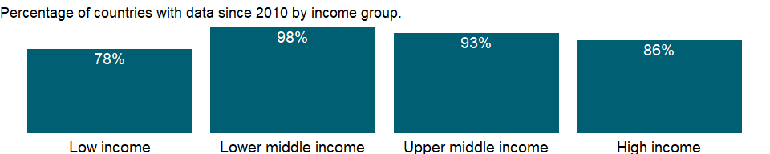

### Why is it relevant?

Estimates of women in the labor force and employment are generally lower than those of men and are not comparable internationally, reflecting that demographic, social, legal, and cultural trends and norms determine whether women’s activities are regarded as economic. In many low-income countries women often work on farms or in other family enterprises without pay, and others work in or near their homes, mixing work and family activities during the day. In many high-income economies, women have been increasingly acquiring higher education that has led to better-compensated, longer-term careers rather than lower-skilled, shorter-term jobs. However, access to good- paying occupations for women remains unequal in many occupations and countries around the world. Labor force statistics by gender is important to monitor gender disparities in employment and unemployment patterns.

### What is the data source?

International Labour Organization, ILOSTAT database. Data retrieved on September 7, 2021.

### What is the methodology?

The labor force is the supply of labor available for producing goods and services in an economy. It includes people who are currently employed and people who are unemployed but seeking work as well as first-time job-seekers. Not everyone who works is included, however. Unpaid workers, family workers, and students are often omitted, and some countries do not count members of the armed forces. Labor force size tends to vary during the year as seasonal workers enter and leave.

### How is it aggregated?

Weighted Average

### What are the limitations?

Data on the labor force are compiled by the ILO from labor force surveys, censuses, and establishment censuses and surveys. For some countries a combination of these sources is used. Labor force surveys are the most comprehensive source for internationally comparable labor force data. They can cover all non-institutionalized civilians, all branches and sectors of the economy, and all categories of workers, including people holding multiple jobs. By contrast, labor force data from population censuses are often based on a limited number of questions on the economic characteristics of individuals, with little scope to probe. The resulting data often differ from labor force survey data and vary considerably by country, depending on the census scope and coverage. Establishment censuses and surveys provide data only on the employed population, not unemployed workers, workers in small establishments, or workers in the informal sector.

The reference period of a census or survey is another important source of differences: in some countries data refer to people’s status on the day of the census or survey or during a specific period before the inquiry date, while in others data are recorded without reference to any period. In countries, where the household is the basic unit of production and all members contribute to output, but some at low intensity or irregularly, the estimated labor force may be much smaller than the numbers actually working.

Differing definitions of employment age also affect comparability. For most countries the working age is 15 and older, but in some countries children younger than 15 work full- or part-time and are included in the estimates. Similarly, some countries have an upper age limit. As a result, calculations may systematically over- or underestimate actual rates.

### What else should I know?

The series for ILO estimates is also available in the WDI database. Caution should be used when comparing ILO estimates with national estimates.

### 1.76.23 Labor force participation rate, total (% of total population ages 15+) (modeled ILO estimate)

### What is the indicator?

Labor force participation rate is the proportion of the population ages 15 and older that is economically active: all people who supply labor for the production of goods and services during a specified period.

Topic: Social Protection & Labor: Labor force structure

Series ID: SL.TLF.CACT.ZS

Copyright: CC BY-4.0 , <https://datacatalog.worldbank.org/public-licenses#cc-by>

First year with any data: 1990

Last year with any data: 2020

### What years are data available?

The figure below shows years in which data is available for at least one country. Dates shaded in black have no data, while dates shaded in green have data for at least one country



### Which countries have data?

The figure below shows the percentage of countries in each income group with a value since 2010 for that indicator.



### Why is it relevant?

Estimates of women in the labor force and employment are generally lower than those of men and are not comparable internationally, reflecting that demographic, social, legal, and cultural trends and norms determine whether women’s activities are regarded as economic. In many low-income countries women often work on farms or in other family enterprises without pay, and others work in or near their homes, mixing work and family activities during the day. In many high-income economies, women have been increasingly acquiring higher education that has led to better-compensated, longer-term careers rather than lower-skilled, shorter-term jobs. However, access to good- paying occupations for women remains unequal in many occupations and countries around the world. Labor force statistics by gender is important to monitor gender disparities in employment and unemployment patterns.

### What is the data source?

International Labour Organization, ILOSTAT database. Data retrieved on June 15, 2021.

### What is the methodology?

The labor force is the supply of labor available for producing goods and services in an economy. It includes people who are currently employed and people who are unemployed but seeking work as well as first-time job-seekers. Not everyone who works is included, however. Unpaid workers, family workers, and students are often omitted, and some countries do not count members of the armed forces. Labor force size tends to vary during the year as seasonal workers enter and leave.

The series is part of the ILO estimates and is harmonized to ensure comparability across countries and over time by accounting for differences in data source, scope of coverage, methodology, and other country-specific factors. The estimates are based mainly on nationally representative labor force surveys, with other sources (population censuses and nationally reported estimates) used only when no survey data are available.

### How is it aggregated?

Weighted average

### What are the limitations?

Data on the labor force are compiled by the ILO from labor force surveys, censuses, and establishment censuses and surveys. For some countries a combination of these sources is used. Labor force surveys are the most comprehensive source for internationally comparable labor force data. They can cover all non-institutionalized civilians, all branches and sectors of the economy, and all categories of workers, including people holding multiple jobs. By contrast, labor force data from population censuses are often based on a limited number of questions on the economic characteristics of individuals, with little scope to probe. The resulting data often differ from labor force survey data and vary considerably by country, depending on the census scope and coverage. Establishment censuses and surveys provide data only on the employed population, not unemployed workers, workers in small establishments, or workers in the informal sector.

The reference period of a census or survey is another important source of differences: in some countries data refer to people’s status on the day of the census or survey or during a specific period before the inquiry date, while in others data are recorded without reference to any period. In countries, where the household is the basic unit of production and all members contribute to output, but some at low intensity or irregularly, the estimated labor force may be much smaller than the numbers actually working.

Differing definitions of employment age also affect comparability. For most countries the working age is 15 and older, but in some countries children younger than 15 work full- or part-time and are included in the estimates. Similarly, some countries have an upper age limit. As a result, calculations may systematically over- or underestimate actual rates.

### What else should I know?

National estimates are also available in the WDI database. Caution should be used when comparing ILO estimates with national estimates.

### 1.76.24 Labor force with intermediate education, female (% of female working-age population with intermediate education)

### What is the indicator?

The ratio of the labor force with intermediate education to the working-age population with intermediate education. Intermediate education comprises upper secondary or post-secondary non tertiary education according to the International Standard Classification of Education 2011 (ISCED 2011).

Topic: Social Protection & Labor: Labor force structure

Series ID: SL.TLF.INTM.FE.ZS

Copyright: CC BY-4.0 , <https://datacatalog.worldbank.org/public-licenses#cc-by>

First year with any data: 1990

Last year with any data: 2020

### What years are data available?

The figure below shows years in which data is available for at least one country. Dates shaded in black have no data, while dates shaded in green have data for at least one country



### Which countries have data?

The figure below shows the percentage of countries in each income group with a value since 2010 for that indicator.

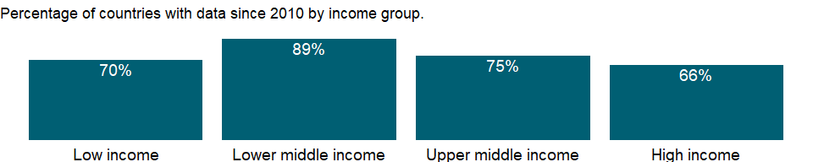

### Why is it relevant?

NA

### What is the data source?

International Labour Organization, ILOSTAT database. Data retrieved on January 29, 2021.

### What is the methodology?

NA

### How is it aggregated?

Weighted Average

### What are the limitations?

NA

### What else should I know?

NA

### 1.76.25 Labor force with intermediate education, male (% of male working-age population with intermediate education)

### What is the indicator?

The ratio of the labor force with intermediate education to the working-age population with intermediate education. Intermediate education comprises upper secondary or post-secondary non tertiary education according to the International Standard Classification of Education 2011 (ISCED 2011).

Topic: Social Protection & Labor: Labor force structure

Series ID: SL.TLF.INTM.MA.ZS

Copyright: CC BY-4.0 , <https://datacatalog.worldbank.org/public-licenses#cc-by>

First year with any data: 1990

Last year with any data: 2020

### What years are data available?

The figure below shows years in which data is available for at least one country. Dates shaded in black have no data, while dates shaded in green have data for at least one country



### Which countries have data?

The figure below shows the percentage of countries in each income group with a value since 2010 for that indicator.



### Why is it relevant?

NA

### What is the data source?

International Labour Organization, ILOSTAT database. Data retrieved on January 29, 2021.

### What is the methodology?

NA

### How is it aggregated?

Weighted Average

### What are the limitations?

NA

### What else should I know?

NA

### 1.76.26 Labor force with intermediate education (% of total working-age population with intermediate education)

### What is the indicator?

The ratio of the labor force with intermediate education to the working-age population with intermediate education. Intermediate education comprises upper secondary or post-secondary non tertiary education according to the International Standard Classification of Education 2011 (ISCED 2011).

Topic: Social Protection & Labor: Labor force structure

Series ID: SL.TLF.INTM.ZS

Copyright: CC BY-4.0 , <https://datacatalog.worldbank.org/public-licenses#cc-by>

First year with any data: 1990

Last year with any data: 2020

### What years are data available?

The figure below shows years in which data is available for at least one country. Dates shaded in black have no data, while dates shaded in green have data for at least one country



### Which countries have data?

The figure below shows the percentage of countries in each income group with a value since 2010 for that indicator.



### Why is it relevant?

NA

### What is the data source?

International Labour Organization, ILOSTAT database. Data retrieved on January 29, 2021.

### What is the methodology?

NA

### How is it aggregated?

Weighted Average

### What are the limitations?

NA

### What else should I know?

NA

### 1.76.27 Labor force, female (% of total labor force)

### What is the indicator?

Female labor force as a percentage of the total show the extent to which women are active in the labor force. Labor force comprises people ages 15 and older who supply labor for the production of goods and services during a specified period.

Topic: Social Protection & Labor: Labor force structure

Series ID: SL.TLF.TOTL.FE.ZS

Copyright: CC BY-4.0 , <https://datacatalog.worldbank.org/public-licenses#cc-by>

First year with any data: 1990

Last year with any data: 2019

### What years are data available?

The figure below shows years in which data is available for at least one country. Dates shaded in black have no data, while dates shaded in green have data for at least one country



### Which countries have data?

The figure below shows the percentage of countries in each income group with a value since 2010 for that indicator.



### Why is it relevant?

NA

### What is the data source?

Derived using data from International Labour Organization, ILOSTAT database. The data retrieved on June 15, 2021.

### What is the methodology?

The labor force is the supply of labor available for producing goods and services in an economy. It includes people who are currently employed and people who are unemployed but seeking work as well as first-time job-seekers. Not everyone who works is included, however. Unpaid workers, family workers, and students are often omitted, and some countries do not count members of the armed forces. Labor force size tends to vary during the year as seasonal workers enter and leave.

Data are generated with World Bank population estimates and ILO estimates on labor force participation rate. The ILO estimates are harmonized to ensure comparability across countries and over time by accounting for differences in data source, scope of coverage, methodology, and other country-specific factors. The estimates are based mainly on nationally representative labor force surveys, with other sources (population censuses and nationally reported estimates) used only when no survey data are available.

### How is it aggregated?

Weighted average

### What are the limitations?

NA

### What else should I know?

Data up to 2016 are estimates while data from 2017 are projections.

### 1.76.28 Labor force, total

### What is the indicator?

Labor force comprises people ages 15 and older who supply labor for the production of goods and services during a specified period. It includes people who are currently employed and people who are unemployed but seeking work as well as first-time job-seekers. Not everyone who works is included, however. Unpaid workers, family workers, and students are often omitted, and some countries do not count members of the armed forces. Labor force size tends to vary during the year as seasonal workers enter and leave.

Topic: Social Protection & Labor: Labor force structure

Series ID: SL.TLF.TOTL.IN

Copyright: CC BY-4.0 , <https://datacatalog.worldbank.org/public-licenses#cc-by>

First year with any data: 1990

Last year with any data: 2020

### What years are data available?

The figure below shows years in which data is available for at least one country. Dates shaded in black have no data, while dates shaded in green have data for at least one country



### Which countries have data?

The figure below shows the percentage of countries in each income group with a value since 2010 for that indicator.



### Why is it relevant?

NA

### What is the data source?

Derived using data from International Labour Organization, ILOSTAT database. The data retrieved on June 15, 2021.

### What is the methodology?

The labor force is the supply of labor available for producing goods and services in an economy. It includes people who are currently employed and people who are unemployed but seeking work as well as first-time job-seekers. Not everyone who works is included, however. Unpaid workers, family workers, and students are often omitted, and some countries do not count members of the armed forces. Labor force size tends to vary during the year as seasonal workers enter and leave.

Data are generated with World Bank population estimates and ILO estimates on labor force participation rate. The ILO estimates are harmonized to ensure comparability across countries and over time by accounting for differences in data source, scope of coverage, methodology, and other country-specific factors. The estimates are based mainly on nationally representative labor force surveys, with other sources (population censuses and nationally reported estimates) used only when no survey data are available.

### How is it aggregated?

Sum

### What are the limitations?

NA

### What else should I know?

Data up to 2016 are estimates while data from 2017 are projections.

## 1.77 Social Protection & Labor: Unemployment

### 1.77.1 Unemployment, youth female (% of female labor force ages 15-24) (national estimate)

### What is the indicator?

Youth unemployment refers to the share of the labor force ages 15-24 without work but available for and seeking employment. Definitions of labor force and unemployment differ by country.

Topic: Social Protection & Labor: Unemployment

Series ID: SL.UEM.1524.FE.NE.ZS

Copyright: CC BY-4.0 , <https://datacatalog.worldbank.org/public-licenses#cc-by>

First year with any data: 1960

Last year with any data: 2020

### What years are data available?

The figure below shows years in which data is available for at least one country. Dates shaded in black have no data, while dates shaded in green have data for at least one country



### Which countries have data?

The figure below shows the percentage of countries in each income group with a value since 2010 for that indicator.

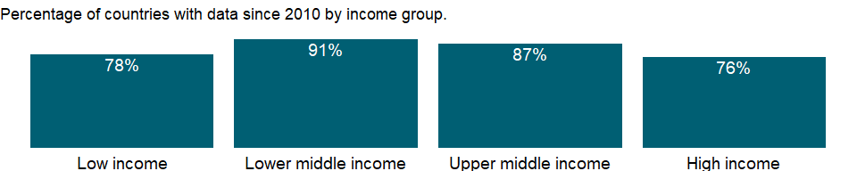

### Why is it relevant?

Paradoxically, low unemployment rates can disguise substantial poverty in a country, while high unemployment rates can occur in countries with a high level of economic development and low rates of poverty. In countries without unemployment or welfare benefits people eke out a living in vulnerable employment. In countries with well-developed safety nets workers can afford to wait for suitable or desirable jobs. But high and sustained unemployment indicates serious inefficiencies in resource allocation.

Youth unemployment is an important policy issue for many economies. Young men and women today face increasing uncertainty in their hopes of undergoing a satisfactory transition in the labour market, and this uncertainty and disillusionment can, in turn, have damaging effects on individuals, communities, economies and society at large. Unemployed or underemployed youth are less able to contribute effectively to national development and have fewer opportunities to exercise their rights as citizens. They have less to spend as consumers, less to invest as savers and often have no “voice” to bring about change in their lives and communities. Widespread youth unemployment and underemployment also prevents companies and countries from innovating and developing competitive advantages based on human capital investment, thus undermining future prospects.

Unemployment is a key measure to monitor whether a country is on track to achieve the Sustainable Development Goal of promoting sustained, inclusive and sustainable economic growth, full and productive employment and decent work for all. [SDG Indicator 8.5.2]

### What is the data source?

International Labour Organization, ILOSTAT database. Data retrieved on September 7, 2021.

### What is the methodology?

The standard definition of unemployed persons is those individuals without work, seeking work in a recent past period, and currently available for work, including people who have lost their jobs or who have voluntarily left work. Persons who did not look for work but have an arrangements for a future job are also counted as unemployed.

Some unemployment is unavoidable. At any time some workers are temporarily unemployed between jobs as employers look for the right workers and workers search for better jobs. It is the labour force or the economically active portion of the population that serves as the base for this indicator, not the total population.

### How is it aggregated?

Weighted Average

### What are the limitations?

The criteria for people considered to be seeking work, and the treatment of people temporarily laid off or seeking work for the first time, vary across countries. In many cases it is especially difficult to measure employment and unemployment in agriculture. The timing of a survey can maximize the effects of seasonal unemployment in agriculture. And informal sector employment is difficult to quantify where informal activities are not tracked.

There may be also persons not currently in the labour market who want to work but do not actively “seek” work because they view job opportunities as limited, or because they have restricted labour mobility, or face discrimination, or structural, social or cultural barriers. The exclusion of people who want to work but are not seeking work (often called the “hidden unemployed” or “discouraged workers”) is a criterion that will affect the unemployment count of both women and men.

However, women tend to be excluded from the count for various reasons. Women suffer more from discrimination and from structural, social, and cultural barriers that impede them from seeking work. Also, women are often responsible for the care of children and the elderly and for household affairs. They may not be available for work during the short reference period, as they need to make arrangements before starting work. Further, women are considered to be employed when they are working part-time or in temporary jobs, despite the instability of these jobs or their active search for more secure employment.

### What else should I know?

The series for ILO estimates is also available in the WDI database. Caution should be used when comparing ILO estimates with national estimates.

### 1.77.2 Unemployment, youth female (% of female labor force ages 15-24) (modeled ILO estimate)

### What is the indicator?

Youth unemployment refers to the share of the labor force ages 15-24 without work but available for and seeking employment.

Topic: Social Protection & Labor: Unemployment

Series ID: SL.UEM.1524.FE.ZS

Copyright: CC BY-4.0 , <https://datacatalog.worldbank.org/public-licenses#cc-by>

First year with any data: 1991

Last year with any data: 2019

### What years are data available?

The figure below shows years in which data is available for at least one country. Dates shaded in black have no data, while dates shaded in green have data for at least one country



### Which countries have data?

The figure below shows the percentage of countries in each income group with a value since 2010 for that indicator.



### Why is it relevant?

Paradoxically, low unemployment rates can disguise substantial poverty in a country, while high unemployment rates can occur in countries with a high level of economic development and low rates of poverty. In countries without unemployment or welfare benefits people eke out a living in vulnerable employment. In countries with well-developed safety nets workers can afford to wait for suitable or desirable jobs. But high and sustained unemployment indicates serious inefficiencies in resource allocation.

Youth unemployment is an important policy issue for many economies. Young men and women today face increasing uncertainty in their hopes of undergoing a satisfactory transition in the labour market, and this uncertainty and disillusionment can, in turn, have damaging effects on individuals, communities, economies and society at large. Unemployed or underemployed youth are less able to contribute effectively to national development and have fewer opportunities to exercise their rights as citizens. They have less to spend as consumers, less to invest as savers and often have no “voice” to bring about change in their lives and communities. Widespread youth unemployment and underemployment also prevents companies and countries from innovating and developing competitive advantages based on human capital investment, thus undermining future prospects.

Unemployment is a key measure to monitor whether a country is on track to achieve the Sustainable Development Goal of promoting sustained, inclusive and sustainable economic growth, full and productive employment and decent work for all. [SDG Indicator 8.5.2]

### What is the data source?

International Labour Organization, ILOSTAT database. Data retrieved on June 15, 2021.

### What is the methodology?

The standard definition of unemployed persons is those individuals without work, seeking work in a recent past period, and currently available for work, including people who have lost their jobs or who have voluntarily left work. Persons who did not look for work but have an arrangements for a future job are also counted as unemployed.

Some unemployment is unavoidable. At any time some workers are temporarily unemployed between jobs as employers look for the right workers and workers search for better jobs. It is the labour force or the economically active portion of the population that serves as the base for this indicator, not the total population.

The series is part of the ILO estimates and is harmonized to ensure comparability across countries and over time by accounting for differences in data source, scope of coverage, methodology, and other country-specific factors. The estimates are based mainly on nationally representative labor force surveys, with other sources (population censuses and nationally reported estimates) used only when no survey data are available.

### How is it aggregated?

Weighted average

### What are the limitations?

The criteria for people considered to be seeking work, and the treatment of people temporarily laid off or seeking work for the first time, vary across countries. In many cases it is especially difficult to measure employment and unemployment in agriculture. The timing of a survey can maximize the effects of seasonal unemployment in agriculture. And informal sector employment is difficult to quantify where informal activities are not tracked.

There may be also persons not currently in the labour market who want to work but do not actively “seek” work because they view job opportunities as limited, or because they have restricted labour mobility, or face discrimination, or structural, social or cultural barriers. The exclusion of people who want to work but are not seeking work (often called the “hidden unemployed” or “discouraged workers”) is a criterion that will affect the unemployment count of both women and men.

However, women tend to be excluded from the count for various reasons. Women suffer more from discrimination and from structural, social, and cultural barriers that impede them from seeking work. Also, women are often responsible for the care of children and the elderly and for household affairs. They may not be available for work during the short reference period, as they need to make arrangements before starting work. Further, women are considered to be employed when they are working part-time or in temporary jobs, despite the instability of these jobs or their active search for more secure employment.

### What else should I know?

National estimates are also available in the WDI database. Caution should be used when comparing ILO estimates with national estimates.

### 1.77.3 Unemployment, youth male (% of male labor force ages 15-24) (national estimate)

### What is the indicator?

Youth unemployment refers to the share of the labor force ages 15-24 without work but available for and seeking employment. Definitions of labor force and unemployment differ by country.

Topic: Social Protection & Labor: Unemployment

Series ID: SL.UEM.1524.MA.NE.ZS

Copyright: CC BY-4.0 , <https://datacatalog.worldbank.org/public-licenses#cc-by>

First year with any data: 1960

Last year with any data: 2020

### What years are data available?

The figure below shows years in which data is available for at least one country. Dates shaded in black have no data, while dates shaded in green have data for at least one country



### Which countries have data?

The figure below shows the percentage of countries in each income group with a value since 2010 for that indicator.



### Why is it relevant?

Paradoxically, low unemployment rates can disguise substantial poverty in a country, while high unemployment rates can occur in countries with a high level of economic development and low rates of poverty. In countries without unemployment or welfare benefits people eke out a living in vulnerable employment. In countries with well-developed safety nets workers can afford to wait for suitable or desirable jobs. But high and sustained unemployment indicates serious inefficiencies in resource allocation.

Youth unemployment is an important policy issue for many economies. Young men and women today face increasing uncertainty in their hopes of undergoing a satisfactory transition in the labour market, and this uncertainty and disillusionment can, in turn, have damaging effects on individuals, communities, economies and society at large. Unemployed or underemployed youth are less able to contribute effectively to national development and have fewer opportunities to exercise their rights as citizens. They have less to spend as consumers, less to invest as savers and often have no “voice” to bring about change in their lives and communities. Widespread youth unemployment and underemployment also prevents companies and countries from innovating and developing competitive advantages based on human capital investment, thus undermining future prospects.

Unemployment is a key measure to monitor whether a country is on track to achieve the Sustainable Development Goal of promoting sustained, inclusive and sustainable economic growth, full and productive employment and decent work for all. [SDG Indicator 8.5.2]

### What is the data source?

International Labour Organization, ILOSTAT database. Data retrieved on September 7, 2021.

### What is the methodology?

The standard definition of unemployed persons is those individuals without work, seeking work in a recent past period, and currently available for work, including people who have lost their jobs or who have voluntarily left work. Persons who did not look for work but have an arrangements for a future job are also counted as unemployed.

Some unemployment is unavoidable. At any time some workers are temporarily unemployed between jobs as employers look for the right workers and workers search for better jobs. It is the labour force or the economically active portion of the population that serves as the base for this indicator, not the total population.

### How is it aggregated?

Weighted Average

### What are the limitations?

The criteria for people considered to be seeking work, and the treatment of people temporarily laid off or seeking work for the first time, vary across countries. In many cases it is especially difficult to measure employment and unemployment in agriculture. The timing of a survey can maximize the effects of seasonal unemployment in agriculture. And informal sector employment is difficult to quantify where informal activities are not tracked.

There may be also persons not currently in the labour market who want to work but do not actively “seek” work because they view job opportunities as limited, or because they have restricted labour mobility, or face discrimination, or structural, social or cultural barriers. The exclusion of people who want to work but are not seeking work (often called the “hidden unemployed” or “discouraged workers”) is a criterion that will affect the unemployment count of both women and men.

However, women tend to be excluded from the count for various reasons. Women suffer more from discrimination and from structural, social, and cultural barriers that impede them from seeking work. Also, women are often responsible for the care of children and the elderly and for household affairs. They may not be available for work during the short reference period, as they need to make arrangements before starting work. Further, women are considered to be employed when they are working part-time or in temporary jobs, despite the instability of these jobs or their active search for more secure employment.

### What else should I know?

The series for ILO estimates is also available in the WDI database. Caution should be used when comparing ILO estimates with national estimates.

### 1.77.4 Unemployment, youth male (% of male labor force ages 15-24) (modeled ILO estimate)

### What is the indicator?

Youth unemployment refers to the share of the labor force ages 15-24 without work but available for and seeking employment.

Topic: Social Protection & Labor: Unemployment

Series ID: SL.UEM.1524.MA.ZS

Copyright: CC BY-4.0 , <https://datacatalog.worldbank.org/public-licenses#cc-by>

First year with any data: 1991

Last year with any data: 2019

### What years are data available?

The figure below shows years in which data is available for at least one country. Dates shaded in black have no data, while dates shaded in green have data for at least one country



### Which countries have data?

The figure below shows the percentage of countries in each income group with a value since 2010 for that indicator.



### Why is it relevant?

Paradoxically, low unemployment rates can disguise substantial poverty in a country, while high unemployment rates can occur in countries with a high level of economic development and low rates of poverty. In countries without unemployment or welfare benefits people eke out a living in vulnerable employment. In countries with well-developed safety nets workers can afford to wait for suitable or desirable jobs. But high and sustained unemployment indicates serious inefficiencies in resource allocation.

Youth unemployment is an important policy issue for many economies. Young men and women today face increasing uncertainty in their hopes of undergoing a satisfactory transition in the labour market, and this uncertainty and disillusionment can, in turn, have damaging effects on individuals, communities, economies and society at large. Unemployed or underemployed youth are less able to contribute effectively to national development and have fewer opportunities to exercise their rights as citizens. They have less to spend as consumers, less to invest as savers and often have no “voice” to bring about change in their lives and communities. Widespread youth unemployment and underemployment also prevents companies and countries from innovating and developing competitive advantages based on human capital investment, thus undermining future prospects.

Unemployment is a key measure to monitor whether a country is on track to achieve the Sustainable Development Goal of promoting sustained, inclusive and sustainable economic growth, full and productive employment and decent work for all. [SDG Indicator 8.5.2]

### What is the data source?

International Labour Organization, ILOSTAT database. Data retrieved on June 15, 2021.

### What is the methodology?

The standard definition of unemployed persons is those individuals without work, seeking work in a recent past period, and currently available for work, including people who have lost their jobs or who have voluntarily left work. Persons who did not look for work but have an arrangements for a future job are also counted as unemployed.

Some unemployment is unavoidable. At any time some workers are temporarily unemployed between jobs as employers look for the right workers and workers search for better jobs. It is the labour force or the economically active portion of the population that serves as the base for this indicator, not the total population.

The series is part of the ILO estimates and is harmonized to ensure comparability across countries and over time by accounting for differences in data source, scope of coverage, methodology, and other country-specific factors. The estimates are based mainly on nationally representative labor force surveys, with other sources (population censuses and nationally reported estimates) used only when no survey data are available.

### How is it aggregated?

Weighted average

### What are the limitations?

The criteria for people considered to be seeking work, and the treatment of people temporarily laid off or seeking work for the first time, vary across countries. In many cases it is especially difficult to measure employment and unemployment in agriculture. The timing of a survey can maximize the effects of seasonal unemployment in agriculture. And informal sector employment is difficult to quantify where informal activities are not tracked.

There may be also persons not currently in the labour market who want to work but do not actively “seek” work because they view job opportunities as limited, or because they have restricted labour mobility, or face discrimination, or structural, social or cultural barriers. The exclusion of people who want to work but are not seeking work (often called the “hidden unemployed” or “discouraged workers”) is a criterion that will affect the unemployment count of both women and men.

However, women tend to be excluded from the count for various reasons. Women suffer more from discrimination and from structural, social, and cultural barriers that impede them from seeking work. Also, women are often responsible for the care of children and the elderly and for household affairs. They may not be available for work during the short reference period, as they need to make arrangements before starting work. Further, women are considered to be employed when they are working part-time or in temporary jobs, despite the instability of these jobs or their active search for more secure employment.

### What else should I know?

National estimates are also available in the WDI database. Caution should be used when comparing ILO estimates with national estimates.

### 1.77.5 Unemployment, youth total (% of total labor force ages 15-24) (national estimate)

### What is the indicator?

Youth unemployment refers to the share of the labor force ages 15-24 without work but available for and seeking employment. Definitions of labor force and unemployment differ by country.

Topic: Social Protection & Labor: Unemployment

Series ID: SL.UEM.1524.NE.ZS

Copyright: CC BY-4.0 , <https://datacatalog.worldbank.org/public-licenses#cc-by>

First year with any data: 1960

Last year with any data: 2020

### What years are data available?

The figure below shows years in which data is available for at least one country. Dates shaded in black have no data, while dates shaded in green have data for at least one country



### Which countries have data?

The figure below shows the percentage of countries in each income group with a value since 2010 for that indicator.

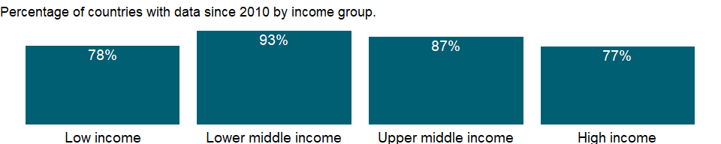

### Why is it relevant?

Paradoxically, low unemployment rates can disguise substantial poverty in a country, while high unemployment rates can occur in countries with a high level of economic development and low rates of poverty. In countries without unemployment or welfare benefits people eke out a living in vulnerable employment. In countries with well-developed safety nets workers can afford to wait for suitable or desirable jobs. But high and sustained unemployment indicates serious inefficiencies in resource allocation.

Youth unemployment is an important policy issue for many economies. Young men and women today face increasing uncertainty in their hopes of undergoing a satisfactory transition in the labour market, and this uncertainty and disillusionment can, in turn, have damaging effects on individuals, communities, economies and society at large. Unemployed or underemployed youth are less able to contribute effectively to national development and have fewer opportunities to exercise their rights as citizens. They have less to spend as consumers, less to invest as savers and often have no “voice” to bring about change in their lives and communities. Widespread youth unemployment and underemployment also prevents companies and countries from innovating and developing competitive advantages based on human capital investment, thus undermining future prospects.

Unemployment is a key measure to monitor whether a country is on track to achieve the Sustainable Development Goal of promoting sustained, inclusive and sustainable economic growth, full and productive employment and decent work for all. [SDG Indicator 8.5.2]

### What is the data source?

International Labour Organization, ILOSTAT database. Data retrieved on September 7, 2021.

### What is the methodology?

The standard definition of unemployed persons is those individuals without work, seeking work in a recent past period, and currently available for work, including people who have lost their jobs or who have voluntarily left work. Persons who did not look for work but have an arrangements for a future job are also counted as unemployed.

Some unemployment is unavoidable. At any time some workers are temporarily unemployed between jobs as employers look for the right workers and workers search for better jobs. It is the labour force or the economically active portion of the population that serves as the base for this indicator, not the total population.

### How is it aggregated?

Weighted Average

### What are the limitations?

The criteria for people considered to be seeking work, and the treatment of people temporarily laid off or seeking work for the first time, vary across countries. In many cases it is especially difficult to measure employment and unemployment in agriculture. The timing of a survey can maximize the effects of seasonal unemployment in agriculture. And informal sector employment is difficult to quantify where informal activities are not tracked.

There may be also persons not currently in the labour market who want to work but do not actively “seek” work because they view job opportunities as limited, or because they have restricted labour mobility, or face discrimination, or structural, social or cultural barriers. The exclusion of people who want to work but are not seeking work (often called the “hidden unemployed” or “discouraged workers”) is a criterion that will affect the unemployment count of both women and men.

However, women tend to be excluded from the count for various reasons. Women suffer more from discrimination and from structural, social, and cultural barriers that impede them from seeking work. Also, women are often responsible for the care of children and the elderly and for household affairs. They may not be available for work during the short reference period, as they need to make arrangements before starting work. Further, women are considered to be employed when they are working part-time or in temporary jobs, despite the instability of these jobs or their active search for more secure employment.

### What else should I know?

The series for ILO estimates is also available in the WDI database. Caution should be used when comparing ILO estimates with national estimates.

### 1.77.6 Unemployment, youth total (% of total labor force ages 15-24) (modeled ILO estimate)

### What is the indicator?

Youth unemployment refers to the share of the labor force ages 15-24 without work but available for and seeking employment.

Topic: Social Protection & Labor: Unemployment

Series ID: SL.UEM.1524.ZS

Copyright: CC BY-4.0 , <https://datacatalog.worldbank.org/public-licenses#cc-by>

First year with any data: 1991

Last year with any data: 2019

### What years are data available?

The figure below shows years in which data is available for at least one country. Dates shaded in black have no data, while dates shaded in green have data for at least one country



### Which countries have data?

The figure below shows the percentage of countries in each income group with a value since 2010 for that indicator.



### Why is it relevant?

Paradoxically, low unemployment rates can disguise substantial poverty in a country, while high unemployment rates can occur in countries with a high level of economic development and low rates of poverty. In countries without unemployment or welfare benefits people eke out a living in vulnerable employment. In countries with well-developed safety nets workers can afford to wait for suitable or desirable jobs. But high and sustained unemployment indicates serious inefficiencies in resource allocation.

Youth unemployment is an important policy issue for many economies. Young men and women today face increasing uncertainty in their hopes of undergoing a satisfactory transition in the labour market, and this uncertainty and disillusionment can, in turn, have damaging effects on individuals, communities, economies and society at large. Unemployed or underemployed youth are less able to contribute effectively to national development and have fewer opportunities to exercise their rights as citizens. They have less to spend as consumers, less to invest as savers and often have no “voice” to bring about change in their lives and communities. Widespread youth unemployment and underemployment also prevents companies and countries from innovating and developing competitive advantages based on human capital investment, thus undermining future prospects.

Unemployment is a key measure to monitor whether a country is on track to achieve the Sustainable Development Goal of promoting sustained, inclusive and sustainable economic growth, full and productive employment and decent work for all. [SDG Indicator 8.5.2]

### What is the data source?

International Labour Organization, ILOSTAT database. Data retrieved on June 15, 2021.

### What is the methodology?

The standard definition of unemployed persons is those individuals without work, seeking work in a recent past period, and currently available for work, including people who have lost their jobs or who have voluntarily left work. Persons who did not look for work but have an arrangements for a future job are also counted as unemployed.

Some unemployment is unavoidable. At any time some workers are temporarily unemployed between jobs as employers look for the right workers and workers search for better jobs. It is the labour force or the economically active portion of the population that serves as the base for this indicator, not the total population.

The series is part of the ILO estimates and is harmonized to ensure comparability across countries and over time by accounting for differences in data source, scope of coverage, methodology, and other country-specific factors. The estimates are based mainly on nationally representative labor force surveys, with other sources (population censuses and nationally reported estimates) used only when no survey data are available.

### How is it aggregated?

Weighted average

### What are the limitations?

The criteria for people considered to be seeking work, and the treatment of people temporarily laid off or seeking work for the first time, vary across countries. In many cases it is especially difficult to measure employment and unemployment in agriculture. The timing of a survey can maximize the effects of seasonal unemployment in agriculture. And informal sector employment is difficult to quantify where informal activities are not tracked.

There may be also persons not currently in the labour market who want to work but do not actively “seek” work because they view job opportunities as limited, or because they have restricted labour mobility, or face discrimination, or structural, social or cultural barriers. The exclusion of people who want to work but are not seeking work (often called the “hidden unemployed” or “discouraged workers”) is a criterion that will affect the unemployment count of both women and men.

However, women tend to be excluded from the count for various reasons. Women suffer more from discrimination and from structural, social, and cultural barriers that impede them from seeking work. Also, women are often responsible for the care of children and the elderly and for household affairs. They may not be available for work during the short reference period, as they need to make arrangements before starting work. Further, women are considered to be employed when they are working part-time or in temporary jobs, despite the instability of these jobs or their active search for more secure employment.

### What else should I know?

National estimates are also available in the WDI database. Caution should be used when comparing ILO estimates with national estimates.

### 1.77.7 Unemployment with advanced education, female (% of female labor force with advanced education)

### What is the indicator?

The percentage of the labor force with an advanced level of education who are unemployed. Advanced education comprises short-cycle tertiary education, a bachelor’s degree or equivalent education level, a master’s degree or equivalent education level, or doctoral degree or equivalent education level according to the International Standard Classification of Education 2011 (ISCED 2011).

Topic: Social Protection & Labor: Unemployment

Series ID: SL.UEM.ADVN.FE.ZS

Copyright: CC BY-4.0 , <https://datacatalog.worldbank.org/public-licenses#cc-by>

First year with any data: 1990

Last year with any data: 2020

### What years are data available?

The figure below shows years in which data is available for at least one country. Dates shaded in black have no data, while dates shaded in green have data for at least one country



### Which countries have data?

The figure below shows the percentage of countries in each income group with a value since 2010 for that indicator.

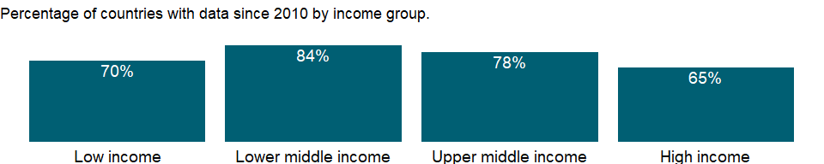

### Why is it relevant?

NA

### What is the data source?

International Labour Organization, ILOSTAT database. Data retrieved on January 29, 2021.

### What is the methodology?

NA

### How is it aggregated?

Weighted Average

### What are the limitations?

NA

### What else should I know?

NA

### 1.77.8 Unemployment with advanced education, male (% of male labor force with advanced education)

### What is the indicator?

The percentage of the labor force with an advanced level of education who are unemployed. Advanced education comprises short-cycle tertiary education, a bachelor’s degree or equivalent education level, a master’s degree or equivalent education level, or doctoral degree or equivalent education level according to the International Standard Classification of Education 2011 (ISCED 2011).

Topic: Social Protection & Labor: Unemployment

Series ID: SL.UEM.ADVN.MA.ZS

Copyright: CC BY-4.0 , <https://datacatalog.worldbank.org/public-licenses#cc-by>

First year with any data: 1990

Last year with any data: 2020

### What years are data available?

The figure below shows years in which data is available for at least one country. Dates shaded in black have no data, while dates shaded in green have data for at least one country



### Which countries have data?

The figure below shows the percentage of countries in each income group with a value since 2010 for that indicator.

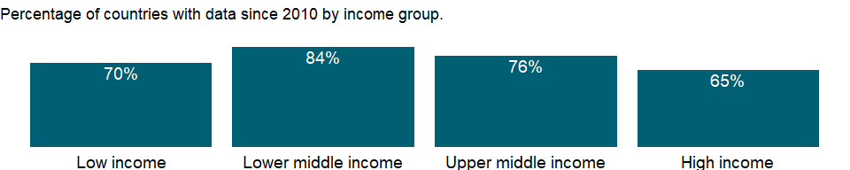

### Why is it relevant?

NA

### What is the data source?

International Labour Organization, ILOSTAT database. Data retrieved on January 29, 2021.

### What is the methodology?

NA

### How is it aggregated?

Weighted Average

### What are the limitations?

NA

### What else should I know?

NA

### 1.77.9 Unemployment with advanced education (% of total labor force with advanced education)

### What is the indicator?

The percentage of the labor force with an advanced level of education who are unemployed. Advanced education comprises short-cycle tertiary education, a bachelor’s degree or equivalent education level, a master’s degree or equivalent education level, or doctoral degree or equivalent education level according to the International Standard Classification of Education 2011 (ISCED 2011).

Topic: Social Protection & Labor: Unemployment

Series ID: SL.UEM.ADVN.ZS

Copyright: CC BY-4.0 , <https://datacatalog.worldbank.org/public-licenses#cc-by>

First year with any data: 1990

Last year with any data: 2020

### What years are data available?

The figure below shows years in which data is available for at least one country. Dates shaded in black have no data, while dates shaded in green have data for at least one country



### Which countries have data?

The figure below shows the percentage of countries in each income group with a value since 2010 for that indicator.

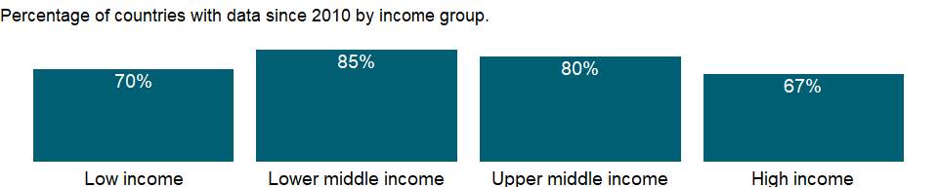

### Why is it relevant?

NA

### What is the data source?

International Labour Organization, ILOSTAT database. Data retrieved on January 29, 2021.

### What is the methodology?

NA

### How is it aggregated?

Weighted Average

### What are the limitations?

NA

### What else should I know?

NA

### 1.77.10 Unemployment with basic education, female (% of female labor force with basic education)

### What is the indicator?

The percentage of the labor force with a basic level of education who are unemployed. Basic education comprises primary education or lower secondary education according to the International Standard Classification of Education 2011 (ISCED 2011).

Topic: Social Protection & Labor: Unemployment

Series ID: SL.UEM.BASC.FE.ZS

Copyright: CC BY-4.0 , <https://datacatalog.worldbank.org/public-licenses#cc-by>

First year with any data: 1990

Last year with any data: 2020

### What years are data available?

The figure below shows years in which data is available for at least one country. Dates shaded in black have no data, while dates shaded in green have data for at least one country



### Which countries have data?

The figure below shows the percentage of countries in each income group with a value since 2010 for that indicator.

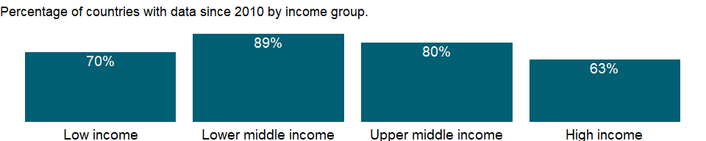

### Why is it relevant?

NA

### What is the data source?

International Labour Organization, ILOSTAT database. Data retrieved on January 29, 2021.

### What is the methodology?

NA

### How is it aggregated?

Weighted Average

### What are the limitations?

NA

### What else should I know?

NA

### 1.77.11 Unemployment with basic education, male (% of male labor force with basic education)

### What is the indicator?

The percentage of the labor force with a basic level of education who are unemployed. Basic education comprises primary education or lower secondary education according to the International Standard Classification of Education 2011 (ISCED 2011).

Topic: Social Protection & Labor: Unemployment

Series ID: SL.UEM.BASC.MA.ZS

Copyright: CC BY-4.0 , <https://datacatalog.worldbank.org/public-licenses#cc-by>

First year with any data: 1990

Last year with any data: 2020

### What years are data available?

The figure below shows years in which data is available for at least one country. Dates shaded in black have no data, while dates shaded in green have data for at least one country



### Which countries have data?

The figure below shows the percentage of countries in each income group with a value since 2010 for that indicator.



### Why is it relevant?

NA

### What is the data source?

International Labour Organization, ILOSTAT database. Data retrieved on January 29, 2021.

### What is the methodology?

NA

### How is it aggregated?

Weighted Average

### What are the limitations?

NA

### What else should I know?

NA

### 1.77.12 Unemployment with basic education (% of total labor force with basic education)

### What is the indicator?

The percentage of the labor force with a basic level of education who are unemployed. Basic education comprises primary education or lower secondary education according to the International Standard Classification of Education 2011 (ISCED 2011).

Topic: Social Protection & Labor: Unemployment

Series ID: SL.UEM.BASC.ZS

Copyright: CC BY-4.0 , <https://datacatalog.worldbank.org/public-licenses#cc-by>

First year with any data: 1990

Last year with any data: 2020

### What years are data available?

The figure below shows years in which data is available for at least one country. Dates shaded in black have no data, while dates shaded in green have data for at least one country



### Which countries have data?

The figure below shows the percentage of countries in each income group with a value since 2010 for that indicator.

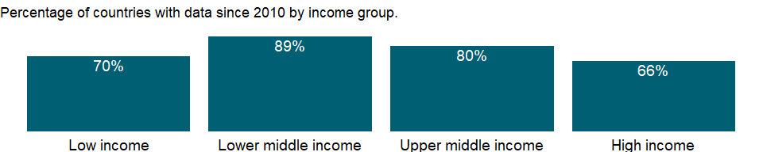

### Why is it relevant?

NA

### What is the data source?

International Labour Organization, ILOSTAT database. Data retrieved on January 29, 2021.

### What is the methodology?

NA

### How is it aggregated?

Weighted Average

### What are the limitations?

NA

### What else should I know?

NA

### 1.77.13 Unemployment with intermediate education, female (% of female labor force with intermediate education)

### What is the indicator?

The percentage of the labor force with an intermediate level of education who are unemployed. Intermediate education comprises upper secondary or post-secondary non tertiary education according to the International Standard Classification of Education 2011 (ISCED 2011).

Topic: Social Protection & Labor: Unemployment

Series ID: SL.UEM.INTM.FE.ZS

Copyright: CC BY-4.0 , <https://datacatalog.worldbank.org/public-licenses#cc-by>

First year with any data: 1990

Last year with any data: 2020

### What years are data available?

The figure below shows years in which data is available for at least one country. Dates shaded in black have no data, while dates shaded in green have data for at least one country



### Which countries have data?

The figure below shows the percentage of countries in each income group with a value since 2010 for that indicator.



### Why is it relevant?

NA

### What is the data source?

International Labour Organization, ILOSTAT database. Data retrieved on January 29, 2021.

### What is the methodology?

NA

### How is it aggregated?

Weighted Average

### What are the limitations?

NA

### What else should I know?

NA

### 1.77.14 Unemployment with intermediate education, male (% of male labor force with intermediate education)

### What is the indicator?

The percentage of the labor force with an intermediate level of education who are unemployed. Intermediate education comprises upper secondary or post-secondary non tertiary education according to the International Standard Classification of Education 2011 (ISCED 2011).

Topic: Social Protection & Labor: Unemployment

Series ID: SL.UEM.INTM.MA.ZS

Copyright: CC BY-4.0 , <https://datacatalog.worldbank.org/public-licenses#cc-by>

First year with any data: 1990

Last year with any data: 2020

### What years are data available?

The figure below shows years in which data is available for at least one country. Dates shaded in black have no data, while dates shaded in green have data for at least one country



### Which countries have data?

The figure below shows the percentage of countries in each income group with a value since 2010 for that indicator.

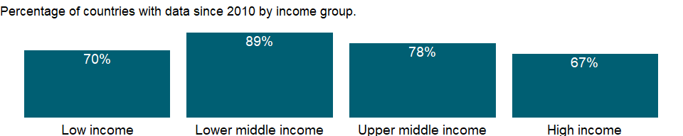

### Why is it relevant?

NA

### What is the data source?

International Labour Organization, ILOSTAT database. Data retrieved on January 29, 2021.

### What is the methodology?

NA

### How is it aggregated?

Weighted Average

### What are the limitations?

NA

### What else should I know?

NA

### 1.77.15 Unemployment with intermediate education (% of total labor force with intermediate education)

### What is the indicator?

The percentage of the labor force with an intermediate level of education who are unemployed. Intermediate education comprises upper secondary or post-secondary non tertiary education according to the International Standard Classification of Education 2011 (ISCED 2011).

Topic: Social Protection & Labor: Unemployment

Series ID: SL.UEM.INTM.ZS

Copyright: CC BY-4.0 , <https://datacatalog.worldbank.org/public-licenses#cc-by>

First year with any data: 1990

Last year with any data: 2020

### What years are data available?

The figure below shows years in which data is available for at least one country. Dates shaded in black have no data, while dates shaded in green have data for at least one country



### Which countries have data?

The figure below shows the percentage of countries in each income group with a value since 2010 for that indicator.

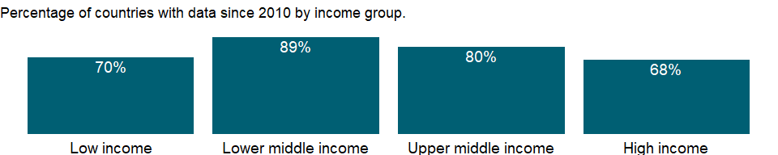

### Why is it relevant?

NA

### What is the data source?

International Labour Organization, ILOSTAT database. Data retrieved on January 29, 2021.

### What is the methodology?

NA

### How is it aggregated?

Weighted Average

### What are the limitations?

NA

### What else should I know?

NA

### 1.77.16 Share of youth not in education, employment or training, female (% of female youth population)

### What is the indicator?

Share of youth not in education, employment or training (NEET) is the proportion of young people who are not in education, employment, or training to the population of the corresponding age group: youth (ages 15 to 24); persons ages 15 to 29; or both age groups.

Topic: Social Protection & Labor: Unemployment

Series ID: SL.UEM.NEET.FE.ZS

Copyright: CC BY-4.0 , <https://datacatalog.worldbank.org/public-licenses#cc-by>

First year with any data: 1976

Last year with any data: 2020

### What years are data available?

The figure below shows years in which data is available for at least one country. Dates shaded in black have no data, while dates shaded in green have data for at least one country



### Which countries have data?

The figure below shows the percentage of countries in each income group with a value since 2010 for that indicator.

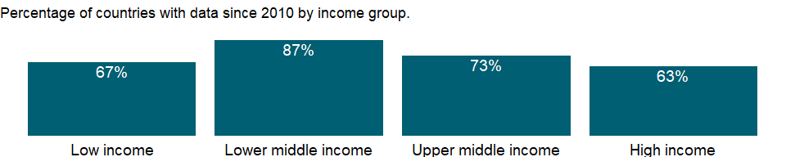

### Why is it relevant?

Unemployment and total employment are the broadest indicators of economic activity as reflected by the labor market. The International Labour Organization(ILO) defines the unemployed as members of the economically active population who are without work but available for and seeking work, including people who have lost their jobs or who have voluntarily left work. Some unemployment is unavoidable. At any time some workers are temporarily unemployed - between jobs as employers look for the right workers and workers search for better jobs. Such unemployment, often called frictional unemployment, results from the normal operation of labor markets.

Youth unemployment is an important policy issue for many economies. Young men and women today face increasing uncertainty in their hopes of undergoing a satisfactory transition in the labour market, and this uncertainty and disillusionment can, in turn, have damaging effects on individuals, communities, economies and society at large. Unemployed or underemployed youth are less able to contribute effectively to national development and have fewer opportunities to exercise their rights as citizens. They have less to spend as consumers, less to invest as savers and often have no “voice” to bring about change in their lives and communities. Widespread youth unemployment and underemployment also prevents companies and countries from innovating and developing competitive advantages based on human capital investment, thus undermining future prospects.

The NEET group is particularly at risk of both labour market and social exclusion, because this group is neither improving their future employability through investment in skills nor gaining experience through employment, . In addition, the NEET group is already in a disadvantaged position due to lower levels of education and lower household incomes. In view of the fact that the NEET group includes unemployed youth as well as economically inactive youth, the NEET rate provides important complementray information to labour force participation rates and unemploymenent rates. For example, if youth participation rates decrease during an economic downturn due to discouragement, this may be reflected in an upward movement in the NEET rate. More generally, a high NEET rate and a low youth unemployment may indicate significant discouragement of young people. A high NEET rate for young women suggests their engagement in household chores, and/or the presence of strong institutional barriers limiting female participation in labour markets.

### What is the data source?

International Labour Organization, ILOSTAT database. Data retrieved on January 29, 2021.

### What is the methodology?

The standard definition of unemployed persons is those individuals without work in a recent past period, and currently available for and seeking for employment. But there may be persons who do not actively “seek” work because they view job opportunities as limited, or because they have restricted labour mobility, or face discrimination, or structural, social or cultural barriers. NEET rates capture more broadly untapped potential youth, including such individuals who want to work but are not seeking work (often called the “hidden unemployed” or “discouraged workers”).

Youth are defined as persons ages 15 to 24; young adults are those ages 25 to 29; and adults are those ages 25 and above. However, countries vary somewhat in their operational definitions. In particular, the lower age limit for young people is usually determined by the minimum age for leaving school, where this exists. When data are available for more than two age groups in a given year, one value for persons ages 15 to 29 is taken, considering that not all people complete their education by the age of 24.

### How is it aggregated?

Weighted Average

### What are the limitations?

Data should be used cautiously because of differences in age coverage.

### What else should I know?

NA

### 1.77.17 Share of youth not in education, employment or training, male (% of male youth population)

### What is the indicator?

Share of youth not in education, employment or training (NEET) is the proportion of young people who are not in education, employment, or training to the population of the corresponding age group: youth (ages 15 to 24); persons ages 15 to 29; or both age groups.

Topic: Social Protection & Labor: Unemployment

Series ID: SL.UEM.NEET.MA.ZS

Copyright: CC BY-4.0 , <https://datacatalog.worldbank.org/public-licenses#cc-by>

First year with any data: 1976

Last year with any data: 2020

### What years are data available?

The figure below shows years in which data is available for at least one country. Dates shaded in black have no data, while dates shaded in green have data for at least one country



### Which countries have data?

The figure below shows the percentage of countries in each income group with a value since 2010 for that indicator.



### Why is it relevant?

Unemployment and total employment are the broadest indicators of economic activity as reflected by the labor market. The International Labour Organization(ILO) defines the unemployed as members of the economically active population who are without work but available for and seeking work, including people who have lost their jobs or who have voluntarily left work. Some unemployment is unavoidable. At any time some workers are temporarily unemployed - between jobs as employers look for the right workers and workers search for better jobs. Such unemployment, often called frictional unemployment, results from the normal operation of labor markets.

Youth unemployment is an important policy issue for many economies. Young men and women today face increasing uncertainty in their hopes of undergoing a satisfactory transition in the labour market, and this uncertainty and disillusionment can, in turn, have damaging effects on individuals, communities, economies and society at large. Unemployed or underemployed youth are less able to contribute effectively to national development and have fewer opportunities to exercise their rights as citizens. They have less to spend as consumers, less to invest as savers and often have no “voice” to bring about change in their lives and communities. Widespread youth unemployment and underemployment also prevents companies and countries from innovating and developing competitive advantages based on human capital investment, thus undermining future prospects.

The NEET group is particularly at risk of both labour market and social exclusion, because this group is neither improving their future employability through investment in skills nor gaining experience through employment, . In addition, the NEET group is already in a disadvantaged position due to lower levels of education and lower household incomes. In view of the fact that the NEET group includes unemployed youth as well as economically inactive youth, the NEET rate provides important complementray information to labour force participation rates and unemploymenent rates. For example, if youth participation rates decrease during an economic downturn due to discouragement, this may be reflected in an upward movement in the NEET rate. More generally, a high NEET rate and a low youth unemployment may indicate significant discouragement of young people. A high NEET rate for young women suggests their engagement in household chores, and/or the presence of strong institutional barriers limiting female participation in labour markets.

### What is the data source?

International Labour Organization, ILOSTAT database. Data retrieved on January 29, 2021.

### What is the methodology?

The standard definition of unemployed persons is those individuals without work in a recent past period, and currently available for and seeking for employment. But there may be persons who do not actively “seek” work because they view job opportunities as limited, or because they have restricted labour mobility, or face discrimination, or structural, social or cultural barriers. NEET rates capture more broadly untapped potential youth, including such individuals who want to work but are not seeking work (often called the “hidden unemployed” or “discouraged workers”).

Youth are defined as persons ages 15 to 24; young adults are those ages 25 to 29; and adults are those ages 25 and above. However, countries vary somewhat in their operational definitions. In particular, the lower age limit for young people is usually determined by the minimum age for leaving school, where this exists. When data are available for more than two age groups in a given year, one value for persons ages 15 to 29 is taken, considering that not all people complete their education by the age of 24.

### How is it aggregated?

Weighted Average

### What are the limitations?

Data should be used cautiously because of differences in age coverage.

### What else should I know?

NA

### 1.77.18 Share of youth not in education, employment or training, total (% of youth population)

### What is the indicator?

Share of youth not in education, employment or training (NEET) is the proportion of young people who are not in education, employment, or training to the population of the corresponding age group: youth (ages 15 to 24); persons ages 15 to 29; or both age groups.

Topic: Social Protection & Labor: Unemployment

Series ID: SL.UEM.NEET.ZS

Copyright: CC BY-4.0 , <https://datacatalog.worldbank.org/public-licenses#cc-by>

First year with any data: 1976

Last year with any data: 2020

### What years are data available?

The figure below shows years in which data is available for at least one country. Dates shaded in black have no data, while dates shaded in green have data for at least one country



### Which countries have data?

The figure below shows the percentage of countries in each income group with a value since 2010 for that indicator.

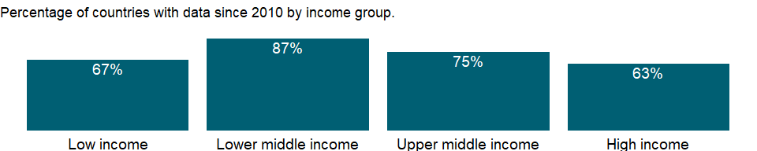

### Why is it relevant?

Unemployment and total employment are the broadest indicators of economic activity as reflected by the labor market. The International Labour Organization(ILO) defines the unemployed as members of the economically active population who are without work but available for and seeking work, including people who have lost their jobs or who have voluntarily left work. Some unemployment is unavoidable. At any time some workers are temporarily unemployed - between jobs as employers look for the right workers and workers search for better jobs. Such unemployment, often called frictional unemployment, results from the normal operation of labor markets.

Youth unemployment is an important policy issue for many economies. Young men and women today face increasing uncertainty in their hopes of undergoing a satisfactory transition in the labour market, and this uncertainty and disillusionment can, in turn, have damaging effects on individuals, communities, economies and society at large. Unemployed or underemployed youth are less able to contribute effectively to national development and have fewer opportunities to exercise their rights as citizens. They have less to spend as consumers, less to invest as savers and often have no “voice” to bring about change in their lives and communities. Widespread youth unemployment and underemployment also prevents companies and countries from innovating and developing competitive advantages based on human capital investment, thus undermining future prospects.

The NEET group is particularly at risk of both labour market and social exclusion, because this group is neither improving their future employability through investment in skills nor gaining experience through employment, . In addition, the NEET group is already in a disadvantaged position due to lower levels of education and lower household incomes. In view of the fact that the NEET group includes unemployed youth as well as economically inactive youth, the NEET rate provides important complementray information to labour force participation rates and unemploymenent rates. For example, if youth participation rates decrease during an economic downturn due to discouragement, this may be reflected in an upward movement in the NEET rate. More generally, a high NEET rate and a low youth unemployment may indicate significant discouragement of young people. A high NEET rate for young women suggests their engagement in household chores, and/or the presence of strong institutional barriers limiting female participation in labour markets.

### What is the data source?

International Labour Organization, ILOSTAT database. Data retrieved on January 29, 2021.

### What is the methodology?

The standard definition of unemployed persons is those individuals without work in a recent past period, and currently available for and seeking for employment. But there may be persons who do not actively “seek” work because they view job opportunities as limited, or because they have restricted labour mobility, or face discrimination, or structural, social or cultural barriers. NEET rates capture more broadly untapped potential youth, including such individuals who want to work but are not seeking work (often called the “hidden unemployed” or “discouraged workers”).

Youth are defined as persons ages 15 to 24; young adults are those ages 25 to 29; and adults are those ages 25 and above. However, countries vary somewhat in their operational definitions. In particular, the lower age limit for young people is usually determined by the minimum age for leaving school, where this exists. When data are available for more than two age groups in a given year, one value for persons ages 15 to 29 is taken, considering that not all people complete their education by the age of 24.

### How is it aggregated?

Weighted Average

### What are the limitations?

Data should be used cautiously because of differences in age coverage.

### What else should I know?

NA

### 1.77.19 Unemployment, female (% of female labor force) (national estimate)

### What is the indicator?

Unemployment refers to the share of the labor force that is without work but available for and seeking employment. Definitions of labor force and unemployment differ by country.

Topic: Social Protection & Labor: Unemployment

Series ID: SL.UEM.TOTL.FE.NE.ZS

Copyright: CC BY-4.0 , <https://datacatalog.worldbank.org/public-licenses#cc-by>

First year with any data: 1960

Last year with any data: 2020

### What years are data available?

The figure below shows years in which data is available for at least one country. Dates shaded in black have no data, while dates shaded in green have data for at least one country



### Which countries have data?

The figure below shows the percentage of countries in each income group with a value since 2010 for that indicator.

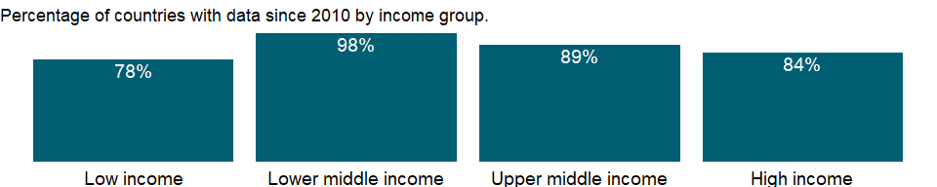

### Why is it relevant?

Paradoxically, low unemployment rates can disguise substantial poverty in a country, while high unemployment rates can occur in countries with a high level of economic development and low rates of poverty. In countries without unemployment or welfare benefits people eke out a living in vulnerable employment. In countries with well-developed safety nets workers can afford to wait for suitable or desirable jobs. But high and sustained unemployment indicates serious inefficiencies in resource allocation.

Youth unemployment is an important policy issue for many economies. Young men and women today face increasing uncertainty in their hopes of undergoing a satisfactory transition in the labour market, and this uncertainty and disillusionment can, in turn, have damaging effects on individuals, communities, economies and society at large. Unemployed or underemployed youth are less able to contribute effectively to national development and have fewer opportunities to exercise their rights as citizens. They have less to spend as consumers, less to invest as savers and often have no “voice” to bring about change in their lives and communities. Widespread youth unemployment and underemployment also prevents companies and countries from innovating and developing competitive advantages based on human capital investment, thus undermining future prospects.

Unemployment is a key measure to monitor whether a country is on track to achieve the Sustainable Development Goal of promoting sustained, inclusive and sustainable economic growth, full and productive employment and decent work for all. [SDG Indicator 8.5.2]

### What is the data source?

International Labour Organization, ILOSTAT database. Data retrieved on September 7, 2021.

### What is the methodology?

The standard definition of unemployed persons is those individuals without work, seeking work in a recent past period, and currently available for work, including people who have lost their jobs or who have voluntarily left work. Persons who did not look for work but have an arrangements for a future job are also counted as unemployed.

Some unemployment is unavoidable. At any time some workers are temporarily unemployed between jobs as employers look for the right workers and workers search for better jobs. It is the labour force or the economically active portion of the population that serves as the base for this indicator, not the total population.

### How is it aggregated?

Weighted Average

### What are the limitations?

The criteria for people considered to be seeking work, and the treatment of people temporarily laid off or seeking work for the first time, vary across countries. In many cases it is especially difficult to measure employment and unemployment in agriculture. The timing of a survey can maximize the effects of seasonal unemployment in agriculture. And informal sector employment is difficult to quantify where informal activities are not tracked.

There may be also persons not currently in the labour market who want to work but do not actively “seek” work because they view job opportunities as limited, or because they have restricted labour mobility, or face discrimination, or structural, social or cultural barriers. The exclusion of people who want to work but are not seeking work (often called the “hidden unemployed” or “discouraged workers”) is a criterion that will affect the unemployment count of both women and men.

However, women tend to be excluded from the count for various reasons. Women suffer more from discrimination and from structural, social, and cultural barriers that impede them from seeking work. Also, women are often responsible for the care of children and the elderly and for household affairs. They may not be available for work during the short reference period, as they need to make arrangements before starting work. Further, women are considered to be employed when they are working part-time or in temporary jobs, despite the instability of these jobs or their active search for more secure employment.

### What else should I know?

The series for ILO estimates is also available in the WDI database. Caution should be used when comparing ILO estimates with national estimates.

### 1.77.20 Unemployment, female (% of female labor force) (modeled ILO estimate)

### What is the indicator?

Unemployment refers to the share of the labor force that is without work but available for and seeking employment.

Topic: Social Protection & Labor: Unemployment

Series ID: SL.UEM.TOTL.FE.ZS

Copyright: CC BY-4.0 , <https://datacatalog.worldbank.org/public-licenses#cc-by>

First year with any data: 1991

Last year with any data: 2019

### What years are data available?

The figure below shows years in which data is available for at least one country. Dates shaded in black have no data, while dates shaded in green have data for at least one country



### Which countries have data?

The figure below shows the percentage of countries in each income group with a value since 2010 for that indicator.



### Why is it relevant?

Paradoxically, low unemployment rates can disguise substantial poverty in a country, while high unemployment rates can occur in countries with a high level of economic development and low rates of poverty. In countries without unemployment or welfare benefits people eke out a living in vulnerable employment. In countries with well-developed safety nets workers can afford to wait for suitable or desirable jobs. But high and sustained unemployment indicates serious inefficiencies in resource allocation.

Youth unemployment is an important policy issue for many economies. Young men and women today face increasing uncertainty in their hopes of undergoing a satisfactory transition in the labour market, and this uncertainty and disillusionment can, in turn, have damaging effects on individuals, communities, economies and society at large. Unemployed or underemployed youth are less able to contribute effectively to national development and have fewer opportunities to exercise their rights as citizens. They have less to spend as consumers, less to invest as savers and often have no “voice” to bring about change in their lives and communities. Widespread youth unemployment and underemployment also prevents companies and countries from innovating and developing competitive advantages based on human capital investment, thus undermining future prospects.

Unemployment is a key measure to monitor whether a country is on track to achieve the Sustainable Development Goal of promoting sustained, inclusive and sustainable economic growth, full and productive employment and decent work for all. [SDG Indicator 8.5.2]

### What is the data source?

International Labour Organization, ILOSTAT database. Data retrieved on June 15, 2021.

### What is the methodology?

The standard definition of unemployed persons is those individuals without work, seeking work in a recent past period, and currently available for work, including people who have lost their jobs or who have voluntarily left work. Persons who did not look for work but have an arrangements for a future job are also counted as unemployed.

Some unemployment is unavoidable. At any time some workers are temporarily unemployed between jobs as employers look for the right workers and workers search for better jobs. It is the labour force or the economically active portion of the population that serves as the base for this indicator, not the total population.

The series is part of the ILO estimates and is harmonized to ensure comparability across countries and over time by accounting for differences in data source, scope of coverage, methodology, and other country-specific factors. The estimates are based mainly on nationally representative labor force surveys, with other sources (population censuses and nationally reported estimates) used only when no survey data are available.

### How is it aggregated?

Weighted average

### What are the limitations?

The criteria for people considered to be seeking work, and the treatment of people temporarily laid off or seeking work for the first time, vary across countries. In many cases it is especially difficult to measure employment and unemployment in agriculture. The timing of a survey can maximize the effects of seasonal unemployment in agriculture. And informal sector employment is difficult to quantify where informal activities are not tracked.

There may be also persons not currently in the labour market who want to work but do not actively “seek” work because they view job opportunities as limited, or because they have restricted labour mobility, or face discrimination, or structural, social or cultural barriers. The exclusion of people who want to work but are not seeking work (often called the “hidden unemployed” or “discouraged workers”) is a criterion that will affect the unemployment count of both women and men.

However, women tend to be excluded from the count for various reasons. Women suffer more from discrimination and from structural, social, and cultural barriers that impede them from seeking work. Also, women are often responsible for the care of children and the elderly and for household affairs. They may not be available for work during the short reference period, as they need to make arrangements before starting work. Further, women are considered to be employed when they are working part-time or in temporary jobs, despite the instability of these jobs or their active search for more secure employment.

### What else should I know?

National estimates are also available in the WDI database. Caution should be used when comparing ILO estimates with national estimates.

### 1.77.21 Unemployment, male (% of male labor force) (national estimate)

### What is the indicator?

Unemployment refers to the share of the labor force that is without work but available for and seeking employment. Definitions of labor force and unemployment differ by country.

Topic: Social Protection & Labor: Unemployment

Series ID: SL.UEM.TOTL.MA.NE.ZS

Copyright: CC BY-4.0 , <https://datacatalog.worldbank.org/public-licenses#cc-by>

First year with any data: 1960

Last year with any data: 2020

### What years are data available?

The figure below shows years in which data is available for at least one country. Dates shaded in black have no data, while dates shaded in green have data for at least one country



### Which countries have data?

The figure below shows the percentage of countries in each income group with a value since 2010 for that indicator.



### Why is it relevant?

Paradoxically, low unemployment rates can disguise substantial poverty in a country, while high unemployment rates can occur in countries with a high level of economic development and low rates of poverty. In countries without unemployment or welfare benefits people eke out a living in vulnerable employment. In countries with well-developed safety nets workers can afford to wait for suitable or desirable jobs. But high and sustained unemployment indicates serious inefficiencies in resource allocation.

Youth unemployment is an important policy issue for many economies. Young men and women today face increasing uncertainty in their hopes of undergoing a satisfactory transition in the labour market, and this uncertainty and disillusionment can, in turn, have damaging effects on individuals, communities, economies and society at large. Unemployed or underemployed youth are less able to contribute effectively to national development and have fewer opportunities to exercise their rights as citizens. They have less to spend as consumers, less to invest as savers and often have no “voice” to bring about change in their lives and communities. Widespread youth unemployment and underemployment also prevents companies and countries from innovating and developing competitive advantages based on human capital investment, thus undermining future prospects.

Unemployment is a key measure to monitor whether a country is on track to achieve the Sustainable Development Goal of promoting sustained, inclusive and sustainable economic growth, full and productive employment and decent work for all. [SDG Indicator 8.5.2]

### What is the data source?

International Labour Organization, ILOSTAT database. Data retrieved on September 7, 2021.

### What is the methodology?

The standard definition of unemployed persons is those individuals without work, seeking work in a recent past period, and currently available for work, including people who have lost their jobs or who have voluntarily left work. Persons who did not look for work but have an arrangements for a future job are also counted as unemployed.

Some unemployment is unavoidable. At any time some workers are temporarily unemployed between jobs as employers look for the right workers and workers search for better jobs. It is the labour force or the economically active portion of the population that serves as the base for this indicator, not the total population.

### How is it aggregated?

Weighted Average

### What are the limitations?

The criteria for people considered to be seeking work, and the treatment of people temporarily laid off or seeking work for the first time, vary across countries. In many cases it is especially difficult to measure employment and unemployment in agriculture. The timing of a survey can maximize the effects of seasonal unemployment in agriculture. And informal sector employment is difficult to quantify where informal activities are not tracked.

There may be also persons not currently in the labour market who want to work but do not actively “seek” work because they view job opportunities as limited, or because they have restricted labour mobility, or face discrimination, or structural, social or cultural barriers. The exclusion of people who want to work but are not seeking work (often called the “hidden unemployed” or “discouraged workers”) is a criterion that will affect the unemployment count of both women and men.

However, women tend to be excluded from the count for various reasons. Women suffer more from discrimination and from structural, social, and cultural barriers that impede them from seeking work. Also, women are often responsible for the care of children and the elderly and for household affairs. They may not be available for work during the short reference period, as they need to make arrangements before starting work. Further, women are considered to be employed when they are working part-time or in temporary jobs, despite the instability of these jobs or their active search for more secure employment.

### What else should I know?

The series for ILO estimates is also available in the WDI database. Caution should be used when comparing ILO estimates with national estimates.

### 1.77.22 Unemployment, male (% of male labor force) (modeled ILO estimate)

### What is the indicator?

Unemployment refers to the share of the labor force that is without work but available for and seeking employment.

Topic: Social Protection & Labor: Unemployment

Series ID: SL.UEM.TOTL.MA.ZS

Copyright: CC BY-4.0 , <https://datacatalog.worldbank.org/public-licenses#cc-by>

First year with any data: 1991

Last year with any data: 2019

### What years are data available?

The figure below shows years in which data is available for at least one country. Dates shaded in black have no data, while dates shaded in green have data for at least one country



### Which countries have data?

The figure below shows the percentage of countries in each income group with a value since 2010 for that indicator.



### Why is it relevant?

Paradoxically, low unemployment rates can disguise substantial poverty in a country, while high unemployment rates can occur in countries with a high level of economic development and low rates of poverty. In countries without unemployment or welfare benefits people eke out a living in vulnerable employment. In countries with well-developed safety nets workers can afford to wait for suitable or desirable jobs. But high and sustained unemployment indicates serious inefficiencies in resource allocation.

Youth unemployment is an important policy issue for many economies. Young men and women today face increasing uncertainty in their hopes of undergoing a satisfactory transition in the labour market, and this uncertainty and disillusionment can, in turn, have damaging effects on individuals, communities, economies and society at large. Unemployed or underemployed youth are less able to contribute effectively to national development and have fewer opportunities to exercise their rights as citizens. They have less to spend as consumers, less to invest as savers and often have no “voice” to bring about change in their lives and communities. Widespread youth unemployment and underemployment also prevents companies and countries from innovating and developing competitive advantages based on human capital investment, thus undermining future prospects.

Unemployment is a key measure to monitor whether a country is on track to achieve the Sustainable Development Goal of promoting sustained, inclusive and sustainable economic growth, full and productive employment and decent work for all. [SDG Indicator 8.5.2]

### What is the data source?

International Labour Organization, ILOSTAT database. Data retrieved on June 15, 2021.

### What is the methodology?

The standard definition of unemployed persons is those individuals without work, seeking work in a recent past period, and currently available for work, including people who have lost their jobs or who have voluntarily left work. Persons who did not look for work but have an arrangements for a future job are also counted as unemployed.

Some unemployment is unavoidable. At any time some workers are temporarily unemployed between jobs as employers look for the right workers and workers search for better jobs. It is the labour force or the economically active portion of the population that serves as the base for this indicator, not the total population.

The series is part of the ILO estimates and is harmonized to ensure comparability across countries and over time by accounting for differences in data source, scope of coverage, methodology, and other country-specific factors. The estimates are based mainly on nationally representative labor force surveys, with other sources (population censuses and nationally reported estimates) used only when no survey data are available.

### How is it aggregated?

Weighted average

### What are the limitations?

The criteria for people considered to be seeking work, and the treatment of people temporarily laid off or seeking work for the first time, vary across countries. In many cases it is especially difficult to measure employment and unemployment in agriculture. The timing of a survey can maximize the effects of seasonal unemployment in agriculture. And informal sector employment is difficult to quantify where informal activities are not tracked.

There may be also persons not currently in the labour market who want to work but do not actively “seek” work because they view job opportunities as limited, or because they have restricted labour mobility, or face discrimination, or structural, social or cultural barriers. The exclusion of people who want to work but are not seeking work (often called the “hidden unemployed” or “discouraged workers”) is a criterion that will affect the unemployment count of both women and men.

However, women tend to be excluded from the count for various reasons. Women suffer more from discrimination and from structural, social, and cultural barriers that impede them from seeking work. Also, women are often responsible for the care of children and the elderly and for household affairs. They may not be available for work during the short reference period, as they need to make arrangements before starting work. Further, women are considered to be employed when they are working part-time or in temporary jobs, despite the instability of these jobs or their active search for more secure employment.

### What else should I know?

National estimates are also available in the WDI database. Caution should be used when comparing ILO estimates with national estimates.

### 1.77.23 Unemployment, total (% of total labor force) (national estimate)

### What is the indicator?

Unemployment refers to the share of the labor force that is without work but available for and seeking employment. Definitions of labor force and unemployment differ by country.

Topic: Social Protection & Labor: Unemployment

Series ID: SL.UEM.TOTL.NE.ZS

Copyright: CC BY-4.0 , <https://datacatalog.worldbank.org/public-licenses#cc-by>

First year with any data: 1960

Last year with any data: 2020

### What years are data available?

The figure below shows years in which data is available for at least one country. Dates shaded in black have no data, while dates shaded in green have data for at least one country



### Which countries have data?

The figure below shows the percentage of countries in each income group with a value since 2010 for that indicator.

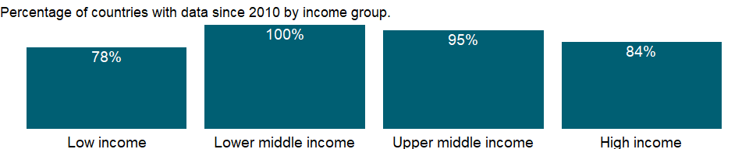

### Why is it relevant?

Paradoxically, low unemployment rates can disguise substantial poverty in a country, while high unemployment rates can occur in countries with a high level of economic development and low rates of poverty. In countries without unemployment or welfare benefits people eke out a living in vulnerable employment. In countries with well-developed safety nets workers can afford to wait for suitable or desirable jobs. But high and sustained unemployment indicates serious inefficiencies in resource allocation.

Youth unemployment is an important policy issue for many economies. Young men and women today face increasing uncertainty in their hopes of undergoing a satisfactory transition in the labour market, and this uncertainty and disillusionment can, in turn, have damaging effects on individuals, communities, economies and society at large. Unemployed or underemployed youth are less able to contribute effectively to national development and have fewer opportunities to exercise their rights as citizens. They have less to spend as consumers, less to invest as savers and often have no “voice” to bring about change in their lives and communities. Widespread youth unemployment and underemployment also prevents companies and countries from innovating and developing competitive advantages based on human capital investment, thus undermining future prospects.

Unemployment is a key measure to monitor whether a country is on track to achieve the Sustainable Development Goal of promoting sustained, inclusive and sustainable economic growth, full and productive employment and decent work for all. [SDG Indicator 8.5.2]

### What is the data source?

International Labour Organization, ILOSTAT database. Data retrieved on September 7, 2021.

### What is the methodology?

The standard definition of unemployed persons is those individuals without work, seeking work in a recent past period, and currently available for work, including people who have lost their jobs or who have voluntarily left work. Persons who did not look for work but have an arrangements for a future job are also counted as unemployed.

Some unemployment is unavoidable. At any time some workers are temporarily unemployed between jobs as employers look for the right workers and workers search for better jobs. It is the labour force or the economically active portion of the population that serves as the base for this indicator, not the total population.

### How is it aggregated?

Weighted Average

### What are the limitations?

The criteria for people considered to be seeking work, and the treatment of people temporarily laid off or seeking work for the first time, vary across countries. In many cases it is especially difficult to measure employment and unemployment in agriculture. The timing of a survey can maximize the effects of seasonal unemployment in agriculture. And informal sector employment is difficult to quantify where informal activities are not tracked.

There may be also persons not currently in the labour market who want to work but do not actively “seek” work because they view job opportunities as limited, or because they have restricted labour mobility, or face discrimination, or structural, social or cultural barriers. The exclusion of people who want to work but are not seeking work (often called the “hidden unemployed” or “discouraged workers”) is a criterion that will affect the unemployment count of both women and men.

However, women tend to be excluded from the count for various reasons. Women suffer more from discrimination and from structural, social, and cultural barriers that impede them from seeking work. Also, women are often responsible for the care of children and the elderly and for household affairs. They may not be available for work during the short reference period, as they need to make arrangements before starting work. Further, women are considered to be employed when they are working part-time or in temporary jobs, despite the instability of these jobs or their active search for more secure employment.

### What else should I know?

The series for ILO estimates is also available in the WDI database. Caution should be used when comparing ILO estimates with national estimates.

### 1.77.24 Unemployment, total (% of total labor force) (modeled ILO estimate)

### What is the indicator?

Unemployment refers to the share of the labor force that is without work but available for and seeking employment.

Topic: Social Protection & Labor: Unemployment

Series ID: SL.UEM.TOTL.ZS

Copyright: CC BY-4.0 , <https://datacatalog.worldbank.org/public-licenses#cc-by>

First year with any data: 1991

Last year with any data: 2020

### What years are data available?

The figure below shows years in which data is available for at least one country. Dates shaded in black have no data, while dates shaded in green have data for at least one country



### Which countries have data?

The figure below shows the percentage of countries in each income group with a value since 2010 for that indicator.



### Why is it relevant?

Paradoxically, low unemployment rates can disguise substantial poverty in a country, while high unemployment rates can occur in countries with a high level of economic development and low rates of poverty. In countries without unemployment or welfare benefits people eke out a living in vulnerable employment. In countries with well-developed safety nets workers can afford to wait for suitable or desirable jobs. But high and sustained unemployment indicates serious inefficiencies in resource allocation.

Youth unemployment is an important policy issue for many economies. Young men and women today face increasing uncertainty in their hopes of undergoing a satisfactory transition in the labour market, and this uncertainty and disillusionment can, in turn, have damaging effects on individuals, communities, economies and society at large. Unemployed or underemployed youth are less able to contribute effectively to national development and have fewer opportunities to exercise their rights as citizens. They have less to spend as consumers, less to invest as savers and often have no “voice” to bring about change in their lives and communities. Widespread youth unemployment and underemployment also prevents companies and countries from innovating and developing competitive advantages based on human capital investment, thus undermining future prospects.

Unemployment is a key measure to monitor whether a country is on track to achieve the Sustainable Development Goal of promoting sustained, inclusive and sustainable economic growth, full and productive employment and decent work for all. [SDG Indicator 8.5.2]

### What is the data source?

International Labour Organization, ILOSTAT database. Data retrieved on June 15, 2021.

### What is the methodology?

The standard definition of unemployed persons is those individuals without work, seeking work in a recent past period, and currently available for work, including people who have lost their jobs or who have voluntarily left work. Persons who did not look for work but have an arrangements for a future job are also counted as unemployed.

Some unemployment is unavoidable. At any time some workers are temporarily unemployed between jobs as employers look for the right workers and workers search for better jobs. It is the labour force or the economically active portion of the population that serves as the base for this indicator, not the total population.

The series is part of the ILO estimates and is harmonized to ensure comparability across countries and over time by accounting for differences in data source, scope of coverage, methodology, and other country-specific factors. The estimates are based mainly on nationally representative labor force surveys, with other sources (population censuses and nationally reported estimates) used only when no survey data are available.

### How is it aggregated?

Weighted average

### What are the limitations?

The criteria for people considered to be seeking work, and the treatment of people temporarily laid off or seeking work for the first time, vary across countries. In many cases it is especially difficult to measure employment and unemployment in agriculture. The timing of a survey can maximize the effects of seasonal unemployment in agriculture. And informal sector employment is difficult to quantify where informal activities are not tracked.

There may be also persons not currently in the labour market who want to work but do not actively “seek” work because they view job opportunities as limited, or because they have restricted labour mobility, or face discrimination, or structural, social or cultural barriers. The exclusion of people who want to work but are not seeking work (often called the “hidden unemployed” or “discouraged workers”) is a criterion that will affect the unemployment count of both women and men.

However, women tend to be excluded from the count for various reasons. Women suffer more from discrimination and from structural, social, and cultural barriers that impede them from seeking work. Also, women are often responsible for the care of children and the elderly and for household affairs. They may not be available for work during the short reference period, as they need to make arrangements before starting work. Further, women are considered to be employed when they are working part-time or in temporary jobs, despite the instability of these jobs or their active search for more secure employment.

### What else should I know?

National estimates are also available in the WDI database. Caution should be used when comparing ILO estimates with national estimates.

## 1.78 Social Protection & Labor: Migration

### 1.78.1 Net migration

### What is the indicator?

Net migration is the net total of migrants during the period, that is, the total number of immigrants less the annual number of emigrants, including both citizens and noncitizens. Data are five-year estimates.

Topic: Social Protection & Labor: Migration

Series ID: SM.POP.NETM

Copyright: CC BY-4.0 , <https://datacatalog.worldbank.org/public-licenses#cc-by>

First year with any data: 1962

Last year with any data: 2017

### What years are data available?

The figure below shows years in which data is available for at least one country. Dates shaded in black have no data, while dates shaded in green have data for at least one country



### Which countries have data?

The figure below shows the percentage of countries in each income group with a value since 2010 for that indicator.



### Why is it relevant?

Movement of people, most often through migration, is a significant part of global integration. Migrants contribute to the economies of both their host country and their country of origin. Yet reliable statistics on migration are difficult to collect and are often incomplete, making international comparisons a challenge.

Global migration patterns have become increasingly complex in modern times, involving not just refugees, but also millions of economic migrants. In most developed countries, refugees are admitted for resettlement and are routinely included in population counts by censuses or population registers.

But refugees and migrants, even if they often travel in the same way, are fundamentally different, and for that reason are treated very differently under modern international law. Migrants, especially economic migrants, choose to move in order to improve the future prospects of themselves and their families. Refugees have to move if they are to save their lives or preserve their freedom.

### What is the data source?

United Nations Population Division. World Population Prospects: 2019 Revision.

### What is the methodology?

The United Nations Population Division provides data on net migration and migrant stock. Because data on migrant stock is difficult for countries to collect, the United Nations Population Division takes into account the past migration history of a country or area, the migration policy of a country, and the influx of refugees in recent periods when deriving estimates of net migration. The data to calculate these estimates come from a variety of sources, including border statistics, administrative records, surveys, and censuses.

When there is insufficient data, net migration is derived through the difference between the overall population growth rate and the rate of natural increase (the difference between the birth rate and the death rate) during the same period. Such calculations are usually made for intercensal periods. The estimates are also derived from the data on foreign-born population - people who have residence in one country but were born in another country. When data on the foreign-born population are not available, data on foreign population - that is, people who are citizens of a country other than the country in which they reside - are used as estimates.

### How is it aggregated?

Sum

### What are the limitations?

International migration is the component of population change most difficult to measure and estimate reliably. Thus, the quality and quantity of the data used in the estimation and projection of net migration varies considerably by country. Furthermore, the movement of people across international boundaries, which is very often a response to changing socio-economic, political and environmental forces, is subject to a great deal of volatility. Refugee movements, for instance, may involve large numbers of people moving across boundaries in a short time. For these reasons, projections of future international migration levels are the least robust part of current population projections and reflect mainly a continuation of recent levels and trends in net migration.

### What else should I know?

NA

### 1.78.2 Refugee population by country or territory of asylum

### What is the indicator?

Refugees are people who are recognized as refugees under the 1951 Convention Relating to the Status of Refugees or its 1967 Protocol, the 1969 Organization of African Unity Convention Governing the Specific Aspects of Refugee Problems in Africa, people recognized as refugees in accordance with the UNHCR statute, people granted refugee-like humanitarian status, and people provided temporary protection. Asylum seekers–people who have applied for asylum or refugee status and who have not yet received a decision or who are registered as asylum seekers–are excluded. Palestinian refugees are people (and their descendants) whose residence was Palestine between June 1946 and May 1948 and who lost their homes and means of livelihood as a result of the 1948 Arab-Israeli conflict. Country of asylum is the country where an asylum claim was filed and granted.

Topic: Social Protection & Labor: Migration

Series ID: SM.POP.REFG

Copyright: CC BY-4.0 , <https://datacatalog.worldbank.org/public-licenses#cc-by>

First year with any data: 1960

Last year with any data: 2020

### What years are data available?

The figure below shows years in which data is available for at least one country. Dates shaded in black have no data, while dates shaded in green have data for at least one country



### Which countries have data?

The figure below shows the percentage of countries in each income group with a value since 2010 for that indicator.

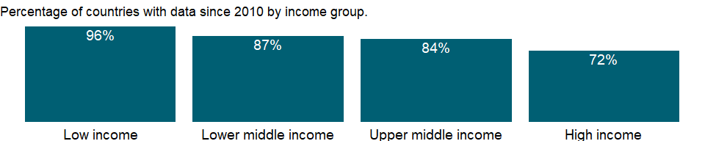

### Why is it relevant?

Movement of people, most often through migration, is a significant part of global integration. Migrants contribute to the economies of both their host country and their country of origin. Yet reliable statistics on migration are difficult to collect and are often incomplete, making international comparisons a challenge.

In most developed countries, refugees are admitted for resettlement and are routinely included in population counts by censuses or population registers. Globally, the number of refugees at end 2010 was 10.55 million, including 597,300 people considered by UNHCR to be in a refugee-like situation; developing countries hosted 8.5 million refugees, or 80 percent of the global refugee population.

Global migration patterns have become increasingly complex in modern times, involving not just refugees, but also millions of economic migrants. But refugees and migrants, even if they often travel in the same way, are fundamentally different, and for that reason are treated very differently under modern international law. Migrants, especially economic migrants, choose to move in order to improve the future prospects of themselves and their families. Refugees have to move if they are to save their lives or preserve their freedom. They have no protection from their own state - indeed it is often their own government that is threatening to persecute them. If other countries do not let them in, and do not help them once they are in, then they may be condemning them to death - or to an intolerable life in the shadows, without sustenance and without rights.

### What is the data source?

United Nations High Commissioner for Refugees (UNHCR) and UNRWA through UNHCR’s Refugee Data Finder at <https://www.unhcr.org/refugee-statistics/>.

### What is the methodology?

The United Nations High Commissioner for Refugees (UNHCR) collects and maintains data on refugees in their Statistical Online Population Database. The refugee data does not include Palestinian refugees residing in areas under the mandate of the United Nations Relief and Works Agency for Palestine Refugees in the Near East (UNRWA). However, the Palestinian refugees living outside the UNRWA areas of operation do fall under the responsibility of UNHCR and are thus included in the Statistical Online Population Database.

Refugees are an important part of migrant stock. The refugee data refer to people who have crossed an international border to find sanctuary and have been granted refugee or refugee-like status or temporary protection. There are three main providers of refugee data: governmental agencies, UNHCR field offices and NGOs. Registrations, together with other sources - including estimates and surveys - are the main sources of refugee data. In the absence of Government estimates, UNHCR has estimated the refugee population in most industrialized countries, based on recognition of asylum-seekers. Prior to 2007, resettled refugees were included in these estimates.

Up to and including 2006, to ensure that the refugee population in countries that lack a refugee registry is reflected in the global statistics, the number of refugees was estimated by UNHCR based on the arrival of refugees through resettlement programmes and the individual recognition of refugees over a 10-year (Europe and, since 2006, the United States) or 5-year (the United States before 2006, Canada and Oceania) period. Starting with the 2007 data, the cut-off period has been harmonized and now covers a 10-year period for Europe and non-European countries. Resettled refugees, however, are excluded from the refugee estimates in all countries.

The 2007-2011 refugee population category includes people in a refugee-like situation, most of who were previously included in the Others of concern group. This sub-category is descriptive in nature and includes groups of persons who are outside their country or territory of origin and who face protection risks similar to those of refugees, but for whom refugee status has, for practical or other reasons, not been ascertained.

Asylum seekers - people who have applied for asylum or refugee status and who have not yet received a decision or who are registered as asylum seekers - and internally displaced people - who are often confused with refugees - are not included in the data. Unlike refugees, internally displaced people remain under the protection of their own government, even if their reason for fleeing was similar to that of refugees.

Palestinian refugees are people (and their descendants) whose residence was Palestine between June 1946 and May 1948 and who lost their homes and means of livelihood as a result of the 1948 Arab-Israeli conflict.

### How is it aggregated?

Sum

### What are the limitations?

There are difficulties in collecting accurate statistics on refugees. Many refugees may not be aware of the need to register or may choose not to do so, and administrative records tend to overestimate the number of refugees because it is easier to register than to de-register. In addition, most industrialized countries lack a refugee register and are thus not in a position to provide accurate information on the number of refugees residing in their country. Many countries have registries that are only maintained at the local level, so the data is not centralized.

Asylum-seekers are persons who have applied for asylum or refugee status, but who have not yet received a final decision on their application. A distinction should be made between the number of asylum-seekers who have submitted an individual request during a certain period (“asylum applications submitted”) and the number of asylum-seekers whose individual asylum request has not yet been decided at a certain date (“backlog of undecided or pending cases”). Caution should therefore be exercised when interpreting data on asylum-seekers.

The United Nations High Commissioner for Refugees (UNHCR) collects and maintains data on refugees, except for Palestinian refugees residing in areas under the mandate of the United Nations Relief and Works Agency for Palestine Refugees in the Near East (UNRWA). Registration is voluntary, and estimates by the UNRWA are not an accurate count of the Palestinian refugee population. The data shows estimates of refugees collected by the UNHCR, complemented by estimates of Palestinian refugees under the UNRWA mandate. Thus, the aggregates differ from those published by the UNHCR.

Statistics concerning the former USSR have been reported under the Russian Federation, those concerning the former Czechoslovakia have been reported under the Czech Republic and those concerning the former Yugoslavia and ‘Serbia and Montenegro’ have been reported under Serbia. Since 2006, separate statistics are available for Serbia and for Montenegro. Prior to 2006, no separate statistics are available and both countries have been reported under Serbia.

### What else should I know?

NA

### 1.78.3 Refugee population by country or territory of origin

### What is the indicator?

Refugees are people who are recognized as refugees under the 1951 Convention Relating to the Status of Refugees or its 1967 Protocol, the 1969 Organization of African Unity Convention Governing the Specific Aspects of Refugee Problems in Africa, people recognized as refugees in accordance with the UNHCR statute, people granted refugee-like humanitarian status, and people provided temporary protection. Asylum seekers–people who have applied for asylum or refugee status and who have not yet received a decision or who are registered as asylum seekers–are excluded. Palestinian refugees are people (and their descendants) whose residence was Palestine between June 1946 and May 1948 and who lost their homes and means of livelihood as a result of the 1948 Arab-Israeli conflict. Country of origin generally refers to the nationality or country of citizenship of a claimant.

Topic: Social Protection & Labor: Migration

Series ID: SM.POP.REFG.OR

Copyright: CC BY-4.0 , <https://datacatalog.worldbank.org/public-licenses#cc-by>

First year with any data: 1960

Last year with any data: 2020

### What years are data available?

The figure below shows years in which data is available for at least one country. Dates shaded in black have no data, while dates shaded in green have data for at least one country



### Which countries have data?

The figure below shows the percentage of countries in each income group with a value since 2010 for that indicator.

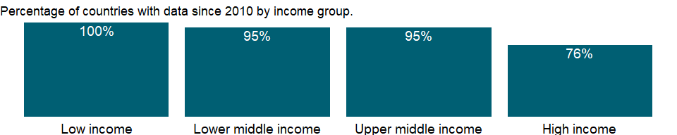

### Why is it relevant?

Movement of people, most often through migration, is a significant part of global integration. Migrants contribute to the economies of both their host country and their country of origin. Yet reliable statistics on migration are difficult to collect and are often incomplete, making international comparisons a challenge.

In most developed countries, refugees are admitted for resettlement and are routinely included in population counts by censuses or population registers. Globally, the number of refugees at end 2010 was 10.55 million, including 597,300 people considered by UNHCR to be in a refugee-like situation; developing countries hosted 8.5 million refugees, or 80 percent of the global refugee population.

Global migration patterns have become increasingly complex in modern times, involving not just refugees, but also millions of economic migrants. But refugees and migrants, even if they often travel in the same way, are fundamentally different, and for that reason are treated very differently under modern international law. Migrants, especially economic migrants, choose to move in order to improve the future prospects of themselves and their families. Refugees have to move if they are to save their lives or preserve their freedom. They have no protection from their own state - indeed it is often their own government that is threatening to persecute them. If other countries do not let them in, and do not help them once they are in, then they may be condemning them to death - or to an intolerable life in the shadows, without sustenance and without rights.

### What is the data source?

United Nations High Commissioner for Refugees (UNHCR), Refugee Data Finder at <https://www.unhcr.org/refugee-statistics/>.

### What is the methodology?

The United Nations High Commissioner for Refugees (UNHCR) collects and maintains data on refugees in their Statistical Online Population Database. The refugee data does not include Palestinian refugees residing in areas under the mandate of the United Nations Relief and Works Agency for Palestine Refugees in the Near East (UNRWA). However, the Palestinian refugees living outside the UNRWA areas of operation do fall under the responsibility of UNHCR and are thus included in the Statistical Online Population Database.

Refugees are an important part of migrant stock. The refugee data refer to people who have crossed an international border to find sanctuary and have been granted refugee or refugee-like status or temporary protection. There are three main providers of refugee data: governmental agencies, UNHCR field offices and NGOs. Registrations, together with other sources - including estimates and surveys - are the main sources of refugee data. In the absence of Government estimates, UNHCR has estimated the refugee population in most industrialized countries, based on recognition of asylum-seekers. Prior to 2007, resettled refugees were included in these estimates.

Up to and including 2006, to ensure that the refugee population in countries that lack a refugee registry is reflected in the global statistics, the number of refugees was estimated by UNHCR based on the arrival of refugees through resettlement programmes and the individual recognition of refugees over a 10-year (Europe and, since 2006, the United States) or 5-year (the United States before 2006, Canada and Oceania) period. Starting with the 2007 data, the cut-off period has been harmonized and now covers a 10-year period for Europe and non-European countries. Resettled refugees, however, are excluded from the refugee estimates in all countries.

The 2007-2011 refugee population category includes people in a refugee-like situation, most of who were previously included in the Others of concern group. This sub-category is descriptive in nature and includes groups of persons who are outside their country or territory of origin and who face protection risks similar to those of refugees, but for whom refugee status has, for practical or other reasons, not been ascertained.

Asylum seekers - people who have applied for asylum or refugee status and who have not yet received a decision or who are registered as asylum seekers - and internally displaced people - who are often confused with refugees - are not included in the data. Unlike refugees, internally displaced people remain under the protection of their own government, even if their reason for fleeing was similar to that of refugees.

Palestinian refugees are people (and their descendants) whose residence was Palestine between June 1946 and May 1948 and who lost their homes and means of livelihood as a result of the 1948 Arab-Israeli conflict.

### How is it aggregated?

Sum

### What are the limitations?

There are difficulties in collecting accurate statistics on refugees. Many refugees may not be aware of the need to register or may choose not to do so, and administrative records tend to overestimate the number of refugees because it is easier to register than to de-register. In addition, most industrialized countries lack a refugee register and are thus not in a position to provide accurate information on the number of refugees residing in their country. Many countries have registries that are only maintained at the local level, so the data is not centralized.

The United Nations High Commissioner for Refugees (UNHCR) collects and maintains data on refugees, except for Palestinian refugees residing in areas under the mandate of the United Nations Relief and Works Agency for Palestine Refugees in the Near East (UNRWA). Registration is voluntary, and estimates by the UNRWA are not an accurate count of the Palestinian refugee population. The data shows estimates of refugees collected by the UNHCR, complemented by estimates of Palestinian refugees under the UNRWA mandate. Thus, the aggregates differ from those published by the UNHCR.

Statistics concerning the former USSR have been reported under the Russian Federation, those concerning the former Czechoslovakia have been reported under the Czech Republic and those concerning the former Yugoslavia and ‘Serbia and Montenegro’ have been reported under Serbia. Since 2006, separate statistics are available for Serbia and for Montenegro. Prior to 2006, no separate statistics are available and both countries have been reported under Serbia.

### What else should I know?

NA

### 1.78.4 International migrant stock, total

### What is the indicator?

International migrant stock is the number of people born in a country other than that in which they live. It also includes refugees. The data used to estimate the international migrant stock at a particular time are obtained mainly from population censuses. The estimates are derived from the data on foreign-born population–people who have residence in one country but were born in another country. When data on the foreign-born population are not available, data on foreign population–that is, people who are citizens of a country other than the country in which they reside–are used as estimates. After the breakup of the Soviet Union in 1991 people living in one of the newly independent countries who were born in another were classified as international migrants. Estimates of migrant stock in the newly independent states from 1990 on are based on the 1989 census of the Soviet Union. For countries with information on the international migrant stock for at least two points in time, interpolation or extrapolation was used to estimate the international migrant stock on July 1 of the reference years. For countries with only one observation, estimates for the reference years were derived using rates of change in the migrant stock in the years preceding or following the single observation available. A model was used to estimate migrants for countries that had no data.

Topic: Social Protection & Labor: Migration

Series ID: SM.POP.TOTL

Copyright: CC BY-4.0 , <https://datacatalog.worldbank.org/public-licenses#cc-by>

First year with any data: 1960

Last year with any data: 2015

### What years are data available?

The figure below shows years in which data is available for at least one country. Dates shaded in black have no data, while dates shaded in green have data for at least one country

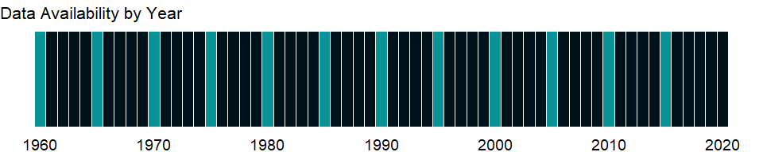

### Which countries have data?

The figure below shows the percentage of countries in each income group with a value since 2010 for that indicator.



### Why is it relevant?

Movement of people, most often through migration, is a significant part of global integration. Migrants contribute to the economies of both their host country and their country of origin. Yet reliable statistics on migration are difficult to collect and are often incomplete, making international comparisons a challenge.

Global migration patterns have become increasingly complex in modern times, involving not just refugees, but also millions of economic migrants. In most developed countries, refugees are admitted for resettlement and are routinely included in population counts by censuses or population registers. But refugees and migrants, even if they often travel in the same way, are fundamentally different, and for that reason are treated very differently under modern international law. Migrants, especially economic migrants, choose to move in order to improve the future prospects of themselves and their families. Refugees have to move if they are to save their lives or preserve their freedom.

### What is the data source?

United Nations Population Division, Trends in Total Migrant Stock: 2012 Revision.

### What is the methodology?

The basic data to estimate the international migrant stock were obtained mostly from population censuses held during the decennial rounds of censuses. Some of the data used were obtained from population registers and nationally representative surveys.

In the majority of cases, the sources available had gathered information on the place of birth of the enumerated population, thus allowing for the identification of the foreign-born population. In estimating the international migrant stock, international migrants have been equated with the foreign-born whenever possible. In most countries lacking data on place of birth, information on the country of citizenship of those enumerated was available and was used as the basis for the identification of international migrants, thus effectively equating international migrants with foreign citizens.

Among the 230 countries or areas that constituted the world in 2008, 91 percent had at least one data source on the international migrant stock, and of those 78 percent used the number of foreign-born persons as the basis for estimation. For about 18 percent of the countries, the number of international migrants was based on data regarding foreign citizens. There were nine countries with no information including China, the Democratic People’s Republic of Korea, Eritrea and Somalia.

For countries having information on the international migrant stock for at least two points in time, interpolation or extrapolation using an exponential growth rate was used to estimate the international migrant stock on 1 July of the reference years. In some instances, the estimates were adjusted on the basis of other relevant information, including the size of the total population in the country, to ensure that the proportion of migrants in small populations did not increase to unacceptable levels.

For all other countries with only one data source, estimates for the reference years were derived by assuming growth rates of the migrant stock in the years preceding or following the only data source available. For the nine countries or areas for which no information was available on the international migrant stock, a model, based on the general observation that the proportion of international migrants tends to be inversely related to the size of the total population, was used.

After the breakup of the Soviet Union in 1991 people living in one of the newly independent countries who were born in another were classified as international migrants. Estimates of migrant stock in the newly independent states from 1990 on are based on the 1989 census of the Soviet Union.

### How is it aggregated?

Sum

### What are the limitations?

In deriving the estimates, an international migrant was equated to a person living in a country other than that in which he or she was born. That is, the number of international migrants, also called the international migrant stock, would represent the number of foreign-born persons enumerated in the countries or areas constituting the world. However, because several countries lack data on the foreign-born, data on the number of foreigners, if available, were used instead as the basis of estimation. Consequently, the overall number of migrants in world regions or at the global level do not quite represent the overall number of foreign-born persons.

The disintegration and reunification of countries causes discontinuities in the change of the international migrant stock. Because an international migrant is equated with a person who was born outside the country in which he or she resides, when a country disintegrates, persons who had been internal migrants because they had moved from one part of the country to another may become, overnight, international migrants without having moved at that time. Such changes introduce artificial but unavoidable discontinuities in the trend of the international migrant stock. The reunification of States also introduces discontinuities, but in the opposite direction.

### What else should I know?

NA

### 1.78.5 International migrant stock (% of population)

### What is the indicator?

International migrant stock is the number of people born in a country other than that in which they live. It also includes refugees. The data used to estimate the international migrant stock at a particular time are obtained mainly from population censuses. The estimates are derived from the data on foreign-born population–people who have residence in one country but were born in another country. When data on the foreign-born population are not available, data on foreign population–that is, people who are citizens of a country other than the country in which they reside–are used as estimates. After the breakup of the Soviet Union in 1991 people living in one of the newly independent countries who were born in another were classified as international migrants. Estimates of migrant stock in the newly independent states from 1990 on are based on the 1989 census of the Soviet Union. For countries with information on the international migrant stock for at least two points in time, interpolation or extrapolation was used to estimate the international migrant stock on July 1 of the reference years. For countries with only one observation, estimates for the reference years were derived using rates of change in the migrant stock in the years preceding or following the single observation available. A model was used to estimate migrants for countries that had no data.

Topic: Social Protection & Labor: Migration

Series ID: SM.POP.TOTL.ZS

Copyright: CC BY-4.0 , <https://datacatalog.worldbank.org/public-licenses#cc-by>

First year with any data: 1990

Last year with any data: 2015

### What years are data available?

The figure below shows years in which data is available for at least one country. Dates shaded in black have no data, while dates shaded in green have data for at least one country

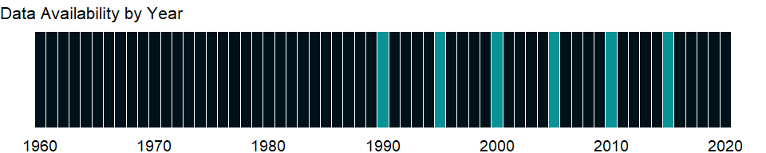

### Which countries have data?

The figure below shows the percentage of countries in each income group with a value since 2010 for that indicator.



### Why is it relevant?

Movement of people, most often through migration, is a significant part of global integration. Migrants contribute to the economies of both their host country and their country of origin. Yet reliable statistics on migration are difficult to collect and are often incomplete, making international comparisons a challenge.

Global migration patterns have become increasingly complex in modern times, involving not just refugees, but also millions of economic migrants. In most developed countries, refugees are admitted for resettlement and are routinely included in population counts by censuses or population registers. But refugees and migrants, even if they often travel in the same way, are fundamentally different, and for that reason are treated very differently under modern international law. Migrants, especially economic migrants, choose to move in order to improve the future prospects of themselves and their families. Refugees have to move if they are to save their lives or preserve their freedom.

### What is the data source?

United Nations Population Division, Trends in Total Migrant Stock: 2008 Revision.

### What is the methodology?

The basic data to estimate the international migrant stock were obtained mostly from population censuses held during the decennial rounds of censuses. Some of the data used were obtained from population registers and nationally representative surveys.

In the majority of cases, the sources available had gathered information on the place of birth of the enumerated population, thus allowing for the identification of the foreign-born population. In estimating the international migrant stock, international migrants have been equated with the foreign-born whenever possible. In most countries lacking data on place of birth, information on the country of citizenship of those enumerated was available and was used as the basis for the identification of international migrants, thus effectively equating international migrants with foreign citizens.

Among the 230 countries or areas that constituted the world in 2008, 91 percent had at least one data source on the international migrant stock, and of those 78 percent used the number of foreign-born persons as the basis for estimation. For about 18 percent of the countries, the number of international migrants was based on data regarding foreign citizens. There were nine countries with no information including China, the Democratic People’s Republic of Korea, Eritrea and Somalia.

For countries having information on the international migrant stock for at least two points in time, interpolation or extrapolation using an exponential growth rate was used to estimate the international migrant stock on 1 July of the reference years. In some instances, the estimates were adjusted on the basis of other relevant information, including the size of the total population in the country, to ensure that the proportion of migrants in small populations did not increase to unacceptable levels.

For all other countries with only one data source, estimates for the reference years were derived by assuming growth rates of the migrant stock in the years preceding or following the only data source available. For the nine countries or areas for which no information was available on the international migrant stock, a model, based on the general observation that the proportion of international migrants tends to be inversely related to the size of the total population, was used.

After the breakup of the Soviet Union in 1991 people living in one of the newly independent countries who were born in another were classified as international migrants. Estimates of migrant stock in the newly independent states from 1990 on are based on the 1989 census of the Soviet Union.

### How is it aggregated?

Weighted average

### What are the limitations?

In deriving the estimates, an international migrant was equated to a person living in a country other than that in which he or she was born. That is, the number of international migrants, also called the international migrant stock, would represent the number of foreign-born persons enumerated in the countries or areas constituting the world. However, because several countries lack data on the foreign-born, data on the number of foreigners, if available, were used instead as the basis of estimation. Consequently, the overall number of migrants in world regions or at the global level do not quite represent the overall number of foreign-born persons.

The disintegration and reunification of countries causes discontinuities in the change of the international migrant stock. Because an international migrant is equated with a person who was born outside the country in which he or she resides, when a country disintegrates, persons who had been internal migrants because they had moved from one part of the country to another may become, overnight, international migrants without having moved at that time. Such changes introduce artificial but unavoidable discontinuities in the trend of the international migrant stock. The reunification of States also introduces discontinuities, but in the opposite direction.

### What else should I know?

NA

## 1.79 Health

### 1.79.1 Prevalence of moderate or severe food insecurity in the population (%)

### What is the indicator?

The percentage of people in the population who live in households classified as moderately or severely food insecure. A household is classified as moderately or severely food insecure when at least one adult in the household has reported to have been exposed, at times during the year, to low quality diets and might have been forced to also reduce the quantity of food they would normally eat because of a lack of money or other resources.

Topic: Health

Series ID: SN.ITK.MSFI.ZS

Copyright: CC BY-4.0 , <https://datacatalog.worldbank.org/public-licenses#cc-by>

First year with any data: 2015

Last year with any data: 2019

### What years are data available?

The figure below shows years in which data is available for at least one country. Dates shaded in black have no data, while dates shaded in green have data for at least one country



### Which countries have data?

The figure below shows the percentage of countries in each income group with a value since 2010 for that indicator.

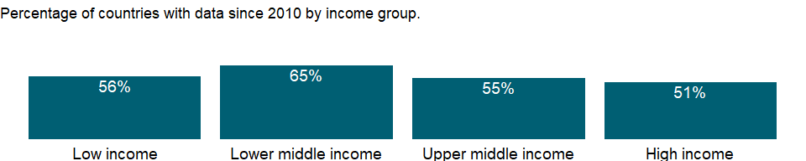

### Why is it relevant?

Food insecurity at moderate levels of severity is typically associated with the inability to regularly eat healthy, balanced diets. As such, high prevalence of food insecurity at moderate levels can be considered a predictor of various forms of diet-related health conditions in the population, associated with micronutrient deficiency and unbalanced diets. Severe levels of food insecurity, on the other hand, imply a high probability of reduced food intake and therefore can lead to more severe forms of undernutrition, including hunger. FAO has identified the FIES as the tool with the greatest potential for becoming a global standard capable of providing comparable information on food insecurity experience across countries and population groups to track progress on reducing food insecurity and hunger

### What is the data source?

Food and Agriculture Organization of the United Nations (FAO)

### What is the methodology?

The assessment is conducted using data collected with the Food Insecurity Experience Scale or a compatible experience-based food security measurement questionnaire (such as the HFSSM). The probability to be food insecure is estimated using the one-parameter logistic Item Response Theory model (the Rasch model) and thresholds for classification are made cross country comparable by calibrating the metrics obtained in each country against the FIES global reference scale, maintained by FAO. The threshold to classify “moderate or severe” food insecurity corresponds to the severity associated with the item “having to eat less” on the global FIES scale. It is an indicator of lack of food access.The indicator is calculated as an average over 3 years (eg. data for 2015 is the average of 2014-2016 data).

### How is it aggregated?

NA

### What are the limitations?

NA

### What else should I know?

NA

### 1.79.2 Prevalence of severe food insecurity in the population (%)

### What is the indicator?

The percentage of people in the population who live in households classified as severely food insecure. A household is classified as severely food insecure when at least one adult in the household has reported to have been exposed, at times during the year, to several of the most severe experiences described in the FIES questions, such as to have been forced to reduce the quantity of the food, to have skipped meals, having gone hungry, or having to go for a whole day without eating because of a lack of money or other resources.

Topic: Health

Series ID: SN.ITK.SVFI.ZS

Copyright: CC BY-4.0 , <https://datacatalog.worldbank.org/public-licenses#cc-by>

First year with any data: 2015

Last year with any data: 2019

### What years are data available?

The figure below shows years in which data is available for at least one country. Dates shaded in black have no data, while dates shaded in green have data for at least one country



### Which countries have data?

The figure below shows the percentage of countries in each income group with a value since 2010 for that indicator.



### Why is it relevant?

Food insecurity at moderate levels of severity is typically associated with the inability to regularly eat healthy, balanced diets. As such, high prevalence of food insecurity at moderate levels can be considered a predictor of various forms of diet-related health conditions in the population, associated with micronutrient deficiency and unbalanced diets. Severe levels of food insecurity, on the other hand, imply a high probability of reduced food intake and therefore can lead to more severe forms of undernutrition, including hunger. FAO has identified the FIES as the tool with the greatest potential for becoming a global standard capable of providing comparable information on food insecurity experience across countries and population groups to track progress on reducing food insecurity and hunger

### What is the data source?

Food and Agriculture Organization of the United Nations (FAO)

### What is the methodology?

The assessment is conducted using data collected with the Food Insecurity Experience Scale or a compatible experience-based food security measurement questionnaire (such as the HFSSM). The probability to be food insecure is estimated using the one-parameter logistic Item Response Theory model (the Rasch model) and thresholds for classification are made cross country comparable by calibrating the metrics obtained in each country against the FIES global reference scale, maintained by FAO. The threshold to classify “severe” food insecurity corresponds to the severity associated with the item “having not eaten for an entire day” on the global FIES scale. It is an indicator of lack of food access.The indicator is calculated as an average over 3 years (eg. data for 2015 is the average of 2014-2016 data).

### How is it aggregated?

NA

### What are the limitations?

NA

### What else should I know?

NA

## 1.80 Health: Population: Dynamics

### 1.80.1 Birth rate, crude (per 1,000 people)

### What is the indicator?

Crude birth rate indicates the number of live births occurring during the year, per 1,000 population estimated at midyear. Subtracting the crude death rate from the crude birth rate provides the rate of natural increase, which is equal to the rate of population change in the absence of migration.

Topic: Health: Population: Dynamics

Series ID: SP.DYN.CBRT.IN

Copyright: CC BY-4.0 , <https://datacatalog.worldbank.org/public-licenses#cc-by>

First year with any data: 1960

Last year with any data: 2019

### What years are data available?

The figure below shows years in which data is available for at least one country. Dates shaded in black have no data, while dates shaded in green have data for at least one country



### Which countries have data?

The figure below shows the percentage of countries in each income group with a value since 2010 for that indicator.

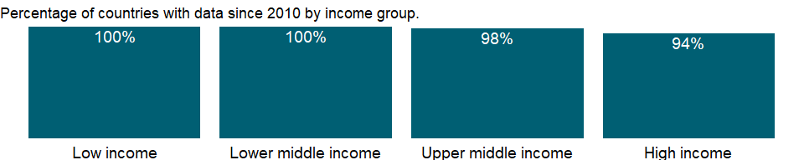

### Why is it relevant?

NA

### What is the data source?

1. United Nations Population Division. World Population Prospects: 2019 Revision. (2) Census reports and other statistical publications from national statistical offices, (3) Eurostat: Demographic Statistics, (4) United Nations Statistical Division. Population and Vital Statistics Reprot (various years), (5) U.S. Census Bureau: International Database, and (6) Secretariat of the Pacific Community: Statistics and Demography Programme.

### What is the methodology?

Vital rates are based on data from birth and death registration systems, censuses, and sample surveys by national statistical offices and other organizations, or on demographic analysis. Data for the most recent year for some high-income countries are provisional estimates based on vital registers. The estimates for many countries are projections based on extrapolations of levels and trends from earlier years or interpolations of population estimates and projections from the United Nations Population Division.

### How is it aggregated?

Weighted average

### What are the limitations?

Vital registers are the preferred source for these data, but in many developing countries systems for registering births and deaths are absent or incomplete because of deficiencies in the coverage of events or geographic areas. Many developing countries carry out special household surveys that ask respondents about recent births and deaths. Estimates derived in this way are subject to sampling errors and recall errors.

### What else should I know?

NA

### 1.80.2 Death rate, crude (per 1,000 people)

### What is the indicator?

Crude death rate indicates the number of deaths occurring during the year, per 1,000 population estimated at midyear. Subtracting the crude death rate from the crude birth rate provides the rate of natural increase, which is equal to the rate of population change in the absence of migration.

Topic: Health: Population: Dynamics

Series ID: SP.DYN.CDRT.IN

Copyright: CC BY-4.0 , <https://datacatalog.worldbank.org/public-licenses#cc-by>

First year with any data: 1960

Last year with any data: 2019

### What years are data available?

The figure below shows years in which data is available for at least one country. Dates shaded in black have no data, while dates shaded in green have data for at least one country



### Which countries have data?

The figure below shows the percentage of countries in each income group with a value since 2010 for that indicator.



### Why is it relevant?

The crude mortality rate is a good indicator of the general health status of a geographic area or population. The crude death rate is not appropriate for comparison of different populations or areas with large differences in age-distributions. Higher crude death rates can be found in some developed countries, despite high life expectancy, because typically these countries have a much higher proportion of older people, due to lower recent birth rates and lower age-specific mortality rates.

### What is the data source?

1. United Nations Population Division. World Population Prospects: 2019 Revision. (2) Census reports and other statistical publications from national statistical offices, (3) Eurostat: Demographic Statistics, (4) United Nations Statistical Division. Population and Vital Statistics Reprot (various years), (5) U.S. Census Bureau: International Database, and (6) Secretariat of the Pacific Community: Statistics and Demography Programme.

### What is the methodology?

The crude death rate is calculated as the number of deaths in a given period divided by the population exposed to risk of death in that period. For human populations the period is usually one year and, if the population changes in size over the year, the divisor is taken as the population at the mid-year. The rate is usually expressed in terms of 1,000 people: for example, a crude death rate of 9.5 (per 1000 people) in a population of 1 million would imply 9500 deaths per year in the entire population. Subtracting the crude death rate from the crude birth rate provides the rate of natural increase, which is equal to the rate of population change in the absence of migration.

Vital rates are based on data from birth and death registration systems, censuses, and sample surveys by national statistical offices and other organizations, or on demographic analysis. Data for the most recent year for some high-income countries are provisional estimates based on vital registers. The estimates for many countries are projections based on extrapolations of levels and trends from earlier years or interpolations of population estimates and projections from the United Nations Population Division.

### How is it aggregated?

Weighted average

### What are the limitations?

Vital registers are the preferred source for these data, but in many developing countries systems for registering births and deaths are absent or incomplete because of deficiencies in the coverage of events or geographic areas. Many developing countries carry out special household surveys that ask respondents about recent births and deaths. Estimates derived in this way are subject to sampling errors and recall errors.

### What else should I know?

NA

### 1.80.3 Female headed households (% of households with a female head)

### What is the indicator?

Female headed households shows the percentage of households with a female head.

Topic: Health: Population: Dynamics

Series ID: SP.HOU.FEMA.ZS

Copyright: CC BY-4.0 , <https://datacatalog.worldbank.org/public-licenses#cc-by>

First year with any data: 1990

Last year with any data: 2020

### What years are data available?

The figure below shows years in which data is available for at least one country. Dates shaded in black have no data, while dates shaded in green have data for at least one country



### Which countries have data?

The figure below shows the percentage of countries in each income group with a value since 2010 for that indicator.



### Why is it relevant?

The household is regarded as the fundamental social and economic unit of society. Transformation at the household form, therefore, has impact at the aggregate level of a country. An increasing number of female-headed households (FHHs) in developing countries are emerging as a result of economic changes, economic downturns and social pressures, rather than as a product of cultural patterns. In many developing countries of Asia and Latin American, there has been a significant increase in the percentage of FHHs. The majority of women in FHHs in developing countries are widowed, and to a lesser extent divorced or separated. In the developed countries most female-headed households consist of women who are never married or who are divorced. The feminization of poverty - the process whereby poverty becomes more concentrated among Individuals living in female-headed households - is a key concept for describing FHH social and economic levels.

### What is the data source?

Demographic and Health Surveys.

### What is the methodology?

NA

### How is it aggregated?

NA

### What are the limitations?

The definition of female-headed household differs greatly across countries, making cross-country comparison difficult. In some cases it is assumed that a woman cannot be the head of any household with an adult male, because of sex-biased stereotype. Caution should be used in interpreting the data.

### What else should I know?

The composition of a household plays a role in the determining other characteristics of a household, such as how many children are sent to school and the distribution of family income.

### 1.80.4 Age dependency ratio (% of working-age population)

### What is the indicator?

Age dependency ratio is the ratio of dependents–people younger than 15 or older than 64–to the working-age population–those ages 15-64. Data are shown as the proportion of dependents per 100 working-age population.

Topic: Health: Population: Dynamics

Series ID: SP.POP.DPND

Copyright: CC BY-4.0 , <https://datacatalog.worldbank.org/public-licenses#cc-by>

First year with any data: 1960

Last year with any data: 2020

### What years are data available?

The figure below shows years in which data is available for at least one country. Dates shaded in black have no data, while dates shaded in green have data for at least one country



### Which countries have data?

The figure below shows the percentage of countries in each income group with a value since 2010 for that indicator.



### Why is it relevant?

Patterns of development in a country are partly determined by the age composition of its population. Different age groups have different impacts on both the environment and on infrastructure needs. Therefore the age structure of a population is useful for analyzing resource use and formulating future policy and planning goals with regards infrastructure and development.

### What is the data source?

World Bank staff estimates based on age distributions of United Nations Population Division’s World Population Prospects: 2019 Revision.

### What is the methodology?

Dependency ratios capture variations in the proportions of children, elderly people, and working-age people in the population that imply the dependency burden that the working-age population bears in relation to children and the elderly. But dependency ratios show only the age composition of a population, not economic dependency. Some children and elderly people are part of the labor force, and many working-age people are not.

Age structure in the World Bank’s population estimates is based on the age structure in United Nations Population Division’s World Population Prospects. For more information, see the original source.

### How is it aggregated?

Weighted average

### What are the limitations?

Because the five-year age group is the cohort unit and five-year period data are used in the United Nations Population Division’s World Population Prospects, interpolations to obtain annual data or single age structure may not reflect actual events or age composition. For more information, see the original source.

### What else should I know?

Relevance to gender indicator: this indicator implies the dependency burden that the working-age population bears in relation to children and the elderly. Many times single or widowed women who are the sole caregiver of a household have a high dependency ratio.

### 1.80.5 Age dependency ratio, old (% of working-age population)

### What is the indicator?

Age dependency ratio, old, is the ratio of older dependents–people older than 64–to the working-age population–those ages 15-64. Data are shown as the proportion of dependents per 100 working-age population.

Topic: Health: Population: Dynamics

Series ID: SP.POP.DPND.OL

Copyright: CC BY-4.0 , <https://datacatalog.worldbank.org/public-licenses#cc-by>

First year with any data: 1960

Last year with any data: 2020

### What years are data available?

The figure below shows years in which data is available for at least one country. Dates shaded in black have no data, while dates shaded in green have data for at least one country



### Which countries have data?

The figure below shows the percentage of countries in each income group with a value since 2010 for that indicator.



### Why is it relevant?

Patterns of development in a country are partly determined by the age composition of its population. Different age groups have different impacts on both the environment and on infrastructure needs. Therefore the age structure of a population is useful for analyzing resource use and formulating future policy and planning goals with regards infrastructure and development.

### What is the data source?

World Bank staff estimates based on age distributions of United Nations Population Division’s World Population Prospects: 2019 Revision.

### What is the methodology?

Dependency ratios capture variations in the proportions of children, elderly people, and working-age people in the population that imply the dependency burden that the working-age population bears in relation to children and the elderly. But dependency ratios show only the age composition of a population, not economic dependency. Some children and elderly people are part of the labor force, and many working-age people are not.

Age structure in the World Bank’s population estimates is based on the age structure in United Nations Population Division’s World Population Prospects. For more information, see the original source.

### How is it aggregated?

Weighted average

### What are the limitations?

Because the five-year age group is the cohort unit and five-year period data are used in the United Nations Population Division’s World Population Prospects, interpolations to obtain annual data or single age structure may not reflect actual events or age composition. For more information, see the original source.

### What else should I know?

NA

### 1.80.6 Age dependency ratio, young (% of working-age population)

### What is the indicator?

Age dependency ratio, young, is the ratio of younger dependents–people younger than 15–to the working-age population–those ages 15-64. Data are shown as the proportion of dependents per 100 working-age population.

Topic: Health: Population: Dynamics

Series ID: SP.POP.DPND.YG

Copyright: CC BY-4.0 , <https://datacatalog.worldbank.org/public-licenses#cc-by>

First year with any data: 1960

Last year with any data: 2020

### What years are data available?

The figure below shows years in which data is available for at least one country. Dates shaded in black have no data, while dates shaded in green have data for at least one country



### Which countries have data?

The figure below shows the percentage of countries in each income group with a value since 2010 for that indicator.



### Why is it relevant?

Patterns of development in a country are partly determined by the age composition of its population. Different age groups have different impacts on both the environment and on infrastructure needs. Therefore the age structure of a population is useful for analyzing resource use and formulating future policy and planning goals with regards infrastructure and development.

### What is the data source?

World Bank staff estimates based on age distributions of United Nations Population Division’s World Population Prospects: 2019 Revision.

### What is the methodology?

Dependency ratios capture variations in the proportions of children, elderly people, and working-age people in the population that imply the dependency burden that the working-age population bears in relation to children and the elderly. But dependency ratios show only the age composition of a population, not economic dependency. Some children and elderly people are part of the labor force, and many working-age people are not.

Age structure in the World Bank’s population estimates is based on the age structure in United Nations Population Division’s World Population Prospects. For more information, see the original source.

### How is it aggregated?

Weighted average

### What are the limitations?

Because the five-year age group is the cohort unit and five-year period data are used in the United Nations Population Division’s World Population Prospects, interpolations to obtain annual data or single age structure may not reflect actual events or age composition. For more information, see the original source.

### What else should I know?

NA

### 1.80.7 Population growth (annual %)

### What is the indicator?

Annual population growth rate for year t is the exponential rate of growth of midyear population from year t-1 to t, expressed as a percentage . Population is based on the de facto definition of population, which counts all residents regardless of legal status or citizenship.

Topic: Health: Population: Dynamics

Series ID: SP.POP.GROW

Copyright: CC BY-4.0 , <https://datacatalog.worldbank.org/public-licenses#cc-by>

First year with any data: 1961

Last year with any data: 2020

### What years are data available?

The figure below shows years in which data is available for at least one country. Dates shaded in black have no data, while dates shaded in green have data for at least one country



### Which countries have data?

The figure below shows the percentage of countries in each income group with a value since 2010 for that indicator.



### Why is it relevant?

NA

### What is the data source?

Derived from total population. Population source: (1) United Nations Population Division. World Population Prospects: 2019 Revision, (2) Census reports and other statistical publications from national statistical offices, (3) Eurostat: Demographic Statistics, (4) United Nations Statistical Division. Population and Vital Statistics Reprot (various years), (5) U.S. Census Bureau: International Database, and (6) Secretariat of the Pacific Community: Statistics and Demography Programme.

### What is the methodology?

Total population growth rates are calculated on the assumption that rate of growth is constant between two points in time. The growth rate is computed using the exponential growth formula:

r = ln(pn/p0)/n,

where r is the exponential rate of growth, ln() is the natural logarithm, pn is the end period population, p0 is the beginning period population, and n is the number of years in between. Note that this is not the geometric growth rate used to compute compound growth over discrete periods.

For information on total population from which the growth rates are calculated, see total population (SP.POP.TOTL).

### How is it aggregated?

Weighted average

### What are the limitations?

NA

### What else should I know?

NA

### 1.80.8 Completeness of birth registration, female (%)

### What is the indicator?

Completeness of birth registration is the percentage of children under age 5 whose births were registered at the time of the survey. The numerator of completeness of birth registration includes children whose birth certificate was seen by the interviewer or whose mother or caretaker says the birth has been registered.

Topic: Health: Population: Dynamics

Series ID: SP.REG.BRTH.FE.ZS

Copyright: CC BY-4.0 , <https://datacatalog.worldbank.org/public-licenses#cc-by>

First year with any data: 2003

Last year with any data: 2020

### What years are data available?

The figure below shows years in which data is available for at least one country. Dates shaded in black have no data, while dates shaded in green have data for at least one country



### Which countries have data?

The figure below shows the percentage of countries in each income group with a value since 2010 for that indicator.

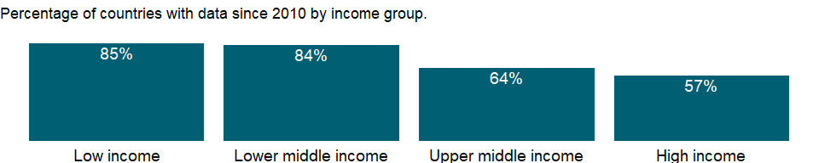

### Why is it relevant?

NA

### What is the data source?

UNICEF’s State of the World’s Children based mostly on household surveys and ministry of health data.

### What is the methodology?

Health systems - the combined arrangements of institutions and actions whose primary purpose is to promote, restore, or maintain health (World Health Organization, World Health Report 2000) - are increasingly being recognized as key to combating disease and improving the health status of populations. The World Bank’s Healthy Development: Strategy for Health, Nutrition, and Population Results emphasizes the need to strengthen health systems, which are weak in many countries, in order to increase the effectiveness of programs aimed at reducing specific diseases and further reduce morbidity and mortality. To evaluate health systems, the World Health Organization (WHO) has recommended that key components - such as financing, service delivery, workforce, governance, and information - be monitored using several key indicators. The data are a subset of the key indicators. Monitoring health systems allows the effectiveness, efficiency, and equity of different health system models to be compared. Health system data also help identify weaknesses and strengths and areas that need investment, such as additional health facilities, better health information systems, or better trained human resources.

Numerous indicators have been proposed to assess a country’s health information system.They can be grouped into two broad types: indicators related to data generation using core sources and methods (health surveys, civil registration, censuses, facility reporting, health system resource tracking) and indicators related to capacity for data synthesis, analysis, and validation. Indicators related to data generation reflect a country’s capacity to collect relevant data at suitable intervals using the most appropriate data sources. Benchmarks include periodicity, timeliness, contents, and availability. Indicators related to capacity for synthesis, analysis, and validation measure the dimensions of the institutional frameworks needed to ensure data quality, including independence, transparency, and access. Benchmarks include the availability of independent coordination mechanisms and micro- and meta-data. Indicators related to data generation include completeness of birth registration.

Birth registration refers to the permanent and official recording of a child’s existence by some administrative levels of the State that is normally coordinated by a particular branch of the government.

Completeness of birth registration indicator is related to the group of indictors of data generation.

### How is it aggregated?

NA

### What are the limitations?

NA

### What else should I know?

NA

### 1.80.9 Completeness of birth registration, male (%)

### What is the indicator?

Completeness of birth registration is the percentage of children under age 5 whose births were registered at the time of the survey. The numerator of completeness of birth registration includes children whose birth certificate was seen by the interviewer or whose mother or caretaker says the birth has been registered.

Topic: Health: Population: Dynamics

Series ID: SP.REG.BRTH.MA.ZS

Copyright: CC BY-4.0 , <https://datacatalog.worldbank.org/public-licenses#cc-by>

First year with any data: 2003

Last year with any data: 2020

### What years are data available?

The figure below shows years in which data is available for at least one country. Dates shaded in black have no data, while dates shaded in green have data for at least one country



### Which countries have data?

The figure below shows the percentage of countries in each income group with a value since 2010 for that indicator.



### Why is it relevant?

NA

### What is the data source?

UNICEF’s State of the World’s Children based mostly on household surveys and ministry of health data.

### What is the methodology?

Health systems - the combined arrangements of institutions and actions whose primary purpose is to promote, restore, or maintain health (World Health Organization, World Health Report 2000) - are increasingly being recognized as key to combating disease and improving the health status of populations. The World Bank’s Healthy Development: Strategy for Health, Nutrition, and Population Results emphasizes the need to strengthen health systems, which are weak in many countries, in order to increase the effectiveness of programs aimed at reducing specific diseases and further reduce morbidity and mortality. To evaluate health systems, the World Health Organization (WHO) has recommended that key components - such as financing, service delivery, workforce, governance, and information - be monitored using several key indicators. The data are a subset of the key indicators. Monitoring health systems allows the effectiveness, efficiency, and equity of different health system models to be compared. Health system data also help identify weaknesses and strengths and areas that need investment, such as additional health facilities, better health information systems, or better trained human resources.

Numerous indicators have been proposed to assess a country’s health information system.They can be grouped into two broad types: indicators related to data generation using core sources and methods (health surveys, civil registration, censuses, facility reporting, health system resource tracking) and indicators related to capacity for data synthesis, analysis, and validation. Indicators related to data generation reflect a country’s capacity to collect relevant data at suitable intervals using the most appropriate data sources. Benchmarks include periodicity, timeliness, contents, and availability. Indicators related to capacity for synthesis, analysis, and validation measure the dimensions of the institutional frameworks needed to ensure data quality, including independence, transparency, and access. Benchmarks include the availability of independent coordination mechanisms and micro- and meta-data. Indicators related to data generation include completeness of birth registration.

Birth registration refers to the permanent and official recording of a child’s existence by some administrative levels of the State that is normally coordinated by a particular branch of the government.

Completeness of birth registration indicator is related to the group of indictors of data generation.

### How is it aggregated?

NA

### What are the limitations?

NA

### What else should I know?

NA

### 1.80.10 Completeness of birth registration, rural (%)

### What is the indicator?

Completeness of birth registration is the percentage of children under age 5 whose births were registered at the time of the survey. The numerator of completeness of birth registration includes children whose birth certificate was seen by the interviewer or whose mother or caretaker says the birth has been registered.

Topic: Health: Population: Dynamics

Series ID: SP.REG.BRTH.RU.ZS

Copyright: CC BY-4.0 , <https://datacatalog.worldbank.org/public-licenses#cc-by>

First year with any data: 2000

Last year with any data: 2019

### What years are data available?

The figure below shows years in which data is available for at least one country. Dates shaded in black have no data, while dates shaded in green have data for at least one country



### Which countries have data?

The figure below shows the percentage of countries in each income group with a value since 2010 for that indicator.

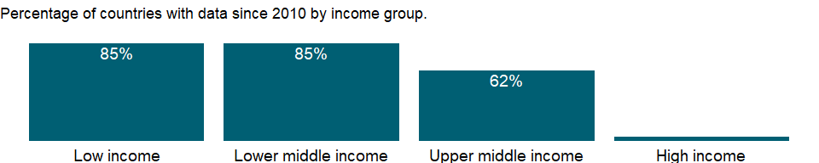

### Why is it relevant?

NA

### What is the data source?

UNICEF’s State of the World’s Children based mostly on household surveys and ministry of health data.

### What is the methodology?

Health systems - the combined arrangements of institutions and actions whose primary purpose is to promote, restore, or maintain health (World Health Organization, World Health Report 2000) - are increasingly being recognized as key to combating disease and improving the health status of populations. The World Bank’s Healthy Development: Strategy for Health, Nutrition, and Population Results emphasizes the need to strengthen health systems, which are weak in many countries, in order to increase the effectiveness of programs aimed at reducing specific diseases and further reduce morbidity and mortality. To evaluate health systems, the World Health Organization (WHO) has recommended that key components - such as financing, service delivery, workforce, governance, and information - be monitored using several key indicators. The data are a subset of the key indicators. Monitoring health systems allows the effectiveness, efficiency, and equity of different health system models to be compared. Health system data also help identify weaknesses and strengths and areas that need investment, such as additional health facilities, better health information systems, or better trained human resources.

Numerous indicators have been proposed to assess a country’s health information system.They can be grouped into two broad types: indicators related to data generation using core sources and methods (health surveys, civil registration, censuses, facility reporting, health system resource tracking) and indicators related to capacity for data synthesis, analysis, and validation. Indicators related to data generation reflect a country’s capacity to collect relevant data at suitable intervals using the most appropriate data sources. Benchmarks include periodicity, timeliness, contents, and availability. Indicators related to capacity for synthesis, analysis, and validation measure the dimensions of the institutional frameworks needed to ensure data quality, including independence, transparency, and access. Benchmarks include the availability of independent coordination mechanisms and micro- and meta-data. Indicators related to data generation include completeness of birth registration.

Birth registration refers to the permanent and official recording of a child’s existence by some administrative levels of the State that is normally coordinated by a particular branch of the government.

Completeness of birth registration indicator is related to the group of indictors of data generation.

### How is it aggregated?

NA

### What are the limitations?

NA

### What else should I know?

NA

### 1.80.11 Completeness of birth registration, urban (%)

### What is the indicator?

Completeness of birth registration is the percentage of children under age 5 whose births were registered at the time of the survey. The numerator of completeness of birth registration includes children whose birth certificate was seen by the interviewer or whose mother or caretaker says the birth has been registered.

Topic: Health: Population: Dynamics

Series ID: SP.REG.BRTH.UR.ZS

Copyright: CC BY-4.0 , <https://datacatalog.worldbank.org/public-licenses#cc-by>

First year with any data: 2000

Last year with any data: 2019

### What years are data available?

The figure below shows years in which data is available for at least one country. Dates shaded in black have no data, while dates shaded in green have data for at least one country



### Which countries have data?

The figure below shows the percentage of countries in each income group with a value since 2010 for that indicator.



### Why is it relevant?

NA

### What is the data source?

UNICEF’s State of the World’s Children based mostly on household surveys and ministry of health data.

### What is the methodology?

Health systems - the combined arrangements of institutions and actions whose primary purpose is to promote, restore, or maintain health (World Health Organization, World Health Report 2000) - are increasingly being recognized as key to combating disease and improving the health status of populations. The World Bank’s Healthy Development: Strategy for Health, Nutrition, and Population Results emphasizes the need to strengthen health systems, which are weak in many countries, in order to increase the effectiveness of programs aimed at reducing specific diseases and further reduce morbidity and mortality. To evaluate health systems, the World Health Organization (WHO) has recommended that key components - such as financing, service delivery, workforce, governance, and information - be monitored using several key indicators. The data are a subset of the key indicators. Monitoring health systems allows the effectiveness, efficiency, and equity of different health system models to be compared. Health system data also help identify weaknesses and strengths and areas that need investment, such as additional health facilities, better health information systems, or better trained human resources.

Numerous indicators have been proposed to assess a country’s health information system.They can be grouped into two broad types: indicators related to data generation using core sources and methods (health surveys, civil registration, censuses, facility reporting, health system resource tracking) and indicators related to capacity for data synthesis, analysis, and validation. Indicators related to data generation reflect a country’s capacity to collect relevant data at suitable intervals using the most appropriate data sources. Benchmarks include periodicity, timeliness, contents, and availability. Indicators related to capacity for synthesis, analysis, and validation measure the dimensions of the institutional frameworks needed to ensure data quality, including independence, transparency, and access. Benchmarks include the availability of independent coordination mechanisms and micro- and meta-data. Indicators related to data generation include completeness of birth registration.

Birth registration refers to the permanent and official recording of a child’s existence by some administrative levels of the State that is normally coordinated by a particular branch of the government.

Completeness of birth registration indicator is related to the group of indictors of data generation.

### How is it aggregated?

NA

### What are the limitations?

NA

### What else should I know?

NA

### 1.80.12 Completeness of birth registration (%)

### What is the indicator?

Completeness of birth registration is the percentage of children under age 5 whose births were registered at the time of the survey. The numerator of completeness of birth registration includes children whose birth certificate was seen by the interviewer or whose mother or caretaker says the birth has been registered.

Topic: Health: Population: Dynamics

Series ID: SP.REG.BRTH.ZS

Copyright: CC BY-4.0 , <https://datacatalog.worldbank.org/public-licenses#cc-by>

First year with any data: 2000

Last year with any data: 2019

### What years are data available?

The figure below shows years in which data is available for at least one country. Dates shaded in black have no data, while dates shaded in green have data for at least one country



### Which countries have data?

The figure below shows the percentage of countries in each income group with a value since 2010 for that indicator.

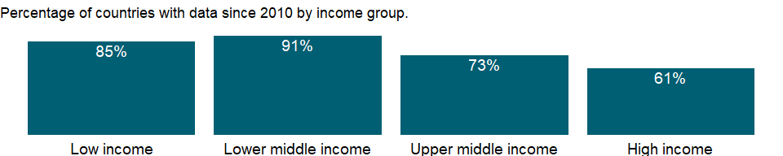

### Why is it relevant?

NA

### What is the data source?

UNICEF’s State of the World’s Children based mostly on household surveys and ministry of health data.

### What is the methodology?

Health systems - the combined arrangements of institutions and actions whose primary purpose is to promote, restore, or maintain health (World Health Organization, World Health Report 2000) - are increasingly being recognized as key to combating disease and improving the health status of populations. The World Bank’s Healthy Development: Strategy for Health, Nutrition, and Population Results emphasizes the need to strengthen health systems, which are weak in many countries, in order to increase the effectiveness of programs aimed at reducing specific diseases and further reduce morbidity and mortality. To evaluate health systems, the World Health Organization (WHO) has recommended that key components - such as financing, service delivery, workforce, governance, and information - be monitored using several key indicators. The data are a subset of the key indicators. Monitoring health systems allows the effectiveness, efficiency, and equity of different health system models to be compared. Health system data also help identify weaknesses and strengths and areas that need investment, such as additional health facilities, better health information systems, or better trained human resources.

Numerous indicators have been proposed to assess a country’s health information system.They can be grouped into two broad types: indicators related to data generation using core sources and methods (health surveys, civil registration, censuses, facility reporting, health system resource tracking) and indicators related to capacity for data synthesis, analysis, and validation. Indicators related to data generation reflect a country’s capacity to collect relevant data at suitable intervals using the most appropriate data sources. Benchmarks include periodicity, timeliness, contents, and availability. Indicators related to capacity for synthesis, analysis, and validation measure the dimensions of the institutional frameworks needed to ensure data quality, including independence, transparency, and access. Benchmarks include the availability of independent coordination mechanisms and micro- and meta-data. Indicators related to data generation include completeness of birth registration.

Birth registration refers to the permanent and official recording of a child’s existence by some administrative levels of the State that is normally coordinated by a particular branch of the government.

Completeness of birth registration indicator is related to the group of indictors of data generation.

### How is it aggregated?

Weighted Average

### What are the limitations?

NA

### What else should I know?

NA

### 1.80.13 Completeness of death registration with cause-of-death information (%)

### What is the indicator?

Completeness of death registration is the estimated percentage of deaths that are registered with their cause of death information in the vital registration system of a country.

Topic: Health: Population: Dynamics

Series ID: SP.REG.DTHS.ZS

Copyright: CC BY-4.0 , <https://datacatalog.worldbank.org/public-licenses#cc-by>

First year with any data: 1992

Last year with any data: 2017

### What years are data available?

The figure below shows years in which data is available for at least one country. Dates shaded in black have no data, while dates shaded in green have data for at least one country

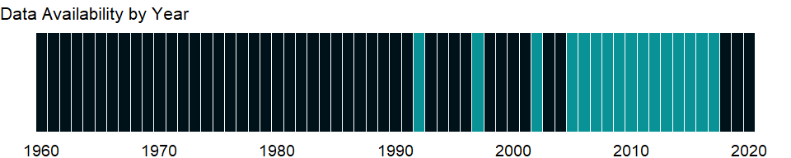

### Which countries have data?

The figure below shows the percentage of countries in each income group with a value since 2010 for that indicator.

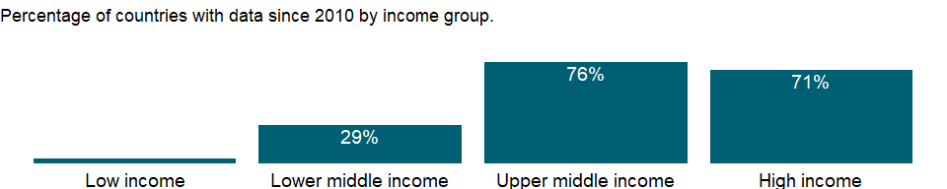

### Why is it relevant?

NA

### What is the data source?

World Health Organization, Global Health Observatory Data Repository/World Health Statistics (<http://apps.who.int/gho/data/node.main.1?lang=en>).

### What is the methodology?

NA

### How is it aggregated?

Weighted Average

### What are the limitations?

NA

### What else should I know?

NA

## 1.81 Gender: Agency

### 1.81.1 Women who were first married by age 15 (% of women ages 20-24)

### What is the indicator?

Women who were first married by age 15 refers to the percentage of women ages 20-24 who were first married by age 15.

Topic: Gender: Agency

Series ID: SP.M15.2024.FE.ZS

Copyright: CC BY-4.0 , <https://datacatalog.worldbank.org/public-licenses#cc-by>

First year with any data: 1985

Last year with any data: 2020

### What years are data available?

The figure below shows years in which data is available for at least one country. Dates shaded in black have no data, while dates shaded in green have data for at least one country



### Which countries have data?

The figure below shows the percentage of countries in each income group with a value since 2010 for that indicator.

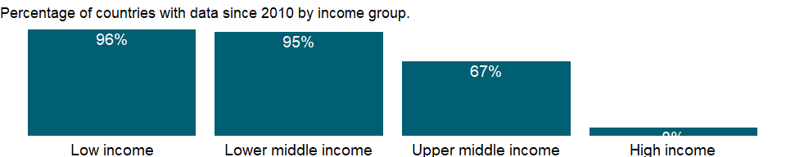

### Why is it relevant?

Although the legal age of marriage is defined as 18 years in most countries, the practice of child marriage remains widespread. A women’s access to education and later her employment opportunities as well as the nature and terms of her work are often compromised by this practice. Young married girls whose schooling is cut short often lack the knowledge and skills for formal work and are limited to occupations with lower incomes and inferior working conditions. Sustainable Development Goal 5 commits to eliminate the practice of child marriage.

### What is the data source?

UNICEF Data; Demographic and Health Surveys (DHS), Multiple Indicator Cluster Surveys (MICS), AIDS Indicator Surveys(AIS), Reproductive Health Survey(RHS), and other household surveys.

### What is the methodology?

NA

### How is it aggregated?

NA

### What are the limitations?

NA

### What else should I know?

This is the Sustainable Development Goal indicator 5.3.1[<https://unstats.un.org/sdgs/metadata/>].

### 1.81.2 Women who were first married by age 18 (% of women ages 20-24)

### What is the indicator?

Women who were first married by age 18 refers to the percentage of women ages 20-24 who were first married by age 18.

Topic: Gender: Agency

Series ID: SP.M18.2024.FE.ZS

Copyright: CC BY-4.0 , <https://datacatalog.worldbank.org/public-licenses#cc-by>

First year with any data: 1985

Last year with any data: 2020

### What years are data available?

The figure below shows years in which data is available for at least one country. Dates shaded in black have no data, while dates shaded in green have data for at least one country



### Which countries have data?

The figure below shows the percentage of countries in each income group with a value since 2010 for that indicator.

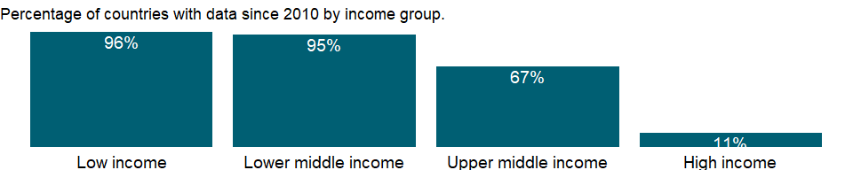

### Why is it relevant?

Although the legal age of marriage is defined as 18 years in most countries, the practice of child marriage remains widespread. A women’s access to education and later her employment opportunities as well as the nature and terms of her work are often compromised by this practice. Young married girls whose schooling is cut short often lack the knowledge and skills for formal work and are limited to occupations with lower incomes and inferior working conditions. Sustainable Development Goal 5 commits to eliminate the practice of child marriage.

### What is the data source?

UNICEF Data; Demographic and Health Surveys (DHS), Multiple Indicator Cluster Surveys (MICS), AIDS Indicator Surveys(AIS), Reproductive Health Survey(RHS), and other household surveys.

### What is the methodology?

NA

### How is it aggregated?

NA

### What are the limitations?

NA

### What else should I know?

This is the Sustainable Development Goal indicator 5.3.1[<https://unstats.un.org/sdgs/metadata/>].

## 1.82 Health: Population: Structure

### 1.82.1 Population ages 00-04, female (% of female population)

### What is the indicator?

Female population between the ages 0 to 4 as a percentage of the total female population.

Topic: Health: Population: Structure

Series ID: SP.POP.0004.FE.5Y

Copyright: CC BY-4.0 , <https://datacatalog.worldbank.org/public-licenses#cc-by>

First year with any data: 1960

Last year with any data: 2020

### What years are data available?

The figure below shows years in which data is available for at least one country. Dates shaded in black have no data, while dates shaded in green have data for at least one country



### Which countries have data?

The figure below shows the percentage of countries in each income group with a value since 2010 for that indicator.



### Why is it relevant?

NA

### What is the data source?

World Bank staff estimates based on age/sex distributions of United Nations Population Division’s World Population Prospects: 2019 Revision.

### What is the methodology?

NA

### How is it aggregated?

NA

### What are the limitations?

NA

### What else should I know?

NA

### 1.82.2 Population ages 00-04, male (% of male population)

### What is the indicator?

Male population between the ages 0 to 4 as a percentage of the total male population.

Topic: Health: Population: Structure

Series ID: SP.POP.0004.MA.5Y

Copyright: CC BY-4.0 , <https://datacatalog.worldbank.org/public-licenses#cc-by>

First year with any data: 1960

Last year with any data: 2020

### What years are data available?

The figure below shows years in which data is available for at least one country. Dates shaded in black have no data, while dates shaded in green have data for at least one country



### Which countries have data?

The figure below shows the percentage of countries in each income group with a value since 2010 for that indicator.



### Why is it relevant?

NA

### What is the data source?

World Bank staff estimates based on age/sex distributions of United Nations Population Division’s World Population Prospects: 2019 Revision.

### What is the methodology?

NA

### How is it aggregated?

NA

### What are the limitations?

NA

### What else should I know?

NA

### 1.82.3 Population ages 0-14, female

### What is the indicator?

Female population between the ages 0 to 14. Population is based on the de facto definition of population, which counts all residents regardless of legal status or citizenship.

Topic: Health: Population: Structure

Series ID: SP.POP.0014.FE.IN

Copyright: CC BY-4.0 , <https://datacatalog.worldbank.org/public-licenses#cc-by>

First year with any data: 1960

Last year with any data: 2020

### What years are data available?

The figure below shows years in which data is available for at least one country. Dates shaded in black have no data, while dates shaded in green have data for at least one country



### Which countries have data?

The figure below shows the percentage of countries in each income group with a value since 2010 for that indicator.



### Why is it relevant?

NA

### What is the data source?

World Bank staff estimates using the World Bank’s total population and age/sex distributions of the United Nations Population Division’s World Population Prospects: 2019 Revision.

### What is the methodology?

NA

### How is it aggregated?

Sum

### What are the limitations?

NA

### What else should I know?

Relevance to gender indicator: Knowing how many girls, adolescents and women there are in a population helps a country in determining its provision of services.

### 1.82.4 Population ages 0-14, female (% of female population)

### What is the indicator?

Female population between the ages 0 to 14 as a percentage of the total female population. Population is based on the de facto definition of population.

Topic: Health: Population: Structure

Series ID: SP.POP.0014.FE.ZS

Copyright: CC BY-4.0 , <https://datacatalog.worldbank.org/public-licenses#cc-by>

First year with any data: 1960

Last year with any data: 2020

### What years are data available?

The figure below shows years in which data is available for at least one country. Dates shaded in black have no data, while dates shaded in green have data for at least one country



### Which countries have data?

The figure below shows the percentage of countries in each income group with a value since 2010 for that indicator.



### Why is it relevant?

NA

### What is the data source?

World Bank staff estimates based on age/sex distributions of United Nations Population Division’s World Population Prospects: 2019 Revision.

### What is the methodology?

NA

### How is it aggregated?

Weighted average

### What are the limitations?

NA

### What else should I know?

Relevance to gender indicator: Knowing how many girls, adolescents and women there are in a population helps a country in determining its provision of services.

### 1.82.5 Population ages 0-14, male

### What is the indicator?

Male population between the ages 0 to 14. Population is based on the de facto definition of population, which counts all residents regardless of legal status or citizenship.

Topic: Health: Population: Structure

Series ID: SP.POP.0014.MA.IN

Copyright: CC BY-4.0 , <https://datacatalog.worldbank.org/public-licenses#cc-by>

First year with any data: 1960

Last year with any data: 2020

### What years are data available?

The figure below shows years in which data is available for at least one country. Dates shaded in black have no data, while dates shaded in green have data for at least one country



### Which countries have data?

The figure below shows the percentage of countries in each income group with a value since 2010 for that indicator.



### Why is it relevant?

NA

### What is the data source?

World Bank staff estimates using the World Bank’s total population and age/sex distributions of the United Nations Population Division’s World Population Prospects: 2019 Revision.

### What is the methodology?

NA

### How is it aggregated?

Sum

### What are the limitations?

NA

### What else should I know?

NA

### 1.82.6 Population ages 0-14, male (% of male population)

### What is the indicator?

Male population between the ages 0 to 14 as a percentage of the total male population. Population is based on the de facto definition of population.

Topic: Health: Population: Structure

Series ID: SP.POP.0014.MA.ZS

Copyright: CC BY-4.0 , <https://datacatalog.worldbank.org/public-licenses#cc-by>

First year with any data: 1960

Last year with any data: 2020

### What years are data available?

The figure below shows years in which data is available for at least one country. Dates shaded in black have no data, while dates shaded in green have data for at least one country



### Which countries have data?

The figure below shows the percentage of countries in each income group with a value since 2010 for that indicator.



### Why is it relevant?

NA

### What is the data source?

World Bank staff estimates based on age/sex distributions of United Nations Population Division’s World Population Prospects: 2019 Revision.

### What is the methodology?

NA

### How is it aggregated?

Weighted average

### What are the limitations?

NA

### What else should I know?

NA

### 1.82.7 Population ages 0-14, total

### What is the indicator?

Total population between the ages 0 to 14. Population is based on the de facto definition of population, which counts all residents regardless of legal status or citizenship.

Topic: Health: Population: Structure

Series ID: SP.POP.0014.TO

Copyright: CC BY-4.0 , <https://datacatalog.worldbank.org/public-licenses#cc-by>

First year with any data: 1960

Last year with any data: 2020

### What years are data available?

The figure below shows years in which data is available for at least one country. Dates shaded in black have no data, while dates shaded in green have data for at least one country



### Which countries have data?

The figure below shows the percentage of countries in each income group with a value since 2010 for that indicator.



### Why is it relevant?

NA

### What is the data source?

World Bank staff estimates using the World Bank’s total population and age/sex distributions of the United Nations Population Division’s World Population Prospects: 2019 Revision.

### What is the methodology?

NA

### How is it aggregated?

Sum

### What are the limitations?

NA

### What else should I know?

NA

### 1.82.8 Population ages 0-14 (% of total population)

### What is the indicator?

Population between the ages 0 to 14 as a percentage of the total population. Population is based on the de facto definition of population.

Topic: Health: Population: Structure

Series ID: SP.POP.0014.TO.ZS

Copyright: CC BY-4.0 , <https://datacatalog.worldbank.org/public-licenses#cc-by>

First year with any data: 1960

Last year with any data: 2020

### What years are data available?

The figure below shows years in which data is available for at least one country. Dates shaded in black have no data, while dates shaded in green have data for at least one country



### Which countries have data?

The figure below shows the percentage of countries in each income group with a value since 2010 for that indicator.



### Why is it relevant?

Patterns of development in a country are partly determined by the age composition of its population. Different age groups have different impacts on both the environment and on infrastructure needs. Therefore the age structure of a population is useful for analyzing resource use and formulating future policy and planning goals with regards infrastructure and development.

This indicator is used for calculating age dependency ratio (percent of working-age population). The age dependency ratio is the ratio of the sum of the population aged 0-14 and the population aged 65 and above to the population aged 15-64. In many developing countries, the once rapidly growing population group of the under-15 population is shrinking. As a result, high fertility rates, together with declining mortality rates, are now reflected in the larger share of the 65 and older population.

### What is the data source?

World Bank staff estimates based on age/sex distributions of United Nations Population Division’s World Population Prospects: 2019 Revision.

### What is the methodology?

Age structure in the World Bank’s population estimates is based on the age structure in United Nations Population Division’s World Population Prospects. For more information, see the original source.

Total population is based on the de facto population including all residents regardless of legal status or citizenship. The values shown are midyear estimates. For more information see metadata for total population (SP.POP.TOTL).

### How is it aggregated?

Weighted average

### What are the limitations?

Because the five-year age group is the cohort unit and five-year period data are used in the United Nations Population Division’s World Population Prospects, interpolations to obtain annual data or single age structure may not reflect actual events or age composition. For more information, see the original source.

### What else should I know?

NA

### 1.82.9 Population ages 05-09, female (% of female population)

### What is the indicator?

Female population between the ages 5 to 9 as a percentage of the total female population.

Topic: Health: Population: Structure

Series ID: SP.POP.0509.FE.5Y

Copyright: CC BY-4.0 , <https://datacatalog.worldbank.org/public-licenses#cc-by>

First year with any data: 1960

Last year with any data: 2020

### What years are data available?

The figure below shows years in which data is available for at least one country. Dates shaded in black have no data, while dates shaded in green have data for at least one country



### Which countries have data?

The figure below shows the percentage of countries in each income group with a value since 2010 for that indicator.



### Why is it relevant?

NA

### What is the data source?

World Bank staff estimates based on age/sex distributions of United Nations Population Division’s World Population Prospects: 2019 Revision.

### What is the methodology?

NA

### How is it aggregated?

NA

### What are the limitations?

NA

### What else should I know?

NA

### 1.82.10 Population ages 05-09, male (% of male population)

### What is the indicator?

Male population between the ages 5 to 9 as a percentage of the total male population.

Topic: Health: Population: Structure

Series ID: SP.POP.0509.MA.5Y

Copyright: CC BY-4.0 , <https://datacatalog.worldbank.org/public-licenses#cc-by>

First year with any data: 1960

Last year with any data: 2020

### What years are data available?

The figure below shows years in which data is available for at least one country. Dates shaded in black have no data, while dates shaded in green have data for at least one country



### Which countries have data?

The figure below shows the percentage of countries in each income group with a value since 2010 for that indicator.



### Why is it relevant?

NA

### What is the data source?

World Bank staff estimates based on age/sex distributions of United Nations Population Division’s World Population Prospects: 2019 Revision.

### What is the methodology?

NA

### How is it aggregated?

NA

### What are the limitations?

NA

### What else should I know?

NA

### 1.82.11 Population ages 10-14, female (% of female population)

### What is the indicator?

Female population between the ages 10 to 14 as a percentage of the total female population.

Topic: Health: Population: Structure

Series ID: SP.POP.1014.FE.5Y

Copyright: CC BY-4.0 , <https://datacatalog.worldbank.org/public-licenses#cc-by>

First year with any data: 1960

Last year with any data: 2020

### What years are data available?

The figure below shows years in which data is available for at least one country. Dates shaded in black have no data, while dates shaded in green have data for at least one country



### Which countries have data?

The figure below shows the percentage of countries in each income group with a value since 2010 for that indicator.



### Why is it relevant?

NA

### What is the data source?

World Bank staff estimates based on age/sex distributions of United Nations Population Division’s World Population Prospects: 2019 Revision.

### What is the methodology?

NA

### How is it aggregated?

NA

### What are the limitations?

NA

### What else should I know?

NA

### 1.82.12 Population ages 10-14, male (% of male population)

### What is the indicator?

Male population between the ages 10 to 14 as a percentage of the total male population.

Topic: Health: Population: Structure

Series ID: SP.POP.1014.MA.5Y

Copyright: CC BY-4.0 , <https://datacatalog.worldbank.org/public-licenses#cc-by>

First year with any data: 1960

Last year with any data: 2020

### What years are data available?

The figure below shows years in which data is available for at least one country. Dates shaded in black have no data, while dates shaded in green have data for at least one country



### Which countries have data?

The figure below shows the percentage of countries in each income group with a value since 2010 for that indicator.



### Why is it relevant?

NA

### What is the data source?

World Bank staff estimates based on age/sex distributions of United Nations Population Division’s World Population Prospects: 2019 Revision.

### What is the methodology?

NA

### How is it aggregated?

NA

### What are the limitations?

NA

### What else should I know?

NA

### 1.82.13 Population ages 15-19, female (% of female population)

### What is the indicator?

Female population between the ages 15 to 19 as a percentage of the total female population.

Topic: Health: Population: Structure

Series ID: SP.POP.1519.FE.5Y

Copyright: CC BY-4.0 , <https://datacatalog.worldbank.org/public-licenses#cc-by>

First year with any data: 1960

Last year with any data: 2020

### What years are data available?

The figure below shows years in which data is available for at least one country. Dates shaded in black have no data, while dates shaded in green have data for at least one country



### Which countries have data?

The figure below shows the percentage of countries in each income group with a value since 2010 for that indicator.



### Why is it relevant?

NA

### What is the data source?

World Bank staff estimates based on age/sex distributions of United Nations Population Division’s World Population Prospects: 2019 Revision.

### What is the methodology?

NA

### How is it aggregated?

NA

### What are the limitations?

NA

### What else should I know?

NA

### 1.82.14 Population ages 15-19, male (% of male population)

### What is the indicator?

Male population between the ages 15 to 19 as a percentage of the total male population.

Topic: Health: Population: Structure

Series ID: SP.POP.1519.MA.5Y

Copyright: CC BY-4.0 , <https://datacatalog.worldbank.org/public-licenses#cc-by>

First year with any data: 1960

Last year with any data: 2020

### What years are data available?

The figure below shows years in which data is available for at least one country. Dates shaded in black have no data, while dates shaded in green have data for at least one country



### Which countries have data?

The figure below shows the percentage of countries in each income group with a value since 2010 for that indicator.



### Why is it relevant?

NA

### What is the data source?

World Bank staff estimates based on age/sex distributions of United Nations Population Division’s World Population Prospects: 2019 Revision.

### What is the methodology?

NA

### How is it aggregated?

NA

### What are the limitations?

NA

### What else should I know?

NA

### 1.82.15 Population ages 15-64, female

### What is the indicator?

Female population between the ages 15 to 64. Population is based on the de facto definition of population, which counts all residents regardless of legal status or citizenship.

Topic: Health: Population: Structure

Series ID: SP.POP.1564.FE.IN

Copyright: CC BY-4.0 , <https://datacatalog.worldbank.org/public-licenses#cc-by>

First year with any data: 1960

Last year with any data: 2020

### What years are data available?

The figure below shows years in which data is available for at least one country. Dates shaded in black have no data, while dates shaded in green have data for at least one country



### Which countries have data?

The figure below shows the percentage of countries in each income group with a value since 2010 for that indicator.



### Why is it relevant?

NA

### What is the data source?

World Bank staff estimates using the World Bank’s total population and age/sex distributions of the United Nations Population Division’s World Population Prospects: 2019 Revision.

### What is the methodology?

NA

### How is it aggregated?

Sum

### What are the limitations?

NA

### What else should I know?

Relevance to gender indicator: Knowing how many girls, adolescents and women there are in a population helps a country in determining its provision of services.

### 1.82.16 Population ages 15-64, female (% of female population)

### What is the indicator?

Female population between the ages 15 to 64 as a percentage of the total female population. Population is based on the de facto definition of population, which counts all residents regardless of legal status or citizenship.

Topic: Health: Population: Structure

Series ID: SP.POP.1564.FE.ZS

Copyright: CC BY-4.0 , <https://datacatalog.worldbank.org/public-licenses#cc-by>

First year with any data: 1960

Last year with any data: 2020

### What years are data available?

The figure below shows years in which data is available for at least one country. Dates shaded in black have no data, while dates shaded in green have data for at least one country



### Which countries have data?

The figure below shows the percentage of countries in each income group with a value since 2010 for that indicator.



### Why is it relevant?

NA

### What is the data source?

World Bank staff estimates based on age/sex distributions of United Nations Population Division’s World Population Prospects: 2019 Revision.

### What is the methodology?

NA

### How is it aggregated?

Weighted average

### What are the limitations?

NA

### What else should I know?

Relevance to gender indicator: Knowing how many girls, adolescents and women there are in a population helps a country in determining its provision of services.

### 1.82.17 Population ages 15-64, male

### What is the indicator?

Male population between the ages 15 to 64. Population is based on the de facto definition of population, which counts all residents regardless of legal status or citizenship.

Topic: Health: Population: Structure

Series ID: SP.POP.1564.MA.IN

Copyright: CC BY-4.0 , <https://datacatalog.worldbank.org/public-licenses#cc-by>

First year with any data: 1960

Last year with any data: 2020

### What years are data available?

The figure below shows years in which data is available for at least one country. Dates shaded in black have no data, while dates shaded in green have data for at least one country



### Which countries have data?

The figure below shows the percentage of countries in each income group with a value since 2010 for that indicator.



### Why is it relevant?

NA

### What is the data source?

World Bank staff estimates using the World Bank’s total population and age/sex distributions of the United Nations Population Division’s World Population Prospects: 2019 Revision.

### What is the methodology?

NA

### How is it aggregated?

Sum

### What are the limitations?

NA

### What else should I know?

NA

### 1.82.18 Population ages 15-64, male (% of male population)

### What is the indicator?

Male population between the ages 15 to 64 as a percentage of the total male population. Population is based on the de facto definition of population, which counts all residents regardless of legal status or citizenship.

Topic: Health: Population: Structure

Series ID: SP.POP.1564.MA.ZS

Copyright: CC BY-4.0 , <https://datacatalog.worldbank.org/public-licenses#cc-by>

First year with any data: 1960

Last year with any data: 2020

### What years are data available?

The figure below shows years in which data is available for at least one country. Dates shaded in black have no data, while dates shaded in green have data for at least one country



### Which countries have data?

The figure below shows the percentage of countries in each income group with a value since 2010 for that indicator.



### Why is it relevant?

NA

### What is the data source?

World Bank staff estimates based on age/sex distributions of United Nations Population Division’s World Population Prospects: 2019 Revision.

### What is the methodology?

NA

### How is it aggregated?

Weighted average

### What are the limitations?

NA

### What else should I know?

NA

### 1.82.19 Population ages 15-64, total

### What is the indicator?

Total population between the ages 15 to 64. Population is based on the de facto definition of population, which counts all residents regardless of legal status or citizenship.

Topic: Health: Population: Structure

Series ID: SP.POP.1564.TO

Copyright: CC BY-4.0 , <https://datacatalog.worldbank.org/public-licenses#cc-by>

First year with any data: 1960

Last year with any data: 2020

### What years are data available?

The figure below shows years in which data is available for at least one country. Dates shaded in black have no data, while dates shaded in green have data for at least one country



### Which countries have data?

The figure below shows the percentage of countries in each income group with a value since 2010 for that indicator.



### Why is it relevant?

NA

### What is the data source?

World Bank staff estimates using the World Bank’s total population and age/sex distributions of the United Nations Population Division’s World Population Prospects: 2019 Revision.

### What is the methodology?

NA

### How is it aggregated?

Sum

### What are the limitations?

NA

### What else should I know?

NA

### 1.82.20 Population ages 15-64 (% of total population)

### What is the indicator?

Total population between the ages 15 to 64 as a percentage of the total population. Population is based on the de facto definition of population, which counts all residents regardless of legal status or citizenship.

Topic: Health: Population: Structure

Series ID: SP.POP.1564.TO.ZS

Copyright: CC BY-4.0 , <https://datacatalog.worldbank.org/public-licenses#cc-by>

First year with any data: 1960

Last year with any data: 2020

### What years are data available?

The figure below shows years in which data is available for at least one country. Dates shaded in black have no data, while dates shaded in green have data for at least one country



### Which countries have data?

The figure below shows the percentage of countries in each income group with a value since 2010 for that indicator.



### Why is it relevant?

Patterns of development in a country are partly determined by the age composition of its population. Different age groups have different impacts on both the environment and on infrastructure needs. Therefore the age structure of a population is useful for analyzing resource use and formulating future policy and planning goals with regards infrastructure and development.

This indicator is used for calculating age dependency ratio (percent of working-age population). The age dependency ratio is the ratio of the sum of the population aged 0-14 and the population aged 65 and above to the population aged 15-64. In many developing countries, the once rapidly growing population group of the under-15 population is shrinking. As a result, high fertility rates, together with declining mortality rates, are now reflected in the larger share of the 65 and older population.

### What is the data source?

World Bank staff estimates based on age/sex distributions of United Nations Population Division’s World Population Prospects: 2019 Revision.

### What is the methodology?

Age structure in the World Bank’s population estimates is based on the age structure in United Nations Population Division’s World Population Prospects. For more information, see the original source.

Total population is based on the de facto population including all residents regardless of legal status or citizenship. The values shown are midyear estimates. For more information see metadata for total population (SP.POP.TOTL).

### How is it aggregated?

Weighted average

### What are the limitations?

Because the five-year age group is the cohort unit and five-year period data are used in the United Nations Population Division’s World Population Prospects, interpolations to obtain annual data or single age structure may not reflect actual events or age composition. For more information, see the original source.

### What else should I know?

NA

### 1.82.21 Population ages 20-24, female (% of female population)

### What is the indicator?

Female population between the ages 20 to 24 as a percentage of the total female population.

Topic: Health: Population: Structure

Series ID: SP.POP.2024.FE.5Y

Copyright: CC BY-4.0 , <https://datacatalog.worldbank.org/public-licenses#cc-by>

First year with any data: 1960

Last year with any data: 2020

### What years are data available?

The figure below shows years in which data is available for at least one country. Dates shaded in black have no data, while dates shaded in green have data for at least one country



### Which countries have data?

The figure below shows the percentage of countries in each income group with a value since 2010 for that indicator.



### Why is it relevant?

NA

### What is the data source?

World Bank staff estimates based on age/sex distributions of United Nations Population Division’s World Population Prospects: 2019 Revision.

### What is the methodology?

NA

### How is it aggregated?

NA

### What are the limitations?

NA

### What else should I know?

NA

### 1.82.22 Population ages 20-24, male (% of male population)

### What is the indicator?

Male population between the ages 20 to 24 as a percentage of the total male population.

Topic: Health: Population: Structure

Series ID: SP.POP.2024.MA.5Y

Copyright: CC BY-4.0 , <https://datacatalog.worldbank.org/public-licenses#cc-by>

First year with any data: 1960

Last year with any data: 2020

### What years are data available?

The figure below shows years in which data is available for at least one country. Dates shaded in black have no data, while dates shaded in green have data for at least one country



### Which countries have data?

The figure below shows the percentage of countries in each income group with a value since 2010 for that indicator.



### Why is it relevant?

NA

### What is the data source?

World Bank staff estimates based on age/sex distributions of United Nations Population Division’s World Population Prospects: 2019 Revision.

### What is the methodology?

NA

### How is it aggregated?

NA

### What are the limitations?

NA

### What else should I know?

NA

### 1.82.23 Population ages 25-29, female (% of female population)

### What is the indicator?

Female population between the ages 25 to 29 as a percentage of the total female population.

Topic: Health: Population: Structure

Series ID: SP.POP.2529.FE.5Y

Copyright: CC BY-4.0 , <https://datacatalog.worldbank.org/public-licenses#cc-by>

First year with any data: 1960

Last year with any data: 2020

### What years are data available?

The figure below shows years in which data is available for at least one country. Dates shaded in black have no data, while dates shaded in green have data for at least one country



### Which countries have data?

The figure below shows the percentage of countries in each income group with a value since 2010 for that indicator.



### Why is it relevant?

NA

### What is the data source?

World Bank staff estimates based on age/sex distributions of United Nations Population Division’s World Population Prospects: 2019 Revision.

### What is the methodology?

NA

### How is it aggregated?

NA

### What are the limitations?

NA

### What else should I know?

NA

### 1.82.24 Population ages 25-29, male (% of male population)

### What is the indicator?

Male population between the ages 25 to 29 as a percentage of the total male population.

Topic: Health: Population: Structure

Series ID: SP.POP.2529.MA.5Y

Copyright: CC BY-4.0 , <https://datacatalog.worldbank.org/public-licenses#cc-by>

First year with any data: 1960

Last year with any data: 2020

### What years are data available?

The figure below shows years in which data is available for at least one country. Dates shaded in black have no data, while dates shaded in green have data for at least one country



### Which countries have data?

The figure below shows the percentage of countries in each income group with a value since 2010 for that indicator.



### Why is it relevant?

NA

### What is the data source?

World Bank staff estimates based on age/sex distributions of United Nations Population Division’s World Population Prospects: 2019 Revision.

### What is the methodology?

NA

### How is it aggregated?

NA

### What are the limitations?

NA

### What else should I know?

NA

### 1.82.25 Population ages 30-34, female (% of female population)

### What is the indicator?

Female population between the ages 30 to 34 as a percentage of the total female population.

Topic: Health: Population: Structure

Series ID: SP.POP.3034.FE.5Y

Copyright: CC BY-4.0 , <https://datacatalog.worldbank.org/public-licenses#cc-by>

First year with any data: 1960

Last year with any data: 2020

### What years are data available?

The figure below shows years in which data is available for at least one country. Dates shaded in black have no data, while dates shaded in green have data for at least one country



### Which countries have data?

The figure below shows the percentage of countries in each income group with a value since 2010 for that indicator.



### Why is it relevant?

NA

### What is the data source?

World Bank staff estimates based on age/sex distributions of United Nations Population Division’s World Population Prospects: 2019 Revision.

### What is the methodology?

NA

### How is it aggregated?

NA

### What are the limitations?

NA

### What else should I know?

NA

### 1.82.26 Population ages 30-34, male (% of male population)

### What is the indicator?

Male population between the ages 30 to 34 as a percentage of the total male population.

Topic: Health: Population: Structure

Series ID: SP.POP.3034.MA.5Y

Copyright: CC BY-4.0 , <https://datacatalog.worldbank.org/public-licenses#cc-by>

First year with any data: 1960

Last year with any data: 2020

### What years are data available?

The figure below shows years in which data is available for at least one country. Dates shaded in black have no data, while dates shaded in green have data for at least one country



### Which countries have data?

The figure below shows the percentage of countries in each income group with a value since 2010 for that indicator.



### Why is it relevant?

NA

### What is the data source?

World Bank staff estimates based on age/sex distributions of United Nations Population Division’s World Population Prospects: 2019 Revision.

### What is the methodology?

NA

### How is it aggregated?

NA

### What are the limitations?

NA

### What else should I know?

NA

### 1.82.27 Population ages 35-39, female (% of female population)

### What is the indicator?

Female population between the ages 35 to 39 as a percentage of the total female population.

Topic: Health: Population: Structure

Series ID: SP.POP.3539.FE.5Y

Copyright: CC BY-4.0 , <https://datacatalog.worldbank.org/public-licenses#cc-by>

First year with any data: 1960

Last year with any data: 2020

### What years are data available?

The figure below shows years in which data is available for at least one country. Dates shaded in black have no data, while dates shaded in green have data for at least one country



### Which countries have data?

The figure below shows the percentage of countries in each income group with a value since 2010 for that indicator.



### Why is it relevant?

NA

### What is the data source?

World Bank staff estimates based on age/sex distributions of United Nations Population Division’s World Population Prospects: 2019 Revision.

### What is the methodology?

NA

### How is it aggregated?

NA

### What are the limitations?

NA

### What else should I know?

NA

### 1.82.28 Population ages 35-39, male (% of male population)

### What is the indicator?

Male population between the ages 35 to 39 as a percentage of the total male population.

Topic: Health: Population: Structure

Series ID: SP.POP.3539.MA.5Y

Copyright: CC BY-4.0 , <https://datacatalog.worldbank.org/public-licenses#cc-by>

First year with any data: 1960

Last year with any data: 2020

### What years are data available?

The figure below shows years in which data is available for at least one country. Dates shaded in black have no data, while dates shaded in green have data for at least one country



### Which countries have data?

The figure below shows the percentage of countries in each income group with a value since 2010 for that indicator.



### Why is it relevant?

NA

### What is the data source?

World Bank staff estimates based on age/sex distributions of United Nations Population Division’s World Population Prospects: 2019 Revision.

### What is the methodology?

NA

### How is it aggregated?

NA

### What are the limitations?

NA

### What else should I know?

NA

### 1.82.29 Population ages 40-44, female (% of female population)

### What is the indicator?

Female population between the ages 40 to 44 as a percentage of the total female population.

Topic: Health: Population: Structure

Series ID: SP.POP.4044.FE.5Y

Copyright: CC BY-4.0 , <https://datacatalog.worldbank.org/public-licenses#cc-by>

First year with any data: 1960

Last year with any data: 2020

### What years are data available?

The figure below shows years in which data is available for at least one country. Dates shaded in black have no data, while dates shaded in green have data for at least one country



### Which countries have data?

The figure below shows the percentage of countries in each income group with a value since 2010 for that indicator.



### Why is it relevant?

NA

### What is the data source?

World Bank staff estimates based on age/sex distributions of United Nations Population Division’s World Population Prospects: 2019 Revision.

### What is the methodology?

NA

### How is it aggregated?

NA

### What are the limitations?

NA

### What else should I know?

NA

### 1.82.30 Population ages 40-44, male (% of male population)

### What is the indicator?

Male population between the ages 40 to 44 as a percentage of the total male population.

Topic: Health: Population: Structure

Series ID: SP.POP.4044.MA.5Y

Copyright: CC BY-4.0 , <https://datacatalog.worldbank.org/public-licenses#cc-by>

First year with any data: 1960

Last year with any data: 2020

### What years are data available?

The figure below shows years in which data is available for at least one country. Dates shaded in black have no data, while dates shaded in green have data for at least one country



### Which countries have data?

The figure below shows the percentage of countries in each income group with a value since 2010 for that indicator.



### Why is it relevant?

NA

### What is the data source?

World Bank staff estimates based on age/sex distributions of United Nations Population Division’s World Population Prospects: 2019 Revision.

### What is the methodology?

NA

### How is it aggregated?

NA

### What are the limitations?

NA

### What else should I know?

NA

### 1.82.31 Population ages 45-49, female (% of female population)

### What is the indicator?

Female population between the ages 45 to 49 as a percentage of the total female population.

Topic: Health: Population: Structure

Series ID: SP.POP.4549.FE.5Y

Copyright: CC BY-4.0 , <https://datacatalog.worldbank.org/public-licenses#cc-by>

First year with any data: 1960

Last year with any data: 2020

### What years are data available?

The figure below shows years in which data is available for at least one country. Dates shaded in black have no data, while dates shaded in green have data for at least one country



### Which countries have data?

The figure below shows the percentage of countries in each income group with a value since 2010 for that indicator.



### Why is it relevant?

NA

### What is the data source?

World Bank staff estimates based on age/sex distributions of United Nations Population Division’s World Population Prospects: 2019 Revision.

### What is the methodology?

NA

### How is it aggregated?

NA

### What are the limitations?

NA

### What else should I know?

NA

### 1.82.32 Population ages 45-49, male (% of male population)

### What is the indicator?

Male population between the ages 45 to 49 as a percentage of the total male population.

Topic: Health: Population: Structure

Series ID: SP.POP.4549.MA.5Y

Copyright: CC BY-4.0 , <https://datacatalog.worldbank.org/public-licenses#cc-by>

First year with any data: 1960

Last year with any data: 2020

### What years are data available?

The figure below shows years in which data is available for at least one country. Dates shaded in black have no data, while dates shaded in green have data for at least one country



### Which countries have data?

The figure below shows the percentage of countries in each income group with a value since 2010 for that indicator.



### Why is it relevant?

NA

### What is the data source?

World Bank staff estimates based on age/sex distributions of United Nations Population Division’s World Population Prospects: 2019 Revision.

### What is the methodology?

NA

### How is it aggregated?

NA

### What are the limitations?

NA

### What else should I know?

NA

### 1.82.33 Population ages 50-54, female (% of female population)

### What is the indicator?

Female population between the ages 50 to 54 as a percentage of the total female population.

Topic: Health: Population: Structure

Series ID: SP.POP.5054.FE.5Y

Copyright: CC BY-4.0 , <https://datacatalog.worldbank.org/public-licenses#cc-by>

First year with any data: 1960

Last year with any data: 2020

### What years are data available?

The figure below shows years in which data is available for at least one country. Dates shaded in black have no data, while dates shaded in green have data for at least one country



### Which countries have data?

The figure below shows the percentage of countries in each income group with a value since 2010 for that indicator.



### Why is it relevant?

NA

### What is the data source?

World Bank staff estimates based on age/sex distributions of United Nations Population Division’s World Population Prospects: 2019 Revision.

### What is the methodology?

NA

### How is it aggregated?

NA

### What are the limitations?

NA

### What else should I know?

NA

### 1.82.34 Population ages 50-54, male (% of male population)

### What is the indicator?

Male population between the ages 50 to 54 as a percentage of the total male population.

Topic: Health: Population: Structure

Series ID: SP.POP.5054.MA.5Y

Copyright: CC BY-4.0 , <https://datacatalog.worldbank.org/public-licenses#cc-by>

First year with any data: 1960

Last year with any data: 2020

### What years are data available?

The figure below shows years in which data is available for at least one country. Dates shaded in black have no data, while dates shaded in green have data for at least one country



### Which countries have data?

The figure below shows the percentage of countries in each income group with a value since 2010 for that indicator.



### Why is it relevant?

NA

### What is the data source?

World Bank staff estimates based on age/sex distributions of United Nations Population Division’s World Population Prospects: 2019 Revision.

### What is the methodology?

NA

### How is it aggregated?

NA

### What are the limitations?

NA

### What else should I know?

NA

### 1.82.35 Population ages 55-59, female (% of female population)

### What is the indicator?

Female population between the ages 55 to 59 as a percentage of the total female population.

Topic: Health: Population: Structure

Series ID: SP.POP.5559.FE.5Y

Copyright: CC BY-4.0 , <https://datacatalog.worldbank.org/public-licenses#cc-by>

First year with any data: 1960

Last year with any data: 2020

### What years are data available?

The figure below shows years in which data is available for at least one country. Dates shaded in black have no data, while dates shaded in green have data for at least one country



### Which countries have data?

The figure below shows the percentage of countries in each income group with a value since 2010 for that indicator.



### Why is it relevant?

NA

### What is the data source?

World Bank staff estimates based on age/sex distributions of United Nations Population Division’s World Population Prospects: 2019 Revision.

### What is the methodology?

NA

### How is it aggregated?

NA

### What are the limitations?

NA

### What else should I know?

NA

### 1.82.36 Population ages 55-59, male (% of male population)

### What is the indicator?

Male population between the ages 55 to 59 as a percentage of the total male population.

Topic: Health: Population: Structure

Series ID: SP.POP.5559.MA.5Y

Copyright: CC BY-4.0 , <https://datacatalog.worldbank.org/public-licenses#cc-by>

First year with any data: 1960

Last year with any data: 2020

### What years are data available?

The figure below shows years in which data is available for at least one country. Dates shaded in black have no data, while dates shaded in green have data for at least one country



### Which countries have data?

The figure below shows the percentage of countries in each income group with a value since 2010 for that indicator.



### Why is it relevant?

NA

### What is the data source?

World Bank staff estimates based on age/sex distributions of United Nations Population Division’s World Population Prospects: 2019 Revision.

### What is the methodology?

NA

### How is it aggregated?

NA

### What are the limitations?

NA

### What else should I know?

NA

### 1.82.37 Population ages 60-64, female (% of female population)

### What is the indicator?

Female population between the ages 60 to 64 as a percentage of the total female population.

Topic: Health: Population: Structure

Series ID: SP.POP.6064.FE.5Y

Copyright: CC BY-4.0 , <https://datacatalog.worldbank.org/public-licenses#cc-by>

First year with any data: 1960

Last year with any data: 2020

### What years are data available?

The figure below shows years in which data is available for at least one country. Dates shaded in black have no data, while dates shaded in green have data for at least one country



### Which countries have data?

The figure below shows the percentage of countries in each income group with a value since 2010 for that indicator.



### Why is it relevant?

NA

### What is the data source?

World Bank staff estimates based on age/sex distributions of United Nations Population Division’s World Population Prospects: 2019 Revision.

### What is the methodology?

NA

### How is it aggregated?

NA

### What are the limitations?

NA

### What else should I know?

NA

### 1.82.38 Population ages 60-64, male (% of male population)

### What is the indicator?

Male population between the ages 60 to 64 as a percentage of the total male population.

Topic: Health: Population: Structure

Series ID: SP.POP.6064.MA.5Y

Copyright: CC BY-4.0 , <https://datacatalog.worldbank.org/public-licenses#cc-by>

First year with any data: 1960

Last year with any data: 2020

### What years are data available?

The figure below shows years in which data is available for at least one country. Dates shaded in black have no data, while dates shaded in green have data for at least one country



### Which countries have data?

The figure below shows the percentage of countries in each income group with a value since 2010 for that indicator.



### Why is it relevant?

NA

### What is the data source?

World Bank staff estimates based on age/sex distributions of United Nations Population Division’s World Population Prospects: 2019 Revision.

### What is the methodology?

NA

### How is it aggregated?

NA

### What are the limitations?

NA

### What else should I know?

NA

### 1.82.39 Population ages 65-69, female (% of female population)

### What is the indicator?

Female population between the ages 65 to 69 as a percentage of the total female population.

Topic: Health: Population: Structure

Series ID: SP.POP.6569.FE.5Y

Copyright: CC BY-4.0 , <https://datacatalog.worldbank.org/public-licenses#cc-by>

First year with any data: 1960

Last year with any data: 2020

### What years are data available?

The figure below shows years in which data is available for at least one country. Dates shaded in black have no data, while dates shaded in green have data for at least one country



### Which countries have data?

The figure below shows the percentage of countries in each income group with a value since 2010 for that indicator.



### Why is it relevant?

NA

### What is the data source?

World Bank staff estimates based on age/sex distributions of United Nations Population Division’s World Population Prospects: 2019 Revision.

### What is the methodology?

NA

### How is it aggregated?

NA

### What are the limitations?

NA

### What else should I know?

NA

### 1.82.40 Population ages 65-69, male (% of male population)

### What is the indicator?

Male population between the ages 65 to 69 as a percentage of the total male population.

Topic: Health: Population: Structure

Series ID: SP.POP.6569.MA.5Y

Copyright: CC BY-4.0 , <https://datacatalog.worldbank.org/public-licenses#cc-by>

First year with any data: 1960

Last year with any data: 2020

### What years are data available?

The figure below shows years in which data is available for at least one country. Dates shaded in black have no data, while dates shaded in green have data for at least one country



### Which countries have data?

The figure below shows the percentage of countries in each income group with a value since 2010 for that indicator.



### Why is it relevant?

NA

### What is the data source?

World Bank staff estimates based on age/sex distributions of United Nations Population Division’s World Population Prospects: 2019 Revision.

### What is the methodology?

NA

### How is it aggregated?

NA

### What are the limitations?

NA

### What else should I know?

NA

### 1.82.41 Population ages 65 and above, female

### What is the indicator?

Female population 65 years of age or older. Population is based on the de facto definition of population, which counts all residents regardless of legal status or citizenship.

Topic: Health: Population: Structure

Series ID: SP.POP.65UP.FE.IN

Copyright: CC BY-4.0 , <https://datacatalog.worldbank.org/public-licenses#cc-by>

First year with any data: 1960

Last year with any data: 2020

### What years are data available?

The figure below shows years in which data is available for at least one country. Dates shaded in black have no data, while dates shaded in green have data for at least one country



### Which countries have data?

The figure below shows the percentage of countries in each income group with a value since 2010 for that indicator.



### Why is it relevant?

NA

### What is the data source?

World Bank staff estimates using the World Bank’s total population and age/sex distributions of the United Nations Population Division’s World Population Prospects: 2019 Revision.

### What is the methodology?

NA

### How is it aggregated?

Sum

### What are the limitations?

NA

### What else should I know?

Relevance to gender indicator: Knowing how many girls, adolescents and women there are in a population helps a country in determining its provision of services.

### 1.82.42 Population ages 65 and above, female (% of female population)

### What is the indicator?

Female population 65 years of age or older as a percentage of the total female population. Population is based on the de facto definition of population, which counts all residents regardless of legal status or citizenship.

Topic: Health: Population: Structure

Series ID: SP.POP.65UP.FE.ZS

Copyright: CC BY-4.0 , <https://datacatalog.worldbank.org/public-licenses#cc-by>

First year with any data: 1960

Last year with any data: 2020

### What years are data available?

The figure below shows years in which data is available for at least one country. Dates shaded in black have no data, while dates shaded in green have data for at least one country



### Which countries have data?

The figure below shows the percentage of countries in each income group with a value since 2010 for that indicator.



### Why is it relevant?

NA

### What is the data source?

World Bank staff estimates based on age/sex distributions of United Nations Population Division’s World Population Prospects: 2019 Revision.

### What is the methodology?

NA

### How is it aggregated?

Weighted average

### What are the limitations?

NA

### What else should I know?

Relevance to gender indicator: Knowing how many girls, adolescents and women there are in a population helps a country in determining its provision of services.

### 1.82.43 Population ages 65 and above, male

### What is the indicator?

Male population 65 years of age or older. Population is based on the de facto definition of population, which counts all residents regardless of legal status or citizenship.

Topic: Health: Population: Structure

Series ID: SP.POP.65UP.MA.IN

Copyright: CC BY-4.0 , <https://datacatalog.worldbank.org/public-licenses#cc-by>

First year with any data: 1960

Last year with any data: 2020

### What years are data available?

The figure below shows years in which data is available for at least one country. Dates shaded in black have no data, while dates shaded in green have data for at least one country



### Which countries have data?

The figure below shows the percentage of countries in each income group with a value since 2010 for that indicator.



### Why is it relevant?

NA

### What is the data source?

World Bank staff estimates using the World Bank’s total population and age/sex distributions of the United Nations Population Division’s World Population Prospects: 2019 Revision.

### What is the methodology?

NA

### How is it aggregated?

Sum

### What are the limitations?

NA

### What else should I know?

NA

### 1.82.44 Population ages 65 and above, male (% of male population)

### What is the indicator?

Male population 65 years of age or older as a percentage of the total male population. Population is based on the de facto definition of population, which counts all residents regardless of legal status or citizenship.

Topic: Health: Population: Structure

Series ID: SP.POP.65UP.MA.ZS

Copyright: CC BY-4.0 , <https://datacatalog.worldbank.org/public-licenses#cc-by>

First year with any data: 1960

Last year with any data: 2020

### What years are data available?

The figure below shows years in which data is available for at least one country. Dates shaded in black have no data, while dates shaded in green have data for at least one country



### Which countries have data?

The figure below shows the percentage of countries in each income group with a value since 2010 for that indicator.



### Why is it relevant?

NA

### What is the data source?

World Bank staff estimates based on age/sex distributions of United Nations Population Division’s World Population Prospects: 2019 Revision.

### What is the methodology?

NA

### How is it aggregated?

Weighted average

### What are the limitations?

NA

### What else should I know?

NA

### 1.82.45 Population ages 65 and above, total

### What is the indicator?

Total population 65 years of age or older. Population is based on the de facto definition of population, which counts all residents regardless of legal status or citizenship.

Topic: Health: Population: Structure

Series ID: SP.POP.65UP.TO

Copyright: CC BY-4.0 , <https://datacatalog.worldbank.org/public-licenses#cc-by>

First year with any data: 1960

Last year with any data: 2020

### What years are data available?

The figure below shows years in which data is available for at least one country. Dates shaded in black have no data, while dates shaded in green have data for at least one country



### Which countries have data?

The figure below shows the percentage of countries in each income group with a value since 2010 for that indicator.



### Why is it relevant?

NA

### What is the data source?

World Bank staff estimates using the World Bank’s total population and age/sex distributions of the United Nations Population Division’s World Population Prospects: 2019 Revision.

### What is the methodology?

NA

### How is it aggregated?

Sum

### What are the limitations?

NA

### What else should I know?

NA

### 1.82.46 Population ages 65 and above (% of total population)

### What is the indicator?

Population ages 65 and above as a percentage of the total population. Population is based on the de facto definition of population, which counts all residents regardless of legal status or citizenship.

Topic: Health: Population: Structure

Series ID: SP.POP.65UP.TO.ZS

Copyright: CC BY-4.0 , <https://datacatalog.worldbank.org/public-licenses#cc-by>

First year with any data: 1960

Last year with any data: 2020

### What years are data available?

The figure below shows years in which data is available for at least one country. Dates shaded in black have no data, while dates shaded in green have data for at least one country



### Which countries have data?

The figure below shows the percentage of countries in each income group with a value since 2010 for that indicator.



### Why is it relevant?

Patterns of development in a country are partly determined by the age composition of its population. Different age groups have different impacts on both the environment and on infrastructure needs. Therefore the age structure of a population is useful for analyzing resource use and formulating future policy and planning goals with regards infrastructure and development.

This indicator is used for calculating age dependency ratio (percent of working-age population). The age dependency ratio is the ratio of the sum of the population aged 0-14 and the population aged 65 and above to the population aged 15-64. In many developing countries, the once rapidly growing population group of the under-15 population is shrinking. As a result, high fertility rates, together with declining mortality rates, are now reflected in the larger share of the 65 and older population.

### What is the data source?

World Bank staff estimates based on age/sex distributions of United Nations Population Division’s World Population Prospects: 2019 Revision.

### What is the methodology?

Age structure in the World Bank’s population estimates is based on the age structure in United Nations Population Division’s World Population Prospects. For more information, see the original source. Total population is based on the de facto population including all residents regardless of legal status or citizenship. The values shown are midyear estimates. For more information see metadata for total population (SP.POP.TOTL).

### How is it aggregated?

Weighted average

### What are the limitations?

Because the five-year age group is the cohort unit and five-year period data are used in the United Nations Population Division’s World Population Prospects, interpolations to obtain annual data or single age structure may not reflect actual events or age composition. For more information, see the original source.

### What else should I know?

NA

### 1.82.47 Population ages 70-74, female (% of female population)

### What is the indicator?

Female population between the ages 70 to 74 as a percentage of the total female population.

Topic: Health: Population: Structure

Series ID: SP.POP.7074.FE.5Y

Copyright: CC BY-4.0 , <https://datacatalog.worldbank.org/public-licenses#cc-by>

First year with any data: 1960

Last year with any data: 2020

### What years are data available?

The figure below shows years in which data is available for at least one country. Dates shaded in black have no data, while dates shaded in green have data for at least one country



### Which countries have data?

The figure below shows the percentage of countries in each income group with a value since 2010 for that indicator.



### Why is it relevant?

NA

### What is the data source?

World Bank staff estimates based on age/sex distributions of United Nations Population Division’s World Population Prospects: 2019 Revision.

### What is the methodology?

NA

### How is it aggregated?

NA

### What are the limitations?

NA

### What else should I know?

NA

### 1.82.48 Population ages 70-74, male (% of male population)

### What is the indicator?

Male population between the ages 70 to 74 as a percentage of the total male population.

Topic: Health: Population: Structure

Series ID: SP.POP.7074.MA.5Y

Copyright: CC BY-4.0 , <https://datacatalog.worldbank.org/public-licenses#cc-by>

First year with any data: 1960

Last year with any data: 2020

### What years are data available?

The figure below shows years in which data is available for at least one country. Dates shaded in black have no data, while dates shaded in green have data for at least one country



### Which countries have data?

The figure below shows the percentage of countries in each income group with a value since 2010 for that indicator.



### Why is it relevant?

NA

### What is the data source?

World Bank staff estimates based on age/sex distributions of United Nations Population Division’s World Population Prospects: 2019 Revision.

### What is the methodology?

NA

### How is it aggregated?

NA

### What are the limitations?

NA

### What else should I know?

NA

### 1.82.49 Population ages 75-79, female (% of female population)

### What is the indicator?

Female population between the ages 75 to 79 as a percentage of the total female population.

Topic: Health: Population: Structure

Series ID: SP.POP.7579.FE.5Y

Copyright: CC BY-4.0 , <https://datacatalog.worldbank.org/public-licenses#cc-by>

First year with any data: 1960

Last year with any data: 2020

### What years are data available?

The figure below shows years in which data is available for at least one country. Dates shaded in black have no data, while dates shaded in green have data for at least one country



### Which countries have data?

The figure below shows the percentage of countries in each income group with a value since 2010 for that indicator.



### Why is it relevant?

NA

### What is the data source?

World Bank staff estimates based on age/sex distributions of United Nations Population Division’s World Population Prospects: 2019 Revision.

### What is the methodology?

NA

### How is it aggregated?

NA

### What are the limitations?

NA

### What else should I know?

NA

### 1.82.50 Population ages 75-79, male (% of male population)

### What is the indicator?

Male population between the ages 75 to 79 as a percentage of the total male population.

Topic: Health: Population: Structure

Series ID: SP.POP.7579.MA.5Y

Copyright: CC BY-4.0 , <https://datacatalog.worldbank.org/public-licenses#cc-by>

First year with any data: 1960

Last year with any data: 2020

### What years are data available?

The figure below shows years in which data is available for at least one country. Dates shaded in black have no data, while dates shaded in green have data for at least one country



### Which countries have data?

The figure below shows the percentage of countries in each income group with a value since 2010 for that indicator.



### Why is it relevant?

NA

### What is the data source?

World Bank staff estimates based on age/sex distributions of United Nations Population Division’s World Population Prospects: 2019 Revision.

### What is the methodology?

NA

### How is it aggregated?

NA

### What are the limitations?

NA

### What else should I know?

NA

### 1.82.51 Population ages 80 and above, female (% of female population)

### What is the indicator?

Female population between the ages 80 and above as a percentage of the total female population.

Topic: Health: Population: Structure

Series ID: SP.POP.80UP.FE.5Y

Copyright: CC BY-4.0 , <https://datacatalog.worldbank.org/public-licenses#cc-by>

First year with any data: 1960

Last year with any data: 2020

### What years are data available?

The figure below shows years in which data is available for at least one country. Dates shaded in black have no data, while dates shaded in green have data for at least one country



### Which countries have data?

The figure below shows the percentage of countries in each income group with a value since 2010 for that indicator.



### Why is it relevant?

NA

### What is the data source?

World Bank staff estimates based on age/sex distributions of United Nations Population Division’s World Population Prospects: 2019 Revision.

### What is the methodology?

NA

### How is it aggregated?

NA

### What are the limitations?

NA

### What else should I know?

NA

### 1.82.52 Population ages 80 and above, male (% of male population)

### What is the indicator?

Male population between the ages 80 and above as a percentage of the total male population.

Topic: Health: Population: Structure

Series ID: SP.POP.80UP.MA.5Y

Copyright: CC BY-4.0 , <https://datacatalog.worldbank.org/public-licenses#cc-by>

First year with any data: 1960

Last year with any data: 2020

### What years are data available?

The figure below shows years in which data is available for at least one country. Dates shaded in black have no data, while dates shaded in green have data for at least one country



### Which countries have data?

The figure below shows the percentage of countries in each income group with a value since 2010 for that indicator.



### Why is it relevant?

NA

### What is the data source?

World Bank staff estimates based on age/sex distributions of United Nations Population Division’s World Population Prospects: 2019 Revision.

### What is the methodology?

NA

### How is it aggregated?

NA

### What are the limitations?

NA

### What else should I know?

NA

### 1.82.53 Sex ratio at birth (male births per female births)

### What is the indicator?

Sex ratio at birth refers to male births per female births. The data are 5 year averages.

Topic: Health: Population: Structure

Series ID: SP.POP.BRTH.MF

Copyright: CC BY-4.0 , <https://datacatalog.worldbank.org/public-licenses#cc-by>

First year with any data: 1962

Last year with any data: 2019

### What years are data available?

The figure below shows years in which data is available for at least one country. Dates shaded in black have no data, while dates shaded in green have data for at least one country

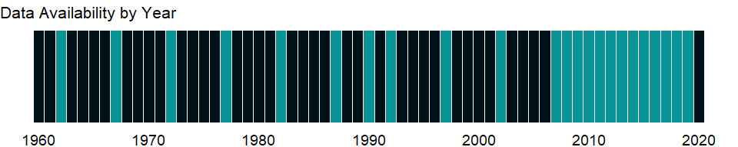

### Which countries have data?

The figure below shows the percentage of countries in each income group with a value since 2010 for that indicator.



### Why is it relevant?

NA

### What is the data source?

United Nations Population Division. World Population Prospects: 2019 Revision.

### What is the methodology?

NA

### How is it aggregated?

Weighted average

### What are the limitations?

NA

### What else should I know?

NA

### 1.82.54 Population, total

### What is the indicator?

Total population is based on the de facto definition of population, which counts all residents regardless of legal status or citizenship. The values shown are midyear estimates.

Topic: Health: Population: Structure

Series ID: SP.POP.TOTL

Copyright: CC BY-4.0 , <https://datacatalog.worldbank.org/public-licenses#cc-by>

First year with any data: 1960

Last year with any data: 2020

### What years are data available?

The figure below shows years in which data is available for at least one country. Dates shaded in black have no data, while dates shaded in green have data for at least one country



### Which countries have data?

The figure below shows the percentage of countries in each income group with a value since 2010 for that indicator.



### Why is it relevant?

Increases in human population, whether as a result of immigration or more births than deaths, can impact natural resources and social infrastructure. This can place pressure on a country’s sustainability. A significant growth in population will negatively impact the availability of land for agricultural production, and will aggravate demand for food, energy, water, social services, and infrastructure. On the other hand, decreasing population size - a result of fewer births than deaths, and people moving out of a country - can impact a government’s commitment to maintain services and infrastructure.

### What is the data source?

1. United Nations Population Division. World Population Prospects: 2019 Revision. (2) Census reports and other statistical publications from national statistical offices, (3) Eurostat: Demographic Statistics, (4) United Nations Statistical Division. Population and Vital Statistics Reprot (various years), (5) U.S. Census Bureau: International Database, and (6) Secretariat of the Pacific Community: Statistics and Demography Programme.

### What is the methodology?

Population estimates are usually based on national population censuses. Estimates for the years before and after the census are interpolations or extrapolations based on demographic models.

Errors and undercounting occur even in high-income countries. In developing countries errors may be substantial because of limits in the transport, communications, and other resources required to conduct and analyze a full census.

The quality and reliability of official demographic data are also affected by public trust in the government, government commitment to full and accurate enumeration, confidentiality and protection against misuse of census data, and census agencies’ independence from political influence. Moreover, comparability of population indicators is limited by differences in the concepts, definitions, collection procedures, and estimation methods used by national statistical agencies and other organizations that collect the data.

The currentness of a census and the availability of complementary data from surveys or registration systems are objective ways to judge demographic data quality. Some European countries’ registration systems offer complete information on population in the absence of a census.

The United Nations Statistics Division monitors the completeness of vital registration systems. Some developing countries have made progress over the last 60 years, but others still have deficiencies in civil registration systems.

International migration is the only other factor besides birth and death rates that directly determines a country’s population growth. Estimating migration is difficult. At any time many people are located outside their home country as tourists, workers, or refugees or for other reasons. Standards for the duration and purpose of international moves that qualify as migration vary, and estimates require information on flows into and out of countries that is difficult to collect.

Population projections, starting from a base year are projected forward using assumptions of mortality, fertility, and migration by age and sex through 2050, based on the UN Population Division’s World Population Prospects database medium variant.

### How is it aggregated?

Sum

### What are the limitations?

Current population estimates for developing countries that lack (i) reliable recent census data, and (ii) pre- and post-census estimates for countries with census data, are provided by the United Nations Population Division and other agencies.

The cohort component method - a standard method for estimating and projecting population - requires fertility, mortality, and net migration data, often collected from sample surveys, which can be small or limited in coverage. Population estimates are from demographic modeling and so are susceptible to biases and errors from shortcomings in both the model and the data. In the UN estimates the five-year age group is the cohort unit and five-year period data are used; therefore interpolations to obtain annual data or single age structure may not reflect actual events or age composition.

Because future trends cannot be known with certainty, population projections have a wide range of uncertainty.

### What else should I know?

Relevance to gender indicator: disaggregating the population composition by gender will help a country in projecting its demand for social services on a gender basis.

### 1.82.55 Population, female

### What is the indicator?

Female population is based on the de facto definition of population, which counts all female residents regardless of legal status or citizenship.

Topic: Health: Population: Structure

Series ID: SP.POP.TOTL.FE.IN

Copyright: CC BY-4.0 , <https://datacatalog.worldbank.org/public-licenses#cc-by>

First year with any data: 1960

Last year with any data: 2020

### What years are data available?

The figure below shows years in which data is available for at least one country. Dates shaded in black have no data, while dates shaded in green have data for at least one country



### Which countries have data?

The figure below shows the percentage of countries in each income group with a value since 2010 for that indicator.



### Why is it relevant?

NA

### What is the data source?

World Bank staff estimates using the World Bank’s total population and age/sex distributions of the United Nations Population Division’s World Population Prospects: 2019 Revision.

### What is the methodology?

NA

### How is it aggregated?

Sum

### What are the limitations?

NA

### What else should I know?

NA

### 1.82.56 Population, female (% of total population)

### What is the indicator?

Female population is the percentage of the population that is female. Population is based on the de facto definition of population, which counts all residents regardless of legal status or citizenship.

Topic: Health: Population: Structure

Series ID: SP.POP.TOTL.FE.ZS

Copyright: CC BY-4.0 , <https://datacatalog.worldbank.org/public-licenses#cc-by>

First year with any data: 1960

Last year with any data: 2020

### What years are data available?

The figure below shows years in which data is available for at least one country. Dates shaded in black have no data, while dates shaded in green have data for at least one country



### Which countries have data?

The figure below shows the percentage of countries in each income group with a value since 2010 for that indicator.



### Why is it relevant?

Females comprise almost one-half of the world population. Female population relative to male population is a primary demographic indicator, reflecting historical events such as wars and the socio-demographic and ethno-cultural characteristics of the population.

### What is the data source?

World Bank staff estimates based on age/sex distributions of United Nations Population Division’s World Population Prospects: 2019 Revision.

### What is the methodology?

Population structure by age and sex in the World Bank’s estimates is based on the population structure by age and sex in United Nations Population Division’s World Population Prospects. For more information, see the original source.

### How is it aggregated?

Weighted average

### What are the limitations?

NA

### What else should I know?

NA

### 1.82.57 Population, male

### What is the indicator?

Male population is based on the de facto definition of population, which counts all male residents regardless of legal status or citizenship.

Topic: Health: Population: Structure

Series ID: SP.POP.TOTL.MA.IN

Copyright: CC BY-4.0 , <https://datacatalog.worldbank.org/public-licenses#cc-by>

First year with any data: 1960

Last year with any data: 2020

### What years are data available?

The figure below shows years in which data is available for at least one country. Dates shaded in black have no data, while dates shaded in green have data for at least one country



### Which countries have data?

The figure below shows the percentage of countries in each income group with a value since 2010 for that indicator.



### Why is it relevant?

NA

### What is the data source?

World Bank staff estimates using the World Bank’s total population and age/sex distributions of the United Nations Population Division’s World Population Prospects: 2019 Revision.

### What is the methodology?

NA

### How is it aggregated?

Sum

### What are the limitations?

NA

### What else should I know?

NA

### 1.82.58 Population, male (% of total population)

### What is the indicator?

Male population is the percentage of the population that is male. Population is based on the de facto definition of population, which counts all residents regardless of legal status or citizenship.

Topic: Health: Population: Structure

Series ID: SP.POP.TOTL.MA.ZS

Copyright: CC BY-4.0 , <https://datacatalog.worldbank.org/public-licenses#cc-by>

First year with any data: 1960

Last year with any data: 2020

### What years are data available?

The figure below shows years in which data is available for at least one country. Dates shaded in black have no data, while dates shaded in green have data for at least one country



### Which countries have data?

The figure below shows the percentage of countries in each income group with a value since 2010 for that indicator.



### Why is it relevant?

NA

### What is the data source?

World Bank staff estimates based on age/sex distributions of United Nations Population Division’s World Population Prospects: 2019 Revision.

### What is the methodology?

Population structure by age and sex in the World Bank’s estimates is based on the population structure by age and sex in United Nations Population Division’s World Population Prospects. For more information, see the original source.

### How is it aggregated?

Weighted average

### What are the limitations?

NA

### What else should I know?

NA

## 1.83 Private Sector & Trade: Travel & tourism

### 1.83.1 International tourism, number of arrivals

### What is the indicator?

International inbound tourists (overnight visitors) are the number of tourists who travel to a country other than that in which they have their usual residence, but outside their usual environment, for a period not exceeding 12 months and whose main purpose in visiting is other than an activity remunerated from within the country visited. When data on number of tourists are not available, the number of visitors, which includes tourists, same-day visitors, cruise passengers, and crew members, is shown instead. Sources and collection methods for arrivals differ across countries. In some cases data are from border statistics (police, immigration, and the like) and supplemented by border surveys. In other cases data are from tourism accommodation establishments. For some countries number of arrivals is limited to arrivals by air and for others to arrivals staying in hotels. Some countries include arrivals of nationals residing abroad while others do not. Caution should thus be used in comparing arrivals across countries. The data on inbound tourists refer to the number of arrivals, not to the number of people traveling. Thus a person who makes several trips to a country during a given period is counted each time as a new arrival.

Topic: Private Sector & Trade: Travel & tourism

Series ID: ST.INT.ARVL

Copyright: CC BY-4.0 , <https://datacatalog.worldbank.org/public-licenses#cc-by>

First year with any data: 1995

Last year with any data: 2019

### What years are data available?

The figure below shows years in which data is available for at least one country. Dates shaded in black have no data, while dates shaded in green have data for at least one country



### Which countries have data?

The figure below shows the percentage of countries in each income group with a value since 2010 for that indicator.

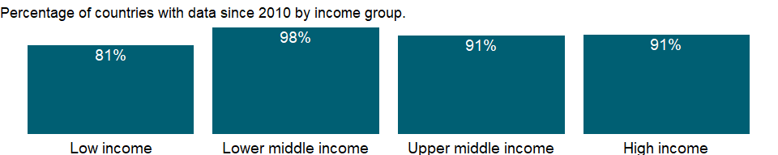

### Why is it relevant?

Tourism is officially recognized as a directly measurable activity, enabling more accurate analysis and more effective policy. Whereas previously the sector relied mostly on approximations from related areas of measurement (e.g. Balance of Payments statistics), tourism today possesses a range of instruments to track its productive activities and the activities of the consumers that drive them: visitors (both tourists and excursionists).

An increasing number of countries have opened up and invested in tourism development, making tourism a key driver of socio-economic progress through export revenues, the creation of jobs and enterprises, and infrastructure development. As an internationally traded service, inbound tourism has become one of the world’s major trade categories. For many developing countries it is one of the main sources of foreign exchange income and a major component of exports, creating much needed employment and development opportunities.

### What is the data source?

World Tourism Organization, Yearbook of Tourism Statistics, Compendium of Tourism Statistics and data files.

### What is the methodology?

Statistical information on tourism is based mainly on data on arrivals and overnight stays along with balance of payments information. These data do not completely capture the economic phenomenon of tourism or provide the information needed for effective public policies and efficient business operations. Data are needed on the scale and significance of tourism. Information on the role of tourism in national economies is particularly deficient. Although the World Tourism Organization reports progress in harmonizing definitions and measurement, differences in national practices still prevent full comparability.

Arrivals data measure the flows of international visitors to the country of reference: each arrival corresponds to one in inbound tourism trip. If a person visits several countries during the course of a single trip, his/her arrival in each country is recorded separately. In an accounting period, arrivals are not necessarily equal to the number of persons travelling (when a person visits the same country several times a year, each trip by the same person is counted as a separate arrival).

Arrivals data should correspond to inbound visitors by including both tourists and same-day non-resident visitors. All other types of travelers (such as border, seasonal and other short-term workers, long-term students and others) should be excluded as they do not qualify as visitors.

Data are obtained from different sources: administrative records (immigration, traffic counts, and other possible types of controls), border surveys or a mix of them. If data are obtained from accommodation surveys, the number of guests is used as estimate of arrival figures; consequently, in this case, breakdowns by regions, main purpose of the trip, modes of transport used or forms of organization of the trip are based on complementary visitor surveys.

### How is it aggregated?

Gap-filled total

### What are the limitations?

Tourism can be either domestic or international. The data refers to international tourism, where the traveler’s country of residence differs from the visiting country. International tourism consists of inbound (arrival) and outbound (departures) tourism.

The data are from the World Tourism Organization (WTO), a United Nations agency. The data on inbound and outbound tourists refer to the number of arrivals and departures, not to the number of people traveling. Thus a person who makes several trips to a country during a given period is counted each time as a new arrival. The data on inbound tourism show the arrivals of nonresident tourists (overnight visitors) at national borders. When data on international tourists are unavailable or incomplete, the data show the arrivals of international visitors, which include tourists, same-day visitors, cruise passengers, and crew members.

Sources and collection methods for arrivals differ across countries. In some cases data are from border statistics (police, immigration, and the like) and supplemented by border surveys. In other cases data are from tourism accommodation establishments. For some countries number of arrivals is limited to arrivals by air and for others to arrivals staying in hotels. Some countries include arrivals of nationals residing abroad while others do not. Caution should thus be used in comparing arrivals across countries.

### What else should I know?

NA

### 1.83.2 International tourism, number of departures

### What is the indicator?

International outbound tourists are the number of departures that people make from their country of usual residence to any other country for any purpose other than a remunerated activity in the country visited. The data on outbound tourists refer to the number of departures, not to the number of people traveling. Thus a person who makes several trips from a country during a given period is counted each time as a new departure.

Topic: Private Sector & Trade: Travel & tourism

Series ID: ST.INT.DPRT

Copyright: CC BY-4.0 , <https://datacatalog.worldbank.org/public-licenses#cc-by>

First year with any data: 1995

Last year with any data: 2019

### What years are data available?

The figure below shows years in which data is available for at least one country. Dates shaded in black have no data, while dates shaded in green have data for at least one country



### Which countries have data?

The figure below shows the percentage of countries in each income group with a value since 2010 for that indicator.

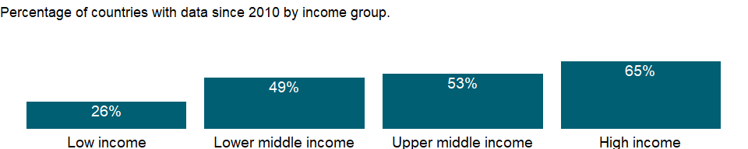

### Why is it relevant?

Tourism is officially recognized as a directly measurable activity, enabling more accurate analysis and more effective policy. Whereas previously the sector relied mostly on approximations from related areas of measurement (e.g. Balance of Payments statistics), tourism today possesses a range of instruments to track its productive activities and the activities of the consumers that drive them: visitors (both tourists and excursionists).

An increasing number of countries have opened up and invested in tourism development, making tourism a key driver of socio-economic progress through export revenues, the creation of jobs and enterprises, and infrastructure development. As an internationally traded service, inbound tourism has become one of the world’s major trade categories. For many developing countries it is one of the main sources of foreign exchange income and a major component of exports, creating much needed employment and development opportunities.

### What is the data source?

World Tourism Organization, Yearbook of Tourism Statistics, Compendium of Tourism Statistics and data files.

### What is the methodology?

Statistical information on tourism is based mainly on data on arrivals and overnight stays along with balance of payments information. These data do not completely capture the economic phenomenon of tourism or provide the information needed for effective public policies and efficient business operations. Data are needed on the scale and significance of tourism. Information on the role of tourism in national economies is particularly deficient. Although the World Tourism Organization reports progress in harmonizing definitions and measurement, differences in national practices still prevent full comparability.

Departures data measure the flows of resident visitors leaving the country of reference. Departures are not necessarily equal to the number of arrivals reported by international destinations for the country of reference.

In many countries, the characteristics of trips and visitors are established through questions on the entry/departure cards, in surveys at the borders, at destination (accommodation surveys) or as part of household surveys (for domestic and outbound tourism). The entry/departure cards, or records of entry and departure, captured and reconciled by the immigration authorities are often the basic source for establishing the flows of inbound and outbound visitors. These cards usually collect information on a census basis on name, sex, age, nationality, current address, date of arrival (or departure in the departure card), purpose of trip, main destination visited and length of stay (expected on arrival and actual on departure for inbound visitors; expected on departure and actual on arrival for outbound visitors).

Data is collected using one of three methods, or a combination of these to determine the flows of outbound visitors: using an entry/departure card; a specific survey at the border, or observing them from household surveys because they belong to resident households. In the latter case, the information on outbound trips is usually collected at the same time as that on domestic trips.

### How is it aggregated?

Gap-filled total

### What are the limitations?

Tourism can be either domestic or international. The data refers to international tourism, where the traveler’s country of residence differs from the visiting country. International tourism consists of inbound (arrival) and outbound (departures) tourism.

The data are from the World Tourism Organization (WTO), a United Nations agency. The data on inbound and outbound tourists refer to the number of arrivals and departures, not to the number of people traveling.

### What else should I know?

NA

### 1.83.3 International tourism, receipts (current US$)

### What is the indicator?

International tourism receipts are expenditures by international inbound visitors, including payments to national carriers for international transport. These receipts include any other prepayment made for goods or services received in the destination country. They also may include receipts from same-day visitors, except when these are important enough to justify separate classification. For some countries they do not include receipts for passenger transport items. Data are in current U.S. dollars.

Topic: Private Sector & Trade: Travel & tourism

Series ID: ST.INT.RCPT.CD

Copyright: CC BY-4.0 , <https://datacatalog.worldbank.org/public-licenses#cc-by>

First year with any data: 1995

Last year with any data: 2019

### What years are data available?

The figure below shows years in which data is available for at least one country. Dates shaded in black have no data, while dates shaded in green have data for at least one country



### Which countries have data?

The figure below shows the percentage of countries in each income group with a value since 2010 for that indicator.

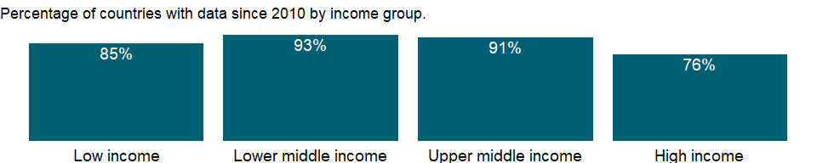

### Why is it relevant?

Tourism is officially recognized as a directly measurable activity, enabling more accurate analysis and more effective policy. Whereas previously the sector relied mostly on approximations from related areas of measurement (e.g. Balance of Payments statistics), tourism today possesses a range of instruments to track its productive activities and the activities of the consumers that drive them: visitors (both tourists and excursionists).

An increasing number of countries have opened up and invested in tourism development, making tourism a key driver of socio-economic progress through export revenues, the creation of jobs and enterprises, and infrastructure development. As an internationally traded service, inbound tourism has become one of the world’s major trade categories. For many developing countries it is one of the main sources of foreign exchange income and a major component of exports, creating much needed employment and development opportunities.

### What is the data source?

World Tourism Organization, Yearbook of Tourism Statistics, Compendium of Tourism Statistics and data files.

### What is the methodology?

Inbound tourism expenditures may include receipts from same-day visitors, except when these are important enough to justify separate classification. For some countries they do not include receipts for passenger transport items. Their share in exports is calculated as a ratio to exports of goods and services (all transactions between residents of a country and the rest of the world involving a change of ownership from residents to nonresidents of general merchandise, goods sent for processing and repairs, nonmonetary gold, and services).

Statistical information on tourism is based mainly on data on arrivals and overnight stays along with balance of payments information. These data do not completely capture the economic phenomenon of tourism or provide the information needed for effective public policies and efficient business operations. Data are needed on the scale and significance of tourism. Information on the role of tourism in national economies is particularly deficient. Although the World Tourism Organization (WTO) reports progress in harmonizing definitions and measurement, differences in national practices still prevent full comparability.

The World Tourism Organization is improving its coverage of tourism expenditure data, using balance of payments data from the International Monetary Fund (IMF) supplemented by data from individual countries. These data include travel and passenger transport items as defined in the IMF’s Balance of Payments. When the IMF does not report data on passenger transport items, expenditure data for travel items are shown.

The aggregates are calculated using the World Bank’s weighted aggregation methodology and differ from the World Tourism Organization’s aggregates.

### How is it aggregated?

Gap-filled total

### What are the limitations?

Tourism can be either domestic or international. The data refers to international tourism, where the traveler’s country of residence differs from the visiting country. International tourism consists of inbound (arrival) and outbound (departures) tourism.

The data are from the World Tourism Organization (WTO), a United Nations agency. The data on inbound and outbound tourists refer to the number of arrivals and departures, not to the number of people traveling. Thus a person who makes several trips to a country during a given period is counted each time as a new arrival. The data on inbound tourism show the arrivals of nonresident tourists (overnight visitors) at national borders. When data on international tourists are unavailable or incomplete, the data show the arrivals of international visitors, which include tourists, same-day visitors, cruise passengers, and crew members.

Sources and collection methods for arrivals differ across countries. In some cases data are from border statistics (police, immigration, and the like) and supplemented by border surveys. In other cases data are from tourism accommodation establishments. For some countries number of arrivals is limited to arrivals by air and for others to arrivals staying in hotels. Some countries include arrivals of nationals residing abroad while others do not. Caution should thus be used in comparing arrivals across countries.

Expenditure associated with the activity of international visitors has been traditionally identified with the travel item of the Balance of Payments (BOP): in the case of inbound tourism, those expenditures associated with inbound visitors are registered as “credits” in the BOP and refers to “travel receipts”.

The 2008 International Recommendations for Tourism Statistics consider that “tourism industries and products” includes transport of passengers. Consequently, a better estimate of tourism-related expenditure by inbound and outbound visitors in an international scenario would be, in terms of the BOP, the value of the travel item plus that of the passenger transport item.

Nevertheless, users should be aware that BOP estimates include, in addition to expenditures associated to visitors, those related to other types of travelers (these might be substantial in some countries; for instance, long-term students or patients, border and seasonal workers, etc.). Also data on expenditure by main purpose of the trip are BOP data.

### What else should I know?

NA

### 1.83.4 International tourism, receipts (% of total exports)

### What is the indicator?

International tourism receipts are expenditures by international inbound visitors, including payments to national carriers for international transport. These receipts include any other prepayment made for goods or services received in the destination country. They also may include receipts from same-day visitors, except when these are important enough to justify separate classification. For some countries they do not include receipts for passenger transport items. Their share in exports is calculated as a ratio to exports of goods and services, which comprise all transactions between residents of a country and the rest of the world involving a change of ownership from residents to nonresidents of general merchandise, goods sent for processing and repairs, nonmonetary gold, and services.

Topic: Private Sector & Trade: Travel & tourism

Series ID: ST.INT.RCPT.XP.ZS

Copyright: CC BY-4.0 , <https://datacatalog.worldbank.org/public-licenses#cc-by>

First year with any data: 1995

Last year with any data: 2019

### What years are data available?

The figure below shows years in which data is available for at least one country. Dates shaded in black have no data, while dates shaded in green have data for at least one country



### Which countries have data?

The figure below shows the percentage of countries in each income group with a value since 2010 for that indicator.

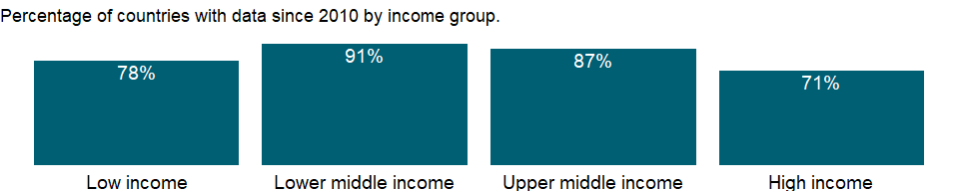

### Why is it relevant?

Tourism is officially recognized as a directly measurable activity, enabling more accurate analysis and more effective policy. Whereas previously the sector relied mostly on approximations from related areas of measurement (e.g. Balance of Payments statistics), tourism today possesses a range of instruments to track its productive activities and the activities of the consumers that drive them: visitors (both tourists and excursionists).

An increasing number of countries have opened up and invested in tourism development, making tourism a key driver of socio-economic progress through export revenues, the creation of jobs and enterprises, and infrastructure development. As an internationally traded service, inbound tourism has become one of the world’s major trade categories. For many developing countries it is one of the main sources of foreign exchange income and a major component of exports, creating much needed employment and development opportunities.

This measure reflects the importance of tourism as an internationally traded service relative to other categories of exports. Such a measure reveals the degree of tourism specialization in a country’s export structure and the relative capability of tourism in generating foreign revenues.

### What is the data source?

World Tourism Organization, Yearbook of Tourism Statistics, Compendium of Tourism Statistics and data files, and IMF and World Bank exports estimates.

### What is the methodology?

Inbound tourism expenditures may include receipts from same-day visitors, except when these are important enough to justify separate classification. For some countries they do not include receipts for passenger transport items. Their share in exports is calculated as a ratio to exports of goods and services (all transactions between residents of a country and the rest of the world involving a change of ownership from residents to nonresidents of general merchandise, goods sent for processing and repairs, nonmonetary gold, and services).

International tourism expenditures’ share in exports is calculated as a ratio to exports of goods and services, which comprise all transactions between residents of a country and the rest of the world involving a change of ownership from residents to nonresidents of general merchandise, goods sent for processing and repairs, nonmonetary gold, and services.

Statistical information on tourism is based mainly on data on arrivals and overnight stays along with balance of payments information. These data do not completely capture the economic phenomenon of tourism or provide the information needed for effective public policies and efficient business operations. Data are needed on the scale and significance of tourism. Information on the role of tourism in national economies is particularly deficient. Although the World Tourism Organization (WTO) reports progress in harmonizing definitions and measurement, differences in national practices still prevent full comparability.

The World Tourism Organization is improving its coverage of tourism expenditure data, using balance of payments data from the International Monetary Fund (IMF) supplemented by data from individual countries. These data include travel and passenger transport items as defined in the IMF’s Balance of Payments. When the IMF does not report data on passenger transport items, expenditure data for travel items are shown.

The aggregates are calculated using the World Bank’s weighted aggregation methodology and differ from the World Tourism Organization’s aggregates.

### How is it aggregated?

Weighted Average

### What are the limitations?

Tourism can be either domestic or international. The data refers to international tourism, where the traveler’s country of residence differs from the visiting country. International tourism consists of inbound (arrival) and outbound (departures) tourism.

The data are from the World Tourism Organization (WTO), a United Nations agency. The data on inbound and outbound tourists refer to the number of arrivals and departures, not to the number of people traveling. Thus a person who makes several trips to a country during a given period is counted each time as a new arrival. The data on inbound tourism show the arrivals of nonresident tourists (overnight visitors) at national borders. When data on international tourists are unavailable or incomplete, the data show the arrivals of international visitors, which include tourists, same-day visitors, cruise passengers, and crew members.

Sources and collection methods for arrivals differ across countries. In some cases data are from border statistics (police, immigration, and the like) and supplemented by border surveys. In other cases data are from tourism accommodation establishments. For some countries number of arrivals is limited to arrivals by air and for others to arrivals staying in hotels. Some countries include arrivals of nationals residing abroad while others do not. Caution should thus be used in comparing arrivals across countries.

Expenditure associated with the activity of international visitors has been traditionally identified with the travel item of the Balance of Payments (BOP): in the case of inbound tourism, those expenditures associated with inbound visitors are registered as “credits” in the BOP and refers to “travel receipts”.

The 2008 International Recommendations for Tourism Statistics consider that “tourism industries and products” includes transport of passengers. Consequently, a better estimate of tourism-related expenditure by inbound and outbound visitors in an international scenario would be, in terms of the BOP, the value of the travel item plus that of the passenger transport item.

Nevertheless, users should be aware that BOP estimates include, in addition to expenditures associated to visitors, those related to other types of travelers (these might be substantial in some countries; for instance, long-term students or patients, border and seasonal workers, etc.). Also data on expenditure by main purpose of the trip are BOP data.

### What else should I know?

NA

### 1.83.5 International tourism, receipts for passenger transport items (current US$)

### What is the indicator?

International tourism receipts for passenger transport items are expenditures by international inbound visitors for all services provided in the international transportation by resident carriers. Also included are passenger services performed within an economy by nonresident carriers. Excluded are passenger services provided to nonresidents by resident carriers within the resident economies; these are included in travel items. In addition to the services covered by passenger fares–including fares that are a part of package tours but excluding cruise fares, which are included in travel–passenger services include such items as charges for excess baggage, vehicles, or other personal accompanying effects and expenditures for food, drink, or other items for which passengers make expenditures while on board carriers. Data are in current U.S. dollars.

Topic: Private Sector & Trade: Travel & tourism

Series ID: ST.INT.TRNR.CD

Copyright: CC BY-4.0 , <https://datacatalog.worldbank.org/public-licenses#cc-by>

First year with any data: 1995

Last year with any data: 2019

### What years are data available?

The figure below shows years in which data is available for at least one country. Dates shaded in black have no data, while dates shaded in green have data for at least one country



### Which countries have data?

The figure below shows the percentage of countries in each income group with a value since 2010 for that indicator.

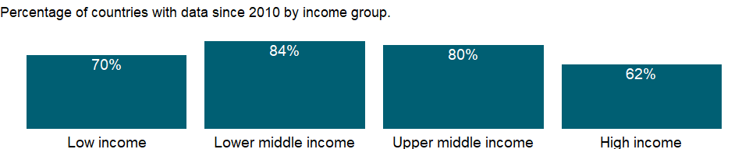

### Why is it relevant?

NA

### What is the data source?

World Tourism Organization, Yearbook of Tourism Statistics, Compendium of Tourism Statistics and data files.

### What is the methodology?

NA

### How is it aggregated?

Gap-filled total

### What are the limitations?

NA

### What else should I know?

NA

### 1.83.6 International tourism, expenditures for passenger transport items (current US$)

### What is the indicator?

International tourism expenditures for passenger transport items are expenditures of international outbound visitors in other countries for all services provided during international transportation by nonresident carriers. Also included are passenger services performed within an economy by nonresident carriers. Excluded are passenger services provided to nonresidents by resident carriers within the resident economies; these are included in travel items. In addition to the services covered by passenger fares–including fares that are a part of package tours but excluding cruise fares, which are included in travel–passenger services include such items as charges for excess baggage, vehicles, or other personal accompanying effects and expenditures for food, drink, or other items for which passengers make expenditures while on board carriers. Data are in current U.S. dollars.

Topic: Private Sector & Trade: Travel & tourism

Series ID: ST.INT.TRNX.CD

Copyright: CC BY-4.0 , <https://datacatalog.worldbank.org/public-licenses#cc-by>

First year with any data: 1995

Last year with any data: 2019

### What years are data available?

The figure below shows years in which data is available for at least one country. Dates shaded in black have no data, while dates shaded in green have data for at least one country



### Which countries have data?

The figure below shows the percentage of countries in each income group with a value since 2010 for that indicator.

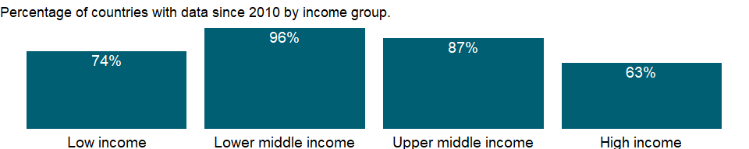

### Why is it relevant?

NA

### What is the data source?

World Tourism Organization, Yearbook of Tourism Statistics, Compendium of Tourism Statistics and data files.

### What is the methodology?

NA

### How is it aggregated?

Gap-filled total

### What are the limitations?

NA

### What else should I know?

NA

### 1.83.7 International tourism, receipts for travel items (current US$)

### What is the indicator?

International tourism receipts for travel items are expenditures by international inbound visitors in the reporting economy. The goods and services are purchased by, or on behalf of, the traveler or provided, without a quid pro quo, for the traveler to use or give away. These receipts should include any other prepayment made for goods or services received in the destination country. They also may include receipts from same-day visitors, except in cases where these are so important as to justify a separate classification. Excluded is the international carriage of travelers, which is covered in passenger travel items. Data are in current U.S. dollars.

Topic: Private Sector & Trade: Travel & tourism

Series ID: ST.INT.TVLR.CD

Copyright: CC BY-4.0 , <https://datacatalog.worldbank.org/public-licenses#cc-by>

First year with any data: 1995

Last year with any data: 2019

### What years are data available?

The figure below shows years in which data is available for at least one country. Dates shaded in black have no data, while dates shaded in green have data for at least one country



### Which countries have data?

The figure below shows the percentage of countries in each income group with a value since 2010 for that indicator.



### Why is it relevant?

NA

### What is the data source?

World Tourism Organization, Yearbook of Tourism Statistics, Compendium of Tourism Statistics and data files.

### What is the methodology?

NA

### How is it aggregated?

Gap-filled total

### What are the limitations?

NA

### What else should I know?

NA

### 1.83.8 International tourism, expenditures for travel items (current US$)

### What is the indicator?

International tourism expenditures are expenditures of international outbound visitors in other countries. The goods and services are purchased by, or on behalf of, the traveler or provided, without a quid pro quo, for the traveler to use or give away. These may include expenditures by residents traveling abroad as same-day visitors, except in cases where these are so important as to justify a separate classification. Excluded is the international carriage of travelers, which is covered in passenger travel items. Data are in current U.S. dollars.

Topic: Private Sector & Trade: Travel & tourism

Series ID: ST.INT.TVLX.CD

Copyright: CC BY-4.0 , <https://datacatalog.worldbank.org/public-licenses#cc-by>

First year with any data: 1995

Last year with any data: 2019

### What years are data available?

The figure below shows years in which data is available for at least one country. Dates shaded in black have no data, while dates shaded in green have data for at least one country



### Which countries have data?

The figure below shows the percentage of countries in each income group with a value since 2010 for that indicator.

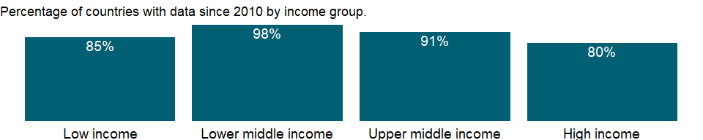

### Why is it relevant?

NA

### What is the data source?

World Tourism Organization, Yearbook of Tourism Statistics, Compendium of Tourism Statistics and data files.

### What is the methodology?

NA

### How is it aggregated?

Gap-filled total

### What are the limitations?

NA

### What else should I know?

NA

### 1.83.9 International tourism, expenditures (current US$)

### What is the indicator?

International tourism expenditures are expenditures of international outbound visitors in other countries, including payments to foreign carriers for international transport. These expenditures may include those by residents traveling abroad as same-day visitors, except in cases where these are important enough to justify separate classification. For some countries they do not include expenditures for passenger transport items. Data are in current U.S. dollars.

Topic: Private Sector & Trade: Travel & tourism

Series ID: ST.INT.XPND.CD

Copyright: CC BY-4.0 , <https://datacatalog.worldbank.org/public-licenses#cc-by>

First year with any data: 1995

Last year with any data: 2019

### What years are data available?

The figure below shows years in which data is available for at least one country. Dates shaded in black have no data, while dates shaded in green have data for at least one country



### Which countries have data?

The figure below shows the percentage of countries in each income group with a value since 2010 for that indicator.

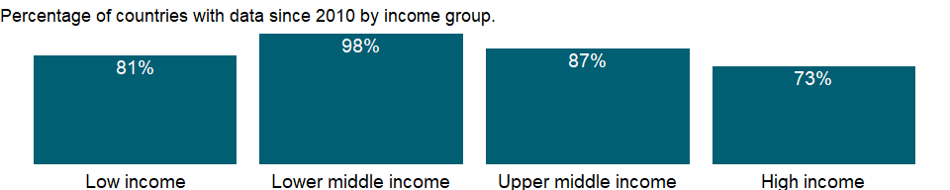

### Why is it relevant?

Tourism is officially recognized as a directly measurable activity, enabling more accurate analysis and more effective policy. Whereas previously the sector relied mostly on approximations from related areas of measurement (e.g. Balance of Payments statistics), tourism today possesses a range of instruments to track its productive activities and the activities of the consumers that drive them: visitors (both tourists and excursionists).

An increasing number of countries have opened up and invested in tourism development, making tourism a key driver of socio-economic progress through export revenues, the creation of jobs and enterprises, and infrastructure development. As an internationally traded service, inbound tourism has become one of the world’s major trade categories. For many developing countries it is one of the main sources of foreign exchange income and a major component of exports, creating much needed employment and development opportunities.

### What is the data source?

World Tourism Organization, Yearbook of Tourism Statistics, Compendium of Tourism Statistics and data files.

### What is the methodology?

Outbound tourism expenditures may include those by residents traveling abroad as same-day visitors, except when these are important enough to justify separate classification. For some countries they do not include expenditures for passenger transport items. Their share in imports is calculated as a ratio to imports of goods and services (all transactions between residents of a country and the rest of the world involving a change of ownership from nonresidents to residents of general merchandise, goods sent for processing and repairs, nonmonetary gold, and services).

Statistical information on tourism is based mainly on data on arrivals and overnight stays along with balance of payments information. These data do not completely capture the economic phenomenon of tourism or provide the information needed for effective public policies and efficient business operations. Data are needed on the scale and significance of tourism. Information on the role of tourism in national economies is particularly deficient. Although the World Tourism Organization reports progress in harmonizing definitions and measurement, differences in national practices still prevent full comparability.

The World Tourism Organization is improving its coverage of tourism expenditure data, using balance of payments data from the International Monetary Fund (IMF) supplemented by data from individual countries. These data include travel and passenger transport items as defined in the IMF’s Balance of Payments. When the IMF does not report data on passenger transport items, expenditure data for travel items are shown.

The aggregates are calculated using the World Bank’s weighted aggregation methodology and differ from the World Tourism Organization’s aggregates.

### How is it aggregated?

Gap-filled total

### What are the limitations?

Tourism can be either domestic or international. The data refers to international tourism, where the traveler’s country of residence differs from the visiting country. International tourism consists of inbound (arrival) and outbound (departures) tourism.

The data are from the World Tourism Organization (WTO), a United Nations agency. The data on inbound and outbound tourists refer to the number of arrivals and departures, not to the number of people traveling.

Expenditure associated with the activity of international visitors has been traditionally identified with the travel item of the Balance of Payments (BOP).

The 2008 International Recommendations for Tourism Statistics consider that “tourism industries and products” includes transport of passengers. Consequently, a better estimate of tourism-related expenditure by inbound and outbound visitors in an international scenario would be, in terms of the BOP, the value of the travel item plus that of the passenger transport item.

Nevertheless, users should be aware that BOP estimates include, in addition to expenditures associated to visitors, those related to other types of travelers (these might be substantial in some countries; for instance, long-term students or patients, border and seasonal workers, etc.). Also data on expenditure by main purpose of the trip are BOP data.

### What else should I know?

NA

### 1.83.10 International tourism, expenditures (% of total imports)

### What is the indicator?

International tourism expenditures are expenditures of international outbound visitors in other countries, including payments to foreign carriers for international transport. These expenditures may include those by residents traveling abroad as same-day visitors, except in cases where these are important enough to justify separate classification. For some countries they do not include expenditures for passenger transport items. Their share in imports is calculated as a ratio to imports of goods and services, which comprise all transactions between residents of a country and the rest of the world involving a change of ownership from nonresidents to residents of general merchandise, goods sent for processing and repairs, nonmonetary gold, and services.

Topic: Private Sector & Trade: Travel & tourism

Series ID: ST.INT.XPND.MP.ZS

Copyright: CC BY-4.0 , <https://datacatalog.worldbank.org/public-licenses#cc-by>

First year with any data: 1995

Last year with any data: 2019

### What years are data available?

The figure below shows years in which data is available for at least one country. Dates shaded in black have no data, while dates shaded in green have data for at least one country



### Which countries have data?

The figure below shows the percentage of countries in each income group with a value since 2010 for that indicator.

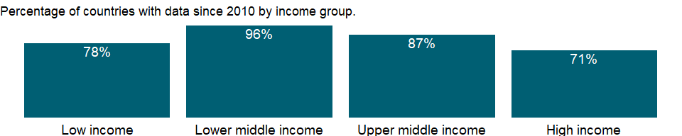

### Why is it relevant?

Tourism is officially recognized as a directly measurable activity, enabling more accurate analysis and more effective policy. Whereas previously the sector relied mostly on approximations from related areas of measurement (e.g. Balance of Payments statistics), tourism today possesses a range of instruments to track its productive activities and the activities of the consumers that drive them: visitors (both tourists and excursionists).

An increasing number of countries have opened up and invested in tourism development, making tourism a key driver of socio-economic progress through export revenues, the creation of jobs and enterprises, and infrastructure development. As an internationally traded service, inbound tourism has become one of the world’s major trade categories. For many developing countries it is one of the main sources of foreign exchange income and a major component of exports, creating much needed employment and development opportunities.

This measure reflects the importance of tourism as an internationally traded service relative to other categories of imports. Such a measure reveals the predilection for tourism in a country’s import structure and the relative degree of an economy’s domestic revenue outflows due to international tourism.

### What is the data source?

World Tourism Organization, Yearbook of Tourism Statistics, Compendium of Tourism Statistics and data files, and IMF and World Bank imports estimates.

### What is the methodology?

Outbound tourism expenditures may include those by residents traveling abroad as same-day visitors, except when these are important enough to justify separate classification. For some countries they do not include expenditures for passenger transport items. Their share in imports is calculated as a ratio to imports of goods and services (all transactions between residents of a country and the rest of the world involving a change of ownership from nonresidents to residents of general merchandise, goods sent for processing and repairs, nonmonetary gold, and services).

International tourism expenditures’ share in imports is calculated as a ratio to imports of goods and services, which comprise all transactions between residents of a country and the rest of the world involving a change of ownership from nonresidents to residents of general merchandise, goods sent for processing and repairs, nonmonetary gold, and services.

Statistical information on tourism is based mainly on data on arrivals and overnight stays along with balance of payments information. These data do not completely capture the economic phenomenon of tourism or provide the information needed for effective public policies and efficient business operations. Data are needed on the scale and significance of tourism. Information on the role of tourism in national economies is particularly deficient. Although the World Tourism Organization reports progress in harmonizing definitions and measurement, differences in national practices still prevent full comparability.

The World Tourism Organization is improving its coverage of tourism expenditure data, using balance of payments data from the International Monetary Fund (IMF) supplemented by data from individual countries. These data include travel and passenger transport items as defined in the IMF’s Balance of Payments. When the IMF does not report data on passenger transport items, expenditure data for travel items are shown.

The aggregates are calculated using the World Bank’s weighted aggregation methodology and differ from the World Tourism Organization’s aggregates.

### How is it aggregated?

Weighted Average

### What are the limitations?

Tourism can be either domestic or international. The data refers to international tourism, where the traveler’s country of residence differs from the visiting country. International tourism consists of inbound (arrival) and outbound (departures) tourism.

The data are from the World Tourism Organization (WTO), a United Nations agency. The data on inbound and outbound tourists refer to the number of arrivals and departures, not to the number of people traveling.

Expenditure associated with the activity of international visitors has been traditionally identified with the travel item of the Balance of Payments (BOP).

The 2008 International Recommendations for Tourism Statistics consider that “tourism industries and products” includes transport of passengers. Consequently, a better estimate of tourism-related expenditure by inbound and outbound visitors in an international scenario would be, in terms of the BOP, the value of the travel item plus that of the passenger transport item.

Nevertheless, users should be aware that BOP estimates include, in addition to expenditures associated to visitors, those related to other types of travelers (these might be substantial in some countries; for instance, long-term students or patients, border and seasonal workers, etc.). Also data on expenditure by main purpose of the trip are BOP data.

### What else should I know?

NA

## 1.84 Private Sector & Trade: Total merchandise trade

### 1.84.1 Merchandise trade (% of GDP)

### What is the indicator?

Merchandise trade as a share of GDP is the sum of merchandise exports and imports divided by the value of GDP, all in current U.S. dollars.

Topic: Private Sector & Trade: Total merchandise trade

Series ID: TG.VAL.TOTL.GD.ZS

Copyright: CC BY-4.0 , <https://datacatalog.worldbank.org/public-licenses#cc-by>

First year with any data: 1960

Last year with any data: 2020

### What years are data available?

The figure below shows years in which data is available for at least one country. Dates shaded in black have no data, while dates shaded in green have data for at least one country



### Which countries have data?

The figure below shows the percentage of countries in each income group with a value since 2010 for that indicator.

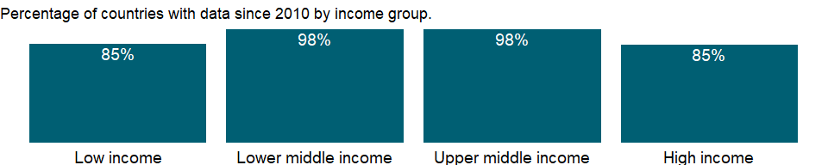

### Why is it relevant?

NA

### What is the data source?

World Trade Organization, and World Bank GDP estimates.

### What is the methodology?

NA

### How is it aggregated?

Weighted average

### What are the limitations?

NA

### What else should I know?

NA

## 1.85 Private Sector & Trade: Trade indexes

### 1.85.1 Import volume index (2000 = 100)

### What is the indicator?

Import volume indexes are derived from UNCTAD’s volume index series and are the ratio of the import value indexes to the corresponding unit value indexes. Unit value indexes are based on data reported by countries that demonstrate consistency under UNCTAD quality controls, supplemented by UNCTAD’s estimates using the previous year’s trade values at the Standard International Trade Classification three-digit level as weights. To improve data coverage, especially for the latest periods, UNCTAD constructs a set of average prices indexes at the three-digit product classification of the Standard International Trade Classification revision 3 using UNCTAD’s Commodity Price Statistics, interna­tional and national sources, and UNCTAD secretariat estimates and calculates unit value indexes at the country level using the current year’s trade values as weights. For economies for which UNCTAD does not publish data, the import volume indexes (lines 73) in the IMF’s International Financial Statistics are used.

Topic: Private Sector & Trade: Trade indexes

Series ID: TM.QTY.MRCH.XD.WD

Copyright: CC BY-4.0 , <https://datacatalog.worldbank.org/public-licenses#cc-by>

First year with any data: 1980

Last year with any data: 2019

### What years are data available?

The figure below shows years in which data is available for at least one country. Dates shaded in black have no data, while dates shaded in green have data for at least one country



### Which countries have data?

The figure below shows the percentage of countries in each income group with a value since 2010 for that indicator.

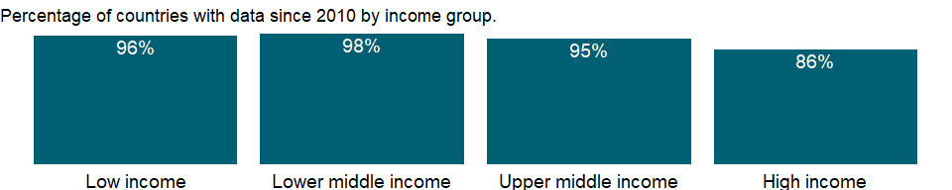

### Why is it relevant?

NA

### What is the data source?

United Nations Conference on Trade and Development, Handbook of Statistics and data files, and International Monetary Fund, International Financial Statistics.

### What is the methodology?

NA

### How is it aggregated?

NA

### What are the limitations?

NA

### What else should I know?

NA

### 1.85.2 Import value index (2000 = 100)

### What is the indicator?

Import value indexes are the current value of imports (c.i.f.) converted to U.S. dollars and expressed as a percentage of the average for the base period (2000). UNCTAD’s import value indexes are reported for most economies. For selected economies for which UNCTAD does not publish data, the import value indexes are derived from import volume indexes (line 73) and corresponding unit value indexes of imports (line 75) in the IMF’s International Financial Statistics.

Topic: Private Sector & Trade: Trade indexes

Series ID: TM.VAL.MRCH.XD.WD

Copyright: CC BY-4.0 , <https://datacatalog.worldbank.org/public-licenses#cc-by>

First year with any data: 1980

Last year with any data: 2019

### What years are data available?

The figure below shows years in which data is available for at least one country. Dates shaded in black have no data, while dates shaded in green have data for at least one country



### Which countries have data?

The figure below shows the percentage of countries in each income group with a value since 2010 for that indicator.

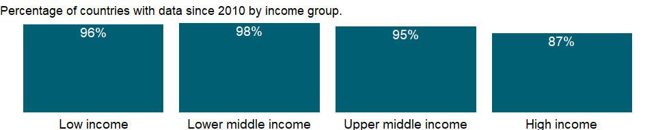

### Why is it relevant?

NA

### What is the data source?

United Nations Conference on Trade and Development, Handbook of Statistics and data files, and International Monetary Fund, International Financial Statistics.

### What is the methodology?

NA

### How is it aggregated?

NA

### What are the limitations?

NA

### What else should I know?

NA

### 1.85.3 Net barter terms of trade index (2000 = 100)

### What is the indicator?

Net barter terms of trade index is calculated as the percentage ratio of the export unit value indexes to the import unit value indexes, measured relative to the base year 2000. Unit value indexes are based on data reported by countries that demonstrate consistency under UNCTAD quality controls, supplemented by UNCTAD’s estimates using the previous year’s trade values at the Standard International Trade Classification three-digit level as weights. To improve data coverage, especially for the latest periods, UNCTAD constructs a set of average prices indexes at the three-digit product classification of the Standard International Trade Classification revision 3 using UNCTAD’s Commodity Price Statistics, interna­tional and national sources, and UNCTAD secretariat estimates and calculates unit value indexes at the country level using the current year’s trade values as weights.

Topic: Private Sector & Trade: Trade indexes

Series ID: TT.PRI.MRCH.XD.WD

Copyright: CC BY-4.0 , <https://datacatalog.worldbank.org/public-licenses#cc-by>

First year with any data: 1980

Last year with any data: 2019

### What years are data available?

The figure below shows years in which data is available for at least one country. Dates shaded in black have no data, while dates shaded in green have data for at least one country



### Which countries have data?

The figure below shows the percentage of countries in each income group with a value since 2010 for that indicator.



### Why is it relevant?

Data on international trade in goods are available from each country’s balance of payments and customs records. While the balance of payments focuses on the financial transactions that accompany trade, customs data record the direction of trade and the physical quantities and value of goods entering or leaving the customs area. Customs data may differ from data recorded in the balance of payments because of differences in valuation and time of recording. The 2008 United Nations System of National Accounts and the sixth edition of the International Monetary Fund’s (IMF) Balance of Payments Manual attempted to reconcile definitions and reporting standards for international trade statistics, but differences in sources, timing, and national practices limit comparability. Real growth rates derived from trade volume indexes and terms of trade based on unit price indexes may therefore differ from those derived from national accounts aggregates.

Trade in goods, or merchandise trade, includes all goods that add to or subtract from an economy’s material resources. Trade data are collected on the basis of a country’s customs area, which in most cases is the same as its geographic area. Goods provided as part of foreign aid are included, but goods destined for extraterritorial agencies (such as embassies) are not.

By international agreement customs data are reported to the United Nations Statistics Division, which maintains the Commodity Trade (Comtrade) and Monthly Bulletin of Statistics databases. The United Nations Conference on Trade and Development (UNCTAD) compiles international trade statistics, including price, value, and volume indexes, from national and international sources such as the IMF’s International Financial Statistics database, the United Nations Economic Commission for Latin America and the Caribbean, the U.S. Bureau of Labor Statistics, Japan Customs, Bank of Japan, and UNCTAD’s Commodity Price Statistics and Merchandise Trade Matrix. The IMF also compiles data on trade prices and volumes in its International Financial Statistics (IFS) database.

### What is the data source?

United Nations Conference on Trade and Development, Handbook of Statistics and data files, and International Monetary Fund, International Financial Statistics.

### What is the methodology?

The terms of trade index measures the relative prices of a country’s exports and imports. There are several ways to calculate it. The most common is the net barter (or commodity) terms of trade index, or the ratio of the export price index to the import price index. When a country’s net barter terms of trade index increases, its exports become more expensive or its imports become cheaper.

### How is it aggregated?

NA

### What are the limitations?

Collecting and tabulating trade statistics are difficult. Some developing countries lack the capacity to report timely data, especially landlocked countries and countries whose territorial boundaries are porous. Their trade has to be estimated from the data reported by their partners. Countries that belong to common customs unions may need to collect data through direct inquiry of companies. Economic or political concerns may lead some national authorities to suppress or misrepresent data on certain trade flows, such as oil, military equipment, or the exports of a dominant producer. In other cases reported trade data may be distorted by deliberate under- or over-invoicing to affect capital transfers or avoid taxes. And in some regions smuggling and black market trading result in unreported trade flows.

### What else should I know?

NA

### 1.85.4 Export volume index (2000 = 100)

### What is the indicator?

Export volume indexes are derived from UNCTAD’s volume index series and are the ratio of the export value indexes to the corresponding unit value indexes. Unit value indexes are based on data reported by countries that demonstrate consistency under UNCTAD quality controls, supplemented by UNCTAD’s estimates using the previous year’s trade values at the Standard International Trade Classification three-digit level as weights. To improve data coverage, especially for the latest periods, UNCTAD constructs a set of average prices indexes at the three-digit product classification of the Standard International Trade Classification revision 3 using UNCTAD’s Commodity Price Statistics, interna­tional and national sources, and UNCTAD secretariat estimates and calculates unit value indexes at the country level using the current year’s trade values as weights. For economies for which UNCTAD does not publish data, the export volume indexes (lines 72) in the IMF’s International Financial Statistics are used.

Topic: Private Sector & Trade: Trade indexes

Series ID: TX.QTY.MRCH.XD.WD

Copyright: CC BY-4.0 , <https://datacatalog.worldbank.org/public-licenses#cc-by>

First year with any data: 1980

Last year with any data: 2019

### What years are data available?

The figure below shows years in which data is available for at least one country. Dates shaded in black have no data, while dates shaded in green have data for at least one country



### Which countries have data?

The figure below shows the percentage of countries in each income group with a value since 2010 for that indicator.



### Why is it relevant?

NA

### What is the data source?

United Nations Conference on Trade and Development, Handbook of Statistics and data files, and International Monetary Fund, International Financial Statistics.

### What is the methodology?

NA

### How is it aggregated?

NA

### What are the limitations?

NA

### What else should I know?

NA

### 1.85.5 Export value index (2000 = 100)

### What is the indicator?

Export values are the current value of exports (f.o.b.) converted to U.S. dollars and expressed as a percentage of the average for the base period (2000). UNCTAD’s export value indexes are reported for most economies. For selected economies for which UNCTAD does not publish data, the export value indexes are derived from export volume indexes (line 72) and corresponding unit value indexes of exports (line 74) in the IMF’s International Financial Statistics.

Topic: Private Sector & Trade: Trade indexes

Series ID: TX.VAL.MRCH.XD.WD

Copyright: CC BY-4.0 , <https://datacatalog.worldbank.org/public-licenses#cc-by>

First year with any data: 1980

Last year with any data: 2019

### What years are data available?

The figure below shows years in which data is available for at least one country. Dates shaded in black have no data, while dates shaded in green have data for at least one country



### Which countries have data?

The figure below shows the percentage of countries in each income group with a value since 2010 for that indicator.



### Why is it relevant?

NA

### What is the data source?

United Nations Conference on Trade and Development, Handbook of Statistics and data files, and International Monetary Fund, International Financial Statistics.

### What is the methodology?

NA

### How is it aggregated?

NA

### What are the limitations?

NA

### What else should I know?

NA

## 1.86 Private Sector & Trade: Tariffs

### 1.86.1 Binding coverage, manufactured products (%)

### What is the indicator?

Binding coverage is the percentage of product lines with an agreed bound rate. Bound rates result from trade negotiations incorporated into a country’s schedule of concessions and are thus enforceable. Manufactured products are commodities classified in SITC revision 3 sections 5-8 excluding division 68.

Topic: Private Sector & Trade: Tariffs

Series ID: TM.TAX.MANF.BC.ZS

Copyright: CC BY-4.0 , <https://datacatalog.worldbank.org/public-licenses#cc-by>

First year with any data: 1995

Last year with any data: 2019

### What years are data available?

The figure below shows years in which data is available for at least one country. Dates shaded in black have no data, while dates shaded in green have data for at least one country



### Which countries have data?

The figure below shows the percentage of countries in each income group with a value since 2010 for that indicator.

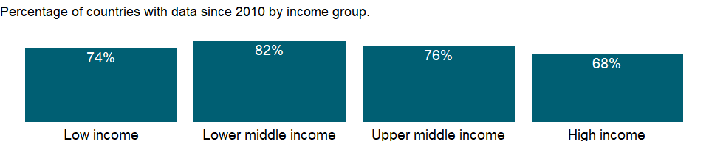

### Why is it relevant?

NA

### What is the data source?

World Bank staff estimates using the World Integrated Trade Solution system, based on data from World Trade Organization.

### What is the methodology?

NA

### How is it aggregated?

NA

### What are the limitations?

NA

### What else should I know?

NA

### 1.86.2 Bound rate, simple mean, manufactured products (%)

### What is the indicator?

Simple mean bound rate is the unweighted average of all the lines in the tariff schedule in which bound rates have been set. Bound rates result from trade negotiations incorporated into a country’s schedule of concessions and are thus enforceable. Manufactured products are commodities classified in SITC revision 3 sections 5-8 excluding division 68.

Topic: Private Sector & Trade: Tariffs

Series ID: TM.TAX.MANF.BR.ZS

Copyright: CC BY-4.0 , <https://datacatalog.worldbank.org/public-licenses#cc-by>

First year with any data: 1995

Last year with any data: 2019

### What years are data available?

The figure below shows years in which data is available for at least one country. Dates shaded in black have no data, while dates shaded in green have data for at least one country



### Which countries have data?

The figure below shows the percentage of countries in each income group with a value since 2010 for that indicator.

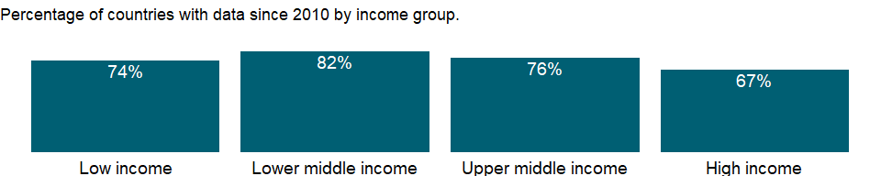

### Why is it relevant?

NA

### What is the data source?

World Bank staff estimates using the World Integrated Trade Solution system, based on data from World Trade Organization.

### What is the methodology?

NA

### How is it aggregated?

NA

### What are the limitations?

NA

### What else should I know?

NA

### 1.86.3 Share of tariff lines with international peaks, manufactured products (%)

### What is the indicator?

Share of tariff lines with international peaks is the share of lines in the tariff schedule with tariff rates that exceed 15 percent. It provides an indication of how selectively tariffs are applied. Manufactured products are commodities classified in SITC revision 3 sections 5-8 excluding division 68.

Topic: Private Sector & Trade: Tariffs

Series ID: TM.TAX.MANF.IP.ZS

Copyright: CC BY-4.0 , <https://datacatalog.worldbank.org/public-licenses#cc-by>

First year with any data: 1988

Last year with any data: 2019

### What years are data available?

The figure below shows years in which data is available for at least one country. Dates shaded in black have no data, while dates shaded in green have data for at least one country



### Which countries have data?

The figure below shows the percentage of countries in each income group with a value since 2010 for that indicator.

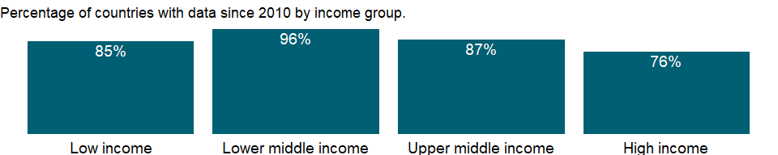

### Why is it relevant?

NA

### What is the data source?

World Bank staff estimates using the World Integrated Trade Solution system, based on data from United Nations Conference on Trade and Development’s Trade Analysis and Information System (TRAINS) database.

### What is the methodology?

NA

### How is it aggregated?

NA

### What are the limitations?

NA

### What else should I know?

NA

### 1.86.4 Tariff rate, applied, simple mean, manufactured products (%)

### What is the indicator?

Simple mean applied tariff is the unweighted average of effectively applied rates for all products subject to tariffs calculated for all traded goods. Data are classified using the Harmonized System of trade at the six- or eight-digit level. Tariff line data were matched to Standard International Trade Classification (SITC) revision 3 codes to define commodity groups. Effectively applied tariff rates at the six- and eight-digit product level are averaged for products in each commodity group. When the effectively applied rate is unavailable, the most favored nation rate is used instead. To the extent possible, specific rates have been converted to their ad valorem equivalent rates and have been included in the calculation of simple mean tariffs. Manufactured products are commodities classified in SITC revision 3 sections 5-8 excluding division 68.

Topic: Private Sector & Trade: Tariffs

Series ID: TM.TAX.MANF.SM.AR.ZS

Copyright: CC BY-4.0 , <https://datacatalog.worldbank.org/public-licenses#cc-by>

First year with any data: 1988

Last year with any data: 2019

### What years are data available?

The figure below shows years in which data is available for at least one country. Dates shaded in black have no data, while dates shaded in green have data for at least one country



### Which countries have data?

The figure below shows the percentage of countries in each income group with a value since 2010 for that indicator.



### Why is it relevant?

NA

### What is the data source?

World Bank staff estimates using the World Integrated Trade Solution system, based on data from United Nations Conference on Trade and Development’s Trade Analysis and Information System (TRAINS) database and the World Trade Organization’s (WTO) Integrated Data Base (IDB) and Consolidated Tariff Schedules (CTS) database.

### What is the methodology?

NA

### How is it aggregated?

NA

### What are the limitations?

NA

### What else should I know?

NA

### 1.86.5 Tariff rate, most favored nation, simple mean, manufactured products (%)

### What is the indicator?

Simple mean most favored nation tariff rate is the unweighted average of most favored nation rates for all products subject to tariffs calculated for all traded goods. Data are classified using the Harmonized System of trade at the six- or eight-digit level. Tariff line data were matched to Standard International Trade Classification (SITC) revision 3 codes to define commodity groups. Manufactured products are commodities classified in SITC revision 3 sections 5-8 excluding division 68.

Topic: Private Sector & Trade: Tariffs

Series ID: TM.TAX.MANF.SM.FN.ZS

Copyright: CC BY-4.0 , <https://datacatalog.worldbank.org/public-licenses#cc-by>

First year with any data: 1988

Last year with any data: 2019

### What years are data available?

The figure below shows years in which data is available for at least one country. Dates shaded in black have no data, while dates shaded in green have data for at least one country



### Which countries have data?

The figure below shows the percentage of countries in each income group with a value since 2010 for that indicator.

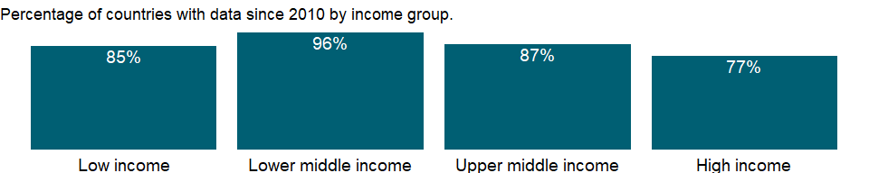

### Why is it relevant?

NA

### What is the data source?

World Bank staff estimates using the World Integrated Trade Solution system, based on data from United Nations Conference on Trade and Development’s Trade Analysis and Information System (TRAINS) database and the World Trade Organization’s (WTO) Integrated Data Base (IDB) and Consolidated Tariff Schedules (CTS) database.

### What is the methodology?

NA

### How is it aggregated?

NA

### What are the limitations?

NA

### What else should I know?

NA

### 1.86.6 Share of tariff lines with specific rates, manufactured products (%)

### What is the indicator?

Share of tariff lines with specific rates is the share of lines in the tariff schedule that are set on a per unit basis or that combine ad valorem and per unit rates. It shows the extent to which countries use tariffs based on physical quantities or other, non-ad valorem measures. Manufactured products are commodities classified in SITC revision 3 sections 5-8 excluding division 68.

Topic: Private Sector & Trade: Tariffs

Series ID: TM.TAX.MANF.SR.ZS

Copyright: CC BY-4.0 , <https://datacatalog.worldbank.org/public-licenses#cc-by>

First year with any data: 1988

Last year with any data: 2019

### What years are data available?

The figure below shows years in which data is available for at least one country. Dates shaded in black have no data, while dates shaded in green have data for at least one country



### Which countries have data?

The figure below shows the percentage of countries in each income group with a value since 2010 for that indicator.



### Why is it relevant?

NA

### What is the data source?

World Bank staff estimates using the World Integrated Trade Solution system, based on data from United Nations Conference on Trade and Development’s Trade Analysis and Information System (TRAINS) database.

### What is the methodology?

NA

### How is it aggregated?

NA

### What are the limitations?

NA

### What else should I know?

NA

### 1.86.7 Tariff rate, applied, weighted mean, manufactured products (%)

### What is the indicator?

Weighted mean applied tariff is the average of effectively applied rates weighted by the product import shares corresponding to each partner country. Data are classified using the Harmonized System of trade at the six- or eight-digit level. Tariff line data were matched to Standard International Trade Classification (SITC) revision 3 codes to define commodity groups and import weights. To the extent possible, specific rates have been converted to their ad valorem equivalent rates and have been included in the calculation of weighted mean tariffs. Import weights were calculated using the United Nations Statistics Division’s Commodity Trade (Comtrade) database. Effectively applied tariff rates at the six- and eight-digit product level are averaged for products in each commodity group. When the effectively applied rate is unavailable, the most favored nation rate is used instead. Manufactured products are commodities classified in SITC revision 3 sections 5-8 excluding division 68.

Topic: Private Sector & Trade: Tariffs

Series ID: TM.TAX.MANF.WM.AR.ZS

Copyright: CC BY-4.0 , <https://datacatalog.worldbank.org/public-licenses#cc-by>

First year with any data: 1988

Last year with any data: 2019

### What years are data available?

The figure below shows years in which data is available for at least one country. Dates shaded in black have no data, while dates shaded in green have data for at least one country



### Which countries have data?

The figure below shows the percentage of countries in each income group with a value since 2010 for that indicator.



### Why is it relevant?

NA

### What is the data source?

World Bank staff estimates using the World Integrated Trade Solution system, based on data from United Nations Conference on Trade and Development’s Trade Analysis and Information System (TRAINS) database and the World Trade Organization’s (WTO) Integrated Data Base (IDB) and Consolidated Tariff Schedules (CTS) database.

### What is the methodology?

NA

### How is it aggregated?

NA

### What are the limitations?

NA

### What else should I know?

NA

### 1.86.8 Tariff rate, most favored nation, weighted mean, manufactured products (%)

### What is the indicator?

Weighted mean most favored nations tariff is the average of most favored nation rates weighted by the product import shares corresponding to each partner country. Data are classified using the Harmonized System of trade at the six- or eight-digit level. Tariff line data were matched to Standard International Trade Classification (SITC) revision 3 codes to define commodity groups and import weights. Import weights were calculated using the United Nations Statistics Division’s Commodity Trade (Comtrade) database. Manufactured products are commodities classified in SITC revision 3 sections 5-8 excluding division 68.

Topic: Private Sector & Trade: Tariffs

Series ID: TM.TAX.MANF.WM.FN.ZS

Copyright: CC BY-4.0 , <https://datacatalog.worldbank.org/public-licenses#cc-by>

First year with any data: 1988

Last year with any data: 2019

### What years are data available?

The figure below shows years in which data is available for at least one country. Dates shaded in black have no data, while dates shaded in green have data for at least one country



### Which countries have data?

The figure below shows the percentage of countries in each income group with a value since 2010 for that indicator.



### Why is it relevant?

NA

### What is the data source?

World Bank staff estimates using the World Integrated Trade Solution system, based on data from United Nations Conference on Trade and Development’s Trade Analysis and Information System (TRAINS) database and the World Trade Organization’s (WTO) Integrated Data Base (IDB) and Consolidated Tariff Schedules (CTS) database.

### What is the methodology?

NA

### How is it aggregated?

NA

### What are the limitations?

NA

### What else should I know?

NA

### 1.86.9 Binding coverage, all products (%)

### What is the indicator?

Binding coverage is the percentage of product lines with an agreed bound rate. Bound rates result from trade negotiations incorporated into a country’s schedule of concessions and are thus enforceable.

Topic: Private Sector & Trade: Tariffs

Series ID: TM.TAX.MRCH.BC.ZS

Copyright: CC BY-4.0 , <https://datacatalog.worldbank.org/public-licenses#cc-by>

First year with any data: 1995

Last year with any data: 2019

### What years are data available?

The figure below shows years in which data is available for at least one country. Dates shaded in black have no data, while dates shaded in green have data for at least one country



### Which countries have data?

The figure below shows the percentage of countries in each income group with a value since 2010 for that indicator.



### Why is it relevant?

NA

### What is the data source?

World Bank staff estimates using the World Integrated Trade Solution system, based on data from World Trade Organization.

### What is the methodology?

NA

### How is it aggregated?

NA

### What are the limitations?

NA

### What else should I know?

NA

### 1.86.10 Bound rate, simple mean, all products (%)

### What is the indicator?

Simple mean bound rate is the unweighted average of all the lines in the tariff schedule in which bound rates have been set. Bound rates result from trade negotiations incorporated into a country’s schedule of concessions and are thus enforceable.

Topic: Private Sector & Trade: Tariffs

Series ID: TM.TAX.MRCH.BR.ZS

Copyright: CC BY-4.0 , <https://datacatalog.worldbank.org/public-licenses#cc-by>

First year with any data: 1995

Last year with any data: 2019

### What years are data available?

The figure below shows years in which data is available for at least one country. Dates shaded in black have no data, while dates shaded in green have data for at least one country



### Which countries have data?

The figure below shows the percentage of countries in each income group with a value since 2010 for that indicator.



### Why is it relevant?

NA

### What is the data source?

World Bank staff estimates using the World Integrated Trade Solution system, based on data from World Trade Organization.

### What is the methodology?

NA

### How is it aggregated?

NA

### What are the limitations?

NA

### What else should I know?

NA

### 1.86.11 Share of tariff lines with international peaks, all products (%)

### What is the indicator?

Share of tariff lines with international peaks is the share of lines in the tariff schedule with tariff rates that exceed 15 percent. It provides an indication of how selectively tariffs are applied.

Topic: Private Sector & Trade: Tariffs

Series ID: TM.TAX.MRCH.IP.ZS

Copyright: CC BY-4.0 , <https://datacatalog.worldbank.org/public-licenses#cc-by>

First year with any data: 1988

Last year with any data: 2019

### What years are data available?

The figure below shows years in which data is available for at least one country. Dates shaded in black have no data, while dates shaded in green have data for at least one country



### Which countries have data?

The figure below shows the percentage of countries in each income group with a value since 2010 for that indicator.



### Why is it relevant?

NA

### What is the data source?

World Bank staff estimates using the World Integrated Trade Solution system, based on data from United Nations Conference on Trade and Development’s Trade Analysis and Information System (TRAINS) database.

### What is the methodology?

NA

### How is it aggregated?

NA

### What are the limitations?

NA

### What else should I know?

NA

### 1.86.12 Tariff rate, applied, simple mean, all products (%)

### What is the indicator?

Simple mean applied tariff is the unweighted average of effectively applied rates for all products subject to tariffs calculated for all traded goods. Data are classified using the Harmonized System of trade at the six- or eight-digit level. Tariff line data were matched to Standard International Trade Classification (SITC) revision 3 codes to define commodity groups. Effectively applied tariff rates at the six- and eight-digit product level are averaged for products in each commodity group. When the effectively applied rate is unavailable, the most favored nation rate is used instead. To the extent possible, specific rates have been converted to their ad valorem equivalent rates and have been included in the calculation of simple mean tariffs.

Topic: Private Sector & Trade: Tariffs

Series ID: TM.TAX.MRCH.SM.AR.ZS

Copyright: CC BY-4.0 , <https://datacatalog.worldbank.org/public-licenses#cc-by>

First year with any data: 1988

Last year with any data: 2019

### What years are data available?

The figure below shows years in which data is available for at least one country. Dates shaded in black have no data, while dates shaded in green have data for at least one country



### Which countries have data?

The figure below shows the percentage of countries in each income group with a value since 2010 for that indicator.



### Why is it relevant?

Poor people in developing countries work primarily in agriculture and labor-intensive manufactures, sectors that confront the greatest trade barriers. Removing barriers to merchandise trade could increase growth in these countries - even more if trade in services were also liberalized.

In general, tariffs in high-income countries on imports from developing countries, though low, are twice those collected from other high-income countries. But protection is also an issue for developing countries, which maintain high tariffs on agricultural commodities, labor-intensive manufactures, and other products and services.

Countries use a combination of tariff and nontariff measures to regulate imports. The most common form of tariff is an ad valorem duty, based on the value of the import, but tariffs may also be levied on a specific, or per unit, basis or may combine ad valorem and specific rates. Tariffs may be used to raise fiscal revenues or to protect domestic industries from foreign competition - or both. Nontariff barriers, which limit the quantity of imports of a particular good, include quotas, prohibitions, licensing schemes, export restraint arrangements, and health and quarantine measures. Because of the difficulty of combining nontariff barriers into an aggregate indicator, they are not included in the data.

Some countries set fairly uniform tariff rates across all imports. Others are selective, setting high tariffs to protect favored domestic industries. The effective rate of protection - the degree to which the value added in an industry is protected - may exceed the nominal rate if the tariff system systematically differentiates among imports of raw materials, intermediate products, and finished goods.

### What is the data source?

World Bank staff estimates using the World Integrated Trade Solution system, based on data from United Nations Conference on Trade and Development’s Trade Analysis and Information System (TRAINS) database and the World Trade Organization’s (WTO) Integrated Data Base (IDB) and Consolidated Tariff Schedules (CTS) database.

### What is the methodology?

Simple averages are often a better indicator of tariff protection than weighted averages, which are biased downward because higher tariffs discourage trade and reduce the weights applied to these tariffs.

### How is it aggregated?

NA

### What are the limitations?

NA

### What else should I know?

NA

### 1.86.13 Tariff rate, most favored nation, simple mean, all products (%)

### What is the indicator?

Simple mean most favored nation tariff rate is the unweighted average of most favored nation rates for all products subject to tariffs calculated for all traded goods. Data are classified using the Harmonized System of trade at the six- or eight-digit level. Tariff line data were matched to Standard International Trade Classification (SITC) revision 3 codes to define commodity groups.

Topic: Private Sector & Trade: Tariffs

Series ID: TM.TAX.MRCH.SM.FN.ZS

Copyright: CC BY-4.0 , <https://datacatalog.worldbank.org/public-licenses#cc-by>

First year with any data: 1988

Last year with any data: 2019

### What years are data available?

The figure below shows years in which data is available for at least one country. Dates shaded in black have no data, while dates shaded in green have data for at least one country



### Which countries have data?

The figure below shows the percentage of countries in each income group with a value since 2010 for that indicator.



### Why is it relevant?

NA

### What is the data source?

World Bank staff estimates using the World Integrated Trade Solution system, based on data from United Nations Conference on Trade and Development’s Trade Analysis and Information System (TRAINS) database and the World Trade Organization’s (WTO) Integrated Data Base (IDB) and Consolidated Tariff Schedules (CTS) database.

### What is the methodology?

NA

### How is it aggregated?

NA

### What are the limitations?

NA

### What else should I know?

NA

### 1.86.14 Share of tariff lines with specific rates, all products (%)

### What is the indicator?

Share of tariff lines with specific rates is the share of lines in the tariff schedule that are set on a per unit basis or that combine ad valorem and per unit rates. It shows the extent to which countries use tariffs based on physical quantities or other, non-ad valorem measures.

Topic: Private Sector & Trade: Tariffs

Series ID: TM.TAX.MRCH.SR.ZS

Copyright: CC BY-4.0 , <https://datacatalog.worldbank.org/public-licenses#cc-by>

First year with any data: 1988

Last year with any data: 2019

### What years are data available?

The figure below shows years in which data is available for at least one country. Dates shaded in black have no data, while dates shaded in green have data for at least one country



### Which countries have data?

The figure below shows the percentage of countries in each income group with a value since 2010 for that indicator.



### Why is it relevant?

NA

### What is the data source?

World Bank staff estimates using the World Integrated Trade Solution system, based on data from United Nations Conference on Trade and Development’s Trade Analysis and Information System (TRAINS) database.

### What is the methodology?

NA

### How is it aggregated?

NA

### What are the limitations?

NA

### What else should I know?

NA

### 1.86.15 Tariff rate, applied, weighted mean, all products (%)

### What is the indicator?

Weighted mean applied tariff is the average of effectively applied rates weighted by the product import shares corresponding to each partner country. Data are classified using the Harmonized System of trade at the six- or eight-digit level. Tariff line data were matched to Standard International Trade Classification (SITC) revision 3 codes to define commodity groups and import weights. To the extent possible, specific rates have been converted to their ad valorem equivalent rates and have been included in the calculation of weighted mean tariffs. Import weights were calculated using the United Nations Statistics Division’s Commodity Trade (Comtrade) database. Effectively applied tariff rates at the six- and eight-digit product level are averaged for products in each commodity group. When the effectively applied rate is unavailable, the most favored nation rate is used instead.

Topic: Private Sector & Trade: Tariffs

Series ID: TM.TAX.MRCH.WM.AR.ZS

Copyright: CC BY-4.0 , <https://datacatalog.worldbank.org/public-licenses#cc-by>

First year with any data: 1988

Last year with any data: 2019

### What years are data available?

The figure below shows years in which data is available for at least one country. Dates shaded in black have no data, while dates shaded in green have data for at least one country



### Which countries have data?

The figure below shows the percentage of countries in each income group with a value since 2010 for that indicator.



### Why is it relevant?

NA

### What is the data source?

World Bank staff estimates using the World Integrated Trade Solution system, based on data from United Nations Conference on Trade and Development’s Trade Analysis and Information System (TRAINS) database and the World Trade Organization’s (WTO) Integrated Data Base (IDB) and Consolidated Tariff Schedules (CTS) database.

### What is the methodology?

NA

### How is it aggregated?

NA

### What are the limitations?

NA

### What else should I know?

NA

### 1.86.16 Tariff rate, most favored nation, weighted mean, all products (%)

### What is the indicator?

Weighted mean most favored nations tariff is the average of most favored nation rates weighted by the product import shares corresponding to each partner country. Data are classified using the Harmonized System of trade at the six- or eight-digit level. Tariff line data were matched to Standard International Trade Classification (SITC) revision 3 codes to define commodity groups and import weights. Import weights were calculated using the United Nations Statistics Division’s Commodity Trade (Comtrade) database.

Topic: Private Sector & Trade: Tariffs

Series ID: TM.TAX.MRCH.WM.FN.ZS

Copyright: CC BY-4.0 , <https://datacatalog.worldbank.org/public-licenses#cc-by>

First year with any data: 1988

Last year with any data: 2019

### What years are data available?

The figure below shows years in which data is available for at least one country. Dates shaded in black have no data, while dates shaded in green have data for at least one country



### Which countries have data?

The figure below shows the percentage of countries in each income group with a value since 2010 for that indicator.



### Why is it relevant?

NA

### What is the data source?

World Bank staff estimates using the World Integrated Trade Solution system, based on data from United Nations Conference on Trade and Development’s Trade Analysis and Information System (TRAINS) database and the World Trade Organization’s (WTO) Integrated Data Base (IDB) and Consolidated Tariff Schedules (CTS) database.

### What is the methodology?

NA

### How is it aggregated?

NA

### What are the limitations?

NA

### What else should I know?

NA

### 1.86.17 Binding coverage, primary products (%)

### What is the indicator?

Binding coverage is the percentage of product lines with an agreed bound rate. Bound rates result from trade negotiations incorporated into a country’s schedule of concessions and are thus enforceable. Primary products are commodities classified in SITC revision 3 sections 0-4 plus division 68 (nonferrous metals).

Topic: Private Sector & Trade: Tariffs

Series ID: TM.TAX.TCOM.BC.ZS

Copyright: CC BY-4.0 , <https://datacatalog.worldbank.org/public-licenses#cc-by>

First year with any data: 1995

Last year with any data: 2019

### What years are data available?

The figure below shows years in which data is available for at least one country. Dates shaded in black have no data, while dates shaded in green have data for at least one country



### Which countries have data?

The figure below shows the percentage of countries in each income group with a value since 2010 for that indicator.



### Why is it relevant?

NA

### What is the data source?

World Bank staff estimates using the World Integrated Trade Solution system, based on data from World Trade Organization.

### What is the methodology?

NA

### How is it aggregated?

NA

### What are the limitations?

NA

### What else should I know?

NA

### 1.86.18 Bound rate, simple mean, primary products (%)

### What is the indicator?

Simple mean bound rate is the unweighted average of all the lines in the tariff schedule in which bound rates have been set. Bound rates result from trade negotiations incorporated into a country’s schedule of concessions and are thus enforceable. Primary products are commodities classified in SITC revision 3 sections 0-4 plus division 68 (nonferrous metals).

Topic: Private Sector & Trade: Tariffs

Series ID: TM.TAX.TCOM.BR.ZS

Copyright: CC BY-4.0 , <https://datacatalog.worldbank.org/public-licenses#cc-by>

First year with any data: 1995

Last year with any data: 2019

### What years are data available?

The figure below shows years in which data is available for at least one country. Dates shaded in black have no data, while dates shaded in green have data for at least one country



### Which countries have data?

The figure below shows the percentage of countries in each income group with a value since 2010 for that indicator.



### Why is it relevant?

NA

### What is the data source?

World Bank staff estimates using the World Integrated Trade Solution system, based on data from World Trade Organization.

### What is the methodology?

NA

### How is it aggregated?

NA

### What are the limitations?

NA

### What else should I know?

NA

### 1.86.19 Share of tariff lines with international peaks, primary products (%)

### What is the indicator?

Share of tariff lines with international peaks is the share of lines in the tariff schedule with tariff rates that exceed 15 percent. It provides an indication of how selectively tariffs are applied. Primary products are commodities classified in SITC revision 3 sections 0-4 plus division 68 (nonferrous metals).

Topic: Private Sector & Trade: Tariffs

Series ID: TM.TAX.TCOM.IP.ZS

Copyright: CC BY-4.0 , <https://datacatalog.worldbank.org/public-licenses#cc-by>

First year with any data: 1988

Last year with any data: 2019

### What years are data available?

The figure below shows years in which data is available for at least one country. Dates shaded in black have no data, while dates shaded in green have data for at least one country



### Which countries have data?

The figure below shows the percentage of countries in each income group with a value since 2010 for that indicator.



### Why is it relevant?

NA

### What is the data source?

World Bank staff estimates using the World Integrated Trade Solution system, based on data from United Nations Conference on Trade and Development’s Trade Analysis and Information System (TRAINS) database.

### What is the methodology?

NA

### How is it aggregated?

NA

### What are the limitations?

NA

### What else should I know?

NA

### 1.86.20 Tariff rate, applied, simple mean, primary products (%)

### What is the indicator?

Simple mean applied tariff is the unweighted average of effectively applied rates for all products subject to tariffs calculated for all traded goods. Data are classified using the Harmonized System of trade at the six- or eight-digit level. Tariff line data were matched to Standard International Trade Classification (SITC) revision 3 codes to define commodity groups. Effectively applied tariff rates at the six- and eight-digit product level are averaged for products in each commodity group. When the effectively applied rate is unavailable, the most favored nation rate is used instead. To the extent possible, specific rates have been converted to their ad valorem equivalent rates and have been included in the calculation of simple mean tariffs. Primary products are commodities classified in SITC revision 3 sections 0-4 plus division 68 (nonferrous metals).

Topic: Private Sector & Trade: Tariffs

Series ID: TM.TAX.TCOM.SM.AR.ZS

Copyright: CC BY-4.0 , <https://datacatalog.worldbank.org/public-licenses#cc-by>

First year with any data: 1988

Last year with any data: 2019

### What years are data available?

The figure below shows years in which data is available for at least one country. Dates shaded in black have no data, while dates shaded in green have data for at least one country



### Which countries have data?

The figure below shows the percentage of countries in each income group with a value since 2010 for that indicator.



### Why is it relevant?

NA

### What is the data source?

World Bank staff estimates using the World Integrated Trade Solution system, based on data from United Nations Conference on Trade and Development’s Trade Analysis and Information System (TRAINS) database and the World Trade Organization’s (WTO) Integrated Data Base (IDB) and Consolidated Tariff Schedules (CTS) database.

### What is the methodology?

NA

### How is it aggregated?

NA

### What are the limitations?

NA

### What else should I know?

NA

### 1.86.21 Tariff rate, most favored nation, simple mean, primary products (%)

### What is the indicator?

Simple mean most favored nation tariff rate is the unweighted average of most favored nation rates for all products subject to tariffs calculated for all traded goods. Data are classified using the Harmonized System of trade at the six- or eight-digit level. Tariff line data were matched to Standard International Trade Classification (SITC) revision 3 codes to define commodity groups. Primary products are commodities classified in SITC revision 3 sections 0-4 plus division 68 (nonferrous metals).

Topic: Private Sector & Trade: Tariffs

Series ID: TM.TAX.TCOM.SM.FN.ZS

Copyright: CC BY-4.0 , <https://datacatalog.worldbank.org/public-licenses#cc-by>

First year with any data: 1988

Last year with any data: 2019

### What years are data available?

The figure below shows years in which data is available for at least one country. Dates shaded in black have no data, while dates shaded in green have data for at least one country



### Which countries have data?

The figure below shows the percentage of countries in each income group with a value since 2010 for that indicator.



### Why is it relevant?

NA

### What is the data source?

World Bank staff estimates using the World Integrated Trade Solution system, based on data from United Nations Conference on Trade and Development’s Trade Analysis and Information System (TRAINS) database and the World Trade Organization’s (WTO) Integrated Data Base (IDB) and Consolidated Tariff Schedules (CTS) database.

### What is the methodology?

NA

### How is it aggregated?

NA

### What are the limitations?

NA

### What else should I know?

NA

### 1.86.22 Share of tariff lines with specific rates, primary products (%)

### What is the indicator?

Share of tariff lines with specific rates is the share of lines in the tariff schedule that are set on a per unit basis or that combine ad valorem and per unit rates. It shows the extent to which countries use tariffs based on physical quantities or other, non-ad valorem measures. Primary products are commodities classified in SITC revision 3 sections 0-4 plus division 68 (nonferrous metals).

Topic: Private Sector & Trade: Tariffs

Series ID: TM.TAX.TCOM.SR.ZS

Copyright: CC BY-4.0 , <https://datacatalog.worldbank.org/public-licenses#cc-by>

First year with any data: 1988

Last year with any data: 2019

### What years are data available?

The figure below shows years in which data is available for at least one country. Dates shaded in black have no data, while dates shaded in green have data for at least one country



### Which countries have data?

The figure below shows the percentage of countries in each income group with a value since 2010 for that indicator.



### Why is it relevant?

NA

### What is the data source?

World Bank staff estimates using the World Integrated Trade Solution system, based on data from United Nations Conference on Trade and Development’s Trade Analysis and Information System (TRAINS) database.

### What is the methodology?

NA

### How is it aggregated?

NA

### What are the limitations?

NA

### What else should I know?

NA

### 1.86.23 Tariff rate, applied, weighted mean, primary products (%)

### What is the indicator?

Weighted mean applied tariff is the average of effectively applied rates weighted by the product import shares corresponding to each partner country. Data are classified using the Harmonized System of trade at the six- or eight-digit level. Tariff line data were matched to Standard International Trade Classification (SITC) revision 3 codes to define commodity groups and import weights. To the extent possible, specific rates have been converted to their ad valorem equivalent rates and have been included in the calculation of weighted mean tariffs. Import weights were calculated using the United Nations Statistics Division’s Commodity Trade (Comtrade) database. Effectively applied tariff rates at the six- and eight-digit product level are averaged for products in each commodity group. When the effectively applied rate is unavailable, the most favored nation rate is used instead. Primary products are commodities classified in SITC revision 3 sections 0-4 plus division 68 (nonferrous metals).

Topic: Private Sector & Trade: Tariffs

Series ID: TM.TAX.TCOM.WM.AR.ZS

Copyright: CC BY-4.0 , <https://datacatalog.worldbank.org/public-licenses#cc-by>

First year with any data: 1988

Last year with any data: 2019

### What years are data available?

The figure below shows years in which data is available for at least one country. Dates shaded in black have no data, while dates shaded in green have data for at least one country



### Which countries have data?

The figure below shows the percentage of countries in each income group with a value since 2010 for that indicator.



### Why is it relevant?

NA

### What is the data source?

World Bank staff estimates using the World Integrated Trade Solution system, based on data from United Nations Conference on Trade and Development’s Trade Analysis and Information System (TRAINS) database and the World Trade Organization’s (WTO) Integrated Data Base (IDB) and Consolidated Tariff Schedules (CTS) database.

### What is the methodology?

NA

### How is it aggregated?

NA

### What are the limitations?

NA

### What else should I know?

NA

### 1.86.24 Tariff rate, most favored nation, weighted mean, primary products (%)

### What is the indicator?

Weighted mean most favored nations tariff is the average of most favored nation rates weighted by the product import shares corresponding to each partner country. Data are classified using the Harmonized System of trade at the six- or eight-digit level. Tariff line data were matched to Standard International Trade Classification (SITC) revision 3 codes to define commodity groups and import weights. Import weights were calculated using the United Nations Statistics Division’s Commodity Trade (Comtrade) database. Primary products are commodities classified in SITC revision 3 sections 0-4 plus division 68 (nonferrous metals).

Topic: Private Sector & Trade: Tariffs

Series ID: TM.TAX.TCOM.WM.FN.ZS

Copyright: CC BY-4.0 , <https://datacatalog.worldbank.org/public-licenses#cc-by>

First year with any data: 1988

Last year with any data: 2019

### What years are data available?

The figure below shows years in which data is available for at least one country. Dates shaded in black have no data, while dates shaded in green have data for at least one country



### Which countries have data?

The figure below shows the percentage of countries in each income group with a value since 2010 for that indicator.



### Why is it relevant?

NA

### What is the data source?

World Bank staff estimates using the World Integrated Trade Solution system, based on data from United Nations Conference on Trade and Development’s Trade Analysis and Information System (TRAINS) database and the World Trade Organization’s (WTO) Integrated Data Base (IDB) and Consolidated Tariff Schedules (CTS) database.

### What is the methodology?

NA

### How is it aggregated?

NA

### What are the limitations?

NA

### What else should I know?

NA

## 1.87 Private Sector & Trade: Trade price indices

### 1.87.1 Import unit value index (2000 = 100)

### What is the indicator?

Import unit value indices come from UNCTAD’s trade database. Unit value indices are based on data reported by countries that demonstrate consistency under UNCTAD quality controls, supplemented by UNCTAD’s estimates using the previous year’s trade values at the Standard International Trade Classification three-digit level as weights. To improve data coverage, especially for the latest periods, UNCTAD constructs a set of average prices indexes at the three-digit product classification of the Standard International Trade Classification revision 3 using UNCTAD’s Commodity Price Statistics, interna¬tional and national sources, and UNCTAD secretariat estimates.

Topic: Private Sector & Trade: Trade price indices

Series ID: TM.UVI.MRCH.XD.WD

Copyright: CC BY-4.0 , <https://datacatalog.worldbank.org/public-licenses#cc-by>

First year with any data: 1980

Last year with any data: 2019

### What years are data available?

The figure below shows years in which data is available for at least one country. Dates shaded in black have no data, while dates shaded in green have data for at least one country



### Which countries have data?

The figure below shows the percentage of countries in each income group with a value since 2010 for that indicator.

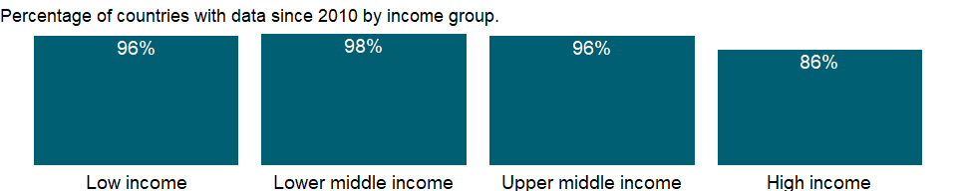

### Why is it relevant?

NA

### What is the data source?

United Nations Conference on Trade and Development, Handbook of Statistics and data files. (<http://unctadstat.unctad.org>)

### What is the methodology?

NA

### How is it aggregated?

NA

### What are the limitations?

NA

### What else should I know?

NA

### 1.87.2 Export unit value index (2000 = 100)

### What is the indicator?

Export unit value indices come from UNCTAD’s trade database. Unit value indices are based on data reported by countries that demonstrate consistency under UNCTAD quality controls, supplemented by UNCTAD’s estimates using the previous year’s trade values at the Standard International Trade Classification three-digit level as weights. To improve data coverage, especially for the latest periods, UNCTAD constructs a set of average prices indexes at the three-digit product classification of the Standard International Trade Classification revision 3 using UNCTAD’s Commodity Price Statistics, interna¬tional and national sources, and UNCTAD secretariat estimates.

Topic: Private Sector & Trade: Trade price indices

Series ID: TX.UVI.MRCH.XD.WD

Copyright: CC BY-4.0 , <https://datacatalog.worldbank.org/public-licenses#cc-by>

First year with any data: 1980

Last year with any data: 2019

### What years are data available?

The figure below shows years in which data is available for at least one country. Dates shaded in black have no data, while dates shaded in green have data for at least one country



### Which countries have data?

The figure below shows the percentage of countries in each income group with a value since 2010 for that indicator.

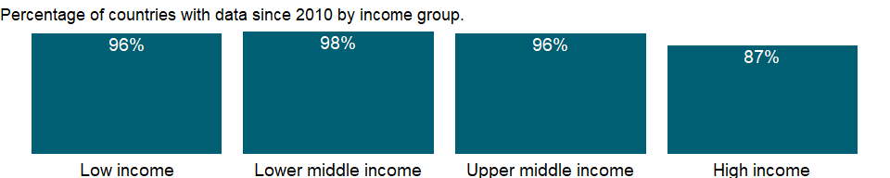

### Why is it relevant?

NA

### What is the data source?

United Nations Conference on Trade and Development, Handbook of Statistics and data files. (<http://unctadstat.unctad.org>)

### What is the methodology?

NA

### How is it aggregated?

NA

### What are the limitations?

NA

### What else should I know?

NA

## 1.88 Private Sector & Trade: Imports

### 1.88.1 Agricultural raw materials imports (% of merchandise imports)

### What is the indicator?

Agricultural raw materials comprise SITC section 2 (crude materials except fuels) excluding divisions 22, 27 (crude fertilizers and minerals excluding coal, petroleum, and precious stones), and 28 (metalliferous ores and scrap).

Topic: Private Sector & Trade: Imports

Series ID: TM.VAL.AGRI.ZS.UN

Copyright: CC BY-4.0 , <https://datacatalog.worldbank.org/public-licenses#cc-by>

First year with any data: 1962

Last year with any data: 2020

### What years are data available?

The figure below shows years in which data is available for at least one country. Dates shaded in black have no data, while dates shaded in green have data for at least one country



### Which countries have data?

The figure below shows the percentage of countries in each income group with a value since 2010 for that indicator.

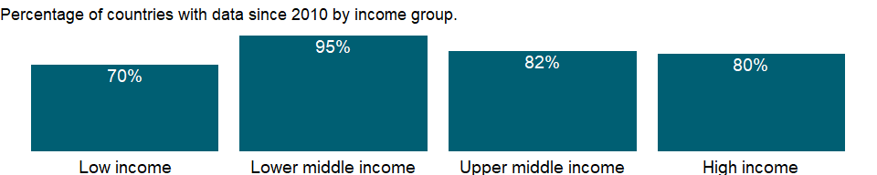

### Why is it relevant?

NA

### What is the data source?

World Bank staff estimates through the WITS platform from the Comtrade database maintained by the United Nations Statistics Division.

### What is the methodology?

The classification of commodity groups is based on the Standard International Trade Classification (SITC) revision 3.

### How is it aggregated?

Weighted average

### What are the limitations?

Previous editions contained data based on the SITC revision 1. Data for earlier years in previous editions may differ because of the change in methodology. Concordance tables are available to convert data reported in one system to another.

### What else should I know?

Merchandise import shares may not sum to 100 percent because of unclassified trade.

### 1.88.2 Food imports (% of merchandise imports)

### What is the indicator?

Food comprises the commodities in SITC sections 0 (food and live animals), 1 (beverages and tobacco), and 4 (animal and vegetable oils and fats) and SITC division 22 (oil seeds, oil nuts, and oil kernels).

Topic: Private Sector & Trade: Imports

Series ID: TM.VAL.FOOD.ZS.UN

Copyright: CC BY-4.0 , <https://datacatalog.worldbank.org/public-licenses#cc-by>

First year with any data: 1962

Last year with any data: 2020

### What years are data available?

The figure below shows years in which data is available for at least one country. Dates shaded in black have no data, while dates shaded in green have data for at least one country



### Which countries have data?

The figure below shows the percentage of countries in each income group with a value since 2010 for that indicator.



### Why is it relevant?

NA

### What is the data source?

World Bank staff estimates through the WITS platform from the Comtrade database maintained by the United Nations Statistics Division.

### What is the methodology?

The classification of commodity groups is based on the Standard International Trade Classification (SITC) revision 3.

### How is it aggregated?

Weighted average

### What are the limitations?

Previous editions contained data based on the SITC revision 1. Data for earlier years in previous editions may differ because of the change in methodology. Concordance tables are available to convert data reported in one system to another.

### What else should I know?

Merchandise import shares may not sum to 100 percent because of unclassified trade.

### 1.88.3 Fuel imports (% of merchandise imports)

### What is the indicator?

Fuels comprise the commodities in SITC section 3 (mineral fuels, lubricants and related materials).

Topic: Private Sector & Trade: Imports

Series ID: TM.VAL.FUEL.ZS.UN

Copyright: CC BY-4.0 , <https://datacatalog.worldbank.org/public-licenses#cc-by>

First year with any data: 1962

Last year with any data: 2020

### What years are data available?

The figure below shows years in which data is available for at least one country. Dates shaded in black have no data, while dates shaded in green have data for at least one country



### Which countries have data?

The figure below shows the percentage of countries in each income group with a value since 2010 for that indicator.



### Why is it relevant?

NA

### What is the data source?

World Bank staff estimates through the WITS platform from the Comtrade database maintained by the United Nations Statistics Division.

### What is the methodology?

The classification of commodity groups is based on the Standard International Trade Classification (SITC) revision 3.

### How is it aggregated?

Weighted average

### What are the limitations?

Previous editions contained data based on the SITC revision 1. Data for earlier years in previous editions may differ because of the change in methodology. Concordance tables are available to convert data reported in one system to another.

### What else should I know?

Merchandise import shares may not sum to 100 percent because of unclassified trade.

### 1.88.4 Insurance and financial services (% of commercial service imports)

### What is the indicator?

Insurance and financial services cover freight insurance on goods imported and other direct insurance such as life insurance; financial intermediation services such as commissions, foreign exchange transactions, and brokerage services; and auxiliary services such as financial market operational and regulatory services.

Topic: Private Sector & Trade: Imports

Series ID: TM.VAL.INSF.ZS.WT

Copyright: CC BY-4.0 , <https://datacatalog.worldbank.org/public-licenses#cc-by>

First year with any data: 1960

Last year with any data: 2020

### What years are data available?

The figure below shows years in which data is available for at least one country. Dates shaded in black have no data, while dates shaded in green have data for at least one country



### Which countries have data?

The figure below shows the percentage of countries in each income group with a value since 2010 for that indicator.



### Why is it relevant?

Trade in services differs from trade in goods because services are produced and consumed at the same time. Thus services to a traveler may be consumed in the producing country (for example, use of a hotel room) but are classified as imports of the traveler’s country. In other cases services may be supplied from a remote location; for example, insurance services may be supplied from one location and consumed in another.

### What is the data source?

International Monetary Fund, Balance of Payments Statistics Yearbook and data files.

### What is the methodology?

The balance of payments (BoP) is a double-entry accounting system that shows all flows of goods and services into and out of an economy; all transfers that are the counterpart of real resources or financial claims provided to or by the rest of the world without a quid pro quo, such as donations and grants; and all changes in residents’ claims on and liabilities to nonresidents that arise from economic transactions. All transactions are recorded twice - once as a credit and once as a debit. In principle the net balance should be zero, but in practice the accounts often do not balance, requiring inclusion of a balancing item, net errors and omissions.

The concepts and definitions underlying the data are based on the sixth edition of the International Monetary Fund’s (IMF) Balance of Payments Manual (BPM6). Balance of payments data for 2005 onward will be presented in accord with the BPM6. The historical BPM5 data series will end with data for 2008, which can be accessed through the World Development Indicators archives.

The complete balance of payments methodology can be accessed through the International Monetary Fund website (www.imf.org/external/np/sta/bop/bop.htm).

### How is it aggregated?

Weighted average

### What are the limitations?

Balance of payments statistics, the main source of information on international trade in services, have many weaknesses. Disaggregation of important components may be limited and varies considerably across countries. There are inconsistencies in the methods used to report items. And the recording of major flows as net items is common (for example, insurance transactions are often recorded as premiums less claims). These factors contribute to a downward bias in the value of the service trade reported in the balance of payments.

Efforts are being made to improve the coverage, quality, and consistency of these data. Eurostat and the Organisation for Economic Co-operation and Development, for example, are working together to improve the collection of statistics on trade in services in member countries.

Still, difficulties in capturing all the dimensions of international trade in services mean that the record is likely to remain incomplete. Cross-border intrafirm service transactions, which are usually not captured in the balance of payments, have increased in recent years. An example is transnational corporations’ use of mainframe computers around the clock for data processing, exploiting time zone differences between their home country and the host countries of their affiliates. Another important dimension of service trade not captured by conventional balance of payments statistics is establishment trade - sales in the host country by foreign affiliates. By contrast, cross-border intrafirm transactions in merchandise may be reported as exports or imports in the balance of payments.

### What else should I know?

NA

### 1.88.5 Manufactures imports (% of merchandise imports)

### What is the indicator?

Manufactures comprise the commodities in SITC sections 5 (chemicals), 6 (basic manufactures), 7 (machinery and transport equipment), and 8 (miscellaneous manufactured goods), excluding division 68 (nonferrous metals).

Topic: Private Sector & Trade: Imports

Series ID: TM.VAL.MANF.ZS.UN

Copyright: CC BY-4.0 , <https://datacatalog.worldbank.org/public-licenses#cc-by>

First year with any data: 1962

Last year with any data: 2020

### What years are data available?

The figure below shows years in which data is available for at least one country. Dates shaded in black have no data, while dates shaded in green have data for at least one country



### Which countries have data?

The figure below shows the percentage of countries in each income group with a value since 2010 for that indicator.



### Why is it relevant?

NA

### What is the data source?

World Bank staff estimates through the WITS platform from the Comtrade database maintained by the United Nations Statistics Division.

### What is the methodology?

The classification of commodity groups is based on the Standard International Trade Classification (SITC) revision 3.

### How is it aggregated?

Weighted average

### What are the limitations?

Previous editions contained data based on the SITC revision 1. Data for earlier years in previous editions may differ because of the change in methodology. Concordance tables are available to convert data reported in one system to another.

### What else should I know?

Merchandise import shares may not sum to 100 percent because of unclassified trade.

### 1.88.6 Ores and metals imports (% of merchandise imports)

### What is the indicator?

Ores and metals comprise commodities in SITC sections 27 (crude fertilizer, minerals nes); 28 (metalliferous ores, scrap); and 68 (non-ferrous metals).

Topic: Private Sector & Trade: Imports

Series ID: TM.VAL.MMTL.ZS.UN

Copyright: CC BY-4.0 , <https://datacatalog.worldbank.org/public-licenses#cc-by>

First year with any data: 1962

Last year with any data: 2020

### What years are data available?

The figure below shows years in which data is available for at least one country. Dates shaded in black have no data, while dates shaded in green have data for at least one country



### Which countries have data?

The figure below shows the percentage of countries in each income group with a value since 2010 for that indicator.



### Why is it relevant?

NA

### What is the data source?

World Bank staff estimates through the WITS platform from the Comtrade database maintained by the United Nations Statistics Division.

### What is the methodology?

The classification of commodity groups is based on the Standard International Trade Classification (SITC) revision 3.

### How is it aggregated?

Weighted average

### What are the limitations?

Previous editions contained data based on the SITC revision 1. Data for earlier years in previous editions may differ because of the change in methodology. Concordance tables are available to convert data reported in one system to another.

### What else should I know?

Merchandise import shares may not sum to 100 percent because of unclassified trade.

### 1.88.7 Merchandise imports from economies in the Arab World (% of total merchandise imports)

### What is the indicator?

Merchandise imports from economies in the Arab World are the sum of merchandise imports by the reporting economy from economies in the Arab World. Data are expressed as a percentage of total merchandise imports by the economy. Data are computed only if at least half of the economies in the partner country group had non-missing data.

Topic: Private Sector & Trade: Imports

Series ID: TM.VAL.MRCH.AL.ZS

Copyright: CC BY-4.0 , <https://datacatalog.worldbank.org/public-licenses#cc-by>

First year with any data: 1960

Last year with any data: 2019

### What years are data available?

The figure below shows years in which data is available for at least one country. Dates shaded in black have no data, while dates shaded in green have data for at least one country



### Which countries have data?

The figure below shows the percentage of countries in each income group with a value since 2010 for that indicator.

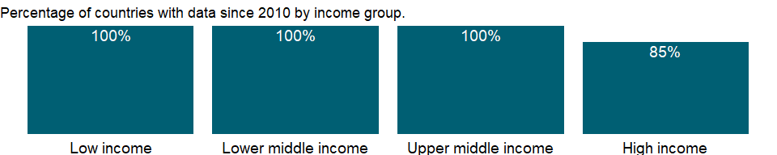

### Why is it relevant?

NA

### What is the data source?

World Bank staff estimates based data from International Monetary Fund’s Direction of Trade database.

### What is the methodology?

NA

### How is it aggregated?

Weighted average

### What are the limitations?

NA

### What else should I know?

NA

### 1.88.8 Merchandise imports (current US$)

### What is the indicator?

Merchandise imports show the c.i.f. value of goods received from the rest of the world valued in current U.S. dollars.

Topic: Private Sector & Trade: Imports

Series ID: TM.VAL.MRCH.CD.WT

Copyright: CC BY-4.0 , <https://datacatalog.worldbank.org/public-licenses#cc-by>

First year with any data: 1960

Last year with any data: 2020

### What years are data available?

The figure below shows years in which data is available for at least one country. Dates shaded in black have no data, while dates shaded in green have data for at least one country



### Which countries have data?

The figure below shows the percentage of countries in each income group with a value since 2010 for that indicator.

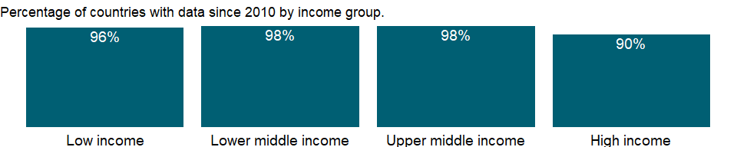

### Why is it relevant?

NA

### What is the data source?

World Trade Organization.

### What is the methodology?

Merchandise trade data are from customs reports of goods moving into or out of an economy or from reports of financial transactions related to merchandise trade recorded in the balance of payments. Because of differences in timing and definitions, trade flow estimates from customs reports and balance of payments may differ. Several international agencies process trade data, each correcting unreported or misreported data, leading to other differences.

The data on total imports of goods (merchandise) are from the World Trade Organization (WTO), which obtains data from national statistical offices and the IMF’s International Financial Statistics, supplemented by the Comtrade database and publications or databases of regional organizations, specialized agencies, economic groups, and private sources (such as Eurostat, the Food and Agriculture Organization, and country reports of the Economist Intelligence Unit). Country websites and email contact have improved collection of up-to-date statistics, reducing the proportion of estimates. The WTO database now covers most major traders in Africa, Asia, and Latin America, which together with high-income countries account for nearly 95 percent of world trade. Reliability of data for countries in Europe and Central Asia has also improved.

### How is it aggregated?

Gap-filled total

### What are the limitations?

The value of imports is generally recorded as the cost of the goods when purchased by the importer plus the cost of transport and insurance to the frontier of the importing country - the cost, insurance, and freight (c.i.f.) value, corresponding to the landed cost at the point of entry of foreign goods into the country. A few countries collect import data on a free on board (f.o.b.) basis and adjust them for freight and insurance costs.

Countries may report trade according to the general or special system of trade. Under the general system imports include goods imported for domestic consumption and imports into bonded warehouses and free trade zones. Under the special system imports comprise goods imported for domestic consumption (including transformation and repair) and withdrawals for domestic consumption from bonded warehouses and free trade zones. Goods transported through a country en route to another are excluded.

Data on imports of goods are derived from the same sources as data on exports. In principle, world exports and imports should be identical. Similarly, exports from an economy should equal the sum of imports by the rest of the world from that economy. But differences in timing and definitions result in discrepancies in reported values at all levels.

### What else should I know?

NA

### 1.88.9 Merchandise imports from high-income economies (% of total merchandise imports)

### What is the indicator?

Merchandise imports from high-income economies are the sum of merchandise imports by the reporting economy from high-income economies according to the World Bank classification of economies. Data are expressed as a percentage of total merchandise imports by the economy. Data are computed only if at least half of the economies in the partner country group had non-missing data.

Topic: Private Sector & Trade: Imports

Series ID: TM.VAL.MRCH.HI.ZS

Copyright: CC BY-4.0 , <https://datacatalog.worldbank.org/public-licenses#cc-by>

First year with any data: 1960

Last year with any data: 2019

### What years are data available?

The figure below shows years in which data is available for at least one country. Dates shaded in black have no data, while dates shaded in green have data for at least one country



### Which countries have data?

The figure below shows the percentage of countries in each income group with a value since 2010 for that indicator.



### Why is it relevant?

Low- and middle-income economies are an increasingly important part of the global trading system. Trade between high-income economies and low- and middle-income economies has grown faster than trade between high-income economies. This increased trade benefits both producers and consumers in developing and high-income economies.

### What is the data source?

World Bank staff estimates based data from International Monetary Fund’s Direction of Trade database.

### What is the methodology?

NA

### How is it aggregated?

Weighted average

### What are the limitations?

Data on exports and imports are from the International Monetary Fund’s (IMF) Direction of Trade database and should be broadly consistent with data from other sources, such as the United Nations Statistics Division’s Commodity Trade (Comtrade) database. All high-income economies and major low- and middle-income economies report trade data to the IMF on a timely basis, covering about 85 percent of trade for recent years. Trade data for less timely reporters and for countries that do not report are estimated using reports of trading partner countries. Therefore, data on trade between developing and high-income economies should be generally complete. But trade flows between many low- and middle-income economies - particularly those in Sub-Saharan Africa - are not well recorded, and the value of trade among low- and middle-income economies may be understated.

### What else should I know?

NA

### 1.88.10 Merchandise imports from low- and middle-income economies outside region (% of total merchandise imports)

### What is the indicator?

Merchandise imports from low- and middle-income economies outside region are the sum of merchandise imports by the reporting economy from other low- and middle-income economies in other World Bank regions according to the World Bank classification of economies. Data are expressed as a percentage of total merchandise imports by the economy. Data are computed only if at least half of the economies in the partner country group had non-missing data.

Topic: Private Sector & Trade: Imports

Series ID: TM.VAL.MRCH.OR.ZS

Copyright: CC BY-4.0 , <https://datacatalog.worldbank.org/public-licenses#cc-by>

First year with any data: 1960

Last year with any data: 2019

### What years are data available?

The figure below shows years in which data is available for at least one country. Dates shaded in black have no data, while dates shaded in green have data for at least one country



### Which countries have data?

The figure below shows the percentage of countries in each income group with a value since 2010 for that indicator.



### Why is it relevant?

Although global integration has increased, low- and middle-income economies still face trade barriers when accessing other markets.

### What is the data source?

World Bank staff estimates based data from International Monetary Fund’s Direction of Trade database.

### What is the methodology?

NA

### How is it aggregated?

Weighted average

### What are the limitations?

Data on exports and imports are from the International Monetary Fund’s (IMF) Direction of Trade database and should be broadly consistent with data from other sources, such as the United Nations Statistics Division’s Commodity Trade (Comtrade) database. All high-income economies and major low- and middle-income economies report trade data to the IMF on a timely basis, covering about 85 percent of trade for recent years. Trade data for less timely reporters and for countries that do not report are estimated using reports of trading partner countries. Therefore, data on trade between developing and high-income economies should be generally complete. But trade flows between many low- and middle-income economies - particularly those in Sub-Saharan Africa - are not well recorded, and the value of trade among low- and middle-income economies may be understated.

### What else should I know?

NA

### 1.88.11 Merchandise imports from low- and middle-income economies in East Asia & Pacific (% of total merchandise imports)

### What is the indicator?

Merchandise imports from low- and middle-income economies in East Asia and Pacific are the sum of merchandise imports by the reporting economy from low- and middle-income economies in the East Asia and Pacific region according to the World Bank classification of economies. Data are expressed as a percentage of total merchandise imports by the economy. Data are computed only if at least half of the economies in the partner country group had non-missing data.

Topic: Private Sector & Trade: Imports

Series ID: TM.VAL.MRCH.R1.ZS

Copyright: CC BY-4.0 , <https://datacatalog.worldbank.org/public-licenses#cc-by>

First year with any data: 1960

Last year with any data: 2019

### What years are data available?

The figure below shows years in which data is available for at least one country. Dates shaded in black have no data, while dates shaded in green have data for at least one country



### Which countries have data?

The figure below shows the percentage of countries in each income group with a value since 2010 for that indicator.



### Why is it relevant?

NA

### What is the data source?

World Bank staff estimates based data from International Monetary Fund’s Direction of Trade database.

### What is the methodology?

NA

### How is it aggregated?

Weighted average

### What are the limitations?

NA

### What else should I know?

NA

### 1.88.12 Merchandise imports from low- and middle-income economies in Europe & Central Asia (% of total merchandise imports)

### What is the indicator?

Merchandise imports from low- and middle-income economies in Europe and Central Asia are the sum of merchandise imports by the reporting economy from low- and middle-income economies in the Europe and Central Asia region according to the World Bank classification of economies. Data are expressed as a percentage of total merchandise imports by the economy. Data are computed only if at least half of the economies in the partner country group had non-missing data.

Topic: Private Sector & Trade: Imports

Series ID: TM.VAL.MRCH.R2.ZS

Copyright: CC BY-4.0 , <https://datacatalog.worldbank.org/public-licenses#cc-by>

First year with any data: 1960

Last year with any data: 2019

### What years are data available?

The figure below shows years in which data is available for at least one country. Dates shaded in black have no data, while dates shaded in green have data for at least one country



### Which countries have data?

The figure below shows the percentage of countries in each income group with a value since 2010 for that indicator.



### Why is it relevant?

NA

### What is the data source?

World Bank staff estimates based data from International Monetary Fund’s Direction of Trade database.

### What is the methodology?

NA

### How is it aggregated?

Weighted average

### What are the limitations?

NA

### What else should I know?

NA

### 1.88.13 Merchandise imports from low- and middle-income economies in Latin America & the Caribbean (% of total merchandise imports)

### What is the indicator?

Merchandise imports from low- and middle-income economies in Latin America and the Caribbean are the sum of merchandise imports by the reporting economy from low- and middle-income economies in the Latin America and the Caribbean region according to the World Bank classification of economies. Data are expressed as a percentage of total merchandise imports by the economy. Data are computed only if at least half of the economies in the partner country group had non-missing data.

Topic: Private Sector & Trade: Imports

Series ID: TM.VAL.MRCH.R3.ZS

Copyright: CC BY-4.0 , <https://datacatalog.worldbank.org/public-licenses#cc-by>

First year with any data: 1960

Last year with any data: 2019

### What years are data available?

The figure below shows years in which data is available for at least one country. Dates shaded in black have no data, while dates shaded in green have data for at least one country



### Which countries have data?

The figure below shows the percentage of countries in each income group with a value since 2010 for that indicator.



### Why is it relevant?

NA

### What is the data source?

World Bank staff estimates based data from International Monetary Fund’s Direction of Trade database.

### What is the methodology?

NA

### How is it aggregated?

Weighted average

### What are the limitations?

NA

### What else should I know?

NA

### 1.88.14 Merchandise imports from low- and middle-income economies in Middle East & North Africa (% of total merchandise imports)

### What is the indicator?

Merchandise imports from low- and middle-income economies in Middle East and North Africa are the sum of merchandise imports by the reporting economy from low- and middle-income economies in the Middle East and North Africa region according to the World Bank classification of economies. Data are expressed as a percentage of total merchandise imports by the economy. Data are computed only if at least half of the economies in the partner country group had non-missing data.

Topic: Private Sector & Trade: Imports

Series ID: TM.VAL.MRCH.R4.ZS

Copyright: CC BY-4.0 , <https://datacatalog.worldbank.org/public-licenses#cc-by>

First year with any data: 1960

Last year with any data: 2019

### What years are data available?

The figure below shows years in which data is available for at least one country. Dates shaded in black have no data, while dates shaded in green have data for at least one country



### Which countries have data?

The figure below shows the percentage of countries in each income group with a value since 2010 for that indicator.



### Why is it relevant?

NA

### What is the data source?

World Bank staff estimates based data from International Monetary Fund’s Direction of Trade database.

### What is the methodology?

NA

### How is it aggregated?

Weighted average

### What are the limitations?

NA

### What else should I know?

NA

### 1.88.15 Merchandise imports from low- and middle-income economies in South Asia (% of total merchandise imports)

### What is the indicator?

Merchandise imports from low- and middle-income economies in South Asia are the sum of merchandise imports by the reporting economy from low- and middle-income economies in the South Asia region according to the World Bank classification of economies. Data are expressed as a percentage of total merchandise imports by the economy. Data are computed only if at least half of the economies in the partner country group had non-missing data.

Topic: Private Sector & Trade: Imports

Series ID: TM.VAL.MRCH.R5.ZS

Copyright: CC BY-4.0 , <https://datacatalog.worldbank.org/public-licenses#cc-by>

First year with any data: 1960

Last year with any data: 2019

### What years are data available?

The figure below shows years in which data is available for at least one country. Dates shaded in black have no data, while dates shaded in green have data for at least one country



### Which countries have data?

The figure below shows the percentage of countries in each income group with a value since 2010 for that indicator.



### Why is it relevant?

NA

### What is the data source?

World Bank staff estimates based data from International Monetary Fund’s Direction of Trade database.

### What is the methodology?

NA

### How is it aggregated?

Weighted average

### What are the limitations?

NA

### What else should I know?

NA

### 1.88.16 Merchandise imports from low- and middle-income economies in Sub-Saharan Africa (% of total merchandise imports)

### What is the indicator?

Merchandise imports from low- and middle-income economies in Sub-Saharan Africa are the sum of merchandise imports by the reporting economy from low- and middle-income economies in the Sub-Saharan Africa region according to the World Bank classification of economies. Data are expressed as a percentage of total merchandise imports by the economy. Data are computed only if at least half of the economies in the partner country group had non-missing data.

Topic: Private Sector & Trade: Imports

Series ID: TM.VAL.MRCH.R6.ZS

Copyright: CC BY-4.0 , <https://datacatalog.worldbank.org/public-licenses#cc-by>

First year with any data: 1960

Last year with any data: 2019

### What years are data available?

The figure below shows years in which data is available for at least one country. Dates shaded in black have no data, while dates shaded in green have data for at least one country



### Which countries have data?

The figure below shows the percentage of countries in each income group with a value since 2010 for that indicator.

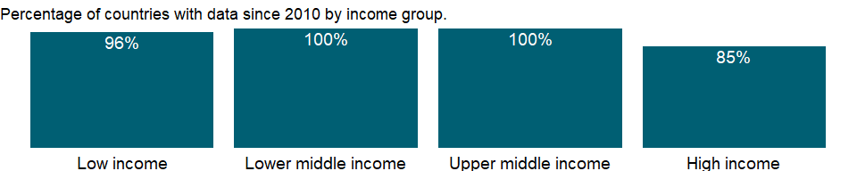

### Why is it relevant?

NA

### What is the data source?

World Bank staff estimates based data from International Monetary Fund’s Direction of Trade database.

### What is the methodology?

NA

### How is it aggregated?

Weighted average

### What are the limitations?

NA

### What else should I know?

NA

### 1.88.17 Merchandise imports by the reporting economy, residual (% of total merchandise imports)

### What is the indicator?

Merchandise imports by the reporting economy residuals are the total merchandise imports by the reporting economy from the rest of the world as reported in the IMF’s Direction of trade database, less the sum of imports by the reporting economy from high-, low-, and middle-income economies according to the World Bank classification of economies. Includes trade with unspecified partners or with economies not covered by World Bank classification. Data are as a percentage of total merchandise imports by the economy.

Topic: Private Sector & Trade: Imports

Series ID: TM.VAL.MRCH.RS.ZS

Copyright: CC BY-4.0 , <https://datacatalog.worldbank.org/public-licenses#cc-by>

First year with any data: 1960

Last year with any data: 2019

### What years are data available?

The figure below shows years in which data is available for at least one country. Dates shaded in black have no data, while dates shaded in green have data for at least one country



### Which countries have data?

The figure below shows the percentage of countries in each income group with a value since 2010 for that indicator.



### Why is it relevant?

NA

### What is the data source?

World Bank staff estimates based data from International Monetary Fund’s Direction of Trade database.

### What is the methodology?

NA

### How is it aggregated?

Weighted average

### What are the limitations?

NA

### What else should I know?

NA

### 1.88.18 Merchandise imports by the reporting economy (current US$)

### What is the indicator?

Merchandise imports by the reporting economy are the total merchandise imports by the reporting economy from the rest of the world, as reported in the IMF’s Direction of trade database. Data are in current U.S. dollars.

Topic: Private Sector & Trade: Imports

Series ID: TM.VAL.MRCH.WL.CD

Copyright: CC BY-4.0 , <https://datacatalog.worldbank.org/public-licenses#cc-by>

First year with any data: 1960

Last year with any data: 2019

### What years are data available?

The figure below shows years in which data is available for at least one country. Dates shaded in black have no data, while dates shaded in green have data for at least one country



### Which countries have data?

The figure below shows the percentage of countries in each income group with a value since 2010 for that indicator.



### Why is it relevant?

NA

### What is the data source?

World Bank staff estimates based data from International Monetary Fund’s Direction of Trade database.

### What is the methodology?

NA

### How is it aggregated?

Sum

### What are the limitations?

NA

### What else should I know?

NA

### 1.88.19 Merchandise imports from low- and middle-income economies within region (% of total merchandise imports)

### What is the indicator?

Merchandise imports from low- and middle-income economies within region are the sum of merchandise imports by the reporting economy from other low- and middle-income economies in the same World Bank region according to the World Bank classification of economies. Data are as a percentage of total merchandise imports by the economy. Data are computed only if at least half of the economies in the partner country group had non-missing data. No figures are shown for high-income economies, because they are a separate category in the World Bank classification of economies.

Topic: Private Sector & Trade: Imports

Series ID: TM.VAL.MRCH.WR.ZS

Copyright: CC BY-4.0 , <https://datacatalog.worldbank.org/public-licenses#cc-by>

First year with any data: 1960

Last year with any data: 2019

### What years are data available?

The figure below shows years in which data is available for at least one country. Dates shaded in black have no data, while dates shaded in green have data for at least one country



### Which countries have data?

The figure below shows the percentage of countries in each income group with a value since 2010 for that indicator.

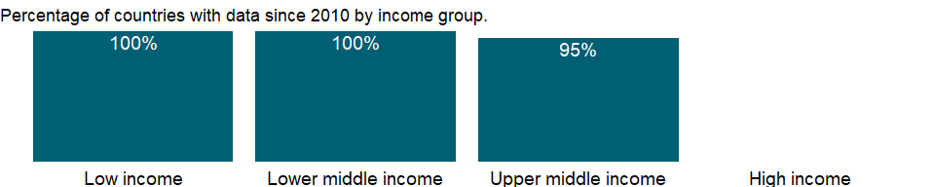

### Why is it relevant?

The relative importance of intraregional trade is higher for both landlocked countries and small countries with close trade links to the largest regional economy. For most low- and middle-income economies - especially smaller ones - there is a “geographic bias” favoring intraregional trade. Despite the broad trend toward globalization and the reduction of trade barriers, the relative share of intraregional trade increased for most economies between 1999 and 2010. This is due partly to trade-related advantages, such as proximity, lower transport costs, increased knowledge from repeated interaction, and cultural and historical affinity. The direction of trade is also influenced by preferential trade agreements that a country has made with other economies. Though formal agreements on trade liberalization do not automatically increase trade, they nevertheless affect the direction of trade between the participating economies.

### What is the data source?

World Bank staff estimates based data from International Monetary Fund’s Direction of Trade database.

### What is the methodology?

NA

### How is it aggregated?

Weighted average

### What are the limitations?

Data on exports and imports are from the International Monetary Fund’s (IMF) Direction of Trade database and should be broadly consistent with data from other sources, such as the United Nations Statistics Division’s Commodity Trade (Comtrade) database. All high-income economies and major low- and middle-income economies report trade data to the IMF on a timely basis, covering about 85 percent of trade for recent years. Trade data for less timely reporters and for countries that do not report are estimated using reports of trading partner countries. Therefore, data on trade between developing and high-income economies should be generally complete. But trade flows between many low- and middle-income economies - particularly those in Sub-Saharan Africa - are not well recorded, and the value of trade among low- and middle-income economies may be understated.

### What else should I know?

NA

### 1.88.20 Computer, communications and other services (% of commercial service imports)

### What is the indicator?

Computer, communications and other services (% of commercial service imports) include such activities as international telecommunications, and postal and courier services; computer data; news-related service transactions between residents and nonresidents; construction services; royalties and license fees; miscellaneous business, professional, and technical services; and personal, cultural, and recreational services.

Topic: Private Sector & Trade: Imports

Series ID: TM.VAL.OTHR.ZS.WT

Copyright: CC BY-4.0 , <https://datacatalog.worldbank.org/public-licenses#cc-by>

First year with any data: 1960

Last year with any data: 2020

### What years are data available?

The figure below shows years in which data is available for at least one country. Dates shaded in black have no data, while dates shaded in green have data for at least one country



### Which countries have data?

The figure below shows the percentage of countries in each income group with a value since 2010 for that indicator.



### Why is it relevant?

Trade in services differs from trade in goods because services are produced and consumed at the same time. Thus services to a traveler may be consumed in the producing country (for example, use of a hotel room) but are classified as imports of the traveler’s country. In other cases services may be supplied from a remote location; for example, insurance services may be supplied from one location and consumed in another.

### What is the data source?

International Monetary Fund, Balance of Payments Statistics Yearbook and data files.

### What is the methodology?

The balance of payments (BoP) is a double-entry accounting system that shows all flows of goods and services into and out of an economy; all transfers that are the counterpart of real resources or financial claims provided to or by the rest of the world without a quid pro quo, such as donations and grants; and all changes in residents’ claims on and liabilities to nonresidents that arise from economic transactions. All transactions are recorded twice - once as a credit and once as a debit. In principle the net balance should be zero, but in practice the accounts often do not balance, requiring inclusion of a balancing item, net errors and omissions.

The concepts and definitions underlying the data are based on the sixth edition of the International Monetary Fund’s (IMF) Balance of Payments Manual (BPM6). Balance of payments data for 2005 onward will be presented in accord with the BPM6. The historical BPM5 data series will end with data for 2008, which can be accessed through the World Development Indicators archives.

The complete balance of payments methodology can be accessed through the International Monetary Fund website (www.imf.org/external/np/sta/bop/bop.htm).

### How is it aggregated?

Weighted average

### What are the limitations?

Balance of payments statistics, the main source of information on international trade in services, have many weaknesses. Disaggregation of important components may be limited and varies considerably across countries. There are inconsistencies in the methods used to report items. And the recording of major flows as net items is common (for example, insurance transactions are often recorded as premiums less claims). These factors contribute to a downward bias in the value of the service trade reported in the balance of payments.

Efforts are being made to improve the coverage, quality, and consistency of these data. Eurostat and the Organisation for Economic Co-operation and Development, for example, are working together to improve the collection of statistics on trade in services in member countries.

Still, difficulties in capturing all the dimensions of international trade in services mean that the record is likely to remain incomplete. Cross-border intrafirm service transactions, which are usually not captured in the balance of payments, have increased in recent years. An example is transnational corporations’ use of mainframe computers around the clock for data processing, exploiting time zone differences between their home country and the host countries of their affiliates. Another important dimension of service trade not captured by conventional balance of payments statistics is establishment trade - sales in the host country by foreign affiliates. By contrast, cross-border intrafirm transactions in merchandise may be reported as exports or imports in the balance of payments.

### What else should I know?

NA

### 1.88.21 Commercial service imports (current US$)

### What is the indicator?

Commercial service imports are total service imports minus imports of government services not included elsewhere. International transactions in services are defined by the IMF’s Balance of Payments Manual (1993) as the economic output of intangible commodities that may be produced, transferred, and consumed at the same time. Definitions may vary among reporting economies.

Topic: Private Sector & Trade: Imports

Series ID: TM.VAL.SERV.CD.WT

Copyright: CC BY-4.0 , <https://datacatalog.worldbank.org/public-licenses#cc-by>

First year with any data: 1960

Last year with any data: 2020

### What years are data available?

The figure below shows years in which data is available for at least one country. Dates shaded in black have no data, while dates shaded in green have data for at least one country



### Which countries have data?

The figure below shows the percentage of countries in each income group with a value since 2010 for that indicator.



### Why is it relevant?

Trade in services differs from trade in goods because services are produced and consumed at the same time. Thus services to a traveler may be consumed in the producing country (for example, use of a hotel room) but are classified as imports of the traveler’s country. In other cases services may be supplied from a remote location; for example, insurance services may be supplied from one location and consumed in another.

### What is the data source?

International Monetary Fund, Balance of Payments Statistics Yearbook and data files.

### What is the methodology?

The balance of payments (BoP) is a double-entry accounting system that shows all flows of goods and services into and out of an economy; all transfers that are the counterpart of real resources or financial claims provided to or by the rest of the world without a quid pro quo, such as donations and grants; and all changes in residents’ claims on and liabilities to nonresidents that arise from economic transactions. All transactions are recorded twice - once as a credit and once as a debit. In principle the net balance should be zero, but in practice the accounts often do not balance, requiring inclusion of a balancing item, net errors and omissions.

The concepts and definitions underlying the data are based on the sixth edition of the International Monetary Fund’s (IMF) Balance of Payments Manual (BPM6). Balance of payments data for 2005 onward will be presented in accord with the BPM6. The historical BPM5 data series will end with data for 2008, which can be accessed through the World Development Indicators archives.

The complete balance of payments methodology can be accessed through the International Monetary Fund website (www.imf.org/external/np/sta/bop/bop.htm).

### How is it aggregated?

Gap-filled total

### What are the limitations?

Balance of payments statistics, the main source of information on international trade in services, have many weaknesses. Disaggregation of important components may be limited and varies considerably across countries. There are inconsistencies in the methods used to report items. And the recording of major flows as net items is common (for example, insurance transactions are often recorded as premiums less claims). These factors contribute to a downward bias in the value of the service trade reported in the balance of payments.

Efforts are being made to improve the coverage, quality, and consistency of these data. Eurostat and the Organisation for Economic Co-operation and Development, for example, are working together to improve the collection of statistics on trade in services in member countries.

Still, difficulties in capturing all the dimensions of international trade in services mean that the record is likely to remain incomplete. Cross-border intrafirm service transactions, which are usually not captured in the balance of payments, have increased in recent years. An example is transnational corporations’ use of mainframe computers around the clock for data processing, exploiting time zone differences between their home country and the host countries of their affiliates. Another important dimension of service trade not captured by conventional balance of payments statistics is establishment trade - sales in the host country by foreign affiliates. By contrast, cross-border intrafirm transactions in merchandise may be reported as exports or imports in the balance of payments.

### What else should I know?

NA

### 1.88.22 Transport services (% of commercial service imports)

### What is the indicator?

Transport services (% of commercial service imports) covers all transport services (sea, air, land, internal waterway, space, and pipeline) performed by residents of one economy for those of another and involving the carriage of passengers, movement of goods (freight), rental of carriers with crew, and related support and auxiliary services. Excluded are freight insurance, which is included in insurance services; goods procured in ports by nonresident carriers and repairs of transport equipment, which are included in goods; repairs of railway facilities, harbors, and airfield facilities, which are included in construction services; and rental of carriers without crew, which is included in other services.

Topic: Private Sector & Trade: Imports

Series ID: TM.VAL.TRAN.ZS.WT

Copyright: CC BY-4.0 , <https://datacatalog.worldbank.org/public-licenses#cc-by>

First year with any data: 1960

Last year with any data: 2020

### What years are data available?

The figure below shows years in which data is available for at least one country. Dates shaded in black have no data, while dates shaded in green have data for at least one country



### Which countries have data?

The figure below shows the percentage of countries in each income group with a value since 2010 for that indicator.



### Why is it relevant?

Trade in services differs from trade in goods because services are produced and consumed at the same time. Thus services to a traveler may be consumed in the producing country (for example, use of a hotel room) but are classified as imports of the traveler’s country. In other cases services may be supplied from a remote location; for example, insurance services may be supplied from one location and consumed in another.

### What is the data source?

International Monetary Fund, Balance of Payments Statistics Yearbook and data files.

### What is the methodology?

The balance of payments (BoP) is a double-entry accounting system that shows all flows of goods and services into and out of an economy; all transfers that are the counterpart of real resources or financial claims provided to or by the rest of the world without a quid pro quo, such as donations and grants; and all changes in residents’ claims on and liabilities to nonresidents that arise from economic transactions. All transactions are recorded twice - once as a credit and once as a debit. In principle the net balance should be zero, but in practice the accounts often do not balance, requiring inclusion of a balancing item, net errors and omissions.

The concepts and definitions underlying the data are based on the sixth edition of the International Monetary Fund’s (IMF) Balance of Payments Manual (BPM6). Balance of payments data for 2005 onward will be presented in accord with the BPM6. The historical BPM5 data series will end with data for 2008, which can be accessed through the World Development Indicators archives.

The complete balance of payments methodology can be accessed through the International Monetary Fund website (www.imf.org/external/np/sta/bop/bop.htm).

### How is it aggregated?

Weighted average

### What are the limitations?

Balance of payments statistics, the main source of information on international trade in services, have many weaknesses. Disaggregation of important components may be limited and varies considerably across countries. There are inconsistencies in the methods used to report items. And the recording of major flows as net items is common (for example, insurance transactions are often recorded as premiums less claims). These factors contribute to a downward bias in the value of the service trade reported in the balance of payments.

Efforts are being made to improve the coverage, quality, and consistency of these data. Eurostat and the Organisation for Economic Co-operation and Development, for example, are working together to improve the collection of statistics on trade in services in member countries.

Still, difficulties in capturing all the dimensions of international trade in services mean that the record is likely to remain incomplete. Cross-border intrafirm service transactions, which are usually not captured in the balance of payments, have increased in recent years. An example is transnational corporations’ use of mainframe computers around the clock for data processing, exploiting time zone differences between their home country and the host countries of their affiliates. Another important dimension of service trade not captured by conventional balance of payments statistics is establishment trade - sales in the host country by foreign affiliates. By contrast, cross-border intrafirm transactions in merchandise may be reported as exports or imports in the balance of payments.

### What else should I know?

NA

### 1.88.23 Travel services (% of commercial service imports)

### What is the indicator?

Travel services (% of commercial service imports) covers goods and services acquired from an economy by travelers in that economy for their own use during visits of less than one year for business or personal purposes. Travel services include the goods and services consumed by travelers, such as lodging, meals, and transport (within the economy visited).

Topic: Private Sector & Trade: Imports

Series ID: TM.VAL.TRVL.ZS.WT

Copyright: CC BY-4.0 , <https://datacatalog.worldbank.org/public-licenses#cc-by>

First year with any data: 1960

Last year with any data: 2020

### What years are data available?

The figure below shows years in which data is available for at least one country. Dates shaded in black have no data, while dates shaded in green have data for at least one country



### Which countries have data?

The figure below shows the percentage of countries in each income group with a value since 2010 for that indicator.



### Why is it relevant?

Trade in services differs from trade in goods because services are produced and consumed at the same time. Thus services to a traveler may be consumed in the producing country (for example, use of a hotel room) but are classified as imports of the traveler’s country. In other cases services may be supplied from a remote location; for example, insurance services may be supplied from one location and consumed in another.

### What is the data source?

International Monetary Fund, Balance of Payments Statistics Yearbook and data files.

### What is the methodology?

The balance of payments (BoP) is a double-entry accounting system that shows all flows of goods and services into and out of an economy; all transfers that are the counterpart of real resources or financial claims provided to or by the rest of the world without a quid pro quo, such as donations and grants; and all changes in residents’ claims on and liabilities to nonresidents that arise from economic transactions. All transactions are recorded twice - once as a credit and once as a debit. In principle the net balance should be zero, but in practice the accounts often do not balance, requiring inclusion of a balancing item, net errors and omissions.

The concepts and definitions underlying the data are based on the sixth edition of the International Monetary Fund’s (IMF) Balance of Payments Manual (BPM6). Balance of payments data for 2005 onward will be presented in accord with the BPM6. The historical BPM5 data series will end with data for 2008, which can be accessed through the World Development Indicators archives.

The complete balance of payments methodology can be accessed through the International Monetary Fund website (www.imf.org/external/np/sta/bop/bop.htm).

### How is it aggregated?

Weighted average

### What are the limitations?

Balance of payments statistics, the main source of information on international trade in services, have many weaknesses. Disaggregation of important components may be limited and varies considerably across countries. There are inconsistencies in the methods used to report items. And the recording of major flows as net items is common (for example, insurance transactions are often recorded as premiums less claims). These factors contribute to a downward bias in the value of the service trade reported in the balance of payments.

Efforts are being made to improve the coverage, quality, and consistency of these data. Eurostat and the Organisation for Economic Co-operation and Development, for example, are working together to improve the collection of statistics on trade in services in member countries.

Still, difficulties in capturing all the dimensions of international trade in services mean that the record is likely to remain incomplete. Cross-border intrafirm service transactions, which are usually not captured in the balance of payments, have increased in recent years. An example is transnational corporations’ use of mainframe computers around the clock for data processing, exploiting time zone differences between their home country and the host countries of their affiliates. Another important dimension of service trade not captured by conventional balance of payments statistics is establishment trade - sales in the host country by foreign affiliates. By contrast, cross-border intrafirm transactions in merchandise may be reported as exports or imports in the balance of payments.

### What else should I know?

NA

## 1.89 Private Sector & Trade: Exports

### 1.89.1 Agricultural raw materials exports (% of merchandise exports)

### What is the indicator?

Agricultural raw materials comprise SITC section 2 (crude materials except fuels) excluding divisions 22, 27 (crude fertilizers and minerals excluding coal, petroleum, and precious stones), and 28 (metalliferous ores and scrap).

Topic: Private Sector & Trade: Exports

Series ID: TX.VAL.AGRI.ZS.UN

Copyright: CC BY-4.0 , <https://datacatalog.worldbank.org/public-licenses#cc-by>

First year with any data: 1962

Last year with any data: 2020

### What years are data available?

The figure below shows years in which data is available for at least one country. Dates shaded in black have no data, while dates shaded in green have data for at least one country



### Which countries have data?

The figure below shows the percentage of countries in each income group with a value since 2010 for that indicator.

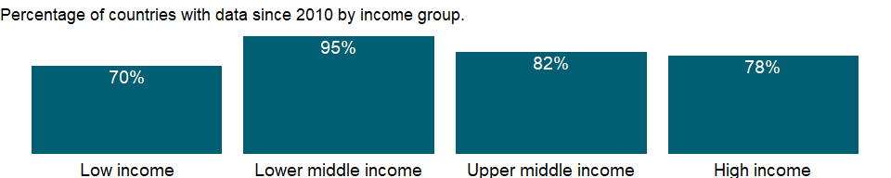

### Why is it relevant?

NA

### What is the data source?

World Bank staff estimates through the WITS platform from the Comtrade database maintained by the United Nations Statistics Division.

### What is the methodology?

The classification of commodity groups is based on the Standard International Trade Classification (SITC) revision 3.

### How is it aggregated?

Weighted average

### What are the limitations?

Previous editions contained data based on the SITC revision 1. Data for earlier years in previous editions may differ because of the change in methodology. Concordance tables are available to convert data reported in one system to another.

### What else should I know?

Merchandise export shares may not sum to 100 percent because of unclassified trade.

### 1.89.2 Food exports (% of merchandise exports)

### What is the indicator?

Food comprises the commodities in SITC sections 0 (food and live animals), 1 (beverages and tobacco), and 4 (animal and vegetable oils and fats) and SITC division 22 (oil seeds, oil nuts, and oil kernels).

Topic: Private Sector & Trade: Exports

Series ID: TX.VAL.FOOD.ZS.UN

Copyright: CC BY-4.0 , <https://datacatalog.worldbank.org/public-licenses#cc-by>

First year with any data: 1962

Last year with any data: 2020

### What years are data available?

The figure below shows years in which data is available for at least one country. Dates shaded in black have no data, while dates shaded in green have data for at least one country



### Which countries have data?

The figure below shows the percentage of countries in each income group with a value since 2010 for that indicator.



### Why is it relevant?

NA

### What is the data source?

World Bank staff estimates through the WITS platform from the Comtrade database maintained by the United Nations Statistics Division.

### What is the methodology?

The classification of commodity groups is based on the Standard International Trade Classification (SITC) revision 3.

### How is it aggregated?

Weighted average

### What are the limitations?

Previous editions contained data based on the SITC revision 1. Data for earlier years in previous editions may differ because of the change in methodology. Concordance tables are available to convert data reported in one system to another.

### What else should I know?

Merchandise export shares may not sum to 100 percent because of unclassified trade.

### 1.89.3 Fuel exports (% of merchandise exports)

### What is the indicator?

Fuels comprise the commodities in SITC section 3 (mineral fuels, lubricants and related materials).

Topic: Private Sector & Trade: Exports

Series ID: TX.VAL.FUEL.ZS.UN

Copyright: CC BY-4.0 , <https://datacatalog.worldbank.org/public-licenses#cc-by>

First year with any data: 1962

Last year with any data: 2020

### What years are data available?

The figure below shows years in which data is available for at least one country. Dates shaded in black have no data, while dates shaded in green have data for at least one country



### Which countries have data?

The figure below shows the percentage of countries in each income group with a value since 2010 for that indicator.

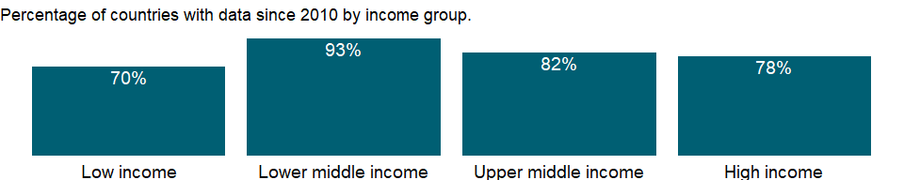

### Why is it relevant?

NA

### What is the data source?

World Bank staff estimates through the WITS platform from the Comtrade database maintained by the United Nations Statistics Division.

### What is the methodology?

The classification of commodity groups is based on the Standard International Trade Classification (SITC) revision 3.

### How is it aggregated?

Weighted average

### What are the limitations?

Previous editions contained data based on the SITC revision 1. Data for earlier years in previous editions may differ because of the change in methodology. Concordance tables are available to convert data reported in one system to another.

### What else should I know?

Merchandise export shares may not sum to 100 percent because of unclassified trade.

### 1.89.4 Insurance and financial services (% of commercial service exports)

### What is the indicator?

Insurance and financial services cover freight insurance on goods exported and other direct insurance such as life insurance; financial intermediation services such as commissions, foreign exchange transactions, and brokerage services; and auxiliary services such as financial market operational and regulatory services.

Topic: Private Sector & Trade: Exports

Series ID: TX.VAL.INSF.ZS.WT

Copyright: CC BY-4.0 , <https://datacatalog.worldbank.org/public-licenses#cc-by>

First year with any data: 1960

Last year with any data: 2020

### What years are data available?

The figure below shows years in which data is available for at least one country. Dates shaded in black have no data, while dates shaded in green have data for at least one country



### Which countries have data?

The figure below shows the percentage of countries in each income group with a value since 2010 for that indicator.



### Why is it relevant?

Trade in services differs from trade in goods because services are produced and consumed at the same time. Thus services to a traveler may be consumed in the producing country (for example, use of a hotel room) but are classified as imports of the traveler’s country. In other cases services may be supplied from a remote location; for example, insurance services may be supplied from one location and consumed in another.

### What is the data source?

International Monetary Fund, Balance of Payments Statistics Yearbook and data files.

### What is the methodology?

The balance of payments (BoP) is a double-entry accounting system that shows all flows of goods and services into and out of an economy; all transfers that are the counterpart of real resources or financial claims provided to or by the rest of the world without a quid pro quo, such as donations and grants; and all changes in residents’ claims on and liabilities to nonresidents that arise from economic transactions. All transactions are recorded twice - once as a credit and once as a debit. In principle the net balance should be zero, but in practice the accounts often do not balance, requiring inclusion of a balancing item, net errors and omissions.

The concepts and definitions underlying the data are based on the sixth edition of the International Monetary Fund’s (IMF) Balance of Payments Manual (BPM6). Balance of payments data for 2005 onward will be presented in accord with the BPM6. The historical BPM5 data series will end with data for 2008, which can be accessed through the World Development Indicators archives.

The complete balance of payments methodology can be accessed through the International Monetary Fund website (www.imf.org/external/np/sta/bop/bop.htm).

### How is it aggregated?

Weighted average

### What are the limitations?

Balance of payments statistics, the main source of information on international trade in services, have many weaknesses. Disaggregation of important components may be limited and varies considerably across countries. There are inconsistencies in the methods used to report items. And the recording of major flows as net items is common (for example, insurance transactions are often recorded as premiums less claims). These factors contribute to a downward bias in the value of the service trade reported in the balance of payments.

Efforts are being made to improve the coverage, quality, and consistency of these data. Eurostat and the Organisation for Economic Co-operation and Development, for example, are working together to improve the collection of statistics on trade in services in member countries.

Still, difficulties in capturing all the dimensions of international trade in services mean that the record is likely to remain incomplete. Cross-border intrafirm service transactions, which are usually not captured in the balance of payments, have increased in recent years. An example is transnational corporations’ use of mainframe computers around the clock for data processing, exploiting time zone differences between their home country and the host countries of their affiliates. Another important dimension of service trade not captured by conventional balance of payments statistics is establishment trade - sales in the host country by foreign affiliates. By contrast, cross-border intrafirm transactions in merchandise may be reported as exports or imports in the balance of payments.

### What else should I know?

NA

### 1.89.5 Manufactures exports (% of merchandise exports)

### What is the indicator?

Manufactures comprise commodities in SITC sections 5 (chemicals), 6 (basic manufactures), 7 (machinery and transport equipment), and 8 (miscellaneous manufactured goods), excluding division 68 (non-ferrous metals).

Topic: Private Sector & Trade: Exports

Series ID: TX.VAL.MANF.ZS.UN

Copyright: CC BY-4.0 , <https://datacatalog.worldbank.org/public-licenses#cc-by>

First year with any data: 1962

Last year with any data: 2020

### What years are data available?

The figure below shows years in which data is available for at least one country. Dates shaded in black have no data, while dates shaded in green have data for at least one country



### Which countries have data?

The figure below shows the percentage of countries in each income group with a value since 2010 for that indicator.



### Why is it relevant?

NA

### What is the data source?

World Bank staff estimates through the WITS platform from the Comtrade database maintained by the United Nations Statistics Division.

### What is the methodology?

The classification of commodity groups is based on the Standard International Trade Classification (SITC) revision 3.

### How is it aggregated?

Weighted average

### What are the limitations?

Previous editions contained data based on the SITC revision 1. Data for earlier years in previous editions may differ because of the change in methodology. Concordance tables are available to convert data reported in one system to another.

### What else should I know?

Merchandise export shares may not sum to 100 percent because of unclassified trade.

### 1.89.6 Ores and metals exports (% of merchandise exports)

### What is the indicator?

Ores and metals comprise the commodities in SITC sections 27 (crude fertilizer, minerals nes); 28 (metalliferous ores, scrap); and 68 (non-ferrous metals).

Topic: Private Sector & Trade: Exports

Series ID: TX.VAL.MMTL.ZS.UN

Copyright: CC BY-4.0 , <https://datacatalog.worldbank.org/public-licenses#cc-by>

First year with any data: 1962

Last year with any data: 2020

### What years are data available?

The figure below shows years in which data is available for at least one country. Dates shaded in black have no data, while dates shaded in green have data for at least one country



### Which countries have data?

The figure below shows the percentage of countries in each income group with a value since 2010 for that indicator.



### Why is it relevant?

NA

### What is the data source?

World Bank staff estimates through the WITS platform from the Comtrade database maintained by the United Nations Statistics Division.

### What is the methodology?

The classification of commodity groups is based on the Standard International Trade Classification (SITC) revision 3.

### How is it aggregated?

Weighted average

### What are the limitations?

Previous editions contained data based on the SITC revision 1. Data for earlier years in previous editions may differ because of the change in methodology. Concordance tables are available to convert data reported in one system to another.

### What else should I know?

Merchandise export shares may not sum to 100 percent because of unclassified trade.

### 1.89.7 Merchandise exports to economies in the Arab World (% of total merchandise exports)

### What is the indicator?

Merchandise exports to economies in the Arab World are the sum of merchandise exports by the reporting economy to economies in the Arab World. Data are expressed as a percentage of total merchandise exports by the economy. Data are computed only if at least half of the economies in the partner country group had non-missing data.

Topic: Private Sector & Trade: Exports

Series ID: TX.VAL.MRCH.AL.ZS

Copyright: CC BY-4.0 , <https://datacatalog.worldbank.org/public-licenses#cc-by>

First year with any data: 1960

Last year with any data: 2019

### What years are data available?

The figure below shows years in which data is available for at least one country. Dates shaded in black have no data, while dates shaded in green have data for at least one country



### Which countries have data?

The figure below shows the percentage of countries in each income group with a value since 2010 for that indicator.



### Why is it relevant?

NA

### What is the data source?

World Bank staff estimates based data from International Monetary Fund’s Direction of Trade database.

### What is the methodology?

NA

### How is it aggregated?

Weighted average

### What are the limitations?

NA

### What else should I know?

NA

### 1.89.8 Merchandise exports (current US$)

### What is the indicator?

Merchandise exports show the f.o.b. value of goods provided to the rest of the world valued in current U.S. dollars.

Topic: Private Sector & Trade: Exports

Series ID: TX.VAL.MRCH.CD.WT

Copyright: CC BY-4.0 , <https://datacatalog.worldbank.org/public-licenses#cc-by>

First year with any data: 1960

Last year with any data: 2020

### What years are data available?

The figure below shows years in which data is available for at least one country. Dates shaded in black have no data, while dates shaded in green have data for at least one country



### Which countries have data?

The figure below shows the percentage of countries in each income group with a value since 2010 for that indicator.

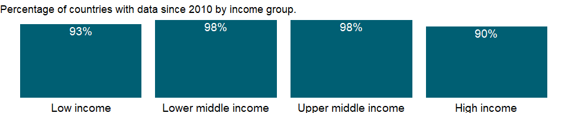

### Why is it relevant?

NA

### What is the data source?

World Trade Organization.

### What is the methodology?

Merchandise trade data are from customs reports of goods moving into or out of an economy or from reports of financial transactions related to merchandise trade recorded in the balance of payments. Because of differences in timing and definitions, trade flow estimates from customs reports and balance of payments may differ. Several international agencies process trade data, each correcting unreported or misreported data, leading to other differences.

The data on total exports of goods (merchandise) are from the World Trade Organization (WTO), which obtains data from national statistical offices and the IMF’s International Financial Statistics, supplemented by the Comtrade database and publications or databases of regional organizations, specialized agencies, economic groups, and private sources (such as Eurostat, the Food and Agriculture Organization, and country reports of the Economist Intelligence Unit). Country websites and email contact have improved collection of up-to-date statistics, reducing the proportion of estimates. The WTO database now covers most major traders in Africa, Asia, and Latin America, which together with high-income countries account for nearly 95 percent of world trade. Reliability of data for countries in Europe and Central Asia has also improved.

### How is it aggregated?

Gap-filled total

### What are the limitations?

Exports are recorded as the cost of the goods delivered to the frontier of the exporting country for shipment - the free on board (f.o.b.) value.

Countries may report trade according to the general or special system of trade. Under the general system exports comprise outward-moving goods that are (a) goods wholly or partly produced in the country; (b) foreign goods, neither transformed nor declared for domestic consumption in the country, that move outward from customs storage; and (c) goods previously included as imports for domestic consumption but subsequently exported without transformation. Under the special system exports comprise categories a and c. In some compilations categories b and c are classified as re-exports. Because of differences in reporting practices, data on exports may not be fully comparable across economies.

Data on exports of goods are derived from the same sources as data on imports. In principle, world exports and imports should be identical. Similarly, exports from an economy should equal the sum of imports by the rest of the world from that economy. But differences in timing and definitions result in discrepancies in reported values at all levels.

### What else should I know?

NA

### 1.89.9 Merchandise exports to high-income economies (% of total merchandise exports)

### What is the indicator?

Merchandise exports to high-income economies are the sum of merchandise exports from the reporting economy to high-income economies according to the World Bank classification of economies. Data are expressed as a percentage of total merchandise exports by the economy. Data are computed only if at least half of the economies in the partner country group had non-missing data.

Topic: Private Sector & Trade: Exports

Series ID: TX.VAL.MRCH.HI.ZS

Copyright: CC BY-4.0 , <https://datacatalog.worldbank.org/public-licenses#cc-by>

First year with any data: 1960

Last year with any data: 2019

### What years are data available?

The figure below shows years in which data is available for at least one country. Dates shaded in black have no data, while dates shaded in green have data for at least one country



### Which countries have data?

The figure below shows the percentage of countries in each income group with a value since 2010 for that indicator.



### Why is it relevant?

Low- and middle-income economies are an increasingly important part of the global trading system. Trade between high-income economies and low- and middle-income economies has grown faster than trade between high-income economies. This increased trade benefits both producers and consumers in developing and high-income economies.

At the regional level most exports from low- and middle-income economies are to high-income economies, but the share of intraregional trade is increasing. Geographic patterns of trade vary widely by country and commodity. Larger shares of exports from oil- and resource-rich economies are to high-income economies.

### What is the data source?

World Bank staff estimates based data from International Monetary Fund’s Direction of Trade database.

### What is the methodology?

NA

### How is it aggregated?

Weighted average

### What are the limitations?

Data on exports and imports are from the International Monetary Fund’s (IMF) Direction of Trade database and should be broadly consistent with data from other sources, such as the United Nations Statistics Division’s Commodity Trade (Comtrade) database. All high-income economies and major low- and middle-income economies report trade data to the IMF on a timely basis, covering about 85 percent of trade for recent years. Trade data for less timely reporters and for countries that do not report are estimated using reports of trading partner countries. Therefore, data on trade between developing and high-income economies should be generally complete. But trade flows between many low- and middle-income economies - particularly those in Sub-Saharan Africa - are not well recorded, and the value of trade among low- and middle-income economies may be understated.

### What else should I know?

NA

### 1.89.10 Merchandise exports to low- and middle-income economies outside region (% of total merchandise exports)

### What is the indicator?

Merchandise exports to low- and middle-income economies outside region are the sum of merchandise exports from the reporting economy to other low- and middle-income economies in other World Bank regions according to the World Bank classification of economies. Data are expressed as a percentage of total merchandise exports by the economy. Data are computed only if at least half of the economies in the partner country group had non-missing data.

Topic: Private Sector & Trade: Exports

Series ID: TX.VAL.MRCH.OR.ZS

Copyright: CC BY-4.0 , <https://datacatalog.worldbank.org/public-licenses#cc-by>

First year with any data: 1960

Last year with any data: 2019

### What years are data available?

The figure below shows years in which data is available for at least one country. Dates shaded in black have no data, while dates shaded in green have data for at least one country



### Which countries have data?

The figure below shows the percentage of countries in each income group with a value since 2010 for that indicator.



### Why is it relevant?

Although global integration has increased, low- and middle-income economies still face trade barriers when accessing other markets.

### What is the data source?

World Bank staff estimates based data from International Monetary Fund’s Direction of Trade database.

### What is the methodology?

NA

### How is it aggregated?

Weighted average

### What are the limitations?

Data on exports and imports are from the International Monetary Fund’s (IMF) Direction of Trade database and should be broadly consistent with data from other sources, such as the United Nations Statistics Division’s Commodity Trade (Comtrade) database. All high-income economies and major low- and middle-income economies report trade data to the IMF on a timely basis, covering about 85 percent of trade for recent years. Trade data for less timely reporters and for countries that do not report are estimated using reports of trading partner countries. Therefore, data on trade between developing and high-income economies should be generally complete. But trade flows between many low- and middle-income economies - particularly those in Sub-Saharan Africa - are not well recorded, and the value of trade among low- and middle-income economies may be understated.

### What else should I know?

NA

### 1.89.11 Merchandise exports to low- and middle-income economies in East Asia & Pacific (% of total merchandise exports)

### What is the indicator?

Merchandise exports to low- and middle-income economies in East Asia and Pacific are the sum of merchandise exports from the reporting economy to low- and middle-income economies in the East Asia and Pacific region according to World Bank classification of economies. Data are as a percentage of total merchandise exports by the economy. Data are computed only if at least half of the economies in the partner country group had non-missing data.

Topic: Private Sector & Trade: Exports

Series ID: TX.VAL.MRCH.R1.ZS

Copyright: CC BY-4.0 , <https://datacatalog.worldbank.org/public-licenses#cc-by>

First year with any data: 1960

Last year with any data: 2019

### What years are data available?

The figure below shows years in which data is available for at least one country. Dates shaded in black have no data, while dates shaded in green have data for at least one country



### Which countries have data?

The figure below shows the percentage of countries in each income group with a value since 2010 for that indicator.



### Why is it relevant?

NA

### What is the data source?

World Bank staff estimates based data from International Monetary Fund’s Direction of Trade database.

### What is the methodology?

NA

### How is it aggregated?

Weighted average

### What are the limitations?

NA

### What else should I know?

NA

### 1.89.12 Merchandise exports to low- and middle-income economies in Europe & Central Asia (% of total merchandise exports)

### What is the indicator?

Merchandise exports to low- and middle-income economies in Europe and Central Asia are the sum of merchandise exports from the reporting economy to low- and middle-income economies in the Europe and Central Asia region according to World Bank classification of economies. Data are as a percentage of total merchandise exports by the economy. Data are computed only if at least half of the economies in the partner country group had non-missing data.

Topic: Private Sector & Trade: Exports

Series ID: TX.VAL.MRCH.R2.ZS

Copyright: CC BY-4.0 , <https://datacatalog.worldbank.org/public-licenses#cc-by>

First year with any data: 1960

Last year with any data: 2019

### What years are data available?

The figure below shows years in which data is available for at least one country. Dates shaded in black have no data, while dates shaded in green have data for at least one country



### Which countries have data?

The figure below shows the percentage of countries in each income group with a value since 2010 for that indicator.



### Why is it relevant?

NA

### What is the data source?

World Bank staff estimates based data from International Monetary Fund’s Direction of Trade database.

### What is the methodology?

NA

### How is it aggregated?

Weighted average

### What are the limitations?

NA

### What else should I know?

NA

### 1.89.13 Merchandise exports to low- and middle-income economies in Latin America & the Caribbean (% of total merchandise exports)

### What is the indicator?

Merchandise exports to low- and middle-income economies in Latin America and the Caribbean are the sum of merchandise exports from the reporting economy to low- and middle-income economies in the Latin America and the Caribbean region according to World Bank classification of economies. Data are as a percentage of total merchandise exports by the economy. Data are computed only if at least half of the economies in the partner country group had non-missing data.

Topic: Private Sector & Trade: Exports

Series ID: TX.VAL.MRCH.R3.ZS

Copyright: CC BY-4.0 , <https://datacatalog.worldbank.org/public-licenses#cc-by>

First year with any data: 1960

Last year with any data: 2019

### What years are data available?

The figure below shows years in which data is available for at least one country. Dates shaded in black have no data, while dates shaded in green have data for at least one country



### Which countries have data?

The figure below shows the percentage of countries in each income group with a value since 2010 for that indicator.



### Why is it relevant?

NA

### What is the data source?

World Bank staff estimates based data from International Monetary Fund’s Direction of Trade database.

### What is the methodology?

NA

### How is it aggregated?

Weighted average

### What are the limitations?

NA

### What else should I know?

NA

### 1.89.14 Merchandise exports to low- and middle-income economies in Middle East & North Africa (% of total merchandise exports)

### What is the indicator?

Merchandise exports to low- and middle-income economies in Middle East and North Africa are the sum of merchandise exports from the reporting economy to low- and middle-income economies in the Middle East and North Africa region according to World Bank classification of economies. Data are as a percentage of total merchandise exports by the economy. Data are computed only if at least half of the economies in the partner country group had non-missing data.

Topic: Private Sector & Trade: Exports

Series ID: TX.VAL.MRCH.R4.ZS

Copyright: CC BY-4.0 , <https://datacatalog.worldbank.org/public-licenses#cc-by>

First year with any data: 1960

Last year with any data: 2019

### What years are data available?

The figure below shows years in which data is available for at least one country. Dates shaded in black have no data, while dates shaded in green have data for at least one country



### Which countries have data?

The figure below shows the percentage of countries in each income group with a value since 2010 for that indicator.



### Why is it relevant?

NA

### What is the data source?

World Bank staff estimates based data from International Monetary Fund’s Direction of Trade database.

### What is the methodology?

NA

### How is it aggregated?

Weighted average

### What are the limitations?

NA

### What else should I know?

NA

### 1.89.15 Merchandise exports to low- and middle-income economies in South Asia (% of total merchandise exports)

### What is the indicator?

Merchandise exports to low- and middle-income economies in South Asia are the sum of merchandise exports from the reporting economy to low- and middle-income economies in the South Asia region according to World Bank classification of economies. Data are as a percentage of total merchandise exports by the economy. Data are computed only if at least half of the economies in the partner country group had non-missing data.

Topic: Private Sector & Trade: Exports

Series ID: TX.VAL.MRCH.R5.ZS

Copyright: CC BY-4.0 , <https://datacatalog.worldbank.org/public-licenses#cc-by>

First year with any data: 1960

Last year with any data: 2019

### What years are data available?

The figure below shows years in which data is available for at least one country. Dates shaded in black have no data, while dates shaded in green have data for at least one country



### Which countries have data?

The figure below shows the percentage of countries in each income group with a value since 2010 for that indicator.



### Why is it relevant?

NA

### What is the data source?

World Bank staff estimates based data from International Monetary Fund’s Direction of Trade database.

### What is the methodology?

NA

### How is it aggregated?

Weighted average

### What are the limitations?

NA

### What else should I know?

NA

### 1.89.16 Merchandise exports to low- and middle-income economies in Sub-Saharan Africa (% of total merchandise exports)

### What is the indicator?

Merchandise exports to low- and middle-income economies in Sub-Saharan Africa are the sum of merchandise exports from the reporting economy to low- and middle-income economies in the Sub-Saharan Africa region according to World Bank classification of economies. Data are as a percentage of total merchandise exports by the economy. Data are computed only if at least half of the economies in the partner country group had non-missing data.

Topic: Private Sector & Trade: Exports

Series ID: TX.VAL.MRCH.R6.ZS

Copyright: CC BY-4.0 , <https://datacatalog.worldbank.org/public-licenses#cc-by>

First year with any data: 1960

Last year with any data: 2019

### What years are data available?

The figure below shows years in which data is available for at least one country. Dates shaded in black have no data, while dates shaded in green have data for at least one country



### Which countries have data?

The figure below shows the percentage of countries in each income group with a value since 2010 for that indicator.



### Why is it relevant?

NA

### What is the data source?

World Bank staff estimates based data from International Monetary Fund’s Direction of Trade database.

### What is the methodology?

NA

### How is it aggregated?

Weighted average

### What are the limitations?

NA

### What else should I know?

NA

### 1.89.17 Merchandise exports by the reporting economy, residual (% of total merchandise exports)

### What is the indicator?

Merchandise exports by the reporting economy residuals are the total merchandise exports by the reporting economy to the rest of the world as reported in the IMF’s Direction of trade database, less the sum of exports by the reporting economy to high-, low-, and middle-income economies according to the World Bank classification of economies. Includes trade with unspecified partners or with economies not covered by World Bank classification. Data are as a percentage of total merchandise exports by the economy.

Topic: Private Sector & Trade: Exports

Series ID: TX.VAL.MRCH.RS.ZS

Copyright: CC BY-4.0 , <https://datacatalog.worldbank.org/public-licenses#cc-by>

First year with any data: 1960

Last year with any data: 2019

### What years are data available?

The figure below shows years in which data is available for at least one country. Dates shaded in black have no data, while dates shaded in green have data for at least one country



### Which countries have data?

The figure below shows the percentage of countries in each income group with a value since 2010 for that indicator.



### Why is it relevant?

NA

### What is the data source?

World Bank staff estimates based data from International Monetary Fund’s Direction of Trade database.

### What is the methodology?

NA

### How is it aggregated?

Weighted average

### What are the limitations?

NA

### What else should I know?

NA

### 1.89.18 Merchandise exports by the reporting economy (current US$)

### What is the indicator?

Merchandise exports by the reporting economy are the total merchandise exports by the reporting economy to the rest of the world, as reported in the IMF’s Direction of trade database. Data are in current US$.

Topic: Private Sector & Trade: Exports

Series ID: TX.VAL.MRCH.WL.CD

Copyright: CC BY-4.0 , <https://datacatalog.worldbank.org/public-licenses#cc-by>

First year with any data: 1960

Last year with any data: 2019

### What years are data available?

The figure below shows years in which data is available for at least one country. Dates shaded in black have no data, while dates shaded in green have data for at least one country



### Which countries have data?

The figure below shows the percentage of countries in each income group with a value since 2010 for that indicator.



### Why is it relevant?

NA

### What is the data source?

World Bank staff estimates based data from International Monetary Fund’s Direction of Trade database.

### What is the methodology?

NA

### How is it aggregated?

Sum

### What are the limitations?

NA

### What else should I know?

NA

### 1.89.19 Merchandise exports to low- and middle-income economies within region (% of total merchandise exports)

### What is the indicator?

Merchandise exports to low- and middle-income economies within region are the sum of merchandise exports from the reporting economy to other low- and middle-income economies in the same World Bank region as a percentage of total merchandise exports by the economy. Data are computed only if at least half of the economies in the partner country group had non-missing data. No figures are shown for high-income economies, because they are a separate category in the World Bank classification of economies.

Topic: Private Sector & Trade: Exports

Series ID: TX.VAL.MRCH.WR.ZS

Copyright: CC BY-4.0 , <https://datacatalog.worldbank.org/public-licenses#cc-by>

First year with any data: 1960

Last year with any data: 2019

### What years are data available?

The figure below shows years in which data is available for at least one country. Dates shaded in black have no data, while dates shaded in green have data for at least one country



### Which countries have data?

The figure below shows the percentage of countries in each income group with a value since 2010 for that indicator.



### Why is it relevant?

The relative importance of intraregional trade is higher for both landlocked countries and small countries with close trade links to the largest regional economy. For most low- and middle-income economies - especially smaller ones - there is a “geographic bias” favoring intraregional trade. Despite the broad trend toward globalization and the reduction of trade barriers, the relative share of intraregional trade increased for most economies between 1999 and 2010. This is due partly to trade-related advantages, such as proximity, lower transport costs, increased knowledge from repeated interaction, and cultural and historical affinity. The direction of trade is also influenced by preferential trade agreements that a country has made with other economies. Though formal agreements on trade liberalization do not automatically increase trade, they nevertheless affect the direction of trade between the participating economies.

### What is the data source?

World Bank staff estimates based data from International Monetary Fund’s Direction of Trade database.

### What is the methodology?

NA

### How is it aggregated?

Weighted average

### What are the limitations?

Data on exports and imports are from the International Monetary Fund’s (IMF) Direction of Trade database and should be broadly consistent with data from other sources, such as the United Nations Statistics Division’s Commodity Trade (Comtrade) database. All high-income economies and major low- and middle-income economies report trade data to the IMF on a timely basis, covering about 85 percent of trade for recent years. Trade data for less timely reporters and for countries that do not report are estimated using reports of trading partner countries. Therefore, data on trade between developing and high-income economies should be generally complete. But trade flows between many low- and middle-income economies - particularly those in Sub-Saharan Africa - are not well recorded, and the value of trade among low- and middle-income economies may be understated.

### What else should I know?

NA

### 1.89.20 Computer, communications and other services (% of commercial service exports)

### What is the indicator?

Computer, communications and other services (% of commercial service exports) include such activities as international telecommunications, and postal and courier services; computer data; news-related service transactions between residents and nonresidents; construction services; royalties and license fees; miscellaneous business, professional, and technical services; and personal, cultural, and recreational services.

Topic: Private Sector & Trade: Exports

Series ID: TX.VAL.OTHR.ZS.WT

Copyright: CC BY-4.0 , <https://datacatalog.worldbank.org/public-licenses#cc-by>

First year with any data: 1960

Last year with any data: 2020

### What years are data available?

The figure below shows years in which data is available for at least one country. Dates shaded in black have no data, while dates shaded in green have data for at least one country



### Which countries have data?

The figure below shows the percentage of countries in each income group with a value since 2010 for that indicator.



### Why is it relevant?

Trade in services differs from trade in goods because services are produced and consumed at the same time. Thus services to a traveler may be consumed in the producing country (for example, use of a hotel room) but are classified as imports of the traveler’s country. In other cases services may be supplied from a remote location; for example, insurance services may be supplied from one location and consumed in another.

### What is the data source?

International Monetary Fund, Balance of Payments Statistics Yearbook and data files.

### What is the methodology?

The balance of payments (BoP) is a double-entry accounting system that shows all flows of goods and services into and out of an economy; all transfers that are the counterpart of real resources or financial claims provided to or by the rest of the world without a quid pro quo, such as donations and grants; and all changes in residents’ claims on and liabilities to nonresidents that arise from economic transactions. All transactions are recorded twice - once as a credit and once as a debit. In principle the net balance should be zero, but in practice the accounts often do not balance, requiring inclusion of a balancing item, net errors and omissions.

The concepts and definitions underlying the data are based on the sixth edition of the International Monetary Fund’s (IMF) Balance of Payments Manual (BPM6). Balance of payments data for 2005 onward will be presented in accord with the BPM6. The historical BPM5 data series will end with data for 2008, which can be accessed through the World Development Indicators archives.

The complete balance of payments methodology can be accessed through the International Monetary Fund website (www.imf.org/external/np/sta/bop/bop.htm).

### How is it aggregated?

Weighted average

### What are the limitations?

Balance of payments statistics, the main source of information on international trade in services, have many weaknesses. Disaggregation of important components may be limited and varies considerably across countries. There are inconsistencies in the methods used to report items. And the recording of major flows as net items is common (for example, insurance transactions are often recorded as premiums less claims). These factors contribute to a downward bias in the value of the service trade reported in the balance of payments.

Efforts are being made to improve the coverage, quality, and consistency of these data. Eurostat and the Organisation for Economic Co-operation and Development, for example, are working together to improve the collection of statistics on trade in services in member countries.

Still, difficulties in capturing all the dimensions of international trade in services mean that the record is likely to remain incomplete. Cross-border intrafirm service transactions, which are usually not captured in the balance of payments, have increased in recent years. An example is transnational corporations’ use of mainframe computers around the clock for data processing, exploiting time zone differences between their home country and the host countries of their affiliates. Another important dimension of service trade not captured by conventional balance of payments statistics is establishment trade - sales in the host country by foreign affiliates. By contrast, cross-border intrafirm transactions in merchandise may be reported as exports or imports in the balance of payments.

### What else should I know?

NA

### 1.89.21 Commercial service exports (current US$)

### What is the indicator?

Commercial service exports are total service exports minus exports of government services not included elsewhere. International transactions in services are defined by the IMF’s Balance of Payments Manual (1993) as the economic output of intangible commodities that may be produced, transferred, and consumed at the same time. Definitions may vary among reporting economies.

Topic: Private Sector & Trade: Exports

Series ID: TX.VAL.SERV.CD.WT

Copyright: CC BY-4.0 , <https://datacatalog.worldbank.org/public-licenses#cc-by>

First year with any data: 1960

Last year with any data: 2020

### What years are data available?

The figure below shows years in which data is available for at least one country. Dates shaded in black have no data, while dates shaded in green have data for at least one country



### Which countries have data?

The figure below shows the percentage of countries in each income group with a value since 2010 for that indicator.



### Why is it relevant?

Trade in services differs from trade in goods because services are produced and consumed at the same time. Thus services to a traveler may be consumed in the producing country (for example, use of a hotel room) but are classified as imports of the traveler’s country. In other cases services may be supplied from a remote location; for example, insurance services may be supplied from one location and consumed in another.

### What is the data source?

International Monetary Fund, Balance of Payments Statistics Yearbook and data files.

### What is the methodology?

The balance of payments (BoP) is a double-entry accounting system that shows all flows of goods and services into and out of an economy; all transfers that are the counterpart of real resources or financial claims provided to or by the rest of the world without a quid pro quo, such as donations and grants; and all changes in residents’ claims on and liabilities to nonresidents that arise from economic transactions. All transactions are recorded twice - once as a credit and once as a debit. In principle the net balance should be zero, but in practice the accounts often do not balance, requiring inclusion of a balancing item, net errors and omissions.

The concepts and definitions underlying the data are based on the sixth edition of the International Monetary Fund’s (IMF) Balance of Payments Manual (BPM6). Balance of payments data for 2005 onward will be presented in accord with the BPM6. The historical BPM5 data series will end with data for 2008, which can be accessed through the World Development Indicators archives.

The complete balance of payments methodology can be accessed through the International Monetary Fund website (www.imf.org/external/np/sta/bop/bop.htm).

### How is it aggregated?

Gap-filled total

### What are the limitations?

Balance of payments statistics, the main source of information on international trade in services, have many weaknesses. Disaggregation of important components may be limited and varies considerably across countries. There are inconsistencies in the methods used to report items. And the recording of major flows as net items is common (for example, insurance transactions are often recorded as premiums less claims). These factors contribute to a downward bias in the value of the service trade reported in the balance of payments.

Efforts are being made to improve the coverage, quality, and consistency of these data. Eurostat and the Organisation for Economic Co-operation and Development, for example, are working together to improve the collection of statistics on trade in services in member countries.

Still, difficulties in capturing all the dimensions of international trade in services mean that the record is likely to remain incomplete. Cross-border intrafirm service transactions, which are usually not captured in the balance of payments, have increased in recent years. An example is transnational corporations’ use of mainframe computers around the clock for data processing, exploiting time zone differences between their home country and the host countries of their affiliates. Another important dimension of service trade not captured by conventional balance of payments statistics is establishment trade - sales in the host country by foreign affiliates. By contrast, cross-border intrafirm transactions in merchandise may be reported as exports or imports in the balance of payments.

### What else should I know?

NA

### 1.89.22 Transport services (% of commercial service exports)

### What is the indicator?

Transport services (% of commercial service exports) covers all transport services (sea, air, land, internal waterway, space, and pipeline) performed by residents of one economy for those of another and involving the carriage of passengers, movement of goods (freight), rental of carriers with crew, and related support and auxiliary services. Excluded are freight insurance, which is included in insurance services; goods procured in ports by nonresident carriers and repairs of transport equipment, which are included in goods; repairs of railway facilities, harbors, and airfield facilities, which are included in construction services; and rental of carriers without crew, which is included in other services.

Topic: Private Sector & Trade: Exports

Series ID: TX.VAL.TRAN.ZS.WT

Copyright: CC BY-4.0 , <https://datacatalog.worldbank.org/public-licenses#cc-by>

First year with any data: 1960

Last year with any data: 2020

### What years are data available?

The figure below shows years in which data is available for at least one country. Dates shaded in black have no data, while dates shaded in green have data for at least one country



### Which countries have data?

The figure below shows the percentage of countries in each income group with a value since 2010 for that indicator.



### Why is it relevant?

Trade in services differs from trade in goods because services are produced and consumed at the same time. Thus services to a traveler may be consumed in the producing country (for example, use of a hotel room) but are classified as imports of the traveler’s country. In other cases services may be supplied from a remote location; for example, insurance services may be supplied from one location and consumed in another.

### What is the data source?

International Monetary Fund, Balance of Payments Statistics Yearbook and data files.

### What is the methodology?

The balance of payments (BoP) is a double-entry accounting system that shows all flows of goods and services into and out of an economy; all transfers that are the counterpart of real resources or financial claims provided to or by the rest of the world without a quid pro quo, such as donations and grants; and all changes in residents’ claims on and liabilities to nonresidents that arise from economic transactions. All transactions are recorded twice - once as a credit and once as a debit. In principle the net balance should be zero, but in practice the accounts often do not balance, requiring inclusion of a balancing item, net errors and omissions.

The concepts and definitions underlying the data are based on the sixth edition of the International Monetary Fund’s (IMF) Balance of Payments Manual (BPM6). Balance of payments data for 2005 onward will be presented in accord with the BPM6. The historical BPM5 data series will end with data for 2008, which can be accessed through the World Development Indicators archives.

The complete balance of payments methodology can be accessed through the International Monetary Fund website (www.imf.org/external/np/sta/bop/bop.htm).

### How is it aggregated?

Weighted average

### What are the limitations?

Balance of payments statistics, the main source of information on international trade in services, have many weaknesses. Disaggregation of important components may be limited and varies considerably across countries. There are inconsistencies in the methods used to report items. And the recording of major flows as net items is common (for example, insurance transactions are often recorded as premiums less claims). These factors contribute to a downward bias in the value of the service trade reported in the balance of payments.

Efforts are being made to improve the coverage, quality, and consistency of these data. Eurostat and the Organisation for Economic Co-operation and Development, for example, are working together to improve the collection of statistics on trade in services in member countries.

Still, difficulties in capturing all the dimensions of international trade in services mean that the record is likely to remain incomplete. Cross-border intrafirm service transactions, which are usually not captured in the balance of payments, have increased in recent years. An example is transnational corporations’ use of mainframe computers around the clock for data processing, exploiting time zone differences between their home country and the host countries of their affiliates. Another important dimension of service trade not captured by conventional balance of payments statistics is establishment trade - sales in the host country by foreign affiliates. By contrast, cross-border intrafirm transactions in merchandise may be reported as exports or imports in the balance of payments.

### What else should I know?

NA

### 1.89.23 Travel services (% of commercial service exports)

### What is the indicator?

Travel services (% of commercial service exports) covers goods and services acquired from an economy by travelers in that economy for their own use during visits of less than one year for business or personal purposes. Travel services include the goods and services consumed by travelers, such as lodging and meals and transport (within the economy visited).

Topic: Private Sector & Trade: Exports

Series ID: TX.VAL.TRVL.ZS.WT

Copyright: CC BY-4.0 , <https://datacatalog.worldbank.org/public-licenses#cc-by>

First year with any data: 1960

Last year with any data: 2020

### What years are data available?

The figure below shows years in which data is available for at least one country. Dates shaded in black have no data, while dates shaded in green have data for at least one country



### Which countries have data?

The figure below shows the percentage of countries in each income group with a value since 2010 for that indicator.



### Why is it relevant?

Trade in services differs from trade in goods because services are produced and consumed at the same time. Thus services to a traveler may be consumed in the producing country (for example, use of a hotel room) but are classified as imports of the traveler’s country. In other cases services may be supplied from a remote location; for example, insurance services may be supplied from one location and consumed in another.

### What is the data source?

International Monetary Fund, Balance of Payments Statistics Yearbook and data files.

### What is the methodology?

The balance of payments (BoP) is a double-entry accounting system that shows all flows of goods and services into and out of an economy; all transfers that are the counterpart of real resources or financial claims provided to or by the rest of the world without a quid pro quo, such as donations and grants; and all changes in residents’ claims on and liabilities to nonresidents that arise from economic transactions. All transactions are recorded twice - once as a credit and once as a debit. In principle the net balance should be zero, but in practice the accounts often do not balance, requiring inclusion of a balancing item, net errors and omissions.

The concepts and definitions underlying the data are based on the sixth edition of the International Monetary Fund’s (IMF) Balance of Payments Manual (BPM6). Balance of payments data for 2005 onward will be presented in accord with the BPM6. The historical BPM5 data series will end with data for 2008, which can be accessed through the World Development Indicators archives.

The complete balance of payments methodology can be accessed through the International Monetary Fund website (www.imf.org/external/np/sta/bop/bop.htm).

### How is it aggregated?

Weighted average

### What are the limitations?

Balance of payments statistics, the main source of information on international trade in services, have many weaknesses. Disaggregation of important components may be limited and varies considerably across countries. There are inconsistencies in the methods used to report items. And the recording of major flows as net items is common (for example, insurance transactions are often recorded as premiums less claims). These factors contribute to a downward bias in the value of the service trade reported in the balance of payments.

Efforts are being made to improve the coverage, quality, and consistency of these data. Eurostat and the Organisation for Economic Co-operation and Development, for example, are working together to improve the collection of statistics on trade in services in member countries.

Still, difficulties in capturing all the dimensions of international trade in services mean that the record is likely to remain incomplete. Cross-border intrafirm service transactions, which are usually not captured in the balance of payments, have increased in recent years. An example is transnational corporations’ use of mainframe computers around the clock for data processing, exploiting time zone differences between their home country and the host countries of their affiliates. Another important dimension of service trade not captured by conventional balance of payments statistics is establishment trade - sales in the host country by foreign affiliates. By contrast, cross-border intrafirm transactions in merchandise may be reported as exports or imports in the balance of payments.

### What else should I know?

NA

## 1.90 Public Sector: Conflict & fragility

### 1.90.1 Battle-related deaths (number of people)

### What is the indicator?

Battle-related deaths are deaths in battle-related conflicts between warring parties in the conflict dyad (two conflict units that are parties to a conflict). Typically, battle-related deaths occur in warfare involving the armed forces of the warring parties. This includes traditional battlefield fighting, guerrilla activities, and all kinds of bombardments of military units, cities, and villages, etc. The targets are usually the military itself and its installations or state institutions and state representatives, but there is often substantial collateral damage in the form of civilians being killed in crossfire, in indiscriminate bombings, etc. All deaths–military as well as civilian–incurred in such situations, are counted as battle-related deaths.

Topic: Public Sector: Conflict & fragility

Series ID: VC.BTL.DETH

Copyright: CC BY-4.0 , <https://datacatalog.worldbank.org/public-licenses#cc-by>

First year with any data: 1989

Last year with any data: 2020

### What years are data available?

The figure below shows years in which data is available for at least one country. Dates shaded in black have no data, while dates shaded in green have data for at least one country



### Which countries have data?

The figure below shows the percentage of countries in each income group with a value since 2010 for that indicator.

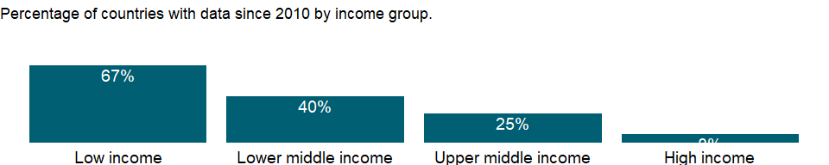

### Why is it relevant?

According to the Geneva Declaration on Armed Violence and Development, more than 526,000 people die each year because of the violence associated with armed conflict and large- and small-scale criminality. Recovery and rebuilding can take years, and the challenges are numerous: infrastructure to be rebuilt, persistently high crime, widespread health problems, education systems in disrepair, and unexploded ordnance to be cleared.

Most countries emerging from conflict lack the capacity to rebuild the economy. Thus, capacity building is one of the first tasks for restoring growth and is linked to building peace and creating the conditions that lead to sustained poverty reduction. UN Peacekeepers serve in some of the most difficult and dangerous situations around the globe. United Nations Peacekeeping force, comprised of civilian, police and military personnel, helps countries torn by conflict create the conditions for lasting peace. In addition to maintaining peace and security, peacekeepers are increasingly charged with assisting in political processes; reforming judicial systems; training law enforcement and police forces; disarming and reintegrating former combatants; supporting the return of internally displaced persons and refugees.

The World Bank and other international development agencies can help, but countries with fragile situations have to build their own institutions tailored to their own needs. Peacekeeping operations in post-conflict situations have been effective in reducing the risks of reversion to conflict.

### What is the data source?

Uppsala Conflict Data Program, <http://www.pcr.uu.se/research/ucdp/>.

### What is the methodology?

During warfare, targets are usually the military and its installations or state institutions and state representatives, but there is often substantial collateral damage of civilians killed in crossfire, indiscriminate bombings, and other military activities. All deaths - civilian as well as military - incurred in such situations are counted as battle-related deaths.

### How is it aggregated?

Sum

### What are the limitations?

An armed conflict is a contested incompatibility that concerns a government or territory where the use of armed force between two parties (one of them the government) results in at least 25 battle related deaths in a calendar year.

Data is from the Uppsala Conflict Data Program (UCDP) Battle-Related Deaths Dataset which focuses on the incompatibility and lists the country, as well as the battle location and territory where battle-related deaths are reported. When more than one country is listed in the dataset, the assignment of battle-related deaths is determined by the battle location. User can refer to the ICDP dataset where they have split the deaths for the actual location of the fighting when the fighting occurred on the disputed border.

### What else should I know?

NA

### 1.90.2 Internally displaced persons, new displacement associated with conflict and violence (number of cases)

### What is the indicator?

Internally displaced persons are defined according to the 1998 Guiding Principles (<http://www.internal-displacement.org/publications/1998/ocha-guiding-principles-on-internal-displacement>) as people or groups of people who have been forced or obliged to flee or to leave their homes or places of habitual residence, in particular as a result of armed conflict, or to avoid the effects of armed conflict, situations of generalized violence, violations of human rights, or natural or human-made disasters and who have not crossed an international border. “New Displacement” refers to the number of new cases or incidents of displacement recorded over the specified year, rather than the number of people displaced. This is done because people may have been displaced more than once.

Topic: Public Sector: Conflict & fragility

Series ID: VC.IDP.NWCV

Copyright: CC BY-4.0 , <https://datacatalog.worldbank.org/public-licenses#cc-by>

First year with any data: 2009

Last year with any data: 2020

### What years are data available?

The figure below shows years in which data is available for at least one country. Dates shaded in black have no data, while dates shaded in green have data for at least one country

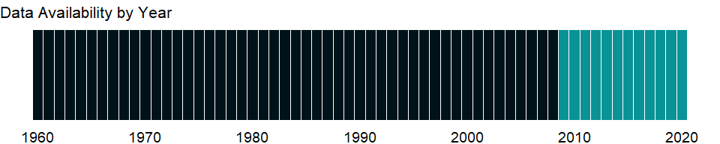

### Which countries have data?

The figure below shows the percentage of countries in each income group with a value since 2010 for that indicator.

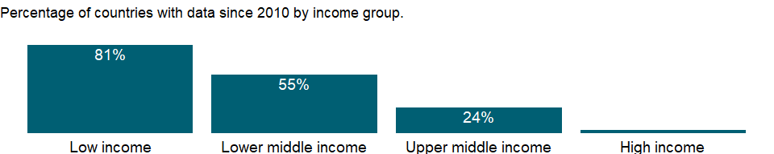

### Why is it relevant?

Although all persons affected by conflict and/or human rights violations suffer, displacement from one’s place of residence may make the internally displaced particularly vulnerable. Following are some of the factors that are likely to increase the need for protection:

1. Internally displaced persons may be in transit from one place to another, may be in hiding, may be forced toward unhealthy or inhospitable environments, or face other circumstances that make them especially vulnerable.
2. The social organization of displaced communities may have been destroyed or damaged by the act of physical displacement; family groups may be separated or disrupted; women may be forced to assume non-traditional roles or face particular vulnerabilities. Internally displaced populations, and especially groups like children, the elderly, or pregnant women, may experience profound psychosocial distress related to displacement.
3. Removal from sources of income and livelihood may add to physical and psychosocial vulnerability for displaced people.
4. Schooling for children and adolescents may be disrupted.
5. Internal displacement to areas where local inhabitants are of different groups or inhospitable may increase risk to internally displaced communities; internally displaced persons may face language barriers during displacement.
6. The condition of internal displacement may raise the suspicions of or lead to abuse by armed combatants, or other parties to conflict.
7. Internally displaced persons may lack identity documents essential to receiving benefits or legal recognition; in some cases, fearing persecution, displaced persons have sometimes got rid of such documents.
8. According to the Internal Displacement Monitoring Centre (IDMC) tens of millions people around the world are displaced every year within their countries by conflict, human rights violations, natural disasters and climate change. Unlike refugees who cross national borders and benefit from an established system of international protection and assistance, those forcibly uprooted within their own countries, by armed conflict, large-scale development projects, systematic violations of human rights, or natural disasters, lack predictable structures of support. Internal displacement has become one of the more pressing humanitarian, human rights and security problems confronting affected countries and the international community at large.

Global migration patterns have become increasingly complex in modern times, involving not just refugees, but also millions of economic migrants. But refugees and migrants, even if they often travel in the same way, are fundamentally different, and for that reason are treated very differently under modern international law. Migrants, especially economic migrants, choose to move in order to improve the future prospects of themselves and their families. Refugees have to move if they are to save their lives or preserve their freedom. They have no protection from their own state - indeed it is often their own government that is threatening to persecute them. If other countries do not let them in, and do not help them once they are in, then they may be condemning them to death - or to an intolerable life in the shadows, without sustenance and without rights.

### What is the data source?

The Internal Displacement Monitoring Centre (<http://www.internal-displacement.org/>)

### What is the methodology?

Internally displaced persons are “persons or groups of persons who have been forced or obliged to flee or to leave their homes or places of habitual residence, in particular as a result of or in order to avoid the effects of armed conflict, situations of generalized violence, violations of human rights or natural or human-made disasters, and who have not crossed an internationally recognized state border.” Internally displaced people are often confused with refugees. Unlike refugees, internally displaced people remain under the protection of their own government, even if their reason for fleeing was similar to that of refugees. Refugees are people who have crossed an international border to find sanctuary and have been granted refugee or refugee-like status or temporary protection. For more information on methodology, please refer to the information published by IDMC: <http://www.internal-displacement.org/database/>

### How is it aggregated?

Sum

### What are the limitations?

Please note that most of the figures are estimates. The definition highlights two issues:

1. The coercive or otherwise involuntary character of movement. The definition mentions some of the most common causes of involuntary movements, such as armed conflict, violence, human rights violations and disasters. These causes have in common that they give no choice to people but to leave their homes and deprive them of the most essential protection mechanisms, such as community networks, access to services, livelihoods. Displacement severely affects the physical, socio-economic and legal safety of people and should be systematically regarded as an indicator of potential vulnerability.
2. The fact that such movement takes place within national borders. Unlike refugees, who have been deprived of the protection of their state of origin, IDPs remain legally under the protection of national authorities of their country of habitual residence. IDPs should therefore enjoy the same rights as the rest of the population. The Guiding Principles on Internal Displacement remind national authorities and other relevant actors of their responsibility to ensure that IDPs’ rights are respected and fulfilled, despite the vulnerability generated by their displacement.

### What else should I know?

NA

### 1.90.3 Internally displaced persons, new displacement associated with disasters (number of cases)

### What is the indicator?

Internally displaced persons are defined according to the 1998 Guiding Principles (<http://www.internal-displacement.org/publications/1998/ocha-guiding-principles-on-internal-displacement>) as people or groups of people who have been forced or obliged to flee or to leave their homes or places of habitual residence, in particular as a result of armed conflict, or to avoid the effects of armed conflict, situations of generalized violence, violations of human rights, or natural or human-made disasters and who have not crossed an international border. “New Displacement” refers to the number of new cases or incidents of displacement recorded over the specified year, rather than the number of people displaced. This is done because people may have been displaced more than once.

Topic: Public Sector: Conflict & fragility

Series ID: VC.IDP.NWDS

Copyright: CC BY-4.0 , <https://datacatalog.worldbank.org/public-licenses#cc-by>

First year with any data: 2008

Last year with any data: 2020

### What years are data available?

The figure below shows years in which data is available for at least one country. Dates shaded in black have no data, while dates shaded in green have data for at least one country

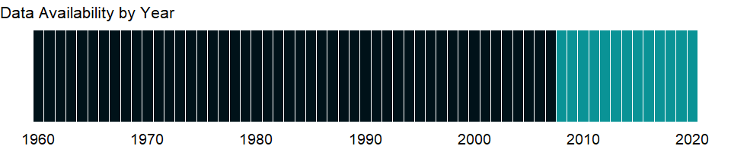

### Which countries have data?

The figure below shows the percentage of countries in each income group with a value since 2010 for that indicator.

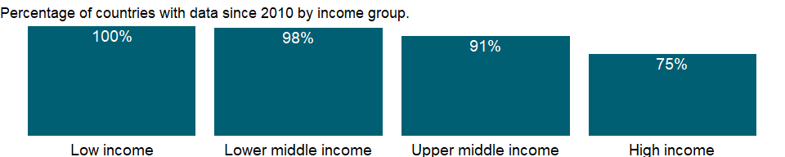

### Why is it relevant?

Although all persons affected by conflict and/or human rights violations suffer, displacement from one’s place of residence may make the internally displaced particularly vulnerable. Following are some of the factors that are likely to increase the need for protection:

1. Internally displaced persons may be in transit from one place to another, may be in hiding, may be forced toward unhealthy or inhospitable environments, or face other circumstances that make them especially vulnerable.
2. The social organization of displaced communities may have been destroyed or damaged by the act of physical displacement; family groups may be separated or disrupted; women may be forced to assume non-traditional roles or face particular vulnerabilities. Internally displaced populations, and especially groups like children, the elderly, or pregnant women, may experience profound psychosocial distress related to displacement.
3. Removal from sources of income and livelihood may add to physical and psychosocial vulnerability for displaced people.
4. Schooling for children and adolescents may be disrupted.
5. Internal displacement to areas where local inhabitants are of different groups or inhospitable may increase risk to internally displaced communities; internally displaced persons may face language barriers during displacement.
6. The condition of internal displacement may raise the suspicions of or lead to abuse by armed combatants, or other parties to conflict.
7. Internally displaced persons may lack identity documents essential to receiving benefits or legal recognition; in some cases, fearing persecution, displaced persons have sometimes got rid of such documents.
8. According to the Internal Displacement Monitoring Centre (IDMC) tens of millions people around the world are displaced every year within their countries by conflict, human rights violations, natural disasters and climate change. Unlike refugees who cross national borders and benefit from an established system of international protection and assistance, those forcibly uprooted within their own countries, by armed conflict, large-scale development projects, systematic violations of human rights, or natural disasters, lack predictable structures of support. Internal displacement has become one of the more pressing humanitarian, human rights and security problems confronting affected countries and the international community at large.

Global migration patterns have become increasingly complex in modern times, involving not just refugees, but also millions of economic migrants. But refugees and migrants, even if they often travel in the same way, are fundamentally different, and for that reason are treated very differently under modern international law. Migrants, especially economic migrants, choose to move in order to improve the future prospects of themselves and their families. Refugees have to move if they are to save their lives or preserve their freedom. They have no protection from their own state - indeed it is often their own government that is threatening to persecute them. If other countries do not let them in, and do not help them once they are in, then they may be condemning them to death - or to an intolerable life in the shadows, without sustenance and without rights.

### What is the data source?

The Internal Displacement Monitoring Centre (<http://www.internal-displacement.org/>)

### What is the methodology?

Internally displaced persons are “persons or groups of persons who have been forced or obliged to flee or to leave their homes or places of habitual residence, in particular as a result of or in order to avoid the effects of armed conflict, situations of generalized violence, violations of human rights or natural or human-made disasters, and who have not crossed an internationally recognized state border.” Internally displaced people are often confused with refugees. Unlike refugees, internally displaced people remain under the protection of their own government, even if their reason for fleeing was similar to that of refugees. Refugees are people who have crossed an international border to find sanctuary and have been granted refugee or refugee-like status or temporary protection.

### How is it aggregated?

Sum

### What are the limitations?

Please note that most of the figures are estimates. The definition highlights two issues:

1. The coercive or otherwise involuntary character of movement. The definition mentions some of the most common causes of involuntary movements, such as armed conflict, violence, human rights violations and disasters. These causes have in common that they give no choice to people but to leave their homes and deprive them of the most essential protection mechanisms, such as community networks, access to services, livelihoods. Displacement severely affects the physical, socio-economic and legal safety of people and should be systematically regarded as an indicator of potential vulnerability.
2. The fact that such movement takes place within national borders. Unlike refugees, who have been deprived of the protection of their state of origin, IDPs remain legally under the protection of national authorities of their country of habitual residence. IDPs should therefore enjoy the same rights as the rest of the population. The Guiding Principles on Internal Displacement remind national authorities and other relevant actors of their responsibility to ensure that IDPs’ rights are respected and fulfilled, despite the vulnerability generated by their displacement.

### What else should I know?

NA

### 1.90.4 Internally displaced persons, total displaced by conflict and violence (number of people)

### What is the indicator?

Internally displaced persons are defined according to the 1998 Guiding Principles (<http://www.internal-displacement.org/publications/1998/ocha-guiding-principles-on-internal-displacement>) as people or groups of people who have been forced or obliged to flee or to leave their homes or places of habitual residence, in particular as a result of armed conflict, or to avoid the effects of armed conflict, situations of generalized violence, violations of human rights, or natural or human-made disasters and who have not crossed an international border. “People displaced” refers to the number of people living in displacement as of the end of each year, and reflects the stock of people displaced at the end of the previous year, plus inflows of new cases arriving over the year as well as births over the year to those displaced, minus outflows which may include returnees, those who settled elsewhere, those who integrated locally, those who travelled over borders, and deaths.

Topic: Public Sector: Conflict & fragility

Series ID: VC.IDP.TOCV

Copyright: CC BY-4.0 , <https://datacatalog.worldbank.org/public-licenses#cc-by>

First year with any data: 2009

Last year with any data: 2020

### What years are data available?

The figure below shows years in which data is available for at least one country. Dates shaded in black have no data, while dates shaded in green have data for at least one country



### Which countries have data?

The figure below shows the percentage of countries in each income group with a value since 2010 for that indicator.

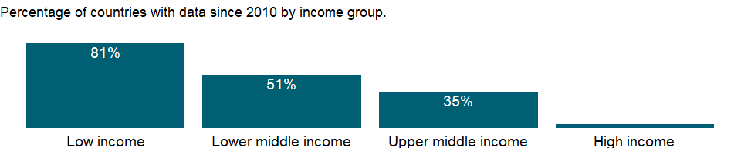

### Why is it relevant?

Although all persons affected by conflict and/or human rights violations suffer, displacement from one’s place of residence may make the internally displaced particularly vulnerable. Following are some of the factors that are likely to increase the need for protection:

1. Internally displaced persons may be in transit from one place to another, may be in hiding, may be forced toward unhealthy or inhospitable environments, or face other circumstances that make them especially vulnerable.
2. The social organization of displaced communities may have been destroyed or damaged by the act of physical displacement; family groups may be separated or disrupted; women may be forced to assume non-traditional roles or face particular vulnerabilities. Internally displaced populations, and especially groups like children, the elderly, or pregnant women, may experience profound psychosocial distress related to displacement.
3. Removal from sources of income and livelihood may add to physical and psychosocial vulnerability for displaced people.
4. Schooling for children and adolescents may be disrupted.
5. Internal displacement to areas where local inhabitants are of different groups or inhospitable may increase risk to internally displaced communities; internally displaced persons may face language barriers during displacement.
6. The condition of internal displacement may raise the suspicions of or lead to abuse by armed combatants, or other parties to conflict.
7. Internally displaced persons may lack identity documents essential to receiving benefits or legal recognition; in some cases, fearing persecution, displaced persons have sometimes got rid of such documents.
8. According to the Internal Displacement Monitoring Centre (IDMC) tens of millions people around the world are displaced every year within their countries by conflict, human rights violations, natural disasters and climate change. Unlike refugees who cross national borders and benefit from an established system of international protection and assistance, those forcibly uprooted within their own countries, by armed conflict, large-scale development projects, systematic violations of human rights, or natural disasters, lack predictable structures of support. Internal displacement has become one of the more pressing humanitarian, human rights and security problems confronting affected countries and the international community at large.

Global migration patterns have become increasingly complex in modern times, involving not just refugees, but also millions of economic migrants. But refugees and migrants, even if they often travel in the same way, are fundamentally different, and for that reason are treated very differently under modern international law. Migrants, especially economic migrants, choose to move in order to improve the future prospects of themselves and their families. Refugees have to move if they are to save their lives or preserve their freedom. They have no protection from their own state - indeed it is often their own government that is threatening to persecute them. If other countries do not let them in, and do not help them once they are in, then they may be condemning them to death - or to an intolerable life in the shadows, without sustenance and without rights.

### What is the data source?

The Internal Displacement Monitoring Centre (<http://www.internal-displacement.org/>)

### What is the methodology?

Internally displaced persons are “persons or groups of persons who have been forced or obliged to flee or to leave their homes or places of habitual residence, in particular as a result of or in order to avoid the effects of armed conflict, situations of generalized violence, violations of human rights or natural or human-made disasters, and who have not crossed an internationally recognized state border.” Internally displaced people are often confused with refugees. Unlike refugees, internally displaced people remain under the protection of their own government, even if their reason for fleeing was similar to that of refugees. Refugees are people who have crossed an international border to find sanctuary and have been granted refugee or refugee-like status or temporary protection. “People displaced” refers to the number of people living in displacement as of the end of each year, and reflects the stock of people displaced at the end of the previous year, plus inflows of new cases arriving over the year as well as births over the year to those displaced, minus outflows which may include returnees, those who settled elsewhere, those who integrated locally, those who travelled over borders, and deaths.

### How is it aggregated?

Sum

### What are the limitations?

Please note that most of the figures are estimates. The definition highlights two issues:

1. The coercive or otherwise involuntary character of movement. The definition mentions some of the most common causes of involuntary movements, such as armed conflict, violence, human rights violations and disasters. These causes have in common that they give no choice to people but to leave their homes and deprive them of the most essential protection mechanisms, such as community networks, access to services, livelihoods. Displacement severely affects the physical, socio-economic and legal safety of people and should be systematically regarded as an indicator of potential vulnerability.
2. The fact that such movement takes place within national borders. Unlike refugees, who have been deprived of the protection of their state of origin, IDPs remain legally under the protection of national authorities of their country of habitual residence. IDPs should therefore enjoy the same rights as the rest of the population. The Guiding Principles on Internal Displacement remind national authorities and other relevant actors of their responsibility to ensure that IDPs’ rights are respected and fulfilled, despite the vulnerability generated by their displacement.

### What else should I know?

NA

### 1.90.5 Intentional homicides, female (per 100,000 female)

### What is the indicator?

Intentional homicides, female are estimates of unlawful female homicides purposely inflicted as a result of domestic disputes, interpersonal violence, violent conflicts over land resources, intergang violence over turf or control, and predatory violence and killing by armed groups. Intentional homicide does not include all intentional killing; the difference is usually in the organization of the killing. Individuals or small groups usually commit homicide, whereas killing in armed conflict is usually committed by fairly cohesive groups of up to several hundred members and is thus usually excluded.

Topic: Public Sector: Conflict & fragility

Series ID: VC.IHR.PSRC.FE.P5

Copyright: CC BY-4.0 , <https://datacatalog.worldbank.org/public-licenses#cc-by>

First year with any data: 1990

Last year with any data: 2018

### What years are data available?

The figure below shows years in which data is available for at least one country. Dates shaded in black have no data, while dates shaded in green have data for at least one country



### Which countries have data?

The figure below shows the percentage of countries in each income group with a value since 2010 for that indicator.

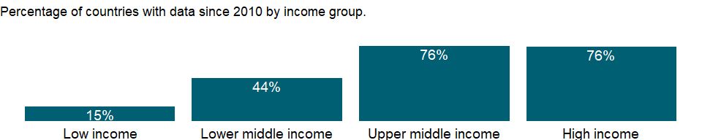

### Why is it relevant?

In some regions, organized crime, drug trafficking and the violent cultures of youth gangs are predominantly responsible for the high levels of homicide. There has been a sharp increase in homicides in some countries, particularly in Central America, are making the activities of organized crime and drug trafficking more visible. Greater use of firearms is often associated with the illicit activities of organized criminal groups, which are often linked to drug trafficking.

Knowledge of the patterns and causes of violent crime are crucial to forming preventive strategies. Young males are the group most affected by violent crime in all regions, particularly in the Americas. Yet women of all ages are the victims of intimate partner and family-related violence in all regions and countries. Indeed, in many of them, it is within the home where a woman is most likely to be killed.

Data on intentional homicides are from the United Nations Office on Drugs and Crime (UNODC), which uses a variety of national and international sources on homicides - primarily criminal justice sources as well as public health data from the World Health Organization (WHO) and the Pan American Health Organization - and the United Nations Survey of Crime Trends and Operations of Criminal Justice Systems to present accurate and comparable statistics. The UNODC defines homicide as “unlawful death purposefully inflicted on a person by another person.” This definition excludes deaths arising from armed conflict.

### What is the data source?

UN Office on Drugs and Crime’s International Homicide Statistics database.

### What is the methodology?

The definitions used to produce data are in line with the homicide definition used in the UNODC Homicide Statistics dataset. On the basis of these selection criteria and subject to data availability, a long and continuous time series including recent data on homicide counts and rates has been identified or created at country level. Data are adjusted to conform to the total number of victims of intentional homicide. The adjustment is carried out by applying the sex ratio of reported victims to the total number of victims of intentional homicide.

The intentional killing of a human being by another is the ultimate crime. Its indisputable physical consequences manifested in the form of a dead body also make it the most categorical and calculable. All existing data sources on intentional homicides, both at national and international level, stem from either criminal justice or public health systems. In the former case, data are generated by law enforcement or criminal justice authorities in the process of recording and investigating a crime event. In the latter, data are produced by health authorities certifying the cause of death of an individual.

Criminal justice data were collected through UNODC regular collections of crime data from Member States, through publicly available data produced by national government sources and from data compiled by other international and regional agencies, including from Interpol, Eurostat, the Organization of American States and UNICEF. Public health data on homicides were mainly derived from databases on deaths by cause disseminated by the World Health Organization (WHO).

The inclusion of recent data was given a higher priority in the selection process than the length of the time series (number of years covered). An analysis of official reports and research literature is regularly carried out to verify homicide data used by government agencies and the scientific community.

As a result of the data collection and validation process, in many countries several homicide datasets have become available from different or multiple sources. Therefore, data series have been selected to provide the most appropriate reference counts.

### How is it aggregated?

NA

### What are the limitations?

Statistics reported to the United Nations in the context of its various surveys on crime levels and criminal justice trends are incidents of victimization that have been reported to the authorities in any given country. That means that this data is subject to the problems of accuracy of all official crime data. The survey results provide an overview of trends and interrelationships between various parts of the criminal justice system to promote informed decision-making in administration, nationally and internationally.

The degree to which different societies apportion the level of culpability to acts resulting in death is also subject to variation. Consequently, the comparison between countries and regions of “intentional homicide”, or unlawful death purposefully inflicted on a person by another person, is also a comparison of the extent to which different countries deem that a killing be classified as such, as well as the capacity of their legal systems to record it. Caution should therefore be applied when evaluating and comparing homicide data.

### What else should I know?

NA

### 1.90.6 Intentional homicides, male (per 100,000 male)

### What is the indicator?

Intentional homicides, male are estimates of unlawful male homicides purposely inflicted as a result of domestic disputes, interpersonal violence, violent conflicts over land resources, intergang violence over turf or control, and predatory violence and killing by armed groups. Intentional homicide does not include all intentional killing; the difference is usually in the organization of the killing. Individuals or small groups usually commit homicide, whereas killing in armed conflict is usually committed by fairly cohesive groups of up to several hundred members and is thus usually excluded.

Topic: Public Sector: Conflict & fragility

Series ID: VC.IHR.PSRC.MA.P5

Copyright: CC BY-4.0 , <https://datacatalog.worldbank.org/public-licenses#cc-by>

First year with any data: 1990

Last year with any data: 2018

### What years are data available?

The figure below shows years in which data is available for at least one country. Dates shaded in black have no data, while dates shaded in green have data for at least one country



### Which countries have data?

The figure below shows the percentage of countries in each income group with a value since 2010 for that indicator.

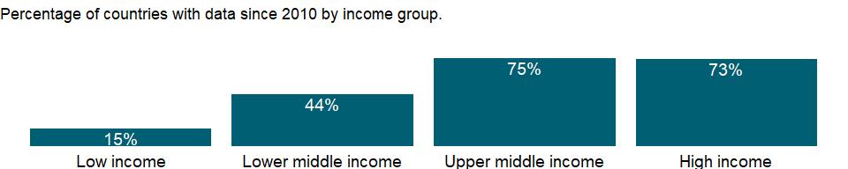

### Why is it relevant?

In some regions, organized crime, drug trafficking and the violent cultures of youth gangs are predominantly responsible for the high levels of homicide. There has been a sharp increase in homicides in some countries, particularly in Central America, are making the activities of organized crime and drug trafficking more visible. Greater use of firearms is often associated with the illicit activities of organized criminal groups, which are often linked to drug trafficking.

Knowledge of the patterns and causes of violent crime are crucial to forming preventive strategies. Young males are the group most affected by violent crime in all regions, particularly in the Americas. Yet women of all ages are the victims of intimate partner and family-related violence in all regions and countries. Indeed, in many of them, it is within the home where a woman is most likely to be killed.

Data on intentional homicides are from the United Nations Office on Drugs and Crime (UNODC), which uses a variety of national and international sources on homicides - primarily criminal justice sources as well as public health data from the World Health Organization (WHO) and the Pan American Health Organization - and the United Nations Survey of Crime Trends and Operations of Criminal Justice Systems to present accurate and comparable statistics. The UNODC defines homicide as “unlawful death purposefully inflicted on a person by another person.” This definition excludes deaths arising from armed conflict.

### What is the data source?

UN Office on Drugs and Crime’s International Homicide Statistics database.

### What is the methodology?

The definitions used to produce data are in line with the homicide definition used in the UNODC Homicide Statistics dataset. On the basis of these selection criteria and subject to data availability, a long and continuous time series including recent data on homicide counts and rates has been identified or created at country level. Data are adjusted to conform to the total number of victims of intentional homicide. The adjustment is carried out by applying the sex ratio of reported victims to the total number of victims of intentional homicide.

The intentional killing of a human being by another is the ultimate crime. Its indisputable physical consequences manifested in the form of a dead body also make it the most categorical and calculable. All existing data sources on intentional homicides, both at national and international level, stem from either criminal justice or public health systems. In the former case, data are generated by law enforcement or criminal justice authorities in the process of recording and investigating a crime event. In the latter, data are produced by health authorities certifying the cause of death of an individual.

Criminal justice data were collected through UNODC regular collections of crime data from Member States, through publicly available data produced by national government sources and from data compiled by other international and regional agencies, including from Interpol, Eurostat, the Organization of American States and UNICEF. Public health data on homicides were mainly derived from databases on deaths by cause disseminated by the World Health Organization (WHO).

The inclusion of recent data was given a higher priority in the selection process than the length of the time series (number of years covered). An analysis of official reports and research literature is regularly carried out to verify homicide data used by government agencies and the scientific community.

As a result of the data collection and validation process, in many countries several homicide datasets have become available from different or multiple sources. Therefore, data series have been selected to provide the most appropriate reference counts.

### How is it aggregated?

NA

### What are the limitations?

Statistics reported to the United Nations in the context of its various surveys on crime levels and criminal justice trends are incidents of victimization that have been reported to the authorities in any given country. That means that this data is subject to the problems of accuracy of all official crime data. The survey results provide an overview of trends and interrelationships between various parts of the criminal justice system to promote informed decision-making in administration, nationally and internationally.

The degree to which different societies apportion the level of culpability to acts resulting in death is also subject to variation. Consequently, the comparison between countries and regions of “intentional homicide”, or unlawful death purposefully inflicted on a person by another person, is also a comparison of the extent to which different countries deem that a killing be classified as such, as well as the capacity of their legal systems to record it. Caution should therefore be applied when evaluating and comparing homicide data.

### What else should I know?

NA

### 1.90.7 Intentional homicides (per 100,000 people)

### What is the indicator?

Intentional homicides are estimates of unlawful homicides purposely inflicted as a result of domestic disputes, interpersonal violence, violent conflicts over land resources, intergang violence over turf or control, and predatory violence and killing by armed groups. Intentional homicide does not include all intentional killing; the difference is usually in the organization of the killing. Individuals or small groups usually commit homicide, whereas killing in armed conflict is usually committed by fairly cohesive groups of up to several hundred members and is thus usually excluded.

Topic: Public Sector: Conflict & fragility

Series ID: VC.IHR.PSRC.P5

Copyright: CC BY-4.0 , <https://datacatalog.worldbank.org/public-licenses#cc-by>

First year with any data: 1990

Last year with any data: 2018

### What years are data available?

The figure below shows years in which data is available for at least one country. Dates shaded in black have no data, while dates shaded in green have data for at least one country



### Which countries have data?

The figure below shows the percentage of countries in each income group with a value since 2010 for that indicator.

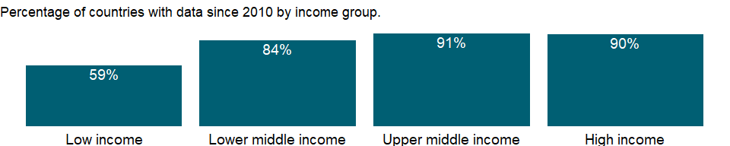

### Why is it relevant?

In some regions, organized crime, drug trafficking and the violent cultures of youth gangs are predominantly responsible for the high levels of homicide. There has been a sharp increase in homicides in some countries, particularly in Central America, are making the activities of organized crime and drug trafficking more visible. Greater use of firearms is often associated with the illicit activities of organized criminal groups, which are often linked to drug trafficking.

Knowledge of the patterns and causes of violent crime are crucial to forming preventive strategies. Young males are the group most affected by violent crime in all regions, particularly in the Americas. Yet women of all ages are the victims of intimate partner and family-related violence in all regions and countries. Indeed, in many of them, it is within the home where a woman is most likely to be killed.

Data on intentional homicides are from the United Nations Office on Drugs and Crime (UNODC), which uses a variety of national and international sources on homicides - primarily criminal justice sources as well as public health data from the World Health Organization (WHO) and the Pan American Health Organization - and the United Nations Survey of Crime Trends and Operations of Criminal Justice Systems to present accurate and comparable statistics. The UNODC defines homicide as “unlawful death purposefully inflicted on a person by another person.” This definition excludes deaths arising from armed conflict.

### What is the data source?

UN Office on Drugs and Crime’s International Homicide Statistics database.

### What is the methodology?

The definitions used to produce data are in line with the homicide definition used in the UNODC Homicide Statistics dataset. On the basis of these selection criteria and subject to data availability, a long and continuous time series including recent data on homicide counts and rates has been identified or created at country level. Data included in the dataset correspond to the original value provided by the source of origin, since no statistical procedure or modeling was used to change collected values or to create new or revised figures.

The intentional killing of a human being by another is the ultimate crime. Its indisputable physical consequences manifested in the form of a dead body also make it the most categorical and calculable. All existing data sources on intentional homicides, both at national and international level, stem from either criminal justice or public health systems. In the former case, data are generated by law enforcement or criminal justice authorities in the process of recording and investigating a crime event. In the latter, data are produced by health authorities certifying the cause of death of an individual.

Criminal justice data were collected through UNODC regular collections of crime data from Member States, through publicly available data produced by national government sources and from data compiled by other international and regional agencies, including from Interpol, Eurostat, the Organization of American States and UNICEF. Public health data on homicides were mainly derived from databases on deaths by cause disseminated by the World Health Organization (WHO).

The inclusion of recent data was given a higher priority in the selection process than the length of the time series (number of years covered). An analysis of official reports and research literature is regularly carried out to verify homicide data used by government agencies and the scientific community.

As a result of the data collection and validation process, in many countries several homicide datasets have become available from different or multiple sources. Therefore, data series have been selected to provide the most appropriate reference counts.

### How is it aggregated?

Weighted average

### What are the limitations?

Statistics reported to the United Nations in the context of its various surveys on crime levels and criminal justice trends are incidents of victimization that have been reported to the authorities in any given country. That means that this data is subject to the problems of accuracy of all official crime data. The survey results provide an overview of trends and interrelationships between various parts of the criminal justice system to promote informed decision-making in administration, nationally and internationally.

The degree to which different societies apportion the level of culpability to acts resulting in death is also subject to variation. Consequently, the comparison between countries and regions of “intentional homicide”, or unlawful death purposefully inflicted on a person by another person, is also a comparison of the extent to which different countries deem that a killing be classified as such, as well as the capacity of their legal systems to record it. Caution should therefore be applied when evaluating and comparing homicide data.

### What else should I know?

NA